Tackling Indigenous Smoking and Healthy Lifestyle Programme Review: Stakeholder Consultation

Report 2 of 3

**21 November 2014**

**Authors**

Dr Penney Upton

Professor Rachel Davey

Professor Mark Evans

Dr Katja Mikhailovich

Lee Simpson

Davina Hacklin

# Introduction

A targeted consultation of key stakeholders was undertaken as part of the review of the Tackling Indigenous[1] Smoking and Healthy Lifestyles (TIS&HL) Programme. The purpose of this consultation was to:

* describe the programme’s impact on individuals and communities;
* document the barriers and enablers to success;
* gather stakeholder suggestions for future development in this area.

# Method

One hundred and forty key stakeholders identified by the Department of Health, were invited to provide a written submission to the programme review via an online semi-structured survey. Provision was also made for organisations to submit additional materials as evidence of programme impact. In addition, a subsample of these stakeholders (N=43) was invited to undertake a brief telephone interview.

# Findings

A total of 111 written consultations were received (response rate=79.3%). Responses were received from 82 teams who had received funding from the TIS&HL programme and 29 other stakeholders who had not received funding under the programme, including 14 industry experts. Respondents came from a range of services including academia, non-government health organisations, National Aboriginal Community Controlled Health Organisation (NACCHO) and their Affiliates, State and Territory Governments, and Regional Tackling Smoking and Healthy Lifestyle (RTSHL) Teams. All six states and two mainland territories were also represented.

Interviews were carried out with 30 individuals (response rate = 71.4%), who again represented teams funded under the programme and industry experts from across the Commonwealth.

Results are presented firstly for the programme teams, then for the industry experts; because of the overlap in information received, written and interview feedback has been integrated for each group.

## Feedback from Programme Teams

### a) Programme Aims and Activities

Programmes generally covered a range of lifestyle topics (Figure 1), with the most common being smoking cessation & prevention (93.2%), physical activity (84.1%) and healthy eating (81.8%), with the main aims of the programmes being to educate the community about the dangers of smoking (92.9%) and so change attitudes towards smoking (92.9%) and behaviours (see Figure 2).

Figure 1: Lifestyle Topics Covered by Programmes

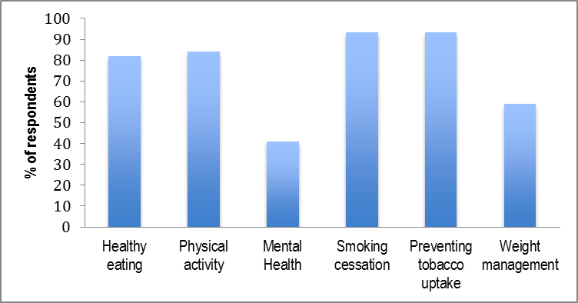

Figure 2: Programme Aims

Figure 2 is a bar graph showing the program aims against the percentage (%) or respondents and the following aims: 
• 92.9% Community education about smoking
• 76.2% Community education about healthy lifestyles
• 92.9% Change community attitudes to smoking
• 76.2% Change community attitudes to healthy lifestyles
• 90.5% Prevent uptake of smoking in young people
• 88.1% Help pregnant women cut down or stop smoking
• 95.2% Help anyone who smokes to cut down or stop
• 69.1% Increase the number of people who consume a nutritious diet
• 73.8% Increase physical activity among the community
• 42.9% Weight management


Figure 3: Components Included in Programmes

Programmes included a number of different elements as shown in Figure 3, with Regional Tobacco Co-ordinator (84.8%) and Tobacco Action Worker (82.6%) being the most common components. In contrast clinical services were the least likely to be featured (30.1%).

The limited number of clinical services is unsurprising given that the programmes were mainly concerned with raising awareness of services available (92.7%), preventing smoking uptake (87.8%) and providing healthy life style activities (80.5%). However over half also saw outreach work (70.0%) and quit support services such as running quit groups for targeted populations (61.0%) and providing NRT (51.2%) as being within their remit.

The sort of activities carried out by programmes also highlighted their educational focus, with promotional events, social marketing and educational sessions around the dangers of smoking and the benefits of healthy lifestyles featuring high on the agenda. Physical activities ranging from Traditional Indigenous Games (TIG), through competitive games such as football and basketball to walking groups and gym sessions were also described. Cooking and nutrition components were also an important feature of a number of programmes. Finally two projects also included a commercial weight management programme for children and families which combines physical activity with advice on nutrition (Mind, Exercise, Nutrition…Do It! or MEND)

### b) Programme Funding

Funding was used primarily to provide workforce salaries. Programme materials and administrative oncosts also took up a substantial part of programme budgets. In addition to this programmes had used their funding to cover items such as travel, purchasing equipment and vehicles, and workforce training.

Interviewees felt that in some areas, particularly where the Regional Tobacco Co-ordinator, or the host agency did not have a good understanding of health promotion as an approach, funding has not always been spent appropriately. Examples included:

* Spending on quit rather than health promotion (e.g. buying NRT)
* Setting up activities such as walking groups, gym programmes and so on, but without linking these activities with healthy lifestyle messages.

### c) Operationalizing the Programme: Partnerships and Workforce

Most programmes had developed partnerships to support their activities (see Figure 4), with the most common being with local community members (92.5%) and Aboriginal healthcare practitioners (87.5%). Partnerships with outreach workers (80.0%) and local community organisations (inter-agency collaborations) were also popular.

Figure 4: Partnerships

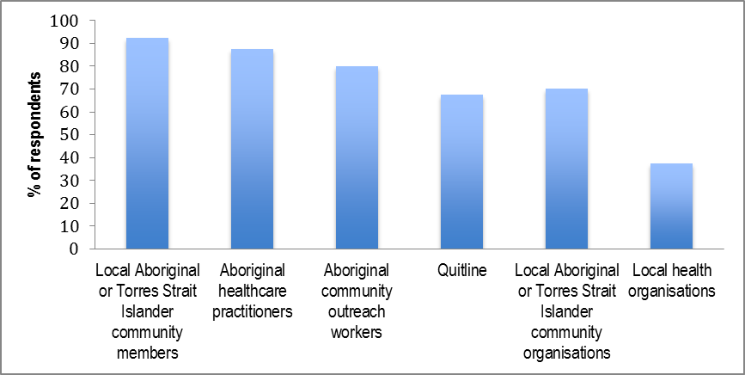

As Figure 5shows, the organisation mostly frequently partnered with (97.4%) was the Aboriginal Medical Services (AMS). Local non-government organisations (82.1%) and schools (84.6%) were also popular choices for inter-agency working. Around three quarters of programmes had also partnered with local youth clubs (79.5%), other health providers (74.5%), local sports clubs (74.5%), and Quitlines (69.2%). Some stakeholders had also partnered with other local and regional services including:

* Medicare local;
* Local councils;
* Local media;
* Prison and/or police services;
* Men’s and women’s groups (e.g. YWCA, Clontarf Foundation);
* Community welfare services;
* National Heart Foundation;
* Regional Cancer Councils.

Figure 5: Inter-agency Collaborators

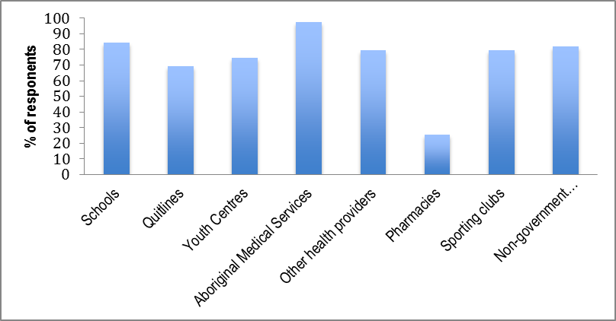

A number of programmes described these partners as enthusiastic collaborators; however 22.5% of respondents outlined some resistance from local organisations, some of whom saw the regional nature of the programme as a threat. Some of the ‘Jealousy, Insecurity and Greed’ displayed by these local organisations seems to have stemmed from a lack of understanding of the programme aims. Community politics was also cited as an issue. However, these seem to have been difficulties that were encountered in the early days of programmes, with respondents noting that developing relationships takes time. Indeed, it was recognised that once a clear understanding of the programme remit was established (usually following the delivery of initial activities) local enthusiasm to collaborate increased. The vastness of the region was also cited as an issue in remote areas where location can challenge the development and maintenance of inter-agency relationships. Interview responses confirmed that the development of networks was a key success of the programme.

The involvement of local community members in the programmes took a variety of forms, however all programmes had undertaken community consultation (see Figure 6). A majority of programmes (76.3%) also employed local people to deliver their activities and do outreach work. Using local people as role models (68.4%) and ambassadors (52.6%) was also popular.

Figure 6: Involvement of Local Community Members

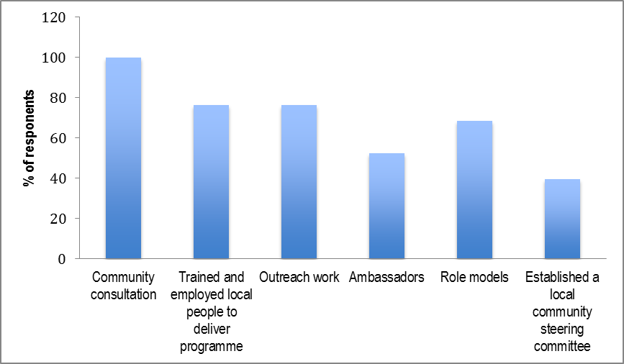

The majority of programmes (92.7%) had undertaken workforce training, with this being primarily around Quitskills training and general business education (e.g. administration, IT). According to interviewees, training local community members in this way allowed them to become real agents of change. This was because not only did they have the knowledge and expertise to support people to make lifestyle changes, but also because of the additional advantage of having the language of the community, and awareness of community politics and “community nuances” which can have an impact on the delivery of any service or programme. In addition to this integrity within the community, those who have quit or are in the process of quitting can often be more empathetic role models.

Over half of the programmes (51.3%) described issues with recruitment of appropriate personnel, whilst 45.0% had also experienced problems with retention of staff. Reasons for recruitment and retention difficulties included difficulty finding appropriately qualified staff, the remoteness of the service location, a poor career pathway, and the uncertainty surrounding funding and future contracts. Suggestions to overcome these issues included ensuring competitive and appropriate rates of pay for staff, and better support and training for workers. Those organisations which had been very successful in recruiting and retaining staff (e.g. 97% retention rate) described a ‘supported employment model’ whereby local Aboriginal and Torres Strait Islanders were employed and supported through training, with ongoing ‘family friendly’ support provided after qualification.

### d) Participant Recruitment

A large number of programmes targeted specific groups such as smokers (95.2%), young people (92.5%) and pregnant women (90.5%), as shown in Figure 7. Participants were recruited through a variety of means, but especially through local community groups and organisations (e.g. sports clubs, clinics, schools). Community engagement, local events, word of mouth, advertising through flyers, and social media were therefore seen as essential to participant recruitment. Some programmes also used direct referral mechanisms (e.g. from GPs, local services and partner organisations), although this was much less common.

Figure 7: Targeted Groups

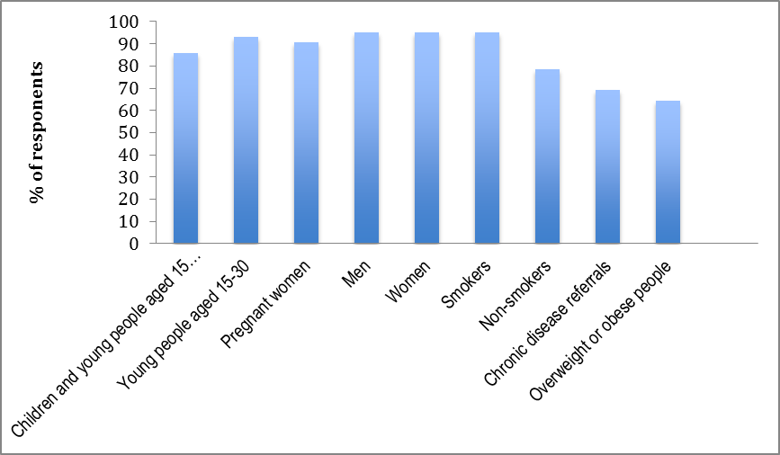

### e) Programme Success and Impact

Almost all respondents (97.4%) believed that their programme had developed capacity for local community tobacco control and healthy lifestyle promotion. This was suggested to have been achieved primarily through increasing community and individual knowledge around the effects of smoking, and the benefits of healthy lifestyle choices around nutrition and exercise. Raising awareness of support for quitting and providing information around healthy eating and physical exercise, was also seen as important. Furthermore, people were seen to be becoming more comfortable about asking advice with regards to quitting, and other lifestyle changes. The development of dedicated resources and programmes for Aboriginal and Torres Strait Islanders, including a local workforce, was also cited as an important success.

The effectiveness and impact of programmes was measured in a number of ways at both community and individual level including:

* Number of community members attending events/activities;
* Number/reach of local community-based initiatives;
* Extent of engagement of programme teams with primary health care clinical teams;
* Number of brochures/information leaflets provided to the community;
* Breath carbon monoxide levels;
* Number of quit attempts by individuals;
* Number of smoke free policies implemented;
* Fagerstrom Test for Nicotine Dependence;
* Length of any quit attempts of individual participants;
* Number of cigarettes smoked by individuals;
* Number of quit smoking groups.

However, success was primarily measured in terms of reach, with the majority of respondents (83.9%) stating that they monitored programme attendance. Thousands of individuals were estimated to have participated in programmes across the Commonwealth. These included smokers and non-smokers, men and women of all ages, and children. Due to the nature of many of the programmes, often it was only possible to estimate programme reach. This was frequently based on event attendance numbers, meaning that overall figures often counted individuals twice. However the fact that individuals participated in more than one activity or event should be seen as further evidence of the effective reach of these programmes.

The majority of programmes (61.8%) stated that they collected data on quit attempts and referrals to smoking cessation services. The remaining programmes that did not collect this data, explained that this was because smoking cessation was never part of the program aims and objectives, or because no requirement to collect these data had been given by the funder. It was also noted that Quitline collects these figures, and that for those programmes not attached to Aboriginal Community Control Health Services, monitoring programme attendance was challenging. Data from those programmes who did collect this information, showed that an estimated 9,000 plus individuals had either been refereed to smoking cessation services or had made a known quit attempt. Whilst all age groups were represented in these data, the majority of these were aged between 16 and 60 years of age.

Information around successful quit attempts was much harder to glean, since many people attempt to quit and relapse, and with transient populations it can be hard to keep track individuals. However the information supplied suggests that the programme has helped over 700 individuals successfully quit. This figure should not be taken to represent the total outcome of programme efforts, since not all programmes collected this data for the reasons outlined above. Furthermore, programme aims were usually broader than just smoking cessation. Indeed, it was also noted that success is not always measured by quitting; communities and individuals had made many other significant changes such as creating smokefree communities and homes, and cutting down on the amount smoked.

Success was also noted in relation to other healthy lifestyle choices (see Figure 8). The most cited change in behaviour related to physical activity, with 87.0% of respondents saying they had seen an increase in physical exercise in communities since the programme began.

Figure 8: Changes in Healthy Lifestyle Choices

Figure 8 is a grouped bar graph with the percentages (%) of respondents, against the changes in the healthy lifestyle choices. 
The data for Yes respondents were: 
• 75% Weight loss
• 77.3% Healthier eating
• 87% Increased involvement in physical exercise 

The data for No respondents were:
• 25% Weight loss
• 22.7% Healthier eating
• 13% Increased involvement in physical exercise


Finally success was also noted by all respondents in terms of workforce and capacity development, increases in networks and partnerships, and community involvement and awareness of the effects of smoking and the benefits of healthy lifestyle choices. Interviewees noted that the presentation of the programme as health promotion, with its broader remit around lifestyle choices, rather than solely focused on ‘quit’ services, was one of the main reasons for the programme being so well accepted in communities.

### f) Participant Satisfaction

Information concerning participant satisfaction with activities and events was collected by the majority of programmes (97.0%), primarily through informal discussion and observation of behaviour change. A number of programmes also used more formal means such as focus groups (90.9%) and end of programme surveys (70.0%). However, one respondent noted that low literacy skills in some groups were a potential barrier to getting formal written feedback, stating that fewer forms for participants have been recommended for their programme so as to ensure community members were not “scared off’.

In general a high level of satisfaction, with the activities and events provided, was reported. In particular sessions were described as informative, providing new knowledge about the dangers of smoking as well as helpful advice around how to have a more healthy lifestyle. Furthermore participants were able to see that behaviour change was something they could achieve.

Over half of all programmes had also undertaken some form of evaluation (56.7%) and when asked to indicate (with supporting evidence) the most effective part of their programme respondents proposed a number of different features which have built awareness of the impact of smoking and the benefits of healthy lifestyle choice, highlighting in particular:

* The development of inter-agency partnerships;
* Project reach, community engagement with activities and events;
* The education in schools and the community.

### g) Challenges to Implementation

Interviewees noted that prior to this programme, health programmes targeted at Aboriginal and Torres Strait Islander populations have, in the main been clinically based. Because of this historical context, community members have often, not unreasonably, expected the current programme to assist them to quit smoking when they make this decision. However, as TIS&HL is not clinically orientated, often the best staff can do is make a referral to a clinician. Community members can be reluctant to move away from the people with whom they have developed a rapport, to a new and unfamiliar person in a clinical setting. Ideally, interviewees felt the TIS&HL programme could have a component that allows workers to become a “broker”, continuing to support the client, until they are comfortable moving into the new “clinical mode” of quitting. Ensuring the link between health promotion and clinical services is a seamless and supportive process is therefore essential, and whilst some local programmes have been able to do this successfully (e.g. Deadly ChoicesTM), others have found this more challenging.

Delivering the programme in remote and rural areas was also described as challenging. For example, it can be very difficult and very expensive to get resources into some isolated areas. Seasonal changes can complicate this further, and present a real barrier to delivery of the programme; during the wet season it may be impossible to get in or out of some remote and isolated communities other than by plane, and flights may be limited and very expensive.

Finally, some concern was also expressed by interviewees, that there was confusion over the aims and purpose of health promotion programmes in some arenas. These respondents believed that health promotion was concerned with prevention only, not cessation. Thus it was felt that measuring quit attempts was not an appropriate measure of success for a health promotion programme; rather the focus should be on reach, attitudes, and community level measures of change. However, as one interviewee noted, measuring stages of change within a community could be an appropriate approach: thus in some communities, where programmes have only recently been implemented, most individuals will still be in a state of ‘contemplation’, and impact will be best represented by community measures such as reach; in other communities where programmes have been running for longer there should be individuals who have reached ‘preparation’ or ‘action’ stages, thus individual measures of behavior change become more relevant.

### h) Services and Activities Important for Reducing Smoking

The majority of respondents agreed that there are a number of different services and activities that are important for reducing smoking. As Table 1 shows, everyone agreed that raising community awareness of the issues related to smoking/healthy lifestyles, improving access to Nicotine Replacement Therapy (NRT), and local media campaigns were very important activities. The majority also placed importance on developing clear pathways to smoking cessation services, improving access to cessation services for communities and individuals, improving one-on-one cessation services, local workforce training and development and culturally appropriate Quitline services. In contrast there was some disagreement regarding the importance of local and national Key Performance Indicators for smoking cessation/healthy lifestyle programmes and national campaigns.

Table 1: Importance of Activities for Reducing Smoking

|  | **Very Unimportant** | **Somewhat Unimportant** | **Neutral** | **Somewhat Important** | **Very Important** |
| --- | --- | --- | --- | --- | --- |
| Raising community awareness of the issues related to smoking/healthy lifestyles | - | - | - | - | 100% |
| Applying locallyagreed Key Performance Indicators for smoking cessation/healthy lifestyle programmes | 3.8% | - | 3.8% | 11.5% | 76.9% |
| Applying nationallyagreed Key Performance Indicators for smoking cessation/healthy lifestyle programmes | 11.5% | - | 7.7% | 30.8% | 42.3% |
| Developing clear pathways to smoking cessation services | - | - | - | 7.7% | 92.3% |
| Improving access to Nicotine Replacement Therapy (NRT) | - | - | - | - | 100% |
| Improving access to cessation services for communities | - | - | - | 3.8% | 96.2% |
| Improving access to cessation services for individuals | - | - | - | 11.5% | 88.5% |
| Improving one-on-one cessation services | - | - | - | 19.2% | 80.8% |
| Social marketing | - | - | - | 11.5% | 88.5% |
| National media campaigns | 3.8% | 7.7% | 7.7% | 26.9% | 50% |
| Local media campaigns | - | - | - | - | 100% |
| Local workforce training and development programmes | - | - | - | 7.7% | 92.3% |
| Culturally appropriate Quitline services | - | - | - | 15.4% | 84.6% |

### i) Future Planning

Most programmes had taken steps to ensure the sustainability of their programme (96.5%). As Figure 9 shows the most popular step was to have developed a detailed plan of what services and activities should be maintained (72.4%), identified what is needed to manage and operate these activities (69.0%%), collected the data to support this choice (69.0%) and made stakeholders aware of these plans (62.1%).

Figure 9: Planning for sustainability

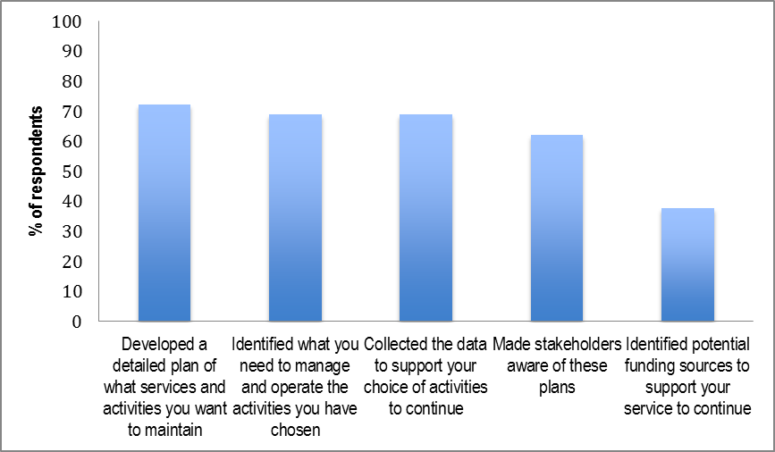

When asked what would provide good value in terms of reducing smoking in the future, respondents pointed towards the importance of population level approaches. In particular it was strongly felt that local teams to deliver educational events, school programmes and targeted culturally sensitive smoking cessation was the way forward. This was supported by the interviews, with one participant stressing that this health promotion advance is a

“… Cultural Revolution – it is a new approach bringing about much needed change.”

Finally great value was placed on the support provided by both the national and regional conferences in terms of networking, sharing good practice and keeping up to date on new evidence in the area. In particular the meetings were seen as providing a framework to the programme; for teams who are working in isolation for much of the year this was seen as an important opportunity for communication, inspiration and guidance.

## Feedback from Industry experts

### a) Allocation of Programme Funding

Respondents were overwhelmingly positive about the appropriateness of the allocation of programme funding to health promotion activities. Examples of funding successes included the development of a network of regional tobacco coordinators and tobacco action workers, delivery of social marketing campaigns, building capacity in the community controlled and health sector to address smoking and other lifestyle related risk factors, and so creating a community of practice. However, it was also noted that whilst TIS&HL teams based in community-driven organisations were a sound approach, the emphasis on achieving national coverage by the teams might have compromised the programme in some areas where the necessary skills and community commitment were lacking. Keeping teams local was seen as important.

Despite the challenges of roll out, industry experts were clear that the programme had been able to change local social norms around smoking and increase protection from second-hand smoke through promotion of smokefree homes, spaces and events. It was also noted that there is clear evidence from ‘Talking about the Smokes’ (TATS) that Aboriginal and Torre Strait Islander smokers are now well informed and are acting to reduce smoking.

### b) Effective Aspects of the Programme

All respondents felt the TIS&HL Programme had been effective in increasing the number of successful quitters among Aboriginal and Torres Strait Islander people and the majority (77.8%) also felt the programme had been effective in reducing tobacco uptake among Aboriginal and Torres Strait Islander people. However less than half thought it had been effective for increasing involvement in physical exercise among Aboriginal and Torres Strait Islander people (44.4%) or Increasing healthy eating within this group (22.2%).

A number of aspects of the programme were highlighted as having had a positive impact on changing attitudes and behaviours in Aboriginal and Torres Strait islander communities. However the primary focus was on the local nature of the programme.

Firstly, the greater ownership of tobacco use, and other lifestyle related chronic disease risk factors within community controlled and Aboriginal Health sectors, was viewed very positively. It was felt that this had resulted in the development of local campaigns, local resources, and new innovative practices (e.g. the Deadly ChoicesTM initiative) that work.

Continuing this local theme, the direct relevance of the social marketing to Indigenous Australians was noted, with the locally developed messaging highlighted as having ensured a cultural shift within communities. For example, the effectiveness of the DASSATM ambassador led model which uses local and respected Indigenous community members to help spread messages about the importance of reducing smoking and increasing healthy behaviours was also highlighted. However it was noted that for many interventions there has been no evaluation, thus there is a lack of hard evidence. It was also noted that the work on changing social norms is not easy to quantify without data from before the teams operated. Furthermore, it was suggested that the evidence from TATS is that a greater focus will need to be on supporting cessation in the future, as much of the preliminary work has now been done. Local efforts however have been extremely important in driving smokers to an interest in quitting.

The development of a local workforce of highly skilled health workers was also commended; in particular, the importance of Quitskills Training was highlighted. It was also noted that for many organisations, this is the first time that they have had such a dedicated workforce. There was high level of agreement among the stakeholders that the trained workers had the necessary skills to deliver the programme, but that the knowledge and skills base of the workers would continue to evolve with ongoing experience, mentoring, and formal training in certificate level skills. Once again, the unique position of this workforce to understand and communicate with the local community was stressed. It was thought to be this that enabled the teams to design activities that would meet the identified needs of the local community.

It was also felt that programme measures had increased the options available to communities to support better lifestyle choices through the provision of brief intervention services, health education and workforce skill development. For example, communities are now more aware that they can access smoking cessation medicines free through ‘Closing the Gap’ scripts. Furthermore, it was suggested that Aboriginal and Torres Strait Islander people are now better supported to access the services that will assist them to modify their lifestyles through the enhancement of Quitline services, the brokering of access to Quitline, and provision of information on NRT. Many of the regional TS&HL teams have worked with their state/territory Quitline services and are encouraging individuals to make use of this service, which together with the national ‘Break the Chain’ campaign are believed to have contributed to the increase in the number of Aboriginal and Torres Strait Islander people making calls to some state/territory Quitlines. For example, there is evidence that shows an increase in Aboriginal and Torres Strait Islander callers to the Quitline in South Australia since the Quitline Enhancement work was undertaken by Cancer Council South Australia. The programme includes culturally secure promotion of the Quitline and the employment of Aboriginal and Torres Strait Islander phone counsellors to provide support.

Finally the national approach taken, and the leadership from its National Coordinator, Dr Tom Calma, was highly praised. Experts explained that feedback from TIS&HL teams has shown that the high regard with which the National Co-ordinator is held in Aboriginal communities has contributed to the high profile of the programme, and therefore its success. The establishment of national meetings, which brought workforces together, and state coordination to encourage networking across services, was also applauded. However, there was also a suggestion that this national approach could be developed further to great success; for example working towards a National Standardisation Framework that can be used by all.

### c) Less Effective Aspects of the Programme

There appeared to be two main themes regarding the less effective aspects of the programme. The first of these concerned programme coverage.

It was noted for example, that recruitment and retention was limited in some areas (particularly in remote and rural regions) meaning that some Aboriginal and Torres Strait Islander communities were not as supported as others. Insecurity regarding funding was seen as adding to the retention issue. In addition anecdotal evidence from the workforce seemed to indicate some confusion around geographical boundaries between some of the teams. It was also noted that even though activity is meant to be state-wide, it is often limited to the region where the administration is set-up. It was also suggested that collaboration with other programs working on similar types of projects/tasks has in some states been minimal, which has led to some duplication of activity. It was felt that better integration of the TIS&HL workforce into the team structure in Aboriginal Medical Services, and an increased focus on forming strong governance and partnership structures within jurisdictions to help guide collaboration and effort was essential for the successful delivery of effective and sustainable programmes to help reduce smoking and increase healthy lifestyle behaviours. For example linking in with clinical cessation services was seen as essential so that once people are motivated, they are able to access practical help with quitting. It was also suggested that local health workers in remote areas should be trained to dispense NRT to enable a more timely provision of medication to support people attempting to quit. Indeed, ensuring people in remote and isolated areas get timely follow-up from both AMSs and mainstream health services was seen as a priority. Essentially it was felt that a large collective effort was needed for the best future outcomes in both policy development and programme implementation.

The second issue concerned the programme evidence base. Primarily this related to the lack of evidence for some programme activities. For example, it was suggested that there had been a lot of effort put into educating children about dangers of smoking, even though the evidence for this approach is weak from other settings. It was also indicated that some activities had been 'invented' to suit local conditions and opinions. For instance, evidence was presented which suggested that pregnant women were being advised to cut down rather than quit, which is inconsistent with the evidence for what works in antenatal smoking cessation. In addition the lack of evidence for what is effective in Indigenous tobacco control was seen as a major impediment; the lack of a rigorous evaluation and research component within the programme with which to generate strong evidence of what actually works was lamented. The introduction of national monitoring and standardised reporting of programme activities was suggested as one way forward with this. It was also noted that a more rigorous approach to collecting smoking data during health checks would help provide evidence as to whether or not the programme is working. This information could then be used to help drive the change. It was proposed that rather than asking a limited polar question such as ‘Do you smoke?’ more detailed questions around smoking status and quit attempts was needed.

### d) Sustainibility of the Programme

The majority of industry experts (57.1%) felt the programme was sustainable, whilst 35.1% were unsure about its sustainability and 7.1% were sure it was not sustainable.

The importance of sustaining the programme in order to maintain the national reduction in smoking rates was agreed, however respondents were clear that without Federal government support and funding, the programme would be unable to continue. It was seen as important that tobacco control was kept near the top of the agenda for some years to sustain falls in smoking prevalence, and so reduce the number of avoidable Aboriginal and Torres Strait Islander deaths due to smoking. Respondents observed that large smoking prevalence reductions among the broader Australian population have been achieved only through sustained commitment over many decades to funding tobacco control activities such as social marketing campaigns and dedicated support services. This same commitment is needed for the Aboriginal and Torres Strait Islander population.

It was therefore felt that reaching the national target of halving the smoking rate among the Indigenous population by 2018, required a long-term funding strategy. One respondent believed that the funding was sustainable, having estimated that Aboriginal and Torres Strait Islander smokers will pay approximately $330m in tobacco tax excise to the Commonwealth and $65m in GST. It was noted that even with some falls in smoking prevalence the amount of excise would increase due to planned tax rises.

It was also agreed that the development of a skilled health promotion workforce, with strong knowledge in tobacco control and a clear opportunity for career progression, was one of the major impacts on the sector in recent years, having the potential to ensure influence on population health outcomes into the future. The importance of allowing the workforce to adapt to meet the changing needs of communities was also raised; in some communities the focus should no longer be on de-normalisation of smoking but rather on supporting action. It was felt that this would require new and different kinds of support for some (particularly disadvantaged) communities. However, it was also noted that workforce development had been jeopardised over the last year due to funding uncertainty related to the election, changes in government, and budget cuts. Concern was also expressed that if such uncertainty were to continue for much longer, any momentum built could be lost, sending a message that this work has been of only marginal importance.

### e) Services and Activities Important for Reducing Smoking

As Table 2 shows, all industry experts agreed that raising community awareness of the issues related to smoking/healthy lifestyles, was a very important activity. The majority also placed importance on improving access to NRT, and local media campaigns, developing clear pathways to smoking cessation services, improving access to cessation services for individuals, improving one-on-one cessation services, local workforce training and development and culturally appropriate Quitline services. In contrast there was some disagreement regarding the importance of local Key Performance Indicators for smoking cessation/healthy lifestyle programmes, developing clear pathways to smoking cessation services and improving access to cessation services for communities.

Table 2: Importance of Activities for Reducing Smoking

|  | **Very Unimportant** | **Somewhat Unimportant** | **Neutral** | **Somewhat Important** | **Very Important** |
| --- | --- | --- | --- | --- | --- |
| Raising community awareness of the issues related to smoking/healthy lifestyles |  |  |  |  | 100% |
| Increasing community engagement with smoking cessation/healthy lifestyle programmes |  |  |  | 4.5% | 95.5% |
| Applyinglocallyagreed Key Performance Indicators for smoking cessation/healthy lifestyle programmes | 7.7% | 7.7% | 7.7% | 7.7% | 69.2% |
| Applyingnationally agreed Key Performance Indicators for smoking cessation/healthy lifestyle programmes |  | 7.7% | 7.7% | 23.1% | 61.5% |
| Developing clear pathways to smoking cessation services | 7.7% | 7.7% |  | 7.7% | 76.9% |
| Improving access to Nicotine Replacement Therapy (NRT) |  | 7.7% |  | 30.8% | 61.5% |
| Improving access to cessation services for communities | 7.7% | 7.7% |  | 7.7% | 76.9% |
| Improving access to cessation services for individuals | 7.7% |  |  | 7.7% | 84.6% |
| Improving one-on-one cessation services | 7.7% |  |  | 23.1% | 69.2% |
| Social marketing |  |  |  | 15.4% | 84.6% |
| National media campaigns |  |  | 7.7% | 7.7% | 84.6% |
| Local media campaigns |  |  |  | 7.7% | 92.3% |
| Culturally appropriate Quitline services |  | 7.7% | 7.7% | 7.7% | 76.9% |
| Preventing tobacco uptake |  |  |  | 7.7% | 92.3% |
| Local workforce training and development programmes |  |  |  | 7.7% | 92.3% |
| Support and leadership from the National Coordinator, Tackling Indigenous Smoking |  |  |  | 16.7% | 83.3% |

### f) Best Value for Future Programmes

Whilst it was generally felt that the message has got across in many areas about the harms of smoking and the benefits of smoke free homes, cars and communities, it was strongly believed that these messages needed to be maintained. Both smoking cessation and prevention of uptake were seen as important for future programmes.

Social marketing was seen as continuing to play a key role in any future programme. One industry expert stated that a strong body of evidence in Australia shows social marketing campaigns are one of the pillars of tobacco control and evaluation of the State funded social marketing campaign ‘Give up smokes for good’ suggests that this is also the case for reducing smoking prevalence among the Indigenous population. Thus it was felt that the highest priority should be given to funding the continuation of high quality social marketing campaigns that are evaluated to inform development and to measure progress. A number of others also felt resources should be directed at anti-tobacco social marketing campaigns. It was suggested that TV campaigns were important, but that these should be supplemented with local campaigns using similar messages. It was also recommended that this would be most cost-effective if Aboriginal actors were used in mainstream TV commercials. This could include refilming existing high-performing ads (where copyright enables this) with Aboriginal actors. Sufficient funds should also be provided for broadcasting these ads. It was also proposed that ‘getting clever’ with media by following the example of Cancer Institute NSW, which provides funding for embedding of smoking cessation stories into TV programmes - both reality TV shows and dramas on NITV – might be another way forward.

One respondent stated that smoking cessation services have been repeatedly evaluated in the mainstream literature, and by Australia's world-leading tobacco control experts, as not being cost-effective. This was put forward as one reason why social marketing at all levels - national mainstream, national indigenous-specific and regional/local – was so important. However this same respondent did feel that community engagement through TIS&HLT teams, support for quitting through Quitlines and NRT would also be a good investment.

Others also agreed that the investment in teams on the ground should continue. With budgetary constraints, this was generally felt to be an important area for funding, particularly as the impact of local programs was felt to be high. It was strongly felt that continued investment in a community controlled highly skilled workforce, would provide increased community engagement with the programme and enhance pathways into quit such as access to NRT

And tailored quitline services. Capacity building activities were therefore seen as crucial in continuing the momentum of activity. Retaining the existing workforce was also seen as a measure of success and example for the Indigenous Advancement Strategy priority areas of Jobs Land and Economy and Children and Schooling.

Ongoing training for this workforce, supporting individuals to develop more skills and knowledge on the job, was therefore also highly recommended. Quitskills Smoking Cessation Training was mentioned by a number of respondents as good training for this workforce. It was also proposed that teams should be encouraged to be influenced by evidenced based best practice. Developing the workforce was seen as one of the best ways of ensuring smoke free messages and quit attempts continue to be promoted.

Increasing access to one on one cessation support (that is not restricted by location and time), was also proposed as a good used of limited funds. It was felt that teams needed to be fully integrated with other services so as to support Aboriginal and Torres Strait Islander individuals to seek such specific services through GPs in community clinics and private practices. Cessation support was thought to be widely available and done well by existing health professionals, but links into the services were perhaps not always seamless. Increasing the acceptability of getting professional quit support, and the importance of adherence to pharmacotherapies should therefore be a priority for health promotion teams. GPs and other health professionals also need to be trained so as to be more competent to provide these services to Aboriginal and Torres Strait Islander individuals. Finally it was emphasised that Quitline should not be the only cessation support option, as not everyone likes to access telephone support.

Funding for targeted interventions was also highlighted. In particular it was felt that programmes that specifically seek to increase the incidence of smoke-free pregnancies were necessary given the high level of pregnant smokers in this population; access to oral forms of NRT were put forward as critical for pregnant smokers. Targeting young people was suggested as important by one respondent who felt that this would stop the initiation of do many into smoking. It was also noted that if parents quit the children are less likely to start smoking. Providing support and incentives (not necessarily financial) for families to quit together was therefore proposed along with targeted messaging around smoking in the household.

It was also felt that broader national and regional interventions would also have an impact on smoking in Aboriginal and Torres Strait Islander populations. These included tax increases on cigarettes, continued tightening of restrictions on tobacco industry marketing and sustained increases in protection from second hand smoke via smoke-free regulations (particularly delivered through local and state policy). The issue of e-cigarettes was also raised; it was suggested that care and possibly regulations will be needed in the future to control industry marketing and promotion of e-cigarettes.

Finally it was recommended that funding rigorous evaluation and research to underpin the programme would also help to ensure that future funding could be directed to the most effective components.

# Summary and Conclusions

## The Programme’s Impact on Individuals and Communities

It is clear from both the written and interview feedback that TIS&HL funded programmes were primarily educational in nature, which is unsurprising given the health promotion focus of the programme. Furthermore this was seen to be one of the most beneficial aspects of the approach and one of the main reasons for the programme being accepted by communities. However most programmes had attempted to develop partnerships so as to link into local services, although this was more successful in some regions than others. Indeed, it was evident that there were regional differences in implementation of the TIS&HL programme, with the greatest challenges being faced by remote and rural communities. However all were able to describe programme successes, with the impact on communities and individuals including:

* Development of a skilled workforce with capacity to effect change;
* Establishment of networks and partnerships with other services;
* Local community involvement in, and acceptance of, the programme – excellent programme reach;
* New capacity for local community tobacco control and healthy lifestyle promotion;
* Increased knowledge (at community and individual level) around the effects of smoking, and the benefits of healthy lifestyle choices around nutrition and exercise;
* Individuals more comfortable about asking advice with regards to quitting, and other lifestyle changes;
* Increase in referrals to smoking cessation services and known quit attempts (estimated to be over 9,000)
* Increase in successful quit attempts (estimated to be over 700);
* More people cutting down on the amount smoked;
* More smoke-free communities and homes;
* Increase in other healthy lifestyle choices, particularly with regard to physical activity

In essence the programme had enabled a shift in community and individual readiness to change, with some communities being able to document change starting to take place. This was also echoed in the information provided by industry experts who generally felt that the programme funding had been appropriately allocated and that the subsequent team activities had been very effective. Industry experts were in full agreement with programme teams cthat the programme had been able to change local social norms around smoking, and that Aboriginal and Torre Strait Islander smokers are now well informed and are even acting to reduce smoking in some communities. Industry experts saw the programme as more effective for changing smoking related behaviours than for changing other health related behaviours.

## The Barriers and enablers to Success

TIS&HL teams were able to articulate a number of barriers and enablers to this success. Enablers included the health promotion focus of the programme referred to earlier, and the participation of the community in programme development. Indeed the community involvement was seen as the prime enabler; from the recruitment of a local workforce, through the active consultation with community members to the use of local champions and ambassadors, this was seen to be the most enabling element of TIS&HL programme. The barriers, which it should be noted are not universal, included:

* Need for a ‘broker’ to support the move from community to clinical services once someone feels ready to quit smoking;
* Delivery in remote and rural areas can be challenging due to accessibility – travel to these areas is expensive and may also be impossible in the wet season;
* Remoteness of service location can also impact on recruitment and retention and the development of service partnerships;
* Possible misunderstanding in some quarters regarding the health promotion and population health focus of the programme.

Industry experts also felt that the local nature of the programme was the biggest contributor to its success. Local ownership, a dedicated local workforce and a directly relevant local approach were again seen as underpinning programme successes. Experts also felt that the programme had also opened new options up to communities; it was suggested that some brokering of services was already taking place, which is in contrast to programme funders who saw the lack of brokers as a challenge to the programme. It may therefore be that this brokering is happening in some communities but not others.

According to industry experts, the national approach taken, and the leadership provided by the National Co-ordinator was also essential for programme success. National and regional meetings were also greatly valued by programme teams, even though not listed as key to programme success; teams felt the support that was provided by national and regional conferences were very useful in terms of networking, sharing good practice and keeping up to date.

Some of the barriers to programme success raised by programme teams were reiterated by industry experts who also felt that there were challenges to implementation in remote and rural areas. Whilst some of these were the same as those raised by teams (recruitment and retention), experts also presented other issues including limitations in the geographical areas covered by some teams on the one hand, and duplication of activity within geographical areas on the other. Greater collaboration and partnership development was put forward as a solution to this issue.

In contrast, industry experts did not mention confusion over the programme purpose as an issue. They did however suggest that sometimes programme activities lacked an evidence base, which was suggested to have resulted in poor advice being given on occasions. The importance of ensuring that evidence based activities are supported going forward was also highlighted by this group.

## Stakeholder Suggestions for Future Development in this Area

In terms of suggestions for future development in this area, funded stakeholders were keen to emphasise the importance of population level approaches. Many had already made plans for the sustainability of their programmes, including identifying what activities should be maintained, and what was needed to operate these services. Overall, it was felt that local teams to deliver educational events, school programmes, and targeted culturally sensitive smoking cessation was the way forward.

The importance of sustaining the programme going forward was reiterated by the industry experts. It was generally felt that the programme had already had a substantial impact on attitudes towards smoking and health lifestyle activities and that it was important that momentum this was maintained. Ongoing social marketing was seen as essential to this, along with investment in the new local workforce. The proposal was also put forward that in some communities where social norms towards smoking had clearly changed, supporting action should also be prioritised.

Finally, all industry experts and programme teams agreed that raising community awareness of the issues related to smoking/healthy lifestyles was an important activity for reducing smoking. The majority of both groups also placed importance on improving access to NRT, local media campaigns, developing clear pathways to smoking cessation services, improving access to cessation services for individuals, improving one-on-one cessation services, local workforce training and development and culturally appropriate Quitline services.

## Conclusion

The programme has seen a number of successes particularly in terms of reach, an important measure of impact for health promotion programmes. There appears to be good evidence that there has been a change in attitudes towards smoking and healthy lifestyles in Aboriginal and Torres Strait Islander communities since the programme commenced. This has started to translate into action, however it is important that the momentum started by the programme is not lost. Continuing to promote healthy life style and anti-smoking messages through social marketing, whilst also developing and strengthening the mechanisms for behavioural change within this group is important. The new Aboriginal and Torres Strait Islander workforce that this programme has established, will have an essential role to play in the maintenance of the change that has begun; developing and supporting this workforce is therefore important. In particular it will be important to find ways of ensuring equity in implementation across the commonwealth, by addressing the differences in workforce recruitment and retention, particularly in remote and rural communities. It will also be important to build evaluation in to the programme, in order to ensure the development of a sound evidence base for what works, with this information being used to underpin decisions about future programme developments. Participants in this consultation were very clear that good work has resulted from the TIS&HL programme, but that this work has only just begun. As one interviewee stated:

“We need to build the bridge for Indigenous people to walk across and bridges take some time to build”

1. The collective term, ‘Indigenous Australians’ will be used to refer to the First Nations’ people of Australia – Aboriginal and Torres Strait Islander peoples - and no offence is intended. It is also acknowledged and respected that Aboriginal peoples and Torres Strait Islanders constitute many nations, language groups and cultures.