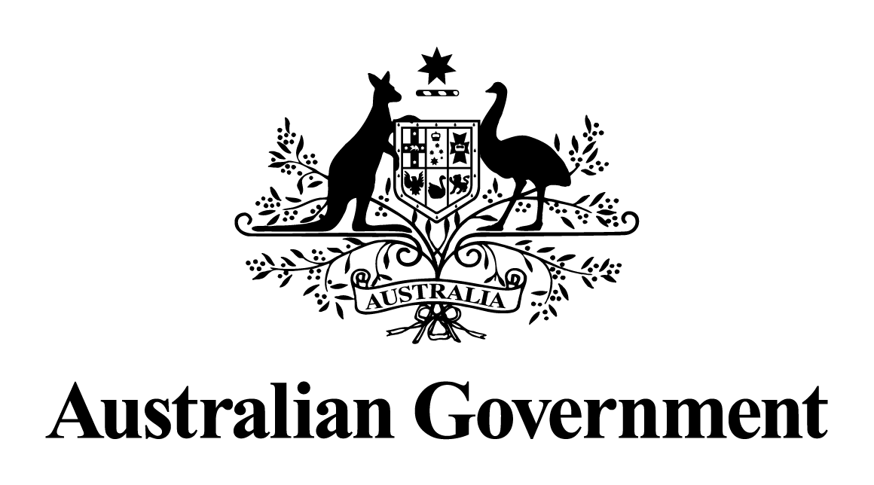

Australian Government response to the Legal and Constitutional Affairs References Committee report

Establishment of a national registration system for Australian paramedics to improve and ensure patient and community safety

October 2017

# Recommendations and Australian Government responses

## Recommendation 1

The Committee recommends that the paramedic profession be nationally registered and accredited throughout Australia, and that such a scheme give consideration to ‘grandparenting’ arrangements for current paramedics, while ensuring that they meet the agreed professional standards.

## Recommendation 2

The Committee recommends the establishment of a paramedics board, operating in conjunction with the National Registration and Accreditation Scheme (NRAS) and administered by the Australian Health Practitioner Regulation Agency (AHPRA).The Government, through the Australian Government Department of Health, will augment the material on tick bite prevention and first aid it has already published with regular review and revision in consultation with experts.

### Australian Government response to recommendations 1 and 2:

On 7 October 2016, all Health Ministers agreed to proceed with amendments to the Health Practitioner Regulation National Law Act (the National Law) that will bring into effect the regulation of paramedics into the NRAS. The Health Practitioner Regulation National Law and Other Legislation Amendment Bill 2017 (the Bill) was introduced into the Queensland Parliament on 13 June 2017 and includes provisions to incorporate paramedics into the National Law. The Bill includes provisions for grand parenting arrangements for current paramedics and will establish the Paramedicine Board of Australia.

## Recommendation 3

The Committee recommends that all Australian states and territories participate in a national registration and accreditation system for paramedics.

### Australian Government response to recommendation 3:

National consistency was a key principle underpinning the establishment of the NRAS. The Government is of the view that maintaining this consistency is critical to the ongoing success of the NRAS and continued achievement of positive outcomes, such as those described by Health Ministers in their [Communique of 7 August 2015](http://www.coaghealthcouncil.gov.au/Announcements/ArtMID/527/ArticleID/71/Reissued-Communique-Final-Report-of-the-Independent-Review-on-the-National-Accreditation-Scheme-for-health-professionals) [1]. The Government welcomes the decision by all Health Ministers at their meeting of 7 October 2016 to participate in the registration of paramedics under the NRAS.

1. http://www.coaghealthcouncil.gov.au/Announcements/ArtMID/527/ArticleID/71/Reissued-Communique-Final-Report-of-the-Independent-Review-on-the-National-Accreditation-Scheme-for-health-professionals