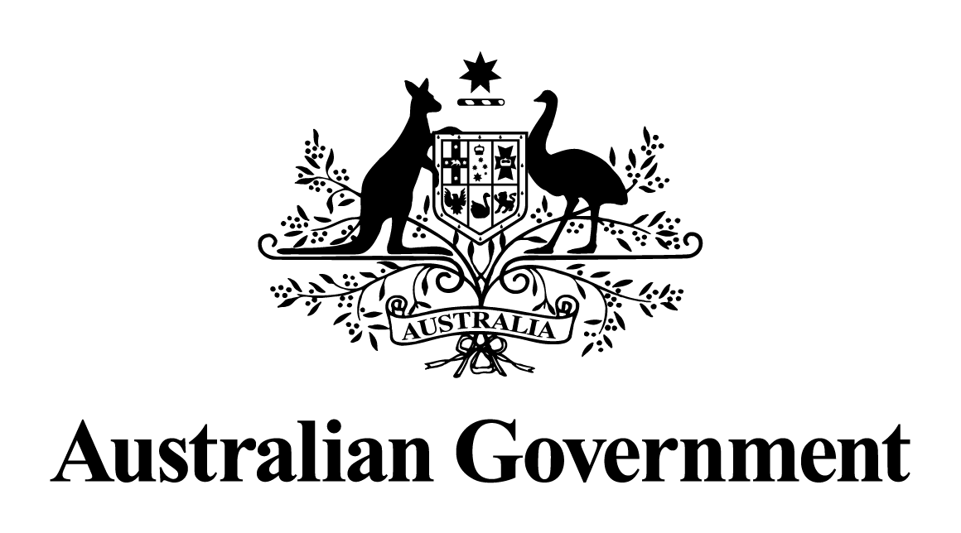

Australian Government Response to the Senate Standing Committee on Rural and Regional Affairs and Transport references

Report on the Inquiry into Beef Imports into Australia (2013)

August 2017

# Introduction

On 27 February 2013, the Senate referred the matter of beef imports into Australia to the Senate Standing Committee on Rural and Regional Affairs and Transport References Committee (the Committee) for inquiry and report. The Committee produced a first and interim report from the inquiry. No final report was produced, and the inquiry was closed in November 2013.

The Australian Government’s response to the recommendations of the 2013 inquiry follows.

## Recommendation 1 (First Report - 2013)

The Committee recommends that beef and beef products should not be imported from any country that has: reported any cases of BSE; or cross‑border trade with an adjoining country which has reported any cases of BSE.

### Response: Noted.

The Australian Government regards the health and safety of Australian consumers and our favourable animal health status as matters of the highest importance. As such, the Government’s current policy on imported beef and beef products does not allow these products to be imported unless the risks associated with all diseases of quarantine concern and affecting public health and safety, including bovine spongiform encephalopathy (BSE), are adequately managed.

Australia maintains comprehensive controls that protect Australians from exposure to unsafe food through the application of food standards developed by Food Standards Australia New Zealand (FSANZ), and implemented by the Department of Agriculture and Water Resources (for imported products) and state and territory food authorities.

Australia’s policy on BSE and imported food safety utilises a science-based risk assessment of applicant countries based on the World Organisation of Animal Health (OIE) risk assessment methodology. Australia’s import conditions require exporting countries to prove they have acceptable controls in place and that those controls are monitored. This includes controls on food safety, animal health, traceability, surveillance, animal feeding and slaughter practices. FSANZ assesses the controls which are in place for each country which applies to Australia for a BSE Food Safety Assessment, and the assessment includes an in-country verification visit by FSANZ if considered necessary. This process and import conditions for beef and beef products are outlined in the Australian Government’s document Bovine Spongiform Encephalopathy: Requirements for the importation of Beef and Beef Products for Human Consumption – Effective 1 March 2010.

The comprehensive assessment by FSANZ determines the BSE risk category to which a country belongs and therefore the certification that must accompany each consignment of beef and beef products imported into Australia. Any country that does not meet the assessment requirements will not be able to export their products to Australia for human consumption.

The Review of Scientific Evidence to Inform Australian Policy on Transmissible Spongiform Encephalopathies (TSEs) 2009 Addendum by Professor Mathews assessed BSE risks pertaining to beef for human consumption. The Addendum notes the decline in BSE cases worldwide and the increased confidence in the efficacy of measures to prevent the occurrence of BSE cases in cattle. These factors are reflected in the much-reduced risk globally of transmission of the BSE agent through beef for human consumption, and support the current Australian Government policy.

Australia must ensure that its processes are consistent with its obligations under the World Trade Organisation (WTO) Agreement on the Application of Sanitary and Phytosanitary Measures (SPS Agreement). Decisions on beef imports are based on risk assessment processes which are consistent with Australia’s WTO obligations, and are based on a robust, science-based approach for the evaluation of countries with regard to BSE. Trading partners were increasingly critical of Australia’s 2001 policy largely because it was inconsistent with current science. This left Australia vulnerable to retaliatory trade action. The trend in key trading partners has been to align BSE import food safety policies for beef more closely to the OIE’s international BSE standard, which can include permitting beef imports from some countries that have reported BSE cases.

## Recommendation 2 (First Report - 2013)

The Committee recommends that the Australian Government work with OIE to develop a live test for BSE.

### Response: Agree in principle.

The Australian Government, through the Department of Agriculture and Water Resources’ Office of the Chief Veterinary Officer, continues to work with the OIE to develop and improve the international standards and guidelines for the prevention, surveillance and management of BSE.

There are a number of post-mortem laboratory tests that have been developed and validated to diagnose BSE in cattle. A number of these tests have been adopted by Australia’s animal health laboratories and are being used in the national Transmissible Spongiform Encephalopathy Freedom Assurance Program, which is supported by the Australian Government. The laboratories in this program, including Australian Animal Health Laboratory in Geelong, have been working with overseas laboratories on tests for BSE.

## Recommendation 3 (First Report - 2013)

The Committee recommends that the relevant Minister report any decision to approve or reject such recommendations to the Parliament and this Committee prior to a determination by the Director of Animal and Plant Quarantine, in the case of a BSE country assessment, and prior to formal advice being provided to the applicant country.

### Response: Noted.

Australia is a strong international advocate of open markets and the application of science‑based decision-making on issues of food safety, and human, animal and plant health. The WTOSPS Agreement requires WTO Members, among other things, to ensure that quarantine rules are based on scientific principles and are not maintained without sufficient scientific evidence.

A robust decision-making framework for the scientific management of both biosecurity and food safety import risk has been established by the Australian Parliament through primary and subordinate legislation, which delegates the decision-making powers under the legislation to officials in the relevant departments. This framework for conducting scientific analyses and implementing Sanitary and Phytosanitary (SPS) measures underpins the integrity and independence of our biosecurity and food safety import risk processes.

Consistent with our international obligations, the Australian Government adopts a science-based approach to decisions about the entry into Australia of imported products. Decision-makers are supported in their decisions by a range of scientific expertise already existing in government agencies (in some cases with the guidance of eminent and independent scientists). There is also an existing range of cross-agency cooperation measures that contribute to the overall strength of the legislated measures adopted by the Australian Parliament.

Ministerial decision-making and parliamentary review of import risk assessments would be inconsistent with Australia’s independent, scientifically-based decision-making processes as required under our obligations in the SPS Agreement and bring into question the credibility and legitimacy of our system. It would likely be criticised by trading partners as political interference. Australia would be concerned if our agricultural exports faced political decision-making processes when SPS measures were being developed and implemented in our export markets.

The Australian Government (Department of Agriculture and Water Resources and Department of Health) works collaboratively with the New Zealand Government and the Australian state and territory governments, through the Australia and New Zealand Ministerial Forum on Food Regulation (the Forum), to develop food regulation policy. FSANZ develops national food standards, having regard to policy guidance from the Forum. State and territory governments develop and administer food legislation, which gives effect to the requirements of the Australia New Zealand Food Standards Code (the Code).

The Imported Food Inspection Scheme, administered by the Department of Agriculture and Water Resources under the Imported Food Control Act 1992, is a risk-based inspection scheme that aims to ensure that imported foods comply with the Code. If unsafe or non-compliant imported food is identified, it is re-exported or destroyed or, in some cases, treated in order to bring it into compliance.

The Biosecurity Act 2015 (the Biosecurity Act) and the Biosecurity (Prohibited and Conditionally Non-prohibited Goods) Determination 2016 prohibit the importation of certain goods unless an import permit is granted. This applies to many commodities, including beef and beef products.

Sections 173 and 174 of the Biosecurity Act require that the directors of Biosecurity and Human Biosecurity are responsible for determining if goods are to be prohibited or conditionally non-prohibited for import into Australia (i.e. require import conditions and/or import permits). These sections also provide that Determinations made under the Biosecurity Act are non-disallowable instruments.

The Director of Biosecurity makes decisions under the legislation, including whether to grant an import permit. In considering whether to issue an import permit, the Director (and the Director’s delegates) is required to take into account a range of information. This includes the level of biosecurity risk and whether the imposition of conditions is necessary to reduce the level of biosecurity risk to an acceptable level.

Biosecurity import risk assessments carried out by the Department of Agriculture and Water Resources are a major reference source on which decisions are based. These risk assessments are science-based and apply Australia’s appropriate level of protection (ALOP) for biosecurity risks, which is expressed as ‘a high level of sanitary and phytosanitary protection aimed at reducing biosecurity risks to a very low level, but not to zero’. Biosecurity Import Risk Analyses (BIRAs) are conducted in accordance with section 167 of the Biosecurity Act. The Minister may only direct that a BIRA is commenced, in accordance with section 168 of the Biosecurity Act.

It must be noted that the Director’s decision to issue a permit is not the sole determinant of an import being allowed into the country. Imports are also subject to the Customs Act 1901 and other relevant laws depending on the particular class of import. In the case of beef, the Director also considers the outcomes of any FSANZ BSE food safety assessments, which are conducted by FSANZ at the request of countries which wish to apply to export beef or beef products for human consumption to Australia.

The Parliament and relevant Ministers have been kept informed of activities relating to BSE Food Safety Assessments. Substantive advice on the schedule of BSE food safety risk assessments and expected completion dates have been readily available through Senate Estimates hearings. Ministers of both the Department of Health and the Department of Agriculture and Water Resources are provided with the FSANZ assessment schedule and work timetable and formally alerted of all BSE food safety risk assessment decisions pending public release of the outcomes.