Quick reference guide to the treatment of alcohol problems
Companion document to The guidelines for the treatment of alcohol problems
Prepared for the Australian Government Department of Health and Ageing by Paul Haber, Nicholas lintzeris, Elizabeth Proude and Olga Lopatko
Sydney South West Area Health Service, NSW Health and The University of Sydney
ISBN: 1-74186-978-1
Online ISBN: 1-74186-979-X
Publications Number: P3-5626

Assessment & treatment planning

Screening
Screening aims to identify and then initiate appropriate interventions in individuals drinking above low-risk levels. Conduct in settings where detection is relevant to both the clinician and the drinker, such as primary care, emergency departments, hospital, specialist medical and general counseling settings. Recommended approaches include:
- quantity-frequency estimates ("how much how often")
- structured questionnaires (e.g. AUDIT)
An abbreviated version, the AUDIT-C, is adequate for identifying high-risk drinkers (score ≥ 5):
- How often do you have a drink containing alcohol?
  - Never (0)
  - Monthly or less (1)
  - 2-4 times a month (2)
  - 2-3 times a week (3)
  - 4 or more times a week (4)
- How many drinks containing alcohol do you have on a typical day when you are drinking?
  - 1 or 2 (0)
  - 3 or 4 (1)
  - 5 or 6 (2)
  - 7 to 9 (3)
  - 10 or more (4)
- How often do you have six or more drinks on one occasion?
  - Never (0)
  - Less than monthly (1)
  - Monthly (2)
  - Weekly (3)
  - Daily or almost daily (4)
(Score of ≥ 5 indicates further assessment is required)
Patients drinking above low-risk levels (see NHMRC recommendations) should be offered a brief intervention. Those experiencing moderate-severe alcohol related problems, including dependence, require more comprehensive assessment and intensive treatment approaches (Figure 1).
Figure 1
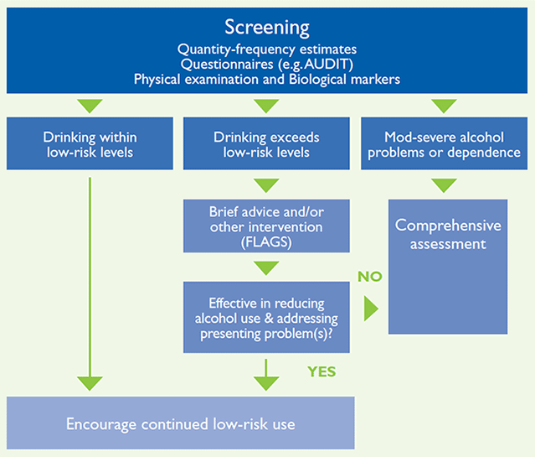

Comprehensive assessment
Recommended where individuals present with significant alcohol (or other drug)-related problems.
May require more than one consultation, and may involve collateral history from relatives, friends, other health or welfare workers.

Presentation
- Presenting problems
- Role of drinking/drug use in presenting problems

Alcohol and other drug use
- Quantity (in grams alcohol per day), frequency, pattern of drinking and other drug use (tobacco, pharmaceutical and illicit drugs, injecting drug use)
- Last use of alcohol and other drugs (time and amount)
- Duration of drug and alcohol use
- Features of abuse or dependence. Dependence highlighted by inability to control use despite harms from alcohol use, tolerance and withdrawal symptoms. If dependent, assess likely withdrawal severity (best predicted by previous withdrawal episodes) and history of withdrawal complications (seizures, delirium, hallucinations).
- Motivation to change pattern of alcohol or other drug use

Consequences of alcohol and other drug use
- Physical health problems (include liver, gastro-intestinal, trauma, cardiovascular, neurological)
- Mental health problems (suicide risk, depression, anxiety, psychosis)
- Social functioning (including relationship, employment, financial, housing, legal)
- Risks to self/others (violence, driving, child protection, occupational risks, falls)

Examination (by suitably trained health professionals)
- Mental state (general presentation, cognition, memory, mood, speech, thought, perception, insight)
- Investigations: Consider breath alcohol test, blood tests (LFTs, FBC, U+Es), investigations for specific conditions

Overall assessment and management plan
- Goals of treatment (abstinence versus reduced drinking, other health concerns)
- Risk management plan (harm to self / others, serious physical or mental illness, medico-legal requirements)
- Treatment plan (need for brief interventions, controlled drinking strategies, intensive interventions (detox, psychosocial interventions, relapse prevention strategies), management of co-morbidities
- Involvement of other health and/or welfare services, family /carers

Alcohol dependence
A chronic relapsing remitting disorder associated with impaired control over alcohol use in which individuals find it difficult to cut down or stop, despite persistent physical, psychological or social harms. Physiological aspects include tolerance (diminished effect with repeated use), and a withdrawal syndrome following cessation of use.
Dependence generally requires more intensive treatment than brief interventions: they may require a withdrawal program (detoxification) to enable them to stop drinking, and ongoing interventions to ‘stay stopped’ (e.g. counselling, pharmacotherapy, self-help programs).

Controlled drinking for dependent drinkers: A realistic goal?
Many people would like to continue drinking at ‘low levels’, or resume ‘moderate’ drinking soon after withdrawal. Severity of dependence is a key factor when setting goals of controlled drinking or abstinence. Controlled drinking is usually more appropriate with lower levels of dependence, while higher levels of dependence indicate abstinence as the best option. Controlled drinking may be attempted after a period of abstinence of at least 3-6 months for such individuals.
Structured counselling programs with the specific goal of 'controlled drinking' are available (see Australian Centre for Addiction Research).

Treatment planning
Discuss treatment options with the patient (and their families or carers as relevant), identifying:
- what is involved with each approach,
- the likely outcomes (including potential adverse outcomes) of treatment options,
- the patient's particular needs.
Provide an opportunity to raise questions or concerns. As with any intervention, informed consent is essential. Involving the patient in decision making may also enhance treatment adherence and improve outcomes.
A stepped care model is proposed. That is, patients should be offered the least “intensive” intervention appropriate to their presentation. Should the first intervention prove to be insufficient to achieve the agreed treatment goals for the patient, the next level of intensity of treatment should be offered until the desired treatment goals (e.g. low risk drinking, abstinence) are achieved. This approach requires ongoing patient review and monitoring.
People with chronic heavy alcohol use often have a range of medical, psychiatric, and social problems that typically requires involvement of multiple services. This in turn requires close communication between service providers, and case-co-ordination (case management) by a service provider that will ensure the patient receives long term follow-up.
Figure 2
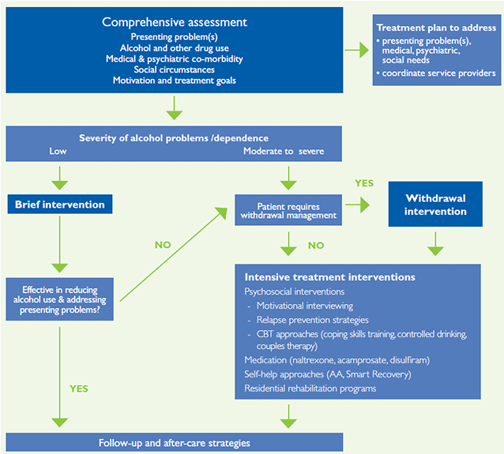

Brief interventions
Brief interventions provide information and advice aimed at reducing risky alcohol use, and/or mild alcohol-related problems. They are not usually sufficient in individuals who have developed dependence or experiencing more severe alcohol related harms (for whom more intensive treatment is recommended). Brief interventions:
- are delivered in one to four sessions, each lasting from 5-10 minutes to 1 hour.
- may be opportunistic, offered to individuals identified through screening who have not sought treatment.
- FLAGS is a useful acronym that helps identify the ingredients of brief Interventions (see following text).
If the patient is still drinking to excess following a brief intervention, more intensive treatment is indicated, and may involve referral to a specialist alcohol and drug service.

Brief intervention using FLAGS approach
- Feedback about the risks associated with continued drinking, based on current drinking patterns, problems and health status. Discuss potential health problems that can arise from risky alcohol use.
- Listen to the patient's response. This should spark a discussion of the patient’s consumption level and how it relates to general population consumption.
- Advice: Give clear Advice about the importance of changing current drinking patterns, in a persuasive but non-judgemental way. Discuss potential benefits of reduced drinking.
- Goals: Discuss the safe drinking limits and assist the patient to set goals for changing drinking patterns. Instil optimism in the patient that his or her chosen goals can be achieved. Motivation-enhancing techniques can be used to encourage patients to develop, implement and commit to plans to stop drinking.
- Strategies: Discuss practical strategies to reduce drinking, such as switching to low-alcohol beer, alternating alcohol with non-alcoholic drinks, reducing drink size, eating during drinking sessions. Plan an alternative focus for socialising or unwinding. Identify high-risk situations and practical ways to deal with these.
- Consider follow-up of the patient.
- Reinforce the brief intervention by self-help material. Examples can be downloaded from the alcohol website.

Alcohol withdrawal
Individuals who regularly drink large amounts of alcohol (e.g. >80gm daily) may experience a withdrawal syndrome when ceasing or reducing their alcohol use. Alcohol withdrawal can result in severe and life threatening complications (e.g. seizures, delirium) if unsupervised or poorly managed.
Withdrawal symptoms generally start within 6 to 24 hours of the last drink, peak over 36 to 72 hours, and usually subside within 5-7 days; although cravings, mood and sleep disturbances may persist for weeks.
- Alcohol withdrawal seizures (tonic-clonic) usually occur in 6-48 hrs after last drink
- Alcohol withdrawal delirium usually occurs 2-5 days after last drink
- Alcohol withdrawal hallucinations can occur at any time during withdrawal

Course of alcohol withdrawal
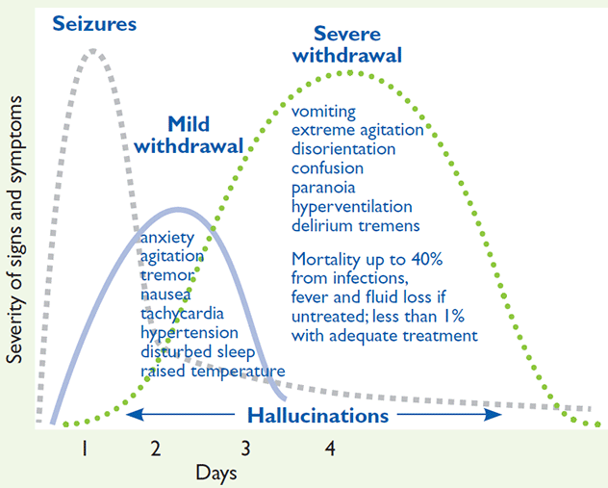
Source: NSW Health Detoxification guidelines

Assessment

History
- Alcohol and other drug use: how much, how often, for how long, when last used, features dependence
- Previous withdrawal attempts and any complications (seizures, delirium, hallucinations)
- Home environment and social supports
- Medical and psychiatric conditions

Examination
- Vital signs (BP, PR, temp, dehydration, level of consciousness), evidence intoxication, withdrawal signs (tremor, anxiety, sweating, tachycardia)
- Signs of liver disease, other complications of alcohol use
Investigations: breath alcohol, LFTs, FBE, U and Es.

Withdrawal setting
In most cases alcohol withdrawal can be safely completed in the patient’s home (ambulatory withdrawal) if there are sufficient supports. There are some exceptions to this:

Contraindications to ambulatory withdrawal
- Severe complications (seizures, delirium, psychosis) in previous (or current) withdrawal attempts
- Unstable medical or psychiatric problems (e.g. suicide risk, recent head injury)
- Unclear history of current drug and alcohol use

Relative contraindications
- Unsuitable home environment: drug or alcohol use by others, no suitable supportive adult
- Withdrawal from multiple drugs
- Repeated failure at ambulatory withdrawal
Refer patients unsuitable for ambulatory withdrawal to a residential detox, unless there are severe medical (e.g. recent seizure, delirium) or psychiatric conditions that warrant hospital admission.

Management of Ambulatory Alcohol Withdrawal

Supportive care
- Provide information about alcohol withdrawal to patient and carers
- Monitoring and supportive counselling from health worker (e.g. GP, drug and alcohol worker, nurse). Focus on strategies for coping with withdrawal symptoms, maintaining motivation and reassurance. Daily if possible.
- 24 hour telephone counselling / crisis telephone service

Nutrition
- Plenty of fluids (at least 2 litres per day); light diet - avoid heavy meals
- Thiamine supplements 300mg per day x 7 days: IM if nutritionally depleted; oral dose if ‘healthy’

Medication
Oral diazepam recommended for moderate to severe withdrawal. Typical ambulatory withdrawal regimen is shown. Adjust dose according to patient’s response, withdrawal severity and other medical conditions:
- Days 1 & 2 10mg QID
- Day 3 10mg TDS
- Day 4 10mg BD
- Day 5 10mg nocte
Do not usually continue diazepam beyond 5 days.
Have contingency plans for any problems, including contact numbers for counselling (e.g., crisis line), doctor, ambulance.
Limit access to diazepam with daily pickup from a pharmacy or clinic, or supervised by a responsible adult.
Withhold doses if patient continues to drink or is sedated.
Adjunct symptomatic (as required) medications for headache (e.g. paracetamol), nausea and vomiting (e.g. metoclopramide), abdominal cramps (e.g. hyoscine), diarrhoea (e.g. loperamide).
Medications NOT usually recommended for withdrawal include anticonvulsants, chlormethiazole, antipsychotics and antidepressants.

Intensive treatment interventions
Detoxification alone rarely results in long-term abstinence from alcohol use – and longer term treatment after withdrawal is generally associated with better outcomes. Recommended treatment strategies include:

Monitoring and support
Regular monitoring by a health practitioner (alcohol and drug worker, GP, nurse) is important to maintain motivation and assist the patient to follow through with services.

Counselling services
Counselling approaches that focus upon relapse prevention strategies can effectively reduce alcohol use, and can be delivered in individual (one to one) or group settings. Relapse prevention approaches are aimed at helping patients to identify situations that in the past have been associated with excessive drinking and to use appropriate cognitive and behavioural strategies to learn how to avoid unnecessary risk, how to deal positively and confidently with inevitable risk, and how to prevent a lapse from becoming a relapse.
Many counselling approaches are based upon CBT principles, including coping skills training and behavioural self-management. Some patients may also benefit from counselling for other issues, such as addressing mood or anxiety problems, unresolved grief, post-traumatic stress.

Linkages to social and welfare services
Individuals may require social and welfare assistance regarding financial, legal, accommodation, child support, employment problems.

Support for families
Family members, friends or carers of heavy drinkers experience a range of emotions in living with, and trying to support drinkers. Many benefit from support and the opportunity to discuss how they are coping. Self-help groups (e.g. AlAnon) and professional services for families and carers are available. Contact Al-Anon.

Medication
Various medications are effective in reducing alcohol use after withdrawal: •Naltrexone: opioid antagonist that reduces cravings for alcohol, reduces number of drinking days and the amount consumed in about 40-60% of patients. Avoid in those requiring opioid analgesia. Dose: 25mg for 2 days, increasing to 50mg once daily. Initiate 3 days after last drink.
Acamprosate: works via glutamate pathways to reduce alcohol cravings. Dose: 666mg tds oral. Can initiate 3 days after last drink
Disulfiram: alcohol dehydrogenase inhibitor: causes severe reaction (nausea, headache, abdo discomfort) if patient drinks alcohol. Requires motivated patient with dose supervision by carer. Consider written agreement with patient. Discuss with addiction specialist if liver or cardiac disease. Dose: 200mg per day. Initiate > 7 days after alcohol withdrawal, > 48 hrs after last drink
Medications should not necessarily be discontinued following a lapse, but review treatment plan. Continue for at least 6 months if effective.

Self-help programs
The main approach is the 12-step AA program. AA is a self-help peer-based organisation that aims to assist members achieve and maintain sobriety. Details of local meetings are available at Alcoholics Anonymous Australia. Smart Recovery is another self-help program for patients who are not keen to attend AA. Contact Smart Recovery Australia or ADIS.

Residential rehabilitation programs
(also known as Therapeutic Communities)
Long term programs (usually 1 to 12 months) where people live in a community of other substance users, ex-users and professional staff. Programs usually include counselling, employment, education and skills training, life skills training (e.g. budgeting, cooking), group work, relapse prevention, and a ‘re-entry’ phase assisting return to the community. Generally suited for moderate to severely dependent people who require structured social supports.

Treatment of psychiatric and physical co-morbidity
Ensure identification and treatment of concomitant conditions. Many medical and mental health problems linked to alcohol use often resolve or improve following drinking cessation, but this can take several weeks (and in some cases months) of abstinence before marked improvement occurs.

Working with the persistent ‘problem’ drinker
Alcohol dependence is a chronic relapsing condition. Many individuals will continue to drink at excessive levels, experience alcohol related harms, and will not be receptive, or respond to the various treatment approaches aimed at reducing alcohol use. It is crucial for the patients to retain engagement with a health practitioner (e.g. primary care worker, counsellor, social worker), and to maintain an underlying sense of hope for the patient is important. Strategies for working with such individuals are discussed below.

Strategies for working with persistent problem drinkers
- Continue to encourage a reduction or cessation of alcohol intake
- Provide regular feedback regarding the impact of alcohol upon their physical, mental & social health
- Minimise the harms from polydrug use, by advising against and offering treatment for other drug problems
- Monitor prescribed and complementary medications to avoid predictable drug/alcohol interactions. Identify and respond to problems of poor medication adherence in heavy drinkers
- Use strategies to enhance patient engagement, including approaches to overcome barriers posed by cognitive disorders, language and cultural issues, or physical disabilities
- Define and attend to any specific medical and psychiatric conditions with relevant services that communicate regularly
- Consider strategies to minimise the consequences of specific medical complications, such as:
  - Thiamine supplements to prevent further CNS and peripheral nerve damage
  - Nutritional management for advanced liver disease
  - Falls prevention strategies for those with cerebellar damage and/or peripheral neuropathy
- Engage psychosocial supports ('meals on wheels', welfare, employment support, community and religious networks, financial or relationship counselling) to reduce personal and family harms
- Empower family and close friends to reduce availability of alcohol and to encourage further engagement with clinicians able to help with alcohol problems
- Consider any medico-legal or ethical obligations, including driving assessment, child protection, welfare, guardianship and employment issues for those in certain trades or professions.

Motivating patients to change drinking patterns
Recognise that patient's motivation to change their drinking patterns is not fixed, and can be influenced by health professionals, families and friends, or changes in circumstances. Motivational interviewing approaches are recommended. Motivational Interviewing is a style of counselling that focuses on helping the individual explore and resolve ambivalence about change. The patient's own reasons for change are elicited and used to motivate movement towards action and behaviour change. Key principles of motivational interviewing are:
- Expressing empathy by listening and reflecting your patient’s concerns, thoughts and feelings.
- Developing discrepancy between their drinking behaviour and their other goals (e.g. 'on the one hand you're worried about how drinking is affecting your work, yet you're not sure if you can stop drinking right now.')
- Rolling with resistance. If your patient is arguing, defending, or remaining silent, do not argue back. Instead, use active listening and reflection to avoid increasing their resistance.
- Supporting self-efficacy. Self-efficacy is the person's confidence in their own ability to achieve their goals. Highlighting even small gains can help (e.g. a patient might not have stopped drinking but may have managed to cut down or have had one or two alcohol free days in the week.)

Resources and contact information
For information regarding local treatment services and referral options, contact the local Alcohol and Drug Information Service or Drug and Alcohol Specialist Advisory Service.
Note. Since this publication was prepared, many of the links have become broken and telephone numbers have changed. Links have been changed where necessary to refer users to current web pages. Outdated phone numbers have been deleted.
- NSW Mental Health and Drug & Alcohol Office
- Vic Alcohol & other drugs services: Phone: 1800 888 236
- Qld Alcohol, tobacco and other drugs: Phone: 1800 177 833
- SA Drug and alcohol services: Phone: 1300 131 340
- WA Drugs and alcohol
- NT Alcohol and other drugs
- Tas Alcohol and drug services
- ACT Alcohol and other drugs: Phone: (02) 6207 9977

Contact details for further help and services
- Australian National Council on Drugs (no longer available)
- Alcoholics Anonymous (AA)
- Al-Anon (for friends & relatives)
- SMART Recovery
- Controlled Drinking - to take part, phone 1800 006 557
- Full treatment guidelines available on the Australian Government Department of Health alcohol website
- NHMRC guidance
- CIWA website (no longer available)

Copyright

Paper-based publications
© Commonwealth of Australia 2010
This work is copyright. You may reproduce the whole or part of this work in unaltered form for your own personal use or, if you are part of an organisation, for internal use within your organisation, but only if you or your organisation do not use the reproduction for any commercial purpose and retain this copyright notice and all disclaimer notices as part of that reproduction. Apart from rights to use as permitted by the Copyright Act 1968 or allowed by this copyright notice, all other rights are reserved and you are not allowed to reproduce the whole or any part of this work in any way (electronic or otherwise) without first being given the specific written permission from the Commonwealth to do so. Requests and inquiries concerning reproduction and rights are to be sent to the Online, Services and External Relations Branch, Department of Health, GPO Box 9848, Canberra ACT 2601, or by email to copyright.

Internet sites
© Commonwealth of Australia 2010
This work is copyright. You may download, display, print and reproduce the whole or part of this work in unaltered form for your own personal use or, if you are part of an organisation, for internal use within your organisation, but only if you or your organisation do not use the reproduction for any commercial purpose and retain this copyright notice and all disclaimer notices as part of that reproduction. Apart from rights to use as permitted by the Copyright Act 1968 or allowed by this copyright notice, all other rights are reserved and you are not allowed to reproduce the whole or any part of this work in any way (electronic or otherwise) without first being given the specific written permission from the Commonwealth to do so. Requests and inquiries concerning reproduction and rights are to be sent to the Online, Services and External Relations Branch, Department of Health, GPO Box 9848, Canberra ACT 2601, or by email to copyright.

