# Private health insurance reforms: Gold/Silver/Bronze/Basic product tiers

The Australian Government has introduced reforms to make private health insurance simpler and help people choose the hospital cover best suited to their needs.

For the first time, private health insurers will be required to classify their private hospital cover into four easy to understand tiers: Gold, Silver, Bronze or Basic.

What is, and is not covered in these tiers will be based on new minimum standard clinical categories.

Clinical categories are simply types of hospital treatments described in a standard way. If a policy covers a certain clinical category, then it must cover everything described as part of the category – not only some things. For example, ‘bone, joint and muscle’ category, or ‘heart and vascular system’ category. This makes policies easier to compare.

Private health insurers will place all policies into one of these tiers – Gold, Silver, Bronze or Basic, and will tell people where their policy has been placed. People can then check if the cover is right for their needs.

The tiers are intended to mandate minimum service coverage generally reflecting the existing range of health insurance policies. Insurers will continue to be able to offer additional coverage above the minimum requirements in Basic Plus (+), Bronze Plus (+) and Silver Plus (+) product tiers.

Health insurers have until 1 April 2020 to introduce the tiers and clinical categories.

Clinical categories can be either ‘restricted’ (R) or ‘unrestricted’. This refers to the level of benefits paid for hospital costs (e.g. hospital accommodation, operating theatre fees, prosthesis costs), which are separate to doctors’ fees.

For clinical categories listed as ‘restricted’ insurers pay only a limited amount for private hospital costs, which means people are likely to face substantial out of pocket expenses.

For unrestricted categories, insurers and most hospitals have agreements meaning people don’t pay out of pocket hospital costs, other than any excess or fixed copayment amount.

Out of pocket costs for doctors’ fees may also be payable if a doctor charges more than the Medicare Benefits Schedule fee and the insurer covers only part of the remaining payment.

The product tiers and minimum clinical categories are set out in the table below.

## Hospital Treatment Product Tiers – Gold, Silver, Bronze and Basic

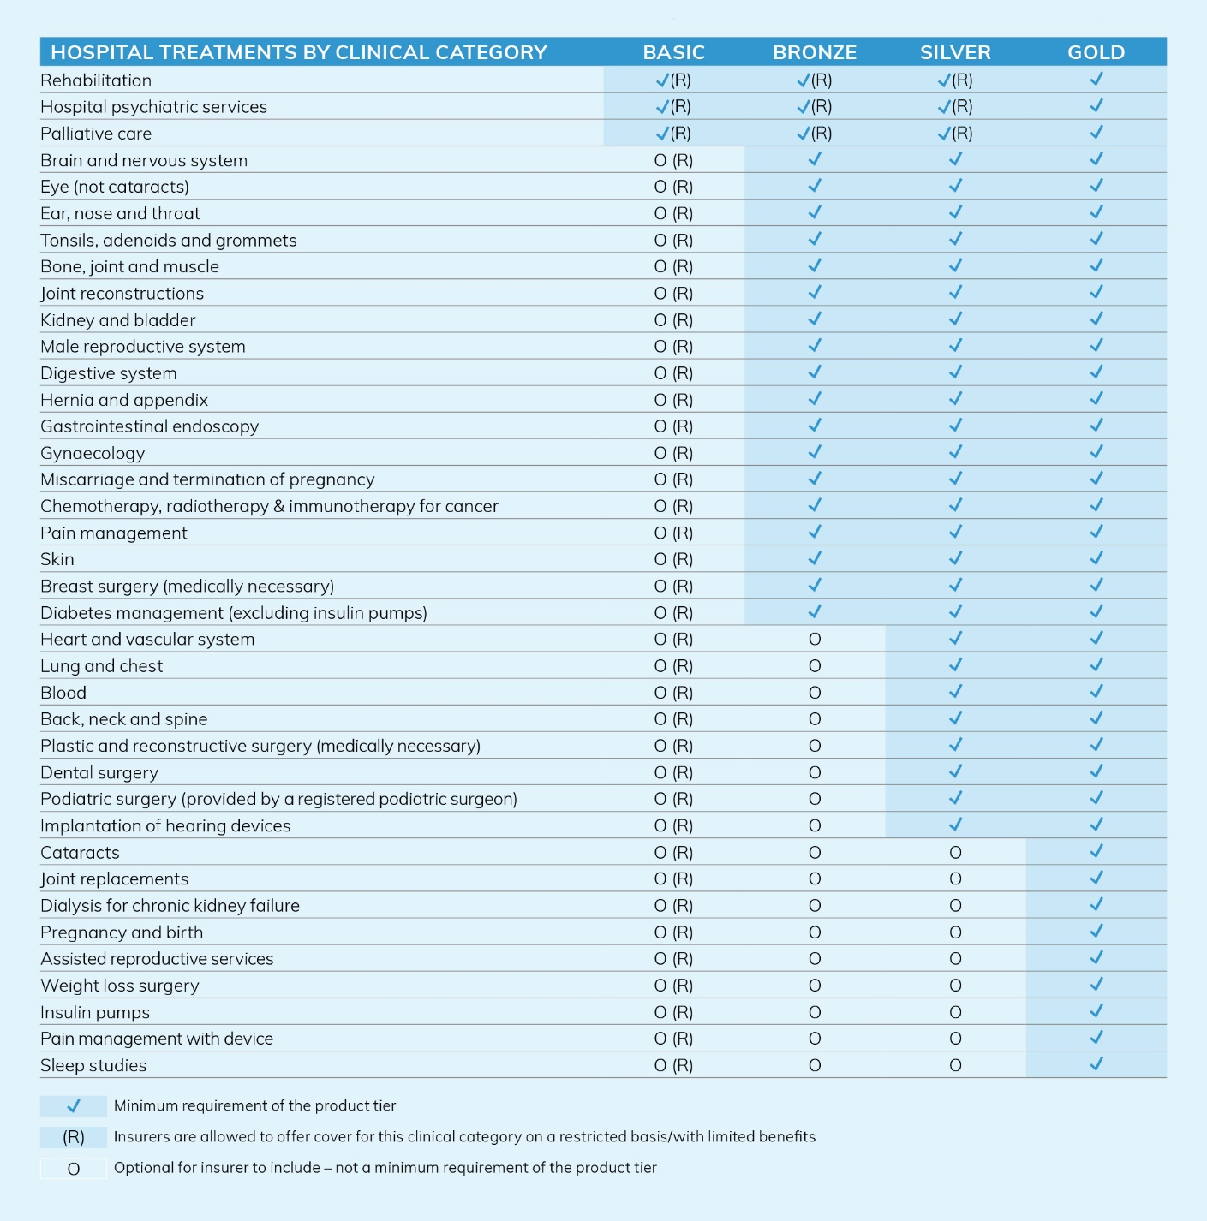

## Who will benefit?

The new product tiers and clinical categories will give people greater certainty about the services covered by each type of private hospital cover.

The changes will make it easier to shop around and compare different hospital policies to find one that meets a person’s or a family’s needs.

## More information

For more information visit health.gov.au/private-health-reforms