# decorative banner with the number and title of this factsheet. Poor Bowel Control: Poor Bowel control is common and it can be helpedWHAT IS POOR BOWEL CONTROL?

People with poor bowel control may have bowel accidents with bowel motions passed at the wrong time or in the wrong place. They may also pass wind when they do not mean to.

# IS POOR BOWEL CONTROL COMMON?

About one in twenty people has poor bowel control, occurring in both men and women. It can occur at any age, but is more common as you get older.

Many people with bowel control problems also have poor bladder control. This means they may also wet themselves.

# WHAT CAUSES POOR BOWEL CONTROL?

## Weak muscles

Your pelvic floor muscles extend in and around your anus (back passage).

These muscles help you to control when you need to empty your bowels and help you hold on until you get to the toilet.

If these muscles are weak, you may:

* not be able to hold on well
* need to rush to the toilet to empty your bowels.

These muscles may become weak because of:

* giving birth
* getting older
* some types of surgery — such as for haemorrhoids (piles)
* radiation therapy

Control of the pelvic floor muscles can also be affected by a number of brain or nerve problems such as stroke, diabetes and dementia.

## Bowel urgency and diarrhoea

Diarrhoea means passing loose bowel motions. This can mean you need to rush to the toilet. Loose bowel motions make it harder to hold on until you get to the toilet.

Diarrhoea has many possible causes, including:

* use of laxatives, especially if overused or used incorrectly
* bowel or stomach infection such as gastroenteritis
* bowel diseases such as diverticulitis, Crohn’s disease, ulcerative colitis and irritable bowel syndrome
* some antibiotics
* food allergies or intolerances e.g. wheat, gluten, lactose, dairy and fructose.

It is recommended you see your doctor about this problem.

## decorative banner with the number and title of this factsheet. Poor Bowel Control: Poor Bowel control is common and it can be helpedConstipation

Bowel motions can sometimes get clogged in the lower bowel. In severe cases, liquid can leak out around the clogged mass. This can cause you to soil yourself.

# WHAT SHOULD YOU DO ABOUT POOR BOWEL CONTROL?

There are many causes of poor bowel control. A careful check is needed to find the causes. The check can also find those things that make it worse. If you have bowel accidents talk to your doctor.

You should also let your doctor know if you have:

* a change in your normal bowel habits, including:
  + going to the toilet more often
  + having loose bowel motions
  + straining to pass hard bowel motions.
* pain or bleeding from the anus (back passage)
* a feeling that your bowel is never quite empty dark or black bowel motions
* weight loss that you can’t explain.

Your doctor may:

* ask you some questions
* do a physical examination
* ask you to keep a diary of your bowel habits for a few days
* ask you to keep a list of what you eat and drink for a few days
* send you for an x-ray or tests.

# HOW CAN POOR BOWEL CONTROL BE HELPED?

Loss of bowel control is a warning sign and not a disease in itself. The right care will depend on what is causing the problem.

Care may include:

* getting constipation under control
* getting diarrhoea under control
* checking the medicines you take
* getting a script for medicine:
* to firm up your motions, or
* to settle your bowels.
* ensuring a good bowel routine
* making sure you are:
* eating the right type and amount of fibre
* drinking the right type and amount of fluid.
* checking how you sit on and use the toilet. Sit on the toilet with your knees bent up a little higher than your hips. Rest your forearms on your thighs
* pelvic floor muscle training to help make your pelvic floor muscles stronger
* referral to a continence service or specialist doctor.

# decorative banner with the number and title of this factsheet. Poor Bowel Control: Poor Bowel control is common and it can be helpedCORRECT TOILET POSITION

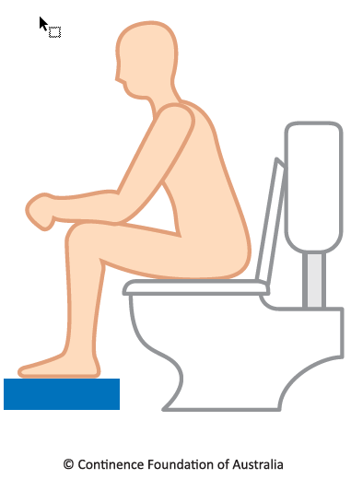

# SEEK HELP

You are not alone. Poor bladder and bowel control can be cured or better managed with the right treatment. If you do nothing, it might get worse.

Phone expert advisors on the National Continence Helpline for free:

* advice
* resources
* information about local services.

1800 33 00 66* (8am–8pm Monday to Friday AEST)

To arrange for an interpreter through the Translating and Interpreting Service (TIS National), phone 13 14 50 Monday to Friday and ask for the National Continence Helpline. Information in other languages is also available from [continence.org.au/other-languages](https://continence.org.au/other-languages.php)

For more information: [continence.org.au](https://continence.org.au/), [pelvicfloorfirst.org.au](http://www.pelvicfloorfirst.org.au/), [bladderbowel.gov.au](http://bladderbowel.gov.au/)

* Calls from mobiles are charged at applicable rates.