**Commonwealth Department of Health**

*Mid-point review of the National Tobacco Strategy*

*2012-2018*

Final report

****Suggested citation****

Health Policy Analysis 2016. *Mid-point review of the National Tobacco Strategy 2012-2018:* *Final report*. Canberra: Commonwealth Department of Health.

****Disclaimer****

In accordance with Health Policy Analysis’ policy, we are obliged to advise that neither Health Policy Analysis nor any employee nor sub-contractor undertakes responsibility in any way whatsoever to any person or organisation (other than the Department of Health) in respect of information set out in this report, including any errors or omissions therein, arising through negligence or otherwise however caused.

**Health Policy Analysis Pty Ltd**

Suite 101, 30 Atchison Street, St Leonards 2065

ABN: 54 105 830 920

Phone: +61 2 8065 6491

Table of contents

Acronyms 2

Executive summary 3

List of recommendations 7

Document structure 13

1. Introduction 14

2. Policy context 18

3. Progress on smoking uptake, prevalence and cessation 20

4. General findings from the consultations 40

5. Priority 1: Protect public health policies from tobacco industry interference 50

6. Priority 2: Strengthen mass media and public education campaigns 54

7. Priority 3: Reduce the affordability of tobacco products 61

8. Priority 4: Reduce smoking rates among Aboriginal and Torres Strait Islander people 66

9. Priority 5: Reduce smoking among populations with a high prevalence of smoking 78

10. Priority 6: Eliminate promotions of tobacco products 87

11. Priority 7: Tobacco product contents, disclosure and supply 92

12. Priority 8: Reduce exceptions to smoke-free workplaces, public places and other settings 99

13. Priority 9: Improve access to evidence based cessation services 105

14. Suggested issues to be addressed in the next national tobacco control strategy 112

Appendix 1 Stakeholder consultation interview questions 114

Appendix 2 Stakeholder consultation written response pro forma 118

Appendix 3 List of stakeholders 120

Appendix 4 List of resources/documents provided by stakeholders 125

Appendix 5 Additional data on uptake, prevalence and quitting 127

Appendix 6 – Examples of good practice initiatives 146

References 150

Acronyms

ABS Australian Bureau of Statistics

ACT Australian Capital Territory

AIHW Australian Institute of Health and Welfare

ANPHA Australian National Preventive Health Agency

FCTC Framework Convention on Tobacco Control

GP General Practitioner

HPA Health Policy Analysis

NGO Non-government organisation

NRT Nicotine replacement therapy

NSW New South Wales

NT Northern Territory

NTS National Tobacco Strategy 2012-2018

PBS Pharmaceutical Benefits Scheme

Qld Queensland

SA South Australia

SEIFA Socio-Economic Indexes for Areas

Tas. Tasmania

TIS Tackling Indigenous Smoking

Vic. Victoria

WA Western Australia

WHO World Health Organization

Executive summary

## Introduction

The Department of Health engaged Health Policy Analysis to undertake the policy component of the mid-point review of the *National Tobacco Strategy 2012-2018* (NTS). The NTS was developed by the then Intergovernmental Committee on Drugs Standing Committee on Tobacco as a sub-strategy under the *National Drug Strategy 2010-2015*.

## Aim

The aim of the mid-point review of the NTS was to conduct a policy analysis of progress between December 2012 and December 2015 by the Commonwealth, states and territories, and non-government organisations (NGOs) towards meeting the policy objectives of the NTS. Based on this analysis, the review provides recommendations on where efforts should be focussed for the remaining period of the NTS to achieve its objectives.

The nine priority areas of the NTS are:

1. Protect public health policy, including tobacco control policies, from tobacco industry interference.
2. Strengthen mass media campaigns to: motivate smokers to quit and recent quitters to remain quit; discourage uptake of smoking; and reshape social norms about smoking.
3. Continue to reduce the affordability of tobacco products.
4. Bolster and build on existing programs and partnerships to reduce smoking rates among Aboriginal and Torres Strait Islander people.
5. Strengthen efforts to reduce smoking among people in populations with a high prevalence of smoking.
6. Eliminate remaining advertising, promotion and sponsorship of tobacco products.
7. Consider further regulation of the contents, product disclosure and supply of tobacco products and alternative nicotine delivery systems.
8. Reduce exceptions to smoke-free workplaces, public places and other settings.
9. Provide greater access to a range of evidence-based cessation services and supports to help smokers to quit.

## Methods

The project was conducted between April and July 2016. It involved a document review of key policies and progress reports by the Commonwealth and jurisdictions against the nine priority areas of the NTS. It also involved consultations (through 42 interviews with 88 people, and seven written submissions) with the Commonwealth, state and territory health authorities, NGOs, and 10 tobacco control experts. Data compiled and analysed by the Australian Institute of Health and Welfare (AIHW) from several national surveys using baseline and mid-point measures were also considered, and have been presented to show progress against each of the indicators from the NTS.

## Findings

### Overall progress

Overall, the findings indicate that significant progress has been made against most of the nine priority areas of the NTS although neither of the two benchmarks set by COAG (to reduce the national adult daily smoking rate to 10 percent of the population, and halve the Aboriginal and Torres Strait Islander adult daily smoking rate over the 2009 baseline), are likely to be reached by 2018. This progress was identified in the feedback from stakeholders, as well as through significant and clear change in most of the outcome indicators of the NTS. The data show statistically significant improvements from the baseline to the mid-point estimates in 11 of the 14 indicators, as well as the two metrics for indicator 10 (fewer people trying cigarettes). There were no indicators with statistically significant change in an adverse direction.

### Key achievements

Data from several sources, including surveys with different population groups at the NTS baseline, and at the mid-point suggest that there have been statistically significant gains in the Council of Australian Governments’ performance benchmark in this area: reduction in overall smoking prevalence and among Aboriginal and Torres Strait Islander people. The smoking prevalence for those aged 18 years and over in the general population has dropped from 19.1% in 2007-8, to 16.3% in   
2011-12, and to 14.8% in 2014-15 (all percentages are age-standardised). However, while this reveals a relatively steady average decline of adult smokers of around 0.5% per annum across the population resulting from the continued implementation of a range of legislative, regulatory and public education measures, the target of 10% may not be achieved by the end of 2018 if this trend continues.

The decline in smoking prevalence among adult Aboriginal and Torres Strait Islander people is also significant, from 47.7% in 2008 to 44.4% in 2012-13 (non-age-standardised, or 44.4% to 42.1% age-standardised). While smoking prevalence is declining at statistically significant levels among the general population as well as specifically Aboriginal and Torres Strait Islander people, based on the current rates of decline in prevalence, neither group is on track to reach the COAG benchmarks by the end of 2018.

Amongst the nine priority areas the strongest achievements were reported by those consulted to be in:

* Priority 2 Strengthen mass media and public education campaigns.
* Priority 3 Reduce the affordability of tobacco products. The efforts at a national level have been widely applauded by stakeholders.
* Priority 4 Reduce smoking rates among Aboriginal and Torres Strait Islander people, where the focus on this group is universally supported alongside a strong recommendation for continued effort.
* Priority 8 Reduce exceptions to smoke-free workplaces, public places and other settings.

This is not to say that there are no further improvements that can be made. For Priority 2 even greater investment in mass media campaigns is recommended for the remainder of the NTS.

For Priority 4 work at the Commonwealth and state and territory level needs to be continued to work towards reducing the unacceptable high rates of smoking among Aboriginal and Torres Strait Islanders.

For Priority 8, achievements have been varied and somewhat inconsistent across states and territories, and further research is recommended to achieve consistency in defining and regulating smoke-free areas.

### Barriers and enabling factors

The major enabling factors to which ongoing achievement in tobacco control over several decades is credited include political commitment and bipartisan support for tobacco control at federal and state level, concerted cross-portfolio and cross-jurisdictional coordination and efforts backed by a dedicated tobacco control community with strong communication networks. Australia has built an international tobacco control profile based on widespread efforts to denormalise smoking and the availability and use of monitoring and evidence. In addition, there has been a growing commitment to addressing smoking prevalence and its related health effects among Aboriginal and Torres Strait Islander people being steered by Aboriginal and Torres Strait Islander leaders who have elevated the importance of tobacco control as a key issue for these communities.

Barriers to meeting the targets of the NTS were reported by those consulted to include:

* The potential for complacency amongst decision makers with a tendency to consider tobacco control as finished business, and to assume that the current trend will continue even in the absence of new initiatives, rather than seeing the need for continued vigilance with existing initiatives and pursuit of new strategies that address the needs of priority groups.
* Lack of coordination between state and Commonwealth governments on planning and resourcing of tobacco control strategies.
* Gaps in evidence on the effectiveness of the initiatives targeted for priority populations, particularly low income groups, people living in rural and remote Australia and Aboriginal and Torres Strait Islander people.
* Discontinuity in funding tobacco control activities and the practice of short-term funding of tobacco control programs and positions, particularly within Aboriginal and Torres Strait Islander health services.
* The need for all levels of government, across all relevant portfolios and across administrative and political arms of government, to implement policies and codes of conduct that give effect to Article 5.3 of the WHO FCTC, related to tobacco industry interference in public health policies.
* Gaps in evidence of what works with disadvantaged groups, hard-to-reach population groups, further research in the short- and long-term health effects of e-cigarettes, and the use of social media as a means of particularly reaching young people to reduce smoking uptake in the first place, and increase successful attempts to quit smoking.

## Recommendations

Recommendations have emerged from the review to continue progress towards achieving the targets and objectives of the NTS for the remaining period. These are contained at the end of the chapters relating to each of the nine priority areas as well as listed in the next Chapter.

Recommendations for the broad areas of focus for tobacco control strategies at the national as well as state/territory level beyond 2018 are also provided in *Chapter 14 Suggested issues to be addressed in the next national tobacco control* strategy .

List of recommendations

## General recommendations – infrastructural support of the NTS

1. All states and territories should have a jurisdictional tobacco control plan that is current and complements the objectives of the NTS.
2. The Commonwealth Department of Health, together with the National Expert Reference Group on Tobacco, should develop and adopt strategies to increase the profile of the NTS with all stakeholder groups to ensure that tobacco control remains a health priority in the face of potential complacency and competing priorities.
3. The Commonwealth Department of Health should develop and facilitate a strategic process by which to communicate progress, new decisions and resources so that all stakeholders (including health agencies in rural and remote areas NGOs throughout the jurisdictions) are actively kept informed of such developments.
4. The Commonwealth Department of Health should compile a clearing house of successful initiatives conducted by different jurisdictions across a range of priority issues (including those identified in Appendix 6), as well as data from AIHW, the South Australian Health and Medical Research Institute, and the Tackling Indigenous Smoking Resource and Information Centre (TISRIC) of the Tackling Indigenous Smoking program.
5. Across all jurisdictions, fund tobacco control positions and programs for a minimum of three years to avoid the recruitment and retention issues with staff and to ensure realistic timeframes for proposed changes to be planned, adopted and evaluated.
6. Commonwealth and state and territory governments to consider mechanisms to provide greater funding support for NGOs and health agencies in remote areas to undertake tobacco control.

## Recommendations for the priority areas of the NTS

The following recommendations represent an analysis of areas of strong and informed input from the stakeholders consulted as well as from relevant data and reports reviewed, and evidence provided. The analysis of findings from these sources suggest that these actions will assist in achieving the objectives of the NTS for the remaining period, that is, from 2016-18.

### Priority 1: Protect public health policy, including tobacco control policies, from tobacco industry interference

1. States and territories to consider adopting or using as appropriate the Article 5.3 Guidance Note being developed by the Commonwealth Department of Health. This Guidance Note aims to provide advice and guidance on achieving transparency in interactions between public officials and the tobacco industry, and covers a range of areas relating to awareness raising, limiting interactions with industry, rejecting partnerships with industry, and avoiding and managing conflicts of interest.
2. All governments (Commonwealth, state and territory) should consider how the commitments under Article 5.3 of the WHO FCTC, can be achieved with respect to interactions between the tobacco industry and various arms of executive government, including government officials. This review should address the need for cross portfolio guidelines on interactions between the tobacco industry and government officials.

### Priority 2: Strengthen mass media to: motivate smokers to quit and recent quitters to remain quit; discourage uptake of smoking; and reshape social norms about smoking

1. Continue to invest in effective national and state/territory media campaigns, ensuring the level of intensity of advertising is in line with the evidence of effective practice.
2. Continue the approach of focusing on Aboriginal and Torres Strait Islander people, and pregnant women and their partners, using approaches that also have broader population appeal in national, state and territory campaigns.
3. Review mechanisms through which information about national and state/territory campaigns can be shared between levels of government, and mechanisms through which information on campaigns can be shared with relevant stakeholders (including NGOs) within each jurisdiction. This should include learnings/results of evaluations of national and state/territory campaigns as they become available.
4. Commonwealth, state and territory governments to continue to review and share the evidence on what works in terms of media and education strategies, including strategies involving social media, local level strategies, and particularly strategies targeting high smoking prevalence groups.
5. Ensure that funding of local adjunct campaign strategies is in line with the evidence on what works, to discourage uptake of smoking and promote successful quitting attempts.
6. Commonwealth, state and territory governments to investigate the effectiveness of initiatives that use social media channels to target smokers of all ages.

### Priority 3: Continue to reduce the affordability of tobacco products

1. Commonwealth, and state and territory governments should continue to focus on identifying practices that may be undermining the effectiveness of the tobacco excise increases in reducing smoking prevalence (e.g. price discounting and sale of illicit tobacco) and develop strategies to minimise these practices.
2. As recommended within the WHO guidelines for the implementation of the WHO FCTC,1 Australia should explore the opportunity to require disclosure by the tobacco industry of their sales figures.
3. NGOs, the Commonwealth Government and research groups should extend the research on the evidence of reduction or cessation of smoking due to price increases, particularly focussing on the lowest socioeconomic group and on young people.

### Priority 4: Bolster and build on existing programs and partnership to reduce smoking rates among Aboriginal and Torres Strait Islander people

1. The Commonwealth, and state and territory governments to continue investment in national and state and territory programs to reduce smoking among Aboriginal and Torres Strait Islander people, with a focus on pregnant women, young people (from 10 years old), and adults aged 25 to 54 years.
2. Maintain training for Aboriginal and Torres Strait Islander health workers as a priority and continue to embed culturally appropriate brief intervention practices in standard practice of health services. This includes training staff (including Aboriginal Health Workers, GPs and hospital staff) and establishing routine procedures for asking Aboriginal and Torres Strait Islander people whether they smoke at every opportunity and supporting them to quit.
3. Increase level of robust evaluation of strategies at local and state levels which seek to reduce the prevalence of smoking among Aboriginal and Torres Strait Islander people.
4. Continue the focus on Aboriginal and Torres Strait Islander communities in national mass media campaigns, complemented by local community-specific campaigns (in line with Recommendation 10).
5. Commonwealth, state and territory governments to ensure that funding for projects and positions that address smoking prevalence among Aboriginal and Torres Strait Islander communities, where possible, are for a minimum of three years.
6. Expand the involvement of local communities and Aboriginal and Torres Strait Islander controlled organisations in design, planning and delivery of initiatives, while also strengthening partnerships between clinical and non-clinical services.
7. Explore opportunities for extending access to and use of stop-smoking medicines such as nicotine replacement therapy and culturally appropriate support for cessation.

### Priority 5: Strengthen efforts to reduce smoking among people in populations with a high prevalence of smoking

1. Opportunities to investigate mechanisms to monitor smoking prevalence for people with mental illness should be considered. An initial focus could be for clients of state and territory mental health services. In the longer term, mechanisms to monitor smoking prevalence in the broader population of people with mental health issues should be considered.
2. State and territory governments to continue actions to achieve smoke-free prisons throughout their jurisdiction.
3. Commission research to assess the impact of smoke-free prisons on long term smoking behaviours following release from prison, and the effectiveness of interventions to support people on release.
4. Commonwealth, state and territory governments and research groups should invest in research into smoking prevalence amongst clients of alcohol and other drug services, culturally and linguistically diverse groups, and members of the lesbian, gay, bi-sexual, trans-gender or intersex community, who are reported to have high smoking prevalence. Effective strategies should follow to reduce smoking among groups found to have high prevalence.

### Priority 6: Eliminate remaining advertising, promotion and sponsorship of tobacco products

1. As identified under action items 6.4, 6.8 and 6.10, of the NTS, the Commonwealth Government to explore:
   * The benefits of requiring tobacco companies to report regularly on any expenditure on any form of marketing and promotions.
   * The benefits of regulatory restrictions on incentive programs between tobacco manufacturers, wholesalers and retailers.
   * Options to regulate the portrayal of smoking in all forms of visual media, and the adequacy of the current classification guidelines.
2. Continue actions to develop regulations to prohibit the display of tobacco products at point of sale and consider extending powers of inspectors to seize products considered counter to these regulations.
3. The Commonwealth Government to release reports on work undertaken to explore regulatory options to prohibit advertising and promotions of tobacco products, including online advertising.

### Priority 7: Consider further regulation of the contents, product disclosure and supply of tobacco products and alternative nicotine delivery systems

1. Finalise the development of options for legislation and associated regulation to remove menthol and masking agents.
2. Conduct a review on the significance of and correlation between tobacco distribution channels and tobacco use.
3. Finalise the review of national policy options to enhance controls on tobacco product ingredients, emissions and product disclosure.
4. Enhance controls on tobacco product ingredients, emissions and product disclosure.

### Priority 8: Reduce exceptions to smoke-free workplaces, public places and other settings

1. Create more consistent approaches across states and territories to define and regulate smoke-free areas, and eliminate remaining exemptions to smoke-free public places that result in second-hand smoke exposure to employees and members of the public, during the remainder of the NTS.
2. Undertake research to identify best practice approaches to monitoring community level compliance with smoke-free areas and enforcement of smoke-free areas.
3. Undertake research to identify the issues associated with establishment of smoke-free areas for balconies and common areas within apartment buildings, with a view to including this as a priority area for the next NTS.

### Priority 9: Provide greater access to a range of evidence-based cessation services and support to help smokers to quit

1. The Commonwealth, state and territory governments to jointly investigate the merits of alternate modes of Quitline service delivery and coordination, and ways in which they can be more effectively promoted, at a national level.
2. State and territory health authorities to adopt greater focus on facilitating work to assist people from disadvantaged groups, particularly people with mental illness, those from Aboriginal and Torres Strait Islander communities, and those of low socioeconomic status to quit smoking.
3. NGOs and health authorities, at state, territory and Commonwealth levels to continue to collaborate and utilise existing guidelines and resources to build the capacity and commitment of GPs and relevant medical specialists, to address smoking cessation.
4. NGOs and health authorities, at state, territory and Commonwealth levels to work towards ensuring all community services, health and allied health professionals address the issue of smoking with their clients and direct them towards cessation support services when indicated.

Document structure

Chapter 1 – Introductionidentifies the background to the NTS, the aims of the   
mid-point review and the review methods.

Chapter 2 – Policy context provides a brief overview of other national strategy documents which preceded the NTS. It also outlines the international context for tobacco control – the World Health Organization (WHO) Framework Convention on Tobacco Control (FCTC).

Chapter 3 – Progress on smoking uptake**,** prevalence and cessationpresents headline data on the performance indicators identified in the NTS, specifically on smoking uptake, prevalence and cessation attempts among priority population groups. Additional data on smoking amongst Aboriginal and Torres Strait Islander people are provided in Chapter 8; Chapter 13 provides data specifically on smoking cessation; and Appendix 5 contains additional data on smoking uptake, prevalence and cessation.

Chapter 4 – General considerations from the consultations **–** provides an analysis of the findings from the consultations with stakeholders on the enabling factors and barriers to progress on the NTS to date, as well as perspectives on issues relating to leadership, partnerships and emerging issues in tobacco control in Australia.

Chapters 5 to 13 cover the nine priority areas under the NTS. Each chapter provides: an assessment of progress from 2012-2015; stakeholder views on progress and barriers and/or enablers impacting progress; and recommendations for the remaining period of the NTS**.**

Chapter 14 – Suggested issues to be addressed in the next national tobacco control strategyprovides recommendations for the next NTS.

Appendix 1contains the stakeholder consultation interview questions.

Appendix 2 contains the written response pro forma for stakeholder responses.

Appendix 3 contains the list of stakeholders interviewed, those providing written submissions, and those contacted but not interviewed.

Appendix 4 contains the list of resources/documents provided by stakeholders towards the review.

Appendix 5 contains additional data (than that presented in the body of the report) on the prevalence uptake, prevalence and quitting.

Appendix 6 contains examples of initiatives and projects which were good practice, potentially for wider roll-out.

1. Introduction

## The National Tobacco Strategy 2012-2018

The *National Tobacco Strategy 2012-2018* (NTS) is a framework to improve the health of all Australians by reducing the prevalence of smoking and its associated health, social and economic costs, and the inequalities it causes.

Under the National Healthcare Agreement in 2008, as updated in 2012, the Council of Australian Governments (COAG) committed, by 2018, to: reduce the national smoking rate to 10 per cent of the population and halve the Aboriginal and Torres Strait Islander smoking rate (over the 2009 baseline).

The objectives of the NTS are to:

* prevent uptake of smoking
* encourage and assist as many smokers as possible to quit as soon as possible, and prevent relapse
* reduce smoking among Aboriginal and Torres Strait Islander people, groups at higher risk from smoking, and other populations with a high prevalence of smoking
* eliminate harmful exposure to tobacco smoke among non-smokers
* reduce harm associated with continuing use of tobacco and nicotine products
* ensure that tobacco control in Australia is supported by focused research and evaluation
* ensure that all the above contribute to the continued denormalisation of smoking.

The NTS identifies nine priority areas that reflect evidence-based best practice in tobacco control and reducing tobacco-related harm. These are as follows:

1. Protect public health policy, including tobacco control policies, from tobacco industry interference.
2. Strengthen mass media campaigns to: motivate smokers to quit and recent quitters to remain quit; discourage uptake of smoking; and reshape social norms about smoking.
3. Continue to reduce the affordability of tobacco products.
4. Bolster and build on existing programs and partnerships to reduce smoking rates among Aboriginal and Torres Strait Islander people.
5. Strengthen efforts to reduce smoking among populations with high prevalence of smoking.
6. Eliminate remaining advertising, promotion and sponsorship of tobacco products.
7. Consider further regulation of contents, product disclosure and supply of tobacco products and alternative nicotine delivery systems.
8. Reduce exceptions to smoke-free workplaces, public places and other settings.
9. Provide greater access to a range of evidence-based cessation services and supports to support smokers to quit.

This project represents the mid-point review of the NTS that is stipulated in *Part 7:* *Monitoring Progress* and is being undertaken to assess whether Australia is on track to achieve the NTS targets.2 (p 38)

## Aim of the mid-point review of the *National Tobacco Strategy 2012-2018*

The aim of the mid-point review of the NTS was to conduct a policy analysis of the progress by the Commonwealth, states and territories and non-government organisation (NGOs) towards meeting the policy objectives of the NTS occurring **between 1 December 2012 and 31 December 2015**, as agreed by the then Intergovernmental Committee on Drugs, National Expert Reference Group on Tobacco.

Based on this analysis, the review provides recommendations on where efforts should be focussed for the remaining period of the NTS to best achieve its objectives.

## Review methods

To achieve the above aims, a mixed methodology was developed, which included review of relevant documents including progress reports from jurisdictions, a national consultation with stakeholders and experts in tobacco control, and analysis of data on key indicators of tobacco use and related matters, prepared by the Australian Institute of Health and Welfare (AIHW).

Below is an outline of these components:

### Documentation review

The following documents were provided to the consultants for consideration as part of the mid-point review:

* *National Drug Strategy 2010-2015*3
* *National Tobacco Strategy 2012-2018*2
* *Tobacco Indicators Baseline Data Reporting under the National Tobacco Strategy* 2012-184 (Baseline Report)
* AIHW, Tobacco indicators: measuring midpoint progress – reporting under the *National Tobacco Strategy 2012-2018*5
* Jurisdictional progress reports on implementation of the *National Tobacco Strategy 2012-2018.*

These documents were reviewed to identify the context and details of the NTS, progress against the nine priority areas of the NTS as reported by state, territory and Commonwealth health authorities, and the selected data available on the key performance indicators within the NTS for the population as a whole and high prevalence groups.

### Stakeholder consultations

Consultations with the Commonwealth, state and territory health authorities, NGOs, and a select number of experts in tobacco control were conducted over a five-week period from 6 May 2016 to 10 June 2016. The consultations were primarily conducted as face-to-face semi-structured interviews. A copy of the interview schedules can be found in *Appendix 1 Stakeholder consultation interview questions*.

Potential respondents for the consultation process were identified by the National Expert Reference Group on Tobacco, which includes representatives from Commonwealth, state and territory health departments, the Commonwealth Department of Immigration and Border Protection, and several tobacco control experts from the Reference Group. Within each jurisdiction, stakeholders invited to participate were representatives from the government health authority and from NGOs actively involved in tobacco control (typically the Cancer Council, Heart Foundation, Aboriginal health agencies, and community agencies or advocacy groups working in tobacco control). In some instances, additional individuals/ organisations were interviewed, as recommended by the initial stakeholders interviewed. Face-to-face interviews were held with stakeholders in each capital city in Australia.

A total of 52 organisations and 10 individual experts in tobacco control research and advocacy were invited to participate in an interview. In all, 87 individuals from 46 organisations plus all 10 experts were consulted. The six organisations that did not participate were either not available during the consultation period (n=4), did not respond to the invitation (n=1) or indicated that tobacco control was not part of their core business (n=1).

The interviews each took approximately one hour. Face-to-face interviews conducted by two consultants were held with 42 organisations and seven experts during a scheduled visit to their city. Telephone interviews were conducted with four organisations and three experts who were not available at the time of the scheduled visit.

All groups were invited to submit a written response. A pro forma for written submissions was sent with the emailed invitation to participate in the review, along with the interview questions. A copy of the pro forma is at *Appendix 2 Stakeholder consultation written response pro forma*. Seven organisations submitted written responses, three in lieu of participating in an interview and four in addition to the interview.

A complete list of the individuals and organisations who participated in the consultation process is in *Appendix 3 List of stakeholders*.

Qualitative analysis was conducted on the notes taken from each interview. The analysis was conducted as a thematic summation of the input from each the organisations.

### Review of the mid-point and baseline data compiled by the AIHW

Data compiled and analysed by the AIHW was further analysed by the project team to identify evidence of progress against each of the indicators from the NTS. Charts and tables based on data supplied by the AIHW have been included in this report. Headline data on each of the performance indicators of the NTS is in a separate Chapter (3), and as part of the chapters on each of the priority areas of the NTS, where relevant.

1. Policy context

The NTS was developed by the then Intergovernmental Committee on Drugs, Standing Committee on Tobacco and was endorsed by all Australian Health Ministers at the Standing Council on Health in November 2012.

The NTS is a sub-strategy of the *National Drug Strategy 2010-2015*3, which provides a framework for action to minimise the harms to individuals, families and communities from alcohol, tobacco and other drugs.

The NTS 2012-2018 takes into account recommendations made by the National Preventative Health Taskforce report in 2009, and the Commonwealth Government’s response to those recommendations. The two key targets included in the NTS were previously agreed performance benchmarks within the National Healthcare Agreement in 2008, as updated in 2012, the COAG committed, by 2018, to: reduce the national smoking rate to 10 per cent of the population and halve the Aboriginal and Torres Strait Islander smoking rate (over the 2009 baseline).

The NTS builds on the achievements of previous National Tobacco Strategies (1999 to 2002-036 and 2004 to 20097) in promoting a reduction in smoking prevalence in Australia across all age and socioeconomic groups, including Aboriginal and Torres Strait Islanders. During the periods of these previous strategies, national smoking prevalence decreased from 22.7% for adults in 1998 to 15.9% in 2010.[1] This decrease was associated with a range of legislative, regulatory and public education initiatives, including tax excise increases, mass media campaigns, graphic health warnings on cigarette packets and requirements that cigarette manufacturers remove misleading descriptors such as *light* and *mild* from cigarette packets. State and territory initiatives during these previous strategies included social marketing campaigns and other educational activities, support for cessation, smoke-free legislation in many public areas and in cars carrying children, and further prohibitions on tobacco marketing and promotion, notably at point of sale, and restrictions on the sale of tobacco to minors. Combined, these measures accelerated the denormalisation of smoking in Australian society over this decade.

Australia was among the first countries to ratify the WHO FCTC in 2004,8 and the NTS recognises its ongoing obligations to the treaty’s aim of protecting the public from the health, social, environmental and economic consequences of tobacco use. As well as contributing to, and reporting biennially to the WHO FCTC Conference of the Parties on treaty implementation progress, the Commonwealth Government has stated its intention to continue to engage with and support low and middle-income countries regionally and globally.

The NTS, consistent with Australia’s obligations as a party to the WHO FCTC, also aims to advance international cooperation to protect present and future generations from the preventable and devastating health, social, environmental and economic consequences of tobacco consumption and exposure to tobacco smoke. As stated in the NTS2 (p. 8):

*The WHO FCTC and its guidelines commit nations to implementing tobacco control measures including policies on tobacco price and tax increases, prohibiting or restricting tobacco advertising, promotion and sponsorship, requiring labelling with more prominent health warnings, protecting against exposure to second-hand smoke, supporting smoking cessation interventions, education and public awareness activities and combating illicit trade. The preamble to the WHO FCTC also recognises the need for the parties to be alert to any efforts by the tobacco industry to undermine or subvert tobacco control efforts*.

1. Progress on smoking uptake, prevalence and cessation

The results presented in this section relate to the 14 indicators specified in the AIHW’s report of baseline data under the NTS. A list of the indicators is given in Table 1 along with their estimates at baseline and the latest available (mid-point) estimates as at the end of 2015. Intermediate values are shown when they were available. Where the difference between the baseline and latest estimates is statistically significant, this is highlighted with a hash (#). The data show statistically significant improvements from the baseline to the mid-point estimates in 11 of the 14 indicators, as well as an improvement in both metrics for indicator 10. There were no measures in which there was a deterioration that was statistically significant.

The mid-point review was for the period between 1 December 2012 and 31 December 2015, as agreed by the then Intergovernmental Committee on Drugs, National Expert Reference Group on Tobacco. A major report was released in April 2016 that provided updated tobacco data for Aboriginal and Torres Strait Islander smokers but this report was not used as it was outside the mid-point review timeframe.

Datasets used by AIHW to measure the indicator at each of the given time points were:

1. Australian Secondary Students Alcohol and Drug Survey in 2011 and 2014 to examine indicators 1, 2, 10 and 13.
2. National Health Survey 2007–08, 2011-12 and 2014-15 to examine indicators 3, 8ii, and 14.
3. National Prisoner Health Data Collection for the years 2010, 2012 and 2015 to examine all indicator relevant for prison entrants.
4. National Drug Strategy Household Survey 2010 and 2013 to examine indicators 2, 4, 6, 7, 9, 10, 11 and 12.
5. National Perinatal Data Collection for the years 2011 to 2013 to examine indicator 5.
6. National Aboriginal and Torres Strait Islander Social Survey 2008 and the Australian Aboriginal and Torres Strait Islander Health Survey 2012–13 to examine indicators 6, 7, 8i and 14.

Table 1 – Baseline and follow-up results (indicated as population prevalence) for each of the indicators

| **Indicator** | **Metric** | **Age group** | **Baseline** | | **Intermediate** | | **Latest** | |
| --- | --- | --- | --- | --- | --- | --- | --- | --- |
| **Year** | **Level** | **Year** | **Level** | **Year** | **Level** |
| 1. Fewer young people smoking regularly | Smoked at least once in previous week (1)* | 12-17 | 2011 | 6.7% |  |  | 2014 | 5.1%# |
| 2. Fewer young people making the transition to established patterns of smoking | Smoked more than 100 cigarettes in their life time (1)* | 12-17 | 2011 | 3.5% |  |  | 2014 | 2.7%# |
| Smoked more than 100 cigarettes in their life time (4)* | 18-24 | 2010 | 29.4% |  |  | 2013 | 23.2%# |
| 3. Fewer adults smoking regularly **(COAG 2018 target 1: 10%)** | Smoke tobacco daily (2)* | 18 or older | 2007-08 | 18.9% | 2011-12 | 16.3% | 2014-15 | 14.5%# |
| 4. More smokers attempting to quit | Made an attempt to quit smoking in the previous 12 months (4)* | 18 or older | 2010 | 44.8% |  |  | 2013 | 46.7% |
| 5.1 Fewer women smoking while pregnant | Smoked during pregnancy (5)* |  | 2011 | 13.2% | 2012 | 12.5% | 2013 | 11.7%# |
| 5.2 Fewer women smoking while pregnant | Smoked during the first 20 weeks of pregnancy (5)* |  | 2011 | 12.9% | 2012 | 12.1% | 2013 | 11.3%# |
| 6. Fewer children exposed to second-hand smoke at home | Households had dependent children who lived with a daily smoker who smoked inside the home. (4)* |  | 2010 | 6.1% |  |  | 2013 | 3.7%# |
| 7. Fewer adults exposed to second-hand smoke at home | Households with a non-smoking adult had a daily smoker who smoked inside the home. (4)* |  | 2010 | 4.0% |  |  | 2013 | 2.4%# |
| 8i. Fewer adults smoking regularly among Aboriginal and Torres Strait Islander people  **(COAG 2018 target 2: halve the baseline rate)** | Aboriginal and Torres Strait Islander adults smoked tobacco daily (6)* | 18 or older | 2008 | 47.7% |  |  | 2012-13 | 44.4%# |
| 8ii. Fewer adults smoking regularly among people of low socioeconomic statusa | People aged 18 or older living in the lowest socioeconomic status areas smoked tobacco daily (2)* | 18 or older | 2007-08 | 30.6% | 2011-12 | 25.9% | 2014-15 | 20.6%# |
| 9. Young people delaying the onset of tobacco smoking | Mean age of smoking their first full cigarette among young people aged 14–24 who smoke (4)* | 14-24 | 2010 | 15.4 years |  |  | 2013 | 15.9 years# |
| 10. Fewer people trying cigarettes | Secondary school students aged 12–17 tried at least a few puffs of a cigarette in their lifetime (1)* | 12-17 | 2011 | 23.3% |  |  | 2014 | 19.1%# |
| Adults smoked a full cigarette in their lifetime (4)* | 18 or older | 2010 | 62.5% |  |  | 2013 | 57.0%# |
| 11. Adult ever-smokers are quitting at a younger age | Average age at which ex-smokers aged 18 or older quit smoking tobacco (4)* | 18 or older | 2010 | 35.3 years |  |  | 2013 | 35.4 years |
| 12. More adult ever-smokers no longer smoking | Ever-smokers (smoked more than 100 cigarettes in their lifetime) did not smoke tobacco in the previous 12 months (4)* | 18 or older | 2010 | 47.4% |  |  | 2013 | 51.8%# |
| 13. Fewer young people smoking | Secondary school students aged 12–17 smoked tobacco at least once in the previous month (1)* | 12-17 | 2011 | 8.9% |  |  | 2014 | 7.5%# |
| 14. Current adult smokers smoking occasionally (weekly or less than weekly) | Current adult smokers smoked weekly or less than weekly (2)* | 18 or older | 2007-08 | 9.0% | 2011-12 | 10.0% | 2014-15 | 9.6% |

* Numbers in brackets correspond to the source of the data, i.e. surveys 1 through 6 as identified on page 20

*a* Lowest socioeconomic decile.

# indicates a statistically significant change.

The status against each indicator is shown below. Figure 25 through Figure 51 in *Appendix 5 Additional data on uptake, prevalence and quitting*, provide more detailed data referenced against each indicator.

## Indicator 1: Fewer young people smoking regularly

There has been a reduction from 6.7% to 5.1% in the percentage of secondary school students who smoked tobacco at least once in the previous week.

Higher levels of smoking in the previous week were seen in males, older secondary students, Aboriginal and Torres Strait Islander secondary students and in those with more available spending money. However, a reduction was seen in both males and females and in both the 12 to 15, and 16 to 17-year age groups (Figure 1). Overall, while some changes within this sub-group occurred between 2011 and 2014, the data do not confirm any clear trends.

Figure 1 - Trends in the prevalence of having smoked in the previous week among school aged children - by sex and age group

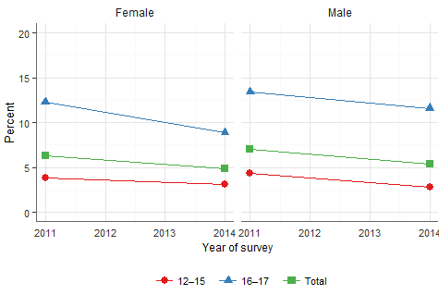

Source: Australian Secondary Students Alcohol and Drug Survey 2011, 2014 (customised request)

## Indicator 2: Fewer young people making the transition to established patterns of smoking

There was a reduction from 3.5% in 2011 to 2.7% in 2014 in the percentage of secondary school aged students who had smoked more than 100 cigarettes in their lifetime. The reduction was seen in males and females and in each of the age groups (Figure 2). Overall, while some changes within these respective sub-groups occurred between 2011 and 2014, the data does not confirm any clear trends. (Figure 26 and Figure 27, Appendix 5).

The changes observed in the results from the Australian Secondary Students Alcohol and Drug Survey used for this analysis are supported by the change seen in the National Drug Strategy Household surveys, which showed the percentage of young people aged 18 to 24 years who had smoked more than 100 cigarettes in their lifetime fell from 29.4% to 23.2% between 2010 and 2013 (Figure 3). The reductions were seen in most subgroups except the unemployed and those whose main language spoken at home is not English (Figure 28, Appendix 5).

Figure 2 - Trends in the prevalence of secondary school age children having smoked more than 100 cigarettes in their lifetime - by sex and age group

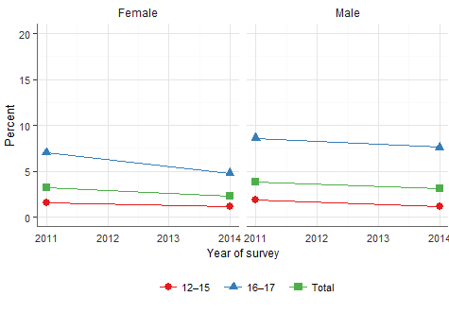

Source: Australian Secondary Students Alcohol and Drug Survey 2011, 2014 (customised request)

Figure 3 - Trends in the prevalence of young people (aged 18-24) having smoked more than 100 cigarettes in their lifetime - by sex

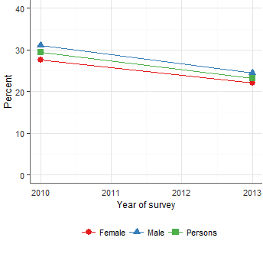

Source: AIHW analysis of the National Drug Strategy Household Survey 2010, 2013

## Indicator 3: Fewer adults smoking regularly

There has been a continuation of the reduction in the percentage of adults aged 18 years or older who smoke daily. The prevalence of daily smoking fell from 18.9% in 2007-08 to 14.5% in 2014-15. For the age-standardised percentages this was 19.1% to 14.8%. The reduction was seen in males and females (Figure 4) but with potentially greater gains in the younger age groups, although the age effect is more noticeable in males (Figure 5).

One of the targets of the NTS is to reduce the prevalence of smoking in the general population to 10% by 2018. Extrapolating from the reduction observed between 2007-08 and 2014-15, 10% prevalence may not be achieved by the end of 2018.

The reduction can be seen in all states and territories and in all subgroups (Figure 29 and Figure 30, Appendix 5).

Figure 4 - The percentage of adults aged over 18 years who smoke daily at each survey - by sex

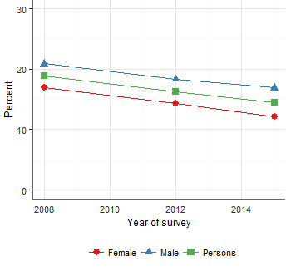

Sources: ABS 2009; AIHW analysis of National Health Survey 2007–08, (re-issue - CURF); ABS Australian Health Survey 2011-12 (National Health Survey component; customised request); and ABS National Health Survey 2014-15 (customised request)

Figure 5 - The prevalence of being a daily smoker among adults by age group and survey year - by sex

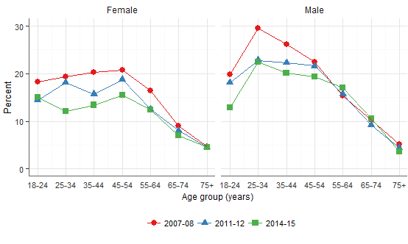

Sources: ABS 2009; AIHW analysis of National Health Survey 2007–08, (re-issue - CURF); ABS Australian Health Survey 2011-12 (National Health Survey component; customised request); and ABS National Health Survey 2014-15 (customised request)

## Indicator 4: More smokers attempting to quit

Between 2010 and 2013 there was little change in the percentage of adult smokers aged 18 years and over who gave up smoking for more than one month or who tried to give up smoking but were unsuccessful. Almost half of smokers made at least one quit attempt over each 12-month period. In 2010, 44.8% of adult smokers had made either a successful or unsuccessful quit attempt, and in 2013 the figure was 46.7%. The data suggest there was a significant increase among males (43.5% to 47.8%) and no significant change among females (46.4% to 45.3%) (Figure 6).

See Figure 31, Figure 32 and Figure 33 in Appendix 5 for trends within groups.

Figure 6 - Trends in the percentage of smokers who made a quit attempt in the past 12 months

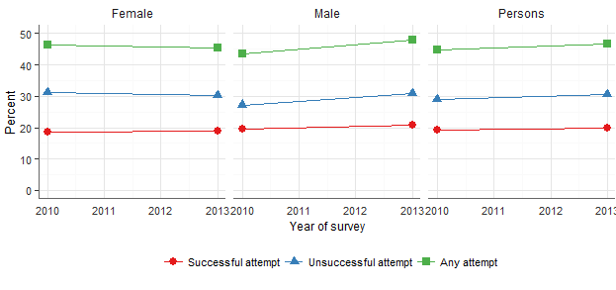

Source: AIHW analysis of the National Drug Strategy Household Survey 2010, 2013

## Indicators 5.1 and 5.2: Fewer women smoking while pregnant

There was very little difference between the percentage of women who smoked at any time during pregnancy and the percentage who smoked in the first half of pregnancy as very few women take up smoking in the second half of pregnancy (Figure 7). The data showed a statistically significant decline in the percentage of women who smoked any time during pregnancy from 13.2% in 2011 to 11.7% in 2013. There is, however, a continuing high rate of smoking by Aboriginal and Torres Strait Islander women during pregnancy (50% in 2011 and 48% in 2013 as reported in the Perinatal Data Collection).

Women who were younger, from lower socioeconomic areas, and women living in more remote areas were more likely to smoke during pregnancy. There was no obvious change in the relationship between these factors and smoking during pregnancy from 2011 to 2013 (Figure 34, Figure 35, Figure 36 and Figure 37, Appendix 5).

Figure 7 - Among women who gave birth, the percentage of women who smoked at any time during the pregnancy

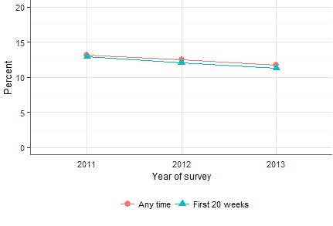

Source: AIHW analysis of the National Perinatal Data Collection

## Indicator 6: Fewer children exposed to second-hand smoke at home

There was a reduction from 6.1% in 2010 to 3.7% in 2013 in the percentage of households with dependent children aged 14 years or younger who live with a smoker who smokes daily inside the house (Figure 8).

The reduction appears to be across the board, with most subgroups showing a statistically significant reduction. A non-significant increase was observed in people for whom English was not the main language spoken at home (5.4% to 6.9%) (Figure 38 and Figure 39, Appendix 5).

Figure 8 – The percentage of households with dependent children (aged 0-14) who live with a daily smoker who smokes inside the home - by sex

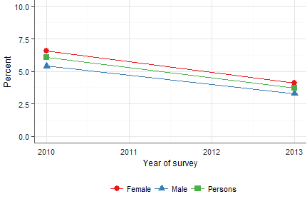

Source: AIHW analysis of the National Drug Strategy Household Survey 2010, 2013

## Indicator 7: Fewer adults exposed to second-hand smoke at home

There was a reduction from 4.0% in 2010 to 2.4% in 2013 in the percentage of adults aged 18 years of older who lived in a household with a smoker who smokes daily inside the house (Figure 9).

The reduction appears to be across the board with most subgroups having a statistically significant reduction(Figure 40 and Figure 41, Appendix 5).

Figure 9 - The proportion of adults aged 18 or older who live in a household with a daily smoker who smokes inside the home - by sex

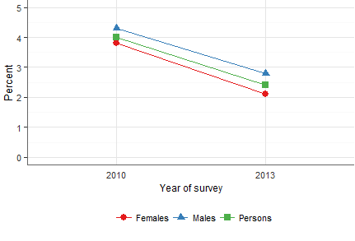

Source: AIHW analysis of the National Drug Strategy Household Survey 2010, 2013

## Indicator 8i: Fewer adults smoking regularly among Aboriginal and Torres Strait Islander people

There was a statistically significant reduction in the percentage of Aboriginal and Torres Strait Islander adults who smoked daily from 47.7% in 2008 to 44.4% in 2012-13 (non-age-standardised, from 44.8% to 42.1% age-standardised). The magnitude of the reduction was similar in males and females (see Figure 10).

More details of trends by subgroups are presented in relation to Priority 4.

Figure 10 - The prevalence (and 95% confidence intervals) of being a daily smoker among Aboriginal and Torres Strait Islander adults - by sex

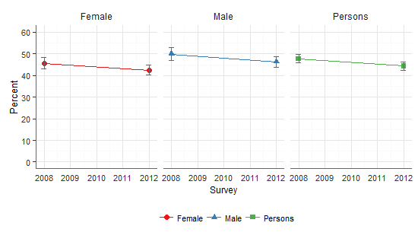

Sources: ABS 2013; ABS National Aboriginal and Torres Strait Islander Social Survey 2008 (customised request); Australian Aboriginal and Torres Strait Islander Health Survey 2012–13 (Core component; customised request)

## Indicator 8ii: Fewer adults smoking regularly among people of low socioeconomic status

Between 2007-08, 2011-12 and 2014-15, reduction in the prevalence of daily smoking in the adult population occurred in all quintiles of socioeconomic status (defined by the Socio-Economic Indexes for Areas (SEIFA), including the lowest socioeconomic status quintile (Figure 11).

The reduction appears to be consistent within socioeconomic status quintiles across most age groups (Figure 44, Appendix 5).

Figure 11 - The prevalence of being a daily smoker by quintiles of socioeconomic status - by sex

Figure 11 shows the smoking rates from 2008 through to 2015 by sex and socioeconomic status. 
The graph tracks the 5 SEIFA - Socio-Economic Indexes for Areas - across the 2008-2015-time span for males, females and combined.
Smoking rates are declining over time at similar rates across each of the 5 SEIFA groupings. The graph clearly shows that with each level of increasing disadvantage smoking prevalence also rises.  


Sources: ABS 2009; AIHW analysis of National Health Survey 2007–08, (re-issue - CURF); ABS Australian Health Survey 2011-12 (National Health Survey component; customised request) and ABS National Health Survey 2014-15 (customised request)

## Indicator 9: Young people delaying the onset of tobacco smoking

The average age that young people from 14 to 24 years of age first smoked a full cigarette increased from 15.4 years to 15.9 years during 2010 and 2013.

Among 20 to 24 year olds a significant increase in the reported age of first smoking a full cigarette occurred in both males (15.9 to 16.7 years) and females (15.3 to 16.1 years). However, in 14 to 19 year olds there was a statistically significant decrease for males (15.1 to 14.4 years) and a non-significant increase for females (14.8 to 15.0 years) (Figure 12).

The increase did appear to occur across all socioeconomic groups defined by quintiles of the SEIFA, but most of the increase appeared to occur in the major cities (Figure 45 and Figure 46, Appendix 5).

It should be noted that the change over time in the average age at which people   
14 to 24 years had their first full cigarette needs to be assessed carefully when the proportion of people who have had a least one full cigarette is changing.

Figure 12 - The average age at which people aged 14 to 24 first smoked a full cigarette - by sex and age group

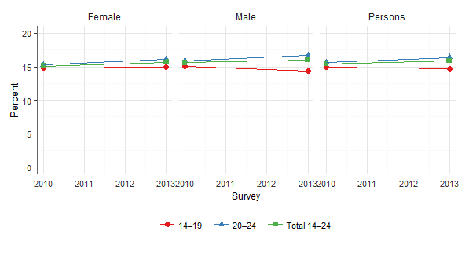

Source: AIHW analysis of the National Drug Strategy Household Survey 2010, 2013

## Indicator 10: Fewer people trying cigarettes

In 2011, 23.3% of secondary school students aged 12 to 17 years tried at least a few puffs of a cigarette in their lifetime and this reduced to 19.1% by 2014. The reduction was seen in both males and females and in both age groups: 12 to 15 year olds and 16 to 17 year olds (Figure 13). The reduction also appears to have occurred in both Indigenous and non-Indigenous people, and in all other socio-demographic groups except in those living in remote and very remote areas (Figure 47, Appendix 5).

There was also a reduction in the percentage of adults who had smoked a full cigarette in their lifetime, from 62.5% in 2010 to 57.0% in 2013, in both males and females (Figure 14). The reduction also appears to have occurred in both Indigenous and non-Indigenous people and in all other demographic groups except in remote and very remote areas and people whose main language at home is not English (Figure 48, Appendix 5).

Figure 13 - The percentage of 12 to 17-year-old secondary school students smoking at least a few puffs of a cigarette - by sex and age group

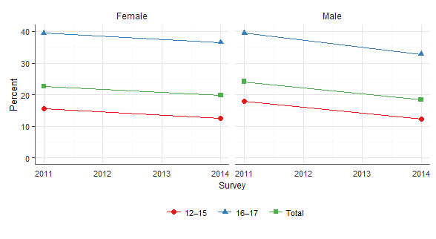

Source: Australian Secondary Students Alcohol and Drug Survey 2011, 2014 (customised request)

Figure 14 - The percentage of adults who had smoked a full cigarette in their lifetime - by sex

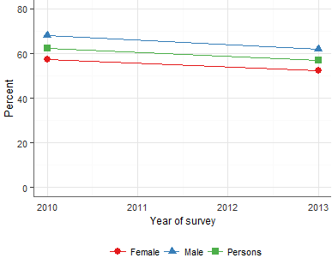

Source: AIHW analysis of the National Drug Strategy Household Survey 2010, 2013

## Indicator 11: Adult ever-smokers are quitting at a younger age

First, from 2010 to 2013, there was little difference in average age at which   
ex-smokers aged 18 or older quit smoking tobacco (35.3 years and 35.4 years respectively) (Figure 15). The population being measured by this statistic is   
ex-smokers and this population has changed over time, probably due to fewer people taking up smoking and more smokers quitting. An increase in this statistic is not necessarily undesirable, for example if it were driven by a sudden increase in older smokers quitting.

Second, there was a statistically significant increase in the proportion of ever-smokers aged 45-74 who had quit smoking before the age of 45 years (from 44.0% in 2010 to 46.4% in 2013). The population being measured in this second statistic is ever-smokers. This population is also changing but likely due to fewer people taking up smoking.

Figure 15 - The average age at which ex-smokers aged 18 or older reported no longer smoking - by sex

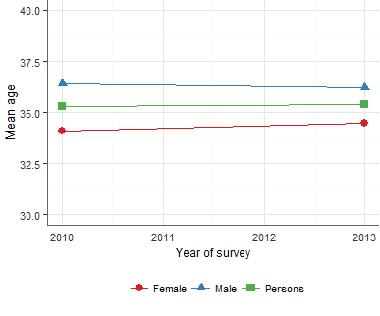

Source: AIHW analysis of the National Drug Strategy Household Survey 2010, 2013

## Indicator 12: More adult ever-smokers no longer smoking

In 2010, 47.7% of adult ever-smokers did not smoke tobacco in the previous 12 months, and this had increased to 51.8% in 2013. The increase was seen in both males (46.9% to 49.3%) and females (48.1% to 54.8%) (Figure 16). Most socioeconomic and demographic subgroups appear to have experienced the increase, although a slight decline was seen in those whose main language at home is not English (Figure 50 and Figure 51, Appendix 5).

Figure 16 - The percentage of ever-smokers aged 18 or older who did not smoke in the last 12 months - by sex

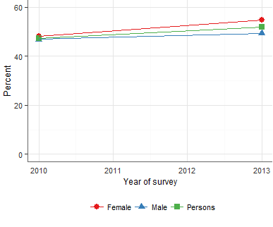

Source: AIHW analysis of the National Drug Strategy Household Survey 2010, 2013

## Indicator 13: Fewer young people smoking

In 2011, 8.9% of secondary school students were monthly smokers and this had decreased to 7.5% in 2014. The decrease was seen in both males and females as well as in both the 12 to 15 and 16 to 17-year age groups (Figure 17).

Most socioeconomic and demographic subgroups appear to have experienced the decline (Figure 52, Appendix 5).

Figure 17 - The percentage of secondary school students who were monthly smokers - by sex and age group

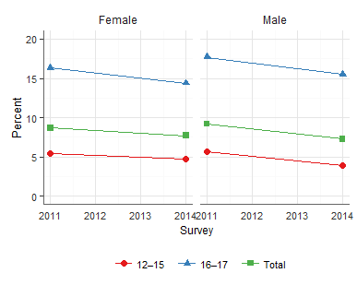

Source: Australian Secondary Students Alcohol and Drug Survey 2011, 2014 (customised request)

## Indicator 14: Current adult smokers smoking occasionally (weekly or less than weekly)

There was little change in the percentage of adult smokers who smoked weekly or less than weekly between 2007-08 (9.0%) and 2014-15 (9.6%) (Figure 18, and Figure 53, Appendix 5).

Figure 18 - The percentage of smokers aged 18 or older who are occasional smokers (smoke weekly or less than weekly) - by sex

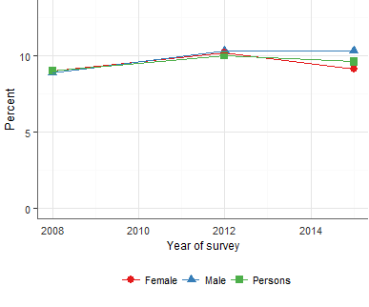

Sources: ABS 2009; AIHW analysis of National Health Survey 2007–08, (re-issue - CURF); ABS Australian Health Survey 2011-12 (National Health Survey component; customised request) and ABS National Health Survey 2014-15 (customised request)

1. General findings from the consultations

This Chapter contains overall findings from the review that do not relate to a specific priority area. Findings relating to specific priority areas are in the chapters following.

## Overall perceptions of the NTS

The NTS was seen by most stakeholders consulted as an evidenced-based   
‘blue-print’ for effective tobacco control. It was widely accepted that the document reflects the key priorities and actions that need to be addressed to continue to reduce the prevalence of smoking in Australia. Some additional issues were identified by stakeholders that had emerged or gained greater prominence since 2012, notably e-cigarettes. There was strong support for the two broad COAG tobacco performance benchmarks (to reduce the general population prevalence of smoking to 10% and to halve the Aboriginal and Torres Strait Islander smoking prevalence) and the nine priority areas of the NTS.

The extent to which the NTS set a framework through which local initiatives were referenced varied across jurisdictions. At the Commonwealth level, there has been a strong focus on the NTS and considerable action on several of the priority areas. However, the NTS has been less prominent within some states and territories where there has been a local (state/territory) strategy. Where this was the case, stakeholders indicated that while there was considerable overlap between the NTS and their own strategy, they were seen as independent strategies, and sometimes it was commented that action on tobacco would have taken a similar path and level of resourcing without the NTS. However, all states and territories reported that the NTS was useful as a tool for gaining support for proposed initiatives at the local level. The states and territories without their own local strategy reported that their planning was guided by the NTS.

Some of the apparent lack of focus on the NTS in some jurisdictions was linked with the timing of the release of the NTS and the development of state/territory tobacco control plans. Jurisdictional plans or strategies were released before the NTS by NSW, South Australia, Tasmania, ACT and NT. Part of the lack of focus on the NTS was also reported to be the absence of any funding tied to its actions. Several stakeholders in states and territories indicated that they needed to prioritise action on funded strategies before unfunded ones.

For approximately half of the NGOs consulted there was a low level of awareness of the NTS, as they reported that there had been little effort by the Commonwealth or state and territory health authorities ‘to put it on our radar’. A small number of NGOs reported that this mid-point review process was their first introduction to the NTS. Many NGOs reported a clear awareness of the NTS and stated that the NTS was an important reference point for identifying both national and local action on tobacco control.

## Overall enablers for tobacco control

The following were commonly reported by stakeholders as the key enablers, or facilitating factors that are believed to be assisting in reducing smoking prevalence throughout Australia:

* **The NTS** was reported by the majority of stakeholders to provide a comprehensive policy framework unifying tobacco control momentum for governments and NGOs.
* **National leadership on legislative change,** specifically achievements inexcise tax increases, tobacco plain packaging and increased graphic health warnings, and successful defence of these measures from legal challenges supported by the tobacco industry, indicated strong government commitment. Political commitment, including bipartisan support for these measures was also an important aspect of national leadership.
* **Jurisdictional strategic plans**.It was evident that states and territories which had a formal intersectoral coordinating tobacco control body and a current state and territory plan had many more achievements over the period 2012-2015, than those that did not. Several of the NGOs in state and territories where this was lacking reported the need for such a structure brought about by a local strategy.
* **Tobacco control community** comprises people working cooperatively across government, NGO and academic sectors. There is a widely-held belief that the tobacco control community is better organised and coordinated than most disciplines within public health, and that this helps drive continued success in this area.
* **Networks and communication** throughout Australia and internationally, where there is sharing of information and resources. Although much of this happens informally, the National Expert Reference Group on Tobacco convened by the Commonwealth Department of Health was one formal network said to enable greater coordination of effort at a national level.
* **Successes**. Tobacco controlisone of the great public health success stories in Australia and internationally. Those who have worked for many years in this field reported that they have witnessed a long history of successes and believe that the clear reductions in the prevalence of smoking have contributed to the ongoing commitment and sustained efforts in this area.
* **Australia’s international tobacco control profile.** The WHO FCTC, for example, has provided a critical underpinning for Australia’s world-leading tobacco control reforms Australia is seen as a world leader in tobacco control. The world-first implementation of tobacco plain packaging and Australia’s contribution to the field internationally is seen as a key strength.
* **Focus on Indigenous communities**. The *Tackling Indigenous Smoking & Healthy Lifestyle Programme* and its successor the *Tackling Indigenous Smoking* program with its National Best Practice Unit have generally been well received by stakeholders. The national media campaign, *Don’t Make Smokes Your Story*, and local programs implemented by Aboriginal health organisations were reported by many stakeholders to be encouraging. They are beginning to show success in terms of declining smoking prevalence in this priority group. While it was acknowledged that there is a long way to go in this area, there are some major initiatives, for example the *Deadly Choices* initiative9 that could be continued, expanded or rolled out to see even greater gains.
* **Broad commitment to denormalisation of smoking** includes significant gains in the expansion of legislated smoke-free areas, plain packaging legislation, and mass media campaigns.
* **Monitoring and evidence.** Collection and dissemination of data is key to planning initiatives and monitoring successes. Data available from the AIHW, the South Australian Health and Medical Research Institute, and *Tobacco in Australia; Facts and Issues* were cited as key examples. The *Tobacco in Australia* website*,* maintained by the Victorian Cancer Council was considered a key reliable source of up-to-date information for the sector. In addition, numerous major reports have been produced towards this goal including: the *Post Implementation Review: Tobacco Plain Packaging 2016,**10* *Tackling Indigenous Smoking and Healthy Lifestyle Programme Review,*11 the *Talking About the Smokes* project, provided an evaluation of tobacco plain packaging, comprehensive data on smoking behaviours among Aboriginal and Torres Strait Islander communities12 and evaluation reports of each phase of the national mass media campaigns. However, there were also issues raised in relation to monitoring and evidence, which are presented in the next section.

## Overall barriers to tobacco control

A key objective of the review was to identify the major barriers to achievements against the nine priority areas of the NTS with a view to being able to address those barriers, where possible, for the remaining period of the NTS. This was one of the areas of focus of the consultations and the written submissions. Below is a summary of the major barriers identified by stakeholders.

* **Lack of coordination and communication** about new developments/ initiatives, campaigns, resources, and evaluation reports and other evidence. The need for this was expressed commonly by NGOs, and it was accompanied by a request for more strategic communication on tobacco control with the ‘people on the ground’. It was also raised that there was a lack of coordination between state and commonwealth governments, particularly about programs for Aboriginal and Torres Strait Islander people. Some stakeholders expressed that communication is sometimes informal and ‘by-chance’, leaving people who have less time or fewer connections to be ‘left behind’ or caught unawares about major initiatives. Recommended strategies included a clearinghouse, a monthly bulletin notifying ‘people on the ground’ (not just to government agencies) about new initiatives, resources and research, and some notice and collaborative planning about national mass media campaigns. This could build on the *Tobacco in Australia* websitemaintained by the Victorian Cancer Council.
* **Short-term funding of programs, positions and organisations** was the predominant concern of stakeholders interviewed from across all types of organisations. The major barrier of the one to two-year funding life of positions and programs to address tobacco control was reported to contribute to the accompanying uncertainty of the longevity of programs and positions, an inability to undertake long-term planning, the loss of opportunities to conduct evaluations, and high staff turnover. Many people expressed a level of frustration with public health priorities like tobacco control, which are going to stay on the health agenda for the foreseeable future, have six-year strategies (2012-2018) but continue to operate under one and two-year contracts.

Just as networks are established – the funding stops. Just as partnerships and programs are in place – the funding stops.

The one and two-year funding cycles have to stop. We lose good people – even if funding is renewed – as we never hear until a week or two before funding expires.

* **Funding**. Several stakeholders indicated that because the NTS has no funding attached to it, ‘it has no teeth’. It was also frequently raised that there have been significant funding cuts in tobacco control over time. This was especially a concern of many of the NGOs, who pointed out that they have little to no government funding to address tobacco control (they rely primarily on donations).
* **Difficulties recruiting and/ or retaining staff** was reported as a significant barrier to progress, mostly due to short-term funding cycles not being conducive to finding staff to fill roles. Staff recruitment and retention was highlighted as a problem for rural and remote areas.
* **Disbanding of infrastructure that supported activity in this area** contributing to the lack of funding, but also to a lack of infrastructural support for tobacco control. Interviewees indicated that particularly detrimental to achievements in tobacco control were the disbanding of:
  + **The Australian National Preventative Health Agency (ANPHA).** Multiple stakeholders, both from government and NGOs, as well as several experts, noted that the ANPHA had provided a ‘road map for action’ to 2020. In 2012 and 2013 ANPHA released five reports on tobacco control:

1. *Australia’s Tobacco-related datasets,**13*
2. *Tobacco Control and Mass Media Campaigns - Evidence Brief,**14*
3. *Smoking and Disadvantage - Evidence Brief,**15*
4. *Priority-driven Research Agenda for Tobacco Control in Australia: final report,**16* *and*
5. *50 years on: Gains and opportunities in tobacco control in Australia. Marking the 50th Anniversary of the Report of the Royal College of Physicians of London Smoking and Health.**17*

Despite that *Th*e *Australian National Preventive Health Agency Act 2010* was not repealed as proposed in 2014, ANPHA no longer exists. Many of the experts commented that this meant the loss of a coordinating body, and the loss of prevention as a key priority on the health agenda.

* **National Quitline Managers group.** It was commented that this resulted in the loss of clear governance arrangements for Quitlines.
* **Action on Smoking and Health** was a key advocacy group in the tobacco control arena that assisted in advancing new strategies. Many NGOs and some health authorities made mention of this as a significant loss to the field. It was noted that it is important that independent advocacy action continues to drive tobacco control in Australia.
* **Monitoring and evidence**. Although this was identified as a strength overall, it was commented that the integration of data from different sources is currently not always well done, particularly on innovations and evaluations of the effectiveness of interventions. Timely communication about available reports was sometimes identified as insufficient. It was proposed by some stakeholders that the *Tobacco in Australia* website could be enhanced to address some of these gaps, including addressing the need for a needed national clearinghouse for developments and innovations.
* **Lack of political will** was cited by stakeholders in several jurisdictions as having led to backwards steps in tobacco control, for example, in exemptions on outdoor smoke-free areas in some jurisdictions.
* **The tobacco industry.** NGOs raised that the tobacco industry is still presenting a significant barrier to progress in terms of the tobacco industry’s influence on tobacco control measures.
* **Rural and remote challenges/hard to reach groups.** It was reported that there were significant barriers to progress posed by distance for rural and remote regions. Western Australian stakeholders for example commented on vast distances as a barrier to reaching Aboriginal people in particular, as well as posing challenges in building the capacity among these communities to address tobacco control. In the Northern Territory, remoteness combined with the logistics of getting to places during the wet season, were noted as considerable barriers to undertaking effective tobacco control measures.
* **Complacency** was reported to be a major barrier to progress in reducing the prevalence of smoking. It was noted that there are many subgroups in society where there is still a critical mass of smokers, which make it acceptable to be a smoker. This was raised as a problem particularly by Northern Territory and Tasmanian stakeholders with regard to the high smoking levels among Aboriginal and Torres Strait Islander people. It was reported that a significant problem was that community role models (including health workers) are smokers, adding to its normalisation.

Complacency from within the health sector itself, due to the gains already made in tobacco control and the competition between this and other public health concern, was also raised as a concern. It was raised that there is a real possibility of a reversal of the gains made in recent years in tobacco control.

One expert commented that one of the greatest challenges is to maintain the focus of decision makers on tobacco, to ensure that ‘we all keep the foot on the accelerator’.

* **Failure to address the social determinants of health.** Many of the risk factors for smoking were reported to be ‘upstream’. It was commented that the speed with which the gap between groups with high smoking prevalence and the mainstream population will be narrowed lies in whether social determinants of health are addressed.
* **Expired state and territory strategies.** In several states/territories, NGOs in particular raised that there was no current local tobacco control strategy. In some instances, an earlier strategy had expired and developing a new plan appeared not to be a priority. This was seen as avoidable, particularly with the existence of the NTS, making it relatively straightforward to identify the elements that are appropriate at the state/territory level.
* **Lack of consensus on e-cigarettes**. This was raised by most stakeholders as a problem that needed to be sorted out quickly given claims being made as to risks and benefits and possible effects on smoking cessation and tobacco control efforts
* **Gaps in information of key aspects of tobacco supply and consumption.** National data on sales of tobacco products and the level of consumption of illicit tobacco are not available, and are critical to tobacco control efforts.
* **Involvement of GPs in tobacco control.** It was reported that GPs could be a valuable contributor to increasing cessation attempts, but relatively few are involved in this capacity. A strategy is required to involve GPs in a more systematic way in assisting patients to quit.
* **Lack of evidence in some areas,** particularly on what works with low socioeconomic groups, culturally and linguistically diverse communities, and even with Aboriginal and Torres Strait Islander people.
* **Lack of nicotine replacement therapy options on the Pharmaceutical Benefits Scheme**. Some stakeholders noted that an array of more affordable nicotine replacement therapy options are needed to be available to increase the quitting rate.
* **Not adequately venturing into new social media marketing** strategies. Some organisations reported that the media campaigns are not adequately tapping into new or emerging forms of media, particularly to reach young people.

## Leadership

When asked about leadership issues and the NTS, the following themes emerged:

* **General recognition of good leadership to date**. Some stakeholders felt that there has been strong national leadership for a long while, which explains why Australia is a world leader on many aspects of tobacco control. It was commented that since 2012 there have been signs of this leadership continuing, particularly on national laws and policies. However, several stakeholders (notably NGOs and some tobacco control experts) reported that this did not always translate or ‘trickle down’ to coordination of effort within jurisdictions or between jurisdictions.
* **Great variability of level of leadership at state and territory level.** Some of the tobacco control experts indicated that while the NTS is a blueprint for best practice in tobacco control, the states and territories are not all on the same track as a result of it. It has been given very different levels of emphasis in each state/territory, in part due to the leadership within the state.

## Partnerships

Partnerships in tobacco control were generally strong. This was observed and reported within state and territory agencies, and particularly between NGOs that have a commitment to tobacco control. Several experts and practitioners who have been working in the field for at least a decade indicated that they felt there has been a good level of coordination on progressing the NTS at state and territory levels, but that this already existed before the NTS.

Collaborations and networks were expanded through initiatives such as the Oceania Tobacco Control Conference in 2015. The National Expert Reference Group on Tobacco membership is Commonwealth, State and Territory Governments and several Australian tobacco control experts. This reference group is important for progressing evidence-based policy and program responses to a range of issues such as e-cigarettes and smoking among people with mental illness.

A number of Commonwealth interdepartmental partnerships have been established to further the aims of the NTS, including a high level of engagement with the Department of Immigration and Border Protection on addressing illicit importation of tobacco products, and working with Treasury in undertaking a post implementation review (PIR) on the 25% tax increase and on a range of other excise related matters.

At an operational level, the Tobacco Policy Officers Group was noted to provide an important forum for sharing information across Commonwealth, state and territory government tobacco control agencies. This enables governments to obtain information about the progress of interstate initiatives and supports consideration of future government initiatives.

The primary threat to effective partnerships was reported to be staff turnover and disbanded programs and structures – notably the ANPHA. Lack of commitment to long-term funding was cited as being primarily responsible for this threat at national, state and territory levels alike.

## Emerging Issues

Several areas were identified as emerging concerns, or existing issues that will continue to pose significant challenges to tobacco control. It is widely held that these issues should be included in discussions around policy development for the remaining period of the NTS and beyond.

* **E-cigarettes**. There is limited evidence to support claims that e-cigarettes can be useful in smoking cessation. There is a little understanding of the   
  short-term health effects and limited evidence on long-term impacts of   
  e-cigarettes on population health. Reaction to current regulation of   
  e-cigarettes in Australia was split between a minority who argue for their benefits in harm reduction, and others who argue that they pose a threat to the denormalisation of smoking. E-cigarettes were highlighted as a major issue that needs attention in terms of ongoing monitoring and research alongside consistent regulations across states and territories.
* **Water-pipe tobacco**. Use of water-pipe tobacco and the increasing number of water-pipe tobacco lounges is a growing concern. Common use of fruit flavour in this form of tobacco may detract from accurate public perception of its perceived health risks.
* **Other non-traditional means of tobacco consumption**. As well as   
  e-cigarettes and water-pipe tobacco, concerns were raised regarding new products available in other markets, particularly nicotine inhalers such as British American Tobacco’s *Voke* product.
* **Changes in media.** The rise of social media, most notably as a source of information and influence among young people, was raised by many organisations as something that tobacco control needs to better understand and utilise.
* **Illicit tobacco trade**.Concerns were expressed that increasing cost of cigarettes would lead to an increased appeal of illicit tobacco products among consumers. A related concern is the tobacco industry’s efforts to use commissioned ‘evidence’ of increased smuggling to call for lower taxes. There was strong and universal support for the tax increase. It was noted, however, that there needs to be a concerted effort to address the potential increase for smuggling of tobacco products.
* **Growing profile of other public health risks**.Growing concerns among key stakeholders regarding increased disease burden related to obesity, poor nutrition and alcohol consumption may impact on policy makers as a competing priority from ongoing mortality and morbidity risks of smoking.
* **Tobacco industry interference**. An ongoing concern in tobacco control was signalled to be tobacco industry interference with policy process via lobbying.
* **Availability of tobacco products**.It was broadly held that cigarettes and other tobacco products are too readily accessible via petrol stations, supermarkets, newsagents and other stores accessed by consumers for basic needs. The number and density of outlets retailing cigarettes is a priority concern.

## General recommendations – infrastructural support of the NTS

The following recommendations have been developed to reflect the general findings reported above. Recommendations relating to the nine priority areas are at the end of each chapter relating to these priorities.

1. All states and territories should have a jurisdictional tobacco control plan that is current and complements the objectives of the NTS.
2. The Commonwealth Department of Health, together with the National Expert Reference Group on Tobacco should develop and adopt strategies to increase the profile of the NTS with all stakeholder groups to ensure that tobacco control remains a health priority in the face of potential complacency and competing priorities.
3. The Commonwealth Department of Health should develop and facilitate a strategic process by which to communicate progress, new decisions and resources so that all stakeholders (including health agencies in rural and remote areas NGOs throughout the jurisdictions) are actively kept informed of such developments.
4. The Commonwealth Department of Health should compile a clearing house of potentially successful initiatives conducted by different jurisdictions across a range of priority issues (including those identified in Appendix 6), as well as publicly-available data from AIHW, the South Australian Health and Medical Research Institute, and the new TIS Best Practice Unit.
5. Across all jurisdictions, tobacco control programs and positions, particularly front-line program delivery staff, to be funded for a minimum of three years to avoid the recruitment and retention issues with staff and ensure realistic timeframes for proposed changes to be planned, adopted and evaluated.
6. Commonwealth and state and territory governments to consider mechanisms to provide greater funding support for NGOs and health agencies in remote areas to undertake tobacco control.
7. Priority 1: Protect public health policies from tobacco industry interference

The NTS recognises that the Commonwealth and state and territory governments have obligations in supporting Article 5.3 of the WHO FCTC.8

The WHO FCTC was developed in response to the globalisation of the tobacco epidemic and is an evidence-based treaty that reaffirms the right of all people to the highest standard of health. Article 5.3 of the WHO FCTC requires that:

In setting and implementing their public health policies with respect to tobacco control, Parties shall act to protect these policies from commercial and other vested interests of the tobacco industry in accordance with national law.

*Guidelines for implementation of Article 5.3* were adopted by the Conference of Parties in 2008 (WHO 2008).1 The guidelines recommend several activities including “*establish*[ing] *measures to limit interactions with the tobacco industry and ensure the transparency of those interactions that occur*.”

## Priority 1: Summary of achievements 2012-2015

The reported current status of the Commonwealth and jurisdictional health authorities in terms of actions to protect public health policies from tobacco industry interference is summarised in Table 2. Policies have been implemented by the Commonwealth and Tasmanian health authorities. New South Wales has identified the need for a protocol in its *Tobacco Strategy 2012-2017*, and although the WHO FCTC is referenced and its principles followed in practice a state-specific protocol has not yet been finalised. While it was generally reported as expected practice that measures are taken to protect public health policy from tobacco industry interference, by the end of 2015 there were no other jurisdictions with a specific policy on this issue.

Table 2 – Priority 1: jurisdictional summary of achievements

| **Jurisdiction** | **Policy on protection from tobacco industry interference** | **Other measures reported** |
| --- | --- | --- |
| Commonwealth | * There is an internal Department of Health policy to limit departmental officers’ interaction with the tobacco industry only when and to the extent strictly necessary to enable effective regulation of the tobacco industry and tobacco products. * The Commonwealth Department of Health is working with the Office of International Law to develop a cross portfolio policy on interactions with the tobacco industry. * The Commonwealth Department of Health requests that participants of meetings complete and sign a conflict of interest form prior to the meeting. | * The Commonwealth Department of Health publishes a record of meetings involving the tobacco industry on the Department’s website. * The WHO FCTC Article 5.3 provision has been interpreted broadly by Australia through an Interpretative Declaration lodged by the Foreign Minister in January 2015. The Interpretative Declaration indicates Australia’s understanding that Parties to the Convention should interact with the tobacco industry or those working to further its interests only when and to the extent strictly necessary to enable them to effectively regulate the tobacco industry and tobacco products, and should ensure that any such interactions are conducted transparently. * A Register of Lobbyists and Code of Conduct has been in operation since 2008, [Register of Lobbyists](http://lobbyists.pmc.gov.au/) * November 2013 the Commonwealth Superannuation Corporation divested in tobacco holdings. |
| NSW | * The *NSW Tobacco Strategy* 2012-2017 includes a commitment to “*Develop a protocol for compliance with Article 5.3 of the [WHO FCTC] regarding transparent communication with the tobacco industry”*. It is understood the protocol has not yet been finalised. * It is understood that in practice interactions between health officials and the tobacco industry are consistent with Article 5.3 of the WHO FCTC. It is also understood there are no policies relating to interactions with the tobacco industry by officials from non-health portfolios and at the ministerial level. | * There is no public record of interactions between health officials or other government officials and the tobacco industry. Records are kept internally. * A register of NSW lobbyists exists at  [Register of Lobbyists](http://www.lobbyists.elections.nsw.gov.au/registeroflobbyists), in accordance with the *Lobbying of Government Officials Act 2011*. * In practice interactions are consistent with Article 5.3 of the WHO FCTC – tobacco companies are only communicated with respect to obligations under existing tobacco legislation. |
| WA | * It is understood there is no health portfolio policy or protocol related directly to this matter, although in practice interactions between health officials and the tobacco industry are consistent with Article 5.3 of the WHO FCTC. It is also understood there are no policies relating to interactions with the tobacco industry by officials from non-health portfolios and at the ministerial level. | * There are various policies across all government departments to ensure accountability and transparency and protection from conflicts of interests, although dealings with the tobacco industry do not appear to have been explicitly addressed in these. * There is no public record of interactions between health officials or other government officials and the tobacco industry. A register of lobbyists has been held since 2006. |
| Tas. | * There is a policy for the health and other sectors of government which states that tobacco companies do not contribute to the development and implementation of tobacco policy in Tasmania. | * Practice of only communicating with tobacco companies with respect to licensing and existing tobacco legislation. * There is no public record of interactions between health officials or other government officials and the tobacco industry. |
| ACT | * It is understood there is no health portfolio policy or protocol related directly to this matter, although in practice interactions between health officials and the tobacco industry are consistent with Article 5.3 of the WHO FCTC. It was reported a health portfolio policy is being drafted for the health sector with adoption planned in 2016-17. It is also understood there are no policies relating to interactions with the tobacco industry by officials from non-health portfolios and at the ministerial level. | * There is no public record of interactions between health officials or other government officials and the tobacco industry. * 2012 – Responsible Investment Policy ACT Government directly-owned share investments will not be invested in the manufacture of tobacco and related products. * 2013 – Adoption of the Open Government Policy ensures that consultations undertaken by the ACT Government are conducted transparently. This includes any consultations undertaken on tobacco-related issues. * 2015 ACT Register of Lobbyists – only those on the list can contact a member of the Legislative Assembly (which serves in part to limit interactions with the tobacco industry). |

In Victoria, Queensland, South Australia and the Northern Territory there is no health portfolio policy or protocol related directly to interaction between health officials and the tobacco industry, although in practice interactions are consistent with Article 5.3 of the WHO FCTC. There are no policies relating to interactions with the tobacco industry by officials from non-health portfolios and at the ministerial level.

## Priority 1: Summary of progress on action items

| **Action item** | **Progress 2012-2015** |
| --- | --- |
| **Action 1.1** Develop policies and regulatory options to implement article 5.3 of the WHO FCTC – which relates to tobacco industry’s interference with public health policies | **Inconsistent.** The only jurisdictions to report achievements in terms of implementing a policy addressing this priority area were the Commonwealth and Tasmanian health portfolios. |

## Issues arising from the consultations

Protecting public health policies from tobacco interference was raised by a minority of stakeholders consulted as an area of achievement between 2012 and 2015. Most stakeholders consulted considered that while Australia compares well to other countries on limiting interference by the tobacco industry on public health policy, there is still room for improvement.

There appeared to be differences between the jurisdictions in the focus given to this priority over the 2012 to 2015 period. Stakeholders believed efforts in this area were patchy and consequently greater focus for the remaining period of the NTS could be given to this priority.

Several stakeholders suggested that there should be a regular release of information on the tobacco industry’s contacts with all levels of government. As discussed, all contacts between the industry and the Commonwealth Department of Health are disclosed on the departmental website. However, similar arrangements do not appear to be in place with state and territory health authorities or other policy making agencies.

The capacity of the industry to influence policy making through interactions with the executive, legislative and judiciary arms of government was also a concern for some stakeholders. It was also suggested by several tobacco control experts that this priority should be extended to include all political donations. However, this falls outside the priorities of the NTS.

## Recommendations for 2016-2018

1. States and territories to consider adopting or using as appropriate the Article 5.3 Guidance Note being developed by the Commonwealth Department of Health. This Guidance Note aims to provide advice and guidance on achieving transparency in interactions between public officials and the tobacco industry, and covers a range of areas relating to awareness raising, limiting interactions with industry, rejecting partnerships with industry, and avoiding and managing conflicts of interest.
2. All governments (Commonwealth, state and territory) should consider how the commitments under Article 5.3 of the WHO FCTC, can be achieved with respect to interactions between the tobacco industry and various arms of executive government, including government officials. This review should address the need for cross portfolio guidelines on interactions between the tobacco industry and government officials.
3. Priority 2: Strengthen mass media and public education campaigns

## Priority 2: Summary of achievements 2012-2015

From 2012 to 2015, several national tobacco campaigns were implemented. These are described in Table 5. These included an added focus from 2011 on high prevalence groups with the adoption of the *More Targeted Approach* campaign – aiming to reach pregnant women and their partners, culturally and linguistically diverse communities, people living in socially disadvantaged areas, people with mental illness and prisoners.

In addition to these, *Break the Chain*, (the first Commonwealth Indigenous-specific campaign) a media campaign targeting Aboriginal and Torres Strait Islander smokers has been placed nationally in mass media since 2011. While outside the period of this review, *Don’t Make Smokes Your Story* (2016), targeting Aboriginal and Torres Strait Islander smokers, was developed and has been placed nationally in mass media. The analysis in this chapter excludes further detailed reference to the 2016 national campaign as it is outside the scope of this report.

Evaluation reports were developed and made available for each of the national tobacco control campaigns run during 2013, 2014 and 2015. These reports have been made available on the quitnow.gov.au website.

Table 3 – Priority 1: Australian Government National Tobacco Campaigns 2012-2016

| **Date of campaign** | **Target audience** |
| --- | --- |
| November 2012 – January 2013* | People from low socioeconomic backgrounds, Aboriginal and Torres Strait Islander smokers. |
| November 2012 – January 2013 | Culturally and linguistically diverse smokers and pregnant women and their partners. |
| May – June 2013 | Culturally and linguistically diverse smokers and pregnant women and their partners, and Aboriginal and Torres Strait Islander smokers. |
| April – June 2013 | People from low socioeconomic backgrounds, Aboriginal and Torres Strait Islander smokers. |
| May – June 2014 | People from low socioeconomic backgrounds, Aboriginal and Torres Strait Islander smokers, people from culturally and linguistically diverse backgrounds who smoke. |
| May – June 2015 | People from low socioeconomic backgrounds, Aboriginal and Torres Strait Islander smokers, people from culturally and linguistically diverse backgrounds who smoke. |

* Campaign managed under ANPHA.

States and territories also sponsored a range of campaigns during the period, which are described in Table 4. Smaller states and territories highlighted that it was challenging to implement media campaigns due to the economies of scale.

Stakeholders highlighted a range of adjunct strategies to mass media campaigns, delivered at the community level. Community events, strategies such as community buses with the campaign images and slogans on them, stands at local fairs, and educational approaches delivered in schools were reported to be a significant area of planning and investment at the local level. While those responsible for these initiatives reported positive feedback from the community, no formal evaluations were identified at the local level. Stakeholders from some NGOs, not directly responsible for these community strategies, suggested that the lack of evidence on the effectiveness of these strategies was problematic, and that resources should be allocated to evidence-based strategies.

Table 4 – Progress on mass media and public education campaigns by jurisdiction

| **Jurisdiction** | **Progress** |
| --- | --- |
| Commonwealth | Table 3 (above) lists the national campaigns undertaken between 2012 and 2015 targeting people from low socioeconomic backgrounds, including Aboriginal and Torres Strait Islander people aged 18 to 50 years old. As noted, the *Break the Chain* campaignhas been placed nationally in mass media since 2011. All major campaigns were evaluated and reports available on the quitnow.gov.au website.  Mobile phone applications - *My Quit Buddy* and *Quit for You, Quit for Two* -were developed for 18 to 50 year olds and pregnant women, respectively. Information for prisoners and fact sheets for people with mental health disorders, their families, friends and medical practitioners as well as numerous creative materials translated for culturally and linguistically diverse groups were developed and distributed. |
| NSW | The Cancer Institute NSW delivered 35 social marketing campaigns to encourage quitting or to stay quit (2012-15). NSW Health developed campaigns in 2013, 2014 and 2015 to promote outdoor smoking bans (*Smoke-free Environment Act*), the latest one focusing on hospitality venues. Pre-and post-awareness surveys were conducted. Monitoring indicated that was 98% compliance in the first three months of the ban on smoking in commercial outdoor dining areas. |
| Vic. | Funding for the Quit Victoria social marketing campaign was continued. Campaigns were run in line with legislative smoking bans. Graphic health warnings were required to be displayed in retail outlets – and this was updated in 2013 to reflect tobacco pack warnings required by the Commonwealth. |
| Qld | Campaigns were run to support community awareness of new tobacco laws (2014-15). Target groups of 25 to 44 years, males and females, and to increase awareness of bans in hospitals and schools (18 years+). The campaign *Your future is not pretty* targeted females 18 to 24 years. The *Deadly Choices* social marketing campaign, run by the Institute of Urban Indigenous Health Queensland, focused on young people. An independent evaluation identified that it was associated with strong recall and brand profile in the community. |
| SA | South Australia invested in tobacco social marketing campaigns at 400 target audience rating points (TARPS) per month on average. The social marketing mass media campaigns encourage smokers to quit and reduce the prevalence of smoking. There was a renewed push for such campaigns after smoking prevalence rates were found to increase in 2012-13 (16.7% to 19.4%), when the media component was removed. In addition, the Aboriginal social marketing campaign – ‘Give up smokes for good’ continued to run. It features respected Aboriginal non-smoking ambassadors delivering positive tobacco related health messages to their local communities. |
| WA | *Making Smoking History* mass media campaign: population-wide, focus on reducing incidence of new smokers (2012-2015). Procurement of agreement to continue campaign to June 2018. The WA Department of Health was the major sponsor of the Oceania Tobacco Control Conference (2015). |
| Tas. | Quit - Social Marketing Program targeted all smokers – focus on males 25 to 44 years. Extended social marketing program to social networking and other multi-media technologies (2013+). Annual evaluations were conducted. |
| ACT | *Beyond Today* social marketing campaign (2012) was a key component of Aboriginal and Torres Strait Islander tobacco control strategy. Funding provided to community organisations to support smoking prevention and cessation. A social marketing campaign targeting women 15 to 24 years, and one targeting pregnant women, partners and family, were conducted in 2015. |
| NT | NT Department of Health regularly held displays and provided educational material at public events (show days) throughout the NT – promoting quit campaign messages. Danila Dilba Health Service ran numerous educational programs in schools and sponsored a community bus displaying tobacco control images and messages. |

## Priority 2: Summary of progress on NTS action items

| **Action item** | **Progress 2012-2015** |
| --- | --- |
| Action 2.1 Run effective mass media campaigns (including television, radio, print and digital media formats) at levels of reach and frequency demonstrated to reduce smoking and based on current best practice principles. | Numerous national and state and territory campaigns were run and have been well received, but higher intensity is recommended. |
| Action 2.2 Continue mass media campaigns targeted to Aboriginal and Torres Strait Islander people, including robust evaluation to inform future campaign strategies. | National campaigns in 2013, 2014 and 2015 were developed and evaluated targeting Aboriginal and Torres Strait Islander people. Although outside the timeframe of this Review, consultations indicated the 2016 campaigns have been particularly well received, and this focus should continue. Several states and territories, including Queensland, ACT and SA, implemented campaigns to specifically address high smoking rates among Aboriginal and Torres Strait Islander communities. |
| Monitoring and evaluation  Action 2.3 Continue to monitor the appropriateness and effectiveness of recommended media weights and media types/channels, including exploration of the potential role of digital media such as YouTube, Facebook and Twitter.  Action 2.7 Continue to build the evidence base on the effectiveness of mass media to inform and refine future campaign development, including specific analysis of the effectiveness of these campaigns among groups with a high prevalence of smoking. | National campaigns targeting Aboriginal and Torres Strait people were run from 2012-2015. All national tobacco campaigns are evaluated and available on the QuitNow website. The evaluation results are considered in developing the next phase of a campaign.  Some NGOs were not aware of the evaluations of the national campaigns. In these instances, stakeholders emphasised the need to evaluate the effectiveness of digital media initiatives and share these results. |
| Action 2.4 Continue to implement national tobacco campaigns and state and territory campaigns, including a balance of existing material with proven effectiveness and a suite of new materials. | National, state and territory campaigns and supportive materials have been developed and implemented; although in some jurisdictions stakeholders indicated that the local efforts were not always evidence-based. Smaller jurisdictions are more limited in their capacity to fund media campaigns, and rely heavily on materials developed by the Commonwealth. |
| Action 2.5 Enhance collaborative action between the Australian Government, state and territory governments and non-government organisations to maximise the effectiveness of mass media campaigns. | NGOs tended to report this was not as well done for 2012-2015 as it could have been, citing receiving little to no notice of national campaigns, and thus little opportunity for collaboration. |
| Action 2.6 Complement the implementation of tobacco control policies (e.g. new health warnings on packs and plain packaging) with mass media campaigns to enhance cessation efforts by smokers. | Graphic health warnings were first introduced by the Commonwealth in 2006. In 2012 graphic health warnings were updated and enlarged in line with the introduction of tobacco plain packaging. |
| Action 2.8 Continue to share campaign materials, evaluations and other evidence of effectiveness of mass media campaigns with the global tobacco control community. | Graphic health warnings and campaign materials are regularly licensed by national and international organisations. Several stakeholders mentioned that sharing of campaign material between jurisdictions occurred regularly. The Commonwealth also provides numerous campaign resources on the *QuitNow* website that are routinely used by jurisdictions and NGOs. |

## Issues arising from the consultations

Tobacco control experts highlighted that in terms of effectiveness to reduce smoking prevalence and quit attempts, media campaigns are second only to strategies to increase the price of tobacco. They argued that it is important to continue investment in media campaigns, and that that this level of investment needs to be sufficiently intense. Campaigns require continuous and significant investment to achieve sufficient population exposure.18

There is evidence of the impact of a reduction in campaign funding from recent experience in South Australia. It was reported that following a pause in local television campaigns during 2013, prevalence increased from 16.7% in 2012 to 19.4% in 2013. In 2014, the South Australian Government reinvested in social marketing campaigns, and smoking prevalence decreased to 15.7% in that same year.

Some stakeholders were concerned that the combined intensity of national and state and territory campaigns may not be sufficient to achieve optimal effectiveness. These stakeholders noted that campaigns were developed independently by the Commonwealth and state and territory governments, and that there is a danger that reducing investments in campaigns by one level of government may reduce the effectiveness of the campaign run by another level.

Several experts suggested that media campaigns are likely to be one of the most effective interventions to address high smoking rates in lower social economic populations, and alongside local initiatives also remain vital to addressing smoking rates for Aboriginal and Torres Strait Islander people.

Changing population preferences for media consumption were identified as an issue. Free to air television, radio and print are being challenged by other media, and there may be a limited period of time in which television and radio campaigns will have the same level of effectiveness as they do currently. Consequently, the opportunities to further reduce smoking prevalence via these mediums should not be lost.

The Commonwealth recognises that the media environment is evolving, and has the view that the traditional target audience rating point (TARP) measure of reach of television messages to target audiences may not be as appropriate as it used to be. It was suggested that, in addition to continuing with evidence-based approaches using traditional media channels, this may be a time to invest heavily in approaches using ‘new media’ and to build the evidence base while there is still the opportunity to compare effectiveness and efficiency of different media strategies.

Investment in research on evolving media to convey tobacco control messages was identified to be particularly important for reaching school-aged children and young adults. Anecdotally these groups are thought to typically watch relatively little commercial television, and it was felt that they are not being reached by the current mass media campaigns.

National campaigns targeting Aboriginal and Torres Strait Islander smokers, such as *Break the Chain (2011-2015)*, and *Don’t Make Smokes Your Story* (2016), were identified by many stakeholders as extremely important. Evaluations of the national campaigns have highlighted that *Break the Chain* has been amongst the most commonly recalled campaigns.

Although outside the timing of this review, it was noted that *Don’t Make Smokes Your Story* appealed to the general population, not just Aboriginal and Torres Strait Islander people. The Commonwealth indicated this was a deliberate strategy and one that is recommended to continue for the remaining period of the NTS, that is, a continued targeting of high smoking prevalence groups in the community with high cross-over appeal to the broader community.

It was also commonly raised that the campaigns were not adequately focusing on deterring uptake among 18 to 24 year olds, with most messages focusing on quitting smoking. However, ANPHA’s Evidence Brief on Tobacco Control and Mass Media found that while it is often proposed to tailor campaigns to youth to stop them from taking up smoking, usually youth campaigns include message themes known to be less effective (short-term consequences, humour, social norms) and there is potential for these campaigns to promote the undesirable notion that smoking is something only youth in particular should avoid, and is not so much an issue for adults. In contrast, general audience messages often include strong health message themes, can avoid promoting this misperception, and can offer a two-for-one impact. There is good evidence that youth respond similarly to general audience anti-smoking campaigns as adults, and strong evidence that general audience campaigns are associated with reduced youth smoking rates.14

Several stakeholders highlighted the need for regular review and circulation of evidence on the most effective ways to deliver social marketing campaigns to the high prevalence groups, including through newly emerging media. With strong support for these groups to be the focus of attention for the remainder of the NTS, investment in evidence-based strategies in this area is seen as crucial.

Several stakeholders commented that coordination between the national and state and territory levels on campaigns and communication within jurisdictions was sometimes problematic. A Commonwealth and state and territory campaign committee meets regularly, and this is the main communication channel through which information on national and state and territory campaigns is shared.

Several NGOs commented that they were unaware that specific national or state and territory campaigns were to be implemented, until they actually appeared in the media. They felt that this compromised their capacity to undertake complementary programs. Therefore, there appears to be opportunities for better communication and coordination of the overall campaign efforts, both between the national and state and territory levels and within states and territories.

However, each jurisdiction has to address relevant protocols related to media campaigns, which may restrict the capacity to share detailed information on proposed campaigns and their timing.

Experts in tobacco control saw the introduction of new and larger graphic health warnings on tobacco products as an effective strategy to discourage uptake of smoking and encourage quitting. However, some indicated that unless the images are regularly renewed, message ‘fatigue’ is likely.

The health warnings on tobacco products were updated and expanded in the *Competition and Consumer (Tobacco) Information Standard 2011* (the Standard), which commenced on 1 January 2012, fully effective from 1 December 2012. The health warnings for most smoked tobacco products rotate in two sets of seven warnings every 12 months (not including cigars and bidis). At the time of writing this report, the Commonwealth Department of Health is commencing an evaluation of the current health warnings on all tobacco products, to assess their effectiveness.

## Recommendations for 2016-2018

1. Continue to invest in effective national and state and territory media campaigns, ensuring the level of intensity of advertising is in line with the evidence of effective practice.
2. Continue the approach of focusing on Aboriginal and Torres Strait Islander people, including pregnant women, using approaches that also have broader population appeal in national, state and territory campaigns.
3. Review mechanisms through which information about national and state and territory campaigns can be shared between levels of government, and mechanisms through which information on campaigns can be shared with relevant stakeholders (including NGOs) within each jurisdiction. This should include learnings and results of evaluations of national, state and territory campaigns as they become available.
4. Commonwealth, state and territory health authorities to develop a process of sharing the evidence on what works in terms of media and education strategies, including strategies involving social media, local level strategies, and particularly strategies targeting high smoking prevalence groups.
5. Ensure that funding of campaign strategies is in line with the evidence on what works, to discourage uptake of smoking and promote successful quitting attempts.
6. Commonwealth, state and territory governments to investigate the effectiveness of initiatives that use social media channels to target smokers of all ages.
7. Priority 3: Reduce the affordability of tobacco products

The NTS recognises the influence of price on the prevalence of tobacco smoking. There is evidence that increasing tobacco prices, through taxation, is one of the most effective population-based measures to reduce the uptake of smoking, particularly among young people, and to increase the number of quitting attempts.19

## Priority 3: Summary of achievements 2012-2015

### Tax excise

In May 2013, the Treasury released its *Post-Implementation Review – 25 per cent Tobacco Excise Increase**20* based on the 25% tobacco excise increase that was announced and introduced in April 2010. This report concluded that while the tax excise was one of several major tobacco control initiatives occurring at the time (so its direct impact was difficult to isolate) there were strong indications of its effectiveness in reducing smoking. These indications included a New South Wales study that revealed a significant increase in quitting attempts the month after the tax was introduced (from 12% of smokers attempting to quit in May 2009, 13% in April 2010 to 22% in May 2010 – the first month of the price increase), although this increase was not sustained after three months. Another indicator was a large decrease in legal sales of tobacco, indicated by an 11% decline in tobacco clearances (reflecting legal sales of tobacco) for a three-month period after the tax increase compared to the same three months two years earlier.21

In November 2013, the Commonwealth Government announced that it would implement four 12.5% tobacco excise increases, introduced: December 2013, September 2014, and September 2015, with the final increase in September 2016. This is in addition to bi-annual excise rate increases based on average weekly ordinary time earnings. This has been a major achievement under the priority to reduce the affordability of tobacco products.

In June 2014, the Commonwealth Government released a Regulatory Impact Statement: *Tobacco Excise and Excise Equivalent Customs Duty: Staged increases and change from CPI to AWOTE*.22 The report considered the health, social and economic impacts, based international literature and a few Australian studies, the context of public education about smoking and an analysis of costs and benefits to society as a whole and to low socioeconomic groups in particular. It also considered possible changes to business practice of retailers (large and small) and the impact on illicit trade.

### Illicit tobacco

One concern raised in association with high taxation on tobacco is the potential increased attractiveness of this product for illegal importation to organised crime. While this was raised as a serious issue, it was not in the context of the excise being inappropriate, but as part of a call for greater efforts to address the potential threat of increased illicit trade. The Department of Immigration and Border Protection, including its operational arm the Australian Border Force (and formerly the Australian Customs and Border Protection Service), have been working closely with the Commonwealth Department of Health to address the issue of smuggling of tobacco, which avoids the tax excise and reduces the cost. In 2012, the Australian Customs and Border Protection Service established a Tobacco Control Taskforce to lead the development and implementation of a regulatory framework for duty drawbacks and a new temporary refund provision for branded tobacco products non-compliant with the *Tobacco Plain Packaging Act 2011.*

Several measures have been taken to reduce illicit trade in tobacco. The Department of Immigration and Border Protection is a member of the Intergovernmental Committee on Drugs, and works closely with the Commonwealth Department of Health on the NTS. Illicit tobacco is an operational priority for the Australian Border Force. In 2015, a dedicated Tobacco Strike Team was established to investigate serious and organised crime involvement in the illicit tobacco trade. In November 2012, the maximum penalty for tobacco smuggling was increased to 10-years’ imprisonment and pecuniary measures were also increased.

There is no reliable evidence that increases in excise on tobacco products have had any appreciable effect on the illicit tobacco market in Australia. For example, a report by KPMG (sponsored by the tobacco industry), *Illicit Tobacco in Australia* (October 2015), suggested that illegal tobacco consumption declined marginally in the 12 months to June 201523, the first observed decline since 2012. The National Drug Strategy Household Survey report (2014) found that based on self-reporting, there was a decline in the proportion of smokers aged 14 years or over who were aware of unbranded tobacco in their lifetime (from 48% in 2007 to 34% in 2013). In addition, the proportion of smokers who reported smoking unbranded tobacco was 10.7% in 2013, from 10.6% in 2010, and 12.7% in 2007.24 International evidence suggests that illicit tobacco market size tends to be driven more by supply factors, including the cost of supply to the market (which is high in Australia), the level of law enforcement activity, presence of corruption, likelihood of detection, and scale of penalties.25, 26

An Illicit Tobacco Interdepartmental Committee, established in 2015, has developed a forward work agenda for whole-of-government efforts to address trade in illicit tobacco.

In 2015 and 2016 the Commonwealth Department of Health continued work on a Regulatory Impact Statement and cost benefit analysis to inform a Government decision regarding accession to the Protocol to Eliminate Illicit Trade in Tobacco Products, which is supplementary to Article 15 of the FCTC. This followed Australia’s contribution as a member of the Intergovernmental Negotiating Body which drafted and negotiated the text of the Protocol, which was adopted in 2014.

Jurisdictional enforcement officers forward information to the Commonwealth Government about any illicit tobacco trade that is observed and reported. In addition, two state health authorities reported undertaking action to support reducing illicit trade in tobacco products:

* NSW Health Authorised Inspectors undertake regular compliance monitoring and enforcement activities of the *Public Health (Tobacco) Act 2008,* which restricts the availability and supply of tobacco, including illegal tobacco products. Amendments to the *Public Health (Tobacco) Act 2008* which came into effect in February 2016 gave inspectors the power to seize illegal tobacco products, defined as products not in accordance with commonwealth health warning regulations, when prescribed are found on retail premises.
* In Victoria, the DHHS works closely with local councils, Victoria Police and Commonwealth authorities to address allegations of illicit tobacco in Victoria on an on-going basis. From 13 April 2015 the penalties under the Victorian *Tobacco Act 1987* for tobacco retailers and wholesalers found with illicit tobacco, were quadrupled to $36,401 for an individual and $182,000 for a body corporate. Due to increases in definition of a penalty unit, the penalty for a natural person is not $37,310.40 and $186,552 for a body corporate.

### Duty-free allowance

Another achievement under this priority area was the introduction of a decrease in the duty-free allowance for tobacco products, from 250 to 50 cigarettes, or from 250 to 50 grams of tobacco, in September 2012.

## Priority 3: Summary of progress on action items

| **Action** | **Progress 2012 - 2015** |
| --- | --- |
| 3.1 Analyse the impact of the 2010 tobacco excise increases, including the impact on young people and smokers from low socioeconomic groups. | In May 2013, Treasury released its *Post-Implementation Review – 25 per cent Tobacco Excise Increase.* |
| 3. 2 Continue to implement regular staged increases in tobacco excise as appropriate, to reduce demand for tobacco. | This was achieved with the 12.5% increases introduced in 2013, 2014 and 2015 and 2016. |
| 3.3 Complement tobacco excise increases with additional supports for low-income smokers to quit. | While there is a focus on cessation services for some socioeconomically disadvantaged groups, many NGOs reported that there has not been enough resourcing in this area. |
| 3.4 Identify practices that may be undermining the effectiveness of the tobacco excise increases in reducing smoking prevalence (e.g. price discounting) and develop strategies to minimise these practices. | NSW and Victorian health authorities undertook activities to monitor sales of illicit tobacco and issue penalties where appropriate. |
| 3.5 Continue to engage in international cooperation relating to tobacco taxation and addressing illicit trade in tobacco products, including through the WHO FCTC. | Australia has adopted a leadership role in the region, acting as WHO FCTC Regional Coordinator for the WHO Western Pacific Region since 2014. This role has involved collaborating with other Parties to the WHO FCTC within the region, as well as working closely with the WHO FCTC Secretariat, to assist with the coordination of tobacco control efforts, including in relation to tobacco taxation and illicit trade in tobacco products, as appropriate. |
| 3.6 Continue enforcement efforts to prevent the illegal importation and illegal supply and cultivation of tobacco and enhance technology and support systems to identify and respond to illicit trade in tobacco. | The Department of Immigration and Border Protection has enhanced resourcing and efforts to stem supply of illegally imported tobacco, including increased maximum penalty for tobacco smuggling. |
| 3.7 Continue to monitor the supply and use of illicit tobacco in Australia and effective approaches to reduce the illicit trade in tobacco. | Measurement of level of illicit importation is difficult, but there are few indications of an increase. The tobacco industry is not required to disclose sales figures. |

## Issues arising from the consultations

The stakeholder consultations revealed very strong support for the national measures to increase the excise on cigarettes. There was very strong support from all sectors, as well as from the tobacco control experts, for the increases that have occurred (as noted above) as well as those announced with bi-partisan support in the 2016-17 Budget (although outside the timeframe of this Review). This action item was reported by many as the most effective measure that has been taken to reduce the prevalence of smoking.

Overall, stakeholders from all groups (experts, NGOs and health authorities) indicated that decreasing the affordability of tobacco would be a stronger incentive for people of lower socioeconomic groups (where smoking is the most prevalent) to give up, and to deter young people from starting to smoke. A few respondents however had concerns that the excises on tobacco would place an additional burden on heavily nicotine dependent smokers in the lowest socioeconomic group. They indicated that it takes a great deal of support and perseverance to quit smoking, and that with the increased price of cigarettes it would be imperative to increase resources to support cessation attempts and follow-up with this group. It was also indicated that now that we are now at the point where the lowest socioeconomic group makes up the majority of smokers, there will need to be greater expenditure per successful quit attempt than previously. Therefore, governments and NGOs have to be prepared for this additional investment.

One of the reported limitations to monitoring achievements and identifying effective approaches in the area of reducing illicit trade in tobacco products (as identified as action item 3.7 under this Priority in the NTS) is that this is a difficult indicator to measure, and currently evidence is limited to self-reporting by smokers as part of the National Drug Strategy Household Survey24 as noted above, suggesting there is no increase in the use of unbranded tobacco products from 2007 to 2013. Stakeholders indicated that assessing changes in this area is something that could be the focus of future research, but it would need to be acknowledged that it is never likely to be a firm figure.

With regards to the duty-free allowance on tobacco, stakeholders, most notably several of the experts, indicated strong support for this to be reduced to zero. While it was noted that this step would be unlikely to have a direct impact on smoking prevalence, it would be a component of the efforts to denormalise smoking in Australia.

## Recommendations for 2016-2018

1. Commonwealth, and state and territory governments should continue to focus on identifying practices that may be undermining the effectiveness of the tobacco excise increases in reducing smoking prevalence (e.g. price discounting and sale of illicit tobacco) and develop strategies to minimise these practices.
2. As recommended within the WHO guidelines for the implementation of the FCTC,1 Australia should explore the opportunity to require disclosure by the tobacco industry of their sales figures.
3. The Commonwealth, and state and territory governments to continue investment in national and state and territory programs to reduce smoking among Aboriginal and Torres Strait Islander people, with a focus on pregnant women, young people (from 10 years old) and adults aged 25 to 54 years.
4. Priority 4: Reduce smoking rates among Aboriginal and Torres Strait Islander people

Based on the commitment of the Council of Australian Governments (COAG), the NTS includes a specific target to “*halve the adult smoking rate among Aboriginal and Torres Strait Islander people, over the 2009 baseline, by 2018*”.

## Priority 4: Summary of achievements 2012-2015

This priority has been the focus of many activities since 2012 at national and state and territory level. However, it was considered by many stakeholders to be the most challenging priority within the NTS.

As discussed in Chapter 3, the national data on smoking rates for Aboriginal and Torres Strait Islander people used for this mid-point review is for 2012-13. Based on these data, daily smoking rates for Aboriginal and Torres Strait Islanders have fallen from 47.7% in 2008 to 44.4% in 2012-13 (non-age-standardised, or 44.4% to 42.1% age-standardised). This is a statistically significant reduction. Aboriginal and Torres Strait Islander populations have a different age profile to the rest of Australia, making it important to consider age-standardised rates. When standardised for the age profile, the rates for Aboriginal and Torres Strait Islander people were estimated to be 44.8% in 2009 and 42.1% in 2012-13 (see

Figure 19). This represents a meaningful reduction in smoking amongst this group; a reduction of around one percentage point per year (0.94% not standardised for age and 0.77% age-standardised). This exceeds the reduction for other Australians in terms of percentage points per year, but smoking reductions in the Aboriginal and Torres Strait Islander population are from a much higher base. As a result, smoking rates for Aboriginal and Torres Strait Islanders remain around 2.8 times higher than the rest of the population, based on crude rates (i.e. not age-standardised). Based on current trends, the COAG performance benchmark for this priority area is unlikely to be achieved during the period of the current NTS.

Early findings from the 2014-15 National Aboriginal and Torres Strait Islander Social Survey27 suggest that further decreases have been found, with the smoking prevalence rate among Indigenous adults of 41.4%, down from 44.4% in 2012-13 (non-age-standardised) and 40.6%, down from 42.1% in 2012-13 (age-standardised).

Figure 19 - Percentage of adults (aged 18 years and older) who smoke daily by Indigenous status, 2007-08, 2011-12 and 2014-15 (non-Indigenous); 2008 and 2012-13 (Aboriginal and Torres Strait Islander people): non-age-standardised and age-standardised rates

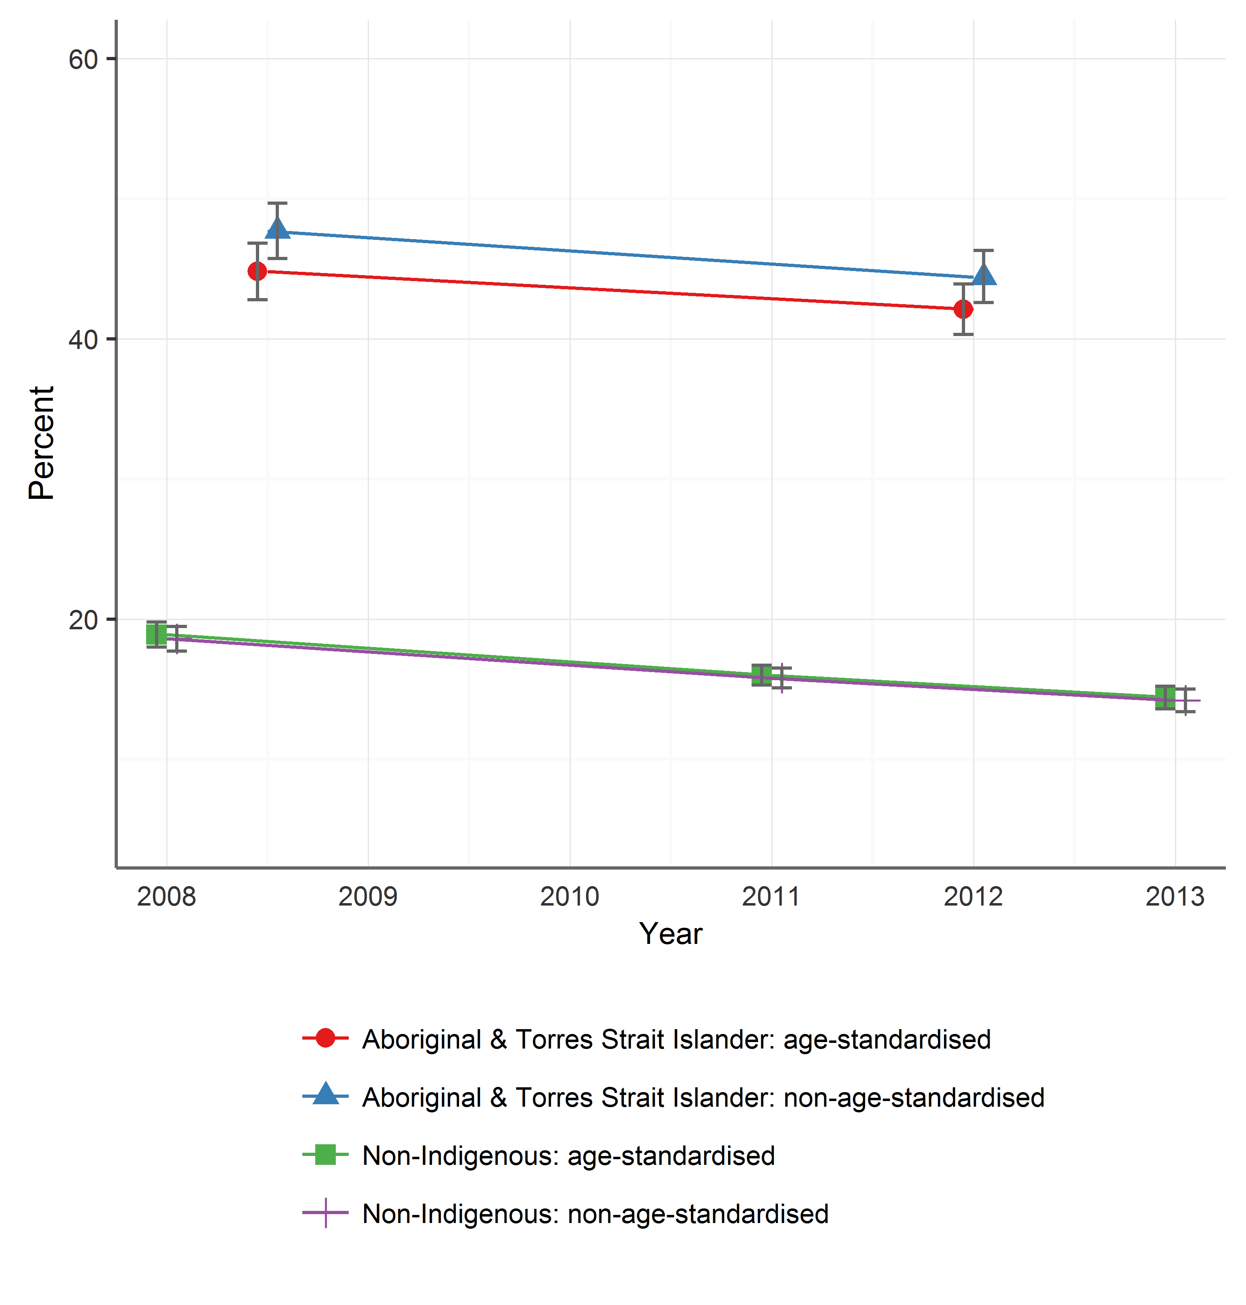

Sources: ABS 2009; AIHW analysis of National Health Survey 2007–08, (re-issue - CURF); ABS Australian Health Survey 2011-12 (National Health Survey component; customised request) and ABS National Health Survey 2014-15 (customised request); National Aboriginal and Torres Strait Islander Social Survey 2008 and the Australian Aboriginal and Torres Strait Islander Health Survey 2012–13

There are indications that smoking rates for young Aboriginal and Torres Strait Islander adults are falling at a greater rate. Figure 20compares daily smoking rates between the two periods for each age group for males and females. These charts suggest the reductions in smoking have been largest for the 18 to 24-year age groups for both males and females, males aged 35 to 44 years and females aged 55 to 64 years. Within each of the age and sex categories, except for 18 to 24-year-old females, none of the differences was statistically significant, which may reflect the small sample sizes for these subgroups. Another perspective on smoking rates for young adults (aged 18 to 24 years) comes from estimates of the proportion of people who have smoked more than 100 cigarettes in their life time (Figure 21). These estimates suggest that this proportion has declined from 51.1% in 2010 to 38.3% in 2013 for young Aboriginal and Torres Strait Islander adults.

Smoking rates for Aboriginal and Torres Strait Islander people show socioeconomic gradients which are broadly similar to those for other Australians. In 2012-13, rates of Aboriginal and Torres Strait Islander people who were daily smokers were estimated to be higher for those who:

* Were unemployed (60.1% compared with 37.3% for employed).
* Had left school before Year 12 (greater than 50% compared with 32.5% for those who have Year 12 of equivalent qualifications and 37.5% with some form of non-school qualification).
* Live in localities identified as more disadvantaged (50.2% for those living in localities in the quintile of greatest disadvantage compared with 23.5% for those living in localities in the quintile of greatest advantage), and
* Live in remote localities (52.7% compared with 42.0% for non-remote).

However, the latest available data suggest rates of daily smoking have been falling across all these categories, with only a few exceptions. These relate to estimates in which there are wide confidence intervals (e.g. people living in very remote localities), where the increases may be due to sampling variations rather than reflecting real increases in smoking.

Figure 20 – Percentage of Aboriginal and Torres Strait Islander adults (aged 18 years and older) who smoke daily, by age and sex, 2008 and 2012-13

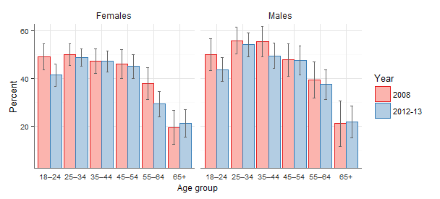

Source: AIHW analysis of the ABS National Aboriginal and Torres Strait Islander Social Survey 2008 and ABS Australian Aboriginal and Torres Strait Islander Health Survey 2012–13

Figure 21 – Young people (aged 18 to 24 years) who have smoked more than 100 cigarettes in their lifetime, by Indigenous status

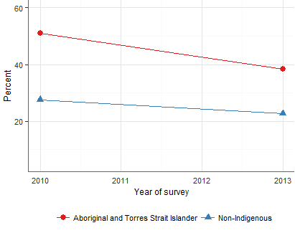

Source: AIHW analysis of the National Drug Strategy Household Survey 2010, 2013

National estimates suggest that in 2013, a higher proportion of Aboriginal and Torres Strait Islander smokers attempted to quit smoking (50.2%) compared with other Australian smokers (46.5%) (see Figure 22). While there has been an increase in the proportion of non-Indigenous smokers who attempt to quit (though non-significant), it appears to have been static for Aboriginal and Torres Strait Islander smokers. In addition, the survey data suggest quit attempts resulting in successfully giving up smoking for more than a month were less likely for Aboriginal and Torres Strait Islander smokers (14.9% of smokers) compared with non-Indigenous smokers (20.0%).

Figure 22 - Quit attempts by Indigenous status

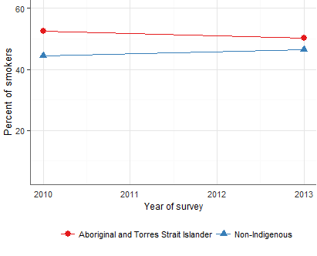

Source: AIHW analysis of the National Drug Strategy Household Survey 2010, 2013

Figure 23 - Pregnant women smokers by Indigenous status

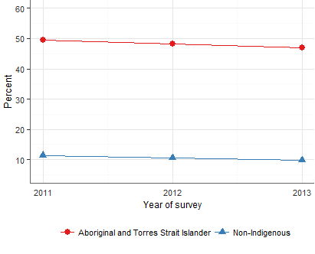

Source: AIHW analysis of the National Perinatal Data Collection

Table 5 below summarises some of the key activities and achievements by government agencies at Commonwealth and jurisdictional level.

Table 5 – Examples of progress on reducing smoking rates among Aboriginal and Torres Strait Islander people by jurisdiction

| **Jurisdiction** | **Progress** |
| --- | --- |
| Commonwealth | Following the 2014 independent review, the former *Tackling Indigenous Smoking and Health Lifestyle Programme* was redesigned and funded in 2015 as the *Tackling Indigenous Smoking* (TIS) program.  Under the TIS program, in 2015/16 regional tobacco control grants were awarded to 37 organisations (with a focus on smoking outcomes and evidence base rather than number of tobacco workers and coordinators), the National Coordinator for Tackling Indigenous Smoking (Professor Tom Calma) was reappointed, a National Best Practice Unit was established, funding for Quitlines and Quitskills brief intervention training continued. An independent evaluator was engaged to design a monitoring and evaluation framework, and conduct the program evaluation.  The Commonwealth provides funds to enhance Quitlines for all states and territories.  The Commonwealth Department of Health funding agreements with organisations that provide primary healthcare services for Aboriginal and Torres Strait Islanders include requirements to have smoke free workplace policies and key performance indicator for data collection on smoking status. |
| NSW | Developed the ATRAC Framework: A Strategic Framework for the Aboriginal Tobacco Resistance *&*and Control *Framework* in NSW, to encourage best practice approaches to addressing smoking in Aboriginal communities (2015). Provided $600K in 2014-16 for the *AH&MRC Tobacco Resistance and Control (ATRAC) Program* to build tobacco control capacity of the Aboriginal Community Controlled Health Organisations, including the delivery of smoking cessation interventions. The NSW Ministry of Health provides funding to several ACCHS in NSW for population health services to report against DKPs for ‘smoking status recorded’ and ‘smoking cessation interventions delivered’ (among other indicators). Over $6.5m committed to the *Quit for new life program* between June 2012 and June 2016 to support women having an Aboriginal baby, to quit smoking as well as others in the household, with a further two years of funding committed to June 2018. Programs at Local Health District level in partnership with Aboriginal Medical Services were undertaken. Undertook social marketing campaign specifically targeting Aboriginal and Torres Strait Islander people (2012). Incorporation of Aboriginal rugby players discussing quitting in TV mini-series. |
| Vic. | Quit Victoria runs Aboriginal Quitline, a brief intervention training for health workers working with Aboriginal and Torres Strait Islander clients and for Aboriginal Community Controlled Health Organisations staff. The Victorian Aboriginal Community Controlled Health Organisations and other Aboriginal Community Controlled Health Organisations are trained and encouraged to continue to deliver culturally appropriate smoking cessation interventions for Aboriginal and Torres Strait Islander clients. Taskforces and workshops to coordinate effort and expertise in this area. |
| Qld | The Deadly Choices social marketing campaign run by the Institute of Urban Indigenous Health, Queensland, focused on young people. An independent evaluation identified that it was associated with strong recall and brand profile in the community. Quitline service includes a team of Aboriginal and Torres Strait Islander counsellors and a call back program for Aboriginal and Torres Strait Islander Queenslanders |
| SA | The social marketing campaign – ‘Give up smokes for good’ is a community based social marketing campaign run by Drug and Alcohol Services South Australia, SA Health. Smoking cessation support services are provided by three Aboriginal community controlled health services – Nunkuwarrin Yunti, Port Lincoln Aboriginal Health Service, and the Aboriginal Health Council of SA. The Maternal Health Service at the Aboriginal Health Council of SA focuses specifically on Aboriginal maternal smoking. An independent evaluation program at the Cancer Council of SA monitors the progress of the initiative and recommends ways to enhance its impact. |
| WA | *Make Smoking History* campaign includes strategies to ensure relevance to Aboriginal and Torres Strait Islander people and other high risk groups. *Quitline Enhancement Project* aims to support services culturally appropriate to Aboriginal people in WA. Efforts to build capacity and strengthen partnerships with Aboriginal and Torres Strait Islander organisations. |
| Tas. | Flinders Island Aboriginal Association Inc. launched the *Smokes won’t crush us* campaign (encouraging quitting or never taking it up). Quitline was promoted as culturally secure for Aboriginal people. Indigenous Early Childhood Development implemented by Department of Health and Human Services, which includes smoking cessation training for Aboriginal health workers and for those who provide antenatal care. Ongoing prevention and cessation services provided by the Tasmanian Aboriginal Centre. |
| ACT | A report on reducing smoking among Aboriginal and Torres Strait Islander pregnant women was submitted to ACT Health in March 2015. The *Aboriginal and Torres Strait Islander Tobacco Control Strategy 2010-2014* was developed to support the ACT Government’s commitment to reduce smoking rates among Aboriginal and Torres Strait Islander people living in the ACT. Funding provided for Street Beat (youth Aboriginal corporation) included a component related to smoking cessation. |
| NT | Dedicated program within NT Health working with other agencies to reduce Aboriginal and Torres Strait Islander smoking rates, primarily through capacity building, information dissemination, culturally appropriate Quit Club Training and resources. In 2013 a two-day workshop was held with all CEOs from community councils in NT to develop smoking management plans, and harm reduction in Aboriginal communities. Community-based workers in over 30 communities to provide culturally appropriate support, intervention to reduce smoking rates, increase quitting and provide nicotine replacement therapy for those having difficulty quitting. |

The major national initiative has been the TIS program, which commenced in 2015. This replaced the *Tackling Indigenous Smoking and Health Lifestyle Programme*, which commenced in 2010 and was reviewed in 2014. The review of the *Tackling Indigenous Smoking and Health Lifestyle Programme* noted:

Aboriginal and Torres Strait Islanders suffer the worst health of any population group in Australia, having a burden of disease that is estimated to be two and a half times that of the total Australian population. This is reflected in a poorer life expectancy for Indigenous Australians, 12 and 10 years less for males and females respectively, than that of the non-Indigenous population. Indigenous Australians are much more likely than non-Indigenous people to die prematurely from preventable chronic diseases such as cardiovascular disease. Tobacco smoking is the most preventable cause of premature death among Indigenous Australians.(p1)11

Consultations undertaken by the *Tackling Indigenous Smoking and Health Lifestyle Programme* review revealed that it is widely accepted that the most effective strategies for addressing smoking within the Aboriginal and Torres Strait Islander populations required multi-level approaches developed in partnership with the community, that is, involving local communities in design, delivery and planning. These strategies need to collaboratively engage clinical and non-clinical services to assist Aboriginal and Torres Strait Islanders who wish to quit smoking. Approaches which are likely to be successful in supporting attitude and behaviour change require a mix of social marketing, community education, quit support groups, nutrition and physical activity program and school-based interventions.11

The transition from the *Tackling Indigenous Smoking and Health Lifestyle Programme* to the TIS program involved a process in which a set of regionally based services were identified through a competitive process. This resulted in a discontinuation of funding for some of the services previously funded under the *Tackling Indigenous Smoking and Health Lifestyle Programme*.

The resulting TIS program, which commenced roll out in mid-2015, is focused on multi-component tobacco control strategies, using and promoting best practice approaches to tobacco control, and building partnerships and collaborations to support innovation, capacity-building and behaviour change. Under the program, funding is provided to services that have a responsibility for developing regional smoking strategies targeting Aboriginal and Torres Strait Islander people. The program offers flexibility in how activities are delivered by grant recipients, with a focus on the outcomes to be achieved, rather than being prescriptive in relation to the activities to be delivered.

It was reported that there had been limited evaluation of regional initiatives in targeting tobacco control among Aboriginal and Torres Strait Islander communities, although there were some excellent examples highlighted (such as the evaluation of the *Deadly Choices* campaign, as noted above).9

The redesigned TIS program is outcomes and evidence-based in its approach. In line with the recommendations of the 2014 review, the program has a monitoring and evaluation framework which will guide evaluation of the program and the assessment of the outcomes of the redesigned approach, with an aim of better understanding what is required to reduce smoking in Aboriginal and Torres Strait Islander communities. Hence, evaluation of funded initiatives has been built into the redesigned TIS program along with mechanisms to identify and communicate best practice (specifically, the National Best Practice Unit).

## Priority 4: Summary of progress on action items

| **Action item** | **Progress 2012 - 2015** |
| --- | --- |
| 4.1 Continue the investment in, and roll-out of, existing and planned national and state and territory programs to reduce smoking among Aboriginal and Torres Strait Islander people. | Considerable activity on this including *Tackling Indigenous Smoking and Health Lifestyle Programme* from the Commonwealth Department of Health, which in 2015 was reviewed and renamed *Tackling Indigenous Smoking* (TIS) program.  States and territories have established and implemented a range of initiatives as noted in the previous Table. |
| 4.2 Monitor and evaluate the impact of these initiatives and use this data to inform and refine future programmes to reduce smoking among Aboriginal and Torres Strait Islander people. | A major review was conducted of the *Tackling Indigenous Smoking and Health Lifestyle Programme*. A limited number of evaluations have been undertaken of specific initiatives. The TIS program has been designed to incorporate ongoing evaluation of funded services and the program, in addition to mechanisms to identify and promulgate best practice. |
| Building capacity & partnerships  4.3 Continue to build tobacco control capacity for Aboriginal and Torres Strait Islander communities within Aboriginal community-controlled organisations and mainstream services.  4.4 Support Aboriginal and Torres Strait Islander organisations in their efforts to promote the benefits of being smoke-free, as reflected in their organisational policies and community programs.  4.5 Strengthen partnerships and collaboration between Aboriginal and Torres Strait Islander organisations, governments and non-government organisations.  4.6 Continue to provide training to Aboriginal and Torres Strait Islander health workers and other relevant workers on effective tobacco control interventions. | There has been some good progress here. However, the transition from the *Tackling Indigenous Smoking and Health Lifestyle Programme* to the TIS program resulted in disruptions in the development of services and partnerships, even where services have continued to be funded under the TIS program. The development of regional partnerships by services funded under the TIS program will require time to develop.  Several NGOs reported active involvement in training of Aboriginal and Torres Strait Islander health workers and other staff in Aboriginal Community Controlled Health Organisations on tobacco control and related issues. |
| Promote screening and cessation programme uptake  4.7 Deliver best practice screening and smoking cessation as part of routine health service delivery and social/community service provision to Aboriginal and Torres Strait Islander clients.  4.8 Encourage Aboriginal and Torres Strait Islander people to access subsidised nicotine replacement therapy (NRT), identify any barriers to access, and develop strategies to overcome these barriers.  4.11 Develop strategies to reduce barriers to successful smoking cessation and uptake of smoking cessation services in Aboriginal and Torres Strait Islander populations. | Initiatives have been undertaken in many Aboriginal Community Controlled Health Organisations to routinely collect information on smoking status extending to information on the client’s readiness to quit. However, there is little capacity to monitor the situation in general practice.  Aboriginal and Torres Strait Islander counsellors have continued to be funded for the Quitlines.  Access to other cessation services was reported to be variable, particularly for remote locations. Many stakeholders emphasised that cessation is a complex process in many communities and multi-modal approaches are required that engage communities, families and individuals. |
| 4.9 Encourage and support Aboriginal and Torres Strait Islander pregnant women and their families to quit and provide messages about the harm associated with second-hand smoke exposure. | Various activities under *Tackling Indigenous Smoking and Health Lifestyle Programme*, theTIS program and state level initiatives have targeted smoking by pregnant women. While some jurisdictional data indicate good progress, such as in South Australia, national data suggest little change in smoking rates for this group (see Figure 23). |
| 4.10 Enhance mass media campaigns for Aboriginal and Torres Strait Islander people by complementing them, where appropriate, with Aboriginal and Torres Strait Islander specific campaign elements and local community-specific campaigns. | Mass media campaigns with an Aboriginal and Torres Strait Islander focus have been successful. These are discussed further in Chapter 6. Coordination with local community-specific campaigns remains a challenge. |

## Issues arising from the consultations

The majority of stakeholders were supportive of the ambitious target of halving the smoking prevalence among Aboriginal and Torres Strait Islander people. All stakeholders believed the target was unachievable within the timeframe of the NTS, with one informant stating, “*It is expecting generational change within six years*”.

Several stakeholders and experts reported that tackling the high prevalence of smoking amongst Aboriginal and Torres Strait Islander people needs to be about tackling issues of equity, racism and the social determinants of health more generally. However, all stakeholders believed that efforts and investment specifically targeting smoking in Aboriginal and Torres Strait Islander people needs to be continued. Those working directly with initiatives to reduce smoking rates in Aboriginal and Torres Strait Islander communities argued for longer term and more certain funding arrangements. They highlighted that short-term funding and program level changes undermined the capacity to build effective community level programs and partnerships.

Many stakeholders suggested that the smoking rates for Aboriginal and Torres Strait Islander people will be influenced by both mainstream anti-smoking initiatives (such as excise increases) and campaigns, and culturally specific activities and campaigns. As discussed with respect to Priority 2, national campaigns that had focussed on Aboriginal and Torres Strait Islander people were strongly supported. However, many stakeholders believed that these needed to be complemented by local activities that engage local communities in design and implementation, and reflect the culture and circumstances of those communities. Many emphasised reducing smoking rates requires changes in attitudes, beliefs and practices which can be achieved best by affirming local culture.

Experts in this area noted that, along with the focus on smoking cessation, more needs to be done to reduce the uptake of smoking among young people, adding that a population approach is needed as well as the individual support for smoking cessation. Campaigns such as those implemented under the Queensland-based *Deadly Choices* health initiative, which utilises rugby league (Broncos) players as positive role models, and targets Aboriginal and Torres Strait Islander young people, could be considered nationally. It has been independently evaluated in terms of knowledge, attitudes and self-efficacy and the results show that it is an effective strategy to better reach Aboriginal and Torres Strait Islander young people with messages about health choices, including not smoking.9

There was a view among stakeholders that culturally specific Quitline approaches (staffed by Aboriginal and Torres Strait Islander counsellors) are more acceptable to Aboriginal and Torres Strait Islander people. Some issues were highlighted around the use and acceptability of these services (when staffed by different cultural groups).

The changes from the *Tackling Indigenous Smoking and Health Lifestyle Programme* to the TISprogram were commented on by several stakeholders. It was highlighted that the change in the program resulted in discontinuation of various services funded under the *Tackling Indigenous Smoking and Health Lifestyle Programme*. This also resulted in disruption in service delivery, even where services were successful in receiving funding under the newprogram. It was also noted that funding under the TIS program was only assured until June 2017, pending the preliminary evaluation. Several stakeholders highlighted that the short-term nature of funding and disruptions related to the redesign of programs create significant challenges in developing, implementing and maintaining local initiatives. It was argued that many of these initiatives aim to address entrenched issues, which require persistent efforts over the longer term to achieve genuine change. It was argued that a longer time frame should be established for funding with adequate allowance for changes that might occur at the end of a funding cycle.

Many stakeholders expressed sentiments that echoed the key findings of the 2014 review of the *Tackling Indigenous Smoking and Health Lifestyle Programme*, around the need for development of local strategies with good community engagement. Some misgivings were expressed around the capacity of services funded under the TIS program to fully engage all providers (including other Aboriginal Community Controlled Health Organisations and mainstream services) within a region.

More and better evidence-based research was considered by many stakeholders to be crucial to ensuring that both available resources were well invested and that they would continue if good outcomes could be demonstrated. In this respect, there was support by several stakeholders for the reporting and evaluation framework established for the TIS program, and for the Best Practice Unit as a means of disseminating information of effective practices.

With a disproportionately large percentage of the prison population, comprising Aboriginal and Torres Strait Islander people, particularly in the Northern Territory and Western Australia, prisoners (including in the juvenile justice system where Aboriginal and Torres Strait Islander people are heavily over-represented in all jurisdictions) were noted by some stakeholders to be a recommended target group. Stakeholders also highlighted the need for programs that provided support for prisoners following release.

## Recommendations for 2016-2018

1. The Commonwealth, and state and territory governments to continue investment in national and state and territory programs to reduce smoking among Aboriginal and Torres Strait Islander people, with particular focus on pregnant women, young people (from as young as 10 years old), and adults aged 25 to 54 years.
2. Maintain training for Aboriginal and Torres Strait Islander health workers as a priority and continue to embed culturally appropriate brief intervention practices in standard practice of health services. This includes training staff (including Aboriginal Health Workers, GPs and hospital staff), provide systems that facilitate access to brief interventions and establish routine procedures for asking Aboriginal and Torres Strait Islander people whether they smoke at every opportunity and supporting them to quit.
3. Increase the level of robust evaluation of strategies at state and local levels which seek to reduce the prevalence of smoking among Aboriginal and Torres Strait Islander people.
4. Continue the focus on Aboriginal and Torres Strait Islander communities in national mass media campaigns, complemented by local community-specific campaigns (in line with Recommendation 10).
5. Expand the involvement of local communities and Aboriginal and Torres Strait Islander controlled organisations in design, planning and delivery of initiatives, while also strengthening partnerships between clinical and non-clinical services.
6. Commonwealth, state and territory governments to ensure that funding projects and positions that address smoking prevalence among Aboriginal and Torres Strait Islander communities are for a minimum of three years.
7. Explore opportunities for extending access to and use of stop-smoking medicines such as nicotine replacement therapy and culturally appropriate support for cessation.
8. Priority 5: Reduce smoking among populations with a high prevalence of smoking

In addition to Aboriginal and Torres Strait Islander people, covered in the previous Chapter, the NTS specifically identifies several other high smoking prevalence groups as the target for specific strategies. High smoking prevalence contributes to a larger burden of disease and reduced life expectancy for several population groups. People from more disadvantaged socioeconomic groups have higher smoking rates28 and data from the National Health Survey reflect this (see Figure 11).

While the groups specifically mentioned in the NTS include socioeconomically disadvantaged people, people with mental illness and prisoners, there is also potentially broader emphasis on building “*new or broader partnerships with organisations that are already working closely with populations with a high prevalence of smoking*” for which a specific action is articulated (action 6.5.1).

## Priority 5: Summary of achievements 2012-2015

The NTS recognises that:

There is strong evidence demonstrating the effectiveness of whole-of-population approaches such as tobacco tax increases and mass media campaigns in reducing smoking among low socioeconomic groups.2 (p 25)

Consequently, the achievements in these areas (discussed under priorities 2 and 3) have also had impacts on these socioeconomic groups.

National mass media campaigns run by the Commonwealth Department of Health targeting 18 to 50 year olds have included a focus on high prevalence groups. From 2010-11 to 2013-14, the *More Targeted Approach* campaign, complementing the *National Tobacco Campaign*, aimed to reduce smoking prevalence among high risk and hard to reach groups, including: pregnant women and their partners; culturally and linguistically diverse communities; people living in socially disadvantaged areas, people with mental illness and prisoners.

One area in which the Commonwealth Government has provided financial support for people to quit smoking has been via the listing of certain medicines on the Pharmaceutical Benefits Scheme (PBS).

In February 2011, prior to the current NTS, the Commonwealth Government had listed nicotine replacement therapy, specifically transdermal patches, on the PBS. From January 2012, additional lower strengths of nicotine transdermal patches have been made available through the PBS. Several other medicines are also available on the PBS to assist patients to quit smoking.

Since 2012, states and territories, often in partnership with NGOs, have implemented many initiatives specifically targeting various high smoking prevalence groups.

Five of the eight states and territories introduced smoke-free legislation in prisons during the period 2012 to 2015. Northern Territory led the way in 2013, with Queensland, New South Wales, Victoria and Tasmania following in 2015 but three jurisdictions, Australian Capital Territory, South Australia and Western Australia, are yet to implement specific smoke-free-prisons legislation. Although, South Australia has smoke-free enclosed workplace legislation which extends to shared areas of prisons and has implemented policy-based smoke-free initiatives in some prisons. These changes have required multi-facetted approaches in which staff and prisoners are engaged and informed of changes and offered various avenues towards smoking cessation. However, little was reported on arrangements that provided support to prisoners to continue cessation after their release.

States and territories also reported on various steps to address smoking rates for people with mental illness. Several states have extended smoke-free regulation to mental health facilities however the extent to which they are complied with depends largely on staff attitudes towards the smoking bans. Strategies have aimed to raise the awareness of the impact of smoking on the physical health of people with mental illness and create options through which people with mental illness can be offered effective support for cessation.

NGOs were active in implementing a range of initiatives targeting socioeconomically disadvantaged groups. The NSW Cancer Council, for example, developed a comprehensive training package, the *Tackling Tobacco* program, which builds the capacity of community organisations working with socially disadvantaged clients to address smoking cessation with their clients. This program has also been run in Tasmania. Queensland Cancer Council identified engaging with social and community services sector to address issues for disadvantaged groups, such as the homeless. They funded three smoking cessation pilot programs in partnership with Mission Australia, Salvation Army, and mental health services. In the Australian Capital Territory, the Alcohol Tobacco and Other Drug Association, as part of their *We can* program, provides capacity building in smoking cessation to community residential service organisations and subsidised access to nicotine replacement therapy for people accessing these services.

Table 6 provides a summary of the achievements towards Priority 5 during the period 2012-2015.

Table 6 – Priority 5: Jurisdictional examples of achievements

| **Jurisdiction** | **Progress** |
| --- | --- |
| Commonwealth | Resources and materials available through *QuitNow* website accessed by GPs, families of smokers with mental illness, prisoners, research funding for universities and research centres. An evidence brief, *Smoking and Disadvantage,* was released in 2013 by the Australian National Preventive Health Agency. *More Targeted Approach* campaign was introduced in 2015 to reach some of the high prevalence groups. Progress on implementing programs for Aboriginal and Torres Strait Islander people is addressed under Priority 4. |
| NSW | NSW Government introduced a *Clean Air: Smoke-free Prisons Policy* in 2015. Since 2012 it awarded 17 grants to community organisations for projects focusing on groups with high smoking prevalence, several targeting Aboriginal communities. NSW Cancer Council’s *Tackling Tobacco* program, by working with community service organisations, targets the most socially economically disadvantaged groups in NSW. |
| Vic. | Prisoners and prison staff provided with access to smoking cessation support prior to and after the implementation of the ban. |
| Qld | Telephone smoking cessation support – *Quit Now* program – extended accessibility to harder to reach groups. Partnership with Mission Australia to target smoking cessation support for unemployed and homeless people. *Workplace Quit Smoking Program* (2014-15) targeted blue collar workers, included telephone counselling and nicotine replacement therapy of up to 12 weeks. The quit rates at program completion and after three months and six months were 68%, 49%, and 39% respectively. Introduced smoking ban in correctional facilities in 2015. |
| SA | Correctional services developed a smoking reduction policy and action plan in custodial institutions with the Adelaide Remand Centre implementing a smoke-free policy in 2016. All SA Health facilities including mental health services are smoke-free. |
| WA | *Make Smoking History* campaign – focus on high risk groups. Increased collaboration and referral between mental health care services and tobacco control group, custodial services. |
| Tas. | Smoke Free Young People Strategy 2013-2017, working group to monitor progress, provision of resources using the *Smoke Free Generation – Be a Part of It!* Branding; A *Smoke Free Start for Every Tasmanian Baby – A Plan for Action* (2014-17). *Targeting Tobacco* implemented by Quit Tasmania 2015. |
| ACT | *Alcohol, Tobacco and Other Drugs Strategy 2010-2014* – identifies at-risk populations for action (mental illness, prisoners). A new strategy is due for 2016 release. ACT Health’s Mental Health, Justice Health and Alcohol & Drug Services (MHJHADS) program – screening of clients for nicotine dependency. Ban on indoor smoking in correctional facilities – select outdoor areas only. Links to Quitline for support. |
| NT | In 2013 NT introduced smoke-free policies in all prisons. |

## Priority 5: Summary of progress on action items

| **Action** | **Progress 2012-2015** |
| --- | --- |
| **General**  5.2 Expand effective programs and frameworks to reduce smoking among populations with a high prevalence of smoking.  5.11 Continue to build the evidence base to identify effective approaches to reducing smoking among populations with a high prevalence of smoking. | Population level interventions, e.g. Quitline, discussed elsewhere in this report have had impacts for high prevalence groups.  Several initiatives have been progressed by state and territory governments and NGOs, including those discussed below. Some of these have been evaluated. However, there appears to have been limited extension to evidence base for effective approaches for high prevalence groups. |
| **Low income earners**  5.3 Increase awareness among low-income smokers of the availability of subsidised medications to assist them to quit. | Improving access to NRT and subsidised medications was mentioned as one aspect initiatives sponsored by states/territories and NGOs. |
| **People with mental illness**  5.1 Identify and form new partnerships between governments, non-government organisations with tobacco control expertise, social service organisations and mental health care providers/organisations to reduce smoking among populations with a high prevalence of smoking.  5.4 Build the capacity of social service organisations and mental health care providers to include tobacco control interventions as part of case management approaches.  5.5 Increase collaboration and referral between mental health care services, social service organisations and smoking cessation services such as Quitline services.  5.6 Strengthen actions to increase awareness among staff in mental health care services of the benefits of quitting for their clients and develop policies to include smoking cessation advice and management of nicotine dependence as part of routine care.  5.7 Ensure that mental health services and drug treatment agencies are smoke-free. | There has been expansion of smoke-free areas to include mental health facilities in several states. This has often been accompanied by multi-facetted strategies to assist people affected.  There have been examples of engagement of social service agencies, but this appears to be variable across jurisdictions. NSW Cancer Council’s *Tackling Tobacco*, and ACT Alcohol Tobacco and Other Drug Association’s *We can* programs build the capacity of community agencies working with socially disadvantaged clients and residents around smoking cessation. |
| **Prisoners**  5.8Enhance partnerships and collaboration between state and territory custodial authorities, health agencies and non-government organisations with expertise in tobacco control.  5.9 Implement and evaluate policies and programs to reduce exposure to second-hand smoke and encourage smokers to quit in correctional facilities.  5.10Provide greater smoking cessation support for prisoners, including access to NRT and other pharmacotherapies. | Five of the eight jurisdictions have introduced specific smoke-free prisons legislation, along with a range of associated programs to assist prisoners and staff to quit smoking. |

## Issues arising from the consultations

Stakeholders and tobacco control experts strongly support the proposition that the focus of efforts on tobacco control needed to shift towards disadvantaged groups with high prevalence. It was emphasised that as smoking prevalence has decreased across the population, a much larger proportion of remaining smokers remained within these groups. Tobacco control experts indicated that whole-of-population approaches such as tobacco tax increases and mass media campaigns would continue to be the most effective mechanisms for reducing smoking in low income groups. Adapting campaigns to target high prevalence groups was supported.

A distinction was made by some stakeholders between strategies that targeted low-income groups more generally and specific population groups such as people with mental illness, the homeless and prisoners. For low-income earners generally, population based strategies will remain relevant. Ensuring options for cessation are affordable, and engaging primary care services more effectively will also be important. Specific strategies, such those targeted at a whole workplace, were also highlighted as potentially effective.

For other specific groups, such as people with mental illness, clients of services related to alcohol and other drugs, and prisoners, more targeted strategies will be required that engage these people, their carers and families, and service delivery agencies.

Stakeholders pointed out that these groups will be harder to influence in terms of promoting smoking cessation. As the smoking population decreases in size, the cost of achieving further reductions in smoking will increase along with cost-benefit ratios.

Comments on specific areas are outlined below.

### Socioeconomically disadvantaged groups

Several stakeholders reported that they considered current tobacco control efforts to have insufficient focus on socioeconomically disadvantaged groups. Various initiatives were mentioned by states and territories and NGOs. For example, the NSW Cancer Council has taken on the challenge of addressing the smoking rates among socioeconomically disadvantaged people. Its *Tackling Tobacco* program has recognised the potential of community service organisations, in their contact with disadvantaged people, to provide the support needed to quit smoking and to denormalise smoking among this group. The program has undertaken capacity building with around 150 community services to develop policies and assist staff and clients of these services to quit smoking. It also offers training to other organisations wishing to promote this approach.

Many stakeholders raised the issue that increasing the range of subsidised smoking cessation medications is particularly important for socioeconomically disadvantaged groups. There is emerging evidence of the effectiveness of these medications, with one study of 7,436 adult smokers, finding that of those who recalled making a quit attempt within one month of the interview, those who reported using varenicline, bupropion or nicotine patch were four to six times more likely [adjusted odds ratio] to maintain 6-month continuous abstinence from smoking compared to those who attempted to quit without medication.29

### People with mental illness

Most stakeholders considered that people with mental illness should be a high priority groups for smoking cessation, particularly given the evidence of the lower life expectancy for people with mental illness, particularly severe mental illness, and the contribution smoking makes to reduced life expectancy. Several highlighted the paucity of regularly collected, high quality data on smoking within this population group, which results in an inability to monitor progress at a national, state and territory level.

Several stakeholders considered that a barrier to reducing smoking prevalence in this target group was the awareness and attitudes of health professionals working with people with mental illness. It was reported there were indications that these attitudes were changing, and there was increasing awareness of the contribution quitting can make to physical and mental health. A recent systematic review was cited that found that “[s]*moking cessation is associated with reduced depression, anxiety, and stress and improved positive mood and quality of life compared with continuing to smoke. The effect sizes are equal or larger than those of antidepressant treatment for mood and anxiety disorders*.”30

### Prisoners

Five states and territories have implemented specific smoke-free prison legislation since 2012. Stakeholders were very supportive of these efforts. It was emphasised that prisoners have previously reported very high smoking prevalence and that there is an overlap between prisoners and other target groups. However, a major reported gap was the level of follow-up support for people to remain non-smokers upon release from prison. Several stakeholders believed that upon release many prisoners resume life in an environment of normalisation of smoking with little to no support to maintain their non-smoker status achieved in prison. It was argued there was a need to develop and evaluate initiatives that target the transition back to the community. These initiatives could involve engaging and educating families to offer support to help ex-prisoners maintain their non-smoking status, and providing follow-up contact to assist them to stay tobacco free.

Stakeholders also flagged issues around other target groups, outlined below.

### Clients of alcohol and other drug services

Several stakeholders mentioned initiatives to make alcohol and other drug services smoke-free, and implement mechanisms to assist clients of these services to quit smoking. Smoking rates amongst these populations is very high. A similar set of issues to those faced for people with mental illness were mentioned, including working on changing the attitudes and beliefs of staff working in these services and related social care agencies. Some stakeholders considered there was now a readiness for change in this sector, and that this group should be a specific target group in the next NTS. One of the challenges mentioned was the difficulty in accessing multi-modal pharmaceutical treatments for these people, as there are limits on what is subsidised under the PBS. It was also pointed out that this group often has only limited engagement with GPs, which also limits access to cessation support.

### Culturally and linguistically diverse (CALD) communities

Several stakeholders indicated that although available data suggests that smoking prevalence among CALD groups is lower than in the general population, there are some groups in which smoking prevalence is high. Studies have reported high smoking rates among Arabic-speakers, and among men in the Vietnamese community, and that a higher proportion of men born in Europe, North Africa and the Middle East were current smokers compared with Australian-born men.31 Several stakeholders pointed out that members of CALD communities may encounter particular obstacles to quitting smoking that include lack of knowledge of related risks exacerbated by low English language competency and culture-specific norms around smoking. Stakeholders generally agreed that more research into smoking rates and behaviours among CALD communities is needed.

### Lesbian, gay, bi-sexual, trans-gender or intersex communities

There is little available data on the smoking prevalence within Australia of sexual minority population groups, including within the lesbian, gay, bi-sexual, trans-gender and intersex communities. A systematic review of the causes of tobacco disparities for sexual minorities reported evidence from studies from around the world that these groups have higher smoking rates than the general population.32 The lesbian, gay, bi-sexual, trans-gender and intersex communities are considered priority groups in the current NTS, and some stakeholders noted that this should continue for the remainder of the NTS, and into the next national tobacco strategy. The Australian Council on Smoking and Health in Western Australia reported having a community program to support these communities in smoking cessation.

### Embedding smoking assessment into client/patient contact

It was recommended by stakeholders that more work needs to be done to embed smoking assessment as part of the routine contact with clients in community residential care facilities, mental health services, and other community service agencies. While some notable programs are underway in some jurisdictions, capacity building among workers in these sectors to routinely conduct smoking assessment and refer clients wishing to quit to local services was suggested.

Issues that run across different high smoking prevalence groups that were raised by several stakeholders during the consultations were:

* A need for increased collaboration between the national bodies (Commonwealth Government and national NGOs) as well as states and territories on initiatives to address high prevalence groups.
* The need for better access to combination nicotine replacement products (e.g. including spray and gum) under the PBS for socioeconomically disadvantaged.
* The need for improved monitoring of smoking prevalence, uptake and quitting for several of these disadvantaged groups, and improvements to the evidence base on intervention strategies for these groups.

Several stakeholders suggested that the Commonwealth Government should consider hypothecating revenue from the tobacco excise increases for cessation programs specifically targeting disadvantaged groups in the Australian community. It was argued that this is particularly important as these groups represent an increasing proportion of the remaining smokers and will be hit hardest by the increased tobacco excises.

## Recommendations for 2016-2018

1. Investigate mechanisms to monitor smoking prevalence for people with mental illness. An initial focus could be for clients of state and territory mental health services. In the longer term, mechanisms to monitor smoking prevalence in the broader population of people with mental health issues should be considered.
2. State and territory governments to continue actions to achieve smoke-free prisons throughout their jurisdiction.
3. Commission research to assess the impact of smoke-free prisons on long term smoking behaviours following release from prison, and the effectiveness of interventions to support people on release.
4. Commonwealth, state and territory governments and research groups should invest in research into smoking prevalence amongst clients of alcohol and other drug services, culturally and linguistically diverse groups, and members of the lesbian, gay, bi-sexual, trans-gender or intersex community, who are reported to have high smoking prevalence. Effective strategies should follow to reduce smoking among groups found to have high prevalence.
5. Priority 6: Eliminate promotions of tobacco products

## Priority 6: Summary of achievements 2012-2015

Efforts to prohibit advertising, promotion of tobacco products, including through sponsorship have been very successful, with significant gains achieved several decades ago. Through the Commonwealth’s *Tobacco Advertising Prohibition Act* *1992* and state and territory legislation, particularly focussed on sponsorship, Australia has successfully prohibited the vast majority of tobacco advertising and promotion.

There have been further significant achievements between 2012 and 2015. A key achievement has been the implementation of regulatory arrangements from December 2012 to enforce the provisions of the *Tobacco Plain Packaging Act 2011.* The effect of the legislation is that tobacco company branding, logos, symbols and other images that may have the effect of advertising or promoting the use of the tobacco product can no longer appear on tobacco products or their packaging. The brand name and variant name are only allowed on packaging in specified locations, in a standard colour, position, font style and size.

In addition to plain packaging, health warnings on tobacco products were updated and expanded in the *Competition and Consumer (Tobacco) Information Standard 2011* *(the Standard)* which commenced on 1 January 2012, fully effective from 1 December 2012. The health warnings for most tobacco products rotate in two sets of seven warnings every 12 months. At the time of writing this report, the Commonwealth Department of Health is commencing an evaluation of the current health warnings on all tobacco products, to assess their effectiveness.

A post-implementation review of the plain packaging measure was undertaken in 2015 and released on 26 February 2016.10, 33 Analysis undertaken as part of the review found that while the impact of plain packaging cannot be disentangled from the increased and updated graphic health warnings, these combined initiatives have had a material impact on smoking prevalence. Specifically, it was estimated the impact was equivalent to an additional reduction in prevalence of 0.55 percentage points during the 34 months examined following implementation (1 December 2012 to 30 September 2015) which represents approximately one quarter of the total decline in prevalence over this period.10 This is an estimated 108,228 fewer smokers over this period. The analysis also concluded that “*given the ways in which the Tobacco Plain Packaging Act was intended to work, the policy’s effects on overall smoking prevalence and tobacco consumption are likely to grow over time*”.33 The post-implementation review concludes that the plain packaging measure has begun to achieve its public health objectives of reducing smoking and exposure to tobacco smoke in Australia, and is expected to have substantial public health outcomes into the future.

During consultations, stakeholders reported concerns over the outcomes of legal challenges to the tobacco plain packaging measure. At the time of writing the tobacco plain packaging measure was subject to international litigation in two fora:

1. the Investor-State dispute brought by Philip Morris Asia (PM Asia) under the Australia – Hong Kong bilateral investment treaty (BIT); and
2. the challenges brought by Honduras, Dominican Republic, Cuba and Indonesia in the World Trade Organization (WTO).

On 18 December 2015, the Arbitral Tribunal hearing the PM Asia dispute published its decision, unanimously agreeing with Australia’s position that the Tribunal has *no jurisdiction* to hear PM Asia’s claim. In May 2016, the Arbitral Tribunal published the reasons for its decision on the Permanent Court of Arbitration website.

The Panel hearing the dispute in the WTO proceedings has indicated that it does not expect to issue its final report to the parties before May 2017.

The potential for increased illicit importation of tobacco was also raised as a concern. The Department of Immigration and Border Protection has been working closely with the Commonwealth Department of Health to address these challenges. A Tobacco Control Taskforce was established in 2012 to work on a regulatory framework for duty drawbacks and a temporary refund provision for branded tobacco products non-compliant with the *Tobacco Plain Packaging Act 2011.*

Amendments to the *Tobacco Advertising Prohibition Act 1992*, which extended the existing restrictions on tobacco advertising to the internet and other electronic media in Australia, were implemented in September 2012. The *Tobacco Advertising Prohibition Act 1992* creates offences related to publishing tobacco advertising on the internet or other electronic media in Australia (such as via mobile phone). The Commonwealth Department of Health has established processes to allow complaints to be lodged, investigated, assessed, actioned, and if necessary, referred to the Commonwealth Director of Public Prosecutions. In many instances where a complaint or a breach of the Act is received, the Department is able to write to the advertiser requesting that the advertising be withdrawn and seeking an assurance that the advertiser will not breach the Act again in the future.

Several states and territories reported extensions of regulation on advertising and display of products at the point of sale (see Table 7).

Government bodies and NGOs consulted indicated that they continued to monitor remaining forms of promotion of tobacco products. Examples of these activities are provided in the Table 7. Western Australia and Queensland reported no new activity towards this priority area.

Table 7 – Priority 6: Jurisdictional examples of achievements

| **Jurisdiction** | **Progress** |
| --- | --- |
| Commonwealth | From 1 December 2012, all tobacco products sold in Australia were required to be in plain packaging with updated and expanded graphic health warnings. A post-implementation review of the tobacco plain packing measure was published on the Office of Best Practice Regulation website on 26 February 2016. Legislation to prohibit publishing a tobacco advertisement on the internet was introduced in September 2012. A set of guidelines for compliance with the legislation about advertising tobacco and guide to internet point-of-sale tobacco advertising were released in 2015. |
| NSW | A complete display ban, introduced in 2013, was the final stage of a range of requirements for the sale, display and advertising of tobacco and smoking products introduced by the *Public Health (Tobacco) Act 2008*. Efforts to monitor compliance were ongoing; compliance with point of sale tobacco retail requirements advertising’ was reported to be 88% in 2015. |
| Vic. | In 2013 a ban on inclusion of tobacco products in shopper loyalty rewards schemes was introduced. In April, 2015 it was legislated that no new certifications for specialist tobacconists would be issued. |
| SA | As part of *Tobacco Products Regulation Act 1997* a ban on display of tobacco products was introduced in general retailers as well as from vending machines. From January 2015 specialist tobacco vendors were also included in this ban. |
| Tas. | Legislation passed in 2012 to prohibit the display of tobacco products by specialist tobacconists; vending machines except in service areas of licensed venues, use of tobacco products for shopper loyalty schemes, sale of tobacco at temporary events. |
| ACT | Under the *Tobacco and Other Smoking Products Act 1927* (the Act) display, advertisement, promotion and sponsorship of smoking products, including tobacco and electronic cigarettes, is prohibited. Use of smoking products in customer rewards schemes, as product give-aways and competitions that promote smoking products are also banned under the Act. |
| NT | All NT major events were encouraged to submit a smoking management plan and how this will be enforced. |

## Priority 6: Summary of progress on action items

| **Action** | **Progress 2012-2015** |
| --- | --- |
| 6.1 Fully implement plain packaging laws by 1 December 2012.  6.2 Fully implement updated and larger health warnings on tobacco packaging by 1 December 2012 and monitor the need for further updating of health warnings. | **Yes**. Plain packaging laws took effect in 2012 and larger and updated graphic health warnings at the same time. |
| 6.3 Monitor and enforce legislation relating to the plain packaging of tobacco products and health warnings on tobacco packaging. | **Ongoing**. Smuggling and resultant non-compliant packs continue to be a concern of the Commonwealth Department of Health and the Department of Immigration and Border Protection. |
| 6.7 Restrict the advertising of tobacco products on the internet by enforcing the *Tobacco Advertising Prohibition Amendment Act 2012*. | **Yes.** The Act was implemented in September 2012 and processes to enforce these provisions have been implemented by the Commonwealth Department of Health. |
| 6.6 Consider and develop regulatory options to prohibit the remaining display of tobacco products at point of sale. | ***Some.*** *See Chapter 11 Priority 7: Tobacco product contents, disclosure and supply.* |
| 6.9 Consider and develop regulatory options to remove tobacco from retailer shopper and reward schemes. | **Some.** Victoria, ACT, NSW and Tasmania have banned the inclusion of tobacco products in shopper loyalty rewards schemes. |
| Items aiming to explore further regulatory options – marketing & promotions:  6.4 Investigate the possible benefits of requiring tobacco companies to report regularly on expenditure on any form of tobacco promotion and marketing activity.  6.5 Explore regulatory options to eliminate any remaining forms of tobacco promotion including advertising of price specials, public relations activities, and payments and incentives to retailers and proprietors of hospitality venues.  6.8 Explore the possible benefits of regulatory restrictions on incentive programs between tobacco manufacturers, wholesalers and retailers.  6.10 Monitor and explore options to regulate the portrayal of smoking in visual media such as movies, TV programs, music clips, video games and digital media, and the adequacy of the current classification guidelines. | **Some.** Some work has been conducted to explore regulatory options on other forms of advertising and promotion.  NSW reported monitoring compliance with ‘no point of sale’ promotions. |

## Issues arising from the consultations

While the Commonwealth Department of Health had initiated several processes to explore additional regulatory options identified under the NTS, stakeholders at state and territory level cannot always be made aware of these developments.

All stakeholders in tobacco control considered the implementation of plan packaging as a significant win for tobacco control in Australia and a significant contribution to tobacco control globally.

There was broad support for proposals to eliminate all remaining forms of tobacco product promotion.

Stakeholders who provided input on this priority area indicated that the next significant challenge is further regulation of internet advertising and other electronic media, particularly in relation to e-cigarettes. Most investigations regarding compliance are resolved when the alleged tobacco advertisements are withdrawn or the Department concludes that the advertising falls within an exception under the *Tobacco Advertising Prohibitions Act* *1992*.

Some experts consulted recommend that the graphic health warnings will need to continue to be refreshed regularly to reduce ‘warning fatigue’. As discussed above, the Commonwealth Department of Health is commencing a review of the current health warnings on tobacco products.

## Recommendations for 2016-2018

1. As identified under action items 6.4, 6.8 and 6.10, of the NTS, the Commonwealth Government to explore:
   * The benefits of requiring tobacco companies to report regularly on any expenditure on any form of marketing and promotions.
   * The benefits of regulatory restrictions on incentive programs between tobacco manufacturers, wholesalers and retailers.
   * Options to regulate the portrayal of smoking in all forms of visual media, and the adequacy of the current classification guidelines.
2. Continue actions to develop regulations to prohibit the display of tobacco products at point of sale and consider extending powers of inspectors to seize products considered counter to these regulations.
3. The Commonwealth Government to release reports available on work undertaken to explore regulatory options to prohibit advertising and promotions of tobacco products, including online advertising.
4. Priority 7: Tobacco product contents, disclosure and supply

Despite the harm caused by tobacco products, there are limited regulatory restrictions on the ingredients in these products in Australia. As with almost every country in the world, tobacco products receive exemption status from government bans on products that are known to have severe health effects on their users.34, 35 Apart from legislation in most states and territories banning the use of fruit and confectionary flavours in tobacco products, there are limited regulatory restrictions on additives to tobacco products. Additives that make tobacco products more palatable, such as menthol, sugar, honey, liquorice and cocoa are commonly used in tobacco products. These can mask the aggravating effects of tobacco smoke and/or enhance the ‘taste’ of tobacco smoke. New and young smokers are more likely to start with menthol cigarettes, and there is evidence that those who start with menthol are more likely to transition to longer-term smokers.36-38

In 2000, the then Commonwealth Department of Health and Ageing negotiated a voluntary agreement for the disclosure of the ingredients of cigarettes with three tobacco companies. An extension of this agreement continues to apply.

There are various regulations governing the sale and supply of tobacco products, largely implemented through state and territory legislation.

The WHO FCTC encourages parties to:

[E]ndeavour to adopt and implement further measures including licensing, where appropriate, to control or regulate the production and distribution of tobacco products in order to prevent illicit trade.8

## Priority 7: Summary of achievements 2012-2015

The Commonwealth Department of Health reported that regulatory options to enhance controls on tobacco products contents and disclosure have been and will be further explored, in line with the guidelines for implementation of Article 9 (Regulation of the contents of tobacco products) and Article 10 (Regulation of tobacco product disclosures) of the WHO FCTC.

From December 2012 to February 2013, the Department conducted targeted consultation to explore potential regulatory options. It commissioned several reports to further explore regulatory options and the associated costs and benefits. The Department continues to monitor emerging research and international developments relevant to Articles 9 and 10 to inform potential regulatory options in this area. During this period, no additional regulations have been implemented related to the contents of tobacco products and their emissions or the tobacco product disclosures.

There were mixed reports of progress towards this priority concerning the regulation of supply across the states and territories. Supply based regulatory approaches potentially include:

* licencing of tobacco retailers and wholesalers
* regulation of number and type of outlets
* sales to minors
* point of sale advertising
* product display restrictions or bans
* mobile (transportable) tobacco sales
* vending machines.

In addition, it is important to consider the systems in place to monitor compliance and prosecute non-compliance.

Some states and territories have implemented systems for licencing retail outlets for tobacco products. States that do not licence retailers operate either a notification scheme (where businesses provide information about themselves to a specified agency, but there are no specific restrictions applied) or negative licencing schemes (where a business can be banned from retailing tobacco if they are found to have breached requirements or standards).

NSW has a ‘negative’ licensing scheme which is both a notification scheme (does not vet applications) but also known as a negative licensing scheme, where registrants are regulated and banned if repeatedly breaching the law. WA has a comprehensive tobacco licensing scheme that requires retail, wholesale and indirect sellers to be licensed.

All states and territories have regulations that ban sales to minors and point of sale advertising and product displays. Some states and territories have prohibited mobile tobacco sales, and most have placed restrictions on vending machines.

Enforcement arrangements vary between states and territories. In some instances, the major aspects of enforcement are devolved to local government, while in others a state agency is responsible.

As outlined in Table 8, states and territories have strengthened aspects of the regulation of supply, although there are some inconsistencies between jurisdictions.

Since 2012 there have been various developments in the regulation of alternative nicotine delivery systems such as e-cigarettes, mostly by states and territories. The current regulatory arrangements for these devices is complex, and a national review of policies jointly sponsored by the Commonwealth and state and territory governments via the then IGCD is currently in progress. While some states and territories have introduced laws specifically addressing e-cigarettes, in other jurisdictions they are regulated by more general laws relating to poisons, therapeutic goods and tobacco control. In all states and territories, ‘the sale and personal possession or use (among other things) of nicotine electronic cigarettes is currently unlawful (unless specifically approved/ authorised/ licensed). This is due to controls on nicotine that apply in each state and territory by reason of it being classified as a ‘Schedule 7- Dangerous Poison’ under the Commonwealth Poisons Standard’ (p. 9).39 Various restrictions or bans have also been imposed on the sale of products that do not include nicotine but resemble tobacco products. Some state and territories have included these products within restrictions or bans on advertising and promotion, and use within smoke-free areas. These devices are not specifically referred to in national legislation and regulations prohibiting advertising of tobacco products.

The current NTS also lists the need for further research on smokeless tobacco (Action 7.5). In 2010, the Commonwealth undertook some exploratory work via a draft regulatory impact statement on electronic cigarettes and smokeless tobacco. Commonwealth legislation banned the manufacture, importation and commercial supply of smokeless tobacco in 1991, although amendments in 2002 allow importation of 1.5 kg for personal use. The issue of the potential use of these products as a treatment or harm reduction strategy has been raised.

Table 8 – Priority 7: Jurisdictional examples of achievements

| **Jurisdiction** | **Progress** |
| --- | --- |
| Commonwealth | Commissioned several consultancies on research and evaluation: disclosure of ingredients and emissions; literature review on palatability enhancers; draft RIS on e-cigarettes and SLT; and RIS compliance with Articles 9 and 10 of the WHO FCTC. The reports are designed to inform a number of planned actions in these areas. |
| National | The National Reference Group on Tobacco is developing a policy paper on electronic nicotine delivery systems/electronic non-nicotine delivery systems. The Reference Group is an intergovernmental group with representation from the Commonwealth and all states and territories. |
| NSW | Compliance monitoring and enforcement program for sales to minors – in 2015 96% of retailers inspected had complied. In 2015, NSW introduced extension of bans on the marketing and sale of e-cigarettes, and their use in cars with children under 16 – to protect children and young people from potential harms associated with them. |
| Vic. | Ongoing compliance monitoring and re sale of tobacco to minors – using local councils to undertake ‘test purchasing’ by minors with approx. 3000 retailers each year from 2012-15 – and enforcement when non-compliant. Ban on possession of nicotine for use in e-cigarettes enforced by Police since 2009. The *Tobacco Amendment Act 2016* will regulate the sale display and advertising of e-cigarettes in the same manner as tobacco products from 1 August 2017. |
| Qld | Amended *Tobacco and other smoking products Act 1988* to include  e-cigarettes (2015) –and subject them to the same regulations in place for tobacco cigarettes. In summary, this means that e-cigarettes cannot be:   * used in no-smoking indoor and outdoor areas * supplied to children under 18 years of age * advertised, promoted or displayed at retail outlets * provided for sale in a vending machine. |
| SA | A parliamentary select committee on e-cigarettes released its recommendations report on e-cigarettes in 2016. In November 2016, the government announced that it will be developing legislation to regulate e-cigarettes in a similar way to how tobacco products are regulated. |
| WA | Regular and ongoing enforcement of *Tobacco Products Control Act 2006* – sales to minors, ongoing implementation of the WA Tobacco Sellers Licensing Scheme. E-cigarettes case in Supreme Court (2014) – vendor convicted of selling product “*designed to resemble a tobacco product or package*”. Appeal lodged by the vendor to the full bench of the Supreme Court found in favour of the Department of Health. |
| Tas. | E-cigarettes discussion paper developed and released for public consultation (2015) and announcement made that legislation to prohibit display and advertising, sale to children and use in smoke free areas to be tabled in Parliament (2016). |
| ACT | Community consultation on the regulation of e-cigarettes undertaken (late 2014) seeking community views on options to address the sale and use of  e-cigarettes.  New legislation in place from mid-2016 regulating personal vaporisers, including e-cigarettes in much the same way as tobacco. It is illegal to sell  e-cigarettes to people under the age of 18 and to use e-cigarettes in legislated smoke-free areas. Restrictions also apply to advertising, displays and marketing. |
| NT | NT developing legislation to control the sale, display and use of e-cigarettes (expected mid-2016). An advertising campaign is to play an important part in promoting the controls to be introduced. |

## Priority 7: Summary of progress on action items

| **Action** | **Progress 2012 - 2015** |
| --- | --- |
| Commission research  7.1 Commission research to inform the development of any further regulatory policies on the disclosure of tobacco product ingredients and emissions data to government authorities and to the public.  7.2 Commission research to examine the effects of flavourings and masking agents in increasing palatability of tobacco products and the impact of these substances on smoking behaviours (particularly smoking initiation and uptake) and identify best practice approaches to regulation.  7.8 Commission research to examine the potential benefits, feasibility and best practice regulatory approaches of placing controls on the number and type of tobacco outlets in the community. | From December 2012 to February 2013, the Commonwealth Department of Health conducted a targeted consultation that explored potential regulatory options relevant to Articles 9 (Regulation of the contents of tobacco products) and 10 (Regulation of tobacco product disclosures) of the WHO FCTC. The Department continues to monitor emerging research and international developments to inform potential regulatory options in this area. |
| 7.5 Commission research on alternative nicotine delivery systems such as electronic cigarettes and smokeless tobacco to: examine the risks and/or benefits of these products; determine whether there is a need to increase restrictions on their availability and use; and identify the most appropriate policy approach for Australia. | Various states and territories have extended regulation of these devices.  A national policy paper on ENDS/ENNDS is currently in progress.  No further research on the potential of smokeless tobacco for harm reduction or treatment has been commissioned. |
| 7.6 Reinvigorate efforts to monitor and enforce legislation prohibiting the sale of tobacco to minors. | This has been pursued by most states and territories. However relative efforts in monitoring and enforcement are not able to be assessed. |
| Explore regulatory options  7.7 Consider and explore further regulatory options to implement tobacco licensing schemes for retailers and wholesalers.  7.3 Explore regulatory options to enhance controls on tobacco product ingredients, emissions and product disclosure in line with agreed guidelines for implementation of Articles 9 and 10 of the WHO FCTC.  7.4 Continue to participate in international cooperation relating to tobacco product regulation and disclosures, including the development of international guidelines for implementation of Articles 9 and 10 of the WHO FCTC. | The general focus has been on strengthening existing regulations, with few indications of new initiatives in this area  Commonwealth has undertaken initial research  This continues as part of Australia’s participation in WHO FCTC Conference of the Parties (COP) discussions. |

## Issues arising from the consultations

Tobacco control experts and other stakeholders reported that regulation of the content of tobacco products and disclosure of information about the content of these products is important to achieve tighter tobacco control. They highlighted that regulation to eliminate menthol from tobacco and other ingredients which mask the nature of tobacco would create additional motivations for smokers to consider quitting. While there have been several policy reviews undertaken between 2012 and 2015, there has been little change to the regulatory environment in this period.

Tobacco control experts and other stakeholders also highlighted the need for tighter or more consistent regulation of other aspects of the supply of tobacco. As mentioned there have been various changes introduced during the period, but arrangements between states and territories vary. Several stakeholders pointed to evidence to support licencing of tobacco retailers,40 and argued that all state and territories should consider a licencing scheme.

The views of experts were less consistent on the issues of regulation of retail density. Some experts believed that further research on the impact of retail density was required, while others felt that evidence from the alcohol area that higher density of retail outlets leads to greater consumption was sufficiently strong to translate to tobacco and consequently further research is not required. However, there are issues around how these regulations of retail density and location could be best formulated and implemented in the Australian context, and this could be a focus for the next NTS.

Developing a national approach to the issue of alternative nicotine delivery systemswashighlighted by all stakeholders.

The emerging issue of e-cigarettes was commonly cited as one of the most significant areas needing further research. The overwhelming position was that until extensive research is completed, e-cigarettes should continue to be tightly regulated and subject to Therapeutic Goods Administration regulation.

Some jurisdictions raised the emerging growing issue of water-pipe tobacco noting the need for further investment in enforcement and community awareness raising. The common use of fruit flavours appears to have engendered the misconception that it is less harmful than tobacco (for the user and as second-hand smoke), or even that it is ‘good for you’.

## Recommendations for 2016-2018

1. Finalise the development of options for legislation and associated regulation to remove menthol and masking agents.
2. Conduct a review on the significance of and correlation between tobacco distribution channels and tobacco use.
3. Finalise the current review of national policy options to enhance controls on tobacco product ingredients, emissions and product disclosure.
4. Enhance controls on tobacco product ingredients, emissions and product disclosure.
5. Priority 8: Reduce exceptions to smoke-free workplaces, public places and other settings

To address the dangers of second-hand smoke for workers and other members of the community, bans on smoking in public places have gained considerable momentum within the last decade. The other benefit of this approach is that it adds to denormalising smoking in society.

## Priority 8: Summary of achievements 2012-2015

It was evident from the consultations that this priority has seen some good progress within the last few years, however it was noted to be a priority area where much greater consistency should be achieved and the influence of commercial interest groups should not be permitted.

Legislation and policies for smoke-free public places are complex, as they can rest with state or territory government, local government or individual workplaces. The issue is complicated further by definitions, allowances and exemptions. Without detailing these sorts of complexities, the Table below attempts to summarise some of the main developments in legislation or regulation for smoke-free places in recent years by across each state and territory.

Commonwealth legislation has been in place over a longer period related to domestic and international air travel, interstate bus transport, and airports. Otherwise there has been no further extension of smoke-free areas through Commonwealth legislation in recent years. The Commonwealth Department of Health requires that services receiving Commonwealth funding have smoke-free policies.

Several, but not all, states and territories made progress under this priority with the introduction of legislation between 2012 and 2015 implementing smoke-free areas around public playgrounds and swimming pools, public transport waiting areas, and prisons. Some jurisdictions had legislation in place prior to 2012 and some still had none at the end of 2015. All states and territories have now prohibited smoking in cars where children are passengers.

Inconsistencies between states and territories remain in relation to smoke-free outdoor eating and drinking areas. Some tobacco control experts were critical of states with less stringent regulation related to outdoor eating and drinking.

During this period there were further extensions of smoke-free areas in and around general health facilities, mental health facilities, and prisons. Stakeholders highlighted the need for multi-faceted strategies to ensure these extensions are accepted and successful, and sensitive to the needs of the people affected.

There are also inconsistencies between states and territories in the treatment of casinos. Five jurisdictions have legislated for smoke-free casinos except in high roller rooms. Several stakeholders recommended that such exemptions be removed.

Several universities have implemented comprehensive smoke-free policies during this period.

The enforcement of smoke-free areas varies between jurisdictions and responsibility is often shared with local government. It is difficult to gauge the level of consistency with which smoke-free areas are enforced. In Victoria, dedicated funding is provided to local government to undertake the state’s tobacco education and enforcement activities.

Table 9 – Summary of extensions to state and territory regulation to achieve smoke-free public spaces up to 2015

| **Legislation** | **NSW** | **Vic.** | **Qld** | **WA** | **SA** | **Tas.** | **ACT** | **NT** |
| --- | --- | --- | --- | --- | --- | --- | --- | --- |
| Cars with children | 2009 | 2010 | 2010 | 2010 | 2007 | 2008 | 2011 | 2014 |
| Near children’s public playground | 2013 | 2014 | 2005 | 2010 | 2012 | 2012 | No | 2010 |
| Public swimming pools | 2013 | 2014 | 2005 | LG* | No | 2012 | 2015 | 2010 |
| Major sporting arenas | 2013 | 2014  (U18 events) | 2005 | No | No | 2012 | Policy only | 2010  (may have designated smoking areas) |
| Public transport waiting areas | 2013 | 2014 | No | No | 2012 | 2012 | No | 2010 |
| Festivals, carnivals, community events | Food areas 2015, Some LGs | No[2] | 2006 | No | 2012 | 2012 | 2010 | 2010  (may have designated smoking areas) |
| Major pedestrian shopping malls | Some LGs | No | 2010[3] | 2013 | 2012, one major mall (LG) | 2012 | No | No  (LG control) |
| Access areas to public buildings | 2013 added hotels, clubs, restaurants in 2015 | 2015[4] | 2005 | No | No | 2001 | No | 2010  (only within  2m) |
| Between the flags on beaches | Some LGs | 2012 | 2005 | 2010 | No | 2012 | NA | No |
| Others: | See NB | See NB | See NB | See NB | See NB | See NB | See NB | See NB |
| Mainstream health facilities | 2013 | 2015[5] | 2015 | (Policy only) | (Policy only) | 2001 | (Policy only) | (Policy only) |
| Mental health facilities | 1999  (but implementation an issue) | 2015[6] | 2015 | (Policy only) | (Policy only) | 2012-13 | (Policy only) | (Policy only) |
| Community services – residential buildings | Public indoor areas and w/l 4m of entrances banned 2013. Residential areas, no. | No | 2015 | No | No | No | No | Yes (but permitted in personal living areas of aged care) |
| Prisons | 2015 | 2015 | 2015 | No | No | 2015 | (Policy only) | 2013 |
| 100% of alfresco dining areas (if not indicate if there is a % smoke-free) | 2015 | No[7] | 2006 | No (50%) When also an outdoor drinking area. | 2016 | 2012 | 2003 | No (50%) |
| 100% of outdoor drinking areas (if not indicate if there is a % smoke-free) | No | No | 2006 | No (50%) | No | No | 2004 | No  (50%) |
| Apartment balconies | No, but 2015 strata by-laws prevent nuisance smoke. | No | No | No | No |  | No | No |
| Casinos | 2000 | 2007 | 2002 | 2005 | 2007 | 2005 | 2003 | 2003 |
| High roller areas | No | No | No | No | 2007 | 2005 | 2003 | No |

*LG = local government control

**Note:** Queensland reported legislation passed for smoke-free public places and also includes: business vehicles with other person present (2010), public transport waiting points (2016), under 18 sports events (2016), public swimming facilities (2016), skate parks (2016), prescribed government precincts (2016), outdoor pedestrian malls (2016), prescribed areas of national parks (2016), state and non-state schools (2015), early childhood centres (2016), and residential aged care centres (2016); ACT report legislation passed for smoke-free government managed play spaces (2016) and powers for Ministerial declaration of smoke free events (2016); and the Northern Territory reported that for educational grounds there is legislation for smoke-free grounds but there is an exemption in terms of a designated smoking area if most staff agree to it and it is out of sight of children.

## Priority 8: Summary of progress on action items

| **Action** | **Progress 2012 - 2015** |
| --- | --- |
| 8.1 Continue to monitor and enforce existing smoke-free legislation.  8.2 Strengthen partnerships between the health sector and local governments to enhance the promotion, monitoring and enforcement of smoke-free laws. | Difficult to assess. There are some good examples of partnerships with local government and police, such as in NSW with a compliance rate of 98% and on-the-spot fines issued to those businesses which are non-compliant. |
| 8.3 Ensure all publicly funded health services have comprehensive smoke-free policies in place. | There has been progress in this area, including smoke-free mental health facilities in some jurisdictions. However, gaps remain. Commonwealth Department of Health ensures that services receiving funding have smoke-free policies. |
| 8.4 Implement policy approaches that reduce children’s exposure to second-hand smoke when travelling as passengers in cars. | Regulations have been implemented in all states and territories. Compliance with policies is difficult to assess. |
| 8.5 Enforce existing smoke-free legislation and work towards all workplaces (indoor and outdoor) being smoke-free (including outdoor areas in restaurants and hotels, near the entrances to buildings and air conditioning intake points, and in workplace vehicles).  8.6 Complement legislative approaches to remaining smoke-free workplaces with efforts to support employees and employers to quit smoking.  8.7 Encourage adoption of policies that restrict smoking outdoors where people gather or move in close proximity – commercial outdoor eating areas; public playgrounds; public swimming pools and public recreation centres; sporting stadiums; public sports grounds; enclosed or covered bus stops and taxi ranks; near entrances to public buildings etc. | There has been progress on these action items. However, inconsistencies between jurisdictions remain on outdoor dining and drinking areas, casino high roller rooms, and outdoor dining areas. |
| 8.8 Monitor the issue of smoking and smoke-drift at residential premises and consider policy approaches to support smoke-free homes, particularly where children are present. | Little progress on this issue since the introduction of the NTS. |

## Issues arising from the consultations

Tobacco control experts consulted considered it important to extend smoke-free areas as one means of further denormalising smoking within Australian society, and reducing exposure by workers, patrons and the general public to second-hand smoke. Stakeholders generally acknowledged the progress on smoke-free areas over recent years but some considered there was a need for states and territories with fewer achievements against this priority area to focus on matching those of other jurisdictions. Most considered that the Queensland Government has set the gold standard for regulation in this area, except with respect residential apartment balconies and high roller rooms in casinos.

Several stakeholders considered that in some instances commercial interests had had greater influence over decision making around the legislative process, to the detriment of public health interests.

Several stakeholders highlighted the extension of smoke-free areas to include common areas in residential apartments as an area in which there had been little progress during the current NTS, but one that should be priority for the next NTS.

Stakeholders considered that measures to enforce smoke-free areas are an important component of these strategies and there were concerns over the consistency with which enforcement was undertaken, both between jurisdictions and between local governments within jurisdictions.

## Recommendations for 2016-2018

1. Create more consistent approaches across states and territories to define and regulate smoke-free areas, and eliminate remaining exemptions to smoke-free public places that result in second-hand smoke exposure to employees and members of the public, during the remainder of the NTS.
2. Undertake research to identify best practice approaches to monitoring community level compliance with smoke-free areas and enforcement of smoke-free areas.
3. Undertake research to identify the issues associated with establishment of smoke-free areas for balconies and common areas within apartment buildings, with a view to including this as a priority area for the next NTS.
4. Priority 9: Improve access to evidence based cessation services

Access to evidence-based smoking cessation services is an important component of a coordinated plan to reduce the harm caused by tobacco. Cessation services include telephone Quitline services, online services, brief intervention by health professionals, support groups, and other specialised services. While it is recognised that the majority of people who quit smoking do so without professional services,41 access to these services is essential to a comprehensive tobacco control strategy. The evidence on effective cessation services and products is evolving and needs ongoing investment to keep up with evolving technologies to aid successful quit attempts. It is important that where the evidence is available, proven approaches are accessible to those smokers who wish to quit.

## Priority 9: Summary of achievements 2012-2015

Quitline services have operated across Australia, covering the whole Australian population, supported through funding from states and territories. In addition, the Commonwealth Department of Health has supported a number of training programs and initiatives to enhance Aboriginal/culturally appropriate services to be provided through Quitlines. The Quitline services provide specialised telephone information and counselling service for people interested in smoking cessation. They represent a low cost accessible option for callers. Quitline services have continued through the period 2012 to 2015. A specific enhancement that has occurred during this period has been the increased appointment of Indigenous Quitline counsellors for Aboriginal and Torres Strait Islander callers. This enhancement has been facilitated through funding provided under the national *Tackling Indigenous Smoking* program. Promoting awareness of and access to Quitlines has continued to be on the agenda for most jurisdictions, and has been promoted within jurisdictional and national campaigns.

Findings from the *National Drug Strategy Household Surveys of 2010 and 2013*, indicated that 3.8% of people who were current smokers in 2010, and 2.9% in 2013, contacted a Quitline service as one of the activities associated with attempts to quit. This is shown in Table 10 below.

The Australian Government, through the PBS, subsidises various medicines, primarily in the form of patches, to assist people to quit smoking. These subsidies help reduce costs for people who want to take the important step of quitting smoking. Two courses of bupropion (a commencement and a completion course) and up to three courses of varenicline (a commencement course, a continuation course and, if smoking cessation has been achieved, a third, completion course) are available per person on the PBS every year. These products are available at a reduced price for eligible patients through the PBS with a prescription from a GP. Under the PBS people prescribed these medications are also required to have coaching support from a health professional or a Quitline service.

Regional tobacco control grants have been allocated under the TIS program for the period 2015-2018. Organisations have been funded to implement multi-level approaches to tobacco control, combining several evidence-based tobacco control activities to meet the needs of different Aboriginal and Torres Strait Islander groups within a region. These activities, which are predominantly run through Aboriginal community controlled health organisations, include improving access to clinical and non-clinical cessation services. It is also expected funded organisations will develop effective systems for monitoring and evaluation of initiatives, and assist with sharing of evidence on best practice to improve knowledge of what works to reduce tobacco use within Aboriginal and Torres Strait Islander communities.

Table 10 – Smoking cessation related activity reported by smokers

| **Activity** | **2010** | **2013** | **Significance** |
| --- | --- | --- | --- |
| Discussed smoking and health at home | 41.5 | 35.3 | * |
| Contacted the Quitline | 3.8 | 2.9 |  |
| Asked the doctor for help | 13.9 | 13.6 |  |
| Used nicotine gum, nicotine patch or nicotine inhaler | 14.2 | 15.7 |  |
| Used a smoking cessation pill (e.g. Zyban) | 7.5 | 5.2 | * |
| Bought a product other than nicotine patch, gum or pill to help with quitting | 6.0 | 6.2 |  |
| Read 'How to Quit' literature | 10.6 | 8.1 | * |
| Used the internet to help with quitting | 3.0 | 3.0 |  |
| Tried to quit smoking by going cold turkey | n.a. | 23.6 |  |
| Used a quit smoking mobile device App | n.a. | 2.6 |  |
| Done something else to help with quitting | 11.1 | 7.6 | * |
| None of the above | 36.4 | 34.7 |  |
| Don't know | 2.0 | 3.0 | * |

* Statistically significant change between 2010 and 2013

Source: AIHW analysis of the National Drug Strategy Household Survey 2010, 2013

Table 11 provides examples of some of the jurisdictional health authority achievements towards this priority area during the period 2012 – 2015.

NGOs undertake important tasks in delivering, monitoring and evaluating evidence-based smoking cessation services. NGO activities are not reflected in the Table 11, below. Some examples of NGO activities are described below.

In New South Wales, the Cancer Council developed the *Tackling Tobacco* program which helps community services organisations, serving the most socioeconomically disadvantaged communities in New South Wales, to give their clients the support they need to quit. This program has been adopted by Quit Tasmania (within the Cancer Council).

A similar approach is adopted by the Alcohol Tobacco and Other Drugs Association in the Australian Capital Territory, which supports its member organisations (community services) to routinely assess the smoking status of their clients. It also provides support for quitting, including *E-assist* (an electronic assistance tool developed by the WHO), and subsidised nicotine replacement therapy.

Quit Victoria and the Cancer Council Victoria have been responsible for some major initiatives and programs to assist people from diverse communities to quit smoking – and some of its work is in partnership with the Victorian Aboriginal Community Controlled Health Organisation to increase access to cessation support for Aboriginal people.

Cancer Council SA, had been managing the Quitline services for South Australia as well as the Northern Territory, and it was reported that it will soon commence operating Western Australia’s service. The South Australian Quitline service has recently introduced the *Webchat* function to cater for clients who may not wish to talk over the telephone to a counsellor and provides another choice for clients seeking support to quit smoking.

In all these initiatives, there is strong collaboration between state and territory NGOs which provide encouragement for and assistance with smoking cessation, reflected in the Tobacco Issues Committee, which comprises representation from all Australian Cancer Councils, the National Heart Foundation, and other national Quit and tobacco control organisations.

Table 11 – Priority Area 9: Jurisdictional examples of achievements

| **Jurisdiction** | **Progress** |
| --- | --- |
| Commonwealth | *My Quit Buddy*, a personalised app to help people quit smoking – was released in 2012. The Government subsidises some nicotine patches and other smoking cessation therapies through the PBS. These products are available at a reduced price for eligible patients with a doctor’s prescription. The national Tackling Indigenous Smoking program includes smoking cessation programs funded through regional grants. |
| NSW | Early 2015 released revised version of guide on evidence-based treatments for nicotine dependent clients of the health system together with smoking cessation support tools and fact sheets for clinicians and clients. Continuation of NSW Quitline services in English and four other languages, and established Aboriginal Quitline. Continuation of Cancer Institute NSW’s online smoking cessation support. |
| Vic. | Roll-out of online and SMS cessation supports tools, and means of capturing calls to Quit Victoria created by social marketing campaigns. Established Victorian Network of Smoke-free Healthcare Services – and pilot program in seven sites for supporting patients to be smoke-free. In 2014 commenced smoke-free Smiles project promoting brief interventions and referrals to Qutline by oral health professionals. |
| Qld | Telephone smoking cessation support – *Quit Now* program (single session) noting 19,440 interactions in 2014-15. There was a three-fold increase in health practitioner referrals of patients to Quitline 2014-15. Workplace quit smoking campaign targeting blue collar workers (longer-term follow-up showed 39% quit rate after six months). Proactive quit support telephone counselling sessions for Aboriginal and Torres Strait Islander people (24% quit rate after 6 months). |
| SA | Funding agreement with Cancer Council SA to operate the Quitline telephone counselling service. |
| WA | Quitline – MOU with MH Commission in conjunction with Alcohol and Drug Info Service (ADIS). Inclusion of *Fresh Start* smoking cessation courses in Department of Health’s healthy workers’ initiative 2012-2015. Communication between metro and rural population health and health promotion officers – up-skilling and coordinating access to cessation programs, and regular video-conferences. |
| Tas. | Funding of Quit Tasmania continued to operate the Quitline and developed a more user friendly website. Smoking Cessation Program delivers training to health care workers to ensure all smokers in contact with the health system are encouraged to quit; *No More Butts* group counselling program established and limited one-on-one inpatient and outpatient services provided in public hospitals. |
| ACT | Funding agreement with St Vincent’s Hospital (NSW) to provide Quitline services to ACT residents. In 2014, the ACT Branch of the Pharmacy Guild of Australia commenced the community Pharmacy Smoking Cessation Program that aims to develop and implement pharmacy-led smoking cessation program to provide improved access to medication expertise and on-going counselling.  The Cancer Council ACT provides cessation services and runs training courses for residents in the ACT seeking to quit. In 2014, ACT Health commenced a smoking cessation clinic to provide brief intervention, and ACT Health officers an eight-week course on NRT to staff. Inpatients and staff at ACT Health facilities receive free NRT. |
| NT | No new activity. |

## Priority 9: Summary of progress on action items

| **Actions** | **Progress 2012 - 2015** |
| --- | --- |
| Promotion of and access to Quitline  9.1 Increase the availability and range of smoking cessation services such as Quitline, particularly for populations with a high prevalence of smoking and people receiving specialist treatment for chronic health conditions.  9.2 Enhance Quitline services for pregnant women (in particular Aboriginal and Torres Strait Islander women), including call-back services and feedback to obstetricians, GPs, midwives and Aboriginal health workers.  9.3 Enhance Quitline services for Aboriginal and Torres Strait Islander people, including cultural competency training for tele-counsellors, culturally appropriate quit materials, call-back services and partnerships with Aboriginal community-controlled organisations.  9.4 Continue to promote Quitline services to smokers and the community through mass media campaigns and other communication channels.  9.5 Increase the range of interactive web-based programs provided as part of Quitline services to provide greater opportunities to interact with smokers and encourage them to quit, and ensure the information is regularly updated to reflect best practice.  9.6 Improve the integration of Quitline with other programs across the health system, primary care services and relevant non-government organisations, with a priority focus on populations with a high prevalence of smoking (as outlined in Priority Area 6.5). | There was continued progress on most of these action items. However, stakeholders reported that greater efficiency of service delivery could be achieved via one national Quitline.  Appointment of Indigenous Quitline counsellors for Indigenous callers is widely held to be a positive step.  Quitline services are being updated, but their overall use remains low among smokers. |
| Enhance involvement of health professionals in cessation promotion  9.7 Develop systems that encourage health professionals to routinely ask patients about their smoking status and provide smokers with appropriate advice and support to quit, including appropriate referral to specialist cessation services.  9.8 Improve management of smoking cessation for all patients in healthcare facilities, particularly for patients on admission to hospital.  9.9 Provide policy guidelines and accredited training in best practice smoking cessation (particularly brief interventions) to a range of health professionals and health, community and welfare workers, and ensure these are regularly updated to reflect best practice. | While there is general commitment to this strategy, issues of reductions in funding (and associated gaps in services) were raised as concerns. Little progress with gaining commitment from GPs was reported. |
| Enhance involvement of community services in cessation promotion  9.10 Provide policy guidelines and training in brief interventions to social service organisations that are already working with populations with a high prevalence of smoking to build their capacity to support quit attempts in these groups, including by appropriate referral, and ensure these are regularly updated to reflect best practice.  9.11 Increase awareness among relevant organisations and populations with a high prevalence of smoking of the availability of subsidised NRTs. | Some key programs were implemented by NGOs in NSW (adopted by Tasmania) and ACT. Indigenous tobacco control groups reported commitment to working with a range of social groups; but reported limited monitoring to date.  Reports of a need for greater funding in this area, to cover all geographic regions and to reach the most disadvantaged groups (comprising a significant proportion of remaining smokers) |
| 9.12 Improve appropriate use of pharmacotherapies and services demonstrated to assist with smoking cessation, especially among populations with a high prevalence of smoking, through increased education and improved referral to smoking cessation services. | There have been some gains in this area but the focus has been on patches (within the array of nicotine replacement products) as they are the only nicotine replacement products under the PBS. Calls to expand coverage to include other types, such as gums, and sprays. There appears to be little interest in other pharmacotherapy treatments such as varenicline or bupropion. |

## Issues arising from the consultations

The consultation revealed some divergence in views about the value of Quitlines, some stakeholders believing them to be an important option, and some stakeholders considering that they absorb a large amount of available funding in this area for relatively small returns. Input from several NGOs indicated that they felt the Commonwealth Government could assist here by providing greater coordination of Quitline players, and potentially one national Quitline service, to eliminate inefficiencies of all the different state and territory services.

Stakeholders indicated strong support for an emphasis on strategies that would encourage medical practitioners, particularly GPs, cardiologists, oncologists and endocrinologists, to encourage their patients to quit smoking. It was highlighted that GPs in particular are a largely untapped resource in promoting evidence-based smoking cessation. However, several NGOs reported that their efforts to increase input and involvement of the medical community has been met with limited success. While much of this effort has been on capacity building, it was commonly reported that the engagement of GPs in promoting smoking cessation is likely to remain an uphill battle until time spent with patients on this issue is reimbursed by Medicare. Other strategies could include formalising the relationship on this issue, such as through Primary Health Networks, where things are picking up in this area but slowly. There was reported to be significant achievement in this area with Aboriginal Medical Services and other Aboriginal Community Controlled Health Organisations, but again it was reported that this was far from universal and that limited funding under the TIS program means that there are gaps in coverage.

## Recommendations for 2016-2018

1. The Commonwealth, and states and territories to jointly investigate the merits of alternate modes of Quitline service delivery and coordination, and ways in which they can be more effectively promoted, at a national level.
2. State and territory health authorities to adopt greater focus on facilitating work to assist people from disadvantaged groups, particularly people with mental illness, those from Aboriginal and Torres Strait Islander communities, and those of low socioeconomic status to quit smoking.
3. NGOs and health authorities, at state, territory and Commonwealth levels to continue to collaborate and utilise existing guidelines and resources to build the capacity and commitment of GPs, and relevant medical specialists, to address smoking cessation.
4. NGOs and health authorities, at state, territory and Commonwealth levels to work towards ensuring all community services, health and allied health professionals address the issue of smoking with their clients and direct them towards cessation support services when indicated.
5. Suggested issues to be addressed in the next national tobacco control strategy

Several broad areas of focus for tobacco control strategies at the national as well as state and territory level emerged as appropriate for increased attention in a NTS beyond 2018. While many are part of the current NTS, they tended to be issues that have either not been fully addressed currently and require a longer time frame to achieve gains, or are issues that have gained more prominence since the development of the current NTS. They include:

* Increase the focus on and resourcing of initiatives targeting disadvantaged groups, which are the population groups with high smoking prevalence. Strategies should include improved monitoring of smoking prevalence amongst these groups and research into effective strategies.
* Consider suitable policy responses for a range of alternative nicotine delivery systems including e-cigarettes, drawing on ongoing monitoring of relevant research.
* Address the emerging issue of water-pipe tobacco, including conducting evaluations of the effectiveness of strategies to reduce water-pipe tobacco use.
* Research the options for regulating the contents of cigarettes, including banning menthol.
* Continue with mass media campaigns with a view to greater attention to social media, including undertaking research into the use of these media sources for effectively conveying tobacco control messages to young people.
* Evidence needs to be updated and disseminated on the social and economic cost of smoking to counter the attitude that ‘tobacco is done’ among some stakeholders.
* Conduct research and collect data on industry lobbying and contact with officials at all levels of government, as well as annual industry spending on remaining available promotional and marketing opportunities.
* Establish goals for reducing licensed tobacco outlets retailing on the basis of good evidence from alcohol and pharmaceutical fields42 and emerging consistent evidence from the tobacco field, predominantly outside Australia.40

# 

Appendix 1 Stakeholder consultation interview questions

## Introduction

The Department of Health has engaged Health Policy Analysis (HPA) to undertake the policy analysis of the Mid-Point Review of the *National Tobacco Strategy 2012-2018* (NTS)*.* The policy analysis of the NTS will determine whether the Commonwealth, state and territory governments and non-government organisations are meeting the policy objectives of the NTS. For this purpose, Health Policy Analysis will be analysing relevant information that falls between 1 December 2012 and 31 December 2015. Also, the final report will provide recommendations as to where Australia should focus its efforts to best achieve the objectives and priorities outlined in the Strategy till 2018.

The goal of the NTS is to improve the health of all Australians by reducing the prevalence of smoking and its associated health, social and economic costs and the inequalities it causes. There are two key **targets** of the Strategy by 2018:

* to reduce the Australian adult daily smoking rate to 10% of the population, and
* to halve the Aboriginal and Torres Strait Islander adult daily smoking rate.

The NTS outlines nine **priority areas** that have been identified as the most likely to achieve these targets:

1. Protect public health policies from tobacco industry interference
2. Strengthen mass media and public education campaigns
3. Reduce the affordability of tobacco products
4. Reduce smoking rates among Aboriginal and Torres Strait Islander people
5. Reduce smoking among populations with high prevalence of smoking
6. Eliminate remaining advertising, promotion and sponsorship of tobacco products
7. Consider further regulation of tobacco product contents, disclosure and supply
8. Increase smoke-free areas
9. Improve access to evidence based cessation services.

## Interview questions

*Below are the questions that we will cover as part of the consultation interview. If you wish to submit responses to these in writing before the interview, we will review them and focus the interview on a few areas that might be helpful to expand upon. We plan to take no more than an hour of your time.*

*In addition, after the interview we would like to invite you, or others from your organisation, to submit a written response as part of the review. This written response will be an opportunity to add anything that, upon reflection or further discussion with colleagues, you would like to have included as part of your response to the review. The written submission pro forma, in a separate document, represents the broad framework of the review. You may provide comments on each area, or you may prefer to select just one or two areas on which to provide additional comments. Please feel free to attach any relevant documentation.*

## Key achievements

1. For the period from 2012 through the end of 2015, what has your organisation done towards achieving the two key targets of the NTS?
2. How have these achievements been measured/monitored?
3. What do you think are the key factors behind these achievements?
4. What were the priority areas that you decided to target as part of the National Strategy?

## Barriers to reaching targets

1. What has not been implemented as planned or as fully as intended?
2. What do you put this down to? What have been the major challenges?
3. Are there plans to address these barriers over the next two years? If so, what are they?

## Partnerships/collaboration

1. How have you worked together with stakeholders, other departments and agencies to implement the actions? Which groups are they and how have you worked together?
2. Has the implementation of the NTS encouraged the formation or strengthening of intersectoral partnerships?
3. Do you feel there is a good level of coordination between you and your counterparts in other jurisdictions?
4. Do you have any recommendations in this area?

Resourcing for tobacco control

1. On which priority areas have you invested most resources (perhaps just the top three if there are many)?
2. What are the key resources that have been utilised on each of these priorities?
3. Are there any significant resourcing issues that have preventing you implementing aspects of the NTS as planned?

## Leadership

1. Do you feel there is sufficient leadership in terms of implementing the NTS?
2. In which areas are things working well in this regard, and in which areas are more leadership, communication or opportunities for collaboration needed?
3. Is there adequate awareness among other sectors/partners of the NTS?

## Evaluation and evidence

1. Has the implementation of the NTS contributed to your organisation’s role in building the evidence for tobacco control?
2. What monitoring or evaluation has been undertaken on your organisation’s tobacco control strategies?
3. How have the findings been used and disseminated – or what are the plans in this area?
4. Do you have any suggestions for how evaluation of local tobacco control strategies can be improved?

## Implementing the NTS to 2018

1. For the period 2016 through 2018, which of the following approaches is your organisation planning to focus on? (If this has not yet been determined, what are the key issues that will be important to selecting the approaches?)

* Awareness raising campaigns
  + Which target groups?
  + What strategies will be employed?
  + What are the key messages?
* High smoking prevalence groups
  + Which ones?
  + What are the primary approaches?
* Working in partnership with other agencies?
  + Which ones?
  + On what priority areas?
* Building capacity of health and community service providers?
  + Which groups?
  + What skills or information will be the focus?
* Enforcement of tobacco control legislation?
  + Which legislative area?
* Monitoring and evaluation
  + Of which type of interventions?
  + How do you plan to report or use the findings?

1. What barriers or obstacles do you expect to encounter in implementing these approaches?
2. Do you have any anticipated strategies to minimise these barriers?
3. Will any of the following issues be likely to impact your efforts in tobacco control for 2016 through 2018:
   1. Banning of duty-free cigarette sales?
   2. Closing loopholes on smoking bans?
   3. Extending outdoors bans?
   4. Licensing smokers?
   5. Emerging evidence on NRT?
   6. E-cigarettes?

## Any other issues?

26. Is there anything you would like to raise that we have not already covered?

# 

Appendix 2 Stakeholder consultation written response pro forma

## Written response to the mid-point review of the *National Tobacco Strategy 2012-2018*

Please use the following headings to guide your input to the mid-point review of the *National Tobacco Strategy* 2012-2018(NTS). This is an opportunity for you to raise any additional issues or viewpoints that were not covered during the interview, or perhaps to provide your input if we were unable to find a suitable time to conduct an interview. You may also use it to include the perspectives of others from your organisation who were not present at the interview.

The goal of the NTS is to improve the health of all Australians by reducing the prevalence of smoking and its associated health, social and economic costs and the inequalities it causes. There are two key **targets** of the NTS, by 2018 to:

* reduce the Australian adult daily smoking rate to 10% of the population, and
* halve the Aboriginal and Torres Strait Islander adult daily smoking rate.

The NTS outlines nine **priority areas** have been identified as the most likely to achieve these targets:

1. Protect public health policies from tobacco industry interference
2. Strengthen mass media and public education campaigns;
3. Reduce the affordability of tobacco products
4. Reduce smoking rates among Aboriginal and Torres Strait Islander people
5. Reduce smoking among populations with high prevalence of smoking
6. Eliminate remaining advertising, promotion and sponsorship of tobacco products
7. Consider further regulation of tobacco product contents, disclosure and supply
8. Increase smoke-free areas
9. Improve access to evidence based cessation services.

Using the following headings below as a guide, please include any information or viewpoints that you feel are important to the review of the NTS.

1. **Major achievements** – what has worked well or been the major achievements on the NTS of your organisation since 2012, and what has facilitated these?
2. **Barriers to reaching targets** – What do you consider the key barriers or challenges to implementing the NTS and reaching its targets?
3. **Partnerships/collaboration** – What do you think is important to pass on about any partnerships with other agencies or across jurisdictions in connection with the NTS
4. **Resourcing** – Have there been any resourcing issues (either opportunities or obstacles) that have impacted your organisation’s implementation of the NTS?
5. **Leadership** – Do you have any feedback on any aspects of leadership within or outside your organisation with respect to implementing the NTS?
6. **Evaluation and evidence** – what issues or achievements have arisen regarding monitoring and evaluating the implementation of the NTS by your organisation?
7. **The nine priority areas -** Do you have any specific input you wish to make with respect to implementation of the nine priority areas since 2012 – either in terms of your organisation or as implemented by others?
8. *Protect public health policies from tobacco industry interference*
9. *Strengthen mass media and public education campaigns*
10. *Reduce the affordability of tobacco products*
11. *Reduce smoking rates among Aboriginal and Torres Strait Islander people*
12. *Reduce smoking among populations with high prevalence of smoking*
13. *Eliminate remaining advertising, promotion and sponsorship of tobacco products*
14. *Consider further regulation of tobacco product contents, disclosure and supply*
15. *Increase smoke-free areas*
16. *Improve access to evidence based cessation services.*
17. **Implementation of the NTS to 2018** – To reach the targets of reducing the national adult daily smoking rate to 10% of the population, and halving the Aboriginal and Torres Strait Islander adult daily smoking rate, what should be maintained and what should be done differently for the remaining period?
18. **Anything else?** Please raise any other issues that you consider important to the review of the NTS to date.

# 

Appendix 3 List of stakeholders

Table 12 – Jurisdictional and non-government organisation stakeholders interviewed

| **Jurisdiction** | **Stakeholder organisation** | **Individuals interviewed** |
| --- | --- | --- |
| Northern Territory | NT Health Department - Alcohol and Other Drugs Unit | Sandra Schmidt, Director  Chris Moon, Research and Evaluation  Bill Medley, Principal Policy Advisor  Peter Boyle, Tobacco and Alcohol Compliance  Philomena Smith, Policy Officer |
| NT Health Department - Services | Ross Carter, A/General Manager, Alcohol and Other Drugs Services Central Australia Central Australia Health Service  Nikki Eaton, Community Support, Alcohol and Other Drugs Services Central Australia Central Australia Health Service  David Parfitt, Remote Tobacco Coordinator, Treatment and Community Team, Alcohol and Other Drugs, Top End Health Service |
| Good Health Alliance | Simon Dixon, Heart Foundation  Brianna Ellis, Heart Foundation  Jan Saunders, Asthma Foundation NT  Kathy Sadler, Cancer Council NT |
| Danila Dilba Health Service | Joy McLoughlin  Joseph Knuth |
| Queensland | Queensland Health | Rebecca Whitehead, Senior Policy Officer  Mark West, Director, Preventive Health Unit |
| Heart Foundation Queensland | Alison Durham, Advocacy Manager |
| Cancer Council Queensland | Nicole Border, Manager - Policy and Advocacy |
| Asthma Foundation NSW & Queensland | Tanya Raineri, Senior Policy Officer |
| Asthma Australia | Mark Brooke, CEO |
| Institute of Urban Indigenous Health | Adrian Carson, CEO |
| Tasmania | Department of Health and Human Services Tasmania | Marina Brkic, Senior Advisor Tobacco Policy & Programs |
| Heart Foundation | Graeme Lynch, CEO |
| State Tobacco Control Coalition (driven by DHHS) | Tobacco Action Planning Day (about 40 attendees to discuss the next state tobacco control plan) |
| Tasmanian Aboriginal Centre | June Sculthorpe, CEO  Dr Maureen Davey, Medical Director |
| Quit Tasmania/Cancer Tasmania | Abbey Smith, Manager |
| South Australia | SA Health | Mark Bandick, Manager, Tobacco Control Unit, Drug and Alcohol Services South Australia  Marina Bowshall, Deputy State Director, Drug and Alcohol Services South Australia. |
| Heart Foundation SA | Rachel MacKay  Tuesday Udell |
| Aboriginal Health Council of SA | Mr Shane Mohor, CEO  Amanda Mitchell, Deputy CEO  Paul Ryan, Tackling Aboriginal Smoking Co-ordinator |
| Cancer Council SA | Mr Lincoln Size, CEO  Jo Raynor, Manager Cancer Prevention |
| New South Wales | NSW Ministry of Health | Audrey Maag, Manager, Strategic and Regulatory Policy Branch, Centre for Population Health  Beth Stickney, Manager, Strategic Research and Evaluation, Centre for Epidemiology and Evidence  Natasha Hayes, Senior Policy Officer, Strategic and Regulatory Policy Branch, Centre for Population Health Policy Branch |
| Cancer Council NSW | Scott Walsberger, Manager Tobacco Control |
| National Heart Foundation, NSW | Julie-Anne Mitchell, ‎NSW Director of Health Programs |
| Aboriginal Health & Medical Research Council of NSW | Jasmine Sarin, Tobacco Resistance & Control, Senior Project Officer  Kerri Lucas, Public Health Manager |
| Cancer Institute NSW | Dr Anita Dessaix, Manager, Cancer Prevention |
| Victoria | DHHS | Laura Andrew, Manager – Tobacco Control  Jessica Deacon, Senior Policy Adviser, Tobacco Control |
| Quit Victoria | Dr Sarah White, Director |
| Municipal Association of Victoria | Rosemary Hancock, Policy Advisor |
| Victorian Aboriginal Community Controlled Health Organisation | Louise Lyons, Manager Public Health Unit and Research Unit |
| WA | Cancer Council WA | Terry Slevin, CEO  Libby Jardine  Fiona Phillips, Policy, Advocacy and Research Coordinator |
| Heart Foundation WA | Maurice Swanson, CEO |
| Australian Council on Smoking and Health | Dora Oliva, CEO |
| Health Promotion Foundation of WA (Healthway) | Dr Jo Clarkson, Director – Health Promotion |
| WA Health | Denise Sullivan  Dishan Weerasooriya  Margie Winstanley  Narelle Heydon  Bruce Hawkins |
| ACT | Alcohol Tobacco and Other Drug Association ACT (ATODA) | Anke van der Sterren, Project Manager |
| ACT Health | Chris Kelly, A/g Manager, Environmental Health Policy and Projects, Health Protection Service  Jessica Foley, A/g Senior Policy Officer  Vojkan Stefanovic, Senior Manager, Environmental Health Policy and Projects |
| National | DoH – Tobacco Policy Unit | Jackie Davis, Assistant Secretary, Tobacco Control Branch  Diana Trionfi, Director, Tobacco Control Policy Section  Karlie Brown, A/g Director, Tobacco Reform Section  Lloyd Weedall, Director, Compliance and Enforcement Section  Michelle Ricketts, Tobacco Control Policy Section  Paul Smith, Compliance and Enforcement Section |
| DoH – Indigenous Health Unit | Helen Cameron, Director Preventive Health Section – Indigenous Health |
| Dept. Immigration and Border Protection | Sasha Billet, Director, Trade Revenue Policy, Trade and Customs Branch  Bjorn Roberts, Superintendent, Organised Crime |

Table 13 – Tobacco control experts interviewed

| **Organisation** | **Expert** |
| --- | --- |
| Menzies School of Health Research | A/Prof David Thomas |
| Director, Centre for Youth Substance Abuse  University of Queensland | Prof Wayne Hall |
| Senior NHMRC Fellow, University of Queensland | Dr Coral Gartner |
| South Australian Health & Medical Research Institute | Dr Jaqueline Bowden |
| Lecturer, School of Public Health, University of Sydney | Dr Becky Freeman |
| University of Sydney, Retired | Emeritus Prof Simon Chapman |
| International Union Against Tuberculosis and Lung Disease | Dr Anne Jones |
| Cancer Council Victoria | Prof Melanie Wakefield |
| Public Health Advocacy Institute of WA | Prof Mike Daube |
| National Coordinator, Tackling Indigenous Smoking | Prof Tom Calma |

Table 14 – List of stakeholder contacted but not interviewed

| **Organisation** | **Individual** |
| --- | --- |
| Central Australian Aboriginal Congress NT | * William Tilmouth * Donna Ah Chee |
| Aboriginal Medical Service Alliance NT | * John Paterson, CEO Tobacco Policy Unit |
| Wuchopperen (Health Service) QLD | * Deb Malthouse, CEO |
| Smoke-free Tasmania | * Kathryn Barnsley |
| Asthma Foundation SA | * Mr David Bedson |
| Heart Foundation Victoria | * Kellie-Anne Jolly * Alexander Clark |

Table 15 – List of written submissions provided

| **Organisation** | **Individuals** |
| --- | --- |
| Alcohol, Tobacco and Other Drugs Council Inc. (ATDC) TAS | * Deborah Rabe A/CEO |
| Quit Tasmania (part of Cancer Council TAS) | * Abby Smith, Director |
| Cancer Council ACT | * Bernadette Urack, Tobacco Action Officer |
| DoH Communications Branch | * Jenny Taylor, Director |
| National Heart Foundation | * Maurice Swanson, Chief Executive |
| NSW Ministry of Health, Strategic and Regulatory Policy Branch | * Audrey Maag, Manager |
| Healthway | * Dr Jo Clarkson, Director, Health Promotion |

Appendix 4 List of resources/documents provided by stakeholders

Aboriginal Health Council of South Australia (2016). *Newsletter our health, our choice, our way* – March 2016.

Aboriginal Health and Medical Research Council of NSW and NSW Ministry of Health (2014). *The ATRAC Framework: A strategic framework for Aboriginal tobacco resistance and control in NSW*, Sydney, NSW.

Aboriginal Health and Medical Research Council of NSW and NSW Ministry of Health (2016). *The ATRAC yarning tool: Where are we in our service and for our mob?* Sydney, NSW.

ACOSH (Australian Council on Smoking and Health). *Strategic Plan – advocacy in action*.

Australian Government, Department of Health (2016). *Post-Implementation Review – Tobacco Plain Packaging 2016*.

ACOSH and AMA: *National Tobacco Control Scoreboard 2016*.

ACT Health. *Future directions for tobacco control in the ACT 2013-2016*, Canberra.

Australian Government Department of Health; Cancer Council (2015) *Oceania – Tobacco control Conference 2015 Conference Program*, 20-22 October, Perth.

Australian Government: Department of Health; Social Research Centre - ANU (2015) – *2015 National Tobacco Campaign Evaluation*. [Quitnow website](http://quitnow.gov.au/internet/quitnow/publishing.nsf/Content/2B624C441CC88083CA257E530081C8AD/$File/2015%20NTC%20Report.pdf)

Department of Health and Families, Northern Territory Department of Health. *Northern Territory Tobacco Action Plan 2010-2013*.

Department of Health, Northern Territory Department of Health. *Northern Territory Tobacco Control Advisory Committee – Annual Report 2014*.

Department of Health, Northern Territory Department of Health. *Northern Territory Tobacco Control Advisory Committee – Annual Report 2013*.

Department of Health, Northern Territory Department of Health. *Northern Territory Tobacco Control Advisory Committee – Annual Report 2012*.

Malseed, C. 2014. *Deadly Choices Health Promotion Initiative Evaluation Report: January 1 – December 31, 2013*. Institute for Urban Indigenous Health.

Medical Journal of Australia: ‘Talking about the smokes –Transforming the evidence to guide Aboriginal and Torres Strait Islander tobacco control’. *Medical Journal of Australia – Supplement*. 1 June 2015; 202 (10).

NSW Government, Aboriginal Health and Medical Research Council of NSW (2016) *The ATRAC Yarning Tool*, Sydney, NSW.

[Deadly Choices Evaluation Report Version 2](https://www.lowitja.org.au/sites/default/files/docs/Deadly-Choices-Evaluation-Report-v2.pdf)

Quit Victoria, Cancer Council Victoria, Heart Foundation, AMA Victoria (2016). *Position statement – smoke-free outdoor dining and drinking in Victoria*, April 2016.

Western Australia (2012). *WA Health Promotion Strategic Framework 2012-16*. Perth, Chronic Disease Prevention Directorate, Department of Health, WA.

# 

Appendix 5 Additional data on uptake, prevalence and quitting

## Indicator 1: Fewer young people smoking regularly

Figure 24 – Trends in the prevalence of having smoked in the previous week among school aged children – by a range of demographic characteristics

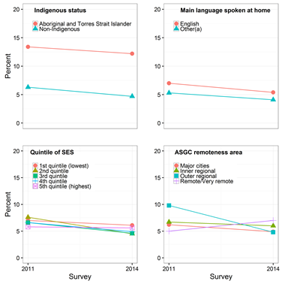

Source: Australian Secondary Students Alcohol and Drug Survey 2011, 2014 (customised request)

Figure 25 – Trends in the prevalence of having smoked in the previous week among school aged children – by available spending money

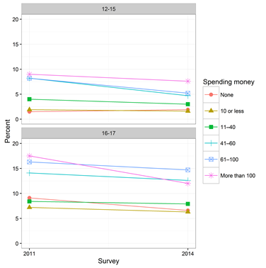

Source: Australian Secondary Students Alcohol and Drug Survey 2011, 2014 (customised request)

## Indicator 2: Fewer young people making the transition to established patterns of smoking

Figure 26 – Trends in the prevalence of secondary school age children having smoked more than 100 cigarettes in their lifetime – by a range of socio-demographic characteristics

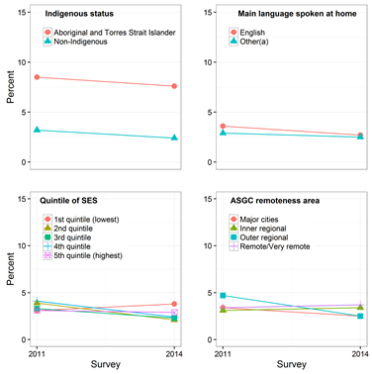

Source: Australian Secondary Students Alcohol and Drug Survey 2011, 2014 (customised request)

Figure 27 – Trends in the prevalence of secondary school age children having smoked more than 100 cigarettes in their lifetime – by age group and available spending money

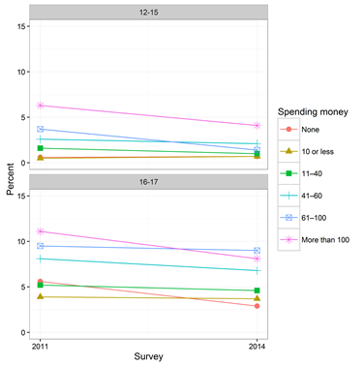

Source: Australian Secondary Students Alcohol and Drug Survey 2011, 2014 (customised request)

Figure 28 - Trends in the prevalence of young people (aged 18-24) having smoked more than 100 cigarettes in their lifetime – by a range of socio-demographic characteristics

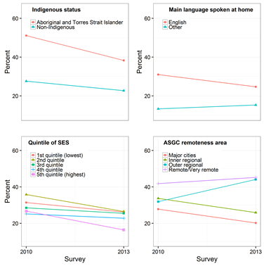

Source: AIHW analysis of the National Drug Strategy Household Survey 2010, 2013

## Indicator 3: Fewer adults smoking regularly

Figure 29 - Trends in the prevalence of daily smoking by a range of demographic characteristics

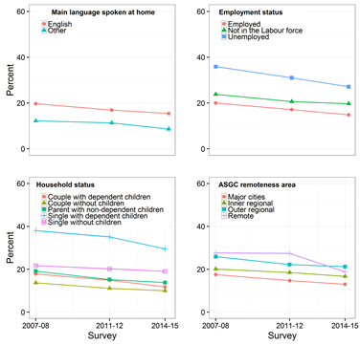

Sources: ABS 2009; AIHW analysis of National Health Survey 2007–08, (re-issue - CURF); ABS Australian Health Survey 2011-12 (National Health Survey component; customised request) and ABS National Health Survey 2014-15 (customised request)

Figure 30 – Trends in the prevalence of daily smoking state – by state and territory

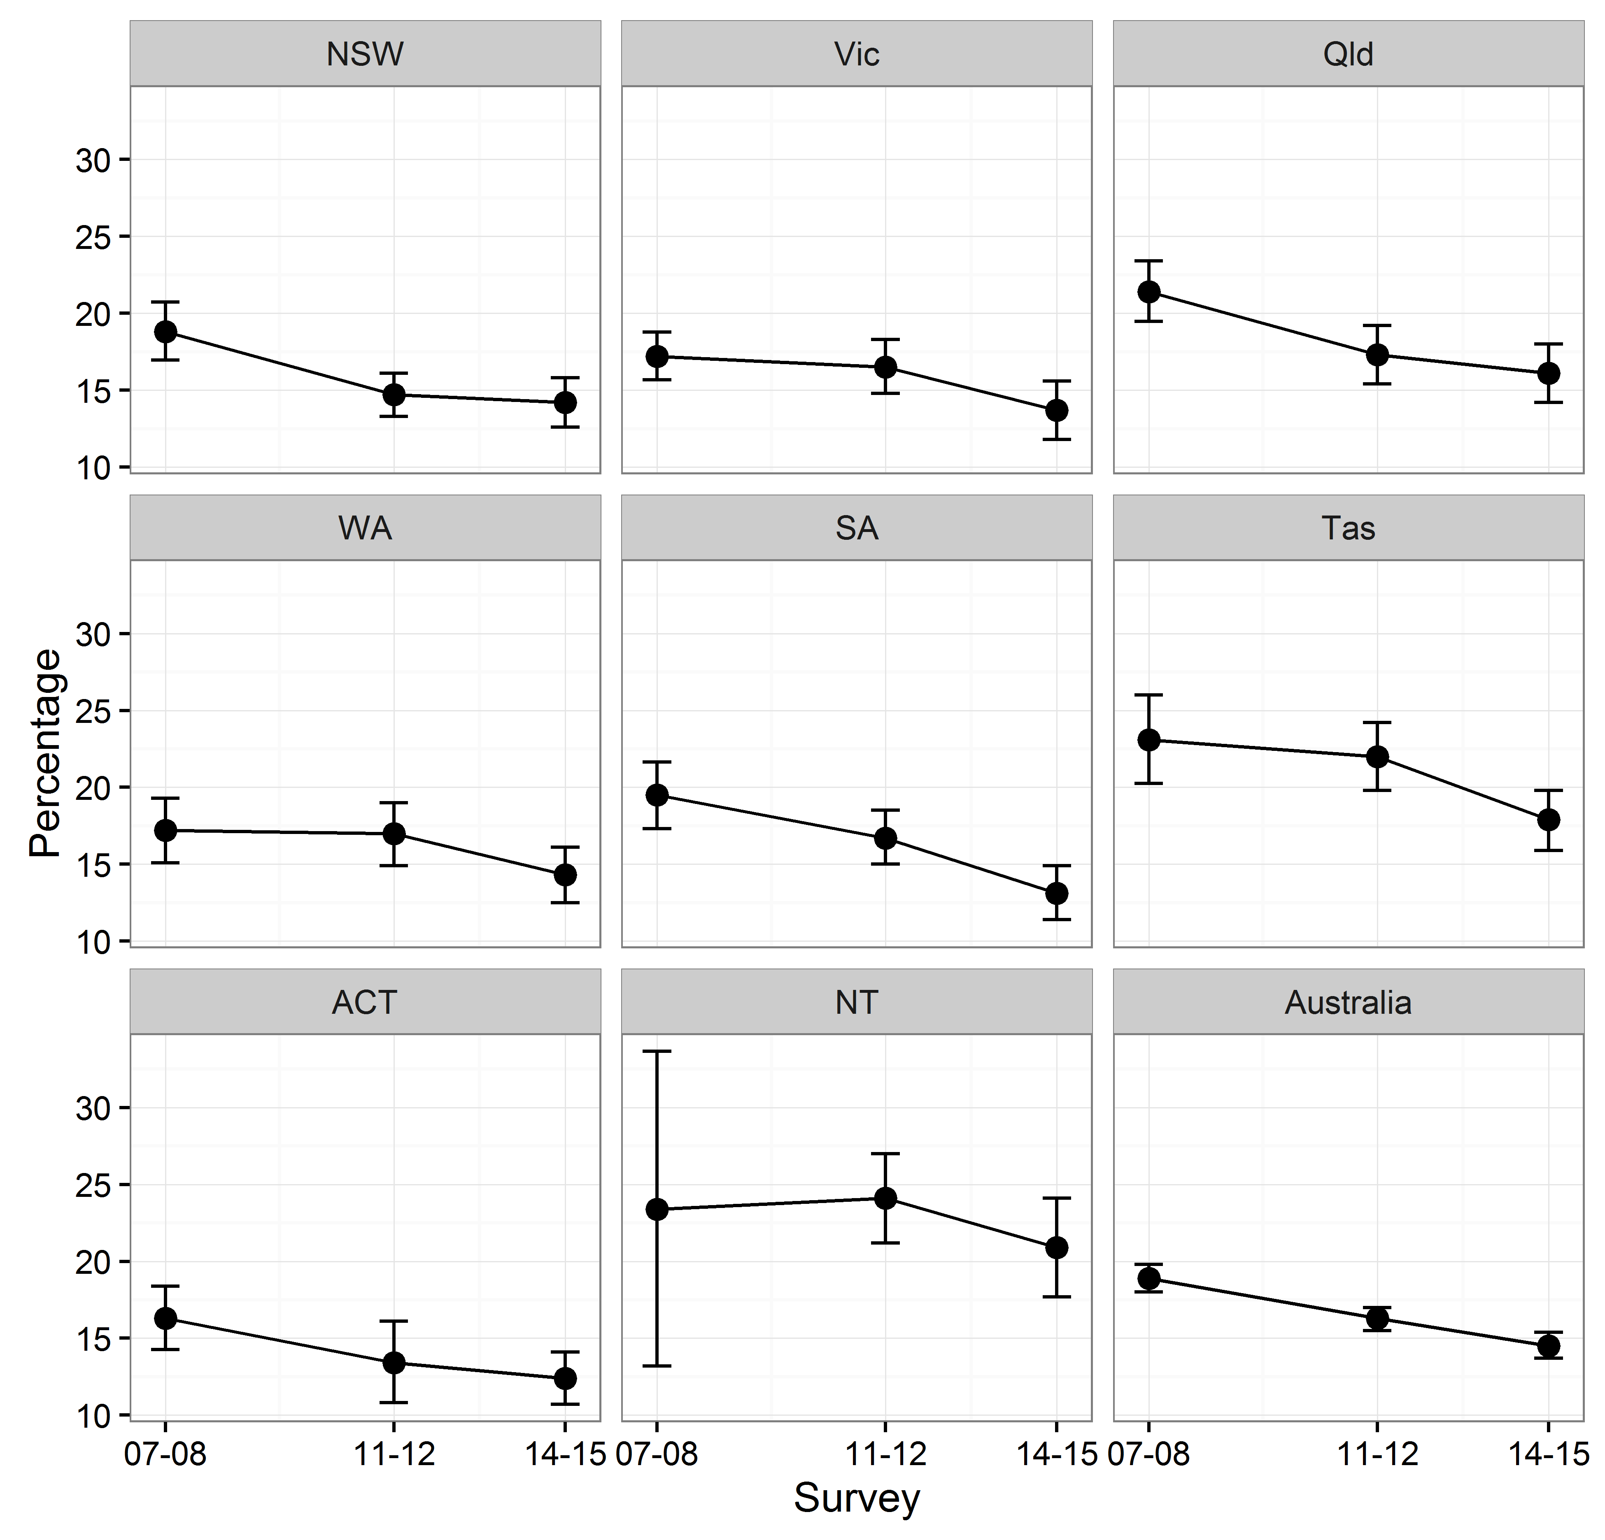

Sources: ABS 2009; AIHW analysis of National Health Survey 2007–08, (re-issue - CURF); ABS Australian Health Survey 2011-12 (National Health Survey component; customised request) and ABS National Health Survey 2014-15 (customised request)

## Indicator 4: More smokers attempting to quit

Figure 31 – Trends in the percentage of smokers who made a quit attempt in the past 12 months – by a range of socio-demographic characteristics

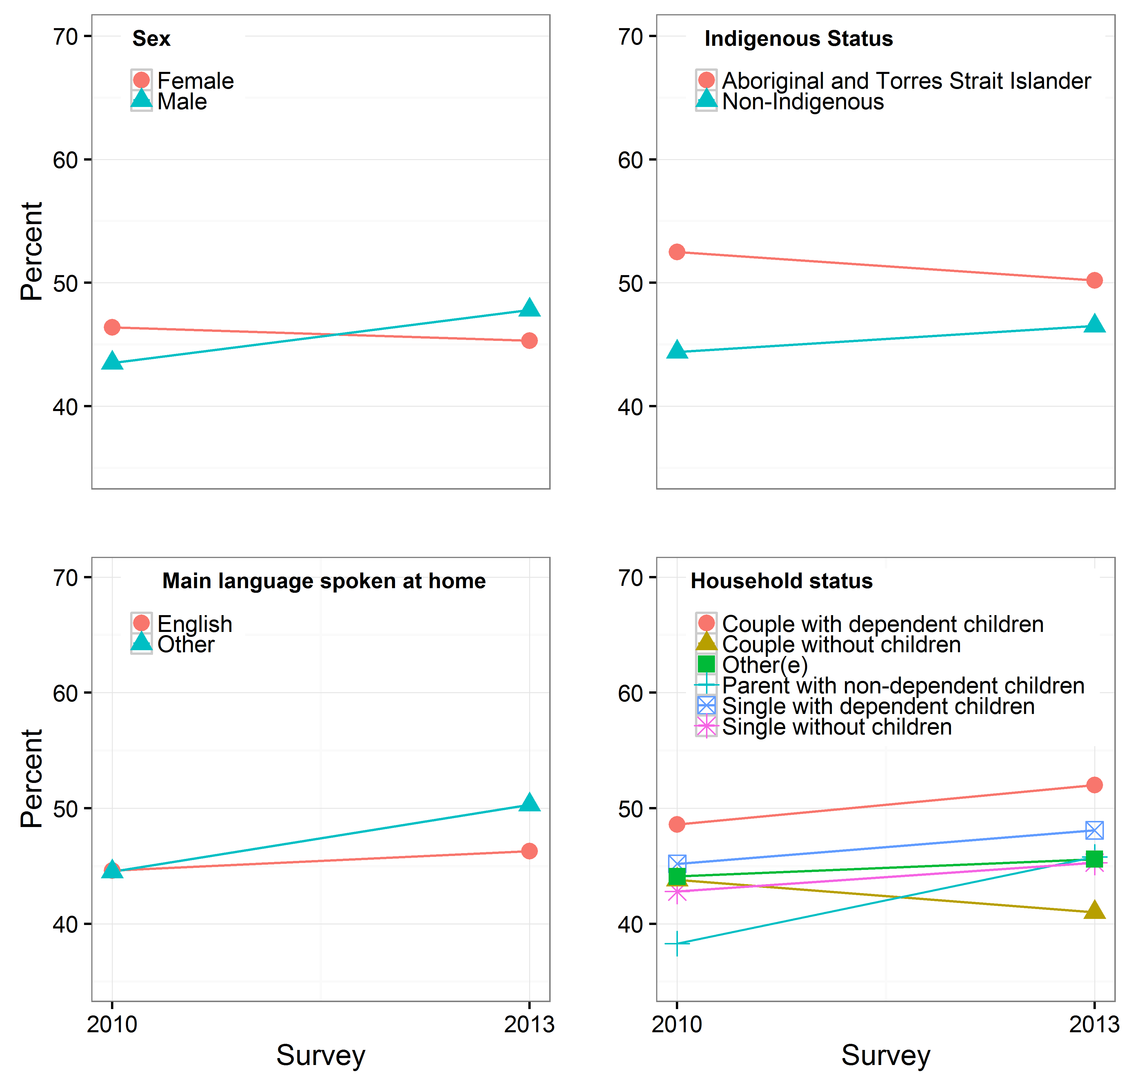

Source: AIHW analysis of the National Drug Strategy Household Survey 2010, 2013

Figure 32– Trends in the percentage of smokers who made a quit attempt in the past 12 months and were successful – by a range of socio-demographic characteristics

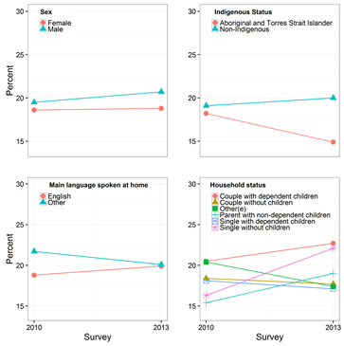

Source: AIHW analysis of the National Drug Strategy Household Survey 2010, 2013

Figure 33 – Trends in the percentage of smokers who made a quit attempt in the past 12 months and were NOT successful

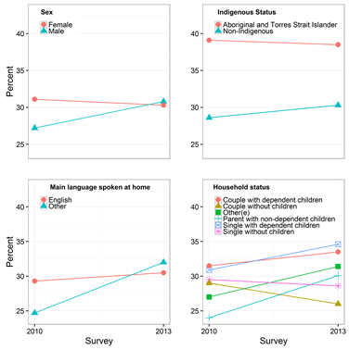

Source: AIHW analysis of the National Drug Strategy Household Survey 2010, 2013

## Indicator 5.1: Fewer women smoking while pregnant

Figure 34 – Among women who gave birth, the percentage of women who smoked at any time during the pregnancy – by a range of socio-demographic characteristics

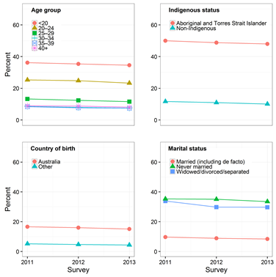

Source: AIHW analysis of the National Perinatal Data Collection

Figure 35 – Among women who gave birth, the percentage of women who smoked at any time during the pregnancy – by socioeconomic status and Australian Standards Geographic Classification remoteness area

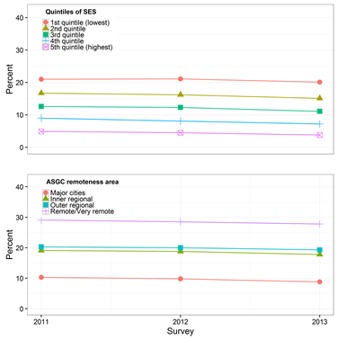

Source: AIHW analysis of the National Perinatal Data Collection

Figure 36 – Among women who gave birth, the percentage of women who smoked in the first 20 weeks of the pregnancy – by a range of socio-demographic characteristics

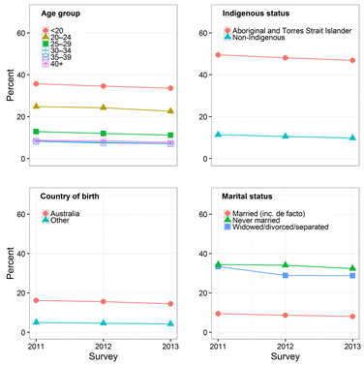

Source: AIHW analysis of the National Perinatal Data Collection

Figure 37 – Among women who gave birth, the percentage of women who smoked in the first 20 weeks of the pregnancy – by socioeconomic status and Australian Standards Geographic Classification remoteness area

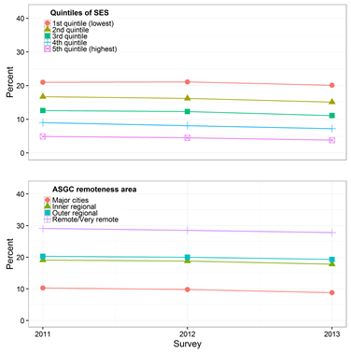

Source: AIHW analysis of the National Perinatal Data Collection

## Indicator 6: Fewer children exposed to second-hand smoke at home

Figure 38 – Percentage of households with dependent children (aged 0–14) who live with a daily smoker who smokes inside the home – by a range of socio-demographic characteristics

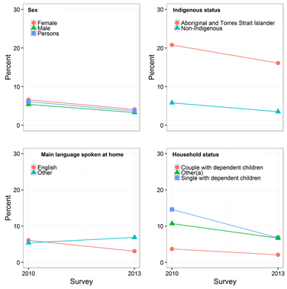

Source: AIHW analysis of the National Drug Strategy Household Survey 2010, 2013

Figure 39 - Percentage of households with dependent children (aged 0–14) who live with a daily smoker who smokes inside the home - by socioeconomic status and Australian Standards Geographic Classification remoteness area

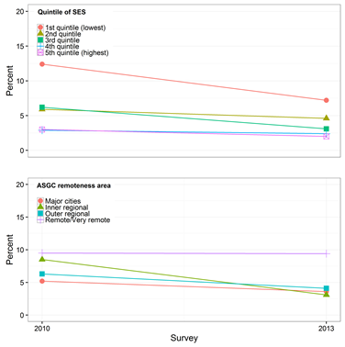

Source: AIHW analysis of the National Drug Strategy Household Survey 2010, 2013

## Indicator 7: Fewer adults exposed to second-hand smoke at home

Figure 40 – Proportion of adults aged 18 or older who live in a household with a daily smoker who smokes inside the home– by a range of socio-demographic characteristics

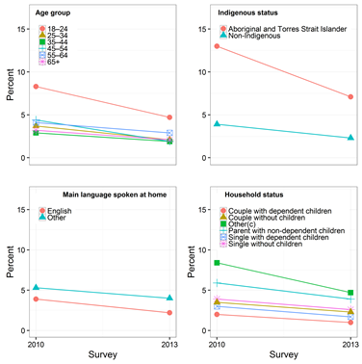

Source: AIHW analysis of the National Drug Strategy Household Survey 2010, 2013

Figure 41 - Proportion of adults aged 18 or older who live in a household with a daily smoker who smokes inside the home - by socioeconomic status and Australian Standards Geographic Classification remoteness area

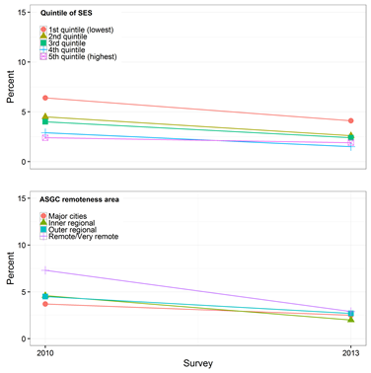

Source: AIHW analysis of the National Drug Strategy Household Survey 2010, 2013

## Indicator 8i: Fewer adults smoking regularly among Aboriginal and Torres Strait Islander people

Figure 42 – The prevalence (95% confidence interval) of being a daily smoker among Aboriginal and Torres Strait Islander adults – by age group

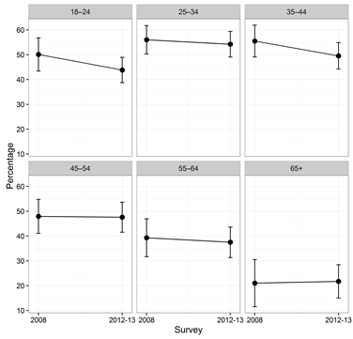

Sources: ABS 2013; ABS National Aboriginal and Torres Strait Islander Social Survey 2008 (customised request); Australian Aboriginal and Torres Strait Islander Health Survey 2012–13 (Core component; customised request)

Figure 43 – The prevalence (95% confidence interval) of being a daily smoker among Aboriginal and Torres Strait Islander adults – by state and territory

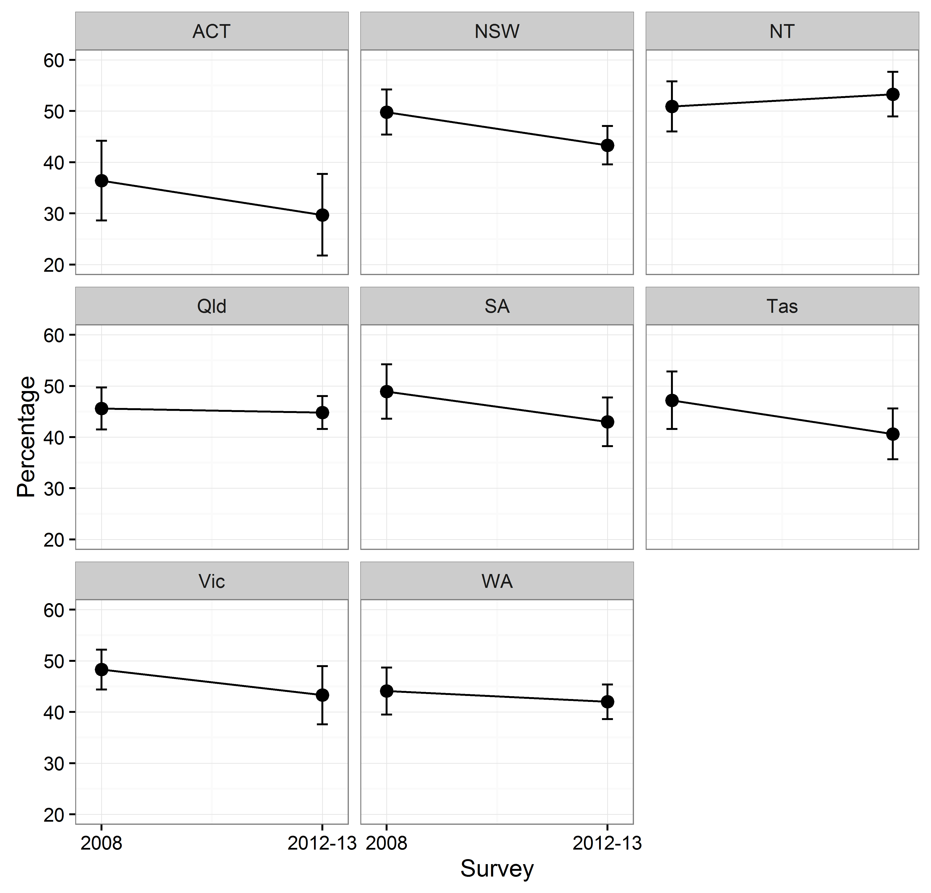

Sources: ABS 2013; ABS National Aboriginal and Torres Strait Islander Social Survey 2008 (customised request); Australian Aboriginal and Torres Strait Islander Health Survey 2012–13 (Core component; customised request)

## Indicator 8ii: Fewer adults smoking regularly among people of low socioeconomic status

Figure 44 – The prevalence of being a daily smoker by quintiles of socioeconomic status by age group

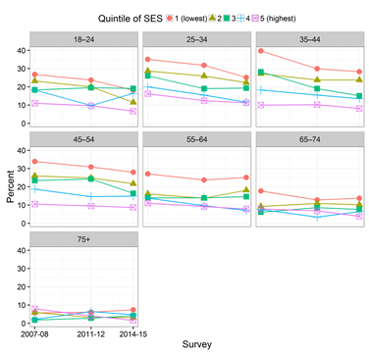

Sources: ABS 2009; AIHW analysis of National Health Survey 2007–08, (re-issue - CURF); ABS Australian Health Survey 2011-12 (National Health Survey component; customised request) and ABS National Health Survey 2014-15 (customised request)

## Indicator 9: Young people delaying the onset of tobacco smoking

Figure 45 – The average age at which people aged 14–24 first smoked a full cigarette – by a range of socio-demographic characteristics

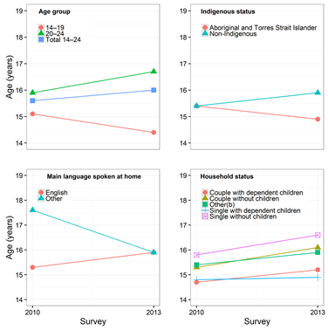

Source: AIHW analysis of the National Drug Strategy Household Survey 2010, 2013

Figure 46 – The average age at which people aged 14–24 first smoked a full cigarette – by socioeconomic status and Australian Standards Geographic Classification remoteness area

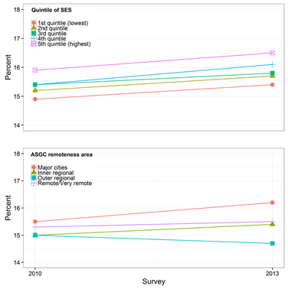

Source: AIHW analysis of the National Drug Strategy Household Survey 2010, 2013

## Indicator 10: Fewer people trying cigarettes

Figure 47 – The percentage of 12- to 17-year-old secondary school students smoking at least a few puffs of a cigarette – by a range of socio-demographic characteristics

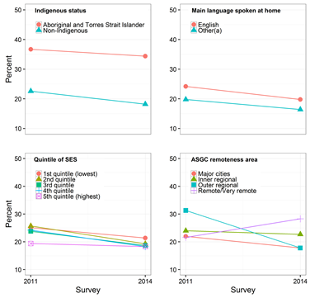

Source: Australian Secondary Students Alcohol and Drug Survey 2011, 2014 (customised request)

Figure 48 – The percentage of persons aged 18 or older who have smoked a full cigarette – by a range of socio-demographic characteristics

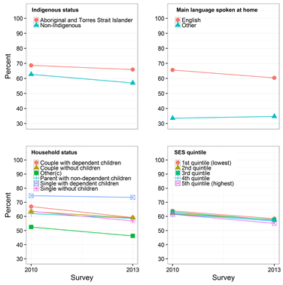

Source: AIHW analysis of the National Drug Strategy Household Survey 2010, 2013

## Indicator 11: Adult ever-smokers are quitting at a younger age

Figure 49 – Average age at which ex-smokers(a) aged 18 or older reported no longer smoking – by a range of socio-demographic characteristics

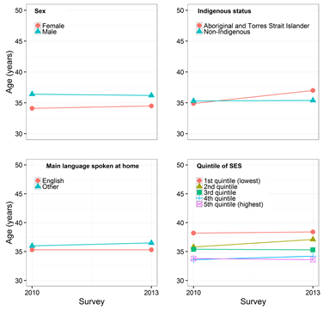

Source: AIHW analysis of the National Drug Strategy Household Survey 2010, 2013

## Indicator 12: More adult ever-smokers no longer smoking

Figure 50 – The percentage of ever-smokers(a) aged 18 or older who did not smoke in the last 12 months– by a range of socio-demographic characteristics

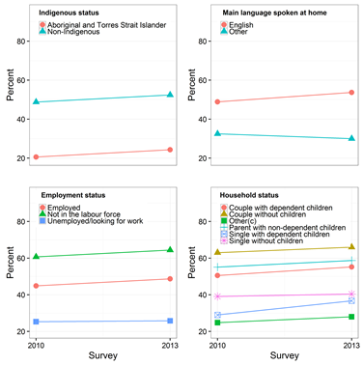

Source: AIHW analysis of the National Drug Strategy Household Survey 2010, 2013

Figure 51 – The percentage of ever-smokers(a) aged 18 or older who did not smoke in the last 12 months – by socioeconomic status and Australian Standards Geographic Classification remoteness area

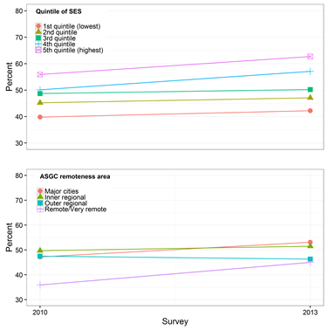

Source: AIHW analysis of the National Drug Strategy Household Survey 2010, 2013

## Indicator 13: Fewer young people smoking

Figure 52 – The percentage of secondary school students (aged 12–17) who were monthly smokers – by a range of socio-demographic characteristics

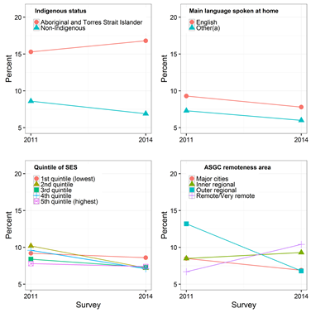

Source: Australian Secondary Students Alcohol and Drug Survey 2011, 2014 (customised request)

## Indicator 14: Current adult smokers smoking occasionally (weekly or less than weekly)

Figure 53 – The percentage of smokers aged 18 or older who are occasional smokers (smoke weekly or less than weekly) – by socio-demographic characteristics

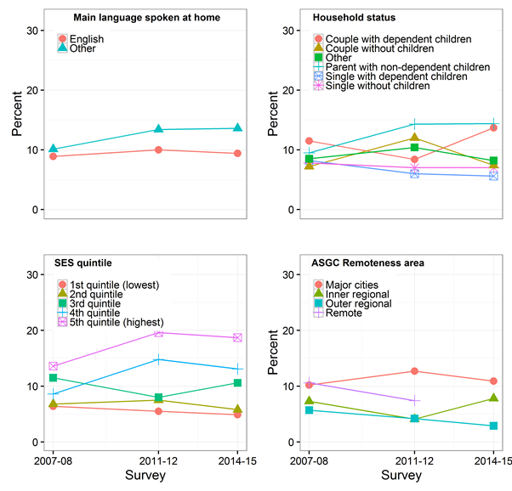

Sources: ABS 2009; AIHW analysis of National Health Survey 2007–08, (re-issue - CURF); ABS Australian Health Survey 2011-12 (National Health Survey component; customised request) and ABS National Health Survey 2014-15 (customised request)

Appendix 6 – Examples of good practice initiatives

The review team was alerted to initiatives and projects which were seen as good practice, potentially worth investing additional resources to enable wider roll-out. Below is a select list (that is not exhaustive) of initiatives that were highlighted during the consultation process.

## National – Tackling Indigenous Smoking & Healthy Lifestyle

This program is a successful initiative to build a dedicated workforce to reduce Indigenous smoking rates and increase healthy behaviours, with an independent review by the University of Canberra pointing to evidence-based outcomes.

[TIS and Healthy Lifestyle Programme Report](https://www.health.gov.au/internet/main/publishing.nsf/Content/904B8752C99678A1CA257EA00026976F/$File/TIS-and-Healthy-lifestyle-Programme_Executive%20Summary.pdf)

## Queensland – smoke-free areas

Queensland has the most comprehensive legislation of all jurisdictions in relation to smoke-free areas. Current legislation received bi-partisan support with the aim of creating a culture that:

* reduces exposure to second-hand smoke
* supports smokers trying to quit
* discourages children from taking up the habit.

[Tobacco Laws in Queensland](https://www.qld.gov.au/health/staying-healthy/atods/smoking/laws/index.html)

## Queensland – Deadly Choices program

This initiative has generated positive results both in its seven-week school program and to a lesser extent in the community events program

[Deadly Choices Evaluation Report Version 2](https://www.lowitja.org.au/sites/default/files/docs/Deadly-Choices-Evaluation-Report-v2.pdf)

## Northern Territory – smoke-free prisons

Northern Territory was the first jurisdiction to introduce smoke-free prisons. Given the preponderance of Aboriginal and Torres Strait Islander prisoners (85%), this was in effect an Aboriginal and Torres Strait Islander initiative. An evaluation by the Menzies School of Health Research found the overall implementation was successful. Most but not all jurisdictions have followed Northern Territory’s lead. A key issue will be follow up and support post-release.

The evaluation report can be accessed at: [Results Evaluation of the Northern Territory smoke-free prisons policy](http://www.phrp.com.au/issues/april-2016-volume-26-issue-2/successes-and-unintended-consequences-of-the-northern-territorys-smoke-free-prisons-policy-results-from-a-process-evaluation/)

## Western Australia – Cancer Council’s Make Smoking History

Cancer Council WA has been running Make Smoking History as a campaign and social media website since 2000, hosting a variety of hard hitting TV advertisements, mostly made by itself or other state Cancer Councils. It has received national and international prominence and is seen as far more than a state-specific initiative.

[Makes Smoking History](http://makesmokinghistory.org.au/)

## Tasmania – Tobacco-free generation

A private member’s Bill is before the Tasmanian parliament to ensure no-one born after the year 2000 would ever be able to purchase tobacco products legally. The Bill caused much public debate and is now in committee.

[Tasmanian Public Health Amendment (Tobacco-free Generation) Bill 2014](http://www.parliament.tas.gov.au/bills/pdf/40_of_2014.pdf)

## New South Wales – apartment balconies

In New South Wales recent legislative changes to the *Strata Titles Act* now give strata committees the authority to ban smoking via by-law if second hand smoke drifts into neighbouring apartments and is considered a nuisance.

[Achieving smoke-free apartment living](https://www.cancercouncil.com.au/wp-content/uploads/2011/08/Passive-smoking-SHS-Apartments-Achieving-smoke-free-Apartment-living-on-line-kit-Final-as-at-30-8-11-30-August-2011.pdf)

## NSW – monitoring & enforcement

NSW Health has developed an effective state-wide tobacco monitoring & enforcement mechanism focussing on both retail sales and smoke-free areas. NSW Health Authorised Inspectors closely monitor compliance with the relevant legislation.

[NSW Smoke-free Laws](http://www.health.nsw.gov.au/tobacco/Pages/smoke-free-laws.aspx)   
[NSW Tobacco Retailing Laws](http://www.health.nsw.gov.au/tobacco/Pages/tobacco-retailing-laws.aspx)

## NSW Cancer Council’s cessation support for disadvantaged groups

The Tackling Tobacco Program from Cancer Council NSW aims to reduce smoking related harm among the most socially economically disadvantaged groups in New South Wales. It does this by supporting community service organisations to address smoking within their organisation and with the population groups they serve. The program is very actively engaged with a range of community service organisations.

[NSW Tackling Tobacco: Action on Smoking and Disadvantage](http://www.cancercouncil.com.au/wp-content/uploads/2011/11/Tackling-Tobacco-new.pdf)

## Victoria – tobacco facts online

Cancer Council Vic maintains an excellent website: [Tobacco in Australia](http://www.tobaccoinaustralia.org.au/) (http://www.tobaccoinaustralia.org.au/), with comprehensive and up to date national information on all relevant aspects on smoking and tobacco control.

## South Australia – Quitskills: online smoking cessation training for Indigenous health workers

Cancer Council SA offers both an online course and a nationally accredited three-day workshop which provides professional, effective and timely education and training to Aboriginal health workers and other health professionals to support smoking cessation.

[Health*InfoNet*: Quitskills](http://www.healthinfonet.ecu.edu.au/key-resources/courses-training?fid=621)

## ACT – No More Boondah

Winnunga Nimmityjah Aboriginal Health Service program that assists people to identify why they smoke, what triggers their smoking and what strategies can help to avoid or delay their smoking.

[ACT Winnunga Ninnityjah, No More Boondah](http://www.winnunga.org.au/index.php?page=no-more-bundah)

## ACT – Regulation of Personal Vaporisers

In April 2016, the ACT Legislative Assembly passed the [*Smoke-Free Legislation Amendment Act 2016*](http://www.legislation.act.gov.au/b/db_53581/) *(the Act)* to amend the [*Tobacco and Other Smoking Products Act 1927*](http://www.legislation.act.gov.au/a/1927-14/). The revised Act took effect on 1 August 2016 and regulates personal vaporisers, including electronic cigarettes, in much the same way as tobacco products. The revised Act is intended to prevent the uptake of personal vaporisers by children and non-smokers, and protect the public from exposure to second-hand vapour.

Further information available on the ACT health [electronic cigarettes](http://www.health.act.gov.au/public-information/public-health/electronic-cigarettes).

# 

References

1. World Health Organization. Guidelines for implementation of Article 5.3 of the WHO Framework Convention on Tobacco Control. Available from: [WHO FCTC Guidelines for implementing Article 5.3](http://www.who.int/fctc/guidelines/article_5_3.pdf).

2. Australian Intergovernmental Committee on Drugs. National Tobacco Strategy 2012 -2018. Canberra: 2012.

3. Ministerial Council on Drug Strategy. National Drug Strategy 2010-2015: A framework for action on alcohol, tobacco and other drugs. Canberra: Ministerial Council on Drug Strategy, 2011.

4. Australian Institute of Health and Welfare. Tobacco Indicators Baseline Data: Reporting under the National Tobacco Strategy 2012–2018. Canberra: AIHW, 2015 Contract No.: Cat. no. PHE 189.

5. Australian Institute of Health and Welfare. Tobacco indicators: measuring midpoint progress—reporting under the National Tobacco Strategy 2012–2018. Canberra: AIHW, 2016.

6. Commonwealth Department of Health and Aged Care. National tobacco strategy 1999 to 2002–03. A framework for action. Canberra: Commonwealth of Australia, 1999.

7. Ministerial Council on Drug Strategy. National Tobacco Strategy 2004–09. Canberra: Ministerial Council on Drug Strategy, 2005.

8. World Health Organization. WHO Framework Convention on Tobacco Control. Geneva: 2003, updated 2004, 2005.

9. Malseed C. Deadly Choices Health Promotion Initiative Evaluation Report: January 1 – December 31, 2013. Carlton: Lowitja Institute, 2014.

10. Australian Government Department of Health. Post-Implementation Review - Tobacco Plain Packaging 2016. Canberra: Department of Health, 2016.

11. Upton P, Davey R, Evans M, Mikhailovich K, Simpson L, Hacklin D. Tackling Indigenous Smoking and Healthy Lifestule Programme Review. University of Canberra, 2014.

12. Thomas Dpl, ,. Talking about the smokes. Medical Journal of Australia. 2015;202(10).

13. Australian National Preventive Health Agency. Australia's tobacco-related datasets. 2013.

14. Tobacco Control and Mass Media Campaigns - Evidence Brief [Internet]. Australian National Preventive Health Agency. 2013 [cited Last accessed 7 October 2016]. Available from: [ANPHA Tobacco mass media campaigns evidence brief](http://health.gov.au/internet/anpha/publishing.nsf/Content/tobacco-mass-media-campaigns-evidence-brief).

15. Australian National Preventive Health Agency. Smoking and disadvantage - evidence brief. 2012.

16. Australian National Preventive Health Agency. Priority-driven Research Agenda for Tobacco Control in Australia: final report. 2013.

17. Australian National Preventive Health Agency. 50 years on: Gains and opportunities in tobacco control in Australia. Marking the 50th Anniversary of the Report of the Royal College of Physicians of London Smoking and Health. 2012.

18. Durkin S, Brennan E, Wakefield M. Mass media campaigns to promote smoking cessation among adults: an integrative review. Tobacco Control. 2012;21:127-38.

19. International Agency for Research on Cancer. Tax, price and tobacco use among the poor. In: IARC, editor. IARC Handbook of Cancer Prevention Volume 14 - Effectiveness of tax and price policies for tobacco control. Lyon: International Agency for Research on Cancer; 2011.

20. Australian Government Department of Prime Minister and Cabinet. 25 per cent Tobacco Excise Increase – Post-implementation Review – Treasury Canberra: Department of Prime Minister and Cabinet; 2013 [19 August 2016]. Available from: [Post-Implementation Review: 25 per cent Tobacco Excise Increase](http://ris.pmc.gov.au/sites/default/files/posts/2013/05/03-25-per-cent-Excise-for-Tobacco.pdf).

21. Dunlop S, Cotter T, Perez D. Impact of the 2010 tobacco tax increase in Australia on short-term smoking cessation: a continuous tracking survey Medical Journal of Australia. 2011;195(8):469-72.

22. Australian Government The Treasury. Regulatory Impact Statement: Tobacco Excise and Excise Equivalent Customs Duty Staged increases and change from CPI to AWOTE. Canberra: The Treasury, 2014.

23. KPMG. Illicit tobacco in Australia: 2015 Half Year Report. London: KPMG, 2015.

24. Australian Institute of Health and Welfare. National Drug Strategy Household Survey detailed report 2013. Canberra: AIHW, 2014 Contract No.: Cat. no. PHE 183.

25. International Agency for Research on Cancer. IARC Handbooks of Cancer Prevention, Tobacco Control, Volume 14: Effectiveness of Tax and Price Policies for Tobacco Control. Lyon: International Agency for Research on Cancer, 2011.

26. Joossens L, Merriman D, Ross H, Raw M. How eliminating the global illicit cigarette trade would increase tax revenue and save lives. Paris: International Union against Tuberculosis and Lung Disease, 2009.

27. Australian Bureau of Statistics. National Aboriginal and Torres Strait Islander Social Survey, 2014-15 2016. Available from: [ABS, National Aboriginal and Torres Strait Islander Social Survey 2014-15](http://www.abs.gov.au/AUSSTATS/abs@.nsf/DetailsPage/4714.02014-15?OpenDocument).

28. Australian Bureau of Statistics. ‘Tobacco Smoking’ in Profiles of Health, Australia, 2011-13 Canberra: ABS; 2013. Available from: <http://www.cancercouncil.com.au/cancer-prevention/smoking/tackling-tobacco/#dr5pCWF906kskCVy.99>.

29. Kasza KA, Hyland AJ, Borland R, McNeill AD, Bansal-Travers M, Fix BV, et al. Effectiveness of stop-smoking medications: findings from the International Tobacco Control (ITC) Four Country Survey. Addiction. 2013;108(1):193-202.

30. Taylor G, McNeill A, Girling A, Farley A, Lindson-Hawley N, Aveyard P. Change in mental health after smoking cessation: systematic review and meta-analysis. BMJ. 2014;348:g1151.

31. Scollo M, Winstanley M. Tobacco in Australia: Facts and issues Melbourne: Cancer Council Victoria; 2015 [30 June 2016]. Available from: [Tobacco in Australia: Facts and Issues](http://www.tobaccoinaustralia.org.au/).

32. Blosnich J, Lee J, Horn K. A systematic review of the aetiology of tobacco disparities for sexual minorities. Tobacco Control. 2013;22:66-73.

33. Chipty A. Study of the Impact of the Tobacco Plain Packaging Measure on Smoking Prevalence in Australia. Canberra: Department of Health, 2016.

34. Warner K. The national and international regulatory environment in tobacco control. Public Health Research & Practice. 2015;25(3):e2531527.

35. Therapeutic Goods Administration. Poisons Standard 2012, (2012).

36. Nonnemaker J, Hersey J, Homsi G, Busey A, Allen J, Vallone D. Initiation with menthol cigarettes and youth smoking uptake. Addiction. 2012;108(1):171-8.

37. Rath JM, Villanti AC, Williams VF, Richardson A, Pearson JL, Vallone DM. Patterns of Longitudinal Transitions in Menthol Use Among U.S. Young Adult Smokers. Nicotine & Tobacco Research. 2015;17(7):839-46.

38. Giovino GA, Villanti AC, Mowery PD, Sevilimedu V, Niaura RS, Vallone DM, et al. Differential trends in cigarette smoking in the USA: is menthol slowing progress? Tobacco Control. 2013.

39. Quit Victoria. Legal status of electronic cigarettes in Australia (October 2016 [cited 2016 7 December 2016]. Available from: [Quit Victoria, Legala status of electronic cigarettes in Australia](http://www.quit.org.au/downloads/resource/policy-advocacy/policy/legal-status-electronic-cigarettes-australia.pdf).

40. Smyth C, Freeman B, Maag A. Tobacco retail regulation: the next frontier in tobacco control? Public Health Research & Practice. 2015;25(3):e2531529.

41. Chapman S, MacKensie R. The global resaerch neglect of unassisted smokinmg cessation: casues and consequences. PLOS Medicine. 2010;7(2):e1000216.

42. Chapman S, Freeman B. Regulating the tobacco retail environment: beyond reducing sales to minors. Tobacco Control. 2009;18(6):496-501.

1. Source:AIHW *National Drug Strategy Household Survey* data from 1991 to 2010.
2. From 1 August 2017, smoking will be banned at food fares and within 10 metres of food stall at organised events. As of March 2006, smoking has been banned at all under-age music or dance events in Victoria
3. Councils provided with power to prohibit smoking at malls.
4. Since April 2015 smoking has been prohibited within four metres of an entrance to the following facilities: all children’s indoor play centres, all public hospitals, all registered community health centres, certain Victorian Government buildings, including Parliament, law courts and police stations. Smoking is also banned within the grounds of, and within four metres of an entrance to, all childcare centres, kindergartens and primary and secondary schools.
5. As outlined above, smoking has been banned within four metres of an entrance at all public hospitals and registered community health centres. However, the ban does not apply to an entrance to a private hospital, unless the entrance also provides access to a public hospital.
6. Ibid.
7. From 1 August 2017, smoking will be banned in all outdoor dining areas, as defined by the *Tobacco Amendment Act 2016*.