# Healthdirect Australia

## ***Home Care Package Research***

*Final Report*

Client Contact

Erin Sharp

Healthdirect Australia

Level 19, 133 Castlereagh Street

Sydney NSW 2000

Ph. 02 9263 9164

AMR Contacts

Jake Moody

Tae Hwan Ahn

Level 6, The Bond

30 Hickson Road

Millers Point

NSW 2000

Ph. 02 9020 6700 Fax: 02 9020 6789

Index of Figures ii

1. Executive Summary 3

2. Research Background & Objectives 5

3. Research Design & Sampling 6

3.1 Consumer Sampling 6

3.2 Provider Sampling 7

4. Respondent Profiles 8

4.1 Consumer Demographics 8

4.2 Provider Organisation Profiles 13

5. Administering and Receiving Home Care Packages 17

5.1 Consumer Service Experience 17

5.2 Consumer Perceptions of the Queue for Services 22

5.3 Funding and Satisfaction 23

5.4 Provider Satisfaction with Aspects of Increasing Choice in Home Care Reforms 25

6. Changes to the Home Care Package Program 26

6.1 Awareness of the Reforms 26

6.2 Consumer views on the Reforms 28

6.3 Provider Views on the Reforms 29

6.4 Likelihood of changing provider 30

6.5 Reasons for Changing or Not Changing Provider 31

6.6 Provider Experience of Client Service Changes 32

7. Provider Choices After the Reforms 34

7.1 Choosing and Arranging a Provider 34

7.2 Support to Set Up Services 37

7.3 Resources Used to Assist in setting up services 38

8. Changes in Provider Business Model 40

9. Views on the My Aged Care System 43

9.1 Consumer Outcomes 43

9.2 Provider Perceptions 45

## Index of Figures

Figure 1: Consumer screening process 6

Figure 2: Provider screening process …7

Figure 3: Consumer state/territory location 8

Figure 4: Consumer age 8

Figure 5: Consumer gender 9

Figure 6: Consumer cultural, linguistic, sexual and intersex identity 9

Figure 7: Consumer household income 10

Figure 8: Consumer Package level 10

Figure 9: Consumer Package progress 11

Figure 10: Provider service delivery regions 12

Figure 11: Provider service types delivered 12

Figure 12: Provider size 13

Figure 13: Provider funding 13

Figure 14: Providers by new/existing Home Care Package status 14

Figure 15: Provider respondent level 14

Figure 16: Satisfaction with aspects of Home Care Package service 15

Figure 17: Services received in Home Care Package 16

Figure 18: Satisfaction with services received in Home Care Package 17

Figure 19: Other services received while awaiting a Home Care Package 18

Figure 20: Most valued aspects of Home Care Package service 19

Figure 21: Participant experience post-assessment (service not received) 20

Figure 22: Alternative outcomes among participants not yet receiving services 20

Figure 23: Participant awareness of Home Care Package funding 21

Figure 24: Participant satisfaction with Home Care Package funding 21

Figure 25: Provider satisfaction with aspects of changes to the Programme 22

Figure 26: Participant awareness of Increasing Choice reforms 23

Figure 27: Participant means of awareness of Increasing Choice reforms 24

Figure 28: Participant agreement with statements on the Increasing Choice reforms 25

Figure 29: Provider views on their adaptation to Increasing Choice reforms 26

Figure 30: Participant likelihood of changing provider 27

Figure 31: Particpant reasons for not considering changing provider 28

Figure 32: Participant reasons for considering changing provider 28

Figure 33: Providers’ perceptions of incidence of clients changing provider 29

Figure 34: Provider ease of delivering services to upgraded-Package clients 30

Figure 35: Participant agreement with statements regarding selecting a provider 31

Figure 36: Participant satisfaction with aspects of arranging a provider 32

Figure 37: Factors contributing to provider choice 33

Figure 38: Participant satisfaction with information received to support setting up services 34

Figure 39: Resources used to assist in setting up services 35

Figure 40: Satisfaction with resources used to assist in setting up services 36

Figure 41: Changes in employment model reported by providers 37

Figure 42: Providers’ projected changes to Package location and level 38

Figure 43: Providers’ projected changes to Package numbers 38

Figure 44: Participant ratings of performance of aspects of My Aged Care 39

Figure 45: Participant likelihood of recommending My Aged Care (NPS) 40

Figure 46: Service provider assessment of consumer outcomes 41

Figure 47: Providers’ ease of carrying out tasks under My Aged Care 42

Figure 48: Provider ratings of support offered under My Aged Care 43

Figure 49: Provider views on consumer experience under My Aged Care 44

## Executive Summary

* A baseline survey on the operations of the Home Care Packages Program was undertaken as part of Wave 2 of the My Aged Care evaluation research in early 2017, before the introduction of the Increasing Choice in Home Care reforms.
* Following the introduction of the reforms, AMR was commissioned to carry out targeted market research among consumers of home care packages and home care package service providers.
* The research focussed on measuring their satisfaction with, and their experiences of, My Aged Care, and specifically with the implementation of the Increasing Choice reforms.
* The results showed that, overall, consumers receiving a home care package displayed a high level of satisfaction with their services – several aspects of the home care package services received were viewed positively by more than 80% of recipients.
* For this reason, very few (7%) were contemplating changing providers. This result is lower still among providers reporting their clients’ actions, where half believe that none have done so, and a further 31% estimate the proportion at below 2%.
* Those who were considering changing service providers were dissatisfied with the services they receive or the people who deliver the services. They were less likely to be dissatisfied with the cost or the service provider’s ability to cater to their background.
* Awareness of the reforms and the option to change providers was moderate (47%), but higher among those already receiving services (60%).
* There was a majority view among consumers (68%) that moving providers has become easier since the implementation of the Increasing Choice in Home Care reforms – this was again stronger among those already receiving a home care package.
* Almost three in four respondents (74%) indicated satisfaction with how long they had to wait to be assigned a package. Around two in three (65%), were happy with how long they had to make a decision on a provider, more than a fifth couldn’t recall or otherwise didn’t answer and only 5% were dissatisfied.
* For some measures, regional differences were observed amongst consumers: those in regional areas were more likely to be satisfied with many aspects of their service, but were also more likely to be affected by a lack of available providers in their area and also receive services less frequently.
* Among consumers, newer entrants’ satisfaction was slightly lower than those already in the system, with those who started receiving services before February 27th consistently being more positive across a range of measures, including:
* An overall Net Promoter Score for My Aged Care of +36 versus +26 (please see Section 9.1 for an explanation of the calculation of the Net Promoter Score)
* Higher agreement that My Aged Care helps people get the services they need (76% versus 65%)
* The suitability of the services they receive as meeting their needs (86% versus 75%)
* Similarly, providers that were already delivering services under the Commonwealth Home Support Programme (CHSP), that had then chosen to ‘opt in’ as an Approved Provider to deliver home care packages, encountered fewer problems than those entering the system as providers of aged care for the first time.
* However, when surveyed more broadly on My Aged Care and the Increasing Choice in Home Care reforms, existing providers were more negative. Findings suggested this is because they felt the reforms had affected their business model and workload.
* Providers found the changing of work practices involved in the reforms challenging. Many indicated they were moving towards a more casual workforce to address the uncertainty in their business pipeline.
* Most were also reacting to the opportunities provided under the reforms: 59% are considering offering Packages in new locations, and 81% anticipate increasing package numbers. These figures were higher still among providers that were new to the system, which were actively seeking to expand their offering.
* Despite the challenges providers were facing, their satisfaction with elements of the information, support and systems available to assist them in providing home care packages was usually moderate rather than low.
* Where results were comparable to those recorded as part of Wave 2 of the My Aged Care evaluation research, they were most commonly statistically similar with no major increases or declines.

## Research Background & Objectives



### Research Background

My Aged Care was introduced as an information service in 2013 and became the gateway to Australian Government funded aged care services in 2015. This was part of the Australian Government’s changes to the aged care system, which have been designed to give people more choice, more control and easier access to aged care services.

Healthdirect Australia and the Department of Health commissioned AMR in 2015 to measure baseline information about My Aged Care brand awareness, and consumers’ and service providers’ experience with aged care, as a benchmark prior to the July 2015 changes taking effect. AMR conducted this baseline wave of research in June and July 2015.

Further waves of research were conducted in 2016 and 2017. Wave 1 was conducted between January and March 2016, and added a number of components to the research, as well as continuing to monitor key metrics around consumer, service provider, assessor and health professional views on the aged care system at large and higher-level aspects of the My Aged Care rollout.

Wave 2 of the My Aged Care Evaluation took place between October 2016 and early 2017, in the lead-up to the 27 February 2017 implementation date of the Increasing Choice in Home Care reforms and other technical changes affecting stakeholders. It was designed to continue to monitor the same high-level measures of consumer, service provider, assessor and health professional views on the aged care system and My Aged Care.

One result of the Wave 2 research was the finding that consumers are not able to reliably self-identify which program they receive services through, when their assessment took place and the type of assessment they had. This posed a problem when seeking to evaluate the experiences of consumers progressing through specific parts of the system.

In August 2017, AMR was commissioned to carry out market research among consumers of home care packages and home care package service providers to measure their satisfaction with, and experiences of, My Aged Care, and specifically with the implementation of the Increasing Choice reforms. Given the sampling challenges outlined above, among consumers key objectives were to:

* Repeat components of the Wave 2 Evaluation research to establish a more reliable baseline of findings
* Measure satisfaction with changes introduced on 27 February 2017.

There was also a requirement to take steps to maximise the inclusion of consumers at a variety of stages in the home care package process, including those assessed and commencing services before and after February 27, those assigned a package but not yet receiving services, and those in the queue for services.

Among home care package providers, the aim was to measure levels of satisfaction with changes introduced in February 2017.

## Research Design & Sampling

A key consideration for this research was the best method for identifying home care package consumers, given that the experience in previous research suggested that self-identification of service types has not been reliable.

* Fieldwork was conducted between 10 August and 18 September 2017.
* The sample was obtained from the list of participants in the My Aged Care Contact Centre Customer Satisfaction Survey, which is conducted by AMR, who consented to be re-contacted for further research.
* The option of using My Aged Care client record information supplied by the Department to identify members of the target population was explored. However, participants in the system are not required at any point while arranging their service to give permission to be contacted for market research purposes. As one outcome of this research, the Department is seeking legal guidance on how this consent may be sought in the future to enable more efficient access to a robust research sample within its client base.
* The majority of final matched interviews (87%) were conducted with care recipients. However, carers were eligible to be included where the care recipient was unable to participate but were able to give permission for their data to be matched.



### Consumer Sampling

The process of generating a final sample of ‘genuine’ consumer participants in home care packages is laid out below.

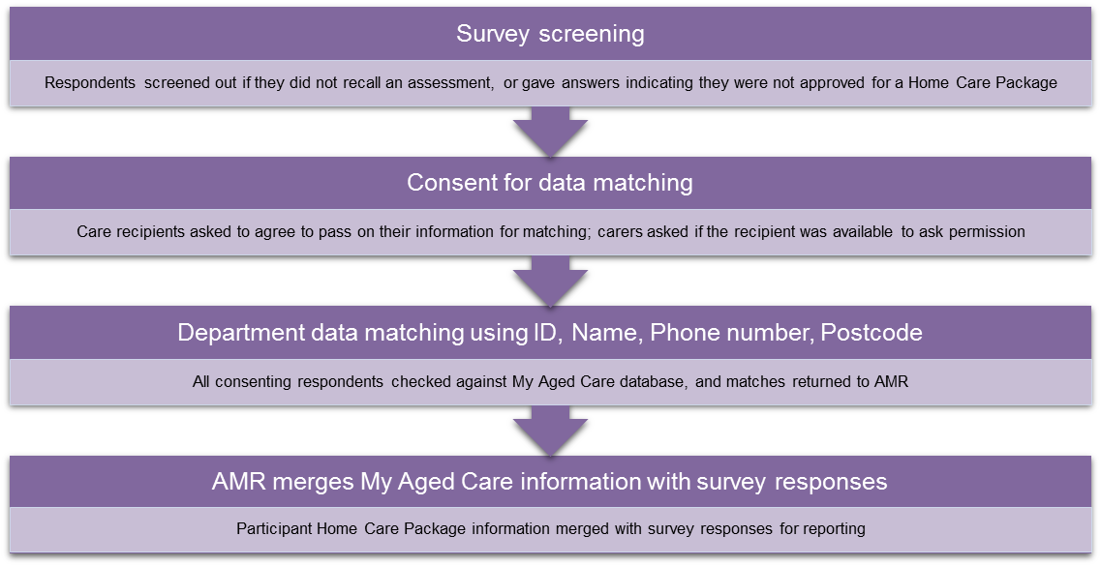***Figure 1: Consumer screening process***

This process resulted in the following breakdown of sample into useable Home Care Package data:

* N=3,554 consented to take part in the telephone survey
* N=1,751 were not screened out and subsequently completed the survey
* N=800 consented to their details being provided to the Department for data matching
* N=215 were successfully matched as being Home Care Package participants

### Provider Sampling

The Department was able to provide a list of active home care package providers based on publicly available information. Given the need to ensure 300 total surveys from the limited sample, it was necessary to build a referral system into the screening to allow interviewers to reach an eligible organisational contact where possible.

* Surveys were conducted by telephone, with an appointment / call-back system in place to allow interviewers to reach the right contact within the organisation
* A total of n=417 providers were contacted and agreed to the survey, with n=117 screening out, resulting in the target of n=300 final surveys completed

Potential respondents were screened according to the process below, to ensure that the results reflected the views of management employees of home care package s providers

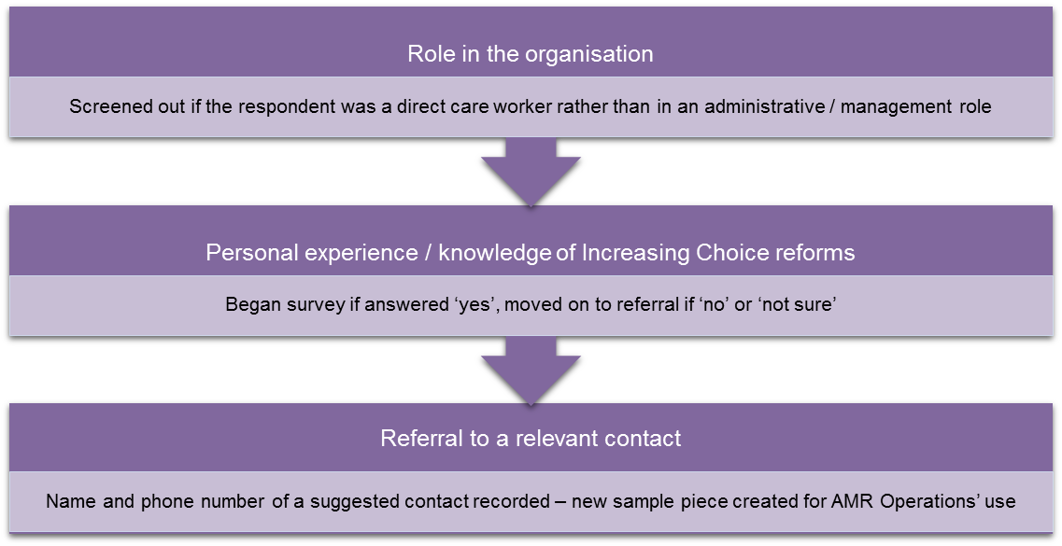***Figure 2: Provider screening process***

All surveys were conducted via telephone, by experienced interviewers based at AMR’s in-house CATI (Computer-Assisted Telephone Interviewing) centre in Mascot, Sydney.

.



## Respondent Profiles



### Consumer Demographics

*Note: all charts in Section 4.1 have a sample size of n=215.*

The methodology used, whereby completed surveys were matched against Department of Health records to determine ‘genuine’ package participants for the final sample, meant that it was not possible to quota for representativeness by age, gender or location. However, a spread of results across most of these demographics was achieved.

* Consumers were surveyed across all states and territories with the exception of the Northern Territory. The highest representation came from New South Wales (35%) and Queensland (33%).

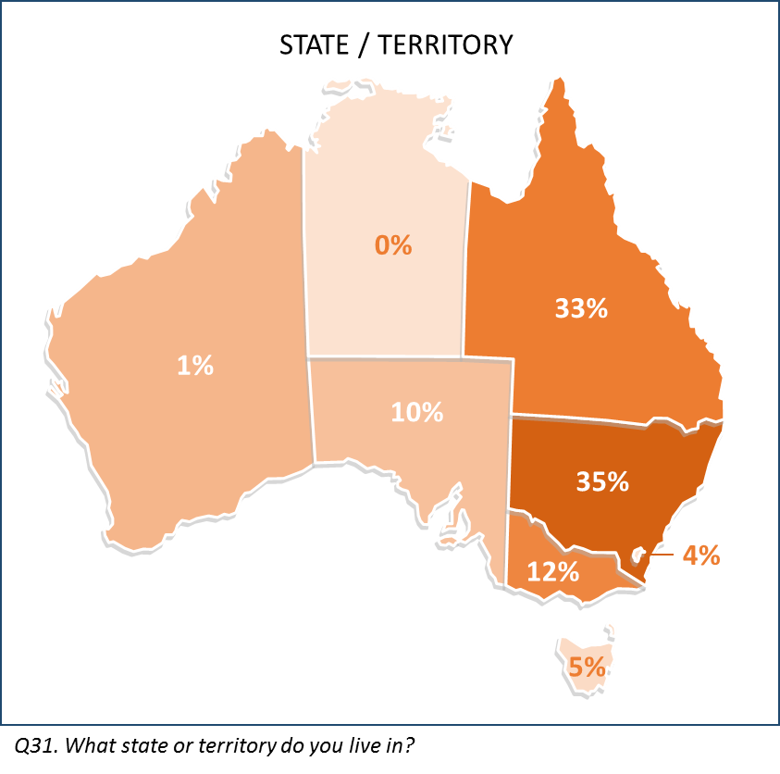***Figure 3: Consumer state/territory location***

* Two in five respondents (40%) were aged 80 or over, in line with the average age of entry to the Home Care Packages Program. Around one in five (21%) were aged under 70, almost all carers completing the survey on behalf of someone else.

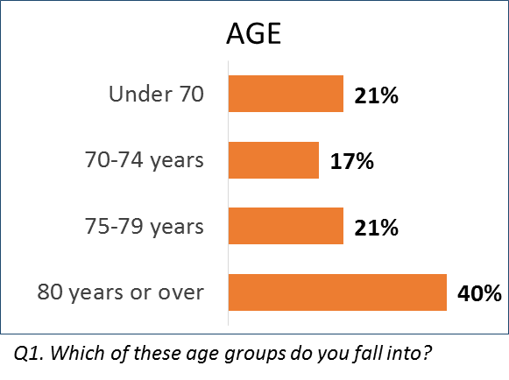***Figure 4: Consumer age***

* Most respondents to the survey were female (71%).

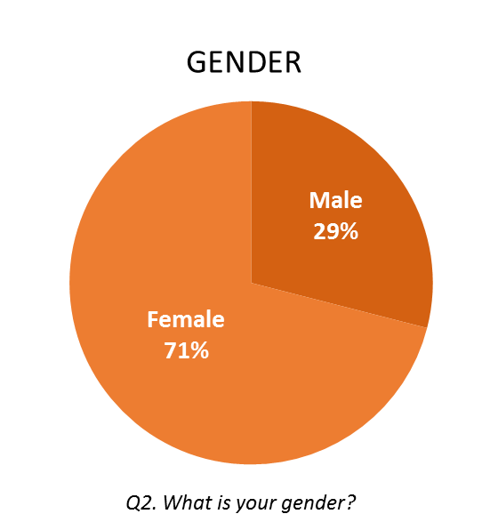***Figure 5: Consumer gender***

* A relatively small portion of the verified sample identified as Culturally and Linguistically Diverse (5%).
* A roughly representative proportion of the sample identified as Aboriginal or Torres Strait Islander (3%).
* Identification as Intersex (n=1) or LGBT (n=1) was less than 1%.

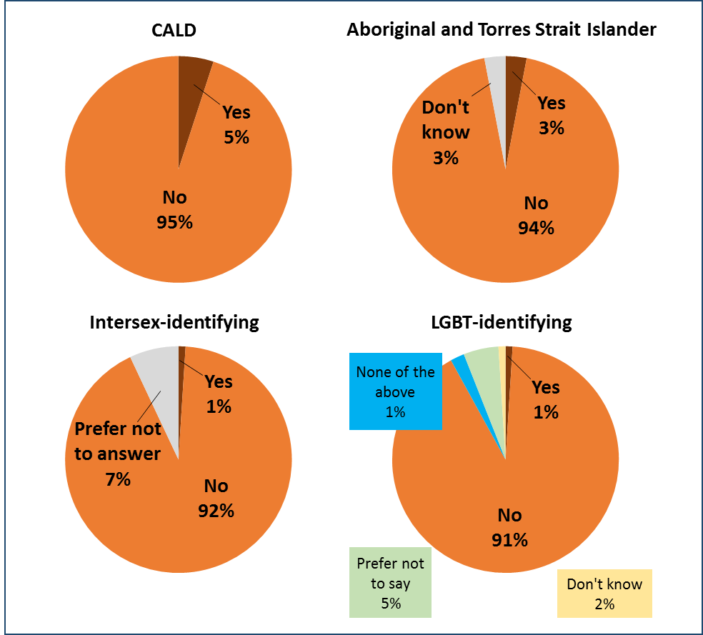***Figure 6: Consumer cultural, linguistic, sexual and intersex identity***

* Household incomes were comparatively low as a result of the high prevalence of pensioners in the sample: almost half (44%) reported income below $30,000, while just 5% reported income over $75,000.

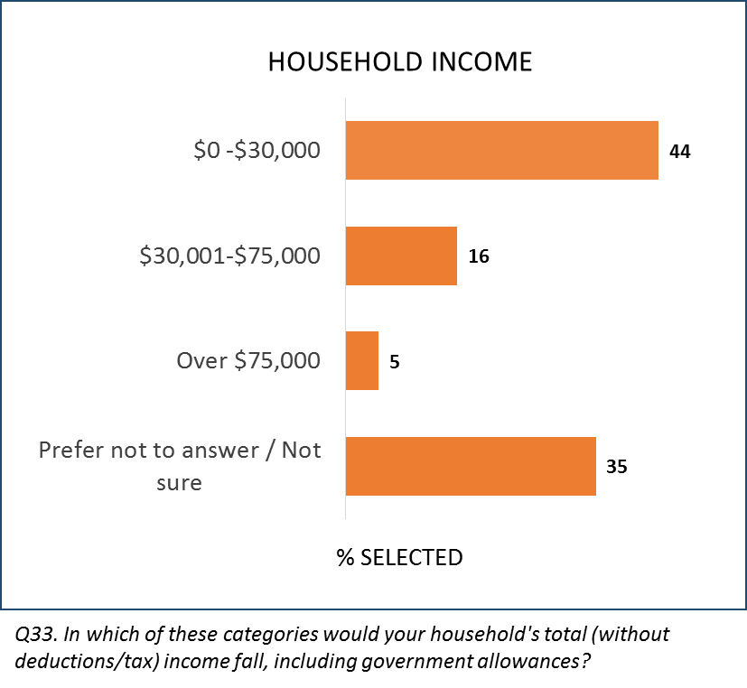***Figure 7: Consumer household income***

* Half of respondents were verified as recipients of, or carers for, a Level 2 Package,   
  13% for a Level 3 Package, and 30% for a Level 4 Package.

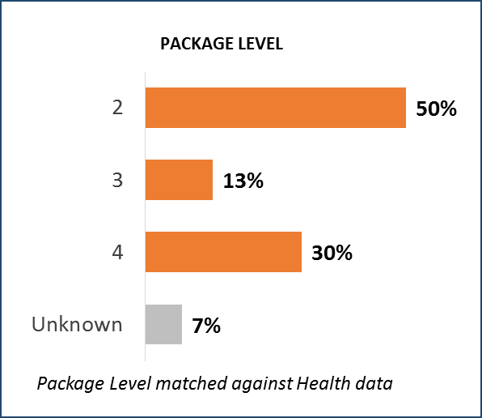***Figure 8: Consumer Package level***

* The research aimed to capture consumers at all stages of their home care package journey from the point of being assessed as eligible. The most common verified status of respondents to the survey was to have been assessed before February 27th and be receiving services: a total of n=83, around 40% of the sample.
* Around 27% of the sample, n=59 people, were confirmed as having been assessed since February 27th. Most of these (n=47) were confirmed to be in the queue.
* Almost all of those assigned a Package (35/38) had been assessed before February 27th, as was the case with those who had begun their Package service (83/91).

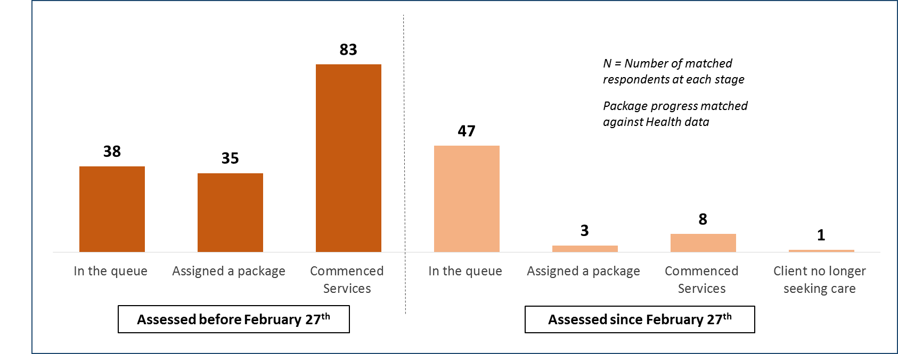***Figure 9: Consumer Package progress***

### Provider Organisation Profiles

*Note: all charts in Section 4.2 have a sample size of n=300.*

* Providers surveyed were quota managed to be representative of the Australian residential population, resulting in the highest proportion of areas serviced on the East coast, especially in NSW (35%), Queensland (24%) and Victoria (21%).

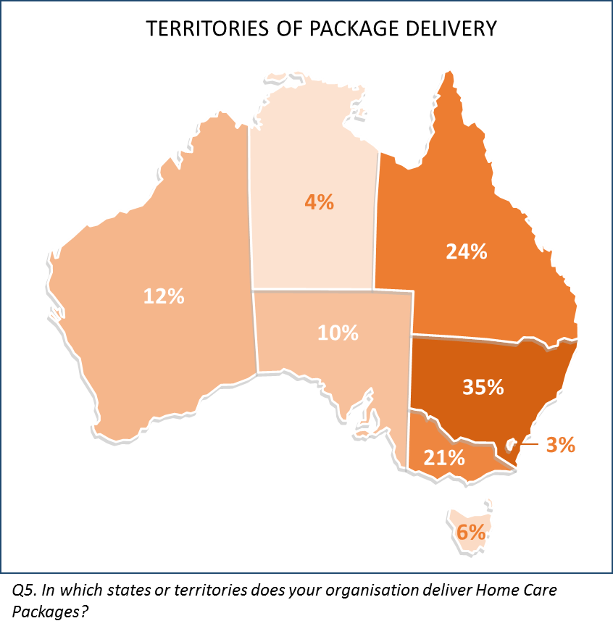***Figure 10: Provider service delivery regions***

* All providers were screened to confirm they provided home care packages. 57% also provided Commonwealth Home Support Programme (CHSP) services, and more than one in three provided residential aged care (34%).

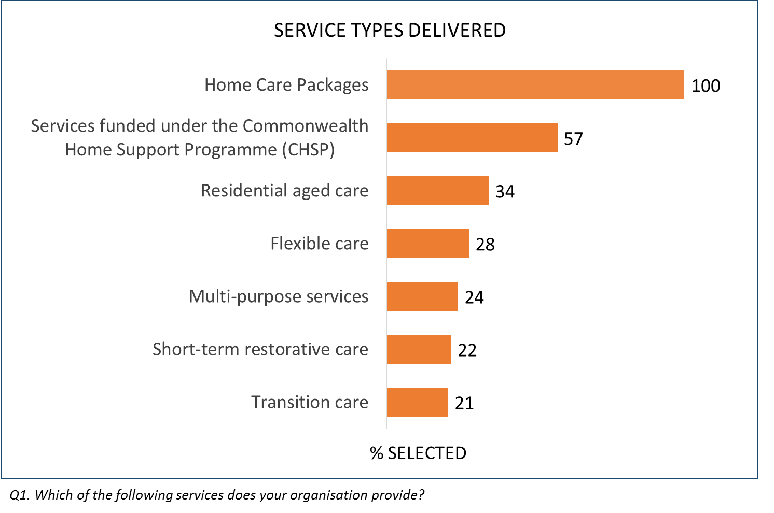***Figure 11: Provider service types delivered***

* A broad spread of organisation sizes was achieved: in total, 30% were considered small businesses (<20 employees), 48% medium-sized (20-199), and 19% large businesses 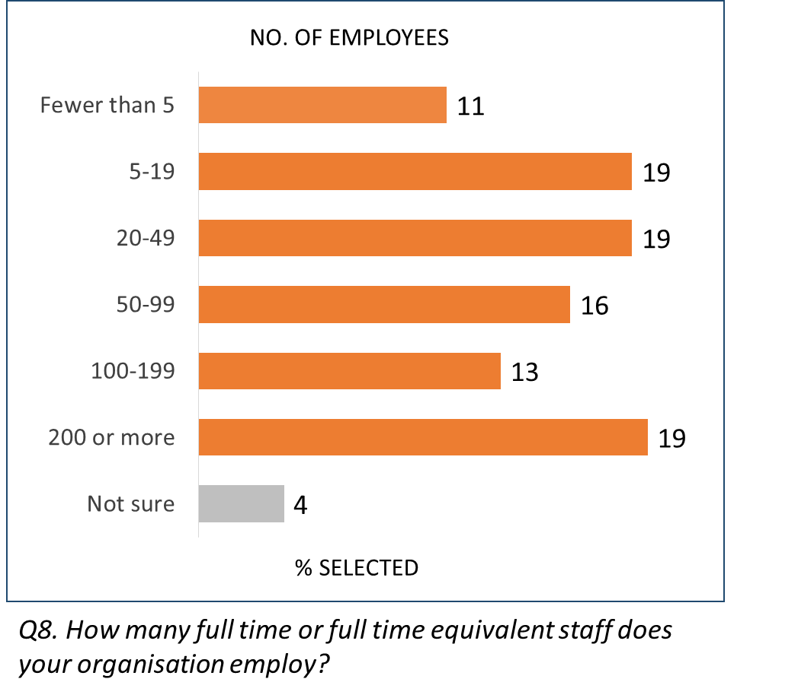(200+).

***Figure 12: Provider size***

* The majority of surveyed providers (54%) were managed by a not-for-profit or religious organisation, with 31% privately managed and the remaining 14% government-managed.

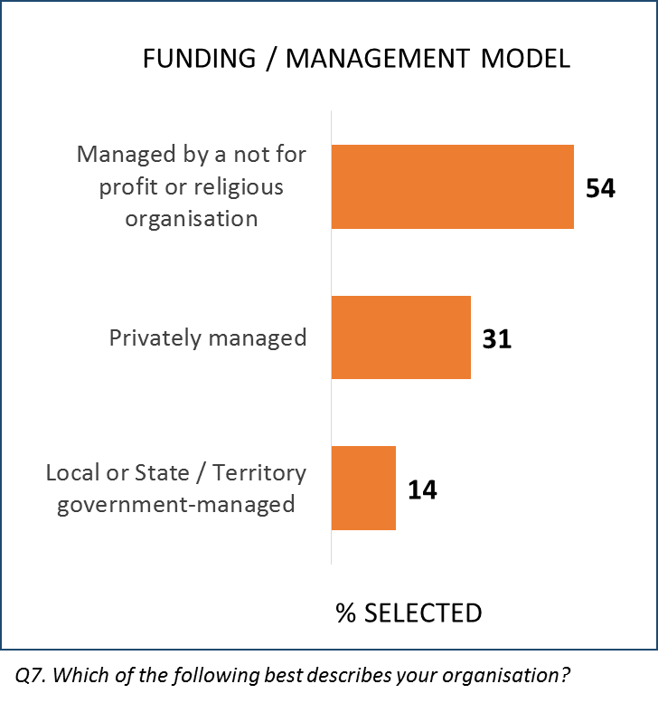***Figure 13: Provider funding***

* Two thirds of providers indicated that their organisation had offered home care packages prior to February 27th.

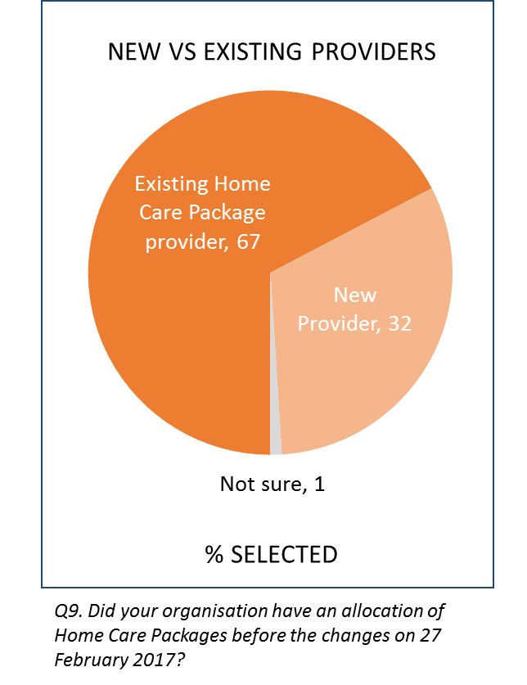***Figure 14: Providers by new/existing Home Care Package status***

* 45% of respondents were in senior management roles in their organisation (45%). Around one in three (22%) were in a middle management role, with the remainder (33% in total) in a care provider or coordinator role.

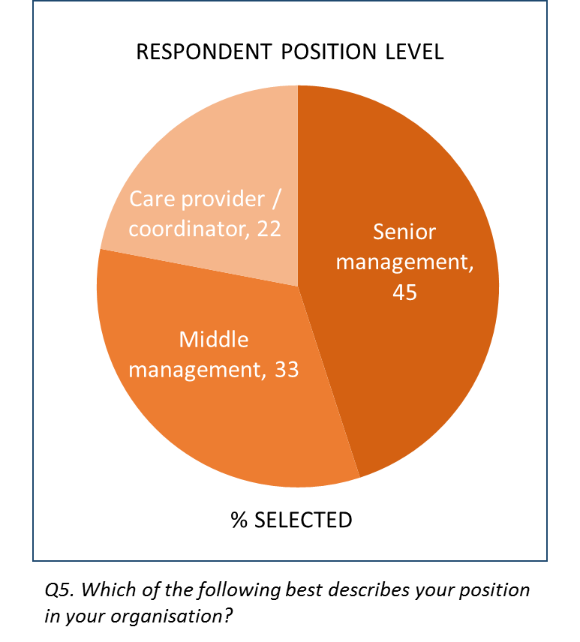***Figure 15: Provider respondent level***



## Administering and Receiving Home Care Packages



### Consumer Service Experience

Questions related to service experience were asked of all of those who believed they had started receiving a home care package, but in order to reflect clients’ experiences more accurately, were filtered to only those verified as receiving a package at the time of fieldwork.

* At least four in five participants (80%) indicated satisfaction with each of the prompted measures, with the highest level of satisfaction recorded for the services matching what was expected (89%).
* Satisfaction was higher still among Level 2 participants, with more than nine in ten satisfied that the services were what they expected (92%).
* Those in regional areas also reported consistently higher satisfaction, as did females and those in Queensland.
* Agreement that the home care package services received were what was expected reached 85% among care recipients and 82% among carers in the Wave 2 evaluation research conducted in early 2017. The continued increase to 89% confirms that home care package participants were experiencing high levels of satisfaction.
* The measures of the standard and suitability of services were also similarly positive results compared with those from the Wave 2 evaluation, all averaging over 80%.

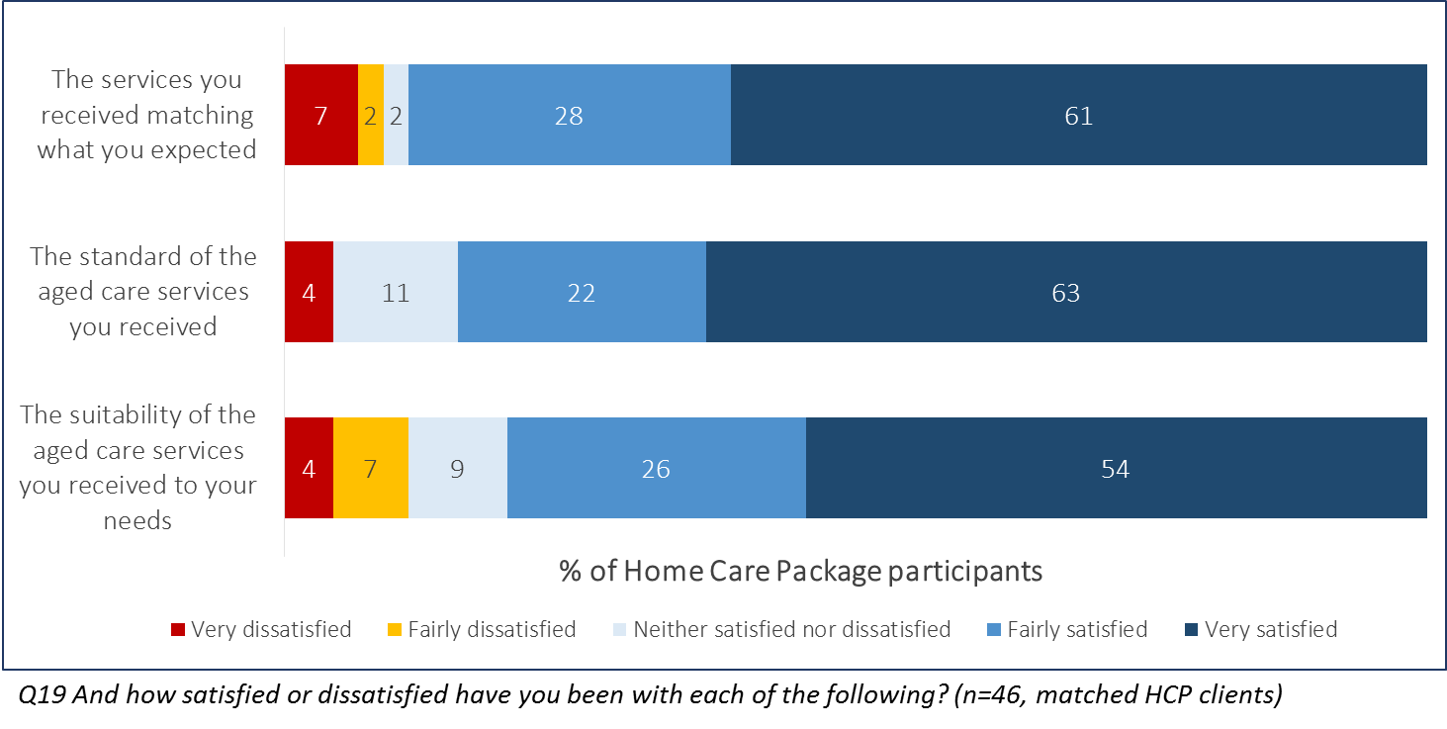***Figure 16: Satisfaction with aspects of Home Care Package service***

* Domestic support was the most common type of service received, reported by almost all (88%) of those saying they receive a service. Transport was next at 45%, with no other individual service type mentioned by more than a third.
* Level 3 & 4 package respondents, carers, and males were significantly more likely to report that the person in care, whether themselves or another, received personal support e.g. help with showering and dressing.
* Those in the younger age groups were more likely to receive domestic support in their package than older consumers (96% of those aged 70-74 vs. 87% of 80+).

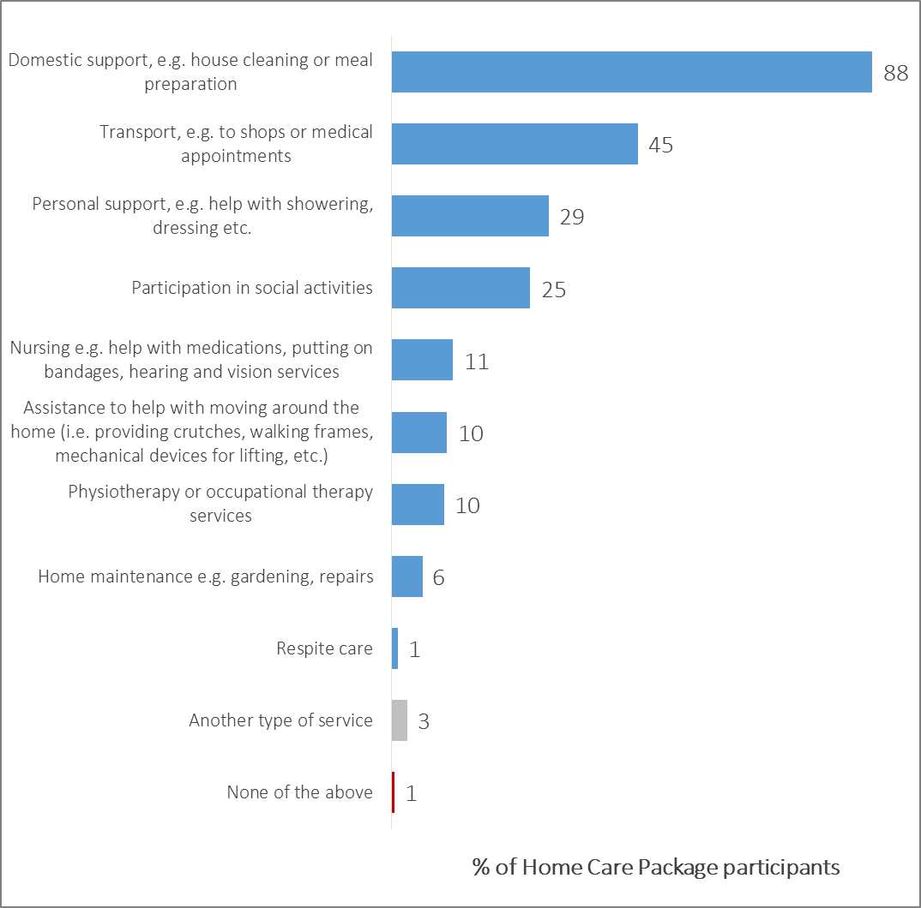***Figure 17: Services received in Home Care Package***

*Q12. Which of the following services [do you/does the person] receive as part of [your/their] Home Care Package? (N=177)*

Participants were surveyed on the frequency of their services received as part of their package.

* Assistance with movement at home (crutches, lifts, etc.) and personal support with washing and dressing were the most frequently received. More than one in three (36%) received personal support at least four times a week.
* Domestic support such as house cleaning, and physiotherapy or related services, were the least frequently-administered service among those receiving them, with under one in five receiving those services two to three days a week or more.
* Those in metropolitan areas tended to report higher frequencies of service than those in regional areas across most service types.

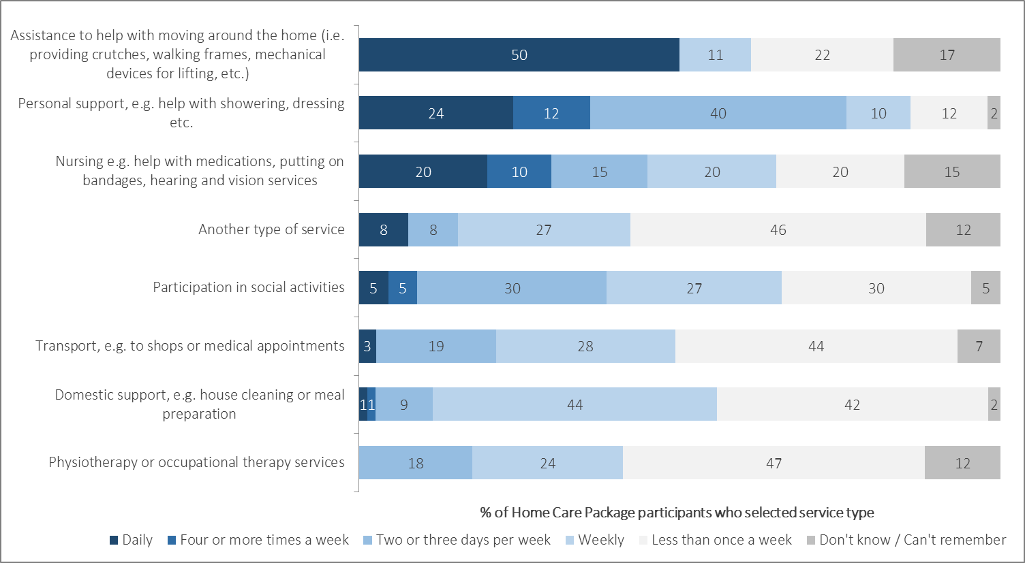***Figure 18: Satisfaction with services received in Home Care Package***

*Q13. How frequently do [you/they] receive those services? (N=17-156)*

Those who indicated their home care package services had begun were also asked of any other service types they had received while waiting. A total of n=41 respondents qualified for this question, and so its results should not be considered wholly representative of the home care package client cohort. Nevertheless, the high proportion not selecting any ‘other’ service is likely indicative of a lack of recognition of other program types.

* Just over half (54%) did not recall a specific program type, and another 17% did not know the name of the program they had received services through.
* A little over one in ten (12%) specifically recalled the receipt of CHSP services, and 10% received privately funded services.
* 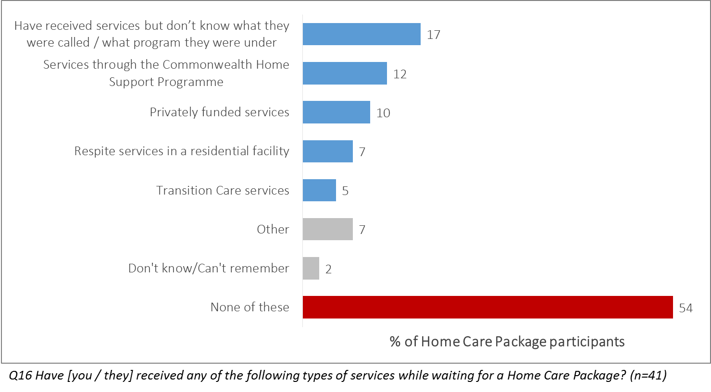One in four carers (25%) indicated that the person they care for had received respite services while waiting for a home care package, compared to only 3% of recipients recalling this. This may be a reflection of the lower level of frailty among care recipients who were able to respond to the survey themselves, rather than their carer responding on their behalf.

***Figure 19: Other services received while awaiting a Home Care Package***

* Of all the service types cited by participants, domestic support was cited as the most valued service by those receiving it (41%), followed by the personal support received mainly by older and higher-Level clients (12%).
* Around one in four did not value any specific services in their package over another (24%).
* Lower-Level participants were significantly more likely to most value domestic support (51%) and transport assistance (11%).
* Domestic support was more likely to be most valued by those in Victoria (52%), transport by those in NSW (12%), and social support by those in Queensland (12%).

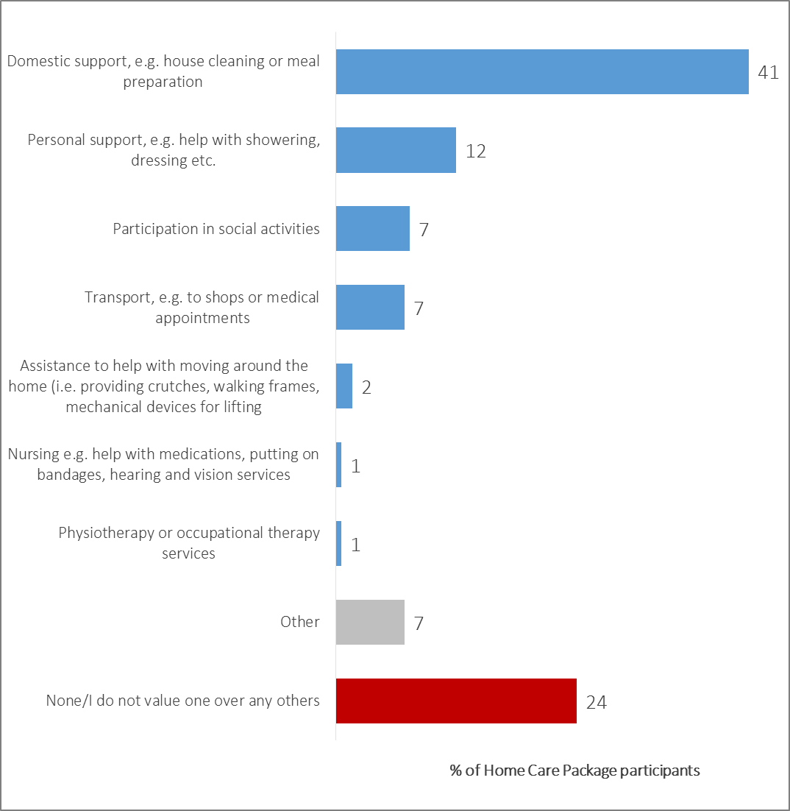***Figure 20: Most valued aspects of Home Care Package service***

*Q14.Which of the types of services that [you/they] receive would you say [you/they] value the most? (N=177)*

### Consumer Perceptions of the Queue for Services

* Those who were still waiting for a service were most likely to report asking someone they knew what to do to arrange services as a next step (29%), although half (50%) had not taken any further action.

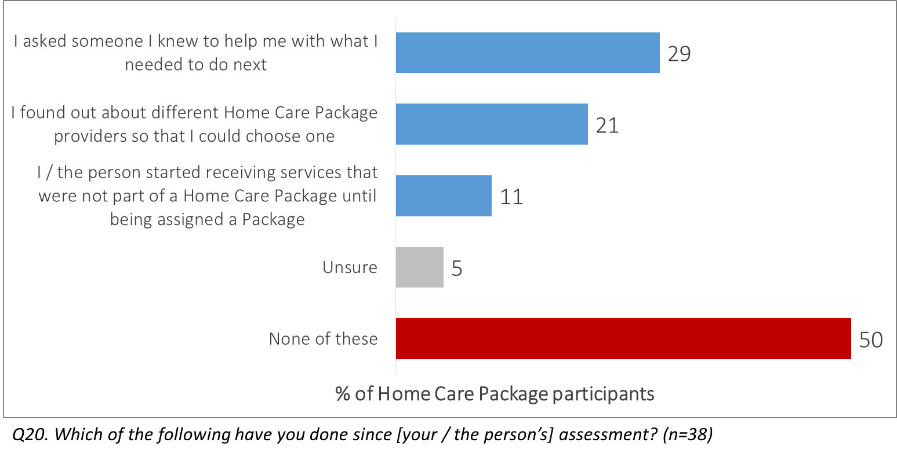***Figure 21: Participant experience post-assessment (service not received)***

* Of the small number receiving alternative services since their assessment, these were mostly either privately funded and CHSP services.
* Most of the small subsample (n=8) who had been assigned but were not yet receiving a package indicated that they had decided not to pursue services any further because they felt they were not needed – but evidently, they had not formally notified My Aged Care of their decision.

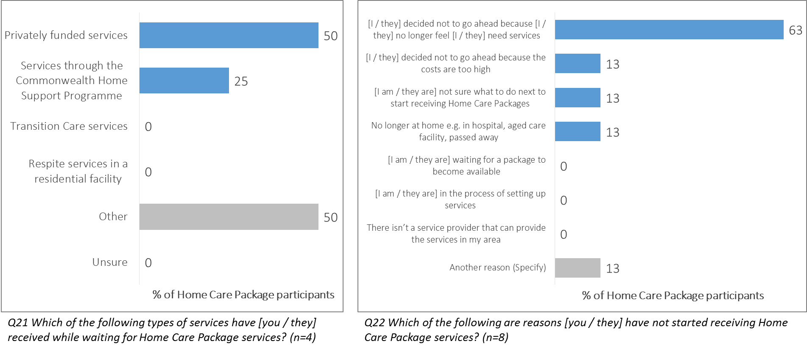***Figure 22: Alternative outcomes among participants not yet receiving services***

### **Funding and Satisfaction**

Questions around package funding were filtered to include only results from those verified to be in receipt of services.

* More than half felt they were aware of the allocation of their package funding to actual service administration, with higher proportions in South Australia (70%), amongst males (64%), and in metropolitan areas (59%).

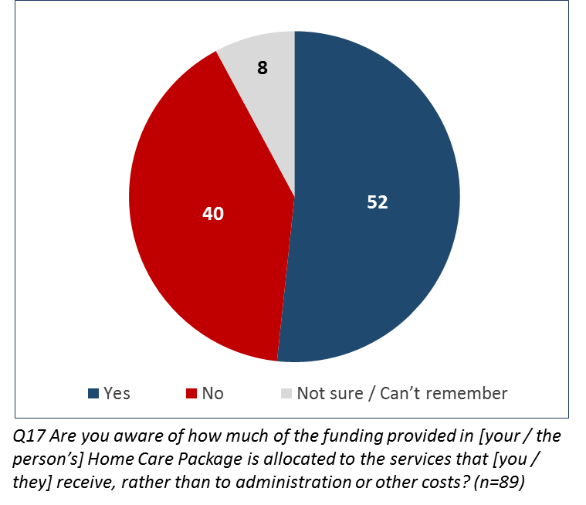***Figure 23: Participant awareness of Home Care Package funding***

* There was broad satisfaction with the funding allocation, with 65% indicating some satisfaction and only one in four (24%) being dissatisfied.
* Females (75%), those in regional areas (76%), and those whose services started before February 27th (76%) were somewhat more likely to indicate satisfaction.
* 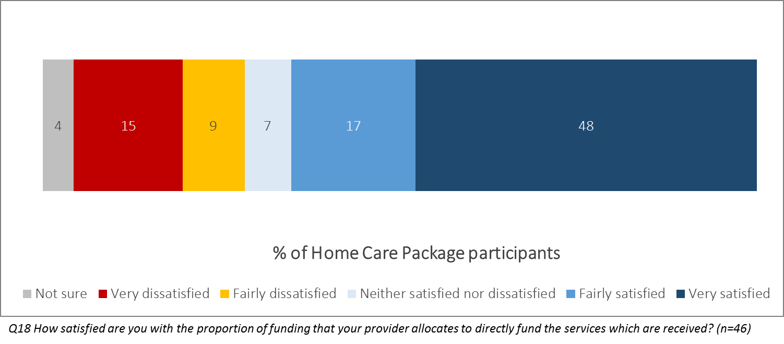Satisfaction with funding allocation reported somewhat lower results for this research when compared with the self-identified (non-verified) sample of home care package participants in Wave 2. At that time, 83% of care recipients and 64% of carers were positive, compared to 65% overall now. The figure from this dedicated home care packages research should be used as a more reliable baseline.

***Figure 24: Participant satisfaction with Home Care Package funding***

### Provider Satisfaction with Aspects of Increasing Choice in Home Care Reforms

Providers’ views on the prompted aspects of information and support provided since the changes were varied. A majority were satisfied with the ease of actioning a referral once a client is assigned a package (60%), and with the information provided by the Department in the lead-up to February 27th (58%). The majority of providers were also positive about the process of becoming an Approved Provider.

However, satisfaction with how My Aged Care has been able to answer questions about the reforms (36%), the ease of actioning package upgrades for existing clients (32%), and the volume of new referrals from consumers (28%) was low.

* Government-managed organisations were significantly more likely to have been satisfied with the Approved Provider process (62%), and also generally recorded higher satisfaction for most other statements.
* Providers that offered packages prior to February 27th were typically more satisfied with aspects of the reforms, including being more satisfied with the information they had received beforehand (62%).
* Providers offering services in NSW tended to rate each measure lower than those in other jurisdictions.

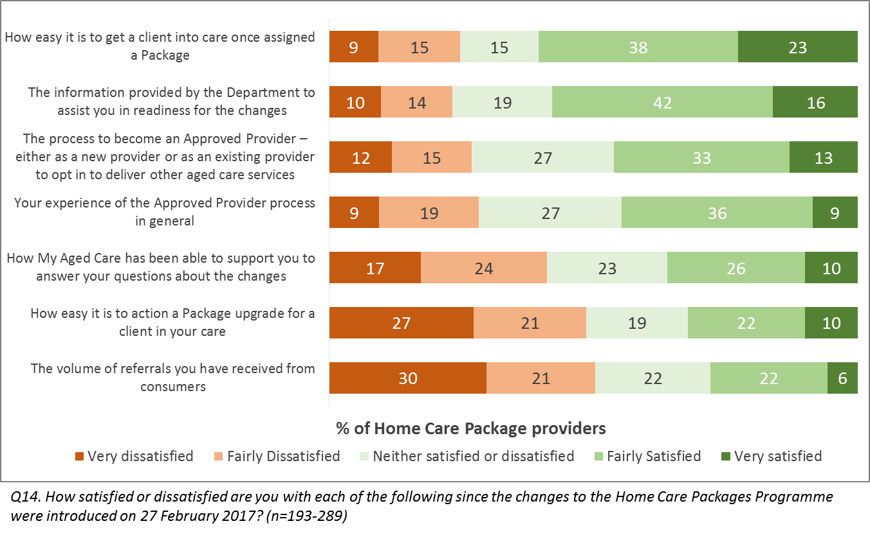***Figure 25: Provider satisfaction with aspects of changes to the Programme***

Specific analysis was undertaken for the measure related to ‘the process to become an Approved Provider’. Those whose other answers suggested they were a newly Approved Provider were split out from those who were previously delivering other care types.

* Those representing providers who were previously delivering aged care were less likely to be dissatisfied with the process of becoming an Approved Provider of home care packages (24% vs. 43% of new applicants), despite similar levels of positive ratings.



## Changes to the Home Care Package Program



### Awareness of the Reforms

* More than one in three consumers were confident that they had heard of the Increasing Choice in Home Care reforms (35%), with a little under half in total (47%) giving a positive response. Slightly fewer participants (43%) had not heard of the reforms at all.
* There was significantly higher overall awareness among those in metro areas (55%) than those in regional locations (40%).
* Those who had already started their services (60%), especially those who had done so before February 27th (64%) were also more likely to know about the reforms.
* The small cohort of carers were also more likely to be aware of the reforms (63%).

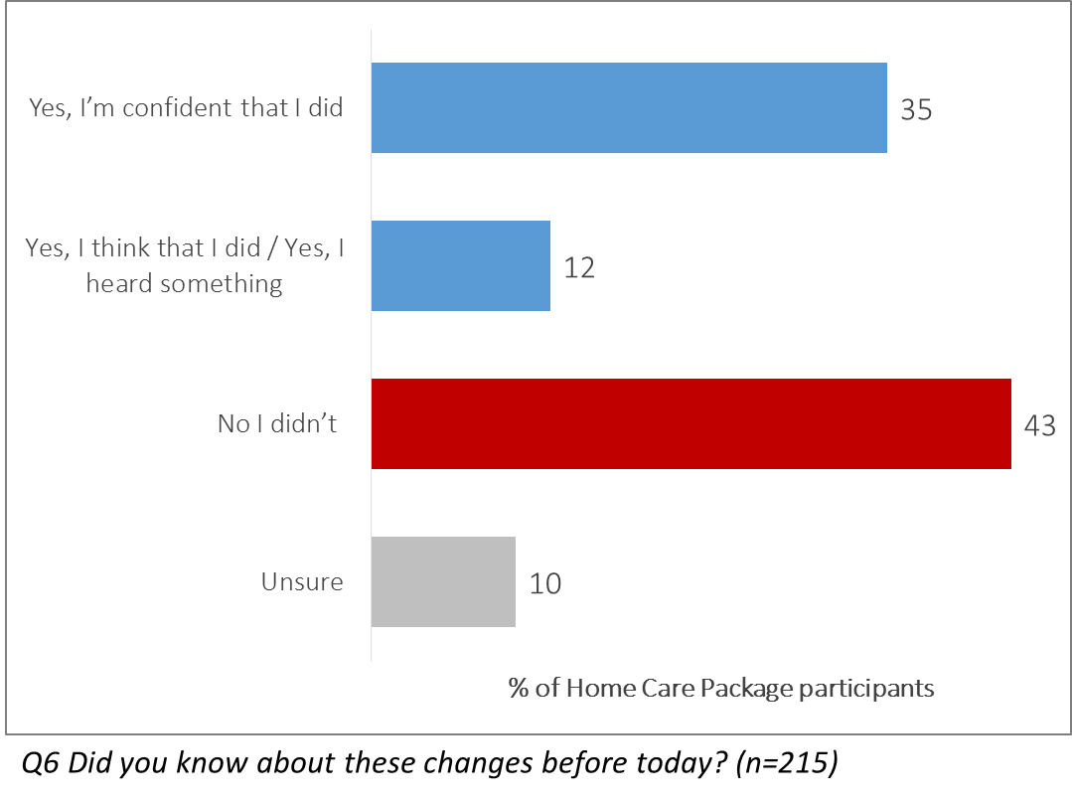***Figure 26: Participant awareness of Increasing Choice reforms***

* The majority of those aware of the reforms had heard via a letter from My Aged Care (60%).
* Being told face-to-face by a service provider (30%) or assessor (27%) was also a common way for existing clients to hear about the Increasing Choice in Home Care reforms.
* Males (79%), those assigned a package but not yet receiving services(80%) and carers (82%) were all significantly more likely to have seen the letter informing them of the changes.
* There were no major differences in means of awareness by package level, time of assessment or location.

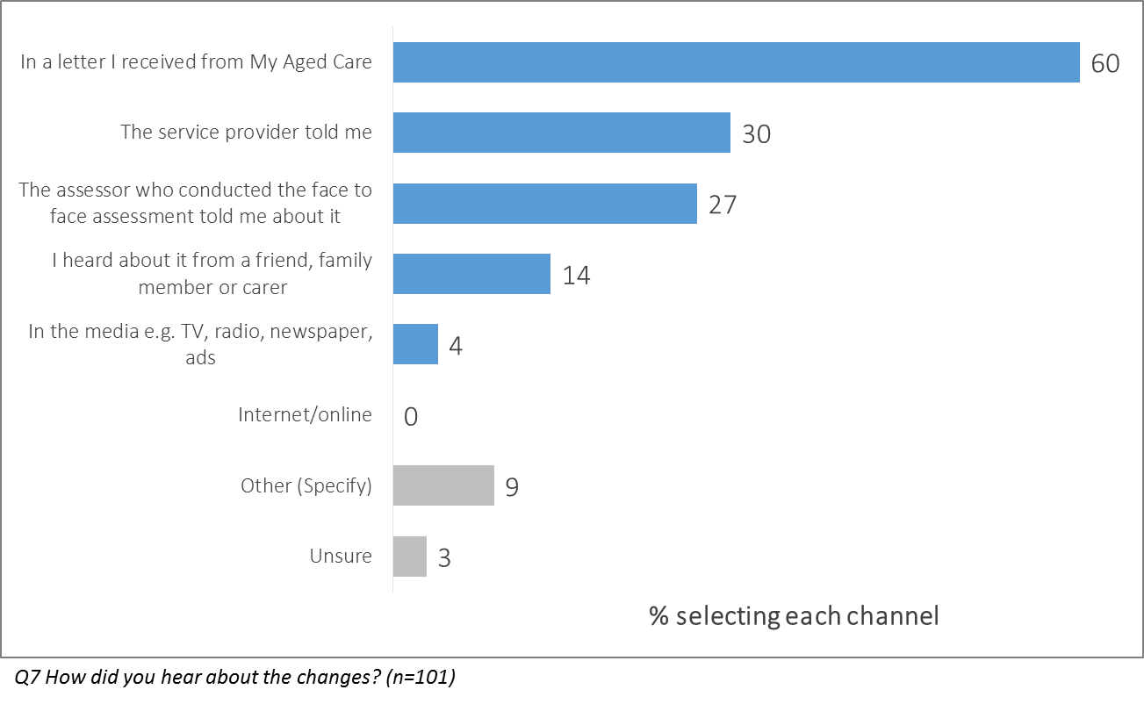***Figure 27: Participant means of awareness of Increasing Choice reforms***

### Consumer views on the Reforms

Home Care Package participants tended to agree with statements relating to the benefits of the reforms. However, each statement also recorded at least 18% ‘unsure’ responses, indicating that around 1 in 5 consumers did not know what the Increasing Choice in Home Care reforms meant for them.

In total, 68% agreed that the reforms would make moving to a new provider easier, with only 9% in disagreement. Statements related to choice of, and control over, providers also received a majority of positive responses. Respondents were less sure that ‘there is now a fairer way of allocating home care packages across Australia’ (48% agree, 9% disagree) and that ‘the costs of receiving services will be reduced’ (34% agree, 25% disagree).

* Those in NSW were generally less likely to agree with the statements, and significantly less likely to believe there would now be a better choice of providers (41%).
* The oldest subgroup, aged 80+, were significantly more likely than others to agree that provider choice in their area would now be better (70%).
* Those assessed prior to February 27th and those who had started receiving services were more likely to agree with each statement, with those still in the queue less likely to do so.

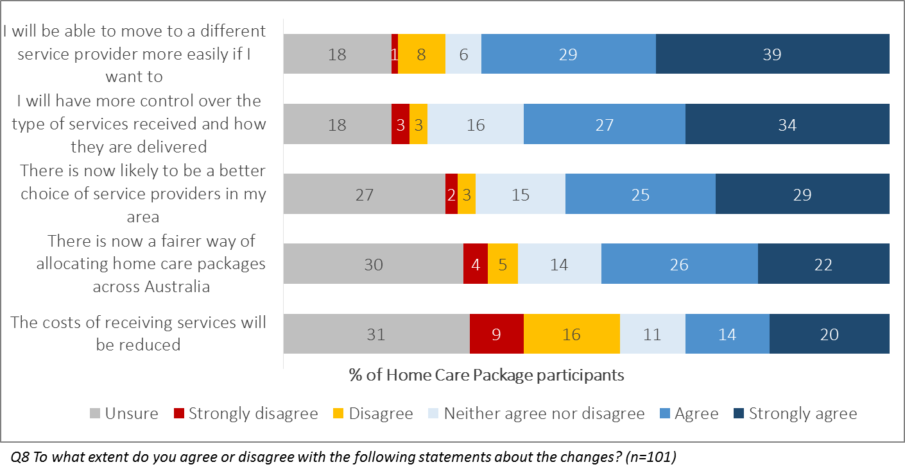***Figure 28: Participant agreement with statements on the Increasing Choice reforms***

### Provider Views on the Reforms

Provider representatives tended to rate their organisation’s ability to adapt to aspects of the changes moderately well, with more than half believing that they had managed ‘the changes needed to the way staff interact with customers’ (64%), the changes to their ‘workforce or work model’ (59%), and ‘adapting systems and processes to the new model’ (58%) at least ‘fairly well’. One area recording notable dissatisfaction was in ‘attracting new clients through marketing activities’, where 26% felt their organisation had done so poorly versus 41% that felt the organisation had done this well.

* Results were generally higher amongst those from religious- or NFP-managed providers.
* Smaller providers with fewer than 20 employees were significantly less likely to believe they had adapted well to workforce changes (50%) and having to find other providers for subcontracting/brokerage/referral (39%).
* Existing home care package providers were again more positive than new providers across all measures except for the statement related to marketing capacity.
* Providers in Victoria reported more negative results across the board.

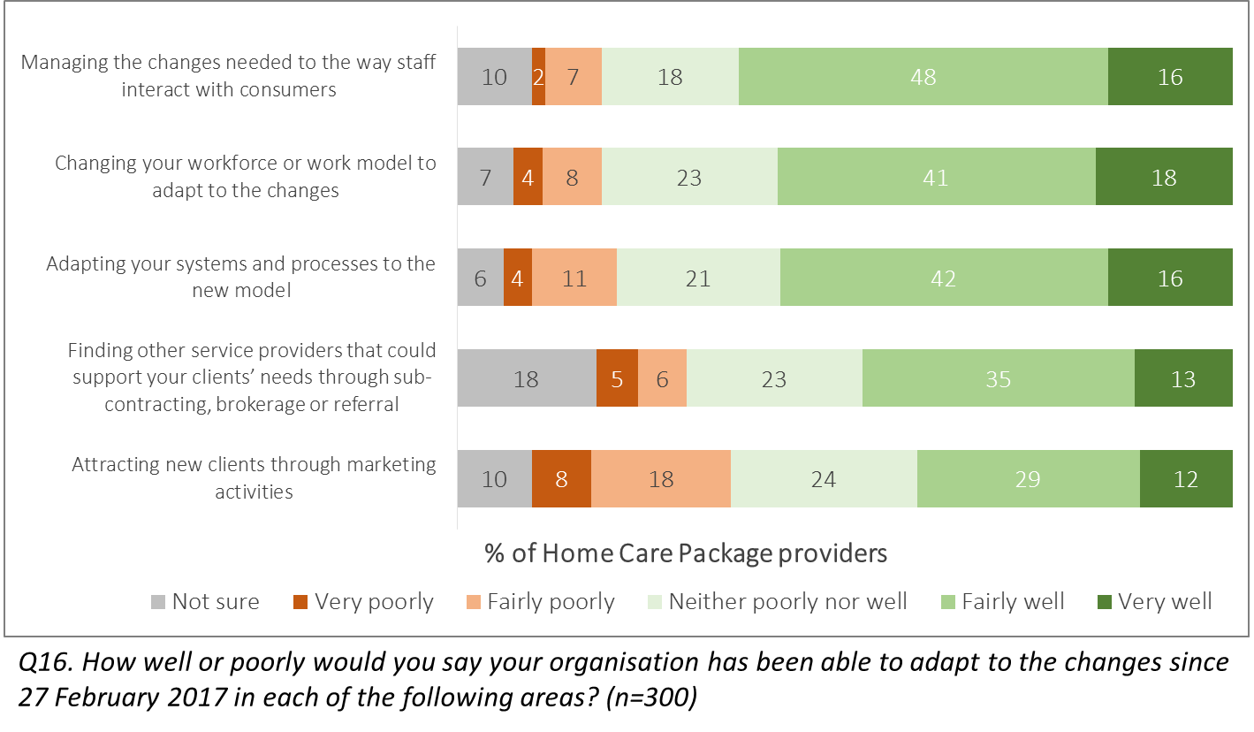***Figure 29: Provider views on their adaptation to Increasing Choice reforms***

### Likelihood of changing provider

Very few consumer respondents indicated they would be likely to change their provider: 4% were ‘very likely’ and 3% ‘quite likely’ to do so, and a majority (58%) were not at all likely.

* There were no major subgroup differences in likelihood of changing provider, with very similar results recorded across metro/regional residents, carers versus recipients, and package Levels.
* Those in Queensland were a little more likely to consider changing (10% of all respondents in that state), as well as females (8% vs. 4% of males) and those whose services started before February 27th (12%).
* The reported likelihood of changing providers was lower among this verified sample than it had been when surveyed in Wave 2. At that time 12% of care recipients and 9% of carers had indicated likelihood of doing so.

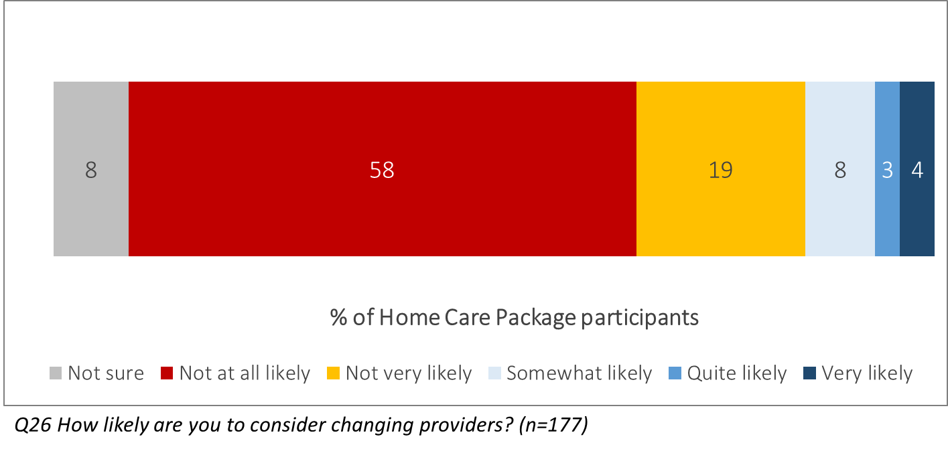***Figure 30: Participant likelihood of changing provider***

### Reasons for Changing or Not Changing Provider

Satisfaction with the services received (85%) and the staff administering them (75%) were the major reasons cited by those not wanting to change provider.

* Those receiving higher-level Packages (3 or 4) were significantly more likely to mention their positive views of the staff providing their services (86%).
* Regional residents were significantly more likely to feel that there are no other providers in their area that can service their needs (26%).

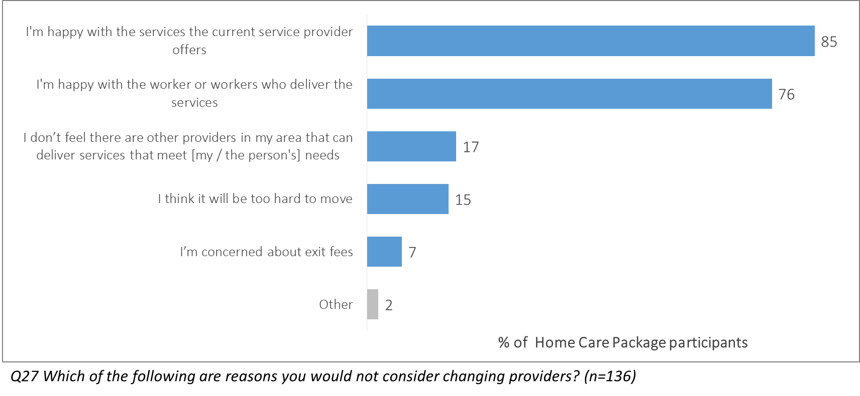***Figure 31: Particpant reasons for not considering changing provider***

Among the few respondents considering changing provider, a lack of satisfaction with the quality of services (50%) and provider staff (46%) were the main reasons for doing so.

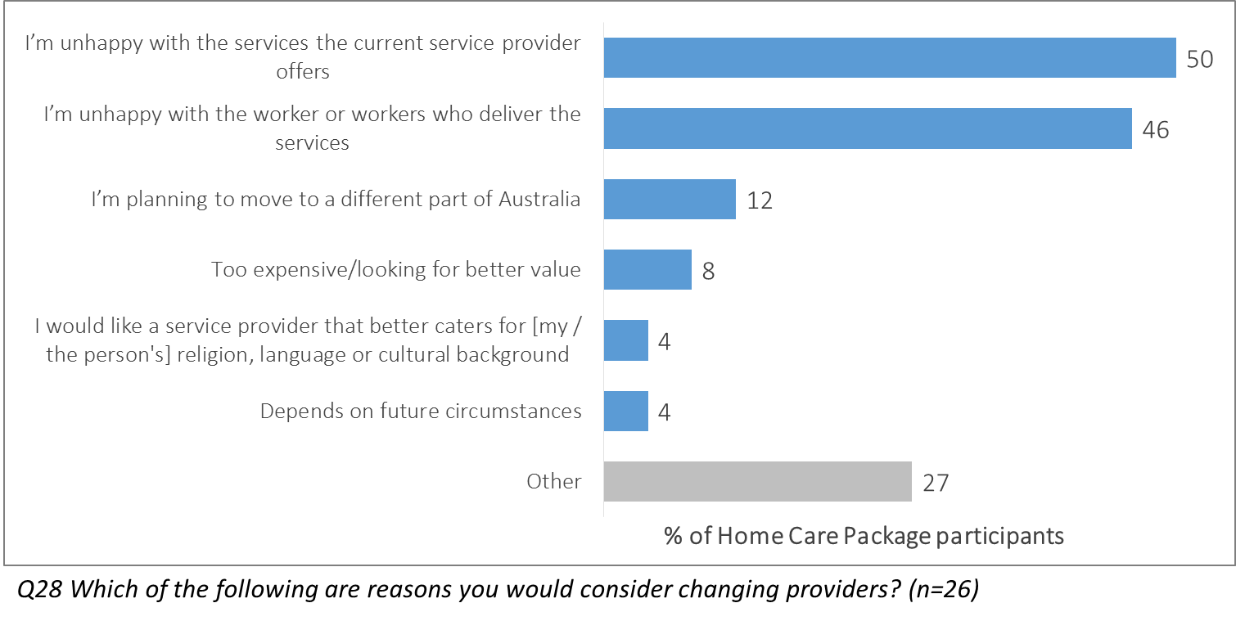Figure : Participant reasons for considering changing provider

### Provider Experience of Client Service Changes

Half of all provider employees surveyed did not think any clients had transferred their services to another provider since February 27th (50%); most of the remainder believed that less than 2% had done so (31%).

* When inferring an average percentage based on the prompted options, it appeared that government-managed providers were significantly less likely to report clients changing services (56% saying zero had done so, an estimated proportion <1%).
* This analysis also suggested that those working at a large provider with more than 200 staff and those offering packages in Major Cities were most likely to report clients changing their provider (33% and 40% saying none had done so respectively).

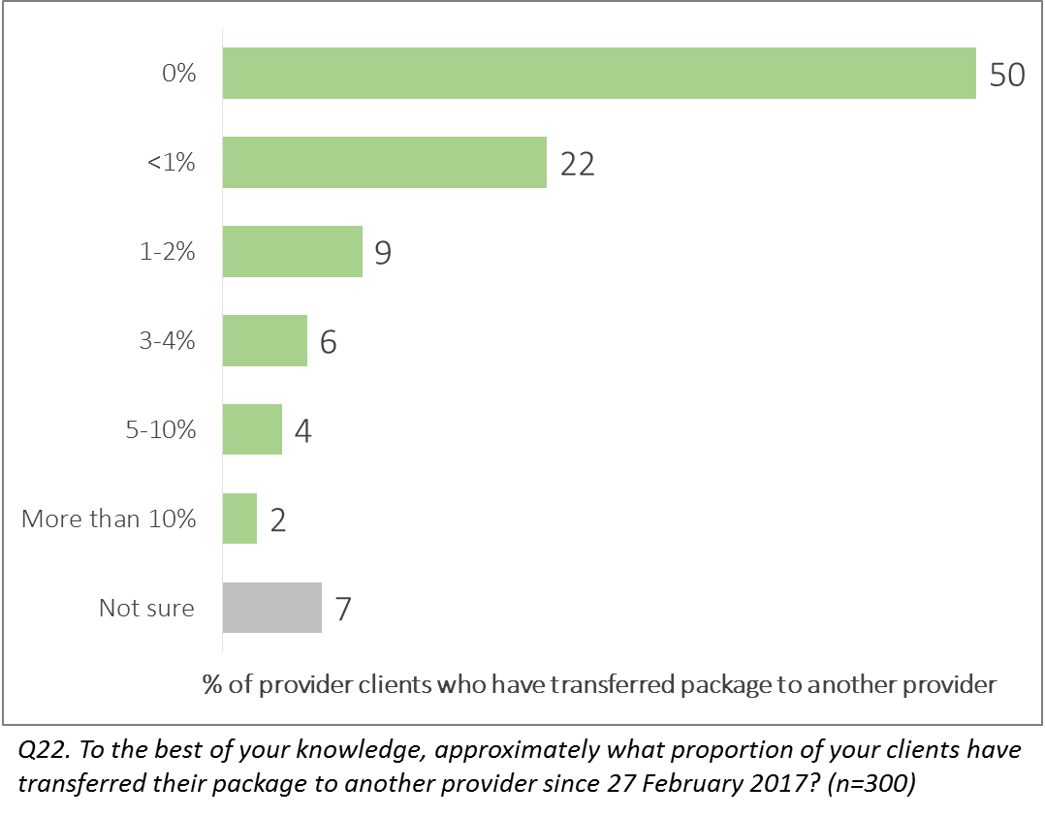***Figure 33: Providers’ perceptions of incidence of clients changing provider***

Provider employees were also surveyed on the experience of administering services to clients who had been upgraded to a higher level package from the same provider rather than transferring from another. More than three in five (64%) reported that this process was easy, and in total only 9% disagreed and felt it was difficult.

* Those representing providers with more than 200 employees (83%), those in Inner Regional areas (73%), those already offering packages prior to the reforms (72%), and those managed by a NFP or religious group (70%) all recorded significantly higher levels of ease than other groups.
* Results were consistent by state, service types (other than home care packages) offered, and level of seniority of respondent.

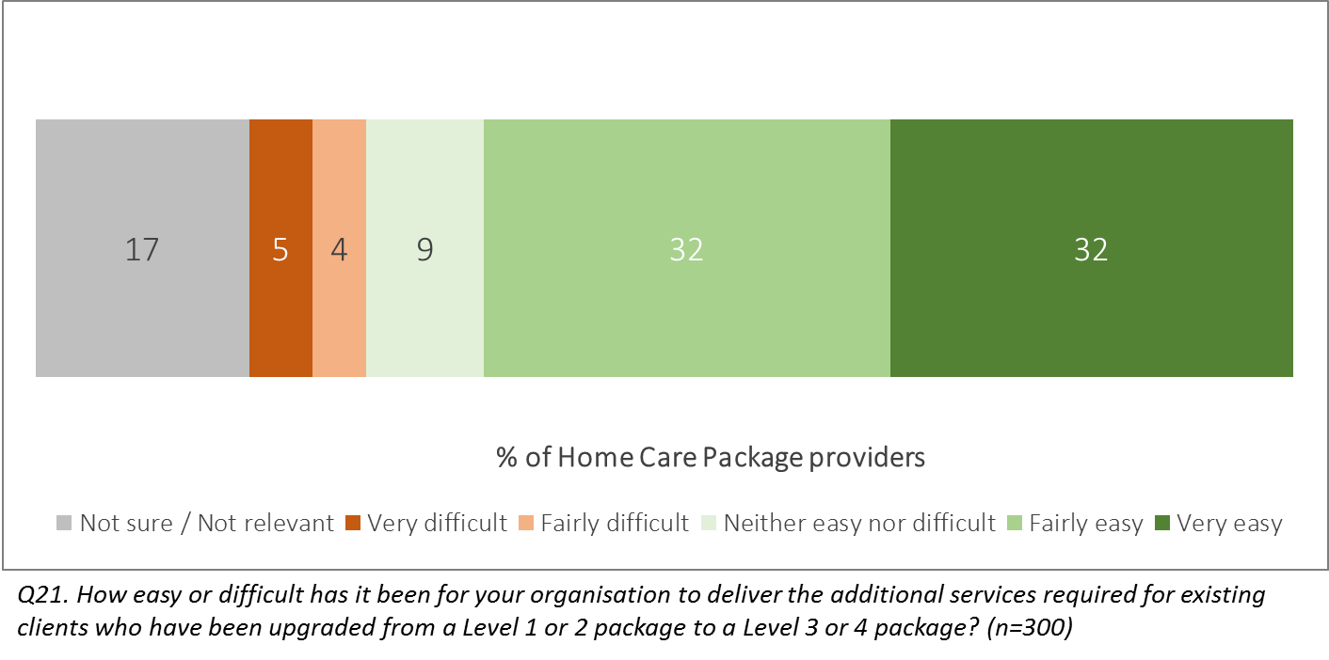***Figure 34: Provider ease of delivering services to upgraded-Package client***



## Provider Choices After the Reforms



### Choosing and Arranging a Provider

Home care package consumers agreed that the provider they had selected had been available (83%) and appropriate to their needs (76%). A smaller majority agreed that My Aged Care had assisted them in finding the provider (62%, with 21% disagreeing).

* Results were generally steady across respondents’ package level and progress through package process, location and age.
* It should be noted that those who started receiving services after February 27th were very likely to agree that their service was available/did not require them to wait too long (90%).
* The measures related to the availability of a provider and their capacity to meet care needs recorded similar results to those recorded amongst participants across the My Aged Care system in Wave 2. At that time:
* 82% of recipients and 77% of carers agreed that the provider was available and didn’t require a long wait time, versus 83% of those surveyed in this research.
* 84% of recipients and 80% of carers agreed that the provider could meet the recipient’s needs, with 76% agreeing in this targeted research.

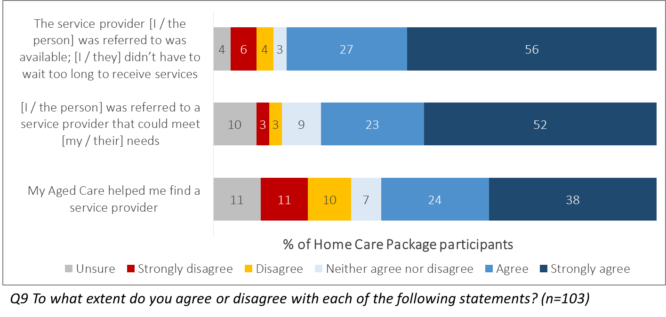***Figure 35: Participant agreement with statements regarding selecting a provider***

Almost three in four respondents (74%) indicated satisfaction with how long they had to wait to be assigned a package, with 11% who were dissatisfied. While fewer respondents, around two in three (65%), were happy with how long they had to make a decision on a provider, more than a fifth couldn’t recall or otherwise didn’t answer: only 5% were dissatisfied.

* Carers and male respondents were more satisfied with both measures.
* 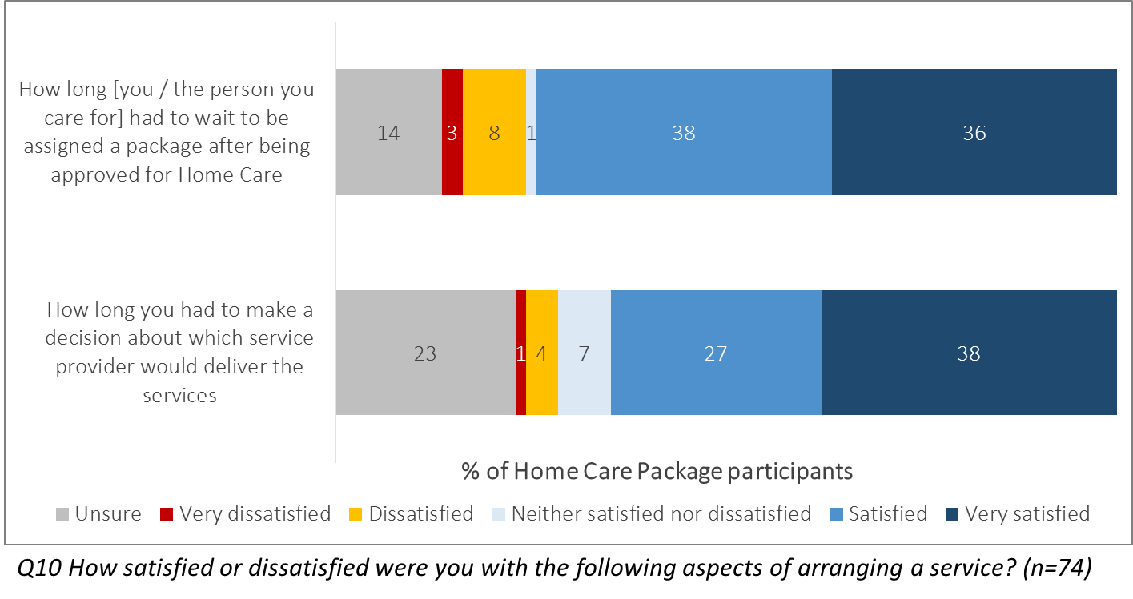There were no major differences based on Package progress or timeline.

***Figure 36: Participant satisfaction with aspects of arranging a provider***

Provider choice was most commonly motivated by personal recommendations and practicality, with a little under half of respondents citing word-of-mouth (49%) and the availability of services locally (46%). Broadly, all of the prompted reasons were selected by at least 20% of participants, confirming the importance of each aspect of Package offerings.

* Males were significantly more likely to have relied on a recommendation than females (76% vs. 40%).
* The availability of services locally was more likely to have informed the decision for those starting to receive services before February 27th (80%) and those in metro areas (61%).
* Respondents aged over 80 were significantly more likely to have been influenced by the range of services that was offered (60%).

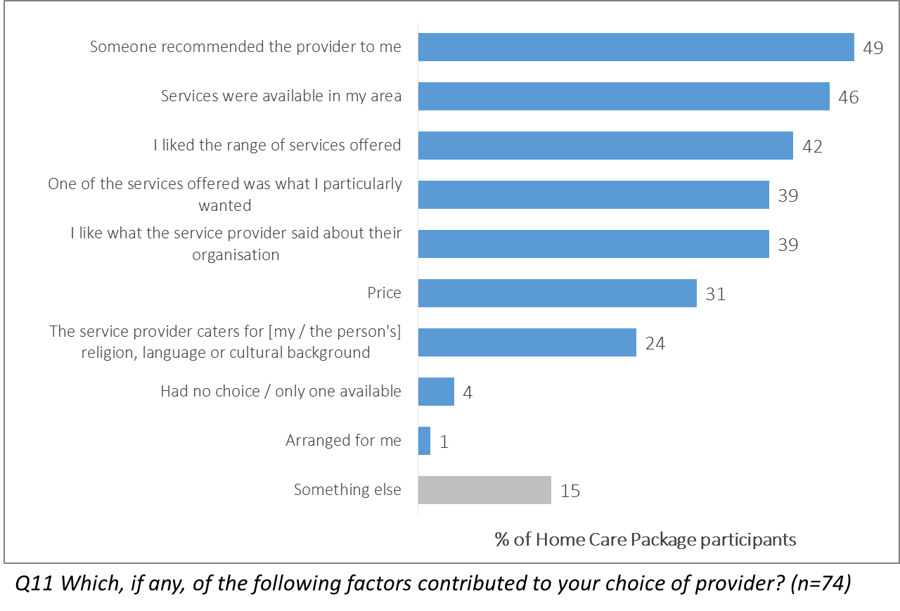***Figure 37: Factors contributing to provider choice***

### Support to Set Up Services

More than two thirds of respondents were satisfied with the information they had received to help them set up services (67%), and only 14% indicated any dissatisfaction. Similarly, 63% were happy with the information available on how to arrange more time to choose a provider.

* Those starting to receive service after February 27th were more likely to be satisfied with each measure (74% & 68% respectively).
* Higher-Level package recipients were less satisfied with both measures: in particular, only 52% those with a Level 3 or 4 package were satisfied with the information they received about extra time to choose a provider.
* Males and those in regional areas were also more satisfied on both counts.

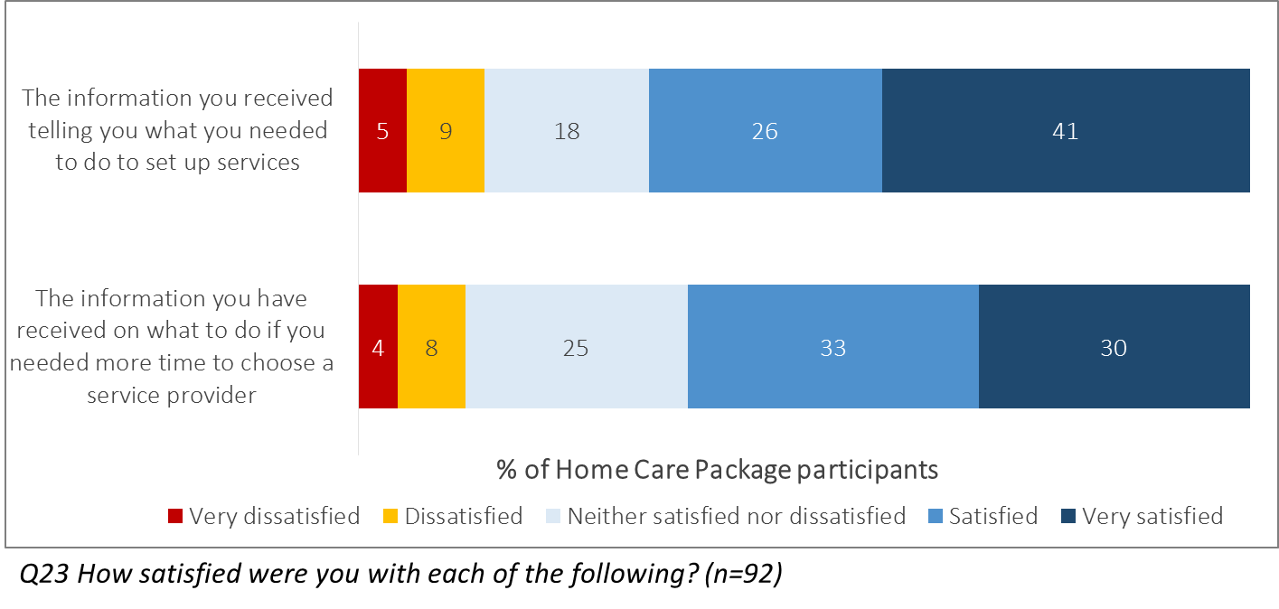***Figure 38: Participant satisfaction with information received to support setting up services***

### Resources Used to Assist in setting up services

Close to half of consumer participants reported using the My Aged Care Contact Centre (49%), a printed brochure/booklet (48%), and information from a service provider (43%) to help them understand setting up services.

* Use of resources was quite consistent across package types and progress as well as location and gender.
* However, carers were significantly more likely to have used the checklists (54%) and the online service finder tool (31%).

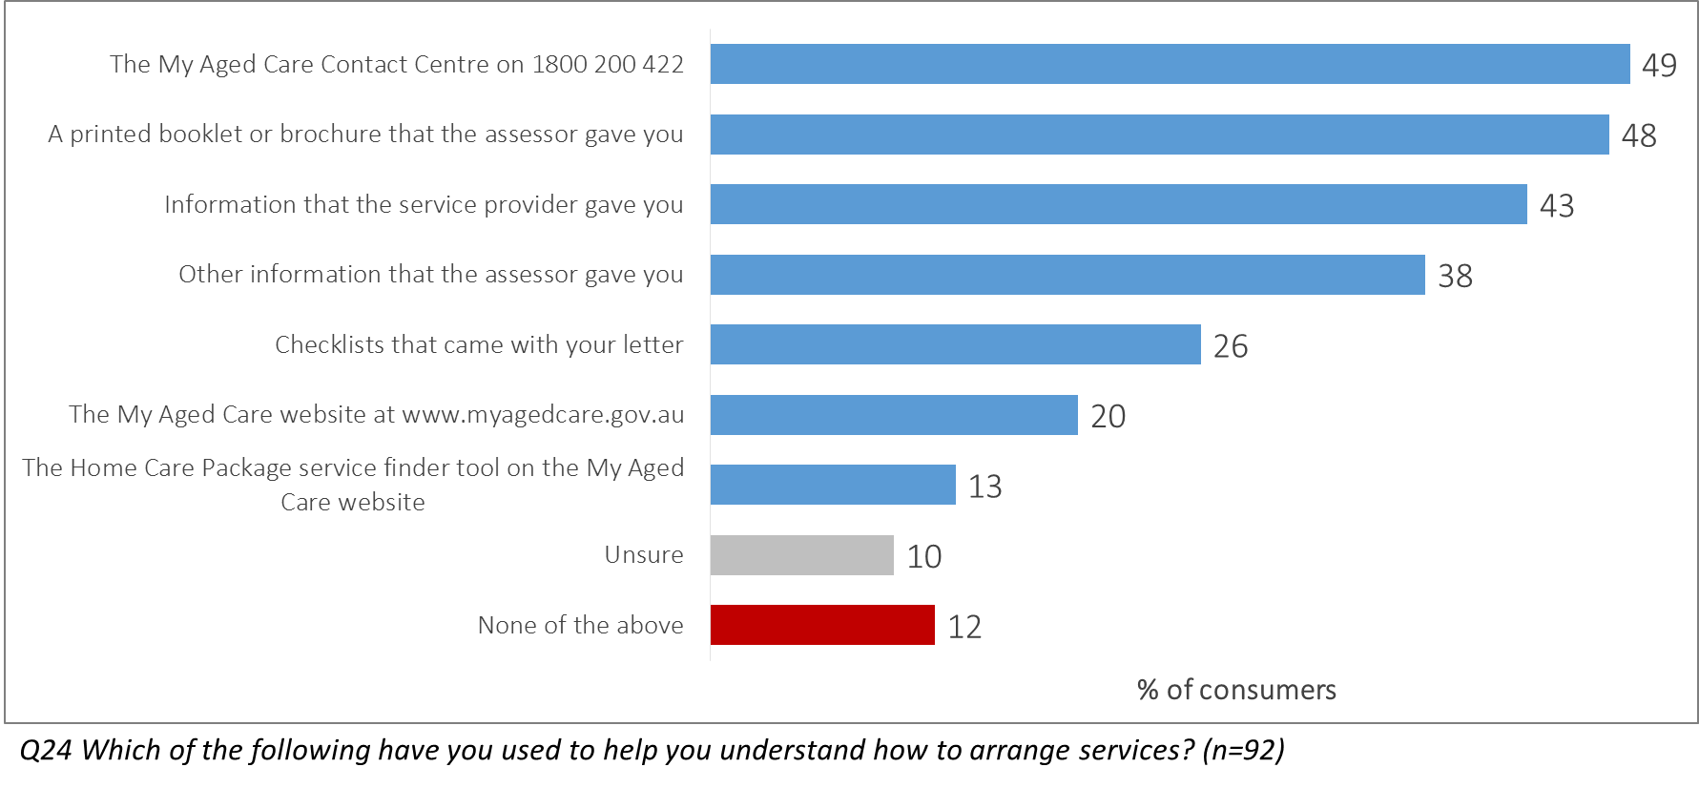***Figure 39: Resources used to assist in setting up services***

Among those using each resource to assist them, information given by a person directly was seen as the most useful: 93% of those hearing from a service provider were satisfied with the information they received, as well as 87% of those calling the My Aged Care Contact Centre. Generally, information was well received, with over two thirds of respondents expressing satisfaction with all resources.

* All of those in regional areas who sought information from a service provider were happy with what they received.
* Among those who used the checklists, all of those who had already started receiving services had been happy with these.

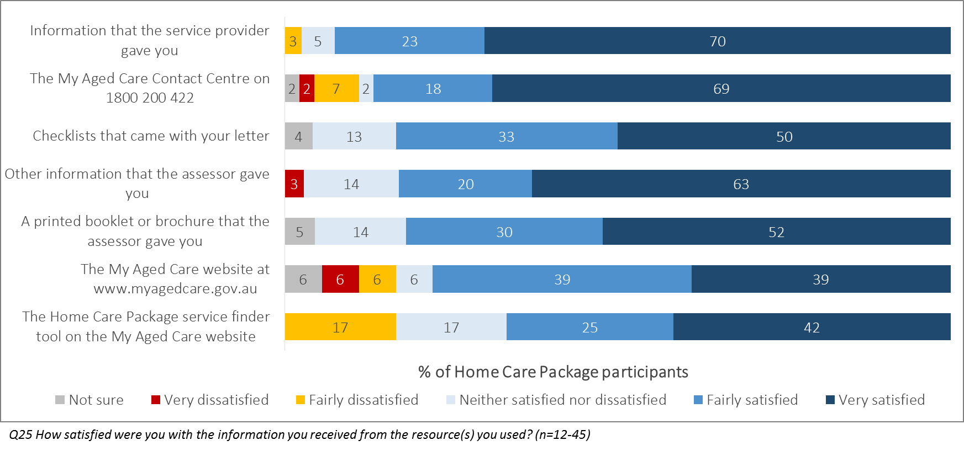***Figure 40: Satisfaction with resources used to assist in setting up services***



## Changes in Provider Business Model

Increases in the use of casual and subcontracted staff were reported by 53% and 40% of provider employees respectively. Overall only 3% of respondents believed there had been no workforce or work model changes for their organisation as a result of the Increasing Choice in Home Care reforms.

* Larger organisations were significantly more likely to report changes to their employment model in general, most notably in terms of increased use of subcontracting (53%). Those already offering packages before the reforms were also more likely to report this change (45% vs. 28% of new providers).
* The reported increase in casual employment, on the other hand, was steady across provider types, sizes, funding models and locations.

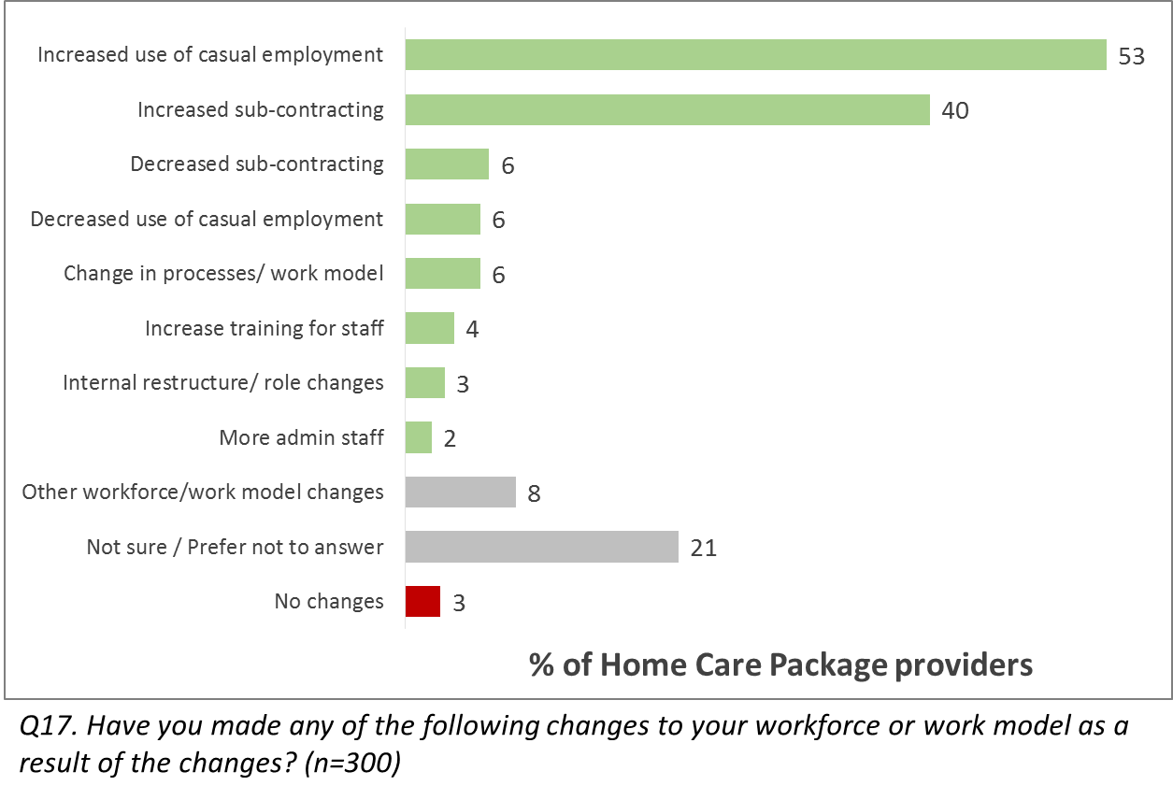***Figure 41: Changes in employment model reported by providers***

The majority of respondents reported considering offering packages in new locations (59%), and that their organisation had begun to offer packages at a different level since the reforms (61%)

* New locations were significantly more likely to be considered by those in the largest provider organisations (71%), those in Major Cities (70%), and those in South Australia (77%).
* Packages were more likely to be offered at a new level by those in the largest organisations (72%), those funded by a NFP/religious body (70%), and those offering packages prior to February 27th (69%).

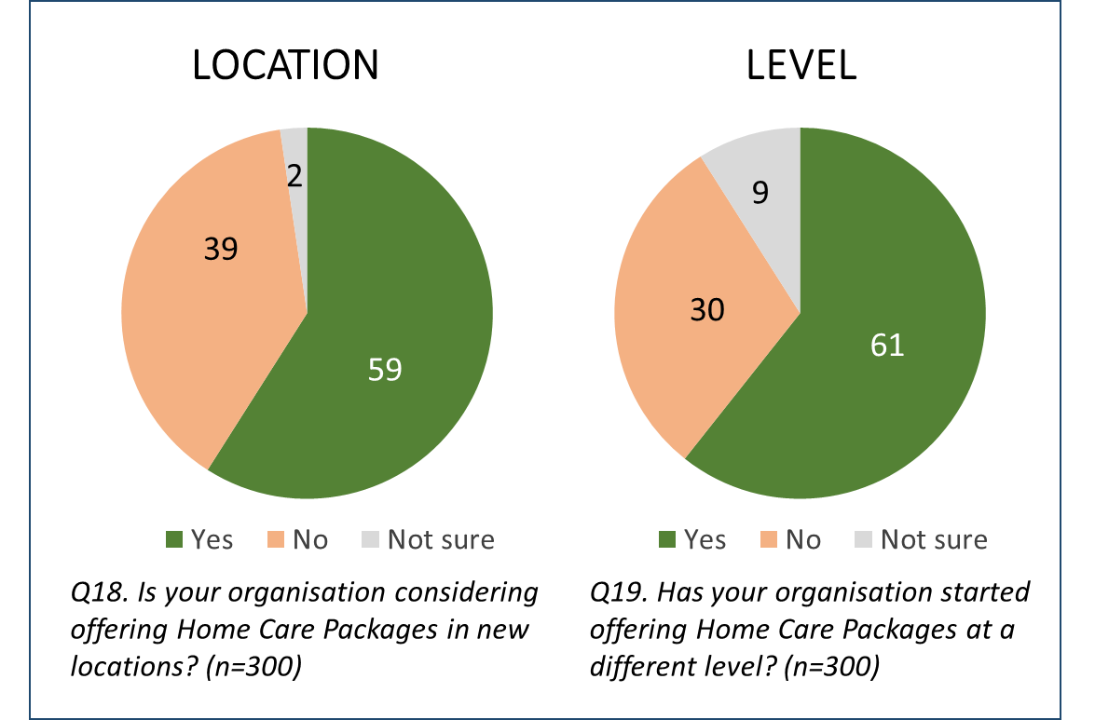***Figure 42: Providers’ projected changes to Package location and level***

More than four in five respondents (81%) indicated that they thought the number of packages offered by their organisation would increase in the next 12 months.

* Providers new to offering home care packages were almost universal in believing their package numbers would rise (94%), while those offering residential care places alongside their package complement were significantly less likely to say so (69%).

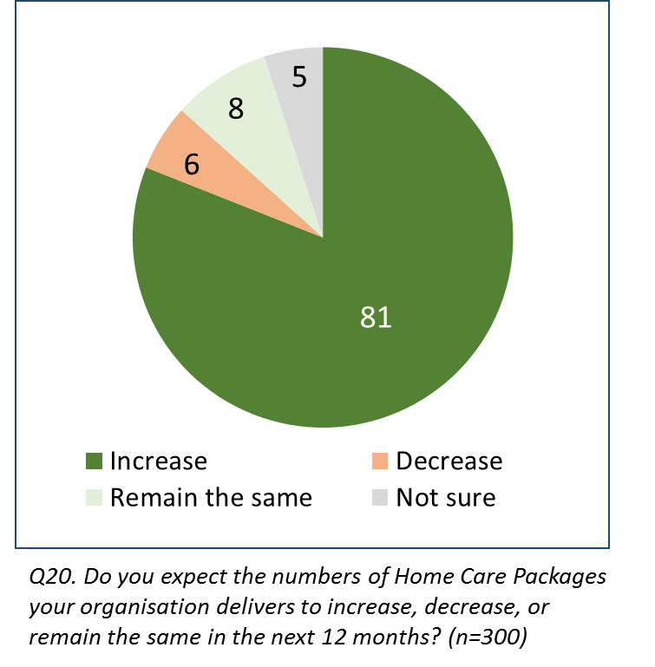***Figure 43: Providers’ projected changes to Package numbers***



## Views on the My Aged Care System



### Consumer Outcomes

A majority of consumers felt that each of the prompted outcomes of My Aged Care had been achieved at least ‘fairly well’, with the highest agreement that it ‘assists people to arrange aged care assessments’ (70%) and the lowest that it ‘provides accurate information on fees and charges’ (54%). No measure recorded more than 13% dissatisfaction.

* Consistently higher ratings were reported amongst those in Queensland, and lower amongst those in Victoria.
* Those whose services had started were significantly more likely to agree that My Aged Care provides information about fees and charges well (67%), with those assigned but not yet receiving a package less likely to do so (39%).
* Level 2 package consumers were significantly more likely to agree that My Aged Care generally helps people get the services they need (74%, versus 59% of Level 3/4 consumers).
* Higher agreement that My Aged Care worked well to achieve each measure was reported among those whose services had started before February 27th.
* The results of this research are similar to those reported in Wave 2 of the My Aged Care Evaluation, where a similar range of carers and recipients (53% to 73%) reported satisfaction across the range of prompted measures.

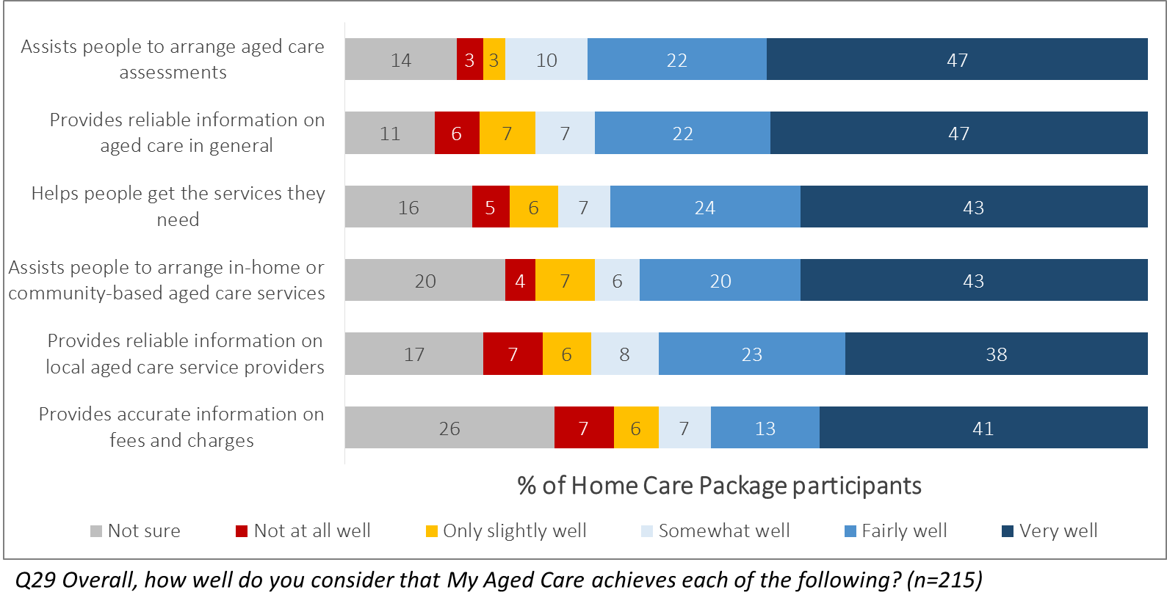***Figure 44: Participant ratings of performance of aspects of My Aged Care***

The calculation of a Net Promoter Score[1] (NPS) for My Aged Care as a whole resulted in a Score of +30, where a result above zero is considered good, indicates a high level of satisfaction with My Aged Care among clients.

* Comparing respondents by location, the NPS was highest among those in Queensland and Tasmania (+40), and those in metropolitan areas (+33), and lowest in the Australian Capital Territory (-13) and Victoria (+21).
* Carers (+19) and those approved for higher levels of care (Level 3 or 4, +23) were also less likely to recommend My Aged Care overall.
* The NPS recorded among care recipients in Wave 2 research was +40, and +37 among carers. Home care package consumers therefore recorded a similar likelihood of recommending My Aged Care as the system’s users on the whole.

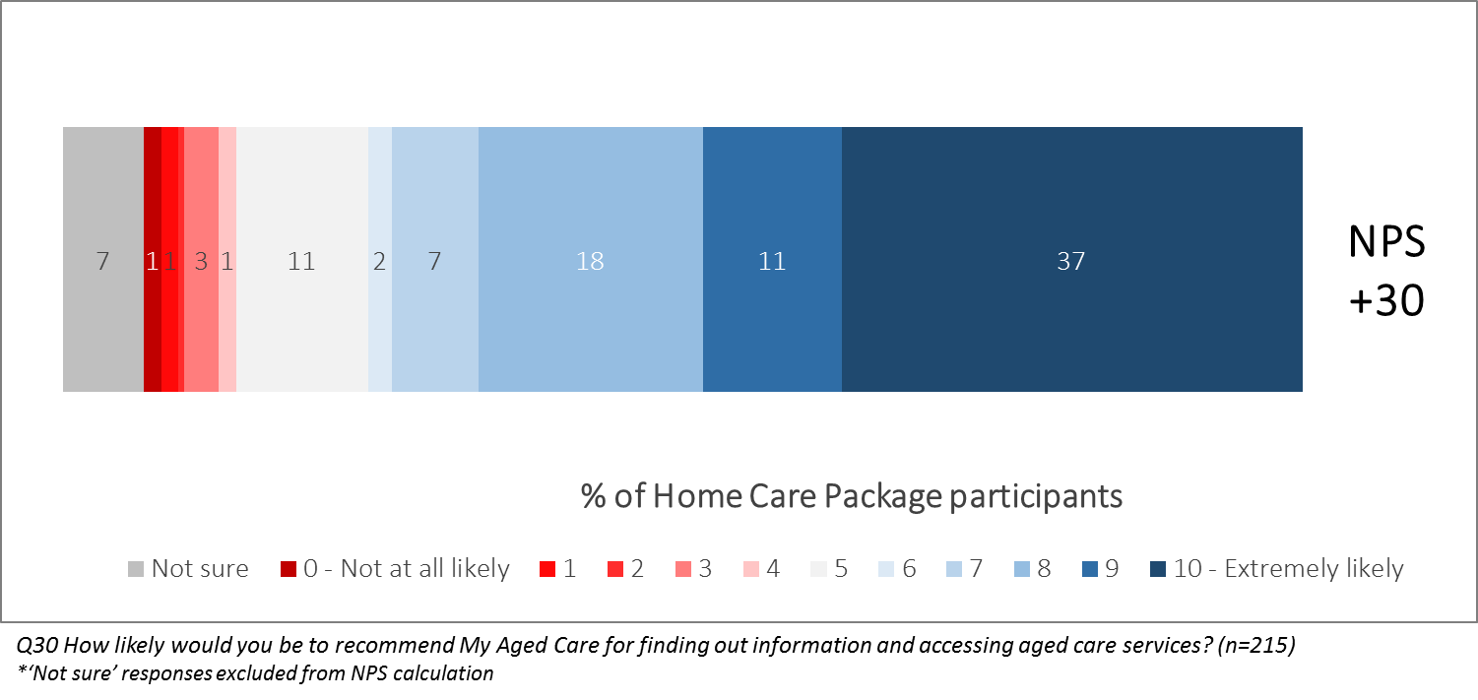***Figure 45: Participant likelihood of recommending My Aged Care (NPS)***

### Provider Perceptions

Overall, one in four provider representatives surveyed (25%) indicated that they were satisfied overall with how My Aged Care has supported their organisation to deliver services since the introduction of the Increasing Choice in Home Care reforms on February 27th, with a further 51% reporting some level of dissatisfaction.

* The key subgroup difference observed was that providers who had been offering home care packages before February 27th were significantly less satisfied on average (21% vs. 35% of new package providers).
* Government-managed providers reported the lowest level of satisfaction of any main subgroup at 19%.
* Satisfaction was consistent across provider size and location.
* Service providers offering home care packages were less satisfied with the overall support provided by My Aged Care than service providers across the system had been when surveyed prior to the Increasing Choice reforms as part of Wave 2. At that time 39% had indicated satisfaction, including 47% of home care package providers.
* However, the 25% satisfaction reported still represents an improvement on the 20% recorded in Wave 1 in 2016.

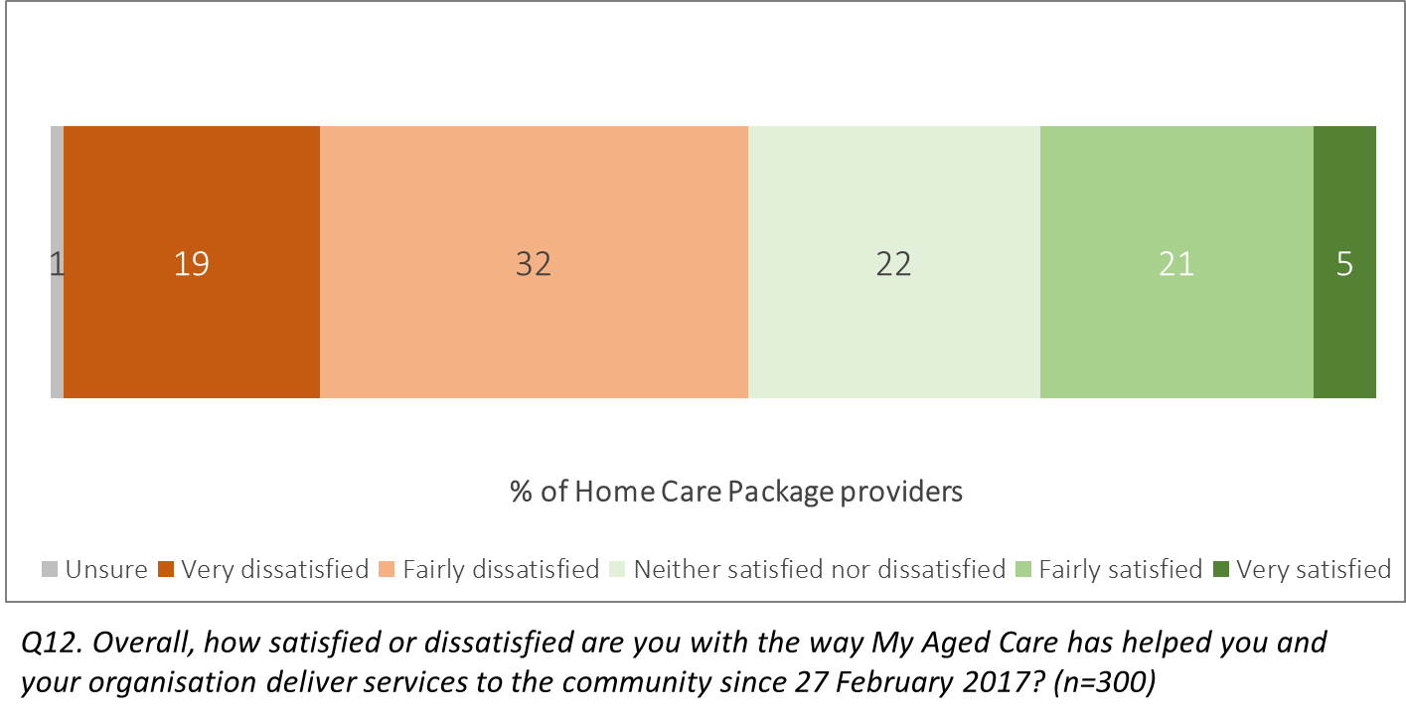***Figure 46: Service provider assessment of consumer outcomes***

Providers were more likely to consider it ‘easy’ than ‘difficult’ to accept referrals for clients who have been assigned a package and to establish basic demographic information about a client (both considered easy by 47%). However, the other prompted statements related to carrying out tasks under My Aged Care were roughly equally likely to be seen as difficult to do.

* Representatives of small providers with fewer than 20 employees were significantly less likely to find it easy to engage with clients to meet their needs at a broad level, with fewer than one in three giving a positive response (31%). Other than this measure, organisational size did not greatly affect providers’ views on the statements.
* Views on these measures were generally consistent across locations and between those whose organisation was an existing or new home care package provider. This is in contrast to the questions asked about specific aspects of the Increasing Choice experience which tended to show varying results by organisation type.
* Comparisons of these results with those from Wave 2 showed that most comparable tasks required of providers under My Aged Care were considered similarly easy by providers before and after the reforms. Home care package providers at that time recorded ratings between 34% and 56% for the measures shown below.

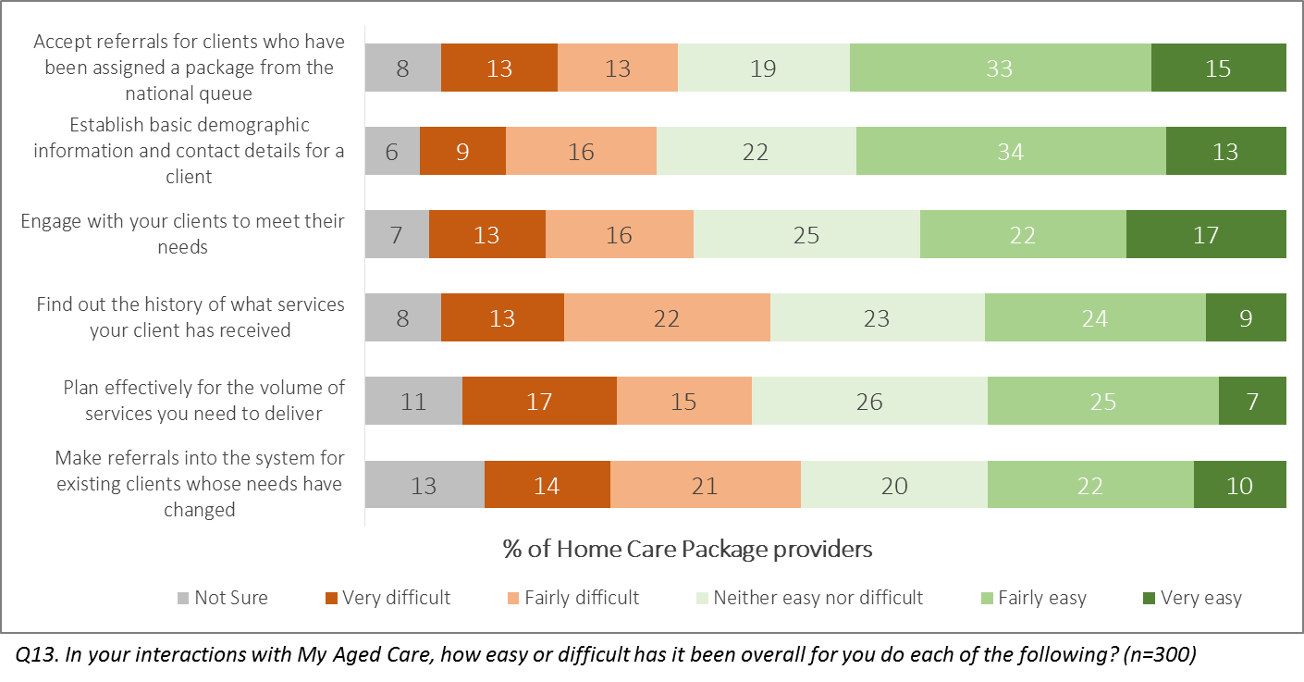***Figure 47: Providers’ ease of carrying out tasks under My Aged Care***

Provider employees were more likely to consider My Aged Care had performed each aspect of supporting providers ‘well’ than ‘poorly’, with the exception of its ability to ‘reduce the administrative burden on your organisation’. The latter measure received 10% positive responses, but one in three (33%) ascribed it the lowest rating of ‘very poorly’. A majority agreed that My Aged Care performed well to allow them to keep information up-to-date via the Portal (51%).

* New home care package providers were significantly more likely to be positive about the support to use the Portal (60%), but otherwise recorded similar results to those already offering the service type.
* Organisations managed by a not-for-profit or religious organisation were generally more positive than other providers.
* Home care package providers’ ratings of how well My Aged Care had supported their organisation to carry out tasks were again similar to those they reported in Wave 2 of the Evaluation. At that time their ratings ranged from 11% to 44%, compared to 10%-51% in this study.

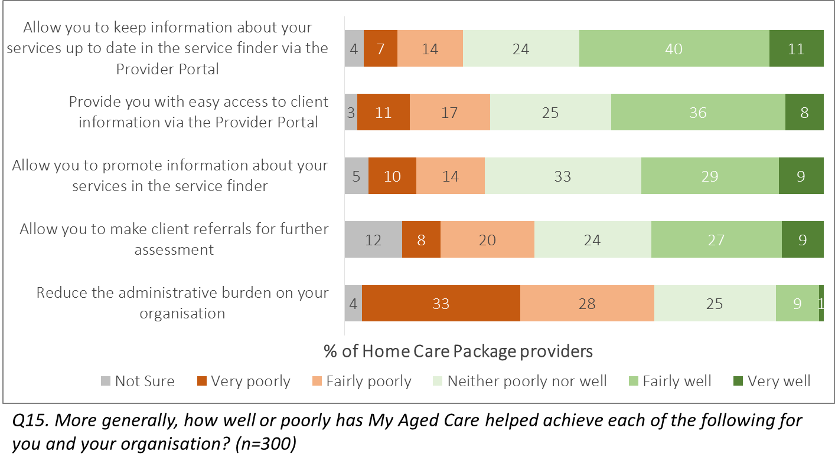***Figure 48: Provider ratings of support offered under My Aged Care***

Despite the positive responses recorded across some measures in relation to providers’ experience of administering the Increasing Choice in Home Care reforms, they were largely negative about the effects on clients since February 27th. Ratings of consumers’ experience navigating aspects of the system ranged from 25% agreeing that generally it was easy for consumers to ‘get the services they need’ to only 6% believing that it was easy for them to ‘understand the letters and printed resources they receive that explain what they need to do’.

* These results were consistent across subgroups with very few significant differences observed.
* One outcome of note was that providers surveyed whose organisation offered packages in Western Australia were significantly more likely to believe it easy for consumers to get the services they need (38%) and to find package providers (30%, vs. 17% overall).
* New and existing home care package providers did not record any major differences.
* Results were somewhat more negative than those recorded among home care package providers in Wave 2, with agreement that consumers could ‘get the services they need’ falling from 31% to 24% and that they could ‘find service providers’ falling from 34% to 17%.

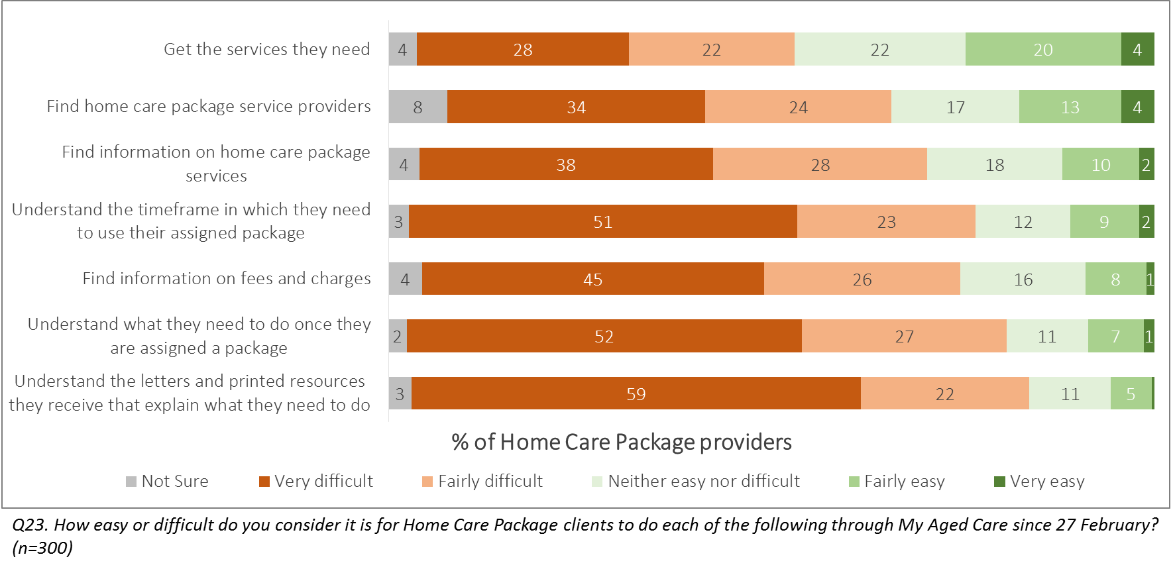***Figure 49: Provider views on consumer experience under My Aged Care***

1. Net Promoter Score (NPS) is a model wherein likelihood of recommendation is asked on a 0-10 scale. Scores of 0-6 are classified as Detractors, 7-8 as Passives, and 9-10 as Promoters. The proportion of Detractors is subtracted from the proportion of Promoters to create a Score in the range of -100 to +100. Therefore, a score above zero means a general tendency towards ‘promoting’ the brand, product, or service discussed.