

Table of Contents

1 EXECUTIVE SUMMARY 3

2 BACKGROUND, OBJECTIVES AND METHODOLOGY 5

2.1 PROJECT BACKGROUND 5

2.2 RESEARCH OBJECTIVES / EXPLORATORY QUALITATAIVE PHASE 5

2.3 RESEARCH OBJECTIVES/QUANTITATIVE BENCHMARK AND SEGMENTATION PHASE 6

2.4 RESEARCH METHODOLOGY 7

2.4.1 Exploratory qualitative phase 7

2.4.2 Quantitative benchmark and segmentation phase 8

2.4.3 Quantitative segmentation analysis 8

3 RESEARCH FINDINGS IN DETAIL 9

3.1 RECOGNITION OF AN AGEING POPULATION 9

3.2 THE PATH TO SENIORITY 10

3.2.1 Inevitable but also unfamiliar new shore 10

3.2.2 Seniority not valued or a protected status 11

3.2.3 Measuring sentiment towards the later years 11

3.3 KEY DRIVERS OF PREPARATION, PLANNING AND SENTIMENT 13

3.3.1 Age/Life stage 14

3.3.2 Socio-economic status 15

3.3.3 Gender, relationship status and family 16

3.3.4 Location 17

3.3.5 Highly diverse aspirations 17

3.3.6 Combination of factors reveals key segments 18

3.4 WORKING SENIOR STYLE 18

3.4.1 Work can be central to a great longevity 18

3.4.2 A number of barriers to working longer 20

3.4.3 Slowing down still central to retirement 23

3.4.4 Work related planning activities vary substantially with age 23

3.4.5 Interest in information from government varies by age 24

3.5 FINANCIAL PREPARATIONS 24

3.5.1 Financial preparations most common, although incomplete 25

3.5.2 Despite the aspiration, transition planning can seem exclusive 26

3.5.3 Triggers and barriers to seeking financial advice 27

3.5.4 Attitudes towards financial future 27

3.5.5 Opportunity for increased promotion of resources including ‘Money Smart’ 28

3.5.6 Financial preparations possible beyond superannuation 29

3.5.7 Interest in financial planning information from the government 30

3.6 HEALTH AND SOCIAL CONNECTEDNESS IN AGE 30

3.6.1 Attitudes to health are largely life stage dependent 30

3.6.2 Healthy and happy: mental wellbeing highly valued with age 31

3.6.3 Diet and exercise in support role 31

3.6.4 Largely positive view of the healthcare system but experience of many gaps 32

3.6.5 Despite more health conditions, sentiment improves with age 32

3.6.6 Shifting from reactive to proactive approach to health: ‘One You’ seen as a wake-up tool 33

3.6.7 Interest in health information from the government 34

3.7 SOCIAL CONNECTEDNESS: PART OF ‘GOOD HEALTH’ 35

3.7.1 Interest in information from government about social connections 37

3.8 AGED CARE OPTIONS 37

3.8.1 “Nursing homes” dominate the discussion 37

3.8.2 In- home care options are not well-known, yet are highly popular 38

3.8.3 Information feels not only lacking but also difficult to access 38

3.8.4 Interest in aged care information from the government 39

3.9 THE CHALLENGE OF CHANGE 39

3.9.1 Government as an educator and information provider 40

3.10 SEGMENTS REVEALED 40

3.10.1 Segments compared 40

3.10.2 Comfortable Optimists 41

3.10.3 Cautious Planners 42

3.10.4 Reliant Battlers 43

3.10.5 Unhealthy Dependants 44

3.10.6 Disheartened Workers 45

4 CONCLUSIONS AND RECOMMENDATIONS 47

4.1 CELEBRATE RATHER THAN SCARE, SHOW RATHER THAN TELL 47

4.2 PROVIDE A MAP OF THE JOURNEY TO SENIORITY 47

4.2.1 Income & workforce 47

4.2.2 Finances 47

4.2.3 Healthy lifestyle 48

4.2.4 Staying connected 48

4.2.5 Care 48

4.3 CHOOSE YOUR ZONE / CHOOSE YOUR TIMING 48

4.4 BEHIND EXAMPLES OF SUCCESS, AN ANCHORING IN FAIRNESS 49

# EXECUTIVE SUMMARY

""Let’ s build a social endorsement of senior prep: bringing seniority out in the open and celebrating the right behaviours is more likely to engage than the negative frames of an ageing population.

The Department of Health commissioned independent social and market research agency Bastion Latitude to conduct a developmental study into ‘ Healthy Ageing’, identifying how best to encourage Australians to make the most of their later years. Twenty group discussions of 2 hours and n= 7-9 each were conducted as well as an online community comprising of 10 discussions and n=40 Australia wide between 21st and 25th March 2018.

A subsequent phase of research benchmarked and segmented the Australian population aged 45 and older, via n=3, 003 online surveys conducted in May 2018.

A central theme permeated conversations throughout the study: the unenviable status of the senior. In Australian culture, seniority is rarely viewed in a positive angle or even simply discussed in the open. It is sometimes shameful, always hidden and certainly not celebrated. As a result, the path to successful seniority is unclear.

The quantitative research clearly confirmed that it is this uncertainty and fear of the unknown that clearly impacts sentiment, towards all aspects of ageing, negatively. Knowledge, understanding and preparation engender confidence, security and positivity.

Encouraging and promoting planning for seniority at an earlier age will be beneficial: not only to improve the mindset of older Australians, but to minimise dependence on government resources. If we want Australians to prepare earlier for their later years, this points to the need to first bring seniority out in the open. This will require building a social endorsement of senior prep by communicating the value of the senior in Australia.

The interest of participants in the stories of others suggests that showing successful seniority rather than telling is more likely to engage. By elevating seniors, their wealth of experience, their success stories and celebrating a breadth of individual narratives, there is a potential to model the expected behaviours, the new normal of senior prep.

The aspiration of Australians is to maintain choice and agency into older age: there is not one single path to successful seniority but as many as there are people. However, all share a dream of an authentic, full, well lived life in their senior years. This points to the need for a positive, energetic tone and a highly active depiction of the senior.

This also points to the need to celebrate seniority and indeed avoid using the usual, more negative, frames placed on ageing: the burden on government services and budgets or the looming crisis brought on by an ageing population. Unless solutions are provided, this is unlikely to disrupt and motivate.

There are also clear differences as people age: a tailored approach is required to address the needs of all Australians aged 45 and older. In particular, messages about positive seniority and future planning need to include the youngest, and most negative group: Australians aged 45-49. Being the furthest from their own perceptions of being a ‘senior’ they will not relate to messaging for 65+ retirees. But this group feels the most uncertain and lacks the most knowledge about planning for a successful future.

There is also a need to recognise the barriers to successful seniority. In the area of work in particular, encouraging increased participation without first addressing the barrier of age discrimination, direct and indirect, is likely to pose risks. The general consensus is that if we want Australians to work longer, we first have to create a culture that enables this.

The lack of clarity around preparation for our later years requires providing a map of the journey to seniority. Six senior ‘zones’ have been identified: an outline is provided in diagrammatic form below.

Figure : Elements of seniority

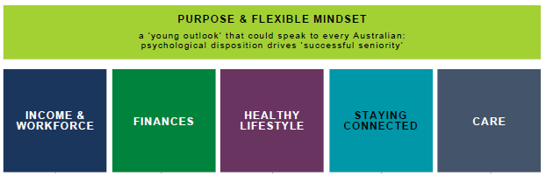

Each of these zones are best illustrated with examples. These cannot be outlandish or risk being not applicable, just aspirational enough to inspire. A few examples are provided in the recommendations section.

Australians will initiate their preparation when the time is right for them. Expecting all to prepare early in all areas may be unrealistic. More likely, they will choose to prepare in the area that feels relevant to them at the time of their choosing. Chunking it down into zones allows them to take action in the zone most easy, at the time the opportunity occurs. That said, Australians need to be encouraged to prepare earlier rather than later.

Up until the mid- forties, Australians are too focused on life now. From the mid- forties, Australians start to experience events or attitudes associated with ageing and will slowly start to prepare partially, if not fully. The opportunity lies from the early fifties onwards, as Australians begin their transition into retiring, however long that journey maybe.

Choice remains an aspiration for many, not a reality. When all else fails, a basic safety net is expected. Protecting older Australians and the vulnerable feels like the foundation that cannot be removed. Most feel that this is what government is for, this is what a society is about. It is expected that any positive communication will come with the reassurance that basic support is always available.

Finally, the segmentation analysis reveals that while age is clearly a factor, there are attitudes and approaches to ageing and planning, going beyond simple demographic differences that are important to address. Effective messaging needs to target the different types of older Australians: addressing their particular concerns, barriers and needs.

# BACKGROUND, OBJECTIVES AND METHODOLOGY

## PROJECT BACKGROUND

A defining feature of Western societies has become their ageing. Despite relatively strong birth and immigration rates, Australia doesn’t eschew the trend, with the proportion of Australians aged 65 and over projected to increase from 14% of the population in 2012 to 20% by 2040 (ABS Population Projections, 2012 Census Base).

An ageing population will have major budget and welfare implications, all the more so if the population is not prepared. Healthcare needs are projected to increase in line with the ageing of the population unless action is taken to reduce chronic disease rates through behaviour change. A majority of Australians do not have a financial plan for their later years, let alone prepare accordingly. Retraining and re- skilling have long been a government priority yet will have to be even more so with major disruptions to the job market likely over the next few years. Finally, older Australians are at greater risk of social isolation and loneliness, itself impacting on health, finances and workforce participation.

The Australian Government is already investing resources in anticipation of the heightening challenges brought by an ageing population. This includes increased investment in aged care with a focus on popular home-based care and more choices for residential care. It is however, unclear, how much the Australian population knows about these investments, or current ongoing support and care options, what they wish to know about maximising the opportunities associated with increased longevity, or even how they frame the issue in their minds today.

The Australian Government is also exploring new ways to support change and empower Australians to live healthier and better prepared. This includes the possible introduction of interactive technology similar to ‘One You’ in the UK to help shift behavior and the impacts of chronic disease, new workforce participation and social connectedness strategies, as well as, financial planning education.

Exploratory and concept testing research was needed to support this work with the major output of a communications campaign aimed at “assisting Australians aged 45+ to prepare for a healthier, more connected and financially prepared longer life”.

In addition, a second phase of research was required to benchmark and segment attitudes and behaviours amongst Australians aged 45+.

The Department commissioned Bastion Latitude to conduct the research. This report outlines findings from the exploratory qualitative stage and the quantitative benchmark and segmentation.

## RESEARCH OBJECTIVES / EXPLORATORY QUALITATAIVE PHASE

Exploratory research was required to understand “current attitudes, beliefs, knowledge and behaviours of the target cohort in regard to preparation for ageing in a number of areas in their life (including health, finances, work and skills, and social connectivity)”. The research also explored the “contemplation of, and attitudes towards making changes in these different areas in anticipation of living a longer life and maintaining independence”.

Key research objectives as listed in the brief are outlined below:

* An understanding of current conversation regarding preparing for ageing and the mid to long term changes required to address the challenges and maximise opportunities associated with increased longevity.
* The importance/ weight that individuals currently place on each of the elements in relation to each other and in relation to other aspects of/ concerns in their life (e.g. caring commitments to others, current financial or health issues etc.).
* The degree to which people feel currently ‘on top of’ each of the areas of interest.
* The degree to which people currently feel prepared for the future in relation to each element and their comfort/willingness (or not) to engage with the idea of planning/making change in each area (also in relation to immediate, intermediate and long- term changes/benefits).
* An exploration of attitudes towards retirement (including expectations regarding the different areas of concern), including plans to retire/ continue working/ transition to retirement.
* “Lessons learned” from those already aged 65+ about their own experiences in relation to planning or failure to plan in each of the areas.

The study included specific focus areas as outlined below:

Healthy ageing and Lifestyle:

* Attitudes towards maintenance of an active lifestyle, including key barriers and enablers, and perceived costs and benefits.
* Attitudes and experiences in regard to social connectedness, including current activities, enablers, barriers, use of tools (including but not limited to electronic tools), costs and benefits, as well as the role of workforce participation (including the impact of changes in workforce participation).
* Current focus on chronic disease prevention, including understanding of key health risks, mitigating behaviours and potential to undertake lifestyle change to minimise these risks.
* Attitudes toward increased life expectancy.

Workforce participation and financial preparedness and understanding:

* Attitudes toward increased opportunities to remain in the workforce, including an understanding of the experiences, motivators and potential enablers and barriers amongst those who have (and have not) remained in the workforce beyond 65 years of age.
* Appetite for retraining and re- skilling.
* Financial readiness for extended lifespans, including planning and budgeting.

Understanding and engagement with options for ongoing support:

* Planning and engagement with options for ongoing support and care.
* Testing of potential options for interactive supports and measures to inform people in their decision making and planning (e. g. the One You site and self- assessment tool developed by Public Health England and Money Smart calculators by the Australians Securities and Investment Commission).
* Understanding of changes to the age care system, including increasing:
* investment;
* focus on home- based care; and
* choices for residential care.

In exploring the objectives, the research was required to provide insights into “key factors and characteristics that impact upon attitudes and behaviours across the target audiences such as SES, education and existing skills sets, remoteness and location”.

## RESEARCH OBJECTIVES/QUANTITATIVE BENCHMARK AND SEGMENTATION PHASE

After the completion of the exploratory research phase, quantitative research was required to “further inform development, targeting and ongoing evaluation of a communication campaign and related strategies in relation to healthy ageing amongst older Australians.” Specifically, the quantitative phase was required to develop benchmark measures against which to measure the success of communications campaigns.

In addition, the quantitative phase built on the exploratory qualitative research to identify, size and describe “definable segments within the target audience… to assist with targeting, media buys, messaging and ongoing strategy development in relation to healthy ageing.”

As stated in the brief, the specific research objectives for this phase were to:

Inform testing of a segmentation model emerging from the qualitative research.

* Establish a baseline measure relating to campaign objectives, messages and calls to action.
* Establish and test a segmentation model that describes groups within the target audiences in relation to the key attitudinal, knowledge and behavioural characteristics.
* Measure:
* current attitudes and knowledge in relation to the six focus areas identified in the qualitative research;
* Intentions to plan and take action in key areas of later life stage planning;
* Behaviours undertaken in relation to key areas of life stage planning; and
* Levels of interaction with currently available tools and resources.

In addition, analysis explored differences between key demographic sub- groups including 5 year age ranges, single versus partnered, income, metro versus regional locations, etc.

## RESEARCH METHODOLOGY

### Exploratory qualitative phase

Twenty group discussions of 2 hours and n=7-9 each were conducted as well as an online community comprising of 10 discussions and n= 40 between 21st and 25th March 2018

Table : Group discussion sample frame

| # | Age | Gender | Working Status | Relationship Status | Education level (SES) | Location |
| --- | --- | --- | --- | --- | --- | --- |
| 1 | 45-55 | Mixed | Working FT,PT | Single | Mix | Bendigo |
| 2 | 45-55 | Mixed | Working FT,PT | Single | Not university | Sydney |
| 3 | 45-55 | Mixed | Working FT,PT | Couple | University | Adelaide |
| 4 | 45-55 | Mixed | Mix | Couple | Not university | Melbourne |
| 5 | 45-55 | Males | Working FT,PT | Mix | University | Newcastle |
| 6 | 45-55 | Females | Working FT,PT | Mix | Mix | Melbourne |
| 7 | 56-65 | Mixed | Working FT,PT | Single | Mix | Bendigo |
| 8 | 56-65 | Mixed | Mix | Single | Not university | Melbourne |
| 9 | 56-65 | Mixed | Working FT,PT | Couple | Not university | Launceston |
| 10 | 56-65 | Mixed | Working FT,PT | Couple | Not university | Sydney |
| 11 | 56-65 | Males | Working FT,PT | Mix |  | Adelaide |
| 12 | 56-65 | Females | Mix | Mix |  | Launceston |
| 13 | 66-75 | Mixed | Working FT,PT | Single | University | Melbourne |
| 14 | 66-75 | Mixed | Mix | Single | Not university | Newcastle |
| 15 | 66-75 | Mixed | Semi-retired/working PT | Couple | Not university | Newcastle |
| 16 | 66-75 | Mixed | Semi-retired/working PT | Couple | Mix | Melbourne |
| 17 | 66-75 | Mixed | Retired/not working | Mix | Mix | Sydney |
| 18 | 66-75 | Mixed | Retired/not working | Mix | Not university | Adelaide |
| 19 | 76+ | Mixed | Retired/not working | Mix | Not university | Sydney |
| 20 | 76+ | Mixed | Retired/not working | Mix | Mix | Melbourne |

More than 20% of the sample was from CALD backgrounds. Online community sample frame:

* n= 40 participants with broadly equal spreads in the primary audience age groups: 45-55, 56-65, 66-75 years
* All states and territories, 50:50 metro: regional

### Quantitative benchmark and segmentation phase

The quantitative research was conducted via an online survey methodology with a questionnaire of approximately 18 minutes in length. The fieldwork was completed from the 26th of April to the 5th of May 2018.

The sampling for the research comprised of a core sample of n= 2,503 sampled to be representative of the age spread of the Australian population aged 45 years and over. In addition, a boost sample of n=500 was also included amongst the primary target of Australian’s aged 50-64 years. The total sample sizes (unweighted) are shown below.

Table : Unweighted sample size

|  | TOTAL | % | n |
| --- | --- | --- | --- |
| 100% | 3003 |
| Age | 45-49 | 15% | 465 |
| 50-54 | 19% | 584 |
| 55-59 | 19% | 573 |
| 60-64 | 20% | 586 |
| 65-69 | 12% | 347 |
| 70+ | 15% | 448 |
| Gender | Female | 46% | 1388 |
| Male | 54% | 1614 |
| Location | Metro | 64% | 1933 |
| Regional | 36% | 1070 |
| Relationship Status | Married, partnered and/ or defacto | 66% | 1974 |
| Net: Single | 34% | 1029 |
| Annual Gross Income | LOW Up to $ 39,999 | 25% | 761 |
| MED $40,000 -$99,999 | 37% | 1102 |
| HIGH $ 100,000+ | 23% | 701 |
| Prefer not to say | 13% | 378 |

Survey data presented in this report has been weighted using the latest ABS Census data to provide a t rue representation of the Australian population aged 45 years and over.

Significant differences noted are at the 95% level of confidence.

### Quantitative segmentation analysis

The final quantitative segmentation solution was derived using Latent Class Analysis (LCA) using Q software.

LCA works by identifying the underlying structure present within the data and allocating individuals to categories within that structure. LCA utilises various parameters to ensure that the globally optimum solution is achieved: these include the maximum number of iterations and the number of start points. Within these parameters, LCA iterates through a large number of potential models and employs the Bayesian Information Criterion (BIC), a best- practice model selection metric, to identify the number of categories/ segments that best describe the underlying data. One of the outputs of LCA is the likelihood of membership of each respondent for each of the categories: respondents are then allocated to the category/ segment for which they have the maximum likelihood.

A total of 2,895 of the 3,003 participants were able to be reliably included in the segmentation solution.

After multiple solutions were considered, the following questions were included in the final segmentation solution:

* Overall sentiment about their future years
* Sentiment about their future years in relation to work and / or retirement
* Sentiment about their future years in relation to finances
* Sentiment about their future years in relation to health
* Sentiment about their future years in relation to social connections
* Sentiment about their future years in relation to aged care services

# RESEARCH FINDINGS IN DETAIL

## RECOGNITION OF AN AGEING POPULATION

There is broad consensus around the ‘facts’ of an ageing population. While, when put to them, some may be surprised by the actual average increase in life expectancy over the last thirty years, current figures (82 years for women and 80 for men) feel right. The topic has also been discussed for a long t time now, either by government or the media, and feels familiar.

As shown in the table below, when shown a list of potential issues and asked which they feel are the biggest challenges facing Australia today, an ageing population is definitely in the mix. This is particularly the case for 55-69 year olds where ‘ageing population’ makes it into their top three areas of concern. Prior to age 55, ageing population is fourth, overshadowed by more immediate concerns about the cost of living and the affordability of housing. From age 70, ageing population is still mentioned, but also becomes a relatively less important issue as it is less relevant / less l likely to impact those who are already older.

Table : Biggest challenges facing Australians

| 45-54 years old | 55-69 year olds | 70+ year olds |
| --- | --- | --- |
| Cost of living (56%) | Cost of living (45%) | Cost of living (39%) |
| Affordability of housing (32%) | Health system (35%) | Health system (37%) |
| Health system (26%) | Ageing Population (29%) | Sustainable energy (26%) |
| Ageing Population (23%) | Sustainable energy (23%) | Ageing Population (26%) |
| Sustainable energy (18%) | Affordability of housing (20%) | Affordability of housing (14%) |

Q7 What do you feel are the 3 biggest challenges facing Australia in the coming years? Base: Top 3 concerns shown for each age group 45-49 (n=465), 50-54 (n=584), 55-59 (n=573), 60-64 (n=586), 65-69 (n=347), 70+ (n=448)

Overall, the top 3 challenges facing Australians 45 and over are the costing of living (47%), sustainability of the health system (32%) and the ageing population (26%). So, while ageing population is a ‘top’ concern, it is well below financial and health considerations.

The cost of living is the primary concern for all age groups, but particularly for Australians aged 45-49 (56%), and those not in a domestic partnership (51%).

As shown below, Australians consistently agree there are many challenges with an ageing population. This indicates that the government has permission to put time, effort and resources into addressing these challenges.

Figure : Agreement that there are challenges with an ageing population

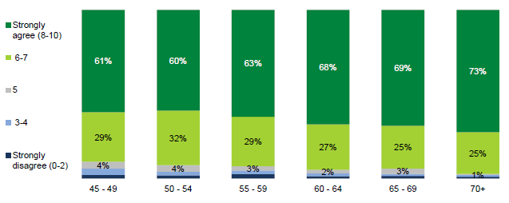

Q11 How do you feel about the following statement? Australia’s population is ageing, people are living longer than ever before and there are many challenges that will come along with this. Strongly disagree=0 to Strongly agree=10.Base:45-49(n=465), 50-54(n=584), 55-59(n=573), 60-64(n=586), 65-69(n=347), 70+(n=448)

While agreement that there are challenges increases steadily with age, even amongst the youngest cohort (45-49 year olds) 61% strongly agree (rating 8-10) with this sentiment.

The qualitative research indicated that while there is agreement with the broad issue, understanding of the consequences of an ageing population to government services and budget is more contrasted. While some are well aware of the pressures, others have too individual a view, lacking systemic understanding: they can grasp personal consequences e.g. that service cuts could result in lower standards for themselves and their loved ones, yet the broader connections between demand, budget, economy and community feel too intangible and remote, requiring more personal communication to help them make the cognitive leap between systemic and individual.

In any case, the topics do not feel empowering or motivating. Conversations about Australia’s lack of planning have felt present for a long t time: it feels like the very fact we are still having them reflects badly on government of all persuasions.

While the issue has been discussed for a long t time, it feels solutions have not. Australians feel at pain to come up with any themselves: instead, they expect government to take leadership and provide vision and forward planning.

## THE PATH TO SENIORITY

### Inevitable but also unfamiliar new shore

Life passes quickly and for many the senior years can come as something of a surprise. Youth and especially mid-life are spent with head down, simply t trying to keep the wheels turning. Those who have worked all their lives have been focusing on moving upwards from the bottom. Those who haven’t worked, continuously or not, have had to create a home and raise a family. Up to the point when they finally gain more control again, most share a sense that family, work, debts or simply luck and circumstances have dictated most of their life “choices”, not themselves.

In this context, there is little time to think about the future. There is a brief, almost minimal window for preparation past age 50 as many gain more freedom again, as well as realise through body signals that they are ageing, yet few are really clear what this will mean for them: many simply find it too difficult to project into a distant future.

For some, entry into the senior years ends up being an exciting new experience. With more time and less financial pressure comes the possibility to say yes to more opportunities and interests to family and community or even indeed work choices. They can finally live for themselves: not the boss, family or creditors. For others though, the senior years are a somewhat daunting destination. They approach it with uncertainty, being unsure how to navigate it, what they are “supposed to do” and what else there can be to it. Those who have not had time or energy to focus on planning for the senior years can be very scared indeed to the point of avoiding the topic or in their own terms planning to “check out”.

“I look forward to living again. The hard work is done. There’s a sense of freedom past 65. Let’s have a bit of fun! We DESERVE it!” (66-75, Female, Newcastle)

“I have my plan; I am checking out.” (55-64, Male, Sydney)

This points to the absence of a ‘senior map’ or narrative framework to guide seniors successfully into their later years. In exploring the different life milestones with people, it becomes evident that while the path to adulthood is well signposted, the path to seniority lacks clarity. Other life stages indeed come with a well- defined narrative: marriage, child bearing, home building, graduation, or even changing jobs come with myths, stories, testimonies, role models and initiations; they’ re well represented in popular culture and are part of people’ s daily experience too. However, later years, including retirement, can feel like a stage in the dark: most sense that they are left to create their own path, having access to outdated models only to guide them, usually their parents’ or grandparents’.

“We didn’t know what to do. Maybe our children are better educated but we were never told about any of this.” (56 -65, Female, Bendigo)

“It’s impossible to know what all the options are or who you are supposed to talk to about it.” (66-75, Female, Melbourne)

The path to seniority used to be clear: work hard, then stop fully and – hopefully – enjoy life without limits again. Now the start lines and the boundaries feel different: the new normal includes both continuing work past ‘normal’ retirement age yet often work life being cut short against people’s will too. The word retirement has become more difficult to define, with many keeping or wanting to keep some form of activity or another, yet not always having the opportunity to do so. In this new normal, planning can feel somewhat naïve: the parameters are so flexible that it can be best not to plan or at least it does not make sense to plan.

“The milestones now are pretty dynamic. Retiring is a bit of a myth now.” (45-55, Male, Bendigo)

“In the past, you could just retire at 65. Now you don’t know when or how you will.” (45-55, Male, Newcastle)

This more flexible path to seniority can bring opportunities with it. Some sense a possibility to engage in a “portfolio” retirement plan: a myriad of work and other income and non- income generating options that can be even more fulfilling than previous ones. Examples abound from people engaging in the gig economy to more simply moving sideways in their career. However, many are not confident of creating a responsive and entrepreneurial path: they view these stories as inspirational but also themselves as lacking these skills, generating high stress.

While this points to the need for more support, from inspiration to personalised advice, it also points to a lack of basic information, a clear “map” into seniority. All are aware of the need to put plans into place, but they are not exactly clear what. The conversation seems limited to Super with little beyond that: in the areas of health, work, where to live (including aged care) and social connections, all share the sentiment of not really knowing “what sorts of things to think about”. It seems information search or even before that the thought process itself are not triggered with a lack of tools – and lack of awareness of existing tools – helping people to articulate “how to think” about these issues, as evidenced by the enthusiasm around the ‘One You’ quiz and the ‘Money Smart’ calculators.

Information about government services also feels lacking. While options around superannuation are well- known by some and information feels at least accessible by the others, awareness of services in relation to work, health care, retirement and social connectedness seems low. Many for example are unclear about such benefits as free dental or health checks past a certain age, availability of clubs and concessions from local councils or state governments or in- home care options. Those few who know how to work the system can access these options: they share how they have investigated these issues to find out more and were pleasantly surprised. The others look on with envy as they feel left in the dark.

### Seniority not valued or a protected status

Many see themselves as devalued in society at large and in the workplace in particular. Discrimination can indeed be an issue, whether in recruitment or day-to-day. Examples include being made to feel unqualified when actually being so during job interviews, promotions being given to younger staff or being left aside from decision-making.

Yet a bigger issue than active discrimination seems to be a more pervasive sense that seniors’ input is not valued appropriately. Many feel they do not share the values of their employer: while many seniors for example feel like they value quality and service, employers are seen to value fast speed and commercial KPIs. Seniors can also feel overtaken by technology with little room given to training. In this context, a message to embrace work longer in their lives feels inadequate: if they are not wanted by employers, how can they not only find employment but also enjoy it?

“Australia is ageist - it’s not like in some other countries where they respect and value the elderly.” (66- 75, Male, Melbourne)

Some can also feel stuck between generations, providing free labour for both their parents and their children, yet lacking recognition for it. As their grown children indeed adopt the head down working focus that they themselves are just leaving behind, they provide vital childcare support – and often financial and material help too. While they see this as a vital contribution to the economy, they feel its heroes are still the income generating young parents, not the silent and free grandparent labour that facilitates and enables it. Some are also caring for aged parents or partners, another role they see as vital to the economy, yet one that does not feel supported and will become even more difficult as they age themselves and their own charge increases.

This lack of value makes many feel like they have “missed the boat”: there is no point in planning or trying to contribute any more. It makes more sense to literally “check out” and live in the day-to-day as best as possible without elaborate plans or ideas to advance themselves.

### Measuring sentiment towards the later years

While there are uncertainties and concerns about the path to seniority, as shown below, overall sentiment is initially very mixed but positive sentiment increases substantially with age.

Figure : Overall sentiment towards their later years

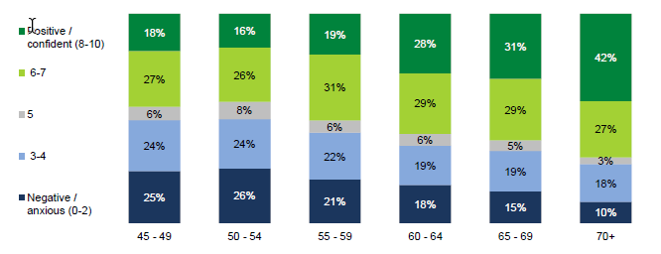

Q8 Overall, how do you feel when you think about your later years in life? (Negative/Anxious=0 to Positive/Confident=10), Base: 45-49(n=465), 50-54(n=584), 55-59(n=573), 60-64(n=586), 65-69(n=347),70+ (n=448)

There are several elements important to note about Australians’ sentiment towards their later years:

* Very few gave a neutral rating: Australians have a clear opinion about the future, one way or the other.
* Particularly for under 55’s, sentiment is highly polarised and at the extremes, with a substantial proportion giving extremely negative ratings (0-2).
* In contrast, those aged 70+ are not only much more positive, but nearly half are extremely so: rating 8-10.

This pattern of increased positivity with age is seen across all key pillars.

As shown below, differences are also seen across a number of attitudinal metrics, related to overall sentiment. In particular, confirming insights from the qualitative research, it appears that positivity is aligned with feeling like there are options for the future.

Figure : Average agreement with overall sentiment attitudes by age

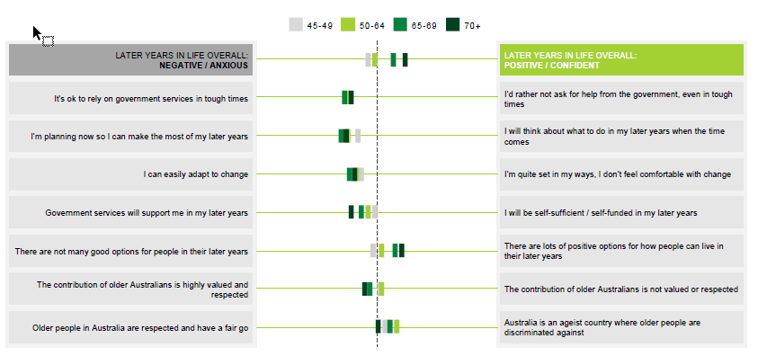

Q 10 Over all attitude (11pt scale, opposing statements as end points) Base: 45-49 (n=465), 50-54 (n=584), 55-59 (n=573), 60-64 (n=347), 70+ (n=448)

Overall, taken as a whole, Australians over 45 feel moderately adaptable to change, are doing some forward planning, and tend towards feeling that it ’ s ok to rely on government services in tough times. Showing a correlation to overall sentiment, agreement that there are positive options for older Australians and that the contribution of older Australians is valued increases with age.

Older Australians are also more likely to feel that government services will support them: no doubt easing their concerns. Whilst they are preparing for retirement they also expect that when the time comes that the Government will do their bit and support them, through the pension and other services (they have been paying taxes all these years and expect they will be looked after now!)

However, whilst Australians are looking forward to this time, there is also a sentiment that Australia is an ageist country where older people are discriminated against, and their contributions (i.e. volunteering, looking after grandkids etc.) are not valued. While these attitudes improve positively with age, when considered against the ideal, there is clearly room for improvement. This is particularly in relation to ensuring that Australians feel they will be valued, respected and have options as they age.

Perhaps realistically, younger Australians (45-49) still in the workforce (particularly metro, partnered and med/high income households) are more likely to plan for a self- funded future rather than rely on government pensions.

## KEY DRIVERS OF PREPARATION, PLANNING AND SENTIMENT

The lack of clarity around planning and preparation for our later years suggests the need to provide a map of the journey to seniority. Within that journey, the qualitative research identified 6 key pillars:

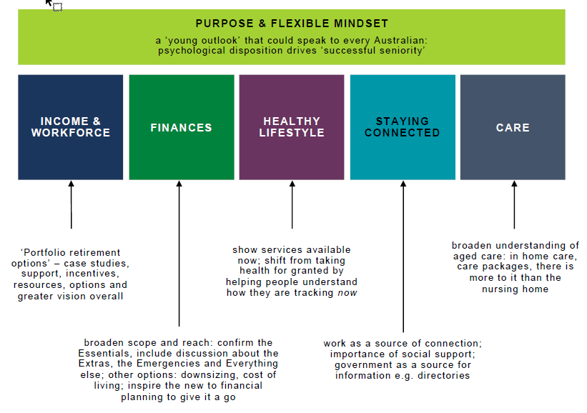

These elements underpinned the design of the quantitative survey. The quantitative survey focused on future sentiment overall (negative/anxious to positive/confident), key attitudinal drivers, behaviours and planning across these topic areas:

1. Overall sentiment towards the future
2. Work and / or retirement
3. Financial situation
4. Health
5. Social life
6. Aged care services

Confirming the qualitative results, the quantitative analysis clearly revealed that differences in preparedness and sentiment within each element, contribute to overall sentiment towards Australians’ ‘future years’.

As with overall sentiment, as shown below, there is a great deal of variation in sentiment across the individual pillars.

Figure : Sentiment towards the future across key pillars

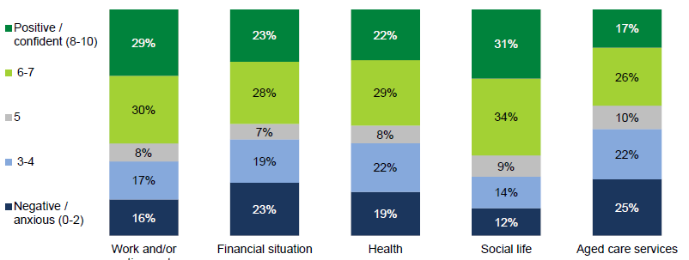

Q8 Overall, how do you feel about your later years? Q12 How do you feel about your later years in terms of work and/or retirement? Q21 How do you feel about our later years in terms of you financial situation? Q30 How do you feel about our later years in terms of your health? Q35 How do you feel about our later years in terms of your social life? Q39 How do you feel about our later years in terms of receiving aged care services? (Negative/Anxious=0 to Positive/Confident=10) Base: Total sample (3003)

The greatest negativity is seen for their future financial situation and their future when it comes to aged care services. In contrast, older Australians have few concerns about their future social life.

It is important to note that while all of these elements work together to drive overall sentiment, they vary in terms of their relative importance. As shown below, while sentiment towards the future of aged care services is the lowest of all key pillars, it also has the lowest relative impact on overall sentiment. Instead it is feelings about their future financial situation and work / retirement that are the biggest drivers of overall sentiment.

Figure : Relative impact of key pillars on overall sentiment

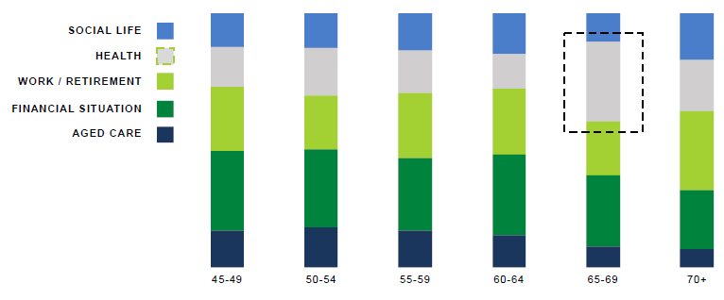

Regression analysis across key pillars. Relative impact on dependent variable Q8 (overall sentiment) indicated. Independent variables included in analysis: Q12 How do you feel about your later years in term of work and/ or retirement? Q21 How do you feel about your later years in terms of your financial situation? Q30 How do you feel about your later years in terms of your health? Q35 How do you f eel about your later years in terms of your social life? Q39 How do you feel about your later years in terms of receiving aged care services? (Negative/ Anxious=0 to Positive/ Confident=10) Base: 45-49 (n=465), 50-54 (n=584), 55-59 (n=573), 60-64 (n=586), 65-69 (n=347), 70+ (n=448)

Up until the age of 65, the primary influences on how people rate their expectations of later life are fairly consistent. Financial and work/retirement situations dominate, followed by expectations of health, aged care and social life. But an interesting shift is seen for 65- 69 year olds. For this group, health becomes the most dominate influencer, dropping again from age 70. We can theorise that this is related to a greater number of health issues appearing amongst that age group, causing increased focus on this element. In fact, Department of Health data shows that burden of disease BOD) is highest amongst the 65-69 age group.[1]

However, it appears that once people learn to manage health issues that may have emerged (age 70+), health again becomes relatively less important. Instead, from 70+ work and/ or retirement is leading driver of overall positive sentiment about their future years. Results also indicate that certainty about the future (as it is ‘now’) and people actively enjoying their retirement is driving positive sentiment even in the face of potentially poorer health. Those aged 70+ are more social (70% regularly catching up with family/ friends), have a higher rate of volunteering (36%), and are more likely to be spending time enjoying hobbies (49%).

The drivers of differences in preparedness and sentiment have been explored in the qualitative research and again in the quantitative phase. The quantitative analysis has confirmed that there are a number of variables at play. First and foremost, age is a consistent differentiator across all pillars. Other factors such as income, gender and relationship status also come into play but to a much lesser degree.

### Age/Life stage

The older, the more likely they are to have a plan or at least an aspiration. Getting closer to an external trigger such as the age pension or the age of super access means that people are compelled to think about their options. This also applies to health, where seniors suddenly find themselves thinking about their needs when a crisis breaks or when offered a seniors’ health check.

The older are also more likely to think that the old framework still applies. Working hard to stop fully at a given age feels more normal. Many feel that they signed an unwritten contract when entering the workforce and that “the rules when I signed up should be the rules when I sign out”. They have paid taxes all their lives, have contributed to the economy and community through family raising and feel like now is the time that they should be rewarded.

This makes older people more difficult to influence: changing a plan once it is already enshrined requires effort, especially if the proposed alternative is not as enjoyable. They can still be influenced on the margins e. g. to take up part time work if they get support to access it but most share the feeling that it has to be their choice as they are at a time in their lives when they finally regain control and don’t want to feel like agency is being taken away from them again.

In addition, for older people their ‘future years’ are less distant and far easier to imagine. This in turn makes planning feel more meaningful, relevant and grounded in ‘reality’. For younger people, there is a sense of fear of the unknown, an uncertainty about what the future will bring. This uncertainty and the need to think so far into the distant future creates more anxiety and negativity.

As noted earlier, this actually results in a steady increase in positive sentiment across all pillars as shown below.

Figure : Mean sentiment score across pillars by age

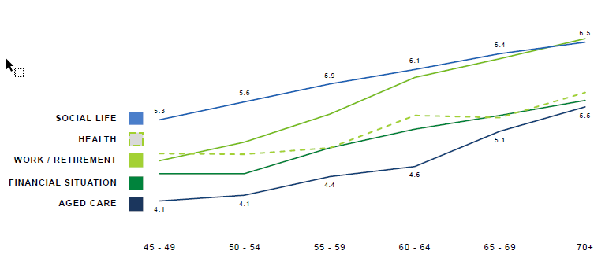

Q12 How do you feel about your later years in terms of work and/or retirement? Q21 How do you feel about your later years in terms of your financial situation? Q30 How do you feel about your later years in terms of your health? Q35 How do you f eel about your later years in terms of your social life? Q39 How do you feel about your later years in terms of receiving aged care services? (Negative/ Anxious=0 to Positive/ Confident=10) Base: 45-49 (n=465), 50-54 (n=584), 55-59 (n=573), 60-64 (n=586), 65-69 (n=347), 70+ (n=448)

While sentiment towards their future health increases less steadily, overall the t rend is still of increasing positivity: despite an increase in health issues. Consistent with health issues coming to the fore at 65- 69, a slight dip in mean sentiment is seen at this age, rising again from age 70.

### Socio-economic status

Socio- economic status and age combine to reduce or increase the amount of choices available. The older and the lower the socio-economic status, the more likely to only start with superannuation late and to have acquired knowledge only recently: many therefore feel they are on a trajectory towards the pension that can’t be changed. The opposite is true of younger people and higher SES: they have always worked towards self- funding and the “normal” path to retirement is more likely to feel like the self- funded version.

The wealthier you are, the more likely you are to already plan well. The simple fact of having extra money prompts the question of what to do with it. They tend to naturally find their way to Financial Advice, either because it is suggested to them by their financial institutions or because this is just the “normal” thing to do in their social and professional circles.

The less wealthy are less likely to afford financial advice or even in fact feel the need for it. It may also feel somewhat of a black hole to them, being unclear what this can entail. This makes them feel like outsiders: if they don’t understand what this involves, it means this is not aimed at them.

As shown below, sentiment increases with income for all pillars, not just those directly related to finances, with the exception of aged care services.

Figure : Mean sentiment score across pillars by income

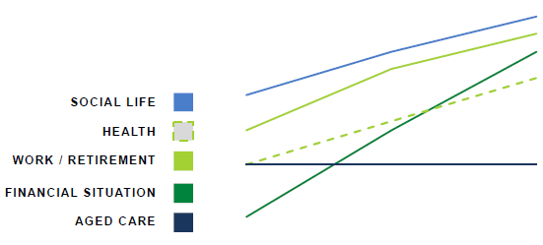

Q12 How do you feel about your later years in terms of work and/or retirement? Q21 How do you feel about your later years in terms of your financial situation? Q30 How do you feel about your later years in terms of your health? Q35 How do you f eel about your later years in terms of your social life? Q39 How do you feel about your later years in terms of receiving aged care services? (Negative/ Anxious=0 to Positive/ Confident=10) Base those who reported an income: Low: (n=761), Med: (n=1102), High: (n=701)

Education correlates with income but in itself is not necessarily a driver of planning: even the less educated can have access to good advice and vice versa. Some share how they actually understand very little of what their Financial Advisor tells them, but it has worked for them anyway, so they just keep working with them.

### Gender, relationship status and family

Many women share anxiety over having spent more time out of the workforce: this means their superannuation balance is necessarily lower and having missed out on career progression opportunities, their super is even lower than it could have been without raising a family. This makes single women in particular or those who find themselves suddenly single after a separation, somewhat more anxious about their future.

Some women also share being less involved in the couple’s finances. They are less clear on the investment strategy of their partner or what should be done at all. Their t rust can extend to plans for the retirement age or housing decisions. Many other women however, are quick to point out that financial preparations are shared on an equal footing in their households.

Single life, especially with children, can mean that resources are stretched, making financial planning more difficult. It is even more difficult for those to which it has happened unexpectedly after a separation. Many women in particular share that they went from relying on their partner to suddenly not knowing whether they will ever be able to afford retirement. They are even more unsure of where to start their preparations and don’t believe it is worth it anyway, given their low superannuation balance and difficulty to save up.

As shown below, when quantified, partnered males generally have the most positive outlook, while single females have the least positive outlook.

Figure : Mean sentiment score across pillars by gender and relationship status

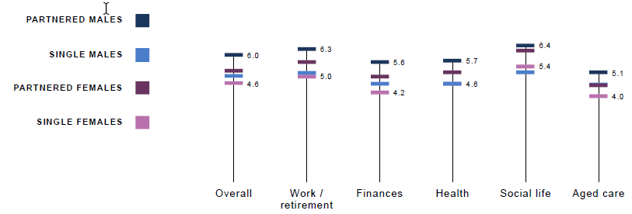

Q8 Overall, how do you feel about your later years? Q12 How do you feel about your later years in terms work and/or retirement? Q21 How do you feel about your later years in terms of your financial situation? Q30 How do you feel about your later years in terms of your health? Q35 How do you f eel about your later years in terms of your social life? Q39 How do you feel about your later years in terms of receiving aged care services? (Negative/ Anxious=0 to Positive/ Confident=10) Base: Partnered males (n=1,119), Single males (n=495), Partnered females (n=855), Single females (n=533)

To seniors, children can be a safety net, bringing financial, care and mental support. Children themselves share how they often pay for in-home services for their parents, care for them at home or simply visit them to keep them feeling connected.

On the other hand, caring for older parents helps seniors be better prepared. Having observed the pitfalls of a lack of preparation, children are keen not to repeat the same mistakes. This is especially true of purpose and social connectedness, where children want to feel more in control of how they interact with others, stage their retirement from work to keep a sense of feeling valued. This is also true of aged care, a system that is difficult to understand and navigate without first- hand experience of it: as children help their parents find and settle into aged care, often with many barriers and bumps, they are hoping that their experience will provide a more straightforward way – and in fact that they may even find a way to avoid the dreaded “nursing home”.

### Location

Access to opportunities can be greatly limited or enhanced by location. The job market in particular can be perceived to be more limiting in the regions with fewer full- time but even more so part- time and casual opportunities for older workers and little support or inspiration to change industry or explore new options. There can also be a broader sense that the economic growth may be benefiting the cities more than it is the regions.

Mobility is an important issue for older Australians: as they age, both walking and driving become more difficult. It seems to be even more of an issue in regional areas, where little public transport is available. While some senior clubs and other community groups do offer some transport options, they are sporadic. For those who cannot afford taxis or do not have family or other support, lack of transportation can further limit social connectedness.

Access to healthcare and aged care can also be mentioned as an issue for regional Australians with concerns with waiting lists and access to specialists, as well as sometimes the need to travel to metropolitan areas, which again can be difficult.

Risk of social isolation can also be higher in remote if not regional centres. While our remote sample size is too small to make definitive conclusions, this points to the need to further investigate the issue.

On a more positive note, many in regional areas also admit that cost of living is lower, feeling like they can live a modest retirement more easily. While this would require quantification, many believe that outright home ownership in particular feels more accessible and the norm in regional areas, greatly reducing financial stress.

These pros and cons of living regionally resulted in some, but not consistent, differences between the metro and regional sample. Overall, while these differences need to be understood, there are no clear advantages or disadvantages to living in a metro versus regional area when it comes to Australians’ sentiment towards their later years.

#### Familiarity with the system

The qualitative research indicates that a clear chasm appears between those who have experience of the welfare, health care, aged care and broader social support system and those who don’t. Those who have had to care for their older parents for example share how they have been able to gain a wealth of information as to what benefits or support options are available. However, they also share the difficulty in accessing that information: there doesn’t seem to be a single central agency or even online information source, meaning they have to interact with multiple market participants, be refused service and encounter contradictor y information before they can get a t rue sense of how the system works.

This creates a consensus that it takes an investigative f lair and doggedness to find out what is available and take advantage of it. Those who know how to work the system, are pro- active in their l if e management and admin and have the ability to access help. Others either feel they are left out or little support is available.

The quantitative analysis shows that those who are currently receiving non family aged care of some sort are significantly more positive about their future when it comes to aged care (6.2 versus 4.2 for those not currently receiving care). While this may appear to be at odds with the qualitative insights, what these results indicate is that it is the initial planning and preparation for aged care services that is difficult. Encouragingly, once past this initial barrier, the more positive sentiment amongst those receiving care suggests that the system is then delivering. As with other elements of ageing, it is uncertainty and the unknown that impacts sentiment negatively. Knowledge, understanding and preparation engender confidence, security and positivity.

### Highly diverse aspirations

To some degree, the self- funded retiree has become an aspirational figure for most. This ties in with a strong desire for agency and control after years spent doing what was expected of the audience as parents, mortgage payers and employees. Ideally, the new retirement model enables people not to be forced into choices that they don’t want including the choice of when to retire, how to retire (stop, slow down, stop and start) and what activities to pursue (like millennials, seniors want to enjoy what they do).

However, while the figure of the self- funded retiree has become normal, it is not necessarily motivating to all due to a wide spectrum of aspirations in old age.

At one end, the wealthier plan for the necessities but also a lot of extras: they have a number of material and entertainment goals in mind from housing to t ravel and everyday entertainment. They may also have a desire to help their children get settled the way they themselves did. This aspiration creates the basis for their financial goal, the “magic figure” they work towards. As such, a “work more to earn more” message makes sense to them: the more, and the faster, they can save up, the more likely they will reach their goal. It is to be noted however that even though this message makes sense to them, they take it to mean working more now rather than longer: when the goal to be self- funded has been reached, why change plans and indeed why keep working?

At the other end, the less wealthy make do with less. Some can even live so modestly to the point of feeling like a struggle. Retiring has meant living close to the edge to the point that they could not afford anything to go wrong: a health crisis, an accident, an unexpected home or car repair. Yet, many have little ambition to l if t themselves out of their current situation: they may have had health issues for a long time (even before they started on the age pension), may have few skills or may have had little confidence to make the most of them. In all cases, getting back into the workforce just feels unattainable and they have resigned themselves to keeping at home (it is to be noted it doesn’t mean they feel they don’t contribute as many volunteer or take care of their family, doing a lot of unpaid work). In that context, messages to “work more to earn more” do not necessarily resonate: they’re too far down the line of relying on – in their view “modest” – welfare. Changing this mindset would require both a change in settings (their pension or living conditions) and support (understand how they can get back in the workforce).

In the middle of this spectrum, a seemingly large number have found a balance between material comfort and a slowing down in activity. Aspirations within this group vary widely too with some finding satisfaction in a modest retirement and others wishing to supplement their income more strongly, even though they may not know how to find employment opportunities. Within this latter sub-group, some may already work part-time and would wish to work even more yet cannot as it will impact on their pension.

"You want to have the option to work if you enjoy it... it's frustrating that I can't work as much as I want to because my Pension gets penalised." (66-75, Male, Melbourne)

### Combination of factors reveals key segments

The multivariate segmentation analysis identified five segments that indicate that the most critical differentiators go beyond demographics alone. So, while we see a clear consistent trend in improving sentiment as Australians age, attitudes, personality, preparation and planning are where key differences, most relevant to a communications strategy, are revealed. These segments are described in detail later in this report.

## WORKING SENIOR STYLE

### Work can be central to a great longevity

Retirement used to be straightforward: age was a trigger to fully stop and hopefully enjoy our f ree time, unconstrained by schedules and the demands of the boss. Some share how common it was to see those not stopping at retirement age as being somewhat incomprehensible, “not normal”.

The days of following a set path however feel over. From an institution, retirement has shifted to become, in great parts, an individual “choice”. For many, it is now self- directed, an individual responsibility, something they feel they have to decide and prepare for themselves. Many are creating their own paths, whether out of desire or necessity.

To many, the biggest shift happens in the area of work: quite simply, retiring does not mean stopping anymore. Language reflects this with a flurry of words now used commonly including “semi- retirement, part- time retirement, pre- retirement, mature worker” or even “slowing down, odd jobs”.

It seems a growing number have become accustomed to the idea of a portfolio of incomes and those who have stopped completely certainly don’t see those still working as being ‘abnormal’ any longer.

"I do a bit of contract work, some work for my brother's company - I've slowed down a bit now, and I like that I can pick and choose the jobs I want to take on." (56-65, Male, Melbourne)

Successful seniors in the workforce focus on three core points:

1. Flexibility: as full- time employment becomes more difficult or less desirable, seniors are open to the idea of reducing hours, working part- time, casual or odd jobs and more generally being more flexible. At an age where they can finally explore the world without constraints, the ultimate ambition is even to work project based or at least being able to stop and start as they wish in order to f it in holidays or family time.
2. Enjoyment: after years of obligations comes a need to find time for oneself again, including on the job. Almost like the stereotypical figure of the millennial, seniors share the view of how enjoyment is central to work past a certain age. The aspiration is to transition from work to interest or at least purpose.
3. Entrepreneurship: often out of necessity and sometimes out of genuine skill, successful seniors have got down to business. Examples abound from taking boarders in their house, permanently house sitting, teaching casual art classes, organising yoga retreats in Bali, freelance bookkeeping, doing odd house maintenance jobs and more. A small minority have even started to partake in the new gig economy, making full use of platforms such as Airbnb and Uber.

The motivation to work in retirement is often income- based but not only. Work is indeed strongly l inked to purpose: feeling valued and needed, being expected somewhere at a certain time. Work is a way for many to remain empowered and in control: for them, it is a solution to the problem of retirement.

“I work in HR - I’ve gone down to 3 days a week, but they’d have me 5 days if they could get me! I love going to work, I have lovely friends there, and they appreciate the work that I do - that's a nice feeling, to feel appreciated.” (65-76, Female, Melbourne)

We note this is especially t rue of men, whose identity and social connections are often l inked to their jobs, and even more so for those who have been employed in the same company for many years. W omen often play multiple roles, and some may more easily leverage networks to develop other interests and instead of work they volunteer, learn, entertain themselves or are active with childcare labour for their grandchildren.

We note this shift in the meaning of retirement does not come without uncertainty. While the more pro- active see this as an opportunity, many can be paralysed and need to be shown how they can do this. While those who have stopped working fully or think about it watch these developments with interest, they need a little push to see these possibilities: they have always done the same thing and don’t know how to apply their skills in a new way. Examples help to inspire but they also share the need for personalised support to help identify how they can work.

A strong opportunity therefore exists to inspire and support people to find their own working model in retirement.

“My husband and I own a cleaning company. When we were younger I guess we thought we'd be retired by now...but we're still going. We've had some health scares so that hurt our savings, it's scary because you don't know how much longer you're going to be able to keep working on your feet.” (56 - 65, Female, Launceston)

As shown below, the positive shift in sentiment towards their future work and/or retirement as Australian’s age is clear.

Figure : Sentiment towards future work and/or retirement by age

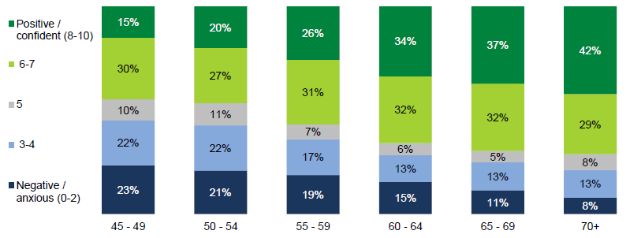

Q12 How do you feel about your later years in terms work and/or retirement? (Negative/ Anxious=0 to Positive/ Confident=10) Base: 45-49 (n=465), 50-54 (n=584), 55-59 (n=573), 60-64 (n=586), 65-69 (n=347), 70+ (n=448)

In fact, nearly half of Australians 45- 49 are anxious about their future when it comes to work and / or retirement. While this drops significantly as Australians age, there is still a substantial proportion anxious and negative about their future up until age 70.

Not surprisingly given greater financial strain, along with differences by age, those who are single/unpartnered and with lower incomes are also more negative / anxious about their future work/retirement:

* 23% of single Australians are anxious/negative (rating 0-2) vs. only 12% of partnered Australians.
* 24% of Australians earning less than $40k annually are anxious/negative (rating 0-2) vs. only 9% of Australians earning $ 100 k or more annually.

### A number of barriers to working longer

#### Lack of value placed on senior workers

To remain in the workforce, seniors want to be feel valued. Yet, this is not the case.

The problem seems to be cultural as much as it is economic. The dominating perception is that Australian employers simply don’t value older people: mature workers feel they are not seen as mentors but a burden to manage. They believe that their departing from the workplace often leads to a loss of experience and knowledge as well as reliability and loyalty, yet they feel they are actively encouraged to quit early.

Discrimination can be an issue, whether in recruitment or day-to-day. Examples include being made to feel unqualified when actually being so during job interviews, promotions being given to younger staff or being left aside from decision- making. This is even when seniors can get an interview or a position: oftentimes, they feel they are disqualified from the start of the process.

“They just don’t want to give jobs to older people.” (54 - 65, Female, Launceston)

Yet a bigger issue than active discrimination seems to be a more pervasive sense of disregard for mature workers’ inputs. Many feel they do not share the values of their employer: many for example value quality and service when their employers are seen to value fast speed and commercial KPIs. Seniors can also feel overtaken by technology with little room given to training.

Even the recruitment process is fraught with barriers seniors don’t know how to navigate. While finding a job used to involve relying on networks and a reputation for good work, it is now heavily process based, starting with online applications and ending up with point scoring on a number of evaluation criteria. This contemporary mode of recruitment feels geared towards younger generations, for whom this feels normal and who have been trained to navigate it.

This leads senior workers to hold on to their jobs for as long as they can, even if they are increasingly dissatisfied with it. They admit to not being a generation that is used to chop and change but more importantly they know that i f they lose their job, it will be hard to get a new one. The sentiment that “no one will look at you if you’re over 50” is very common: mobility feels discouraged.

At the extreme end of the scale, are the many who have experienced redundancy and now feel very set back. It feels difficult for them to re- enter the workforce if their role is lost. They have never been trained to job search and the system seems to have changed significantly since they last tried. Many simply don’t know where to find support and while some manage to “get back on the saddle”, others just “check out”.

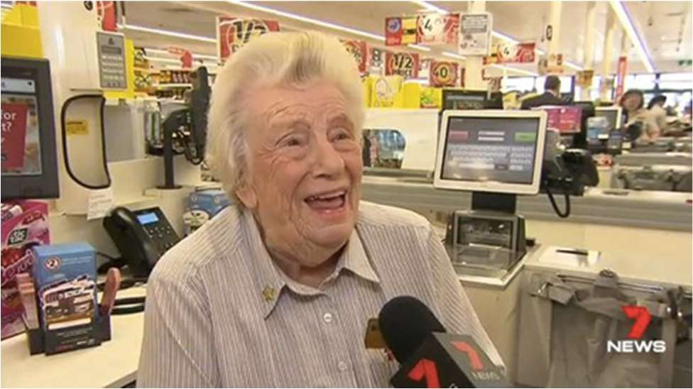

In this context, a message to seniors to embrace working longer in their lives feels inadequate: if they are not wanted by employers, how can they not only find employment but also enjoy it? This points to a need and opportunity for government to shift the dial and help employers recognise the value of seniority as well as help those who need job search and skill t raining support.

"They should have something where the government links older people up to employers who offer part time work and that sort of thing. Or even volunteering." (56-65, Female, Melbourne)

#### Lack, perceived or real, of work options

Those mature workers already looking to increase their work hours share how difficult it can be: options for work are, or at least are perceived, to be lacking.

Many mature workers want part- time work or casual and odd jobs. They also want the flexibility to stop and start e. g. to go away for two months and come back to employment. Yet these flexible options are not always available in their line of work and are not encouraged by employers e. g. it may be easy for a bookkeeper or yoga instructor but more difficult for a teacher or a machine operator.

”In my industry, you can’t take a ‘gap year’.” (55-65, Male, Newcastle)

Part- time and casual work feels also most available and is wanted at the unskilled end of the spectrum, where it is also most competitive. The dominating belief is that positions will go to younger, more- abled people. On a side note, while seniors feel this is regrettable, many have also internalised age discrimination and believe it is normal that priority should be given to young people.

"There isn't even jobs for the young kids, it's more important they they're working than me." (56-65, Female, Launceston)

We also note that opportunities for continual workforce participation feels even more limited in regional areas. In towns such as Bendigo, Launceston or Newcastle, where the bulk of the regional leg of the study was conducted, the general narrative is that of increasing difficulties finding jobs, young and older people alike.

While the perception of lack of opportunities – in regional and metro areas – feels like it closely matches the reality of the traditional economy, it also points to a lack of awareness of new economy options or ways to transfer skills to new ways of working. In our discussions for example, teachers who shared “they couldn’t possibly teach prep until age 65” had never considered the option, posed to them by others, that they could start their own in- home childcare part- time business; machine operators had not considered how they could advertise their skills to complete handiwork jobs for home owners in their local area. In their own admission, changing this mindset and considering these opportunities would require strong personal support.

“If you don’t have the connections, you can’t even do these odd jobs [not thinking of new ways to advertise]” (56-65, Female, Bendigo)

This also points to a lack of awareness of resources already available. Many for example were surprised to hear that tools such as [olderworkers.com.au](https://olderworkers.com.au/), a job search website for mature workers existed. Many are also genuinely interested in hearing stories from mature workers who have retrained e. g. someone working in retail who was offered a social services training opportunity and now counsels other seniors.

This also points to a lack of consideration of new economy tools. Many want to keep in control of when and how much they work, yet very few are aware of gig economy opportunities such as advertising skills on Air Tasker, start driving with Uber or making the most of their homes through Airbnb. As many have never used them as customers themselves, they simply do not understand what they are and consequently don’t see themselves as potential participants.

These gaps point to a need for information, inspiration and personal support.

As shown below, the perception that there are fewer options for older workers is confirmed in the quantitative results.

Figure : Average agreement with work / retirement sentiment attitudes by age.

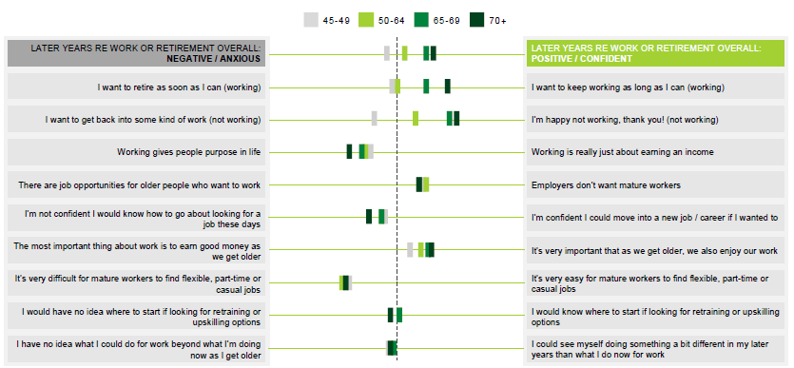

Q18 Work and retirement overall attitudes (11pt scale, opposing statements as end points). Base: 45-49 (n=465), 50-54 (n=584), 55-59 (n=573), 60-64 (n=586), 65-69 (n=347), 70+ (n=448)

The general sentiment for working in later life is that employers do not value mature workers, and that it is difficult to find flexible, part time or casual jobs. Additionally, many people would not feel confident about how to go about finding a job.

For those that are working longer, their motivation is less about earning an income and more about enjoying themselves and having a purpose. Younger people are mixed about wanting to retire versus keep working. While those who are older (particularly 65+) appear to be still working because they want to be. Similarly, those over 65 who are not working are generally retired and happy to be not working. While younger people who are not working want to get back to work (as they are less likely to have chosen not to work).

#### Retraining feels too abstract in its current form

Workforce discussions invariably lead to the importance of mastering technology and adapting to new work methods. Middle- aged Australians are already learning ever y day on the job and understand the necessity to ‘get on with the times’. Older Australians marvel at what they’ve learnt recently: from teaching themselves computer skills to teaching themselves more through YouTube tutorials. In many circles, there is excitement around the idea of skills development.

W here the conversation fails to move is to learning for new jobs or industries. While many are open to training on the job and basic upskilling, re- training feels more abstract, foreign and as a consequence too difficult.

A key barrier is a lack of inspiration or interest: most simply don’t really know what to retrain into. At their age, they don’t want to start from scratch, but they feel they have no support to help them understand where their skills could take them. They may also never have developed interests beyond their current line of work and may have mentally already ‘checked out’.

Most don’t really know what kind of training could even be available. They already have computer, customer service or organisation skills: what else could there be to learn? They have never been exposed to training offers and even less so to what these training options could lead to.

“But I can use a computer already, file, organise, take calls, manage... what else do you retrain into...?” (Female, 45 -55, Bendigo)

Many also share a sense of uncertainty about the jobs of the future: what will be in demand? Without clarity, it feels too risk y to invest time and money – time and especially money being significant barriers in themselves.

Finally, formal education can be scar y, especially to those who have never studied before or who studied many years ago. Entry requirements can also have changed, or qualifications are no longer valid, making it a difficult path to make, especially without support.

These barriers combine to make broad- brushed retraining messages obscure and abstract, and ultimately, irrelevant. Yet, many feel theoretically open to the idea of retraining and are inspired by the story of those who have. They point to the following conditions for the opportunity of retraining to be considered seriously:

1. Support: qualified professionals to help them understand not only what t raining is available but even to get an idea of what kind of (in- demand) jobs they could retrain for. They need to be able to share their story to get feedback and inspiration.
2. On- the-job: preference is for training to be connected to an actual job, not a generalist degree or certificate. Apprenticeships for the seniors for example is a concept that is highly appealing.
3. Up-skilling: desire for retraining to harness their current life skills, not start from scratch at a time when they feel they have little time left.

#### Conversations about automation are not empowering

Automation is not a topic that is spontaneously raised, showing a lack of understanding of its significance at the moment. Workers are unsure how their own job could be automated and while most are aware of conversations in the public arena, these have not filtered down to community level.

Yet, when the topic is raised, workers understand the potential impact at a broad level. Some anecdotes are shared and internalised such as having heard from their university aged children that they are being trained for jobs that don’t even exist yet when they will graduate. It feels like automation could change workforce dynamics indeed.

However, understanding does not trigger action. In fact, action seems impossible: if work can be disrupted anytime and the nature of these disruptions cannot even be forecast up to the next five years, why even prepare at all?

"I guess you know [automation] is coming, it's inevitable, but what's the solution? That's saying that lots of people are going to lose their jobs... So, what is the government doing?" (45-55, Male, Newcastle)

Conversations about automation therefore only seem to create uncertainty: they are not empowering or motivating. Without solutions, the conversation is best avoided.

### Slowing down still central to retirement

While many of the conversations on the topic of retirement actually focused on working in our study (as per the research objectives), many others also focused on the need to slow down.

A consensus seems to build that as workers but also as bodies, we all seem to be peaking in our 40s. Past the mid- 40s, we gradually lose some of our mental and physical motivation. This is not just t rue of the stereotypically difficult jobs such as trades but also of many less taxing jobs such as administration or teaching. Physical and mental tasks themselves become more difficult but also the system in general: the workplace politics, the external pressures from deadlines to customers and suppliers, the demands of zealous bosses or in some extreme cases, the subtle continuous bullying. A lack of interest can also simply hold sway after many years in the same area.

"You can't just keep going and going, it's hard when your job is working on your feet, you get so tired. I'm looking forward to retirement, I want to relax...I want to sleep in!" (56-65, Female, Launceston)

“You can’t teach prep until age 65!” (Female, 56-65, Bendigo)

All realise at some point that they have to live for the now. Work is an essential ingredient to successful senior years but not the only one: older Australians have missed out on enough of the rest of life to know how important it is to live for the present.

This makes slowing down still a broadly shared aspiration. Many want a recognition that they can’t be expected to be as active as they used to be. Even though typical paths to retirement disappear, seniors still want to least work less.

### Work related planning activities vary substantially with age

As shown below, not surprisingly the proportion who have retired from work increases dramatically with age, spiking from 60 and again at 65.

Table : Work related planning activities undertaken

|  | 45-49 | 50-54 | 55-59 | 60-64 | 65-69 | 70+ |
| --- | --- | --- | --- | --- | --- | --- |
| Retired from work | 4% | 8% | 17% | 37% | 68% | 81% |
| Spent time volunteering | 12% | 16% | 19% | 26% | 30% | 41% |
| Worked out my plan for retirement | 12% | 13% | 26% | 30% | 33% | 29% |
| Moved to part time , casual or more flexible hours | 11% | 16% | 19% | 23% | 17% | 10% |
| Explored options for changing role/different type of work | 15% | 18% | 15% | 11% | 7% | 5% |
| Changed to a less demanding career/role | 7% | 11% | 13% | 15% | 9% | 6% |
| Restrained/reskilled | 9% | 10% | 8% | 8% | 3% | 2% |
| Organised ongoing supplemental involve | 6% | 9% | 7% | 8% | 5% | 4% |
| Stated a business | 7% | 6% | 8% | 5% | 3% | 3% |

Q18 Work and retirement overall attitudes (11pt scale, opposing statements as end points). Base: 45-49 (n=465), 50-54 (n=584), 55-59 (n=573), 60-64 (n=586), 65-69 (n=347), 70+ (n=448)

Along with a jump in the proportion retired, there is an increase in those who are spending their time volunteering.

While slowing down is an aspiration, but job flexibility and options for mature workers is a challenge, relatively few have changed careers / roles to achieve that, instead they have retired.

### Interest in information from government varies by age

As shown below, interest in information from the government about work, transition and retirement drops sharply from age 60.

Figure : interest in information from the government about work, transition and retirement by age

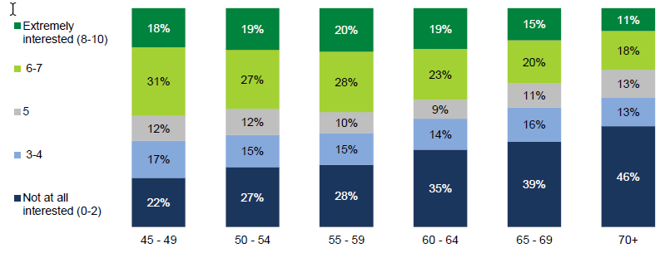

Q45 How interested are you in receiving information or resources from the government about the following? Not at all interested=0 to Extremely interceded=10 Base: 45-49 (n=465), 50-54 (n=584), 55-59 (n=573), 60-64 (n=586), 65-69 (n=347), 70+ (n=448)

However, before age 60 about half are interested in more information or resources from the government. Note that this is general interest: participants were not asked about specific messages or resources.

## FINANCIAL PREPARATIONS

As with other key pillars, as shown below sentiment towards their future financial situation also increases with age.

Figure : Sentiment towards future financial situation by age

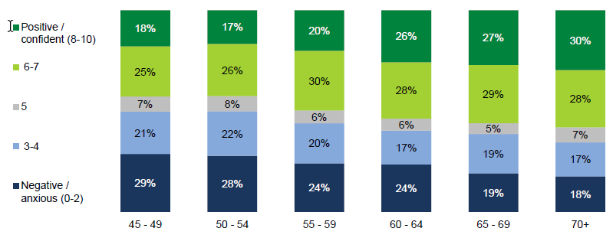

Q21 How do you feel about your later years in terms of your financial situation? (Negative/Anxious=0 to Positive/Confident=10) Base: 45-49 (n=465), 50-54 (n=584), 55-59 (n=573), 60-64 (n=586), 65-69 (n=347), 70+ (n=448)

While age is a key differentiator, consistent with other results, there are also other sub groups who are more worried about their future financial situation:

* Women (27% rating 0-2) versus men (21% rating 0-2).
* Those in a regional area (26% rating 0-2) versus metro residents (22% rating 0-2).
* Those who are single (32% rating 0-2) versus those who are partnered (19% rating 0-2).
* Those who earn less than $40 K annually (36% rating 0-2) versus those who earn $100 K or more (12% rating 0-2).

### Financial preparations most common, although incomplete

Most aspire to the idea of saving up to retire. Seniors share that past a certain age, the Great Australian dream shifts from outright home ownership to self- funded retirement. As such, the ‘ normal’ trajectory for those who can afford it is already to save up to the ‘ magic figure’ with a wide combination of investments and what they see as smart ‘ tricks’, from SMSF to property to extra contributions.

"We saw a financial advisor and worked out the amount we needed in super, so we'd be comfortable and be able to travel. We knew we wanted to be able to go overseas and do the things we want to." (66-75, Female, Melbourne)

The less wealthy however, are more summary in their preparation. All know that superannuation is a key way of providing for senior years and there is a broadly shared sense that once this box is ticked, they have a safety net which will, hopefully, provide income for Essentials – everyday expenses that constitute the basis of a modestly comfortable life. However, the thinking often stops to the Essentials and does not extend to Extras. Many are indeed not actually clear about the level of income their Super will provide. Salary sacrifice and other opportunities to increase income to cover a lifestyle target are indeed not widely discussed. Many are also not sure that what they are saving up for in the future is as exciting and motivating as ‘living life in the now’. They believe there is lit t le incentive to offset current for future pleasures.

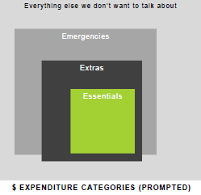

Very few want to think even harder about Emergencies such as unexpected home or car repairs or sudden increases in local rates, and Everything Else such as redundancy or forced retirement to funeral planning, serious illness, death of partner or even taking on grandchildren. These scenarios were raised in the study but very few are prepared for them.

In short, while the debate around preparation has focused on finances, more details are needed to extend plans and to provide motivation.

As shown below, of particular interest is the relatively low proportion who have worked out their plan for retirement. While this increases at 55, only one in 4 report that they have worked out a plan.

Table : Retirement planning by age

|  | 45-49 | 50-54 | 55-59 | 60-64 | 65-69 | 70+ |
| --- | --- | --- | --- | --- | --- | --- |
| Worked out my plan for retirement | 12% | 13% | 26% | 30% | 33% | 29% |

Q18 Work and retirement overall attitudes (11pt scale, opposing statements as end points). Base: 45-49 (n=465), 50-54 (n=584), 55-59 (n=573), 60-64 (n=586), 65-69 (n=347), 70+ (n=448)

In fact, as shown below, when looking at overall sentiment towards their financial future, the differences by age group virtually disappear when looking just at those who have a retirement plan.

Figure : Sentiment towards future financial situation by age amongst those with a retirement plan

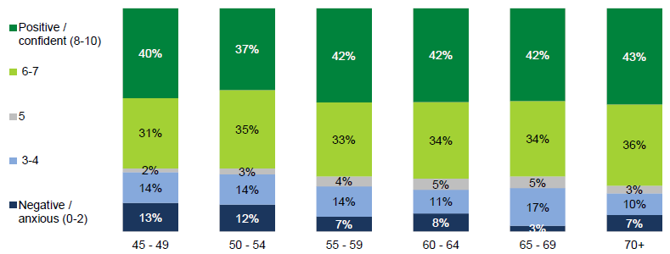

Q21 How do you feel about your later years in terms of your financial situation? (Negative/Anxious=0 to Positive/Confident=10) Base: 45-49 (n=465), 50-54 (n=584), 55-59 (n=573), 60-64 (n=586), 65-69 (n=347), 70+ (n=448)

Amongst those that have a retirement plan, sentiment towards their financial future is resoundingly positive regardless of their age. Further, as shown below, while income has a clear impact on sentiment regarding their financial future, having a retirement plan is still a key to driving positive sentiment.

Figure : Sentiment towards future financial situation by age amongst those with a retirement plan

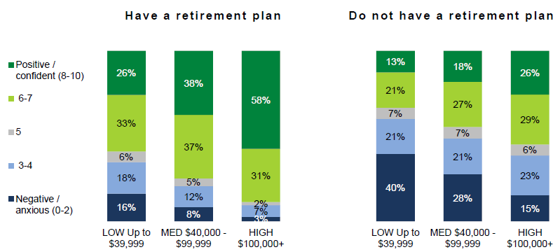

Q21 How do you feel about your later years in terms of your financial situation? (Negative/Anxious=0 to Positive/Confident=10) Base those who reported an income: Have a plan, Low income (n=121), Med income (n=271), High income (n=211), Do not have a plan, Low income (n=640), Medium income (n=831), High income (n=490).

So, while sentiment increases with income levels as would be expected, positive sentiment towards their financial future is substantially higher where they have a plan: regardless of income. In fact, those with a plan on a low income have the same degree of positive sentiment as those without a plan but on a high income.

### Despite the aspiration, transition planning can seem exclusive

The wealthiest are naturally triggered to plan for later: an excess of savings automatically prompts the question of what to do with it and who to consult for guidance. For others, the priority is to get through the week: when little is left over from wages now, planning for later seems illusory.

"I plan for my retirement to spend less, not to earn more. I will probably rely on my savings and government pension. I have a house without any mortgage and I plan to grow my own food, so the government pension should be enough for me." (45-55, Male, Metro QLD)

When the goal seems so far out of reach, demotivation takes over. Many would rather not think about it at all. Any message about superannuation or other types of preparation feels irrelevant. While the figure of the self- funded retiree appeals, it is not achievable or empowering to all.

“I prefer not to look at it. I know I can’t do anything about it.” (56 -65, Female, Bendigo)

“My priority now is to pay off the mortgage.” (56 -65, Male, Newcastle)

Accentuating this tendency to tune out of preparation messages, is the lack of affinity with financial planning. Getting financial advice is indeed not quite ‘normal’ just yet. To those already with sufficient funds, financial planning is a given, while to those with little, it obviously makes no sense. Yet, a large band in the middle who may benefit from advice are unsure what ‘financial planning’ actually entails: at the moment it somewhat feels like a black hole.

Despite a lack of relevance at the moment, those in this middle band are somewhat intrigued by the stories of others who have gone through the experience. Hearing about the mechanics and the benefits of financial planning motivates, showing scope to broaden its reach.

“[After hearing story] I see. I’ll ask my husband. We should really look into it.” (Female, 56-65, Bendigo)

### Triggers and barriers to seeking financial advice

#### Barriers

The main barrier to accessing financial advice is the lack of insight into the mechanics and benefits of financial planning. Many wonder how financial planning can indeed benefit them and are surprised to hear conversations about how useful it has been to others. Anecdotes such as those that people could save on tax through unknown investment options, that delaying mortgage repayments can sometimes be beneficial or that any investment should double in value ever y seven years are the kind of information that help reframe the understanding of financial planning and make it relevant.

Once the decision to see a financial advisor has been made, the next hurdle is knowing where to start i.e. who to see and t rust. Because the topic is not widely discussed at community level, word of mouth does not work as effectively as in other areas. There are also seemingly few tools to understand the difference in positioning and offer between different services, let alone their quality. While listings do exist, they provide little guidance. This is all the more important as some have heard a number of stories relating to poor financial advice.

Those with prior experience may in fact be ‘burned’ by poor financial advice. Some have even resorted to seeing a multiplicity of advisors as no single one can be trusted, evidenced by the fact they all give different advice. This can lead to fatigue and in the end limit the number of contacts they have with financial advisors. For a minority, this may have been exacerbated by the latest global financial crisis as they lost much and depending on circumstances, may have not recovered.

Price is an obvious deterrent too. Advice can not only be expensive, price structures can vary widely and be unclear too, leading to uncertainty as to the ‘right price’ to pay and why some may be suspiciously more affordable than others.

#### Triggers

A number of external triggers are usually the source of the first foray into financial advice. Life events, especially starting a family trigger many questions and uncertainties that can lead to financial advisors. So can surplus savings e.g. an inheritance, a promotion or finishing paying off the mortgage.

A number of external triggers also help to update a plan and return seeing a financial advisor. The most common are changes in financial circumstances but importantly so are a change in investment rules. Financial advisors are often the first destination to help comprehend the nature of these changes.

Some need more than external triggers though. The motivation becomes the possibility to access investment options or benefits they had never thought of before. An exposure to the story of others helps to build surprise and familiarity with the financial planning process and ultimately relevance.

### Attitudes towards financial future

As shown below, aligned with increasingly positive sentiment with age, knowledge and awareness of what financial planners can do also appears related to more positive sentiment towards their financial future.

Figure : Average agreement with financial situation sentiment attitudes by age

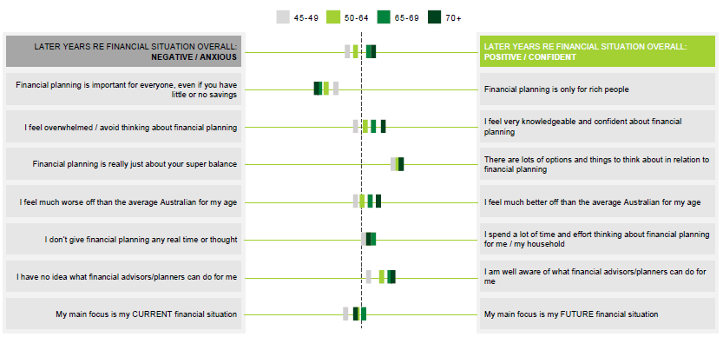

Q27 Financial Planning Overall Attitudes (11pt scale, opposing statements as end points). Base: 45-49 (n=465), 50-54 (n=584), 55-59 (n=573), 60-64 (n=586), 65-69 (n=347), 70+ (n=448)

As Australians’ age they feel more confident about their financial planning skills, and interestingly are also more likely to feel better off than average.

Focus on the present versus the future is mixed, with most age groups clustering around the middle when looking at mean scores. When looking in detail, this ‘average’ reflects polarised / mixed opinions rather than neutral attitudes.

### Opportunity for increased promotion of resources including ‘Money Smart’

Money management information feels abundant: it can be accessed online, through financial institutions and superannuation funds, or simply consumed passively through the media, yet paradoxically, it is relatively rarely accessed. Awareness of actual tools is low. There is a sense that information is available but because few triggers exist, it is not sought out.

Awareness of ‘Money Smart’ (the Australian Securities and Investment Commission website aimed at helping Australians manage their money) or any other government sources is low. While many have heard about ‘Money Smart’, they cannot describe its content or purpose. They are often not even sure it is a government source.

Only those at the extreme end of the financial preparation spectrum read the financial or money pages of the paper, watch the TV finance news or purposefully access information online on their own volition.

The only source becomes their superannuation company, but only when they publish information. This often comes in the form of annual statements indicating how much super their clients can expect to accumulate until they can access but little more. Interest in these calculations however shows that external triggers such as savings goals can help start a conversation about planning if followed up.

Three sections of ‘Money Smart’ were tested as part of this study: the ‘super & retirement calculators’, the ‘superannuation & retirement’ general information page and the ‘over 55s’ general information page.

Out of the three sections, the calculators generated the most interest – to the point that participants even scribbled the web address to consult them later at home. Most were genuinely surprised at the level of interactivity and usefulness, with the tool feeling relevant at all stages of retirement planning. Two motivations for use surfaced:

1. A great conversation starter for financial planning: the ability to project concretely into the future generates further questions as well as a broader sense of opportunity about what could be possible. The tool in itself helps to trigger the thought that ‘something’ could be done, financial planning could be relevant.
2. Setting goals and tracking them: in such a low involvement category as superannuation, the ability to use external triggers to motivate action are essential. These calculations also help to guide conversations with financial planners for those who already use them, helping them to prepare ahead and maximise time with them.

Other sections feel less relevant. The ‘Superannuation & Retirement’ section feels too basic for their life stage and may be directed to younger people only. The ‘Over 55’ section is more relevant, especially for those who care for older parents: they may dip in and out on a needs basis.

As shown below, overall awareness of Money Smart is at 36%, but only 6% have ever used it. This is consistent across age groups.

Figure : Awareness of Money Smart

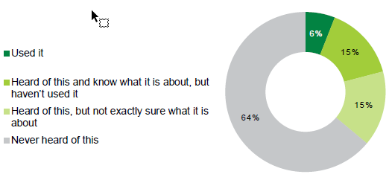

Q45 Which of these government websites/ services have you heard of? And which are you using? Base: total sample (n=3,003).

### Financial preparations possible beyond superannuation

Those Australians who cannot act on superannuation already act on other opportunities when they can. Other examples of setting themselves up for retirement include downsizing, moving to a cheaper area, divert inheritance to children and many more steps from working holidays and starting a commune to house sitting permanently and moving into a friend’ s granny f lat.

”I can’t even retire in my own country - I'm going to buy a place in Thailand. I know for what I have in super, I'll be able to live in a big air-conditioned house, with a pool, and a driver, and someone to cook and clean for me!" (56-65, Male, Melbourne)

This shows a commercial or at least business- minded approach can be achieved. Many however need the example and inspiration of others to reach that stage, hence the need for more information.

As shown below, financial planning activities undertaken peak around age 60- 64.

Figure : Financial planning activities undertaken

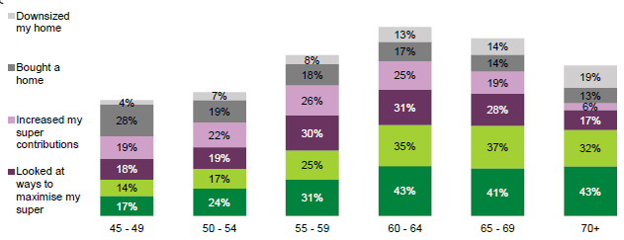

Q28 Thinking about financial planning, which of these have you already done? Base: Top activities, ranked n total sample, 45-49 (n=465), 50-54 (n=584), 55-59 (n=573), 60-64 (n=586), 65-69 (n=347), 70+ (n=448)

Housing, financial planning and superannuation are the key areas of focus when looking at financial planning. For pre retirees, paying off their home and increasing their super contributions are the main focus areas when preparing for retirement.

While looking at ways to increase their superannuation and seeing a financial planner increases at age 55, ideally a greater proportion should be doing this sort of preparation much earlier.

As shown below, consistent with the results above, engagement in their superannuation jumps from age 55 with many more reporting that they know the exact amount.

Figure : Engagement with superannuation by age

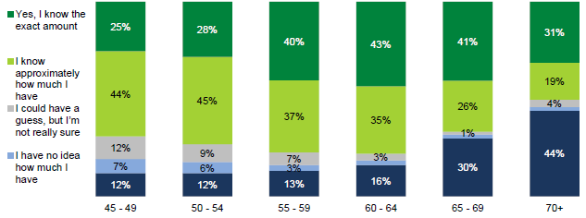

Q23 Do you know what your current superannuation balance is? (don’t worry, we won’t ask you the amount! ) Base: 45-49 (n=465), 50-54 (n=584), 55-59 (n=573), 60-64 (n=586), 65-69 (n=347), 70+ (n=448)

In particular, those aged 45- 49 and 50- 54 are significantly less likely to know exactly how much money they have in their superannuation versus those aged over 55.

Importantly, those who know the exact amount are more positive about their future generally. While those who have none are the least positive. But again, those differences largely disappear when looking at those who have a plan for retirement versus those who do not. This further indicates that it is the planning that is more important rather than simply knowing the amount of their superannuation.

### Interest in financial planning information from the government

As shown below, interest in financial planning information from the government also drops with age.

Figure : Interest in financial planning information from the government by age

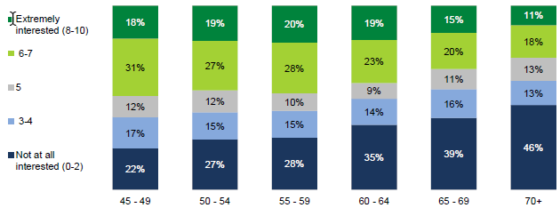

Q45 How interested are you in receiving information or resources from the government about the following? Not at all interested=0 to Extremely interested = 10. Base: 45-49 (n=465), 50-54 (n=584), 55-59 (n=573), 60-64 (n=586), 65-69 (n=347), 70+ (n=448)

This decline in interest is in line with an increase in seeing a financial planner. For these Australians this information from the government is not relevant as it is too late. Note that this is general interest: participants were not asked about specific messages or resources.

## HEALTH AND SOCIAL CONNECTEDNESS IN AGE

### Attitudes to health are largely life stage dependent

Unsurprisingly, the main trigger of awareness of the role of health is ill health itself. Good health is rarely discussed: it takes experience and indeed a diagnostic to realise its importance and the need for healthy behaviours throughout life. Preparation as regards health is accordingly very limited. When all is still well, most will not invest effort in health.

It takes the first signs of an ageing body, often in our fi ties, to start to adjust behaviours, if at all. Adjustments are often limited to basic diet and physical activity choices and are often more reactive than pro- active i.e. needing to make a change because the body or the doctor demands it.

The sixties often bring with them more serious conditions and therefore more serious adjustments. These are most likely diagnostics driven and can include everything from diet and light exercise to management of chronic conditions, and many actually see chronic conditions as a natural part of the entry into the sixties. Hospital treatment also becomes more important with many needing common operations such as knee and hip replacements or cataract surgery: hospital and post- operation care options are suddenly discussed more openly and more often, sparking debates about public and private health care including costs, timelines and choices.

The seventies and onwards are often marked by even more serious conditions. This is the stage where i l l health really starts to limit choices. It is part and parcel of the everyday, to the point that for the first time, it takes precedent over other aspects of life such as finances. In home treatment and continuous care options come to the fore and with this again debates about care choices.

Chronic conditions are seen as a natural or ‘normal’ part of old age, meaning most fail to see potential for prevention. Looking back, it often feels like little could have been done to delay their onset. Many conditions are also seen as manageable, an annoyance but not a life sentence. The dominant mindset is to accept them and ‘get on with it’, rather than dwell on what could have been done differently.

Maintaining mobility is often more of a direct concern than chronic condition management. In fact, it becomes a priority and entering into the seventies even a challenge. This includes mobility in the home, where in home help becomes highly valued but also importantly outside: getting around is key to maintaining mental wellbeing.

“I’m a member of the aquatic centre and I go swimming most mornings. Main thing keeping me going is that I know the moment I stop, I might not ever be able to start again! So I’ m not dead yet!” (66 - 75, Female, Melbourne)

Dementia is the ultimate concern. It is often connected with the idea of loss of independence and “nursing homes”, which most if not all would rather avoid. Conversations about dementia often lead to talk of checking out and indeed euthanasia. Dementia signals end of life.

### Healthy and happy: mental wellbeing highly valued with age

Those who have prepared for physical health understand its connection to mental health: without one, the other is not possible.

At an age where they slow down and have time to take stock of their lives, a sense of purpose becomes central to mental wellbeing. The need for purpose is not usually articulated so directly but expressed through such terms as “keeping busy” or being “healthy and happy”. A number of dimensions form the core of the idea of purpose:

1. Activity: as they slow down, having a schedule actually becomes even more important. Having to be somewhere at a certain time, a reason to set the alarm and get up help to feel needed and valued. For some this comes through work; for many others it could come through work if they were offered opportunities. In fact, the choice to work is sometimes removed against their will and the repercussions can set them back significantly. Contributing through volunteering is another key component of good mental health for many.
2. Mental capacity: maintaining it as they slow down becomes more difficult yet crucial. Keeping cognition and mental alertness or in their own words “the memory working” to prevent dementia is actively sought. Most of the time, this is not achieved through specific training but rather by keeping busy and indeed through finding new activities such as studying, hobbies, volunteering or work. Seniors often refer to it as “keeping the wheels turning”. Like finding work, finding new activities can also be a challenge, with inspiration sometimes needed.
3. Social health: social support networks become even more critical with age. Only people of the same age are able to understand the struggles of old age and help either physically or morally. Poor mental wellbeing often comes as a consequence of external factors such as the death of a loved one, ill health or redundancy. Recovery often requires external support too: this is more easily achieved for those with good social health, less so those without.

“Have you tried the University of the Third Age [woman to man in relation to getting more social]?” (65-75, Female, Newcastle)

### Diet and exercise in support role

Conversations about the preventative aspect of diet and exercise are usually limited. While knowledge of their importance is high, it is often not actively acted upon until it needs to be.

Still, a few priorities emerge with a progression from diet to exercise with age. W eight, and indeed looks, dominate as we are still active: how to eat better is more top of mind, if not always acted upon. With age, mobility becomes the key issue and ways to be more active suddenly come to the fore: numerous examples abound from joining a walking group to getting a pet to spend more time outside.

“I have three walking groups I belong to, each meets once a week - we start at the shopping centre and walk around and talk - I’ve made some nice friends doing that.” (66 - 75, Female, Melbourne)

### Largely positive view of the healthcare system but experience of many gaps

Most feel highly grateful to the public system. This is often expressed through the idea that they would not want to do without it, even if they hold private health insurance. Medicare is seen as a major national asset requiring utmost respect and indeed protection. Older audiences feel even more strongly about it, being more likely to have had extensive experience of the system and placing more emphasis on health generally.

"We have some of the best hospitals anywhere in the world. You wouldn't want to be sick if you lived in America, but here you're taken care of.” (56-65, Female, Melbourne)

Yet the public system is also perceived to be failing with population pressures. We note the sense is not that the public system is being pressured by an ageing population but rather an increasing population overall. For example, dental is free past a certain age, but the waiting list can be up to three years. Elective surgery waiting lists are also a commonly discussed sore point.

Past waiting lists, the public system is perceived to handle hospital treatment reasonably well, an important point for seniors. Yet it is seen to be failing with post hospital care, which feels incomplete: rehab after a knee operation for example feels difficult to access.

Population pressures and incomplete post operation care can make private health insurance particularly appealing – in addition to choice and tax breaks obviously. While provision of service is seen to be superior and often worthy, many sore points emerge, and they seem to be increasing rather than decreasing.

Discussions about cutting private health insurance in particular are ever more present. As money pressure increases in retirement many question the expense, even though they know this is when they will use it the most. But more than dwindling incomes, it is dwindling value that concerns. With increasing premiums and gaps, it becomes not only increasingly unaffordable but also unclear whether private hospital treatment is that superior.

While insurers are seen unkindly, it is government that is seen to shoulder most of the blame for in their views not regulating these gaps and premium increases strongly enough. Stronger action is expected, even if it remains unclear what.

"The public system is shocking, waiting lists are shocking. Yet they’re not making private health insurance easy: why do they allow these increases.” (56-65, Female, Bendigo)

### Despite more health conditions, sentiment improves with age

While Australians experience more health issues as they age, how they feel about their future years in terms of their health also increases with age.

Figure : Sentiment towards future health by age

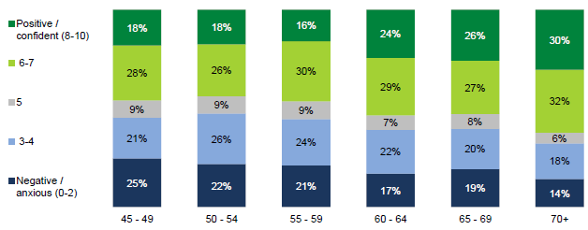

Q30 How do you feel about your later years in terms of your health? (Negative/ Anxious=0 to Positive/ Confident=10). Base: 45-49 (n=465), 50-54 (n=584), 55-59 (n=573), 60-64 (n=586), 65-69 (n=347), 70+ (n=448), chronic illness (1162), no chronic illness (1841)

While sentiment improves with age, this is heavily influenced by whether they already have a chronic health condition. Not surprisingly, those who do not have a chronic illness, or a family history of chronic illness are more likely to feel positive about their health into later life. However, as shown below, sentiment increases with age amongst both those who do and do not have a chronic illness.

Figure : Average sentiment about future health by age by chronic illness

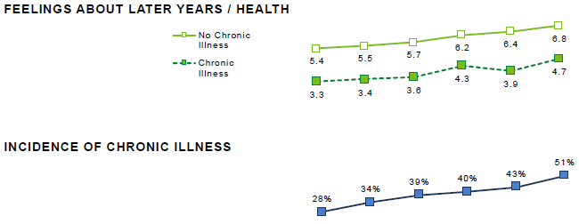

Q32 Do you currently have any chronic diseases or serious ongoing medical conditions? Q30 How do you feel about your later years in terms of your health? (Negative/ Anxious=0 to Positive/ Confident=10) Base: 45-49 (n=465), 50-54 (n=584), 55-59 (n=573), 60-64 (n=586), 65-69 (n=347), 70+ (n=448)

As shown below, increasing positivity with age is in line with increasing agreement that they are living a healthy lifestyle and feeling that it is easier to be healthy as they age. So, while having a chronic illness makes people less positive about their future health, and incidence of chronic illness increases with age, age overall still improves sentiment.

Figure : Average agreement with health sentiment attitudes by age

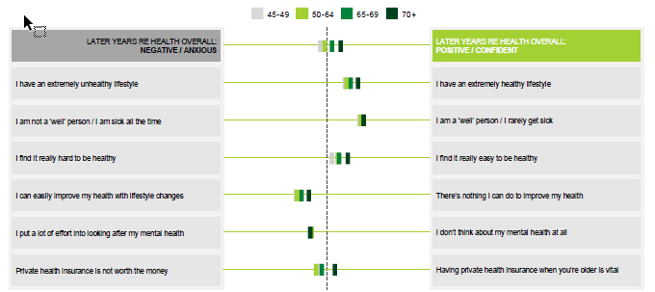

Q31 Health Overall Attitudes (11pt scale, opposing statements as end points). Base: 45-49 (n=465), 50-54 (n=584), 55-59 (n=573), 60-64 (n=586), 65-69 (n=347), 70+ (n=448)

That said, in terms of improving their health, perceived efficacy drops with age. There is a sense amongst older Australians that they can manage their current state of health, but as they age, there is less ability to actually affect change.

Despite differences in rates of chronic illness by age, Australian’ s across these age groups generally feel similarly that they are ‘ well’ people.

### Shifting from reactive to proactive approach to health: ‘One You’ seen as a wake-up tool

As shown below, when measured quantitatively, Australians report being more proactive about their health as they age.

Figure : Self classified approach to health

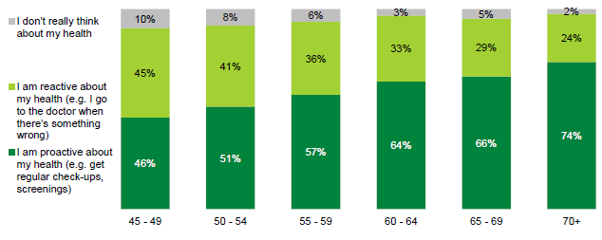

Q34 Which of these is most like you? Base: 45-49 (n=465), 50-54 (n=584), 55-59 (n=573), 60-64 (n=586), 65-69 (n=347), 70+ (n=448)

There is clear room to improve with nearly half of younger Australians being reactive to their health rather than proactive. Of concern is that even amongst those aged 70 or older, one in four are still reactive not proactive. Not surprisingly, those with a chronic illness are more proactive about their health.

The UK’s NHS’ ‘One You’ website was summarily tested for relevance in this study. It proved to be highly popular and potentially a game- changing tool, helping a shift from reactive to preventive health, even amongst the younger.

Central to this success is the ‘How Are You’ quiz. With its promise of a score, it helps us understand how we track, providing a personal and external trigger for action. I f the score is high, it provides reinforcement of the right behaviours. I f the score is average or low, it acts as a wake- up call to change.

Another successful aspect of the quiz is its tone, which attracts and kept people engaged throughout. Humour but more importantly the lifestyle rather than less engaging medical health angle helps to make it feel relevant, for me.

The apps offered at the end of the quiz are central to the success of ‘One You’ too. Because they are targeted instead of generalist, they offer the promise of achievable steps: small nudges rather than holistic lifestyle change. This helps to initiate, and hopefully with time habituate, healthier behaviours.

The consensus is that an Australian version, if well promoted, would be highly popular. This was evidenced by participants even noting down the web address of ‘One You’ to complete the quiz as they went home after the group discussions.

### Interest in health information from the government

As shown below, interest in health information from the government is strong across all age groups. This is clearly a topic where the government is expected to play a role.

Figure : Interest in health information from the government by age

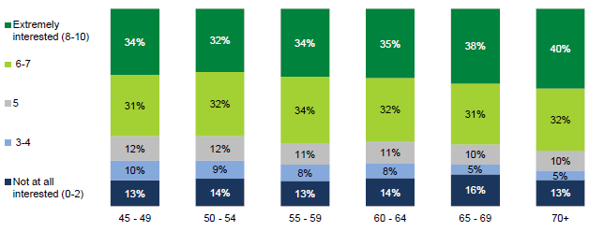

Q45 How interested are you in receiving information or resources from the government about the following? Not at all interested=0 to Extremely interested = 10. Base: 45-49 (n=465), 50-54 (n=584), 55-59 (n=573), 60-64 (n=586), 65-69 (n=347), 70+ (n=448)

Note that this is general interest: participants were not asked about specific messages or resources.

## SOCIAL CONNECTEDNESS: PART OF ‘GOOD HEALTH’

There is protection in the circles that surround us. Aged social circles provide practical and moral support, from information to in home care or simply sympathy in relation to ill-health or loss. There is a common perception that the young cannot understand the challenges of the older: having a social network our own age is highly sought after.

Yet with age comes difficulty to build new social networks. Friendships are built over time and as result of shared experience, often from school or from work. At some point, it simply feels too late.

A number of factors drive social isolation:

1. Lack of activity: those with little to do end up with smaller social circles too. Work can be central to social connection for some: men in particular can easily find themselves at a loose end when it stops, while women usually play multiple roles and are more likely to find new social circles elsewhere. Many need inspiration to know what to replace work with or find new work opportunities.
2. Poor mental health: in a self- sustaining cycle, feeling down or purposeless contributes to active isolation from others. Asking for help can feel practically impossible, not knowing where to turn to.
3. Moving is another common disruptor of social connection. Downsizing to a new area, moving from the city to country where it is cheaper, or moving to retirement and even more so aged care homes can severely disrupt social connection. It becomes apparent only too late, with little warning given to those who take the leap.
4. A continuation of old patterns: those with reduced social circles in young age find themselves with even smaller circles in age following loss, moves and simply natural attrition.

As social isolation is very much seen as an individual problem, seniors don’t expect government to intervene. At most, it could offer information about available options from clubs and community organisations, volunteering, studying and indeed work opportunities.

We also note that technology is often seen as a powerful connection tool. Social media is cited unprompted as a positive by many women in particular, helping them keep connected to the younger generations but also the local community e. g. clubs, councils and other organisations.

Technology also helps to keep informed as some have taken to the internet to keep on top of what health services and benefit they can access or how they can plan their finances. We note however that the vast majority still expect personal advice and are unlikely to be able to navigate the system online on their own.

“Facebook! To keep connected, Facebook!” (66-75, Female, Newcastle)

Finally, many acknowledge the need for basic technology skills to remain in the workforce today. Having no skills in this area leaves you behind and even those who haven’t furthered their skills yet often look to do so in the near future.

"I'm doing an online course through Coursera, it's fantastic - it's a creative writing course through a university in the UK. And it's free!” (66 - 75, Male, Melbourne)

As with other key pillars, overall sentiment towards their future social life also increases with age.

Figure : Sentiment towards future social life by age

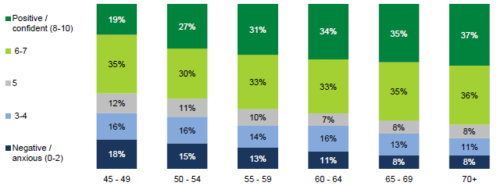

Q35 How do you feel about your later years in terms of your social life? (Negative/ Anxious=0 to Positive/ Confident=10). Base: 45-49 (n=465), 50-54 (n=584), 55-59 (n=573), 60-64 (n=586), 65-69 (n=347), 70+ (n=448)

Overall 2 in 3 (65%) Australians feel positive about their social life in their later years. However, compared to other age groups, those aged 45 - 49 are the most anxious/ negative about what this time would look like. Interestingly, positivity about their future social life is also l inked to income, with those on a higher income feeling more positive (19% of those on annual incomes of less than $ 40 K rate 0- 2 versus 8% of those on an annual income of $ 100K or more).

As shown below, 45- 49 year olds are consistently more negative about the future: regardless of the topic. They have also given their future social connections less thought as they are too busy getting on with their day to day challenges.

Figure : Average agreement with social connection sentiment attitudes by age

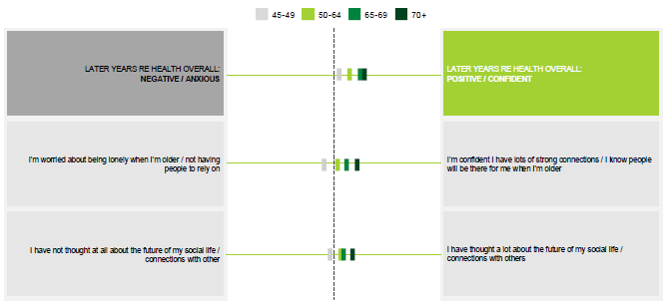

'Q36 Social Life Overall Attitudes (11pt scale, opposing statements as end points). Base: 45-49 (n=465), 50-54 (n=584), 55-59 (n=573), 60-64 (n=586), 65-69 (n=347), 70+ (n=448)

Relationship status is also important when considering their future social life. As shown below, partnered Australians are not surprisingly more positive about the outlook of their social lives. In particular, singles are more likely to be concerned about being lonely in later life.

Figure : Mean sentiment towards future social life by age and by singles vs. partnered Australians

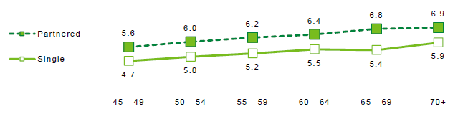

Q35 How do you feel about your later years in terms of your social life? (Negative/ Anxious=0 to Positive/ Confident=10). Base: 45-49 (n=465), 50-54 (n=584), 55-59 (n=573), 60-64 (n=586), 65-69 (n=347), 70+ (n=448)

Whilst singles are more anxious at any age, sentiment amongst both groups still increases with age.

While there may be difficulties building new networks with age, as shown below, Australians have more time to spend with existing networks as they age, and work commitments are fewer.

Figure : Social activities undertaken by age

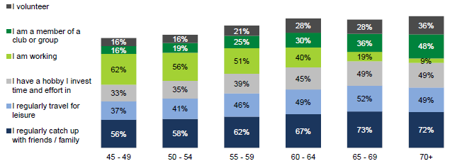

Q36 Thinking about your social life, which of these are you already doing? Multiple response, randomised. Base: 45-49 (n=465), 50-54 (n=584), 55-59 (n=573), 60-64 (n=586), 65-69 (n=347), 70+ (n=448)

Australians are doing a number of things to remain social. While 45-49 year olds’ activities are dominated by working (62%), they are also regularly catching up with friends (56%). Time with friends and investment in hobbies and clubs increases steadily as work commitments drop off. From age 65, 3 in 4 are regularly catching up with friends or family.

### Interest in information from government about social connections

As shown below, interest in information from the government about social connections is mixed, but unaffected by age.

Figure : Interest in information from government about social connections by age

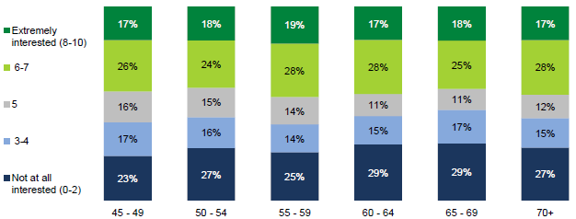

Q45 How interested are you in receiving information or resources from the government about the following? Not at all interested=0 to Extremely interested = 10. Base: 45-49 (n=465), 50-54 (n=584), 55-59 (n=573), 60-64 (n=586), 65-69 (n=347), 70+ (n=448)

Note that this is general interest: participants were not asked about specific messages or resources.

## AGED CARE OPTIONS

### “Nursing homes” dominate the discussion

The dominant view of aged care is that of “nursing homes”: in the absence of personal experience, knowledge of the broader system is low. Older Australians therefore rely on popular t ropes: the old age home where those who can’t care for themselves are left to “finish their lives”. Negative media stories of failure to care for the elderly in nursing homes over the last few years have heightened negative perceptions.

This makes for a seemingly bleak view of the system, one they would rather avoid at all costs. This is even more true for those who have put their own parents into a home and do not want to see themselves going through the same experience. Lack of physical ability is seen as the ultimate insult after a well- lived l if e. In this context, talk of euthanasia is common and even socially acceptable, with many seeing this as a viable alternative to a nursing home and many even having planned how they would go. Whether they would act on this is to be seen, but the very fact they entertain the thought is evidence of the current scare of the “nursing home”.

Government, more than private providers, is often blamed for the lack of “nursing home” care. Regulation as well as oversight do not feel up to scratch with under-resourcing and lack of expertise and training two major issues. Aged care homes are also seen as unaffordable by many: they cannot afford the ongoing costs or even provide a deposit and Government is seen to provide little help.

As shown below, despite these concerns and despite being more likely to need aged care services as they get older, sentiment actually becomes more positive with age.

Figure : Sentiment towards future with regards to aged care services by age

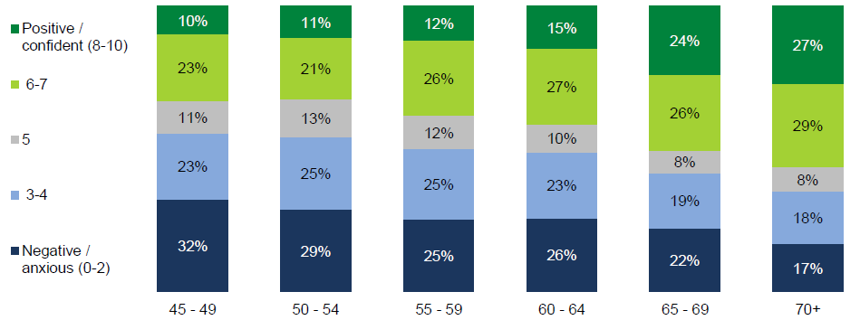

Q39 How do you feel about your later years in terms of receiving aged care services? (Negative/ Anxious =0 to Positive/ Confident =10) Base: 45-49 (n =465), 50-54 (n =584), 55-59 (n =573), 60 -64 (n =586), 65-69 (n =347), 70+ (n =448)

While overall positive sentiment increases with age, there are clearly anxieties around aged care as shown below.

Figure : Average agreement with aged care services sentiment attitudes by age

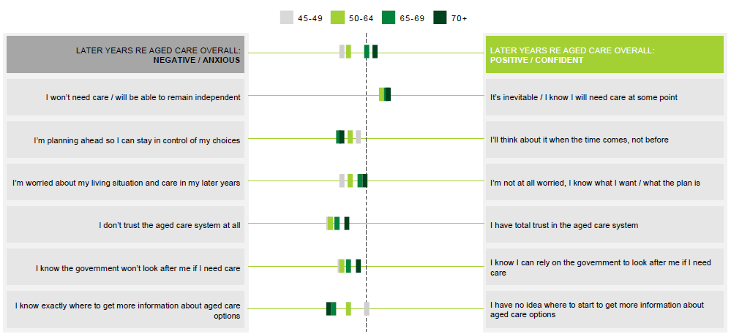

Q31 Health Attitudes Overall Attitudes (11pt scale, opposing statements as end points). Base: 45-49 (n =465), 50-54 (n =584), 55-59 (n=573), 60 -64 (n =586), 65 -69 (n =347), 70+ (n =448)

It appears that positive sentiment with regard to aged care services, as with other pillars, is also l inked to forward planning. Older Australians are more likely to say that they are planning ahead, while 45- 49 year olds are not. In line with having done more planning, Australians feel more confident about where to look for information as they age. Planning, knowledge and information gives a greater sense of control: driving overall positive sentiment.

While t rust in the aged care system increases with age, there is still a definite lack of trust across all ages. This is the same when considering whether or not they feel they can rely on the government to look after them: trust increases with age, but is still on the negative side.

### In- home care options are not well-known, yet are highly popular

A general consensus emerges amongst older Australians that we are better in our own home, where social connection and mental health, underpinning factors of good health, can better be maintained.

What most are looking for is therefore broader “assistance in health and living capacity” rather than “aged care”. Many share how vital it is to “their good spirits” to live in their own homes, yet realise they need increasing help to keep independent.

“We organised for someone to come in to help with Mum through the local council, they had someone come in to do the cleaning, gardening, to organise meals and help them bathe and toilet. Was a godsend.” [Others asking her for more information, advice on how to access] (66-75, Female, Melbourne)

Those who can rely on their family or relatives make the full use of it. Those who can’t however can feel at a loose end. Some can afford private help while others have sought information into what support they could access, often with difficulty and sometimes with few results (see below).

There is recognition amongst the more aware that government is moving towards in- home care. Most often, this comes from experience researching services for their elderly parents. Amongst the broader population however, awareness is low.

Interest however is high: when those with experience share their stories, those who have none listen intently. Knowledge will help them better plan before it gets to crisis point; it may even help them reconsider some of their darker thoughts. Additional information would be welcome.

### Information feels not only lacking but also difficult to access

Those with elderly parents have had to seek out information and options... and often testify to a difficult process. A common complaint is a lack of a central point for information with no perceived coordination between the different agencies and services. Bodies consulted include hospitals, local councils, individual “nursing homes”, community organisations and in some cases even Centrelink: people keep enquiring around without absolute or definitive answers.

“I went through hell trying to get mum into care. There are so many hoops, so many forms, and you just worry that you're not doing the right thing, or there could be a better option, but you just don't know.” (56-65, Female, Melbourne)

Those who turn to Centrelink are often disappointed. They come with precise questions such as where they could place their elderly parents, what kind of benefits they could access or what are the steps to start the placement process. Yet the overall feeling is that of lack of resources or even knowledge with few answers provided. For others, Centrelink is about unemployment or pension, not broader welfare, making it an unnatural destination.

Those who are not used to navigating complex systems, don’t have an investigative f lair or are less determined in their information searches share how they can end up feeling discouraged, leaving the “nursing home” search to a more capable sibling or relative.

### Interest in aged care information from the government

As shown below, not surprisingly, interest in aged care information from the government increases steadily with age as it becomes more necessary and therefore more relevant. This is also a topic where information is actually expected from the government.

Figure : Interest in aged care information from the government by age

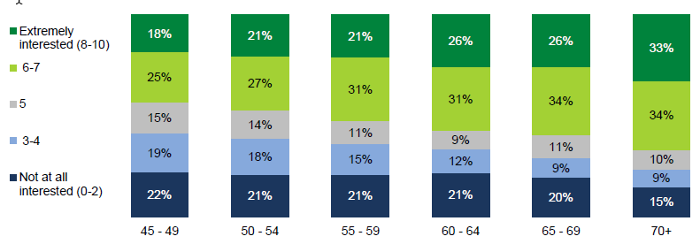

Q45 How interested are you in receiving information or resources from the government about the following? Not at all interested =0 to Extremely interested = 10. Base: 45 -49 (n =465), 50 -54 (n=584), 55 -59 (n =573), 60 -64 (n =586), 65 -69 (n=347), 70+ (n =448)

Note that this is general interest: participants were not asked about specific messages or resources.

As shown below, awareness that the government may help pay for in home care services also increases with age.

Figure : Awareness that the government may help pay for in home care by age

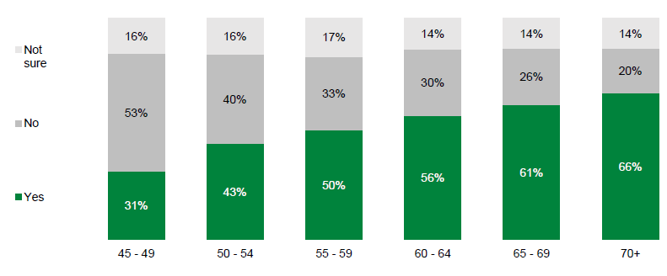

Q47 In home care is something that the government may help pay for. Were you aware of this before today? Base: 45 -49 (n =465), 50 -54 (n =584), 55 -59 (n =573), 60 -64 (n=586), 65 -69 (n =347), 70+ (n =448)

While a good proportion of those over 70 are aware of this, it is potentially concerning that 34% are not aware.

Also, not surprisingly, as shown below, awareness of My Aged Care also increases with age. Total awareness amongst older Australians is 46%, rising to 60% amongst those aged 70 and over.

Figure : Awareness and familiarity with My Aged Care overall and by age

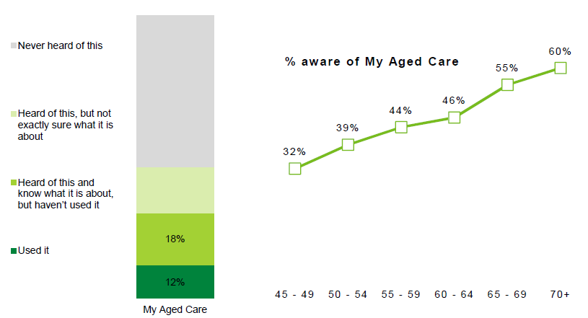

Q45. Which of these government websites/ services have you heard of? And which are you using? Base: 45 -49 (n =465), 50 -54 (n=584), 55 -59 (n =573), 60 -64 (n =586), 65 -69 (n =347), 70+ (n =448)

Again, while a good proportion of those over 70 are aware of My Aged Care, it is potentially concerning that 40% are not.

Low awareness of existing resources contributes to the feeling of lack of support. The ‘My Aged Care’ government website in particular is rarely if ever mentioned and Home Care Packages are not commented on either. But when introduced, they feel like a vital missing l ink, one that would benefit from being better communicated.

## THE CHALLENGE OF CHANGE

As noted earlier in this report, there is a broad consensus around the facts of an ageing population. However, understanding of the consequences on government services and budget is more contrasted. While some are well aware of the pressures, others have too individual a view, lacking systemic understanding: they can grasp personal consequences e. g. that service cuts could result in lower standards for themselves and their loved ones, yet the broader connections between demand, budget, economy and community feel too intangible and remote, requiring more personal communication to help them make the cognitive leap between systemic and individual.

Regardless of understanding, the topic itself is not engaging as it does not feel empowering or motivating. Conversations about Australia’s lack of planning have felt present for a long time: it feels like the very fact we are still having them reflects badly on government of all persuasions.

While the issue has been discussed for a long time, it feels solutions have not. Australians feel at pains to come up with any solutions themselves: instead, they want, and expect, government to take leadership and provide vision and forward planning.

As many have stopped listening, small steps like tinkering around the edges of superannuation, the pension or aged care will be seen as business as usual. That said, many share a sense of openness towards bold reform, but on certain conditions. Three are most commonly cited:

1. Fairness: even many of the self- funded have an expectation that government will not leave Australians behind when all else fails. The consensus is that i f government can’t pay a modest pension to our senior citizens, what can it still afford to do at all?
2. Warning: those who have already retired or are close to, accept that changes may be needed for people down the line, but not for them now that time to prepare and adapt is lacking.
3. Flexibility: if Australians are asked to be flexible, it is expected government programs should be too. Physical jobs, ill health or unforeseen circumstances for example are expected to be taken into account with regard to accessibility of benefits.

If vision and solutions are not put forward, a new frame to the debate would at least be welcome. Older Australians are often already made to feel like a burden. Hero-ing their formidable contributions is more likely to take hold of the community conversation. Showing how the community already responds to the challenges of an ageing population and setting this as the new normal is more likely to engage than top down communication.

We note this comes with a caveat. It feels like in a market situation, there will always be winners and losers. Many, even the self- funded, feel like the community cannot expect those on the minimum wage, the underemployed, the sick or the non- l iterate to plan or even just “save up” for their retirement. Reassurance that support is provided to those who really deserve it is expected.

“It becomes a question of priority: do we prioritise submarines or our elderly?” (56-65, Female, Bendigo)

“There will always be a pension. There can’t not be one.” (45 -55, Male, Newcastle)

### Government as an educator and information provider

When it comes to interest in information from government, as shown below, there is the most interest in health and aged care topics.

Figure : Interest in information from government by topic

Figure 36 is a stacked bar graph showing the interest in information from government by topic


Q45 How interested are you in receiving information or resources from the government about the following? Not at all interested =0 to Extremely interested = 10. Base: Total sample (3003)

In general terms, older Australians see health and aged care as within the realm of what the government is ‘allowed’ to get involved with and talk about. Financial planning and transition to retirement garnered much lower interest: these topics are the role of independent professionals. There is also less interest in information about social connectedness. To a degree, this may be because it is unclear as to what that would involve and not necessarily something that a lot of people are thinking about.

As shown below, Facebook has potential as an effective channel when speaking to older Australians. Social media use drops by age, but this is primarily due to fewer platforms used. Usage of Facebook is prevalent, to a similar degree, across all age groups.

Figure : Social media usage by age

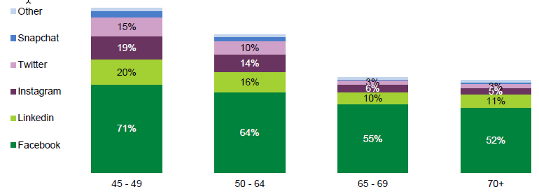

Q57 Do you use social media? Which of these do you use regularly Base: 45 -49 (n =465), 50 -54 (n =584), 55 -59 (n =573), 60 -64 (n=586), 65 -69 (n =347), 70+ (n =448)

Other media that older Australians engage with also varies by age. However, as shown below, regardless of age free to air TV will still have the greatest broad reach, followed by the internet and radio.

Figure : Media usage by age

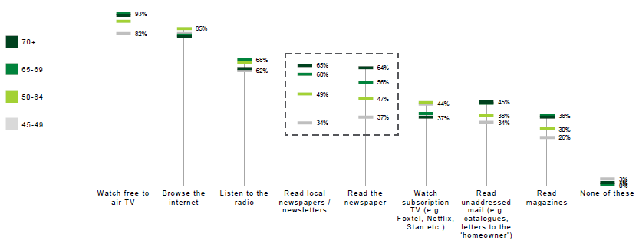

Q58 Which of the following do you do regularly? Base: Ranked on total sample, 45 -49 (n=465), 50 -54 (n =584), 55-59 (n =573), 60 -64 (n=586), 65 -69 (n =347), 70+ (n =448)

The biggest age differences are seen for newspapers: interest in newspapers is more moderate, but increases with age.

## SEGMENTS REVEALED

Using multivariate segmentation analysis, a number of segmentation solutions were considered. The end result of this analysis identified 5 key segments as shown below.

Figure : Segmentation solution

Figure 39 is a donut chart showing the segmentation solution. The percentages for each group are: 
- cautious planners 15%
- disheartened workers 18%
- reliant battlers 24%
- comfortable optimists 35%
- unhealthy dependants 7%

Base: Sample where segment was able to be reliably identified (n =2,895)

Each of these is described in more detail in the sections following.

### Segments compared

The 5 segments vary a great deal in terms of attitudes and sentiment towards their future years across all key pillars. While there are some demographic skews, the differences between segments go beyond demographics alone.

As shown below, Comfortable Optimists have earned their name by being by far the most positive of all segments when it comes to their future years overall. In contrast, Disheartened Workers, followed by Reliant Battlers, are the most anxious.

Figure : Sentiment towards the future overall by segment

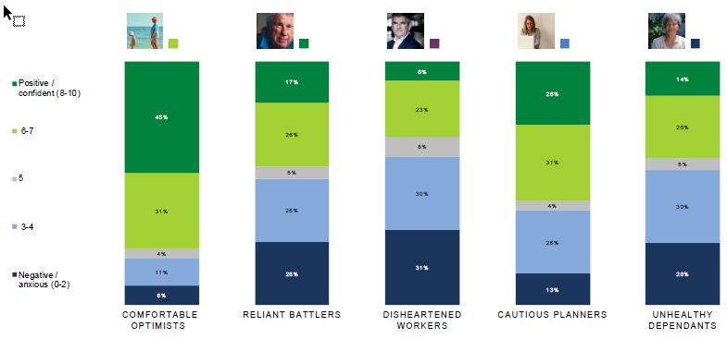

Q8 Overall, how do you feel when you think about your later years in life? (Negative/ Anxious =0 to Positive/ Confident =10) Base: Comfortable Optimists (n =1002), Reliant Battlers (n =703), Disheartened Workers (n =539), Cautious Planners (n =450), Unhealthy Dependants (n =201)

While Comfortable Optimists are the most positive of all segments when it comes to their future years overall, Cautious Planners have the most positivity and confidence when it comes to their future work and / or retirement. Again, Disheartened Workers are the most anxious.

Figure : Sentiment towards the future re: work and retirement by segment

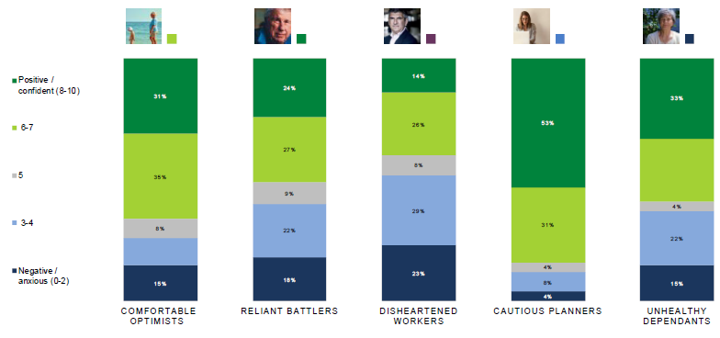

Q12 How do you feel about your later years in terms of work and/or retirement? (Negative/ Anxious =0 to Positive/ Confident =10) Base: Comfortable Optimists (n=1002), Reliant Battlers (n =703), Disheartened Workers (n =539), Cautious Planners (n =450), Unhealthy Dependants (n =201)

Cautious Planners also have the most positivity and confidence when it comes to their future financial situation. Again, Disheartened Workers are one of the most anxious. But it is the Unhealthy Dependants who are the most negative / anxious of all segments.

Figure : Sentiment towards the future re: financial situation by segment

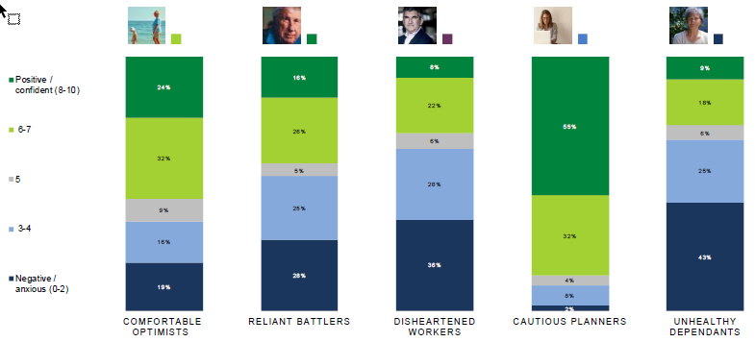

Q21 How do you feel about your later years in terms of your financial situation? (Negative/ Anxious =0 to Positive/ Confident =10) Base: Comfortable Optimists (n=1002), Reliant Battlers (n =703), Disheartened Workers (n =539), Cautious Planners (n =450), Unhealthy Dependants (n =201)

However, while negative about their future overall, about their future work / retirement and finances, Disheartened Workers are the most positive about their future health, followed by Comfortable Optimists. Unhealthy Dependants stand out as by are the most negative about their future health.

Figure Sentiment towards the future re: health by segment

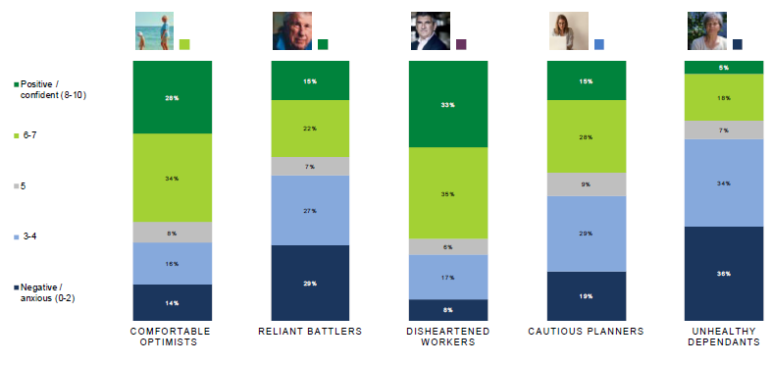

Q30 How do you feel about your later years in terms of your health? (Negative/ Anxious =0 to Positive/ Confident =10) Base: Comfortable Optimists (n =1002), Reliant Battlers (n =703), Disheartened Workers (n =539), Cautious Planners (n =450), Unhealthy Dependants (n =201)

In stark contrast to their perceptions of their future health, Unhealthy Dependants stand out as by far the most positive about their future social life and social connections.

Figure Sentiment towards the future re: social life by segment

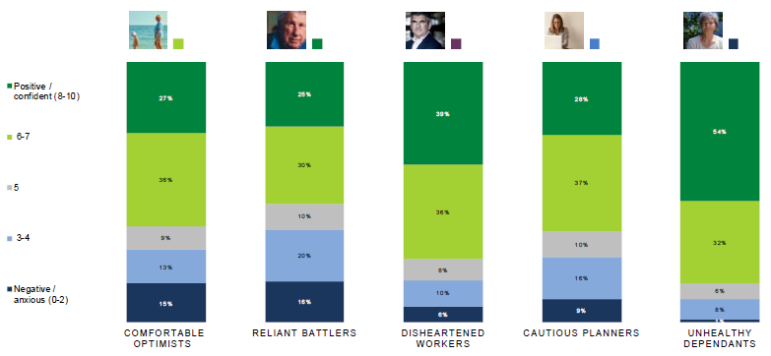

Q35 How do you feel about your later years in terms of your social life? (Negative/ Anxious =0 to Positive/ Confident =10) Base: Comfortable Optimists (n =1002), Reliant Battlers (n =703), Disheartened Workers (n =539), Cautious Planners (n =450), Unhealthy Dependants (n =201)

There is less positivity about their future when it comes to aged care services across all segments except for Reliant Battlers. This segment is the only group predominantly positive about the future when it comes to aged care services.

Figure : Sentiment towards the future re: aged care services by segment

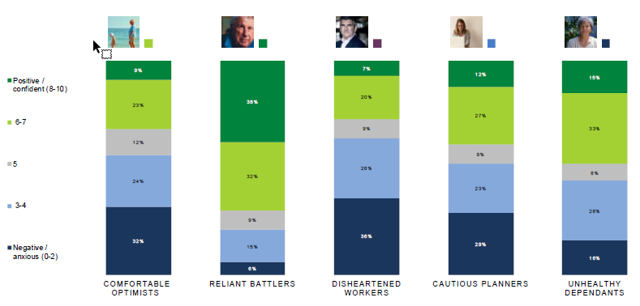

Q39 How do you feel about your later years in terms of receiving aged care services? (Negative/ Anxious =0 to Positive/ Confident =10) Base: Comfortable Optimists (n =1002), Reliant Battlers (n=703), Disheartened Workers (n =539), Cautious Planners (n =450), Unhealthy Dependants (n =201)

### Comfortable Optimists

Comfortable Optimists (35% of the population of older Australians) represent the ‘average’ Australian. Everything is on track for the future and everything is fine.

**The future overall**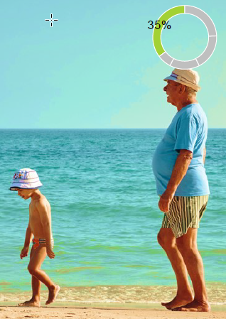

This segment is the most positive about their later years. They are more likely to be self- funded in later years.

They are also more likely to feel there are lots of positive options for them as they age, and that the contributions of older Australians are valued.

**Demographics**

There are no particular demographic skews for this segment. They appear to be predominantly ‘middle class’ and comfortable, but not necessarily wealthy.

**Work and / or retirement**

They feel moderately positive about retirement (2nd overall). Though they retirement feel valued in the workplace and working gives them a sense of purpose, they would be happy to stop. Those who have retired are happy staying retired, those who are still working are doing so because they want to.

**Finances**

Comfortable Optimists feel moderately positive about their financial future (2nd overall) and feel marginally better off than average. They are 2nd most likely to have paid off their home, 2nd most likely to have other assets and 2nd most likely to feel that they are knowledgeable and confident when it comes to financial planning.

**Health**

This segment is moderately optimistic about their future health (2nd overall). In general, they feel like they are a well person and find it easy to be healthy. They are also least likely to have a family history of chronic illness.

**Social life**

However, while positive about a lot of areas, this group may be more likely to suffer from isolation. They are one of the least positive segments when it comes to their future social life and are more worried about being lonely. At the same time, they are least likely to have thought about the future of their social life: perhaps not recognising its importance in their later health and happiness.

**Aged care**

This segment is one of the most negative about aged care, and are more likely to think that the government will not look after them. However, this segment are also least likely to feel that they will need care in the future (likely aligned with their perceptions of themselves as healthy and well).

**In summary**

W here this segment sits compared to other segments on all of the key pillars is shown below. While being the most positive and confident about the future overall, they are one of the lowest when it comes to their future social life and the future in terms of aged care services.

While optimistic and doing some planning for their future, this segment should be encouraged to consider whether they have done enough planning. In addition, this segment could benefit from understanding the importance of social connections for their future health and wellbeing.

Figure : Comfortable Optimists’ average sentiment by key pillars

Figure 46 is a comparison graph showing the comfortable Optimists’ average sentiment by key pillars


Q8 Overall, how do you feel about your later years? Q12 How do you feel about your later years in terms of work and/or retirement? Q21 How do you feel about your later years in terms of your financial situation? Q30 How do you feel about your later years in terms of your health? Q35 How do you feel about your later years in terms of your social life? Q39 How do you feel about your later years in terms of receiving aged care services? (Negative/ Anxious =0 to Positive/ Confident =10) Grey bar: lowest scoring segment. Black bar: highest scoring segment. Coloured square: Comfortable Optimists segment.

**Government resources**

There are no differences in awareness, usage, or interest in government resources.

**Media**

While most do use social media, they have one of the lowest levels of Facebook usage (58%). Free to air TV and the internet will have the greatest cut through of the channels tested.

### Cautious Planners

Cautious Planners (15% of the population of older Australians) are doing well financially, but worry has driven high levels of planning and preparation.

**The future overall**

Despite greater financial security, this segment is only moderately positive about their later years overall.

They are the most likely to feel they will be self-funded in later years, most likely to be planning now, and least likely to want to ask the government for help. They are also the most likely segment to feel there are lots of positive options for them as they age.

But they are least likely segment to feel that the contributions of older Australians are valued.

**Demographics**

There are some slight demographic skews for this segment. They over index as living in a metro area, being retired and having a higher income. They also have the highest level of education. Consistent with those skews, they are also more likely to be / have been a manager or professional.

Not surprisingly they are the least likely to be currently receiving any government pensions or benefits.

**Work and / or retirement**

They are the most positive about their future work / retirement of all segments. They are also the most confident about having choices / options when it comes to their future work.

They are most likely to have either retired already, or have a plan for retirement. While work does provide a sense of purpose, those that are, are happy being retired.

**Finances**

They are the most positive about their financial future of all segments (55% rating 8-10). They are most likely to know their exact super amount, have a range of other assets and own their home outright.

They also recognise that they are better off than average, and feel the most confident and knowledgeable about financial planning.

**Health**

Despite financial security, when it comes to their future health, they are not overly positive about their future health (polarized opinions).

While they feel that they have a fairly healthy lifestyle, feel fairly ‘well’, feel it is somewhat easy to be healthy, there is a sense of unpredictability when it comes to their future health

They are the biggest believers in private health insurance: as this is something about their future health that they can control.

**Social Life**

This segment feels moderately positive about their future social life. Overall, it doesn’t appear to be something that they really worry about.

**Aged care**

This segment has little positivity about their future in terms of aged care services, but this is similar to several other segments.

Again, as it is something hard to control and linked to health, this segment responds by planning. They are the most likely to be planning ahead and most likely to have moved someone else into aged care (i.e. they have experience).

**In summary**

Where this segment sits compared to other segments on all of the key pillars is shown below. While being the most positive and confident about their future when it comes to work and / or retirement and their financial situation, they are only middle of the road when it comes to their overall future outlook. This appears to be driven by those element of the future that are more out of their control: aged care services and their health.

As they are ‘planners’, any assistance or guidance in how to plan when it comes to their possible future health care, aged care, end of life needs could improve their overall sentiment. This segment could also benefit from understanding the importance of social connections for their future health and wellbeing.

Figure ****Cautious Planners’ average sentiment by key pillars****

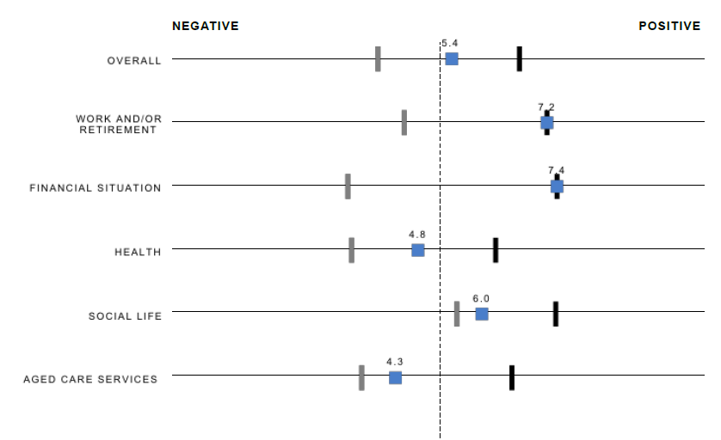

Q8 Overall, how do you feel about your later years? Q12 How do you feel about your later years in terms of work and/or retirement? Q21 How do you feel about your later years in terms of your financial situation?Q30 How do you feel about your later years in terms of your health? Q35 How do you feel about your later years in terms of your social life? Q39 How do you feel about your later years in terms of receiving aged care services? (Negative/ Anxious =0 to Positive/ Confident =10) Grey bar: lowest scoring segment. Black bar: highest scoring segment. Coloured square: Cautious Planners segment.

**Government resources**

There are no differences in awareness, or interest in government resources. Significantly more likely to have used MoneySmart (9%).

**Media**

While most do use social media, they have the lowest levels of social media usage overall (40% do not use it). They also have the lowest Facebook usage (54%).

**Free to air TV and the internet will have the greatest cut through. That said, this segment is more likely to read the newspaper and browse the internet than other segments.**

### photographic image of an elderly manReliant Battlers

Reliant Battlers (24% of the population of older Australians) are somewhat dependent on the government for assistance, but feel more of a sense of appreciation rather than entitlement. They would like to be self-sufficient, but health and other factors mean that they need some assistance.

**The Future overall**

This segment is only moderately positive about their later years overall.

They are the most likely to feel they will need to be supported by the government in their later years, least likely to be planning now, and most likely to feel that they will need to ask the government for help. They have mixed views on what options they will have later in life. But, encouragingly, they are most likely to feel that the contributions of older Australians are valued

**Demographics**

There are some slight demographic skews for this segment. They over index as single, in no longer being able to work (but not retired), and having a lower income. In fact, 15% of Reliant Battlers (well above other segments) report that they are unable to work due to disability, poor health or are unemployed. Consistent with those skews, they under index in professional roles, and over index as labourers.

This segment has the lowest level of education and are the most likely to be currently receiving a pension or benefit.

**Work and / or retirement**

Reliant Battlers are one of the least positive segments about their future work / retirement. Along with this, this segment shows the greatest proportion who are no longer able to work due to disability or poor health (11%). They are also the least confident about how to go about finding work.

**Finances**

Overall, they are not positive about their financial future (but are not the most pessimistic segment). They are most likely to not have any superannuation, are one of the segments most likely to be renting and least likely to have any other assets.

They are more likely to find financial planning overwhelming and to be focused on their current financial position rather than planning for the future.

**Health**

This segment is also one of the most negative about their future health. They are more likely to not feel that they are healthy or well and that being healthy is difficult.

Along with that is a sense of helplessness: they are more likely to feel that there is nothing they can do to improve their health. This is consistent with having one of the highest levels of chronic illness.

**Social life**

This segment is one of the least positive about their future social life. They are least likely to be part of a club, travel for leisure regularly or be working.

**Aged Care**

Despite not being positive about other areas in their life, this segment is the most positive about their future when it comes to aged care services. This appears to be related to the fact that this segment is also more likely to be currently receiving some sort of care. Encouragingly this suggests that this level of personal experience is actually positively impacting attitudes.

While not planning ahead, they have the greatest trust in the system and feel that they can rely on the government to look after them.

**In summary**

Where this segment sits compared to other segments on all of the key pillars is shown below. This segment needs a great deal of support when it comes to the future. Despite having lower incomes, financial planning would still be beneficial. Currently, they do not know where to start and may not see the point. This segment could benefit from being shown that financial planning need not be overwhelming via some simple approaches to planning for their future.

Figure Reliant Battlers’ average sentiment by key pillars

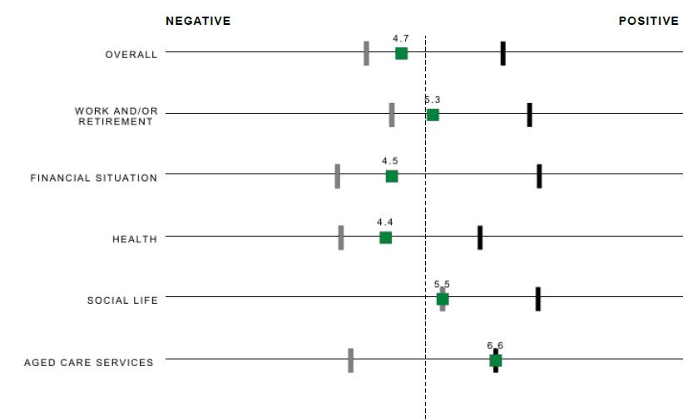

Q8 Overall, how do you feel about your later years? Q12 How do you feel about your later years in terms of work and/ or retirement? Q21 How do you feel about your later years in terms of your financial situation? Q30 How do you feel about your later years in terms of your health? Q35 How do you f eel about your later years in terms of your social life? Q39 How do you feel about your later years in terms of receiving aged care services? (Negative/ Anxious=0 to Positive/ Confident=10) Grey bar: lowest scoring segment. Black bar: highest scoring segment. Coloured square: Reliant Battlers segment.

**Government resources**

There are no differences in awareness, usage, or interest in government resources, with the exception that they have the lowest level of usage of MoneySmart.

**Media**

Their social media use is on a par with the average.

Free to air TV and the internet will have the greatest cut through.

### Photographic image of an elderly femaleUnhealthy Dependants

Unhealthy Dependants (7% of the population of older Australians) are somewhat dependent on the government for assistance, but feel more of a sense of entitlement. They feel they have ‘done their bit’ in other ways (e.g. having children). And now it is the government’s duty to care for them.

**The Future overall**

This segment is the 2n d most negative about their later years overall. They are also most likely to feel they will need to be supported by the government in later years, least likely to be planning now, and most likely to need to ask the government for help (and feel that that’s ok). They have mixed views on what options they will have later in life.

**Demographics**

There are some slight demographic skews for this segment. Unhealthy Dependants are slightly skewed to being older: under-indexing in under 50’s.

This segment over indexes as female and in being unable to work due to disability / poor health. Along with this, they have one of the highest levels of chronic disease or illness, and the highest levels of chronic disease or illness in the family. As a result, they are one of the most likely to be receiving a pension or benefit.

**Work and / or retirement**

This segment has a moderately positive sentiment towards their future work and / or retirement. However, the have little confidence about how to go about finding work if they wanted to, and are far less likely to agree that mature workers have options.

**Finances**

This segment is the most negative about their financial future (43% rating 0-2). They are one of the most likely to not have any superannuation, are one of the segments most likely to be renting and one of the least likely to have any other assets.

They are also more likely to find financial planning overwhelming and to be focused on their current financial position rather than planning for the future.

**Health**

This segment is also the most negative about their future health. They are more likely to not feel that they are healthy or well and that being healthy is difficult.

Along with that is a sense of helplessness: they are more likely to feel that there is nothing they can do to improve their health. This is consistent with having the highest levels of chronic illness: both themselves and their family.

**Social life**

Despite health and financial issues, unlike Reliant Battlers, this segment is the most positive about their future social life. This is consistent with being the segment most likely to regularly catch up with friends and family.

**Aged Care**

Also, unlike Reliant Battlers, this segment is on the fence about their future in terms of aged care: not overly positive or negative.

**In summary**

Where this segment sits compared to other segments on all of the key pillars is shown below. This segment is likely to be hard to reach as they are not looking to be more self-sufficient. They are reliant on the government and do not appear to want to change that.

Figure : Unhealthy Dependants’ average sentiment by key pillars

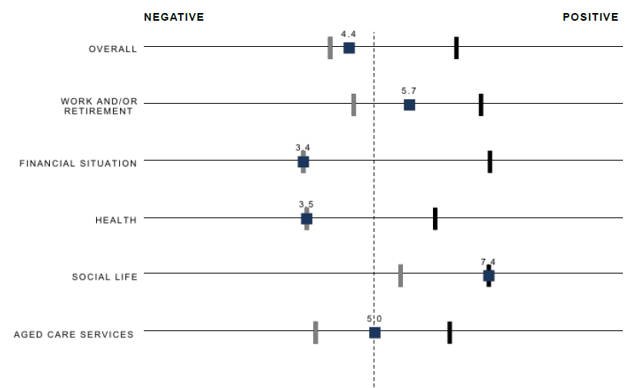

Q8 Overall, how do you feel about your later years? Q12 How do you feel about your later years in terms of work and/ or retirement? Q21 How do you feel about your later years in t erms of your financial situation?Q30 How do you feel about your lat er years in t erms of your health? Q35 How do you f eel about your later years in terms of your social life? Q39 How do you feel about your lat er years in terms of receiving aged care services? (Negative/ Anxious=0 t o Positive/ Confident=10) Grey bar: lowest scoring segment. Black bar: highest scoring segment. Coloured square: Unhealthy Dependants segment.

**Government resources**

There are no differences in awareness, usage, or interest in government resources.

**Media**

Their social media use is on a par with the average.

Free to air TV and the internet will have the greatest cut through.

### photographic image of a middle aged business manDisheartened Workers

Disheartened Workers (24% of the population of older Australians) are characterized by pessimism and negativity about the future. This segment feels short changed; that the goal posts have changed.

**The Future**

The feel worried about the future because it is so uncertain: their parents’ road map no longer applies to them. This segment is the most negative about their later years of all segments.

They feel helpless and worry that they will have to work ‘until they’re dead’. They also feel that they are at the worst possible time for the rules to have changed. The rules of the ‘game’ have changed after they joined it: after they started working and thinking about their future.

They are unsure whether the government will look after them or whether they’ll be self-funded. They are unsure about their future options and more likely to feel that older Australians are discriminated against and that their contributions are not valued.

**Demographics**

There are some slight demographic skews for this segment. They are skewed towards being younger: over indexing in under 50’s (25%), and still working (60%). Consistent with the younger age skew they are also more likely to still have kids at home (i.e. additional financial dependants and responsibilities).

**Work and / or retirement**

Disheartened Workers also feel the most negative about their future work / retirement (23% rating 0-2). They expect to retire later than other segments, are more likely to feel that employers do not want mature workers, and that older workers have fewer options.

They are also least likely to have a plan for their own retirement.

**Finances**

This segment is also the least positive about their future finances. Along with that is less confidence and knowledge when it comes to financial planning. They are the least likely to have paid off their home, and are less likely to have other significant assets.

**Health**

Despite pessimism about work and finances, consistent with their younger age skew, they are the most optimistic about their future health of all segments.

They feel like they are a well person and find it easy to be healthy. They are also more likely to feel that they can even improve their health with lifestyle changes. They are also least likely to have a chronic illness.

**Social life**

This segment is also one of the most positive when it comes to their future social life.

**Aged Care**

This group is the most negative about aged care. While worried about their future care needs, they are less likely to be planning ahead. Along with that they are the least likely to trust the government and feel that they will be looked after.

They are also the least likely to be aware that the government may help pay for in home care services.

**In summary**

Where this segment sits compared to other segments on all of the key pillars is shown below. This segment needs to understand the ‘new rules’. Along with that, they need to be encouraged to plan for their future: sooner rather than later. Not only will this help this segment be more prepared and need less future government support, but will also make them feel more certain and more positive about their future years.

Figure : Disheartened Workers’ average sentiment by key pillars

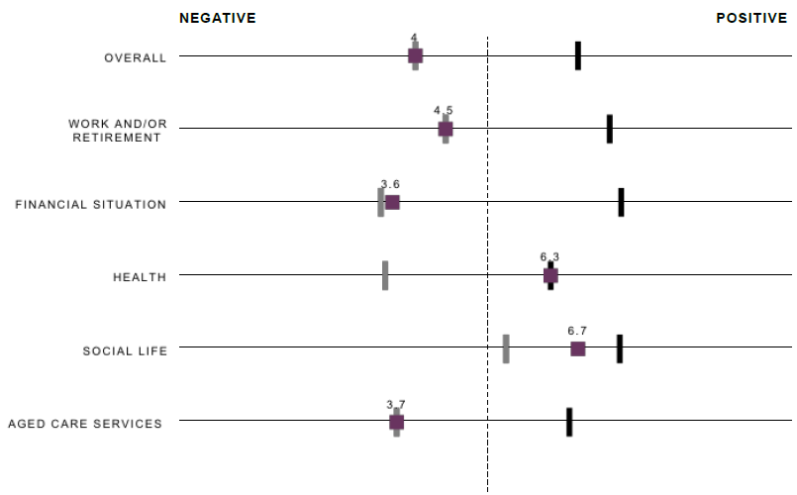

Q8 Overall, how do you feel about your later years? Q12 How do you feel about your later years in terms of work and/ or retirement? Q21 How do you feel about your later years in t erms of your financial situation?Q30 How do you feel about your later years in terms of your health? Q35 How do you f eel about your later years in terms of your social life? Q39 How do you feel about your lat er years in terms of receiving aged care services? (Negative/ Anxious=0 t o Positive/ Confident=10) Grey bar: lowest scoring segment. Black bar: highest scoring segment. Coloured square: Disheartened W orkers segment.

**Government resources**

There are no differences in awareness, usage, or interest in government resources.

**Media**

They have the highest use social media, and the highest usage of Facebook (69%).

Free to air TV and the internet will have the greatest cut through. That said, this segment is less likely to read newspapers and unaddressed mail, and more likely to listen to the radio.

# CONCLUSIONS AND RECOMMENDATIONS

## CELEBRATE RATHER THAN SCARE, SHOW RATHER THAN TELL

A central theme permeated conversations throughout the study: the unenviable status of the senior. Seniority is rarely viewed in a positive angle or even simply discussed in the pen. It is sometimes shameful, always hidden and certainly not celebrated. As a result, the path to successful seniority is unclear.

If we want Australians to prepare earlier for their later years, this points to the need to first bring seniority out in the open. This will require building a social endorsement of senior prep by communicating the value of the senior in Australia.

The interest of participants in the stories of others suggests that showing successful seniority rather than telling is more likely to engage. By elevating seniors and their success stories and celebrating a breadth of individual narratives, there is a potential to model the expected behaviours, the new normal of senior prep.

The aspiration of Australians is to maintain choice and agency into old age: there is not one single path to successful seniority but as many as there are people. However, all share a dream of an authentic, full, well lived life in their senior years. This points to the need for a positive, energetic tone and a highly active depiction of the senior.

This also points to the need to celebrate seniority and indeed avoid using the usual more negative frames placed on ageing: the burden on government services and budgets or the looming crisis brought on by an ageing population. Unless solutions are provided, this is unlikely to disrupt and motivate.

There is also a need to recognise the barriers to successful seniority. In the area of work in particular, encouraging increased participation without first addressing the barrier of age discrimination, direct and indirect, is likely to pose risks. The general consensus is that if we want Australians to work longer, we first have to create a culture that enables this.

## PROVIDE A MAP OF THE JOURNEY TO SENIORITY

The lack of clarity around preparation for our later years requires providing a map of the journey to seniority. Six senior ‘zones’ have been identified: an outline is provided in diagrammatic form below.

A map of the journey to seniority idientifies 6 senior ‘zones’. these have been outlined in this diagrammatic form. The 6 zones are:
purpose & flexible mindset
income & workforce
finances 
healthy lifestyle
staying connected
care

Each of these zones are best illustrated with examples. These cannot be outlandish or risk being not applicable, just aspirational enough to inspire. A few examples are provided below.

### Income & workforce

Examples on the employee side abounded in our discussions. The most inspiring were not just the most atypical such as organising yoga retreats in Bali but those that showed that with a little bit of imagination, our skills in one trade could be repurposed in a side activity. Often, this also included ‘getting down to business’ or starting one’s own small business.

* Moving from a full-time trade to casual odd jobs e.g. using AirTasker
* Moving from full-time teaching prep to part-time childcare e.g. family day care
* Moving from a full-time admin job to record keeping for a local community organisation
* An older man gets inspired by a job website aimed at older job-seekers

Importantly, it will be necessary to show the role employers play or rather should play in the employment of seniors. Focusing on the employee side only is indeed likely to create backlash as it is not indicative of the real world: the fact that Australians already want to work longer but often can’t. Examples on the employer side could include:

* A small business owner recently employed two older workers for their skills in customer care
* A manager testifies to the work ethics of older Australians

### Finances

Broaden the scope of financial planning: shine a light on what questions need to be asked, what topic areas need to be thought about. For example, a working couple in their 50s have realised that if they want to live well into their later years, they need to work out how much they need to set aside for home maintenance, the unexpected and the extras - and they need to adjust their working balance so that both will have an ongoing career that will support them if the other dies.

Broaden the reach of financial planning: shine a light on what professional financial planning is and motivate by highlighting the key benefit i.e. accessing options that are even unthinkable; show it is not an exclusive option, but one available to anyone with modest savings. For example, a couple in their late 40s are amazed at the number of options they could look at - including examples from other couples as to how they are radically approaching the task of creating a roadmap (buy to let, boarders, side business).

### Healthy lifestyle

Inspire by showing examples of how physical activity can be maintained. Inspiring examples in the study included senior bushwalking groups, the gym or more organised activities such as water aerobics or even Zumba Gold.

Younger audiences will need validation that they should be concerned. In the longer term, a tool like ‘One You’ to trigger action through understanding how people ‘track’ followed by personalised nudges.

### Staying connected

Show how connectivity through ‘work’ or interests can be achieved. Examples mentioned in the study include:

* A man well into his 60s finds purpose again through part-time work in a retail environment
* Volunteering at local community centre
* Join local artists group who gather to paint each week at a new location

Government is not expected to help directly but can still point to help and inspire through examples. Examples include:

* A man well into his 60s has been introduced to his local Men’s Shed and to the University of the 3rd Age
* Taking computer classes to stay on top of technology

### Care

Show at home care options. In our study, the example of a single older woman who had just arranged a new home care package and was surprised to see the number of options was enough to pique interest and trigger searches by others.

Point towards information. For example, a woman in her 50s has just discovered the My Aged Care website when planning for her parents and is surprised at the amount of information available.

## CHOOSE YOUR ZONE / CHOOSE YOUR TIMING

Australians will initiate their preparation when the time is right for them. Expecting all to prepare early in all areas may be unrealistic. More likely, they will choose to prepare in the area that feels relevant to them at the time of their choosing. Being offered a map / chunking it down allows them to take action in the zone most easy, at the time the opportunity occurs.

To the mid-forties, Australians are focused on life now. There is a sense that life is for living and that focusing too soon on retirement will mean a life missed out. The priority is also to simply get our head above water at a time when there is so much to do for ourselves and others close to us.

From the mid-forties, Australians start to experience events or attitudes associated with ageing. At what could be considered the start of this journey, this age group is the most negative and anxious about all aspects of seniority. Being made familiar with, and encouraging, future planning is key to maintaining confidence. Being engaged as soon as these events occur helps us to take action at a point when action will still be effective. Australians may then be triggered to dip in and out of one or some of the senior zones and slowly start to prepare partially, if not fully.

From the early fifties onwards, Australians begin their transition into retiring. They are likely to start with preparations that have little negative impact on now but that may have positive impact later e.g. starting a course. This requires support through deeper engagement with each of the senior zones and is a key moment in their lives when they will need to be introduced to them. Being updated on the long-term impact will also help to maintain momentum: Australians need to know how they are tracking along the way, pointing to the need for tools such as ‘One You’ and ‘Money Smart’.

There are clear differences as people age: a tailored approach is required to address the needs of all Australians aged 45 and older. In particular, messages about positive seniority and future planning need to include the youngest, and most negative group: Australians aged 45-49. Being the furthest from their own perceptions of being a ‘senior’ they will not relate to messaging for 65+ retirees. But this group feels the most uncertain and lacks the most knowledge about planning for a successful future.

## BEHIND EXAMPLES OF SUCCESS, AN ANCHORING IN FAIRNESS

Choice remains an aspiration for many, not a reality. When all else fails, a basic safety net is expected. Protecting older Australians and the vulnerable feels like the foundation that cannot be removed. Most feel that this is what government is for, this is what a society is about. It is expected that any positive communication will come with the reassurance that basic support is always available.

1. https://www.aihw.gov.au/reports/older-people/older-australia-at-a-glance/contents/health-functioning/burden-of-disease