Don’t Make Smokes your story 2018 evaluation

Prepared By:

ORC International

September 2018

**Contents**

Acknowledgements 4

1 Executive Summary 5

2 Introduction 7

3 Methodology 10

4 Smoking Background 16

5 Smoking and Health 26

6 Campaign Results 29

7 Use of My QuitBuddy App 55

8 Department Internal Data 57

9 Demographics 58

10 Conclusions and Recommendations 63

Appendix A: Detailed Methodology 65

Appendix B: Print Ads 71

Appendix C: Online Ads 72

Appendix D: Social Media Ads 73

Appendix E: Quit for You, Quit for Two ad 74

Appendix F: My QuitBuddy App 75

**List of Tables**

Table 1. Target sample design for the Indigenous evaluation 11

Table 2. Achieved sample profile (unweighted) 13

Table 3. Target sample profile 14

Table 4. Achieved sample profile (unweighted) 15

**Table 5. Distribution of Indigenous population according to 2011 Census** 66

**Table 6. Target Sample Design** 67

**Table 7. Achieved Sample Design (unweighted)** 67

**List of Figures**

Figure 1. Sampling points 11

Figure 2. Previously attempted to quit 16

Figure 3. Number of quit attempts 17

Figure 4. Support tools previously used - Indigenous evaluation 18

Figure 5. Support tools previously used - non-Indigenous evaluation 19

Figure 6. Most recent motive for quitting - Indigenous 20

Figure 7. Most recent motive for quitting - non-Indigenous 21

Figure 8. Quitting intentions 22

Figure 9. Plan to quit 23

Figure 10. Financial benefit of quitting 24

Figure 11. Personal health benefits of quitting 25

Figure 12. Health damage from smoking 26

Figure 13. Future health damage 27

Figure 14. Health effects on others 28

Figure 15. Recall of quit smoking advertising 30

Figure 16. Unprompted recall of Don't Make Smokes Your Story - Indigenous 31

Figure 17. Unprompted recall of Don't Make Smokes Your Story - Non-Indigenous 32

Figure 18. Prompted recognition of the TVC 33

Figure 19. Prompted recognition of the radio ad 34

Figure 20. Prompted recognition of print ads 35

Figure 21. Prompted recognition of social media and online ads 36

Figure 22. Prompted recognition of below the line community outreach events 37

Figure 23. Overall campaign recognition by year 38

Figure 24. TVC diagnostics, 2018 40

Figure 25. TVC Wear out 41

Figure 26. Message take outs - Indigenous 42

Figure 27. Message take out - non-Indigenous 43

Figure 28. Difference to previous campaigns - Indigenous 44

Figure 29. Difference to previous campaigns - non-Indigenous 45

Figure 30. Actions taken - Indigenous 47

Figure 31. Actions taken - Non-Indigenous 49

Figure 32. Intended action - Indigenous 50

Figure 33. Intended actions - Non-Indigenous 51

Figure 34. Quit for You, Quit for Two prompted recognition 52

Figure 35. Key message take outs 54

Figure 36. Prompted recognition of the My QuitBuddy app 55

Figure 37. Effectiveness of the app 56

Figure 38. Respondents who spoke an Indigenous language at home – Indigenous 58

Figure 39. Education 59

Figure 40. Income 60

Figure 41. Health conditions 61

Figure 42. Main household earner’s job 62

Figure 43. Sampling points for the 2018 Indigenous evaluation 68

Figure 44. Sampling points for the 2017 Indigenous evaluation 69

Figure 45. Sampling points for the 2016 Indigenous evaluation 70

# Acknowledgements

ORC International would like to acknowledge our partner organisations operating in Indigenous communities who either recruited interviewers or interviewed Aboriginal and Torres Strait Islander people on our behalf.

* Yarn’n – Aboriginal Employment Services, Surry Hills
* Tribal Warrior Aboriginal Corporation, Redfern
* Walhallow Aboriginal Corporation, Tamworth
* Narrabri Local Aboriginal Land Council, Narrabri
* Ngwala Willumbong, St Kilda
* Gunaikurnai Land and Waters Aboriginal Corporation, Bairnsdale
* Bahloo Women’s Youth Shelter, Woolloongabba
* Kurbingui Youth Development Association, Zillmere
* Aboriginal Medical Centre, Woolloongabba
* Ghymarhl Corporation, Gladstone
* Townsville Aboriginal & Islanders Health Services, Townsville
* Mura Kosker Sorority, Thursday Island
* South Australian Health and Medical Research Institute, Adelaide
* Port Pirie Regional Health Services, Port Pirie
* Derbarl Yerrigan Health Service, East Perth
* Murray District Local Shire, Mandurah
* IBN Aboriginal Group, Tom Price
* Circular Head Aboriginal Corporation, Smithton
* Wise Employment, Darwin
* The ALPA Community Development Program (CDP) - Milingimbi
* Warlpiri Youth Development Aboriginal Corporation, Yuendumu

Without the generous assistance and advice of these organisations and the individual interviewers, the research would not have been possible.

# Executive Summary

In 2018 the Australian Government Department of Health (the department) ran Don’t Make Smokes Your Story, an Indigenous focused anti-smoking campaign which was launched in 2016 and also ran in 2017.

An evaluation survey was conducted to assess the effectiveness of the 2018 campaign amongst Indigenous and non-Indigenous smokers and recent quitters.

For the Indigenous evaluation, Indigenous interviewers were recruited from community organisations nationally and trained by the research team. These interviewers conducted face to face interviews with respondents from their local community, often with the assistance of the Indigenous organisation. The non-Indigenous evaluation was conducted via an online survey.

The research found that 86% of Indigenous smokers and recent quitters were aware of the campaign; a much higher level than amongst non-Indigenous audiences (56%). Recognition of the campaign in Indigenous communities was higher in regional locations (93%) than in remote (83%) and urban (79%) areas.

The television commercial (TVC) was the most effective channel amongst both Indigenous and non-Indigenous audiences (75% and 50% respectively), with the radio, print and online ads reaching between 45% and 62% of Indigenous audiences, and 24% to 26% of non-Indigenous audiences. Additionally, 27% of Indigenous respondents recalled seeing the campaign at community outreach events.

Diagnostic performance of the TVC was strong, particularly in terms of being easy to understand (98% of Indigenous and 94% of non-Indigenous respondents), and believable (90% Indigenous, 86% non-Indigenous).

The campaign continued to drive quitting behaviour and intentions amongst Indigenous respondents, and was also effective in driving behaviour change and intentions amongst non-Indigenous audiences. Amongst those who recognised the campaign, 7% of Indigenous respondents stated that they had quit as a result of the campaign (17% for non-Indigenous), 26% had reduced the amount they smoke (29% for non-Indigenous) and 14% had discussed smoking and health with family and friends (22% for non-Indigenous). Furthermore, 20% of Indigenous respondents stated they intended to quit smoking as a result of the campaign (28% for non-Indigenous), 20% intended to reduce the amount they smoke (34% for non-Indigenous) and 9% intended to ask their doctor or health worker for help to quit (12% for non-Indigenous).

The evaluation results on increased quit attempts and intentions are supported by the department’s own data around the increased use of support tools. Specifically, during the campaign period there was a 25% increase in the number of visits to the *Quit Now* website, a 13% increase in calls made to the *Quitline* and a 43% increase in downloads of the My QuitBuddy app.

TVC ‘wear out’ (those reporting that they were getting sick of seeing the ad) was 20% amongst Indigenous respondents and 18% for non-Indigenous respondents. This was an improvement on previous years (2017 Indigenous 26%, 2016 Indigenous 23%, and 2017 non-Indigenous 20%).

**In summary, the evaluation of the 2018** Don’t Make Smokes Your Story **Campaign suggests that the success of the 2016 and 2017 campaigns has been further reinforced with similar high levels of impact on behaviour and intentions. The campaign also demonstrated meaningful cross-over to non-Indigenous smoking audiences, with somewhat lower, though still impressive, reach being achieved and impressive diagnostic performance and reported behaviour change.**

# Introduction

## Background

In 2018 the department launched the Indigenous focused anti-smoking campaign, Don’t Make Smokes Your Story, for the third consecutive year. The campaign was initially launched in 2016 as part of the National Tobacco Campaign (NTC) which is a vital component of the Australian Government’s tobacco control measures; aimed at reducing the prevalence of smoking and its associated health and social costs, and the inequalities it creates. This phase of the NTC intends to contribute towards achieving one of the Council of Australian Governments’ (COAG) performance benchmarks for tobacco, to reduce the daily smoking rate amongst Aboriginal and Torres Strait Islander people.

The present 2018 campaign is intended to build on the achievements of the 2016 and 2017 campaigns which achieved strong recognition and recorded an impact on behaviour and intentions.

Don’t Make Smokes Your Story features an Aboriginal man (Ted) reflecting on his experiences of smoking and the benefits of quitting; with a particular focus on spending time with his family. The main TVC concludes with a call to action, which encourages smokers to download the My QuitBuddy app, call the Quitline number, or visit the Quitnow website. In contrast to previous NTC campaigns, Don’t Make Smokes Your Story has a positive tone which focuses on the benefits of quitting, rather than just the consequences of smoking.

The campaign was specifically aimed at smokers, recent quitters and their families.

The key objectives of the campaign were to:

* encourage quit attempts amongst current smokers and to encourage them to keep trying to quit
* encourage family members and service providers to reinforce the campaign
* drive people to the support resources including the Quitline, the quit smoking apps and the website
* communicate the risks of smoking
* show the benefits of quitting for smokers and their families.

Key campaign material from Don’t Make Smokes Your Story can be found in appendices D-F.

## Media strategy

The media campaign ran across television (mainstream and Indigenous), radio (regional and Indigenous), newspapers, out of home advertising, online and social media.

The campaign also consisted of a large amount of public relations activity in community (below the line) from local Indigenous organisations as part of the Tackling Indigenous Smoking program and was featured at community events such as the Barunga Festival.

The media buy also incorporated advertising for the Quit for You, Quit for Two campaign which targets pregnant women and their partners. Placement of Quit for You Quit for Two stickers on pregnancy kits formed a significant part of this component of the campaign.

## Research objectives

The department commissioned independent research agency ORC International to conduct an evaluation survey to assess the effectiveness of the 2018 campaign amongst Aboriginal and Torres Strait Islander people in urban, regional and remote locations. The 2018 evaluation, like the 2017 evaluation, also aimed to assess the effectiveness of the campaign amongst non-Indigenous audiences (this was not assessed in the 2016 evaluation).

Specifically the research aimed to measure:

* level of campaign awareness
* awareness of the support tools available to help quit smoking
* increased quit attempts, attributed to exposure to campaign messages
* intention for target groups to quit or stay quit
* campaign wear out, providing recommendations for future use of Don’t Make Smokes Your Story.

## About this report

This report focuses on the results from the 2018 evaluation and changes since the 2017 and 2016 survey are highlighted in the text and graphs where applicable.

It is important to note that comparisons between the Indigenous and the non-Indigenous evaluation should be interpreted with caution, due to potential mode effects arising from the different methodologies (face to face vs online), and recruitment and sampling methods.

### Reporting conventions

Unless specified otherwise, all of the results that have been reported on are based on weighted data.

Response options that were not selected by any respondents are not included in the report. Therefore, if a response is reported at 0%, this indicates that some respondents did select the response, but the result was less than 0.5% and so has been rounded down.

Totals for questions with single-response answers may not add to 100% due to rounding. ’Refused’ responses have not been included. Multiple-response items may add to more than 100% due to respondents selecting multiple response codes.

Sample sizes may vary between questions, either because the question was only asked of specific respondents, or because some respondents may not have answered a particular question.

Some sections and questions reported on have a small sample size – these findings should be interpreted with caution.

# Methodology

## Indigenous evaluation

The below section provides detailed information on the methodology for the Indigenous evaluation.

### Community engagement and recruitment

To evaluate the campaign amongst Indigenous people ORC used a similar methodology to the 2017 and 2016 evaluations. Specifically, ORC International sought to engage in an appropriate way with Indigenous communities, to meet the research objectives while at the same time being sensitive to local needs and protocols and aiding in local capacity building. ORC International worked closely with our local Indigenous community organisation partners in each location; who provided advice on local protocols and practices, as well as recommending appropriate interviewing personnel and providing logistical support. The use of commercial market research fieldwork companies was eschewed in favour of using interviewers recruited from Indigenous grass-roots organisations (our partner organisations). Where possible the same interviewers who were involved in the 2016 and 2017 evaluation were recruited for the present 2018 evaluation. All interviewers were trained in basic interviewing techniques by the ORC International research team, using a mixture of face-to-face, skype and telephone training.

These interviewers conducted face to face computer assisted personal interviews (CAPI) through a tablet with respondents from their local community. Administrative and logistical support (such as a venue in which to conduct interviews) was provided by the local Indigenous organisation.

All survey respondents were paid an incentive for their participation, with the amount and form of incentives based on the advice of our partner organisations.

### Sample design

The target sample for the evaluation was Aboriginal people 15 years and over who currently smoke or quit smoking within the last 12 months. A national sample design was constructed with geographic stratification in proportion to the Indigenous population in urban, regional and remote locations in each state or territory.

Again, where possible, the same interviewers and locations were used as in the 2016 and 2017 evaluations; in order to allow comparison to the present 2018 evaluation. Respondents who had been interviewed in the 2016 or 2017 survey were not eligible for re-interview in the 2018 survey.

Fieldwork was completed across 20 locations and the sampling points for each location are shown below in Figure 1. The target sample sizes based on remoteness and age are shown below in Table 1.

Figure . Sampling points

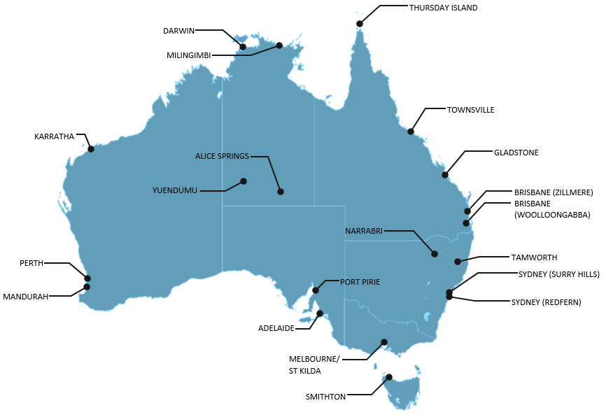

Table . Target sample design for the Indigenous evaluation

| Target Sample Design | Target |
| --- | --- |
| n= | 350 |
| Remoteness | NIL |
| Major City | 36% |
| Regional | 44% |
| Remote | 20% |
| ****Smoking status**** | NIL |
| Current smoker | 85% |
| Recent quitter* | 15% |
| ****Gender**** | NIL |
| Male | 50% |
| Female | 50% |
| ****Age**** | NIL |
| 15 – 17 years | 15% |
| 18 – 40 years | 55% |
| 41 + years | 30% |

* Recent quitters were defined as respondents who had quit smoking less than 12 months ago

### Dates of fieldwork

Fieldwork was conducted at the completion of the campaign, from the 2nd July to the 29th July (4 weeks).

### Questionnaire

The questionnaire was kept the same as the 2016 and 2017 evaluations where possible in order to allow comparison, and only edited where required.

### Weighting adjustment

The data for Indigenous smokers was weighted by age, gender, state and geographical remoteness, to represent the national Indigenous smoker population aged 15 years and over. Due to the small sample size (n=42), recent quitters were unable to be weighted and therefore have each been provided a weight of one. The weight adjustments were calculated with rim weighting using three sets of smoker population totals: (1) Age x gender; (2) State/territory; and (3) Region (defined by Main cities; Regional; and Remote). The population data used for the weighting was obtained from the ABS National Aboriginal and Torres Strait Islander Social Survey, 2014-15, publication 4714.0.

### Sample profile

Table 2. Achieved sample profile (unweighted) below shows the unweighted sample profile for the Indigenous evaluation based on the final sample size of 356 respondents.

Table . Achieved sample profile (unweighted)

| Target Sample Design | Target (%) |
| --- | --- |
| n= | 356 |
| Remoteness | NIL |
| Urban | 42% |
| Regional | 41% |
| Remote | 17% |
| Smoking status | NIL |
| Current smoker | 88% |
| Recent quitter* | 12% |
| Gender | NIL |
| Male | 46% |
| Female | 54% |
| Age | NIL |
| 15 – 17 years | 6% |
| 18 – 40 years | 59% |
| 41 + years | 35% |

* Recent quitters were defined as respondents who had quit smoking less than 12 months ago

## Non-indigenous evaluation

The below section provides detailed information on the methodology for the evaluation amongst non-Indigenous people.

### Online survey

In order to evaluate the campaign amongst a non-Indigenous audience an online self-complete survey was conducted through Survey Sampling International’s (SSI) online panel.

### Sample design

The non-Indigenous evaluation targeted non-Indigenous Australian smokers and recent quitters (quit within the last 12 months) aged 18 – 50 years. A national sample design was constructed with geographic stratification in proportion to the Australian population by state and regional status.

The target sample design is shown below in Table 3.

Table . Target sample profile

| Target Sample Profile | Target |
| --- | --- |
| n= | 500 |
| ****Remoteness**** | NIL |
| Major City | 63% |
| Regional / remote | 37% |
| ****Smoking status**** | NIL |
| Current smoker | 85% |
| Recent quitter* | 15% |
| ****Gender**** | NIL |
| Male | 49% |
| Female | 51% |
| ****Age**** | NIL |
| 18-29 years | 34% |
| 30-40 years | 31% |
| 40-50 years | 35% |

* Recent quitters were defined as respondents who had quit smoking less than 12 months ago

### Dates of fieldwork

Fieldwork was conducted at the completion of the campaign, from the 2nd July to the 22nd July (20 days).

### Questionnaire

To allow comparison between the two evaluations, the non-Indigenous questionnaire was based on the Indigenous survey and only edited where required.

### Weighting

The results for the non-Indigenous evaluation have been weighted by age, gender and state.

### Sample profile

Table 4 below shows the unweighted sample profile for the mainstream evaluation based on the final sample size of 510 respondents.

Table . Achieved sample profile (unweighted)

| Target Sample Profile | Target |
| --- | --- |
| n= | 510 |
| Remoteness | NIL |
| Major City | 64% |
| Regional / remote | 36% |
| Smoking status | NIL |
| Current smoker | 87% |
| Recent quitter* | 13% |
| Gender | NIL |
| Male | 49% |
| Female | 51% |
| Age | NIL |
| 18-29 years | 35% |
| 30-40 years | 31% |
| 41-50 years | 35% |

* Recent quitters were defined as respondents who had quit smoking less than 12 months ago

# Smoking Background

The following section describes the general smoking background and quitting intentions of all current smokers (*n=314* for the Indigenous sample and *n=449* for the non-Indigenous sample).

All current smokers were asked if they had previously tried to quit smoking, and the majority in both the Indigenous (62%) and non-Indigenous (86%) evaluation stated they had (see Figure 2). Amongst the Indigenous sample, teenagers aged 15-17 were the least likely to have previously tried to quit (33%) compared to 57% of those aged 18-40 and 73% amongst those aged 41 years and over.

Figure . Previously attempted to quit

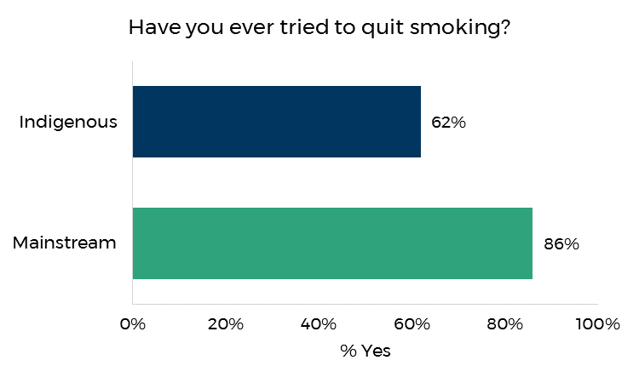

Base): All current smokers (n=314 Indigenous; n=449 Non-Indigenous)

Respondents who had tried to quit smoking were asked how many times. As shown in Figure 3, both Indigenous (68%) and non-Indigenous (70%) respondents most commonly reported trying to quit smoking between one and three times.

Figure . Number of quit attempts

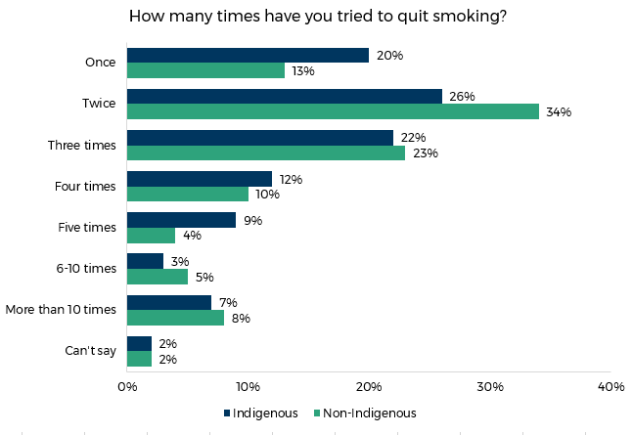

Base): Current smokers who had tried to quit (n=194 Indigenous; n=387 Non-Indigenous)

Respondents were asked whether they had used any aids to support their quit smoking attempts in the past. Note that these questions cover more than one occasion (if respondents had tried to quit more than once) and therefore total more than 100%. Figure 4 shows that the majority of Indigenous respondents (59%) had once attempted to quit on their own without any quitting aids or assistance. Just over half (51%) of Indigenous respondents had (on at least one attempt) used a quitting aid such as Nicotine Replacement Therapy, Champix or Zyban. Nearly a quarter (23%) had asked for or sought advice from a professional, support group or support tool.

Respondents who live in urban areas more commonly reported using quitting tools (66%) than respondents who lived regionally (47%) or remotely (43%). Similarly, urban respondents also more frequently sought advice (36%) compared to regional (18%) and remote respondents (18%). Male respondents were more likely to attempt to quit without aids or assistance (67%) than female respondents (51%).

Figure . Support tools previously used - Indigenous evaluation

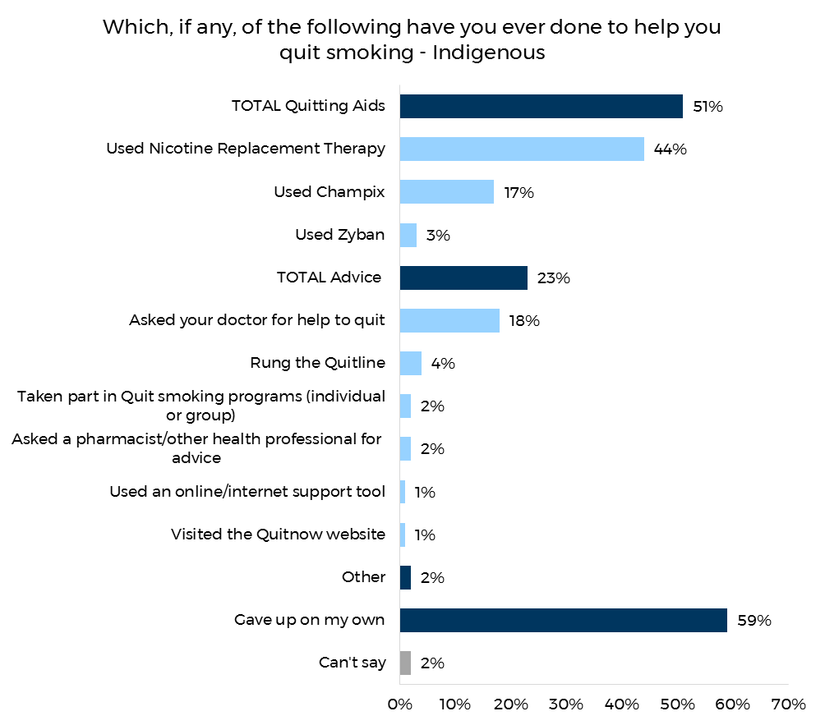

Base: Indigenous current smokers who had tried to quit (n=194)

Non-Indigenous smokers (71%) were more likely than Indigenous smokers (51%) to report using quitting aids. Furthermore, non-Indigenous respondents were almost twice as likely to attempt to quit by seeking advice or assistance (53%) as Indigenous respondents (23%). Forty-six per cent of non-Indigenous respondents reported at least one attempt to quit on their own (see Figure 5).

Figure . Support tools previously used - non-Indigenous evaluation

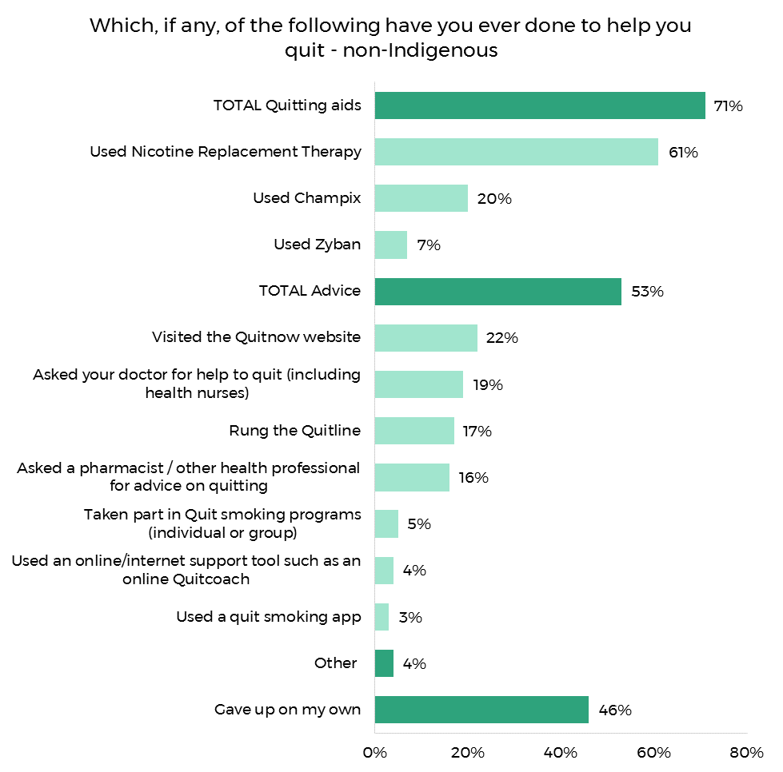

Base: Non-Indigenous current smokers who had tried to quit (n=387)

Those who had tried to quit smoking in the past were asked to think about the most recent time, and to indicate what had caused them to quit. Multiple responses could be provided.

The most common category of response amongst both the Indigenous (60%) and the mainstream sample (65%) pertained to reasons of health and fitness.

Other common responses included financial reasons (42% Indigenous, 44% non-Indigenous) and ‘Family and Friends’ (41% Indigenous, 33% non-Indigenous).

Figure . Most recent motive for quitting - Indigenous

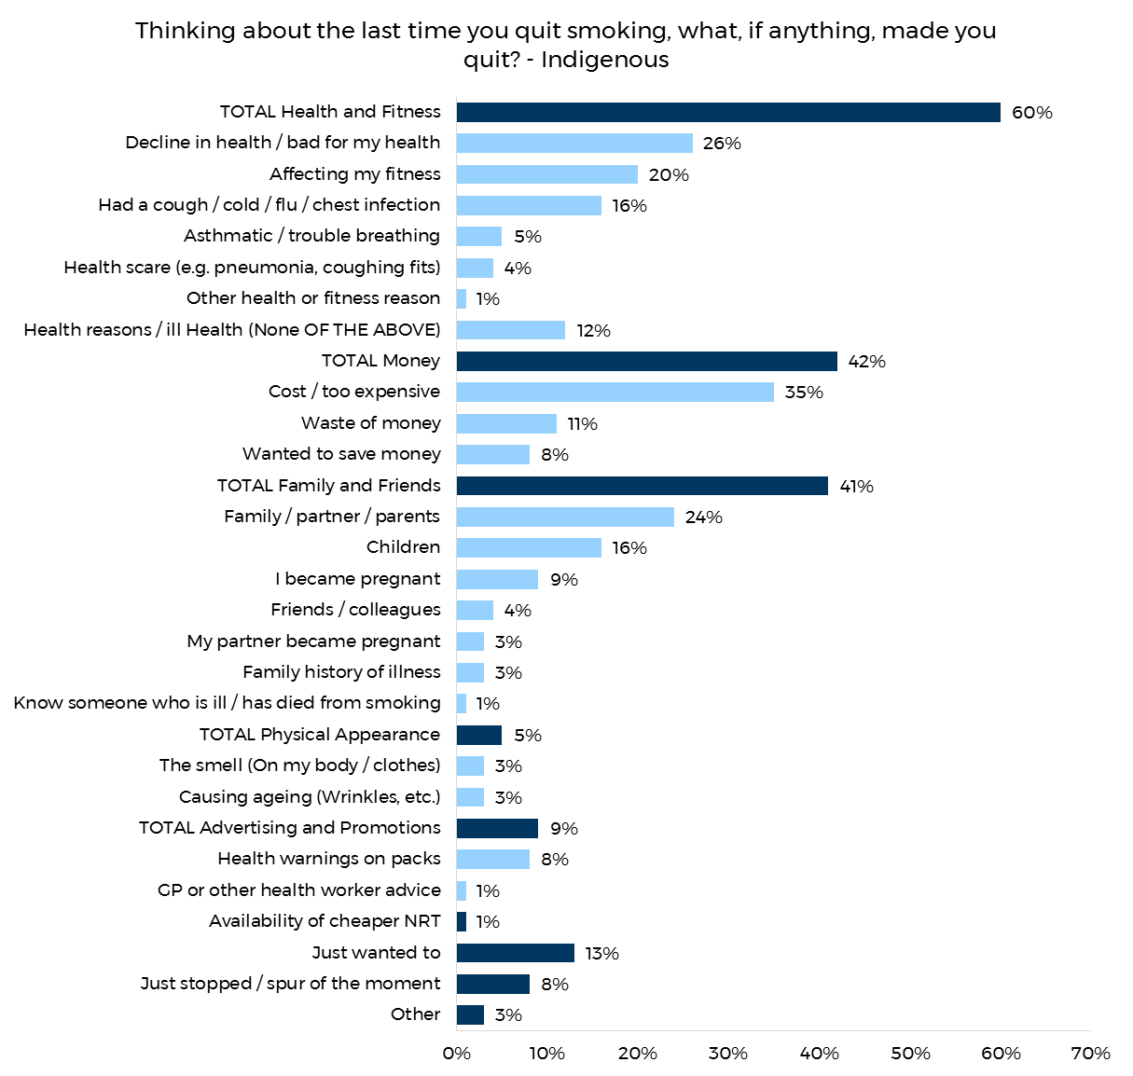

Base: Indigenous current smokers who had tried to quit (n=194)

Figure . Most recent motive for quitting - non-Indigenous

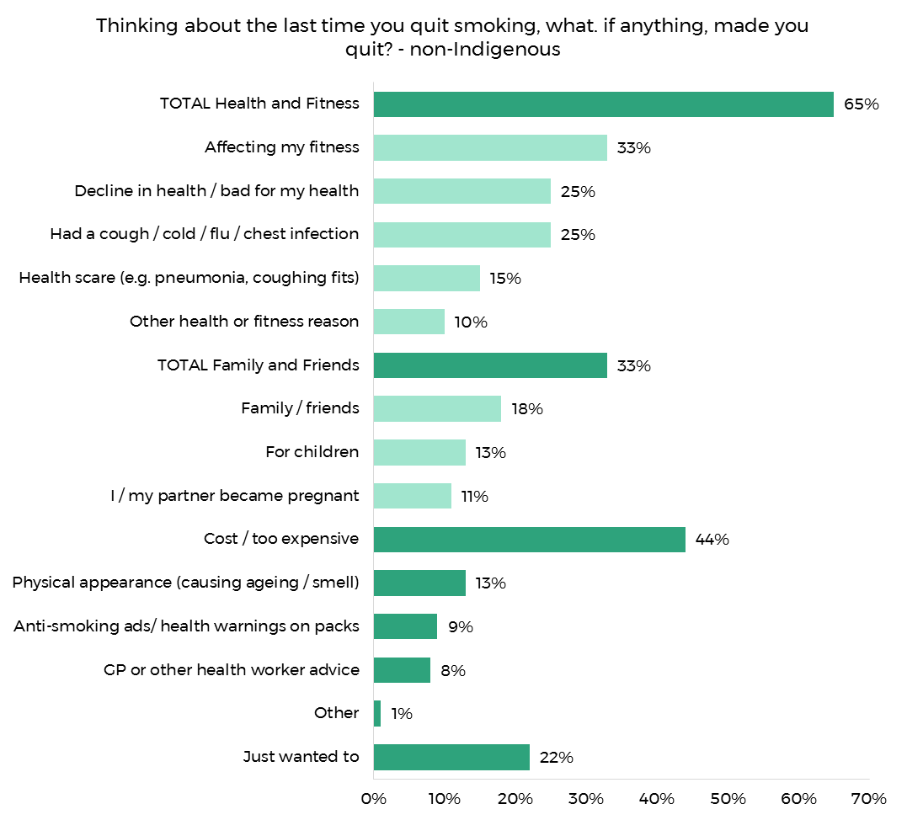

Base: Non-Indigenous current smokers who had tried to quit (n=379)

All current smokers were asked whether they were planning to quit smoking. Note that this question was asked early on during the interview, and should not be confused with a later survey question which asked whether or not those who recognised *Don’t Make Smokes Your Story* were planning to quit as a result of the campaign.

Sixty-three percent of Indigenous smokers said that they were planning to quit; a somewhat lower figure than the equivalent amongst non-Indigenous smokers (72%).

Figure . Quitting intentions

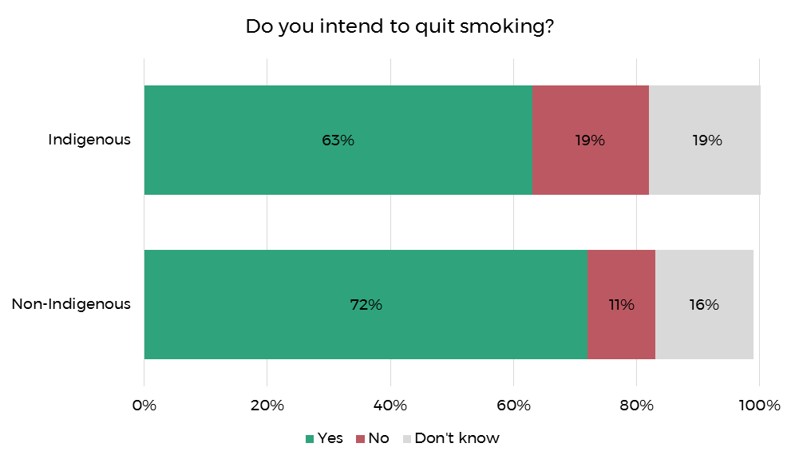

Base): All current smokers (n=314 Indigenous; n=449 Non-Indigenous)

Those who expressed an intention to quit were asked when they planned to put this intention into action (see Figure 9). Non-Indigenous smokers were more likely to intend to quit within the next six months (79%), than Indigenous respondents (54%). Indigenous respondents were more likely to answer that they planned to quit sometime in the future but not within the next six months (44% compared to 17% of the non-Indigenous smoker sample).

Figure . Plan to quit

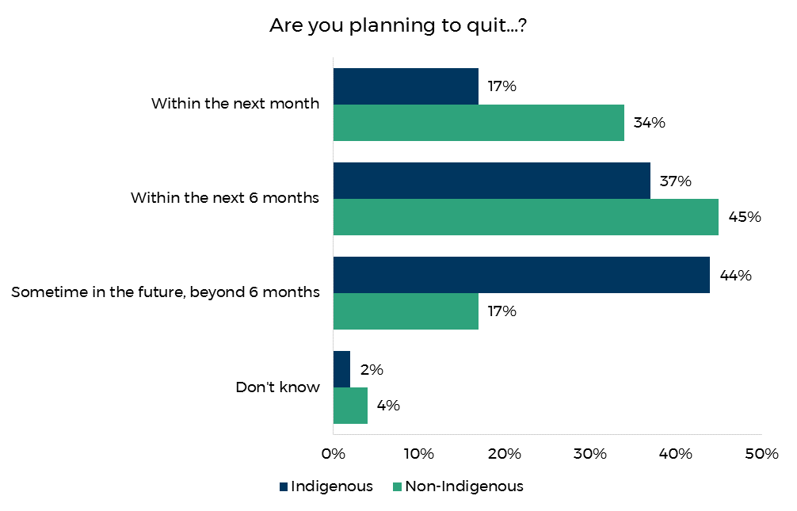

Base: Current smokers who stated they intend to quit (n=194 Indigenous; n=325 Non-Indigenous)

Current smokers were asked how much they would benefit financially from quitting in the next six months. Indigenous respondents were on par with Indigenous respondents to report it would benefit them ‘extremely’ or ‘very much’ (69% vs 70% non-Indigenous) Eleven percent of Indigenous respondents agreed it would benefit them ‘slightly’ compared to non-Indigenous respondents (6%).

Figure . Financial benefit of quitting

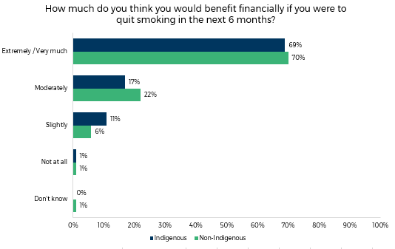

Base: All current smokers (n=314 Indigenous; n=449 Non-Indigenous)

Similarly, Indigenous smokers in 2018 were on par with non-Indigenous respondents in how compelled they were by the potential impact on their health if they were to quit smoking, with 72% of Indigenous and 72% non-Indigenous respondents reporting that they would benefit ‘extremely or very much.’

Figure . Personal health benefits of quitting

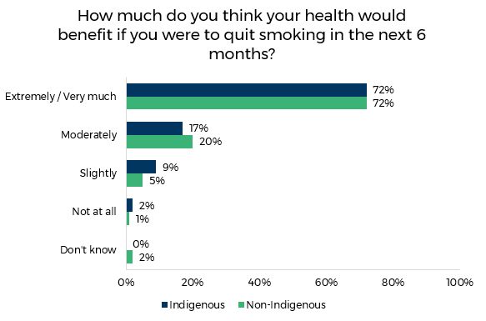

Base): All current smokers (n=314 Indigenous; n=449 Non-Indigenous)

# Smoking and Health

Current smokers were asked a series of questions about their perceptions of the impact of smoking on their health. Overall, Indigenous smokers were less likely than non-Indigenous smokers to acknowledge the impact of smoking on their health, and the health of others.

Respondents were asked how much, if at all, smoking has damaged their health, and the results are shown in Figure 12. Non-Indigenous respondents were more likely to report that smoking has had a greater impact on their health, with 24% reporting “a great deal”, compared to 13% of Indigenous smokers. Correspondingly, Indigenous respondents were more likely to report smoking has damaged their health “just a little” or “not at all” (38%, compared to 29% of non-Indigenous smokers).

Figure . Health damage from smoking

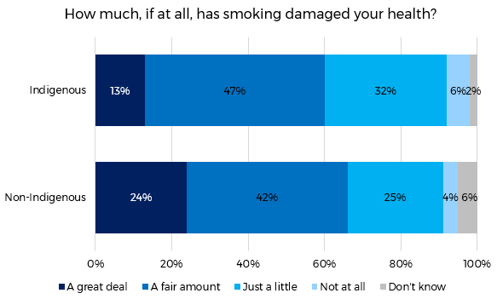

Base: All current smokers (n=314 Indigenous; n=449 Non-Indigenous)

Current smokers were asked how worried they were that smoking would damage their health in the future. Just over a third of Indigenous smokers (34%) reported that they were ‘very worried’, with a further 37% that they were ‘moderately worried’. Only 6% reported that they had no concerns about smoking damaging their health.

The results were very similar for non-Indigenous smokers.

Figure . Future health damage

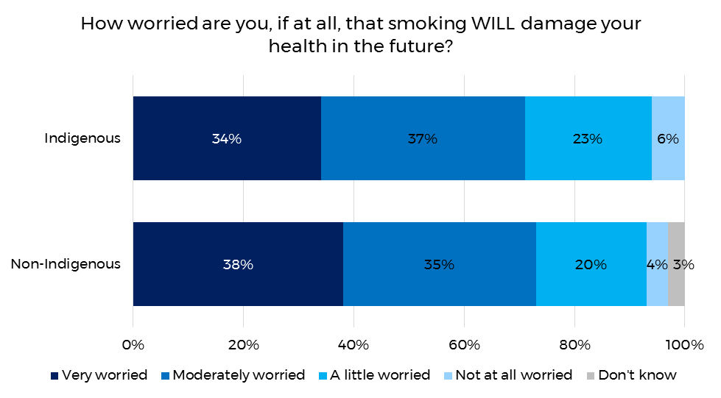

Base: All current smokers (n=314 Indigenous; n=449 Non-Indigenous)

Just over one quarter of Indigenous smokers (26%) in 2018 felt that their smoking had affected the health of others ‘a great deal’ or ‘a fair amount’. This was considerably lower than the equivalent result amongst non-Indigenous smokers (38%).

Figure . Health effects on others

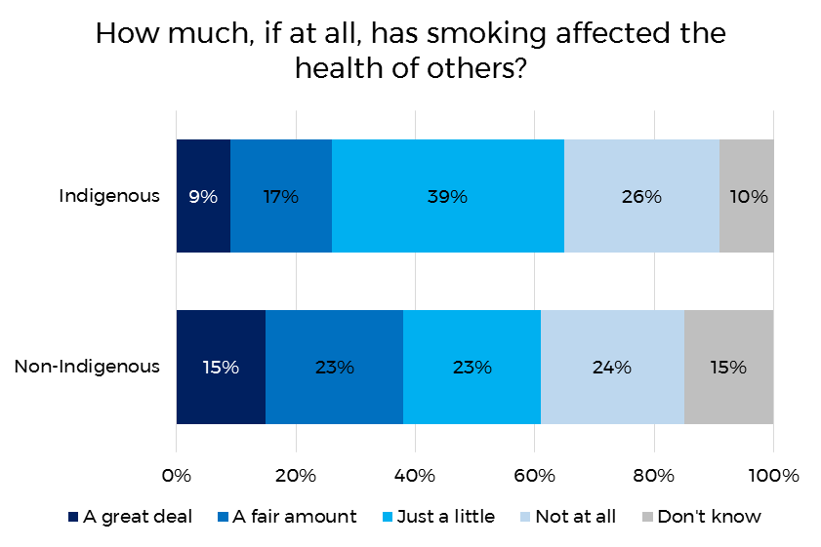

Base: All current smokers (n=314 Indigenous; n=449 Non-Indigenous)

# Campaign Results

All respondents in the evaluation round were asked if they had been exposed to Don’t Make Smokes Your Story and, if so, actions taken as a result of the campaign and their attitudes towards the campaign.

## Unprompted Recall

Respondents were asked whether they had seen or heard any advertisements about the dangers of smoking, and to describe the first two advertisements that came to mind. As shown below in Figure 15, 78% of Indigenous respondents reported having been exposed to such advertising. This figure is markedly higher than the equivalent 2018 result amongst the non-Indigenous population (55%).

The percent of Indigenous respondents answering yes to this question had decreased by 11 pp since the 2017 evaluation.

Figure . Recall of quit smoking advertising

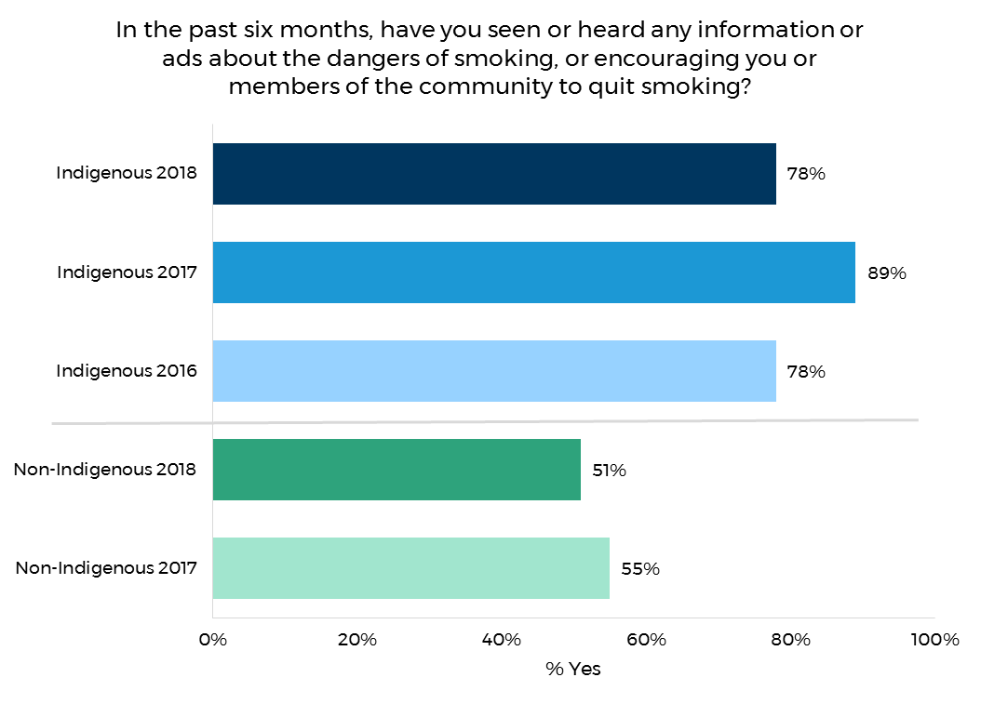

Base: All respondents (n=356 Indigenous 2018; n=352 Indigenous 2017; n= 308 Indigenous 2016; n=510 Non-Indigenous 2018; n=508 non-Indigenous 2017)

Respondents who mentioned that they had seen or heard anti-smoking information were asked to describe the first two ads that came to mind.

As illustrated in Figure 16, the Don’t Make Smokes Your Story campaign was spontaneously recalled by 35% of Indigenous respondents. Unprompted recall amongst the Indigenous audience in 2018 was an increase of 23 percentage points on the 2017 result (12%) and an increase of 26 percentage points on the 2016 result (9%).

Figure . Unprompted recall of Don't Make Smokes Your Story - Indigenous

Base: Indigenous respondents who had seen any quit-smoking information in the past six months (n=279)

Unprompted recall of *Don’t Make Smokes Your Story* amongst non-Indigenous respondents is shown in Figure 17. *Don’t Make Smokes Your story* was the most commonly recalled campaign in the non-Indigenous evaluation (12%), however it was still considerably lower than the Indigenous result (35%).

Figure . Unprompted recall of Don't Make Smokes Your Story - Non-Indigenous

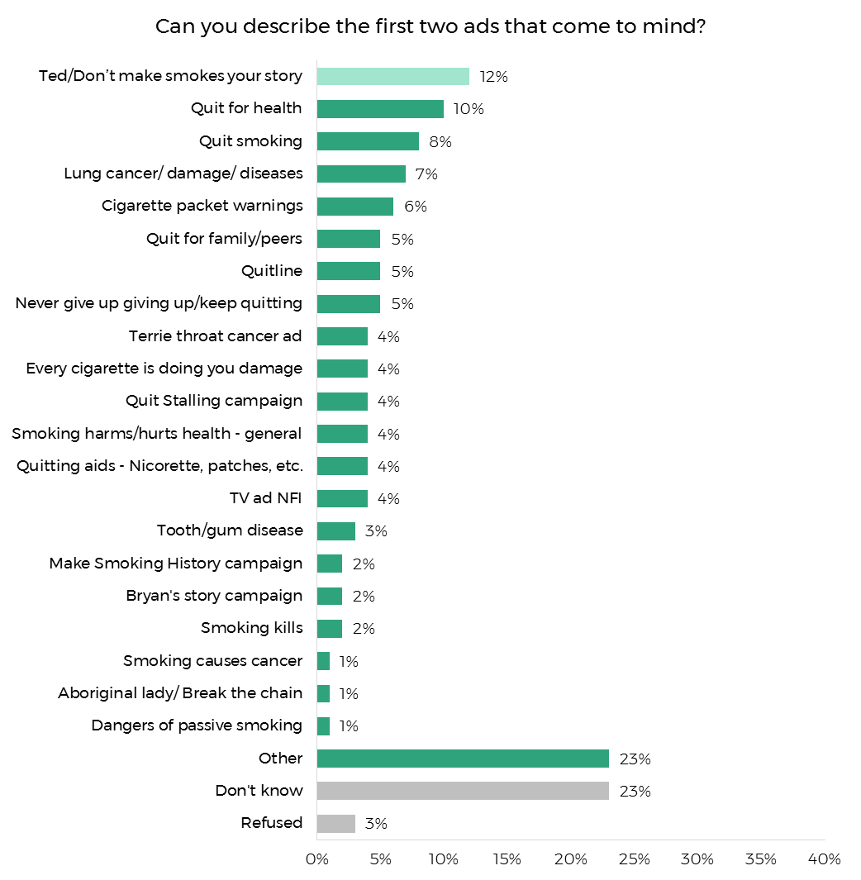

Base: Non-Indigenous respondents who had seen any quit-smoking information in the past six months (n=261)

## Prompted Recognition

The Don’t Make Smokes Your Story TVC was played to all respondents on the tablet. They were then asked if they had seen it before. Figure 18 shows that 75% of Indigenous respondents reported having seen the TVC, with the majority reporting they saw it on TV (67%). Thirteen percent saw it online and 4% reported having seen it but could not recall where.

Prompted recognition of the TVC was considerably lower amongst non-Indigenous respondents, as shown in Figure 18, with 50% of the sample reporting they had seen the TVC, again the majority seeing it on TV (41%).

Non-Indigenous respondents located outside of urban areas (63%) were more likely to recognise the TVC than respondents in urban locations (43%). Similarly, older non-Indigenous respondents (58%) were more likely to recognise the TV ad than the younger non-Indigenous age groups (46% of 30 to 40 year olds and 47% of 18 to 29 year olds).

Recognition of the TVC did not significantly differ by age or location amongst Indigenous respondents.

Figure . Prompted recognition of the TVC

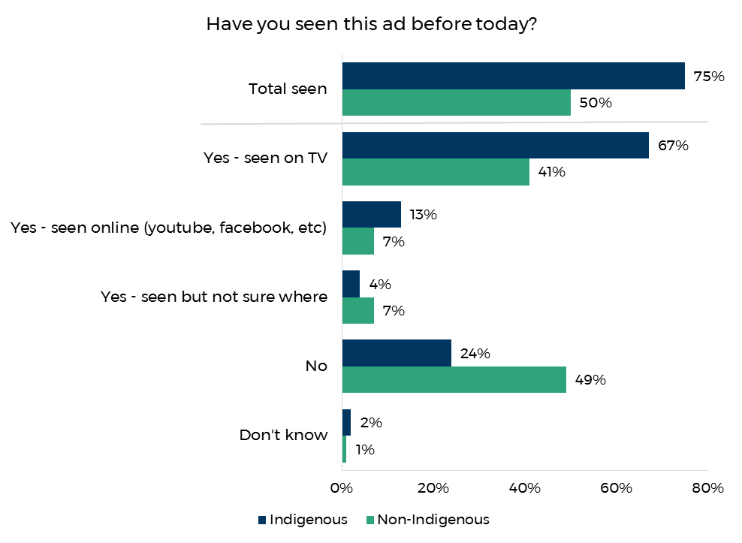

Base: All respondents (n=356 for Indigenous; n=510 Non-Indigenous)

The radio ad was also played for all respondents, who were then asked if they had heard it before. As shown in Figure 19 45% of Indigenous respondents reported having heard the ad, with nearly all (99%) hearing it in English.

Recognition of the radio ad was much lower (26%) amongst non-Indigenous respondents, and further decreased in urban locations (21% compared to 35% in regional / metro).

For the Indigenous evaluation recognition pf the radio ad was much lower in remote locations (23%), compared to those in urban (55%) and regional (50%) locations.

Figure . Prompted recognition of the radio ad

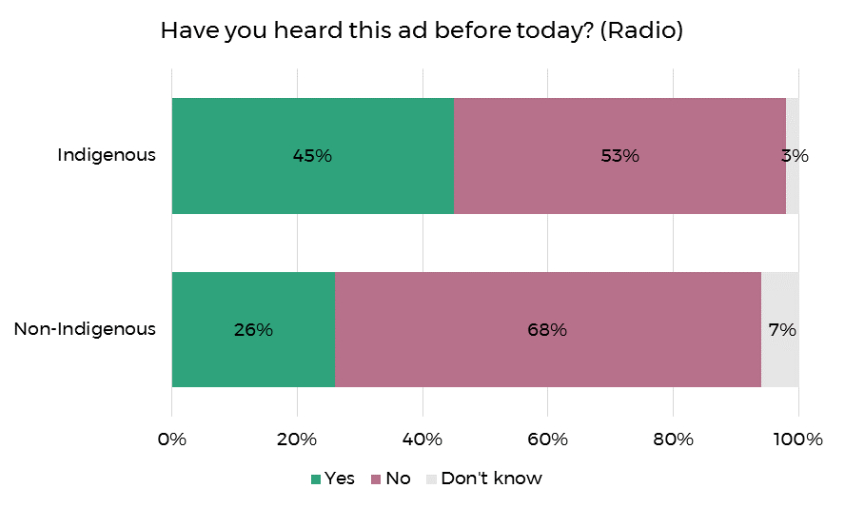

Base: All respondents (n=356 for Indigenous; n=510 non-Indigenous)

Respondents were shown the Don’t Make Smokes Your Story print ads and asked if they had seen any of them before (see Appendix D for print ads displayed). As shown in Figure 20, 62% of Indigenous respondents reported seeing the ads, with 32% having seen them in an out of home poster or billboard, 13% in a magazine or newspaper, and 22% who had seen them but weren’t sure where.

Again recognition was much lower amongst non-Indigenous respondents (62%), and decreased with age from 31% of 18 to 29 year olds, to 19% of 41 to 50 year olds. As with the TV and radio ad, non-Indigenous respondents living in regional / remote locations (32%) were more likely to have seen the print ads than those living in urban areas (23%).

Figure . Prompted recognition of print ads

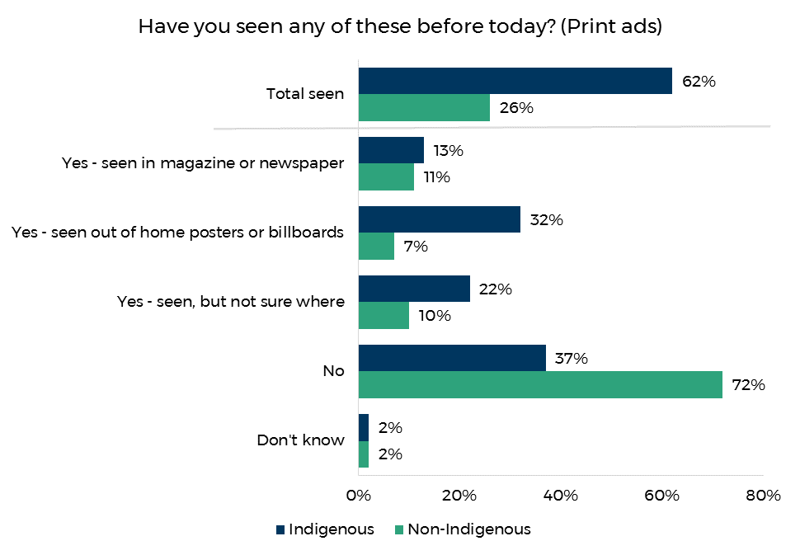

Base): All respondents (n=356 for Indigenous; n=510 Non-Indigenous)

Respondents were shown images from Don’t Make Smokes Your Story online and social media ads and asked if they had seen them before (see appendices E and F for ads displayed). More than half (52%) of Indigenous respondents reported seeing the ads, with 29% having seen them on social media, 18% online and 12% having seen them, but weren’t sure where.

Older Indigenous respondents (aged 41 years and over) were less likely report seeing the online ads (40%) than those aged 18 to 40 years (59%) and 15 to 17 years (52%).

As with all of the other channels, non-Indigenous respondents were much less likely to recognise the online ads (24%). As with Indigenous respondents, recognition amongst the general population for the online and social media ads decreased with age, from 30% of 18 to 29 year olds, 25% of 30 to 50 year olds to only 15% of 41 to 50 year olds.

Figure . Prompted recognition of social media and online ads

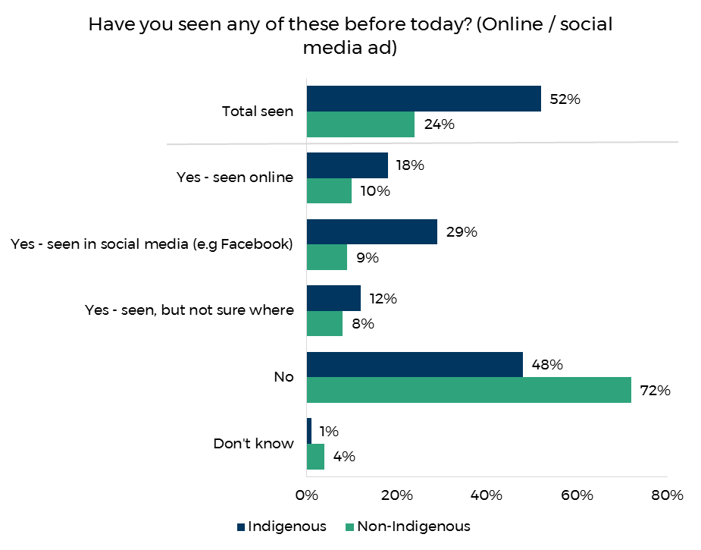

Base: All respondents (n=356 for Indigenous; n=510 Non-Indigenous)

To assess exposure to Don’t Make Smokes Your Story at community outreach programs and events, Indigenous respondents were asked if they had seen or heard anything else about Don’t Make Smokes Your Story at community events. As shown in Figure 22, 27% of respondents reported seeing Don’t Make Smokes Your Story at community events. Recognition was the lowest in remote locations (15%) compared to regional and urban (31% for both).

Figure . Prompted recognition of below the line community outreach events

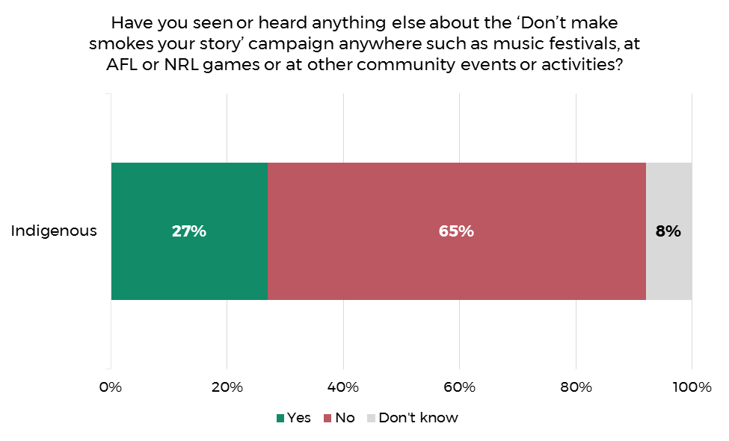

Base): All Indigenous respondents (n=356)

Figure 23 below shows the cut through for any of the campaign material amongst both the Indigenous and non-Indigenous samples compared to the previous campaign years.

## Overall Recognition

Overall, 86% of Indigenous respondents recognised the campaign in the 2018 evaluation. This figure is in-line with the 2017 result (87%) and an 11 percentage point increase on the 2016 Indigenous evaluation.

As in 2017, overall recognition was lower among non-Indigenous audiences (56% compared with 86%).

Overall campaign recognition amongst the Indigenous community peaked in regional locations (93%) compared to urban (79%) and remote (83%). Overall recognition did not significantly differ by age amongst the Indigenous community, although there were age differences by campaign material as discussed above.

Overall campaign recognition amongst non-Indigenous respondents was higher outside of urban areas (68% compared to 49% in urban).

Figure . Overall campaign recognition by year

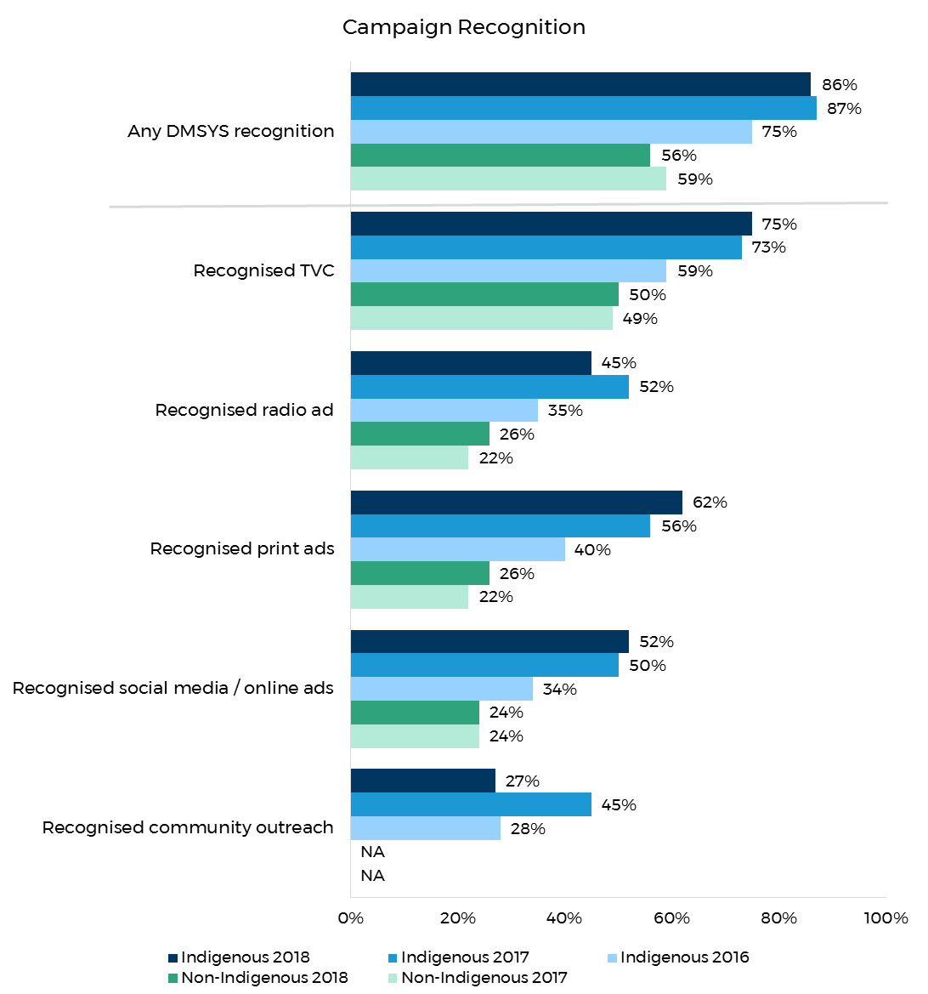

Base: Respondents who recognised any of the campaign material (n=356 Indigenous 2018; n=352 Indigenous 2017; n= 310 Indigenous 2016; n=510 Non-Indigenous 2018; n=508 non-Indigenous 2017

## DMSYS Results

Respondents who reported having seen the TVC (n=266 of Indigenous respondents; n=254 of mainstream respondents) were asked whether they agreed or disagreed with various statements about the ad. As shown in Figure 24 the results for the Indigenous and non-Indigenous evaluations were fairly similar. Ninety-eight percent of Indigenous respondents agreed that the ad was easy to understand (94% non-Indigenous), 90% that the ad was believable (86% non-Indigenous) and 80% that the ad made them stop and think (75% non-Indigenous). The lowest scoring diagnostics for both audiences were ‘Taught me something new’ (54% Indigenous, 29% non-Indigenous) and ‘Makes me feel uncomfortable’ (30% Indigenous, 40% non-Indigenous).

The positive campaign message appears to have resonated with audiences, with the majority of respondents across both evaluations agreeing it made them feel hopeful (69% Indigenous, 73% non-Indigenous) and made them feel inspired (61% Indigenous, 72% non-Indigenous). Furthermore, despite the campaign being an Indigenous focused initiative, 70% of non-Indigenous respondents felt that the ad related to them, in-line with the result for the Indigenous evaluation (69%).

The TVC tended to perform best amongst Indigenous respondents in regional areas. Specifically, the diagnostics: “Makes me feel hopeful” (61% urban, 75% regional, 68% remote), ‘Makes me feel worried about my smoking’ (55% urban, 79% regional, 66% remote) and ‘Makes me more likely to try to quit’ (55% urban, 75% regional, 44% remote). Respondents from regional areas were also more likely to agree that the ad taught them something new (41% urban, 65% regional, 49% remote), made them feel empowered to quit (urban 45%, regional 69%, remote 47%) and made them feel inspired’ (57% urban, 69% regional, 49% remote).

Figure . TVC diagnostics, 2018

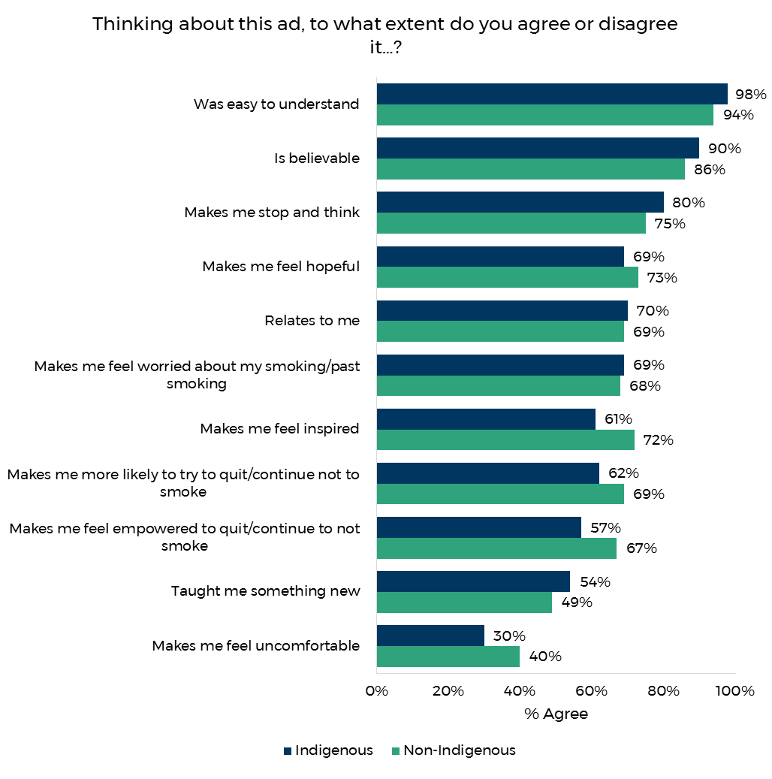

Base: All Indigenous and non-Indigenous respondents who recognised the TVC (n=266 Indigenous, n=254 Non-Indigenous)

To assess potential ‘wear out’ respondents who recognised the TVC were asked if they agreed or disagreed that they were getting tired of seeing the ad. As shown in Figure 25, 20% of Indigenous respondents agreed with this contention. This figure is lower than the equivalent 2017 (26%) and 2016 (23%) result amongst Indigenous smokers. The level of wear-out was similar amongst the general public (18%), which was also slightly lower than the previous year (20%).

Further analysis showed that wear out was highest in urban areas for Indigenous (31%; compared with regional 16% and remote 11%) and non-Indigenous respondents (24% compared to 10% in regional / remote).

Figure . TVC Wear out

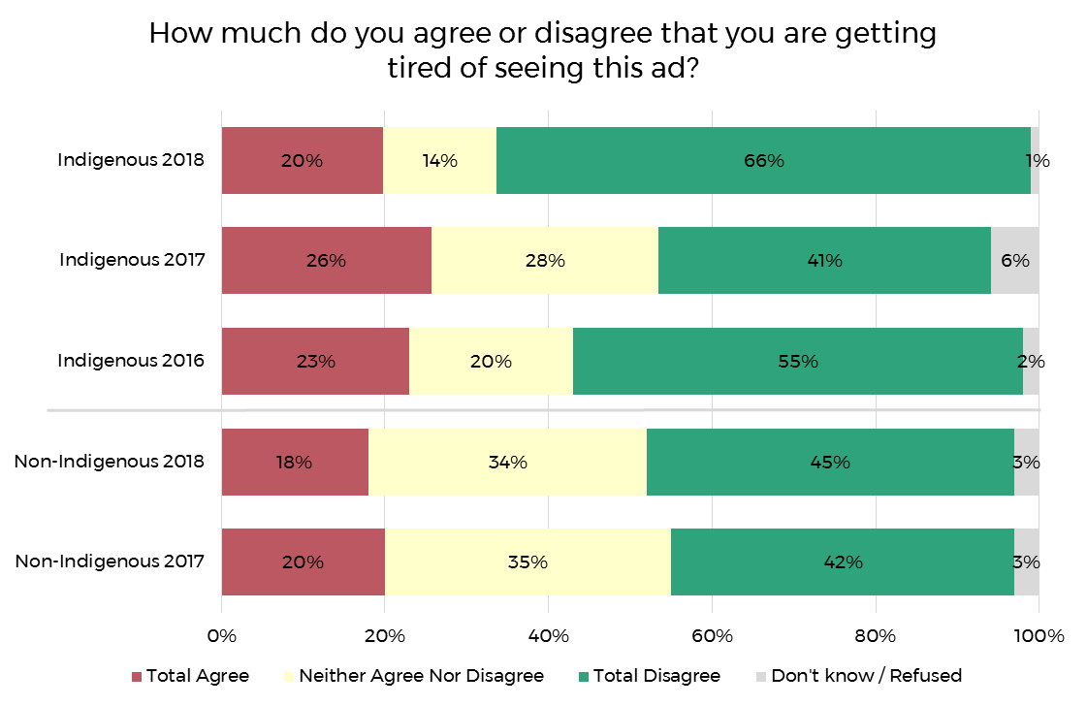

Base: Respondents who recognised the TVC (n=266 Indigenous 2018; n=258 Indigenous 2017; n=185 Indigenous 2016; n=254 Non-Indigenous 2018; n=241 non-Indigenous 2017)

Respondents who reported having seen or heard any of the campaign material were asked what they thought were the key messages of the ads. This was an open question to which respondents could answer multiple responses. As shown in Figure 26, the most commonly cited take out messages amongst the Indigenous community were ‘quit smoking’ (56%), ‘you should quit for your kids/family’ (35%), and quitting has health benefits (34%).

Figure . Message take outs - Indigenous

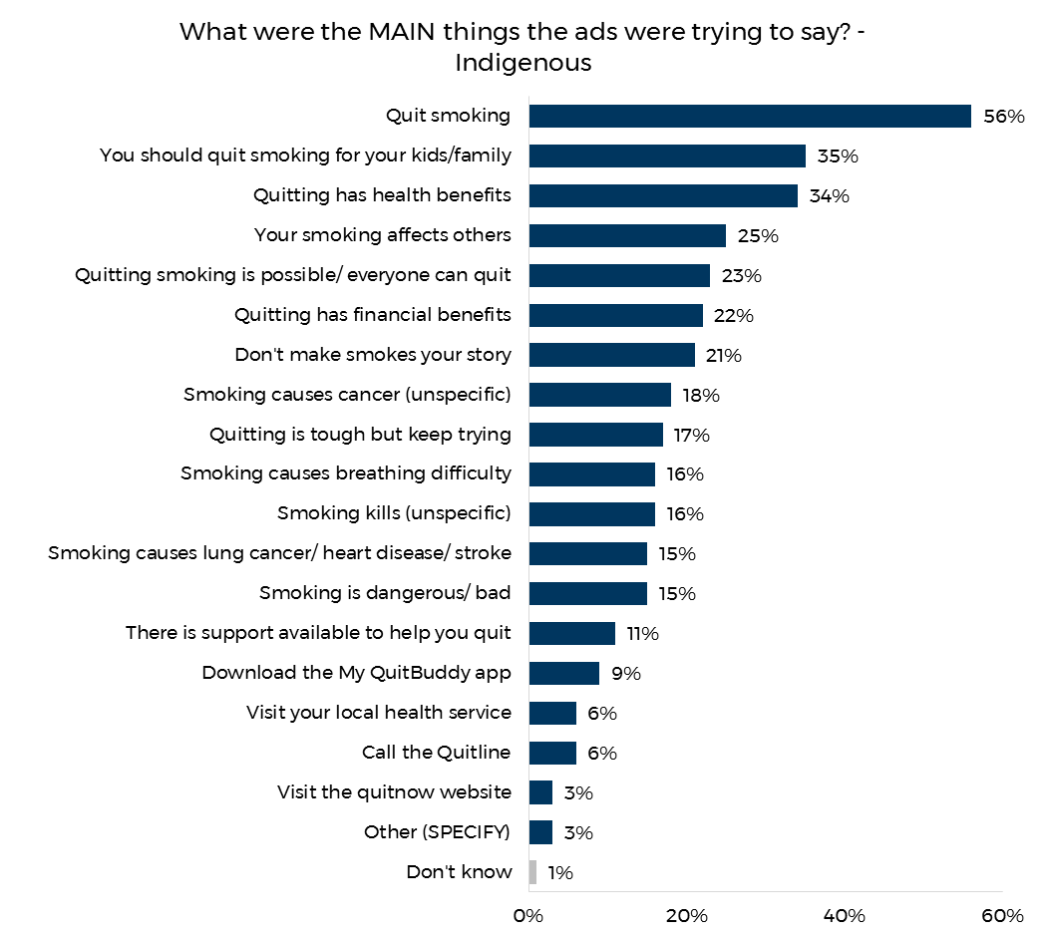

Base: All Indigenous respondents who recognised the TVC, print, radio or online ads (n=300)

Figure 27 depicts the equivalent results for key message take outs amongst the non-Indigenous sample. The messages ‘you should quit smoking for your kids/family’ (67%), and ‘quitting smoking is possible/ everyone can quit’ (61%), also resonated highly with these respondents.

Figure . Message take out - non-Indigenous

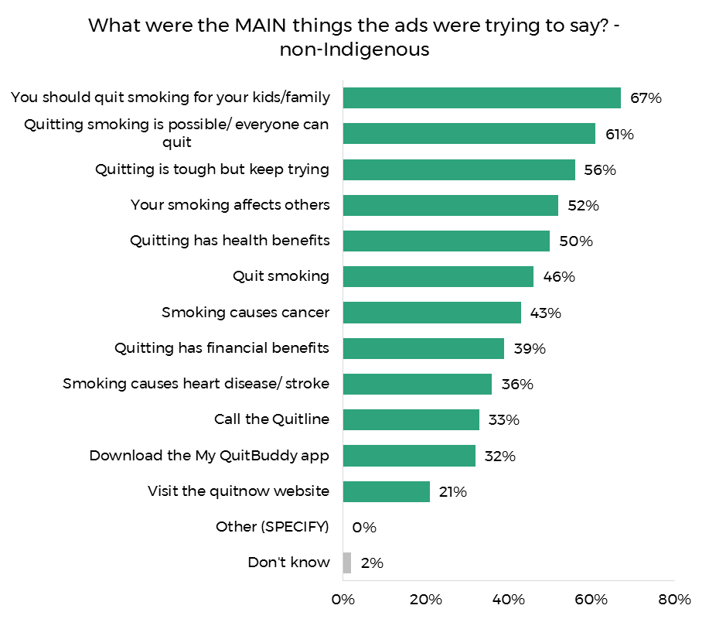

Base: All Non-Indigenous respondents who recognised the TVC, print, radio or online ads (n=283)

Respondents who reported having seen or heard any of the campaign material were then asked if they thought the approach of the campaign was different to previous anti-smoking ads, and if so why. The vast majority of Indigenous respondents (88%) felt that the *Don’t Make Smokes Your Story* campaign was different (see Figure 28). The primary reasons provided were that it ‘focuses on family’ (40%), was ‘more positive’ (36%) and more relevant to them as Indigenous Australians (31%). Twenty-seven percent also reported it was different as it showed the positives of quitting rather than the negatives of smoking and 9% because it’s less judgemental.

Indigenous respondents living in urban locations were more likely to report unprompted that the ads were more relevant to them as an Indigenous Australian (50%) compared to regional (27%) and remote (15%) locations.

Figure . Difference to previous campaigns - Indigenous

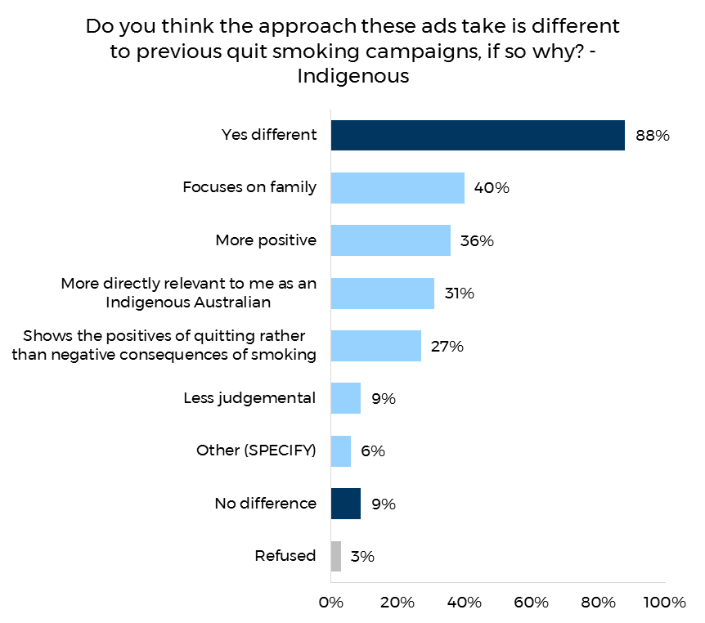

Base: Indigenous respondents who recognised the TVC, print, radio or online ads (n=300)

Figure 29 shows the equivalent results for the non-Indigenous sample. As with the Indigenous result, 85% of non-Indigenous respondents agreed the campaign was different to previous anti-smoking advertisements. The most salient reason for this audience was that it is more positive (47%), followed by ‘it shows the positive of quitting rather than the negatives of smoking’ (44%) and focuses on family (40%).

Figure . Difference to previous campaigns - non-Indigenous

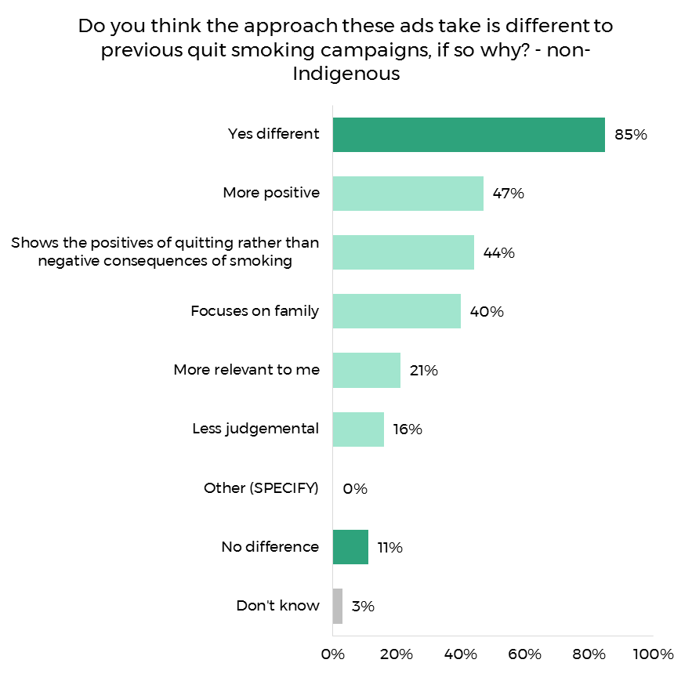

Base: Non-Indigenous respondents who recognised the TVC, print, radio or online ads (n=283)

## DMSYS Impact

Respondents who reported seeing or hearing any of the Don’t Make Smokes Your Story campaign material (n=304 Indigenous; n=295 non-Indigenous) were asked what, if anything, they had done as a result of seeing these ads. For Indigenous respondents this was an open response question and multiple responses were accepted. More than half (53%) of those respondents reported having taken some action as a result of seeing the campaign. This was in-line with the 2017 figure (54%) but slightly lower than the 2016 result (58%).

The most commonly cited actions were consistent with the 2016 and 2017 results, with 26% reporting they ‘cut down the amount they smoke’ (24% in 2017, 27% in 2016), 14% ‘discussed smoking and health with family/friends’ (19% 2017, 20% 2016) and 7% ‘quit smoking’ (8% 2017, 9% 2016).

Respondents from urban locations were the most likely to report they had taken some form of action (61%, compared with 55% in regional locations and 41% in remote). Specifically, urban audiences were more likely to report they cut down smoking (32% vs 27% regional and 17% remote) and they asked their doctor or health worker for help to quit (11% vs 5% regional and 0% remote).

Figure . Actions taken - Indigenous

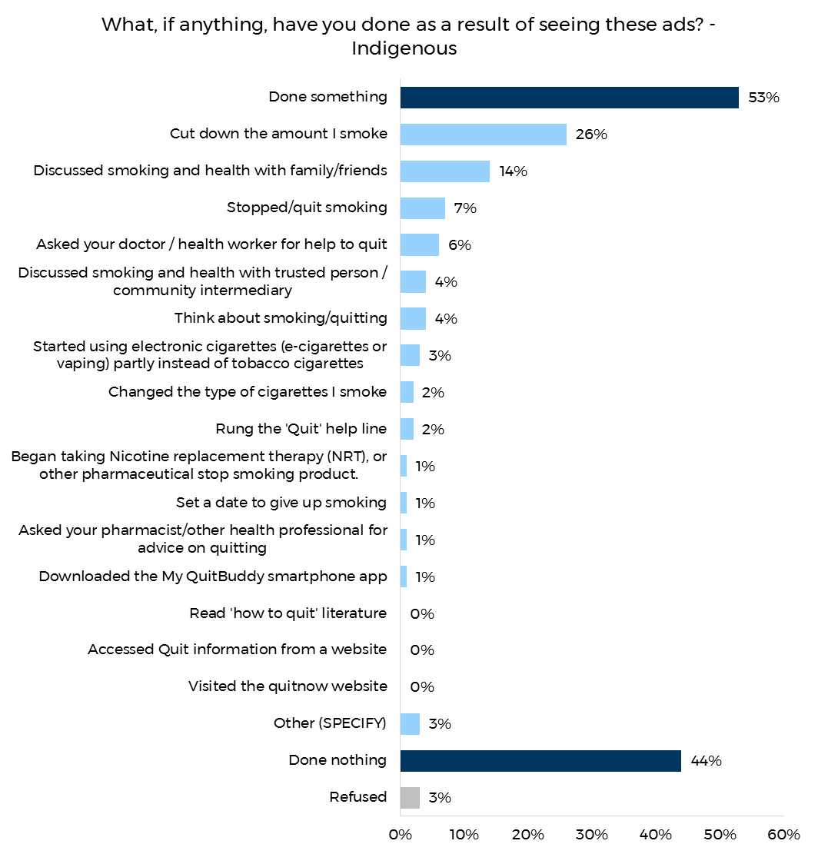

Base: Indigenous respondents who recognised any of the campaign material (n=307)

For the non-Indigenous evaluation a list of possible actions was provided, with an option to select ‘other’ and specify the action they took, the results of which are depicted in Figure 31. The proportion of non-Indigenous respondents who reported taking some form of action as a direct result of having been exposed to the campaign was the same as it had been in 2017 (66%). The three most common actions in the 2018 evaluation followed the same pattern as the Indigenous results: cutting down the amount they smoke (29%), discussing smoking with family and friends (22%) and quit smoking (17%). Accessing quit information online (13%) was the fourth most common action reported for mainstream audiences, but less than one percent of Indigenous respondents. Of note, 3% of respondents answered that they had ‘quit smoking’ and that they had also started smoking e-cigarettes.

The proportion of respondents reporting that they had taken some form of action as a result of the campaign was highest amongst 18 to 29 year olds (77%) and decreased with age (70% of 30 to 40 year olds; 51% of 41 to 50 year olds). Further analysis showed younger respondents were specifically more likely to report that they had discussed smoking and health with family and friends (27%) compared to the two older age groups (20% 30 to 40 years, 16% 41 to 50 years). Younger respondents were also more likely to report having quit smoking (22% compared to 16% 30 to 40 years, 11% 41 to 50 years) and rung the Quitline (19% compared to 9% 30 to 40 years, 7% 41 to 50 years).

Figure . Actions taken - Non-Indigenous

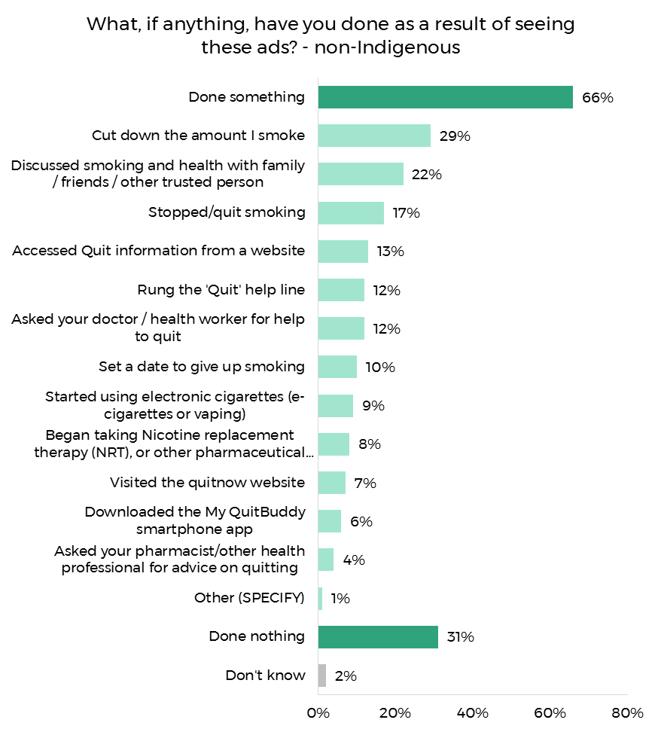

Base: Non-Indigenous respondents who recognised any of the campaign material (n=283)

Respondents who reported having seen or heard any of the *Don’t Make Smokes Your Story* campaign material were asked what, if anything, they intended to do in the next month in response to seeing the ads. As shown in Figure 32, nearly two thirds (66%) of Indigenous respondents intended to do something, a slight increase on the 2017 result (61%). The most commonly reported intentions were to quit smoking (20%), reduce the amount of cigarettes they smoke (20%), and discuss smoking and health with others (10%).

As with the results on actions as a result of the campaign, reported intentions to change behaviour were highest in urban areas (66%), and lowest in remote areas (55%). However, regional respondents were the most likely to report the specific intention to quit smoking (33%), compared to urban (21%) and remote (18%). Seven percent of respondents from remote areas intended to ask their doctor to quit, compared to 17% from regional and 10% from urban areas.

Figure . Intended action - Indigenous

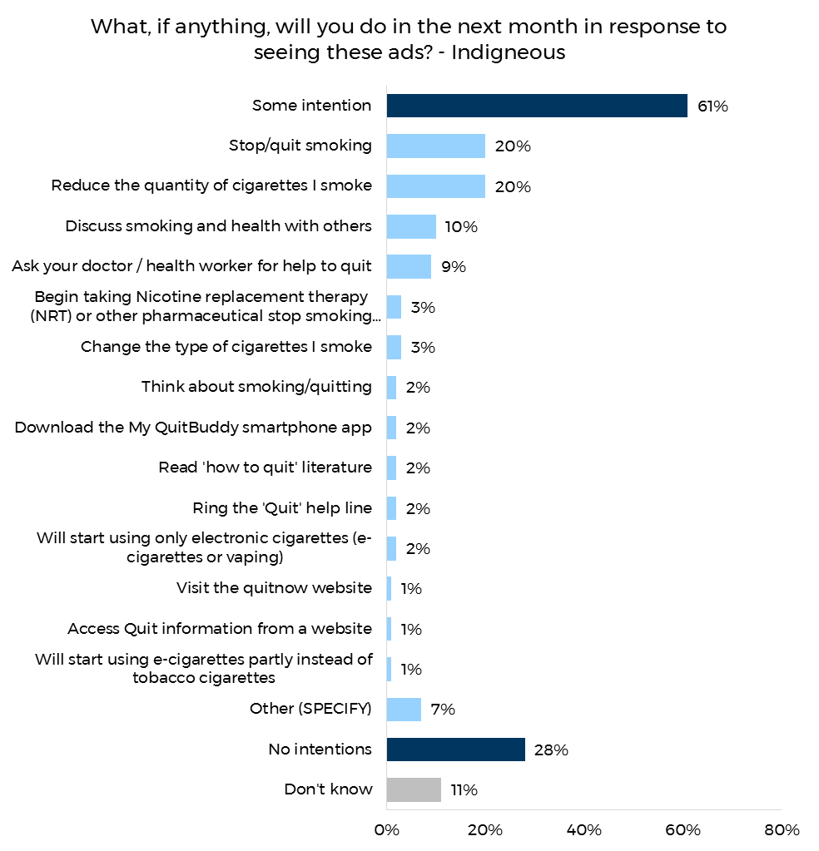

Base: Indigenous respondents who recognised any of the campaign material (n=307)

Nearly three quarters (74%) of non-Indigenous respondents who recognised *Don’t Make Smokes Your Story*, stated that they intended to take some form of action as a result of the campaign, which is 13 percentage points higher than the Indigenous evaluation. The three most common stated intentions were the same as the Indigenous evaluation: to reduce the amount they smoke (34%), quit smoking (28%) and read how to quit literature (14%).

Figure . Intended actions - Non-Indigenous

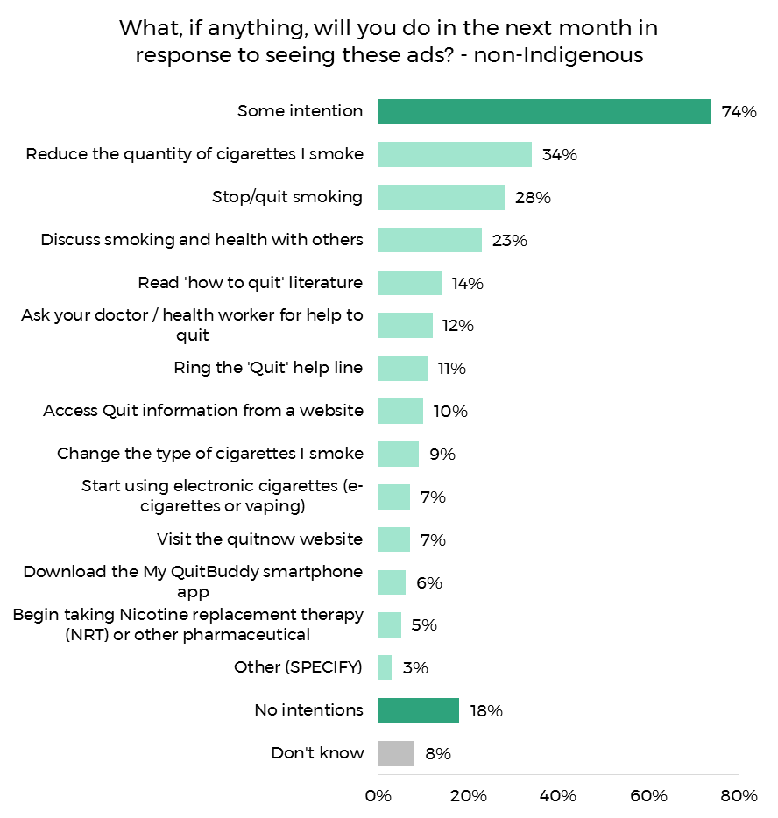

Base: Non-Indigenous respondents who recognised any of the campaign material (n=283)

## QFYQF2 Awareness

As the Quit for You, Quit for Two campaign was running at the same time as Don’t Make Smokes Your Story, recognition of the Quit for You, Quit for Two advertisements was also assessed. Respondents were shown a poster from the campaign and asked if they had previously seen any similar advertisements. Prompted recognition for the campaign amongst Indigenous respondents was just over one third (34%); a decrease on the result for the 2017 (43%) and 2016 (40%) campaign. Within Indigenous communities women were significantly more likely to recognise the campaign (44%) than men (25%).

Compared to Indigenous respondents, prompted recognition of Quit for You, Quit for Two was considerably lower amongst the non-Indigenous sample (16%), but in-line with the 2017 result (16%). Women were again more likely to recognise the campaign (20%) compared to men (13%). Unlike the Indigenous survey, the non-Indigenous evaluation found younger respondents (aged 18 to 29 years) were more likely to have recognised the ad (27%) than 30 to 40 year olds (11%) and 41 to 50 year olds (7%).

Figure . Quit for You, Quit for Two prompted recognition

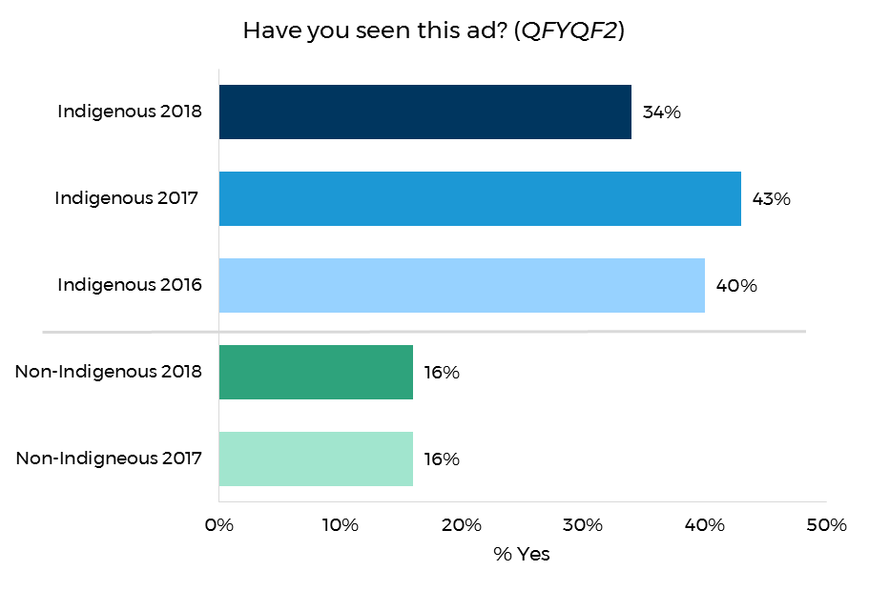

Base: All respondents (n=356 Indigenous 2018; n=352 Indigenous 2017; n=309 Indigenous 2016; n=510 Non-Indigenous 2018; n= 508 non-Indigenous 2017)

## Messages Communicated by the Campaigns

Respondents who reported they recognised any Don’t Make Smokes Your Story or Quit for You, Quit for Two campaign material, were asked if the campaigns communicated a number of messages (listed in Figure 35). Messages that Indigenous respondents most commonly felt were communicated to them were ‘you can quit smoking for a better future for you and your family’ (99%) and ‘when you choose to quit smoking there is support available to help you’ (97%). Less resonant were messages around the quit tools available, these being ‘visit the Quitnow website’ (76%) and ‘download the My QuitBuddy app’ (63%).

The message most commonly recalled by non-Indigenous respondents was ‘you can quit smoking for a better future for you and your family’ (93%) followed by ‘there are financial benefits to quitting’ (89%).

Figure . Key message take outs

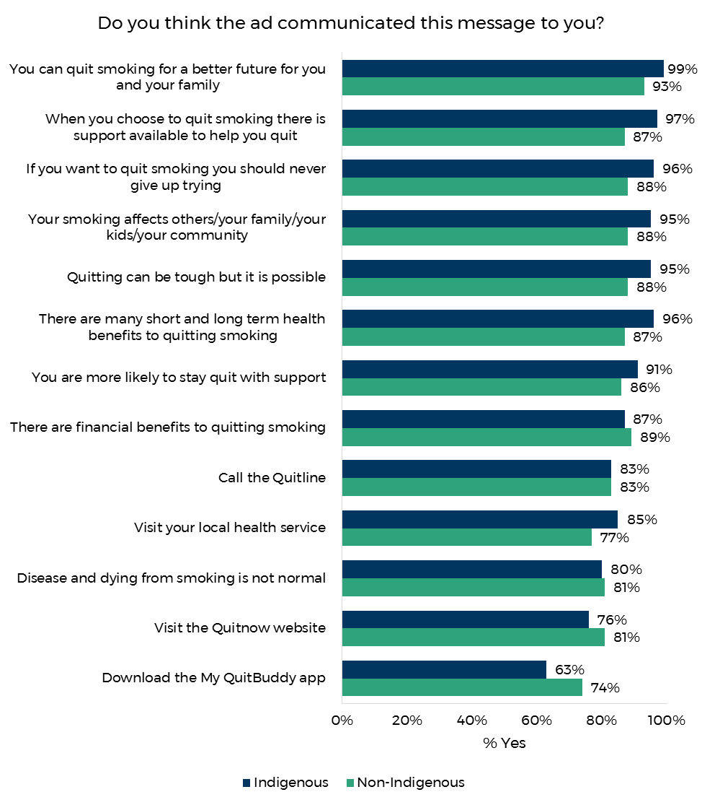

Base: Respondents who recognised any of the Don’t Make Smokes Your Story or Quit for You, Quit for Two campaign material (n=307 Indigenous, n=300 non-Indigenous)

# Use of My QuitBuddy App

All respondents were shown images of the *My QuitBuddy* app (see appendix H) and asked if they had previously seen it, and if yes where. Figure 36 illustrates that approximately a third of respondents from the Indigenous (33%) and non-Indigenous evaluation (29%) had seen the app.

Exposure to the app amongst Indigenous respondents was most prevalent in remote areas (38%), followed by regional (35%) and urban areas (25%). Exposure decreased with age from 41% of 15 to 17 year olds, 38% of 18 to 40 year olds to 23% of 41 year olds. This decline in exposure by age was similar to last year’s result.

Similarly, non-Indigenous respondents’ recall of the app also declined by age, from 40% of 18 to 29 year olds, 29% of 30 to 40 year olds to 13% amongst 41 years or older.

Figure . Prompted recognition of the My QuitBuddy app

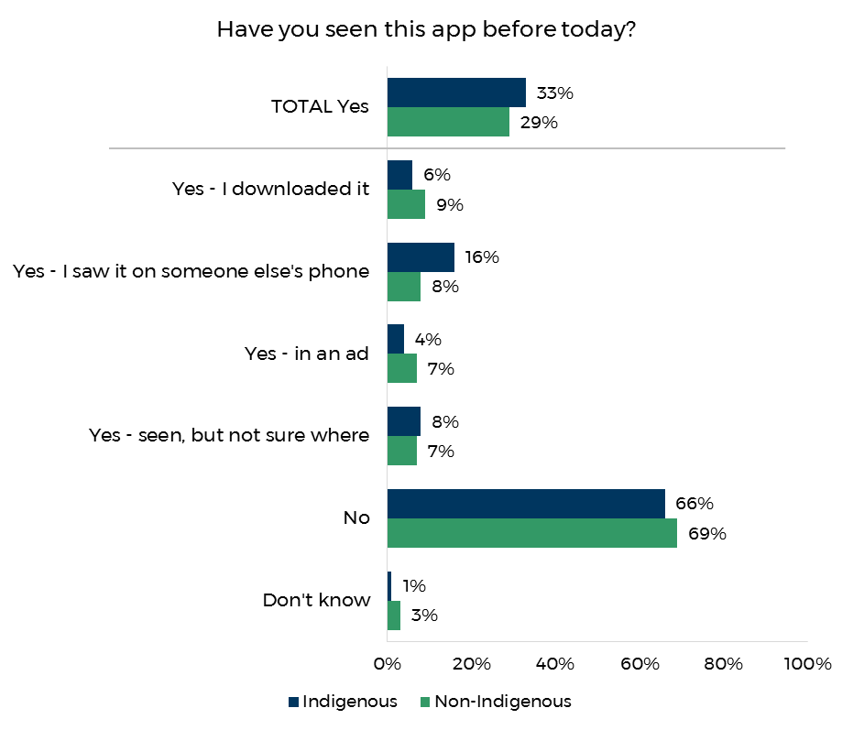

Base: All respondents (n=356 Indigenous; n=510 non-Indigenous)

Respondents who had downloaded the app were asked how useful they found it, and the results are shown in Figure 37. The majority of respondents in both the Indigenous (97%) and non-Indigenous (88%) evaluation reported it was ‘somewhat’ or ‘very’ useful. This result is an increase of 10 percentage points amongst Indigenous respondents and 8 percentage points amongst non-Indigenous respondents since 2017.

Figure . Effectiveness of the app

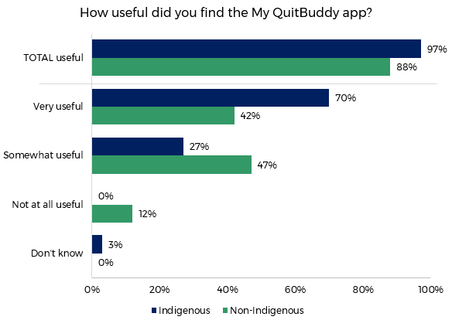

Base: Respondents who had downloaded the My QuitBuddy app (n=20 Indigenous; n=47 non-Indigenous)

# Department Internal Data

Internal data from the department was provided and analysed to compare use of the quit tools My QuitBuddy, the Quitline and the Quit Now website prior and throughout the campaign launch.

During the five week campaign period (25 May to 30 June 2018) there were 42,609 visits to the *Quit Now* website. This is a 25% increase on the number of visits during the five week period (19 April to 24 May 2018) prior to the campaign (34,027). Similarly, the number of calls made to the Quitline during the campaign period (4,859) increased by 13% compared to the five week period prior to the campaign (4,314). The largest increase was with the number of downloads of the *My QuitBuddy* app, which increased by 43% during the campaign period, with 13,524 downloads in the five weeks prior to the campaign, and 19,275 during the campaign.

# Demographics

This section describes the demographic information of smokers and recent quitters from the Indigenous and non-Indigenous samples.

Indigenous respondents were asked if they speak an Aboriginal or Indigenous language at home, and as shown in Figure 38, just over third of respondents (35%) did.

Respondents in remote communities were by far the most likely to report they speak an Indigenous language at home at 83%, compared to urban (24%) and regional (15%) respondents.

Figure . Respondents who spoke an Indigenous language at home – Indigenous

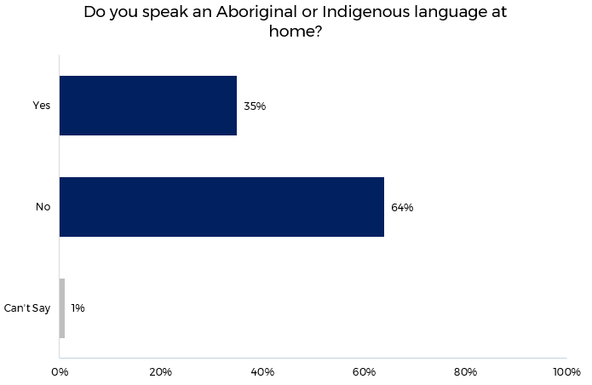

Base: All Indigenous respondents (n=356)

All respondents were asked what their highest level of education was. As shown in Figure 39, 45% of Indigenous respondents had not finished secondary school, 19% had completed a TAFE certificate or apprenticeship, and 5% held a bachelor’s degree or higher.

A much smaller proportion of non-Indigenous respondents had not completed secondary school (14%), and a much larger proportion had completed a TAFE certificate or apprenticeship (34%), or a bachelor’s degree or higher (30%).

Figure . Education

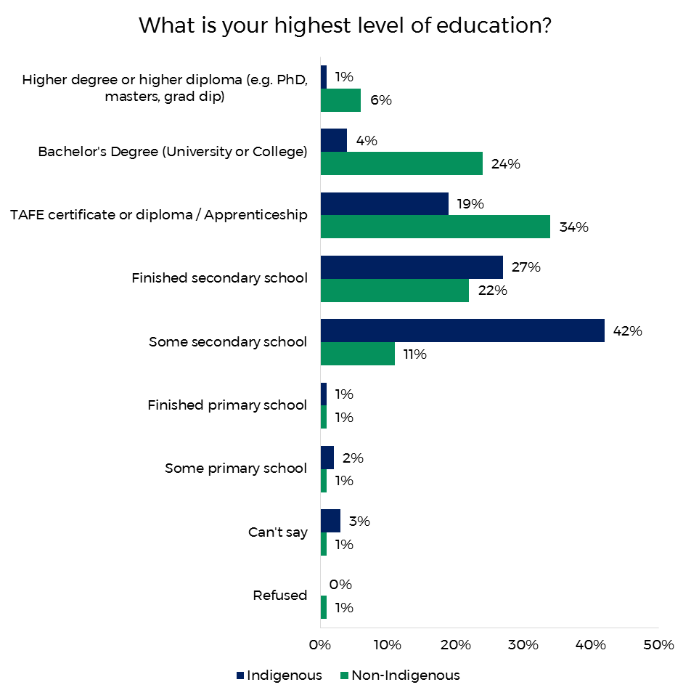

Base: All respondents (n=356 for Indigenous; n=510 Non-Indigenous)

Figure 40 shows the reported household annual income of respondents in the Indigenous and the non-Indigenous evaluations. Indigenous respondents were most likely to fall into the three lowest income brackets, with 65% reporting a household income below $60,000. In contrast, non-Indigenous respondents were most likely to report a household income between $30,000 and $120,000 (62%).

Figure . Income

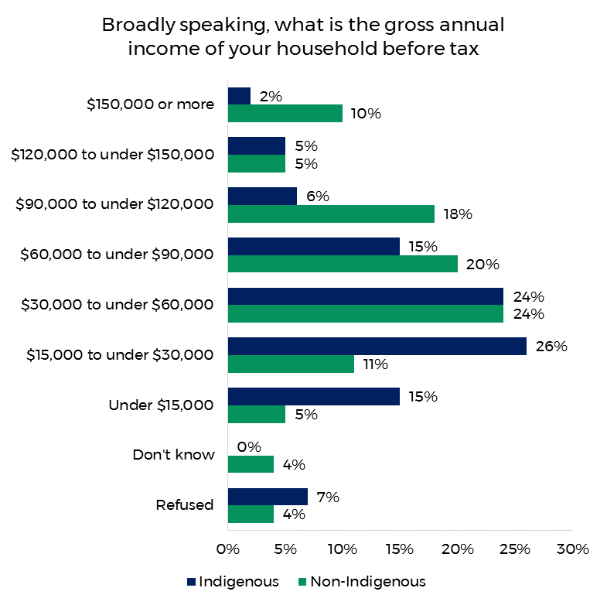

Base: All respondents (n=356 or Indigenous; n=510 Non-Indigenous)

Respondents were asked if they had been told by a doctor or nurse that they had any of the health conditions listed in Figure 41. Thirty-six percent of Indigenous respondents had at least one of the health conditions, the most common being asthma (14%), followed by mental health problems (12%). A similar proportion of non-Indigenous respondents (39%) had at least one of the health conditions listed; again the most commonly reported being asthma (14%) and mental health problems (19%).

Figure . Health conditions

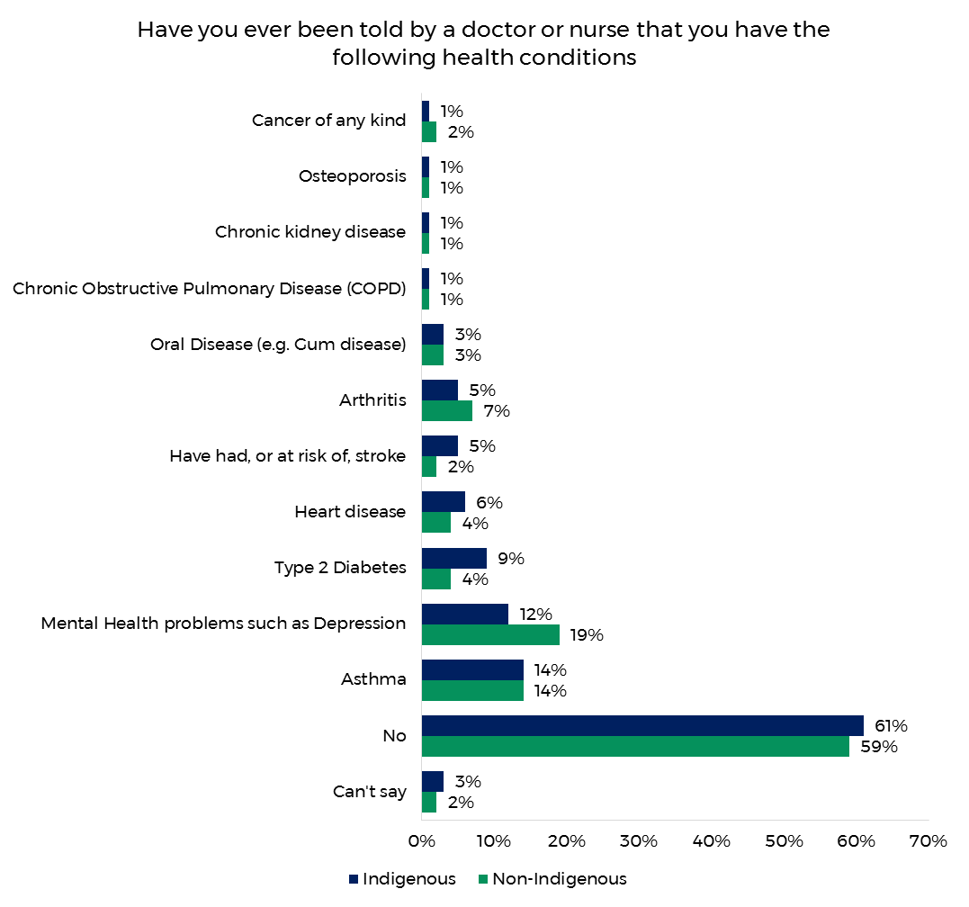

Base: All respondents (n=356 for Indigenous; n=510 Non-Indigenous)

Respondents were asked about the job of the main income earner in their household. As illustrated in Figure 42, the most common response was ‘no occupation’ (31%) for Indigenous respondents, followed by ‘community or personal service worker’ (13%) and ‘labourer’ (14%). In contrast, only 10% of the non-Indigenous sample reported ‘no occupation’, and ‘professional’ (19%) and ‘manager’ (15%) were the most common responses.

Figure . Main household earner’s job

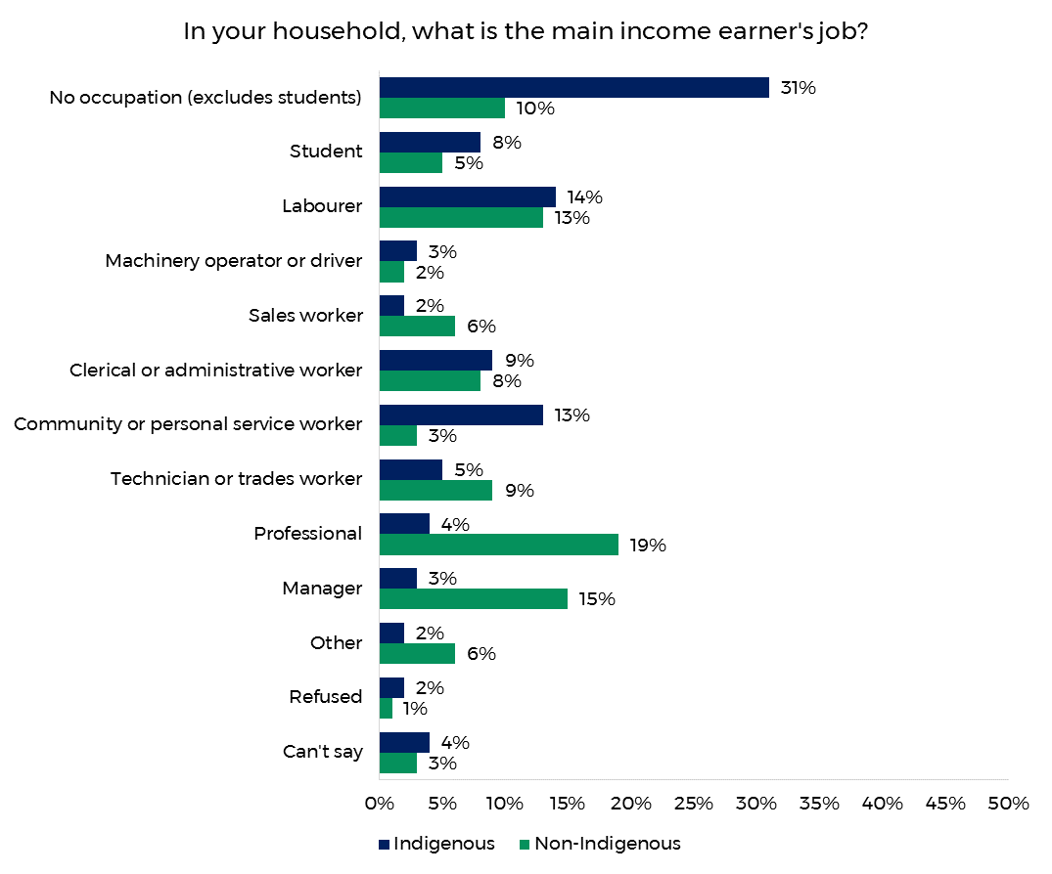

Base: All respondents (n=356 for Indigenous; n=510 Non-Indigenous)

# Conclusions and Recommendations

**The 2018 evaluation research suggests that the** Don’t Make Smokes Your Story **campaign has continued the success of the 2017 and 2016 campaign and delivered against all of the key campaign objectives, while also demonstrating significant cross-over appeal to mainstream smoking audiences.**

Eighty-six percent of the participants surveyed from the target audience of Indigenous smokers and recent quitters aged 15 years and over reported having seen or heard the campaign. This is in-line with the 2017 evaluation (87%), and an increase on the 2016 evaluation (75%). More than half of the non-Indigenous sample (56%) also recognised the campaign, which was again roughly in-line with the 2017 result (59%).

Overall prompted campaign recognition amongst the Indigenous community peaked in regional locations (93%) compared to remote (83%) and urban (79%). A similar pattern was found with the non-Indigenous sample, where recognition was higher in regional / remote areas (68%, regional and remote were combined for the non-Indigenous evaluation), compared to urban areas (49%).

Overall recognition did not significantly differ by age for either Indigenous or non-Indigenous respondents, although there were age differences associated with different campaign material. Specifically, older Indigenous respondents were less likely to recognise the online ads (40% compared to 59% of 18 to 40 year olds and 52% of 15 to 17 year olds). Similarly, the oldest non-Indigenous group was less likely to recognise the print ads (19% compared to 28% for 30 to 40 year olds and 31% for 18 to 29 year olds).

Unprompted recall of the campaign amongst Indigenous smokers and recent quitters had considerably increased since 2017. More than a third (35%) of Indigenous respondents recalled the ad unprompted (compared to 12% in 2017). This indicates that, although overall exposure to the campaign did not increase, the campaign was more ‘top of mind’ this year.

The diagnostic performance of the TVC was again very strong. In particular, it was regarded as being easy to understand (by 98% of Indigenous and 94% of non-Indigenous respondents), and believable (90% Indigenous, 86% non-Indigenous).

Of note, the TVC was regarded as ‘empowering’ and ‘inspiring’ by 57% and 61% of Indigenous respondents respectively and 67% and 72% (respectively) of non-Indigenous respondents, effectively delivering on the positive campaign strategy across both audiences. This is further supported, by the 88% of Indigenous and 85% of non-Indigenous respondents who stated that this campaign is different from previous anti-smoking advertisements. The reasons provided included it is more positive in general (40% Indigenous, 47% non-Indigenous), it shows the positives of quitting (27% Indigenous, 44% non-Indigenous) and focuses on family (40% Indigenous, 40% non-Indigenous). Thirty-one percent of Indigenous respondents also stated that *Don’t Make Smokes Your Story* is different from previous campaigns, as it is more relevant to them as an Indigenous Australian.

It was evident that the campaign had cross-over appeal and relevance with non-Indigenous audiences, with 69% of non-Indigenous respondents agreeing the campaign ‘relates to me’ (70% for Indigenous) and 21% stating that the campaign was different from previous anti-smoking ads specifically because it was more relevant to them.

The campaign continued to drive impressive quitting behaviour and intentions amongst Indigenous and non-Indigenous audiences. Of those who recognised the campaign, 7% of Indigenous respondents stated that they had quit as a result of the campaign (17% for non-Indigenous), 26% had reduced the amount they smoke (29% for non-Indigenous) and 14% had discussed smoking and health with family and friends (22% for non-Indigenous). Furthermore, 20% of Indigenous respondents stated they intended to quit smoking as a result of the campaign (28% for non-Indigenous), 20% intended to reduce the amount they smoke (34% for non-Indigenous) and 9% intended to ask their doctor or health worker for help to quit (12% for non-Indigenous).

TVC ‘wear out’ (those reporting that they were getting sick of seeing the ad) was 20% amongst Indigenous respondents and 18% for non-Indigenous respondents. This was a slight improvement on previous years (2017 Indigenous 26%, 2016 Indigenous 23%, and 2017 non-Indigenous 20%).

The evaluation results on increased quit attempts and intentions are supported by the department’s own data around the increased use of support tools (the My QuitBuddy app, the Quit Now website and the Quitline). During the five week campaign period there was a 25% increase in the number of visits to the *Quit Now* website, a 13% increase in calls made to the *Quitline* and a 43% increase in downloads of the My QuitBuddy app.

**In summary, the evaluation of the 2018** Don’t Make Smokes Your Story **Campaign suggests that the success of the 2016 and 2017 campaign has been further reinforced with similar high levels of impact on behaviour and intentions to change. The campaign also demonstrated meaningful cross-over to non-Indigenous smoking audiences, with somewhat lower, though still impressive, reach being achieved and impressive diagnostic performance and reported behaviour change.**

Appendix A: Detailed Methodology

Indigenous Evaluation

The below section provides a detailed description of the methodology and the research approach of the Indigenous evaluation.

Overall Evaluation Approach

The most significant challenge to address in conducting the Don’t Make Smokes Your Story campaign evaluations amongst Indigenous people was to obtain a sample reflecting the diversity of the target population from whom reliable information could be obtained. This required careful consideration of the sampling strategy, fieldwork methodology and interviewing processes employed.

Obtaining a true random probability sample of this population was not possible, because:

* there is no sample frame of Indigenous people in Australia
* no representative research panel of Indigenous Australians exists
* Random Digit Dial (RDD) telephone interviewing would not be an appropriate approach (given low rates of telephone ownership in some communities as well as the likely difficulty of administering complex surveys over the phone with some segments of the Indigenous population).

As a random probability sampling approach was not feasible, the principle considerations in designing the evaluation approach was:

* the importance of appropriately representing regional and remote as well as urban Indigenous communities in the evaluation
* the importance of representing different states and territories
* the desirability of establishing proper rapport with potential evaluation participants – arguing strongly for a face-to-face methodology.

The overall approach adopted comprised:

* A national sample design with geographic stratification in proportion to the Indigenous population in urban, regional and remote locations in each state or territory.
* A face-to-face interviewing methodology was employed, which involved identifying, training and briefing community-based interviewers local to the communities they were interviewing in.
* A purposive sampling approach was adopted, with our community-based interviewers screening Indigenous community members according the study’s qualifying criteria. Some controls on age, gender and smoking status were also applied, as described in more detail below.

Sampling Strategy and Sample Design

The target audience for the Indigenous evaluation matched that for the campaign and the 2016 evaluation - Indigenous smokers and recent quitters aged 15 years and over, with a primary target audience of Indigenous smokers aged 18-40.

The campaign was planned to appeal particularly to Indigenous smokers and recent quitters in regional and remote locations. The research sample needed to reflect the key target audiences for the campaign, i.e. smokers and recent quitters aged 18-40, and enable separate analysis by factors such as gender, smoking status, location, and campaign recognition.

A national sample design was constructed for the evaluation with geographic stratification in proportion to the Indigenous population in urban, regional and remote locations in each state or territory.

The 2011 Census of Population and Housing (ABS Catalogue 3238.0.55.001 - *Estimates of Aboriginal and Torres Strait Islander Australians*, June 2011) provided the following breakdown (collapsing “inner regional” and “outer regional” together and collapsing “remote” and “very remote” together).

**Table 5. Distribution of Indigenous population according to 2011 Census**

| State | Major Cities | Regional | Remote | Total |
| --- | --- | --- | --- | --- |
| NSW | 14% | 16% | 1% | 31% |
| VIC | 4% | 3% | NIL | 7% |
| QLD | 9% | 14% | 5% | 28% |
| SA | 3% | 2% | 1% | 6% |
| WA | 5% | 3% | 5% | 13% |
| TAS | NIL | 4% | NIL | 4% |
| NT | NIL | 2% | 8% | 10% |
| ACT | 1% | NIL | NIL | 1% |
| Total | 36% | 44% | 20% | 100% |

The following quotas (which were also used for the 2017 and 2016 evaluation) were therefore proposed.

**Table 6. Target Sample Design**

| State | Major Cities | Regional | Remote | Total |
| --- | --- | --- | --- | --- |
| NSW/ACT | 53 | 56 | NIL | 109 |
| VIC | 14 | 11 | NIL | 25 |
| QLD | 31 | 49 | 20 | 100 |
| SA | 21 | 7 | NIL | 18 |
| WA | 17 | 11 | 21 | 49 |
| TAS | NIL | 14 | NIL | 14 |
| NT | NIL | 7 | 28 | 35 |
| Total | 126 | 155 | 69 | 350 |

The achieved sample design for the 2017 evaluation is shown below.

**Table 7. Achieved Sample Design (unweighted)**

| State | Major Cities | Regional | Remote | Total |
| --- | --- | --- | --- | --- |
| NSW/ACT | 53 | 56 | NIL | 109 |
| VIC | 14 | 11 | NIL | 25 |
| QLD | 31 | 44 | 24 | 99 |
| SA | 11 | 7 | NIL | 18 |
| WA | 17 | 11 | 26 | 54 |
| TAS | NIL | 14 | NIL | 14 |
| NT | NIL | 7 | 28 | 35 |
| Total | 126 | 150 | 78 | 354 |

The final sample design represented a compromise between the ideal scenario of maximising the number of sampling points and the practical considerations of timing and budget constraints. ORC believes that the resulting coverage provided good representation of the target audience within these operating constraints. In selecting fieldwork locations for interviewing definitions of metropolitan and non-metropolitan were based on Australian Bureau of Statistics ASGS Remoteness Structure classification; with metropolitan areas being defined as those within the ABS ASGS Remoteness Structure classification, Major Cities of Australia.

The fieldwork design assumed that the total sample for each wave would be spread across approximately 20 sampling points Australia-wide, meaning around 15-20 interviews would be conducted per sampling point (for a total of *n=350*). Details of precise fieldwork locations were finalised following examination of ABS data, a detailed review of available interviewers, and further discussion with the Department in order to achieve the optimal geographic coverage (and of course the sample size).

The sampling points for the evaluation are shown below in Figure 42. Where possible the same locations and interviewers were used as the 2016 evaluation to allow comparisons, although respondents who had been interviewed in the 2016 survey were not eligible for re-interview in the 2017 survey. The sampling points for the 2016 evaluation are depicted below in Figure 43.

Figure . Sampling points for the 2018 Indigenous evaluation



Figure . Sampling points for the 2017 Indigenous evaluation

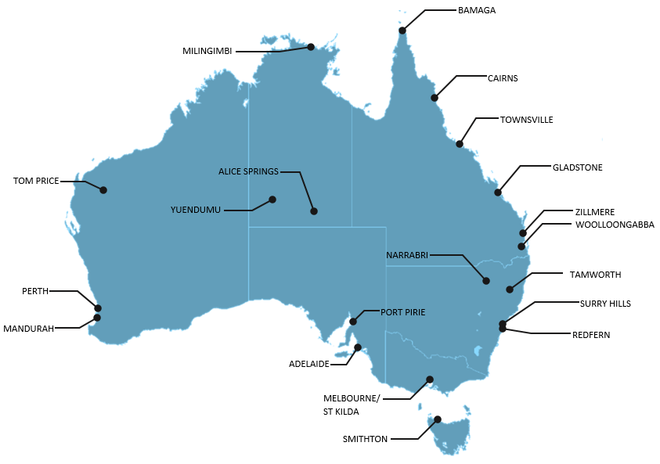

Figure . Sampling points for the 2016 Indigenous evaluation

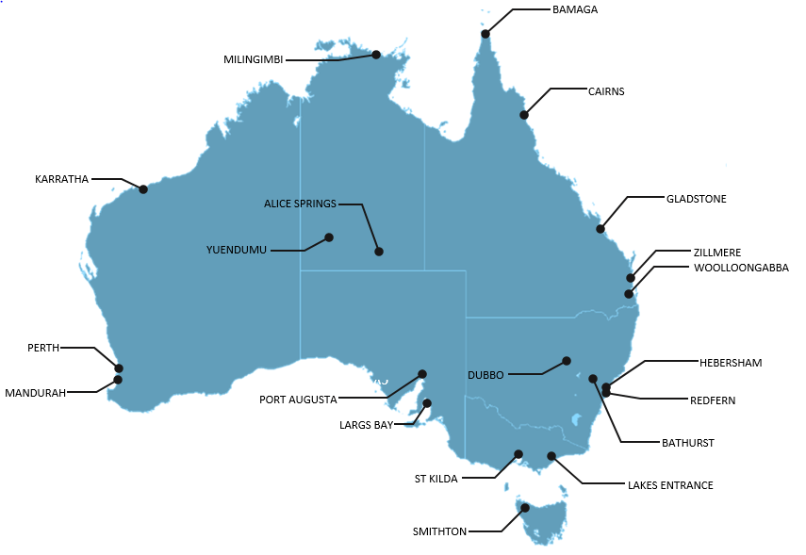

Appendix B: Print Ads

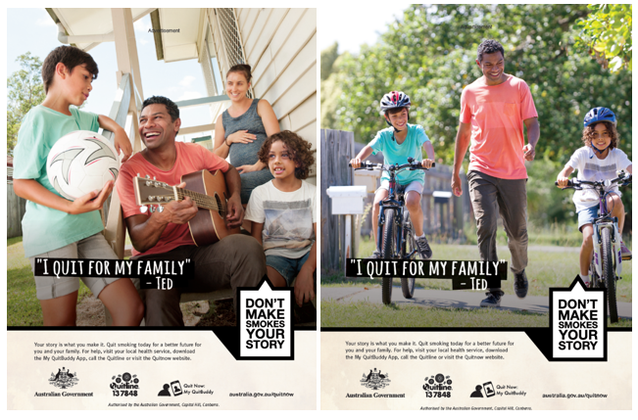

Appendix C: Online Ads

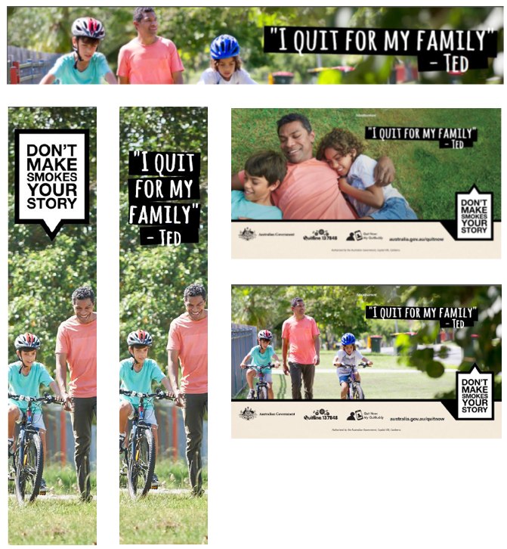

Appendix D: Social Media Ads

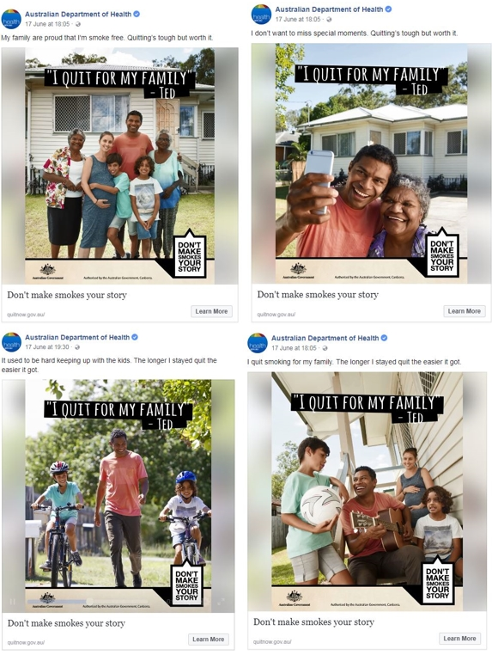

Appendix E: Quit for You, Quit for Two ad

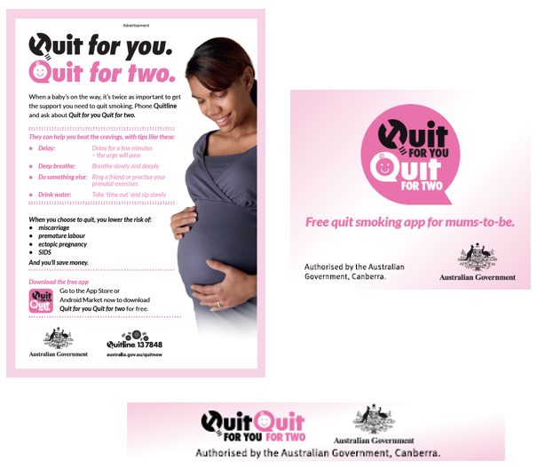

Appendix F: My QuitBuddy App

