DON’T MAKE SMOKES YOUR STORY 2017 EVALUATION

Prepared For:

Penelope Marles, Department of Health

Prepared By:

Craig Young, Alison Woods, and Kerry Sproston

Phone: +61 3 9935 5700

Email: Craig.Young@orcinternational.com

ORC International Ref: AU3000386.prp

September 2017

Contents

Acknowledgements 1

1 Executive Summary 2

2 Introduction 4

3 Methodology 7

4 Smoking Background 13

5 Smoking and Health 23

6 Campaign Results 26

7 Use of My QuitBuddy App 52

8 Department Internal Data 54

9 Demographics 55

10 Conclusions & Recommendations 60

Appendix A: Detailed Methodology 62

Appendix B: Questionnaire 75

Appendix C: Don’t Make Smokes Your Story – Print Ads 103

Appendix D: Online Ads 105

Appendix E: Social Media Ads 106

Appendix F: Quit for You, Quit for Two ad 107

Appendix G: My QuitBuddy app 108

List of Tables

Table 1. Target sample design for the Indigenous evaluation 8

Table 2. Achieved sample profile (unweighted) 9

Table 3. Target sample profile 10

Table 4. Achieved sample profile (unweighted) 12

Table 5. Distribution of Indigenous population according to 2011 Census 63

Table 6. Target Sample Design 64

Table 7. Achieved Sample Design (unweighted) 64

Table 8. Target sample design for the Indigenous evaluation 70

Table 9. Achieved sample profile (unweighted) 71

Table 10. Target sample profile 72

Table 11. Achieved Sample Profile (unweighted) 74

List of Figures

Figure 1. Sampling points 11

Figure 2. Previously attempted to quit 17

Figure 3. Number of quit attempts 18

Figure 4. Support tools previously used – Indigenous evaluation 19

Figure 5. Support tools previously used – Mainstream evaluation 20

Figure 6. Previous motive for quitting - Indigenous 21

Figure 7. Previous motive for quitting - Mainstream 22

Figure 8. Quitting intentions 23

Figure 9. Plan to quit 24

Figure 10. Financial benefit of quitting 25

Figure 11. Personal health benefits of quitting 26

Figure 12. Health damage from smoking 27

Figure 13. Future health damage 28

Figure 14. Health effects on others 29

Figure 15. Recall of quit smoking advertisements 30

Figure 16. Unprompted recall of Don’t Make Smokes Your Story 32

Figure 17. Prompted recall of the TVC 33

Figure 18. Prompted recall of the radio ad 34

Figure 19. Prompted recall of print ads 35

Figure 20. Prompted recall of social media and online ads 36

Figure 21. Prompted recall of below the line community outreach events 37

Figure 22. Overall campaign exposure 38

Figure 23. Overall exposure by remoteness 39

Figure 24. TVC diagnostics - Indigenous 40

Figure 25. TVC diagnostics - Mainstream 41

Figure 26. Campaign wear out 42

Figure 27. Message take outs - Indigenous 43

Figure 28. Message take outs - mainstream 44

Figure 29. Actions taken - Indigenous 46

Figure 30. Actions taken - mainstream 48

Figure 31. Intended actions - Indigenous 50

Figure 32. Intended actions - mainstream 52

Figure 33. Quit for You, Quit for Two prompted recall 53

Figure 34. Message take outs 55

Figure 35. Prompted recall of the My QuitBuddy app 56

Figure 36. Effectiveness of the app 57

Figure 37. Respondents who spoke an Indigenous language at home – Indigenous 59

Figure 38. Education 60

Figure 39. Income 61

Figure 40. Health conditions 62

Figure 41. Main household earner’s job 63

Figure 42. Sampling points for the 2017 Indigenous evaluation 70

Figure 43. Sampling points for the 2016 Indigenous evaluation 70

# Acknowledgements

ORC International would like to acknowledge our partner organisations operating in Indigenous communities who either recruited interviewers or interviewed Aboriginal and Torres Strait Islander people, on our behalf.

* Aboriginal Health and Medical Research Council, Surry Hills
* Tribal Warrior, Redfern
* Walhallow Aboriginal Corporation, Tamworth
* Narrabri Local Aboriginal Land Council, Narrabri
* Ngwala Willumbong, St Kilda
* Gippsland & East Gippsland Aboriginal Co-operative, Bairnsdale
* Bahloo Womens Youth Shelter, Woolloongabba
* Kurbingui Youth Development Association, Zillmere
* Ghymarhl Corporation, Gladstone
* TAIHS, Townsville
* Nai-Beguta Agama Aboriginal Corporation, Bamaga
* Health and Medical Research Institute, Adelaide
* Port Pirie Regional Health Services, Port Pirie
* Derbarl Yerrigan Health Service, East Perth
* Bilya Noongar Organisation Inc
* IBN Aboriginal Group, Tom Price
* Circular Head Aboriginal Corporation, Smithton
* Gap Youth and Community Centre, Alice Springs
* WYDAC Learning Centre, Yuendumu
* The Arnhem Land Progress Aboriginal Corporation, Milingimbi

Without the generous assistance and advice of these organisations and the individual interviewers, the research would not have been possible.

# Executive Summary

In 2017 the Australian Government Department of Health (the department) launched Don’t Make Smokes Your Story, an Indigenous focused anti-smoking campaign which first commenced in 2016.

An evaluation survey was conducted to assess the effectiveness of the 2017 campaign amongst Aboriginal and Torres Strait Islander people(s) in urban, regional and remote locations (n=352). The 2017 evaluation also included a separate online study to assess the effectiveness of the campaign amongst mainstream audiences (n= 508).

For the Indigenous evaluation, Indigenous interviewers were recruited from community organisations nationally and trained by the research team. These interviewers conducted face to face interviews with respondents from their local community, often with the assistance of the Indigenous organisation.

The research found that 87% of the people surveyed from the target audience of Indigenous smokers and recent quitters were aware of the campaign; a much higher cut through than amongst mainstream audiences (56%). Exposure to the campaign in Indigenous communities was lower in remote (80%) than urban (88%) and regional (90%) locations.

The television commercial (TVC) had the highest reach for both the Indigenous and mainstream evaluation (73% and 54% respectively), with the radio, print and online ads having a 50% to 56% reach amongst Indigenous audiences, and 22% to 27% for mainstream audiences. Additionally, 45% of Indigenous respondents recalled seeing the campaign at community outreach events.

Diagnostic performance of the TVC was strong, particularly in terms of being regarded as easy to understand (by 96% of Indigenous and 95% of mainstream respondents), and believable (88% Indigenous, 82% mainstream).

The campaign also continued to drive quitting behaviour and intentions amongst Indigenous respondents, and was also effective in driving behaviour change and intentions amongst mainstream audiences. Of those exposed, 8% of Indigenous respondents stated that they had quit as a result of the campaign (14% for mainstream) and 27% stated they intended to quit (30% for mainstream).

The effectiveness of the campaign in driving quitting behaviour and intentions is supported by the department’s internal data around the increased use of support tools throughout the campaign. Specifically, downloads of the My QuitBuddy app increased by 21% during the campaign period, calls to the Quitline increased by 13% and the number of visits to the Quit Now website increased by 342%.

TVC ‘wear out’ (those reporting that they were getting sick of seeing the ad) was 26% amongst Indigenous respondents, a 3 percentage point increase on the equivalent 2016 result, and 6 percentage points higher than the mainstream figure (20%).

Wear out amongst Indigenous audiences was significantly higher in remote locations (37%) compared to regional (26%) and urban areas (18%), despite the campaign diagnostics performing better in remote locations.

**In summary, the evaluation of the 2017** Don’t Make Smokes Your Story **Campaign suggests that the success of the 2016 campaign has been further reinforced with the Indigenous target audience, with even higher levels of reach being achieved, and similarly high levels of behaviour change. The campaign also demonstrated significant cross-over appeal to mainstream smoking audiences, with somewhat lower, though still impressive, reach being achieved with mainstream audiences and impressive diagnostic performance and reported behaviour change.**

# Introduction

## Background

In 2017 the department launched the Indigenous focused anti-smoking campaign, Don’t Make Smokes Your Story. The campaign was initially launched in 2016 as part of the National Tobacco Campaign (NTC) which is a vital component of the Australian Government’s tobacco control measures which are aimed at reducing the prevalence of smoking and its associated health and social costs, and the inequalities it creates. This phase of the NTC intends to contribute towards achieving one of the Council of Australian Governments’ (COAG) performance benchmarks for tobacco, to reduce the daily smoking rate amongst Aboriginal and Torres Strait Islanders.

The 2017 campaign is intended to build on the achievements of the 2016 campaign which achieved strong recognition and recorded an impact on behaviour and intentions.

Don’t Make Smokes Your Story features an Aboriginal man (Ted) reflecting on his experiences of smoking and the benefits of quitting; with a particular focus on spending time with his family. The main TVC concludes with a call to action, which encourages smokers to download the My QuitBuddy app, call the Quitline number, or visit the Quitnow website. In contrast to previous NTC campaigns, Don’t Make Smokes Your Story has a positive tone which focuses on the benefits of quitting, rather than just the consequences of smoking.

The campaign was specifically aimed at smokers, recent quitters and their families.

The key objectives of the campaign were to:

* encourage quit attempts amongst current smokers and to encourage them to keep trying to quit
* encourage family members and service providers to reinforce the campaign
* drive people to the support resources including the Quitline, the quit smoking apps and the website
* communicate the risks of smoking
* show the benefits of quitting for smokers and their families.

Key campaign material from Don’t Make Smokes Your Story can be found in appendices B, C and D.

## Media Strategy

The media campaign ran across television (mainstream and Indigenous), radio (regional and Indigenous), newspapers, out of home advertising, online and social media.

The campaign also consisted of a large amount of public relations activity in community (below the line) from local Indigenous organisation as part of the Tackling Indigenous Smoking program and was featured at community event such as the Barunga Festival, Desert Fringe Festival and Lightning Carnival.

The media buy also incorporated advertising for the Quit for You, Quit for Two campaign which targets pregnant women and their partners. Placement of Quit for You Quit for Two stickers on pregnancy kits formed a significant part of this component of the campaign.

### Research Objectives

The department commissioned independent research agency ORC International to conduct an evaluation survey to assess the effectiveness of the 2017 campaign amongst Aboriginal and Torres Strait Islander people(s) in urban, regional and remote locations. The 2017 evaluation also aimed to assess the effectiveness of the campaign amongst mainstream audiences, as this was not assessed in the 2016 evaluation.

Specifically the research aimed to measure:

* level of campaign awareness
* awareness of the support tools available to help quit smoking
* increased quit attempts, attributed to exposure to campaign messages
* intention for target groups to quit or stay quit
* campaign wear out, providing recommendations for future use of Don’t Make Smokes Your Story.

## About this Report

This report focuses on the results from the 2017 Indigenous evaluation and changes since the 2016 survey are highlighted in the text and graphs.

In addition, key results from the comparison sample – the mainstream evaluation - are included for comparison and/or contrast where relevant. However, it is important to note that comparisons between the Indigenous and the mainstream evaluation should be interpreted with caution, due to potential mode effects arising from the different methodologies (face to face vs online), and recruitment and sampling methods.

### Reporting Conventions

Unless specified otherwise, all of the results that have been reported on are based on weighted data.

Response options that were not selected by any respondents are not included in the report. Therefore, if a response is reported at 0%, this indicates that some respondents did select the response, but the result was less than 0.5% and so has been rounded down.

Totals for questions with single-response answers may not add to 100% due to rounding or refused responses have not been included. Multiple-response items may add to more than 100% due to respondents selecting multiple response codes.

Sample sizes may vary between questions, either because the question was only asked of specific respondents, or because some respondents may not have answered a particular question.

Some sections and questions reported on have a small sample size – these findings should be interpreted with caution.

# Methodology

## Indigenous Evaluation

The below section provides detailed information on the methodology for the Indigenous evaluation.

### Community engagement and recruitment

To evaluate the campaign amongst Indigenous people ORC used a similar methodology to the 2016 evaluation. Specifically, ORC International sought to engage in an appropriate way with Indigenous communities, to meet the research objectives while at the same time being sensitive to local needs and protocols and aiding in local capacity building. ORC International worked closely with our local Indigenous community organisation partners in each location; who provided advice on local protocols and practices, as well as recommending appropriate interviewing personnel and providing logistical support. The use of commercial market research fieldwork companies was eschewed in favour of using Indigenous interviewers recruited from our partner organisations. Where possible the same interviewers who were involved in the 2016 evaluation were recruited for the present 2017 evaluation. All interviewers were trained in basic interviewing techniques by the ORC International research team, using a mixture of face-to-face, skype and telephone training.

These interviewers conducted face to face computer assisted personal interviews (CAPI) through a tablet with respondents from their local community. Administrative and logistical support (such as a venue in which to conduct interviews) was provided by the local Indigenous organisation.

All survey respondents were paid an incentive for their participation, with the amount and form of incentives based on the advice of our partner organisations.

### Sample design

The target sample for the evaluation was Aboriginal and Torres Strait Islanders aged 15 years and over who currently smoke or quit smoking within the last 12 months. A national sample design was constructed with geographic stratification in proportion to the Indigenous population in urban, regional and remote locations in each state or territory.

Again, where possible, the same interviewers and locations were used as in the 2016 evaluation; in order to allow comparison to the present 2017 evaluation. Respondents who had been interviewed in the 2016 survey were not eligible for re-interview in the 2017 survey.

Fieldwork was completed across 20 locations and the sampling points for each location are shown below in Figure 1. The target sample sizes based on remoteness and age are shown below in Table 1.

Figure 1. Sampling points

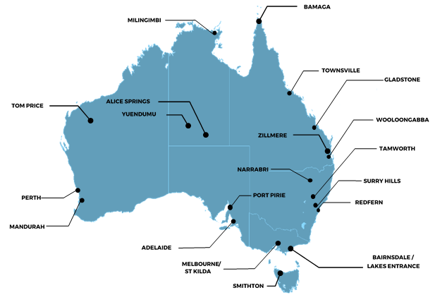

Table 1. Target sample design for the Indigenous evaluation

|  |  |
| --- | --- |
| Target Sample Design | Target |
| n= | 350 |
| **Remoteness** | NIL |
| Major City | 36% |
| Regional | 44% |
| Remote | 20% |
| **Smoking status** | NIL |
| Current smoker | 85% |
| Recent quitter* | 15% |
| **Gender** | NIL |
| Male | 50% |
| Female | 50% |
| **Age** | NIL |
| 15 – 17 years | 15% |
| 18 – 40 years | 55% |
| 41 + years | 30% |

* Recent quitters were defined as respondents who had quit smoking less than 12 months ago

### Dates of fieldwork

Fieldwork was conducted at the completion of the campaign, from the 19th June to the 28th July (6 weeks).

### Questionnaire

The questionnaire was kept the same as the 2016 evaluation where possible in order to allow comparison, and only edited where required.

### Weighting adjustment

The data for smokers was weighted by age, gender, state and geographical remoteness, to represent the national Indigenous smoker population aged 15 years and over. Due to the small sample size (n=20), recent quitters were unable to be weighted and therefore have each been provided a weight of one. The weight adjustments were calculated with rim weighting using three sets of smoker population totals: (1) Age x gender; (2) State/territory; and (3) Region (defined by Main cities; Regional; and Remote). The population data used for the weighting was obtained from the ABS National Aboriginal and Torres Strait Islander Social Survey, 2014-15, publication 4714.0.

### Sample profile

Table 2 below shows the unweighted sample profile for the Indigenous evaluation based on the final sample size of 352 respondents.

Table 2. Achieved sample profile (unweighted)

|  |  |
| --- | --- |
| Achieved Sample Profile | Target |
| n= | 352 |
| **Remoteness** | NIL |
| Major City | 33% |
| Regional | 49% |
| Remote | 18% |
| **Smoking status** | NIL |
| Current smoker | 94% |
| Recent quitter* | 6% |
| **Gender** | NIL |
| Male | 45% |
| Female | 55% |
| **Age** | NIL |
| 15-17 years | 10% |
| 18-40 years | 54% |
| 41+ years | 36% |

* Recent quitters were defined as respondents who had quit smoking less than 12 months ago

## Mainstream Evaluation

The below section provides detailed information on the methodology for the mainstream evaluation.

### Online survey

In order to evaluate the campaign amongst a mainstream audience an online self-complete survey was conducted through Survey Sampling International’s (SSI) online panel.

### Sample design

The mainstream evaluation targeted non-Indigenous Australians smokers and recent quitters (quit within the last 12 months) aged 18 – 50 years. A national sample design was constructed with geographic stratification in proportion to the Australian population by state and regional status.

The target sample design is shown below in table 3.

Table 3. Target sample profile

|  |  |
| --- | --- |
| Target Sample Profile | Target |
| n= | 500 |
| **Remoteness** | NIL |
| Major City | 63% |
| Regional / remote | 37% |
| **Smoking status** | NIL |
| Current smoker | 85% |
| Recent quitter* | 15% |
| **Gender** | NIL |
| Male | 49% |
| Female | 51% |
| **Age** | NIL |
| 18-29 years | 34% |
| 30-40 years | 31% |
| 40-50 years | 35% |

* Recent quitters were defined as respondents who had quit smoking less than 12 months ago

### Dates of fieldwork

Fieldwork was conducted at the completion of the campaign, from the 21st June to the 30th June (10 days).

### Questionnaire

The questionnaire for the mainstream survey was based on the Indigenous survey, with changes only made where necessary to accommodate the different survey mode, and Indigenous specific questions were removed. (e.g. Do you speak an Aboriginal or Indigenous language at home?)

### Weighting

The results for the mainstream evaluation have been weighted by age, gender and state.

### Sample profile

Table 4 below shows the unweighted sample profile for the mainstream evaluation based on the final sample size of 508 respondents.

Table 4. Achieved sample profile (unweighted)

|  |  |
| --- | --- |
| Achieved Sample Profile | Target |
| n= | 508 |
| **Remoteness** | NIL |
| Major City | 62% |
| Regional / remote | 38% |
| **Smoking status** | NIL |
| Current smoker | 85% |
| Recent quitter* | 15% |
| **Gender** | NIL |
| Male | 51% |
| Female | 49% |
| **Age** | NIL |
| 18-29 years | 33% |
| 30-40 years | 31% |
| 40-50 years | 35% |

# Smoking Background

The following section describes the general smoking background and quitting intentions of all current smokers (n=332 for the Indigenous sample and n=427 for the mainstream sample).

All current smokers were asked if they had previously tried to quit smoking, and the majority in both the Indigenous (72%) and mainstream (79%) evaluation stated that they had (see Figure 2). Amongst the Indigenous sample, teenagers aged 15 to 17 years were the least likely to have previously tried to quit (41%, compared 75% amongst those aged 18 to 40 and 74% amongst those aged 41 years and over.

Figure 2. Previously attempted to quit

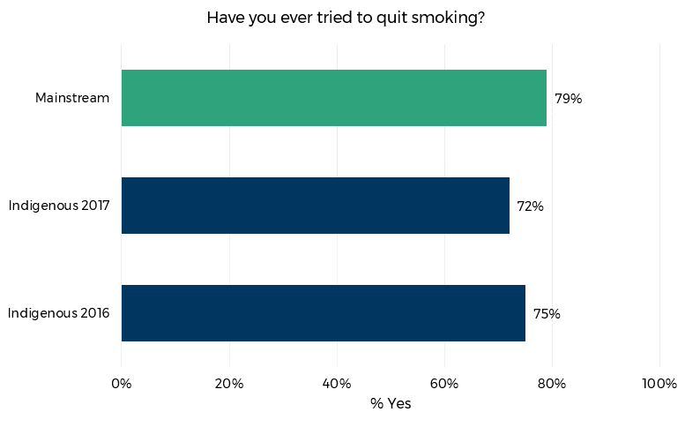

Base (weighted): All current smokers (n=332 Indigenous; n=427 mainstream)

Respondents who reported that they had tried to quit smoking were asked how many times. As shown in Figure 3, Indigenous respondents most commonly reported trying to quit smoking between one and three times (64%).

A similar pattern was found for the mainstream sample with 67% having tried to quit one to three times.

Figure 3. Number of quit attempts

Figure 3 is a bar chart which shows the results for the question "how many times have you tried to quit smoking?" for the mainstream, 2017 Indigenous and 2016 Indigenous evaluations. 
Results (respectively) for 'More than 10 times" 8% ,7%, 10%, '6-10 times' 6%, 9%, 8%, 'Five times' 5%, 6%, 9%, 'Four times' 12%, 13%, 7%, 'Three times' 25%, 18%, 18%, 'Twice' 29%, 28%, 24%, 'once' 13%, 18%, 22%, 'Can't say' 2%, 2%, 2%.

Base (weighted): Current smokers who had tried to quit (n=240 Indigenous; n=345 mainstream)

Respondents were asked whether they had used any aids to support their quit smoking attempts in the past. Note that these questions cover more than one occasion (if respondents had tried to quit more than once). Figure 4 shows that the majority of Indigenous respondents (56%) who had tried to quit smoking had done so (on at least one occasion) on their own without any assistance. Just over half (52%) had (on at least one attempt) used the quitting aids, nicotine replacement therapy (NRT), Zyban or Champix. One third (33%) had asked or searched for advice / recommendations from others or quit support tools.

Further analysis showed that Indigenous communities located in urban areas were more likely to have used quitting tools (69%) than those living in regional (49%) and remote locations (39%). In contrast, respondents from remote locations were more likely to report that they had sought advice (71%) than those in regional (50%) and urban locations (51%).

Figure 4. Support tools previously used – Indigenous evaluation

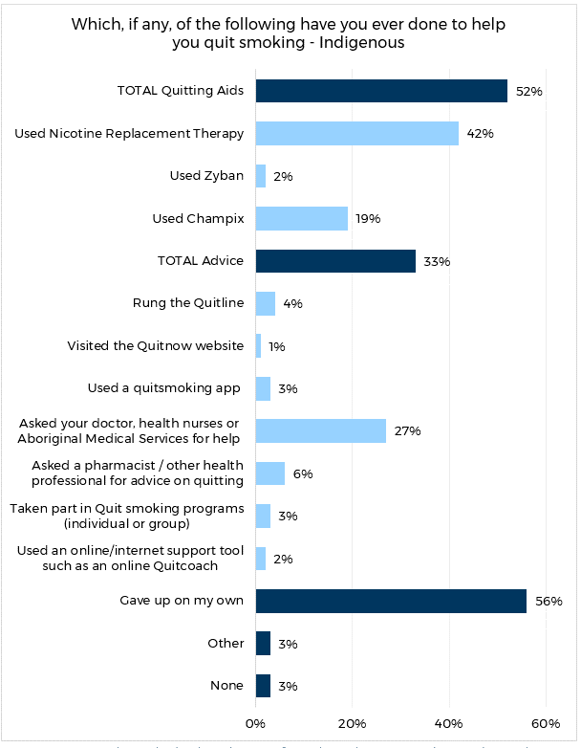

Base (weighted): Current smokers who had tried to quit from the Indigenous evaluation (n=240)

Smokers in the general population (70%) were more likely than Indigenous smokers to report having used quitting aids in the past to help them quit, 53% had sought advice and 46% had tried to give up on their own (see Figure 5).

Figure 5. Support tools previously used – Mainstream evaluation

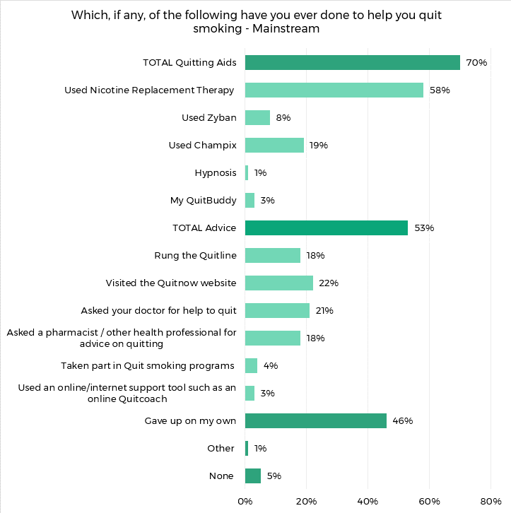

Base (weighted): Current smokers who had tried to quit from the Mainstream evaluation (n=345)

Those who had tried to quit smoking in the past were asked to think about the most recent time, and to indicate what had caused them to quit. Multiple responses could be provided.

The most common category of response amongst both the Indigenous (68%) and the mainstream sample (66%) pertained to reasons of health and fitness.

This was followed by financial reasons (49% and 45% respectively) and family and friends (39% and 40% respectively).

Figure 6. Previous motive for quitting - Indigenous

A bar chart which shows the results for the question "Thinking about the last time you quit smoking, what, if anything, made you quit?" for the 2017 Indigenous evaluation. The total percentage of respondents who reported a health or fitness reason (including 'affecting my fitness', "bad for my health", "had a cough/cold/flu/chest infection" etc). Forty-nine percent for total money reasons (including cost/too expensive", "waste of money" and "wanted to save money"). Eleven percent for the total of reasons related to physical appearance (including, 'the smell', and "causing ageing - causing wrinkles etc"). Eleven percent for total reasons related to advertising and promotions (including "health warnings on packs", health warning advertisements", "GP or other health worker advice" and "smoking support groups/ programs").  Eighteen percent for "just wanted to", 10% for "just stopped / spur of the moment", one percent for "availability of cheaper NRT" and 2% for "other."


Base (weighted): Current smokers who had tried to quit from the Indigenous evaluation (n=240)

Figure 7. Previous motive for quitting - Mainstream

Figure 7 is a bar chart which shows the results for the question "Thinking about the last time you quit smoking, what, if anything, made you quit?" for the 2017 Mainstream evaluation.
A total of 66% of respondents reported a health or fitness reason (including 'affecting my fitness', "bad for my health", "had a cough/cold/flu/chest infection" etc). Forty-five per cent of respondents reported the cost being too expensive, followed by 40% who reported family and friends (including children's health, role modelling) as the main reason. A further 13% of respondents reports physical appearance (aging and smell), 9% reported GP advice and 5% reported anti-smoking advertisements/health warning on packs. Twenty-three per cent of respondents reported that they "just wanted to."


Base (weighted): Current smokers who had tried to quit from the Mainstream evaluation (n=345)

All current smokers were asked whether they were planning to quit smoking. Note that this question was asked early on during the interview, and should not be confused with a later survey question which asked whether or not those who recalled Don’t Make Smokes Your Story were planning to quit as a result of being exposed to the campaign. Seventy per cent of Indigenous smokers in 2017 said that they were planning on quitting; a somewhat lower figure than the equivalent amongst the general population (77%); and in line with the 2016 result (67%).

Figure 8. Quitting intentions

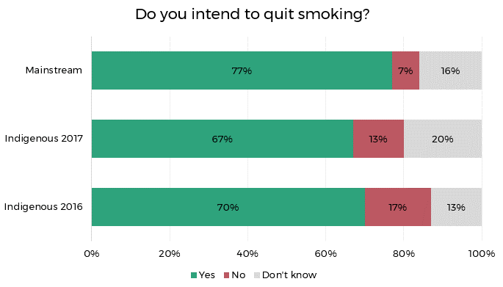

Base (weighted): All current smokers (n=332 Indigenous; n=427 mainstream)

Those who expressed an intention to quit were asked when they planned to put this intention into action. Smokers in the mainstream sample intended to quit sooner than Indigenous smokers (around a third in the next month, compared with around a quarter of the Indigenous sample in both 2016 and 2017). Indigenous respondents were correspondingly more likely to answer that they planned to quit at some point in the future, but not within the next six months (43% in both 2016 and 2017, compared with 17% of the mainstream smoker sample).

Figure 9. Plan to quit

Figure 9 is a bar chart which shows the percent of respondents who are planning to quit either within the next month, next 6 months, beyond 6 months or who don't know. 
Forty-three percent of both Indigenous respondents from 2016 and 2017 reported planning to quit beyond the next 6 months while 17% planned doing so from the mainstream evaluation.
Thirty percent and 28% of Indigenous respondents from 2017 and 2016 respectively chose within next 6 months with 44% of mainstream respondents choosing the same.
Twenty-two percent , 25% and 31% of respondents chose within the next month from Indigenous 2016, 2017 and mainstream studies respectively. 
Lastly, 5%, 4% and 8% was the total for respondents that did not know from indigenous 2016, 2017 and mainstream respectively.

Base (weighted): All current smokers who stated they intend to quit (n=219 Indigenous; n=315 mainstream)

Indigenous smokers in 2017 were somewhat less likely (66%) than they had been in 2016 (71%) to believe that quitting smoking would benefit them financially ‘extremely’ or ‘very much’. The equivalent figure amongst mainstream smokers was on par with the 2016 Indigenous result (71%).

Figure 10. Financial benefit of quitting

Figure 10 is a bar chart that shows the extent to which respondents believed they would benefit financially if they were to quit smoking in the next 6 months.
Of the mainstream respondents, 44%, 27%, 20%, 7%, 1% and, -1% said "extremely," "very much" "moderately, "slightly", "not at all" and "don't know" respectively.
Of the Indigenous 2017 respondents, 32%, 34%, 17%, 11%, 2% and 5% answered "extremely," "very much" "moderately, "slightly", "not at all" and "don't know" respectively.
Of the Indigenous 2016 respondents, 35%, 36%, 13%, 10%, 2%, 4% answered "extremely," "very much" "moderately, "slightly", "not at all" and "don't know" respectively.


Base (weighted): All current smokers (n=332 Indigenous; n=427 mainstream)

Similarly, Indigenous smokers in 2017 were less compelled by the potential impact on their health if they were to quit smoking, with 32% reporting that they would benefit ‘extremely’, compared with 37% in 2016. The equivalent figure amongst the 2017 mainstream comparison sample was 48%.

Figure 11. Personal health benefits of quitting

Figure 11 is a bar chart that shows the extent to which respondents believed their health would benefit if they were to quit smoking in the next 6 months.
Of the mainstream respondents, 48%, 28%, 18%, 4%, 1% and 2% said "extremely," "very much," "moderately," "slightly" "not at all," and "don't know" respectively.
Of the Indigenous 2017 respondents, 32%, 43% 13%, 7%, 2% and 5% said "extremely," "very much," "moderately," "slightly," "not at all," and "don't know" respectively.
Of the Indigenous 2016 respondents, 37%, 35%, 11%, 11%, 2% and 3% said extremely," "very much," "moderately," "slightly," "not at all," and "don't know" respectively.



Base (weighted): All current smokers (n=332 Indigenous; n=427 mainstream)

# Smoking and Health

Respondents were asked a series of questions about their perceptions of the impact of smoking on their health. The Indigenous sample was more likely than the mainstream sample to report that smoking had damaged their health ‘a great deal’ or ‘a fair amount’ (62% vs 55%), although the proportion of Indigenous smokers in these categories had reduced somewhat since 2016 (from 65%).

Figure 12. Health damage from smoking

Figure 12 is a bar chart that prompts respondents to consider "how much, if at all, smoking has damaged [their] health."
18% of mainstream respondents said "a great deal," followed by 37%, 26% and 6% who said "a fair amount," "just a little and "not at all worried" respectively.
Of the Indigenous 2017 respondents, 23% said "a great deal" while 39%, 27% and 5% answered "a fair amount", "just a little" and "not at all worried."
Lastly, of the Indigenous 2016 respondents, 29% said "a great deal" while, 36% said "a fair amount," and 27% said "just a little." 5% were "not at all worried."

Base (weighted): All current smokers (n=332 Indigenous; n=427 mainstream)

Similarly, Indigenous smokers were also more likely than smokers sampled from the general population to believe that their smoking would damage their health in the future; with 46% reporting that they were ‘very’ worried (compared with 39% of mainstream smokers). The latter were correspondingly more likely to say that they were ‘moderately’ worried (32% vs 24%). The results for the Indigenous population had changed very little since 2016.

Figure 13. Future health damage

Figure 13 is a bar char that asks "how worried are you, if at all, that smoking WILL damage your health in the future."
Thirty-nine per cent, 46% and 48% of mainstream, Indigenous 2017 and Indigenous 2016 reported being "very worried" respectively.
Thirty-two per cent, 24% and 22% of mainstream, Indigenous 2017 and Indigenous 2016 reported being "moderately worried" respectively.
Twenty-one per cent, 22% and 21%  of mainstream, Indigenous 2017 and Indigenous 2016 reported being "a little worried" respectively.
Lastly, 5%, 5% and 8% of mainstream, Indigenous 2017 and Indigenous 2016 reported being "not at all worried" respectively.


Base (weighted): All current smokers (n=332 Indigenous; n=427 mainstream)

One in ten (10%) Indigenous smokers in 2017 felt that smoking affected the health of others ‘a great deal’, and this was on par with the result amongst mainstream smokers (11%). The equivalent figure from the 2016 Indigenous evaluation was much higher at 29%.

Figure 14. Health effects on others

Figure 14 is a bar chart that asks, "if at all, has your smoking affected the health of others?"
Of main stream respondents, 11% reported "a great deal," 21% reported "a fair amount," 25% reported "just a little" and 25% reported "not at all worried."
Of Indigenous 2017 respondents, 10% agreed "a great deal," 21% reported "a fair amount," 31% reported "just a little" and 20% reported "not at all worried."
Of the Indigenous 2016 respondents, 29% agreed "a great deal," 36% agreed "a fair amount," 27% reported  "just a little" and 5% reported "not at all worried."

Base (weighted): All current smokers (n=332 Indigenous; n=427 mainstream)

# Campaign Results

All respondents in the evaluation round were asked if they had been exposed to Don’t Make Smokes Your Story and, if so, actions taken as a result of the campaign and their attitudes towards the campaign.

## Unprompted Recall

Respondents were asked whether they had seen or heard any advertisements about the dangers of smoking, and to describe the first two advertisements that came to mind. As shown below in Figure 15, 89% of Indigenous respondents reported having been exposed to such advertising. This figure is higher than the equivalent result amongst the general population (55%); and also represents an increase of 11 percentage points since the 2016 NTC evaluation.

Fewer Indigenous respondents from remote areas (83%) reported being exposed to quit smoking material than those from urban (89%) or regional areas (92%).

Figure 15. Recall of quit smoking advertisements

Figure 15 is a bar chart that prompts respondents to answer "yes'" to whether "in the past six months, have you seen or heard any information or ads about the dangers of smoking, or encouraging you or members of the community to quit smoking?"
Fifty-five per cent of mainstream respondents answered yes, while 89% of Indigenous 2017 respondents answered yes, followed by 78% of Indigenous 2016 respondents.

Base (weighted): All respondents (n=352 for Indigenous; n=508 mainstream)

Respondents who mentioned that they had seen or heard anti-smoking information were asked to describe the first two ads that came to mind.

As illustrated in Figure 16, the Don’t Make Smokes Your Story campaign was spontaneously recalled by 12% of Indigenous respondents, which is a 3 percentage point increase on the 2016 result (9%). Respondents from regional areas were more likely to spontaneously recall Don’t Make Smokes Your Story (14%), than those from urban (9%) and remote areas (3%).

Spontaneous recall of the campaign was lower overall amongst mainstream respondents (8%).

Figure 16. Unprompted recall of Don’t Make Smokes Your Story

Figure 16 is a bar chart that asks respondents to "describe the first two ads that come to mind..."
A total of 22% answered "cigarette packet warnings," including "Ted/Young dad/Don't make smokes your story," "quit smoking" and "quit for health."
18% of respondents answered with other while 26% said "don't know." One per cent could not recall ("none") and a further 2% refused to answer.

Base (weighted): All respondents (n=352 Indigenous; n=508)

## Prompted Recall

The Don’t Make Smokes Your Story TVC was played to all respondents on the tablet. They were then asked if they had seen it before. Figure 17 shows that 73% of Indigenous respondents reported having seen the TVC, with the majority reporting they saw it on TV (69%). Six percent saw it online and 4% reported having seen it but could not recall where.

Significantly fewer Indigenous respondents from remote areas reported seeing the TVC (62%) compared with those from urban and regional areas (both 77%).

Prompted recall of the TVC was considerably lower amongst mainstream respondents, as shown in Figure 17, with 54% of the sample reporting they had seen the TVC, again the majority seeing it on TV (38%).

Figure 17. Prompted recall of the TVC

Figure 17 is a bar graph that asks respondents where they had seen the "Don't make smokes your story" ad before that day.
A total of 73% Indigenous respondents reported having seen the ad while 54% of mainstream respondents had seen it.
69% of Indigenous respondents had seen it on TV while 38% of mainstream respondents had seen it on TV.
Meanwhile 48% of mainstream respondent hadn't seen the ad prior in comparison to 25% of Indigenous respondents who hadn't seen it. Three per cent of mainstream respondents didn't know compared to 1% of Indigenous respondents.


Base (weighted): All respondents (n=352 for Indigenous; n=508 mainstream)

The radio ad was also played for all respondents, who were then asked if they had heard it before. As shown in Figure 18 just over half of Indigenous respondents (52%) reported having heard the ad, with nearly all hearing it in English (less than 1% in a language other than English).

Significantly fewer respondents aged 15 to 17 years reported hearing the radio ad (30%), than those aged 18 to 40 years (57%) and 41 years and over (51%). Respondents from urban areas were also less likely to report hearing the radio ad (45%) than those in regional (56%) and remote areas (54%).

Figure 18 also shows that recall of the radio ad was much lower (22%) amongst mainstream respondents.

Figure 18. Prompted recall of the radio ad

Figure 18 is a bar chart that prompted recall of the "Don't make Smokes your story" radio ad.
Fifty-two percent of Indigenous respondents compared to 22% of mainstream respondents answered "yes," while 73% of mainstream respondents compared to 45% of Indigenous respondents answered "no."
A further 5% and 3% of mainstream and Indigenous respondents answered that they didn't know respectively.

Base (weighted): All respondents (n=352 for Indigenous; n=508 mainstream)

Respondents were then shown the Don’t Make Smokes Your Story print ads and asked if they had seen any of them before (see Appendix C for print ads displayed). As shown in Figure 19, 56% of Indigenous respondents reported seeing the ads, with 30% having seen them in an out of home poster or billboard, 15% in a magazine or newspaper, and 21% who had seen them but weren’t sure where.

Again exposure was much lower amongst mainstream respondents (22%), and decreased further with age from 34% of 18 to 29 year olds to 12% of 41 to 50 year olds.

Figure 19. Prompted recall of print ads

Figure 19 is a bar chart that prompted recall of the print ads for "Don't make smokes your story," including in magazines, newspapers, or billboards.
The total number for mainstream and Indigenous respondents who had seen it was 24% and 56% respectively.
Meanwhile 74% of mainstream and 42% of Indigenous respondents hadn't seen it respectively.
Of mainstream respondents, 6% had seen in magazine or newspaper, 6% had seen it on billboards and 12% had seen but unsure where. Of Indigenous respondents, 15% had seen it in a magazine, 30% had seen it on a billboard and 21% had seen it but unsure where.
Four per cent and 2% of mainstream and Indigenous respondents didn't know respectively.

Base (weighted): All respondents (n=352 for Indigenous; n=508 mainstream)

Respondents were shown images from Don’t Make Smokes Your Story online and social media ads and asked if they had seen them before (see appendices C and D for ads displayed). Half (50%) of Indigenous respondents reported seeing the ads, with 27% having seen them on social media, 16% online and 20% having seen them, but weren’t sure where.

Significantly fewer Indigenous respondents from urban areas reported seeing the ads (41%) compared to those from regional (56%) or remote areas (53%). Older respondents (aged 41 years and over) were also less likely report seeing the online ads than those aged 18 to 40 years (56%) and 15 to 17 years (57%).

As with all of the other channels, mainstream respondents were much less likely to recall seeing the online ads (27%). As with Indigenous respondents, recall amongst the general population for the online and social media ads decreased with age, from 40% of 18 to 29 year olds to only 10% of 41 to 50 year olds.

Figure 20. Prompted recall of social media and online ads

Figure 20 is a bar chart that prompted recall of social media and online ads. A total of 24% and 50% of mainstream and Indigenous respondents had seen it respectively, while 74% of mainstream and 49% of Indigenous respondents did not see it.
Of those who had seen it, 6% of mainstream and 16% of Indigenous respondents saw it online, a further 6% of mainstream and 27% saw it on social media eg Facebook and 12% mainstream and 20% Indigenous saw it but were unsure where. Lastly 4% and 1% of Indigenous and mainstream respondents didn't know if they had seen it.


Base (weighted): All respondents (n=352 for Indigenous; n=508 mainstream)

To assess exposure to Don’t Make Smokes Your Story at community outreach programs and events, Indigenous respondents were asked if they had seen or heard anything else about Don’t Make Smokes Your Story at community events. As shown in Figure 21, 45% of respondents reported seeing Don’t Make Smokes Your Story somewhere else. Exposure peaked in the middle age group, with 52% of those aged 18 to 40 years reporting seeing the ad, compared to 27% of 15 to 17 year olds and 39% of 41 year olds and over.

Figure 21. Prompted recall of below the line community outreach events

Figure 21. is a bar chart that asked Indigenous respondents "Have you seen or hear anything else about the 'Don't make smokes your story' campaign anywhere such as music festival, or at community events or activities?"
A total of 45% said "yes," while 48% said "no" and 7% said "Don't know."

Base (weighted): All Indigenous respondents (n=352)

Figure 22 below shows the cut through (prompted recall) for any of the campaign material amongst both the Indigenous and mainstream samples. Overall 87% of Indigenous respondents had been exposed to the campaign. This figure represents a 12 percentage point increase on the 2016 evaluation (75%), and is 31 percentage points higher than exposure amongst mainstream audiences (56%).

Campaign exposure did not significantly differ by age amongst the Indigenous community, although there were age differences by media type as discussed above. Specifically radio had higher cut through with the two older groups (18 years and over), whereas online ads had a higher level of reach amongst the younger two age groups (40 years and below).

Exposure amongst the general population peaked in the youngest group (64%) and was lower in the middle and oldest groups (51% and 55% respectively).

Figure 22. Overall campaign exposure

Figure 22 is a bar chart that demonstrates the total campaign exposure amongst mainstream and Indigenous respondents from 2016 and 2017.
Of the total exposed, 56% were mainstream (2017), 87% and 75% were Indigenous (2017 and 2016 respectively).
The total exposure amongst Indigenous respondents from 2017 in every category (TVC, Heard radio, Seen print ads, seen social media/online and seen community outreach) was 73%, 52%, 56%, 50%, 45% compared to 59%, 35%, 40%, 34% and 28% from 2016 respectively.
Mainstream respondents totalled 54$, 22%, 24%, 27% and NA in the respective categories above.


Base (weighted): All respondents (n=352 for Indigenous; n=508 mainstream)

Figure 23 illustrates the variation in exposure amongst Indigenous respondents by remoteness. Respondents from remote areas (80%) were less likely to have been exposed to the campaign than respondents from urban (88%) and regional areas (90%). This replicated the pattern from the 2016 evaluation; although the disparity between remote (58% in 2016) and other locations (81% regional; 80% urban) has notably decreased.

Figure 23. Overall exposure by remoteness

Figure 23 is a bar chart that categories overall campaign exposure by platform and remoteness amongst Indigenous respondents only.
Of the total exposures, 88% were urban, 90% were regional and 80% were remote.
Of TVC exposures, 77%, 77% and 62% were urban, regional and remote (respectively).
Of radio exposures, 54%, 56% and 45% were urban, regional and remote.
Of print ads, 50%, 61% and 54% were urban, regional and remote.
Of print ads, 50%, 61% and 54% were urban regional and remote.
Of online and social media, 41%, 56% and 53% were urban, regional and remote.
Lastly, of community outreach programs, 45%, 44% and 47% were urban, regional and remote.


Base (weighted): All Indigenous respondents (n=352)

## DMSYS Results

Respondents who reported having seen the TVC (n=258 of Indigenous respondents; n=241 of mainstream respondents) were asked whether they agreed or disagreed with various statements about the ad. As shown in Figure 24, 96% of Indigenous respondents agreed that the ad was easy to understand, and 88% that the ad was believable. Seventy percent agreed that the ad made them stop and think, 73% that it made them feel worried about their smoking, and 63% that it made them more likely to quit/ stay quit. Sixty-nine percent agreed that the ad made them feel hopeful, 62% that it made them feel inspired, and 63% that it made them feel empowered to quit/stay quit. The statements with the lowest level of agreement were that ‘the ad taught me something new’ (52%) and that ‘the ad made me feel uncomfortable’ (37%).

The campaign tended to perform best in remote areas and weakest in urban areas. Specifically, the diagnostics: “makes me feel hopeful” (100% remote, 97% regional, 91% urban), makes me feel worried about my smoking (89% remote, 75% regional, 58% urban), makes me more likely to try to quit (84% remote, 76% regional, 25% urban) and makes me feel empowered (81% remote, 73% regional, 36% urban). Respondents from remote (84%) and regional areas (74%) were also more likely to agree that the ad related to them than those in urban areas (56%). Males were also more likely to feel the ad related to them (76%, compared with 64% of females.

Figure 24. TVC diagnostics - Indigenous

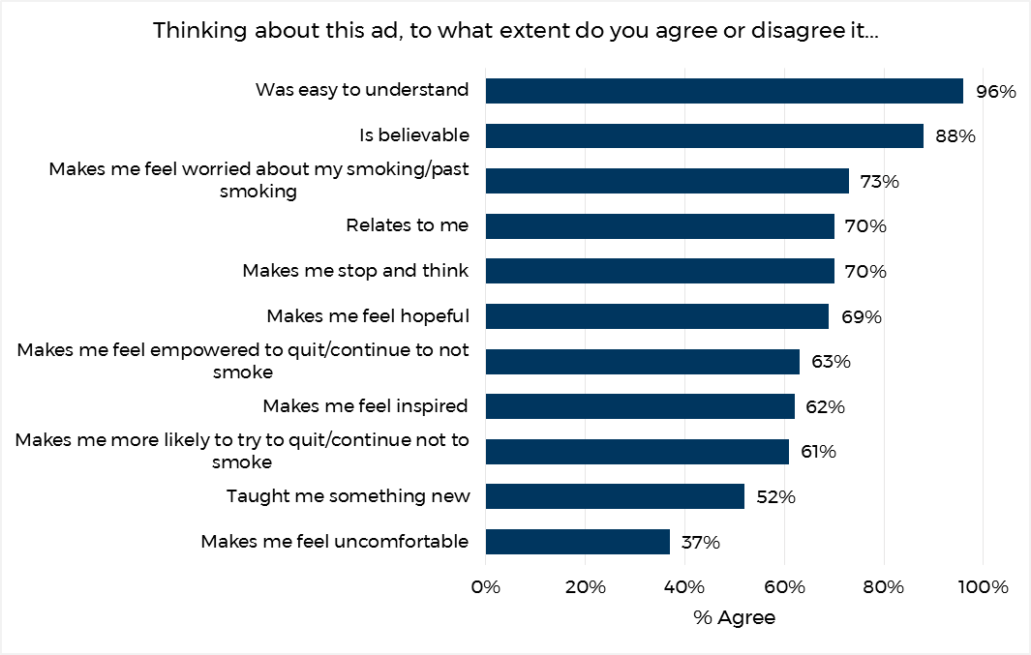

Base (weighted): All Indigenous respondents exposed to the TVC (n=241 - 258)

Figure 25 below, shows the results for the same diagnostic measures for mainstream respondents. The mainstream results are generally in line with the Indigenous results, with the highest levels of endorsement for being “easy to understand” (95%) and “believable” (82%); with “taught me something new” (43%) and “made me uncomfortable” the weakest (41%).

Figure 25. TVC diagnostics - Mainstream

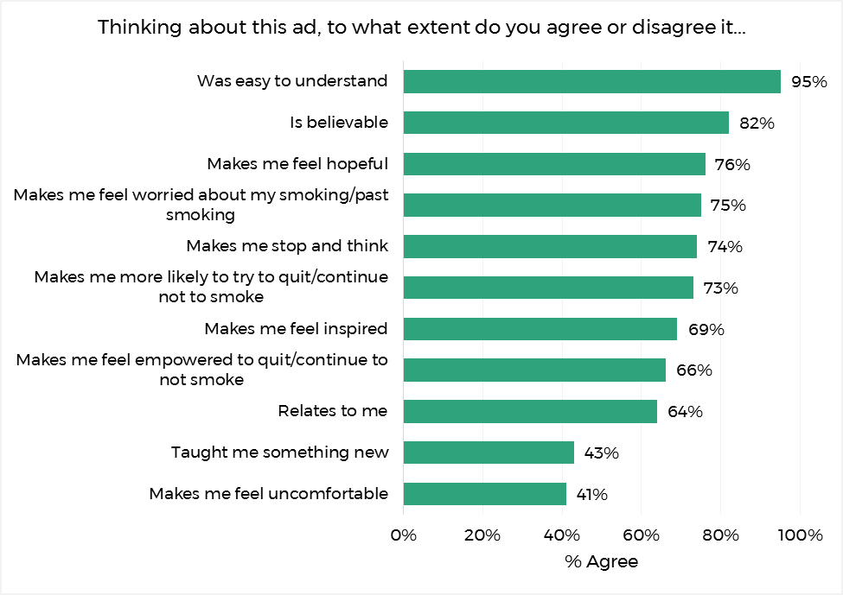

Base (weighted): All mainstream respondents exposed to the TVC (n=241)

To assess potential ‘wear out’ (people getting tired of seeing the ad), respondents who recognised the TVC were asked if they agreed or disagreed that they were getting tired of seeing the ad. As shown in Figure 26, 26% of Indigenous respondents agreed with this contention. This figure is higher than the equivalent result amongst the general population (20%); and represents a 3 percentage point increase since the 2016 Indigenous evaluation.

Further analysis showed that wear out was lowest in urban areas (18%); compared with regional (26%) and remote areas (37%).

Figure 26. Campaign wear out

Figure 26 is a bar chart that asks how much respondents agree or disagree that they are getting tired of seeing the ad.
Twenty per cent of main stream respondents agree, 26% of indigenous 2017 respondents agree while 23% of indigenous 2916 respondents agreed.

Base (weighted): All respondents exposed to the TVC (n=258 Indigenous, mainstream=n 241)

Respondents who reported having seen or heard any of the campaign material were asked what they thought were the key messages of the ads. This was an open question to which respondents could answer multiple responses. As shown in Figure 27, the most commonly cited take out messages amongst the Indigenous community were ‘quit smoking’ (58%), ‘you should quit for your kids/family’ (34%), and quitting has health benefits (33%).

Figure 27. Message take outs - Indigenous

Figure 27 is a bar chart that asked Indigenous respondents  "What would you say were the main  things the ads were trying to say?"
Fifty-eight per cent said "quit smoking," 34% said "you should quit smoking for your kids/family, 33% said "quitting has health benefits", 31% said "your smoking affects others/your family/etc, 30% said "quitting smoking is possible/ everyone can do it."
A further 28% said smoking is dangerous, 28% said don't make smokes your story, 25% said smoking kills, 24% said quitting is tough but keep trying, 23% said smoking causes breathing difficulty, 23% said smoking causes cancer, 22% said quitting has financial benefits. Lastly 21% said smoking causes lung cancer, 16% said there is support available to help you quit, 15% said Download the My QuitBuddy app, 15% said visit your local health service, 15% said call the quitline and 13% said visit the quitnow website, with 2% and 1% saying "other" or "don't know respectively."

Base (weighted): All Indigenous respondents exposed to the TVC, print, radio or online ads (n=241 - 258)

Figure 28 depicts the equivalent results for key message take outs amongst the general population sample. The messages ‘you should quit smoking for your kids/family’ (69%), and ‘quitting has health benefits’ (56%), also resonated highly with these respondents.

Figure 28. Message take outs - mainstream

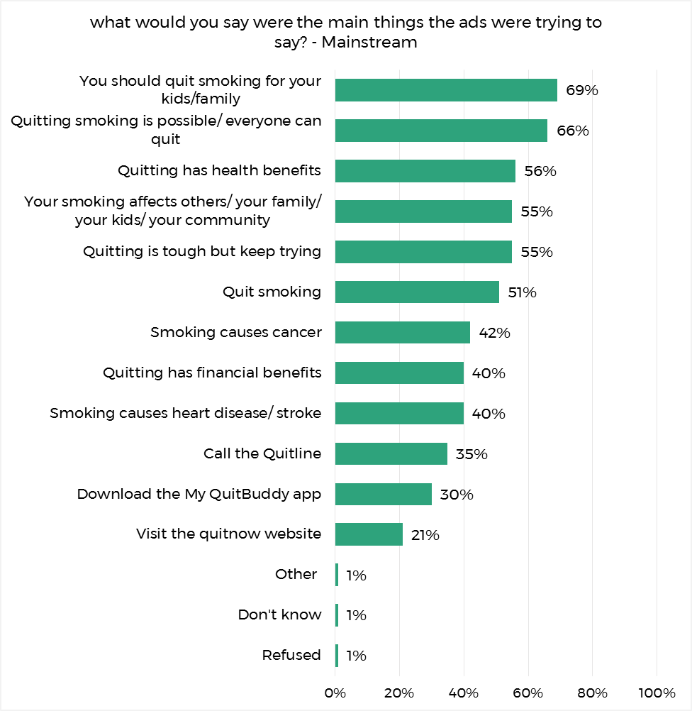

Base (weighted): All mainstream respondents exposed to the TVC, print, radio or online ads (n=275)

## DMSYS Impact

### Actions Taken

Respondents who reported seeing or hearing any of the Don’t Make Smokes Your Story campaign material (n=307 Indigenous; n=275 mainstream) were asked what, if anything, they had done as a result of seeing these ads. For Indigenous respondents this was an open response question and multiple responses were accepted. The results are depicted in Figure 29 for Indigenous respondents and show that 54% of those respondents reported having taken some action as a result of seeing the campaign. The most commonly cited actions were ‘cutting down the amount they smoke’ (24%), ‘discussing smoking and health with family/friends’ (19%) and ‘quit smoking’ (8%). Additionally, 4% of respondents reported that they had set a date to quit and 3% had begun taking Nicotine Replacement Therapy as a direct result of the campaign. By way of comparison, a slightly higher proportion (58%) of respondents in the 2016 evaluation reported taking some form of action and the five most commonly reported actions have remained consistent.

As a result of seeing the campaign, just over one third of regional respondents exposed to the campaign reported they had cut down the amount they smoke (34%), compared to only 16% of urban and 9% of remote respondents. Similarly, regional respondents were more like to report they had asked their doctor for help (13%) or a pharmacist / other health worker for advice (5%), compared to urban (3% and 0% respectively) and remote respondents (0% for both).

Figure 29. Actions taken - Indigenous

Figure 29 is a bar chart that asks Indigenous respondents: "What if anything, have you done as a result of seeing these ads?"
A total of 54% said they had "done something. Twenty-four per cent said they had cut down the amount they smoke and 19% discussed it with family and friends.  Meanwhile 10% said "other" and 42% had done nothing. Four per cent said they don't know.

Base (weighted): All Indigenous respondents exposed to any of the campaign material (n=307)

For the mainstream evaluation a list of possible actions was provided, with an option to select ‘other’ and specify the action they took, the results of which are depicted in Figure 30. A larger proportion of mainstream audiences exposed to the campaign reported taking some form of action (66%) compared to Indigenous respondents (54%). The two most common actions followed the same pattern as the Indigenous results: cutting down the amount they smoke (32%) and discussing smoking with family and friends (23%). Accessing quit information online (17%) was the third most common action reported for mainstream audiences, but it was only the eleventh for Indigenous communities (2%).

The proportion of respondents reporting that they had taken some form of action as a result of the campaign was highest amongst 18 to 29 year olds (75%) and decreased with age (62% of 30 to 40 year olds; 57% of 41 to 50 year olds). Further analysis showed younger respondents were specifically more likely to report that they had rung the Quitline (20%) than the two older age groups, 30 to 40 year olds (8%) and 41 to 50 year olds (6%). Younger respondents were also more likely to have had accessed quit information online (23%) than 30 to 40 year olds and 41 to 50 year olds (15% and 11% respectively).

Figure 30. Actions taken - mainstream

Figure 30 is a bar chart that asks respondents: “what, if anything, have you done as a result of seeing these ads?”
Sixty-six per cent said “done something” while 34% said “don’t nothing.” Of those that did something, 32% said “cut down the amount I smoke,” 23% said “discussed smoking and health with family,” and 17% said “accessed Quit information from a website.” The remaining responses were: "set up a date to give up smoking (16%)," "asked your doctor for help to quit" (14%), "stopped/quit smoking" (14%), "rung the quit line" (12%), "asked pharmacist for advice" (8%), "downloaded the My QuitBuddy ap" (7%), nicotine replacement (7%), visited the quitnow website (6%) and other (2%).


Base (weighted): All mainstream respondents exposed to any of the campaign material (n=275)

### Intended Actions

Respondents who reported having seen or heard the Don’t Make Smokes Your Story campaign material were asked what, if anything, they intended to do in the next month in response to seeing the ads. As shown in Figure 31, 61% of Indigenous respondents intended to do something, 3 percentage points higher than the equivalent 2016 result. The most commonly reported intentions were to quit smoking (27%), reduce the amount of cigarettes they smoke (21%) and ask their doctor or health worker for help to quit (11%).

Reports of any intended action(s) were highest in remote locations (80%), followed by regional locations (66%) and lowest in urban areas (40%). This pattern was also evident for reporting the intention to quit smoking, which was 59% for remote, 25% for regional and 6% for urban areas. No respondents from remote areas intended to ask their doctor or health worker for help quitting, while 17% of regional and 10% of urban respondents did.

Figure 31. Intended actions - Indigenous

Figure 31 is a bar chat that asks Indigenous respondents: 'What if anything, will you do in the next month in response to seeing these ads?"
Sixty-one per cent had some intention for action, with 27% said to quit smoking while 21% said to reduce the quantity of cigarettes they smoke. Meanwhile, 26% had no intentions for actions and 13% said they "don't know."

Base (weighted): All Indigenous respondents exposed to any of the campaign material (n=307)

Nearly three quarters (74%) of mainstream respondents exposed to the Don’t Make Smokes Your Story, stated that they intended to take action in some form as a result of the campaign, 13 percentage points higher than the equivalent Indigenous figure. The most common intentions stated being to reduce the amount they spoke (32%), quit smoking (30%) and read how to quit literature (22%).

Figure 32. Intended actions - mainstream

Figure 32 asks mainstream respondents: "What if anything, will you do in the next month in response to seeing these ads?
Seventy-four per cent had "some intention" of action, with 32% wanting to reducing the quantity of cigarettes they smoke and 30% stopping/quitting smoking. Another 22% would read 'how to quit' literature and 21% would "discuss smoking and health with others." Twenty per cent had no intentions of action and another 6% said they don't know.

Base (weighted): All mainstream respondents exposed to any of the campaign material (n=275)

## QFYQF2 Awareness

As the Quit for You, Quit for Two campaign was running at the same time as Don’t Make Smokes Your Story, exposure to the Quit for You, Quit for Two advertisements was also assessed. Respondents were shown a poster from the campaign and asked if they had previously seen any similar advertisements. Prompted recall for the campaign amongst Indigenous respondents had increased by 5 percentage points since 2016 (see Figure 33). As with Don’t Make Smokes Your Story, recall of the campaign was higher in urban and regional areas (both 47%) than remote locations (33%). Within Indigenous communities women were more likely to recall the campaign (52%) than men (35%).

Prompted recall of Quit for You, Quit for Two was considerably lower amongst the mainstream sample (16%). Within the general population, regional / remote (22%) respondents were more likely to have been exposed to Quit for You, Quit for Two than urban respondents (13%). Unlike the Indigenous survey, the mainstream evaluation found younger respondents (aged 18 to 29 years) were more likely to have been exposed (26%) than 30 to 40 year olds (12%) and 41 to 50 year olds (9%).

Figure 33. Quit for You, Quit for Two prompted recall

Figure 33 is a bar chat that asked for recall of another recent ad.
Sixteen per cent of the mainstream audience had seen it, while 43% of Indigenous respondents from 2017 and 38% of Indigenous respondents from 2016 had seen it. 


Base (weighted): All respondents (n=352 Indigenous, n=508 mainstream)

## Messages Communicated by all Campaigns

Respondents who reported being exposed to any Don’t Make Smokes Your Story or Quit for You, Quit for Two campaign material, were asked if the campaigns communicated a number of messages (listed in Figure 34). Messages that Indigenous respondents most commonly felt were communicated to them were ‘Quitting can be tough but is possible’ (98%), ‘you can quit smoking for a better future for you and your family’ (97%) and ‘smoking affects others (96%). Less resonant were messages around the quit tools available, these being ‘call the Quitline’ (79%) ‘visit the Quitnow website’ (78%) and ‘download the My QuitBuddy app’ (65%).

The message most commonly recalled by mainstream respondents was ‘there are many short and long term benefits to quitting’ (91%). This was followed by ‘there are financial benefits to quitting’, ‘if you want to quit smoking you should never give up trying’ and ‘you can quit smoking for a better future for you and your family’ (all 89%). The message which was least resonant amongst mainstream respondents was ‘disease and dying from smoking is not normal’ (70%).

Figure 34. Message take outs

Figure 34 is a bar chart that asks respondents: "Do you think the ad communicated this message to you?"
At least 60% of Indigenous and mainstream respondents agreed to the following statements: "your smoking affects others", "if you want to quit smoking you should never give up trying," "when you chose to quit smoking there is support available to help you quit," "there are financial benefits to you quitting smoking" etc.

Base (weighted): Respondents exposed to any of the Don’t Make Smokes Your Story or Quit for You, Quit for Two campaign material (n=295-301 Indigenous, n=288 mainstream)

# Use of My QuitBuddy App

All respondents were shown images of the My QuitBuddy app (see appendix G) and asked if they had previously seen it, and if yes where. Figure 35 illustrates that just under one third (32%) of respondents in the Indigenous and mainstream evaluation had seen the app.

For the Indigenous result this was an 11 percentage point increase on the proportion of respondents who had seen app in 2016. Exposure to the app amongst Indigenous respondents was highest within regional areas (39%) and lower in urban (25%) and remote areas (29%). Exposure dropped to 25% for respondents aged 41 years and over, from 34% of 15 to 17 year olds and 37% of 18 to 40 year olds.

For the mainstream evaluation recall of the app also decreased by age, from 51% of 18 to 29 year olds, to 30% of 30 to 40 year olds, and dropping to only 14% of 40 to 50 year olds.

Figure 35. Prompted recall of the My QuitBuddy app

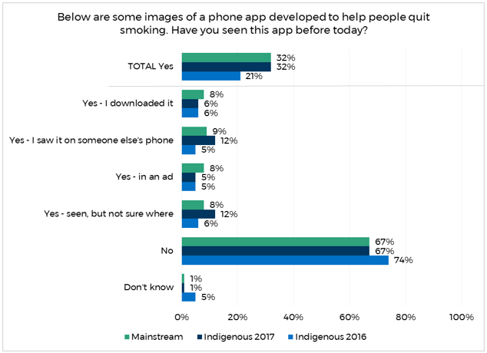

Base (weighted): All respondents (n=352 Indigenous; n=508 mainstream)

Respondents who had downloaded the app were asked how useful they found it, and the results are shown in Figure 36. The majority of respondents in both the Indigenous (87%) and mainstream (80%) evaluation reported it was somewhat to very useful.

Figure 36. Effectiveness of the app

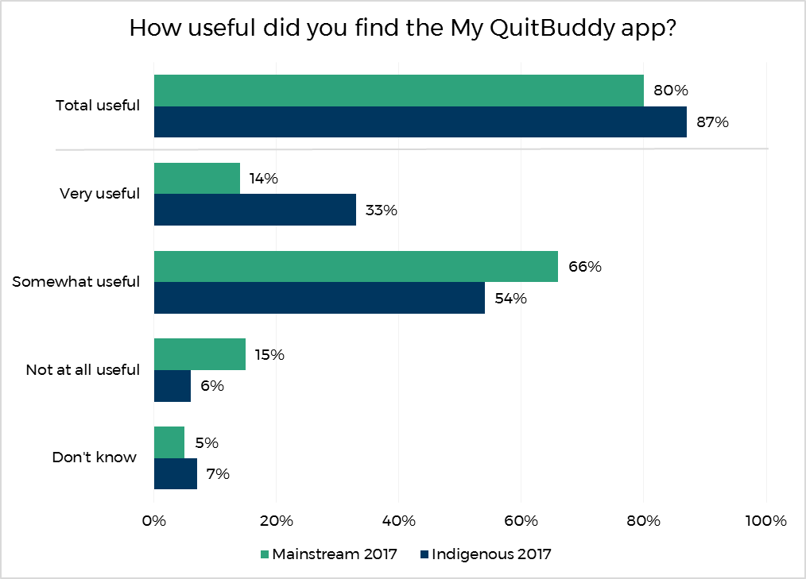

Base (weighted): Respondents who had downloaded the My QuitBuddy app (n=22 Indigenous; n=48 mainstream)

# Department Internal Data

Internal data from the department was provided and analysed to compare use of the quit tools My QuitBuddy, the Quitline and the Quit Now website prior and throughout the campaign launch.

During the 5 month campaign period (February to June 2017) the My QuitBuddy app was downloaded 74,320 times. This is a 21% increase in the number of downloads that were made in the 5 month period immediately prior to the campaign launch (61,508). Similarly, the number of calls made to the Quitline during the campaign period (20,148) increased by 13% compared to the 5 months prior to the campaign (17,819). The largest increase was with the number of visits to the Quit Now website, which increased by 342% during the campaign period, with 71,000 visits made prior to the campaign, and 314,000 during the campaign.

# Demographics

This section describes the demographic information of smokers and recent quitters from the Indigenous and general population samples.

Indigenous respondents were asked if they speak an Aboriginal or Indigenous language at home, and as shown in Figure 37 just over one quarter of respondents did (27%). The youngest age group (15 to 17 years) were less likely to speak an Indigenous language than the older age groups (29% for 18 years and over). Respondents in regional areas were also less likely to speak an Indigenous language at home (10%) and respondents from remote locations were the most likely (62%; urban 21%).

Figure 37. Respondents who spoke an Indigenous language at home – Indigenous

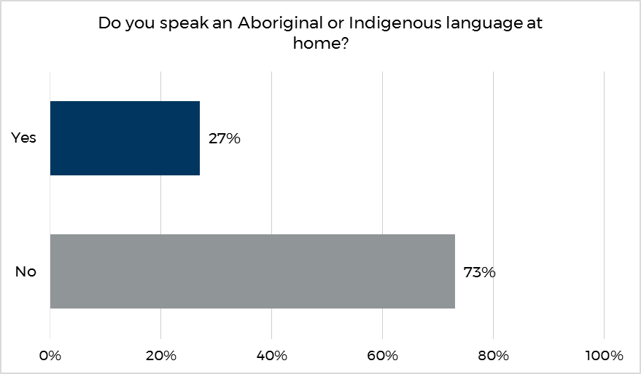

Base (weighted): All respondents in the Indigenous evaluation (n=352)

All respondents were asked what their highest level of education was. As shown in Figure 38, 45% of respondents in the Indigenous evaluation had not finished secondary school and 25% had completed some form of tertiary education.

A much larger proportion of respondents in the mainstream evaluation reported they had completed some form of tertiary education (65%) and only 15% had not completed secondary school.

Figure 38. Education

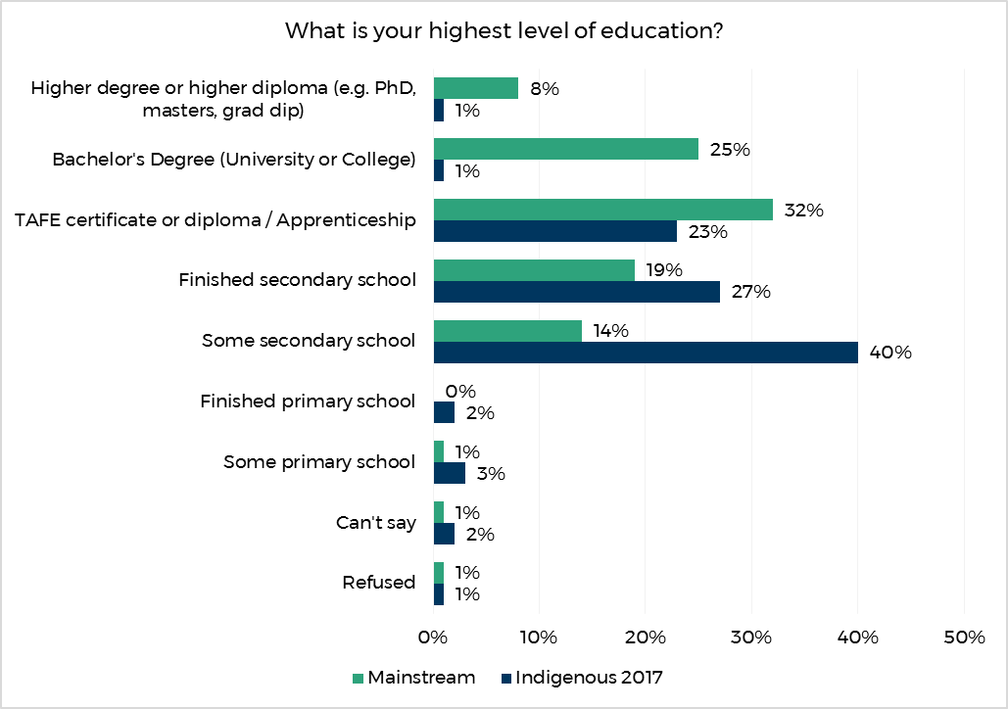

Base (weighted): All respondents (n=352 for Indigenous; n=508 mainstream)

Figure 39 shows the reported household annual income of respondents in the Indigenous and the mainstream evaluations. Indigenous respondents were most likely to fall into the two lowest income brackets, with 48% reporting a household income below $30,000. In contrast, mainstream respondents were most likely to report a household income between $30,000 and $90,000 (41%), and only 15% had a household income below $30,000.

Figure 39. Income

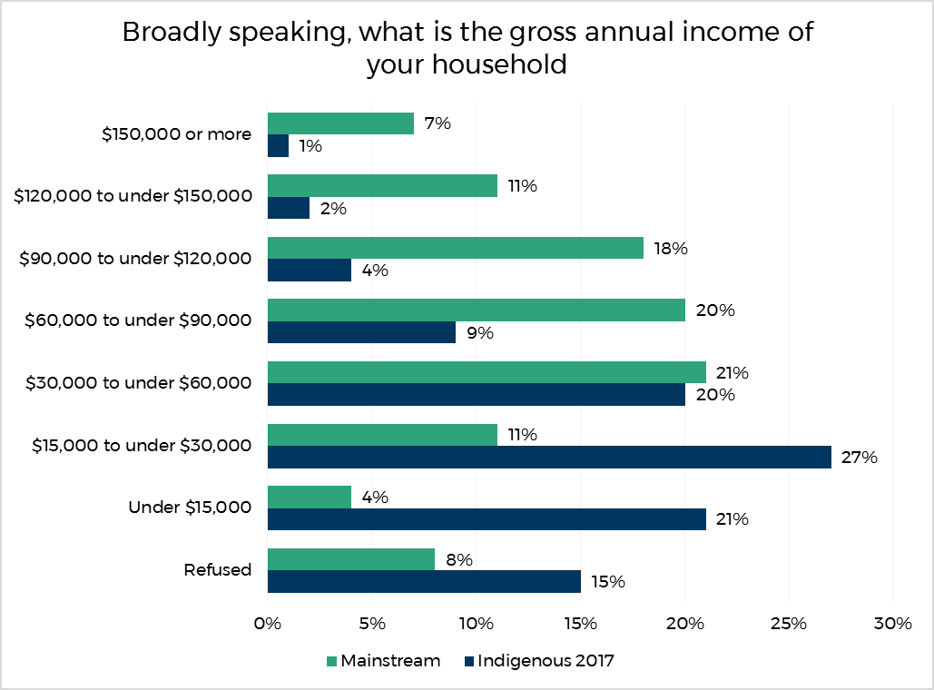

Base (weighted): All respondents (n=352 for Indigenous; n=508 mainstream)

Respondents were asked if they had been told by a doctor or nurse that they had any of the health conditions listed in Figure 40. Forty-one percent of Indigenous respondents had at least one of the health conditions, the most common being asthma (19%), followed by mental health problems (17%). A similar proportion of mainstream respondents (40%) had at least one of the health conditions listed; again the most commonly reported being asthma (14%) and mental health problems (20%).

Figure 40. Health conditions

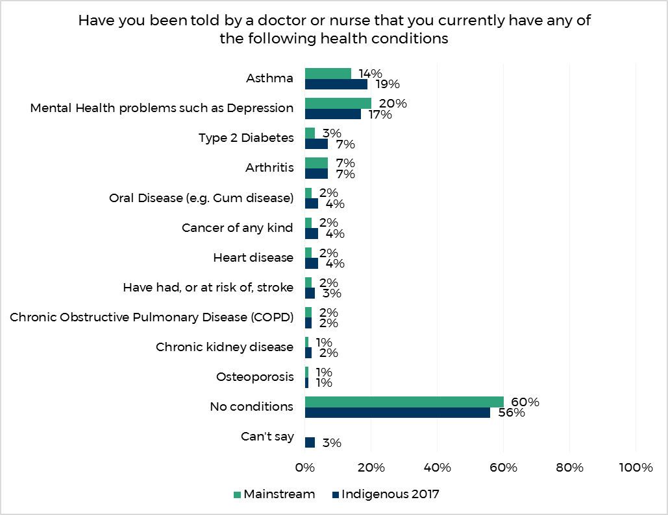

Base (weighted): All respondents (n=352 for Indigenous; n=508 mainstream)

Respondents were asked about the job of the main income earner in their household. As illustrated in Figure 41, the most common response was ‘no occupation’ (30%) for Indigenous respondents, followed by ‘community or personal service worker’ (16%) and ‘labourer’ (13%). In contrast, only 9% of the mainstream sample reported ‘no occupation’, and ‘professional’ (19%) and ‘manager’ (15%) were the most common responses.

Figure 41. Main household earner’s job

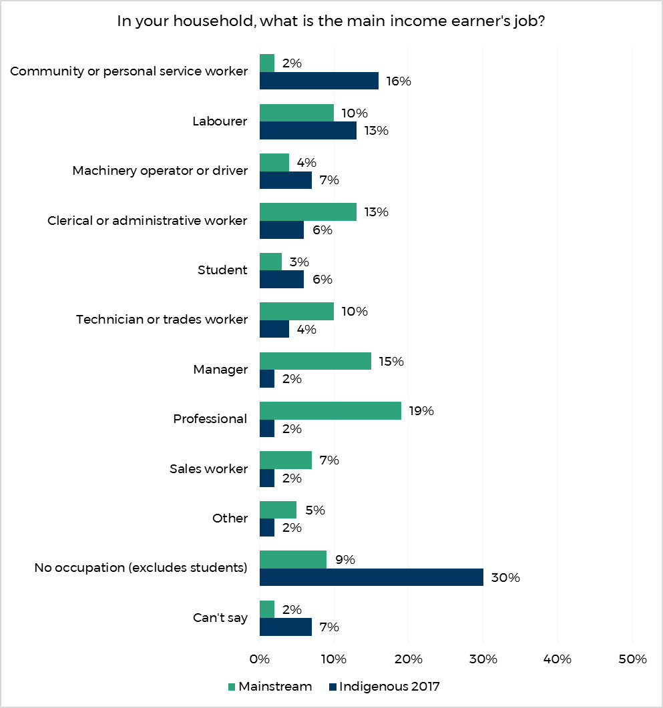

Base (weighted): All respondents (n=352 for Indigenous; n=508 mainstream)

# Conclusions & Recommendations

**The 2017 evaluation research suggests that the** Don’t Make Smokes Your Story **campaign has built on the success of the 2016 campaign and delivered against all of the key campaign objectives, while also demonstrating significant cross-over appeal to mainstream smoking audiences.**

Eighty-seven percent of the participants surveyed from the target audience of Indigenous smokers and recent quitters aged 15 years and over reported being aware of the campaign. This is a 12 percentage point increase on the 2016 evaluation. Additionally, more than half (56%) of the sample from the general population recalled seeing the campaign when prompted. Exposure to the campaign amongst Indigenous respondents was lower in remote locations (80%, compared with 88% in urban and 90% in regional), but there were no significant differences by age or gender in overall exposure. Exposure to the campaign in the general population was notably lower (56%), and peaked in the youngest age group (64%), but did not significantly differ by remoteness or gender.

Exposure to the campaign through each of the individual media channels had also increased amongst Indigenous audiences since the 2016 evaluation. The TVC had the highest reach for both Indigenous (73%) and mainstream (54%) smokers and recent quitters. The radio, print and online ads had a reach of 50% to 56% amongst Indigenous audiences and 22% to 27% for mainstream audiences. In terms of community outreach events, 45% of respondents reported seeing Don’t Make Smokes Your Story ‘somewhere else’. Exposure peaked in the 18 to 40 years primary target audience, with 52% of those reporting seeing the ad, compared to 27% of 15 to 17 year olds and 39% of 41 year olds and over.

The diagnostic performance of the TVC was very strong. In particular, it was regarded as being easy to understand (by 96% of Indigenous and 95% of mainstream respondents), and believable (88% Indigenous, 82% mainstream). Of note, the TVC was regarded as ‘empowering’ and ‘inspiring’ by 63% and 62% of Indigenous respondents respectively and 66% and 69% (respectively) of mainstream respondents, effectively delivering on the positive campaign strategy across both audiences.

Amongst Indigenous respondents, campaign diagnostics tended to be strongest in remote locations and weakest in urban. Indigenous respondents from remote locations (84%) were more likely than those in regional (74%) and urban areas (56%) to agree that the ad related to them. Additionally, males from the Indigenous sample were also more likely than females to agree that the ad related to them (76% vs 64%). Indigenous respondents overall were more likely to agree the ad related to them (70%) than non-Indigenous respondents (64%).

The campaign has also continued to drive impressive quitting behaviour and intentions amongst Indigenous respondents, and was also effective in driving behaviour change and intentions amongst mainstream audiences. Of those exposed, 8% of Indigenous respondents stated that they had quit as a result of the campaign (14% for mainstream), 24% had reduced the amount they smoke (32% for mainstream) and 19% had discussed smoking and health with family and friends (23% for mainstream). Furthermore, 27% of Indigenous respondents stated they intended to quit smoking as a result of the campaign (30% for mainstream), 21% intended to reduce the amount they smoke (32% for mainstream) and 11% intended to ask their doctor or health worker for help to quit (16% for mainstream).

TVC ‘wear out’ (those reporting that they were getting sick of seeing the ad) was 26%, a 3 percentage point increase on the equivalent 2016 result and 6 percentage points higher than the mainstream figure (20%). Wear out amongst Indigenous audiences was significantly higher in remote locations (37%) compared to regional (26%) and urban areas (18%), despite the campaign diagnostics performing stronger in remote areas. Wear out did not significantly differ amongst mainstream audiences by remoteness.

Even allowing for some over-claim on stated intentions, the campaign has generated large numbers of quit attempts amongst the target audience as well as mainstream audiences (8% and 14% respectively).

The evaluation results on increased quit attempts and intentions are also supported by the department’s own data around the increased use of support tools (the My QuitBuddy app, the Quit Now website and the Quitline). During the five month campaign period there was a 21% increase in the number of downloads of the My QuitBuddy app, a 13% increase in calls made to the Quitline and 342% increase in the number of visits to the Quit Now website, with 71,000 visits made prior to the campaign, and 314,000 during the campaign.

**In summary, the evaluation of the 2017** Don’t Make Smokes Your Story **Campaign suggests that the success of the 2016 campaign has been further reinforced with even higher levels of reach being achieved, and similarly high levels of behaviour change. The campaign also demonstrated significant cross-over appeal to mainstream smoking audiences, with somewhat lower, though still impressive, reach being achieved with mainstream audiences and impressive diagnostic performance and reported behaviour change.**

Appendix A: Detailed Methodology

Indigenous Evaluation

The below section provides a detailed description of the methodology and the research approach of the Indigenous evaluation.

Overall Evaluation Approach

The most significant challenge to address in conducting the Don’t Make Smokes Your Story campaign evaluation amongst Indigenous people was to obtain a sample reflecting the diversity of the target population from whom reliable information could be obtained. This required careful consideration of the sampling strategy, fieldwork methodology and interviewing processes employed.

Obtaining a true random probability sample of this population was not possible, because:

* there is no sample frame of Indigenous people in Australia
* no representative research panel of Indigenous Australians exists
* Random Digit Dial (RDD) telephone interviewing would not be an appropriate approach (given low rates of telephone ownership in some communities as well as the likely difficulty of administering complex surveys over the phone with some segments of the Indigenous population).

As a random probability sampling approach was not feasible, the principle considerations in designing the evaluation approach was:

* the importance of appropriately representing regional and remote as well as urban Indigenous communities in the evaluation
* the importance of representing different states and territories
* the desirability of establishing proper rapport with potential evaluation participants – arguing strongly for a face-to-face methodology.

The overall approach adopted comprised:

* A national sample design with geographic stratification in proportion to the Indigenous population in urban, regional and remote locations in each state or territory.
* A face-to-face interviewing methodology was employed, which involved identifying, training and briefing community-based Indigenous interviewers local to the communities they were interviewing in.
* A purposive sampling approach was adopted, with our community-based Indigenous interviewers screening Indigenous community members according the study’s qualifying criteria. Some controls on age, gender and smoking status were also applied, as described in more detail below.

Sampling Strategy and Sample Design

The target audience for the Indigenous evaluation matched that for the campaign and the 2016 evaluation - Indigenous smokers and recent quitters aged 15 years and over, with a primary target audience of Indigenous smokers aged 18-40.

The campaign was planned to appeal particularly to Indigenous smokers and recent quitters in regional and remote locations. The research sample needed to reflect the key target audiences for the campaign, i.e. smokers and recent quitters aged 18-40, and enable separate analysis by factors such as gender, smoking status, location, and campaign exposure.

A national sample design was constructed for the evaluation with geographic stratification in proportion to the Indigenous population in urban, regional and remote locations in each state or territory.

The 2011 Census of Population and Housing (ABS Catalogue 3238.0.55.001 - Estimates of Aboriginal and Torres Strait Islander Australians, June 2011) provided the following breakdown (collapsing “inner regional” and “outer regional” together and collapsing “remote” and “very remote” together).

Table 5. Distribution of Indigenous population according to 2011 Census

|  |  |  |  |  |
| --- | --- | --- | --- | --- |
| State | Major Cities | Regional | Remote | Total |
| NSW | 14% | 16% | 1% | 31% |
| VIC | 4% | 3% | NIL | 7% |
| QLD | 9% | 14% | 5% | 28% |
| SA | 3% | 2% | 1% | 6% |
| WA | 5% | 3% | 5% | 13% |
| TAS | NIL | 4% | NIL | 4% |
| NT | NIL | 2% | 8% | 10% |
| ACT | 1% | NIL | NIL | 1% |
| **Total** | **36%** | **44%** | **20%** | **100%** |

The following quotas (which were also used for the 2016 evaluation) were therefore proposed.

Table 6. Target Sample Design

|  |  |  |  |  |
| --- | --- | --- | --- | --- |
| State | Major Cities | Regional | Remote | Total |
| NSW/ACT | 53 | 56 | NIL | 109 |
| VIC | 14 | 11 | NIL | 25 |
| QLD | 31 | 49 | 20 | 100 |
| SA | 21 | 7 | NIL | 18 |
| WA | 17 | 11 | 21 | 49 |
| TAS | NIL | 14 | NIL | 14 |
| NT | NIL | 7 | 28 | 35 |
| **Total** | **126** | **155** | **69** | **350** |

The achieved sample design for the 2017 evaluation is shown below.

Table 7. Achieved Sample Design (unweighted)

|  |  |  |  |  |
| --- | --- | --- | --- | --- |
| State | Major Cities | Regional | Remote | Total |
| NSW/ACT | 37 | 65 | NIL | 102 |
| VIC | 15 | 11 | NIL | 26 |
| QLD | 27 | 49 | 17 | 93 |
| SA | 21 | 7 | NIL | 28 |
| WA | 17 | 11 | 20 | 48 |
| TAS | NIL | 24 | NIL | 24 |
| NT | NIL | 4 | 27 | 31 |
| **Total** | **117** | **171** | **64** | **352** |

The final sample design represented a compromise between the ideal scenario of maximising the number of sampling points and the practical considerations of timing and budget constraints. ORC believes that the resulting coverage provided good representation of the target audience within these operating constraints. In selecting fieldwork locations for interviewing definitions of metropolitan and non-metropolitan were based on Australian Bureau of Statistics ASGS Remoteness Structure classification; with metropolitan areas being defined as those within the ABS ASGS Remoteness Structure classification, Major Cities of Australia.

The fieldwork design assumed that the total sample for each wave would be spread across approximately 20 sampling points Australia-wide, meaning around 15-20 interviews would be conducted per sampling point (for a total of n=350). Details of precise fieldwork locations were finalised following examination of ABS data, a detailed review of available interviewers, and further discussion with the Department in order to achieve the optimal geographic coverage (and of course the sample size).

The sampling points for the evaluation are shown below in Figure 42. Where possible the same locations and interviewers were used as the 2016 evaluation to allow comparisons, although respondents who had been interviewed in the 2016 survey were not eligible for re-interview in the 2017 survey. The sampling points for the 2016 evaluation are depicted below in Figure 43.

Figure 42. Sampling points for the 2017 Indigenous evaluation

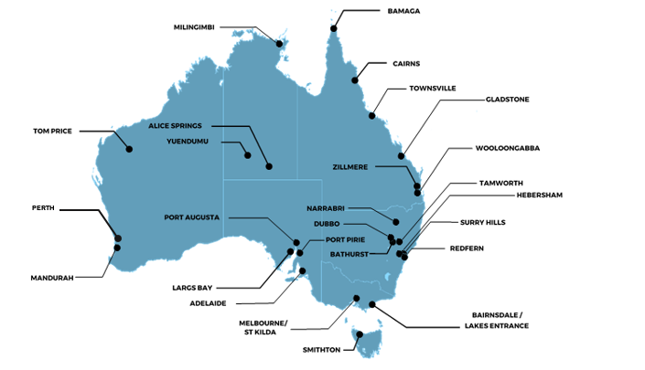

Figure 43. Sampling points for the 2016 Indigenous evaluation

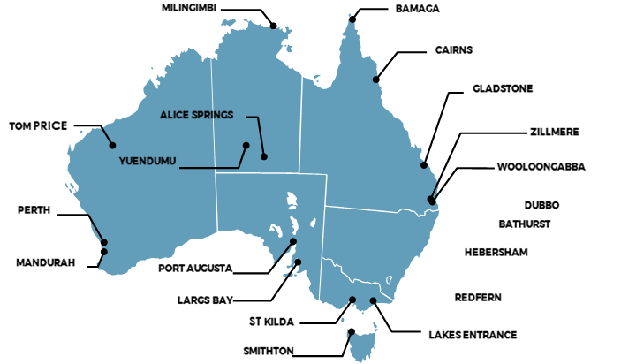

The target sample profile for the 2017 Indigenous evaluation by age, gender, smoking status and remoteness are shown below:

Conduct of Fieldwork

Building a National Indigenous Field Force

To undertake the 2016 Indigenous fieldwork, ORC recruited, trained and briefed a nation-wide team of Indigenous interviewers. ORC again utilised this field force for the 2017 Indigenous evaluation, working with the same interviewers where possible and recruiting new organisations where required. ORC strongly believes the use of community-based Indigenous interviewers generates high quality data through the establishment of excellent rapport and trust with respondents and therefore the provision of more open, honest feedback.

ORC has extensive experience in recruiting and maintaining interviewing field forces in this manner, including working closely with Indigenous community organisations to schedule and conduct interviews with community members. To establish the field force in 2016 and where required in 2017 we primarily recruited Indigenous interviewers via known Indigenous community organisations. ORC research staff then screened, recruited and trained Indigenous interviewers for this project.

Survey fieldwork

ORC International was responsible for:

* Programming the survey questionnaire.
* Briefing and training interviewers on the sensitivities of the project, as well as project background, objectives, interview targets and timelines.
* Management and monitoring of fieldwork progress.
* Implementing fieldwork controls and other quality assurance measures such as:
  + provision of a toll-free telephone number and interviewer contact for respondents to raise questions about the survey;
  + sample management procedures;
  + We required interviewers to progressively upload batches of completed questionnaires to be audited for quality control purposes.
* Conducting the face-to-face interviews.
* Training and briefing of interviewers was conducted via a combination of face-to-face, skype and phone.
* All fieldwork processes were carried out in compliance with ISO 20252 and membership requirements for AMSRO (The Association of Market and Social Research Organisations) and AMSRS (The Australian Market and Social Research Society).

All interviewers, regardless of where they were recruited from, were subject to the same thorough briefing and training procedures.

Respondent Selection

Indigenous interviewers were responsible for recruiting other Indigenous individuals for interview in their location.

A purposive sampling approach was adopted, with our community-based Indigenous interviewers screening Indigenous community members according the study’s qualifying criteria.

Some controls on age, gender and smoking status were also applied, as described in the Sample Profile section.

* A maximum quota of 15% of the sample quota was placed on recent quitters.
* In addition, in an attempt to prevent the final sample from being substantially skewed, targets were established to obtain approximately equal numbers of males and females in each interviewing location, and to also obtain a spread of different ages. These targets did not constitute firm quotas, as this would have made filling quotas very difficult, especially in some remote locations with small populations. In any case, the survey data was to be post-weighted by age and gender to the Indigenous smoking population.
* Interviewers in remote communities were permitted to interview people they knew (this was a practical necessity given the small populations and tight-knit nature of remote communities) – but this could not include immediate family members.
* Respondents who had been interviewed for the 2016 evaluation were not eligible for re-interview for the 2018 evaluation.

Community engagement and recruitment

In conducting the research, ORC International sought to engage in an appropriate way with Indigenous communities, to meet the research objectives while at the same time being sensitive to local needs and protocols and aiding in local capacity building. To conduct the research fieldwork, ORC International worked closely with our local Indigenous community organisation partners in each location who provided advice on local protocols and practices, as well as recommending appropriate interviewing personnel and providing logistical support. The use of commercial market research fieldwork companies was eschewed in favour of using Indigenous interviewers recruited from our partner organisations and trained in basic interviewing techniques by the ORC International research team, using a mixture of face-to-face, skype and telephone training.

These interviewers conducted face to face interviews with respondents from their local community, with administrative and logistical support (such as a venue to conduct interviews in) provided by the local Indigenous organisation.

Interviews were conducted using tablets, which were also used to show campaign materials to ensure correct recall measures.

ORC paid community organisations for their participation and support of the research, and paid interviewers for the interviewing work done as well as for attending training on market research techniques and briefings on the questionnaire.

All survey respondents were paid incentives for their participation, with the amount and form of incentives based on the advice of our partner organisations. A payment of a $30 incentive was usually provided for each interview (sometimes this was increased, decreased or provided as an aggregate ‘community’ amount or gift, depending on local advice).

Questionnaire Development

The questionnaire from the 2016 evaluation was reviewed and edited only where appropriate to reflect the updated campaign strategy, and reduce the survey length. The questionnaire was reviewed by the department before being finalised. The final questionnaire covered:

* Smoking status
* Intention to quit/remain quit
* Awareness of the campaign
* Exposure to the campaign
* Campaign recall (unprompted)
* Campaign recall (prompted)
* Attitudes to the campaign
* Personal relevance of the campaign
* Perceived impact of the campaign on own intentions/behaviour
* Awareness of associated tools, such as My QuitBuddy app
* Demographics

The 2016 evaluation was conducted using hard copy questionnaires, with tablets to show respondents the TVC, radio, print and social media/ online ads. Computer assisted personal interviewing was used in the 2017 evaluation to expedite retrieval of the data and to improve survey delivering by automating the questionnaire routing for interviewers.

Dates of fieldwork

The initial benchmark round of fieldwork was conducted 18 April to 6 May. Fieldwork continued following the launch of Don’t Make Smokes Your Story, because the original campaign launch date was brought forward from 31 May to 1 May. This impacted negatively upon the final sample size (n=201 prior to 1 May and n=262 including interviews collected post-campaign launch). Surveys collected post campaign launch are excluded for comparisons between benchmark and evaluation results, but are included for media consumption and demographic information.

The evaluation round (n=310) was conducted from 20 June to 12 August, following the end of the paid media buy for the campaign.

Weighting adjustment

The data for smokers was weighted by age, gender, state and geographical remoteness, to represent the national Indigenous smoker population aged 15 years and over. Due to the small sample size (n=20), recent quitters were unable to be weighted and therefore have each been provided a weight of one. The weight adjustments were calculated with rim weighting using three sets of smoker population totals: (1) Age x gender; (2) State/territory; and (3) Region (defined by Main cities; Regional; and Remote). The population data used for the weighting was obtained from the ABS National Aboriginal and Torres Strait Islander Social Survey, 2014-15, publication 4714.0.

Sample profile

Table 8 below shows the target sample design for the Indigenous evaluation. Table 9 shows the actual unweighted sample profile based on the final sample size of 352 respondents.

Table 8. Target sample design for the Indigenous evaluation

|  |  |
| --- | --- |
| Target Sample Design | Target |
| n= | 350 |
| **Remoteness** | NIL |
| Major City | 36% |
| Regional | 44% |
| Remote | 20% |
| **Smoking status** | NIL |
| Current smoker | 85% |
| Recent quitter* | 15% |
| **Gender** | NIL |
| Male | 50% |
| Female | 50% |
| **Age** | NIL |
| 15-17 years | 15% |
| 18-40 years | 55% |
| 41 years and over | 30% |

* Recent quitters were defined as respondents who had quit smoking less than 12 months ago

Table 9. Achieved sample profile (unweighted)

|  |  |
| --- | --- |
| Achieved Sample Profile | Target |
| n= | 352 |
| **Remoteness** | NIL |
| Major City | 33% |
| Regional | 49% |
| Remote | 18% |
| **Smoking status** | NIL |
| Current smoker | 94% |
| Recent quitter* | 6% |
| **Gender** | NIL |
| Male | 45% |
| Female | 55% |
| **Age** | NIL |
| 15-17 years | 10% |
| 18-40 years | 54% |
| 41+ years | 36% |

* Recent quitters were defined as respondents who had quit smoking less than 12 months ago

Mainstream Evaluation

The below section provides further details on the methodology for the mainstream evaluation.

Overall Evaluation Approach

As Don’t Make Smokes Your Story was an Indigenous focused campaign, mainstream audiences were not a target population for the campaign, however the research still aimed to assess to some degree the campaign reach and impact amongst non-Indigenous smokers and recent quitters.

After careful consideration it was determined that a self-complete online survey was the most appropriate methodology to adequately evaluate the campaign amongst mainstream audiences within the allocated budget and time.

SSI’s online panel was selected as it is Australia’s largest, comprising over 400,000 members, which ensured coverage was adequate for the purpose of this research.

Sample design

The mainstream evaluation targeted non-Indigenous Australians smokers and recent quitters (quit within the last 12 months) aged 18 – 50 years. A national sample design was constructed with geographic stratification in proportion to the Australian population by state and regional status.

The target sample design is shown below in table 10.

Table 10. Target sample profile

|  |  |
| --- | --- |
| Target Sample Profile | Target |
| n= | 500 |
| **Remoteness status** | NIL |
| Urban | 64% |
| Regional / remote | 36% |
| **Smoking status** | NIL |
| Current smoker | 85% |
| Recent quitter* | 15% |
| **Gender** | NIL |
| Male | 49% |
| Female | 51% |
| **Age** | NIL |
| 18-29 years | 34% |
| 30-40 years | 31% |
| 40-50 years | 35% |

* Recent quitters were defined as respondents who had quit smoking less than 12 months ago

Dates of fieldwork

Fieldwork was conducted at the completion of the campaign, from the 21st June to the 30th June (10 days). Due to the online nature of the mainstream evaluation and the use of a panel of willing respondents, the mainstream evaluation was able to be completed in a much shorter time-frame compared to the Indigenous fieldwork (6 weeks in-field).

Questionnaire

The questionnaire for the mainstream survey was based on the Indigenous survey, with changes only made where necessary to accommodate the different survey mode, and Indigenous specific questions were removed. (e.g. Do you speak an Aboriginal or Indigenous language at home?)

Weighting

Weighting was carried out at the Age (18-24, 25-29, 30-34, 35-40, 41-50) x Gender x State x Greater Capital City Statistical Area level. Estimated Resident Population (ERP) projections at this level for use in weighting were obtained from the ABS.Stat module (Dataset: Population Projections by Region, 2012 -2061). This source provided the required ERP data for June 2017 with the exception of data for the 18-24 year group. The age groups provided were 15-19 and 20-24. This required some interpolation to provide the required age group values. Data for this interpolation was obtained from ABS release 3101.0 Australian Demographic Statistics, Table 59, Estimated Resident Population By Single Year Of Age, Australia, Mar 2017, Released at 11:30 AM 27/06/2017.

Sample profile

Table 11 below shows the unweighted sample profile for the mainstream evaluation based on the final sample size of 508 respondents.

Table 11. Achieved Sample Profile (unweighted)

|  |  |
| --- | --- |
| Achieved Sample Profile | Target |
| n= | 508 |
| **Remoteness** | NIL |
| Urban | 62% |
| Regional / remote | 38% |
| **Smoking status** | NIL |
| Current smoker | 85% |
| Recent quitter* | 15% |
| **Gender** | NIL |
| Male | 51% |
| Female | 49% |
| **Age** | NIL |
| 18-29 years | 33% |
| 30-40 years | 31% |
| 40-50 years | 35% |

Appendix B: Questionnaire

Interviewer to confirm location

OPEN RESPONSE

Thank you for agreeing to participate in this survey. The survey is being conducted on behalf of the Australian Government Department of Health. The purpose of the survey is to find out what the community thinks about smoking and information about smoking. The survey should take around 15-20 minutes to complete.

First, I need to ask you a few questions to find out whether you qualify to take part in the survey.

Screener Questions

ALL

INDIGENOUS IDENTIFICATION:

Interviewers to confirm whether respondent identifies as:

|  |  |
| --- | --- |
| Response Options | Response Code |
| Aboriginal (CONTINUE) | 1 |
| Torres Strait Islander (CONTINUE) | 2 |
| Both Aboriginal and Torres Strait Islander (CONTINUE) | 3 |
| Neither (GO TO TERM) | 4 |

ALL

Record Gender:

|  |  |
| --- | --- |
| Response Options | Response Code |
| Male (CONTINUE) | 1 |
| Female (CONTINUE) | 2 |

ALL

SS1. What is your age?

READ OUT IF NECESSARY:

|  |  |
| --- | --- |
| Response Options | Response Code |
| Less than 15 years old (GO TO TERM) | 1 |
| 15-17 (GO TO SS2) | 2 |
| 18-24 (GO TO SS2) | 3 |
| 25-29 (GO TO SS2) | 4 |
| 30-34 (GO TO SS2) | 5 |
| 35-40 (GO TO SS2) | 6 |
| 41 and over (GO TO SS2) | 7 |
| Refused (GO TO TERM) | 99 |

ALL

SS2. How often, if at all, do you currently smoke cigarettes? Do you smoke them:

READ OUT

|  |  |
| --- | --- |
| Response Options | Response Code |
| Daily (CLASSIFY AS SMOKER AND GO TO SS5) | 1 |
| At least weekly(CLASSIFY AS SMOKER AND GO TO SS5) | 2 |
| At least monthly (ASK SS3) | 3 |
| Less often than monthly (ASK SS3) | 4 |
| Not at all (ASK SS3) | 5 |
| Refused (GO TO TERM) | 99 |

IF SS2=3-5

SS3. Have you **ever** smoked cigarettes at least weekly?

|  |  |
| --- | --- |
| Response Options | Response Code |
| Yes (ASK SS4) | 1 |
| No, never (GO TO TERM) | 2 |
| Can’t say (GO TO TERM) | 98 |

IF SS3=1

SS4. Did you stop smoking cigarettes at least weekly within the last 12 months?

INTERVIEWER CHECK: AT LEAST 85% of respondents are CURRENT SMOKERS

|  |  |
| --- | --- |
| Response Options | Response Code |
| Yes (CLASSIFY AS RECENT QUITTER AND GO TO SS5) | 1 |
| No – it was longer than 12 months ago or longer (GO TO TERM) | 2 |
| Can’t say (GO TO TERM) | 98 |

SS5: SAMPLE SUMMARY (FOR PROGRAMMING PURPOSES ONLY):

|  |  |
| --- | --- |
| Response Options | Response Code |
| SS2=Daily or weekly (RESPONDENT IS A CURRENT SMOKER – GO TO SECTION A) | 1 |
| SS4=Yes (RESPONDENT IS A RECENT QUITTER – GO TO SECTION C) | 2 |

Thank you for that, you’re definitely one of the people we need to speak to. To start off we just have some questions about your present and past smoking behaviour.

TERM: Unfortunately, you don’t qualify for our survey as we are looking to speak with Aboriginal and Torres Strait Islanders aged 15 years and over who currently smoke, or who have recently quit smoking. Thank you very much for your time.

Section A: Current Smokers’ Quitting Attempts & Experience

ALL CURRENT SMOKERS (SS5=1)

A1 Have you ever tried to quit smoking?

|  |  |
| --- | --- |
| Response Options | Response Code |
| Yes | 1 |
| No (GO TO A7) | 2 |
| Can’t say (GO TO A7) | 98 |

IF A1=1

A2 How many times have you tried to quit smoking?

IF UNSURE: Your best guess will do

|  |  |
| --- | --- |
| Response Options | Response Code |
| Once | 1 |
| Twice | 2 |
| Three times | 3 |
| Four times | 4 |
| Five times | 5 |
| 6-10 times | 6 |
| More than 10 times | 7 |
| Can’t say | 98 |

IF A1=1

A3 Which, if any, of the following have you ever done to help you quit smoking?

READ OUT. MULTIPLES ACCEPTED.

|  |  |
| --- | --- |
| Response Options | Response Code |
| **Quitting Aids** | NIL |
| Used Nicotine Replacement Therapy (patches, gum, inhaler, lozenges, etc.) | 1 |
| Used Zyban | 2 |
| Used Champix | 3 |
| **Advice** | NIL |
| Rung the Quitline | 4 |
| Visited the Quitnow website | 5 |
| Used a quit smoking app such as My QuitBuddy or Quit for You, Quit for Two (PLEASE SPECIFY): | 6 |
| Asked your doctor for help to quit (including health nurses, Aboriginal Medical Services) | 7 |
| Asked a pharmacist / other health professional for advice on quitting | 8 |
| Taken part in Quit smoking programs (individual or group) | 9 |
| Used an online/internet support tool such as an online Quitcoach | 10 |
| **No quitting aids or advice** | NIL |
| Gave up on my own | 11 |
| **Other** | NIL |
| Other (SPECIFY) | 96 |
| Can't say (DO NOT READ OUT) | 98 |
| None (DO NOT READ OUT) | 12 |

IF A1=1

A5 Thinking about the last time you quit smoking, what, if anything, made you quit?

DO NOT READ OUT. MULTIPLES ACCEPTED

|  |  |
| --- | --- |
| Response Options | Response Code |
| **Health & Fitness** | NIL |
| Asthmatic / trouble breathing | 1 |
| Had a cough / cold / flu / chest infection | 2 |
| Health scare (e.g. pneumonia, coughing fits) | 3 |
| Heart attack | 4 |
| Decline in health / bad for my health | 5 |
| Affecting my fitness | 6 |
| Other health or fitness reason  (SPECIFY): | 7 |
| Health reasons / ill Health (UNSPECIFIED, NOne OF THE ABOVE) | 8 |
| **Family & Friends** | NIL |
| I became pregnant | 9 |
| My partner became pregnant | 10 |
| Children in the house / children's health / role model for children / children encouraged me to quit | 11 |
| Family / partner / parents | 12 |
| Friends / colleagues | 13 |
| Family history of illness (e.g. throat cancer) | 14 |
| Know someone who is ill / has died from smoking related illness | 15 |
| **Money** | NIL |
| Cost / too expensive | 16 |
| Waste of money | 17 |
| Wanted to save money | 18 |
| **Physical Appearance** | NIL |
| The smell (On my body / clothes) | 19 |
| Causing ageing (Wrinkles, etc.) | 20 |
| **Advertising & Promotions** | NIL |
| Health warnings on packs | 21 |
| Health warning advertisements / anti-smoking advertisements / health information | 22 |
| Smoking support groups / programs | 23 |
| GP or other health worker advice | 24 |
| **Others** | NIL |
| Just stopped / spur of the moment | 25 |
| Just wanted to | 26 |
| Availability of cheaper NRT | 27 |
| Other (SPECIFY) | 96 |
| Can't say | 98 |

ALL CURRENT SMOKERS (SS5=1)

A7 During the past 6 months has anybody you know been trying to get you to quit smoking?

|  |  |
| --- | --- |
| Response Options | Response Code |
| Yes | 1 |
| No (GO TO A9a) | 2 |
| Can't say (GO TO A9a) | 98 |

IF A7=1

A8 And who has been trying to get you to quit smoking?

DO NOT READ OUT. MULTIPLES ACCEPTED.

|  |  |
| --- | --- |
| Response Options | Response Code |
| Partner / spouse | 1 |
| Child / children | 2 |
| Sibling (brother or sister) | 3 |
| Parents/ guardians | 4 |
| Other family member (e.g. aunts and uncles) | 5 |
| Friend / flatmate / work colleague | 6 |
| Doctor/ medical practitioner/ health worker | 7 |
| Other (SPECIFY) | 96 |
| Don’t know | 98 |

ALL CURRENT SMOKERS (SS5=1)

A9a On a scale of 1-10, how much do you want to quit smoking? Where 1 is not at all and 10 is very much?

IF NECESSARY: by quit we mean stop totally.

|  |  |
| --- | --- |
| Response Options | Response Code |
| 1. Not at all | 1 |
| 2. | 2 |
| 3. | 3 |
| 4. | 4 |
| 5. | 5 |
| 6. | 6 |
| 7. | 7 |
| 8. | 8 |
| 9. | 9 |
| 10. Very Much | 10 |
| Can’t Say | 98 |

ALL CURRENT SMOKERS (SS5=1)

A9b Do you intend to quit smoking?

|  |  |
| --- | --- |
| Response Options | Response Code |
| Yes (GO TO A10) | 1 |
| No (GO TO A12) | 2 |
| Don't know (GO TO A12) | 98 |

a9b=1

A10 Are you planning to quit?

READ OUT

|  |  |
| --- | --- |
| Response Options | Response Code |
| Within the next month | 1 |
| Within the next 6 months | 2 |
| Sometime in the future, beyond 6 months | 3 |
| Don't know (DO NOT READ OUT) | 98 |

ALL CURRENT SMOKERS (SS5=1)

A12 I would now like to ask you how much you agree or disagree with the following statement about smoking and quitting.

|  |  |  |  |  |  |  |  |
| --- | --- | --- | --- | --- | --- | --- | --- |
| No. | Response Options | Strongly Agree | Agree | Neither agree nor disagree | Disagree | Strongly disagree | Don’t Know |
| b. | You are confident you could quit smoking if you wanted to | 1 | 2 | 3 | 4 | 5 | 98 |

ALL CURRENT SMOKERS (SS5=1)

A13 How much do you think you would benefit financially if you were to quit smoking in the next 6 months?

READ OUT

|  |  |
| --- | --- |
| Response Options | Response Code |
| Not at all | 1 |
| Slightly | 2 |
| Moderately | 3 |
| Very much | 4 |
| Extremely | 5 |
| Don’t know (DO NOT READ OUT) | 98 |
| Refused (DO NOT READ OUT) | 99 |

ALL CURRENT SMOKERS (SS5=1)

A14 How much do you think your health would benefit if you were to quit smoking in the next 6 months?

READ OUT

|  |  |
| --- | --- |
| Response Options | Response Code |
| Not at all | 1 |
| Slightly | 2 |
| Moderately | 3 |
| Very much | 4 |
| Extremely | 5 |
| Don’t know (DO NOT READ OUT) | 98 |
| Refused (DO NOT READ OUT) | 99 |

Section B: Smoking & Health (Current Smokers)

ALL CURRENT SMOKERS (SS5=1)

B2 How much, if at all, has smoking damaged your health? Would you say:

READ OUT

|  |  |
| --- | --- |
| Response Options | Response Code |
| Not at all | 1 |
| Just a little | 2 |
| A fair amount | 3 |
| A great deal | 4 |
| Don't know (DO NOT READ OUT) | 98 |
| Refused (DO NOT READ OUT) | 99 |

ALL CURRENT SMOKERS (SS5=1)

B3 How much, if at all, has your smoking affected the health of others? Would you say:

READ OUT

|  |  |
| --- | --- |
| Response Options | Response Code |
| Not at all | 1 |
| Just a little | 2 |
| A fair amount | 3 |
| A great deal | 4 |
| Don't know (DO NOT READ OUT) | 98 |
| Refused (DO NOT READ OUT) | 99 |

ALL CURRENT SMOKERS (SS5=1)

B5. How worried are you, if at all, that smoking WILL damage your health in the future? Would you say you are:

READ OUT

|  |  |
| --- | --- |
| Response Options | Response Code |
| Not at all worried (GO TO SECTION D) | 1 |
| A little worried (GO TO SECTION D) | 2 |
| Moderately worried (GO TO SECTION D) | 3 |
| Very worried (GO TO SECTION D) | 4 |
| Don't know (DO NOT READ OUT) (GO TO SECTION D) | 98 |
| Refused (DO NOT READ OUT) (GO TO SECTION D) | 99 |

Section C: Recent Quitters Quitting Attempts & Experience

ALL RECENT QUITTERS (SS5=2)

C2. Not including the most recent time, how many times have you tried to quit smoking?

IF UNSURE: Your best guess will do

|  |  |
| --- | --- |
| Response Options | Response Code |
| Never | 0 |
| Once | 1 |
| Twice | 2 |
| Three times | 3 |
| Four times | 4 |
| Five times | 5 |
| 6-10 times | 6 |
| More than 10 times | 7 |
| Can’t say | 99 |

ALL RECENT QUITTERS (SS5=2)

C3. On average, how many cigarettes did you smoke before you quit?

|  |  |
| --- | --- |
| Response Options | Response Code |
| Per day (OR) | 1 |
| Per week | 2 |
| Refused | 98 |

ALL RECENT QUITTERS (SS5=2)

C4. Is it likely or unlikely that you’ll be able to stay quit?

ENCOURAGE BEST GUESS

|  |  |
| --- | --- |
| Response Options | Response Code |
| Likely | 1 |
| Unlikely | 2 |
| Can’t say | 98 |

ALL RECENT QUITTERS (SS5=2)

C5. What, if anything, made you quit?

DO NOT READ OUT. MULTIPLES ACCEPTED

|  |  |
| --- | --- |
| Response Options | Response Code |
| **Health & Fitness** | NIL |
| Asthmatic / trouble breathing | 1 |
| Had a cough / cold / flu / chest infection | 2 |
| Health scare (e.g. pneumonia, coughing fits) | 3 |
| Heart attack | 4 |
| Decline in health / bad for my health | 5 |
| Affecting my fitness | 6 |
| Other health or fitness reason (SPECIFY) | 7 |
| Health reasons / ill health (UNSPECIFIED, NOne of the above) | 8 |
| **Family & Friends** | NIL |
| I became pregnant | 9 |
| My partner became pregnant | 10 |
| Children in the house / children's health / role model for children / children encouraged me to quit | 11 |
| Family / partner / parents | 12 |
| Friends / colleagues | 13 |
| Family history of illness (e.g. throat cancer) | 14 |
| Know someone who is ill / has died from smoking related illness | 15 |
| **Money** | NIL |
| Cost / too expensive | 16 |
| Waste of money | 17 |
| Wanted to save money | 18 |
| **Physical Appearance** | NIL |
| The smell (On my body / clothes) | 19 |
| Causing ageing (Wrinkles, etc.) | 20 |
| **Advertising & Promotions** | NIL |
| Health warnings on packs | 21 |
| Health warning advertisements / anti-smoking advertisements/health information | 22 |
| Smoking support groups / programs | 23 |
| GP or other health worker advice | 24 |
| **Others** | NIL |
| Just stopped / spur of the moment | 25 |
| Just wanted to | 26 |
| Availability of cheaper Nicotine Replacement Therapy | 27 |
| Other (SPECIFY) | 96 |
| Can't say (DO NOT READ OUT) (SR) | 98 |

ALL RECENT QUITTERS (SS5=2)

C6. Which, if any, of the following have you ever done to help you quit smoking?

READ OUT. MULTIPLES ACCEPTED.

|  |  |
| --- | --- |
| Response Options | Response Code |
| **Quitting Aids** | NIL |
| Used Nicotine Replacement Therapy (patches, gum, inhaler, lozenges etc.) | 1 |
| Used Zyban | 2 |
| Used Champix | 3 |
| **Advice** | NIL |
| Rung the Quitline | 4 |
| Visited the Quitnow website | 5 |
| Used a quitsmoking app such as My QuitBuddy or Quit for You, Quit for Two  (PLEASE SPECIFY) | 6 |
| Asked your doctor for help to quit (including health nurses, Aboriginal Medical Services) | 7 |
| Asked a pharmacist / other health professional for advice on quitting | 8 |
| Taken part in Quit smoking programs (individual or group) | 9 |
| Used an online / internet support tool such as an online Quitcoach | 10 |
| **No quitting aids or advice** | NIL |
| Gave up on my own | 11 |
| **Other** | NIL |
| Other (SPECIFY) | 96 |
| Can't say (DO NOT READ OUT) | 98 |
| None (DO NOT READ OUT) | 12 |

ALL RECENT QUITTERS (SS5=2)

C7. Before you gave up, had anybody you know been trying to get you to quit smoking?

|  |  |
| --- | --- |
| Response Options | Response Code |
| Yes (ASK C8) | 1 |
| No (GO TO SECTION D) | 2 |
| Can't say (GO TO SECTION D) | 98 |

IF C7=1

C8. And who was trying to get you to quit smoking?

DO NOT READ OUT. MULTIPLES ACCEPTED.

|  |  |
| --- | --- |
| Response Options | Response Code |
| Partner / spouse | 1 |
| Child / children | 2 |
| Sibling (brother or sister) | 3 |
| Parents / guardians | 4 |
| Other family member (e.g. aunts and uncles) | 5 |
| Friend / flatmate / work colleague | 6 |
| Doctor / medical practitioner / health worker | 7 |
| Other (SPECIFY): | 96 |
| Don’t know | 98 |

Section D: Attitudes Towards Smoking And Quitting (Everyone)

ALL

D1 I will now read out some statements about smoking and quitting.

Do you strongly agree, agree, neither agree nor disagree, disagree or strongly disagree that?

|  |  |  |  |  |  |  |  |
| --- | --- | --- | --- | --- | --- | --- | --- |
| No. | Response Options | Strongly Agree | Agree | Neither agree nor disagree | Disagree | Strongly disagree | Don’t Know |
| a. | Australians generally disapprove of smoking | 1 | 2 | 3 | 4 | 5 | 9 |
| b. | Aboriginal and/or Torres Strait Islander community leaders where you live disapprove of smoking | 1 | 2 | 3 | 4 | 5 | 9 |
| c. | Smoking is widely disapproved of in my community | 1 | 2 | 3 | 4 | 5 | 9 |
| d. | There are more positives from smoking than negatives | 1 | 2 | 3 | 4 | 5 | 9 |
| e. | Quitting smoking is easy | 1 | 2 | 3 | 4 | 5 | 9 |
| f. | It’s never too late to quit smoking | 1 | 2 | 3 | 4 | 5 | 9 |
| g. | Quitting will reduce your risk of sickness caused by smoking | 1 | 2 | 3 | 4 | 5 | 9 |
| h. | There are many benefits to quitting smoking | 1 | 2 | 3 | 4 | 5 | 9 |
| i. | If you want to quit smoking you should never give up trying | 1 | 2 | 3 | 4 | 5 | 9 |
| j. | You’re more likely to stay quit with support | 1 | 2 | 3 | 4 | 5 | 9 |
| l. | If you had to do it over again, you would not have started smoking | 1 | 2 | 3 | 4 | 5 | 9 |

ALL

D2 In your opinion, what, if any, are the benefits to you of quitting smoking?

DO NOT READ OUT. MULTIPLES ACCEPTED

|  |  |
| --- | --- |
| Response Options | Response Code |
| Decreased risk of premature death/ less likely to die early | 1 |
| Decreased risk of cancer | 2 |
| Decreased risk of stroke | 3 |
| Decreased risk of heart disease | 4 |
| Decreased risk of other diseases / illness / getting sick | 5 |
| Improved smell and taste | 6 |
| Improved lung function / breathing | 7 |
| Improved blood flow to the skin | 8 |
| Improved fitness / general health | 9 |
| Fewer complications during pregnancy / healthier baby | 10 |
| Save money / more money | 11 |
| Kids / family would like it | 12 |
| Not being a bad role model to others in the family or community | 13 |
| Stopping others from being exposed to cigarette smoke (passive smoking) | 14 |
| Easier when going out | 15 |
| Not smelling like smoke / cigarettes | 16 |
| Other benefit (SPECIFY) | 17 |
| No benefits (SR) | 18 |
| Don’t know (SR) | 98 |
| Refused (SR) | 99 |

Section F: Advertising Awareness (Everyone)

ALL

The next few questions are about advertising

F1 In the past six months, have you seen or heard any information or ads about the dangers of smoking, or encouraging you to quit smoking?

|  |  |
| --- | --- |
| Response Options | Response Code |
| Yes | 1 |
| No (GO TO F4) | 2 |
| Can’t Say (GO TO F4) | 99 |

IF F1=1

F2 i, Can you please describe the first ad that comes to mind? And what was the ad trying to say?

PROBE FULLY

|  |  |
| --- | --- |
| Response Options | Response Code |
| Record Response | 1 |
| Don’t know | 98 |
| Refused | 99 |

IF F2=1

F3 ii. Can you please describe the next ad that comes to mind? And what was the ad trying to say?

PROBE FULLY

|  |  |
| --- | --- |
| Response Options | Response Code |
| Record Response | 1 |
| Don’t know | 2 |
| Refused | 98 |

Don’t Make Smokes Your Story’ Campaign – Prompted Recall

ALL

F4 I am now going to show you a recent TV ad and I would like to know if you have seen it.

(PLAY DON’T MAKE SMOKES YOUR STORY TV AD)

Have you seen this ad before today?

IF YES ASK WHERE, MULTIPLES ACCEPTED

|  |  |
| --- | --- |
| Response Options | Response Code |
| Yes – seen on TV | 1 |
| Yes – seen online (YouTube, Facebook, etc.) | 2 |
| Yes – seen but not sure where | 4 |
| No (GO TO F7) | 5 |
| Don’t know (GO TO F7) | 99 |
| Refused (GO TO F7) | 98 |

IF F4=1-4

F5 Thinking about this ad, to what extent do you agree or disagree it:

Do you strongly agree, agree, neither agree nor disagree, disagree or strongly disagree?

|  |  |  |  |  |  |  |  |
| --- | --- | --- | --- | --- | --- | --- | --- |
| No. | Response Options | Strongly Agree | Agree | Neither agree nor disagree | Disagree | Strongly disagree | Don’t Know |
| a. | Was easy to understand | 1 | 2 | 3 | 4 | 5 | 98 |
| b. | Taught me something new | 1 | 2 | 3 | 4 | 5 | 98 |
| c. | Makes me stop and think | 1 | 2 | 3 | 4 | 5 | 98 |
| d. | Is believable | 1 | 2 | 3 | 4 | 5 | 98 |
| e. | Makes me feel uncomfortable | 1 | 2 | 3 | 4 | 5 | 98 |
| f. | Relates to me | 1 | 2 | 3 | 4 | 5 | 98 |
| g. | Makes me feel worried about my smoking / past smoking | 1 | 2 | 3 | 4 | 5 | 98 |
| h. | Makes me more likely to try to quit / continue not to smoke | 1 | 2 | 3 | 4 | 5 | 98 |
| i. | Makes me feel empowered to quit / continue to not smoke | 1 | 2 | 3 | 4 | 5 | 98 |
| j. | Makes me feel hopeful | 1 | 2 | 3 | 4 | 5 | 98 |
| k. | Makes me feel inspired | 1 | 2 | 3 | 4 | 5 | 98 |

F4=1-4

F6 And how much do you agree or disagree that you are getting tired of seeing this ad?

Do you strongly agree, agree, neither agree nor disagree, disagree or strongly disagree?

|  |  |
| --- | --- |
| Response Options | Response Code |
| Strongly agree | 1 |
| Agree | 2 |
| Neither agree nor disagree | 3 |
| Disagree | 4 |
| Strongly disagree | 5 |
| Don’t know (DO NOT READ OUT) | 99 |
| Refused (DO NOT READ OUT) | 98 |

ALL

F7 There is also a radio version of this ad. I am going to play you the ad and would like to know if you have heard it.

(IF RECORDING DOES NOT PLAY BACK PROPERLY, READ SCRIPT:“Over the years, I’ve had my battles with smokes. My lungs got pretty bad, sometimes I could hardly breathe. I’m not sure why I smoked; I just did. I wanted to be there for my kids, so I quit. I’ve quit before; I just kept trying. I get to see their smiles every day. Mum and the Aunties are pretty happy too. They didn’t want me to die from smokes like Dad did. My name is Ted, and family is my story. Don’t Make Smokes Your Story. For help download the My QuitBuddy app, call the Quitline, or visit Quitnow.”

Have you heard this ad before today?

IF YES, ask if they heard it in English or in a language other than English (both responses accepted)

PROGRAMMER NOTE: 2, 99 AND 98 SR

|  |  |
| --- | --- |
| Response Options | Response Code |
| Yes, in English | 1 |
| Yes, in a language other than English | 3 |
| No | 2 |
| Don’t know | 99 |
| Refused | 98 |

ALL

F8 There are also print versions of this ad that might be used in magazines, newspapers or out of home posters/billboards in shopping centres or at bus stops.

(SHOW PRINT ADS)

Have you seen any of these before today?

IF YES, PROBE WHERE:

PROGRAMMER NOTE: mULTIPLES ACCEPTED (4, 99, 98 SR)

|  |  |
| --- | --- |
| Response Options | Response Code |
| Yes – seen in magazine or newspaper | 1 |
| Yes – seen out of home posters or billboards | 2 |
| Yes – seen, but not sure where | 3 |
| No | 4 |
| Don’t know | 99 |
| Refused | 98 |

ALL

F9 There are also versions for online or social media.

(SHOW ONLINE/SOCIAL MEDIA ADS)

Have you seen any of these before today?

IF YES, PROBE WHERE: MULTIPLES ACCEPTED

(PROGRAMMER: 4,99,98 SR)

|  |  |
| --- | --- |
| Response Options | Response Code |
| Yes – seen online | 1 |
| Yes – seen in social media (e.g. Facebook) | 2 |
| Yes – seen, but not sure where | 3 |
| No | 4 |
| Don’t know | 99 |
| Refused | 98 |

IF ‘F4=1-4’ or ‘F7=1 or 3’ or ‘F8=1-3’ or ‘F9=1-3’

F10 Thinking about any of the television, radio, magazine, newspaper, out of home or online ads I have just shown you, what would you say were the MAIN things the ads were trying to say?

DO NOT READ OUT, MULTIPLES ACCEPTED

|  |  |
| --- | --- |
| Response Options | Response Code |
| Smoking causes cancer (unspecific) | 1 |
| Smoking causes lung cancer / heart disease / stroke | 2 |
| Smoking causes breathing difficulty | 3 |
| Quitting smoking is possible / everyone can quit | 4 |
| You should quit smoking for your kids / family | 5 |
| Smoking kills (unspecific) | 6 |
| Quitting is tough but keep trying | 7 |
| Your smoking affects others / your family / your kids / your community | 8 |
| Smoking is dangerous / bad | 9 |
| Quit smoking | 10 |
| Quitting has financial benefits | 11 |
| Quitting has health benefits | 12 |
| Don’t Make Smokes Your Story | 13 |
| There is support available to help you quit | 14 |
| Visit your local health service | 15 |
| Download the My QuitBuddy app | 16 |
| Call the Quitline | 17 |
| Visit the Quitnow website | 18 |
| Other (SPECIFY) | 96 |
| Don’t know | 99 |
| Refused | 98 |

Don’t Make Smokes Your Story Below the Line – Prompted Recall

ALL

F11 As well as being on air in advertising Don’t Make Smokes Your Story has been featured at community events and other activities.

Have you seen or heard anything else about the ‘Don’t Make Smokes Your Story’ campaign anywhere such as music festivals, on NITV’s league nation or at community events or activities?

|  |  |
| --- | --- |
| Response Options | Response Code |
| Yes | 1 |
| No | 2 |
| Don’t know | 99 |
| Refused | 98 |

Direct Influence of the Campaign

if ‘f4=1-4’ or ‘f7=1 or 3’ or ‘f8=1-3’ or ‘f9=1-3’ or ‘f11=1’

F15 What, if anything, have you done as a result of seeing these ads?

MULTIPLES ACCEPTED, DO NOT READ OUT

|  |  |
| --- | --- |
| Response Options | Response Code |
| Discussed smoking and health with family / friends | 1 |
| Discussed smoking and health with trusted person / community intermediary | 2 |
| Changed the type of cigarettes I smoke | 3 |
| Cut down the amount I smoke | 4 |
| Stopped / quit smoking | 5 |
| Rung the "Quit" help line | 6 |
| Read "how to quit" literature | 7 |
| Accessed Quit information from a website | 8 |
| Asked your doctor / health worker for help to quit | 9 |
| Began taking Nicotine replacement therapy (NRT), or other pharmaceutical stop smoking product. | 10 |
| Set a date to give up smoking | 11 |
| Asked your pharmacist / other health professional for advice on quitting | 12 |
| Downloaded the My QuitBuddy smartphone app | 13 |
| Visited the Quitnow website | 14 |
| Other (SPECIFY) | 15 |
| Done nothing | 16 |
| Don’t know | 99 |
| Refused | 98 |

IF ‘F4=1-4’ or ‘F7=1 or 3’ or ‘F8=1-3’ or ‘F9=1-3’ or ‘F11=1’

F16 What, if anything, will you do in the next month in response to seeing these ads?

MULTIPLES ACCEPTED, DO NOT READ OUT

|  |  |
| --- | --- |
| Response Options | Response Code |
| Discuss smoking and health with others | 1 |
| Change the type of cigarettes I smoke | 2 |
| Reduce the quantity of cigarettes I smoke | 3 |
| Stop / quit smoking | 4 |
| Ring the "Quit" help line | 5 |
| Read "how to quit" literature | 6 |
| Access Quit information from a website | 7 |
| Ask your doctor / health worker for help to quit | 8 |
| Begin taking Nicotine replacement therapy (NRT) or other pharmaceutical stop smoking products | 9 |
| Download the My QuitBuddy smartphone app | 10 |
| Visit the Quitnow website | 11 |
| Other (SPECIFY) | 96 |
| No intentions | 12 |
| Don’t know | 99 |

Quit For You Quit For Two – Prompted Recall

(ASK ALL)

F13 I am now going to show you a picture from another recent ad and I would like to know if you have seen it. You may have also seen similar images or messaging in posters, on TV or online.

(SHOW IMAGE FROM ‘QUIT FOR YOU QUIT FOR TWO’ ADVERTISEMENT)

Have you seen this ad?

|  |  |
| --- | --- |
| Response Options | Response Code |
| Yes | 1 |
| No | 2 |
| Don’t know | 99 |
| Refused | 98 |

Key Campaign Message Takeouts

if ‘f4=1-4’ or ‘f7=1 or 3’ or ‘f8=1-3’ or ‘f9=1-3’ or ‘f11=1’ or ‘f13=1’

F14 Whether or not you have seen ALL of the ads shown to you today, we are interested in YOUR THOUGHTS about the ads you saw.

Please tell me if you think the ads communicated each of the following or not … we don’t want to know if you think the statement is true, we want to know if you felt that this is what the ad was trying to say to you.

READ OUT EACH STATEMENT followed by “Do you think the ad communicated this message to you?”

|  |  |  |  |  |
| --- | --- | --- | --- | --- |
| No. | Response Options | Yes | No | Don’t know |
| a. | There are many short and long term health benefits to quitting smoking | 1 | 2 | 98 |
| b. | There are financial benefits to quitting smoking | 1 | 2 | 98 |
| c. | You can quit smoking for a better future for you and your family | 1 | 2 | 98 |
| d. | Quitting can be tough but it is possible | 1 | 2 | 98 |
| e. | If you want to quit smoking you should never give up trying | 1 | 2 | 98 |
| f. | Your smoking affects others / your family / your kids / your community | 1 | 2 | 98 |
| g. | Disease and dying from smoking is not normal | 1 | 2 | 98 |
| h. | When you choose to quit smoking there is support available to help you quit | 1 | 2 | 98 |
| i. | You are more likely to stay quit with support | 1 | 2 | 98 |
| j. | Call the Quitline | 1 | 2 | 98 |
| k. | Visit the Quitnow website | 1 | 2 | 98 |
| l. | Download the My QuitBuddy app | 1 | 2 | 98 |
| m. | Visit your local health service | 1 | 2 | 98 |

Section G: Use Of Apps (Everyone)

ALL

G1. I’m going to show you some images of phone apps developed to help people quit smoking.

SHOW MY QUITBUDDY APP

Have you seen this app before today?

ACCEPT MULTIPLE RESPONSES

IF YES, PROBE WHERE/ WHETHER DOWNLOADED

PROGRAMMER NOTE: (5,98,99 SR)

|  |  |
| --- | --- |
| Response Options | Response Code |
| Yes – I downloaded it (ASK G2) | 1 |
| Yes – I saw it on someone else’s phone (GO TO SECTION H) | 2 |
| Yes – in an ad (GO TO SECTION H) | 3 |
| Yes – seen, but not sure where (GO TO SECTION H) | 4 |
| No (GO TO SECTION H) | 5 |
| Don’t know (GO TO SECTION H) | 98 |
| Refused (GO TO SECTION H) | 99 |

IF G1=1

G2. How useful did you find the My QuitBuddy app? Was it…?

READ OUT

|  |  |
| --- | --- |
| Response Options | Response Code |
| Very useful | 1 |
| Somewhat useful | 2 |
| Not at all useful | 3 |
| Don’t know (DO NOT READ) | 98 |
| Refused (DO NOT READ) | 99 |

Section H: Demographics

ALL

To make sure we’ve spoken with a good range of people, I’d like to ask you a few final questions.

H2 Do you speak an Aboriginal or Indigenous language at home?

|  |  |
| --- | --- |
| Response Options | Response Code |
| Yes | 1 |
| No | 2 |
| Can’t Say | 98 |
| Refused | 99 |

ALL

H3 In your household, what is the main income earner's job?

PROBE IF NECESSARY.

IF RETIRED OR NOT CURRENTLY WORKING, PROBE FOR PREVIOUS OCCUPATION IF ANY

|  |  |
| --- | --- |
| Response Options | Response Code |
| Manager | 1 |
| Professional | 2 |
| Technician or trades worker | 3 |
| Community or personal service worker | 4 |
| Clerical or administrative worker | 5 |
| Sales worker | 6 |
| Machinery operator or driver | 7 |
| Labourer | 8 |
| Student | 9 |
| Other (SPECIFY) | 96 |
| No occupation (excludes students) | 97 |
| Can’t say | 98 |
| Refused | 99 |

ALL

H4 Are there any people aged under 18 years living in this household?

|  |  |
| --- | --- |
| Response Options | Response Code |
| Yes | 1 |
| No | 2 |
| Can’t say | 98 |
| Refused | 99 |

ALL

H5 Can you please tell me what is your highest level of education?

|  |  |
| --- | --- |
| Response Options | Response Code |
| Some primary school | 1 |
| Finished primary school | 2 |
| Some secondary school | 3 |
| Finished secondary school | 4 |
| TAFE certificate or diploma / Apprenticeship | 5 |
| Bachelor’s Degree (University or College) | 6 |
| Higher degree or higher diploma (e.g. PhD, masters, grad dip) | 7 |
| Can’t say | 98 |
| Refused | 99 |

ALL

H8 Have you been told by a doctor or nurse that you currently have any of the following health conditions:

READ OUT. MUTIPLES ACCEPTED

|  |  |
| --- | --- |
| Response Options | Response Code |
| Arthritis | 1 |
| Asthma | 2 |
| Heart disease | 3 |
| Have had, or at risk of, stroke | 4 |
| Chronic kidney disease | 5 |
| Cancer of any kind | 6 |
| Mental Health problems such as Depression | 7 |
| Type 2 Diabetes | 8 |
| Oral Disease (e.g. Gum disease) | 9 |
| Osteoporosis | 10 |
| Chronic Obstructive Pulmonary Disease (COPD) | 11 |
| No (DO NOT READ OUT) | 12 |
| Can’t say (DO NOT READ OUT) | 98 |

H9 Broadly speaking, what is the gross annual income of your household before tax?

(GROSS = INCOME FROM ALL SOURCES (E.G. WAGES, SALARY, RENT, DIVIDENDS, GOVERNMENT PAYMENTS) FOR ALL PEOPLE LIVING IN THE HOUSEHOLD)

READ OUT

|  |  |
| --- | --- |
| Response Options | Response Code |
| Under $15,000 | 1 |
| $15,000 to under $30,000 | 2 |
| $30,000 to under $60,000 | 3 |
| $60,000 to under $90,000 | 4 |
| $90,000 to under $120,000 | 5 |
| $120,000 to under $150,000 | 6 |
| $150,000 or more | 7 |
| Refused (DO NOT READ OUT) | 99 |

For quality control purposes we may contact you again just to ask you about your experience of being interviewed today. We will not be asking you to do another survey.

The Department of Health just wants to make sure that you were actually interviewed and that you were happy with the way the interview went, and that you thought the interview was conducted fairly. We will remove your contact details when all interviewing is completed.

Can I just confirm your name and phone number?

Respondent’s Name:

Respondent’s Phone:

REFUSED: 99

CLOSE: That’s the end of the interview. Thanks so much for your help. Just in case you missed it my name is (…) and this survey was conducted for the Department of Health.

IF NECESSARY: If you have any queries about this survey, or would like any further information, you can call us on 03 9935 5700

As this is a market research interview, I can assure you it is carried out in compliance with the Australian Privacy Act and the information you provided will be used only for research purposes.

IF ASKS FOR FURTHER INFORMATION ON SMOKING AND QUITTING:

[www.quitnow.gov.au](http://www.quitnow.gov.au/) - Quitline 137 848

INTERVIEWER TO COMPLETE

I have informed the respondent of the purpose of the research and their rights.

I have informed the respondent that their identity will be kept confidential and that any information they supply will only be used for the purposes of the research.

I have informed the respondent of their right to stop the interview at any time and / or ask that the information provided not be used.

The respondent has consented to participate.

Interviewer Name:

Appendix C: Don’t Make Smokes Your Story – Print Ads

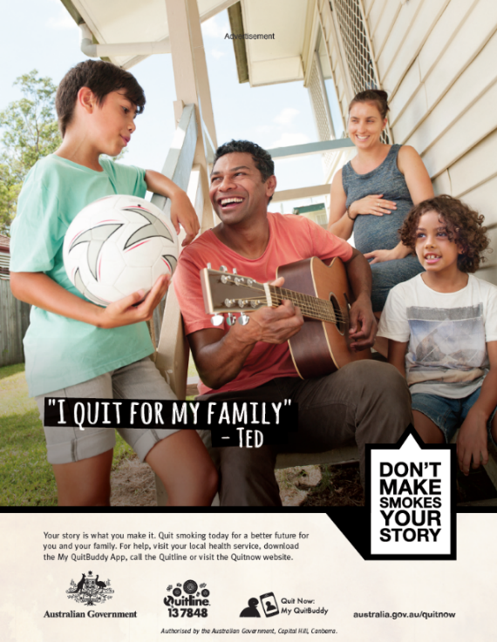

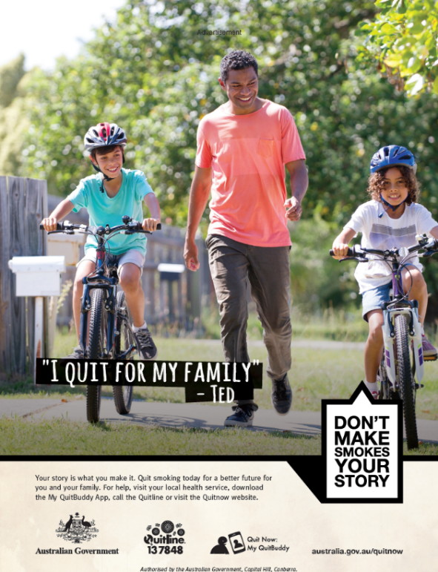

Appendix D: Online Ads

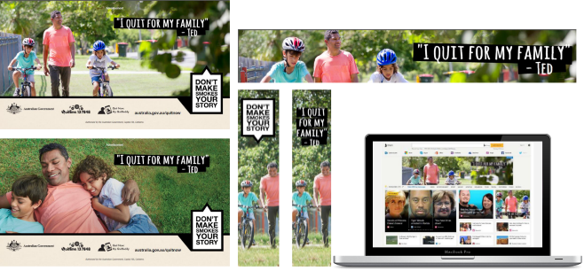

Appendix E: Social Media Ads

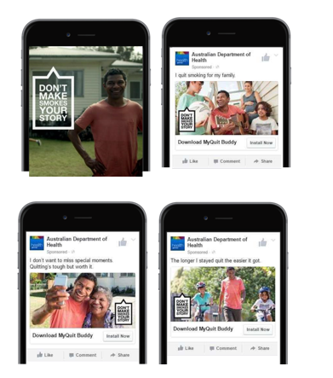

Appendix F: Quit for You, Quit for Two ad

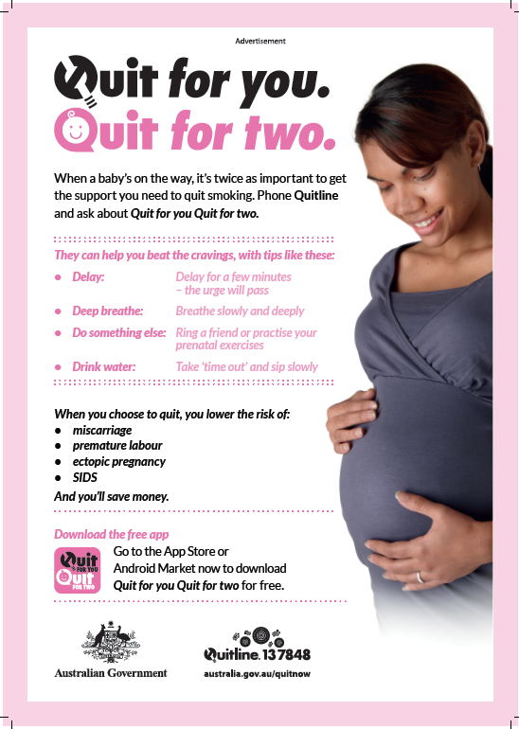

Appendix G: My QuitBuddy app

