National Tobacco Campaign: Indigenous
Evaluation Report on the Don’t Make Smokes Your Story Campaign
Prepared for:
Australian Government Department of Health
Prepared by:
Craig Young
Phone: +61 2 8912 5600
Email: Craig.Young@ORCInternational.com
ORC International Ref: AU3000230
September 2016

Table of Contents
Acknowledgements 4
1 Executive Summary 7
2 Introduction 9
3 Methodology 11
4 Results 16
5 Conclusion 31
Appendix A: Evaluation Questionnaire 32
Appendix B: Don’t Make Smokes Your Story – Print Ads 59
Appendix C: Don’t Make Smokes Your Story – Online Ads 61
Appendix D: Don’t Make Smokes Your Story – Social Media Ads 62

List of Figures
Figure 1: Interviewers by location 5
Figure 2 Benchmark sampling points and sample sizes 12
Figure 3 Evaluation sampling points and sample sizes 13
Figure 4: Respondents’ smoking status 14
Figure 5: Respondents’ Indigenous status 14
Figure 6: Respondents’ gender 15
Figure 7: Respondents’ age 15
Figure 8: In the past 6 months, have you seen or heard any information or ads about the dangers of smoking, or encouraging you to quit smoking? 16
Figure 9: Can you please describe the first ad that comes to mind? Can you please describe the next ad that comes to mind? 17
Figure 10: Have you seen this ad before today (TVC)? 18
Figure 11: Where respondents reported seeing the TVC? 18
Figure 12: Thinking about this ad, to what extent do you agree or disagree it. 19
Figure 13: How much do you agree or disagree that you are getting tired of seeing this ad? 20
Figure 14: Have you heard this ad before today (radio ad)? 20
Figure 15: Have you seen any of these before today (Print ads)? 21
Figure 16: Have you seen any of these before today (online/social media ads)? 22
Figure 17: What would you say were the MAIN things the ads were trying to say to you? 23
Figure 18: Have you seen or heard anything else about the ‘Don’t Make Smokes Your Story’ campaign anywhere such as music festivals, on NITV’s League Nation or at community events or activities? 24
Figure 19: Overall proportion of respondents who reported seeing Don’t Make Smokes Your Story in any form 24
Figure 20: What, if anything, have you done as a result of seeing these ads? 26
Figure 21: Actions taken as a result of exposure to Break the Chain, results from the 2011 Break the Chain evaluation 27
Figure 22: What, if anything, will you do in the next month in response to seeing these ads? 28
Figure 23: Actions planned in the next month as a result of exposure to Break the Chain, results from the 2011 Break the Chain evaluation 29
Figure 24: Have you seen this ad (for both Break the Chain and Quit for You, Quit for Two)? 30
Figure 25: Do you think the ad communicated this message to you? 31
List of Tables
Table 1: Interviewers by location 6

Acknowledgements
ORC International would like to acknowledge our partner organisations operating in Indigenous communities who recruited and interviewed Aboriginal and Torres Strait Islander people on our behalf.
- Butucarbin Aboriginal Corporation, Hebersham and Dubbo
- Bathurst Local Land Council, Bathurst
- Ngwala Willumbong, St Kilda
- Kurbingui Youth Development Association, Zillmere
- Gap Youth and Community Centre, Alice Springs
- The Arnhem Land Progress Aboriginal Corporation, Milingimbi
- Balkanu, Cairns
- Circular Head Aboriginal Corporation, Smithton
- Derbarl Yerrigan Health Service, East Perth
- Tribal Warrior, Redfern
- Kura Yerlo Aboriginal Community Group, Largs Bay
- Mission Australia, Port Augusta
- Lake Tyers Health and Childrens Services, Lakes Entrance
- Bahloo Womens Youth Shelter
- IBN Aboriginal Corporation, Tom Price
- Bilya Noongar Organisation Inc
- Ghymarhl Corporation, Gladstone
- Nai-Beguta Agama Aboriginal Corporation, Bamaga
- WYDAC Learning Centre, Yuendumu
- Australian Red Cross, Port Augusta
- Gippsland & East Gippsland Aboriginal Co-operative, Bairnsdale
Without the generous assistance and advice of these organisations and the individual interviewers, the research would not have been possible. Photographs of some of the interviewers from our partner organisations are shown below in Figure 1 and a complete list of interviewers is shown in Table 1.

Figure 1: Interviewers by location
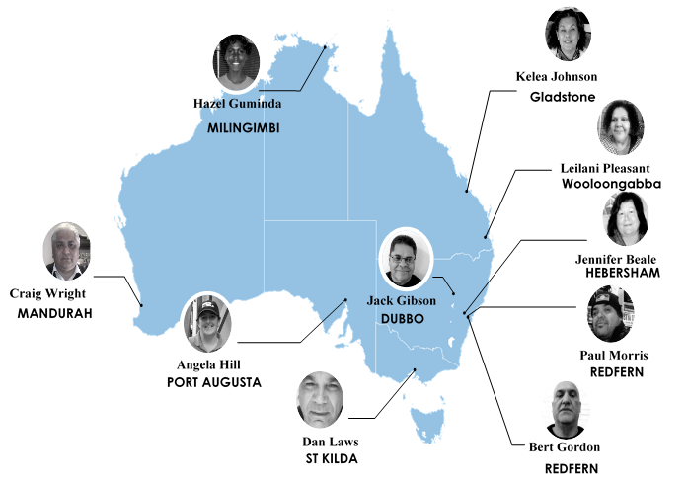

Table 1: Interviewers by location
Location | Interviewer
Redfern, NSW | Paul Morris & Bert Gordon
Hebersham, NSW | Jennifer Beale & Jack Gibson
Dubbo, NSW | Jack Gibson
Bathurst, NSW | Patricia Edwards
St Kilda, VIC | Dan Laws
Lake Entrance, VIC | Kathy So
Zillmere, QLD | Milliana Nuga
Wooloongabba, QLD | Leilani Pleasant
Gladstone, QLD | Kelea Johnson
Cairns, QLD | Imelda Stevens
Bamaga, QLD | Colina Wymarra
Alice Springs, NT | Michelle Krauer
Milingimbi, NT | Hazel Guminda
Yuendumu, NT | Aaron Bradshaw
Largs Bay, SA | Tina Quitadamo
Port Augusta, SA | Angela Hill
Perth, WA | Clint Bussey & Paige Pryor
Tom Price, WA | Karis Drummond
Mandurah, WA | Craig Wright
Smithton, TAS | Rihanna Blakemore

Executive Summary
On 1 May 2016 the Australian Government Department of Health (the department) launched Don’t Make Smokes Your Story - an Indigenous focused anti-smoking campaign.
The campaign contributes to the department’s overall goal of halving Indigenous smoking rates by 2018 (from 44.8% in 2008) and is intended to build on the success of the previous Indigenous focussed anti-smoking campaign Break the Chain. In contrast to previous tobacco campaigns, Don’t Make Smokes Your Story has a positive tone which focuses on the benefits of quitting, rather than just the consequences of smoking.
The aim of the research was to measure the effectiveness of the campaign amongst the target audience: Indigenous smokers and recent quitters aged 15 years and over. Specifically the research aimed to measure awareness of the campaign and quit tools available, as well as smoking behaviours and intentions, resulting from the campaign.

Method
Two rounds of research were conducted amongst the target audience of Aboriginal and Torres Strait Islander current smokers and recent quitters (quit within the last 12 months) aged 15 years and over. An initial benchmark survey (n=201) was completed prior to the launch of Don’t Make Smokes Your Story to provide a baseline of smoking attitudes and behaviours. A follow up evaluation survey (n=310), which is the focus of the present report, was completed following the end of the media buy for the campaign.
Indigenous interviewers were recruited from Indigenous organisations nationally and trained by the research team. These interviewers conducted face to face interviews with respondents from their local community, often with the assistance of the Indigenous organisation.

Results
The research found that 75% of respondents reported being aware of the campaign. This equates to approximately 130,000 of Australia’s 172,200 Indigenous smokers aged 15 years or older. In addition, 59% reported that they had seen the television commercial (TVC), 35% had heard the radio ad and 40% reported seeing the print ads.
Furthermore, 34% reported they had seen the social media/online ads and 28% that they had seen the campaign at a community outreach event, including the National Indigenous Television’s (NITV’s) League Nation sponsorship.
Exposure to the campaign was lower in remote areas (58%) than regional (81%) and urban (80%) areas for all campaign materials and channels.
Diagnostic performance of the TVC was strong, particularly in terms of being regarded as easy to understand (97% of respondents agreed), being believable (90%) and making respondents ‘stop and think’ (84%).
The majority of respondents agreed that the campaign directed them to call the Quitline hotline (71%), visit the Quitnow website (65%) or download the My QuitBuddy app (58%).
Significant behavioural changes have been reported as a direct result of campaign exposure, with 58% of respondents who had seen or heard the campaign reporting they had taken some form of action as a result. Nine percent of respondents reported that they had quit smoking, and 27% reported that they had reduced the amount they smoked. In addition, 26% of respondents exposed to the campaign reported that they intended to quit smoking within the next month, and 30% intended to reduce the amount they smoked.

Conclusion
The results from the research suggest that the campaign delivered a quit smoking campaign that has provoked significant behaviour change among the target audience.
Even allowing for some over-claim on stated intentions, the campaign has generated large numbers of quit attempts among the target audience, and contributed strongly to increased use of support tools (the My QuitBuddy app, Quitnow website and Quitline) which is supported by other reporting tools used by the department. The research suggests that the campaign should be run again in order to capitalise on the possibility of entrenching behaviour change (long-term smoking cessation) among the target audience.

Introduction

Background
On 1 May 2016 the department launched the Indigenous anti-smoking campaign, Don’t Make Smokes Your Story as part of the National Tobacco Campaign (NTC). The objective of the NTC is to help achieve the Council of Australian Governments’ (COAG) goal to halve the Aboriginal and Torres Strait Islander adult daily smoking rate by 2018 (from 44.8% in 2008).
The Australian Bureau of Statistics (ABS) National Aboriginal and Torres Strait Islander Social Survey 2014-15 reported that 39% of Aboriginal and Torres Strait Islander people aged 15 years and over were daily smokers. As a result, these populations in urban, regional and remote locations were the priority audience for this phase of the NTC, Don’t Make Smokes Your Story.
Don’t Make Smokes Your Story is intended to build on the achievements of the previous Indigenous focused Anti-Smoking campaign Break the Chain. The Break the Chain campaign was evaluated using a similar methodology, and achieved strong recognition and recorded an impact on behaviour and intentions.
Don’t Make Smokes Your Story features an Aboriginal man (Ted) reflecting on his experiences of smoking and the benefits of quitting; with a particular focus on spending time with his family. The main TVC concludes with a call to action, which encourages smokers to download the My QuitBuddy app, call the Quitline number, or visit the Quitnow website. In contrast to previous NTC campaigns, Don’t Make Smokes Your Story has a positive tone which focuses on the benefits of quitting, rather than just the consequences of smoking.
The media campaign ran across television (mainstream and Indigenous), radio (regional and Indigenous), print (mainstream and Indigenous advertising), online and social media, and below the line community outreach events, including a feature on the NITV’s League Nation.
The campaign was specifically aimed at smokers, recent quitters and their families.
The key objectives of the campaign were to:
- encourage quit attempts among current smokers and to encourage them to keep trying to quit
- encourage family members and service providers to reinforce the campaign
- drive people to the support resources including the Quitline, the quit smoking apps and the website
- communicate the risks of smoking
- show the benefits of quitting for smokers and their families.
Key campaign material can be found in appendices B, C and D.
The department commissioned independent research agency ORC International to conduct a benchmark and evaluation survey to assess the effectiveness of the campaign among Aboriginal and Torres Strait Islander people in urban, regional and remote locations.

Research Objectives
An initial benchmark survey was conducted prior to the launch of the campaign to obtain a baseline measure of knowledge, attitudes, beliefs, behaviours and intentions in relation to smoking and quitting.
The follow up evaluation described in this report aimed to measure the effectiveness of the campaign among the target audience against the campaign’s objectives.
Specifically the research aimed to measure:
- level of campaign awareness
- awareness of the support tools available to help quit smoking
- increased quit attempts, attributed to exposure to campaign messages
- intention for target groups to quit or stay quit
- campaign wear out, providing recommendations for future use of Don’t Make Smokes Your Story.

About this report
This report focuses on the campaign measures assessed in the evaluation survey.
Response options which were not selected by any respondents are not included in the report. Therefore, if a response is reported at 0%, this indicates that some respondents did select the response, but the result was less than 0.5% and so has been rounded down.
Totals for questions with single-response answers may not add to 100% due to rounding. Multiple-response items may add to more than 100% due to respondents selecting multiple response codes.
Sample sizes may vary between questions, either because the question was only asked of specific respondents, or because some respondents may not have answered a particular question.
Some sections and questions reported on have a small sample size – these findings should be interpreted with caution.

Methodology
The project was carried out in compliance with ISO 20252 and membership requirements for AMSRO (The Association of Market and Social Research Organisations) and AMSRS (The Australian Market and Social Research Society).

Dates of fieldwork
The evaluation round (n=310), which is the focus of the current report, was conducted from 20 June to 12 August, following the end of the paid media buy for the campaign.

Community engagement and recruitment
In conducting the research, ORC International sought to engage in an appropriate way with Indigenous communities, to meet the research objectives while at the same being sensitive to local needs and protocols and aiding in local capacity building. To conduct the research fieldwork, ORC International worked closely with our local Indigenous community organisation partners in each community who provided advice on local protocols and practices, as well as recommending appropriate interviewing personnel and providing logistical support. The use of commercial market research fieldwork companies was eschewed in favour of using Indigenous interviewers recruited from our partner organisations and trained in basic interviewing techniques by the ORC International research team, using a mixture of face-to-face, skype and telephone training.
These interviewers conducted face to face interviews with respondents from their local community, with administrative and logistical support (such as a venue to conduct interviews in) provided by the local Indigenous organisation.
Interviews were conducted using hard copy questionnaires but tablets were used to show campaign materials to ensure correct recall measures.
ORC paid community organisations for their participation and support of the research, and paid interviewers for the interviewing work done as well as for attending training on market research techniques and briefing on the questionnaire.
All survey respondents were paid for their participation, with the amount and form of incentives based on the advice of our partner organisations.
Across the research program, 28 individuals were provided with market research training and casual employment and over $90,000 was paid to Indigenous organisations and individuals.

Sampling points
A national sample design was constructed with geographic stratification in proportion to the Indigenous population in urban, regional and remote locations in each state or territory.
Where possible the same interviewers and locations were used for the benchmark and the evaluation round. Respondents who had been interviewed for the benchmark survey were not eligible for re-interview for the evaluation survey. Due to time constraints for the benchmark fieldwork, there were fewer sampling points and interviews conducted than for the evaluation round. For the benchmark survey, interviews were conducted across 13 different locations, and the evaluation was conducted across 20 locations.
The sampling points and sample sizes for each location for the benchmark and evaluation round are shown below in Figure 2 and Figure 3. The collective evaluation sample size for urban areas was 115, 136 for regional areas and 59 for remote areas.
Figure 2 Benchmark sampling points and sample sizes
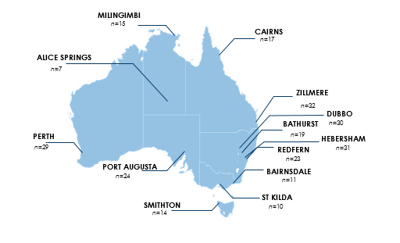
Figure 3 Evaluation sampling points and sample sizes
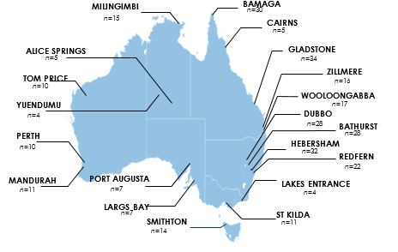

Questionnaire Development
A draft pen and paper questionnaire was developed by ORC International. The questionnaire drew on the questions used for the 2011 evaluation of Break the Chain. The questionnaire was reviewed by the department before being finalised.
While interviewing was conducted using hard copy questionnaires, tablets were used during the evaluation survey in order to show respondents the TVC, radio, print and social media/ online ads.

Data weighting
The data for smokers was weighted by age, gender, state and geographical remoteness, to represent the national Indigenous smoker population aged 15 years and over. The weights were calculated with rim weighting using three sets of smoker population totals: (1) Age x gender; (2) State/territory; and (3) Region (defined by Main cities; Regional; and Remote). Estimates of Indigenous smokers for these classifications were obtained from the ABS publication 4714.0 National Aboriginal and Torres Strait Islander Social Survey, Australia, 2014–15, released on Thursday 28 April, 2016. The smoker weights were scaled so that the sum of the weights equalled the smoker sample size. The data for recent quitters were all given a weight of 1, as no suitable population data for recent quitters was available for weighting.

Sample Profile
As shown in Figure 4 the majority of the sample (79%) were daily smokers, 9% being weekly smokers (both classified as current smokers) and the remaining 12% had quit smoking within the previous 12 months, and were classified as recent quitters. The primary target audience for Don’t Make Smokes Your Story was Indigenous smokers and recent quitters aged 15 years and over, and therefore the sample was intentionally focussed on this segment.
Figure 4: Respondents’ smoking status
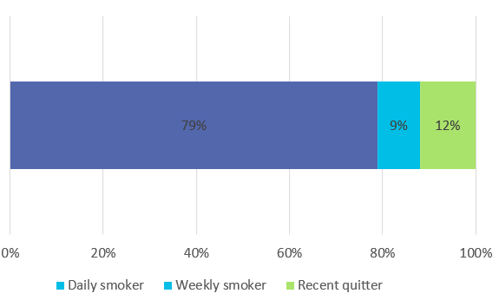
Base: All respondents (n=310), percentages are unweighted
As shown in Figure 5, the majority of respondents identified as being Aboriginal (85%), with a further 4% identifying as Torres Strait Islanders and 11% reporting as both.
Figure 5: Respondents’ Indigenous status
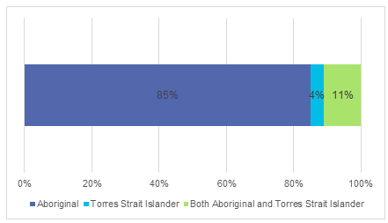
Base: All respondents (n=310), percentages are unweighted
As shown in Figure 6, the sample consisted of more females (57%) than males (43%).
Figure 6: Respondents’ gender
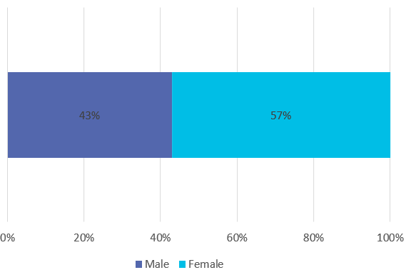
Base: All respondents (n=310), percentages are unweighted
As shown in Figure 7, 11% of respondents were aged 15 to 17 years old, 55% were 18 to 40 years old, and 34% were aged 41 years or older. The primary target audience of Don’t Make Smokes Your Story was Indigenous smokers and recent quitters aged 15 years and over, and therefore the sample deliberately targeted this segment.
Figure 7: Respondents’ age
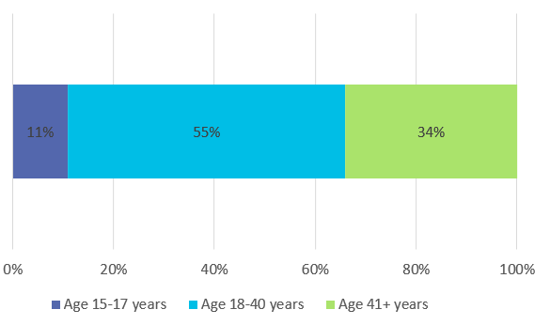
Base: All respondents (n=310), percentages are unweighted

Results

Campaign Awareness and Outcomes
Respondents were asked whether they had seen or heard any advertisements about the dangers of smoking, and to describe the first two advertisements that came to mind. As shown below in Figure 8, just over three-quarters of respondents (78%) reported having seen or heard information or ads about the dangers of smoking, or encouraging them to quit smoking, in the past 6 months. The proportion of respondents who reported being exposed to quit smoking material increased with age, from 65% of 15 to 17 year olds, to 75% of 18 to 40 year olds, and 85% of those aged 41 years and over.
Significantly fewer respondents from remote areas (57%), reported being exposed to quit smoking material compared to those from urban (81%) or regional areas (87%).
Figure 8: In the past 6 months, have you seen or heard any information or ads about the dangers of smoking, or encouraging you to quit smoking?
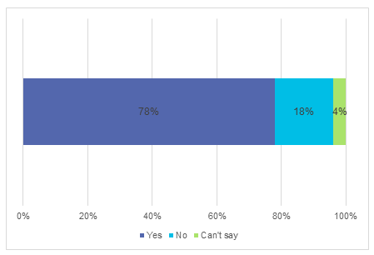
Base: All respondents (n=310)
As illustrated in Figure 9, cigarette packet warnings were the most common spontaneously recalled source of quit smoking advertising (28%). This was followed by the Break the Chain campaign (22%) which was being aired again at the same period as Don’t Make Smokes Your Story. The Don’t Make Smokes Your Story campaign was spontaneously recalled by 9% of respondents.
Figure 9: Can you please describe the first ad that comes to mind? Can you please describe the next ad that comes to mind?
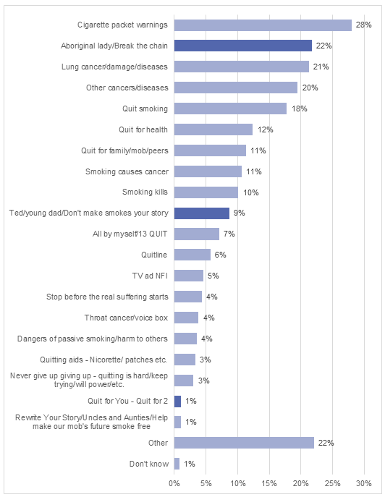
Base: Respondents who reported seeing or hearing information about the dangers of smoking in the past 6 months (n=237)

Don’t Make Smokes Your Story Prompted Recall
The Don’t Make Smokes Your Story TVC was played to all respondents, who were then asked if they had seen it before. Figure 10 shows that 59% of respondents reported having seen the TVC, with Figure 11 showing that the majority saw it on TV only (48%), 2% saw it online, 6% saw it on TV as well as online and 3% reporting having seen it but could not recall where. Significantly fewer respondents from remote areas reported seeing the TVC (40%) compared to those from urban and regional areas (both 66%).
Figure 10: Have you seen this ad before today (TVC)?
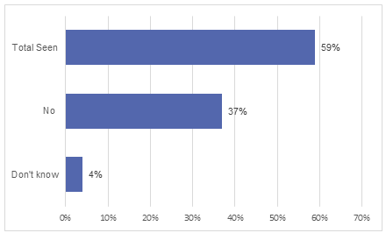
Base: All respondents (n=309)
Figure 11: Where respondents reported seeing the TVC?
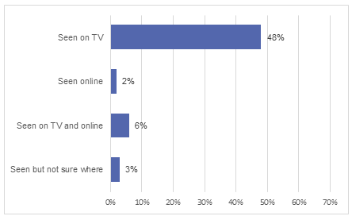
Base: Respondents who reported seeing the TVC (n=182)
Respondents who reported seeing the TVC (n=185) were asked whether they agreed or disagreed with various statements about the ad. As shown in Figure 12, 97% of respondents agreed that the ad was easy to understand, and 90% that the ad was believable. Eighty-four percent of respondents agreed that the ad made them stop and think, 78% that it made them feel worried about their smoking, and 71% that it made them more likely to quit/ stay quit. Seventy-one percent agreed that the ad made them feel hopeful, 63% that it made them feel inspired, and 60% that it made them feel empowered to quit/stay quit. The statements with the lowest level of agreement were that ‘the ad taught me something new’ (50%) and that ‘the ad made me feel uncomfortable’ (41%).
Figure 12: Thinking about this ad, to what extent do you agree or disagree it.
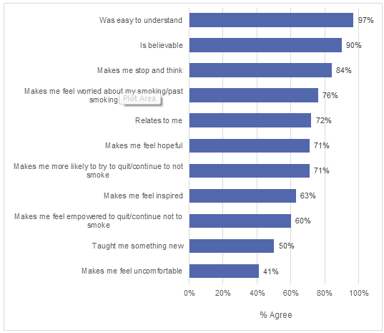
Base: Respondents who reported they had seen the Don’t Make Smokes Your Story TVC (n=184-185)
To assess ‘wear out’ (getting sick of seeing the ad), respondents who recognised the TVC were asked if they agreed or disagreed that they were getting tired of seeing the ad. As shown in Figure 13, 23% of respondents agreed with this contention. Further analysis showed that significantly fewer respondents from urban areas agreed that they were tired of seeing the TVC (15%) than those from regional and remote areas (28%).
Figure 13: How much do you agree or disagree that you are getting tired of seeing this ad?
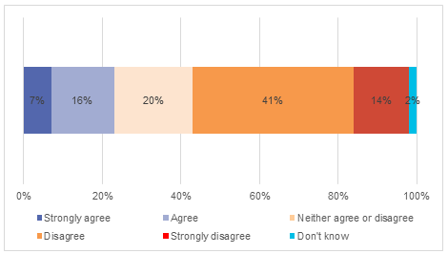
Base: Respondents who reported they had seen the Don’t Make Smokes Your Story TVC (n=185)
The radio ad was played for all respondents, who were then asked if they had heard it before. As shown in Figure 14, just over one third of respondents (35%) reported having heard the ad, 64% reported not hearing it, and 2% did not know. Similar to the TVC, significantly fewer respondents from remote areas reported hearing the radio ad (17%) compared to those from urban (37%) or regional areas (43%).
Figure 14: Have you heard this ad before today (radio ad)?
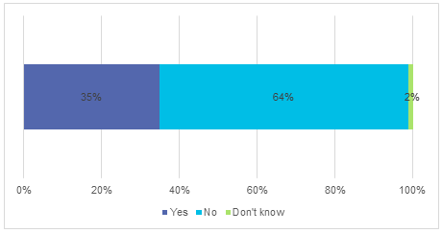
Base: All respondents (n=308)
Respondents were then shown the Don’t Make Smokes Your Story print ads and asked if they had seen any of them before (see Appendix B for print ads displayed). As shown in Figure 15, 40% of respondents reported seeing the ads, with 20% having seen them in an out of home poster or billboard, 12% in a magazine or newspaper, and 8% who had seen them but weren’t sure where. As with the TVC and radio ad, significantly fewer respondents from remote areas reported seeing the print ads (24%) than those from urban (44%) or regional areas (46%).
Figure 15: Have you seen any of these before today (Print ads)?
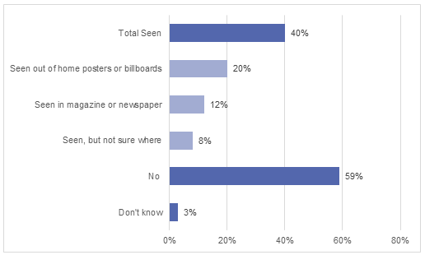
Base: All respondents (n=308)
Respondents were shown images from Don’t Make Smokes Your Story online and social media ads and asked if they had seen them before (see appendices C and D for ads displayed). As shown in Figure 16, 34% of respondents reported seeing the ads, with 18% having seen them on social media, 7% online and 8% having seen them, but weren’t sure where. As with the campaign material described above, significantly fewer respondents from remote areas reported seeing the ads (15%) compared to those from urban (40%) or regional areas (41%).
Figure 16: Have you seen any of these before today (online/social media ads)?
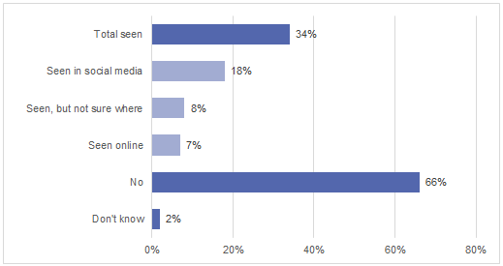
Base: All respondents (n=310)
Respondents who reported having seen or heard any of the campaign material were asked what they thought were the key messages of the ads. This was an open question to which respondents could answer multiple responses to. As shown in Figure 17, the most commonly cited key messages were ‘trying to get them to quit smoking’ (44%) followed by ‘you should quit for your kids/family’ (40%), and quitting has health benefits (33%).
Figure 17: What would you say were the MAIN things the ads were trying to say to you?
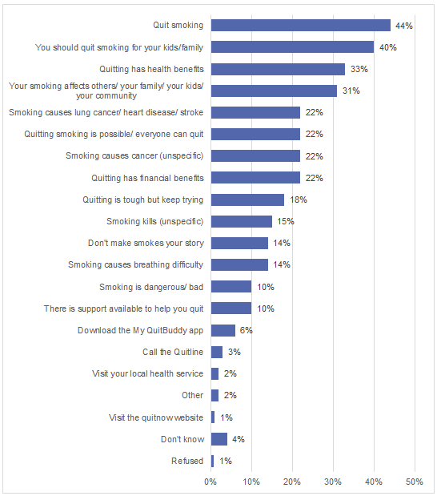
Base: Respondents who had reported seeing any Don’t Make Smokes Your Story ads (n=222)
To assess exposure to Don’t Make Smokes Your Story at community outreach programs and events, respondents were asked if they had seen or heard anything else about Don’t Make Smokes Your Story at community events (including NITV’s League Nation). As shown in Figure 18, 28% of respondents reported seeing Don’t Make Smokes Your Story somewhere else. Consistent with the previous material described earlier, significantly fewer respondents from remote areas reported seeing the campaign at these events (13%) compared to those from urban (38%) and regional areas (29%).
Figure 18: Have you seen or heard anything else about the ‘Don’t Make Smokes Your Story’ campaign anywhere such as music festivals, on NITV’s League Nation or at community events or activities?
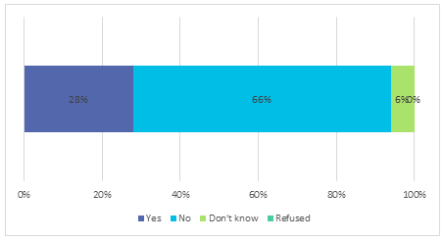
Base: All respondents (n=309)
As shown in Figure 19, three quarters of all respondents (75%) reported seeing or hearing Don’t Make Smokes Your Story in some form, with the TVC being the most commonly seen (59%). Overall, significantly fewer respondents from remote areas reported having seen the campaign in any form (58%), than those from regional (81%) and urban areas (80%). Exposure varied based on age, with 83% of respondents aged 41 years and older reporting hearing or seeing the campaign in some form, 78% of respondents aged 15 to 17, and 69% of respondents aged 18 to 40.
Figure 19: Overall proportion of respondents who reported seeing Don’t Make Smokes Your Story in any form
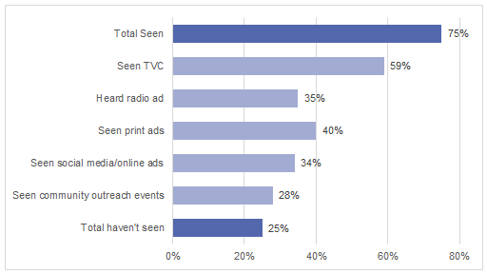
Base: All respondents (n=310)

Campaign Impact
Respondents who reported seeing or hearing any of the Don’t Make Smokes Your Story campaign material (n=237) were asked what, if anything, they had done as a result of seeing these ads. This was an open response question and multiple responses were accepted. As shown in Figure 20, the most commonly cited actions were ‘cutting down the amount they smoke’ (27%), ‘discussing smoking and health with family/friends’ (20%) and ‘quit smoking’ (9%). Thirty-four percent of respondents reported they had done nothing and 7% did not know. By way of comparison, Figure 21, shows the results of the same question from the Break the Chain 2011 evaluation. Comparison of the results from the two surveys shows that the four most commonly cited actions were the same for both campaigns. However a higher proportion of respondents exposed to Don’t Make Smokes Your Story reported taking action of some kind as a result of being exposed to the campaign (58%) compared to Break the Chain (48%).
Figure 20: What, if anything, have you done as a result of seeing these ads?
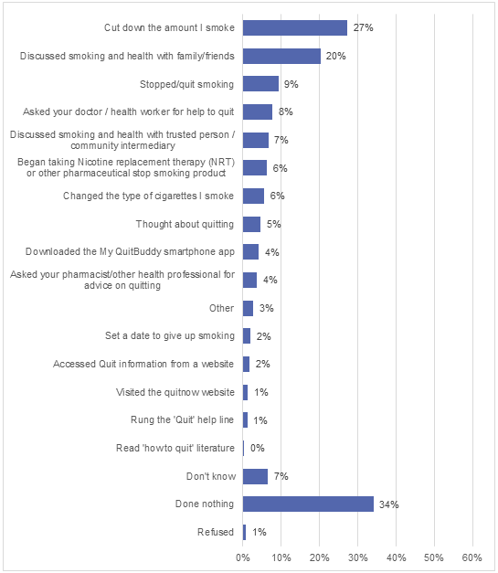
Base: Respondents who had reported seeing any Don’t Make Smokes Your Story ads (n=237)
Figure 21: Actions taken as a result of exposure to Break the Chain, results from the 2011 Break the Chain evaluation
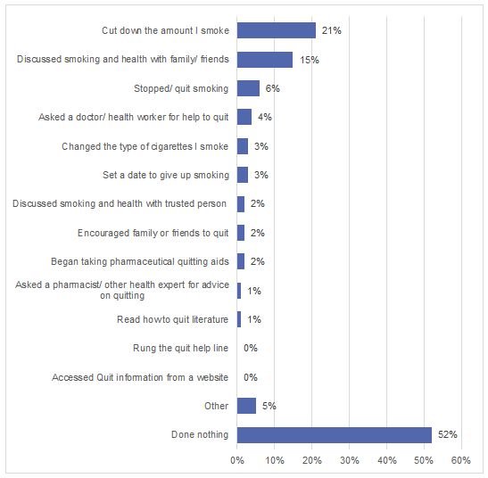
Base: Respondents exposed to any Break the Chain ads from the 2011 evaluation (n=302)

Respondents who reported seeing or hearing any Don’t Make Smokes Your Story campaign material were asked what, if anything, they will do in the next month in response to seeing the ads. As shown in Figure 22, the most commonly cited intentions were ‘reduce the quantity of cigarettes they smoke’ (30%), ‘quit smoking’ (26%) and ‘discuss smoking and health with others’ (19%). Seventeen percent of respondents reported no intentions and 11% did not know. Figure 23, shows the results of the same question from the 2011 evaluation of Break the Chain 2011. As with the results for actions already taken, the four most commonly cited intentions were consistent for both campaigns. Again, a higher proportion of respondents exposed to Don’t Make Smokes Your Story reported the intention to take some action (72%) compared to those exposed to Break the Chain in the 2011 evaluation (50%).
Figure 22: What, if anything, will you do in the next month in response to seeing these ads?
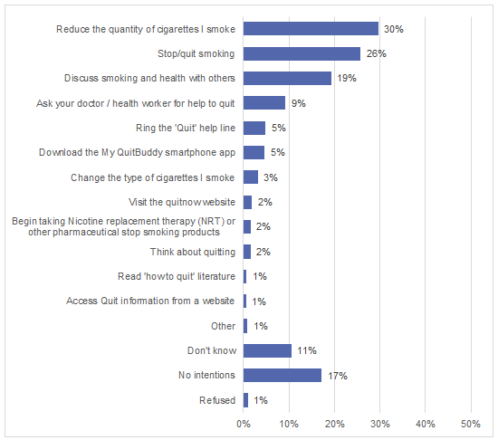
Base: Respondents exposed to any Don’t Make Smokes Your Story ads (n=237)

Figure 23: Actions planned in the next month as a result of exposure to Break the Chain, results from the 2011 Break the Chain evaluation
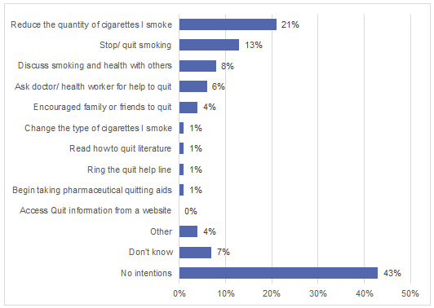
Base: Respondents exposed to any Break the Chain ads from the 2011 evaluation (n=302)

In order to obtain a read on the level of exposure to other campaigns, respondents were shown key images from the Break the Chain and Quit for You, Quit for Two TV ads and asked if they had previously seen them. As shown in Figure 24, just under two thirds of respondents reported seeing Break the Chain (65%) and 38% reported seeing Quit for You, Quit for Two. Respondents from regional areas were more likely to report exposure to the Break the Chain campaign (79% compared with 67% from urban and 39% from remote areas). There were no significant differences by geography in terms of exposure to Quit for You, Quit for Two.
Figure 24: Have you seen this ad (for both Break the Chain and Quit for You, Quit for Two)?
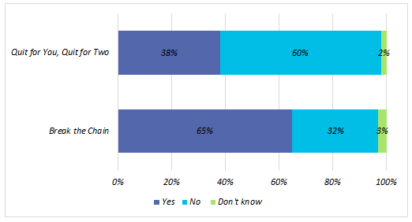
Base: All respondents (n=308-309)

Respondents who reported being exposed to any Don’t Make Smokes Your Story, Break the Chain or Quit for You, Quit for Two ads, were asked if the campaigns communicated a number of messages (listed in Figure 25). As shown in Figure 25, the messages that respondents most commonly felt were communicated to them were ‘you can quit smoking for a better future for you and your family’ (97%), ‘smoking affects others’ (96%) and ‘there is support available to help you quit’ (94%). Less resonant were messages around the quit tools available, these being ‘call the quitline’ (71%) ‘visit the Quitnow website’ (65%) and ‘download the MyQuitBuddy app’ (58%).
Figure 25: Do you think the ad communicated this message to you?
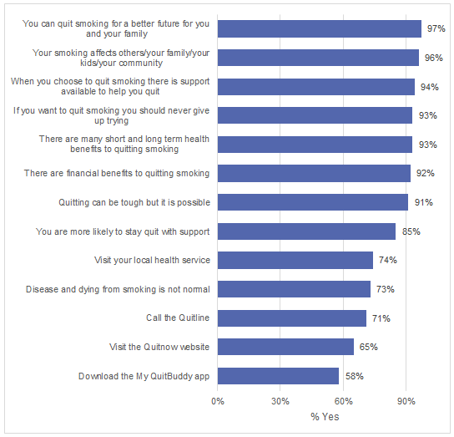
Base: Recognised any of the Don’t Make Smokes Your Story, Break the chain or Quit for You, Quit for Two ads (n=269-273)

Conclusion
The evaluation research suggests that the Don’t Make Smokes Your Story campaign has delivered against all key campaign objectives.
Seventy-five percent of the target audience of Indigenous smokers aged 15 years and over, reported being aware of the campaign. This is a similar total reach to that achieved by the Break the Chain campaign when initially launched. In terms of the reach of individual channels, the results demonstrate the effectiveness of an integrated multi-channel strategy, with the TVC having a total reach of 59%, radio 35%, print 40%, online 34% (including 18% specifically on social media) and community events (including NITV’s League Nation) 28%.
The diagnostic performance of the TVC was very strong. In particular, it was regarded as being easy to understand (by 97% of respondents), being believable (90%) and ‘making me stop and think’ (84%). More than 70% of respondents felt that the TVC related to them, made them worry about their smoking, and would make them more likely to quit/stay quit. Importantly, the TVC has successfully encouraged smokers in a non-judgemental, positive way, with 71% of smokers saying the TVC ‘made me feel hopeful’, 63% saying it made them feel inspired, and 60% saying it made them feel empowered to quit.
The campaign was effective in conveying messaging to direct smokers to the quit smoking support tools, with a significant majority of respondents agreeing that the campaign directed them to call the Quitline (71%), visit the Quitnow website (65%) and download the My QuitBuddy app (58%).
In terms of generating behaviour change, the campaign must be regarded at this stage as being highly effective, with 58% of respondents exposed reporting they had taken some form of action. Nearly one in ten (9%) Indigenous smokers exposed to the campaign reported that they had quit as a result of the campaign, and 27% said they had reduced the amount they smoke. Substantial proportions of Indigenous smokers said they had discussed smoking/quitting with family or friends (20%), or with a doctor (8%) or health intermediary (7%). Stated future intentions to change smoking behaviour were also very high.
TVC ‘wear out’ (those reporting that they were getting sick of seeing the ad) was an acceptable 23%, though this should be monitored closely if the campaign is re-run. Wear out against mainstream audiences should also be measured.
In summary, the campaign has delivered on the objective of creating a quit smoking campaign with a positive tone, provoking significant behaviour change in the target audience.
Even allowing for some over-claim on stated intentions, the campaign has generated large numbers of quit attempts among the target audience, and contributed strongly to increased use of support tools (the My QuitBuddy app and Quitnow website) which is supported by the department’s own internal data. The research suggests that the campaign should be run again in order to capitalise on the possibility of entrenching behaviour change (long-term smoking cessation) among the target audience.

Appendix A: Evaluation Questionnaire
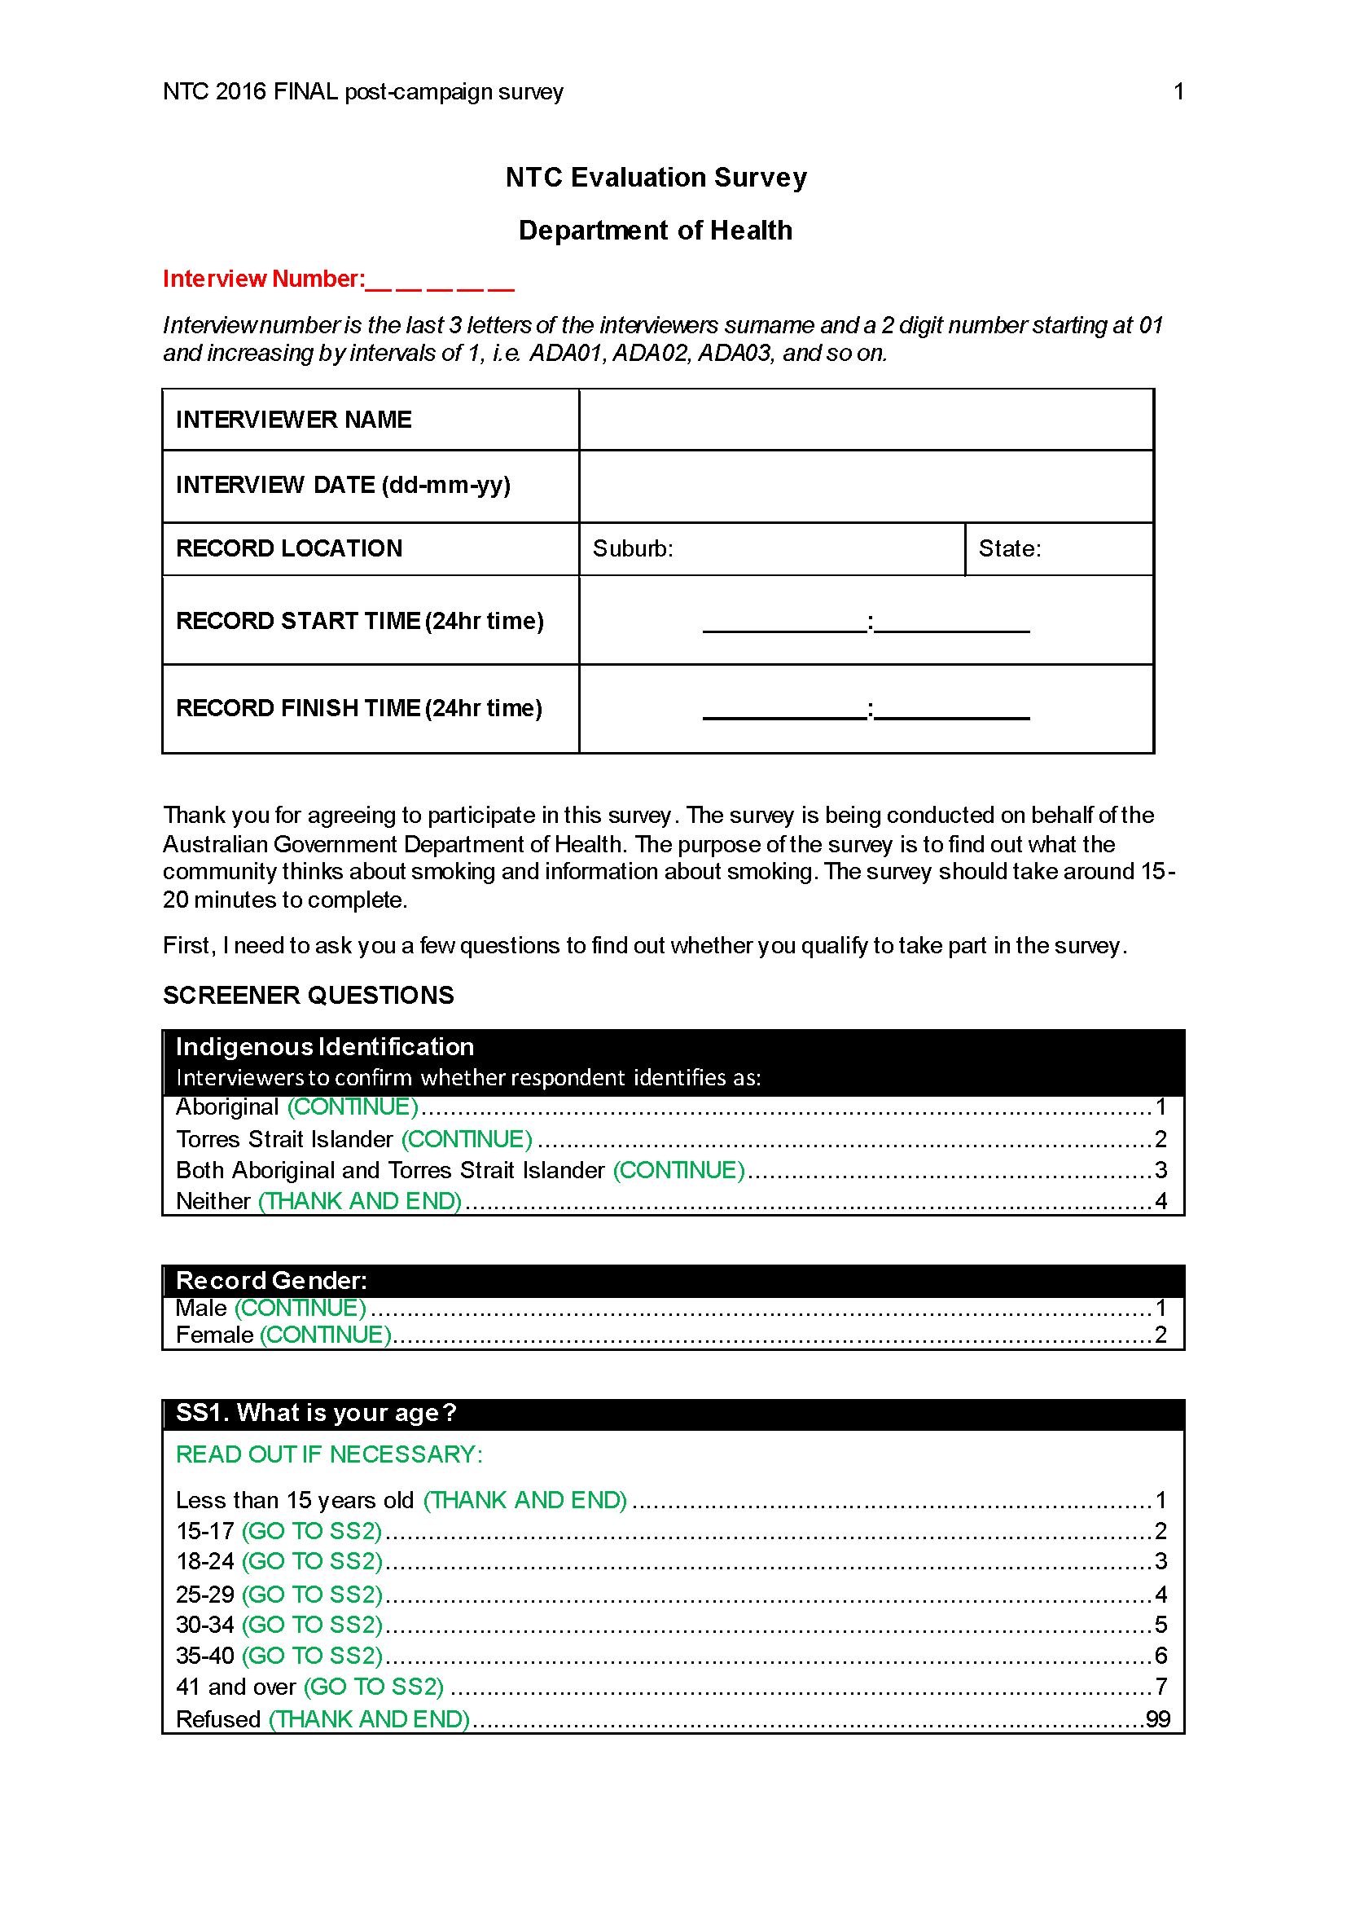

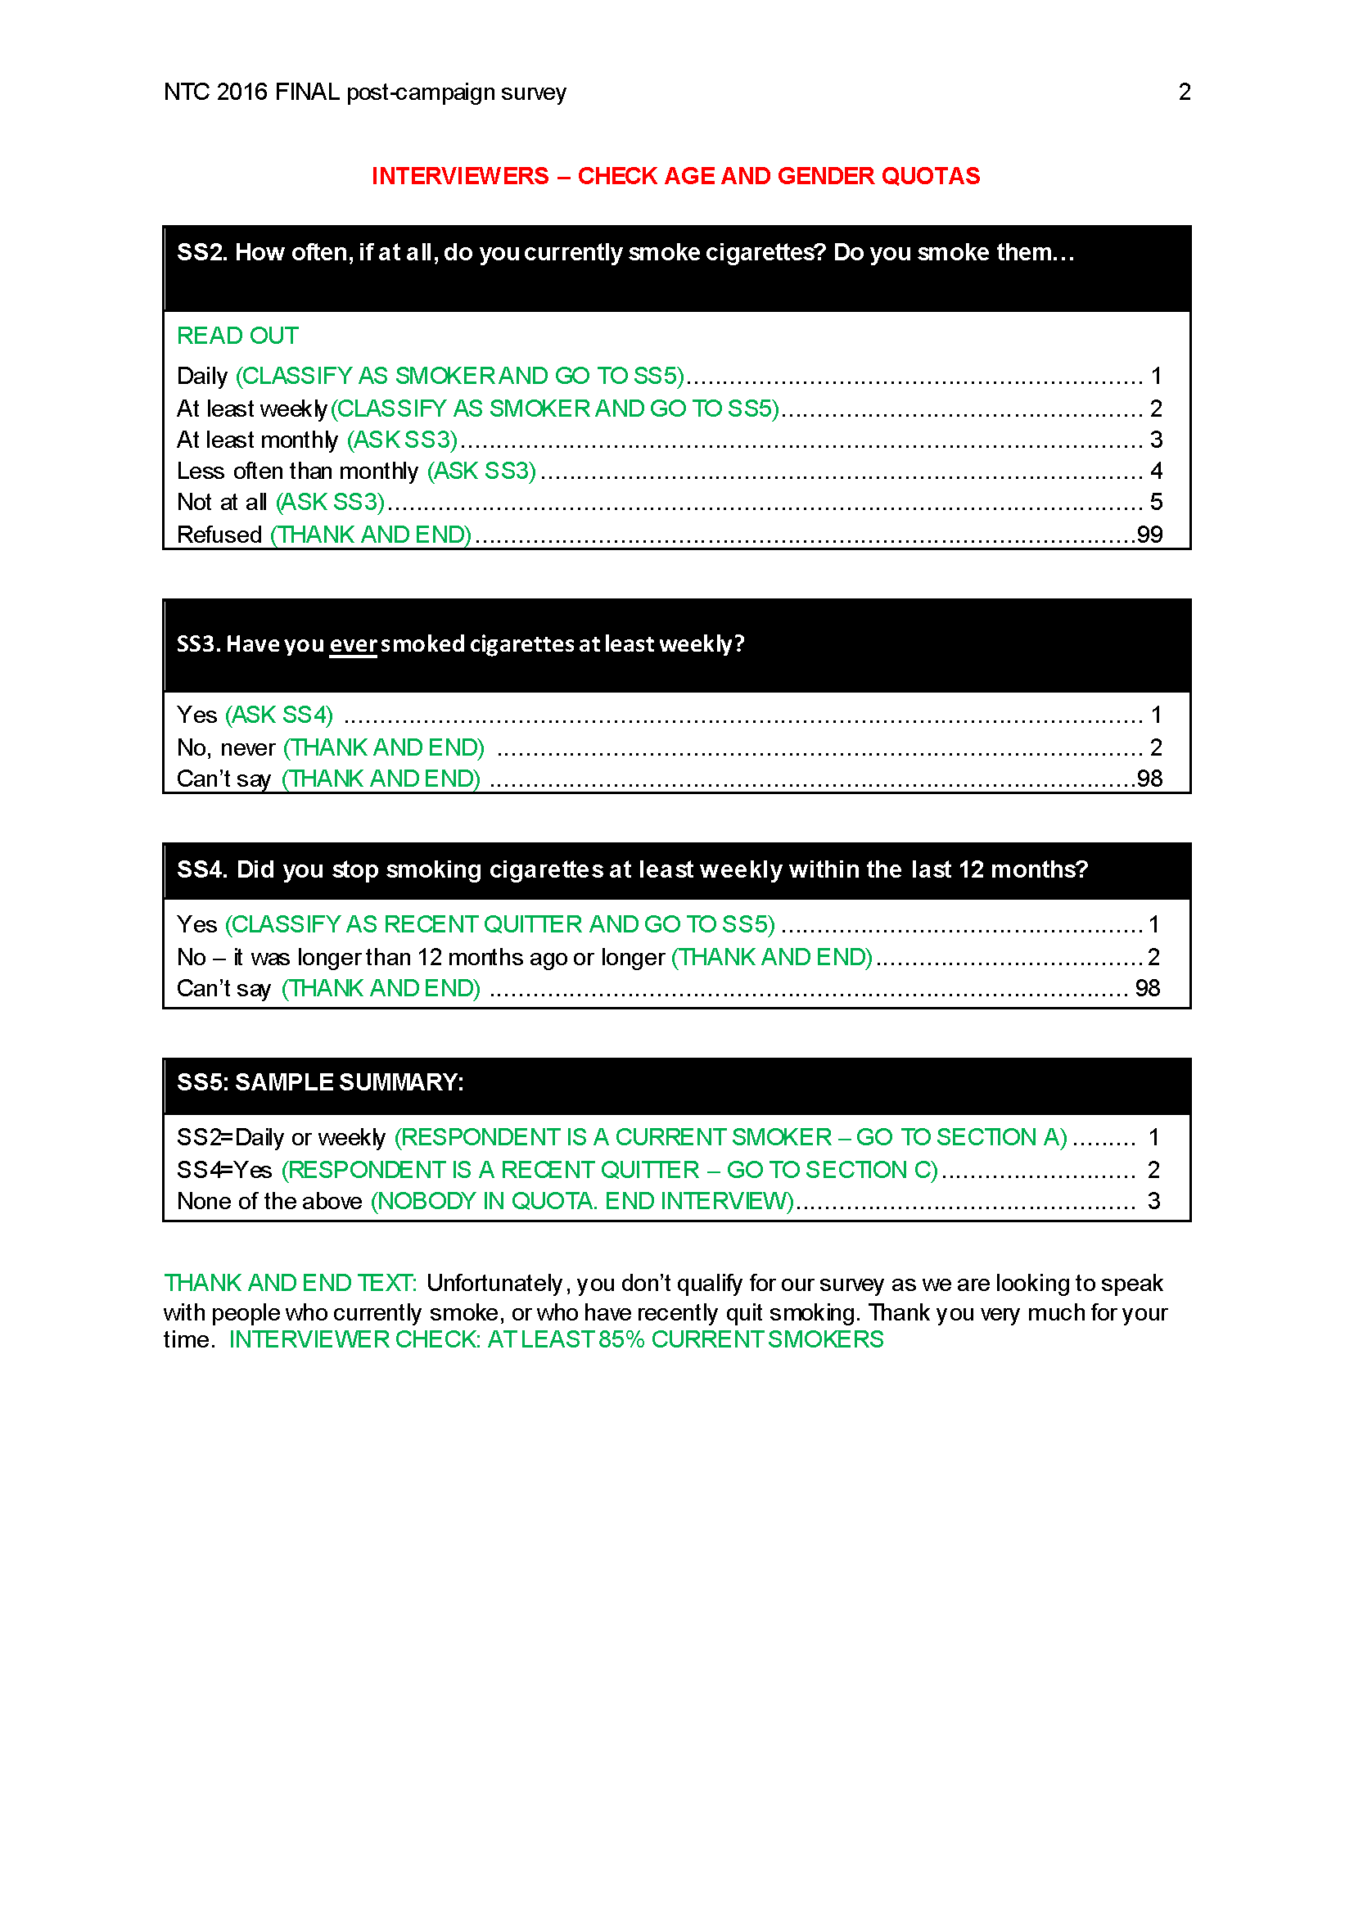

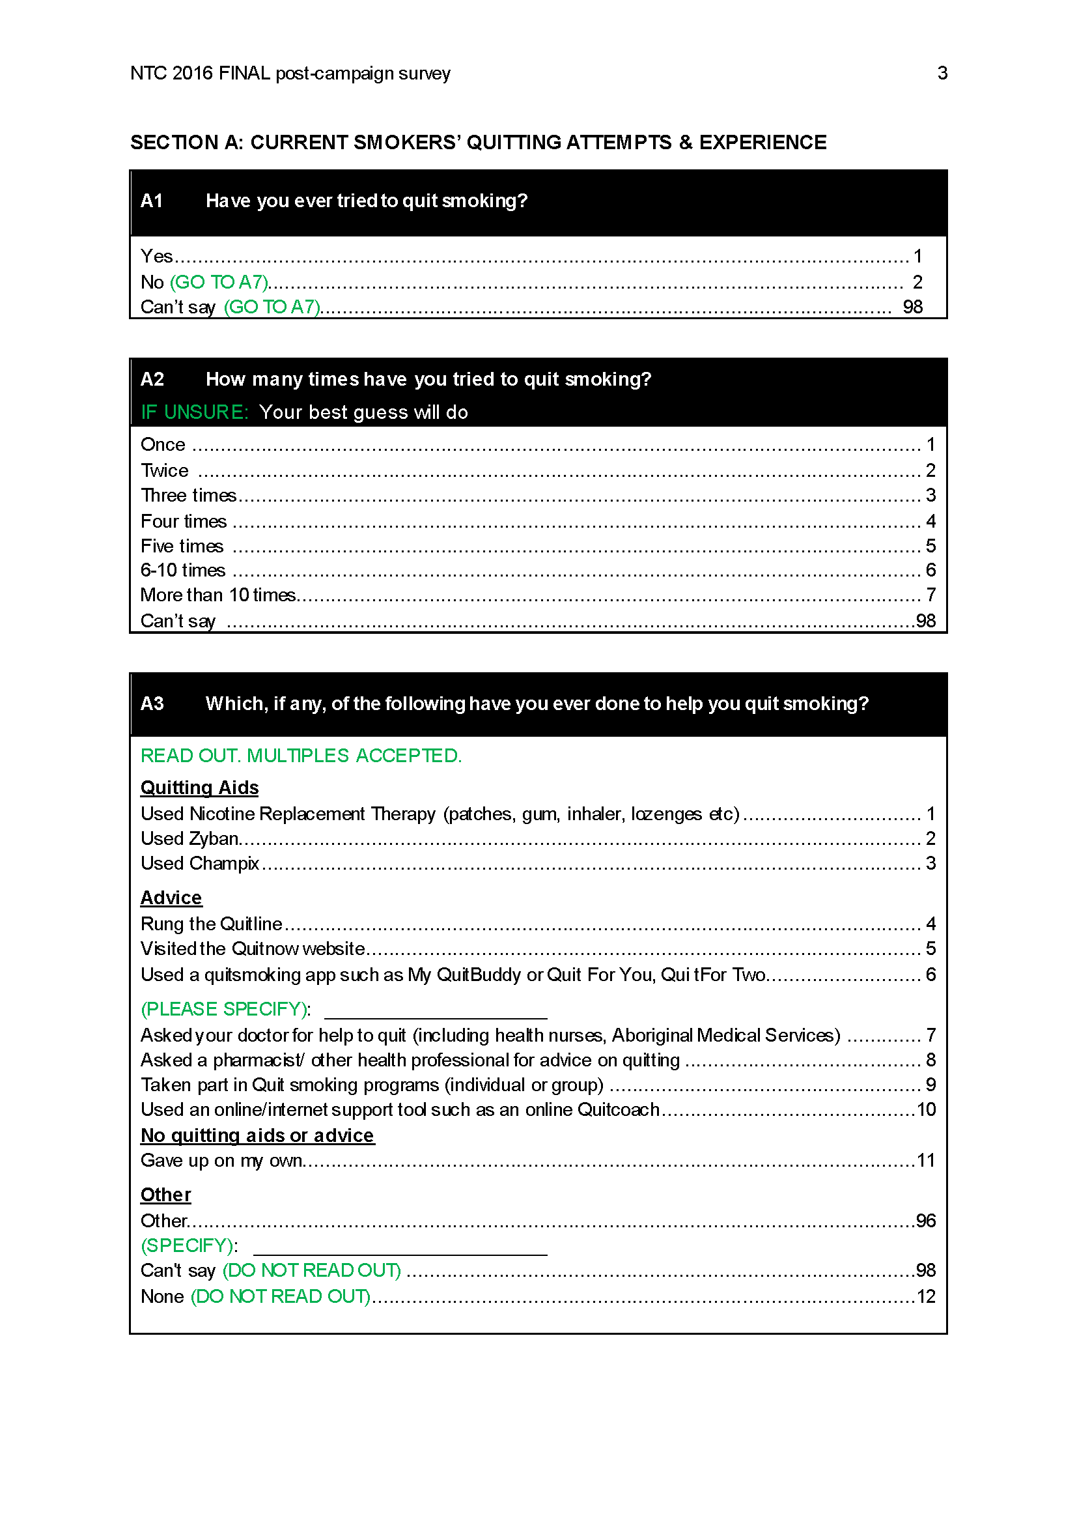

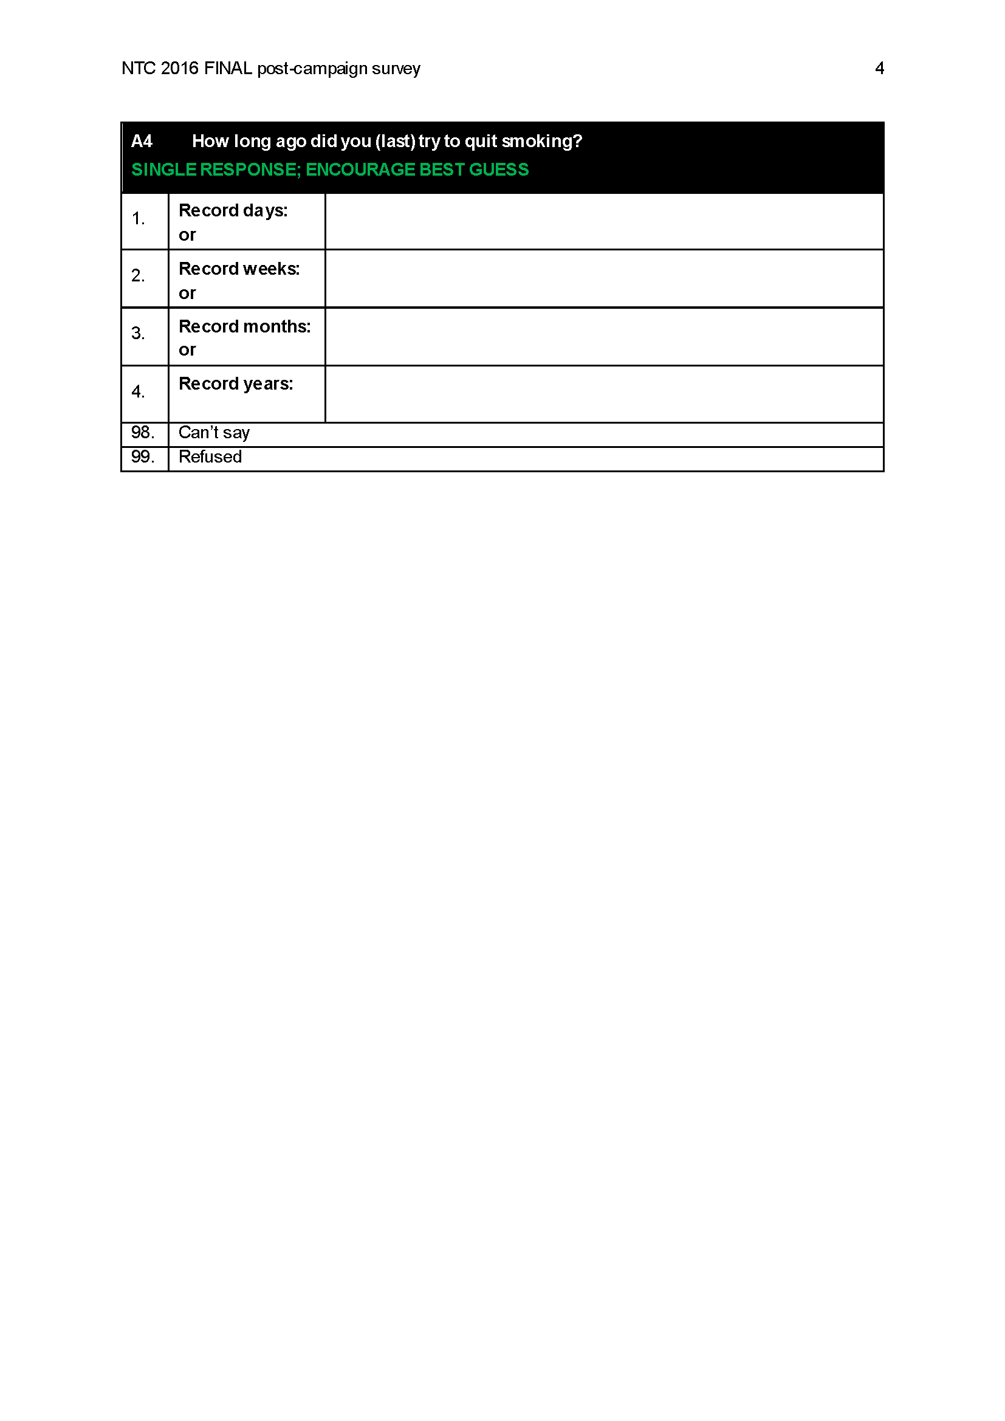

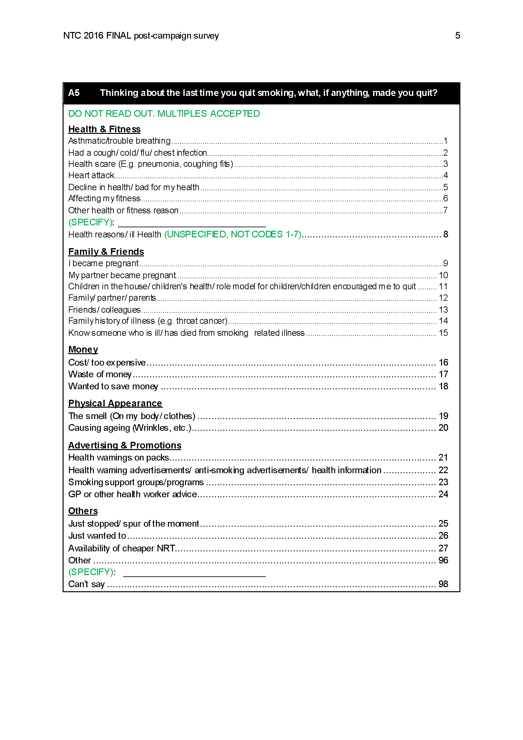

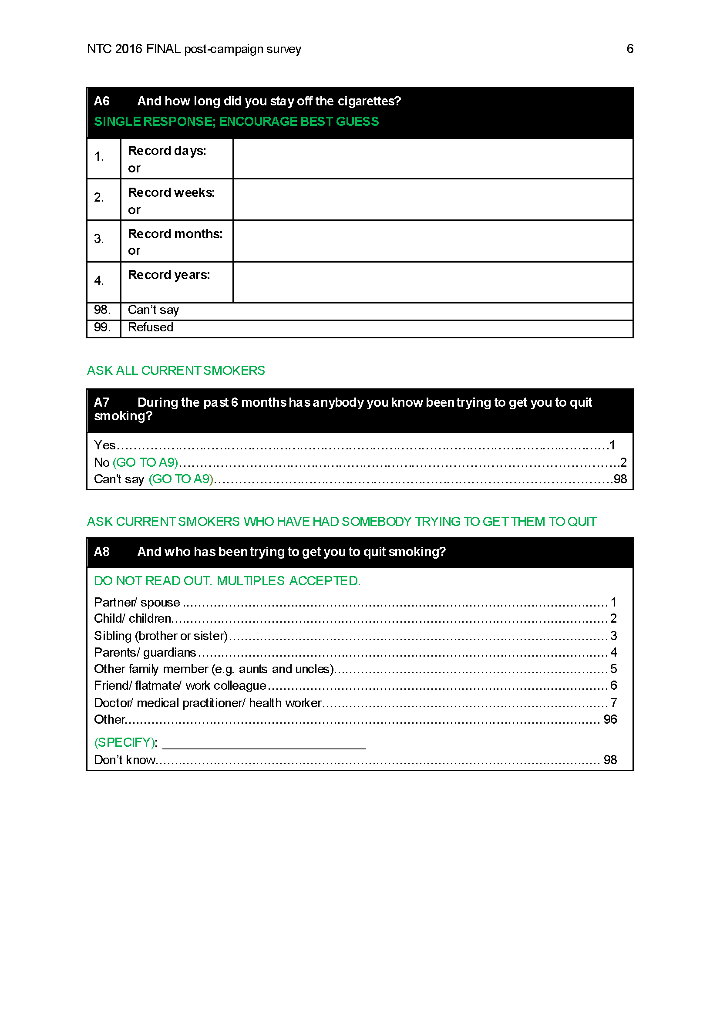

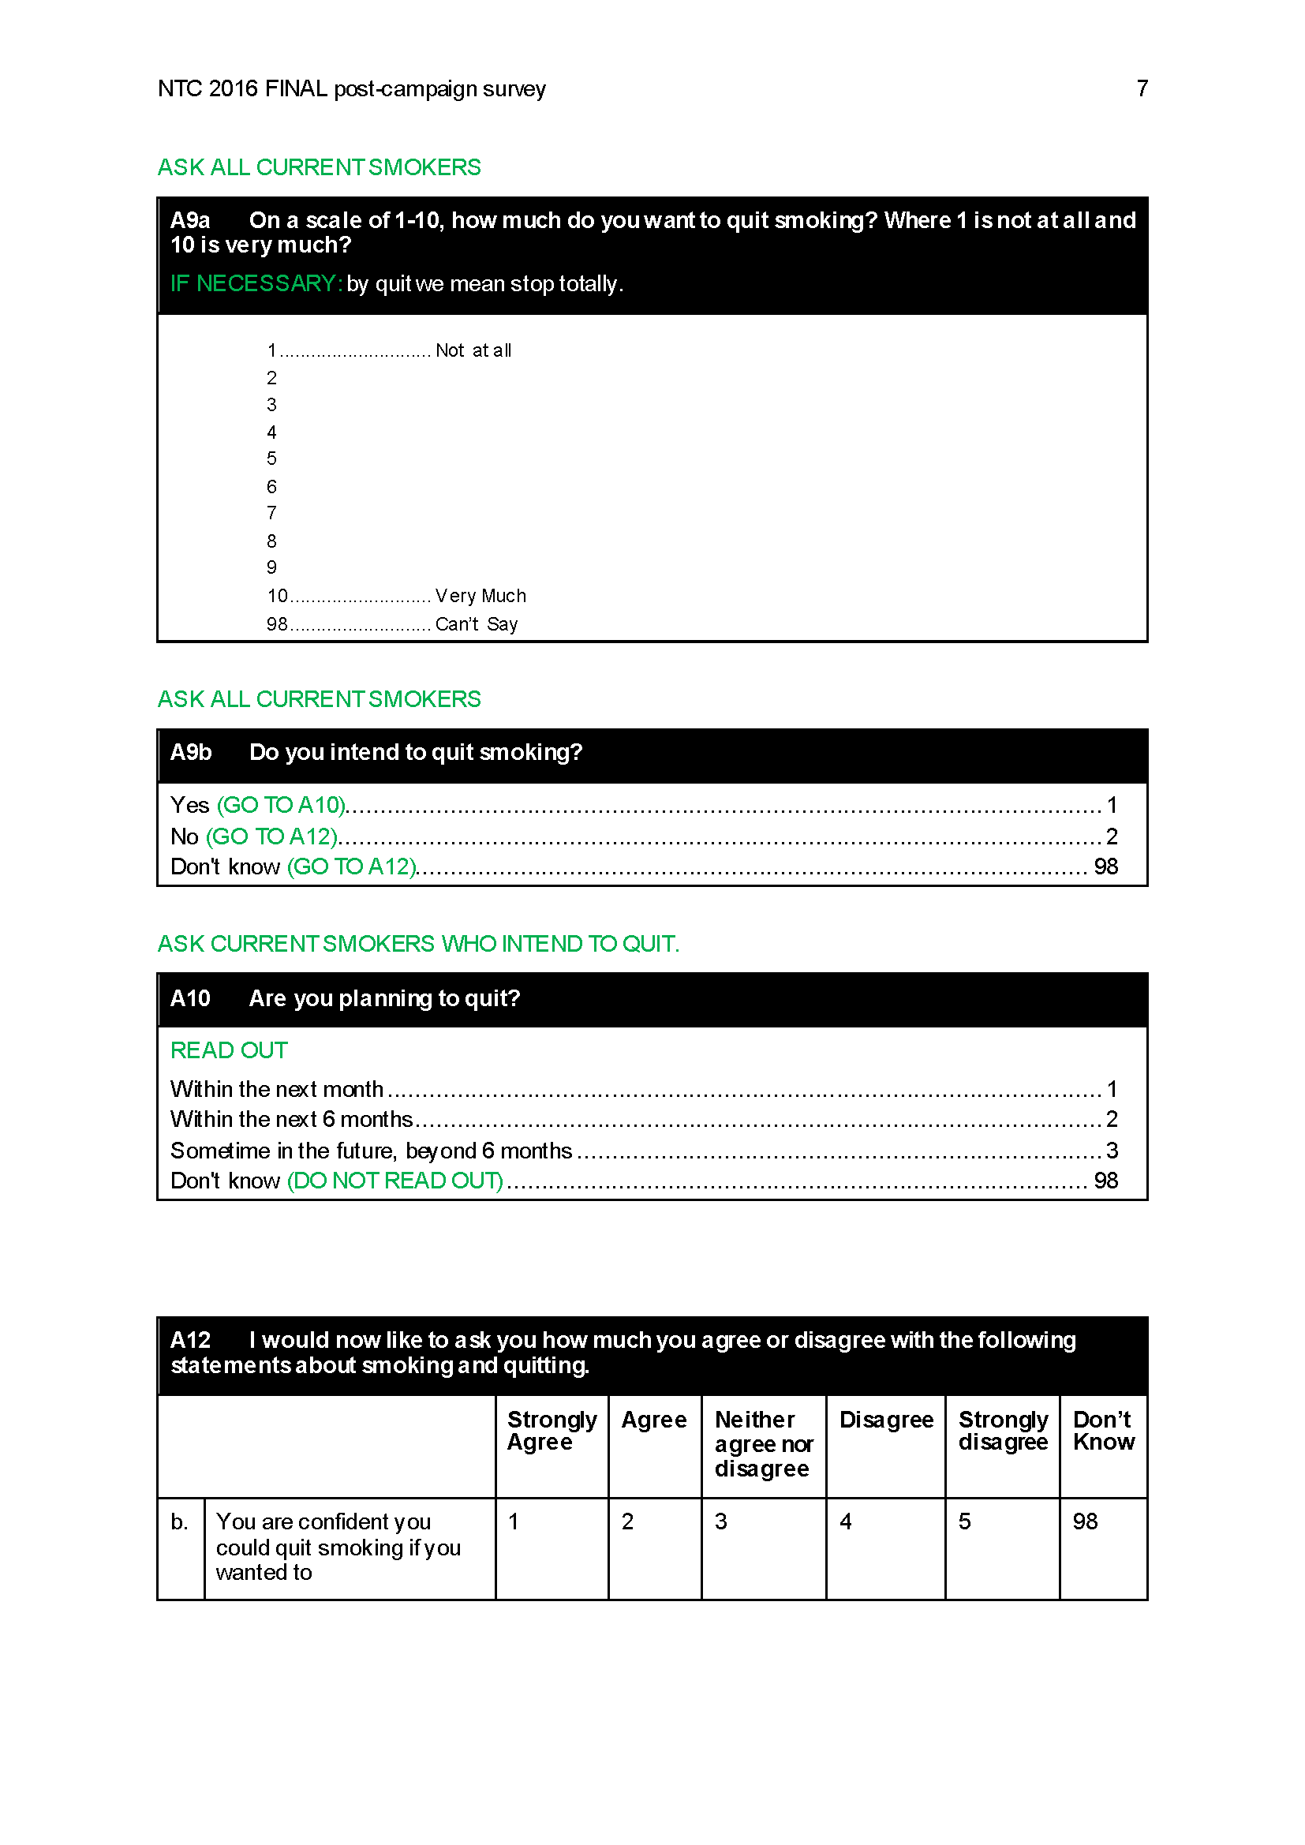

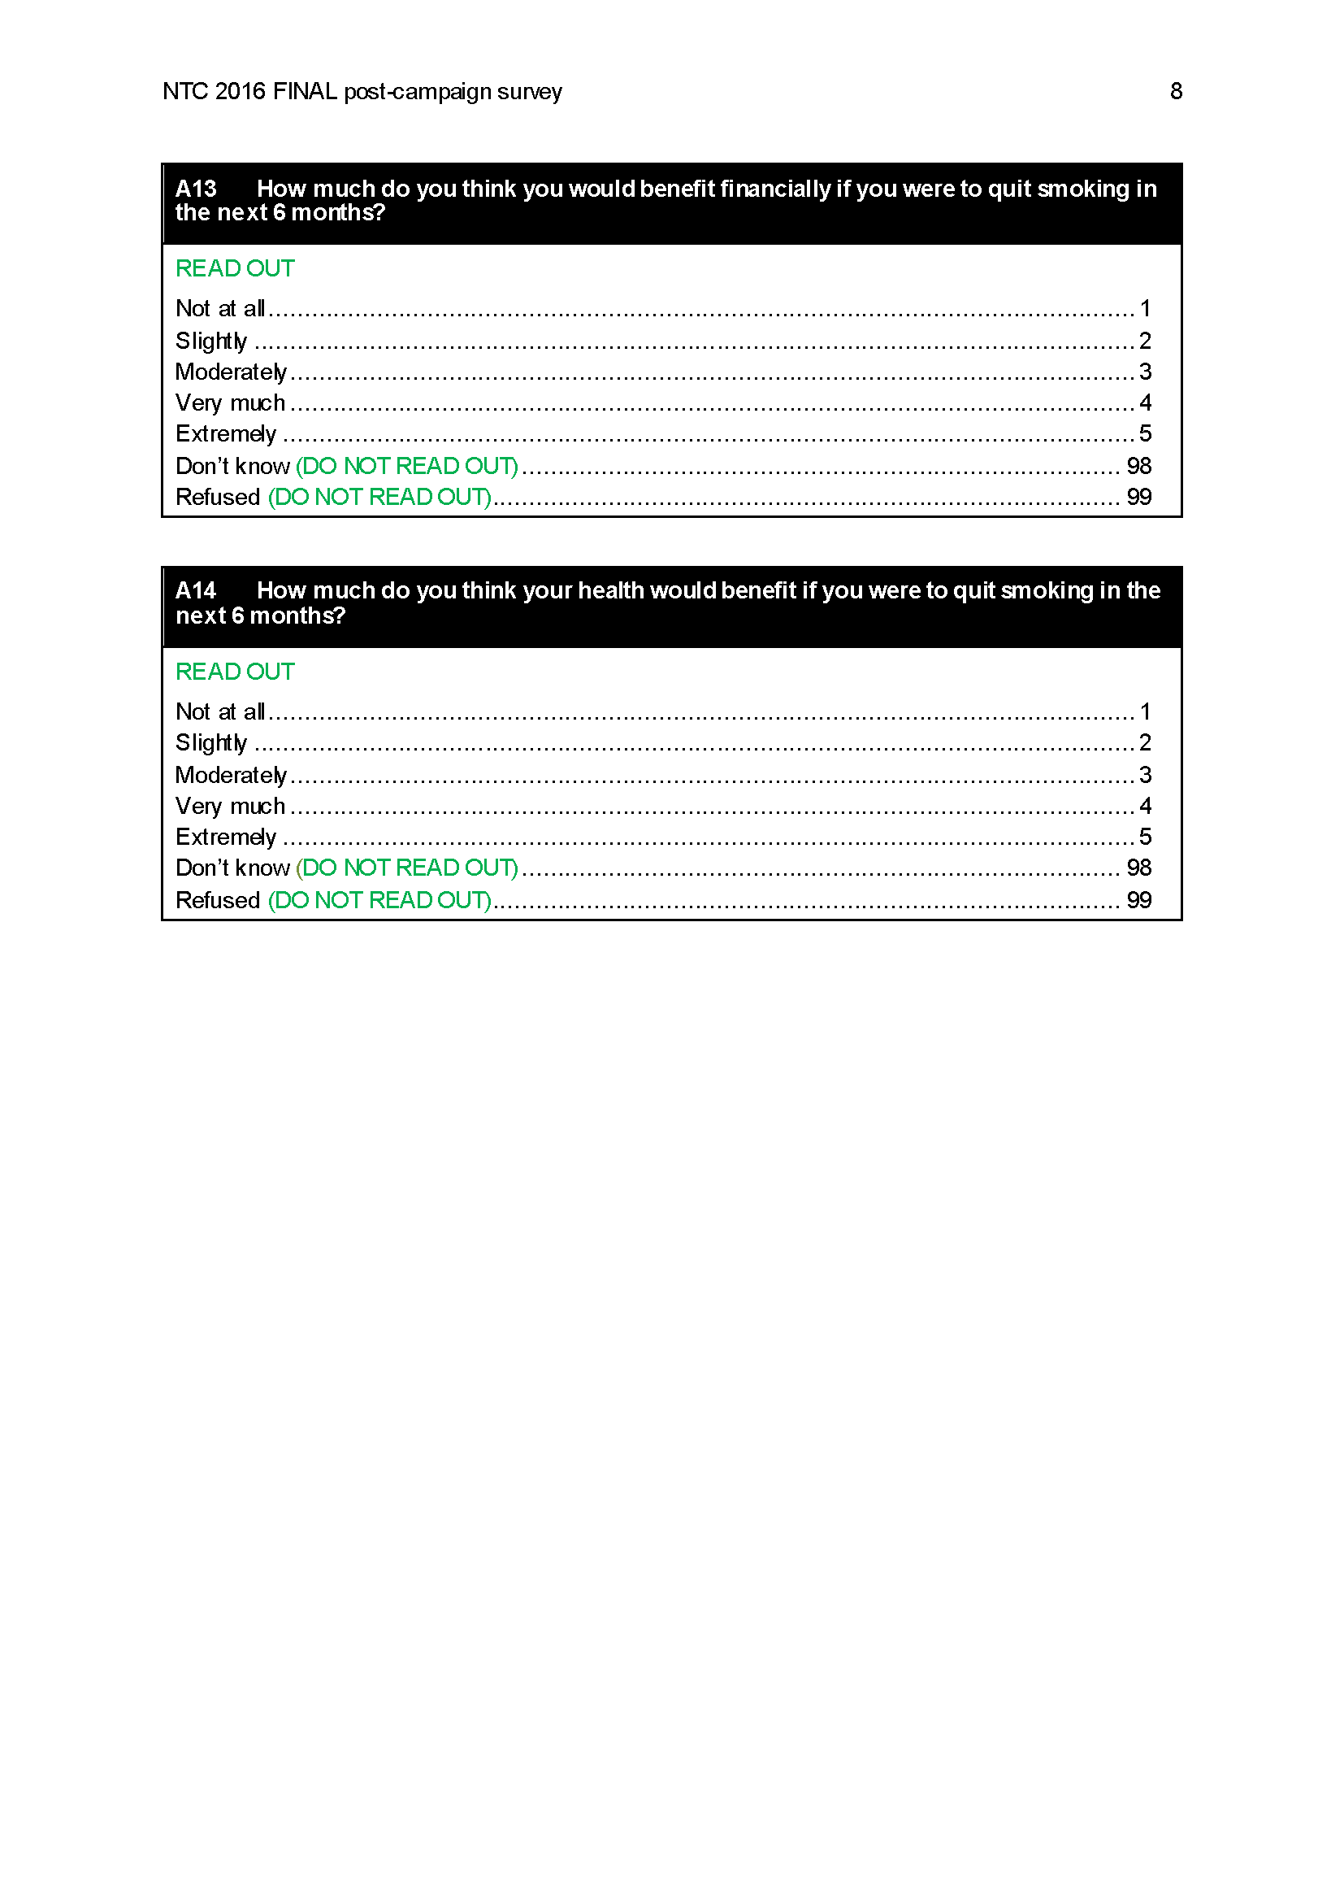

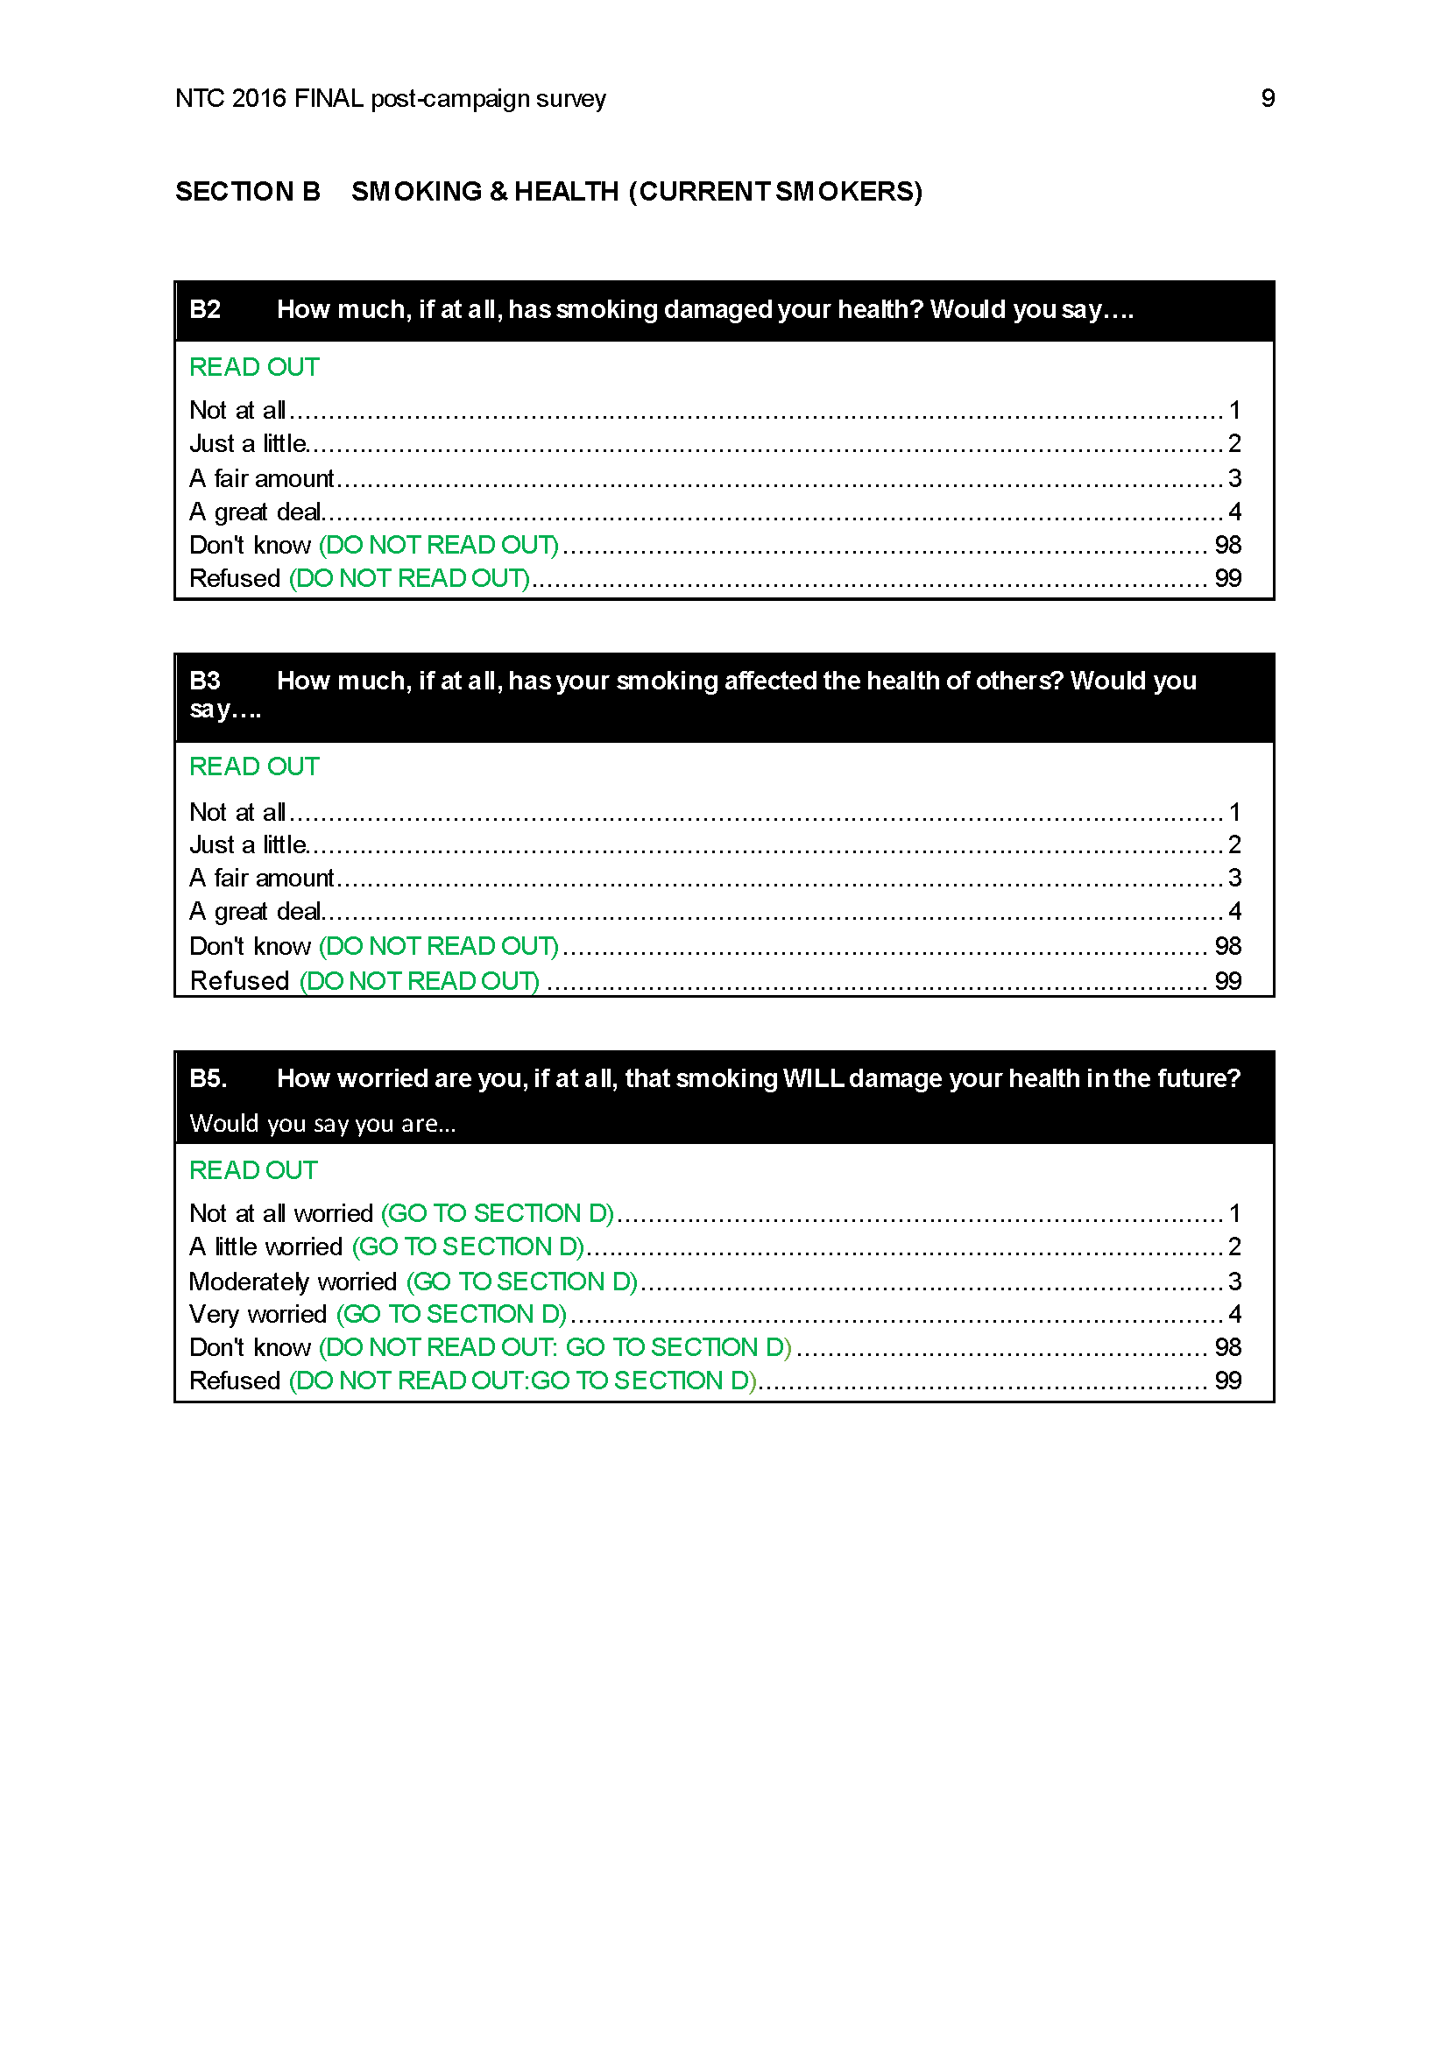

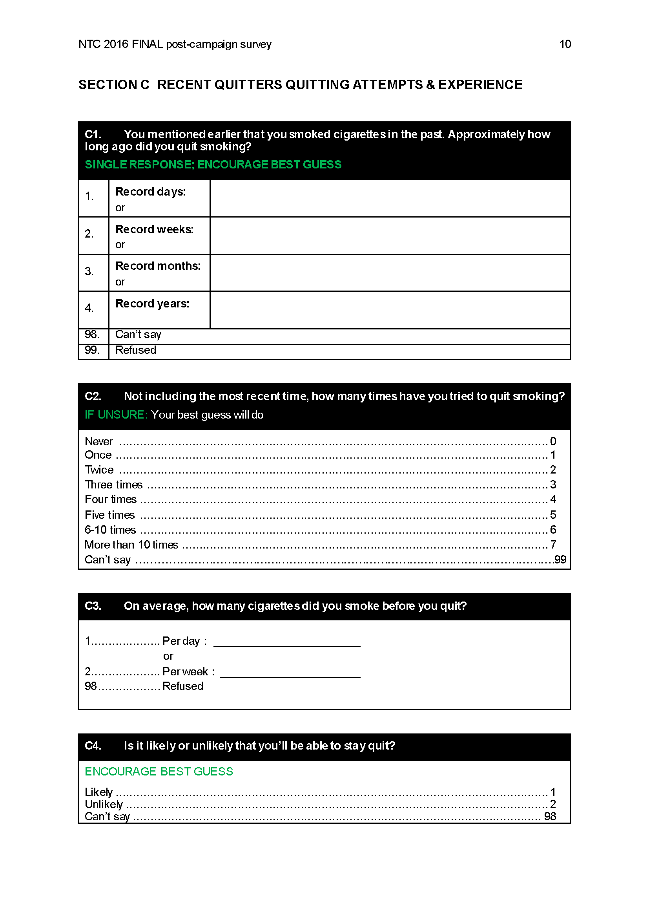

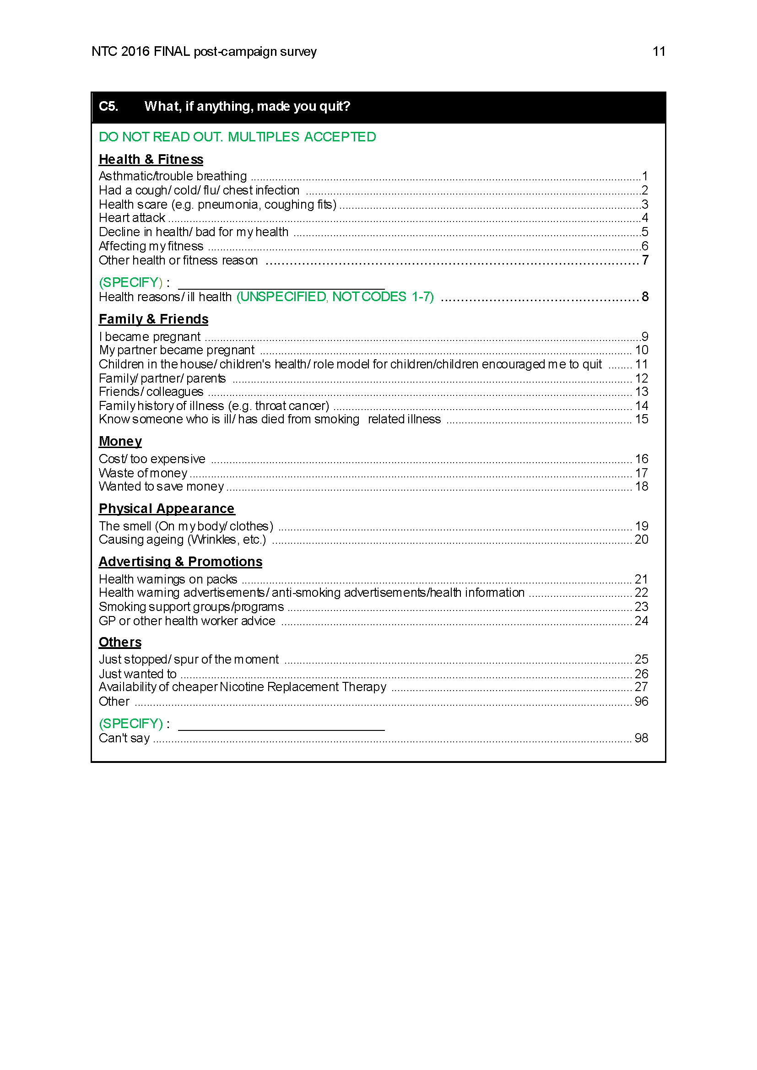

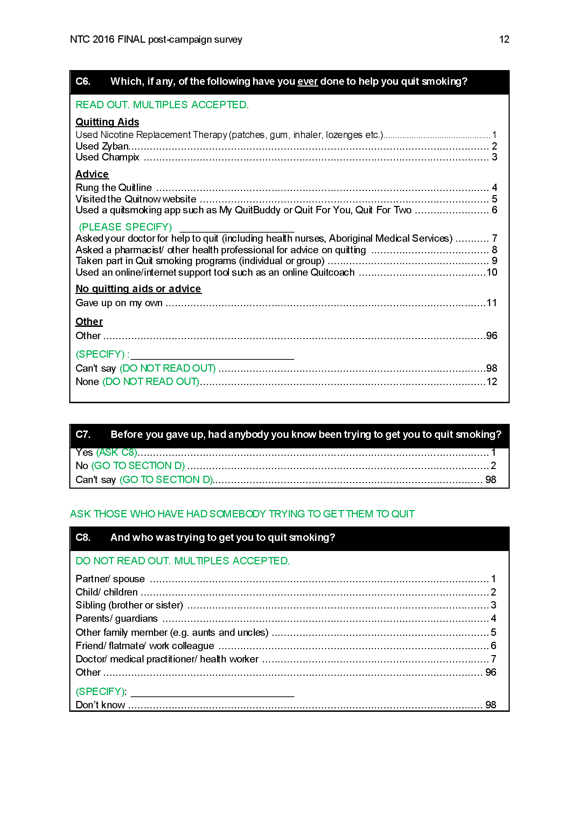

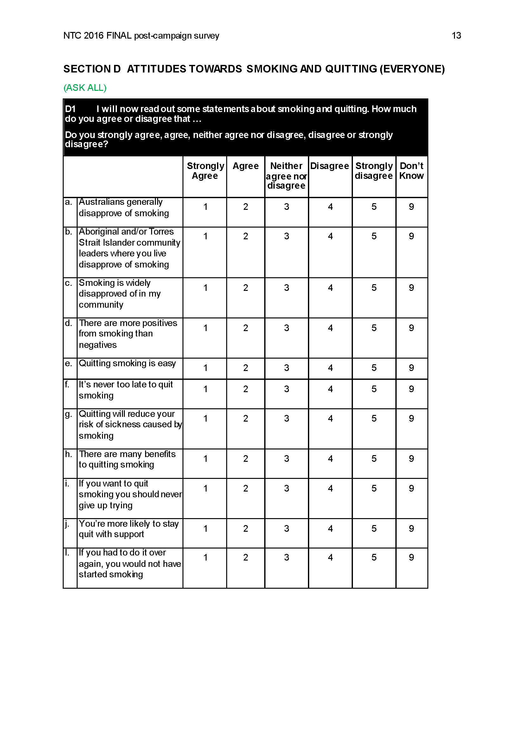

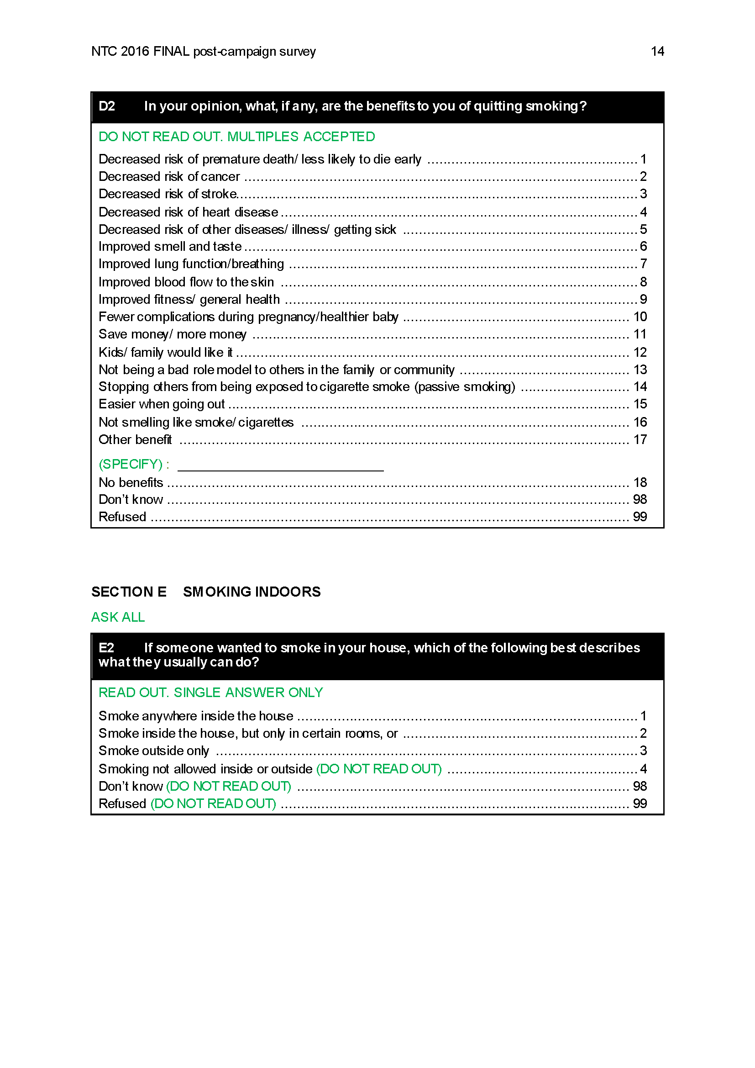

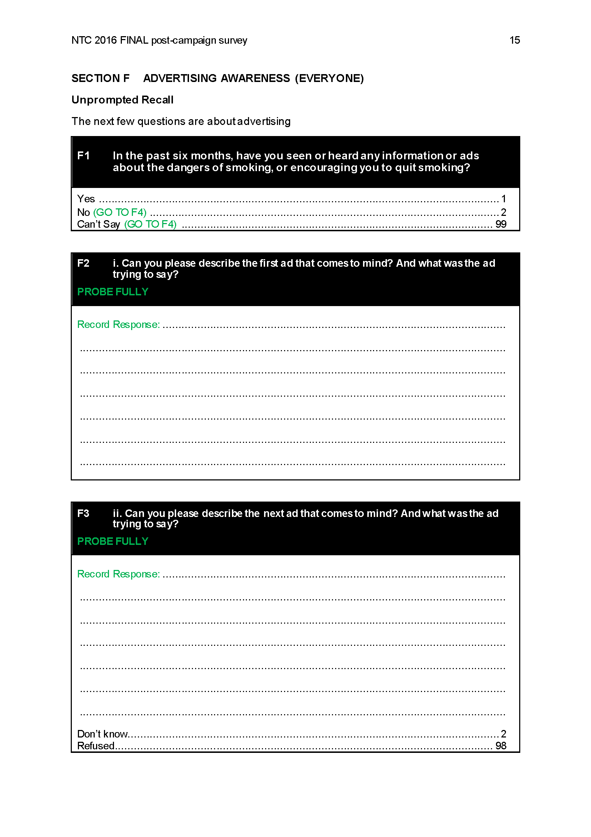

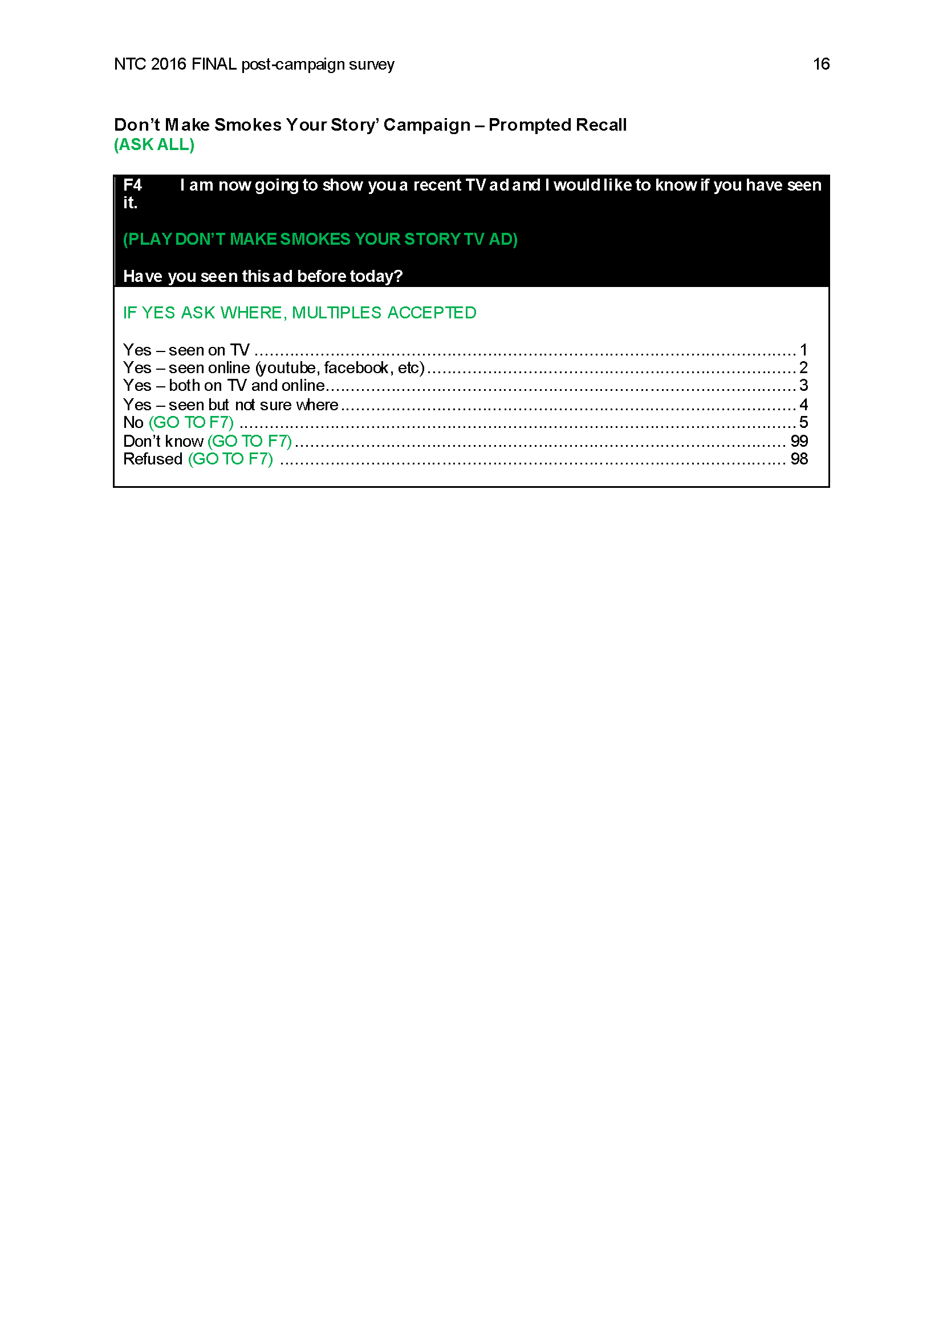

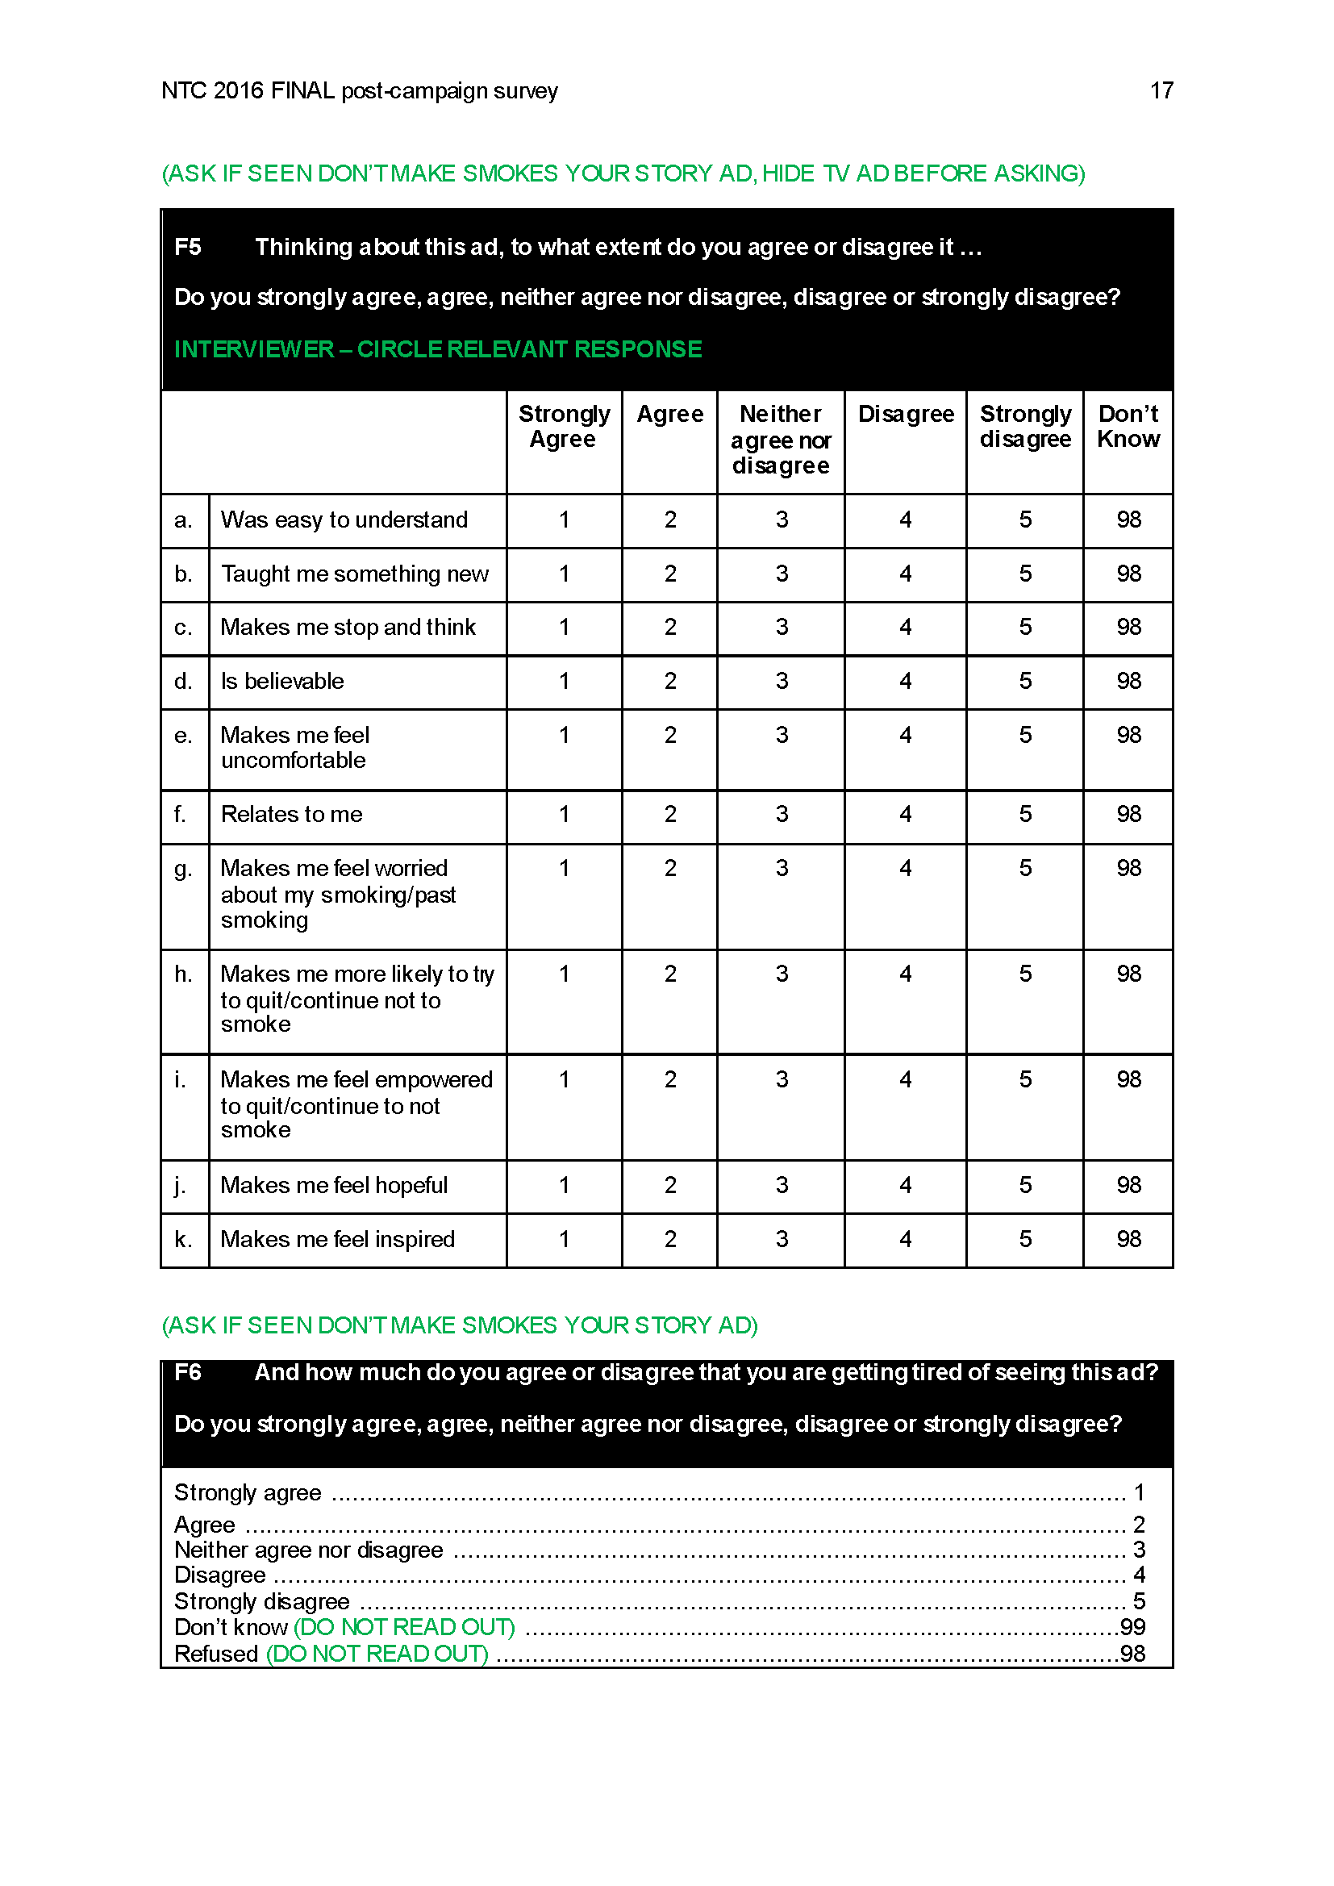

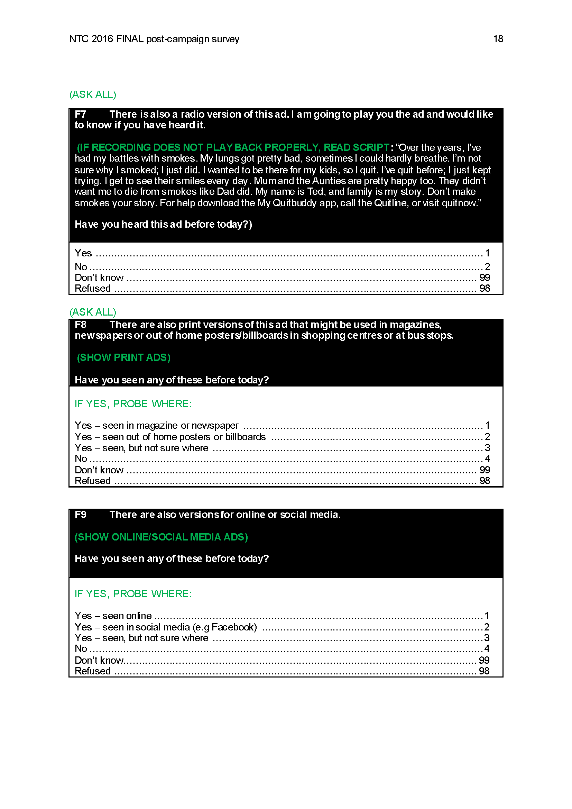

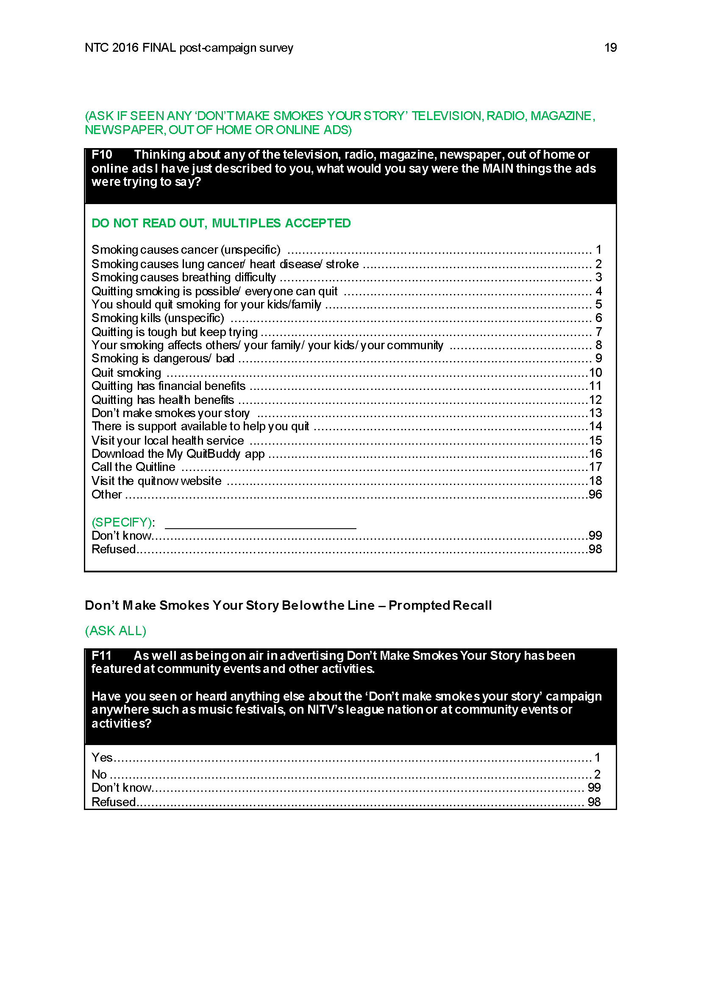

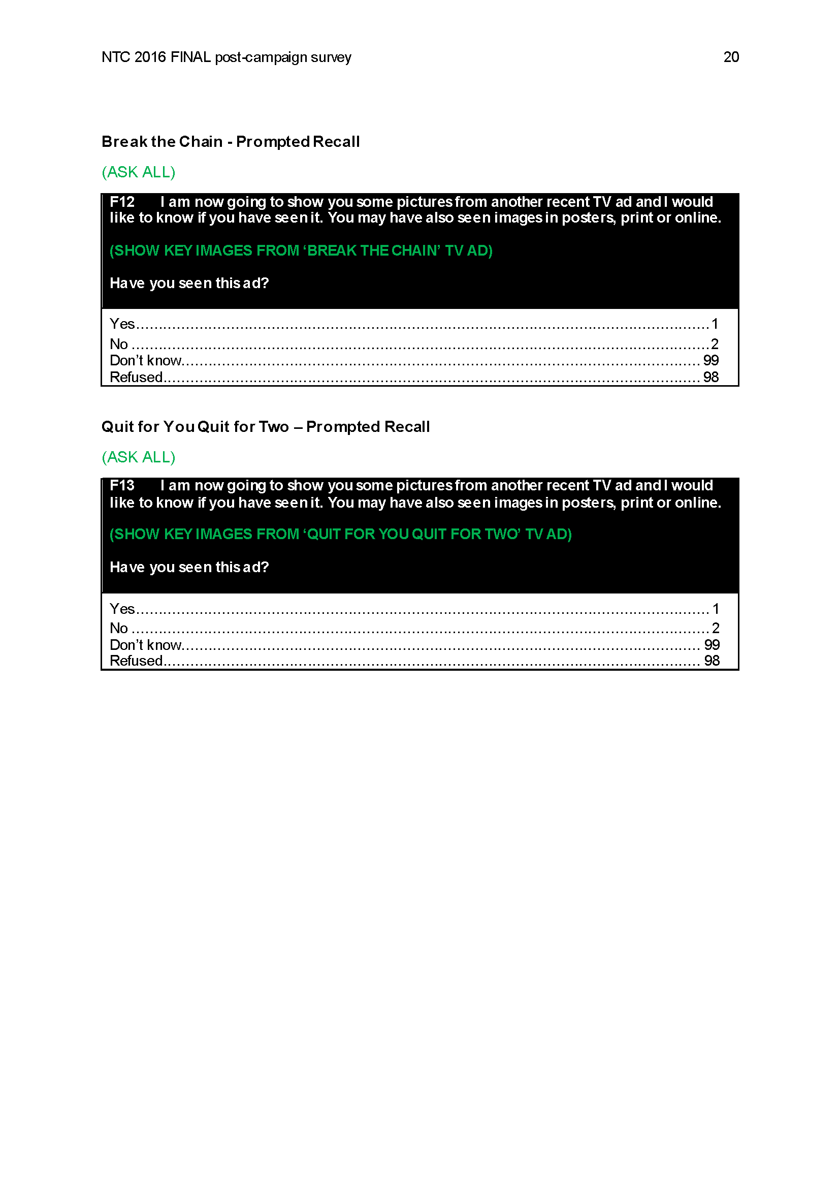

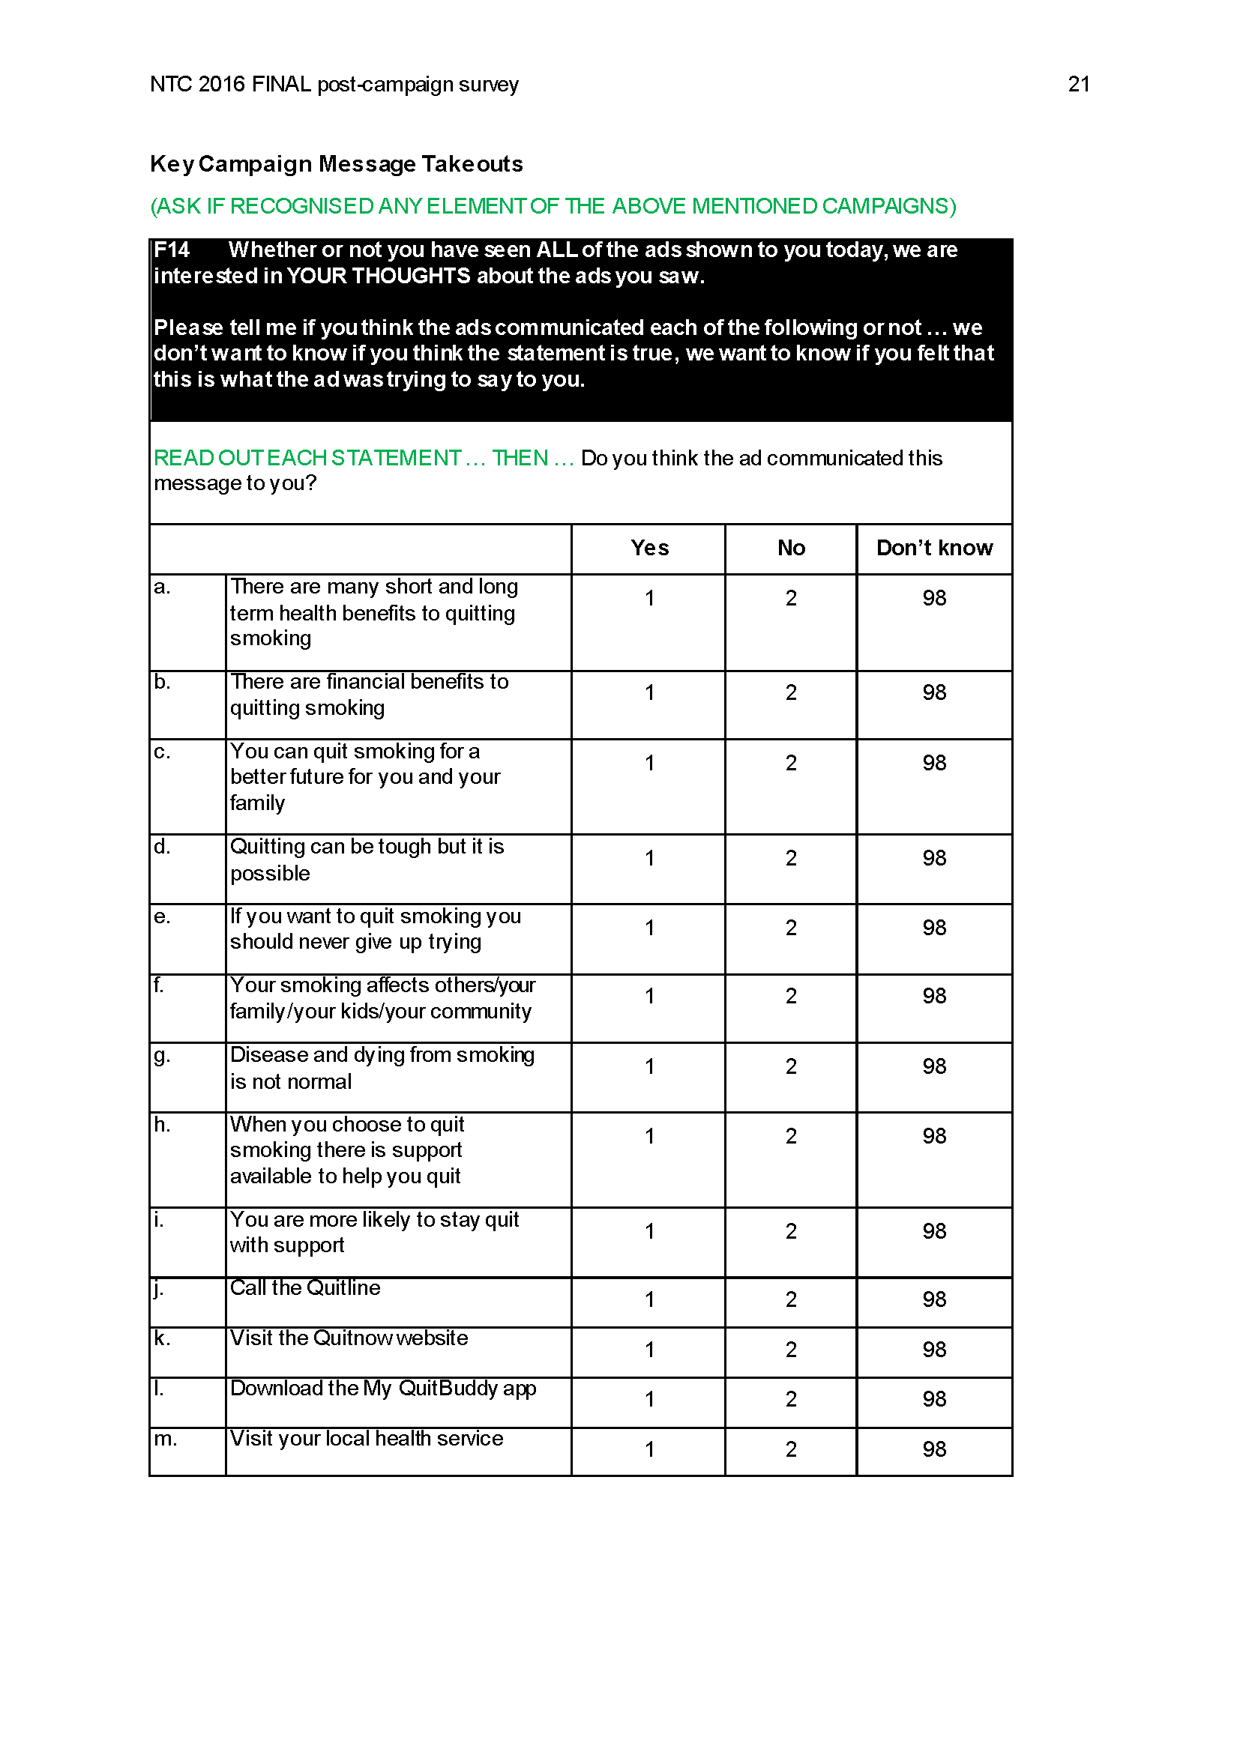

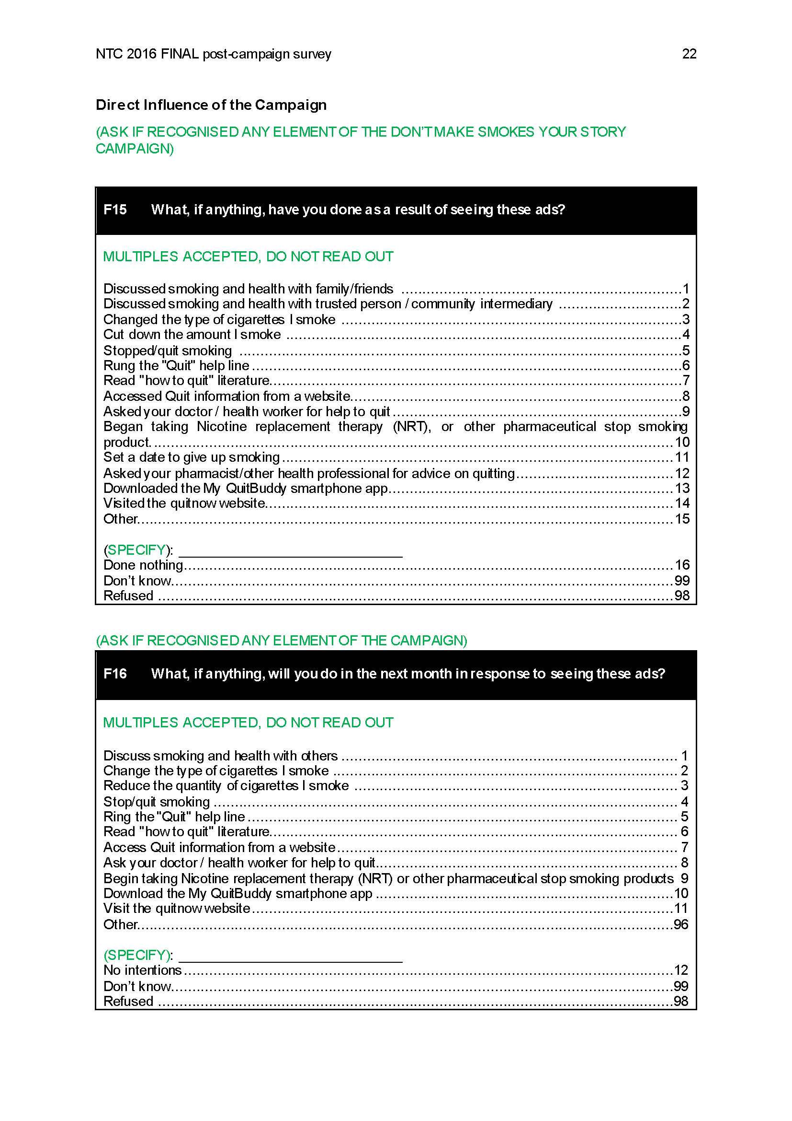

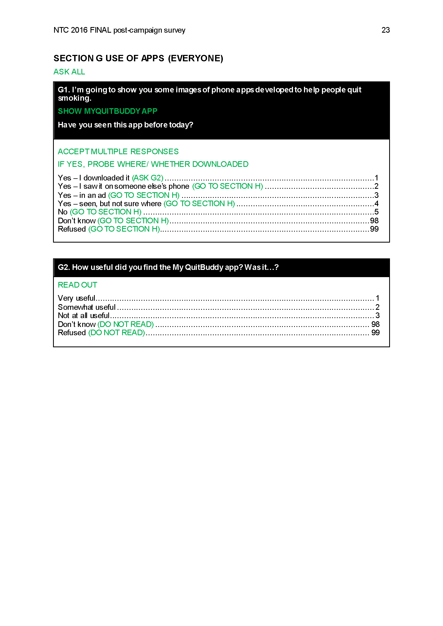

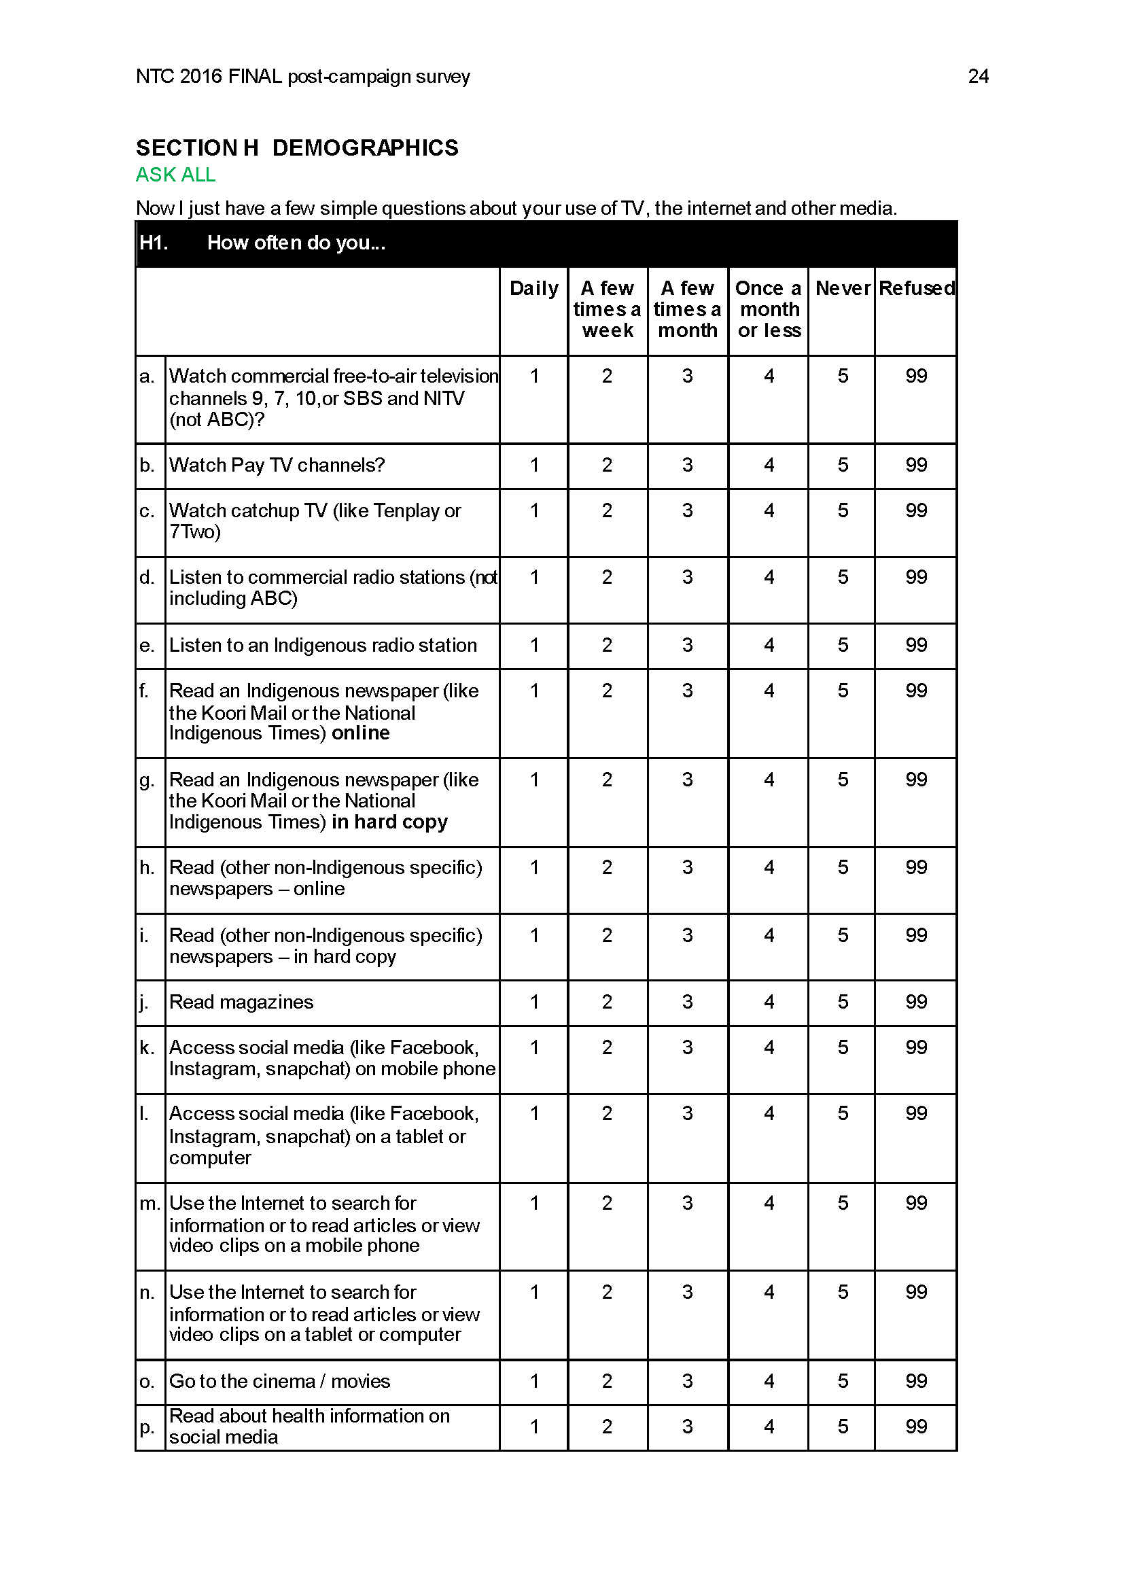

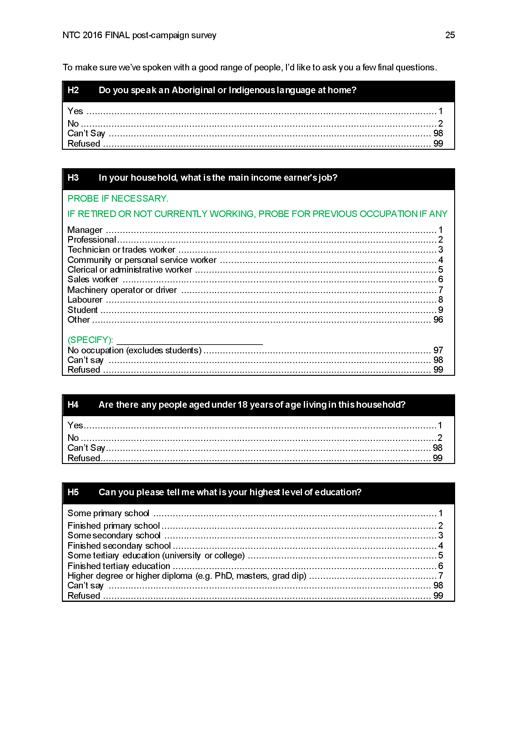

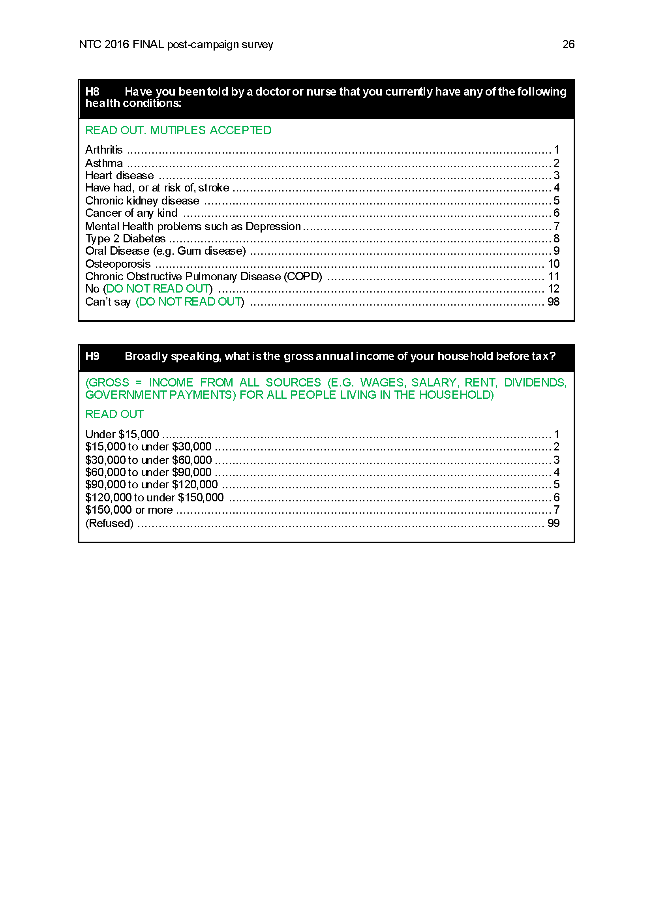

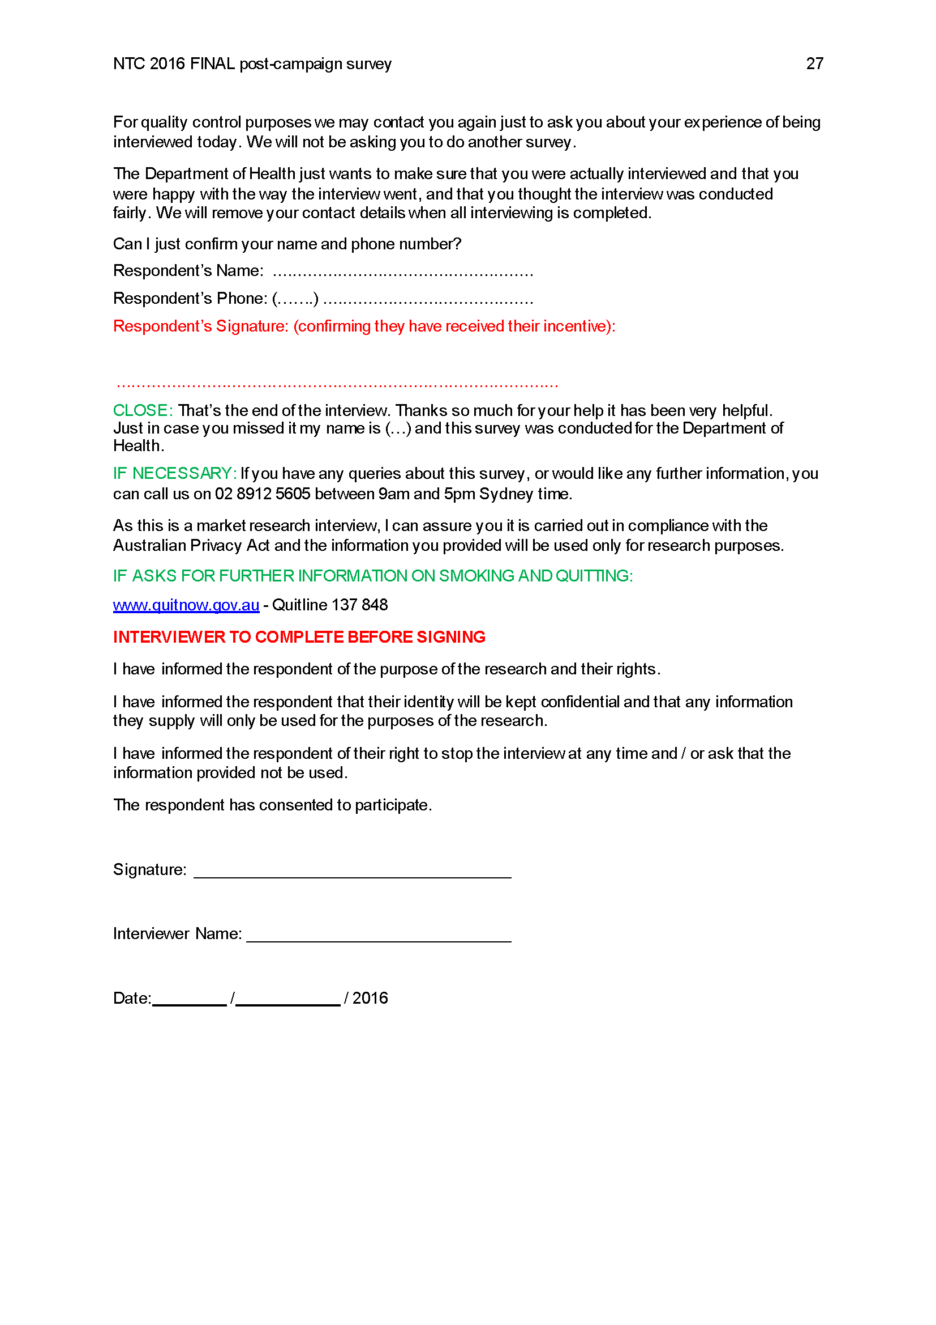

Appendix B: Don’t Make Smokes Your Story – Print Ads
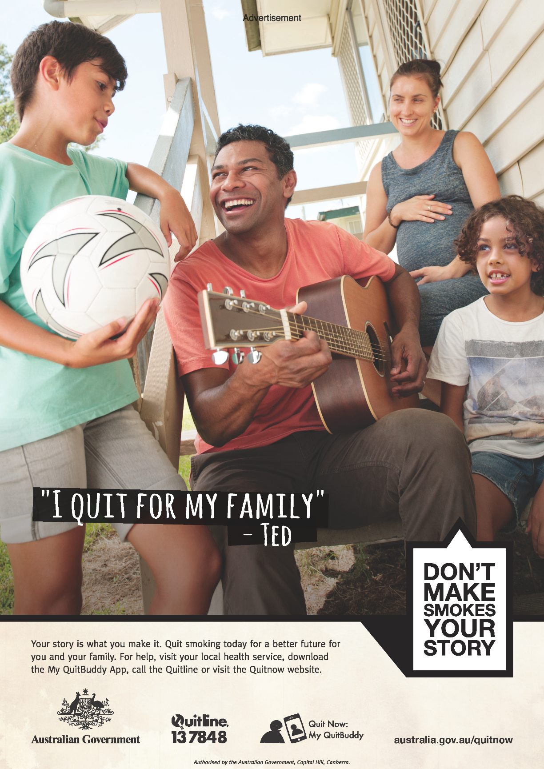
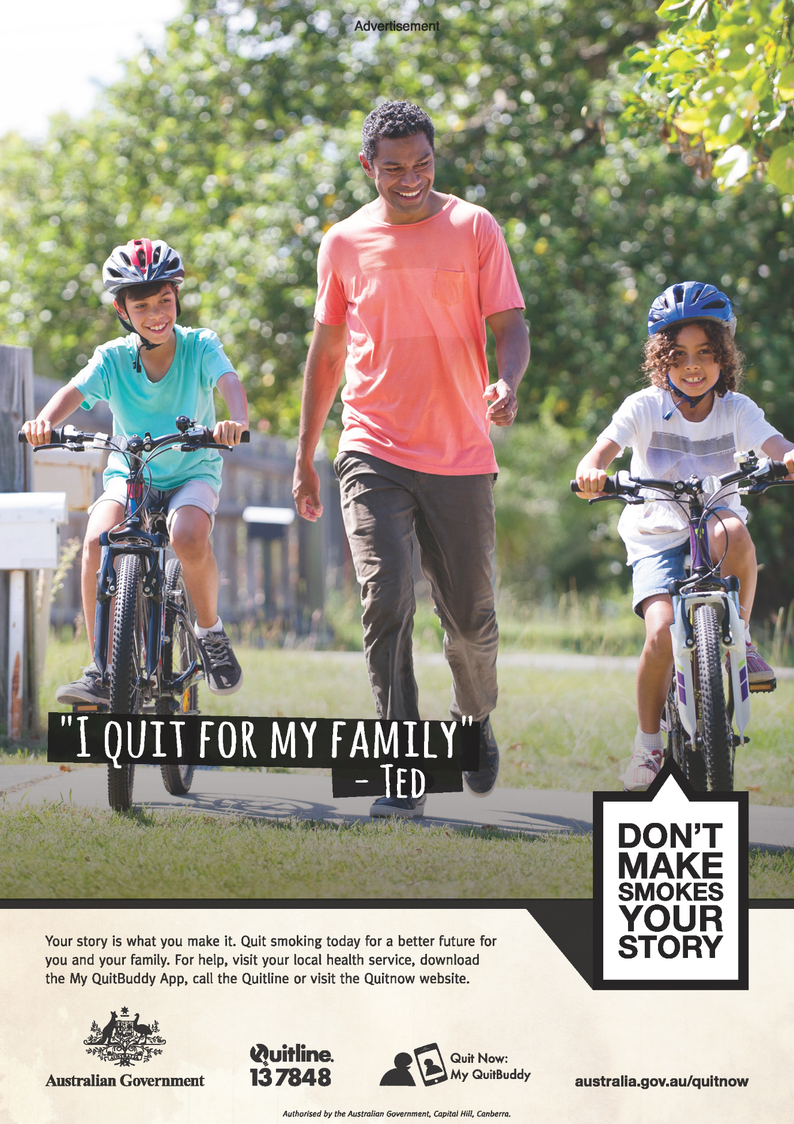

Appendix C: Don’t Make Smokes Your Story – Online Ads
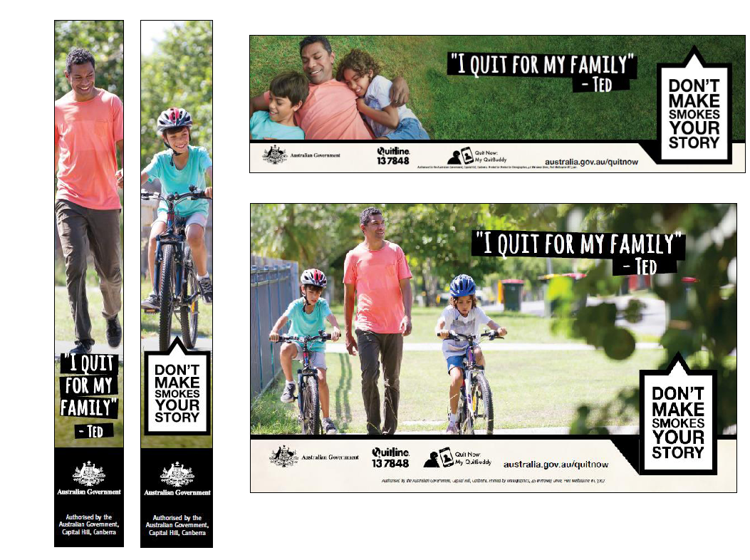

Appendix D: Don’t Make Smokes Your Story – Social Media Ads
