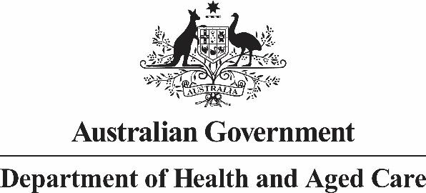

**Nurse Practitioner 10 Year Plan Steering Committee**

**Meeting Communique 18 October 2022**

The sixth Nurse Practitioner 10 Year Plan Steering Committee (NPSC) meeting was hosted from the land of the Ngunnawal people and chaired by Professor (Practice) Alison McMillan PSM.

Steering Committee members reviewed the draft Nurse Practitioner 10 Year Plan (Plan) and contributed valuable feedback on the four main themes of Education & Lifelong Learning, Recruitment & Retention, Models of Care and Health Workforce Planning. Members also contributed feedback to the prioritisation and scheduling of actions that may sit within the Plan.

A summary of stakeholder engagement to date was presented to the NPSC, in addition to an outline of the next phase of public consultation.

The NPSC will meet again in early 2023 to review the refined Plan and the monitoring and evaluation framework (MEF).

As the development of the Plan continues, further wide-ranging consultation with stakeholders will be undertaken and will be conducted through a variety of mechanisms, including through the Department of Health and Aged Care’s [Consultation Hub](https://consultations.health.gov.au/).