# How to access and use the Service and Support Portal for Serious Incident Response Scheme (SIRS): In-Home Care

This *My Aged Care User Guide* is designed to inform ‘administrators’, ‘team leaders’ and ‘staff members’ about how to access and use the SIRS portal through the Service and Support portal.

The guide is split into sections as follows:

* What am I able to do based on my role?
* How do I provide access to the SIRS portal?
* How do I submit a new SIRS notice?
* How do I view SIRS notifications?
* How do I edit or delete draft SIRS notices?
* How do I search existing SIRS notices?
* How do I export a list of draft SIRS notices?
* Help and further information
* How do I view SIRS follow up notifications?
* How do I upload multiple SIRS notices at once?

This guide does not cover:

* Detailed instructions on how to set up organisations to use the Service and Support Portal in the Relationship Authorisation Manager (RAM), which can be found on the [RAM website](https://info.authorisationmanager.gov.au/).
* Detailed instructions on how portal users obtain a myGovID to access the Service and Support Portal can be found in the user guide [My Aged Care – Logging in to the Service and Support Portal using myGovID](https://www.health.gov.au/resources/publications/my-aged-care-logging-in-to-the-my-aged-care-provider-portal-using-mygovid)

### What am I able to do based on my role?

| Role | Description of access |
| --- | --- |
| Administrator | Administrators have access at either an organisation or outlet level to:   * Provide staff access to the SIRS portal * Manage the roles within the SIRS portal * View all SIRS notifications * Edit and delete all draft SIRS notification * Submit SIRS notifications * Upload multiple notices at once |
| Team Leader | Team leaders have access at either an organisation or outlet level to:   * View all SIRS notifications * Edit or delete all draft SIRS notifications * Submit SIRS notifications |
| Staff Member | Staff members have access at an outlet level to:   * View their created SIRS notifications * Edit or delete their draft SIRS notifications Submit SIRS notifications |

### How do I provide access to the SIRS portal?

If you are an administrator, you can provide staff access to the SIRS dashboard tile within your organisation or outlet, by following the steps below.

1. Log in to the My Aged Care Service and Support Portal.
2. Select ‘Staff administration’ tile.

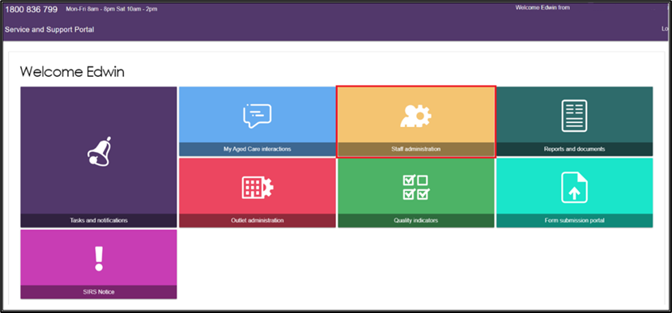

1. Scroll down to the “Staff” section of the ‘Staff administration' tile. Use the search fields to filter for the staff member who requires access to the SIRS portal. Click on the name of the staff member.

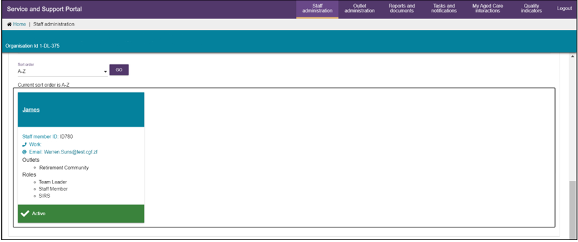

|  |  |
| --- | --- |
| ! | For more information about how to add a staff member to your facility in the My Aged Care provider portal, please refer to the [My Aged Care Quick Reference Guide – Create and maintain staff accounts.](https://www.health.gov.au/resources/publications/my-aged-care-quick-reference-guide-create-and-maintain-staff-accounts) |

1. Click the ‘EDIT STAFF DETAILS’ button.

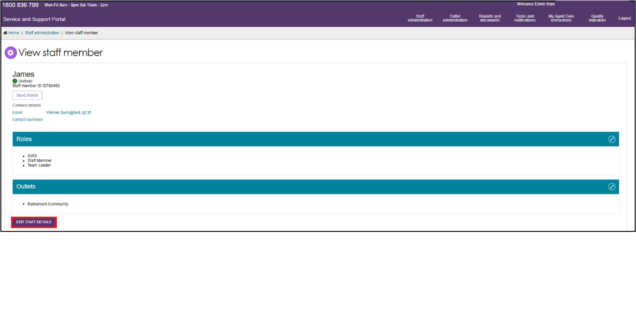

1. Select ‘MANAGE ROLES’ button’.

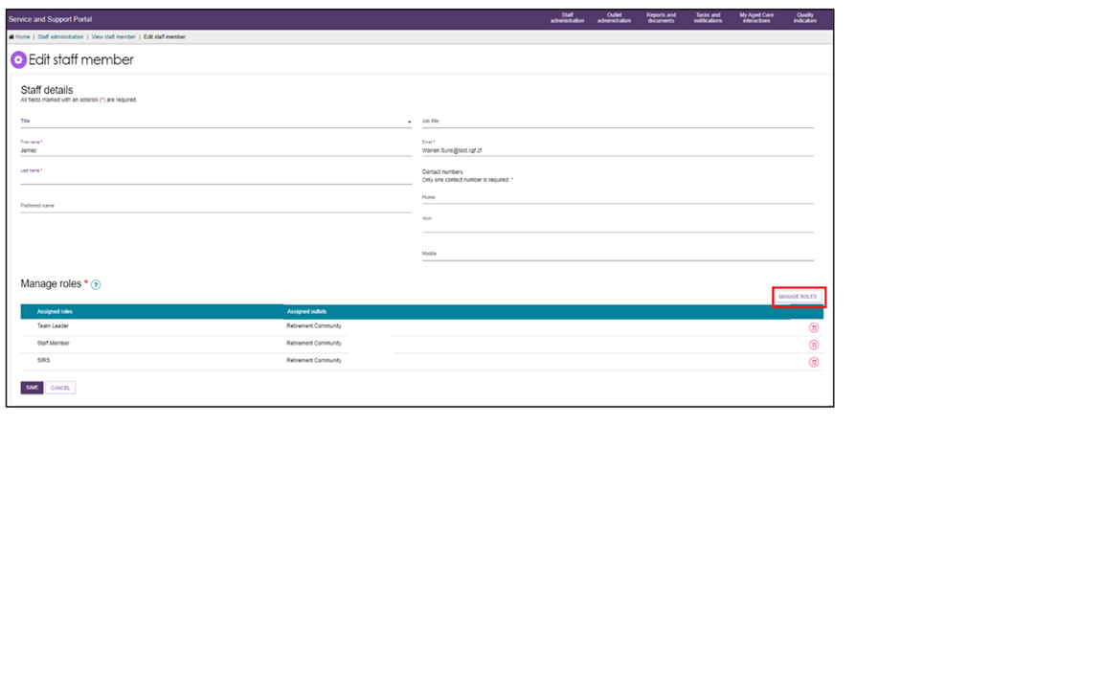

1. Then, click the ‘SAVE’ button. A popup box will appear displaying a series of checkboxes. If the staff member already possesses a role, the corresponding box will be checked.

Check the corresponding ‘SIRS’ checkbox by selecting it.

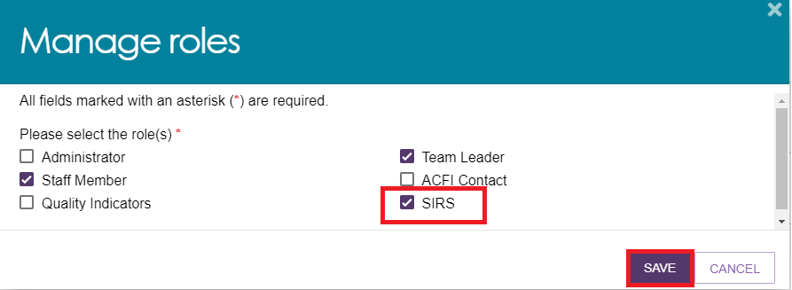

1. Pop up will appear confirming the successful edit.



### How do I submit a new SIRS notice?

|  |  |
| --- | --- |
| ! | For information on what incidents must be reported, see the [Aged Care Quality and Safety Commission’s website](https://www.agedcarequality.gov.au/sirs) |

1. Log in to the My Aged Care Service and Support Portal.
2. From the home screen of the My Aged Care Service and Support Portal, click the ‘SIRS Notice’ tile.

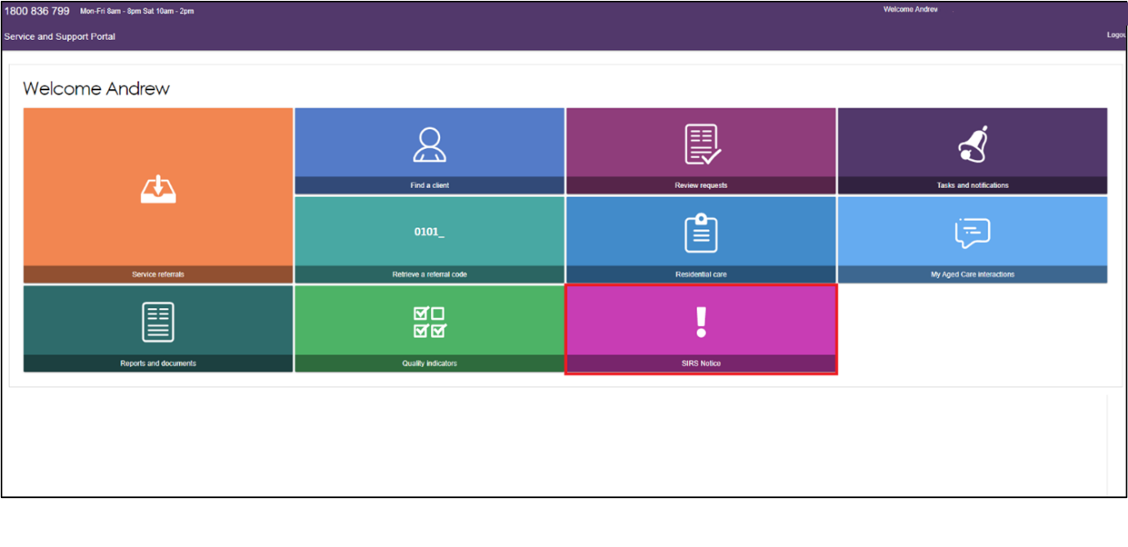

1. Click the ‘Submit new notice’ tile to begin filling out a new SIRS notice form.

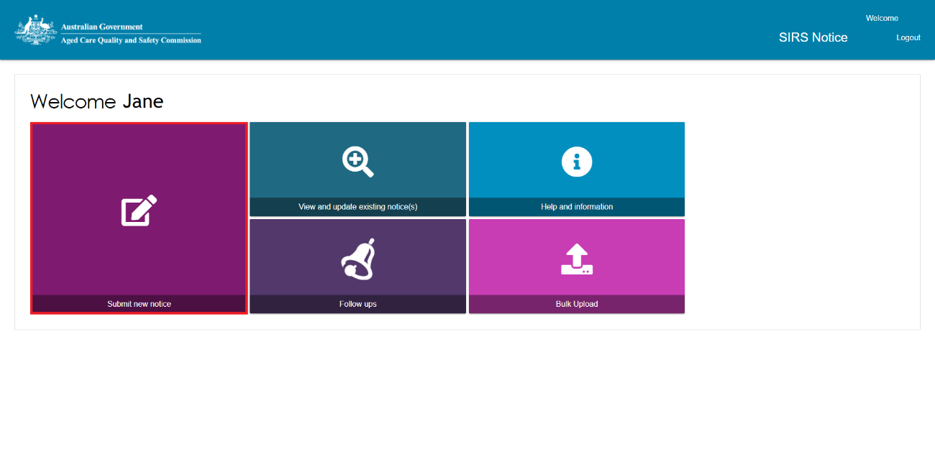

1. A new tab will open containing important information regarding the SIRS notice. Read the information carefully, then select the ‘NEXT’ button to proceed.

|  |  |
| --- | --- |
| ! | Additional helpful information and examples can be found by following the link to the [Aged Care Quality and Safety Commission website](https://www.agedcarequality.gov.au/sirs/submit-notifications). |

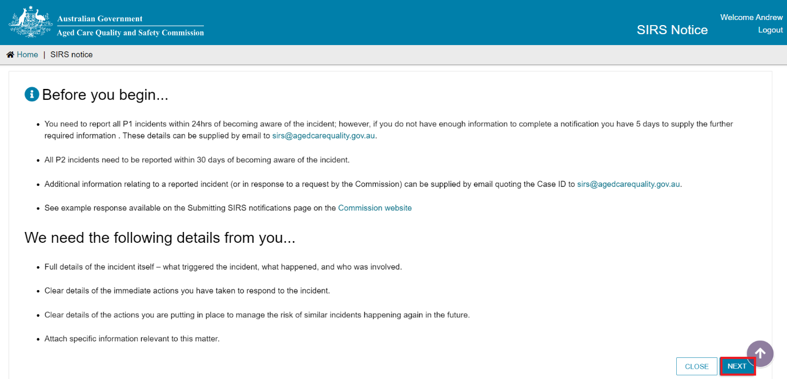

1. Complete the relevant information on the ‘Your details’ tab. Ensure you have entered information for each field marked with an asterisk (*). Once you have finished, navigate to the ‘Incident details’ tab by clicking the ‘NEXT’ button.

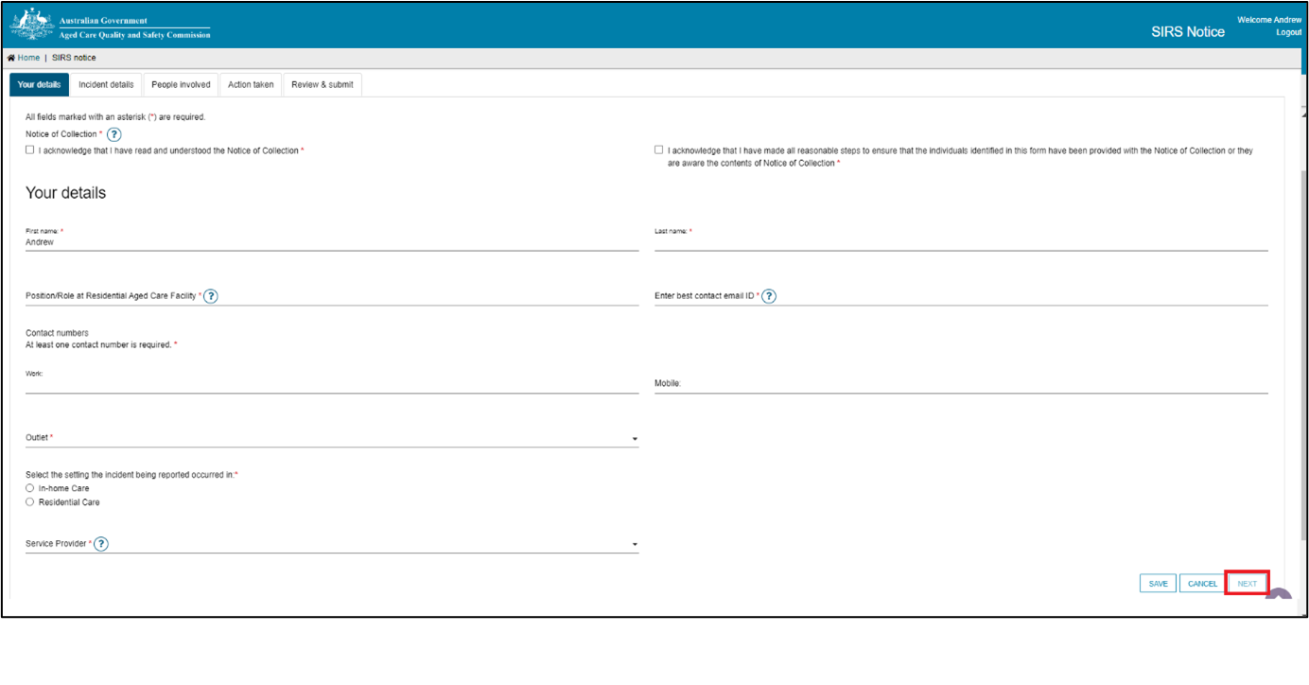

|  |  |
| --- | --- |
| ! | If you are unsure what information is required within each field, you can view the help text by clicking the question mark symbol to the right of the field title. |

|  |  |
| --- | --- |
| ! | Please note: the two notices of collection acknowledgements located near the top of the ‘Your details’ page of the SIRS form must be checked before proceeding. |

|  |  |
| --- | --- |
| ! | You must select an Outlet from the drop-down menu available and ‘Type of incident’ as ‘In Home Care’ in order to complete the ‘Approved Provider’, ‘Care Type’ and ‘Service’ fields. |

1. Complete the required information on the ‘Incident details’, ‘People involved’ and ‘Action taken’ tabs. Ensure you have entered information for each field marked with an asterisk (*).

|  |  |
| --- | --- |
| ! | The SIRS notification form allows you to capture details for up to a maximum of six Alleged offenders within a single notification.  Visual display of SIRS notification form. |

1. After completing all four tabs of the SIRS form, you will be taken to the ‘Review & Submit’ page. This page summarises the information you have provided, please review it carefully.

If mandatory information is missing, a red “X” will appear at the bottom of the relevant page summary. As well as the below error message indicating the missing mandatory information.



1. Review the information you have entered. You can navigate back to any tabs requiring edits using the pencil on the right.

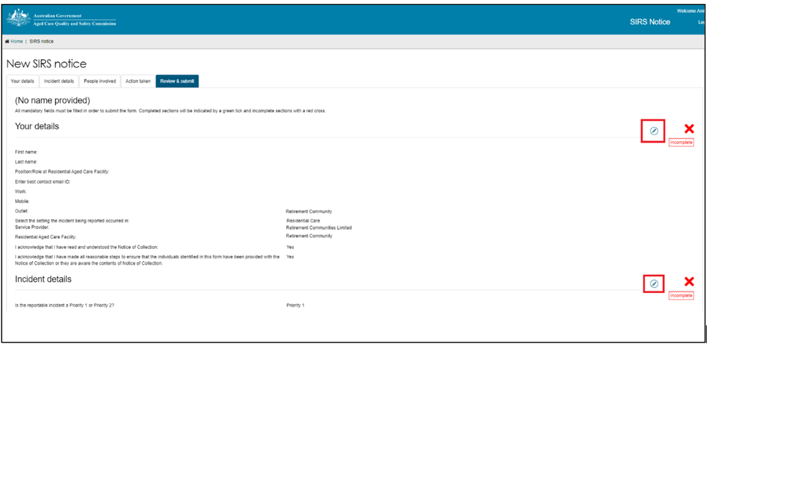

|  |  |
| --- | --- |
| ! | You can save your notification at any point without submitting by clicking ‘Save’ at the bottom of the ‘Review & submit’ page. This will save the notification as a draft.  Example of the save button which is located at the bottom right of the screen and highlighted by a red box. |

1. Once you have finished reviewing the information click ‘SUBMIT’. A confirmation message will be displayed to confirm that the notification is ready for submission. Click ‘SUBMIT’ to send the notification.

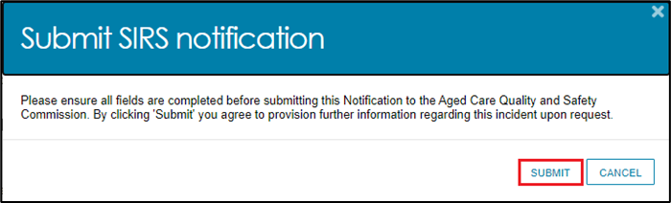

1. The submitted notification can now be viewed in the list of existing notifications.

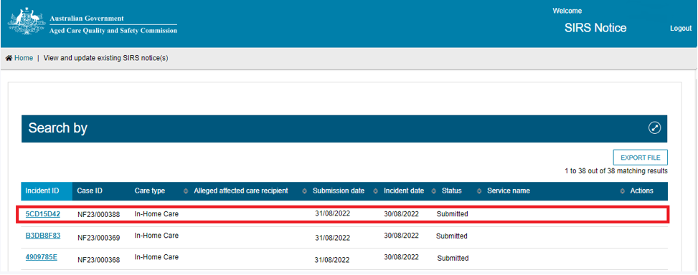

### How do I view SIRS notices?

Administrators, team leaders, and staff members can view existing SIRS notices based on their permissions. See the What am I able to do based on my role? section of this guide for more information.

1. Log in to the My Aged Care Service and Support Portal.
2. From the home screen of the My Aged Care Service and Support Portal, select the ‘SIRS Notice’ tile.

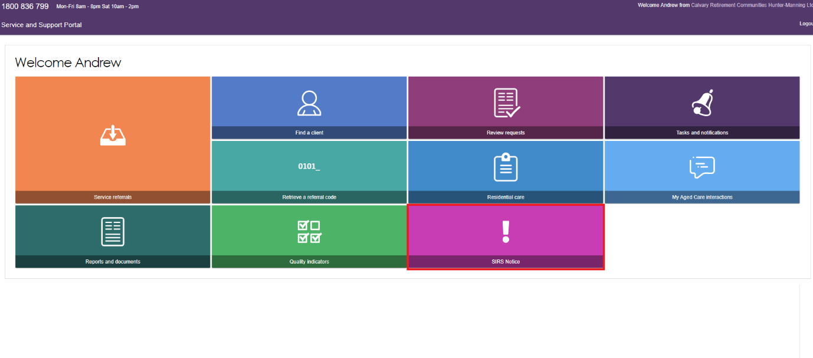

1. Select ‘View and update existing notices’ tile.

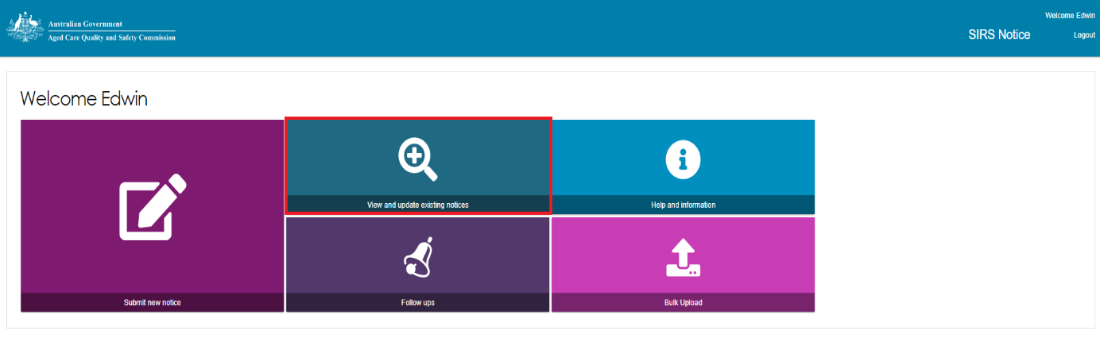

1. Use the search fields and the ‘FILTER’ button near the top of the page to search for the appropriate SIRS notice.

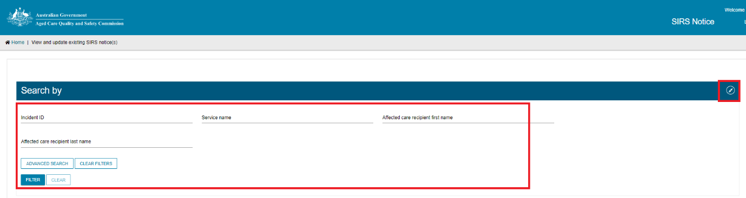

1. Once you have found the appropriate notice in the table, select the relevant ‘Incident ID’ to view the notice.

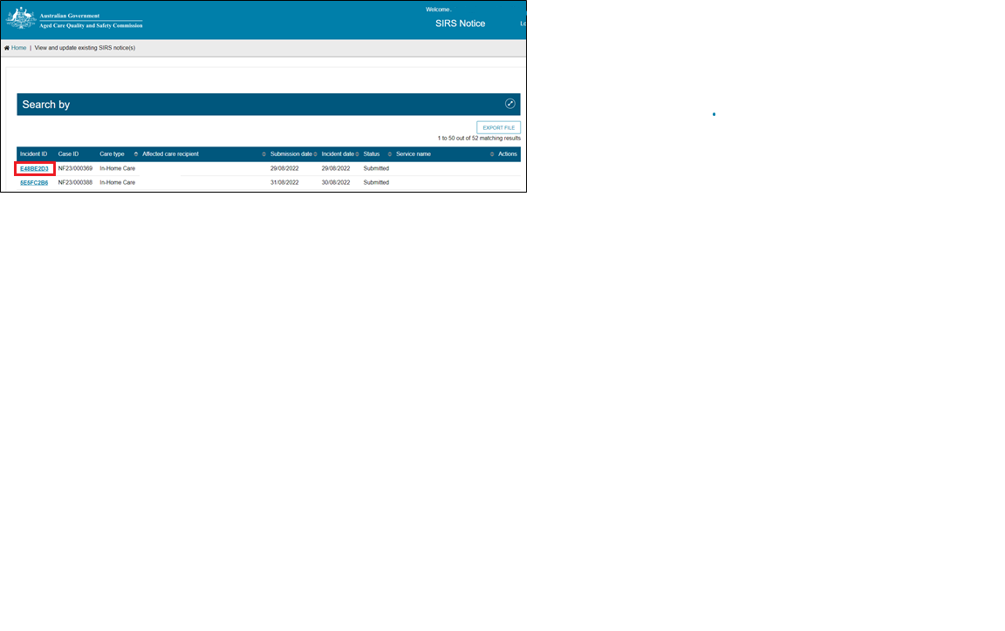

|  |  |
| --- | --- |
| ! | If you are an administrator or team leader at the organisation level, you will see a list of all in-draft and completed notifications for your organisation. If you are an administrator or team leader for only your outlet, you will see a list of all draft and completed notifications for your outlet. Drafts will be deleted after 60 days. |

1. You can now view and navigate through the draft or submitted notification using ‘NEXT’ button.

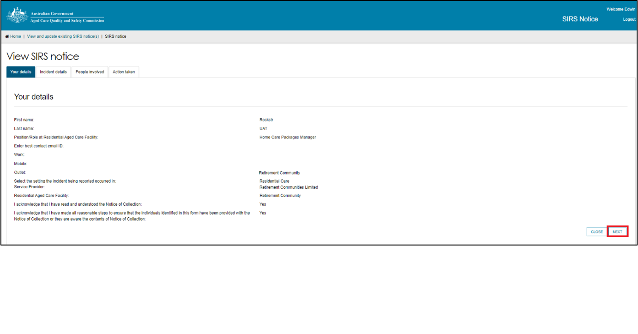

### How do I edit or delete draft SIRS notices?

Administrators, team leaders, and staff members can edit or delete draft SIRS notices based their permissions. See the ‘What am I able to do based on my role?’ section of this guide for more information.

1. Log in to the My Aged Care Service and Support Portal.
2. From the home screen of the My Aged Care Service and Support Portal, select the ‘SIRS Notice’ tile.

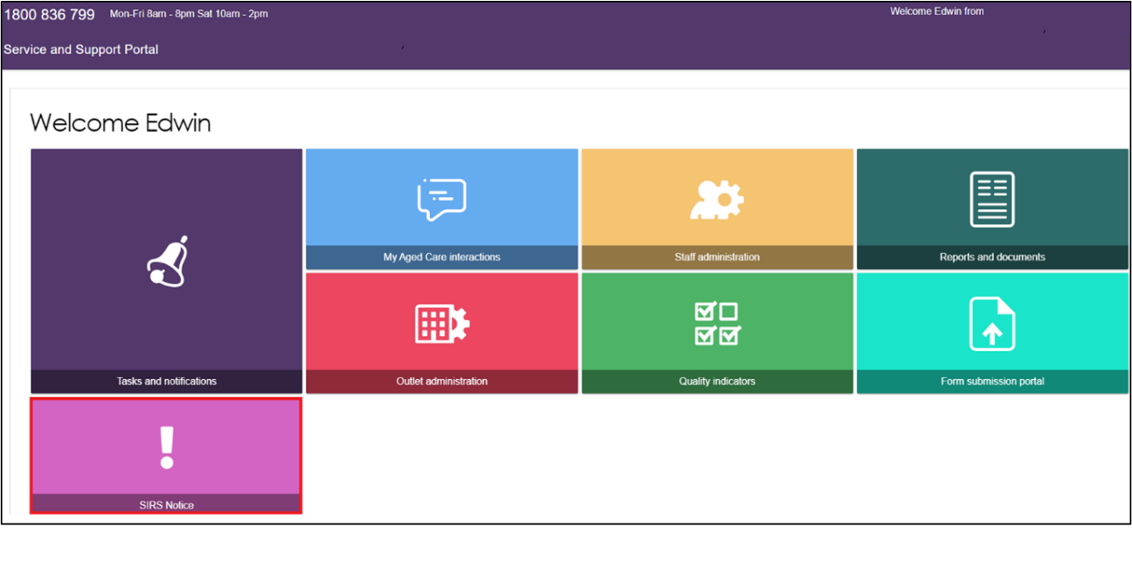

1. Click the ‘View and update existing notifications’ tile.

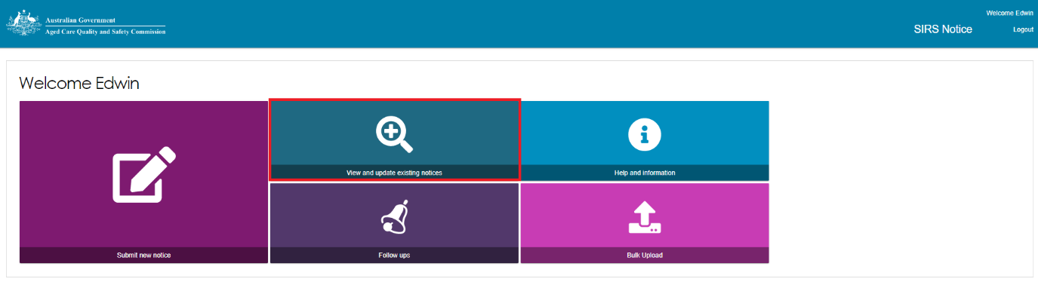

1. Use the search fields and the ‘FILTER’ button near the top of the page to search for the appropriate SIRS notice. Once you have found the appropriate draft notice in the table, you can select the pencil symbol to edit the draft notice.

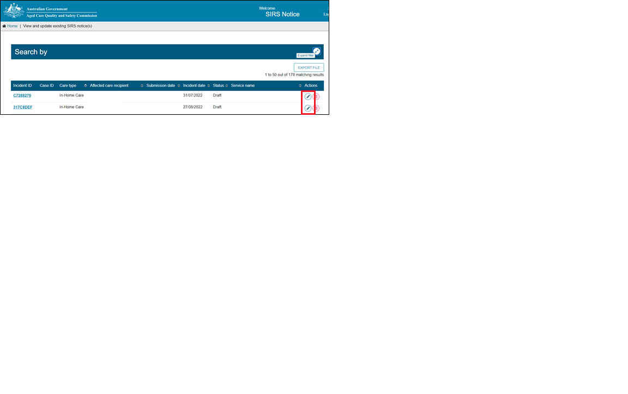

The process for editing a draft notice is similar to creating a new notice. See the ‘How do I submit a new SIRS notice?’ section of this guide for more information.

|  |  |
| --- | --- |
| ! | If you are an administrator or team leader at the organisation level, you will see a list of all draft and completed notifications for your organisation. If you are an administrator or team leader for only your outlet, you will see a list of all draft and completed notifications for your outlet. |

1. To delete the draft notice, select the bin symbol to the right of the notice.

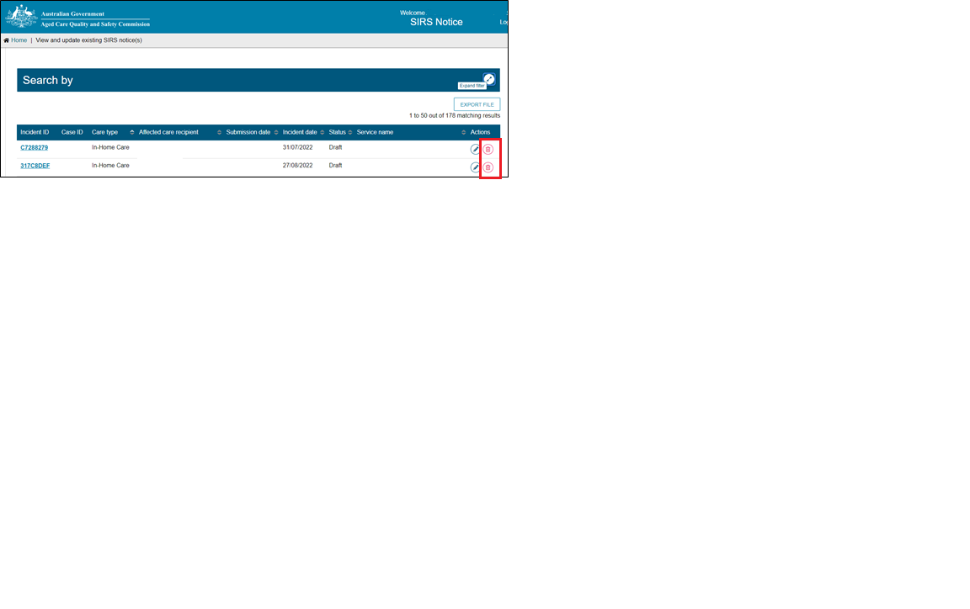

1. A popup will appear prompting you to confirm your deletion. Select ‘OK’ to delete the draft notice.

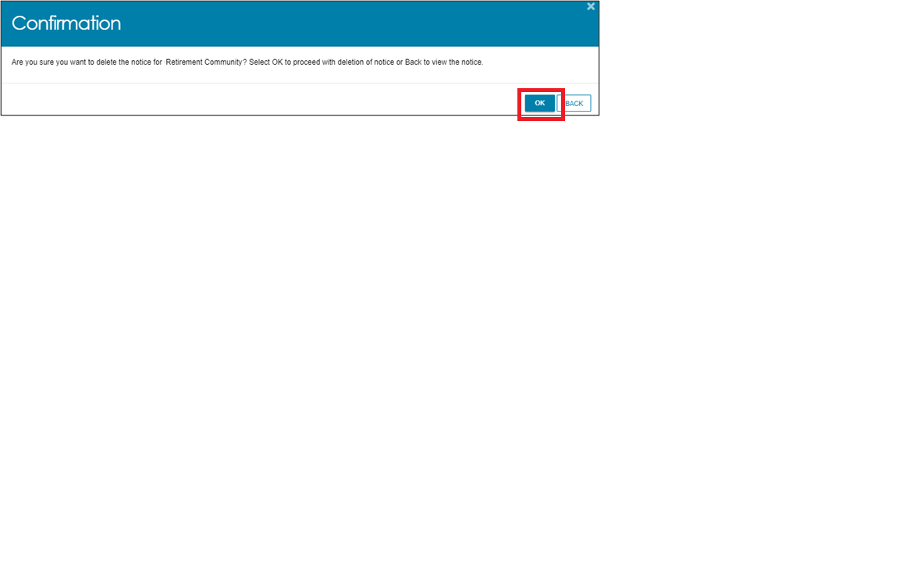

|  |  |
| --- | --- |
| ! | Once a notification is deleted, it will not appear anywhere on the portal and cannot be searched for. |

### How do I search existing SIRS notices?

1. Log in to the My Aged Care Service and Support Portal.
2. From the home screen of the My Aged Care Service and Support Portal, select the ‘SIRS Notice’ tile.



1. Click the ‘View and update existing notices’ tile.



|  |  |
| --- | --- |
| ! | If you are an administrator or team leader at the organisation and/or outlet level, you will see a list of all draft and completed notifications for your organisation/outlet. |

1. To perform a **basic search**, type the appropriate terms into either the ‘Incident ID’, ‘Service name’, ‘Affected care recipient first name’, or ‘Affected care recipient last name’ input field(s). Then select the ‘FILTER’ button to near the top of the page to search for the appropriate SIRS notice.

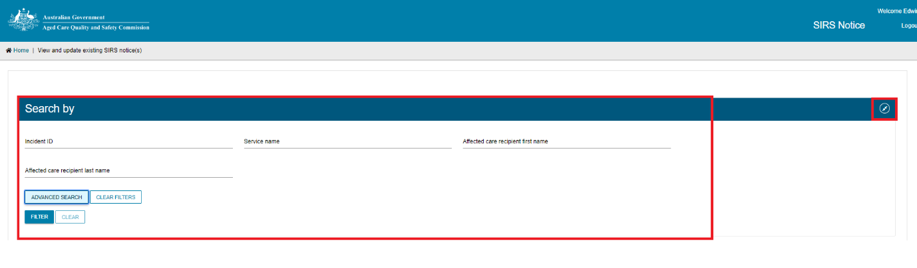

1. The results of your basic search will appear in the table below.

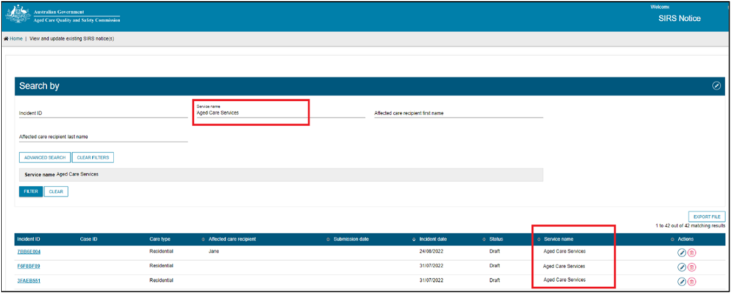

1. To clear a basic search, select the ‘CLEAR’ button.

Visual display of the clear button


1. To perform an **advanced search**, select the ‘ADVANCED SEARCH’ button.

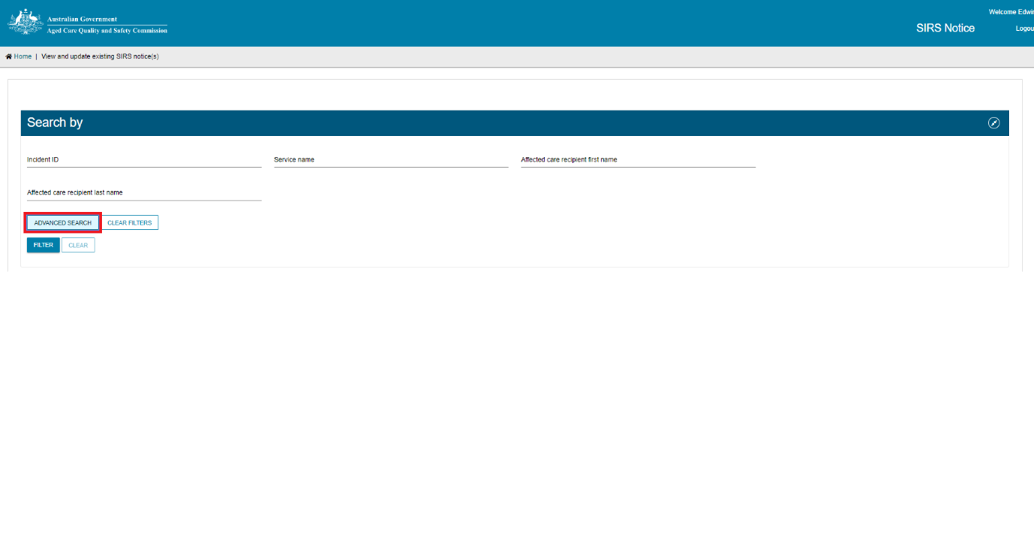

1. A popup window will appear. Select the ‘Choose an item’ drop down menu and select a search item from the list then click ‘ADD FILTER’. You can do this for multiple search items. When you have finished selecting items, complete the search item fields you have added then click ‘FILTER’.

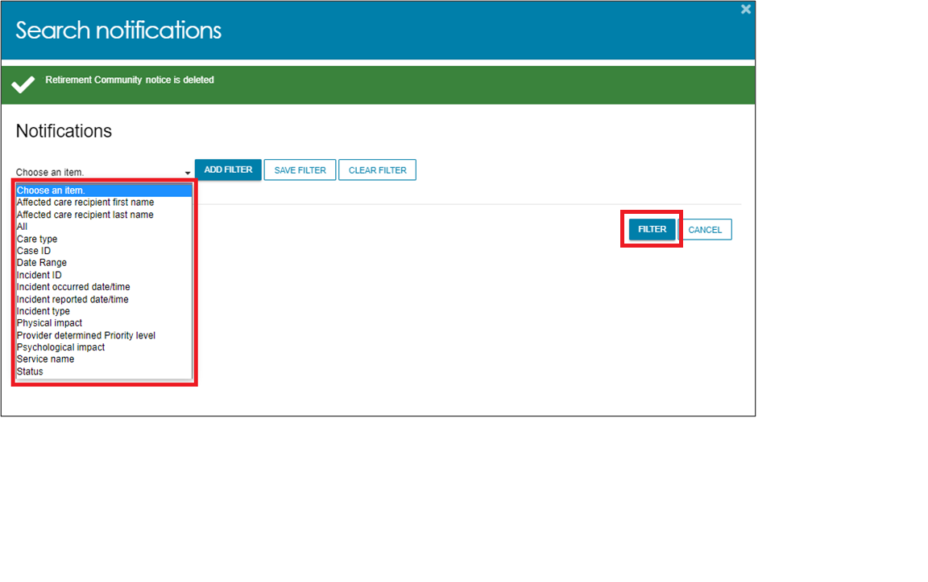

1. The results of your search will be displayed.

### How do I export a list of draft SIRS notices?

If you are an Organisation Administrator, you will be able to export a list of draft SIRS notices.

1. Log in to the My Aged Care Service and Support Portal.
2. From the home screen of the My Aged Care Service and Support Portal, select the ‘SIRS Notice’ tile.



1. Select the ‘View and update existing notices’ tile.



1. If you are an Organisation Administrator, you will be able to see an ‘EXPORT FILE’ button on the right-hand side of the page. If this button is not visible, check your permissions. Select the ‘EXPORT FILE’ button.

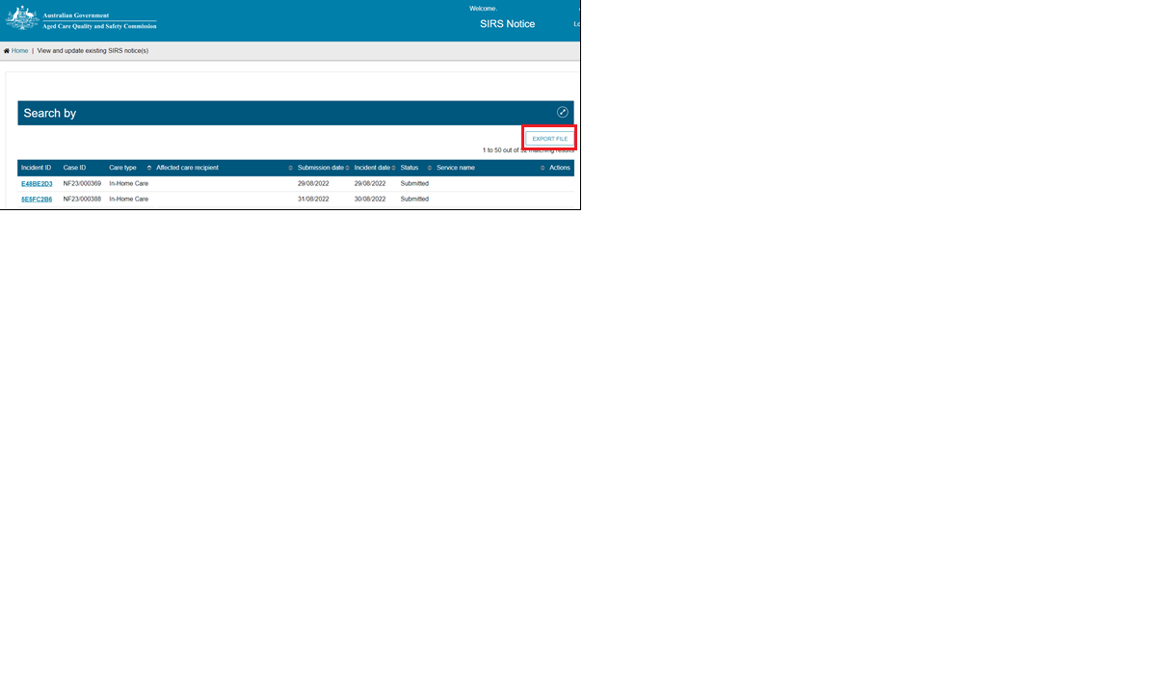

1. A .csv file will be automatically downloaded to your computer with the following name format:

“DraftNotices_” + “YYYY” + “MM” + “DD” + “hhmmss” + “#” + “.csv”

E.g. “DraftNotices_202206101504556.csv” (where “hh” is 24hr time).

The file contains the following information about each draft SIRS notice as a table:

1. Notification status
2. Care Type
3. Service name
4. Date/time incident reported
5. Date/time incident occurred
6. Incident type
7. Affected care recipient first name
8. Affected care recipient last name
9. Psychological impact
10. Physical impact
11. Provider determined priority level

Use Excel or an equivalent spreadsheet editor to open the.csv file.

|  |  |
| --- | --- |
| ! | Please note: .csv files cannot store anything beyond numbers and text. If you edit a .csv file in Excel, and then use any of Excel’s formatting or formula tools, you must “save as” an .xlsx file to keep your changes. |

### Help and further information

You can access help and further information by following the steps below.

1. Log in to the My Aged Care Service and Support Portal.
2. From the home screen of the My Aged Care Service and Support Portal, select the ‘SIRS Notice’ tile.

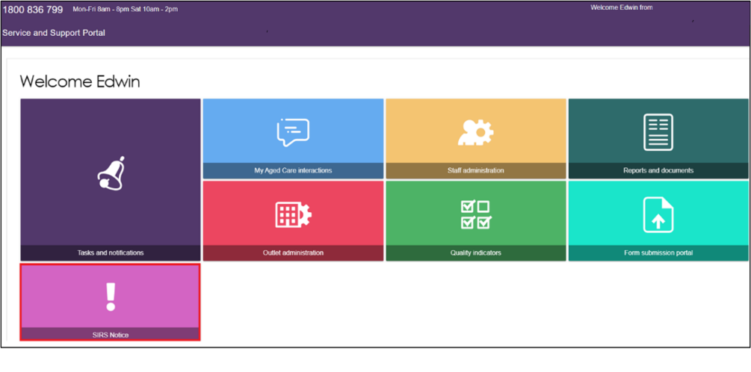

1. Click ‘Help and Information’.

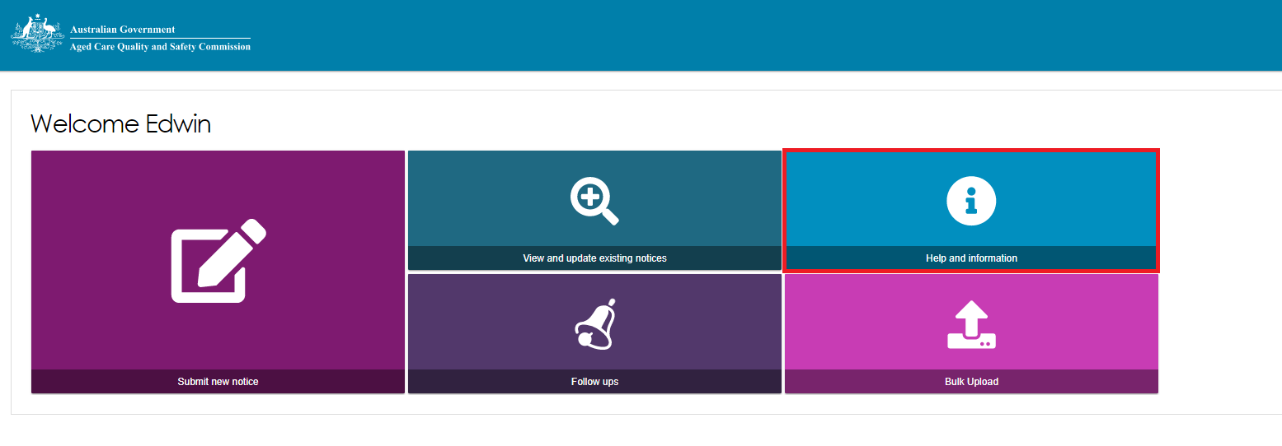

1. The various channels for help and information will then be displayed.

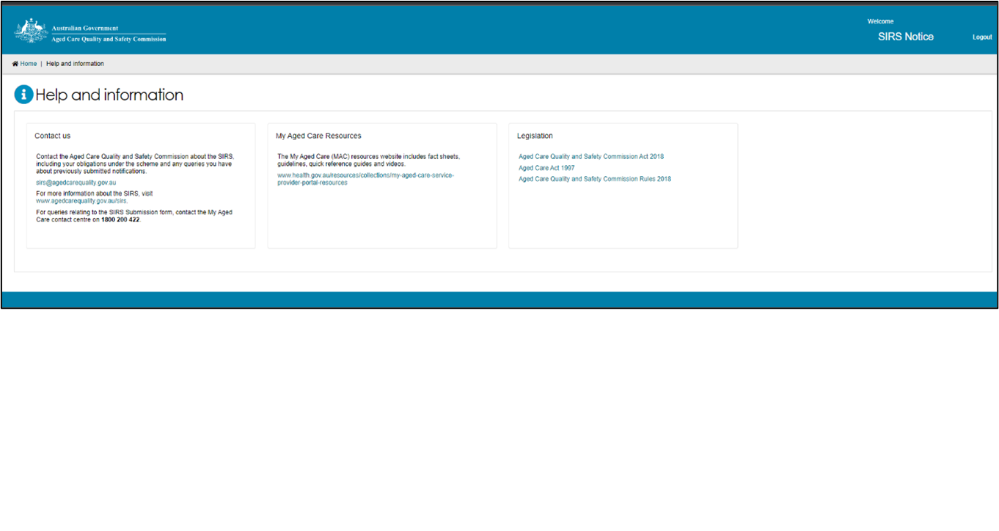

|  |  |
| --- | --- |
| ! | You can also call the My Aged Care Service Provider and Assessor Helpline on **1800 836 799**. If you have a technical issue, don’t forget you can ask the Call Centre staff to escalate your query to the tier 2 team for resolution. |

### How do I view SIRS follow up notifications?

Administrators and team leaders can view all follow up emails concerning cases relevant to their organisation and outlet respectively. Staff members can only view follow ups concerning draft notifications created by themselves. These follow up emails will be sent to the outlet’s administrator, as well as recorded within the SIRS Notice tile, when a draft SIRS notification has been inactive for seven days.

1. Log in to the My Aged Care Service and Support Portal.
2. From the home screen of the My Aged Care Service and Support Portal, select the ‘SIRS Notice’ tile.

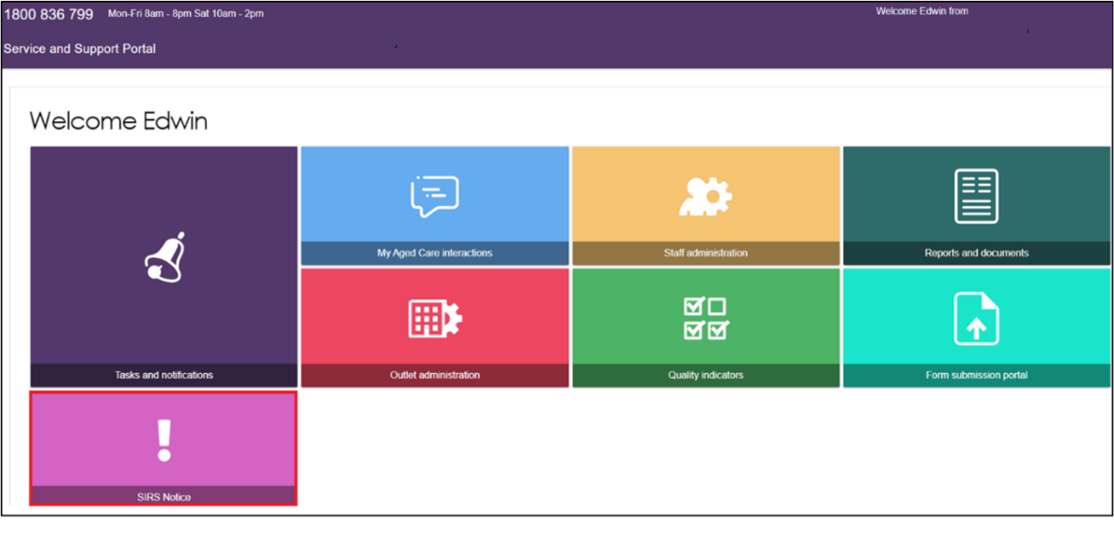

1. Click the ‘Follow ups’ tile.

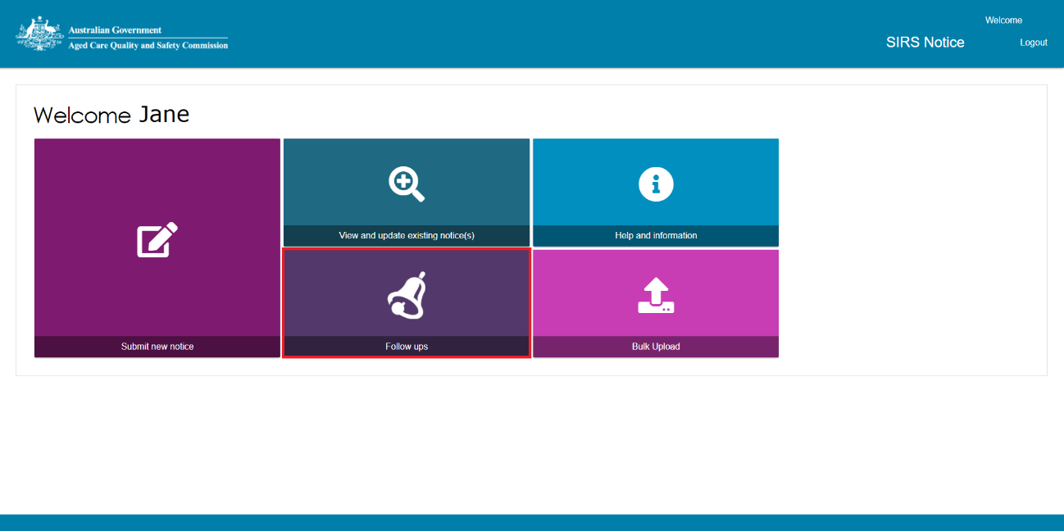

1. You will now see a list of the reminders for draft notifications.

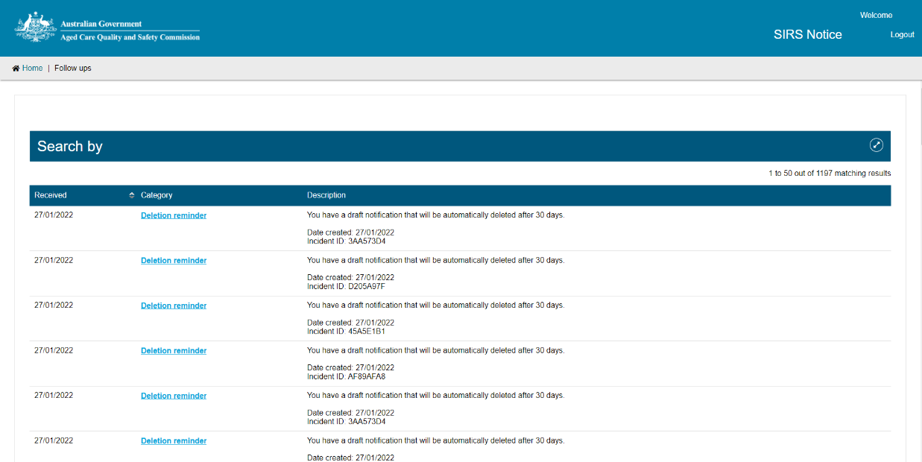

|  |  |
| --- | --- |
| ! | If you are an administrator or team leader you will be able to view all follow up emails concerning cases relevant to your organisation and outlet respectively. Staff members can only view follow ups concerning draft notifications created by themselves. |

1. You can also search for specific follow ups. To complete a search, expand the search section by clicking the double arrows then enter your search parameters in the fields provided and click ‘FILTER’. The filtered results will be displayed. To reset the search, click ‘CLEAR’.

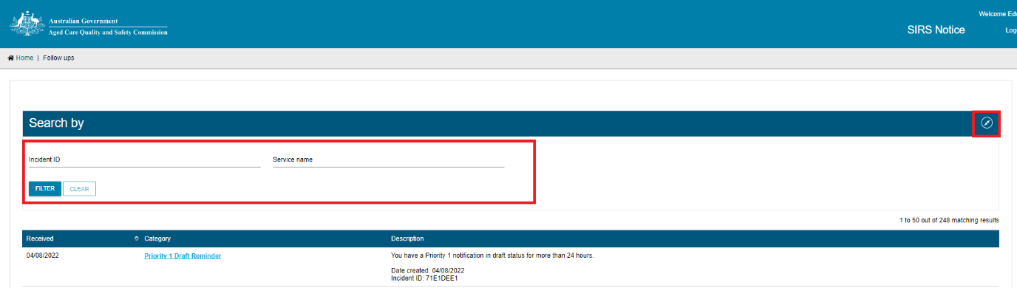

1. You will now see a list of reminders concerning drafts. Click the ‘Draft reminder’ hyperlink of the reminder you wish to view.

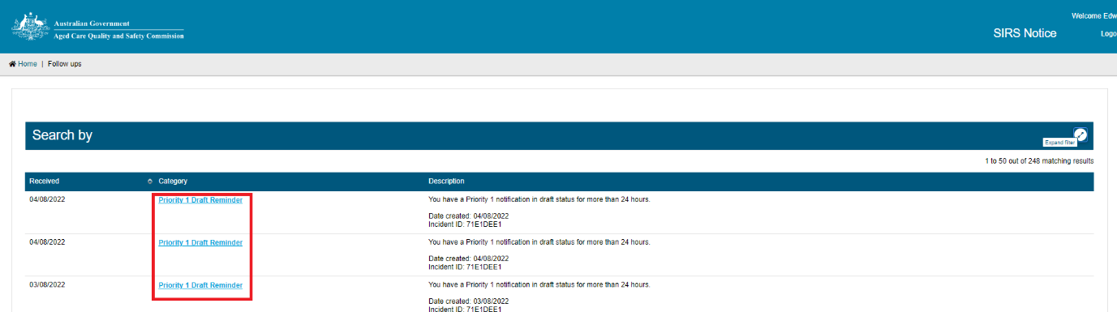

1. You can now view the reminder concerning the draft. When you have finished viewing, click ‘CLOSE’.

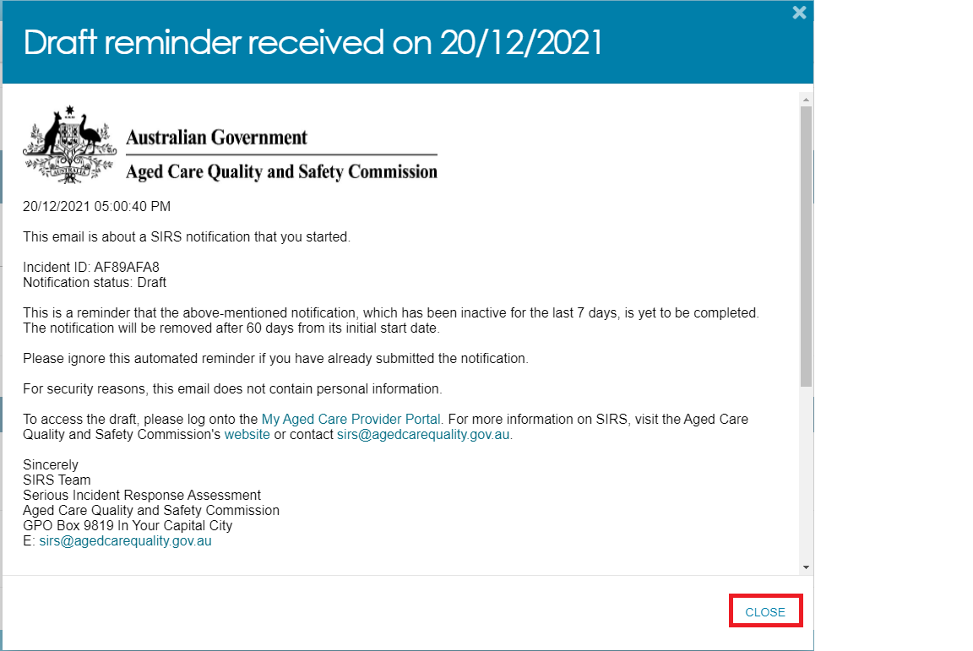

1. You can also navigate to submit a new notification. Click ‘New SIRS Notification’.

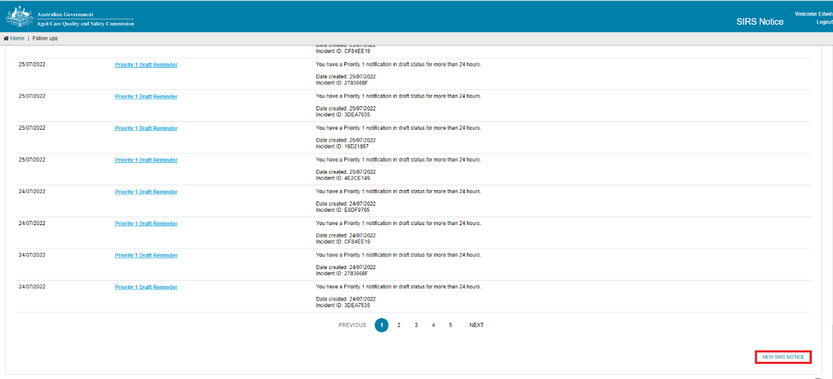

For information on how to submit a new notification please see the ‘How do I submit a new notice?’ section of this guide for more information.

|  |  |
| --- | --- |
| ! | Reminders for drafts will remain in your list for 60 days. |

### How do I upload multiple SIRS notices at once?

Organisation and outlet administrators can upload multiple Priority 2 SIRS notices at once with the bulk upload function. However, the function does not support SIRS notices that contain multiple offenders or Priority 1 incidents.

To use the bulk upload function, follow the steps below:

1. Log in to the My Aged Care Service and Support Portal.
2. From the home screen of the My Aged Care Service and Support Portal, select the ‘SIRS Notice’ tile.

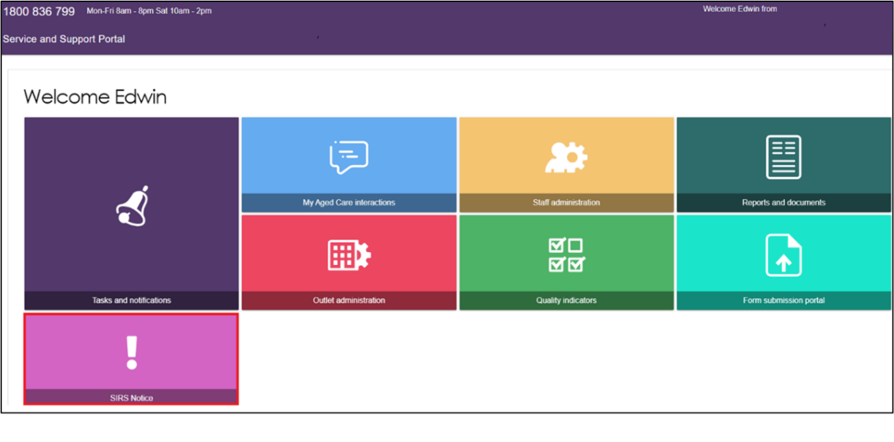

1. Click the ‘Bulk Upload’ tile.

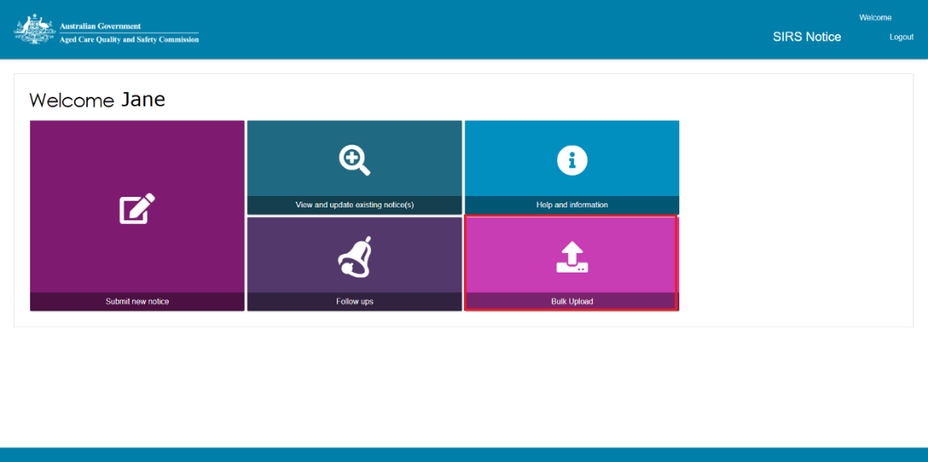

1. The ‘Bulk SIRS Notice upload’ page will be displayed.

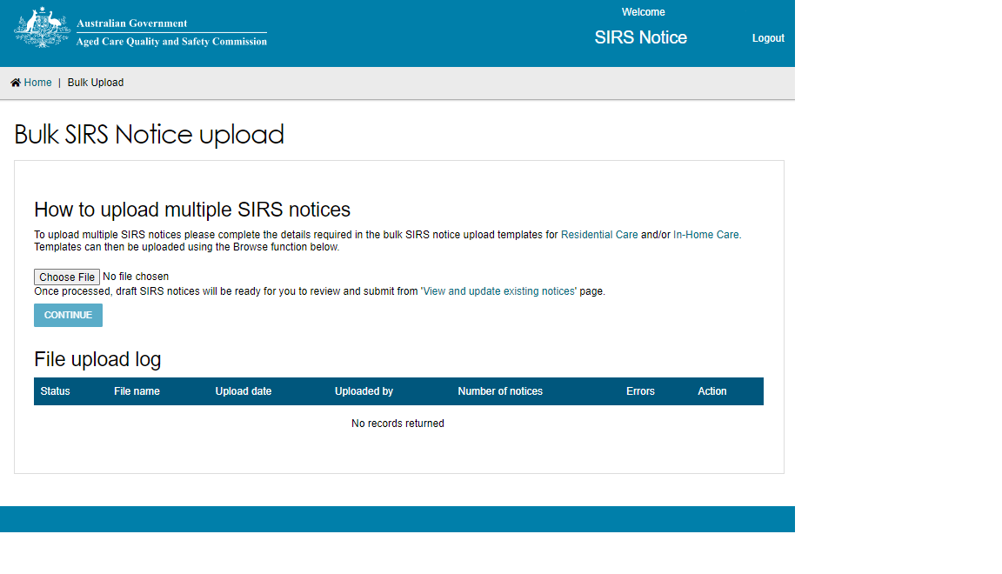

1. Bulk uploads need to conform to a specific template in order to be valid. For In-home care, click the ‘In-home Care’ link to download the bulk SIRS Notice upload template.

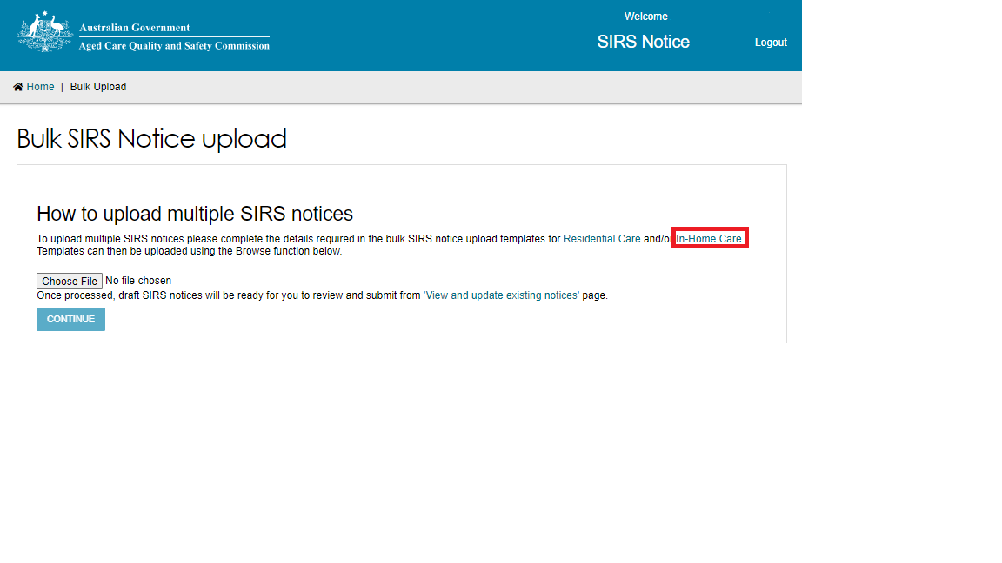

An .xlsx file will be downloaded to your computer called ‘SIRS_template_hcp’. Open the file and begin inputting the details of your SIRS notice(s).

Once you have filled out the .xlsx. file save the file with a unique name – this will help you find the file later.

1. Once completed, select the ‘Choose file’ button on the bulk upload page. Browse and select the completed SIRS Notice template to be uploaded.

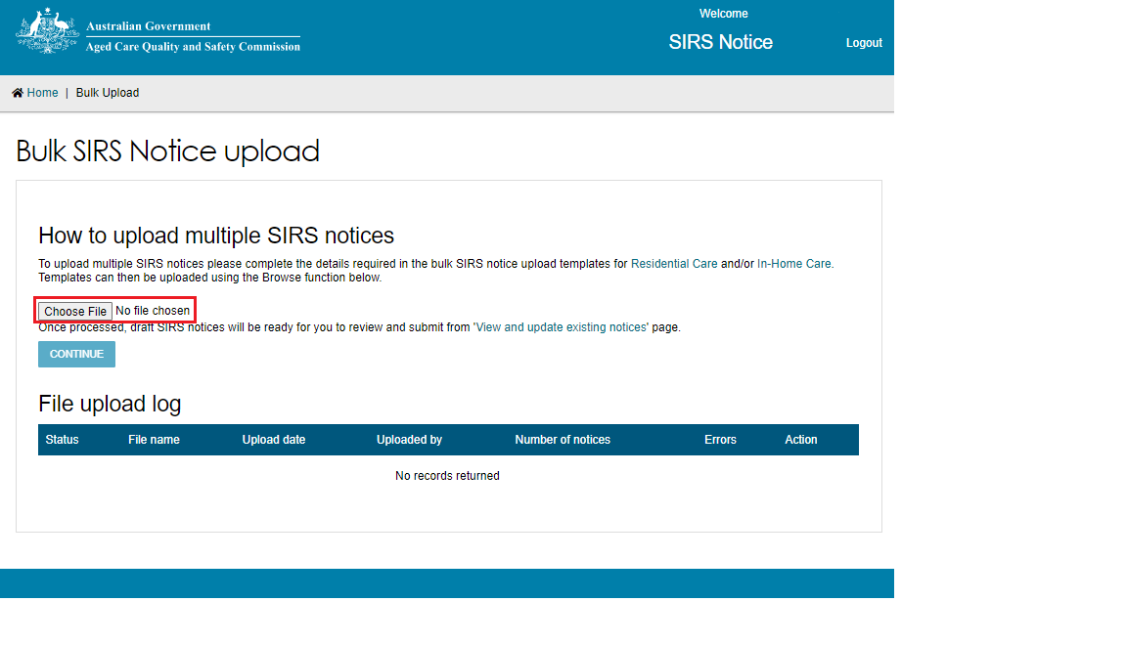

|  |  |
| --- | --- |
| ! | You can only upload files up to 5mb in size (roughly 500 row items). |

1. Click ‘CONTINUE’.

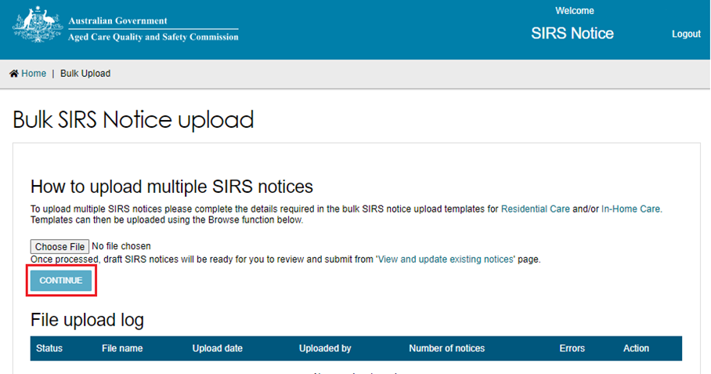

1. Processing of the file will begin, as indicated by the ‘Processing’ status in the table. Reload the web page after a few minutes to see the results of the processing.

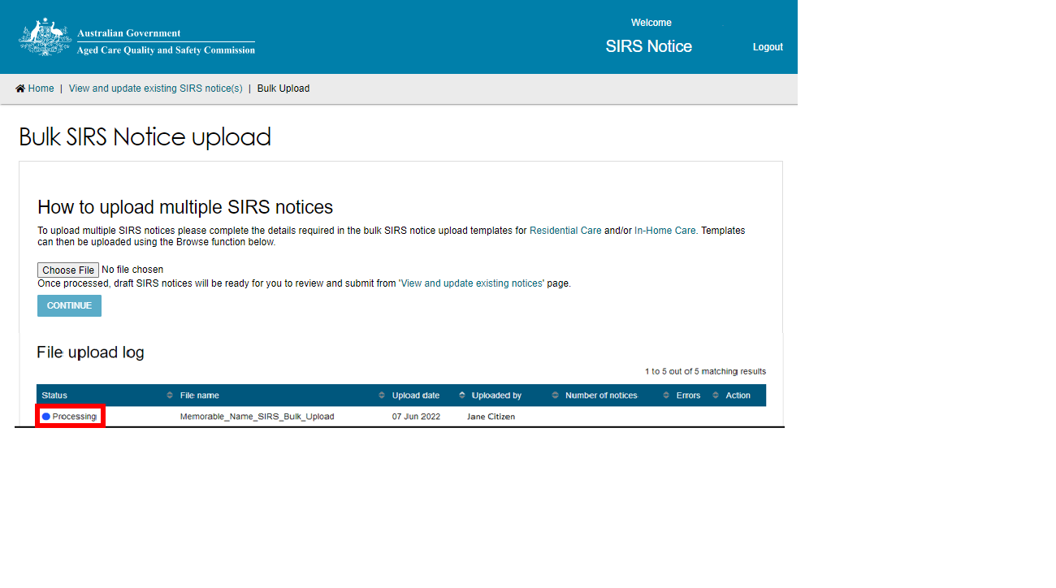

1. Once the status changes to ‘Processed’ or ‘Processed with errors’, select the magnifying glass symbol to view the upload details.

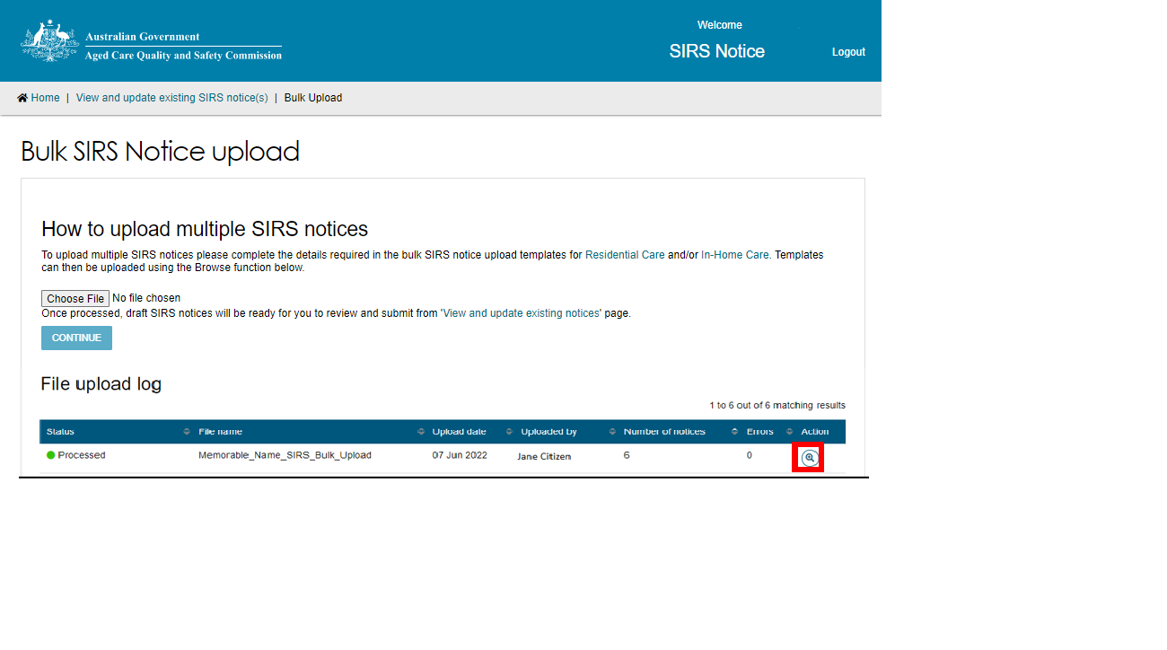

1. An Upload validation page will be displayed listing the SIRS notices uploaded from the template. Each notice contained within the bulk upload will be listed in a separate row.

Notices with a ‘Ready for submission’ status possess no errors and can be submitted immediately by selecting the paper airplane symbol on the right-hand side of the notice.

You can also submit all notices which are ‘Ready for submission’ by selecting the ‘SUBMIT ALL VALID REPORTS’ button.

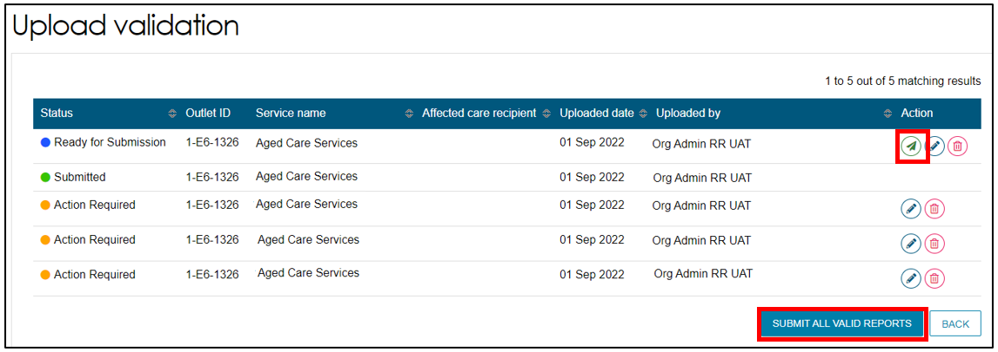

1. Notices with an ‘Action Required’ status possess errors and must be edited before submission. To edit a draft notice, select the pencil symbol on the right-hand side of the notice.

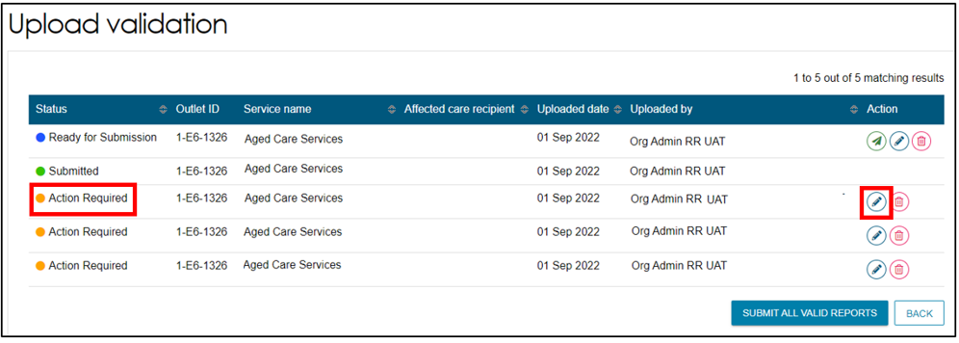

1. After selecting the pencil symbol, you will be taken to the ‘Review & Submit’ page of the SIRS form, allowing you to review the incomplete or incorrect segments of the notice and submit them individually.

Please see ‘How do I submit a new SIRS notice?’ for more information regarding this step.

1. Duplicates or other erroneous notices can also be removed by selecting the bin symbol on the right-hand side of the notice.

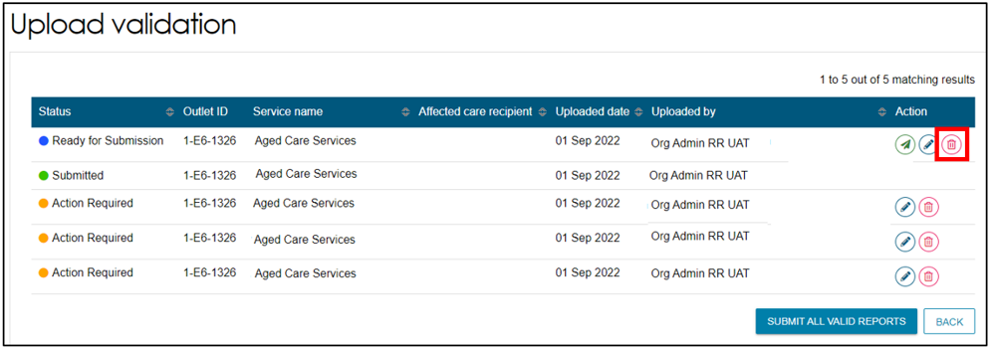

|  |  |
| --- | --- |
| ! | All the SIRS Notifications that are in status ‘DRAFT’ over 60 days will be removed. |