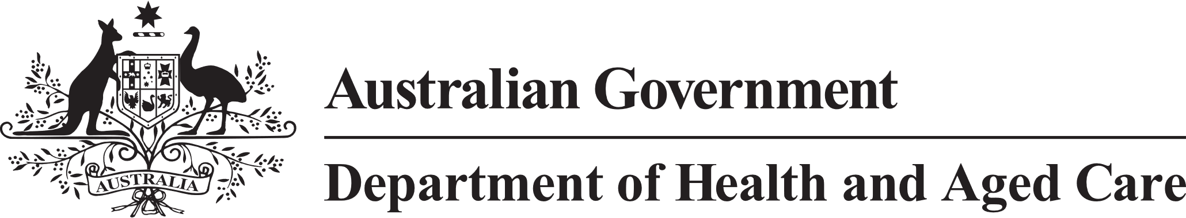

**Council of Elders**

# Communique – 11 October 2022

During its October meeting the Council of Elders met with the Minister for Aged Care, the Hon Anika Wells MP, to provide advice from older Australians on the aged care reforms. This included:

* welcoming the latest in-home care consultation paper, which has been updated to reflect advice provided by the Council, and others
* the importance of ensuring older people from diverse backgrounds and First Nations Elders are supported to navigate and access care and that the aged care reform process fully engages them
* welcoming the introduction of Star Ratings from December 2022 noting the important role the ratings will play in helping older Australians choose residential aged care services that best meet their needs, and strongly supporting the inclusion of consumer experience reports as a significant component of the Ratings, including the presumption of capacity of residents to participate
* the need for work to be done on clarity, equity, consistency and sustainability of consumer fees and contributions in aged care – the Council offered to work with the Minister and the Department on this

The Council provided feedback on the consultation approach for the draft **National Dementia Action Plan**. Members advised that engagement on dementia action needed to be undertaken across a wider range of stakeholders across the community, not just in health and aged care. The Council will support the consultation process, which is expected to take place from 1 December.

The Council considered the latest **in-home aged care consultation** **paper**, which is [now available on the department’s website](https://www.health.gov.au/resources/publications/a-new-program-for-in-home-aged-care-summary), and highlighted the need to ensure people requiring short term intensive support are assisted, including through training of the assessment workforce.

The Council welcomed the upcoming launch of [**Star Ratings**](https://www.health.gov.au/initiatives-and-programs/star-ratings-for-residential-aged-care) for residential aged care facilities in December 2022. Members acknowledged the need to monitor and fine-tune Star Ratings over time. A subgroup of Members has been established to assist with this.

Members discussed the establishment and functions of the **Aboriginal and Torres Strait Islander Aged Care Commissioner** (ATSIACC) and expressed interest in being involved in the development of ATSIACC. Members emphasised the importance of considering how ATSIACC will sit alongside other roles such as the Inspector-General for Aged Care.

The Council considered an update on **financial transparency measures** and emphasised the importance of financial information being available to older Australians and their families to help inform decisions about care services.

The Council also considered the [**Aged Care Data Strategy**](https://www.gen-agedcaredata.gov.au/Data-improvements)and indicated strong support for the approach and the improved and expanded data it will make available to providers and older Australians.

The next meeting of the Council will be held on 10 November 2022 via video conference.