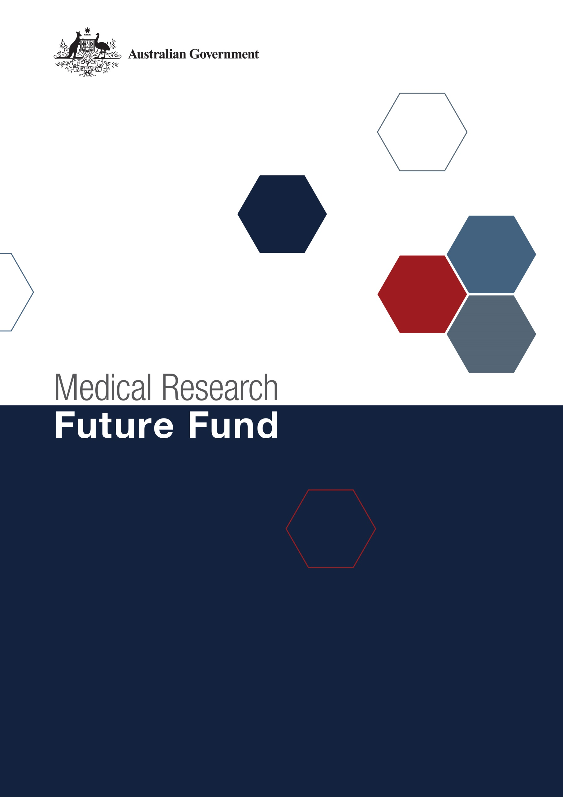**Australian Medical Research   
and Innovation Priorities   
2022-2024**

# *Australian Medical Research and Innovation Priorities aligning with the Australian Medical Research and Innovation Strategy 2021-26*

*Preamble*

In accordance with the *Medical Research Future Fund Act 2015* (the MRFF Act), the independent Australian Medical Research Advisory Board (AMRAB) must develop a five-year Australian Medical Research and Innovation Strategy, and the Australian Medical Research and Innovation Priorities (Priorities), to be in force for two years. The Australian Medical Research and Innovation Strategy 2021-2026 (the 2021-26 Strategy) was registered on the Federal Register of Legislation through the *Australian Medical Research and Innovation Strategy 2021-2026 Determination 2021* and took effect on 9 November 2021.

The MRFF Act requires AMRAB to take into account the following matters when determining the Priorities:

* the burden of disease on the Australian community;
* how to deliver practical benefits from medical research and medical innovation to as many Australians as possible;
* how to ensure that financial assistance provided under the MRFF complements and enhances other financial assistance provided for medical research and innovation; and
* any other relevant matters.

AMRAB has developed these Priorities (2022-24 Priorities) concurrently with the 2021-2026 Strategy, through a comprehensive national consultation process, in order to align with and facilitate the achievement of the 2021-26 Strategy’s vision, aim and strategic objectives. The 2022-24 Priorities took effect on 6 November 2022, superseding the 2020-22 Priorities, which were registered on the Federal Register of Legislation through the *Australian* *Medical Research and Innovation Priorities 2020-2022 Determination 2020*, and remained in force until 5 November 2022.

Each priority is outlined in the table below with its relevance (the ‘why’) and a recommended implementation approach (the ‘how’). This provides the context on how each priority will contribute to the key elements across one or more of the strategic objectives to achieve health equity and deliver health and economic benefits through transformative and innovative research and a health system that is responsive to health challenges and underpinned by a skilled and sustainable workforce.

*Priorities aligning with the Australian Medical Research and Innovation Strategy 2021-26*

| Priority | Why action is needed | How best addressed |
| --- | --- | --- |
| Consumer-Driven Research  Research that is driven by meaningful consumer involvement and partnerships, to incorporate priorities, needs, values and experiences to deliver fit-for-purpose outcomes that can be adopted by consumers, carers, healthcare professionals and other end-users. | Increased and more effective consumer involvement will assist in ensuring MRFF­funded research delivers the best possible outcome for improving the health and wellbeing of individuals, their families and carers. | Support partnerships that drive meaningful consumer involvement by pairing researchers with consumers, carers, healthcare professionals and other end-users. |
| Research Infrastructure and Capability  Address gaps in the generation of knowledge and in early biomedical and medical technology product development by supporting access to expertise, capability and infrastructure (i.e. research facilities, equipment, systems, services), including in partnership with industry, that seeks to drive new research discoveries and accelerate innovation. | Access to advanced biomedical research and translation assets is required to ensure that discoveries are effectively and rapidly converted to new preventive interventions, diagnostics, therapeutic products and medical devices, based on quality data. | Support access to expertise and infrastructure that facilitates innovation and the development of research discoveries for practical impact.  Emphasis should be placed on building capacity and capability, including through collaboration and partnerships with industry. This includes better integration with NCRIS on infrastructure support. |
| Translation and Commercialisation  Provide a focus on research translation, implementation and commercialisation by facilitating collaborations between the research sector, industry and community. This includes accelerating and advancing innovation to bring about progress in health outcomes by leveraging opportunities from novel or emerging tools and technologies (e.g. personalised medicine, synthetic biology, advanced communications and manufacturing technologies) that can transform health and medical research, health interventions and care. | Australia is recognised as a world leader in biomedical research outputs, but this is not reflected in levels of research translation and commercialisation. Narrowing this gap is critical to realising the benefits of research outputs, through health and economic outcomes. | Support for translation of research into improved healthcare, new healthcare technologies, treatments and models of care. This includes supporting transitions through the ‘valleys of death’ and de-risking projects to support commercial viability and implementation. |
| Comparative Effectiveness Research  Systematic evaluation and demonstration of the comparative value of therapeutics, devices and health interventions to inform the decisions by policy makers, clinicians and consumers regarding healthcare, and to minimise unnecessary, ineffective and harmful health interventions. | Knowledge of the benefits and harms of alternative means to prevent, diagnose, treat, and to monitor care, can transform health outcomes. Evidence generated by comparative effectiveness research improves treatments and informs decision-making about investment and disinvestment. | Support comparative effectiveness research driven by clinicians, consumers and policy makers to inform decisions on the most effective care. |
| Preventive and Public Health Research  Invest in preventive health to maximise the social and economic benefits of better health. The investments in preventive health research made through the MRFF are expected to contribute to policy objectives of the National Preventive Health Strategy 2021-2030 and other national initiatives. | Chronic conditions are the leading cause of illness, disability and death in Australia. Primary causes are typically known (nutritional, behavioural and biomedical) and often modifiable. There is great potential for integrating prevention and public health interventions with healthcare to maintain and improve health and wellbeing, and reduce the burden of disease. | Support innovative approaches in prevention and public health interventions through multidisciplinary collaborative teams to improve public health outcomes, including by addressing modifiable risk factors and co-morbidities. |
| Primary Care Research  Support primary care research with an emphasis on multi-disciplinary collaboration, adaptive research methodologies, innovative models of care, and clinician capability. This can include developing the evidence base about the efficacy and value of different primary care models and health systems, including to improve primary care intersection with both secondary care and tertiary care for a more integrated and efficient health care sector. | The growing complexity of care environments makes practitioner and care team decisions increasingly difficult. While most healthcare occurs in primary care within the community, most research occurs in tertiary or specialist settings. In primary care, people typically present early with undifferentiated disease and multiple co-morbidities. The growth in chronic and complex diseases calls for a more concerted effort in primary care research that is geographically relevant and, where possible, scalable nationally to maximise impact. | Conduct primary care research that is led by health care professionals, which can permeate daily practice and has potential for scalability. |
| Health and Medical Researcher Capacity and Capability  Support and enhance Australian health and medical research capacity, especially clinician researchers, with a focus on multidisciplinary engagement and improving the translation and integration of evidence-based research into primary through to tertiary care and commercial outcomes. This includes fostering gender equity and opportunities for early to mid-career researchers in the research workforce. | Building and growing this capacity is critical for the long-term development and retention of the next generation of health and medical researchers, especially women, in order to ensure the availability of diverse skills within the research workforce, that intersect clinical practice, healthcare innovation, research translation, and consumer and end-user engagement. | Support capacity and capability development with a focus on priority areas including clinical researchers and early to mid-career researchers, and building research translation, innovation and commercialisation skills. |
| Aboriginal and Torres Strait Islander Health  Improve the health of Aboriginal and Torres Strait Islander people to close the gap in health mortality and morbidity through Aboriginal and Torres Strait Islander leadership and Aboriginal and Torres Strait Islander-led priority setting to drive health-related research. | Health and social equity for Aboriginal and Torres Strait Islander Australians remains one of Australia’s most enduring challenges. The gap between Aboriginal and Torres Strait Islander and other Australians in life expectancy, mortality and wellbeing is unacceptable. Some Aboriginal and Torres Strait Islander health research investment to date has been fragmented and not always prioritised or led by communities. | Support Aboriginal and Torres Strait Islander leadership, agency and community empowerment, the promotion of health equity, elimination of discrimination and strengthening research capacity.  Drive this through Aboriginal and Torres Strait Islander governance and with regard to the social and cultural determinants of health and the priority reforms of the *National Agreement on Closing the Gap, the National Aboriginal and Torres Strait Islander Health Plan 2021–2031* and the *National Aboriginal and Torres Strait Islander Health Workforce Strategic Framework 2016–2023.* |
| Priority Populations  Ensure equitable health outcomes for all people living in Australia by targeting funding towards biomedical discovery and health service innovation to address specific and unique health challenges for priority populations, including:   * older people experiencing diseases of ageing (e.g. cognitive decline and dementia) * people with rare or currently untreatable diseases/conditions * people in remote/rural communities * people with a disability (including people with intellectual disability) * individuals from culturally and linguistically diverse communities.   This includes supporting research into specific health and healthcare needs to improve diagnosis, treatment and care to meet the needs of individuals and communities, to improve quality of life. | Australia consists of a mix of socially, ethnically, culturally, linguistically and geographically diverse populations, who may have very different health and healthcare needs.  In addition, as the Australian population shifts towards a higher proportion of older people, there is a need for a concerted research focus on optimising the physical and cognitive health and wellbeing of older members of the community.  Research to address differences in health and healthcare needs is important to reduce inequities in health outcomes. | Support research to understand the complex biomedical, social, socio-economic and health system determinants of health and health outcomes, such as prevention, behaviour, biomarkers, disability and mobility, co-morbidity, models of care, consumer choice and care needs.  Investment focus needs to be responsive and complement any research-relevant outcomes relating to the specific priority populations, in line with national initiatives to address health inequities. |
| Antimicrobial Resistance  Reduce the health impact of antimicrobial resistance (AMR). This includes supporting research into stewardship practices, diagnostic and treatment tools, preventive measures, and new or novel antimicrobials, host-directed therapeutics and vaccines that span the divide between human health and animal health. | Australia has one of the highest rates of antibiotic use in the world. High rates of antibiotic use are associated with increasing rates of antibiotic resistance. *Australia's National AMR Strategy-2020 and Beyond* recognises that AMR is a One Health issue requiring a coordinated response in all sectors including the human health, animal health, food and agriculture sectors, as well as global coordination. | Support collaborative multidisciplinary research to understand mechanisms of microbe transfer between animals and humans and development of strategies to reduce inappropriate antibiotic use and apply novel therapeutic solutions. |
| Global Health and Health Security  Build capacity for preparedness, prevention, response, eradication and/or management of identified and emerging or potential global health threats, including pandemics and zoonotic disease threats. This includes building and strengthening international collaborations and capabilities, particularly within the Indo-Pacific region. | Health and medical research is an international effort, as highlighted by the COVID-19 response, which significantly benefits from partnerships across jurisdictions, disciplines and sectors. Australia, as a recognised world leader in health and medical research, has the potential to provide strategic leadership and contribute expertise to address shared health issues. | Support multidisciplinary and cross-sectoral research and partnerships to address global health and health security issues of relevance to Australia, including preparedness, prevention, response, eradication and/or management for both identified and emerging global threats. |
| Health Impacts from Environmental Factors  Address the emerging and long-term health impacts of environmental factors, such as bushfires and climate change. The indirect impact of the COVID-19 pandemic has also resulted in delayed health screening, treatment and care for other illnesses. | Increased globalisation and global population size can have an ongoing impact on the environment, resulting in changes to the climate, natural resources, biodiversity and population distributions. These environmental changes can have a significant impact on health in a multi-faceted and complex way. | Support multidisciplinary and cross-sectoral research to address health challenges resulting from environmental factors relevant to Australia. This includes research into short and long-term health impacts, early and better diagnosis, prevention, treatments and healthcare delivery. |
| Data, Digital Health and Artificial Intelligence  Improve data utilisation for more integrated and effective health and healthcare systems. Support for informatics (e.g. data registries, biobanks, data linkage platforms and secure data storage), artificial intelligence, machine learning and predictive analytics research, advanced clinical decision-making tools, wearables, and other emerging innovative digital technologies is the key to realising the benefits of healthcare digitalisation. | Digital health uses data and information technology to support and enhance clinical safety, improve productivity and efficiency, and connect the health system. There is potential for improved prevention, patient care, behavioural change, and care compliance through better access to existing data and development of new data sets and digital technologies. | Support research that leverages and enhances data platforms, linkage, data storage and analytics; applied artificial intelligence, end-user digital utility; and the development of novel decision tools. |