**A New Program for In-home Aged Care Discussion Paper – Industry Q&A Session**

## ****Wednesday 2 November 2022 2:00pm – 3:00pm AEDT****

**Nick Morgan**

**Assistant Secretary, Support at Home Reform Branch**

## Update on reforming in-home aged care

* A new program will commence 1 July 2024 combing existing in-home aged care programs
* Objectives
  + 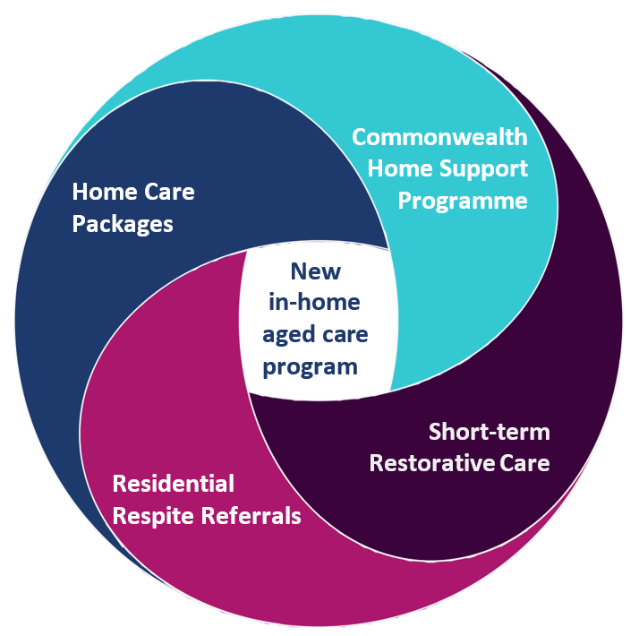improve access to services
  + better align services to needs
  + reduce administrative costs
  + better support independence
  + make aged care simpler
  + facilitate innovation and investment

## Discussion paper

* Released on 18 October 2022
* Outlines proposed reforms to the in-home aged care system that
  + Incorporate what we have heard with a focus on five key areas
  + Seeks submissions from the community by 25 November 2022

Information on the discussion paper and submissions process are on the

[**Aged Care**](https://agedcareengagement.health.gov.au/engagement/a-new-program-for-in-home-aged-care-discussion-paper/)[**Engagement Hub**](https://agedcareengagement.health.gov.au/engagement/a-new-program-for-in-home-aged-care-discussion-paper/)

## Overview of Proposed Model

Diagram first box shows Client process
Assessment with referral to Short Term Support for Independence and/or Ongoing supports at home
2nd Box shows Providers
Short term support for independence and mixed funding model for ongoing supportFive key areas of focus – seeking views in submissions

1. **Self-management of services**
2. **Care management**
3. **Funding model**
4. **Flexibly for changing needs**
5. **Innovation**

## Provider preparation to transition to new program

* **Activity based payments** - Could your business operate if paid on services delivered at current CHSP prices?
* **Service data** - Do you hold data on the services you have delivered, by service type by client? Could that be regularly uploaded for invoicing?
* **Thin markets** - Do you feel you service a thin market – how would you justify that in a grant round?
* **Care management** - What happens when a care worker identifies an issue with one of your clients? Could you share that information with a care partner not in your organisation?
* **Regulation** - If there is a streamlined registration process for the new program, would things like police checks all be up to date?
* **Expansion** - Is there demand for your services that you turn away today? Have you considered opportunities to expand to deliver additional services?

## Process from here

**18 Oct** Discussion paper released – open for submissions for six weeks to 25 November

**26 – 31 Oct (Complete)** Initial sessions with Provider peaks, Older Australians, Consumer peaks

**2 Nov – 22 Nov** Weekly open Older Australian and Industry online Q&A sessions

Three one day workshops consulting on Indigenous delivery options

**7 Dec** Webinar outlining feedback on discussion paper

**Current – 24 Feb** Targeted consultations on specific elements based on submission feedback

Client groups - eg CALD, Carers, Dementia, Indigenous, Provider groups – eg by service type

**March** Government consideration of final program design

## Thank you

* You can have your say through [our online submission process](https://healthau.au1.qualtrics.com/jfe/form/SV_eR62WsCIVgyGtnw) or by calling 1800 318 209
* Submissions will be open until 25 November 2022
* For more information, please contact the Department of Health and Aged Care
* Email: [SAH.implementation@health.gov.au](mailto:SAH.implementation@health.gov.au)
* Go to the Ageing and Aged Care Engagement Hub: [www.agedcareengagement.health.gov.au](http://www.agedcareengagement.health.gov.au/)