

Revised
Aged Care
Quality
Standards
  - Detailed version for public consultation

Table of contents
Table of contents 2
Standard 1: The Person 5
Intent of Standard 1 5
Standard 1 expectation statement for older people: 6
Outcome 1.1: Person-centred care 6
Outcome 1.2: Dignity, respect and privacy 8
Outcome 1.3: Choice, independence and quality of life 8
Outcome 1.4: Transparency and agreements 9
Standard 2: The Organisation 11
Intent of Standard 2 11
Standard 2 expectation statement for older people: 11
Outcome 2.1: Partnering with older people 12
Outcome 2.2: Quality and safety culture 12
Outcome 2.3: Accountability and quality systems 13
Outcome 2.4: Risk management 14
Outcome 2.5: Incident management 14
Outcome 2.6: Feedback and complaints management 15
Outcome 2.7: Information management 16
Outcome 2.8: Workforce planning 17
Outcome 2.9: Human resource management 17
Outcome 2.10: Emergency and disaster management 18
Standard 3: The Care and Services 19
Intent of Standard 3 19
Standard 3 expectation statement for older people: 19
Outcome 3.1 Assessment and planning 20
Outcome 3.2: Delivery of care and services 21
Outcome 3.3: Communicating for safety and quality 22
Outcome 3.4: Coordination of care and services 23
Standard 4: The Environment 24
Intent of Standard 4 24
Standard 4 expectation statement for older people: 24
Outcome 4.1a: Environment and equipment at home 25
Outcome 4.1b Environment and equipment in a service environment 25
Outcome 4.2: Infection prevention and control 26
Standard 5: Clinical Care 28
Intent of Standard 5 28
Standard 5 expectation statement for older people: 28
Outcome 5.1: Clinical governance 29
Outcome 5.2: Preventing and controlling infections in clinical care 30
Outcome 5.3: Medication safety 31
Outcome 5.4: Comprehensive care 32
Outcome 5.5: Care at the end of life 36
Standard 6: Food and Nutrition 38
Intent of Standard 6 38
Standard 6 expectation statement for older people: 39
Outcome 6.1: Partnering with older people on food and nutrition 39
Outcome 6.2: Assessment of nutritional needs and preferences 40
Outcome 6.3: Provision of food and drink 40
Outcome 6.4: Dining experience 41
Standard 7: The Residential Community 42
Intent of Standard 7 42
Standard 7 expectation statement for older people: 43
Outcome 7.1: Daily living 43
Outcome 7.2: Planned transitions 44

Below are the proposed strengthened Aged Care Quality Standards, including the expectation statements for older people, intent of each standard, enforceable outcomes and detailed actions to be demonstrated by a provider under each standard.
Further information about how these strengthened Quality Standards have been developed can be found through the detailed consultation paper and summary version. You may also like to read a summary version of these strengthened Quality Standards. To get involved and have your say, visit the Aged Care Engagement Hub.
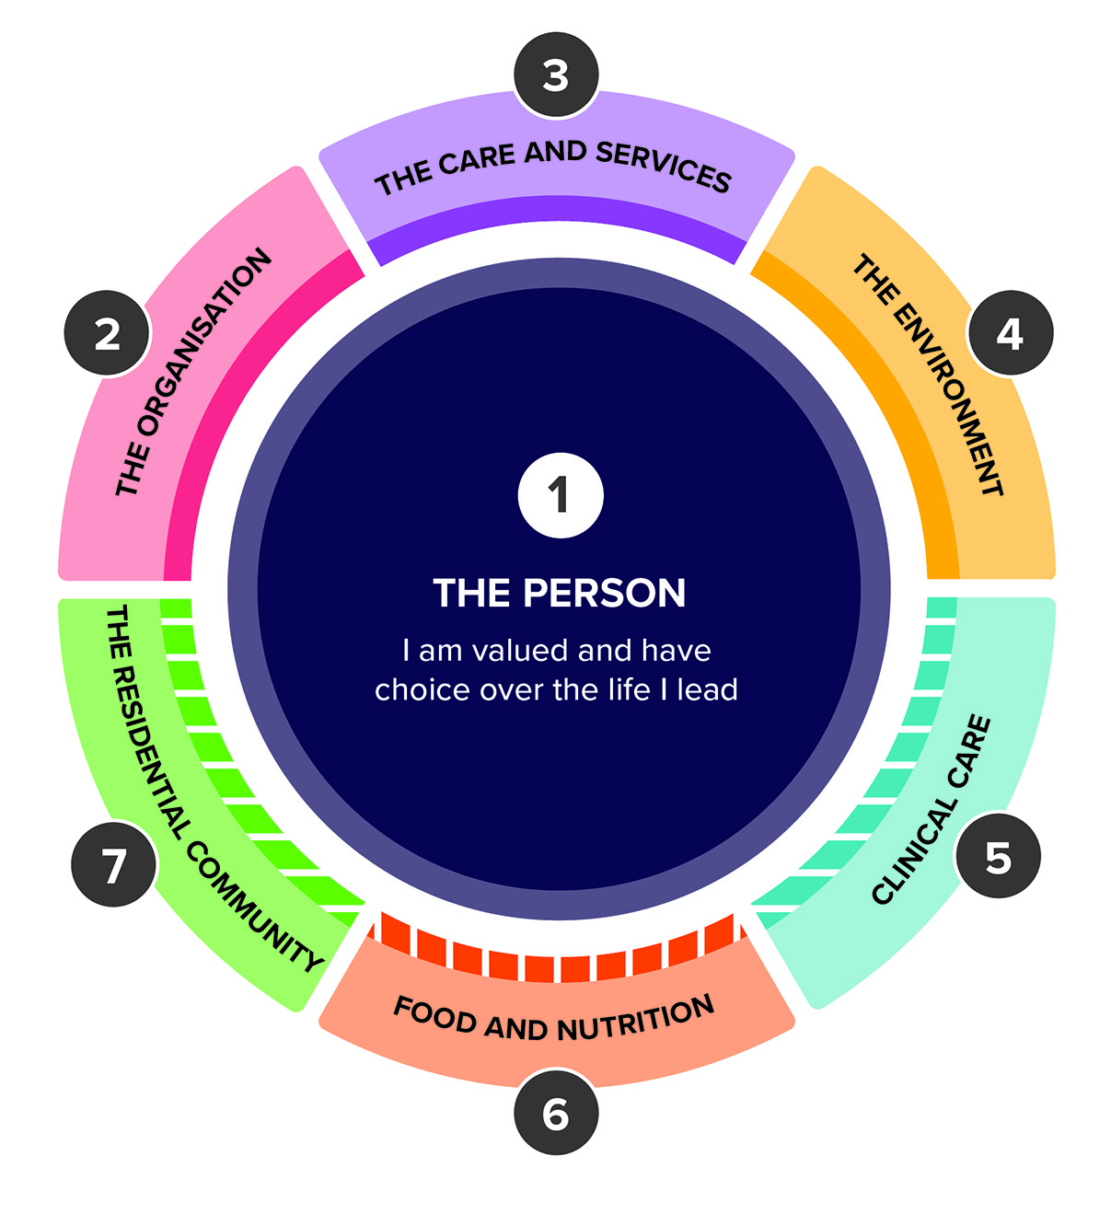

Standard 1: The Person

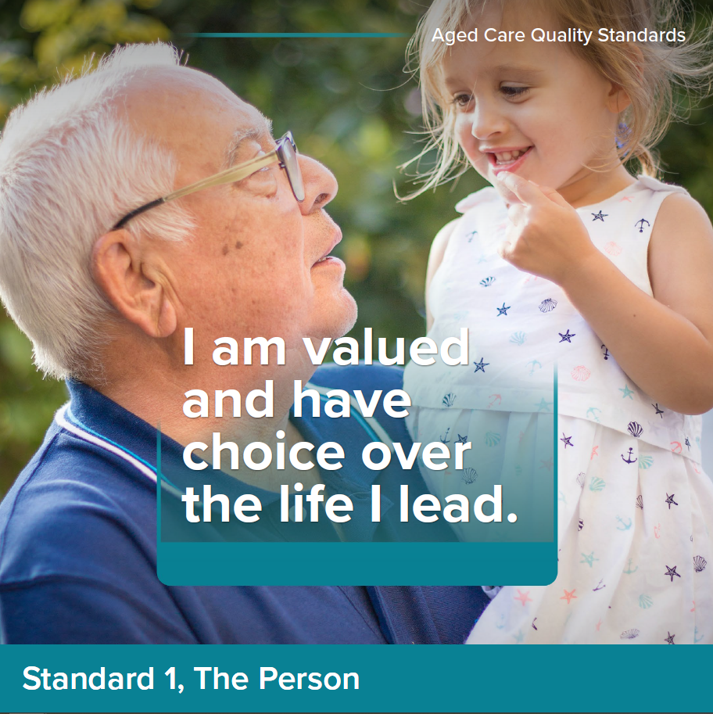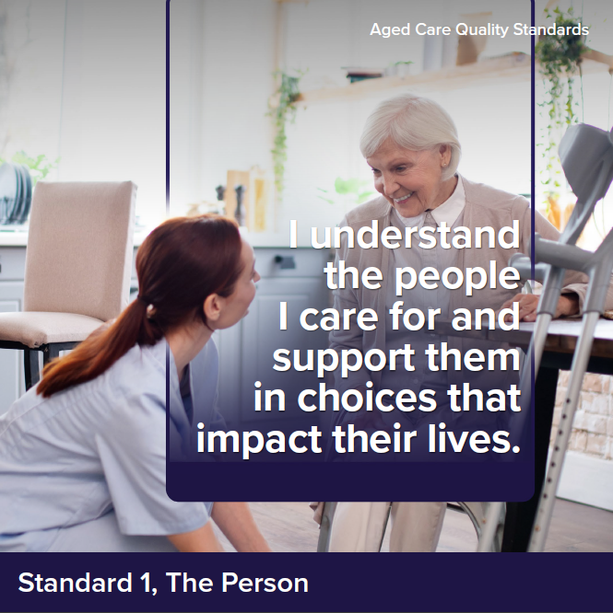

Intent of Standard 1
Standard 1 underpins the way that providers and workers are expected to treat older people as relevant to all standards. Standard 1 reflects important concepts about dignity and respect, older person individuality and diversity, independence, choice and control, culturally safe care and dignity of risk. These are all important in fostering a sense of safety, autonomy, inclusion and well-being for older people.
Older people are valuable members of society, with rich and varied histories, characteristics and life experiences.
Older people can come from a diverse range of backgrounds, including, but not limited to, Aboriginal and Torres Strait Islander peoples, people from culturally and linguistically diverse backgrounds, people living in rural or remote areas, people who are financially or socially disadvantaged, people who are veterans, people experiencing homelessness or at risk of becoming homeless, people who are care leavers (i.e. a person who spent time in care as a child), parents separated from their children by forced adoption or removal, people who are lesbian, gay, bisexual, transgender or intersex, people of various religions, people experiencing mental health problems and mental illness, people living with cognitive impairment including dementia, people living with disability.
A person’s diversity does not define who they are, but it is critical that providers recognise and embrace each person’s diversity and who they holistically are as a person, and that this drives how providers and workers engage with older people and deliver their care and services.

Standard 1 expectation statement for older people:
I have the right to be treated with dignity and respect and to live free from any form of discrimination. I make decisions about my care and services, with support when I want it. My identity, culture and diversity are valued and supported, and I have the right to live the life I choose. My provider understands who I am and what is important to me, and this determines
the way my care and services are delivered.

Outcome 1.1: Person-centred care

Outcome statement:
The provider understands and values the older person, including their identity, culture, diversity, beliefs and life experiences. Care and services are developed with, and tailored to, the older person. Care and services are provided in a way that upholds the rights of older people and fosters their relationships and social connections.

Actions:
- The way the provider and workers engage with older people supports them to feel safe, welcome, included and understood.
- The provider implements strategies to:
  - identify the older person’s individual background, culture, diversity, beliefs and life experiences as part of assessment and planning and use this to direct the way their care and services are delivered
  - deliver care that is trauma aware, healing informed and culturally safe
  - deliver care that is right for older people with specific needs and diverse backgrounds, including Aboriginal and Torres Strait Islander peoples and people living with dementia
  - continuously improve its approach to inclusion and diversity.
- The provider recognises the rights, and respects the autonomy, of older people, including their right to intimacy and sexual expression.
- Workers have professional and trusting relationships with older people and work in partnership with them to deliver care and services.

Notes:
- ‘Person-centred care’ is an approach to the planning, delivery and evaluation of care that is founded on partnerships between providers and the older person. Person-centred care is respectful of, and responsive to, the preferences, needs and values of the older person.
- ‘Trauma aware and healing informed’ approaches must be used to restore wellbeing and enable older people to self-manage and control their care decisions.
- ‘Culturally safe’ care and services are planned and delivered in a way that is spiritually, socially, emotionally and physically safe and respectful for older people. Culturally safe care and services ensure that an older person’s identity is respected so that who they are and what they need is not questioned or denied. Whether care and services are ‘culturally safe’ can only be determined by those receiving care.
- For Aboriginal and Torres Strait Islander peoples, culturally safe practice is the ongoing critical reflection on provider knowledge, skills, attitudes, practicing behaviours and power differentials in delivering safe, accessible and responsive care and services free of racism.
- ‘Older people with specific needs and diverse backgrounds’ are identified more fully under the Intent of Standard 1. While we recognise the need to improve outcomes for all older people from diverse backgrounds and with specific needs, we have intentionally specified Aboriginal and Torres Strait Islander peoples and people living with dementia in response to findings from the Royal Commission regarding the need for additional efforts to improve outcomes for these groups.
- Workers can build trusting relationships with older people by listening to, and engaging with, the older person in a way that is right for them, free from judgement or assumptions.

Outcome 1.2: Dignity, respect and privacy

Outcome statement:
Older people are treated with dignity and respect, they receive care and services free from discrimination, and their personal privacy is respected.

Actions:
- Older people are treated with kindness, dignity and respect.
- The relationship between older people and their carers is recognised
and respected.
- The provider implements a system to prevent and respond to violence, abuse, racism, neglect, exploitation and discrimination.
- The personal privacy of older people is respected, older people have choice about how and when they receive intimate physical care or treatment, and this is carried out sensitively and in private.
Notes:
- A ‘carer’ is a partner, family member or friend who provides unpaid care, support and help to an older person. A carer may also be an older person. This does not include employees of the provider, or people the provider contracts or pays to provide care and services, or people who help as a volunteer. This definition is in line with the Carer Recognition Act 2010.
- A ‘system to prevent violence, abuse, etc.’ could include incident management systems, worker training, encouraging reporting of incidents (by both workers and older people), etc.

Outcome 1.3: Choice, independence and quality
of life

Outcome statement:
Older people have independence and make decisions about their care and services, with support when they want it. Older people are provided accurate and sufficient information in a way they understand. Care and services are provided in a way that supports independence, dignity of risk and personal goals.

Actions:
- The provider implements a system to ensure information provided to
older people:
  - is current, accurate and timely
  - is plainly expressed and presented in a way the older person understands
  - enables the older person to make informed decisions.
- The provider implements a system to ensure the informed consent of older people where this is required for a treatment, procedure or other intervention.
- The provider implements a system to ensure older people who require support with decision-making are identified and have access to the support necessary to make, communicate and participate in decisions that affect their lives.
- The provider supports older people to access advocates of their choosing.
- The provider supports older people to live the best life they can, including by exercising dignity of risk.
Notes:
- As part of Action 1.3.1, where the provider (and/or workers) require translating or interpreting services to communicate effectively with older people, it is expected that the provider would arrange this.
- ‘Informed consent’ refers to an older person’s decision, given voluntarily, to agree to a healthcare treatment, procedure or other intervention that is made:
  - following the provision of accurate and relevant information about the healthcare intervention and alternative options available
  - with adequate knowledge and understanding of the benefits and material risks of the proposed intervention relevant to the older person.
- ‘Dignity of risk’ is about the right of older people to make their own decisions about their care and services, as well as their right to take risks. Organisations need to take a balanced approach to managing risk and respecting the rights of older people.

Outcome 1.4: Transparency and agreements

Outcome statement:
Older people have autonomy and can take time and seek advice before entering into any agreements about their care and services. Older people are supported to understand agreements, fees and invoices.

Actions:
- Prior to entering into any agreement or care commencing (whichever comes first), the provider gives older people information to enable them to make informed decisions about their care and services.
- The provider supports older people to understand information provided to them, including any agreement they will be required to enter into, the terms relating to the older person’s rights and responsibilities, the care and services to be provided and the fees and other charges to be paid under the agreement.
- The provider allows older people sufficient time to consider and review their options and seek external advice as they wish to.
- The provider informs the older person of any changes to previously agreed fees and charges and seeks their consent to implement these changes before they are made.
- The provider implements a system to ensure prices, fees and payments are accurate, and transparent for older people.
- The provider ensures invoices are accurate, clear and presented in a way the older person understands.
- The provider promptly addresses any overcharging and provides refunds to older people.
Notes:
- It is expected that (as per Outcome 1.3), all information relating to agreements is provided to older people in a way they understand, including where this may require the provider to engage a translator or interpreter to help communicate with older people.

Standard 2: The Organisation

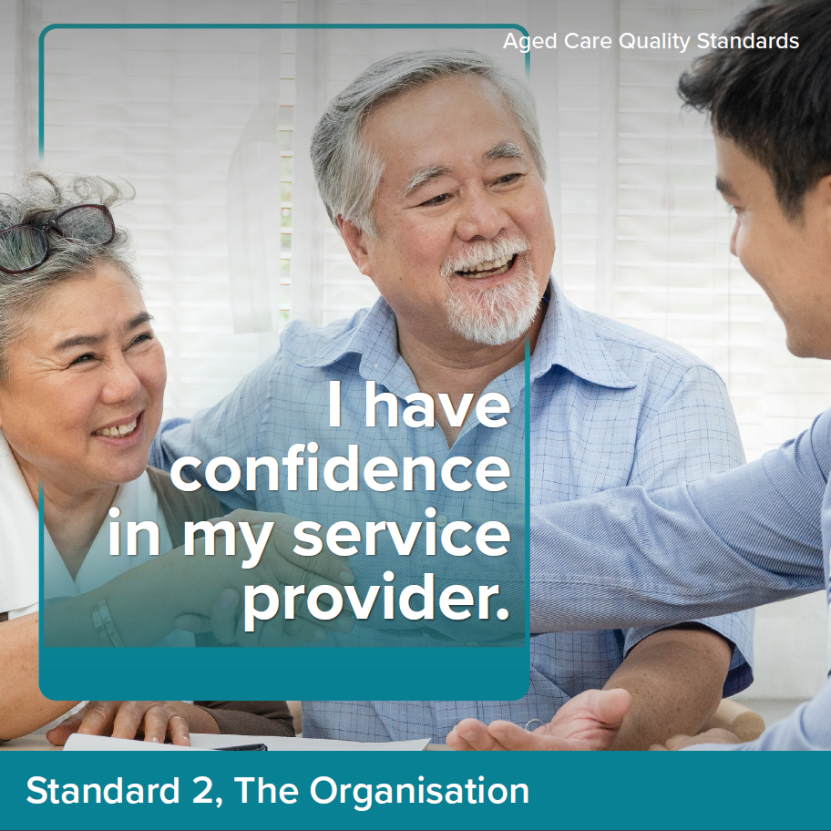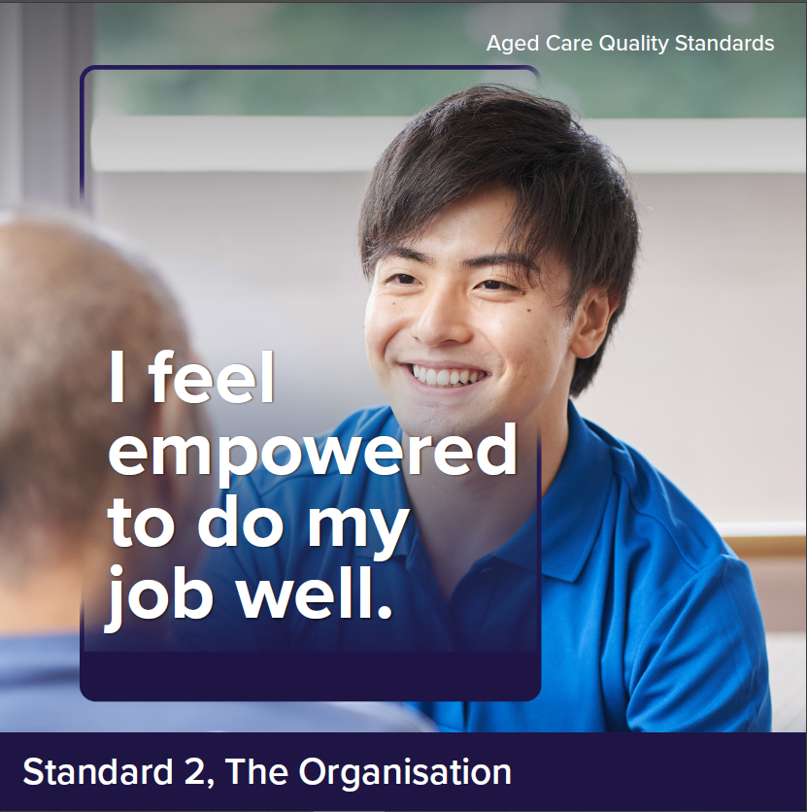

Intent of Standard 2
The intent of Standard 2 is to hold the governing body responsible for meeting the requirements of the Quality Standards and delivering safe and quality care and services.
The governing body sets the strategic priorities for the organisation and promotes a culture of safety and quality. The governing body is also responsible for driving and monitoring improvements to care and services, informed by engagement with older people, their carers and families, workers and data on care quality.
A provider’s governance systems and workforce are critical to the delivery of safe, quality, effective and person-centred care for every older person, and continuous care and service improvement.

Standard 2 expectation statement for older people:
The organisation is well run. I can contribute to improvements to care and services. My provider and workers listen and respond to my feedback and concerns. I receive care and services from workers who are knowledgeable, competent, capable and caring.

Outcome 2.1: Partnering with older people

Outcome statement:
Meaningful and active partnerships with older people inform organisational priorities and improvements to care and services.

Actions:
- The governing body directly engages with older people to set priorities and strategic directions for the way care and services are provided.
- The provider supports older people to partner in the governance of the organisation and the design, evaluation and improvement of care and services. The provider engages with older people that reflect the diversity of those who use their services.
- The provider understands the diversity of older people who use their services, including those at higher risk of harm, and tailors information, communication and services to meet their needs.
- The provider engages with Aboriginal and Torres Strait Islander older people to ensure care and services are accessible to, and culturally safe for, Aboriginal and Torres Strait Islander peoples.

Outcome 2.2: Quality and safety culture

Outcome statement:
The governing body leads a culture of quality, safety and inclusion that embraces diversity and prioritises the rights, safety and well-being of older people and the workforce.

Actions:
- The governing body leads a positive culture of safety, inclusion and quality improvement, and demonstrates that this culture exists within the organisation.
- In strategic and business planning, the governing body:
  - prioritises the rights, safety and quality of life of older people
  - ensures that care and services are accessible to, and appropriate for, people with specific needs and diverse backgrounds, Aboriginal and Torres Strait Islander peoples and people living with dementia
  - considers legislative requirements, organisational and operational risks, workforce needs and the wider organisational environment.

Notes:
- ‘Quality care’ refers to care that is safe, effective and person-centred for every older person.
- In ensuring that care and services ‘are accessible to, and appropriate for, people with specific needs and diverse backgrounds, Aboriginal and Torres Strait Islander peoples and people living with dementia’, it is expected the provider would engage with older people from these backgrounds and with these needs to assess how care and services can be made more accessible and appropriate for them.

Outcome 2.3: Accountability and quality systems

Outcome statement:
The governing body is accountable for the delivery of safe and quality care and services and maintains oversight of all aspects of the organisation’s operations.
The provider’s quality system supports continuous improvement.

Actions:
- The provider implements a quality system that:
  - sets out accountabilities and responsibilities
  - sets expectations for the organisation’s performance, including against the Quality Standards
  - enables the governing body to monitor the organisation’s performance, including the safety and quality of services, informed by feedback from older people, carers and workers, analysis of risks, complaints and incidents (and their underlying causes), quality indicator data and contemporary evidence-based practice
  - supports the provider to meet performance expectations and identify opportunities for improvement.
- The governing body ensures improvements are made and monitors that investment in priority areas delivers outcomes for older people.
- The provider regularly reviews and improves the effectiveness of the
quality system.
- The provider regularly reports on its quality system and performance to older people and their families and carers.
- The provider practices open disclosure, including to communicate with older people and their families and carers when things go wrong.

Notes:
- ‘Open disclosure’ refers to open discussions with older people, their family, carers and others of issues or incidents that have caused harm or had the potential to cause harm to the older person. It involves an expression of regret and a factual explanation of what happened, the potential consequences and what steps are being taken to manage this and prevent it happening again.

Outcome 2.4: Risk management

Outcome statement:
Risks to older people, workers and the organisation are identified, managed and continuously reviewed.

Actions:
- The provider implements a risk management system to identify, assess, document, manage and regularly review risks to older people, workers and the organisation.
- The provider puts strategies in place and undertakes actions to control, minimise or eliminate identified risks.
- The provider collects and analyses data and engages with older people and workers to inform risk assessment and management. This feeds into the provider’s quality system to improve the quality of care and services.
- The provider regularly reviews and improves the effectiveness of the risk management system.

Outcome 2.5: Incident management

Outcome statement:
The provider uses an incident management system to safeguard older people and acknowledge, respond to, effectively manage and learn from incidents.

Actions:
- The provider implements an incident management system to record, investigate, respond to and manage incidents that occur in connection with the delivery of care and services and reduces or prevents incidents from recurring.
- The provider takes timely action to respond to and manage incidents and practices open disclosure when things go wrong.
- The provider encourages older people to report incidents and supports their involvement in identifying ways to reduce incidents from occurring.
- The provider supports the workforce to recognise, respond to and report incidents.
- The provider collects and analyses incident data. Outcomes are reported to older people and workers and feed into the provider’s quality system to improve the quality of care and services.
- The provider regularly reviews and improves the effectiveness of the incident management system.
Notes:
- An incident is any act, omission, event or circumstance that occurs in connection with the provision of care or services that:
  - has (or could reasonably be expected to have) caused harm to an older person or another person (such as a worker or family member)
  - is suspected or alleged to have (or could reasonably be expected to have) caused harm to an older person or another person, or
  - the provider becomes aware of and has caused harm to an older person.
- In relation to 2.5.3, some older people may need particular support or encouragement to feel safe to voice a concern. It is expected that providers foster an environment where older people, carers and workers feel safe to raise concerns, report incidents and provide particular support for older people with diverse needs and from specific backgrounds to report incidents.

Outcome 2.6: Feedback and complaints management

Outcome statement:
Older people and others are encouraged and supported to provide feedback and make complaints about care and services. Feedback and complaints made by all parties are acknowledged, managed transparently and contribute to the continuous improvement of care and services. Older people and others can complain without reprisal.

Actions:
- The provider implements a complaints management system to receive, record, respond to and report on complaints.
- The provider encourages and supports older people, their families and carers, workers and others to provide feedback and make complaints.
- Older people are empowered to access advocates, language services and other ways of raising and resolving complaints.
- The provider takes timely action to resolve complaints and uses an open disclosure process when things go wrong.
- The provider collects and analyses feedback and complaints data. Outcomes are reported to the governing body, older people and workers and inform the provider’s quality system to improve the quality of care and services.
- The provider regularly reviews and improves the effectiveness of the complaints management system.
Notes:
- In the context of feedback and complaints management, ‘others’ includes other service providers, health professionals, volunteers and others that may identify concerns relating to the delivery of care and services.

Outcome 2.7: Information management

Outcome statement:
Information is identifiable, accurately recorded, current and able to be accessed and understood by those who need it. The information of older people is confidential and managed appropriately, in line with their consent. Current policies and procedures guide the way workers undertake their roles.

Actions:
- The provider implements an information management system to securely manage records.
- The provider’s information management system ensures that:
  - workers and older people have access to the right information at the right time to deliver safe and quality care and services
  - the accuracy and completeness of information collected and stored is maintained
  - informed consent is sought to collect, use and store the information of older people or to disclose their information (including assessments) to other parties
  - older people understand their right to access or correct their information or withdraw their consent to share information
  - information from different sources is integrated.
- The provider regularly reviews and improves the effectiveness of the information management system.
- The provider maintains policies and procedures that are current, regularly reviewed, informed by contemporary evidence-based practices, and are understood and accessible by workers.

Outcome 2.8: Workforce planning

Outcome statement:
The provider understands and manages its workforce needs and plans for the future.

Actions:
- The provider implements a workforce strategy to:
  - identify the number and mix of workers required to manage and deliver quality care and services
  - identify the skills, qualifications and competencies required for each role
  - engage suitably qualified and competent workers
  - engage workers as employees whenever possible, and minimise the use of independent contractors
  - mitigate the risk of workforce shortages and worker absences or vacancies.
- The provider implements strategies for supporting and maintaining a healthy and resilient workforce.

Outcome 2.9: Human resource management

Outcome statement:
The care and service needs of older people are met by workers who are skilled and competent in their role, hold relevant qualifications and who have relevant expertise and experience to provide safe and quality care and services.

Actions:
- The provider maintains records of worker pre-employment checks, contact details, qualifications and experience.
- The provider deploys the number and mix of workers to enable the delivery and management of safe and quality care and services.
- Workers have access to supervision, support and resources.
- The provider maintains and implements a training system that:
  - includes training strategies to ensure that workers have the necessary skills, qualifications and competencies to effectively perform their role
  - draws on the experience of older people to inform training strategies
  - is responsive to feedback, complaints, incidents, identified risks and the outcomes of regular worker performance reviews.
- The provider regularly reviews and improves the effectiveness of the
training system.
- All workers are regularly trained in relation to core matters such as:
  - the delivery of person-centred, rights-based care
  - culturally safe, trauma aware and healing informed care
  - caring for people living with dementia
  - responding to medical emergencies
  - the requirements of the Code of Conduct, the Quality Standards and other requirements relevant to the worker’s role.
- The provider undertakes regular assessment, monitoring and review of the performance of workers.

Outcome 2.10: Emergency and disaster management

Outcome statement:
Emergency and disaster management considers and manages the risks to the health, safety and wellbeing of older people and workers.

Actions:
- The provider develops emergency and disaster management plans that describe how the organisation will respond to an emergency or disaster and manage risks to the health, safety and wellbeing of older people and workers.
- The provider implements strategies to prepare for, and respond to, an emergency or disaster.
- The provider engages with workers, older people and their families and carers about the emergency and disaster management plans.
- The provider regularly tests and reviews the emergency and disaster management plans in partnership with workers, older people, their families and carers and other response partners.
Notes:
- ‘Response partners’ may include government agencies, the State Emergency Service, other service providers, community organisations, etc.

Standard 3: The Care and Services

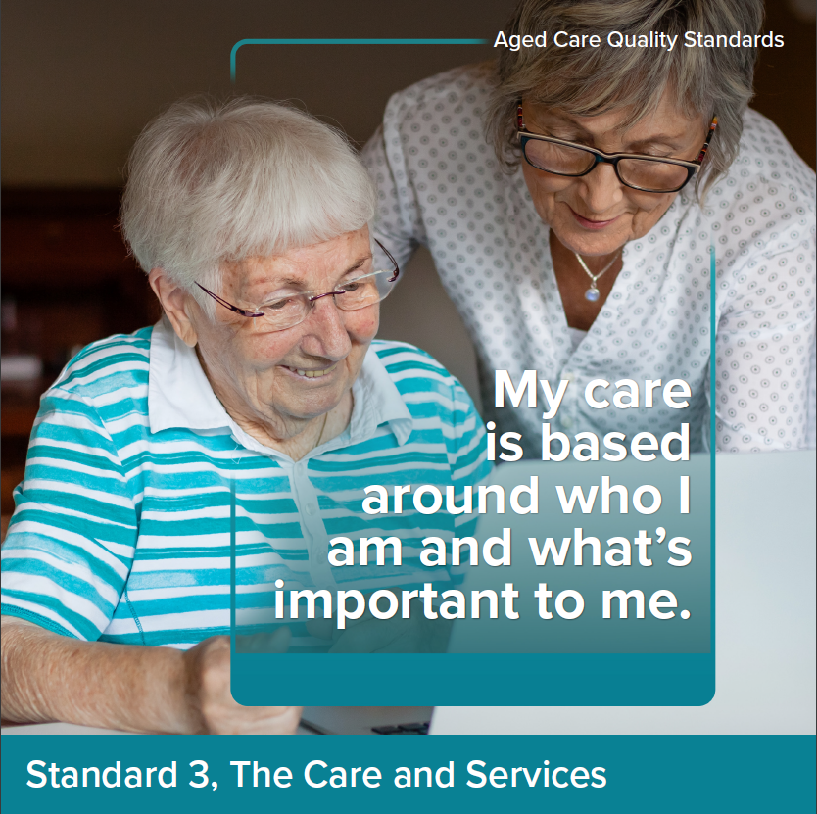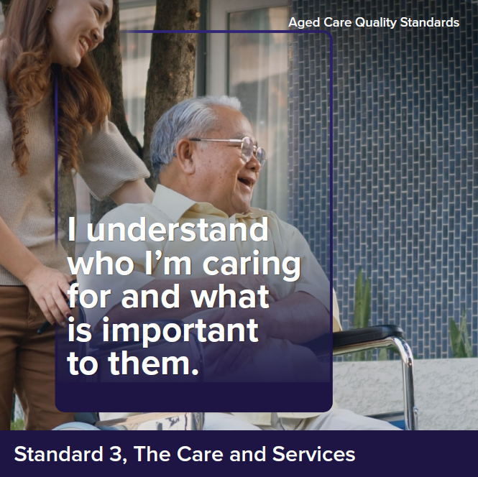

Intent of Standard 3
Standard 3 describes the way providers must deliver care and services, agnostic to the type of service being delivered (noting that other standards describe requirements relevant to specific service types). Effective assessment and planning, communication and coordination are critical to the delivery of safe and quality care that meets the older person’s needs, is tailored to their preferences and supports them to live their best lives.
In delivering care and services, providers and workers must draw on all relevant standards, with particular reference to Standard 1, including to ensure care is tailored to the individual and what’s important to them.

Standard 3 expectation statement for older people:
The care and services I receive:
- are safe and effective
- optimise my well-being and quality of life
- meet my current needs, goals and preferences
- are well planned and coordinated.

Outcome 3.1 Assessment and planning

Outcome statement:
Older people are actively engaged in developing and reviewing their care and services plans. Care and services plans describe the current needs, goals and preferences of older people, are regularly reviewed and are used by workers to guide the delivery of care and services.

Actions:
- The provider implements a system for assessment and planning that:
  - supports the older person to express their needs, goals and preferences
  - identifies risks to the older person’s health, safety and well-being (including their physical, mental and emotional wellbeing) and with the older person, identifies strategies for managing these risks
  - informs the delivery of safe and quality care and services.
- Assessment and planning are based on ongoing partnership with the older person and others that the older person wishes to involve.
- The outcomes of assessment and planning are effectively communicated to:
  - the older person, in a way they understand
  - with the older person’s consent, their family and carers and others involved in the older person’s care.
- Care and services plans are individualised and:
  - describe the older person’s needs, goals and preferences
  - are current and reflect the outcomes of assessments
  - include information about the risks associated with care and service delivery and how workers can support older people to manage these risks
  - are able to be accessed by the older person
  - are used and understood by workers to guide the delivery of care and services.
- Care and service plans are reviewed regularly, including when:
  - the older person’s needs, goals or preferences change
  - the older person’s ability to perform activities of daily living, mental health, cognitive or physical function, capacity or condition deteriorates or changes
  - the care that can be provided by an older person’s carer changes
  - risks emerge or change or there is an incident that impacts the older person
  - all, or part, of the older person’s care is transferred between others involved in the older person’s care.
Notes:
- Where care plans are accessed by older people, the provider may develop a summary version, noting that care plans are often likely to includes significant volumes of information about a person’s care and services.

Outcome 3.2: Delivery of care and services

Outcome statement:
Older people get safe and quality care and services that meet their needs, goals
and preferences. Care and services are provided in a way that is culturally safe, appropriate for people with specific needs and diverse backgrounds and supports reablement.

Actions:
- Older people get care and services that:
  - are provided in accordance with contemporary evidence-based practices
  - meet their current needs, goals and preferences
  - are culturally safe, trauma aware and healing informed
  - support their well-being and quality of life.
- The provider delivers care and services in a way that maximises the older person’s independence and supports their reablement, where this is consistent with their preference.
- The provider ensures older people receive timely and appropriate referrals
to other service providers.
- The provider implements a system for caring for people living with
dementia that:
  - incorporates contemporary evidence--based strategies for the timely recognition of dementia and the delivery of care that best supports people living with dementia
  - enables the identification and regular review of the strengths and skills of people living with dementia and encourages use of these day-to-day
  - enables those who know the older person well to be involved in the planning and delivery of their care and services.
- The provider minimises the use of restrictive practices and, where restrictive practices are used, these are:
  - used as a last resort
  - used in the least restrictive form and for the shortest time needed
  - used with the consent of the older person
  - monitored and regularly reviewed.
- The provider makes reasonable efforts to involve the older person in selecting their workers (including the preferred gender of, and language spoken by, workers providing care) and maximise worker continuity.
- The provider has strategies for supporting workers to:
  - understand the way different older people communicate, including people living with dementia or who otherwise have difficulty communicating
  - communicate effectively with different older people, both verbally and non-verbally.
Notes:
- This outcome is intended to apply to all care and services, regardless of the service type or setting.
- It is intended that Action 3.2.5 align with any requirements regarding the use of restrictive practices in the legislation when this is settled.

Outcome 3.3: Communicating for safety and quality

Outcome statement:
Critical information relevant to the older person’s care and services is communicated effectively with older people, between workers and with others involved in the older person’s care. Risks, changes and deterioration in an older person’s condition are escalated and communicated as appropriate.

Actions:
- The provider implements a system for communicating structured information about older people and their care and services that ensures critical information is effectively communicated in a timely way to workers and other others involved in the older person’s care.
- The provider’s communication system is used when:
  - the older person commences receiving care and services
  - the older person’s needs, goals or preferences change
  - risks emerge or change or there is an incident that impacts the older person
  - handover or transfer occurs between workers or others involved in the older person’s care.

- The provider has strategies for supporting workers to:
  - recognise risks or concerns related to an older person’s health, safety and well-being
  - identify deterioration or changes to an older person’s ability to perform activities of daily living, mental health, cognitive or physical function, capacity or condition
  - respond to, and escalate, risks in a timely manner.
- The provider ensures older people are correctly identified and matched to their care and services.

Outcome 3.4: Coordination of care and services

Outcome statement:
Older people receive planned and coordinated care and services, including where multiple health and aged care providers, carers and others are involved in the delivery of care and services.

Actions:
- The provider, in partnership with the older person, identifies others involved in the older person’s care and ensures coordination.
- Carers are recognised as partners in the older person’s care and involved in the coordination of care and services.
- The provider facilitates a planned and coordinated transition to or from the provider in collaboration with the older person and other providers of care and services, and this is documented, communicated and effectively managed.
Notes:
- Under the new Support at Home Program, it is expected there will be a care management service type. Where this service is being provided, care coordination would be the responsibility of this provider.

Standard 4: The Environment

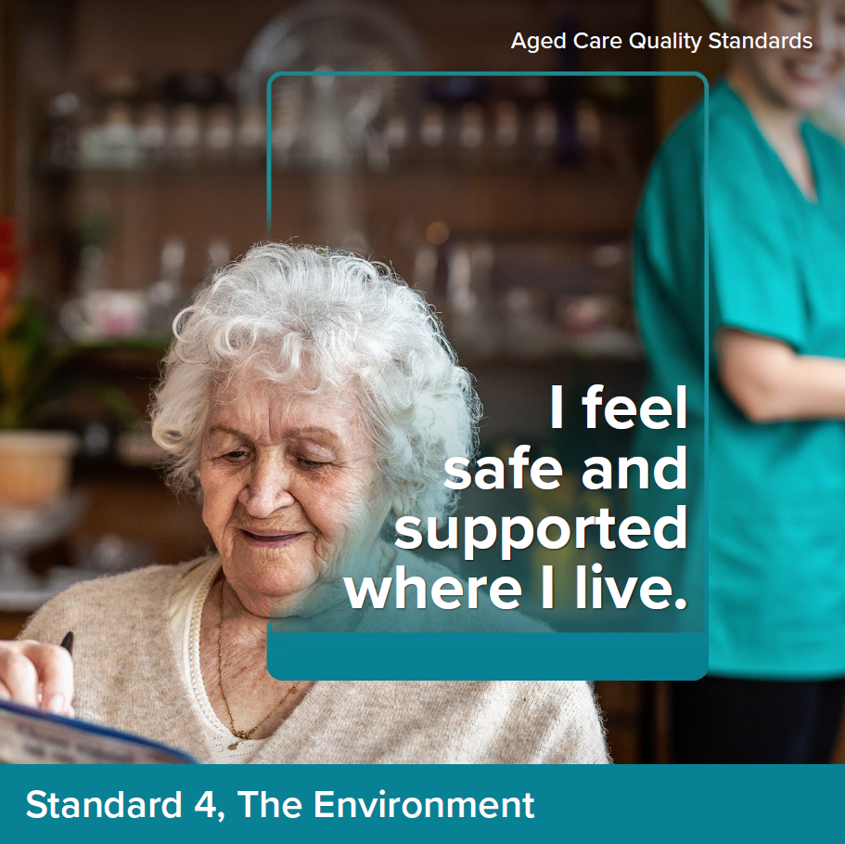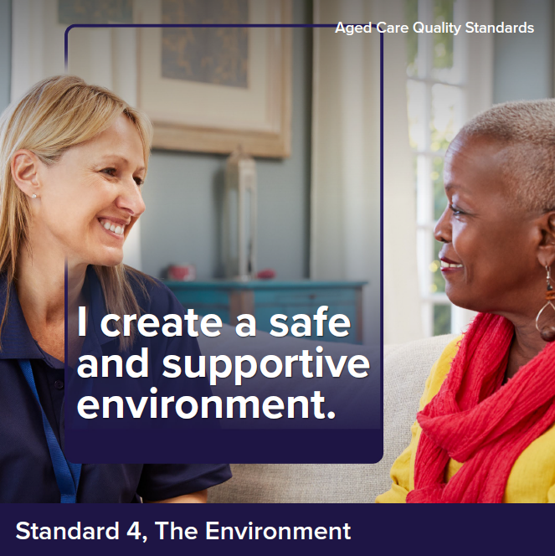

Intent of Standard 4
The intent of Standard 4 is to ensure that older people receive care and services in
a physical environment that is safe, supportive and meets their needs. Effective infection prevention and control measures are a core component of service delivery to protect older people, their families and carers and workers.

Standard 4 expectation statement for older people:
I feel safe when receiving care and services. Where I receive care and services through a service environment, the environment is clean, safe and comfortable and enables me to move around freely. Precautions are taken to prevent the spread of infections.

Outcome 4.1a: Environment and equipment at home

Outcome statement:
Providers support older people to mitigate environmental risks relevant to their care and services. Where equipment is used in the delivery of care and services or given to the older person by the provider, it is safe and meets their needs.

Actions:
- Where care and services are delivered in the older person’s home, as relevant to the services being delivered, the provider:
  - undertakes screening to identify any environmental risks to the safety of the older person and workers
  - discusses with the older person, any environmental risks and options to mitigate these.
- Equipment provided by the provider is safe, clean, well-maintained and meets the needs of older people.
Notes:
- These requirements would apply to care and services delivered to older people in their own home.

Outcome 4.1b Environment and equipment in a service environment

Outcome statement:
Older people access care and services in a clean, safe and comfortable environment that optimises their sense of belonging, interaction and function. Equipment used in the delivery of care and services is safe and meets the needs of older people

Actions:
- The provider ensures the service environment is:
  - clean and well-maintained
  - safe, welcoming and comfortable
  - fit-for--purpose.
- The provider ensures the service environment:
  - promotes movement, engagement and inclusion through design
  - enables older people to move freely both indoors and outdoors
  - unobtrusively reduces safety risks, optimises useful stimulation and is easy to understand.
- Equipment used in the delivery of care and services is safe, clean, well-maintained and meets the needs of older people.
Notes:
- ‘Service environment’ would be defined to include the service/site where care and services are delivered to older people (such as in a day therapy centre, centre-based respite delivered in a community centre, residential care service and day and overnight respite service (cottage). It would not include environments such as community centres, shopping centres, GP clinics, etc. where the provider may take older people for appointments, excursions, etc. but where the environment is not under the control of the provider.
- ‘Unobtrusively’ means that providers should aims to minimise safety risks in a way that is least restrictive on an older person’s freedom (e.g. fences and locked doors may inhibit movement) however, where it is in the interests of an older person’s safety, visible signage, handrails etc. would be appropriate.
- Action 4.1.2 draws on dementia enabling environment principles. Moving ‘freely indoors and outdoors’ means that people are able to go in and outside at their leisure, acknowledging that there may be some areas of a service that would be inaccessible to older people (such as commercial laundries, kitchens or storage areas).

Outcome 4.2: Infection prevention and control

Outcome statement:
The provider has appropriate infection prevention and control processes. Workers use hygienic practices and take appropriate infection prevention and control precautions when providing care and services.

Actions:
- The provider implements a system for infection prevention and control that:
  - identifies an appropriately qualified and trained infection prevention and control lead
  - describes standard and transmission-based precautions appropriate for the setting, including but not limited to cleaning practices, hand hygiene practices, respiratory hygiene, cough etiquette and waste management and disposal
  - is used where care and services are delivered
  - complies with contemporary evidence-based practice
  - includes additional precautions to respond to novel viruses and where older people are suspected or confirmed to be infected with agents transmitted by contact, droplet or airborne routes
  - manages risks to the provider, workers, older people, their carers and family
  - is informed by staff and older person immunisation and infection rates.
- The provider implements a system to ensure:
  - that personal protective equipment is available to workers, older people and others who may need it
  - workers and older people are supported to correctly use personal protective equipment.
Notes:
- Some baseline requirements regarding infection prevention and control are included in other standards to ensure all providers adopt appropriate precautions, noting that Standard 5 sets out additional expectations relevant to the delivery of clinical care.

Standard 5: Clinical Care

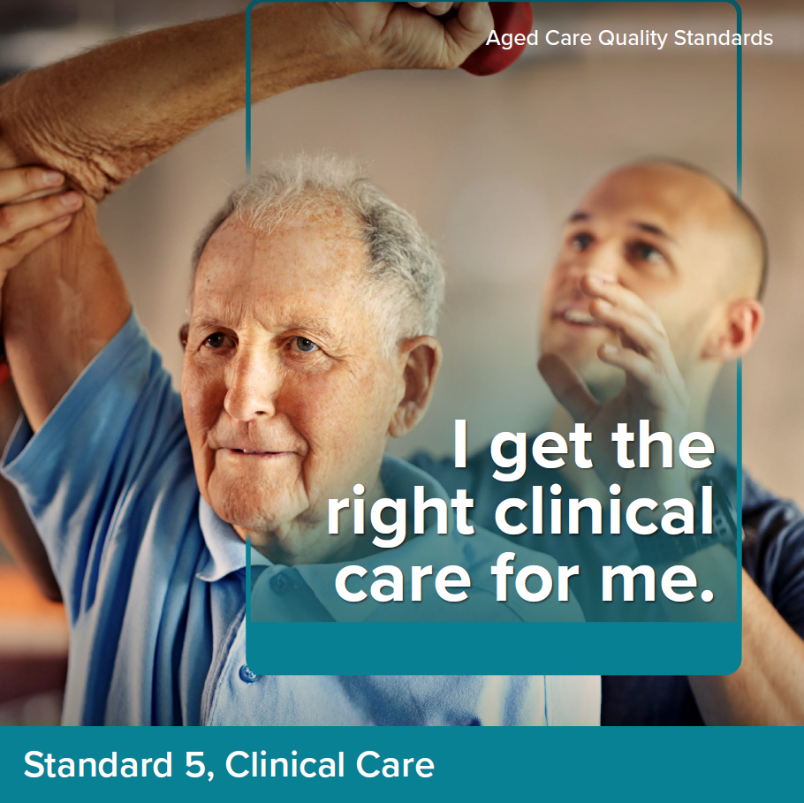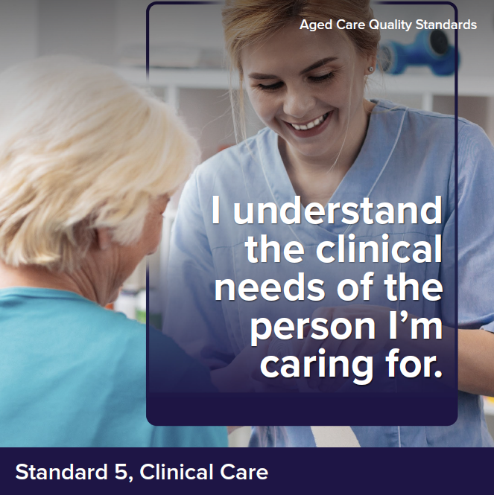

Intent of Standard 5
The Clinical Care Standard describes the responsibilities of providers to deliver safe and quality clinical care to older people. The governing body has overall responsibility to ensure a clinical governance framework is implemented and to monitor its effectiveness. Providers operationalise the clinical governance framework and report on its performance.
Many older people who require clinical care are frail with multiple chronic co-morbidities and complex care needs. These people may be experiencing sickness, frailty, disability, cognitive impairment or be nearing the end of their life. At all times, the clinical care provided should be person-centred and address the older person’s specific clinical needs and preferences. Delivering safe, quality care requires a skilled workforce, that are supported to deliver evidence-based care.
Effective implementation of Standard 5 is reliant on the systems and processes from Standards 1–7. These systems and processes support the delivery of safe clinical care, ensure that risks of harm to older people from clinical care are minimised and support continuous quality improvement.

Standard 5 expectation statement for older people:
I receive safe, effective, and person-centred clinical care which meets
my needs.

Outcome 5.1: Clinical governance

Outcome statement:
The governing body meets its duty of care to older people and the community, and continuously improves the safety and quality of the provider’s clinical care. The provider integrates clinical governance into corporate governance to actively manage and improve the safety and quality of clinical care.

Actions:
- The governing body:
  - sets priorities and strategic directions for safe and quality clinical care, and ensures that these are communicated effectively to workers and older people
  - endorses the clinical governance framework
  - monitors the safety and quality of clinical systems and performance.
- The provider implements a clinical governance framework as part of its corporate governance, that:
  - drives improvements to the safety and quality of clinical care informed by the feedback and experiences of older people, carers and workers, analysis of clinical risk management and quality indicator data
  - includes strategies to ensure clinical care is trauma aware, healing informed and culturally safe
  - supports workers to adopt contemporary, evidence-based practice when providing clinical care to older people.
- The provider works towards implementing a digital clinical information
system that:
  - enables clinical information to be integrated into nationally agreed electronic health and aged care digital records
  - supports interoperability by the use of national healthcare and aged care unique identifier and standard national terminology.
- Where the provider is adding clinical information into the nationally agreed electronic health and aged care digital records, they implement processes for workers and others to access information in compliance with legislative requirements.
- The provider implements a system for identifying capacity and obtaining informed consent from the older person prior to clinical care being provided.
- The provider implements a system for older people to be partners in their own clinical care.
- The provider has processes to ask the older person if they are of Aboriginal and/or Torres Strait Islander origin, record and use this information to optimise the planning and delivery of clinical care.
Notes:
- ‘Clinical governance’ is an integrated set of leadership behaviours, policies, procedures, responsibilities, relationships, planning, monitoring and improvement mechanisms that are implemented to support safe, quality clinical care and good clinical outcomes for each older person. The purpose of clinical governance in aged care is to support workers and visiting practitioners to provide safe, quality clinical care as part of a holistic approach to aged care that is based on the needs, goals and preferences of older people.
- ‘Digital clinical information system’ refers to the software used by the provider to enter and access an older person’s clinical information.
- ‘Interoperability’ Is the ability of different information systems, devices and applications (systems) to access, exchange, integrate and cooperatively use data in a coordinated manner. Health data exchange architectures, application interfaces and standards enable data to be accessed and shared appropriately and securely across the complete spectrum of care, within all applicable settings and with relevant stakeholders, including the older person.

Outcome 5.2: Preventing and controlling infections in clinical care

Outcome statement:
Infection risks are minimised and, if they occur, are managed effectively. Older people, workers and others are encouraged and supported to use antimicrobials appropriately to reduce risks of increasing resistance.

Actions:
- The provider implements an antimicrobial stewardship system relevant to the service context and consistent with national guidance.
- The provider implements processes to:
  - perform clean procedures and aseptic techniques
  - minimise infection when using and managing invasive devices.
Notes:
- ‘Antimicrobials’ are a medicine that kills microorganisms, like bacteria, or stops them from growing. Antibiotics and antifungals are antimicrobials.
- ‘Antimicrobial stewardship’ refers to efforts by the provider to reduce the risks related to increasing antimicrobial resistance and to extend the effectiveness of antimicrobial treatments. It can include a broad range of strategies, such as monitoring and reviewing how antimicrobials are used.

Outcome 5.3: Medication safety

Outcome statement:
Medicines-related risks to older people are identified and reduced. Medicine-related incidents are analysed and acted on to improve the safe and quality use of medicines.
Note: These actions apply to providers responsible for prescribing and/or administering medicines.

Actions:
- The provider implements a system for the safe and quality use of medicines according to evidence-based guidance.
- The provider ensures access to medicine reviews, including
  - on commencement and at transitions of care, regularly, and when there is a change in diagnosis, behaviour, cognition or mental or physical condition
  - when there is polypharmacy and the potential to deprescribe
  - when there is a new medicine or change to the medication management plan.
- The provider documents existing or known medicine allergies at the commencement of care and when changes occur.
- The provider refers adverse drug reactions to the Therapeutic Goods Administration.
- The provider implements processes to identify, monitor and mitigate risks to older people associated with the use of high-risk medicines and reduce the inappropriate use of psychotropics.
- The provider implements systems for the safe use of medicines that includes:
  - reviewing and improving the effectiveness of medicines review and reconciliation
  - supporting remote access for prescribing
  - ensuring that workers and others caring for an older person have access to the older person’s medicines list and other supporting information at transitions of care
  - minimising interruptions to the administration of prescribed medicines and supports access to medicines when an older person is prescribed a new medicine or an urgent change to their medicine
  - ensuring medicines-related information is available to workers and the older person, including on safe, alternative formulations for the older person with swallowing difficulties
  - responding to changes in medication requirements when the older person is acutely unwell.
Notes:
- ‘Medication reconciliation’ refers to a formal process of obtaining and verifying a complete and accurate list of each older person’s current medicines and matching the medicines the older person should be prescribed to those they are prescribed. Any discrepancies are discussed with the prescriber, and reasons for changes to therapy are documented and communicated when care is transferred.
- ‘Medication review’ refers to a systematic, comprehensive and collaborative assessment of medication management for an older person that aims to optimise their medicines and outcomes of therapy by providing a recommendation or making a change. It includes the objective of reaching an agreement with the older person about treatment, optimising the impact of medicines, minimising the number of medication-related problems and reducing waste. Medication review may be part of medication reconciliation.

Outcome 5.4: Comprehensive care

Outcome statement:
Older people receive safe, quality and person-centred clinical care. Clinical safety risks to older people are identified, managed and minimised
Note: These actions apply to providers according to their service context and the service types being delivered

Actions:
- The provider uses its assessment and planning systems to:
  - regularly identify clinical risks and chronic conditions, particularly on commencement, at transitions of care and when there is a change in diagnosis, behaviour, cognition or mental or physical condition
  - develop the clinical assessment and treatment care plan, including for acute exacerbation of chronic conditions.
- The provider implements a system for the delivery of evidence-based comprehensive care that responds to clinical safety risks including but not limited to:
  - changed behaviours
  - choking and swallowing
  - cognitive impairment, including dementia and delirium
  - continence
  - falls and mobility
  - malnutrition and dehydration
  - mental health
  - oral health
  - pain
  - pressure injuries and wounds
  - sensory impairment.
- The provider uses the comprehensive care system to:
  - deliver comprehensive, coordinated, multidisciplinary and holistic care in accordance with the treatment care plan
  - support workers and others involved in the older person’s care to collaborate
  - facilitate access to expert advice and support, and referral when clinical care needs are beyond the service context
  - support older people and their representatives to escalate healthcare concerns when there are changes in an older person’s condition
  - use equipment, devices and products to effectively prevent and manage clinical risks.

Technical nursing
- The provider implements a system to ensure delivery of technical nursing including but not limited to safe and quality:
  - catheter care
  - stoma care
  - complex wound management
  - oxygen therapy and suctioning of airways
  - enteral feeding
  - tracheostomy care
  - dialysis treatment
  - daily injections
  - tubes including intravenous and nasogastric tubes
  - insertion of suppositories
  - enema administration
  - blood glucose monitoring
  - continuous positive airways pressure (CPAP) management.

Advance care planning
- The provider implements advance care planning processes to:
  - support the older person to set goals of care, develop and review advance care planning documents that are consistent with their needs, preferences, cultural practices and traditions
  - ensure that advance care planning documents are stored, managed, used and shared with all relevant parties and at transitions of care; in accordance with relevant law and evidence-based guidance.

Changed behaviours
- The provider implements processes to work collaboratively with older people and their representatives to:
  - identify, understand, mitigate and respond to situations that may precipitate changed behaviours
  - identify, understand, and respond to changed behaviours
  - conduct clinical assessment and reassessment and manage the clinical and other identified causes of behavioural change
  - respond to changed behaviours and minimise harm to the older person and others involved in their care.

Choking and swallowing
- The provider implements evidence-based processes to manage swallowing and choking risks including when the older person is eating, drinking, or taking oral medicines.

Cognitive impairment, including dementia and delirium
- The provider implements processes for:
  - early recognition, referral and management of delirium, dementia and other forms of cognitive impairment
  - identifying deterioration and underlying contributing clinical factors
  - accessing specialist health, allied health and behavioural advisory services.

Continence
- The provider implements processes for continence care that:
  - optimises the older person’s dignity, functional abilities, mobility and environment
  - provides toileting assistance that is safe, timely and responsive to the older person’s needs and preferences.

Falls and mobility
- The provider implements processes to:
  - minimise falls and harm from falls
  - clinically assess the reason and consequences of the fall and deliver post-fall management
  - maximises mobility to prevent functional decline.

Malnutrition and dehydration
- The provider implements processes to recognise, monitor and manage malnutrition and dehydration, and ensures:
  - timely referral to an appropriate health professional of all older people identified as being malnourished or with unplanned weight loss or gain
  - nutrition and hydration support is provided for older people who cannot meet their nutritional requirements with food and fluid alone
  - food and fluids provided are consistent with evidence-based care of chronic conditions.

Mental health
- The provider implements processes to recognise, monitor and respond to changes in an older person’s mental health including but not limited to:
  - depressive symptoms or other mental health conditions
  - their distress
  - when thoughts of self-harm or suicide are expressed or present a risk of harm to others
  - self-harming or harming others.

Oral health
- The provider implements processes to ensure:
  - timely clinical oral health assessments are conducted
  - referral to oral health professionals when required
  - access and use of products and equipment required for daily oral hygiene.

Pain
- The provider implements processes to:
  - recognise an older person’s pain, including where the older person experiences challenges communicating
  - monitor, record and manage an older person’s pain.

Pressure injury and wounds
- The provider implements processes to:
  - prevent pressure injuries and wounds from occurring
  - conduct comprehensive skin inspections
  - manage pressure injuries and wounds when they occur.

Sensory Impairment
- The provider implements processes to:
  - recognise, monitor, and respond to hearing loss, vision loss and balance disorders
  - support the use of assistive devices and aids to maximise the older person’s independence, function, and wellbeing.
Notes:
- ‘Technical nursing’ refers to technical tasks and procedures for which nurses receive specific education and which require nursing knowledge of expected therapeutic effect, possible side-effects, complications and appropriate actions related to each.
- ‘Advance care planning’ is the process of planning for future health and personal care needs. It provides a way for an older person to make their beliefs, values and preferences for future medical care known to inform future medical decisions, if the older person cannot make or communicate these decisions themselves.

Outcome 5.5: Care at the end of life

Outcome statement:
The older person’s needs, goals and preferences for care at the end of life are recognised and addressed. The older person’s pain and symptoms are actively managed, their dignity is preserved, and their representatives are informed and supported at the end of life and during the last days of life.
Note: These actions apply to providers according to their service context and the services being delivered.

Actions:
- The provider has processes to recognise when the older person is approaching the end of life, supports them to prepare for the end of life and responds to their changing needs and preferences.

- The provider supports the older person approaching the end of life to develop or review advance care planning documents to align with their needs, goals and preferences, including requesting or declining life-prolonging care or responding to reversible acute conditions.
- The provider uses its processes from comprehensive care, to plan and deliver end of life care that:
  - prioritises the comfort and dignity of the older person, and supports their spiritual, cultural, and psychosocial needs
  - identifies and manages changes in pain and symptoms in a timely way
  - communicates information about the older person’s preferences for end-of-life care and the place where they wish to receive this care with workers, representatives, and others
  - supports access to specialist palliative care
  - provides a suitable environment for end-of-life care, including timely access to specialist equipment
  - provides information about loss and bereavement to others.
- The provider implements processes to minimise harm to older people in the last days of life including to:
  - recognise that the older person is in the last days of life and respond to rapidly changing needs
  - provide pressure care, oral care, eye care and bowel and bladder care
  - recognise and respond to delirium
  - minimise unnecessary transfer to hospital, where this is in line with the older person’s preferences
  - ensure that medicines to manage pain and symptoms are prescribed, administered and available 24-hours a day.

Standard 6: Food and Nutrition

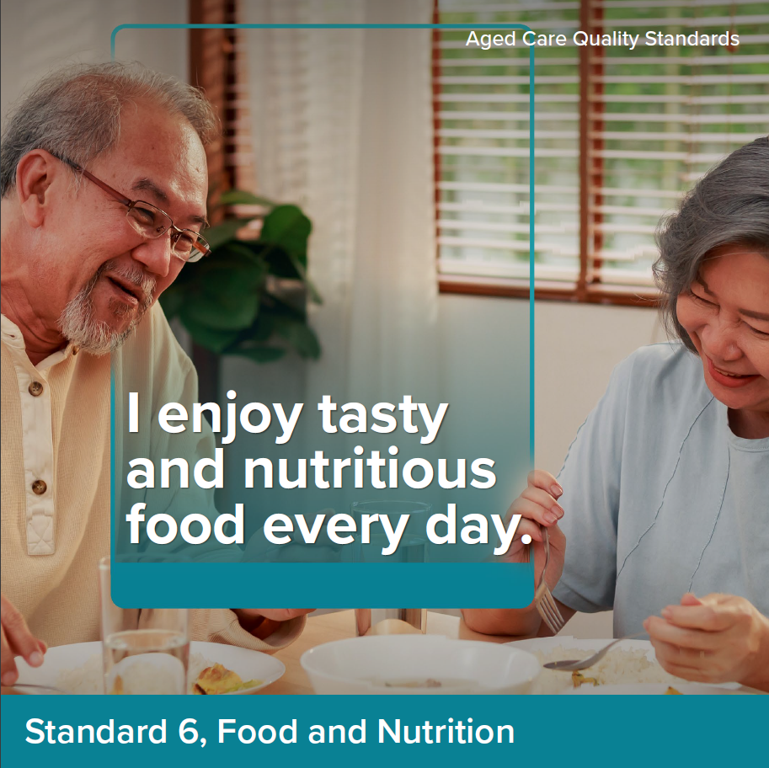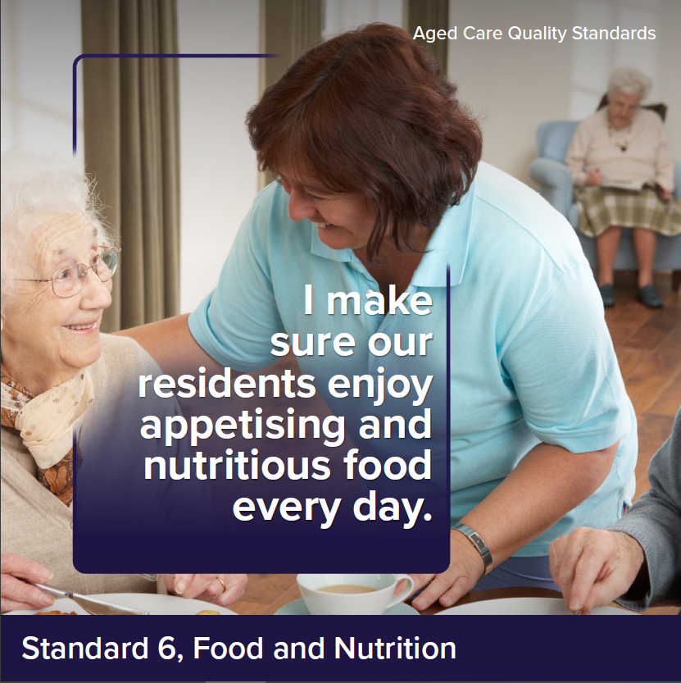

Intent of Standard 6
Food, drink and the dining experience can have a huge impact on a person’s quality of life. As people age, they may lose their appetite or experience conditions that impact on their ability to eat and drink. As such, it is particularly important that providers engage with older people about what and how they like to eat and drink, deliver choice and meals that are full of flavour, appetising and nutritious (including for older people with texture modified diets), and support older people to consume as much as they want.
In many cultures, food also plays a large role in fostering feelings of inclusion and belonging. The experience of sharing food and drink with other older people, friends and families is important for many older people.
Providers must draw on Standard 3 in delivering food services to ensure this is informed by robust assessment and planning, and services are delivered in line with the needs, goals and preferences of older people. It is also critical for providers to monitor older people for malnutrition and dehydration and respond appropriately where concerns are identified – this is addressed as part of Standard 5.
Standard 6 is intended to apply only to residential care services.

Standard 6 expectation statement for older people:
I receive plenty of food and drinks that I enjoy. Food and drinks are appetising, nutritious and safe, and meet my needs and preferences. The dining experience is enjoyable, includes variety and supports a sense of belonging.

Outcome 6.1: Partnering with older people on food and nutrition

Outcome statement:
The provider partners with older people to provide a quality food service, which includes appealing and varied food and drinks and an enjoyable dining experience.

Actions:
- The provider partners with older people on how to create enjoyable food, drinks and dining experience at the service.
- The provider implements a system to monitor and continuously improve the food service in response to:
  - the satisfaction of older people with the food, drink and the dining experience
  - older people’s intake of food and drink to ensure it meets their needs (including review of Quality Indicator data on unplanned weight loss)
  - the impact of food and drink on the health outcomes of older people
  - contemporary evidence--based practice regarding food and drink.
Notes:
- The ‘dining experience’ refers to the environment, service, ambience, aromas, company, time provided to eat, serving size, temperature, presentation of food and drinks, etc.
- ‘Intake’ refers to however older people meet their nutritional and hydration needs, including through oral intake, enteral nutrition through a percutaneous endoscopic gastrostomy, etc.

Outcome 6.2: Assessment of nutritional needs
and preferences

Outcome statement:
The provider understands the specific nutritional needs of older people and assesses each older person’s current needs, abilities and preferences in relation to what and how they eat and drink.

Actions:
- As part of assessment and planning, the provider assesses and regularly re-assesses each older person’s nutrition, hydration and dining needs and preferences. The assessment considers:
  - what the older person likes to eat and drink
  - when the older person likes to eat and drink
  - what makes a positive dining experience for the older person
  - the older person’s individual and nutritional needs
  - issues that impact the older person’s ability to eat and drink.
Notes:
- ‘Individual and nutritional needs’ includes consideration any allergies, intolerances or relevant health risks and conditions, dietary needs (particularly protein and calcium), religious, cultural preferences, etc.
- ‘Issues that may impact the older person’s ability to eat and drink’ may include but are not limited to consideration of their oral health, ability to chew and swallow, the impact of medications on appetite, seating and positioning requirements for eating and drinking, dexterity, physical assistance needed to eat and drink, etc.

Outcome 6.3: Provision of food and drink

Outcome statement:
Older people have food and drinks that are appetising, flavoursome and nutritious, have variation and choice about what they eat and drink and are able to eat and drink as much as they want.

Actions:
- Menus (including for texture modified diets):
  - are designed in partnership with older people
  - are developed and reviewed with the input of chefs/cooks and an Accredited Practising Dietitian, particularly for older people with specialised dietary needs
  - are regularly changed, include variety and enable older people to make choices about what they eat and drink
  - enable older people to meet their nutritional needs.
- For each meal, older people can exercise choice about what, when, where and how they eat and drink.
- Meals provided to older people:
  - are appealing (including the use of moulds to shape texture modified foods) and flavourful
  - served at the correct temperature and in an appetising way
  - are prepared and served safely
  - are in accordance with each older person’s choice and needs, including where older people have specialised diets or need support to eat.
- Older people can safely access snacks and drinks (including water) at all times.
Notes:
- ‘Prepared and served safely’ refers to food and drink being prepared in line with the applicable food safety requirements and specialised dietary requirements, but also served to older people in a way that is safe for them (e.g. to prevent older people from burning themselves, etc.).
- It is intended that older people have opportunities to be safely involved in the preparation of food and drink. This is not explicitly drawn out here as it is expected to be covered by Action 7.1.1(e).

Outcome 6.4: Dining experience

Outcome statement:
Older people are supported to eat and drink and enjoy the dining experience.

Actions:
- The provider makes sufficient workers available to support older people to eat and drink.
- Workers encourage and physically support older people to eat and drink where required and ensure that older people eat and drink as much as
they want.
- The dining environment supports a sense of belonging, social engagement, reablement and enjoyment.
- There are opportunities for older people to share food and drinks with their visitors.

Standard 7: The Residential Community

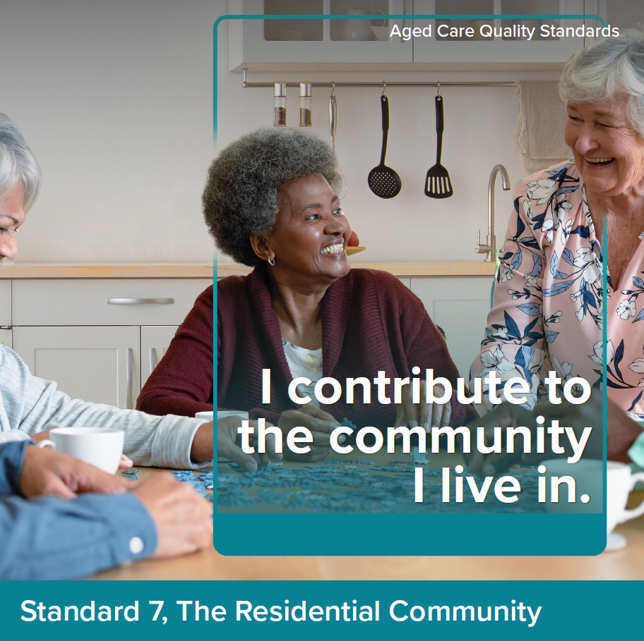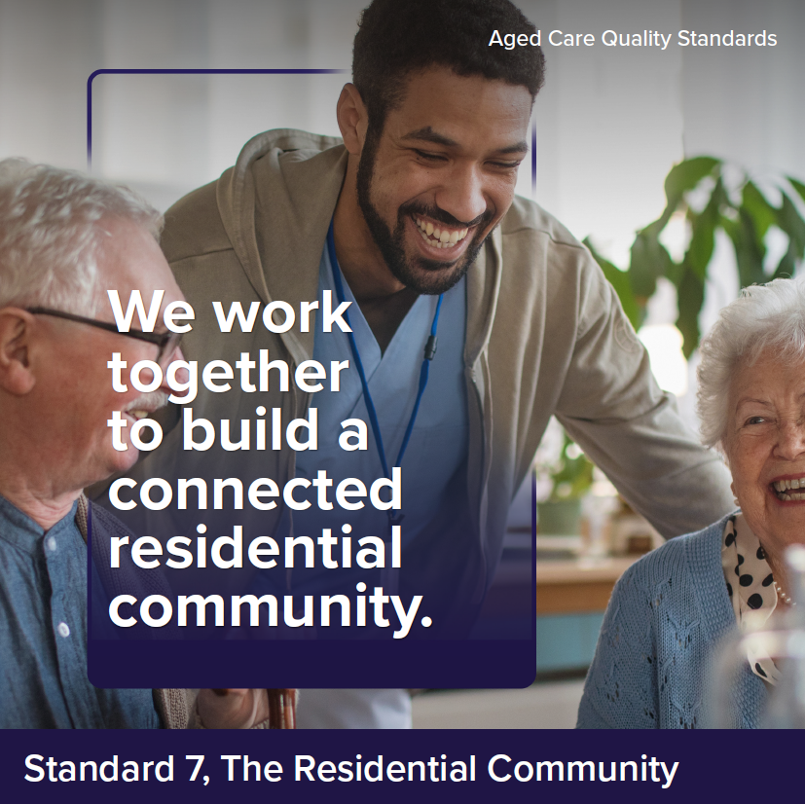

Intent of Standard 7
When people move into a residential service, the residential community becomes a central feature of their lives. It is critical that older people feel safe and at home in the residential community, have opportunities to do things that are meaningful to them and are supported to maintain connections with people important to them. Meaningful activities can include participating in hobbies or community groups, seeing friends and family or activities that contribute to the residential community such as gardening, cooking and setting tables.
A residential community can involve diverse members from different cultures and backgrounds. It is important that each older person's culture is respected, and their diversity valued so they feel included, safe and at home in the service.
Given the scope of responsibility in residential care, providers also have increased requirements to ensure that older people have access to other services and to coordinate a planned transition to or from the service to maximise continuity of care for older people.
Standard 7 is intended to apply only to residential care services.

Standard 7 expectation statement for older people:
I am supported to do the things I want and to maintain my relationships and connections with my community. I am confident in the continuity of my care and security of my accommodation.

Outcome 7.1: Daily living

Outcome statement:
Older people get the services and supports for daily living that are important for their health and well-being, consider their specific circumstances and enable them to do the things they want to do. Older people feel safe in their service environment.

Actions:
- The provider supports and enables older people to do the things they want to do, including to:
  - participate in activities that promote their emotional, spiritual and psychological well-being
  - minimise boredom and loneliness
  - maintain connections, and participate in activities that occur, outside the residential community
  - have social and personal relationships
  - contribute to their community through participating in meaningful activities that engage the older person in normal life.
- The provider implements strategies to protect the physical and psychological safety of older people.
- Older people have control over who goes into their room and when this happens.
- Older people can entertain their visitors in private.
- Older people can maintain relationships of choice free from judgement, including intimate relationships, and engage in sexual activity.
Notes:
- Action 7.1.1(e) is intended to enable older people to participate in activities that would be a normal part of their life at home. For example, helping with food preparation, cooking and meal service, setting tables, doing laundry, arranging flowers, etc.

Outcome 7.2: Planned transitions

Outcome statement:
Older people experience a planned and coordinated transition to or from the provider. There is clear responsibility and accountability for an older person’s care and services between workers and across organisations.

Actions:
- The provider has processes for transitioning older people to and from hospital, other care services and stays in the community, and ensures that:
  - there is continuity of care for the older person
  - older people, their families and carers as appropriate, are engaged in decisions regarding transfers
  - receiving individuals or organisations are given timely, current and complete information about the older person as required
  - when the older person transitions back to the service, their care and services are reviewed and adjusted as needed.
- The provider facilitates access to services offered by other individuals or organisations when it is unable to meet the older person’s needs.
- The provider maintains connections with specialist dementia care services and accesses these services as required.
Notes:
- While there are some actions relevant to ensuring continuity of care when coordinating with, and transferring older people between, others involved in the older person’s care as part of Outcome 3.4, this outcome describes additional/increased expectations about this applicable to residential services, where providers are entirely responsible for the older person’s care and services (noting that, under the Support at Home Program, older people are likely to have multiple providers involved in delivery of their care and services).

Australian Government Department of Health, Aboriginal and Torres Strait Islander Health Plan 2021-2031, p. 33.
Australian Government Department of Health, Aboriginal and Torres Strait Islander Health Plan 2021-2031, p. 94.
Aged Care Quality and Safety Commission, Standard 1: Older person dignity and choice.
https://www.enablingenvironments.com.au/dementia-enabling-environment-principles.html, https://www.dementia.org.au/sites/default/files/helpsheets/Helpsheet-Environment03_HowToDesign_english.pdf

