

Independent evaluation of the Head to Health Digital Mental Health Gateway

Final report

Bridget Bassilios, Maria Ftanou, Anna Machlin,

Shaminka Mangelsdorf, Michelle Banfield, Andrew Tan,

Leo Roberts, Katrina Scurrah, Long Le, Matthew Spittal,

Cathy Mihalopoulos, Jane Pirkis

List of acronyms and key terms

| Abbreviation | | Term |
| --- | --- | --- |
| AAPI | Australian Association of Psychologists inc. | |
| AASW | Australian Association of Social Workers | |
| ACACIA | The ACT Mental Health Consumer and Carer Research Unit | |
| ACMHN | The Australian College of Mental Health Nurses | |
| ACPA | The Australian Clinical Psychology Association | |
| ACRRM | The Australian College of Rural and Remote Medicine | |
| ADSL | Asymmetric Digital Subscriber Line | |
| AIPA | Australian Indigenous Psychologists’ Association | |
| CEO | Chief Executive Officer | |
| cf | Compare | |
| Conversion | The completion of a key or desired action, including search completions, SAM (chatbot) completions, emailing resources, and printing resources | |
| Conversion rate | Proportion of sessions which include a conversion | |
| CPD | Continuing professional development | |
| DMHS | Digital mental health services | |
| eMHPrac | eMental Health in Practice | |
| GP | General practitioner | |
| Head to Health | Head to Health National Digital Mental Health Gateway | |
| ICP | Institute of Clinical Psychologists | |
| ICER | Incremental cost-effectiveness ratio. Summary measure representing the economic value of an intervention, compared with an alternative (comparator). | |
| KEQs | Key evaluation questions | |
| LGBTQIA+ | Lesbian, Gay, Bisexual, Transgender, Queer, Intersex, Asexual and others | |
| Lowess | Locally Weighted Scatterplot Smoothing. Non-parametric regression technique in which simple linear regression models are fitted to overlapping subsets of the data, and the results are combined to form a smooth curve through the complete set of data points. It is very flexible and makes few assumptions about the distribution of data or the shape of the changes in the outcome over time. | |
| Max | Maximum | |
| MHC | Mindhealthconnect. e-Mental health web portal that provided access to trusted online mental health resources and programs, replaced by Head to Health | |
| MHO | Mental Health Online | |
| Min | Minimum | |
| n | Frequency/count of subset of sample | |
| N | Frequency/count of total sample | |
| NBN | National Broadband Network | |
| NSW | New South Wales | |
| OTA | Occupational Therapy Australia | |
| QALY | Quality Adjusted Life Year. A QALY is a widely used health index that combines both health-related quality of life and length of life – one QALY is equal to one year of life in full health. Briefly, QALYs are determined by weighting the length of life (or length of time spent in a particular health state) by a weight denoting the quality of that health state. | |
| RANCP | Royal Australian and New Zealand College of Psychiatrists | |
| RACGP | Royal Australian College of General Practitioners | |
| RCT | Randomised control trial. A gold standard research method to measure efficacy of an intervention, whereby one group is exposed to the intervention and another group acts as a control and is not exposed to the intervention. Assignment to each group is based on randomisation and is therefore not influenced by participant characteristics. | |
| RFQ | Request for Quote | |
| SD | Standard deviation. Measure of the amount of variation in values, within a sample. | |
| Slido | A web-based, interactive question and answer (Q&A) and polling app that encourages participation in virtual events (https://www.sli.do/) | |
| WTP | Willingness to pay. An evaluation method used to determine the maximum amount of money an individual is willing to pay for a particular outcome or benefit (e.g., to receive a health care service). | |

Table of Contents

Executive summary 1

Background 1

Evaluation aims 1

Data sources 2

Findings 2

Recommendations for the new National Mental Health Platform 10

Conclusions 13

1. Background 14

1.1. Evaluation aims 15

1.2. Evaluation method 15

1.3. This report 15

2. Google analytics data 18

2.1. Our approach 18

2.2. Findings 18

2.3. Summary 31

3. Service data 32

3.1. Our approach 32

3.2. Findings 32

3.3. Summary 36

4. Secondary data from user survey 37

4.1. Our approach 37

4.2. Findings 37

4.3. Summary 41

5. Consumer experiences 42

5.1. Our approach 42

5.2. Findings 42

5.3. Summary 50

6. Experience of people living with mental health problems 51

6.1. Our approach 51

6.2. Findings 51

6.3. Summary 54

7. Health professional experiences 55

7.1. Our approach 55

7.2. Findings 55

7.3. Summary 63

8. Other key stakeholder experiences 64

8.1. Our approach 64

8.2. Findings 64

8.3. Summary 72

9. Cost effectiveness of Head to Health 73

9.1. Our approach 73

9.2. Costs and outcomes of implementing Head to Health 73

9.3. Health care utilisation by Head to Health users 75

9.4. Cost-effectiveness of Head to Health 76

9.5. Summary 81

10. Discussion and conclusions 82

10.1. Summary of findings 82

10.2. Limitations and strengths of evaluation 90

10.3. Recommendations for the new National Mental Health Platform 90

10.4. Conclusions 92

References 94

Appendix A: Evaluation questions 96

Implementation 96

Appropriateness 96

Effectiveness 96

Efficiency 97

Appendix B: Additional methods and analysis for google analytics 98

Raw data 98

Plotting trend lines 98

Page helpfulness 98

Appendix C: Detailed methods for survey of users of the Head to Health website and additional health professionals 100

Method details 100

Promotional activity for Head to Health user survey 102

Consumer survey and interview 111

Health professional survey 118

Appendix D: Detailed methods and analysis of community conversations 124

Methods 124

Analysis 125

Appendix E: Detailed methods for consultation with other key stakeholders 131

Method 131

Interview/survey questions 132

Appendix F: Cost effectiveness modelling 133

F1. Economic model parameters 133

F2. Usual care comparison 135

F3. Results of economic modelling without the inclusion of Head to Health 136

F4. Sensitivity analysis results 138

Executive summary

Background

In October 2017, the Australian Government launched the Head to Health National Digital Mental Health Gateway ([www.headtohealth.gov.au](http://www.headtohealth.gov.au)) to improve access to, and navigation of, digital mental health services. It provides a directory of 693 government-funded clinically effective Australian digital mental health resources, including apps, online programs, online forums, phone services and digital information resources.1

The objectives of Head to Health are to:

* Give Australians the tools and information they need to understand when everyday distress requires additional support and to successfully navigate the mental health system and make informed choices about their care;
* Improve access by bringing together, streamlining, and providing access to evidence-based information, advice, and digital mental health treatments through a centralised portal;
* Provide people needing additional support a range of options, including practical tips and advice on how to connect with support;
* Make it easy to access a range of clinically effective Australian digital mental health services that are often free or low cost, accessible from anywhere/at anytime, and offer an effective alternative or complement to face to face services; and
* Foster a sense of trust and confidence in using digital services listed on Head to Health by ensuring they meet an agreed minimum quality standard.

Head to Health replaced mindhealthconnect, an e-Mental health web portal that provided access to trusted online mental health resources and programs.2 Mindhealthconnect was operational from July 2012 to 13 November 2017; and managed by Healthdirect Australia, on behalf of the Australian Government.2

In response to recommendations of the 2020 Productivity Commission Mental Health Inquiry Report,3 the Australian Government is in the process of transforming Head to Health into a new national mental health platform. This transformation aims to develop Head to Health into a comprehensive national mental health platform that will provide Australians with greater choice in accessing the treatment and services they need, and more seamless connections across the broader health and mental health system.

## Evaluation aims

The Centre for Mental Health at the University of Melbourne has been commissioned by the Department of Health to undertake the independent evaluation of the Head to Health website’s appropriateness, effectiveness, and efficiency. The purpose of the evaluation is to inform the development of the national mental health platform and the Australian Government’s consideration of digital mental health services and infrastructure.

The evaluation is guided by the six key evaluation questions (KEQs) including:

* **KEQ 1:** How effective has Head to Health been to date and what can we learn from it?
* **KEQ 2:** Who are the current users of the Head to Health website?
* **KEQ 3:** What are the experiences of users of the website?
* **KEQ 4:** What are the needs of current users of the website? Are these being met? What needs should be met by the planned national mental health platform?
* **KEQ 5:** How effective is Head to Health in achieving its objectives?
* **KEQ6:** How efficiently and effectively has Australian Government funding for Head to Health been used?

Data sources

We used a mixed-methods evaluation approach, involving collecting and analysing data from a range of primary and secondary quantitative and qualitative data sources, which are briefly described below.

Existing data

We utilised existing data provided to us by:

* The Department of Health (financial data, including development and maintenance costs; and data from a previous Head to Health survey of 258 users, conducted by the Department of Health in 2019);
* Liquid Interactive, the Head to Health website developer (Head to Health google analytics and user feedback data); and
* Three key Australian digital mental health services (DMHS) providers (Mental Health Online, MindSpot and THIS WAY UP) (DMHS website analytics data).

Consultations with key stakeholders

We conducted consultations with a broad range of stakeholders who had and had not used Head to Health, including:

* 47 users of the Head to Health website with lived experience of mental health problems via survey (and optional interview);
* 16 people with lived experience of mental health problems via community conversations;
* 92 health professionals via survey; and
* 64 additional key mental health sector stakeholders representing 41 organisations.

Findings

KEQ 1: How effective has Head to Health been to date and what can we learn from it?

Data from Head to Health google analytics; website analytics from three key digital mental health services (DMHSs); and our consultations with a range of stakeholders (63 people with lived experience of mental health problems, 92 health professionals and 64 other key mental health sector representatives), with or without experience using Head to Health, contribute to addressing KEQ 1.

Google analytics data

From October 2017 to October 2021, the mean number of unique users per month was 50,694, and almost all appeared to be new users (mean = 48,509). The mean number of sessions was 62,357, and the mean number of views per month was 97,235. This suggests that the monthly mean uptake has halved compared with equivalent monthly average data for mindhealthconnect from February to June 2017 (e.g., 103,136 unique users; 185,140 page views).2 Although uptake figures were higher during campaign periods (e.g., 84,620 unique users; 151,162 page views), these were still below the mindhealthconnect equivalent monthly averages from February to June 2017.2

However, the Head to Health average monthly bounce rate over its life is much better than that of mindhealthconnect from February to June 2015 (25% cf 75%),2 which means proportionally less sessions involved users not interacting with the website before leaving.

Furthermore, despite the lower than expected monthly average uptake, the trend from October 2017 to October 2021 has been for the overall uptake of Head to Health to increase over time. In 2020, the most recent calendar year with complete data, Head to Health reached around 4.3% of the Australian population.4 By comparison a Canadian website, which sounds similar to the new National Mental Health Platform, reached less than 2% of their population in 2017.5

A range of devices are being used to access Head to Health. In 2021, 49% of sessions were accessed via desktop, 47% via mobile and 4% tablet devices. Search engine results are the main source of traffic to Head to Health, and most referrals come via Facebook.

Website analytics from DMHSs

In a 3.75-year period (October 2017 to June 2021), Head to Health referred almost double the number of visitors to three DMHS websites as mindhealthconnect in a 3.25-year period (July 2014 to September 2017; 69,595 cf 36,455). However, because the overall number of visitors to the websites of these services more than tripled, proportionally there were fewer referrals from Head to Health than from mindhealthconnect (1% cf 2%). These findings suggest that although more people have continued to become aware of Head to Health over time, people are also increasingly becoming aware of DMHSs through pathways other than Head to Health.

Stakeholder consultations

Awareness of and engagement with the Head to Health website varied widely among the 200+ stakeholders we consulted. Of the 47 people with lived experience who took part in the survey, 57% were aware of the Head to Health website, and around half used it. Of the 16 lived experience participants who participated in the community conversations, 44% had heard of Head to Health, and 25% had used it. Only 43% of the 92 health professionals who completed surveys had used Head to Health. Finally, engagement with the website among the 64 key mental health sector stakeholders (representing 41 organisations) varied ranging from actively engaged to less engaged.

The 23 consumers who had used Head to Health mainly found the website through an online search. Twelve of these consumers were first-time users, and six had used it between one and five times. The most common reasons for using the website included struggles with coping, wanting to access information for family and friends, needing professional help or experiencing a crisis or traumatic event. Almost half of consumer users reported experiencing barriers to accessing mental health services before accessing Head to Health (e.g., thinking symptoms would improve without intervention and/or were not sufficiently severe to warrant intervention, feeling embarrassed about needing mental health care, a lack of knowledge about how to access care, the affordability of care and a preference to rely on oneself).

Lived experience community conversation participants described the website as a broad and credible gateway suited to family members or those new to mental health. However, they reported insufficient tailoring for those with complex needs, who frequently miss out in ‘one-size-fits-all’ approaches and may need their own section or website to cover information and programs relevant only to people with severe illness and complex needs. Lived experience participants also expressed concern that the website does not include specific groups such as Aboriginal and Torres Strait Islander peoples, those who identify as LGBTQIA+ and those from different cultural backgrounds. They viewed the overall language as clinical or pathologising and complex, requiring a level of literacy and digital literacy that may exclude some users, including people from non-English speaking backgrounds or with disabilities. Some lived experience participants thought the volume of information was overwhelming, but at the same time, they felt that some issues and specific apps were not described well enough. This reduced the website’s effectiveness as they struggled to navigate what was needed, and then found the website did not have enough depth to the information on the topics in which they were interested.

The 39 health professional survey respondents who had used Head to Health reported finding out about the website through a variety of sources including online searches, workplace recommendations, flyers, eMHPrac and other continuing professional development activities. These professionals varied in their frequency of using the website, ranging from having used it on a single occasion (15%) to over 11 times (26%). Most commonly, providers used the website to access information and resources for themselves or their clients. Health professionals had mixed views about whether the gateway met consumers’ needs. Around 40% of professionals reported that the website has benefited clients under their care and 15% reported negative impacts for clients. The most commonly reported client benefits were improved access to information, improved convenience of care, improved mental health and wellbeing, and reduced costs associated with care. The negative client impacts were not getting the information or support needed or not being able to find the information needed. Approximately 51% and 18% of health professionals 'occasionally' or 'frequently' referred consumers to the Head to Health website, respectively.

Key mental health sector representatives reported more positive than negative effects of Head to Health. Positive effects included the provision of a quality filter for digital tools; improved credibility, use and awareness of DMHSs; increased access to evidence-based information; provision of a front door for DMHSs; provision of a fast referral source for clinicians; reduced burden on providers by offering consumers options for self-management or other supports; facilitating a stepped care model; and efficient use of waitlist time. Insufficient or negative effects were consumer and provider lack of awareness; low uptake and effects; questionable suitability for consumers with acute or complex needs; lack of marketing to young people; navigation difficulties; and preferences for other means of searching for information or face-to-face services.

Stakeholders’ experiences of using Head to Health are elaborated in response to KEQ 3.

KEQ 2: Who are the current users of the Head to Health website?

Data describing the users of Head to Health are not routinely collected. However, secondary data from the Department administered survey, and the stakeholders who participated in the evaluation, provide some insight into the characteristics of Head to Health users and non-users.

Secondary survey data users

Of the 258 respondents who completed the survey, most were female (73%) and of mixed age groups, most commonly 18-50 years (62%) followed by 51-65 years (18%) and under 18 years (17%). Survey respondents represented all states and territories and a range of hard-to-reach minority subpopulations. Survey respondents most commonly heard about Head to Health through an internet search or from a friend/co-worker/family member.

User and non-user stakeholders consulted

The characteristics of the 200+ stakeholders we consulted are described below. Their characteristics should be interpreted in the context that, as described in response to KEQ1, over half the lived experience participants and health professionals had not used Head to Health, and engagement with the website among key mental health sector representatives varied considerably.

Survey data from 47 consumers show that these participants had a similar profile to secondary survey data users. Around two-thirds were female, 70% were aged 20-49 years, but 23% were aged 60+ years.

By comparison, of the 16 lived experience community conversations participants, one third were female, 47% were male and 20% were non-binary; they represented people across a range of ages; and over one-quarter were from inner or outer regional areas.

In total, 92 health professionals completed surveys. Of these, 84% were female, 2% were Indigenous, 86%, were aged 30-69 years and most were from NSW (36%) or Victoria (29%). They included psychologists (40%), social workers (22%) and GPs (14%), among other professions, and the length of their professional experience varied.

Sixty-four individual key mental health sector stakeholders from 41 organisations participated in the evaluation. Most were female (58%), aged 30-59 years (83%), from Victoria (28%) or NSW (20%), and 6% were Indigenous. In order of decreasing frequency, they represented mental health provider organisations, PHNs, peak bodies, professional associations, universities, government, and website developers.

KEQ 3: What are the experiences of users of the website?

Data from Head to Health google analytics including user feedback, the Department survey, and consultations with stakeholders address KEQ 3.

Google analytics data

Google analytics data provide insights into how users engage with the Head to Health website.

On average, only 1-2 pages are viewed per session, and the average session duration is 2.5 minutes. Overall, engagement with Head to Health has declined over time, irrespective of campaigns. One in 10 Head to Health sessions results in a conversion (i.e., completing a desired action including search completions, chatbot completions, and emailing or printing resources). The Head to Health conversion rate is somewhat lower than that of mindhealthconnect at 13%,2 but the absolute number of conversions has increased over time.

A relatively small number of users provide data on whether they perceive the pages they use to be helpful. Pages relating to COVID-19 support, Health professionals, Meaningful life, Mental health difficulties, Supporting someone else and Supporting yourself are more often rated as helpful than not (~60-80%).

Similarly, a relatively small number of users provide feedback about their experience of the Head to Health website overall and its specific pages. Only half of these users’ responses indicate positive (good or great) experiences of the overall website and less than half (~40%) do so for the homepage and other content pages. Consistent with these ratings, less than half of these user responses indicate that they would recommend (> 7/10) the website and even fewer would recommend specific website content and the chatbot.

Secondary user survey data

Just under two-thirds of respondents of the Department administered survey reported that the website was easy or very easy to use, most (88%) reported moderate to high trust in the content, and around 60% reported a good or great user experience. Around two-thirds indicated a relatively high likelihood (> 7/10) of recommending Head to Health.

Consumer experiences

Our survey data show that of the 23 consumers who had used Head to Health, only four reported that they found all relevant information on the website’s front page, or they could easily find the information they were looking for. Approximately 40% of consumers ‘somewhat’ or ‘strongly agreed’ that the information on the website was trustworthy, easy to understand, offered new knowledge and was appropriate for people who want to help someone with a mental health problem. Approximately one-third of consumers ‘somewhat’ or ‘strongly agreed’ that the website contained the information they were looking for and that the information was relevant, easy to read, accurate, and appropriate for people with a mental health problem. Approximately one-third of consumers ‘somewhat’ or ‘strongly agreed’ that the website was easy to navigate, visually appealing, engaging and interactive. Overall, only 20% of consumers reported that they were ‘satisfied’ or ‘very satisfied’ with the website, and 35% would recommend it to others.

Experiences of people living with mental health problems

Based on demonstration of its functionality during the community conversations, lived experience participants’ positive feedback related to experiencing the website as warm, user-friendly, and easy to use. They particularly appreciated the comprehensive menu system that allowed drilling down to specific information, the ability to bookmark important parts, and that the website is mobile friendly. They commented that it is ‘not a typical government website’ and were impressed by the comprehensive information presented on a very broad range of issues, including specific disorders and COVID-19.

The negative feedback from lived experience participants related to lack of user friendliness, particularly the nature of the content, its organisation, and the overall feel. Some felt that the website was too broad and overwhelming to navigate. Some content, particularly regarding LGBTQIA+ populations, was reported to be outdated, and other areas too focused on self-help and information rather than providing a true gateway to mental health services. The cartoon characters were particularly unpopular, and some participants suggested that it made it feel like the website did not take mental health seriously.

The other major area lived experience participants viewed as a barrier was accessibility. Some expressed concern that Head to Health may systematically exclude some of the most vulnerable people, for example, people without reliable technology, people with vision impairment, and people from different cultural backgrounds, including Aboriginal and Torres Strait Islander peoples.

Importantly, some lived experience participants reported that the crisis resources were not easy to find and were too superficial.

Experiences of health professionals

Of the 39 health professionals who had used Head to Health, around 50% ‘somewhat’ or ‘strongly’ agreed that the website contained the information they wanted, they could quickly find the information they were searching for, and the website was easy to navigate. However, only one-third ‘somewhat’ or ‘strongly’ agreed that all relevant information was on the website’s front page. At least 60% ‘somewhat’ or ‘strongly’ agreed that the information was trustworthy, accurate, easy to read and understand, relevant, and appropriate for both people with a mental health problem and those who want to support someone with a mental health problem. Not surprisingly, given that the respondents had mental health expertise, only 31% ‘somewhat’ or ‘strongly’ agreed that the website provided new information. Around 50% reported that the website was visually appealing and engaging, and 64% reported that the website was interactive. Sixty percent of respondents found the website to be helpful, and nearly 70% ‘somewhat’ or ‘strongly’ agreed that they plan to revisit the website. Around 18% indicated that the website did not meet their needs and was not worthy of their time compared to 44% who indicated that the website met their needs and 54% who found it worthy of their time. Overall, 44% of health professionals reported that they were ‘satisfied’ or ‘very satisfied’ with the website.

Experiences of key mental health sector stakeholders

As mentioned in response to KEQ 1, key mental health sector stakeholders representing 41 organisations identified more positive than negative effects of Head to Health.

They also identified a range of barriers to the uptake and use of Head to Health. The most frequently mentioned barrier was Head to Health’s lack of visibility, with many clinicians and consumers being unaware of its existence and purpose or confusing it with other services with the same name. The second key barrier related to difficulties with navigation and site features, including the potential for the volume of information and number of options provided to overwhelm consumers, the lack of human navigation support, circular referral pathways, and lack of user friendliness. The third barrier related to access inequity due to: literacy, language/culture, Indigenous status, internet access, cost of devices and data, technical skills, and visual impairments. Preferences for non-digital mental health care was less commonly mentioned as a barrier to the uptake and use of Head to Health.

Stakeholders also provided suggestions for addressing the above-mentioned barriers and improving Head to Health more generally. These suggestions are summarised in response to KEQ 4.

KEQ 4: What are the needs of current users of the website? Are these being met? What needs should be met by the planned national mental health platform?

Data from the Department’s survey and some of our stakeholder consultations contribute to addressing KEQ 4.

Secondary user survey data

The most commonly used features of the Head to Health website according to respondents of the Department administered survey are the topic and content pages and the search resources (58% and 57%, respectively). More than half (61%) of survey respondents reported that the resources were relevant or extremely relevant. This suggests that these are features that are performing relatively well and should be retained in the planned National Mental Health Platform.

Survey respondents suggested that some features could be improved including:

* Providing more information/content/resources (e.g., information on specific disorders or subpopulations; and information about accessing face-to-face services, particularly based on location; costs and other requirements for entry into suggested services; and including lived experience views, for example in providing user ratings of services);
* Updating outdated information;
* Further refining both chatbot and search functionality and ensuring that suggestions are tailored to the individual; and
* Website design (e.g., look and feel, and ease of navigation of the website, as well as its speed).

Stakeholder consultations

Community conversation participants echoed several of the suggestions made by Department survey respondents in addition to offering other characteristics of an ideal mental health gateway including:

* A visually appealing website with use of calming colours, and that is less childish-looking;
* Comprehensive information (on all mental health issues, not just the most common), organised in a way that is not overwhelming and assists users to find the depth they need;
* A website that is accessible to everyone, which is easy to read and compatible with screen readers for example;
* Removal of medical jargon and complex language, replaced with plain language and recovery-oriented information;
* Better information that normalises mental health issues and recovery, and connects to options beyond mainstream mental health approaches, such as peer services;
* Input from peers in design and navigation;
* Links to physical (real world) services such as mental health professionals, support groups and non-digital tools; and
* The addition of live chat or interaction with a real person rather than a robot to help people in distress find what they need.

Other stakeholders – mainly key mental health sector representatives and several health professionals – pointed to two priority areas requiring improvement, which stand for the new National Mental Health Platform. The first of these was better promoting the website and increasing its visibility as a trusted source of information among GPs, health professionals and the wider community (e.g., via face-to-face service providers and newsletters of advocacy organisations). Importantly, promotional activities were thought to have the added benefit of improving integration of Head to Health in the health system.

The second key area for improvement related to changing various website features and using a process of co-design to inform the changes. Co-design with consumers, carers and Indigenous peoples, in particular, was suggested. Examples of desired changes to the website include:

* Simplifying layout and improving ease of navigation;
* Streamlining search results so that recommendations are tailored (based on self-triage or assessment options);
* Modifying or adding content applicable to a range of focus populations (e.g., providing resources for CALD people, translating content, incorporating more videos and less text);
* Providing human phone help for therapeutic or technical support; and
* Ensuring that listed (digital) services are all accredited (by the National Safety and Quality Digital Mental Health Standards)6 and include information about which groups and for what problems they have demonstrated effectiveness.

Stakeholders mentioned a range of other important improvements that are needed. These mainly fell into three categories – better system integration, sustainability, and quality assurance. They commented that better system integration is synonymous with a ‘no wrong door’ approach, which requires strong relationships (e.g., cross branding) between Head to Health and a range of service providers including the face-to-face Head to Health hubs. They suggested that connection of services in the background (e.g., with electronic health records and DMHSs) and supporting health professionals with how to integrate digital tools in clinical practice could help improve integration so consumers can enter the care system via Head to Health or any other (digital) service and be directed to the right care. Issues mentioned in terms of sustainability were keeping content up to date, conducting research to guide developments, scaling up of services to meet demand, adhering to privacy and data legislation, and supporting consumers who lack digital literacy or access to affordable devices/internet – all of which require long term funding. Finally, in terms of quality assurance, stakeholders highlighted the importance of clinical governance, measurement of outcomes and ensuring that services match consumers’ needs.

KEQ 5: How effective is Head to Health in achieving its objectives?

This section lists each Head to Health objective and indicates whether it has been achieved based on the data sources used to inform the evaluation.

* Give Australians the tools and information they need to understand when everyday distress requires additional support and to successfully navigate the mental health system and make informed choices about their care.

As reported in response to KEQs 1 and 3, stakeholders indicated that there is a desire for more comprehensive mental health service options (e.g., face-to-face and peer support services; and services for all mental health problems, minority groups and people with complex needs).

None of the available data sources provide information about the first part of this objective (i.e., when everyday distress requires additional support). As far as we can tell, Head to Health provides Australians with tools and information to navigate DMHSs but not necessarily the mental health system in its entirety, which is the remit of the new National Mental Health Platform.

* Improve access by bringing together, streamlining, and providing access to evidence-based information, advice, and digital mental health treatments through a centralised portal.

As mentioned in response to KEQ 1, the trend has been for the overall uptake of Head to Health to increase over time. However, it is not the only source of visits to the websites of key Australian DMHSs (referring only 1% of visitors).

* Provide people needing additional support a range of options, including practical tips and advice on how to connect with support.

As mentioned in response to the first objective, users expressed a desire for a more comprehensive gateway to mental health services, not just DMHSs and mainstream majority population services.

As reported in response to KEQ 4, stakeholders also suggested that the range of support options could be improved by including support options for focus populations and all mental health problems and for services beyond DMHSs (e.g., face-to-face and peer support). They also indicated that support options could be improved either by further refining both chatbot and search functionality to ensure that suggestions are individually tailored, or through the addition of complementary live chat or interaction with a real person rather than a chatbot to help people in distress find what they need.

* **Make it easy to access a range of clinically effective Australian digital mental health services that are often free or low cost, accessible from anywhere/anytime, and offer an effective alternative or complement to face to face services.**

As reported in response to KEQ 3, just under two-thirds of respondents of the Department administered survey reported that the website was easy or very easy to use. Of the 23 consumers who reported they had used Head to Health, only 20% reported that they were ‘satisfied’ or ‘very satisfied’ with the website, and only 35% would recommend it to others. The community conversation participants appreciated the comprehensive menu system and the broad content; but also felt that navigating the website was overwhelming and criticised the lack of user-friendliness and content targeting minority groups. However, these findings do not directly inform the ease of accessing services themselves and, in any case, as noted in response to KEQ 1, Head to Health only accounts for 1% of visitors to websites of key Australian DMHSs.

* Foster a sense of trust and confidence in using digital services listed on Head to Health by ensuring they meet an agreed minimum quality standard.

As mentioned in response to KEQ 3, 88% of Department survey respondents reported moderate to high trust in the content of Head to Health. This was corroborated to a lesser extent by the stakeholders with whom we directly consulted. For example, as mentioned in response to KEQ 3, approximately 40% of consumers appreciated that the website was a trusted source of information, easy to understand, and offered new knowledge. However, trust and confidence are likely to improve if, as mentioned in response to KEQ 4, all listed digital services were accredited by the National Safety and Quality Digital Mental Health Standards6 and their listing includes summary information about who and what problems the services are effective for.

KEQ 6: How efficiently and effectively has Australian Government funding for Head to Health been used?

KEQ 6 was addressed using a range of data sources including Head to Health google analytics data, expenditure reports provided by the Department of Health, surveys of Head to Health consumers, routinely collected DMHS data and peer-reviewed publications by some of our evaluation team.

We summarised costs and cost-effectiveness of the Australian Government-funded Head to Health National Digital Mental Health Gateway. Over a period of four years, a total of $17 million has been budgeted to implement and maintain Head to Health. The highest cost incurred for Head to Health implementation was related to technology and infrastructure – however, this cost has decreased by 63% since the gateway’s launch in 2017. The cost per unit of website-specific outcomes has generally declined over time, suggesting efficiency of resource use from the allocated budget provided by the Government. For example, the cost per unique visitor and cost per conversion have decreased by approximately 90% since 2017.

The results of our modelled cost-effectiveness analysis suggest that the inclusion of Head to Health in the context of individuals with depression or anxiety symptoms seeking treatment is cost-effective compared to usual care. Excluding productivity losses, the incremental cost-effectiveness ratios ranged from $1,823 to $34,293 per QALY for self-guided DMHS treatment, and from $1,124 to $37,363 per QALY for therapist-supported DMHS treatment. These ratios were lower than the standard willingness-to-pay threshold of $50,000 per QALY, which is commonly used to evaluate the cost-effectiveness of public health programs in Australia.7-9 Furthermore, this intervention pathway costed less and produced greater benefits than the indirect comparator groups (representing usual care) when productivity impacts were taken into consideration. It is important to note that our analysis assumed that individuals will use evidence-based online interventions such as Mental Health Online, MindSpot and THIS WAY UP. We recognise that this assumption may not apply to everyone and therefore conducted threshold analysis to indicate the level of conversions or referrals needed to make the inclusion of Head to Health cost-effective.

Our findings are consistent with the findings of another study that investigated the cost-effectiveness of an Internet-based mental health help-seeking navigation tool called Link to for young adults.10 Similar to Head to Health, Link was designed to guide young adults to appropriate online and offline sources of mental health information and care. However, Link involves a four-step process in which (1) users select symptoms they experience, (2) rate how much they are affected by them, (3) choose their preferred way to receive help (face-to-face, online information, telephone, and online chat), and then (4) finally, click on service options presented by the program for more information on how to seek help within that service. The authors concluded that Link was more effective and less costly compared with usual help-seeking strategies and has a 100% likelihood of being cost-effective below a willingness-to-pay value-for-money threshold of $28,033 per QALY.

Overall, our modelled economic evaluation analysis has shown that the provision of a digital mental health gateway such as Head to Health is generally low-cost and beneficial. When considered within the context of improving access to DMHSs, there is good evidence to suggest that Head to Health is likely to be cost-effective.

Recommendations for the new National Mental Health Platform

1. INVEST IN RE-DEVELOPMENT OF HEAD TO HEALTH

Recommendation 1: Stakeholder experiences and views of the Head to Health National Mental Health Gateway should shape the development of the new National Mental Health Platform (Platform).

Only around one in 10 sessions on the Head to Health National Mental Health Gateway have involved conversions (i.e., completion of key or desired actions). Taking up key suggestions for the improvement of Head to Health made by stakeholders consulted in our evaluation is likely to increase engagement with the new Platform.

These suggestions are described in response to KEQ 4 and briefly summarised below.

First, design and navigation need to be improved using a meaningful co-design process that includes people with lived experience from a range of focus, minority, and disadvantaged populations. Information needs to be comprehensive but organised in a way that is not overwhelming and assists users to find the depth they need. The website needs to be accessible to everyone and easy to read (e.g., CALD, compatible with screen readers);

Second, stakeholders suggested content changes including normalising mental health issues and recovery by removing medical jargon and complex language and replacing it with plain, recovery-oriented language; connecting users to diverse service option types and modalities (e.g., peer services, mental health professionals, support groups and non-digital tools); and including service effectiveness, costs and eligibility criteria.

Finally, refinement of chatbot and search functionality was advised particularly to tailor search results to individual needs. For example, adding live chat or interaction with a real person rather than robot may be valuable to this end.

Stakeholders who were aware of upcoming Platform developments were generally positive about the planned changes, which they considered to be in line with their suggestions.

Recommendation 2: People with lived experience and other key mental health sector stakeholders need to be involved in the development and ongoing continuous improvement of the new Platform to ensure it meets their needs.

Co-design is an effective model for developing appropriate services, achieving engagement of focus population groups and integration with mainstream services. People with lived experience of mental health problems have an invaluable contribution to make in the development and ongoing improvement of the new Platform and their knowledge and expertise needs to be harnessed.

Involving an advisory group with representatives from all other relevant key stakeholder groups (e.g., mental health professionals, referrers, other health sector and community service providers) in the Platform’s development and maintenance is also necessary. This will increase confidence across the sector to engage with the Platform and facilitate its integration in the system.

Recommendation 3: Build in quality assurance.

A key component of quality assurance is establishing governance and leadership. A governance structure will contribute to ensuring the clinical effectiveness of services listed in the new Platform, privacy, and data safety legislation.

Leadership with the capacity to involve stakeholders from all levels of government, the service sector and the community, including people in decision-making positions, is fundamental for effective planning and implementation.

1. PROMOTE THE NEW NATIONAL MENTAL HEALTH PLATFORM

Recommendation 4: Resources and mechanisms are required to increase awareness of the new Platform and its purpose among key mental health sector and community stakeholders.

There is a clear need for greater promotion of the new Platform amongst consumers and service providers.

The new Platform needs better visibility and branding than that associated with Head to Health. Our evaluation of Head to Health found that its use was much higher during campaign periods, which suggests the need for ongoing regular campaigns.

Given that users most commonly accessed Head to Health using organic searches, investment in Google search engine optimisation should be considered. Users next most commonly accessed Head to Health via directly typing its URL, which suggests promotional activities that target GPs and mental health professionals, and organisations providing services to focus populations is important. Finally, continuing Facebook advertisements is reasonable since it was the most common referral source to Head to Health.

Consideration should also be given to promoting consumer access and use of the new Platform through health clinics so that people without (reliable) access to internet can be reached. This approach may also serve to improve the integration of the new Platform in the (mental) health system.

1. **DEVELOP A LONG-TERM STRATEGY**

Recommendation 5: A long-term strategy and approach to resourcing are required to build confidence across the sector, support a responsive continuous improvement approach to the new Platform’s development and implementation, and facilitate system integration.

Ongoing coordination and funding are required to ensure the sustainability of the Platform, quality and recency of information; and keep pace with technological advances and use of devices. For example, Head to Health has been increasingly accessed via mobile devices, which means the Platform should be checked for its mobile friendliness.

Resources are also needed to scale up services to meet demand.

Recommendation 6: Invest in developing the evidence base for the new Platform.

Funding is needed for ongoing research and development.

Further investigation of the effects of the new Platform on consumers, carers, service providers and clinical care more generally will be needed.

Given that proportionally few users provide feedback, user incentives could be considered to obtain feedback in initial stages of rolling out the new Platform.

Going forward, evaluation of the new Platform should be incorporated. A multipronged approach could be adopted involving both one-off and follow-up user feedback, and the collection of outcome data (e.g., service use and changes to mental health as result of using the new Platform).

Recommendation 7: Address broader barriers to use of digital mental health.

Many barriers to using Head to Health reflect the barriers to more generally using digital tools, therefore solving these issues is likely to have an impact on uptake of the new Platform.

Examples include supporting consumers who lack digital literacy, making devices/internet more affordable and accessible; and support clinicians with integration of digital tools in clinical practice.

Conclusions

Head to Health has at least partially met its objectives and has the potential to be cost effective. A significant number of people use Head to Health each month, many of whom interact with the website in a meaningful way and go on to access DMHSs. However, on average users only spend 2.5 minutes per session on the website, suggesting that people either quickly find what they need or are unable to find what they need and leave the website. The latter interpretation is supported by data indicating that only one in 10 people complete a key or desired action. Furthermore, our consultations with a large number and broad range of key stakeholders indicate that some stakeholders are unaware of the existence and/or purpose of Head to Health. Those who have used the Head to Health website report mixed views about its design, look and feel. In its current form, although a high proportion of users report high trust in the content, only some users experience Head to Health as easy to use and report a good experience. Our consultations with stakeholders indicated that the website is simultaneously overwhelming in its current volume of information, and there are gaps in the information provided. Thus, the challenge for developing the new National Mental Health Platform will be to strike a balance between providing comprehensive information for navigating the mental health system (more broadly than DMHSs) while not overwhelming users.

# Background

A major review (Review) of Australia’s mental health programs and services conducted in 2014 by

the National Mental Health Commission, highlighted poor integration of existing digital mental health services amongst other findings calling for reform of the mental health system.11 As part of its response,12 the Australian Government funded the digital mental health gateway, Head to Health ([www.headtohealth.gov.au](http://www.headtohealth.gov.au)). Head to Health provides a directory of 693 government-funded clinically effective Australian digital mental health resources, including apps, online programs, online forums, phone services and digital information resources.1 Launched in October 2017, this gateway website, aims to improve access to, and navigation of, digital mental health services by:

* Enabling people and professionals to choose the products and services that can best support a person’s mental health and wellbeing;
* Connecting people with resources and support, conveniently, safely, and securely; and
* Complementing and enhancing, not competing with, existing digital mental health services.

The objectives of Head to Health are to:

* Give Australians the tools and information they need to understand when everyday distress requires additional support and to successfully navigate the mental health system and make informed choices about their care;
* Improve access by bringing together, streamlining, and providing access to evidence-based information, advice, and digital mental health treatments through a centralised portal;
* Provide people needing additional support a range of options, including practical tips and advice on how to connect with support;
* Make it easy to access a range of clinically effective Australian digital mental health services that are often free or low cost, accessible from anywhere/at anytime, and offer an effective alternative or complement to face-to-face services; and
* Foster a sense of trust and confidence in using digital services listed on Head to Health by ensuring they meet an agreed minimum quality standard.

Head to Health replaced mindhealthconnect, an e-Mental health web portal that provided access to trusted online mental health resources and programs.2 Mindhealthconnect was operational from July 2012 to 13 November 2017; and managed by Healthdirect Australia, on behalf of the Australian Government.2

More recently, the 2020 Productivity Commission Mental Health Inquiry Report noted the potential benefits of digital mental health services.3 It recommended that the Australian Government continues developing and improving Head to Health and uses it to inform the development of a new National Mental Health Platform.3 In response, the Government is transforming Head to Health into a new national mental health platform. This transformation aims to develop Head to Health into a comprehensive national mental health platform that will provide Australians with greater choice in accessing the treatment and services they need, and more seamless connections across the broader health and mental health system.

Transformation of Head to Health is timely in the context of COVID-19 pandemic related lockdowns, restrictions and social distancing, all of which are worsening the population’s mental health and increasing demand for mental health services.13 Evidence based digital mental health services can play a greater role in the mental health system to help meet this demand; and a single national mental health platform has the potential to help improve access to both digital and face-to-face services.

## Evaluation aims

The Centre for Mental Health at the University of Melbourne has been commissioned by the Department of Health to undertake the independent evaluation of the Head to Health website’s appropriateness, effectiveness, and efficiency. The purpose of the evaluation is to inform the development of the national mental health platform and the Australian Government’s consideration of digital mental health services and infrastructure.

The evaluation is guided by the six key evaluation questions (KEQs) and associated sub-questions outlined in the Request for Quote (RFQ) including:

* **KEQ 1:** How effective has Head to Health been to date and what can we learn from it?
* **KEQ 2:** Who are the current users of the Head to Health website?
* **KEQ 3:** What are the experiences of users of the website?
* **KEQ 4:** What are the needs of current users of the website? Are these being met? What needs should be met by the planned national mental health platform?
* **KEQ 5:** How effective is Head to Health in achieving its objectives?
* **KEQ6:** How efficiently and effectively has Australian Government funding for Head to Health been used?

Sub-questions associated with the six KEQs are shown in Appendix A.

## Evaluation method

Our evaluation was guided by the program logic for Head to Health shown in Table 1.

We used a mixed-methods evaluation approach, involving collecting and analysing data from a range of primary and secondary quantitative and qualitative data sources, which are briefly described below.

### Existing data

We used existing data provided to us by the Department of Health, Liquid Interactive (the Head to Health website developer) and three key Australian digital mental health services (DMHS) providers (Mental Health Online, MindSpot and THIS WAY UP) including:

* Head to Health google analytics and user feedback data;
* DMHS website analytics data;
* Financial data, including development and maintenance costs; and
* Data from a previous survey of 258 Head to Health users conducted by the Department of Health.

### Consultations with key stakeholders

We conducted consultations with a broad range of stakeholders who had and had not used Head to Health, including:

* Users of the Head to Health website with lived experience of mental health problems via survey (and optional interview);
* People with lived experience of mental health problems via community conversations;
* Health professionals via survey; and
* Other key mental health sector stakeholders via survey (or interview).

## This report

This is the report for the independent evaluation of the Head to Health Digital Mental Health Gateway. Its purpose is to describe our findings regarding the evaluation to generate recommendations and conclusions to inform the development of the new National Mental Health Platform.

Findings are outlined, by data source, in Sections 2 to 9. Finally, Section 10 summarises findings by evaluation question, provides high level policy recommendations, and draws conclusions.

Table 1. Program logic for Head to Health

| Program Objective: To improve access to, and navigation of, digital mental health services | | | | | | |
| --- | --- | --- | --- | --- | --- | --- |
| PROBLEM STATEMENT | INPUTS | OUTPUTS: ACTIVITIES | OUTPUTS: PARTICIPATION | SHORT-TERM OUTCOMES | MEDIUM-TERM OUTCOMES | LONG-TERM OUTCOMES |
| Almost one in five Australians experiences mental ill-health, and many more experience mental health problems in a given year. Many do not receive the treatment and support they need, which results in preventable distress; disruptions in education, employment and relationships; stigma, and loss of life satisfaction and opportunities.3 | **Funding**  **Management and governance**  policies, guidelines, standards  **Key stakeholder staff**  digital mental health service providers, partners, referrers, gateway website developers  **Community and consumer stakeholders**  **Technology**  **Research and evaluation expertise**  **Head to Health -specific resources** | **Head to Health planning and development**  **Client (consumer and provider) needs identification**  **Stakeholder education and** **support**  e.g., promoting Head to Health/educating potential providers, referrers and consumers | **Head to Health gateway developed and maintained**  **Head to Health gateway evaluated** | **Increase in number of appropriate users (referrers, consumers, providers) of Head to Health gateway**  **Improved navigation of digital mental health services** | **Improved access to mental health information and digital services**  **Head to Health gateway meets consumer needs**  **Consumers satisfied with Head to Health gateway** | **Increase in number of consumers using appropriate digital mental health services**  **Improved adherence to digital mental health services**  **Improved mental health outcomes**  **Cost-effective Head to Health gateway website** |
| **Assumptions**: Head to Health complements and enhances existing digital mental health services; the community and particularly people with mental ill-health (or problems) and those providing them with mental health care are aware of, will use and engage with, and benefit from Head to Health; Head to Health connects people with resources and support, conveniently, safely, and securely; Head to Health enables people and professionals to choose the products and services that can best support a person’s mental health and wellbeing. | | | | **External Factors:** Funding and contracts, other mental health directories and services available to consumers, research and evidence on Head to Health gateway and digital mental health services, COVID-19 related quarantine, restrictions and lockdowns, other disasters or crises. | | |

Note. Stakeholders include people with lived experience of mental health problems, providers delivering digital and other mental health services, partners, referrers, others in the (mental) health sector, website gateway developers, funders**.**

# Google analytics data

## Our approach

We used raw google analytics, including user feedback, data from October 2017 to October 2021 provided by Liquid Interactive. Liquid Interactive also provided some summary data (a multi-tab Excel file) and example monthly reports, which were useful to cross-check with the raw data. Summarised monthly data were analysed using STATA v16.1.

The relationships between monthly counts of all uptake measures (users, new users, total sessions, total views, bounce rate) were estimated using Pearson’s correlation coefficients. Plots showing the counts for each month over time with trend lines were also produced (details in Appendix 3). These analyses were repeated for four measures of engagement: pages per session, duration, total conversions, and conversion rate.

We conducted descriptive analyses of other google analytics data including device use, referral source and user feedback; by calendar year and overall.

Our methods are elaborated in Appendix B.

## Findings

### Uptake

Head to Health website uptake (usage) data were available for the 49-month period from October 2017 to October 2021. During this period, Head to Health was accessed by 2,503,730 users, 2,395,006 of whom were new users. The number of users has increased over time, with 78,464 users from October to December 2017, 298,663 users in 2018, 382,702 in 2019, 1,100,067 in 2020, and 643,834 users from January to October 2021. Using data from the most recent full calendar year, Head to Health reached approximately 4.3% of Australia’s population in 2020.4

In total, there were 3,081,033 sessions and 4,802,120 page views.

The raw data provided by Liquid Interactive indicated that in this period, campaigns were running for 16 months in:

* 2021: January, February
* 2020: March-June, August, November, December
* 2019: January, February
* 2018: January, October, December
* 2017: November, December.

Table 2 provides the mean and standard deviation (SD) per month for Head to Health uptake measures – overall and for campaign and non-campaign periods. The mean number of unique users per month was 50,694, and almost all appeared to be new users (mean=48,509). The mean number of sessions was 62,357, and the mean number of views per month was 97,235. In about 25% of sessions, users did not make any recorded interactions on the website before leaving.

Table 2. Head to Health monthly uptake overall, and during non-campaign and campaign periods, October 2017 to October 2021

|  |  | **Overall** | | | | **Non-campaign** | | **Campaign** | |
| --- | --- | --- | --- | --- | --- | --- | --- | --- | --- |
| Measure | Description | mean | Sd | Min | max | mean | sd | mean | sd |
| Users | An estimate of the number of unique people who have visited the website. | 50,694 | 37,569 | 14,603 | 139,783 | 34,244 | 16,684 | 84,620 | 45,823 |
| New users | A ‘new user’ is counted when a visitor to the website does not have an existing browser cookie from Head to Health. | 48,509 | 36,445 | 13,583 | 134,749 | 32,453 | 15,869 | 81,624 | 44,455 |
| Total sessions | The number of groups of user interactions (hits) that have occurred within a discrete time frame. | 62,357 | 45,591 | 18,574 | 167,628 | 42,421 | 20,094 | 103,474 | 55,787 |
| Total views | The total number of times pages on the website were viewed (total number of views for each page, summed). | 97,235 | 65,136 | 33,971 | 258,851 | 68,180 | 24,818 | 157,162 | 81,084 |
| Bounce rate | [Bounces] / [Sessions] – the proportion of sessions which bounced (i.e., did not make recorded interactions on the website before leaving) | 0.246 | 0.0595 | 0.138 | 0.392 | 0.244 | 0.0596 | 0.250 | 0.0611 |

Figures 1-5 display plots for each Head to Health uptake measure over time, including trend (Lowess) lines, from October 2017 to October 2021. These plots show that the numbers of users, new users, total sessions and total views have increased over time, and tended to be higher during campaigns, especially during the two most recent campaigns (which ran in 2020 and until February 2021). The bounce rate varied over time, but the mean did not appear to change (systematically) over time or between campaign and non-campaign periods.

As expected, there was very high correlation (> 0.98) between users, new users, total sessions and total views.

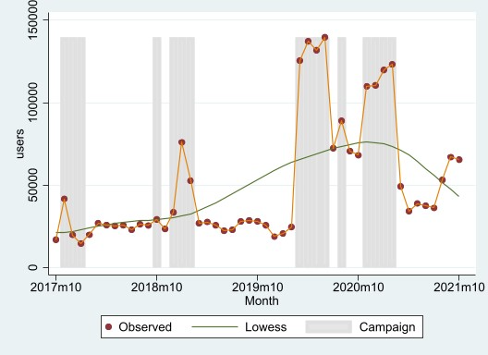

Figure 1. Monthly number of users, October 2017 to October 2021

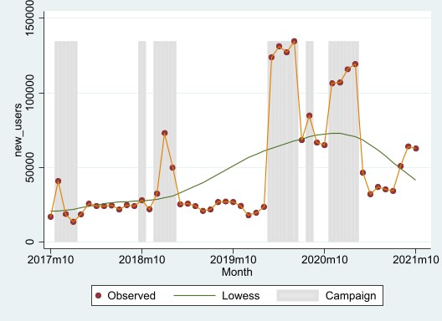

Figure 2. Monthly number of new users, October 2017 to October 2021

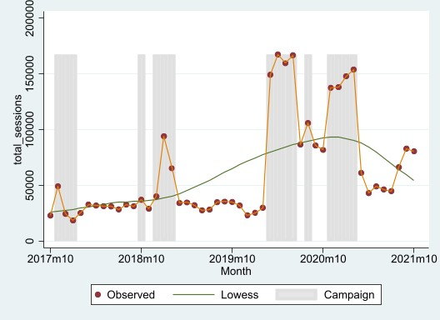

Figure 3. Monthly number of sessions, October 2017 to October 2021

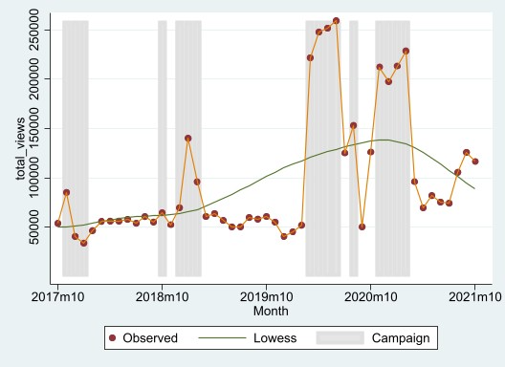

Figure 4. Monthly number of views, October 2017 to October 2021

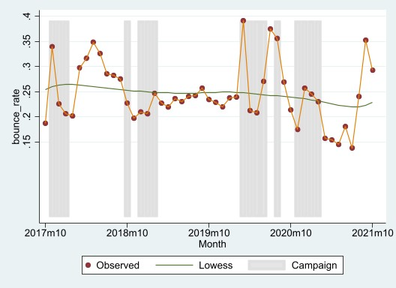

Figure 5. Monthly bounce rate, October 2017 to October 2021

#### Device use and referral source

Figure 6 shows that there has been a small decline in the use of desktop devices to access Head to Health from 52% in 2017 to 49% in 2021. The use of tablets has also halved from 8% in 2017 to 4% in 2021. Correspondingly, there has been an increase in the use of mobile devices from 40% in 2017 to 47% in 2021.

Figure 6. Device types over time, October 2017 to October 2021
Device categories are desktop, mobile and tablet

Figure 6. Device types over time, October 2017 to October 2021

Figure 7 shows the top five traffic sources to Head to Health by year from 2017 to 2021. It shows that organic searches (search engine results that were not paid ads) have accounted for the majority of traffic from 2018 to 2021. As of 2021, this is followed by directly typing the Head to Health URL in the web browser address bar or using a bookmark, and then referrals (from hyperlinks on external websites excluding ads), paid searches, and social media.

Figure 7. Top five traffic sources over time, October 2017 to October 2021.
Traffic source categories are: direct, organic search, paid, search, referral, social and other

Figure 7. Top five traffic sources over time, October 2017 to October 2021

Figure 8 displays the top 5 referral sources to Head to Health by year from 2017 to 2021. A referral source refers to a web location that directed a Head to Health visitor to the website. It shows that in all years, the majority of referrals came from Facebook. In 2020, this was followed by referrals from the Department of Health website.

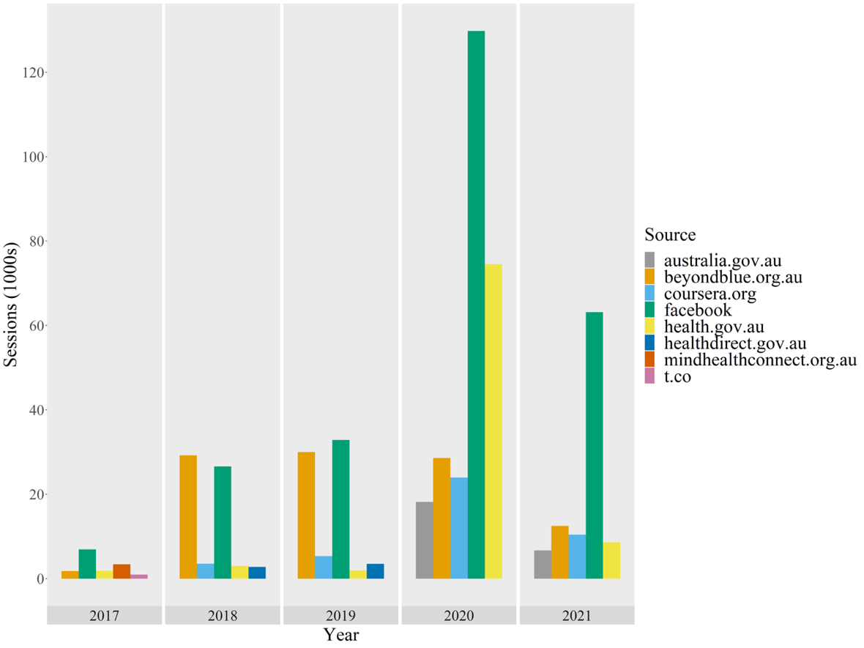

Figure 8. Top five referral sources over time, October 2017 to October 2021

### Engagement

Measures of engagement provide information about how users engage with the Head to Health website. These include the number of pages viewed per session, the average length of time spent on the website per session and the number of conversions. A conversion is the completion of a key or desired action, including search completions, SAM (chatbot) completions, emailing resources, and printing resources. In the period from October 2017 to October 2021, there was a total of 275,348 conversions. Table 3 displays the Head to Health monthly engagement overall, and during non-campaign and campaign periods, from October 2017 to October 2021.

The overall mean number of pages viewed per session was quite low (1-2). The average time spent on the website per session was about 2.5 minutes. A relatively small number and proportion of sessions included a conversion (~ 10%).

Table 3. Head to Health monthly engagement overall, and during non-campaign and campaign periods, October 2017 to October 2021

|  |  | Overall | | | | Non-campaign | | Campaign | |
| --- | --- | --- | --- | --- | --- | --- | --- | --- | --- |
| Measure | Description | mean | Sd | Min | max | mean | sd | mean | sd |
| Pages per session | Average number of pages viewed per session | 1.673 | 0.168 | 1.430 | 2.346 | 1.723 | 0.163 | 1.570 | 0.131 |
| Duration | Average length of time (seconds) spent on the website per session | 152.4 | 31.16 | 79.25 | 216.5 | 166.7 | 21.44 | 123.1 | 27.61 |
| Total conversions | Number of sessions in which key or desired actions are completed | 5,609 | 3,322 | 1,654 | 13,912 | 4,142 | 955.4 | 8,635 | 4,345 |
| Conversion rate | Proportion of sessions which include a conversion | 0.103 | 0.0314 | 0.0267 | 0.160 | 0.110 | 0.0322 | 0.0880 | 0.0242 |

Note. Each conversion is counted only once per session – i.e. unique count of conversions. Thus, a user who makes 2 ‘search completions’ and 2 ‘email resources’ will be counted as having made two conversions only.

Figures 9-12 display the monthly engagement with Head to Health, and include trend (Lowess) lines, from October 2017 to October 2021. These figures show that the number of pages per session, duration, and conversion rate have decreased over time, during both campaign and non-campaign periods.

The number of conversions has increased over time (until early 2021), with peaks during the 2020-2021 campaigns, which is overall a very similar trend to those observed for users, new users, total sessions and total views. The total number of conversions was higher in campaign than non-campaign periods.

There was a high negative correlation between number of users and duration (-0.83).

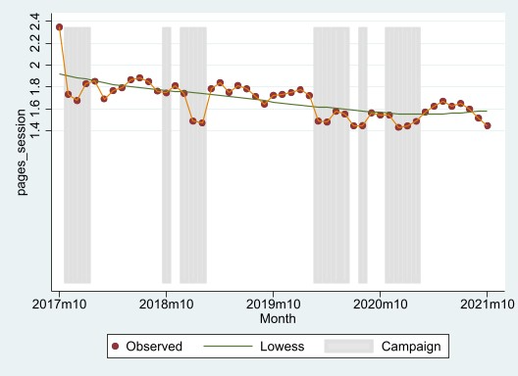

Figure 9. Monthly number of pages per session, October 2017 to October 2021

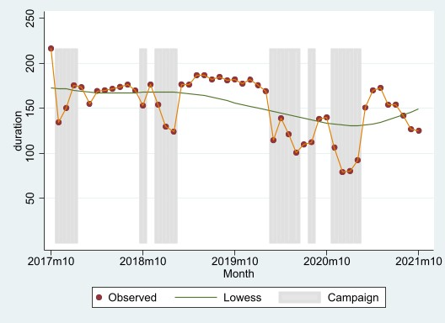

Figure 10. Monthly duration in seconds on website, October 2017 to October 2021

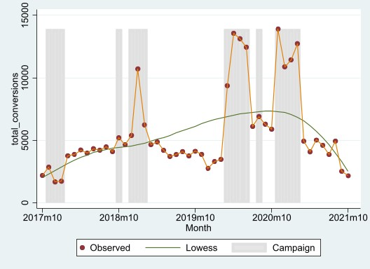

Figure 11. Monthly number of conversions, October 2017 to October 2021

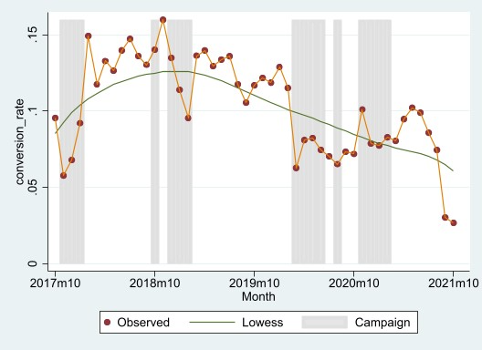

Figure 12. Monthly conversion rate, October 2017 to October 2021

#### User feedback

Head to Health website users can give feedback on the utility and quality of the website overall and the individual pages within it. Two sets of questions are offered to users; one set relates to the Head to Health website overall, and the other set relates to the specific page/content being accessed. These questions can be accessed by users by clicking the ‘Feedback’ tab in the lower right section on each page of the website. Within both sets of feedback items are the following ‘overall’ questions that allow an overall website/page appraisal from users including:

1. How do you rate your overall experience on Head to Health? (website feedback item);
2. How do you rate the home page overall? (page feedback item for the home page);
3. How do you rate this page overall? (page feedback item for content/topic pages within the website; e.g., ‘Covid 19 Support’, ‘What helps us thrive?’);
4. How do you rate the search page overall? (page feedback item for the search page);
5. How do you rate Sam the Chatbot overall? (page feedback item for the chatbot).

From July 2021, the overall items have been rated on the following scale: ‘terrible’, ‘bad’, ‘okay’, ‘good’, ‘great’. Before this time, the overall items were rated as either ‘could be much better’, ‘could be better’, ‘okay’, ‘good’ or ‘great’. In our analysis, all ‘could be much better’ and ‘could be better’ responses were relabelled as ‘terrible’ and ‘bad’, respectively.

Relative to the tens of thousands of Head to Health website users and sessions each month, only a very small number of feedback responses (less than 1000) have been provided over the life of the website.

Figure 13 displays the percentage of ratings for each point of the scale by the type of overall feedback item, for all years combined (2017-2021). Only data for the first three feedback items listed above are displayed (because less than 10 users per year on average gave feedback on the search page and chatbot). Around 50% of overall Head to Health website ratings were positive (i.e., ‘good’ or ‘great’). Around 40% of ratings were positive for the home page and website content pages.

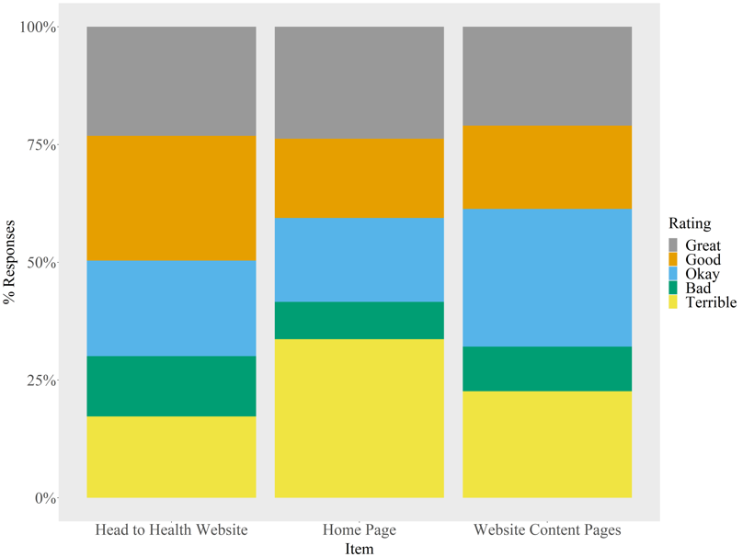

Figure 13. Head to Health website user feedback – overall, home page and content pages, October 2017 to October 2021

The feedback questionnaires also include some items that allow users to record if they would recommend the website or pages within the website to others as follows:

1. Would you recommend us to someone else? (website feedback item);
2. Would you recommend this page to someone else?' (page feedback item for content/topic pages within the website);

Would you recommend Sam the chatbot to someone else? (page feedback item for chatbot?).

Responses to these items are rated on a scale of ‘0 – Not at All’ to ’10 – Absolutely!’. For the purposes of analysis, a rating of seven or more was considered a ‘recommendation’, allowing the percentage of responses that were recommendations to be calculated.

Figure 14 displays the percentage of responses recommending the Head to Health website – overall, specific pages and the chatbot over the life of the website (2017-2021). The frequency (n) of recommendation responses is also provided. Overall, 46% of responses recommended the website, 28% recommended specific webpage topics/content and 28% recommended the chatbot.

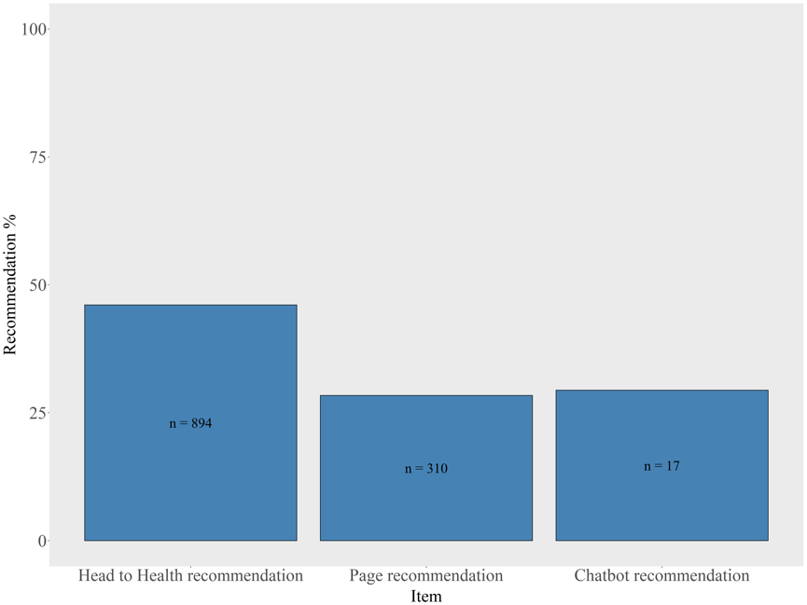

Figure 14. Percentage of responses recommending the Head to Health website – overall, specific page and chatbot, October 2017 to October 2021

Figure 15 displays the percentage of responses recommending the Head to Health website (N = 985) and specific pages (N = 385) by year. The percentage of responses recommending the Head to Health website fluctuates at around 50% from year to year. Slightly lower recommendation percentages are evident for webpage topics/content. Chatbot data are not represented due to small numbers.

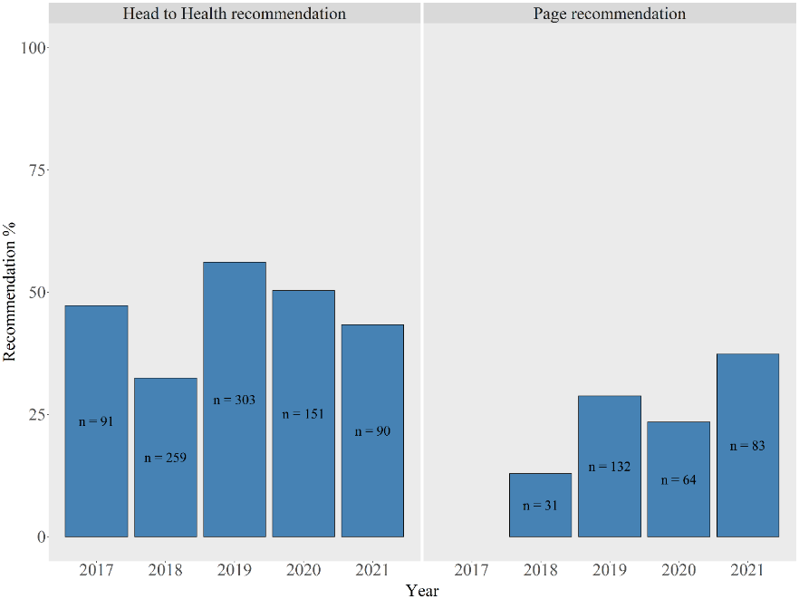

Figure 15. Percentage of responses recommending the Head to Health website and specific page by year, October 2017 to October 2021

#### Page helpfulness

Appendix B provides details on the source of page helpfulness data. As with the user feedback data, only a very small number of helpfulness responses have been provided over the life of the Head to Health website.

Figure 16 shows the percentage of responses in which the page was endorsed as helpful by year (2017-2021). Page helpfulness was steady over time at around 75%.

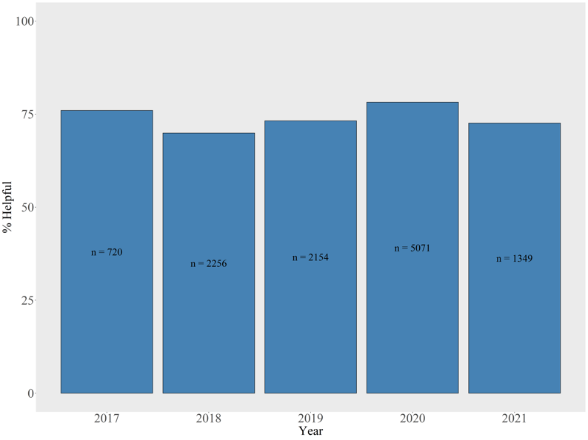

Figure 16. Percentage of responses endorsing a Head to Health website page as helpful by year, October 2017 to October 2021

Figure 17 displays the percentage of webpage ratings that were helpful by webpage topic category over the life of the Head to Health website, excluding any topic categories with <10 responses. The N in the figure below (the denominator) is the number of occasions that the pages under these topic headings were rated for helpfulness (i.e., the number of rating events). The Y axis is the percentage of all ratings that were helpful (i.e., 100 * (helpful ratings/total ratings). It can be seen that the *Meaningful life* topic was the most rated (N = 4844) and, excluding topics with <10 responses, the *For health professionals* topic was the least rated (N = 77) in terms of helpfulness. Each topic was more likely to be rated as helpful than not helpful, with each topic endorsed as helpful in around 60-80% of occasions.

Figure 16. Proportion of webpages endorsed as helpful by topic, October 2017 to October 2021



Figure 17. Proportion of webpages endorsed as helpful by topic, October 2017 to October 2021

Figure 18 displays the percentage of webpage ratings that were endorsed as helpful by webpage subtopic category over the life of the Head to Health website, excluding any subtopic categories with <10 responses. It shows that the subtopics most frequently (> 75%) rated as helpful were: What helps us thrive (Meaningful life), Chatstarter (COVID-19 support), Find support that works for you (COVID-19 support), Domestic violence (Supporting yourself) and Self-harm (Mental health difficulties). It should, however, be noted that for four of these five subtopics the total number of ratings in either direction was only n < 66; whereas the total number of ratings for What helps us thrive (Meaningful life) was more substantial at 2027. The three subtopic pages least endorsed as helpful (in < 50% of ratings) were Impacts on everyday life (COVID-19 support), COVID-19 support (Mental health difficulties) and Seeking support (Supporting yourself). However, these subtopics were rated on a relatively small number of occasions (n = 19, 76 and 110, respectively).

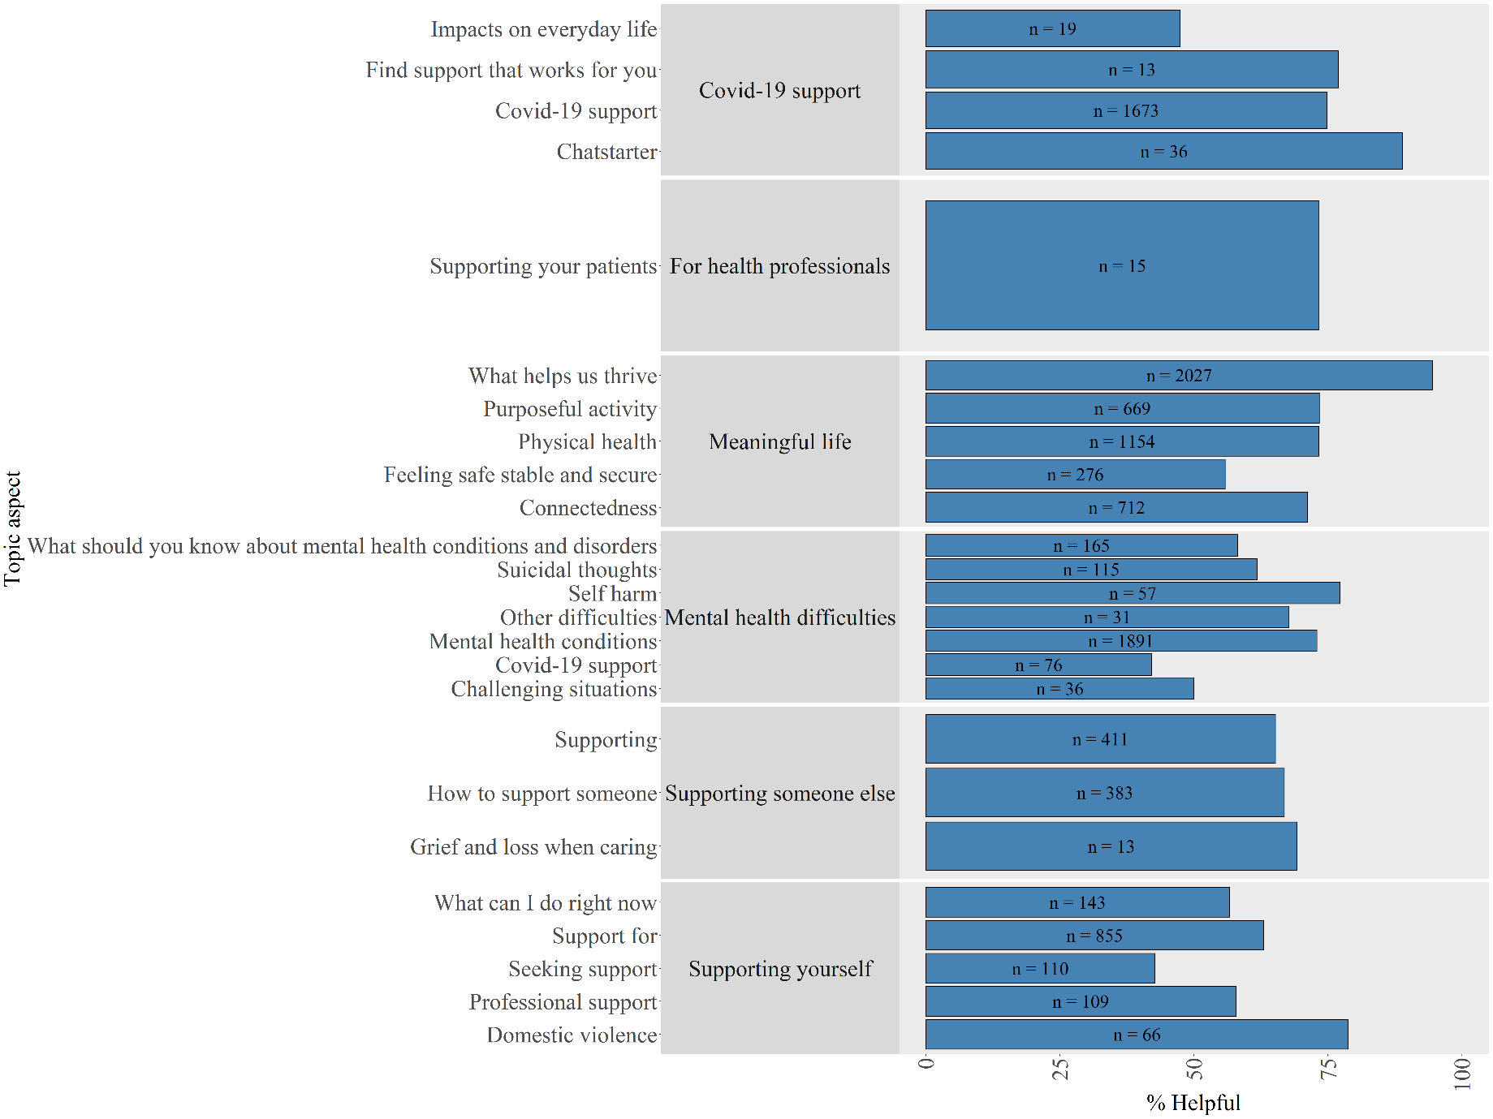

Figure 18. Proportion of webpages endorsed as helpful by subtopic, October 2017 to October 2021

## Summary

Between October 2017 and October 2021, Head to Health was accessed by 2.5 million users (2.4 million new users). Uptake has increased over time and has been higher during campaign periods, with the mean number of monthly users of 50,694 overall, 34,244 in non-campaign periods and 84,820 in campaign periods. In about 25% of sessions, users did not make any recorded interactions on the website before leaving. Users most commonly accessed Head to Health through search engine results that were not paid ads, and most referrals came from Facebook. In terms of engagement with the Gateway, users tended to view website 1-2 pages per session and spend an average of 2.5 minutes on the website. Only around 10% of all sessions included a conversion. The number of pages per session, duration, and conversion rate have decreased over time, during both campaign and non-campaign periods. Only a very small minority of Head to Health users have provided feedback over the life of the website. Of these, around 50% of overall website ratings and 40% of home page and website content pages ratings were positive; and around 50% users who provided feedback would recommend Head to Health.

# Service data

## Our approach

We requested monthly data from July 2014 to June 2021 on total number of unique website visitors and number of unique website visitors via Head to Health (October 2017-June 2021), and its predecessor mindhealthconnect (July 2014-September 2017), from three key Australian digital mental health services (DMHSs) – MindSpot, ThisWayUp and Mental Health Online. Mental Health Online provided data on ‘total’ and ‘new’ rather than unique visitors, and we chose to use ‘new’ users as the equivalent of ‘unique’ users for our analyses.

We calculated the proportion of website visitors via Head to Health and mindhealthconnect. We also produced plots showing the counts for each month over time and included a trend line to assess both short-term and long-term trends.

## Findings

### Overall service uptake and referrals from Health to Health

Table 4 provides data on the total number of visitors to each of the three DMHSs from July 2014 to June 2021 and the number of referrals from mindhealthconnect and/or Head to Health. It shows that, in the 3.75-year period (October 2017 to June 2021), Head to Health referred almost double the number of visitors to the websites of three key digital mental health services as mindhealthconnect in a 3.25-year period (July 2014 to September 2017; 69,595 cf 36,455). However, because the overall number of visitors to the websites of these services more than tripled, proportionally, there were fewer referrals from Head to Health than from mindhealthconnect (1% cf 2%).

Proportionally, the impact of mindhealthconnect and Head to Health has been the same for MindSpot (1.2% for both). By comparison, there was a decrease in the percentage of referrals to ThisWayUp and an increase in the percentage of referrals to Mental Health Online from Head to Health compared with mindhealthconnect (3.1% cf 0.5% and 7.0% cf 8.0%, respectively).

Table 4. Total visitors, and referrals from Head to Health/mindhealthconnect, to DMHSs, July 2014 to June 2021

|  | MindSpot | ThisWayUp | Mental Health Online | Total |
| --- | --- | --- | --- | --- |
| **Jul 2014-Sept 2017 (3.25 years)** |  |  |  |  |
| Total number of visitors | 1,021,566 | 563,619 | 101,905 | 1,687,090 |
| Number of referrals from MHC | 11,767 | 17,461 | 7,227 | 36,455 |
| Percentage of referrals from MHC | 1.15% | 3.10% | 7.09% | 2.16% |
| **Oct 2017-Jun 2021 (3.75 years)** |  |  |  |  |
| Total number of visitors | 1,787,745 | 5,343,793 | 238,572 | 5,363,235 |
| Number of referrals from H2H | 21,620 | 28,760 | 19,215 | 69,595 |
| Percentage of referrals from H2H | 1.21% | 0.54% | 8.05% | 1.30% |
| **Jul 2014-Jun 2021 (7 years)** |  |  |  |  |
| Total number of visitors | 2,809,311 | 5,907,412 | 340,477 | 8,427,933 |
| Number of referrals from MHC/H2H | 33,387 | 46,221 | 26,442 | 100,161 |
| Percentage of referrals from MHC/H2H | 1.19% | 0.78% | 5.64% | 1.19% |

H2H, Head to Health; MHC, mindhealthconnect.

### Trends over time in monthly service uptake and referrals from Head to Health

Table 5 provides the mean monthly uptake of the three DMHSs and the mean monthly proportions referred via Head to Health/mindhealthconnect.

Like the data on total numbers of visits, the mean monthly proportions show that for:

* MindSpot the mean monthly proportion of referrals from mindhealthconnect and Head to Health were about the same (1.3% cf 1.2%);
* ThisWayUp the mean monthly proportion of referrals from Head to Health was smaller than that attributable to mindhealthconnect (5.1% cf 0.8%);
* Mental Health Online the mean monthly proportion of referrals from Head to Health was somewhat larger than that attributable to mindhealthconnect (8.9% cf 8.4%); and
* All three services combined the mean monthly proportion of referrals from Head to Health was smaller than that attributable to mindhealthconnect (4.9% cf 3.6%).

Figures 19-21 display the monthly proportion of website visitors referred via Head to Health or mindhealthconnect from July 2014 to June 2021 and include a trend line.

For MindSpot, the trend line suggests that the proportion of referrals appeared to increase over the Head to Health period (from October 2017 until June 2021), with a maximum monthly proportion of 3%. The trend for This Way Up was less clear but the trend line suggests that the proportion of referrals over the Head to Health period appeared to initially decrease (October 2017 until July 2018), then remain steady for some time (until around November 2020) when there was a sharp increase for 4 months (to 3%), before dropping back to the previous steady proportion of about 1%. For Mental Health Online, the trend line suggests that the proportion of referrals appeared to be relatively stable for the initial Head to Health period (from October 2017 until about April 2021), and then decrease, although there was considerable fluctuation during the entire Head to Health period with a minimum monthly proportion of 3% and a maximum of 18%.

Table 5. Mean monthly uptake of digital mental health services, overall and via Head to Health/mindhealthconnect, July 2014 – June 2021

|  | MindSpot | | ThisWayUp | | MHO* | | All | |
| --- | --- | --- | --- | --- | --- | --- | --- | --- |
|  | mean | sd | mean | sd | mean | sd | mean | SD |
| **Jul 2014-Sept 2017 (3.25 years)** |  |  |  |  |  |  |  |  |
| Number of unique website visitors during MHC period | 26,194 | 8,186 | 14,452 | 11,971 | 2,613 | 853.4 | 14,420 | 12,752 |
| Number of unique website visitors referred from MHC | 301.7 | 143.0 | 447.7 | 96.43 | 0 | 0 | 249.8 | 211.7 |
| Proportion of unique website visitors referred from MHC | 0.0132 | 0.00814 | 0.0507 | 0.0293 | 0.0841 | 0.0694 | 0.0493 | 0.0522 |
| **Oct 2017-Jun 2021 (3.75 years)** |  |  |  |  |  |  |  |  |
| Number of unique website visitors during H2H period | 39,728 | 8,540 | 118,751 | 52,842 | 5,302 | 2,179 | 54,593 | 56,699 |
| Number of unique website visitors referred from H2H | 480.4 | 262.1 | 639.1 | 359.4 | 427 | 151.0 | 515.5 | 283.9 |
| Proportion of unique website visitors referred from H2H | 0.0121 | 0.00560 | 0.00756 | 0.00760 | 0.0893 | 0.0330 | 0.0363 | 0.0425 |
| **Jul 2014-Jun 2021 (7 years)** |  |  |  |  |  |  |  |  |
| Total number of unique visitors | 33,444 | 10,745 | 70,326 | 65,453 | 4,053 | 2,161 | 35,941 | 46,845 |
| Number of unique website visitors referred from MHC/H2H | 397.5 | 232.0 | 550.3 | 286.3 | 314.8 | 174.2 | 420.8 | 253.9 |
| Proportion of unique website visitors referred from MHC/H2H | 0.0126 | 0.00687 | 0.0276 | 0.0298 | 0.0869 | 0.0528 | 0.0424 | 0.0476 |

H2H, Head to Health; MHC, mindhealthconnect; MHO, Mental Health Online

*Data from MHO are counts of new website visitors (not unique website visitors).

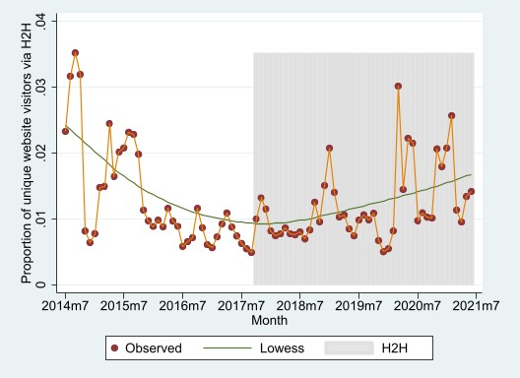

**Figure 19. Monthly proportion of MindSpot unique visitors referred from mindhealthconnect or Head to Health, July 2014 to June 2021**

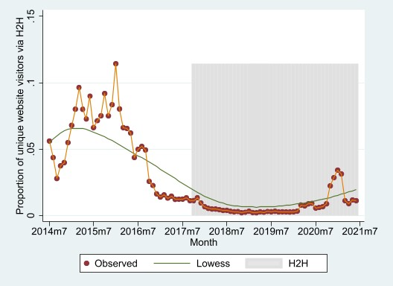

**Figure 20. Monthly proportion of ThisWayUp unique visitors referred from mindhealthconnect or Head to Health, July 2014 to June 2021**

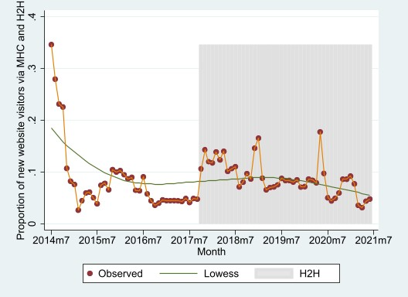

**Figure 21. Monthly proportion of Mental Health Online unique (new) visitors referred from mindhealthconnect or Head to Health, July 2014 to June 2021**

## Summary

In absolute numbers, Head to Health referred almost double the number of visitors to the websites of three key digital mental health services in the 3.75-year period (October 2017 to June 2021) as mindhealthconnect in a 3.25-year period (July 2014 to September 2017; 69,595 cf 36,455). However, because the overall number of visitors to the websites of these services more than tripled, proportionally, there were fewer referrals from Head to Health than from mindhealthconnect (1% cf 2%).

Proportionally, the impact of mindhealthconnect and Head to Health has been the same for MindSpot (1.2% for both). By comparison, there was a decrease in the percentage of referrals to ThisWayUp and an increase in the percentage of referrals to Mental Health Online from Head to Health compared with mindhealthconnect (3.1% cf 0.5% and 7.0% cf 8.0%, respectively).

# Secondary data from user survey

## Our approach

We used secondary quantitative and qualitative data from a survey conducted by the Department of Health from 10 July 2019 to 18 November 2019. Visitors to the Head to Health website were invited to participate in an online survey, which included closed and open-ended questions about their demographics, reasons for accessing Head to Health, experience of using Head to Health, and feedback on features, ease of use, relevance and potential improvements of the website. A total of 258 individuals responded to the survey.

## Findings

### Socio-demographic characteristics of survey respondents

Table 6 shows the demographic characteristics of survey respondents. The majority of respondents were female (73%) and half were aged 35 years or younger. Over one quarter (27%) of respondents resided in NSW and 24 % in Victoria. Close to 20% resided in a rural or remote location. Forty-six percent of respondents had lived experience of mental illness. Twenty percent of respondents identified as LGBTQIA+.

Table 6. Characteristics of survey respondents (N=258)

| Characteristic | Frequency | % |
| --- | --- | --- |
| Gender |  |  |
| Female | 187 | 72.5 |
| Male | 60 | 23.3 |
| Prefer not to answer | 2 | 0.8 |
| Self-described | 9 | 3.5 |
| Age range |  |  |
| Under 18 years | 43 | 16.7 |
| 18-35 years | 86 | 33.3 |
| 36-50 years | 73 | 28.3 |
| 51-65 years | 46 | 17.8 |
| 66-79 years | 9 | 3.5 |
| 80 years or older | 1 | 0.4 |
| State |  |  |
| Australian Capital Territory | 12 | 4.7 |
| New South Wales | 70 | 27.1 |
| Northern Territory | 3 | 1.2 |
| Queensland | 47 | 18.2 |
| South Australia | 23 | 8.9 |
| Tasmania | 7 | 2.7 |
| Victoria | 61 | 23.6 |
| Western Australia | 32 | 12.8 |
| Not answered | 2 | 0.8 |
| Population groups identified with a |  |  |
| Aboriginal and Torres Strait Islander | 10 | 3.9 |
| Culturally and linguistically diverse/ main language spoken at home is not English | 21 | 8.1 |
| Living in a rural or remote location | 50 | 19.4 |
| Lesbian, Gay, Bisexual, Transgender, Intersex and Queer people | 51 | 19.8 |
| Person who has personally experienced mental illness (lived experience) | 120 | 46.5 |
| Person with a disability | 36 | 13.9 |
| Person who provides unpaid care/support to family members/friends who have a disability, mental illness, chronic condition, terminal illness, an alcohol or other drug issue or who are frail aged (Carer) | 42 | 16.3 |
| Veteran | 5 | 1.9 |
| Not answered | 65 | 25.2 |

aMultiple responses permitted.

### Use of Head to Health

Table 7 shows how respondents first heard about Head to Health, their reasons for visiting the website and the website features they used.

As shown in Table 7, one third of respondents first heard about Head to Health through an internet search, with 17% hearing about it from a friend, co-worker, or family member. Respondents who provided additional information (free text response) and indicated they heard about it elsewhere (n=60), most indicated they heard about it from their workplace (n=18), a mental health service (n=10) or their school or educational institution (n=10).

The most cited reason for visiting the website was to find mental health resources for oneself (39%) followed by finding mental health resources for a friend, family member or co-worker; and seeking resources for a client or patient (Table 7). Of those who indicated they were visiting the website for another reason (n = 64), 20 indicated it was related to their schoolwork, 11 to activities at work and 10 to search for general information.

Twelve percent of respondents (n=30) reported having recommended a specific digital mental health resource to a patient or client. Twenty-seven respondents provided further details about the services they recommended. Eight respondents had recommended Beyond Blue, six headspace, four SANE, and three each mentioned Head to Health, Lifeline, moodgym, and Beyond Now. When asked if there were any reasons for, or barriers to, recommending digital mental health resources, five respondents provided further details related to a lack of awareness or experience using digital mental health resources. Of those who indicated they were visiting the website for another reason (n = 64), 20 indicated it was related to their schoolwork, 11 to activities at work and 10 to search for general information.

The most used features of the Head to Health website were the topic and content pages (58%) and the search resources (57%) (Table 7). Thirty-seven respondents provided additional feedback on features. This feedback most commonly related to limited information provision (n=17), poor website design (n=8) and outdated or inappropriate information (n=6).

Table 7. Referral source, reason for visiting and website features used (N=258)

|  | Frequency | % |
| --- | --- | --- |
| Referral source |  |  |
| Friend, co-worker or family member | 45 | 17.4 |
| A GP or health professional | 20 | 7.7 |
| Social media | 33 | 12.8 |
| Internet search (e.g., Google) | 92 | 35.7 |
| I don’t remember | 11 | 4.3 |
| Other (please specify)a | 57 | 22 |
| Reason for visiting |  |  |
| I’m looking to find mental health resources for myself | 100 | 38.8 |
| I’m looking to find mental health resources for a friend, family member or co-worker | 40 | 15.5 |
| I’m a carer looking to find mental health resources for someone I care for | 9 | 3.5 |
| I’m a health professional or GP looking to find mental health resources for my client/patient | 40 | 15.5 |
| I am a service provider listed on Head to Health | 6 | 2.3 |
| Otherb | 63 | 24.4 |
| Features usedc,d |  |  |
| Sam the Chatbot | 51 | 19.8 |
| Search resources | 154 | 56.7 |
| Save resources | 33 | 12.8 |
| Topic/content pages (e.g., Anxiety disorders, Depressive disorders, Contentedness, etc.) | 150 | 58.1 |
| Not answered | 41 | 15.9 |

a60 respondents provided additional information in the free text space.

b64 respondents provided additional information in the free text space.

cMultiple responses permitted.

d37respondents provided additional feedback in the free text space.

### Head to Health user experiences

User experiences of Head to Health were assessed in a series of questions concerning ease of use, relevance of resources, rating of the experience and likelihood of recommending the website. As shown in Table 8, 62% of respondents indicated that the website was easy or very easy to use, with less than 10% indicating it was very hard. Forty-three respondents provided further details about ease of use, with 22 of these respondents indicating information was limited and 10 respondents reporting other difficulties.

Sixty-one percent of respondents found the resources to be extremely relevant or relevant and 8% indicated the resources were not at all relevant. Thirty-three respondents provided additional feedback on resource relevance, with 11 respondents indicating missing information, six identifying gaps in certain digital resources and five mentioning barriers to using the recommended resources.

When asked about the extent to which they trusted the information and resources on Head to Health, 59% of respondents indicated a great deal or a lot of trust, 29% indicated a moderate level of trust and 5% indicated not at all trusting the information or resources. Thirty individuals provided additional feedback on trust, 10 of whom cited missing information as inhibiting their trust in the site, and nine respondents provided further positive information that promoted their trust in the website.

Sixty percent of respondents rated their experience of using the Head to Health website as good or great, with around two-thirds reporting a relatively high likelihood (> 7/10) of recommending the website. Thirty-one respondents provided additional feedback on their rating of the website, 15 of whom provided positive feedback, seven reported difficulties using the website, and four suggested updating or including additional information.

Forty participants responded to the question about recommending Head to Health to a client or patient experiencing mental health concerns. Over half of these respondents (52.5%) had not recommended the website.

Table 8. User experiences of Head to Health (N=258)a

|  | Frequency | | % |
| --- | --- | --- | --- |
| Ease of usea | | | |
| Very easy | 63 | | 24.4 |
| Easy | 97 | | 37.6 |
| Neither easy or hard | 60 | | 23.3 |
| Hard | 14 | | 5.4 |
| Very hard | 24 | | 9.3 |
| Relevance of resourcesb | | | |
| Extremely relevant | | 52 | 20.2 |
| Relevant | | 106 | 41.1 |
| Somewhat relevant | | 50 | 19.4 |
| Not very relevant | | 18 | 7.0 |
| Not at all relevant | | 21 | 8.1 |
| Not answered | | 11 | 4.3 |
| Extent of trustc | | | |
| A great deal | 74 | | 28.7 |
| A lot | 79 | | 30.6 |
| A moderate amount | 75 | | 29.1 |
| A little | 17 | | 6.6 |
| Not at all | 13 | | 5.0 |
| Rating of experienced | | | |
| Terrible | 11 | | 4.3 |
| Bad | 18 | | 7.0 |
| Okay | 75 | | 29.1 |
| Good | 93 | | 36.0 |
| Great | 61 | | 23.6 |
| Likelihood of recommending | | | |
| 0 – not at all | 16 | | 6.2 |
| 1 | 5 | | 1.9 |
| 2 | 10 | | 3.9 |
| 3 | 6 | | 2.3 |
| 4 | 12 | | 4.6 |
| 5 | 28 | | 10.8 |
| 6 | 12 | | 4.6 |
| 7 | 23 | | 8.9 |
| 8 | 39 | | 15.1 |
| 9 | 25 | | 9.7 |
| 10 – Absolutely | 82 | | 31.8 |

a43respondents provided additional feedback in the free text space.

b33 respondents provided additional feedback in the free text space.

c30 respondents provided additional feedback in the free text space.

d31respondents provided additional feedback in the free text space.

### Suggested improvements Head to Health

Respondents were also asked about additional services, topics, features, or other improvements they would like to see. Respondents (n=133) made specific requests for additional content or resources, including information for specific disorders or subpopulations; and information about accessing face-to-face services, particularly based on location. Comments also included the need to improve the look and feel and ease of navigation of the website and its speed. Some respondents reported that the website was adequate as it was. Others expressed that the gateway needs to outline costs and other requirements for entry into suggested services, as well as including the voices of those with lived experience, for example, in providing user ratings of services. Others also commented on needing to further refine both chatbot and search functionality and to ensure that suggestions are tailored to the individual.

## Summary

Of the 258 survey respondents, most were female (73%) and half were aged 35 years or younger, around 20% resided in a rural or remote location, 46% had lived experience of mental illness and 20%s identified as LGBTQIA+. Most reported having first heard about Head to Health through an internet search or word of mouth. Their most common reason for visiting the website was to find mental health resources for themselves; followed by finding mental health resources for a friend, family member or co-worker; and seeking resources for a client or patient. They most used the topic and content pages (58%) and the search resources (57%). Respondents suggested improvements including additional content or resources (e.g., specific disorders or subpopulations, accessing face-to-face services by location, outlining costs and eligibility requirements for entry into suggested services). They also commented on the need to improve the look and feel and ease of navigation of the website and its speed. Others expressed that the voices of those with lived experience should be included (e.g., user service ratings). Others also mentioned refining chatbot and search functionality and ensuring that suggestions are individually tailored.

# Consumer experiences

## Our approach

We conducted an online survey with visitors to the Head to Health website. The survey was open from 8 December 2021 to 2 May 2022 and included closed and open-ended questions about consumers’ experiences of using Head to Health and their demographic characteristics. The survey was also widely promoted by the Department of Health, eMHPrac, the Black Dog Institute and our own University of Melbourne website.

We also conducted interviews with survey participants who agreed to provide more in-depth information.

Survey and interview questions and further details about our methods are in Appendix C.

## Findings

### Characteristics of consumer survey respondents

In total, 47 consumers completed the survey, and Table 9 describes their demographic characteristics and internet access. Two thirds of consumers were female, 72% were under the age of 50 years and 45% resided in New South Wales (NSW). Eighty-seven percent of consumers had reliable internet, and 76% used the National Broadband Network to access the internet.

Table 9. Consumer survey respondent characteristics (N=47)

| Characteristic | Frequency | % |
| --- | --- | --- |
| Gender | | |
| Male  Female  Missing | 15  31  1 | 32  66  2 |
| Age | | |
| 16-17 years  20-29 years  30-39 years  40-49 years  50-59 years  60-69 years  70-79 years | 1  14  10  9  2  9  2 | 2  30  21  19  4  19  4 |
| Indigenous status | | |
| Aboriginal  Both Aboriginal and Torres Strait Islander  Neither  Missing | 1  1  43  2 | 2  2  92  4 |
| State | | |
| Northern Territory  New South Wales  Victoria  Queensland  South Australia  Western Australia | 2  21  8  8  7  1 | 4  45  17  17  15  2 |
| Type of internet | | |
| ADSL or ADSL2+  National Broadband  Satellite Connection  Wireless Router  Mobile Broadband  Other | 1  36  2  8  5  3 | 2  76  4  17  11  7 |
| Reliability of internet | | |
| Unreliable all the time  Unreliable most of the time  Unreliable/reliable some of the time  Reliable most of the time  Reliable all the time | 2  3  1  25  16 | 4  6  2  53  34 |

Five consumer survey respondents also agreed to take part in an interview about their experience of using Head to Health. Two of these consumers completed the interviews. Several attempts were made to contact the other three consumers, but we were unsuccessful in scheduling an interview.

### Consumer experiences of the Head to Health website

Consumers were asked about their experiences of using the Head to Health website. Their responses are recorded in Table 10. Fifty-seven per cent of consumers were aware of the Head to Health website. However, 48% had never used it. Consumers primarily found the Head to Health website through an online search.

Twenty-three (49%) consumers indicated they had used the Head to Health website. Of these consumers, 12 (52%) were first-time users, and 6 (26%) had used it between 1 and 5 times. Most commonly, consumers spent less than 20 minutes on the website. The most common reasons for using the website included struggles with coping, wanting to access information for family and friends, needing professional help or experiencing a crisis or traumatic event. Fifty-seven percent of consumers had accessed other mental health services prior to Head to Health, mainly face-to-face services.

Of the 23 consumers who had used the website, 47% reported experiencing barriers to accessing mental health services before accessing Head to Health. Most commonly, barriers included thinking symptoms would improve without intervention and/or were not sufficiently severe to warrant intervention, feeling embarrassed about needing mental health care, a lack of knowledge on how to access care, the affordability of care and a preference to rely on oneself.

The two consumers we interviewed about the Head to Health had contradicting experiences. One reported that their experience was ‘awful’, overwhelming and anxiety-provoking due to there being too many resources and information available. They also found the design to be excessive. They said:

I think from a design perspective, just so over the top … the problem is that there is so many different resources online and it’s hard to know what a correct [Head to Health] might try and help you with … but I just find it so overwhelming. Literally, I went on to the website, clicked anxiety and stress, clicked search for my sister who is experiencing anxiety quite a bit and then the first thing it tells you is there are so many resources for anxiety and stress and that got my anxiety up.

On the other hand, although the other consumer agreed that on first accessing the website it appeared overwhelming, they found the website engaging, appreciated the design and found what they were looking for. They said:

My first impression was that it was overwhelming – that there was too much information but once I started using it, I thought it was good to navigate. The cartoons were cute, it was engaging, the categories were logical, aesthetics were great – one of the better government websites I have visited.

Both consumers had accessed mental health services prior to using Head to Health and were informed service users. One consumer, however, had learnt about new services and went on to access these after using Head to Health. The other consumer however did not go on to access other services following their use of Head to Health.

Table 10. Consumers’ use of the Head to Health website

|  |  |  |
| --- | --- | --- |
|  | Frequency | % |
| Method of finding Head to Health (n=47) | | |
| Online search  Health provider recommended  Heard of Head to Health but have not used  Have not heard of or used Head to Health  Missing | 21  1  5  19  1 | 44  2  11  40  3 |
| Frequency of use of Head to Health (n=23) | | |
| First time  Used 2 to 5 times  Used 6 to 10 times  Used 11 or more times  Missing | 12  6  2  1  2 | 52  26  9  4  9 |
| Time spent on Head to Health (n=23) | | |
| Less than 10 minutes  10 to 20 minutes  20 to 30 minutes  30 to 40 minutes  Over 40 minutes  Missing | 10  1  4  1  1  6 | 43  4  17  4  4  26 |
| Reason(s) for accessing Head to Health (n=23)a | | |
| Was not coping  To access information for a family member /friend  Needed professional help  Symptoms were getting worse  Experienced a crisis or traumatic event  Family /friend suggested it  Health professional referred me  Other | 10  7  4  3  4  1  1  6 | 43  30  17  13  17  4  4  30 |
| Prior access to mental health services (n=23) | | |
| Yes  No  Missing | 13  3  7 | 57  13  30 |
| Types of mental health services accessed (n=13) | | |
| Face to face  Group  Video  Other online support | 11  2  3  6 | 85  15  23  46 |
| Prior barriers to seeking mental health care (n=23) | | |
| Yes  No  Missing | 11  5  7 | 47  22  30 |
| Types of barriers (n=11) | | |
| I didn’t think my symptoms were severe enough  I thought things would get better  I was embarrassed  I didn’t want anyone to know about my mental health  I preferred to rely on myself  I was unable to afford mental health care  I had limited knowledge of available MH treatment options  I didn’t recognise the symptoms related to my mental health  My mental health was not a priority  I was on a long waiting list  I believed I did not need mental health treatment  I didn’t think mental health treatment would help  I preferred to rely on my family/friends  Mental health services were unavailable in my area  Other | 7  6  6  6  6  6  5  4  4  4  3  3  2  1  2 | 64  55  55  55  55  55  45  36  36  36  27  27  18  9  18 |

aMultiple responses permitted.

### Consumer experiences of specific aspects of Head to Health

The 23 consumers who had used the website were asked about their experiences with particular elements of Head to Health, including the quality and relevance of information, navigation, and website design. Their responses are described in Table 11.

Only 17% (n=4) of consumers reported that they found all relevant information on the front page of Head to Health, or they could easily find the information they were looking for. Approximately 40% of consumers ‘somewhat’ or ‘strongly agreed’ that the information on the website was trustworthy, easy to understand, offered new knowledge and was appropriate for people who want to help someone with a mental health problem.

Approximately one-third of consumers ‘somewhat’ or ‘strongly agreed’ that the website contained the information they were looking for and that the information was relevant, easy to read, accurate, and appropriate for people with a mental health problem.

Regarding navigation and appeal, approximately one-third of consumers ‘somewhat’ or ‘strongly agreed’ that the website was easy to navigate, visually appealing, engaging and interactive.

Table 11. Consumers experience of the Head to Health website (N=23)

| Aspects of website | Frequency | | | % | |
| --- | --- | --- | --- | --- | --- |
| All relevant information can be found on the front page | | | | | |
| Strongly disagree | 4 | | | 17 | |
| Somewhat disagree | 1 | | | 4 | |
| Neither agree nor disagree | 8 | | | 35 | |
| Somewhat agree | 1 | | | 4 | |
| Strongly agree | 3 | | | 13 | |
| Missing | 6 | | | 26 | |
| I can quickly find the information that I am looking for | | | | | |
| Strongly disagree | 4 | | | 17 | |
| Somewhat disagree | 5 | | | 22 | |
| Neither agree nor disagree | 4 | | | 17 | |
| Somewhat agree | 3 | | | 13 | |
| Strongly agree | 1 | | | 4 | |
| Missing | 6 | | | 26 | |
| The website is easy to navigate | | | | | |
| Strongly disagree | 3 | | | 13 | |
| Somewhat disagree | 2 | | | 9 | |
| Neither agree nor disagree | 5 | | | 22 | |
| Somewhat agree | 4 | | | 17 | |
| Strongly agree | 3 | | | 13 | |
| Missing | 6 | | | 26 | |
| The information on the website is trustworthy | | | | | |
| Strongly disagree | 1 | | | 4 | |
| Somewhat disagree | 2 | | | 9 | |
| Neither agree nor disagree | 4 | | | 17 | |
| Somewhat agree | 5 | | | 22 | |
| Strongly agree | 5 | | | 22 | |
| Missing | 6 | | | 26 | |
| The website offers information that is new to me | | | | | |
| Strongly disagree | 1 | | | 4 | |
| Somewhat disagree | 1 | | | 4 | |
| Neither agree nor disagree | 6 | | | 26 | |
| Somewhat agree | 8 | | | 35 | |
| Strongly agree | 1 | | | 4 | |
| Missing | 6 | | | 26 | |
| The website contains the information I was looking for | | | | | |
| Strongly disagree | 2 | | | 9 | |
| Somewhat disagree | 4 | | | 17 | |
| Neither agree nor disagree | 3 | | | 13 | |
| Somewhat agree | 6 | | | 26 | |
| Strongly agree | 2 | | | 9 | |
| Missing | 6 | | | 26 | |
| The information on the website is easy to understand | | | | | |
| Strongly disagree | 2 | | | 9 | |
| Somewhat disagree | 2 | | | 9 | |
| Neither agree nor disagree | 3 | | | 13 | |
| Somewhat agree | 6 | | | 26 | |
| Strongly agree | 4 | | | 17 | |
| Missing | 6 | | | 26 | |
| The information on the website is relevant to me | | | | | |
| Strongly disagree | 1 | | | 4 | |
| Somewhat disagree | 1 | | | 4 | |
| Neither agree nor disagree | 6 | | | 26 | |
| Somewhat agree | 6 | | | 26 | |
| Strongly agree | 2 | | | 9 | |
| Missing | 7 | | | 30 | |
| The information on the website is easy to read (concise and clear layout) | | | | |
| Strongly disagree | | 1 | 4 | |
| Somewhat disagree | | 3 | 13 | |
| Neither agree nor disagree | | 5 | 22 | |
| Somewhat agree | | 6 | 26 | |
| Strongly agree | | 2 | 9 | |
| Missing | | 6 | 26 | |
| The information on the website is accurate | | | | |
| Strongly disagree | | 0 | 0 | |
| Somewhat disagree | | 1 | 4 | |
| Neither agree nor disagree | | 9 | 39 | |
| Somewhat agree | | 5 | 22 | |
| Strongly agree | | 2 | 9 | |
| Missing | | 6 | 26 | |
| The information on the website is appropriate for people with mental health problems | | | | |
| Strongly disagree | | 1 | 4 | |
| Somewhat disagree | | 3 | 13 | |
| Neither agree nor disagree | | 5 | 22 | |
| Somewhat agree | | 6 | 26 | |
| Strongly agree | | 2 | 9 | |
| Missing | | 6 | 26 | |
| The information on the website is appropriate for people who want to support someone with a mental health problem | | | | |
| Strongly disagree | | 0 | 0 | |
| Somewhat disagree | | 1 | 4 | |
| Neither agree nor disagree | | 8 | 35 | |
| Somewhat agree | | 4 | 17 | |
| Strongly agree | | 4 | 17 | |
| Missing | | 6 | 26 | |
| The website is visually appealing | | | | |
| Strongly disagree | | 3 | 13 | |
| Somewhat disagree | | 1 | 4 | |
| Neither agree nor disagree | | 3 | 13 | |
| Somewhat agree | | 5 | 22 | |
| Strongly agree | | 4 | 17 | |
| Missing | | 7 | 30 | |
| The website is engaging | | | | |
| Strongly disagree | | 3 | 13 | |
| Somewhat disagree | | 2 | 9 | |
| Neither agree nor disagree | | 3 | 13 | |
| Somewhat agree | | 6 | 26 | |
| Strongly agree | | 2 | 9 | |
| Missing | | 7 | 30 | |
| The website is interactive | | | | |
| Strongly disagree | | 2 | 9 | |
| Somewhat disagree | | 1 | 4 | |
| Neither agree nor disagree | | 6 | 26 | |
| Somewhat agree | | 5 | 22 | |
| Strongly agree | | 2 | 9 | |
| Missing | | 7 | 30 | |

### Consumer satisfaction with Head to Health

Consumers were asked about the extent to which they were satisfied with the Head to Health website. Their responses are displayed in Table 12. Approximately one-third of consumers indicated that they ‘somewhat’ or ‘strongly agreed’ that the website was helpful, met their needs, and would return to the website and recommend it to others. Overall, about 20% of consumers reported that they were ‘satisfied’ or ‘very satisfied’ with the Head to Health website and that it was worth their time.

Table 12. Consumer satisfaction with the Head to Health Website (N=23)

|  |  |  |
| --- | --- | --- |
| Satisfaction | Frequency | % |
| The website is helpful | | |
| Strongly disagree | 2 | 9 |
| Somewhat disagree | 1 | 4 |
| Neither agree nor disagree | 6 | 26 |
| Somewhat agree | 3 | 13 |
| Strongly agree | 4 | 17 |
| Missing | 7 | 30 |
| The website met my needs | | |
| Strongly disagree | 3 | 13 |
| Somewhat disagree | 2 | 9 |
| Neither agree nor disagree | 5 | 22 |
| Somewhat agree | 2 | 9 |
| Strongly agree | 4 | 17 |
| Missing | 7 | 30 |
| Using the website was worth my time | | |
| Strongly disagree | 2 | 9 |
| Somewhat disagree | 4 | 17 |
| Neither agree nor disagree | 5 | 22 |
| Somewhat agree | 1 | 4 |
| Strongly agree | 4 | 17 |
| Missing | 7 | 30 |
| Overall, satisfaction with Head to Health | | |
| Not at all satisfied | 5 | 22 |
| Somewhat satisfied | 4 | 17 |
| Satisfied | 1 | 4 |
| Very satisfied | 4 | 17 |
| Missing | 9 | 39 |
| I plan to visit the website again | | |
| Strongly disagree | 2 | 9 |
| Somewhat disagree | 3 | 13 |
| Neither agree nor disagree | 5 | 22 |
| Somewhat agree | 4 | 17 |
| Strongly agree | 3 | 13 |
| Missing | 6 | 26 |
| I would recommend the website to others | | |
| Strongly disagree | 1 | 4 |
| Somewhat disagree | 2 | 9 |
| Neither agree nor disagree | 6 | 26 |
| Somewhat agree | 5 | 22 |
| Strongly agree | 3 | 13 |
| Missing | 6 | 26 |

Consumers were asked about the helpful and unhelpful aspects of Head to Health. In terms of helpful aspects, 7 of 23 consumers provided written feedback. Five consumers appreciated that the website made mental health resources accessible. Two consumers appreciated that the website provides a vast range of resources from evidence-based or trustworthy sources and the navigation of the website. One consumer liked that the website improved their awareness. These consumers made comments such as:

‘Accessible and covers a range of topics.’

I really like the drop-down menus at the top, as well as the lists grouping by alphabetical order of the service providers available. I think it's handy at a glance to show what resources are available to each service so that you can quickly identify the services you would consider.

‘It links to a lot of different evidence-based resources. You can find free resources and services.’

The access to resources, the fact that resources are reputable, the popular topics section, the search function, the variety of sections on the front page in the tab (such as mental health difficulties, supporting yourself, supporting someone now.

‘It gave me awareness about the importance of mental and physical health.’

Regarding unhelpful aspects, 3 of 23 consumers provided written feedback. Two consumers reported that there was too much information on the website and one consumer reported that the helpline operators were unhelpful. They made the following remarks:

There are too many linked services, resources, websites and apps. The issue with online mental health resources isn't that they are hard to find (we can google and find them pretty easy!), the issue is there are way too many government-funded online (web/telehealth) services to choose from. Aggregating/indexing them all on Head to Health doesn't solve the problem, it simply amplifies the issue. The business and clutter of Head to Health highlights this problem. One single online source of health information is what we need (for physical and mental health) - not hundreds of different sites all trying to do the same thing. Head to Health is overwhelming and impossible to navigate.

There is TOO much going on. It's hard to find what you want/need. When I'm already feeling unwell, it's just too overwhelming. You have to click through so many different options to find something suitable.

‘Helpline operators were not helpful.’

The two consumers who were interviewed were also asked about the types of improvements that could be made to the website. One consumer was very positive about the website reporting that the sections that they had used were very appropriate, addressed their needs, and exceeded their expectations. They also found the virtual assistant very helpful. They recommended the Head to Health website ensures that it remains LGBTQIA+ and culturally inclusive. The other consumer reported that Head to Health needs to be one source of reliable and truthful information, engaging and user-friendly. Their recommendations centred around simplifying the website including the design, navigation, language and information provided. They also suggested that it needs trustworthy branding like ‘Medicare.’ This consumer made the following comments:

[The Head to Health website] … needs to be the single source of truth … like … the headspace for kids’ website. The headspace website can almost be treated as a single source of truth for help for kids, like you trust it, you know the information on the website doesn’t link you to a hundred different other websites. It can kind of direct you in the right way in what to do and provides information about anxiety on there and how to get support and I feel like Head to Health is just throwing you in a million different directions.

‘I think some of the language is a bit odd. For example ... the average person doesn’t really understand what a service provider is.’

It would be a single portal … with …the … recognisability of something like headspace to be … this is where you go as an adult to get help, and most of the information (unless it’s very specific) is actually held on this website – it’s one website not all these others, unless it may be something very unique you know breastfeeding mothers or something – then maybe you could link it out. The other thing is it’s, I guess, I know Health Direct I think that’s also a very cool website but that’s supposed to be your single go-to website for all … physical health topics …I feel like it just needs to – just have one website that can give you the advice and information about what to do.

It’s just over-designed… I think you can give more information by having you know a more simple design … I think there’s still scope to solve a lot of the problems out there in terms of needing to help people navigate the system but I think first thing is just to make it much more simple design and less gimmicky.

## Summary

Of the 47 consumers who took part in the survey, most were female, under the age of 50 years and were residing in New South Wales (NSW). Only 57% of consumers were aware of the Head to Health website and 48% had never used it or were mainly first-time users. Approximately 40% of consumers appreciated that the website was a trusted source of information, easy to understand, and offered new knowledge. One-third of consumers also appreciated the visual appeal of the website and found it easy to navigate. Overall, about 20% of consumers were satisfied with the website and found it worthy of their time.

# Experience of people living with mental health problems

## Our approach

We conducted three online community conversations using a modified World Café method.14 Each conversation involved 4-8 people who identified as consumers or carers, and was held during November 2021, using Zoom.

These community conversations were combined with discussion of supported online mental health services to reduce participant burden. The conversations focused on four areas:

1. What are the strengths or enablers for use of the Head to Health website?
2. What are the weaknesses or barriers for use of the Head to Health website?
3. How effective is the Head to Health website, particularly for different groups e.g., symptom severity, cultural diversity, socioeconomic background etc.?
4. What are the:
   1. Most important features to create the optimal Head to Health Digital Gateway;
   2. Least important features to create the optimal Health to Health Digital Gateway?

Methods and analysis details are provided in Appendix D.

## Findings

### Participant characteristics

Table 13 presents the demographic characteristics of the 16 participants in the three community conversations. One participant did not provide any demographic or service use data, and one did not provide their age.

The demographics demonstrate participation by a range of people, representing multiple genders and age groups. Four participants were located in regional areas and none in remote locations, and all but two used the NBN to access the internet. None of the participants identified as Aboriginal or Torres Strait Islander, but during discussions, several identified strongly as Culturally and Linguistically Diverse or reported disabilities.

Participants’ familiarity with online mental health services was mixed. Only three reported that they had not used digital mental health services, but half reported that they had not heard of the Head to Health website, and only four of the 16 reported ever using it. Therefore, community conversation facilitators accessed the website and shared their screens with participants to facilitate exploration in real time.

Table 13. Demographic characteristics of community conversation participants (N = 15)a

| Characteristic | Frequency | % |
| --- | --- | --- |
| Gender | | |
| Male | 7 | 46.7 |
| Female | 5 | 33.3 |
| Non-binary | 3 | 20.0 |
| Ageb | | |
| <20 | 2 | 13.3 |
| 20-29 | 5 | 33.3 |
| 30-39 | 3 | 20.0 |
| 40-49 | 2 | 13.3 |
| 50-59 | 1 | 6.7 |
| 60-69 | 1 | 6.7 |
| Location | | |
| Major cities | 11 | 73.3 |
| Inner regional | 2 | 13.3 |
| Outer regional | 2 | 13.3 |
| Type of internet | | |
| NBN | 13 | 86.7 |
| Wireless | 1 | 6.7 |
| Mobile | 1 | 6.7 |
| Used digital services | | |
| Yes | 12 | 80.0 |
| No | 3 | 13.3 |
| Heard of Head to Health Digital Gateway | | |
| Yes | 7 | 46.7 |
| No | 8 | 53.3 |
| Used Head to Health Digital Gateway |  |  |
| Yes | 4 | 26.7 |
| No | 11 | 73.3 |

aAn additional participant did not provide any demographic information.

bOne participant did not provide their age.

### Strengths of the Head to Health website

Discussions about the strengths of the Head to Health website focused mainly on user friendliness and the scope of content. Since most participants had never used the site, their experience was limited to demonstration of its functionality during the community conversations, with little time to explore its content and functionality in any depth. Many participants commented that the site has a warm, user-friendly feel and is easy to use. They particularly appreciated the comprehensive menu system that allowed drilling down to specific information, the ability to bookmark important parts, and that the site is mobile friendly. They commented that it is ‘not a typical government website.’ They were impressed by the comprehensive information presented on a very broad range of issues, including specific disorders and COVID-19, and thought that the site was a trustworthy starting point for people seeking information and links to professionals for mental health issues. The full word clouds created in each conversation are contained in Appendix D.

### Weaknesses of the Head to Health website

The weaknesses of the website and barriers to its use tended to mirror the strengths. The largest focus of discussion was on user friendliness, and in particular the nature of the content, its organisation and the overall feel. Although some users had found the breadth and depth of content a strength, others felt that the website was too broad and overwhelming to navigate. Some content, particularly regarding LGBTQIA+ populations was reported to be outdated, and other areas too focused on self-help and information rather than providing a true gateway to mental health services. The cartoon characters were particularly unpopular, described as ‘Humpty Dumpty people’ that infantilised or patronised people with mental health problems and made it feel like the website did not take these issues seriously.

The other major area considered to be a barrier was accessibility. There were concerns about the Head to Health Digital Gateway being the major way of gaining information and referral within the system when there were people without access to technology such as smartphones and the internet. As a gateway, people were uncertain whether the Head to Health website was meant to be a primary point of entry to the entire system, and were thus concerned that it may systematically exclude some of the most vulnerable who did not have reliable technology. Likewise, the accessibility of the design was questioned for people with vision impairment. Finally, the diversity of appeal and accessibility to people from different cultural backgrounds was questioned due to the complexity of the English used, and the limited translations available. The figure holding the tiny Aboriginal and Torres Strait Island flags was commented on as ‘tokenistic.’

One group focussed on the crisis and suicide resources on the website, which is a critical area of any mental health resource. They commented that the crisis resources were not as easy to find as possible and were too superficial. This group also thought that the website would benefit from involving peers in co-designing the platform.

Appendix D contains the word clouds for barriers.

### Effectiveness of the Head to Health website

In the third session, participants were asked to consider the effectiveness of the Head to Health website, especially for different groups such as those from different cultural backgrounds or with different levels of mental health problem severity. Consistent with the discussions about strengths and weaknesses, the breadth of the website was viewed as a double-edged sword. Participants described the website as a broad and credible gateway that was particularly well-suited to providing general introductory information and may appeal to family members or those new to mental health who were seeking this type of information. However, they observed that there was not sufficient tailoring for those with complex needs, who frequently miss out in ‘one-size-fits-all’ approaches and may need their own section or even website to cover information and programs relevant only to people with severe illness and complex needs. Further, there was concern that specific groups such as Aboriginal and Torres Strait Islander peoples, those who identify as LGBTQIA+ and those from different cultural backgrounds may feel ‘alienated’ by the website due to the relative lack of information specific to these groups.

Some participants thought the volume of information was overwhelming, but at the same time felt that some issues and specific apps were not described well enough. This reduced the website’s effectiveness as they struggled to navigate to what was needed, then the website did not have enough depth to the information on the topics in which they were interested. They suggested it would be helpful to add further layers of detail to drill down on all mental health issues, not just the most common, again to reduce the sense of being excluded if not in a majority group. They also suggested it would increase the website’s effectiveness and profile as a gateway if the information also included referrals or searchable databases of physical services rather than just digital services, and had a section on peer services.

The other major area of focus was on accessibility. As for the weaknesses, there was concern that the literacy and digital literacy required to use the website may exclude some users. Participants described the overall language as quite clinical or pathologising, with both complex language and an approach to mental health that many with lived experience do not favour. Some also found navigation difficult, and were unsure they were getting the information they needed. Further, there were concerns that people from non-English speaking backgrounds or with disabilities may not be able to effectively interact with the website due to its complex language and setup.

The word clouds containing all the suggestions for effectiveness are included in Appendix D.

### What would an optimal Head to Health website look like?

In the final session, participants were provided with the word clouds produced in the strengths, weaknesses and effectiveness discussions and asked to consider what they thought an optimal Head to Health website would include. They were informed that the website was under redevelopment and encouraged to consider the features that would be useful to include in an ideal world, along with those they would like to see removed.

Interest for the most important features focused primarily on design and navigation. Participants wanted a visually appealing website with use of calming colours, and that is less childish-looking. They wanted information to be comprehensive but organised in a way that is not overwhelming and assists them to find the depth they need. Some suggested that addition of live chat or interaction with a real person rather than a robot would assist with this. They also stated that an ideal website should be accessible to everyone, so easy to read (e.g., compatible with screen readers).

The second major area that was described as most important was the overall focus of the website. Participants described the Head to Health Digital Gateway as an ‘opportunity to normalise, to reduce stigma and self-stigma, and promote help-finding,’ but thought it was largely missing this opportunity by using a deficit-based, medical approach. They wanted to see better information that normalises mental health issues and recovery, and connects to options beyond mainstream mental health approaches, such as peer services.

The final area on the wish list of most important features was links to physical (real world) services such as mental health professionals, support groups and non-digital tools. Participants were unsure of the scope of the digital gateway, but thought that describing it as a ‘gateway’ implied that there was more than just basic digital health links to be found.

Discussion of the least important features was more limited, and focused on the few issues about which participants felt most strongly. They suggested that the medical jargon and complex language needed to be removed and replaced with plain language and recovery-oriented information that deals with topics in sufficient depth. They also wanted the cartoon figures replaced with something less childish and with broader appeal. One group also disliked the chatbot, suggesting that interacting with a robot when in distress was not useful.

The full lists of most and least important features are included in Appendix D.

## Summary

Sixteen people with lived experience of mental health problems participated in community conversations about Head to Health. Only three reported that they had not used digital mental health services, but half reported that they had not heard of the Head to Health website, and only one-quarter reported ever using it.

Examples of strengths of the site from their perspective included: its user-friendliness and ease of use, the comprehensive menu system that allowed drilling down to specific information, the ability to bookmark important parts, and its mobile friendliness. Some of the weaknesses mentioned were the website’s breadth, which made it overwhelming to navigate; some content, particularly regarding LGBTQIA+ populations, was reported to be outdated; and other content was too focused on self-help and information rather than providing a true gateway to mental health services. They also expressed concerns about Head to Health’s gateway function given that there are people without access to technology such as smartphones and the internet or who are vision impaired. Finally, they also questioned the site’s accessibility and appropriateness for certain groups of people due to the relative lack of information specific to these groups. Specifically, they mentioned people from different cultural backgrounds; people with severe illness and complex needs; Aboriginal and Torres Strait Islander peoples; and those who identify as LGBTQIA+. They suggested potential enhancements such as improving the visual appeal of the site; adding layers to assist with navigation and depth of information; incorporating referrals or searchable databases of physical services (e.g., mental health professionals, support groups and non-digital tools); devoting a section to peer services; avoiding clinical, pathologising and complex language; and including the option of live chat or interaction with a human.

# Health professional experiences

## Our approach

We consulted with health professionals via purpose-designed online surveys from December 2021 to April 2022. We recruited health professionals through their professional associations, and through the broad promotion of the evaluation by the Department of Health, eMHPrac, the Black Dog Institute and the University of Melbourne. The survey took approximately 10-15 minutes to complete. We asked closed and open-ended questions and elicited demographic information in the survey. Survey content related to health professionals’ experiences with, and views of, the Head to Health Digital Mental Health Gateway. Appendix C describes our method in more detail and includes the survey questions.

## Findings

### Health professional characteristics

A total of 92 health professionals participated in the survey (80 respondents recruited through professional associations and 12 via broad promotion of the evaluation). Table 14 summarises their socio-demographic characteristics. Most respondents were female (84%), 71% were aged 30-59 years, two participants identified as Aboriginal, and most participants were from either NSW (36%) or Victoria (29%).

Table 14. Socio-demographic characteristics of health professionals (N=92)

|  | Frequency | % |
| --- | --- | --- |
| Gender | | |
| Male | 13 | 14.1 |
| Female | 77 | 83.7 |
| I do not identify with either term | 2 | 2.2 |
| Age | | |
| 20-29 years | 8 | 8.7 |
| 30-39 years | 17 | 18.5 |
| 40-49 years | 22 | 23.9 |
| 50-59 years | 26 | 28.3 |
| 60-69 years | 14 | 15.2 |
| 70-79 years | 4 | 4.3 |
| 80 years or older | 1 | 1.1 |
| Indigenous status | | |
| Aboriginal | 2 | 2.2 |
| Torres Strait Islander | 0 | 0.0 |
| Both Aboriginal and Torres Strait Islander | 0 | 0.0 |
| Neither Aboriginal nor Torres Strait Islander | 89 | 96.7 |
| Missing | 1 | 1.1 |
| State | | |
| Northern Territory | 2 | 2.2 |
| Australian Capital Territory | 2 | 2.2 |
| New South Wales | 33 | 35.9 |
| Victoria | 27 | 29.3 |
| Queensland | 8 | 8.7 |
| South Australia | 4 | 4.3 |
| Western Australia | 12 | 13.0 |
| Tasmania | 3 | 3.3 |
| Missing | 1 | 1.1 |

Table 15 shows the professional characteristics and internet access of health professional survey respondents. Forty percent of these health professionals were psychologists (general 12% or clinical psychologists 28%), and 22% were social workers. GPs and occupational therapists and to a lesser extent, psychiatrists and mental health nurses, also participated. Nearly 50% of the respondents had more than 16 years’ experience working in their profession. Almost half of respondents indicated they worked in a private practice setting, and 34% delivered face-to-face mental health services. A small percentage worked in a not-for-profit community organisation (13%), digital or online mental health service (10%) and general practice (14%). Respondents held several roles in the organisations, ranging from clinical to leadership positions. Around 70% of the health professionals accessed the internet via the National Broadband Network and described their internet as reliable.

Table 15. Professional characteristics of survey respondents (N=92)

|  | Frequency | % |
| --- | --- | --- |
| Profession | | |
| General practitioner | 13 | 14.0 |
| Psychiatrist | 1 | 1.0 |
| General psychologist | 11 | 12.0 |
| Clinical psychologist | 26 | 28.3 |
| Mental health nurse | 4 | 4.3 |
| Social worker | 20 | 21.7 |
| Occupational therapist | 12 | 12.0 |
| Other | 6 | 6.5 |
| Length of time working in profession | | |
| Less than 1 year | 2 | 2.2 |
| 1-5 years | 21 | 22.8 |
| 6-10 years | 12 | 13.0 |
| 11-15 years | 12 | 13.0 |
| 16-20 years | 12 | 13.0 |
| More than 20 years | 33 | 35.9 |
| Type of organisation work ina | | |
| Digital/online mental health service | 9 | 9.8 |
| Face-to-face mental health service | 31 | 33.7 |
| Telephone mental health service | 8 | 8.7 |
| Private practice – mental health | 42 | 45.7 |
| General practice | 13 | 14.1 |
| Private hospital | 0 | 0.0 |
| Public hospital | 5 | 5.4 |
| Not-for-profit community organisation | 12 | 13.0 |
| Primary Health Network | 1 | 1.1 |
| Aboriginal health | 1 | 1.1 |
| Careers consultant | 1 | 1.1 |
| Community mental health | 2 | 2.2 |
| Government | 2 | 2.2 |
| Education | 5 | 5.4 |
| Research | 1 | 1.1 |
| Other | 2 | 2.2 |
| Role within organisationa | | |
| Clinical psychologist | 15 | 16.3 |
| Counsellor | 7 | 7.6 |
| Director/manager/ leader/ owner | 22 | 23.9 |
| Mental health nurse | 3 | 3.3 |
| Mental health clinician/ therapist | 16 | 17.4 |
| General practitioner | 13 | 14.1 |
| Occupational therapist | 6 | 6.5 |
| Psychologist | 9 | 9.8 |
| Social worker | 6 | 6.5 |
| Psychiatrist | 1 | 1.1 |
| Other | 6 | 6.5 |
| Type of Internet | | |
| ADSL or ADSL2+ | 10 | 10.8 |
| Cable | 0 | 0 |
| National Broadband Network (NBN) | 64 | 69.5 |
| Satellite connection | 2 | 2.1 |
| Wireless router | 9 | 9.7 |
| Mobile broadband (e.g., hot spot, dongle) | 7 | 7.6 |
| Other | 2 | 2.1 |
| Reliability of Internet | | |
| Unreliable most of the time | 1 | 1.1 |
| Unreliable/reliable some of the time | 12 | 13.0 |
| Reliable most of the time | 63 | 68.5 |
| Reliable all the time | 16 | 17.4 |

a Multiple responses permitted.

### Health professionals’ use of Head to Health

Of the 92 respondents, 40 (43%) had used the Head to Health gateway, 39 (98%) of whom provided feedback about their use. Table 16 shows that of the 39 health professionals that had used the website, about 30% had found out about Head to Health through an online search. Over 60% of respondents had used the gateway between 1 and 5 times, with 15% being first-time users. One-quarter of the respondents had used the gateway 11 or more times. Around 60% of respondents used the gateway to find information, support, or services for a client, and 56% spent less than 10 minutes on the site when they visited.

Table 16. Health professionals’ use of Head to Health (n=39)

|  | Frequency | % |
| --- | --- | --- |
| Method of finding out about Head to Health | | |
| Online search | 11 | 28.2 |
| Recommended by family or friend | 2 | 5.1 |
| Recommended by workplace | 5 | 12.8 |
| Other | 20 | 51.3 |
| Missing | 1 | 2.6 |
| Frequency of use | | |
| First time | 6 | 15.4 |
| Used 1 and 5 times | 18 | 46.2 |
| Used 6 and 10 times in the past | 5 | 12.8 |
| 11 or more times | 10 | 25.6 |
| Reason for the recent visita | | |
| To find resources for myself as a health professional | 16 | 41.0 |
| To find information, support or services for a client | 23 | 59.0 |
| To find information, support or services for a family member or friend | 1 | 2.6 |
| Other | 4 | 10.3 |
| Length of visit | | |
| Less than 10 minutes | 22 | 56.4 |
| 10 to 20 minutes | 10 | 25.6 |
| 20 to 30 minutes | 5 | 12.8 |
| Over 40 minutes | 2 | 5.1 |

a Multiple responses permitted.

### Health professionals’ experience of using Head to Health

Health professionals who had used the Head to Health website also provided feedback about their experience with the website's navigation, information, and appeal. As shown in Table 17, approximately 50% of respondents ‘somewhat’ or ‘strongly’ agreed that the website contained the information they wanted, they could quickly find the information they were searching for, and the website was easy to navigate. However, only one-third of respondents ‘somewhat’ or ‘strongly’ agreed that all relevant information was on the website’s front page. In terms of the quality and relevance of information, over 60% of respondents ‘somewhat’ or ‘strongly’ agreed that the information was trustworthy, accurate, easy to read and understand, relevant, and appropriate for both people with a mental health problem and those who want to support someone with a mental health problem. Not surprisingly, given that the respondents had mental health expertise, only 31% ‘somewhat’ or ‘strongly’ agreed that the website provided new information. Regarding the appeal of Head to Health, around 50% of respondents reported that the website was visually appealing and engaging, and 64% reported that the website was interactive.

Table 17. Health professionals’ experience of using Head to Health (n=39)

|  | Strongly disagree | | Somewhat disagree | | | Neither agree or disagree | | Somewhat agree | | | Strongly agree | | | Missing | |
| --- | --- | --- | --- | --- | --- | --- | --- | --- | --- | --- | --- | --- | --- | --- | --- |
|  | Freq. | % | Freq. | % | | Freq. | % | Freq. | % | | Freq. | | % | Freq. | % |
| All relevant information can be found on the front page | 4 | 10.3 | 3 | | 7.7 | 13 | 33.3 | 10 | | 25.6 | 4 | 10.3 | | 5 | 12.8 |
| I can quickly find the information I am looking for | 5 | 12.8 | 4 | | 10.3 | 8 | 20.5 | 14 | | 35.9 | 4 | 10.3 | | 4 | 10.3 |
| The website is easy to navigate | 3 | 7.7 | 4 | | 10.3 | 8 | 20.5 | 15 | | 38.5 | 4 | 10.3 | | 5 | 12.8 |
| The information on the website is trustworthy | 1 | 2.6 | 1 | | 2.6 | 8 | 20.5 | 11 | | 28.2 | 14 | 35.9 | | 4 | 10.3 |
| The website offers information that is new to me | 4 | 10.3 | 4 | | 10.3 | 15 | 38.5 | 8 | | 20.5 | 4 | 10.3 | | 4 | 10.3 |
| The website contains the information that I was looking for | 5 | 12.8 | 0 | | 0 | 8 | 20.5 | 15 | | 38.5 | 6 | 15.4 | | 5 | 12.8 |
| The information on the website is easy to understand | 2 | 5.1 | 2 | | 5.1 | 5 | 12.8 | 17 | | 43.6 | 9 | 23.1 | | 4 | 10.3 |
| The information on the website is relevant to me | 4 | 10.3 | 0 | | 0 | 6 | 15.4 | 12 | | 30.8 | 13 | 33.3 | | 4 | 10.3 |
| The information on the website is easy to read | 3 | 7.7 | 4 | | 10.3 | 5 | 12.8 | 14 | | 35.9 | 9 | 23.1 | | 4 | 10.3 |
| The information on the website is accurate | 2 | 5.1 | 0 | | 0 | 10 | 25.6 | 11 | | 28.2 | 11 | 28.2 | | 4 | 10.3 |
| The information is appropriate for people with mental health problems | 2 | 5.1 | 1 | | 2.6 | 7 | 17.9 | 15 | | 38.5 | 10 | 25.6 | | 4 | 10.3 |
| Information is appropriate for people who want to support someone with a mental health problem | 2 | 5.1 | 3 | | 7.7 | 6 | 15.4 | 16 | | 41 | 8 | 20.5 | | 4 | 10.3 |
| The website is visually appealing | 1 | 2.6 | 6 | | 15.4 | 6 | 15.4 | 12 | | 30.8 | 9 | 23.1 | | 5 | 12.8 |
| The website is engaging | 3 | 7.7 | 3 | | 7.7 | 10 | 25.6 | 15 | | 38.5 | 4 | 10.3 | | 4 | 10.3 |
| The website is interactive | 2 | 5.1 | 1 | | 2.6 | 7 | 17.9 | 20 | | 51.3 | 5 | 12.8 | | 4 | 10.3 |

### Health professionals’ perceptions of the benefits and negative impacts of Head to Health on consumers

Health professionals were asked about the Head to Health website's impact on consumers/ patients. As shown in Table 18, health professionals had mixed views about whether the gateway met consumers’ needs. Fifteen percent ‘strongly disagreed’, and 8% ‘disagreed’ that the website met consumer needs, 26% were neutral, and 33% ‘somewhat agreed’ and 8% ‘strongly agreed’ that Head to Health meets consumer needs. Forty-one percent of respondents reported that Head to Health benefited consumers. The most commonly identified benefits were improved access to information (81%), improved convenience of care (69%) and improved mental health and wellbeing (69%). Only six (15%) respondents could identify negative impacts of using Health to Health on consumers under their care. These health professionals were concerned that consumers are not getting the information and support they need (67%) and/or are unable to find the information they need on the website (50%). Approximately 51% and 18% of health professionals 'occasionally' or 'frequently' referred consumers to the Head to Health website, respectively.

Table 18. Health professionals’ perception of the benefits and negative impacts of using the Head to Health (N=39)

|  | Frequency | % |
| --- | --- | --- |
| Head to Health meets consumer needs | | |
| Strongly disagree | 6 | 15.4 |
| Somewhat disagree | 3 | 7.7 |
| Neither agree or disagree | 10 | 25.6 |
| Somewhat agree | 13 | 33.3 |
| Strongly agree | 3 | 7.7 |
| Missing | 4 | 10.3 |
| Benefitted clients/patients under care | | |
| Yes | 16 | 41.0 |
| No | 18 | 46.2 |
| Missing | 5 | 12.8 |
| Benefitsa (n=16) | | |
| Improved access to information | 13 | 81.3 |
| Improved access to care | 6 | 37.5 |
| Improved privacy | 3 | 18.8 |
| Improved waiting times for services | 5 | 31.3 |
| Reduced costs associated with care (travel and cost of sessions) | 10 | 62.5 |
| Improved convenience of care (access from own home 24/7) | 11 | 68.8 |
| Improved mental health and wellbeing | 11 | 68.8 |
| Other | 3 | 18.8 |
| Negative impacts on clients/patients under care | | |
| Yes | 6 | 15.4 |
| No | 28 | 71.8 |
| Missing | 5 | 12.8 |
| Negative impactsa (n=6) | | |
| Consumers are not getting the information/support they need | 4 | 66.7 |
| Consumers are unable to find the information they need | 3 | 50.0 |
| Other | 4 | 66.7 |
| Recommend clients/ patients to Head to Health | | |
| Never | 7 | 17.9 |
| Occasionally | 20 | 51.3 |
| Frequently | 7 | 17.9 |
| All the time | 1 | 2.5 |
| Missing | 4 | 10.3 |

a Multiple responses permitted.

Health professionals were also given the opportunity to further elaborate on aspects of the Head to Health website that they found to be most and least helpful. Forty-six percent (n=18) of health professionals took up this opportunity. Nine of these health professionals indicated that they found the access to clear and useful information most helpful. They made comments like:

‘The links to other websites and the services that is offered which is not even on our system. It is helpful.’

‘Information on ways to get support.’

Six respondents indicated that the database of resources was most helpful, one respondent liked the chatbot and another reported that the website was easy to navigate.

Thirty-eight percent (n=15) of respondents also took up the opportunity to provide written information on what they found unhelpful. Five of these respondents reported the website was difficult to navigate and did not cater to groups with low computer literacy. Four respondents indicated that information lacked clarity. Three respondents felt that there was not enough depth of information with another three respondents suggesting that the website was not accessible to those with limited resources. Two respondents were concerned that some of the information/forums might not be appropriate for some consumers. One respondent was also worried about duplication of resources, and another reported that there was too much information on the website. These health professionals made the following remarks:

‘Forum can be a bit tricky for someone with severe mental health problems.’

‘Mental health information not always appropriate. This function duplicates a lot of what is available elsewhere.’

Everything is too big on the page, and because the ‘forums’ are listed first, it is easy to think that that's all that's available (the user has to scroll down instead of being able to see the relevant info).

‘… lots of information in the landing page, sometimes it can get bit overwhelming with all these information.’

‘Lack of accessibility to poorly resourced patients’

Health professionals also provided feedback on how the website can be improved. Seven mentioned changes to simplify layout and improve ease of navigation. Seven mentioned changes to content, for example, providing resources for people in languages other than English or providing more detailed information. These respondents said:

‘Inclusion of reliable programs in languages other than English.’

‘The layout of the webpage to make the info easier to understand at a glance.’

‘Declutter the landing page, make it easier to navigate through website.’

### Health professionals’ satisfaction with Head to Health

Health professionals were asked about the extent to which they were satisfied with the Head to Health website. Their responses are displayed in Table 19. Overall, approximately 23% of respondents were either ‘somewhat satisfied’, ‘satisfied’ or ‘very satisfied’ compared to 15% who were ‘not at all satisfied’ with the website. Sixty percent of respondents found the website to be helpful, and nearly 70% of respondents ‘somewhat’ or ‘strongly’ agreed that they plan to revisit the website. Around 18% of respondents indicated that the website did not meet their needs and was not worthy of their time compared to 44% who indicated that the website met their needs and 54% who found it worthy of their time.

Table 19. Health professionals’ satisfaction with Head to Health

|  | Frequency | % |
| --- | --- | --- |
| Satisfaction with Head to Health | | |
| Not at all satisfied | 6 | 15.4 |
| Somewhat satisfied | 10 | 25.6 |
| Satisfied | 8 | 20.5 |
| Very satisfied | 9 | 23.1 |
| Missing | 6 | 15.4 |
| Plan to visit the website again | | |
| Strongly disagree | 5 | 12.8 |
| Somewhat disagree | 1 | 2.6 |
| Neither agree or disagree | 2 | 5.1 |
| Somewhat agree | 13 | 33.3 |
| Strongly agree | 14 | 35.9 |
| Missing | 4 | 10.3 |
| The website is helpful | | |
| Strongly disagree | 4 | 10.3 |
| Somewhat disagree | 3 | 7.7 |
| Neither agree or disagree | 5 | 12.8 |
| Somewhat agree | 14 | 35.9 |
| Strongly agree | 9 | 23.1 |
| Missing | 4 | 10.3 |
| The website meets my needs | | |
| Strongly disagree | 6 | 15.4 |
| Somewhat disagree | 1 | 2.6 |
| Neither agree or disagree | 11 | 28.2 |
| Somewhat agree | 13 | 33.3 |
| Strongly agree | 4 | 10.3 |
| Missing | 4 | 10.3 |
| The website is worth my time | | |
| Strongly disagree | 6 | 15.4 |
| Somewhat disagree | 1 | 2.6 |
| Neither agree or disagree | 7 | 17.9 |
| Somewhat agree | 10 | 25.6 |
| Strongly agree | 11 | 28.2 |
| Missing | 4 | 10.3 |

## Summary

A total of 92 health professionals participated in the survey. Most respondents were female (84%), 70% were aged 30-59 years and resided in either NSW (36%) or Victoria (29%). Forty percent of respondents were psychologists, and 22% were social workers. Only 43% of health professionals had used Head to Health and tended to spend less than 10 minutes on the site when using it. Health professionals appreciated that the website was a trusted source of information but were concerned that there was too much information, and the information might not be suitable for all consumers. Forty-one percent of health professionals reported that Head to Health benefited consumers and half would occasionally recommend the website to clients or patients. Health professionals’ satisfaction was variable, but 70% planned to revisit the website, and 54% indicated that Head to Health was worth their time.

# Other key stakeholder experiences

## Our approach

This stakeholder group included management staff from Head to Health (and the new national mental health platform) website developers, DMHSs, funders, partners, and others in the mental health sector (e.g., representatives from relevant health professions and peak bodies for people with lived experience). We purposively selected organisations based on their relevance to both the Head to Health and complementary DMHS evaluations. Representatives were invited to participate via either a survey or interview. See Appendix E for further details on recruitment, data collection and analysis, and the questions we asked this group of stakeholders.

The number of analysed responses is reported with the preliminary findings for each question as not every respondent answered every question. The themes are presented in order of decreasing frequency for each question. Survey responses are denoted by a three-digit ID code, and interview responses, a two-digit ID code.

## Findings

### Characteristics of key stakeholders

In total, 64 individuals representing 41 organisations participated in this part of the evaluation and provided sufficient data to be included in our analysis.

Table 20 shows the socio-demographic characteristics of stakeholder participants (N=64), and the organisations that were represented. Over half of participants were female (58%), and/or aged 40-59 (61%). All states and territories of Australia were represented, and two participants were from overseas. Overseas participants were included to present an international perspective, based on the recommendation of one of the DMHSs. Four participants (6%) identified as Aboriginal peoples and most respondents had internet access via the National Broadband Network (NBN; 73%). Most participants were from mental health provider organisations (42%) and others were from Primary Health Networks, peak bodies, professional associations, universities, government organisations and a website development agency.

Table 20. Characteristics of key stakeholders (N=64)

| Characteristic | Frequency | % |
| --- | --- | --- |
| Gender | | |
| Female | 37 | 57.8 |
| Male | 21 | 32.8 |
| Did not identify with either term | 1 | 1.6 |
| Not answered | 5 | 7.8 |
| Age range | | |
| 20-29 years | 1 | 1.6 |
| 30-39 years | 14 | 21.9 |
| 40-49 years | 20 | 31.3 |
| 50-59 years | 19 | 29.7 |
| 60-69 years | 6 | 9.4 |
| Not answered | 4 | 6.3 |
| State | | |
| Australian Capital Territory | 3 | 4.7 |
| New South Wales | 13 | 20.3 |
| Northern Territory | 3 | 4.7 |
| Queensland | 10 | 15.6 |
| South Australia | 3 | 4.7 |
| Tasmania | 6 | 9.4 |
| Victoria | 18 | 28.1 |
| Western Australia | 1 | 1.6 |
| Overseas | 2 | 3.1 |
| Not answered | 5 | 7.8 |
| Indigenous status | | |
| Aboriginal | 4 | 6.4 |
| Torres Strait Islander | 0 | 0 |
| Both Aboriginal and Torres Strait Islander | 0 | 0 |
| Neither Aboriginal nor Torres Strait Islander | 55 | 85.9 |
| Not answered | 5 | 7.8 |
| Internet | | |
| ADSL or ADSL2+ | 4 | 6.3 |
| Cable | 1 | 1.6 |
| Mobile Broadband (e.g., hot spot, dongle) | 2 | 3.1 |
| NBN | 47 | 73.4 |
| Wireless Router | 4 | 6.3 |
| Other | 2 | 3.1 |
| Not answered | 4 | 6.3 |
| Organisation typea | | |
| Government organisation | 2 | 3.1 |
| Mental health provider organisation | 27 | 42.2 |
| Peak body | 10 | 15.6 |
| PHN | 14 | 21.9 |
| Professional association | 8 | 12.5 |
| University | 5 | 7.8 |
| Website development agency | 2 | 3.1 |

NBN, National Broadband Network; PHN, Primary Health Network

aMultiple responses permitted.

Twenty-eight individuals participated in 16 interviews (seven of these were group interviews) and 36 individuals completed 32 survey responses, leading to a total of 48 individual or group responses. Of the 48 individual or group responses, 41 (85%) included at least one manager or executive (e.g., CEO, board member, clinical director, lead, etc.), eight (17%) included at least one clinician (e.g., psychologist, GP, etc.), four (8%) included at least one advisor or consultant, three (6%) were professors and three (6%) included a stakeholder with a unique role title.

### Engagement with Head to Health

Respondents described their level of engagement with Head to Health (see Table 21).

Table 21. Organisational engagement with Head to Health (n=48)

| Type of Engagementa | Frequency | % |
| --- | --- | --- |
| Engaged | | |
| Listed on Head to Health | 13 | 27.1 |
| Promote and/or refer to Head to Health | 13 | 27.1 |
| Involved in platform redevelopment consultations | 11 | 22.9 |
| Actively engaged/key partner | 7 | 14.6 |
| Gain traffic through Head to Health | 4 | 8.3 |
| Maintenance and updating | 2 | 4.2 |
| Generally engaged/familiar | 2 | 4.2 |
| Provide escalation support for site visitors | 1 | 2.1 |
| Less engaged | | |
| Not engaged | 8 | 16.7 |
| Minimally engaged/use only as needed | 3 | 6.3 |
| Peripherally involved, would like to be more involved | 1 | 2.1 |
| Other | | |
| Familiar with face-to-face and digital Head to Health | 4 | 8.3 |
| Unknown or N/A | 3 | 6.3 |

aMultiple responses permitted.

Organisations were most commonly engaged with Head to Health by being listed on the website (27%) or by promoting or referring to Head to Health (27%). Four respondents (8%) representing DMHSs were listed on, and promoted, the Head to Health website. Eight respondents (17%) indicated that they were not engaged with Head to Health at all, and one of these respondents had never heard of it.

### Promotion or facilitation of use of Head to Health

Respondents (45 responses, 94% of the sample) described how and if their organisations promoted or facilitated use of Head to Health (see Table 22).

Table 22. Promotion or facilitation of use of Head to Health (n=45)a

|  |  |  |
| --- | --- | --- |
|  | Frequency | % |
| Engaged in promotion or facilitation of use of Head to Health | | |
| When talking to consumers/referring consumers for support | 15 | 33.3 |
| Link included on organisation’s website | 10 | 22.2 |
| Presentations/newsletters to clinicians | 10 | 22.2 |
| Social media | 4 | 8.9 |
| Asking others to promote it | 2 | 4.4 |
| Yes (unspecified) | 2 | 4.4 |
| Inclusion in assessment and treatment reports to health practitioners and consumers | 1 | 2.2 |
| Staff in my organisation use Head to Health to stay up to date | 1 | 2.2 |
| Indirectly through research | 1 | 2.2 |
| Not engaged in promotion or facilitation of use of Head to Health | | |
| Not involved in promotion currently | 14 | 31.1 |
| Focusing on promotion of face-to-face/pop up Head to Health services | 2 | 4.4 |
| Other | | |
| Head to Health will be more useful to refer to after platform redevelopments | 3 | 6.7 |
| Facilitated platform redevelopments | 1 | 2.2 |
| Open to being involved in more promotion | 1 | 2.2 |
| Concerned that promoting Head to Health may be perceived as promoting the government | 1 | 2.2 |

aMultiple responses permitted.

The majority of respondents who promoted Head to Health, did so directly to consumers or clinicians via referrals/recommendations, websites, newsletters and social media, and presentations to clinicians as potential users. Nearly one third of the sample was not currently engaged in promotion activities (n=14, 31%).

### Effects of Head to Health on consumers and carers

Participants were asked about the effects of Head to Health on consumers and carers and 42 (88%) provided a response.

Many respondents (41%; 17 of 42 responses) stated that they were unable to answer this question or did not know the answer, most commonly because they had not directly consulted with consumers and carers or had limited knowledge of Head to Health.

The remaining respondents described mostly positive effects and, to a lesser extent, negative or insufficient effects.

#### Positive effects

Just over half of respondents (52%; 22 of 42 responses) identified positive effects of Head to Health on consumers and carers. They mainly focused on Head to Health increasing access to evidence-based information and psychoeducation; and improving use, navigation, and awareness of the available DMHSs. They spoke of its role as a ‘front door’ for DMHSs, its use within a stepped care model, and its potential to efficiently use waitlist time. These sentiments are exemplified by the following comments:

I think it’s increased awareness … around the signs and symptoms to look out for if you are experiencing mental health issues and supporting people to know that there is help out there and facilitating them in that journey. (05)

Accessibility … that there's this one point … of contact is so pivotal for people to know that they can go through the journey from just one phone call, or one click on the computer and they will get the help that they need no matter what it is and at what level … you can’t overstate the importance of that. (14)

‘Easy, one stop resource that lists all available services for consumers to search and make an informed decision about care.’ (006)

Additionally, several respondents indicated that consumers appreciate the ‘more centralised way to access services’ (035), the provision of choices and options, the quality of the information provided, opportunities for improving mental health literacy and providing psychoeducation, and the ease of use. Less commonly reported positive effects included accessibility in different languages, potential relevance to carers for managing their own mental health, improved integration, informed decision-making, improved navigation of the mental health system, increased connectedness, and increased hope.

#### Negative or insufficient effects

Several respondents (19%; 8 of 42 responses) described negative or insufficient effects of Head to Health on consumers and carers. Most commonly, respondents described that uptake and effects are low (based on analytics or other data).

‘I don’t think it's used as much as it should be … people are much more likely to Google … depression and then they’ll hit one of the … organisations rather than Head to Health.’ (07)

Several respondents suggested that Head to Health was most suitable for individuals accessing mental health services for the first time or at a low intensity and may be too basic for others in more acute settings.

Less commonly, respondents indicated that Head to Health is not marketed to young people and may be more suitable for clinician use. Others suggested that the website is difficult to navigate, requires skills with technology, and that consumers may prefer to use Google, recommendations by word of mouth, or face-to-face services.

### Effects of Head to Health on clinical care and service providers

Participants were asked how clinical care for people with mental health problems had changed since the introduction of Head to Health and what effects it has had on mental health service providers and 44 (92%) provided a response. Many of these respondents (48%; 21 of 44 responses) reported that they did not know or were unsure of the impact of Head to Health on clinical care and/or mental health service providers. Few respondents also suggested that they were ‘not sure it's fair to expect a service and information portal/gateway to impact clinical care’ (027), especially as existing issues with the mental health system extend beyond the reach of Head to Health, and changes often take time to implement.

Other respondents identified both positive and negative effects of Head to Health on clinical care and service providers.

#### Positive effects

Over half of respondents (52%; 23 of 44 responses) mentioned positive effects on clinical care and mental health service providers. Most commonly, respondents indicated that Head to Health may have increased use or awareness of DMHSs, centralised and improved access to care and resources, provided a fast referral destination/source and assisted clinicians in navigating available options. They also suggested that Head to Health may have provided additional support and information for clinicians, reduced burden on providers by offering consumers options for self-management or other support, and encouraged an integrated holistic approach to care.

For services to know of each other in terms of referral pathways, so also to providers it's a great space. And for our teams and for everyone to know … what services are available for consumers. So … connecting the system and making it accessible is incredibly useful. (14)

Less commonly, respondents suggested that clinicians may find Head to Health useful as a quality filter for digital tools, and that it has built credibility of DMHSs. Clinicians may also trust recommendations from Head to Health because it is a government body or may find Head to Health useful when working with interstate clients.

‘As a professional, I’ve used it to find digital mental health tools, and I use it as a bit of a quality filter … because that means they’ve met a minimum standard.’ (12)

‘[Head to Health] allows providers to see their service in the context of the many other great services that are available to users.’ (025)

‘Hopefully, for some, a way to strengthen their therapeutic alliance with clients/patients.’ (017)

#### Negative or minimal effects

Many respondents (46%; 20 of 44 responses) suggested that Head to Health has not made a significant impact on clinical care or mental health service providers. Most commonly, respondents suggested that many clinicians are still unaware of Head to Health or prefer to use other methods to search for information (e.g., print outs, word of mouth, internet searches). They also suggested that clinicians may lack trust in recommendations or may be sceptical and resistant to change. For example:

‘The GPs, in particular … are not that familiar with the notion of a blended care model, and they're a bit sceptical still around … the efficacy of digital tools in treatment.’ (09)

Less commonly, respondents suggested that some clinicians may simply prefer to refer to face-to-face services and some may not find Head to Health useful, particularly if its content and purpose is duplicated by other services or its use is not linked to a process.

### Barriers to use of Head to Health

Participants were asked about barriers to the use of Head to Health and 39 responses (81%) were provided. We identified four key themes including: (1) visibility; (2) navigation and site features; (3) accessibility; and (4) preferences for other types of care.

#### Visibility

Two thirds of responses (67%; 26 of 39 responses) mentioned barriers relating to the visibility of Head to Health. Specifically, respondents indicated that many clinicians and consumers are unaware of Head to Health’s existence, purpose and intended use.

Several respondents also expressed that consumers may confuse the Head to Health name with other services in the market with similar names, including new face-to-face services with the same name.

I think there’s a real risk that changing the way the Head to Health platform operates and marketing that across Australia confuses consumers as to where they should be going for help. (02)

#### Navigation and site features

Many responses (46%; 18 of 39 responses) mentioned issues with navigation and other site features as barriers to use of Head to Health. Specifically, respondents indicated that the amount of information and number of options provided on Head to Health may be overwhelming for consumers. One respondent suggested that navigation problems are not unique to Head to Health but represents the complexities of navigating the broader mental health system:

There are 100s and 100s of different options out there for people, but there's no clear consistent way for them to access … mental health services. And when they're in that state of really needing that sort of support, there's not enough out there in terms of people to help … guide them through that process. (09)

A few respondents suggested that Head to Health lacked human navigation support and coordination with the digital mental health standards, and that referral pathways were circular.

More generally, respondents indicated that Head to Health in its current form was not consumer-friendly, or easy to use. One respondent suggested that the graphics may be off-putting:

‘I think the graphics are a bit silly… it looks rather trivialised, you know... It's like a comic book.’ (04)

#### Accessibility

Over one third of respondents (39%; 15 of 39 responses) mentioned access barriers. Specifically, respondents noted inequities in access due to literacy, language/culture, Indigenous status, internet access, cost of devices and data, technical skills, and visual impairments.

#### Preferences for other types of care

Several responses (10%; 4 of 39 responses) suggested that consumers may not use Head to Health if they prefer seeking help from people they know, face-to-face and/or local services, known online services or the broader internet. Clinicians may also prefer to develop their own set of recommendations, or use printed rather than digital guides. Several respondents indicated that use of Head to Health may also remove care from the community which may be particularly important for Aboriginal and Torres Strait Islander peoples.

### Integration and use of Head to Health

Participants were asked how Head to Health can be better integrated and used in mental health care across Australia and 36 responses (75%) were provided including two responses indicating that they were unsure. Apart from this, we identified four key themes including: (1) promotion; (2) system coordination and supports; (3) integration of services; and (4) quality assurance and site improvements.

#### Promotion

Many respondents (61%; 22 of 36 responses) indicated a need for greater promotion of Head to Health to improve its visibility, establish its identity as a trusted source of information, provide ‘clarity on what it is and how it is used’ (042), and how it fits in with other services. For example:

I mean the Commonwealth went down the path of calling the, adult mental health centres the Head to Health centres, it created a level of confusion which has further made the system that was supposed to be fairly simple, more complex…but if you want people to use a website I think defining it a bit better about what it's for and how to use it, and not just randomly applying the name, which appears to be how it's sort of happened. (16)

Others focused on how it could be promoted, mentioning face-to-face service providers and inclusion in newsletters of advocacy organisations as means of promotion.

#### System coordination and supports

Many respondents (50%; 18 of 36 responses) indicated that integration requires time, coordination and reducing duplication of efforts in digital mental health. Respondents also suggested that integration would require communication between Head to Health and service providers, with several speaking positively of consultations for the upcoming platform redevelopments. Stakeholders suggested that the government is in a good position to provide long-term funding, privacy and data safety legislation and trust associated with the Head to Health brand. Funding was suggested for research and development, scaling up of services to meet demand, and remunerating clinicians for time spent navigating DMHSs. Respondents suggested ensuring that outcomes are measured and services match needs.

#### Integration with usual care

Many respondents (44%; 16 of 36 responses) suggested that Head to Health could integrate with the whole health system, including other face-to-face and DMHSs. Several respondents (39%; 14 of 36 responses) noted the potential for the upcoming platform redevelopments to assist in this regard.

The redevelopment was noted as an opportunity to communicate the new platform’s function in complementing rather than replacing face-to-face services, linking consumers to low-intensity services, and directing them to DMHSs and face-to-face services for specialist care as needed. This integration of Head to Health with other services may be supported by referrals from GPs to Head to Health, and streamlined referral pathways from Head to Health to other services. Respondents also suggested integration with the face-to-face Head to Health hubs and noted the need to support clinicians with how to integrate digital tools in their practice.

Several respondents also suggested backend integration with electronic health records and DMHSs, so that consumers could enter via Head to Health or any of the DMHSs and be directed to the care that they need.

#### Quality assurance and site improvements

Respondents mentioned the need for Head to Health to adopt appropriate clinical governance, regulate standards of care and use person-centred models.

They also noted the importance of Head to Health becoming a trusted brand so that it is preferred over non-evidence-based competitors. Department of Health branding was viewed as fostering trust through providing a sense of authority.

Others suggested specific site improvements to increase uptake and integration, which are described in Sections 8.2.8.

### Suggested improvements to Head to Health

Participants were asked how Head to Health could be improved in the future and 42 (88%) responses were provided. Just over one third (36%) of responses reported that they either were unsure, had no improvements to suggest, or they referred to the improvements to Head to Health that are already ‘being explored with a range of stakeholders in the current re-design project’ (028). Apart from this, we identified four key themes including: (1) site features and co-design; (2) integration; (3) sustainability; and (4) promotion.

#### Site features and co-design

Half of responses suggested improvements to specific features of the Head to Health website and/or the process of improvement.

Primarily, respondents suggested improvements to the navigation of the website and streamlining of search results so that recommendations are tailored (based on self-triage or assessment options), understandable and not overwhelming for the user:

You put your issue in and you might get back 9 different phone/webchat lines to contact and it's not clear why someone should [choose] one over the other. People need more guidance on what the results are. (018)

‘There's a whole lot of things that it could potentially do if the navigation of it was better and … it was more tailored to the needs of people who were searching for information.’ (08)

Stakeholders discussed that translating content and incorporating more videos and less text would increase the site’s accessibility. Several respondents indicated the need for users to have a supported experience, ranging from altering the tone of messaging, to the provision of human phone support for therapeutic or technical support. They also suggested the need to include clear referral pathways and provide multiple modes of care.

Several respondents indicated a need to involve consumers in improvements and incorporate lived experience (including carer) content. Others suggested adopting a co-design approach (particularly with Indigenous peoples) to ensure that the website is culturally safe, trauma-informed and that the look and feel is developmentally appropriate for the target audience. Respondents also suggested that more content could be incorporated including ‘helping users to understand which services have proven effectiveness (with which groups and for what issues)’ (025). One respondent suggested the need for all recommendations to be accredited by the National Digital Mental Health Standards.

#### Integration

Just over one third of responses (36%) suggested improvements to integration of Head to Health with other services, which echoed stakeholder views on how Head to Health could be better integrated. For example, several respondents suggested a ‘no wrong door’ approach, so that consumers can access services regardless of their point of entry, requiring strong relationships between Head to Health and service providers (e.g., cross branding with face-to-face services), and services being connected in the background. Respondents suggested that the platform could be linked to therapeutic or peer support (e.g., using a single session framework). Respondents also suggested a coordinated approach to integrate care: creating clearer links between the face-to-face and digital services both branded as Head to Health, streamlining referral processes, and encouraging use of Head to Health as a stop gap.

Respondents also suggested providing frameworks and guidelines to guide clinicians in integrated care.

#### Sustainability

Several respondents (26%) commented on the need for continuous improvements to maintain Head to Health over time, with some noting this undertaking would be expensive and labour-intensive. Specifically, they mentioned the need to keep information up to date and conduct research to guide developments, which require ongoing investment from government.

‘[Head to Health] needs continuous quality assurance - improvements are never ending.’ (017)

Stakeholders also suggested an ongoing focus on meeting internet, device, and language requirements to enable access for all consumer groups. For example, supporting consumers who lack digital literacy, and making devices and internet more affordable and accessible.

#### Promotion

Several respondents (17%) reiterated the need for increased promotion of Head to Health, which was also mentioned as a strategy to improve its integration (Section 8.2.7). Specifically, stakeholders indicated a need to raise community awareness, educate GPs and other providers about the purpose and uses of Head to Health.

‘We are told that it is great to have one site with links to so many [digital mental health] options. However, we also hear that many people still don't know about it.’ (037)

## Summary

Sixty-four individual key mental health sector stakeholders from 41 organisations participated in the evaluation. In order of decreasing frequency, they represented mental health provider organisations, PHNs, peak bodies, professional associations, universities, government, and website developers. Their level of engagement with Head to Health varied. They reported more positive than negative effects of Head to Health. Positive effects included the provision of a quality filter for digital tools; improved credibility, use and awareness of DMHSs; increased access to evidence-based information; provision of a front door for DMHSs; provision of a fast referral source for clinicians; reduced burden on providers by offering consumers options for self-management or other support; facilitating a stepped care model; and efficient use of waitlist time. Insufficient or negative effects were consumer and provider lack of awareness; low uptake and effects low; questionable suitability for consumers with acute or complex needs; lack of marketing to young people; navigation difficulties; and preferences for other means of searching for information or preferring face-to-face services. Stakeholders offered useful suggestions for improving Head to Health’s integration in the health system and improving content and navigation of the website itself.

# Cost effectiveness of Head to Health

## Our approach

We conducted a modelled cost-effectiveness analysis of Head to Health together with digital mental health services (DMHS). We took a holistic approach in which we considered consumers’ journey from help seeking (e.g., using the Head to Health website) to receiving treatment (e.g., access to a DMHS). Our analysis comprised two major components – the first determined the costs of implementing Head to Health and the second used economic modelling to evaluate the cost-effectiveness of DMHS in combination with Head to Health. We drew on our cost-effectiveness analysis of DMHSs in the complementary evaluation of DMHSs.15 Section 9.2 presents the costs and selected outcomes associated with implementing Head to Health. Section 9.3 presents health care utilisation by Head to Health users. Section 9.4 presents the results of the cost-effectiveness modelling for Head to Health together with DMHSs. The methodology is briefly discussed at the start of each section with further details provided in Appendix F where indicated.

## Costs and outcomes of implementing Head to Health

We examined both the costs and outcomes of implementing and providing Head to Health. The costs associated with providing Head to Health were based on internal financial and budgeting documents obtained from the Department of Health. These costs were separated into six categories – operations (includes staffing), technology and infrastructure, marketing, governance, capital purchases and COVID-19 enhancements – and aggregated by financial year from 2017-18 to 2020-21. We used the google analytics data provided by Liquid Interactive (and analysed in Section 2) to analyses the costs of selected outcomes. The outcomes of interest were number of visits to the Head to Health Gateway, unique visitors, conversions (defined as the number of sessions in which key or desired actions are completed, including search completions, chatbot completions, and emailing or printing resources), completion rate and bounce rate. These data are reported in different ways for the period from October 2017 to October 2021 in Section 2 of the report. In this section, we calculated monthly data totalled and averaged for each financial year to enable meaningful comparisons between costs and outcomes, including cost per unit of outcome.

### Costs by financial year, 2017-18 to 2020-2021

Table 23 presents the costs associated with Head to Health by financial year. The majority of the costs were related to technology and infrastructure expenditure, primarily from the engagement of an external website delivery partner (Speedwell/Liquid). Operations expenditure, including staffing, declined from 2017-18 onwards until a significant increase in 2020/21. Expenditure related to enhancing the Head to Health website with COVID-19 materials formed 9-10% of the total costs in 2019-20 and 2020-21. Since its inception, the total costs of delivering Head to Health amounted to approximately $17 million, with the highest annual cost incurred in 2017-18, its first year of operation, at $8.7 million.

Table 23. Costs of delivering the Head to Health from 2017-18 to 2020-21

| Category | 2017-18 | | 2018-19 | | 2019-20 | | 2020-21 | |
| --- | --- | --- | --- | --- | --- | --- | --- | --- |
| $ | % | $ | % | $ | % | $ | % |
| Technology & Infrastructure | 5,484,724 | 63 | 1,463,577 | 43 | 1,520,427 | 74 | 1,900,000 | 58 |
| Operations | 738,760 | 9 | 401,301 | 12 | 304,085 | 15 | 600,000 | 18 |
| Governance | 741,452 | 9 | . | 0 | . | 0 | . | 0 |
| Marketing | 291,537 | 3 | 388,839 | 11 | 4,054 | 0 | 500,000 | 15 |
| Capital Purchases | 1,427,468 | 16 | 1,140,476 | 34 | . | 0 | . | 0 |
| COVID-19 Enhancements | . | 0 | . | 0 | 212,974 | 10 | 300,000 | 9 |
| Total | 8,683,942 | 100 | 3,394,193 | 100 | 2,041,542 | 100 | 3,300,000 | 100 |

The items for the financial year 2017-18 were costed from October 2017 because data were not available for July, August and September since Head to Health was not yet operational. All costs were adjusted for inflation and converted to 2020/2021 values using the AIHW total health price index.16

### Outcomes by financial year, 2017-18 to 2020-2021

Table 24 presents selected outcomes from Head to Health in the form of uptake by financial year. It should be noted that data were not available for July, August and September in the financial year 2017-18 because Head to Health was not yet operational. The numbers of visits, unique visitors, new users and conversion have grown over time, with the highest year-on-year growth occurring between 2017-18 and 2018-19, ranging from 80 to 118 percent.

Table 24. Selected outcomes of Head to Health from 2017-18 to 2020-21

| Outcomes | 2017-18 | | 2018-19 | | 2019-20 | | 2020-21 | | |
| --- | --- | --- | --- | --- | --- | --- | --- | --- | --- |
| Total | Monthly average | Total | Monthly average | Total | Monthly average | Total | Monthly average | |
| Visits | 267,392 | 29,710 | 487,371 | 40,614 | 888,086 | 74,007 | 1,137,632 | | 94,803 |
| Usersa | 216,515 | 24,057 | 391,538 | 32,628 | 731,215 | 60,935 | 923,188 | | 76,932 |
| New usersb | 206,501 | 22,945 | 371,341 | 30,945 | 704,171 | 58,681 | 883,197 | | 73,600 |
| Conversionc | 28,548 | 3,172 | 62,341 | 5,195 | 77,734 | 6,478 | 92,763 | | 7,730 |

aAn estimate of the number of unique people who have visited the website.

bA ‘new user’ is counted when a visitor to the website does not have an existing browser cookie from Head to Health.

cNumber of sessions in which key or desired actions are completed, including search completions, chatbot completions, and emailing or printing resources.

### Cost-outcome by financial year, 2017-18 to 2020-2021

The cost per unit for the majority of outcomes decreased between 2017-18 and 2020-21, indicating increased efficient usage of the budget in the delivery of Head to Health. Figure 22 presents the cost per unit of visit, unique visitor, new users and conversion during the study period. In 2017-18, the cost per visit, per unique visitor and per new user were $32.48, $40.11 and $42.05, respectively, while the cost per conversion was $304.19. All three metrics significantly declined by 2020-21, with the cost per visit, per unique visitor and per new user dropping by approximately 91% to $2.90, $3.57 and $3.74, respectively, while the cost per conversion dropped by 88% to $35.57. These findings suggest efficiency (defined as reduced costs per unit of output) of resource use from the allocated budget. However, further evaluation is necessary to determine the cost-effectiveness of Head to Health (defined as overall good value for money) and is presented in Section 9.4.

Figure 22. Cost per unit of outcome, 2017-18 to 2020-21

## Health care utilisation by Head to Health users

Although the cost of implementing Head to Health is an important part of the analysis, it is also important to include any other resource or economic impacts that might also be a consequence of accessing this service. The consumer survey we conducted (Section 5), included questions that enabled us to estimate the use of health care (and associated costs) by Head to Health users. In addition, we collected data on Head to Health users from the complementary evaluation of DMHSs.15 Table 25 presents health care service use by consumer survey participants (n=32) and average cost of use in the previous six months. A six-month recall period was chosen because it is reasonably long enough to capture usage of health care services and short enough for recall. Overall, 50% of participants reported at least one visit to the GP and approximately 38% visited a psychiatrist at least once in the last 6 months. Compared to GP consultations, there were fewer consumers visiting psychologists and allied health professionals. About 16% of consumers reported use of ambulance and emergency department and 19% use of hospital.

Table 25. Number of Head to Health consumer survey respondents self-reporting health care service use, average number of visits and costs, in the previous six months (N=32)

| Service type | Number (%) of consumers using service | Average number of visits | Cost |
| --- | --- | --- | --- |
|  | Mean (min, max) | $ |
| GP | 16 (50.0) | 1.09 (0, 5) | 50.53 |
| Psychiatrist | 12 (37.5) | 1.23 (0, 12) | 212.32 |
| Psychologist | 11 (34.4) | 0.75 (0, 6) | 82.34 |
| Allied health | 10 (31.2) | 0.53 (0, 3) | 16.91 |
| Ambulance | 5 (15.6) | 0.19 (0, 2) | 29.03 |
| Emergency department | 5 (15.6) | 0.28 (0, 3) | 166.21 |
| Hospital | 6 (18.8) | 0.81 (0, 20) | 2,110.15 |

All costs were adjusted for inflation and converted to 2020/2021 values using the AIHW total health price index.16 Health professional visits were costed based on the location of the visit. For visits at a doctor’s room or private practice, a weighted average cost paid by the government for the corresponding health professional, derived from the MBS item reports was used.17 Hospitalisations were costed using the national average cost of an acute admission to a public hospital from the 2016/2017 National Hospital Cost Data Collection18 while emergency department visits used a national average cost derived from the same report. The cost of an ambulance call was based on a national average cost.19

## Cost-effectiveness of Head to Health

To address the key evaluation question of how efficiently and effectively Australian Government funding for Head to Health has been used, we framed our cost-effectiveness analysis around the main objective of Head to Health, which is to improve access to DMHSs. A broader analytical perspective was adopted to evaluate not only consumers’ outcome within the Head to Health gateway but also potential treatment benefits that they attain from using DMHSs. This approach is advantageous because it is a more holistic evaluation of Head to Health and captures the consumer experience of help-seeking intent (e.g., using the website) and accessing treatment from DMHS.

In our separate evaluation of three Australian-based DMHSs (MindSpot, Mental Health Online and THIS WAY UP), we conducted a modelled cost-effectiveness analysis of these services.15 The modelling results suggest that DMHSs are cost-effective to usual care. For the current evaluation, we extended this modelled cost-effectiveness analysis to include Head to Health. Figure 23 shows a schematic representation of the extended model with Head to Health acting as an ‘intermediary’ linking help-seeking consumers with DMHSs. The model uses a simple decision tree structure, with quality-adjusted life years (QALYs) as the outcome measure. A QALY is a widely used health index that combines both health-related quality of life and length of life – one QALY is equal to one year of life in full health. QALYs are determined by weighting the length of life (or length of time spent in a particular health state) by a weight denoting the quality of that health state. The weights are commonly referred to as utility weights and are often derived from health-related quality of life questionnaires with added utility weight scoring algorithms.

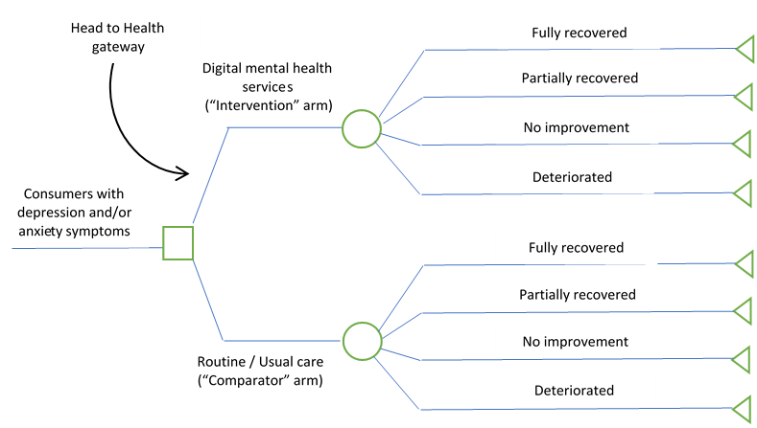

Figure 23. Diagrammatic structure of the decision tree model

Briefly, the model simulates how population cohorts move between four health states over a 1-year period. The model population is the number of consumers completing assessment at the respective DMHS and eligible for treatment. The four health states are: (i) fully recovered, (ii) partially recovered, (iii) no improvement and (iv) deteriorated. These health states are based on diagnostic cut-off points of instruments that measure depression and anxiety such as the PHQ-9 and GAD-7 (Lee et al., 2017).20 Transition probabilities (the probability of moving from one health state to another) were estimated based on routinely collected data provided by the DMHSs or peer-reviewed publications. This includes the proportion of consumers experiencing improvement, deterioration or no change in symptoms after commencing treatment. Further details about the transition probabilities can be found in Section F1.1 in Appendix F. The utility weights used to calculate QALYs in our model were derived from individual-level and population-representative datasets with clinical outcomes as described in Lee et al. (2017)20 (further details are presented in sub-section F1.2 in Appendix F).

Since economic evaluation is by its nature comparative, it was necessary to estimate the likely care people would receive if Head to Health and DMHSs were not available. Therefore, to compare the health care costs and productivity impacts (as well as health outcomes) between the ‘intervention arm’ (Head to Health and DMHSs) and ‘comparator arm’ (routine/usual care), we constructed indirect comparator groups using data from two recent economic evaluations of randomised controlled trials (RCTs) of mental health care based in Australia – the Link-me RCT (Chatterton et al., 2022)21 and the Target-D RCT (Lee et al. 2022).22 The transition probabilities and utility weights for these indirect comparator groups were based on the values estimated by Lee et al. (2017),20 which in turn were based on data from the National Survey of Mental Health and Wellbeing and individual-level dataset provided by MindSpot, respectively. We present the results from the two symptom severity groups from each RCT. Given that consumers with varying levels of symptom severity may use DMHSs, we use these groups as differential comparators. In addition, only a small proportion of Link-me participants (<10%) reported usage of online therapy and the recruitment of Target-D participants began before Head to Health was launched. These attributes made the control groups from both trials suitable comparator groups for our analysis. Further details about the economic model, usual care comparison and model parameters can be found in Sections F1-F3 in Appendix F. It is important to note that for the purpose of evaluating Head to Head, we included its implementation costs as part of the referral process for the DMHS, which was not included in the evaluation of DMHSs.15 We used cost per conversion for the latest financial year (i.e., $35.57), as outlined in Figure 22, for the purpose of incorporating Head to Health in the economic modelling.

Table 26 presents the cost-effectiveness modelling results for Mental Health Online and the indirect comparator groups. Incremental cost-effectiveness ratios (ICERs) were calculated as the difference in mean costs between the intervention and indirect comparator arms divided by the difference in mean QALYs and expressed as costs per QALY gained. The self-directed treatment component of Mental Health Online was shown to have lower costs and greater benefits (i.e., dominant) compared to all indirect comparator groups except for the Link-me RCT minimal/mild group. The same trend is observed for the therapist-supported treatment component. With incremental cost-effectiveness ratios (ICERs) below the commonly used willingness-to-pay (WTP) threshold of $50,000/QALY in Australia,7-9 both treatment components are considered cost-effective when compared against the minimal/mild group from the Link-me RCT. The ICERs remained similar when the implementation costs of Head to Health were excluded (Table F5 in Appendix F).

Table 26. Results of economic modelling for Mental Health Online

|  | Mental Health Online | Indirect comparator: Link-me  (all participants) | Indirect comparator: Target-D  (all participants) | Indirect comparator: Link-me (minimal/ mild group) | Indirect comparator: Target-D (minimal/ mild group) | Indirect comparator: Link-me (severe group) | Indirect comparator: Target-D (severe group) |
| --- | --- | --- | --- | --- | --- | --- | --- |
| Self-directed treatment | | | | | | | |
| QALY | 6,037 | 5,736 | 5,736 | 5,736 | 5,736 | 5,736 | 5,736 |
| Total costs excluding productivity losses | $6,484,757 | $21,155,546 | $13,648,215 | $4,858,126 | $11,879,578 | $37,255,585 | $19,978,906 |
| Costs per QALY gained | - | [dominant] | [dominant] | $5,402 | [dominant] | [dominant] | [dominant] |
| Total costs including productivity losses | $12,629,613 | $83,665,576 | $133,127,109 | $36,048,646 | $131,442,013 | $130,720,880 | $127,001,374 |
| Costs per QALY gained | - | [dominant] | [dominant] | [dominant] | [dominant] | [dominant] | [dominant] |
| Therapist-supported treatment | | | | | | | |
| QALY | 473 | 451 | 451 | 451 | 451 | 451 | 451 |
| Total costs excluding productivity losses | $673,491 | $1,662,756 | $1,072,704 | $381,833 | $933,695 | $2,928,165 | $1,570,276 |
| Costs per QALY gained | - | [dominant] | [dominant] | $12,323 | [dominant] | [dominant] | [dominant] |
| Total costs including productivity losses | $1,156,457 | $6,575,837 | $10,463,349 | $2,833,304 | $10,330,906 | $10,274,227 | $9,981,887 |
| Costs per QALY  gained | - | [dominant] | [dominant] | [dominant] | [dominant] | [dominant] | [dominant] |

QALY, quality-adjusted life year.

A ‘dominant’ costs per QALY gained indicates that the DMHS was found to have lower costs and greater benefits.

Table 27 presents the cost-effectiveness modelling results for MindSpot and the indirect comparator groups. Both the self-directed and therapist-supported treatment components of MindSpot were found to be dominant (lower costs, greater benefits) compared to the Link-me (all participants) control group regardless of the inclusion or exclusion of productivity costs. For the remaining comparison scenarios where productivity costs were not included, the ICERs were below the WTP threshold of $50,000/QALY. When productivity costs were considered, both treatment components of MindSpot costed less than the indirect comparator groups with increased gain in QALYs (i.e., dominant). The ICERs remained similar when the implementation costs of Head to Health were excluded (Table F6 in Appendix F).

Table 27. Results of economic modelling for MindSpot

|  | MindSpot | Indirect comparator: Link-me  (all participants) | Indirect comparator: Target-D  (all participants) | Indirect comparator: Link-me (minimal/ mild group) | Indirect comparator: Target-D (minimal/ mild group) | Indirect comparator: Link-me (severe group) | Indirect comparator: Target-D (severe group) |
| --- | --- | --- | --- | --- | --- | --- | --- |
| Self-directed treatment | | | | | | | |
| QALY | 918 | 871 | 871 | 871 | 871 | 871 | 871 |
| Total costs excluding productivity losses | $2,330,576 | $3,213,319 | $2,073,029 | $737,901 | $1,804,391 | $5,658,756 | $3,034,596 |
| Cost per QALY gained | - | [dominant] | $5,545 | $34,293 | $11,330 | [dominant] | [dominant] |
| Total costs including productivity losses | $2,951,270 | $12,707,975 | $20,220,694 | $5,475,434 | $19,964,744 | $19,855,211 | $19,290,255 |
| Cost per QALY gained | - | [dominant] | [dominant] | [dominant] | [dominant] | [dominant] | [dominant] |
| Therapist-supported treatment | | | | | | | |
| QALY | 4,270 | 4,054 | 4,054 | 4,054 | 4,054 | 4,054 | 4,054 |
| Total costs excluding productivity losses | $11,509,048 | $14,953,295 | $9,646,916 | $3,433,851 | $8,396,797 | $26,333,224 | $14,121,615 |
| Cost per QALY gained | - | [dominant] | $8,616 | $37,363 | $14,400 | [dominant] | [dominant] |
| Total costs including productivity losses | $14,397,472 | $59,137,022 | $94,097,731 | $25,480,128 | $92,906,661 | $92,396,945 | $89,767,901 |
| Costs per QALY gained | - | [dominant] | [dominant] | [dominant] | [dominant] | [dominant] | [dominant] |

QALY, quality-adjusted life year.

A ‘dominant’ costs per QALY gained indicates that the DMHS was found to have lower costs and greater benefits.

Table 28 presents the cost-effectiveness modelling results for THIS WAY UP and the indirect comparator groups. Both the self-directed and therapist-supported treatment components of THIS WAY UP were found to be dominant (lower costs, greater benefits) compared to the Link-me (all participants) control group regardless of the inclusion or exclusion of productivity costs. For the remaining comparison scenarios where productivity costs were not included, the ICERs were below the WTP threshold of $50,000/QALY. When productivity costs were considered, both treatment components of THIS WAY UP costed less than the indirect comparator groups with increased gain in QALYs (i.e., dominant). The ICERs remained similar when the implementation costs of Head to Health were excluded (Table F7 in Appendix F).

Table 28. Results of economic modelling for THIS WAY UP

|  | THIS WAY UP | Indirect comparator: Link-me  (all participants) | Indirect comparator: Target-D  (all participants) | Indirect comparator: Link-me (minimal/ mild group) | Indirect comparator: Target-D (minimal/ mild group) | Indirect comparator: Link-me (severe group) | Indirect comparator: Target-D (severe group) |
| --- | --- | --- | --- | --- | --- | --- | --- |
| Self-directed treatment | | | | | | | |
| QALY | 2,724 | 2,597 | 2,597 | 2,597 | 2,597 | 2,597 | 2,597 |
| Total costs excluding productivity losses | $6,410,716 | $9,579,544 | $6,180,114 | $2,199,831 | $5,379,249 | $16,869,880 | $9,046,744 |
| Costs per QALY gained | - | [dominant] | $1,823 | $33,290 | $8,155 | [dominant] | [dominant] |
| Total costs including productivity losses | $8,997,094 | $37,885,010 | $60,281,924 | $16,323,360 | $59,518,888 | $59,192,348 | $57,508,101 |
| Costs per QALY gained | - | [dominant] | [dominant] | [dominant] | [dominant] | [dominant] | [dominant] |
| Therapist-supported treatment | | | | | | | |
| QALY | 10,921 | 10,457 | 10,457 | 10,457 | 10,457 | 10,457 | 10,457 |
| Total costs excluding productivity losses | $25,403,450 | $38,568,453 | $24,881,917 | $8,856,798 | $21,657,534 | $67,920,264 | $36,423,333 |
| Costs per QALY gained | - | [dominant] | $1,124 | $35,647 | $8,070 | [dominant] | [dominant] |
| Total costs including productivity losses | $35,816,532 | $152,529,830 | $242,702,631 | $65,719,907 | $239,630,551 | $238,315,860 | $231,534,868 |
| Costs per QALY gained | - | [dominant] | [dominant] | [dominant] | [dominant] | [dominant] | [dominant] |

QALY, quality-adjusted life year.

A ‘dominant’ costs per QALY gained indicates that the DMHS was found to have lower costs and greater benefits.

### Sensitivity analysis

We conducted a sensitivity analysis of our modelling results by using cost per referral instead of cost per conversion to represent Head to Health in the model. Using uptake data from the three DMHSs as presented in Table 29, we calculated the referral-conversion ratio by dividing the average number of Head to Health referrals per year by the average number of conversions per year. The referral conversion ratio was 9.3 percent or 9.3 referrals for every 100 conversions. The cost per referral was $382.47 and we used this cost to represent Head to Health in the model. Substituting cost per conversion with cost per referral in our model did not have a significant impact on our results. The ICERs for Mental Health Online, MindSpot and THIS WAY UP remained fairly similar – see section F4 in Appendix F.

Table 29. Mean monthly uptake of DMHSs via Head to Health to DMHSs, Oct 2017 - Jun 2021

|  | MindSpot | ThisWayUp | Mental Health Online* | Total |
| --- | --- | --- | --- | --- |
| Number of unique website visitors | 39,728 | 118,751 | 5,302 | 54,593 |
| Number of unique website visitors referred from Head to Health | 480.4 | 639.1 | 427 | 515.5 |

Notes: Average number of referrals per year = 515.5 X 12 = 6,186; Average number of conversions per year = 66,347 (based on Table 24); Referral conversion ratio = 6,186 / 66,347 = 0.093 or 9.3 referrals for every 100 conversions; Cost per referral in financial year 2020-21 = $35.57 / 0.093 = $382.47.

Based on the $50,000/QALY threshold, we also calculated the maximum cost per conversion and minimum referral-conversion ratio that are required for the inclusion of Head to Health in our model to be cost-effective. We chose the most conservative scenario – an indirect comparator group with lowest cost (i.e., Link-me minimal/mild group) and excluded productivity impacts. Across the three DMHSs, the cost per conversion threshold ranged from $670 to $1,900 for self-directed treatment and from $530 to $1,600 for therapist-supported treatment (Table 30). The cost per conversion of $35.57 that we used in our model was well below any of these thresholds. The referral-conversion ratio thresholds ranged from 2 to 5 percent for self-directed treatment and from 2 to 7 percent for therapist-supported treatment. The referral-conversion ratio that we estimated in Table 29 (i.e., 9.3 percent) was well above these thresholds.

Table 30. Cost per conversion and referral-conversion ratio thresholds

|  | Mental Health Online | MindSpot | THIS WAY UP |
| --- | --- | --- | --- |
| Self-directed treatment | | | |
| Cost per conversion threshold | $1,861.73 | $724.24 | $670.29 |
| Referral-conversion ratio threshold | 1.9% | 4.9% | 5.3% |
| Therapist-supported treatment | | | |
| Maximum cost per conversion | $1,578.32 | $596.57 | $532.49 |
| Referral-conversion ratio threshold | 2.3% | 6.0% | 6.7% |

Notes: Referral-conversion ratio is presented in proportion. For example, a 1.9% referral conversion ratio means 1.9 referral for every 100 conversions.

## Summary

Over a period of four years, a total of $17 million has been budgeted to implement and maintain Head to Health. The highest cost incurred for Head to Health implementation was related to technology and infrastructure – however, this cost has decreased by 63% since the gateway’s launch in 2017. The cost per unit of website-specific outcomes has generally declined over time, suggesting efficiency of resource use.

The results of our modelled cost-effectiveness analysis suggest that the inclusion of Head to Health in the context of individuals with depression or anxiety symptoms seeking treatment is cost-effective compared to usual care. Excluding productivity losses, the incremental cost-effectiveness ratios ranged from $1,823 to $34,293 per QALY for self-guided DMHS treatment, and from $1,124 to $37,363 per QALY for therapist-supported DMHS treatment. These ratios were lower than the standard willingness-to-pay threshold of $50,000 per QALY, which is commonly used to evaluate the cost-effectiveness of public health programs in Australia. Furthermore, this intervention pathway costed less and produced greater benefits than the indirect comparator groups (representing usual care) when productivity impacts were taken into consideration.

# Discussion and conclusions

## Summary of findings

This section summarises findings according to the six KEQs. The KEQs are addressed by different combinations of, and not necessarily all, data sources.

### KEQ 1: How effective has Head to Health been to date and what can we learn from it?

Data from Head to Health google analytics; website analytics from three key digital mental health services (DMHSs); and our consultations with a range of stakeholders (63 people with lived experience of mental health problems, 92 health professionals and 64 other key mental health sector representatives), with or without experience using Head to Health, contribute to addressing KEQ 1.

#### Google analytics data

From October 2017 to October 2021, the mean number of unique users per month was 50,694, and almost all appeared to be new users (mean = 48,509). The mean number of sessions was 62,357, and the mean number of views per month was 97,235. This suggests that the monthly mean uptake has halved compared with equivalent monthly average data for mindhealthconnect from February to June 2017 (e.g., 103,136 unique users; 185,140 page views).2 Although uptake figures were higher during campaign periods (e.g., 84,620 unique users; 151,162 page views), these were still below the mindhealthconnect equivalent monthly averages from February to June 2017.2

However, the Head to Health average monthly bounce rate over its life is much better than that of mindhealthconnect from February to June 2015 (25% cf 75%),2 which means proportionally less sessions involved users not interacting with the website before leaving.

Furthermore, despite the lower than expected monthly average uptake, the trend from October 2017 to October 2021 has been for the overall uptake of Head to Health to increase over time. In 2020, the most recent calendar year with complete data, Head to Health reached around 4.3% of the Australian population.4 By comparison a Canadian website, which sounds similar to the new National Mental Health Platform, reached less than 2% of their population in 2017.5

A range of devices are being used to access Head to Health. In 2021, 49% of sessions were accessed via desktop, 47% via mobile and 4% tablet devices. Search engine results are the main source of traffic to Head to Health, and most referrals come via Facebook.

#### Website analytics from DMHSs

In a 3.75-year period (October 2017 to June 2021), Head to Health referred almost double the number of visitors to three DMHS websites as mindhealthconnect in a 3.25-year period (July 2014 to September 2017; 69,595 cf 36,455). However, because the overall number of visitors to the websites of these services more than tripled, proportionally there were fewer referrals from Head to Health than from mindhealthconnect (1% cf 2%). These findings suggest that although more people have continued to become aware of Head to Health over time, people are also increasingly becoming aware of DMHSs through pathways other than Head to Health.

#### Stakeholder consultations

Awareness of and engagement with the Head to Health website varied widely among the 200+ stakeholders we consulted. Of the 47 people with lived experience who took part in the survey, 57% were aware of the Head to Health website, and around half used it. Of the 16 lived experience participants who participated in the community conversations, 44% had heard of Head to Health, and 25% had used it. Only 43% of the 92 health professionals who completed surveys had used Head to Health. Finally, engagement with the website among the 64 key mental health sector stakeholders (representing 41 organisations) varied ranging from actively engaged to less engaged.

The 23 consumers who had used Head to Health mainly found the website through an online search. Twelve of these consumers were first-time users, and six had used it between one and five times. The most common reasons for using the website included struggles with coping, wanting to access information for family and friends, needing professional help or experiencing a crisis or traumatic event. Almost half of consumer users reported experiencing barriers to accessing mental health services before accessing Head to Health (e.g., thinking symptoms would improve without intervention and/or were not sufficiently severe to warrant intervention, feeling embarrassed about needing mental health care, a lack of knowledge about how to access care, the affordability of care and a preference to rely on oneself).

Lived experience community conversation participants described the website as a broad and credible gateway suited to family members or those new to mental health. However, they reported insufficient tailoring for those with complex needs, who frequently miss out in ‘one-size-fits-all’ approaches and may need their own section or website to cover information and programs relevant only to people with severe illness and complex needs. Lived experience participants also expressed concern that the website does not include specific groups such as Aboriginal and Torres Strait Islander peoples, those who identify as LGBTQIA+ and those from different cultural backgrounds. They viewed the overall language as clinical or pathologising and complex, requiring a level of literacy and digital literacy that may exclude some users, including people from non-English speaking backgrounds or with disabilities. Some lived experience participants thought the volume of information was overwhelming, but at the same time, they felt that some issues and specific apps were not described well enough. This reduced the website’s effectiveness as they struggled to navigate what was needed, and then found the website did not have enough depth to the information on the topics in which they were interested.

The 39 health professional survey respondents who had used Head to Health reported finding out about the website through a variety of sources including online searches, workplace recommendations, flyers, eMHPrac and other continuing professional development activities. These professionals varied in their frequency of using the website, ranging from having used it on a single occasion (15%) to over 11 times (26%). Most commonly, providers used the website to access information and resources for themselves or their clients. Health professionals had mixed views about whether the gateway met consumers’ needs. Around 40% of professionals reported that the website has benefited clients under their care and 15% reported negative impacts for clients. The most commonly reported client benefits were improved access to information, improved convenience of care, improved mental health and wellbeing, and reduced costs associated with care. The negative client impacts were not getting the information or support needed or not being able to find the information needed. Approximately 51% and 18% of health professionals 'occasionally' or 'frequently' referred consumers to the Head to Health website, respectively.

Key mental health sector representatives reported more positive than negative effects of Head to Health. Positive effects included the provision of a quality filter for digital tools; improved credibility, use and awareness of DMHSs; increased access to evidence-based information; provision of a front door for DMHSs; provision of a fast referral source for clinicians; reduced burden on providers by offering consumers options for self-management or other supports; facilitating a stepped care model; and efficient use of waitlist time. Insufficient or negative effects were consumer and provider lack of awareness; low uptake and effects; questionable suitability for consumers with acute or complex needs; lack of marketing to young people; navigation difficulties; and preferences for other means of searching for information or face-to-face services.

Stakeholders’ experiences of using Head to Health are elaborated in response to KEQ 3.

### KEQ 2: Who are the current users of the Head to Health website?

Data describing the users of Head to Health are not routinely collected. However, secondary data from the Department administered survey, and the stakeholders who participated in the evaluation, provide some insight into the characteristics of Head to Health users and non-users.

#### Secondary survey data users

Of the 258 respondents who completed the survey, most were female (73%) and of mixed age groups, most commonly 18-50 years (62%) followed by 51-65 years (18%) and under 18 years (17%). Survey respondents represented all states and territories and a range of hard-to-reach minority subpopulations. Survey respondents most commonly heard about Head to Health through an internet search or from a friend/co-worker/family member.

#### User and non-user stakeholders consulted

The characteristics of the 200+ stakeholders we consulted are described below. Their characteristics should be interpreted in the context that, as described in response to KEQ1, over half the lived experience participants and health professionals had not used Head to Health, and engagement with the website among key mental health sector representatives varied considerably.

Survey data from 47 consumers show that these participants had a similar profile to secondary survey data users. Around two-thirds were female, 70% were aged 20-49 years, but 23% were aged 60+ years.

By comparison, of the 16 lived experience community conversations participants, one third were female, 47% were male and 20% were non-binary; they represented people across a range of ages; and over one-quarter were from inner or outer regional areas.

In total, 92 health professionals completed surveys. Of these, 84% were female, 2% were Indigenous, 86%, were aged 30-69 years and most were from NSW (36%) or Victoria (29%). They included psychologists (40%), social workers (22%) and GPs (14%), among other professions, and the length of their professional experience varied.

Sixty-four individual key mental health sector stakeholders from 41 organisations participated in the evaluation. Most were female (58%), aged 30-59 years (83%), from Victoria (28%) or NSW (20%), and 6% were Indigenous. In order of decreasing frequency, they represented mental health provider organisations, PHNs, peak bodies, professional associations, universities, government, and website developers.

### KEQ 3: What are the experiences of users of the website?

Data from Head to Health google analytics including user feedback, the Department survey, and consultations with stakeholders address KEQ 3.

#### Google analytics data

Google analytics data provide insights into how users engage with the Head to Health website.

On average, only 1-2 pages are viewed per session, and the average session duration is 2.5 minutes. Overall, engagement with Head to Health has declined over time, irrespective of campaigns. One in 10 Head to Health sessions results in a conversion (i.e., completing a desired action including search completions, chatbot completions, and emailing or printing resources). The Head to Health conversion rate is somewhat lower than that of mindhealthconnect at 13%,2 but the absolute number of conversions has increased over time.

A relatively small number of users provide data on whether they perceive the pages they use to be helpful. Pages relating to COVID-19 support, Health professionals, Meaningful life, Mental health difficulties, Supporting someone else and Supporting yourself are more often rated as helpful than not (~60-80%).

Similarly, a relatively small number of users provide feedback about their experience of the Head to Health website overall and its specific pages. Only half of these users’ responses indicate positive (good or great) experiences of the overall website and less than half (~40%) do so for the homepage and other content pages. Consistent with these ratings, less than half of these user responses indicate that they would recommend (> 7/10) the website and even fewer would recommend specific website content and the chatbot.

#### Secondary user survey data

Just under two-thirds of respondents of the Department administered survey reported that the website was easy or very easy to use, most (88%) reported moderate to high trust in the content, and around 60% reported a good or great user experience. Around two-thirds indicated a relatively high likelihood (> 7/10) of recommending Head to Health.

#### Consumer experiences

Our survey data show that of the 23 consumers who had used Head to Health, only four reported that they found all relevant information on the website’s front page, or they could easily find the information they were looking for. Approximately 40% of consumers ‘somewhat’ or ‘strongly agreed’ that the information on the website was trustworthy, easy to understand, offered new knowledge and was appropriate for people who want to help someone with a mental health problem. Approximately one-third of consumers ‘somewhat’ or ‘strongly agreed’ that the website contained the information they were looking for and that the information was relevant, easy to read, accurate, and appropriate for people with a mental health problem. Approximately one-third of consumers ‘somewhat’ or ‘strongly agreed’ that the website was easy to navigate, visually appealing, engaging and interactive. Overall, only 20% of consumers reported that they were ‘satisfied’ or ‘very satisfied’ with the website, and 35% would recommend it to others.

#### Experiences of people living with mental health problems

Based on demonstration of its functionality during the community conversations, lived experience participants’ positive feedback related to experiencing the website as warm, user-friendly and easy to use. They particularly appreciated the comprehensive menu system that allowed drilling down to specific information, the ability to bookmark important parts, and that the website is mobile friendly. They commented that it is ‘not a typical government website’ and were impressed by the comprehensive information presented on a very broad range of issues, including specific disorders and COVID-19.

The negative feedback from lived experience participants related to lack of user friendliness, particularly the nature of the content, its organisation and the overall feel. Some felt that the website was too broad and overwhelming to navigate. Some content, particularly regarding LGBTQIA+ populations, was reported to be outdated, and other areas too focused on self-help and information rather than providing a true gateway to mental health services. The cartoon characters were particularly unpopular, and some participants suggested that it made it feel like the website did not take mental health seriously.

The other major area lived experience participants viewed as a barrier was accessibility. Some expressed concern that Head to Health may systematically exclude some of the most vulnerable people, for example, people without reliable technology, people with vision impairment, and people from different cultural backgrounds, including Aboriginal and Torres Strait Islander peoples.

Importantly, some lived experience participants reported that the crisis resources were not easy to find and were too superficial.

#### Experiences of health professionals

Of the 39 health professionals who had used Head to Health, around 50% ‘somewhat’ or ‘strongly’ agreed that the website contained the information they wanted, they could quickly find the information they were searching for, and the website was easy to navigate. However, only one-third ‘somewhat’ or ‘strongly’ agreed that all relevant information was on the website’s front page. At least 60% ‘somewhat’ or ‘strongly’ agreed that the information was trustworthy, accurate, easy to read and understand, relevant, and appropriate for both people with a mental health problem and those who want to support someone with a mental health problem. Not surprisingly, given that the respondents had mental health expertise, only 31% ‘somewhat’ or ‘strongly’ agreed that the website provided new information. Around 50% reported that the website was visually appealing and engaging, and 64% reported that the website was interactive. Sixty percent of respondents found the website to be helpful, and nearly 70% ‘somewhat’ or ‘strongly’ agreed that they plan to revisit the website. Around 18% indicated that the website did not meet their needs and was not worthy of their time compared to 44% who indicated that the website met their needs and 54% who found it worthy of their time. Overall, 44% of health professionals reported that they were ‘satisfied’ or ‘very satisfied’ with the website.

#### Experiences of key mental health sector stakeholders

As mentioned in response to KEQ 1, key mental health sector stakeholders representing 41 organisations identified more positive than negative effects of Head to Health.

They also identified a range of barriers to the uptake and use of Head to Health. The most frequently mentioned barrier was Head to Health’s lack of visibility, with many clinicians and consumers being unaware of its existence and purpose or confusing it with other services with the same name. The second key barrier related to difficulties with navigation and site features, including the potential for the volume of information and number of options provided to overwhelm consumers, the lack of human navigation support, circular referral pathways, and lack of user friendliness. The third barrier related to access inequity due to: literacy, language/culture, Indigenous status, internet access, cost of devices and data, technical skills, and visual impairments. Preferences for non-digital mental health care was less commonly mentioned as a barrier to the uptake and use of Head to Health.

Stakeholders also provided suggestions for addressing the above-mentioned barriers and improving Head to Health more generally. These suggestions are summarised in response to KEQ 4.

### KEQ 4: What are the needs of current users of the website? Are these being met? What needs should be met by the planned national mental health platform?

Data from the Department’s survey and some of our stakeholder consultations contribute to addressing KEQ 4.

#### Secondary user survey data

The most commonly used features of the Head to Health website according to respondents of the Department administered survey are the topic and content pages and the search resources (58% and 57%, respectively). More than half (61%) of survey respondents reported that the resources were relevant or extremely relevant. This suggests that these are features that are performing relatively well and should be retained in the planned National Mental Health Platform.

Survey respondents suggested that some features could be improved including:

* Providing more information/content/resources (e.g., information on specific disorders or subpopulations; and information about accessing face-to-face services, particularly based on location; costs and other requirements for entry into suggested services; and including lived experience views, for example in providing user ratings of services);
* Updating outdated information;
* Further refining both chatbot and search functionality and ensuring that suggestions are tailored to the individual; and
* Website design (e.g., look and feel, and ease of navigation of the website, as well as its speed).

#### Stakeholder consultations

Community conversation participants echoed several of the suggestions made by Department survey respondents in addition to offering other characteristics of an ideal mental health gateway including:

* A visually appealing website with use of calming colours, and that is less childish-looking;
* Comprehensive information (on all mental health issues, not just the most common), organised in a way that is not overwhelming and assists users to find the depth they need;
* A website that is accessible to everyone, which is easy to read and compatible with screen readers for example;
* Removal of medical jargon and complex language, replaced with plain language and recovery-oriented information;
* Better information that normalises mental health issues and recovery, and connects to options beyond mainstream mental health approaches, such as peer services;
* Input from peers in design and navigation;
* Links to physical (real world) services such as mental health professionals, support groups and non-digital tools; and
* The addition of live chat or interaction with a real person rather than a robot to help people in distress find what they need.

Other stakeholders – mainly key mental health sector representatives and several health professionals – pointed to two priority areas requiring improvement, which stand for the new National Mental Health Platform. The first of these was better promoting the website and increasing its visibility as a trusted source of information among GPs, health professionals and the wider community (e.g., via face-to-face service providers and newsletters of advocacy organisations). Importantly, promotional activities were thought to have the added benefit of improving integration of Head to Health in the health system.

The second key area for improvement related to changing various website features and using a process of co-design to inform the changes. Co-design with consumers, carers and Indigenous peoples, in particular, was suggested. Examples of desired changes to the website include:

* Simplifying layout and improving ease of navigation;
* Streamlining search results so that recommendations are tailored (based on self-triage or assessment options);
* Modifying or adding content applicable to a range of focus populations (e.g., providing resources for CALD people, translating content, incorporating more videos and less text);
* Providing human phone help for therapeutic or technical support; and
* Ensuring that listed (digital) services are all accredited (by the National Safety and Quality Digital Mental Health Standards)6 and include information about which groups and for what problems they have demonstrated effectiveness.

Stakeholders mentioned a range of other important improvements that are needed. These mainly fell into three categories – better system integration, sustainability, and quality assurance. They commented that better system integration is synonymous with a ‘no wrong door’ approach, which requires strong relationships (e.g., cross branding) between Head to Health and a range of service providers including the face-to-face Head to Health hubs. They suggested that connection of services in the background (e.g., with electronic health records and DMHSs) and supporting health professionals with how to integrate digital tools in clinical practice could help improve integration so consumers can enter the care system via Head to Health or any other (digital) service and be directed to the right care. Issues mentioned in terms of sustainability were keeping content up to date, conducting research to guide developments, scaling up of services to meet demand, adhering to privacy and data legislation, and supporting consumers who lack digital literacy or access to affordable devices/internet – all of which require long term funding. Finally, in terms of quality assurance, stakeholders highlighted the importance of clinical governance, measurement of outcomes and ensuring that services match consumers’ needs.

### KEQ 5: How effective is Head to Health in achieving its objectives?

This section lists each Head to Health objective and indicates whether it has been achieved based on the data sources used to inform the evaluation.

* Give Australians the tools and information they need to understand when everyday distress requires additional support and to successfully navigate the mental health system and make informed choices about their care.

As reported in response to KEQs 1 and 3, stakeholders indicated that there is a desire for more comprehensive mental health service options (e.g., face-to-face and peer support services; and services for all mental health problems, minority groups and people with complex needs).

None of the available data sources provide information about the first part of this objective (i.e., when everyday distress requires additional support). As far as we can tell, Head to Health provides Australians with tools and information to navigate DMHSs but not necessarily the mental health system in its entirety, which is the remit of the new National Mental Health Platform.

* Improve access by bringing together, streamlining, and providing access to evidence-based information, advice, and digital mental health treatments through a centralised portal.

As mentioned in response to KEQ 1, the trend has been for the overall uptake of Head to Health to increase over time. However, it is not the only source of visits to the websites of key Australian DMHSs (referring only 1% of visitors).

* Provide people needing additional support a range of options, including practical tips and advice on how to connect with support.

As mentioned in response to the first objective, users expressed a desire for a more comprehensive gateway to mental health services, not just DMHSs and mainstream majority population services.

As reported in response to KEQ 4, stakeholders also suggested that the range of support options could be improved by including support options for focus populations and all mental health problems and for services beyond DMHSs (e.g., face-to-face and peer support). They also indicated that support options could be improved either by further refining both chatbot and search functionality to ensure that suggestions are individually tailored, or through the addition of complementary live chat or interaction with a real person rather than a chatbot to help people in distress find what they need.

* Make it easy to access a range of clinically effective Australian digital mental health services that are often free or low cost, accessible from anywhere/anytime, and offer an effective alternative or complement to face to face services.

As reported in response to KEQ 3, just under two-thirds of respondents of the Department administered survey reported that the website was easy or very easy to use. Of the 23 consumers who reported they had used Head to Health, only 20% reported that they were ‘satisfied’ or ‘very satisfied’ with the website, and only 35% would recommend it to others. The community conversation participants appreciated the comprehensive menu system and the broad content; but also felt that navigating the website was overwhelming and criticised the lack of user-friendliness and content targeting minority groups. However, these findings do not directly inform the ease of accessing services themselves and, in any case, as noted in response to KEQ 1, Head to Health only accounts for 1% of visitors to websites of key Australian DMHSs.

* Foster a sense of trust and confidence in using digital services listed on Head to Health by ensuring they meet an agreed minimum quality standard.

As mentioned in response to KEQ 3, 88% of Department survey respondents reported moderate to high trust in the content of Head to Health. This was corroborated to a lesser extent by the stakeholders with whom we directly consulted. For example, as mentioned in response to KEQ 3, approximately 40% of consumers appreciated that the website was a trusted source of information, easy to understand, and offered new knowledge. However, trust and confidence are likely to improve if, as mentioned in response to KEQ 4, all listed digital services were accredited by the National Safety and Quality Digital Mental Health Standards6 and their listing includes summary information about who and what problems the services are effective for.

### KEQ 6: How efficiently and effectively has Australian Government funding for Head to Health been used?

KEQ 6 was addressed using a range of data sources including Head to Health google analytics data, expenditure reports provided by the Department of Health, surveys of Head to Health consumers, routinely collected DMHS data and peer-reviewed publications by some of our evaluation team.

We summarised costs and cost-effectiveness of the Australian Government-funded Head to Health National Digital Mental Health Gateway. Over a period of four years, a total of $17 million has been budgeted to implement and maintain Head to Health. The highest cost incurred for Head to Health implementation was related to technology and infrastructure – however, this cost has decreased by 63% since the gateway’s launch in 2017. The cost per unit of website-specific outcomes has generally declined over time, suggesting efficiency of resource use from the allocated budget provided by the Government. For example, the cost per unique visitor and cost per conversion have decreased by approximately 90% since 2017.

The results of our modelled cost-effectiveness analysis suggest that the inclusion of Head to Health in the context of individuals with depression or anxiety symptoms seeking treatment is cost-effective compared to usual care. Excluding productivity losses, the incremental cost-effectiveness ratios ranged from $1,823 to $34,293 per QALY for self-guided DMHS treatment, and from $1,124 to $37,363 per QALY for therapist-supported DMHS treatment. These ratios were lower than the standard willingness-to-pay threshold of $50,000 per QALY, which is commonly used to evaluate the cost-effectiveness of public health programs in Australia.7-9 Furthermore, this intervention pathway costed less and produced greater benefits than the indirect comparator groups (representing usual care) when productivity impacts were taken into consideration. It is important to note that our analysis assumed that individuals will use evidence-based online interventions such as Mental Health Online, MindSpot and THIS WAY UP. We recognise that this assumption may not apply to everyone and therefore conducted threshold analysis to indicate the level of conversions or referrals needed to make the inclusion of Head to Health cost-effective.

Our findings are consistent with the findings of another study that investigated the cost-effectiveness of an Internet-based mental health help-seeking navigation tool called Link to for young adults.10 Similar to Head to Health, Link was designed to guide young adults to appropriate online and offline sources of mental health information and care. However, Link involves a four-step process in which (1) users select symptoms they experience, (2) rate how much they are affected by them, (3) choose their preferred way to receive help (face-to-face, online information, telephone, and online chat), and then (4) finally, click on service options presented by the program for more information on how to seek help within that service. The authors concluded that Link was more effective and less costly compared with usual help-seeking strategies and has a 100% likelihood of being cost-effective below a willingness-to-pay value-for-money threshold of $28,033 per QALY.

Overall, our modelled economic evaluation analysis has shown that the provision of a digital mental health gateway such as Head to Health is generally low-cost and beneficial. When considered within the context of improving access to DMHSs, there is good evidence to suggest that Head to Health is likely to be cost-effective.

## Limitations and strengths of evaluation

Findings should be interpreted in the context of several caveats and strengths.

First, participation rates by users of Head to Health were lower than expected. However, this may be a broader reflection of low uptake of the Head to Health website. The other key limitation is, because of the real-world nature of the evaluation and the limited time frame available to us, it was not feasible to include a comparison group.

The first limitation is countered by the evaluation’s key strength of triangulating findings from multiple primary and secondary data sources, including secondary data from a survey of 258 users conducted by the Department of Health, findings from which were consistent with our primary data sources. Our primary data sources involved consultations with a large number and broad range of stakeholders, including: 47 people with lived experience of mental health problems (23 with experience using the Head to Head website); 16 people with lived experience of mental health problems (four with experience using the website); 92 health professionals (39 with experience using the website); and 64 other key mental health sector stakeholders representing 41 organisations (with varying levels of engagement with the website).

The second limitation was addressed by including indirect comparator groups (representing usual care) from peer-reviewed publications by some of our evaluation team.

## Recommendations for the new National Mental Health Platform

1. INVEST IN RE-DEVELOPMENT OF HEAD TO HEALTH

**Recommendation 1: Stakeholder experiences and views of the Head to Health National Mental Health Gateway should shape the development of the new National Mental Health Platform (Platform).**

Only around one in 10 sessions on the Head to Health National Mental Health Gateway have involved conversions (i.e., completion of key or desired actions). Taking up key suggestions for the improvement of Head to Health made by stakeholders consulted in our evaluation is likely to increase engagement with the new Platform.

These suggestions are described in response to KEQ 4 and briefly summarised below.

First, design and navigation need to be improved using a meaningful co-design process that includes people with lived experience from a range of focus, minority, and disadvantaged populations. Information needs to be comprehensive but organised in a way that is not overwhelming and assists users to find the depth they need. The website needs to be accessible to everyone and easy to read (e.g., CALD, compatible with screen readers);

Second, stakeholders suggested content changes including normalising mental health issues and recovery by removing medical jargon and complex language and replacing it with plain, recovery-oriented language; connecting users to diverse service option types and modalities (e.g., peer services, mental health professionals, support groups and non-digital tools); and including service effectiveness, costs and eligibility criteria.

Finally, refinement of chatbot and search functionality was advised particularly to tailor search results to individual needs. For example, adding live chat or interaction with a real person rather than robot may be valuable to this end.

Stakeholders who were aware of upcoming Platform developments were generally positive about the planned changes, which they considered to be in line with their suggestions.

**Recommendation 2: People with lived experience and other key mental health sector stakeholders need to be involved in the development and ongoing continuous improvement of the new Platform to ensure it meets their needs.**

Co-design is an effective model for developing appropriate services, achieving engagement of focus population groups and integration with mainstream services. People with lived experience of mental health problems have an invaluable contribution to make in the development and ongoing improvement of the new Platform and their knowledge and expertise needs to be harnessed.

Involving an advisory group with representatives from all other relevant key stakeholder groups (e.g., mental health professionals, referrers, other health sector and community service providers) in the Platform’s development and maintenance is also necessary. This will increase confidence across the sector to engage with the Platform and facilitate its integration in the system.

**Recommendation 3: Build in quality assurance.**

A key component of quality assurance is establishing governance and leadership. A governance structure will contribute to ensuring the clinical effectiveness of services listed in the new Platform, privacy, and data safety legislation.

Leadership with the capacity to involve stakeholders from all levels of government, the service sector and the community, including people in decision-making positions, is fundamental for effective planning and implementation.

1. PROMOTE THE NEW NATIONAL MENTAL HEALTH PLATFORM

**Recommendation 4: Resources and mechanisms are required to increase awareness of the new Platform and its purpose among key mental health sector and community stakeholders.**

There is a clear need for greater promotion of the new Platform amongst consumers and service providers.

The new Platform needs better visibility and branding than that associated with Head to Health. Our evaluation of Head to Health found that its use was much higher during campaign periods, which suggests the need for ongoing regular campaigns.

Given that users most commonly accessed Head to Health using organic searches, investment in Google search engine optimisation should be considered. Users next most commonly accessed Head to Health via directly typing its URL, which suggests promotional activities that target GPs and mental health professionals, and organisations providing services to focus populations is important. Finally, continuing Facebook advertisements is reasonable since it was the most common referral source to Head to Health.

Consideration should also be given to promoting consumer access and use of the new Platform through health clinics so that people without (reliable) access to internet can be reached. This approach may also serve to improve the integration of the new Platform in the (mental) health system.

1. DEVELOP A LONG-TERM STRATEGY

**Recommendation 5: A long-term strategy and approach to resourcing are required to build confidence across the sector, support a responsive continuous improvement approach to the new Platform’s development and implementation, and facilitate system integration.**

Ongoing coordination and funding are required to ensure the sustainability of the Platform, quality and recency of information; and keep pace with technological advances and use of devices. For example, Head to Health has been increasingly accessed via mobile devices, which means the Platform should be checked for its mobile friendliness.

Resources are also needed to scale up services to meet demand.

**Recommendation 6: Invest in developing the evidence base for the new Platform.**

Funding is needed for ongoing research and development.

Further investigation of the effects of the new Platform on consumers, carers, service providers and clinical care more generally will be needed.

Given that proportionally few users provide feedback, user incentives could be considered to obtain feedback in initial stages of rolling out the new Platform.

Going forward, evaluation of the new Platform should be incorporated. A multipronged approach could be adopted involving both one-off and follow-up user feedback, and the collection of outcome data (e.g., service use and changes to mental health as result of using the new Platform).

**Recommendation 7: Address broader barriers to use of digital mental health.**

Many barriers to using Head to Health reflect the barriers to more generally using digital tools, therefore solving these issues is likely to have an impact on uptake of the new Platform.

Examples include supporting consumers who lack digital literacy, making devices/internet more affordable and accessible; and support clinicians with integration of digital tools in clinical practice.

## Conclusions

Head to Health has at least partially met its objectives and has the potential to be cost effective. A significant number of people use Head to Health each month, many of whom interact with the website in a meaningful way and go on to access DMHSs. However, on average users only spend 2.5 minutes per session on the website, suggesting that people either quickly find what they need or are unable to find what they need and leave the website. The latter interpretation is supported by data indicating that only one in 10 people complete a key or desired action. Furthermore, our consultations with a large number and broad range of key stakeholders indicate that some stakeholders are unaware of the existence and/or purpose of Head to Health. Those who have used the Head to Health website report mixed views about its design, look and feel. In its current form, although a high proportion of users report high trust in the content, only some users experience Head to Health as easy to use, and report a good experience. Our consultations with stakeholders indicated that the website is simultaneously overwhelming in its current volume of information, and there are gaps in the information provided. Thus, the challenge for developing the new National Mental Health Platform will be to strike a balance between providing comprehensive information for navigating the mental health system (more broadly than DMHSs) while not overwhelming users.

# References

**1.** Department of Health. Head to Health. <https://headtohealth.gov.au/>. Accessed 5 June, 2021.

**2.** Australian Government Department of Health. *Head to Health - The Digital Mental Health Gateway: Benefits Management Plan.* Canberra: Digital Mental Health Section; 2017.

**3.** Productivity Commission. Mental Health, Report no. 95 Canberra; 2020.

**4.** Australian Bureau of Statistics. 3101.0 National, state and territory population. <https://www.abs.gov.au/statistics/people/population/national-state-and-territory-population/dec-2021>. Accessed 30/08/2022, 2022.

**5.** Jeong D, Cheng M, St-Jean M, Jalali A. Evaluation of eMentalHealth.ca, a Canadian Mental Health Website Portal: Mixed Methods Assessment. *JMIR Ment Health.* 2019;6(9):e13639.

**6.** Australian Commission on Safety and Quality in Health Care. National Safety and Quality Digital Mental Health Standards. <https://www.safetyandquality.gov.au/standards/national-safety-and-quality-digital-mental-health-standards>. Accessed 30 August 2022.

**7.** Carter R, Vos T, Moodie M, Haby M, Magnus A, Mihalopoulos C. Priority setting in health: origins, description and application of the Australian Assessing Cost-Effectiveness initiative. *Expert Rev Pharmacoecon Outcomes Res.* 2008;8(6):593-617.

**8.** George B, Harris A, Mitchell A. Cost-effectiveness analysis and the consistency of decision making: evidence from pharmaceutical reimbursement in australia (1991 to 1996). *Pharmacoeconomics.* 2001;19(11):1103-1109.

**9.** Harris AH, Hill SR, Chin G, Li JJ, Walkom E. The role of value for money in public insurance coverage decisions for drugs in Australia: a retrospective analysis 1994-2004. *Med Decis Making.* 2008;28(5):713-722.

**10.** Le LK-D, Sanci L, Chatterton ML, Kauer S, Buhagiar K, Mihalopoulos C. The Cost-Effectiveness of an Internet Intervention to Facilitate Mental Health Help-Seeking by Young Adults: Randomized Controlled Trial. *Journal of medical Internet research.* 2019;21(7):e13065.

**11.** National Mental Health Commission. *The National Review of Mental Health Programmes and Services.* Sydney: National Mental Health Commission; 2014.

**12.** Australian Government. *Australian Government Response to Contributing Lives, Thriving Communities – Review of Mental Health Programmes and Services.* Canberra: Australian Government; 2015.

**13.** Newby JM, O’Moore K, Tang S, Christensen H, Faasse K. Acute mental health responses during the COVID-19 pandemic in Australia. *PloS one.* 2020;15(7):e0236562.

**14.** Consumer and Community Involvement Program. Types of Consumer and Community Involvement. <https://cciprogram.org/researcher-services/types-of-community-involvement/>. Accessed 23 April, 2021.

**15.** Bassilios B, Ftanou M, Machlin A, Mangelsdorf S, Tan A, Scurrah K, Morgan A, Roberts L, Le L, Banfield M, Spittal M, Mihalopoulos C, Pirkis J. *Independent evaluation of supported digital mental health services: Phase 2 final report.* Melbourne: Centre for Mental Health, University of Melbourne; 2022.

**16.** Australian Institute of Health and Welfare. *Australian Institute of Health and Welfare. Health expenditure Australia 2019-20. Health and welfare expenditure series no. 65.* Canberra: Australian Institute of Health and Welfare; 2021.

**17.** Australian Government. Medicare Australia Statistics, Medicare Item Reports 2021. <http://medicarestatistics.humanservices.gov.au/statistics/mbs_item.jsp>. Accessed 17 May 2022, 2022.

**18.** Independent Hospital Pricing Authority. National Hospital Cost Data Collection Report, Public Sector, Round 21 (Financial year 2016-17). <https://www.ihpa.gov.au/publications/national-hospital-cost-data-collection-report-public-sector-round-21-financial-year>. Accessed 21 June 2020, 2020.

**19.** Australian Government. Report on Government Services: Ambulance services 2019. <https://www.pc.gov.au/research/ongoing/report-on-government-services/2019/health/ambulance-services/rogs-2019-parte-chapter11.pdf>. Accessed 17 May 2022, 2022.

**20.** Lee Y-C, Gao L, Dear BF, Titov N, Mihalopoulos C. The cost-effectiveness of the online MindSpot Clinic for the treatment of depression and anxiety in Australia. *J Ment Health Policy Econ.* 2017;20(4):155-166.

**21.** Chatterton M, Harris M, Burgess P, Fletcher S, Spittal M, Faller J, Palmer V, Chondros P, Bassilios B, Pirkis J, Gunn J, Mihalopoulos C. Economic evaluation of a Decision Support Tool to guide intensity of mental health care in general practice: the Link-me pragmatic randomised controlled trial. *(under review).* 2022.

**22.** Lee Y, Mihalopoulos C, Chatterton M, Fletcher S, Chondros P, Densley K, Murray E, Dowrick C, Coe A, Hegarty K, SK D, Wachtler C, Palmer V, Gunn J. Economic evaluation of the Target-D platform to match depression management to severity prognosis in primary care: a within-trial cost-utility analysis. *PLOS ONE.* 2022;(under review).

**23.** Fletcher S, Chondros P, Palmer VJ, Chatterton ML, Spittal MJ, Mihalopoulos C, Wood A, Harris M, Burgess P, Bassilios B, Pirkis J, Gunn J. Link-me: Protocol for a randomised controlled trial of a systematic approach to stepped mental health care in primary care. *Contemp Clin Trials.* 2019;78:63-75.

**24.** Fletcher S, Spittal MJ, Chondros P, Palmer VJ, Chatterton ML, Densley K, Potiriadis M, Harris M, Bassilios B, Burgess P, Mihalopoulos C, Pirkis J, Gunn J. Clinical efficacy of a Decision Support Tool (Link-me) to guide intensity of mental health care in primary practice: a pragmatic stratified randomised controlled trial. *Lancet Psychiatry.* 2021;8(3):202-214.

**25.** Fletcher S, Chondros P, Densley K, Murray E, Dowrick C, Coe A, Hegarty K, Davidson S, Wachtler C, Mihalopoulos C, Lee YY, Chatterton ML, Palmer VJ, Gunn J. Matching depression management to severity prognosis in primary care: results of the Target-D randomised controlled trial. *British Journal of General Practice.* 2021;71(703):e85-e94.

Appendix A: Evaluation questions

Implementation

**KEQ 1: How effective has Head to Health been to date and what can we learn from it?**

* What is the overall level of awareness and use of the Head to Health website amongst the population(s)?
* Are the content and resources available on Head to Health fit for purpose, appropriately targeted, and accessible for the target audiences? Including consumers, carers and health professionals?
* Are there gaps or duplication in the content and resources offered on the website?
* Have timely and appropriate updates (content and technology) to Head to Health been delivered?

Appropriateness

**KEQ 2: Who are the current users of the Head to Health website?**

* Who are the current users of the website?
* Are there any segments of the population who do not appear to be using the website? How might these needs be met in the future?

**KEQ 3: What are the experiences of users of the website?**

* How do people currently use website? Are there differences in how different groups of people use the website? Is it easy to navigate and find what users are looking for? Map and describe typical user experiences of the website
* Can consumers be connected in a timely way to the appropriate resources and/or support?
* Map and describe the current services and resources offered or linked through the website, highlighting the most used and least used areas of the website
* How satisfied are users with their experience of the website? Can this be improved?

**KEQ 4: What are the needs of current users of the website? Are these being met? What needs should be met by the planned national mental health platform?**

* What are the needs of current users’ of the website? Consider at a minimum, consumers, carers and health service providers
* Are these needs consistent with the objectives and policy intent of Head to Health?
* Are users current needs being met? What improvements can be made in the short-term? What improvements should be included in the national mental health platform beta site and ultimate state?
* What content or design features of the current website are particularly effective and should be retained in any future state platform?
* What content or design features of the current website are failing to meet user’s needs and should be redesigned, categorised into high, medium and low priority?

Effectiveness

**KEQ 5: How effective is Head to Health in achieving its objectives?**

* To what extent does Head to Health
* provide users with the tools and information they need to understand when everyday distress requires additional support?
* assist users to successfully navigate the mental health system?
* assist users to make informed choices about their care?
* Refer users to appropriate information, resources, support and treatment according to relevant clinical guidelines?
* Assist health professionals to choose the products and services that can best support a person’s mental health and wellbeing
* Are there differences in outcomes for different sub-populations? If so, why?
* To what extent does Head to Health met the needs of hard to reach or high risk populations, including Aboriginal and Torres Strait Islander peoples, men, young people, people with more serious mental illness?
* Has Head to Health provided an effective gateway to digital mental health services for mental health consumers?
* Has Head to Health improved access to evidence-based mental health information, advice, support and treatment services?
* Has Head to Head improved service choice for consumers?
* Has Head to Health made it easier for those who need it to access a range of clinically effective Australian digital mental health services that are free or low cost, accessible from anywhere/anytime, and offer an effective alternative or complement to face to face services?
* Has Head to Health increased access to high quality services?
* What is the level of trust in the information and services provided to consumers on the Head to Health website?
* Has Head to Health led to increased confidence and trust in the services and resources on the website amongst consumers?

Efficiency

**KEQ 6: How efficiently and effectively has Australian Government funding for Head to Health be used?**

* How cost-effective is Head to Health?
* Are there opportunities to improve the cost-effectiveness of Head to Health?
* What are the implications of free versus low cost versus higher costs to consumers and/or health professionals to access the resources and services provided or linked to on Head to Health?
* Have there been unintended outcomes/consequences from the implementation of Head to Health? If so, explain
* What impact has Head to Health had on adoption of digital mental health in Australia?
* What impact has Head to Health had on mental health information, support and treatment services in Australia?
* What impact has Head to Health had on mental health organisations in Australia?

Appendix B: Additional methods and analysis for google analytics

Raw data

Raw google analytics data were provided in a series of comma separated variable files (csv). Summarised monthly data were constructed in R and compared against the Excel summary for validation and understanding.

Raw data were in five sets: users’ data (1 file), landing page data (8 files), website event data (15 files), page views data (10 files) and goals data (4 files).Using the R programming software, the data was appended by set, yielding five files (one for each data type; e.g., one user file, one landing page file etc.)**.** Each data set had some overlapping and some unique information (some metrics could be obtained from more than one file).

Table A1 shows a concordance between key metrics we analysed and their source file.

Table A1. Concordance between key metrics and source data file

|  |  |
| --- | --- |
| **Metric** | **Source of data** |
| N users | Users file |
| N new users | Users file |
| N sessions | Landing file |
| Bounce rate | Landing file |
| N page views | Landing fille |
| Pages per session | Landing file |
| Mean session duration | Landing file |
| N conversions | Goals file |
| Conversion rate | Goals file and Landing file |
| N SAM, email, print, topic, search, homepage | Goals file |

N, number.

Plotting trend lines

A lowess (Locally Weighted Scatterplot Smoothing) smoothed line was included on plots of uptake and engagement to assess both short-term and long-term trends. Lowess is a non-parametric regression technique in which simple linear regression models are fitted to overlapping subsets of the data, and the results are combined to form a smooth curve through the complete set of data points. It is very flexible and makes few assumptions about the distribution of data or the shape of the changes in the outcome over time.

Page helpfulness

At the bottom of every webpage on the Head to Health website, there is an option to indicate whether that page was helpful or not by answering the question, ‘Was this information helpful?’This page helpfulness data is in the raw data Events file. Each time someone answers the question about whether a page was helpful or not, this is recorded as an event and is given a row of data.The Events file includes other information on each row that can be used to classify the pages specifically rated for helpfulness (e.g., a COVID-19 topic page, or a Meaningful life topic page and so on).The number of times the page was rated as helpful was calculated by summing a column called ‘Unique.events’ in the Events file for rows where a given page was considered helpful (indicated in the data by a ‘yes’ in the ‘Event.label’ field). Similarly, the number of times the page was rated as unhelpful was calculated by summing Unique.events for rows where a given page was considered unhelpful (Event.label = ‘no’). The percentage of helpful ratings was then calculated. Using notes found in Liquid Interactive’s summary Excel file, helpfulness data was restricted to English rating answers (i.e., ‘yes’ and ‘no’). It is perhaps relevant to note that although ‘yes’ is an English word, ‘no’ is used in several other languages, but this noise was ignored for our purpose.

Appendix C: Detailed methods for survey of users of the Head to Health website and additional health professionals

Method details

Consumer and provider users of Head to Health

The survey for consumers and providers who use the Head to Health website went live on the Head to Health website on 8December 2021 and closed on 2 May 2022.

These user surveys were widely promoted with support from the Department of Health and eMHPrac.

Specifically, the Department of Health promoted the user surveys via:

eMHPrac has promoted the user surveys via:

* Their internal newsletter that reached 3,885 staff members on 16 December 2021;
* The Head to Health newsletter that was sent to 5,021 subscribers on 16 December 2021; and
* Their websites and social media (LinkedIn, Facebook, Twitter, and Instagram) throughout December 2021, and January and February 2022.
* Their newsletter, which has 2,314 subscribers, on 17 December 2021;
* Their Brief Edition newsletter reaching 2,289 subscribers and through the Menzies School of Health newsletter reaching another 1,182 subscribers – both on 2 February 2022;
* Their social media platforms (Facebook, Instagram, Twitter and LinkedIn), reaching up to 1,931 followers on 5 January and 2 February 2022; and,
* The WellMob Facebook page, which specifically targets Indigenous providers and consumers, on 3 February 2022.

On 10 February 2022, the survey was also advertised on both the University of Melbourne Centre for Mental Health and the Melbourne School of Population Health news and events websites.

On 18 February 2022, the Black Dog Institute sent out the advertisement and link to 5,000 mental health professional members of their Mental Health Community of Practice.

The Department of Health’s and eMHPrac’s social media posts are included below.

Additional health professionals

We consulted with additional health professionals delivering (or referring consumers) to mental health services from December 2021 to April 2022. Professionals were asked whether they had used the Head to Health website (and questions concerning DMHSs for a complementary evaluation). If so, they were asked about their past experience of using the Head to Health website, what prompted them to visit the website, whether they recommend the website to consumers and whether it had had positive or negative impacts on consumers under their care.

We asked professional associations to act as intermediaries for the recruitment of these professionals. The health professional associations that helped with engaging their members were: Royal Australian College of General Practitioners(RACGP), Royal Australian and New Zealand College of Psychiatrists (RANZCP), Australian Association of Social Workers (AASW), Occupational Therapy Australia (OTA), The Australian College of Mental Health Nurses (ACMHN), The Australian Clinical Psychology Association (ACPA), Institute of Clinical Psychologists (ICP), Australian Association of Psychologists Inc. (AAPI) and the Australian College of Rural and Remote Medicine (ACRR).

The survey was advertised on 8 December 2021 via the ACMHN’s newsletter, College Connections (approximately 2,600 readers) with a follow-up post on social media in January 2022. The AASW’s website advertised the survey on 8 December 2021 with a follow-up notice on social media in January 2022 (> 15,000 members). The RANZCP featured a notice about the survey in their January newsletter with a follow-up notice in the 28 February edition of their newsletter (approximately 5,200 Australian members). OTA advertised the survey in their 25 January newsletter (> 11,000 members). RACGP sent out an email notice to the members of the Psychological Medicine Specific Group (n=859) on 14 February. ACPA included notice of the survey in their 11 March newsletter; they currently have over 3,000 members. ICP distributed the survey on the 14 April to approximately 200 psychologists via a newsletter. ACRR included a notice about the survey in their 24 March newsletter; they have a membership of 32,000 and expected 34% to view the notice. AAPI shared a notice about the survey with their members on 8 March and again the following week. The Australian Psychological Society (APS) opted to provide an organisational perspective instead of circulating the evaluation survey to individual members (as described in Appendix E).

From 8 December 2021 to 2 May 2022, 141 people consented to participating in the survey. Of these 141, 47 completed less than 35% of the questions and were excluded from the analysis which left 94 respondents. Fourteen of the respondents did not answer the question concerning whether they had used Head to Health, leading to a final sample of 80 respondents.

Promotional activity for Head to Health user survey

Department of Health promotion of survey via social media

| Survey for people 16+ years | Copy | Image |
| --- | --- | --- |
| Post 1 – published December/January | | |
| Facebook | If you’re 16+ we want to hear from you. Help improve the mental health gateway - Head to Health.  This website helps users find mental health services from some of 🇦🇺 most trusted organisations. It brings together:  📱apps  🖥️online programs  💬online forums, and  ☎️phone services  📚digital information resources.  Have your say. Take part in the survey today at 💻 https://melbourneuni.au1.qualtrics.com/jfe/form/SV_55NxrsCjajxabmS |  |
| Twitter | If you’re 16+ we want to hear from you. Help improve the mental health gateway #HeadtoHealth.  This helps users find #mentalhealth services from some of 🇦🇺most trusted organisations. Have your 💬say.  Take part in this survey at 💻 https://melbourneuni.au1.qualtrics.com/jfe/form/SV_55NxrsCjajxabmS |
| Instagram | If you’re 16+ we want to hear from you. Help improve the mental health gateway - Head to Health.  This website helps users find digital mental health services from some of 🇦🇺 most trusted organisations. It brings together:  📱apps  🖥️online programs  💬online forums, and  ☎️phone services  📚digital information resources.  Have your say. Take part in the survey today by clicking 🖱️ the link in our bio and selecting ‘Head to Health survey’.  #Mentalhealth #HeadtoHealth  https://melbourneuni.au1.qualtrics.com/jfe/form/SV_55NxrsCjajxabmS |  |
| LinkedIn | If you’re 16+ we want to hear from you. Help improve the mental health gateway -Head to Health.  This website helps users find mental health services from some of 🇦🇺 most trusted organisations. It brings together:  📱apps  🖥️online programs  💬online forums, and  ☎️phone services  📚digital information resources.  Have your say. Take part in the survey today at 💻https://melbourneuni.au1.qualtrics.com/jfe/form/SV_55NxrsCjajxabmS  #Mentalhealth #HeadtoHealth |  |

| Post 2 – published 17 January | | |
| --- | --- | --- |
| Facebook | The Head to Health survey is closing ⏰soon. Have you had your say❓  If you’re 16+ we want to hear 🗣️from you. Help improve the mental health gateway today. Take part before 📅February 2022 at 💻 https://melbourneuni.au1.qualtrics.com/jfe/form/SV_55NxrsCjajxabmS |  |
| Twitter | The #HeadtoHealth survey is closing ⏰soon. Have you had your say❓  If you’re 16+, we want to hear 🗣️from you. Help improve the #mentalhealth gateway today. Take part before 📅 February 2022 at 💻 https://melbourneuni.au1.qualtrics.com/jfe/form/SV_55NxrsCjajxabmS |
| Instagram | The Head to Health survey is closing ⏰soon. Have you had your say❓  If you’re 16+ we want to hear 🗣️from you. Help improve the mental health gateway today. Take part before 📅 February 2022 by clicking 🖱️ the link in our bio and selecting ‘Head to Health survey’.  #Mentalhealth #HeadtoHealth |
| LinkedIn | The Head to Health survey is closing ⏰soon. Have you had your say❓  If you’re 16+ we want to hear 🗣️from you. Help improve the mental health gateway today. Take part before 📅 February 2022 at 💻 https://melbourneuni.au1.qualtrics.com/jfe/form/SV_55NxrsCjajxabmS  #Mentalhealth #HeadtoHealth |

| Survey for health professionals | Copy | Image |
| --- | --- | --- |
| Post 1 – published December/January | | |
| LinkedIn | If you’re a health professional 👩‍⚕️ we want to hear from you. Take part in a survey that will help improve the mental health gateway - Head to Health.  This website 🖥️provides your patients 👪access a range of mental health resources from trusted organisations across 🇦🇺  Digital resources 📄can be beneficial for people with or at risk of mild to moderate mental health difficulties, or people supporting someone with mental health issues.  Have your say at 💻https://melbourneuni.au1.qualtrics.com/jfe/form/SV_beH6FafiQTd6pRs  #Mentalhealth #HeadtoHealth |  |
| Post 2 – published 20 January | | |
| LinkedIn | The Head to Health survey is closing ⏰soon. Have you had your say❓  If you’re a health professional 👩‍⚕️ we want to hear from you. Help improve this important mental health gateway. Take part before 📅 February 2022 at 💻https://melbourneuni.au1.qualtrics.com/jfe/form/SV_beH6FafiQTd6pRs  #Mentalhealth #HeadtoHealth |  |

eMHPrac promotion of survey

Newsletters

eMHPrac Newsletter – Vol. 3, No. 12, December 2021

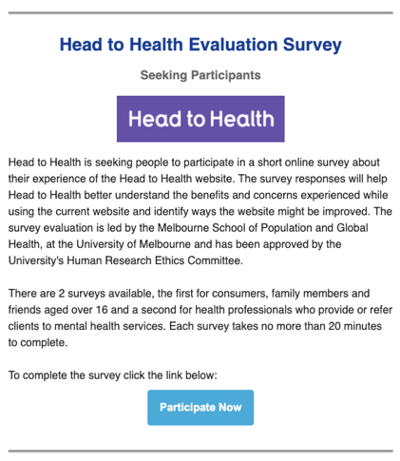

Sent: Friday, 17th December 2021

Recipients: 2,314

Opens: 716

Total Link Clicks: 362

Clicks on Head to Health Evaluation Survey Link: 13 (3.6%)

eMHPrac Brief Edition: ‘Head to Health’ Evaluation Newsletter

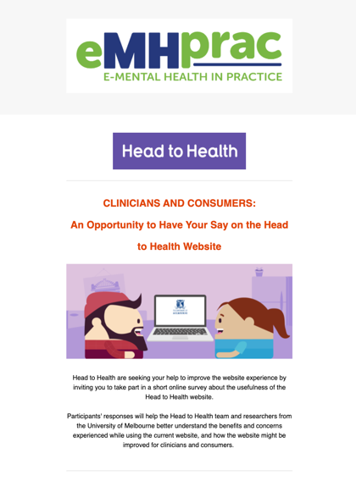

Sent: Wednesday, 2nd February 2022

Recipients: 2,289

Opens: 526

Total Link Clicks: 74

Clicks on Head to Health Evaluation Consumer, Family Member or Friend Survey Link: 15 (20.3%)

Clicks on Head to Health Evaluation Health Professionals Survey Link: 16 (21.6%)

Menzies School of Health Research – AIMhi Newsletter:

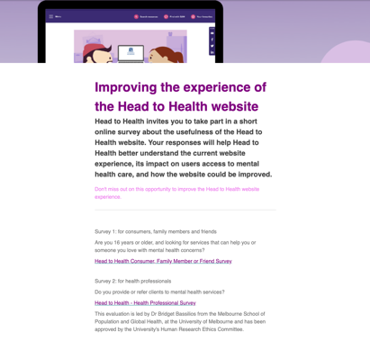

Sent: Wednesday, 2nd February 2022

Recipients: 1,182

Opens: 168

Total Link Clicks: 1,193

Clicks on Head to Health Evaluation Consumer, Family Member or Friend Survey Link: 108 (9.1%)

Clicks on Head to Health Evaluation Health Professionals Survey Link: 112 (9.4%)

Social media promotion

eMHPrac Facebook

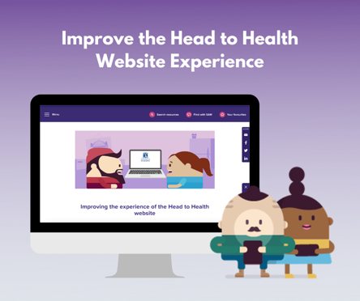

Posted: January 5th 2022

Reach: 145

Impressions: 154

Likes, comments and shares: 1

Link Clicks: 0

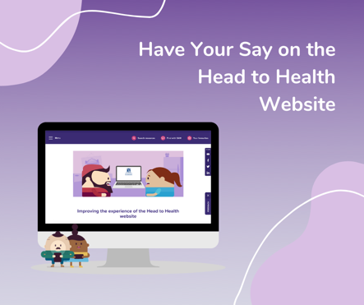

Posted: February 2nd 2022

Reach: 260

Impressions: 280

Likes, comments and shares: 4

Link Clicks: 2

WellMob Facebook

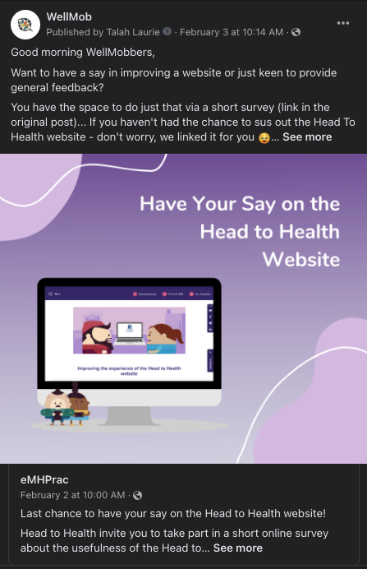

Posted: February 3rd 2022

Reach: 175

Impressions: 187

Likes, comments and shares: 0

Link Clicks: 1

eMHPrac Instagram

Posted: January 5th 2022

Reach: 69

Impressions: 75

Engagements: 8

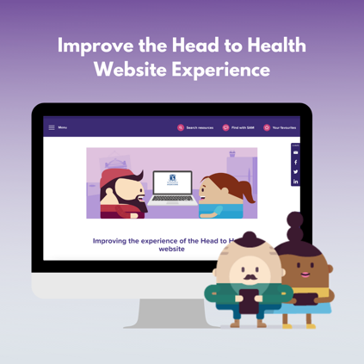

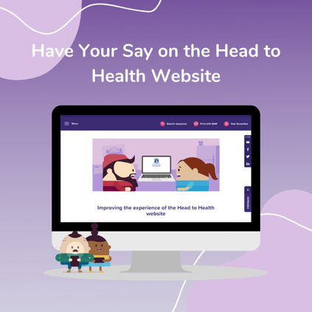

Posted: February 2nd 2022

Reach: 41

Impressions: 44

Engagements: 6

eMHPrac LinkedIn

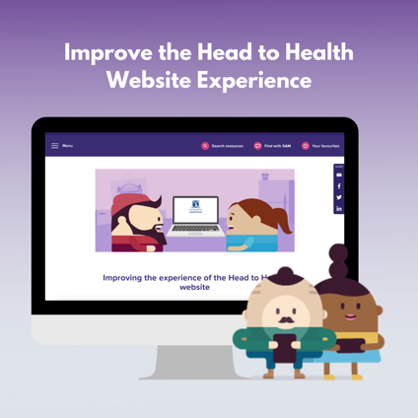

Posted: January 5th 2022

Impressions: 67

Engagements: 1

Link Clicks: 1

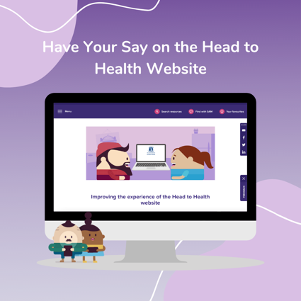

Posted: February 2nd 2022

Impressions: 76

Engagements: 4

Link Clicks: 3

**eMHPrac Twitter**

Posted: January 5th 2022

Impressions: 121

Engagements: 2

Link Clicks: 0

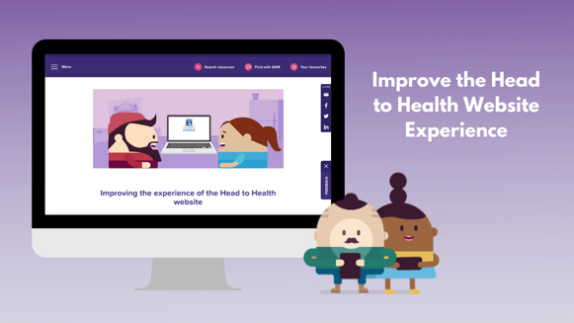

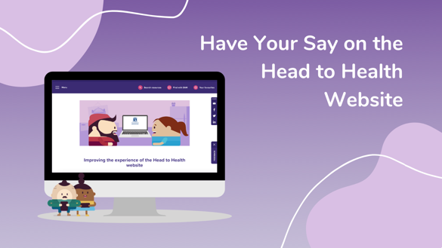

Posted: February 2nd 2022

Impressions: 262

Engagements: 13

Link Clicks: 1

## Consumer survey and interview

### Consumer survey

Thank you for agreeing to participate in this survey about your experiences of using (or not using) the Head to Health website. The survey will take about 20 minutes. Your responses are confidential, and you are free to withdraw from the survey at any stage.

**Some information about who you are**

**This section asks some basic question about who you are.**

1. **What is your gender?**

* Female
* Male
* I do not identify with either term

1. **What is your age?**

* 19 years or younger
* 20-29 years
* 30-39 years
* 40-49 years
* 50-59 years
* 60-69 years
* 70-79 years
* 80 years or older

1. **Do you identify as Aboriginal and/or Torres Strait Islander?**

* Aboriginal
* Torres Strait Islander
* Both Aboriginal and Torres Strait Islander
* Neither Aboriginal nor Torres Strait Islander

**Access to mental health care**

1. **How did you find out about the Head to Health website?**

* Online search
* Recommended by friends or family
* Recommended by a health provider
* Psychologist
* GP
* Psychiatrist
* Social Worker
* Nurse
* Other, please specify:_____________________________
* I have heard of the Head to Health website but have not used it.
* Why have you not used the Head to Health website? **END OF SURVEY**
* I have not heard of or used the Head to Health website – **END OF SURVEY**

1. **Please select the statement below which most accurately describes your previous experience with using the Head to Health website.**

* This is the first time I have used the Head to Health website
* I have used the Head to Health website between 1 and 5 times in the past
* I have used Head to Health website between 6 and 10 times in the past
* I have used the Head to Health website 11 or more times in the past

1. **Thinking about your recent experience with using the Head to Health website, please select all the reasons that prompted you to visit the website.**

* I felt I was not coping
* My symptoms were getting worse
* I experienced a crisis or traumatic event
* I felt I needed professional help
* A family member/friend suggested it
* A health professional referred me
* To find information, support or services for a family member or friend
* Other (specify):__________________________

**IF YOU ACCESSED THE HEAD TO HEALTH WEBSITE TO FIND INFORMATION, SUPPORT OR SERVICES FOR YOURSELF:**

1. **Prior to accessing the Head to Health website, have you accessed any other mental health service(s)?**

* Yes
* No

**If yes, please tick all the previous services you accessed**

* Face-to-face services
* Group services
* Video (meaning you can see the therapist who is in a different location using smart devices such as computers, mobile phones or tablets)
* Other online supports

1. **Have there been any barriers to you seeking mental health care in the past?**

* Yes
* No

**If yes, please select all the barriers you experienced to seeking mental health care in the past.**

* I didn’t recognise the symptoms I was experiencing as being related to my mental health
* I believed I did not need mental health treatment
* My mental health was not a priority
* I thought things would get better
* I didn’t think my symptoms were severe enough
* I didn’t think mental health treatment would help
* I was embarrassed
* I didn’t want anyone to know that I was having problems with my mental health
* I preferred to rely on myself
* I preferred to rely on my family/friends
* I had limited knowledge of available mental health treatment options
* Mental health services were unavailable in my area
* I was unable to afford mental health care
* Getting transport was difficult (e.g., affordability or reliability of public or personal transport)
* Other (specify):______________________________

1. **To what extent did the Head to Health website improve your access to care?**

* Not at all, I always had access to mental health care
* Partly my improved access to mental health care
* Improved my access to care
* Completely improved my access to mental health

**IF YOU ACCESSED THE HEAD TO HEALTH WEBSITE TO FIND INFORMATION, SUPPORT OR SERVICES FOR SOMEONE ELSE:**

**To what extent did the Head to Health website provide you with information, support or services for that person:**

* Not at all
* Partly
* Completely

**This section asks about how relevant and engaging you found the different aspects of the Head to Health website.**

1. **How long did you spend using the Head to Health website on this (or the most) recent occasion?**

* Less than 10 minutes
* 10 to 20 minutes
* 20 to 30 minutes
* 30 to 40 minutes
* Over 40 minutes

1. **Thinking about your experience using the Head to Health website, please select your response to each of the following items**

|  | **Strongly disagree** | **Somewhat disagree** | **Neither**  **agree or disagree** | **Somewhat**  **agree** | **Strongly agree** |
| --- | --- | --- | --- | --- | --- |
|  | 1 | 2 | 3 | 4 | 5 |
| I plan to visit the website again |  |  |  |  |  |
| I would recommend the website to others |  |  |  |  |  |
| All relevant information can be found on the front page |  |  |  |  |  |
| I can quickly find the information that I am looking for |  |  |  |  |  |
| The website is easy to navigate |  |  |  |  |  |
| The information on the website is trustworthy |  |  |  |  |  |
| The website offers information that is new to me |  |  |  |  |  |
| The website contains the information that I was looking for |  |  |  |  |  |
| The information on the website is easy to understand |  |  |  |  |  |
| The information on the website is relevant to me |  |  |  |  |  |
| The information on the website is easy to read (concise and clear layout) |  |  |  |  |  |
| The information on the website is accurate |  |  |  |  |  |
| The information on the website is appropriate for people with mental health problems |  |  |  |  |  |
| The information on the website is appropriate for people who want to support someone with a mental health problem |  |  |  |  |  |
| The website is visually appealing |  |  |  |  |  |
| The website is engaging |  |  |  |  |  |
| The website is interactive |  |  |  |  |  |
| The website is helpful |  |  |  |  |  |
| The website met my needs |  |  |  |  |  |
| Using the website was worth my time |  |  |  |  |  |

**Overall feedback about the Head to Health website**

1. **Overall, how satisfied are you with the Head to Health website?**

* Not at all satisfied
* Somewhat satisfied
* Satisfied
* Very satisfied
* Completely satisfied

1. **What aspects of the Head to Health website are most useful/helpful?**
2. **What aspects of the Head to Health website are least useful/helpful?**
3. **Do you have any other comments about your experience of using the Head to Health website on this (or the most recent) occasion?**

**Out-of-pocket costs, healthcare utilization, medication and productivity**

1. **In the past six months, how many times have you used the Head to Health Website?**

* Once
* Twice
* Three times
* Other, please specify:________________________ (whole numbers only)

1. **In the past six months, how many times did you see a GP because of your mental health?**

* No, I did not see one (go to question 4)
* Once
* Twice
* Three times
* Other, please specify:________________________ (whole numbers only)

1. **On average, how much of your own money did you pay each time you saw a GP?**

$____________ (whole numbers only)

1. **In the past six months, how many times did you see a psychiatrist because of your mental health?**

* No, I did not see one (go to question 6)
* Once
* Twice
* Three times
* Other, please specify:________________________ (whole numbers only)

1. **On average, how much of your own money did you pay each time you saw a psychiatrist?**

$____________ (whole numbers only)

1. **In the past six months, how many times did you see a psychologist because of your mental health?**

* No, I did not see one (go to question 8)
* Once
* Twice
* Three times
* Other, please specify:________________________ (whole numbers only)

1. **On average, how much of your own money did you pay each time you saw a psychologist?**

$____________ (whole numbers only)

1. **In the past six months, how many times did you see another allied health professional because of your mental health? (e.g., occupational therapist, counsellor, social worker)**

* No, I did not see one (go to question 10)
* Once
* Twice
* Three times
* Other, please specify:________________________ (whole numbers only)

1. **On average, how much of your own money did you pay each time you saw another allied health professional?**

$____________ (whole numbers only)

1. **In the past six months, how many times have you received help from an ambulance for your mental health?**

* No, I did not receive this help (go to question 12)
* Once
* Twice
* Three times
* Other, please specify:________________________ (whole numbers only)

1. **On average, how much of your own money did you pay each time you received help from an ambulance?**

$____________ (whole numbers only)

1. **In the past six months, how many times have you attended a hospital emergency department or casualty ward for your mental health?**

* No, I did not attend (go to question 14)
* Once
* Twice
* Three times
* Other, please specify:________________________ (whole numbers only)

1. **On average, how much of your own money did you pay each time you attended a hospital emergency department or casualty ward for your mental health?**

$____________ (whole numbers only)

1. **In the past six months, how many nights in total did you spend in hospital for your mental health?**

* No, I did not spend any nights there
* One
* Two
* Three
* Other, please specify:________________________ (whole numbers only)

1. **Are you taking any medications for your mental health?**

* Yes
* No (go to question 18)

1. **What is the name of the medication you are taking?**

____________ (free text)

1. **How many months have you been taking this medicine?**

____________ months (whole numbers only)

1. **In the past six months, have you had to take any time off from paid work?**

* Yes
* No (go to question 20)

1. **How much time have you had to take off paid work?**

____________ days in the past six months (whole numbers only)

1. **In the past six months, have you had to take any time off from unpaid work? Unpaid work may include study, voluntary work, housekeeping, caring for others, etc.**

* Yes
* No (go to question 22)

1. **How much time have you had to take off unpaid work?**

____________ days in the past six months (whole numbers only)

1. **During the past six months, have there been days in which you worked but were bothered by mental health problems?**

* Yes
* No (go to next section “Participation in an interview”)

1. **How much of the time did you work but were bothered mental health problems?**

____________ days in the past six months (whole numbers only)

1. **On average, how much of your normal work capacity were you able to achieve on the days that you were bothered by mental health problems? Use the following 0 to 10 scale.**

* 0 (None of what I would normally do)
* 1
* 2
* 3
* 4
* 5 (Half as much as I would normally do)
* 6
* 7
* 8
* 9
* 10 (Worked at full capacity)

**Participation in an interview**

**Are you willing to take part in a follow-up interview, which should take around 20 minutes, to provide more detailed information about your experience?**

* No
* Yes

**If yes, please provide your contact details.**

Name:___________________

Phone number:___________________

Days and times for us to contact you:_________________

### Consumer interview

Thank you for agreeing to participate in this interview about your experience of using the Head to Health website. The interview will take about 15 minutes. Your responses are confidential, and you are free to withdraw from the interview at any stage. I’d like to ask you some questions about the services you received.

1. What prompted you to use the Head to Health website?
2. What was it like to use the Head to Health website?
3. Did you access a digital (or other) mental health service because of using the Head to Health website?
   1. If yes, have you completed the course of treatment? How helpful has it been? Were you satisfied with the care that you received? Have you noticed any change in your health and wellbeing since accessing the mental health service?
   2. If no, why not?
4. Have you accessed any other mental health services?
5. What changes are needed to improve the Head to Health website?
6. Are there any other comments you would like to make?

Thank you for participating in the interview

## Health professional survey

Thank you for agreeing to participate in this survey of your experiences of using (or not using) the Head to Health digital mental health gateway [as well as your views and experiences of digital mental health services]. The survey will take about 15 minutes. Your responses are confidential, and you are free to withdraw from the survey at any stage.

We are asking demographic questions because we are interested in the impact of these factors on your experiences of using (or not using) the Head to Health Digital Mental Health Gateway.

**What is your profession?**

* GP
* Psychiatrist
* General Psychologist
* Clinical Psychologist
* Mental health nurse
* Social worker
* Occupational therapist
* Peer support worker
* Aboriginal and Torres Strait Islander Health/Mental Health Worker
* Other, specify:_________________

**How long have you been working in this profession?**

* Less than 1 year
* 1-5 years
* 6-10 years
* 11-15 years
* 16-20 years
* More than 20 years

**What type of organisation do you work in?**

* Digital/online mental health service
* Face-to-face mental health service
* Telephone mental health service
* Private practice – mental health
* General practice
* Private hospital
* Public hospital
* Not-for-profit community organization
* PHN
* Other, please specify:_________________

**What is your role in the organisation?**

**What is your postcode?**

**What is your gender?**

* Female
* Male
* I do not identify with either term

**What is your age?**

* 18-19 years
* 20-29 years
* 30-39 years
* 40-49 years
* 50-59 years
* 60-69 years
* 70-79 years
* 80 years or older

**Do you identify as Aboriginal and/or Torres Strait Islander?**

* Aboriginal
* Torres Strait Islander
* Both Aboriginal and Torres Strait Islander
* Neither Aboriginal nor Torres Strait Islander

**What type of internet do you have?**

* Dial up
* ADSL or ADSL2+
* Cable
* National Broadband Network (NBN)
* Satellite Connection
* Wireless Router
* Mobile Broadband (e.g., hot spot, dongle)
* Other____________

**How reliable is your internet?**

* Unreliable all of the time
* Unreliable most of the time
* Unreliable/reliable some of the time
* Reliable most of the time
* Reliable all of the time

**Have you used the Head to Health digital mental health gateway? (ONLY ASKED OF THOSE RECRUITED VIA PROFESSIONAL ASSOCIATIONS)**

* Yes
* No

**If yes, why/how do you use the website?**

**If not, why not? [End of survey]**

**How did you find out about the Head to Health digital mental health gateway?**

* Online search
* Recommended by workplace
* Recommended by family or friend
* Other, please specify:_____________________________

**Please select the statement below which most accurately describes your previous experience with using the Head to Health digital mental health gateway?**

* This is the first time I have used the Head to Health Digital Mental Health Gateway
* I have used the Head to Health Digital Mental Health Gateway between 1 and 5 times in the past
* I have used Head to Health Digital Mental Health Gateway between 6 and 10 times in the past
* I have used the Head to Health Digital Mental Health Gateway 11 or more times in the past

**Thinking about your recent experience with using the Head to Health Digital Mental Health Gateway, please select all the reasons that prompted you to visit the website.**

* To get listed on the website
* To find resources for myself as a health professional
* To find information, support or services for a client
* To find information, support or services for a family member or friend
* For personal reasons
* Other (specify):__________________________

**How long did you spend using the Head to Health digital mental health gateway on this (or the most) recent occasion?**

* Less than 10 minutes
* 10 to 20 minutes
* 20 to 30 minutes
* 30 to 40 minutes
* Over 40 minutes

**Thinking about your experience using the Head to Health wesbite, please select your response to each of the following items**

|  |  |  |  |  |  |  |  |  |  |  |  |
| --- | --- | --- | --- | --- | --- | --- | --- | --- | --- | --- | --- |
|  | | **Strongly disagree** | | **Somewhat disagree** | | **Neither**  **agree or disagree** | | **Somewhat**  **agree** | | **Strongly agree** | |
|  | | 1 | | 2 | | 3 | | 4 | | 5 | |
| I plan to visit the website again | |  | |  | |  | |  | |  | |
| I would recommend the website to others | |  | |  | |  | |  | |  | |
| All relevant information can be found on the front page | |  | |  | |  | |  | |  | |
| I can quickly find the information that I am looking for | |  | |  | |  | |  | |  | |
| The website is easy to navigate | |  | |  | |  | |  | |  | |
| The information on the website is trustworthy | |  | |  | |  | |  | |  | |
| The website offers information that is new to me | |  | |  | |  | |  | |  | |
| The website contains the information that I was looking for | |  | |  | |  | |  | |  | |
| The information on the website is easy to understand | |  | |  | |  | |  | |  | |
| The information on the website is relevant to me | |  | |  | |  | |  | |  | |
| The information on the website is easy to read (concise and clear layout) | |  | |  | |  | |  | |  | |
| The information on the website is accurate | |  | |  | |  | |  | |  | |
| The information on the website is appropriate for people with mental health problems | |  | |  | |  | |  | |  | |
| The information on the website is appropriate for people who want to support someone with a mental health problem (including health professionals) | |  | |  | |  | |  | |  | |
| The website is visually appealing | |  | |  | |  | |  | |  | |
| The website is engaging | |  | |  | |  | |  | |  | |
| The website is interactive | |  | |  | |  | |  | |  | |
| The website is helpful | |  | |  | |  | |  | |  | |
| The website meets my needs | |  | |  | |  | |  | |  | |
| Using the website is worth my time | |  | |  | |  | |  | |  | |
| The website meets the needs of my clients/patients | |  | |  | |  | |  | |  | |
| The website benefits my clients/patients | |  | |  | |  | |  | |  | |
| The website negatively impacts my client/patients | |  | |  | |  | |  | |  | |

**Do you recommend that your clients/patients use the Head to Health digital mental health** **gateway?**

* Never
* Occasionally
* Frequently
* All the time

**Has the Head to Health digital mental health gateway benefited clients/patients under your care?**

* Yes
* No

**If yes, please select all the benefits that apply.**

* Improved access to information
* Improved access to care
* Improved privacy
* Improved waiting times for services
* Reduced costs associated with care (travel and cost of sessions)
* Improved convenience of care (access from own home 24/7)
* Improved mental health and wellbeing
* Other please specify:__________________________

**Has the Head to Health Digital Mental Health Gateway had negative impacts on clients/patients under your care?**

* Yes
* No

**If yes, please tick all the negative impacts that apply**

* Consumers are not getting the information and support they need
* Consumers are unable to find the information they need on the website
* Other please specify__________________________

**Overall, how satisfied are you with the Head to Health digital mental health gateway?**

* Not at all satisfied
* Somewhat satisfied
* Satisfied
* Very satisfied
* Completely satisfied

**What aspects of the Head to Health digital mental health gatewayare most useful/helpful to you as a health professional?**

**What changes are needed to improve the Head to Health digital mental health gateway?**

**Do you have any other comments about your experience of using the Head to Health digital mental health gateway?**

**Thank you for participating in the survey.**

Appendix D: Detailed methods and analysis of community conversations

Methods

Community conversations were conducted using the World Café method.14 The World Café is a powerful way of facilitating group discussions. It is particularly useful for gathering multiple views on an issue to generate collective solutions, where you have all the experts already in the ‘room’, and creative thinking is helpful to generate ideas. It typically involves bringing together small groups of people at tables to discuss a particular issue, shuffling people to new tables with new issues, and then repeating the process several times. The World Café method is therefore easily adapted to be used online for conversations about Head to Health and digital mental health services.

Recruitment was conducted in four main ways:

* An email sent to the ACACIA register, a database of more than 130 consumers, carers and lived experience organisations interested in participation or active involvement in lived experience research;
* A post to the ACACIA Facebook page, which was also shared by Lived Experience Australia and several ACACIA members;
* A paid ad through the ACACIA Facebook account, which ran from 10-23 November, targeting all Australians over 16 years of age. The ad reached 21,411 people, had engagement from 243 people and resulted in 99 clicks through to the Expression of Interest form;
* Tweets from A/Prof Banfield’s account on 10 and 18 November, which were retweeted more than 30 times, including by consumer and researcher networks.

People who were interested in taking part clicked a link in the ad/post to complete a brief expression of interest survey on Qualtrics. A member of the research team responded by email, providing the information sheet and consent form, which also collected demographics and information about knowledge of the Head to Health website. Consent was requested prior to the group, but for a small number of participants, it was completed at the time of the conversation, prior to the commencement of discussions. A reminder email was sent the week before the conversations containing the Zoom links for the three conversations and a prompt to return the consent form.

The community conversations ran for 2.5 hours including breaks, and consisted of four sessions: three rounds of small group discussions to discuss strengths, barriers and effectiveness, and one final group discussion to bring the previous discussions together in optimal features. The full World Cafe method included the creation of small group ‘tables’ using the breakout room feature, with one researcher assigned to each room as facilitator, assisted by an observer/note taker. Due to low attendance, only one conversation was run in this way; the other two were conducted as single group discussions for all four questions.

Many participants were not familiar with the Head to Health website prior to the community conversations, so facilitators accessed the website and shared their screens to facilitate exploration in real time, and discussion of observations about strengths and weaknesses and perceived effectiveness.

Note takers and participants entered ideas and issues into the Slido app (https://www.sli.do/). Slido is a web-based, interactive Q&A and polling app that encourages participation in virtual events. There are no downloads or personal information required from participants. They simply follow a link, which was provided live in the Zoom chat, and entered the unique event ID to access the interactive tools for the community conversation. Participants were asked to enter words and phrases in response to the questions to create a ‘word cloud.’ They were able to enter words already present in the cloud to increase their emphasis, or enter further words to expand the cloud. Facilitators encouraged discussion about topics emerging in response to the emphasis suggested by the cloud at several points in each session. A fresh Slido event was created for each of the three sessions, allowing the groups to develop their own ideas.

Discussion about each question lasted for 20 minutes. In the conversation run using the World Cafe method, when participants moved between rooms, the facilitator for that room shared the word cloud developed to that point, and asked for comments and additions to the question for that room. This allowed both reinforcement of key issues already raised and the opportunity to add novel areas in an accessible visual format. This was not necessary in the conversations run as single group discussions, as all participants had the opportunity to build the word clouds together at the same time.

For the final discussions, the word clouds developed for strengths, barriers and effectiveness were displayed via shared screen to facilitate discussion on the features of an optimal digital gateway. Participants were invited to reflect on their prior discussions and think about how an ideal website would look, feel and act. They were then invited to enter the most and least important features they thought the website should have.

After the conclusion of the discussion, participants were emailed a $50 e-gift card as a reimbursement for their time.

Analysis

The lists of ideas entered into Slido for all three conversations were downloaded for preliminary thematic analysis using Nvivo qualitative analysis software. An initial list of codes was developed line-by-line, interrogating the data for common issues. These issues were then combined into larger thematic areas, given descriptive titles to demonstrate the major areas of strength, barriers and effectiveness. A summary of these preliminary themes is provided in the preliminary findings section of the report, alongside discussion of the most and least important features for a redeveloped Head to Health website. The full word clouds and survey results are available below in the appendix. Full thematic analysis, including additional notes taken by notetakers, will be undertaken for the final evaluation report.

Strengths of Head to Health word clouds

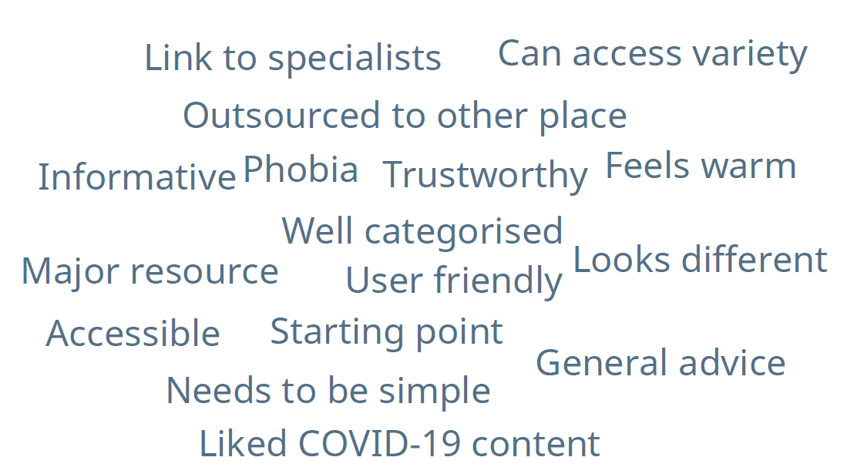

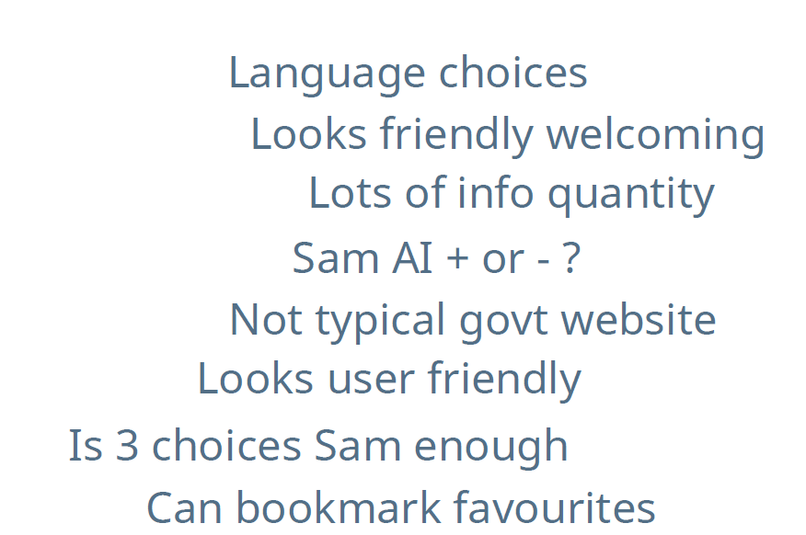

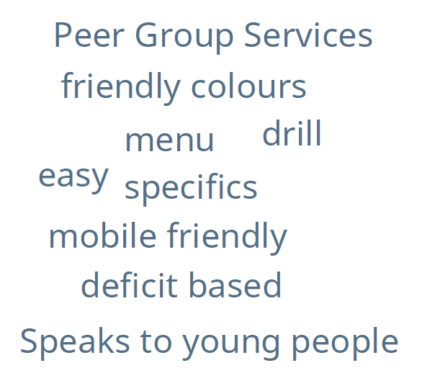

Weaknesses of Head to Health word clouds

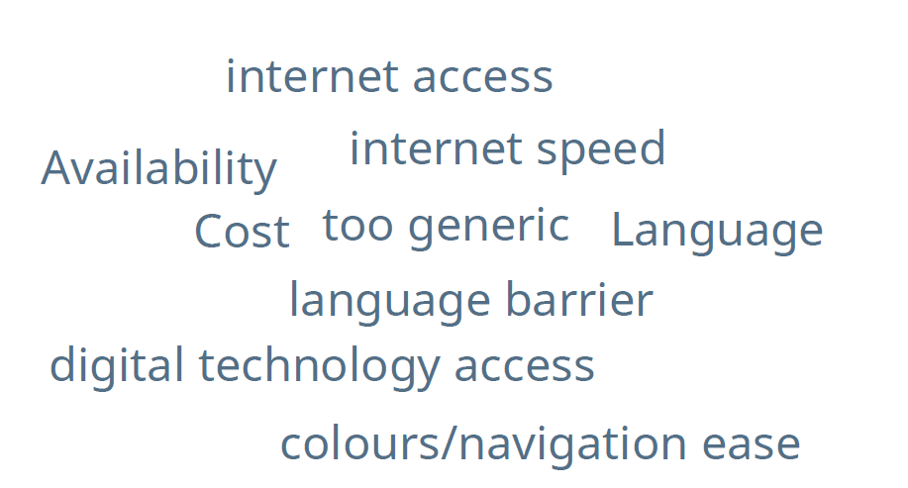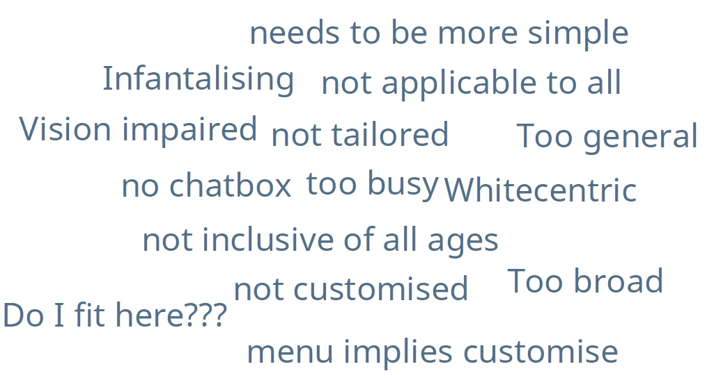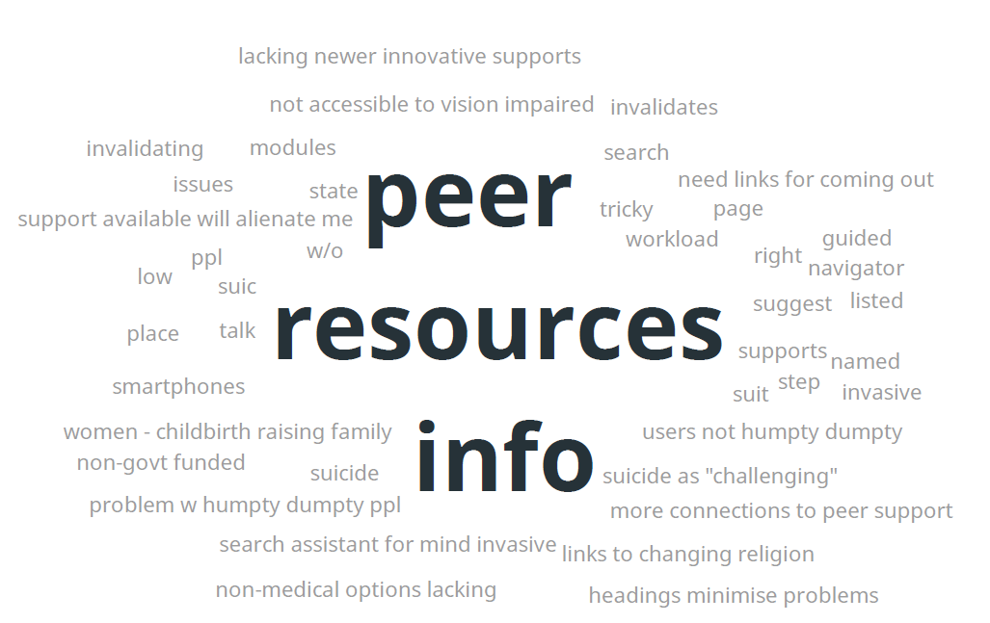

Effectiveness of Head to Health word clouds

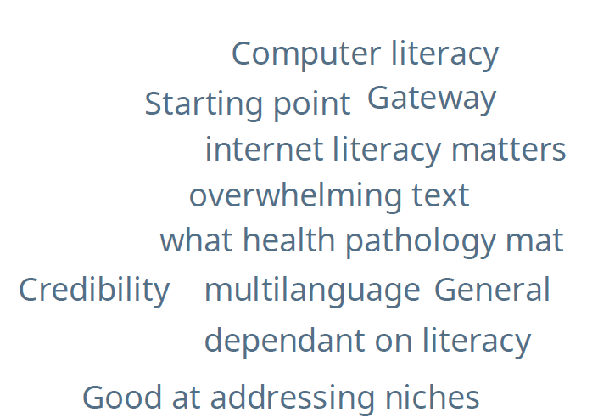

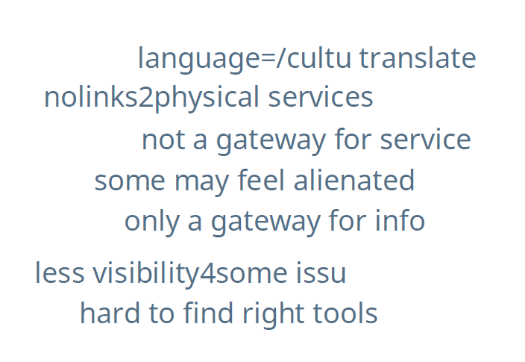

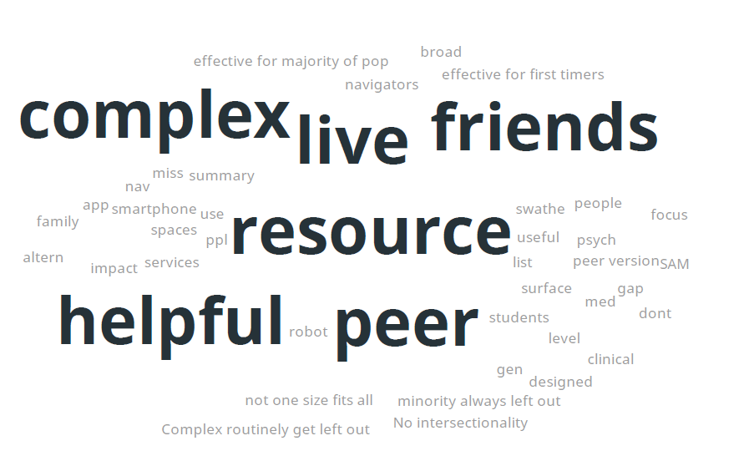

Most and least important features of Head to Health

|  |  |
| --- | --- |
| **Most important**  Tailored links | |
| An easy to understand interface | |
| Visually appealing but not excessive use of colours | |
| easy to understand | |
| Engaging not over-whelming | |
| Some live chat, real time interaction | |
| Visually calming and accessible | |
| Way to Narrow info down to me so less overwhelming | |
| Accessibility | |
| Comprehensive without being too overwhelming | |
| Design - a bit childish looking | |
| Link to real people and services - it won’t replace specialists | |
| Don’t think this replaces specialists and access especially rural | |
| Link to support groups too | |
| Has the information you need/want | |
| Links to further discussion or tools or physical services | |
| being able to rate the relevance/effectiveness of resources, | |
| accessibility | |
| wide variety of resources | |
| Need way through via HOPE, recovery | |
| Focus on recovery | |
| empowering people to update an engaged info space | |
| don’t just connect back to mainstream models that don’t connect back too community. | |
| Opportunity to normalise to reduce stigma and self stigma and promote help finding… | |
| need to mention that it is normal that a significant number of people experience. | |
| A lot of transformative stuff is peer base, grass roots, non govt, so it would be great to make those resources available to a wider audience and updating and remaining in touch with the peer spaces | |
| We need redesign for people with substantial and enduring distress. | |
| Normalise mental health issues  **Least important** | |
| Jargon |
| Formal language |
| Very long paragraphs |
| all relevant |
| Bloody awful cartoon figures |
| Chatbots |
| Referral to Beyond Blue or Lifeline |
| Need less basic info and address more complex needs |

Appendix E: Detailed methods for consultation with other key stakeholders

Method

From 7 December 2021, we approached 94 individuals from 53 organisations to participate in either a survey or interview. Individuals/organisations were approached via email and phone. Those that did not respond were contacted at least 3 times before recruitment efforts ceased. Our original list of mental health organisations and peak bodies was enhanced with recommendations from the Department, the three services involved in the supported DMHS evaluation (MindSpot, THIS WAY UP and Mental Health Online), as well as recommendations from representatives of organisations that were contacted. Some contacted representatives held positions within multiple organisations and some organisations chose more than one representative to participate. A small number declined due to being too busy (2 academics).

The list of organisations that were approached included:

* Australian Indigenous Psychologists Association (AIPA)
* Australian Psychological Society (APS)
* BeyondBlue
* Black Dog
* Butterfly Foundation
* Carer Lived Experience Workforce Network/Tandem
* Department of Health/Head to Health
* eMental Health International Collaborative, New Zealand
* eMental Health in Practice (eMHPrac)
* Gayaa Dhuwi (Proud Spirit) Australia
* Headspace
* Helping Minds WA
* Indigenous Allied Health Australia
* Lifeline
* Liquid/Speedwell
* Lived Experience Australia
* Mental Health Association of Central Australia
* Mental Health Australia
* Mental Health Carers Australia, VIC
* Mental Health Carers NSW
* Mental Health Families & Friends Tasmania
* Mental Health Online
* Mental Illness Fellowship of Australia (NT)
* Mental Wheels Foundation
* MH@Work
* Mind Australia, Vic
* MindSpot
* National Mental Health Commission
* Orygen Digital
* PHNs (Brisbane South PHN, Central and Eastern Sydney PHN, Country SA PHN, Northern Territory PHN, Primary Health Tasmania, South Eastern Melbourne PHN, WA PHN)
* ReachOut
* SANE
* Selected academics and international experts
* Smiling Mind
* The Aboriginal and Torres Strait Islander Lived Experience Centre
* The Northern Territory Mental Health Coalition
* THIS WAY UP/CRUfAD/St Vincent's Hospital

Online, written consent was obtained from 70 individuals from 44 organisations. Forty-two of these participated in a survey, 30 completed a survey individually, 6 individuals provided 2 group survey responses, and 6 started but did not provide sufficient data to be included in the analysis. Sixteen interviews were conducted between 6 January and 7 March with 28 individuals as seven were group interviews with 2-5 representatives at a time. One group interview participant also provided some brief survey responses. This led to a final sample size of 64 individuals from 41 organisations.

Interview/survey questions

Participants were asked 35 questions in the survey/interview – 3 relating to the organisation being represented, 17 relating to the supported DMHS evaluation, 10 relating to the Head to Health evaluation and 5 demographic questions. The 13 questions relating to the organisation and Head to Health evaluation are listed here. All questions were optional and were mostly short answer questions, with a few multiple-choice questions relating to the supported DMHS evaluation.

1. What is the name of organisation(s) you are representing?
2. What is your job/position title?
3. What is your/your organisation’s role in mental health service delivery?
4. How are you/your organisation engaged with the Head to Health Digital Mental Health Gateway?
5. How are you/your organisation facilitating or promoting the use of the Head to Health Digital Mental Health Gateway?
6. What effects has the Head to Health Digital Mental Health Gateway had on consumers and carers?
7. How has clinical care for people with mental health problems changed since the introduction of the Head to Health Digital Mental Health Gateway?
8. What effects has the Head to Health Digital Mental Health Gateway had on mental health service providers?
9. How might the Head to Health Digital Mental Health Gateway be better integrated and used in mental health care across Australia?
10. How can the Head to Health Digital Mental Health Gateway improve access to mental health care?
11. What are the barriers to the use of the Head to Health Digital Mental Health Gateway?
12. How might the Head to Health Digital Mental Health Gateway be improved in the future?
13. Provide other comments, if you have any, about the Head to Health Digital Mental Health Gateway.

Appendix F: Cost effectiveness modelling

F1. Economic model parameters

F1.1 Data sources for model parameters

Table F1 outlines the data sources for the model parameters, including parameters associated with the DMHSs and indirect comparator groups. Further details on costs associated with implementing DMHSs and the indirect comparator groups are available in our complementary evaluation of DMHSs.15

Table F1. Model parameters and data sources

|  |  |
| --- | --- |
| Parameter | Data source(s) |
| Model population | Routinely collected data of DMHSs (i.e., number of consumers for self-directed treatment and therapist-supported treatment) |
| Transition probabilities of ‘intervention’ arm | Routinely collected data and/or peer-reviewed publications of DMHSs |
| Transition probabilities of ‘comparator’ arm | Previous modelled economic evaluation of MindSpot –  Lee et al. 2017 (based on National Survey of Mental Health and Wellbeing)20 |
| Cost of implementing DMHSs | Financial records/budgets of DMHSs |
| Health care costs and productivity impacts of ‘intervention’ arm | Head to Health and DMHS consumer surveys conducted in January 2022 |
| Health care costs and productivity impacts of ‘comparator’ arm | Economic evaluations of Link-me and Target-D RCTs –  Chatterton et al. (2022)21 & Lee et al. (2022)22 |
| Utility weights to calculate QALYs | Previous modelled economic evaluation of MindSpot –  Lee et al. 201720 |

### F1.2 Transition probabilities

To operationalise the model, transition probabilities for the four health states described in Figure 22 were estimated. We used mental health outcome data for each DMHS (i.e., MindSpot, Mental Health Online, THIS WAY UP) from their routinely collected service use data or peer-reviewed publications. These data include clinical outcomes such as the Kessler Psychological Distress 6-Item Scale (K6), Kessler Psychological Distress 10-Item Scale (K10), Patient Health Questionnaire 9-Item Scale (PHQ-9) and Generalised Anxiety Disorder 7-Item Scale (GAD-7), which we used to derive transition probabilities for each health state. Transition probabilities specific to a service pathway (i.e., self-directed or therapist-supported) were calculated if data were available and, if not, the probabilities were assumed to be the same for all service pathways.

The transition probabilities for the model were calculated based on the treatment outcomes that were collected from each DMHS. Table F2 presents the PHQ-9 outcomes in three health states (deteriorated, no change and improved) for consumers who commenced treatment. The number of cases in each health state were then converted to proportions, which represent the transition probabilities used in our cost-effectiveness modelling. The ‘deteriorated’ and ‘no change’ health states were equivalent to the corresponding health states in our model. The ‘improved’ health state was equivalent to the combination of ‘fully recovered’ and ‘partially recovered’ health states in our model. We assume that 70% of the ‘improved’ health state can be attributed to ‘fully recovered’ and the balance 30% can be attributed to ‘partially recovered’. This assumption is based on the ratio of ‘fully recovered’ and ‘partially recovered’ health states estimated in a prior economic evaluation of MindSpot (Table 3 in Lee et al. 2017).20

The transition probabilities for the indirect comparator groups were based on the values estimated in a published economic evaluation of MindSpot in 2017.20 These values were calculated based on data from the National Mental Health Survey and an internal dataset provided by MindSpot at the time of this previous evaluation.

Table F2. The PHQ-9 outcomes for consumers who commenced treatment by service and treatment pathway

|  |  |  |  |
| --- | --- | --- | --- |
|  | Deteriorated | No change | Improved |
| MINDSPOT |  |  |  |
| Therapist-supported treatment (n=3,532) |  |  |  |
| Number of cases | 258 | 987 | 2,287 |
| Proportion | 0.073 | 0.280 | 0.647 |
| THIS WAY UP |  |  |  |
| Self-directed treatment (n=26,602) |  |  |  |
| Number of cases | 1,799 | 8,709 | 16,093 |
| Proportion | 0.068 | 0.327 | 0.605 |
| Therapist-supported treatment (n=27,530) |  |  |  |
| Number of cases | 1,743 | 10,857 | 14,930 |
| Proportion | 0.063 | 0.394 | 0.542 |

Table F3 presents the transition probabilities used in our cost-effectiveness modelling, based on PHQ-9 outcomes. Due to data unavailability, the transition probabilities for Mental Health Online were assumed to be the average of those for MindSpot and THIS WAY UP.

Table F3 Transition probabilities used in the cost-effectiveness modelling (based on PHQ-9 outcomes)

|  |  |  |  |  |
| --- | --- | --- | --- | --- |
| Parameter | Indirect comparatora | Mental Health Onlineb | MindSpotc | THIS WAY UPd |
| Self-directed treatment |  |  |  |  |
| Transition probabilities: |  |  |  |  |
| Fully recovered | 0.111 | 0.438 | 0.453 | 0.423 |
| Partially recovered | 0.044 | 0.188 | 0.194 | 0.181 |
| No improvement | 0.689 | 0.304 | 0.280 | 0.327 |
| Deteriorated | 0.156 | 0.071 | 0.073 | 0.068 |
| Therapist-supported treatment |  |  |  |  |
| Transition probabilities: |  |  |  |  |
| Fully recovered | 0.111 | 0.417 | 0.453 | 0.380 |
| Partially recovered | 0.044 | 0.179 | 0.194 | 0.163 |
| No improvement | 0.689 | 0.337 | 0.280 | 0.394 |
| Deteriorated | 0.156 | 0.068 | 0.073 | 0.063 |

aAs estimated in Lee et al. (2017)20 based on datasets from (i) the National Survey of Mental Health and Wellbeing (NSMHWB), a population-level survey collecting epidemiology and health resource use of common mental disorders and (ii) a 8-week ‘waitlist’ dataset. The transition probabilities for self-directed treatment were assumed to be the same as those for therapist-supported treatment.

bDue to data unavailability, the transition probabilities for Mental Health Online were assumed to be the average of MindSpot and THIS WAY UP.

cTransition probabilities for MindSpot were estimated using the proportion of consumers moving between symptom severity groups (based on PHQ-9 cut-off points) after commencing therapist-supported treatment, based on routinely collected data. The transition probabilities for self-directed treatment were assumed to be the same as those for therapist-supported treatment.

dTransition probabilities for THIS WAY UP were estimated using the proportion of consumers moving between symptom severity groups (based on PHQ-9 cut-off points) after commencing therapist-supported treatment, based on routinely collected data.

### F1.3 Utility weights

The utility weights used to calculate QALYs were derived from individual-level and population-representative datasets with clinical outcomes as described in Lee et al. (2017).20 Utilities are typically expressed as being between zero and one, where the value of one represents perfect health and zero represents death. The QALYs of the four health states were calculated by multiplying the period spent in a particular health state (in this case, one year) by the utility assigned to that health state. Table F4 presents the utility weights used in the analysis, which were based on estimates reported in Lee et al. (2017).20

Table F4. Utility weights used in the cost-effectiveness modelling

|  |  |  |
| --- | --- | --- |
| Parameter | Parameter value | 95% confidence interval |
| Utility weighta |  |  |
| Fully recovered | 0.858 | 0.835-0.881 |
| Partially recovered | 0.839 | 0.798-0.879 |
| No improvement | 0.779 | 0.746-0.812 |
| Deterioration | 0.712 | 0.473-0.952 |

aAs estimated in Lee et al. (2017)20 based on an 8-week dataset using EQ-5D-5L as the measurement tool. QALYs of the four health states were calculated by multiplying the period spent in a particular health state by the utility assigned to that state.

F2. Usual care comparison

We used data from two recent Australian RCTs of primary mental health care – the Link-me RCT and the Target-D RCT. It is likely that the participants in these trials are generally representative of the types of consumers who receive usual care services if they do not have access to DMHSs. In addition, economic evaluations were conducted alongside these trials (Chatterton et al., 2022; Lee et al. 2022)21, 22 and, therefore, we had access to relevant cost data that we could compare with those of DMHSs.

The Link-me RCT (Fletcher et al., 2019; Fletcher et al., 2021a)23, 24 was conducted in 23 general practices in three states (New South Wales, Victoria and Queensland) across metropolitan, outer metropolitan and regional locations in collaboration with three Primary Health Networks (PHNs). Adults attending a participating general practice for any reason were invited to complete an eligibility screening tool. The inclusion criteria were individuals aged 18-75 years; proficient in English; providing a phone number and email address; having a Medicare card; reporting current anxiety or depression symptoms (≥2 on the 2-item version of the PHQ) or use of medication for mental health. Eligible participants were classified into three prognostic groups – minimal/mild, moderate and severe – based on a patient-completed Decision Support Tool that predicted their anxiety and depressive symptom trajectory over the next three months. Participants categorised into the minimal/mild and severe groups were individually randomised to the intervention or control group. Participants randomised to the control group for both prognostic groups received advice to discuss any mental health concerns with their GP.

Similarly, the Target-D RCT (Fletcher et al., 2021b)25 recruited participants from the waiting rooms of 14 general practices in metropolitan Melbourne, Australia. Adults aged 18-65 years were invited to complete an eligibility survey on an iPad. Participants were eligible if they reported: current depressive symptoms (≥2 on the 2-item version of the PHQ); no self-reported change to antidepressant medication in the past month; had access to the internet; and sufficient written English to follow an internet-based cognitive behavioural therapy (iCBT) program. A clinical prediction tool with self-reported biopsychosocial data was used to classify eligible participants into one of three prognostic groups – minimal/mild, moderate or severe – based on predicted severity of their depressive symptoms in the next three months. Participants randomised to the control group received usual care plus attention control in the form of a telephone call from a research assistant about trial involvement and views about research participation.

We used the Link-me and Target-D control groups as the indirect comparator groups representing usual care.

F3. Results of economic modelling without the inclusion of Head to Health

Table F5. Results of economic modelling for Mental Health Online excluding Head to Health

|  | Mental Health Online | Indirect comparator: Link-me  (all participants) | Indirect comparator: Target-D  (all participants) | Indirect comparator: Link-me (minimal/ mild group) | Indirect comparator: Target-D (minimal/ mild group) | Indirect comparator: Link-me (severe group) | Indirect comparator: Target-D (severe group) |
| --- | --- | --- | --- | --- | --- | --- | --- |
| Self-directed treatment | | | | | | | |
| QALY | 6,037 | 5,736 | 5,736 | 5,736 | 5,736 | 5,736 | 5,736 |
| Total costs excluding productivity losses | $6,223,175 | $21,155,546 | $13,648,215 | $4,858,126 | $11,879,578 | $37,255,585 | $19,978,906 |
| Costs per QALY  gained | - | [dominant] | [dominant] | $4,533 | [dominant] | [dominant] | [dominant] |
| Total costs including productivity losses | $12,368,031 | $83,665,576 | $133,127,109 | $36,048,646 | $131,442,013 | $130,720,880 | $127,001,374 |
| Costs per QALY  gained | - | [dominant] | [dominant] | [dominant] | [dominant] | [dominant] | [dominant] |
| Therapist-supported treatment | | | | | | | |
| QALY | 473 | 451 | 451 | 451 | 451 | 451 | 451 |
| Total costs excluding productivity losses | $652,932 | $1,662,756 | $1,072,704 | $381,833 | $933,695 | $2,928,165 | $1,570,276 |
| Costs per QALY  gained | - | [dominant] | [dominant] | $12,042 | [dominant] | [dominant] | [dominant] |
| Total costs including productivity losses | $1,135,897 | $6,575,837 | $10,463,349 | $2,833,304 | $10,330,906 | $10,274,227 | $9,981,887 |
| Costs per QALY  gained | - | [dominant] | [dominant] | [dominant] | [dominant] | [dominant] | [dominant] |

QALY, quality-adjusted life year.

A ‘dominant’ costs per QALY gained indicates that the DMHS was found to have lower costs and greater benefits.

Table F6. Results of economic modelling for MindSpot excluding Head to Health

|  | Mental Health Online | Indirect comparator: Link-me  (all participants) | Indirect comparator: Target-D  (all participants) | Indirect comparator: Link-me (minimal/ mild group) | Indirect comparator: Target-D (minimal/ mild group) | Indirect comparator: Link-me (severe group) | Indirect comparator: Target-D (severe group) |
| --- | --- | --- | --- | --- | --- | --- | --- |
| Self-directed treatment | | | | | | | |
| QALY | 918 | 871 | 871 | 871 | 871 | 871 | 871 |
| Total costs excluding productivity losses | $2,251,112 | $3,213,319 | $2,073,029 | $737,901 | $1,804,391 | $5,658,756 | $3,034,596 |
| Costs per QALY  gained | - | [dominant] | $3,834 | $32,582 | $9,619 | [dominant] | [dominant] |
| Total costs including productivity losses | $2,911,539 | $12,707,975 | $20,220,694 | $5,475,434 | $19,964,744 | $19,855,211 | $19,290,255 |
| Costs per QALY  gained | - | [dominant] | [dominant] | [dominant] | [dominant] | [dominant] | [dominant] |
| Therapist-supported treatment | | | | | | | |
| QALY | 4,270 | 4,054 | 4,054 | 4,054 | 4,054 | 4,054 | 4,054 |
| Total costs excluding productivity losses | $11,139,262 | $14,953,295 | $9,646,916 | $3,433,851 | $8,396,797 | $26,333,224 | $14,121,615 |
| Costs per QALY  gained | - | [dominant] | $6,905 | $35,652 | $12,689 | [dominant] | [dominant] |
| Total costs including productivity losses | $14,212,580 | $59,137,022 | $94,097,731 | $25,480,128 | $92,906,661 | $92,396,945 | $89,767,901 |
| Costs per QALY  gained | - | [dominant] | [dominant] | [dominant] | [dominant] | [dominant] | [dominant] |

QALY, quality-adjusted life year.

A ‘dominant’ costs per QALY gained indicates that the DMHS was found to have lower costs and greater benefits.

Table F7. Results of economic modelling for THIS WAY UP excluding Head to Health

|  | Mental Health Online | Indirect comparator: Link-me  (all participants) | Indirect comparator: Target-D  (all participants) | Indirect comparator: Link-me (minimal/ mild group) | Indirect comparator: Target-D (minimal/ mild group) | Indirect comparator: Link-me (severe group) | Indirect comparator: Target-D (severe group) |
| --- | --- | --- | --- | --- | --- | --- | --- |
| Self-directed treatment | | | | | | | |
| QALY | 2,724 | 2,597 | 2,597 | 2,597 | 2,597 | 2,597 | 2,597 |
| Total costs excluding productivity losses | $6,292,268 | $9,579,544 | $6,180,114 | $2,199,831 | $5,379,249 | $16,869,880 | $9,046,744 |
| Costs per QALY  gained | - | [dominant] | $887 | $32,354 | $7,218 | [dominant] | [dominant] |
| Total costs including productivity losses | $8,878,646 | $37,885,010 | $60,281,924 | $16,323,360 | $59,518,888 | $59,192,348 | $57,508,101 |
| Costs per QALY  gained | - | [dominant] | [dominant] | [dominant] | [dominant] | [dominant] | [dominant] |
| Therapist-supported treatment | | | | | | | |
| QALY | 10,921 | 10,457 | 10,457 | 10,457 | 10,457 | 10,457 | 10,457 |
| Total costs excluding productivity losses | $24,926,563 | $38,568,453 | $24,881,917 | $8,856,798 | $21,657,534 | $67,920,264 | $36,423,333 |
| Costs per QALY  gained | - | [dominant] | $96 | $34,620 | $7,043 | [dominant] | [dominant] |
| Total costs including productivity losses | $35,339,645 | $152,529,830 | $242,702,631 | $65,719,907 | $239,630,551 | $238,315,860 | $231,534,868 |
| Costs per QALY  gained | - | [dominant] | [dominant] | [dominant] | [dominant] | [dominant] | [dominant] |

QALY, quality-adjusted life year.

A ‘dominant’ costs per QALY gained indicates that the DMHS was found to have lower costs and greater benefits.

F4. Sensitivity analysis results

TableF8. Sensitivity analysis results for Mental Health Online

|  | Mental Health Online | Indirect comparator: Link-me  (all participants) | Indirect comparator: Target-D  (all participants) | Indirect comparator: Link-me (minimal/ mild group) | Indirect comparator: Target-D (minimal/ mild group) | Indirect comparator: Link-me (severe group) | Indirect comparator: Target-D (severe group) |
| --- | --- | --- | --- | --- | --- | --- | --- |
| Self-directed treatment | | | | | | | |
| QALY | 6,037 | 5,736 | 5,736 | 5,736 | 5,736 | 5,736 | 5,736 |
| Total costs excluding productivity losses | $9,035,860 | $21,155,546 | $13,648,215 | $4,858,126 | $11,879,578 | $37,255,585 | $19,978,906 |
| Costs per QALY  gained | - | [dominant] | [dominant] | $13,874 | [dominant] | [dominant] | [dominant] |
| Total costs including productivity losses | $15,180,715 | $83,665,576 | $133,127,109 | $36,048,646 | $131,442,013 | $130,720,880 | $127,001,374 |
| Costs per QALY  gained | - | [dominant] | [dominant] | [dominant] | [dominant] | [dominant] | [dominant] |
| Therapist-supported treatment | | | | | | | |
| QALY | 473 | 451 | 451 | 451 | 451 | 451 | 451 |
| Total costs excluding productivity losses | $874,000 | $1,662,756 | $1,072,704 | $381,833 | $933,695 | $2,928,165 | $1,570,276 |
| Costs per QALY  gained | - | [dominant] | [dominant] | $21,862 | [dominant] | [dominant] | [dominant] |
| Total costs including productivity losses | $1,356,965 | $6,575,837 | $10,463,349 | $2,833,304 | $10,330,906 | $10,274,227 | $9,981,887 |
| Costs per QALY  gained | - | [dominant] | [dominant] | [dominant] | [dominant] | [dominant] | [dominant] |

QALY, quality-adjusted life year.

A ‘dominant’ costs per QALY gained indicates that the DMHS was found to have lower costs and greater benefits.

Table F9. Sensitivity analysis results for MindSpot

|  | MindSpot | Indirect comparator: Link-me  (all participants) | Indirect comparator: Target-D  (all participants) | Indirect comparator: Link-me (minimal/ mild group) | Indirect comparator: Target-D (minimal/ mild group) | Indirect comparator: Link-me (severe group) | Indirect comparator: Target-D (severe group) |
| --- | --- | --- | --- | --- | --- | --- | --- |
| Self-directed treatment | | | | | | | |
| QALY | 918 | 871 | 871 | 871 | 871 | 871 | 871 |
| Total costs excluding productivity losses | $2,678,331 | $3,213,319 | $2,073,029 | $737,901 | $1,804,391 | $5,658,756 | $3,034,596 |
| Costs per QALY  gained | - | [dominant] | $13,033 | $41,780 | $18,817 | [dominant] | [dominant] |
| Total costs including productivity losses | $3,338,758 | $12,707,975 | $20,220,694 | $5,475,434 | $19,964,744 | $19,855,211 | $19,290,255 |
| Costs per QALY  gained | - | [dominant] | [dominant] | [dominant] | [dominant] | [dominant] | [dominant] |
| Therapist-supported treatment | | | | | | | |
| QALY | 4,270 | 4,054 | 4,054 | 4,054 | 4,054 | 4,054 | 4,054 |
| Total costs excluding productivity losses | $13,127,341 | $14,953,295 | $9,646,916 | $3,433,851 | $8,396,797 | $26,333,224 | $14,121,615 |
| Costs per QALY  gained | - | [dominant] | $16,104 | $44,850.77 | $21,888 | [dominant] | [dominant] |
| Total costs including productivity losses | $16,200,659 | $59,137,022 | $94,097,731 | $25,480,128 | $92,906,661 | $92,396,945 | $89,767,901 |
| Costs per QALY  gained | - | [dominant] | [dominant] | [dominant] | [dominant] | [dominant] | [dominant] |

QALY, quality-adjusted life year.

A ‘dominant’ costs per QALY gained indicates that the DMHS was found to have lower costs and greater benefits.

Table F10. Sensitivity analysis results for THIS WAY UP

|  | THIS WAY UP | Indirect comparator: Link-me  (all participants) | Indirect comparator: Target-D  (all participants) | Indirect comparator: Link-me (minimal/ mild group) | Indirect comparator: Target-D (minimal/ mild group) | Indirect comparator: Link-me (severe group) | Indirect comparator: Target-D (severe group) |
| --- | --- | --- | --- | --- | --- | --- | --- |
| Self-directed treatment | | | | | | | |
| QALY | 2,724 | 2,597 | 2,597 | 2,597 | 2,597 | 2,597 | 2,597 |
| Total costs excluding productivity losses | $7,565,893 | $9,579,544 | $6,180,114 | $2,199,831 | $5,379,249 | $16,869,880 | $9,046,744 |
| Costs per QALY  gained | - | [dominant] | $10,956 | $42,423 | $17,287 | [dominant] | [dominant] |
| Total costs including productivity losses | $10,152,271 | $37,885,010 | $60,281,924 | $16,323,360 | $59,518,888 | $59,192,348 | $57,508,101 |
| Costs per QALY  gained | - | [dominant] | [dominant] | [dominant] | [dominant] | [dominant] | [dominant] |
| Therapist-supported treatment | | | | | | | |
| QALY | 10,921 | 10,457 | 10,457 | 10,457 | 10,457 | 10,457 | 10,457 |
| Total costs excluding productivity losses | $30,054,338 | $38,568,453 | $24,881,917 | $8,856,798 | $21,657,534 | $67,920,264 | $36,423,333 |
| Costs per QALY  gained | - | [dominant] | $11,143 | $45,667 | $18,090 | [dominant] | [dominant] |
| Total costs including productivity losses | $40,467,421 | $152,529,830 | $242,702,631 | $65,719,907 | $239,630,551 | $238,315,860 | $231,534,868 |
| Costs per QALY  gained | - | [dominant] | [dominant] | [dominant] | [dominant] | [dominant] | [dominant] |

QALY, quality-adjusted life year.

A ‘dominant’ costs per QALY gained indicates that the DMHS was found to have lower costs and greater benefits.