

Evaluation of the PHNs’ Improved Access to Psychological Services in Aged Care Facilities initiative

Technical supplement to the final report

Australian Government Department of Health

16 March 2022



© Commonwealth of Australia as represented by the , 2022

Apart from uses permitted by the Copyright Act 1968 and this copyright notice, all other rights (including all commercial rights) are expressly reserved.

Permitted uses

You may download, display, print, and reproduce the whole or part of this publication in unaltered form for:

* your own personal use;
* use within your organisation; or
* distribution and sharing with third parties,

but only if:

* you or your organisation do not use or reproduce the publication for any commercial purpose; and
* if reproduced, this copyright notice and all disclaimer notices are included as part of any reproduction.

This licence does not cover, and there is no permission given for, use of the Commonwealth Coat of Arms or any logos and trademarks (including the logo of the ).

Disclaimer

This publication has been produced independently by Australian Healthcare Associates at the request of the .

The Australian Government accepts no responsibility for material contained in the publication. The views or recommendations expressed in this publication may include the views or recommendations of third parties and do not necessarily reflect those of the Australian Government or indicate a commitment to a particular course of action.

Providing access to the publication does not constitute an endorsement, approval or recommendation by the Australian Government of any organisation, association, entity, service, program, products or research offered by virtue of any information, material or content within the publication.

The information in this publication is provided on the basis that all persons accessing it undertake responsibility for assessing the relevance and accuracy of its content.

Suggested citation: Australian Healthcare Associates, 2022, Evaluation of the PHNs’ Improved Access to Psychological Services in Aged Care Facilities initiative: Technical supplement to the final report, , Canberra.

Australian Healthcare Associates: Australia's largest health and human services consulting firm

Level 6, 140 Bourke St, Melbourne VIC 3000

Locked Bag 32005, Collins Street East, VIC 8006

1300 242 111

aha@ahaconsulting.com.au

www.ahaconsulting.com.au

Acknowledgement of Country

In the spirit of respect and reconciliation, Australian Healthcare Associates acknowledges the traditional custodians of Country, the Aboriginal and Torres Strait Islander peoples, and their continuing connection to land, waters, sea, and community.

Australian Healthcare Associates is located on the lands of the Kulin Nation. We pay respect to Elders past and present.

Abbreviations

|  |  |  |
| --- | --- | --- |
| Term |  | Definition |
| AHA |  | Australian Healthcare Associates |
| CALD |  | culturally and/or linguistically diverse |
| the department |  | the Australian Government Department of Health |
| FY |  | financial year |
| GP |  | general practitioner |
| the initiative |  | Primary Health Networks' Improved Access to Psychological Services in Aged Care Facilities initiative |
| K10 |  | Kessler psychological distress scale (10-item version) |
| K5 |  | Kessler psychological distress scale (5-item version) |
| OPMH service |  | Older Persons Mental Health service |
| PHN |  | Primary Health Network |
| PMHC MCS |  | Primary Mental Health Care Minimum Data Set |
| RACF |  | residential aged care facility |
| the royal commission |  | the Royal Commission into Aged Care Quality and Safety |

Note: PHNs are referred to throughout this document using a unique identifier created solely for the purposes of this evaluation, using a random number generator.

Contents

1 Overview of recent literature 6

1.1 Mental health problems in residential aged care 6

1.2 Challenges to addressing residents’ mental health needs 7

1.3 Options for effectively responding to or preventing mental illness 7

2 Stakeholder interviews 9

2.1 PHN representatives 9

2.2 Peak bodies 9

2.3 Health professionals and service provider representatives 10

2.4 RACF staff 11

3 Health professional and service provider survey results 12

3.1 Health professionals 14

3.2 Mental health practitioners 19

3.3 Service provider managers 25

4 Resident survey results 30

4.1 Respondent characteristics 30

4.2 Awareness of available mental health support 32

4.3 Experiences of mental health care in RACFs 33

4.4 What are the reasons that residents do not access mental health care? 41

5 Selected results from analysis of PMHC MDS data 43

5.1 Client characteristics 44

5.2 Referral characteristics 47

5.3 Practitioner characteristics 49

5.4 Services provided 51

5.5 Client outcomes 53

5.6 Costing analysis 56

6 Additional information on service models 57

6.1 Approach to designing the service model 57

6.2 Building mental health workforce capacity 58

6.3 Characteristics of effective service models 58

References 63

Tables

Table 3‑1: Distribution of survey respondents by deidentified PHN region 12

Table 3‑2: Respondent profession category and type 13

Table 3‑3: Health professionals’ confidence in identifying aged care residents’ mental health needs 14

Table 3‑4: Proportion of health professionals providing care to residents from special needs groups 15

Table 3‑5: Most common level of mental illness severity that health professionals encounter in aged care residents 15

Table 3‑6: Levels of mental health care available for aged care residents, reported by health professionals 16

Table 3‑7: Health professionals’ pathways to becoming aware of the initiative 16

Table 3‑8: Implementation support provided by PHNs to health professionals 17

Table 3‑9: Mental health referral pathways used for aged care residents, reported by health professionals 17

Table 3‑10: Mental health practitioners’ confidence in identifying aged care residents’ mental health needs 19

Table 3‑11: Most common level of mental illness severity that mental health practitioners encounter in aged care residents 19

Table 3‑12: Sources of initiative referrals, reported by mental health practitioners 20

Table 3‑13: Levels of mental health care provided by mental health practitioners under the initiative 21

Table 3‑14: Modality of support provided by mental health practitioners to residents, across all levels of care 22

Table 3‑15: Service delivery support provided by PHNs to mental health practitioners 23

Table 3‑16: Levels of mental health care offered by service providers under the initiative 25

Table 3‑17: Types of practitioners engaged to deliver mental health services under the initiative 26

Table 3‑18: Supports provided by PHNs to service providers to assist with implementing the initiative 26

Table 3‑19: Supports provided by service provider organisations to assist mental health practitioners to deliver services under the initiative 27

Table 3‑20: Strategies to raise awareness of available supports among RACF staff and residents 27

Table 3‑21: Strategies to encourage GPs and others to refer to initiative-funded services 28

Table 4‑1: Proportion of surveys completed by respondents included in analysis 30

Table 4‑2: Types of supporters who assisted residents to complete the survey or filled it out on their behalf 31

Table 4‑3: Resident surveys received, by deidentified PHN region 31

Table 4‑4: Residents’ self-reported membership of aged care special needs groups 32

Table 4‑5: How residents found out about the options for mental health care at their RACF 33

Table 4‑6: Year that respondents most recently received mental health care 34

Table 4‑7: Residents’ main reason for seeking help with mental health 35

Table 4‑8: Source of referral for mental health care 35

Table 4‑9: Resident perspectives of the adequacy of information given upon referral to mental health care 36

Table 4‑10: Resident perspectives of how well mental health practitioners explained their practitioner role 37

Table 4‑11: Resident-reported time from referral to first session of mental health care 37

Table 4‑12: Resident reports of the type of mental health care received 38

Table 4‑13: Residents’ self-rated impact of mental health care on their overall wellbeing 39

Table 4‑14: Resident reports of whether the mental health care they received was appropriate for their needs 40

Table 4‑15: Residents’ level of satisfaction with mental health care 40

Table 4‑16: Residents’ reasons for not accessing mental health care 41

Table 5‑1: Number of clients seen in RACFs, by financial year and by percentage growth over time 44

Table 5‑2: Ten most common principal diagnoses at service commencement 47

Table 5‑3: Professions of referrers who initiate episodes of care 48

Table 5‑4: Mean days between referral and commencement of an episode of care for RACF clients and all clients recorded in the PMHC MDS, by deidentified PHN 48

Table 5‑5: Number and proportion of service contacts, by practitioner type 49

Table 5‑6: Number and proportion of service contacts, by practitioner gender 50

Table 5‑7: Number and proportion of service contacts, by practitioner Aboriginal and/or Torres Strait Islander status 50

Table 5‑8: Number and proportion of service contacts, by practitioner completion of cultural awareness training 51

Table 5‑9: Principal focus of treatment for episodes of care 51

Table 5‑10: Selected service characteristics by principle focus of treatment 51

Table 5‑11: Modality of service contacts, by financial year 52

Table 5‑12: Proportion of service contacts conducted with an interpreter, by financial year 52

Table 5‑13: Change in psychological distress over episodes of care, by deidentified PHN 53

Table 5‑14: Cost metrics for PHNs recording more than 100 clients in FY 20–21 56

Figures

Figure 3‑1: Distribution of health professionals’ experience in providing care to aged care residents 14

Figure 3‑2: Health professionals’ perceptions of whether the initiative has improved the mental health of aged care residents 18

Figure 3‑3: Number of residents seen by mental health practitioners per month 20

Figure 3‑4: Mental health practitioner-reported time from referral to first session of mental health care 21

Figure 3‑5: Format of support provided by mental health practitioners to residents, at each level of care 22

Figure 3‑6: Mental health practitioners’ perceptions of whether the initiative has improved the mental health of aged care residents 24

Figure 3‑7: Service provider managers’ perceptions of whether the initiative has improved the mental health of aged care residents 29

Figure 4‑1: Proportion of residents who are aware of a program for mental health care, by special needs group 33

Figure 4‑2: Proportion of residents satisfied with the information they received about what to expect from their referral to mental health care, by special needs group 36

Figure 4‑3: Distribution of number of sessions with a mental health practitioner, as reported by residents 38

Figure 4‑4: Mean number of sessions with a mental health practitioner, by special needs group 38

Figure 4‑5: Percentage of residents who felt ‘better’ or ‘much better’ after receiving mental health care, by special needs group 39

Figure 5‑1: Age distribution of clients receiving psychological services in RACFs 45

Figure 5‑2: Client gender, by financial year 46

Figure 5‑3: Client Indigenous status, by financial year 46

Figure 5‑4: Client self-reported ability to speak English, by financial year 47

Figure 5‑5: Proportion of clients showing improvement, deterioration, or no change in psychological distress, by financial year 55

Figure 5‑6: Mental health outcome by likely disorder severity at episode of care commencement 55

Figure 6‑1: Characteristics of effective service models 58

# Overview of recent literature

In August 2021, our team at Australian Healthcare Associates (AHA) began a scan of peer-reviewed and grey literature that is relevant to delivering psychological services in residential aged care facilities (RACFs). We focused on publications of any type[1] that were released in the last 5 years and were primarily concerned with the mental health needs and care of residents without significant cognitive impairment.

## Mental health problems in residential aged care

Recent literature confirms that mental health problems are a significant problem in RACFs, highlighting the importance of the Primary Health Networks’ Improved Access to Psychological Services in Aged Care Facilities initiative (the initiative). For example, 58% of Australian residents have at least one mental health disorder on admission to aged care (Amare et al. 2020). While previous research focused largely on depression in the residential aged care facility (RACF) population, there is increasing recognition of the prevalence and impact of anxiety, as well as its continued under-reporting and residents’ subsequent lack of access to appropriate support (Creighton et al. 2017, Creighton et al. 2018). A national survey of RACF staff provided evidence that residents’ mental health concerns were exacerbated by the COVID-19 pandemic, with respondents commonly reporting that residents in their facility experienced increased loneliness (41%), anxiety or stress (33%), or depression (26%) (Brydon et al. 2022).

Emerging evidence suggests that residents may be predisposed to experiencing anxiety in the RACF setting (e.g. due to an anxious attachment style[2] and low sense of control over events) (Creighton et al. 2019). Further, a Melbourne-based study found that lower self-reported health and a perceived decline in physical functioning predicts problems with adjustment, depression, or anxiety upon admission to aged care, and that without intervention these problems are unlikely to improve over time (Davison, McCabe, Busija, Martin, et al. 2021). These results imply a potential role for intake screening or assessment in order to identify residents at risk, and deliver targeted interventions to support their transition to residential care (one example is the intervention recently tested by Davidson and colleagues, discussed in section 1.3). Indeed, the National Suicide Prevention Adviser recommended interventions that support people through transitions - including when commencing engagement with aged or supported care services – as a key area for implementation and evaluation (recommendation 5.3; National Suicide Prevention Adviser 2020).

## Challenges to addressing residents’ mental health needs

Recent publications also highlight the known challenges in improving access to and outcomes of appropriate psychological care. These include, for example:

* the historical absence of government-funded psychological services in RACFs (which this initiative is designed to address)[3] that meant that responsibility for mental health care defaulted to RACFs, with a lack of guidance leaving open the door to limited or ad hoc support (Radermacher 2021)
* the potential for mental health care to be a lesser priority than other issues for the aged care sector and its staff, given sweeping reform to the sector as a result of the Royal Commission into Aged Care Quality and Safety (the royal commission), and a necessary shift in funding and human resources to support residents’ physical health during the COVID-19 pandemic (Radermacher 2021)
* the lack of a mental health workforce that is able and willing to provide mental health care in RACFs, and insufficient infrastructure to support service delivery (Radermacher 2021, Davison et al. 2017, Looi et al. 2022)
* organisational factors within RACFs, with staff requiring improved mental health literacy, the resources and time required to support service delivery (Kelly et al. 2022) and an environment in which they feel comfortable putting their knowledge and skills to use. Specifically, organisational cultures that foster high job satisfaction, low job stress, and a sense of role autonomy (i.e. where staff feel they have the ability to schedule their own work activities) are associated with increased staff confidence in caring for residents with depression, regardless of level of experience or seniority. Further, staff feel more confident applying their knowledge of depression when they feel supported by their colleagues to do so (McCabe et al. 2017).

While the barriers above affect all aged care residents, members of special needs groups experience additional service gaps. For example, one systematic review highlights that Aboriginal and Torres Strait Islander resident are less likely to receive mental health services than the general resident population (Keelan et al. 2021). This review discussed the importance of having RACF staff and managers that reflect the cultural background of the RACF population they serve, to maximise alignment between the needs and preferences of residents and the services and support available. Similarly, policies and practices that support social and spiritual connections can be particularly important in maintaining or improving wellbeing for residents from culturally and/or linguistically diverse (CALD) backgrounds (Frey & Balmer 2021, Wardle & Bennett 2021).

## Options for effectively responding to or preventing mental illness

Challenges to delivery notwithstanding, there is growing evidence for the appropriateness and effectiveness of a range of psychological therapies in the RACF population. For example, Chan and colleagues (2021) conducted a systematic review of 18 studies (3 Australian) of cognitive behavioural therapy for RACF residents. They found that around three-quarters of eligible residents will accept the offer of face-to-face therapy for anxiety and depression.[4] Therapy was viewed positively by both RACF staff and residents, and was more likely to improve symptoms than not. Better results were achieved when therapy incorporated psychoeducation, pleasant events scheduling, and problem solving, suggesting that these strategies should be considered by service providers that are funded by PHNs (Primary Health Networks) to deliver mental health care in RACFs.

Another line of enquiry has been the use of animals to improve RACF residents’ mental health and wellbeing. A recent review of 18 studies (1 Australian) found that animal (specifically, dog) assisted therapy is effective in reducing depressive symptoms regardless of the number, frequency, or duration of sessions (Franklin et al. 2022). Sessions conducted twice weekly may also improve residents’ overall quality of life. Animal-assisted therapy may be more effective if delivered in a group than an individual setting, and when it involves physical interaction with the animal. However, Newton et al (Newton et al. 2021) identified the potential physical and legal risks associated with animal-assisted therapies. They highlighted a need to ensure that appropriate protections are in place for the welfare of both residents and animals, noting that relevant RACF policies and guidelines are not well established or implemented either in Australia or internationally.

Australian researchers are making substantial contributions to the evidence base, via 2 randomised controlled trials of different approaches to supporting aged care residents’ mental health. First, Davison and colleagues (2020, 2021) tested a structured intervention targeted at new residents adjusting to the RACF setting. The intervention comprised: 3 weekly individual therapy sessions, 2 booster sessions (2 and 4 weeks after the final weekly session) to review and modify strategies, and liaison with RACF staff to discuss and implement individually tailored care. The intervention showed promising results, with a significant short-term reduction in depressive symptoms. Case studies highlight additional benefits such as greater participation in RACF activities, increased confidence, improved personal care, and improved awareness of residents’ values and beliefs among RACF staff enabling (Kelly et al. 2022).

In a trial currently underway, Doyle and colleagues (2021) are exploring the effectiveness of a ‘befriending’ intervention in improving residents’ depression, anxiety, and loneliness. This low-intensity intervention involves a trained volunteer meeting with a resident every week for 4 months, to discuss neutral, mutually agreed topics of interest. While the trial itself is ongoing, a nested study explored the impact of a change to remote befriending during COVID-19 restrictions (Fearn et al. 2021). Volunteers perceived that while face-to-face support is preferable, remote befriending is better than none at all. Facilitators to remote delivery of the intervention included having at least one face-to-face meeting to establish rapport, securing support from RACF staff to assist with technology, and identifying residents’ preferred method of communication (e.g. telephone or video call, letter, text message, or email).

Finally, both new and existing residents may benefit from interventions that address their physical health and environmental health, with flow-on benefits reducing the need for formal, reactive mental health supports. For example, there is some evidence that reablement programs (which aim to promote physical functioning) also improve depression and anxiety (Lewis et al. 2021). An early pilot program (conducted in Victoria in 2010 but not published until 2021) suggested that social workers may have an important role to play in preventing emotional distress by providing practical support to both residents and families, particularly during the transition to residential care (Lee et al. 2022). Consideration could also be given to policy and environmental changes that, to the extent possible, help all residents to maintain their wellbeing, personal relationships, and control over their day-to-day life (Carnemolla et al. 2021, Carver et al. 2020, Sugiyama et al. 2021, Cleary et al. 2019).

# Stakeholder interviews

This evaluation was informed by 62 interviews with 134 individual participants, all conducted using Microsoft Teams and lasting between 30 and 60 minutes. As reflected below, the interviewees spanned 4 stakeholder groups (PHN representatives, peak bodies, health professionals and service provider representatives, and RACF staff) and we tailored our approach to engaging each of these groups.

## PHN representatives

After the Australian Government Department of Health (the department) sent an introductory email to all PHN CEOs, we emailed interview invitations to nominated staff in each region using a contact list provided by the department. The response rate to this initial email was high and only a small number of PHNs required follow-up before confirming their willingness to participate. We conducted interviews with a total of 67 PHN program leaders, managers, or coordinators, representing all PHNs across Australia.

## Peak bodies

We employed a 2-pronged approach to engaging members of this stakeholder group: the department emailed members of its Aged Care Sector Committee Diversity Sub-group, while we emailed other professional organisations representing service providers or consumers in the health, mental health, and aged care sectors. For simplicity, we refer to stakeholders engaged through either of these channels as peak bodies.

Forty representatives of the health, mental health, and aged care sectors contributed to the evaluation, with one interview conducted with each of the following 21 organisations:

* Aged Care Services Australia
* Allied Health Professions Australia
* Australian Association of Gerontologists
* Australian Association of Psychologists
* Australian Association of Social Workers
* Australian Music Therapy Association
* Australian Psychological Society
* Centre for Cultural Diversity in Ageing
* Exercise and Sports Science Australia
* Helping Hand
* Leading Age Services Australia
* LGBTIQ+ Health Australia
* Mental Health Australia
* Micah Projects
* National Mental Health Consumer and Carer Forum
* Occupational Therapy Australia
* Older Persons Advocacy Network
* Royal Australian College of General Practitioners
* Speech Pathology Australia
* Swinburne University
* TPI Federation.

## Health professionals and service provider representatives

We emailed all PHNs a participant information sheet and link to the online health professional and service provider survey and asked them to distribute these to relevant individuals or organisations in their region. We supplemented this activity by sending information directly to service providers for whom contact details were publicly available.

Representatives of 4 service provider organisations contacted us directly via email to request an interview, and 32 survey respondents expressed interest in an interview by entering their contact details in the final section of the survey itself. We emailed these individuals an outline of the interview questions and an invitation to indicate their preferred interview time(s) in a Doodle poll. The poll included options for after-hours interviews on multiple days. We sent a reminder to non-responders approximately one week after our initial email. We then drew on the poll results to schedule interviews in line with participant preferences, resulting in a mix of group and individual interviews:

* Between 25 and 28 October 2021, we conducted 3 interviews with 4 health professionals (2 general practitioners [GPs] and 2 nurses) with a role in referring residents to the initiative. These individuals represented 3 PHNs, and they reported having worked in residential aged care for between 2 and 35 years. They had between 2 years and 4 months of experience referring residents to the initiative, and they reported referring between 1 and 3 residents per month on average.
* Between 27 October and 4 November 2021, we conducted 4 interviews with 8 mental health practitioners from 6 PHN regions. Participants comprised 5 social workers with mental health training, one psychologist, one mental health nurse and one low-intensity mental health worker. These mental health practitioners had an average of around 15 months’ experience delivering services under the initiative (ranging from 3 to 27 months), and they reported delivering services to an average of 27 residents per month (ranging from 5 to 100 months).
* Between 4 November and 9 December 2021, we interviewed 9 program managers from 4 service provider organisations, servicing 10 PHN regions.

## RACF staff

We adopted a multifaceted approach to inviting RACF staff to contribute to the evaluation. This involved:

* requesting that PHNs distribute information about the interview to RACFs in their region, either directly or by asking service providers to perform this task
* sending information about the interview to health professionals and service provider representatives we interviewed, or those for whom contact details were publicly available, and asking that they distribute this information to the RACFs they work with
* contacting RACFs directly where the PHN or service provider provided us with their contact details.

We received expressions of interest from 14 RACF staff, contacted them by phone and/or email to confirm their availability, and sent a reminder to non-responders after approximately one week. As a result of this process, between 9 and 17 November 2021 we conducted 5 interviews with individual RACF staff members, located in 4 different PHN regions. Four of these interviewees held the role of care manager, while one indicated they were a clinical nurse. Participants worked in RACFs that varied both in size (from 70 beds to 134 beds) and complexity of resident needs. For example, one interviewee noted a relatively even one-third split between dementia, high-care beds, and low-care beds, while another shared that approximately 90% of current residents are deemed to have high-care needs.

# Health professional and service provider survey results

In total, 144 people completed the health professional and service provider survey between 20 September and 20 October 2021,[5] representing 27 PHNs (Table 3‑1). Of the 4 PHNs not represented in the survey data:

* 2 did not have a service provider engaged at the time of the survey
* one shared a service provider with other PHNs and the perspectives of this service provider were therefore captured in surveys submitted under these PHNs
* one was focused on the COVID-19 pandemic at the time of the survey, leaving little capacity for survey distribution or completion.

Given that the total population of eligible health professionals, mental health practitioners, and service managers is unknown, we were unable to determine the proportion that comprised our final sample.

Table 3‑1: Distribution of survey respondents by deidentified PHN region

|  |  |  |
| --- | --- | --- |
| PHN region | n | % |
| PHN 6 | 17 | 12% |
| PHN 27 | 17 | 12% |
| PHN 18 | 14 | 10% |
| PHN 3 | 12 | 8% |
| PHN 7 | 9 | 6% |
| PHN 16 | 8 | 6% |
| PHN 5 | 8 | 6% |
| PHN 15 | 8 | 6% |
| PHN 20 | 6 | 4% |
| PHN 10 | 6 | 4% |
| PHN 22 | 6 | 4% |
| PHN 9 | 5 | 3% |
| PHN 30 | 5 | 3% |
| PHN 31 | 4 | 3% |
| PHN 21 | 2 | 1% |
| PHN 23 | 2 | 1% |
| PHN 1 | 2 | 1% |
| PHN 2 | 2 | 1% |
| PHN 20 | 2 | 1% |
| PHN 11 | 2 | 1% |
| PHN 25 | 1 | 1% |
| PHN 12 | 1 | 1% |
| PHN 8 | 1 | 1% |
| PHN 13 | 1 | 1% |
| PHN 26 | 1 | 1% |
| PHN 17 | 1 | 1% |
| PHN 28 | 1 | 1% |
| PHN 24 | 0 | 0% |
| PHN 14 | 0 | 0% |
| PHN 19 | 0 | 0% |
| PHN 4 | 0 | 0% |
| Total | 144 | 100% |

Half of respondents completed the survey in their role as a mental health practitioner responsible for delivering services under the initiative (most commonly, as a social worker or psychologist), with most of the remainder holding a managerial role in a service provider organisation (Table 3‑2). The smallest group of respondents was health professionals who refer residents to psychological services; nurses accounted for two-thirds of this group.

Table 3‑2: Respondent profession category and type

|  |  |  |
| --- | --- | --- |
| Profession category/type | n | % |
| Health professional: total | 24 | 17% |
| Health professional: Nurse | 15 | 63% |
| Health professional: General practitioner | 4 | 17% |
| Health professional: Other | 5 | 21% |
| Mental health practitioner: total | 73 | 51% |
| Mental health practitioner: Social worker (with mental health training) | 24 | 33% |
| Mental health practitioner: Psychologist | 23 | 32% |
| Mental health practitioner: Mental health nurse | 14 | 19% |
| Mental health practitioner: Low-intensity mental health worker | 5 | 7% |
| Mental health practitioner: Counsellor | 3 | 4% |
| Mental health practitioner: Other | 4 | 5% |
| Manager in a service provider organisation: total | 47 | 33% |
| Total | 144 | 100% |

Note: The ‘Other’ category contains professions selected by only one respondent. For health professionals who refer to the initiative, this included the professions of psychologist, social worker, and mental health nurse. For mental health practitioners who deliver services under the initiative, this included the professions of occupational therapist (with mental health training), psychosocial support worker, psychiatrist, and social worker.

Respondents saw different survey questions depending on which profession category they selected. Below, we present findings for each of these groups in turn.

## Health professionals

### Characteristics of respondents and their patients

Our sample of 24 health professionals reported an average of 12 years’ experience providing care to aged care residents, with half of respondents indicating that they had worked with this population for between 3 and 19 years (Figure 3‑1). Their experience with the initiative was similarly varied, ranging from early adopters who first referred residents to PHN-commissioned services in late 2018, to more recent arrivals whose first referrals coincided with our survey in late 2021.

Figure 3‑1: Distribution of health professionals’ experience in providing care to aged care residents

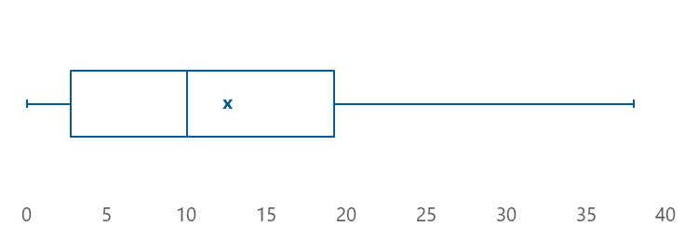

All respondents indicated feeling at least some confidence in identifying residents’ mental health needs, with the majority feeling moderately or very confident in this respect (Table 3‑3). Every respondent who expanded on their response indicated that they were very or extremely confident in identifying residents’ mental health needs, and they suggested that their previous experience in mental health (through attaining qualifications or working with mental health specialists) was the reason for this.

Table 3‑3: Health professionals’ confidence in identifying aged care residents’ mental health needs

|  |  |  |
| --- | --- | --- |
| Level of confidence | n | % |
| Not at all | 0 | 0% |
| Slightly | 1 | 4% |
| Moderately | 10 | 42% |
| Very | 10 | 42% |
| Extremely | 3 | 13% |
| Total | 24 | 100% |

We asked health professionals to provide some high-level information on their residential aged care patients. All health professionals indicated that they provided care to aged care residents from at least 3 (and up to 10) special needs groups, with the 3 most common special needs groups (cared for by more than 90% of respondents) being: people who are financially disadvantaged; veterans, war widows, and widowers; and older people with disabilities (Table 3‑4).

Table 3‑4: Proportion of health professionals providing care to residents from special needs groups

|  |  |  |  |
| --- | --- | --- | --- |
| Special needs group | Yes | No | Unsure |
| People from Aboriginal and/or Torres Strait Islander backgrounds | 29% | 58% | 13% |
| People from culturally and/or linguistically diverse backgrounds | 83% | 13% | 4% |
| People living in rural or remote Australia | 42% | 54% | 4% |
| People with disabilities | 92% | 8% | 0% |
| People of diverse sexual orientation and gender identity/identities, including LGBTI | 42% | 33% | 25% |
| Care leavers, including Forgotten Australians, Former Child Migrants, and members of the Stolen Generations | 38% | 33% | 29% |
| Veterans, war widows, and war widowers | 92% | 0% | 8% |
| People who are financially disadvantaged | 96% | 4% | 0% |
| People who are homeless or facing homelessness | 38% | 50% | 13% |
| People affected by forced adoption or removal | 29% | 38% | 33% |

Note: Percentages are based on the number of respondents that selected each response option, divided by the total number of respondents that answered the question (n = 24).

In terms of their patients’ mental health needs, respondents were most likely to indicate that moderate mental illness is the predominant presentation they encounter (Table 3‑5). Residents with severe mental illness and those at risk of but not currently experiencing mental illness rarely account for the majority of health professionals’ mental health work.

Table 3‑5: Most common level of mental illness severity that health professionals encounter in aged care residents

|  |  |  |
| --- | --- | --- |
| Severity | n | % |
| At risk | 2 | 8% |
| Mild mental illness | 7 | 29% |
| Moderate mental illness | 14 | 58% |
| Severe mental illness | 1 | 4% |
| Unsure | 0 | 0% |
| Total | 24 | 100% |

### Awareness of and support in implementing the initiative

To gauge health professionals’ perception of the service context in their region, we asked which of the 5 levels of care defined in the PHN stepped care framework are available for the aged care residents they refer. Respondents could select as many levels as they believed applied; they most commonly selected moderate-intensity services, while few were aware of the availability of acute and specialist services (Table 3‑6). This suggests relatively good awareness of PHN-commissioned services, given the initiative’s focus on level 2 and 3 services. Further, given that respondents considered mild to moderate illness to be most common among their patients, their awareness of services appropriate to this level of need is reassuring.

Table 3‑6: Levels of mental health care available for aged care residents, reported by health professionals

|  |  |  |  |
| --- | --- | --- | --- |
| Level of care | Available | Not available | Unsure |
| Level 1: Self-management | 54% | 25% | 21% |
| Level 2: Low-intensity services | 79% | 8% | 13% |
| Level 3: Moderate-intensity services | 92% | 8% | 0% |
| Level 4: High-intensity services | 38% | 46% | 17% |
| Level 5: Acute and specialist mental health services | 8% | 71% | 21% |

Note: Percentages are based on the number of respondents that selected each response option for each level of care, divided by the total number of respondents that answered the question (n = 24).

Respondents reported that they first became aware of the initiative and the availability of PHN‑commissioned services for aged care residents through their PHN, either through information sessions or workshops (n = 7; 29%) or written communication (n = 6; 25%) (Table 3‑7). Other pathways to awareness included direct contact from service providers, and promotion through other aged care support services such as the Aged Care Emergency service.

Table 3‑7: Health professionals’ pathways to becoming aware of the initiative

|  |  |  |
| --- | --- | --- |
| Pathway | n | % |
| Information session/workshop run by the PHN | 7 | 29% |
| Written communication from the PHN | 6 | 25% |
| RACF staff | 5 | 21% |
| Communication from a professional body (e.g. The Royal Australian College of General Practitioners) | 0 | 0% |
| Other | 6 | 25% |
| Total | 24 | 100% |

In relation to support from PHNs to implement the initiative and refer residents to appropriate services, health professionals most commonly indicated that they had received written information about available services (Table 3‑8).

Table 3‑8: Implementation support provided by PHNs to health professionals

|  |  |  |
| --- | --- | --- |
| Type of support | n | % |
| Written resources on available services | 14 | 74% |
| Involvement in consultations about developing appropriate referral pathways | 7 | 37% |
| Individual feedback on referrals | 7 | 37% |
| Professional development/training/workshop | 5 | 26% |
| Other | 1 | 5% |

Note: Percentages are based on the number of respondents that selected each support, divided by the total number of respondents that selected at least one type of support (n = 19).

Two out of five respondents (n = 10; 42%) reported that they had received multiple types of support, while one in five respondents (n = 5; 21%) advised that they had not received any supports or resources from their PHN.

### Referral pathways

When asked to indicate the referral pathways that they use for aged care residents who require mental health support, the majority of respondents (n = 19; 79%) selected multiple pathways. This suggests that the respondents tailor their referral approach to the needs of the resident and/or the services available. Respondents reported that they commonly used both PHN-commissioned and non-PHN-commissioned services,[6] with few health professionals indicating that they referred via the Better Access aged care expansion (Table 3‑9).

Table 3‑9: Mental health referral pathways used for aged care residents, reported by health professionals

|  |  |  |
| --- | --- | --- |
| Referral pathway | n | % |
| I refer to other support services | 20 | 83% |
| I refer to PHN-commissioned services | 17 | 71% |
| I provide mental health care myself | 10 | 42% |
| I advise on privately funded mental health care | 5 | 21% |
| I refer through Better Access | 3 | 13% |
| Other | 3 | 13% |

As well as reporting on their referral pathways overall, we also asked health professionals to indicate the referral pathways they use for members of each of the special needs groups that they provide care to (see section 3.1.1, Table 3‑4). The pattern of results mirrored that seen in Table 3‑9, with referral to PHN-commissioned services and other support services being the primary pathways. Key differences related to referrals for:

* Aboriginal and/or Torres Strait Islander peoples: Some respondents indicated that they were unsure as to the appropriate pathway or that they refer to Aboriginal mental health services where possible
* veterans, war widows, and war widowers: Respondents indicated a preference to refer to the Department of Veterans’ Affairs or other veteran-specific services.

Additionally, we invited respondents to comment further on the referral pathways they use. Their responses highlighted that the ability to select an appropriate pathway hinges on awareness of both the pathways themselves and the services they lead to. Several respondents perceived the scarcity of resources and lack of information on available services to be a barrier to appropriate referral, while others noted that developing good relationships with PHN-commissioned service providers had helped them to gain an understanding of the service landscape. One respondent commented that although they refer to PHN-commissioned and other support services if required, their preferred option is to recommend privately funded care if the resident has private health insurance and a mental health practitioner is available within a timely period (the respondent did not expand further on why this was the case).

### Perceived effectiveness of the initiative

The majority of health professionals felt that the initiative has improved the mental health of aged care residents in their region (Figure 3‑2). Only one respondent believed that this was not the case, due to services being underutilised by residents, challenges associated with the COVID-19 pandemic, and workforce shortages. One person who indicated that the initiative has only partly achieved its objectives reflected that this is due to service capacity in their region being constrained by resourcing limitations.

Figure 3‑2: Health professionals’ perceptions of whether the initiative has improved the mental health of aged care residents

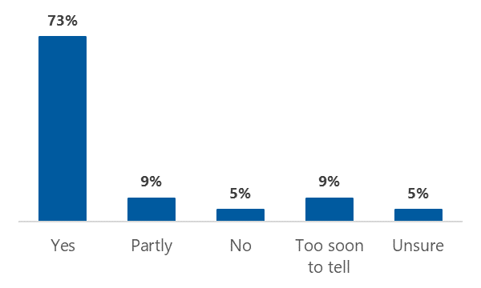

Note: Percentages are based on the number of respondents that selected each option, divided by the total number of respondents to this question (n = 22).

Lastly, we invited respondents to suggest how the initiative could be improved to better support aged care residents’ mental health. Two respondents provided only positive feedback: one indicated that they found the referral process efficient and effective; the other commented on the value of the initiative in providing older people with choice and support that was not previously available. GPs suggested a need for greater promotion of the initiative – noting that they became aware of it only through this evaluation or their own research – and for improved information sharing about their patients’ progress and outcomes after referral. Another respondent reflected that although residents could be reluctant to accept help, all those who had accessed the services had experienced benefits; this respondent suggested that better conveying these benefits to other residents could help to improve uptake. Finally, other comments related to the impact of COVID-19 on the uptake of services, the need to support RACF staff as well as residents, the importance of sufficient program funding and mental health practitioner salaries to ensure high-quality care, and the potential to improve crisis support and referral pathways for residents with cognitive impairment.

## Mental health practitioners

### Characteristics of respondents and their clients

Nearly the entire sample of 73 mental health practitioners indicated that they are employed (n = 46; 72%) or contracted (n = 15; 23%) by an organisation that has been commissioned by their PHN, with only a handful (n = 3; 5%) being directly contracted by their PHN as a sole practitioner. Nine respondents did not disclose their relationship to their PHN. The duration of respondents’ engagement with the initiative varied, from early adopters who first started delivering services to residents in early 2018, to one person who was only just becoming involved at the time of our survey and had not yet commenced service delivery.

As would be expected, mental health practitioners indicated greater confidence in identifying aged care residents’ mental health needs than their health professional counterparts, with most feeling very or extremely confident (Table 3‑10). Similar to health professionals, those mental health practitioners who expanded on their response suggested that this was due to their previous experience in mental health (through attaining qualifications or working with mental health specialists). Consistent with these perspectives, the one respondent (a counsellor) who was not at all confident in their ability to identify mental health needs attributed this to their limited tertiary-level training in psychology. This individual also had limited work experience in the aged care setting, having commenced working with RACF residents relatively recently.

Table 3‑10: Mental health practitioners’ confidence in identifying aged care residents’ mental health needs

|  |  |  |
| --- | --- | --- |
| Level of confidence | n | % |
| Not at all | 1 | 1% |
| Slightly | 1 | 1% |
| Moderately | 12 | 16% |
| Very | 37 | 51% |
| Extremely | 22 | 30% |
| Total | 73 | 100% |

Like health professionals, more than half of the mental health practitioners who estimated their clients’ level of mental health needs indicated that moderate mental illness is most common (Table 3‑11). Few mental health practitioners primarily care for residents at risk of but not currently experiencing mental illness, or those at the other end of the spectrum who are experiencing severe mental illness.

Table 3‑11: Most common level of mental illness severity that mental health practitioners encounter in aged care residents

|  |  |  |
| --- | --- | --- |
| Severity | n | % |
| At risk | 1 | 2% |
| Mild mental illness | 22 | 34% |
| Moderate mental illness | 37 | 58% |
| Severe mental illness | 2 | 3% |
| Unsure | 2 | 3% |
| Total | 64 | 100% |

### Service delivery characteristics

On average, respondents reported that they deliver initiative-funded psychological services to 25 residents per month, with half indicating that they see between 10 and 34 residents per month (Figure 3‑3).

Figure 3‑3: Number of residents seen by mental health practitioners per month

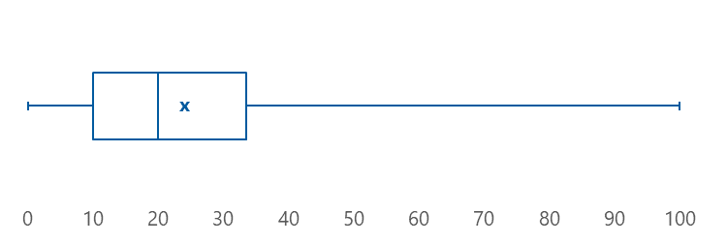

Note: Nine respondents did not provide any information on the number of aged care residents they see under the initiative.

These residents are most frequently referred by RACF staff (Table 3‑12), with the majority of practitioners (n = 56; 88%) indicating they receive referrals from multiple sources.

Table 3‑12: Sources of initiative referrals, reported by mental health practitioners

|  |  |  |
| --- | --- | --- |
| Referrer | n | % |
| RACF staff | 55 | 86% |
| General practitioners | 50 | 78% |
| Nurses | 43 | 67% |
| Residents and/or their family members | 29 | 45% |
| Social workers | 11 | 17% |
| Psychologists | 9 | 14% |
| Occupational therapists | 9 | 14% |
| Aboriginal health workers | 3 | 5% |
| Other | 5 | 8% |

Note: More than one response option could be selected. Percentages are based on the total number of responses for each option, divided by the total number of respondents for this question (n = 64).

We asked mental health practitioners how long residents need to wait for their first appointment after being referred. Most indicated that the wait time was between one week and one month, with few practitioners indicating that their clients wait longer than one month (Figure 3‑4).

Figure 3‑4: Mental health practitioner-reported time from referral to first session of mental health care

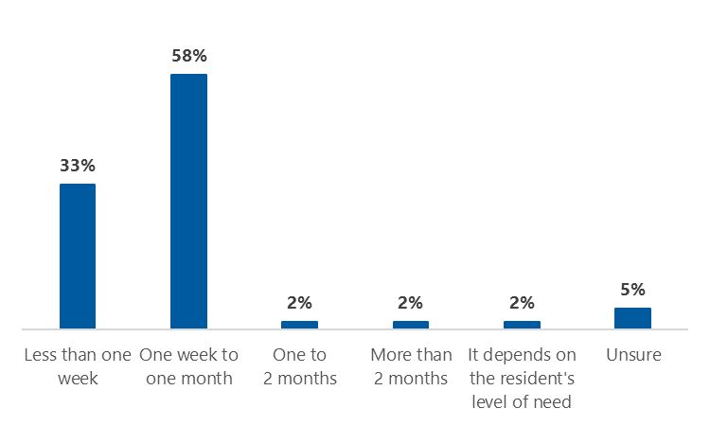

Note: Percentages are based on the number of respondents that selected each option, divided by the total number of respondents to this question (n = 64).

To gauge in greater detail the type of support that mental health practitioners deliver under the initiative, we asked which of the 5 levels of care defined in the PHN stepped care framework they provide to aged care residents. Respondents could select as many levels as applicable, with most indicating that they provide moderate- or low-intensity services (Table 3‑13). This finding is consistent with practitioners’ reports that residents typically experience mild to moderate mental illness, and implies that the initiative is meeting its objective to improve access to care for residents with mild to moderate mental health needs.

Table 3‑13: Levels of mental health care provided by mental health practitioners under the initiative

|  |  |  |
| --- | --- | --- |
| Level of care | n | % |
| Level 1: Self-management | 21 | 34% |
| Level 2: Low-intensity services | 39 | 64% |
| Level 3: Moderate-intensity services | 46 | 75% |
| Level 4: High-intensity services | 18 | 30% |
| Level 5: Acute and specialist mental health services | 3 | 5% |

Note: More than one response option could be selected. Percentages are based on the number of responses for each option, divided by the total number of respondents that selected any of the 5 levels of care (n = 61).

To gain a better understanding of what service delivery looks like at different levels of intensity, we asked respondents to indicate the format and modality of support they provide for each level of care that they selected. At all levels, individual support is the most common, but it accounts for an increasing proportion of service delivery as the level of intensity increases (Figure 3‑5). In contrast, access to both group and individual support is more likely at lower levels of care.

Figure 3‑5: Format of support provided by mental health practitioners to residents, at each level of care

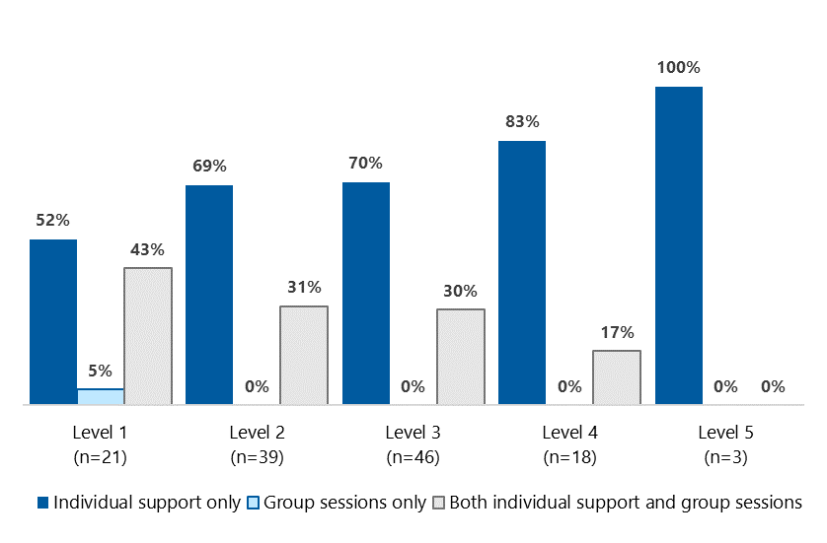

Almost all mental health practitioners offer face-to-face support onsite at residents’ RACF, with telephone or video support the next most common (Table 3‑14). There was no interaction between the level and modality of care, the one exception being that acute and specialist care is not delivered online.

Table 3‑14: Modality of support provided by mental health practitioners to residents, across all levels of care

|  |  |  |
| --- | --- | --- |
| Modality | n | % |
| Face-to-face at the RACF | 58 | 91% |
| Over the telephone | 27 | 42% |
| Over video | 26 | 41% |
| Face-to-face at another location | 5 | 8% |
| Online | 2 | 3% |
| Other | 0 | 0% |
| Total number of respondents | 64 | 100% |

### PHN support for service delivery

One in three (n = 24; 38%) practitioners had received multiple types of support from their PHN to deliver services under the initiative, with the most common type of support being assistance with developing referral pathways (Table 3‑15). However another 1 in 3 respondents (n = 22; 34%) advised that they have not received any supports or resources from their PHN, and 2 of the 5 practitioners that indicated an ‘other’ type of support went on to explain that they have no direct contact with the PHN so are unsure what supports are being provided (i.e. they are unclear whether the PHN or their organisation is responsible for the support that they receive).

Table 3‑15: Service delivery support provided by PHNs to mental health practitioners

|  |  |  |
| --- | --- | --- |
| Type of support | n | % |
| Assistance with developing referral pathways | 21 | 50% |
| Assistance with entering minimum dataset data | 20 | 48% |
| Written resources (e.g. guidance, pamphlets) | 17 | 40% |
| Professional development/training/workshops | 13 | 31% |
| Options for stepping clients down or up to other services | 11 | 26% |
| Clinical supervision | 7 | 17% |
| Other | 5 | 12% |

Note: Percentages are based on the number of respondents that selected each support, divided by the total number of respondents that selected at least one support type (n = 42).

### Challenges in delivering services under the initiative

When asked if they have encountered any specific challenges in delivering services to aged care residents under the initiative, 51 of the 63 respondents (81%) answered in the affirmative. For those that expanded on this response, the main challenges identified were associated with characteristics of their organisation and service model, RACFs and staff, and residents themselves. Several mental health practitioners reported that these difficulties were compounded by the impact of COVID-19.

At the organisational and service model level, practitioners experienced difficulties with a lack of flexibility. They felt trapped by ‘guidelines that are rigid and do not take into account the individual’, and they wanted greater freedom to tailor the number of sessions and the type and timing of assessments to residents’ needs and abilities. Moreover, some respondents reported a ‘morale-destroying’ focus on numbers and throughput, and one felt that the administrative burden associated with PHN reporting reduces the time that they can dedicate to resident care. Some respondents noted challenges associated with referral pathways, such as the need for a GP referral, processes being ‘clunky’ and off-putting for RACF staff, and a service gap meaning that residents with more severe presentations have nowhere to be stepped up to.

In terms of RACF staff, a key barrier to service delivery for mental health practitioners was a lack of awareness of the initiative and gaps in knowledge of the mental health issues of the resident population. Due to high staff turnover and demanding workloads, respondents found it difficult to raise awareness of the initiative and provide staff with training to address the gaps in knowledge. One respondent also noted that time constraints are a barrier to RACF staff supporting recommended management strategies (e.g. behavioural activation). Respondents had also experienced challenges related to the RACF environment, such as the need to fit appointments in around the facility’s schedule (e.g. shower and meal times) and visits from family or other health practitioners. Further, respondents identified that some RACFs lack an appropriate, confidential location for service delivery. One individual noted that face-to-face sessions must often be conducted in the resident’s room, but that this may not be the resident’s preference. Another respondent commented that telehealth appointments are conducted in more public spaces in RACFs that do not have telephone or internet access in resident rooms. During COVID-19, practitioners found restrictions on face-to-face visits and the transition to telehealth particularly challenging, noting that staff assistance is often required to set up technology and that telehealth appointments are more easily missed or forgotten than those conducted onsite.

The older population are so much more resilient than younger people and often tell me that I should not waste time with them as there must be other people who need my help more than they do. They are very selfless, so getting through that barrier takes time.

Social worker with mental health training

In terms of resident characteristics, mental health practitioners suggested that aged care residents can be more hesitant than other populations to engage in mental health services, due to stigma about mental health specifically and a reluctance to accept help more generally. Further, residents’ *ability* to effectively engage is often impeded by cognitive and physical decline. Respondents noted that residents with dementia experience difficulties understanding and retaining awareness of supports available under the initiative, and that mental health care can be hampered by many other obstacles – from hospitalisations for acute and episodic health issues, to sub-optimal management of chronic and relatively uncomplicated issues (e.g. hearing loss).

### Perceived effectiveness of the initiative

Overall, mental health practitioners felt that the initiative has improved the mental health of aged care residents in their region (Figure 3‑6). Only one respondent indicated otherwise, commenting that they have not yet received any referrals under the initiative.

Figure 3‑6: Mental health practitioners’ perceptions of whether the initiative has improved the mental health of aged care residents

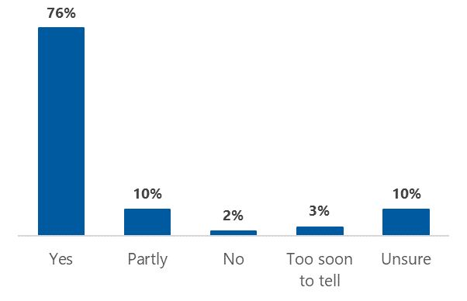

Note: Percentages are based on the number of respondents that selected each option, divided by the total number of respondents for this question (n = 63).

Practitioners provided several suggestions for how the initiative could be better designed, promoted, or supported to address aged care residents’ mental health needs. Several respondents identified a need for service models to incorporate a more holistic approach to care – for example, by expanding to include more narrative and reminiscence therapies, group sessions, and music, art and animal-assisted therapy. These aspects of service design were seen as important supplements to more traditional psychological services, with benefits including increased social connection and enhanced outcomes for residents.

Not surprisingly given the challenges noted above, practitioners frequently suggested that raising mental health literacy and awareness of available supports among RACF staff would be beneficial in increasing referrals and service uptake. Some respondents provided examples of how this could be achieved, such as requiring RACFs who wish to take part in the initiative to make their staff available for training, or to include information about the service and referral pathways as part of staff induction processes. One individual also suggested they would like to see staff training expanded to address topics such as grief and loss, and a more collaborative approach where mental health practitioners attend RACF clinical meetings.

Lastly, respondents felt that improving provision of psychological services within RACFs requires additional funding to enable more practitioners to visit RACFs more regularly and provide more sessions. Individual practitioners also noted a need for increased funding to:

* better support practitioners with access to relevant resources and paid clinical supervision
* support assistive technology to improve residents’ ability to engage in telehealth
* support RACF staff, particularly lifestyle teams, to better manage residents’ mental health needs
* address structural issues in the way that RACFs are designed and operate, which impact residents’ mental health and the effectiveness of available supports (see challenges discussed in section 3.2.4).

## Service provider managers

### Commissioning and service delivery arrangements

One-quarter (n = 11; 23%) of the 47 service provider managers who completed the survey advised that they have been commissioned by more than one PHN to deliver services under the initiative, and just under three-quarters (n = 33; 70%) reported that they also receive PHN funding to deliver psychological services in other settings. As expected, most managers indicated that their organisation is commissioned to deliver low- to moderate-intensity services, while a handful indicated that they also offer acute and specialist services (Table 3‑16).

Table 3‑16: Levels of mental health care offered by service providers under the initiative

|  |  |  |  |
| --- | --- | --- | --- |
| Level of care | Offered | Not offered | Unsure |
| Level 1: Self-management | 55% | 40% | 4% |
| Level 2: Low-intensity services | 89% | 9% | 2% |
| Level 3: Moderate-intensity services | 94% | 6% | 0% |
| Level 4: High-intensity services | 30% | 62% | 9% |
| Level 5: Acute and specialist mental health services | 9% | 87% | 4% |

Note: More than one response option could be selected. Percentages are based on the number of respondents that selected each response option for each level of care, divided by the total number of respondents that answered this question (n = 47).

Reach and throughput of services was highly varied, with respondents indicating that since first being commissioned under the initiative, their organisation has supported between 0 and 3,000 residents (M = 488, SD = 706) from between 0 and 202 RACFs (M = 46, SD = 57). Four out of five (n = 79%) respondents indicated that their organisation engages multiple types of practitioners to deliver these services, with social workers with mental health training and psychologists being most common (Table 3‑17).

Table 3‑17: Types of practitioners engaged to deliver mental health services under the initiative

|  |  |  |
| --- | --- | --- |
| Type of practitioner | n | % |
| Social workers with mental health training | 35 | 74% |
| Psychologists | 33 | 70% |
| Mental health nurses | 28 | 60% |
| Low-intensity mental health workers | 15 | 32% |
| Occupational therapists with mental health training | 5 | 11% |
| Psychosocial support workers | 5 | 11% |
| Peer support workers | 5 | 11% |
| GPs | 4 | 9% |
| Psychiatrists | 3 | 6% |
| Other medical specialists | 3 | 6% |
| Aboriginal and/or Torres Strait Islander health/mental health workers | 0 | 0% |
| Other | 6 | 13% |

Note: Respondents could select multiple options. Percentages are based on the number of respondents that selected each option, divided by the total number of respondents to this question (n = 47).

### Support to implement the initiative

One in 10 service provider managers (n = 5; 11%) reported they have not received any support from their PHN to assist in the initiative’s implementation. The remainder had received a range of supports, the most common being assistance with developing referral pathways and entering data into the Primary Mental Health Care Minimum Data Set (PMHC MDS) (Table 3‑18).

Table 3‑18: Supports provided by PHNs to service providers to assist with implementing the initiative

|  |  |  |
| --- | --- | --- |
| Support | n | % |
| Assistance with developing referral pathways | 24 | 60% |
| Assistance with entering PMHC MDS data | 24 | 60% |
| Written resources (e.g. guidance, pamphlets) | 23 | 58% |
| Professional development/training/workshops | 16 | 40% |
| Options for stepping clients up or down to other services | 12 | 30% |
| Clinical supervision | 2 | 5% |
| Other | 7 | 18% |

Note: Respondents could select multiple options. Percentages are based on the number of respondents that selected each support type, divided by the total number of respondents that selected at least one support type (n = 40).

We then asked managers about the support that their organisation has provided to the practitioners they engage to deliver services under the initiative. Almost all managers indicated that they assist with developing referral pathways and provide written resources such as pamphlets (Table 3‑19), although a small number of respondents (n = 2; 4%) reported that they were not aware of any support available to practitioners engaged by their organisation.

Table 3‑19: Supports provided by service provider organisations to assist mental health practitioners to deliver services under the initiative

|  |  |  |
| --- | --- | --- |
| Support | n | % |
| Assistance with developing referral pathways | 40 | 93% |
| Written resources (e.g. guidance, pamphlets) | 40 | 93% |
| Professional development/training/workshops | 36 | 84% |
| Assistance with entering minimum dataset data | 36 | 84% |
| Clinical supervision | 35 | 81% |
| Options for stepping clients down or up to other services | 30 | 70% |
| Other | 8 | 19% |

Note: Respondents could select multiple options. Percentages are based on the number of respondents that selected each support type, divided by the total number of respondents that selected at least one support type (n = 43).

#### Strategies to raise awareness of services and encourage referrals

Nine out of ten (n = 37; 93%) managers advised that their organisation raised awareness of available supports among RACF staff and residents via a multifaceted approach, with written communication from the service provider being more common than activities led by the PHN (Table 3‑20). Only 2 respondents indicated that they were not aware of any strategies in place to raise RACF awareness of the initiative.

Table 3‑20: Strategies to raise awareness of available supports among RACF staff and residents

|  |  |  |
| --- | --- | --- |
| Awareness-raising strategy | n | % |
| Written communication to RACFs from the service provider | 37 | 88% |
| Information sessions or in-services run by the service provider | 36 | 86% |
| Promotion on the service provider’s website | 29 | 69% |
| Written communication to RACFs from the PHN | 19 | 45% |
| Promotion on the PHN’s website | 18 | 43% |
| Information sessions or in-services run by the PHN | 13 | 31% |
| Other | 5 | 17% |

Note: Respondents could select multiple options. Percentages are based on the number of respondents that selected each strategy, divided by the total number of respondents that selected at least one strategy (n = 42).

Managers also indicated that their organisation used multiple strategies to encourage referrals to the service from GPs and others, with written communication from the service provider to RACFs again being the most common strategy (Table 3‑21). Four respondents (9%) could not identify any activities that their organisation or PHN used to encourage referrals.

Table 3‑21: Strategies to encourage GPs and others to refer to initiative-funded services

|  |  |  |
| --- | --- | --- |
| Strategy to encourage referrals | n | % |
| Written communication to RACFs from the service provider | 34 | 85% |
| Information sessions or in-services run by the service provider | 31 | 78% |
| Promotion on the service provider’s website | 28 | 70% |
| Promotion on the PHN’s website | 23 | 58% |
| Written communication to GPs from the service provider | 22 | 55% |
| Written communication to RACFs from the PHN | 18 | 45% |
| Written communication to GPs from the PHN | 17 | 43% |
| Information sessions or in-services run by the PHN | 16 | 40% |
| Other | 4 | 8% |

Note: Respondents could select multiple options. Percentages are based on the number of respondents that selected each strategy, divided by the total number of respondents that selected at least one strategy (n = 40).

### Challenges in delivering services under the initiative

Just under two-thirds (63%) of respondents indicated that adapting their organisation’s model of service delivery for residential aged care was a challenge. These managers identified several similar issues to those raised by mental health practitioners, including:

* the impact of RACF structure, staff workload, and staff turnover on staff members’ ability to participate in capacity-building sessions, facilitate telehealth appointments, and support residents to implement self-management strategies. One respondent noted that the time required to collaborate with RACF staff to ensure that residents are well supported has been a factor that they had not initially considered
* scheduled appointments being disrupted by hospital admissions, impromptu family visits, and personal care
* the stigma associated with mental health in the older population and their declining physical and cognitive abilities, which present additional considerations for consent processes and power imbalances, and increase the time required to build rapport
* uncertainty over how to select and administer outcome measures that are suitable for the resident population. Respondents considered the K10 to be too long and confusing for older people, but these respondents were also unsure of an appropriate alternative.

In addition, managers discussed several challenges not reported by mental health practitioners – most notably, a shortage of these practitioners, an unsustainable funding structure, and the geographic distance between RACFs and the associated travel burden. One respondent also reflected that the stepped care model is new to RACFs and is not well suited to this setting, but this manager did not elaborate on why this may be the case.

### Perceived effectiveness of the initiative

As with health professionals and mental health practitioners, the majority of service managers felt that the initiative has improved the mental health of aged care residents in their region (Figure 3‑7). Four of the 5 individuals who believed that this objective has only partly been met explained why this is the case. They reiterated the challenges associated with limited RACF time to facilitate referrals and support residents to implement self-management strategies, COVID-19 lockdowns limiting RACF access, and competing demands on RACFs in the wake of the royal commission. One manager also reflected that the initiative has only been partly effective due to stigma-related barriers to engaging residents; however, this manager noted that these issues are resolving after the program name was changed to relate to ‘wellbeing’ rather than mental health.

Figure 3‑7: Service provider managers’ perceptions of whether the initiative has improved the mental health of aged care residents

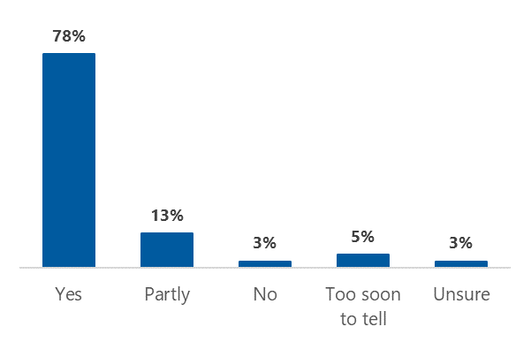

Note: Percentages are based on the number of respondents that selected each option, divided by the total number of respondents for this question (n = 40).

Finally, as well as calling for guidance on appropriate outcome measures (echoing their identification of current measures as a significant challenge to date), managers resoundingly called for increased and ongoing funding to improve the initiative and better support aged care residents’ mental health. Like mental health practitioners, they identified that expanded funding would allow their organisation to engage with more RACFs and more residents and to provide a more holistic suite of support options (including formal psychological services and complementary approaches such as befriending and music and animal therapies). Further, a small number of respondents suggested that ensuring RACFs are adequately resourced is key to enhancing the initiative’s impact. As one individual commented, ‘We just need to ensure that there are no gaps in mental health services to RACFs. They have incredibly difficult jobs and need to be supported as much as possible, so that the residents are supported.’

# Resident survey results

Between 11 and 21 November 2021, we received a total of 162 resident survey responses. Of these, we excluded 41 (25%) from the analysis due to insufficient data (defined as less than 50% of questions completed), leaving a final sample of 121 surveys. Most of these surveys were completed in full, as shown in Table 4‑1.

Table 4‑1: Proportion of surveys completed by respondents included in analysis

|  |  |  |
| --- | --- | --- |
| Proportion of survey completed | n | % |
| 50% to 74% | 4 | 3% |
| 75% to 99% | 9 | 7% |
| 100% | 108 | 89% |
| Total | 121 | 100% |

We calculated descriptive statistics for each multiple-choice question and used thematic analysis for open-ended questions. Within the completed surveys, the number of respondents per question varied due to: skip logic (i.e. a question being displayed to only a subgroup of respondents, based on their answers to previous questions); respondents choosing not to answer a particular question; or respondents leaving the survey early. We analysed each question independently, irrespective of response patterns to the survey overall, to ensure that no information was lost. As such, the denominator for analysis varies in the analyses presented below.

## Respondent characteristics

Although the survey was targeted at RACF residents, we provided options for residents to be supported to complete it, due to the particular needs and preferences of this population. Around one-quarter of surveys (n = 29; 27%) were completed by the resident alone, while half (n = 56; 51%) were completed by the resident with assistance. Less often, the survey was completed by a supporter on the resident’s behalf (n = 14; 13%) or an ‘other’ respondent type (n = 9; 8%). Where respondents selected the ’other’ category, they either declined to provide further information or indicated their relationship to the resident, implying that the survey was completed with assistance or on the resident’s behalf without specifying which of these was the case. As shown in Table 4‑2, RACF staff members were the most likely to have either lent assistance or completed the survey on the resident’s behalf (n = 34; 45%), followed by mental health care providers (n = 31; 41%). The latter included both mental health practitioners and other representatives of the service provider organisation (specifically, a stakeholder engagement coordinator).

Table 4‑2: Types of supporters who assisted residents to complete the survey or filled it out on their behalf

|  |  |  |
| --- | --- | --- |
| Supporter type | n | % |
| RACF staff member | 34 | 45% |
| Mental health care provider | 31 | 41% |
| Family or friend | 5 | 7% |
| GP or other health professional | 1 | 1% |
| Other | 5 | 7% |
| Total | 76 | 100% |

Note: Respondents who chose not to provide information on who completed the survey, and those who indicated they were an aged care resident who completed the survey alone, were excluded from this analysis. ‘Other’ supporter types included volunteer and guardian (no further details were provided for either).

We did not identify any systematic differences between responses submitted by residents alone and responses submitted with support. We have therefore collated the information from all participants in the results that follow.

In terms of geographic distribution, we received survey responses from 12 of the 31 PHN regions, located in 5 of Australia’s 8 states and territories. PHN 27 had the highest number of responses, accounting for one-quarter of completed surveys overall (Table 4‑3).

Table 4‑3: Resident surveys received, by deidentified PHN region

|  |  |  |
| --- | --- | --- |
| PHN region | n | % |
| PHN 27 | 27 | 24% |
| PHN 9 | 23 | 21% |
| PHN 24 | 17 | 15% |
| PHN 6 | 16 | 14% |
| PHN 2 | 7 | 6% |
| PHN 17 | 5 | 4% |
| PHN 20 | 4 | 4% |
| PHN 29 | 3 | 3% |
| PHN 7 | 3 | 3% |
| PHN 23 | 3 | 3% |
| PHN 4 | 3 | 3% |
| PHN 8 | 1 | 1% |
| Total | 112 | 100% |

Note: Residents were asked to provide their postcode, which we mapped to PHNs using the department’s concordance table: <https://www.health.gov.au/resources/publications/primary-health-networks-phn-concordance-files-postal-areas-2017> (accessed 22 November 2021). Residents who did not provide their postcode (n = 9) were excluded from this analysis.

All survey respondents identified as either male (n = 42; 35%) or female (n = 79; 65%), although they also had the option to disclose a different gender identity or decline to answer. Just over half of respondents (n = 62; 51%) identified as being a member of one or more of the special needs groups defined in the Aged Care Act 1997 and/or My Aged Care system.[7] These respondents identified as members of between one (n = 42; 68%) and 4 (n = 2; 3%) special needs groups, most commonly indicating that they have a disability, come from a CALD background, or are financially disadvantaged (Table 4‑4). In subsequent analyses, we considered differences in response patterns between these 3 special needs groups, between residents identifying as a member of any special needs group and not, and between men and women. For brevity, in the sections that follow we report the results of these analyses only where differences between subgroups were observed. Note that small numbers mean that these findings should be interpreted with caution.

Table 4‑4: Residents’ self-reported membership of aged care special needs groups

|  |  |  |
| --- | --- | --- |
| Special needs group | n | % |
| Has a disability | 35 | 56% |
| Comes from a CALD background | 19 | 31% |
| Is financially disadvantaged | 16 | 26% |
| Lives in a rural or remote area | 8 | 13% |
| Is a veteran, war widow or war widower | 8 | 13% |
| Is Aboriginal and/or Torres Strait Islander | 2 | 3% |
| Is lesbian, gay, bisexual, trans, intersex, or another diverse sexual orientation or gender identity | 1 | 2% |
| Is homeless or facing homelessness | 1 | 2% |
| Is a Care Leaver, including a Forgotten Australian, Former Child Migrant, or member of the Stolen Generations | 0 | 0% |
| Has been affected by forced adoption or removal | 0 | 0% |
| Any special needs group | 62 | 51% |

Note: Respondents could select more than one group. Percentages are based on the number of respondents that selected each option, divided by the total number of respondents who selected at least one group (n = 62).

## Awareness of available mental health support

Because of the regional differences in branding, we were unable to assess residents’ awareness of the initiative specifically. Instead, we asked if they were aware, prior to the survey, of a program to provide mental health care to aged care residents. Over half of the survey respondents indicated that they were aware of such a program (n = 69; 57%), with awareness slightly higher among women (n = 48; 61%) than men (n = 21; 50%). Additionally, people who identified as a member of at least one special needs group were more likely to report awareness of a mental health program (n = 28; 45%) than those who reported no special needs group affiliation (n = 41; 69%). There were also variations in awareness among specific special needs groups; those who identified as coming from a CALD background were more likely to be aware of available mental health care than those who are financially disadvantaged or have a disability (Figure 4‑1).

Figure 4‑1: Proportion of residents who are aware of a program for mental health care, by special needs group

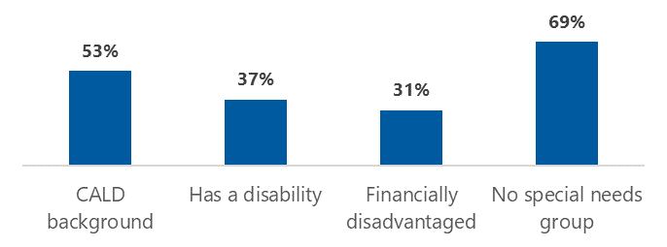

Note: Percentages are based on the proportion of people within each group who responded to this question. CALD background, n = 19; has a disability, n = 35; financially disadvantaged, n = 16; no special needs group, n = 59.

We were also interested in how residents find out that mental health care is available within their RACF. As shown in Table 4‑5, RACF staff play by far the most important role in raising awareness, with doctors and other health professionals a distant second. Eight residents indicated that they learned of their options for mental health care through some other source; the most common of these ‘Other’ responses was via a visit to the RACF from the PHN’s commissioned provider.

Table 4‑5: How residents found out about the options for mental health care at their RACF

|  |  |  |
| --- | --- | --- |
| Response | n | % |
| Told by a member of RACF staff | 59 | 56% |
| Told by doctor or other health professional | 19 | 18% |
| Information around the RACF (e.g. posters, newsletters) | 12 | 11% |
| Told by a family member or friend | 8 | 7% |
| Told by another resident | 3 | 3% |
| Information in the media or online | 2 | 2% |
| N/A, not aware of mental health care at the RACF | 6 | 6% |
| Unsure | 8 | 7% |
| Other | 12 | 1% |
| Prefer not to say | 1 | 1% |

Note: More than one response option could be selected. Percentages are based on the number of respondents that selected each option, divided by the total number of respondents for this question (n = 106).

## Experiences of mental health care in RACFs

Just over two-thirds of residents indicated that they have received mental health care since moving into their current RACF (n = 82; 68%). Mental health care was slightly more common among residents who identified with at least one special needs group than those who did not (73% vs 63%), with this difference driven by higher rates of care among residents reporting financial disadvantage (88%) or a disability (83%). The majority of respondents had most recently received mental health care in 2021 (Table 4‑6) and, consistent with the initiative’s gradual rollout, this most recent episode was also the only time that most (n = 54; 66%) had accessed mental health support since moving into residential care.

Table 4‑6: Year that respondents most recently received mental health care

|  |  |  |
| --- | --- | --- |
| Response | n | % |
| 2021 | 72 | 88% |
| 2020 | 6 | 7% |
| 2019 | 2 | 2% |
| 2018 or earlier | 1 | 1% |
| Unsure | 0 | 0% |
| Prefer not to say | 1 | 1% |
| Total | 82 | 100% |

Note: Respondents who had not received mental health care, or were unsure if they had, were excluded from this analysis (n = 39).

For the reasons noted in section 4.2, we could not ask residents specifically about their experiences of mental health care under the initiative. However, to gauge whether their feedback was likely to relate to PHN-funded support, we invited residents to provide the name of their service provider. Over half of the respondents who had received mental health care remembered which organisation their mental health practitioner was from (n = 44; 55%), and all but one of those who expanded on their response specified service providers that are commissioned to deliver services under the initiative. Consistent with residents from PHN 27 representing the largest proportion of respondents, the program delivered in this region was the most commonly named (n = 12). A service provider operating in PHNs 20 and 24 (among other PHNs not represented in the survey data) was the second-most frequently mentioned, with 10 residents recalling that their mental health practitioner came from this organisation.

### Help-seeking and referrals

When asked why they sought help for their mental health, more than half of residents indicated that they did so because a staff member at their RACF suggested it, while a little over one-third reported that they were not coping with day-to-day life (Table 4‑7). Note that these options are not mutually exclusive, and residents could report that multiple factors influenced their decision to seek help. Of the residents who selected ‘other’ and elaborated on their response, some suggested they were unsure about their reasons for accessing mental health care while others hinted at ongoing mental health issues or previous engagement with mental health care, or mentioned physical injuries impacting mental health. One resident indicated that they had not chosen to seek help but had been referred by a staff member without being consulted.

Table 4‑7: Residents’ main reason for seeking help with mental health

|  |  |  |  |  |
| --- | --- | --- | --- | --- |
| Reason for seeking mental health care | | n | | % |
| Staff at the aged care home suggested it | | 46 | | 57% |
| I felt I was not coping with day-to-day life | | 29 | | 36% |
| I experienced something that was very upsetting | | 23 | | 28% |
| My symptoms were getting worse | | 19 | | 23% |
| I felt I needed professional help | | 19 | | 23% |
| A GP or other doctor suggested it | | 14 | | 17% |
| A friend or family member suggested it | | 8 | | 9% |
| Other | 8 | | 12% | |

Note: Respondents could select more than one option. Percentages are based on the number of respondents that selected each option, divided by the total number of respondents for this question (n = 81).

Consistent with their role in raising awareness of available mental health supports and suggesting to residents that they access them, RACF staff appeared to play a critical role in subsequently initiating referrals. They represented by far the most common referral source (Table 4‑8), although it is worth noting that this may also be a function of the lack of visibility of the referral process to residents and the frequency of their interactions with RACF staff compared to GPs.

Table 4‑8: Source of referral for mental health care

|  |  |  |
| --- | --- | --- |
| Referrer | n | % |
| RACF staff | 56 | 68% |
| GP | 6 | 7% |
| Another health professional | 5 | 6% |
| Self | 4 | 5% |
| Family member or friend | 4 | 5% |
| Other | 4 | 5% |
| I prefer not to say | 2 | 2% |
| Unsure | 1 | 1% |
| Total | 82 | 100% |

### Satisfaction with information provided

Only half of residents felt that they were provided with all the information they needed about what to expect from their referral to a mental health practitioner (Table 4‑9). This information was provided by their mental health care practitioner, RACF staff, or both. Moreover, other residents indicated that RACF staff were not able to provide much detail about the service, and one resident had asked their GP and been left with unanswered questions. Where residents expanded on what specifically they would have liked to know more about, they suggested a need for further information about how the service could help them and how much time it would take. There was one respondent who indicated that the service ‘came as a knock on the door’, suggesting they had either been provided with no information about what to expect, or that the information was presented in a way that was not meaningful or memorable.

Table 4‑9: Resident perspectives of the adequacy of information given upon referral to mental health care

|  |  |  |
| --- | --- | --- |
| Response | n | % |
| Yes, I was provided with all the information I needed | 39 | 49% |
| I was given some information, but it didn’t answer all my questions | 18 | 23% |
| I didn’t get any information about what to expect from the referral | 11 | 14% |
| Unsure | 11 | 14% |
| Total | 79 | 100% |

Residents who did not identify as a member of any of the special needs groups were more likely to feel satisfied with the information they received (n = 24; 67%) than their counterparts who belonged to at least one of these groups (n = 15; 35%) (Figure 4‑2). Of particular concern, only 15% (n = 4) of those with a self-reported disability indicated that they were provided with all the information they needed about what to expect from their mental health referral. In contrast, residents from a CALD background were almost as likely to be satisfied with the information they received as residents with no special needs group membership. An important caveat here, however, is the impact of cultural differences on willingness to express dissatisfaction with health or other care.

Figure 4‑2: Proportion of residents satisfied with the information they received about what to expect from their referral to mental health care, by special needs group

Figure 4.1 is bar chart showing the percentages 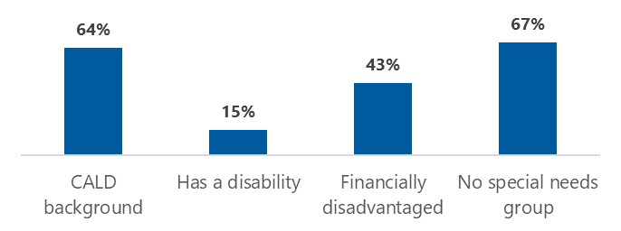

Note: Percentages are based on the proportion of people within each group who responded to this question. CALD background, n = 11; has a disability, n = 27; financially disadvantaged, n = 14; no special needs group, n = 36.

Respondents appeared to be generally satisfied with the way that their mental health practitioner explained their practitioner role when they first met, with close to 80% reporting that the practitioner had done so ‘very’ or ‘somewhat’ well (Table 4‑10). Among the respondents in special needs groups, residents from a CALD background were more likely to be satisfied with how their mental health practitioner explained their practitioner role (n = 9; 91%), while those with a disability were, again, generally less positive about the information they received (n = 19; 64%). Residents with a disability did not provide any explanation as to why this may be the case.

Table 4‑10: Resident perspectives of how well mental health practitioners explained their practitioner role

|  |  |  |
| --- | --- | --- |
| Response | n | % |
| Very well | 47 | 59% |
| Somewhat well | 16 | 20% |
| Moderately well | 4 | 5% |
| Slightly well | 3 | 4% |
| Not well at all | 1 | 1% |
| Unsure | 9 | 11% |
| Total | 80 | 100% |

### Service characteristics

About half of residents who had received mental health care waited between one week and one month for their first session after being referred to the service (Table 4‑11). Many were unsure of the wait time, perhaps reflecting, as noted in section 4.3.1, a lack of visibility of and information about the referral process. Compared to females, males were more likely to report that their first session was less than a week after referral, but males were also more likely to be unsure about how long they waited for services to commence. Residents who indicated an ‘other’ wait time suggested that they experienced delays in service commencement not attributable to the service itself, such as COVID-19 lockdowns and their own health problems.

Table 4‑11: Resident-reported time from referral to first session of mental health care

|  |  |  |  |
| --- | --- | --- | --- |
| Response | Female | Male | Total |
| Less than one week | 17% | 25% | 20% |
| Between one week and one month | 59% | 29% | 49% |
| More than one month | 2% | 0% | 1% |
| Other | 2% | 11% | 5% |
| Unsure | 20% | 32% | 24% |
| I prefer not to say | 0% | 4% | 1% |
| Total number of respondents | 54 | 28 | 82 |

The majority of respondents felt that their wait time was about right (n = 47; 59%) with only 4 people (5%) thinking that it was too long and one person considering it to be too short (the remainder were unsure; n = 27; 34%). Interestingly, among residents in special needs groups, the proportion of residents who felt that they waited too long for their first session was higher among those living in rural or remote areas (n = 2; 25%).

For most respondents, mental health care entailed individual, face-to-face support delivered at their RACF (Table 4‑12). The 12% of respondents who received telehealth support typically did so in addition to, rather than instead of, face-to-face sessions. Some of the ‘other’ responses included speaking to staff and family, and receiving telephone follow-ups to previous services.

Table 4‑12: Resident reports of the type of mental health care received

|  |  |  |
| --- | --- | --- |
| Type of mental health care | n | % |
| Individual support, face-to-face onsite at the RACF | 77 | 94% |
| Group support | 6 | 9% |
| Individual support, over the telephone | 6 | 7% |
| Individual support, over video | 3 | 4% |
| Individual support, face-to-face offsite | 1 | 1% |
| Self-help via an online program or app | 1 | 1% |
| Other | 4 | 5% |
| I prefer not to say | 1 | 1% |

Note: Respondents could select more than one option. Percentages are based on the number of respondents that selected each option, divided by the total number of respondents for this question (n = 82).

At the time of the survey, residents had met with their mental health practitioner 8.8 times on average, with the majority having participated in between 2 and 12 sessions (Figure 4‑3). Six residents (7%) had seen their mental health practitioner for more than 20 sessions. It is important to note that residents may have still been receiving mental health care at the time of the survey, so these figures could underestimate the total number of sessions delivered once all current episodes of care have concluded.

Figure 4‑3: Distribution of number of sessions with a mental health practitioner, as reported by residents

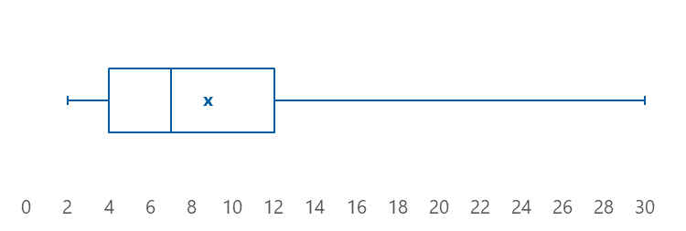

Residents who identified as being a member of one or more special needs groups reported more sessions with a mental health care practitioner on average (M = 9.58) compared to those who did not identify as a member of any of these groups (M = 7.86). Looking at common special needs groups, the reported number of sessions on average was highest among residents from a CALD background and lowest among those who reported being financially disadvantaged (Figure 4‑3).

Figure 4‑4: Mean number of sessions with a mental health practitioner, by special needs group

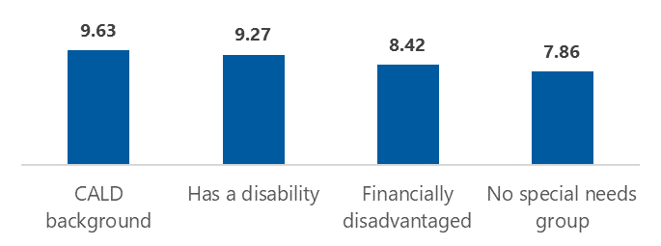

Note: Means are based on data provided by those within each group who responded to this question. CALD background, n = 8; has a disability, n = 22; financially disadvantaged, n = 12; no special needs group, n = 29.

### Service impacts and opportunities for improvement

Overall, services delivered under the initiative appear to have had a positive impact on the residents’ overall wellbeing, with 78% (n = 61) reporting that they felt ‘better’ or ‘much better’ after receiving mental health care (Table 4‑13). Reassuringly, there were no respondents who reported feeling ‘worse’ or ‘much worse’.

Table 4‑13: Residents’ self-rated impact of mental health care on their overall wellbeing

|  |  |  |
| --- | --- | --- |
| Impact of mental health care | n | % |
| Much better | 35 | 45% |
| Better | 26 | 33% |
| About the same | 10 | 13% |
| Worse | 0 | 0% |
| Much worse | 0 | 0% |
| Unsure | 4 | 5% |
| I prefer not to say | 3 | 4% |
| Total | 78 | 100% |

Residents who identified as a member of at least one special needs group were less likely (71%; n = 30) to report that their wellbeing was ‘better’ or ‘much better’ as a result of the mental health care they received, as compared to those who did not identify as a member of any special needs groups (86%; n = 31). Residents who identified as being financially disadvantaged were least likely to report a positive outcome after receiving mental health care (Figure 4‑5), although it is worth noting that they also did not feel that their wellbeing had deteriorated (recall that no residents reported worse mental health, as shown in Table 4‑13).

Figure 4‑5: Percentage of residents who felt ‘better’ or ‘much better’ after receiving mental health care, by special needs group

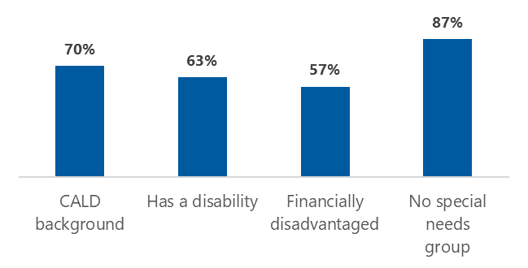

Note: Percentages are based on the proportion of people within each group who responded to this question. CALD background, n = 10; has a disability, n = 27; financially disadvantaged, n = 14; no special needs group, n = 36.

We also asked whether residents felt that the service they received was appropriate for their needs, with particular reference to their status as a member of special needs groups, if applicable. Ninety percent of residents indicated that the service met their needs (Table 4‑14); this proportion was consistent across the subgroups of residents who identified and did not identify as belonging to any special needs groups.

Table 4‑14: Resident reports of whether the mental health care they received was appropriate for their needs

|  |  |  |
| --- | --- | --- |
| Response | n | % |
| Yes | 74 | 90% |
| No | 1 | 1% |
| Unsure | 4 | 5% |
| Prefer not to say | 3 | 4% |
| Total | 82 | 100% |

Residents were able to elaborate on why they felt the service was appropriate to their needs. A key theme was that the service was culturally appropriate. For example, one resident indicated that they were able to reflect on their cultural background which made them feel comfortable to talk freely; another resident appreciated their service provider helping them to contact family overseas and changing the language settings on their web browser to help them understand things they were looking for online. Respondents also reflected on other characteristics of the service – for example, the service being provided directly to them in their RACF while giving them someone to talk to who was external to the RACF. Other respondents gave examples of the positive impacts that the service had as evidence of it meeting their needs; for example, that it had helped to provide comfort and support, strategies to overcome problems with sleep and nerves, and assistance to process grief. However, some respondents felt that their problems had not been adequately addressed by the care they had received, and they would have liked more regular support.

Unsurprisingly given the improvements in residents’ wellbeing and their perceived appropriateness of services, residents reported high levels of satisfaction with the mental health care they received (Table 4‑15).

Table 4‑15: Residents’ level of satisfaction with mental health care

|  |  |  |
| --- | --- | --- |
| Level of satisfaction | n | % |
| Very satisfied | 45 | 58% |
| Satisfied | 27 | 35% |
| Neither satisfied nor dissatisfied | 4 | 5% |
| Unsatisfied | 0 | 0% |
| Very unsatisfied | 0 | 0% |
| Unsure | 0 | 0% |
| I prefer not to say | 2 | 3% |
| Total | 78 | 100% |

When asked to reflect on what was good about the experience of receiving mental health care in their RACF, residents commented along some similar lines as above: they liked having someone independent to talk to and the convenience of someone coming to their RACF. In addition, some residents reflected that they enjoyed the group sessions, appreciated that they were able to access confidential support, and liked the fact that the service was free.

The main feedback from residents on how the service could be improved was simply that there should be more of these services available, offering a higher number of sessions, longer session times, and more face-to-face sessions. One person commented that there should be fewer questionnaires and 2 residents suggested that having a mental health care provider based onsite would be helpful.

## What are the reasons that residents do not access mental health care?

Thirty residents (30%) reported that they had not received mental health care since moving to their current RACF. Acknowledging that there may be many reasons for this, we asked residents what the primary influences were for them. Encouragingly, no residents reported that they were actively discouraged from seeking help or made to feel unwelcome when they did.

Instead, residents most commonly indicated that they did not seek help because they were not concerned about their mental or emotional wellbeing (Table 4‑16), providing some reassurance that services are generally being accessed appropriately and in response to identified need. Supporting this theory, 2 residents explained that they get the support they need from RACF staff or friends and families; for these residents, additional formal supports were perceived to be unnecessary. However, just over one-third of respondents suggested that they prefer to manage mental or emotional issues on their own, and another indicated that they do not like to talk to strangers about personal matters, suggesting a potential barrier to care associated with stigma.

Table 4‑16: Residents’ reasons for not accessing mental health care

|  |  |  |
| --- | --- | --- |
| Response | n | % |
| I haven’t had any concerns about my mental or emotional wellbeing | 20 | 61% |
| I prefer to manage these things on my own | 12 | 36% |
| I didn’t think it was appropriate for me | 8 | 24% |
| I didn’t know that it was available | 6 | 18% |
| I didn’t think it would help | 6 | 18% |
| My physical health problems were a higher priority | 6 | 18% |
| I was too embarrassed | 3 | 9% |
| I was worried about the cost | 3 | 9% |
| I don’t know | 3 | 9% |
| I was too nervous or afraid | 1 | 3% |
| I don’t have the technology (e.g. a mobile phone or computer) to access the mental health care that was available/recommended to me | 1 | 3% |
| I’m not confident using technology to access the mental health care that was available/recommended to me | 1 | 3% |
| Other | 1 | 3% |
| Someone told me not to | 0 | 0% |
| I tried to access mental health care but didn’t feel welcome | 0 | 0% |
| I didn’t think I would be able to access support in my language | 0 | 0% |

Note: Residents could select more than one option. Percentages are based on the number of respondents that selected each option, divided by the total number of respondents for this question (n = 33).

We invited residents who had not received mental health care to provide general feedback on the way that mental health is supported in their RACF. Those that commented indicated that they liked the fact that:

* support is available to everyone and residents are able to ask for help when required
* staff are supportive and invested in helping residents to feel well
* residents have access to activities such as social groups and gardening within the RACF
* their RACF offers external programs to help with mental health concerns.

Two residents commented that there are no changes needed to improve the way that mental health is supported in their RACF, while others suggested variations on a theme in calling for ‘more’: more awareness of the help available, more opportunities for regular support (suggestions included more frequent visits from external services and access to a dedicated mental health practitioner onsite), more time for care staff to talk to residents, and more activities and outings.

People should not be ashamed to talk about things like that and should be made aware that help is available and that people are there to help them.

# Selected results from analysis of PMHC MDS data

We received the PMHC MDS data extract on 4 November 2021. The data extract comprised 9 separate files. This included data for all individuals who have received PHN-commissioned mental health care and consented to their anonymised data being released – a total of 352,778 people who received approximately 3.3 million service contacts.

The PMHC MDS includes data on:

* client characteristics: date of birth, gender, Aboriginal and/or Torres Strait Islander status, English language proficiency, principal diagnosis
* practitioner characteristics: profession, gender, Aboriginal and/or Torres Strait Islander status, completion of Aboriginal and Torres Strait Islander cultural competency training
* services delivered: contact date, duration, modality, participants, postcode, venue (for face-to-face services), whether or not an interpreter was used
* clinical outcomes: collection timepoint (i.e. beginning, middle, or end of an episode of care), score on the 10-item (K10; Kessler et al. 2002) or 5-item (K5; Australian Institute of Health and Welfare 2009) Kessler psychological distress scale.

As the PMHC MDS contains no specific indicator of initiative-funded services, in order to identify services most likely to have been funded by the initiative we filtered for those delivered:

* in residential aged care
* since July 2018
* to people aged 65 or older (or 50 years for people of Aboriginal and/or Torres Strait Islander origin).

The resulting dataset relates to 11,850 clients (8,623 unique individuals) who received approximately 70,000 service contacts over 10,551 episodes of care. We also retained the remaining data to explore differences between the initiative and other services, including those delivered in RACFs before and after the initiative’s introduction.

We conducted preliminary analysis and cleaning to check for invalid responses and ensure missing data were recognised and handled appropriately (e.g. K10 scores fall between 10 and 50 inclusive and scores of 99 are recognised as missing values and ignored). We then explored client, referral, practitioner, and service characteristics, and the impact of services on clients’ psychological distress. We also conducted a blunt costing analysis, drawing on funding information provided by the department. All analyses were conducted overall and by financial year (FY). Selected results of these analyses are presented below; please note that we submitted more comprehensive findings to the department in the form of an interactive online dashboard, as per the schedule of deliverables for this evaluation.

## Client characteristics

The initiative’s introduction saw a marked increase in the number of clients seen in RACFs, from a total of 78 across all PHNs in FY 17–18 to 1,005 in FY 18–19. Client numbers have continued to climb with each year of the initiative’s operation, with an average annual growth of 491% (Table 5‑1). Four PHNs, however, have recorded a decrease in the number of clients receiving services in RACFs.

Table 5‑1: Number of clients seen in RACFs, by financial year and by percentage growth over time

|  |  |  |  |  |
| --- | --- | --- | --- | --- |
| PHN region | FY 18–19 | FY 19–20 | FY 20–21 | % growth |
| PHN 6 | 0 | 2 | 73 | n/a |
| PHN 17 | 2 | 100 | 320 | 15,900% |
| PHN 27 | 1 | 1 | 71 | 7,000% |
| PHN 1 | 4 | 95 | 240 | 5,900% |
| PHN 16 | 3 | 63 | 144 | 4,700% |
| PHN 13 | 2 | 47 | 72 | 3,500% |
| PHN 29 | 9 | 70 | 283 | 3,044% |
| PHN 28 | 3 | 37 | 63 | 2,000% |
| PHN 5 | 19 | 135 | 370 | 1,847% |
| PHN 22 | 4 | 4 | 65 | 1,525% |
| PHN 21 | 8 | 119 | 127 | 1,488% |
| PHN 20 | 41 | 317 | 647 | 1,478% |
| PHN 11 | 18 | 99 | 267 | 1,383% |
| PHN 8 | 60 | 417 | 687 | 1,045% |
| PHN 25 | 1 |  | 11 | 1,000% |
| PHN 19 | 1 | 2 | 11 | 1,000% |
| PHN 3 | 5 | 3 | 47 | 840% |
| PHN 30 | 21 | 64 | 174 | 729% |
| PHN 23 | 7 | 12 | 57 | 714% |
| PHN 24 | 67 | 291 | 498 | 643% |
| PHN 7 | 10 | 4 | 64 | 540% |
| PHN 2 | 17 | 29 | 107 | 529% |
| PHN 15 | 61 | 101 | 269 | 341% |
| PHN 12 | 243 | 525 | 588 | 142% |
| PHN 9 | 131 | 202 | 264 | 102% |
| PHN 10 | 14 | 17 | 28 | 100% |
| PHN 18 | 182 | 337 | 359 | 97% |
| PHN 14 | 22 | 19 | 20 | -9% |
| PHN 31 | 17 | 34 | 15 | -12% |
| PHN 4 | 23 | 11 | 3 | -87% |
| PHN 26 | 9 | 22 | 0 | -100% |
| Total | 1,005 | 3,179 | 5,944 | 491% |

Clients’ mean age at the time of their most recent service contact was 84.8 years. The age distribution of people receiving psychological services in RACFs is generally similar to the resident population at large, although clients are slightly more likely to be aged between 65 and 84 and less likely to be aged 90 or more (Figure 5‑1). The filters we applied to the data mean that the small number of clients aged between 50 and 64 are of Aboriginal and/or Torres Strait Islander origin; however the broader population of RACF residents in this age group may include some individuals who do not identify as Aboriginal and/or Torres Strait Islander.

Figure 5‑1: Age distribution of clients receiving psychological services in RACFs

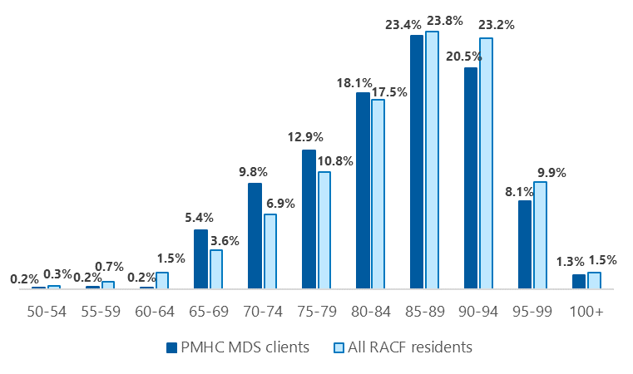

Note: The age distribution of RACF residents reflects the population as of 30 June 2020 and is sourced from GEN aged care data (Australian Institute of Health and Welfare 2021).

As shown in Figure 5‑2, women consistently account for around two-thirds of people receiving mental health care in RACFs. This aligns with the gender profile of the residential aged care population, where women also have a two-thirds majority (Australian Institute of Health and Welfare 2021). No aged care clients have been recorded under the ‘other' gender category since the initiative was introduced.

Figure 5‑2: Client gender, by financial year

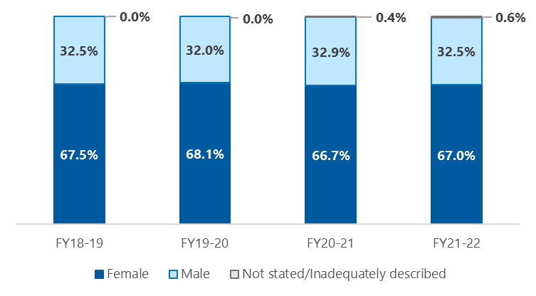

Aboriginal and/or Torres Strait Islander Australians accounted for 1% of aged care residents overall in FY 18–19 (the most recent year for which data are available; Department of Health 2019) and there is no reason to suspect this figure is markedly different in 2022. However, the proportion of people of Aboriginal and/or Torres Strait Islander origin receiving PHN-funded mental health services in residential aged care has decreased since the initiative’s introduction (Figure 5‑3).

Figure 5‑3: Client Indigenous status, by financial year

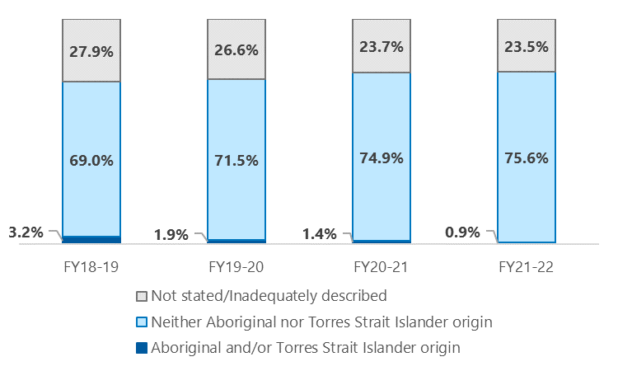

Although English is not the preferred language for 9% of aged care residents overall (Australian Institute of Health and Welfare 2021), few PMHC MDS clients reported that they are unable to speak English well (Figure 5‑4). While this may suggest that residents from CALD backgrounds are underrepresented among people accessing mental health care, it is important to note that *preferring* to speak a language other than English does not necessarily equate to a lack of English language proficiency. Further, the ability to speak English was not stated or inadequately described for between 13% and 18% of PMHC MDS clients. It is possible that many non-English speakers are being recorded here, in which case this group might account for a larger proportion of mental health clients than it appears.

Figure 5‑4: Client self-reported ability to speak English, by financial year

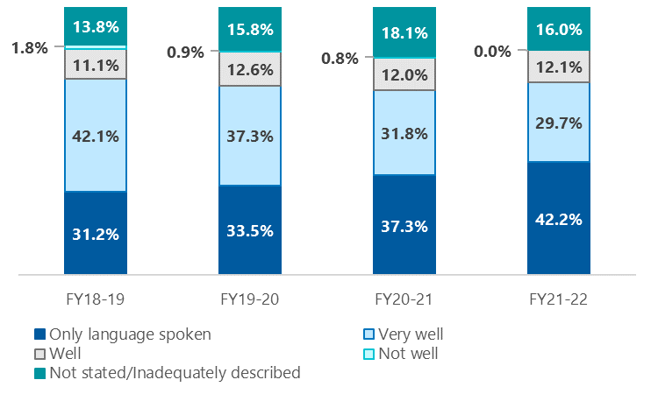

Depressive, mixed anxiety and depressive, and anxiety symptoms are the most common primary presentations among aged care residents (Table 5‑2 ), accounting for two-thirds of diagnoses at the beginning of an episode of care. Diagnostic information was missing for one in fourteen clients.

Table 5‑2: Ten most common principal diagnoses at service commencement

|  |  |  |
| --- | --- | --- |
| Principal diagnosis | n | % |
| Depressive symptoms | 756 | 27.0% |
| Mixed anxiety and depressive symptoms | 632 | 22.6% |
| Anxiety symptoms | 365 | 13.1% |
| Other | 221 | 7.9% |
| Adjustment disorder | 219 | 7.8% |
| Missing | 202 | 7.2% |
| Stress-related | 153 | 5.5% |
| Major depressive disorder | 120 | 4.3% |
| Generalised anxiety disorder | 101 | 3.6% |
| Depressive disorder not otherwise specified | 83 | 3.0% |
| Total | 2,796 | 100.0% |

## Referral characteristics

Just over 4% of episodes of care were initiated by residents themselves, indicating that they are heavily dependent on those who manage their care, health and wellbeing to refer them to psychological services. Most episodes delivered in RACFs were initiated by someone in an ‘other’ profession (Table 5‑3). We assume that this category is capturing registered nurses and other aged care staff, given the absence of these groups from the specific referrer types available within the PMHC MDS and their prominence in referrals as highlighted by participants in this evaluation (see for example the survey findings discussed in sections 3 and 4).

Table 5‑3: Professions of referrers who initiate episodes of care

|  |  |  |
| --- | --- | --- |
| Referrer profession | Episodes of care | % |
| Other | 1,709 | 57.0% |
| GP | 703 | 23.4% |
| Not stated | 159 | 5.3% |
| Other medical specialist | 147 | 4.9% |
| Self-referral | 123 | 4.1% |
| Psychologist | 76 | 2.5% |
| Mental health nurse | 53 | 1.8% |
| Social worker | 47 | 1.6% |
| Maternal health nurse | 14 | 0.5% |
| Psychiatrist | 6 | 0.2% |
| Total | 2,999 | 100.0% |

On average, residents receive services more quickly than people accessing PHN-funded mental health care in other settings, waiting an average of 20.6 days between referral and their first service contact compared to 44.9 for other clients (Table 5‑4). This trend is seen across all PHNs except PHN 28, where services commence later in RACFs than other settings (32.6 and 28.3 days respectively).

Table 5‑4: Mean days between referral and commencement of an episode of care for RACF clients and all clients recorded in the PMHC MDS, by deidentified PHN

|  |  |  |  |  |
| --- | --- | --- | --- | --- |
| PHN region | Number of RACF clients | Mean days from referral to service for RACF clients | Total number of clients | Mean days from referral to service for all clients |
| PHN 29 | 334 | 8.2 | 7,485 | 22.2 |
| PHN 9 | 528 | 13.6 | 14,355 | 66.2 |
| PHN 7 | 79 | 14.3 | 6,730 | 43.2 |
| PHN 8 | 937 | 15.0 | 7,752 | 25.4 |
| PHN 17 | 344 | 15.5 | 6,497 | 57.5 |
| PHN 27 | 72 | 15.7 | 5,794 | 43.6 |
| PHN 21 | 200 | 15.8 | 4,509 | 42.1 |
| PHN 22 | 72 | 16.4 | 6,770 | 37.7 |
| PHN 6 | 77 | 17.3 | 6,727 | 65.1 |
| PHN 23 | 71 | 17.9 | 7,650 | 35.3 |
| PHN 24 | 736 | 18.4 | 12,967 | 25.8 |
| PHN 2 | 125 | 18.7 | 4,734 | 20.5 |
| PHN 25 | 12 | 18.7 | 3,480 | 41.3 |
| PHN 10 | 49 | 19.3 | 17,939 | 31.4 |
| PHN 15 | 404 | 19.3 | 15,831 | 27.2 |
| PHN 11 | 328 | 19.8 | 4,508 | 42.5 |
| PHN 12 | 1,143 | 19.8 | 10,570 | 32.7 |
| PHN 14 | 43 | 20.4 | 6,750 | 32.8 |
| PHN 5 | 439 | 21.6 | 4,421 | 36.8 |
| PHN 31 | 57 | 21.8 | 4,970 | 38.9 |
| PHN 20 | 831 | 23.2 | 11,418 | 51.6 |
| PHN 16 | 175 | 24.4 | 20,517 | 40.8 |
| PHN 1 | 325 | 27.4 | 4,541 | 42.9 |
| PHN 26 | 22 | 27.5 | 4,852 | 119.7 |
| PHN 13 | 117 | 31.4 | 12,530 | 57.7 |
| PHN 28 | 88 | 32.6 | 5,571 | 28.3 |
| PHN 30 | 238 | 33.4 | 11,731 | 79.0 |
| PHN 18 | 691 | 38.7 | 22,195 | 48.3 |
| PHN 3 | 54 | 39.3 | 5,889 | 61.5 |
| PHN 19 | 13 | 42.7 | 2,611 | 50.9 |
| PHN 4 | 28 | 44.8 | 12,963 | 65.7 |
| All PHNs | 8,632 | 20.6 | 275,257 | 44.9 |

## Practitioner characteristics

Almost half of the service contacts that have taken place in RACFs were delivered by general psychologists or low-intensity mental health workers (a category that includes provisional psychologists) (Table 5‑5). Consistent with the initiative’s primary target population of residents requiring low- to moderate-intensity intervention, psychiatrists have been involved in a very small proportion of services delivered. Three-quarters of service contacts have been delivered by female practitioners, while practitioner gender has not been recorded for one out of every 8 service contacts (Table 5‑6). It may be that some practitioners are recording their gender only for one service contact out of an episode of care.

Table 5‑5: Number and proportion of service contacts, by practitioner type

|  |  |  |
| --- | --- | --- |
| Practitioner type | Service contacts | % |
| General psychologist | 17,438 | 27.1% |
| Low-intensity mental health worker | 13,532 | 21.1% |
| Other | 12,584 | 19.6% |
| Not stated | 7,015 | 10.9% |
| Social worker | 6,808 | 10.6% |
| Mental health nurse | 3,361 | 5.2% |
| Clinical psychologist | 1,833 | 2.9% |
| Psychosocial support worker | 526 | 0.8% |
| Aboriginal and Torres Strait Islander health/mental health worker | 499 | 0.8% |
| Peer support worker | 332 | 0.5% |
| Occupational therapist | 139 | 0.2% |
| GP | 99 | 0.2% |
| Psychiatrist | 58 | 0.1% |
| Other medical | 43 | 0.1% |
| Total | 64,267 | 100.0% |

Table 5‑6: Number and proportion of service contacts, by practitioner gender

|  |  |  |
| --- | --- | --- |
| Practitioner gender | Service contacts | % |
| Female | 48,872 | 76.1% |
| Not stated/inadequately described | 8,045 | 12.5% |
| Male | 7,350 | 11.4% |
| Total | 64,267 | 100.0% |

A very small proportion of RACF services are delivered by a practitioner identifying as Aboriginal and/or Torres Strait Islander (Table 5‑7). It is worth noting that Indigenous status was not stated or inadequately described for over one-quarter of service contacts; it is possible that some practitioners of Aboriginal and/or Torres Strait Islander origin are being recorded here.

Table 5‑7: Number and proportion of service contacts, by practitioner Aboriginal and/or Torres Strait Islander status

|  |  |  |
| --- | --- | --- |
| Practitioner Aboriginal and/or Torres Strait Islander status | Service contacts | % |
| Neither Aboriginal nor Torres Strait Islander origin | 44,818 | 69.7% |
| Not stated/inadequately described | 18,497 | 28.8% |
| Aboriginal but not Torres Strait Islander origin | 891 | 1.4% |
| Both Aboriginal and Torres Strait Islander origin | 61 | 0.1% |
| Total | 64,267 | 100.0% |

Just under half of services have been delivered by practitioners who have completed cultural awareness training (Table 5‑8). As with the practitioner characteristics above, information on training completion status was missing for a substantial number of service contacts; more complete data may present a different picture of the workforce responsible for delivering services to aged care residents.

Table 5‑8: Number and proportion of service contacts, by practitioner completion of cultural awareness training

|  |  |  |
| --- | --- | --- |
| Training completed | Service contacts | % |
| Yes | 31,189 | 48.5% |
| Missing/not recorded | 19,664 | 30.6% |
| No | 13,093 | 20.4% |
| Not required | 321 | 0.5% |
| Total | 64,267 | 100.0% |

## Services provided

Psychological therapy and low-intensity interventions account for over 90% of treatment provided to clients under the initiative (Table 5‑9), as would be expected given the initiative’s objective of improving access to low- to moderate-intensity interventions. However, a very small number of episodes of care have focused on the delivery of more complex interventions, including clinical care coordination and complex care packages.

Table 5‑9: Principal focus of treatment for episodes of care

|  |  |  |
| --- | --- | --- |
| Treatment focus | n | % |
| Psychological therapy | 4,859 | 55.8% |
| Low-intensity intervention | 3,369 | 38.7% |
| Psychosocial support | 282 | 3.2% |
| Clinical care coordination | 66 | 0.8% |
| Complex care package | 8 | 0.1% |
| Other | 118 | 1.4% |
| Total | 8,702 | 100.0% |

Clients receiving psychological therapy and low intensity interventions are likely to have a broadly similar experience of care, which differs from those receiving less common, more intensive forms of support. Those receiving clinical care coordination, for example, may have a particularly lengthy wait for service commencement and receive a small number of longer service contacts (Table 5‑10). This may reflect a lack of service provider capacity to respond to residents with higher needs.

Table 5‑10: Selected service characteristics by principle focus of treatment

|  |  |  |  |  |  |
| --- | --- | --- | --- | --- | --- |
| Characteristic | Psychological therapy | Low intensity intervention | Psychosocial support | Clinical care coordination | Other |
| Mean days between referral and service commencement | 20.7 | 17.5 | 26.4 | 89.0 | 9.8 |
| Mean service contacts per client | 7.8 | 6.6 | 9.7 | 5.9 | 6.4 |
| Service contact duration | n/a | n/a | n/a | n/a | n/a |
| <30 mins | 14.6% | 18.8% | 17.6% | 20.4% | 10.1% |
| 31-45 mins | 12.6% | 18.0% | 45.3% | 4.6% | 16.8% |
| 46-60 mins | 64.0% | 52.2% | 28.9% | 32.1% | 53.2% |
| 61-75 mins | 3.9% | 4.3% | 2.3% | 11.2% | 16.5% |
| >75 mins | 4.9% | 6.7% | 6.0% | 31.6% | 3.4% |
| Total service contacts | 37,785 | 22,302 | 2,738 | 392 | 760 |

Note: Percentages may not sum to 100 due to rounding. Given the small number of clients receiving complex care packages, this treatment focus is not included in the table above.

Services are delivered primarily in a face-to-face setting (Table 5‑11). However, there was a small and temporary increase in sessions conducted via telehealth in FY 19–20, likely reflecting the impact of COVID-19 and the restrictions in place in RACFs.

Table 5‑11: Modality of service contacts, by financial year

|  |  |  |  |  |
| --- | --- | --- | --- | --- |
| Modality | FY 18–19 | FY 19–20 | FY 20–21 | Total |
| Face-to-face | 97.5% | 94.0% | 97.6% | 96.6% |
| Telephone | 0.5% | 2.4% | 1.1% | 1.4% |
| Video | 0% | 1.2% | 0.4% | 0.6% |
| Internet-based | <0.1% | 0.6% | 0.3% | 0.4% |
| No contact took place | 2.0% | 1.8% | 0.5% | 1.0% |

Note: Percentages are based on the number of service contacts delivered in each modality, divided by the total number of service contacts for that financial year. In FY 18–19, n = 4,247; in FY 19–20, n = 18,082; in FY 20–21, n = 41,938; overall, n = 64,267.

In line with the vanishingly small proportion of clients who reported not being proficient in English, since the initiative was introduced less than one percent of service contacts in RACFs have been conducted with an interpreter. While it remains uncommon for interpreter use to be unstated, the use of this response option has increased markedly since 2018.

Table 5‑12: Proportion of service contacts conducted with an interpreter, by financial year

|  |  |  |  |  |
| --- | --- | --- | --- | --- |
| Interpreter used | FY 18–19 | FY 19–20 | FY 20–21 | Total |
| Yes | 1.2% | 1.2% | 0.6% | 0.8% |
| No | 98.6% | 97.4% | 97.2% | 97.3% |
| Not stated | 0.2% | 1.4% | 2.2% | 1.8% |

Note: Percentages are based on the number of service contacts in which an interpreter was used, not used, or the usage not stated, divided by the total number of service contacts for that financial year. In FY 18–19, n = 4,247; in FY 19–20, n = 18,082; in FY 20–21, n = 41,938; overall n = 64,267.

## Client outcomes

A note on interpreting K10 scores

The findings below relate to client’s scores on the K10 measure of psychological distress. The K10 is scored from 10 to 50, with higher scores indicating more severe distress. Therefore, an increase in scores represents deterioration, while a decrease indicates improvement. Scores can be interpreted on a continuous scale or used to categorise the likely severity of mental disorder, as follows (Australian Bureau of Statistics 2012):

* scores between 10 and 19 = likely to be well
* scores between 20 and 24 = likely to have a mild mental disorder
* scores between 25 and 29 = likely to have a moderate mental disorder
* scores between 30 and 50 = likely to have a severe mental disorder.

In addition to calculating average change in psychological distress, we also explored the proportion of residents experiencing clinically meaningful change over the course of an episode of care, defined as follows:

* improvement: a decrease of at least 5 points
* deterioration: an increase of at least 5 points
* no change: a change of between -5 and +5 points.

Our analysis of client outcomes was conducted with the subset (n = 1,248; 14.5%) of records with complete K10 data at the start and end of an episode of care. We therefore present results with the caveat that they may overstate or understate the true impact of the initiative. With that in mind, clients reported an average K10 score of 24.2 at service commencement and 20.0 at completion, demonstrating a 4.2-point or 17.5% improvement. This effect was consistent over time; clients reported a mean improvement of 4.1 points in FY 18–29 and 4.4 points in FY 20–21. As such, for the remainder of this section we present data collapsed across financial years.

Table 5‑13 shows average client outcomes by PHN; these data should be interpreted with caution as most PHNs have a small number of clients with complete K10 data. Thus, the very small and very large changes evident towards the bottom of the table reflect the experiences and characteristics of individual clients rather than the (in)effectiveness of the services delivered in these regions.

Table 5‑13: Change in psychological distress over episodes of care, by deidentified PHN

|  |  |  |  |  |
| --- | --- | --- | --- | --- |
| PHN region | Number of clients | K10 at episode start | K10 at episode end | % change |
| 5 | 175 | 25.1 | 20.4 | -18.7% |
| 17 | 151 | 24.5 | 18.8 | -23.3% |
| 12 | 143 | 22.0 | 20.3 | -7.7% |
| 11 | 143 | 23.4 | 20.2 | -13.7% |
| 29 | 107 | 23.9 | 20.8 | -13.0% |
| 9 | 103 | 22.8 | 17.7 | -22.4% |
| 15 | 64 | 24.8 | 21.9 | -11.7% |
| 7 | 54 | 23.8 | 17.4 | -26.9% |
| 30 | 45 | 23.8 | 19.1 | -19.7% |
| 2 | 34 | 25.6 | 22.6 | -11.7% |
| 24 | 33 | 24.0 | 20.3 | -15.4% |
| 31 | 30 | 28.7 | 24.8 | -13.6% |
| 1 | 27 | 20.4 | 18.0 | -11.8% |
| 13 | 23 | 23.7 | 17.4 | -26.6% |
| 23 | 22 | 23.1 | 14.2 | -38.5% |
| 10 | 18 | 27.2 | 23.9 | -12.1% |
| 8 | 15 | 25.9 | 23.1 | -10.8% |
| 6 | 14 | 24.4 | 21.0 | -13.9% |
| 14 | 10 | 28.2 | 24.1 | -14.5% |
| 25 | 7 | 31.2 | 21.1 | -32.4% |
| 3 | 6 | 22.9 | 15.2 | -33.6% |
| 20 | 6 | 22.1 | 22.0 | -0.5% |
| 22 | 4 | 28.7 | 21.0 | -26.8% |
| 18 | 3 | 26.4 | 27.0 | 2.3% |
| 27 | 3 | 26.7 | 16.0 | -40.1% |
| 4 | 2 | 33.0 | 19.5 | -40.9% |
| 21 | 1 | 42.0 | 31.0 | -26.2% |
| 26 | 1 | 21.5 | 20.5 | -4.7% |
| 19 | 1 | 21.0 | 13.0 | -38.1% |
| 28 | 1 | 41.0 | 22.0 | -46.3% |
| All PHNs | 1,248 | 24.2 | 20.0 | -17.4% |

Note: Only clients with complete K10 data at the beginning and end of an episode of care are included in these calculations.

Of course, average change is a relatively blunt measure of service impact. Using our pre-specified criteria for meaningful change, we found that around half of aged care residents for whom data were available experienced neither improvement nor deterioration in their symptoms over the course of an episode of care (Figure 5‑5). Most of the remainder demonstrate reduced psychological distress, with this pattern of results consistent over time. As discussed in the final report (section 4.1.8), symptom maintenance maybe an appropriate and positive outcome for many residents; particularly for those who are experiencing low levels of distress at service commencement and therefore have limited scope to improve.

Figure 5‑5: Proportion of clients showing improvement, deterioration, or no change in psychological distress, by financial year

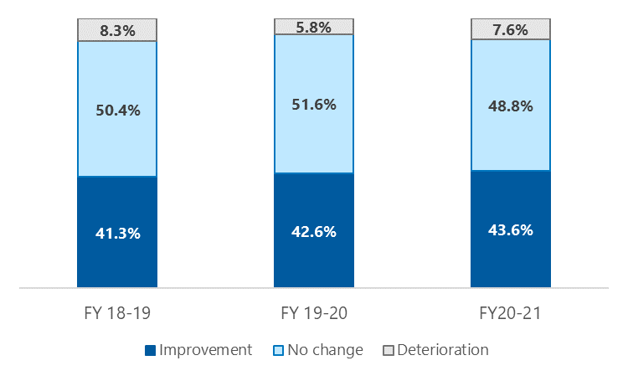

To demonstrate the impact of initial K10 scores on service outcomes, we calculated the proportion of residents demonstrating meaningful change by their likely severity of mental illness at service commencement. As seen in Figure 5‑6, those with severe illness at the start of their care are more likely to improve than their counterparts who are likely to be well. However, they are also more likely to deteriorate. Given the limitations of the PMHC MDS we are unable to explore the factors that predict poorer outcomes in more detail, however it would be interesting to explore the degree to which the RACF environment and individual characteristics (e.g. changes in cognitive or physical functioning) impact the direction and magnitude of changes in psychological distress.

Figure 5‑6: Mental health outcome by likely disorder severity at episode of care commencement

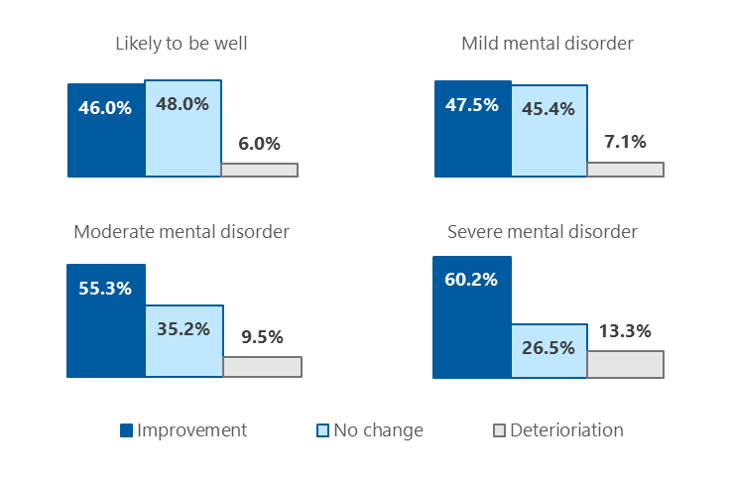

## Costing analysis

The costing analysis shown in Table 5‑14 should be evaluated conservatively, as it reflects the total funding provided to each PHN, rather than breaking down their operational and service delivery costs. To remove outliers and nonsensical values, we have restricted our analysis to funding received and services delivered in FY 20–21, and present metrics only for PHNs that recorded more than 100 clients in that year. For these PHNs, initiative funding resulted in services being delivered to an average of 334 clients, at an average cost of $3,513 client or $570 per service contact. Of note, the 4 PHNs with the lowest costs per service contact share a service provider, as do 2 of the next 3. PHN 1 has a relatively low cost per client but high cost per service contact, reflecting a lower-than-average number of service contacts per client.

Table 5‑14: Cost metrics for PHNs recording more than 100 clients in FY 20–21

|  |  |  |  |  |
| --- | --- | --- | --- | --- |
| PHN region | Clients | Mean $ per client | Mean $ per episode | Mean $ per service contact |
| 8 | 687 | $881 | $862 | $120 |
| 20 | 647 | $1,444 | $1,422 | $170 |
| 12 | 588 | $1,503 | $1,488 | $175 |
| 24 | 498 | $1,913 | $1,865 | $241 |
| 5 | 370 | $2,173 | $1,971 | $343 |
| 17 | 320 | $2,405 | $2,339 | $417 |
| 24 | 267 | $3,134 | $2,999 | $437 |
| 29 | 283 | $3,591 | $3,354 | $509 |
| 2 | 107 | $2,983 | $2,513 | $536 |
| 9 | 264 | $5,691 | $5,444 | $550 |
| 1 | 240 | $1,624 | $1,617 | $642 |
| 15 | 269 | $5,510 | $5,489 | $656 |
| 18 | 359 | $4,899 | $4,872 | $755 |
| 30 | 174 | $4,530 | $4,331 | $928 |
| 16 | 144 | $5,957 | $5,429 | $1,191 |
| 21 | 127 | $7,971 | $6,981 | $1,442 |
| Mean | 334 | $3,513 | $3,311 | $570 |

# Additional information on service models

In this concluding chapter, we build on our overview of the service models currently in place (see section 4.1.1 of the final report). We begin by exploring the approaches that PHNs took to designing these service models and how the mental health workforce responsible for delivering services is being supported.

We then expand on the evidence underpinning the 4 characteristics of effective services (as presented in section 4.1.2 of the final report).

## Approach to designing the service model

All but 2 PHNs reported that their service model was informed by consultation or co-design activities. In most cases, these activities were conducted as a standalone piece of work prior to service commencement, although in a handful of PHNs they occurred as part of a pilot phase of service delivery. All told, around two-thirds of PHNs piloted their service model in a small number of RACFs prior to embarking on a broader rollout, using the learnings to refine the service model and develop commissioning specifications. In addition, several PHNs conducted or commissioned a literature review to inform their service model.

Consultation activities included inviting input via email, conducting surveys, holding meetings with individual stakeholder groups, and bringing different stakeholder groups together for roundtable meetings or workshops. PHNs most frequently reported consulting with RACF representatives, GPs, and psychological service providers and/or allied health professionals in their region. Other commonly engaged stakeholder groups included Older Persons Mental Health services (OPMH services) and local health districts, dementia support services (e.g. Dementia Australia), and residents and/or family members. One PHN reported that their service model was informed by consultation with ‘local Aboriginal health organisations’[8] and another consulted with CALD community leaders.

A small number of PHNs engaged with peak bodies representing aged care providers, but none indicated that they consulted with peak bodies in the health or mental health sectors. In our interviews, representatives of these peak bodies confirmed their lack of involvement in the service design phase of the initiative.

## Building mental health workforce capacity

While RACF capacity building is a feature of service models in most regions, activities to build capacity of the health or mental health workforce are less common. Where this is a feature of the service model, it typically hinges on the service provider’s use, training, and supervision of provisional psychologists. Along similar lines, in one region, the service model includes support for social workers to obtain mental health accreditation; in another region, the service provider offers placements for university students enrolled in a mental health discipline.

There is a small number of inter- and intra-PHN communities of practice for mental health practitioners delivering psychological services to aged care residents. These have been established by PHNs or service providers. Some service models specify the availability of specialist advisors for case consultation.

Finally, individual PHNs indicated that the following resources have been developed or made available to support their region’s health and mental health workforce:

* Australian Psychological Society e-learning modules in Applied Mental Health in Residential Aged Care
* a low-intensity intervention that can be delivered by local care workers under psychologist supervision
* a phone line for GPs and clinical RACF staff that provides advice and support on diagnosis, medication, therapeutic management, and referral pathways.

## Characteristics of effective service models

Effective service models are those that perform well across multiple domains, across all stages of implementation, and are subject to continuous monitoring and quality improvement. As discussed in section 4.1.2 of the final report, they can be understood in terms of 4 key characteristics (Figure 6‑1), each of which is discussed in turn below.

Figure 6‑1: Characteristics of effective service models

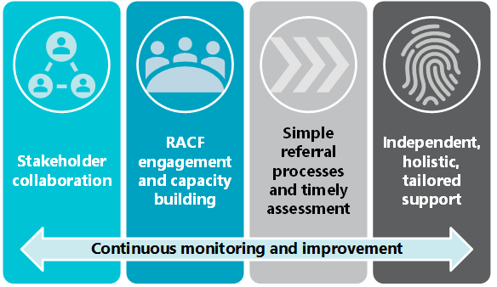

### Stakeholders work collaboratively

Representatives of several stakeholder groups – including PHNs, service providers, and RACF staff – highlighted that effective service models are characterised by a ‘partnership model’. For example, as one PHN commented:

[Our service provider] has appreciated our flexibility and openness to trial and change the approach as needed. They have appreciated our willingness to take on an action research approach and learn as we go along and reflect together in partnership and modify KPIs accordingly. So, we are working in a partnership mode, rather than solely as a transactional funding body.

PHN representative

Importantly, this sentiment was echoed by the service provider in question.

Representatives of PHNs that had commissioned multiple service providers reflected that these different organisations work collaboratively, resulting in a consistent service model across the region and a common approach to overcoming challenges as they arise. Meanwhile, the importance of service providers and RACF staff working in partnership and communicating effectively was highlighted both by representatives of these groups and peak bodies. They, and PHNs, felt that a service model that includes a designated mental health practitioner for each RACF supports collaboration because relationships and trust between the practitioner, RACF staff, and visiting health professionals develop over time.

### RACF engagement and capacity building are prioritised

PHNs, service providers, and RACF staff alike considered that securing RACF buy-in to the initiative is essential, and that this is best achieved through engagement and capacity building. These activities require significant time and effort at the outset to bring RACFs on board, and an ongoing investment to maintain buy-in and build capacity over time. One PHN noted that their pilot phase was unsuccessful because they underestimated the importance of, and resources required for, these components of the service.

Further, a small number of service providers and PHNs commented that fee-for-service models are ineffective because they do not account for the work involved in engagement and capacity building, despite these activities being critical to the initiative’s success. On the other hand, in regions where RACF engagement was perceived to be high, PHNs and service providers attributed this to the establishment of a dedicated RACF engagement role, usually located within the service provider organisation. We also heard that working with RACFs to identify staff members who can act as mental health or wellbeing ‘champions’ and drive the initiative internally is an effective way of encouraging buy-in among other staff.

There was general agreement that it is important for RACFs and service providers to have a shared understanding of the service arrangements, although opinions were mixed on the extent to which a shared understanding should be formalised. For example, some PHNs and service providers considered memoranda of understanding to be effective in defining roles and expectations, while others felt they were too restrictive and introduced unnecessary delays in establishing services. Interestingly, one PHN commented that commissioning an organisation that both provides psychological services and manages RACFs did not result in improved staff engagement within that organisation’s facilities. This model also raises questions about the degree to which the mental health practitioner is independent from the resident’s day-to-day care (see section 6.3.4).

The capacity building has been a key component of the program, not just in terms of providing support to staff and families and carers, but it also helped to integrate the program into the RACF environment in the region.

PHN representative

Service models with an emphasis on capacity building were seen to improve the overall effectiveness of the service for several reasons. For example, staff training was perceived to provide a ‘hook’ to encourage RACFs to enrol in the initiative, and to increase the number and appropriateness of referrals. Training was generally well received by participating staff, with features of effective training including: face-to-face delivery in brief, small-group sessions that fit into the RACF schedule; delivery to staff at all levels; and content addressing mental health literacy, available services and referral pathways, and topics of broader importance such as cultural awareness and trauma-informed care. One PHN had trialled a model in which a separate training provider was responsible for capacity building, and found this to be unsuccessful as this organisation did not have established relationships with the RACFs involved.

We have done training sessions with executive directors right through to kitchen staff … those kitchen staff see everything, and they are the staff who residents feel really safe with. So often they are the ones who may see if there are any concerns.

Service provider representative

### Simple referral processes facilitate timely assessment

Across stakeholder groups, there was a view that effective service models are those with few barriers to referral – where referrals are accepted directly by the provider, from multiple sources, and without a requirement for detailed paperwork. One service provider, commissioned by multiple PHNs with different referral protocols, reflected that they prefer the direct-to-provider pathway (and subsequent direct-to-referrer follow-up) as this enables more timely service provision.

Streamlining the referral pathway has resulted in increased referrals, increased registrations and increased stability in the team.

PHN representative

Ease of referral is an especially important aspect of the service for RACF staff in particular, who may be less familiar with mental health referrals than GPs. RACF staff identified simple strategies that had made the referral process easier – for example, including forms in the referral folder stored within each wing of the RACF so they are easily accessible to and routinely seen by nursing and care staff.

Our service provider has a nominated referral person in each facility, which streamlines the process.

PHN representative

Importantly, effective referral processes are those that remove barriers to residents being assessed and triaged to an appropriate intervention or level of care; they are **not** those that expediate the commencement of services without due consideration of the resident’s treatment needs. Regardless of how a resident was referred and by whom, service providers require clear guidance on how to determine first, whether the resident is suitable for their service and second, the type of support within their scope of practice that is most likely to be of benefit.

If the provider undertakes an assessment and the potential client is more than mild or moderate, then the provider does not deliver the service and refers onwards.

PHN representative

### Residents have access to independent, holistic, tailored support

The other thing which has worked really well is that the service provider has become part of the team and just for the residents to know that there is a familiar face who they can talk to who is completely confidential; I think this has been really important to them.

RACF staff member

Service providers, RACF staff, and residents alike considered the service provider’s independence from the RACF a particularly important aspect of the service model as it ensures that residents can speak confidentially with someone not involved in their day-to-day care. At the same time, they noted that it is important for mental health practitioners to be highly visible within the facility in order to build trust with residents (and support collaboration with staff, as mentioned in section 6.3.1 ). Allowing additional time to build trust and rapport with residents was also seen as critical to providing appropriate and effective support, especially for residents with cognitive impairment. Representatives of several stakeholder groups highlighted the benefits of giving residents some control over their own care – for example, by ensuring the mental health practitioner has the resident’s direct contact number and, following the initial assessment, liaises with them directly to schedule appointments.

Effective services were also seen to offer multidisciplinary care, appropriately tailored to meet resident, staff, and family need. Representatives of PHNs, peak bodies, and service providers consistently identified that adopting a holistic approach to supporting residents’ mental health is crucial, and requires going beyond diagnostic manuals to recognise and respond to a broad spectrum of wellbeing needs. Capacity to address issues with adjustment, grief and loss, and loneliness was seen as particularly essential. However, some PHNs expressed uncertainty over the extent to which the department’s guidance allows them to expand their service model and incorporate alternative supports.

In some instances, psychological therapies are not necessarily what the residents need. We felt constrained to that, but we were getting feedback that this service was not necessarily helpful for some. Without being able to support everyone and have multiple treatment options it can be quite challenging in a sense that you are almost limiting consumer choice.

PHN representative

We also heard of the value of a mixed service model, in which both individual support and group support are available.[9] For example, some residents commented that they ‘felt more comfortable [alone] than in a group’ as they could open up and discuss more personal issues, while others felt that ‘meeting in a group gave a sense of support and cooperation’.

Although its delivery has been somewhat disrupted to date, stakeholders across the board noted that group therapy is particularly useful for RACF residents, for several reasons. For example:

* By mirroring the format of many lifestyle programs available within RACFs, group services:
  + offer a model of care that residents are familiar and confident with
  + can facilitate seamless transitions between PHN-funded and existing supports.
* Groups have the added benefit of addressing loneliness and residents’ need for social connection, without requiring residents to explicitly discuss these issues.
* Music therapy (a common element of current service models under the initiative) was seen to be a particularly important component of mental health care in aged care, due to its accessibility by people who do not speak English, are unable to communicate verbally, or have cognitive difficulties.

Opinions were mixed on whether group therapy is more effective when delivered before or after individual support. Several PHNs and peak bodies indicated that groups (including music therapy and other options such as yoga, gardening, or book clubs) offer a less stigmatising pathway into care for many older people. On the other hand, some service providers felt that groups are more effective for residents who have already participated in individual therapy, as the mental health practitioner then understands resident need and can design and conduct group sessions accordingly. Importantly, service providers and RACF staff highlighted that even residents with high-level needs can benefit from low-intensity, lifestyle, or environmental interventions (see section 4.1.8 of the final report). However, it is worth noting that one GP commented on the potential duplication of services, with this individual perceiving that low-intensity services are already available through RACFs and therefore are an unnecessary component of PHN service models.

References

Amare, AT, Caughey, GE, Whitehead, C, Lang, CE, Bray, SCE, Corlis, M, Visvanathan, R, Wesselingh, S, & Inacio, MC 2020, The prevalence, trends and determinants of mental health disorders in older Australians living in permanent residential aged care: implications for policy and quality of aged care services, *Australian and New Zealand Journal of Psychiatry*, vol. 54, no. 12, pp. 1200–1211.

Australian Bureau of Statistics 2012, 4817.0.55.001 - Information paper: use of the Kessler Psychological Distress Scale in ABS Health Surveys, Australia, 2007-08, viewed 5 February 2022, <https://www.abs.gov.au/ausstats/abs@.nsf/lookup/4817.0.55.001chapter92007-08>.

Australian Institute of Health and Welfare 2009, Measuring the social and emotional wellbeing of Aboriginal and Torres Strait Islander peoples, AIHW, Canberra.

Australian Institute of Health and Welfare 2021, People using aged care, *GEN aged care data*, viewed 1 February 2022, <https://www.gen-agedcaredata.gov.au/Topics/People-using-aged-care>.

Brydon, A, Bhar, S, Doyle, C, Batchelor, F, Lovelock, H, Almond, H, Mitchell, L, Nedeljkovic, M, Savvas, S, & Wuthrich, V 2022, National Survey on the impact of COVID-19 on the mental health of Australian residential aged care residents and staff, *Clinical Gerontologist*, vol. 45, no. 1, pp. 58–70.

Carnemolla, P, Debono, D, Hourihan, F, Hor, S, Robertson, H, & Travaglia, J 2021, The influence of the built environment in enacting a household model of residential aged care for people living with a mental health condition: a qualitative post-occupancy evaluation, *Health and Place*, vol. 71, p. 102624.

Carver, A, Lorenzon, A, Veitch, J, Macleod, A, & Sugiyama, T 2020, Is greenery associated with mental health among residents of aged care facilities? A systematic search and narrative review, *Aging and Mental Health*, vol. 24, no. 1, pp. 1–7.

Chan, P, Bhar, S, Davison, TE, Doyle, C, Knight, BG, Koder, D, Laidlaw, K, Pachana, NA, Wells, Y, & Wuthrich, VM 2021, Characteristics and effectiveness of cognitive behavioral therapy for older adults living in residential care: a systematic review, *Aging and Mental Health*, vol. 25, no. 2, pp. 187–205.

Cleary, M, Raeburn, T, West, S, & Childs, C 2019, The environmental temperature of the residential care home: role in thermal comfort and mental health?, *Contemporary Nurse*, vol. 55, no. 38–46.

Creighton, AS, Davison, TE, & Kissane, DW 2017, The correlates of anxiety among older adults in nursing homes and other residential aged care facilities: a systematic review, *International Journal of Geriatric Psychiatry*, vol. 32, no. 2, pp. 141–154.

Creighton, AS, Davison, TE, & Kissane, DW 2018, The prevalence, reporting, and treatment of anxiety among older adults in nursing homes and other residential aged care facilities, *Journal of Affective Disorders*, vol. 227, pp. 416–423.

Creighton, AS, Davison, TE, & Kissane, DW 2019, The factors associated with anxiety symptom severity in older adults living in nursing homes and other residential aged care facilities, *Journal of Aging and Health*, vol. 31, no. 7, pp. 1235–1258.

Davison, TE, Koder, D, Helmes, E, Doyle, C, Bhar, S, Mitchell, L, Hunter, C, Knight, B, & Pachana, N 2017, Brief on the role of psychologists in residential and home care services for older adults, *Australian Psychologist*, vol. 52, no. 6, pp. 397–405.

Davison, TE, McCabe, MP, Busija, L, O’Connor, DW, Costa, VC, & Byers, J 2020, A cluster randomised trial of the program to enhance adjustment to residential living (PEARL): a novel psychological intervention to reduce depression in newly admitted aged care residents, *BMC Geriatrics*, vol. 20, no. 1, pp. 1–8.

Davison, TE, McCabe, MP, Busija, L, Martin, C, & Graham, A 2021, Trajectory and predictors of mental health symptoms and wellbeing in newly admitted nursing home residents, *Clinical Gerontologist*, vol. 71, p. 102624.

Davison, TE, McCabe, MP, Busija, L, Graham, A, Camões-Costa, V, Kelly, J, & Byers, J 2021, The effectiveness of the Program to Enhance Adjustment to Residential Living (PEARL) in reducing depression in newly admitted nursing home residents, *Journal of Affective Disorders*, vol. 282, pp. 1067–1075.

Department of Health 2019, Aboriginal and Torres Strait Islander people using aged care services, viewed 1 February 2022, <https://www.gen-agedcaredata.gov.au/www_aihwgen/media/DoH-factsheets/Aboriginal-and-Torres-Strait-Islander-peoples-use-of-aged-care-services-2018-19.pdf?ext=.pdf>.

Doyle, C, Bhar, S, Bryant, C, Dow, B, Dunt, D, Mnatzaganian, G, O’Connor, D, Ratcliffe, J, You, E, Bagnall, AM, Major, G, Harper, R, & Fearn, M 2021, BEFRIENding for Depression, Anxiety and Social support in older adults living in Australian residential aged care facilities (BEFRIENDAS): randomised controlled trial protocol, *BMC Geriatrics*, vol. 21, no. 1, pp. 1–11.

Fearn, M, Harper, R, Major, G, Bhar, S, Bryant, C, Dow, B, Dunt, D, Mnatzaganian, G, O’Connor, D, Ratcliffe, J, Samuel, S, Bagnall, AM, & Doyle, C 2021, Befriending older adults in nursing homes: volunteer perceptions of switching to remote befriending in the COVID-19 era, *Clinical Gerontologist*, vol. 44, no. 4, pp. 430–438.

Franklin, MA, Parnell, T, Versi, N, & Pope, R 2022, Animal assisted therapy for older adults in aged care facilities: a rapid review, *Internet Journal of Allied Health Sciences and Practice*, vol. 20, p. 14.

Frey, R & Balmer, D 2021, Resident and family spirituality in New Zealand residential aged care: an exploration, *Journal of Religion, Spirituality and Aging*, vol. 34, pp. 121–142.

Keelan, K, Pitama, S, Wilkinson, T, & Lacey, C 2021, Indigenous peoples’ experiences and preferences in aged residential care: a systematic review, *AlterNative*, vol. 17, no. 2, pp. 175–182.

Kelly, J, Davison, TE, & McCabe, MP 2022, A psychological needs-based intervention to facilitate adjustment and improve wellbeing in newly admitted aged care residents: three illustrative case studies, *Clinical Psychologist*, , no. 26, pp. 44–52.

Kessler, RC, Andrews, G, Colpe, LJ, Hiripi, E, Mroczek, DK, Normand, SLT, Walters, EE, & Zaslavsky, AM 2002, Short screening scales to monitor population prevalences and trends in non-specific psychological distress, *Psychological Medicine*, vol. 32, pp. 959–976.

Lee, JL, Splawa-Neyman, M, & McDermott, F 2022, The role of social work in residential aged care facilities: evaluation of a pilot program in Australia, *Qualitative Report*, vol. 27, no. 1, pp. 64–78.

Lewis, LK, Henwood, T, Boylan, J, Hunter, S, Lange, B, Lawless, M, Milte, R, & Petersen, J 2021, Re-thinking reablement strategies for older adults in residential aged care: a scoping review, *BMC Geriatrics*, vol. 21, no. 1, pp. 1–12.

Looi, JCL, Kisely, S, Bastiampillai, T, & Allison, S 2022, Psychiatric care implications of the Aged Care Royal Commission: putting the cart before the horse, *Australian and New Zealand Journal of Psychiatry*, vol. 56, no. 1, pp. 11–13.

McCabe, MP, Mellor, D, Karantzas, G, Von Treuer, K, Davison, TE, & O’Connor, D 2017, Organizational factors related to the confidence of workers in working with residents with dementia or depression in aged care facilities, *Aging and Mental Health*, vol. 21, no. 5, pp. 487–493.

National Suicide Prevention Adviser 2020, Final advice, viewed 7 October 2021, <https://www.health.gov.au/resources/publications/national-suicide-prevention-adviser-final-advice>.

Newton, W, Signal, T, & Judd, J 2021, The guidelines and policies that influence the conduct of animal-assisted activities in resiadential aged care facilities: a systematic integrative review, *Complementary Therapies in Clinical Practice*, vol. 44, p. 101395.

Radermacher, H 2021, Mental health and residential aged care: are we there yet?, *Australasian Journal on Ageing*, vol. 40, no. 1, pp. 10–11.

Sugiyama, T, Carver, A, Sugiyama, M, Lorenzon, A, & Davison, TE 2021, Views of greenery and psychological well-being in residential aged care facilities: longitudinal associations, *Health Environments Research & Design Journal*, vol. Nov 22, p. Online ahead of print.

Wardle, S & Bennett, C 2021, Spiritual inclusiveness at end-of-life for Punjabi Indians: experience with regional residential aged care facilities, *Journal of Religion, Spirituality and Aging*, vol. 33, no. 2, pp. 155–171.

1. Including, for example, systematic and narrative reviews, articles describing planned or completed primary research, and opinion pieces and editorials)
2. Anxious attachment was assessed using the Experience in Close Relationships – Relationship Structures Adult Attachment Questionnaire, and is defined as excessive concern that a partner will not be available to provide support when it is required.
3. Radermacher also commented on the relatively low number of services delivered in the first 18 months of the initiative’s funding, which as discussed in the final report is not surprising given that many PHNs were focused on service design and commissioning at this time.
4. One in 5 residents who commenced therapy did not complete it (due to death, hospitalisation, or other medical issues).
5. The 144 respondents included in our analysis represent 82% of people who accessed the survey. We excluded data from 16 (9%) who opened the survey but did not answer any questions, and 15 (9%) who provided only limited information (their PHN and role).
6. Specifically, respondents reported referring an average of 5 aged care residents each month (range 0 to 40) to PHN-commissioned services. We did not ask what proportion of their total mental health referrals this accounts for, or how many residents are referred through other pathways.
7. Older people with disabilities are not specified as a special needs group in legislation, but are considered as such within the [My Aged Care](https://www.myagedcare.gov.au/accessible-all#languages) system and so are included here. One-third (n=41; 34%) of respondents did not identify with any special needs groups, 9 (7%) were unsure, and 9 (7%) preferred not to say.
8. It is unclear whether this individual was referring to Aboriginal Community Controlled Health Services, community clinics, or other government or non-government funded organisations specialising in Aboriginal health.
9. And further, that residents have the choice of face-to-face or telehealth services.