The Department of Health and Aged Care logo


Consultation  
paper: Aged Care Quality Standards Review

Summary Consultation Paper

# Table of contents

Section 1: Context 3

What is the purpose of this consultation? 3

What has been the process to strengthen the Quality Standards? 4

Section 2: Drivers for change 5

Why are the current Quality Standards changing? 5

What are the goals of any changes? 5

Section 3: Overview of the changes 6

What is the role of the Quality Standards? 6

Who will the strengthened Quality Standards apply to? 6

What else is in place to drive quality care? 7

What do the strengthened Quality Standards look like? 7

What are the main changes? 8

Outcomes for older people 9

Governance and partnerships 9

Clear expectations 10

Detailed requirements 10

How can you provide feedback? 10

**Thank you**

Thank you for taking the time to contribute to this process and to those who have already contributed to the development of the draft strengthened Quality Standards.

Your experiences and thoughts are valued and will help to deliver a  
better aged care system.

# Section 1: Context

## What is the purpose of this consultation?

The purpose of this consultation process is to seek your feedback on a set of draft strengthened Aged Care Quality Standards (Quality Standards) that seek to improve the safety and quality of aged care. Your feedback will help us further improve the Quality Standards.

The Quality Standards set out the things providers need to do to deliver quality care and what older people can expect from their care and services.

As part of improvements being made to the aged care system, and in response to findings from the [Royal Commission into Aged Care Quality and Safety](https://agedcare.royalcommission.gov.au/publications/final-report) (the Royal Commission), the Department of Health and Aged Care (the department) is reviewing the [current Quality Standards](https://www.agedcarequality.gov.au/providers/standards) and has developed a draft set of strengthened Quality Standards in response to feedback from older people, their families and aged care providers.

To view the strengthened Quality Standards and provide your feedback, please go to the department’s [Aged Care Engagement Hub](https://agedcareengagement.health.gov.au/qualitystandards/) (the Engagement Hub).

### Terminology

For the purposes of this consultation paper and the draft strengthened Quality Standards, we have used the following terms:

* **Quality care** – refers to care that:
  + is **person-centred**, provided with kindness and compassion, responding to the holistic needs of the older person and aiming to improve their wellbeing and quality of life
  + is smoothly **coordinated** when care is provided by the workforce, visiting practitioners, and external providers (where relevant)
  + is **effective**, providing the right care to meet the older person’s needs goals and preferences
  + keeps older people **safe** from preventable harm.
* **Older person / older people** – this refers to a person (or people) receiving Commonwealth-funded aged care services. The current Quality Standards  
  use the term ‘consumer’; however, this term is not generally well accepted by older people and is being reviewed as part of the development of a new Aged Care Act.
* Reference to an older person includes reference to a representative of the older person, so far as the provision can apply to a representative. A representative is a person appointed to act or make decisions on behalf of an older person and who the older person nominates to be told about matters affecting them.
* **Provider** – this refers to the organisation providing Commonwealth-funded  
  aged care services.
* **Governing body** – this refers to the governing body (such as the Board) of  
  the provider.
* **Worker** – this refers to an individual who is employed, hired, retained or contracted by the provider (whether directly or through an employment or recruiting agency) to provide care or other services.
* **Others involved in the older person’s** **care** – this refers to any individuals or organisations that are involved in delivering care, services or supports to older people. It may involve other aged care providers, healthcare professionals, health services, community organisations, carers, etc.

It is important to note that these definitions are included to explain the expectations of how the Quality Standards could direct care and services only. A number of these terms will change as the new Aged Care Act is developed.

## What has been the process to strengthen the Quality Standards?

The draft strengthened Quality Standards have been developed by the department, in collaboration with:

* the Aged Care Quality and Safety Commission (the Aged Care Commission), which has responsibility for assessing aged care providers against the Quality Standards
* the Australian Commission on Safety and Quality in Health Care (the Health Commission), which has responsibility for setting the clinical components of the Quality Standards.

The strengthened Quality Standards have been informed by:

* engagement with older people, their carers and families, subject matter experts and sector representatives, including aged care providers and peak bodies
* relevant findings from the [Royal Commission](https://agedcare.royalcommission.gov.au/)
* an independent review of the current Quality Standards[1]
* standards for health care and disability support in Australia (the [National Safety and Quality Health Service (NSQHS) Standards](https://www.safetyandquality.gov.au/standards/nsqhs-standards) and the [National Disability Insurance Scheme (NDIS) Practice Standards](https://www.ndiscommission.gov.au/providers/registered-ndis-providers/provider-obligations-and-requirements/ndis-practice-standards#paragraph-id-2711))
* discussions with aged care policy areas in other countries such as New Zealand, Canada and the United Kingdom.

Feedback from this consultation process will inform further changes to the strengthened Quality Standards, which will be included in the review report submitted to Government at the end of 2022.

It is intended that the strengthened Quality Standards will be implemented alongside broader reforms to the aged care system, including the new Aged Care Act and regulatory framework.

# 

# Section 2: Drivers for change

## Why are the current Quality Standards changing?

While the [current Quality Standards](https://www.agedcarequality.gov.au/consumers/standards/resources) have set expectations to support the delivery of quality care, the Royal Commission found they need to be improved, including to:

* provide more detail on what people can expect from aged care services and the things providers need to do to deliver quality care
* make the requirements for providers less subjective and more measurable
* strengthen requirements:
  + relating to provider governance and human resources
  + to better recognise the diversity of people receiving aged care services
  + to better reflect the needs of people living with dementia
  + relating to food and nutrition, including to ensure meals are desirable to eat and meet each older person’s individual needs
  + relating to clinical care, including to address clinical risks and ensure clinical care is safe and meets each older person’s needs.

These findings were supported by a recent review of the Quality Standards[2].

Government is also making broader changes to improve aged care and the way it is regulated. Changes to the Quality Standards will support these broader changes.

## What are the goals of any changes?

The goals for revising the Quality Standards include:

* a stronger focus on the older person and ensuring that the design of care and services are tailored to individual needs and preferences
* addressing issues raised by the Royal Commission and strengthening requirements in relation to provider governance, diversity, dementia, food and clinical care
* clearly communicating expectations and what actions providers can take to achieve the desired outcomes
* enabling some standards to be applied based on the types of service being delivered
* improving harmonisation with the National Disability Insurance Scheme (NDIS) Practice Standards, while recognising the differences between aged care and disability support.

# Section 3: Overview of the changes

## What is the role of the Quality Standards?

The role of the Quality Standards under the new aged care system will be similar  
to that of the current Quality Standards.

* **For older people** – The Quality Standards will define what older people can expect from their aged care provider. Older people will be asked about their experience with their provider, and this will inform assessments of the provider’s performance against the Quality Standards and the Star Rating system for residential aged care.
* **For providers** – The Quality Standards will set out the things providers need  
  to do to deliver quality care and will apply to most Commonwealth-funded aged care services (discussed below). Providers subject to the Quality Standards would be required to meet the outcomes described in the Quality Standards  
  and demonstrate how they do this.
* **For government** – The Aged Care Commission will assess provider performance against the Quality Standards at regular intervals. This will continue to involve interviews with older people receiving care and services from the provider.

The Quality Standards will be supported by detailed guidance and other resources, to be developed by government.

## Who will the strengthened Quality Standards apply to?

Currently, the Quality Standards apply to all providers of Commonwealth-funded aged care, regardless of the risk profile of the provider or the service type. Feedback has identified that having the same standards apply to all providers can lead to   
over-regulation of some providers and under-regulation of others.

As part of the new aged care legislation, government is exploring different options  
for regulating providers, including a new approach to registering providers. Under this approach, the strengthened Quality Standards would be applied based on the types of services being delivered by a provider and proportionate to the risks those services present to older people. For example, it is anticipated that:

* providers delivering lower risk services such as gardening and outside maintenance may not be subject to the Quality Standards (but would continue  
  to be subject to other requirements)
* most providers would be subject to the Quality Standards, which include four standards that apply regardless of the service types being delivered
* some providers of higher risk services (such as residential care and clinical care) would be subject to the Quality Standards, which may include some additional standards, as relevant to those service types.

This means that, for service types where there are specific expectations or risks, standards have been developed to address those risks.

This approach will be further explored in upcoming consultation on the new model  
for regulating aged care, anticipated to occur in late 2022. Please [register](https://healthau.au1.qualtrics.com/jfe/form/SV_2tWXoF3uTem0tdc) at Engagement Hub to be kept up to date on upcoming consultations.

## What else is in place to drive quality care?

Standards are just one part of the aged care system. Providers will still be required to meet other requirements under the law.

The new aged care legislation will continue to set out requirements for providers of aged care. It will be founded in the principles of rights-based and person-centred care, complementing some of the key concepts set out in the strengthened Quality Standards. Legislation will set out certain requirements all providers must meet, including in relation to complaints management and incident reporting.

Older people are encouraged to provide feedback and raise concerns with their provider (where they feel comfortable to do so). This helps to improve the quality  
of care and services for themselves and for other older people. Older people, their carers and families can also provide feedback and make complaints to the Aged Care Commission, including where they feel their provider is not meeting the requirements of the Quality Standards[3].

There are a range of improvements being made to aged care over the coming years, as part of [aged care reforms](https://www.health.gov.au/initiatives-and-programs/aged-care-reforms), seeking to drive provider performance and quality care.

## What do the strengthened Quality Standards look like?

The strengthened Quality Standards align structurally with the NDIS Practice Standards. Under this structure, certain standards apply to providers based on their registration category (which would be determined based on the types of services they deliver).

It is anticipated that all providers subject to the Quality Standards would be required to demonstrate their performance against standards 1 to 4. Some providers would also be required to demonstrate their performance against standards 5 to 7, based on the types of services they deliver.

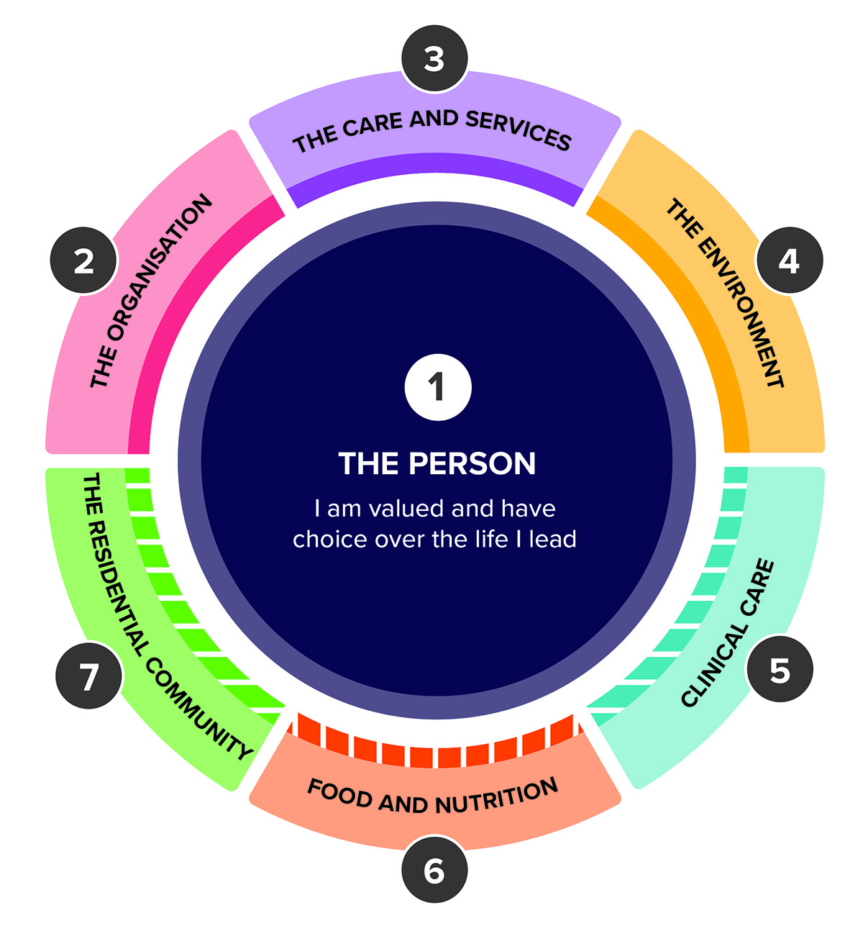

**The draft strengthened Quality Standards include:**

|  |
| --- |
| **Standards applicable to most providers** |

|  |  |
| --- | --- |
| **Standard 1: The Person** | * Person-centred care * Dignity, respect and privacy * Choice, independence and quality of life * Transparency and agreements |
| **Standard 2:  The Organisation** | * Partnering with older people * Quality and safety culture * Accountability and quality systems * Risk management * Incident management * Feedback and complaints management * Information management * Workforce planning * Human resource management * Emergency and disaster management |
| **Standard 3: The Care and Services** | * Assessment and planning * Delivery of care and services * Communicating for safety and quality * Coordination of care and services |
| **Standard 4: The Environment** | * Environment and equipment *(at home or in a service environment)* * Infection prevention and control |

|  |
| --- |
| **Additional standards applicable to providers based on the service types they deliver** |

|  |  |
| --- | --- |
| **Standard 5: Clinical Care** | * Clinical governance * Preventing and managing infections in clinical care * Medication safety * Comprehensive care * Care at the end of life   *This standard is intended to apply to providers delivering clinical care, whether it is in an older person’s home or a residential environment.* |
| **Standard 6: Food and Nutrition** | * Partnering with older people on food and nutrition * Assessment of nutritional needs and preferences * Provision of food and drink * Dining experience   *This standard is intended to apply to providers delivering residential care.* |
| **Standard 7: The Residential Community** | * Daily living * Planned transitions   *This standard is intended to apply to providers delivering residential care.* |

## What are the main changes?

While the structure of the strengthened Quality Standards has changed, the content and language have drawn on the current Quality Standards. For example, in the strengthened Quality Standards:

* **Standard 1** remains similar in its focus on the older person
* **Standard 2** draws on Standards 6, 7 and 8 from the current Quality Standards
* **Standard 3** draws on Standard 2 and parts of Standards 3 and 4 from the current Quality Standards
* **Standard 4** draws on Standard 5 and parts of Standard 3 from the current Quality Standards
* **Standard 5** draws on parts of Standards 2, 3 and 8 from the current Quality Standards
* **Standard 6** expands significantly on parts of Standards 2 and 4 from the current Quality Standards
* **Standard 7** draws on parts of Standards 3 and 4 from the current Quality Standards.

The strengthened Quality Standards seek to strengthen requirements to ensure older people receive quality care that is person-centred, safe, coordinated and effective.

Key changes to the strengthened Quality Standards include:

* a stronger focus on the rights of and outcomes for older people
* an increased focus on the provider’s governance and partnerships with  
  older people
* clearer expectations3 for providers
* more detailed requirements across a range of areas.

### Outcomes for older people

A key focus of the strengthened Quality Standards is ensuring that care and services are person-centred i.e. tailored for each individual.

There is strong support for the consumer outcome statements included in the current Quality Standards. These are retained in the strengthened Quality Standards to simply state what older people can expect from their provider.

The language used throughout the strengthened Quality Standards improves the focus on outcomes for older people, particularly in relation to choice, inclusion and quality of life. The Quality Standards also seek to use words that have meaning for older people.

In line with the new aged care legislation, the strengthened Quality Standards  
focus on:

* **‘person-centred care’** – requiring providers to get to know each older person and to orient their care and services around what’s important to them.
* a **‘rights-based’** approach – requiring providers to respect and support the autonomy and choices of older people in all aspects of their care.

### Governance and partnerships

Standard 2 describes requirements for how the organisation is run, including the responsibilities of the provider’s governing body and the quality systems the provider must have in place to monitor the safety and quality of care and services.

As part of this, providers are expected to actively engage with older people to set goals for their organisation and identify improvements needed. This ensures that the safety and quality of services for all older people is at the forefront of the provider’s strategic and operational business planning.

### Clear expectations

The strengthened Quality Standards include 142 actions that seek to help providers and workers to understand how they might demonstrate achievement of the outcomes.

The actions expand on the requirements under the current Quality Standards to make requirements more clear, specific and measurable for providers.

It will be important to balance the level of detail included in the Quality Standards to ensure there is enough detail to make it clear what is expected of providers while giving them enough flexibility to innovate and provide care in a way that best suits each individual.

### Detailed requirements

The strengthened Quality Standards set out in detail what is expected of providers  
in delivering care. In particular, the Quality Standards have been strengthened in relation to:

* **provider governance** – Standard 2 describes the systems providers should have in place to deliver quality care (including partnerships with older people, accountability, quality systems, workforce planning, emergency and disaster management, etc.)
* **food and nutrition** – Standard 6 describes what older people can expect of the food and drink they are provided in residential care services
* **diversity** – Standard 1 in particular requires providers to support older people  
  to feel safe, welcome and included, and to deliver care that is trauma-aware, healing-informed, culturally safe and right for people from diverse backgrounds
* **dementia care** – Standard 3 in particular requires providers to have systems for caring for people with dementia
* **clinical care** – Standard 5 describes clinical care requirements, developed by the Health Commission
* **assessment and planning** – Standard 3 describes how providers must assess each older person’s needs, goals and preferences, document this in a care plan and use this to inform the way care is delivered
* **infection prevention and control** – Standard 4 describes the systems providers should have in place to prevent infections and minimise risk of harm to older people.

## How can you provide feedback?

The following documents may help you to provide feedback:

* the strengthened Quality Standards – a [summary version](https://health.gov.au/resources/publications/revised-aged-care-quality-standards-summary-draft-for-public-consultation) or a more [detailed version](https://health.gov.au/resources/publications/revised-aged-care-quality-standards-detailed-draft-for-public-consultation).
* [detailed version of this consultation paper](https://health.gov.au/resources/publications/consultation-paper-detailed-aged-care-quality-standards-review).

Please go to the department’s [Engagement Hub](https://agedcareengagement.health.gov.au/qualitystandards/) to complete an online survey, provide a submission through the survey or to find other opportunities to be involved.

**Your feedback on the strengthened Quality Standards is appreciated.  
Thank you again for your time.**

1. KPMG, 27 September 2021, Evaluation of the Aged Care Quality Standards: Lightning Review Summary Report.
2. KPMG, January 2022, Evaluation of the Aged Care Quality Standards.
3. Aged Care Quality and Safety Commission, 6 April 2022, [Making a complaint](https://www.agedcarequality.gov.au/consumers/serious-incident-response-scheme).