The Department of Health and Aged Care logo


Consultation  
Paper: Aged Care Quality Standards Review

Detailed Consultation Paper

# Table of contents

Table of contents 2

Section 1: Context 4

What is the purpose of this consultation? 4

Terminology 5

What has been the process to review the Quality Standards? 6

Section 2: Drivers for change 7

Why are the current Quality Standards changing? 7

The Royal Commission 7

Independent Evaluation 8

A new regulatory model 8

Regulatory harmonisation 9

What are the goals of any changes? 9

Section 3: Overview of the changes 10

What is the role of the Quality Standards? 10

Who will the strengthened Quality Standards apply to? 10

What other levers are in place to drive high quality care? 11

What do the strengthened Quality Standards look like? 11

What are the main changes 15

Focus on the older person 16

Strengthened concepts 16

Clear expectations 17

More detailed requirements 17

Proportionate, risk-based application of standards 18

Harmonisation 18

What does this mean for aged care providers? 18

Pilot of the strengthened Quality Standards 19

How can you provide feedback? 19

Attachment A: Other reforms driving quality care 20

**Thank you**

Thank you for taking the time to contribute to this process and to those who have already contributed to the development of the strengthened Quality Standards.

Your experiences, thoughts and expert advice are valued and will help to deliver a better aged care system.

# Section 1: Context

## What is the purpose of this consultation?

The purpose of this consultation process is to seek your feedback on a set of draft strengthened Aged Care Quality Standards (Quality Standards) that seek to improve the safety and quality of aged care. Your feedback will help us further improve the Quality Standards.

Achieving conformance with the Quality Standards is one of the ways in which a provider demonstrates its commitment to delivering quality care and services.

As part of improvements being made to the aged care system, and in response to findings from the [Royal Commission into Aged Care Quality and Safety](https://agedcare.royalcommission.gov.au/publications/final-report) (the Royal Commission), the Department of Health and Aged Care (the department) is reviewing the [current Quality Standards](https://www.agedcarequality.gov.au/providers/standards) and has developed a draft set of strengthened Quality Standards in response to feedback from older people, their families and aged care providers.

To view the strengthened Quality Standards and provide your feedback, please go to the department’s  [Aged Care Engagement Hub](https://agedcareengagement.health.gov.au/qualitystandards/) (the Engagement Hub).

### Terminology

For the purposes of this consultation paper and the draft strengthened Quality Standards, we have used the following terms:

* **Quality care** – refers to care that:
  + is **person-centred**, provided with kindness and compassion, responding to the holistic needs of the older person and aiming to improve their wellbeing and quality of life
  + is smoothly **coordinated** when care is provided by the workforce, visiting practitioners, and external providers (where relevant)
  + is **effective**, providing the right care to meet the older person’s needs goals and preferences
  + keeps older people **safe** from preventable harm.
* **Older person / older people** – this refers to a person (or people) receiving Commonwealth-funded aged care services. The current Quality Standards use the term ‘consumer’, however, this term is not generally well accepted by older people and is being reviewed as part of the development of a new Aged Care Act.
* Reference to an older person includes reference to a representative of the older person, so far as the provision can apply to a representative. A representative is a person appointed to act or make decisions on behalf of an older person and who the older person nominates to be told about matters affecting them.
* **Provider** – this refers to the organisation providing Commonwealth-funded aged care services.
* **Governing body** – this refers to the governing body (such as the Board) of  
  the provider.
* **Worker** – this refers to an individual who is employed, hired, retained or contracted by the provider (whether directly or through an employment or recruiting agency) to provide care or other services.
* **Others involved in the older person’s** **care** – this refers to any individuals or organisations that are involved in delivering care, services or supports to older people. It may involve other aged care providers, healthcare professionals, health services, community organisations, carers, etc.

It is important to note that these definitions are included to explain the expectations of how the Quality Standards could direct care and services only. A number of these terms will change as the new Aged Care Act is developed.

## What has been the process to review the Quality Standards?

The draft strengthened Quality Standards have been developed by the department, in collaboration with:

* the [Aged Care Quality and Safety Commission](https://www.agedcarequality.gov.au/) (the Aged Care Commission), which has responsibility for assessing aged care providers against the Quality Standards
* the [Australian Commission on Safety and Quality in Health Care](https://www.safetyandquality.gov.au/) (the Health Commission), which has responsibility for setting the clinical components of  
  the Quality Standards.

The strengthened Quality Standards have been informed by:

* engagement with older people, their carers and families, subject matter experts and sector representatives, including aged care providers and peak bodies
* relevant findings from the [Royal Commission](https://agedcare.royalcommission.gov.au/)
* an [independent review of the current Quality Standards](https://www.health.gov.au/resources/publications/evaluation-of-the-aged-care-quality-standards-evaluation-report) [1]
* standards for health care and disability support (the [National Safety and Quality Health Service (NSQHS) Standards](https://www.safetyandquality.gov.au/standards/nsqhs-standards) and the [National Disability Insurance Scheme (NDIS) Practice Standards](https://www.ndiscommission.gov.au/providers/registered-ndis-providers/provider-obligations-and-requirements/ndis-practice-standards#paragraph-id-2711))
* discussions with aged care policy areas in other countries such as New Zealand, Canada and the United Kingdom.

Feedback from this consultation process will inform further changes to the strengthened Quality Standards, which will be included in the review report submitted to Government at the end of 2022.

It is intended that the strengthened Quality Standards will be implemented alongside broader reforms to the aged care system, including the new Aged Care Act and new aged care regulatory model.

# Section 2: Drivers for change

## Why are the current Quality Standards changing?

The [current Quality Standards](https://www.agedcarequality.gov.au/providers/standards) were introduced in 2019 and set expectations to support the delivery of quality care. The aged care sector, and particularly providers, have invested time and resources to adjust their systems and practices to meet the outcomes required under the current Quality Standards and improve their performance.

Recognising the need to continuously improve the aged care sector, there are a range of drivers for changes to the current Quality Standards. This includes responding to feedback from older people and providers, findings from the Royal Commission and other sector-wide changes occurring over the coming years.

### The Royal Commission

The Royal Commission highlighted that the current Quality Standards ‘set out the minimum acceptable standards for accreditation’ rather than motivating providers to achieve quality. It also found that they are not sufficiently ‘comprehensive, rigorous and detailed’[2].

The Royal Commission identified specific areas for improvements to the current Quality Standards, including to:

* reflect the needs of **people living with dementia** and a requirement to provide quality dementia care, noting this should be ‘core business’ for all aged care providers[3]
* better recognise **diversity and improve cultural safety** for Aboriginal and Torres Strait Islander peoples[4]
* strengthen requirements in relation to **governance and human resources**
* describe more detailed requirements relating to **food and nutrition**, including ensuring meals are desirable to eat, having regard for a person’s preferences and religious / cultural considerations
* improve **clinical care** requirements, particularly in relation to oral care, medication management, pressure injury prevention, wound management, continence care, falls prevention and mobility, infection control, palliative care, and provide sufficient detail on what these requirements involve and how they are to be achieved.

The Royal Commission recommended an urgent review of the Quality Standards to address the issues identified above (recommendation 19).

### Independent Evaluation

KPMG completed an [evaluation of the Quality Standards](https://www.health.gov.au/resources/publications/evaluation-of-the-aged-care-quality-standards-evaluation-report) in January 2022.  
The evaluation found:

* some areas where the requirements in the Quality Standards are insufficient and don’t meet stakeholder expectations, as identified by the Royal Commission
* a need to introduce more prescriptive or detailed requirements to help providers understand expectations and improve measurability
* some repetition / duplication in requirements across standards
* challenges putting certain complex themes of the Quality Standards into practice, including cultural safety, cultural diversity, dignity of risk, best practice and governance
* challenges applying requirements across all service types and settings.

The evaluation identified opportunities to improve the Quality Standards, including to address gaps identified by the Royal Commission, and to include more specific requirements and expand on the existing requirements with more detailed descriptions of expectations.

### A new regulatory model

The Australian Government is currently undertaking a significant program of [aged care reform](https://www.health.gov.au/initiatives-and-programs/aged-care-reforms), which is being rolled out over 2021 to 2025.

This includes the introduction of a new regulatory model, set out in a modernised, person-centred and rights based Aged Care Act (which will replace the existing *Aged Care Act 1997*, *Aged Care Quality and Safety Commission Act 2018* and related subordinate legislation).

The Royal Commission highlighted that the current regulatory framework is no longer suitable and reforms to date have been incremental. The new regulatory model will be:

* **Rights-based** – ensuring protections are in place to uphold the rights of  
  older people
* **Person-centred** – placing the needs, goals, values and preferences of older people at the heart of the regulatory model
* **Risk-based** – strengthening the regulatory response through a risk-based approach
* **Focused on continuous** **improvement** – requiring an ongoing commitment to enhancing the capability of the aged care sector and the quality of care and services older people receive.

The new Act will place older people at the heart of the system and support other reforms aimed at ensuring quality care and services for older people. It will be supported by subordinate legislation and guidance to support providers to understand expectations.

It is expected there would be an implementation period to enable existing providers to understand the regulatory changes, including how the new Act and strengthened Quality Standards apply to them and to establish systems to demonstrate their performance. Further consultation will be undertaken on this in 2023.

These concepts will be further explored in upcoming consultation on the new model for regulating aged care, anticipated to occur in late 2022. Please [register](https://healthau.au1.qualtrics.com/jfe/form/SV_2tWXoF3uTem0tdc) at the department’s Engagement Hub to be kept up to date on upcoming consultations.

### Regulatory harmonisation

In the 2021–22 Budget, the Australian Government committed to harmonise regulation across Commonwealth funded care and supports, including aged care, disability support and veterans’ care. This is intended to improve quality and safety for participants and older people and remove unnecessary duplication of obligations for service providers and workers to work more seamlessly across different types  
of care.

The strengthened Quality Standards take the first step towards regulatory harmonisation of standards across sectors by pursuing structural alignment with the NDIS Practice Standards, acknowledging that differences will remain appropriate in the immediate term given the differences between aged care and disability support (including different service types, funding arrangements, and a larger cohort accessing aged care in a residential setting, etc.)[5].

## What are the goals of any changes?

Collectively, these drivers have informed the approach to strengthening the  
Quality Standards.

The goals for revising the Quality Standards include:

* stronger focus on the rights of the older person and ensuring that the design of care and services are tailored to individual needs and preferences
* addressing issues raised by the Royal Commission and strengthening requirements in relation to provider governance, diversity, dementia, food and clinical care
* clearly communicating expectations and what actions providers can take to achieve the desired outcomes
* enabling some standards to be applied based on the types of service being delivered
* improving harmonisation with the NDIS Practice Standards, while recognising the differences between aged care and [disability support](https://www.health.gov.au/health-topics/aged-care/aged-care-reforms-and-reviews/designing-a-new-approach-to-regulating-aged-care).

# Section 3: Overview of the changes

## What is the role of the Quality Standards?

The role of the Quality Standards under the new aged care system will be similar  
to that of the current Quality Standards, however, they will differ in their application (see below).

The Quality Standards will set out the things providers need to do to deliver quality care and define what older people can expect from their provider. Providers subject to the Quality Standards would be required to demonstrate their performance against the Quality Standards at market entry (to commence delivering Commonwealth funded aged care) and also at certain intervals following market entry.

It is intended that the Quality Standards would focus on the essential systems and controls that providers must have in place to achieve outcomes and ensure the delivery of safe and quality aged care.

The Aged Care Commission will continue to assess provider performance against the Quality Standards, with the outcomes of assessments published to provide transparency regarding provider performance. The focus of any performance assessment against the Quality Standards would be on ensuring that the provider has appropriate governance, systems and processes in place and testing that these are working in practice to deliver safe and quality care for older people.

## Who will the strengthened Quality Standards apply to?

Currently, the Quality Standards apply to all providers of Commonwealth-funded aged care, including those delivering flexible care services, home services and residential services. Feedback has identified that having the same standards apply to all providers of aged care (regardless of the risk profile of the provider or the service type) can lead to over-regulation of some providers and under-regulation  
of others.

As part of the new regulatory model, government is exploring different options for regulating providers, including a registration model.

Under this approach, requirements for market entry and ongoing provider responsibilities would be applied proportionately, based on the provider’s registration category. A provider’s registration category would be determined based on the types of care and services the provider is seeking to deliver and the risks associated with them. As such, certain provider responsibilities (such as the Quality Standards) may not apply to some providers or may differ for providers based on the service types they deliver. For example, it is anticipated that:

* providers delivering lower risk services such as gardening and outside maintenance may not be subject to the Quality Standards (but would continue to be subject to other regulatory requirements)
* most providers would be subject to the Quality Standards, which include four standards that apply regardless of the service types being delivered
* some providers of higher risk services (such as residential care and clinical care) would be subject to the Quality Standards, including some additional standards, as relevant to those service types (see below).

This means that, for service types where there are specific expectations or risks, standards have been developed to address those risks. This is similar to how the NDIS Practice Standards operate.

This approach will be further explored in upcoming consultation on the new model for regulating aged care, anticipated to occur in late 2022.

## What other levers are in place to drive high quality care?

The Quality Standards would be one of a range of regulatory requirements used to drive provider performance and protect older people.

The new Aged Care Act and related legislation will continue to set out requirements for providers of aged care. As discussed above, the legislative framework will be founded in the principles of rights‑based and person-centred care, complementing some of the key concepts set out in the strengthened Quality Standards. Legislation will set out certain requirements all providers must meet, including in relation to complaints management and incident reporting.

Older people are encouraged to provide feedback and raise concerns with their provider (where they feel comfortable to do so). This helps to improve the quality  
of care and services for themselves and for other older people. Older people, their carers and families can also make complaints to the Aged Care Commission, including where they feel their provider is not meeting the requirements of the  
Quality Standards[6].

There are also a range of improvements being made to aged care over the coming years as part of aged care reforms, summarised at Attachment A.

## What do the strengthened Quality Standards look like?

The approach to the strengthened Quality Standards pursues structural harmonisation with the NDIS Practice Standards, providing a modular approach whereby certain standards would apply to providers based on their registration category (which group the types of services available).

It is anticipated that all providers subject to the Quality Standards would be required to demonstrate their performance against standards 1 to 4, and some providers would also be required to demonstrate their performance against standards 5 to 7, based on the types of services they deliver.

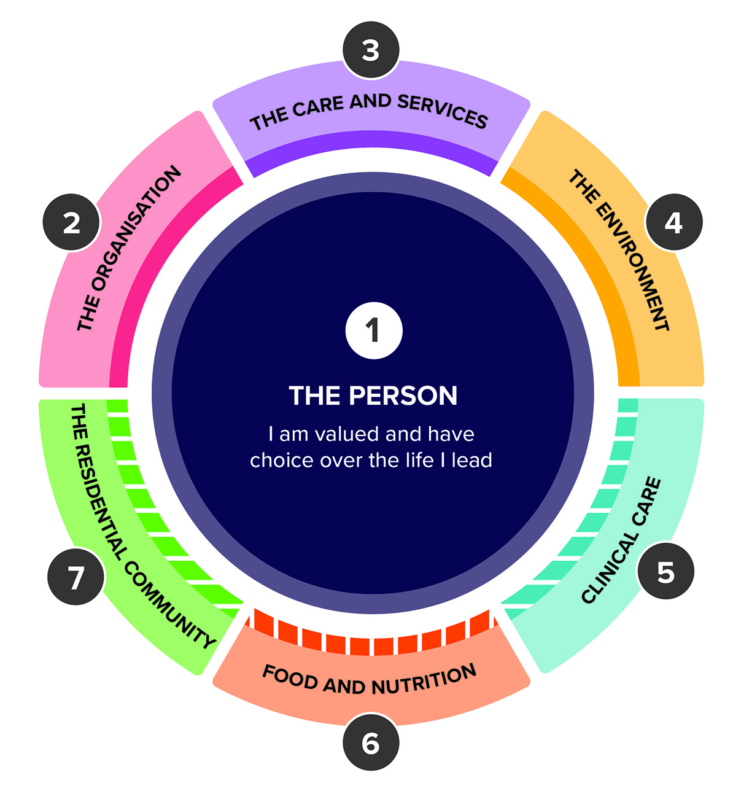

**The draft strengthened Quality Standards include:**

|  |
| --- |
| **Standards applicable to most providers** |

|  |  |
| --- | --- |
| **Standard 1: The Person** | * Person-centred care * Dignity, respect and privacy * Choice, independence and quality of life * Transparency and agreements |
| **Standard 2:  The Organisation** | * Partnering with older people * Quality and safety culture * Accountability and quality systems * Risk management * Incident management * Feedback and complaints management * Information management * Workforce planning * Human resource management * Emergency and disaster management |
| **Standard 3: The Care and Services** | * Assessment and planning * Delivery of care and services * Communicating for safety and quality * Coordination of care and services |
| **Standard 4: The Environment** | * Environment and equipment *(at home or in a service environment)* * Infection prevention and control |

|  |
| --- |
| **Additional standards applicable to providers based on the service types they deliver** |

|  |  |
| --- | --- |
| **Standard 5: Clinical Care** | * Clinical governance * Preventing and managing infections in clinical care * Medication safety * Comprehensive care * Care at the end of life   *This standard is intended to apply to providers delivering clinical care, whether it is in an older person’s home or a residential environment.* |
| **Standard 6: Food and Nutrition** | * Partnering with older people on food and nutrition * Assessment of nutritional needs and preferences * Provision of food and drink * Dining experience   *This standard is intended to apply to providers delivering residential care.* |
| **Standard 7: The Residential Community** | * Daily living * Planned transitions   *This standard is intended to apply to providers delivering residential care.* |

The structure of the Quality Standards has been adjusted to allow for the proportionate application of requirements to service types and to align more closely with that of the NDIS Practice Standards. For each standard, it is proposed that there would be:

* an expectation statement for older people that simply and clearly describes what they can expect from their provider in relation to that standard
* a number of outcomes, each supported by:
  + an outcome statement, which is **what** the provider would be assessed against
  + a number of actions, which are **how** the provider might demonstrate achievement of the outcome.

The inclusion of detailed actions against each outcome responds to the identified need for more prescriptive and detailed requirements to help providers understand expectations and improve measurability of the standards.

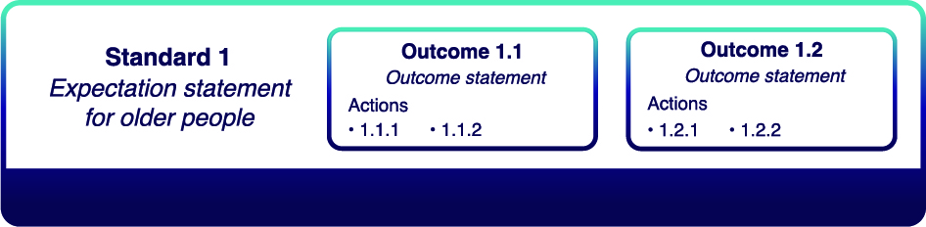

## What are the main changes

While the structure of the NDIS Practice Standards has provided a framework for the strengthened Quality Standards, the content and language have been tailored to the aged care context and draw on the strengths of the current Quality Standards. For example, in the strengthened Quality Standards:

* **Standard 1** remains similar in its focus on the older person
* **Standard 2** draws on Standards 6, 7 and 8 from the current Quality Standards
* **Standard 3** draws on Standard 2 and parts of Standards 3 and 4 from the current Quality Standards
* **Standard 4** draws on Standard 5 and parts of Standard 3 from the current Quality Standards
* **Standard 5** draws on parts of Standards 2, 3 and 8 from the current Quality Standards
* **Standard 6** expands significantly on parts of Standards 2 and 4 from the current Quality Standards
* **Standard 7** draws on parts of Standards 3 and 4 from the current Quality Standards.

Providers will be familiar with much of the language used throughout the strengthened Quality Standards, including concepts such as ‘assessment and planning’, ‘dignity of risk’, ‘cultural safety’, ‘clinical governance’ and ‘antimicrobial stewardship’.

The strengthened Quality Standards also:

* retain a focus on the older person
* introduce strengthened concepts about how care is delivered to older people and the rights of older people
* provide clear expectations for providers
* include more detailed requirements across a range of areas, including priority areas identified by the Royal Commission
* enable proportionate application of standards based on the service setting and types of services being delivered
* move towards harmonisation of standards across the care and support sectors.

### Focus on the older person

A key focus of the strengthened Quality Standards is ensuring that care and services are person centred, i.e. tailored around each individual.

There is strong support for the consumer outcome statements included in the current Quality Standards. These are retained in the strengthened Quality Standards (framed as ‘expectation statements for older people’ for each standard) to clearly and simply articulate what older people can expect from their provider.

The language used throughout the strengthened Quality Standards improves the focus on outcomes for older people, particularly in relation to choice, inclusion and quality of life.

Standard 1 in particular strengthens the focus on the individuality of the older person, including requiring providers to provide care that is person-centred, culturally safe and ‘right’ for each person.

The strengthened Quality Standards seek to use words that have meaning for older people, such as being made to feel ‘safe, welcomed and ‘included’, food that is ‘appetising, flavourful and enjoyable’, minimising ‘boredom and loneliness’, etc.

### Strengthened concepts

In line with the new regulatory framework and legislation, the strengthened Quality Standards have a focus on person-centred, rights-based care:

* **‘Person-centred care’** is an approach to the planning, delivery and evaluation of care that is founded on partnerships between providers and the older person. It is respectful of, and responsive to, the preferences, needs and values of the older person. The strengthened Quality Standards require providers to get to know each older person and to orient their care and services around what’s important to them.
* A **‘rights-based’** approach recognises human rights and freedoms as legally enforceable entitlements. It is expected that the rights of older people will be specifically outlined in the new Aged Care Act. The strengthened Quality Standards require providers to respect and support the autonomy and choices of older people in all aspects of their care.

The strengthened Quality Standards also recognise the importance of care that is ‘**trauma-aware and healing-informed**’. This acknowledges that most people have experienced some kind of trauma in their lives and takes this into consideration when providing care (noting that trauma can cause lifelong repercussions, affecting how people relate to the world around them). The principles of trauma-aware healing-informed care include understanding the effects of trauma, promoting safety and trust, providing choice and control, building connections, focusing on strengths and promoting quality of life[7].

### Clear expectations

The current Quality Standards are outcomes-focused and comprise eight standards, each including a consumer outcome, organisation statement and a number of requirements describing expectations of providers.

The strengthened Quality Standards describe more detailed expectations for providers on the outcome to be met and how that outcome might be demonstrated, taking the standards from 42 requirements to 31 outcomes with 142 supporting actions. While this may seem like an increase in regulatory requirements, the intent is to provide more clarity to providers regarding how they can achieve the outcomes required by the Quality Standards. Many of the actions recognise things that providers are likely already doing in order to deliver quality aged care.

A key consideration for changes to the Quality Standards is the appropriate level of detail to include in the standards. It will be important to ensure the right balance between setting out clear expectations for providers while enabling sufficient flexibility for providers to innovate and demonstrate compliance as relevant to them and their context.

### More detailed requirements

The strengthened Quality Standards set out in detail what is expected of providers in delivering care. In particular, requirements have been strengthened in relation to:

* **provider governance** – Standard 2 sets out more detailed requirements regarding the systems and structures providers should have in place to deliver safe and quality care (including requirements regarding partnering with older people, accountability and quality systems, workforce planning, emergency and disaster management, etc.)
* **food and nutrition** – Standard 6 sets out requirements regarding what older people can expect of the food and drink they are provided in residential care services
* **diversity** – the strengthened Quality Standards require providers to support older people to feel safe, welcome and included, and to deliver care that is trauma-aware, healing informed, culturally safe and right for people from diverse backgrounds (see Standard 1 in particular)
* **dementia care** – the strengthened Quality Standards require providers to have systems for caring for people with dementia (see Standard 3 in particular)
* **clinical care** – Standard 5 sets out detailed requirements regarding clinical care, developed by the Health Commission
* **assessment and planning** – Standard 3 sets out more detailed requirements regarding how providers assess each older person’s needs, goals and preferences, document this in a care plan and use this to inform the way care is delivered
* **infection prevention and control** – Standard 4 sets out requirements regarding the systems providers should have in place to prevent infections and minimise risk of harm to older people.

Many of these were highlighted as areas for improvement by the Royal Commission.

### Proportionate, risk-based application of standards

As described under who will the strengthened Quality Standards apply to?, the strengthened Quality Standards will be applied based on the level of risk associated with the type of services a provider is delivering. This means that, for service types where there are specific expectations or risks, standards have been developed to address those risks.

### Harmonisation

The strengthened Quality Standards align structurally with the NDIS Practice Standards by adopting the modular approach and using outcomes and actions (which are called ‘quality indicators’ in the NDIS Practice Standards).

The standards don’t have the same names or exactly the same content, however they cover similar concepts while ensuring the requirements remain specific and relevant to the context. While the outcomes and action/indicators differ between the NDIS Practice Standards and the strengthened Quality Standards, the same evidence may be used to demonstrate compliance with outcomes across both the standards. For example, a provider’s incident management system might be used to demonstrate compliance with the incident management outcome under both the NDIS Practice Standards and the strengthened Quality Standards.

## What does this mean for aged care providers?

It is recognised that the strengthened Quality Standards may present a significant change for many aged care providers and that (with the reforms broadly), there will be a need for education and support for the sector.

While the outcomes sought under the strengthened Quality Standards are similar to those required under the existing Quality Standards, the actions provide much more detail regarding how providers can achieve those outcomes. There is a focus on requiring providers to implement robust governance, quality systems and practices (informed by contemporary evidence-based practice) to achieve outcomes and continuously improve their performance.

While many providers will already have such systems in place, it may take other providers some time to establish robust quality systems to meet the requirements of the strengthened Quality Standards. It is expected that there will be an implementation period to enable providers to familiarise themselves with the strengthened Quality Standards, and to establish and embed robust governance, systems and practices.[8]

## Pilot of the strengthened Quality Standards

Following the public consultation, the Aged Care Commission will conduct a pilot to test a redesigned audit methodology for assessing provider performance against the strengthened Quality Standards.

The Aged Care Commission will invite a range of providers to participate, ensuring the sample is representative of the aged care sector, including considerations of service type, size and location, and diversity of older people. The pilot findings will inform refinements to the audit methodology and the development of guidance for providers and older people, and may lead to further changes to the strengthened Quality Standards.

Guidance will support older people and providers to prepare for the revised Quality Standards and understand how the Aged Care Commission will regulate them. The guidance will be developed in consultation with providers and older people, with public consultation expected to occur in early 2023. Further information will be made available on the [Aged Care Commission’s website](https://www.agedcarequality.gov.au/).

This work is critical to ensure the Aged Care Commission has processes, tools and guidance in place to regulate the aged care sector consistently and effectively, and ensure providers are delivering safe and quality care for older people.

## How can you provide feedback?

The following documents may help you to provide feedback:

* the strengthened Quality Standards – a [summary version](https://health.gov.au/resources/publications/revised-aged-care-quality-standards-summary-draft-for-public-consultation) or a more [detailed version](https://health.gov.au/resources/publications/revised-aged-care-quality-standards-detailed-draft-for-public-consultation).
* [summary version of this consultation paper](https://health.gov.au/resources/publications/consultation-paper-summary-aged-care-quality-standards-review).

Please go to the department’s [Engagement Hub](https://agedcareengagement.health.gov.au/qualitystandards/) to complete an online survey, provide a submission through the survey or to find other opportunities to be involved.

**Your feedback on the strengthened Quality Standards is appreciated.  
Thank you again for your time.**

# 

# Attachment A: Other reforms driving quality care

There are a range of improvements being made to aged care over the coming years seeking to drive provider performance and quality care. Some of these include:

* **changes to the way providers are regulated** 
  + Currently, the regulatory framework does not differentiate home services providers based on the risks associated with the types of services they deliver.
  + The new regulatory framework will seek to differentiate providers so that  
    the level of regulation imposed is proportionate to the risk. It will also improve the use of data and intelligence to understand risk and differentiate across the sector.
  + This acknowledges that there are different risks associated with different types of care and services. For example, services such as garden maintenance present different risks compared to the provision of  
    clinical care.[9]
* **a new** [**Support at Home Program**](https://www.health.gov.au/health-topics/aged-care/aged-care-reforms-and-reviews/reform-to-in-home-aged-care)
  + The Support at Home Program will replace the Commonwealth Home Support Programme (CHSP), the Home Care Packages (HCP) Program, Short‑Term Restorative Care Programme (STRC) and residential respite programs. Under this program, it is intended that older people would receive individualised service approvals (based on their assessed needs and circumstances). There will also be a new point-of-delivery payment system for providers to help improve transparency for older people and reduce administrative costs.
* **the new Code of Conduct for Aged Care (the Code) and a national registration scheme for personal care workers in the aged care sector**
  + The national registration scheme will protect residents and further professionalise the aged care workforce. It will include requirements for ongoing training, English proficiency, criminal history screening and a code  
    of conduct.
  + The Code, the first element of the registration scheme, will set out expectations of how providers and their aged care workers and governing persons are expected to behave.
  + The Code is based on the NDIS Code of Conduct.
* **the** [**National Aged Care Mandatory Quality Indicator Program**](https://www.health.gov.au/initiatives-and-programs/national-aged-care-mandatory-quality-indicator-program-qi-program) **(the QI Program)**
  + Under the QI Program, residential care providers are required to regularly collect and report on quality indicators to the department. The quality indicators measure important aspects of care quality that can affect an older person’s health and wellbeing, including in relation to pressure injuries, physical restraint, unplanned weight loss, falls and major injuries and medication management.
  + QI data is used to help improve quality of care.
  + The QI Program is currently being expanded, including the introduction of more indicators in residential care and new indicators for home services.
* [**Star Ratings for residential aged care**](https://www.health.gov.au/initiatives-and-programs/star-ratings-for-residential-aged-care)
  + Star ratings are intended to help older people make more informed choices about their care by providing information about the quality of services.
  + Star ratings will be based on Quality Indicator data, service compliance ratings, consumer experience and staff care minutes.
  + Star ratings are planned to be introduced for residential care services from the end of 2022.
* [**24/7 nursing in residential services**](https://www.health.gov.au/ministers/the-hon-mark-butler-mp/media/delivering-labors-plan-to-fix-aged-care)
  + All residential services will be required to have a qualified registered nurse on site 24 hours a day, seven days a week to ensure older people receive quality care as needed.
* **strengthened requirements for** [**provider governance arrangements**](https://www.health.gov.au/sites/default/files/documents/2021/05/governance-pillar-5-of-the-royal-commission-response-strengthening-provider-governance.pdf)
  + Legislative changes are being made and training provided to support providers to improve their governance arrangements and lift sector capability. This includes requirements regarding the membership of provider governing bodies, the provider’s constitution, advisory bodies, staff qualifications, skills and experience, the suitability of key personnel and the submission of an annual statement on the provider’s operations.
* **the new** [**Financial and Prudential Monitoring, Compliance and Intervention Framework**](https://www.health.gov.au/health-topics/aged-care/aged-care-reforms-and-reviews/financial-and-prudential-monitoring-compliance-and-intervention-framework) **(the Framework)**
  + The Framework will strengthen government oversight of provider financial and prudential arrangements, including through stricter reporting and disclosure obligations and financial oversight and prudential requirements.

1. KPMG, January 2022, Evaluation of the Aged Care Quality Standards.
2. Royal Commission into Aged Care Quality and Safety, 2021,  
   [Final Report: Care, Dignity and Respect](https://agedcare.royalcommission.gov.au/sites/default/files/2021-03/final-report-volume-1_0.pdf), p. 94.
3. Royal Commission into Aged Care Quality and Safety, 2021,  
   [Final Report: Care, Dignity and Respect](https://agedcare.royalcommission.gov.au/sites/default/files/2021-03/final-report-volume-1_0.pdf), p. 69.
4. Royal Commission into Aged Care Quality and Safety, 2021,  
   [Final Report: Care, Dignity and Respect](https://agedcare.royalcommission.gov.au/sites/default/files/2021-03/final-report-volume-1_0.pdf), p. 67.
5. Department of Health, 7 March 2022, [Aligning regulation across the care and support sectors](https://www.health.gov.au/initiatives-and-programs/aligning-regulation-across-the-care-and-support-sectors).
6. Aged Care Quality and Safety Commission, 6 April 2022, [Making a complaint](https://www.agedcarequality.gov.au/consumers/serious-incident-response-scheme).
7. Phoenix Australia, [Trauma and Aged Care: Support and Information Hub](https://phoenixaustralia.org/aged-care/).
8. Transition will be further explored in upcoming consultation on the new model for regulating aged care, anticipated to occur in late 2022 or early 2023.
9. This is described in more detail in the Department’s [Concept paper: Concepts for a new framework for regulating aged care](https://www.health.gov.au/sites/default/files/documents/2022/02/concepts-for-a-new-framework-for-regulating-aged-care.pdf), February 2022.