| Logo | **Australian Influenza**  **SURVEILLANCE REPORT**  **No. 7, 2020**  **29 June to 12 July 2020** |
| --- | --- |

The Department of Health acknowledges the providers of the many sources of data used in this report and greatly appreciates their contribution.

## KEY MESSAGES

**It is important to note that due to the COVID-19 epidemic in Australia, data reported from the various influenza surveillance systems may not represent an accurate reflection of influenza activity. Results should be interpreted with caution, especially where comparisons are made to previous influenza seasons. Interpretation of 2020 influenza activity data should take into account, but are not limited to, the impact of social distancing measures, likely changes in health seeking behaviour of the community including access to alternative streams of acute respiratory infection specific health services, and focussed testing for COVID-19 response activities. Current COVID-19 related public health measures and the community’s adherence to public health messages are also likely having an effect on transmission of acute respiratory infections, including influenza.**

* **Activity** – Following a high start to the 2020 interseasonal period, currently, influenza and influenza-like illness (ILI) activity are lower than average across all systems for this time of year. At the national level, notifications of laboratory-confirmed influenza have substantially decreased since mid-March and remain low.
* **Impact** – There is no indication of the potential impact on society of the 2020 season at this time.
* **Severity** – There is no indication of the potential severity of the 2020 season at this time. In the year to date, of the 20,830 notifications of laboratory confirmed influenza, 36 (0.17%) laboratory-confirmed influenza-associated deaths have been notified to the National Notifiable Diseases Surveillance System (NNDSS).
* **Virology** – In the year to date, the majority of nationally reported laboratory-confirmed influenza cases were influenza A (87.3%). The proportion of cases attributed to influenza B has increased in the past fortnight (27.7%), compared to the previous fortnight (15.3%; 15 to 28 June 2020).
* **Vaccine match and effectiveness** – It is too early in the season to assessvaccine match and effectiveness.

### Introduction

Each year, the influenza virus changes and different strains can circulate in the population. Particular subtypes of influenza can affect different groups of the population more than others. Depending on the susceptibility of the population, the subtypes that are circulating and the changes to the virus itself, the influenza season can be very different year to year. Our surveillance systems help us to understand influenza activity, severity of the infection in individuals and impact of the illness on society in Australia. We are also able to monitor which influenza viruses are circulating, which populations might be more affected, the effectiveness of the vaccine, and any resistance to antiviral drugs that has developed.

**Activity** measures the capacity of the circulating influenza viruses to spread person to person and may be measured indirectly through systems that monitor ILI and more directly through systems that monitor laboratory-confirmed influenza.

**Impact** measures how the influenza epidemic affects society, including stress on health-care resources and societal and economic consequences.

**Severity** is a measure of adverse outcomes or complications as a result of ILI such as hospital referrals, admissions, need for intensive care and deaths. Measuring and understanding the severity of circulating influenza is difficult to establish at the beginning of the influenza season. The proportion of confirmed influenza cases with serious outcomes might be skewed initially because there are only a small number of people notified at the beginning of the season. This means that the measure of severity will vary substantially fortnight to fortnight until after the peak of the season, when there is enough data for measurements to stabilise. An assessment of severity can be provided once the signals become clearer.

## Analysis of influenza surveillance systems

### Healthdirect

*Healthdirect provides free health triage advice and information services by telephone and online, and can assist in identifying symptoms including those that may be classified as an ILI syndrome. Community level ILI syndromic trends are monitored using Healthdirect data.*

#### Activity

* Calls to Healthdirect relating to ILI for the year to date appear to have been impacted by the bushfires and COVID-19 (Figure 1).
* In late January and early February 2020, the Healthdirect helpline reported an increase in ILI calls related to bushfire smoke.
* During February and March, there was an increase in media coverage of COVID-19 and its symptoms, which overlap with ILI symptoms reported.
* The National Coronavirus Helpline was established on 16 March 2020. Since then, callers to the Healthdirect helpline who have concerns about COVID-19 have been diverted to the National Coronavirus Helpline. This explains the sudden drop in ILI related calls to the helpline in mid-March.
* This fortnight (29 June to 12 July) 2.7% of calls to the Healthdirect helpline have been related to ILI, an slight decrease from 3.1% compared to the previous fortnight.

Figure 1. Per cent of calls to Healthdirect related to ILI, Australia, 1 January 2015 to 12 July 2020, by month and week of call*

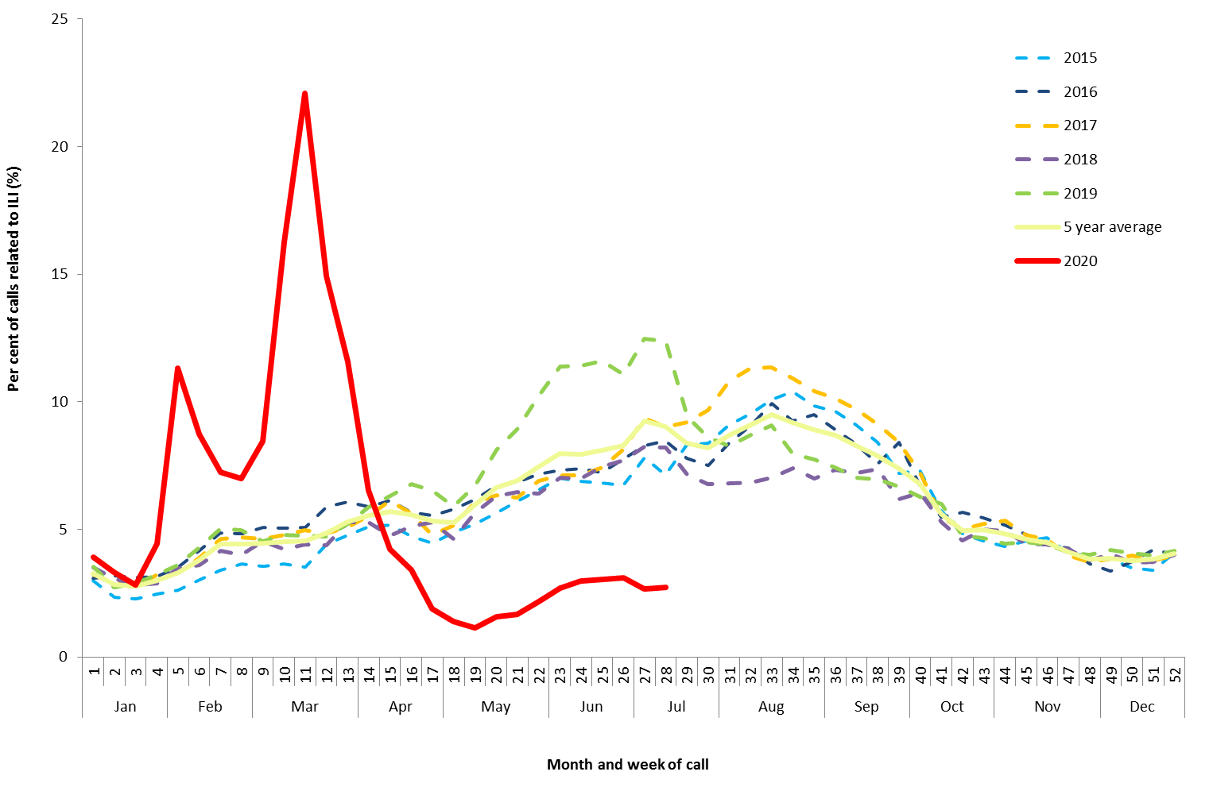

Source: Healthdirect

* All data are preliminary and subject to change as updates are received.

### Flutracking

*Flutracking is an online syndromic surveillance system which monitors ILI in the community.*

#### Activity

* Flutracking began reporting earlier than usual this year due to COVID-19. As such, historical comparisons are not available for data reported prior to April 2020.
* Since reporting commenced in week 8, Flutracking participants reporting ILI (fever and cough) has decreased from a peak of 1.5% to a low of 0.20% in week 20 (Figure 2).

* This fortnight (29 June to 12 July), Flutracking participants reporting ILI (0.38%) were similar compared to the previous fortnight (0.39%).

#### Impact

* Since week 8, the proportion of Flutracking survey respondents reporting having ILI and taking time off regular duties while unwell has declined from a peak of 1.1% in week 8 to a low of 0.09% in week 19. From week 20 to week 26 this proportion began to increase slowly.
* This fortnight (29 June to 12 July), there was a decrease in Flutracking participants reporting ILI and taking time off regular duties (0.23%) compared to the previous fortnight (0.28%).

Figure 2. Proportion of fever and cough among Flutracking participants, Australia, between February and October, 2015 to 2020, by month and week*

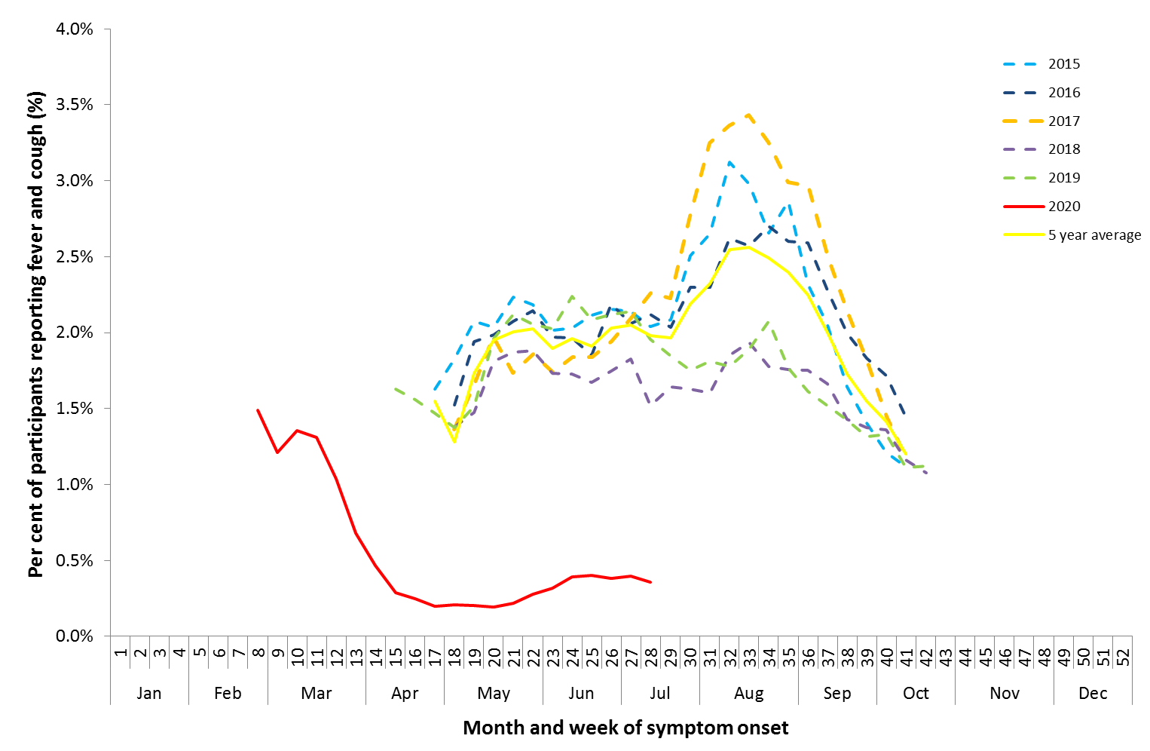

Source: Flutracking

* All data are preliminary and subject to change as updates are received.

### Sentinel General Practitioners (ASPREN)

*ASPREN is a year-round sentinel general practice surveillance system in which general and nurse practitioners report de-identified information on the number of ILI patient presentations seen in participating practices each week.*

*It should be noted that in addition to the overarching impacts of COVID-19 on influenza surveillance systems (see page 1), interpretation of ASPREN’s 2020 influenza data should take into account the following COVID-19 impacts:*

* + *changes in the health seeking behaviour at ASPREN sentinel sites due to the availability of telehealth and respiratory clinics may result in less presentations to General Practice (GP); and*
  + *changes to GPs swabbing at ASPREN sentinel sites, due to the availability of telehealth and respiratory clinics, may result in a lower number of swabs being undertaken by ASPREN reporters.*

#### Activity

* From weeks 1 to 9, sentinel ASPREN GPs reported on average of 1.6 per 1,000 consultations per week due to ILI.
* From week 9, ILI consultations increased and peaked in week 12 (5.5 per 1,000), following which they declined to 1.3 per 1,000 consultations in week 20 (Figure 3).
* In this fortnight, 1.5 per 1,000 consultations due to ILI were reported by sentinel ASPREN GPs.
* In the year to date, the proportion of ILI cases with confirmed influenza seen by sentinel GPs is low. Of the ILI cases presenting to sentinel GPs who were tested for influenza, 20 (3.9%) were influenza positive.
* In this fortnight (29 June to 12 July), there were no influenza positive results for patients that were tested through sentinel ASPREN GPs.

Figure 3. Unweighted rate of ILI reported from sentinel GP surveillance systems, Australia, 1 January 2015 to 12 July 2020, by month and week*#

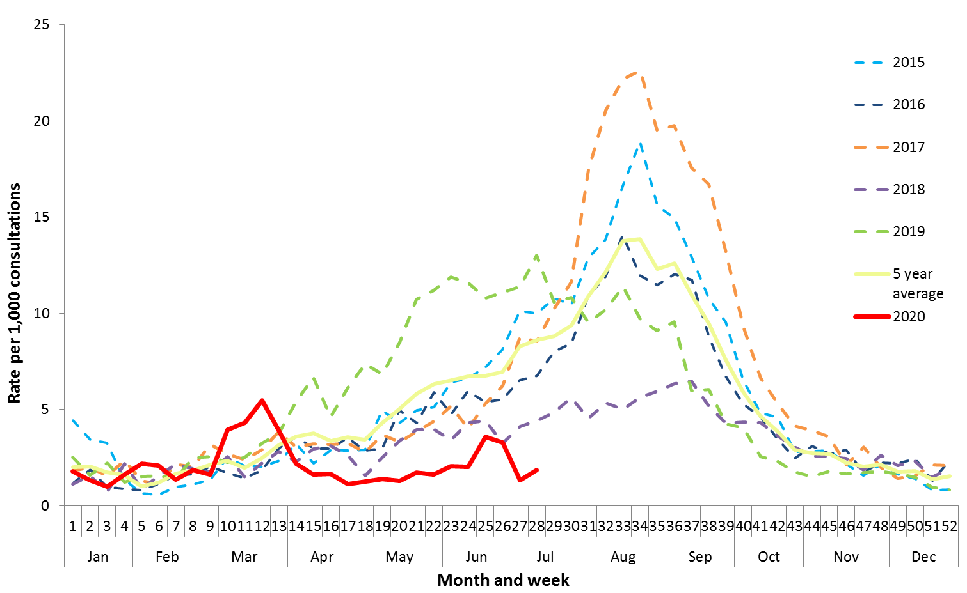

Source: ASPREN

* All data are preliminary and subject to change as updates are received.

# Some patients reported with ILI in Victoria were sent to COVID-19 clinics for testing and did not have a swab collected for influenza testing at the time of consultation.

#### Virology

* Of the 20 influenza positive samples detected year to date, 14 were influenza A(H1N1)pdm09, three were influenza A(H3N2) and one was influenza A(unsubtyped). The remaining two were influenza B; one was influenza B/Victoria and the other was influenza B (unsubtyped) (Figure 4).
* The most common respiratory virus reported so far this year of cases reported from sentinel ASPREN GPs is rhinovirus, accounting for 30.6% (158/516) of all tests.

Figure 4. Proportion of respiratory viral tests positive for influenza in ASPREN ILI patients and ASPREN ILI consultation rate, Australia, 1 January to 12 July 2020, by month and week*

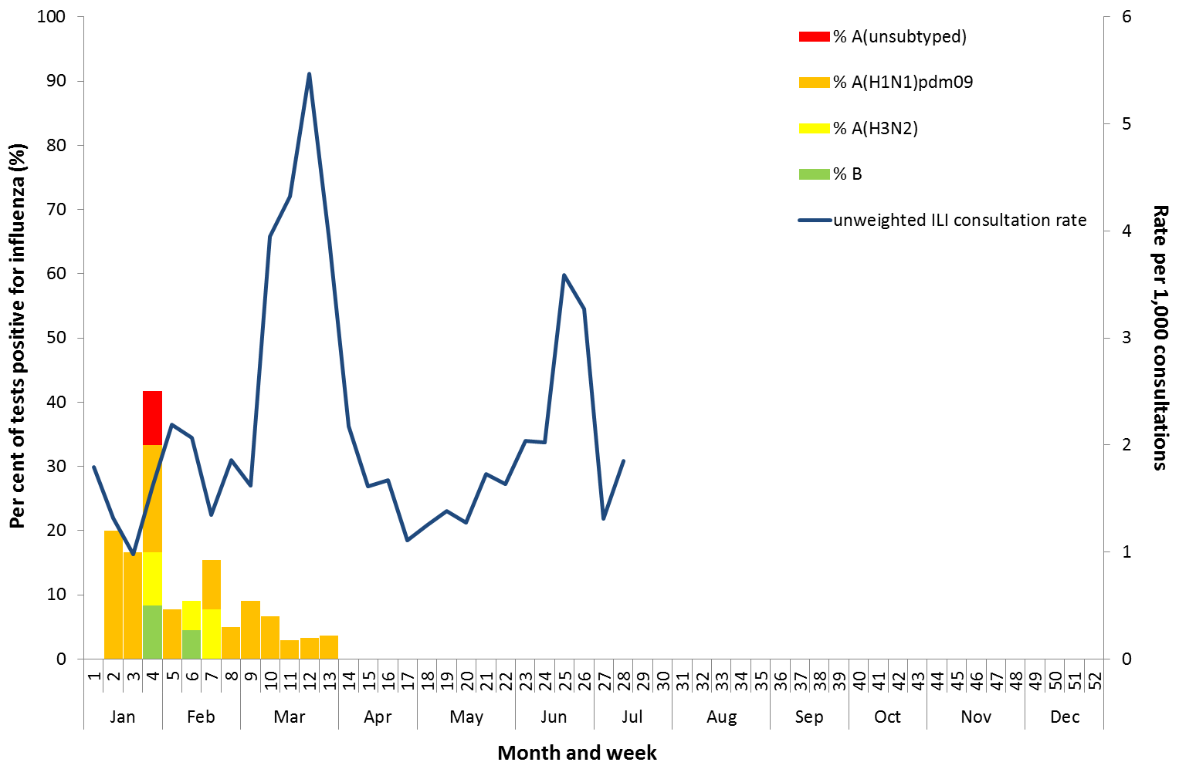

Source: ASPREN

* All data are preliminary and subject to change as updates are received.

### Sentinel Laboratories

*Sentinel laboratory surveillance systems provide fortnightly reporting of influenza testing. This includes the number of tests undertaken, the number of positive results, and the detected viruses.*

#### Activity

* Of the 220,374 samples tested across sentinel laboratories in the year to date, 1,982 (0.9%) were positive for influenza.
* Detections of influenza across sentinel laboratories increased from 4.5% in week 1 to 8.3% in week 4 (unweighted percentage of tests positive for influenza across all sentinel laboratories) and have steadily decreased to below 0.1% from week 15 (Figure 5).

Figure 5. Proportion of sentinel laboratory tests positive for influenza, 1 January to 12 July 2020, by contributing laboratoryor jurisdiction and month and week†

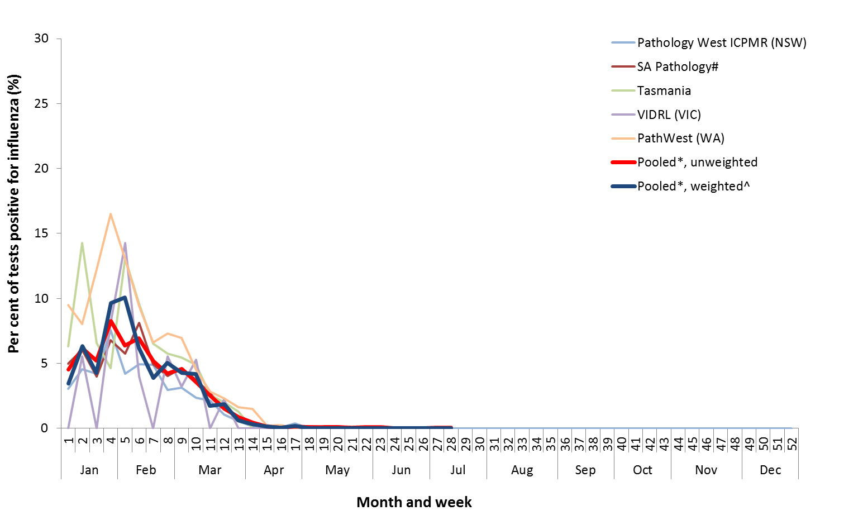

Source: Sentinel laboratories

† All data are preliminary and subject to change as updates are received.

* Pooled percentage positive indicators should be interpreted with caution, noting that collectively pooled contributing laboratories are not representative of testing across Australia and individually contributing laboratories may not be representative of the jurisdiction in which they are located.

^ Weighted according to jurisdictional population in which laboratories are located.

The percentage of tests positive for influenza in the interseasonal period should be interpreted with caution due to small numbers of tests being undertaken in this time, resulting in high variability in the indicators.

# South Australia data only includes specimens tested at SA Pathology. Data from the private laboratories for total number of specimens is not available.

#### Virology

* In the year to date, 0.9% of samples detected in sentinel laboratories were positive for influenza. Of these 81.9% were influenza A (of which 34.8% were influenza A(unsubtyped), 18.1% were influenza A(H1N1)pdm09, and 3.8% were influenza A(H3N2)) and 18.1% were influenza B (Figure 6).
* This fortnight (29 June to 12 July 2020) there were 14 influenza positive samples detected in sentinel laboratories. Of these, two was influenza A and 12 were influenza B.
* This fortnight (29 June to 12 July 2020), the most commonly detected respiratory viruses by laboratory site were:
  + rhinovirus in both weeks by the Institute of Clinical Pathology and Medical Research in New South Wales (NSW) ,Tasmania (TAS) and Western Australia (WA);
  + adenovirus in both weeks by South Australia (SA); and
  + Picornavirus in both weeks by Victorian Infectious Diseases Reference Laboratory (VIDRL).

Figure 6. Proportion of sentinel laboratory tests positive for influenza and total number of specimens tested, 1 January to 12 July 2020, by subtype and month and week*

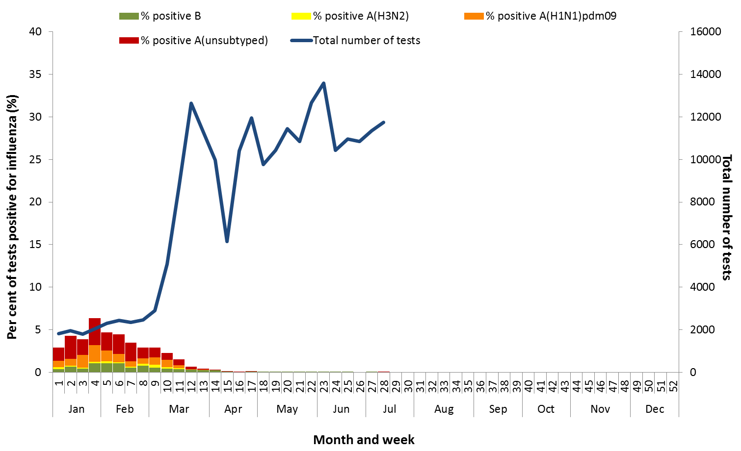

Source: Sentinel laboratories

* Total number of tests include all specimens that were tested for influenza, including multiplex respiratory panels which include both influenza and SARS-CoV2. Testing methodologies in the response to COVID-19 vary across jurisdictions.

All data are preliminary and subject to change as updates are received.

### The Influenza Complications Alert Network (FluCAN)

*FluCAN conducts surveillance of severe influenza at sentinel hospitals across the country during the influenza season.*

#### Activity

* Since seasonal sentinel hospital surveillance began on 16 March 2020, the total number of people admitted to hospital with confirmed influenza (n=12) has been below historical trends (Figure 7).
* This fortnight (29 June to 12 July), there were no confirmed influenza case admitted to a participating FluCAN hospital. The last reported case admitted to a participating FluCAN hospital was in week 21.

#### Severity

* Of the 12 people with confirmed influenza admitted to sentinel hospitals since 16 March 2020, only one has been admitted to an intensive care unit (ICU).

#### Virology

* Of the 12 confirmed influenza admissions to sentinel hospitals:
* nine were influenza A (four influenza A(H1N1)pdm09, four A(unsubtyped) and one A(H3N2)); and
* three were influenza B (Figure 8).

#### At-risk Populations

* Of the 12 people admitted with confirmed influenza:
* six were children aged 15 years and younger, of which one was admitted to ICU;
* three were aged between 16 and 64 years; and
* three were aged 65 years and older.

Figure 7. Number of influenza hospitalisations at sentinel hospitals, between March and October, 2014 to 2020 by month and week*

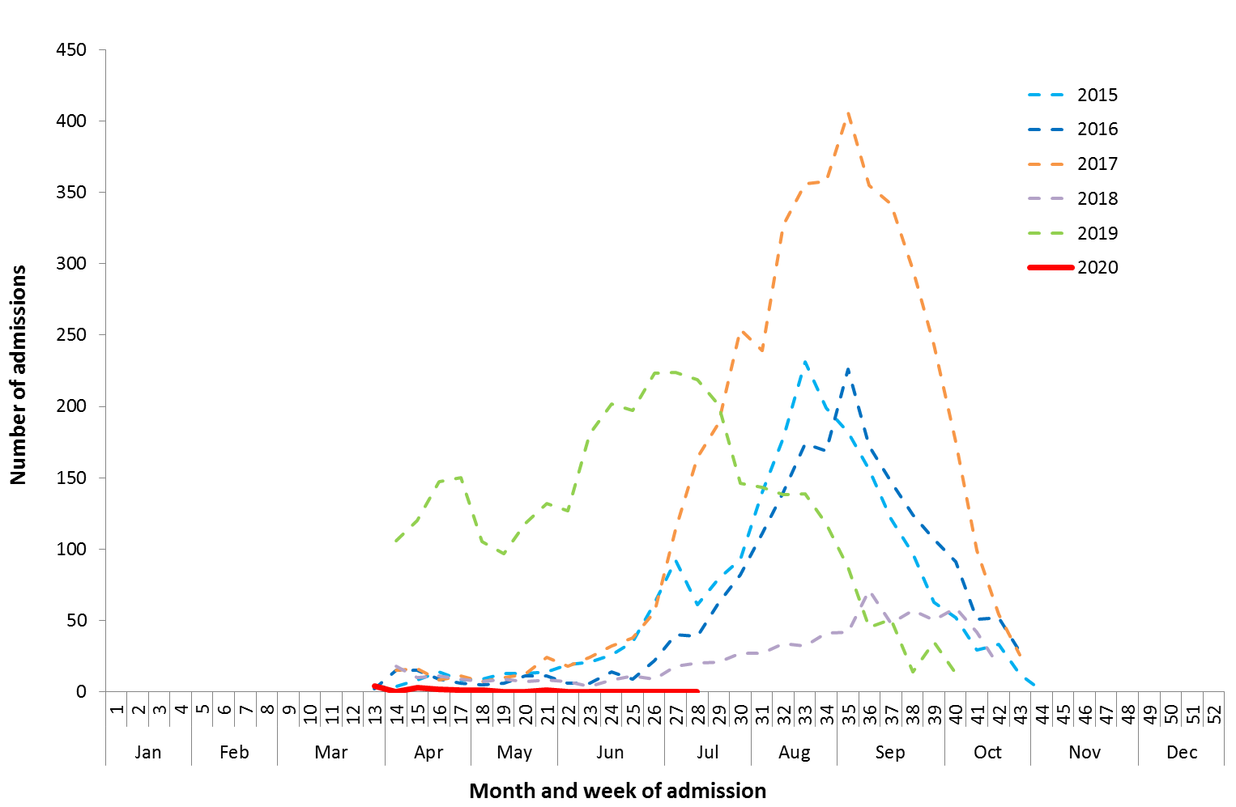

Source: FluCAN

* All data are preliminary and subject to change as updates are received.

Figure 8. Number of influenza hospitalisations at sentinel hospitals by subtype and ICU admission, 16 March to 12 July 2020, by month and week*

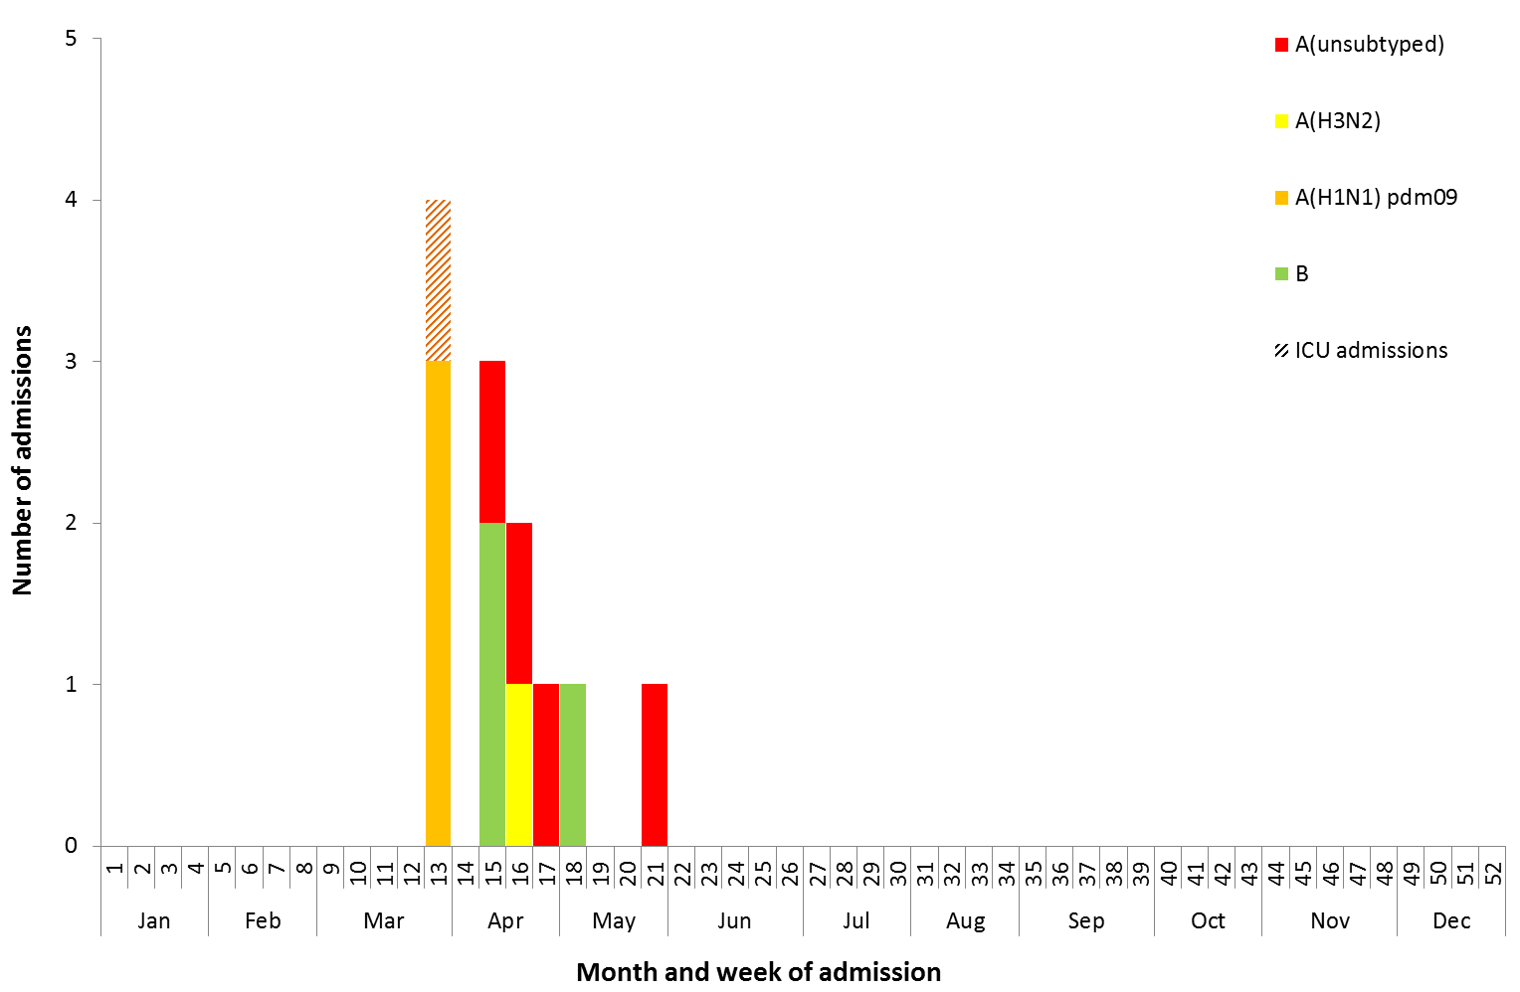

Source: FluCAN

* All data are preliminary and subject to change as updates are received.

### National Notifiable Diseases Surveillance System (NNDSS) Notifications

*The NNDSS coordinates the national surveillance of more than 50 communicable diseases or disease groups. Notifications of laboratory-confirmed influenza are made to the States or Territory health authority and supplied daily to the Australian Government Department of Health via the NNDSS for collation, analysis and to assist in the coordination of public health responses.*

#### Activity

* In the year to date, 20,830 there have been notifications of laboratory-confirmed influenza to the NNDSS. This fortnight (29 June to12 June 2020)there were 65 notifications.
* There was a steady increase in notifications from weeks 1 to 11 of 2020. From week 12, notifications have declined and remained low (Figure 9).

Figure 9. Notifications of laboratory confirmed influenza, Australia, 1 January 2013 to 12 July 2020, by month and week of diagnosis*

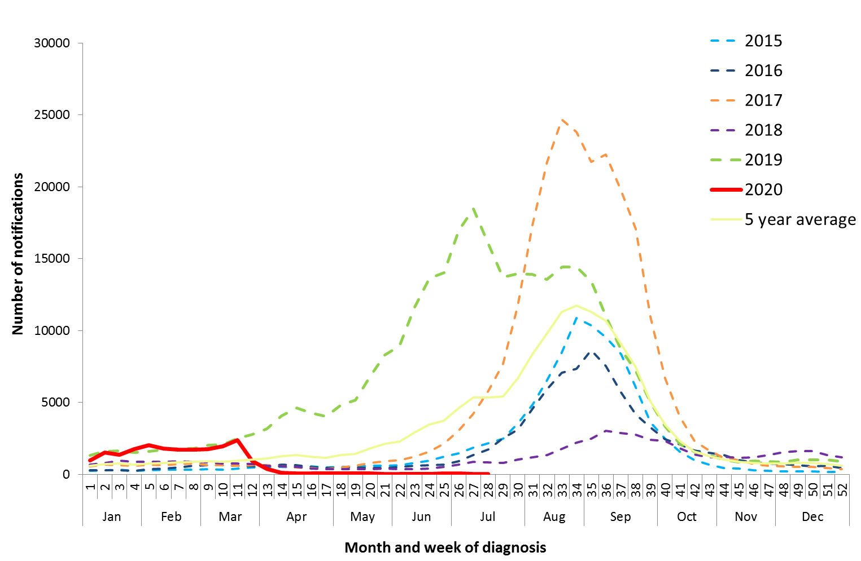

Source: NNDSS

*NNDSS notification data provided for the current and most recent weeks may be incomplete. All data are preliminary and subject to change as updates are received.

#### Geographical distribution of activity

* Notifications of influenza have declined across all jurisdictions and remain low compared to previous weeks (Figure 10).
* In the year to date, of the 20,830 notifications of influenza reported to the NNDSS, 7,105 were from New South Wales (NSW), 5,878 from Queensland (QLD), 4,534 from Victoria (VIC), 1,515 from South Australia (SA), 1,173 from Western Australia (WA), 277 from the Northern Territory (NT), 189 from the Australian Capital Territory (ACT) and 159 from Tasmania (TAS).

Figure 10. Notifications of laboratory confirmed influenza*, 1 January to 12 July 2020, by state or territory and week

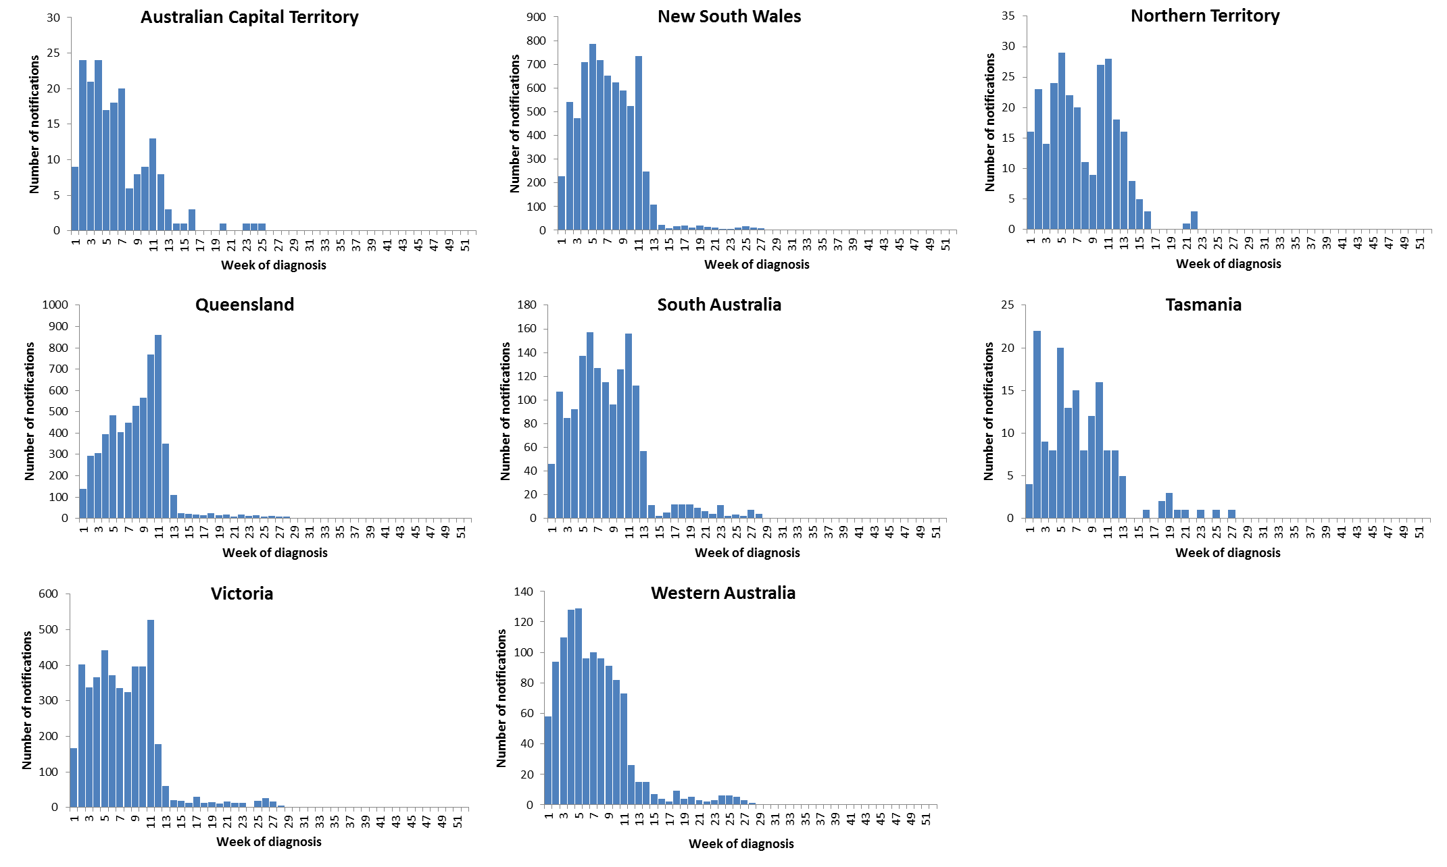

Source: NNDSS

*NNDSS notification data provided for the current and most recent weeks may be incomplete. All data are preliminary and subject to change as updates are received.

For further information regarding influenza activity at the jurisdictional level, please refer to the following State and Territory health surveillance reports:

* ACT: [ACT Influenza Report](https://www.health.act.gov.au/about-our-health-system/population-health/winter-wellbeing-and-flu/flu-act)

(www.health.act.gov.au/about-our-health-system/population-health/winter-wellbeing-and-flu/flu-act)

* NSW: [Influenza Surveillance Report](http://www.health.nsw.gov.au/Infectious/Influenza/Pages/reports.aspx) (http://www.health.nsw.gov.au/Infectious/Influenza/Pages/reports.aspx)
* QLD: [Statewide Weekly Influenza Surveillance Report](https://www.health.qld.gov.au/clinical-practice/guidelines-procedures/diseases-infection/surveillance/reports/flu) (https://www.health.qld.gov.au/clinical-practice/guidelines-procedures/diseases-infection/surveillance/reports/flu)
* SA: [Weekly Epidemiological Summary](http://www.sahealth.sa.gov.au/wps/wcm/connect/public+content/sa+health+internet/about+us/health+statistics/surveillance+of+notifiable+conditions) (Influenza section) (http://www.sahealth.sa.gov.au/wps/wcm/connect/public+content/sa+health+internet/about+us/health+statistics/surveillance+of+notifiable+conditions)
* TAS: [fluTAS Reports](http://www.dhhs.tas.gov.au/publichealth/communicable_diseases_prevention_unit) (http://www.dhhs.tas.gov.au/publichealth/communicable_diseases_prevention_unit)
* VIC: [Influenza Surveillance Reports](https://www2.health.vic.gov.au/public-health/infectious-diseases/infectious-diseases-surveillance/seasonal-influenza-reports) (https://www2.health.vic.gov.au/public-health/infectious-diseases/infectious-diseases-surveillance/seasonal-influenza-reports)
* WA: [Virus WAtch](http://ww2.health.wa.gov.au/Articles/F_I/Infectious-disease-data/Virus-WAtch) (http://ww2.health.wa.gov.au/Articles/F_I/Infectious-disease-data/Virus-WAtch)

#### Severity

* So far in 2020, of the 20,830 notifications of laboratory confirmed influenza, 36 (0.17%) laboratory-confirmed influenza-associated deaths have been notified to the NNDSS.
* Where subtyping information was available, seven were associated with influenza A(H1N1), one with influenza A(H3N2), and two with influenza B.
* Of the notified deaths, one was in a child aged less than 5 years, seven were aged between 20 and 64 years and 28 were aged 65 years and older.
* The median age of notified deaths was 79 years.

*Note that the number of influenza-associated deaths reported to the NNDSS does not represent the true mortality associated with this disease. The number of deaths is reliant on the follow up of cases to determine the outcome of their infection. The follow up of cases is not a requirement of notification, and are only inclusive of laboratory-confirmed cases of influenza. Due to retrospective revision, the variation across jurisdictions in methodology, representativeness and timeliness of death data, and reporting of an outcome of infection not being a requirement of notification, year on year comparisons of deaths in notified cases of influenza may not be reliable.*

#### Virology

* In the year to date, 87.3% of notifications of laboratory-confirmed influenza to the NNDSS were influenza A (of which, 91.4% were influenza A(unsubtyped), 7.5% were influenza A(H1N1)pdm09 and 1.2% were influenza A(H3N2)), 12.4% were influenza B, and less than 1% were influenza A&B co-infections or untyped (Figure 11).
* The proportion of cases reported as influenza B this fortnight (27.7%) is more compared to the proportion reported last fortnight (15.3%; 15 to 29 June).
* In this reporting fortnight (29 June to 12 July 2020), 70.8% of notifications of laboratory confirmed influenza to the NNDSS were influenza A (of which all (100%) were A(unsubtyped)), 27.7% were influenza B ad 1.5% were untyped.
* In the year to date, the proportion of all notifications reported as influenza A has been fairly similar across jurisdictions, ranging from 86.8% in TAS to 90.6% in NT, with the exception of SA (79.6%)   
  (Figure 12).

#### At-risk Populations

* In the year to date, notification rates have been highest in children aged less than 10 years   
  (114.4 notifications per 100,000), while rates in adults aged 65 years or older (70.9 notifications per 100,000) have been low (Figure 13).
* In the year to date, influenza A accounted for the greatest number of notifications across all age groups.
* Where further subtyping information was available, notifications were highest in adults aged 80 years and over (7.9 per 100,000) and children aged less than five years (7.7 per 100,000) for influenza A(H1N1)pdm09; in adults aged 85 years and older (2.5 per 100,000) for influenza A(H3N2); and children aged 5 to 9 years (19.3 per 100,000) for influenza B.

Figure 11. Per cent of laboratory confirmed influenza, Australia, 1 January to 12 July 2020 by subtype and week

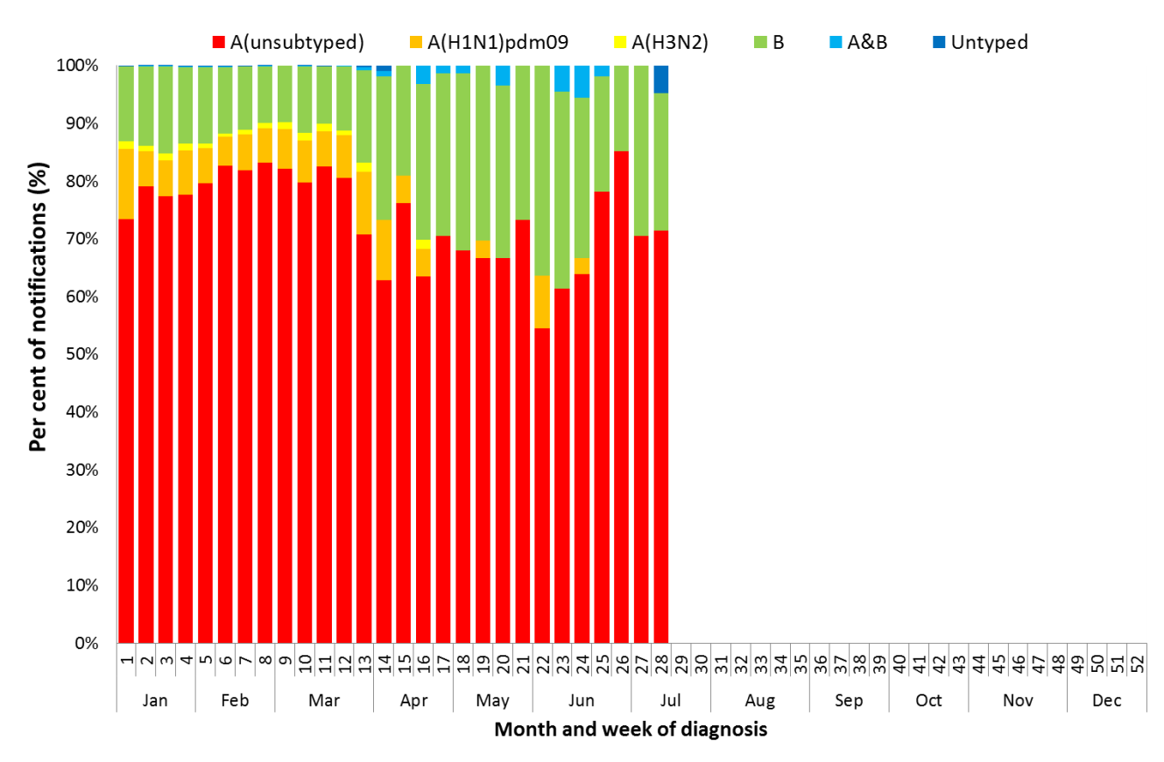

Source: NNDSS

Figure 12. Per cent of notifications of laboratory confirmed influenza, Australia, 1 January to 12 July 2020, by subtype and state or territory

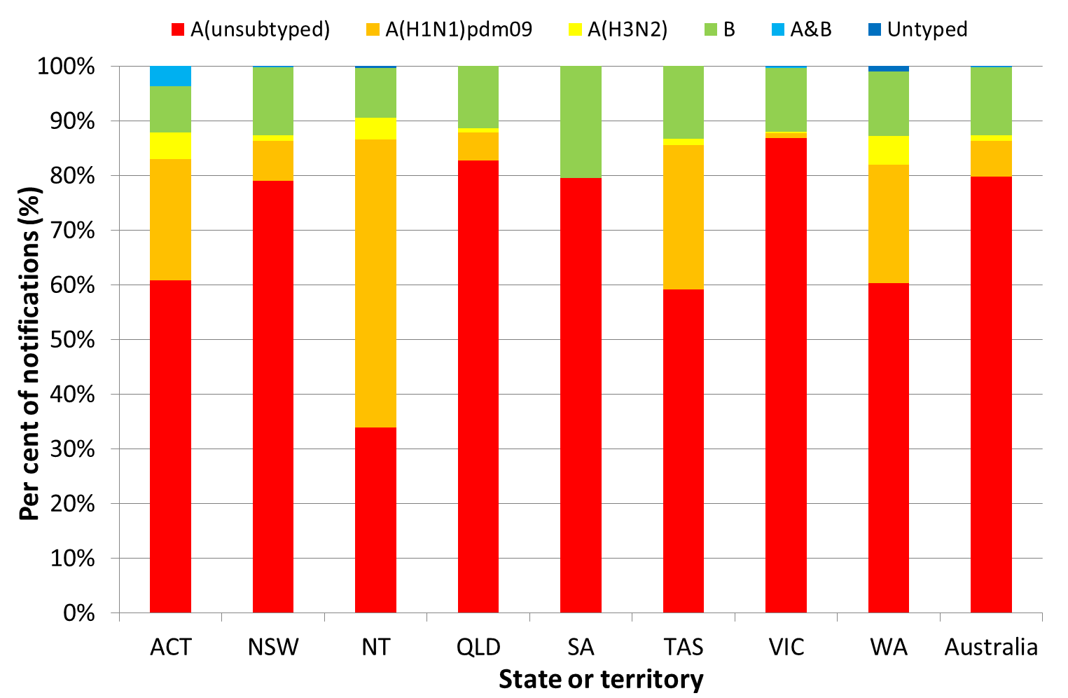

Source: NNDSS

Figure 13. Rate of notifications of laboratory confirmed influenza, Australia, 1 January to 12 July 2020, by age group and subtype

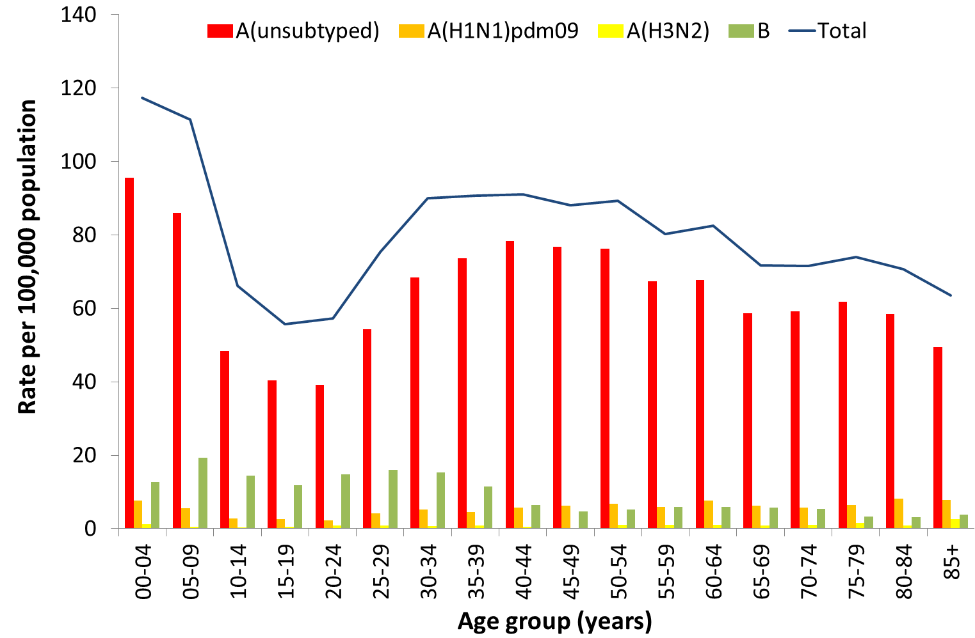

Source: NNDSS

### World Health Organization Collaborating Centre (WHOCC) for Reference and Research on Influenza

*The WHOCC monitors the frequent changes in influenza viruses with the aim of reducing the impact of influenza through the use of vaccine containing currently circulating strains.*

#### Australian Influenza Vaccines Composition 2020

In 2020 all seasonal influenza vaccinations registered for use in Australia are quadrivalent influenza vaccines (QIVs). The influenza virus strains included in the 2020 seasonal influenza vaccines in Australia are:

* A/Brisbane/02/2018 (H1N1)pdm09-like virus;
* A/South Australia/34/2019 (H3N2)-like virus;
* B/Washington/02/2019-like (B/Victoria lineage) virus; and
* B/Phuket/3073/2013-like (B/Yamagata lineage) virus.

The best way to determine how well the vaccine protects against circulating viruses during the season is by determining the vaccine effectiveness. These estimates provide an indication of how effective the vaccine was in providing protection against influenza infection. Vaccine effectiveness is usually estimated from observational studies and is calculated after the end of the influenza season, though interim analyses are sometimes available where there is sufficient data.

#### Virology

* From 1 January to 29 June 2020, the WHOCC characterised 265 influenza viruses (Table 1). Of these, 94.7% were influenza A (of which, 88.8% were A(H1N1)pdm09 and 11.2% A(H3N2)), and 5.3% were influenza B Victoria lineage.

#### Vaccine match

* Of the 289 isolates characterised for similarity to their corresponding vaccine components by haemagglutination inhibition (HI) assay (Table 1):
* 44% of influenza A(H1N1)pdm09 isolates were antigenically similar to the corresponding vaccine components and 56% were characterised as low reactors;
* 71% of influenza A(H3N2) isolates were antigenically similar to the corresponding vaccine components and 29% were characterised as low reactors; and
* Of the 17 influenza B/Victoria isolates, all were antigenically similar to the corresponding vaccine component. Year to date there have been no influenza B/Yamagata isolates characterised.

Table 1. Australian influenza viruses typed by HI from the WHOCC, 1 January to 13 July 2020*

| Type/Subtype | ACT | NSW | NT | QLD | SA | TAS | VIC | WA | TOTAL |
| --- | --- | --- | --- | --- | --- | --- | --- | --- | --- |
| A(H1N1) pdm09 | 33 | 28 | 43 | 17 | 12 | 10 | 76 | 25 | **244** |
| A(H3N2) | 4 | 4 | 7 | 0 | 4 | 0 | 7 | 2 | **28** |
| B/Victoria lineage | 1 | 2 | 0 | 1 | 0 | 2 | 7 | 4 | **17** |
| B/Yamagata lineage | 0 | 0 | 0 | 0 | 0 | 0 | 0 | 0 | **0** |
| Total | **38** | **34** | **50** | **18** | **16** | **12** | **90** | **31** | **289** |

SOURCE: WHOCC

* Viruses tested by the WHO CC are not necessarily a random sample of all those in the community. State indicates the residential location for the individual tested, not the submitting laboratory. There may be up to a month delay on reporting of samples.

#### Antiviral Resistance

* The WHOCC reported that from 1 January to 13 July 2020, two of the 277 influenza viruses tested for neuraminidase inhibitor resistance, demonstrated reduced inhibition to Oseltamivir.

### Data considerations

This report presents an overview of influenza activity based on a number of complimentary systems. No one single system, including notification data, provides the full picture on influenza, because influenza is a common disease and its presenting symptoms are non-specific. The epidemiology of influenza is informed by a number of different systems based in the community, laboratories, primary care and hospitals, as well as notifiable diseases data, which includes officially reported deaths. The information in this report is reliant on the surveillance sources available to the Department of Health at the time of production.

Data in this summary is reported by International Organization for Standardization (ISO) 8601 weeks, with the week ending on Sunday. Throughout the summary, where the year to date is presented, this includes data from 1 January to 12 July 2020. NNDSS data were extracted on 14 July 2020. Due to the dynamic nature of the NNDSS and other surveillance systems, data in this report are subject to retrospective revision and may vary from data reported in other national reports and reports by states and territories. Detailed notes on interpreting the data presented in this report are available at the Department of Health’s [Australian Influenza Surveillance Report website](http://www.health.gov.au/flureport) (www.health.gov.au/flureport).

While every care has been taken in preparing this report, the Commonwealth does not accept liability for any injury or loss or damage arising from the use of, or reliance upon, the content of the report. Delays in the reporting of data may cause data to change retrospectively. For further details about information contained in this report please contact the [Influenza Surveillance Team](mailto:flu@health.gov.au) (flu@health.gov.au).