| **Australian Influenza**  **SURVEILLANCE REPORT**  **No. 04, 2022**  **Reporting fortnight: 09 May to 22 May 2022** |
| --- |

The Department of Health acknowledges the providers of the many sources of data used in this report and greatly appreciates their contribution.

## KEY MESSAGES

**It is important to note that due to the COVID-19 epidemic in Australia, data reported from the various influenza surveillance systems may not represent an accurate reflection of influenza activity.** **Results should be interpreted with caution, especially where comparisons are made to previous influenza seasons. Interpretation of influenza data from April 2020 onwards should take into account, but are not limited to, the impact of social distancing measures, likely changes in health seeking behaviour of the community including access to alternative streams of acute respiratory infection specific health services, and focussed testing for COVID-19 response activities. For information on COVID-19 incidence, severity, and distribution in Australia, please refer to** [**COVID-19 epidemiology reports**](https://www1.health.gov.au/internet/main/publishing.nsf/Content/novel_coronavirus_2019_ncov_weekly_epidemiology_reports_australia_2020.htm)**.**

| **Activity**   * Influenza-like-illness (ILI) activity in the community this year has increased since March 2022. * In the year to date in 2022, there have been 38,743 notifications reported to the National Notifiable Diseases Surveillance System (NNDSS) in Australia, of which 26,193 notifications had a diagnosis date this fortnight—more than three times the notifications in the previous fortnight. * From mid-April 2022, the weekly number of notifications of laboratory-confirmed influenza reported in Australia has exceeded the 5 year average.   **Severity**   * In the year to date, of the 38,743 notifications of laboratory-confirmed influenza, three influenza-associated deaths have been notified to the NNDSS. * Since commencement of seasonal surveillance in April 2022, there have been 368 hospital admissions due to influenza reported across sentinel hospitals sites, of which 7.6% were admitted directly to ICU.   **Impact**   * There is no indication of the potential impact of the 2022 season on society at this time.   **At-risk populations**   * In 2022 to date, people aged 5–19 years, adults aged 20–24 years, and children aged younger than 5 years have the highest notification rates.   **Virology**   * To date, 98.7% of notifications of laboratory-confirmed influenza reported to the NNDSS were influenza A, of which 94.2% were influenza A(unsubtyped), 1.2% were influenza A(H1N1), and 4.7% were influenza A(H3N2). Influenza B accounted for 0.1% of notifications, less than 0.1% were A&B co-infections, and 1.2% were untyped.   **Vaccine match and effectiveness**   * Of the 623 samples referred to the WHOCC to date, all influenza A(H1N1) and 94.5% of influenza A(H3N2) samples were characterised as antigenically similar to the corresponding vaccine components, while the influenza B/Victoria sample was characterised as antigenically dissimilar. * It is too early to assess vaccine match and effectiveness for this season. |
| --- |

### Introduction

Each year, the influenza virus changes and different strains can circulate in the population. Particular subtypes of influenza can affect different groups of the population more than others. Depending on the susceptibility of the population, the subtypes that are circulating and the changes to the virus itself, the influenza season can be very different year to year. Our surveillance systems help us to understand influenza activity, severity of the infection in individuals and impact of the illness on society in Australia. We are also able to monitor which influenza viruses are circulating, which populations might be more affected, the effectiveness of the vaccine, and any resistance to antiviral drugs that has developed.

### National Influenza Surveillance Systems

This report presents an overview of influenza activity based on a number of complimentary systems. No one single system, including notification data, provides the full picture on influenza, because influenza is a common disease and its presenting symptoms are non-specific. The epidemiology of influenza is informed by a number of different systems based in the community, laboratories, primary care and hospitals, as well as notifiable diseases data, which includes officially reported deaths. The information in this report is reliant on the surveillance sources available to the Department of Health at the time of production.

The **National Notifiable Diseases Surveillance System (NNDSS)** coordinates the national surveillance of more than 60 communicable diseases or disease groups. Notifications of laboratory-confirmed influenza are made to state or territory health authorities and supplied daily to the Australian Government Department of Health via the NNDSS for collation, analysis, and to assist in the coordination of public health responses.

**Healthdirect** provides free health triage advice and information services by telephone and online, and can assist in identifying symptoms including those that may be classified as an ILI syndrome. Community level ILI syndromic trends are monitored using Healthdirect data.

**FluTracking** is an online syndromic surveillance system which monitors ILI in the community.

The **Australian Sentinel Practices Research Network (ASPREN**) is a year-round sentinel general practice (GP) surveillance system in which general and nurse practitioners report de-identified information on the number of ILI patient presentations seen in participating practices each week.

It should be noted that in addition to the overarching impacts of COVID-19 on influenza surveillance systems (see page 1), interpretation of ASPREN’s data from 2020 onwards should consider the following COVID-19 impacts:

* + changes in the health seeking behaviour at ASPREN sentinel sites due to the availability of telehealth and respiratory clinics may result in fewer presentations to General Practice (GP); and
  + changes to GPs swabbing at ASPREN sentinel sites, due to the availability of telehealth and respiratory clinics, may result in a lower number of swabs being undertaken by ASPREN reporters.

The **Influenza Complications Alert Network (FluCAN)** conducts surveillance of severe influenza at sentinel hospitals across the country during the influenza season. The Paediatric Active Enhanced Disease Surveillance (PAEDS) network also contributes data on influenza via FluCAN.

The **World Health Organization Collaborating Centre (WHOCC) for Reference and Research on Influenza** analyses influenza viruses currently circulating in the human population in Australia and other countries, to inform which strains should be included in annual seasonal influenza vaccines for the Northern and Southern Hemispheres.

**Sentinel laboratory surveillance** systems provide fortnightly reporting of influenza testing. This includes the number of tests undertaken, the number of positive results, and the detected viruses. Please note that tests conducted at sentinel laboratory sites may include samples taken from people in home or hotel quarantine for COVID-19, and may not reflect respiratory viruses circulating in the community alone.

### Data considerations

**NNDSS laboratory-confirmed influenza surveillance case definition**—From 01 January 2022, the [NNDSS surveillance case definition for laboratory-confirmed influenza](https://www.health.gov.au/resources/publications/influenza-laboratory-confirmed-surveillance-case-definition) was updated to remove Point 5 ‘Single high titre by complement fixation test (CFT) or haemagglutination inhibition (HAI) to influenza virus’ from the list of laboratory definitive evidence. This change has minimal impact on the interpretation of influenza notification trends, with the change ensuring consistency with the influenza laboratory case definition. For further information, please refer to the [NNDSS laboratory-confirmed influenza case definition Technical Supplement](https://www.health.gov.au/resources/publications/technical-supplement-2022-update-to-nndss-laboratory-confirmed-influenza-case-definition).

Data in this summary is reported by International Organization for Standardization (ISO) 8601 weeks, with the week ending on Sunday. Throughout the summary, where the year to date is presented, this includes data from 01 January to 22 May 2022. NNDSS data is analysed and reported based on diagnosis date, which is the true onset date of a case if known, otherwise it is the earliest of the specimen date, the notification date, or the notification received date. NNDSS data were extracted on 25 May 2022.

In interpreting these data, it is important to note that changes in notifications over time may not solely reflect changes in disease prevalence or incidence. Depending on the disease, the number of notifications may be influenced by changes in testing policies; changes in case definitions; changes in testing practices and screening programs; the use of less invasive and more sensitive diagnostic tests; and periodic awareness campaigns. In particular, analyses including data from 2020 should be interpreted with caution. In 2020, there was a significant decrease in influenza and ILI activity related to the COVID-19 pandemic and associated public health measures. Data from 2020 may reduce 5 year averages and affect usual seasonal trends. In some circumstances, comparison to data in years prior to 2020 may be more relevant.

Due to the dynamic nature of the NNDSS and other surveillance systems, data in this report are subject to retrospective revision and may vary from data reported in other national reports and reports by states and territories. Detailed notes on interpreting the data presented in this report are available at the Department of Health’s [Australian Influenza Surveillance Report website](http://www.health.gov.au/flureport) (www.health.gov.au/flureport). While every care has been taken in preparing this report, the Commonwealth does not accept liability for any injury or loss or damage arising from the use of, or reliance upon, the content of the report. Delays in the reporting of data may cause data to change retrospectively. For further details about information contained in this report please contact the [Influenza Surveillance Team](mailto:flu@health.gov.au) ([flu@health.gov.au](mailto:flu@health.gov.au)).

## ANALYSIS

### Activity

*Activity measures the capacity of the circulating influenza viruses to spread person to person and may be measured indirectly through systems that monitor influenza-like illness and more directly through systems that monitor laboratory-confirmed influenza.*

**Influenza-like-illness (ILI)**

*Healthdirect:*

* This fortnight (09 May to 22 May 2022, weeks 19 and 20), 11.8% of calls to the Healthdirect helpline have been related to ILI (Figure 1)—an increase from the 9.3% reported in the previous fortnight.
* Since March 2022, the proportion of ILI-related calls has increased over time. In the year to date, the proportion of ILI-related calls to Healthdirect has been highest this fortnight.

*FluTracking:*

* This fortnight (09 May to 22 May 2022), the proportion of FluTracking participants reporting ILI (fever and cough) is 2.26%—an increase from the 1.61% reported in the previous fortnight.
* In the year to date, the proportion of FluTracking participants reporting ILI decreased in mid-February (0.43%), after which ILI activity has increased overall (Figure 2).

*Sentinel General Practitioners (ASPREN):*

* This fortnight (09 May to 22 May 2022), an average of 6.8 per 1,000 consultations due to ILI were reported by sentinel ASPREN GPs—an increase from the 2.8 per 1,000 consultations in the previous fortnight.
* In the year to date, sentinel ASPREN GPs have reported between 0.3 and 7.8 consultations due to ILI per 1,000 consultations per week (Figure 3). The highest ILI rate to date this year was observed in week 20 (7.8 per 1,000 consultations). The weekly ILI rate exceeded the 5 year average this fortnight (weeks 19 and 20).
* To date, of the 171 people presenting to a sentinel ASPREN GP with ILI who were tested for respiratory viruses, there have been 32 (18.7%) positive influenza samples identified.
* To date, of those presenting to sentinel ASPREN GPs with ILI who were tested for respiratory viruses, 66.1% (113/171) tested positive for a respiratory virus. Among those positive for a respiratory virus, the most common virus reported was rhinovirus, accounting for 40.7% (46/113) of positive results. Other viruses detected include influenza (28.3%), SARS-CoV-2 (13.3%), respiratory syncytial virus (RSV) (8.0%), adenovirus (5.3%), human metapneumovirus (HMPV) (2.7%), and parainfluenza virus (PIV) type 3 (1.8%)

*Sentinel laboratories:*

* This fortnight (09 May to 22 May 2022, weeks 19 and 20), the most commonly detected respiratory viruses by sentinel laboratory site were:
  + SARS-CoV-2 and Rhinovirus in weeks 19 and 20 in Western Australia (WA);
  + Rhinovirus and influenza A in weeks 19 and 20, respectively, in Tasmania (TAS);
  + Influenza A in weeks 19 and 20 in New South Wales (NSW) and Victoria (VIC); and
  + Rhinovirus in weeks 19 and 20 in South Australia (SA).

**Figure 1. Per cent of calls to Healthdirect related to ILI, Australia, 01 January 2017 to 22 May 2022, by month and week of call\***

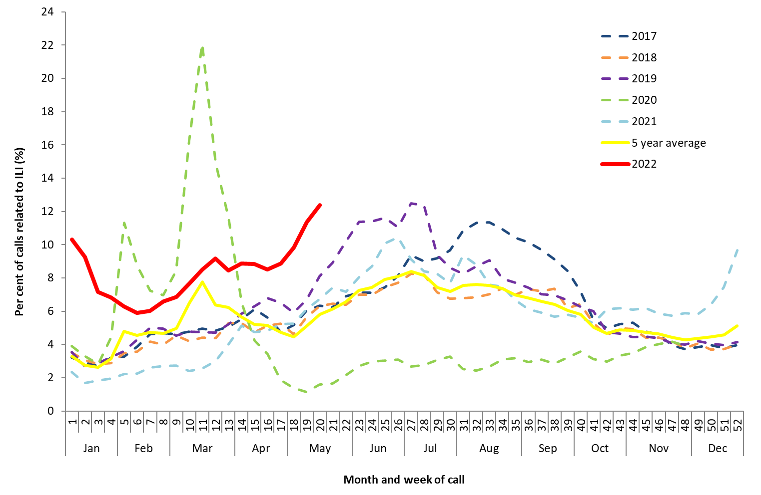

Source: Healthdirect

*All data are preliminary and subject to change as updates are received. Please refer to Data considerations for interpretation of the 5 year average.  
Note: From March 2020 onwards, the proportion of calls to Healthdirect relating to ILI were impacted by calls related to bushfires (February) and COVID-19 (March). The National Coronavirus Helpline was established on 16 March 2020, and callers to the Healthdirect helpline with concerns about COVID-19 have since been diverted to the National Coronavirus Helpline. This explains the sudden drop in ILI related calls to the helpline in mid-March 2020.

**Figure 2. Proportion of fever and cough among FluTracking participants, Australia, 2017 to 2022, by month and week*#**

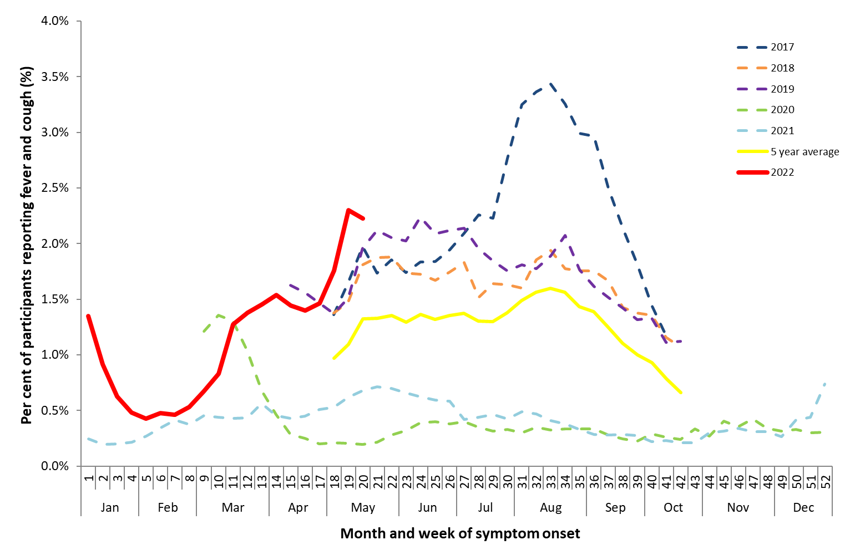

Source: FluTracking

*All data are preliminary and subject to change as updates are received.

#FluTracking have expanded their reporting period from 2020 onwards due to COVID-19. As such, 5 year historical comparisons are not available for data reported before May and after October for any year before 2020. Please refer to Data considerations for interpretation of the 5 year average.

Figure . Unweighted rate of ILI reported from ASPREN sentinel GP surveillance systems, Australia, 01 January 2017 to 22 May 2022, by month and week*#

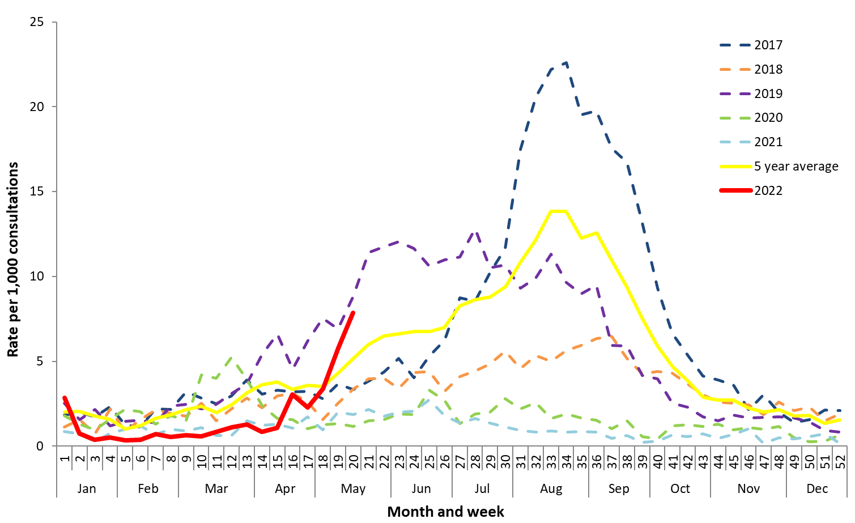

Source: ASPREN

* All data are preliminary and subject to change as updates are received. Please refer to Data considerations for interpretation of the 5 year average.

# Please refer to surveillance system description (Page 2) for notes on impact of COVID-19 on ASPREN data.

**Laboratory-confirmed influenza**

*National notification data (NNDSS):*

* There were 26,193 laboratory-confirmed influenza notifications with a diagnosis date this fortnight (09 May to 22 May 2022). This is more than three times the number of notifications with a diagnosis date in the previous fortnight, and higher than the weekly 5 year average for this time of year.
* In the year to date, there have been 38,743 notifications of laboratory-confirmed influenza to the NNDSS (Figure 4). This is a national notification rate of 150.5 per 100,000 population.
* The cumulative number of notifications in the year to date is higher than the 5 year mean for the same time period.

*ASPREN:*

* In the year to date, there have been 32 (18.7%) influenza detections among the 171 ILI cases presenting to sentinel GPs who were tested for respiratory viruses.

*Sentinel laboratories:*

* This fortnight (09 May to 22 May 2022) of the 15,742 samples tested across sentinel laboratories, 12.37% (n=1,948) have been positive for influenza—an increase from 5.11% in the previous fortnight.
* Of the 99,519 samples tested across sentinel laboratories in the year to date, 3.0% (n=2,949) have been positive for influenza (Figure 5).

Figure . Notifications of laboratory-confirmed influenza, Australia, 01 January 2017 to 22 May 2022, by month and week of diagnosis*

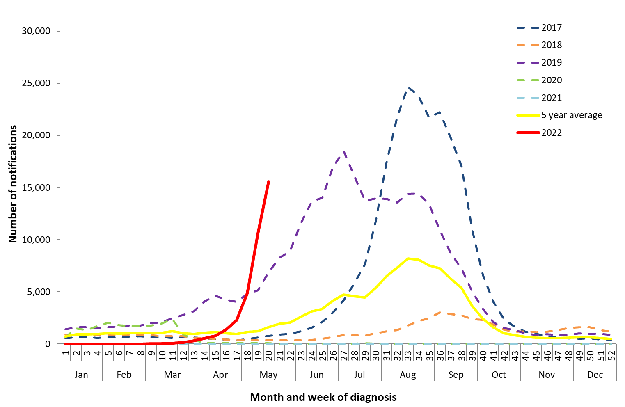

Source: NNDSS

*NNDSS notification data provided for the current and most recent weeks may be incomplete. All data are preliminary and subject to change as updates are received. Please refer to Data considerations for interpretation of the 5 year average.

Figure 5. Proportion of sentinel laboratory tests positive for influenza and total number of specimens tested, 01 January 2017 to 22 May 2022, by subtype and week*

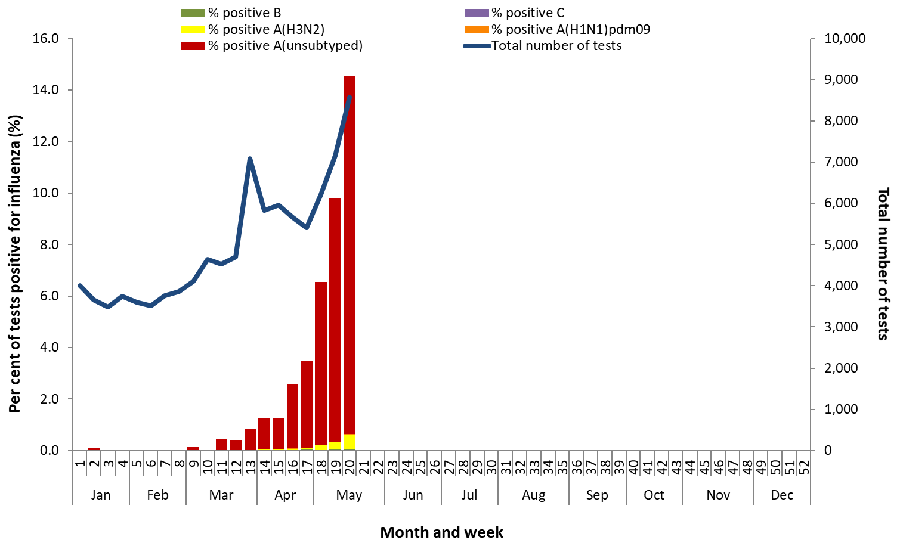

Source: Sentinel laboratories

*Total number of tests include all specimens that were tested for influenza, including multiplex panels used to test for SARS-CoV-2. Testing methodologies vary across jurisdictions and laboratories.

**Geographical distribution of influenza activity**

*National notification data (NNDSS):*

* In the year to date, notifications have increased across jurisdictions from week 13 (Figure 6).
* Of the 38,743 notifications of influenza reported to the NNDSS in the year to date, there have been:
  + 16,139 notifications in New South Wales (NSW);
  + 11,416 notifications in Victoria (VIC);
  + 7,992 notifications in Queensland (QLD);
  + 1,296 notifications in South Australia (SA);
  + 989 notifications in the Northern Territory (NT);
  + 689 notifications in the Australian Capital Territory (ACT);
  + 127 notifications in Western Australia (WA); and
  + 95 notifications in Tasmania (TAS);
* Year to date, the influenza notification rate has been highest in Northern Territory (401.5 per 100,000 population).

**Figure 6. Notifications of laboratory-confirmed influenza*, 01 January to 22 May 2022, by state or territory and week of diagnosis**

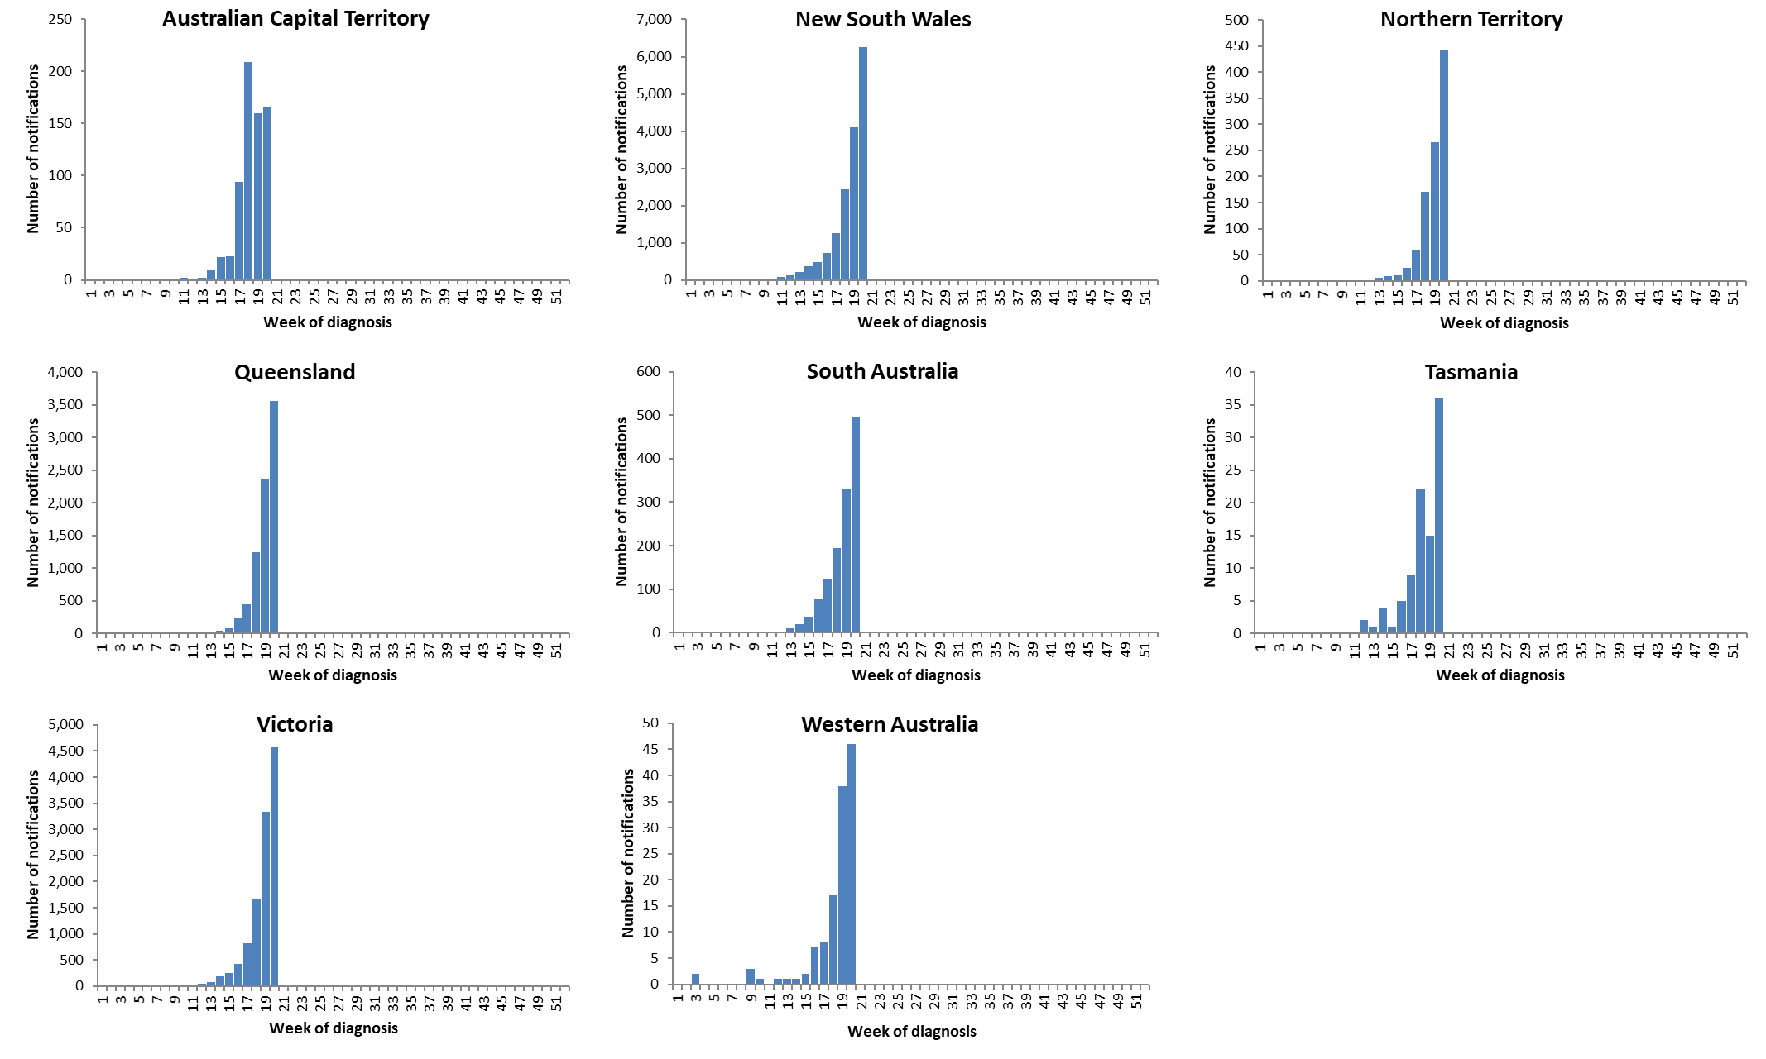

Source: NNDSS

*NNDSS notification data provided for the current and most recent weeks may be incomplete. All data are preliminary and subject to change as updates are received.

For further information regarding influenza activity at the jurisdictional level, please refer to the following State and Territory health surveillance reports:

* ACT: [ACT Influenza Report](https://www.health.act.gov.au/about-our-health-system/population-health/winter-wellbeing-and-flu/flu-act)

(www.health.act.gov.au/about-our-health-system/population-health/winter-wellbeing-and-flu/flu-act)

* NSW: [Influenza Surveillance Report](http://www.health.nsw.gov.au/Infectious/Influenza/Pages/reports.aspx) (http://www.health.nsw.gov.au/Infectious/Influenza/Pages/reports.aspx)
* QLD: [Statewide Weekly Influenza Surveillance Report](https://www.health.qld.gov.au/clinical-practice/guidelines-procedures/diseases-infection/surveillance/reports/flu) (https://www.health.qld.gov.au/clinical-practice/guidelines-procedures/diseases-infection/surveillance/reports/flu)
* SA: [Weekly Epidemiological Summary](http://www.sahealth.sa.gov.au/wps/wcm/connect/public+content/sa+health+internet/about+us/health+statistics/surveillance+of+notifiable+conditions) (Influenza section) (http://www.sahealth.sa.gov.au/wps/wcm/connect/public+content/sa+health+internet/about+us/health+statistics/surveillance+of+notifiable+conditions)
* TAS: [fluTAS Reports](https://www.health.tas.gov.au/health-topics/flu-influenza/flutas-reports) (https://www.health.tas.gov.au/health-topics/flu-influenza/flutas-reports)
* VIC: [Influenza Surveillance Reports](https://www2.health.vic.gov.au/public-health/infectious-diseases/infectious-diseases-surveillance/seasonal-influenza-reports) (https://www2.health.vic.gov.au/public-health/infectious-diseases/infectious-diseases-surveillance/seasonal-influenza-reports)
* WA: [Virus WAtch](http://ww2.health.wa.gov.au/Articles/F_I/Infectious-disease-data/Virus-WAtch) (http://ww2.health.wa.gov.au/Articles/F_I/Infectious-disease-data/Virus-WAtch)

### Severity

*Severity is a measure of adverse outcomes or complications as a result of ILI such as hospital referrals, admissions, need for intensive care, and deaths. Measuring and understanding the severity of circulating influenza is difficult to establish at the beginning, or during a low, influenza season. The proportion of confirmed influenza cases with serious outcomes might be skewed initially because there are only a small number of people notified. This means that the measure of severity will vary substantially fortnight to fortnight until numbers are sufficiently high and there is enough data for measurements to stabilise. An assessment of severity can be provided once the signals become clearer.*

***FluCAN:***

* This fortnight (09 May to 22 May 2022), there have been 151 hospitalisations due to influenza across FluCAN sentinel hospital sites, of which 16 (10.6%) were admitted directly to ICU. Total sentinel hospital admissions this fortnight have increased from the previous fortnight (Figure 7).
* Since seasonal surveillance commenced in April 2022, there have been 368 sentinel hospital admissions, of which 28 (7.6%) were admitted directly to ICU.

***National notification data (NNDSS):***

* Year to date, of the 38,743 notifications of laboratory-confirmed influenza, there have been three influenza-associated deaths notified to the NNDSS. All deaths were associated with influenza A(unsubtyped). The median age of deaths notified was 91 years (range: 87–92 years).

**Note that the number of influenza-associated deaths reported to the NNDSS does not represent the true mortality associated with this disease. The number of deaths is reliant on the follow up of cases to determine the outcome of their infection. The follow up of cases is not a requirement of notification, and are only inclusive of laboratory-confirmed cases of influenza. Due to retrospective revision, the variation across jurisdictions in methodology, representativeness, and timeliness of death data, and reporting of an outcome of infection not being a requirement of notification, year on year comparisons of deaths in notified cases of influenza may not be reliable.**

Figure 7. Number of influenza hospitalisations at sentinel hospitals, from April to October, 2017 to 2022 by month and week of diagnosis*

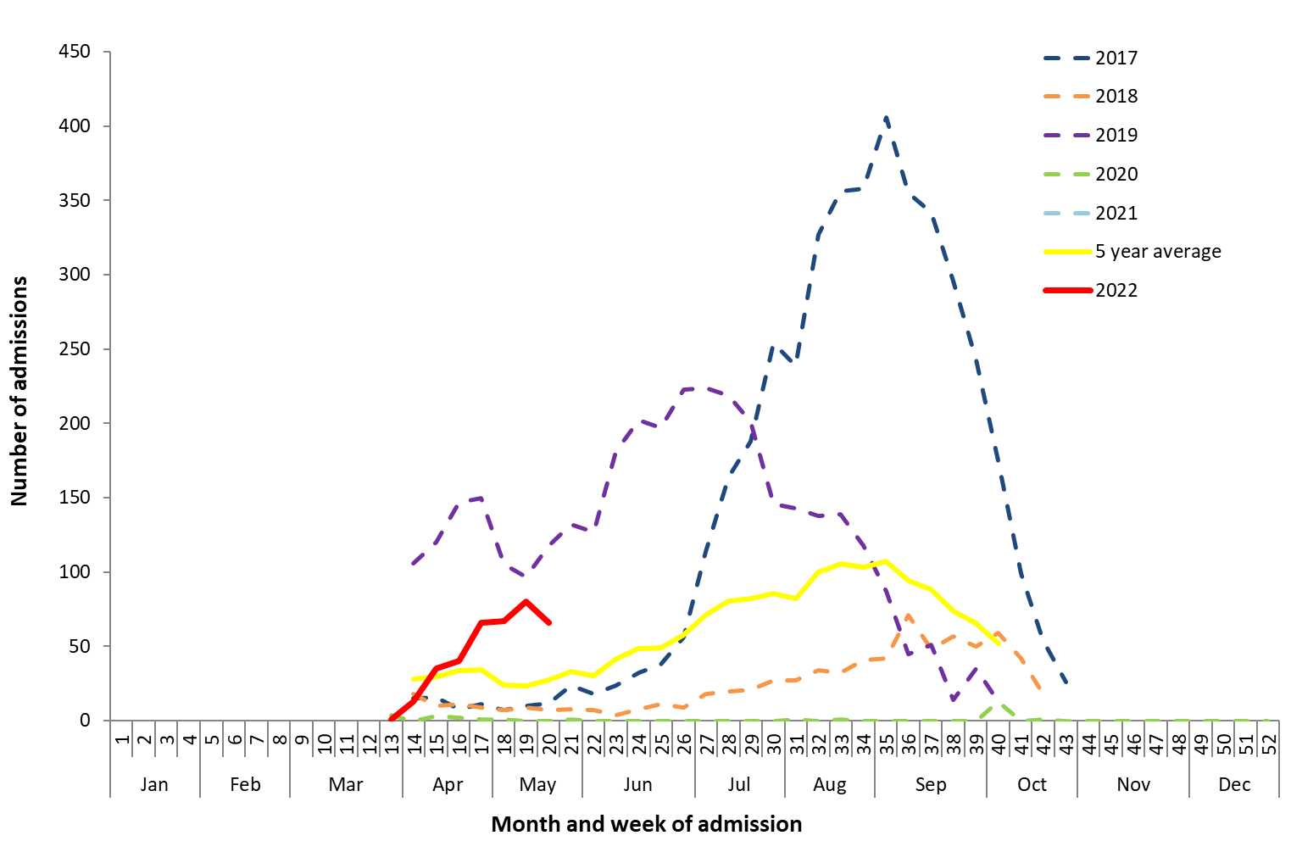

* All data are preliminary and subject to change as updates are received. Source: FluCAN

### Impact

*Impact measures how influenza affects society, including stress on health-care resources and societal and economic consequences.*

Impact for the season to date, as measured through the rate of FluTracking respondents absent from normal duties and the number of FluCAN sentinel hospital beds occupied by patients with influenza, is minimal.

***FluTracking:***

* This fortnight (09 May to 22 May 2022), the proportion of FluTracking participants reporting ILI and taking time off regular duties while unwell was 1.79%—a slight increase from 1.30% reported in the previous fortnight.
* In the year to date, the proportion of FluTracking survey respondents reporting having ILI and taking time off regular duties while unwell has increased since March 2022.

***FluCAN:***

* Since seasonal surveillance commenced in April 2022, there have been 368 people admitted to hospital across FluCAN sentinel sites due to confirmed influenza, of which 28 (9.8%) were admitted directly to ICU.

### At-risk populations

*At-risk populations are people who may be more susceptible to infection with the influenza virus and/or who may be more likely to experience severe outcomes from their infection.*

***National notification data (NNDSS):***

* In the year to date, notification rates have been highest in people aged 5–19 years (325.0 notifications 100,000 population), followed by people aged 20–24 years (246.5 notifications per 100,000 population), and children aged younger than 5 years (233.9 notifications per 100,000 population) (Figure 8).
* In the year to date, influenza A accounted for the highest number of notifications across all age groups.

***FluCAN:***

* Since seasonal surveillance commenced in April 2022, 49.2% of people admitted with confirmed influenza across sentinel hospital sites were children aged younger than 16 years, 30.2% were adults aged 16 to 64 years, and 20.7% were adults aged 65 years or older. Of children aged younger than 16 years admitted with confirmed influenza to date, 6.1% were admitted directly to ICU, compared to 11.7% of adults aged 16 to 64 years, and 5.3% of adults aged 65 years or older.

Figure . Rate of notifications of laboratory-confirmed influenza, Australia, 01 January to 22 May 2022, by age group and subtype

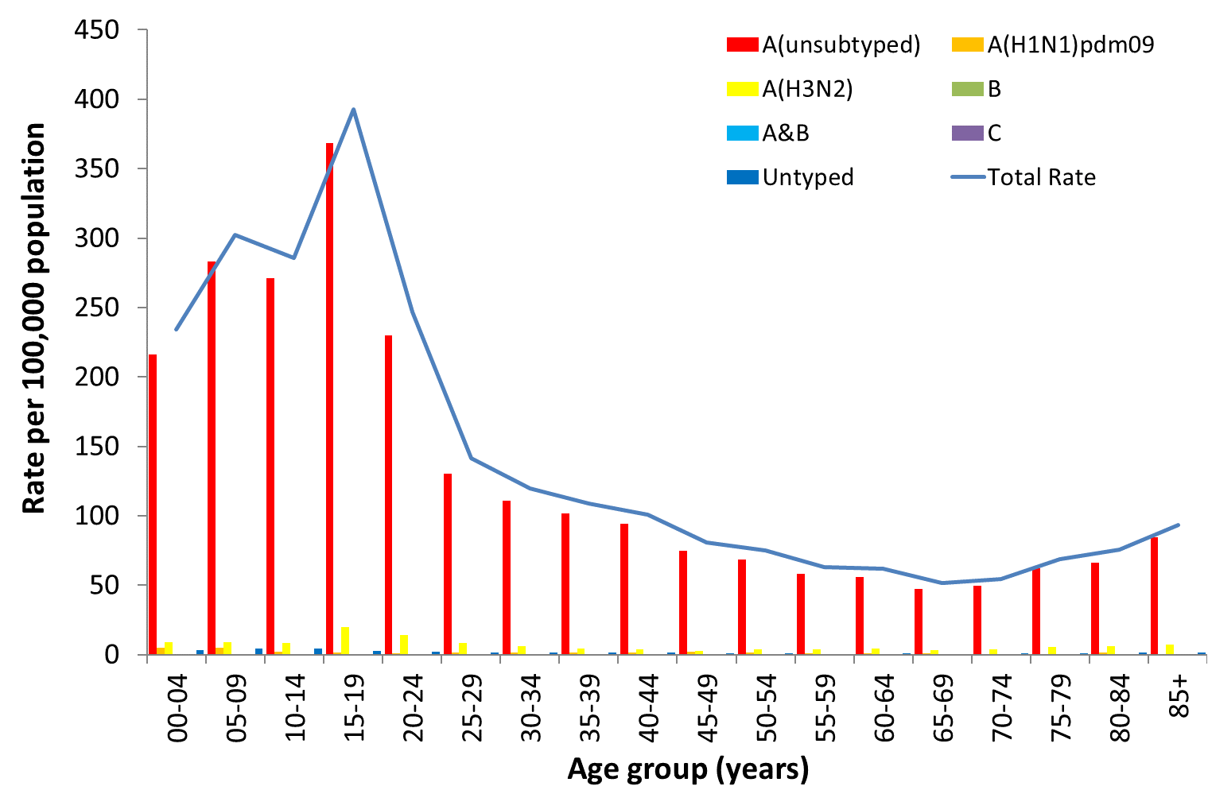

Source: NNDSS

### Virology

***National notification data (NNDSS):***

* Of the 26,193 notifications of laboratory-confirmed influenza with a diagnosis date this fortnight (09 May to 22 May 2022) reported to the NNDSS, 98.3% (n=25,748) were influenza A (of which 95.2% were A(unsubtyped, 0.8% were A(H1N1), and 4.0% were A(H3N2)), 0.1% (n=14) were influenza B, less than 0.1% (n=5) were A&B co-infections, and 1.6% (n=426) were untyped.
* In the year to date, 98.7% of notifications of laboratory-confirmed influenza reported to the NNDSS were influenza A, of which 94.2% were influenza A(unsubtyped), 1.2% were influenza A(H1N1), and 4.7% were influenza A(H3N2). Influenza B accounted for 0.1% of notifications, less than 0.1% were A&B co-infections, and 1.2% were untyped (Figure 9).
* Year to date, the proportion of all notifications reported as influenza A has been 83% or higher across jurisdictions (Figure 10).

***ASPREN:***

* There have been 32 influenza positive samples detected through ASPREN GPs in the year to date. All were influenza A, of which three were A(H1N1), 11 were A(H3N2), and 18 were A(unsubtyped).

***FluCAN:***

* Since seasonal surveillance commenced in April 2022, all confirmed influenza hospital admissions across sentinel hospitals were due to influenza A, of which 17% were A(H1N1), 6% were A(H3N2), and 77% were A(unsubtyped). Of the 28 people admitted directly to ICU, 18% were A(H1N1) and 82% were A(unsubtyped).

***Sentinel laboratories:***

* In the year to date, 3.0% (n=2,949) of samples detected in sentinel laboratories were positive for influenza. Of the positive samples, 99.7% (n=2,940) were influenza A (of which 96.4% (n=2,835) were influenza A(unsubtyped), 3.4% (n=99) were A(H3N2), and 0.2% (n=6) were A(H1N1)), and 0.3% (n=9) were influenza B.

***WHOCC:***

* From 01 January to 23 May 2022, the WHOCC characterised 632 influenza viruses (Table 1), of which 24% (n=147) were influenza A(H1N1), 76% (n=475) were influenza A(H3N2), and less than 1% (n=1) were influenza B/Victoria.
* The WHOCC reported that from 01 January to 23 May 2022, none of the influenza A(H1N1), influenza A(H3N2), or influenza B/Victoria samples tested for neuraminidase inhibitor resistance demonstrated reduced inhibition to Oseltamivir or Zanamivir.

Figure . Per cent of notifications of laboratory-confirmed influenza, Australia, 01 January to 22 May 2022, by subtype and week of diagnosis*

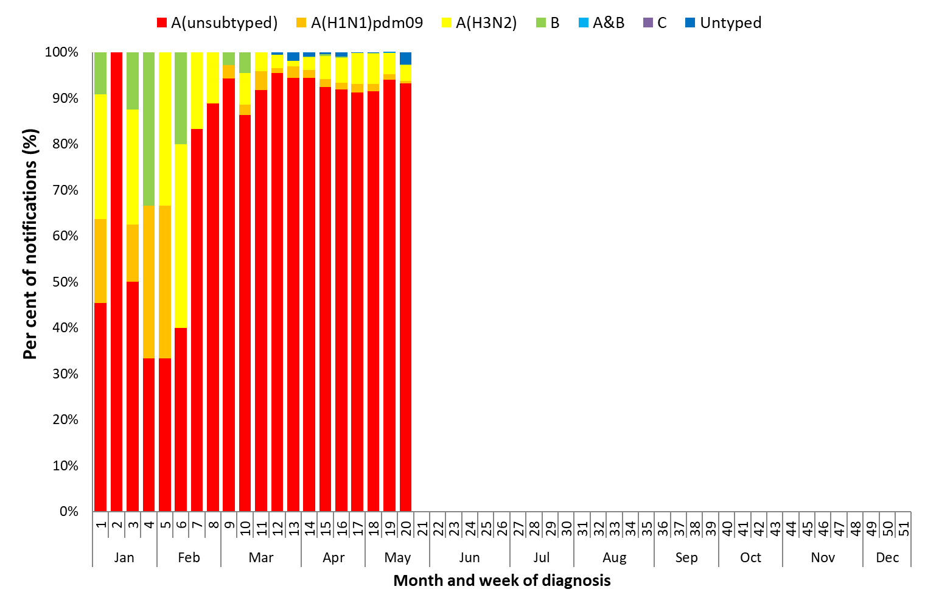

Source: NNDSS

*NNDSS notification data provided for the current and most recent weeks may be incomplete. All data are preliminary and subject to change as updates are received.

Figure . Per cent of notifications of laboratory-confirmed influenza, Australia, 01 January to 22 May 2022, by subtype and state or territory*

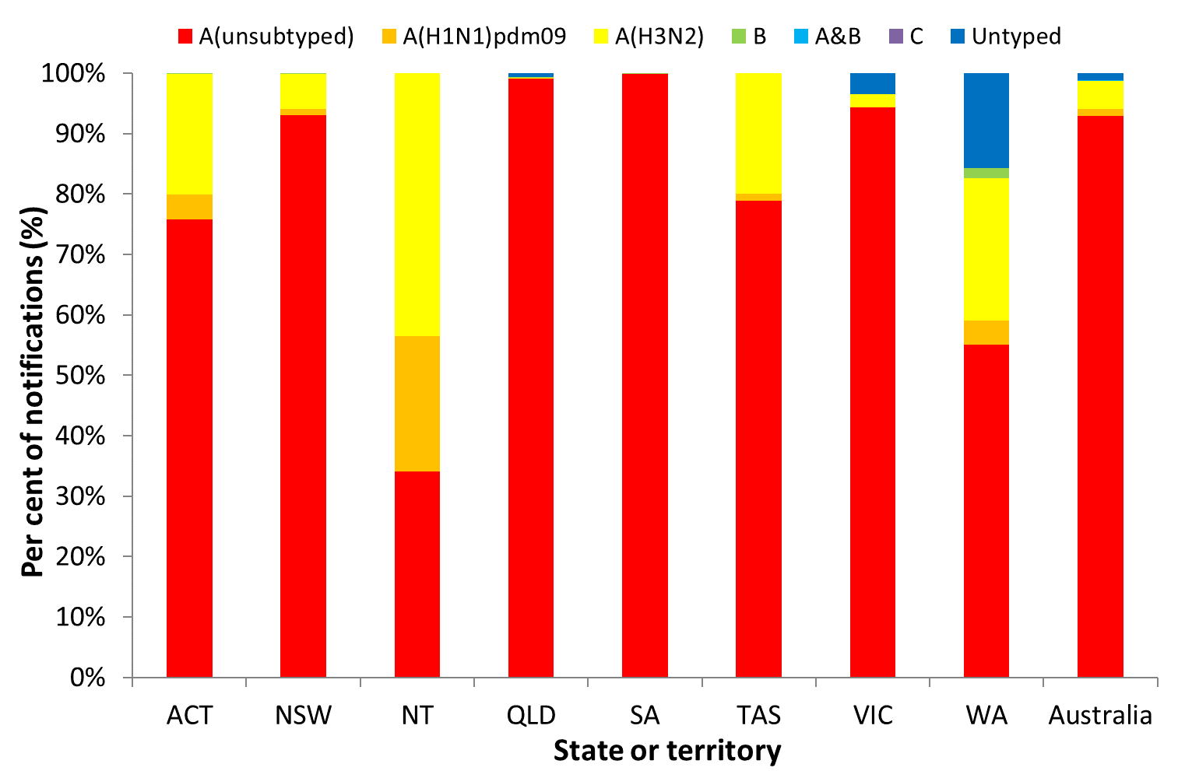

Source: NNDSS

*NNDSS notification data provided for the current and most recent weeks may be incomplete. All data are preliminary and subject to change as updates are received.

Table . Australian influenza viruses typed by haemagglutination inhibition (HI) assay from the WHOCC, 01 January to 23 May 2022*

| Type/Subtype | ACT | NSW | NT | QLD | SA | TAS | VIC | WA | TOTAL |
| --- | --- | --- | --- | --- | --- | --- | --- | --- | --- |
| A(H1N1) pdm09 | 2 | 91 | 39 | 4 | 0 | 0 | 10 | 1 | **147** |
| A(H3N2) | 16 | 21 | 10 | 0 | 4 | 2 | 420 | 2 | **475** |
| B/Victoria lineage | 0 | 1 | 0 | 0 | 0 | 0 | 0 | 0 | **1** |
| B/Yamagata lineage | 0 | 0 | 0 | 0 | 0 | 0 | 0 | 0 | **0** |
| Total | **18** | **113** | **49** | **4** | **4** | **2** | **430** | **3** | **623** |

Source: WHOCC

* Viruses tested by the WHOCC are not necessarily a random sample of all those in the community. State indicates the residential location for the individual tested, not the submitting laboratory. There may be up to a month delay on reporting of samples.

### Vaccine match and effectiveness

***WHOCC:***

* Of the 632 isolates characterised for antigenic similarity to their corresponding vaccine components by HI assay (Table 1):
  + All influenza A(H1N1) isolates characterised in the year to date have been antigenically similar to the corresponding vaccine components;
  + 94.5% of influenza A(H3N2) isolates were antigenically similar to the corresponding vaccine components; and
  + The one influenza B/Victoria isolate characterised in the year to date was antigenically dissimilar to the corresponding vaccine components.

#### Australian Influenza Vaccines Composition 2022

All 2022 southern hemisphere seasonal influenza vaccinations registered for use in Australia are quadrivalent influenza vaccines (QIVs).

The influenza virus strains included in egg-based QIVs in Australia in 2022 are:

* an A/Victoria/2570/2019 (H1N1)pdm09-like virus;
* an A/Darwin/9/2021 (H3N2)-like virus;
* a B/Austria/1359417/2021-like (B/Victoria lineage) virus; and
* a B/Phuket/3073/2013-like (B/Yamagata lineage) virus.

The influenza virus strains included in cell-based QIVs in Australia in 2022 are:

* an A/Wisconsin/588/2019 (H1N1)pdm09-like virus;
* an A/Darwin/6/2021 (H3N2)-like virus;
* a B/Austria/1359417/2021 (B/Victoria lineage)-like virus; and
* a B/Phuket/3073/2013 (B/Yamagata lineage)-like virus.

The best way to determine how well the vaccine protects against circulating viruses during the season is by determining the vaccine effectiveness. These estimates provide an indication of how effective the vaccine was in providing protection against influenza infection. Vaccine effectiveness is usually estimated from observational studies and is calculated after the end of the influenza season, though interim analyses are sometimes available where there is sufficient data.

#### Vaccine effectiveness

It is too early to assess vaccine match and effectiveness for this season.