| Logo | **Australian Influenza**  **SURVEILLANCE REPORT**  **No. 3, 2019**  **20 May to 2 June 2019** |
| --- | --- |

The Department of Health acknowledges the providers of the many sources of data used in this report and greatly appreciates their contribution.

## KEY MESSAGES

* **Activity** – Currently, influenza and influenza-like illness (ILI) activity are high for this time of year compared to previous years. At the national level, notifications of laboratory-confirmed influenza have increased in the past fortnight. The number of laboratory-confirmed notifications of influenza reported to the NNDSS in the 2019 year-to-date are greater when compared to the same periods in 2017 and 2018, however, this is due to heightened interseasonal activity.
* **Severity** –There is no indication of the potential severity of the 2019 season at this time.
* **Impact** – There is no indication of the potential impact on society of the 2019 season at this time.
* **Virology** – In the year to date and in the past fortnight, the majority of confirmed influenza cases reported nationally were influenza A (81%). Where subtyping data were available, influenza A(H3N2) was the dominant influenza A subtype in the past fortnight, however, the proportion of influenza B has been steadily increasing in a number of jurisdictions since late April.

## ANALYSIS

### Introduction

Each year, the influenza virus changes and different strains can circulate in the population. Particular subtypes of influenza can affect different groups of the population more than others. Depending on the susceptibility of the population, the subtypes that are circulating and the changes to the virus itself, the influenza season can be very different year to year. Our surveillance systems help us to understand influenza activity, severity of the infection in individuals and impact of the illness on society in Australia. We are also able to monitor which influenza viruses are circulating, which populations might be more affected, the effectiveness of the vaccine, and any resistance to antiviral drugs that has developed.

### Activity

*Activity measures the capacity of the circulating influenza viruses to spread person to person and may be measured indirectly through systems that monitor influenza-like illness and more directly through systems that monitor laboratory confirmed influenza.*

#### Influenza-like illness

Following high levels of ILI (fever and cough) activity over the interseasonal period, ILI in the community is currently high for this time of year. The proportion of calls to Healthdirect related to ILI, and GP presentations, are above the historical range.

* **Healthdirect:** In the year to date, the proportion of calls to the Healthdirect public health hotline related to ILI have been increasing steadily from 3.6% in week 1 to 10.2% in week 22 (Figure 1). This is above the range reported for the same week over the past five years (range = 6.2% - 7.2%)
* **Sentinel General Practitioners (ASPREN) and Victorian Sentinel Practice Influenza Network (VicSPIN):** Consultations due to ILI in sentinel general practices have been steadily increasing since the beginning of the year. In week 21, 11.9 per 1,000 consultations in sentinel general practices were due to ILI (Figure 2), decreasing to 9.9 per 1,000 consultations in week 22. ILI consultations are approximately twice the 5 year average for this time of year.
* **Flutracking:** Since reporting began in week 15, Flutracking participants reporting ILI has increased from 1.6% to 2.1% in week 22. Activity in weeks 21 and 22 is within the range of the previous five years (Figure 3).

Confirmed influenza

Laboratory-confirmed influenza activity is above average levels and is a major cause of ILI this fortnight.

* **Proportion of ILI with confirmed influenza seen by sentinel GPs:** Of the 249 ILI cases presenting to sentinel ASPREN GPs this fortnight who were tested for influenza, 79 (31.7%) had a positive result. This is an increase from the previous fortnight when 27.4% (52/190) of swabbed ILI patients tested positive for influenza. Since week 14, the proportion of influenza B positive tests has increased steadily, consistent with results from other surveillance systems. In the past fortnight, influenza A(H3N2) has been the predominant subtype.
* Proportion of ILI with confirmed influenza in sentinel labs:

In the year to date, the unweighted percentage of tests positive for influenza began to increase in week 8 with a high in week 16 at 26.9%. This has decreased slightly in subsequent weeks to 20.2% in week 22. Positivity was highest in Western Australia (WA) in the last fortnight (Figure 4).

The most commonly detected respiratory viruses this fortnight by laboratory site were:

* + rhinovirus in both weeks 21 and 22 by the Institute of Pathology West ICPMR;
  + influenza A in both weeks by SA Pathology;
  + rhinovirus in both weeks by Tasmania (TAS);
  + picornavirus in week 21, and influenza A and picornavirus in week 22 by VIDRL;
  + influenza A(H3N2) in both weeks by PathWest; and
* **NNDSS notifications**: In the year to date there have been 70,341 notifications of laboratory-confirmed influenza to the National Notifiable Diseases Surveillance System (NNDSS). This fortnight there were 14,522 notifications of laboratory confirmed influenza to the NNDSS, which is an increase in reported cases compared to the previous fortnight (n=10,729) (Figure 5).
* **FluCAN**: Since seasonal sentinel hospital surveillance began on 1 April 2019, a total of 589 people have been admitted with confirmed influenza (Figure 6). In the fortnight to 2 June 2019, 83 people have been admitted with confirmed influenza, over 3 times the 5-year average for the same fortnight (n=26). Note that a sentinel hospital in South Australia (SA) has not yet begun reporting. A number of hospitals may also have a backlog of cases and it is expected that numbers may be revised upwards.

Figure 1. Per cent of calls to Healthdirect related to ILI, Australia, 1 January 2014 to 2 June 2019, by month and week of call.

Figure 1. Per cent of calls to Healthdirect related to ILI, Australia, 1 January 2014 to December 2019, by month
This figure illustrates the proportion of calls to Healthdirect related to influenza like illness over a five year period from 2014 to 19 May 2019. The figure shows an increase from late January, with a peak in mid February followed by a secondary peak in mid April. The peak for the year typically occurs in August.


Source: Healthdirect

**Figure 2. Unweighted rate of ILI reported from sentinel GP surveillance systems, Australia, 1 January 2014 to 2 June 2019, by month and week.**

Figure 2. Unweighted rate of ILI reported from sentinel GP surveillance systems, Australia, 1 January 2014 to 31 December 2019, by month and week.
This table demonstrates the rate of ILI in sentinel GP surveillance systems over the current year, with data for the previous 5 years for comparison.


Source: ASPREN and VicSPIN

Figure 3. Proportion of fever and cough among FluTracking participants, Australia, between April and October, 2014 to 2019, by month and week.

Figure 3. Proportion of fever and cough among FluTracking participants, Australia, between April and October, 2014 to 2019, by month and week.
Fever and cough reported by flutracking participants as a proportion of the total number of participants from April to October of each year since 2014


Source: FluTracking

Figure 4. Proportion of sentinel laboratory tests positive for influenza, 1 January to 2 June 2019, by contributing laboratoryor jurisdiction and month and week.

Figure 4. Proportion of sentinel laboratory tests positive for influenza, 1 January to October 2019, by contributing laboratory or jurisdiction and month and week.
The presents the percent positivity for influenza tests performed at multiple labs, as well as weighted and unweighted pooled results.


* Pooled percentage positive indicators should be interpreted with caution, noting that collectively pooled contributing laboratories are not representative of testing across Australia and individually contributing laboratories may not be representative of the jurisdiction in which they are located.

^ Weighted according to jurisdictional population in which laboratories are located.

The percentage of tests positive for influenza in the interseasonal period should be interpreted with caution due to small numbers of tests being undertaken in this time, resulting in high variability in the indicators.

Figure 5. Notifications of laboratory confirmed influenza, Australia, 1 January 2014 to 2 June 2019, by month and week of diagnosis.

Figure 5. Notifications of laboratory confirmed influenza, Australia, 1 January 2014 to 31 December 2019, by month and week of diagnosis
This figure illustrates the number of influenza notifications in Australia over 5 years, from 2014 to 31 December 2019. The figure shows a steady increase in notifications since mid March. The peak for the year typically occurs in mid to late August.
Source: NNDSS

Figure 6. Number of influenza hospitalisations at sentinel hospitals, between March and October, 2014 to 2019 by month and week.

Figure 6. Number of influenza hospitalisations at sentinel hospitals, between March and October, 2014 to 2019 by month and week
This figure illustrates the number of influenza hospitalisations to sentinel hospitals over 5 years, from 2014 to October 2019. The peak for the year typically occurs in early September.


Source: FluCAN

#### Geographical distribution of activity

* **Jurisdictional reports:** In the fortnight ending 2 June 2019, the geographic spread of influenza activity was reported by state and territory health departments as being widespread in the Australian Capital Territory (ACT), SA, New South Wales (NSW), Victoria (VIC), TAS and the Perth metro region. The Northern Territory (NT), Rural South and Northwest regions of WA and South and Central regions of Queensland (QLD) reported regional activity, while activity was localised in the Tropical region of QLD.

There was no change in influenza activity compared to the previous fortnight in the Top End region of the NT and decreased in SA, TAS the Tropical region of QLD and Central NT. All other regions and jurisdictions reported an increase in activity (Figure 7).

* **NNDSS**: Of the 14,522 notifications of influenza reported to the NNDSS in the last fortnight, 4,072 were from NSW, 3,791 from VIC, 2,391 from SA, 2,001 from WA, 1,861 from QLD, 233 from ACT, 96 from TAS, and 77 from NT (Figure 8).

Of the 70,341 notifications of influenza reported to the NNDSS this year to 2 June 2019, 18,022 were from NSW, 16,953 from SA, 14,749 from VIC, 13,004 from QLD, 5,222 from WA, 968 from TAS, 819 from NT and 604 from the ACT.

For further information regarding influenza activity at the jurisdictional level, please refer to the following State and Territory health surveillance reports:

* ACT: [ACT Influenza Report](https://www.health.act.gov.au/about-our-health-system/population-health/winter-wellbeing-and-flu/flu-act)

(www.health.act.gov.au/about-our-health-system/population-health/winter-wellbeing-and-flu/flu-act)

* NSW: [Influenza Surveillance Report](http://www.health.nsw.gov.au/Infectious/Influenza/Pages/reports.aspx) (www.health.nsw.gov.au/Infectious/Influenza/Pages/reports.aspx)
* QLD: [Statewide Weekly Influenza Surveillance Report](https://www.health.qld.gov.au/clinical-practice/guidelines-procedures/diseases-infection/surveillance/reports/flu) (www.health.qld.gov.au/clinical-practice/guidelines-procedures/diseases-infection/surveillance/reports/flu)
* SA: [Weekly Epidemiological Summary](http://www.sahealth.sa.gov.au/wps/wcm/connect/public+content/sa+health+internet/about+us/health+statistics/surveillance+of+notifiable+conditions) (Influenza section) (www.sahealth.sa.gov.au/wps/wcm/connect/public+content/sa+health+internet/about+us/health+statistics/surveillance+of+notifiable+conditions)
* TAS: [fluTAS Reports](http://www.dhhs.tas.gov.au/publichealth/communicable_diseases_prevention_unit) (www.dhhs.tas.gov.au/publichealth/communicable_diseases_prevention_unit)
* VIC: [Influenza Surveillance Reports](https://www2.health.vic.gov.au/public-health/infectious-diseases/infectious-diseases-surveillance/seasonal-influenza-reports) (www2.health.vic.gov.au/public-health/infectious-diseases/infectious-diseases-surveillance/seasonal-influenza-reports)
* WA: [Virus WAtch](http://ww2.health.wa.gov.au/Articles/F_I/Infectious-disease-data/Virus-WAtch) (ww2.health.wa.gov.au/Articles/F_I/Infectious-disease-data/Virus-WAtch)

Figure 7. Map of influenza activity by state and territory, Australia, 20 May to 2 June 2019

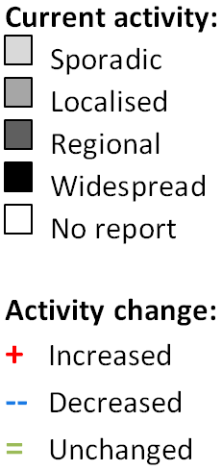

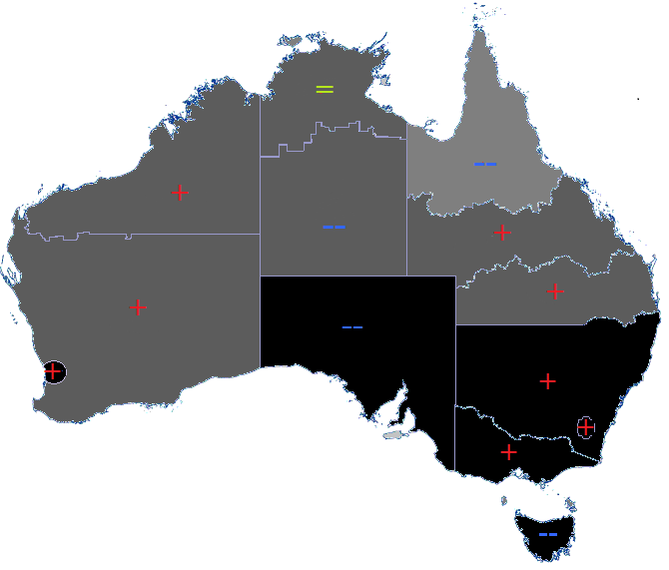

**Figure 8. Notifications of laboratory confirmed influenza, 1 January to 2 June 2019, by state or territory and week.**

**The number of notifications for the 2019 year to date for each state and territory.
**

Source: NNDSS

### Severity

*Severity is a measure of adverse outcomes or complications as a result of influenza or influenza-like illness (ILI) such as hospital referrals, admissions, need for intensive care and deaths. Measuring and understanding the severity of circulating influenza is difficult to establish at the beginning of the influenza season. The proportion of confirmed influenza cases with serious outcomes might be skewed initially because there are only a small number of people notified with influenza at the beginning of the season. This means that the measure of severity will vary substantially fortnight to fortnight until after the peak of the season when there is enough data for measurements to stabilise. An assessment of severity can be provided once the signals become clearer.*

#### Intensive care admissions

* **FluCAN**: Since seasonal sentinel hospital surveillance began on 1 April 2019, 589 people with influenza have been admitted to sentinel hospitals. Of those admitted, 38 (6.5%) were admitted to ICU. In the fortnight to 2 June 2019, 6 of the 83 people admitted to sentinel hospitals with confirmed influenza (7.2%) were admitted to ICU. A number of hospitals may also have a backlog of cases and it is expected that numbers may be revised upwards.

#### Deaths in confirmed influenza cases

* **NNDSS**: So far in 2019, 147 influenza associated deaths have been notified to the NNDSS. The majority of deaths were due to influenza A (98%, n=144), with 3 due to influenza B. Where subtyping information was available for influenza A viruses, 11 were associated with influenza A(H1N1)pdm09 and 20 with influenza A(H3N2). The median age of deaths notified was 85 years (range <1 to 105 years).

The number of influenza-associated deaths reported to the NNDSS does not represent the true mortality associated with this disease. The number of deaths is reliant on the follow up of cases to determine the outcome of their infection. The follow up of cases is not a requirement of notification, and are only inclusive of laboratory-confirmed cases of influenza. Due to retrospective revision, the variation across jurisdictions in methodology, representativeness and timeliness of death data, and reporting of an outcome of infection not being a requirement of notification, year on year comparisons of deaths in notified cases of influenza may not be reliable.

### Impact

*Impact measures how the influenza epidemic affects society, including stress on health-care resources and societal and economic consequences.*

#### Absenteeism

* **Flutracking**: In weeks 21 and 22, 1.5% and 1.4% of Flutracking survey respondents respectively reported having ILI and taking time off regular duties while unwell. This is a moderate level of impact when compared to trends in recent years.

### Virology

#### National notification data

**NNDSS:** In the reporting fortnight, 81% of notifications of laboratory confirmed influenza to the NNDSS were influenza A (77% influenza A(unsubtyped), 4% influenza A(H3N2) and less than 1% influenza A(H1N1)pdm09), 18% were influenza B and less than 1% were influenza C, influenza A&B co-infections or untyped (Figure 9). Where subtyping information was available for influenza A viruses, the NT, QLD, TAS and WA reported a greater proportion of influenza A(H3N2) than influenza A(H1N1)pdm09 in the past fortnight. NSW and the ACT reported similar proportions of both influenza A subtypes.

For the year to 2 June 2019, 89% of notifications of laboratory confirmed influenza to the NNDSS were influenza A (82% influenza A(unsubtyped), 3% influenza A(H1N1)pdm09 and 4% influenza A(H3N2)), 10% were influenza B, and less than 1% were influenza C, influenza A&B co-infections or untyped. The proportion of all notifications year to date reported as influenza A has ranged across jurisdictions from 79% in WA to 96% in SA and TAS (Figure 10).

#### Reference Laboratory data

* **World Health Organization Collaborating Centre for Reference and Research on Influenza (WHOCC):** From 1 January to 3 June 2019, the WHOCC characterised 620 influenza viruses. Of these, 90% were influenza A (55% influenza A(H1N1)pdm09 and 35% influenza A(H3N2)), and 10% were influenza B (6% influenza B Victoria lineage and 4% influenza B Yamagata lineage).

#### Sentinel laboratory surveillance

* In the reporting fortnight, 86% of influenza positive samples detected in sentinel laboratories were influenza A (66% were influenza A(unsubtyped), 19% were influenza A(H3N2), and less than 1% were influenza A(H1N1)pdm09), and 14% were influenza B (Figure 11).

#### Sentinel GP surveillance

* **ASPREN**: Of the 79 influenza positive samples detected this fortnight through swab testing patients presenting with ILI to ASPREN sentinel GPs, 2 were influenza A (unsubtyped), 56 were influenza A(H3N2) and 5 were influenza A(H1N1)pdm09. The remaining 16 were influenza B (Figure 12).

#### Sentinel hospital surveillance

* **FluCAN**: Since seasonal sentinel hospital surveillance began on 1 April 2019, 91% of admissions with confirmed influenza to sentinel hospitals were influenza A (70% A(unsubtyped), 5% influenza A(H1N1)pdm09 and 16% influenza A (H3N2)) and 9% were influenza B (Figure 13).
* Of the 38 patients admitted directly to ICU, 36 patients were infected with influenza A (82% influenza A(unsubtyped), 5% influenza A(H3N2) and 8% influenza A(H1N1)pdm09), with two people infected with influenza B (5%).

**Figure 9. Per cent of laboratory confirmed influenza, Australia, 1 January to 2 June 2019 by subtype and week.**

**Figure 9. Per cent of laboratory confirmed influenza, Australia, 1 January to 31 December 2019 by subtype and week.
Per cent of laboratory confirmed influenza by week and subtype for the 2019 year to date.
**

Source: NNDSS

Figure 10. Per cent of notifications of laboratory confirmed influenza, Australia, 1 January to 2 June 2019, by subtype and state or territory.

Figure 10. Per cent of notifications of laboratory confirmed influenza, Australia, 1 January to 31 December 2019, by subtype and state or territory. Per cent of notifications of laboratory confirmed influenza reported to the NNDSS by subtype and jurisdiction in the 2019 year to date.

Source: NNDSS

Figure 11. Proportion of sentinel laboratory tests positive for influenza and total number of specimens tested, 1 January to 2 June 2019, by subtype and month and week.

Figure 11. Proportion of sentinel laboratory tests positive for influenza and total number of specimens tested, 1 January to 31 December 2019, by subtype and month and week.
This figure illustrates the proportion of subtypes of positive influenza tests, along with the total number of tests for the year to date.

Figure 12. Proportion of respiratory viral tests positive for influenza in ASPREN ILI patients and ASPREN ILI consultation rate, Australia, 1 January to 2 June 2019, by month and week.

Figure 12. Proportion of respiratory viral tests positive for influenza in ASPREN ILI patients and ASPREN ILI consultation rate, Australia, 1 January to 31 December 2019, by month and week.
The proportion of subtypes in positive influenza tests from ASPREN ILI patients and the unweighted consultation rate, by each week in the 2019 year to date.


Source: ASPREN

Figure 13. Number of influenza hospitalisations at sentinel hospitals by subtype and ICU admission, 1 April to 2 June 2019, by month and week.

Figure 13. Number of influenza hospitalisations at sentinel hospitals by subtype and ICU admission, 1 April to 31 December 2019, by month and week
This figure shows the number of admissions to FluCAN sentinel hospitals by subtype in the year to date, which illustrates a large number of influenza A(unsubtyped), followed by influenza A(H1N1).


Source: FluCAN

### At-risk Populations

#### National notification data

* **NNDSS:** So far in 2019, notification rates have been highest in adults aged 80 years or older (517.4 notifications per 100,000), followed by children aged under 10 years (492.2 notifications per 100,000) (Figure 14). Influenza A accounted for the greatest number of notifications across all age groups. Where further subtyping information was available, notifications of influenza A(H1N1)pdm09 were highest in children aged less than 5 years (15.2 per 100,000) and notifications of influenza A(H3N2) were highest in adults aged 80 years and older (52.4 per 100,000). Notification rates for influenza B were highest in children aged 5 to 9 years (121.5 per 100,000).

Among broader age groups, where further subtyping information was available, influenza B was the predominant subtype in children of all ages and adults between the ages of 20 and 64 years. Influenza A(H3N2) was the predominant subtype in adults aged 65 years and older (Figure 15).

#### Sentinel hospital surveillance

* **FluCAN:** Since seasonal sentinel hospital surveillance began on 1 April 2019, 37% of people admitted with confirmed influenza were children aged 15 years and younger, 37% were adults aged between 16 and 64 years, and 26% were adults aged 65 years and older. Of the children admitted with confirmed influenza to date, 4.7% (n=10) were admitted to ICU, compared to 9.7% of adults aged between 16 and 64 years and 4.5% of adults aged 65 years and older.

Figure 14. Rate of notifications of laboratory confirmed influenza, Australia, 1 January to 2 June 2019, by age group and subtype.

Figure 14. Rate of notifications of laboratory confirmed influenza, Australia, 1 January to 2 June 2019, by age group and subtype.This figure demonstrates the rate of different subtypes of influenza in the year to date by 5 year age groups

Source: NNDSS

Figure 15. Notifications of laboratory confirmed influenza by week of diagnosis and cumulative year-to-date, Australia, 1 January to 2 June 2019, by age group and subtype.

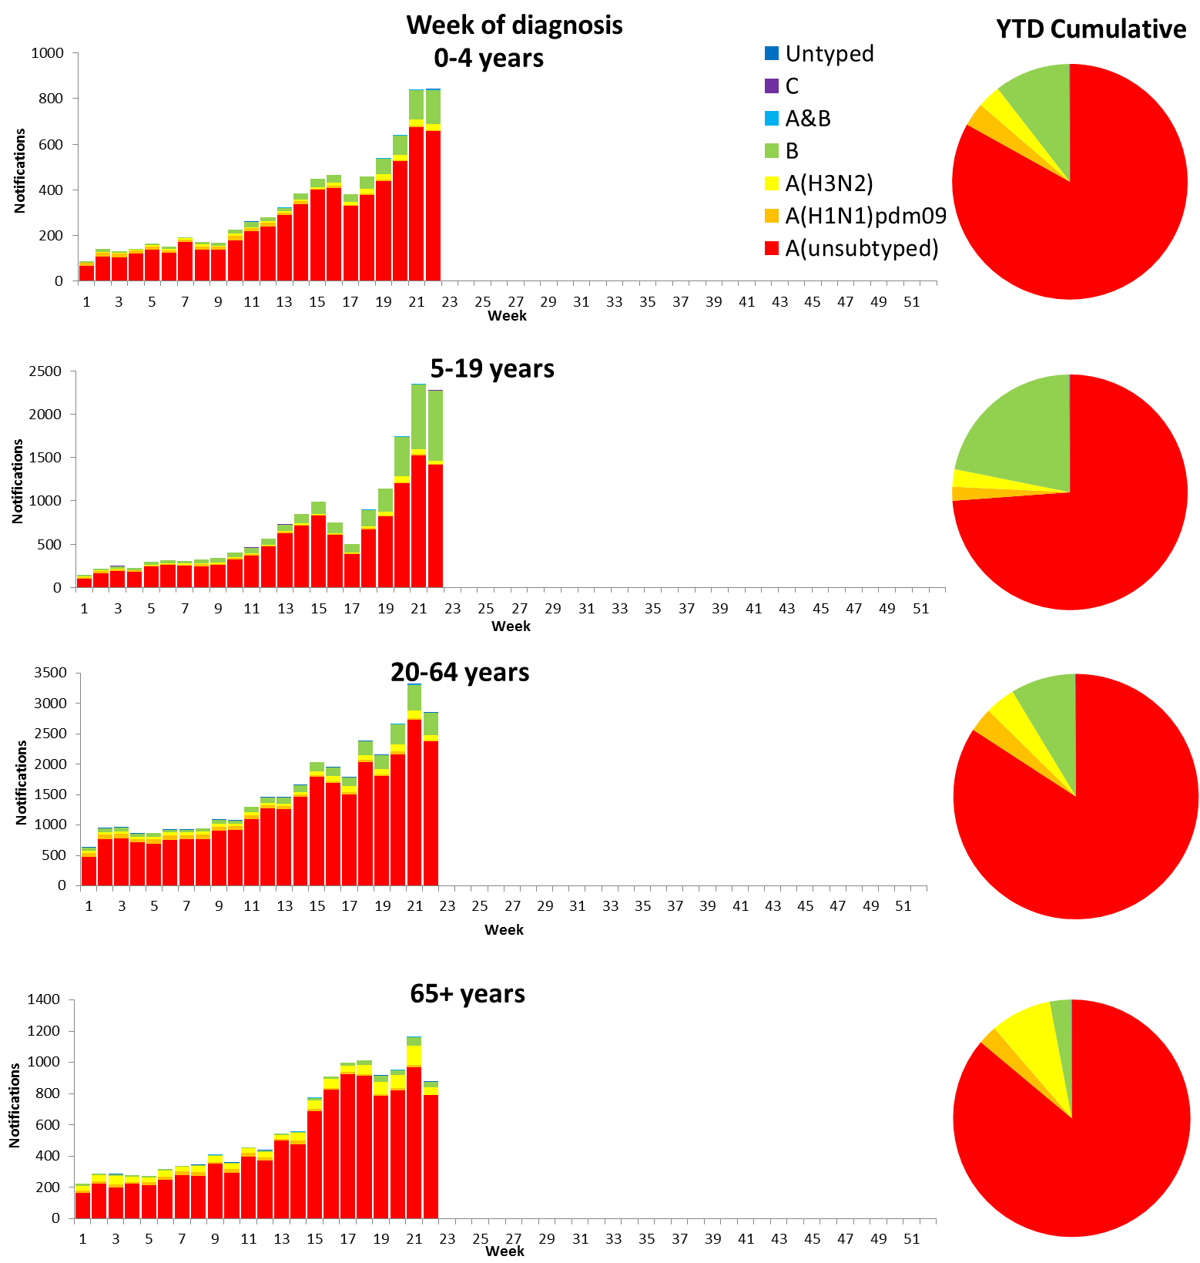

Source: NNDSS

### Vaccine effectiveness

#### Australian Influenza Vaccines Composition 2019

The influenza virus strains included in the 2019 seasonal influenza vaccines in Australia are:

* A/Michigan/45/2015, (H1N1)pdm09-like virus;
* A/Switzerland/8060/2017, (H3N2)-like virus; and
* B/Phuket/3073/2013-like virus, Yamagata lineage.
* B/Colorado/06/2017-like virus, Victoria lineage.

The best way to determine how well the vaccine protects against circulating viruses during the season is by determining the vaccine effectiveness. These estimates provide an indication of how effective the vaccine was in providing protection against influenza infection.

#### 

#### WHOCC

From 1 January to 3 June 2019, 620 isolates were characterised for similarity to their corresponding vaccine components by haemagglutination inhibition (HI) assay (Table 1). Most influenza A(H1N1)pdm09 viruses and viruses from both influenza B lineages appeared to be antigenically similar to the corresponding vaccine components. 8 A(H1N1)pdm09, 8 B/Victoria and no B/Yamagata viruses were characterised as low reactors. The majority of influenza A(H3N2) isolates that were able to be assessed by HI assay appeared to be antigenically matched to the vaccine. Of the 219 influenza A(H3N2) isolates, 46 (21%) were characterised as low reactors, and an additional 43 isolates were unable to be characterised in the HI assay due to insufficient haemagglutination titre.

**Table 1. Australian influenza viruses typed by HI from the WHOCC, 1 January to 3 June 2019.**

| Type/Subtype | ACT | NSW | NT | QLD | SA | TAS | VIC | WA | TOTAL |
| --- | --- | --- | --- | --- | --- | --- | --- | --- | --- |
| A(H1N1) pdm09 | 24 | 128 | 32 | 24 | 64 | 4 | 54 | 7 | 337 |
| A(H3N2) | 36 | 59 | 24 | 9 | 39 | 6 | 37 | 9 | 219 |
| B/Victoria lineage | 3 | 7 | 16 | 3 | 8 | 0 | 3 | 0 | 40 |
| B/Yamagata lineage | 4 | 6 | 1 | 1 | 9 | 0 | 1 | 2 | 24 |
| Total | 67 | 200 | 73 | 37 | 120 | 10 | 95 | 18 | 620 |

SOURCE: WHO CC

Note: Viruses tested by the WHO CC are not necessarily a random sample of all those in the community.

State indicates the residential location for the individual tested, not the submitting laboratory.

There may be up to a month delay on reporting of samples.

### Antiviral Resistance

The WHOCC reported that from 1 January to 3 June 2019, none of the 827 influenza viruses tested for neuraminidase inhibitor resistance, demonstrated reduced inhibition to the antiviral drugs Zanamivir or Oseltamivir.

### Data considerations

No one single system, including notification data, provides the full picture on influenza, because influenza is a common disease and its presenting symptoms are non-specific. The epidemiology of influenza is informed by a number of different systems based in the community, laboratories, primary care and hospitals, as well as notifiable diseases data, which includes officially reported deaths. The information in this report is reliant on the surveillance sources available to the Department of Health at the time of production.

Data in this summary is reported by International Organization for Standardization (ISO) 8601 weeks, with the week ending on Sunday. Throughout the summary, where the year to date is presented, this includes data from 1 January to 2 June 2019. NNDSS data were extracted on 5 June 2019. Due to the dynamic nature of the NNDSS and other surveillance systems, data in this report are subject to retrospective revision and may vary from data reported in other national reports and reports by states and territories. Detailed notes on interpreting the data presented in this report are available at the Department of Health’s [Australian Influenza Surveillance Report website](http://www.health.gov.au/flureport) (www.health.gov.au/flureport).

While every care has been taken in preparing this report, the Commonwealth does not accept liability for any injury or loss or damage arising from the use of, or reliance upon, the content of the report. Delays in the reporting of data may cause data to change retrospectively. For further details about information contained in this report please contact the [Influenza Surveillance Team](mailto:flu@health.gov.au) (flu@health.gov.au).