| Logo | **Australian Influenza**  **SURVEILLANCE REPORT**  **No. 2, 2019**  **6 to 19 May 2019** |
| --- | --- |

The Department of Health acknowledges the providers of the many sources of data used in this report and greatly appreciates their contribution.

## KEY MESSAGES

* **Activity** –Currently, influenza and influenza-like illness (ILI) activity are high for this time of year compared to previous years. At the national level, notifications of laboratory-confirmed influenza have increased in the past fortnight and it is likely these figures will be revised upwards due to backlogs in data entry. Influenza A was the most common respiratory virus detected in patients presenting with ILI to sentinel general practices this fortnight.
* **Severity** –There is no indication of the potential severity of the 2019 season at this time.
* **Impact** – There is no indication of the potential impact on society of the 2019 season at this time.
* **Virology** – In the year to date and in the past fortnight, the majority of confirmed influenza cases reported nationally were influenza A (87%). Where subtyping data were available, influenza A(H3N2) was the dominant influenza A subtype in the past fortnight.

## ANALYSIS

### Introduction

Each year, the influenza virus changes and different strains can circulate in the population. Particular subtypes of influenza can affect different groups of the population more than others. Depending on the susceptibility of the population, the subtypes that are circulating and the changes to the virus itself, the influenza season can be very different year to year. Our surveillance systems help us to understand influenza activity, severity of the infection in individuals and impact of the illness on society in Australia. We are also able to monitor which influenza viruses are circulating, which populations might be more affected, the effectiveness of the vaccine, and any resistance to antiviral drugs that has developed.

### Activity

*Activity measures the capacity of the circulating influenza viruses to spread person to person and may be measured indirectly through systems that monitor influenza-like illness and more directly through systems that monitor laboratory confirmed influenza.*

#### Influenza-like illness

Following high levels of ILI activity over the interseasonal period, ILI in the community is currently high for this time of year. The proportion of calls to Healthdirect related to ILI, and GP presentations, are above the historical range.

* **Healthdirect:** In the year to date, the proportion of calls to the Healthdirect public health hotline related to ILI have been increasing steadily from 3.6% in week 1 to 8.1% in week 20 (Figure 1), after a slight decrease in week 18.
* **Sentinel General Practitioners (ASPREN) and Victorian Sentinel Practice Influenza Network (VicSPIN):** 7.6 per 1,000 consultations in sentinel general practices were due to ILI in week 20 (Figure 2), decreasing from 8.7 per 1,000 consultations in week 17. ILI consultations are approximately twice the 5 year average for this time of year. Consultations due to ILI in sentinel general practices have been steadily increasing since the beginning of the year.
* **Flutracking:** Flutracking began reporting early this year due to the high interseasonal activity. Since reporting began in week 14, Flutracking participants reporting ILI (fever and cough) has decreased from 2.4% to 1.4% in week 18, and subsequently increased to 1.9% in week 20. Activity in weeks 19 and 20 is within the range of the previous five years (Figure 3).

Confirmed influenza

Influenza is above average levels and is a major cause of ILI this fortnight.

* **Proportion of ILI with confirmed influenza seen by sentinel GPs:** Of the 150 ILI cases presenting to sentinel ASPREN GPs this fortnight who were tested for influenza, 37 (24.7%) had a positive result. This is a slight decrease from the previous fortnight when 26.9% (39/145) of swabbed ILI patients tested positive for influenza. Since March 2019, positive results for patients tested for influenza have ranged between 23.8% and 36.8% each week. In weeks 1 to 13, all influenza positive cases were influenza A. From week 14 onwards, influenza B has accounted for 2% to 6% of all tests processed.
* Proportion of ILI with confirmed influenza in sentinel labs:

Amendment to AISR #1: *Due to a calculation error, analyses in the previous report did not include data from South Australia (SA). This error did not impact the overall assessment of the trend in positivity.*

In the year to date, the unweighted percentage of tests positive for influenza began to increase in week 8 and has remained steady at 23.7% in week 20. Positivity was highest in South Australia (SA) in the last fortnight (Figure 4).

The most commonly detected respiratory viruses this fortnight by laboratory site were:

* + rhinovirus in both weeks 19 and 20 by the Institute of Pathology West ICPMR;
  + influenza A in both weeks by SA Pathology;
  + picornavirus in week 19, and influenza A in week 20 by VIDRL;
  + influenza A(H3N2) in both weeks by PathWest; and
  + rhinovirus in both weeks by Tasmania (TAS).
* **NNDSS notifications**: In the year to date there have been 55,240 notifications of laboratory-confirmed influenza to the National Notifiable Diseases Surveillance System (NNDSS). This fortnight there were 10,073 notifications of laboratory confirmed influenza to the NNDSS, which is an increase in reported cases compared to the previous fortnight (n=8,242). However, notifications remain substantially higher compared to this period in the previous five years (Figure 5).
* **FluCAN**: Since seasonal sentinel hospital surveillance began on 1 April 2019, a total of 386 people have been admitted with confirmed influenza (Figure 6). In the fortnight to 19 May 2019, 67 people have been admitted with confirmed influenza, almost 3 times the 5-year average for the same fortnight (n=23.8). Note that sentinel hospitals in the Australian Capital Territory (ACT), SA and Northern Territory (NT) have not yet begun reporting. A number of hospitals may also have a backlog of cases and it is expected that numbers may be revised upwards.

Figure 1. Per cent of calls to Healthdirect related to ILI, Australia, 1 January 2014 to 19 May 2019, by month and week of call.

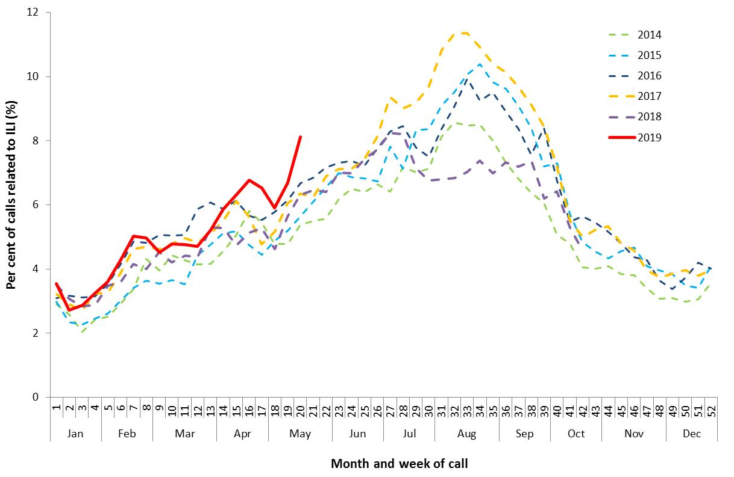

Source: Healthdirect

**Figure 2. Unweighted rate of ILI reported from sentinel GP surveillance systems, Australia, 1 January 2014 to 19 May 2019, by month and week.**

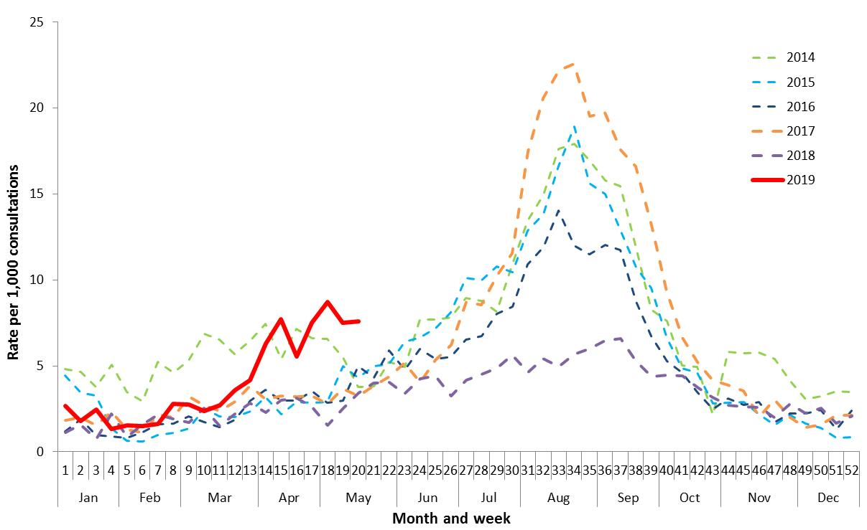

Source: ASPREN and VicSPIN

Figure 3. Proportion of fever and cough among FluTracking participants, Australia, between April and October, 2014 to 2019, by month and week.

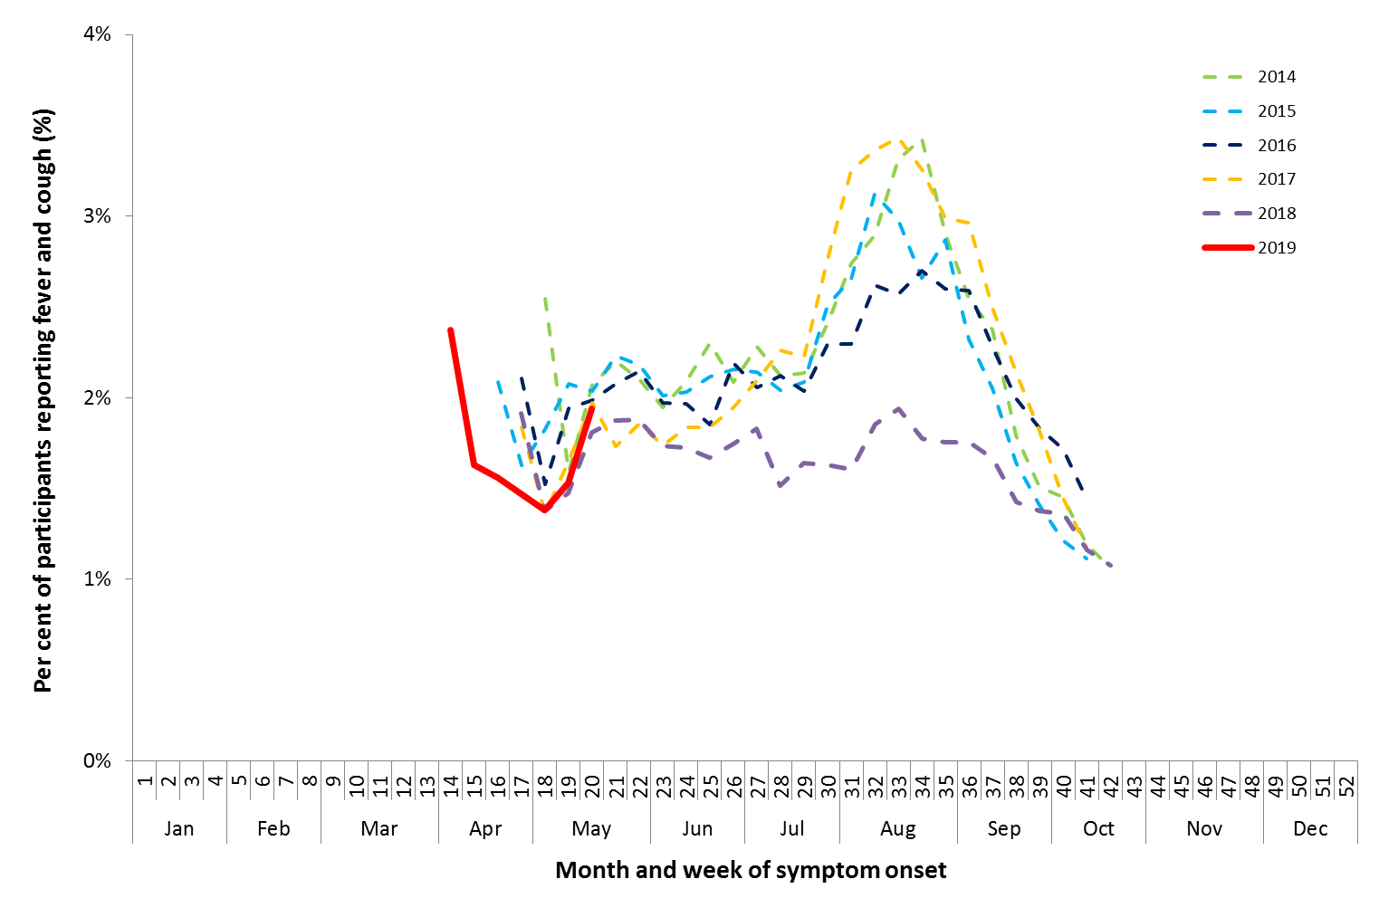

Source: FluTracking

Figure 4. Proportion of sentinel laboratory tests positive for influenza, 1 January to 19 May 2019, by contributing laboratoryor jurisdiction and month and week.

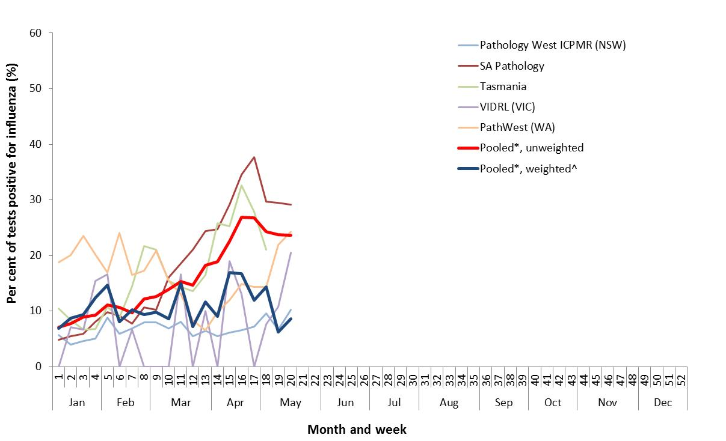

* Pooled percentage positive indicators should be interpreted with caution, noting that collectively pooled contributing laboratories are not representative of testing across Australia and individually contributing laboratories may not be representative of the jurisdiction in which they are located.

^ Weighted according to jurisdictional population in which laboratories are located.

The percentage of tests positive for influenza in the interseasonal period should be interpreted with caution due to small numbers of tests being undertaken in this time, resulting in high variability in the indicators.

Figure 5. Notifications of laboratory confirmed influenza, Australia, 1 January 2014 to 19 May 2019, by month and week of diagnosis.

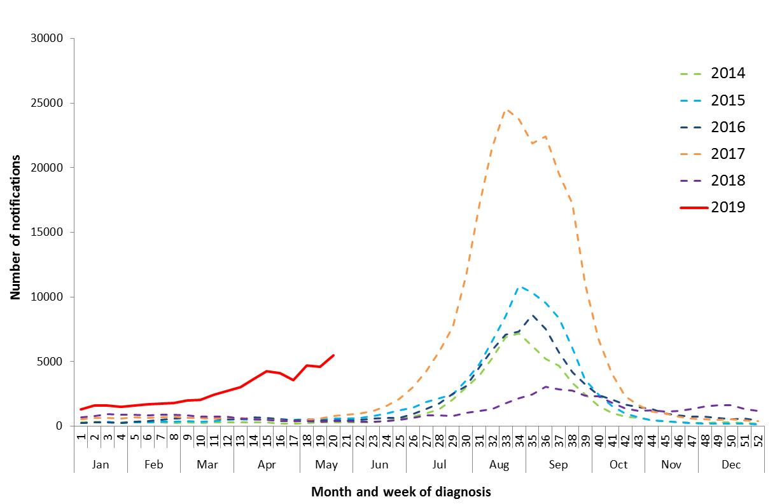

Source: NNDSS

Figure 6. Number of influenza hospitalisations at sentinel hospitals, between March and October, 2014 to 2019 by month and week.

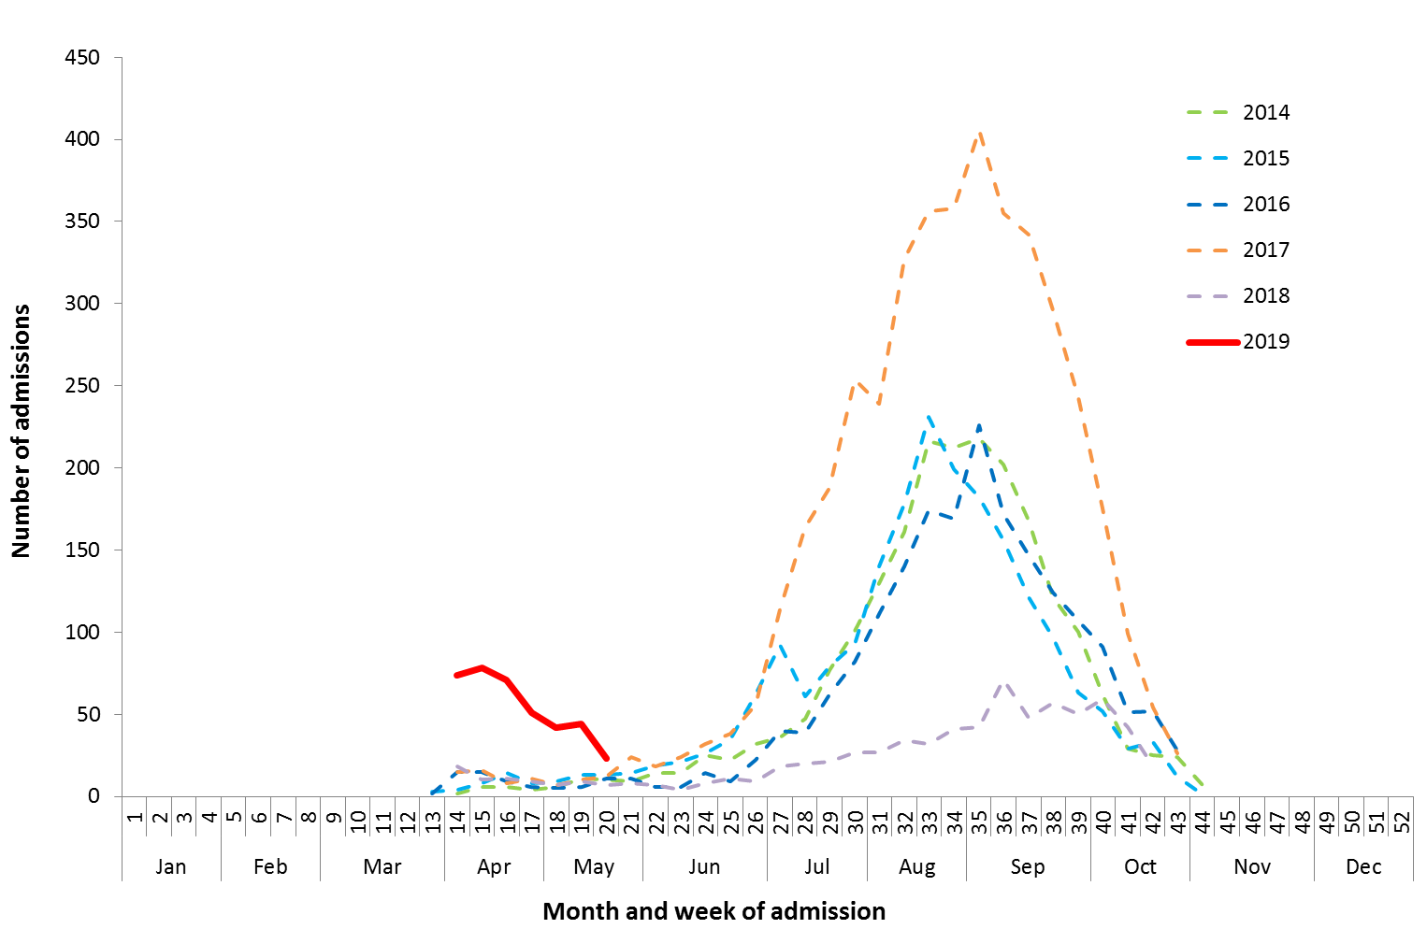

Source: FluCAN

#### Geographical distribution of activity

* **Jurisdictional reports:** In the fortnight ending 19 May 2019, the geographic spread of influenza activity was reported by state and territory health departments as being localised in the ACT, Queensland (QLD), and Rural South and Northwest regions of WA. The Northern Territory (NT) reported regional activity, while activity was widespread in TAS, SA, VIC, NSW and the Perth metro region.

There was no change in influenza activity compared to the previous fortnight in the South and Central regions of QLD. The ACT, SA, VIC, NSW, Perth metro and Northwest regions of WA and the Top End region of the NT reported an increase in activity level. A decrease in activity was reported in TAS, Central NT, Tropical region of QLD and the Rural South region of WA. (Figure 7).

* **NNDSS**: Of the 10,073 notifications of influenza reported to the NNDSS in the last fortnight, 3,209 were from SA, 2,392 from VIC, 2,248 from NSW, 1,160 from QLD, 750 from WA, 128 from TAS, 102 from NT and 85 from ACT (Figure 8).

Of the 55,240 notifications of influenza reported to the NNDSS this year to 19 May 2019, 14,415 were from SA, 13,532 from NSW, 11,282 from VIC, 11,092 from QLD, 2,961 from WA, 861 from TAS, 729 from NT and 368 from the ACT.

For further information regarding influenza activity at the jurisdictional level, please refer to the following State and Territory health surveillance reports:

* ACT: [ACT Influenza Report](https://www.health.act.gov.au/about-our-health-system/population-health/winter-wellbeing-and-flu/flu-act)

(www.health.act.gov.au/about-our-health-system/population-health/winter-wellbeing-and-flu/flu-act)

* NSW: [Influenza Surveillance Report](http://www.health.nsw.gov.au/Infectious/Influenza/Pages/reports.aspx) (www.health.nsw.gov.au/Infectious/Influenza/Pages/reports.aspx)
* QLD: [Statewide Weekly Influenza Surveillance Report](https://www.health.qld.gov.au/clinical-practice/guidelines-procedures/diseases-infection/surveillance/reports/flu) (www.health.qld.gov.au/clinical-practice/guidelines-procedures/diseases-infection/surveillance/reports/flu)
* SA: [Weekly Epidemiological Summary](http://www.sahealth.sa.gov.au/wps/wcm/connect/public+content/sa+health+internet/about+us/health+statistics/surveillance+of+notifiable+conditions) (Influenza section) (www.sahealth.sa.gov.au/wps/wcm/connect/public+content/sa+health+internet/about+us/health+statistics/surveillance+of+notifiable+conditions)
* TAS: [fluTAS Reports](http://www.dhhs.tas.gov.au/publichealth/communicable_diseases_prevention_unit) (www.dhhs.tas.gov.au/publichealth/communicable_diseases_prevention_unit)
* VIC: [Influenza Surveillance Reports](https://www2.health.vic.gov.au/public-health/infectious-diseases/infectious-diseases-surveillance/seasonal-influenza-reports) (www2.health.vic.gov.au/public-health/infectious-diseases/infectious-diseases-surveillance/seasonal-influenza-reports)
* WA: [Virus WAtch](http://ww2.health.wa.gov.au/Articles/F_I/Infectious-disease-data/Virus-WAtch) (ww2.health.wa.gov.au/Articles/F_I/Infectious-disease-data/Virus-WAtch)

Figure 7. Map of influenza activity by state and territory, Australia, 22 April to 19 May 2019

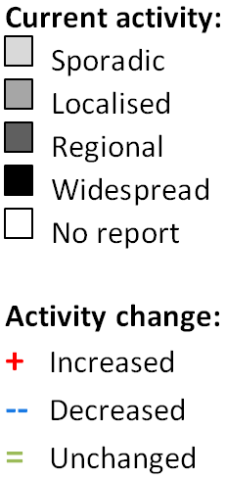

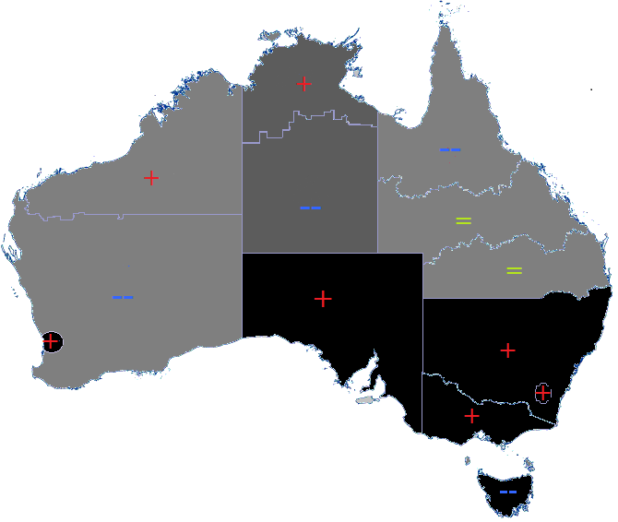

**Figure 8. Notifications of laboratory confirmed influenza, 1 January to 19 May 2019, by state or territory and week.**

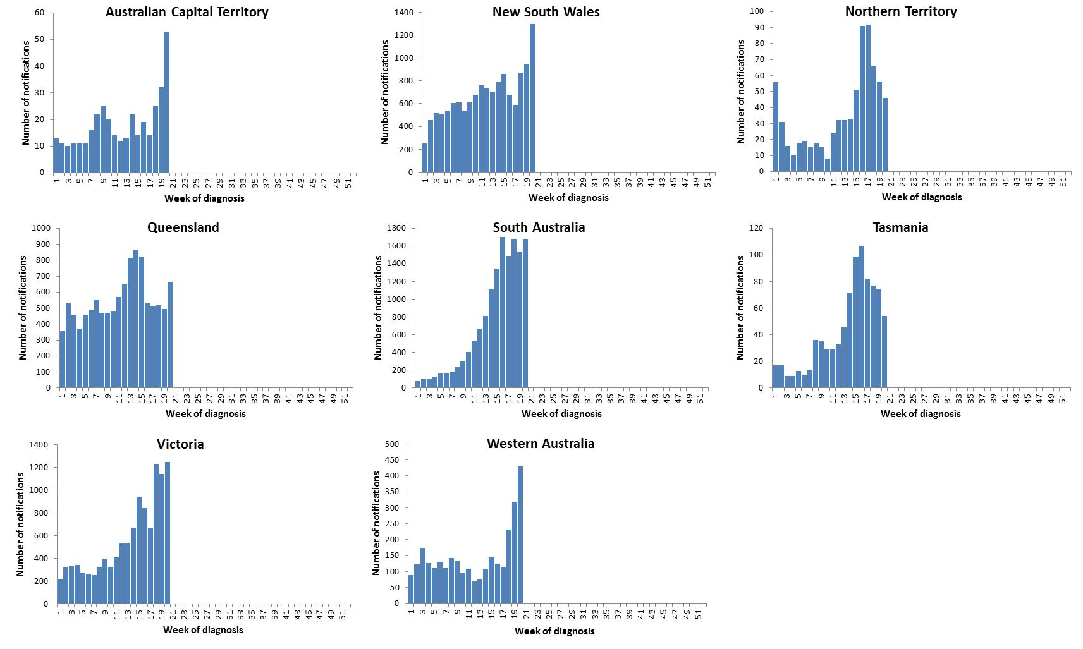

Source: NNDSS

### Severity

*Severity is a measure of adverse outcomes or complications as a result of influenza or influenza-like illness (ILI) such as hospital referrals, admissions, need for intensive care and deaths. Measuring and understanding the severity of circulating influenza is difficult to establish at the beginning of the influenza season. The proportion of confirmed influenza cases with serious outcomes might be skewed initially because there are only a small number of people notified with influenza at the beginning of the season. This means that the measure of severity will vary substantially fortnight to fortnight until after the peak of the season when there is enough data for measurements to stabilise. An assessment of severity can be provided once the signals become clearer.*

#### Intensive care admissions

* **FluCAN**: Since seasonal sentinel hospital surveillance began on 1 April 2019, 386 people with influenza have been admitted to sentinel hospitals. Of those admitted, 24 (6.2%) were admitted to ICU. In the fortnight to 19 May 2019, 3 of the 67 people admitted to sentinel hospitals with confirmed influenza (4.5%) were admitted to ICU. A number of hospitals may also have a backlog of cases and it is expected that numbers may be revised upwards.

#### Deaths in confirmed influenza cases

* **NNDSS**: So far in 2019, 119 influenza associated deaths have been notified to the NNDSS. The majority of deaths were due to influenza A (80%, n=95). Where subtyping information was available, 8 were associated with influenza A(H1N1)pdm09, 15 with influenza A(H3N2) and 1 with influenza B. The median age of deaths notified was 86 years (range 2 to 105 years).

The number of influenza-associated deaths reported to the NNDSS does not represent the true mortality associated with this disease. The number of deaths is reliant on the follow up of cases to determine the outcome of their infection. The follow up of cases is not a requirement of notification, and are only inclusive of laboratory-confirmed cases of influenza. Due to retrospective revision, the variation across jurisdictions in methodology, representativeness and timeliness of death data, and reporting of an outcome of infection not being a requirement of notification, year on year comparisons of deaths in notified cases of influenza may not be reliable.

### Impact

*Impact measures how the influenza epidemic affects society, including stress on health-care resources and societal and economic consequences.*

#### Absenteeism

* **Flutracking**: In weeks 19 and 20, 1.0% and 1.2% of Flutracking survey respondents respectively reported having ILI and taking time off regular duties while unwell.

### Virology

#### National notification data

**NNDSS:** In the reporting fortnight, 87% of notifications of laboratory confirmed influenza to the NNDSS were influenza A (83% influenza A(unsubtyped), 3% influenza A(H3N2) and less than 1% influenza A(H1N1)pdm09), 13% were influenza B and less than 1% were influenza C, influenza A&B co-infections or untyped (Figure 9). Where subtyping information was available, the NT, QLD, TAS and WA reported a greater proportion of influenza A(H3N2) than influenza A(H1N1)pdm09 in the past fortnight, while the ACT reported a greater proportion of influenza A(H1N1)pdm09. NSW reported similar proportions of both influenza A subtypes.

For the year to 19 May 2019, 91% of notifications of laboratory confirmed influenza to the NNDSS were influenza A (84% influenza A(unsubtyped), 3% influenza A(H1N1)pdm09 and 4% influenza A(H3N2)), 8% were influenza B, and less than 1% were influenza C, influenza A&B co-infections or untyped. The proportion of all notifications year to date reported as influenza A has ranged across jurisdictions from 83% in the NT to 97% in TAS and SA (Figure 10).

#### Reference Laboratory data

* **World Health Organization Collaborating Centre for Reference and Research on Influenza (WHOCC):** From 1 January to 20 May 2019, the WHOCC characterised 492 influenza viruses. Of these, 87% were influenza A (63% influenza A(H1N1)pdm09 and 24% influenza A(H3N2)), 13% were influenza B (5% influenza B Yamagata lineage and 8% influenza B Victoria lineage).

#### Sentinel laboratory surveillance

* In the reporting fortnight, 93% of influenza positive samples detected in sentinel laboratories were influenza A (83% were influenza A(unsubtyped), 9% were influenza A(H3N2), 1% were influenza A(H1N1)pdm09), and 7% were influenza B (Figure 11).

#### Sentinel GP surveillance

* **ASPREN**: Of the 37 influenza positive samples detected this fortnight through swab testing patients presenting with ILI to ASPREN sentinel GPs, 13 were influenza A (unsubtyped), 13 were influenza A(H3N2) and 3 were influenza A(H1N1)pdm09. The remaining 8 were influenza B (Figure 12).

#### Sentinel hospital surveillance

* **FluCAN**: Since seasonal sentinel hospital surveillance began on 1 April 2019, 91% of admissions with confirmed influenza to sentinel hospitals were influenza A (70% A(unsubtyped), 5% influenza A(H1N1)pdm09 and 16% influenza A (H3N2)) and 9% were influenza B (Figure 13).
* Of the 24 patients admitted directly to ICU, 23 patients were infected with influenza A (79% influenza A(unsubtyped), 8.5% influenza A(H3N2) and 8.5% influenza A(H1N1)pdm09), with one person infected with influenza B (5%).

**Figure 9. Per cent of laboratory confirmed influenza, Australia, 1 January to 19 May 2019 by subtype and week.**

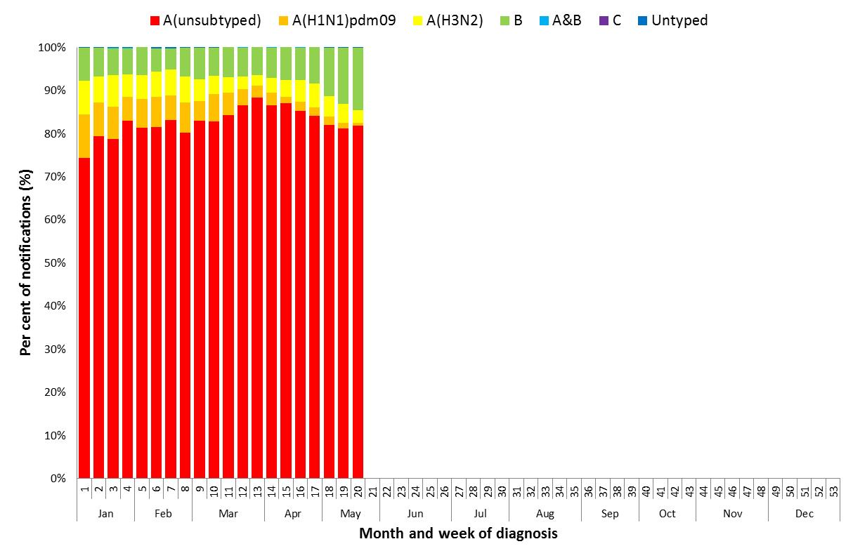

Source: NNDSS

Figure 10. Per cent of notifications of laboratory confirmed influenza, Australia, 1 January to 19 May 2019, by subtype and state or territory. 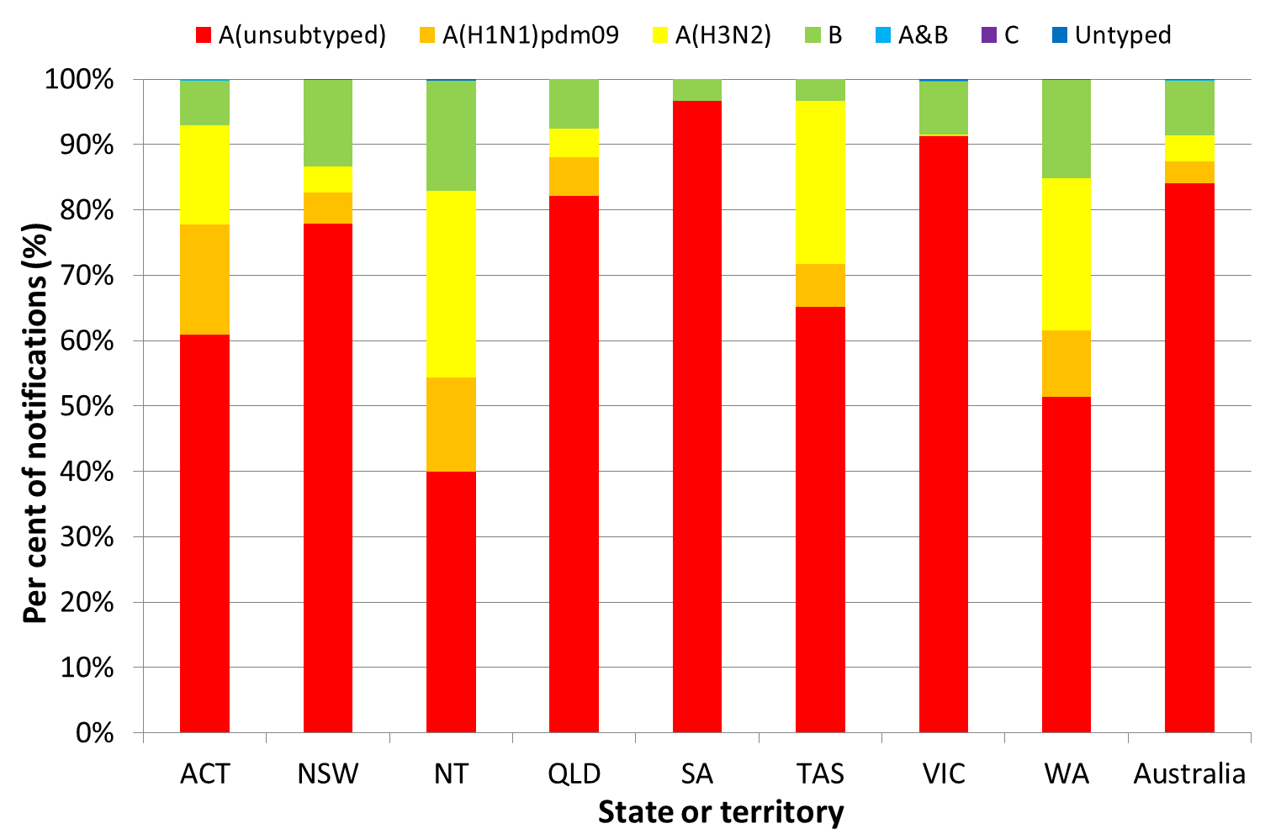

Source: NNDSS

Figure 11. Proportion of sentinel laboratory tests positive for influenza and total number of specimens tested, 1 January to 19 May 2019, by subtype and month and week.

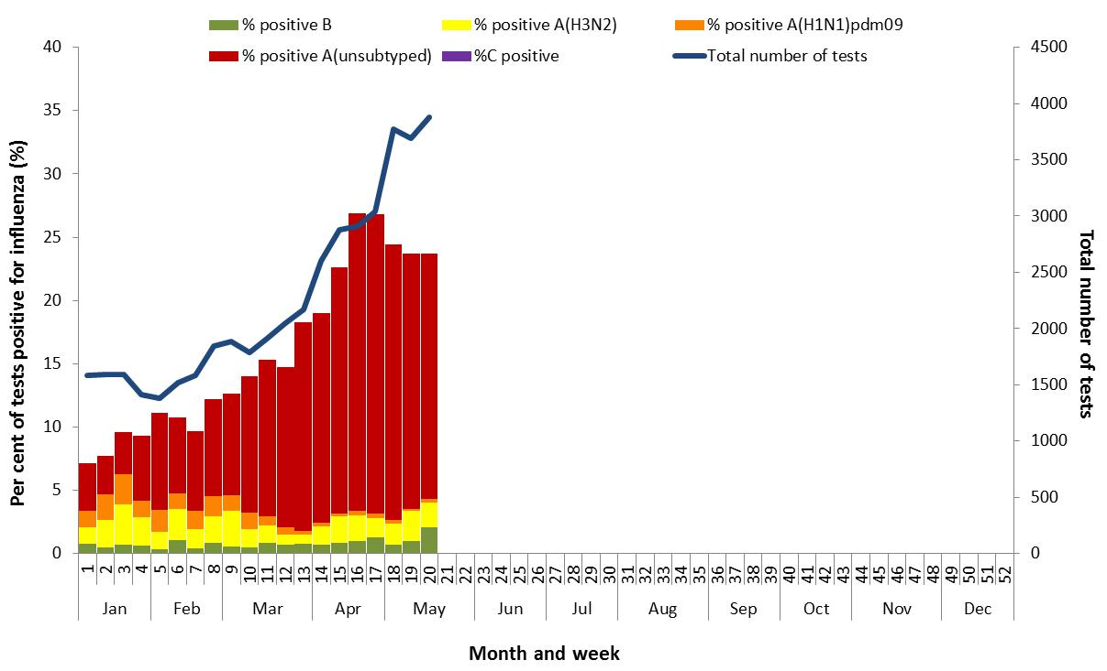

Figure 12. Proportion of respiratory viral tests positive for influenza in ASPREN ILI patients and ASPREN ILI consultation rate, Australia, 1 January to 19 May 2019, by month and week.

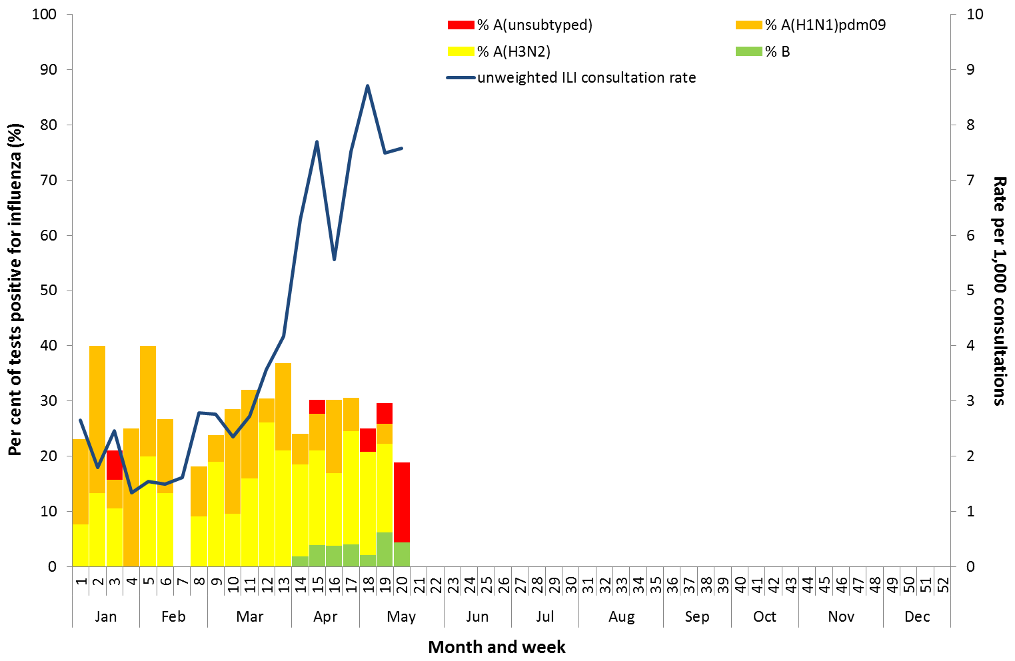

Source: ASPREN

Figure 13. Number of influenza hospitalisations at sentinel hospitals by subtype and ICU admission, 1 April to 19 May 2019, by month and week.

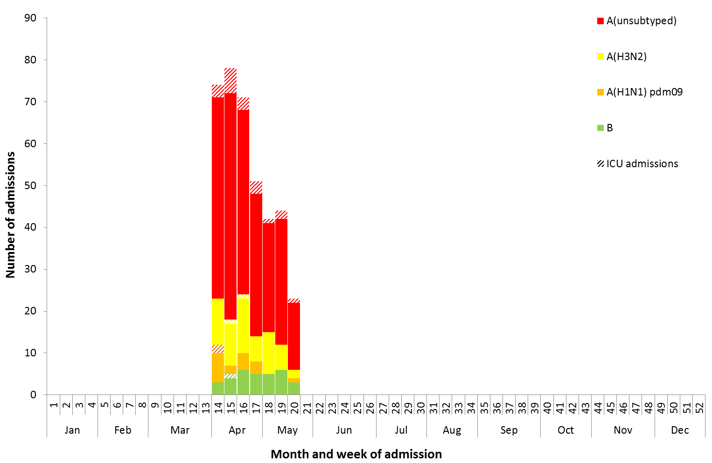

Source: FluCAN

### At-risk Populations

#### National notification data

* **NNDSS:** So far in 2019, notification rates have been highest in adults aged 80 years or older (420.9 notifications per 100,000), followed by children aged under 10 years (361.6 notifications per 100,000) (Figure 14). Influenza A accounted for the greatest number of notifications across all age groups. Where further subtyping information was available, notifications of influenza A(H1N1)pdm09 were highest in children aged less than 10 years (11.9 per 100,000) and notifications of influenza A(H3N2) were highest in adults aged 80 years and older (40.2 per 100,000). Notification rates for influenza B were highest in children aged 5 to 9 years (66.7 per 100,000).

Among broader age groups, where further subtyping information was available, influenza B was the predominant subtype in children of all ages and adults between the ages of 20 and 64 years. Influenza A(H3N2) was the predominant subtype in adults aged 65 years and older (Figure 15).[1]

#### Sentinel hospital surveillance

* **FluCAN:** Since seasonal sentinel hospital surveillance began on 1 April 2019, 36% of people admitted with confirmed influenza were children aged 15 years and younger, 35% were adults aged between 16 and 64 years, and 29% were adults aged 65 years and older. Of the children admitted with confirmed influenza to date, 4.3% (n=6) were admitted to ICU, compared to 9.6% of adults aged between 16 and 64 years and 4.5% of adults aged 65 years and older.

Figure 14. Rate of notifications of laboratory confirmed influenza, Australia, 1 January to 19 May 2019, by age group and subtype.

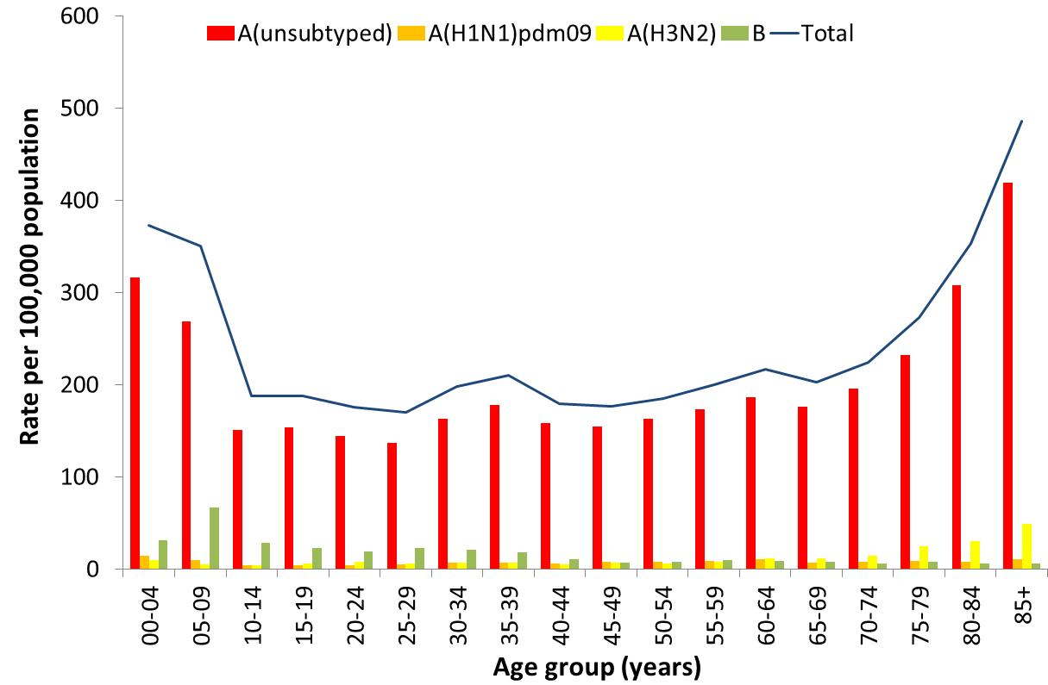

Source: NNDSS

Figure 15. Notifications of laboratory confirmed influenza by week of diagnosis and cumulative year-to-date, Australia, 1 January to 19 May 2019*, by age group and subtype.

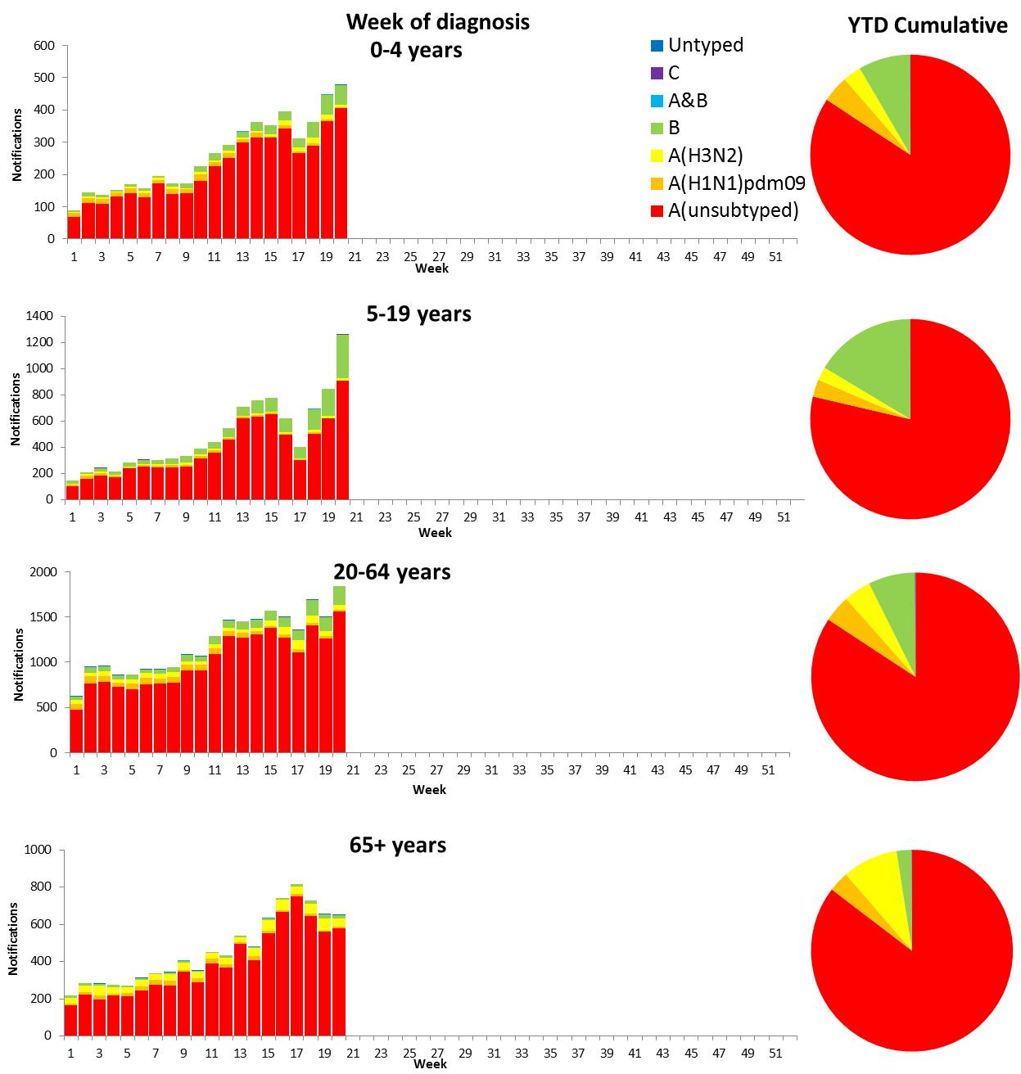

*Excluding laboratory-confirmed notifications in Victoria from 8 April to 19 May 2019 due to data transmission issues Source: NNDSS

### Vaccine effectiveness

#### Australian Influenza Vaccines Composition 2019

The influenza virus strains included in the 2019 seasonal influenza vaccines in Australia are:

* A/Michigan/45/2015, (H1N1)pdm09-like virus;
* A/Switzerland/8060/2017, (H3N2)-like virus; and
* B/Phuket/3073/2013-like virus, Yamagata lineage.
* B/Colorado/06/2017-like virus, Victoria lineage.

The best way to determine how well the vaccine protects against circulating viruses during the season is by determining the vaccine effectiveness. These estimates provide an indication of how effective the vaccine was in providing protection against influenza infection.

#### 

#### WHOCC

From 1 January to 20 May 2019, 492 isolates were characterised for similarity to their corresponding vaccine components by haemagglutination inhibition (HI) assay (Table 1). Most influenza A(H1N1)pdm09 viruses and viruses from both influenza B lineages appeared to be antigenically similar to the corresponding vaccine components. 8 A(H1N1)pdm09, 8 B/Victoria and 0 B/Yamagata viruses were characterised as low reactors. The majority of influenza A(H3N2) isolates that were able to be assessed by HI assay appeared to be antigenically matched to the vaccine. Of the 119 influenza A(H3N2) isolates, 39 were characterised as low reactors, and an additional 36 isolates were unable to be characterised in the HI assay due to insufficient haemagglutination titre.

**Table 1. Australian influenza viruses typed by HI from the WHOCC, 1 January to 20 May 2019.**

| Type/Subtype | ACT | NSW | NT | QLD | SA | TAS | VIC | WA | TOTAL |
| --- | --- | --- | --- | --- | --- | --- | --- | --- | --- |
| A(H1N1) pdm09 | 17 | 111 | 32 | 23 | 64 | 1 | 54 | 7 | 309 |
| A(H3N2) | 8 | 41 | 7 | 9 | 34 | 1 | 14 | 5 | 119 |
| B/Victoria lineage | 3 | 7 | 16 | 3 | 8 | 0 | 3 | 0 | 40 |
| B/Yamagata lineage | 4 | 6 | 1 | 1 | 9 | 0 | 1 | 2 | 24 |
| Total | 32 | 165 | 56 | 36 | 115 | 2 | 72 | 14 | 492 |

SOURCE: WHO CC

Note: Viruses tested by the WHO CC are not necessarily a random sample of all those in the community.

State indicates the residential location for the individual tested, not the submitting laboratory.

There may be up to a month delay on reporting of samples.

### Antiviral Resistance

The WHOCC reported that from 1 January to 20 May 2019, none of the 492 influenza viruses tested for neuraminidase inhibitor resistance, demonstrated reduced inhibition to the antiviral drugs Zanamivir or Oseltamivir.

### Data considerations

No one single system, including notification data, provides the full picture on influenza, because influenza is a common disease and its presenting symptoms are non-specific. The epidemiology of influenza is informed by a number of different systems based in the community, laboratories, primary care and hospitals, as well as notifiable diseases data, which includes officially reported deaths. The information in this report is reliant on the surveillance sources available to the Department of Health at the time of production.

Data in this summary is reported by International Organization for Standardization (ISO) 8601 weeks, with the week ending on Sunday. Throughout the summary, where the year to date is presented, this includes data from 1 January to 19 May 2019. NNDSS data were extracted on 22 May 2019. Due to the dynamic nature of the NNDSS and other surveillance systems, data in this report are subject to retrospective revision and may vary from data reported in other national reports and reports by states and territories. Detailed notes on interpreting the data presented in this report are available at the Department of Health’s [Australian Influenza Surveillance Report website](http://www.health.gov.au/flureport) (www.health.gov.au/flureport).

While every care has been taken in preparing this report, the Commonwealth does not accept liability for any injury or loss or damage arising from the use of, or reliance upon, the content of the report. Delays in the reporting of data may cause data to change retrospectively. For further details about information contained in this report please contact the [Influenza Surveillance Team](mailto:flu@health.gov.au) (flu@health.gov.au).

1. Since 7 April 2019, data for these broad age groups has not been available from Victorian notification data due to a data transmission issue.