| Logo | **Australian Influenza**  **SURVEILLANCE REPORT**  **No. 12, 2019**  **23 September to 6 October 2019** |
| --- | --- |

The Department of Health acknowledges the providers of the many sources of data used in this report and greatly appreciates their contribution.

## KEY MESSAGES

* **Activity** – Currently, influenza and influenza-like illness (ILI) activity is lower than average for this time of year compared to previous years, and is consistent with past activity following a peak in notifications and coming to the end of the influenza season. At the national level, notifications of laboratory-confirmed influenza have decreased in the past fortnight.
* **Impact** – Impact for the season to date, as measured through the number of sentinel hospital beds occupied by patients with influenza and the rate of Flutracking respondents absent from normal duties, is low to moderate.
* **Severity** – Clinical severity for the season to date, as measured through the proportion of patients admitted directly to ICU, and deaths attributed to influenza, is low.
* **Virology** – The majority of confirmed influenza cases reported nationally were influenza A in the year to date (76.9%) and past fortnight (61.9%). The proportion of cases attributed to influenza B has decreased slightly in the past fortnight.
* **Vaccine match and effectiveness**– Antigenic analysis of circulating influenza viruses in Australia in 2019 shows that the influenza A(H1N1)pdm09 and influenza B/Yamagata-lineage viruses are well matched to the 2019 influenza vaccine while some A(H3N2) and B/Victoria-lineage viruses are less well matched. Overall vaccine effectiveness appears good and as expected based on preliminary estimates from general practice (ASPREN) and sentinel hospitals (FluCAN-PAEDS), noting that effectiveness typically ranges from around 40-60% each year.

### Introduction

Each year, the influenza virus changes and different strains can circulate in the population. Particular subtypes of influenza can affect different groups of the population more than others. Depending on the susceptibility of the population, the subtypes that are circulating and the changes to the virus itself, the influenza season can be very different year to year. Our surveillance systems help us to understand influenza activity, severity of the infection in individuals and impact of the illness on society in Australia. We are also able to monitor which influenza viruses are circulating, which populations might be more affected, the effectiveness of the vaccine, and any resistance to antiviral drugs that has developed.

### Activity

*Activity measures the capacity of the circulating influenza viruses to spread person to person and may be measured indirectly through systems that monitor influenza-like illness and more directly through systems that monitor laboratory confirmed influenza.*

#### Influenza-like illness

Following high levels of ILI activity over the interseasonal period, ILI in the community has decreased in the last fortnight and is now below the 5 year average.

* **Healthdirect:** In the year to date, the proportion of calls to the Healthdirect public health hotline related to ILI have been declining since a peak of 12.5% in week 27 to 6.7% in week 39 and 6.3% in week 40 (Figure 1). Current activity is below the 5 year average.
* **Sentinel General Practitioners (ASPREN):** 4.5 per 1,000 consultations in sentinel general practices were due to ILI in week 39 and 3.9 per 1,000 consultations in week 40 (Figure 2), decreasing from a high of 13.3 per 1,000 consultations in week 28. ILI consultations have continued to drop and are still below the 5 year average and have been since week 31.
* **Flutracking:** Since reporting began in week 16 Flutracking participants reporting ILI (fever and cough) increased to a high of 2.2% in week 24, and has decreased to 1.3% in week 40. Activity in the past fortnight is below the 5 year average for the same period (Figure 3).
* **Proportion of ILI with confirmed influenza seen by sentinel GPs:** Of the 58 ILI cases presenting to sentinel ASPREN GPs this fortnight who were tested for influenza, 13 (22.4%) had a positive result for influenza. This is a decrease from the previous fortnight when 23.8% (20/84) of swabbed ILI patients tested positive for influenza. In weeks 1 to 13, all influenza positive cases were influenza A. From week 14 onwards, the proportion of influenza cases testing positive for influenza B has increased steadily to 33.3% in week 40, varying between 17% and 33% in weeks 26 to 40.
* Proportion of ILI with confirmed influenza in sentinel labs: In the year to date, overall detections of influenza across sentinel laboratories decreased to 9.2% in week 40 (unweighted percentage of tests positive for influenza across all sentinel laboratories) after a peak in week 16 of 26.9%. In the past fortnight, positivity has been highest in Tasmania (TAS) (Figure 4); however, percent positivity has decreased across all sentinel labs in the past 4 weeks, with the exception of South Australia (SA) where there has been a slight increase in positivity in week 40.

The most commonly detected respiratory viruses this fortnight by laboratory site were:

* + influenza A in both weeks 39 and 40 by the Institute of Clinical Pathology and Medical Research in New South Wales (NSW);
  + rhinovirus in both weeks by South Australia (SA);
  + Picornavirus and Human Metapneumovirus (hMPV) in week 39 and Coronavirus in week 40 by the Victorian Infectious Diseases Reference Laboratory (VIDRL);
  + hMPV in both weeks by PathWest in Western Australia (WA); and
  + rhinovirus in week 39 and influenza A in week 40 by Tasmania (TAS), noting that this only relates to testing performed at the Royal Hobart Hospital.
* **NNDSS notifications[1]**: In the year to date, there have been 298,120 notifications of laboratory-confirmed influenza to the National Notifiable Diseases Surveillance System (NNDSS). This fortnight there were 7,583 notifications of laboratory-confirmed influenza to the NNDSS. This is a decrease in reported cases compared to the previous fortnight (n=15,769). Notifications this fortnight were slightly lower compared to this period in the previous five years (Figure 5). Whilst the number of notifications has decreased in the past fortnight, this is at least partly due to a backlog in data entry in some states and territories.
* **FluCAN**: Since seasonal sentinel hospital surveillance began on 1 April 2019, a total of 3,915 people have been admitted with confirmed influenza (Figure 6). In the fortnight to 6 October 2019, 48 people have been admitted with confirmed influenza. This is a decrease from the 65 reported in the previous fortnight, however, it is likely that this is a result of an administrative backlog and that numbers will be revised upwards. The total number of admissions is less than the 5-year average for the same fortnight (n=200.4).

Figure . Per cent of calls to Healthdirect related to ILI, Australia, 1 January 2014 to 6 October 2019, by month and week of call.

Figure 1. Per cent of calls to Healthdirect related to ILI, Australia, 1 January 2014 to 28 July 2019, by month and week of call.Source: Healthdirect

**Figure 2. Unweighted rate of ILI reported from sentinel GP surveillance systems, Australia, 1 January 2014 to 6 October 2019, by month and week.**

Figure 2. Unweighted rate of ILI reported from sentinel GP surveillance systems, Australia, 1 January 2014 to 28 July 2019, by month and week.Source: ASPREN

Figure 3. Proportion of fever and cough among FluTracking participants, Australia, between April and October, 2014 to 2019, by month and week.

Figure 3. Proportion of fever and cough among FluTracking participants, Australia, between April and October, 2014 to 2019, by month and week.

Source: FluTracking

Figure 4. Proportion of sentinel laboratory tests positive for influenza, 1 January to 6 October 2019, by contributing laboratoryor jurisdiction and month and week.Figure 4. Proportion of sentinel laboratory tests positive for influenza, 1 January to 28 July 2019, by contributing laboratory or jurisdiction and month and week.

* Pooled percentage positive indicators should be interpreted with caution, noting that collectively pooled contributing laboratories are not representative of testing across Australia and individually contributing laboratories may not be representative of the jurisdiction in which they are located.

^ Weighted according to jurisdictional population in which laboratories are located.

The percentage of tests positive for influenza in the interseasonal period should be interpreted with caution due to small numbers of tests being undertaken in this time, resulting in high variability in the indicators.

Figure 5. Notifications of laboratory confirmed influenza, Australia, 1 January 2013 to 6 October 2019, by month and week of diagnosis.*

**Figure 5. Notifications of laboratory confirmed influenza, Australia, 1 January 2013 to 28 July 2019, by month and week of diagnosis.**

Source: NNDSS

*NNDSS notification data provided for the current and most recent weeks may be incomplete. All data are preliminary and subject to change as updates are received.

Figure 6. Number of influenza hospitalisations at sentinel hospitals, between March and October, 2014 to 2019 by month and week.*

Figure 6. Number of influenza hospitalisations at sentinel hospitals, between March and October, 2014 to 2019 by month and week.

Source: FluCAN

*FluCAN data provided for the current fortnight may be incomplete. All data are preliminary and subject to change as updates are received.

#### Geographical distribution of activity

* **Jurisdictional reports:** In the fortnight ending 6 October 2019, the geographic spread of influenza activity was reported by state and territory health departments as being:
  + Widespread – The Australian Capital Territory (ACT), Victoria (VIC), South Australia (SA)
  + Regional – New South Wales, Tropical, Central and Southern Queensland (QLD) and Tasmania (TAS).
  + Localised – Central Northern Territory (NT).
  + Sporadic – Southern NT and all regions of Western Australia (WA).

The change in activity level was reported by state and territory health departments as being:

* + Increased – SA
  + Decreased – NSW, Central NT, Central and Southern QLD, ACT, VIC and TAS
  + No change – All of the regions in WA, Tropical QLD and Southern NT.
* **NNDSS**: Of the 7,583 notifications of influenza reported to the NNDSS in the last fortnight, 2,310 were from QLD, 2,179 from VIC, 2,025 from NSW, 696 from SA, 114 from WA, 103 from TAS, 97 from the ACT, and 59 from the NT (Figure 8). This is a decrease in notifications reported from the previous fortnight for all jurisdictions.

Of the 298,120 notifications of influenza reported to the NNDSS this year to 6 October 2019, 111,710 were from NSW, 65,583 from QLD, 64,575 from VIC, 25,415 from SA, 22,621 from WA, 3,912 from the ACT, 2,886 from TAS and 1,418 from the NT.

For further information regarding influenza activity at the jurisdictional level, please refer to the following State and Territory health surveillance reports:

* ACT: [ACT Influenza Report](https://www.health.act.gov.au/about-our-health-system/population-health/winter-wellbeing-and-flu/flu-act)

(www.health.act.gov.au/about-our-health-system/population-health/winter-wellbeing-and-flu/flu-act)

* NSW: [Influenza Surveillance Report](http://www.health.nsw.gov.au/Infectious/Influenza/Pages/reports.aspx) (http://www.health.nsw.gov.au/Infectious/Influenza/Pages/reports.aspx)
* QLD: [Statewide Weekly Influenza Surveillance Report](https://www.health.qld.gov.au/clinical-practice/guidelines-procedures/diseases-infection/surveillance/reports/flu) (https://www.health.qld.gov.au/clinical-practice/guidelines-procedures/diseases-infection/surveillance/reports/flu)
* SA: [Weekly Epidemiological Summary](http://www.sahealth.sa.gov.au/wps/wcm/connect/public+content/sa+health+internet/about+us/health+statistics/surveillance+of+notifiable+conditions) (Influenza section) (http://www.sahealth.sa.gov.au/wps/wcm/connect/public+content/sa+health+internet/about+us/health+statistics/surveillance+of+notifiable+conditions)
* TAS: [fluTAS Reports](http://www.dhhs.tas.gov.au/publichealth/communicable_diseases_prevention_unit) (http://www.dhhs.tas.gov.au/publichealth/communicable_diseases_prevention_unit)
* VIC: [Influenza Surveillance Reports](https://www2.health.vic.gov.au/public-health/infectious-diseases/infectious-diseases-surveillance/seasonal-influenza-reports) (https://www2.health.vic.gov.au/public-health/infectious-diseases/infectious-diseases-surveillance/seasonal-influenza-reports)
* WA: [Virus WAtch](http://ww2.health.wa.gov.au/Articles/F_I/Infectious-disease-data/Virus-WAtch) (http://ww2.health.wa.gov.au/Articles/F_I/Infectious-disease-data/Virus-WAtch)

Figure . Map of influenza activity by state and territory, Australia, 29 July to 6 October 2019

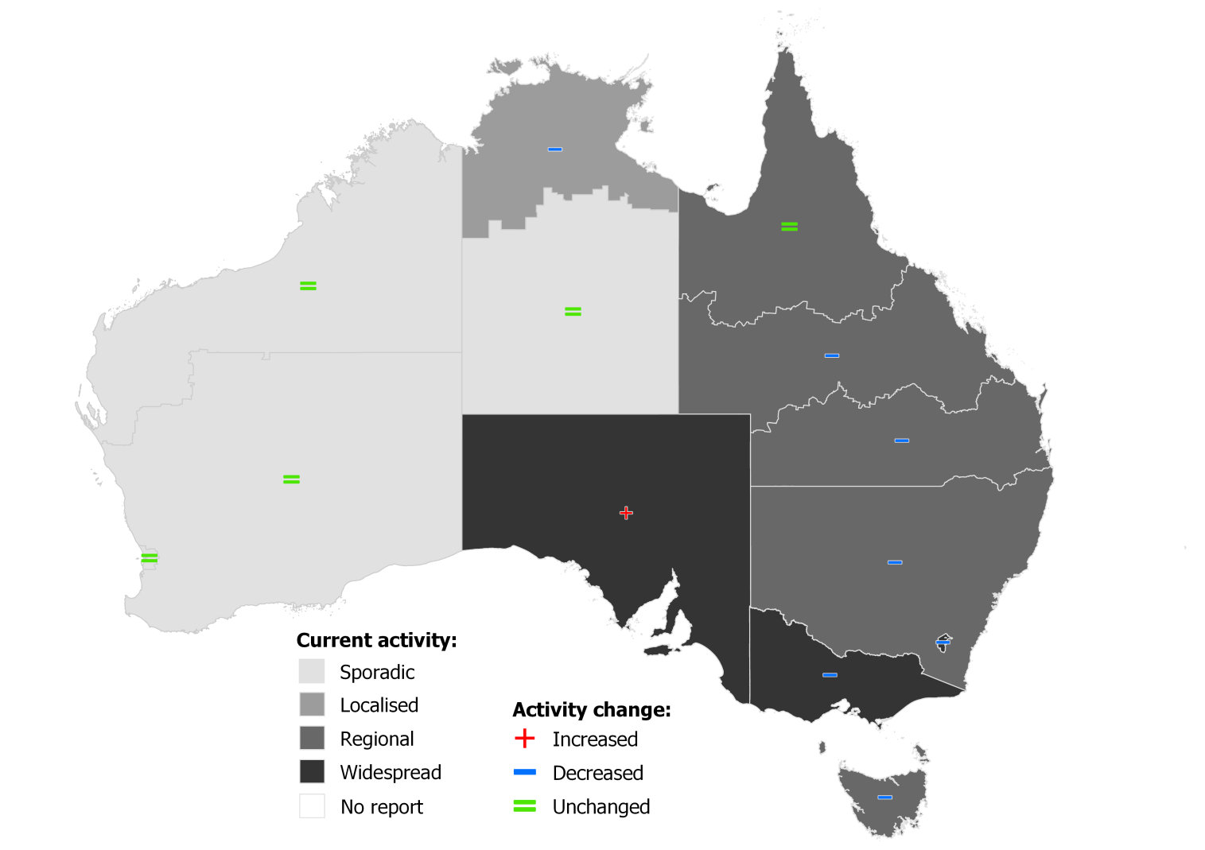

**Figure 8. Notifications of laboratory confirmed influenza*, 1 January to 6 October 2019, by state or territory and week.**

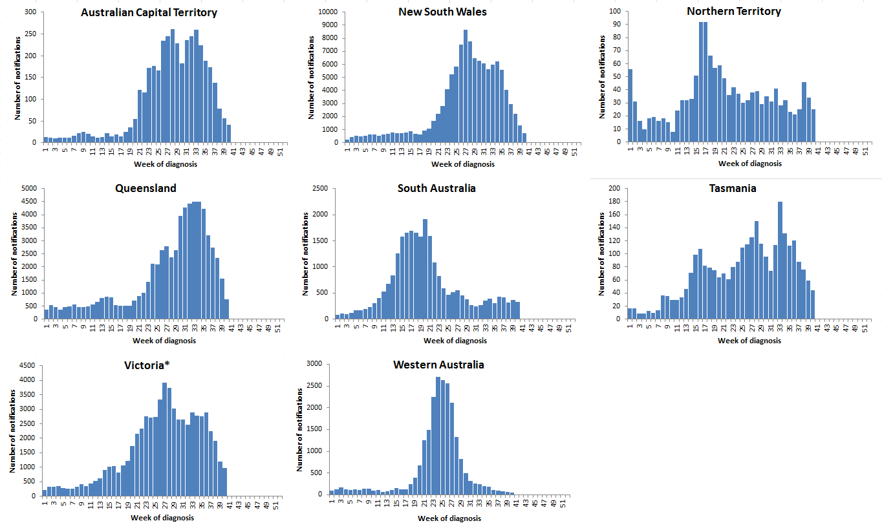

Source: NNDSS

*NNDSS notification data provided for the current and most recent weeks may be incomplete. All data are preliminary and subject to change as updates are received. Victoria is currently experiencing a significant backlog in data entry.

### Severity

*Severity is a measure of adverse outcomes or complications as a result of influenza or influenza-like illness (ILI) such as hospital referrals, admissions, need for intensive care and deaths. Measuring and understanding the severity of circulating influenza is difficult to establish at the beginning of the influenza season. The proportion of confirmed influenza cases with serious outcomes might be skewed initially because there are only a small number of people notified with influenza at the beginning of the season. This means that the measure of severity will vary substantially fortnight to fortnight until after the peak of the season when there is enough data for measurements to stabilise. An assessment of severity can be provided once the signals become clearer.*

Clinical severity for the season to date, as measured through the proportion of patients admitted directly to ICU, and deaths attributed to influenza, is low.

#### Intensive care admissions

* **FluCAN**: Since seasonal sentinel hospital surveillance began on 1 April 2019, 3,915 people with influenza have been admitted to sentinel hospitals. Of those admitted, 246 (6.3%) were admitted to ICU. In the fortnight to 6 October 2019, none of the 37 people admitted to sentinel hospitals with confirmed influenza were admitted to ICU.

#### Deaths in confirmed influenza cases

* **NNDSS**: So far in 2019, 812 influenza-associated deaths have been notified to the NNDSS. The majority of deaths were due to influenza A (96%, n=782). Where subtyping information was available, 128 were associated with influenza A(H3N2), 29 with influenza A(H1N1)pdm09, and 30 with influenza B. The median age of deaths notified was 86 years (range <1 to 106 years).

*The number of influenza-associated deaths reported to the NNDSS does not represent the true mortality associated with this disease. The number of deaths is reliant on the follow up of cases to determine the outcome of their infection. The follow up of cases is not a requirement of notification, and are only inclusive of laboratory-confirmed cases of influenza. Due to retrospective revision, the variation across jurisdictions in methodology, representativeness and timeliness of death data, and reporting of an outcome of infection not being a requirement of notification, year on year comparisons of deaths in notified cases of influenza may not be reliable.*

### Impact

*Impact measures how the influenza epidemic affects society, including stress on health-care resources and societal and economic consequences.*

Impact for the season to date, as measured through the number of sentinel hospital beds occupied by patients with influenza and the rate of Flutracking respondents absent from normal duties, is low to moderate.

#### Absenteeism

* **Flutracking**: In week 39 and week 40, 0.9% and 0.8% of Flutracking survey respondents, respectively, reported having ILI and taking time off regular duties while unwell, a decrease from the previous week of 1.0%. This is below the five year average for the same period.

Use of hospital beds

* **FluCAN:** In the past fortnight, 0.7% of beds available in FluCAN hospitals were occupied with patients with confirmed influenza, compared to 1.0% in the previous fortnight and a high of 6.7% in the fortnight covering weeks 27 and 28. This is within the range of the rate of influenza admissions per 1,000 available hospital beds in the past 5 years. However, it is likely that a number of hospitals may have a backlog of cases, and it is expected that numbers for the past fortnight may be revised upwards.

### Virology

#### National notification data

* **NNDSS:** In the reporting fortnight, 61.9% of notifications of laboratory confirmed influenza to the NNDSS were influenza A (59.8% influenza A(unsubtyped), <1% influenza A(H1N1)pdm09 and 1.8% influenza A(H3N2)), 37.9% were influenza B and less than 1% were influenza A&B co-infections or untyped (Figure 9). This is a slight decrease in the proportion of cases reported as influenza B compared to the previous fortnight (38.4%).
* For the year to 6 October 2019, 76.9% of notifications of laboratory confirmed influenza to the NNDSS were influenza A (72.1% influenza A(unsubtyped), less than 1% influenza A(H1N1)pdm09 and 3.9% influenza A(H3N2)), 22.8% were influenza B, and less than 1% were influenza A&B co-infections or untyped. The proportion of all notifications year to date reported as influenza A has ranged across jurisdictions from 72.7% in WA to 88.7% in TAS (Figure 10).

#### Reference Laboratory data

* **World Health Organization Collaborating Centre for Reference and Research on Influenza (WHOCC):** From 1 January to 6 October 2019, the WHOCC characterised 3,949 influenza viruses. Of these, 88% were influenza A (28% influenza A(H1N1)pdm09 and 60% influenza A(H3N2)), and 12% were influenza B (1% influenza B Yamagata lineage and 11% influenza B Victoria lineage).

#### Sentinel laboratory surveillance

* In the reporting fortnight, 67.7% of influenza positive samples detected in sentinel laboratories were influenza A (62.9% were influenza A(unsubtyped), 4.2% were influenza A(H3N2), and less than 1% were influenza A(H1N1)pdm09), and 32% were influenza B (Figure 11). This is a decrease in the proportion attributed to influenza B compared to the previous fortnight (38.5%).

#### Sentinel GP surveillance

* **ASPREN**: Of the 13 influenza positive samples detected this fortnight through swab testing patients presenting with ILI to ASPREN sentinel GPs, 69% were influenza A (unsubtyped), none were influenza A(H3N2) or influenza A(H1N1)pdm09. The remaining four (31%) were influenza B (Figure 12).

#### Sentinel hospital surveillance

* **FluCAN**: Since seasonal sentinel hospital surveillance began on 1 April 2019, 84.3% of admissions with confirmed influenza to sentinel hospitals were influenza A (53.9% A(unsubtyped), 5.8% influenza A(H1N1)pdm09, 24.7% influenza A (H3N2)) and 15.4% were influenza B (Figure 13). Of the 246 patients admitted directly to ICU, 222 patients were infected with influenza A (54.5% influenza A(unsubtyped), 23.6% influenza A(H3N2) and 12.2% influenza A(H1N1)pdm09), with 24 people infected with influenza B (9.8%).

**Figure 9. Per cent of laboratory confirmed influenza, Australia, 1 January to 6 October 2019 by subtype and week.**

**Figure 9. Per cent of laboratory confirmed influenza, Australia, 1 January to 28 July 2019 by subtype and week.**

Source: NNDSS

Figure 10. Per cent of notifications of laboratory confirmed influenza, Australia, 1 January to 6 October 2019, by subtype and state or territory.

Figure 10. Per cent of notifications of laboratory confirmed influenza, Australia, 1 January to 28 July 2019, by subtype and state or territory.

Source: NNDSS

Figure 11. Proportion of sentinel laboratory tests positive for influenza and total number of specimens tested, 1 January to 6 October 2019, by subtype and month and week.

Figure 11. Proportion of sentinel laboratory tests positive for influenza and total number of specimens tested, 1 January to 28 July 2019, by subtype and month and week.

Figure 12. Proportion of respiratory viral tests positive for influenza in ASPREN ILI patients and ASPREN ILI consultation rate, Australia, 1 January to 6 October 2019, by month and week.

Figure 12. Proportion of respiratory viral tests positive for influenza in ASPREN ILI patients and ASPREN ILI consultation rate, Australia, 1 January to 28 July 2019, by month and week

Source: ASPREN

Figure 13. Number of influenza hospitalisations at sentinel hospitals by subtype and ICU admission, 1 April to 6 October2019, by month and week.

Figure 13. Number of influenza hospitalisations at sentinel hospitals by subtype and ICU admission, 1 April to 11 August 2019, by month and week.

Source: FluCAN

### At-risk Populations

#### National notification data

* **NNDSS:** As of 6 October 2019, notification rates were highest in children aged between 5 and 9 years of age (2,618 notifications per 100,000) followed by children aged 0 and 4 years (2,180 notifications per 100,000) (Figure 14).
* In the year to date, influenza A accounted for the greatest number of notifications across all age groups. Where further subtyping was available, notifications of influenza A(H1N1)pdm09 were highest in children aged less than 4 years (24 notifications per 100,000) and notifications of influenza A(H3N2) were highest in adults aged 85 years and older (239 notifications per 100,000). Notification rates for influenza B were highest in children aged 5 to 9 years (1,100 notifications per 100,000).
* Among broader age groups, where further subtyping information was available, influenza B was the predominant subtype in children of all ages and adults between the ages of 20 and 64 years, whereas influenza A(H3N2) was the predominant subtype in adults aged 65 years and older (Figure 15).
* In the past fortnight, notification rates were highest in adults aged 85 years and over (73 notifications per 100,000), followed by children aged 5 to 9 years of age (60 notifications per 100,000).
* In the past fortnight, influenza A has accounted for the majority of notifications but influenza B has had the greatest number of notifications for the 5 to 19 year old age groups.

#### Sentinel hospital surveillance

* **FluCAN:** Since seasonal sentinel hospital surveillance began on 1 April 2019, 28.6% of people admitted with confirmed influenza were children aged 15 years and younger, 31% were adults aged between 16 and 64 years, and 40.4% were adults aged 65 years and older. Of the children admitted with confirmed influenza to date, 5.2% (n=58) were admitted to ICU, compared to 8.4% of adults aged between 16 and 64 years and 5.4% of adults aged 65 years and older.

Figure 14. Rate of notifications of laboratory confirmed influenza, Australia, 1 January to 6 October 2019, by age group and subtype.

Figure 14. Rate of notifications of laboratory confirmed influenza, Australia, 1 January to 28 July 2019, by age group and subtype.

Source: NNDSS

Figure 15. Notifications of laboratory confirmed influenza by week of diagnosis and cumulative year-to-date, Australia, 1 January to 6 October 2019, by age group and subtype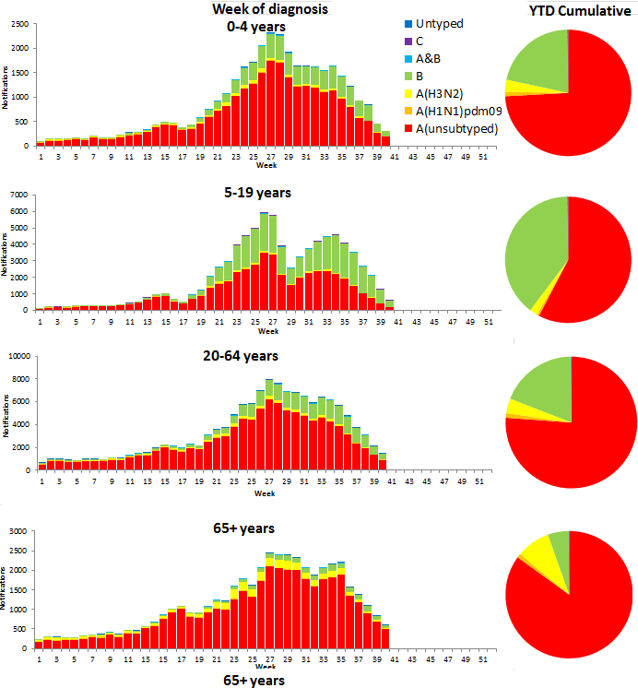

Source: NNDSS

### Vaccine match and effectiveness

#### Australian Influenza Vaccines Composition 2019

The influenza virus strains included in the 2019 seasonal influenza vaccines in Australia are:

* A/Michigan/45/2015, (H1N1)pdm09-like virus;
* A/Switzerland/8060/2017, (H3N2)-like virus; and
* B/Phuket/3073/2013-like virus, Yamagata lineage.
* B/Colorado/06/2017-like virus, Victoria lineage.

The best way to determine how well the vaccine protects against circulating viruses during the season is by determining the vaccine effectiveness. These estimates provide an indication of how effective the vaccine was in providing protection against influenza infection. Vaccine effectiveness is usually estimated from observational studies and is calculated after the end of the influenza season, though interim analyses are sometimes available where there is sufficient data. Antigenic characterisation, as presented below, provides an estimate of the match of circulating influenza viruses to components of the vaccines utilised in the 2019 influenza season.

#### WHOCC

From 1 January to 7 October 2019, 1,502 isolates were characterised for similarity to their corresponding vaccine components by haemagglutination inhibition (HI) assay (Table 1). Most influenza A(H1N1)pdm09 viruses and influenza B/Yamagata viruses appeared to be antigenically similar to the corresponding vaccine components. 21 A(H1N1)pdm09 and 1 B/Yamagata viruses were characterised as low reactors. The majority of influenza A(H3N2) and B/Victoria isolates that were able to be assessed by HI assay appeared to be antigenically matched to the vaccine. Of the 636 influenza A(H3N2) isolates, 135 were characterised as low reactors, and an additional 245 isolates were unable to be characterised in the HI assay due to insufficient haemagglutination titre. Of the 188 influenza B/Victoria isolates, 38 were characterised as low reactors.

**Table 1. Australian influenza viruses typed by HI from the WHOCC, 1 January to 7 October 2019.**

|  |  |  |  |  |  |  |  |  |  |
| --- | --- | --- | --- | --- | --- | --- | --- | --- | --- |
| **Type/Subtype** | **ACT** | **NSW** | **NT** | **QLD** | **SA** | **TAS** | **VIC** | **WA** | **TOTAL** |
| **A(H1N1) pdm09** | **70** | **210** | **48** | **67** | **87** | **12** | **131** | **27** | 652 |
| **A(H3N2)** | **69** | **118** | **109** | **32** | **86** | **47** | **132** | **43** | 636 |
| **B/Victoria lineage** | **34** | **42** | **26** | **23** | **11** | **2** | **32** | **18** | 188 |
| **B/Yamagata lineage** | **4** | **6** | **2** | **1** | **9** | **0** | **1** | **3** | 26 |
| Total | 177 | 376 | 185 | 123 | 193 | 61 | 296 | 91 | 1502 |

SOURCE: WHO CC

Note: Viruses tested by the WHO CC are not necessarily a random sample of all those in the community.

State indicates the residential location for the individual tested, not the submitting laboratory.

There may be up to a month delay on reporting of samples.

#### Vaccine effectiveness

The protective effect of influenza vaccines against influenza and complications, known as vaccine effectiveness, is monitored by several sentinel influenza surveillance systems in Australia. This varies from season to season based on the match between the strains in the vaccine to circulating strains, but typically is around 40-60%. Overall in 2019, vaccine effectiveness appears good and as expected based on preliminary estimates from general practice (ASPREN) and sentinel hospitals (FluCAN-PAEDS).

### Antiviral Resistance

The WHOCC reported that from 1 January to 7 October 2019, one of the 2,231 influenza viruses tested for neuraminidase inhibitor resistance, demonstrated reduced inhibition to Oseltamivir and one with a reduced inhibition to Zanamivir.

### Data considerations

This report presents an overview of influenza activity based on a number of complimentary systems. No one single system, including notification data, provides the full picture on influenza, because influenza is a common disease and its presenting symptoms are non-specific. The epidemiology of influenza is informed by a number of different systems based in the community, laboratories, primary care and hospitals, as well as notifiable diseases data, which includes officially reported deaths. The information in this report is reliant on the surveillance sources available to the Department of Health at the time of production.

Data in this summary is reported by International Organization for Standardization (ISO) 8601 weeks, with the week ending on Sunday. Throughout the summary, where the year to date is presented, this includes data from 1 January to 6 October 2019. NNDSS data were extracted on 10 October 2019. Due to the dynamic nature of the NNDSS and other surveillance systems, data in this report are subject to retrospective revision and may vary from data reported in other national reports and reports by states and territories. Detailed notes on interpreting the data presented in this report are available at the Department of Health’s [Australian Influenza Surveillance Report website](http://www.health.gov.au/flureport) (www.health.gov.au/flureport).

While every care has been taken in preparing this report, the Commonwealth does not accept liability for any injury or loss or damage arising from the use of, or reliance upon, the content of the report. Delays in the reporting of data may cause data to change retrospectively. For further details about information contained in this report please contact the [Influenza Surveillance Team](mailto:flu@health.gov.au) (flu@health.gov.au).

1. NNDSS notification data provided for the current and most recent weeks may be incomplete. All data are preliminary and subject to change as updates are received.