| Logo | **Australian Influenza**  **SURVEILLANCE REPORT**  **No. 11, 2021**  **Reporting fortnight: 16 to 29 August 2021** |
| --- | --- |

The Department of Health acknowledges the providers of the many sources of data used in this report and greatly appreciates their contribution.

## KEY MESSAGES

**It is important to note that due to the COVID-19 epidemic in Australia, data reported from the various influenza surveillance systems may not represent an accurate reflection of influenza activity. Results should be interpreted with caution, especially where comparisons are made to previous influenza seasons. Interpretation of influenza data from April 2020 onwards should take into account, but are not limited to, the impact of social distancing measures, likely changes in health seeking behaviour of the community including access to alternative streams of acute respiratory infection specific health services, and focussed testing for COVID-19 response activities. Current COVID-19 related public health measures and the community’s adherence to public health messages are also likely having an effect on transmission of acute respiratory infections, including influenza.**

| **Activity**   * Influenza-like-illness (ILI) activity in the community remains at historically low levels in 2021. While ILI levels increased between January and May 2021, a decrease has been observed since June. * Notifications of laboratory-confirmed influenza have remained low since April 2020. In the year to date in 2021, there have been 483 notifications to the National Notifiable Diseases Surveillance System (NNDSS) in Australia, of which 21 notifications had a diagnosis date this fortnight.   **Severity**   * There is no indication of the potential severity of the 2021 season at this time. * In the year to date, of the 483 notifications of laboratory-confirmed influenza, no influenza-associated deaths have been notified to the NNDSS. * There have been no hospital admissions due to influenza reported across sentinel hospitals sites since commencement of surveillance in April 2021.   **Impact**   * Given the low number of laboratory-confirmed influenza notifications, low community ILI activity, and no hospitalisations due to influenza at sentinel hospital sites, it is likely there is minimal impact on society due to influenza in 2021 to date.   **At-risk populations**   * In 2021 to date, adults aged 85 years and older, adults aged 60–69 years, children under 5 years of age, and adults aged 75–84 have the highest influenza notification rates.   **Virology**   * To date, 64.4% of notifications of laboratory-confirmed influenza to the NNDSS were influenza A, of which 98.4% were influenza A(unsubtyped) and 1.6% were influenza A(H3N2). Influenza B accounted for 20.3% of notifications, 3.1% were influenza A and B co-infection, 0.2% were influenza C, and 12.0% were untyped.   **Vaccine match and effectiveness**   * It is too early to assess vaccine match and effectiveness for this season. * Of the 10 samples referred to the WHOCC to date, 1 influenza B/Victoria sample was characterised as antigenically similar to the corresponding vaccine component, while 9 influenza A(H3N2) samples were characterised as antigenically dissimilar. |
| --- |

### Introduction

Each year, the influenza virus changes and different strains can circulate in the population. Particular subtypes of influenza can affect different groups of the population more than others. Depending on the susceptibility of the population, the subtypes that are circulating and the changes to the virus itself, the influenza season can be very different year to year. Our surveillance systems help us to understand influenza activity, severity of the infection in individuals and impact of the illness on society in Australia. We are also able to monitor which influenza viruses are circulating, which populations might be more affected, the effectiveness of the vaccine, and any resistance to antiviral drugs that has developed.

### National Influenza Surveillance Systems

This report presents an overview of influenza activity based on a number of complimentary systems. No one single system, including notification data, provides the full picture on influenza, because influenza is a common disease and its presenting symptoms are non-specific. The epidemiology of influenza is informed by a number of different systems based in the community, laboratories, primary care and hospitals, as well as notifiable diseases data, which includes officially reported deaths. The information in this report is reliant on the surveillance sources available to the Department of Health at the time of production.

The **National Notifiable Diseases Surveillance System (NNDSS)** coordinates the national surveillance of more than 60 communicable diseases or disease groups. Notifications of laboratory-confirmed influenza are made to state or territory health authorities and supplied daily to the Australian Government Department of Health via the NNDSS for collation, analysis, and to assist in the coordination of public health responses.

**Healthdirect** provides free health triage advice and information services by telephone and online, and can assist in identifying symptoms including those that may be classified as an ILI syndrome. Community level ILI syndromic trends are monitored using Healthdirect data.

**FluTracking** is an online syndromic surveillance system which monitors ILI in the community.

The **Australian Sentinel Practices Research Network (ASPREN**) is a year-round sentinel general practice (GP) surveillance system in which general and nurse practitioners report de-identified information on the number of ILI patient presentations seen in participating practices each week.

It should be noted that in addition to the overarching impacts of COVID-19 on influenza surveillance systems (see page 1), interpretation of ASPREN’s 2020 and 2021 influenza data should consider the following COVID-19 impacts:

* + changes in the health seeking behaviour at ASPREN sentinel sites due to the availability of telehealth and respiratory clinics may result in fewer presentations to General Practice (GP); and
  + changes to GPs swabbing at ASPREN sentinel sites, due to the availability of telehealth and respiratory clinics, may result in a lower number of swabs being undertaken by ASPREN reporters.

The **Influenza Complications Alert Network (FluCAN)** conducts surveillance of severe influenza at sentinel hospitals across the country during the influenza season.

The **World Health Organization Collaborating Centre (WHOCC) for Reference and Research on Influenza** analyses influenza viruses currently circulating in the human population in Australia and other countries, to inform which strains should be included in annual seasonal influenza vaccines for the Northern and Southern Hemispheres.

**Sentinel laboratory surveillance** systems provide fortnightly reporting of influenza testing. This includes the number of tests undertaken, the number of positive results, and the detected viruses. Please note that tests conducted at sentinel laboratory sites may include samples taken from people in home or hotel quarantine for COVID-19, and may not reflect respiratory viruses circulating in the community alone.

### Data considerations

Data in this summary is reported by International Organization for Standardization (ISO) 8601 weeks, with the week ending on Sunday. Throughout the summary, where the year to date is presented, this includes data from 01 January to 29 August 2021. NNDSS data is analysed and reported based on diagnosis date, which is the true onset date of a case if known, otherwise it is the earliest of the specimen date, the notification date, or the notification received date. NNDSS data were extracted on 01 September 2021.

In interpreting these data, it is important to note that changes in notifications over time may not solely reflect changes in disease prevalence or incidence. Depending on the disease, the number of notifications may be influenced by changes in testing policies; changes in case definitions; changes in testing practices and screening programs; the use of less invasive and more sensitive diagnostic tests; and periodic awareness campaigns. In particular, analyses including data from 2020 should be interpreted with caution. In 2020, there was a significant decrease in influenza and ILI activity related to the COVID-19 pandemic and associated public health measures. Data from 2020 may reduce 5 year averages and affect usual seasonal trends. In some circumstances, comparison to data in years prior to 2020 may be more relevant.

Due to the dynamic nature of the NNDSS and other surveillance systems, data in this report are subject to retrospective revision and may vary from data reported in other national reports and reports by states and territories. Detailed notes on interpreting the data presented in this report are available at the Department of Health’s [Australian Influenza Surveillance Report website](http://www.health.gov.au/flureport) (www.health.gov.au/flureport). While every care has been taken in preparing this report, the Commonwealth does not accept liability for any injury or loss or damage arising from the use of, or reliance upon, the content of the report. Delays in the reporting of data may cause data to change retrospectively. For further details about information contained in this report please contact the [Influenza Surveillance Team](mailto:flu@health.gov.au) ([flu@health.gov.au](mailto:flu@health.gov.au)).

## ANALYSIS

### Activity

*Activity measures the capacity of the circulating influenza viruses to spread person to person and may be measured indirectly through systems that monitor influenza-like illness and more directly through systems that monitor laboratory-confirmed influenza.*

**Influenza-like-illness (ILI)**

*Healthdirect:*

* This fortnight (16 to 29 August 2021, weeks 33 and 34), 7.5% of calls to the Healthdirect helpline have been related to ILI—a decrease from 8.0% reported in the previous fortnight (Figure 1).
* In the year to date, the proportion of ILI-related calls to Healthdirect has been highest in weeks 25 to 26 (10.3%) and week 31 (9.4%) of 2021.

*FluTracking:*

* FluTracking expanded their reporting period in 2020 and 2021 due to COVID-19. As such, 5 year historical comparisons are not available for data reported before May and after October for any year before 2020.
* This fortnight (16 to 29 August 2021), the proportion of FluTracking participants reporting ILI (fever and cough) was 0.40%—a slight decrease from the 0.48% in the previous fortnight.
* From January to May 2021, the proportion of FluTracking participants reporting ILI increased over time, with a gradual decrease in the proportion reported since June 2021 (Figure 2).

*Sentinel General Practitioners (ASPREN):*

* This fortnight (16 to 29 August 2021, an average of 0.7 per 1,000 consultations due to ILI were reported by sentinel ASPREN GPs, similar to 0.8 per 1,000 consultations in the previous fortnight.
* To date, sentinel ASPREN GPs have reported between 0.3 and 2.8 consultations due to ILI per 1,000 consultations per week (Figure 3). The highest ILI rate to date this year was observed in week 25 (2.8 per 1,000 consultations). The ILI rate to date in 2021 remains below the 5 year average.
* To date, of those presenting to sentinel ASPREN GPs with ILI who were tested for respiratory viruses, the most common respiratory virus reported was rhinovirus, accounting for 36.6% (121/331) of all tests. Other respiratory viruses detected include respiratory syncytial virus (RSV) (7.6%), parainfluenza virus (PIV) type 3 (4.5%), PIV type 1 (4.2%), adenovirus (2.4%), human metapneumovirus (HMPV)(1.2%), and pertussis (0.3%).

*Sentinel laboratories:*

* This fortnight (16 to 29 August 2021, weeks 33 and 34), the most commonly detected respiratory viruses by laboratory site were:
  + PIV type 3 in weeks 33 and 34 in Western Australia (WA);
  + Picornavirus and HMPV in week 33, and picornavirus in week 34 in Victoria (VIC);
  + HMPV in weeks 33 and 34 in New South Wales (NSW);
  + Rhinovirus in weeks 33 and 34 in Tasmania (TAS); and
  + Rhinovirus in weeks 33 and 34 in South Australia (SA).

**Figure 1. Per cent of calls to Healthdirect related to ILI, Australia, 01 January 2016 to 29 August 2021, by month and week of call\***

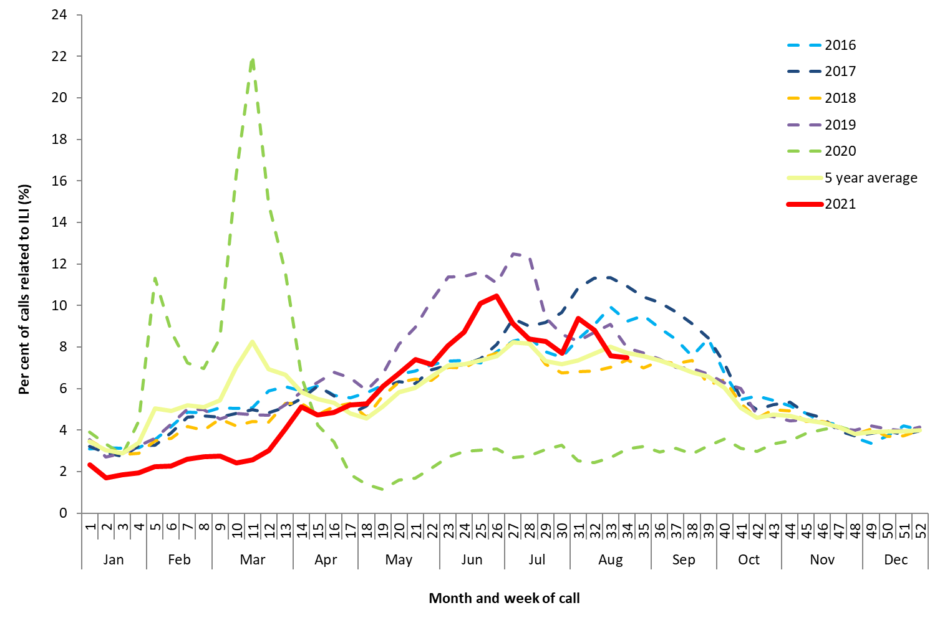

Source: Healthdirect

*All data are preliminary and subject to change as updates are received. Please refer to Data considerations for interpretation of the 5 year average.  
Note: From March 2020 onwards, the proportion of calls to Healthdirect relating to ILI were impacted by calls related to bushfires (February) and COVID-19 (March). The National Coronavirus Helpline was established on 16 March 2020, and callers to the Healthdirect helpline with concerns about COVID-19 have since been diverted to the National Coronavirus Helpline. This explains the sudden drop in ILI related calls to the helpline in mid-March 2020. ILI-related calls returned to average levels at the end of November.

Figure 2. Proportion of fever and cough among FluTracking participants, Australia, 2016 to 2021, by month and week*#

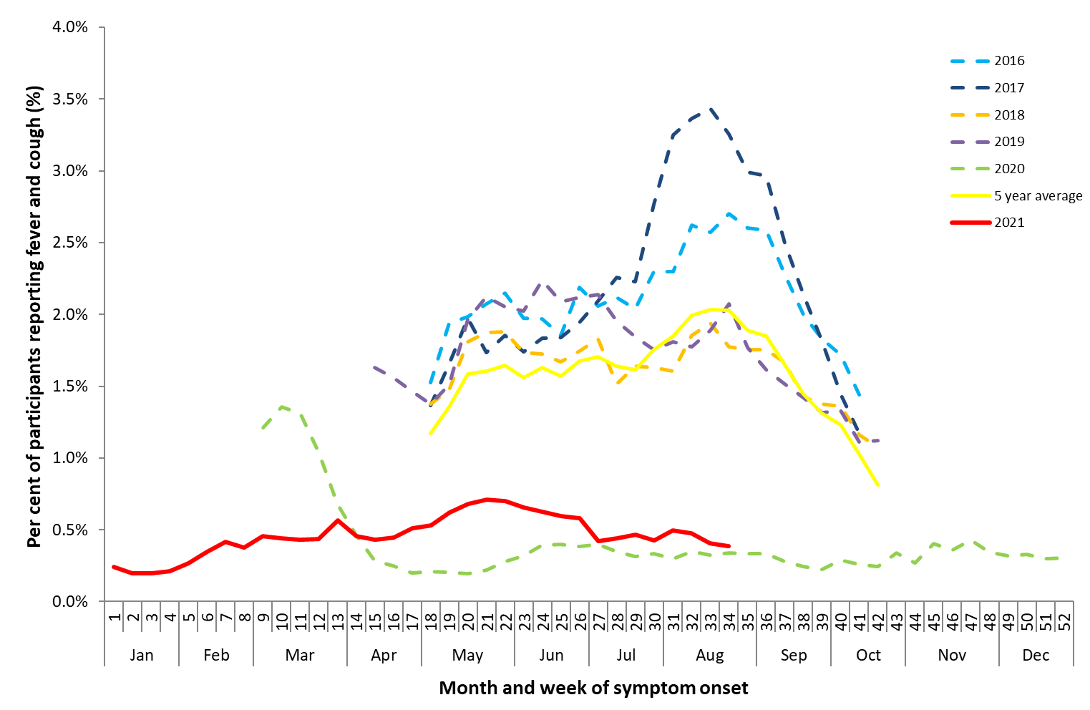

Source: FluTracking

*All data are preliminary and subject to change as updates are received. Please refer to Data considerations for interpretation of the 5 year average.  
# Data to calculate the 5 year average are available from week 18 to week 42 only.

Figure 3. Unweighted rate of ILI reported from ASPREN sentinel GP surveillance systems, Australia, 01 January 2016 to 29 August 2021, by month and week*#

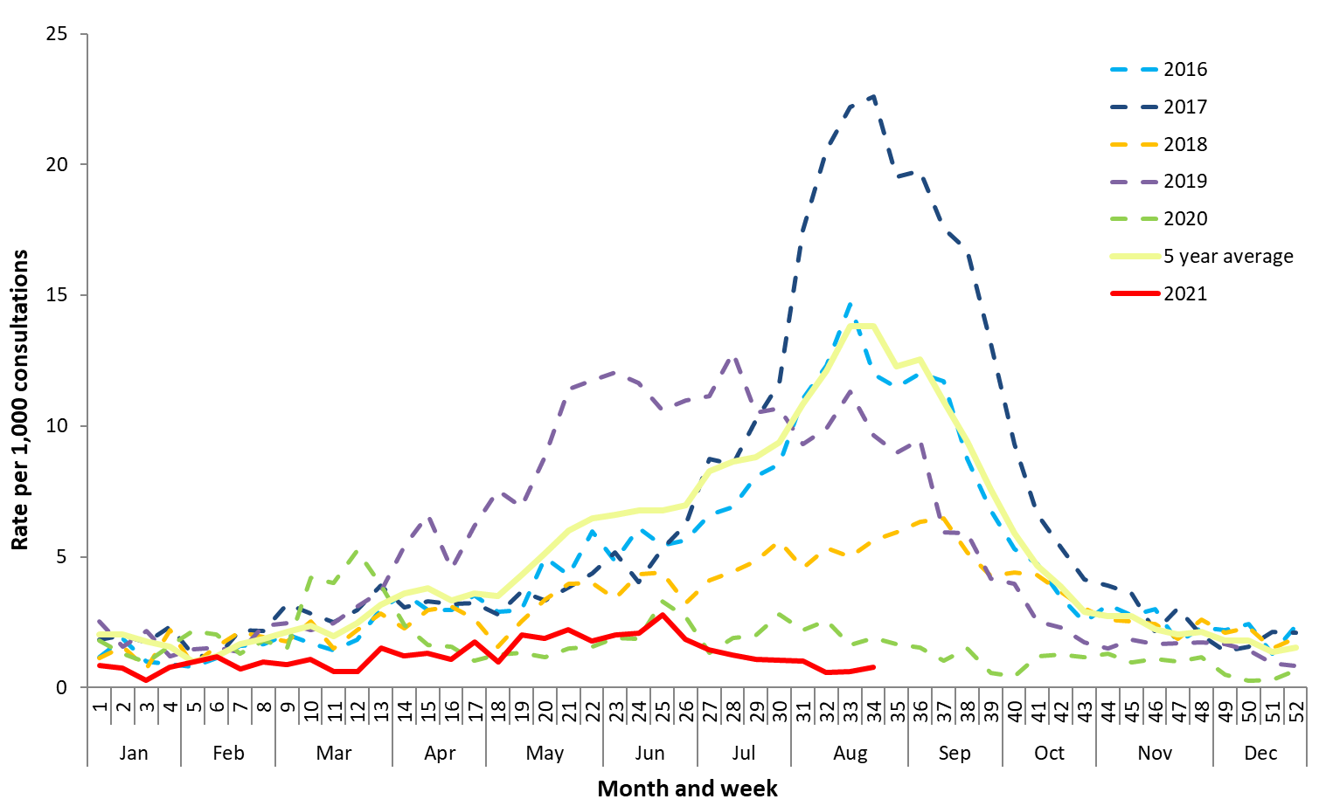

Source: ASPREN

* All data are preliminary and subject to change as updates are received. Excludes Victorian Sentinel Practice Influenza Network (VicSPIN) data from week 45-53 of 2020. Please refer to Data considerations for interpretation of the 5 year average.

# Please refer to surveillance system description (Page 2) for notes on impact of COVID-19 on ASPREN data

**Laboratory-confirmed influenza**

*National notification data (NNDSS):*

* There were 21 laboratory-confirmed influenza notifications with a diagnosis date this fortnight (16 to 29 August 2021),a decrease from the 26 notifications in the previous fortnight.
* In the year to date, there have been 483 notifications of laboratory-confirmed influenza to the NNDSS (Figure 4). This is a national notification rate of 1.9 per 100,000 population.
* The number of notifications in 2021 to date have remained steady and are well below the 5 year average.

*ASPREN:*

* There have been no influenza detections among the 331 ILI cases presenting to sentinel GPs in the year to date who were tested for respiratory viruses.

*Sentinel laboratories:*

* This fortnight (16 to 29 August 2021) of the 8,353 samples tested across sentinel laboratories, there were no positive influenza samples detected.
* Cumulatively in the year to date, of the 115,599 samples tested across sentinel laboratories, 20 (0.02%) have been positive for influenza.

Figure 4. Notifications of laboratory-confirmed influenza, Australia, 01 January 2016 to 29 August 2021, by month and week of diagnosis*

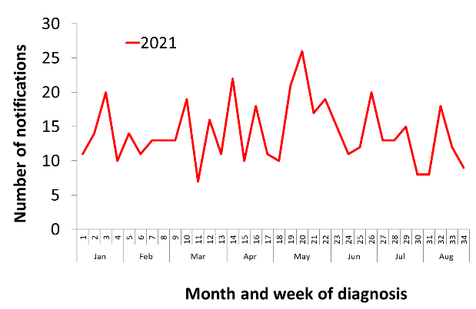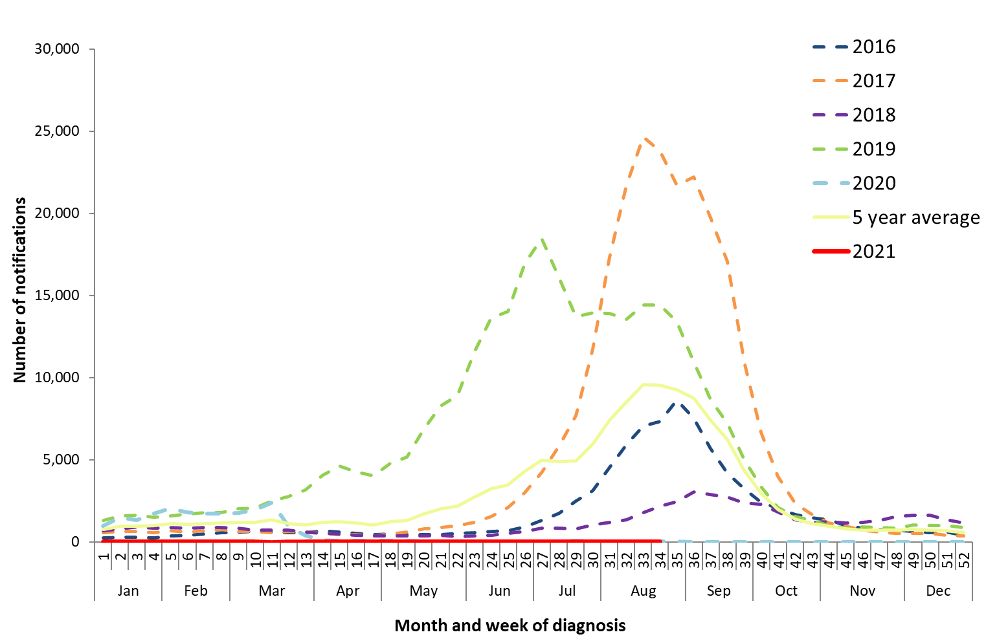

Source: NNDSS

*NNDSS notification data provided for the current and most recent weeks may be incomplete. All data are preliminary and subject to change as updates are received. Please refer to Data considerations for interpretation of the 5 year average.  
Inset: Notifications of laboratory-confirmed influenza, Australia, 01 January to 29 August 2021, by month and week of diagnosis.

**Geographical distribution of influenza activity**

*National notification data (NNDSS):*

* Following a below average number of notifications from April 2020 onwards, in the year to date notifications of influenza have remained low across all jurisdictions (Figure 5).
* Of the 483 notifications of influenza reported to the NNDSS in the year to date, there have been:
  + 235 notifications in Queensland (QLD);
  + 75 notifications in Victoria (VIC);
  + 61 notifications in New South Wales (NSW);
  + 31 notifications in the Northern Territory (NT);
  + 30 notifications in Tasmania (TAS);
  + 25 notifications in Western Australia (WA);
  + 18 notifications in South Australia (SA); and
  + 8 notifications in the Australian Capital Territory (ACT).
* Year to date, the influenza notification rate has been highest in the Northern Territory (12.6 per 100,000 population), Tasmania (5.6 per 100,000 population), and Queensland (4.6 per 100,000 population).

Figure 5. Notifications of laboratory-confirmed influenza*, 01 January to 29 August 2021, by state or territory and week of diagnosis

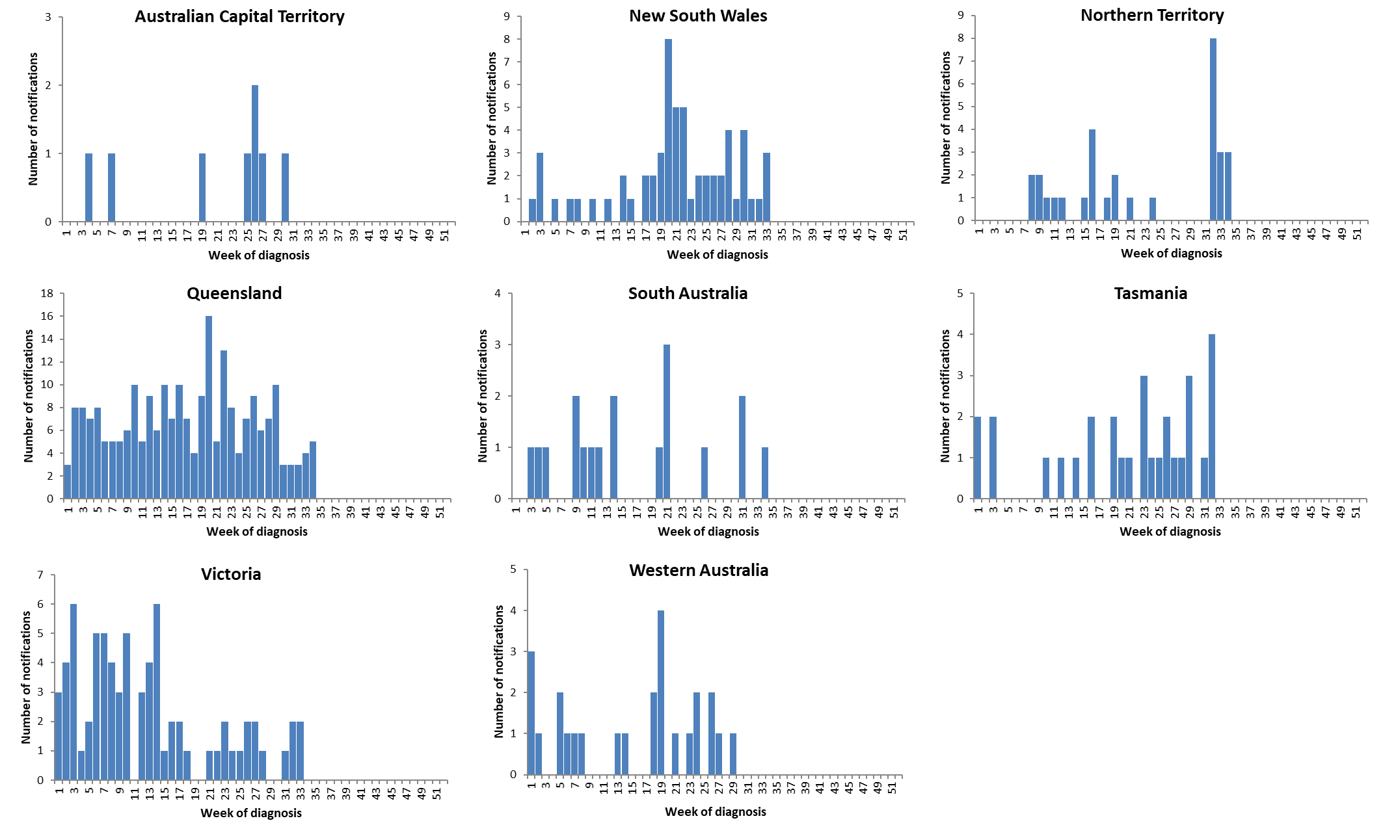

Source: NNDSS

*NNDSS notification data provided for the current and most recent weeks may be incomplete. All data are preliminary and subject to change as updates are received.

For further information regarding influenza activity at the jurisdictional level, please refer to the following State and Territory health surveillance reports:

* ACT: [ACT Influenza Report](https://www.health.act.gov.au/about-our-health-system/population-health/winter-wellbeing-and-flu/flu-act)

(www.health.act.gov.au/about-our-health-system/population-health/winter-wellbeing-and-flu/flu-act)

* NSW: [Influenza Surveillance Report](http://www.health.nsw.gov.au/Infectious/Influenza/Pages/reports.aspx) (http://www.health.nsw.gov.au/Infectious/Influenza/Pages/reports.aspx)
* QLD: [Statewide Weekly Influenza Surveillance Report](https://www.health.qld.gov.au/clinical-practice/guidelines-procedures/diseases-infection/surveillance/reports/flu) (https://www.health.qld.gov.au/clinical-practice/guidelines-procedures/diseases-infection/surveillance/reports/flu)
* SA: [Weekly Epidemiological Summary](http://www.sahealth.sa.gov.au/wps/wcm/connect/public+content/sa+health+internet/about+us/health+statistics/surveillance+of+notifiable+conditions) (Influenza section) (http://www.sahealth.sa.gov.au/wps/wcm/connect/public+content/sa+health+internet/about+us/health+statistics/surveillance+of+notifiable+conditions)
* TAS: [fluTAS Reports](http://www.dhhs.tas.gov.au/publichealth/communicable_diseases_prevention_unit) (http://www.dhhs.tas.gov.au/publichealth/communicable_diseases_prevention_unit)
* VIC: [Influenza Surveillance Reports](https://www2.health.vic.gov.au/public-health/infectious-diseases/infectious-diseases-surveillance/seasonal-influenza-reports) (https://www2.health.vic.gov.au/public-health/infectious-diseases/infectious-diseases-surveillance/seasonal-influenza-reports)
* WA: [Virus WAtch](http://ww2.health.wa.gov.au/Articles/F_I/Infectious-disease-data/Virus-WAtch) (http://ww2.health.wa.gov.au/Articles/F_I/Infectious-disease-data/Virus-WAtch)

### Severity

*Severity is a measure of adverse outcomes or complications as a result of ILI such as hospital referrals, admissions, need for intensive care, and deaths. Measuring and understanding the severity of circulating influenza is difficult to establish at the beginning, or during a low, influenza season. The proportion of confirmed influenza cases with serious outcomes might be skewed initially because there are only a small number of people notified. This means that the measure of severity will vary substantially fortnight to fortnight until numbers are sufficiently high and there is enough data for measurements to stabilise. An assessment of severity can be provided once the signals become clearer.*

***FluCAN:***

* There have been no admissions to hospital (including intensive care units) across FluCAN sentinel hospital sites since sentinel hospital surveillance commenced in April 2021.

***National notification data (NNDSS):***

* Year to date, of the 483 notifications of laboratory-confirmed influenza, there have been no influenza-associated deaths notified to the NNDSS.

**Note that the number of influenza-associated deaths reported to the NNDSS does not represent the true mortality associated with this disease. The number of deaths is reliant on the follow up of cases to determine the outcome of their infection. The follow up of cases is not a requirement of notification, and are only inclusive of laboratory-confirmed cases of influenza. Due to retrospective revision, the variation across jurisdictions in methodology, representativeness and timeliness of death data, and reporting of an outcome of infection not being a requirement of notification, year on year comparisons of deaths in notified cases of influenza may not be reliable.**

### Impact

*Impact measures how influenza affects society, including stress on health-care resources and societal and economic consequences.*

Impact for the season to date, as measured through the rate of FluTracking respondents absent from normal duties and the number of FluCAN sentinel hospital beds occupied by patients with influenza, is minimal.

***FluTracking:***

* This fortnight (16 to 29 August 2021), the proportion of FluTracking participants reporting ILI and taking time off regular duties while unwell was 0.28%—a decrease from the 0.34% reported in the previous fortnight.
* In the year to date, the proportion of FluTracking survey respondents reporting having ILI and taking time off regular duties while unwell was highest in May 2021 (week 20, 0.54%), and has otherwise remained relatively unchanged since March 2021.

***FluCAN:***

* Since seasonal sentinel hospital surveillance began in April 2021, there have been no admissions due to laboratory-confirmed influenza.

### At-risk populations

*At-risk populations are people who may be more susceptible to infection with the influenza virus and/or who may be more likely to experience severe outcomes from their infection.*

***National notification data (NNDSS):***

* In the year to date, notification rates have been highest in adults aged 85 years and older (4.9 notifications per 100,000 population); adults aged 60–69 years (4.1 notifications per 100,000 population); children aged younger than 5 years (2.8 notifications per 100,000 population), and adults aged 75–84 years (2.7 notifications per 100,000 population) (Figure 6).
* In the year to date, influenza A accounted for the highest number of notifications across all age groups.

Figure 6. Rate of notifications of laboratory-confirmed influenza, Australia, 01 January to 29 August 2021, by age group and subtype

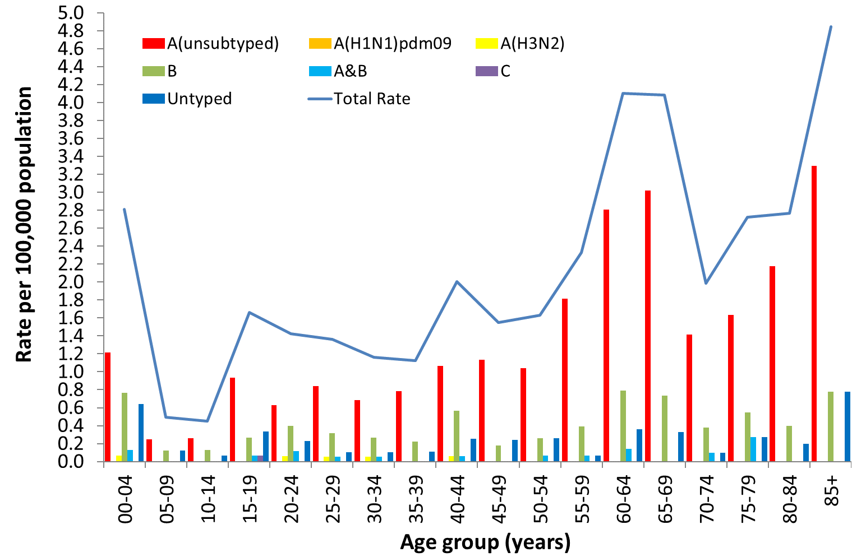

Source: NNDSS

### Virology

***National notification data (NNDSS):***

* Of the 21 notifications of laboratory-confirmed influenza with a diagnosis date this fortnight (16 to 29 August 2021) reported to the NNDSS, 76.2 % (n=16) were influenza A (of which 100.0% were A(unsubtyped)), 14.3% (n=3) were influenza B, and 9.5% (n=2) were influenza A and B co-infection.
* In the year to date, 64.4% of notifications of laboratory-confirmed influenza to the NNDSS were influenza A, of which 98.4% were influenza A(unsubtyped) and 1.6% were influenza A(H3N2). Influenza B accounted for 20.3% of notifications, 3.1% were influenza A and B co-infection, 0.2% were influenza C, and 12.0% were untyped (Figure 7).
* Year to date, the proportion of all notifications reported as influenza A has varied across jurisdictions (Figure 8), ranging from 37.5% in the ACT, to 82.7% in VIC.

***ASPREN:***

* There have been no influenza positive samples detected through ASPREN GPs in the year to date.

***Sentinel laboratories:***

* In the year to date, 0.02% (n=20) of samples detected in sentinel laboratories were positive for influenza. Of these, 65.00% (n=13) were influenza A (of which all were influenza A(unsubtyped)), 25.00% (n=5) were influenza B, and 10.00% (n=2) were influenza C.

***WHOCC:***

* From 01 January to 30 August 2021, the WHOCC characterised 10 influenza viruses (Table 1), of which 90% (n=9) were influenza A(H3N2) and 10% (n=1) were influenza B/Victoria.
* The WHOCC reported that from 01 January to 30 August 2021, none of the 9 influenza A(H3N2) viruses tested for neuraminidase inhibitor resistance demonstrated reduced inhibition to Oseltamivir or Zanamivir. The one influenza B/Victoria isolate has not yet been tested for neuraminidase inhibitor resistance.

**Figure 7. Per cent of laboratory-confirmed influenza, Australia, 01 January to 29 August 2021, by subtype and week of diagnosis\***

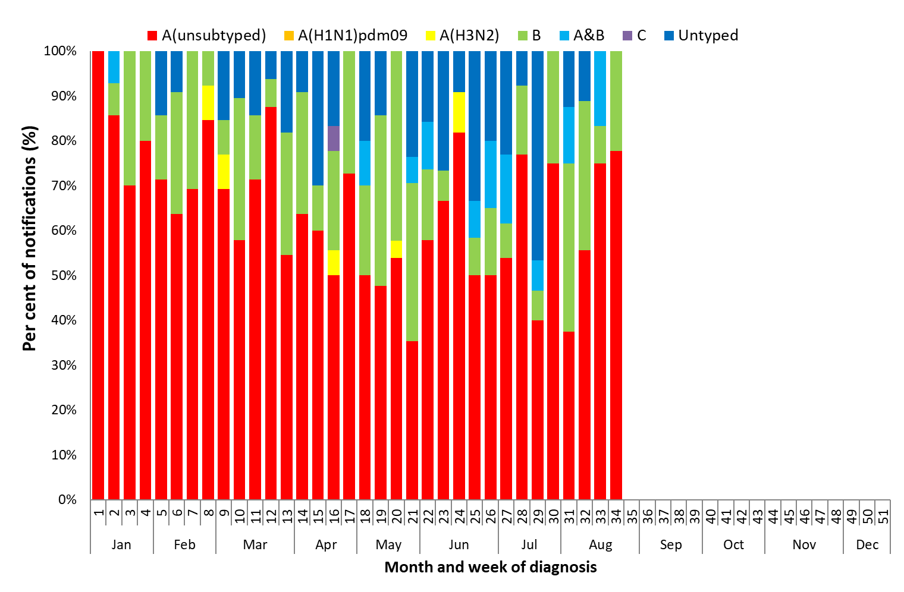

Source: NNDSS

*NNDSS notification data provided for the current and most recent weeks may be incomplete. All data are preliminary and subject to change as updates are received.

Figure 8. Per cent of notifications of laboratory-confirmed influenza, Australia, 01 January to 29 August 2021, by subtype and state or territory*

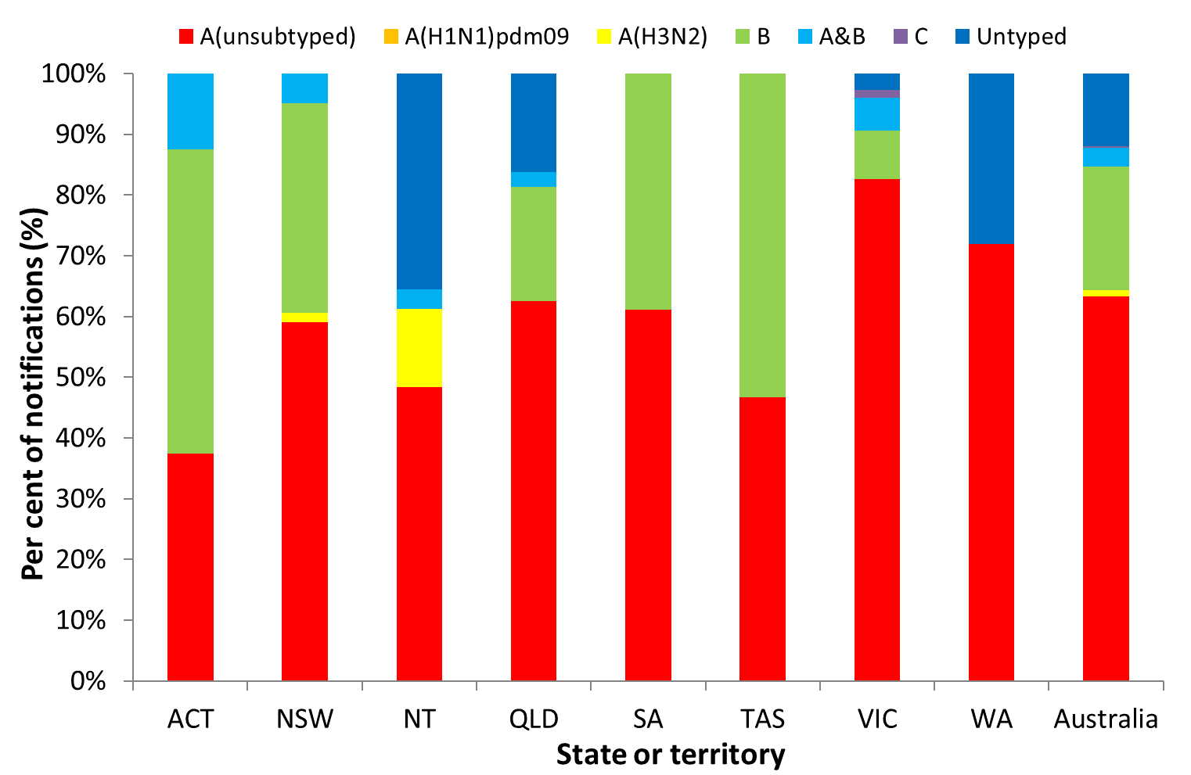

Source: NNDSS

*NNDSS notification data provided for the current and most recent weeks may be incomplete. All data are preliminary and subject to change as updates are received.

Table 1. Australian influenza viruses typed by haemagglutination inhibition (HI) assay from the WHOCC, 01 January to 30 August 2021*

| Type/Subtype | ACT | NSW | NT | QLD | SA | TAS | VIC | WA | TOTAL |
| --- | --- | --- | --- | --- | --- | --- | --- | --- | --- |
| A(H1N1) pdm09 | 0 | 0 | 0 | 0 | 0 | 0 | 0 | 0 | 0 |
| A(H3N2) | 0 | 0 | 9 | 0 | 0 | 0 | 0 | 0 | 9 |
| B/Victoria lineage | 0 | 0 | 0 | 0 | 0 | 0 | 1 | 0 | 1 |
| B/Yamagata lineage | 0 | 0 | 0 | 0 | 0 | 0 | 0 | 0 | 0 |
| Total | 0 | 0 | 9 | 0 | 0 | 0 | 1 | 0 | 10 |

Source: WHOCC

* Viruses tested by the WHOCC are not necessarily a random sample of all those in the community. State indicates the residential location for the individual tested, not the submitting laboratory. There may be up to a month delay on reporting of samples.

### Vaccine match and effectiveness

***WHOCC:***

* Of the 10 isolates characterised for antigenic similarity to their corresponding vaccine components by HI assay (Table 1):
  + All 9 influenza A(H3N2) isolates were antigenically dissimilar to the corresponding vaccine components; and
  + The one influenza B/Victoria isolate characterised in the year to date was antigenically similar to the corresponding vaccine components.

#### Australian Influenza Vaccines Composition 2021

In 2021 all seasonal influenza vaccinations registered for use in Australia are quadrivalent influenza vaccines (QIVs). The influenza virus strains included in egg-based QIVs in Australia in 2021 are:

* an A/Victoria/2570/2019 (H1N1)pdm09-like virus;
* an A/Hong Kong/2671/2019 (H3N2)-like virus;
* a B/Washington/02/2019-like (B/Victoria lineage) virus; and
* a B/Phuket/3073/2013-like (B/Yamagata lineage) virus.

The influenza virus strains included in cell-based QIVs in Australia in 2021 are:

* an A/Wisconsin/588/2019 (H1N1)pdm09-like virus;
* an A/Hong Kong/45/2019 (H3N2)-like virus;
* a B/Washington/02/2019 (B/Victoria lineage)-like virus; and
* a B/Phuket/3073/2013 (B/Yamagata lineage)-like virus.

The best way to determine how well the vaccine protects against circulating viruses during the season is by determining the vaccine effectiveness. These estimates provide an indication of how effective the vaccine was in providing protection against influenza infection. Vaccine effectiveness is usually estimated from observational studies and is calculated after the end of the influenza season, though interim analyses are sometimes available where there is sufficient data.

#### Vaccine effectiveness

It is too early to assess vaccine match and effectiveness for this season.