| Logo | **INFormation BRIEF**  **Updated: December 2021**  **Reporting period: 01 January to 07 November 2021** |
| --- | --- |

**National 2021 Influenza Season Summary**

## KEY MESSAGES

**It is important to note that due to the COVID-19 epidemic in Australia, data reported from the various influenza surveillance systems may not accurately reflect influenza activity. Results should be interpreted with caution, especially where comparisons are made to previous influenza seasons. Interpretation of 2020 and 2021 influenza activity data should take into account, but are not limited to, the impact of physical distancing measures, likely changes in health seeking behaviour of the community including access to alternative streams of acute respiratory infection specific health services, and focussed testing for COVID-19 response activities. Current COVID-19 related public health measures and the community’s adherence to public health messages are also likely to have had an effect on transmission of acute respiratory infections, including influenza.**

Influenza season-specific surveillance systems typically operate from April to October of each year. Due to the COVID-19 pandemic, this year monitoring of influenza was expanded to March to November. For the purposes of this summary, the 2021 season covers the period 29 March to 07 November 2021. The reporting period is from 1 January to 07 November 2021. The 5 year average reported in this summary includes data for 2016–2020, and therefore is expected to be impacted by the low number of influenza notifications in 2020. The low number of influenza notifications alone in 2020 is not expected to impact the proportion of influenza notifications reported as influenza-associated deaths (case fatality rate).

* **Activity**—Influenza and influenza-like illness (ILI) activity levels remained well below average across all systems. At the national level, notifications of laboratory-confirmed influenza remained at low levels, with a peak in notifications occurring in mid-May.
* **Impact**—Given the low number of laboratory-confirmed influenza notifications, low community ILI activity, and small number of hospitalisations due to influenza at sentinel hospital sites, it is likely there was minimal impact on society due to influenza during the reporting period.
* **Severity**—Given the low case numbers of laboratory-confirmed influenza, it is difficult to determine the potential severity of the 2021 season. During the reporting period, of the 598 notifications of laboratory-confirmed influenza, there were no laboratory-confirmed influenza-associated deaths notified to the National Notifiable Diseases Surveillance System (NNDSS)—the lowest rate reported in the last 5 years. The number of patients with confirmed influenza admitted to sentinel hospitals was also the lowest reported in the last 5 years.
* **At-risk populations**—Adults aged 85 years and older and those aged 60–69 years had the highest influenza notification rates, followed by children under 5 years of age. The notification rate was lowest among children aged 5–14 years.
* **Virology**—During the reporting period, the majority of nationally reported laboratory-confirmed influenza cases were influenza A (67.7%). Influenza B accounted for 21.9% of notifications, 3.5% were influenza A and B co-infection, 0.5% were influenza C, and 6.4% were untyped.
* **Vaccine match and effectiveness**—The low case numbers of influenza across all systems during the 2021 season precludes meaningful analysis to estimate vaccine effectiveness. Of the relatively small number of samples referred to the WHO Centre for Collaboration (WHOCC), there was reasonable matching between the influenza A(H1N1) and influenza B/Victoria sample and the corresponding 2021 vaccine component. The influenza (H3N2) samples were not well matched with the corresponding vaccine component.

### Introduction

Each year, the influenza virus changes and different strains can circulate in the population. Particular subtypes of influenza can affect different groups of the population more than others. Depending on the susceptibility of the population, the subtypes that are circulating and the changes to the virus itself, the influenza season can be very different year to year. Our surveillance systems help us to understand influenza activity, severity of the infection in individuals and impact of the illness on society in Australia. We are also able to monitor which influenza viruses are circulating, which populations may be more affected, the effectiveness of the vaccine, and any resistance to antiviral drugs that has developed.

**Definitions of influenza measures**

**Activity** measures the capacity of the circulating influenza viruses to spread person to person and may be measured indirectly through systems that monitor ILI and more directly through systems that monitor laboratory-confirmed influenza.

**Impact** measures how influenza affects society, including stress on health-care resources and societal and economic consequences.

**Severity** is a measure of adverse outcomes or complications as a result of ILI such as hospital referrals, admissions, need for intensive care and deaths. Measuring and understanding the severity of circulating influenza is difficult to establish at the beginning, or during a low influenza season. The proportion of confirmed influenza cases with serious outcomes might be skewed initially because there are only a small number of influenza notifications. This means that the measure of severity will vary substantially fortnight to fortnight until numbers are sufficiently high and there is enough data for measurements to stabilise.

## ANALYSIS

### Activity

* During the reporting period, influenza activity remained at below average levels across all systems.
* Nationally, the average sentinel GP ILI consultation rate for the seasonal period in 2021 (1.2 per 1,000 consultations) was 79% lower than the 5 year average for the same period (5.8 per 1,000 consultations) (Figure 1).1,2
* During the 2021 seasonal period, ILI activity among Flutracking participants was highest in mid-May (0.7%), with multi-modal peaks occurring in late March (0.6%) and early August (0.5%) (Figure 2). Reports of ILI among Flutracking participants was below the 5 year average during the 2021 seasonal period.3
* There were 598 notifications of laboratory confirmed influenza to the National Notifiable Diseases Surveillance System (NNDSS) during the reporting period—a substantial decrease from the 5 year average (141,635).4
* There were three admissions with confirmed influenza to sentinel hospitals during the 2021 season—notably lower than the 5 year average (n=2,089).5
* Influenza circulated at low levels throughout the 2021 season. During the seasonal period, 6% of patients presenting to sentinel GPs with ILI tested positive for influenza.2

Figure 1. ILI presentations to sentinel general practitioners, by week, 2021 and 5 year average, Australia

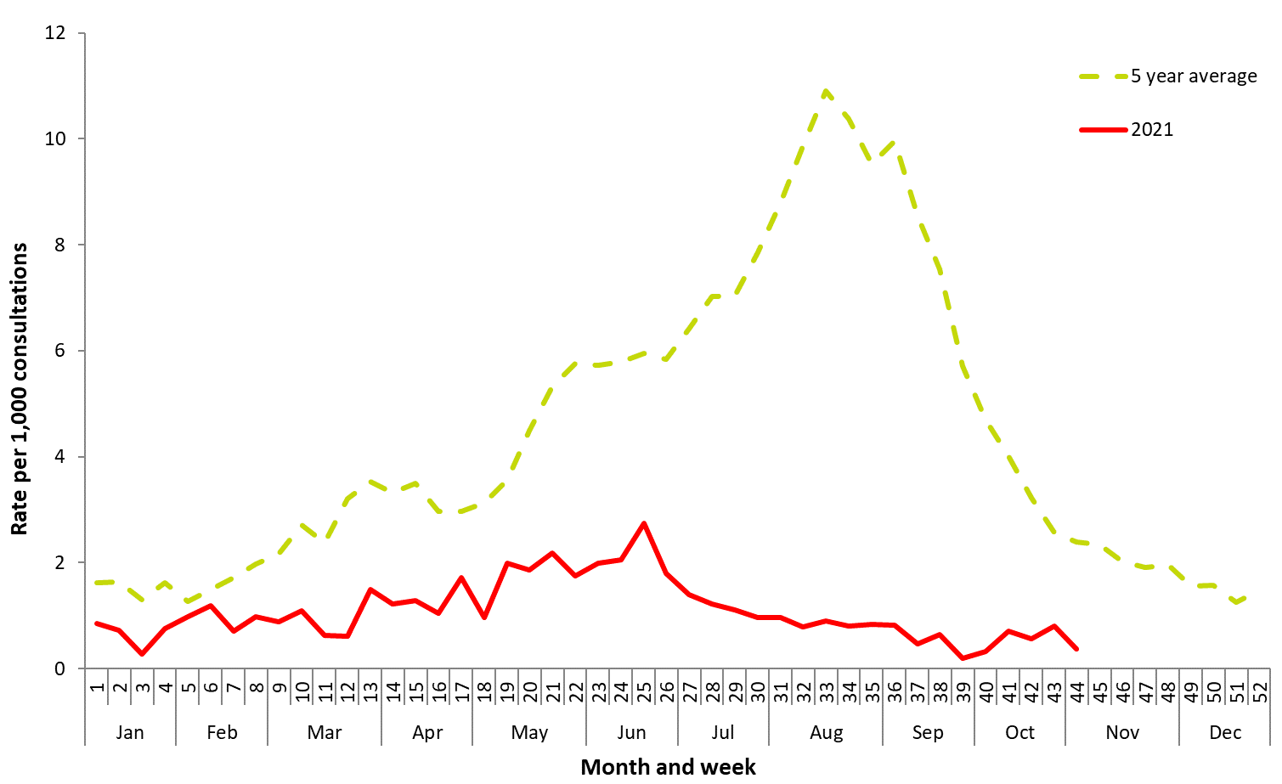

Source: ASPREN

### Impact

* Given low case numbers of laboratory-confirmed notifications for influenza to date in 2021, it is likely that there has been minimal impact on society, and the healthcare system, as a result of influenza circulation during the 2021 season.
* During the 2021 seasonal period, 0.5% (weekly average) of Flutracking survey respondents reported having ILI, with 0.3% (weekly average) of all respondents reporting taking time off regular duties while unwell with ILI. This is below the 5 year average of 1.6% (weekly average) of respondents reporting ILI, and 1.1% (weekly average) of respondents taking time off regular duties while having ILI (Figure 2).1

Figure . Symptoms reported by Flutracking participants, by week, 2021 and 5 year average, Australia

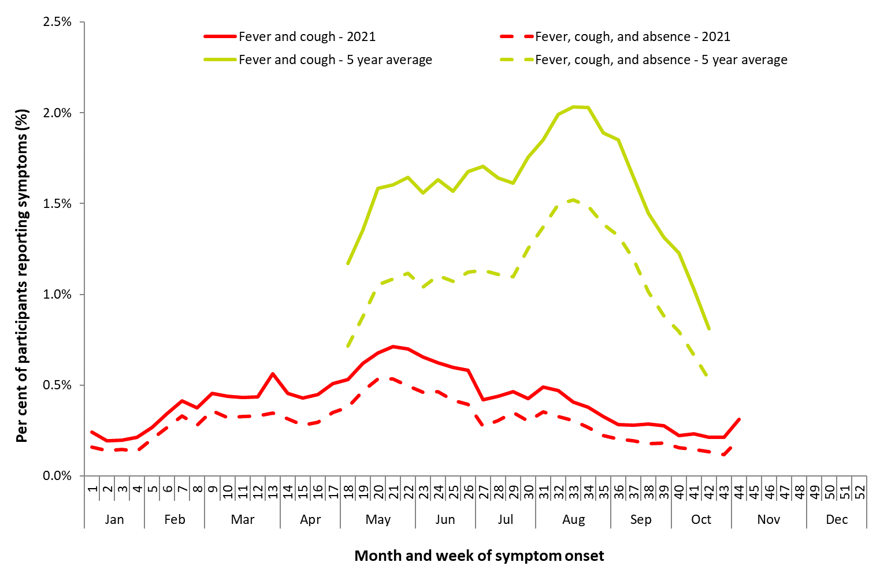

Source: FluTracking

### Severity

* The number of sentinel hospital admissions due to laboratory confirmed influenza was notably lower than in previous years.
* Of the three patients admitted to sentinel hospitals, none were admitted to ICU.
  + Over the past 5 years, of patients with confirmed influenza admitted to sentinel hospitals, the proportion who were admitted to ICU, has ranged from 6.7% in 2020 to 11.6% in 2017.5
  + Due to the low number of patients admitted, it is difficult to meaningfully assess severity.
* Of the three hospitalised patients, one was due to influenza A(H3N2), one was due to influenza A(unsubtyped), and one was due to influenza B.5
* Of the 598 notifications of laboratory-confirmed influenza to date in 2021, there were no influenza-associated deaths notified to the NNDSS.4
  + Over the past 5 years, the proportion of notified cases who were notified to the NNDSS as influenza-associated deaths (case fatality rate) ranged from 0.17% in 2020 to 0.47% in 2017, with a 5 year average of 0.35%. The 5 year average case fatality rate prior to 2020 (2015–2019) was 0.34%, suggesting that the low number of influenza notifications in 2020 had minimal impact on the 5 year average case fatality rate.
* To note, the number of influenza-associated deaths reported to the NNDSS does not represent the true mortality associated with this disease. The number of deaths is reliant on the follow up of cases to determine the outcome of their infection. The follow up of cases is not a requirement of notification, and notified deaths are only inclusive of laboratory-confirmed cases of influenza. Due to retrospective revision, the variation across jurisdictions in methodology, representativeness and timeliness of death data, and reporting of an outcome of infection not being a requirement of notification, year on year comparisons of deaths in notified cases of influenza may not be reliable.
* The Australian Bureau of Statistics (ABS) provides an alternative source of influenza mortality data. During the COVID-19 pandemic, the ABS began producing ‘Provisional Mortality Statistics’ reports, which provide data on preliminary counts of doctor certified deaths by date of occurrence for Australia.6
  + Note that these data are provisional, and do not include deaths that have been referred to a coroner. More information on the report methodology can be accessed [here](https://www.abs.gov.au/methodologies/provisional-mortality-statistics-methodology/jan-2020-aug-2021) (<https://www.abs.gov.au/methodologies/provisional-mortality-statistics-methodology/jan-2020-aug-2021>).
* As of the most recent Provisional Mortality Statistics report (capturing the period 01 January 2021 to 31 October 2021), there were two deaths due to influenza in 2021—one each in July and October 2021. These were the first deaths certified as being due to influenza since July 2020.6
* Note that the number of deaths caused by influenza captured in ABS datasets may differ from the number of influenza-associated deaths reported to the NNDSS. This may be due to deaths caused by influenza captured in ABS datasets that may not meet the [NNDSS influenza case definition](https://www1.health.gov.au/internet/main/publishing.nsf/Content/cda-surveil-nndss-casedefs-cd_flu.htm), and due to reasons detailed above regarding underrepresentation of the true mortality associated with this disease in the NNDSS.

### Virology

* Subtyping information was limited in 2021 due to the low number of suitable samples available for testing.
* During the reporting period, 67.7% of notifications of laboratory-confirmed influenza to the NNDSS were influenza A, of which 95.8% were influenza A(unsubtyped), 3.0% were influenza A(H3N2), and 1.2% were influenza A(H1N1). Influenza B accounted for 21.9% of notifications, 3.5% were influenza A and B co-infection, 0.5% were influenza C, and 6.4% were untyped.4
* Of the 27 samples characterised by the WHOCC between 01 January and 8 November 2021, 93% (n=25) were influenza A(H3N2), 4% (n=1) were influenza A(H1N1), and 4% (n=1) were influenza B/Victoria.7
* Of the 27 isolates characterised by the WHOCC for antigenic similarity to their corresponding vaccine components by hemagglutination inhibition assay, both the one influenza B/Victoria isolate and the one influenza A(H1N1) were antigenically similar to the corresponding vaccine components, while all 25 influenza A(H3N2) isolates were antigenically dissimilar to the corresponding vaccine components (low reactors).

### Vaccine effectiveness

* Influenza viruses are continually changing, making the targeting of an effective vaccine a constant challenge each year.
* The small number of cases reported across systems during the 2021 influenza season in Australia precludes meaningful analysis to estimate vaccine effectiveness.

### Geographical variations

* Following the sudden drop to a below average number of notifications from April 2020 onwards, notifications of influenza during the reporting period remained low across all jurisdictions. 4
* During the reporting period, the influenza notification rate has been highest in the Northern Territory (23.6 per 100,000 population), Tasmania (6.9 per 100,000 population), and Queensland (5.6 per 100,000 population).
  + The higher notification rate in the Northern Territory in 2021 is due to testing procedures for travellers in hotel quarantine. In the Northern Territory, all travellers in quarantine are tested for influenza as well as COVID-19, whereas in other jurisdictions, those in hotel quarantine may only be tested for COVID-19.
* There was variation across jurisdictions in the influenza type and subtype distribution, with the proportion of all notifications reported as influenza A varying across jurisdictions, ranging from 37.5% in the ACT to 100.0% in WA. The proportion of Influenza B notifications ranged from 0% in WA to 54% in Tasmania.
  + Subtyping information was limited in 2021 (see *Virology* section above), but where subtyping information was available, jurisdictions reported a greater proportion of influenza A(H3N2) than A(H1N1).4

### At-risk Populations

* Consistent with previous years (excepting 2020), notification rates in the 2021 season have been highest in adults aged over 65 years and in children aged younger than 5 years.4
  + To date in 2021, notification rates were highest in those aged 85 years and older (4.9 notifications per 100,000 population); adults aged 60–69 years (4.8 notifications per 100,000 population); children aged younger than 5 years (3.5 notifications per 100,000 population); and adults aged 75–84 years (3.2 notifications per 100,000 population).
* To date in 2021, influenza A accounted for the highest proportion of notifications in all age groups, except those aged 5–9 years, with the proportion ranging from 54% (20–24 years) to 82% (80–84 years).4
  + In those aged 5–9 years, influenza B accounted for the highest proportion of notifications at 55%.
* Of the three patients with confirmed influenza admitted to sentinel hospitals, two (67%) were in children under 16 years of age, and one case (33%) was aged between 16 and 64 years. Two cases (67%) were female, and one case (33%) was Aboriginal and/or Torres Strait Islander.5 Due to the small number of hospital admissions, it is difficult to meaningfully assess severity among at-risk populations.
* Medical comorbidities were reported in one case admitted to sentinel hospitals. No cases required admission to ICU and no patients died.5

### Antiviral Resistance

• The WHOCC reported that from 01 January to 08 November 2021, none of the influenza A(H3N2), influenza A(H1N1), or influenza B/Victoria samples tested for neuraminidase inhibitor resistance demonstrated reduced inhibition to Oseltamivir or Zanamivir.7

### Data considerations and further information

Due to an overlap between COVID-19 and ILI symptoms, several influenza surveillance systems commenced surveillance activities earlier than usual in 2020 and 2021.

This report presents an overview of influenza activity based on a number of complimentary systems. No one single system, including notification data, provides the full picture on influenza, because influenza is a common disease and its presenting symptoms are non-specific. The epidemiology of influenza is informed by a number of different systems based in the community, laboratories, primary care and hospitals, as well as notifiable diseases data, which includes officially reported deaths. The information in this report is reliant on the surveillance sources available to the Department of Health at the time of production.

Data in this summary is reported by International Organization for Standardization (ISO) 8601 weeks, with the week ending on Sunday. Throughout the summary, where the seasonal period is presented, refers to the period from week 13 (week beginning 29 March 2021) to week 44 (week beginning 1 November 2021). The reporting period is from 01 January to 07 November 2021. NNDSS data is analysed and reported based on diagnosis date, which is the true onset date of a case if known, otherwise it is the earliest of the specimen date, the notification date or the notification received date. NNDSS data were extracted on 11 November 2021. Due to the dynamic nature of the NNDSS and other surveillance systems, data in this report are subject to retrospective revision and may vary from data reported in other national reports and reports by states and territories. Detailed notes on interpreting the data presented in this report are available at the Department of Health’s [Australian Influenza Surveillance Report](http://www.health.gov.au/flureport) website ([www.health.gov.au/flureport](http://www.health.gov.au/flureport)).

While every care has been taken in preparing this report, the Commonwealth does not accept liability for any injury or loss or damage arising from the use of, or reliance upon, the content of the report. Delays in the reporting of data may cause data to change retrospectively. For further details about information contained in this report please contact the Influenza Surveillance Team (flu@health.gov.au).

For further information regarding influenza activity at the jurisdictional level, please refer to the following State and Territory health surveillance reports:

* ACT: [ACT Influenza Report](https://www.health.act.gov.au/about-our-health-system/population-health/winter-wellbeing-and-flu/flu-act)

(www.health.act.gov.au/about-our-health-system/population-health/winter-wellbeing-and-flu/flu-act)

* NSW: [Influenza Surveillance Report](http://www.health.nsw.gov.au/Infectious/Influenza/Pages/reports.aspx) (http://www.health.nsw.gov.au/Infectious/Influenza/Pages/reports.aspx)
* QLD: [Statewide Weekly Influenza Surveillance Report](https://www.health.qld.gov.au/clinical-practice/guidelines-procedures/diseases-infection/surveillance/reports/flu) (https://www.health.qld.gov.au/clinical-practice/guidelines-procedures/diseases-infection/surveillance/reports/flu)
* SA: [Weekly Epidemiological Summary](http://www.sahealth.sa.gov.au/wps/wcm/connect/public+content/sa+health+internet/about+us/health+statistics/surveillance+of+notifiable+conditions) (Influenza section) (http://www.sahealth.sa.gov.au/wps/wcm/connect/public+content/sa+health+internet/about+us/health+statistics/surveillance+of+notifiable+conditions)
* TAS: [fluTAS Reports](https://www.health.tas.gov.au/health-topics/flu-influenza) (<https://www.health.tas.gov.au/health-topics/flu-influenza/flutas-reports>)
* VIC: [Influenza Surveillance Reports](https://www2.health.vic.gov.au/public-health/infectious-diseases/infectious-diseases-surveillance/seasonal-influenza-reports) (https://www2.health.vic.gov.au/public-health/infectious-diseases/infectious-diseases-surveillance/seasonal-influenza-reports)
* WA: [Virus WAtch](http://ww2.health.wa.gov.au/Articles/F_I/Infectious-disease-data/Virus-WAtch) (http://ww2.health.wa.gov.au/Articles/F_I/Infectious-disease-data/Virus-WAtch)

### References

Australian Sentinel Practitioners Research Network (ASPREN) – <https://aspren.dmac.adelaide.edu.au/>

Victorian Sentinel Practice Influenza Network (VicSPIN) – <http://www.vidrl.org.au/surveillance/influenza-surveillance/>

FluTracking – <https://info.flutracking.net/reports-2/australia-reports/>

National Notifiable Diseases Surveillance System (NNDSS) – [www.health.gov.au/nndssdata](http://www.health.gov.au/nndssdata)

Influenza Complications Alert Network (FluCAN)

Australian Bureau of Statistics (ABS) - <https://www.abs.gov.au/>

World Health Organization Collaborating Centre for Reference and Research on Influenza (WHOCC) – <http://www.influenzacentre.org/Surveillance_Samples_Received.html>