| Logo | **INFormation BRIEF**  **Updated on 02 December 2020** |
| --- | --- |

**National 2020 Influenza Season Summary**

## KEY MESSAGES

**It is important to note that due to the COVID-19 epidemic in Australia, data reported from the various influenza surveillance systems may not accurately reflect influenza activity. Results should be interpreted with caution, especially where comparisons are made to previous influenza seasons. Interpretation of 2020 influenza activity data should take into account, but are not limited to, the impact of physical distancing measures, likely changes in health seeking behaviour of the community including access to alternative streams of acute respiratory infection specific health services, and focussed testing for COVID-19 response activities. During 2020, COVID-19 related public health measures and the community’s adherence to public health messages are also likely to have had an effect on transmission of acute respiratory infections, including influenza.**

Influenza season-specific surveillance systems typically operate from April to October of each year. Due to the COVID-19 pandemic, this year monitoring of influenza was expanded to March to November. For the purposes of this summary, the 2020 season covers the period 06 April to 29 November 2020. Any year to date data captures data until 29 November 2020. The interseasonal period encompasses 01 January to 05 April 2020.

* **Activity** – Following a high start to the 2020 interseasonal period, influenza and influenza-like illness (ILI) activity levels were lower than average across all systems. At the national level, notifications of laboratory-confirmed influenza substantially decreased in mid-March and remained low to the end of the 2020 season.
* **Impact** – Given low case numbers of laboratory-confirmed notifications for influenza, it is likely that there is minimal impact on society due to influenza circulation in the 2020 season.
* **Severity** – Given low case number of laboratory-confirmed notifications for influenza, it is difficult to determine the potential severity during the 2020 season. In the year to the end of the 2020 season, of the 21,266 notifications of laboratory confirmed influenza, 37 (0.17%) laboratory-confirmed influenza-associated deaths were notified to the National Notifiable Diseases Surveillance System (NNDSS), the lowest rate reported in the last five years. However, the proportion of patients with confirmed influenza admitted to ICU in sentinel hospitals was similar to recent years.
* **At-risk populations:** Children younger than 10 years of age had the highest influenza notification rate, while the notification rate among those aged 65 years or older was lower compared to other age groups.
* **Virology** – In the year to date in 2020, the majority of nationally reported laboratory-confirmed influenza cases were influenza A (87.1%).
* **Vaccine match and effectiveness** – The low case numbers of influenza across all systems during the 2020 season precludes meaningful analysis to estimate vaccine effectiveness. Of the samples referred to the WHOCC, there was reasonable matching between influenza subtype and lineage, and the corresponding vaccine component.

### Introduction

Each year, the influenza virus changes and different strains can circulate in the population. Particular subtypes of influenza can affect different groups of the population more than others. Depending on the susceptibility of the population, the subtypes that are circulating and the changes to the virus itself, the influenza season can be very different year to year. Our surveillance systems help us to understand influenza activity, severity of the infection in individuals and impact of the illness on society in Australia. We are also able to monitor which influenza viruses are circulating, which populations may be more affected, the effectiveness of the vaccine, and any resistance to antiviral drugs that has developed.

**Activity** measures the capacity of the circulating influenza viruses to spread person to person and may be measured indirectly through systems that monitor ILI and more directly through systems that monitor laboratory-confirmed influenza.

**Impact** measures how influenza affects society, including stress on health-care resources and societal and economic consequences.

**Severity** is a measure of adverse outcomes or complications as a result of ILI such as hospital referrals, admissions, need for intensive care and deaths. Measuring and understanding the severity of circulating influenza is difficult to establish at the beginning, or during a low influenza season. The proportion of confirmed influenza cases with serious outcomes might be skewed initially because there are only a small number of influenza notifications. This means that the measure of severity will vary substantially fortnight to fortnight until numbers are sufficiently high and there is enough data for measurements to stabilise.

## ANALYSIS

### Activity

* Following a high level of ILI in the Australian community during the interseasonal period in 2020, from mid-March, influenza activity decreased and remained at below average levels across all systems.
* During the 2020 seasonal period, ILI activity among Flutracking participants was highest in early April (0.5%), with multi-modal peaks occurring in June (0.4%) and November (0.4%). Reports of ILI among Flutracking participants was below the 5 year mean during the 2020 seasonal period.1
* Nationally, the average sentinel GP ILI consultation rate for the seasonal period in 2020 (1.6 per 1000 consultations) was 4 times less than the five year average for the same period (8.1 per 1000 consultations) (Figure 1).2,3
* There were 21,266 notifications of laboratory confirmed influenza to the National Notifiable Diseases Surveillance System (NNDSS) in the year to the end of the 2020 influenza season —almost 8 times less than the 5 year average (163,015).4
* Admissions with confirmed influenza to sentinel hospitals in 2020 (n=15) was notably lower than the 5 year average (n=2,641).5
* Influenza circulated at low levels throughout the 2020 season. For the seasonal period, 6% of patients presenting to sentinel GPs with ILI tested positive for influenza.2

Figure . ILI presentations to sentinel general practitioners, by week, 2020, 2015-2020 Australia

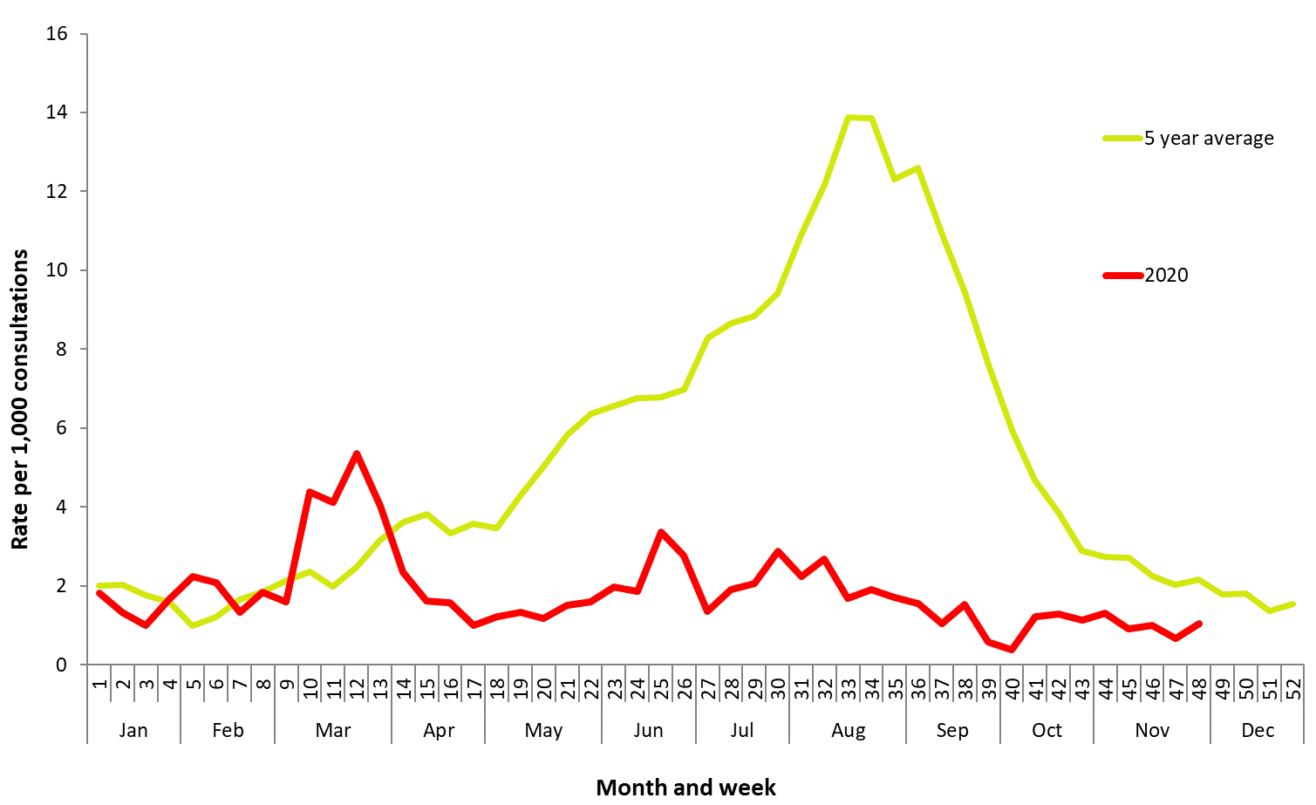

### Impact

* Given low case numbers of laboratory-confirmed notifications for influenza this year, it is likely that there has been minimal impact on society, and the healthcare system, as a result of influenza circulation during the 2020 season.
* During the 2020 seasonal period, 0.3% (weekly average) of Flutracking survey respondents reported having ILI, with 0.2% (weekly average) of all respondents reporting taking time off regular duties while unwell with ILI. This is well below the five year average of 1.9% (weekly average) of respondents reporting ILI, and 1.3% (weekly average) of respondents taking time off regular duties while having ILI (Figure 2).1

**Figure 2. Symptoms reported by Flutracking participants, by week, 2020, 2015-2020, Australia**

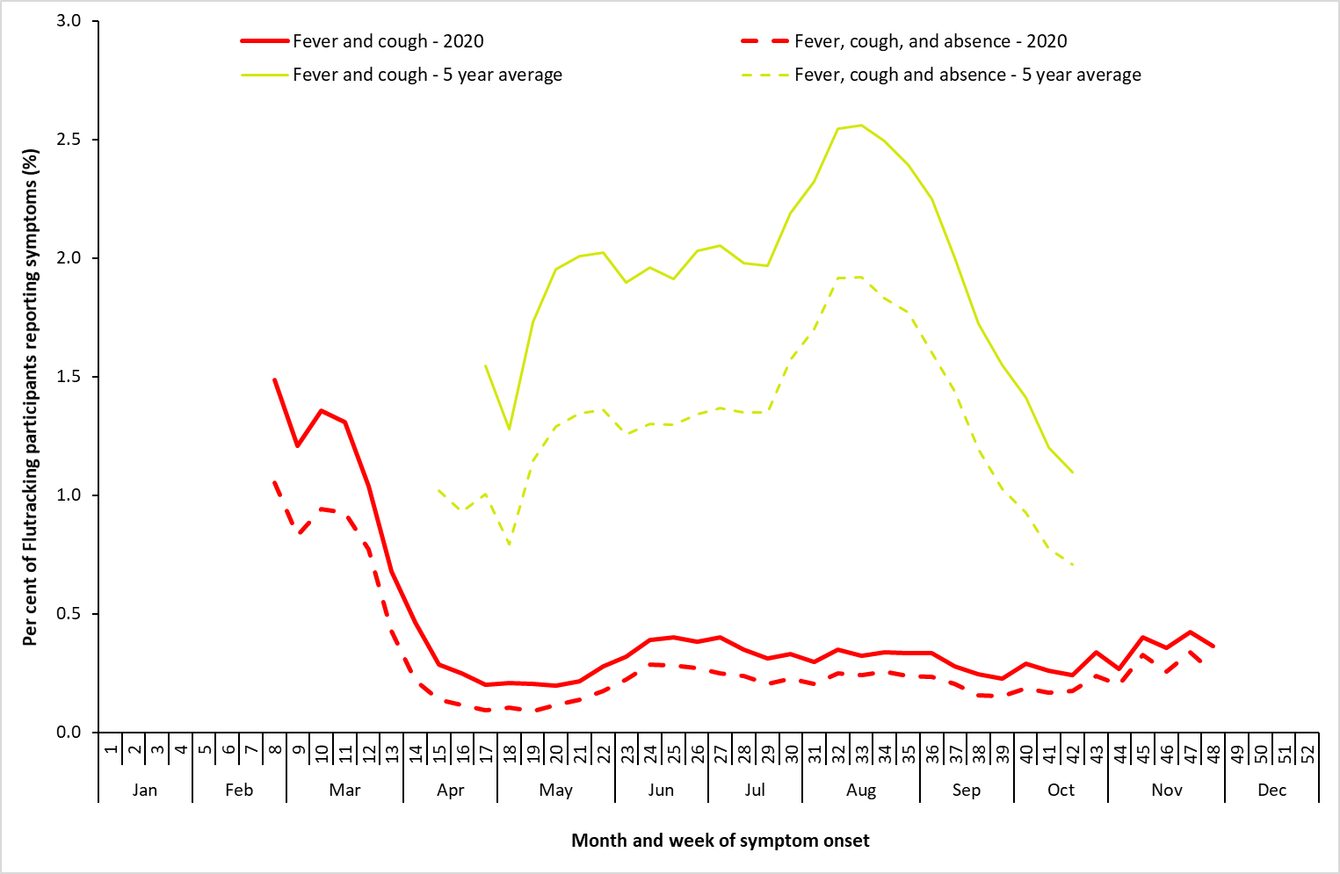

### Severity

* Due to the low number of cases year to date in 2020, the number of sentinel hospital admissions due to laboratory confirmed influenza were lower than previous years. However, the proportion admitted to ICU, was similar to recent years.
* Of patients with confirmed influenza at sentinel hospitals during the season, only one person (6.7% of all sentinel site admissions) were admitted to ICU, which is similar to the range of the past 5 years (range: 7.4% in 2015 to 11.6% in 2017).5
* Of patients hospitalised at sentinel hospitals with influenza, the proportion with influenza A was 73% (40% influenza A(unsubtyped); 27% influenza A(H1N1); 7% influenza A(H3N2)). Influenza B was associated with 27% of sentinel site hospitalisations. The one ICU admission was due to influenza A(H1N1).5
* In the first quarter of 2020, an average of 10% of patients presenting to sentinel GPs each week were influenza positive. This is lower than the weekly average proportion of influenza positive patients during the first quarter of 2019 (27%). In the year to date in 2020, the highest proportion of influenza positive patients occurred in week 4 (42%). During the influenza season, there was one influenza positive patient that presented to a sentinel GP with ILI (6%).2
* Of notifications of laboratory confirmed influenza in the year to date, 0.17% (n=37; 1 death per 575 notifications) were notified to the NNDSS as influenza-associated deaths. This is the lowest rate of influenza associated deaths reported in the last five years, and is a 50% decrease from the 5 year mean (n=0.34%, 1 death per 293 notifications).4
* Influenza associated deaths notified to the NNDSS have largely been in older adults, with 77% of deaths occurring in people aged 65 years and older. The median age of deaths reported in notified cases was 78 years (range: 4 to 97 years).4
* Of the 37 deaths, 95% (n=35) were associated with influenza A (twenty-seven influenza A(unsubtyped); seven influenza A(H1N1); one influenza A(H3N2)), with 5% (n=2) of deaths associated with influenza B.
* The number of influenza-associated deaths reported to the NNDSS does not represent the true mortality associated with this disease. The number of deaths is reliant on the follow up of cases to determine the outcome of their infection. The follow up of cases is not a requirement of notification, and are only inclusive of laboratory-confirmed cases of influenza. Due to retrospective revision, the variation across jurisdictions in methodology, representativeness and timeliness of death data, and reporting of an outcome of infection not being a requirement of notification, year on year comparisons of deaths in notified cases of influenza may not be reliable.

### Virology

* Influenza A(H1N1)pdm09 was the predominant virus in circulation this season.4
* In the year to date, 87.1% of notifications of laboratory confirmed influenza to the NNDSS were influenza A (of which 91.1% were influenza A(unsubtyped), 7.8% influenza A(H1N1)pdm09, and 1.2% influenza A(H3N2)), 12.6% were influenza B, and less than 1% were influenza A&B co‐infections or untyped.4
* From 1 January to 30 November 2020, 306 isolates were characterised for similarity to the corresponding vaccine components by haemagglutination inhibition (HI) assay. Of the isolates characterised, 44% of influenza A(H1N1)pdm09, 65% of influenza A(H3N2), and all influenza B/Victoria and B/Yamagata isolates showed antigenic similarity to the corresponding vaccine components.6
* Fifty-six percent of influenza A(H1N1)pdm09 and 35% of influenza A(H3N2) isolates were characterised as low reactors.6

### Vaccine effectiveness

* Influenza viruses are continually changing, making the targeting of an effective vaccine a constant challenge each year.
* The small number of cases reported across systems during the 2020 influenza season in Australia precludes meaningful analysis to estimate vaccine effectiveness.

### Geographical variations

* Influenza activity from January to March 2020 was similar to previous years across Australia, with all jurisdictions experiencing a sudden drop in influenza notifications at the end of March, coinciding with the commencement of lockdown and physical distancing measures in Australia.
* Overall, all jurisdictions experienced lower levels of influenza activity in 2020 compared to previous years, with the annual notification rate in jurisdictions dropping between 4 and 11 times lower than the five year mean.4
* There was also variation across jurisdictions in the influenza type and subtype distribution. The proportion of all notifications in 2020 reported as influenza A ranged from 79.3% in South Australia, to 90.1% in the Northern Territory. Where subtyping information was available, all jurisdictions reported a greater proportion of influenza A(H1N1)pdm09 than A(H3N2).4

### At-risk Populations

* Compared to other age groups, influenza notification rates were highest in children aged under 10 years. In previous years, the notification rate in adults aged 65 years or older has been higher than the rate in younger adults aged 20–64 years. However, in 2020, the notification rate in adults aged 65 years or older was lower than the rate in younger adults.4
* Where influenza A subtyping information was available, influenza A(H1N1) was the predominant strain in all age groups. Of those who had influenza B, the rate was highest in those aged younger than 40 years.4
* Of hospitalised patients with confirmed influenza, 20% occurred among people aged 65 or older, with children younger than 16 years accounting for most (54%) hospitalisations. Among those hospitalised, 31% were Aboriginal and/or Torres Strait Islander people. Males accounted for 80% of influenza associated hospitalisations across sentinel sites.5
* Medical comorbidities were reported in all (n=3) in patients aged 65 or older hospitalised at sentinel hospital sites.5
* There was one ICU admission recorded in sentinel hospitals, occurring in a child aged younger than 16 years.5

### Antiviral Resistance

• The WHOCC reported that from 1 January to 30 November 2020, two of the 323 influenza viruses tested for neuraminidase inhibitor resistance, demonstrated reduced inhibition to Oseltamivir.6

### Data considerations and further information

Due to an overlap between COVID-19 and ILI symptoms, several influenza surveillance systems commenced surveillance activities earlier than usual in 2020.

This report presents an overview of influenza activity based on a number of complimentary systems. No one single system, including notification data, provides the full picture on influenza, because influenza is a common disease and its presenting symptoms are non-specific. The epidemiology of influenza is informed by a number of different systems based in the community, laboratories, primary care and hospitals, as well as notifiable diseases data, which includes officially reported deaths. The information in this report is reliant on the surveillance sources available to the Department of Health at the time of production.

Data in this summary is reported by International Organization for Standardization (ISO) 8601 weeks, with the week ending on Sunday. Throughout the summary, where the seasonal period is presented, refers to the period from week 15 (week beginning 06 April 2020) to week 48 (week beginning 23 November 2020). Year to date refers to the period 01 January to 29 November 2020. NNDSS data is analysed and reported based on diagnosis date, which is the true onset date of a case if known, otherwise it is the earliest of the specimen date, the notification date or the notification received date. NNDSS data were extracted on 02 December 2020. Due to the dynamic nature of the NNDSS and other surveillance systems, data in this report are subject to retrospective revision and may vary from data reported in other national reports and reports by states and territories. Detailed notes on interpreting the data presented in this report are available at the Department of Health’s [Australian Influenza Surveillance Report](http://www.health.gov.au/flureport) website ([www.health.gov.au/flureport](http://www.health.gov.au/flureport)).

While every care has been taken in preparing this report, the Commonwealth does not accept liability for any injury or loss or damage arising from the use of, or reliance upon, the content of the report. Delays in the reporting of data may cause data to change retrospectively. For further details about information contained in this report please contact the Influenza Surveillance Team (flu@health.gov.au).

For further information regarding influenza activity at the jurisdictional level, please refer to the following State and Territory health surveillance reports:

* ACT: [ACT Influenza Report](https://www.health.act.gov.au/about-our-health-system/population-health/winter-wellbeing-and-flu/flu-act)

(www.health.act.gov.au/about-our-health-system/population-health/winter-wellbeing-and-flu/flu-act)

* NSW: [Influenza Surveillance Report](http://www.health.nsw.gov.au/Infectious/Influenza/Pages/reports.aspx) (http://www.health.nsw.gov.au/Infectious/Influenza/Pages/reports.aspx)
* QLD: [Statewide Weekly Influenza Surveillance Report](https://www.health.qld.gov.au/clinical-practice/guidelines-procedures/diseases-infection/surveillance/reports/flu) (https://www.health.qld.gov.au/clinical-practice/guidelines-procedures/diseases-infection/surveillance/reports/flu)
* SA: [Weekly Epidemiological Summary](http://www.sahealth.sa.gov.au/wps/wcm/connect/public+content/sa+health+internet/about+us/health+statistics/surveillance+of+notifiable+conditions) (Influenza section) (http://www.sahealth.sa.gov.au/wps/wcm/connect/public+content/sa+health+internet/about+us/health+statistics/surveillance+of+notifiable+conditions)
* TAS: [fluTAS Reports](http://www.dhhs.tas.gov.au/publichealth/communicable_diseases_prevention_unit) (http://www.dhhs.tas.gov.au/publichealth/communicable_diseases_prevention_unit)
* VIC: [Influenza Surveillance Reports](https://www2.health.vic.gov.au/public-health/infectious-diseases/infectious-diseases-surveillance/seasonal-influenza-reports) (https://www2.health.vic.gov.au/public-health/infectious-diseases/infectious-diseases-surveillance/seasonal-influenza-reports)
* WA: [Virus WAtch](http://ww2.health.wa.gov.au/Articles/F_I/Infectious-disease-data/Virus-WAtch) (<http://ww2.health.wa.gov.au/Articles/F_I/Infectious-disease-data/Virus-WAtch>)

### References

FluTracking – <https://info.flutracking.net/reports-2/australia-reports/>

Australian Sentinel Practitioners Research Network (ASPREN) – <https://aspren.dmac.adelaide.edu.au/>

Victorian Sentinel Practice Influenza Network (VicSPIN) – <http://www.vidrl.org.au/surveillance/influenza-surveillance/>

National Notifiable Diseases Surveillance System (NNDSS) – [www.health.gov.au/nndssdata](http://www.health.gov.au/nndssdata)

Influenza Complications Alert Network (FluCAN)

World Health Organization Collaborating Centre for Reference and Research on Influenza (WHOCC) – <http://www.influenzacentre.org/Surveillance_Samples_Received.html>