| Logo | **INFormation BRIEF**  **Updated on 30 June 2021** |
| --- | --- |

**2019 Influenza Season in Australia**

**A summary from the National Influenza Surveillance Committee**

## KEY MESSAGES

* **Activity** – The 2019 influenza season began earlier compared with recent years. While there was geographic variation across Australia, in general, activity levels in the 2019 influenza season were higher than the 2017 season, but it was a longer season with a smaller peak.
* **Impact** – The impact of circulating influenza on society, as measured through the proportion of people with influenza-like illness (ILI) taking time off work, and the burden placed on hospitals with people admitted with influenza, was high.
* **Severity** – Clinical severity for the 2019 season, as measured through the proportion of patients admitted directly to intensive care units (ICU), and deaths attributed to influenza, was moderate.
* **Virology** – Influenza A(H3N2) predominated nationally, accounting for an estimated 83% of notified laboratory-confirmed cases of influenza in 2019.
* **At-risk populations** – Children aged less than 10 years were more commonly infected with influenza; however, the severity of illness in this population was on par with other age-groups.
* **Vaccine match and effectiveness** – Based on available data, vaccinated individuals were 46% less likely to present to a general practitioner (GP) with an ILI and test positive for influenza, and 43% less likely to be hospitalised due to influenza, when compared to unvaccinated individuals.

## ANALYSIS

### Activity

* ILI in the Australian community in the 2019 influenza season was within the bounds of recent years, but when compared with previous years, activity began substantially earlier in the year (late April compared to June/July), leading to a longer season that lasted just over six months.
* ILI activity captured by FluTracking displayed an early rise from May in 2019, with the peak of activity occurring two months earlier compared to 2018. ILI levels were above average in the beginning of the season (week 20 to week 27) but dropped to below the 5 year average from week 29 for the remainder of the season.
* In the peak seven weeks of seasonal activity for Flutracking ILI, 12% of participants reported fever and cough, compared with the 5 year average of 11%.[1]
* Nationally, the average sentinel GP ILI consultation rate for the seasonal period (9.2 per 1000 consultations) was slightly higher than the 5 year average for the same period (8.5 per 1000 consultations) (Figure 1).[2],[3]
* There were 313,033 notifications of laboratory-confirmed influenza to the National Notifiable Diseases Surveillance System (NNDSS) in 2019, which is 2.7 times higher than the 5 year average (113,861.2).[4]
* There were 3,913 admissions with confirmed influenza to sentinel hospitals in 2019 (1 April to 6 October), which was higher when compared to the 5 year average.[5]
* Influenza circulated at high levels throughout the 2019 season. For the seasonal period, 34% of patients presenting to sentinel GPs with ILI tested positive for influenza. 2

Figure . ILI presentations to sentinel general practitioners, by week, 2009, 2014-2019 Australia

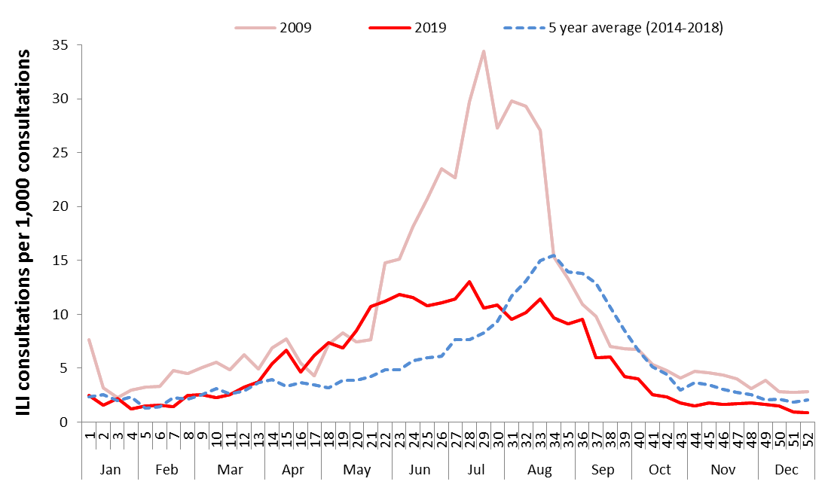

### Impact

* The extended level of activity in the community in 2019 led to circulating influenza having a high level of impact on society and the healthcare system.
* In 2019, 57% of hospital beds available in Influenza Complications Alert Network (FluCAN) sentinel hospitals were occupied by patients with confirmed influenza. This is a higher level of impact when compared to temporal trends (5 year average of 32%).5
* Based on the ratio of beds in sentinel hospitals to the number of hospital beds nationally, there were an estimated 30,000 admissions with confirmed influenza in Australia throughout the 2019 influenza season.
* In the 2019 seasonal period, 27.9% of Flutracking survey respondents reported having ILI and taking time off regular duties while unwell, which was slightly below the 5 year average of 30.0% for same period (Figure 2).1

**Figure 2. Fever, cough and absence among Flutracking participants, by week, 2019, 2014-2019, Australia**

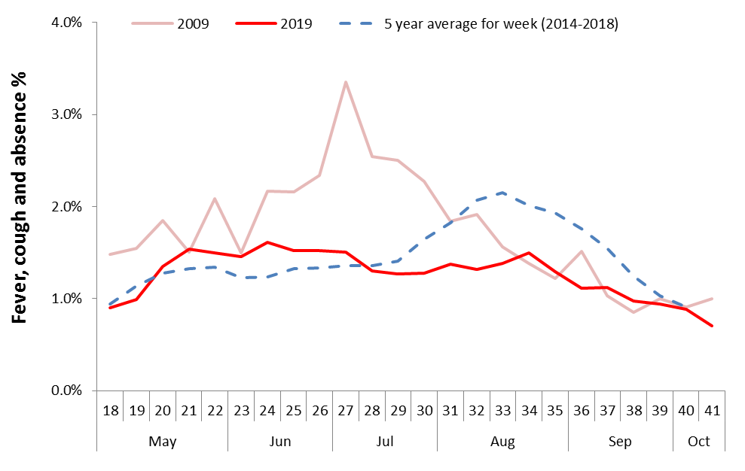

### Severity

* The clinical severity of patients hospitalised with confirmed influenza, based on the proportion admitted to ICU, was on par with recent years.
* Approximately 6.3% of patients with confirmed influenza at sentinel hospitals were admitted to ICU in 2019, which is within the range of the past 5 years (range: 7% in 2015 to 11% in 2014).5
* The proportion of hospitalised patients admitted to ICU ranged by influenza type and subtype – 13.3% of patients with influenza A(H1N1), 6.0% of patients with influenza A(H3N2), and 4.0% of patients with influenza B were admitted to ICU. Of those with an unsubtyped influenza A infection, 6.4% were admitted to ICU.5
* Influenza positivity in patients presenting to sentinel GPs with ILI did not exceed 50% in any week during the seasonal period of 2019. In the previous 5 years, weekly influenza positivity exceeded 50% at no point in 2018, for six weeks in 2017, three weeks in 2016, five weeks in 2015, and 1 week in 2014.2
* The number of deaths reported in notified cases of laboratory-confirmed influenza to the NNDSS in 2019 (n=953) was considerably higher than the 5 year average (403.8), but 19% lower than the number of deaths reported in 2017 (n=1,183).
* The ratio of deaths to all notified cases in 2019 (1 death per 328 notifications) was higher than the 5 year historic range (range: 1 death per 451 notifications in 2015 to 1 death per 391 notifications in 2018).4
* Deaths reported in notified cases to the NNDSS have largely been in older adults. The median age of deaths reported in notified cases was 86 years (range: 1 to 106 years), with 87% of deaths reported in people aged 65 years and older.4
* *The number of influenza-associated deaths reported to the NNDSS does not represent the true mortality associated with this disease. The number of deaths is reliant on the follow up of cases to determine the outcome of their infection. The follow up of cases is not a requirement of notification, and notified cases are only inclusive of laboratory-confirmed cases of influenza. Due to retrospective revision, the variation across jurisdictions in methodology, representativeness and timeliness of death data, and reporting of an outcome of infection not being a requirement of notification, year on year comparisons of deaths in notified cases of influenza may not be reliable.*

### Virology

* Influenza A(H3N2) was the predominant virus in circulation this season.
* In 2019, 76.6% of notifications of laboratory-confirmed influenza to the NNDSS were influenza A, of which 94% were A(unsubtyped), 1% influenza A(H1N1)pdm09, and 4% influenza A(H3N2). Influenza B accounted for 23% of notifications, and less than 1% were influenza A&B co‐infections or untyped.
* Based on the assumption that A(unsubtyped) notifications had the same subtype distribution as the swab tests from Australian Sentinel Practices Research Network (ASPREN) GPs, the distribution of influenza viruses nationally for 2019 was estimated to be 83% influenza A(H3N2), 14% influenza A(H1N1)pdm09, and 23% influenza B.4
* From 1 January to 31 December 2019, 2,985 isolates were characterised for similarity to the corresponding vaccine components by haemagglutination inhibition (HI) assay. Influenza A(H1N1)pdm09 viruses and viruses from both influenza B lineages appeared to be antigenically similar to the corresponding vaccine components. Four per cent of Influenza A(H1N1)pdm09, 11% of influenza B(Yamagata), and 3% of influenza B(Victoria) isolates were characterised as low reactors.[6]
* Of the influenza A(H3N2) isolates that were able to be assessed by HI assay, 21% were characterised as low reactors. However, there are ongoing technical issues that significantly limit the capacity of the Australian World Health Organization Collaborating Centre for Reference and Research on Influenza (WHOCC) to fully assess the similarity of circulating influenza A(H3N2) viruses to the vaccine strain. In 2019, there were an additional 266 influenza A(H3N2) isolates that were unable to be characterised by HI assay due to insufficient haemagglutination titre.6

### Vaccine effectiveness

* Influenza viruses are continually changing, making the targeting of an effective vaccine a constant challenge each year.
* Vaccine effectiveness estimates were determined using sentinel GP presentation and hospitalisation data.
* Compared to unvaccinated individuals, vaccinated individuals were 46% (95% CI: 36, 55) less likely to present to a GP with an ILI and test positive for influenza. Protection was estimated to be higher against influenza B (VE=64%, 95% CI: 48, 75) and influenza A(H1N1)pdm09 (VE=62%, 95% CI: 39, 77), and lower for influenza A(H3N2) (VE=37%. 95% CI:24, 48).2
* Compared to unvaccinated individuals, vaccinated individuals were 43% (95% CI: 36, 49) less likely to be hospitalised due to all influenza. Protection was estimated to be slightly higher against influenza A(H1N1)pdm09 (VE=69%, 95% CI: 55, 79) and lower for influenza B (VE=45%, 95% CI: 31, 56) and influenza A(H3N2) (VE=34%, 95% CI: 20, 46).5
* Differences between vaccine effectiveness against GP presentation and against hospitalisation may reflect differences in populations (older patients in the hospitalised group) and potential attenuation of severity of illness by vaccination.
* The estimate of vaccine effectiveness against GP presentation for the 2019 season is consistent with previous years. Vaccine effectiveness against GP presentation ranged from 35% to 60% between 2012 and 2017.7-10
* The estimated effectiveness of the vaccine may depend on a number of factors – the outcome being measured, the age group predominantly affected (vaccine effectiveness is generally lower in older people than in younger adults and children), the match between vaccine and circulating influenza strains (generally protection against infection with A(H1N1)pdm09 is greater than against A(H3N2)), and the vaccine type used.

### Geographical variations

* All jurisdictions displayed higher levels of activity in 2019 compared to the 5 year mean.
* While all jurisdictions displayed an earlier than expected increase in influenza activity, their seasonal peaks and breadth varied. Western Australia (WA) displayed the shortest seasonal peak with a sharp increase in activity occurring between week 21 and week 27.
* There was also variation across jurisdictions in the influenza type and subtype distribution. The proportion of all notifications in 2019 reported as influenza A ranged from 73.1% in New South Wales and WA to 88.5% in TAS. Where subtyping information was available, all jurisdictions reported a greater proportion of influenza A(H3N2) than A(H1N1)pdm09.4

### At-risk Populations

* Notification rates were highest in children aged under 10 years with a secondary peak in adults aged 80 years or older, mainly attributable to influenza A(H3N2).4
* Medical comorbidities were common in hospitalized patients aged over 65 years (87.3% had comorbidities) but less common in children aged 15 years or younger (36.5% had comorbidities).5
* Of hospitalized patients with confirmed influenza, 7.7 % were Indigenous Australians. Of the 461 hospitalisations with influenza in females aged 16-49 years, 1.7% were pregnant. 5
* Where subtyping information was available, influenza A(H3N2) was the predominant strain in all age groups.4
* ICU admissions with confirmed influenza were similar by age group. Of children (0-15 years) admitted with confirmed influenza, 5.2% were admitted to ICU. This is slightly less than the percentage of adults aged between 16 and 64 years (8.4%) and adults aged 65 years and older (5.4%) that were admitted to ICU.5

### Antiviral Resistance

• The WHOCC reported that from 1 January to 31 December 2019, of the 3,975 influenza viruses tested for neuraminidase inhibitor resistance, one demonstrated reduced inhibition to Oseltamivir and two demonstrated reduced inhibition to Zanamivir. 5

### Further Information

No one single system, including notification data, provides the full picture on influenza, because influenza is a common disease and its presenting symptoms are non-specific. The epidemiology of influenza is informed by a number of different systems based in the community, laboratories, primary care and hospitals, as well as official deaths and notifiable diseases data. Throughout the influenza season in Australia these systems are reported in the [Australian Influenza Surveillance Report](http://www.health.gov.au/flureport) at www.health.gov.au/flureport. For further details about information contained in this report please contact the [Influenza Surveillance Team](mailto:flu@health.gov.au) (flu@health.gov.au).

Throughout the summary, where the seasonal period is presented, this is from week 18 (week beginning   
29 April 2019) to week 40 (week beginning 30 September 2019). FluCAN data on hospitalised influenza cases is reported for the period 1 April to 6 October 2019. NNDSS data were extracted on 29 April 2020 for the period 1 January 2019 to 31 December 2019. Due to the dynamic nature of the NNDSS and other surveillance systems, data in this report are subject to retrospective revision and may vary from data reported in other national reports and in reports by states and territories.

The National Influenza Surveillance Committee is a subcommittee of the Communicable Diseases Network Australia.

For further information regarding influenza activity at the jurisdictional level, please refer to the following State and Territory health surveillance reports:

* Australian Capital Territory: [Flu in the ACT](https://www.health.act.gov.au/about-our-health-system/population-health/winter-wellbeing-and-flu/flu-act) (https://www.health.act.gov.au/about-our-health-system/population-health/winter-wellbeing-and-flu/flu-act)
* New South Wales: [Influenza Surveillance Report](http://www.health.nsw.gov.au/Infectious/Influenza/Pages/reports.aspx) (http://www.health.nsw.gov.au/Infectious/Influenza/Pages/reports.aspx)
* Queensland: [Statewide Weekly Influenza Surveillance Report](https://www.health.qld.gov.au/clinical-practice/guidelines-procedures/diseases-infection/surveillance/reports/flu) (https://www.health.qld.gov.au/clinical-practice/guidelines-procedures/diseases-infection/surveillance/reports/flu)
* South Australia: [Weekly Epidemiological Summary](http://www.sahealth.sa.gov.au/wps/wcm/connect/public+content/sa+health+internet/about+us/health+statistics/surveillance+of+notifiable+conditions) (Influenza section) (http://www.sahealth.sa.gov.au/wps/wcm/connect/public+content/sa+health+internet/about+us/health+statistics/surveillance+of+notifiable+conditions)
* Tasmania: [fluTAS Reports](http://www.dhhs.tas.gov.au/publichealth/communicable_diseases_prevention_unit) (http://www.dhhs.tas.gov.au/publichealth/communicable_diseases_prevention_unit)
* Victoria: [Seasonal influenza reports](https://www2.health.vic.gov.au/about/publications/researchandreports/seasonal-influenza-reports-2018) (https://www2.health.vic.gov.au/about/publications/researchandreports/seasonal-influenza-reports-2018)
* Western Australia: [Virus WAtch](http://ww2.health.wa.gov.au/Articles/F_I/Infectious-disease-data/Virus-WAtch) (http://ww2.health.wa.gov.au/Articles/F_I/Infectious-disease-data/Virus-WAtch)

1. . [Flutracking](https://info.flutracking.net): <https://info.flutracking.net/>
2. . [Australian Sentinel Practitioners Research Network](https://aspren.dmac.adelaide.edu.au/) (ASPREN): <https://aspren.dmac.adelaide.edu.au/>
3. . [Victorian Sentinel Practice Influenza Network](http://www.vidrl.org.au/surveillance/influenza-surveillance/) (VicSPIN): <http://www.vidrl.org.au/surveillance/influenza-surveillance/>
4. . [National Notifiable Diseases Surveillance System](http://www.health.gov.au/nndssdata) (NNDSS): [www.health.gov.au/nndssdata](http://www.health.gov.au/nndssdata)
5. . [Influenza Complications Alert Network](https://monashhealth.org/services/monash-infectious-diseases/research/influenza-research/flucan-influenza-surveillance-2/) (FluCAN): <https://monashhealth.org/services/monash-infectious-diseases/research/influenza-research/flucan-influenza-surveillance-2/>
6. . [World Health Organization Collaborating Centre for Reference and Research on Influenza](http://www.influenzacentre.org/surveillance_samplesreceived.htm) (WHOCC): <http://www.influenzacentre.org/surveillance_samplesreceived.htm>l

   7. Sheena G Sullivan, Monique B-N Chilver, Geoff Higgins, Allen C Cheng, Nigel P Stocks. Influenza vaccine effectiveness in Australia: results from the Australian Sentinel Practices Research Network, *Medical Journal of Australia*. 2014 Jul 21;201(2):109-11. [DOI: 10.5694/MJA14.00106](https://onlinelibrary.wiley.com/doi/full/10.5694/mja14.00106).

   8. Sullivan SG, Carville KS, Chilver M, Fielding JE, Grant KA, Kelly H, Levy A, Stocks NP, Tempone SS, Regan. AK. Pooled influenza vaccine effectiveness estimates for Australia, 2012-2014. *Epidemiolgy and Infection*. 2016 Aug;144(11):2317-28. [DOI: 10.1017/S0950268816000819](https://www.cambridge.org/core/journals/epidemiology-and-infection/article/pooled-influenza-vaccine-effectiveness-estimates-for-australia-20122014/5FDC2D885A8AF020C952F47395AE09B8).

   9. Fielding JE, Levy A, Chilver MB, Deng YM, Regan AK, Grant KA, Stocks NP, Sullivan SG. Effectiveness of seasonal influenza vaccine in Australia, 2015: An epidemiological, antigenic and phylogenetic assessment. *Vaccine*. 2016 Sep 22;34(41):4905-4912. [DOI: 10.1016/j.vaccine.2016.08.067](https://www.sciencedirect.com/science/article/pii/S0264410X16307630?via%3Dihub). Epub 2016 Aug 28.PMID: 27577556

   10. Sullivan SG, Chilver MB, Carville KS, Deng YM, Grant KA, Higgins G, Komadina N, Leung VK, Minney-Smith CA, Teng D, Tran T, Stocks N, Fielding JE. Low interim influenza vaccine effectiveness, Australia, 1 May to 24 September 2017. *Eurosurveillance*. 2017 Oct;22(43):17-00707. [DOI: 10.2807/1560-7917.ES.2017.22.43.17-00707](https://www.eurosurveillance.org/content/10.2807/1560-7917.ES.2017.22.43.17-00707).PMID: 29090681