This is an image. 

To change the image right click on it and select 'Change Picture' > 'From File'. 

Please do not change the size of this header image

Header graphics housing department logo and corner device.  

These header graphics should only appear on the first page.Aged Care Quality Standards

The Aged Care Quality Standards provide a shared understanding of what is expected in aged care, making quality everyone’s business.

****About the Aged Care Quality Standards****

The Aged Care Quality Standards help older Australians to feel secure and supported, give families confidence that their loved ones are looked after, and ensure that aged care providers and workers know what is expected of them, whatever their size, location or offering.

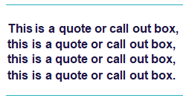

**“The Quality Standards set the expectations for quality aged care in Australia.”**

**We are currently reviewing the Aged Care Quality Standards**

The Royal Commission into Aged Care Quality and Safety highlighted that while the Quality Standards are a powerful tool to maintain and improve quality of care across the aged care sector, they required urgent revision to make them relevant and appropriate for the people they are intended to support.

We are urgently reviewing the Quality Standards. Through significant consultation with older Australians, their families and carers, the sector and experts, we are strengthening the Quality Standards with a focus on key areas such as dementia, clinical care, governance, diversity and food and nutrition.

A strengthened version of the Quality Standards has been developed and can be seen in the following diagram.

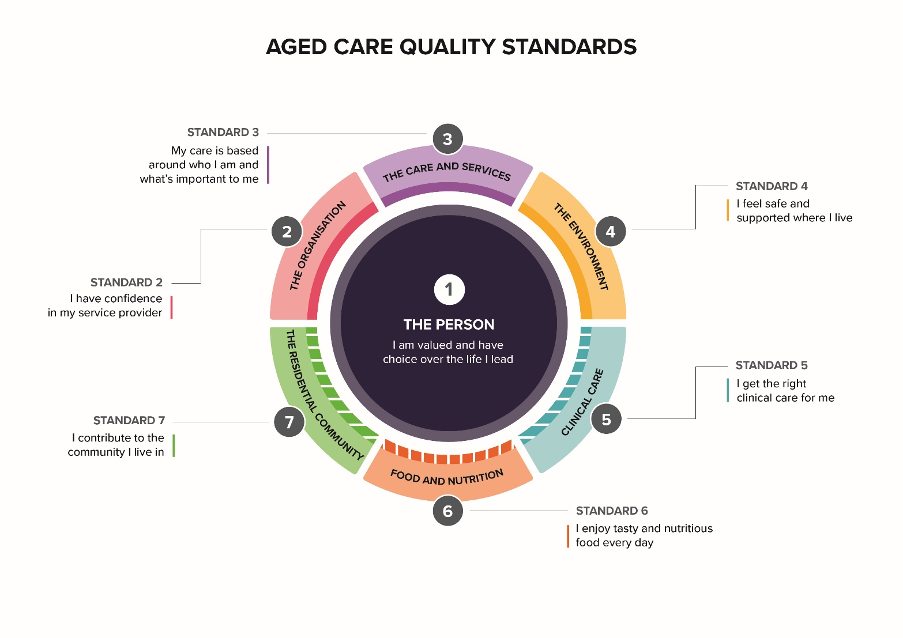**Have your say, because quality aged care matters**

We want to hear your views on the strengthened Quality Standards, because we understand that quality aged care means different things to different people.

Through public consultation we aim to test key concepts and seek feedback on any gaps or opportunities to clarify expectations in the Quality Standards. This will inform the final report on the strengthened Quality Standards to Government by the end of 2022.

Public consultation will occur over six weeks commencing on 17 October 2022 and concluding on 25 November 2022. There will be opportunities to engage via a webinar, surveys and focus groups.

For more information and to have your say, visit **AgedCareEngagement.health.gov.au**



Phone **1800 318 209** (My Aged Care’s free call phone line) if you would like to request a copy of the survey by mail.



Visit **AgedCareEngagement.health.gov.au**

For translating and interpreting services, call 131 450.

To use the National Relay Service, visit nrschat.nrscall.gov.au/nrs or call 1800 555 660.