PBS Approved Suppliers Portal

How to request reissue of a PBS Approval to Supply (s90) Certificate

Table of Contents

1. Purpose 3

2. Important information 3

3. Accessing the PBS Approved Suppliers Portal 3

4. Requesting a Certificate 5

5. Contact us 6

# Purpose

This guide provides instructions on how to request reissue of your PBS Approval to Supply (s90) Certificate (Certificate) via the PBS Approved Suppliers Portal (Portal).

# Important information

* You do not need to sign in to the PBS Approved Suppliers Portal to use the Certificate Reissue function; you can access this function whether or not you are registered and signed in to the Portal.
* Please do **not** request a copy of your Certificate if you have been approved to supply PBS medicines within the last 10 business days. Your Certificate will be sent to you in due course.
* Requests for reissue of a Certificate made via the PBS Approved Suppliers Portal will be processed within 10 business days. Please do not send another request if it is within this period.
* Requests for reissue of a Certificate will be accepted from a business owner only.

# Accessing the PBS Approved Suppliers Portal

Type <https://pbsapprovedsuppliers.health.gov.au> into your browser. The preferred browsers are Google Chrome or Firefox.

* If you choose not to sign in to the Portal to request reissue of your Certificate, simply select the ‘Certificate Reissue’ tab from the Home screen.

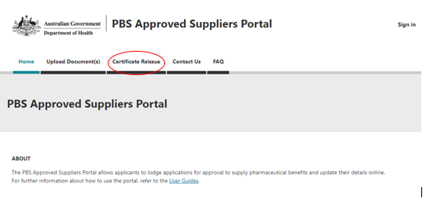

* If you choose to **sign in** to the Portal to request your Certificate, sign-in as usual or, for further details on how to register and sign in to the Portal for the first time, refer to [How to register and sign in to the PBS Approved Suppliers Portal](https://www1.health.gov.au/internet/main/publishing.nsf/Content/pharmaceutical-benefits-scheme-approved-supplier-guides-and-forms).
* When you have signed in, select the ‘Certificate Reissue’ tab from the Home screen.

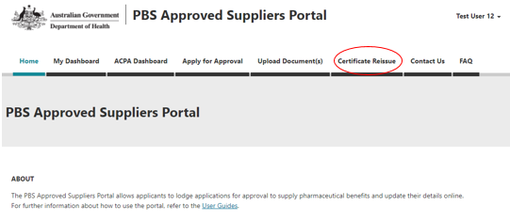

From this point, the process for requesting reissue of a Certificate is essentially the same, whether or not you are signed in to the Portal.

# Requesting a Certificate

After you click on the ‘Certificate Reissue’ tab, the following screen will be displayed:

Screenshot of the mandatory fields for certificate reissues request. 
First Name, Last name, Email, Phone number, approval number, pharmacy name, address details. 
Verification code required for non-signed in users

If you are signed in, the verification code is not required and will not be displayed.

* Enter the details for all mandatory fields, then
* if you are signed in, click on the ‘Submit’ button; or
* if you are not signed in, enter the verification code from the image, and then click on the ‘Submit’ button.

Once you click on the ‘Submit’ button, the following acknowledgement screen will be displayed and you will receive an email confirming receipt of your request.

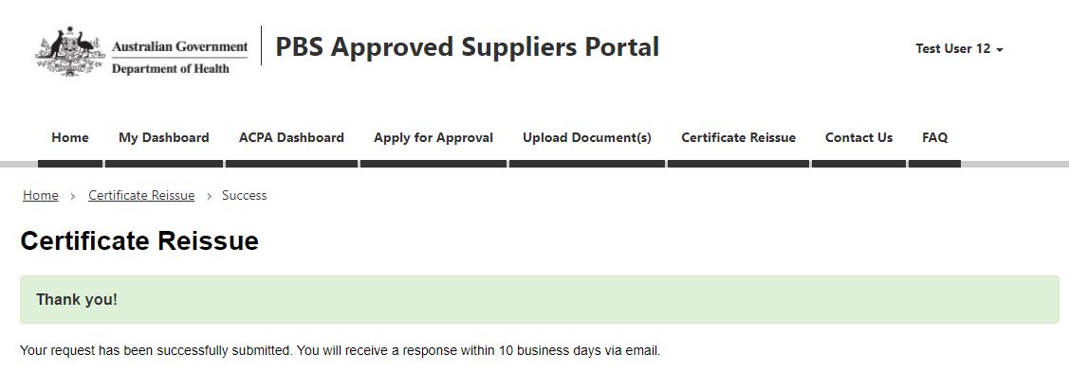

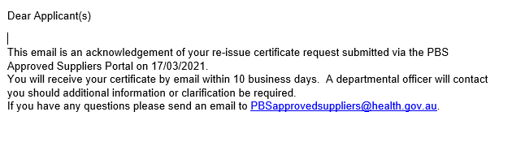

# Contact us

If you have any questions about using the PBS Approved Suppliers Portal or the Certificate Reissue function, please send an email with details of your enquiry and include your approval number to [PBSApprovedSuppliers@health.gov.au](mailto:PBSApprovedSuppliers@health.gov.au).