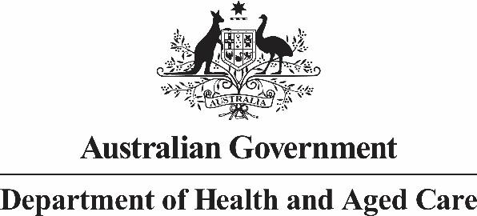

Nurse Practitioner 10 Year Plan Steering Committee

Meeting Communique 04 August and 05 August 2022

The fifth Nurse Practitioner 10 Year Plan Steering Committee (NPSC) meeting was held across two consecutive sessions on 04 and 05 August 2022. Adjunct Professor (Practice) Alison McMillan PSM chaired the two-day meeting, which was hosted from the land of the Ngunnawal people.

Steering Committee members contributed valuable feedback on provisional actions that may sit within the Plan, grouped by the themes of Education & Training, Recruitment & Retention, Models of Care and Workforce Planning. The proposed aims, outcomes and responsible organisations in respect of each of the actions were also considered by Steering Committee members.

The NPSC will meet again in October 2022 to review the draft Nurse Practitioner 10 Year Plan and the approach to the next phase of consultation.

As the development of the Plan continues, further consultation with stakeholders will be undertaken and will be conducted through a variety of mechanisms, including through the Department of Health and Aged Care’s [Consultation Hub](https://consultations.health.gov.au/).