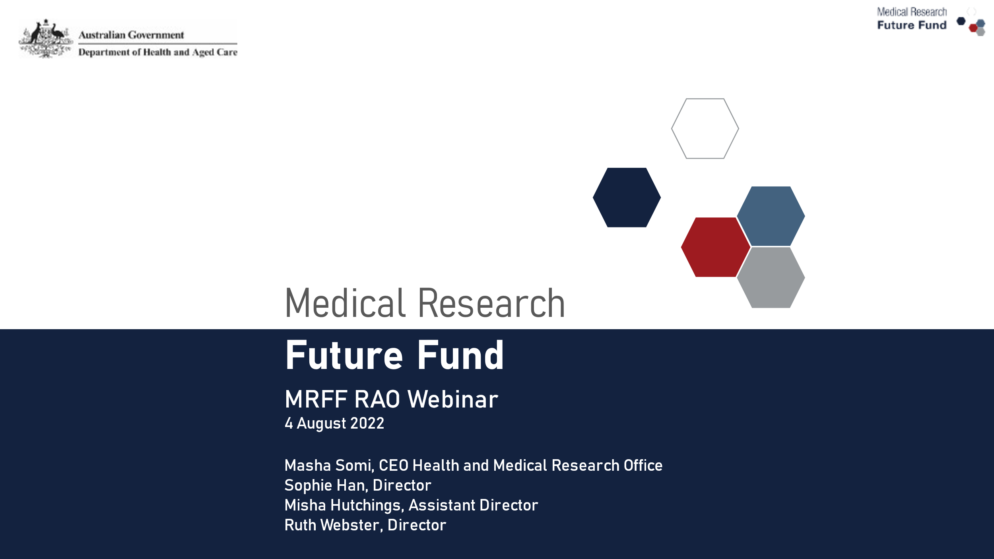
Contents
- The Medical Research Future Fund
  - MRFF RAO Webinars
  - Phases of the MRFF grant lifecycle
- Medical Research Future Fund Act, Strategies and Priorities
- Designing MRFF grant opportunities
- Selecting and establishing MRFF grants
- Managing MRFF grants
- Q&A
- Keep Connected

MRFF Research Administration Officer Webinars
Aim to:
- provide practical information to the sector and Research Administration Officers (RAOs) in particular about MRFF administrative arrangements
- assist RAOs and potential grantees in better supporting MRFF funded research and researchers
- aid the implementation of any administrative changes to the MRFF
- seek feedback from RAOs, with a view toward continuous MRFF administration improvement

Phases of the MRFF grant lifecycle
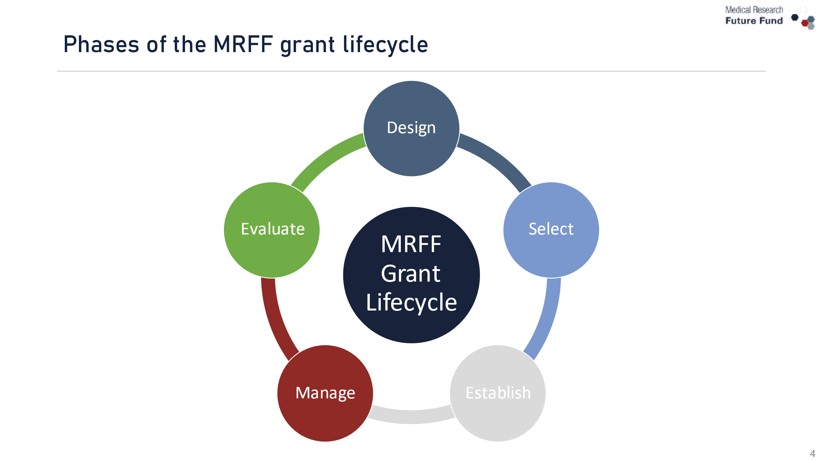

Medical Research Future Fund Act, Strategies and Priorities
Sophie Han, Director of Strategy and Governance Section


Guidance documents and the MRFF
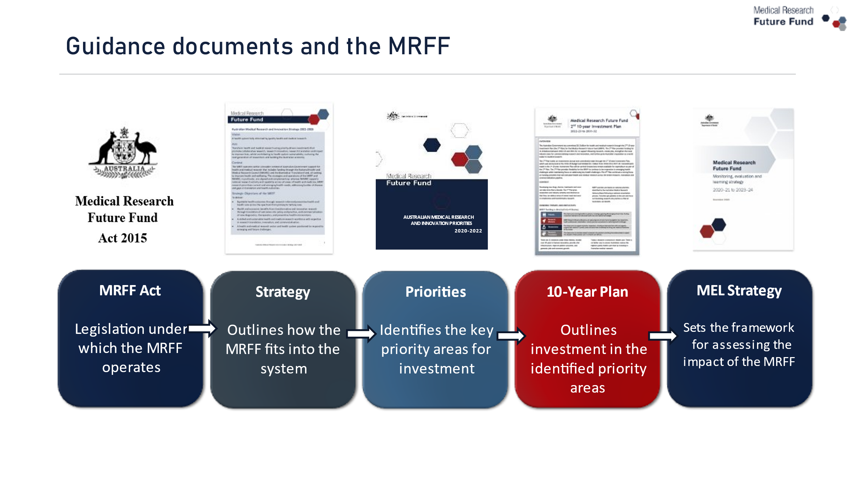

Australian Medical Research and Innovation Strategy 2021-2026 and related Priorities
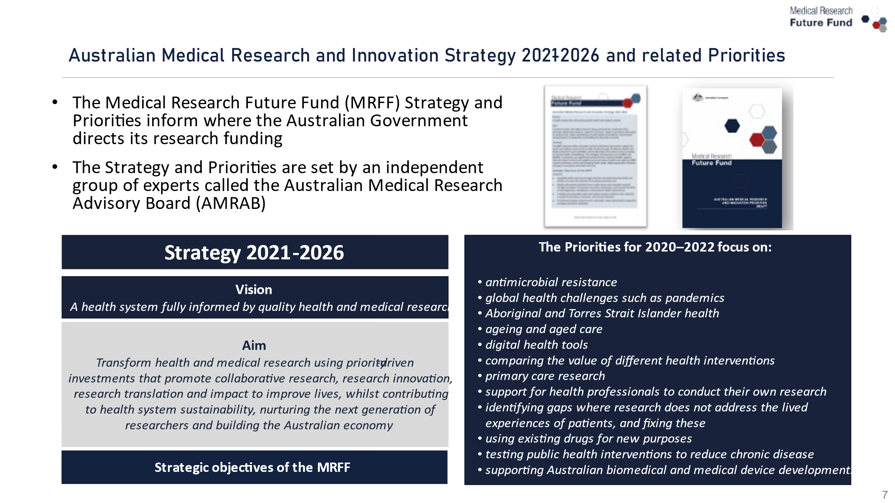

2nd MRFF 10-year Investment Plan
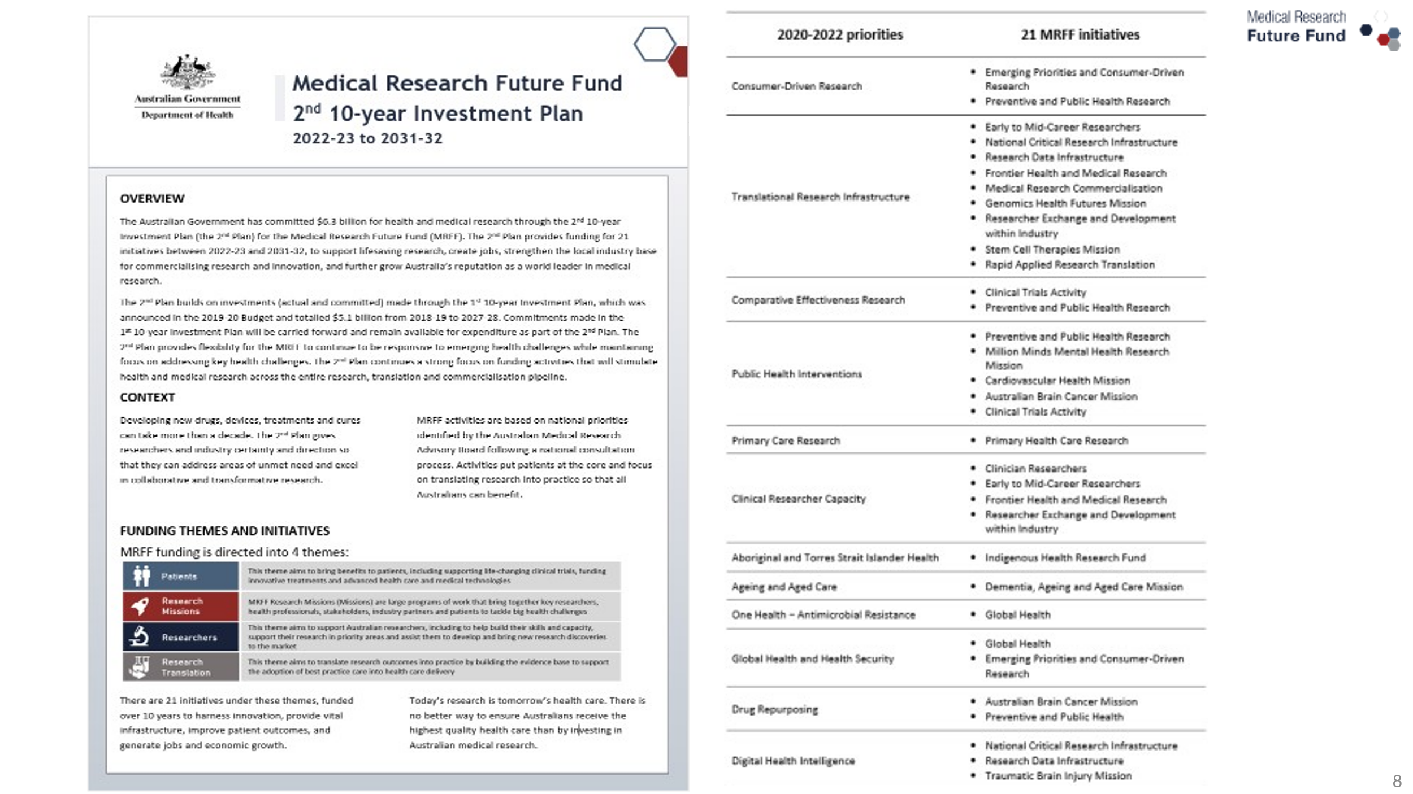

Missions – Roadmap and Implementation Plan
- An Expert Advisory Panel develops a Roadmap and Implementation Plan following national consultation and international review
- The Roadmap is a high level strategic document that includes the aim, vision, goal and priorities for investment for the Mission
- Implementation Plan supports the Roadmap
  - Maps the research required to achieve the goal set out for the Mission (i.e. it will guide research short, medium, and long term investments over the life of the Mission)
  - It establishes how the outcomes from each priority will be evaluated in terms of benefit to Australian patients and facilitate tracking of the Mission’s progress towards its objectives

MRFF Missions, Roadmaps and Implementation Plans
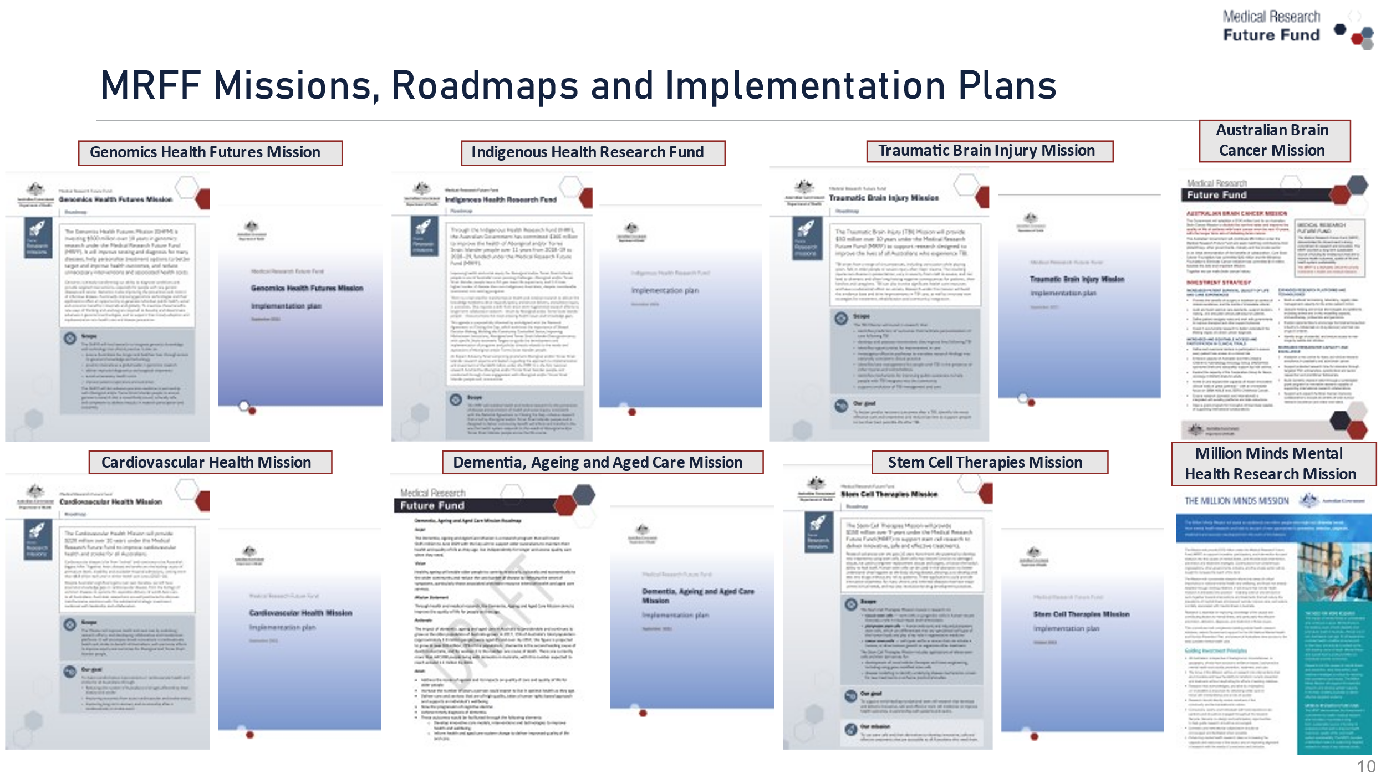

Designing MRFF grant opportunities
Ruth Webster, Director of Patients and Infrastructure Section

How is the MRFF different?
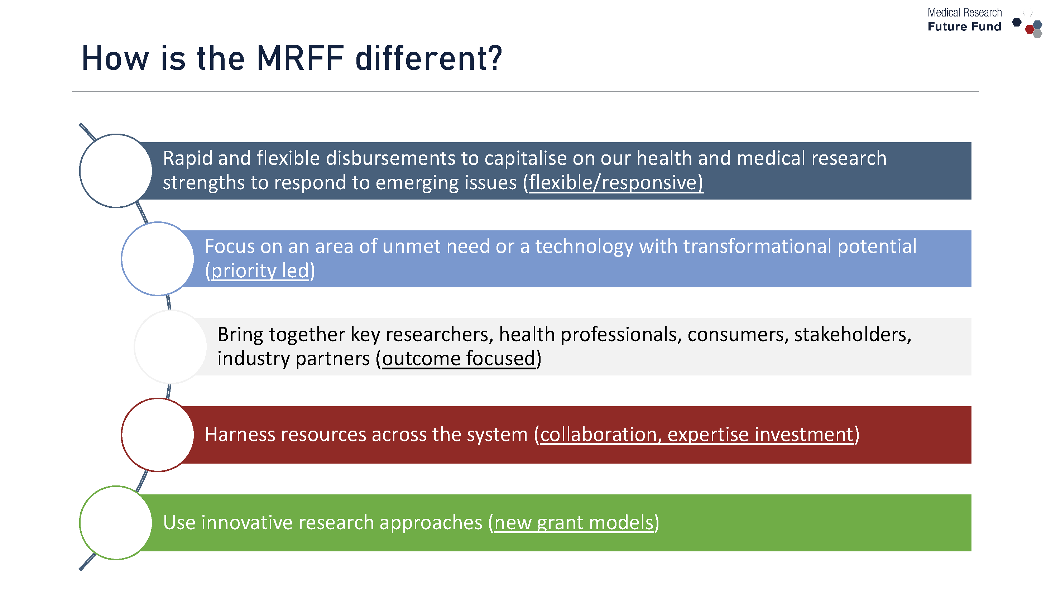

Designing Grant Opportunities
Grant opportunities are designed, taking into account many factors:
- Government priorities and objectives
- AMRAB advice through the Strategy and Priorities as previously mentioned
- Mission Roadmaps and Implementation Plans
- Aims for each Initiative
- Funding available to each Initiative in that financial year
- Literature review
- Scan of the research area for trends and research gaps

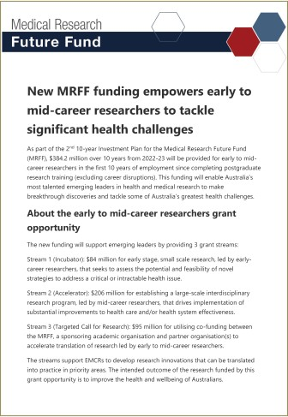
Grant opportunities may:
- Be general, e.g. Early to Mid-Career Researchers
- Be topic specific, e.g. pain relief for Pancreatic cancer
- Use different grant models
- Have multiple streams
  - As a priority-driven funder, this allows us to focus funding on multiple priorities under a single topic
  - If there are differences in eligibility or assessment criteria between streams this will be spelled out

What to look out for in each grant opportunity
Each grant opportunity
- is different – look beyond the title to the objectives and outcomes (section 1.3), eligibility criteria (section 3) and selection criteria (section 5)
- aligns with the Australian Medical Research and Innovation Priorities that are in force (section 1.3)
- must meet the objective of the MRFF Initiative it sits within (e.g. primary care must be a focus of grants under the Primary Health Care Research Initiative)
- requires researchers to identify how they will contribute to the MRFF Measures of Success (section 5 – assessment criteria 1 and 4)
- includes assessment criteria that are focused on outcomes (Impact, Methodology, Capacity/Capability/Resources, Overall Value and Risk)
- uses different MRFF grant models

MRFF grant models
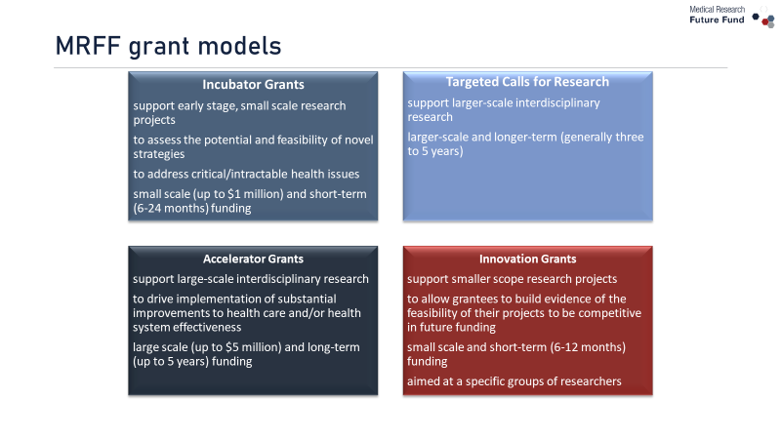

Key considerations when applying
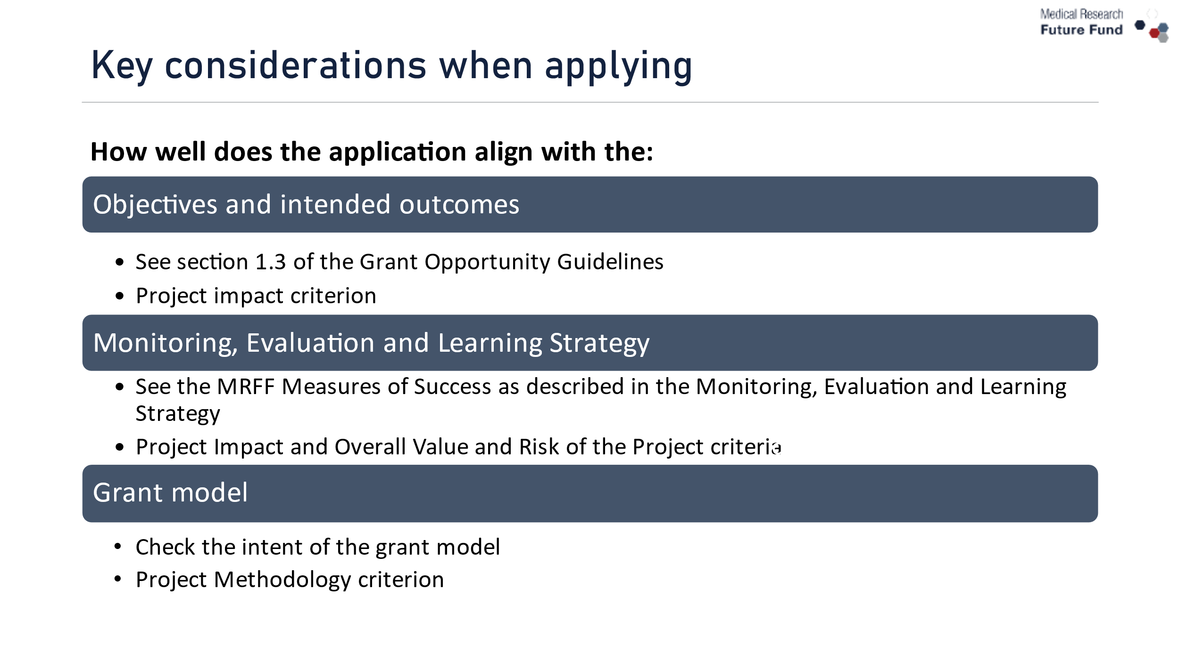

Things to note
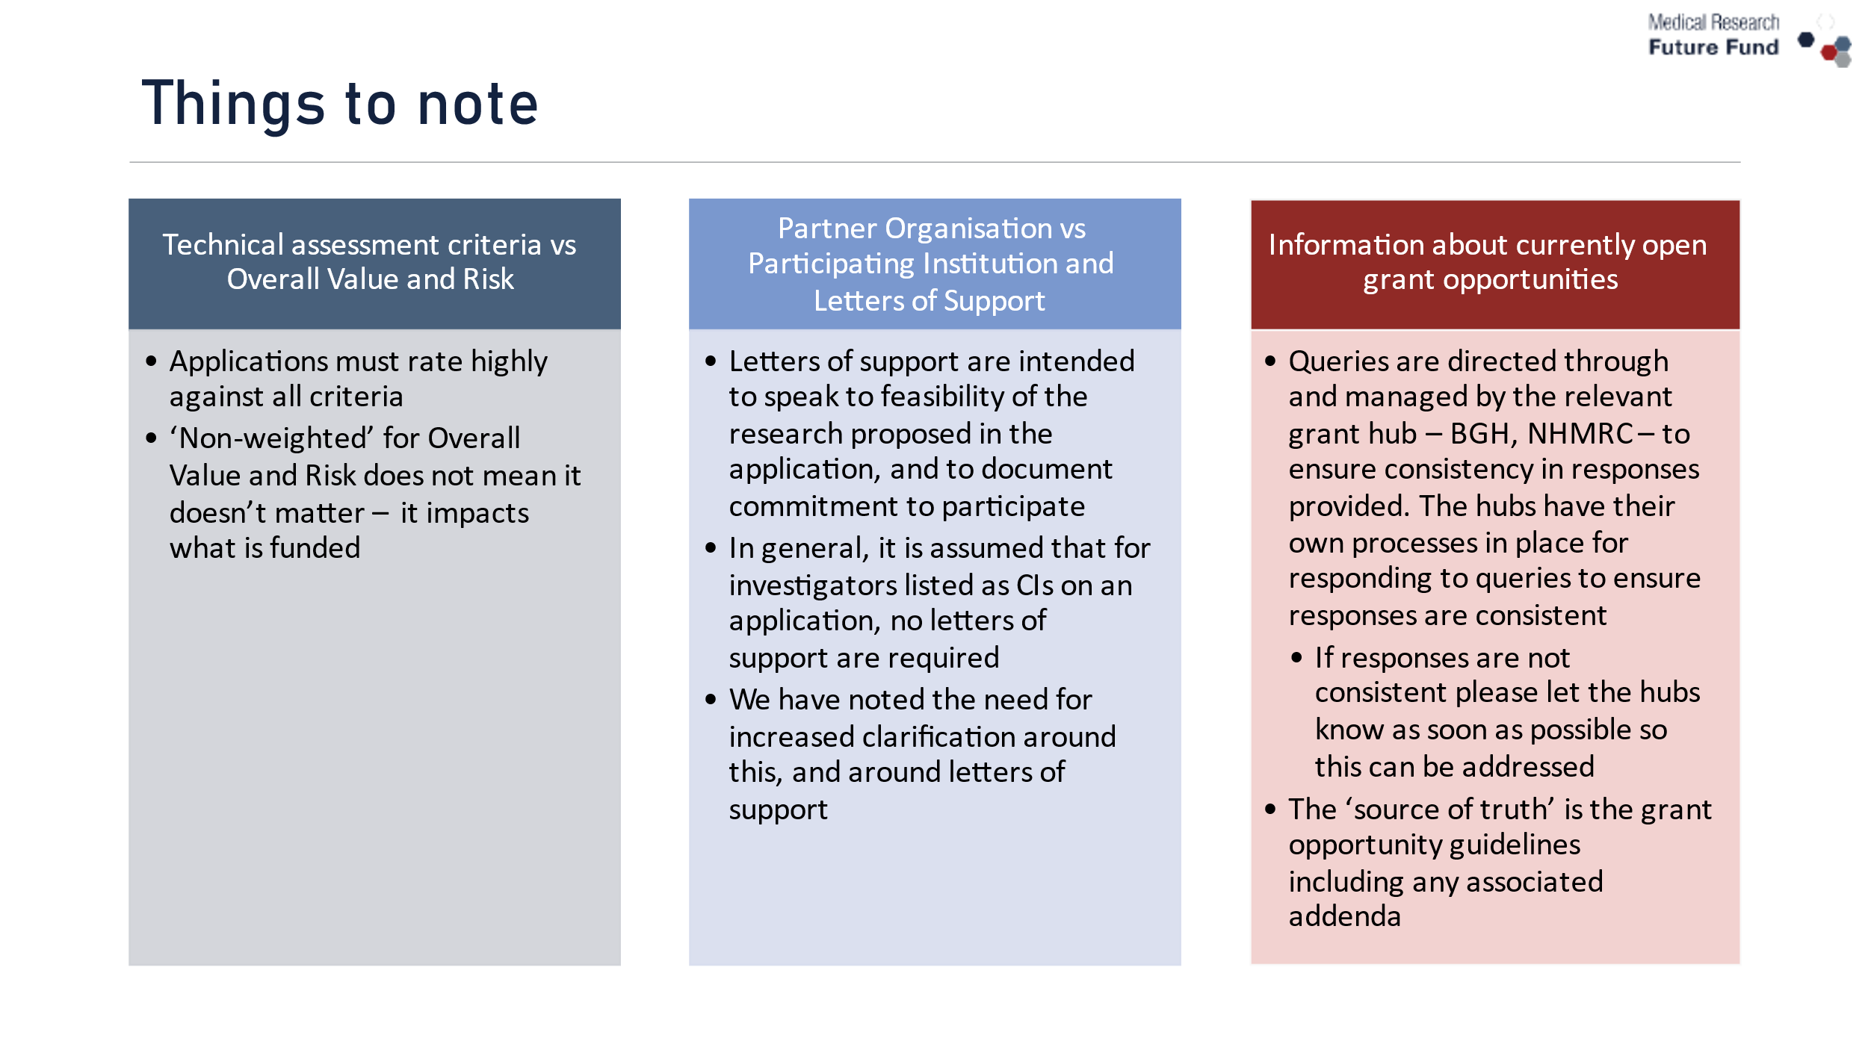

Addenda
The decision to issue an addendum (or FAQs) primarily sits with the grant administration hub (BGH, NHMRC), in consultation with the Department
Addenda are issued:
- to ensure there is equity of information provided to applicants
- when there are points which require clarification of intent or definition
Some matters raised may not require an addendum
- For example, a specific administrative matter that only pertains to a single application, and is not relevant to other applications
Continuous updating of grant opportunity guideline templates occurs to try and address issues for future grant opportunity openings.
- For example, recent issue around definition of 5 year period for publications

Selecting and establishing MRFF grants
Ruth Webster, Director of Patients and Infrastructure Section


The grant opportunity has closed. What next?
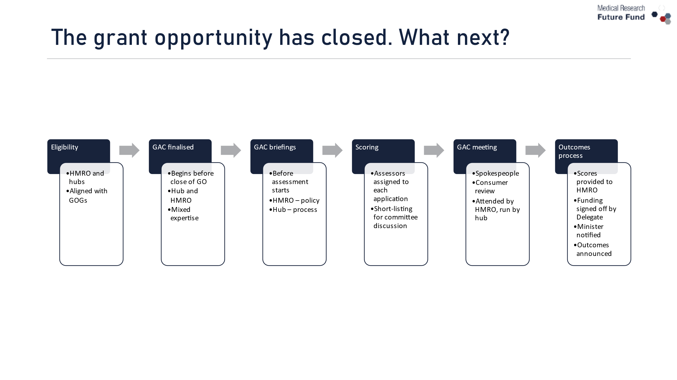

How is a Grant Assessment Committee formed?
The Department works with the grant administration hub to identify suitable Grant Assessment Committee (GAC) members.
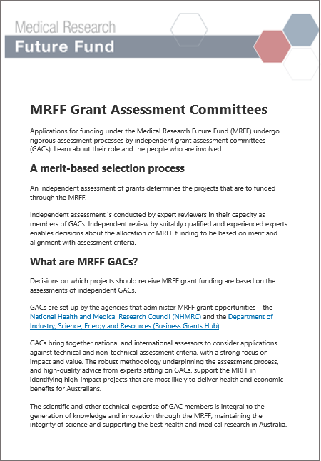
Independent assessment is conducted by expert reviewers in their capacity as members of GACs.
We consider gender balance and geographical representation
Members are selected based on experience and expertise in a range of areas:
- transdisciplinary (e.g. in areas of health economics, biostatistics)
- academia
- clinical
- health services delivery
- translation research
- consumers and patients
- Aboriginal and/or Torres Strait Islander health
- industry and commercialisation expertise

Grant assessment process
Grant Assessment Committee Briefings
- Emphasise to GAC members that MRFF is unique, with different objectives and criteria to that of other funders – how does this reflect in expert assessment?
- Documents provided – application documents, grant opportunity guidelines, scoring matrices

GAC scoring
- Spokesperson model
  - Each application scored by nominated assessors
  - If there is a low number of applications, all applications may be assessed by all assessors
  - Spokesperson allocated to lead discussion at the committee meeting
  - Everyone scores/rescores all the short-listed applications
- Committee Chair/s and the Consumer Representative are usually non-scoring members. However, in some situations the Consumer Representative can also score if they are confident with assessing the methodology and capacity; those with lived-experience are invited to provide comments.

Assessment of applications against criteria
Assessment Criteria | Relevant Grant Proposal section
Project impact (40%) | A – Project impact  F – Measures of success statement
Project methodology (30%) | B – Project methodology  C – Milestones and Performance Indicators
Capacity, capability and resources to deliver the project (30%) | D – Capacity, capability and resources to deliver the project
Overall Value and Risk of the Project (non- weighted) | E – Overall Value and Risk of the Project (risk management plan and partner funding)  F – Measures of success statement
Threshold for funding:
- NHMRC: 4 or higher against all technical criteria, at least ‘Good’ for Overall Value and Risk
- BGH: 5 or higher against all technical criteria, at least ‘Good’ for Overall Value and Risk

Assessment criteria scoring matrices
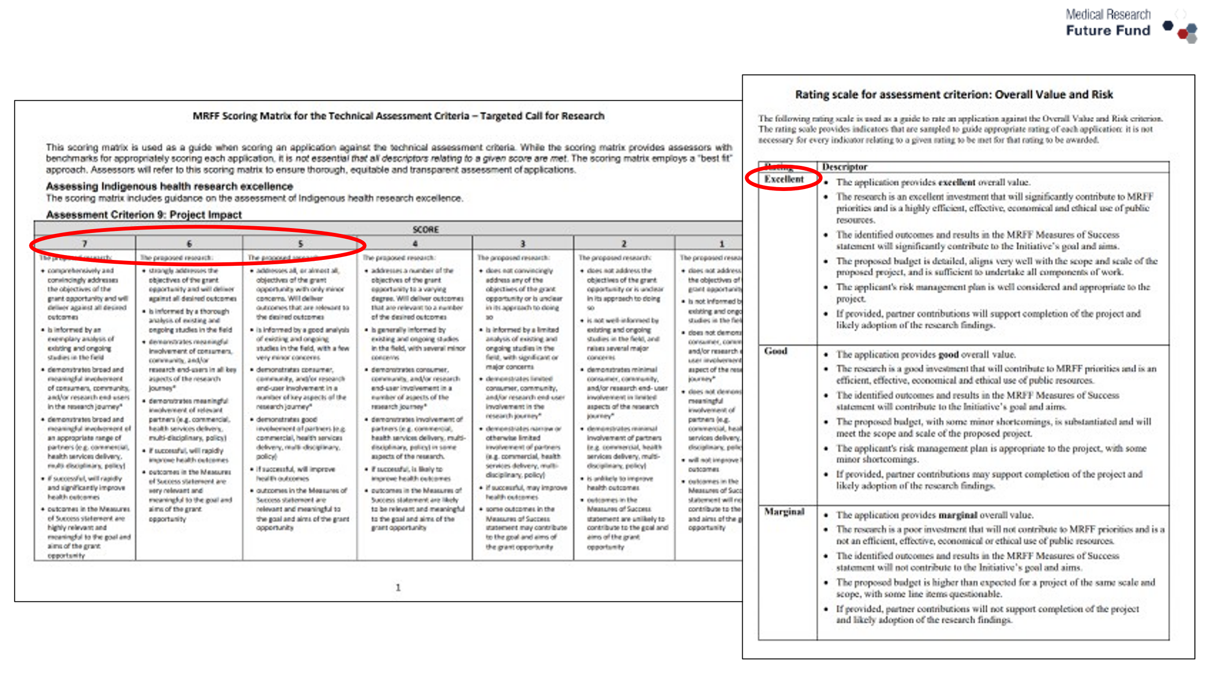

Outcomes Process
- GAC recommendations provided by hub Delegate to the Department delegate
- Grant offers are signed off by the Department delegate
- The Minister for Health and Aged Care is notified
- Grants are announced
  - Processes for notifying applicants are being reviewed
- What feedback is provided to applicants?
  - Feedback varies between the two hubs and is currently under review

You might have noticed…..
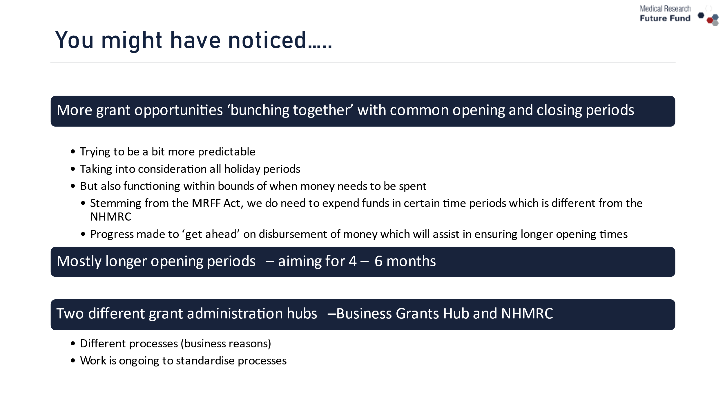

Continuous feedback loops…we are listening and learning
- Receive feedback via AMRAB consultation processes
- Seek and receive feedback from sector, including through structured processes
- Observing which grant opportunities generate most interest, which had challenges
- Identifying gaps in funding opportunities
- Scanning the environment for emerging issues and unmet needs
- We do have some system limitations, but address what we can, when we can

Managing MRFF grants
Misha Hutchings, Assistant Director of Grants Management Office
- Managing grant agreements through reporting and variations
- Monitoring grantee performance and compliance with the grant agreement
- Managing risks and issues


Project reporting
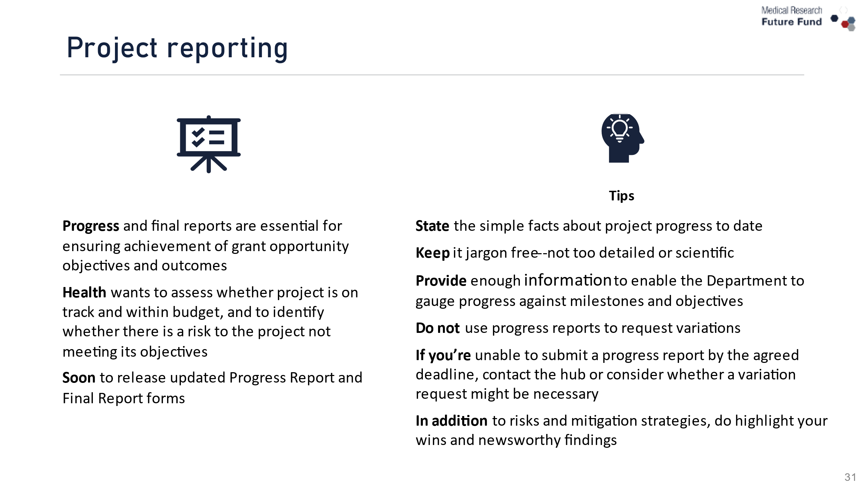

Varying the project and grant agreement
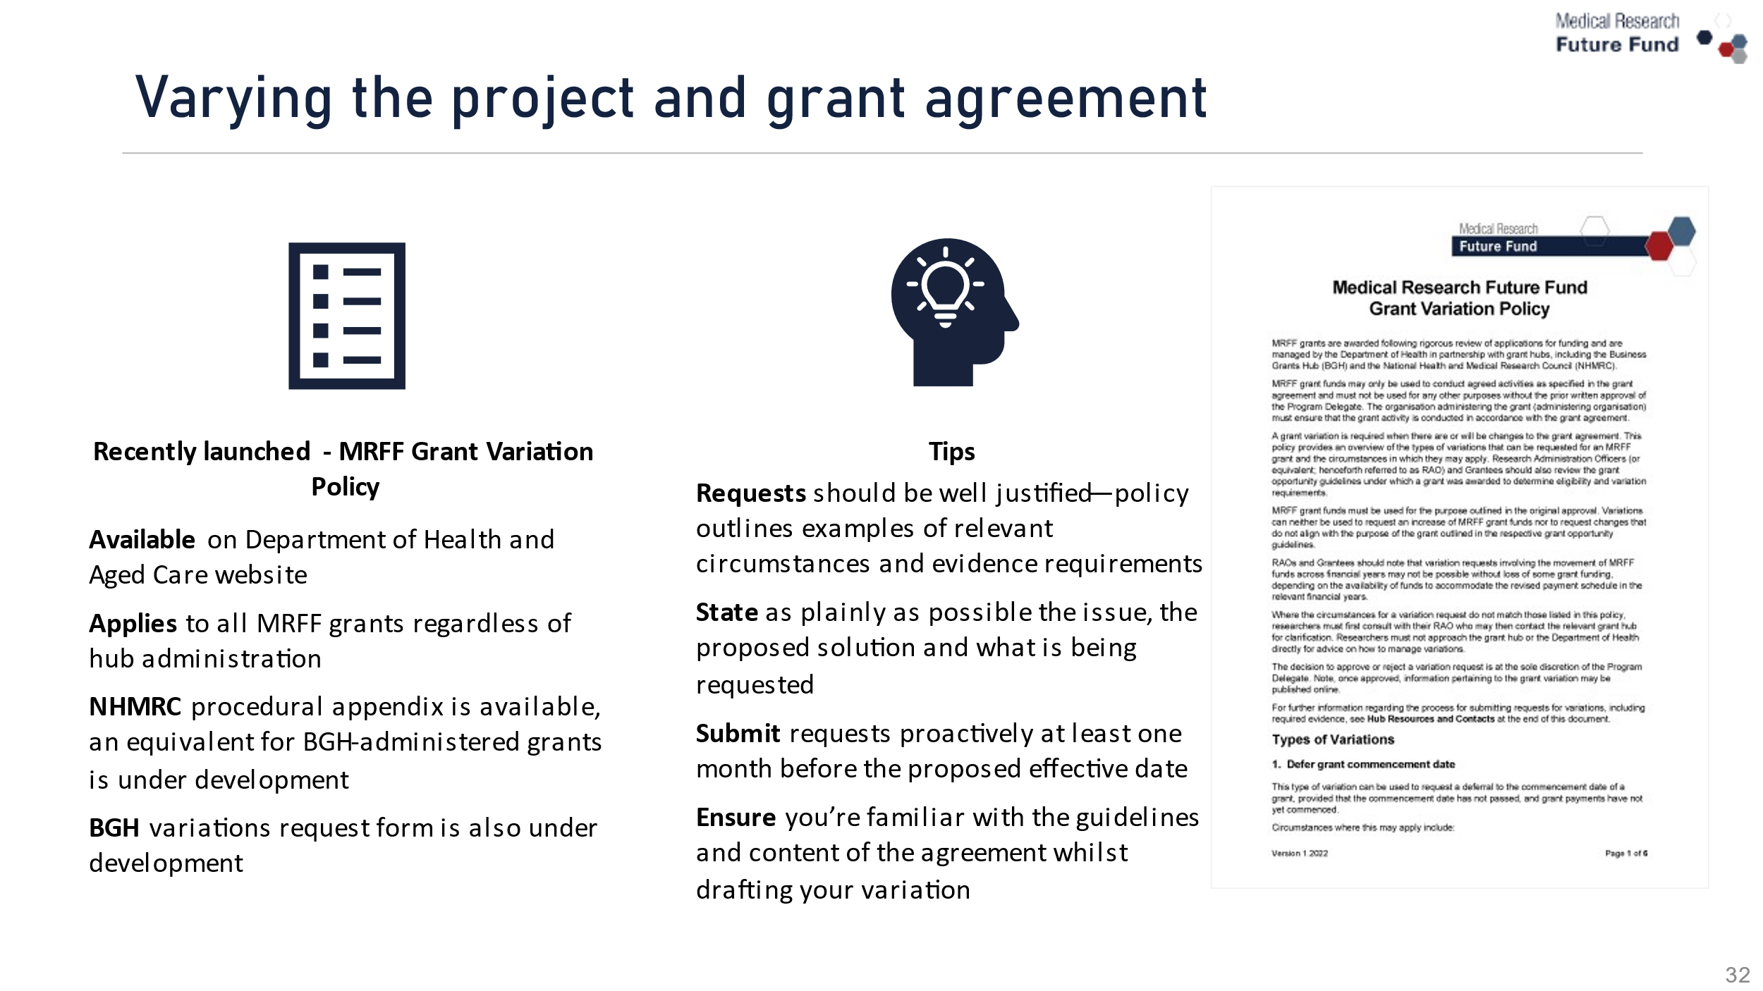

Upcoming post-award developments
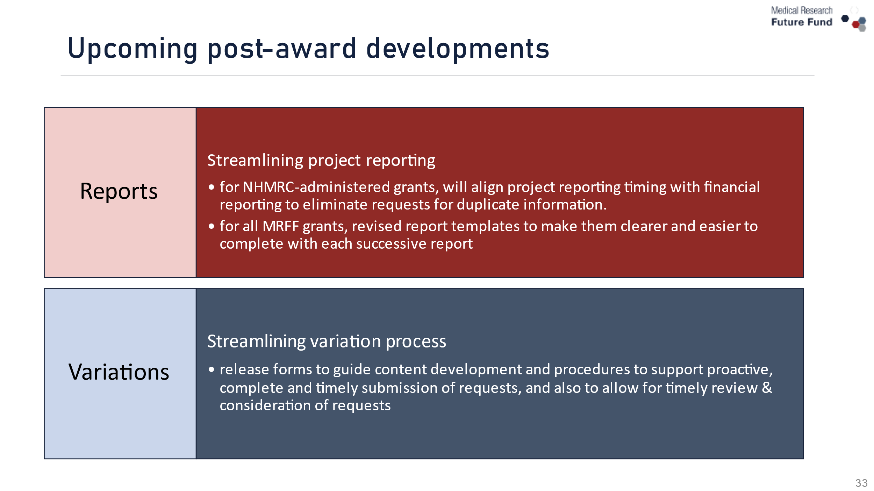

Q&A


Keep Connected
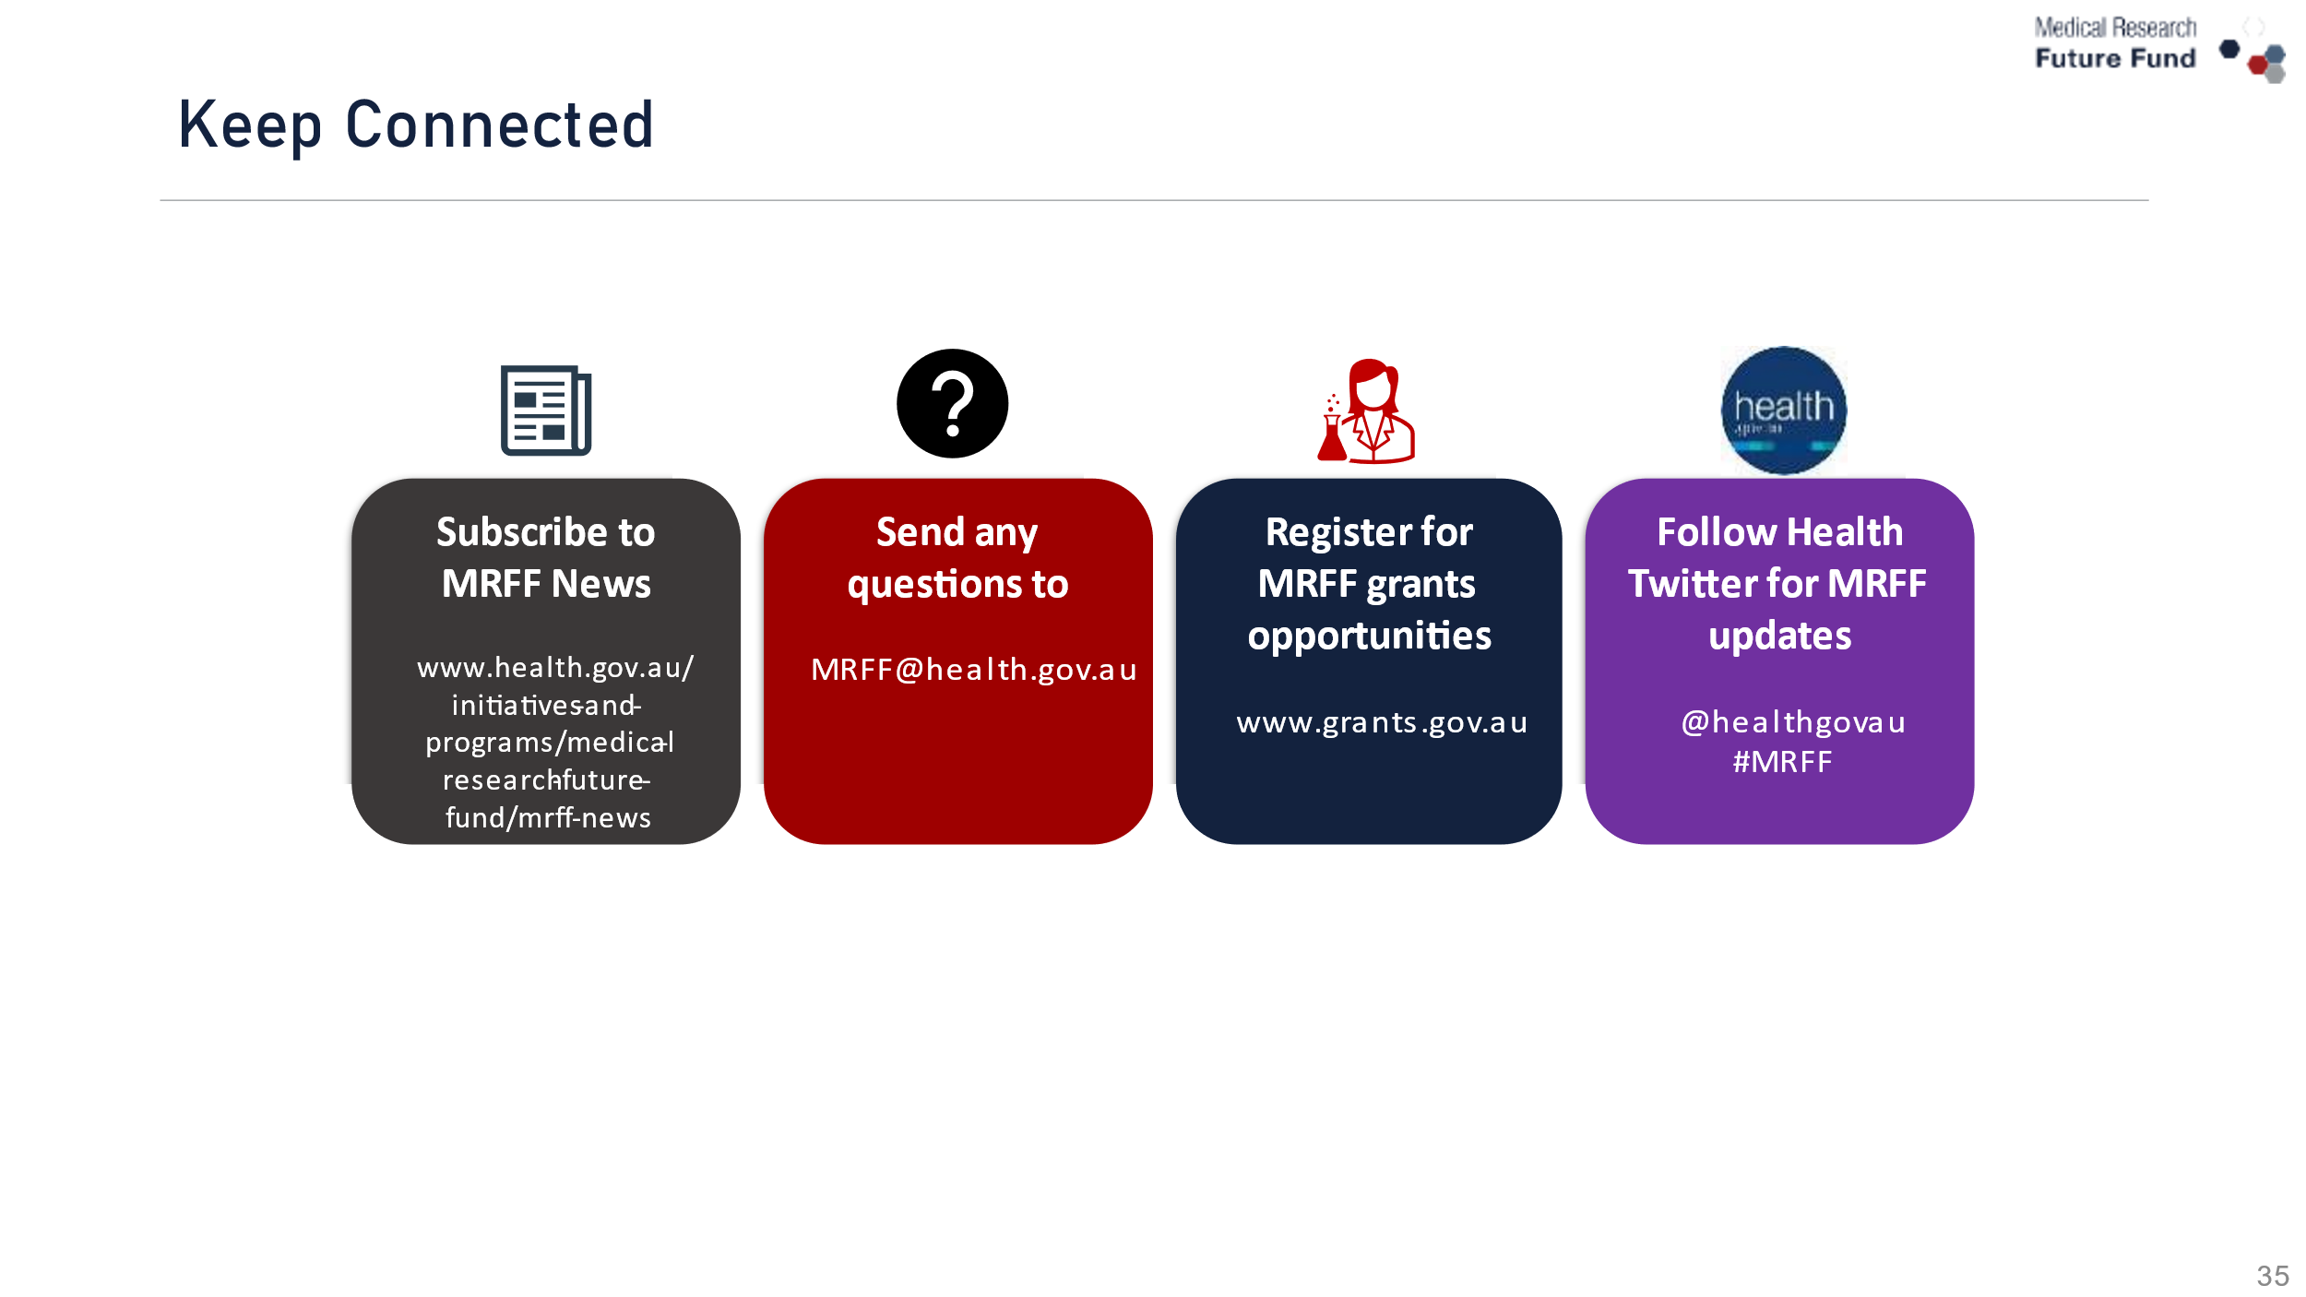


Thank you for your time

