
Independent evaluation of supported digital mental health services: Phase 2 final report
Bridget Bassilios, Maria Ftanou, Anna Machlin, Shaminka Mangelsdorf, Andrew Tan, Katrina Scurrah, Amy Morgan, Leo Roberts, Long Le,
Michelle Banfield, Matthew Spittal, Cathy Mihalopoulos, Jane Pirkis
July 2022

Glossary
Terminology, abbreviations and definitions used in this report.

Abbreviation | Term
AAPI | Australian Association of Psychologists inc.
AASW | Australian Association of Social Workers
ACACIA | The ACT Mental Health Consumer and Carer Research Unit
ACMHN | The Australian College of Mental Health Nurses
ACPA | The Australian Clinical Psychology Association
ACRRM | The Australian College of Rural and Remote Medicine
ADSL | Asymmetric Digital Subscriber Line
AIPA | Australian Indigenous Psychologists’ Association
AMHOCN | Australian Mental Health Outcomes and Classification Network
ATAPS | Access to Allied Psychological Services
AUD | Australian Dollar
Aus | Australian born consumers
AV | Audio Visual
CALD | Culturally and Linguistically Diverse
CBT | Cognitive Behavioural Therapy
CI | Confidence Interval
Chi | Chi squared value
df | degrees of freedom
DMHS | Digital Mental Health Service
DMHI | Digital Mental Health Intervention
ePASS | Online Psychological Assessment (for Mental Health Online)
eMHPrac | eMental Health in Practice
ERR | Excess Rate Ratio
ESB | Migrant of an English-Speaking Background
FTE | Full Time Equivalent
FY | Financial Year
GAD | Generalised Anxiety Disorder
GAD-7 | Generalised Anxiety Disorder 7-Item Scale
GP | General Practitioner
MH | Mental Health
IAPT | Improving Access to Psychological Therapies (UK)
iCBT | internet Cognitive Behavioural Therapy
ICER | Incremental cost-effectiveness ratio
ICP | Institute Clinical Psychologists
IRR | Incidence Rate Ratio
ISI | Insomnia Severity Index
IT | Information Technology
K6 | Kessler Psychological Distress 6-Item Scale
K10 | Kessler Psychological Distress 10-Item Scale
K10+ | Kessler Psychological Distress 10 item scale, plus four additional questions to assess disability
KEQs | Key Evaluation Questions
LGBTQIA+ | Lesbian, Gay, Bisexual, Transgender, Queer, Intersex, and Asexual
Max | Maximum
MBS | Medicare Benefit Scheme
MCID | Minimum Clinically Important Difference
MHO | Mental Health Online
Mig. | Migrant (overseas) born consumer
Min | Minimum
Mini-SPIN | Mini-Social Phobia Inventory
MS | MindSpot
n | Counts
NBN | National Broadband Network
NESB | Migrant of a Non-English-Speaking Background
NHS | National Health Service (UK)
OCD | Obsessive Compulsive Disorder
OTA | Occupational Therapy Australia
p | p value
PCL-C | Posttraumatic Stress Disorder Checklist—Civilian Version
PDSS | Panic Disorder Severity Scale
PHN | Primary Health Network
PHQ-9 | Patient Health Questionnaire 9-Item Scale
Psychs | Psychologists
PTSD | Post Traumatic Stress Disorder
QALY | Quality Adjusted Life Years
QA | Quality Assurance
RANCP | Royal Australian and New Zealand College of Psychiatrists
RACGP | Royal Australian College of General Practitioners
RCI | Reliable Change Index
SAD | Social Anxiety Disorder
SD | Standard Deviation
SE | Standard Error
SMI | Serious Mental Illness
SMS | Short Message Service
SPSS | Statistical Package for Social Sciences
t | T test
TA | Therapist Assist
TP | Transition probability
TWU | THIS WAY UP
VR | Virtual Reality
vs | Versus
WHODAS 2 | World Health Organization Disability Assessment Schedule-II
WHO-QOL-BREF | World Health Organization Quality of life questionnaire-BREF
YBOCS | Yale-Brown Obsessive-Compulsive Scale

Term | Definition
CI | Confidence interval. The interval in which the population parameter will fall 95% of the time.
CRUfAD | THIS WAY UP’s former name.
ePASS | Mental Health Online’s web-based optional psychological assessment, which screens for a range of psychological conditions and provides a summary of the symptoms users may be experiencing and suggestions for which Mental Health Online courses may be helpful.
Cohen’s d | See effect size
Effect size | Measures the strength of relationship between treatment and outcome. An effect size (measured using Cohen’s d or Hedge’s g) of around 0.2 is considered a small effect size, 0.5 considered medium and 0.8 considered large.
GAD-7 | Generalised Anxiety Disorder 7-Item Scale. A measure of level of worry and anxiety symptoms.
Gayaa Dhuwi | Proud Spirit Australia: Aboriginal and Torres Strait Islander Leadership in Social and Emotional Wellbeing, Mental Health and Suicide Prevention.
Hoarding Online Plus! | Mental Health Online course
ISI | Insomnia Severity Index. A of measure of type of insomnia experienced and its severity and impact.
ICER | Incremental cost-effectiveness ratio. Summary measure representing the economic value of an intervention, compared with an alternative (comparator).
K10 | Kessler Psychological Distress 10-Item Scale. A measure of psychological distress.
Made-4-me: | Mental Health Online program designed to help manage one or more mental health issues or a range of symptoms at one time. The course is based on CBT and can be used to address up to three of the following: depression, GAD, panic disorder, PTSD, social anxiety and OCD.
Mini OCI-R | Obsessive Compulsive Inventory – Short Version. A measure of compulsive behaviours.
Mini-SPIN | Mini-Social Phobia Inventory. A measure of the level of social anxiety symptoms.
Mood Mechanic | A transdiagnostic course for young adults (18-24 years) with anxiety and depression provided by MindSpot
n.s. | Not significant. Statistical result indicating insufficient evidence to reject the null hypothesis that there is no difference between the groups.
OCD Stop! | Mental Health Online course
p | P value. Measure of the strength of the evidence against the null hypothesis. Values around 0.05 indicate weak evidence against the null; values around 0.01 indicate moderate evidence against the null and values around 0.001 indicate strong evidence against the null.
Panic Stop! | Mental Health Online course
PCL-C | Posttraumatic Stress Disorder Checklist. A measure of stress symptoms associated with a traumatic event experienced.
PDSS | Panic Disorder Severity Scale. A measure of level of panic symptoms.
PHQ-9 | Patient Health Questionnaire 9-Item Scale. A measure of the level of depression symptoms.
Qualtrics | An online survey tool that allows users to easily create surveys
QALY | Quality Adjusted Life Years. A QALY is a widely used health index that combines both health-related quality of life and length of life – one QALY is equal to one year of life in full health. Briefly, QALYs are determined by weighting the length of life (or length of time spent in a particular health state) by a weight denoting the quality of that health state.
RCT | Randomised control trial. A gold standard research method to measure efficacy of an intervention, whereby one group is exposed to the intervention and another group acts as a control and is not exposed to the intervention. Assignment to each group is based on randomisation and is therefore not influenced by participant characteristics.
Reliable change | Measures whether change unlikely to be due to measurement error, and is an absolute measure of change. A reliable change index is used to interpret the clinical significance of change (e.g., reliable improvement, deterioration or no change). The numeric value for reliable change is calculated using the initial standard deviation of the measure and its reliability within a given sample.
Recovery | Improvement in symptoms by a set (variably defined) proportion (e.g., 50% symptom improvement).
Reliable recovery | Change in score from above a clinical cut-off on an assessment instrument at baseline to score below the clinical cut-off at the end of treatment, plus reliable change (improvement).
Remission | Improvement in mental health state from clinically significant symptom level (or “caseness” as indicated by scoring above a stated cut-off score on a validated symptom measurement scale) to non-clinically significant symptom level (scoring below a state cut-off on the scale).
SD | Standard deviation. A measure of the amount of variation in values within a sample.
SE | Standard error. A measure of the amount of variation in the mean within a sample of a population.
Slido | A web-based, interactive Q&A and polling app that encourages participation in virtual events (https://www.sli.do/).
Sleep-e! | Mental Health Online course
Take a test | THIS WAY UP’s web-based assessment tool comprising validated mental health questionnaires to measure the frequency and intensity of symptoms of mental health conditions. It provides users with a summary of their results and treatment and support recommendations, including THIS WAY UP programs.
TP | Transition probability. The probability of moving from one health state to another.
Wellbeing Plus Course | MindSpot transdiagnostic course for adults aged 60+ years
Whiteley-7 | A measure of health anxiety,
WTP | Willingness to pay. An evaluation method used to determine the maximum amount of money an individual is willing to pay for a particular outcome or benefit (e.g., to receive a health care service).

Acknowledgements
This report would not have been possible without the support of many who generously gave their time and made valuable contributions.
In particular, the evaluators would like to thank the three digital mental health services – Mental Health Online, MindSpot and THIS WAY UP – who have shown a high level of commitment to data provision, provided input on our stakeholder consultation questions and facilitated our access to data and various stakeholder groups.
We also extend thanks to all the stakeholder groups – consumers and providers of digital mental health services, others with lived experience of mental health problems, additional health providers, and other key mental health sector representatives – who provided their views on, and experiences of, digital mental health services; and Robert Lukins for general project support.
The evaluation of the supported digital mental health services was funded by the Australian Government Department of Health.

Table of Contents
Executive summary 1
Background 1
Evaluation aims 1
Data sources 2
Findings 2
Conclusions 13
1. Policy background to the evaluation 14
1.1. Digital mental health services 14
1.2. Purpose of the evaluation 14
1.3. Our approach 15
1.4. This report 17
2. Service delivery models of supported DMHSs 18
2.1. Similarities in service delivery models 18
2.2. Differences in therapist support 18
2.3. Service offerings beyond therapist-supported treatment 18
2.4. Risk management 19
2.5. Summary 19
3. Service uptake and consumer characteristics 23
3.1. Our approach 23
3.2. Uptake of Mental Health Online, January 2015 – December 2021 23
3.3. Uptake of MindSpot, January 2013 – December 2021 26
3.4. Uptake of THIS WAY UP, July 2015 – December 2021 28
3.5. Consumer characteristics 31
3.6. Summary 36
4. Outcomes of DMHS use 37
4.1. Our approach 37
4.2. Measuring change in mental health outcomes 37
4.3. Mental Health Online outcomes 39
4.4. MindSpot outcomes 45
4.5. THIS WAY UP outcomes 61
4.6. Mental health outcomes compared with usual care 76
4.7. Summary 79
5. Stakeholder experiences: Consumers of DMHSs 80
5.1. Our approach 80
5.2. Characteristics of DMHS consumer survey and interview participants 80
5.3. Consumer experiences of DMHSs 82
5.4. Consumer experiences of specific aspects of DMHSs 84
5.5. Consumer wellbeing and satisfaction 91
5.6. Summary 93
6. Stakeholder experiences: Providers of DMHSs 94
6.1. Our approach 94
6.2. Characteristics of DMHS provider survey respondents 94
6.3. Characteristics of DMHS provider interview respondents 95
6.4. Provider views about suitability of DMHSs 96
6.5. Provider experiences of using DMHSs 97
6.6. Provider perceptions about impact of DMHSs on consumers 98
6.7. Provider satisfaction with DMHSs 100
6.8. Summary 102
7. Stakeholder experiences: People with lived experience of mental health problems 103
7.1. Our approach 103
7.2. Participant characteristics 103
7.3. Strengths of supported DMHSs 104
7.4. Barriers to supported DMHSs 104
7.5. Effectiveness of supported DMHSs 105
7.6. What would an optimal supported DMHS look like? 105
7.7. Summary 105
8. Stakeholder experiences: Additional health professionals 106
8.1. Our approach 106
8.2. Socio-demographic and professional characteristics, and internet access, of survey respondents 106
8.3. Views on DMHSs for different consumer groups and improving use of DMHSs 108
8.4. Experiences and views of professionals delivering DMHSs (n=55) 110
8.5. Experiences and views of professionals who do not deliver DMHSs (n=38) 113
8.6. Summary 113
9. Stakeholder experiences: Other key stakeholders 114
9.1. Our approach 114
9.2. Characteristics of key stakeholders 114
9.3. Perceived suitability of DMHSs for mental health problems 116
9.4. Effects of DMHSs on consumers and carers 118
9.5. Integration of DMHSs 119
9.6. Barriers to use of DMHSs 122
9.7. Suggested improvements to DMHSs 123
9.8. Changes needed to improve use of DMHSs 125
9.9. Tailoring for specific consumer groups 126
9.10. Summary 127
10. The cost-effectiveness of DMHSs 128
10.1. Our approach 128
10.2. Costs of DMHSs 128
10.3. Health care cost savings and productivity impacts 131
10.4. Cost-effectiveness modelling 134
10.5. Summary 143
11. Discussion 144
11.1. KEQ 1: How effective has the implementation of online mental health treatment services been to date, and what can we learn from it? 144
11.2. KEQ 2: What difference are existing supported online mental health treatment services making compared with usual care (e.g., face-to-face or other treatment service types)? 146
11.3. KEQ 3: How cost effective are Australian Government funded supported online mental health treatment services compared with usual care? 148
11.4. KEQ 4: How effective are supported online mental health treatment services for consumers and health providers? 149
11.5. KEQ 5: How can the commissioning and implementation of online mental health treatment services be best supported going forward? 151
11.6. Limitations 154
11.7. Strengths 154
11.8. Conclusions 155
References 156
Appendix A: Evaluation questions 161

Appendix B: Phase 2 evaluation method 162
Existing data 162
Consultations with key stakeholders 163
Data analysis 169
Appendix C: Mental Health Online outcome evaluation of Therapist Assist 171
K6 data collection 171
Sample representativeness 171
Appendix D: Consumer survey and interview questions 172
Survey questions 172
Interview questions 181
Appendix E: DMHS provider survey and interview questions 182
Survey questions 182
Interview questions 186
Appendix F: Strengths of supported DMHSs word clouds 187
Appendix G: Barriers to use of supported DMHSs word clouds 188
Appendix H: Effectiveness of supported DMHSs word clouds 189
Appendix I: Most and least important features of supported DMHSs 190
Appendix J: Survey questions for additional health professionals delivering (or referring consumers to) mental health services 191
Appendix K: Other key stakeholder interview/survey questions 197
Appendix L: Cost effectiveness modelling 199

Executive summary

Background
The Australian Government funds numerous digital mental health services (DMHSs), listed on the Australian Department of Health digital mental health gateway, Head to Health (www.headtohealth.gov.au).¹
DMHSs refer to mental health organisations or programs that remotely deliver a range of psychological strategies and interventions via online (desktops, mobile devices and apps) and/or mobile platforms.^{2, 3} DMHSs include services delivered by phone (e.g., crisis and counselling services) or videoconference-based connections (e.g., telehealth).³ Digital mental health interventions (DMHIs) refer specifically to digital mental health treatment, which is one of several components of what DMHSs offer.
Online DMHSs, which are the focus of this evaluation, differ in the type and level of therapist support provided. Some online DMHSs do not offer any therapist support and are considered to be fully automated self-directed (or unguided) programs, and others involve support (or guidance) from clinicians, volunteer crisis supporters, teachers, administrators or peers.³
The Productivity Commission Mental Health Inquiry Report noted the potential benefits of therapist-supported (guided) DMHSs.⁴ It recommended that the Australian Government fosters supported DMHSs as a treatment option by: increasing funding to expand their availability; commissioning an evaluation of their performance; and developing information campaigns for people with lived experience of mental illness and health professionals to increase the awareness of supported DMHSs.⁴

Evaluation aims
The Centre for Mental Health at the University of Melbourne was commissioned by the Department of Health to undertake the independent evaluation of three key Australian government funded supported DMHSs, including:
- Mental Health Online, Swinburne University;
- MindSpot, Macquarie University; and
- This Way Up, St Vincent’s Hospital and the University of New South Wales.
The overall evaluation aims to inform Australian Government decisions related to future funding for supported DMHSs and activities to increase awareness and utilisation of these services by people with lived experience of mental illness and health professionals.
The evaluation is guided by the five key evaluation questions (KEQs) outlined by the Department of Health, including:
- KEQ 1: How effective has the implementation of online mental health treatment services been to date, and what can we learn from it?
- KEQ 2: What difference are existing supported online mental health treatment services making compared with usual care (e.g. face-to-face or other treatment service types)?
- KEQ 3: How cost effective are Australian Government funded supported online mental health treatment services compared with usual care)?
- KEQ 4: How effective are supported online mental health treatment services for consumers and health providers?
- KEQ 5: How can the commissioning and implementation of online mental health treatment services be best supported going forward?

Data sources
The evaluation was completed in two phases.
Phase 1 involved conducting a systematic review of reviews⁵ and an environmental scan,⁶ the findings from each of which have been separately reported and are cross referenced in this (final) report’s recommendations and conclusions.
In Phase 2, which is the focus of this report, we utilised a mixed-methods evaluation approach, involving collecting and analysing data from a range of primary and secondary quantitative and qualitative data sources, which are briefly described below.

Existing data
We utilised existing (secondary) data, including:
- Aggregate routinely collected service use uptake, outcome and financial data;
- Progress reports prepared by the three DMHSs for the Department of Health;
- Peer-reviewed and grey literature published by the three DMHSs; and
- Peer-reviewed and grey literature on mental health outcomes of other forms of mental health treatment.

Consultations with key stakeholders
We conducted consultations with a broad range of stakeholders, including:
- 351 consumers of the three DMHSs via survey (and optional interview);
- 30 providers of the three DMHSs via survey (and optional interview);
- 16 people with lived experience of mental health problems (with or without experience using DMHSs) via community conversations;
- 94 additional health professionals (with or without experience using DMHSs) such as GPs and mental health professionals (e.g., psychologists, mental health nurses, psychiatrists, social workers, occupational therapists) via survey through professional associations; and
- 68 other key mental health sector stakeholders representing 44 organisations via survey (or interview), e.g., management staff from the DMHSs, funders, partners, Head to Health (and the new national mental health platform) website developers, and others in the mental health sector (e.g., representatives from relevant health professions and peak bodies for people with lived experience).

Findings
This section summarises findings from all the data sources used in this report according to the five overarching KEQs. Note that KEQs are addressed by different combinations of, and not necessarily all, data sources.
Findings should be interpreted in the context of several important caveats. First, the evaluation focused largely on therapist-supported and self-directed treatments offered by the three DMHSs, but treatment is only one component of their service offerings. All three services also provide web-based information and assessment. Second, key differences exist in the service delivery models of the three DMHSs and they receive different amounts of government funding. The providers of therapist support differ across the DMHS; these include provisional (trainee) psychologists at Mental Health Online, internal clinicians at MindSpot, and external clinicians at THIS WAY UP. Third, although therapist support is available, consumers can choose not to take up this support, instead electing to complete online treatment on their own (self-directed treatment). Finally, the time frames are different for the routinely collected data we analysed.
Furthermore, the evaluation was not designed to compare the three services. Some of the differences observed could be accounted for by methodological variation. For example, the services are likely to have used different methods to apportion costs for the assessment, and self-directed and therapist-supported treatment service elements.

KEQ 1: How effective has the implementation of online mental health treatment services been to date, and what can we learn from it?
Routinely collected service use data, peer-reviewed and grey literature, and consultations with DMHS consumers and providers, additional mental health professionals and referrers, and key mental health sector representatives contribute to addressing KEQ 1.

Overall uptake of DMHSs
Overall, the routinely collected service use data (Section 3) suggest that the three DMHSs we evaluated are an important part of the Australian mental health service system, with the number of consumers accessing, and providers delivering, care through them steadily increasing.
Over seven years from January 2015 to December 2021, 64,825 consumers and 2,066 health care professionals registered with the Mental Health Online website. Nearly 25,000 consumers completed an assessment, more than half of whom did not register for treatment. About 18,000 users registered for a treatment program; of these, 11,500 (64%) had also completed an assessment and 2,300 (11%) registered to receive therapist support.
For MindSpot over nine years from January 2013 to December 2021, 133,447 assessments were completed and 27% (35,942) of consumers who completed an assessment enrolled in either therapist-supported or self-directed treatment programs. This should be interpreted in the context that around 67% of MindSpot consumers report that an assessment is their primary need.⁷ Most consumers enrolled for therapist-supported treatment (96%, n=34,390). This is not surprising as self-directed treatment was only introduced in July 2019. Two-thirds of those who started therapist-supported treatment completed treatment (i.e., at least 4 of 5 lessons), which is comparable to UK published CBT completion rates (based on reason for discharge) in IAPT.⁸ However, the flip side is that around one-third of consumers drop out of therapist-supported treatment, which is higher than the 26% dropout rate reported in a recent meta-analysis.⁹
Data from THIS WAY UP show that over 6.5 years from July 2015 to December 2021, 124,270 Stage 1 and 71,069 Stage 2 assessment were completed. Approximately 72,000 consumers enrolled in any treatment and 47% (n=34,048) in clinician-supported treatment. Three-quarters of all enrolments (n=54,510) started treatment. Of consumers who started, 46% (n=24,989) completed treatment (i.e., at least two-thirds of lessons), which is lower than published IAPT treatment completion rates. This means around 54% of consumers drop out, double the CBT treatment dropout rate reported in the above-mentioned meta-analysis.⁹
Dropout rates could not be examined in the routinely collected data provided by Mental Health Online. Dropout rates for MindSpot and THIS WAY UP should be interpreted in the context of several considerations including the current pandemic, face-to-face mental health services disruptions, and removal of THIS WAY UP consumer program fees. Furthermore, pre-COVID program completion rates were somewhat higher for both services. At least one study has shown that consumers who drop out of online courses benefit from each successive lesson completed to a similar degree as those who complete the entire course,¹⁰ and the overall number of treated consumers has increased over time (despite lower treatment completion rates). Finally, treatment completion rates for THIS WAY UP self-directed and clinician-supported programs are similar, which is promising given that adherence to self-directed digital mental health programs is typically poorer.¹¹
Over 80% of consumers who enrol in MindSpot and THIS WAY UP treatments commence treatment (comparable data were not available from Mental Health Online). This suggests an efficient transition into treatment, with a minority of consumers disengaging from, or referred elsewhere for, treatment.
Coinciding with the COVID-19 pandemic, there was a pronounced increase in registrations and enrolments for all three DMHSs examined, demonstrating their high potential for scalability. However, the corresponding increase in treatment completions was less pronounced.
Together, the three DMHSs are providing psychological treatment to thousands of consumers per year, and this represents only one component of their service offerings. Importantly, they are also conducting tens of thousands of assessments per year, which helps to support consumers with navigating other services in the mental health system and identify consumers at increased risk of suicide.

Consumer characteristics
Routinely collected service use data, peer-reviewed publications and DMHS consumer survey findings (Sections 3 and 5) highlight that people who use DMHSs tend to be females under the age of 54 years living in urban areas experiencing severe symptoms and are not accessing any other mental health services. This consumer profile is appropriate given that preliminary insights from Australia’s National Study of Mental Health and Wellbeing (2020-21) indicate that females and younger people are more likely to experience high or very high psychological distress than males and older people, respectively.¹² Having said that, the DMHSs are reaching relatively significant proportions of typically hard-to-reach groups and/or groups who are less likely to seek help (e.g., 7-19% from rural and remote locations, 4-8% Indigenous peoples, 9-29% males, 5-12% aged 55+, and 22% of MindSpot consumers are born overseas).
All three DMHSs aim to provide an online mental health service largely directed at people with depression and anxiety disorders. On average consumers of MindSpot and THIS WAY UP treatment are experiencing moderate to moderately severe depression (PHQ-9: 14.9 and 14.1) and likely generalised anxiety disorder (GAD-7: 12.5 and 11.8), and close to two-thirds of Mental Health Online consumers are experiencing probable serious mental illness (K6: 19-30). These data suggest the DMHSs are reaching their target populations. The online interventions provided by all three DMHSs are CBT-based, which is appropriate given that the systematic review of digital mental health interventions we conducted as part of this evaluation showed that online CBT is effective.⁵
Although there is overlap between the services in that they target consumers with depression and anxiety disorders, there are differences in the socio-demographic and clinical characteristics of consumers using each service. For example, Mental Health Online is reaching proportionally more younger adults aged 18-34 and married or cohabitating consumers than MindSpot (70% vs 55% and 54% vs 38%, respectively). Baseline symptom severity is slightly worse for MindSpot than THIS WAY UP consumers. MindSpot consumers with higher symptom severity (K10, PHQ-9 and GAD-7) appear to receive therapist-supported treatment. There is also a trend for THIS WAY UP consumers with higher depression symptom severity to receive therapist-supported treatment. Importantly, the DMHSs operate differently and offer consumers choice.

Consumer satisfaction
Data collected routinely by MindSpot and THIS WAY UP, and episodically by Mental Health Online, indicate that consumers are highly satisfied with the care they receive from these DMHSs (presented in Sections 4.3.1, 4.4.6 and 4.5.5). For example, 27of 27 Mental Health Online consumers surveyed in 2020-21 reported they were satisfied with the Therapist Assist program and would recommend it to someone else. Between 95% and 98% of consumers report that MindSpot therapist-supported treatment is worthwhile, and they would recommend it. Between 81% and 84% of consumers are likely to recommend THIS WAY UP.
The survey we conducted with 351 consumers, 23 of whom we also interviewed, confirmed these findings with 85% being satisfied with the care (Section 5). Consumers reported that the DMHSs are having a positive impact on their wellbeing. Over 80% of consumers indicated that they had experienced improvements in health and wellbeing, and approximately 80% of consumers attributed these changes to the support they received through the DMHS. Consumers described that DMHSs had helped them with developing insight and understanding of their situation; and improved their sleep, mood, physical health, and coping through learning new skills.

Provider and health professional satisfaction
Similarly, surveys (N=30) and interviews (n=6) highlight that the majority of DMHS providers (86%) are satisfied with the delivering services (Section 6). These providers reported that the DMHS benefited their clinical and teaching practices. They also reported that DMHSs complemented clinical and face-to-face interventions, helped reinforce therapeutic interventions and strategies, assisted with training junior clinicians, reduced waitlists, helped prioritise consumers, and assisted with reaching consumers in rural and regional areas.
However, 57% of DMHS providers reported experiencing some difficulties with delivering digital mental health care. Commonly experienced difficulties include internet connection, technical problems and the online program not being suitable for the consumers’ needs. Although most providers reported that delivering services digitally did not negatively impact on building rapport, 17% mentioned experiencing difficulties in building rapport.
Providers also highlighted that DMHSs were benefiting consumers. Nearly 80% of providers reported that DMHSs were mostly meeting the needs of consumers and 97% believed that they were benefiting consumers. These benefits included improved: mood and wellbeing, relationship functioning, skills, coping, self-efficacy and confidence.
Most mental health professionals, referrers and key mental health sector representatives we consulted also acknowledged the positive effects of DMHSs on consumers and carers (Sections 8 and 9). Of the 55 additional mental health professionals who provide digital mental health care surveyed, around 58% reported being satisfied with providing mental health care in this way. Others echoed the same difficulties experienced by the three DMHS providers.

KEQ 2: What difference are existing supported online mental health treatment services making compared with usual care (e.g., face-to-face or other treatment service types)?
Data from peer-reviewed publications on DMHS and comparator mental health outcomes and routinely collected DMHS data contribute to addressing KEQ 2.

Improving access to care
As demonstrated in response to KEQ 1, the three DMHSs are providing treatment (among other service offerings) to significant numbers of consumers and are therefore contributing to improving overall access to mental health care in Australia. Furthermore, by offering their services free of charge they are likely to be reaching segments of the population who might not otherwise access mental health treatment and/or are disadvantaged to varying extents.
As discussed in Section 3, DMHSs are providing services to a high number of people who are not accessing any other support. At least half of Mental Health Online and MindSpot consumers are not accessing other mental health services, which suggests DMHSs are reducing the burden of care on other mental health services. The consumer surveys indicated that prior to accessing DMHSs, over 50% of consumers experienced several barriers to care. The most common barriers were affordability of care (47%) and personal beliefs about the need for help (e.g., believing things would improve [49%], symptoms not severe enough [43%], preferring to rely on self [41%]). Similarly, the provider interviews also highlighted that DMHS are enabling providers to deliver care to more consumers and reduce waitlists. The consumer interviews indicated the anonymity of care, free access and 24-hour availability of care allows people to access affordable care at a time and place that is convenient for them.

Mental health and other outcomes
As illustrated in Section 4, the three DMHSs are using a variety of outcome measures to assess mental health and wellbeing outcomes for consumers, most commonly the K10, PHQ-9 and GAD-7 (MindSpot and THIS WAY UP) and the K6 at baseline only (Mental Health Online). Pooling data mostly from peer-reviewed publications by the three DMHSs, we found that therapist-supported online treatment significantly improves the mental health of consumers who use these services (d=0.95, Mental Health Online; d=1.42, MindSpot; and d=1.04 THIS WAY UP). Specifically, consistent with findings from our literature review,⁵ therapist-supported treatment produced reductions in psychological distress and other symptoms including, OCD, PTSD, panic disorder, GAD, social anxiety disorder and depression. These positive findings are consistent across different demographic characteristics, including young and older adults, people born overseas, and Indigenous peoples. To some extent, these findings fill gaps in knowledge identified in our literature review about the effectiveness of digital mental health interventions for traditionally underserviced groups and across age groups.⁵
Therapist-supported treatment by DMHSs also produced positive outcomes on quality of life, functioning (as assessed by days out role) and disability, but the effects on these domains was smaller (e.g., d=0.12, 0.35 and 0.48, respectively).
Additionally, peer reviewed publications showed that self-directed treatment by Mental Health Online produces moderate reduction (d=0.59) in clinical disorder severity ratings for GAD, panic disorder, OCD, PTSD and SAD. Trends in routinely collected data on self-directed treatment by MindSpot and THIS WAY UP support these positive findings, but we were unable to calculate effect sizes because we did not have baseline data for the cohort of consumers who completed post-treatment assessments.
There was also a trend for consumers with more severe symptoms to be more likely to show improvement.
Overall, therapist-supported treatments by all three DMHSs produce improvements in mental health symptoms that are close, or equivalent, to most comparator treatments (Australian primary, public and low intensity mental health care; UK stepped psychological care) we examined. Both therapist-supported and self-directed treatments produce superior outcomes to treatment as usual (discussing mental health concerns with the GP). They also produce superior outcomes to pharmacological treatment in primary care, which have been reported to produce small to moderate effects.⁷
Around one-third of MindSpot consumers who in enroll in therapist-supported treatment choose not to take up the therapist support component, and around one third of consumers who enroll in self-directed treatment end up receiving therapist support. Additionally, although in our pooled estimates of THIS WAY UP treatment effects, we labelled all treatments as “therapist-supported”, the extent of therapist support is unknown given that this service element is provided externally by the consumer’s own mental health professional. Therefore, differences in findings between therapist-supported and self-directed treatments should be interpreted with caution.
A key strength of the way in which outcome data are collected by MindSpot and THIS WAY UP is that consumers are assessed using standardised outcome measures at each session. This means that analysis of their outcome data provides the opportunity to examine the effects of treatment for consumers who drop out of treatment. Other mental health programs that only assess consumer outcomes at the commencement and the completion of treatment risk introducing a systematic bias in which people who drop out of treatment (potentially with poorer outcomes) are excluded from effectiveness analyses. Furthermore, MindSpot endeavours to assess consumer outcomes at three-months post-treatment and have shown that benefits are maintained at follow up.⁷

KEQ 3: How cost effective are Australian Government funded supported online mental health treatment services compared with usual care?
DMHS routinely recorded or collected financial, service use and effectiveness data; resource use and costs data from our consumer surveys; and peer-reviewed literature on indirect usual care comparators contribute to addressing KEQ 3.
We summarised costs and cost-effectiveness of Mental Health Online, MindSpot and THIS WAY UP. The delivery costs of these services ranged from $52 to $99 per consumer for self-directed treatment and $21 to $362 per consumer for therapist-supported treatment. It is estimated that an additional 1,181 QALYs (that is an additional 1,181 years of life lived in full health) across one year was achieved through the treatments delivered by these services. Excluding productivity losses, the incremental cost-effectiveness ratios for self-guided treatment ranged from $887 to $32,354 per QALY, and for therapist-supported treatment from $96 to $35,062 per QALY. These ratios were lower than the standard willingness-to-pay threshold of $50,000 per QALY, which is commonly used to evaluate the cost-effectiveness of public health programs in Australia.¹³⁻¹⁵
The results of our analyses show that DMHSs are cost effective compared to usual care (e.g., face-to-face treatment) for individuals with depression or anxiety symptoms who access treatment. When productivity impacts were taken into consideration, the DMHSs costed less and produced greater benefits than the indirect comparator groups (representing usual care). Our findings are in line with the recently released Productivity Commission Inquiry Report into Mental Health,⁴ which presented evidence that online-based treatments such as the DMHSs can be cost-saving. In particular, the report highlighted that “MindSpot treatment for people with mild to moderate symptoms of depression and anxiety costed less than the comparison group (minimum adequate treatment in usual routine care) with an increase in quality-adjusted life years.”
Our results support findings from the meta-review we conducted as part of the evaluation and are also consistent with previously published international evidence, including systematic reviews and meta-analyses.¹⁶⁻¹⁹ For example, the most recent systematic review on the economic evaluations of digital mental health interventions for anxiety and depressive disorders found 81% of the included studies concluded that the interventions evaluated were cost-effective compared to their respective control condition (e.g., treatment as usual, waitlist, another online intervention).²⁰ In addition, there were several studies based in Australia that have reported the cost-effectiveness of digital-based mental health treatments for older older adults with depression and anxiety symptoms when compared to a delayed-treatment waitlist control group.^{21, 22}
Our economic evaluation of DMHSs involved constructing a simple decision tree model with four health states (fully recovered, partially recovered, no improvement, deteriorated) for people with either depression and/or anxiety symptoms. In addition to QALY gains, the provision of DMHSs also led to considerable improvement in health states for individuals. Using just one of the DMHSs as an example, our modelling results suggest that an additional 3,580 fully recovered and 1,582 partially recovered cases were achieved from therapist-supported treatment by THIS WAY UP compared to usual care. There are also likely to be economies of scale in the service provision by the DMHSs as evidenced by their generally lower cost of assessment per individual (ranging from $1.10 to $113.30) compared to a standard face-to-face assessment with a psychologist ($154 per visit based on the Australian Psychological Society National Schedule of Recommended Fees or $110 per visit based on Medicare Benefit Schedule fee).²³
The relatively low cost of implementing the DMHSs is indicative of the efficiency of funding and resource use by these services. Consumers also incurred little to no cost when accessing the services offered by the DMHSs, thus, improving the affordability of mental health treatment. Low-cost therapist-supported online treatment provides an alternative to consumers who may not be able to afford the out-of-pocket costs associated with regular face-to-face consultations.
Overall, our modelled economic evaluation analysis has shown that the provision of diverse online mental health treatment services (i.e., Mental Health Online, MindSpot, THIS WAY UP) is generally low-cost and likely cost effective. When considered together with the findings from our previous two-stage pragmatic review of local and international evidence, there is good evidence to suggest that treatment delivered by these online-based services is likely to be cost-effective compared with usual care across different settings, population groups and policy contexts. Therefore, in addition to improving clinical outcomes, DMHSs have the potential to be good value for money.

KEQ 4: How effective are supported online mental health treatment services for consumers and health providers?
Data from our stakeholder consultations contribute to addressing KEQ 4. Specifically, stakeholders consulted included DMHS consumers and providers; people with lived experience of mental health problems and additional health professionals (with or without experience of DMHSs) and other key mental health sector representatives.

Consumer access enablers and barriers
Enablers to consumer access mentioned by people with lived experience of mental health problems related to the digital nature of service delivery and benefits conferred by the therapist support component (Section 7).
The modality of service delivery was thought to provide more timely access, reduce waitlists for face-to-face services, and be particularly useful for groups who may struggle to access other services, such as people with disabilities or people in rural areas with limited service availability. Not needing to travel to appointments, and the additional layer of safety during the COVID-19 pandemic were also mentioned as key to the accessibility DMHSs offered. Similarly, DMHS consumer and provider stakeholders indicated that DMHS services reduce barriers to care by improving access, making care affordable and convenient, and reducing waitlist and the stigma associated with mental health care (Sections 5 and 6).
The therapist support component was described as good for motivation and adherence to the program. Participants felt that compared with self-directed programs, having a therapist helped with comprehension of material, personalisation of content to their own needs, validation of their progress and increase accountability. Some people also commented that compared with face-to-face services, they had experienced the support offered through DMHSs to be less judgemental, which increased their comfort with seeking help. They suggested that supported DMHSs may therefore be more appealing to people who would not normally seek help from face-to-face services.
The most common barriers to people using supported DMHSs were related to the modality of service delivery: lack of technology and/or internet access and challenges in digital or internet literacy. Some people also thought that, compared with face-to-face services, supported DMHSs were impersonal and made it difficult to establish rapport. This was particularly thought to be an issue for marginalised communities for whom strong relationships may be core to success, and the lack of peer-led services was noted here.
The other major barrier discussed was the complexity of the sites. Participants expressed concern about the amount of text on the sites, and challenges with navigation, particularly for people with low literacy or English as a second language. Although the support to access the sites and understand material was one of the main strengths, concern was expressed about service users with literacy or language challenges being the most likely to experience the technology and relationship barriers, and therefore less likely to benefit from the supported aspect of the sites.
The final key barrier related to lived experience and other stakeholder perceptions about the suitability and effectiveness of DMHSs for certain groups (Sections 5-9), including a lack of trust in DMHSs and privacy concerns. For example, lived experience stakeholders thought that supported DMHSs were more likely to be suitable for young people, and were possibly an effective solution for groups facing access issues such as where there may be a shortage of other specialist help, or for those with stigma for help-seeking. Finally, in response to our questions about the suitability of DMHSs for certain groups and mental health symptom severity, all stakeholder groups that DMHSs are not suitable for people with severe symptoms or complex needs, nor were these services suitable for crisis support. They also expressed that DMHSs did not adequately cater to the needs of several minority or disadvantaged groups such as Indigenous peoples, people from CALD backgrounds and LGBTQIA+ people. Another view articulated by a several key mental health sector representatives was that self-directed DMHSs may be too simplistic, not provide enough accountability or simply have unknown or minimal effects.
The other stakeholder groups echoed these sentiments about enablers and barriers to varying extents (Sections 5, 6, 8 and 9).

Improving consumer access and use
DMHS providers and key mental health sector representatives made several recommendations for improving consumer access and use of DMHSs (Sections 6 and 9). At a policy level, stakeholders called for policy to promote and raise community and mental health sector awareness, communicate intended outcomes for sector, train the workforce and unite efforts. Related to this, they articulated that Government funding is critical for ongoing service development and evaluation and ensuring that programs remain available at no or little cost to consumers (Section 9). Other suggestions involved centralising programs and providing consumers with access to relevant technology to ensure equity of care (Section 6).
At a service level, all stakeholders highlighted the opportunity for DMHSs to be further developed to meet the needs of a variety of populations including Indigenous peoples, people from CALD backgrounds and LGBTQIA+ people (Sections 5-9). They also mentioned rural and remote communities, but it seems likely that the focus here would be on improving access rather than necessarily adapting program content. DMHS providers and key mental health sector representatives reported that DMHSs need to continuously improve quality and care by improving instep with technology advances and new innovations like artificial intelligence, expanding the evidence base, maintaining standards equivalent to face-to-face services and being responsive to consumer feedback. For example, DMHSs can continuously improve existing platforms to suit user preferences and enable connectivity between different online systems.
Lived experience stakeholders provided further insights about potential service developments that fell into three main areas: accessibility, navigation and the nature of support offered (Section 7).
Participants emphasised the importance of these sites being visually accessible and attractive, written in clear language that is easy to understand, with a variety of content including videos and other visuals to accompany text. As one participant described it, sites need to be “comprehensive without being too overwhelming.” They wanted to see branding, medical jargon and confusing language reduced to improve clarity.
This extended to navigation options: participants wanted the ability to narrow content to what was most relevant to them, track their own progress and perhaps have peer support to find and use content.
They thought that co-production/co-design with people with lived experience could improve design and language, reduce the deficit focus and offer hope, and assist with creating links to online and in-person communities to improve the support the sites offer. The human element was noted as important for making the sites more relevant and engaging, but participants cautioned against referring service users back to face-to-face professionals instead of providing adequate support within the DMHS.
Stakeholders voiced that more needs to be done to integrate DMHSs with the mental health system including improving awareness about the services, embedding and in-cooperating DMHSs with routine care. They stated that the health workforce needs to understand what services are available, their effectiveness and for whom they are best suited. All three DMHSs currently provide some form of workforce training – Mental Health Online provides training for provisional psychologists, MindSpot delivers training via the MindSpot Academy to interns or recent graduates to learn how to use DMHSs, THIS WAY UP offers an accredited continuing professional development (CPD) program for clinicians on integrating iCBT in clinical practice. Stakeholders expressed that integration of DMHSs with face-to-face services needs a comprehensive change management approach to ensure that clinicians understand referral processes and have sufficient time to learn about, navigate and incorporate new methods in a blended care model. Finally, stakeholders suggested implementing a funding structure, such as Medicare rebates, to incentivise health professionals to provide or refer for care via DMHSs.

Barriers and enablers for DMHS providers, mental health professionals and referrers
Barriers for mental health professionals and referrers were largely related to their limited exposure to DMHSs and the impact of this on their beliefs, knowledge and trust in DMHSs.
The professional characteristics of the 94 health professionals surveyed showed that only 12% worked in a digital or online mental health service whilst 39% worked in a face-to-face mental health service (Section 8). This suggests that quite a limited proportion of those surveyed had firsthand insight into the workings of a digital mental health service. Like other stakeholder groups, most of health professionals viewed DMHSs as suitable for mild or moderate (but not severe mental problems) and for managing depression and anxiety (but not psychotic disorders or suicidal ideation). Health professionals and DMHS providers commonly identified access to technology as a barrier to using DMHSs. Technology and connectivity issues were also identified as the major source of difficulties of using DMHS. Additionally, 71% of health professionals did not provide an onsite space for clients or patients to access DMHSs.
Other barriers mentioned by stakeholders included: problems with rapport building and a preference for face-to-face service delivery (client or provider), access, cost of services, demographic characteristics impeding use (e.g., age and language) and concerns about privacy and safety. Some of the same barriers were also identified by the key mental health sector representative stakeholders who also mentioned that some clinicians are threatened by the potential impact on their face-to-face roles and the negative impact of ‘being overwhelmed with choice’ (Section 9).
When asked how DMHSs could be better integrated into the mental health system, stakeholders proposed education about DMHS would be beneficial. This was also noted by some respondents as an area requiring change to improve use of DMHSs. Given a strong preference for face to face service delivery, further education about the benefits and use of DMHSs may help to improve uptake of DMHSs and shift preferences amongst mental health professionals. This is further exemplified by one third of those who refer consumers to DMHSs being unaware of whether the service involved a therapist.

KEQ 5: How can the commissioning and implementation of online mental health treatment services be best supported going forward?
All our data sources, including our literature review⁵ and environmental scan,⁶ contribute to addressing KEQ 5.
The evaluation of three supported DMHSs has yielded a wealth of information on the impacts of delivering DMHSs. Recommendations for consideration in future policy making are provided below.
- DEVELOP A LONG-TERM STRATEGY
Recommendation 1: A long-term strategy and approach to resourcing are required to build confidence across the sector, support a responsive continuous improvement approach to service development and implementation, and enable and embed system-wide changes.
A longer-term strategy and resourcing model are necessary to provide confidence across the sector to engage with DMHSs, establish and consolidate integration and coordination, and retain and develop an appropriately skilled workforce.
A time-limited approach does not accommodate the developmental and foundational work which is required to develop and sustain DMHS activities. Future policy should support a continuous improvement model where planning is an ongoing iterative process informed by evaluation in a virtuous cycle.
To understand the longer-term impacts and outcomes of DMHSs, monitoring and analysis of outcome data should be ongoing.
- BUILD CAPACITY ACROSS THE SYSTEM
Recommendation 2: Resources and mechanisms are required to build capacity across the system. National or service-based resources may be an appropriate mechanism.
Infrastructure, resources and mechanisms are needed to ensure that users have access to the right equipment and tools (e.g., technology, reliable internet) and access to education to improve technical skills and digital literacy.
Increasing knowledge and awareness of community stakeholders and service providers is the cornerstone of system-wide integration. There needs to be unity in the definitions and purpose of, and efforts to dispel myths about, DMHSs while respecting preferences for face-to-face services.
Community stakeholders and providers require assistance in navigating the wealth of service options and finding appropriate and quality services. The new National Mental Health Platform has the potential to support with navigation.
DMHS provider, mental health professional (including peer worker and Indigenous mental health provider) and referrer workforce capacity needs to be built through education and training, including ongoing clinical supervision. Mental Health Online and MindSpot already provide training to provisional psychologists and other mental health interns and THIS WAY UP provides continuing professional development. Collectively, their work may provide an opportunity to scale training at national level. Building workforce capacity will contribute to quality assurance and clinical governance. Continuity of funding is crucial for building and retaining that workforce.
Building community and service provider knowledge and confidence to engage with evidence-based DMHSs are required.
Building workforce capacity will be a key driver of adoption, implementation and sustainability of DMHSs.
Recommendation 3: Innovative approaches are required to achieve to system integration.
Multi-pronged, innovative approaches will contribute to embedding DMHSs in the mental health system.
Collaborating and partnering with other parts of mental health sector and tertiary education will foster integration and simultaneously contribute to capacity building.
The introduction of onsite spaces for consumers to access DMHSs (e.g., health clinics and other face-to-face health and community services) may improve access to DMHSs in low socio-economic and rural and remote areas where internet connections are not reliable or are unaffordable.
Recommendation 4: Increase capacity to collect and provide timely accessible data and explore opportunities to optimise currently collected data.
Access to timely and appropriate data is crucial to support ongoing planning and evaluation, to ensure resources are directed according to need and so that outcomes of DMHS treatment can be evaluated.
Standardised data collection and outcome measurement will improve the robustness of statistical analysis and maximise comparisons between DMHSs and other areas of the mental health system.
- BUILD THE EVIDENCE BASE
Recommendation 5: Continuing investment to develop the evidence base for DMHSs is crucial.
Continued investment is required to develop the evidence base through directly sponsoring research to establish effectiveness of interventions. Although robust evidence exists for the efficacy and effectiveness of using digital mental health interventions to treat depression and anxiety, further research is needed to explore the efficacy of these interventions for traditionally underserviced (e.g., Indigenous peoples, people from culturally and linguistically diverse backgrounds and people who are LGBTQIA+); and other mental disorders (e.g., psychotic disorders, personality disorders, substance dependence) and co-morbid conditions. For example, exploring whether consumers experiencing psychotic disorders, suicidal ideation and/or more complex presentations benefit from therapist-supported DMHS treatment as a component of a suite of care (e.g., medical follow-up, specialist mental health care), which for many, does not include evidence-based psychological treatment.²⁴
Future research is also needed to increase understanding of who engages with, adheres to and benefits from DMHSs and why. This work could contribute to comprehensive assessment and screening of consumers to identify consumers suited to and most likely to benefit from DMHSs. It may also help identify the information gaps on people who don’t engage with DMHSs and how can this be addressed.
Resourcing to develop evaluation capacity and embed evaluation as part of a continuous improvement approach within DMHSs will also contribute to building the evidence base. Evaluation of DMHSs should be ongoing, and findings shared to allow scaling up of service models, or components of service models which are effective.
- INVEST IN SERVICE DEVELOPMENT
Recommendation 6: Service development initiatives involving people with lived experience are needed to address the diversity within focus populations and scale services.
Future development needs to focus on the broader inclusion of disadvantaged sub-populations. Tailored approaches may be needed to target minority and disadvantaged groups. Time and resources to develop and evaluate these are necessary.
Harness knowledge and expertise of people with lived experience and mental health professionals in meaningful co-design.
Co-design is an effective model for developing appropriate services, achieving engagement of focus population groups and integration with mainstream services. People with lived experience of mental health problems have an invaluable contribution to make in the development and delivery of DMHSs and their knowledge and expertise needs to be harnessed.
There is a role for whole-of-population initiatives in reaching people from focus population groups who do not necessarily identify with those groups. For example, MindSpot has shown that Indigenous peoples benefit equally from mainstream and tailored online therapist-supported treatment.²⁵
Recommendation 7: Service development needs to keep pace with technological advances.
Enhancing digital self-help treatments to include therapist support has been identified as an important implementation strategy. However, the role of technological advances, such as artificial intelligence, in personalising or tailoring of DMHS delivery warrants consideration as means to address differences in consumer needs, promote adherence and positive outcomes, and potentially increase efficiency.
Technological advances also have the potential to be used to scale up service delivery, which can improve the cost-effectiveness of services by reducing the per consumer service delivery cost to lower the incremental cost-effectiveness ratio.
Recommendation 8: Commission evidence-based services.
Only DMHSs delivering evidence-based treatments (e.g., CBT) that complement rather than duplicate existing services should be commissioned.
DMHSs should adhere to quality standards and complete a National Safety and Quality Digital Mental Health Standards accreditation assessment.

Conclusions
Our evaluation has shown that Mental Health Online, MindSpot and THIS WAY UP are using different service delivery models to provide consumers with a range of digital mental health service offerings including assessment and treatment. They have provided these services free of charge to a substantial number of consumers and have become an integral part of Australia’s mental health care system. They are reaching mainly consumers across the adult lifespan with varying levels of depression and anxiety symptom severity including substantial numbers with severe symptoms. Online treatment programs are delivered in 3-12 sessions with or without therapist support in accordance with consumer preference – irrespective of whether consumers enrol in therapist-supported or self-directed programs. The outcome data, where available, show that treatments delivered by DMHSs are producing significant clinical improvement for consumers. The magnitude of improvement produced, especially by therapist-supported treatment, is comparable with more resource intensive face-to-face treatment options. Services have the potential to be scalable and good value for money.
The services offered by these DMHSs are largely intended to target consumers with depression and anxiety disorders who choose to use digital mental health treatment or who, for a range of reasons, may have limited, or no, access to alternative treatment options. DMHSs are not intended to serve Australia’s entire help-seeking population, which may be better served through other components of the mental health system (e.g., the larger-scale Better Access program, state-funded public mental health services and the not-for-profit sector). DMHSs are relatively new innovative elements of the Australian mental health care landscape and will become further embedded with time. DMHSs are contributing to ensuring that consumers get the right care at the right time, and importantly, in accordance with consumer needs and preferences.

Policy background to the evaluation

Digital mental health services
The Australian Government funds numerous digital mental health services (DMHSs), which provide a range of interventions, including promotion and prevention, assessment, referral, treatment and recovery. The Australian Department of Health digital mental health gateway, Head to Health (www.headtohealth.gov.au), lists government funded DMHSs.¹
We use the term DMHSs to refer to mental health organisations or programs that remotely deliver a range of psychological strategies and interventions via online (desktops, mobile devices and apps) and/or mobile platforms.^{2, 3} DMHSs include services delivered by phone (e.g., crisis and counselling services) or videoconference-based connections (e.g., telehealth).³ We use the term digital mental health interventions (DMHIs) refer specifically to digital mental health treatment, which is typically one of several components of what DMHSs offer.
DMHSs can help improve access to mental health care or complement traditional face-to-face care given their scalability and the ubiquity of desktop, mobile and telephone devices. DMHSs are low-cost for end-users and have the potential to reach people who do not or cannot access traditional services (e.g., people in rural/remote and low-income regions) in a convenient setting (home, workplace, schools, through clinicians’ workplaces). DMHSs are portable and have the added advantage of reducing the stigma associated with using mental health services by offering users anonymity and the ability to manage their mental health problems in real-time, 24 hours a day, seven days a week.²⁶
DMHSs differ in the type and level of therapist (clinician) support provided. Some DMHSs do not offer any therapist support and are considered to be fully automated self-directed (or unguided) programs, and others involve support (or guidance) from therapists, volunteer crisis supporters, teachers, administrators or peers.³ The latter, that is, DMHSs involving human support, can be further grouped into those that provide monitoring and optional support completing self-directed online modules and those involving therapist support, usually occurring after consumers complete successive online modules.
The Productivity Commission Mental Health Inquiry Report noted the potential benefits of supported or guided DMHSs.⁴ It recommended that the Australian Government fosters supported DMHSs as a treatment option by: increasing funding to expand their availability; commissioning an evaluation of their performance; and developing information campaigns for people with lived experience of mental illness and health professionals to increase the awareness of supported DMHSs.⁴ It is essential to understand how DMHSs work and sit in the broader Australian mental health service system in the context of the COVID-19 related quarantine, restrictions and lockdowns in which traditional face-to-face services may not be tenable.

Purpose of the evaluation
The Centre for Mental Health at the University of Melbourne was commissioned by the Department of Health to undertake the independent evaluation of three key Australian government funded supported DMHSs, including:
- Mental Health Online, Swinburne University;
- MindSpot, Macquarie University; and
- This Way Up, St Vincent’s Hospital and the University of New South Wales.
The overall evaluation aims to inform Australian Government decisions related to future funding for supported DMHSs and activities to increase awareness and utilisation of these services by people with lived experience of mental illness and health professionals.

Our approach

Evaluation phases
There are two phases of the independent evaluation:
- Phase 1, which has been completed, involved undertaking an environmental scan⁶ and literature review.⁵

- Phase 2 involves analysis of existing data and consultation with key stakeholders.

Evaluation questions
The evaluation is guided by the five key evaluation questions (KEQs) outlined by the Department of Health in the RFQ³, including:
- KEQ 1: How effective has the implementation of online mental health treatment services been to date, and what can we learn from it?
- KEQ 2: What difference are existing supported online mental health treatment services making compared with usual care (e.g. face-to-face or other treatment service types)?
- KEQ 3: How cost effective are Australian Government funded supported online mental health treatment services compared with usual care?
- KEQ 4: How effective are supported online mental health treatment services for consumers and health providers?
- KEQ 5: How can the commissioning and implementation of online mental health treatment services be best supported going forward?
Sub-questions associated with the five KEQs are shown in Appendix A. Both Phases 1 and 2 contribute to addressing all five KEQs.

Evaluation data sources
Table 1 below shows that multiple data sources are being used to address the evaluation questions. It shows that (to varying extents) the data sources will potentially inform most evaluation questions.

Table 1. Relationship between KEQs and data sources
 | PHASE 1 |  | PHASE 2
 | Environmental scan | Systematic literature review | Existing data: service documents | Existing data: routinely collected service use data | Consultation with stakeholders
KEQ 1: How effective has the implementation of online mental health treatment services been to date, and what can we learn from it? | ✓ | ✓ | ✓ | ✓ | ✓
KEQ 2: What difference are existing supported online mental health treatment services making compared with usual care (e.g. face-to-face or other treatment service types)? | ✓ | ✓ | ✓ | ✓
KEQ 3: How cost effective are Australian Government funded supported online mental health treatment services compared with usual care? | ✓ | ✓ | ✓ | ✓ | ✓
KEQ 4: How effective are supported online mental health treatment services for consumers and health providers? | ✓ |  |  |  | ✓
KEQ 5: How can the commissioning and implementation of online mental health treatment services be best supported going forward? | ✓ | ✓ | ✓ | ✓ | ✓

We have used comprehensive existing and purpose-designed quantitative and qualitative data from the following sources:
- Existing routinely collected service use data;
- Existing service documents, and peer-reviewed and grey publications;
- Surveys with consumers of DMHSs, a subset of whom we also interviewed;
- Surveys with providers of DMHSs, a subset of whom we also interviewed;
- Community conversations with people with lived experience of mental health problems who did not necessarily have experience using DMHSs;
- Surveys with mental health professionals who did not necessarily have experience using DMHSs; and
- Surveys or interviews with additional mental health sector key stakeholders.
Further details on the evaluation data sources used for this report can be found in the detailed methodology section in Appendix B.
The methodology used for the environmental scan and systematic review are described in the respective reports.^{5, 6}

This report
Two previous reports have been produced as part of this evaluation.
The first report was a systematic review of reviews, which found that supported DMHIs for adults with anxiety disorder and depression, particularly those founded on evidence-based cognitive behavioural therapy (CBT), work – often as well as usual treatment – and have the potential to be good value for money. The evidence base for young people is promising but limited by comparison.⁵ Our review also highlighted diversity in the type, format and extent of support or guidance offered; and in the duration of treatment.
The second report was an environmental scan. It found that DMHSs have been an important part of the Australian mental health service landscape since at least 2014, with the number of consumers accessing them steadily increasing. However, DMHSs are not for everyone, with some consumers preferring face-to-face services. This report also highlighted many opportunities for improving reach and use of DMHSs, making optimal use of technology, and embedding and sustaining DMHSs in the mental health service system.
This is the third and final report for the evaluation of the three key Australian supported DMHSs. Its purpose is to describe our findings regarding Phase 2 of the evaluation and synthesise findings from both phases to generate recommendations and conclusions.
The next section of this report (Section 2) describes the service delivery models of the three DMHSs to contextualise the preliminary Phase 2 evaluation findings. These findings are outlined, by data source, in Sections 3 to 10. Finally, Section 11 summarises findings by evaluation question and draws conclusions.

Service delivery models of supported DMHSs
We used data from an ecosystem scan of DMHSs compiled by MindSpot; and the websites of, and direct communication with, all three DMHSs that are the focus of this evaluation to present their service delivery models.
Tables 2-4 describe key service delivery characteristics of Mental Health Online, MindSpot and THIS WAY UP, respectively. It is also noted that the services receive different amounts of funding.

Similarities in service delivery models
Some service delivery characteristics are similar across the DMHSs. They were launched in 2009 to 2012. All three provide web-based information (including information specifically for health professionals), assessment and self-directed or therapist-supported CBT-based interventions for mainly adults with mental health difficulties, particularly depression and anxiety disorders. In 2021, Mental Health Online introduced a virtual reality mindfulness service; and in 2022, MindSpot introduced a brief telephone therapy service. All three DMHSs are free to consumers to access with therapist support.

Differences in therapist support
There are also some key differences in the service delivery models of the three DMHSs. For example, the number and length of courses, and the way therapist support is provided differ. In terms of the latter, therapist support at Mental Health Online is delivered by provisional psychologists (~25 per year) studying at Swinburne University of Technology and other tertiary institutions and supervised by registered psychologists. This support is provided weekly over 12 weeks via email, with up to four optional live sessions (video and/or instant messaging) also available. Therapist support at MindSpot involves weekly or as needed phone or email contact over eight weeks, provided mainly by registered psychologists, but also social workers, mental health occupational therapists and counsellors (~19 FTE). Additionally, MindSpot only relatively recently introduced self-directed courses in July 2019. Finally, THIS WAY UP courses are available with or without support from the consumer’s own mental health professional (e.g., GP, psychologist, medical specialist), with thousands of health professionals registered.

Service offerings beyond therapist-supported treatment
Importantly, therapist-supported online interventions represent only one component of services delivered by all three DMHSs. All three DMHSs also provide web-based information about common mental health problems. Assessment of symptoms of mental disorders and suicidality is also a key component of service provision for all three DMHSs and provides an important opportunity for service navigation and referral to services beyond the DMHS. For example, around 67% of MindSpot consumers report that their primary reason for using MindSpot is for assessment and information, and only 26% report their primary reason is to receive online treatment.⁷
Furthermore, although all three services provide therapist support, consumers do not necessarily take up this option. The implications of these observations for the evaluation are that some findings presented throughout this report relate to overall service offerings and others relate specifically to the therapist-supported or other service offerings (e.g., assessment or self-directed treatment).

Risk management
Finally, an essential element of service delivery for the three DMHSs is the management of suicide risk.
In the case of Mental Health Online, automated crisis referral occurs in response to specific trigger questions being answered as part of the ePASS assessment. Crisis referrals do not prevent continued service use. Individualised referrals occur when it is identified that consumers will benefit from additional, alternative or crisis services. Individualised referrals are generally made by Mental Health Online clinicians in the Therapist Assist arm of the service at intake, during and at the conclusion of therapist support.
MindSpot’s online screening assessment includes questions about suicidal thoughts and plans.⁷ In response, at-risk individuals who can be contacted by phone are further assessed using a structured risk assessment and an appropriate safety plan is developed. At-risk individuals who cannot be contacted by phone are referred to local police for a welfare check. MindSpot urgently refers 3-4 consumers to mental health crisis and emergency services across Australia each week (150-200 consumers/year). A recent study of 59,033 MindSpot consumers in the four-year period from January 2013 to December 2016 linked to the National Death Index found that, although tragic, only 1.4% (4 of 285) consumers who were urgently referred for crisis service interventions died by suicide within two years indicating MindSpot plays an important role in suicide reduction.²⁷
At THIS WAY UP, ongoing and automated risk assessment is embedded within the service model. Crisis referral information and support are immediately sent to consumers (via email and on-screen message) when consumers report severe distress and/or suicidal ideation on validated questionnaires (e.g., the Patient Health Questionnaire 9-Item Scale [PHQ-9]²⁸ or Kessler Psychological Distress 10-Item Scale [K10]²⁹). Currently, most consumers elect to complete THIS WAY UP treatment programs with the support of their local clinician. When consumers report severe distress or suicidality, their clinician (for consistency with the other DMHSs, referred to as ‘therapist’ throughout the report) is also notified (via direct email) and assured that the consumer has been provided crisis information and support. This process occurs during all THIS WAY UP assessment and treatment programs and does not prevent continued service use. THIS WAY UP clinicians directly provide individualised risk assessment and management to consumers who contact the service and report severe distress and/or suicidal ideation. Several studies indicate that THIS WAY UP programs significantly reduce suicidal ideation.^{30, 31}

Summary
Mental Health Online, MindSpot and THIS WAY UP have been operating for 10+ years. They all provide web-based information, online assessments including risk management, and self-directed and therapist-supported treatment mainly for people with depression and anxiety disorders. However, their service delivery models differ and so does the amount of funding they each receive. For example, the therapist support component comprises internal provisional psychologists at Mental Health Online, internal mental health professionals at MindSpot, and the consumer’s own health professional externally at THIS WAY UP. These nuances should be kept in mind when interpreting data differences between the services, which is not the intended purpose of the evaluation.

Table 2. Mental Health Online service delivery characteristics
Aim | Launched | Services offered |  |  |  | Conditions  treated | Treatment course structure | Therapist support | Demographic | Cost to Consumer | Psychology
 |  | Information | Assessment | Online treatment | Virtual reality mindfulness
Offer self-directed and supported services to help people experiencing mental health difficulties, including anxiety and depression. | 2009 | - Mental health information and where to get help available via website.  - Tens of thousands of unique website visitors per year. | - Includes (now optional) comprehensive electronic psychological assessment screening system (ePASS) to assess type and severity of difficulties, and suggest treatments, including Mental Health Online programs and therapist support.  - Phone intake assessment with focus on risk and needs of consumers registering for therapist support.  - Referral alerts to crisis options if indicated. | - 7 self-guided online courses  - Optional access to therapist (Therapist Assist Program) | - Series of virtual reality mindfulness practices utilising immersive nature environments.  - Used as standalone tool for practicing mindfulness or together with self-guided programs that use mindfulness. | - Depression  - GAD  - OCD  - Panic  - PTSD  - Social anxiety  - Made-4-Me (tailored program) | - 12-week programs  - Materials accessible for 1 year | - Provided in Therapist Assist Program involving weekly contact over 12 weeks via email, and up to 4 optional live sessions (video or instant messaging). Requires GP/psychologist details as part of risk management processes.  - Support provided by provisional psychologists, supervised by registered psychologist.  - Approximately 25 therapists per year support clients in Therapist Assist Program. (2-3 students commence each month and spend approximately 15 weeks with the service). | Adults 18+ years | No | - CBT  - Mindfulness
CBT, cognitive behavioural therapy; GAD, generalised anxiety disorder; OCD, obsessive compulsive disorder; PTSD, post-traumatic stress disorder.

Table 3. MindSpot service delivery characteristics
Aim | Launched | Services offered |  |  |  | Conditions  treated | Treatment course structure | Therapist support | Demographic | Cost to Consumer | Psychology
 |  | Information | Assessment | Online treatment | Telephone therapy
Deliver psychological assessment and treatments to Australian adults experiencing anxiety and depressive disorders, and (now) other high prevalence disorders (e.g., chronic pain, other chronic health conditions). | 2012 | - Mental health, wellbeing and chronic pain information via email and telephone enquiries or website (including free, online resources)  - 400-500 thousand unique website visitors per year. | - Administered online or via telephone, using validated clinical tools to identify presenting psychological and psychosocial symptoms and difficulties.  - Assessment report with treatment options automatically generated, made available to consumers and nominated health professionals.  - Consumers can schedule appointment with therapist to discuss their results and treatment options.  - Screen consumers for suicidal risk and support high risk consumers to receive emergency crisis interventions. | - 9 validated courses – online (or via workbook) | - Brief Telephone Therapy (teletherapy) introduced in January 2022.  - For people unlikely to benefit from online courses or with strong preference for teletherapy. | - Anxiety and GAD  - Chronic Pain  - Depression  - Emotional wellbeing  - General distress  - OCD  - PTSD  - Panic  - Resilience  - Stress | - Up to 5 online modules delivered over 8 weeks.  - Weekly outcome measurement for online and telephone therapy to track progress and identify consumers at risk.  - All consumers enrolled in treatment receive follow-up at 3 months post-treatment. | - Choice of weekly or as needed contact with therapist via phone or email.  - Most therapists are registered psychologists but also provisional psychologists, social workers, mental health occupational therapists, and counsellors.  - Approximately 19 FTE therapists. | Adults 18+ years (18-25, 26-65, 60+) | No | - CBT  - Problem solving therapy  - Interpersonal therapy
CBT, cognitive behavioural therapy; FTE, full-time equivalent; GAD, generalised anxiety disorder; OCD, obsessive compulsive disorder; PTSD, post-traumatic stress disorder.
ª Introducing additional service models in late 2021/early 2022 to meet needs of broader consumers (e.g., social work support service to help people with severe symptoms/ psychosocial challenges access broader services to address social and economic issues; and fully automated online and SMS ultra low-intensity interventions to support habit change).

Table 4. THIS WAY UP service delivery characteristics
Aim | Launched | Services offered |  |  | Conditions  treated | Treatment course structure | Therapist support | Demographic | Cost to Consumer | Psychology
 |  | Information | Assessment | Online  treatment
Provide internet-CBT for anxiety disorders, depression and other mental health conditions. | 2012 | - Mental health and COVID-19 support information (including free online resources) via website, email and telephone enquiries.  - Hundreds of thousands of unique website visitors per year.  - Comprehensive, in-person and video-conference clinician education and training seminars. | Free, online ‘Take-A-Test’ decision support tool  Comprises standardised battery of validated assessment measures that index anxiety and depression symptom severity. Consists of 41 questions, typically completed in 15 minutes. The tool provides immediate feedback to consumers about their symptoms and provides recommendations on treatment options (including which THIS WAY UP course may be suitable). | 18 online courses | - Chronic pain  - Depression  - GAD  - Health anxiety  - OCD  - PTSD  - Panic  - Mixed depression and anxiety  - Insomnia  - Pregnancy anxiety and depression  - Postnatal anxiety and depression  - Social anxiety  - Student wellbeing  - Stress | Self-guided courses, 3-8 modules | - All courses available with or without support from consumer's own mental health professional (GP, psychologist, medical specialist etc).  - >27,000 clinicians registered since 2008 (2200 Jan-Jun 2021) – most in Australia  - ~40/60 self-directed/supported | - Adults (18+ years)  - Teens (12-17 years) | - Pre-2019 $59 for most courses.  - 2019 no cost if referred by registered clinician.  - 2020 no cost for any course | - CBT  - Mindfulness
CBT, cognitive behavioural therapy; GAD, generalised anxiety disorder; OCD, obsessive compulsive disorder; PTSD, post-traumatic stress disorder.

Service uptake and consumer characteristics

Our approach
We used aggregate routinely collected service use data (assessment, self-directed treatment and therapist-supported treatment), peer-reviewed publications and service documents provided by the three DMHSs. We used these data sources to describe service uptake and the socio-demographic and clinical characteristics of consumers accessing these DMHSs. Appendix B provides further details about the data sources we used.
Findings in this section of the report should be read keeping in mind not only the different service delivery models used, but also differences in the data capture systems and the types of data collected by each of the DMHSs. Additionally, the services provided data for different time periods (ranging from service commencement in 2013 to 2021 for MindSpot to the implementation of reliable data capture systems in 2015 to 2021 for THIS WAY UP) and there is considerable variability in the amount of funding each service receives. Therefore, data across services have not been statistically compared or totalled.

Uptake of Mental Health Online, January 2015 – December 2021

Overall uptake of all Mental Health Online services
Table 5 summarises key uptake data for Mental Health Online over the seven years from January 2015 to December 2021. These data are for all services offered by Mental Health Online, not just treatment.

Table 5. Summary of Mental Health Online uptake statistics, January 2015 – December 2021
Unit of counting | Frequency
Website visits | 395,204
Website visitors | 375,889
Consumers registered | 64,825
Health care professional registrations | 2,066
Assessments (ePASS)ª | 25,547
Consumers completed assessment | 24,495
Treatment program registrationsª | 22,008
Consumers registered for program | 17,916
Therapist Assist registrationsª | 2,500
Consumers registered for Therapist Assist | 2,319
Therapist Assist allocations | 1,082
Consumers allocated to therapist | 1,011
ªConsumers can be assessed and register for treatment programs on multiple occasions.
Over the seven-year period, 64,825 consumers and 2,066 health care professionals registered with the Mental Health Online website. Note that registered consumers represent only one-sixth of website visitors.
Of the 64,825 consumers who registered with Mental Health Online, 33,936 (52%) did not go on to receive either an assessment or treatment. In total, 30,889 (48%) completed an assessment and/or registered for a treatment program, of whom 12,973 (42%) completed an assessment only, 6,394 (21%) registered for a treatment program only, and 11,522 (37%) completed an assessment and registered for a treatment program.
In the seven-year period, 25,547 assessments were completed for 24,495 consumers, more than half (12,973) of whom did not register for treatment with Mental Health Online. There were 22,008 treatment program registrations by 17,916 consumers, 11,522 of whom completed an assessment.
Of the 22,008 users who registered for a treatment program, 2,500 (11.4%) registered to receive therapist support (Therapist Assist). Not everyone who registers for therapist supported digital treatment is suitable for the services without additional support, in which case they are referred for additional or alternative support. Not everyone suitable for therapist supported digital treatment takes up the service (therapist). As shown in Table 6, 1,011 consumers were allocated a therapist from January 2015 to December 2021. Of consumers allocated a therapist, 833 (82%) had and 178 (18%) had not completed an assessment. Therapist Assist session completion rates were calculated for the period July 2018 to August 2021, a period during which session attendance was being documented in a readily collatable dataset; in this time, 815 consumers were allocated a therapist of whom 463 (57%) completed supported treatment meaning they engaged for at least six of the possible 12 weeks of therapist support.

Table 6. Consumers using Mental Health Online by therapist support, January 2015 – December 2021ª
Support | Frequency
 | Registeredª | ePASS completedª | TA registeredª | TA allocatedª | TA complete^{b} | TA incomplete^{b} | TA missing^{b}
No, self-directed | 16,905 | 10,690 | 1,308 | 0 | 0 | 0 | 0
Yes, supported^{c} | 1,011 | 832 | 1,011 | 1,011 | 431 | 333 | 51
No program | 46,909 | 12,973 | 0 | 0 | 0 | 0 | 0
Total | 64,825 | 24,495 | 2,319 | 1,011 | 431 | 333 | 51
ePASS, assessment; TA, Therapist Assist.
ªCohort of users who registered for an account in January 2015 – December 2021. Excludes users who registered for a Mental Health Online account prior to January 2015 but who completed ePASS, registered for treatment programs, registered for/were allocated to Therapist Assist, January 2015 – December 2021.
^{b}As assessed for July 2018 – August 2021 cohort of 815 consumers.
^{c}Ever allocated a therapist.
Table 7 shows the number of consumers registering for various Mental Health Online treatment programs by Therapist Assist status from January 2015 to December 2021. Most consumers registered for GAD Online, Multi-Disorder Program and Depression Online (24.9%, 23.6% and 20.4%, respectively). Correspondingly, these treatment programs account for most Therapist Assist registrations, allocations and completions. On average, consumers use 6-8 weeks of therapist support – excluding the Sleep-e! program for which only one consumer completed a therapist supported course of treatment. Those in the OCD Stop! program use therapist support for the longest (7.86 weeks), and those in the PTSD Online program, the shortest, average duration (6.11 weeks).

Table 7. Consumers using Mental Health Online by treatment program and Therapist Assist status, January 2015 – December 2021ª
Program | Registeredª | ePASS completedª | TA registeredª | TA allocatedª | TA complete^{b} | TA incomplete^{b} | TA missing^{b} | TA average weeks^{b}
Depression Online | 3,655 | 3,032 | 440 | 170 | 76 | 72 | 7 | 6.82
GAD Online | 4,471 | 3,615 | 577 | 302 | 120 | 90 | 21 | 7.37
Hoarding Online Plus! | 13 | 2 | 0 | 0 | 0 | 0 | 0 | -
Multi-Disorder Program | 4,235 | 1,075 | 537 | 195 | 98 | 67 | 6 | 7.18
OCD Stop! | 1,815 | 905 | 201 | 108 | 44 | 25 | 3 | 7.86
Panic Stop! | 770 | 606 | 118 | 65 | 28 | 21 | 3 | 6.82
PTSD Online | 1,186 | 896 | 217 | 83 | 31 | 34 | 5 | 6.11
SAD Online | 1,713 | 1,368 | 228 | 87 | 33 | 24 | 6 | 7.33
Sleep-e! | 58 | 23 | 1 | 1 | 1 |  |  | 12.00
No program | 46,909 | 12,973 | 0 | 0 | 0 | 0 | 0 | -
Total | 64,825 | 24,495 | 2,319 | 1,011 | 431 | 333 | 51
GAD, generalised anxiety disorder; OCD, obsessive compulsive disorder; PTSD, post-traumatic stress disorder; SAD, social anxiety disorder; TA, Therapist Assist.
ªCohort of consumers who registered for an account in January 2015 – December 2021. This excludes users who registered for a Mental Health Online account prior to January 2015 but who completed ePASS, registered for treatment programs.
^{b}As assessed for July 2018 – August 2021 cohort of 815 consumers for whom data were available.

Uptake of Mental Health Online treatment over time
Figure 1 shows the uptake of all Mental Health Online treatment programs by half year from January 2015 to December 2021. Specifically, all treatment program registrations, Therapist Assist registrations (as a subset of all treatment registrations) and Therapist Assist allocations are shown.

Figure 1. Uptake of Mental Health Online treatment by half year, January 2015 – December 2021
The number of registrations for any treatment program, registrations for Therapist Assist and allocations to Therapist Assist all increased from 2015 to 2021, particularly from 2019, which coincides with the start of the COVID-19 pandemic. The number treatment program registrations was relatively stable (with a mean of 515) from early 2015 to late 2018, increasing to a high of approximately 3,500 (early 2020-late 2021). The number of Therapist Assist registrations was also stable at approximately 40 from early 2015 until early 2018, increasing steadily to a high of 435 in early 2020, then decreasing. Similar trends were observed for Therapist Assist allocations, with very low counts in 2015 (13 total), low counts (approximately 24) from 2016 to early 2018, and then consistently high counts since 2019 (over 140).

Uptake of MindSpot, January 2013 – December 2021

Overall uptake of all MindSpot services
Table 8 presents a summary of key uptake data for MindSpot over the nine-year period from January 2013 to December 2021. These data are for all services offered by MindSpot, not just treatment.

Table 8. Summary of MindSpot uptake statistics, January 2013 – December 2021
Unit of counting | Frequency
Consumers started assessment | 171,070
Consumers completed assessment | 133,447
Consumers enrolled in any treatment | 35,942
Consumers started any treatment | 30,384
Consumers completed any treatmentª | 20,267
Consumers completed 3-month follow up | 10,473
Consumers enrolled in therapist-supported treatment | 34,390
Consumers started therapist-supported treatment | 28,832
Consumers completed therapist-supported treatmentª | 18,715
Consumers of therapist-supported treatment completed 3-month follow up | 10,163
Consumers enrolled in self-directed treatment^{b} | 1,552
Consumers started self-directed treatment^{b} | 1,552
Consumers completed self-directed treatment^{a, b} | 1,552
Consumers of self-directed treatment completed 3-month follow up^{b} | 310
ªCompletion defined as the completion of 4 or more lessons.
^{b}July 2019 – December 2021 because self-directed treatment introduced in July 2019.
In the nine-year period, 171,070 assessments were commenced, 78% (133,447) of which were completed. Of consumers who completed an assessment, 27% (35,942) enrolled in either therapist-supported or self-directed treatment programs. Not surprisingly, given that self-directed treatment was recently introduced in July 2019, the majority (96%, n=34,390) of treatment enrolments were for therapist-supported treatment.
Of consumers who enrolled in therapist-supported treatment, 84% (n=28,832) started treatment. Almost two thirds of those who started therapist-supported treatment completed treatment (i.e., at least 4 of 5 lessons).
Of consumers who enrolled in self-directed treatment (n=1,552), 100% started and completed treatment (i.e., at least 4 of 5 lessons).
MindSpot’s treatment completion rates vary by treatment course, as shown in Table 9, from 53% for the Mood Mechanic (for young adults aged 18-25 years) course to 80% for the Wellbeing Plus (adults aged >65 years) course.

Table 9. MindSpot treatment completion rates by course, January 2013 – December 2021
Course |  |  | Completion
Wellbeing Plus (adults over 65 years) |  |  | 80%
Wellbeing (adults aged 26-65 years) |  |  | 67%
Mood Mechanic (adults aged 18-25 years) |  |  | 53%
Indigenous Wellbeing |  |  | 56%
Chronic Pain |  |  | 74%
Obsessive Compulsive Disorder |  |  | 71%
Post-Traumatic Stress Disorder |  |  | 69%

Uptake of MindSpot therapist-supported treatment over time
Self-directed treatment uptake is not included in this section because this service offering was introduced in July 2019 and, therefore, these data are only available for three half years and comprise a negligible proportion of overall treatment uptake (e.g., 7.7% of all consumers who completed any treatment [1,552/20,267], were enrolled in a self-directed program).
Figure 2 shows the uptake of therapist-supported MindSpot treatment programs by half year from January 2013 to December 2021.
The number of individuals who enrolled in treatment, started treatment and completed treatment increased quite consistently over this nine-year analysis period. The number enrolled in treatment increased from 1,128 to a high of 2,822 in the first half of 2020. The number who started treatment increased from 1,035 to 2,497 in the second half of 2020. The number who completed treatment (4 or more sessions) increased from 723 to 1,518 in the second half of 2020. This increase is likely related to additional COVID-19 mental health early intervention government funding.
Poisson regression models fitted to these counts showed that the estimated increase was approximately 5% per 6 months on average, or 9% per year (95% CI 6-13%) for the number of individuals enrolled in or who started treatment, and 7% per year (95% CI 4-10%) for those completing treatment.
However, the proportion of those completing treatment decreased slightly over time, from approximately 70% in 2013 to 59% in 2021, attributable to the introduction of the Mood Mechanic Course for young adults who have a moderate course completion rate (50%).

Figure 2. Uptake of MindSpot therapist-supported treatment by half year, January 2013 – December 2021

Uptake of THIS WAY UP, July 2015 – December 2021

Overall uptake of all THIS WAY UP services
Table 10 summarises key uptake treatment data for THIS WAY UP over the 6.5-year period from July 2015 to December 2021.
In this period, around 72,000 enrolled in any treatment, 76% (n=54,510) of whom started treatment. Of consumers who started, 46% (n=24,989) completed treatment (i.e., at least two-thirds of lessons).
Almost half of all treatment enrolments (47%, n=34,048) were for clinician-supported treatment. Eighty percent (n=27,405) of these enrolments started clinician-supported treatment, and about half (n=13,431) completed treatment.
Of consumers who enrolled in self-directed treatment (n=37,959), 71% (n=27,105) started treatment; and of those who started, 42% (n=11,558) completed treatment (i.e., at least two-thirds of lessons).
Uptake of clinician-supported and self-directed treatment via THIS WAY UP is relatively more equally distributed than Mental Health Online, which provides relatively more self-directed; and MINDSPOT, more therapist-supported, treatment. This difference may be related to therapist support in THIS WAY UP being delivered externally by the consumer’s own health professional.

Table 10. Summary of THIS WAY UP treatment uptake statistics, July 2015 – December 2021
Unit of counting | Frequency
Consumers enrolled in any treatment | 72,007
Consumers started any treatment | 54,510
Consumers completed any treatmentª | 24,989
Consumers enrolled in clinician-supported treatment | 34,048
Consumers started clinician-supported treatment | 27,405
Consumers completed clinician-supported treatmentª | 13,431
Consumers enrolled in self-directed treatment | 37,959
Consumers started self-directed treatment | 27,105
Consumers completed self-directed treatmentª | 11,558
ªTreatment completion defined as completing two-thirds of course lessons.
In addition, THIS WAY UP offers an assessment service involving two-stages. The first stage is the fully automated “Take a Test” tool that is directly available to website service users. The tool comprises validated mental health questionnaires to measure the frequency and intensity of symptoms of mental health conditions. Take a Test users receive a summary of their results and treatment and support recommendations, including THIS WAY UP programs and options for managing severe distress. Users receive initial feedback after the first stage and can then choose to complete the second stage for a more personalised assessment and treatment recommendation. Thousands of people use Take a Test each month for guidance with their mental health treatment. Table 11 shows the uptake of THIS WAY UP’s assessment by stage and half year for two years from January 2020 to December 2021. It shows that overall, 149,000 consumers started the assessment, 83% completed Stage 1 and 48% completed Stage 2. These figures are likely to be affected by COVID-19 and are not necessarily mutually exclusive from treatment uptake figures meaning at least some of the consumers who completed assessments will have gone on to receive treatment.

Table 11. Uptake of THIS WAY UP assessment by half year, January 2020 – December 2021
Half year | N started "Take-a-Test" assessmentª | n completed Stage 1 | % completed Stage 1 | n completed Stage 2 | % completed Stage 2
Jan-Jun 2020 | 51,157 | 48,675 | 95 | 24,174 | 47
Jul-Dec 2020 | 28,820 | 28,201 | 98 | 13,808 | 48
Jan-Jun 2021 | 34,539 | 23,876 | 69 | 16,506 | 48
Jul-Dec 2021 | 34,486 | 23,518 | 68 | 16,581 | 48
Total | 149,002 | 124,270 | 83 | 71,069 | 48
ªMeasures severity of psychological distress (Kessler Psychological Distress 10-Item Scale [K10]);³² depression symptoms (Patient Health Questionnaire 9-Item Scale [PHQ-9]);²⁸ worry and anxiety symptoms (Generalised Anxiety Disorder 7-Item Scale [GAD-7]);³³ panic symptoms (Panic Disorder Severity Scale [PDSS]);³⁴ social anxiety symptoms (Mini-Social Phobia Inventory [Mini-SPIN]);³⁵ stress symptoms associated with a traumatic event experienced (Posttraumatic Stress Disorder Checklist [PCL-C]);³⁶ compulsive behaviours (Obsessive Compulsive Inventory – Short Version [Mini OCI-R]);³⁷ health anxiety (Whiteley-7);³⁸ and type of insomnia experienced, its severity and impact (Insomnia Severity Index [ISI]).³⁹

Uptake of THIS WAY UP treatment over time
Figure 3 shows the uptake of THIS WAY UP clinician-supported and self-directed treatment over time from July 2015 to December 2021.
The number of consumers enrolling were initially approximately equal for both therapist-supported and self-directed treatments (e.g., 107 vs 109 in late 2015). Enrolments for both treatment types increased from late 2015 until late 2021; however, trends were quite different. There was a slow increase for therapist-supported treatment from early 2016 to late 2019, then a much steeper increase from early 2020-late 2021. For self-directed treatment, the increase remained slow for all time periods, excluding a very large increase in early 2020, which was not sustained. Due to these underlying trends, the proportion of enrolments for therapist-supported treatment increased from approximately 50% in late 2015 to 85% in late 2021.
The numbers of consumers starting treatment followed very similar trends – initially roughly equally distributed between therapist-supported and self-directed treatment but climbing to 84% for therapist-supported treatment in late 2021. Initially (in late 2015), approximately 95% of enrolled individuals started courses, but this gradually reduced to 79% (therapist-supported) and 87% (self-directed) by late 2021.
The numbers of consumers who completed (two-thirds or more) treatment courses were also similar, starting at 57 (therapist-supported) and 44 (self-directed) in late 2015 and increasing to 4,282 (therapist-supported) and 946 (self-directed) in late 2021. The proportion completing therapist-supported treatment (of those who started treatment) decreased over time from 55% to 47%, and the proportion completing self-directed treatment increased slightly from 43% in late 2015 to 53% in late 2021.
Current therapist-supported treatment completion rates should be interpreted in the context of the COVID-19 pandemic, disruptions to face-to-face mental health services, and removal of THIS WAY UP program fees. Due to post-COVID-19 increased access and uptake, the overall number of treated consumers is considerably greater despite lower treatment completion rates. Before 2020, the mean six-monthly count of therapist-supported treatment completers was 277. The equivalent mean count in 2020 and 2021 was 2,735 representing a 987% increase in the number of consumers completing treatment.
Given the inconsistency of observed trends in THIS WAY UP’s uptake data, it was not appropriate to fit Poisson models.

Therapist-supported treatment

Self-directed treatment
Note. Outlier values >7000 have been set to 7000. In Jan-Jun 2020: 25,789 consumers enrolled and 16,281 started self-directed treatment.

Figure 3. Uptake of THIS WAY UP therapist-supported and self-directed treatment by half year, July 2015 – December 2021

Consumer characteristics
Table 12 summarises some of the key socio-demographic and clinical characteristics of consumers of the three DMHSs. Note that denominators differ, ranging from those who register for an account (all courses) to those who start an assessment or treatment (all courses or a specific course). Data collection periods also differ and are specified in the footnotes to Table 12.

Table 12. Socio-demographic and clinical characteristics of consumers using DMHSs
 | Mental Health Online  (N=64,825)ª | MindSpot  (N=121,652)^{b} | THIS WAY UP  (N=15,360)^{c}
Sex (n)  Male  Female  Other | (42,484)  18.9%  67.5%  13.6%^{d} | (121,652)  26.5%  72.9%  0.6% | (15,360)  29%  67%  4%
Age (n)  Mean (SD)  18-34  35-54  55+ | (40,224)  -  69.8%  25.4%  4.8% | (121,652)  35.7 (13.8)  54.9%  33.4%  11.7% | (15,360)  38.8
Indigenous status (n)  Aboriginal or Torres Strait Islander | (9,359)^{e}  8.3% | (79,390)  3.7%
Location of residence (n)  Rural or remote region | (2,676)^{f}  14.3% | (80,849)  18.9% | (88,961)^{g}  6.6%
Country of residence (n)  Australia  Overseas  Unknown | (64,825)  72.5%  7.0%  20.5% | (121,652)  100%
Employment (n)  Employed  Unemployed  Home duties/disability support/retired  Student/other | (3,880)^{h}  65.5%  10.2%  13.5%  10.8% | (108,864)  56.7%  11.8%  16.1%  15.4%
Education (n)  University degree | (3,880)^{h}  37.3% | (108,316)  38.6%
Relationship status (n)  Married or cohabiting  Other | (3,880)^{h}  54.3%  45.7% | (108,649)  38.0%  62.0%
Using other mental health services/GP (n)  Yes | (3,880)^{h}  36.5% | (57,176)  47.4%
Symptom severity before treatment (n) | (31,906)  K6^{i}  No probable SMI: 35.2%  Probable SMI: 64.6%  Incomplete: 0.2% | (121,652)  K10: M=31.8 (SD 7.5)^{j}  GAD-7: M=12.5 (SD 5.2)^{k}  PHQ-9: M=14.9 (SD 6.2)^{l} | (6,132)^{m}  K10: M=30.5 (SD 7.4)  GAD-7: M=11.8 (SD 5.2)  PHQ-9: M=14.1 (SD 6.1)
GAD-7, Generalised Anxiety Disorder 7-Item Scale; K6, Kessler Psychological Distress 6-Item Scale; K10, Kessler Psychological Distress 10-Item Scale; PHQ-9, Patient Health Questionnaire 9-Item Scale; SMI, serious mental illness.
Missing/not recorded=column N minus row n at least in part due to system changes or introduction of new data items within the data collection period unless otherwise specified.
ªTotal number account registrations, January 2015 – December 2021; excludes users who registered prior to January 2015 but who completed assessment and/or registered for treatment in January 2015-December 2021.
^{b}Total number of assessments started, January 2013 – December 2019.⁷
^{c}Total unique users registering for one or more courses from July 2020 – December 2020.⁴⁰
^{d}Unknown.
^{e}Data collection commenced June 2021.
^{f}Service users in 2018-2019.⁴¹
^{g}Participants who completed assessment from October 2009 – January 2012 and commenced treatment.⁴²
^{h}Website users’ rural status November 2015 – December 2020.⁴⁰
^{i}K6 scores 6-18, no probable SMI; scores 19-30 probable SMI.^{43, 44}
^{j}K10 scores 10-15, little or no psychological distress; scores 16-21, moderate psychological distress; scores 22-29, high psychological distress; scores 30-50; very high psychological distress.²⁹
^{k}GAD-7 total score range 0-21. Score > 10, likely presence of Generalised Anxiety Disorder.³³
^{l}PHQ-9 total score range 0-27. Scores 0-4, no depression; scores 5-9, mild depression; scores 10-14, moderate depression; scores 15-19, moderately severe depression; scores 20-27, severe depression.²⁸
^{m}Consumers who commenced the Depression and anxiety course from March 2019 to October 2020 and provided socio-demographic information.

Mental Health Online
Based on routinely collected service use data, Table 12 shows that of consumers who register with Mental Health Online, around one in five are male (19%) and just over two-thirds are female (68%) (excluding missing data). Most (70%) are young adults (18-34 years), with around 25% aged 35-54 years and 5% aged 55 or older. A significant percentage (8%) are Aboriginal and/or Torres Strait Islander peoples (in the period for which this information was collected). Around 14.3% live in rural and remote areas; this proportion has been increasing over time.^{4, 41} Around one-tenth of consumers for whom this information is known are overseas (7% vs 73% in Australia), one-third are not employed, almost two-thirds do not hold a university degree, and 45% are not married or cohabitating.
Of those for whom baseline symptom severity was assessed using the Kessler Psychological Distress 6-Item Scale (K6),^{43, 44} almost two-thirds (65%) were classified as having a probable serious mental illness. Just over one-third of consumers are using other mental health services.
Figure 4 shows uptake of the service by demographic and clinical characteristics. Data exclude users who originally registered pre-2015 and completed an assessment and/or registered for treatment in January 2015-December 2021. Trends observed indicate that proportionally more females, younger adults, non-Indigenous people and consumers with more severe K6 baseline symptoms access Mental Health Online services. These proportions were relatively consistent across assessment (ePASS) completion, registration for any program and registration for Therapist Assist for gender (78% female), Indigenous status (6% Indigenous) and baseline K6 severity (62%, 58% and 65% with a score of 19-30). However, the proportion of younger adults (aged 18-34) decreased from 69% for assessment completion to 64% for any program registration to 60% for Therapist Assist registration.
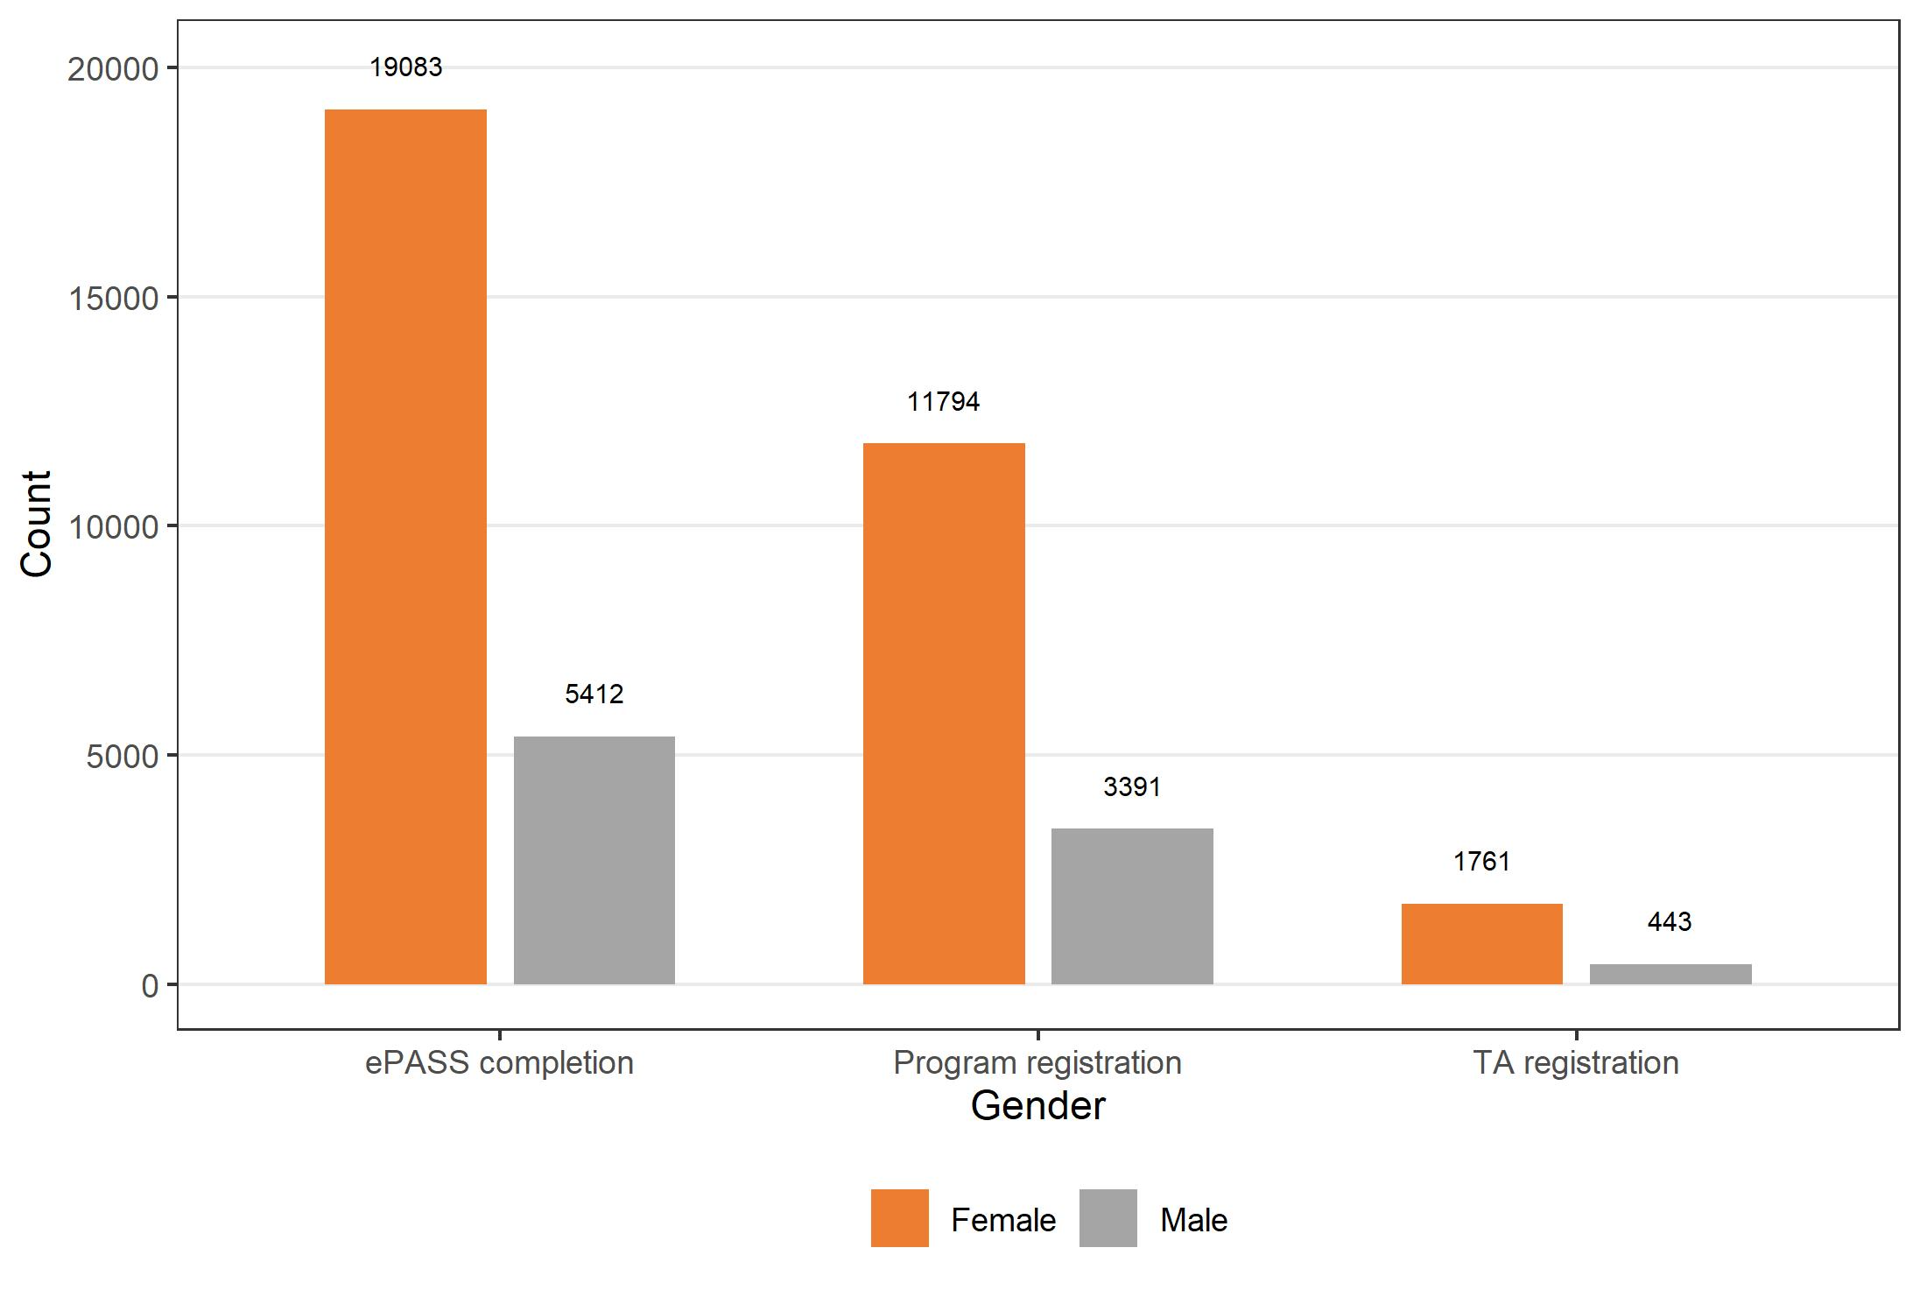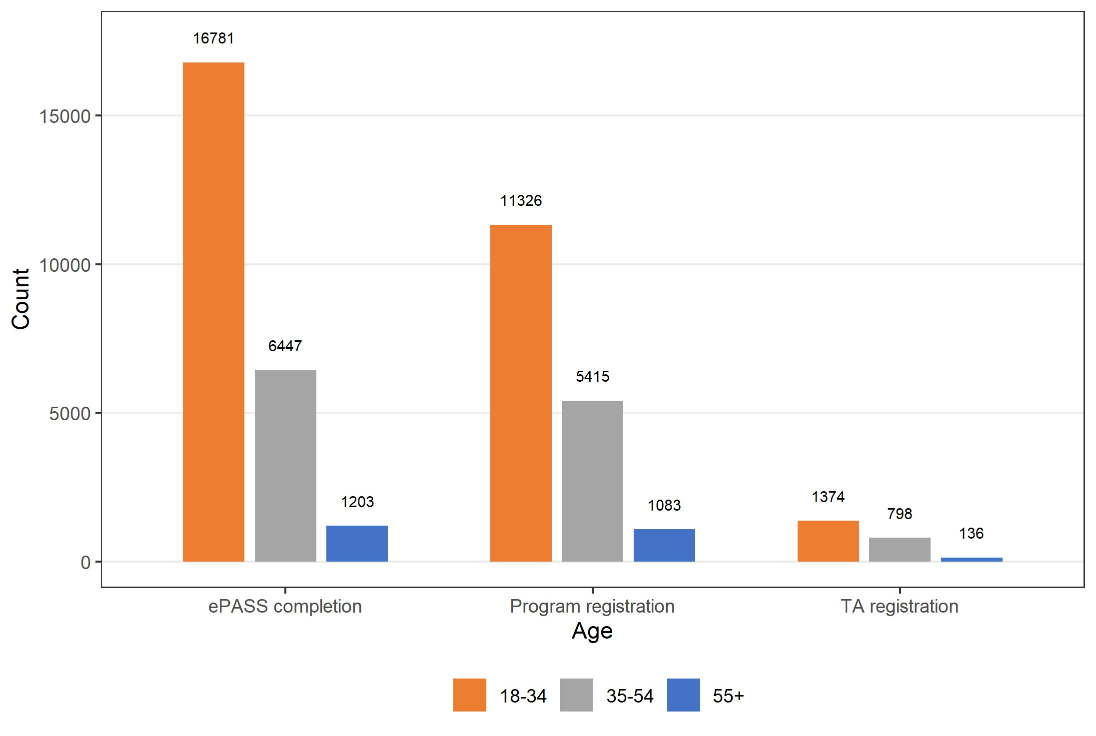
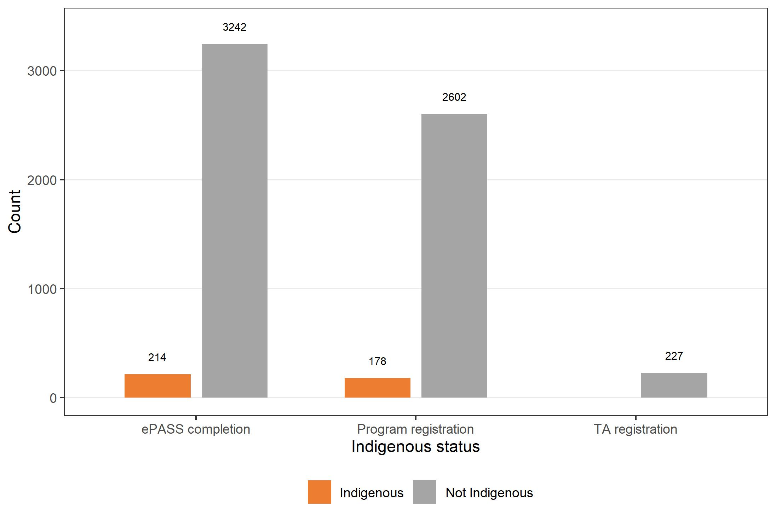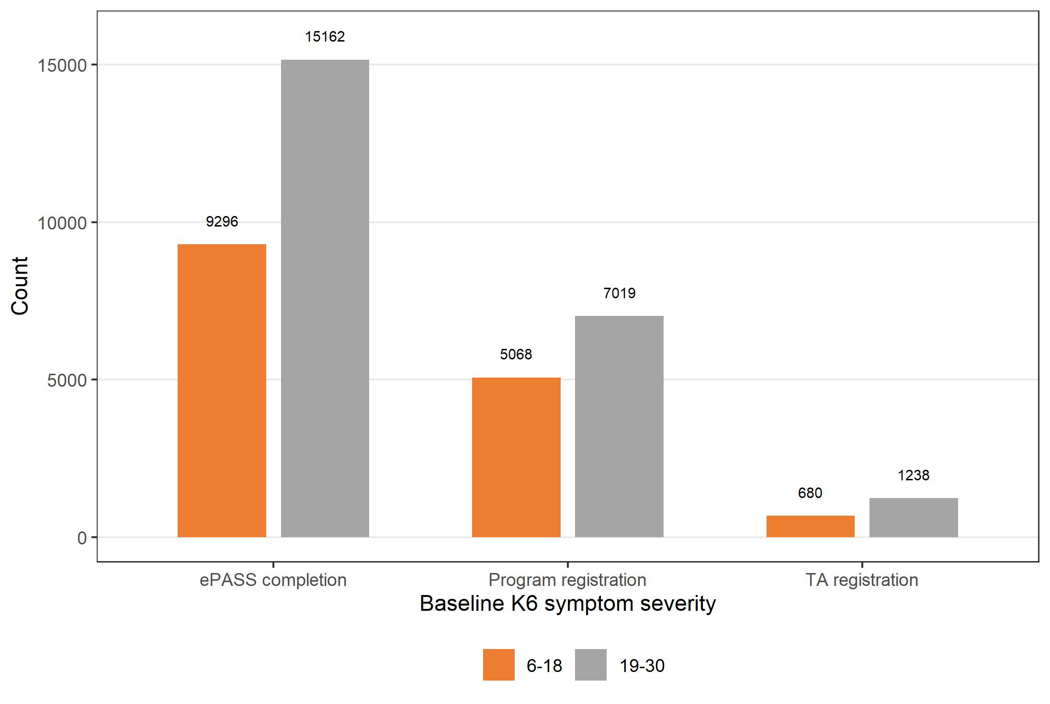

Figure 4. Uptake of Mental Health Online assessment, all treatment and therapist-supported treatment by demographic and clinical characteristics, January 2015 to December 2021
ePASS, assessment; TA, Therapist Assist.
K6 scores 6-18, no probable serious mental illness; scores 19-30 probable serious mental illness.^{43, 44}

Predictors of treatment uptake and dropout
Al Asadi et al (2014) examined predictors of online treatment uptake and dropout among 9,394 potential participants who had completed Anxiety Online’s (Mental Health Online’s former name) assessment between October 2009 and January 2012.⁴² In total, 3,880 consumers enrolled and 5,514 did not enrol in treatment resulting in a pre-treatment attrition rate of 58.7%.
People who took up or commenced treatment differed significantly (p<.001 to p=0.03) from those who did not, with the odds of enrolling in an Anxiety Online treatment program being:
- 2.9 times higher for those who gave “seeking to use one of the online self-help programs” as a reason for joining the program;
- 30% lower for those who expressed concerns about eating and weight issues;
- 1.29 times higher for those who completed undergraduate degrees and 19% lower for those possessing other certificates as for those with no postsecondary education;
- 1.35 times higher for those who heard about Anxiety Online from the traditional media (compared with internet, family/friend or health professional);
- 3% lower for each additional point an individual scored on the K6 total score;
- 2.16, 2.21, and 2.29 times higher for those who were prepared to make changes, reporting that they were already making changes, and who reported being in relapse and seeking further assistance, respectively, relative to those who were disinterested or indifferent;
- 1.92, 1.35, and 1.26 times higher for those who rated their quality of life as very poor, poor, and neither poor nor good, respectively, relative to those who gave a rating of very good;
- 1.55 and 1.53 times higher for married and single individuals, respectively, relative to those reporting some other relationship status (compared with those married, single, cohabitating, not living together, separated/divorced, widowed);
- 1.18 times higher for those indicating that they learn best by reading relative to those who said they learn best by doing; and
- 1.19 times higher for those who identified themselves as non-smokers.⁴²
Of the 3,880 enrolled (including 135 in therapist-supported) treatment, 142 formally dropped out resulting in a during treatment dropout rate of 4.25%.⁴² Two smaller studies by Klein et al (2010) and Kyrios et al (2018) also demonstrated high treatment completion rates, with 73% (16/22) completing all 10 modules⁴⁵ and only 7% (6/89) discontinuing treatment,⁴⁶ respectively.
Al Asadi et al (2014) also found that those who dropped out of treatment differed significantly (p=.002 to p=0.03) from those who did not formally withdraw.⁴² Specifically, they were less likely to: express concerns about anxiety, stress, and depression; rate their quality of life as very poor, poor, or good; report adequate levels of social support; and report readiness to make or were in the process of making changes.⁴²

MindSpot
As shown in Table 12, of all MindSpot consumers commencing assessment from January 2013 to December 2019, around 27% are male and 73%, female.⁷ The average age of these consumers is 36 years, with 55% aged 18-34 years.⁷ Almost 4% are Aboriginal or Torres Strait Islander peoples, 22% are born overseas, 19% reside in rural or remote locations, 32% are from New South Wales, 43% are not employed, 62% do not hold a university degree, and 62% are not married or cohabitating.⁷
In terms of clinical characteristics, overall, MindSpot consumers have very high psychological distress (K10), moderately severe depression (PHQ-9) and moderate anxiety (GAD-7). Almost half (47%) are consulting with a GP about their mental health, over one-quarter take psychotropic medication and over one-third have never previously used mental health services.⁷ Around one in five of all consumers are referred or advised to use MindSpot by a GP or health professional.⁴⁷ Significant proportions have suicidal thoughts (32%) or a current suicidal plan (4%); or are experiencing psychosocial stressors (59% relationship, 58% vocational, 45% physical health and 38% financial), which have resulted in 5.6 whole or 8.9 part days out of role in the previous month.⁷
Two-thirds (67%) of all consumers report their main reason for using MindSpot is to obtain a confidential assessment and around 27%, for treatment.⁷
Compared with all consumers who start an assessment, those who start a MindSpot treatment course are slightly more likely to be female (15,533/21,067; 73.7%), have an older average age (M=39.9, SD=13.7) and experience a similar level of psychological distress (K10, M=30.2, SD=6.9).⁷ Note that all MindSpot treatment courses in this period offered the option of therapist support, but around one-third of consumers do not take up this support (N. Titov, personal communication, 15 March 2022).

Predictors of treatment uptake and completion
Using data from 15,882 consumers who accessed MindSpot between 1 January and 31 December 2019, Cross et al (2022) conducted a series of univariate regression models and multivariate classification algorithms to investigate predictors of therapist-supported treatment uptake and completion.⁴⁸ The average rate of treatment uptake was reported to be 21.6% (of those who completed an assessment), and completion (i.e., 4 out of 5 lessons), 68%.⁴⁸
The following consumer characteristics were found to be positively associated with treatment uptake and completion:
- Older age – consumers aged 65 years and older have an uptake of 40% compared with those aged 18-24 years who have an uptake of 11% (p < .001) and completion rates increase with age;
- Being male – although fewer males than females complete an assessment (24.2% vs 75.8%), males are more likely to start treatment than females (25.7% vs 20.4%, p < .001), and once started are equally likely to complete treatment (69.9% vs 67.1%; p=.105);
- Rurality – consumers from rural or remote regions are significantly more likely to start treatment (26.1% vs 20.3% for capital city and 21.6% for other urban region, p<.001), but there are no difference in treatment completion rates based on locality;
- Higher educational attainment – those with a university degree are more likely to start (25.9% vs 19% p < .001) and complete (72.2% vs 63.9%, p < .001) treatment; and
- Being in a relationship – uptake was 27.6% for those who were married vs 30.5% widowed vs 16.1% single/never married (p < .001) and completion was 72.3% vs 61.4% single/never married (p < .001).⁴⁸
The following consumer characteristics were found to be negatively associated with treatment uptake and completion:
- Indigeneity, with Aboriginal and Torres Strait Islander peoples being less likely to start (14.4% vs 21.9%, p<.001) and less likely to complete (51.4% vs 67.8%, p=.005) treatment;
- Higher initial symptom severity (K10 and PHQ-9), with uptake reducing from 26.9% for those with mild symptoms to 18.8% for those with severe symptoms (p<.001), and completion reducing from 76% for those with mild symptoms to 64% for those with severe symptoms (p<.001); and
- Increasing self-reported psychosocial difficulties, with uptake decreasing from 25.3% for those with no difficulties to 14.6% for those with six difficulties, and completion reducing from 74.1% for those with no difficulties to 53% for those with six difficulties (p < .001).⁴⁸

THIS WAY UP
Based on routinely collected service use data, Table 12 shows that of the 15,360 unique consumers who registered with THIS WAY UP in July 2020 – December 2020, 29% were male and around two-thirds female (67%).⁴⁰ The average age of these consumers was 39 years, the median, 37, and range, 11-91.⁴⁰ Note the youngest age is typically 12 years, however, referring clinicians may use their discretion to enable 11-year-olds to access services.
Around 7% of website consumers are from rural and remote locations, November 2015 – December 2020.⁴⁰
Based on 6,132 consumers who commenced the Depression and anxiety course from March 2019 to October 2020, average baseline: psychological distress (K10) was very high; anxiety (GAD-7) was moderate; and depression (PHQ-9) was moderate.⁴⁹ Around three-quarters (74.5%) have a probable diagnosis of major depressive disorder (PHQ-9 score > 10) and almost two thirds (64%) a probable diagnosis of GAD (GAD-7 score > 10).⁴⁹ Most are prescribed the Depression and anxiety course by their psychologists or GPs (38.7% and 34.8%, respectively) and 12.4% by medical specialists.⁴⁹ Around 15% complete the course with support from their prescribing clinician and 85% completed the course using a self-directed format.⁴⁹

Predictors of treatment completion
Several studies have examined predictors of completion of THIS WAY UP treatment.⁵⁰⁻⁵⁴ Because we used the same studies to extract THIS WAY UP outcome data, details about predictors of adherence are summarised together with those regarding outcomes in Section 4.5 (Table 20).
Briefly, findings indicated that older adults and consumers with less severe symptoms are more likely to complete treatment. One study suggested that more contacts from prescribing clinicians during the course was associated with treatment completion.⁵³

Summary
Together, the three DMHSs are providing free online psychological treatment to thousands of consumers per year, and this represents only one component of their service offerings. Importantly, they are also conducting tens of thousands of assessments per year, which helps to support consumers with navigating other services in the mental health system and identify consumers at increased risk of suicide. Consumers using DMHSs tend to be females, under 54 years living in urban areas and experiencing clinically significant symptoms. Significant proportions of consumers are not accessing any other mental health services.

Outcomes of DMHS use

Our approach
We used aggregate routinely collected mental health outcomes data, peer-reviewed publications and service documents provided by the three DMHSs to describe consumer outcomes of accessing these services.
We also used data sourced from peer-reviewed and grey literature to compare consumer outcomes of DMHSs with other mental health care.
Appendix B provides further details about the data sources we used.

Measuring change in mental health outcomes

Outcome measurement scales
All three DMHSs use a range of validated mental health and other outcome tools to assess severity of distress and symptoms, functioning and quality of life. Measures most used by the DMHSs and/or analysed in our report are summarised in Table 13.

Table 13. Mental health and other outcome measurement scales used by DMHSs
Measure | Brief description | Scoring
Generalised Anxiety Disorder scale (GAD-7)³³ | Consumer-rated measure of anxiety symptoms. Comprises seven questions about how often the consumer has been bothered by selected anxiety symptoms in the past two weeks. | Each item is scored 0 (Not at all), 1 (Several days), 2 (More than half the days) or 3 (Nearly every day). The total score ranges from 0-21. A score of 10 or more indicates the likely presence of Generalised Anxiety Disorder.
Kessler-10 (K10)²⁹ | Consumer-rated measure developed to assess non-specific psychological distress. Comprises 10 items about symptoms of depression and anxiety in the past four weeks. | Each item is rated from 1 (None of the time) to 5 (All of the time), resulting in a total score that ranges from 10 to 50. Scores of 10-15 indicate little or no psychological distress, scores of 16-21 indicate moderate psychological distress, scores of 22-29 indicate high psychological distress, and scores of 30-50 indicate very high psychological distress.
K10+⁵⁵ | As described above and includes four additional questions to assess degree of  disability experienced by consumer. | The additional four questions do not contribute to the total score. They provide number of full or part days out of (work/education) role and number of visits to health services.
Kessler- 6 (K6)^{43, 44} | Consumer-rated measure of non-specific psychological distress intended to be used as a quick tool to assess risk for serious mental illness in the general population. Comprises six items about symptoms of depression and anxiety in the past four weeks. | Each item is rated from 1 (None of the time) to 5 (All of the time), resulting in a total score ranging from 6 to 30.⁴³ Scores of 6-18 indicate no probable serious mental illness and scores of 19-30 indicate probable serious mental illness.
Mini-Social Phobia Inventory (Mini-SPIN)³⁵ | Consumer-rated three-item scale about avoidance and fear of embarrassment over the past week to screen for generalised social anxiety disorder. Developed based on the longer 17-item social phobia inventory (SPIN). | Each item is rated using a 5-point Likert scale from 0 (Not at all) to 4 (Extremely). Scores range from 0 to 12, with scores of 6 or higher indicating possible problems with social anxiety.
Patient Health Questionnaire (PHQ-9)²⁸ | Consumer-rated measure of depressive symptoms. Comprises nine items about how often the consumer has been bothered by depressive symptoms in the past two weeks. | Each item is scored 0 (Not at all), 1 (Several days), 2 (More than half the days) or 3 (Nearly every day). Total scores range from 0-27. Scores of 0-4 indicate no depression, scores of 5-9 indicate mild depression, scores of 10-14 indicate moderate depression, scores of 15-19 indicate moderately severe depression, and scores of 20-27 indicate severe depression.
Posttraumatic Stress Disorder Checklist (PCL-C)³⁶ | Consumer-rated 17 item measure that assesses the DSM-5 symptoms of PTSD over the past month. | Items are rated on a five-point scale, from 1 (not at all) to 5 (extremely) and generate a total symptom severity score between 17 and 85. Scores of 17-29 indicate little to no severity; scores of 30-44 indicate moderate to moderately high severity; and scores of 45-85 indicate high severity.
Panic Disorder Severity Scale Self-Report version (PDSS-SR)³⁴ | Consumer-rated seven-item measure of panic disorder symptoms over the previous week. | Items are rated on a five-point scale from 0 (not at all/none) to 4 (extreme) and generate a total score between 0 and 28. Cut-off scores ≥8 suggest clinical levels of panic disorder.
World Health Organization Disability Assessment Schedule (WHODAS 2)⁵⁶ | Consumer-rated 36-item measure that assesses health and disability across six domains including: measured functional impairment  Consumer-rated 12-item measure of functional impairment and activity limitation over the past 30 days. Assesses Cognition, Mobility, Self-care, Getting along, Life activities and Participation. | Items are assessed on a five-point scale, from 1 (none) to 5 (extreme) and are summed to yield a score ranging from 12 to 60. Higher scores indicate higher disability or loss of function.
World Health Organization Quality-of-Life Scale (WHO-QOL-BREF) Psychological Domain subscale⁵⁷ | Consumer-rated 26-item instrument consisting of four domains: physical health (7 items), psychological health (6 items), social relationships (3 items), and environmental health (8 items); it also contains QOL and general health items. The psychological domain measures include self-image, negative thoughts, positive attitudes, self-esteem, mentality, learning ability, memory concentration, religion, and mental health status. | Each item is scored on a five-point scale, from 1 (not at all) to 5 (completely), to determine a raw score. Mean score of items in each domain is used to derive each domain’s score. Higher scores indicate better quality of life.
Yale Brown Obsessive-Compulsive Scale (Y-BOCS)⁵⁸ | Clinician-administered 10-item scale used to assess for obsessive compulsive disorder | Items are scored on a five-point scale from 0 (no symptoms) to 4 (extreme symptoms). The sum of the first five items is a severity index for obsessions, and the sum of the last five is an index for compulsions. Scores of: 0-7 indicate subclinical symptoms; 8-15 indicate mild symptoms; 16-23 indicate moderate symptoms; 24-31 indicate severe symptoms; and 32-40 indicate extreme symptoms.

Statistics used to measure treatment effect
The change in mean score on a given measurement scale between the first and last assessment occasion was used to examine the effect of treatment on symptoms or functioning. Decreases in scores for measures of symptoms and disability, and increases in scores for measures of quality of life and functioning, indicate improvement. Because different measures are used between and within the three DMHSs, we calculated effect size (Cohen’s d) to compare pre- and post-treatment means for specific groups using a common metric to assess the magnitude of the effect of treatment by the DMHSs on these domains. Cohen (1992) recommends interpreting effect sizes of d = 0.2 as 'small', 0.5 as 'medium' and 0.8 as 'large' effect sizes.⁵⁹ For ease of interpretation, all Cohen’s d estimates are reported as positive if post-treatments means showed improvements compared with pre-treatment means, and negative if post-treatments means showed deterioration compared with pre-treatment means.

Where available, we extracted other statistics used to describe effectiveness from peer-reviewed publications on mental outcomes produced by treatment from the three DMHSs and other comparison treatments. These include the remission rate, which is the proportion of consumers who are no longer “cases” at the end of treatment out of the total number who were “cases” at the start of treatment. In these instances, “caseness” is usually defined as having a clinically significant symptom level as indicated by a value greater than a stated cut-off score on a validated standardised symptom measurement scale. In these studies, the recovery rate represents the proportion of consumers whose symptoms improve by a particular (variably defined) proportion (e.g., the proportion of consumers whose symptom levels were 50% lower at the end of treatment than at the start of treatment). Sometimes remission and recovery rates are used interchangeably in published studies. Because there are shortcomings associated with both these rates, the reliable change index is often reported alongside them. Reliable change is about whether the magnitude of the change from before to after treatment exceeds the unreliability of the measurement scale (measurement error or natural variance).⁶⁰ It is used to interpret the clinical significance of change (e.g., reliable improvement, deterioration or no change). The numeric value for reliable change is calculated using the initial standard deviation of the measure and its reliability within a given sample.⁶⁰ Finally, reliable recovery is the proportion of consumers who score above a clinical cut-off on an assessment instrument at baseline (denominator), and score below the clinical cut-off and show reliable improvement at the end of treatment (numerator).⁶¹

Mental Health Online outcomes
Mental Health Online does not routinely collect mental health outcome data. Instead, it conducts discrete evaluations of various service aspects. Table 14 shows the mental health and quality of life outcomes produced by Mental Health Online in relation to one such recent evaluation (directly provided by Mental Health Online). Appendix C provides details about how Mental Health Online collected these data and their analysis indicating this sample’s representativeness of the wider group of consumers (N=2,318) of the Therapist Assist program.
Table 14 also summarised treatment outcomes extracted from several selected peer-reviewed publications of program trials before their implementation by Mental Health Online.^{45, 46, 62}

Table 14. Selected Mental Health Online outcome data before and after (10-12 weeks) treatment by support status
Treatment | Outcome measure | Baseline N | Baseline Mean | Baseline SD | 12-week  N | 12-week M | 12-week SD | Effect size  (d) and  95% CI
- Supported iCBTª | K6 | 25 | 18.96 | 5.52 | 25 | 14.88 | 6.1 | 0.81  (0.35, 1.26)
- Supported OCD iCBT^{b} | YBOCS | 89 | 22.44 | 5.36 | 89 | 15.86 | 5.65 | 1.05  (0.72, 1.37)
- Supported PTSD Online^{c} | PTSD clinician severity rating | 22 | 5.73 | 1.12 | 22^{c} | 4.06^{c} | 2.01^{c} | 1.68  (0.79, 2.57)
- Supported PTSD Online^{c} | PTSD checklist  (PCL-C) | 21 | 54.38 | 13.89 | 21^{c} | 45.52^{c} | 15.64^{c} | 0.66  (0.29, 1.03)
- Supported PTSD Online^{c} | Quality of life (WHO-QOL-BREF), psychological subscale | 18 | 44.21 | 14.58 | 18^{c} | 46.3^{c} | 18.68^{c} | Not reported
- Self-directed GAD Online^{d} | K6 | 88 | 16.64 | 4.4 | 88 | 13.65 | 4.2 | 1.16  (2.2, 3.8)
- Self-directed Panic Stop!^{d} | K6 | 40 | 15.18 | 4.5 | 40 | 13.43 | 4.9 | 0.81  (0.8, 2.7)
- Self-directed  OCD Stop!^{d} | K6 | 17 | 14.06 | 6.2 | 17 | 13.47 | 6.6 | 0.23  (-1.3, 2.5)
- 10. Self-directed PTSD Online^{d} | K6 | 30 | 18.53 | 5.2 | 30 | 14.2 | 5.7 | 0.95  (1.9, 6.7)
- Self-directed SAD Online^{d} | K6 | 50 | 15.3 | 5.3 | 50 | 14.26 | 4.9 | 0.31  (-0.3, 2.4)
- Self-directed GAD Online^{d} | GAD clinical disorder severity rating^{e} | 88 | 3.26 | 1.5 | 88 | 1.82 | 1.6 | 1.22  (1.1, 1.8)
- Self-directed Panic Stop!^{d} | PD clinical disorder severity rating^{e} | 40 | 3.13 | 1.9 | 40 | 1.63 | 2.2 | 1.12  (0.9, 2.1)
- Self-directed OCD Stop!^{d} | OCD clinical disorder severity rating^{e} | 17 | 2.33 | 0.9 | 17 | 1.52 | 1.8 | 0.83  (0.04, 1.6)
- Self-directed PTSD Online^{d} | PTSD clinical disorder severity rating^{e} | 30 | 3.17 | 1.6 | 30 | 1.98 | 1.8 | 0.72  (0.3, 2.1)
- Self-directed SAD Online^{d} | SAD  clinical disorder severity rating^{e} | 50 | 3.1 | 1.7 | 50 | 2.2 | 2 | 0.84  (0.4, 1.3)
- Self-directed GAD Online ^{d} | Quality of life^{f} | 88 | 3.37 | 0.8 | 88 | 3.59 | 0.8 | 0.36  (-0.4, -.04)
- Self-directed Panic Stop! ^{d} | Quality of life^{f} | 40 | 3.55 | 1 | 40 | 3.6 | 1 | 0.11  (-0.3, 0.2)
- Self-directed OCD Stop!^{d} | Quality of life^{f} | 17 | 3.71 | 1.1 | 17 | 4 | 1.1 | 0.87  (-0.5, -0.1)
- Self-directed PTSD Online^{d} | Quality of life^{f} | 30 | 2.97 | 0.9 | 30 | 3.5 | 0.9 | 0.96  (-0.8, -0.2)
- Self-directed SAD Online^{d} | Quality of life^{f} | 50 | 3.24 | 0.9 | 50 | 3.52 | 0.9 | 0.51  (-0.5, -0.1)
CI, confidence interval; GAD, generalised anxiety disorder; iCBT, internet cognitive behavioural therapy; K6, Kessler Psychological Distress 6-Item Scale; K10, Kessler Psychological Distress 10-Item Scale; M, mean; N, number; OCD, obsessive compulsive disorder; PCL-C, Posttraumatic Stress Disorder Checklist—Civilian Version; PTSD, post-traumatic stress disorder; SAD, social anxiety disorder; SD, standard deviation; WHO-QOL-BREF, World Health Organization Quality of life questionnaire-BREF; YBOCS, Yale-Brown Obsessive-Compulsive Scale.
ªData directly provided by Mental Health Online from Therapist Assisted programs collected via optional surveys from September 2021 to February 2022 and $10 gift cards given (see Appendix C for further details).
^{b}Sourced from Kyrios et al (2018) randomised controlled trial of 12-week therapist-supported iCBT for OCD.⁴⁶
^{c}Sourced from Klein et al (2010) open trial of 10-week therapist-supported online treatment for PTSD.⁴⁵ Improvement in quality of life is denoted by higher post-treatment scores.
^{d}Sourced from Klein et al (2011) evaluation of post-treatment effects of completers of 5 self-directed Anxiety Online (Mental Health Online’s former name) programs.⁶² Improvement in quality of life is denoted by higher post-treatment scores.
^{e}Likely clinical disorder severity based on ePASS online self-report diagnostic tool that assesses for 21 DSM-IV-TR disorders. Severity ratings range from 0 (absence of any symptoms) to 8 (very severe clinical disorder). Likely clinical disorder severity scores below 3.50 are given a subclinical label and rating.⁶²
^{f}Quality of life assessed using single-item self-report question asking participants to rate their overall quality of life on a 5-point scale from 1 (very poor) to 5 (very good).⁶²
We calculated effect sizes (as standardised mean differences) for each of the therapist-supported and self-directed treatment outcomes in Table 14. We did this to ensure that the same approach was used for all studies, and as a result some of our calculations differ from those presented in Table 14. Our calculated estimates and confidence intervals are presented graphically in Figure 5, which shows that taken together, therapist-supported treatments produced large (d=0.95), and self-directed treatments produced medium (d=.59), improvements in mental health symptom severity. However, treatment had small effects on quality of life irrespective of whether supported or self-directed (d=0.12 and d=0.28, respectively).
There were significant differences in effect sizes between the four subgroups (p < 0.01). Studies in the same subgroup had similar effects (as demonstrated by low heterogeneity, with I² from 0-35%; and no evidence against homogeneity, all p > 0.16).
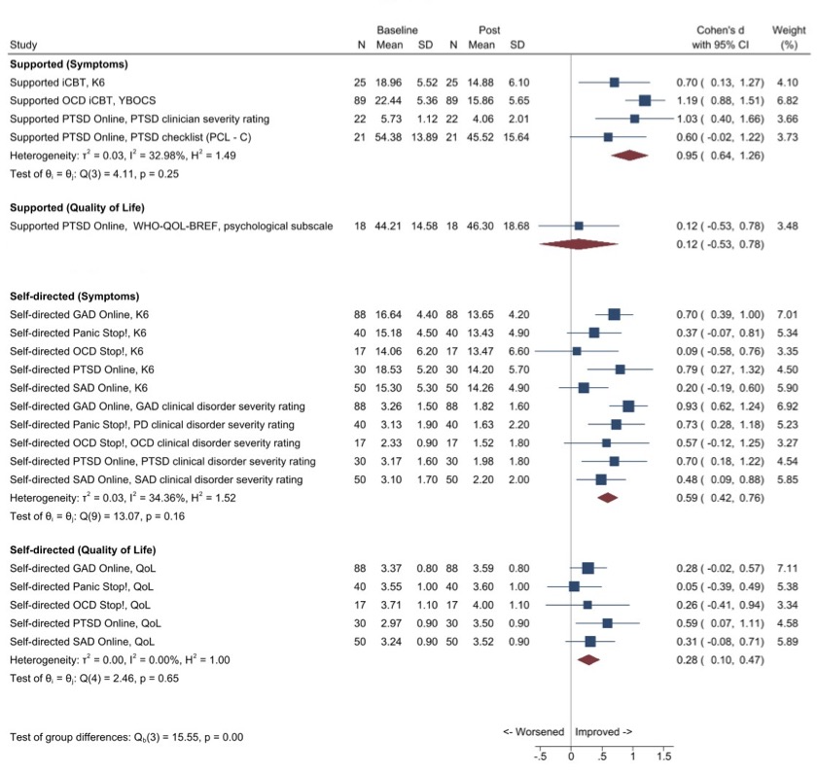

Figure 5. Forest plot of Mental Health Online treatment effects on mental health symptoms and quality of life by therapist support
CI, confidence interval; GAD, generalised anxiety disorder; iCBT, internet cognitive behavioural therapy; K6, Kessler Psychological Distress 6-Item Scale; K10, Kessler Psychological Distress 10-Item Scale; M, mean; N, number; OCD, obsessive compulsive disorder; PCL-C, Posttraumatic Stress Disorder Checklist—Civilian Version; PTSD, post-traumatic stress disorder; QoL, quality of life; SAD, social anxiety disorder; SD, standard deviation; WHO-QOL-BREF, World Health Organization Quality of life questionnaire-BREF; YBOCS, Yale-Brown Obsessive-Compulsive Scale.
Note. Better mental health and quality of life are represented by lower scores and higher scores, respectively.

Table 15 shows other treatment outcomes we extracted from the above three selected publications used for determining Mental Health Online’s effectiveness. Two studies examined 12 and 10 weeks’ therapist-supported iCBT for OCD and PTSD, respectively.^{45, 46} The third study examined self-directed iCBT for GAD, panic disorder, OCD, PTSD, and SAD delivered over 12 weeks.⁶² Treatment completion rates ranged from 63% to 93%, with on average, higher completion rates for therapist-supported treatment.
The study of therapist-supported treatment by Klein et al (2010) was the only one to report remission rates and include follow-up assessment at three months.⁴⁵ Specifically, 69% (9/13) at post-treatment, and 77% (10/13) at 3-month follow-up, no longer met clinical diagnostic criteria for PTSD. Additionally, mental health improvements were maintained at 3-month follow-up. This study also reported high participant therapeutic alliance ratings (88%), with 194.5 minutes average total therapist time.
The study of therapist-supported iCBT for OCD by Kyrios et al (2018) was the only one that reported reliable change data for participants with clinically significant OCD symptoms (score of >16 on the YBOCS).⁴⁶ Specifically, 49% (25/51) achieved a reliable improvement (> 6 units YBOCS reduction [~1 standard deviation]) and 33% (17/51) made a reliable recovery (reliable improvement plus YBOCS < 16 at post-treatment). This was also the only study to examine predictors of outcomes, the findings of which indicated that socio-demographic variables and indicators of disability did not predict improvements in OCD symptoms.⁴⁶

Table 15. Other outcomes from Mental Health Online therapist-supported and self-directed treatment
Publication | Aim | Treatment completion rate | Remission rate | Reliable change | Follow up | Predictors of outcome
Kyrios et al (2018)⁴⁶ | Examine 12 weeks’ therapist-supported iCBT for OCD using a randomised controlled trial (N=89) | 93% (83/89) | Not reported | 49% (25/51) reliable improvement (> 6 units YBOCS change [~1 SD])  33% (17/51) made a reliable recovery (reliable improvement plus YBOCS < 16 at post-treatment) | Not examined | Improvements in OCD symptoms not predicted by:  - socio-demographic variables (gender, age, number of children, education, and marital status) (F_{5,96}=0.42, p=0.84)  - indicators of disability (pre-treatment global assessment of functioning, depression, anxiety scores, medication, number of hospitalisations) (F_{5,95}=2.06, p=0.08)
Klein et al (2010)⁴⁵ | Evaluate an open trial of a 10-week therapist-supported iCBT treatment for PTSD (N=22) | 73% (10/10 modules) | 69% (9/13) no longer met diagnostic criteria for PTSD | Not reported | 77% (10/13) no longer met diagnostic criteria for PTSD | Not examined
Klein et al (2011)⁶² | Evaluated effects of five 12-week fully self-directed iCBT programs for GAD (n=88), panic disorder (n=40), OCD (n=17), PTSD (n=30) and SAD (n=50) | 69% (88/128) GAD  77% (40/52) Panic 63% (17/27) OCD 79% (30/38) PTSD 65% (50/77) SAD | Not reported | Not reported | Not examined | Not examined
GAD, generalised anxiety disorder; iCBT, internet cognitive behavioural therapy; OCD, obsessive compulsive disorder; PTSD, post-traumatic stress disorder; SAD, social anxiety disorder; SD, standard deviation; YBOCS, Yale Brown Obsessive-Compulsive Scale.

Consumer experiences
Mental Health Online has recently (2020-2021) evaluated consumer experiences of the therapist-supported treatment (Therapist Assist program) by sending a survey to 107 consumers who remained engaged with the program for the full 12 weeks. All 27 consumers who completed the survey reported that the service had had a positive impact on their mental health, with 13 (48.1%) reporting it was much better, 5 (18.5%) moderately better, and 9 (33.3%) slightly better. All 27 consumers reported they were satisfied (17 [63%] completely and 10 [37%] moderately) with the Therapist Assist program and would recommend it to someone else. Findings from 13 of these survey respondents are summarised in Table 16 and provide insights into the three therapist communication modalities offered by Mental Health Online. These findings suggest there is a place for all three communication modalities offered – email, video and instant chat.

Table 16. Consumer experiences of different therapist communication modalities
Modality | Characteristics | Functions
Email | - more structured, permanent and informational  - offers more of a sense of control and predictability, more time to reflect, consider and apply skills and suggestions  - supports detailed self-disclosure for some (e.g., trauma) | - a starting place to build comfort towards live communication methods  - opportunities to think, reflect and apply skills and suggestions from module content and therapist suggestions  - the provision of information and detail (which is available for thorough and repeat viewing)  - sharing of uncomfortable information  - the opportunity to check in and make minor adjustments between live sessions  - providing reminders for engagement
Video | - more human and dynamic  - focus on relationship, connection, and real-time interaction  - more immediate (less time to think/consider/reflect)  - less predictable; opportunities to address issues as they come up | - relationship and trust building  - real-time discussion, exploration and problem solving  - working together  - planning  - positive reinforcement
Instant chat | - characteristics similar to video  - provides a sense of psychological distance | - roles similar to video  - further stepping-stone towards video communication
Source: Mental Health Online Progress Report 20, July – December 2020.⁶³
In July 2019, Mental Health Online sent a survey to all consumers who had completed the online assessment (ePASS) in the previous 6 months and received responses from 21 consumers. Twenty of these 21 consumers reported being satisfied with the assessment system, ranging from seven (33.3%) who were very, nine (42.9%) highly and four (19%) moderately satisfied. Correspondingly, most (17 or 81%) indicated they would, three (14.3%) were unsure whether they would, and one (4.7%) would not, recommend the assessment to someone they know. Using a five-star (with 5 indicating the best) rating, 18 (85.7%) consumers gave the overall quality, and 19 (90.5%) the overall credibility, of the assessment system 4 or 5 stars.

MindSpot outcomes
Table 17 shows mental health outcomes and functional outcomes of therapist-supported routine treatment produced by MindSpot for all, and different subgroups of, consumers over different time periods.
MindSpot directly provided some data in aggregate form, so we were unable to determine baseline scores for the subset of consumers who completed post-treatment assessments. Therefore, these data are included in Table 17 solely to demonstrate trends in mean scores before and after therapist-supported and self-directed treatment over the life of MindSpot.
We also extracted outcome data from several of their peer-reviewed publications of routine care outcomes, including one which provided pre- and post-treatment outcomes of routine therapist-supported treatment for the same group of consumers at each assessment point over MindSpot’s first seven years of operation, and which we used for calculating effect sizes instead of the aggregated routinely collected data.⁷ The other studies we selected complemented findings from this key publication by focusing on outcomes of routine therapist-supported treatment in younger and older adults, Indigenous peoples and migrants.⁴¹⁻⁴⁴

Table 17. Selected MindSpot outcome data before and after (8 weeks/5 modules) treatment for all, and subgroups of, consumers by support status
Population group | Treatment | Outcome measure | Baseline N | Baseline Mean | Baseline SD or CI | Post  N | Post M | Post SD or CI | Effect size and 95% CI
- Allª | Supported iCBT | K10 | 28,808 | 31.6 | 7.5 | 17,137 | 21.0 | 8.0 | N/A
- Allª | Supported iCBT | PHQ-9 | 28,808 | 14.7 | 6.2 | 17,137 | 6.6 | 5.4 | N/A
- Allª | Supported iCBT | GAD-7 | 28,808 | 12.3 | 5.2 | 17,137 | 5.9 | 4.7 | N/A
- Allª | Self-directed iCBT | K10 | 1,350 | 29.4 | 7.0 | 600 | 21.2 | 8.0 | N/A
- Allª | Self-directed iCBT | PHQ-9 | 1,350 | 12.8 | 5.8 | 600 | 6.6 | 5.4 | N/A
- Allª | Self-directed iCBT | GAD-7 | 1,350 | 11.6 | 5.0 | 600 | 6.2 | 4.9 | N/A
- All^{b} | Supported iCBT | K10 | 21,745 | 30.1 | 6.9 | 21,745 | 20.8 | 6.2 | d=1.42 (1.40, 1.44)
- All^{b} | Supported iCBT | PHQ-9 | 21,745 | 13.6 | 5.9 | 21,745 | 6.5 | 4.2 | d=1.40 (1.37, 1.43)
- All^{b} | Supported iCBT | GAD-7 | 21,745 | 12.0 | 5.0 | 21,745 | 5.7 | 3.6 | d=1.45 (1.42, 1.47)
- All^{b} | Supported iCBT | Whole days out of role^{c} | 5,120 | 5.4 | 7.5 | 5,120 | 3.5 | 6.2 | d=0.28 (0.25, 0.31)
- All^{b} | Supported iCBT | Part days out of role^{c} | 5,120 | 9.3 | 8.4 | 5,120 | 6.0 | 7.2 | d=.42 (0.39, 0.45)
- Young adults^{d} | Supported iCBT | K10 | 222 | 31 | 6.3 | 222 | 23.5 | 6.7 | d=.1.15 (0.95, 1.35)
- Young adults^{d} | Supported iCBT | PHQ-9 | 222 | 13.8 | 5.7 | 222 | 7.7 | 4.7 | d=1.17 (0.96, 1.37)
- Young adults^{d} | Supported iCBT | GAD-7 | 222 | 12.9 | 4.6 | 222 | 7.1 | 4.3 | d=.1.30 (1.10, 1.50)
- Older adults^{e} | Supported iCBT | K10 | 516 | 28.1 | 6.9 | 516 | 19.1 | 6.2 | d=1.4 (1.2, 1.5)
- Older adults^{e} | Supported iCBT | PHQ-9 | 516 | 12.7 | 6 | 516 | 5.3 | 4.1 | d=1.4 (1.3, 1.6)
- Older adults^{e} | Supported iCBT | GAD-7 | 516 | 10.5 | 5 | 516 | 4.5 | 3.5 | d=1.4 (1.3, 1.5)
- Indigenous Australians^{f} | Supported iCBT | K10 | 70 | 31.6 | 7.2 | 70 | 20.7 | 6.7 | d=1.57 (1.18, 1.94)
- Indigenous Australians^{f} | Supported iCBT | PHQ-9 | 70 | 15.2 | 6.2 | 70 | 6.8 | 4 | d=1.60 (1.21, 1.97)
- Indigenous Australians^{f} | Supported iCBT | GAD-7 | 70 | 12.8 | 4.8 | 70 | 6.2 | 3.4 | d=1.57 (1.18, 1.94)
- NESB MidEast^{g} | Supported iCBT | PHQ-9 | 43 | 12.88 | 95%CI 10.96, 14.81 | 43 | 6.33 | 95%CI 4.47, 8.19 | g=1.13 (0.95, 1.32)
- NESB Europe^{g} | Supported iCBT | PHQ-9 | 115 | 13.05 | 95%CI 12.01, 14.1 | 115 | 7.3 | 95%CI 6.28, 8.31 | g=1.08 (0.97, 1.2)
- NESB Asia^{g} | Supported iCBT | PHQ-9 | 182 | 12.79 | 95%CI 11.92, 13.67 | 182 | 5.78 | 95%CI 4.72, 6.85 | g=1.35 (1.26, 1.45)
- NESB English | Supported iCBT | PHQ-9 | 323 | 13.69 | 95%CI 13.06, 14.32 | 323 | 6.87 | 95%CI 6.23, 7.51 | g=1.28 (1.21, 1.35)
- ESB English^{g} | Supported iCBT | PHQ-9 | 930 | 13.48 | 95%CI 13.14, 13.83 | 930 | 6.32 | 95%CI 6.0, 6.63 | g=1.43 (1.39, 1.47)
- NESB MidEast^{g} | Supported iCBT | GAD-7 | 43 | 11.44 | 95%CI 9.8, 13.09 | 43 | 5.58 | 95%CI 3.16, 8 | g=1.09 (0.91, 1.28)
- NESB Europe^{g} | Supported iCBT | GAD-7 | 115 | 11.91 | 95%CI 10.95, 12.87 | 115 | 6.75 | 95%CI 5.31, 8.19 | g=1.07 (0.95, 1.18)
- NESB Asia^{g} | Supported iCBT | GAD-7 | 182 | 11.43 | 95%CI 10.68, 12.18 | 182 | 5.18 | 95%CI 4.49, 5.87 | g=1.39 (1.3, 1.49)
- NESB English^{g} | Supported iCBT | GAD-7 | 323 | 11.55 | 95%CI 10.99, 12.11 | 323 | 6.19 | 95%CI 5.56, 6.81 | g=1.12 (1.06, 1.19)
- ESB English^{g} | Supported iCBT | GAD-7 | 930 | 11.83 | 95%CI 11.53, 12.13 | 930 | 5.72 | 95%CI 5.45, 5.99 | g=1.37 (1.33, 1.41)
CI, confidence interval; ESB, migrant of an English-speaking background; GAD-7, Generalised Anxiety Disorder 7-item Scale; iCBT, internet cognitive behavioural therapy; K10, Kessler Psychological Distress 10-Item Scale; N/A, not applicable (because post-treatment score is only for a subset of consumers with baseline scores); NESB, migrant of a non-English speaking background; PHQ-9, Patient Health Questionnaire-9;Post, post-treatment (5 modules over 8 weeks); SD, standard deviation.
ªData directly provided by MindSpot, all treatment courses, January 2013 – June 2021. For each 6-month period, the mean and SD of each outcome were provided, as well as the number of people used to calculate these. We used the 6-month means to calculate a grand (overall) weighted mean. Using this approach, more weight is given to means from later time periods where there were more people. The SDs for the 6-month periods varied little over the total time available (e.g., for baseline PHQ-9 from a minimum of 6.1 to a maximum of 6.6). The weighted average of the SDs was therefore also estimated to give an indication of the typical SD for a 6-month period.
^{b}Sourced from Titov et al (2020) observational study of consumers registered with MindSpot over its first 7 year of operation, January 2013 – December 2019.⁷
^{c}As assessed using K10+.⁵⁵
^{d}Sourced from Staples et al (2019) comparison of outcomes of Mood Mechanic, a transdiagnostic course, for young adults (18-24 years) with anxiety and depression provided in MindSpot (January – June 2016) and a research trial.⁶⁴
^{e}Sourced from Staples et al (2016) comparison of effectiveness of the Wellbeing Plus Course (transdiagnostic course for adults aged 60+ years) in routine care (January 2013 – June 2015) with its efficacy in a randomised controlled trial.⁶⁵
^{f}Sourced from Titov et al (2019) comparison between Indigenous and non-Indigenous consumers who registered with MindSpot between January 2015 and December 2016; outcomes reported from 49 Indigenous consumers enrolled in standard Wellbeing course and 21 in the Indigenous Wellbeing course.²⁵
^{g}Sourced from Kayrouz et al (2020) exploratory study of consumers who completed MindSpot treatment (Wellbeing course) between January 2014 and December 2016.⁶⁶

Self-directed treatment outcomes
As previously mentioned, MindSpot recently introduced self-directed treatment in July 2019 as part of their treatment offerings, so they have not yet produced peer-reviewed publications on this aspect.
However, their routinely collected data show reduction trends in psychological distress (K10), depression (PHQ-9) and anxiety (GAD-7) (Table 17, rows 4-6). Effect sizes cannot be estimated for these data because the pre-treatment scores are for all consumers who provided these data (N=1,350) and not specifically for the subgroup who provided post-treatment scores (n=600).
These findings should be interpreted in the context that around one-third of consumers enrolled in self-directed MindSpot treatment, end up receiving therapist support (N. Titov, personal communication, 15 March 2022).

Therapist-supported treatment outcomes
Effect sizes shown in Table 17 were extracted from the literature. Figure 6 shows the results of effect sizes we calculated (as standardised mean differences) to ensure that the same approach was used for all studies, consequently some of our calculations differ from those presented in Table 17.
There were significant differences in effect sizes between the subgroups (p < 0.01). Therapist-supported treatments produced large to very large improvements in mental health symptom severity for all consumers, ranging from d=0.89 for those born in non-English-speaking European countries to d=1.59 for Indigenous peoples. Additionally, therapist-supported treatment had small effects on functioning (d=0.35) as assessed by whole or part days out of role (K10+).
The level of heterogeneity within subgroups varied substantially and ranged from approximately 0 (for Indigenous, “ESB English”, “NESB MidEast”, “Older adults”, and “Younger adults”, all with low-moderate sample sizes) to extremely high (96%). Three subgroups (all with medium sample sizes) had moderate heterogeneity at around 40%-60% (“NESB [Asia]”, “NESB [English]”, and “NESB” [Europe]). Heterogeneity was extremely high for two subgroups, “All (Symptoms)” and “All (Functioning)”. All studies included in these subgroups had very large sample sizes (> 5000) and thus very narrow confidence limits, so the tests may be less relevant and useful. For example, the estimated effect sizes within the “All (Symptoms)” subgroup were quite consistent, at d=1.42, d=1.39 and d=1.45.
The positive mental health effects of MindSpot therapist-supported treatment are consistent across time, with Titov et al (2020) demonstrating post-treatment symptom improvement on all measures (K10, PHQ-9, GAD-7) for all years in 2013-2019.⁷
The findings presented in this section should be interpreted in the previously mentioned context that not all consumers take up the offered therapist support; around one-third do not take up the therapist support component of treatment (N. Titov, personal communication, 15 March 2022).

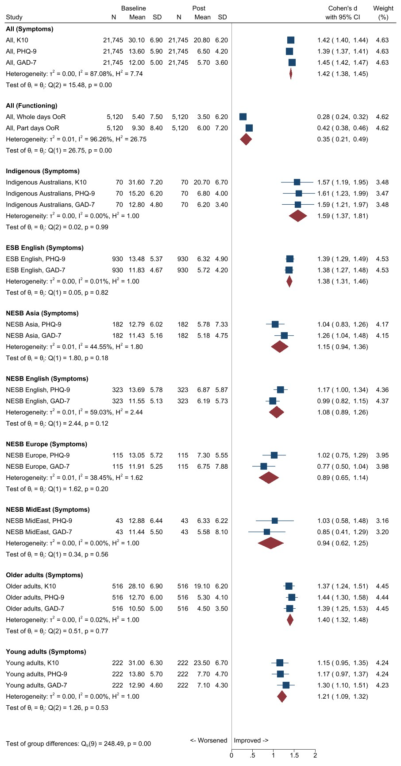

Figure 6. Forest plot of MindSpot therapist-supported treatment effects on mental health symptoms and functioning
CI, confidence interval; ESB, migrant of an English-speaking background; GAD-7, Generalised Anxiety Disorder 7-item Scale; K10, Kessler Psychological Distress 10-Item Scale; N, number; NESB, migrant of a non-English speaking background; PHQ-9, Patient Health Questionnaire-9; Post, post-treatment; SD, standard deviation.

Table 18 shows other outcomes we extracted from the above five selected publications used for determining the effectiveness of therapist-supported, transdiagnostic online treatment by MindSpot. One study reported on outcomes for all consumers;⁷ the others each focused on younger adults,⁶⁴ older adults,⁶⁵ Indigenous peoples²⁵ and migrants. Treatment completion rates ranged from 59% to 78%, with higher rates for older adults and migrants born in the Middle East and lower rates for migrants born in Asia.
Four studies reported the average percentage of symptom improvement. The study by Titov et al (2020), which examined effectiveness for all consumers over seven years, reported post-treatment symptom improvement ranging from 46% on the K10 to 53% on the PHQ-9 and GAD-7.⁷ The equivalent rates were lower (36% on the K10) for younger adults⁶⁴ and higher (58% on the PHQ-9) for older adults.⁶⁵
Only the study of outcomes for migrants by Kayrouz et al (2020) reported remission rates, operationalised as >50% symptom improvement. These ranged from 53-70% for migrants and 56% for Australian-born consumers.⁶⁶
Four studies reported reliable change data. These demonstrated low deterioration rates ranging from 1.2% in older adults⁶⁵ to 2.2% for all consumers,⁷ and up to 7% for migrants from non-English speaking backgrounds.⁶⁶ The study of migrant consumers also reported post-treatment change in Australian born consumers, with 56% remitting (>50% improvement), 19% minimally improving (<30% improvement), 21% no change (-30 to 30% change) and 5% deteriorating (>30% deterioration).⁶⁶ The study of all consumers also reported reliable recovery rates of 60% in consumers with clinically significant baseline depression and anxiety symptoms and lower than cut-offs at post-treatment with evidence of reliable change (at least 6 points on the PHQ-9 and at least 5 points on the GAD-7).⁷
Three studies on all consumers, and younger and older adults, demonstrated that treatment gains were maintained at three-month follow up from baseline assessments.^{7, 64, 65}
Titov et al (2019) showed positive mental health outcomes for Indigenous Australians, who have poorer pre-treatment symptom scores and are more likely to live in remote locations than their non-Indigenous counterparts.²⁵ These outcomes were observed irrespective of whether Indigenous consumers chose the general Wellbeing or the Indigenous Wellbeing Course.²⁵ Lesson completion rates were similar for Indigenous and non-Indigenous consumers (70.0 vs 71.9%), but Indigenous consumers were more likely to report using an online mental health service because of difficulty accessing local services or non-existent services in their residing locations (7.3% vs 5.8%, p<.05).²⁵

Table 18. Other outcomes from MindSpot therapist-supported treatment
Publication | Aim | Treatment completion rate | Percentage improvement | Remission rate | Reliable change | Follow up
Titov et al (2020)⁷ | Observational study of consumers registered with MindSpot over its first seven years of operation, January 2013 – December 2019 (N=21745 started treatment course, mostly transdiagnostic Wellbeing course) | 66.7 % completed more than 4 (of 5) lessons | 46.3% (K10)  52.5% (PHQ-9 and GAD-7) | Not reported | Reliable recovery  - 59.5% (5419/9105 with baseline PHQ-9>10)  - 59.8% (5852/9810 with baseline GAD-7>8)  Reliable deterioration among 13058 who completed post-treatment assessment  - 1.4 % PHQ-9  - 2.2% GAD-7 | Improvement on PHQ-9 (d=1.36, 95% CI 1.34-1.38) and GAD-7 (d=1.42, 95% CI 1.4-1.44)  Percentage improvement:  47.8% (K10) to 52.5% (GAD-7)
Staples et al (2019)⁶⁴ | Examine effects of transdiagnostic intervention (Mood Mechanic) for young adults aged 18-24 years with anxiety and depression in routine MindSpot care (N=222) | Mean: 3.5 (of 5) | K10, PHQ-9 and GAD-7 ranged from 35.6% (K10) to 44.6% (GAD-7) | Not reported | Reliable deterioration  - 1.4% (3/222) PHQ-9  - 1.8% (4/222) GAD-7 | Improvement on K10, PHQ-9 and GAD-7 ranged from 39.9% (K10) to 51.5% (GAD-7)
Staples et al (2016)⁶⁵ | Examine effects of transdiagnostic intervention (Wellbeing Plus course) for older adults aged 60+ years with anxiety and depression in routine MindSpot care (N=516) | 75% (n=388)  Mean 4.4 (SD=1.2) | 57% (GAD-7)  58% (PHQ-9) | Not reported | Deterioration (by≥30% and scored above the clinical cut-off at post-treatment)  1.2% (6/516) PHQ-9 and GAD-7 | Percentage improvements were 58% (PHQ-9) and 62 % (GAD-7)
Titov et al (2019)²⁵ | Examine outcomes for Indigenous Australian who used MindSpot, January 2015 – December 2016 (N=92) | 70% completed treatment  62.8% completed post-treatment questionnaires | Not reported | Not reported | Not reported | Not examined
Kayrouz et al (2020)⁶⁶ | Examine characteristics and effects of transdiagnostic intervention (Wellbeing course) for non-Australian born (migrant) users of MindSpot, January 2014 – December 2016 (N=1631) | 59%-78%  Mean 3.58-4.06 of 5 | 44-55% (PHQ-9)  43-55% (GAD-7) | >50% symptom improvement:  - 56-64% on PHQ-9  - 53-70% on GAD-7 | Deterioration (>-30%)  - 0-5%PHQ-9  - 0-7% GAD-7  No reliable change (-30% to 30%)  - 12-25% PHQ-9  - 13-23% GAD-7  Minimal improvement (31-50% change)  - 13-23% PHQ-9  - 14-24% GAD-7 | Not examined
Generalised Anxiety Disorder 7-item Scale; iCBT, K10, Kessler Psychological Distress 10-Item Scale; PHQ-9, Patient Health Questionnaire-9.

Trends in mental health outcomes of therapist-supported treatment by consumer demographics
We used aggregated routinely collected data provided by MindSpot for 3,532 consumers enrolled in 2019 to report on observed trends in outcomes by consumer demographics. Because we did not have baseline data for the cohort who completed baseline assessments (n=2,358) and three-month follow-up assessments (n=1,397), we cannot definitively state that their symptoms changed in any direction.
The mean number of sessions completed was 3.9 (SD=1.5, range 1-5). This mean did not vary by gender. However, it was slightly lower for younger (3.5 for those aged 18-24 and 3.6 for those, 25-34) and Indigenous consumers (3.5); and slightly higher for those aged 45+ (4.1-4.3).
Figure 7 shows outcomes as assessed with the K10, PHQ-9 and GAD-7 at baseline, post-therapist-supported treatment and three-month follow-up by demographic characteristics. The final available assessments were used as post-treatment data for consumers who did not complete a treatment course (i.e., four or more sessions).
Across all three measures, symptoms were less severe post-treatment for consumers who completed post-treatment assessments (n= 2,358) than for those who completed baseline assessments (N=3,532). This trend was observed irrespective of gender, age, and cultural and linguistic diversity.
Mean K10 symptom severity was similar for the females and males who completed baseline assessments (31.6 and 30.4; very high psychological distress), those who completed post-treatment assessments (21 for both; moderate psychological distress) and those who completed three-month follow-up assessments (around 19.5 for both, moderate psychological distress). Mean PHQ-9 symptom severity was slightly worse for females (14.7, moderately severe depression) than males (13.8, moderate depression) who completed baseline assessments; and equivalent, indicating mild depression, for both males and females who completed post-treatment assessments. Finally, mean GAD-7 scores for both females and males who commenced treatment indicated the likely presence of GAD (females:12.5; males:11.9), and the scores of those who completed baseline assessments indicated the absence of GAD (5.9 for both).
Overall, mean K10 scores indicated very high psychological distress at baseline (31.3). Baseline mean K10 scores were slightly higher for younger adults aged 18-24 (33.8 vs 31.3) and somewhat lower for older adults (25.6 for those aged 75+ and 28 for those 65-67), indicating high psychological distress. Mean K10 scores for all consumers who completed post-treatment assessments were much lower, at 21, indicating moderate psychological distress. Again, younger consumers aged 18-24 who completed post-treatment assessments had slightly higher scores suggesting (low end) high, and older consumers had slightly lower scores suggesting (low end) moderate, distress post-treatment (22.9 vs 17.7). Similar age trends are observed for the PHQ-9 and GAD-7.
Finally, trends on all three measures for Indigenous and overseas-born consumers were similar to those observed for the overall baseline and post-treatment samples.

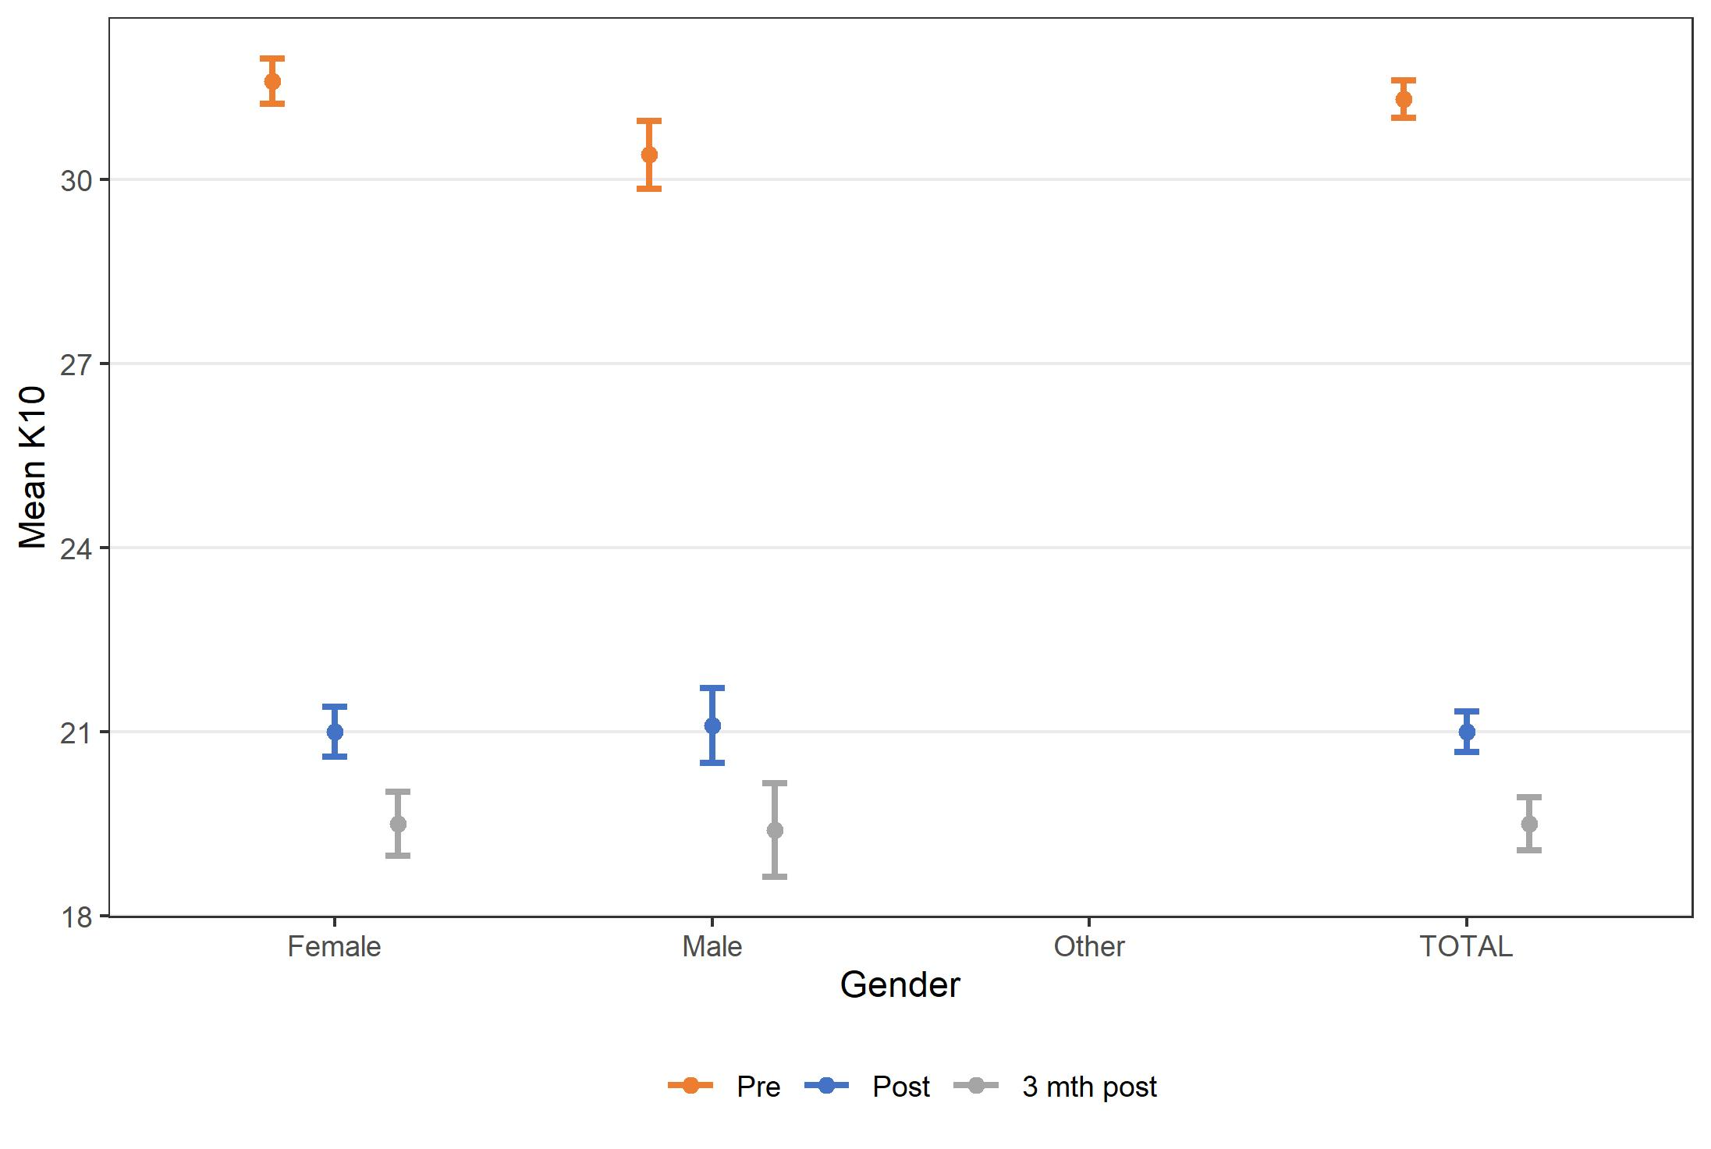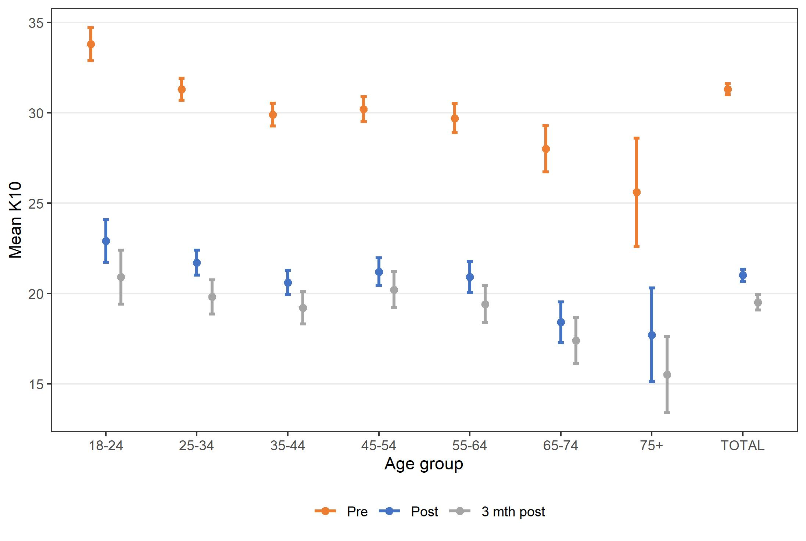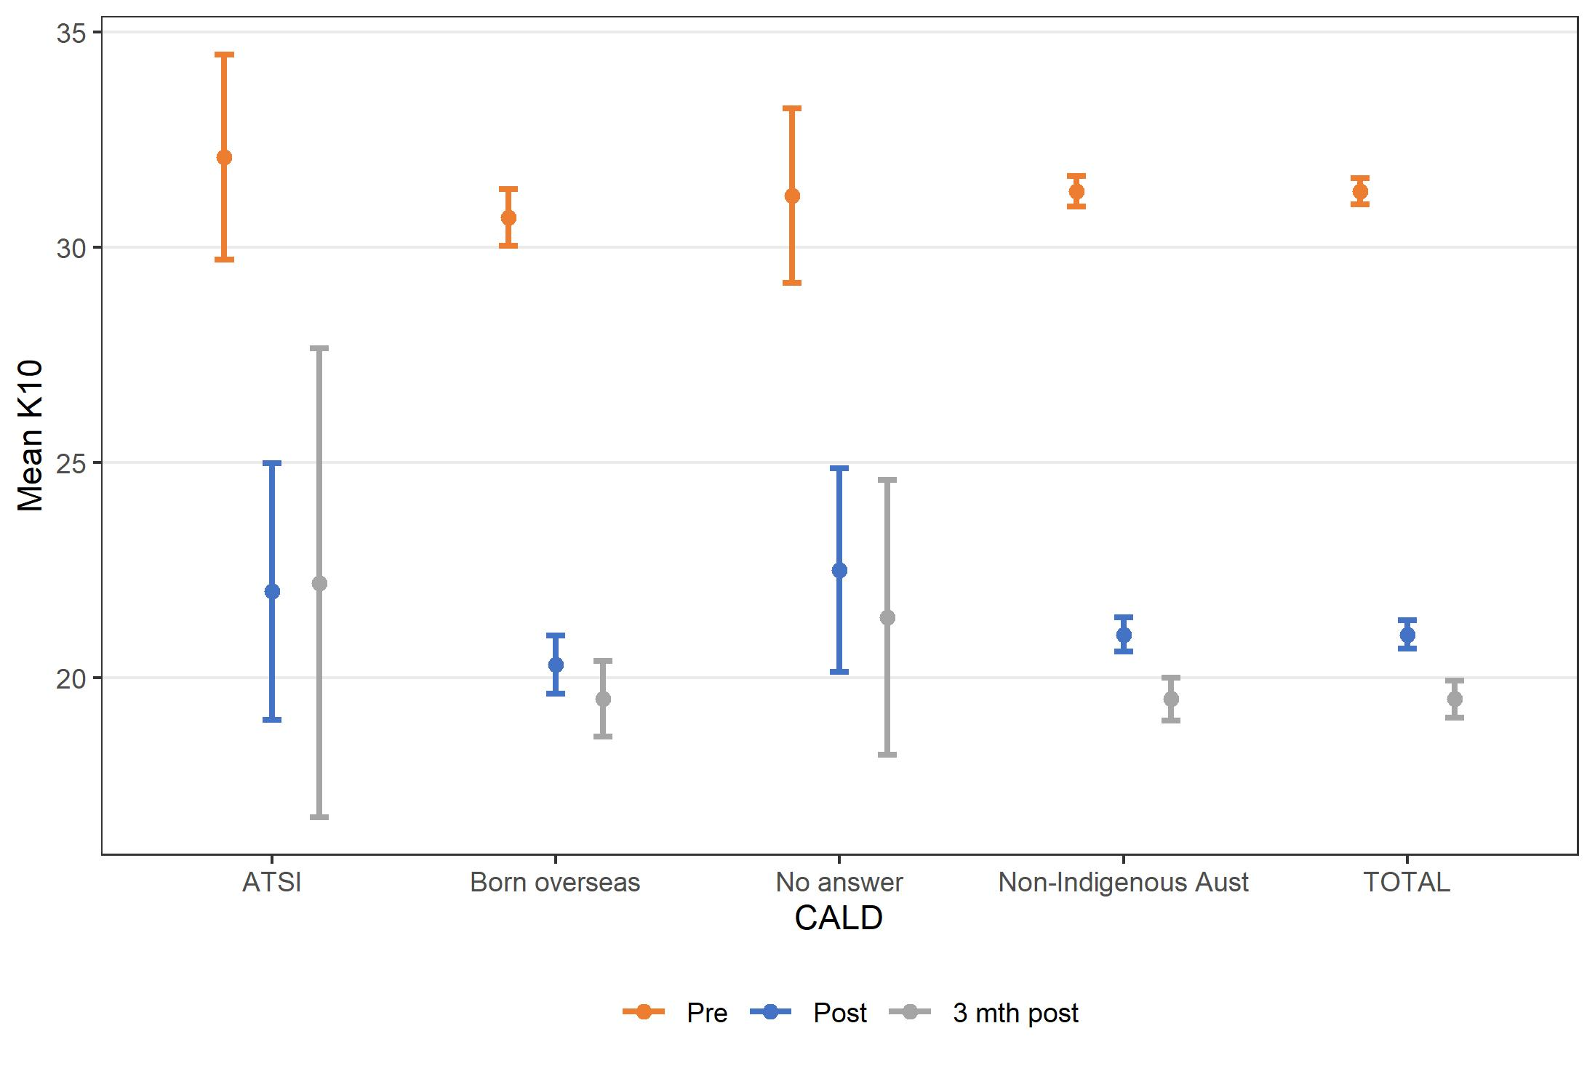
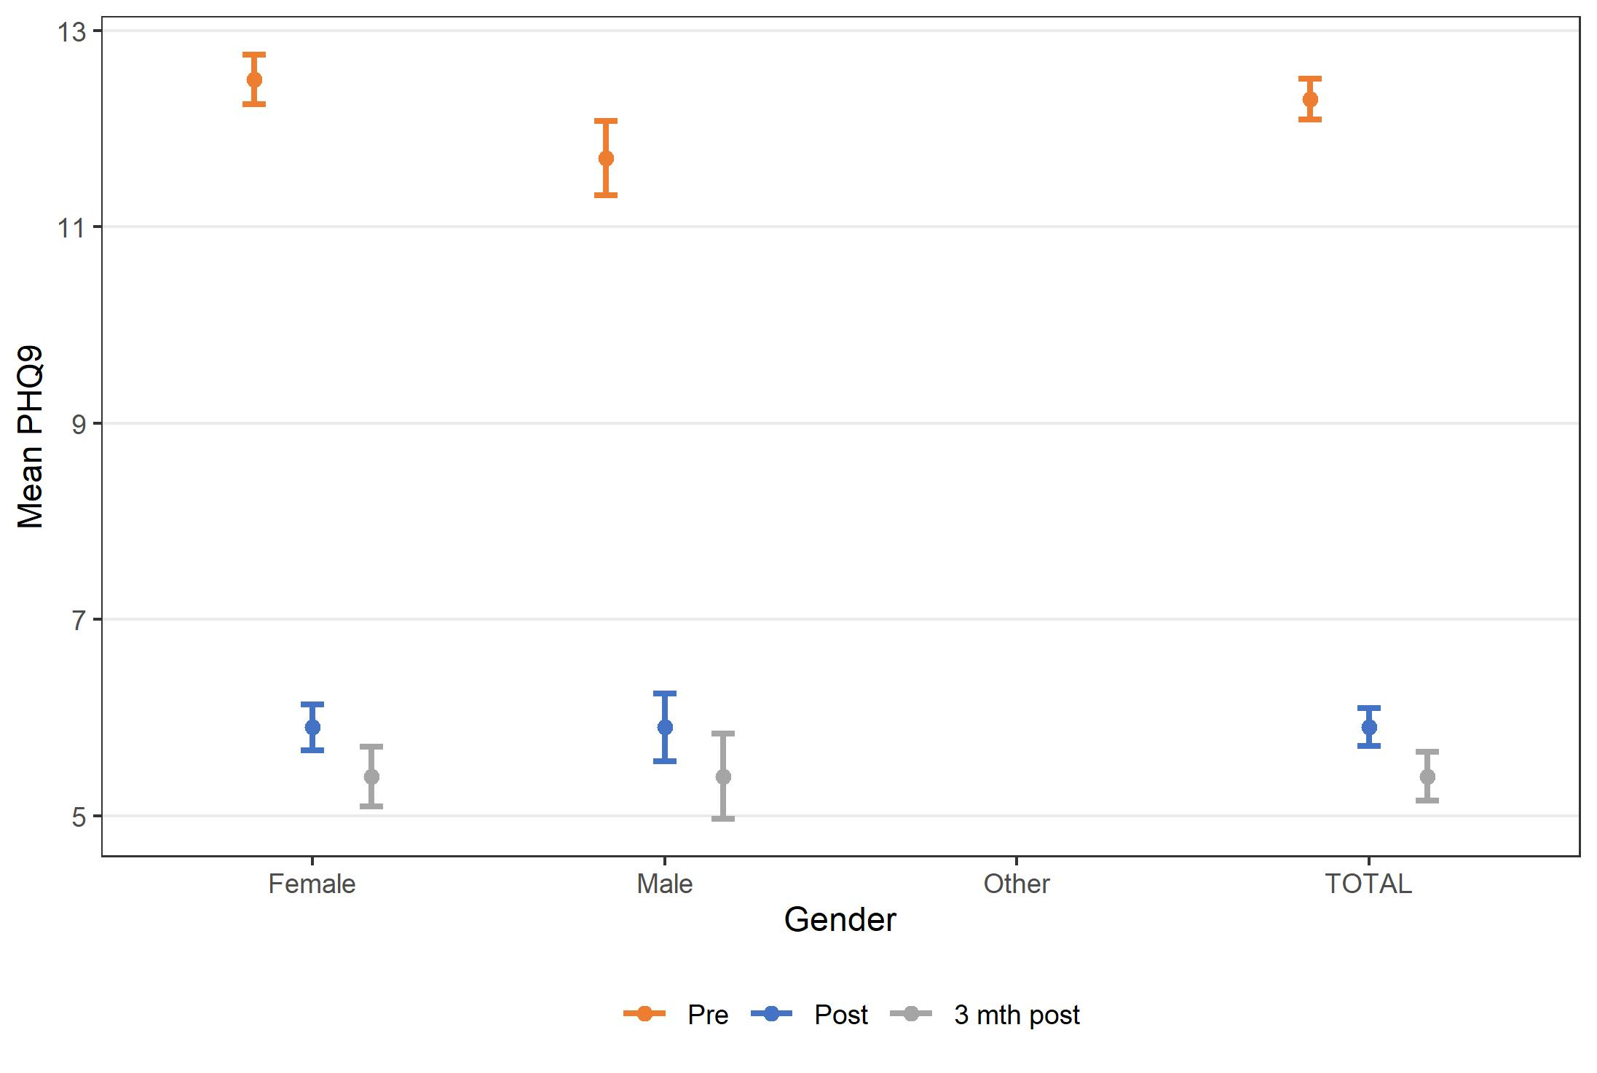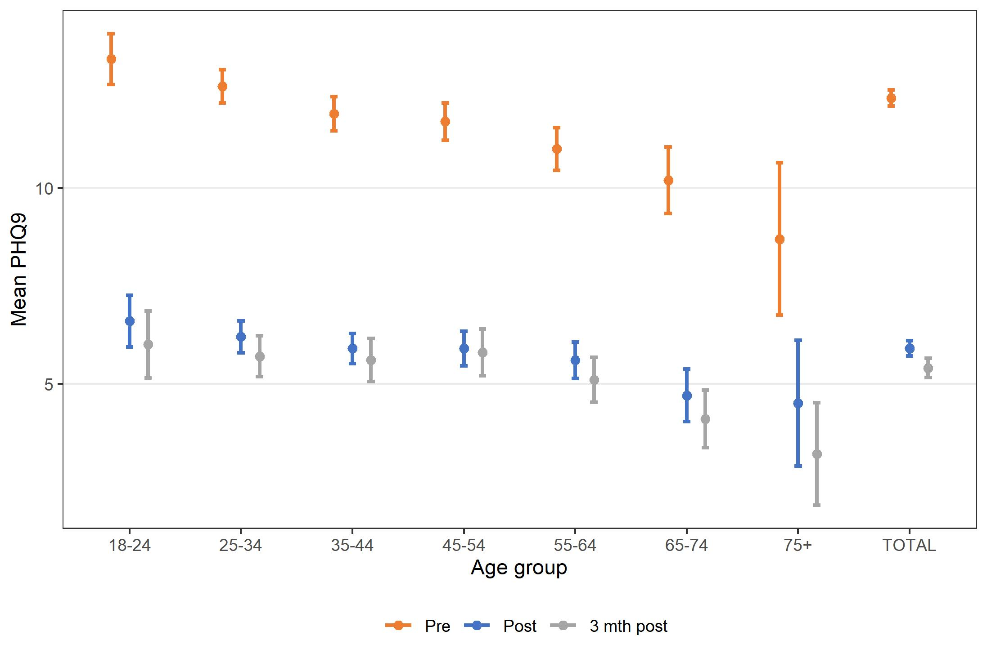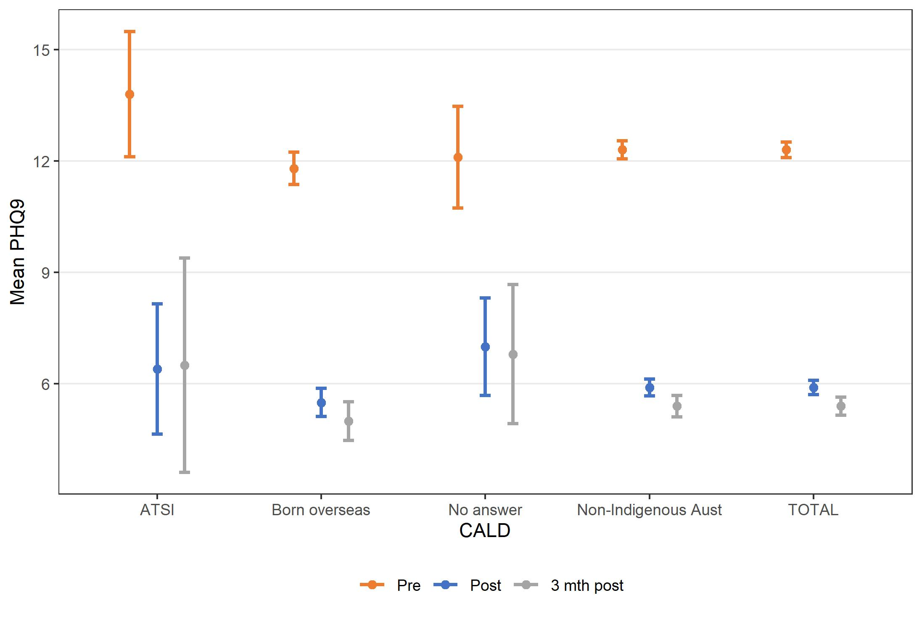
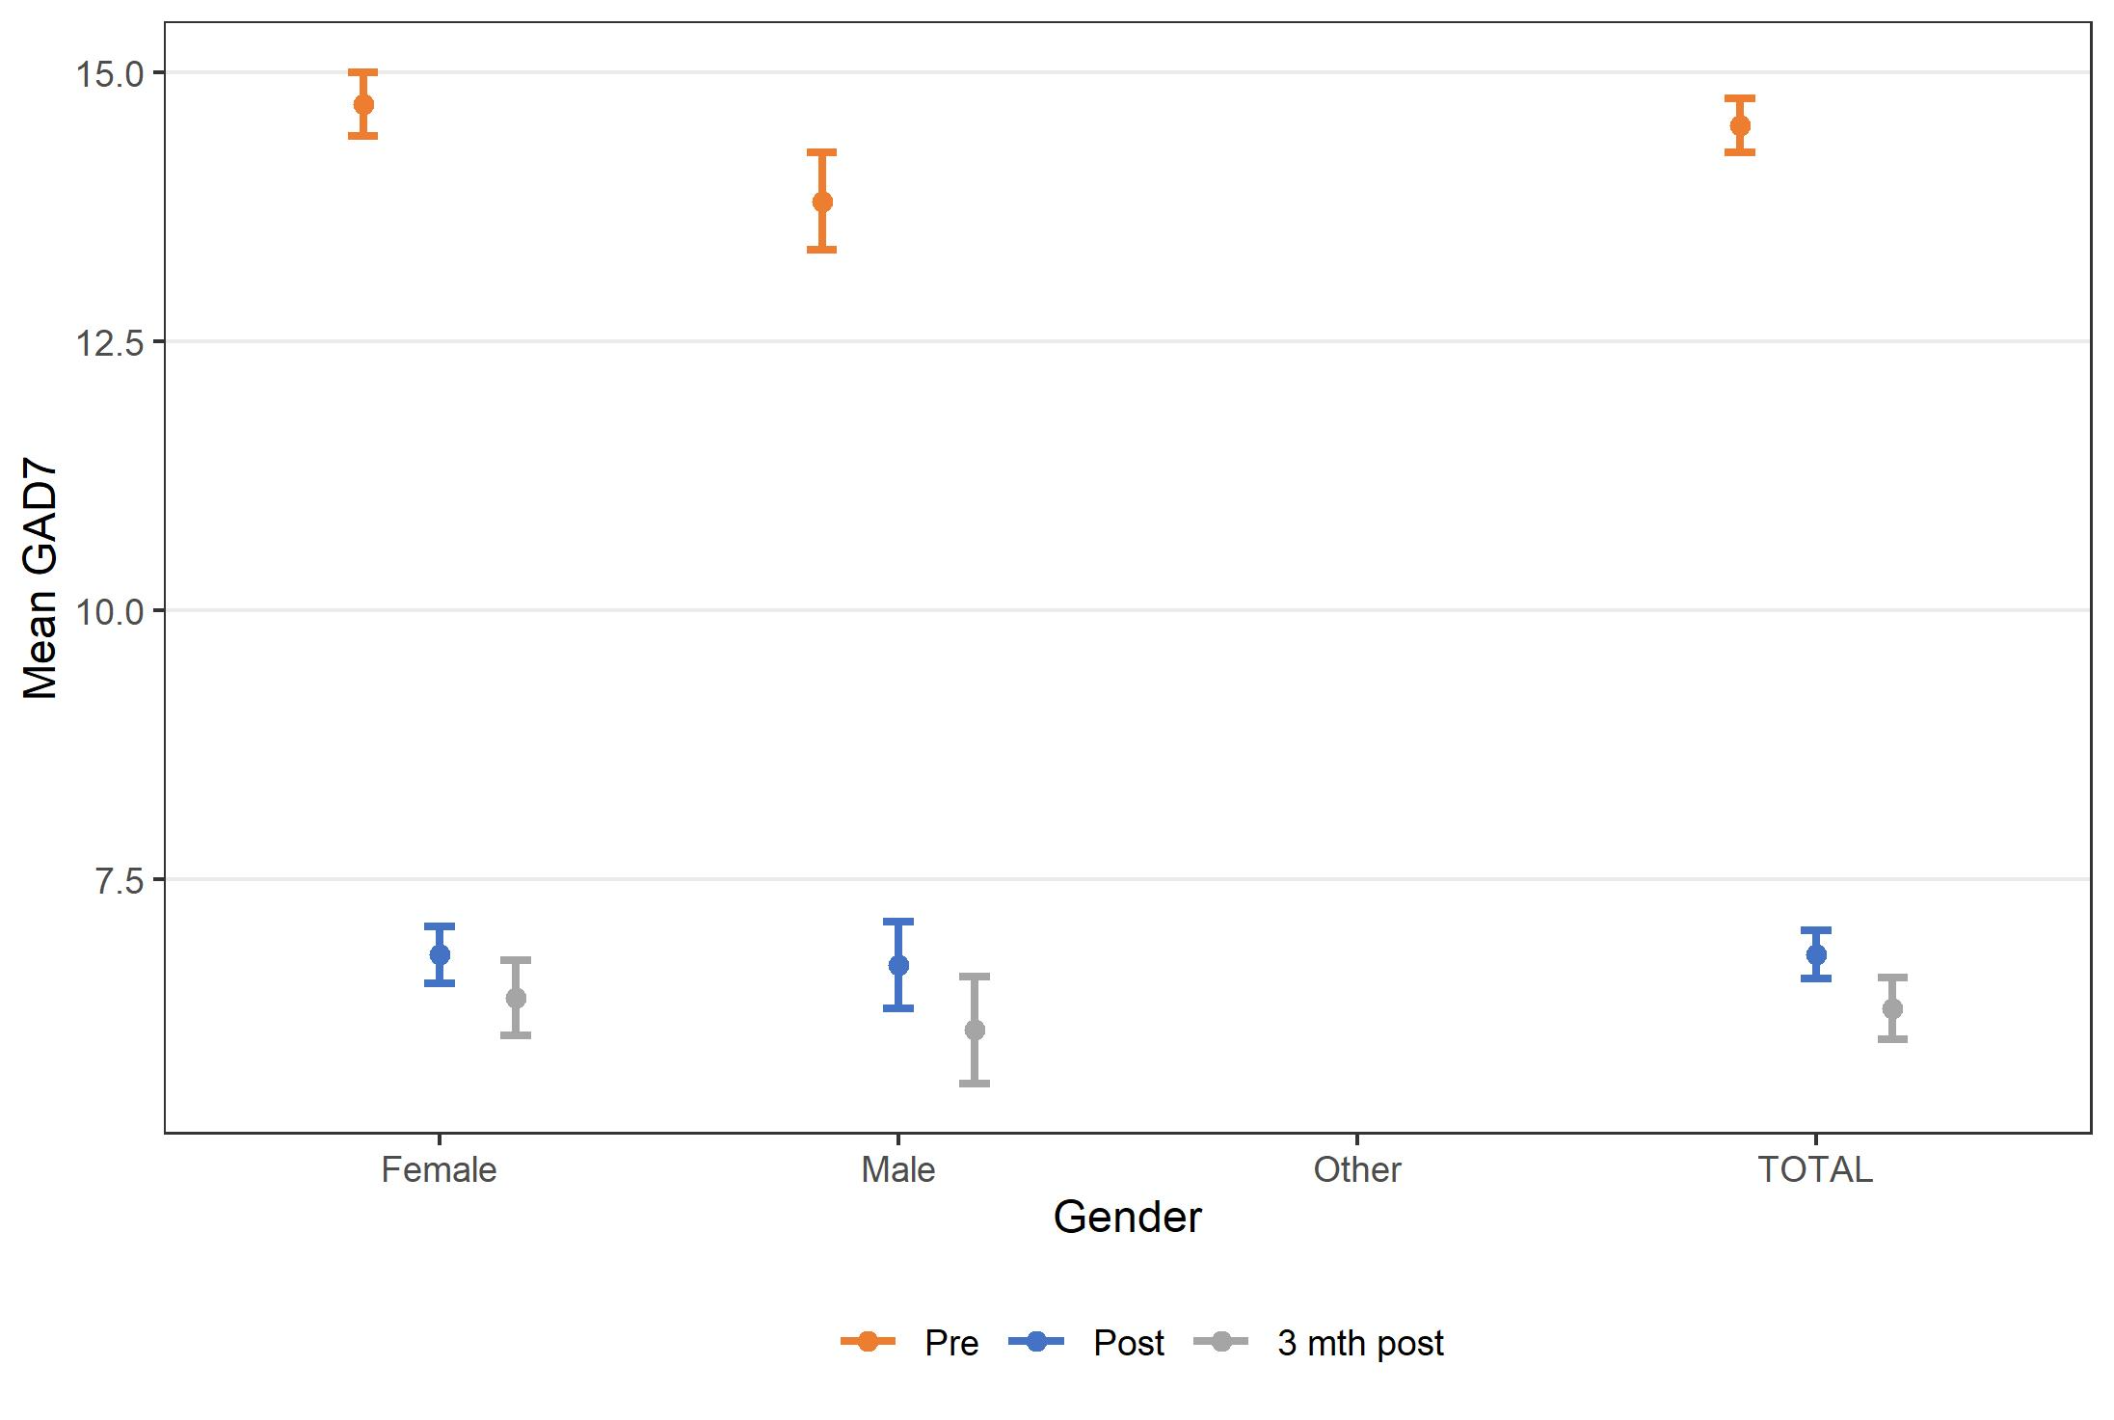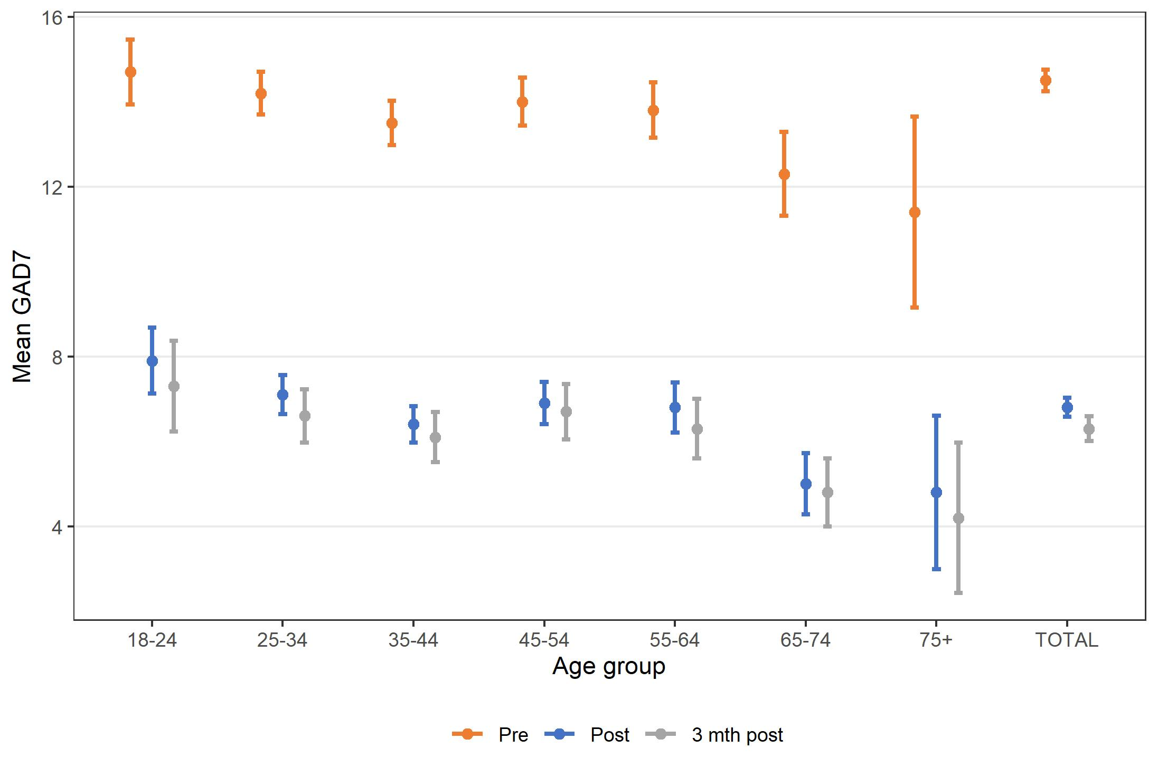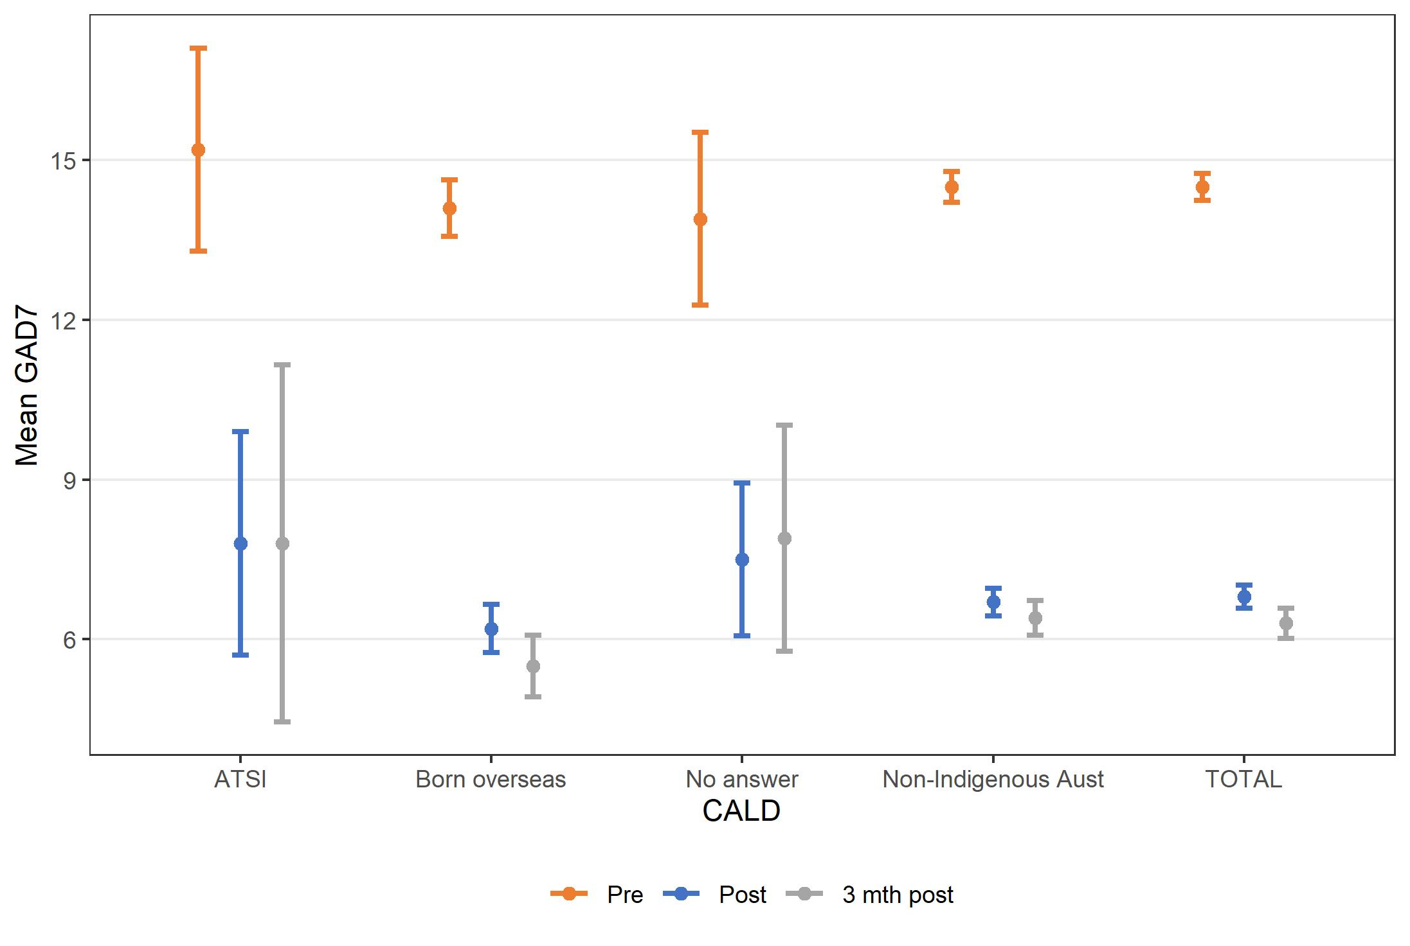

Figure 7. Mean K10, PHQ-9 and GAD-7 before (N=3,532) and after treatment (n=2,358), and at three-month follow-up (n=1,397), by demographic characteristics for consumers commencing MindSpot therapist-treatment in 2019

Trends in mental health outcomes of therapist-supported treatment by baseline symptom severity
We used the same aggregated routinely collected data provided by MindSpot for 3,532 consumers enrolled in 2019 that we used in the above section to report on observed trends in outcomes by baseline symptom severity. Therefore, the same caveat applies – because we did not have baseline data for the cohort who completed baseline assessments (n=2,358), we cannot definitively state that their symptoms changed in any direction.
Figure 8 shows the mental health outcomes by baseline symptom severity as assessed using the K10, PHQ-9 and GAD-7, respectively, for consumers who commenced MindSpot therapist-supported treatment in 2019 (N=3,532). Across all measures, consumers commenced treatment with varying levels of symptom severity, and substantial numbers experienced severe symptoms.
Because we received pre- and post-treatment mental health outcomes data in aggregate form rather than at the individual consumer level, we used change in symptom severity category (e.g., severe to moderate) in either direction to indicate “significant change”. Therefore, it is possible that some consumers categorised as not having experienced significant change could have improved or deteriorated within their baseline symptom severity category. Conversely, it is also possible that some consumers who were at the lower (or upper) end of a given symptom severity category at baseline were classified as “significantly improved” (or “significantly deteriorated”) if their score decreased (or increased) by one, respectively. Importantly, the use of aggregate data meant we could not report on the statistical or clinical significance of change (reliable improvement or deterioration), which applies a reliable change threshold that considers the reliability (measurement error or natural variance) of a given assessment instrument.⁶⁷ Therefore, the trends reported in this section are more useful than the actual data, which should not be compared to published reliable change data.
Between 56-61% of consumers with medium severity or higher K10 scores significantly improved (as indicated by moving to a lower symptom severity category) at the end of treatment (or their last recorded K10 score if they did not complete treatment). K10 symptom severity worsened (as indicated by moving to a higher symptom severity category) for only 8-15% of consumers (with low to high K10 baseline symptom severity). The proportion worsening decreased as baseline K10 severity increased.
Similar trends were observed for both the PHQ-9 and the GAD-7, with 52-76% of consumers significantly improving and those with more severe baseline scores on either measure being more likely to show improvement. As with the K10, 19% or less of consumers with no/minimal to moderately severe symptoms deteriorated, and these proportions decreased for higher levels of baseline severity.

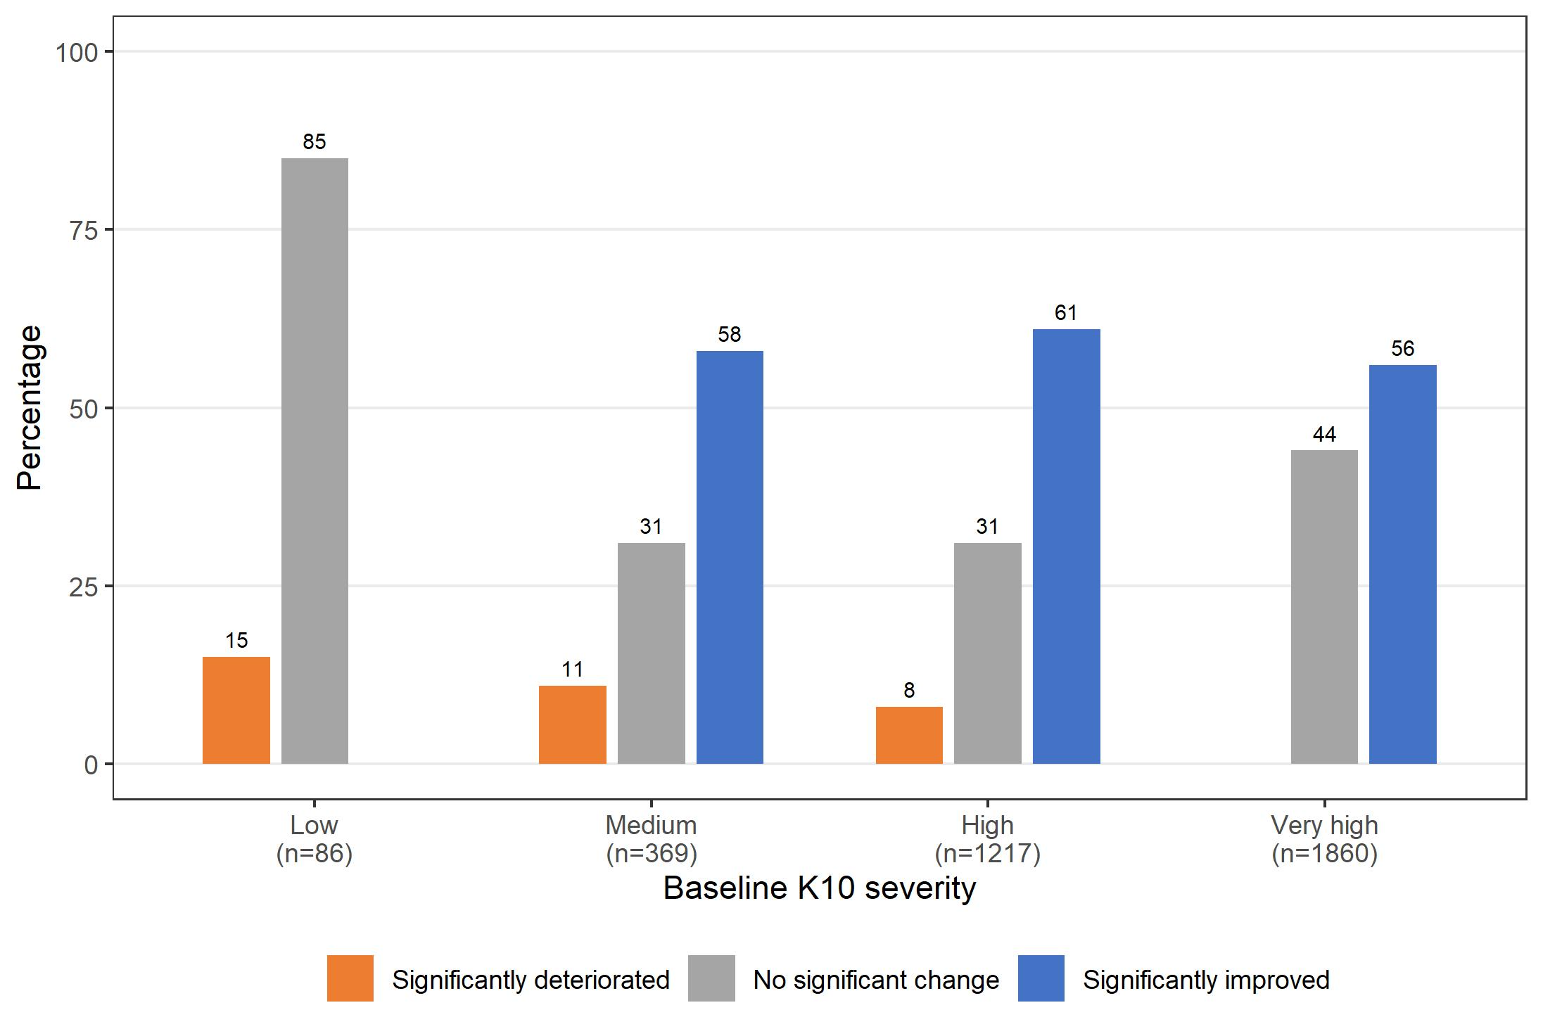
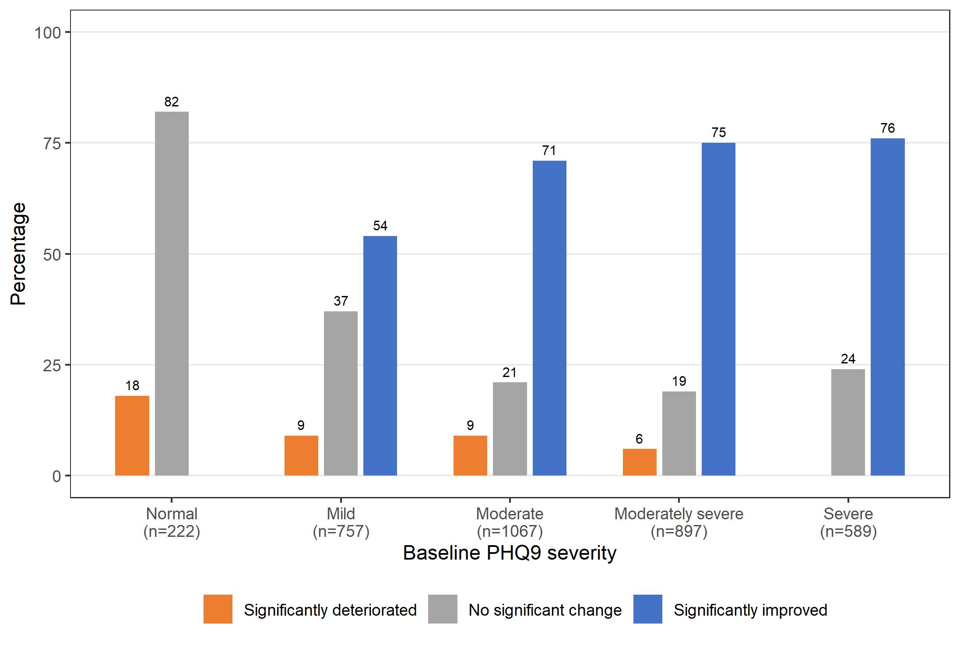
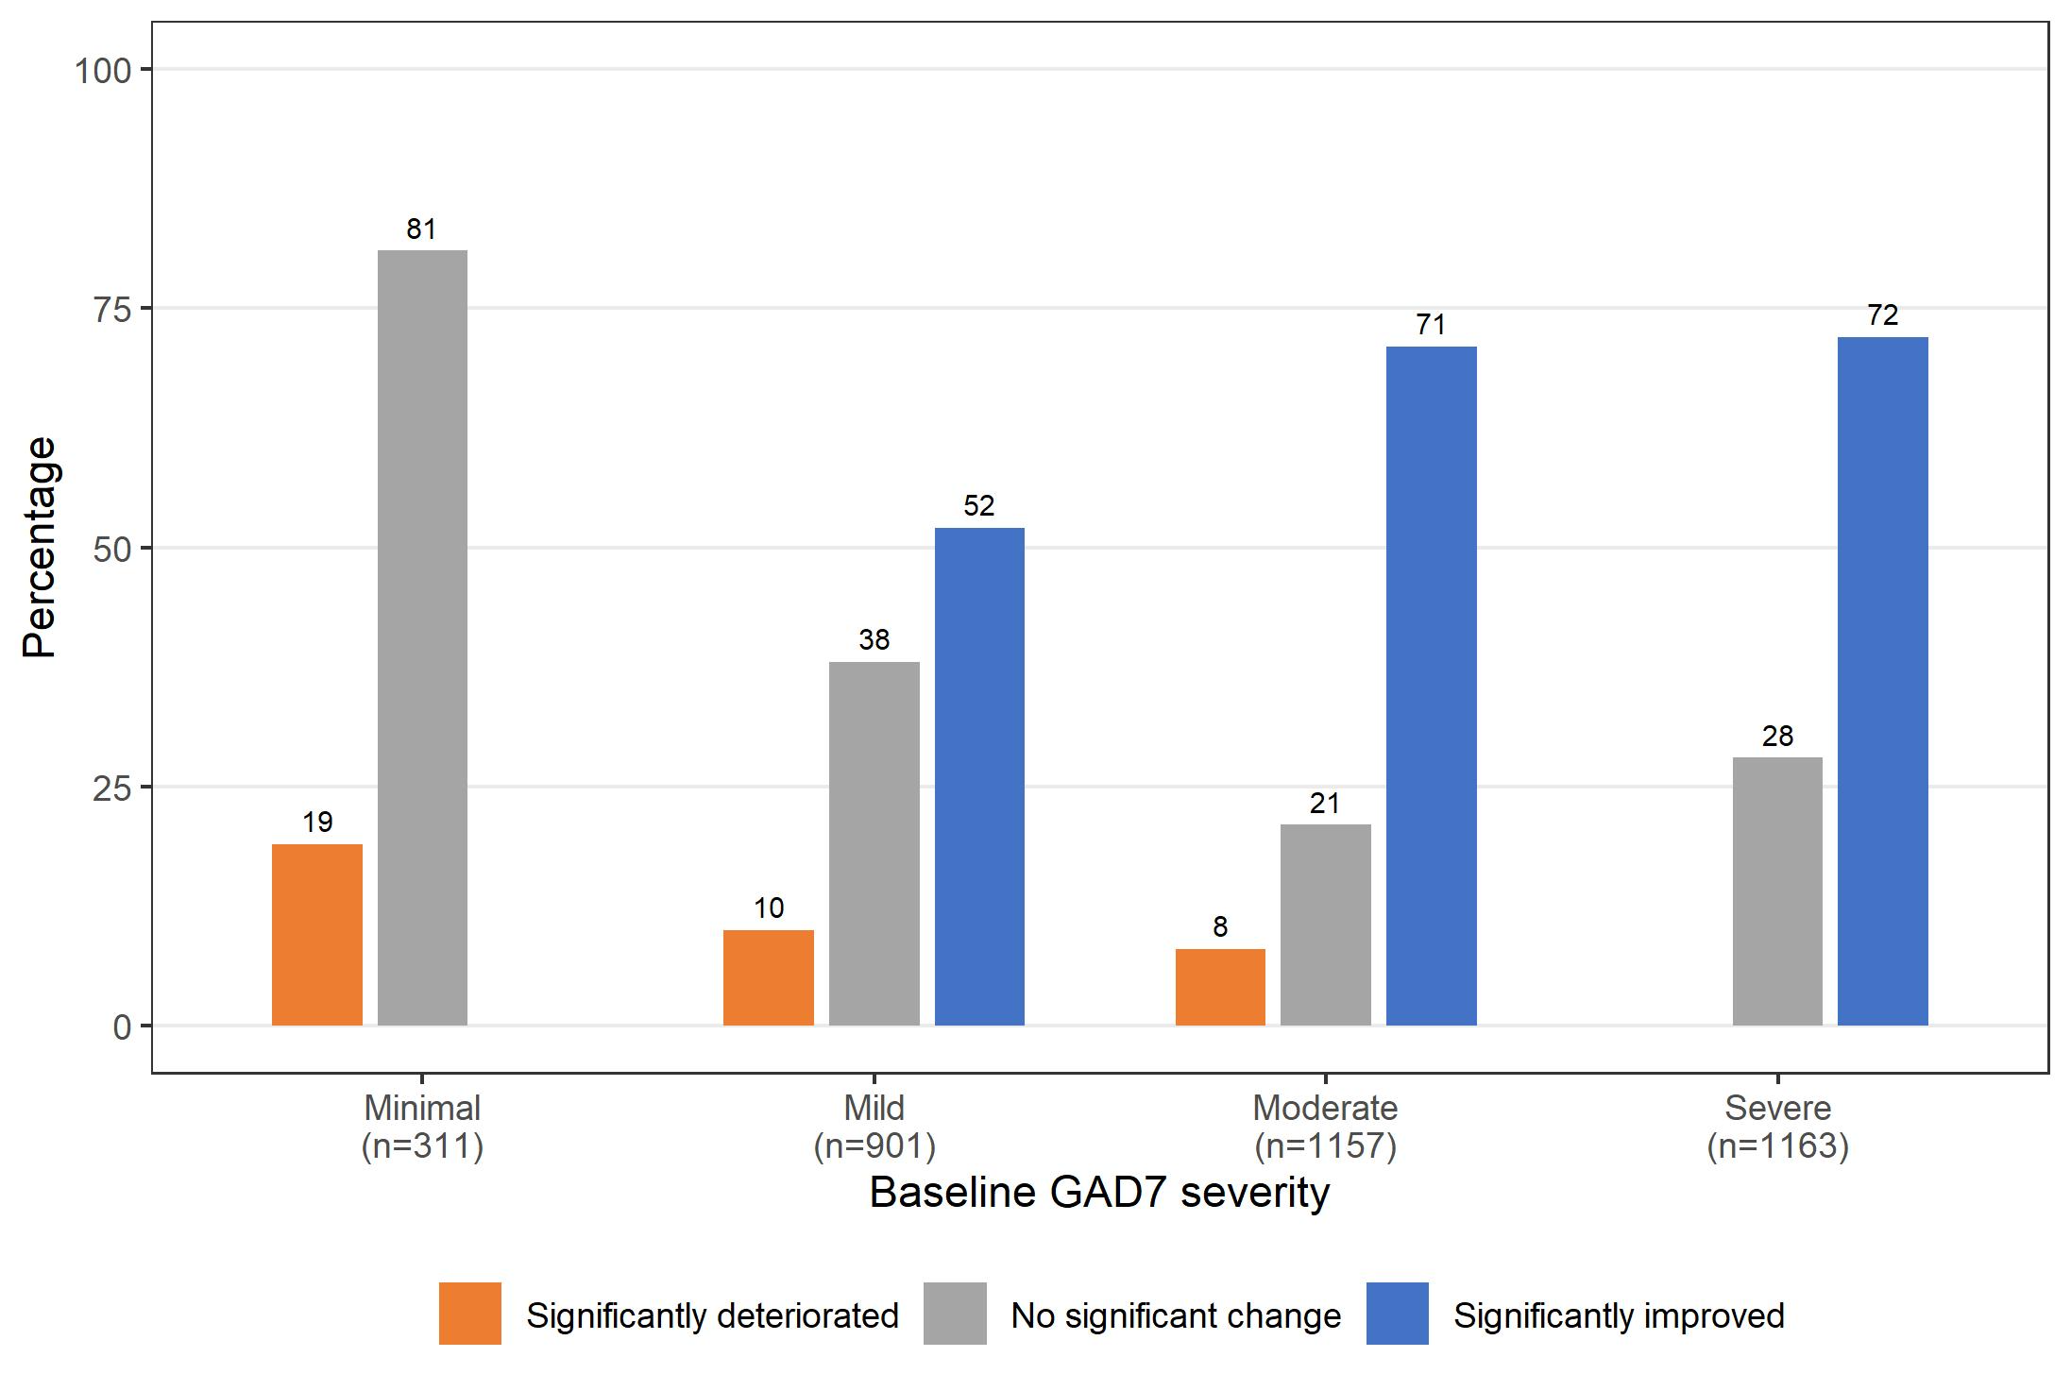

Figure 8. K10, PHQ-9 and GAD-7 outcomes by baseline symptom severity for consumers who commenced MindSpot therapist-supported treatment in 2019 (N=3,532)

Trends in mental health outcomes by therapist time
MindSpot provided us with approximations of the mean contact time per patient (in minutes) for each six-month interval from January 2013 to December 2021, based on unpublished and published estimates.^{7, 68, 69} Estimates exclude therapist time spent conducting assessments, managing crises, providing supervision and general administration. In addition, MindSpot informed us that they had introduced service efficiencies in 2020 that resulted in an approximately 20% decrease, and that early estimates for 2021 suggest a further 20% decrease, in therapist time per consumer in treatment.
Figure 9 plots treatment outcomes on the K10, PHQ-9 and GAD-7 by mean therapist time in minutes from January 2013 to June 2021. These means ranged from 86 minutes (in late 2021) to 135 mins (early 2016-late 2019). As there was little variation in therapist time across the 18 time periods (only four distinct values), therapist time was classified into two groups: Low (<=120) and High (>120). Figure 10 shows that the median of mean outcome scores post-treatment tended to be lower for K10, PHQ-9 and GAD-7 in time periods when the mean therapist time was higher. However, there was considerable variation in outcome scores within the high therapist group and several outlying scores (in both the high and low groups).
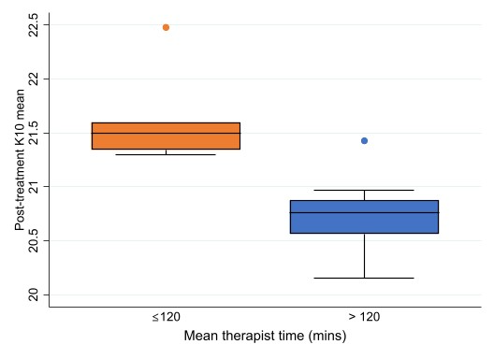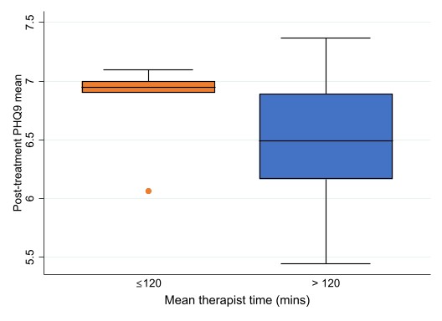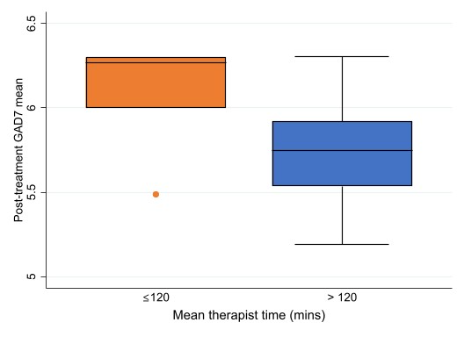

Figure 9. Mean post-treatment K10, PHQ-9 and GAD-7 by MindSpot therapist time, January 2013 – June 2021 (N=17,137)

Trends in mental health outcomes of therapist-supported treatment over time, January 2013 – December 2021
Figure 10 shows the baseline, post-treatment, and 3-month post-treatment mean K10, PHQ-9 and GAD-7 scores and 95% CIs, for MindSpot consumers of therapist-supported treatment by half year from January 2013 to December 2021.
As shown in Figure 9, the mean baseline K10 scores decreased very slightly (non-significantly) over time, with a high of 32 (in January 2013-June 2014) to a low of 30.5 (in January-June 2021). Immediate post-treatment means were significantly lower at approximately 21, and 3-month post-treatment means were slightly lower again at 19.5, with no consistent trend over time for either of these.
Similarly, mean baseline PHQ-9 scores decreased slightly over time, from 15 in 2013 to 13.8 in 2021 (Figure 5). This was substantially and consistently higher than the mean PHQ-9 immediately post-treatment, which varied slightly over time with a high of 7.4 (in January-June 2017) and a low of 5.4 (in January-June 2014). The post-treatment means were not significantly different from the 3-month post-treatment means. There was no consistent trend over time for the post-treatment means.
Similar effects were seen for GAD-7 (Figure 6). Baseline means were approximately 12, with no consistent trend over time. Immediate post-treatment means were just below 6, and 3-month post-treatment means were slightly but not significantly lower at approximately 5, both with no apparent trend over time.
As data at the individual level were not available, it is not clear to what extent these results reflect changes due to the treatment program and to what extent they are due to self-selection (for example, if those with the lowest K10 scores choose to complete the 3-month post-treatment assessment). However, MindSpot has previously published findings based on individual level data that showed clear improvement in consumers of therapist-supported treatment at post-treatment and follow-up over a seven year period from 2013 to 2019.⁷

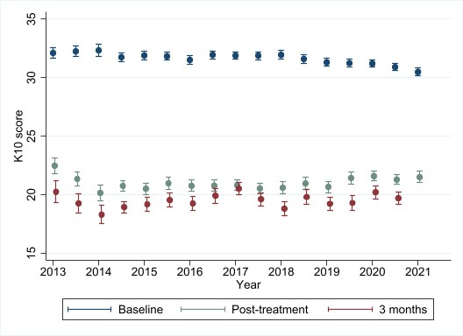
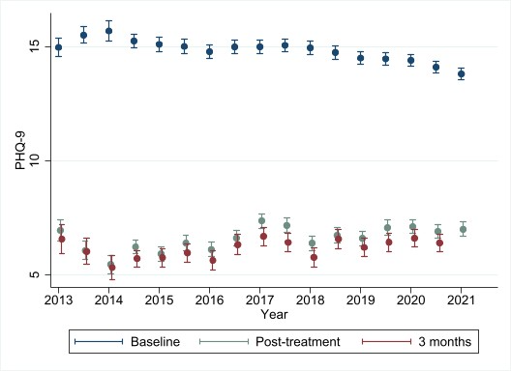
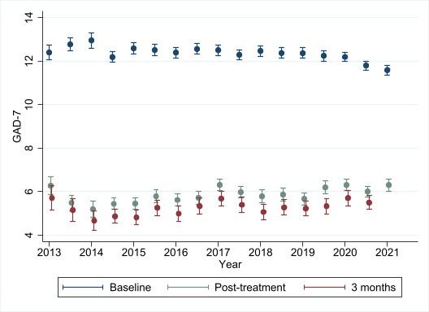

Figure 10. Baseline, post-treatment and 3-month post-treatment mean K10, PHQ-9 and GAD-7 scores and 95% CIs for MindSpot consumers of therapist-guided treatment by half year, January 2013 – December 2021.
Note. Baseline N=28,808, post-treatment n=17,137 and three-month post-treatment n=10,163.

Trends in self-directed treatment outcomes
As previously mentioned, MindSpot recently introduced self-directed treatment in July 2019 as part of their treatment offerings, so they have not yet produced peer-reviewed publications on this aspect.
However, their routinely collected data show reduction trends in psychological distress (K10), depression (PHQ-9) and anxiety (GAD-7) (Table 17, rows 4-6). Effect sizes cannot be estimated for these data because the pre-treatment scores are for all consumers who provided these data (N=1,350) and not specifically for the subgroup who provided post-treatment scores (n=600).
These findings should be interpreted in the context that around one-third of consumers enrolled in self-directed MindSpot treatment end up receiving therapist support (N. Titov, personal communication, 15 March 2022).

Comparing trends in therapist-guided and self-directed treatment outcomes
Figure 11 compares therapist-guided and self-directed mean K10, PHQ-9 and GAD-7 mean scores, and 95% CIs, at baseline, post-treatment and 3-month post-treatment for the July to December 2020 period. These figures show that at baseline, those who enrol in therapist-guided treatment have significantly higher K10, PHQ-9 and GAD-7 scores than those who enrol in self-directed treatment. All mean outcome scores post self-directed treatment are significantly lower (better) than the baseline mean outcomes scores and similar to those for post therapist-guided treatment. Mean outcome scores for 3-month post self-directed treatment tended to be lower again, and not significantly different from mean outcome scores 3 months post therapist-guided treatment. However, as previously mentioned, we used aggregate data with different sample sizes across time – from 2,484 as baseline to 1,434 at post-treatment and 793 at three-month follow-up for those enrolled in therapist-supported treatment, and from 532 at baseline to 231 at post-treatment and 134 at three-month follow-up for those enrolled in self-directed treatment. This means we cannot be certain that those for whom we had post-treatment or three-month follow-up outcome data improved. Having said that, MindSpot has previously published routinely collected data over seven years from 2013 to 2019 on the same group of consumers at each assessment point and demonstrated a clear improvement across measurement occasions for therapist-supported treatment.⁷

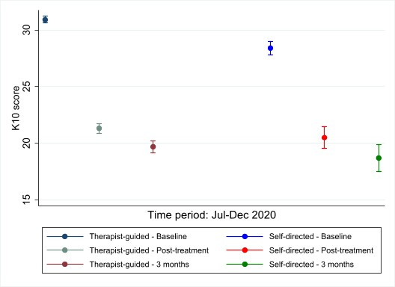

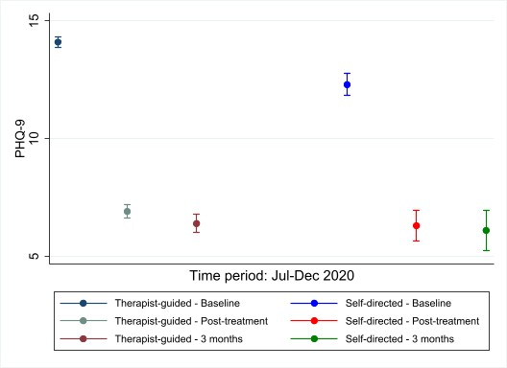

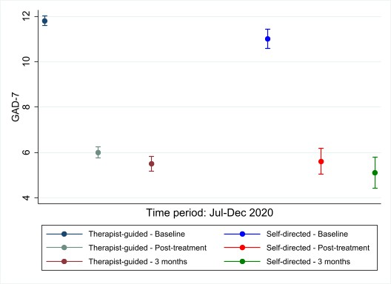

Figure 11. Therapist -guided and self-directed baseline, post-treatment and 3-month post-treatment K10, PHQ-9 and GAD-7 mean scores, and 95% CIs, for MindSpot consumers, July – December 2020.
Note. Therapist-guided: baseline N=2,484, post-treatment n=1,434 and three-month post-treatment n=793. Self-directed: baseline N= 542, post-treatment n=231 and three-month post-treatment n=134

Predictors of mental health outcomes
The previously mentioned study by Cross et al (2022), which explored predictors of uptake and completion, also examined predictors of therapist-supported treatment outcome.⁴⁸ This study reported an average rate of improvement of 45.8%.⁴⁸
The following consumer characteristics were positively associated with treatment outcomes:
- Current or past relationship (65% widowed vs 48.4% married/de facto vs 45.2% separated vs 41.4% single/never married, p=.005);
- Being employed (48.7% vs 33.2% unemployed vs 39.6% student vs 45.4% other, p < .001); and
- Being born overseas (51.6% vs 44.8%, p=0.011).⁴⁸
The following consumer characteristics, also negatively associated with uptake and completion, were negatively associated with treatment outcomes:
- higher initial symptom severity (PHQ-9; 53.8% mild vs 46.8% moderate vs 38.8% severe, p < .001); and
- increasing number of self-reported psychosocial difficulties (ranging from 51.3% for one difficulty to 29.3% for six difficulties, p < .001).⁴⁸
The following characteristics did not affect symptom improvement:
- Age (range 44.7%-56%, p=0.162);
- Gender, with males and females equally gaining significant symptomatic improvement (46.8% vs 43.8%, p=.205);
- Indigeneity (39.5% vs 45.1%, p=.495); and
- Rural or remote location of residence (45.4% vs 44.6% urban region vs 46.4% capital city, p=0.916); and
- Having a degree (46.6% vs 45.2%, p=.495).⁴⁸

Consumer experiences
MindSpot routinely assesses satisfaction using two questions about whether consumers: (1) would recommend the service to someone else and (2) believe that treatment was worth their time.
In the six-month periods from January 2013 to June 2021, between 95% and 98% of consumers who have responded to these questions over time have reported that MindSpot therapist-supported treatment is worthwhile, and they would recommend it. Similarly, peer-reviewed publications have demonstrated equally high satisfaction rates among different population groups - young people aged 18-24,⁶⁴ older aged 60+,⁶⁵ and Indigenous consumers.²⁵
In the 1.5 years since the introduction of self-directed treatment courses in July 2019, 94% of consumers who responded to these items indicated they would recommend the service and felt it was worthwhile.

THIS WAY UP outcomes
Table 19 shows mental health and disability outcomes of therapist-supported routine treatment produced by THIS WAY UP for consumers accessing their service over different time periods.
As with MindSpot, some data were directly provided by THIS WAY UP in aggregate form, so we were unable to determine baseline scores for the subset of consumers who completed post-treatment assessments. Therefore, these data are included in Table 19 solely to demonstrate trends in mean scores before and after treatment over the life of THIS WAY UP.
We also extracted outcome data from several of their peer-reviewed publications of routine care outcomes,⁵⁰⁻⁵⁴ which we used for calculating effect sizes instead of the aggregated routinely collected data. We selected publications covering outcomes across disorders and age groups.
It should be noted that we classified all treatments in peer-reviewed publications as therapist-supported because we understand that THIS WAY UP encourages all registered clinicians to contact their patients at least twice during the iCBT program to maximise adherence and if their patient’s distress is high or increases between lessons.^{54, 70} However, there is wide variability in the number and type of contacts clinicians initiate with their patients, with the median number being one contact, and more than 50% of patients reporting that they had no contact from their clinician during their iCBT program.⁷⁰ So, iCBT is likely to include both therapist-supported and self-directed treatment.

Table 19. Selected THIS WAY UP mental health outcome data before and after (6 module) treatment by support status
Population group | Treatment | Outcome measure | Baseline N | Baseline Mean | Baseline SD | Post  N | Post M | Post SD | Effect size (g)
All | Self-directed iCBTª | K10 | 27,874 | 27.9 | 7.8 | 8,156 | 19.7 | 7.5 | N/A
All | Self-directed iCBTª | PHQ-9 | 26,601 | 11.8 | 6.4 | 7,729 | 6.6 | 5.6 | N/A
All | Self-directed iCBTª | GAD-7 | 19,292 | 11.2 | 5.3 | 5,419 | 6.3 | 4.8 | N/A
All | Supported iCBTª | K10 | 29,259 | 29.2 | 7.8 | 9,484 | 21.3 | 8.4 | N/A
All | Supported iCBTª | PHQ-9 | 27,530 | 12.9 | 6.4 | 9,023 | 8.2 | 6.3 | N/A
All | Supported iCBTª | GAD-7 | 18,236 | 11.5 | 5.1 | 5,482 | 6.4 | 4.8 | N/A
Adults 18-29 years | Supported iCBT for GAD^{b} | K10 | 100 | 26.11 | 4.69 | 100 | 19.23 | 4.10 | 1.34 (1.09, 1.59)
Adults 30-39 years | Supported iCBT for GAD^{b} | K10 | 117 | 25.71 | 4.68 | 117 | 18.80 | 4.19 | 1.70 (1.45, 1.95)
Adults 40-49 years | Supported iCBT for GAD^{b} | K10 | 82 | 25.71 | 4.67 | 82 | 18.49 | 4.18 | 1.54 (1.25, 1.84)
Adults 50-59 years | Supported iCBT for GAD^{b} | K10 | 77 | 25.58 | 4.67 | 77 | 18.90 | 4.37 | 1.30 (0.98, 1.61)
Adults 60+ years | Supported iCBT for GAD^{b} | K10 | 65 | 25.54 | 4.67 | 65 | 18.64 | 4.24 | 1.39 (1.05, 1.73)
Adults 18-29 years | Supported iCBT for GAD^{b} | PHQ-9 | 100 | 11.00 | 5.42 | 100 | 6.94 | 4.06 | 0.85 (0.61, 1.09)
Adults 30-39 years | Supported iCBT for GAD^{b} | PHQ-9 | 117 | 9.65 | 5.63 | 117 | 6.32 | 4.43 | 0.71 (0.48, 0.93)
Adults 40-49 years | Supported iCBT for GAD^{b} | PHQ-9 | 82 | 9.44 | 5.41 | 82 | 5.36 | 3.93 | 0.96 (0.69, 1.23)
Adults 50-59 years | Supported iCBT for GAD^{b} | PHQ-9 | 77 | 9.42 | 5.84 | 77 | 5.79 | 4.20 | 0.75 (0.46, 1.05)
Adults 60+ years | Supported iCBT for GAD^{b} | PHQ-9 | 65 | 7.57 | 5.43 | 65 | 4.78 | 4.29 | 0.59 (0.28, 0.91)
Adults 18-29 years | Supported CBT for GAD^{b} | GAD-7 | 100 | 12.63 | 5.07 | 100 | 7.27 | 3.96 | 1.34 (1.08, 1.58)
Adults 30-39 years | Supported iCBT for GAD^{b} | GAD-7 | 117 | 11.92 | 5.06 | 117 | 6.82 | 4.02 | 1.25 (1.02, 1.49)
Adults 40-49 years | Supported iCBT for GAD^{b} | GAD-7 | 82 | 11.48 | 5.07 | 82 | 5.68 | 4.03 | 1.40 (1.11, 1.68)
Adults 50-59 years | Supported iCBT for GAD^{b} | GAD-7 | 77 | 10.74 | 5.07 | 77 | 5.93 | 4.12 | 1.19 (0.88, 1.49)
Adults 60+ years | Supported iCBT for GAD^{b} | GAD-7 | 65 | 9.63 | 5.07 | 65 | 5.28 | 4.10 | 1.01 (0.69, 1.34)
Adults 18-29 years | Supported iCBT for GAD^{b} | WHODAS 2.0 | 100 | 12.94 | 7.53 | 100 | 10.10 | 6.23 | 0.44 (0.21, 0.68)
Adults 30-39 years | Supported iCBT for GAD^{b} | WHODAS 2.0 | 117 | 11.52 | 7.32 | 117 | 8.36 | 6.31 | 0.52 (0.30, 0.74)
Adults 40-49 years | Supported iCBT for GAD^{b} | WHODAS 2.0 | 82 | 11.41 | 7.45 | 82 | 7.99 | 6.30 | 0.51 (0.24, 0.77)
Adults 50-59 years | Supported iCBT for GAD^{b} | WHODAS 2.0 | 77 | 11.69 | 7.48 | 77 | 9.18 | 6.65 | 0.38 (0.09, 0.67)
Adults 60+ years | Supported iCBT for GAD^{b} | WHODAS 2.0 | 65 | 11.72 | 7.53 | 65 | 8.33 | 6.69 | 0.41 (0.10, 0.72)
All | Supported iCBT for depression^{c} | K10 | 586 | 29.72 | 5.10 | 586 | 20.76 | 4.70 | 1.71 (1.60, 1.82)
Adults 18-24 years | Supported iCBT for depression^{c} | K10 | 44 | 30.14 | 5.12 | 44 | 20.24 | 4.54 | 2.34 (1.72, 2.28)
Adults 25-34 years | Supported iCBT for depression^{c} | K10 | 105 | 29.89 | 5.12 | 105 | 19.81 | 4.59 | 1.99 (1.63, 2.12)
Adults 35-44 years | Supported iCBT for depression^{c} | K10 | 149 | 29.73 | 5.10 | 149 | 21.00 | 4.71 | 1.59 (1.35, 1.77)
Adults 45-54 years | Supported iCBT for depression^{c} | K10 | 135 | 29.61 | 5.10 | 135 | 21.42 | 4.71 | 1.61 (1.63, 2.14)
Adults 55-64 years | Supported iCBT for depression^{c} | K10 | 108 | 29.52 | 5.11 | 108 | 20.56 | 4.80 | 1.66 (0.97, 1.54)
Adults 65+ years | Supported iCBT for depression^{c} | K10 | 45 | 29.04 | 5.13 | 45 | 21.02 | 4.85 | 1.39 (0.97, 1.81)
All | Supported iCBT for depression^{c} | PHQ-9 | 586 | 14.21 | 6.35 | 586 | 8.09 | 5.79 | 1.02 (0.92, 1.12)
Adults 18-24 years | Supported iCBT for depression^{c} | PHQ-9 | 44 | 15.98 | 6.32 | 44 | 9.28 | 5.60 | 1.29 (0.97, 1.48)
Adults 25-34 years | Supported iCBT for depression^{c} | PHQ-9 | 105 | 14.68 | 6.31 | 105 | 8.06 | 5.66 | 1.21 (0.90, 1.34)
Adults 35-44 years | Supported iCBT for depression^{c} | PHQ-9 | 149 | 14.36 | 6.31 | 149 | 8.26 | 5.75 | 0.99 (0.76, 1.15)
Adults 45-54 years | Supported iCBT for depression^{c} | PHQ-9 | 135 | 14.20 | 6.31 | 135 | 7.86 | 5.77 | 1.05 (0.91, 1.38)
Adults 55-64 years | Supported iCBT for depression^{c} | PHQ-9 | 108 | 12.99 | 6.32 | 108 | 7.61 | 5.89 | 0.91 (0.36, 0.89)
Adults 65+ years | Supported iCBT for depression^{c} | PHQ-9 | 45 | 11.13 | 6.31 | 45 | 6.80 | 5.96 | 0.48 (0.10, 0.86)

Table 19. Selected THIS WAY UP mental health outcome data before and after (6 module) treatment by support status (continued)
Population group | Treatment | Outcome measure | Baseline N | Baseline Mean | Baseline SD | Post  N | Post M | Post SD | Effect size (g)
All | Supported iCBT for depression^{c} | WHODAS 2.0 | 586 | 17.37 | 9.01 | 586 | 12.16 | 7.84 | 0.61 (0.51, 0.70)
Adults 18-24 years | Supported iCBT for depression^{c} | WHODAS 2.0 | 44 | 19.25 | 8.97 | 44 | 14.43 | 7.52 | 0.48 (0.36 − 0.85)
Adults 25-34 years | Supported iCBT for depression^{c} | WHODAS 2.0 | 105 | 17.27 | 8.98 | 105 | 11.79 | 7.63 | 0.77 (0.52 − 0.96)
Adults 35-44 years | Supported iCBT for depression^{c} | WHODAS 2.0 | 149 | 17.30 | 8.96 | 149 | 11.93 | 7.84 | 0.61 (0.42 − 0.80)
Adults 45-54 years | Supported iCBT for depression^{c} | WHODAS 2.0 | 135 | 17.54 | 8.98 | 135 | 12.14 | 7.87 | 0.62 (0.33 − 0.77)
Adults 55-64 years | Supported iCBT for depression^{c} | WHODAS 2.0 | 108 | 16.69 | 8.96 | 108 | 12.43 | 8.13 | 0.44 (0.21 − 0.74)
Adults 65+ years | Supported iCBT for depression^{c} | WHODAS 2.0 | 45 | 15.33 | 8.97 | 45 | 9.79 | 8.26 | 0.57 (0.18 − 0.95)
Adults | Supported iCBT for SAD^{d} | K10 | 368 | 26.98 | SE=.37 | 368 | 20.34 | SE=.5 | d=.85 (.68, 1.01)
Adults | Supported iCBT for SAD^{d} | PHQ-9 | 368 | 11.2 | SE=.47 | 368 | 7.86 | SE=.54 | d=.36 (.19, .52)
Adults | Supported iCBT for SAD^{d} | WHODAS 2.0 | 368 | 28.08 | SE=0.41 | 368 | 24.22 | SE=0.50 | d=0.45 (0.28, 0.61)
Adults | Supported iCBT for SAD^{d} | Mini-SPIN | 368 | 8.56 | SE=.13 | 368 | 5.7 | SE=0.2 | d=.99 (.82, 1.15)
Adults | Supported iCBT for PDe | K10 | 330 | 24.59 | 9.26 | 185 | 17.62 | 7.89 | 0.92 (0.73, 1.11)
Adults | Supported iCBT for PDe | PHQ-9 | 330 | 8.91 | 7.92 | 185 | 5.19 | 7.06 | 0.53 (0.33, 0.73)
Adults | Supported iCBT for PDe | PDSS-SR | 330 | 9.83 | 5.81 | 185 | 6.29 | 5.85 | 1.00 (0.81, 1.19)
Adults | Supported iCBT for PDe | WHODAS 2.0 | 330 | 23.98 | 10.54 | 185 | 20.93 | 9.39 | 0.45 (0.27, 0.63)
Adults | Supported transdiagnostic iCBT^{f} | K10 | 1005 | 30.52 | 7.61 | 451 | 21.4 | 7.01 | d=1.39 (1.27, 1.51)
Adults | Supported transdiagnostic iCBT^{f} | GAD-7 | 1005 | 12.09 | 5.07 | 451 | 6.34 | 4.25 | d=1.30 (1.17, 1.42)
Adults | Supported transdiagnostic iCBT^{f} | PHQ-9 | 1005 | 14.26 | 6.34 | 451 | 8.06 | 5.52 | d=1.15 (1.03, 1.27)
Adults | Supported transdiagnostic iCBT^{f} | WHODAS 2.0 | 1005 | 28.04 | 8.94 | 451 | 23.31 | 8.94 | d=0.63 (0.51, 0.74)
CI, confidence interval; GAD, Generalised Anxiety Disorder; Generalised Anxiety Disorder 7-item Scale; iCBT, internet cognitive behavioural therapy; K10, Kessler Psychological Distress 10-Item Scale; Mini-SPIN, Mini-Social Phobia Inventory; M, mean; N, frequency; N/A, not applicable (because post-treatment score is only for a subset of consumers with baseline scores); PD, panic disorder; PDSS-SR, PHQ-9, Patient Health Questionnaire-9; Post, post-treatment (6 modules); SAD, social anxiety disorder; SD, standard deviation; SE, standard error; WHODAS 2, World Health Organization Disability Assessment Schedule-II.
ªData directly provided by THIS WAY UP, all treatment courses, July 2015 – December 2021. For each 6-month period, the mean and SD of each outcome were provided, as well as the number of people used to calculate these. We used the 6-month means to calculate a grand (overall) weighted mean. Using this approach, more weight is given to means from later time periods where there were more people. The SDs for the 6-month periods varied little over the total time available (e.g., for baseline PHQ-9 from a minimum of 5.2 to a maximum of 6.5). The weighted average of the SDs was therefore also estimated to give an indication of the typical SD for a 6-month period.
^{b}Sourced from Hobbs et al (2017) investigation of age-related differences in presentation, adherence and effects of iCBT for GAD among patients in routine clinical care.⁵¹
^{c}Sourced from Hobbs et al (2018) examination of effects of iCBT for depression across adult lifespan among patients seeking help in routine clinical care.⁵⁰
^{d}Sourced from Williams et al (2014) evaluation of effectiveness of iCBT program for SAD (THIS WAY UP Clinic Shyness Program) delivered in routine practice through two different pathways. Outcome measures presented for prescription pathway. Williams, 2014 #190}
^{e}Sourced from Allen et al (2016) evaluation of effectiveness of 5-module iCBT for panic disorder when delivered in routine practice through primary care.⁵³
^{f}Sourced from Newby et al (2017) presents effectiveness of iCBT for mixed depression and anxiety delivered in routine practice through primary care. Outcome measures presented for transdiagnostic program only.⁵⁴

Effect sizes shown in Table 19 were extracted from the literature. Figure 12 shows the results of effect sizes we calculated (as standardised mean differences) to ensure that the same approach was used for all studies, consequently some of our calculations differ from those presented in Table 19.
Taken together, therapist-supported treatments produced large (d=1.04) improvements in mental health symptom severity for all adult consumers, across different age ranges, disorders (depression and anxiety disorders), and outcome measures.
Therapist-supported treatment produced moderate effect size reductions in disability (d=0.48), which were similar across the adult lifespan and for different disorder types (depression and anxiety).
There were significant differences in pooled effect sizes between the mental health symptoms and functioning subgroups (p < 0.01). There was high heterogeneity between studies reporting on symptoms (I²=96% and p < 0.01), which means there were differences in the magnitude of outcomes produced in this subgroup of studies. This was partly due to outcome measure, with larger effect sizes observed for the K10, but this heterogeneity was not further investigated using meta-regression or other approaches. Heterogeneity was much lower for the disability subgroup (I²=37% and p =0.22), which means the studies in this subgroup produced outcomes of a similar magnitude.
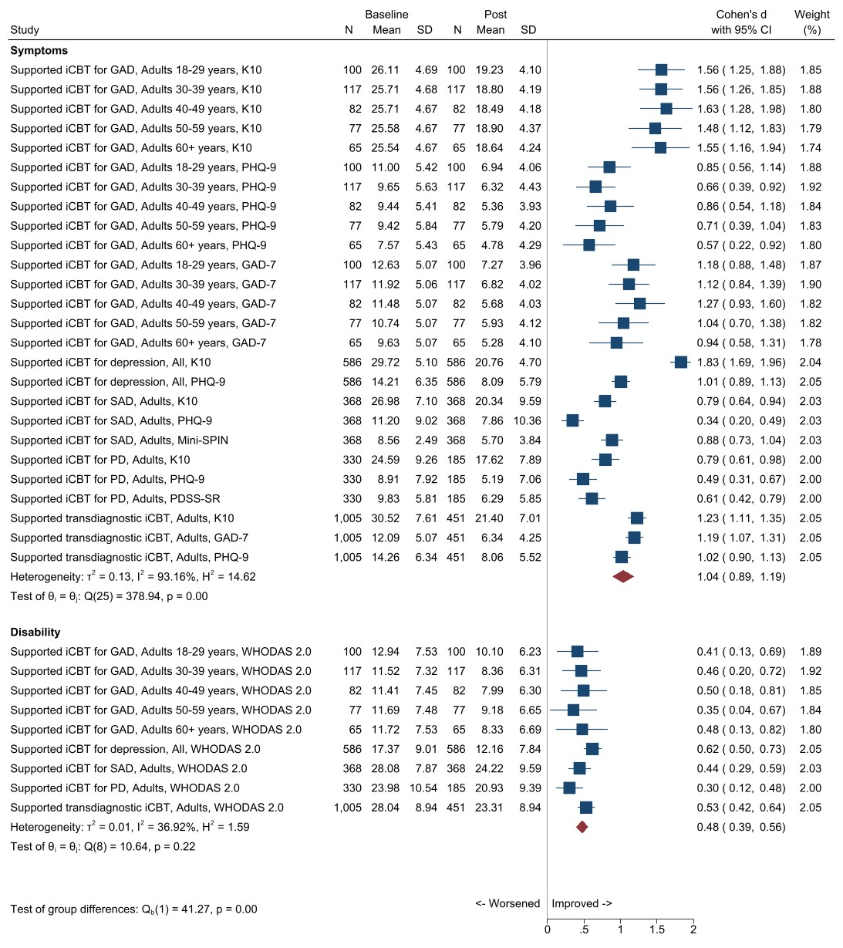

Figure 12. Forest plot of THIS WAY UP therapist-supported treatment effects on mental health symptoms and disability
CI, confidence interval; GAD, Generalised Anxiety Disorder; Generalised Anxiety Disorder 7-item Scale; iCBT, internet cognitive behavioural therapy; K10, Kessler Psychological Distress 10-Item Scale; Mini-SPIN, Mini-Social Phobia Inventory; M, mean; N, frequency; PD, panic disorder; PDSS-SR, PHQ-9, Patient Health Questionnaire-9; Post, post-treatment (6 modules); SAD, social anxiety disorder; SD, standard deviation; SE, standard error; WHODAS 2, World Health Organization Disability Assessment Schedule-II.

Table 20 summarises other treatment outcomes we extracted from the above selected publications used for determining THIS WAY UP’s effectiveness. Four studies involved six, and one involved five, online lessons completed independently by consumers as part of routine care. In all five studies, THIS WAY UP recommended that the consumer’s prescribing clinician (GP, psychiatrist, primary health care physician, psychologist, or other mental or allied health professional) provided support and supervision.
These studies showed that 45% to 56% of consumers complete all six (or five), and on average they complete four lessons. The studies also confirm that improvement in mental health was clinically significant as measured by recovery rates (44-66%), remission rates (58-70%) and/or reliable improvement (22-48%).
THIS WAY UP does not routinely collect follow up data. However, a randomised controlled trial component in the study by Allen et al (2016) found that gains from iCBT for panic disorder were maintained at three months post-treatment.⁵³
Collectively, the studies indicated that older adults and consumers with less severe symptoms are more likely to complete treatment. Findings from one study suggested that more contacts from prescribing clinicians during the course was associated with treatment completion.⁵³

Table 20. Other outcomes from THIS WAY UP therapist-supported treatment and predictors of adherence
Publication | Aim | Treatment completion rate | Predictors of adherence | Recovery rate | Remission rate | Reliable change
Hobbs et al (2017)⁷¹ | Examine age-related differences in presentation, adherence and effects of iCBT for GAD among patients in routine clinical care (N=942; 18–29 years (n=267); 30–39 years (n=260); 40–49 years(n=180); 50–59 years (n=124); and 60+ years (n=111) | 46.8% (441)  Mean 4.44 (SD=1.81) | More likely to complete treatment  - aged > 50 years  - no probable GAD diagnosis at baseline  Unrelated to completion:  - probable diagnosis of MDD  - sex  - rurality  - prescribers’ profession  - baseline K10  - baseline WHODAS 2 | 44% (192/441)  GAD-7 total scores reduced by at least 50% from pre-to-post treatment | 70% (178/256)  Those with probable pre-treatment GAD diagnosis who achieved post-treatment GAD-7<10 (standard threshold for probable GAD diagnosis) | - 39% (171/441) reliable reduction in GAD -7 symptom severity  - < 1% reliable deterioration (2/441)
Hobbs et al (2018)⁵⁰ | Examines effects of iCBT for depression across adult lifespan among patients seeking help in routine clinical care (N=1288) | 45.5% (586)  Mean: 4.15  (SD=1.99) | Age group significantly associated with adherence after controlling for probable MDD diagnosis, rurality, and baseline psychological distress  Those aged > 65 years more likely to complete treatment compared to those aged 18-54 years, but did not differ from those aged 55-64 years | 44.2% (259/586)  PHQ9 scores reducing at least 50% pre to post among those who completed all 6 lessons | 58.8% (241/410)  Baseline PHQ-9>10 and post-treatment PHQ-9<10 (standard threshold for probable MDD diagnosis) | - 44.97% (210/467)ª reliable improvement on PHQ-9 (change of >7.04)  - 0.34% (2/586)^{b} reliable deterioration on PHQ-9
Williams et al (2014)⁵² | Evaluate effectiveness of iCBT program for SAD when delivered in routine practice (N=368) | 52% (191) | Age only significant predictor; completers significantly older (M=36.81, SD=14.21) than non-completers (M=32.46, SD=13.07) and drop-outs (M = 28.63, SD=9.85), p <.001.  Post-hoc comparisons on K10 scores, F(2, 365)=3.98, p<.05, η2 = .02 indicated higher mean baseline scores in non-completers (28.44, SD=6.74) relative to completers (26.05, SD = 7.57), p = .04. | Not reported | Not reported | Not reported
Allen et al (2016)⁵³ | Determine effectiveness of a five-lesson iCBT programme for panic disorder (N=330) | 56.1% (185)  Mean: 3.94 (of 5 lessons) (SD=1.42) | Lesson completion predicted by:  - lower baseline K10  - older age  - more contacts from clinician  Lesson completion not associated with:  - baseline panic severity  - rurality  - gender | 65.9% (122/185)  Achieved normalisation of symptoms (scores below validated  clinical cut-off scores) on PDSS-SR | 57.9% (88/152)  PDSS-SR <8. Calculated on completers only and those who were above the cut-off at baseline | - 21.9% (41/185) reliable improvement  - 0% reliable deterioration
Newby et al (2017)⁵⁴ | Examine effectiveness of transdiagnostic iCBT for anxiety and depression (N=1005) | 44.9% (451)  Mean: 4.36 (SD=1.81) | - Higher baseline distress (K10) less likely to complete treatment than those with lower distress scores  - Older adults more likely to complete all six lessons than their younger counterparts [t (2097) = −9.07, p < 0.001].  - Gender, rurality and clinician profession not associated with course completion (p’s > 0.05). | Not reported | Not reported | - 47.7% (215/451) treatment completers reliable improvement on GAD-7  - 44.3% (200/451) reliable improvement on PHQ-9  - 0.4% (2) reliable deterioration on GAD-7  - 1.6% (7) reliable deterioration on PHQ-9
ªimprovement estimates were based on completers who presented to treatment with a PHQ-9 total score of 8 or greater (i.e., the group where reliable improvement was possible to measure).
^{b}Reliabe deterioration was calculated among all completers (i.e., irrespective of pre-treatment total score).
GAD, generalised anxiety disorder; GAD-7, Generalised Anxiety Disorder 7-item Scale; iCBT, internet cognitive behavioural therapy; K10, Kessler Psychological Distress 10-Item Scale; MDD, major depressive disorder; N, frequency; PHQ-9 Patient Health Questionnaire-9, SD, standard deviation; WHODAS 2, World Health Organization Disability Assessment Schedule 2.

Trends in mental health outcomes by baseline symptom severity
Figure 13 shows the mental health outcomes by baseline symptom severity as assessed using the K10, PHQ-9 and GAD-7, for consumers THIS WAY UP treatment from July 2015 to December 2021, overall and therapist support status. Across all measures, consumers commenced treatment with varying levels of symptom severity and substantial numbers experienced severe symptoms.
As was the case for MindSpot, because we received pre- and post-treatment mental health outcomes data in aggregate form rather than at the individual consumer level, we used change in symptom severity category (e.g., severe to moderate) in either direction to indicate “significant change”. Therefore, it is possible that some consumers categorised as not having experienced significant change could have improved or deteriorated within their baseline symptom severity category. Conversely, it is also possible that some consumers who were at the lower (or upper) end of a given symptom severity category at baseline were classified as “significantly improved” (or “significantly deteriorated”) if their score decreased (or increased) by one, respectively. Therefore, the trends reported in this section are more useful than the actual data, which should not be compared to published reliable change data.
Between 57% and 70% of all consumers with medium or more severe K10 scores significantly improved (as indicated by moving to a lower symptom severity category) at the end of treatment (or their last recorded K10 score if they did not complete treatment). K10 symptom severity worsened (as indicated by moving to a higher symptom severity category) for only 5-17% of consumers with low to high K10 baseline symptom severity, with the proportion worsening decreasing as baseline K10 severity increased. A somewhat higher proportion of consumers of self-directed treatment who had higher baseline psychological distress (K10) improved than their therapist-supported counterparts (73% and 72% vs 68% and 65% with high and very high distress, respectively).
Similar trends were observed for both the PHQ-9 and the GAD-7, with 50-78% of all consumers significantly improving and those with more severe baseline scores on either measure being more likely show improvement. As with the K10, 19% or less of consumers with no/minimal to moderately severe symptoms deteriorated, with the proportion worsening decreasing as baseline PHQ-9 and GAD-7 severity increased. Again, a somewhat higher proportion of consumers of self-directed treatment who had higher baseline depression (PHQ-9) improved than their therapist-supported counterparts. However, a slightly higher proportion of consumers of therapist-supported treatment with mild baseline anxiety (GAD-7) improved than those who accessed self-directed treatment (52% vs 48%).

All (N:K10=57,134; PHQ-9=54,132; GAD-7=37,528) Therapist-supported (N:K10=29,259; PHQ-9=27,530; GAD-7=18,236) Self-directed (N:K10=27,875; PHQ-9=26,602; GAD-7=19,292)
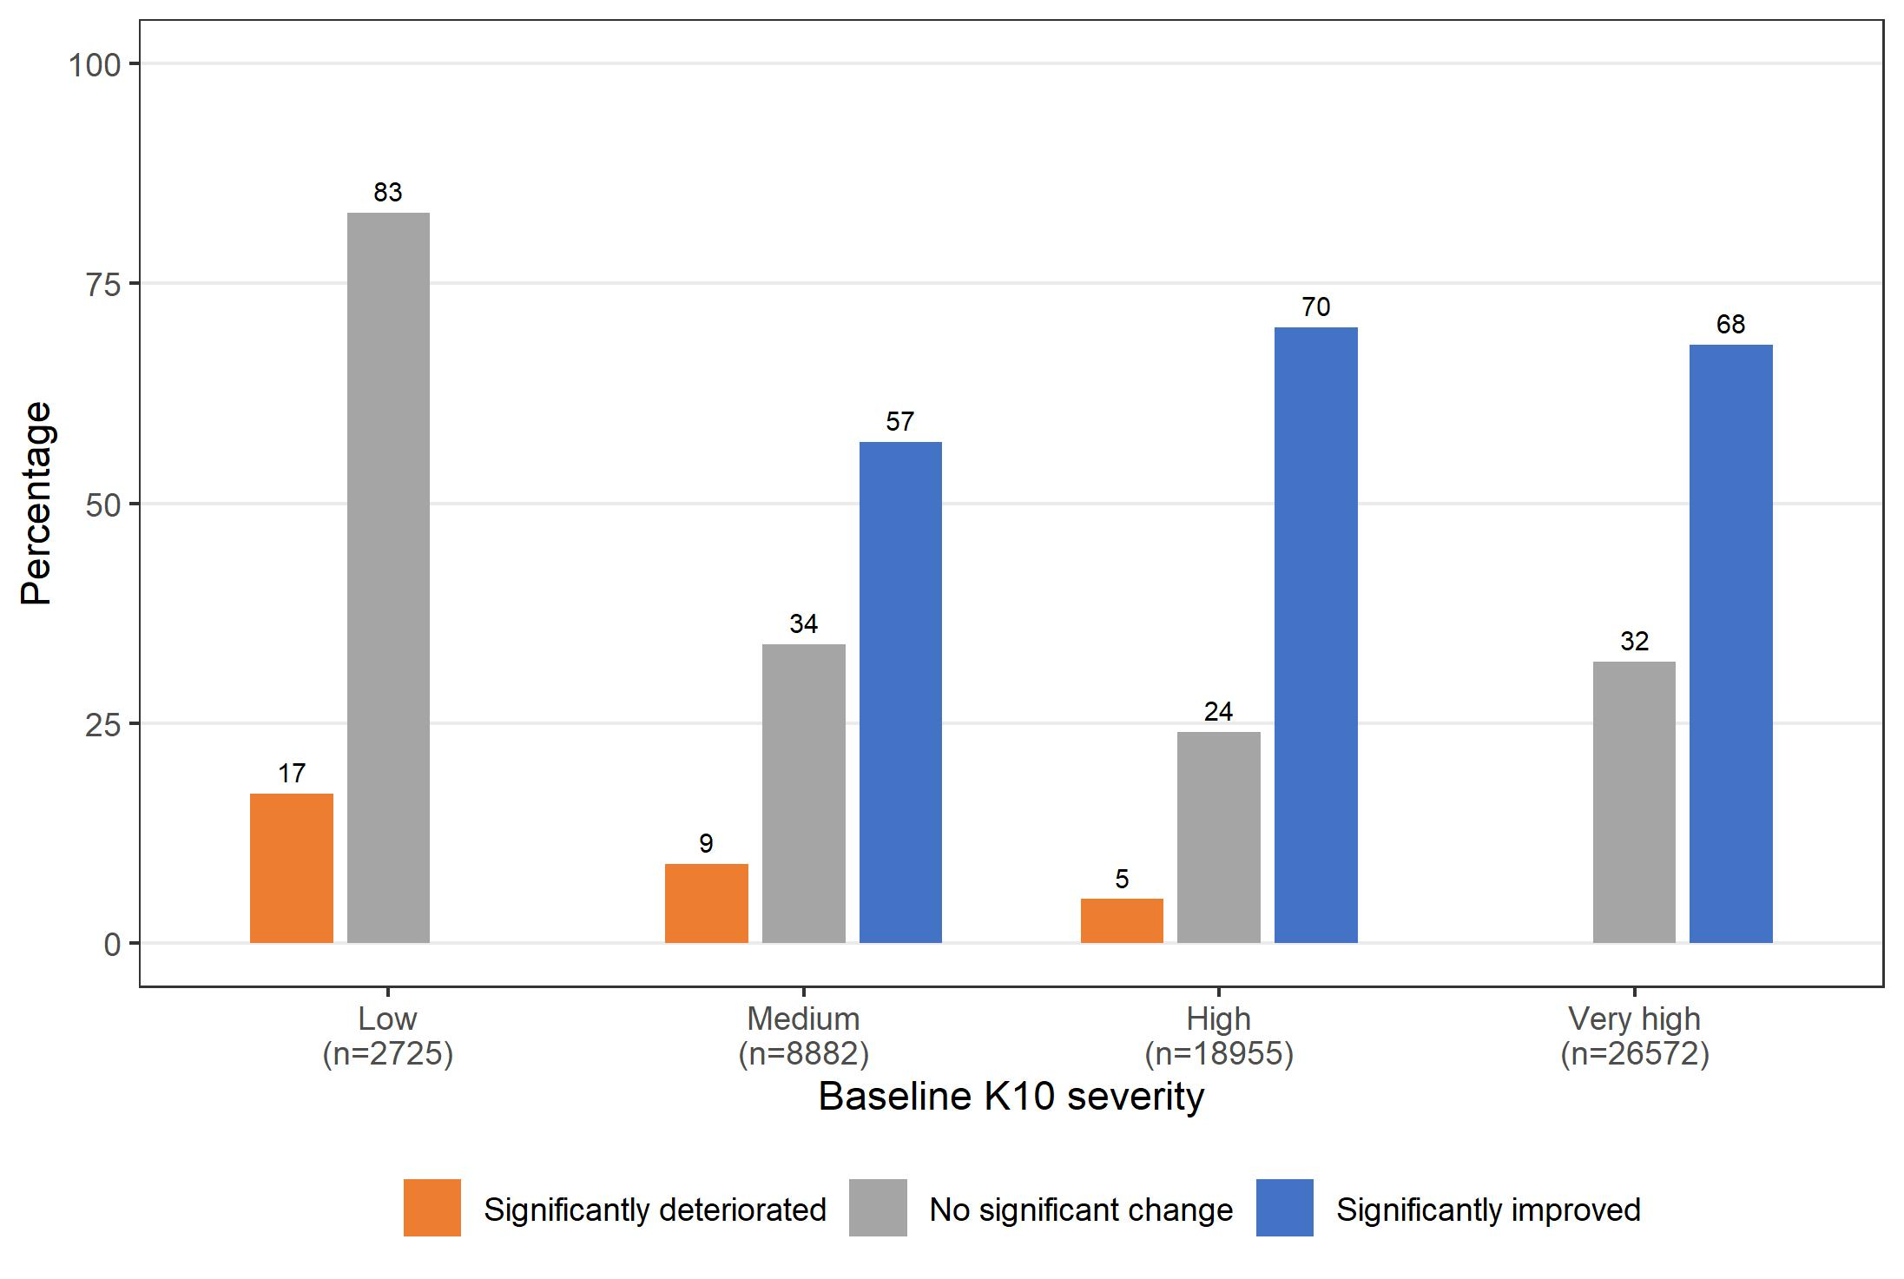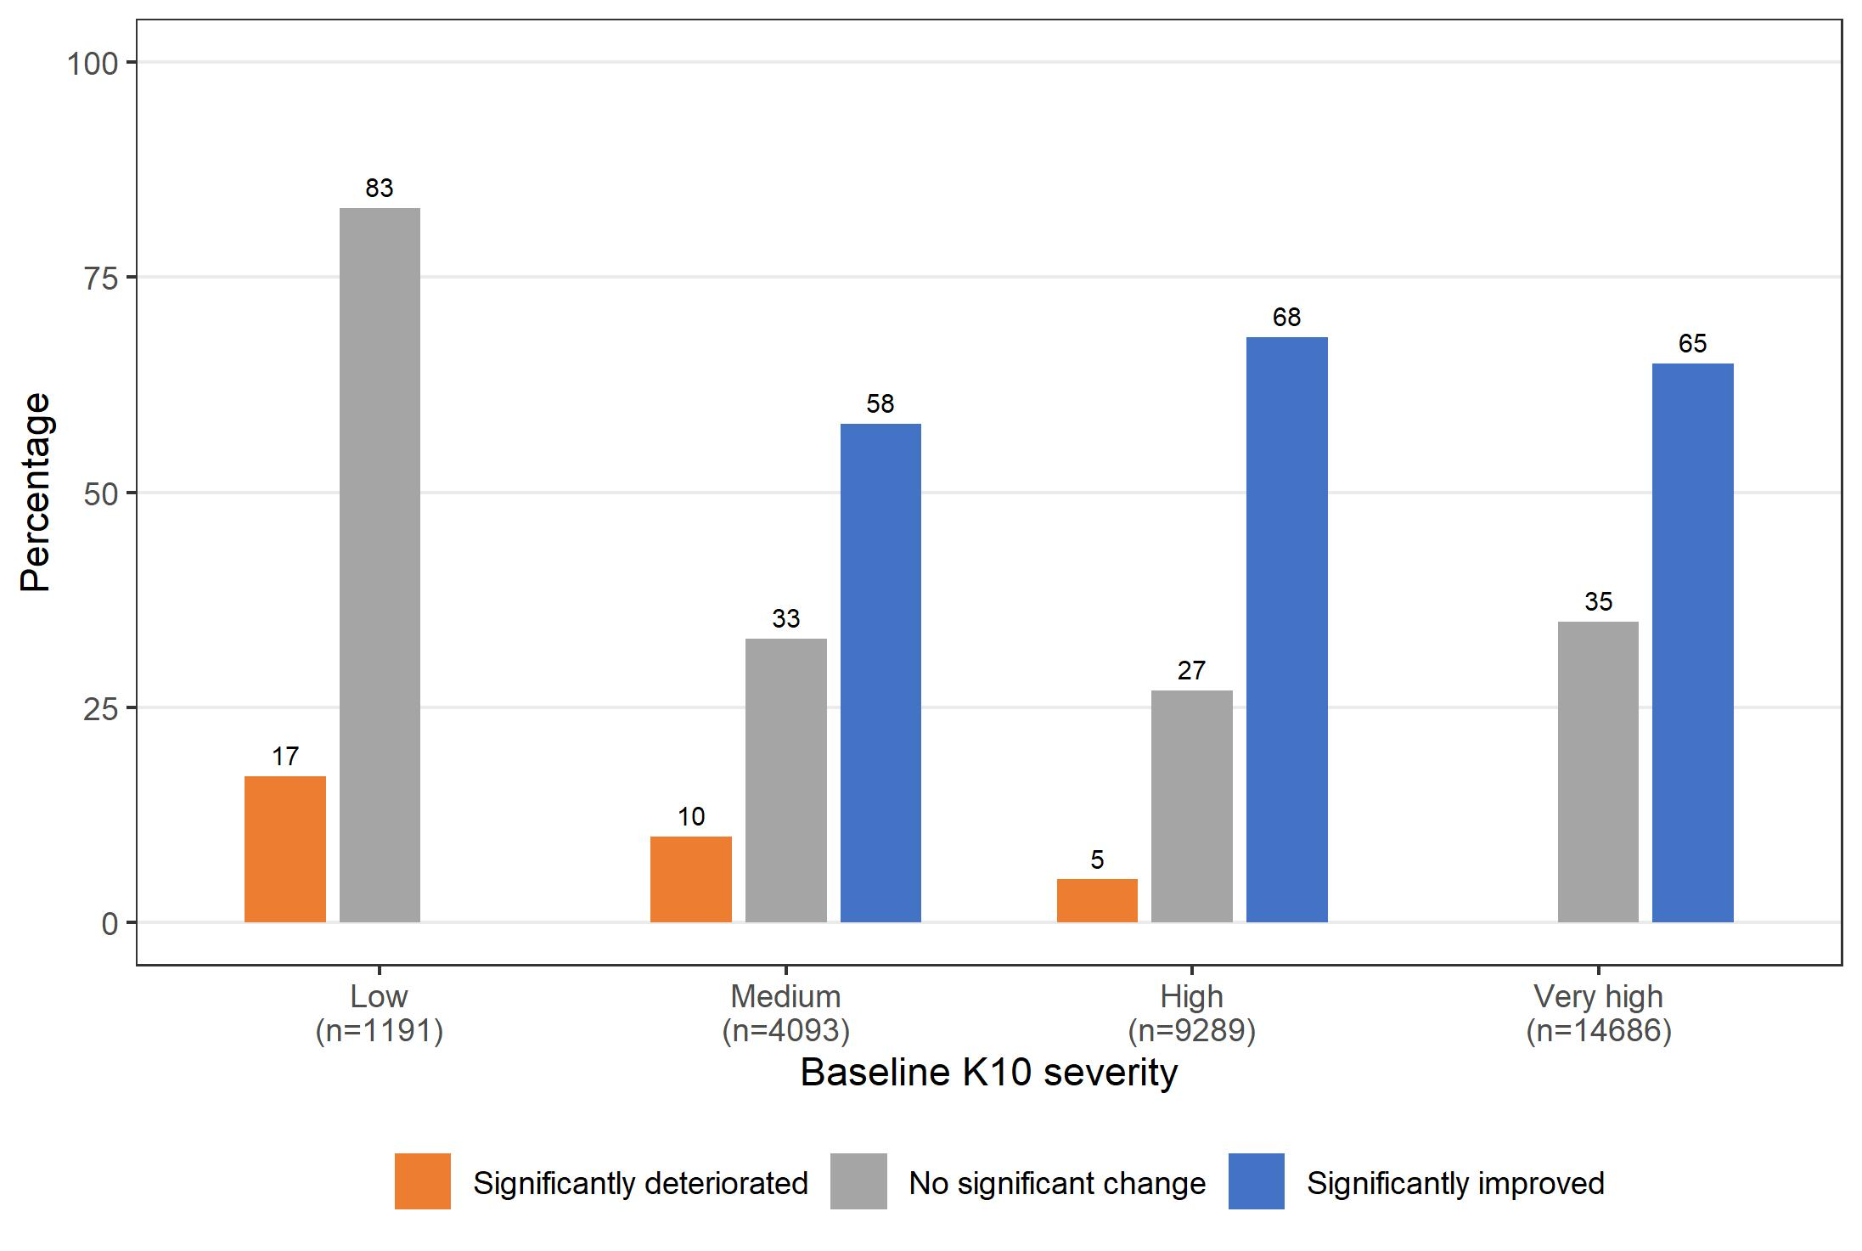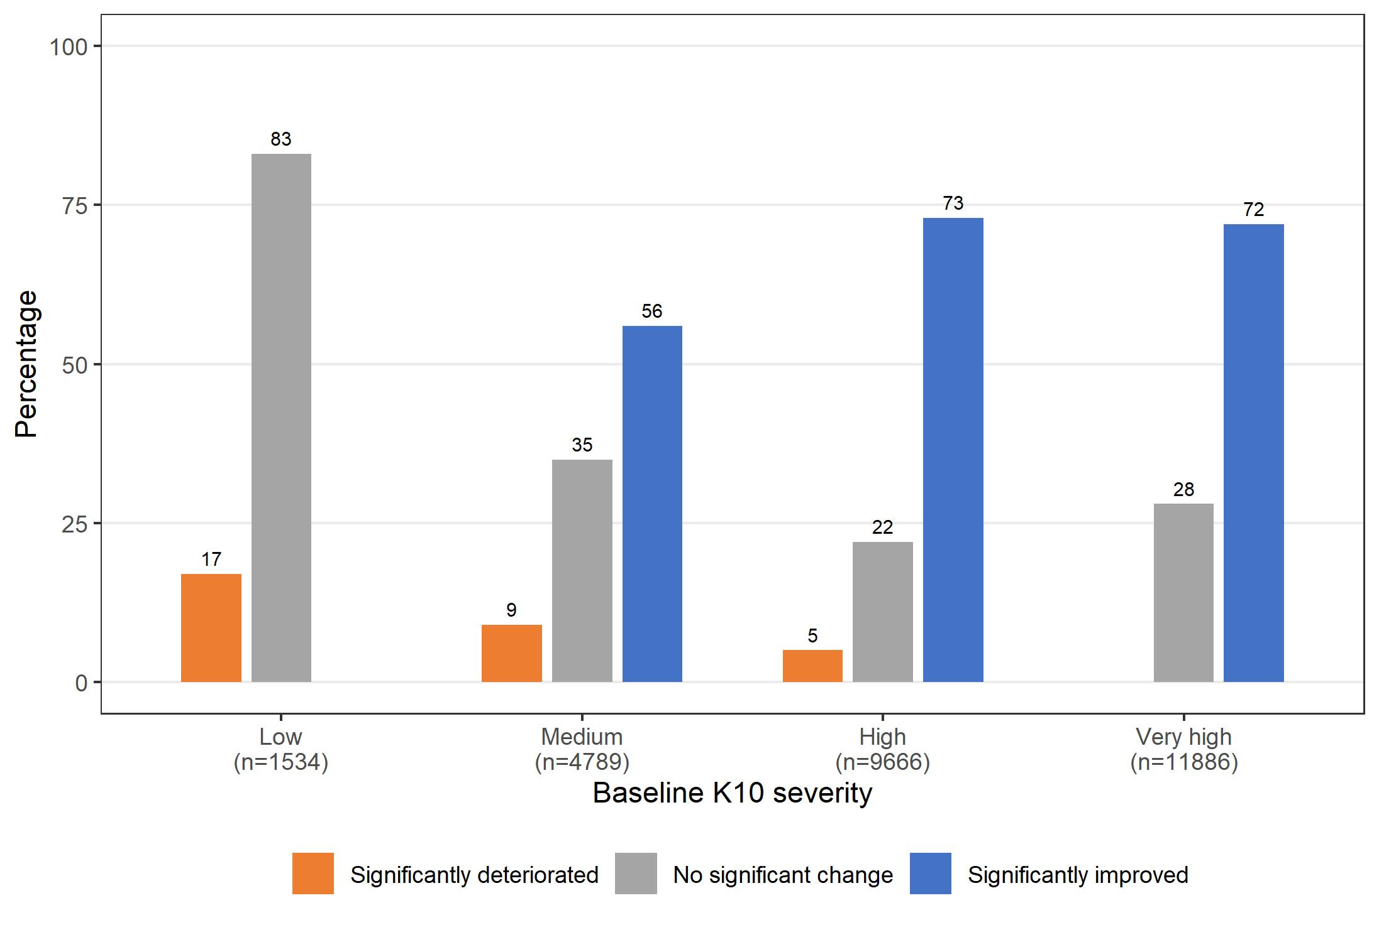
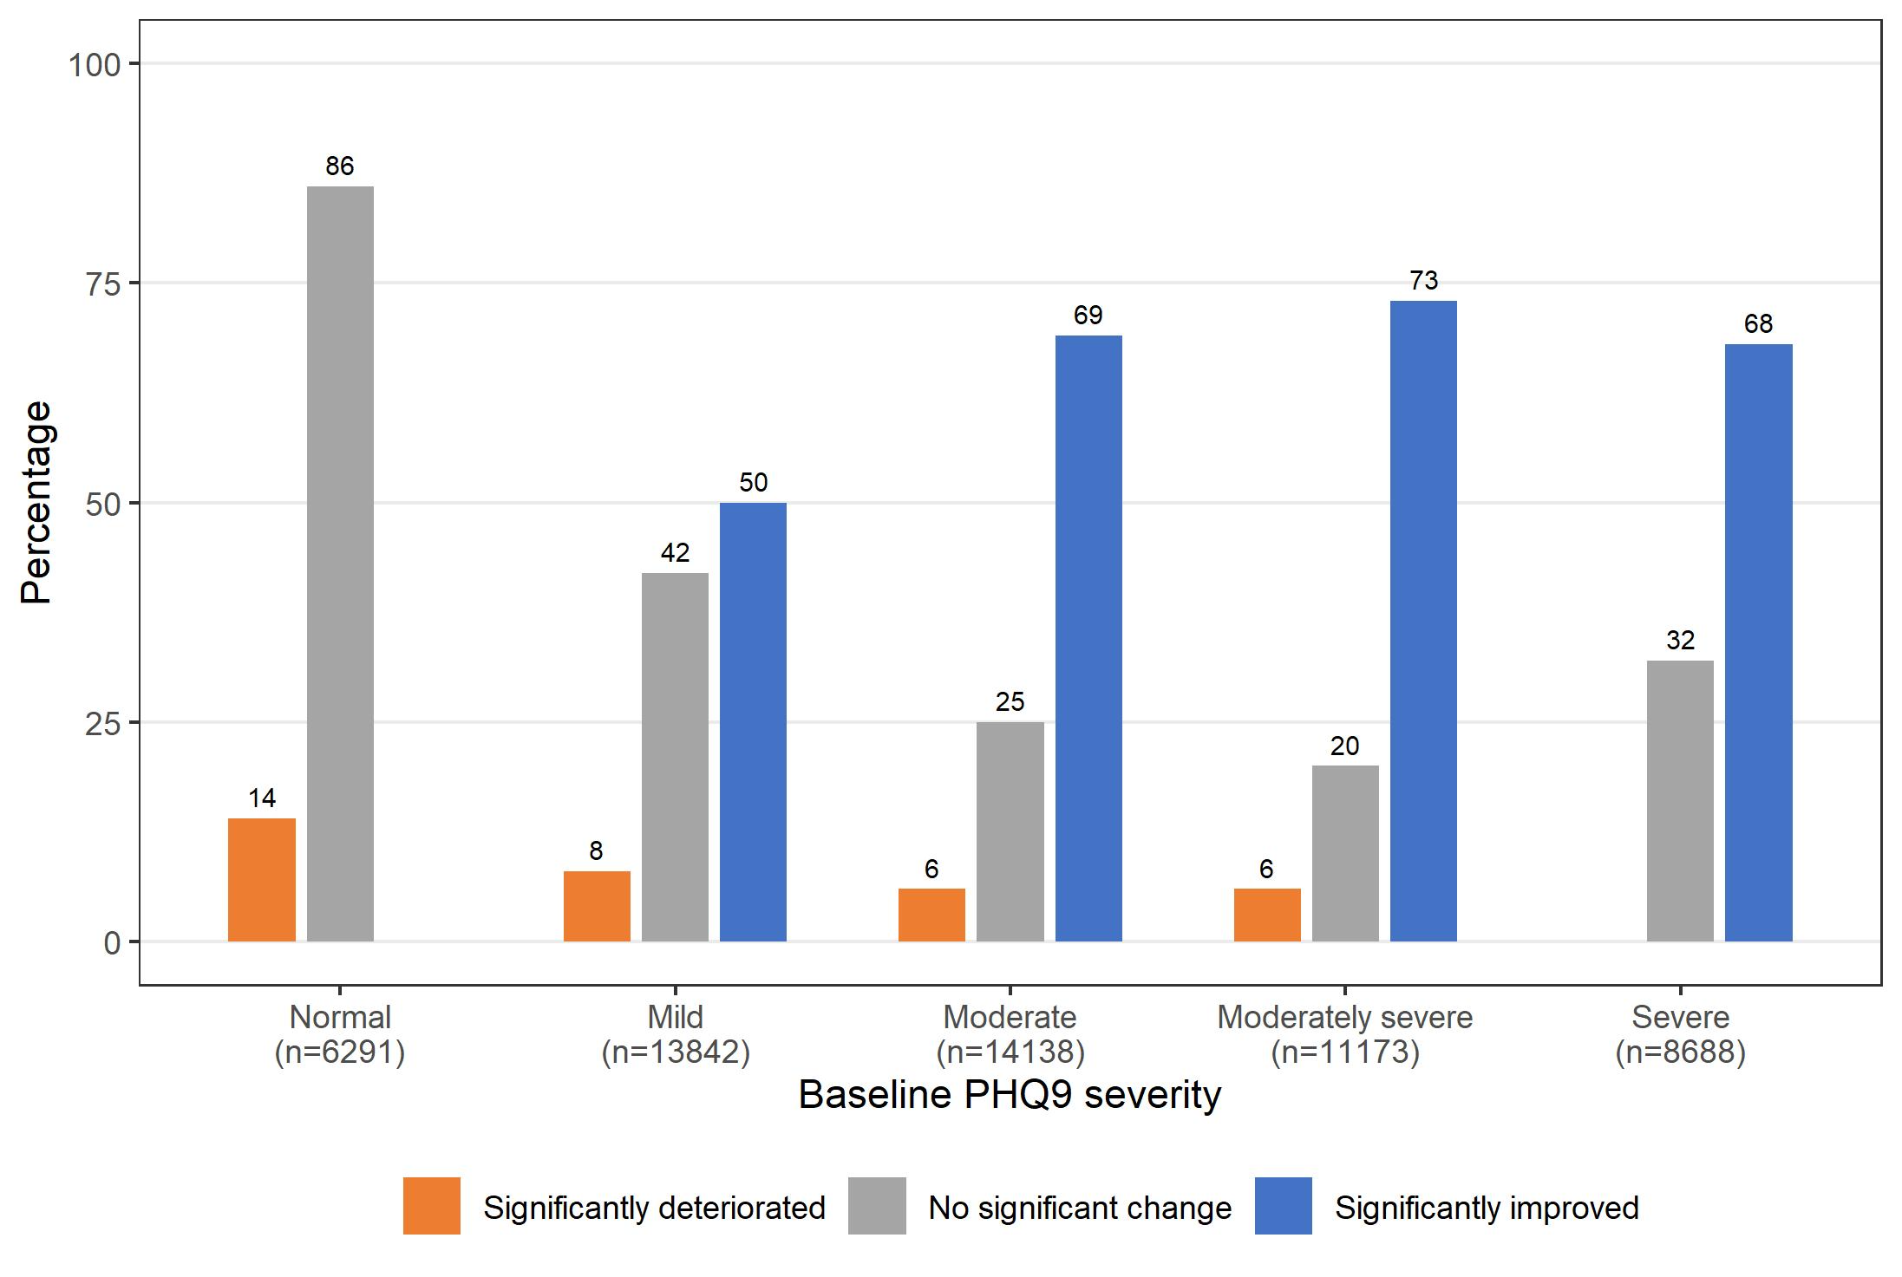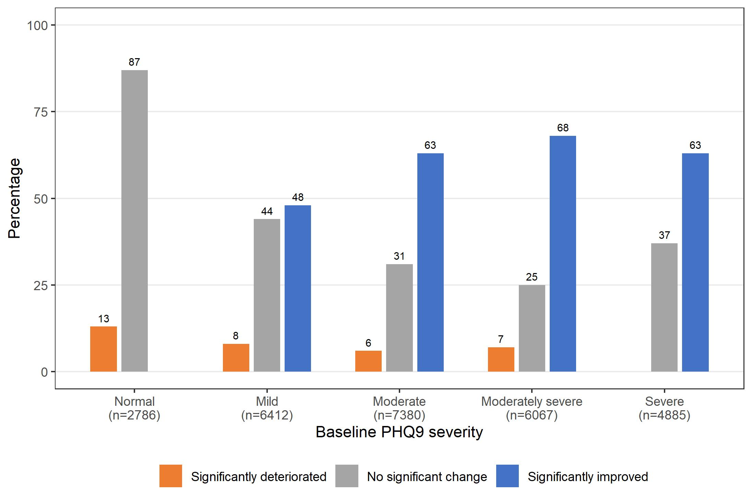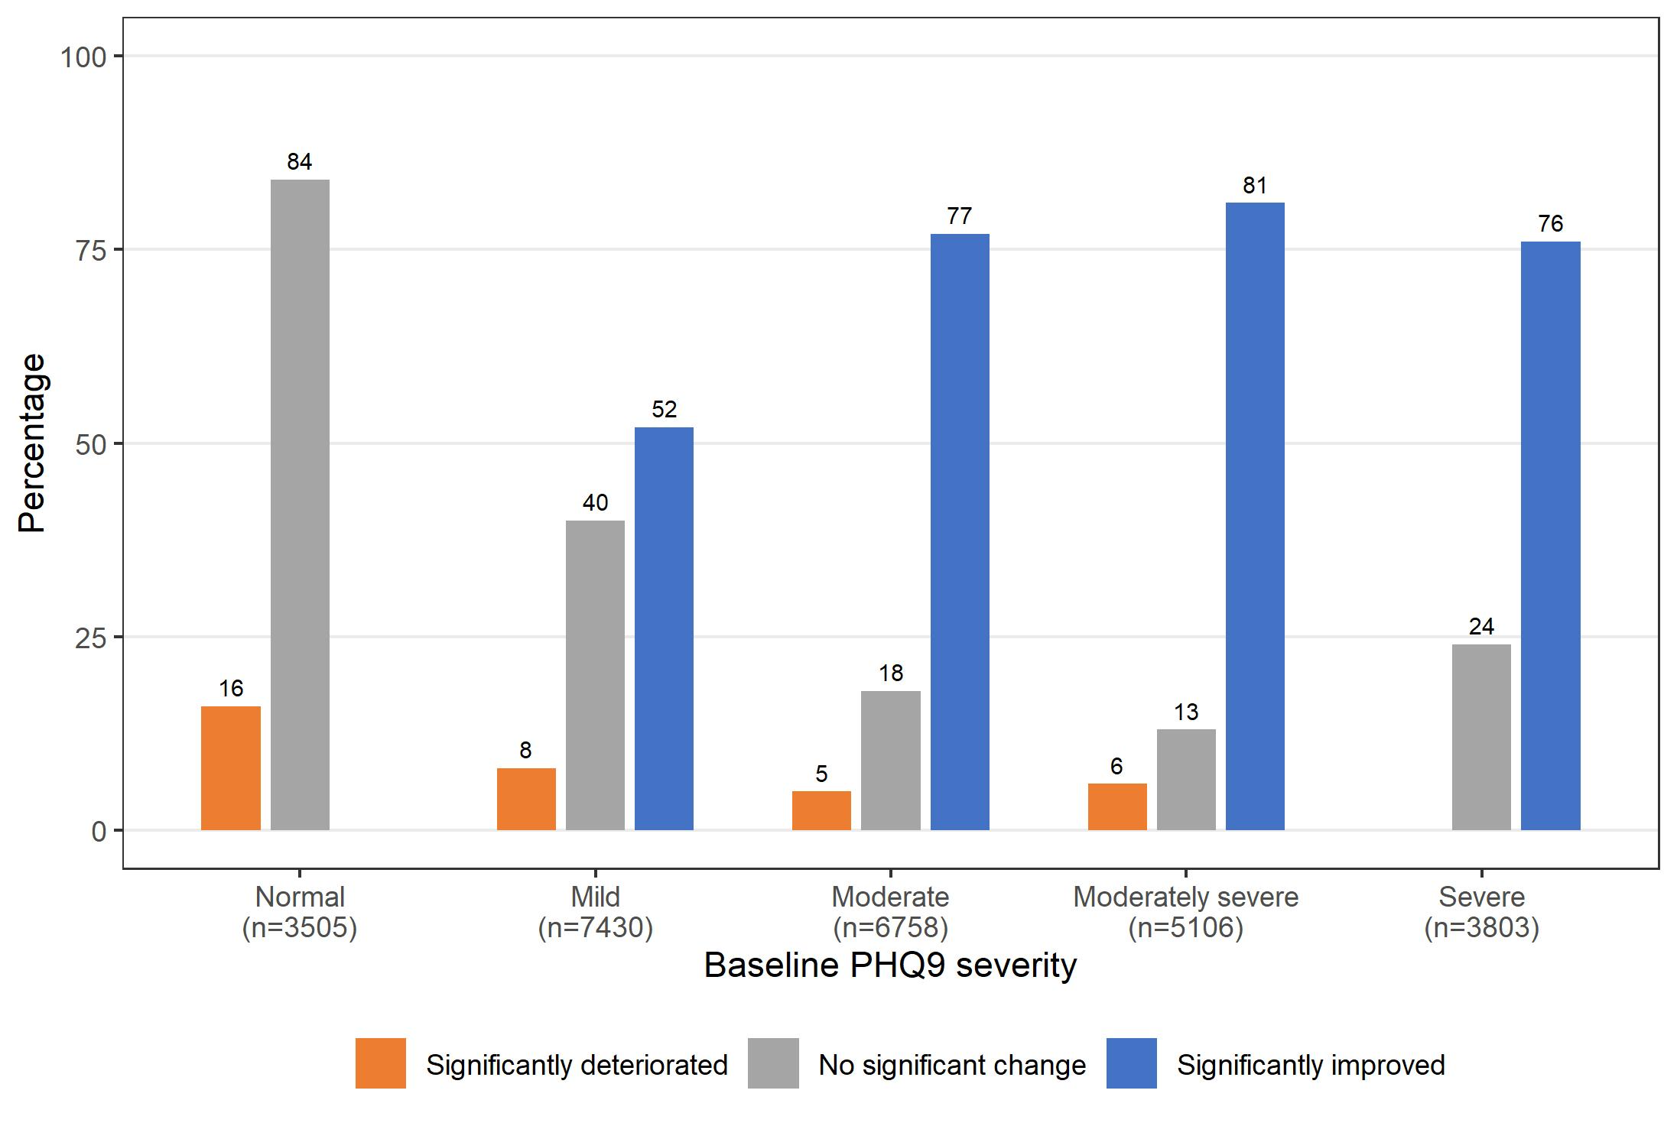

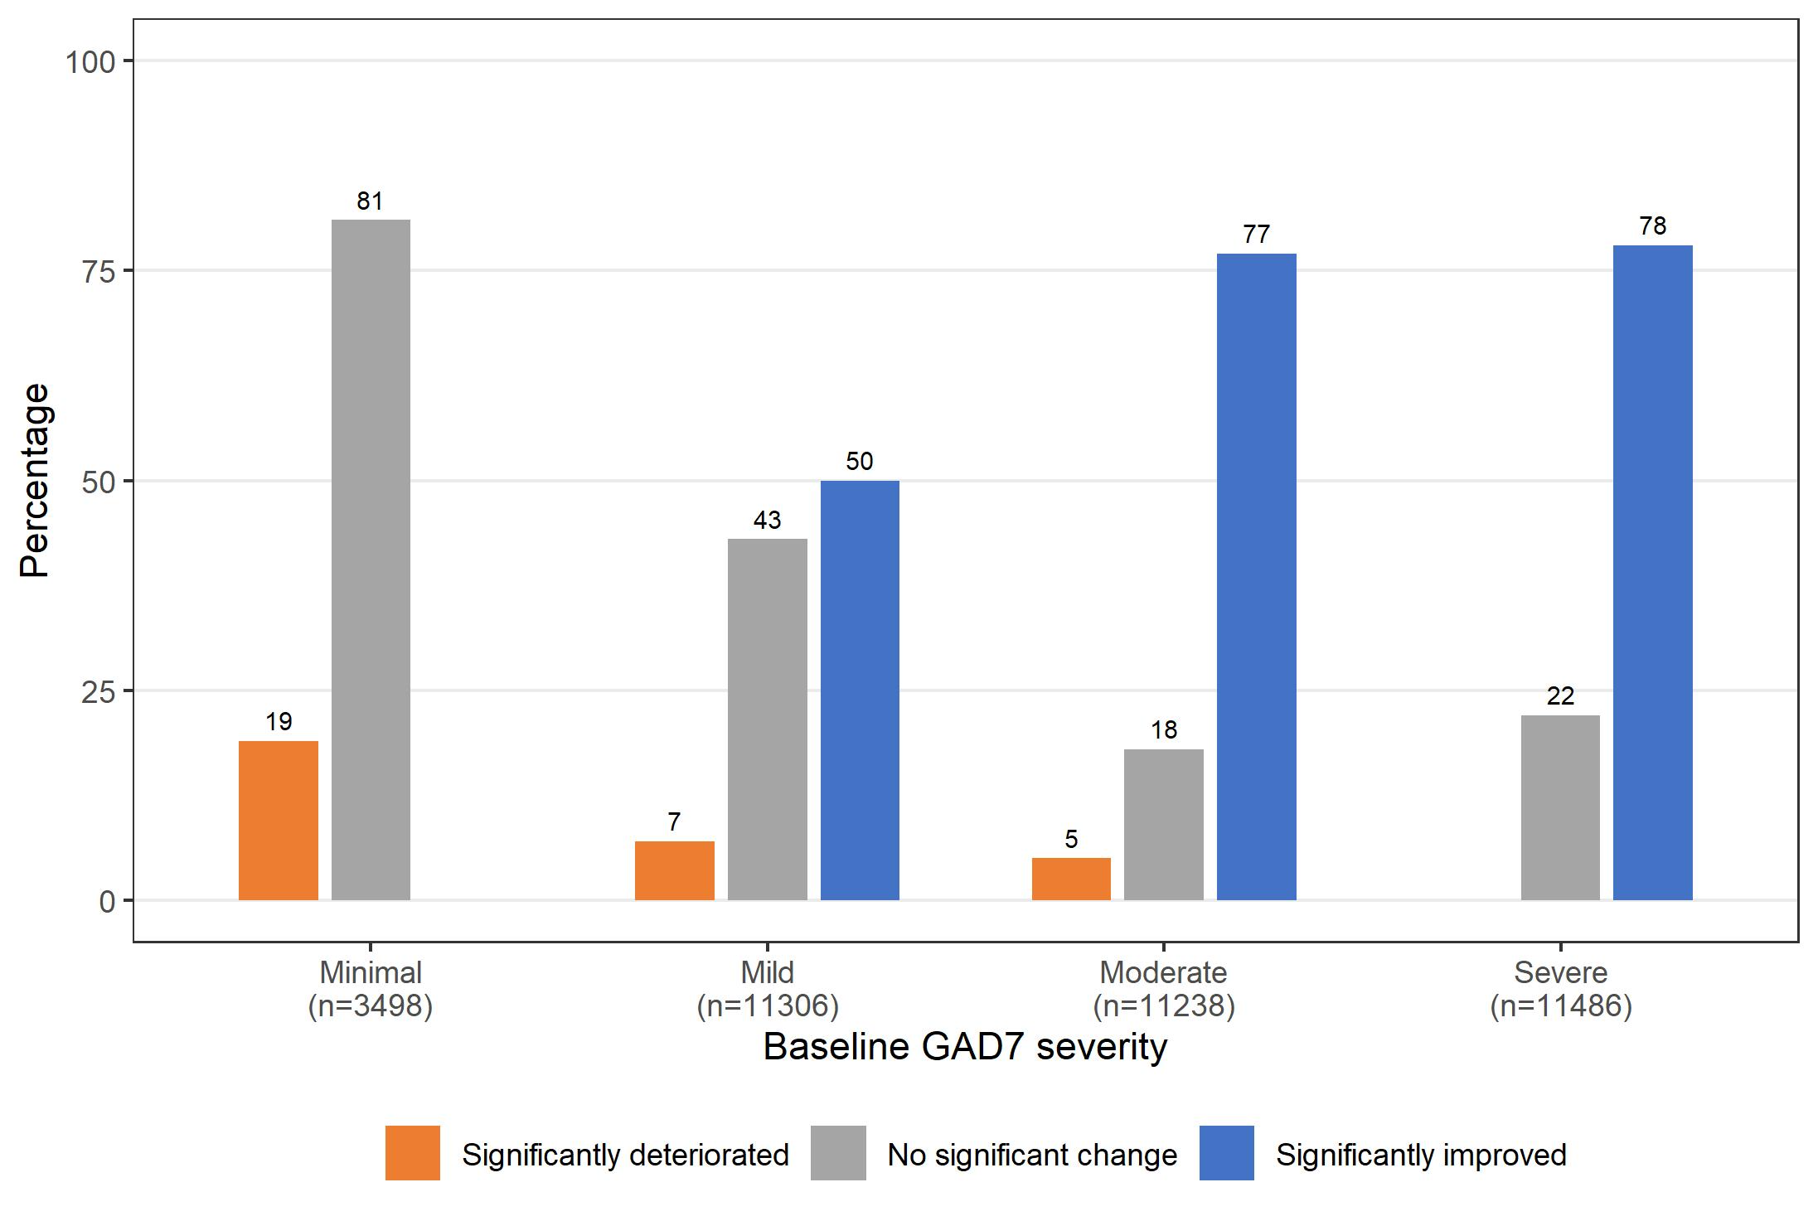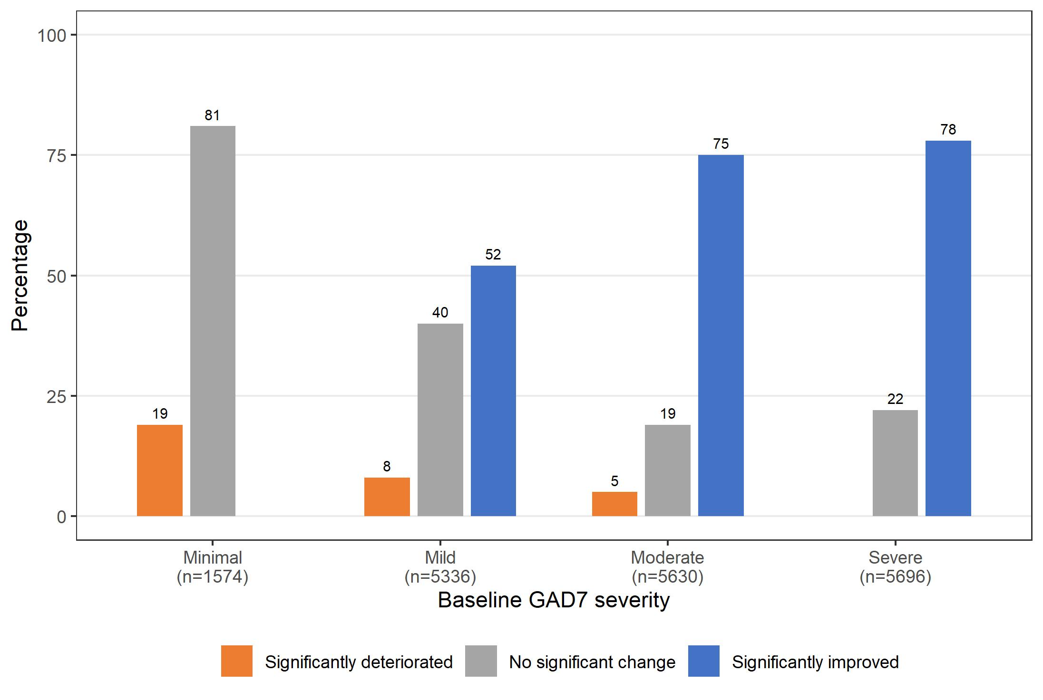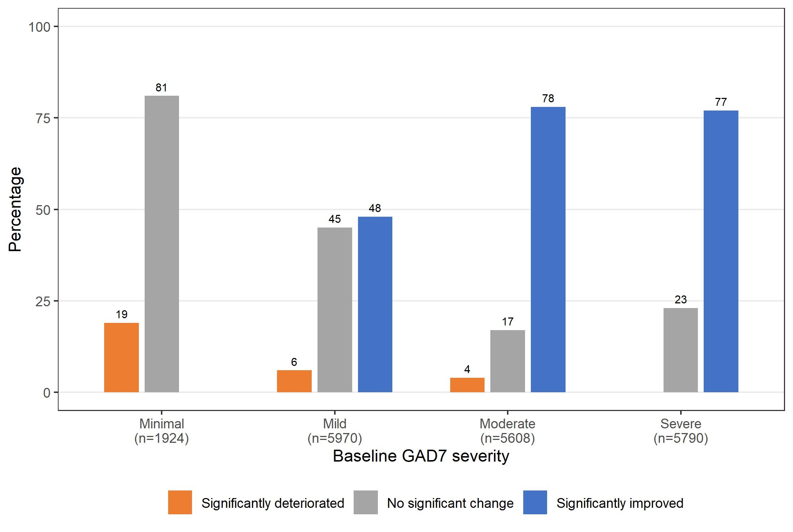

Figure 13. K10, PHQ-9 and GAD-7 outcomes by baseline symptom severity for THIS WAY UP consumers, overall and by support status, July 2015 – December 2021

Trends in mental health outcomes by demographic characteristics
Figures 14-16 show THIS WAY UP consumer before and after treatment symptom severity on the K10, PHQ-9 and GAD-7 by demographic characteristics and therapist-support status from July 2015 to December 2021.
The difference between the pre- and post-treatment means was very similar for males and females for all treatment, therapist-supported, and self-directed treatments; and for all three outcome measures.
The difference between the pre- and post-treatment means was also similar for most age groups, for all treatment, therapist-supported, and self-directed treatments; and for all three outcome measures. There was a slightly smaller difference for < 18-year-olds (all treatment types and outcome measures), and a slightly larger difference for 18-24-year-olds (especially for self-directed treatment) and for 65-74-year-olds.

All Therapist-supported Self-directed
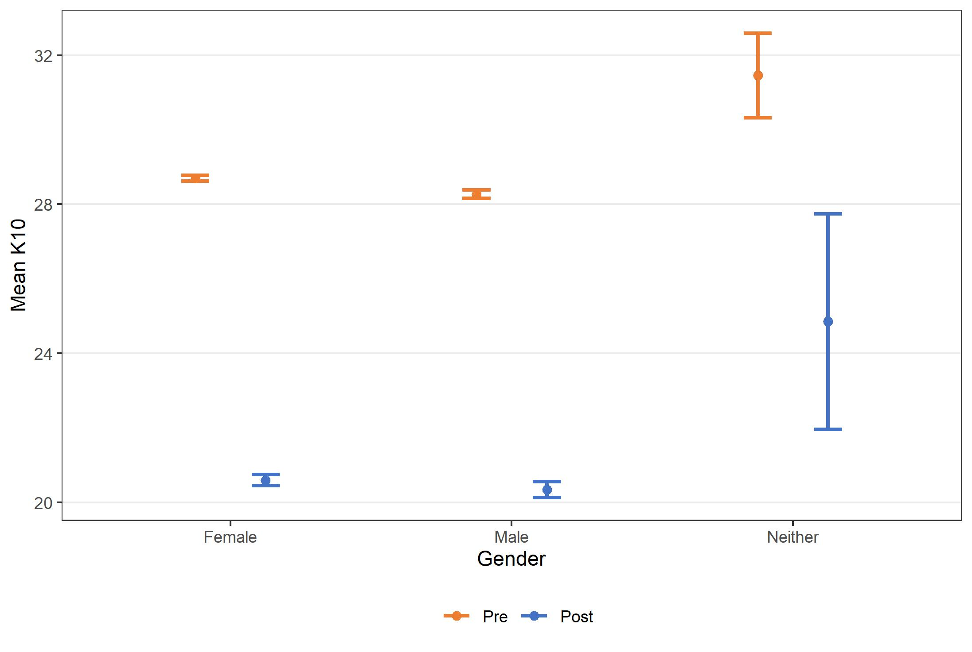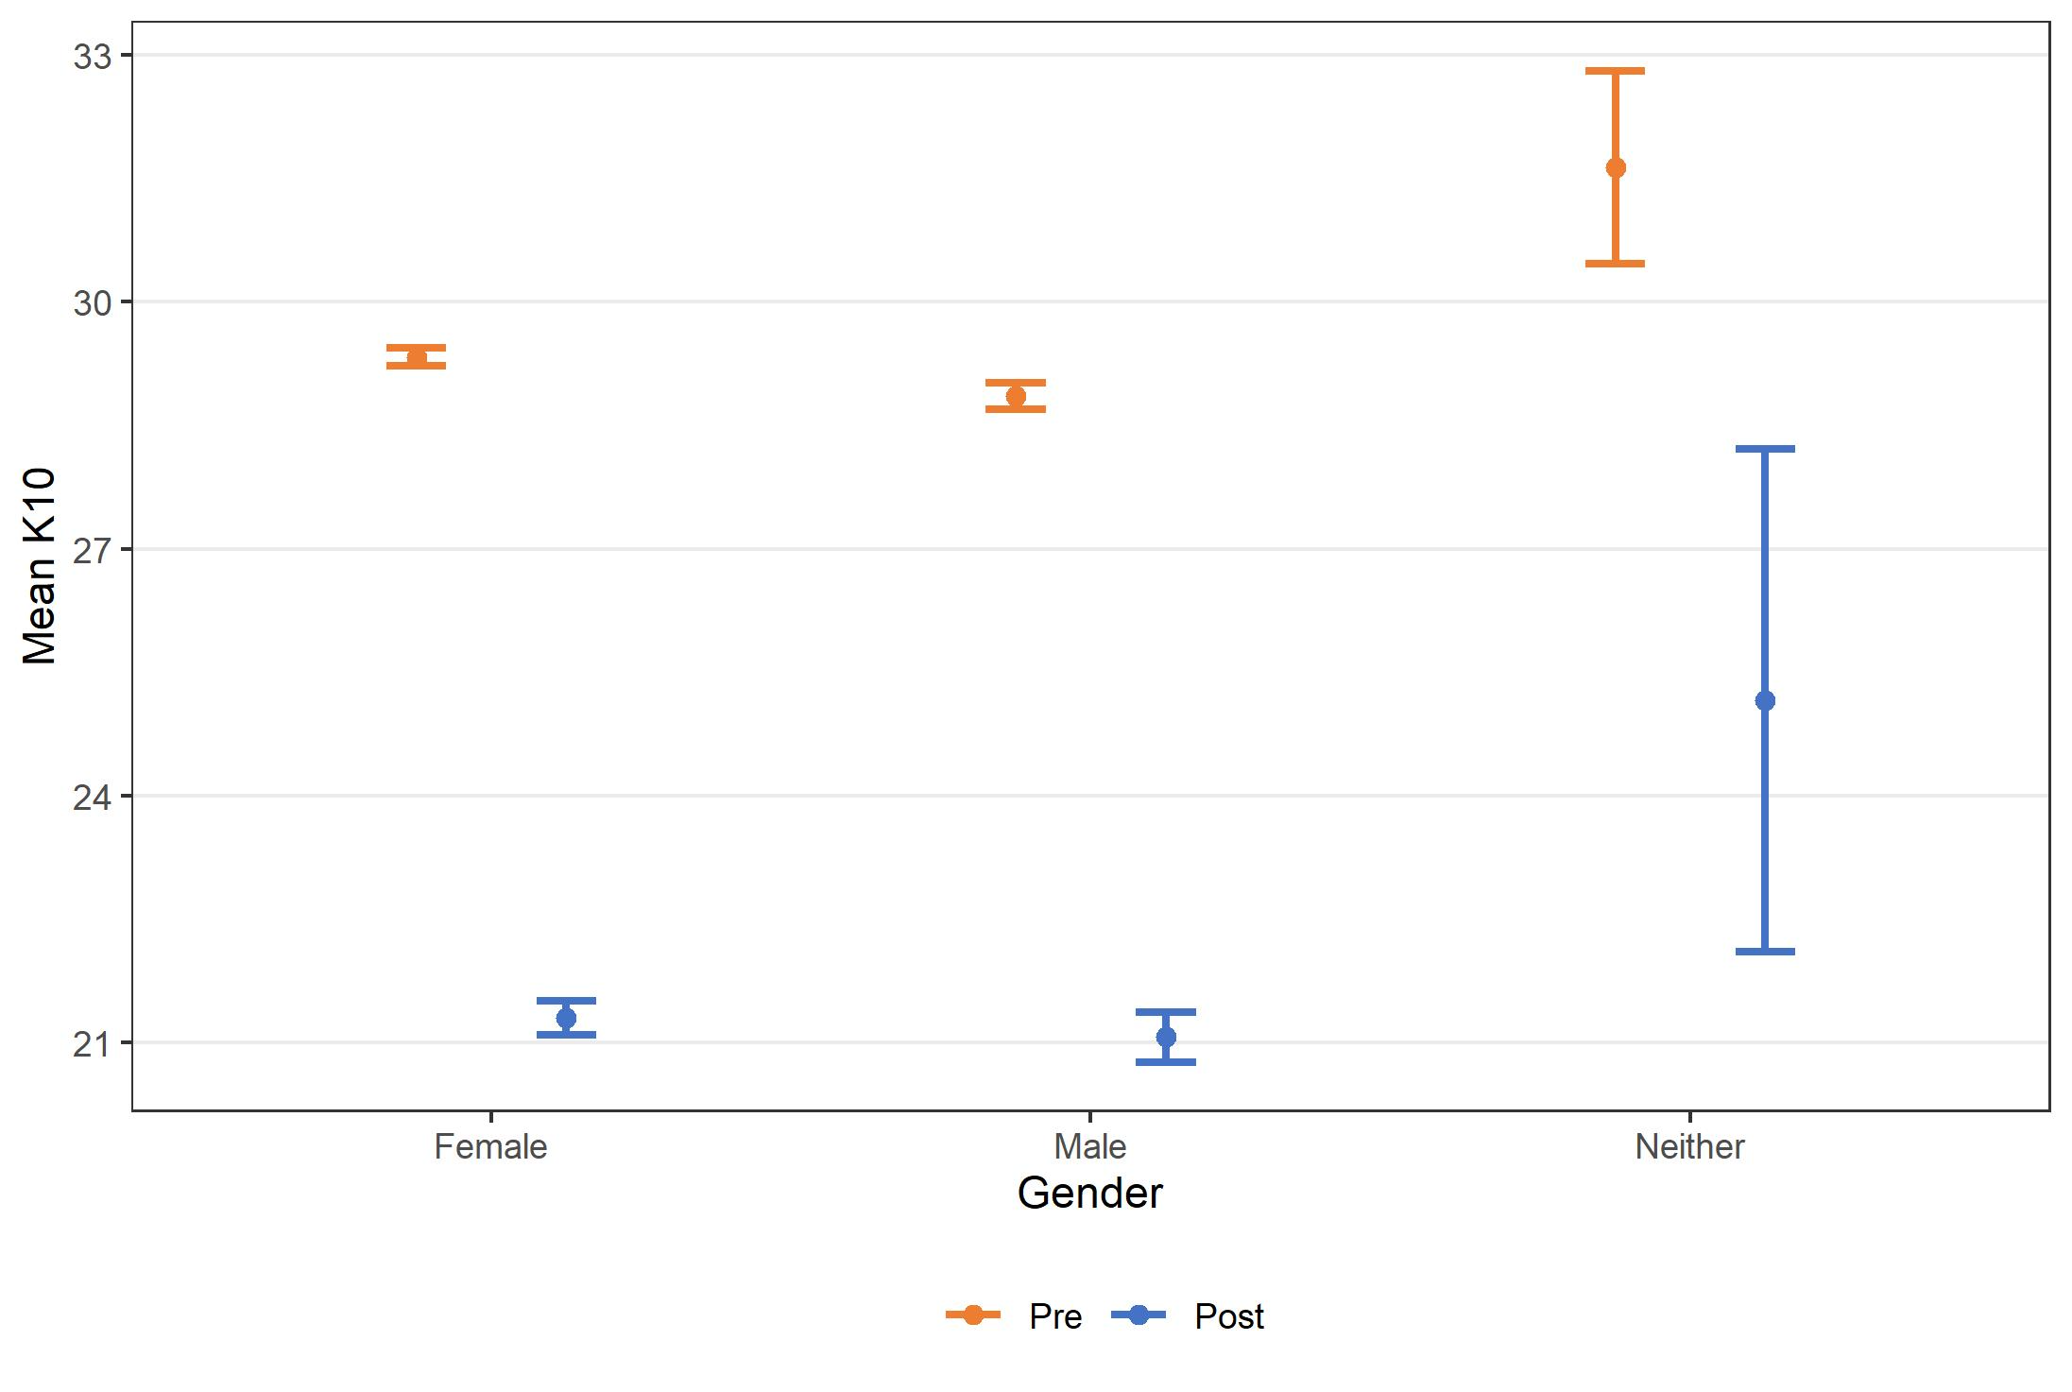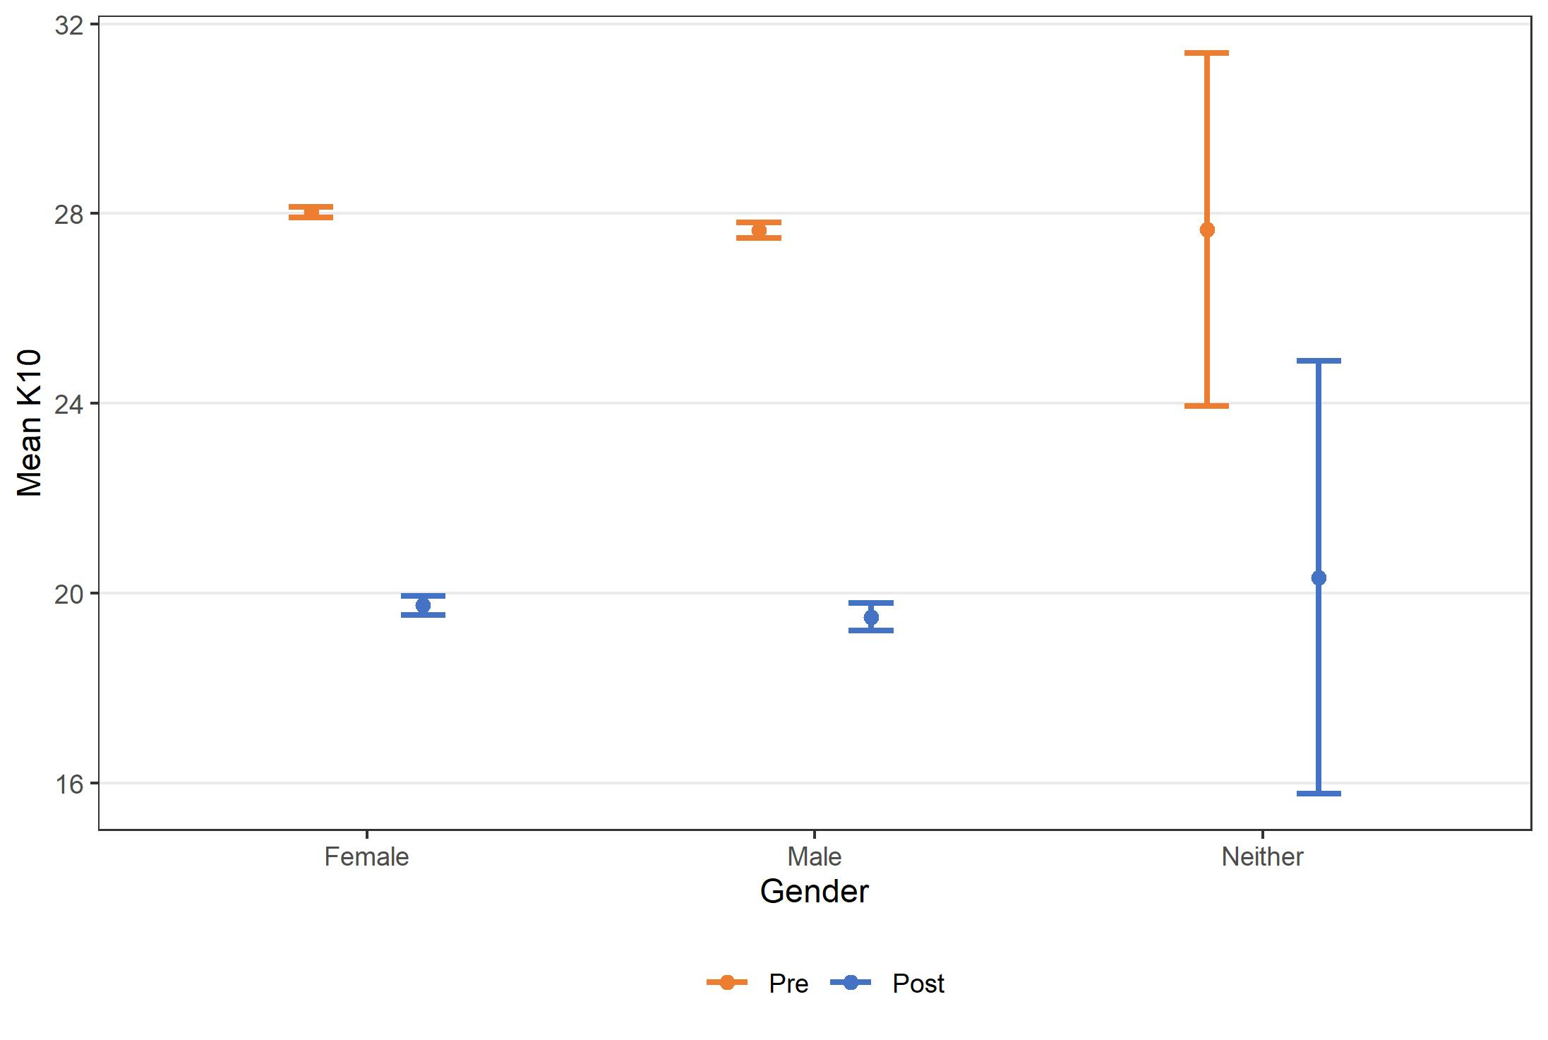
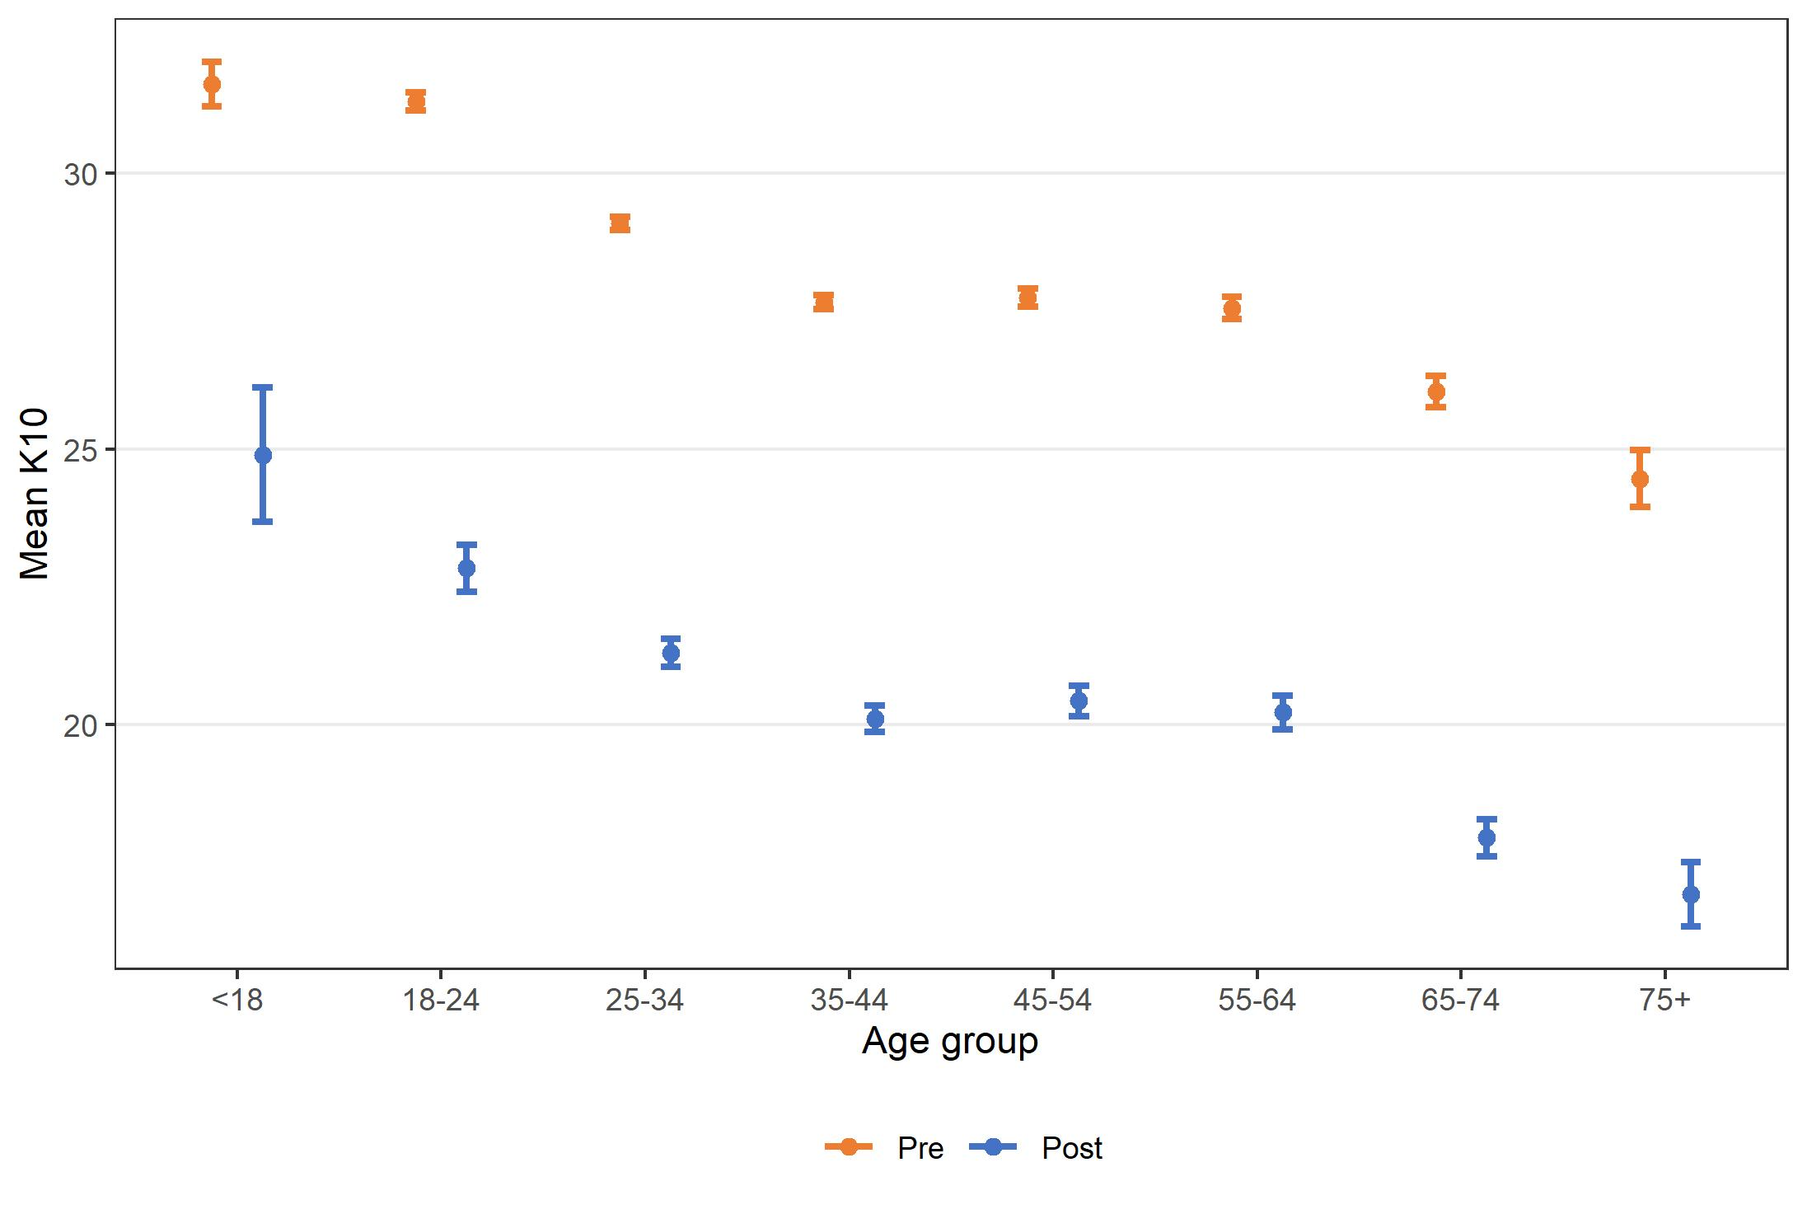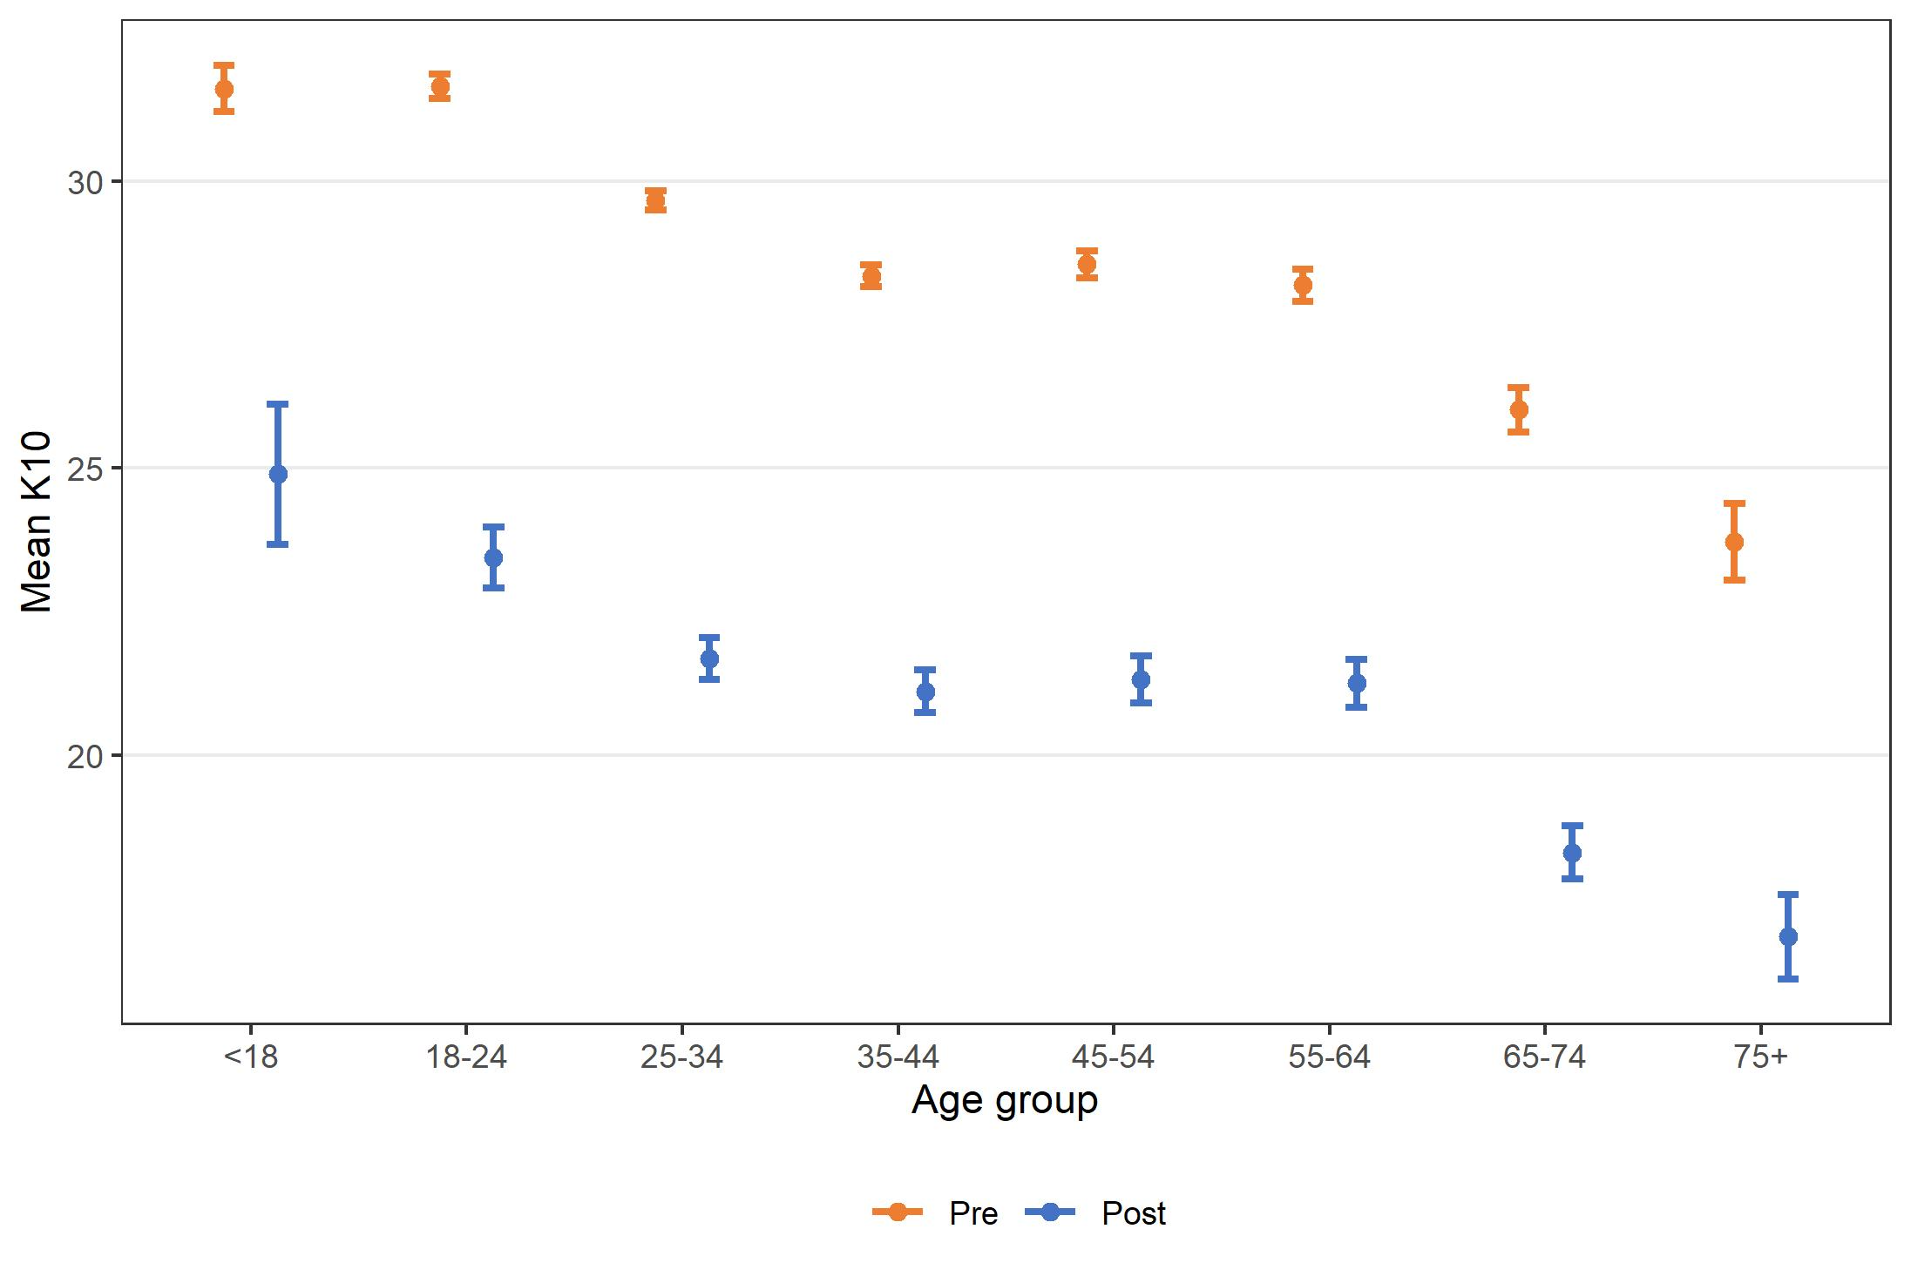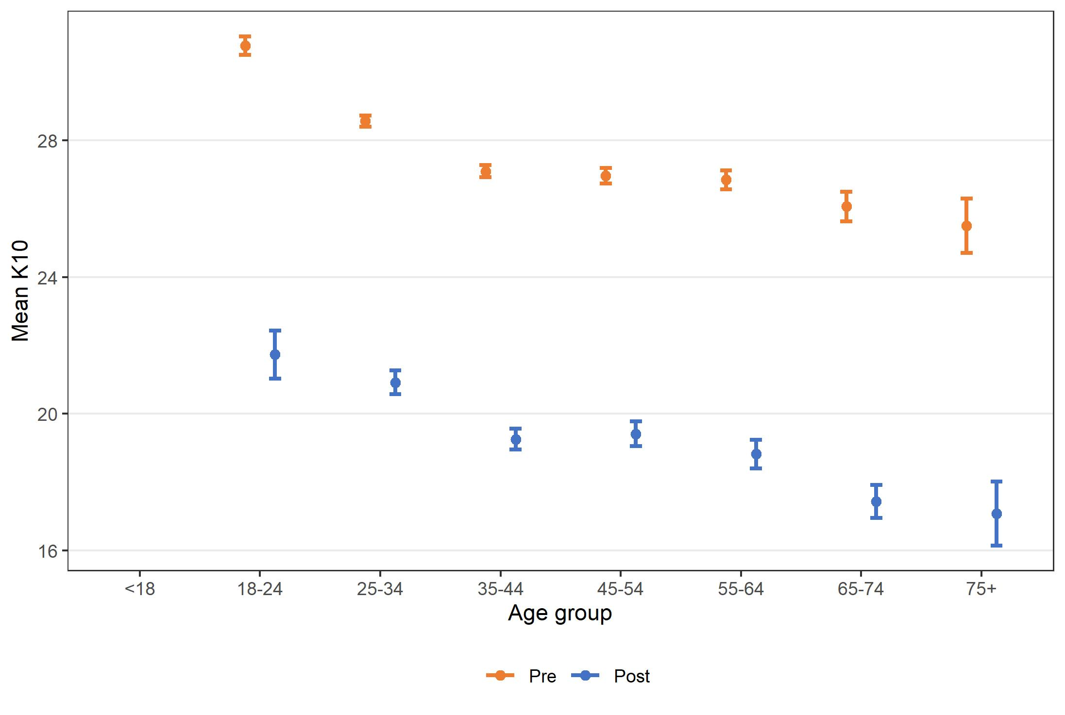

Figure 14. THIS WAY UP outcomes on K10 by demographic characteristics and support status, July 2015 – December 2021

All Therapist-supported Self-directed
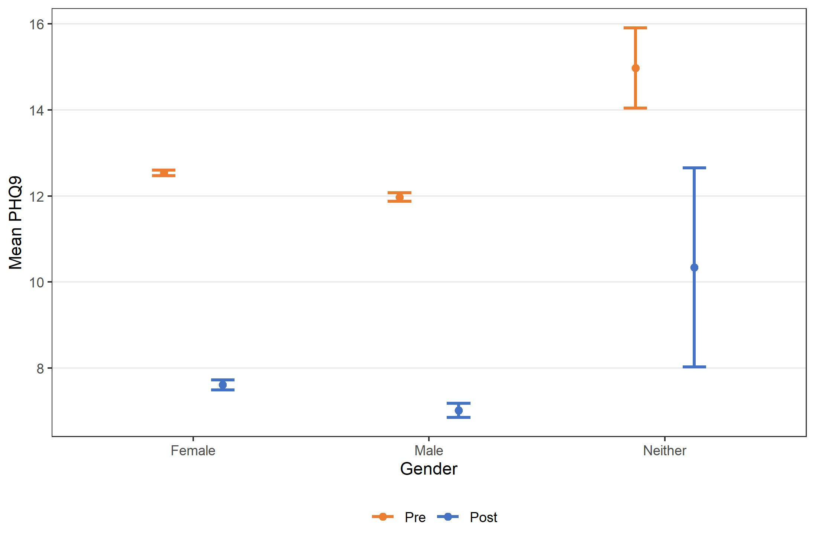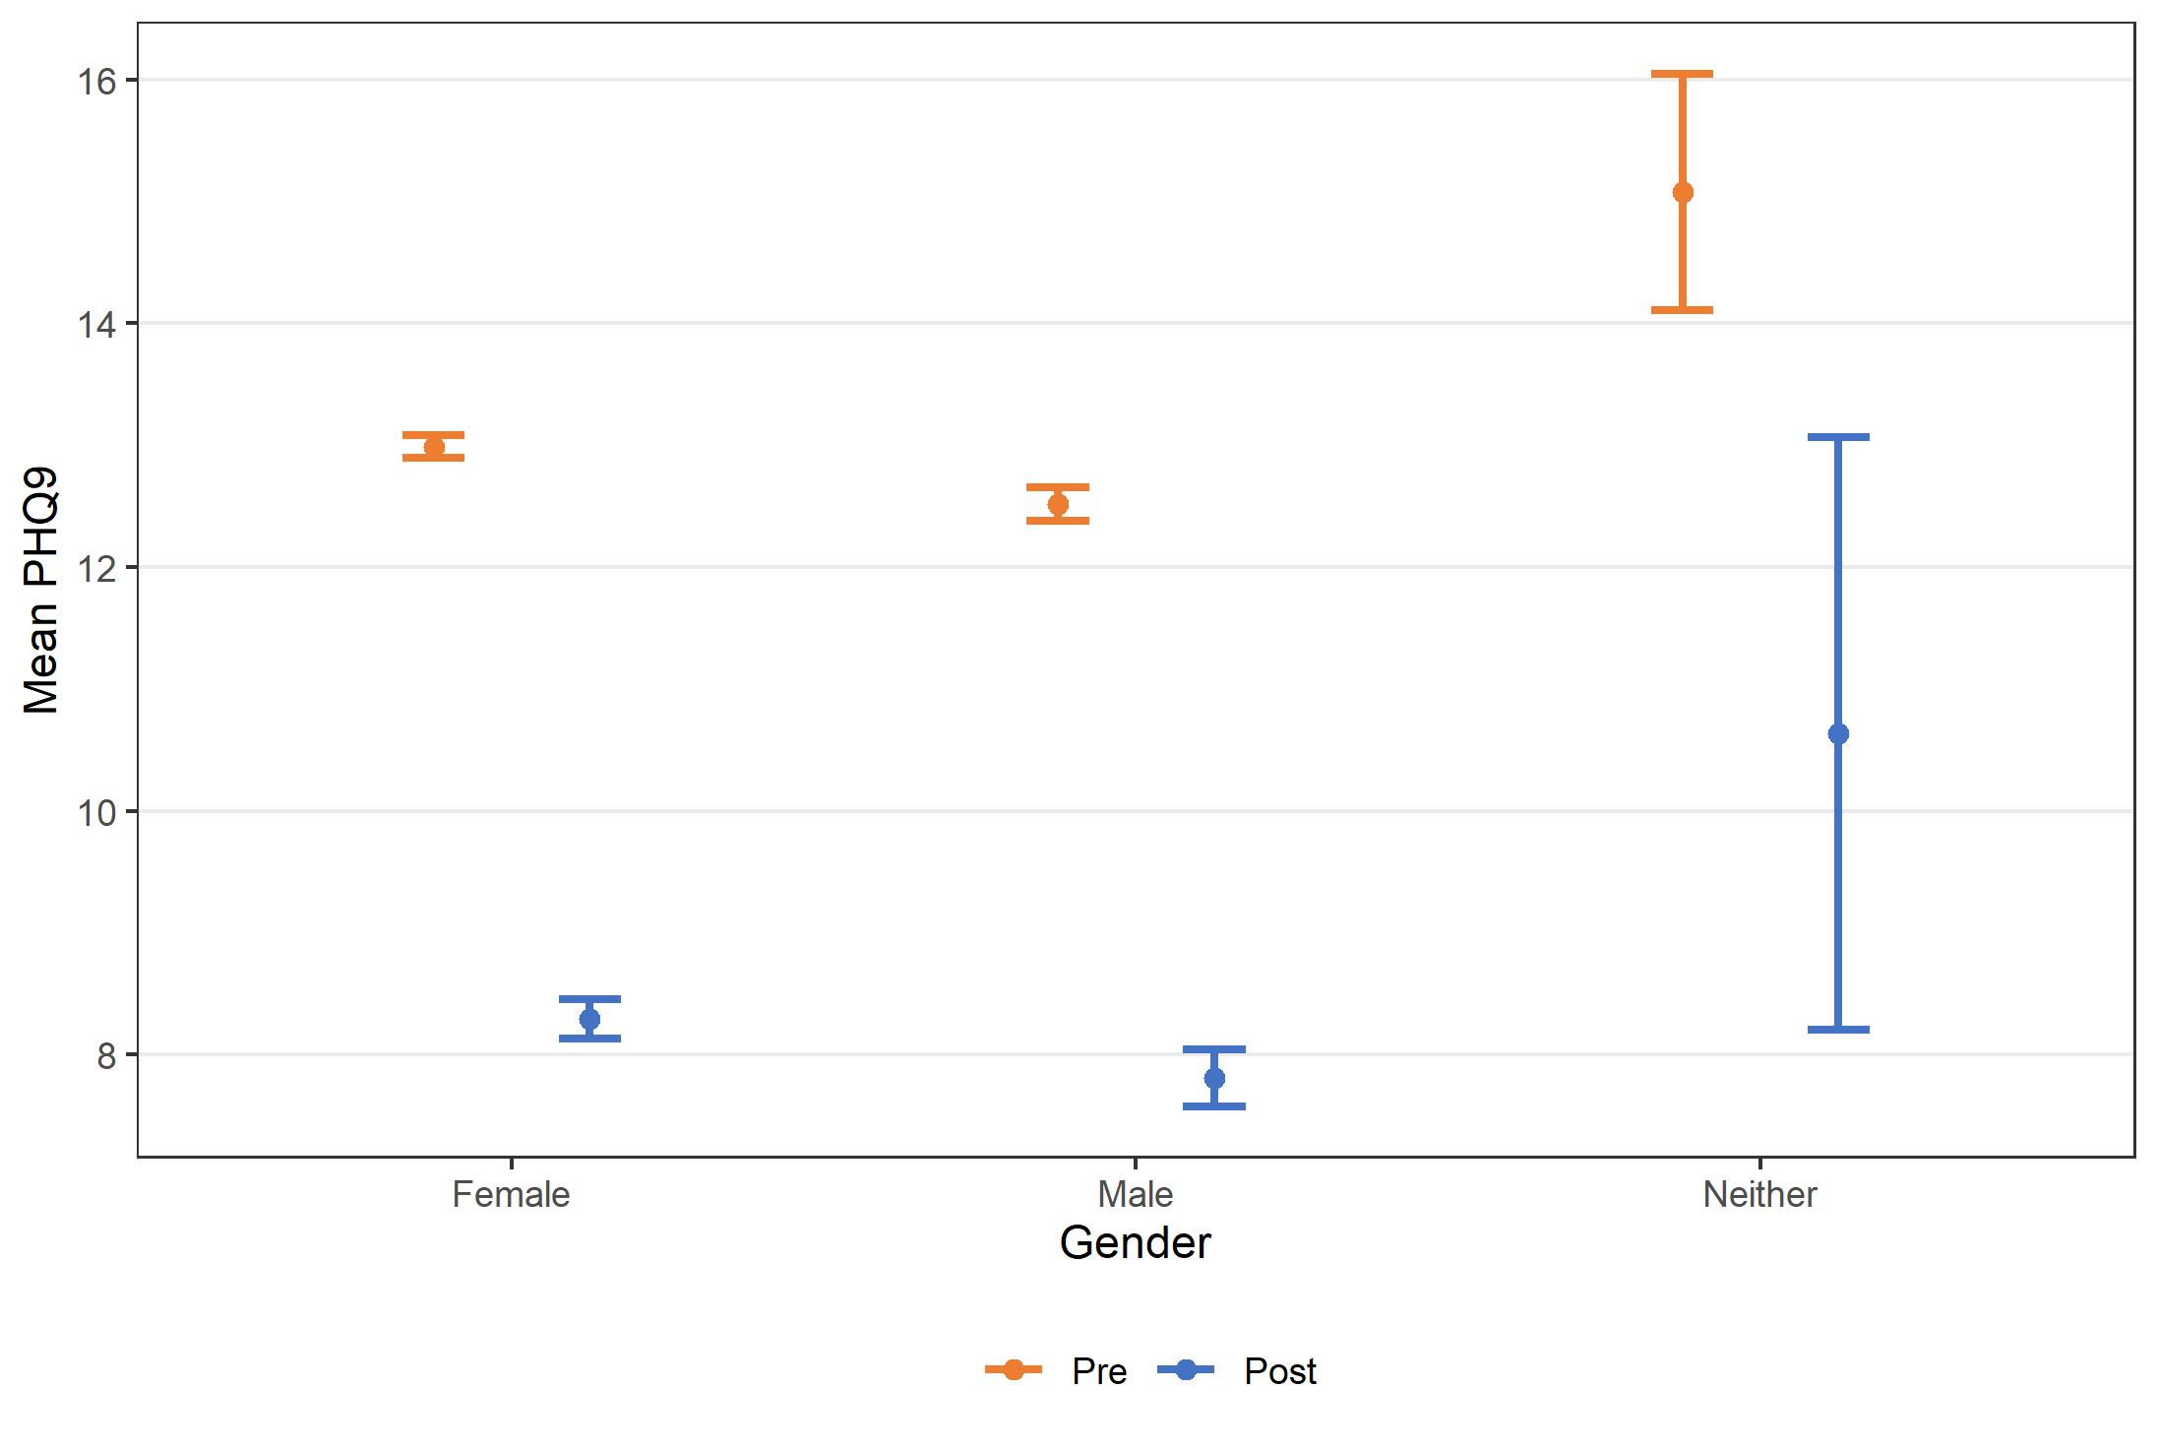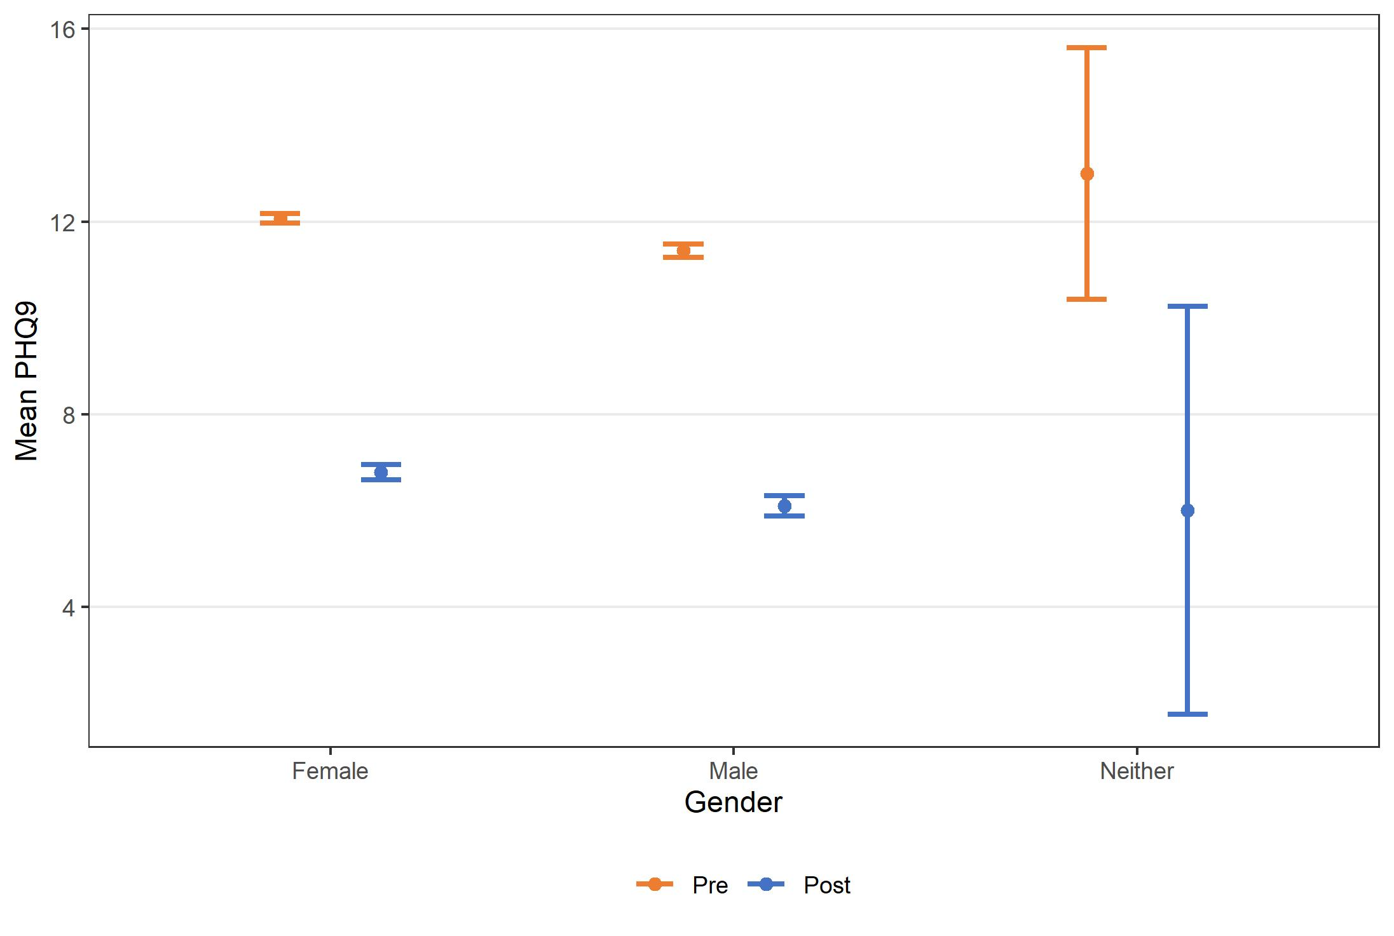

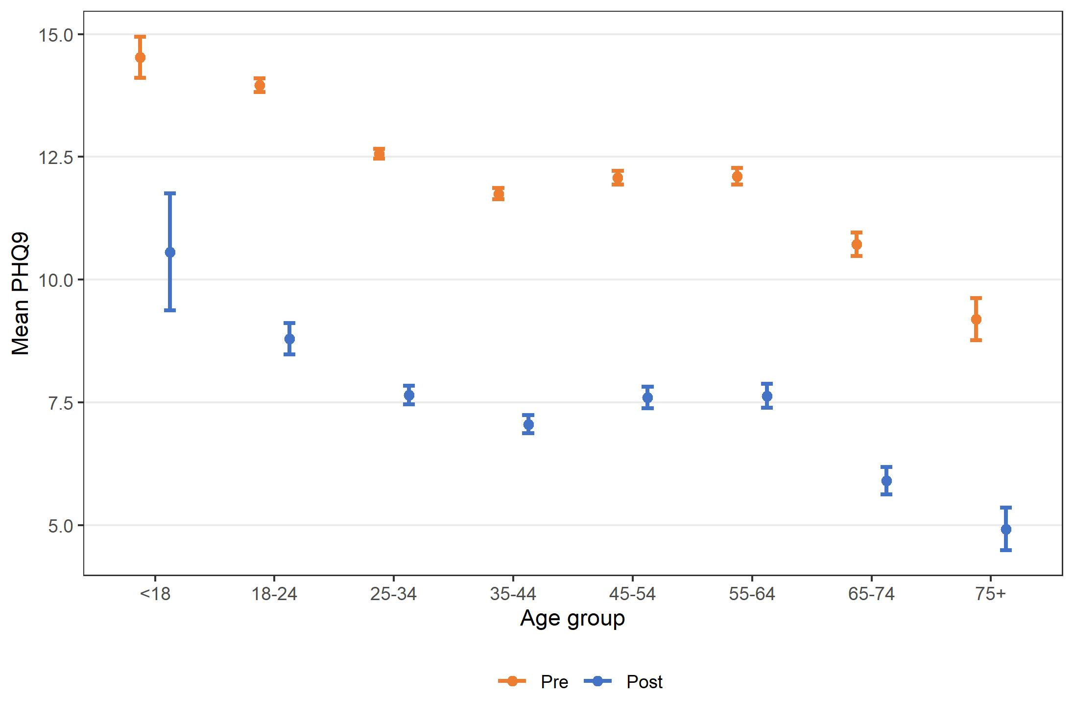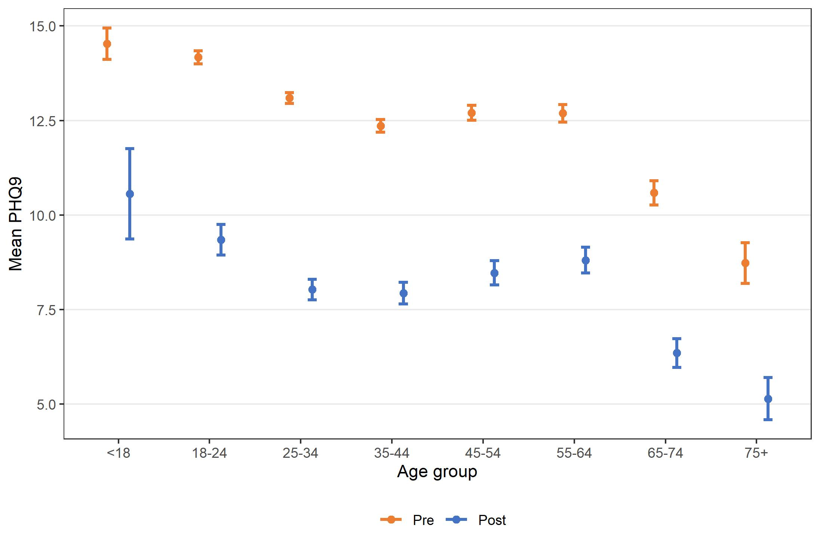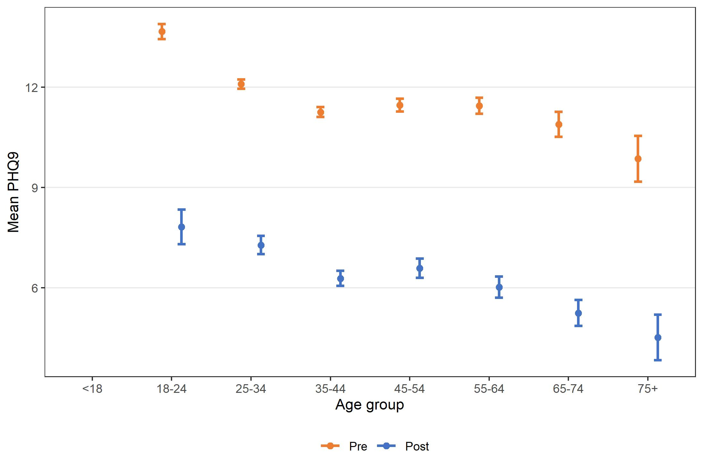

Figure 15. THIS WAY UP outcomes on PHQ-9 by demographic characteristics and support status, July 2015 – December 2021

All Therapist-supported Self-directed
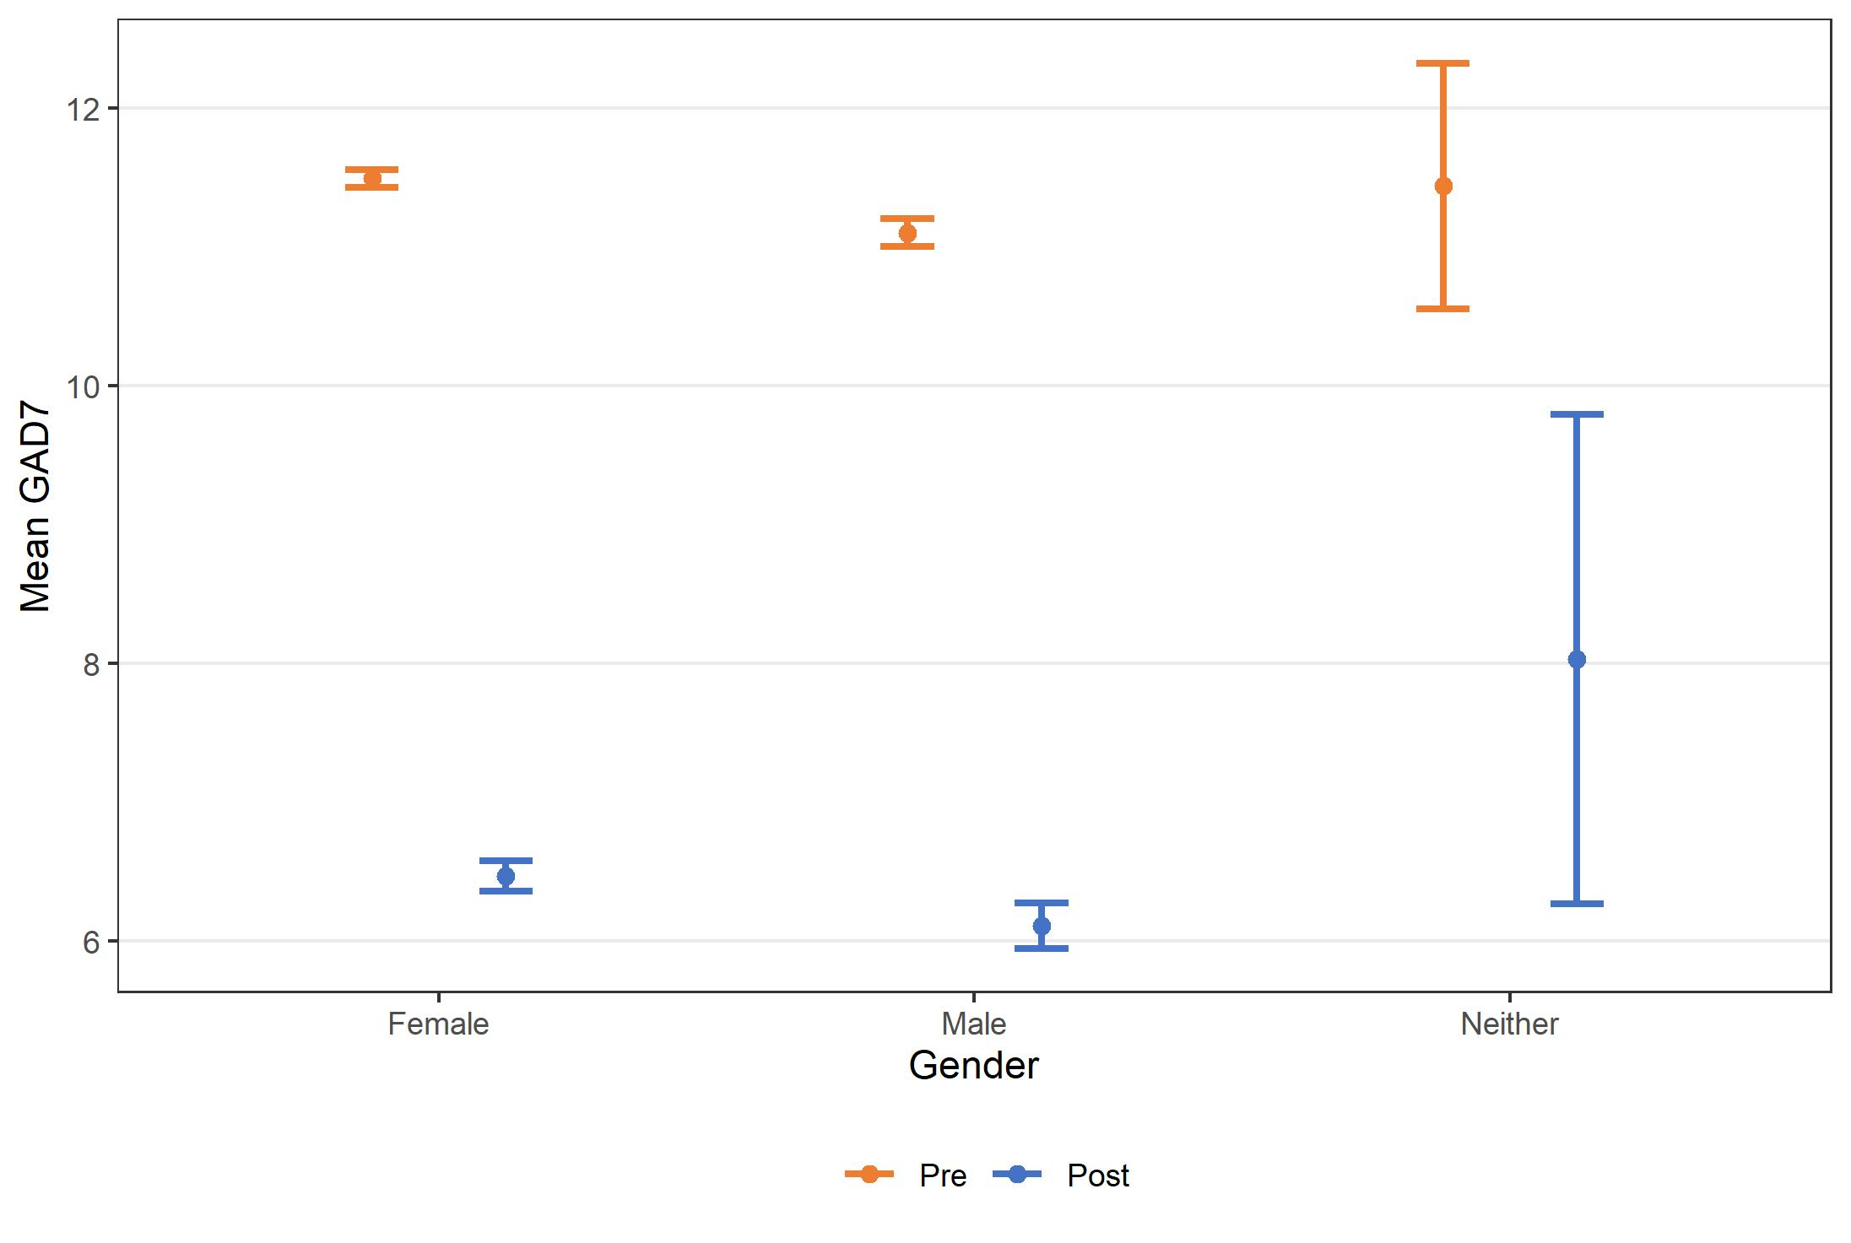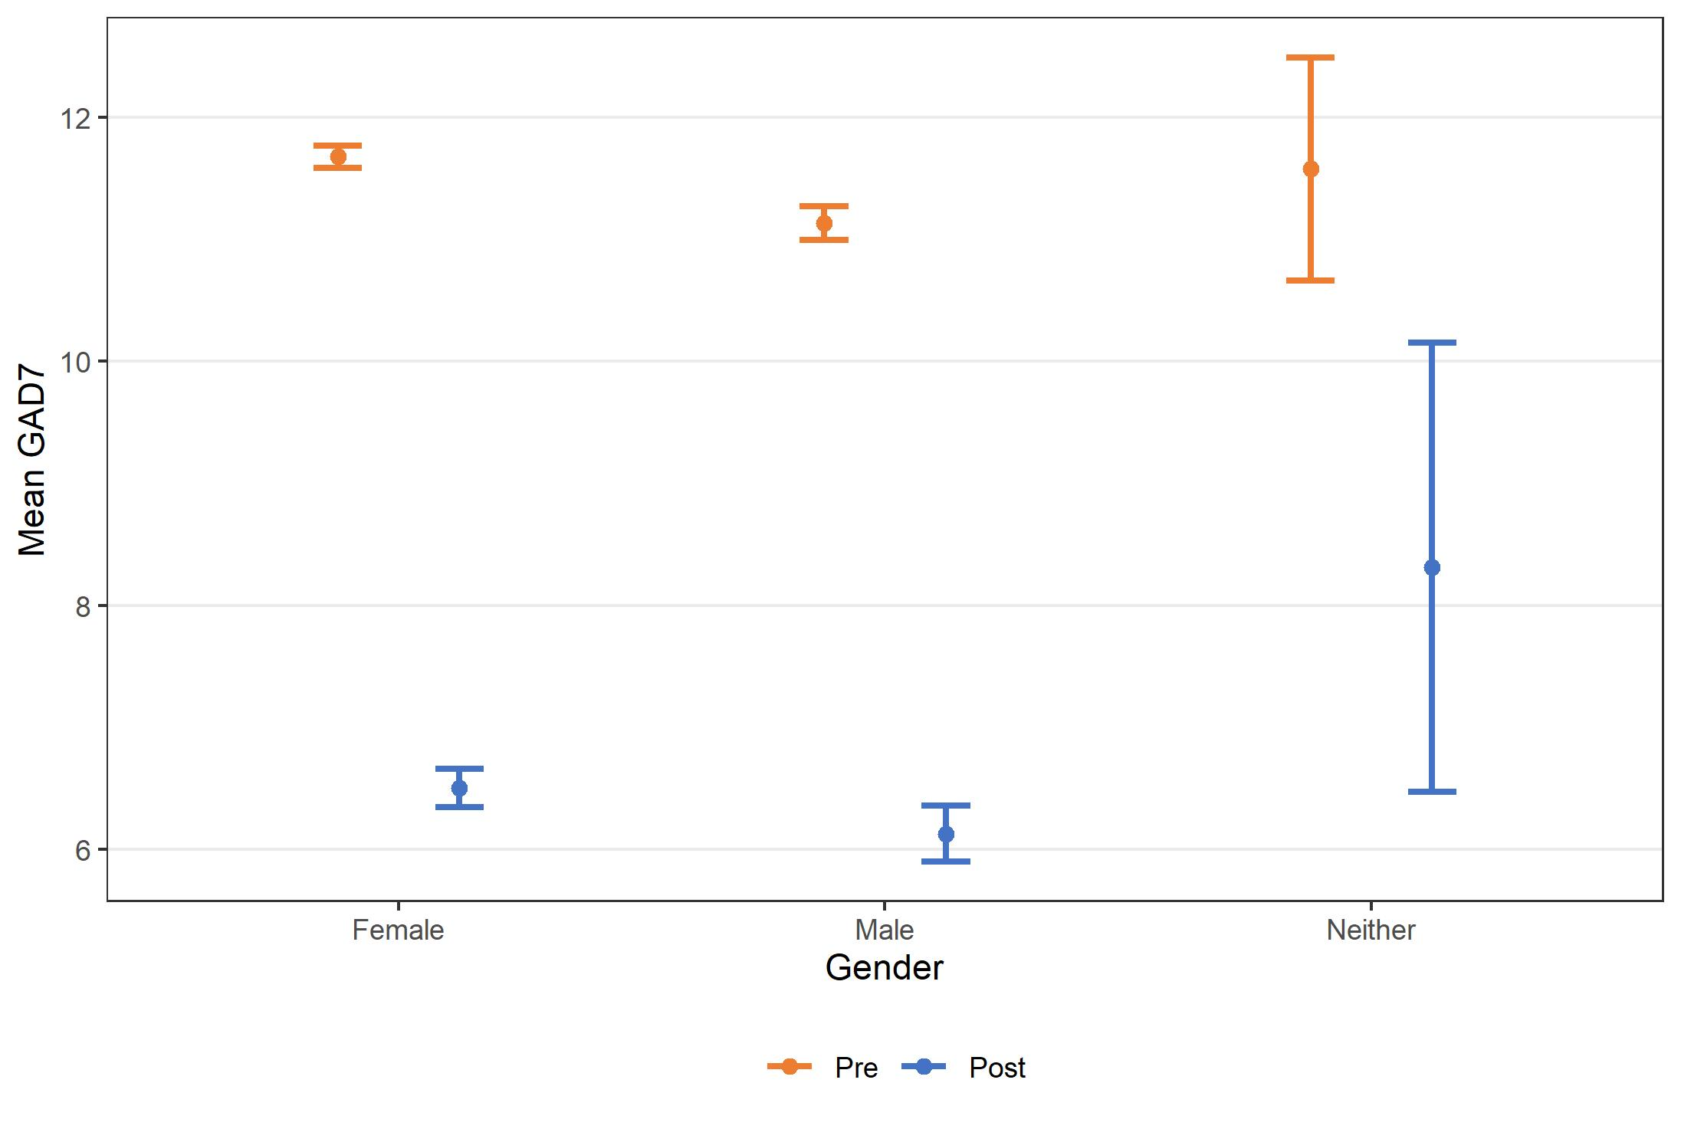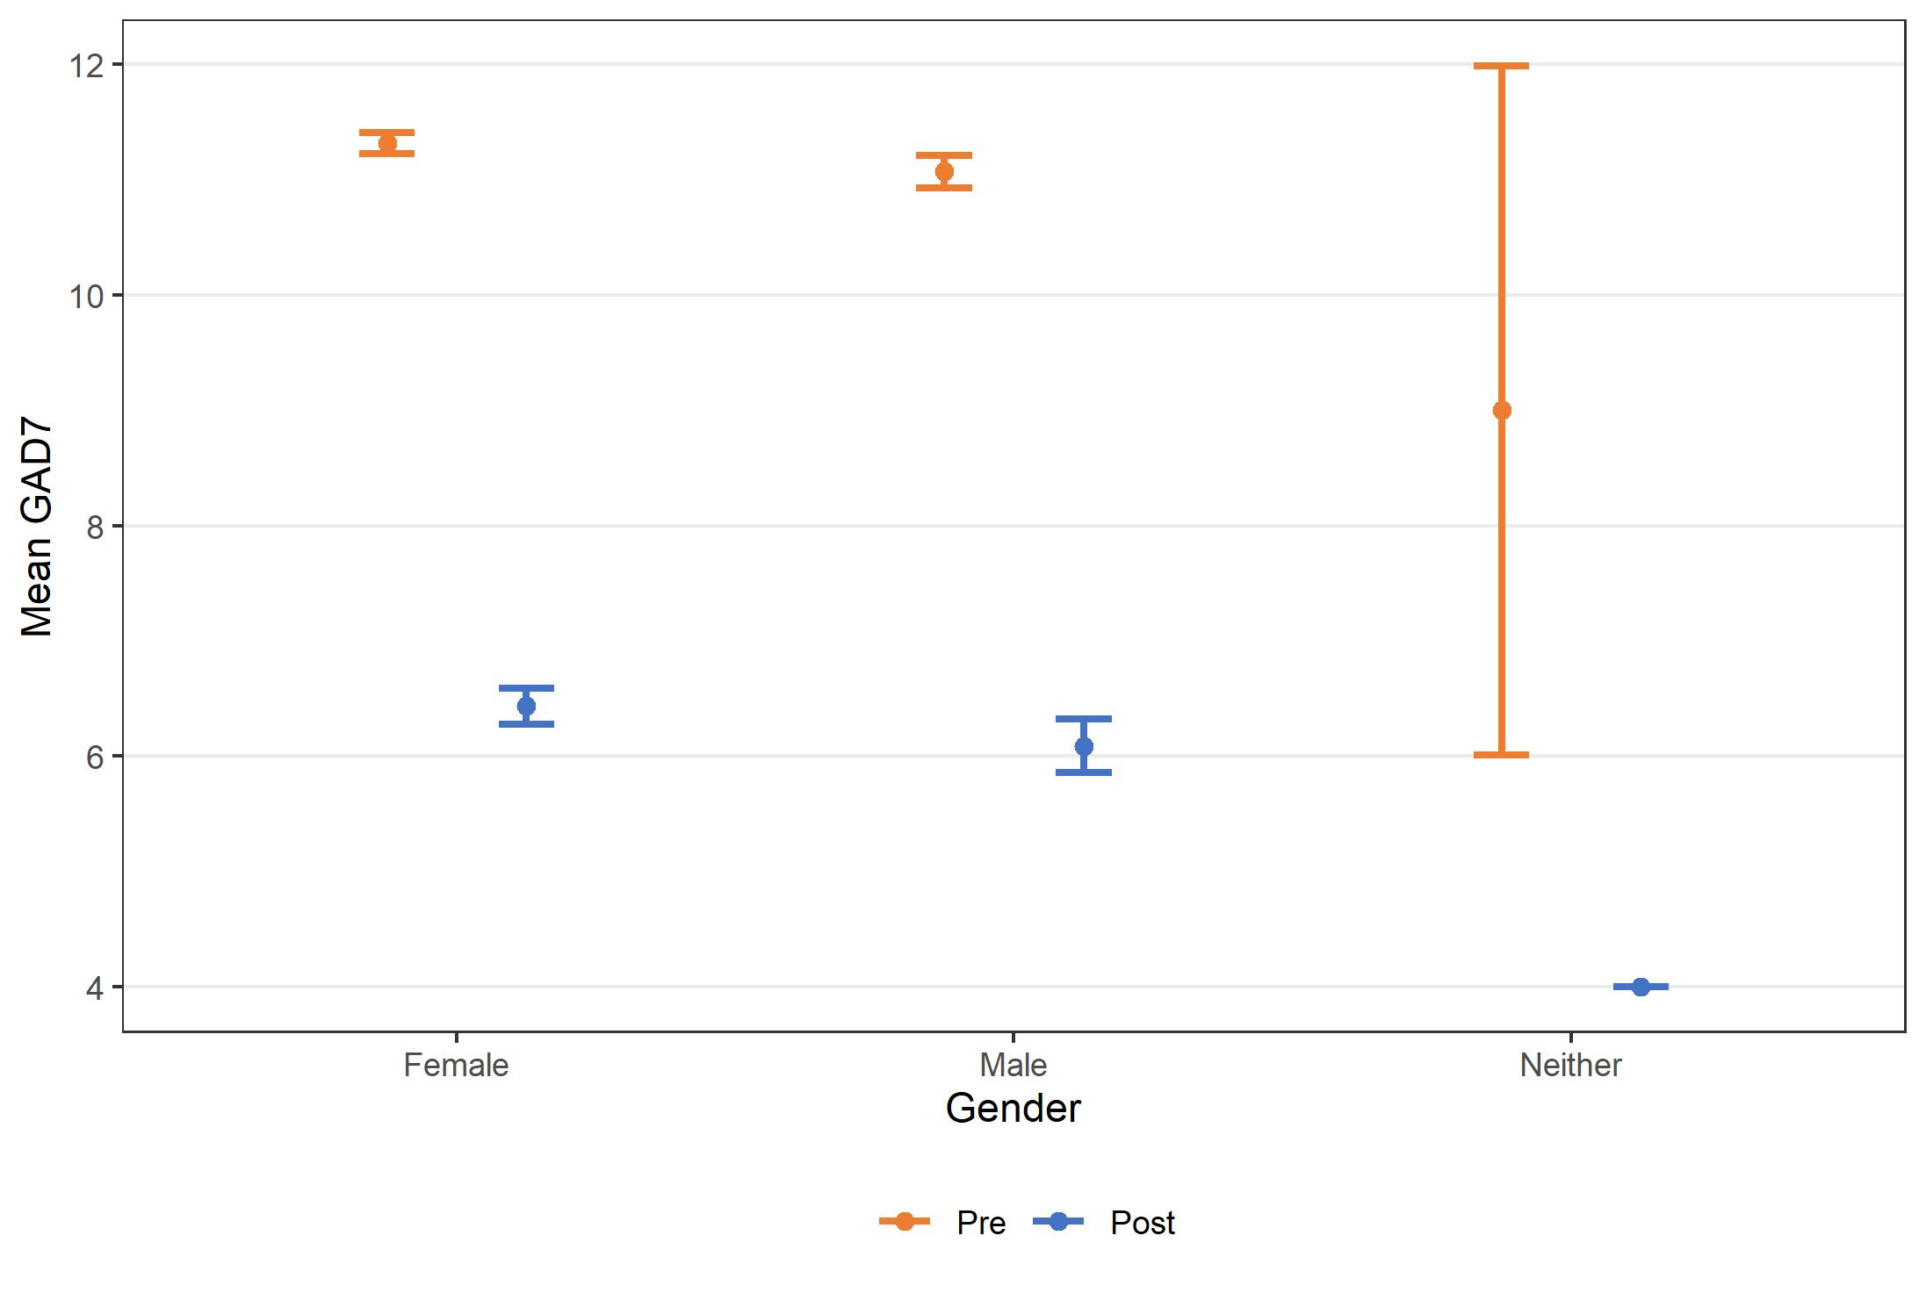
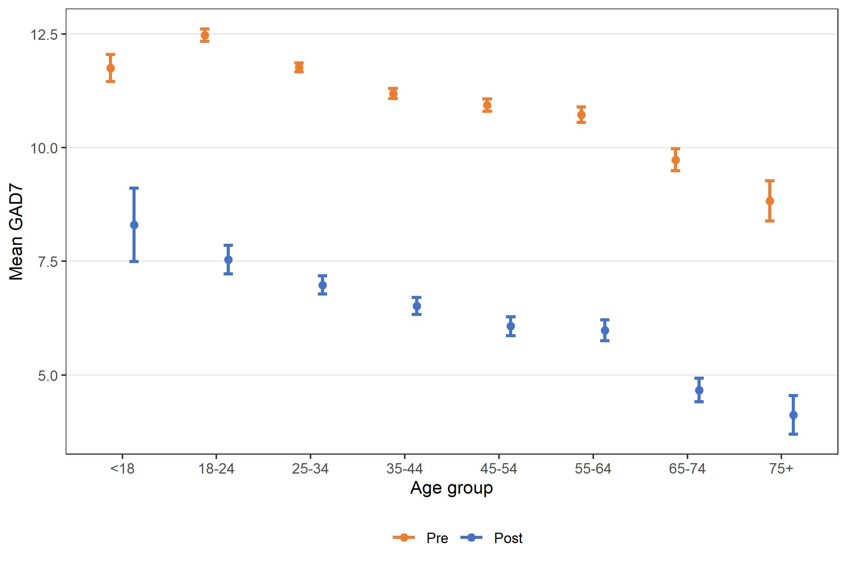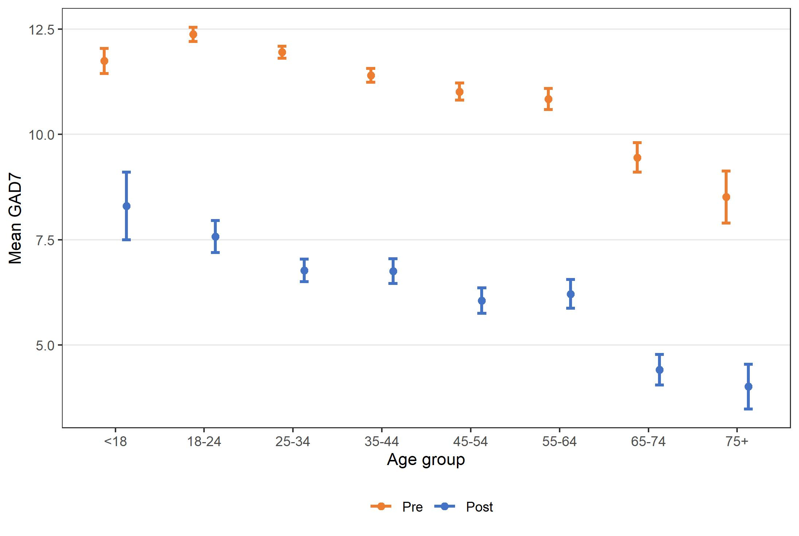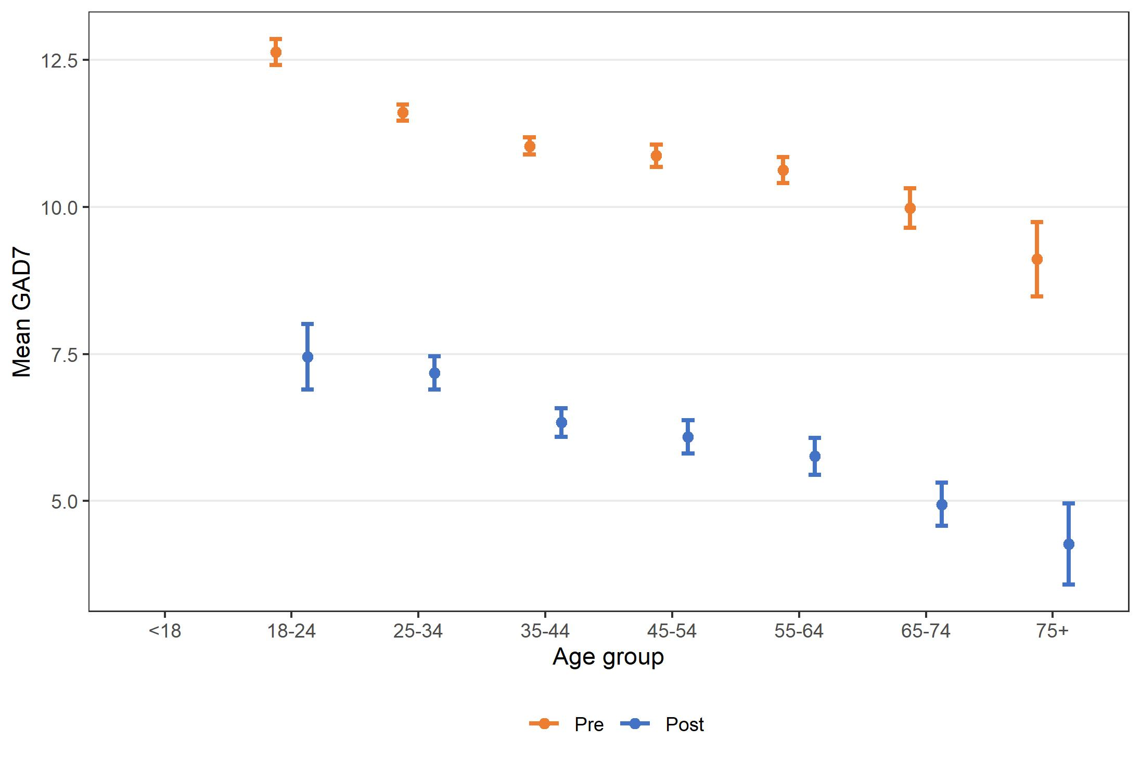

Figure 16. THIS WAY UP outcomes on GAD-7 by demographic characteristics and support status, July 2015 – December 2021

Trends in mental health outcomes over time
Figure 17 shows that the baseline K10 scores increased slightly over time (in both the therapist-supported and self-directed groups), while baseline PHQ9 scores decreased slightly over time (in both the therapist-supported and self-directed groups). Baseline GAD-7 scores were approximately constant over time for the therapist-supported group but decreased slightly over time for the self-directed group. For all outcomes and groups, post-treatment scores were significantly lower than baseline scores and there appeared to be no consistent trends over time in either post-treatment scores or the differences between baseline and post-treatment scores.

Therapist -supported Self-directed
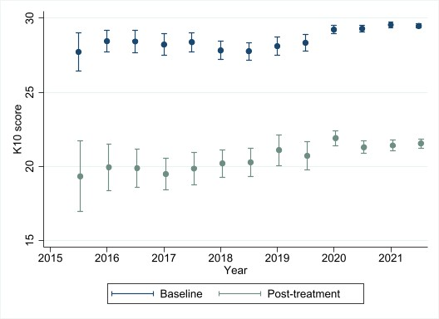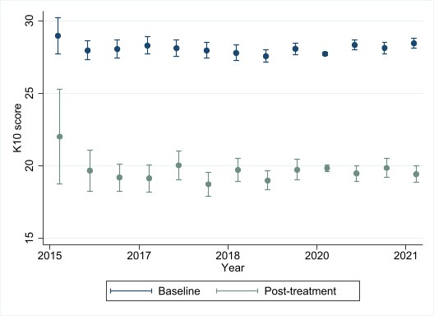
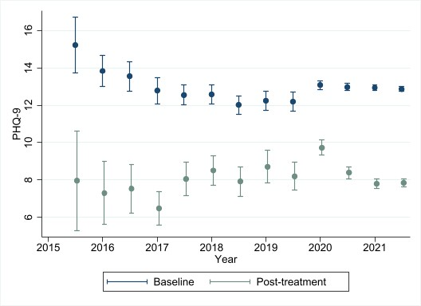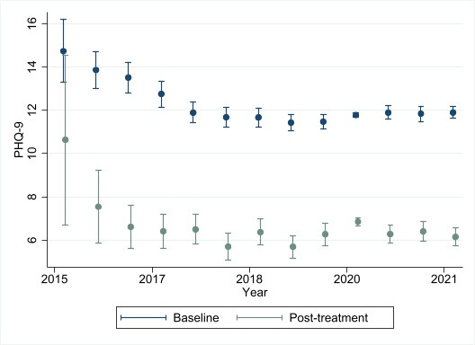
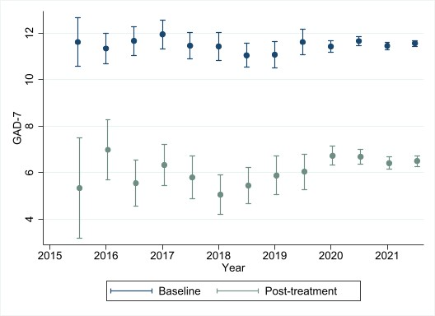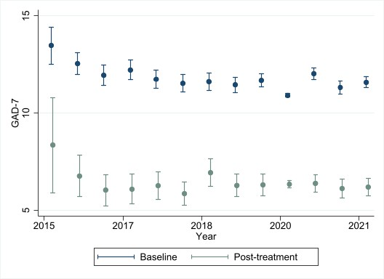

Figure 17. Mean K10, PHQ-9 and GAD-7 before and after THIS WAY UP treatment over time, by support status, July 2015 – December 2021

Predictors of outcomes
Sunderland et al (2012) conducted a study of 302 patients who completed an online CBT course for depression and 361 patients who completed an online CBT course for generalised anxiety disorder, both through the Clinical Research Unit for Anxiety and Depression (CRUfAD, now THIS WAY UP).⁷¹ They found that 75% and 80%, respectively, experienced improvement in psychological distress across all six lessons (responders). The remainder of participants (low responders) had similar socio-demographic characteristics but tended to have higher levels of symptom severity and psychological distress at baseline compared to the responders.
Based on findings showing that consumers who drop out of CRUfAD (now THIS WAY UP) courses benefit from each successive lesson completed to a similar degree as those who complete the entire course, Hilvert-Bruce et al (2012) conclude that treatment adherence is an essential determinant of effectiveness.¹⁰

Consumer experiences
Consumer experiences of THIS WAY UP are largely positive.
THIS WAY UP has been collecting routine feedback data from all course users via online surveys since 2016. Data from 13,157 course users from 2016 to 2020 and 2,195 course users from 2021 indicates they are 84% and 81%, likely to recommend THIS WAY UP courses to others, respectively.⁷²

Mental health outcomes compared with usual care
We extracted data from peer-reviewed and grey literature to compare mental health outcomes produced by the DMHSs and other types of treatment. To do this, we used the pooled mental health effect sizes we calculated for the DMHSs in Sections 4.3 to 4.5 – 0.95 for therapist-supported and 0.59 for self-directed treatment by Mental Health Online, 1.42 for therapist-supported treatment by MindSpot, and 1.04 for therapist-supported treatment by THIS WAY UP.
Table 21 presents descriptions of five key categories of comparator mental health treatment types and mental health outcomes they have produced. Four treatment categories are Australian based, including low intensity mental health care (New Access),⁷³ primary mental health care (Better Access,⁷⁴ Access to Allied Psychological Services⁷⁵), treatment as usual control groups from a randomised controlled trial (Link-me),⁷⁶ and adult ambulatory (outpatient) public mental health care.⁵⁵ The final category is UK based stepped mental health care (Improving Access to Psychological Therapies [IAPT]).⁷⁷ Two comparators (low intensity mental health care and ambulatory public mental health care) were included because they were specifically requested by key stakeholders. We chose the remaining comparators based on previous relevant evaluations we have conducted and our knowledge of IAPT.
Some important differences between the comparators should be acknowledged. First, they vary in terms of the severity of mental health problems they target, ranging from milder severity in New Access and low intensity IAPT to mild-moderate severity in Better Access and more severe in the public mental health system.
Having said that, baseline mean K10 data for the primary care treatments, ambulatory public mental health treatment and the Link-me (treatment as usual) severe control group cohort range from 28.2 (ambulatory public mental health) to 31.9 (Link-me severe control group). These means indicate baseline psychological distress at the upper limit of high and lower limit of very high for these comparators. This is comparable to MindSpot and THIS WAY UP baseline mean K10 data (31.6 and 29.2, respectively); Mental Health Online collects the K6 at baseline, which indicates that around two thirds of consumers have a probable serious mental illness at the start of treatment. In contrast and unsurprisingly, baseline psychological distress was lower in participants of the Link-me moderate and mild (treatment as usual) control groups.
Baseline depression is somewhat higher for consumers of IAPT (PHQ-9=15.6; moderately severe) than MindSpot (PHQ-9=14.7; moderate/moderately severe), THIS WAY UP (PHQ-9=11.8; moderate) and New Access (PHQ-9=12.7; moderate). Baseline anxiety is also slightly higher for consumers of IAPT (GAD-7=14.3) than MindSpot (GAD-7=12.3), THIS WAY UP (GAD-7=11.2) and New Access (GAD-7=11.5), but in all cases, indicate probable generalised anxiety disorder (GAD-7>10).
Second, data for MindSpot, THIS WAY UP and most comparators were collected as part of routine care. However, because Mental Health Online does not routinely collect outcome data, as mentioned in Section 4.3, we used data they collected for a discrete evaluation and extracted data from several of their published pre-implementation studies (various designs) to generate pooled effect sizes for their therapist-supported and self-directed treatments. The primary care patients comprising the three Link-me treatment as usual control groups were invited by RCT or practice staff (while attending selected general practices in NSW, Victoria and Queensland for any reason) to trial a Decision Support Tool (Link-me) that guided stepped primary mental health care. They were eligible for the trial if they reported any mental health need, indicated by current depressive or anxiety symptoms (a score of 2 or more on the two-item version of the PHQ or the two item GAD scale) or current use of medication for their mental health. Participants in the Better Access evaluation were recruited using the Medical Benefits Division of the Department of Health and Ageing, acting as an intermediary in the recruitment of random samples of psychologists and GPs who billed for at least 100 occasions of service under the Better Access item numbers in 2008. Participating providers then acted as intermediaries and were asked to recruit their subsequent 5-10 English-speaking patients at the commencement of services partially or fully funded through the MBS item numbers.

Table 21. Outcome data for comparator mental health treatments
Comparator |  | Treatment description and data collection period | Outcome  measure | Baseline N | Baseline M | Baseline SD | Post N | Post M  (95% CI) | Post SD
Australian low intensity mental health care based on low intensity IAPT
New Access (Baigent et al 2020)⁷³ | Low intensity psychological interventions for mild to moderate depression and anxiety. Six coaching sessions are provided over the phone but may be face to face in some circumstances. October 2013-October 2016 |  | PHQ-9 | 3579 | 12.7 | 0.09 | 3579 | 5.64 | 0.09
New Access⁷³ | As above |  | GAD-7 | 3579 | 11.5 | 0.08 | 3579 | 4.5 | 0.08
Australian primary mental health care
Better Access, clin psychs (Pirkis et al 2011)⁷⁴ | Access to 12 (18 in exceptional circumstances) of face-to- face psychological intervention, following development of a mental health care plan by a GP and with review by a GP at defined intervals. October 2009-October 2010 |  | K10 | 193 | 28.6 | 7.57 | 193 | 19.09 | 6.96
Better Access, reg psychs⁷⁴ | As above |  | K10 | 192 | 29.4 | 7.33 | 192 | 18.86 | 7.13
Better Access, GPs⁷⁴ | As above |  | K10 | 177 | 30.9 | 7.94 | 177 | 22.88 | 8.54
Tier 1 ATAPSª (Bassilios et al 2017)⁷⁵ | This care was typically delivered in up to 12 (or 18 in exceptional circumstances) individual face to face and/or 12 group sessions. Review by the referring GP was essential after each block of six sessions and/or the final session. July 2003-June 2016 |  | K10 | 22399 | 30.9 | 8 | 22399 | 23 | 8.5
Australian treatment as usual control groups from Link-me RCT
Link-me severe control group  (Fletcher et al 2021)⁷⁶ | Control group from RCT involving patient-completed Decision Support Tool (DST) completed via tablet, to predict severity of depression or anxiety. Control group encouraged, on the tablet and via an automated email sent on completion of the Link-me DST, to discuss any mental health concerns with their GP. Participants were free to continue or modify any treatment they were receiving at trial entry, and to commence new or additional treatments at any time. November 2017-October 2018 |  | K10 | 421 | 31.9 (31.2, 32.6) | - | 421 | 29.1 (28.2, 30.0) | -
Link-me moderate control group⁷⁶ | As above |  | K10 | 427 | 20.7 (20.1, 21.3) | - | 427 | 21.3 (20.6, 22.0) | -
Link-me mild control group⁷⁶ | As above |  | K10 | 416 | 17.3 (16.8, 17.7) | - | 416 | 19.5 (18.8, 20.2) | -
Australian public mental health outpatient care
Ambulatory adult mental health care | Includes all non-admitted, non-residential services provided by health professionals with specialist mental health qualifications or training. Ambulatory mental health services include community–based crisis assessment and treatment teams, day programs, psychiatric outpatient clinics provided by either hospital or community–based services, child and adolescent outpatient and community teams, social and living skills programs, psychogeriatric assessment services etc. July 2000-June 2020 |  | K10 | 144288 | 28.2 | 10.3 | 25946 | 18.6 | 8.2
UK stepped mental health care
IAPT (NHS Digital, 2021)⁷⁷ | National Institute for Health and Care Excellence approved therapies for treating people with anxiety or depression. Includes face to face services, low intensity services, group services and self-directed computer-based programs. April 2020-March 2021 |  | PHQ-9 | 595840 | 15.6 | 5.5 | 595840 | 9.2 | 6.4
IAPT⁷⁷ | As above |  | GAD-7 | 595840 | 14.3 | 4.4 | 595840 | 8.3 | 5.6
ATAPS, Access to Allied Psychological Services; clin psychs, clinical psychologists; GAD-7, Generalised Anxiety Disorder 7-item Scale; IAPT, Improving Access to Psychological Therapies; K10, Kessler Psychological Distress 10-Item Scale; PHQ-9, Patient Health Questionnaire-9; RCT, randomised controlled trial; reg psychs; registered psychologists.
ªBase funding, known as general ATAPS (as opposed to Tier 2 funding which targets hard-to-reach groups).
Finally, the data collection periods, and their recency, vary for each of the comparators. Data collection periods range from two decades for adult ambulatory public mental health care and the entire life of ATAPS to one year for Better Access, Link-me and IAPT. Data collection recency ranges from October 2009-October 2010 for Better Access to March 2020-April 2021 for IAPT. By comparison, pooled effect size data for the DMHSs were derived from:
- Routinely collected data from September 2021 to February 2022 and three studies of pre-implementation trials (published in 2010, 2011 and 2018) for Mental Health Online;^{45, 46, 62}
- Published routinely collected data for MindSpot consumers over seven years from January 2013 to December 2019;⁷ and
- Five observational studies of discrete periods of routine care (published between 2014 and 2018) for Mental Health Online.⁵⁰⁻⁵⁴
To ensure consistency of method, we calculated effect sizes for each of the comparator treatments using the data presented in Table 21. Figure 18 presents these effect sizes plotted against the pooled effect sizes we calculated for each of the DMHSs (Sections 4.3-4.5).
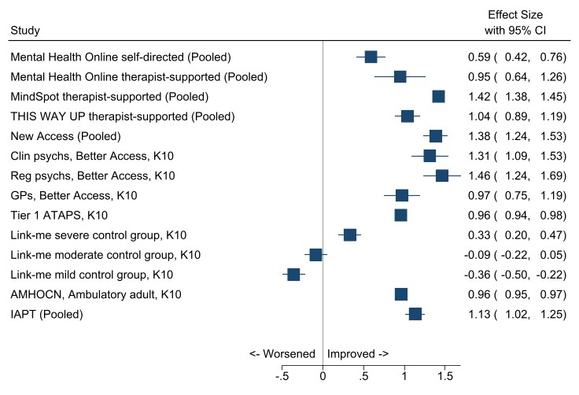

Figure 18. Forest plot of Cohen’s d (95% confidence interval) in mental health outcomes for DMHSs and comparators
AMHOCN; Australian Mental Health Outcomes and Classification Network; ATAPS, Access to Allied Psychological Services; clin psychs, clinical psychologists; GAD-7, Generalised Anxiety Disorder 7-item Scale; IAPT, Improving Access to Psychological Therapies; K10, Kessler Psychological Distress 10-Item Scale; PHQ-9, Patient Health Questionnaire-9; reg psychs; registered psychologists.
Pooled effect sizes for Mental Health Online treatment as per Figure 5 – “Supported (Symptoms)” and “Self-directed (Symptoms)”. Pooled effect size for MindSpot therapist-supported treatment as per Figure 6 – “All (Symptoms)”. Pooled effect size for THIS WAY UP therapist-supported treatment as per Figure 7 – “Symptoms”. Effect sizes are pooled for PHQ-9 and GAD-7 for New Access and IAPT.
Tier 1 ATAPS refers to base funding, known as general ATAPS (as opposed to Tier 2 funding which targets hard-to-reach groups).

The majority of effect sizes were large, ranging from 0.95 (Mental Health Online, therapist-supported) to 1.46 (Better Access). Of these, the largest effect sizes (around 1.4) were observed for Better Access (delivered by registered psychologists), MindSpot (therapist-supported treatment) and New Access. One effect size was medium (Mental Health Online, self-directed, d=0.59) and three (all for Link-me) were small (ranging from -0.36 to 0.33). There was significant heterogeneity between these effect sizes (I²>99, p < 0.001) so no attempts to pool these were made. Overall, these findings suggest that therapist-supported treatments by all three DMHSs produce improvements in mental health symptoms that are close or equivalent to most comparator treatments included in our analysis, and both therapist-supported and self-directed treatments produce superior outcomes to treatment as usual in the form of discussing mental health concerns with the GP.
Table 22 summarises a range of clinically significant mental health treatment outcomes by the DMHSs (previously presented in Sections 4.3-4.5) and three comparators with published equivalent data available. On average, the three DMHSs produce improvement rates broadly comparable with IAPT, which treats mild to severe mental health problems. The three DMHSs produce better remission rates than both untreated depression within three months,⁷⁸ and face-to-face psychotherapies for depression (53-70% vs 23% and 33%).⁷⁹ They also result in lower rates of no reliable change than face-to-face psychotherapies for depression (12-25% vs 54%).⁷⁹
However, these comparisons should be interpreted with caution, given methodological differences. For example, as previously mentioned, DMHS data were sourced from selected publications of routine care and pre-implementation trials, whereas findings on the effects of psychotherapy for, and untreated, depression are based on meta-analyses. Furthermore, most change rates were not reported (but were estimated using a validated method) and variability in the direction and magnitude of treatment effects was high in the psychotherapy meta-analysis.⁷⁹ The meta-analysis of untreated depression sourced data from consenting waitlist and primary-care samples, which may have over-represented mild-to-moderate cases of depression.⁷⁸

Table 22. Clinically significant change in mental health following treatment by DMHSs and comparators
Comparator | Reliable improvement | No reliable change | Reliable deterioration | Reliable recovery | Recovery | Remission
Mental Health Online, therapist-supported iCBT | 49%ª |  |  | 33%ª |  | 69%^{b}
MindSpot, therapist-supported iCBT | 75% Aus^{c,d}  70-87 Mig^{e} | 21% Aust^{c}  12-25% Mig^{c} | <2% all^{e}  0-7% Mig^{c} | 60% all^{e} |  | 56% Aus^{c}  53-70% Mig^{c}
THIS WAY UP, therapist-supported iCBT^{f} | 22-45% |  | <1% |  | 44-66% | 58-70%
IAPT^{e} | 68% | 25% | 5% | 49% | 51%
Any psychotherapy for depression^{f} | 41% | 54% | 5% |  |  | 33%
Untreated depression^{g} |  |  |  |  |  | 23% in 3 months  32% in 6 months  53% in 12 months
Aus, Australian-born consumers; IAPT, Improving Access to Psychological Therapies; iCBT, internet cognitive behavioural therapy; Mig, Migrant (born overseas) consumers.
ªSourced from Kyrios et al (2018).⁴⁶
^{b}Sourced from Klein et al (2010).⁴⁵
^{c}Sourced from Kayrouz et al (2020).⁶⁶
^{d}Comprising 56% with >50% improvement and 19% classified as minimal response (30-50% improvement).⁶⁶
^{e}Includes 30-100% improvement.
Sourced from Titov et al (2020).⁷
^{f}Sourced from Hobbs et al (2017),⁵¹ Hobbs et al (2018)⁵⁰ and Allen et al (2016).⁵³
Sourced from Cuijpers et al (2021).⁷⁹
^{g}Sourced from Whiteford et al (2013).⁷⁸

Summary
The three DMHSs are using a variety of outcome measures to assess mental health and wellbeing outcomes for consumers, most commonly the K10, PHQ-9 and GAD-7 (MindSpot and THIS WAY UP) and the K6 at baseline only (Mental Health Online). Therapist-supported online treatment significantly improves the mental health of consumers who use these services (d=0.95, Mental Health Online; d=1.42, MindSpot; and d=1.04 THIS WAY UP). Specifically, therapist-supported treatment produced reductions in psychological distress and other symptoms, including OCD, PTSD, panic disorder, GAD, social anxiety disorder and depression. These positive findings are consistent across different demographic characteristics, including young and older adults, people born overseas, and Indigenous peoples. Therapist-supported treatment by DMHSs also produced positive outcomes on quality of life, functioning (as assessed by days out role) and disability, but the effects on these domains were smaller (e.g., d=0.12, 0.35 and 0.48, respectively).

Stakeholder experiences: Consumers of DMHSs

Our approach
We consulted with consumers accessing DMHSs via purpose-designed online surveys and interviews from December 2021 to March 2022. The survey took approximately 20 minutes to complete. We asked closed and open-ended questions and elicited demographic information in the survey. At the end of the survey, consumers were invited to expand on their thoughts through a telephone interview. DMHSs acted as intermediaries by recruiting consumers on our behalf, and we sent each DMHS a unique link for their consumers to access the online survey. Appendix B provides more details about our processes for consulting with consumers. Survey and interview questions are in Appendix D.

Characteristics of DMHS consumer survey and interview participants

Consumer survey respondents
After data cleansing (see Appendix B), we included a total of 351 consumers who completed the consent process in our analyses. Most of these consumers (63%) had used THIS WAY UP; 29%, MindSpot; and 9%, Mental Health Online. Table 23 describes their socio-demographic characteristics and internet access. Most consumers across DMHSs were female (73%), under the age of 50 years (75%) and, except for Mental Health Online consumers, resided in New South Wales (NSW). Mental Health Online consumers most commonly lived in Victoria. Consumers primarily used the National Broadband Network to access the internet.

Table 23. DMHS consumer survey respondent characteristics and internet access, by service and overall
Characteristics | MHO  (n=32) |  | MS  (n=100) |  | TWU  (n=219) |  | Total  (N= 351)
 | Freq | % | Freq | % | Freq | % | Freq | %
Gender  Female  Male  I do not identify with either term | 26  5  1 | 81  16  3 | 68  32  0 | 68  32  0 | 161  56  2 | 74  26  1 | 255  93  3 | 73  26  1
Age  16-17 years  18-19 years  20-29 years  30-39 years  40-49 years  50-59 years  60-69 years  70-79 years  80 years or older | 0  2  11  10  4  3  2  0  0 | 0  6  34  31  13  9  6  0  0 | 1  3  25  31  20  14  4  2  0 | 1  3  25  31  20  14  4  2  0 | 2  4  48  59  44  37  18  5  2 | 1  2  22  27  20  17  8  2  1 | 3  9  84  100  68  54  24  7  2 | 1  3  23  28  19  15  7  2  1
Indigenous Status  Aboriginal  Both Aboriginal/ Torres Strait Islander  Neither Aboriginal/ Torres Strait Islander  Torres Strait Islander  Missing | 2  0  29  0  1 | 6  0  91  0  3 | 8  8  77  7  0 | 8  8  77  7  0 | 2  0  215  0  2 | 1  0  98  0  1 | 12  8  321  7  3 | 3  2  91  2  1
State  Northern Territory  NSW  Victoria  Queensland  South Australia  Western Australia  Tasmania  Missing | 0  8  9  7  4  2  0  2 | 0  25  28  22  13  6  0  6 | 1  35  30  19  7  6  1  1 | 1  35  30  19  7  6  1  1 | 0  109  51  24  11  14  4  6 | 0  50  23  11  5  6  2  3 | 1  152  90  50  22  22  5  9 | 0  43  26  14  6  6  1  3
Type of internetª  Dial up  ADSL or ADSL2+  Cable  National Broadband Network  Satellite Connection  Wireless Router  Mobile Broadband  Other | 0  1  0  19  0  8  6  1 | 0  3  0  59  0  25  19  3 | 5  7  7  53  8  28  23  1 | 5  7  7  53  8  28  23  1 | 0  9  3  162  3  23  22  7 | 0  4  1  74  1  11  10  3 | 5  17  10  234  11  59  51  9 | 1  5  3  67  3  17  15  3
MHO, Mental Health Online; MS, MindSpot; TWU, THIS WAY UP.
ªMultiple responses permitted.

Consumer interviewees
Twenty-three of these consumers also completed interviews – 39% were users of MindSpot; 35%, THIS WAY UP and 26%, Mental Health Online. Table 24 describes their socio-demographic characteristics and internet access. Most consumers across digital mental health services were female (73%), and were residing in New South Wales (NSW) or Victoria. Consumers who took part in the interviews appeared to be slightly older than those who took part in the surveys, with approximately 50% of consumers being over the age of 59 years. Consumers primarily used the National Broadband Network to access the internet.

Table 24. DMHS consumer interviewee characteristics and internet access, by service and overall
Characteristics | MHO  (n=6) |  | MS  (n=9) |  | TWU  (n=8) |  | Total  (N= 23)
 | Freq | % | Freq | % | Freq | % | Freq | %
Gender  Female  Male  I do not identify with either term | 6  0  0 | 100  0  0 | 7  2  0 | 78  22  0 | 5  3  0 | 63  37  0 | 18  5  0 | 78  22  0
Age  16-17 years  18-19 years  20-29 years  30-39 years  40-49 years  50-59 years  60-69 years  70-79 years  80 years or older | 0  0  2  1  2  1  0  0  0 | 0  0  33  17  33  17  0  0  0 | 0  0  0  2  0  5  1  1  0 | 0  0  0  22  0  55  11  11  0 | 0  1  1  3  0  2  1  0  0 | 0  12  12  38  0  25  12  0  0 | 0  1  3  6  2  8  2  1  0 | 0  4  13  26  8  35  26  4  0
Indigenous Status  Aboriginal  Both Aboriginal/ Torres Strait Islander  Neither Aboriginal/ Torres Strait Islander | 0  0  6 | 0  0  100 | 0  0  9 | 0  0  100 | 0  0  8 | 0  0  100 | 0  0  23 | 0  0  100
State  Northern Territory  NSW  Victoria  Queensland  South Australia  Western Australia  Tasmania | 0  3  2  1  0  0  0 | 0  50  33  17  0  0  0 | 0  3  3  1  1  0  1 | 0  33  33  11  11  0  11 | 0  4  3  0  0  0  1 | 0  50  37  0  0  0  13 | 0  10  8  2  1  0  2 | 0  43  35  9  4  0  9
Type of internetª  Dial up  ADSL or ADSL2+  Cable  National Broadband Network  Satellite Connection  Wireless Router  Mobile Broadband  Other | 0  0  0  3  0  0  2  1 | 0  0  0  50  0  0  33  17 | 0  1  0  7  0  1  1  0 | 0  11  0  77  0  11  11  0 | 0  0  1  6  0  1  0  0 | 0  0  13  75  0  13  10  0 | 0  1  1  16  0  2  3  1 | 0  4  4  70  0  9  13  4

Consumer experiences of DMHSs
Consumer survey respondents (N=351) were asked about their experiences of using the DMHS. Their responses are recorded in Table 25. Most Mental Health Online (78%) and MindSpot (39%) consumers found out about the DMHS via an online search, whereas most THIS WAY UP (72%) consumers found out about the service through their provider. More than half of the overall number of consumers (61%) indicated that the DMHS was their preferred method of accessing mental health care.
Proportionally, more Mental Health Online (78%) than MindSpot (48%) and THIS WAY UP (47%) consumers had experienced previous barriers to seeking care. Consumers experienced a range of previous help seeking barriers, most common among which were thinking symptoms would improve without intervention and/or were not sufficiently severe, the affordability of care and a preference to rely on oneself.
The majority of all consumers (64%) were first-time users of a DMHS. A variety of reasons prompted consumers to access the DMHS. Most commonly, across services, consumers accessed care because they were struggling to cope, they felt they needed professional help, and they had noticed that their symptoms had worsened. A higher percentage of THIS WAY UP (58%) than Mental Health Online (0%) and MindSpot (19%) consumers had also sought help because a provider had recommended it.

Table 25. Consumer use of DMHS, by service and overall
 | MHO  (n=32) |  | MS  (n=100) |  | TWU  (n=219) |  | Total  (N= 351)
 | Freq | % | Freq | % | Freq | % | Freq | %
Method of finding DMHS  Head to Health Gateway  Online search  Recommended by a health provider  Recommended by friends or family | 1  25  3  3 | 3  78  9  9 | 10  39  26  25 | 10  39  26  25 | 7  43  157  12 | 3  20  72  5 | 18  107  186  40 | 5  30  53  11
DMHS preferred method  No  Yes  Missing | 11  21  0 | 34  66  0 | 32  68  0 | 32  68  0 | 92  126  1 | 42  58  0 | 135  215  1 | 38  61  1
Preferred method (n=135)ª  Face-to-face  Phone  Video  Other | 10  0  2  1 | 91  0  18  9 | 22  5  15  0 | 69  16  47  0 | 83  5  27  5 | 90  5  29  5 | 115  10  44  6 | 85  7  33  4
Experience barriers  No  Yes | 7  25 | 22  78 | 52  48 | 51  48 | 117  102 | 53  47 | 176  175 | 50  50
Types of barriers (n=175)ª  Thought things would get better  Unable to afford mental health care  My symptoms not severe enough  I preferred to rely on myself  My MH was not a priority  I was embarrassed  I didn’t recognise the MH symptoms  Didn’t want anyone to know  I did not need MH treatment  I had limited knowledge options  I was on a long waiting list  Didn’t think treatment would help  MH services unavailable in my area  Getting transport was difficult  I preferred to rely on family/friends  Other | 7  16  7  6  8  9  7  3  4  7  5  4  3  3  0  5 | 28  64  28  24  32  36  28  12  16  28  20  16  12  12  0  20 | 25  21  18  18  20  13  9  15  13  15  13  12  7  7  2  7 | 52  44  38  38  42  27  19  31  27  31  27  25  15  15  4  15 | 53  46  50  48  36  42  44  36  34  24  24  19  13  11  3  18 | 52  45  49  47  35  41  43  35  33  24  24  19  13  11  3  18 | 85  83  75  72  64  64  60  54  51  46  42  35  23  21  5  30 | 49  47  43  41  37  37  34  31  29  26  24  20  13  12  3  17
Reason for seeking helpª  I felt I was not coping  I felt I needed professional help  My symptoms were getting worse  A health professional referred me  Experienced a crisis/ traumatic event  Family member/friend suggested it  Other | 22  19  14  0  12  4  2 | 69  59  41  0  38  13  6 | 41  61  41  19  31  25  7 | 41  61  41  19  31  25  7 | 125  103  97  127  47  17  16 | 57  47  44  58  21  8  7 | 188  183  152  146  90  46  25 | 54  53  43  42  26  13  7
Frequency of use  First time I have used DMHS  I rarely use DMHS  I sometimes use DMHS  I often use DMHS | 21  0  9  2 | 66  0  28  6 | 43  21  24  12 | 43  21  24  12 | 160  23  29  7 | 73  11  13  3 | 224  44  62  21 | 64  13  18  6
DMHS, digital mental health service; MH, mental health; MHO, Mental Health Online; MS, MindSpot; TWU, THIS WAY UP.
ªMultiple responses permitted.
Consumers who took part in the interview (n=23) were also asked whether DMHSs were their preferred method for accessing treatment and to describe the main reasons for accessing help. Sixty percent of consumers (n=14) indicated that DMHSs were their preferred method for accessing help. A small portion of consumers preferred face-to-face services or a combination of DMHSs with face-to-face or phone services. One such consumer said:
‘I actually do think the combination is helpful. Like, I do think having some face to face where you're physically with the person and building that relationship is very valuable.’
Consumers reported a variety of reasons for accessing DMHSs. One-third of consumers (n=8) cited the accessibility and the option to access the service in their own time as their main reason for using the supported DMHS. These consumers made comments like:
‘I feel I understand my own circumstances, and the digital online allowed me to access what I need quickly.’
I got access to the modules quite quickly and I wanted to do something that was self-directed. I wanted to feel like I was taking charge of my own mental health recovery and I thought what the program offered was an ability for me to really be in control of it.
Other consumers who took part in the interview reported that they accessed DMHSs because it was recommended by a health provider (n=5) or they had difficulties accessing other mental health services (n=5) or because an online search led them to the digital mental health services(n=5).

Consumer experiences of specific aspects of DMHSs
Consumer survey respondents were asked about their experiences with specific aspects of the DMHS, including assessment, activities, modules and accessing support through a therapist. Their responses are recorded in Table 26 and discussed below.

Assessments
Approximately 90% of consumers across services completed an assessment. Most Mental Health Online (65%) and MindSpot (68%) consumers completed the assessment in between 10 and 30 minutes, and most THIS WAY UP (55%) consumers completed their assessment in under 10 minutes. Most consumers described their experience of completing an online assessment as positive. Approximately 80% of consumers across DMHSs “strongly agreed” or “somewhat agreed” that the assessment was appropriate, relevant, accurate, easy to read and understand and that it assisted them in understanding their situations.

Table 26. Consumer experience of DMHS assessment, by service and overall
 | MHO  (n=32) |  | MS  (n=100) |  | TWU  (n=219) |  | Total  (N=351)
 | Freq | % | Freq | % | Freq | % | Freq | %
Competed assessment | 31 | 97 | 92 | 92 | 194 | 89 | 317 | 90
Time taken to complete (n=317)  10 to 20 minutes  21 to 30 minutes  31 to 40 minutes  Less than 10 minutes  Over 40 minutes | 16  4  2  7  2 | 52  13  6  23  6 | 35  28  6  22  1 | 38  30  7  24  1 | 58  18  7  106  5 | 30  9  4  55  3 | 109  50  15  135  8 | 34  6  5  43  3
Appropriate (n=317)  Strongly agree  Somewhat agree  Neither agree nor disagree  Somewhat disagree  Strongly disagree | 18  9  3  0  1 | 58  29  10  0  3 | 43  38  10  0  1 | 47  41  11  0  1 | 91  83  15  2  3 | 47  43  8  1  2 | 152  130  28  2  5 | 48  41  9  1  2
Relevant (n=317)  Strongly agree  Somewhat agree  Neither agree nor disagree  Somewhat disagree  Strongly disagree | 17  10  3  1  0 | 55  32  10  3  0 | 46  22  18  3  2 | 50  24  20  3  2 | 79  89  11  10  4 | 41  46  6  5  2 | 142  121  32  14  6 | 45  38  10  4  2
Understand situation (n=317)  Strongly agree  Somewhat agree  Neither agree nor disagree  Somewhat disagree  Strongly disagree | 12  12  5  2  0 | 39  39  16  6  0 | 35  40  13  3  1 | 38  43  14  3  1 | 75  76  24  14  4 | 39  39  12  7  2 | 122  128  42  19  5 | 38  40  13  6  2
Accurate (n=317)  Strongly agree  Somewhat agree  Neither agree nor disagree  Somewhat disagree  Strongly disagree | 10  15  3  1  0 | 32  48  10  3  0 | 41  36  8  5  1 | 45  39  9  5  1 | 69  95  20  5  4 | 36  49  10  3  2 | 120  146  31  11  5 | 38  46  10  3  2
Easy to read (n=317)  Strongly agree  Somewhat agree  Neither agree nor disagree  Somewhat disagree  Strongly disagree | 22  3  5  1  0 | 71  10  16  3  0 | 51  29  8  3  1 | 55  32  9  3  1 | 128  56  6  2  2 | 66  29  3  1  1 | 201  88  19  6  3 | 63  28  6  2  1
Easy to understand (n=317)  Strongly agree  Somewhat agree  Neither agree nor disagree  Somewhat disagree  Strongly disagree | 23  4  3  1  0 | 74  13  10  3  0 | 50  32  7  2  1 | 54  35  8  2  1 | 129  56  5  1  2 | 66  29  3  1  1 | 202  92  15  4  3 | 64  29  5  1  1
MHO, Mental Health Online; MS, MindSpot; TWU, THIS WAY UP.

Modules
Similarly, approximately 97% of consumers across all three services completed modules. Their responses are recorded in Table 27. About 70% of both MindSpot and THIS WAY UP consumers completed modules in under 31 minutes, and 50% of Mental Health Online consumers took 31 minutes or longer to finish. Most consumers described their experience of using the modules as positive. Over 80% of consumers across DMHSs “strongly agreed” or “somewhat agreed” that the modules were informative, relevant, easy to understand, easy to navigate, made them think and taught them new strategies. Proportionally, fewer Mental Health Online (64%) consumers “strongly agreed” or “somewhat agreed” that the modules were appealing compared to MindSpot (70%) or THIS WAY UP (77%) consumers.

Table 27. Consumer experience of DMHS modules, by service and overall
 | MHO  (n=32) |  |  | MS  (n=100) |  |  | TWU  (n=219) |  | Total  (n= 351)
 | Freq | % | Freq |  | % | Freq |  | % | Freq | %
Completed modules | 30 | 94 | 92 |  | 92 | 217 |  | 99 | 339 | 97
Time (n=339)  10 to 20 minutes  21 to 30 minutes  31 to 40 minutes  Less than 10 minutes  Over 40 minutes | 3  9  5  3  10 | 10  30  17  10  33 | 27  32  9  7  17 |  | 29  35  10  8  18 | 62  65  35  8  47 |  | 29  30  16  4  22 | 92  106  49  18  74 | 27  31  14  5  22
Informative (n=339)  Strongly agree  Somewhat agree  Neither agree nor disagree  Somewhat disagree  Strongly disagree | 21  7  2  0  0 | 70  23  7  0  0 | 41  37  12  2  0 |  | 45  40  13  2  0 | 133  76  4  3  1 |  | 61  35  2  1  0 | 195  120  18  5  1 | 58  35  5  1  0
Relevant (n=339)  Strongly agree  Somewhat agree  Neither agree nor disagree  Somewhat disagree  Strongly disagree | 15  13  1  1  0 | 50  43  3  3  0 | 47  24  13  7  0 |  | 51  26  14  8  0 | 122  72  12  6  4 |  | 56  33  6  3  2 | 184  109  26  14  4 | 54  32  8  4  1
Made to think (n=339)  Strongly agree  Somewhat agree  Neither agree nor disagree  Somewhat disagree  Strongly disagree | 17  10  3  0  0 | 57  33  10  0  0 | 47  32  7  4  1 |  | 51  35  8  4  1 | 124  77  11  3  2 |  | 57  35  5  1  1 | 188  119  21  7  3 | 55  35  6  2  1
Taught new strategies (n=339)  Strongly agree  Somewhat agree  Neither agree nor disagree  Somewhat disagree  Strongly disagree | 17  8  3  2  0 | 57  27  10  7  0 | 43  30  14  5  0 |  | 47  33  15  5  0 | 120  75  14  3  4 |  | 55  35  6  1  2 | 180  113  31  10  4 | 53  33  9  3  1
Easy to understand (n=339)  Strongly agree  Somewhat agree  Neither agree nor disagree  Somewhat disagree  Strongly disagree | 22  5  2  1  0 | 73  17  7  3  0 | 50  31  7  2  2 |  | 54  34  8  2  2 | 155  59  1  1  1 |  | 71  27  0  0  0 | 227  95  10  4  3 | 67  28  3  1  1
Easy to navigate (n=339)  Strongly agree  Somewhat agree  Neither agree nor disagree  Somewhat disagree  Strongly disagree | 15  7  4  4  0 | 50  23  13  13  0 | 62  17  10  3  0 |  | 67  18  11  3  0 | 126  69  13  6  1 |  | 58  32  6  3  0 | 203  93  27  13  1 | 60  27  8  4  0
Engaging (n=339)  Strongly agree  Somewhat agree  Neither agree nor disagree  Somewhat disagree  Strongly disagree | 12  12  4  1  1 | 40  40  13  3  3 | 32  37  17  5  1 |  | 35  40  18  5  1 | 84  93  25  11  3 |  | 39  43  12  5  1 | 128  142  46  17  5 | 38  42  14  5  1
Visually appealing (n=339)  Strongly agree  Somewhat agree  Neither agree nor disagree  Somewhat disagree  Strongly disagree | 8  11  5  5  1 | 27  37  17  17  3 | 26  39  17  8  2 |  | 28  42  18  9  2 | 84  82  34  13  4 |  | 39  38  16  6  2 | 118  132  56  26  7 | 35  39  17  8  2
MHO, Mental Health Online; MS, MindSpot; TWU, THIS WAY UP.
These beneficial outcomes are also supported by consumers who took part in the interviews. Three-quarters (n=18) of these consumers discussed the modules in a positive light. Fifty percent (n=9) of these consumers indicated that the structure of the modules was good, with 46% of interviewees indicating that the modules were easy and “logical” to use and navigate. One consumer commented:
I thought they were all very well structured, like they were all quite similar in the way they presented the information so it was the background stuff and then it moved into the experiences … of how the material worked for real people in real life, so I found that it was kind of good that they were all following a similar structure so you kind of knew what to expect and yeah and it was a good mix of theory and practical in there.
Forty-three percent (n=10) also found the content of the modules to be informative, with consumers indicating the information was relevant, accessible, engaging and easy to understand. These consumers made comments such as:
So it was actually for me helpful because it was stuff that I’d never encountered and enabled me to evaluate my mental health and why I thought the way I thought and that type of stuff – so for me, it was all new stuff.
‘I like that they were broken up into sessions; the modules you could do every week were broken up and, then you could basically take it step by step.’
On the other hand, 21% (n=5) of consumers interviewed voiced that there was too much information in the modules. One such consumer commented:
‘It's not really negative but is that there was a lot of content in some, like really, really packed full of different topics some of them.’

Activities
In total, 87% (n=307) consumers across all services completed activities. Their responses are recorded in Table 28 Over 70% of consumers across services completed activities in under 31 minutes. As with the assessments and modules, most consumers described their experience of using the activities as positive. Over 80% of consumers across DMHSs “strongly agreed” or “somewhat agreed” that the activities were informative, relevant, easy to understand, engaging, made them think and taught them new strategies. Proportionally, fewer Mental Health Online (75%) consumers “strongly agreed” or “somewhat agreed” that the activities were easy to navigate compared to MindSpot (87%) and THIS WAY UP (87%) consumers. Proportionally fewer consumers across all services (approximately 70%) “strongly agreed” or “somewhat agreed” that the activities were visually appealing.

Table 28. Consumer experience of DMHS activities, by service and overall
 | MHO  (n=32) |  | MS  (n=100) |  | TWU  (n=219) |  | Total  (n= 351)
 | Freq | % | Freq | % | Freq | % | Freq | %
Complete activities | 28 | 88 | 77 | 77 | 202 | 92 | 307 | 87
Time to complete (n=307)  10 to 20 minutes  21 to 30 minutes  31 to 40 minutes  Less than 10 minutes  Over 40 minutes | 8  6  2  6  6 | 29  21  7  21  21 | 25  21  4  11  16 | 32  27  5  14  21 | 87  39  22  37  17 | 43  19  11  18  8 | 120  66  28  54  39 | 39  21  9  18  13
Informative (n=307)  Strongly agree  Somewhat agree  Neither agree nor disagree  Somewhat disagree  Strongly disagree | 18  7  3  0  0 | 64  25  11  0  0 | 33  35  8  1  0 | 43  45  10  1  0 | 99  90  10  3  0 | 49  45  5  1  0 | 150  132  21  4  0 | 49  43  7  1  0
Relevant (n=307)  Strongly agree  Somewhat agree  Neither agree nor disagree  Somewhat disagree  Strongly disagree | 12  14  2  0  0 | 43  50  7  0  0 | 34  28  10  3  2 | 44  36  13  4  3 | 84  100  9  7  1 | 42  50  4  3  0 | 130  142  21  10  3 | 42  46  7  3  1
Made to think (n=307)  Strongly agree  Somewhat agree  Neither agree nor disagree  Somewhat disagree  Strongly disagree | 13  12  1  0  0 | 46  43  4  0  0 | 39  28  6  4  0 | 51  36  8  5  0 | 104  83  10  4  0 | 51  41  5  2  0 | 156  123  17  8  0 | 51  40  6  3  0
Taught new strategies (n=307)  Strongly agree  Somewhat agree  Neither agree nor disagree  Somewhat disagree  Strongly disagree | 14  11  3  0  0 | 50  39  11  0  0 | 38  29  7  3  0 | 49  38  9  4  0 | 95  88  11  4  3 | 47  44  5  2  1 | 147  128  21  7  3 | 48  42  7  2  1
Easy to understand (n=307)  Strongly agree  Somewhat agree  Neither agree nor disagree  Somewhat disagree  Strongly disagree | 18  8  1  0  0 | 64  29  4  0  0 | 48  20  6  3  0 | 62  26  8  4  0 | 114  82  2  1  1 | 56  41  1  0  0 | 180  110  9  4  1 | 59  36  3  1  0
Easy to navigate (n=307)  Strongly agree  Somewhat agree  Neither agree nor disagree  Somewhat disagree  Strongly disagree | 15  6  5  2  0 | 54  21  18  7  0 | 44  23  7  3  0 | 57  30  9  4  0 | 102  74  18  4  1 | 50  37  9  2  0 | 161  103  30  9  1 | 52  34  10  3  0
Engaging (n=307)  Strongly agree  Somewhat agree  Neither agree nor disagree  Somewhat disagree  Strongly disagree | 11  13  3  0  1 | 39  46  11  0  4 | 33  33  4  5  2 | 43  43  5  6  3 | 80  78  28  8  4 | 40  39  14  4  2 | 124  124  35  13  7 | 40  40  11  4  2
Appealing (n=307)  Strongly agree  Somewhat agree  Neither agree nor disagree  Somewhat disagree  Strongly disagree | 8  11  6  2  1 | 29  39  21  7  4 | 28  26  17  6  0 | 36  34  22  8  0 | 65  82  38  11  3 | 32  41  19  5  1 | 101  119  61  19  4 | 33  39  20  6  1
MHO, Mental Health Online; MS, MindSpot; TWU, THIS WAY UP.
Consumers who took part in the interviews were also asked about their experience with the activities. Seventy-two percent (n=17) of these consumers again discussed the activities in a positive light. One said:
‘On the whole, a lot of the stuff they recommend is really… valuable advice.’
Approximately 50% (n=12) of consumers cited that the content was relevant and that they learnt new strategies and were able to apply the content and strategy to their situations. These consumers made comments like:
The practising and the reinforcing that these activities may give you to try over the week and so on – yeah, I found them very useful yeah – I can't recall all of them but some of the ones that have stuck in my mind I still use today.
Even the other day, I was anxious about something, and I got out the worksheet and used it; it helped me. So, I don’t actually worry anymore like I used to. So, it's just showing that that practical format and the templates, so I think it's the actual templates that you can refer back to and keep.
Other positive elements of the activities included that they were easy to understand, informative and caused consumers to reflect and think about their situation. However, a small percentage (17%) of interview participants did not complete the activities and reported that the activities were not all relevant to their situation.

Therapist support
In total, one-third (n=117) of all consumers had accessed a therapist as part of their DMHS experience. Their responses are recorded in Table 29. Approximately 80% of Mental Health Online and MindSpot consumers accessed a therapist, whereas only 33% of THIS WAY UP consumers had received support from a therapist while working through the modules and activities. The number of times consumers accessed therapist supported services varied. Over one-third of consumers had accessed therapist support between three to four sessions. No consumers of Mental Health Online and THIS WAY UP, and 14% of MindSpot consumers, attended only one session with a therapist. One-third of Mental Health Online consumers had accessed a therapist more than 10 times compared to 1% of MindSpot and 4% of THIS WAY UP consumers. Consumers across groups reported that therapists commonly provided them with counselling, explained online information, and supported working through the activities. Proportionally, more THIS WAY UP (96%) consumers endorsed that the therapist was helpful than Mental Health Online (86%) and MindSpot (77%) consumers. Nearly all THIS WAY UP consumers “strongly agreed” or “somewhat agreed that the therapist addressed their needs compared to 80% of Mental Health Online and MindSpot users. Over 70% of all consumers across groups strongly agreed” or “somewhat agreed” that the therapist taught them new strategies or motivated them.

Table 29. Consumer experience of DMHS therapist support, by service and overall
 | MHO  (n=32) |  |  | MS  (n=100) |  | TWU  (n=219) |  |  | Total  (N=351)
 | Freq | % | Freq |  | % |  | Freq | % |  | Freq | %
Accessed a therapist | 27 | 84 | 66 |  | 66 |  | 24 | 11 |  | 117 | 33
Number of times seen (n=117)  Once  Twice  Three times  Four times  Five times  Six times  7-10 times  More than 10 times | 0  4  5  3  3  1  4  7 | 0  15  19  11  11  4  15  26 | 9  8  18  16  4  6  4  1 |  | 14  12  27  24  6  9  6  2 |  | 0  5  2  4  4  3  5  1 | 0  21  8  17  17  13  21  4 |  | 9  17  25  23  11  10  13  9 | 8  15  22  20  9  9  11  8
Supports received from therapist (n=117)  Counselling  Explained online information  Helped with the activities  Provided other resources  Other | 17  12  12  9  4 | 63  44  44  33  15 | 29  35  27  21  11 |  | 44  53  41  32  17 |  | 18  7  4  4  2 | 75  29  17  17  8 |  | 64  54  43  34  17 | 55  46  37  29  15
Helpful (n=117)  Strongly agree  Somewhat agree  Neither agree nor disagree  Somewhat disagree  Strongly disagree | 18  5  2  0  2 | 67  19  7  0  7 | 31  20  10  5  0 |  | 47  30  15  8  0 |  | 18  5  1  0  0 | 75  21  4  0  0 |  | 67  30  13  5  2 | 57  26  11  4  2
Addressed needs (n=117)  Strongly agree  Somewhat agree  Neither agree nor disagree  Somewhat disagree  Strongly disagree | 15  6  1  2  3 | 56  22  4  7  11 | 34  16  10  3  3 |  | 52  24  15  5  5 |  | 15  8  1  0  0 | 63  33  4  0  0 |  | 64  30  12  5  6 | 55  26  10  4  5
Taught new strategies (n=117)  Strongly agree  Somewhat agree  Neither agree nor disagree  Somewhat disagree  Strongly disagree | 15  5  2  2  2 | 56  19  7  7  7 | 24  23  14  3  2 |  | 36  35  21  5  3 |  | 16  4  2  1  0 | 67  17  8  4  0 |  | 55  32  18  6  4 | 47  27  15  5  3
Motivated to complete program(n=117)  Strongly agree  Somewhat agree  Neither agree nor disagree  Somewhat disagree  Strongly disagree | 15  7  2  1  2 | 56  26  7  4  7 | 35  27  3  0  1 |  | 53  41  5  0  2 |  | 17  6  0  1  0 | 71  25  0  4  0 |  | 67  40  5  2  3 | 57  34  4  2  3
MHO, Mental Health Online; MS, MindSpot; TWU, THIS WAY UP.
Consumers who took part in the interviews were also asked about their experience with the support received from a therapist. Over 60% (n=15) of those interviewed indicated that a therapist was available as part of the supported DMHS they accessed, with 25% indicating there was no therapist involved and 12.5% indicating they received support from their GP.
Of those who received support from a therapist or their GP, 72% found the experience worthwhile and positive, with half of these consumers indicating that their needs were addressed. Consumers commonly identified that the therapist reinforced online content or provided counselling. The following comments highlight consumer views about therapists’ beneficial roles in supporting them using DMHSs.
So, it’s just talking through somebody supportive and listening on the other end, and also someone can get back to say the skill that you’re learning this week or this fortnight, so …it encourages you to apply the skills.
So, the therapist was good. Actually, I had two meetings with her, and most of them were via email, so they were always there to help me to understand what my modules meant, if I needed any help, and what should I do for the week or what part that I should start working on.

Consumer wellbeing and satisfaction
Consumers were asked about the extent DMHSs improved their health and wellbeing. Approximately 82% of consumers indicated that they had experienced improvements in health and wellbeing, and approximately 80% of consumers attributed these changes to the support they had received through the DMHS.
Consumers were also asked whether DMHSs were worthy of their time and the extent of their satisfaction with the service. Over 85% of consumers in each service endorsed that the DMHS was worthy of their time, very worthy of their time or completely worthy of their time. Approximately 85% of consumers across services were satisfied with their care.
Table 30 shows consumer responses regarding wellbeing and satisfaction with DMHSs.

Table 30. Consumer changes in wellbeing and satisfaction with DMHSs, by service and overall
 | MHO  (n=32) |  | MS  (n=100) |  | TWU  (n=219) |  | Total  (N= 351)
 | Freq | % | Freq | % | Freq | % | Freq | %
Changes in health and wellbeing  My health and wellbeing is much better  My health and wellbeing is somewhat  My health and wellbeing has not changed  My health and wellbeing is somewhat worse  My health and wellbeing is much worse | 10  18  4  0  0 | 31  57  13  0  0 | 30  47  15  6  2 | 30  47  15  6  2 | 66  122  28  3  0 | 30  56  13  1  0 | 106  187  47  9  2 | 30  52  13  3  1
Changes related to DMHSs  Completely related  Very related  Related  Partly related  Not at all related | 5  13  8  4  2 | 16  41  25  13  6 | 19  38  26  14  3 | 19  38  26  14  3 | 23  65  62  50  19 | 11  30  28  22  8 | 47  116  96  68  24 | 13  33  27  19  7
DMHS worthy of time  Completely worth my time  Very worth my time  Worth my time  Partly worth my time  Not at all  Missing | 17  4  8  2  1  0 | 53  13  25  6  3  0 | 37  24  32  6  1  1 | 37  24  32  6  1  0 | 83  57  52  24  2  1 | 38  26  24  11  1  0 | 137  85  92  32  4  1 | 39  24  26  9  1  0
Satisfaction with DMHSs  Very satisfied  Completely satisfied  Satisfied  Somewhat satisfied  Not at all satisfied | 8  14  6  3  1 | 25  44  19  9  3 | 48  24  18  9  1 | 48  24  18  9  1 | 92  54  39  29  5 | 42  25  18  13  2 | 148  92  63  41  7 | 42  26  18  12  2
MHO, Mental Health Online; MS, MindSpot; TWU, THIS WAY UP.
Consumers who took part in the interviews were also asked about their satisfaction with DMHSs and their benefits.
All consumers interviewed (n=23) indicated that they were satisfied with the care they received and would recommend DMHSs to others. In terms of benefits, two-thirds of respondents (n=16) cited helpful content, and 50% (n=12) of consumers mentioned the self-paced nature of the service. Respondents also mentioned the benefits of accessibility and privacy of supported DMHSs. Interviewees made the following comments:
‘I learnt a lot about myself and at least how to, if I am sometimes feeling very depressed … to channel my energy in better ways to make something.’
I think it’s helped to clarify things for me – what I was feeling – it wasn’t just me, there were plenty of other people around with similar sorts of problems, and … I don’t know confronting them is the right word, perhaps understanding what you’re going through and that you can get help if you can know where to find it – because I spent quite some time – they say you should spend 3 or 4 hours a week doing it because I wasn’t doing anything else I was spending probably twice that just going backwards and forwards over it and just clarifying things in my mind and getting out of crisis mode if you like – you know calming myself down is the way to describe it.
‘Yeah, yes, I already have recommended it to the others, just because it's like you can access it at your own pace … it's free, and yeah, it's an excellent service.’
‘Because it’s confidential and your own and I’m in the country and time – mental health services are pretty thin on the ground in the country areas.’
Nearly all the consumers (n=22) interviewed also indicated that treatment via DMHSs led to positive changes. These changes were associated with developing insight and understanding of their situation, experiencing improvements in their sleep, mood, and physical health, and improved coping through learning new skills. Some of these sentiments are captured in the following quotes:
‘There has just been a bit of a deeper understanding, so it has been a positive change.’
‘I’ve literally got no insomnia anymore, and to me, that’s probably like the best thing in the world, like I’m sleeping now, so it's like wow.’
Consumer interviewees were asked about any difficulties they experienced with DMHSs and the types of changes that needed to be made to improve their use and functionality. A variety of difficulties associated with using supported DMHSs were raised. One-third (n=8) of respondents mentioned personal motivation as a difficulty. For example, one consumer said:
‘The difficulty is maintaining the exercises and making time for it, you know, as you’re getting better.’
One-fifth (n=5) of respondents indicated time constraints on the content as a source of the difficulty. For example, one said:
I think the only thing I would consider changing would be to allow the psychology support to draw out a little bit longer, so maybe it was fortnightly, so you could have two weeks to do a module.
Respondents also mentioned technical difficulties, needing more time with a therapist, finding the content not being individualised and being locked out of the modules as difficulties they faced. Close to 30% (n=7) of respondents did not identify any problems.
Regarding the types of changes needed to improve DMHSs, most commonly, consumers highlighted that the promotion and awareness of DMHSs need to be boosted. One such consumer said:
It took about five years before I received proper help…I think that it should be advertised more because – the other thing as well is that it doesn’t cost money if you don’t go through your GP, if you just had an advertisement, you know how like when you see flyers in the doctor’s office, I feel like you see all these other ones but you never see anything really about mental health or online services aren’t there… You need to know about it.
In line with the difficulties they experienced, a minority of consumers indicated that the programs could be simplified, easier to navigate, have more interactive activities, utilise innovative technologies (e.g., apps) and be supported by a clinician or therapist telehealth. One consumer also highlighted that funding DMHSs is an ongoing need.
Finally, consumers who were interviewed were provided with the opportunity to make additional comments about DMHSs, and 13 consumers took up the opportunity. Consumers tended to reiterate and emphasise the benefits of, and their satisfaction with, supported DMHSs. Typical comments included:
Digital mental health services drastically increase accessibility for people not necessarily in rural or remote settings, but even people who live in metro settings because of the chronic under-funding of mental health services and regular pain services in Australia, and I think that digital online mental health services are an incredibly cost-effective way to increase accessibility for all people.
‘Just that it's an amazing program, and I’m so glad I did it, and one of the best things I’ve ever done.’
I just really want to reiterate how much of a benefit this was for me and just about how inaccessible other services were and that this really came at a moment where I was having a lot of difficulties trying to find a service, and I had a real need for a service so just being able to get access to something like this when even my work couldn’t find a service to have me access I think you know really it was almost lifesaving in a way to be able to have access to something like this.

Summary
Overall, consumers were very positive about their experience with using DMHSs. They appreciated the accessibility, convenience, self-paced nature, therapeutic support and guidance. Most found the services user-friendly, easy to use and navigate and were satisfied with their experience. A small number of consumers experienced difficulties with the technology and internet connections. Most consumers would recommend services to their peers and recommend that DMHSs be better promoted to improve awareness.

Stakeholder experiences: Providers of DMHSs

Our approach
We consulted with providers delivering DMHSs via purpose-designed online surveys and interviews from December 2021 to March 2022. The survey took approximately 15 minutes to complete. We asked closed and open-ended questions and elicited demographic information in the survey. At the end of the survey, providers were also invited to expand on their thoughts through a telephone interview. DMHSs acted as intermediaries by recruiting providers on our behalf. Appendix B provides more details about our method for consulting with DMHS providers and the survey and interview questions we asked them are in Appendix E.

Characteristics of DMHS provider survey respondents
In total, 30 providers completed the survey. Table 31 describes their demographic and professional characteristics by DMHS and overall.
Most providers across DMHSs were female (83%), with only two males (7%) from the THIS WAY UP completing the survey. Generally, providers across services were 39 years or younger (73%). One provider (3%) from MindSpot was Aboriginal.
Unsurprisingly, providers who delivered services through Mental Health Online (63%) were from Victoria, whereas most MindSpot (71%) and THIS WAY UP (67%) providers were from NSW. In terms of profession, most MindSpot (86%) and THIS WAY UP (73%) providers were psychologists, whereas Mental Health Online providers were provisional psychologists (75%). Years of experience varied across services. As expected, given their professions and stage of training, the majority of Mental Health Online providers had five years or less experience, whereas 85% of MindSpot and 47% of THIS WAY UP providers had between 6 and 20 years of experience.
Among all 30 providers, it was most common to support DMHS consumers by providing cognitive behaviour therapy (97%) and psychoeducation (90%). More providers from MindSpot (86%) and THIS WAY UP (80%) conducted risk assessments compared to Mental Health Online (50%).

Table 31. Provider characteristics by DMHS (N = 30)
Characteristics | MHO  (n=8) |  | MS  (n=7) |  | TWU  (n=15) |  | Total  (N=30)
 | n | % | n | % | n | % | n | %
Gender  Female  Male  Missing | 7  0  1 | 88  0  13 | 7  0  0 | 100  0  0 | 11  2  2 | 73  13  13 | 25  2  3 | 83  7  10
Age  20-29 years  30-39 years  40-49 years  50-59 years  Missing | 7  0  0  0  1 | 88  0  0  0  13 | 2  4  0  1  0 | 29  57  0  14  0 | 6  3  4  0  2 | 40  20  27  0  13 | 15  7  4  1  3 | 50  23  13  3  10
Indigenous status  Aboriginal  Neither Aboriginal/Torres Strait Islander  Prefer not to say  Missing | 0  7  0  1 | 0  88  0  13 | 1  5  1  0 | 14  71  14  0 | 0  13  0  2 | 0  87  0  13 | 1  25  1  3 | 3  83  3  10
State  Victoria  NSW  Missing | 5  0  3 | 63  0  38 | 0  5  2 | 0  71  29 | 0  10  5 | 0  67  33 | 5  15  10 | 17  50  33
Profession  General psychologist  Clinical psychologist  Provisional psychologist  Occupational therapist  Aboriginal /Torres Strait Islander worker  Other  Missing | 0  0  6  1  0  0  1 | 0  0  75  13  0  0  13 | 3  3  0  0  1  0  0 | 43  43  0  0  14  0  0 | 3  8  0  0  0  1  2 | 20  53  0  0  0  7  13 | 6  11  6  1  1  1  3 | 20  37  20  3  3  3  10
Years of experience  Less than 1 year  1-5 years  6-10 years  11-15 years  16-20 years  More than 20 years  Missing | 2  5  0  0  0  0  1 | 25  63  0  0  0  0  13 | 0  1  1  4  0  1  0 | 0  14  14  57  0  14  0 | 1  5  3  3  1  0  2 | 7  33  20  20  7  0  13 | 3  11  4  7  1  1  3 | 10  37  13  23  3  3  10
Support services providedª  Cognitive behavioural therapy  Psycho-education  Reinforce strategies  Risk assessments  Referrals to other services  Mindfulness and relaxation interventions  Counselling  Carer supports  Other | 8  8  7  4  4  5  6  0  0 | 100  100  88  50  50  63  75  0  0 | 7  6  6  6  6  5  4  2  2 | 100  86  86  86  86  71  57  29  29 | 14  13  11  12  9  7  6  2  2 | 93  87  73  80  60  47  40  13  13 | 29  27  24  22  19  17  16  4  4 | 97  90  80  73  63  57  53  13  13
MHO, Mental Health Online; MS, MindSpot; TWU, THIS WAY UP.
ªMultiple responses permitted.

Characteristics of DMHS provider interview respondents
Six providers also took part in an interview about DMHSs. Four providers were from THIS WAY UP and two providers from MindSpot. No providers from Mental Health Online took part in an interview. Because of the small number of providers who took part in interviews, results are described for the total group rather than by service to protect privacy and anonymity.
All six providers were from New South Wales, five were female, one was male and five were under the age of 50 years. Five were trained as clinical psychologists and one was a general practitioner. Four of the six providers had under 10 years’ experience. All six providers had multiple roles within the DMHS. Some were involved in supporting consumers with using resources, others were also involved in research, the development of the online modules, supervising or supporting clinicians through the delivery of the intervention or had operational or managerial responsibilities. The number of consumers that providers supported through the program each week varied from 4 to 40. Three providers did not directly support consumers due to managerial responsibilities.

Provider views about suitability of DMHSs
Table 32 highlights which consumer groups providers perceived DMHSs to be most suitable for and whether particular groups would benefit from tailored DMHSs. Overall, providers specified that DMHSs were ideal for those with mild (97%) and moderate (90%) symptomology. Across services, providers specified that DMHSs were most suitable for the following five mental health problems: anxiety, depression, OCD, PTSD, and substance use disorders; and least suitable for psychotic disorders. Sixty-seven percent of providers also indicated that there were consumer groups who would benefit from tailored DMHSs. These groups included people from CALD populations, LGBTQIA+ populations, Aboriginal or Torres Strait Islander populations and people living in rural or remote locations.
Table 32. Suitability of DMHSs (N = 30)
Suitability | MHO  (n=8) |  | MS  (n=7) |  | TWU  (n=15) |  | Total  N=30)
 | n | % | n | % | n | % | n | %
Severity suitability  Mild  Moderate  Severe | 7  6  1 | 88  75  13 | 7  6  5 | 100  86  71 | 15  15  1 | 100  100  7 | 29  27  7 | 97  90  23
Diagnostic suitability^{d}  Anxiety  Depression  OCD  PTSD  Substance use disorders  Self-harm  Suicidal ideation  Personality disorders  Eating disorders  Bipolar disorders  Psychotic disorders  Other | 8  7  3  2  2  1  1  2  2  1  1  1 | 100  88  38  25  25  13  13  25  25  13  13  13 | 7  7  7  7  4  4  5  4  4  5  1  2 | 100  100  100  100  57  57  71  57  57  71  14  29 | 15  15  13  9  9  6  5  4  3  3  0  2 | 100  100  87  60  60  40  33  27  20  20  0  13 | 30  29  23  18  15  11  11  10  9  9  2  5 | 100  97  77  60  50  37  37  33  30  30  7  17
Diagnostic unsuitabilityª  Psychotic disorders  Suicidal ideation  Eating disorders  Self-harm  Bipolar disorders  PTSD  Substance use disorders  OCD  Personality disorders  Other | 5  4  2  3  1  2  2  1  1  0 | 63  50  25  38  13  25  25  13  13  0 | 5  0  0  0  0  0  0  0  0  1 | 71  0  0  0  0  0  0  0  0  14 | 7  3  4  3  4  2  1  0  0  1 | 47  20  27  20  27  13  7  0  0  7 | 17  7  6  6  5  4  3  1  1  2 | 57  23  20  20  17  13  10  3  3  7
Adaption of DMHSsª  CALD populations  LGBTQIA+ populations  Aboriginal /Torres Strait Islander  Rural or remote populations  Other | 3  2  2  2  1 | 38  25  25  25  13 | 6  2  0  0  0 | 86  29  0  0  0 | 7  4  3  2  6 | 47  27  20  13  40 | 16  8  5  2  7 | 53  27  17  7  23
MHO, Mental Health Online; MS, MindSpot; TWU, THIS WAY UP.
ªMultiple responses permitted.

Provider experiences of using DMHSs
Survey respondents experience with using DMHSs
Survey respondent providers were asked about their experiences of using the DMHSs. All providers indicated that their DMHS was very easy, easy, or somewhat easy to use. Fifty-seven percent of providers indicated that they had experienced some difficulty using the DMHS. Table 33 shows the types of problems experienced by providers. Commonly experienced difficulties across DMHSs include internet connection, technical problems and the online program not being suitable for the consumers’ needs. Fifty percent of Mental Health Online providers also highlighted difficulties in building rapport.
Table 33. Types of difficulties providers experienced using DMHSs (N = 30)
Types of difficultiesª | MHO  (n=8) |  | MS  (n=7) |  | TWU  (n=15) |  | Total  (N=30)
 | n | % | n | % | n | % | n | %
Problems with connections | 3 | 38 | 2 | 29 | 3 | 20 | 8 | 27
Technical problems | 3 | 38 | 2 | 29 | 3 | 20 | 8 | 27
DMHSs are not suitable for consumer’s needs | 3 | 38 | 1 | 14 | 3 | 20 | 7 | 23
Difficulties with rapport building | 4 | 50 |  | 0 | 1 | 7 | 5 | 17
Lack of user background information | 2 | 25 | 1 | 14 | 1 | 7 | 4 | 13
Unfamiliar with resources close to users home | 2 | 25 | 1 | 14 | 1 | 7 | 4 | 13
Other | 2 | 25 | 2 | 29 | 2 | 13 | 6 | 20
MHO, Mental Health Online; MS, MindSpot; TWU, THIS WAY UP.
ªMultiple responses permitted.
Interview respondents experience with using DMHSs
The six providers who took part in the interview were also asked about whether DMHSs had an impact on their consultations, rapport with consumers, caseload and multidisciplinary planning.
All six providers indicated that DMHSs led to positive changes with their consultations. Providers reported that DMHSs provide: greater choices, access, convenience and flexibility for consumers, improved progress monitoring, discharge and relapse prevention planning and helped reinforce new strategies and coping strategies. The comments below capture the sentiments of these positive changes:
It helps in a few different ways in allowing progress tracking, so, being able to check in on both their safety and their symptom severity across time so we can measure how well they’re doing and respond early if needed, like, if either they’re deteriorating or have had an increase in distress.
It’s also slightly changed the way, so, we have a practice in that we use the online program to provide foundational skills and information and then use the in-person treatment sessions or telehealth treatment sessions to … troubleshoot the skills and do more … modelling and in-session practice as opposed to focusing all of that session on the psychoeducation.
‘I think it’s definitely enhanced the … flexibility of the interventions that I can tell people about and offer to them.’
Providers also did not perceive that DMHSs changed their rapport with patients. They generally reported that both face-to-face and digital interactions were positive and beneficial.
Most providers expressed that DMHSs enabled them to see more patients. One such provider said:
It actually increased my caseload. So, on top of a client load of face-to-face clients, I’d have you know anywhere between 20 or 30 online participants as well that I was guiding through their online program. So, I sort of treated more people as opposed to when I just worked face to face.
One provider also observed that DMHSs helped consumers improve quickly because they were getting more support in between appointment times. They said:
I would say more I guess through things like my private practice work it does mean that people can reach treatment goals a bit quicker because they’re learning, they’re not just getting the one hour a week with me they’re also getting the extra time and learning therapeutic skills outside of sessions so, I think in that role it has more had an effect on being able to kind of see people for slightly shorter amounts of time and being able to engage with a new client.
On the other hand, one provider reported that their caseload had not change because they did not promote or advertise that they were providing DMHSs.
Most of the providers indicated DMHSs did not impact on multidisciplinary communication. Two providers highlighted that DMHSs improved communication and helped with discharge planning. These providers said:
I could communicate, say, with GPs or the referring clinician with recommending certain programs, or can provide more specifics from that, I guess inform them of the screening tools or measures they were doing fairly regularly.
When I liaise with GP’s now, I also mention whether or not the client has done a digital mental health program, has that been helpful or if they relapse in the future, they could consider a digital mental health program, that kind of thing.

Provider perceptions about impact of DMHSs on consumers

Survey respondents’ perceptions about impact of DMHSs on consumers
Providers were asked about the extent to which DMHSs met consumers’ needs and how DMHSs benefited consumers. Their responses are reported in Table 34. Over 70% of providers indicated that DMHSs mostly met consumers’ needs, and 100% of both Mental Health Online and MindSpot providers and 93% of THIS WAY UP providers indicated that DMHSs benefited consumers. The three most endorsed benefits were improved: convenience of care, mental health and wellbeing, and access. Twenty-five percent of Mental Health Online and 20% of THIS WAY UP providers indicated that DMHSs had had negative impacts on consumers; however, no MindSpot providers indicated any such impacts. Three endorsed negative impacts included consumers not getting the level of care they need, DMHSs being isolating for consumers and consumers dropping out of care.

Table 34. Impact of DMHSs on consumers by service (N = 30)
 | MHO  n=8 |  | MS  (n=7) |  | TWU  (n=15) |  | Total  (N=30)
 | n | % | n | % | n | % | n | %
Extent DMHS meet needs  Somewhat  Mostly | 2  6 | 25  75 | 1  6 | 14  86 | 4  11 | 27  73 | 7  23 | 23  77
Benefits for consumers  Yes  No | 8  0 | 100  0 | 7  0 | 100  0 | 14  1 | 93  7 | 29  1 | 97  3
Type of benefitsª  Improved convenience of care  Improved mental health wellbeing  Improved access to care  Reduced costs associated with care  Improved waiting times for services  Improved privacy  Other | 7  7  6  6  5  0  0 | 88  88  75  75  63  0  0 | 7  7  6  7  7  6  0 | 100  100  86  100  100  86  0 | 14  13  13  12  10  8  5 | 93  87  87  80  67  53  33 | 28  27  25  25  22  14  5 | 93  90  83  83  73  47  17
Negative impacts on consumers  Yes  No | 2  6 | 25  75 | 0  7 | 0  1 | 3  12 | 20  80 | 5  25 | 17  83
Types of negative impactsª  Not getting the level of care they need  DMHS isolating for consumers  Dropping out of care  Other | 2  1  2  0 | 25  13  25  0 | 0  0  0  0 | 0  0  0  0 | 0  1  1  3 | 0  7  7  20 | 2  2  3  3 | 7  7  10  10
MHO, Mental Health Online; MS, MindSpot; TWU, THIS WAY UP.
ªMultiple responses permitted.

Interview respondents’ perceptions about impact of DMHSs on consumers
Providers who took part in the interview were also asked about whether DMHSs had benefited, or had any negative impacts on, consumers under their care.
Most providers reported that DMHSs had benefited consumers. As described in the survey findings, benefits included improved access, affordability, convenience and anonymity of care, improved mood and wellbeing, improved relationship functioning, skills, coping, self-efficacy and confidence. One provider also reported that DMHSs normalised mental health and help-seeking behaviours. The sentiments of these benefits are captured by the following remarks:
Stronger normalisation of mental health conditions so it’s not just me, one person saying you know lots of people struggle with anxiety they’re also hearing this from a program that they know lots of other people have used and its very normalising which can be validating for people.
They’re improving in their symptoms, for example, that they never thought that they are going to be able to do it themselves, so they’ve had a lot of therapies, a lot of counselling before and they’ve never had any improvement and they start to see the symptom reduction and they start to see self-efficacy in how they are improving so feedback like that.
People that improve, you know, you can see life-changing improvements and that could be in their depression and anxiety symptom severity, in reduced suicidal thinking like reduced risk of suicide, improved quality of life like better relationships, having the confidence to manage their symptoms on their own and stay well over the long term or even if they have relapses in the future they have a place to go back to refresh their skills. I’ve seen a huge benefit.
In terms of negative impacts on consumers, three providers described such impacts. Specifically, these providers worried that, for some consumers, DMHSs could lead to deterioration in mental health or might not address the consumer’s concern effectively. These providers said:
If consumers have anxiety about stepping out of the house, or anxiety to practise social skills, we haven’t evolved to an extent where we can have, say, a supported group where we know other clients participate in that group. Where they can practise those skills. Because you really need to be in that behavioural experiment, experimentation phase to practise.
I think it’s 1 in 20 patients experience like deterioration of symptoms and, so, I don’t know whether that’s because of the online program or because of something else related to their experience or profile or diagnosis or comorbidity, but I think with any psychological therapy some people will deteriorate and I’ve seen that in online programs as well. There’s other side effects I think of any treatment as well, so, you know when we’ve asked our clients about how they felt some people can experience like elevated anxiety at the start of an online program.
One provided was also concerned that DMHSs might not be the consumers’ preferred treatment option or that consumers might not benefit if they are not self-motivated.

Provider satisfaction with DMHSs

Survey respondents’ satisfaction with DMHSs
Providers were asked about their satisfaction with delivering digital mental health care. Their responses are summarised in Table 35. All MindSpot and 40% of THIS WAY UP providers indicated that the DMHS was their preferred method of delivering mental health care. All Mental Health Online and 60% of THIS WAY UP providers revealed that DMHSs were not their preferred method. One hundred percent of Mental Health Online and 88% of THIS WAY UP providers indicated that their preferred methods were face to face or video. The majority of MindSpot (71%) and THIS WAY UP (60%) providers were ‘very satisfied’ with delivering digital mental health care and the majority of Mental Health Online (63%) providers were ‘satisfied’ with the DMHS.
Table 35. Provider satisfaction with delivering DMH by service (N=30)
 | MHO  n=8 |  | MS  (n=7) |  | TWU  (n=15) |  | Total  (N=30)
 | n | % | n | % | n | % | n | %
DHMS preferred method of service delivery  Yes  No | 0  8 | 0  100 | 7  0 | 100  0 | 6  9 | 40  60 | 13  17 | 43  57
Preferred methodª (n=17)  Face-to-face  Phone  Video  Other | 8  0  2  0 | 100  0  25  0 | 0  0  0  0 | 0  0  0  0 | 8  3  6  1 | 88  33  66  11 | 16  3  8  1 | 94  18  47  19
Satisfaction with DMHS  Not at all satisfied  Somewhat satisfied  Satisfied  Very satisfied  Completely satisfied  Missing | 0  0  5  2  0  1 | 0  0  63  25  0  13 | 0  0  0  5  2  0 | 0  0  0  71  29  0 | 0  1  2  9  1  2 | 0  7  13  60  7  13 | 0  1  7  16  3  3 | 0  3  23  53  10  10
MHO, Mental Health Online; MS, MindSpot; TWU, THIS WAY UP.
ªMultiple responses permitted.

Survey respondents’ satisfaction with DMHSs
The six providers who took part in the interviews were also asked whether DMHSs had had any benefits or negative impact on themselves. All six highlighted that DMHSs benefited their clinical and teaching practices. Providers reported that DMHSs complemented clinical and face-to-face intervention, helped reinforce therapeutic interventions and strategies, assisted with training junior clinicians, reduced waitlist and helped to triage and prioritise consumers, and assisted with reaching consumers in rural and regional areas.
These benefits are highlighted by the following quotes:
‘I think they’re really helpful for me in the psychoeducation aspect and really being clear on the step-by-step process of different skills.’
I teach other trainees as well and it helps as a teaching tool because you know the trainees come and learn through experience, but understanding, like having a better understanding, or empathy for what the client’s going through different stories and examples through the online programs, but also have a better like experiential understanding of what those skills look like and feel like when they’re doing them.
It’s had a big positive impact for me in that my clients are getting better, are getting more … and better support because it’s not just in that one hour a week or a fortnight that they’re able to get therapeutic support, it’s also outside of hours at times that are suitable to them that they can learn new skills or reiterate the skills that we’ve been going over together.
Another huge benefit for me has been the exposure I’ve had to clients across the country, which otherwise I wouldn’t. I mean, if I was in private practice, I’d only see people around my area or certain areas. But this has given me much wider exposure. And seeing them in their home setting as well.
Providers did not report that DMHSs had had negative impacts on themselves.
Lastly, providers were asked about how DMHSs can be better integrated into the mental health system.
The six providers made several recommendations including implementing a funding structure associated with DMHS care delivery, co-designing DMHSs with providers so that they remain relatable and feasible to use in routine care, improving awareness and promotion of DMHSs, centralising programs and providing consumers with access to relevant technology to ensure equity of care. These recommendations are reflected in the quotes below:
‘First of all, I think having Medicare rebates for guiding clients through these programs is one great facilitator of integrations.’
I think people who don’t have access to a computer or the internet or a smart phone app or tablet or can’t afford it or people who just have no computer literacy or who don’t have internet access wherever they live, I think there’s a gap there.
Another way is to design programs from the very beginning, like together, with the health professionals that are going to be using it to make sure they’re fit for purpose and to really think about the practitioner’s workflow and how this might fit or not fit within their actual routine care and services that they provide to clients.
We had some kind of like a flow system where there is a dashboard and the person comes and they can choose the area of concern and then they can have a flow effect of, you know, those are the services and this is what they’re doing to educate them along the way and show them how to navigate that, but I suppose that would be really good.
I think there needs to be a culture change and a culture shift, which is going to take a huge time again between, you know, the GPs and allied health as well, physiotherapists and broader sort of health care practitioners as a first step, and then to look at where are the gaps and what are the possibilities to potentially centralise.
I think just more knowledge of them, and the ones that are available, because it's a really great option, resource, alternative but also an adjunct to other treatments, particularly at the moment. And I just feel like not enough even GPs know about it.

Summary
Providers were overall very positive about the impacts of DMHSs for both consumers and themselves. Providers highlighted that DMHSs improved access to care, convenience and affordability of care. Providers observed that consumers receiving DMHSs improved and learnt new skills. For a minority of consumers, providers were concerned that DMHSs might not be able to meet their needs. Providers recommended the services be better integrated into the broader mental health landscape by offering funding incentives, increased promotion, and co-designing programs.

Stakeholder experiences: People with lived experience of mental health problems

Our approach
To investigate the awareness, content and usefulness of supported DMHSs, we conducted three online community conversations using a modified World Café method.⁸⁰ Each conversation involved 4-8 people who identified as consumers or carers, and was held during November 2021, using Zoom.
These community conversations were combined with discussion of the Head to Health national digital mental health gateway to reduce participant burden. The conversations focused on four areas:
- What are the strengths or enablers for use of supported DMHSs?
- What are the weaknesses or barriers for use of supported DMHSs?
- How effective are supported DMHSs, particularly for different groups e.g., symptom severity, cultural diversity, socioeconomic background etc.?
- What are the:
  - Most important features to create the optimal supported DMHSs?
  - Least important features to create the optimal supported DMHSs?
Methods and analysis details are provided in Appendix B.

Participant characteristics
Table 36 presents the demographic characteristics of participants in the three community conversations. Of the 16 participants, one did not provide any demographic or service use data, and one did not provide an age.
The demographics demonstrate participation by a range of people, including good representation of multiple genders and age groups. However, most participants resided in major cities, with only four participants in regional areas and none in remote locations; and all but two used the NBN to access the internet. None of the community conversation participants identified as Aboriginal or Torres Strait Islander, but during discussions, several identified strongly as Culturally and Linguistically Diverse or reported disabilities.
Participants’ familiarity with DMHSs was mixed. Although only three reported that they had not used DMHSs, half reported that they had not heard of the Head to Health website and only four of the 16 reported ever using it. This provided a good mix of knowledge and experience about these services, to understand questions from multiple perspectives.

Table 36. Participant characteristics (n=15)
Characteristic | Frequency
Gender
Male | 7
Female | 5
Non-binary | 3
Age
<20 | 2
20-29 | 5
30-39 | 3
40-49 | 2
50-59 | 1
60-69 | 1
Location
Major cities | 11
Inner regional | 2
Outer regional | 2
Type of internet
NBN | 13
Wireless | 1
Mobile | 1
Used digital services
Yes | 12
No | 3
Heard of Head to Health Digital Gateway
Yes | 7
No | 8
Used Head to Health Digital Gateway
Yes | 4
No | 11

Strengths of supported DMHSs
The main strengths of supported DMHSs were, unsurprisingly, focused on accessibility and the benefits of the supported aspects. Participants described the services as providing more timely access, reducing waitlists for face-to-face services, and particularly useful for groups who may struggle to access other services, such as people with disabilities or people in rural areas with limited service availability. Not needing to travel to appointments, and the additional layer of safety during the COVID-19 pandemic were also mentioned as key to the accessibility DMHSs offered. Participants also described therapist-supported DMHSs as good for motivation and adherence to the program. They felt that having a therapist helped with comprehension of material, personalisation of content to their own needs, validation of their progress and greater accountability than self-directed programs. Some people also commented that they found the support offered through DMHSs to be less judgemental than what they had experienced face to face, increasing their comfort with seeking help. They suggested that supported DMHSs may therefore be more appealing to people who would not normally seek help from face-to-face services.
The full word clouds created in each conversation are presented in Appendix F.

Barriers to supported DMHSs
The main barriers to use of supported DMHSs were the “flip side” of the strengths. The biggest barrier to people using supported DMHSs was considered to be accessibility: a lack of technology and/or internet access, and challenges in digital or internet literacy. Some people also thought that, compared with face-to-face services, supported online services were impersonal, made it difficult to establish rapport, and felt too much like talking to a stranger. This was particularly thought to be an issue for marginalised communities for whom strong relationships may be core to success, and the lack of peer-led services was noted here. Although it was clear that participants valued the professional support as a strength of these services, some were nonetheless unsure that the quality of the relationships developed digitally were equivalent to what they experienced with face-to-face services. The other major barrier discussed was the complexity of the sites. Participants expressed concern about the amount of text on the sites, and challenges with navigation, particularly for people with low literacy or English as a second language. Although the support to access the sites and understand material was one of the main strengths, there was discussion of whether service users with literacy or language challenges would also be the most likely to experience the technology and relationship barriers, and therefore less likely to benefit from the supported aspect of the sites.
Appendix G contains the word clouds for barriers.

Effectiveness of supported DMHSs
Consistent with the phrasing of the question, discussions of effectiveness focused on whether supported DMHSs worked for various groups. Community conversation participants thought that supported DMHSs were more likely to be suitable for young people, and were possibly an effective solution for groups facing access issues such as where there may be a shortage of other specialist help, or for those with stigma for help-seeking. However, as discussed in barriers, they thought that DMHSs may be less effective for people facing literacy or language challenges, and those who experience poor internet coverage. All three groups were clear in discussions that they did not think that supported DMHSs were suitable for people with severe symptoms or complex needs, nor were these services suitable for crisis support. Although DMHSs were seen as an effective part of the system, participants thought that these sites often have a “static, fix-it approach” that does not allow exploration of context and causal factors needed for people with more complex histories.
The word clouds containing all suggestions for effectiveness are included in Appendix H.

What would an optimal supported DMHS look like?
In the final session of each community conversation, participants were asked to consider what the most and least important features of an optimal supported DMHS would be, based on their previous discussions of strengths, barriers and effectiveness. Suggestions fell into three main areas: accessibility, navigation and the nature of support offered. Participants emphasised the importance of these sites being visually accessible and attractive, written in clear language that was easy to understand, with a variety of content including videos and other visuals to accompany text. As one participant described it, sites need to be “comprehensive without being too overwhelming.” They wanted to see branding, medical jargon and confusing language reduced to improve clarity. This extended to navigation options: participants wanted the ability to narrow content to what was most relevant to them, track their own progress and perhaps have peer support to find and use content. They thought that co-production with people with lived experience could improve design and language, reduce the deficit focus and offer hope, and assist with creating links to online and in-person communities to improve the support the sites offer. The human element was noted as important for making the sites more relevant and engaging, but participants cautioned against referring service users back to face-to-face professionals instead of providing adequate support within the DMHS.
The full list of most and least important features is included in Appendix I.

Summary
Lived experience participants identified strengths of supported DMHSs that were associated with the increased accessibility conferred by the digital modality of service delivery for groups who may struggle to access other services, and therapist support for increasing motivation and treatment adherence. They noted lack of technology/internet access and digital or internet literacy, and impersonality as key barriers. They thought that supported DMHSs were more likely to be suitable for young people, and less likely to effective for people facing literacy or language challenges; and people with severe symptoms, complex needs, or those in need of crisis support. Participants emphasised the importance of DMHS sites being visually appealing, written in clear language that was easy to understand, with limited branding and medical jargon and a variety of content including videos and other visuals. They also described the importance of easy navigation to content most relevant to users.

Stakeholder experiences: Additional health professionals

Our approach
We consulted with additional health professionals (who did not necessarily have direct experience with DMHSs) via purpose-designed online surveys from December 2021 to April 2022. The survey took approximately 10-15 minutes to complete. We asked closed and open-ended questions and elicited demographic information in the survey (see Appendix J). Survey content related to health professionals’ experiences with, and views of, DMHSs. The survey also included questions for our complementary evaluation of the Head to Health national digital mental health gateway to reduce participant burden (reported elsewhere).⁸¹ Health professional associations acted as intermediaries by recruiting providers on our behalf. Appendix B provides further details about the methods we used.

Socio-demographic and professional characteristics, and internet access, of survey respondents
Ninety-four health professionals participated in the survey after seeing a notice distributed by their health professional association. Table 37 summarises their socio-demographic characteristics. Most respondents were female (84%), 30% were aged 50-59 and 43% aged 30-49 years, and two participants identified as Aboriginal. Thirty percent of respondents were from NSW and an additional 30% were from Victoria (see Table 37).

Table 37. Socio-demographic characteristics of survey respondents (N=94)
 | Frequency | %
Gender
Male | 13 | 13.8
Female | 79 | 84.0
I do not identify with either term | 1 | 1.1
Missing | 1 | 1.1
Age
20-29 years | 6 | 6.4
30-39 years | 20 | 21.3
40-49 years | 21 | 22.3
50-59 years | 28 | 29.8
60-69 years | 13 | 13.8
70-79 years | 4 | 4.3
80 years or older | 1 | 1.1
Missing | 1 | 1.1
Indigenous status
Aboriginal | 2 | 2.1
Torres Strait Islander | 0 | 0.0
Both Aboriginal and Torres Strait Islander | 0 | 0.0
Neither Aboriginal nor Torres Strait Islander | 88 | 93.6
Missing | 4 | 4.3
State
Northern Territory | 1 | 1.1
Australian Capital Territory | 1 | 1.1
New South Wales | 28 | 29.8
Victoria | 28 | 29.8
Queensland | 11 | 11.7
South Australia | 5 | 5.3
Western Australia | 15 | 16.0
Tasmania  Missing | 3  2 | 3.2  2.1
Table 38 shows the professional characteristics of survey respondents. Twenty-nine percent of respondents were social workers and 25.5% were clinical psychologists. Occupational therapists, general psychologists, GPs and mental health nurses also participated. One-third of respondents had more than 20 years’ experience working in their profession and close to one-quarter indicated they had worked 5 years or less in their profession. Forty-one percent of respondents indicated they worked in a private practice setting, 39% worked in a face-to-face mental health service, 13% worked in a not-for-profit community organisation, 12% worked in a digital or online mental health service and 11% in general practice. In terms of their role in the organisation, 21% of respondents indicated they were directors, team leaders or managers, 24.5% were psychologists (including clinical), 17% were mental health clinicians or therapists and 10.6% were General practitioners.

Table 38. Professional characteristics of survey respondents (N=94)
 | Frequency | %
Profession
General practitioner | 10 | 10.6
General psychologist | 11 | 11.7
Clinical psychologist | 24 | 25.5
Mental health nurse | 4 | 4.3
Social worker | 27 | 28.7
Occupational therapist | 14 | 14.9
Other | 3 | 3.2
Missing | 1 | 1.1
Length of time working in profession
Less than 1 year | 2 | 2.1
1-5 years | 21 | 22.3
6-10 years | 13 | 13.8
11-15 years | 13 | 13.8
16-20 years | 13 | 13.8
More than 20 years | 31 | 33.0
Missing | 1 | 1.1
Type of organisation work inª
Digital/online mental health service | 11 | 12.2
Face-to-face mental health service | 35 | 38.9
Telephone mental health service | 6 | 6.7
Private practice – mental health | 37 | 41.1
General practice | 10 | 11.1
Private hospital | 0 | 0
Public hospital | 3 | 3.3
Not-for-profit community organization | 12 | 13.3
Primary Health Network | 1 | 1.1
Aboriginal Health | 2 | 2.2
Careers consultant | 1 | 1.1
Community Mental Health | 2 | 2.2
Government | 2 | 2.2
Disability Support | 1 | 1.1
Education | 4 | 4.4
Research | 1 | 1.1
Role within organisationª
Clinical psychologist | 15 | 16.0
Counsellor | 6 | 6.4
Director/manager/ leader/ owner | 20 | 21.3
Mental health nurse | 3 | 3.2
Mental health clinician/ therapist | 16 | 17.0
General practitioner | 10 | 10.6
Occupational therapist | 8 | 8.5
Psychologist | 9 | 9.6
Social worker | 5 | 5.3
Other | 6 | 6.4
ª Multiple responses permitted.
More than two-thirds of respondents indicated that the type of internet they used was NBN and that it was reliable most of the time (see Table 39). Most respondents (71.3%) did not provide an onsite space for clients or patients to access DMHSs (see Table 39).

Table 39. Survey respondents’ internet access and onsite space for consumer DMHS access (N=94)
 | Frequency |  | %
Type of Internet
ADSL or ADSL2+ |  | 10 |  | 10.6
Cable |  | 1 |  | 1.1
NBN |  | 64 |  | 68.1
Satellite Connection |  | 2 |  | 2.1
Wireless Router |  | 7 |  | 7.4
Mobile Broadband (e.g., hot spot, dongle) |  | 6 |  | 6.4
Other |  | 3 |  | 3.2
Missing |  | 1 |  | 1.1
Reliability of Internet
Unreliable most of the time |  | 1 |  | 1.1
Unreliable/reliable some of the time |  | 12 |  | 12.8
Reliable most of the time |  | 62 |  | 66.0
Reliable all the time |  | 18 |  | 19.1
Missing |  | 1 |  | 1.1
Onsite space for DMHS access
Yes |  | 26 |  | 27.7
No |  | 67 |  | 71.3
Missing |  | 1 |  | 1.1
ADSL, Asymmetric Digital Subscriber Line ; DMHS, digital mental health service; NBN, National Broadband Network.

Views on DMHSs for different consumer groups and improving use of DMHSs
All respondents were asked about the suitability of DMHSs for people with specific mental health problems. Three-quarters of respondents thought DMHSs were suitable for people with mild mental problems with half of respondents indicating they were suitable for people with moderate mental health problems. Close to three-quarters of respondents indicated that DMHSs were suitable for those with anxiety and depression, with respondents also indicating suitability for OCD (45.7%), substance use disorders (40.4%), PTSD (39.4%), suicidal ideation, self harm and personality disorders (35.1% of respondents for each problem), and bipolar disorders (33%) (see Table 40). When asked whether DMHSs were not suitable for people with specific mental health problems, psychotic disorders (58.5%) followed by PTSD, suicidal ideation, personality disorders, eating disorders and self harm were identified (see Table 40).

Table 40. Suitability of DMHSs by severity and type of mental health problems (N=94)ª
 |  | Frequency | %
Severity of mental health problems DMHSs most suitable for:
Mild |  | 72 | 76.6
Moderate |  | 48 | 51.1
Severe |  | 13 | 13.8
DMHSs suitable for people with:
Depression |  | 70 | 74.5
Anxiety |  | 74 | 78.7
PTSD |  | 37 | 39.4
OCD |  | 43 | 45.7
Eating disorders |  | 28 | 29.8
Bipolar disorders |  | 31 | 33.0
Psychotic disorders (e.g., schizophrenia) |  | 16 | 17.0
Personality disorders |  | 33 | 35.1
Self-harm |  | 33 | 35.1
Suicidal ideation |  | 33 | 35.1
Substance use disorders |  | 38 | 40.4
Other, specify: |  | 14 | 14.9
Unsure |  | 6 | 6.4
DMHSs not suitable for people with:
Depression |  | 6 | 6.4
Anxiety |  | 6 | 6.4
PTSD |  | 34 | 36.2
OCD |  | 20 | 21.3
Eating disorders |  | 32 | 34.0
Bipolar disorders |  | 28 | 29.8
Psychotic disorders (e.g., schizophrenia) |  | 55 | 58.5
Personality disorders |  | 33 | 35.1
Self-harm |  | 31 | 33.0
Suicidal ideation |  | 38 | 40.4
Substance use disorders |  | 23 | 24.5
Other, specify: |  | 7 | 7.4
Unsure | 13 |  | 13.8
DMHS, digital mental health service; OCD, obsessive compulsive disorder; PTSD, post-traumatic stress disorder.
ª Multiple responses permitted.
Respondents were asked if they thought there were any groups who would benefit from DMHSs but for whom programs were not yet tailored. Although the majority of respondents could not identify groups that were not catered for (51.1%), 36.2% of respondents identified groups that would benefit but who were not catered for (see Table 41). Most commonly, people from culturally or linguistically diverse backgrounds (58.8%), followed by people in rural or remote areas (41.2%) were identified as likely to benefit, but not catered for.

Table 41. Consumers who would benefit from DMHSs but for whom programs were not yet tailored
 | Frequency | %
Benefit (N=94)
Yes | 34 | 36.2
No | 48 | 51.1
Missing | 12 | 12.8
Consumer groupª (n=34)
Aboriginal and/or Torres Strait Islander peoples | 12 | 35.3
People who are from CALD backgrounds or whose main language spoken at home is not English | 20 | 58.8
People living in a rural or remote location | 14 | 41.2
People who identify as LGBTQIA+ | 11 | 32.4
Other^{b} | 19 | 55.9
CALD, culturally and linguistically diverse; LBTQIA+, lesbian, gay, bisexual, transgender, queer, intersex, and asexual.
aMultiple responses permitted.
b Includes parents, older adults, children, people with a disability, neurological diverse individuals and people with chronic pain.

Seventy-eight respondents commented on barriers to the use of DMHSs, with two-thirds of these respondents identifying technology access and connectivity issues as barriers. Other barriers that were mentioned were: problems with rapport building and a preference for face-to-face service delivery (client or provider) (37.2%), access, cost of services, demographic characteristics impeding use (e.g., age and language) and concerns about privacy and safety.
Seventy-one respondents mentioned changes that were needed to improve use of DMHSs. The most commonly identified change was access to technology to use DMHSs with respondents suggesting provision of smart devices or access to a public computer are required. Respondents also identified provider and consumer training and education about services (17%) for example, more promotion and advertising to increase awareness and normalise service use. Changes to course content were also viewed as requiring change (14 % of respondents), for example, to make it more user friendly, flexible and include more therapeutic options.
Sixty-five respondents provided suggestions for how DMHSs could be better integrated within the mental health system. Twenty-nine percent of these respondents cited better education and awareness of DMHSs for both providers and consumers of mental health care as beneficial for integration. Respondents also mentioned needing to better link DMHSs with health care, for example with face-to-face mental health care or with care provided by a GP or other medical specialist. Additional comments about DMHSs were provided by 32 respondents, 25% (n=8) of whom described how they found DMHSs effective or useful and 22% mentioning provider preference for face-to-face service provision and changes required to DMHS content, for example, to emphasise research-based content and to increase flexibility of service (e.g., length of course).

Experiences and views of professionals delivering DMHSs (n=55)
Over half of respondents indicated that they delivered DMHSs (58.5%, n=55). When asked about how they supported users of DMHSs, 87.3% of respondents indicated they provided psycho-education, 83.6% provided counselling and 78.2% provided mindfulness and relaxation interventions (see Table 42). Two-thirds of respondents indicated they provided cognitive behavioural therapy to support users of DMHSs and a further two-thirds conducted risk assessments, with over half making referrals to other services and close to half providing carer support.

Table 42. Experience supporting users of DMHSs
 | Frequency | %
Support provided to users of DMHSs (n=55)ª
I provide counselling | 46 | 83.6
I reinforce strategies learnt through the online modules | 18 | 32.7
I provide psycho-education | 48 | 87.3
I provide cognitive behavioural therapy | 37 | 67.3
I provide mindfulness and relaxation interventions | 43 | 78.2
I provide carer supports | 27 | 49.1
I conduct risk assessments | 37 | 67.3
I make referrals to other services | 31 | 56.4
Other^{b} | 11 | 20.0
Ease of process of supporting DMHS users (n=55)
Very easy | 16 | 29.1
Easy | 14 | 25.5
Somewhat easy | 17 | 30.9
Difficult | 6 | 10.9
Very difficult | 2 | 3.6
Difficulties associated with supporting users of DMHSs (n=37)ª
Lack of user background information | 9 | 24.3
Difficulties with rapport building | 18 | 48.6
Unfamiliar with resources close to users' home | 9 | 24.3
Problems with connections | 30 | 81.1
Lack of multidisciplinary care planning | 5 | 13.5
Lack of communication with other health professionals | 8 | 21.6
Online program not suitable for consumer’s needs | 13 | 35.1
Technical problems | 23 | 62.2
Other^{c} | 7 | 18.9
ªMultiple responses permitted.
^{b}Includes provision of psychiatric services (n=2), referral to Head to Health (n=1), assessments (n=1) and reporting (n=1).
^{c}Includes client motivation (n=2), managing expectations (n=1), individualised support (n=1) and receipt of payment (n=1).
As shown in Table 42, over half of respondents found the process of supporting users of DMHSs easy or very easy. However, of those who delivered DMHSs, 67.3% (n=37) indicated that they experienced difficulties. The most commonly identified difficulty was problems with connections (81.1%), followed by technical problems (62.2%) and difficulties with rapport building (48.6%) (see Table 42).
Close to half of respondents that provided DMHS (45.5%) felt that DMHS were somewhat meeting users’ needs with 43.6% felt that users’ needs were mostly met (see Table 43).

Table 43. Extent DMHSs are meeting consumer needs (n=55)
 | Frequency | %
Not at all | 1 | 1.8
Somewhat | 25 | 45.5
Mostly | 24 | 43.6
Completely | 3 | 5.5
Missing | 2 | 3.6
Most survey respondents who provided DMHSs indicated that supported DMHSs had benefitted consumers under their care (n=50, 90.9%). The most commonly identified benefits were improved access to care (86%) followed by reduced costs associated with care (80%), improved mental health and wellbeing (80%) and improved convenience of care (76%; see Table 44).

Table 44. Benefits to consumers (n=50) a
 | Frequency | %
Improved mental health and wellbeing | 39 | 78.0
Improved access to care | 43 | 86.0
Improved privacy | 14 | 28.0
Improved waiting times for services | 25 | 50.0
Reduced costs associated with care (travel and cost of sessions) | 40 | 80.0
Improved convenience of care (access from own home 24/7) | 38 | 76.0
Other^{b} | 7 | 14.0
ªMultiple responses permitted.
^{b}Includes accessing services when face to face unavailable (n=3), decreased stress (n=1), convenience for families (n=1) and reduced clinician cost (n=1).
When asked about negative impacts on consumer under their care, 38.2% (n=21) of respondents who provide DMHSs identified negative impacts (Table 45). The most commonly identified negative impacts were consumers not getting the level of care they need (57.1%) and digital mental health care being isolating for consumers (57.1%), followed by consumers dropping out of care (47.6%).

Table 45. Negative impacts on consumers (n=21) a
 | Frequency | %
Consumers are not getting the level of care they need | 12 | 57.1
Digital mental health is isolating for consumers | 12 | 57.1
Consumers are dropping out of care | 10 | 47.6
Other^{b} | 7 | 33.3
ª Multiple responses permitted.
^{b}Includes preference for face-to-face services (n=4), delays receiving medication (n=1), rapport building difficult (n=1), patient misdiagnosis (n=1).
Most respondents who provided DMHSs indicated that this was not their preferred way to deliver mental health care (72.7%). Almost all of those who did not prefer DMHSs indicated that their preferred way of delivering care was face to face (95%) (see Table 46).

Table 46. Preferred way to deliver mental health services (n=40)a
 | Frequency | %
Face-to-face | 38 | 95.0
Phone | 6 | 15.0
Video | 5 | 12.5
Other (specify): | 5 | 12.5
ª Multiple responses permitted.
As shown in Table 47, 31% of respondents who delivered DMHSs indicated that, overall, they were somewhat satisfied with providing this care and a further 30%, were very satisfied with delivering mental health care in this format.

Table 47. Overall satisfaction with providing supported DMHSs (n=55)
 | Frequency | %
Not at all satisfied | 4 | 7.3
Somewhat satisfied | 17 | 30.9
Satisfied | 10 | 18.2
Very satisfied | 16 | 29.1
Completely satisfied | 6 | 10.9
Missing | 2 | 3.6

Experiences and views of professionals who do not deliver DMHSs (n=38)
Most of the 38 respondents who did not provide DMHSs indicated that they recommended DMHSs to their clients/patients (n=32, 84.2%), with 59.4% of those who recommend them indicating they provide some benefit to their clients/patients (see Table 48). Close to one-third of respondents who recommend DMHS were unsure if a therapist was a feature of the DMHS, and 40.6% indicated a therapist was a feature of the DMHS.

Table 48. Extent DMHSs benefit clients’/patients’ mental health and provision of therapist as feature of DMHS (n=32)
 | Frequency | %
Extent DMHSs benefit clients’/patients’ mental health
No benefit | 3 | 9.4
Some benefit | 19 | 59.4
Much benefit | 4 | 12.5
Missing | 6 | 18.8
Therapist provided as a feature of the DMHS
Yes | 13 | 40.6
No | 4 | 12.5
Unsure | 10 | 31.3
Missing | 5 | 15.6

Summary
Three-quarters of all respondents thought DMHSs were suitable for people with mild mental health problems and half of respondents thought they were suitable for moderate mental health problems. Three-quarters of respondents also indicated that DMHSs were suitable for people with anxiety or depression. The most commonly identified barriers to the use of DMHSs and opportunities for improving the use of DMHS was access to technology. Over half of survey respondents delivered DMHSs, with the majority of those delivering DMHS identifying the process as easy or very easy, however it was not their preferred method of delivering mental health care (face to face was the preference). The benefits to consumers of DMHSs were indicated to be improved convenience, reduced costs, improved access and improved mental health and wellbeing. Most respondents who did not deliver DMHSs, indicated that they recommended DMHS to their clients or patients.

Stakeholder experiences: Other key stakeholders

Our approach
This stakeholder group included management staff from the DMHSs, funders, partners, Head to Health (and the new national mental health platform) website developers, and others in the mental health sector (e.g., representatives from relevant health professions and peak bodies for people with lived experience). We purposively selected organisations based on their relevance to both the supported DMHS and complementary Head to Health evaluations. Representatives were invited to participate via either a survey or interview. See Appendix B for further details on recruitment, data collection and analysis and Appendix K for the questions we asked this group of stakeholders.
The number of analysed responses is reported with the preliminary findings for each question as not every respondent answered every question. The themes are presented in order of decreasing frequency for each question. Survey responses are denoted by a three-digit ID code, and interview responses, a two-digit ID code.

Characteristics of key stakeholders
In total, 68 individuals representing 44 organisations participated in this part of the evaluation and provided sufficient data to be included in our analysis. Twenty-eight individuals participated in 16 interviews and 40 individuals completed 36 survey responses, leading to a total of 52 individual or group responses.
Table 49 shows the socio-demographic characteristics of stakeholder participants (N=68), and the organisations that were represented. Over half of participants were female (n=37, 54.4%), and/or aged 40-59 years (n=39, 57.4%). All states and territories of Australia were represented, and two participants were from overseas. Overseas participants were included to present an international perspective, based on the recommendation of one of the DMHSs. Four participants (5.9%) identified as Aboriginal and most respondents had internet access via the National Broadband Network (NBN; n=47, 69.1%). Most participants were from mental health provider organisations (n=27; 39.7%) and others were from Primary Health Networks, peak bodies, professional associations, universities, government organisations and a website development agency.

Table 49. Characteristics of key stakeholders (N=68)
Characteristic | Frequency | %
Gender
Female | 37 | 54.4
Male | 21 | 30.9
Did not identify with either term | 1 | 1.5
Not answered | 9 | 13.2
Age range
20-29 years | 1 | 1.5
30-39 years | 14 | 20.6
40-49 years | 20 | 29.4
50-59 years | 19 | 27.9
60-69 years | 6 | 8.8
Not answered | 8 | 11.8
State
Australian Capital Territory | 3 | 4.4
New South Wales | 13 | 19.1
Northern Territory | 3 | 4.4
Queensland | 10 | 14.7
South Australia | 3 | 4.4
Tasmania | 6 | 8.8
Victoria | 18 | 26.5
Western Australia | 1 | 1.5
Overseas | 2 | 2.9
Not answered | 9 | 13.2
Indigenous status
Aboriginal | 4 | 5.9
Torres Strait Islander | 0 | 0
Both Aboriginal and Torres Strait Islander | 0 | 0
Neither Aboriginal nor Torres Strait Islander | 55 | 80.9
Not answered | 9 | 13.2
Internet
ADSL or ADSL2+ | 4 | 5.9
Cable | 1 | 1.5
Mobile Broadband (e.g., hot spot, dongle) | 2 | 2.9
NBN | 47 | 69.1
Wireless Router | 4 | 5.9
Other | 2 | 2.9
Not answered | 8 | 11.8
Organisation typeª
Government organisation | 3 | 4.4
Mental health provider organisation | 27 | 39.7
Peak body | 10 | 14.7
PHN | 14 | 20.6
Professional association | 9 | 13.2
University | 6 | 8.8
Website development agency | 2 | 2.9
NBN, National Broadband Network; PHN, Primary Health Network
ªMultiple responses permitted.

Perceived suitability of DMHSs for mental health problems

Overall suitability of DMHSs for mental health problems
As seen in Table 50, most respondents indicated that both therapist-supported and self-directed DMHSs are suitable for mild to moderate mental health problems. Therapist-supported DMHSs were also endorsed as suitable for severe mental health problems by over half of respondents (n=28; 53.8%).
Regarding specific mental health problems, depression and anxiety were most commonly selected as suitable for both self-directed and therapist-supported DMHSs. Psychotic disorders were the most commonly selected as unsuitable for both types of DMHSs.

Table 50. Perceived suitability of self-directed and therapist-supported DMHSs for mental health problems (N=52)
 | Self-directed DMHSs |  | Supported DMHS
 | Freq | % | Freq | %
Suitable severity of mental health problems  Mild  Moderate  Severe  Missing | 45  36  17  7 | 86.5  69.2  32.7  13.5 | 44  43  28  7 | 84.6  82.7  53.8  13.5
Suitable  Depression  Anxiety  PTSD  OCD  Eating disorders  Bipolar disorders  Psychotic disorders (e.g., Schizophrenia)  Personality disorders  Self-harm  Suicidal ideation  Substance use disorders  Otherª  Unsure  Did not select a response | 39  40  25  30  22  20  13  23  23  23  25  8  5  7 | 75.0  76.9  48.1  57.7  42.3  38.5  25.0  44.2  44.2  44.2  48.1  15.4  9.6  13.5 | 40  40  33  34  33  29  25  32  31  35  32  9  5  8 | 76.9  76.9  63.5  65.4  63.5  55.8  48.1  61.5  59.6  67.3  61.5  17.3  9.6  15.4
Unsuitable  Depression  Anxiety  PTSD  OCD  Eating disorders  Bipolar disorders  Psychotic disorders (e.g., Schizophrenia)  Personality disorders  Self-harm  Suicidal ideation  Substance use disorders  Otherª  Unsure  Did not select a response | 0  0  5  4  7  9  17  9  8  6  6  5  8  22 | 0.0  0.0  9.6  7.7  13.5  17.3  32.7  17.3  15.4  11.5  11.5  9.6  15.4  42.3 | 0  0  2  2  3  2  9  4  3  4  3  4  8  29 | 0.0  0.0  3.8  3.8  5.8  3.8  17.3  7.7  5.8  7.7  5.8  7.7  15.4  55.8
ªOther responses are listed in the qualitative analysis below.

Severity of mental health problems
Sixteen respondents (30.8% of the sample) also discussed the suitability of varying levels of severity of mental health problems for DMHSs and supported DMHSs.
Respondents suggested that individuals with mild to moderate mental health problems could use self-directed DMHSs for early intervention and provision of psychoeducation. Respondents also expressed concern about the use of self-directed DMHSs due to the inability of these services to monitor and step up an individual with more complex needs or greater risk or acuity. For this reason, some respondents indicated that DMHSs should not be offered to individuals with severe mental health problems, at least not without more evidence. Respondents also suggested that individuals with moderate to severe mental health issues may use self-directed DMHSs to deliver one aspect of care as an adjunct to face-to-face or other support services. However, respondents also indicated that these considerations may depend on the individual’s needs, preferences, diagnosis and abilities, as well as the specific characteristics of the DMHS (e.g., some services may have in-built safety alerts).
Yeah, I think at the very low level of need, there are lots of people who could do an e-mental health intervention by themselves or look at some mindfulness videos online and they’ll be fine, and they might do as much as they need and then leave it. But as people need more assistance, then maybe sometimes, just that little bit of extra kind of motivation and helping along, and yeah, the supported option is a good one (012).
Respondents suggested that the concept of severity of mental health problems may also conflate other factors like complexity (e.g., number of comorbid conditions) and acuity (i.e., urgency of care).
Respondents suggested that therapist-supported DMHSs may be better positioned to manage individuals across the spectrum of severity, compared to self-directed DMHSs. Again, they indicated that the utility of the service may depend on the characteristics of the specific service and the skills and qualifications of the individuals providing support. Therapist-supported DMHS may also simply be a pragmatic solution to waitlists and gaps in service provision:
‘There are too many gaps in service provision so again if someone is really keen and wants to engage I would want them to give it a go’ (01).
Respondents from DMHSs indicated that individuals across the spectrum of severity already access both self-directed and therapist-supported DMHSs. They believed that this may be due to reduced stigma and increased anonymity of the digital format, as well as greater accessibility compared to face-to-face services. Respondents also indicated that many unsupported online options already exist on social media platforms, outside of any quality standards.

Suitability of DMHSs for specific mental health problems
Twenty-four respondents (46.2% of the sample) discussed the suitability of specific mental health problems for self-directed and therapist-supported DMHSs. Twenty-one respondents (40.4% of the sample) also discussed which mental health problems are not suitable for DMHSs and supported DMHSs.
Respondents endorsed therapist-supported DMHSs as suitable for a greater number of mental health problems compared to self-directed DMHSs. Stated reasons for this included the skill of the therapist in assessing and ensuring the individual accesses the right care, and use of DMHSs as an adjunct to face-to-face services. Additionally, in determining the suitability of DMHSs for specific mental health problems, respondents referred to the evidence base (e.g., the efficacy of DMHSs for depression and anxiety), the availability of specific DMHSs (e.g., psychoeducational programs for obsessive-compulsive disorder), and characteristics of specific disorders (e.g., needing more support to work through trauma). In the absence of existing programs or a strong evidence base, respondents indicated an interest in development of programs for eating disorders, personality disorders, psychotic disorders and bipolar disorders. On the other hand, others suggested that these programs have not been developed because the digital environment is less appropriate for individuals with these mental health problems. Respondents also suggested that, for more complex disorders like schizophrenia or personality disorders, the DMHS may offer one component of care, particularly for young people, for example:
‘Where you have a physician usually…who is acting as the coordinating point’ (04).
Apart from the listed disorders (see Table 50), respondents also suggested use of self-directed DMHSs for anger management, trauma, social and emotional wellbeing and therapist-supported DMHSs for externalising disorders. Respondents also noted that many individuals experience comorbid mental health problems and may therefore seek support for one or more issues at a time:
‘I think person-centred care is the answer to that, that you’re not treating a disorder, you’re working with a person around their immediate experience of mental illness to support their immediate recovery from that experience’ (02).
As in the section on severity of mental health problems, respondents indicated that DMHS suitability also depends on the individual (e.g., cognitive ability) and the particular service offering (e.g., appropriateness of the therapeutic modality). Respondents stated the need to monitor risk and respond appropriately, with one stakeholder questioning whether therapists providing online support have enough information for a proper assessment of risk. Respondents raised the need for appropriate qualifications for therapists providing support. One respondent noted that the level of support may also depend on funding, as qualified therapists cost more than trained non-clinical staff. Others added that support may provide accountability and referrals if needed. Respondents also mentioned the self-directed DMHSs being dominated by commercial apps with a lack of quality standards.
Apart from diagnosis, respondents deemed DMHSs unsuitable if the consumer: prefers not to access care via digital means, experiences issues accessing DMHSs, is in an acute crisis (e.g., suicidal or experiencing a psychotic episode) or needs family involvement. They also considered DMHSs unsuitable if an appropriate program is not available or if more appropriate care is delayed as a result of accessing a DMHS. Respondents indicated that some aspects of care are also not suitable for a digital format, for example, medication provision.

Effects of DMHSs on consumers and carers
There were 43 responses (82.7% of the sample) to a question regarding the perceived effects of therapist-supported and self-directed DMHSs on consumers and carers. Three key themes emerged, which we categorised as: (1) positive effects; (2) special considerations; and (3) negative effects.

Positive effects
Most respondents (90.7%; 39 out of 43 responses) described positive effects of DMHSs on consumers and carers. Several respondents indicated that there is already published evidence of equivalent outcomes to face-to-face services (e.g., improvements in wellbeing and reduced distress/symptoms), consistent engagement and increasing uptake and use of DMHSs. Furthermore, respondents reported positive consumer feedback and satisfaction, for example:
‘We hear from our consumers and carers that our programs can be lifesaving’ (05).
Respondents also indicated that DMHSs reduced barriers to access to care, particularly in comparison to face-to-face services including cost, rural location, and waitlists. According to respondents, DMHSs offered consumers the ability to learn skills and improve their mental health literacy while waiting for face-to-face services and some reported feeling more connected during online peer support programs. Additionally, DMHSs offered evidence-based, person-centred and cost-effective services with a greater reach and scale compared with face-to-face services. DMHSs also purportedly offered more flexibility, choice and empowerment for the consumer, particularly as an alternative to face-to-face services and a potentially less stigmatising first step to accessing care.

Special considerations
Respondents (51.2%; 22 of 43 responses) also identified factors that might influence their reports of the effects of DMHS on consumers and carers. For example, respondents noted that effects can be measured in different ways, including user feedback, outcome measures, and functional impact. Different effects may be valued or prioritised by different stakeholder groups (i.e., consumers, researchers, funders, policymakers). Responses also differed based on the type of organisation participants represented, as they had different points of reference and data sources. For example, PHNs often reported not having access to outcome data and were unable to describe DMHS effects, and DMHSs themselves generally had access to specific feedback from users and could cite publications to support the effectiveness of their services.
Several respondents also noted the impact of the COVID-19 pandemic on perceptions of DMHSs, with some grateful for access to DMHSs during lockdowns, others suffering from ‘zoom fatigue’, and many unaware of the differences between Telehealth and DMHSs. One respondent also noted that negative consumer perceptions of DMHSs may shift with greater education and exposure. Several respondents noted that some consumers may simply not prefer DMHSs nor find them as useful as face-to-face services, in which case they should not be restricted to using DMHSs.

Negative effects
Ten of the 43 responses (23.3%) described potential negative effects of DMHSs on consumers and carers. Specifically, several respondents indicated that self-directed DMHSs may be too simplistic, not provide enough accountability or simply have unknown or minimal effects. Some reported slow uptake of DMHSs in the past, consumers dropping out of programs or experiencing harm if the care received was inappropriate. One respondent reflected on the increased stress for carers in learning how to use Telehealth during the pandemic and that many prefer face-to-face rather than phone or Telehealth services. Apart from preferences to use face-to-face services, respondents suggested that consumers may express concerns about the use of their data, become overwhelmed by the choices available online, or even select inappropriate DMHSs in the absence of support or guidance.

Integration of DMHSs
There were 48 responses (92.3% of the sample) to a question regarding how therapist-supported and self-directed DMHSs could be better integrated and used in mental health care across Australia. We identified six key themes including: (1) training, addressing misconceptions and awareness raising; (2) positioning DMHSs within the system; (3) approach to and enablers of system change; (4) funding; (5) improving consumer experience; and (6) reducing barriers for consumers.

Training, addressing misconceptions and awareness raising
Over half of the responses (56.3%; 27 of 48 responses) related to training, addressing misconceptions about DMHSs and awareness raising amongst consumers, clinicians and policymakers.
Respondents noted that many consumers and clinicians remain unaware of the availability and existence of DMHSs or may confuse different types of digital health services. They suggested clear marketing and promotion so that consumers and clinicians know how to access information, the differences between service offerings for the consumer (e.g., cost, time commitment), as well as at what stage of care DMHSs may be best suited. Additionally, respondents suggested that a curated list of resources, or a national platform like Head to Health may assist in navigating the options available.
Respondents indicated that clinician motivation to recommend DMHSs would improve with a better understanding of benefits of DMHSs for their patients or client and for easing the burden on the mental health system. Correspondingly, it was noted that consumers also need to be informed of the benefits and risks of various treatment options, including DMHSs, so they can make informed decisions about their care. Consumer confidence could be increased with trusted recommendations from clinicians and mental health authorities.
Several respondents noted the need to address ‘therapeutic tribalism’ (04) so that clinicians are more open to alternative methods. It was suggested this could in part be addressed by training junior clinicians or providing exposure to DMHSs during mental health clinician training. In the meantime, respondents noted that clinicians need to be personally motivated to seek out and receive training in digital mental health. One respondent indicated that THIS WAY UP has a course designed for clinicians for this purpose.
At a policy- or system-wide-level, respondents indicated that misconceptions about DMHSs need to be addressed to enable uptake and integration. Specifically, there is a need to clarify the differences between face-to-face and DMHSs, and the utility and efficacy of DMHSs. Several respondents indicated that DMHSs needed to be treated as high quality as face-to-face treatment services.

Positioning DMHSs within the system
Just over half of the responses (54.2%; 26 of 48 responses) related to where DMHSs might be integrated across the broader health system.
Respondents suggested that DMHSs could fit into a stepped care model as low intensity services, and to provide early intervention and relapse prevention. Furthermore, DMHSs could be used as a demand management strategy, potentially reducing the length of waitlists if consumers receive sufficient care from the DMHS. DMHSs may also allow the broader health system to cope with variations in quantity and type of need, such as managing seasonal variations in depression rates.
Respondents also suggested that DMHSs could also act as either blended or stand-alone treatment services; for example, following discharge from a mental health or crisis support service, as an alternative to face-to-face sessions, between sessions with a clinician, within hospitals or other residential services, and in routine care from a GP. Within blended care, it was suggested that DMHSs could also be used to address specific issues like anxiety while face-to-face sessions focus on more complex mental health issues or managing chronic health conditions like diabetes.
Many respondents noted the importance of integration with GPs and psychologists:
‘I think we need to be looking at implementing supported digital mental health not just in specific specialist services, but we really need it to be used by the largest mental health workforce in the country – GPs and psychologists in private practice, that big workforce I think is being under-utilised’ (01).
Logistically, respondents suggested that DMHSs could be integrated with one another, and with other digital services like electronic health records, although one respondent noted that differing uses of these services may make this difficult. Others suggested that a national platform like Head to Health could also enable integration, particularly if integrated with a ‘care model or digital record’ (039). Integration was also reported to be occurring organically with ‘peer-led social media platforms’ (06).

Approach to, and enablers of, system change
Many responses (43.8%; 21 of 48 responses) related to the approach to, and enablers of, change within the system for integration of DMHSs. Respondents indicated that a clearer definition of what integration is and what is expected of services and clinicians might assist in the effort to integrate DMHSs within the mental health system. They stated a need for measurement of outcomes, as well as research and evaluation funding, with greater clarity of what success entails and the intended scope of supported DMHSs. Stakeholders also mentioned that receiving feedback on outcomes is important for clinicians and PHNs to be able to show outcomes more broadly and that consultation with people with lived experience will enable co-design and continuous improvement of services.
At a broad level, respondents indicated that integration will require national coordination of the mental health system, including PHNs, local mental health services, and peak bodies to enable system change. It will also be important to facilitate implementation of the National Digital Mental Health Standards and to reduce duplication of effort so that funding is managed efficiently. Quality will also remain an important concern:
‘Creating a national framework that focuses on the logistics but also the quality of care, which is quite important to ensure that the quality of the care doesn't [diminish] being digitally provided’ (042).
Within face-to-face services, respondents indicated that support from leadership is needed, as well as clear communication between face-to-face and digital clinicians. Regarding the supported DMHSs themselves, consistency in digital architecture across services will assist in scaling up of services, as well as use of implementation science to guide practice models. Additionally, respondents indicated that it will be important to proactively manage the unique considerations of the digital sphere that may be of concern to consumers, such as ‘information management issues, including communication channels and platforms, privacy and data sovereignty’ (068) as well as modifications that need to be made for the consumer when offering therapy in a different format.
To facilitate GP involvement, stakeholders indicated that GPs need clear referral processes (e.g., inclusion of DMHS in the Medicare system) and progress reporting following referrals to DMHSs. As an example of enabling system change, THIS WAY UP include some of their programs in clinical practice guidelines for GPs.

Funding
Several responses (27.1%; 13 of 48 responses) related to the theme of funding. Respondents indicated that funding was required for clinicians/referrers and DMHSs to facilitate integration of services. Specifically, clinicians need to have sufficient financial incentives to use and recommend DMHSs, including being properly remunerated for their time as in the example of the Medicare Benefits Scheme. Additionally, DMHSs need financial support to invest time in establishing links between health services more broadly (e.g., electronic health records), as well as research and evaluation.
It was suggested that long-term financial investment is also needed for the DMHSs to develop and maintain quality, facilitate operations and scale up of services to meet demand. One respondent suggested that although funding needs to increase as demand for services increases, scalability of services ought to eventually lead to efficiencies and greater cost effectiveness. Another stated that funding also needs to be sufficiently flexible so as not to act as a barrier for integration, as in the case of specific funding contracts for DMHSs.
One stakeholder indicated that investing in DMHSs may also save money overall within the system. In contrast, others highlighted that equivalent costs to face-to-face services may be incurred to provide quality treatment services:
I think there’s a few things which need to be dispelled, the idea that digital platforms are more expedient or necessarily economical because let’s say in our context, the average duration of a web chat is 44 minutes. Still has to have clinical notes written, care plan written so it’s not vastly different from an in-person service, still requires a person at the other end (06).

Improving consumer experience
Several responses (20.8%; 10 of 48 responses) related to the consumer experience, particularly that service integration will assist in providing a ‘seamless and integrated experience’ (02), in contrast to existing issues with integration within the mental health system at large. Respondents suggested that DMHSs may play an important role in overall integration:
Various lived experience groups have identified a “disjointed” experience where you bounce between services to find the one that is appropriate to you. [DMHSs] can provide greater cohesiveness in this space (036).
It was also noted that it is important to provide consumers with options, rather than mandating use of DMHSs for particular populations. Respondents indicated that consumer choice is also likely to lead to empowerment, improved engagement and outcomes. Additionally, stakeholders indicated that DMHSs can provide consumers with greater flexibility than face-to-face services, and may also reduce carer burden.

Reducing barriers for consumers
Several responses (18.8%; 9 of 48 responses) related to specific barriers for consumers that need to be managed in order to increase integration of services. These barriers included digital literacy, device access, and cost of services and data, which may differ in different states. One respondent suggested:
‘Providing infrastructure within health clinics/community organisation for clients to access programs, especially if they struggle to afford internet data’ (006).
Specific cultural considerations for CALD groups, older people, LGBTQIA+, Aboriginal and Torres Strait Islander peoples and rural communities were also highlighted. Respondents indicated that consumers need access to culturally safe programs. Additionally, respondents reported that stigma related to help-seeking needs to be addressed in these populations. Barriers for consumers will be addressed in more detail in the following section.

Barriers to use of DMHSs
There were 47 responses (90.4% of the sample) to a question regarding the barriers to use of therapist-supported and self-directed DMHS. We identified four key themes including: (1) consumer access or suitability; (2) consumer beliefs and awareness; (3) services and systems; and (4) barriers for clinicians.

Consumer access or suitability
Most responses (74.5%; 35 of 47 responses) related to consumer access or suitability issues. These barriers included access to appropriate devices, internet/data, a confidential space, service cost and IT issues. There were additional consumer suitability factors including their readiness to seek help, digital literacy, reading/literacy, mental health literacy, language/cultural issues, time/energy, age, rural and remote considerations, physical health or disability and the fear of speaking to someone on the phone.
Respondents indicated that consumers may also simply experience fatigue from using other digital means such as Telehealth. More broadly, one respondent suggested that consumers may experience agency and choice differently when dealing with mental health issues and may therefore find a digital format requiring more autonomy difficult to manage. Respondents indicated that consumers may also experience several of these barriers at once.

Consumer beliefs and awareness
Over half of responses (59.6%; 28 of 47 responses) related to consumer beliefs and awareness. Some consumers were thought to lack awareness of, or lack trust in, DMHSs; and prefer face-to-face services. Stakeholders also voiced that some consumers believe that the digital format may negatively affect the therapeutic relationship and compromise service quality.
Stigma and privacy concerns were also listed as barriers. A few respondents suggested that stigma and preferences for face-to-face services were perpetuated by the lack of integration within the mental health system itself. For example, ‘I think one of the huge ones is the stigma from the sector so from service providers not integrating it within their models of care’ (06) and there may be a ‘perception that in-person is better’ (029). One respondent suggested that consumers may have fears about the impact of DMHSs on their insurance cover.

Services and systems
Many responses (46.8%; 22 of 47 responses) related to barriers within the broader system and the DMHSs themselves. Respondents stated that the large number of DMHS options available can lead to difficulties in navigation and visibility. Despite being ‘overwhelmed by choice’ (029), there are simultaneously inadequate options for disadvantaged groups, particularly Aboriginal and Torres Strait Islander peoples. Respondents also indicated that integration with face-to-face services may be poorly or insufficiently implemented and initiating change in ‘already stretched services’ (054) is viewed as challenging. Stakeholders also reported difficulties within a stepped care model:
‘You can’t step them up without connecting them back to a GP, so you create a downstream encumbrance on the process’ (04).
Regarding the DMHSs themselves, respondents suggested that the design and format of delivery are important, so that programs are equally accessible via laptops and mobile devices. Furthermore, stakeholders mentioned that without support, consumers may not use DMHSs as intended and that this support needs to be consistent and focused on supporting engagement in DMHSs. Respondents also suggested that as DMHSs receive different amounts of funding, this can impact consumers with some programs requiring payment. They also mentioned that DMHSs are ‘not supported by governance/policy/practice frameworks/standards’ (029). These factors may all create barriers to uptake of DMHSs by the consumer.

Barriers for clinicians
Several responses (34.0%; 16 of 47 responses) noted clinician-related barriers, including their lack of: understanding, awareness and training, trust, time and resources. Additionally, respondents suggested that clinicians may be concerned that their face-to-face clinician role may be threatened or that sole use of DMHS may restrict the amount of observational information available to them.
More specifically, respondents indicated that the general ‘lack of awareness of DMHSs’ (006) amongst clinicians may be compounded by differences in clinical training for, and awareness of, therapies more generally by referrers like GPs and nurses. Clinicians may not be aware of the evidence base for DMHSs, which may also feed into a lack of trust and concerns about appropriate risk management. They may also have a general reluctance to use services, for example ‘our research indicates that …the health workforce is the most reluctant for adoption of digital innovations’ (041). This reluctance may be fuelled by beliefs about ‘stigma/poor reputation, which is perpetuated by low quality services and applications’ (005).
Lack of training and exposure at the university level and in ongoing professional development were reported as key barriers. However, as this training can take additional time, an alternative suggestion was championing of DMHSs by clinicians who use these services:
‘We have clinicians sharing their experiences to try to encourage other clinicians so that taking that leap is not so scary and that it’s not such a big deal to integrate digital tools into routine care’ (05).

Suggested improvements to DMHSs
There were 46 responses (88.4% of the sample) to a question regarding how self-directed and therapist-supported DMHSs may be improved in the future. We identified four key themes including: (1) quality and care improvement; (2) integration of services; (3) training, promotion and awareness; and (4) support for improvement.

Quality and care improvement
Most responses (63.0%; 29 of 46 responses) included suggestions on how to improve the quality and care of DMHSs.
Several respondents indicated that although the field is improving overall, DMHSs need to continuously improve, particularly as technology advances. Stakeholders mentioned that use of new and emerging technologies such as artificial intelligence (AI) and virtual reality (VR) could further enhance treatment and even streamline care. They also suggested that the evidence base for DMHS needs to be expanded.
Respondents indicated that maintaining a standard of quality at least equivalent to face-to-face services will be important. Respondents suggested achieving this through implementation of the Digital Mental Health Standards, especially as the digital format provides a unique opportunity for standardisation of the quality of care. Additionally, therapists providing support must have appropriate training and qualifications to be competent for their roles, and sufficient time to build rapport and provide appropriate care. Therapists also need access to their patients’ care plans and need to monitor their patients’ progress so that they can ‘step up’ patient care if needed.
Respondents indicated that consumer consultation and being responsive to consumer feedback is vital to improving care. Additionally, they stated that it is important to ensure that care does no harm to consumers, and that it is person-centred and trauma-informed. More specifically, respondents noted the importance of providing support for engagement in, and cultural safety on, digital platforms, particularly for Aboriginal and Torres Strait Islander peoples.
Regarding the features of DMHSs, stakeholders noted that it is important to ensure transparency around consumers’ service expectations and options so that they have more choice. It was suggested that DMHSs could: generally be more interactive and less didactic, provide greater tailoring and personalisation, simplify notifications, enhance sound and picture quality, and make better use of platform data to guide moderation.

Integration of services
Over half of responses (52.2%; 24 of 46 responses) related to improving the integration of services. Specifically, respondents indicated that DMHSs need to be better embedded in the broader system and seen as an adjunct to existing services. Respondents suggested that these changes also require ‘better planning for integration with established services’ (028), ‘better alignment around the phases of care that are being provided to users’ (036), use of holistic community care models and scaling up of DMHSs.
To achieve better integration, services also ‘need a really well funded and comprehensive referral database for national [DMHSs] to use to be able to help their clients connect in with other services in their area’ (018). This will support a ‘no wrong door’ approach where DMHSs could refer to other services more easily. Respondents also offered several suggestions to support integration, including DMHS users having a medical or other type of record to provide greater continuity between services, involvement of GPs, inviting nursing expertise ‘to ensure practical relevance’ (041), collaboration with peak bodies, and local consultation with Aboriginal and Torres Strait Islander peoples.
At the user end, it was suggested that both consumers and clinicians need support with navigation of online resources, particularly to find ‘evidence based, … credible, trustworthy information’ (017). The Head to Health digital mental health gateway was suggested as a tool to improve navigation.

Training, promotion and awareness
Several responses (26.1%; 12 of 46 responses) related to training, promotion and awareness raising. Respondents suggested that the health workforce needs to understand what services are available, their effectiveness and for whom they are best suited. Promotion and awareness raising was also recommended for consumers.
As described in responses to other questions, respondents suggested that clinician training in digital mental health care could begin during university education and continue via professional development:
‘It should also be built into tertiary courses so that new graduates are already familiar and skilled at utilising digital mental health as part of their clinical practice.’ (037)

Support for improvement
Several responses (21.7%; 10 of 46 responses) related to external/government financial and non-financial supports for improving DMHSs. One respondent commented that Australia is leading the world in DMHS delivery but needs a clear vision and innovation for the sector.
The importance of ‘stable, long-term funding, investment’ (031) was highlighted as respondents suggested this will assist with improvements to service delivery being made overtime and this process needs to be underpinned by adequate research and evaluation. It was also mentioned that supported DMHSs targeting ‘the more complex end need more support and resources’ (018), indicating that funding needs may differ depending on the service offering. Accreditation and financial incentives for organisations were suggested to assist integration. Funding was also suggested for a ‘comprehensive referral database’ (018), and ‘technology development’ (028).
Respondents also suggested support to improve consumer access by assisting with affordability of devices, improving IT infrastructure and reception, and providing education on how to use devices, particularly for disadvantaged groups.

Changes needed to improve use of DMHSs
There were 39 responses (75.0% of the sample) to a question regarding the changes needed to improve the use of therapist-supported and self-directed DMHSs. We identified five key themes including: (1) changes for DMHSs; (2) training and promotion; (3) technology; (4) changes for government and (5) integration of services.

Changes for DMHSs
Several responses (46.2%; 18 of 39 responses) related to changes that could be maintained or instigated by DMHSs. These included ongoing research and evaluation, including allowing findings to be available to other organisations like PHNs to guide planning. Respondents suggested that DMHSs need to be responsive to consumer feedback, provide transparent information to the consumer (particularly around privacy and data use), and involve family and carers where possible. DMHSs need to offer flexible, tailored and culturally adapted programs for a range of diagnoses, and develop their therapeutic and engagement models to guide the provision of support. Respondents indicated that these changes may also be underpinned by the implementation of the Digital Mental Health Standards and appropriate registration and professional qualifications for therapists providing support, as well as collaboration with commercial organisations where needed.

Training and promotion
As stated in responses to other questions, several responses (41.0%; 16 of 39 responses) related to the need for training and promotion. Specifically, the workforce needs to be trained and aware of ‘digital mental health services and how and for what they can be used’ (004). Broadly, awareness raising campaigns are needed to instil trust and confidence in evidence-based programs for both consumers and referrers. There is also a need to clarify what digital services can offer, including differences between Telehealth and DMHSs, similarities and differences to face-to-face offerings, and the quality of DMHSs.

Technology
Several responses (41.0%; 16 of 39 responses) related to the theme of technology. More specifically, respondents indicated the importance of staying abreast of changes to technology and new innovations like AI, and continuously improving existing platforms to suit user preferences and enable connectivity between different online systems. Additionally, a few stakeholders outlined the need to address digital literacy and access issues with data, internet and devices by providing support for those who are less technologically literate and offering hubs where consumers can access devices and internet free of charge.

Changes for government
Several responses (35.9%; 14 of 39 responses) related to changes that could be made by the Australian Government, including providing funding to DMHSs for ongoing development and evaluation, and to ensure that programs remain available at no or little cost to the consumer. Government policy may also assist in clarifying intended outcomes for the sector and uniting efforts of DMHSs under a national strategy, beginning with a focus on supported DMHSs. Respondents suggested that it will also be important to determine which sections of the population both need and want to use DMHS to ensure that efforts are targeted and outcomes are measured appropriately.

Integration of services
Several responses (28.2%; 11 of 39 responses) echoed the need for further integration of DMHSs within the broader health system. Specifically, respondents indicated that integration of DMHSs with face-to-face services needs proper change management to ensure that clinicians understand referral processes and have sufficient time to learn about and incorporate new methods in a blended care model. Respondents suggested that clinicians and consumers may also require assistance to navigate the variety of options of DMHSs available to find the right fit. Specifically, a centralised platform or even a flowchart diagram to outline a process may assist with navigation of treatment options available.

Tailoring for specific consumer groups
In total, 44 respondents (84.6% of the sample) responded to a question about consumer groups who would benefit from digital mental health services but for whom programs have not yet been tailored. As seen in Table 51, most respondents indicated that there are consumer groups who would benefit from DMHSs but for whom programs require tailoring (n=38; 73.1%). The most commonly endorsed groups were people from culturally and linguistically diverse (CALD) backgrounds or whose main language spoken at home is not English (n=34; 65.4%) and Aboriginal and Torres Strait Islander peoples (n=26; 50.0%).

Table 51. Tailoring of DMHSs for specific consumer groups (N=52)
 | Freq | %
Are there any consumer groups who would benefit from digital mental health services but for whom programs have not yet been tailored?  Yes  No  Missing | 38  4  10 | 73.1  7.7  19.2
If yes, please specify who these consumer groups are: ª  Aboriginal and/or Torres Strait Islander peoples  People who are from culturally and linguistically diverse backgrounds or whose main language spoken at home is not English  People living in a rural or remote location  People who identify as LGBTQIA+  Other^{b}  Missing | 26  34  20  19  20  9 | 50.0  65.4  38.5  36.5  38.5  17.3
ªMultiple responses accepted.
^{b}Other responses included carers; children and young people; men; older people; parents; people with chronic health conditions; people experiencing poverty or social disadvantage; people in the forensic/custodial system; people who are visually impaired or experiencing other disabilities; people who misuse Alcohol and Other Drugs; people who prefer not to use digital methods; refugees.
Forty of these respondents (76.9% of the sample) expanded further on what modifications are needed for these and other groups. Many respondents indicated that adaptations for CALD groups and Aboriginal and Torres Strait Islander peoples necessitate being culturally sensitive and employing co-design methods so that programs are not only superficially translated.
Respondents suggested that for people living in rural and remote locations, removing barriers like device and internet access may assist in accessing services. Other groups like people who identify as LGBTQIA+ and carers may feel more connected through the involvement of peer workers or people with shared lived experience. For those who are visually impaired, using Microsoft accessibility tools and embedding other functions like screen readers may assist.
Although modifications may increase access and assist in providing consumers with options, several respondents also indicated that modifications can also reinforce stigma, or potentially reduce the effectiveness of DMHSs. Respondents indicated that DMHSs include skills that are broadly applicable, and therefore ensuring that the ‘front door’ is accessible and trauma-informed is most important. For example, one respondent noted that THIS WAY UP includes a diversity statement on their website to indicate their commitment to diverse groups, and acknowledgement that not all programs have been modified or tailored.
I think within those groups there’s enormous diversity and I think, to some extent, you don’t need to tailor everything perfectly, you need to tailor things to the extent that the person finds them engaging and relatable enough so that they can consume and digest the mental health principles and skills that we know to be effective in international communities (01).
Respondents also indicated that there are some existing adapted DMHSs for Aboriginal and Torres Strait Islander peoples, CALD groups, people who identify as LGBTQIA+, and people living in rural or remote locations. Respondents noted that adapting DMHSs appropriately requires diverse developers and researchers, as well as further research on uptake, engagement and adherence to ensure programs have equivalent outcomes.

Summary
Key mental health sector stakeholders provided their views on therapist-supported and self-directed DMHSs, including which mental health problems DMHSs are most suitable for. Stakeholders most commonly suggested that self-directed DMHSs were suitable for depression and anxiety, and endorsed a broad array of mental health problems for therapist-supported DMHSs. Stakeholders reported positive effects of DMHSs on consumers and carers, including mental health improvements, positive feedback and satisfaction, and improved access to care. They also noted that some consumers and carers may find DMHSs overwhelming, simplistic or simply prefer face-to-face services. Stakeholders highlighted recommendations to support integration of DMHS in the broader system and suggested broad changes as well as specific improvements to the DMHSs, including increased workforce training and awareness raising, ongoing financial support, quality improvement and reducing barriers for consumers. Finally, stakeholders discussed adaptations for specific consumer groups, for example employing co-design methods for proper cultural adaptation of programs.

The cost-effectiveness of DMHSs

Our approach
We conducted a modelled cost-effectiveness analysis of the DMHSs. There were two major components in this analysis – the first was to determine the costs of implementing the DMHSs and the second was to evaluate the cost-effectiveness of DMHSs using economic modelling. Section 10.2 presents the costs associated with DMHSs, including the operating cost of each service. Section 10.3 outlines the other costs associated with attending the DMHSs – health care cost savings and productivity impacts. Section 10.4 presents the results of the cost-effectiveness modelling for each service. The methodology is briefly discussed at the start of each section with further details provided in Appendix L where indicated.

Costs of DMHSs
The primary data sources used to determine the cost of implementing each service were the internal financial records and budgets of the DMHSs. We requested the costs associated with each service pathway (i.e., assessment, self-directed treatments and therapist-supported treatments) from the three DMHSs for the most recent financial year and, if available, previous financial years since inception.

Mental Health Online
As previously mentioned (Section 3), the majority of services provided by Mental Health Online are self-directed and only a small proportion are therapist-supported. The majority of Mental Health Online’s therapist-supported services are provided by post-graduate psychology students as part of their course placement requirements. These students are not paid for this work and they are mainly supervised by Swinburne University or relevant institution staff psychologists as part of the funding allocated for teaching. However, Mental Health Online staff provide ancillary support services such as additional placement orientation, supervision, quality assurance and risk management. Table 52 presents a breakdown of the total cost for Mental Health Online for the 2020-21 financial year.

Table 52. Total cost breakdown for Mental Health Online, July 2020 – June 2021
Item | Assessment only | Self-directed treatment | Therapist-supported treatment | Total costs
Number of consumers | 19,867 | 7,354 | 578
Salary ª:
Clinical | $14,582 | $62,290 | $22,459 | $89,052
QA/evaluation | $12,460 | $53,227 | $19,191 | $84,878
Development | $18,452 | $78,825 | $28,420 | $125,697
Operations/management/marketing | $36,526 | $156,034 | $56,258 | $254,432
AV/IT/ VR | $23,182 | $99,030 | $35,705 | $157,918
Non-salary operations/management/marketing | $4,555 | $19,460 | $7,016 | $31,032
Evaluation | $554 | $2,366 | $853 | $3,773
Levy | $25,713 | $109,840 | $39,603 | $175,155
Overall cost | $136,059 | $581,066 | $209,478 | $926,602.00
Annual cost per consumer | $6.85 | $79.01 | $362.42
AV, audio visual; IT, information technology; QA, quality assurance; VR, virtual reality.
ªIncludes 34.54% on costs for contracted staff and 17.47% for sessional staff charged by Swinburne University. Most staff are on contracted and few are sessional salary.
Of total costs, salary was the largest component (60% of total costs), followed by an infrastructure levy charged by Swinburne University (20%) and audio visual, information technology and virtual reality expenses (17%). The development activities (under the salary component) include personnel that contributed to virtual reality (VR), website functionality, website upgrade, multimedia creation and new programs. The levy, set at 20% of the total cost of Mental Health Online’s activities, includes the costs of administrative, financial management and other corporate services; buildings and physical infrastructure; equipment not subject to usage charges; insurance; libraries; computer services; telecommunications; electricity and water; cleaning services; and costs associated with managing the relationship with any other parties involved with Mental Health Online. The cost per consumer was highest for therapist-supported treatment ($362.42), followed by self-directed treatment ($79.01) and assessment only ($6.85).

Table 53 shows the opportunity cost associated with the psychology students’ time providing the therapist-assisted services to consumers. It is important to note that this cost is not part of Mental Health Online’s total expenditure and is mainly presented to demonstrate the potential costs that can be incurred if these students were paid for their services or other professionals, apart from students, had to provide this service. The hourly wage rate for a counsellor was used to convert the students’ time into dollar value.⁸²

Table 53. Opportunity costs of students associated with Mental Health Online’s Therapist Assist program, July 2020 – June 2021ª
 | Hourly rate ($) | Time per allocated client (hours) | Time per non-allocated client (hours) | Supervision & training time per week (hours) | Total time per year (hours) | Total cost per year ($)
Post-graduate psychology student | 40.14ª | 8.8 | 1.5 | 1 | 2,839.2^{b} | 113,965.49
Total cost of students’ time for Therapist Assist program |  |  |  |  |  | 113,965.49
Average cost of students’ time per consumer for therapist-assisted program |  |  |  |  |  | 379.88
ªBased on the hourly wage rate (including oncosts) of a counsellor as reported in the ABS Employee Earnings and Hours Survey 2018. The hourly wage rate was adjusted for inflation and presented in 2021 AUD.
^{b}MHO has approximately 300 consumers per year for Therapist Assist program (276 allocated and 24 non-allocated) and 25 students per year that spend approximately 15 weeks on placement. The total time per year (hours) for post-graduate psychology students is obtained through the following calculation: (8.8 hours x 276 consumers) + (1.5 hours x 24 consumers) + (25 students x 15 weeks x 1 hour)).

MindSpot
As previously mentioned throughout the report, MindSpot provides online assessment including triage screening to determine the best referral pathway for individuals in urgent need of care; therapist-supported online CBT; and, more recently, self-directed treatments (available from July 2019). The screening assessment is available to consumers accessing the website in two modes: self-administered or therapist-administered.
Table 54 presents a breakdown of MindSpot’s total cost by service type (assessment, self-directed and therapist-supported services) for the 2020-21 financial year. The breakdown of costs was obtained directly from MindSpot and did not require further extrapolation from us. Of total costs, the cost of therapists was the largest component (78% of total costs), followed by supervision (8%) and website maintenance costs (8%). The cost per consumer was highest for therapist-supported treatment ($226.22), followed by assessment only ($113.30) and self-directed treatment ($98.55).

Table 54. Total cost breakdown for MindSpot, July 2020 – June 2021
 | Assessment only | Self-directed treatment | Therapist-supported treatment | Total costs
Number of consumers | 23,115 | 1,117 | 5,198
Therapists cost | $2,131,769 | $55,000 | $870,722 | $3,057,491
Supervisors cost | $187,500 | $25,000 | $116,397 | $328,897
Website maintenance | $150,000 | $10,000 | $142,227 | $302,227
Internet access /telecommunications | $52,000 | $1,000 | $27,229 | $80,229
Computers (estimate) | $15,099 | $3,083 | $6,167 | $24,349
Administrative expenses | $75,000 | $15,000 | $8,576 | $98,576
Software (if applicable) | $7,500 | $1,000 | $4,557 | $13,057
Overall Expense | $2,618,868 | $110,083 | $1,175,875 | $3,904,826
Annual cost per consumer | $113.30 | $98.55 | $226.22 | -
Figure 19 shows the number of therapist-supported consumers and cost per therapist-supported consumer from 2014-15 to 2021-22. Although the number of consumers has increased steadily over the years, the cost per therapist-supported consumer has decreased from $382.38 in 2014-15 to $226.22 in 2020-21. This suggests cost efficiencies in MindSpot’s operations. It is expected that the cost per therapist-supported consumer will continue to decrease in 2021-22, in part due to planned enhancements of MindSpot’s clinical software platform (N. Titov, personal communication, 8 March 2022).
Figure 19. Number of therapist-supported consumers and cost per consumer, July 2014 – June 2022.ª
ªThis figure was provided by MindSpot.

THIS WAY UP
Table 55 presents a breakdown of THIS WAY UP’s total cost by service type (assessment, self-directed and therapist-supported services) for the financial year 2021-22. The breakdown of costs wasobtained directly from THIS WAY UP and did not require further extrapolation from us. Of total costs, salary was the largest component (79% of total costs), followed by external consultants (9%) and administrative expenses (5%). The cost per consumer was highest for self-directed treatment ($51.79), followed by therapist-supported treatment ($21.44) and assessment only ($1.10).

Table 55. Total cost breakdown for THIS WAY UP, July 2021 – June 2022
 | Assessment only | Self-directed treatment | Therapist-supported treatment | Total costs
Number of consumers | 52,077 | 3,330 | 13,407
Salaryª | $45,401 | $136,203 | $227,005 | $408,609
External consultants^{b} | $5,232 | $15,698 | $26,162 | $47,092
Marketing and promotions | $1,500 | $4,500 | $7,500 | $13,500
Administrative expenses^{c} | $2,850 | $8,550 | $14,250 | $25,650
System services, software and server hosting | $2,500 | $7,500 | $12,500 | $22,500
Overall Expense | $57,483.50 | $172,450.00 | $287,417.00 | $517,350.0
Annual cost per consumer | $1.10 | $51.79 | $21.44
ªConsists of Project Director (0.2 FTE), Program Manager (1.0 FTE), Clinical Psychologist (0.4 FTE), Web Developer (1.0 FTE) and User Support Officer (1.0 FTE). On-costs included.
^{b}Consists of sub-contractors for cybersecurity, IT, digital communications and content.
^{c}Consists of accounting audit, bank and trust fund charges and insurance.
As described in Section 2.2, it is important to note here that unlike Mental Health Online and MindSpot, THIS WAY UP does not employ in-house clinicians to provide therapist-supported treatment. Rather, the support is provided by the consumer’s own mental health professional (GP, psychologist, medical specialist etc.). It can be argued that regardless of whether consumers use THIS WAY UP, these mental health professionals provide their consumers with mental health support, including promoting treatment engagement and regularly reviewing progress and patient wellbeing (A. Mahoney, personal communication, 9 June 2022). Based on anecdotal evidence, THIS WAY UP services can reduce the time spent by these mental health professionals compared to the time they usually spend in their consults (e.g., explaining depression and cognitive behavioural therapy, prescribing/ monitoring/ changing medications, explaining side effects, writing referrals, developing and reviewing mental health care plans multiple times) (A. Mahoney, personal communication, 9 June 2022). As a result of this service delivery model, THIS WAY UP’s annual cost per consumer for therapist-supported treatment was considerably lower than those of Mental Health Online and MindSpot. Given that our consumer surveys elicited health care resource use from consumers of THIS WAY UP (including visits to GPs, psychologists, psychiatrists), presented in sub-section 10.3, we did not calculate the opportunity costs of these mental health professionals to avoid double counting. Furthermore, somewhat counterintuitively, the therapist-supported treatment costs are lower than the self-directed treatment component. This is a consequence of the larger number of consumers using the former (over 13,000).

Health care cost savings and productivity impacts
Although the costs of delivering the three DMHSs is an important part of the cost-effectiveness analysis, it is also important to include any other resources or economic impacts that might also be impacted as a consequence of completing this therapy. To estimate what these costs might be, we analysed the consumer surveys we disseminated through each DMHS, which included questions that enabled us to estimate the health care use and productivity impacts on DMHS users. This survey was conducted in January 2022 among consumers who have accessed the DMHSs. Table 56 presents the number and proportion of consumer survey participants self-reporting any use of health services and productivity impacts by DMHS in the previous six months. A six-month recall period was chosen because it is reasonably long enough to capture usage of health care services. Although we have conducted statistical tests to measure the difference between DMHSs in terms of resource use by consumers, these differences need to be interpreted carefully given the relatively small sample sizes for Mental Health Online (n=32) and MindSpot (n=100). Overall, about 70% of participants reported at least one visit to the GP and approximately half visited a psychiatrist at least once in the last 6 months. Compared to GP consultations, there were fewer consumers visiting psychologists and allied health professionals. The use of ambulance, emergency department and hospital by participants appears to be higher among consumers of MindSpot than those of Mental Health Online and THIS WAY UP (about 20% vs <10%). Use of medication was higher among Mental Health Online consumers (>50%) than the other two services. Approximately one out of two consumers in each DMHS reported taking time off paid work and at least one quarter of them took time off from unpaid work.

Table 56. Consumer survey participants self-reporting any use of specific services and time off work in the previous six months, by DMHS (N=351).
Service type | Mental Health Online  n=32 | MindSpot  n=100 | THIS WAY UP  n=219 | Total  n=351 | Difference MHO vs MS | Difference MS vs TWU | Difference MHO vs TWU
 | n (%) | n (%) | n (%) | n (%) | % | % | %
GP | 25 (78.1) | 63 (63.0) | 164 (74.9) | 252 (71.8) | 15.1 | -11.9* | 3.2
Psychiatrist | 16 (50.0) | 47 (47.0) | 111 (50.7) | 174 (49.6) | 3.0 | -3.7 | -0.7
Psychologist | 9 (28.1) | 30 (30.0) | 39 (17.8) | 78 (22.2) | -1.9 | 12.2* | 10.3
Allied health | 7 (21.9) | 36 (36.0) | 50 (22.8) | 93 (26.5) | -14.1 | 13.2* | -0.9
Ambulance | 1 (3.1) | 21 (21.0) | 2 (0.9) | 24 (6.8) | -17.9* | 20.1** | 2.2
Emergency department | 3 (9.4) | 20 (20.0) | 7 (3.2) | 30 (8.6) | -10.6 | 16.8** | 6.2
Hospital | 0 (0.0) | 18 (18.0) | 0 (0.0) | 18 (5.1) | -18.0** | 18.0** | 0.0
Medication | 17 (53.1) | 26 (26.0) | 89 (40.6) | 132 (37.6) | 27.1** | -14.6* | 12.5
Time off paid work (days) | 16 (50.0) | 49 (49.0) | 90 (41.1) | 155 (44.2) | 1.0 | 7.9 | 8.9
Time off unpaid work (days) | 8 (25.0) | 39 (39.0) | 61 (27.9) | 108 (30.8) | -14.0 | 11.1* | -2.9
MHO = Mental Health Online, MS = MindSpot, TWU = THIS WAY UP,
Proportion difference between each service were estimated using t-test of proportions, with p value below 0.05 suggesting the difference is statistically significantly different from zero. (*= p<0.05, **= p<0.001)
Table 57 presents the mean number of self-reported visits to health services and days off work by the participants across the three DMHSs. Participants from MindSpot had a lower mean number of visits to the GP compared to Mental Health Online and THIS WAY UP (1.5 vs 2.8 and 2.2, p-value<0.05). The same pattern is observed for visits to psychiatrists (1.4 vs 2.5 and 3.1, p-value <0.05). Visits to psychologists and allied health professionals were not statistically different between services. Ambulance callouts, presentations to the emergency department and hospital stays were also not statistically different between the services except for the comparison between MindSpot and THIS WAY UP (p-value<0.05). In terms of time off paid work, participants from Mental Health Online and THIS WAY UP reported an average of 16 days compared to MindSpot consumers’ average of 10 days.

Table 57. Mean number of self-reported visits to health services and days off work in the previous six months, by DMHS (N=351).
Service type | Mental Health Online | MindSpot | THIS WAY UP | Mean difference MHO vs MS | Mean difference MS vs TWU | Mean difference MHO vs TWU
 | Mean  (min, max) | Mean  (min, max) | Mean  (min, max)
GP | 2.78 (0,20) | 1.51 (0,10) | 2.23 (0,20) | 1.27* | -0.72* | 0.55
Psychiatrist | 2.47 (0,12) | 1.35 (0,20) | 3.10 (0,24) | 1.12 | -1.75** | -0.63
Psychologist | 0.75 (0,7) | 0.72 (0,20) | 0.66 (0,24) | 0.03 | 0.06 | 0.09
Allied health | 1.50 (0,24) | 0.81 (0,8) | 1.00 (0,20) | 0.69 | -0.19 | 0.50
Ambulance | 0.03 (0,1) | 0.37 (0,3) | 0.02 (0,3) | -0.34* | 0.35** | 0.01
Emergency department | 0.13 (0,2) | 0.34 (0,3) | 0.04 (0,3) | -0.22 | 0.30** | 0.08
Hospital (days) | 0 (0,0) | 0.48 (0,21) | 0.41 (0,70) | -0.48 | 0.07 | -0.41
Time off paid work (days) | 15.88 (0,180) | 9.74 (0,180) | 15.63 (0,183) | 6.14 | -5.89 | 0.24
Time off unpaid work (days) | 9.84 (0,180) | 12.95 (0,182) | 5.67 (0,183) | -3.11 | 7.28* | 4.17
MHO = Mental Health Online, MS = MindSpot, TWU = THIS WAY UP,
Mean difference between each service were estimated using t-test, with p value below 0.05 suggesting the difference is statistically significantly different from zero. (*= p<0.05, **= p<0.001)
Since economic evaluation is comparative by its nature, it was necessary to estimate the likely care people would receive if these DMHSs were not available. Therefore, to compare the health care costs and productivity impacts (as well as health outcomes) between the DMHSs and usual care, we constructed indirect comparator groups using data from two recent economic evaluation of RCTs of mental health care based in Australia – the Link-me RCT (Chatterton et al, 2022) and the Target-D RCT (Lee et al 2022). In a previously published economic evaluation of Mindspot,⁸³ data from the National Survey of Mental Health and Wellbeing was used, but given the age of this survey, we opted to use more recent evidence. Although the population in these two RCTs may not be exactly representative of the users of DMHSs, the demographic characteristics of the RCTs samples are not too dissimilar from the demographic characteristics of the consumers using DMHSs. We present the results from the two severity groups from each RCT. Given that consumers with varying levels of severity may use DMHSs, we used these groups as differential comparators. More details of these RCTs and the relevant data used for our analysis are presented in sub-sections L1 and L2 in Appendix L.
Table 58 presents the mean health care cost (comprising any visit to GP, psychiatrist, psychologists, allied health professionals, ambulance, emergency department and hospital stays) and productivity losses (comprising time off paid work and unpaid work) between the three DMHSs and indirect comparator groups. The number of self-reported visits to health services and days off work were converted to dollar value using MBS item reports and national averages where applicable (details in the footnote of Table 58) and adjusted to a 12-month period to facilitate comparison with the indirect comparator groups. The mean health care costs for all participants from the three DMHSs were lower than costs for all control group, and higher than the minimal/mild group, of the Link-me RCT. A similar trend is observed when the Target-D RCT control group (all participants) is used as the indirect comparator, except for MindSpot, which recorded slightly higher mean health care costs. Of the three DMHSs, only Mental Health Online reported lower mean health care costs than the minimal/mild group of Target-D. However, when productivity costs in the form of time off from paid and unpaid work were included, all three DMHSs recorded lower mean costs than the control groups of Link-me and Target-D, including the minimal/mild prognostic groups. For example, the highest mean health care and productivity costs among the three DMHSs ($2,614.47) was approximately half of the lowest mean health care and productivity costs among the indirect comparator groups ($4,901.91).

Table 58. Mean health care costs and productivity losses between DMHSs and indirect comparator groups over a 12-month period
Service | Mean cost  (health care) | Mean cost  (health care &  productivity losses)
Indirect comparator: Link-me (all participantsª) | $2,876.74 | $11,376.88
Indirect comparator: Link-me (minimal/mild group^{b}) | $660.61 | $4,901.91
Indirect comparator: Link-me (severe group) | $5,066.03 | $17,775.48
Indirect comparator: Target-D (all participantsª) | $1,855.89 | $18,102.68
Indirect comparator: Target-D (minimal/mild group^{b}) | $1,615.39 | $17,873.54
Indirect comparator: Target-D (severe group) | $2,716.74 | $17,269.70
Mental Health Online | $767.22 | $1,602.80
MindSpot | $1,916.77 | $2,508.02
THIS WAY UP | $1,837.78 | $2,614.47
ªAll participants in the control group of the randomised controlled trial (RCT).
^{b}Participants in the control group that were classified as having a minimal/mild prognosis.
All costs were adjusted for inflation and converted to 2020/2021 values using the AIHW total health price index.⁸⁴ The mean costs for the indirect comparator groups were sourced from economic evaluation studies of Link-me and Target-D RCTs (Chatterton et al, 2022; Lee et al 2022). Health care costs include items listed in Table 57. Health professional visits were costed based on the location of the visit. For visits at a doctor’s room or private practice, a weighted average cost paid by the government for the corresponding health professional, derived from the MBS item reports was used.²³ Hospitalisations were costed using the national average cost of an acute admission to a public hospital from the 2016/2017 National Hospital Cost Data Collection⁸⁵ while emergency department visits used a national average cost derived from the same report. The cost of an ambulance call was based on a national average cost.⁸⁶ The human capital approach was used to value lost paid productivity using an average hourly wage rate calculated from the average weekly earnings reported by the Australian Bureau of Statistics plus 25% overhead costs.⁸⁷ Time off from unpaid activities (i.e., housework) was valued at 25% of the average wage rate plus overhead costs to represent the value of participants’ lost leisure time.

Cost-effectiveness modelling
To address the key evaluation question of how cost-effective Australian Government funded supported online mental health treatment services are compared with usual care, we developed an economic model using a simple decision tree structure, with quality-adjusted life years (QALYs) as the outcome measure. A QALY is a widely used health index that combines both health-related quality of life and length of life – one QALY is equal to one year of life in full health. Briefly, QALYs are determined by weighting the length of life (or length of time spent in a particular health state) by a weight denoting the quality of that health state. The weights are commonly referred to as utility weights and are often derived from health-related quality of life questionnaires with added utility weight scoring algorithms (such as the EuroQoL five-dimensional questionnaire).
A schematic representation of our decision tree model is presented by Figure L1 in Appendix L. Briefly, the model simulated how population cohorts move between four health states over a 1-year period. The model population is the number of consumers completing assessment at the respective DMHS and eligible for treatment. The four health states were: (i) fully recovered, (ii) partially recovered, (iii) no improvement and (iv) deteriorated. These health states were based on diagnostic cut-off points of instruments that measure depression and anxiety such as the PHQ-9 and GAD-7 (Lee et al, 2017).⁸³ Transition probabilities (the probability of moving from one health state to another) were estimated based on routinely collected data provided by the DMHSs or peer-reviewed publications, in particular the proportion of consumers experiencing improvement, deterioration or no change in symptoms after commencing treatment. Further details about the transition probabilities can be found in sub-section L3.1 in Appendix L. The utility weights used to calculate QALYs in our model were derived from individual-level and population-representative datasets with clinical outcomes as described in Lee et al (2017)⁸³ (further details are presented in sub-section L3.2 in Appendix L).
Given that the DMHSs have already been in operation well before this evaluation project was commissioned, it was not pragmatic to implement a randomised controlled trial (RCT) to evaluate a concurrent comparator group, which is the care that people who use these services would receive if the DMHSs were not available. As previously mentioned, we used data from two recent RCTs of mental health care located in primary care based in Australia – the Link-me RCT and the Target-D RCT – to construct indirect comparator groups representing usual care. The transition probabilities and utility weights for these indirect comparator groups were based on the values estimated by Lee et al (2017),⁸³ which in turn were based on data from the National Survey of Mental Health and Wellbeing and individual-level dataset provided by MindSpot, respectively. Further details about the economic model, usual care comparison and model parameters can be found in sub-sections L1-3 in Appendix L.
Table 59 presents the cost-effectiveness modelling results for Mental Health Online and the indirect comparator groups. Incremental cost-effectiveness ratios (ICERs) were calculated as the difference in mean costs between the intervention and indirect comparator arms divided by the difference in mean QALYs and expressed as costs per QALY gained. The self-directed treatment component of Mental Health Online was shown to have lower costs and greater benefits (i.e., dominant) when compared to all indirect comparator groups except for the Link-me RCT minimal/mild group. The same trend is observed for the therapist-supported treatment component. With incremental cost-effectiveness ratios (ICERs) below the commonly used willingness-to-pay (WTP) threshold of $50,000/QALY in Australia (refs),¹³⁻¹⁵ both treatment components are considered cost-effective when compared against the minimal/mild group from the Link-me RCT.

Table 59. Results of economic modelling for Mental Health Online
 | Mental Health Online | Indirect comparator: Link-me  (all participants) | Indirect comparator: Target-D  (all participants) | Indirect comparator: Link-me (minimal/ mild group) | Indirect comparator: Target-D (minimal/ mild group) | Indirect comparator: Link-me (severe group) | Indirect comparator: Target-D (severe group)
Self-directed treatmentª
Input population (n) | 7,354 | 7,354 | 7,354 | 7,354 | 7,354 | 7,354 | 7,354
Fully recovered (n) | 3,221 | 816 | 816 | 816 | 816 | 816 | 816
Partially recovered (n) | 1,383 | 324 | 324 | 324 | 324 | 324 | 324
No improvement (n) | 2,236 | 5,067 | 5,067 | 5,067 | 5,067 | 5,067 | 5,067
Deteriorated (n) | 522 | 1,147 | 1,147 | 1,147 | 1,147 | 1,147 | 1,147
QALY | 6,037 | 5,736 | 5,736 | 5,736 | 5,736 | 5,736 | 5,736
Total costs excluding productivity losses | $6,223,175 | $21,155,546 | $13,648,215 | $4,858,126 | $11,879,578 | $37,255,585 | $19,978,906
Costs per QALY  gained | - | [dominant] | [dominant] | $4,533 | [dominant] | [dominant] | [dominant]
Total costs including productivity losses | $12,368,031 | $83,665,576 | $133,127,109 | $36,048,646 | $131,442,013 | $130,720,880 | $127,001,374
Costs per QALY  gained | - | [dominant] | [dominant] | [dominant] | [dominant] | [dominant] | [dominant]
Therapist-supported treatment^{b}
Input population (n) | 578 | 578 | 578 | 578 | 578 | 578 | 578
Fully recovered (n) | 241 | 64 | 64 | 64 | 64 | 64 | 64
Partially recovered (n) | 103 | 25 | 25 | 25 | 25 | 25 | 25
No improvement (n) | 195 | 398 | 398 | 398 | 398 | 398 | 398
Deteriorated (n) | 39 | 90 | 90 | 90 | 90 | 90 | 90
QALY | 473 | 451 | 451 | 451 | 451 | 451 | 451
Total costs excluding productivity losses | $652,932 | $1,662,756 | $1,072,704 | $381,833 | $933,695 | $2,928,165 | $1,570,276
Costs per QALY  gained | - | [dominant] | [dominant] | $12,042 | [dominant] | [dominant] | [dominant]
Total costs including productivity losses | $1,135,897 | $6,575,837 | $10,463,349 | $2,833,304 | $10,330,906 | $10,274,227 | $9,981,887
Costs per QALY  gained | - | [dominant] | [dominant] | [dominant] | [dominant] | [dominant] | [dominant]
QALY = quality-adjusted life year
A ‘dominant’ costs per QALY gained indicates that the DMHS was found to have lower costs and greater benefits.
ªBased on (i) an input population of 7,354 consumers and annual cost of service delivery per consumer as reported in Table 52 and (ii) health care cost and productivity losses as reported in Table 58.
^{b}Based on (i) an input population of 578 consumers and annual cost of service delivery per consumer as reported in Table 52 and (ii) health care cost and productivity losses as reported in Table 58.
Table 60 presents the cost-effectiveness modelling results for MindSpot and the indirect comparator groups. Both the self-directed and therapist-supported treatment components of MindSpot were found to be dominant (lower costs, greater benefits) compared to the Link-me (all participants) control group regardless of the inclusion or exclusion of productivity costs. For the remaining comparison scenarios where productivity costs were not included, the ICERs were below the $50,000/QALY value-for-money threshold commonly used in Australia. When productivity costs were considered, both treatment components of MindSpot costed less than the indirect comparator groups with increased gain in QALYs (i.e., dominant).

Table 60. Results of economic modelling for MindSpot
 | MindSpot | Indirect comparator: Link-me  (all participants) | Indirect comparator: Target-D  (all participants) | Indirect comparator: Link-me (minimal/ mild group) | Indirect comparator: Target-D (minimal/ mild group) | Indirect comparator: Link-me (severe group) | Indirect comparator: Target-D (severe group)
Self-directed treatmentª
Input population (n) | 1,117 | 1,117 | 1,117 | 1,117 | 1,117 | 1,117 | 1,117
Fully recovered (n) | 506 | 124 | 124 | 124 | 124 | 124 | 124
Partially recovered (n) | 217 | 49 | 49 | 49 | 49 | 49 | 49
No improvement (n) | 313 | 770 | 770 | 770 | 770 | 770 | 770
Deteriorated (n) | 82 | 174 | 174 | 174 | 174 | 174 | 174
QALY | 918 | 871 | 871 | 871 | 871 | 871 | 871
Total costs excluding productivity losses | $2,251,112 | $3,213,319 | $2,073,029 | $737,901 | $1,804,391 | $5,658,756 | $3,034,596
Costs per QALY  gained | - | [dominant] | $3,834 | $32,582 | $9,619 | [dominant] | [dominant]
Total costs including productivity losses | $2,911,539 | $12,707,975 | $20,220,694 | $5,475,434 | $19,964,744 | $19,855,211 | $19,290,255
Costs per QALY  gained | - | [dominant] | [dominant] | [dominant] | [dominant] | [dominant] | [dominant]
Therapist-supported treatment^{b}
Input population (n) | 5,198 | 5,198 | 5,198 | 5,198 | 5,198 | 5,198 | 5,198
Fully recovered (n) | 2,355 | 577 | 577 | 577 | 577 | 577 | 577
Partially recovered (n) | 1,008 | 229 | 229 | 229 | 229 | 229 | 229
No improvement (n) | 1,455 | 3,581 | 3,581 | 3,581 | 3,581 | 3,581 | 3,581
Deteriorated (n) | 379 | 811 | 811 | 811 | 811 | 811 | 811
QALY | 4,270 | 4,054 | 4,054 | 4,054 | 4,054 | 4,054 | 4,054
Total costs excluding productivity losses | $11,139,262 | $14,953,295 | $9,646,916 | $3,433,851 | $8,396,797 | $26,333,224 | $14,121,615
Costs per QALY  gained | - | [dominant] | $6,905 | $35,652 | $12,689 | [dominant] | [dominant]
Total costs including productivity losses | $14,212,580 | $59,137,022 | $94,097,731 | $25,480,128 | $92,906,661 | $92,396,945 | $89,767,901
Costs per QALY  gained | - | [dominant] | [dominant] | [dominant] | [dominant] | [dominant] | [dominant]
QALY = quality-adjusted life year
A ‘dominant’ costs per QALY gained indicates that the DMHS was found to have lower costs and greater benefits.
ªBased on (i) an input population of 1,117 consumers and annual cost of service delivery per consumer as reported in Table 54 and (ii) health care cost and productivity losses as reported in Table 58.
^{b}Based on (i) an input population of 5,198 consumers and annual cost of service delivery per consumer as reported in Table 54 and (ii) health care cost and productivity losses as reported in Table 58.
Table 61 presents the cost-effectiveness modelling results for THIS WAY UP and the indirect comparator groups. Both the self-directed and therapist-supported treatment components of THIS WAY UP were found to be dominant (lower costs, greater benefits) compared to the Link-me (all participants) control group regardless of the inclusion or exclusion of productivity costs. For the remaining comparison scenarios where productivity costs were not included, the ICERs were below the WTP threshold of $50,000/QALY. When productivity costs were considered, both treatment components of THIS WAY UP costed less than the indirect comparator groups with increased gain in QALYs (i.e., dominant).

Table 61. Results of economic modelling for THIS WAY UP
 | THIS WAY UP | Indirect comparator: Link-me  (all participants) | Indirect comparator: Target-D  (all participants) | Indirect comparator: Link-me (minimal/ mild group) | Indirect comparator: Target-D (minimal/ mild group) | Indirect comparator: Link-me (severe group) | Indirect comparator: Target-D (severe group)
Self-directed treatmentª
Input population (n) | 3,330 | 3,330 | 3,330 | 3,330 | 3,330 | 3,330 | 3,330
Fully recovered (n) | 1,409 | 370 | 370 | 370 | 370 | 370 | 370
Partially recovered (n) | 603 | 147 | 147 | 147 | 147 | 147 | 147
No improvement (n) | 1,089 | 2,294 | 2,294 | 2,294 | 2,294 | 2,294 | 2,294
Deteriorated (n) | 226 | 519 | 519 | 519 | 519 | 519 | 519
QALY | 2,724 | 2,597 | 2,597 | 2,597 | 2,597 | 2,597 | 2,597
Total costs excluding productivity losses | $6,292,268 | $9,579,544 | $6,180,114 | $2,199,831 | $5,379,249 | $16,869,880 | $9,046,744
Costs per QALY  gained | - | [dominant] | $887 | $32,354 | $7,218 | [dominant] | [dominant]
Total costs including productivity losses | $8,878,646 | $37,885,010 | $60,281,924 | $16,323,360 | $59,518,888 | $59,192,348 | $57,508,101
Costs per QALY  gained | - | [dominant] | [dominant] | [dominant] | [dominant] | [dominant] | [dominant]
Therapist-supported treatment^{b}
Input population (n) | 13,407 | 13,407 | 13,407 | 13,407 | 13,407 | 13,407 | 13,407
Fully recovered (n) | 5,095 | 1,488 | 1,488 | 1,488 | 1,488 | 1,488 | 1,488
Partially recovered (n) | 2,185 | 590 | 590 | 590 | 590 | 590 | 590
No improvement (n) | 5,282 | 9,237 | 9,237 | 9,237 | 9,237 | 9,237 | 9,237
Deteriorated (n) | 845 | 2,091 | 2,091 | 2,091 | 2,091 | 2,091 | 2,091
QALY | 10,921 | 10,457 | 10,457 | 10,457 | 10,457 | 10,457 | 10,457
Total costs excluding productivity losses | $24,926,563 | $38,568,453 | $24,881,917 | $8,856,798 | $21,657,534 | $67,920,264 | $36,423,333
Costs per QALY  gained | - | [dominant] | $96 | $34,620 | $7,043 | [dominant] | [dominant]
Total costs including productivity losses | $35,339,645 | $152,529,830 | $242,702,631 | $65,719,907 | $239,630,551 | $238,315,860 | $231,534,868
Costs per QALY  gained | - | [dominant] | [dominant] | [dominant] | [dominant] | [dominant] | [dominant]
QALY = quality-adjusted life year
A ‘dominant’ costs per QALY gained indicates that the DMHS was found to have lower costs and greater benefits.
ªBased on (i) an input population of 3,330 consumers and annual cost of service delivery per consumer as reported in Table 55 and (ii) health care cost and productivity losses as reported in Table 58.
^{b}Based on (i) an input population of 13,407 consumers and annual cost of service delivery per consumer as reported in Table 55 and (ii) health care cost and productivity losses as reported in Table 58.

Results of sensitivity analysis
A deterministic sensitivity analysis was also conducted to evaluate the robustness of our modelling results. This includes replacing the transition probabilities calculated based on PHQ-9 cut-off points (Table L1.3 in Appendix L) with those that were calculated based on GAD-7 cut-off points (Table L1.4 in Appendix L), to determine if our results were impacted by the measurement type of depression or anxiety. Another sensitivity test involves sequentially setting the transition probability of each health state for the DMHSs to be equal to that of the indirect comparator group (Tables L1.5-1.8 in Appendix L). A further sensitivity analysis was conducted for MindSpot by using data from a previous publication of treatment outcomes of consumers who completed online treatment at the MindSpot.⁶⁶ Lastly, the utility values for each health state were varied by the lower or higher 95% confidence interval to investigate if our results were influenced by these values (Table L1.9 in Appendix L). Further details of the sensitivity analysis are available in sub-section L3 in Appendix L.
For brevity, we only present the sensitivity analysis results for the comparison between each DMHS and the indirect comparator group with the lowest mean costs – the minimal/mild prognostic group from the Link-me RCT – without the inclusion of productivity impacts. One of the key input parameters of our model, the utility values attached to each health state, were varied using the 95% confidence interval to determine their impact on the ICER. Generally, the final ICER for each DMHS remained qualitatively similar and below the $50,000 WTP threshold in most scenarios. Although the tornado diagrams (Figures 20-22) demonstrate that the results were sensitive to the utility values associated with the deteriorated health state and led to ICERs above the cost-effectiveness threshold, we believe this is likely to be an overestimation due to the upper bound utility value of 0.952 for the deteriorated health state, which is very close to perfect health.
Furthermore, in scenarios in which the proportion of people who partially recovered, experienced no improvement or deteriorated were set to be equal to that of the indirect comparator group, the ICER remained well below the cost-effectiveness threshold for all three DMHSs. For the scenario in which the proportion of people who fully recovered was set to be equal to that of the indirect comparator group, the ICER for Mental Health Online increased but was below $50,000 per QALY and the ICERs for MindSpot and THIS WAY UP were above the cost-effectiveness threshold. However, we believe setting the proportion of people who fully recovered to be equal to the indirect comparator group is extremely conservative and an unlikely scenario given the findings on effectiveness presented in Section 4. We also varied the treatment effect for each service by applying the transition probabilities based on GAD-7 cut-off points. Tables L2.1-2.3 in Appendix L present the economic modelling results – the ICERs remain very similar. The additional sensitivity analysis conducted for MindSpot with transition probabilities based on data from a peer-reviewed publication revealed no significant change to the results. (Table L2.4 in Appendix L). Therefore, our results are generally robust and support the conclusion that DMHSs are value for money.

TP = transition probabilities. One of the sensitivity analysis involved setting the transition probability for each health state to be equal to the transition probability of the indirect comparator group (i.e., Link-me RCT mild/minimal group) sequentially. The other sensitivity analysis involved varying the utility values by their 95% confidence interval values.

Figure 20. Tornado diagram of the deterministic sensitivity analysis for Mental Health Online
TP = transition probabilities. One of the sensitivity analysis involved setting the transition probability for each health state to be equal to the transition probability of the indirect comparator group (i.e., Link-me RCT mild/minimal group) sequentially. The other sensitivity analysis involved varying the utility values by their 95% confidence interval values.

TP = transition probabilities. One of the sensitivity analysis involved setting the transition probability for each health state to be equal to the transition probability of the indirect comparator group (i.e., Link-me RCT mild/minimal group) sequentially. The other sensitivity analysis involved varying the utility values by their 95% confidence interval values.

Figure 21. Tornado diagram of the deterministic sensitivity analysis for MindSpot
TP = transition probabilities. One of the sensitivity analysis involved setting the transition probability for each health state to be equal to the transition probability of the indirect comparator group (i.e., Link-me RCT mild/minimal group) sequentially. The other sensitivity analysis involved varying the utility values by their 95% confidence interval values.

TP = transition probabilities. One of the sensitivity analysis involved setting the transition probability for each health state to be equal to the transition probability of the indirect comparator group (i.e., Link-me RCT mild/minimal group) sequentially. The other sensitivity analysis involved varying the utility values by their 95% confidence interval values.

Figure 22. Tornado diagram of the deterministic sensitivity analysis for THIS WAY UP
TP = transition probabilities. One of the sensitivity analysis involved setting the transition probability for each health state to be equal to the transition probability of the indirect comparator group (i.e., Link-me RCT mild/minimal group) sequentially. The other sensitivity analysis involved varying the utility values by their 95% confidence interval values.

Summary
The delivery costs of the three Australian Government-funded DMHSs ranged from $52 to $99 per consumer for self-guided treatment and $21 to $362 per consumer for therapist-supported treatment. It is estimated that an additional 1,181 QALYs (that is an additional 1,181 years of life lived in full health) across one year was achieved through the treatments delivered by these services. Excluding productivity losses, the incremental cost-effectiveness ratios for self-guided treatment ranged from $887 to $32,354 per QALY, and for therapist-supported treatment from $96 to $35,062 per QALY. These ratios were lower than the standard willingness-to-pay threshold of $50,000 per QALY, which is commonly used to evaluate the cost-effectiveness of public health programs in Australia. Our results show that DMHSs are cost effective compared to usual care (e.g., face-to-face treatment) for individuals with depression or anxiety symptoms who access treatment. The DMHSs costed less and produced greater benefits than the indirect comparator groups (representing usual care) when productivity impacts were taken into consideration.

Discussion
This section summarises findings from all the data sources used in this report according to the five overarching KEQs. Note that KEQs are addressed by different combinations of, and not necessarily all, data sources.
Findings should be interpreted in the context of several important caveats. First, the evaluation focused largely on therapist-supported and self-directed treatments offered by the three DMHSs, but treatment is only one component of their service offerings. All three services also provide web-based information and assessment. Second, key differences exist in the service delivery models of the three DMHSs and they receive different amounts of government funding. The providers of therapist support differ across the DMHS; these include provisional (trainee) psychologists at Mental Health Online, internal clinicians at MindSpot, and external clinicians at THIS WAY UP. Third, although therapist support is available, consumers can choose not to take up this support, instead electing to complete online treatment on their own (self-directed treatment). Finally, the time frames are different for the routinely collected data we analysed.
Furthermore, the evaluation was not designed to compare the three services. Some of the differences observed could be accounted for by methodological variation. For example, the services are likely to have used different methods to apportion costs for the assessment, and self-directed and therapist-supported treatment service elements.

KEQ 1: How effective has the implementation of online mental health treatment services been to date, and what can we learn from it?
Routinely collected service use data, peer-reviewed and grey literature, and consultations with DMHS consumers and providers, additional mental health professionals and referrers, and key mental health sector representatives contribute to addressing KEQ 1.

Overall uptake of DMHSs
Overall, the routinely collected service use data (Section 3) suggest that the three DMHSs we evaluated are an important part of the Australian mental health service system, with the number of consumers accessing, and providers delivering, care through them steadily increasing.
Over seven years from January 2015 to December 2021, 64,825 consumers and 2,066 health care professionals registered with the Mental Health Online website. Nearly 25,000 consumers completed an assessment, more than half of whom did not register for treatment. About 18,000 users registered for a treatment program; of these, 11,500 (64%) had also completed an assessment and 2,300 (11%) registered to receive therapist support.
For MindSpot over nine years from January 2013 to December 2021, 133,447 assessments were completed and 27% (35,942) of consumers who completed an assessment enrolled in either therapist-supported or self-directed treatment programs. This should be interpreted in the context that around 67% of MindSpot consumers report that an assessment is their primary need.⁷ Most consumers enrolled for therapist-supported treatment (96%, n=34,390). This is not surprising as self-directed treatment was only introduced in July 2019. Two-thirds of those who started therapist-supported treatment completed treatment (i.e., at least 4 of 5 lessons), which is comparable to UK published CBT completion rates (based on reason for discharge) in IAPT.⁸ However, the flip side is that around one-third of consumers drop out of therapist-supported treatment, which is higher than the 26% dropout rate reported in a recent meta-analysis.⁹
Data from THIS WAY UP show that over 6.5 years from July 2015 to December 2021, 124,270 Stage 1 and 71,069 Stage 2 assessment were completed. Approximately 72,000 consumers enrolled in any treatment and 47% (n=34,048) in clinician-supported treatment. Three-quarters of all enrolments (n=54,510) started treatment. Of consumers who started, 46% (n=24,989) completed treatment (i.e., at least two-thirds of lessons), which is lower than published IAPT treatment completion rates. This means around 54% of consumers drop out, double the CBT treatment dropout rate reported in the above-mentioned meta-analysis.⁹
Dropout rates could not be examined in the routinely collected data provided by Mental Health Online. Dropout rates for MindSpot and THIS WAY UP should be interpreted in the context of several considerations including the current pandemic, face-to-face mental health services disruptions, and removal of THIS WAY UP consumer program fees. Furthermore, pre-COVID program completion rates were somewhat higher for both services. At least one study has shown that consumers who drop out of online courses benefit from each successive lesson completed to a similar degree as those who complete the entire course,¹⁰ and the overall number of treated consumers has increased over time (despite lower treatment completion rates). Finally, treatment completion rates for THIS WAY UP self-directed and clinician-supported programs are similar, which is promising given that adherence to self-directed digital mental health programs is typically poorer.¹¹
Over 80% of consumers who enrol in MindSpot and THIS WAY UP treatments commence treatment (comparable data were not available from Mental Health Online). This suggests an efficient transition into treatment, with a minority of consumers disengaging from, or referred elsewhere for, treatment.
Coinciding with the COVID-19 pandemic, there was a pronounced increase in registrations and enrolments for all three DMHSs examined, demonstrating their high potential for scalability. However, the corresponding increase in treatment completions was less pronounced.
Together, the three DMHSs are providing psychological treatment to thousands of consumers per year, and this represents only one component of their service offerings. Importantly, they are also conducting tens of thousands of assessments per year, which helps to support consumers with navigating other services in the mental health system and identify consumers at increased risk of suicide.

Consumer characteristics
Routinely collected service use data, peer-reviewed publications and DMHS consumer survey findings (Sections 3 and 5) highlight that people who use DMHSs tend to be females under the age of 54 years living in urban areas experiencing severe symptoms and are not accessing any other mental health services. This consumer profile is appropriate given that preliminary insights from Australia’s National Study of Mental Health and Wellbeing (2020-21) indicate that females and younger people are more likely to experience high or very high psychological distress than males and older people, respectively.¹² Having said that, the DMHSs are reaching relatively significant proportions of typically hard-to-reach groups and/or groups who are less likely to seek help (e.g., 7-19% from rural and remote locations, 4-8% Indigenous peoples, 9-29% males, 5-12% aged 55+, and 22% of MindSpot consumers are born overseas).
All three DMHSs aim to provide an online mental health service largely directed at people with depression and anxiety disorders. On average consumers of MindSpot and THIS WAY UP treatment are experiencing moderate to moderately severe depression (PHQ-9: 14.9 and 14.1) and likely generalised anxiety disorder (GAD-7: 12.5 and 11.8), and close to two-thirds of Mental Health Online consumers are experiencing probable serious mental illness (K6: 19-30). These data suggest the DMHSs are reaching their target populations. The online interventions provided by all three DMHSs are CBT-based, which is appropriate given that the systematic review of digital mental health interventions we conducted as part of this evaluation showed that online CBT is effective.⁵
Although there is overlap between the services in that they target consumers with depression and anxiety disorders, there are differences in the socio-demographic and clinical characteristics of consumers using each service. For example, Mental Health Online is reaching proportionally more younger adults aged 18-34 and married or cohabitating consumers than MindSpot (70% vs 55% and 54% vs 38%, respectively). Baseline symptom severity is slightly worse for MindSpot than THIS WAY UP consumers. MindSpot consumers with higher symptom severity (K10, PHQ-9 and GAD-7) appear to receive therapist-supported treatment. There is also a trend for THIS WAY UP consumers with higher depression symptom severity to receive therapist-supported treatment. Importantly, the DMHSs operate differently and offer consumers choice.

Consumer satisfaction
Data collected routinely by MindSpot and THIS WAY UP, and episodically by Mental Health Online, indicate that consumers are highly satisfied with the care they receive from these DMHSs (presented in Sections 4.3.1, 4.4.6 and 4.5.5). For example, 27of 27 Mental Health Online consumers surveyed in 2020-21 reported they were satisfied with the Therapist Assist program and would recommend it to someone else. Between 95% and 98% of consumers report that MindSpot therapist-supported treatment is worthwhile, and they would recommend it. Between 81% and 84% of consumers are likely to recommend THIS WAY UP.
The survey we conducted with 351 consumers, 23 of whom we also interviewed, confirmed these findings with 85% being satisfied with the care (Section 5). Consumers reported that the DMHSs are having a positive impact on their wellbeing. Over 80% of consumers indicated that they had experienced improvements in health and wellbeing, and approximately 80% of consumers attributed these changes to the support they received through the DMHS. Consumers described that DMHSs had helped them with developing insight and understanding of their situation; and improved their sleep, mood, physical health, and coping through learning new skills.

Provider and health professional satisfaction
Similarly, surveys (N=30) and interviews (n=6) highlight that the majority of DMHS providers (86%) are satisfied with the delivering services (Section 6). These providers reported that the DMHS benefited their clinical and teaching practices. They also reported that DMHSs complemented clinical and face-to-face interventions, helped reinforce therapeutic interventions and strategies, assisted with training junior clinicians, reduced waitlists, helped prioritise consumers, and assisted with reaching consumers in rural and regional areas.
However, 57% of DMHS providers reported experiencing some difficulties with delivering digital mental health care. Commonly experienced difficulties include internet connection, technical problems and the online program not being suitable for the consumers’ needs. Although most providers reported that delivering services digitally did not negatively impact on building rapport, 17% mentioned experiencing difficulties in building rapport.
Providers also highlighted that DMHSs were benefiting consumers. Nearly 80% of providers reported that DMHSs were mostly meeting the needs of consumers and 97% believed that they were benefiting consumers. These benefits included improved: mood and wellbeing, relationship functioning, skills, coping, self-efficacy and confidence.
Most mental health professionals, referrers and key mental health sector representatives we consulted also acknowledged the positive effects of DMHSs on consumers and carers (Sections 8 and 9). Of the 55 additional mental health professionals who provide digital mental health care surveyed, around 58% reported being satisfied with providing mental health care in this way. Others echoed the same difficulties experienced by the three DMHS providers.

KEQ 2: What difference are existing supported online mental health treatment services making compared with usual care (e.g., face-to-face or other treatment service types)?
Data from peer-reviewed publications on DMHS and comparator mental health outcomes and routinely collected DMHS data contribute to addressing KEQ 2.

Improving access to care
As demonstrated in response to KEQ 1, the three DMHSs are providing treatment (among other service offerings) to significant numbers of consumers and are therefore contributing to improving overall access to mental health care in Australia. Furthermore, by offering their services free of charge they are likely to be reaching segments of the population who might not otherwise access mental health treatment and/or are disadvantaged to varying extents.
As discussed in Section 3, DMHSs are providing services to a high number of people who are not accessing any other support. At least half of Mental Health Online and MindSpot consumers are not accessing other mental health services, which suggests DMHSs are reducing the burden of care on other mental health services. The consumer surveys indicated that prior to accessing DMHSs, over 50% of consumers experienced several barriers to care. The most common barriers were affordability of care (47%) and personal beliefs about the need for help (e.g., believing things would improve [49%], symptoms not severe enough [43%], preferring to rely on self [41%]). Similarly, the provider interviews also highlighted that DMHS are enabling providers to deliver care to more consumers and reduce waitlists. The consumer interviews indicated the anonymity of care, free access and 24-hour availability of care allows people to access affordable care at a time and place that is convenient for them.

Mental health and other outcomes
As illustrated in Section 4, the three DMHSs are using a variety of outcome measures to assess mental health and wellbeing outcomes for consumers, most commonly the K10, PHQ-9 and GAD-7 (MindSpot and THIS WAY UP) and the K6 at baseline only (Mental Health Online). Pooling data mostly from peer-reviewed publications by the three DMHSs, we found that therapist-supported online treatment significantly improves the mental health of consumers who use these services (d=0.95, Mental Health Online; d=1.42, MindSpot; and d=1.04 THIS WAY UP). Specifically, consistent with findings from our literature review,⁵ therapist-supported treatment produced reductions in psychological distress and other symptoms including, OCD, PTSD, panic disorder, GAD, social anxiety disorder and depression. These positive findings are consistent across different demographic characteristics, including young and older adults, people born overseas, and Indigenous peoples. To some extent, these findings fill gaps in knowledge identified in our literature review about the effectiveness of digital mental health interventions for traditionally underserviced groups and across age groups.⁵
Therapist-supported treatment by DMHSs also produced positive outcomes on quality of life, functioning (as assessed by days out role) and disability, but the effects on these domains was smaller (e.g., d=0.12, 0.35 and 0.48, respectively).
Additionally, peer reviewed publications showed that self-directed treatment by Mental Health Online produces moderate reduction (d=0.59) in clinical disorder severity ratings for GAD, panic disorder, OCD, PTSD and SAD. Trends in routinely collected data on self-directed treatment by MindSpot and THIS WAY UP support these positive findings, but we were unable to calculate effect sizes because we did not have baseline data for the cohort of consumers who completed post-treatment assessments.
There was also a trend for consumers with more severe symptoms to be more likely to show improvement.
Overall, therapist-supported treatments by all three DMHSs produce improvements in mental health symptoms that are close, or equivalent, to most comparator treatments (Australian primary, public and low intensity mental health care; UK stepped psychological care) we examined. Both therapist-supported and self-directed treatments produce superior outcomes to treatment as usual (discussing mental health concerns with the GP). They also produce superior outcomes to pharmacological treatment in primary care, which have been reported to produce small to moderate effects.⁷
Around one-third of MindSpot consumers who in enroll in therapist-supported treatment choose not to take up the therapist support component, and around one third of consumers who enroll in self-directed treatment end up receiving therapist support. Additionally, although in our pooled estimates of THIS WAY UP treatment effects, we labelled all treatments as “therapist-supported”, the extent of therapist support is unknown given that this service element is provided externally by the consumer’s own mental health professional. Therefore, differences in findings between therapist-supported and self-directed treatments should be interpreted with caution.
A key strength of the way in which outcome data are collected by MindSpot and THIS WAY UP is that consumers are assessed using standardised outcome measures at each session. This means that analysis of their outcome data provides the opportunity to examine the effects of treatment for consumers who drop out of treatment. Other mental health programs that only assess consumer outcomes at the commencement and the completion of treatment risk introducing a systematic bias in which people who drop out of treatment (potentially with poorer outcomes) are excluded from effectiveness analyses. Furthermore, MindSpot endeavours to assess consumer outcomes at three-months post-treatment and have shown that benefits are maintained at follow up.⁷

KEQ 3: How cost effective are Australian Government funded supported online mental health treatment services compared with usual care?
DMHS routinely recorded or collected financial, service use and effectiveness data; resource use and costs data from our consumer surveys; and peer-reviewed literature on indirect usual care comparators contribute to addressing KEQ 3.
We summarised costs and cost-effectiveness of Mental Health Online, MindSpot and THIS WAY UP. The delivery costs of these services ranged from $52 to $99 per consumer for self-directed treatment and $21 to $362 per consumer for therapist-supported treatment. It is estimated that an additional 1,181 QALYs (that is an additional 1,181 years of life lived in full health) across one year was achieved through the treatments delivered by these services. Excluding productivity losses, the incremental cost-effectiveness ratios for self-guided treatment ranged from $887 to $32,354 per QALY, and for therapist-supported treatment from $96 to $35,062 per QALY. These ratios were lower than the standard willingness-to-pay threshold of $50,000 per QALY, which is commonly used to evaluate the cost-effectiveness of public health programs in Australia.¹³⁻¹⁵
The results of our analyses show that DMHSs are cost effective compared to usual care (e.g., face-to-face treatment) for individuals with depression or anxiety symptoms who access treatment. When productivity impacts were taken into consideration, the DMHSs costed less and produced greater benefits than the indirect comparator groups (representing usual care). Our findings are in line with the recently released Productivity Commission Inquiry Report into Mental Health,⁴ which presented evidence that online-based treatments such as the DMHSs can be cost-saving. In particular, the report highlighted that “MindSpot treatment for people with mild to moderate symptoms of depression and anxiety costed less than the comparison group (minimum adequate treatment in usual routine care) with an increase in quality-adjusted life years.”
Our results support findings from the meta-review we conducted as part of the evaluation and are also consistent with previously published international evidence, including systematic reviews and meta-analyses.¹⁶⁻¹⁹ For example, the most recent systematic review on the economic evaluations of digital mental health interventions for anxiety and depressive disorders found 81% of the included studies concluded that the interventions evaluated were cost-effective compared to their respective control condition (e.g., treatment as usual, waitlist, another online intervention).²⁰ In addition, there were several studies based in Australia that have reported the cost-effectiveness of digital-based mental health treatments for older adults with depression and anxiety symptoms when compared to a delayed-treatment waitlist control group.^{21, 22}
Our economic evaluation of DMHSs involved constructing a simple decision tree model with four health states (fully recovered, partially recovered, no improvement, deteriorated) for people with either depression and/or anxiety symptoms. In addition to QALY gains, the provision of DMHSs also led to considerable improvement in health states for individuals. Using just one of the DMHSs as an example, our modelling results suggest that an additional 3,580 fully recovered and 1,582 partially recovered cases were achieved from therapist-supported treatment by THIS WAY UP compared to usual care. There are also likely to be economies of scale in the service provision by the DMHSs as evidenced by their generally lower cost of assessment per individual (ranging from $1.10 to $113.30) compared to a standard face-to-face assessment with a psychologist ($154 per visit based on the Australian Psychological Society National Schedule of Recommended Fees or $110 per visit based on Medicare Benefit Schedule fee).²³
The relatively low cost of implementing the DMHSs is indicative of the efficiency of funding and resource use by these services. Consumers also incurred little to no cost when accessing the services offered by the DMHSs, thus, improving the affordability of mental health treatment. Low-cost therapist-supported online treatment provides an alternative to consumers who may not be able to afford the out-of-pocket costs associated with regular face-to-face consultations.
Overall, our modelled economic evaluation analysis has shown that the provision of diverse online mental health treatment services (i.e., Mental Health Online, MindSpot, THIS WAY UP) is generally low-cost and likely cost effective. When considered together with the findings from our previous two-stage pragmatic review of local and international evidence, there is good evidence to suggest that treatment delivered by these online-based services is likely to be cost-effective compared with usual care across different settings, population groups and policy contexts. Therefore, in addition to improving clinical outcomes, DMHSs have the potential to be good value for money.

KEQ 4: How effective are supported online mental health treatment services for consumers and health providers?
Data from our stakeholder consultations contribute to addressing KEQ 4. Specifically, stakeholders consulted included DMHS consumers and providers; people with lived experience of mental health problems and additional health professionals (with or without experience of DMHSs) and other key mental health sector representatives.

Consumer access enablers and barriers
Enablers to consumer access mentioned by people with lived experience of mental health problems related to the digital nature of service delivery and benefits conferred by the therapist support component (Section 7).
The modality of service delivery was thought to provide more timely access, reduce waitlists for face-to-face services, and be particularly useful for groups who may struggle to access other services, such as people with disabilities or people in rural areas with limited service availability. Not needing to travel to appointments, and the additional layer of safety during the COVID-19 pandemic were also mentioned as key to the accessibility DMHSs offered. Similarly, DMHS consumer and provider stakeholders indicated that DMHS services reduce barriers to care by improving access, making care affordable and convenient, and reducing waitlist and the stigma associated with mental health care (Sections 5 and 6).
The therapist support component was described as good for motivation and adherence to the program. Participants felt that compared with self-directed programs, having a therapist helped with comprehension of material, personalisation of content to their own needs, validation of their progress and increase accountability. Some people also commented that compared with face-to-face services, they had experienced the support offered through DMHSs to be less judgemental, which increased their comfort with seeking help. They suggested that supported DMHSs may therefore be more appealing to people who would not normally seek help from face-to-face services.
The most common barriers to people using supported DMHSs were related to the modality of service delivery: lack of technology and/or internet access and challenges in digital or internet literacy. Some people also thought that, compared with face-to-face services, supported DMHSs were impersonal and made it difficult to establish rapport. This was particularly thought to be an issue for marginalised communities for whom strong relationships may be core to success, and the lack of peer-led services was noted here.
The other major barrier discussed was the complexity of the sites. Participants expressed concern about the amount of text on the sites, and challenges with navigation, particularly for people with low literacy or English as a second language. Although the support to access the sites and understand material was one of the main strengths, concern was expressed about service users with literacy or language challenges being the most likely to experience the technology and relationship barriers, and therefore less likely to benefit from the supported aspect of the sites.
The final key barrier related to lived experience and other stakeholder perceptions about the suitability and effectiveness of DMHSs for certain groups (Sections 5-9), including a lack of trust in DMHSs and privacy concerns. For example, lived experience stakeholders thought that supported DMHSs were more likely to be suitable for young people, and were possibly an effective solution for groups facing access issues such as where there may be a shortage of other specialist help, or for those with stigma for help-seeking. Finally, in response to our questions about the suitability of DMHSs for certain groups and mental health symptom severity, all stakeholder groups that DMHSs are not suitable for people with severe symptoms or complex needs, nor were these services suitable for crisis support. They also expressed that DMHSs did not adequately cater to the needs of several minority or disadvantaged groups such as Indigenous peoples, people from CALD backgrounds and LGBTQIA+ people. Another view articulated by a several key mental health sector representatives was that self-directed DMHSs may be too simplistic, not provide enough accountability or simply have unknown or minimal effects.
The other stakeholder groups echoed these sentiments about enablers and barriers to varying extents (Sections 5, 6, 8 and 9).

Improving consumer access and use
DMHS providers and key mental health sector representatives made several recommendations for improving consumer access and use of DMHSs (Sections 6 and 9). At a policy level, stakeholders called for policy to promote and raise community and mental health sector awareness, communicate intended outcomes for sector, train the workforce and unite efforts. Related to this, they articulated that Government funding is critical for ongoing service development and evaluation and ensuring that programs remain available at no or little cost to consumers (Section 9). Other suggestions involved centralising programs and providing consumers with access to relevant technology to ensure equity of care (Section 6).
At a service level, all stakeholders highlighted the opportunity for DMHSs to be further developed to meet the needs of a variety of populations including Indigenous peoples, people from CALD backgrounds and LGBTQIA+ people (Sections 5-9). They also mentioned rural and remote communities, but it seems likely that the focus here would be on improving access rather than necessarily adapting program content. DMHS providers and key mental health sector representatives reported that DMHSs need to continuously improve quality and care by improving instep with technology advances and new innovations like artificial intelligence, expanding the evidence base, maintaining standards equivalent to face-to-face services and being responsive to consumer feedback. For example, DMHSs can continuously improve existing platforms to suit user preferences and enable connectivity between different online systems.
Lived experience stakeholders provided further insights about potential service developments that fell into three main areas: accessibility, navigation and the nature of support offered (Section 7).
Participants emphasised the importance of these sites being visually accessible and attractive, written in clear language that is easy to understand, with a variety of content including videos and other visuals to accompany text. As one participant described it, sites need to be “comprehensive without being too overwhelming.” They wanted to see branding, medical jargon and confusing language reduced to improve clarity.
This extended to navigation options: participants wanted the ability to narrow content to what was most relevant to them, track their own progress and perhaps have peer support to find and use content.
They thought that co-production/co-design with people with lived experience could improve design and language, reduce the deficit focus and offer hope, and assist with creating links to online and in-person communities to improve the support the sites offer. The human element was noted as important for making the sites more relevant and engaging, but participants cautioned against referring service users back to face-to-face professionals instead of providing adequate support within the DMHS.
Stakeholders voiced that more needs to be done to integrate DMHSs with the mental health system including improving awareness about the services, embedding and in-cooperating DMHSs with routine care. They stated that the health workforce needs to understand what services are available, their effectiveness and for whom they are best suited. All three DMHSs currently provide some form of workforce training – Mental Health Online provides training for provisional psychologists, MindSpot delivers training via the MindSpot Academy to interns or recent graduates to learn how to use DMHSs, THIS WAY UP offers an accredited continuing professional development (CPD) program for clinicians on integrating iCBT in clinical practice. Stakeholders expressed that integration of DMHSs with face-to-face services needs a comprehensive change management approach to ensure that clinicians understand referral processes and have sufficient time to learn about, navigate and incorporate new methods in a blended care model. Finally, stakeholders suggested implementing a funding structure, such as Medicare rebates, to incentivise health professionals to provide or refer for care via DMHSs.

Barriers and enablers for DMHS providers, mental health professionals and referrers
Barriers for mental health professionals and referrers were largely related to their limited exposure to DMHSs and the impact of this on their beliefs, knowledge and trust in DMHSs.
The professional characteristics of the 94 health professionals surveyed showed that only 12% worked in a digital or online mental health service whilst 39% worked in a face-to-face mental health service (Section 8). This suggests that quite a limited proportion of those surveyed had firsthand insight into the workings of a digital mental health service. Like other stakeholder groups, most of health professionals viewed DMHSs as suitable for mild or moderate (but not severe mental problems) and for managing depression and anxiety (but not psychotic disorders or suicidal ideation). Health professionals and DMHS providers commonly identified access to technology as a barrier to using DMHSs. Technology and connectivity issues were also identified as the major source of difficulties of using DMHS. Additionally, 71% of health professionals did not provide an onsite space for clients or patients to access DMHSs.
Other barriers mentioned by stakeholders included: problems with rapport building and a preference for face-to-face service delivery (client or provider), access, cost of services, demographic characteristics impeding use (e.g., age and language) and concerns about privacy and safety. Some of the same barriers were also identified by the key mental health sector representative stakeholders who also mentioned that some clinicians are threatened by the potential impact on their face-to-face roles and the negative impact of ‘being overwhelmed with choice’ (Section 9).
When asked how DMHSs could be better integrated into the mental health system, stakeholders proposed education about DMHS would be beneficial. This was also noted by some respondents as an area requiring change to improve use of DMHSs. Given a strong preference for face to face service delivery, further education about the benefits and use of DMHSs may help to improve uptake of DMHSs and shift preferences amongst mental health professionals. This is further exemplified by one third of those who refer consumers to DMHSs being unaware of whether the service involved a therapist.

KEQ 5: How can the commissioning and implementation of online mental health treatment services be best supported going forward?
All our data sources, including our literature review⁵ and environmental scan,⁶ contribute to addressing KEQ 5.
The evaluation of three supported DMHSs has yielded a wealth of information on the impacts of delivering DMHSs. Recommendations for consideration in future policy making are provided below.
- DEVELOP A LONG-TERM STRATEGY
Recommendation 1: A long-term strategy and approach to resourcing are required to build confidence across the sector, support a responsive continuous improvement approach to service development and implementation, and enable and embed system-wide changes.
A longer-term strategy and resourcing model are necessary to provide confidence across the sector to engage with DMHSs, establish and consolidate integration and coordination, and retain and develop an appropriately skilled workforce.
A time-limited approach does not accommodate the developmental and foundational work which is required to develop and sustain DMHS activities. Future policy should support a continuous improvement model where planning is an ongoing iterative process informed by evaluation in a virtuous cycle.
To understand the longer-term impacts and outcomes of DMHSs, monitoring and analysis of outcome data should be ongoing.
- BUILD CAPACITY ACROSS THE SYSTEM
Recommendation 2: Resources and mechanisms are required to build capacity across the system. National or service-based resources may be an appropriate mechanism.
Infrastructure, resources and mechanisms are needed to ensure that users have access to the right equipment and tools (e.g., technology, reliable internet) and access to education to improve technical skills and digital literacy.
Increasing knowledge and awareness of community stakeholders and service providers is the cornerstone of system-wide integration. There needs to be unity in the definitions and purpose of, and efforts to dispel myths about, DMHSs while respecting preferences for face-to-face services.
Community stakeholders and providers require assistance in navigating the wealth of service options and finding appropriate and quality services. The new National Mental Health Platform has the potential to support with navigation.
DMHS provider, mental health professional (including peer worker and Indigenous mental health provider) and referrer workforce capacity needs to be built through education and training, including ongoing clinical supervision. Mental Health Online and MindSpot already provide training to provisional psychologists and other mental health interns and THIS WAY UP provides continuing professional development. Collectively, their work may provide an opportunity to scale training at national level. Building workforce capacity will contribute to quality assurance and clinical governance. Continuity of funding is crucial for building and retaining that workforce.
Building community and service provider knowledge and confidence to engage with evidence-based DMHSs are required.
Building workforce capacity will be a key driver of adoption, implementation and sustainability of DMHSs.
Recommendation 3: Innovative approaches are required to achieve to system integration.
Multi-pronged, innovative approaches will contribute to embedding DMHSs in the mental health system.
Collaborating and partnering with other parts of mental health sector and tertiary education will foster integration and simultaneously contribute to capacity building.
The introduction of onsite spaces for consumers to access DMHSs (e.g., health clinics and other face-to-face health and community services) may improve access to DMHSs in low socio-economic and rural and remote areas where internet connections are not reliable or are unaffordable.
Recommendation 4: Increase capacity to collect and provide timely accessible data and explore opportunities to optimise currently collected data.
Access to timely and appropriate data is crucial to support ongoing planning and evaluation, to ensure resources are directed according to need and so that outcomes of DMHS treatment can be evaluated.
Standardised data collection and outcome measurement will improve the robustness of statistical analysis and maximise comparisons between DMHSs and other areas of the mental health system.

- BUILD THE EVIDENCE BASE
Recommendation 5: Continuing investment to develop the evidence base for DMHSs is crucial.
Continued investment is required to develop the evidence base through directly sponsoring research to establish effectiveness of interventions. Although robust evidence exists for the efficacy and effectiveness of using digital mental health interventions to treat depression and anxiety, further research is needed to explore the efficacy of these interventions for traditionally underserviced (e.g., Indigenous peoples, people from culturally and linguistically diverse backgrounds and people who are LGBTQIA+); and other mental disorders (e.g., psychotic disorders, personality disorders, substance dependence) and co-morbid conditions. For example, exploring whether consumers experiencing psychotic disorders, suicidal ideation and/or more complex presentations benefit from therapist-supported DMHS treatment as a component of a suite of care (e.g., medical follow-up, specialist mental health care), which for many, does not include evidence-based psychological treatment.²⁴
Future research is also needed to increase understanding of who engages with, adheres to and benefits from DMHSs and why. This work could contribute to comprehensive assessment and screening of consumers to identify consumers suited to and most likely to benefit from DMHSs. It may also help identify the information gaps on people who don’t engage with DMHSs and how can this be addressed.
Resourcing to develop evaluation capacity and embed evaluation as part of a continuous improvement approach within DMHSs will also contribute to building the evidence base. Evaluation of DMHSs should be ongoing, and findings shared to allow scaling up of service models, or components of service models which are effective.
- INVEST IN SERVICE DEVELOPMENT
Recommendation 6: Service development initiatives involving people with lived experience are needed to address the diversity within focus populations and scale services.
Future development needs to focus on the broader inclusion of disadvantaged sub-populations. Tailored approaches may be needed to target minority and disadvantaged groups. Time and resources to develop and evaluate these are necessary.
Harness knowledge and expertise of people with lived experience and mental health professionals in meaningful co-design.
Co-design is an effective model for developing appropriate services, achieving engagement of focus population groups and integration with mainstream services. People with lived experience of mental health problems have an invaluable contribution to make in the development and delivery of DMHSs and their knowledge and expertise needs to be harnessed.
There is a role for whole-of-population initiatives in reaching people from focus population groups who do not necessarily identify with those groups. For example, MindSpot has shown that Indigenous peoples benefit equally from mainstream and tailored online therapist-supported treatment.²⁵
Recommendation 7: Service development needs to keep pace with technological advances.
Enhancing digital self-help treatments to include therapist support has been identified as an important implementation strategy. However, the role of technological advances, such as artificial intelligence, in personalising or tailoring of DMHS delivery warrants consideration as means to address differences in consumer needs, promote adherence and positive outcomes, and potentially increase efficiency.
Technological advances also have the potential to be used to scale up service delivery, which can improve the cost-effectiveness of services by reducing the per consumer service delivery cost to lower the incremental cost-effectiveness ratio.
Recommendation 8: Commission evidence-based services.
Only DMHSs delivering evidence-based treatments (e.g., CBT) that complement rather than duplicate existing services should be commissioned.
DMHSs should adhere to quality standards and complete a National Safety and Quality Digital Mental Health Standards accreditation assessment.

Limitations
The above findings should be interpreted in the context of several caveats.
Key among these was the use of aggregate routinely collected service use data, which prevented us from conducting a comprehensive analysis of these data (e.g., consumer profile, treatment description and outcomes). This meant that we limited our analysis of aggregate routinely collected data to describe observed trends in outcomes. Our key effectiveness findings were based on analysis of secondary data we extracted from selected key peer-reviewed publications from the wealth of studies published by the DMHSs. It was beyond our scope to extract data from all their publications.
We used aggregate data on treatment effectiveness to derive the transition probabilities for the economic evaluation. This may have over- or under-estimated the proportion of people who fully or partially recovered after commencing treatment. However, we conducted several sensitivity analyses by varying the transition probabilities and found no significant changes to our overall conclusion about cost effectiveness of DMHSs. Additionally, we limited our modelled cost-effectiveness to a one-year time horizon to ensure that any estimates around benefits and costs were based on plausible empirical data. Therefore, it is possible that the benefits of treatment (and potential downstream costs) associated with each DMHS may have been underestimated.
It should also be noted that even if we used deidentified individual-level consumer data, some data elements are either lacking or not readily available in the data capture systems of the DMHSs (e.g., nature and dose of therapist support, post-treatment outcome data for Mental Health Online). Data on nature therapist support may provide important insights about adherence and effectiveness.
Another key limitation is, because of the real-world nature of the evaluation and the limited time frame available to us, it was not feasible to include a comparison group. As a result, we relied on published findings on other mental health treatments and treatment as usual control groups that may not be entirely representative of the consumers who use DMHSs.
Finally, despite the achievements of the three DMHSs, their impact has been reported in isolation from community needs analyses, prohibiting comment on the true magnitude of their achievements or their reach within the intended target consumer groups.

Strengths
A key strength of our evaluation is that we used multiple data sources ranging from routinely collected data, peer-reviewed and grey literature, and consultations with a large number and broad range of stakeholders. Our stakeholders included 351 consumers and 30 providers of the three DMHSs; 16 people with lived experience of mental health problems (with or without experience using DMHSs); 94 additional health professionals (with or without experience using DMHSs) such as GPs and mental health professionals; and 68 other key mental health sector stakeholders representing 44 organisations (e.g., management staff from the DMHSs, representatives from relevant health professions and peak bodies for people with lived experience). This enabled us to assess processes and impacts and to triangulate findings from a range of perspectives relating to the key evaluation questions. The flexibility of our evaluation approach meant that some stakeholder groups could choose their preferred consultation method, which helped to maximise participation rates. Our collaborative approach with the three DMHSs and the Department of Health also helped to maximise participation rates and the potential utilisation of our findings.
Our holistic approach also meant that we considered both therapist-supported and self-directed treatment in modelling cost effectiveness. Our analysis also highlighted, where possible, the diversity of the three DMHSs in terms of operational and cost structure. This was particularly important given that there are appreciable differences between Mental Health Online, MindSpot and THIS WAY UP in service delivery, which necessitates modelling the cost-effectiveness of each DMHS separately. Finally, we included the use (and cost) of other health care resources that consumers used in parallel with the DMHS (using our consumer survey data), which made our results more representative of the real-world setting.

Conclusions
Our evaluation has shown that Mental Health Online, MindSpot and THIS WAY UP are using different service delivery models to provide consumers with a range of digital mental health service offerings including assessment and treatment. They have provided these services free of charge to a substantial number of consumers and have become an integral part of Australia’s mental health care system. They are reaching mainly consumers across the adult lifespan with varying levels of depression and anxiety symptom severity including substantial numbers with severe symptoms. Online treatment programs are delivered in 3-12 sessions with or without therapist support in accordance with consumer preference – irrespective of whether consumers enrol in therapist-supported or self-directed programs. The outcome data, where available, show that treatments delivered by DMHSs are producing significant clinical improvement for consumers. The magnitude of improvement produced, especially by therapist-supported treatment, is comparable with more resource intensive face-to-face treatment options. Services have the potential to be scalable and good value for money.
The services offered by these DMHSs are largely intended to target consumers with depression and anxiety disorders who choose to use digital mental health treatment or who, for a range of reasons, may have limited, or no, access to alternative treatment options. DMHSs are not intended to serve Australia’s entire help-seeking population, which may be better served through other components of the mental health system (e.g., the larger-scale Better Access program, state-funded public mental health services and the not-for-profit sector). DMHSs are relatively new innovative elements of the Australian mental health care landscape and will become further embedded with time. DMHSs are contributing to ensuring that consumers get the right care at the right time, and importantly, in accordance with consumer needs and preferences.

References
1. Department of Health. Head to Health. https://headtohealth.gov.au/. Accessed 5 June, 2021.
2. Lattie EG, Stiles-Shields C, Graham AK. An overview of and recommendations for more accessible digital mental health services. Nature Reviews Psychology. 2022;1(2):87-100.
3. Department of Health. Form of Request for Quotation: Procurement of an organisation to undertake the independent evaluation of supported online mental health treatment services. Canberra: Australian Government; 2021.
4. Productivity Commission. Mental Health, Report no. 95 Canberra; 2020.
5. Bassilios B, Morgan A, Tan A, Ftanou M, Krysinska K, Le L, Scurrah K, Banfield M, Spittal M, Mihalopoulos C, Pirkis J. Literature review of effectiveness of supported digital mental health interventions (DMHIs). Melbourne: Centre for Mental Health, University of Melbourne; 2022.
6. Bassilios B, Ftanou M, Tan A, Morgan A, Machlin A, Mangelsdorf S, Le L, Banfield M, Spittal M, Mihalopoulos C, Pirkis J. Environmental scan of digital mental health services. Melbourne: Centre for Mental Health, University of Melbourne; 2022.
7. Titov N, Dear BF, Nielssen O, Wootton B, Kayrouz R, Karin E, Genest B, Bennett-Levy J, Purtell C, Bezuidenhout G, Tan R, Minissale C, Thadhani P, Webb N, Willcock S, Andersson G, Hadjistavropoulos HD, Mohr DC, Kavanagh DJ, Cross S, Staples LG. User characteristics and outcomes from a national digital mental health service: An observational study of registrants of the Australian MindSpot Clinic. The Lancet Digital Health. 2020;2(11):e582-e593.
8. Leonidaki V, Constantinou MP. A comparison of completion and recovery rates between first-line protocol-based cognitive behavioural therapy and non-manualized relational therapies within a UK psychological service. Clin Psychol Psychother. 2022;29(2):754-766.
9. Fernandez E, Salem D, Swift JK, Ramtahal N. Meta-analysis of dropout from cognitive behavioral therapy: Magnitude, timing, and moderators. J Consult Clin Psychol. 2015;83(6):1108-1122.
10. Hilvert-Bruce Z, Rossouw PJ, Wong N, Sunderland M, Andrews G. Adherence as a determinant of effectiveness of internet cognitive behavioural therapy for anxiety and depressive disorders. Behaviour research and therapy. 2012;50(7-8):463-468.
11. Van Ballegooijen W, Cuijpers P, Van Straten A, Karyotaki E, Andersson G, Smit JH, Riper H. Adherence to Internet-based and face-to-face cognitive behavioural therapy for depression: a meta-analysis. PloS one. 2014;9(7):e100674.
12. Australian Bureau of Statistics. First insights from the National Study of Mental Health and Wellbeing, 2020-21. https://www.abs.gov.au/articles/first-insights-national-study-mental-health-and-wellbeing-2020-21. Accessed 8 July 2022.
13. Carter R, Vos T, Moodie M, Haby M, Magnus A, Mihalopoulos C. Priority setting in health: origins, description and application of the Australian Assessing Cost-Effectiveness initiative. Expert Rev Pharmacoecon Outcomes Res. 2008;8(6):593-617.
14. George B, Harris A, Mitchell A. Cost-effectiveness analysis and the consistency of decision making: evidence from pharmaceutical reimbursement in australia (1991 to 1996). Pharmacoeconomics. 2001;19(11):1103-1109.
15. Harris AH, Hill SR, Chin G, Li JJ, Walkom E. The role of value for money in public insurance coverage decisions for drugs in Australia: a retrospective analysis 1994-2004. Med Decis Making. 2008;28(5):713-722.
16. Hedman E, Ljótsson B, Lindefors N. Cognitive behavior therapy via the Internet: a systematic review of applications, clinical efficacy and cost–effectiveness. Expert Review of Pharmacoeconomics & Outcomes Research. 2012;12(6):745-764.
17. Donker T, Blankers M, Hedman E, Ljótsson B, Petrie K, Christensen H. Economic evaluations of Internet interventions for mental health: a systematic review. Psychological Medicine. 2015;45(16):3357-3376.
18. Ahern E, Kinsella S, Semkovska M. Clinical efficacy and economic evaluation of online cognitive behavioral therapy for major depressive disorder: a systematic review and meta-analysis. Expert Review of Pharmacoeconomics and Outcomes Research. 2018;18(1):25-41.
19. Arnberg FK, Linton SJ, Hultcrantz M, Heintz E, Jonsson U. Internet-Delivered Psychological Treatments for Mood and Anxiety Disorders: A Systematic Review of Their Efficacy, Safety, and Cost-Effectiveness. PLOS ONE. 2014;9(5):e98118.
20. Mitchell LM, Joshi U, Patel V, Lu C, Naslund JA. Economic Evaluations of Internet-Based Psychological Interventions for Anxiety Disorders and Depression: A Systematic Review. Journal of Affective Disorders. 2021;284:157-182.
21. Dear BF, Zou JB, Ali S, Lorian CN, Johnston L, Sheehan J, Staples LG, Gandy M, Fogliati VJ, Klein B, Titov N. Clinical and Cost-Effectiveness of Therapist-Guided Internet-Delivered Cognitive Behavior Therapy for Older Adults With Symptoms of Anxiety: A Randomized Controlled Trial. Behavior Therapy. 2015;46(2):206-217.
22. Titov N, Dear BF, Ali S, Zou JB, Lorian CN, Johnston L, Terides MD, Kayrouz R, Klein B, Gandy M, Fogliati VJ. Clinical and Cost-Effectiveness of Therapist-Guided Internet-Delivered Cognitive Behavior Therapy for Older Adults With Symptoms of Depression: A Randomized Controlled Trial. Behavior Therapy. 2015;46(2):193-205.
23. Australian Government. Medicare Australia Statistics, Medicare Item Reports 2021. http://medicarestatistics.humanservices.gov.au/statistics/mbs_item.jsp. Accessed 17 May 2022, 2022.
24. Harvey C, Lewis J, Farhall J. Receipt and targeting of evidence-based psychosocial interventions for people living with psychoses: findings from the second Australian national survey of psychosis. Epidemiol Psychiatr Sci. 2019;28(6):613-629.
25. Titov N, Schofield C, Staples L, Dear BF, Nielssen O. A comparison of Indigenous and non-Indigenous users of MindSpot: An Australian digital mental health service. Australasian Psychiatry. 2019;27(4):352-357.
26. Hollis C, Morriss R, Martin J, Amani S, Cotton R, Denis M, Lewis S. Technological innovations in mental healthcare: harnessing the digital revolution. British Journal of Psychiatry. 2015;206(4):263-265.
27. Nielssen O, Staples LG, Ryan K, Karin E, Kayrouz R, Dear BF, Cross S, Titov N. Suicide after contact with a national digital mental health service. Internet Interventions. 2022;28:100516.
28. Kroenke K, Spitzer RL, Williams JBW. The PHQ-9 - Validity of a brief depression severity measure. Journal of General Internal Medicine. 2001;16(9):606-613.
29. Kessler RC, Andrews G, Colpe LJ, Hiripi E, Mroczek DK, Normand SL, Walters EE, Zaslavsky AM. Short screening scales to monitor population prevalences and trends in non-specific psychological distress. Psychological Medicine. 2002;32(6):959-976.
30. Watts S, Newby JM, Mewton L, Andrews G. A clinical audit of changes in suicide ideas with internet treatment for depression. BMJ open. 2012;2(5):e001558.
31. Mewton L, Andrews G. Cognitive behaviour therapy via the internet for depression: A useful strategy to reduce suicidal ideation. Journal of affective disorders. 2015;170:78-84.
32. Kessler RC, Andrews G, Colpe LJ, Hiripi E, Mroczek DK, Normand SLT, Walters EE, Zaslavsky AM. Short screening scales to monitor population prevalences and trends in non-specific psychological distress. Psychological Medicine. 2002;32(6):959-976.
33. Spitzer RL, Kroenke K, Williams JB, Löwe B. A brief measure for assessing generalized anxiety disorder: The GAD-7. Archives of Internal Medicine. 2006;166(10):1092-1097.
34. Shear MK, Rucci P, Williams J, Frank E, Grochocinski V, Vander Bilt J, Houck P, Wang T. Reliability and validity of the Panic Disorder Severity Scale: Replication and extension. Journal of Psychiatric Research. 2001;35(5):293-296.
35. Connor KM, Kobak KA, Churchill LE, Katzelnick D, Davidson JRT. Mini-spin: A brief screening assessment for generalized social anxiety disorder. Depression and Anxiety. 2001;14(2):137-140.
36. Weathers FW, Litz BT, Huska JA, Keane TM. PCL-C for DSM-IV. Boston: National Centre for PTSD, Behavioral Science Divison; 1994.
37. Foa EB, Huppert JD, Leiberg S, Langner R, Kichic R, Hajcak G, Salkovskis PM. The obsessive-compulsive inventory: Development and validation of a short version. Psychological Assessment. 2002;14(4):485-496.
38. Fink P, Ewald H, Jensen J, Sorensen L, Engberg M, Holm M, Munk-Jorgensen P. Screening for somatization and hypochondriasis in primary care and neurological in-patients: A seven-item scale for hypochondriasis and somatization. Journal of Psychosomatic Research. 1999;46(3):261-273.
39. Bastien CH, Vallieres A, Morin CM. Validation of the Insomnia Severity Index as an outcome measure for insomnia research. Sleep Medicine. 2001;2(4):297-307.
40. THIS WAY UP. Project THIS WAY UP Clinic: Progress Report 21. For project period 1 July 2020 – 31 December 2020. Version 1.0, 29 January 2021. Sydney: St Vincent’s Hospital; 2021.
41. Thomas N, Seabrook L, Foley F. Mental Health Online: Report to the Australian Government Productivity Commission on delivery of an online mental health service, Unpublished report. Melbourne: Centre for Mental Health, Swinburne University of Technology; 2019.
42. Al-Asadi AM, Klein B, Meyer D. Pretreatment attrition and formal withdrawal during treatment and their predictors: An exploratory study of the anxiety online data. Journal of Medical Internet Research. 2014;16(6):e152-e152.
43. Australian Bureau of Statistics. Information Paper: Use of the Kessler Psychological Distress Scale in ABS health surveys, Australia, 2007-08. https://www.abs.gov.au/ausstats/abs@.nsf/Lookup/4817.0.55.001Chapter92007-08. Accessed 13 April 2022.
44. Kessler RC, Green JG, Gruber MJ, Sampson NA, Bromet E, Cuitan M, Furukawa TA, Gureje O, Hinkov H, Hu CY, Lara C, Lee S, Mneimneh Z, Myer L, Oakley-Browne M, Posada-Villa J, Sagar R, Viana MC, Zaslavsky AM. Screening for serious mental illness in the general population with the K6 screening scale: results from the WHO World Mental Health (WMH) survey initiative. International Journal of Methods in Psychiatric Research. 2010;19 Suppl 1(Suppl 1):4-22.
45. Klein B, Mitchell J, Abbott J, Shandley K, Austin D, Gilson K, Kiropoulos L, Cannard G, Redman T. A therapist-assisted cognitive behavior therapy internet intervention for posttraumatic stress disorder: Pre-, post- and 3-month follow-up results from an open trial. Journal of Anxiety Disorders. 2010;24(6):635-644.
46. Kyrios M, Ahern C, Fassnacht DB, Nedeljkovic M, Moulding R, Meyer D. Therapist-Assisted Internet-Based Cognitive Behavioral Therapy Versus Progressive Relaxation in Obsessive-Compulsive Disorder: Randomized Controlled Trial. Journal of Medical Internet Research. 2018;20(8):e242.
47. MindSpot. University of Melbourne evaluation of supported digital mental health services. Sydney: Macquarie University; 2021.
48. Cross SP, Karin E, Staples LG, Bisby MA, Ryan K, Duke G, Nielssen O, Kayrouz R, Fisher A, Dear BF, Titov N. Factors associated with treatment uptake, completion, and subsequent symptom improvement in a national digital mental health service. Internet Interventions. 2022;27:100506.
49. Mahoney AEJ, Li I, Haskelberg H, Millard M, Newby JM. The uptake and effectiveness of online cognitive behaviour therapy for symptoms of anxiety and depression during COVID-19. Journal of Affective Disorders. 2021.
50. Hobbs MJ, Joubert AE, Mahoney AE, Andrews G. Treating late-life depression: Comparing the effects of internet-delivered cognitive behavior therapy across the adult lifespan. Journal of Affective Disorders. 2018;226:58-65.
51. Hobbs MJ, Mahoney AE, Andrews G. Integrating iCBT for generalized anxiety disorder into routine clinical care: treatment effects across the adult lifespan. Journal of Anxiety Disorders. 2017;51:47-54.
52. Williams AD, O'Moore K, Mason E, Andrews G. The effectiveness of internet cognitive behaviour therapy (iCBT) for social anxiety disorder across two routine practice pathways. Internet Interventions. 2014;1(4):225-229.
53. Allen AR, Newby JM, Mackenzie A, Smith J, Boulton M, Loughnan SA, Andrews G. Internet cognitive-behavioural treatment for panic disorder: randomised controlled trial and evidence of effectiveness in primary care. BJPsych open. 2016;2(2):154-162.
54. Newby JM, Mewton L, Andrews G. Transdiagnostic versus disorder-specific internet-delivered cognitive behaviour therapy for anxiety and depression in primary care. Journal of Anxiety Disorders. 2017;46:25-34.
55. Australian Mental Health Outcomes and Classification Network. Kessler-10+. https://www.amhocn.org/publications/kessler-10. Accessed 4 June 2022.
56. Ustün TB, Chatterji S, Kostanjsek N, Rehm J, Kennedy C, Epping-Jordan J, Saxena S, von Korff M, Pull C. Developing the World Health Organization Disability Assessment Schedule 2.0. Bull World Health Organ. 2010;88(11):815-823.
57. WHOQOL Group. Development of the World Health Organization WHOQOL-BREF quality of life assessment. Psychological Medicine. 1998;28(3):551-558.
58. Goodman WK, Price LH, Rasmussen SA, Mazure C, Fleischmann RL, Hill CL, Heninger GR, Charney DS. The Yale-Brown obsessive compulsive scale: I. Development, use, and reliability. Archives of general psychiatry. 1989;46(11):1006-1011.
59. Cohen J. A power primer. Psychol Bull. 1992;112(1):155-159.
60. Evans C. Reliable and clinically significant change. https://www.psyctc.org/stats/rcsc.htm. Accessed 14 July 2022.
61. Gyani A, Shafran R, Layard R, Clark DM. Enhancing recovery rates: lessons from year one of IAPT. Behav Res Ther. 2013;51(9):597-606.
62. Klein B, Meyer D, Austin DW, Kyrios M. Anxiety online: a virtual clinic: preliminary outcomes following completion of five fully automated treatment programs for anxiety disorders and symptoms. J Med Internet Res. 2011;13(4):e89.
63. The National eTherapy Centre. Mental Health Online Progress Report 20, July - December 2020. Melbourne: Swinburne University of Technology; 2021.
64. Staples LG, Dear BF, Johnson B, Fogliati V, Gandy M, Fogliati R, Nielssen O, Titov N. Internet-delivered treatment for young adults with anxiety and depression: Evaluation in routine clinical care and comparison with research trial outcomes. Journal of Affective Disorders. 2019;256:103-109.
65. Staples LG, Fogliati VJ, Dear BF, Nielssen O, Titov N. Internet-delivered treatment for older adults with anxiety and depression: Implementation of the Wellbeing Plus Course in routine clinical care and comparison with research trial outcomes. BJPsych Open. 2016;2(5):307-313.
66. Kayrouz R, Karin E, Staples LG, Nielssen O, Dear BF, Titov N. A comparison of the characteristics and treatment outcomes of migrant and Australian-born users of a national digital mental health service. BMC Psychiatry. 2020;20(1):111.
67. Wise EA. Methods for analyzing psychotherapy outcomes: A review of clinical significance, reliable change, and recommendations for future directions. Journal of personality assessment. 2004;82(1):50-59.
68. Titov N, Dear BF, Staples LG, Bennett-Levy J, Klein B, Rapee RM, Shann C, Richards D, Andersson G, Ritterband L, Purtell C, Bezuidenhout G, Johnston L, Nielssen OB. MindSpot Clinic: An Accessible, Efficient, and Effective Online Treatment Service for Anxiety and Depression. Psychiatric Services. 2015;66(10):1043-1050.
69. Titov N, Dear BF, Staples LG, Bennett-Levy J, Klein B, Rapee RM, Andersson G, Purtell C, Bezuidenhout G, Nielssen OB. The first 30 months of the MindSpot Clinic: Evaluation of a national e-mental health service against project objectives. Australian & New Zealand Journal of Psychiatry. 2016;51(12):1227-1239.
70. Newby JM, Mewton L, Williams AD, Andrews G. Effectiveness of transdiagnostic internet cognitive behavioural treatment for mixed anxiety and depression in primary care. Journal of Affective Disorders. 2014;165:45-52.
71. Sunderland M, Wong N, Hilvert-Bruce Z, Andrews G. Investigating trajectories of change in psychological distress amongst patients with depression and generalised anxiety disorder treated with internet cognitive behavioural therapy. Behaviour Research and Therapy. 2012;50(6):374-380.
72. THIS WAY UP. THIS WAY UP: Consumer engagement and the user experience. Sydney: THIS WAY UP; n.d.
73. Baigent M, Smith D, Battersby M, Lawn S, Redpath P, McCoy A. The Australian version of IAPT: Clinical outcomes of the multi-site cohort study of NewAccess. Journal of Mental Health. 2020:1-10.
74. Pirkis J, Ftanou M, Williamson M, Machlin A, Spittal M, Bassilios B, Harris M. Australia's Better Access initiative: An evaluation. Australian and New Zealand Journal of Psychiatry. 2011;45:726-739.
75. Bassilios B, Nicholas A, King K, Reifels L, Fletcher J, Pirkis J. Evaluating the Access to Allied Psychological Services (ATAPS) and Mental Health Services in Rural and Remote Areas (MHSRRA) programs: Final ATAPS and MHSRRA evaluation report. Melbourne: Centre for Mental Health, University of Melbourne; 2017.
76. Fletcher S, Spittal MJ, Chondros P, Palmer VJ, Chatterton ML, Densley K, Potiriadis M, Harris M, Bassilios B, Burgess P, Mihalopoulos C, Pirkis J, Gunn J. Clinical efficacy of a Decision Support Tool (Link-me) to guide intensity of mental health care in primary practice: a pragmatic stratified randomised controlled trial. Lancet Psychiatry. 2021;8(3):202-214.
77. NHS Digital Community and Mental Health team. Psychological Therapies: Annual report on the use of IAPT services Engalnd 2020-21. https://digital.nhs.uk/data-and-information/publications/statistical/psychological-therapies-annual-reports-on-the-use-of-iapt-services/annual-report-2020-21.
78. Whiteford HA, Harris MG, McKeon G, Baxter A, Pennell C, Barendregt JJ, Wang J. Estimating remission from untreated major depression: a systematic review and meta-analysis. Psychological Medicine. 2013;43(8):1569-1585.
79. Cuijpers P, Karyotaki E, Ciharova M, Miguel C, Noma H, Furukawa TA. The effects of psychotherapies for depression on response, remission, reliable change, and deterioration: A meta-analysis. Acta Psychiatrica Scandinavica. 2021;144(3):288-299.
80. Consumer and Community Involvement Program. Types of Consumer and Community Involvement. https://cciprogram.org/researcher-services/types-of-community-involvement/. Accessed 23 April, 2021.
81. Bassilios B, Ftanou M, Mangelsdorf S, Machlin A, Banfield M, Tan A, Roberts L, Scurrah K, Le L, Spittal M, Mihalopoulos C, Pirkis J. Independent evaluation of the Head to Health Digital Mental Health Gateway: Final Report. Melbourne: Centre for Mental Health, University of Melbourne; 2022.
82. Australian Bureau of Statistics. Employee Earnings and Hours, Australia. https://www.abs.gov.au/statistics/labour/earnings-and-working-conditions/employee-earnings-and-hours-australia/may-2018. Accessed 17 May 2022, 2022.
83. Lee Y-C, Gao L, Dear BF, Titov N, Mihalopoulos C. The cost-effectiveness of the online MindSpot Clinic for the treatment of depression and anxiety in Australia. J Ment Health Policy Econ. 2017;20(4):155-166.
84. Australian Institute of Health and Welfare. Australian Institute of Health and Welfare. Health expenditure Australia 2019-20. Health and welfare expenditure series no. 65. Canberra: Australian Institute of Health and Welfare; 2021.
85. Independent Hospital Pricing Authority. National Hospital Cost Data Collection Report, Public Sector, Round 21 (Financial year 2016-17). https://www.ihpa.gov.au/publications/national-hospital-cost-data-collection-report-public-sector-round-21-financial-year. Accessed 21 June 2020, 2020.
86. Australian Government. Report on Government Services: Ambulance services 2019. https://www.pc.gov.au/research/ongoing/report-on-government-services/2019/health/ambulance-services/rogs-2019-parte-chapter11.pdf. Accessed 17 May 2022, 2022.
87. Australian Bureau of Statistics. 6306.0 - Employee Earnings and Hours, Australia, May 2018 https://www.abs.gov.au/AUSSTATS/abs@.nsf/Lookup/6306.0Main+Features1May%202018.
88. Conteh L, Walker D. Cost and unit cost calculations using step-down accounting. Health Policy and Planning. 2004;19(2):127-135.
89. Batura N, Pulkki-Brännström AM, Agrawal P, Bagra A, Haghparast-Bidgoli H, Bozzani F, Colbourn T, Greco G, Hossain T, Sinha R, Thapa B, Skordis-Worrall J. Collecting and analysing cost data for complex public health trials: Reflections on practice. Global Health Action. 2014;7:23257.
90. Chapko MK, Liu CF, Perkins M, Li YF, Fortney JC, Maciejewski ML. Equivalence of two healthcare costing methods: bottom-up and top-down. Health Economics. 2009;18(10):1188-1201.
91. Cunnama L, Sinanovic E, Ramma L, Foster N, Berrie L, Stevens W, Molapo S, Marokane P, McCarthy K, Churchyard G, Vassall A. Using Top-down and Bottom-up Costing Approaches in LMICs: The Case for Using Both to Assess the Incremental Costs of New Technologies at Scale. Health Economics. 2016;25 Suppl 1(Suppl 1):53-66.
92. Cotton SM, Menssink J, Filia K, Rickwood D, Hickie IB, Hamilton M, Hetrick S, Parker A, Herrman H, McGorry PD, Gao C. The psychometric characteristics of the Kessler Psychological Distress Scale (K6) in help-seeking youth: What do you miss when using it as an outcome measure? Psychiatry Research. 2021;305:114182.
93. Kaltenthaler E, Brazier J, De Nigris E, Tumur I, Ferriter M, Beverley C, Parry G, Rooney G, Sutcliffe P. Computerised cognitive behaviour therapy for depression and anxiety update: a systematic review and economic evaluation. Health Technol Assess. 2006;10(33):iii, xi-xiv, 1-168.
94. Chatterton M, Harris M, Burgess P, Fletcher S, Spittal M, Faller J, Palmer V, Chondros P, Bassilios B, Pirkis J, Gunn J, Mihalopoulos C. Economic evaluation of a Decision Support Tool to guide intensity of mental health care in general practice: the Link-me pragmatic randomised controlled trial. (under review). 2022.
95. Fletcher S, Chondros P, Palmer VJ, Chatterton ML, Spittal MJ, Mihalopoulos C, Wood A, Harris M, Burgess P, Bassilios B, Pirkis J, Gunn J. Link-me: Protocol for a randomised controlled trial of a systematic approach to stepped mental health care in primary care. Contemp Clin Trials. 2019;78:63-75.
96. Fletcher S, Chondros P, Densley K, Murray E, Dowrick C, Coe A, Hegarty K, Davidson S, Wachtler C, Mihalopoulos C, Lee YY, Chatterton ML, Palmer VJ, Gunn J. Matching depression management to severity prognosis in primary care: results of the Target-D randomised controlled trial. British Journal of General Practice. 2021;71(703):e85-e94.

Appendix A: Evaluation questions
KEQ 1: How effective has the implementation of online mental health treatment services been to date and what can we learn from it?
- What is the overall level of uptake of the supported online mental health treatment services (e.g. accessibility, consumer attendance and drop-out rates)?
- How satisfied are consumers and health professionals with supported online mental health treatment services?
- To what extent has each service reached its target population?
- To what extent are consumers willing to use digital mental health services, including supported online mental health treatment services?
- Are clients getting appropriate treatment according to relevant clinical guidelines?
- How effective is the step-up or step-down in care for consumers if required?
- Are there gaps or areas of duplication in online mental health treatment services (including services funded by the Australian Government)? How can these be addressed?

KEQ 2: What difference are existing supported online mental health treatment services making compared with usual care (e.g. face-to-face or other treatment service types)?
- Have the services improved overall access to mental health care?
- Have the services improved access to mental health care for disadvantaged or priority groups?
- To what extent are supported online mental health treatment services based on solid evidence of effectiveness? How can this be improved if necessary?
- To what extent are supported online mental health treatment services utilising emerging technology? Can this be improved?
- How effective are supported online mental health treatment services in improving consumer health outcomes, (e.g. improvement/reduction of mental health symptoms and/or psychological distress, mental health risk and protective factors such as consumer self-efficacy, social connectedness) and consumer quality of life?
- For whom are these services effective? Treating mild, moderate, or severe mental disorders? Different disorder types? Different age groups? People with more complex or severe mental illness or comorbid mental or physical disorders? Aboriginal and Torres Strait Islander peoples? People from culturally and linguistically diverse populations? People with a disability? People with lower levels of literacy? People with lower levels of computer skills?
- What factors or service design features (e.g. workforce, training, needs of consumers) impact on the effectiveness of supported online mental health treatment services?
- What evidence is there about health provider’s use of evidence emerging technology and use of government funding?

KEQ 3: How cost effective are Australian Government funded supported online mental health treatment services compared with usual care (e.g. face-to-face or other treatment service types)?
- Where relevant, how effectively are these services utilising funding provided by the Australian Government?
- Where relevant, what outcomes has the provision of Australian Government funding achieved?
- How efficiently have resources been used by supported online mental health treatment services? Can this be improved?
- How cost-effective are supported online mental health treatment services compared with usual care (e.g. face-to-face or other treatment service types)?
- Are there opportunities to improve the cost-effectiveness of services?
- What are the implications of free versus low cost versus higher costs to consumers and/or health professionals to access services?
- What factors/design features are considered the minimum required to deliver an effective supported online mental health treatment service?

KEQ 4: How effective are supported online mental health treatment services for consumers and health providers?
- What barriers and enablers are there for consumers to access supported online mental health treatment programs?
- How can access and use of supported online mental health treatment services be improved?
- Do the program service providers and clinicians feel supported to use online mental health treatment services, how are they best supported?
- What barriers and enablers are there for health professionals to offer and/or refer clients to supported online mental health treatment services?
- How effective are supported online mental health treatment services in improving consumer health outcomes, (e.g. improvement/reduction of mental health symptoms and/or psychological distress, mental health risk and protective factors such as consumer self-efficacy, social connectedness) and consumer quality of life?
- For whom is supported online mental health treatment services effective? Treating mild, moderate, or severe mental disorders? Different disorder types? Different age groups? People with more complex or severe mental illness or comorbid mental or physical disorders? Aboriginal and Torres Strait Islander peoples? People from culturally and linguistically diverse populations? People with a disability? People with lower levels of literacy? People with lower levels of computer skills?
- What factors or service design features (e.g. workforce, training, needs of consumers) impact on the effectiveness of supported online mental health treatment services?

KEQ 5: How can the commissioning and implementation of online mental health treatment services be best supported going forward?
- How successfully are supported online mental health treatment services integrated into the broader mental health system?
- How can supported online mental health treatment services be better integrated into the broader mental health system?
- To what extent do supported online mental health treatment services support a multi-disciplinary approach to mental health care?
- What technology do supported online mental health treatment services require for consumers and health professionals to access the service? Is this readily available? If not, are there workable alternative options?
- What factors/features are required to deliver an optimal supported online mental health treatment service?
- Given the identified barriers and enablers, how can the capacity of effective supported online mental health treatment services be best expanded over time?

Appendix B: Phase 2 evaluation method
As previously mentioned, Phase 1 of the evaluation involved conducting an environmental scan and literature review. The Phase 1 methodology and findings are reported elsewhere.^{5, 6}
Our approach to data collation/collection in Phase 2 of the evaluation is outlined below. Phase 2 involved collation/collection of existing data (routinely collected service use data, service documents and publications) and conducting consultations with stakeholders.

Existing data
We utilised two existing data source categories to address relevant evaluation questions: (1) routinely collected administrative service use data; (2) service documents and peer-reviewed publications about the three DMHSs and possible comparator services.

Routinely collected service use data
We requested routinely collected administrative service use data from the three Australian Government funded DMHSs. Specifically, we requested uptake and outcomes (assessed by standardised instruments) data in six-monthly blocks. We requested that these data were split by service pathway (i.e., assessment, self-directed treatment and therapist-supported treatment), and socio-demographic and clinical characteristics.
We also requested data on costs associated with each service pathway from the three DMHSs for the most recent financial year and, if available, previous financial years since inception. We used a top-down approach to estimate the costs of delivering each of the DMHSs. A top-down approach involves obtaining the overall expenditures for each input and assigning the costs based on allocation factors to estimate unit costs.⁸⁸ On the other hand, a bottom-up approach estimates unit costs by using detailed usage data directly attributable to the service produced for consumers.⁸⁹ Although the top-down approach may be less precise than a bottom-up approach, it can fully capture any under-utilised capacity or inefficiency within the service.^{90, 91}

Service documents and peer-reviewed publications
We sourced documents relating to Australian Government funded supported DMHSs from the Department and the services themselves. Documents included example 6-monthly performance reports, a detailed service description document prepared by MindSpot and selected peer-reviewed publications from more extensive lists supplied by all three DMHSs.
In general, we selected peer-reviewed publications that:
- Complemented the routinely collected services use data we requested;
- Focused specifically on evaluation of mental health treatment programs of the three DMHS, routine care (rather than randomised controlled trials) and disadvantaged groups;
- Provided data on a range of outcomes (not just mental health outcomes);
- Included data on therapist-supported treatment; and
- Were the most recently published and/or included the largest sample size for each disorder/program.
We also selectively searched for peer-reviewed literature on comparator mental health treatments. Some of these were our own evaluations of Australian national primary mental health programs (e.g., Better Access, Access to Allied Psychological Services, Link-me randomised control trial). Others were comparators requested by the Department of Health (e.g., New Access) and the DMHSs (e.g., public sector).
We undertook a desktop review of these documents and peer-reviewed publications, extracting information relating to consumer socio-demographic and clinical characteristics, and mental health and other outcomes, in a systematic manner.

Consultations with key stakeholders
We conducted consultations with a broad range of stakeholders, including:
- Consumers and providers of DMHSs;
- Additional people with lived experience of mental health problems;
- Additional health professionals who deliver, or refer consumers to, mental health services; and
- Other key stakeholders in the mental health sector.
These stakeholders participated in surveys and/or interviews. All interviews were audio recorded and then transcribed by a professional transcription service.

Consumers of DMHSs
We used a purpose-built brief online survey and telephone interviews to gain information about consumers’ experience receiving mental health care through DMHSs. The survey and interview included closed and open-ended questions (adapted from our previous evaluations of mental health services and relevant DMHS peer-reviewed literature). Questions elicited information about consumers’ experiences of receiving care through the supported DMHS, whether they think that the service improved their access to care and /or the quality of care they received, their satisfaction with this care, and whether this care had any impact on outcomes for them. We also asked resource use questions (adapted from our previous work) to inform the economic evaluation component.
The DMHSs acted as intermediaries for our recruitment of consumers. They emailed an invitation to complete the survey to > 3000 consumers (130 Mental Health Online, 447 MindSpot, 2600 THIS WAY UP) between the 20 and 24 January 2022. MindSpot also advertised the survey via social media on 20 January, and Mental Health Online placed the survey on its landing page where users login (from 21 January to 23 February). Surveys for MindSpot and THIS WAY UP were open until the 25 January, and the Mental Health Online survey closed on 15 February 2022. At the end of the survey, consumers had the opportunity to register their interest in taking part in an interview to provide more in-depth information.
As a way of thanks, consumers completing the survey received a $20 e-voucher to compensate them for their time. Consumers who completed the interview were provided with an additional $30 e-voucher to compensate them for their time.

Final consumer sample
The survey went live via Qualtrics on 20 January 2022 and on 25 January we noticed that participation was much higher than anticipated(N>1,500), specifically by participants using the MindSpot and THIS WAY UP survey links. Believing it was likely we had received fake and/or bot responses, we closed the survey links for those services and implemented security measures (e.g., bot detection, reCapcha, flagging duplicate submissions) the same day. The survey link for Mental Health Online consumers remained open until 15 February.
We also sought advice from Qualtrics experts about detecting fraudulent data and notified our ethics committee and the DMHSs from 25 to 27 January and submitted a Human Research Ethics incident report on 3 February.
We created a total likely fake variable by summing scores for responses deemed to be likely fake on several individual variables with higher scores indicating higher likelihood of fake response. This involved examining meta-data fields recorded by Qualtrics and scoring one for each of the following conditions:
- Multiple uses of same IP address;
- Longitude and latitude overseas; and
- Less than 5 minutes taken to complete survey (several of our team members timed ourselves and it took 8 minutes to complete the survey).
We also examined other variables and cases scored one for each of the following:
- Suspicious email address;
- Name unmatched to email address for emails that included names;
- Name unmatched to gender;
- Qualitative data (if completed) responses were nonsense or not in English;
- Postcode (if provided) unmatched to state based on longitude/latitude;
- Landline (if provided) unmatched to state based on longitude/latitude;
- Reported cost of using DMHS unmatched to known actual cost (free for Mental Health Online and MindSpot, and free or $59 for THIS WAY UP).
In total the survey links were used 2,110 times (1,578 by 26 January and 532 by 22 February). However, only 450 were assessed as (potentially) genuine respondents:
- 431 whose total fake scores were zero or one (n=298 and n=133, respectively). We sent emails to those with scores of zero on 15 February and 81 reminder emails on 3 March requesting that they validate the authenticity of their responses. We sent emails to those with scores of one on 3 March. Of these participants, 341 validated their responses (by replying to our email and/or participating in the optional interview).
- 10 who participated after we had implemented the Qualtrics security measures
- 9 who declined participation at the stage of consent.
In addition to using the total fake score to exclude participants, we excluded cases who used a survey link that was not assigned to one of the three services.
Our analysis is based on 351 respondents assessed as genuine. Table B.1 presents a summary of our process of validating consumer survey respondents.

Table B.1. Validation of consumer survey respondents
Date data extracted | Total cases | Excluded with duration of zero seconds | Excluded for other reason | Non-consenters | Cases for potential/definite inclusion | Included respondents
26 January | 1578 | 121 | 305 – not service survey link  703 – likely fake score >1  11 – duplicates (fake score=1) | 7 | 298 (fake score=0)  133 (fake score=1) | 244  97
22 February | 532 | 427ª | 7 – no service^{b}  3 – ballot box stuffing^{b}  3 – likely fraudulent^{b}  1 – duplicate^{b} | 2 | 10 | 10
Total | 2110 | 548 | 761 | 9 | 441 | 351
ªIncludes n=180 ballot box stuffing, n=92 spam, n=20 not service survey link, n=1 survey preview.
^{b}Exclusion reasons are not necessarily mutually exclusive.

Providers of DMHSs
We used a purpose-built brief online survey and telephone interviews to gain information about providers’ experience delivering mental health care through DMHSs. The survey and interview included closed and open-ended questions (adapted from our previous evaluations of mental health services and relevant DMHS peer-reviewed literature).
The surveys and interviews with health professionals elicited information on their experiences delivering the supported DMHS, the processes involved, whether delivering supported digital services has changed their practices in any way, the perceived impacts for themselves and consumers regarding improvements in access to and quality of care, and whether access to these services had flow-on effects in terms of better mental health outcomes for consumers.
Again, the DMHSs acted as intermediaries for our recruitment of DMHSs providers. They emailed an invitation to complete the survey to 94 providers (38 MHO, 19 MS, and 37 TWU) in December 2021 and January 2022. At the end of the survey, providers were also invited to expand on their thoughts through a telephone interview.

Additional people with lived experience
Community conversations eliciting perspectives about KEQs from additional people with lived experience were held online to facilitate national participation and to be COVID-safe.
We conducted these community conversations using the World Cafe method.⁸⁰ The World Café is a powerful way of facilitating group discussions. It is particularly useful for gathering multiple views on an issue to generate collective solutions, where you have all the experts already in the “room”, and creative thinking is helpful to generate ideas. It typically involves bringing together small groups of people at tables to discuss a particular issue, shuffling people to new tables with new issues, and then repeating the process several times. The World Café method is therefore easily adapted to be used online for conversations about digital mental health services.
Three World Café community conversations of 4-8 people were held during November 2021, using Zoom. Recruitment was conducted in four main ways:
- An email sent to the ACACIA register, a database of more than 130 consumers, carers and lived experience organisations interested in participation or active involvement in lived experience research;
- A post to the ACACIA Facebook page, which was also shared by Lived Experience Australia and several ACACIA members;
- A paid ad through the ACACIA Facebook account, which ran from 10-23 November, targeting all Australians over 16 years of age. The ad reached 21,411 people, had engagement from 243 people and resulted in 99 clicks through to the Expression of Interest form;
- Tweets from A/Prof Banfield’s account on 10 and 18 November, which were retweeted more than 30 times, including by consumer and researcher networks.
People who were interested in taking part clicked a link in the ad/post to complete a brief expression of interest survey on Qualtrics. A member of the research team responded by email, providing the information sheet and consent form, which also collected demographics and information about knowledge of supported digital mental health services, and the Head to Health Gateway. Consent was requested prior to the group, but for a small number of participants, it was completed at the time of the conversation, prior to the commencement of discussions. A reminder email was sent the week before the conversations containing the Zoom links for the three conversations and a prompt to return the consent form.
The community conversations ran for 2.5 hours including breaks, and consisted of four sessions: three rounds of small group discussions to discuss strengths, barriers and effectiveness, and one final group discussion to bring the previous discussions together in optimal features. The full World Cafe method included the creation of small group “tables” using the breakout room feature, with one researcher assigned to each room as facilitator, assisted by an observer/note taker. Due to low attendance, only one conversation was run in this way; the other two were conducted as single group discussions for all four questions.
Some participants were not familiar with supported DMHSs and many were unaware of the Head to Health website prior to the community conversations. Facilitators gave a brief overview and examples of supported services, and demonstrated the Head to Health website to facilitate discussion about strengths and weaknesses, and perceived effectiveness.
Note takers and participants entered ideas and issues into the Slido app. Slido is a web-based, interactive Q&A and polling app that encourages participation in virtual events (https://www.sli.do/). There are no downloads or personal information required for participants. They simply follow a link, which was provided live in the Zoom chat, and entered the unique event ID to access the interactive tools for the community conversation. Participants were asked to enter words and phrases in response to the questions to create a “word cloud.” They were able to enter words already present in the cloud to increase their emphasis, or enter further words to expand the cloud. Facilitators encouraged discussion about topics emerging in response to the emphasis suggested by the cloud at several points in each session. A fresh Slido event was created for each of the three community conversations, allowing the groups to develop their own ideas.
Discussion about each question lasted for 20 minutes. In the conversation run using the World Cafe method, when participants moved between rooms, the facilitator for that room shared the word cloud developed to that point, and asked for comments and additions to the question for that room. This allowed both reinforcement of key issues already raised and the opportunity to add novel areas in an accessible visual format. This was not necessary in the conversations run as single group discussions, as all participants had the opportunity to build the word clouds together at the same time.
For the final discussions, the word clouds developed for strengths, barriers and effectiveness were displayed via shared screen to facilitate discussion on the features of an optimal supported digital mental health service. Participants were invited to reflect on their prior discussions and think about how an ideal service would look, feel and act. They were then invited to enter the most and least important features they thought the website should have.
After the conclusion of the discussion, participants were emailed a $50 e-gift card as a reimbursement for their time.

Additional health professionals
We consulted with additional health professionals delivering (or referring consumers) to mental health services from December 2021 to April 2022. Professionals were asked whether they have delivered/recommended supported DMHSs to consumers. If so, they were asked which service, why, how and with what effect; if not, they were asked why not. They were also asked about barriers, enablers, and improvements to, and system integration of, this service type.
We asked professional associations to act as intermediaries for the recruitment of these professionals. The health profession associations that helped with engaging their members were: Royal Australian College of General Practitioners(RACGP), Royal Australian and New Zealand College of Psychiatrists (RANZCP), Australian Association of Social Workers (AASW), Occupational Therapy Australia (OTA), The Australian College of Mental Health Nurses (ACMHN), The Australian Clinical Psychology Association (ACPA), Institute Clinical Psychologists (ICP), Australian Association of Psychologists inc.(AAPI) and the Australian College of Rural and Remote Medicine (ACRR).
The survey was advertised on 8 December 2021 via the ACMHN’s newsletter, College Connections (approximately 2,600 readers) with a follow-up post on social media in January 2022. The AASW’s website advertised the survey on 8 December 2021 with a follow-up notice on social media in January 2022 (> 15,000 members). The RANZCP featured a notice about the survey in their January 2022 newsletter with a follow-up notice in the 28 February 2022 edition of their newsletter (approximately 5,200 Australian members). OTA advertised the survey in their 25 January 2022 newsletter (> 11,000 members). RACGP sent out an email notice to the members of the Psychological Medicine Specific Group (n=859) on 14 February 2022. ACPA included notice of the survey in their 11 March 2022 newsletter; they currently have over 3,000 members. ICP distributed the survey on 14 April 2022 to approximately 200 psychologists via a newsletter. ACRR included a notice about the survey in their 24 March newsletter; they have a membership of 32,000 and expected 34% to view the notice. AAPI shared a notice about the survey with their members on 8 March and again the following week.
The Australian Psychological Society (APS) opted to provide an organisational perspective instead of circulating the evaluation survey to individual members (as described below under Other key stakeholders).
From 8 December 2021 to 2 May 2022, 141 people consented to participating in the survey. Of these 141, 47 completed less than 35% of the questions and were excluded from the analysis. This led to a sample of 94 respondents.

Other key stakeholders
From 7 December 2021, we approached 94 individuals from 53 organisations to participate in either a survey or interview. Individuals/organisations were approached via email and phone. Those that did not respond were contacted at least 3 times before recruitment efforts ceased. Our original list of mental health organisations and peak bodies was enhanced with recommendations from the Department, the three services involved in the supported DMHS evaluation (MindSpot, THIS WAY UP and Mental Health Online), as well as recommendations from representatives of organisations that were contacted. Some contacted representatives held positions within multiple organisations and some organisations chose more than one representative to participate. A small number declined due to being too busy (2 academics).
The list of organisations that were approached included:
- Australian Indigenous Psychologists Association (AIPA)
- Australian Psychological Society (APS)
- BeyondBlue
- Black Dog
- Butterfly Foundation
- Carer Lived Experience Workforce Network/Tandem
- Department of Health/Head to Health
- eMental Health International Collaborative, New Zealand
- eMental Health in Practice (eMHPrac)
- Gayaa Dhuwi (Proud Spirit) Australia
- Headspace
- Helping Minds WA
- Indigenous Allied Health Australia
- Lifeline
- Liquid/Speedwell
- Lived Experience Australia
- Mental Health Association of Central Australia
- Mental Health Australia
- Mental Health Carers Australia, VIC
- Mental Health Carers NSW
- Mental Health Families & Friends Tasmania
- Mental Health Online
- Mental Illness Fellowship of Australia (NT)
- Mental Wheels Foundation
- MH@Work
- Mind Australia, Vic
- MindSpot
- National Mental Health Commission
- Orygen Digital
- PHNs (Brisbane South PHN, Central and Eastern Sydney PHN, Country SA PHN, Northern Territory PHN, Primary Health Tasmania, South Eastern Melbourne PHN, WA PHN)
- ReachOut
- SANE
- Selected academics and international experts
- Smiling Mind
- The Aboriginal and Torres Strait Islander Lived Experience Centre
- The Northern Territory Mental Health Coalition
- THIS WAY UP/CRUfAD/St Vincent's Hospital
Online, written consent was obtained from 70 individuals from 44 organisations. Forty-two of these participated in a survey, 30 completed a survey individually, 6 individuals provided 2 group survey responses, and 6 started but did not complete their survey (4 of these included sufficient data for analysis). Sixteen interviews were conducted between 6 January and 7 March with 28 individuals as seven were group interviews with 2-5 representatives at a time. One group interview participant also provided some brief survey responses. This led to a final sample size of 68 individuals from 44 organisations.

Data analysis

Quantitative data
We used standard quantitative analysis software packages (e.g., Microsoft Excel, SPSS) to perform descriptive and inferential statistical analyses to summarise results.
We extracted quantitative data from service documents and peer-reviewed literature review to generate frequencies and percentages on consumer characteristics and predictors of treatment uptake and/or outcomes.
We used existing routinely collected service use data provided in aggregate form by the supported DMHSs to report on uptake and clinical outcomes by treatment type (therapist-supported or self-directed), demographic groups and symptoms severity.
Poisson regression models were fitted to the counts of uptake of treatment over time, with one observation (count) for every available 6-month period. A linear trend (on the log scale) was assumed for the change in counts over time. The main estimate was the incidence rate ratio (IRR), 95% confidence interval and p-value for this. The results reported in the text are the excess rate ratios (ERRs) where ERR=1-IRR. These are reported as percentages. For example, and IRR=1.05 corresponds to an ERR of 0.05 and is interpreted as a 5% increase every 6 months. These models were fitted using Stata.
Data for analysis of time trends in outcomes for therapist-guided treatments were provided as means (M), standard deviations (SD) and counts (n) for each 6-month time period. The standard error was calculated as SE=SD/√n and from this, 95% confidence intervals were calculated as (M×1.96*SE, M+1.96×SE). The means and confidence intervals were then plotted against time (half-yearly period).
Data for comparison of outcomes for therapist-guided and self-directed treatments were provided as means (M), standard deviations (SD) and counts (n) for each 6 month time period. The standard error was calculated as SE=SD/√n and from this, 95% confidence intervals were calculated as (M×1.96*SE, M+1.96×SE). The means and confidence intervals were then plotted against time (half-yearly period).
We compared DMHS treatment outcomes with other mental health treatments by extracting quantitative data from peer-reviewed literature and calculating effect sizes (Cohen’s d).

Qualitative data
In the case of qualitative interview and survey data, we developed coding templates using Microsoft Excel to summarise and organise salient themes as they emerged from the given data source. Separate coding templates were developed for the different evaluation questions. In each case, the analysis process began with the identification of some broad, a priori themes. Qualitative information pertaining to each evaluation question were read and re-read with these themes in mind, and segments of text were coded as belonging to these themes. During this process, additional broad themes were identified, and portions of text were coded as being relevant to these new themes. Once the final set of broad themes were settled upon, the text relating to each theme were re-examined and narrower themes were identified and coded. The complete set of broad and narrow themes then formed the final coding template that was applied across all relevant information for a given evaluation question. This process was iterative, and information relating to each evaluation question was read several times.
Descriptive coding of responses and development of themes was conducted by one team member (AM, MF or SM). Ten percent of these descriptive codes were double coded by another member of the team (AM, MF or SM).
We entered the lists of ideas generated in the community conversations with lived experience participants into Slido. Then we downloaded these lists for preliminary thematic analysis using NVivo qualitative analysis software. We developed an initial list of codes line-by-line, interrogating the data for common issues. We then combined these issues into larger thematic areas, and assigned descriptive titles to demonstrate the major areas of strength, barriers and effectiveness.

Appendix C: Mental Health Online outcome evaluation of Therapist Assist

K6 data collection
In September 2021, Mental Health Online commenced an ongoing evaluation of their Therapist Assist program. This involved collecting Kessler Psychological Distress Scale 6 -Item version (K6) data at baseline, 6 weeks and 12 weeks via brief, optional surveys between 2 September 2021 and 2 February 2022. Consumers were reimbursed with a $10 gift card per timepoint completed. Consumers who did not provide baseline data were not invited to complete the 6-week survey, but all eligible consumers during this period received a 12-week survey invitation. Overall, 101 consumers were invited to complete baseline surveys, 69 6-week surveys and 110 12-week surveys.
Eleven consumers’ baseline K6 scores were drawn from a separate (optional), assessment (ePASS) on the Mental Health Online website (used if completed within four weeks of commencing therapist support), as they commenced Therapist Assist prior to the data collection period (n=8) or they completed the 12-week, but not the baseline survey (n=3).
Mental Health Online conducted an interim analysis of the data collected from September 2021 to January 2022 inclusive and noted that baseline scores are equivalent to those aged 18+ at headspace .⁹²

Sample representativeness
Mental Health Online found that there were no significant differences between this sample (n=25) and the broader group of consumers (N=2,318) allocated to Therapist Assist in average age (t(24)=.31, p=.62), sex (Chi²=0.377, df=1, p > .1) or the distribution of program types completed (Chi²=0.444, df=3, p > .1). Accordingly, Mental Health Online concluded the sample was representative of the broader population of consumers allocated to Therapist Assist.

Appendix D: Consumer survey and interview questions

Survey questions
Thank you for agreeing to participate in this survey about using ‘supported’ digital mental health services. We are interested in mental health services that are delivered online via desktop computers or mobile devices. When we refer to supported digital mental health services, we mean that the digital service includes the option of receiving support from a therapist within the program. This survey focuses on your experiences of care. The survey will take about 20 minutes. Your responses are confidential, and you are free to withdraw from the survey at any stage.
Access and barriers to mental health care
- How did you find out about the digital mental health service?
- Online search
- Head to Health Digital Mental Health Gateway
- Recommended by friends or family
- Recommended by a health provider
Psychologist
GP
Psychiatrist
Social Worker
Nurse
Other, please specify:_________________
- Was accessing the supported digital mental health service your preferred way to access mental health care?
- Yes
- No
If no, please list how you would have preferred to have accessed mental health care?
- Face-to-face
- Phone
- Video (meaning you can see the therapist who is in a different location using smart devices such as computers, mobile phones or tablets)
- Other, please specify_________________
- Please select the statement below which most accurately describes your previous experience with using supported digital mental health services.
- This will be the first time I have used supported digital mental health services
- I rarely use supported digital mental health services
- I sometimes use supported digital mental health services
- I often use supported digital mental health services
- Thinking about your recent experience with using supported digital mental health services, please select all the reasons that prompted you to seek care.
- I felt I was not coping
- My symptoms were getting worse
- I experienced a crisis or traumatic event
- I felt I needed professional help
- A family member/friend suggested it
- A health professional referred me
- Other (specify):__________________________
- Prior to accessing this supported digital mental health service, have you accessed any other mental health service(s)?
- Yes
- No
If yes, please tick all the previous services you accessed
- Face-to-face individual services
- Face-to-face group services
- Video (meaning you can see the therapist who is in a different location using smart devices such as computers, mobile phones or tablets) – individual services
- Video – group services
- Telephone counselling
- Other online supports (e.g., self-guided, peer support, mobile app)
- Have there been any barriers to you seeking mental health care in the past?
- Yes
- No
If yes, please select all the barriers you experienced to seeking mental health care in the past.
- I didn’t recognise the symptoms I was experiencing as being related to my mental health
- I believed I did not need mental health treatment
- My mental health was not a priority
- I thought things would get better
- I didn’t think my symptoms were severe enough
- I didn’t think mental health treatment would help
- I was embarrassed
- I didn’t want anyone to know that I was having problems with my mental health
- I preferred to rely on myself
- I preferred to rely on my family/friends
- I had limited knowledge of available mental health treatment options
- Mental health services were unavailable in my area
- I was on a long waiting list
- I was unable to afford mental health care
- Getting transport was difficult (e.g., affordability or reliability of public or personal transport)
- Other (specify):______________________________
- To what extent do you believe that the supported digital mental health services improved your access to mental health care when you needed it?
- Not at all, I still don’t have access to mental health care
- Not at all, I always had access to mental health care
- Improved my access to mental health care to some extent
- Improved my access to mental health care to a large extent
- Completely improved my access to mental health
Online mental health modules, activities and therapist support
This sections asks about how relevant and engaging you found the different aspects of the supported digital mental health service.
- Did you complete an online assessment
- Yes
- No

If you did not complete any of the online assessments, can you please select all that apply
- Did not know I had to
- Not relevant to me
- Did not have time
- Too difficult to understand
- Did not believe that they would be helpful
- Other, please specify_______________(go to question 4)

- How long did the assessment take?
- Less than 10 minutes
- 10 to 20 minutes
- 21 to 30 minutes
- 31 to 40 minutes
- Over 40 minutes
- Thinking about the online assessment that you have completed or are working through please select your response to each of the following items
 | Strongly disagree | Somewhat disagree | Neither  agree or disagree | Somewhat  agree | Strongly agree
The online mental health assessment:
- was appropriate | 1 | 2 | 3 | 4 | 5
- was relevant to me | 1 | 2 | 3 | 4 | 5
- helped me understand what was going on for me | 1 | 2 | 3 | 4 | 5
- was accurate | 1 | 2 | 3 | 4 | 5
- was easy to read | 1 | 2 | 3 | 4 | 5
- was easy to understand | 1 | 2 | 3 | 4 | 5
- Did you complete any of the online mental health modules
- Yes
- No
If you did not complete any of the online modules can you please select all the reasons that apply?
  - Not relevant to me
  - Did not have time
  - Too difficult to understand
  - Did not believe that they would be helpful
  - Other, please specify_______________ (go to question 8)
- On average, how many modules have you completed? _________________
- On average, how long did you spend on each of the online modules?
- Less than 10 minutes
- 10 to 20 minutes
- 21 to 30 minutes
- 31 to 40 minutes
- Over 40 minutes

- Thinking about the online modules that you have completed or are working through, please select your response to each of the following items.
 | Strongly disagree | Somewhat disagree | Neither  agree or disagree | Somewhat  agree | Strongly agree
The online mental health modules
- were informative | 1 | 2 | 3 | 4 | 5
- were relevant to me | 1 | 2 | 3 | 4 | 5
- made me stop and think | 1 | 2 | 3 | 4 | 5
- taught me new strategies to help me cope | 1 | 2 | 3 | 4 | 5
- were easy to understand | 1 | 2 | 3 | 4 | 5
- were easy to navigate and move between the different sections and activities | 1 | 2 | 3 | 4 | 5
- were engaging | 1 | 2 | 3 | 4 | 5
- were visually appealing | 1 | 2 | 3 | 4 | 5
- Did you complete any of the recommended activities?
- Yes
- No
If you did not complete any of the activities, can you please select all that apply
- Not relevant to me
- Did not have time
- Difficult to understand
- Did not believe that they would be helpful
- Other, please specify_______________ (go to question 12)
If yes
- On average, how many activities have you completed _________________
- On average, how long did you spend on each of the activities?
- Less than 10 minutes
- 10 to 20 minutes
- 21 to 30 minutes
- 31 to 40 minutes
- Over 40 minutes

- Thinking about the online activities that you have completed please select your response to each of the following items
 | Strongly disagree | Somewhat disagree | Neither  agree or disagree | Somewhat  agree | Strongly agree
The online mental health activities:
- were informative | 1 | 2 | 3 | 4 | 5
- were relevant to me | 1 | 2 | 3 | 4 | 5
- made me stop and think | 1 | 2 | 3 | 4 | 5
- taught me new strategies to help me cope | 1 | 2 | 3 | 4 | 5
- were easy to understand | 1 | 2 | 3 | 4 | 5
- were easy to navigate and move between the different sections and activities | 1 | 2 | 3 | 4 | 5
- were engaging | 1 | 2 | 3 | 4 | 5
- were visually appealing | 1 | 2 | 3 | 4 | 5
- While working through the supported digital mental health program, did you get support from a therapist from within the program?
- Yes
- No

If no, what were the reasons that you did not access support from a therapist? Please tick all that apply.
- Did not know that I could
- Did not think I needed it
- I tried it before and it did not help
- Other, please specify (go to the next section)

If yes, what kind of support did the therapist provide you? Please select all that apply.
- The therapist provided me with counselling
- The therapist explained the online information to me
- The therapist helped me with the activities
- The therapist provided me with other resources
- Other, please specify:________________________

- How many times did you have contact with the therapist?
- Once
- Twice
- Three times
- Four times
- Five times
- Six times
- 7-10 times
- More than 10 times

- Were you satisfied with the number of times you received support from a therapist?
- Yes
- No
If no, how many contacts would you have liked? Please specify___________________

- On average, how long was each contact with the therapist?
- Less than 15 minutes
- 15 to 30 minutes
- 30 to 45 minutes
- 45 to 60 minutes
- Over 60 minutes

- Thinking about the support you received from the therapist, please select your response to each of the following items.
 | Strongly disagree | Somewhat disagree | Neither  agree or disagree | Somewhat  agree | Strongly agree
Support from therapist | 1 | 2 | 3 | 4 | 5
- was helpful | Q | q | q | q | q
- met my needs | Q | q | q | q | q
- taught me new strategies | Q | q | q | q | q
- motivated me to complete the program | Q | q | q | q | q

Overall feedback about the whole program
- Was it worth your time completing/accessing the supported digital mental health service?
- Not at all
- Partly worth my time
- Worth my time
- Very worth my time
- Completely worth my time
- To what extent do you feel the supported digital mental health services you received were appropriate to your needs?
- Not at all appropriate
- Somewhat appropriate
- Appropriate
- Very appropriate
- Extremely appropriate
- Overall, how satisfied were you with the supported digital mental health service you received?
- Not at all satisfied
- Somewhat satisfied
- Satisfied
- Very satisfied
- Completely satisfied
- Which of the following statements best describes any change in your mental health and wellbeing since receiving supported digital mental health care?
- My health and wellbeing is much worse since receiving digital mental health care
- My health and wellbeing is somewhat worse since receiving digital mental health care
- My health and wellbeing has not changed since receiving digital mental health care
- My health and wellbeing is somewhat better since receiving digital mental health care
- My health and wellbeing is much better since receiving digital mental health care
- In your opinion, to what extent are any changes in your mental health and wellbeing related to the supported digital mental health services that you received?
- Not at all related
- Partly related
- Related
- Very related
- Completely related
- What aspects of the care were most useful/helpful?
- What aspects of the care were least useful/helpful?
- Would you recommend supported digital mental health interventions to others?
- Yes
- No
- Do you have any other comments about your experience of receiving digital mental health services on this occasion?
Out-of-pocket costs, healthcare utilisation, medication and productivity
- In the past six months, how many times have you used a supported digital mental health service?
- Once
- Twice
- Three times
- Other, please specify:________________________ (whole numbers only)

- On average, how much of your own money did you pay for each supported digital mental health service that you have accessed?
- $____________ (whole numbers only)

- In the past six months, how many times did you see a GP because of your mental health?
- No, I did not see one (go to question 5)
- Once
- Twice
- Three times
- Other, please specify:________________________ (whole numbers only)

- On average, how much of your own money did you pay each time you saw a GP?
  - $____________ (whole numbers only)

- In the past six months, how many times did you see a psychiatrist because of your mental health?
- No, I did not see one (go to question 7)
- Once
- Twice
- Three times
- Other, please specify:________________________ (whole numbers only)

- On average, how much of your own money did you pay each time you saw a psychiatrist?
  - $____________ (whole numbers only)
- In the past six months, how many times did you see a psychologist because of your mental health?
- No, I did not see one (go to question 9)
- Once
- Twice
- Three times
- Other, please specify:________________________ (whole numbers only)

- On average, how much of your own money did you pay each time you saw a psychologist?
$____________ (whole numbers only)

- In the past six months, how many times did you see another allied health professional because of your mental health? (e.g., occupational therapist, counsellor, social worker)
- No, I did not see one (go to question 11)
- Once
- Twice
- Three times
- Other, please specify:________________________ (whole numbers only)

- On average, how much of your own money did you pay each time you saw another allied health professional?
$____________ (whole numbers only)

- In the past six months, how many times have you received help from an ambulance for your mental health?
- No, I did not receive this help (go to question 13)
- Once
- Twice
- Three times
- Other, please specify:________________________ (whole numbers only)

- On average, how much of your own money did you pay each time you received help from an ambulance?
$____________ (whole numbers only)

- In the past six months, how many times have you attended a hospital emergency department or casualty ward for your mental health?
- No, I did not attend (go to question 15)
- Once
- Twice
- Three times
- Other, please specify:________________________ (whole numbers only)

- On average, how much of your own money did you pay each time you attended a hospital emergency department or casualty ward for your mental health?
$____________ (whole numbers only)
- In the past six months, how many nights in total did you spend in hospital for your mental health?
- No, I did not spend any nights there
- One
- Two
- Three
- Other, please specify:________________________ (whole numbers only)
- Are you taking any medications for your mental health?
  - Yes
  - No (go to question 19)
If yes, please list all the medications you are taking for your mental health and indicate how many months (using whole numbers only).
e.g. Medication 1, 2 months
______________________________________
- In the past six months, have you had to take any time off from paid work?
  - Yes
  - No (go to question 21)
- How much time have you had to take off paid work?
____________ days in the past six months (whole numbers only)
- In the past six months, have you had to take any time off from unpaid work? Unpaid work may include study, voluntary work, house-keeping, caring for others, etc.
- Yes
- No (go to question 23)
- How much time have you had to take off unpaid work?
____________ days in the past six months (whole numbers only)
- During the past six months, have there been days in which you worked but were bothered by mental health problems?
- Yes
- No (go to next section “Overall feedback about the whole program)
- How much of the time did you work but were bothered mental health problems?
____________ days in the past six months (whole numbers only)
- On average, how much of your normal work capacity were you able to achieve on the days that you were bothered by mental health problems? Use the following 0 to 10 scale.
0 (None of what I would normally do)
1
2
3
4
5 (Half as much as I would normally do)
6
7
8
9
10 (Worked at full capacity)

Some information about who you are
This section asks some basic questions about who you are.
We are asking these questions because we are interested in the impact of these factors on your experiences of using supported digital mental health services.
- What is your gender?
- Female
- Male
- I do not identify with either term
- What is your age?
- 16-17 years
- 18-19 years
- 20-29 years
- 30-39 years
- 40-49 years
- 50-59 years
- 60-69 years
- 70-79 years
- 80 years or older
- Do you identify as Aboriginal and/or Torres Strait Islander?
- Aboriginal
- Torres Strait Islander
- Both Aboriginal and Torres Strait Islander
- Neither Aboriginal nor Torres Strait Islander
- What is your postcode?
- What type of internet do you have?
- Dial up
- ADSL or ADSL2+
- Cable
- National Broadband Network (NBN)
- Satellite Connection
- Wireless Router
- Mobile Broadband (e.g., hot spot, dongle)
- Other ______________
- How reliable is your internet?
- Unreliable all of the time
- Unreliable most of the time
- Unreliable/reliable some of the time
- Reliable most of the time
- Reliable all of the time
Participation in an interview
- Are you willing to take part in a follow-up interview, which should take around 20 minutes, to provide more detailed information about your experience?
- Yes
- No
If yes, please provide your contact details.
Name:___________________
Phone number:___________________
Days and times to contact you:_________________

Interview questions
Thank you for agreeing to participate in this interview about supported digital mental health services. We are interested in mental health services that are delivered online via desktop computers or mobile devices. When we refer to supported digital mental health services, we mean that the digital service includes the option of receiving support from a therapist within the program. You were invited to participate because you received psychological services from an online provider. The interview will take about 20 minutes. Your responses are confidential, and you are free to withdraw from the interview at any stage. I’d like to ask you some questions about the services you received.
- What was it like to go through the program(s)?
- Can you tell me about your experience with the modules?
- Can you tell me about your experience with the activities?
- Can you tell me about your experience with the therapist?
- Can you tell me a little about why you decided to use supported digital mental health?
- What were the benefits of receiving supported digital mental health services?
- What were the difficulties you experienced with using supported digital mental health services?
- What is your preferred means of accessing mental health care?
- Were you satisfied with the care that you received from the supported digital mental health service?
- Have you accessed any other supported digital mental health services?
- Which other digital mental health services would you like to use?
- Have you noticed any change in your health and wellbeing since accessing the supported digital mental health service?
- What changes are needed to improve the use of digital mental health services?
- Would you recommend supported digital mental health services to others?
If yes, why?
If no, why not?
- Are there any other comments you would like to make?

Appendix E: DMHS provider survey and interview questions
Thank you for agreeing to participate in this survey about providing supported digital mental health interventions. We are interested in mental health services that are delivered online via desktop computers or mobile devices. When we refer to supported digital mental health services, we mean that the digital service includes the option of receiving support from a therapist within the program. This survey focuses on your experiences of providing care. The survey will take about 10 minutes. Your responses are confidential, and you are free to withdraw from the survey at any stage.

Survey questions
- Which digital mental health service are you a provider for?
• MindSpot
• This Way Up
• Mental Health Online
• Other, specify:________________________
- What kind of support do you provide to users of digital mental health interventions? Please tick all that best describe what you do.
- I provide counselling
- I reinforce strategies learnt through the online modules
- I provide psycho-education
- I provide cognitive behavioural therapy
- I provide mindfulness and relaxation interventions
- I provide carer supports
- I conduct risk assessments
- I make referrals to other services
- Other, specify:___________________
- What severity of mental health problems do you think the digital mental health interventions are most suitable for? Select all responses that apply
- Mild
- Moderate
- Severe
4. In your experience, do you think digital mental health services are suitable for any particular mental health problems? Please select all that apply.
Digital mental health services are suitable for people with:
• Depression
• Anxiety
• PTSD
• OCD
• Eating disorders
• Bipolar disorders
• Psychotic disorders (e.g., schizophrenia)
• Personality disorders
• Self-harm
• Suicidal ideation
• Substance use disorders
• Other, specify:___________________
• Unsure
5. In your experience, do you think digital mental health services are not suitable for any particular mental health problems? Please select all that apply.
Digital mental health services are not suitable for people with:
• Depression
• Anxiety
• PTSD
• OCD
• Eating disorders
• Bipolar disorders
• Psychotic disorders (e.g., Schizophrenia)
• Personality disorders
• Self-harm
• Suicidal ideation
• Substance use disorders
• Other, specify:___________________
• Unsure
6. Are there any consumer groups who would benefit from digital mental health services but for whom programs have not yet been tailored?
• Yes
• No
If yes, please specify who these consumer groups are:
• Aboriginal and/or Torres Strait Islander peoples
- People who are from culturally and linguistically diverse backgrounds or whose main language spoken at home is not English
- People living in a rural or remote location
- People who identify as LGBTQIA+
- Other, please specify _____________

Please describe the modifications needed for each group you’ve selected.
_______________________________________________________________
- How easy do you find the process of providing supported digital mental health interventions?
- Very easy
- Easy
- Somewhat easy
- Difficult
- Very difficult
- Have you experienced any difficulties associated with supporting users of digital mental health interventions?
- Yes
- No

If yes , please select all that apply.
- Lack of user background information
- Difficulties with rapport building
- Unfamiliar with resources close to users home
- Problems with connections
- Lack of multidisciplinary care planning
- Lack of communication with other health professionals
- Online program not suitable for consumer’s needs
- Technical problems
- Other (specify):______________________________

- To what extent do you think that digital mental health interventions are meeting users’ needs?
- Not at all
- Somewhat
- Mostly
- Completely

- Have supported digital mental health interventions benefited consumers under your care?
- Yes
- No

If yes, please select all the benefits that apply.
- Improved mental health and wellbeing
- Improved access to care
- Improved privacy
- Improved waiting times for services
- Reduced costs associated with care (travel and cost of sessions)
- Improved convenience of care (access from own home 24/7)
- Other (specify): __________________________

- Have supported digital mental health interventions had negative impacts on consumers under your care?
- Yes
- No
If yes, please tick all the negative impacts that apply
- Consumers are not getting the level of care they need
- Digital mental health is isolating for consumers
- Consumers are dropping out of care
- Other (specify) __________________________

- Is providing supported digital mental health interventions your preferred way to deliver mental health care?
- Yes
- No
If no, please list how you would prefer to deliver mental health interventions. (Select all that apply
- Face-to-face
- Phone
- Video
- Other (specify):______________

- Overall, how satisfied are you with providing supported digital mental health interventions?
- Not at all satisfied
- Somewhat satisfied
- Satisfied
- Very satisfied
- Completely satisfied

- What aspects of supported digital mental health interventions are most useful/helpful?
- What aspects of supported digital mental health interventions least useful/helpful?
- What changes are needed to improve the use of digital mental health interventions?
- How can digital mental health interventions be better integrated within the mental health system?
- Do you have any other comments about your experience of providing supported digital mental health interventions?

Finally, here are some questions about you.
- What is your profession?
- GP
- Psychiatrist
- General Psychologist Clinical Mental Health Nurse
- Social Worker
- Occupational Therapist
- Peer Support Worker
- Psychologist
- Aboriginal and Torres Strait Islander Health/Mental Health Worker
- Other, specify:_________________
- Prefer not to say

- How long have you been working in this profession?
- Less than 1 year
- 1-5 years
- 6-10 years
- 11-15 years
- 16-20 years
- More than 20 years
• Prefer not to say
- What is your gender?
- Female
- Male
- I do not identify with either term
- Prefer not to say
- What is your age?
- 18-19 years
- 20-29 years
- 30-39 years
- 40-49 years
- 50-59 years
- 60-69 years
- 70-79 years
- 80 years or older
- Prefer not to say

- Do you identify as Aboriginal and/or Torres Strait Islander?
- Aboriginal
- Torres Strait Islander
- Both Aboriginal and Torres Strait Islander
- Neither Aboriginal nor Torres Strait Islander
- Prefer not to say
- What is your postcode? (Please leave blank if you prefer not to say.)
- Are you willing to take part in a follow-up interview, which should take around 20 minutes, to provide more detailed information about your experience?
- Yes
- No
If yes, please provide your contact details.
Name:___________________
Phone number:_________________________
Best days and times to contact you: ________________________
Thank you for participating in the survey.

Interview questions
Thank you for agreeing to participate in this interview about supported digital mental health services. We are interested in mental health services that are delivered online via desktop computers or mobile devices. When we refer to supported digital mental health services, we mean that the digital service includes the option of receiving support from a therapist within the program. You were invited to participate because you have recently provided online psychological services. The interview will take about 15 minutes. Your responses are confidential, and you are free to withdraw from the interview at any stage.
- Please describe your role and the interventions you provide to support the digital mental health intervention?
- Approximately how many clients a week do you support through the digital mental health program?
- Has providing digital mental health interventions had an impact on your consultations with consumers? If yes, how?
- Has providing digital mental health interventions impacted your overall caseload? If yes, how?
- Has providing digital mental health interventions impacted your rapport with clients? If yes, how?
- Has providing digital mental health interventions impacted multidisciplinary case planning or communication with other health professionals? If yes, how?
- Have you found that providing digital mental health interventions has had positive impacts for you? If so, what have these impacts been?
- Have you found that providing digital mental health interventions has had negative impacts for you? If so, what have these impacts been?
- Would you say that being able to provide supported digital mental health interventions has benefited consumers under your care? If so, in what way(s)?
- Would you say that being able to provide supported digital mental health interventions has had any negative impacts for consumers under your care? If so, what?
- What changes are needed to improve the use of digital mental health interventions?
- How can digital mental health interventions be better integrated within the mental health system?
Thank you for participating in the interview

Appendix F: Strengths of supported DMHSs word clouds
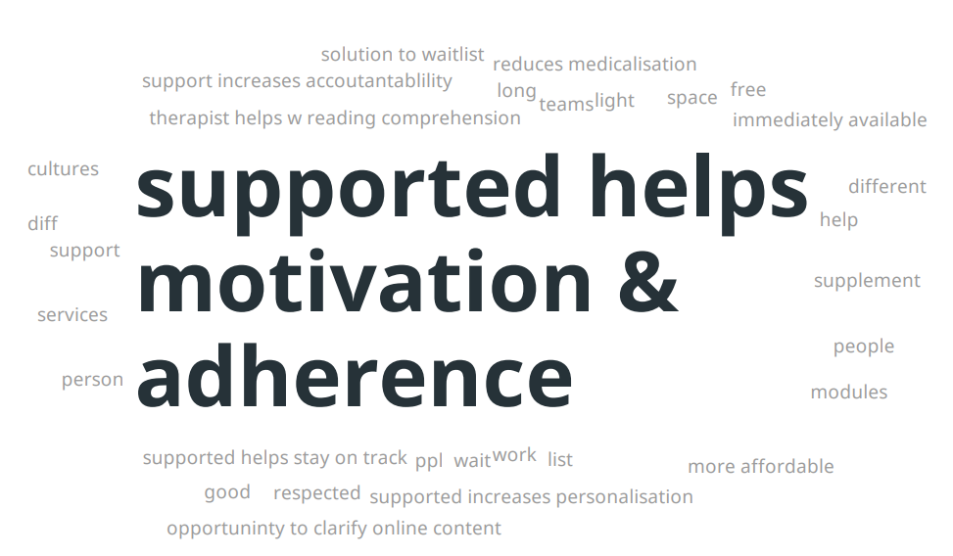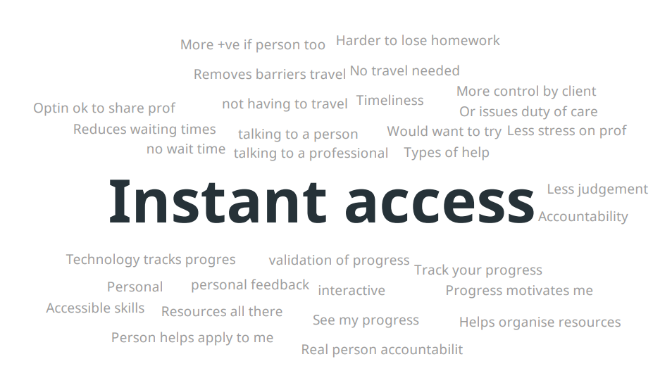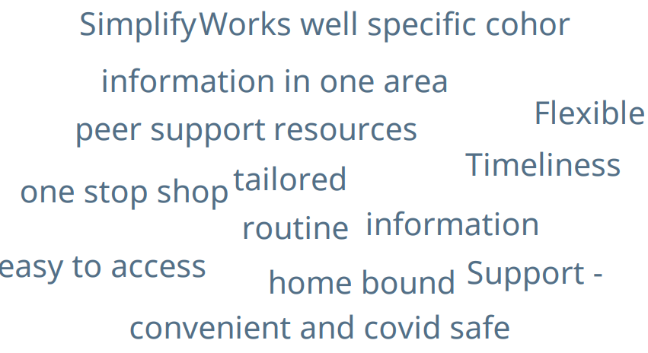

Appendix G: Barriers to use of supported DMHSs word clouds
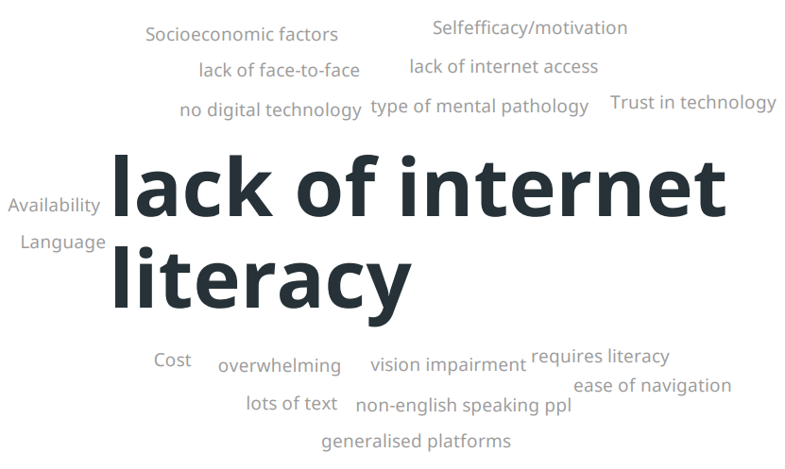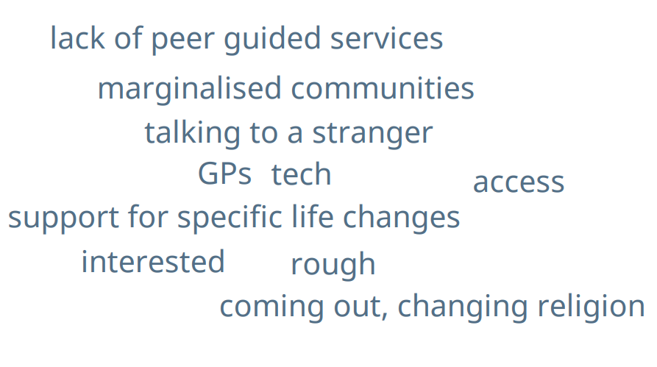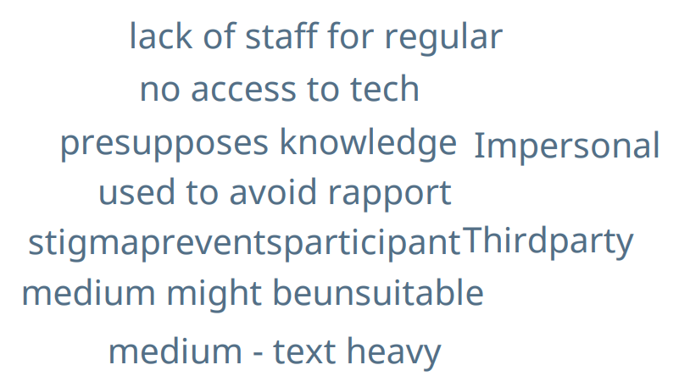

Appendix H: Effectiveness of supported DMHSs word clouds
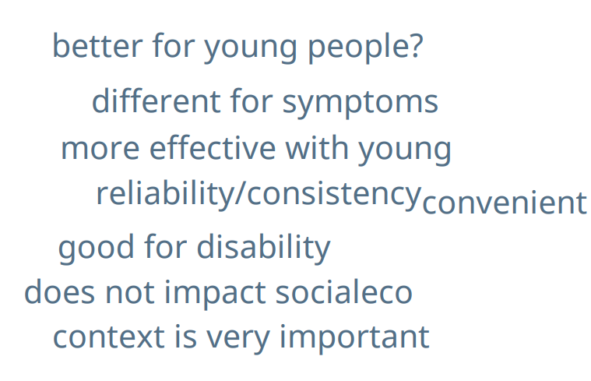
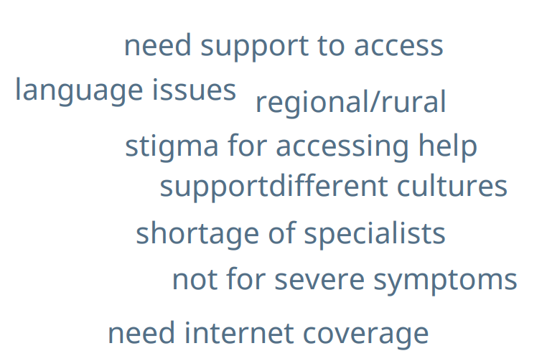
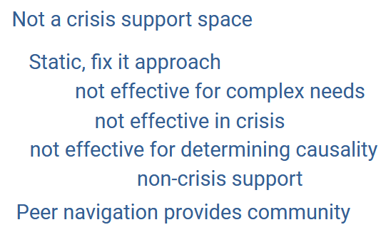

Appendix I: Most and least important features of supported DMHSs
Optimal site - most important features
Accessibility
Clarity of language so that everyone can understand
Video contents
Visually accessible, different language supports, spaced out text, screen reader support, subtitled videos, colour contrast options
Video content
User friendly
Caters to your situation
Meets your needs
Inclusive, accessible, culturally sensitive, comprehensive without being too overwhelming
Address intersectionality…content now single MH issue, don’t include impact of life experiences, e.g., physical disability, LGBTQI+, non-English speaking, neurodiverse, use gender neutral language, impact of life trauma.
Give people hope
Inclusiveness
Ease of navigation
Visuals
Keep track of my progress
Design, visual, attractive
Not overwhelming
Can narrow and personalise to respond to me
Marketed to people who can use it
Anonymity of user
HOPE - no mention of hope and recovery, need that….
How communities of recovery can be offered, see examples of this, mini videos of people chatting about experiences and journeys, referencing well established consumer movements.
Show how you can find and access a supported community….links that show how to do what is recommended.
Links to both online and in person communities.
Innovations, transformative, peer and grass roots spaces need to be in an engaged space that can be updated
Peer based service navigation models worth trained peers.
If codesigned and coproduced with people with living experience then issues with design, language, would change and be improved.
Bringing a human element to the site would be more engaging and relevant.
Missing housing, income security, advocacy, trauma dealing with Centrelink and NDIS.
Addressing basic needs - homelessness, financial, employment, social factors, building blocks…how can you work on wellbeing if you struggle with the basics
Advocacy plus, plus
Human rights, peak consumer bodies, ombudsman services, disability justice
Optimal site - least important features
The branding
Medical jargon or confusing language
All relevant
Referral back to MH professional (when you're already meant to be supported by them)
Deficit focus language…not hopeful, off putting
Don’t see point of putting all the basic info there…wasting time and space instead of addressing the more complex needs

Appendix J: Survey questions for additional health professionals delivering (or referring consumers to) mental health services
What is your profession?
- GP
- Psychiatrist
- General Psychologist
- Clinical Psychologist
- Mental health nurse
- Social worker
- Occupational therapist
- Peer support worker
- Aboriginal and Torres Strait Islander Health/Mental Health Worker
- Other, specify:_________________

How long have you been working in this profession?
- Less than 1 year
- 1-5 years
- 6-10 years
- 11-15 years
- 16-20 years
- More than 20 years

What type of organisation do you work in?
- Digital/online mental health service
- Face-to-face mental health service
- Telephone mental health service
- Private practice – mental health
- General practice
- Private hospital
- Public hospital
- Not-for-profit community organization
- PHN
- Other, please specify:_________________
What is your role in the organisation?
What is your postcode?

What is your gender?
- Female
- Male
- I do not identify with either term

What is your age?
- 18-19 years
- 20-29 years
- 30-39 years
- 40-49 years
- 50-59 years
- 60-69 years
- 70-79 years
- 80 years or older
Do you identify as Aboriginal and/or Torres Strait Islander?
- Aboriginal
- Torres Strait Islander
- Both Aboriginal and Torres Strait Islander
- Neither Aboriginal nor Torres Strait Islander
What type of internet do you have?
- Dial up
- ADSL or ADSL2+
- Cable
- National Broadband Network (NBN)
- Satellite Connection
- Wireless Router
- Mobile Broadband (e.g., hot spot, dongle)
- Other____________
How reliable is your internet?
- Unreliable all of the time
- Unreliable most of the time
- Unreliable/reliable some of the time
- Reliable most of the time
- Reliable all of the time
The following questions ask about your views and experiences of delivering or recommending digital mental health services. We are interested in mental health services that are delivered online via desktop computers or mobile devices (not telehealth items subsidised by the MBS). When we refer to supported digital mental health services, we mean that the digital service includes the option of receiving support from a therapist within the program.
Do you provide onsite space/technology for clients/patients to access digital mental health services?
- Yes
- No

Do you deliver any digital mental health services?
- Yes
- No
If yes, which ones?
If no, do you recommend any digital mental health services to your patients?
    - Yes
    - No
If yes:
Which one(s)?
Why?
To what extent do the digital mental health services benefit your clients’/patients’ mental health?
- No benefit
- Some benefit
- Much benefit
Was support from a therapist provided as a feature of the digital mental health service?
- Yes
- No
- Unsure
If no, why not?
What kind of support do you provide to users of digital mental health services? Please tick all that best describe what you do.
- I provide counselling
- I reinforce strategies learnt through the online modules
- I provide psycho-education
- I provide cognitive behavioural therapy
- I provide mindfulness and relaxation interventions
- I provide carer supports
- I conduct risk assessments
- I make referrals to other services
- Other, specify:________________________
How easy do you find the process of providing supported digital mental health services?
- Very easy
- Easy
- Somewhat easy
- Difficult
- Very difficult

Have you experienced any difficulties associated with supporting users of digital mental health services?
- Yes
- No
If yes, please select all that apply.
    - Lack of user background information
    - Difficulties with rapport building
    - Unfamiliar with resources close to users’ home
    - Problems with connections
    - Lack of multidisciplinary care planning
    - Lack of communication with other health professionals
    - Online program not suitable for consumer’s needs
    - Technical problems
    - Other (specify):______________________________
To what extent do you think that digital mental health services are meeting users’ needs?
- Not at all
- Somewhat
- Mostly
- Completely
Have supported digital mental health services benefited consumers under your care?
- Yes
- No
If yes, please select all the benefits that apply
    - Improved mental health and wellbeing
    - Improved access to care
    - Improved privacy
    - Improved waiting times for services
    - Reduced costs associated with care (travel and cost of sessions)
    - Improved convenience of care (access from own home 24/7)
    - Other please specify __________________________
Have supported digital mental health services had negative impacts on consumers under your care?
- Yes
- No
If yes, please select all the negative impacts that apply
    - Consumers are not getting the level of care they need
    - Digital mental health is isolating for consumers
    - Consumers are dropping out of care
    - Other please specify __________________________
Is providing supported digital mental health services your preferred way to deliver mental health care?
    - Yes
    - No
If no, please indicate how you would prefer to deliver mental health services. Please select all that apply.
    - Face-to-face
    - Phone
    - Video
    - Other
Overall, how satisfied are you with providing supported digital mental health services?
- Not at all satisfied
- Somewhat satisfied
- Satisfied
- Very satisfied
- Completely satisfied
What severity of mental health problems do you think are suitable for digital mental health services? Select all responses that apply
- Mild
- Moderate
- Severe
In your experience, do you think digital mental health services are suitable for any particular mental health problems? Please select all that apply.
Digital mental health services are suitable for people with:
- Depression
- Anxiety
- PTSD
- OCD
- Eating disorders
- Bipolar disorders
- Psychotic disorders (e.g., schizophrenia)
- Personality disorders
- Self-harm
- Suicidal ideation
- Substance use disorders
- Other, specify:___________________
- Unsure
In your experience, do you think digital mental health services are not suitable for any particular mental health problems? Please select all that apply.
Digital mental health services are not suitable for people with:
- Depression
- Anxiety
- PTSD
- OCD
- Eating disorders
- Bipolar disorders
- Psychotic disorders (e.g., Schizophrenia)
- Personality disorders
- Self-harm
- Suicidal ideation
- Substance use disorders
- Other, specify:___________________
- Unsure
Are there any consumer groups who would benefit from digital mental health services but for whom programs have not yet been tailored?
- Yes
- No
If yes, please specify who these consumer groups are:
- Aboriginal and/or Torres Strait Islander peoples
- People who are from culturally and linguistically diverse backgrounds or whose main language spoken at home is not English
- People living in a rural or remote location
- People who identify as LGBTQIA+
- Other, please specify _____________
Please describe the modifications needed for each group you’ve selected.

What are the barriers to the use of digital mental health services?
What changes are needed to improve the use of digital mental health services?
How can digital mental health services be better integrated within the mental health system?
Provide other comments, if you have any, about digital mental health services.

Appendix K: Other key stakeholder interview/survey questions
Participants were asked 35 questions in the survey/interview – 3 relating to the organisation being represented, 17 relating to the supported DMHS evaluation, 10 relating to the Head to Health evaluation and 5 demographic questions. The 20 questions relating to the organisation and supported DMHS evaluation are listed here. All questions were optional and were mostly short answer questions, with a few multiple-choice questions.
- What is the name of organisation(s) you are representing?
- What is your job/position title?
- What is your/your organisation’s role in mental health service delivery?
- How are you/your organisation engaged with digital mental health services? Which services? Are any supported digital mental health services?
- How are you/your organisation facilitating or promoting the use of digital mental health services?
- How might digital mental health services in general, and supported digital mental health services specifically, be better integrated and used in mental health care across Australia?
- How can digital mental health services in general, and supported digital mental health services specifically, improve access to mental health care?
- How might digital mental health services in general, and supported digital mental health services specifically, be improved in the future?
- What effects have digital mental health services in general, and supported digital mental health services specifically, had on consumers and carers?
- How has clinical care for people with mental health problems changed since the introduction of digital mental health services in general, and supported digital mental health services specifically?
- What severity of mental health problems do you think are suitable for digital mental health services in general? Select all responses that apply
- Mild
- Moderate
- Severe
- What severity of mental health problems do you think are suitable for supported digital mental health services specifically? Select all responses that apply
- Mild
- Moderate
- Severe

- In your experience, do you think digital mental health services are suitable for any particular mental health problems? Please select all that apply.
Digital mental health services are suitable for people with:
- Depression
- Anxiety
- PTSD
- OCD
- Eating disorders
- Bipolar disorders
- Psychotic disorders (e.g., Schizophrenia)
- Personality disorders
- Self-harm
- Suicidal ideation
- Substance use disorders
- Other, specify:___________________
- Unsure
- In your experience, do you think supported digital mental health services are suitable for any particular mental health problems? Please select all that apply.
Digital mental health services are suitable for people with:
- See list in question 13
- In your experience, do you think digital mental health services are not suitable for any particular mental health problems? Please select all that apply.
Digital mental health services are not suitable for people with:
- See list in question 13
- In your experience, do you think supported digital mental health services are not suitable for any particular mental health problems? Please select all that apply.
Digital mental health services are not suitable for people with:
- See list in question 13
- Are there any consumer groups who would benefit from digital mental health services but for whom programs have not yet been tailored?
- Yes
- No
If yes, please specify who these consumer groups are:
- Aboriginal and/or Torres Strait Islander peoples
- People who are from culturally and linguistically diverse backgrounds or whose main language spoken at home is not English
- People living in a rural or remote location
- People who identify as LGBTQIA+
- Other, please specify _____________
Please describe the modifications needed for each group you’ve selected.
- What are the barriers to the use of digital mental health interventions in general and supported digital mental health services specifically?
- What changes are needed to improve the use of digital mental health services in general and supported digital mental health services specifically?
- Provide other comments, if you have any, about digital mental health services in general and supported digital mental health services specifically.

Appendix L: Cost effectiveness modelling

L1. Economic model
Our economic model is based on a model we previously developed to evaluate the cost-effectiveness of a treatment program offered by MindSpot for people with symptoms of depression and/or anxiety (Lee et al, 2017).⁸³ Figure L1 presents a schematic representation of the model structure, developed using decision tree methodology. This methodology is easy to understand and interpret and has been used in previous research of online-based mental health interventions.⁹³ A one-year time horizon was chosen for the model given the relatively short lifespan of the DMHSs and the lack of longer-term information on both treatment outcomes and cost impacts. We believe this is a reasonable and conservative approach because no assumptions are made regarding treatment benefits accrued beyond one year.
Patients with depression and/or anxiety
Supported online mental health service
(“Intervention” arm)
Routine / Usual care
(“Comparator” arm)
Fully recovered
Partially recovered
No improvement
Deteriorated
Fully recovered
Partially recovered
No improvement
Deteriorated
Figure L1. Diagrammatic structure of the decision-tree model
The model population is the number of consumers completing assessment at the respective DMHS and eligible for treatment. The treatment effects are categorised into four health states: (i) fully recovered, (ii) partially recovered, (iii) no improvement and (iv) deteriorated. The four health states are based on diagnostic cut-off points of instruments that measure depression and anxiety such as the PHQ-9 and GAD-7 (Lee et al, 2017).⁸³ Further information about the model parameters such as transition probabilities (the probability of moving from one health state to another) and utility weights are presented in sub-section L3.

L2. Usual care comparison
We used data from two recent RCTs of mental health care located in primary care based in Australia – the Link-me RCT and the Target-D RCT. It is likely that the participants in these trials are generally representative of the types of consumers who receive usual care services if they do not have access to DMHSs. In addition, economic evaluations were conducted alongside these trials (Chatterton et al, 2022; Lee et al, 2022)^{83, 94} and therefore we had access to relevant cost data that we could compare with those of DMHSs.
The Link-me RCT (Fletcher et al, 2019; Fletcher et al, 2021a)^{76, 95} was conducted in 23 general practices in three states (New South Wales, Victoria and Queensland) across metropolitan, outer metropolitan and regional locations in collaboration with three Primary Health Networks (PHNs). Adults attending a participating general practice for any reason were invited to complete an eligibility screening tool. The inclusion criteria were individuals aged 18-75 years; proficient in English; providing a phone number and email address; having a Medicare card; reporting current anxiety or depression symptoms (≥2 on the 2-item version of the PHQ) or use of medication for mental health. Eligible participants were classified into three prognostic groups – minimal/mild, moderate and severe – based on a patient-completed Decision Support Tool that predicted their anxiety and depressive symptom trajectory over the next three months. Participants categorised into the minimal/mild and severe groups were individually randomised to the intervention or control group. Participants randomised to the control group for both prognostic groups received advice to discuss any mental health concerns with their GP.
Similarly, the Target-D RCT (Fletcher et al, 2021b)⁹⁶ recruited participants from the waiting rooms of 14 general practices in metropolitan Melbourne, Australia. Adults aged 18-65 years were invited to complete an eligibility survey on an iPad. Participants were eligible if they reported: current depressive symptoms (≥2 on the 2-item version of the PHQ); no self-reported change to antidepressant medication in the past month; had access to the internet; and sufficient written English to follow an internet-based cognitive behavioural therapy (iCBT) program. A clinical prediction tool with self-reported biopsychosocial data was used to classify eligible participants into one of three prognostic groups – minimal/mild, moderate or severe – based on predicted severity of their depressive symptoms in the next three months. Participants randomised to the control group received usual care plus attention control in the form of a telephone call from a research assistant about trial involvement and views about research participation. We used the Link-me and Target-D control groups as the indirect comparator groups representing usual care.

L3. Model parameters and sensitivity analysis

L3.1 Transition probabilities
To operationalise the model, transition probabilities for the four health states described in Figure L1 were estimated. As previously mentioned, we received mental health outcome data for each DMHS through their routinely collected service use data or peer-reviewed publications. These data include clinical outcomes such as K6, K10, PHQ-9 and GAD-7 (presented in Section 4), which we used to derive transition probabilities for each health state. Transition probabilities specific to a service pathway (i.e., self-directed or therapist-supported) were calculated if data were available and, if not, the probabilities were assumed to be the same for all service pathways. The transition probabilities for the model were calculated based on the treatment outcomes that were presented in Section 4 (Figure 8 in sub-section 4.4 and Figure 13 in sub-section 4.5). Table L1.1 and L1.2 present the PHQ-9 and GAD-7 outcomes in three health states (deteriorated, no change and improved) for consumers who commenced treatment. The number of cases in each health state were then converted to proportions, which represent the transition probabilities used in our cost-effectiveness modelling. The ‘deteriorated’ and ‘no change’ health states were equivalent to the corresponding health states in our model. The ‘improved’ health state was equivalent to the combination of ‘fully recovered’ and ‘partially recovered’ health states in our model. We assume that 70% of the ‘improved’ health state can be attributed to ‘fully recovered’ and the balance 30% can be attributed to ‘partially recovered’. This assumption is based on the ratio of ‘fully recovered’ and ‘partially recovered’ health states estimated in a prior economic evaluation of MindSpot (Table 3 in Lee et al, 2017).⁸³
The transition probabilities for the indirect comparator groups were based on the values estimated in a published economic evaluation of MindSpot in 2017.⁸³ These values were calculated based on data from the National Mental Health Survey and an internal dataset provided by MindSpot at the time of this previous evaluation.

Table L1.1. The PHQ-9 outcomes for consumers who commenced treatment by service and treatment pathway
 | Deteriorated | No change | Improved
MINDSPOT
Therapist-supported treatment (n=3,532)
Number of cases | 258 | 987 | 2,287
Proportion | 0.073 | 0.280 | 0.647
THIS WAY UP
Self-directed treatment (n=26,602)
Number of cases | 1,799 | 8,709 | 16,093
Proportion | 0.068 | 0.327 | 0.605
Therapist-supported treatment (n=27,530)
Number of cases | 1,743 | 10,857 | 14,930
Proportion | 0.063 | 0.394 | 0.542

Table L1.2. The GAD-7 outcomes for consumers who commenced treatment by service and treatment pathway
 | Deteriorated | No change | Improved
MINDSPOT
Therapist-supported treatment (n=3,532)
Number of cases | 242 | 1,163 | 2,127
Proportion | 0.068 | 0.329 | 0.602
THIS WAY UP
Self-directed treatment (n=19,292)
Number of cases | 948 | 6,646 | 11,698
Proportion | 0.049 | 0.344 | 0.606
Therapist-supported treatment (n=18,236)
Number of cases | 1,007 | 5,788 | 11,440
Proportion | 0.055 | 0.317 | 0.627
Tables L1.3 and L1.4 presents the transition probabilities used in our cost-effectiveness modelling, based on PHQ-9 and GAD-7 outcomes, respectively. Due to data unavailability, the transition probabilities for Mental Health Online were assumed to be the average of those for MindSpot and THIS WAY UP.

Table L1.3 Transition probabilities used in the cost-effectiveness modelling (based on PHQ-9 outcomes)
Parameter | Indirect comparatorª | Mental Health Online^{b} | MindSpot^{c} | THIS WAY UP^{d}
Self-directed treatment
Transition probabilities:
Fully recovered | 0.111 | 0.438 | 0.453 | 0.423
Partially recovered | 0.044 | 0.188 | 0.194 | 0.181
No improvement | 0.689 | 0.304 | 0.280 | 0.327
Deteriorated | 0.156 | 0.071 | 0.073 | 0.068
Therapist-supported treatment
Transition probabilities:
Fully recovered | 0.111 | 0.417 | 0.453 | 0.380
Partially recovered | 0.044 | 0.179 | 0.194 | 0.163
No improvement | 0.689 | 0.337 | 0.280 | 0.394
Deteriorated | 0.156 | 0.068 | 0.073 | 0.063
ªAs estimated in Lee et al (2017)⁸³ based on datasets from (i) the National Survey of Mental Health and Wellbeing (NSMHWB), a population-level survey collecting epidemiology and health resource use of common mental disorders and (ii) a 8-week “waitlist” dataset. The transition probabilities for self-directed treatment were assumed to be the same as those for therapist-supported treatment.
^{b}Due to data unavailability, the transition probabilities for Mental Health Online were assumed to be the average of MindSpot and THIS WAY UP.
^{c}Transition probabilities for MindSpot were estimated using the proportion of consumers moving between symptom severity groups (based on PHQ-9 cut-off points) after commencing therapist-supported treatment, as presented by Figure 8 in sub-section 4.4. The transition probabilities for self-directed treatment were assumed to be the same as those for therapist-supported treatment.
^{d}Transition probabilities for THIS WAY UP were estimated using the proportion of consumers moving between symptom severity groups (based on PHQ-9 cut-off points) after commencing therapist-supported treatment, as presented by Figure 13 in sub-section 4.5.

Table L1.4 Transition probabilities used in the cost-effectiveness modelling (based on GAD-7 outcomes)
Parameter | Indirect comparatorª | Mental Health Online^{b} | MindSpot^{c} | THIS WAY UP^{d}
Self-directed treatment
Transition probabilities:
Fully recovered | 0.111 | 0.423 | 0.422 | 0.424
Partially recovered | 0.044 | 0.182 | 0.181 | 0.182
No improvement | 0.689 | 0.337 | 0.329 | 0.344
Deteriorated | 0.156 | 0.059 | 0.068 | 0.049
Therapist-supported treatment
Transition probabilities:
Fully recovered | 0.111 | 0.439 | 0.422 | 0.439
Partially recovered | 0.044 | 0.188 | 0.181 | 0.188
No improvement | 0.689 | 0.317 | 0.329 | 0.317
Deteriorated | 0.156 | 0.055 | 0.068 | 0.055
ªAs estimated in Lee et al (2017)⁸³ based on datasets from (i) the National Survey of Mental Health and Wellbeing (NSMHWB), a population-level survey collecting epidemiology and health resource use of common mental disorders and (ii) a 8-week “waitlist” dataset. The transition probabilities for self-directed treatment were assumed to be the same as those for therapist-supported treatment.
^{b}Due to data unavailability, the transition probabilities for Mental Health Online were assumed to be the average of MindSpot and THIS WAY UP.
^{c}Transition probabilities for MindSpot were estimated using the proportion of consumers moving between symptom severity groups (based on GAD-7 cut-off points) after commencing therapist-supported treatment, as presented by Figure 8 in sub-section 4.4. The transition probabilities for self-directed treatment were assumed to be the same as those for therapist-supported treatment.
^{d}Transition probabilities for THIS WAY UP were estimated using the proportion of consumers moving between symptom severity groups (based on GAD-7 cut-off points) after commencing therapist-supported treatment, as presented by Figure 13 in sub-section 4.5.

L3.2 Utility weights
The utility weights used to calculate QALYs were derived from individual-level and population-representative datasets with clinical outcomes as described in Lee et al (2017). Utilities are typically expressed as being between zero and one, where the value of one represents perfect health and zero represents death. The QALYs of the four health states were calculated by multiplying the period spent in a particular health state (in this case, one year) by the utility assigned to that health state. Table L1.9 in the Appendix lists the utility weights used in our modelling. Table L1.9 presents the utility weights used in the analysis, which were based on estimates reported in Lee et al (2017).⁸³

Table L1.9 Utility weights used in the cost-effectiveness modelling
Parameter | Parameter value | 95% confidence interval
Utility weightª
Fully recovered | 0.858 | 0.835-0.881
Partially recovered | 0.839 | 0.798-0.879
No improvement | 0.779 | 0.746-0.812
Deterioration | 0.712 | 0.473-0.952
ªAs estimated in Lee et al (2017)⁸³ based on an 8-week dataset using EQ-5D-5L as the measurement tool. QALYs of the four health states were calculated by multiplying the period spent in a particular health state by the utility assigned to that state.

L3.3 Sensitivity analysis
A deterministic sensitivity analysis was also conducted to evaluate the robustness of our modelling results. This includes replacing the transition probabilities calculated based on PHQ-9 cut-off points (Table L1.3) with those that were calculated based on GAD-7 cut-off points (Table L1.4), to determine if our results were sensitive to the type of depression or anxiety measures. Another sensitivity test involves sequentially setting the transition probability of each health state for the DMHSs to be equal to that of the indirect comparator group (Tables L1.5-1.8). Lastly, the utility values for each health state were varied by the lower or higher 95% confidence interval to test if our results were influenced by these values (Table L1.9).

We also conducted another sensitivity analysis by setting the DMHS’s transition probability of one health state to be equal to that of the indirect comparator’s corresponding health state and redistributing the initial difference among the remaining health states. This was done sequentially for each health state. For example, the difference of ‘fully recovered’ between MHO and the indirect comparator, based on PHQ-9 outcomes, was 0.438-0.111=0.327. The transition probability of ‘fully recovered’ for MHO was then set to 0.111 and the initial difference (i.e., 0.327) was re-distributed equally to the remaining health states for MHO (i.e., 0.109 was added to ‘partially recovered’, ‘no improvement’ and ‘deteriorated’). Table L1.5-1.8 present the transition probabilities used for this sensitivity analysis.

Table L1.5 Transition probabilities for sensitivity analysis (‘fully recovered’ value equals to indirect comparator)
Parameter | Indirect comparatorª | Mental Health Online^{b} | MindSpot^{c} | THIS WAY UP^{d}
Self-directed treatment
Transition probabilities:
Fully recovered | 0.111 | 0.111 | 0.111 | 0.111
Partially recovered | 0.044 | 0.297 | 0.308 | 0.285
No improvement | 0.689 | 0.413 | 0.394 | 0.431
Deteriorated | 0.156 | 0.180 | 0.187 | 0.172
Therapist-supported treatment
Transition probabilities:
Fully recovered | 0.111 | 0.111 | 0.111 | 0.111
Partially recovered | 0.044 | 0.281 | 0.308 | 0.253
No improvement | 0.689 | 0.439 | 0.394 | 0.484
Deteriorated | 0.156 | 0.170 | 0.187 | 0.153

Table L1.6 Transition probabilities for sensitivity analysis (‘partially recovered’ value equals to indirect comparator)
Parameter | Indirect comparatorª | Mental Health Online^{b} | MindSpot^{c} | THIS WAY UP^{d}
Self-directed treatment
Transition probabilities:
Fully recovered | 0.111 | 0.486 | 0.503 | 0.469
Partially recovered | 0.044 | 0.044 | 0.044 | 0.044
No improvement | 0.689 | 0.352 | 0.330 | 0.373
Deteriorated | 0.156 | 0.119 | 0.123 | 0.114
Therapist-supported treatment
Transition probabilities:
Fully recovered | 0.111 | 0.462 | 0.503 | 0.420
Partially recovered | 0.044 | 0.044 | 0.044 | 0.044
No improvement | 0.689 | 0.382 | 0.330 | 0.434
Deteriorated | 0.156 | 0.113 | 0.123 | 0.103

Table L1.7 Transition probabilities for sensitivity analysis (‘no improvement’ value equals to indirect comparator)
Parameter | Indirect comparatorª | Mental Health Online^{b} | MindSpot^{c} | THIS WAY UP^{d}
Self-directed treatment
Transition probabilities:
Fully recovered | 0.111 | 0.310 | 0.317 | 0.302
Partially recovered | 0.044 | 0.060 | 0.058 | 0.060
No improvement | 0.689 | 0.689 | 0.689 | 0.689
Deteriorated | 0.156 | -0.057 | -0.063 | -0.053
Therapist-supported treatment
Transition probabilities:
Fully recovered | 0.111 | 0.300 | 0.317 | 0.282
Partially recovered | 0.044 | 0.062 | 0.058 | 0.065
No improvement | 0.689 | 0.689 | 0.689 | 0.689
Deteriorated | 0.156 | -0.049 | -0.063 | -0.035

Table L1.8 Transition probabilities for sensitivity analysis (‘deteriorated’ value equals to indirect comparator)
Parameter | Indirect comparatorª | Mental Health Online^{b} | MindSpot^{c} | THIS WAY UP^{d}
Self-directed treatment
Transition probabilities:
Fully recovered | 0.111 | 0.410 | 0.425 | 0.394
Partially recovered | 0.044 | 0.160 | 0.166 | 0.152
No improvement | 0.689 | 0.276 | 0.252 | 0.298
Deteriorated | 0.156 | 0.156 | 0.156 | 0.156
Therapist-supported treatment
Transition probabilities:
Fully recovered | 0.111 | 0.388 | 0.425 | 0.349
Partially recovered | 0.044 | 0.150 | 0.166 | 0.132
No improvement | 0.689 | 0.308 | 0.252 | 0.363
Deteriorated | 0.156 | 0.156 | 0.156 | 0.156

A further sensitivity analysis was conducted for MindSpot by using data from a previously publication of treatment outcomes of consumers who completed online treatment at the MindSpot clinic.⁶⁶ These outcomes were presented in four categories – remission, minimal response, non-response and deterioration – and were converted to transition probabilities and mapped accordingly to the four health states in our model. Table L1.9 presents the transition probabilities used for MindSpot in this sensitivity analysis.

Table L1.9 Transition probabilities of MindSpot for sensitivity analysis (based on Kayrouz et al, 2020)⁶⁶
Parameter | MindSpot
Self-directed treatment
Transition probabilities:
Fully recovered | 0.560
Partially recovered | 0.190
No improvement | 0.210
Deteriorated | 0.050
Therapist-supported treatment
Transition probabilities:
Fully recovered | 0.560
Partially recovered | 0.190
No improvement | 0.210
Deteriorated | 0.050

L4. Results of sensitivity analysis

Table L2.1 Results of economic modelling for Mental Health Online (utility values based on GAD-7 cut-off points)
 | Mental Health Online | Indirect comparator: Link-me  (all participants) | Indirect comparator: Target-D  (all participants) | Indirect comparator: Link-me (minimal/ mild group) | Indirect comparator: Target-D (minimal/ mild group) | Indirect comparator: Link-me (severe group) | Indirect comparator: Target-D (severe group)
Self-directed treatmentª
Input population (n) | 7,354 | 7,354 | 7,354 | 7,354 | 7,354 | 7,354 | 7,354
Fully recovered (n) | 3,111 | 816 | 816 | 816 | 816 | 816 | 816
Partially recovered (n) | 1,338 | 324 | 324 | 324 | 324 | 324 | 324
No improvement (n) | 2,478 | 5,067 | 5,067 | 5,067 | 5,067 | 5,067 | 5,067
Deteriorated (n) | 434 | 1,147 | 1,147 | 1,147 | 1,147 | 1,147 | 1,147
QALY | 6,031 | 5,736 | 5,736 | 5,736 | 5,736 | 5,736 | 5,736
Total costs excluding productivity losses | $6,223,175 | $21,155,546 | $13,648,215 | $4,858,126 | $11,879,578 | $37,255,585 | $19,978,906
Costs per QALY  gained | - | [dominant] | [dominant] | $4,617 | [dominant] | [dominant] | [dominant]
Total costs including productivity losses | $12,368,031 | $83,665,576 | $133,127,109 | $36,048,646 | $131,442,013 | $130,720,880 | 127,001,374
Costs per QALY  gained | - | [dominant] | [dominant] | [dominant] | [dominant] | [dominant] | [dominant]
Therapist-supported treatment^{b}
Input population (n) | 578 | 578 | 578 | 578 | 578 | 578 | 578
Fully recovered (n) | 254 | 64 | 64 | 64 | 64 | 64 | 64
Partially recovered (n) | 109 | 25 | 25 | 25 | 25 | 25 | 25
No improvement (n) | 183 | 398 | 398 | 398 | 398 | 398 | 398
Deteriorated (n) | 32 | 90 | 90 | 90 | 90 | 90 | 90
QALY | 473 | 451 | 451 | 451 | 451 | 451 | 451
Total costs excluding productivity losses | $625,932 | $1,662,756 | $1,072,704 | $381,833 | $933,695 | $2,928,165 | $1,570,276
Costs per QALY  gained | - | [dominant] | [dominant] | $11,570 | [dominant] | [dominant] | [dominant]
Total costs including productivity losses | $1,135,897 | $6,575,837 | $10,463,349 | $2,833,304 | $10,330,906 | $10,274,227 | $9,981,887
Costs per QALY  gained | - | [dominant] | [dominant] | [dominant] | [dominant] | [dominant] | [dominant]
A ‘dominant’ costs per QALY gained indicates that the DMHS was found to have lower costs and greater benefits.
ªBased on (i) an input population of 7,354 consumers and annual cost of service delivery per consumer as reported in Table 52 and (ii) health care cost and productivity losses as reported in Table 58.
^{b}Based on (i) an input population of 578 consumers and annual cost of service delivery per consumer as reported in Table 52 and (ii) health care cost and productivity losses as reported in Table 58.

Table L2.2 Results of economic modelling for MindSpot (utility values based on GAD-7 cut-off points)
 | MindSpot | Indirect comparator: Link-me  (all participants) | Indirect comparator: Target-D  (all participants) | Indirect comparator: Link-me (minimal/ mild group) | Indirect comparator: Target-D (minimal/ mild group) | Indirect comparator: Link-me (severe group) | Indirect comparator: Target-D (severe group)
Self-directed treatmentª
Input population (n) | 1,117 | 1,117 | 1,117 | 1,117 | 1,117 | 1,117 | 1,117
Fully recovered (n) | 471 | 124 | 124 | 124 | 124 | 124 | 124
Partially recovered (n) | 202 | 49 | 49 | 49 | 49 | 49 | 49
No improvement (n) | 367 | 770 | 770 | 770 | 770 | 770 | 770
Deteriorated (n) | 76 | 174 | 174 | 174 | 174 | 174 | 174
QALY | 914 | 871 | 871 | 871 | 871 | 871 | 871
Total costs excluding productivity losses | $2,251,112 | $3,213,319 | $2,073,029 | $737,901 | $1,804,391 | $5,658,756 | $3,034,599
Costs per QALY  gained | - | [dominant] | $4,121 | $35,019 | $10,338 | [dominant] | [dominant]
Total costs including productivity losses | $2,911,539 | $12,707,975 | $20,220,694 | $5,475,434 | $19,964,744 | $19,855,211 | $19,290,255
Costs per QALY  gained | - | [dominant] | [dominant] | [dominant] | [dominant] | [dominant] | [dominant]
Therapist-supported treatment^{b}
Input population (n) | 5,198 | 5,198 | 5,198 | 5,198 | 5,198 | 5,198 | 5,198
Fully recovered (n) | 2,194 | 577 | 577 | 577 | 577 | 577 | 577
Partially recovered (n) | 941 | 229 | 229 | 229 | 229 | 229 | 229
No improvement (n) | 1,710 | 3,581 | 3,581 | 3,581 | 3,581 | 3,581 | 3,581
Deteriorated (n) | 353 | 811 | 811 | 811 | 811 | 811 | 811
QALY | 4,255 | 4,054 | 4,054 | 4,054 | 4,054 | 4,054 | 4,054
Total costs excluding productivity losses | $11,139,262 | $14,953,295 | $9,646,916 | $3,433,851 | $8,396,797 | $26,333,224 | $14,1216,15
Costs per QALY  gained | - | [dominant] | $7,421 | $38,319 | $13,638 | [dominant] | [dominant]
Total costs including productivity losses | $14,212,580 | $59,137,022 | $94,097,731 | $25,480,128 | $92,906,661 | $92,396,945 | $89,767,901
Costs per QALY  gained | - | [dominant] | [dominant] | [dominant] | [dominant] | [dominant] | [dominant]
A ‘dominant’ costs per QALY gained indicates that the DMHS was found to have lower costs and greater benefits.
ªBased on (i) an input population of 1,117 consumers and annual cost of service delivery per consumer as reported in Table 54 and (ii) health care cost and productivity losses as reported in Table 58.
^{b}Based on (i) an input population of 5,198 consumers and annual cost of service delivery per consumer as reported in Table 54 and (ii) health care cost and productivity losses as reported in Table 58.

Table L2.3 Results of economic modelling for THIS WAY UP (utility values based on GAD-7 cut-off points)
 | THIS WAY UP | Indirect comparator: Link-me  (all participants) | Indirect comparator: Target-D  (all participants) | Indirect comparator: Link-me (minimal/ mild group) | Indirect comparator: Target-D (minimal/ mild group) | Indirect comparator: Link-me (severe group) | Indirect comparator: Target-D (severe group)
Self-directed treatmentª
Input population (n) | 3,330 | 3,330 | 3,330 | 3,330 | 3,330 | 3,330 | 3,330
Fully recovered (n) | 1,412 | 370 | 370 | 370 | 370 | 370 | 370
Partially recovered (n) | 606 | 147 | 147 | 147 | 147 | 147 | 147
No improvement (n) | 1,146 | 2,294 | 2,294 | 2,294 | 2,294 | 2,294 | 2,294
Deteriorated (n) | 163 | 519 | 519 | 519 | 519 | 519 | 519
QALY | 2,728 | 2,597 | 2,597 | 2,597 | 2,597 | 2,597 | 2,597
Total costs excluding productivity losses | $6,292,268 | $9,579,544 | $6,180,114 | $2,199,831 | $5,379,249 | $16,869,880 | $9,046,744
Costs per QALY  gained | - | [dominant] | $855 | $31,194 | $6,959 | [dominant] | [dominant]
Total costs including productivity losses | $8,878,646 | $37,885,010 | $60,281,924 | $16,323,360 | $59,518,888 | $59,192,348 | $57,508,101
Costs per QALY  gained | - | [dominant] | [dominant] | [dominant] | [dominant] | [dominant] | [dominant]
Therapist-supported treatment^{b}
Input population (n) | 13,407 | 13,407 | 13,407 | 13,407 | 13,407 | 13,407 | 13,407
Fully recovered (n) | 5,886 | 1,488 | 1,488 | 1,488 | 1,488 | 1,488 | 1,488
Partially recovered (n) | 2,521 | 590 | 590 | 590 | 590 | 590 | 590
No improvement (n) | 4,250 | 9,237 | 9,237 | 9,237 | 9,237 | 9,237 | 9,237
Deteriorated (n) | 737 | 2,091 | 2,091 | 2,091 | 2,091 | 2,091 | 2,091
QALY | 11,000 | 10,457 | 10,457 | 10,457 | 10,457 | 10,457 | 10,457
Total costs excluding productivity losses | $24,926,563 | $38,568,453 | $24,881,917 | $8,856,798 | $21,657,534 | $67,920,264 | $36,423,333
Costs per QALY  gained | - | [dominant] | $82 | $29,566 | $6,015 | [dominant] | [dominant]
Total costs including productivity losses | $35,339,645 | $152,529,830 | $242,702,631 | $65,719,907 | $239,630,551 | $238,315,860 | $231,534,868
Costs per QALY  gained | - | [dominant] | [dominant] | [dominant] | [dominant] | [dominant] | [dominant]
A ‘dominant’ costs per QALY gained indicates that the DMHS was found to have lower costs and greater benefits.
ªBased on (i) an input population of 3,330 consumers and annual cost of service delivery per consumer as reported in Table 55 and (ii) health care cost and productivity losses as reported in Table 58.
^{b}Based on (i) an input population of 13,407 consumers and annual cost of service delivery per consumer as reported in Table 55 and (ii) health care cost and productivity losses as reported in Table 58.

Table L2.4 Results of economic modelling for MindSpot (transition probabilities based on Kayrouz et al, 2020)⁶⁶
 | MindSpot | Indirect comparator: Link-me  (all participants) | Indirect comparator: Target-D  (all participants) | Indirect comparator: Link-me (minimal/ mild group) | Indirect comparator: Target-D (minimal/ mild group) | Indirect comparator: Link-me (severe group) | Indirect comparator: Target-D (severe group)
Self-directed treatmentª
Input population (n) | 1,117 | 1,117 | 1,117 | 1,117 | 1,117 | 1,117 | 1,117
Fully recovered (n) | 623 | 124 | 124 | 124 | 124 | 124 | 124
Partially recovered (n) | 212 | 49 | 49 | 49 | 49 | 49 | 49
No improvement (n) | 235 | 770 | 770 | 770 | 770 | 770 | 770
Deteriorated (n) | 56 | 174 | 174 | 174 | 174 | 174 | 174
QALY | 937 | 871 | 871 | 871 | 871 | 871 | 871
Total costs excluding productivity losses | $2,251,112 | $3,213,319 | $2,073,029 | $737,901 | $1,804,391 | $5,658,756 | $3,034,599
Costs per QALY  gained | - | [dominant] | $2,697 | $22,913 | $6,764 | [dominant] | [dominant]
Total costs including productivity losses | $2,911,539 | $12,707,975 | $20,220,694 | $5,475,434 | $19,964,744 | $19,855,211 | $19,290,255
Costs per QALY  gained | - | [dominant] | [dominant] | [dominant] | [dominant] | [dominant] | [dominant]
Therapist-supported treatment^{b}
Input population (n) | 5,198 | 5,198 | 5,198 | 5,198 | 5,198 | 5,198 | 5,198
Fully recovered (n) | 2,911 | 577 | 577 | 577 | 577 | 577 | 577
Partially recovered (n) | 988 | 229 | 229 | 229 | 229 | 229 | 229
No improvement (n) | 1,092 | 3,581 | 3,581 | 3,581 | 3,581 | 3,581 | 3,581
Deteriorated (n) | 260 | 811 | 811 | 811 | 811 | 811 | 811
QALY | 4,362 | 4,054 | 4,054 | 4,054 | 4,054 | 4,054 | 4,054
Total costs excluding productivity losses | $11,139,262 | $14,953,295 | $9,646,916 | $3,433,851 | $8,396,797 | $26,333,224 | $14,1216,15
Costs per QALY  gained | - | [dominant] | $4,856 | $25,073 | $8,924 | [dominant] | [dominant]
Total costs including productivity losses | $14,212,580 | $59,137,022 | $94,097,731 | $25,480,128 | $92,906,661 | $92,396,945 | $89,767,901
Costs per QALY  gained | - | [dominant] | [dominant] | [dominant] | [dominant] | [dominant] | [dominant]
A ‘dominant’ costs per QALY gained indicates that the DMHS was found to have lower costs and greater benefits.
ªBased on (i) an input population of 1,117 consumers and annual cost of service delivery per consumer as reported in Table 54 and (ii) health care cost and productivity losses as reported in Table 58.
^{b}Based on (i) an input population of 5,198 consumers and annual cost of service delivery per consumer as reported in Table 54 and (ii) health care cost and productivity losses as reported in Table 58.

