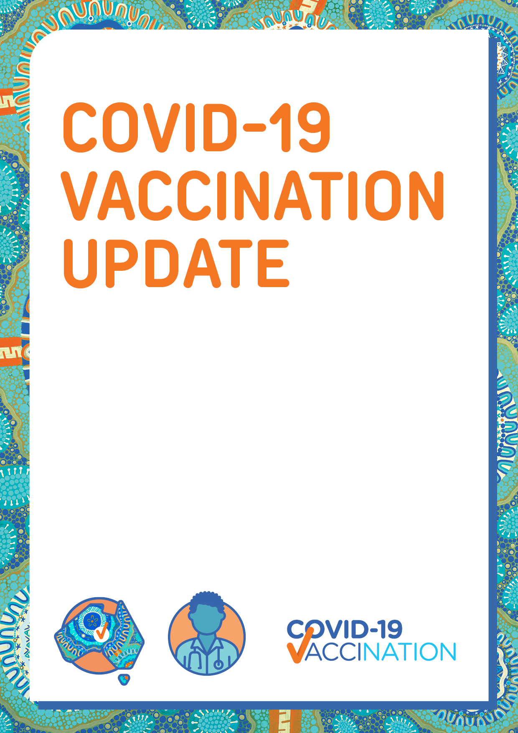Children aged 6 months to under 5 years who are at higher risk of severe illness from COVID-19 may be eligible for the COVID-19 vaccine

To find out how you can book your appointment, ask the clinic, or visit **health.gov.au/covid19-vaccines.**