# Childhood immunisation community kit

September 2022

This stakeholder kit offers a range of activities to help children learn how to stay safe from viral infections like COVID-19, with helpful information for parents and guardians about the importance of all childhood vaccinations. This fun and interactive booklet was developed for kids by the Department of Health and Aged Care to complement Teeny Tiny Stevies *‘I Got You’* campaign.

This kit can be used by organisations, including schools and community groups, to help provide trusted information to parents, carers and guardians. We encourage you to share this with your networks and print out the children’s section to teach them about simple hygiene habits in a fun way!

## Within this kit you will find:

* Fun and educational activities for kids
* A printable poster
* Social media content that you can use on your social channels, and
* Helpful information for parents and guardians

## Contact us

Should you need any more information, please get in touch with us at [publichealthcomms@health.gov.au](mailto:publichealthcomms@health.gov.au)

## Let’s stay healthy and happy

Staying safe from viral infections like COVID-19 is very important! Let’s work together to help keep ourselves and our loved ones healthy and happy. This booklet will help you to learn about some of the things we can all do to stay healthy.

Sing, dance and draw your way through this booklet and when you are finished, teach the people around you how to stay protected as well!

## Learn to stay healthy and safe from viral infections with Teeny Tiny Stevies

Listen to **‘*I Got You’*** by Teeny Tiny Stevies and sing and dance along using the lyrics and dance moves below!

### I Got You – by Teeny Tiny Stevies

🎵 How do you catch a virus?

When it’s cold out, we spend more time indoors

So, here’s a list of reminders

How to stay well inside between four walls

Get vaccinated if you can

Stay at home when you feel bad

Think about how close you stand

Don’t forget to wash your hands

And I’ll do the same, cause I got you 🎵

Visit <http://www.health.gov.au/i-got-you-song> for the Teeny Tiny Stevies music video.

## Teeny Tiny Stevies colouring in!

Print out this Teeny Tiny Stevies ‘I Got You’ colouring-in page and take it to your immunisation appointment.

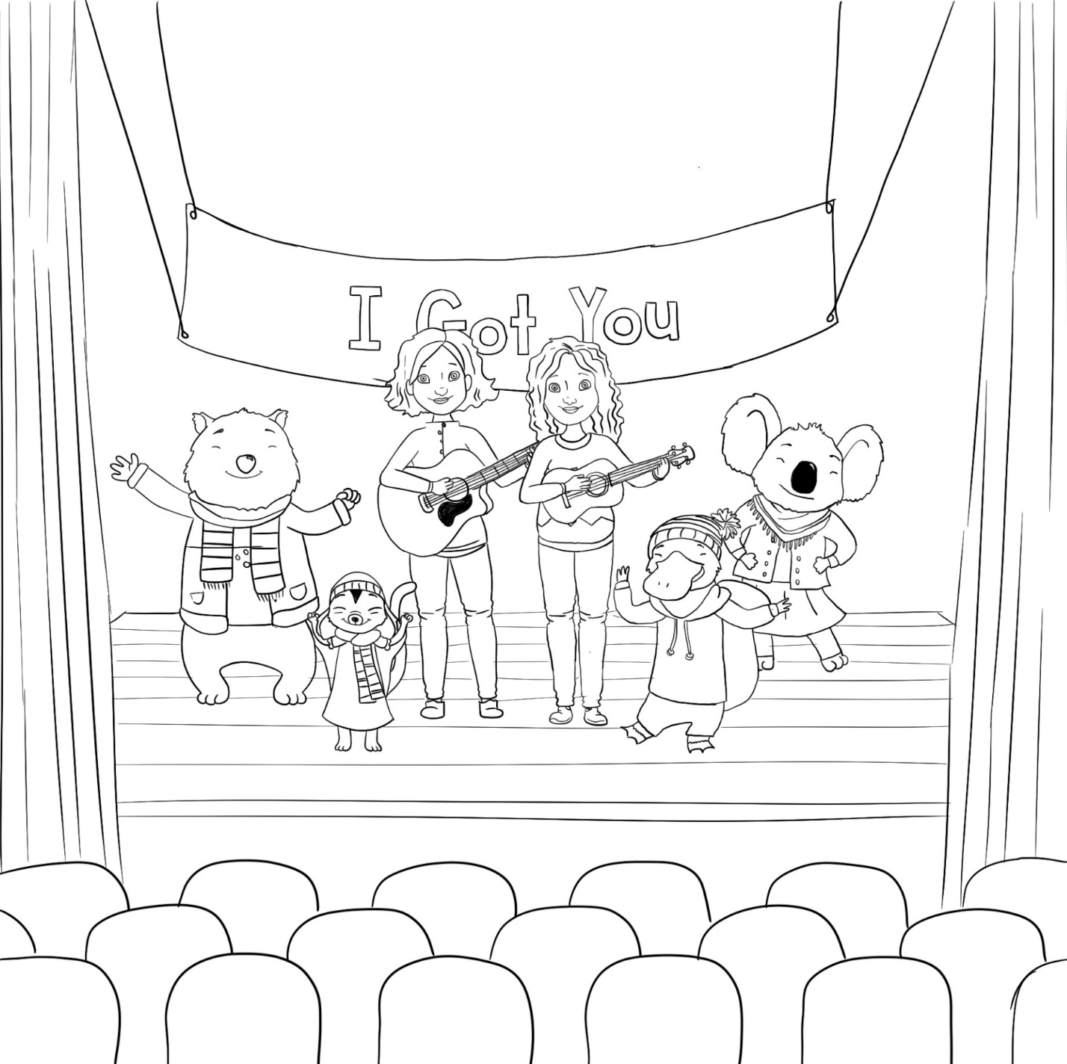

## Staying healthy activity

Using the words below, fill in the blank spaces to complete these sentences:

1. When I got my vaccine, I felt \_\_\_\_\_\_\_\_\_\_\_\_\_\_\_\_\_\_\_\_\_\_\_­.
2. Before eating, I need to wash my hands with soap and \_\_\_\_\_\_\_\_\_\_\_\_\_\_\_\_\_\_.
3. I should wash my hands for at least \_\_\_\_\_\_\_\_\_\_\_\_\_\_\_\_\_\_\_ seconds.
4. If I need to sneeze, I should do it into my \_\_\_\_\_\_\_\_\_\_\_\_\_\_\_\_\_\_\_\_\_\_\_.
5. \_\_\_\_\_\_\_\_\_\_\_\_\_\_\_\_\_\_\_ are little things that live inside people’s bodies. You can have good germs and bad germs.
6. If I catch a virus like COVID-19 or a cold, I need to stay at \_\_\_\_\_\_\_\_\_\_\_\_\_\_\_\_\_\_\_\_\_\_ and rest.
7. Making sure that I do not stand too \_\_\_\_\_\_\_\_\_\_\_\_\_\_\_\_\_\_\_\_\_\_ to people around me helps to keep us all \_\_\_\_\_\_\_\_\_\_\_\_\_\_\_\_\_\_\_\_\_\_.
8. It is better to play \_\_\_\_\_\_\_\_\_\_\_\_\_\_\_\_\_\_\_\_ than inside so that there is fresh air around us.
9. If I can’t wash my hands I can use \_\_\_\_\_\_\_\_\_\_\_\_\_\_\_\_\_\_\_\_ instead.
10. Protected
11. Water
12. 20
13. Elbow
14. Germs
15. Home
16. Close and healthy
17. Outside
18. Sanitiser

## Social media content

We invite you to share the below social media content to educate your community about keeping children protected against viral infections like COVID-19.

### Download social tiles here.

| **Post Copy** | **Post Image** |
| --- | --- |
| Teeny Tiny Stevies ‘I Got You’ 🎶 is all about reminding children and parents of the simple steps we can take to protect ourselves, and our community from COVID-19 and other viral infections.  Together we can slow the virus from spreading.  For more tips on staying healthy and safe visit <http://www.health.gov.au/health-alerts/covid-19/protect-yourself-and-others> | [www.health.gov.au/i-got-you-song](http://www.health.gov.au/i-got-you-song) |
| To slow the spread of COVID-19 and other viral infections, it’s important to wash your hands often for at least 20 seconds with soap and water or use hand sanitiser and avoid touching your eyes, nose and mouth.  For more tips on staying safe visit [www.health.gov.au/health-alerts/covid-19/protect-yourself-and-others](http://www.health.gov.au/health-alerts/covid-19/protect-yourself-and-others) |  |
| If you’re unwell, it’s best to stay home. 🤧 🏠  This helps slow the spread and protect ourselves and the vulnerable from viral infections like COVID-19.  By doing so, we protect not only ourselves and our community, but also help keep the pressure off our hospitals and health system.  For more tips on staying safe visit [www.health.gov.au/health-alerts/covid-19/protect-yourself-and-others](http://www.health.gov.au/health-alerts/covid-19/protect-yourself-and-others). |  |

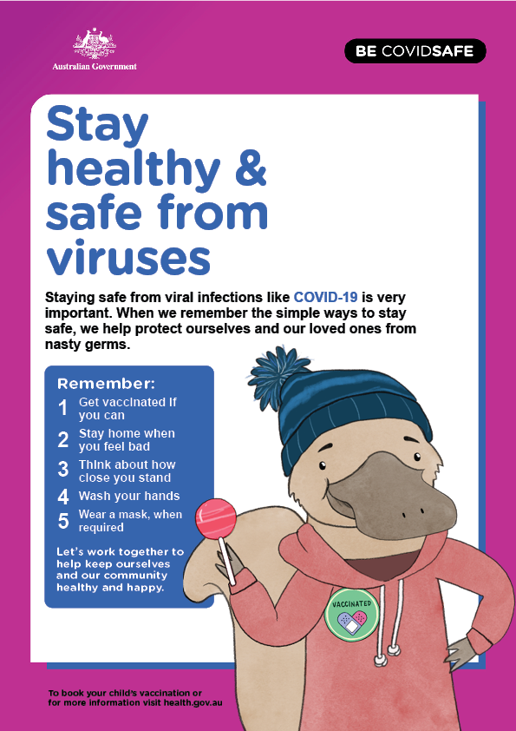

## Parent and guardian information

### Importance of childhood vaccination

Vaccinations are a simple, safe and effective way to protect children from serious preventable diseases.

Disease can also lead to serious complications, some of which may threaten children’s lives, which is why vaccination is a safer way to develop immunity.

The National Immunisation Program (NIP) provides free and essential vaccines to protect eligible people, including infants and children, against a range of diseases. The NIP provides routine childhood immunisations recommended for all children in Australia, free of charge.

The NIP schedule recommends certain vaccines for children at certain times, so it’s important not to skip or delay a vaccination so they can get the best possible protection.

To stay up to date with your child’s vaccinations, follow the NIP schedule and set a reminder to book your child’s next appointment.

The NIP covers the most serious childhood diseases, although some children may need extra vaccines. It’s important to speak to your doctor about your child’s health needs.

While COVID-19 vaccines are not part of the NIP, they are also available free of charge to people in Australia – even if you don’t have a Medicare card.

Speak to your GP or other health care provider about your child’s vaccinations.

### Vaccine safety

Vaccines are only made available in Australia after they have been rigorously tested, evaluated and approved by the Therapeutic Goods Administration to ensure they meet stringent safety and efficacy guidelines.

Vaccines continue to be tested after their introduction via additional clinical trials, surveillance and monitoring. Vaccines, like any other medicines, can have side effects. However, all vaccines used within Australia provide benefits which greatly outweigh their risks.

### Tips to protect your family against viruses

To help stay healthy and protected against viral infections like COVID-19 and the flu, keep the below checklist handy.

1. Get vaccinated, if you can

* Vaccination is the safest way to protect yourself and your family from viral infections like COVID-19.
* The influenza vaccine is safe, effective and free for children aged 6 months to under 5 years.
* All children aged 5 to 11 years are eligible to receive a free COVID-19 vaccine today.
* If your child is aged 5 years or older, they can receive a COVID-19 and a flu vaccination at the same time.
* Children aged 6 months to under 5 years who have a serious underlying health condition or disability can receive a free COVID-19 vaccine from 5 September 2022.
* If you or your child is afraid of needles, speak to your health care provider about what can be done to help.

1. Stay home when you feel bad

* If you are feeling unwell it is best to stay home.
* By doing so, you protect not only yourself and your community, but also help keep the pressure off our hospitals and health system.

1. Think about how close you stand

* Stay **1.5 metres** away from others wherever possible.
* Avoid physical greetings such as handshaking, hugs and kisses.
* If you have cold or flu-like symptoms you should get tested for COVID-19, even if your symptoms are mild.

1. Wash your hands

* Wash your hands often for at least 20 seconds with soap and water.
* Use alcohol-based hand sanitisers when you cannot use soap and water.
* Avoid touching your eyes, nose, and mouth.

1. Wear a mask, when required

* A mask stops you from breathing someone else’s breath and that is useful because it’s how germs spread – from person to person.
* Wash or sanitise your hands before putting it on or taking it off.
* Make sure it covers your nose and mouth and fits snugly under your chin.

### Fear of needles

If your child is afraid of needles, there are things you can do to help ease their nerves and improve their experience.

1. Let your health care provider know in advance if your child is afraid of needles so they can set aside enough time and make sure the process is not rushed or forced.
2. Speak to your health care provider about what can be done to help. Techniques like distraction or even preparing the vaccination area to numb the feeling of a needle can help.
3. It may help your child to attend a smaller, more familiar location, such as a local pharmacy or their usual GP’s office.
4. Bring along your child’s favourite toys or books to create a positive experience and distraction.

### Handy resources

**We have a range of tailored resources that you may find helpful:**

* [**Vaccine Clinic Finder**](https://covid-vaccine.healthdirect.gov.au/booking/): Head to the Vaccine Clinic Finder to find a clinic near you and book in your child’s vaccine appointments.
* [**Healthdirect Symptom Checker**](https://www.healthdirect.gov.au/symptom-checker/tool/basic-details): Use this tool to check if your symptoms relate to COVID-19 or the flu, get advice on the next health care steps to take, or to help you understand symptoms and possible signs of illness.
* [COVID-19 vaccine information for children, teens and parents/guardians](https://www.health.gov.au/resources/publications/covid-19-vaccine-information-for-children-teens-and-parentsguardians)
* [How to speak to kids about COVID-19 vaccines](https://www.health.gov.au/resources/publications/covid-19-vaccination-how-to-speak-to-kids-about-covid-19-vaccines" \t "_blank)
* [**COVID-19 vaccine information for people with disability and disability service providers:**](https://www.health.gov.au/initiatives-and-programs/covid-19-vaccines/disability-sector)Information about COVID-19 vaccines for people with disability and people who work in the disability sector.
* [**COVID-19 vaccination information for Aboriginal and Torres Strait Islander people:**](https://www.health.gov.au/initiatives-and-programs/covid-19-vaccines/indigenous)Information about how the vaccineprotects you, your family, elders and community from getting really sick with COVID-19, or even dying.
* [**COVID-19 vaccine information in your language:**](https://www.health.gov.au/initiatives-and-programs/covid-19-vaccines/covid-19-vaccine-information-in-your-language)Information about COVID-19 vaccines has been translated into multiple languages. Find information in your language on the Department of Health and Aged Care website.

## More information

For more information visit the Department of Health and Aged Care website at **www.health.gov.au**, or call the **National Coronavirus Helpline** on 1800 020 080, press 8 for **interpreting services**. The **Disability Gateway** on 1800 643 787 has   
information and services to help people with disability, their family and carers.