| Logo | **technical supplement** |
| --- | --- |

The Department of Health acknowledges the providers of the many sources of data used in this report and greatly appreciates their contribution.

# Update to NNDSS laboratory-confirmed influenza case definition

### Overview

From 01 January 2022, the National Notifiable Disease Surveillance System (NNDSS) case definition for laboratory-confirmed influenza was updated to remove Point 5 ‘Single high titre by complement fixation test (CFT) or haemagglutination inhibition (HAI) to influenza virus’ from the list of laboratory definitive evidence. Details of the updated case definition can be accessed here: [Australian national notifiable diseases case definitions - Influenza](https://www.health.gov.au/resources/publications/influenza-laboratory-confirmed-surveillance-case-definition)

The updated NNDSS laboratory-confirmed influenza case definition (Version 2.0) now aligns with the Public Health Laboratory Network (PHLN) national [influenza laboratory case definition](https://www.health.gov.au/resources/publications/influenza-laboratory-case-definition) for laboratory definitive criteria. The change follows careful review and consideration by the National Influenza Surveillance Committee, and endorsement by the Communicable Disease Public Health Laboratory Network (PHLN) and Communicable Diseases Network Australia (CDNA).

This technical supplement analyses the impact of this change in case definition and explains how data will be presented in influenza reports going forward.

### Impact of case definition update on interpreting NNDSS influenza notification trends

Single high titre by CFT or HAI to influenza virus is an uncommonly used influenza laboratory diagnostic method. Prior to 2020, of notifications where laboratory diagnostic method was reported to the NNDSS, the proportion of influenza notifications diagnosed using this method alone was low and on average accounted for 8% of annual notifications from 2016–2019 (Figure 1). In 2020 and 2021, this average proportion increased to 45% and 50%, respectively, and is largely due to a substantial decrease in the number of notifications diagnosed by other laboratory methods.

**Figure 1: Proportion of NNDSS laboratory-confirmed influenza notifications diagnosed by serology alone*, Australia, 01 January 2016 to 31 December 2021, by month and week of diagnosis.**

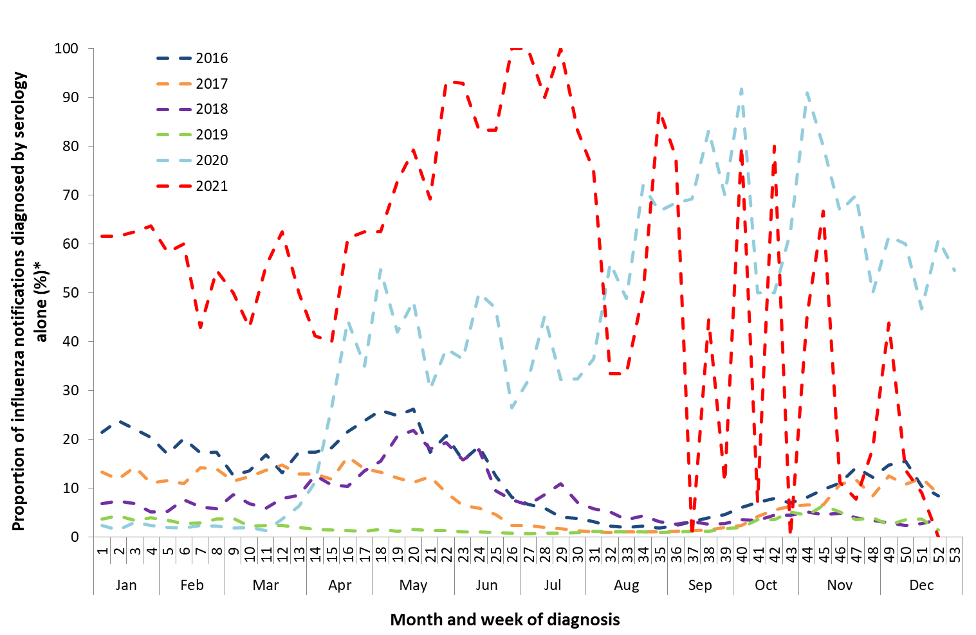

* Excludes influenza notifications where laboratory diagnostic method was unknown or not reported. Please note that this figure may include a negligible number of influenza notifications who were diagnosed by ‘IgG seroconversion or a significant increase in antibody level or a fourfold or greater rise in titre to influenza virus’.

Influenza notifications from 2016 to 2021 notified to NNDSS per the relevant case definition at the time (Version 1.1) are shown in Figure 2a, while Figure 2b illustrates these notifications if the updated case definition (Version 2.0) was retrospectively applied. While notifications diagnosed on serology alone in 2020 and 2021 accounted for a larger proportion of total notifications compared to previous years, excluding notifications diagnosed on serology alone does not substantially impact the overall trend of influenza notifications over time (Figure 3). The analyses below demonstrates the minimal impact of the updated case definition on interpreting and comparing historic influenza notifications trends, with notifications from 01 January 2022. The updated case definition (Version 2.0) implemented from 01 January 2022, will therefore not be retrospectively applied to notifications prior to this date. Reports that describe NNDSS data, including the [Australian Influenza Surveillance Report](https://health.gov.au/resources/collections/aisr), will continue to report on laboratory-confirmed influenza notifications as reported to the NNDSS per the case definition applicable at the time of notification.

**Figure 2a: Notifications of laboratory-confirmed influenza based on case definition Version 1.1, Australia, 01 January 2016 to 31 December 2021, by month and week of diagnosis** 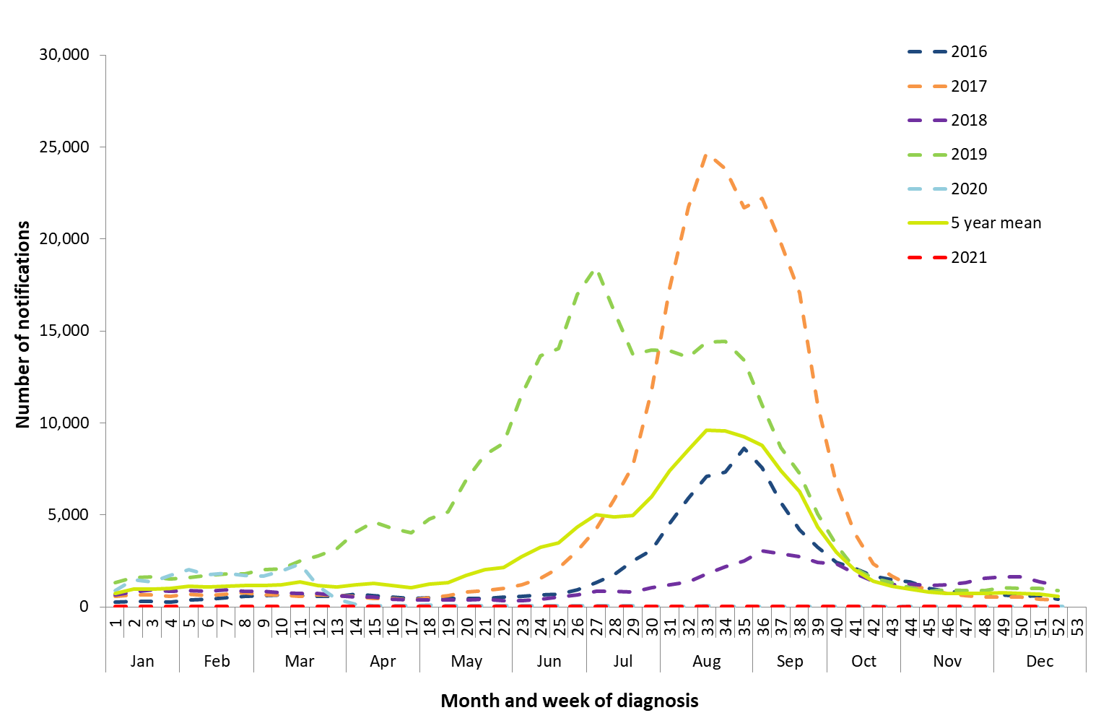

**Figure 2b: Notifications of laboratory-confirmed influenza based on case definition Version 2.0*, Australia, 01 January 2016 to 31 December 2021, by month and week of diagnosis**

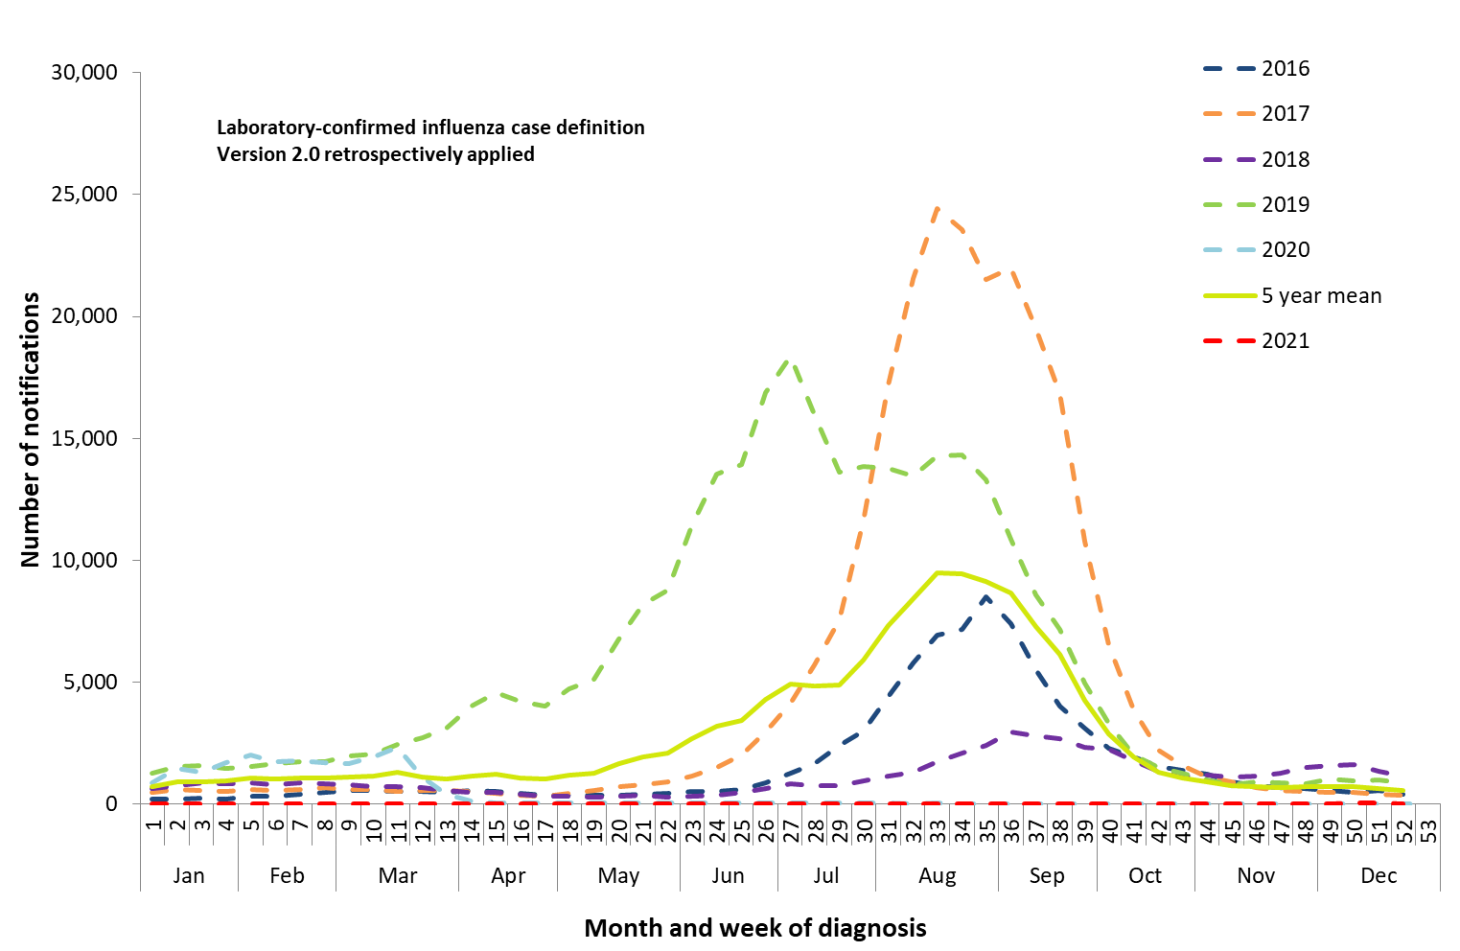

* Excludes influenza notifications where laboratory diagnostic method was unknown or not reported. Please note that this figure may include a negligible number of influenza notifications who were diagnosed by ‘IgG seroconversion or a significant increase in antibody level or a fourfold or greater rise in titre to influenza virus’.

**Figure 3: Notifications of laboratory-confirmed influenza based on case definition Version and 1.1 and Version 2.0*, Australia, 01 January 2020 to 31 December 2021, by month and week of diagnosis**

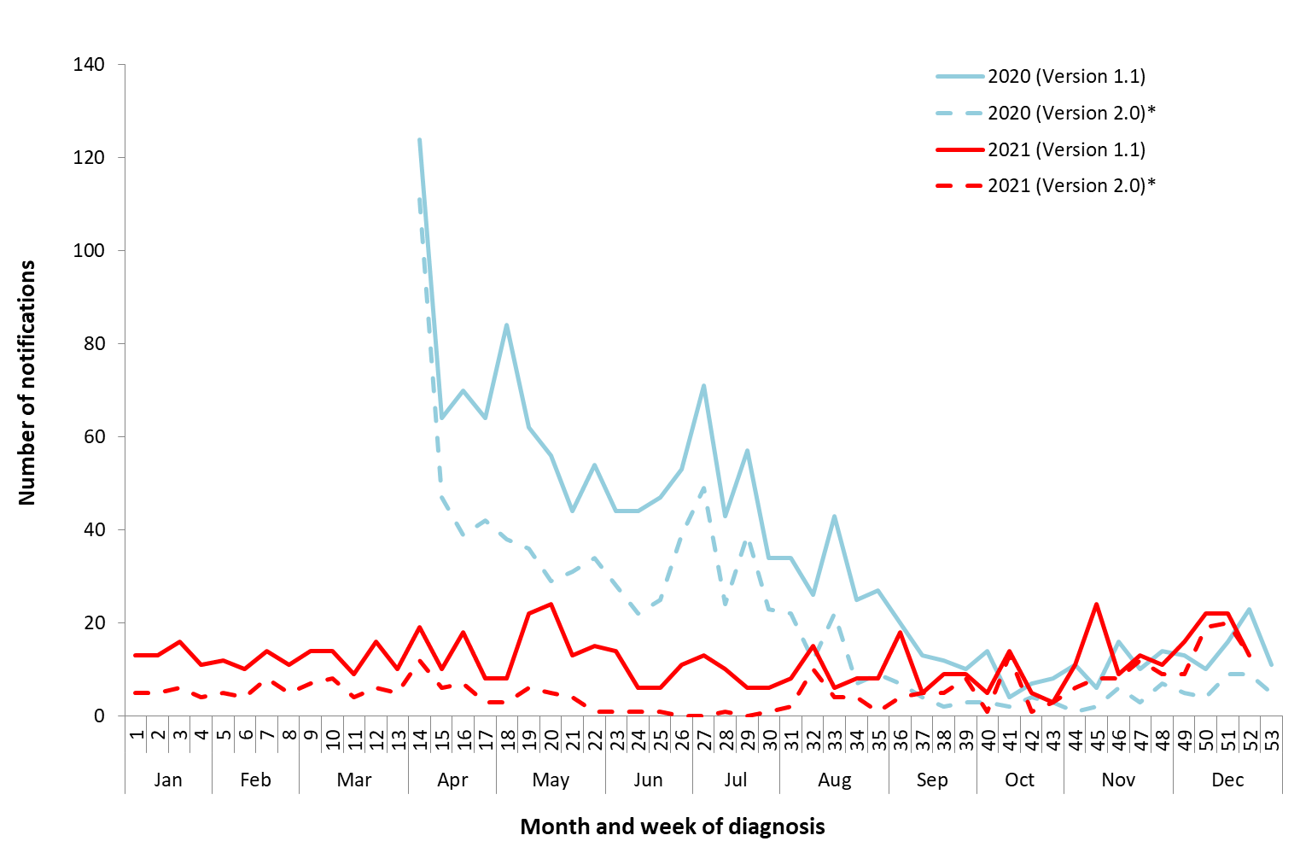

* Excludes influenza notifications with laboratory diagnosis ‘Single high titre by complement fixation test (CFT) or haemagglutination inhibition (HAI) to influenza virus’. Please note that this may include a negligible number of influenza notifications who were diagnosed by ‘IgG seroconversion or a significant increase in antibody level or a fourfold or greater rise in titre to influenza virus’.

For further details about information contained in this document please contact the [Influenza Surveillance Team](mailto:flu@health.gov.au) ([flu@health.gov.au](mailto:flu@health.gov.au)).