Scoping study on best practice multidisciplinary models of care in residential aged care homes

Summary

In 2021-22, the Department of Health (the ‘Department’) engaged HealthConsult to assess best practice multidisciplinary models of care to avoid preventable hospital admissions, emergency department (ED) presentations and/or readmissions (collectively referred to as ‘avoidable hospitalisations’) in residential aged care homes.

Their final report presents a proposed model of care that aims to improve resident health and wellbeing by integrating allied health professionals as a core part of a multidisciplinary approach to providing care in residential aged care homes. The role of allied health professionals in the model focuses on maintaining and improving resident function, and by doing so, preventing hospitalisations that may result in functional decline, psychological distress, and reduced quality of life for residents.

The evidence underpinning the proposed model of care responds to key research questions posed by the Department that focused on:

* **examining the factors influencing avoidable hospital encounters** for residential aged care residents
* **identifying and evaluating models implemented domestically and internationally** to reduce avoidable hospital encounters for residents
* **understanding the issues, opportunities and constraints associated with providing integrated, multidisciplinary care to residents** that draw on greater involvement of allied health expertise
* **identifying pragmatic, implementable (and ideally, scalable) strategies** that can be further developed and tested to reduce avoidable hospital encounters in residential aged care homes across Australia.

1. Key findings

The development of the proposed model of care has been underpinned by literature review, stakeholder consultation and data analysis. Key findings that have influenced the development of the model include that:

* **the key drivers of avoidable hospitalisation in residential aged care homes are falls and fall-related injuries, chronic cardiovascular disease, and chronic respiratory disease**.[1] Data analysis identified a range of individual and facility-level factors as being associated with variations in avoidable hospitalisation. However, these three reasons for hospitalisation have been adopted as focus points for the model to maximise its impact on improving resident health and wellbeing.
* **the level and breadth of allied health involvement in Australian residential aged care homes is limited**. Published research, stakeholder consultations and a survey of residential aged care homes all identified that physiotherapists are the allied health professionals most often used in residential aged care homes. However, even the levels of physiotherapist utilisation in Australian residential aged care homes are below international comparators.[2]
* **very little post-acute care is currently provided in residential aged care homes, which is likely to contribute to avoidable hospital readmissions**. Analysis of the Registry of Senior Australian (ROSA) data set identified that only 0.43% of residents in care between 2014 to 2016 accessed in-hospital rehabilitation. The residential aged care homes survey indicated that 41% of respondents did not have post-acute care programs in place. This was corroborated by the grey literature, where post-acute care was found in three out of the eight Australian models that were identified (38%). Few residential aged care homes that were consulted identified formalised post-acute care arrangements for residents.
* **there is little research, and consequently evidence, demonstrating the inclusion of allied health services within multidisciplinary models of care for residents to reduce hospitalisations**. The evidence generally focuses on wellbeing and quality of life rather than avoiding hospitalisation.[3] Grey and published literature only identified a few multidisciplinary models of care in residential aged care homes where the primary outcome was to reduce hospital admissions. Most of the identified models involved nursing and medical professionals. Other key health outcomes included across the identified studies were quality of life, physical activity/mobility, mood/depression, and activities of daily living. A stronger focus on wellbeing and quality of life is consistent with the recommendations made by the Royal Commission.[4] Focusing on wellbeing and quality of life outcomes may therefore help to achieve greater uptake of multidisciplinary models of care involving allied health.
* **preventing functional decline, early intervention and restoration of function were proposed as key areas for allied health interventions to reduce avoidable hospitalisations in residential aged care homes**.[5] Both the literature and stakeholder consultations acknowledged that maintaining and improving function and quality of life are key outcomes in the context of residential aged care residents, who usually have high levels of comorbidities and functional impairment. Stakeholders strongly supported the important role allied health professionals can play in maintaining the functional ability to prevent hospitalisation. They also acknowledged that there are significant opportunities for allied health involvement to reduce the risk of falls and fall-related injuries.
* **while ongoing access to allied health care is required to have a meaningful impact on resident function and quality of life, it is recognised that it is often challenging for residents to access regular, ongoing allied health care**. The residential aged care homes survey and consultations highlighted that the difficulties in accessing allied health professionals in residential aged care homes were commonly due to funding constraints, workforce issues and limited understanding of the value of allied health within residential aged care homes. Flexibility within the model of care has been embedded to support access to allied health professionals for residential aged care homes in different locations, including consideration of service delivery modalities such as telehealth in areas where workforce access is challenging.

1. Proposed model of care

Figure 1 provides an overview of the model of care. Key characteristics of the proposed model include:

* **a focus on addressing the top three drivers of avoidable hospitalisation in residential aged care homes**:
* falls and fall-related injuries
* chronic respiratory disease, and
* chronic cardiovascular disease.
* **providing care through a ‘streamed’ approach** that includes:
* **an ‘enablement/restorative stream’** that provides a base level of care from nurses, core allied health professionals (physiotherapists, dietitians, pharmacists and social workers) and other residential aged care staff (including personal care workers, lifestyle officers and other staff) that is focused on improving resident wellbeing by maintaining and improving function. The enablement/restorative stream would also provide additional care to support functional improvement, in response to the assessed need (including from occupational therapists, speech pathologists, podiatrists and exercise physiologists).
* **a ‘post-acute care stream’** that seeks to address a gap in current care availability for residents after a hospital stay or ED presentation. The post-acute care stream would provide additional, tailored allied health interventions (in addition to baseline care) through a multidisciplinary approach to restore function and wellbeing.
* **embedding a dedicated Care Coordinator role(s) within each residential aged care home** that would lead the multidisciplinary team and be responsible for assessment and coordinating resources to respond to resident needs. The Care Coordinator would be a nurse or allied health professional skilled in aged care, provide a central point to integrate the multidisciplinary team with residential aged care home operations, and ensure effective coordination of the multidisciplinary team with other health professionals, such as GPs and specialists, to support an integrated approach to care.
* **a focus on resident needs through assessment** upon entry to residential care and regular monitoring and re-assessment against care goals by the multidisciplinary team.
* **building the capacity of (clinical and non-clinical) residential aged care home staff** through by integrating tightly with residential aged care homes operations and delivering additional support by delivering education, developing guidelines and conducting regular case review meetings.
* **flexibility** for the model to work successfully across different types of residential aged care homes settings and locations. The proposed model prescribes only those professions that are needed for it to succeed, and how members of the multidisciplinary team would work together to achieve its objectives. Residential aged care homes would engage members of the multidisciplinary team in a way that will work best for them (i.e., on an employed or contracted basis); could deliver services using Allied Health Assistants where appropriate (under the direction of an appropriately qualified allied health professional) and would be encouraged to use telehealth as a service delivery modality where appropriate.

Figure 1: Overview of the proposed model of care

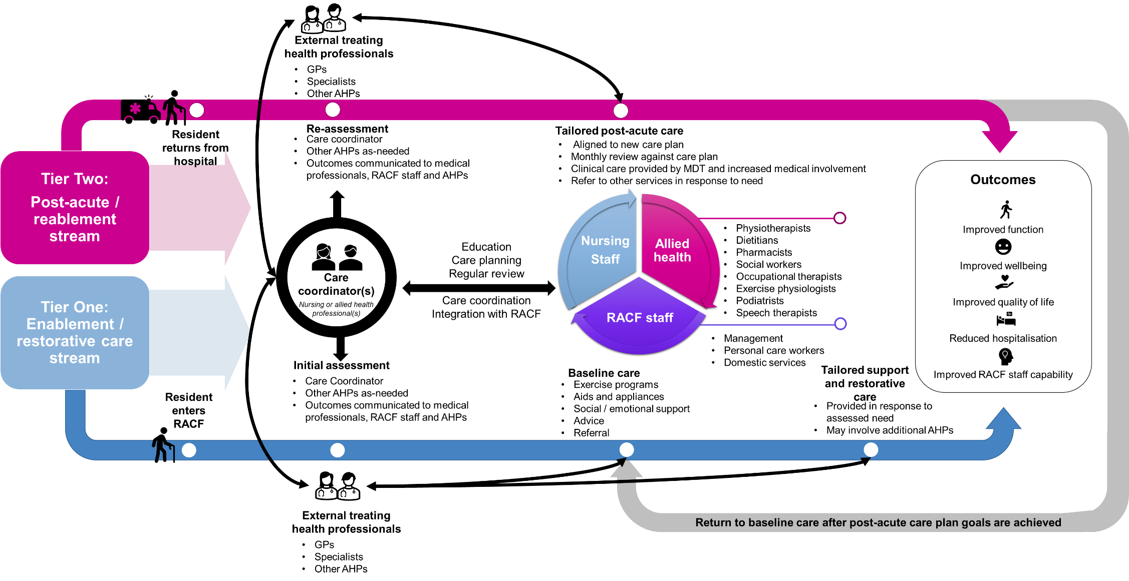

AHP = allied health professional

MDT = multidisciplinary team

RACF = residential aged care home or facility

Table 1 summarises how the model would operate across the enablement/restorative and post-acute care streams.

Table 1: Summary of the proposed model of care, by stream

| Characteristic | Enablement/restorative care stream | Post-acute care stream |
| --- | --- | --- |
| Focus | * To provide residents with a baseline level of care that focuses on maintaining and improving function through assessment; care coordination; care planning; clinical care; and a regular six-monthly review. | * To restore function and wellbeing upon re-entry to the residential aged care home following a hospital admission or ED presentation through assessment; care coordination; updated care planning; and clinical care. |
| Approach | * Provide a base level of care for all residents from physiotherapists, dietitians, social workers and pharmacists. Baseline care is focused on improving function by embedding greater allied health involvement into ongoing activities and care. * Provide tailored allied health support and restorative care to address specific risks related to falls and fall-related injuries and chronic diseases that may be identified during assessment (including occupational therapists, speech pathologists, podiatrists and exercise physiologists). | * Provide increased on-site allied health care to residents after hospitalisations due to fall-related injuries or chronic respiratory or cardiovascular disease. * Provide timely referral to specialists and other health professionals. * Provide tailored interventions in response to- post-acute events would be tailored to individual needs. |
| Assessment | * Conducted upon each resident’s entry to a residential aged care home. * Supported by a checklist that would ensure Care Coordinators consider whether additional care needs above the ‘baseline’ level exist that require tailored care from specific allied health professions. * Would draw on information provided by other existing assessment processes. | * Conducted within 24 hours of return to the residential aged care home post-hospital admission or ED presentation (ideally) - but no longer than seven days after. * Led by the Care Coordinator and involving an allied health professional (physiotherapist or occupational therapist). |
| Care coordination | * The Care Coordinator would be responsible for: * coordinating assessments and clinical resources under the model * managing care plans and ensuring they are up to date * liaising with the facility manager to ensure an adequate amount and type of allied health care is available to meet resident needs * trigger a GP/geriatrician referral for chronic disease needs and overall care. | * For the Post-Acute Care stream, the Care Coordinator would be responsible for the same tasks as the enablement/restorative care stream, plus: * liaising with the facility manager to ensure an adequate amount and type of allied health care is available to meet resident needs post-hospitalisation * liaising with the resident’s geriatrician, rehabilitation physician (or specialist dedicated to clinical care) for rehabilitation monitoring and funded case conferencing coordination with the multidisciplinary team * trigger a GP/geriatrician/specialist medical practitioner referral for pain management that would be managed in conjunction with the resident’s GP * ensure timely access to discharge summaries and hospital handover notes. |
| Care planning | * Led by the Care Coordinator. Other allied health professionals would be included where specific expertise is identified as being required. * Individual care planning would be supported by regular meetings between the Facility Manager(s)/Unit Manager(s), the Care Coordinator(s) and allied health professionals engaged under the model to review and plan for resident needs. | * The resident’s original care plan (completed upon entry to the residential aged care home) or the most recent updated review would be revised by the multidisciplinary team based on the outcomes of the re-assessment (post-hospitalisation / ED presentation). New goals and interventions would be established (as necessary) and communicated to relevant care providers (medical, nursing and/or allied health), via the Care Coordinator. * Reviews against the care plan would be conducted monthly until reablement goals are achieved, then six-monthly thereafter (in line with the enablement/restorative stream review period). |
| Clinical care | * Baseline clinical care would be provided by a multidisciplinary team that includes professionals qualified in physiotherapy, social work, pharmacy, and dietetics. A minimum amount of these services would be embedded into each resident’s care plan to improve wellbeing, function and other domains of health that may reduce avoidable hospitalisations. * Additional, tailored care may be provided by occupational therapists, exercise physiologists, podiatrists, or speech pathologists in response to identified need. Other allied health professionals may be contracted to deliver specific services (such as optometry, or orthotics and prosthetics). | * Post-Acute Care would be provided by a multidisciplinary team that would be tailored to the resident’s needs. This may include professionals involved in the delivery of baseline care (i.e. physiotherapy, dietetics, social work, pharmacy), but may also involve additional clinical care and allied health services (e.g. exercise physiology, occupational therapy, podiatry, or speech pathology). * Increased involvement of medical professionals (particularly GPs, rehabilitation specialists or geriatricians) is likely to be required during the post-acute phase and would be led by the Care Coordinator. |

1. Royal Commission into Aged Care Quality and Safety, Research Paper 18 (Hospitalisations in Australian Aged Care: 2014/15-2018/19).
2. Brett, L. Noblet, T, Jorgensen, M. and Georgiou, A. (2019). ‘The use of physiotherapy in nursing homes internationally: A systematic review’. PLoS ONE 14(7): e0219488.
3. Hamel C, Garritty C, Hersi M, Butler C, Esmaeilisaraji L, Rice D, et al. (2021). ‘Models of provider care in long-term care: A rapid scoping review’. PLoS ONE 16(7): e0254527.
4. Royal Commission into Aged Care Quality and Safety. (2019). Draft proposition – Allied Health.
5. Royal Commission into Aged Care Quality and Safety. (2019). Draft proposition – Allied Health.