Health Care Assistance Fund

# **Factsheet – Making a claim to the HCAF**

## Australian Thalidomide Survivors Support Program

The information provided in this factsheet is for thalidomide survivors registered with the Australian Thalidomide Survivors Support Program (the Program)

This factsheet provides information about how to make a claim to the Health Care Assistant Fund (HCAF).

## About the Program

The Program is an Australian Government program aimed at providing financial support to Australian thalidomide survivors. The Program includes a HCAF and an Extraordinary Assistance Fund (EAF) which provides health, medical and daily living support to eligible Australian thalidomide survivors.

## What is the Health Care Assistance Fund (HCAF)?

The HCAF is intended to cover the out-of-pocket health care expenses incurred in Australia that are likely associated with thalidomide‑related injuries. This may include:

* health products and consumables;
* out-of-pocket pharmaceutical costs;
* out-of-pocket health service costs, including medical, surgical and allied health; and
* health-related travel and transport costs.

The HCAF is intended to cover out-of-pocket health care expenses, including those which are not covered, or are only partially covered, by Medicare, the Pharmaceutical Benefits Scheme (PBS) and/or any other relevant Australian, state or territory government schemes; or private health insurance.

Further information about the goods and/or services that are eligible or ineligible to be claimed under the HCAF is available in the Factsheet – HCAF support categories.

For information about the support available to help cover the costs of goods and/or services to assist with activities of daily living, please refer to Factsheet ‑ Making a claim to the EAF and Factsheet – EAF support categories.

## Eligibility requirements

To claim for support through HCAF or the EAF, you must be:

* a Australian thalidomide survivor;
* registered with the Program;
* eligible for Medicare entitlements;
* an Australian resident.

Registered Australian survivors who have resided overseas for greater than 12 months, are ineligible to access the EAF or HCAF, until they return to reside in Australia.

Support through the HCAF is available for eligible thalidomide survivors only. The estates or carers of thalidomide survivors are not eligible to access support under the HCAF.

## HCAF claim process

The following information is required to support each claim under the HCAF:

* evidence from a health care practitioner registered in one of the 15 health care professions regulated by a national board clearly stating that the goods and/or services are required as a likely consequence of thalidomide injuries;
* information about any reimbursement or subsidy that you have sought from Medicare, the Pharmaceutical benefits Scheme (PBS), the National Disability Insurance Scheme (NDIS) and/or other relevant Australian, state or territory government schemes; or private insurance, where appropriate; and
* documentation that details the goods and/or service being claimed, cost and payment status.

In some circumstance you will be required to seek pre-approval of an anticipated claim. The table below outlines which HCAF claims require pre-approval.

Table 1: HCAF claims that require pre-approval

|  |  |  |  |
| --- | --- | --- | --- |
| Claim Type | Payment Type | Value of goods and/or service being claimed | Is pre-approval required |
| Claim Type 1 | Reimbursement to you (eligible survivor) | Under $5,000 (GST incl) | No |
| Claim Type 2 | Reimbursement to you (eligible survivor) | Over $5,000 (GST incl) | Yes |
| Claim Type 3 | Payment to a third party (supplier/provider) | Goods and/or services of **ANY** value | Yes |

If you would like assurance that a claim will be approved through either the EAF or the HCAF, you may wish to seek pre-approval, irrespective of the anticipated value of the goods and/or services.

## HCAF – Further information

The Extraordinary Assistance Fund (EAF) and Health Care Assistance Fund (HCAF) - Program Guidelines provide further information about:

* eligibility to the HCAF;
* making a claim under the HCAF;
* the requirements for pre-approval of an HCAF claim;
* supporting documentation; and
* the goods and/or services eligible to be claimed under the HCAF, including guidance for complex claims (such as private health care costs, and support for travel and accommodation).

## Steps to make a claim

Claim Type – Reimbursement to you (eligible survivor) – UNDER $5,000 (GST incl)

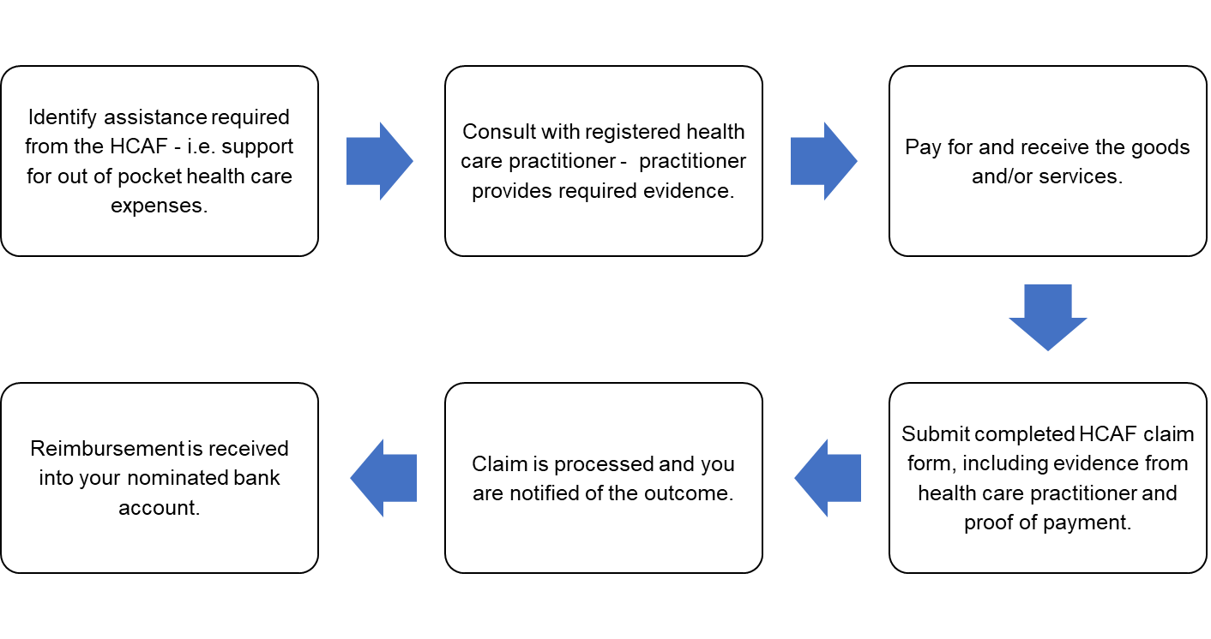

Claim Type – Reimbursement to you (eligible survivor) – OVER $5,000 (GST incl)

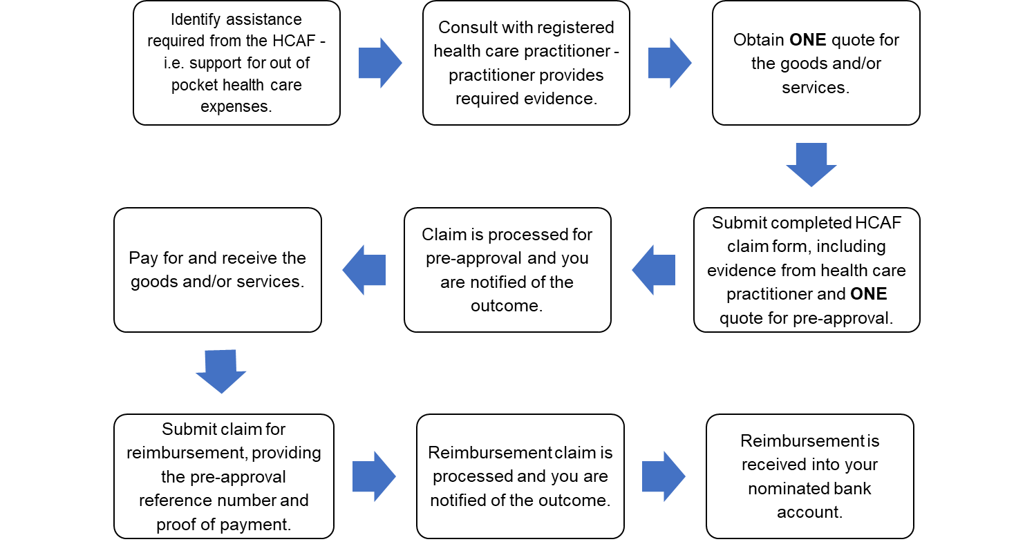

Claim Type – Payment to a third party (supplier/provider) – ANY value

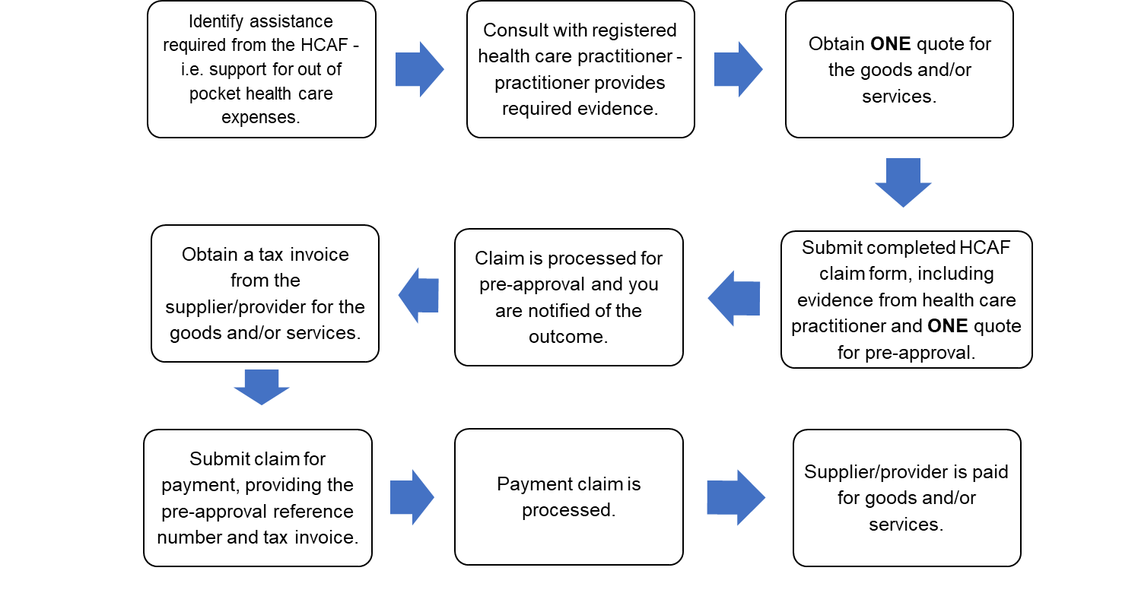

# How can I get more information?

## Thalidomide Support Service

For queries about the HCAF or EAF, including how to make a claim, or for general queries concerning the Program, you can contact the Thalidomide Support Service by calling 1800 643 787 or via email at [thalidomide.support@benevolent.org.au](mailto:thalidomide.support@benevolent.org.au).

For further information about the Thalidomide Support Service, please visit the Thalidomide Support Service website at: www.benevolent.org.au/thalidomidesupportservice.

## Services Australia

Information about the HCAF or the EAF, including how to make a claim, can also be found on the Services Australia website at [www.servicesaustralia.gov.au/thalidomide](http://www.servicesaustralia.gov.au/thalidomide).

Alternatively, for more information, you can call Services Australia on 1800 565 863 or email at [thalidomide.claims@servicesaustralia.gov.au](mailto:thalidomide.claims@servicesaustralia.gov.au).

## Australian Thalidomide Survivors Support Program

General information about the Program can be found on the Department of Health and Aged Care website at [www.health.gov.au/initiatives-and-programs/australian-thalidomide-survivors-support-program](http://www.health.gov.au/initiatives-and-programs/australian-thalidomide-survivors-support-program).