Extraordinary Assistance Fund (EAF)

# **Factsheet – Making a claim to the EAF**

## Australian Thalidomide Survivors Support Program

The information provided in this factsheet is for thalidomide survivors registered with the Australian Thalidomide Survivors Support Program (the Program)

This factsheet provides information about how to make a claim to the Extraordinary Assistance Fund (EAF).

## About the Program

The Program is an Australian Government program aimed at providing financial support to Australian thalidomide survivors. The Program includes a Health Care Assistance Fund (HCAF) and an EAF which provides health, medical and daily living support to eligible Australian thalidomide survivors.

## What is the Extraordinary Assistance Fund (EAF)?

The EAF is intended to help cover the costs of goods and/or services supplied and received in Australia, to assist with activities of daily living, impacted as a likely consequence of thalidomide-related injuries. This may include:

* assistance with personal domestic activities and self-care activities;
* personal aids and appliances, such as wheelchairs, scooters and hoists;
* assistive technology, such as household aids and appliances, and computer software;
* vehicle modifications, such as accessories/adaptations for driver control, car access lifter/hoist; and
* home modifications, such as necessary renovations/installations, slip resistant coatings, grab and/or guide rails and ramps.

The EAF is intended to cover costs that you are not eligible to receive support for through existing mechanisms and schemes, such as the National Disability Insurance Scheme (NDIS) and/or any other relevant Australian, state or territory government schemes, or private insurance.

Further information about the goods and/or services that are eligible or ineligible to be claimed under the EAF is available in the Factsheet – EAF support categories.

For information about the support available to help cover out of pocket health care expenses, please refer to [Factsheet ‑ Making a claim to the HCAF](https://www.health.gov.au/resources/publications/making-a-claim-to-the-hcaf-fact-sheet) and [Factsheet – HCAF support categories](https://www.health.gov.au/resources/publications/hcaf-support-categories-fact-sheet).

## Eligibility requirements

To claim for support through the EAF or the HCAF, you must be:

* an Australian thalidomide survivor;
* registered with the Program;
* eligible for Medicare entitlements; and
* an Australian resident.

Registered Australian survivors who have resided overseas for greater than 12 months, are ineligible to access the EAF or HCAF, until they return to reside in Australia.

Support through the EAF is available for eligible thalidomide survivors only. The estates or carers of thalidomide survivors are not eligible to access support under the EAF*.*

## EAF claim process

The following information is required to support each claim under the EAF:

* evidence from a health care practitioner registered in one of the 15 health care professions regulated by a national board, clearly stating that the goods and/or services are required as a likely consequence of thalidomide injuries;
* information about any reimbursement or subsidy that you have sought from Medicare, the National Disability Insurance Scheme (NDIS) and/or other relevant Australian, state or territory government schemes; or private insurance, where appropriate; and
* documentation that details the goods and/or service being claimed, cost and payment status.

In some circumstance you will be required to seek pre-approval of an anticipated claim. The table below outlines which EAF claims require pre-approval.

Table 1: EAF claims that require pre-approval

|  |  |  |  |
| --- | --- | --- | --- |
| Claim Type | Payment Type | Value of goods and/or service being claimed | Is pre-approval required |
| Claim Type 1 | Reimbursement to you (eligible survivor) | Under $10,000 (GST incl) | No |
| Claim Type 2 | Reimbursement to you (eligible survivor) | Over $10,000 (GST incl) | Yes |
| Claim Type 3 | Payment to a third party (supplier/provider) | Goods and/or services of **ANY** value | Yes |

If you would like assurance that a claim will be approved through either the EAF or the HCAF, you may wish to seek pre-approval, irrespective of the anticipated value of the goods and/or services.

## EAF – Further information

The Extraordinary Assistance Fund (EAF) and Health Care Assistance Fund (HCAF) - Program Guidelines provide further information about:

* eligibility to the EAF;
* making a claim under the EAF;
* the requirements for pre-approval of an EAF claim;
* supporting documentation; and
* the goods and/or services eligible to be claimed under the EAF, including guidance for complex claims (such as home and vehicle modifications).

## Steps to make a claim

Claim Type – Reimbursement to you (eligible survivor) – UNDER $10,000 (GST incl)

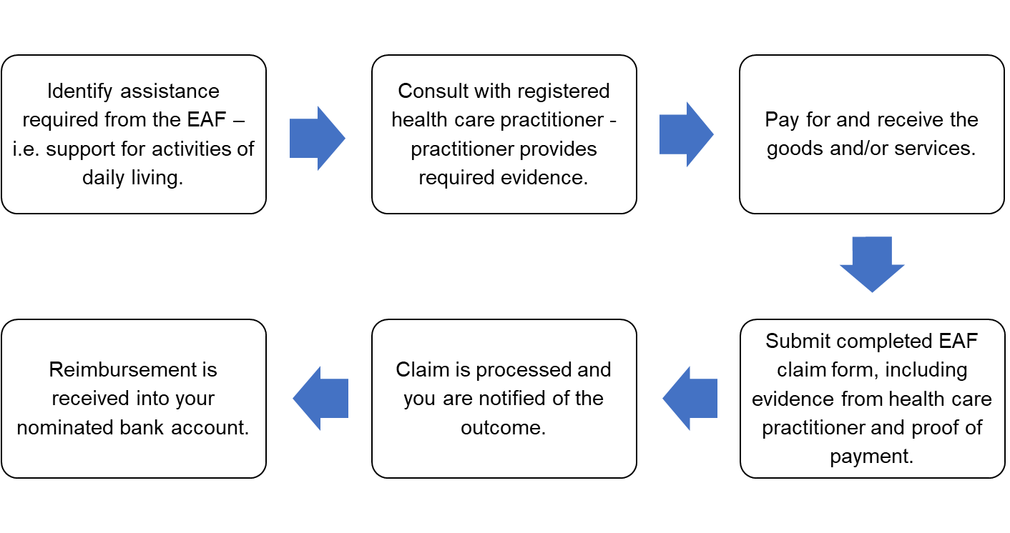

Claim Type – Reimbursement to you (eligible survivor) – OVER $10,000 (GST incl)

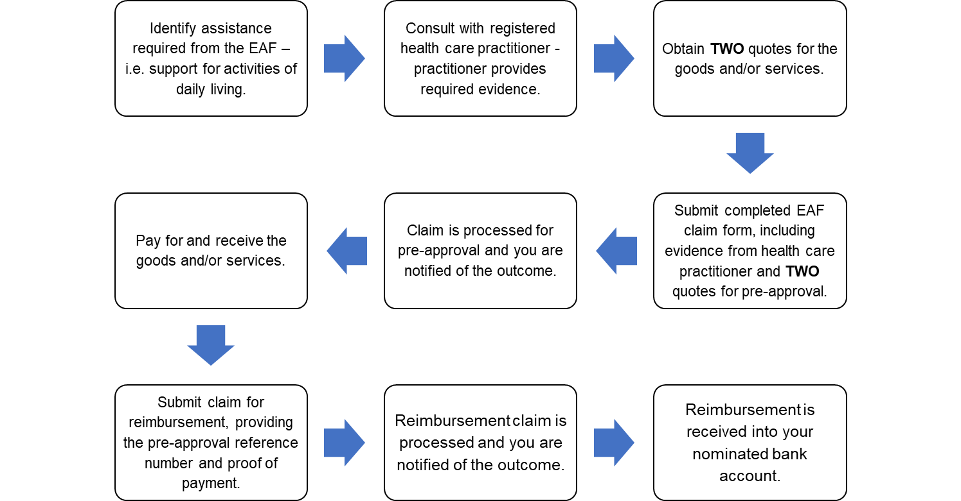

Claim Type – Payment to a third party (supplier/provider) – ANY value

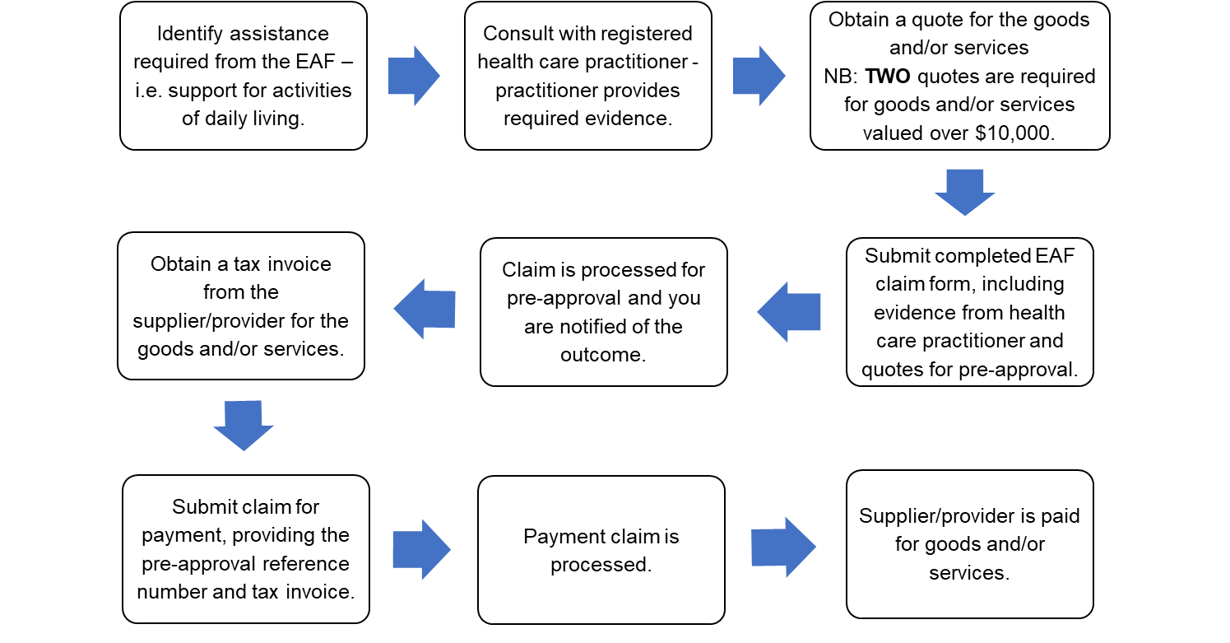

# How can I get more information?

## Thalidomide Support Service

For queries about the EAF or HCAF, including how to make a claim, or for general queries concerning the Program, you can contact the Thalidomide Support Service by calling 1800 643 787 or via email at [thalidomide.support@benevolent.org.au](mailto:thalidomide.support@benevolent.org.au).

For further information about the Thalidomide Support Service, please visit the Thalidomide Support Service website at: www.benevolent.org.au/thalidomidesupportservice.

## Services Australia

Information about the EAF or the HCAF, including how to make a claim, can also be found on the Services Australia website at [www.servicesaustralia.gov.au/thalidomide](http://www.servicesaustralia.gov.au/thalidomide).

Alternatively, for more information, you can call Services Australia on 1800 565 863 or email at [thalidomide.claims@servicesaustralia.gov.au](mailto:thalidomide.claims@servicesaustralia.gov.au).

## Australian Thalidomide Survivors Support Program

General information about the Program can be found on the Department of Health and Aged Care website at [www.health.gov.au/initiatives-and-programs/australian-thalidomide-survivors-support-program](http://www.health.gov.au/initiatives-and-programs/australian-thalidomide-survivors-support-program).