Home Care Packages Program − helping you understand costs

August 2022

This fact sheet provides information about assessing value for money in Home Care Packages (HCP).

****Background****

The HCP Program supports people with complex care needs to live independently in their own homes. This factsheet can help care recipients and the public understand package costs and get the best value for money.

It draws on relevant findings from the first Home Care Packages Program Assurance Review – Indirect and care management charges.

Use the provider comparison tool available at [www.myagedcare.gov.au/find-a-provider/compare](http://www.myagedcare.gov.au/find-a-provider/compare) to compare provider costs.

Pricing transparency

* Providers must disclose information about all HCP charges in the care recipient’s Home Care Agreement.
* If this information is not available or there is not enough detail, ask your provider to send you more detailed pricing information.
* The department [publishes the national median prices for common home care services, care management and package management](https://www.health.gov.au/resources/collections/national-summary-of-home-care-prices). It’s a good idea to check this guide when reviewing your HCP charges.

Review your mothly statement

Your monthly statement is an important tool to help you assess value for money.

* A Consumer Guidance document: [Consumer Guidance – Understanding your Home Care Package](https://www.health.gov.au/resources/publications/consumer-guidance-understanding-your-home-care-package-statement) is available to support you to make informed choices on how best to use your HCP funds and to understand your monthly statements.
* Your statement must list the details and charges of each good and service received so you know how your HCP funds are being spent.
* It must also include your Home Care Account Balance, unspent fund amount held by the provider, and fees paid.
* If you have questions about charges in your monthly statement, or don’t have enough visibility of HCP charges in your monthly statements, ask your provider for more information.

****Ensure a like-for-like comparision of different providers’ charges****

* Charges may appear to be similar across providers, but what you get for the price may differ. For example, some providers charge an all-inclusive rate while others may have additional charges which are less obvious.
* To make well-informed choices try and make a like-for-like comparison. Our [provider comparison tool](https://www.myagedcare.gov.au/find-a-provider/compare) can help.

Third party sourcing and invoice processing charges​

* Check if you are being charged for having your preferred provider deliver goods or services. If so, it’s important you understand how these charges are calculated, and if they are capped or not.
  + For example, a 10% surcharge on a $2 good or service may be reasonable (20c surcharge), while the same charge applied to $2,000 ($200 surcharge) may not.
* If you are changing providers, or finding a provider for the first time, make sure to assess these charges carefully before you sign your Home Care Agreement. ​

Staff travel ​

* Staff travel charges (where a HCP staff member travels without you to your HCP address) vary widely. Ask your provider for clarification if you are unsure how these charges are calculated and whether these are capped or not.

Care management​

* Care management is a key part of every HCP. It includes reviewing your Home Care Agreement and care plan, coordinating and scheduling care and services, ensuring care and services are aligned with other supports, liaising with the care recipient and the care recipient’s representatives, ensuring that care and services are culturally appropriate, and identifying and addressing risks to the care recipient’s safety.
* Even if your provider is charging you $0 for care management, your provider still needs to provide care management support. This also applies if you are a self-managed care recipient.
* Make sure you understand what your provider supplies under care management and ask for further detail if you’re unsure.

Package management​

* Package management is the ongoing administration and organisational activities associated with delivery and management of your HCP. If you have concerns over what’s being charged and/or delivered under package management, speak to your provider and get them to clarify.

Excluded items under the HCP Program​

* Providers must only charge for goods and services that are approved under the   
  HCP Program. They cannot pay for living expenses through HCP funds.
* Ask your provider if you are unsure of any charges.

Dissatisfied with provider pricing transparency?

* Every provider must have a free complaints process in place. Start by speaking to your provider about your pricing transparency concerns.
* If you have concerns about your provider’s pricing information, or the types of things being charged for, you can complain to the Australian Competition and Consumer Commission.

[Australian Competition and Consumer Commission](https://www.accc.gov.au/consumers/complaints-problems) - 1300 302 502 or via the [enquiry form.](https://www.accc.gov.au/contact-us/contact-the-accc/make-an-enquiry)

* If you are concerned about the quality of care and services you receive, you can complain to the Aged Care Quality and Safety Commission.

[Aged Care Quality and Safety Commission](mailto:Aged%20Care%20Quality%20and%20Safety%20Commission) - 1800 951 822 or [info@agedcarequality.gov.au](mailto:info@agedcarequality.gov.au).

How to compare HCP provider charges

* Go to the [My Aged Care website](https://www.myagedcare.gov.au/)
* In the top menu, click on the arrow next to 'Find a provider' and choose ['Search for a provider'](https://www.myagedcare.gov.au/find-a-provider/).
* Enter the location



* Enter the details in the 'Care type' and 'Services'. (You can click 'More…' and enter a provider name if you would like).

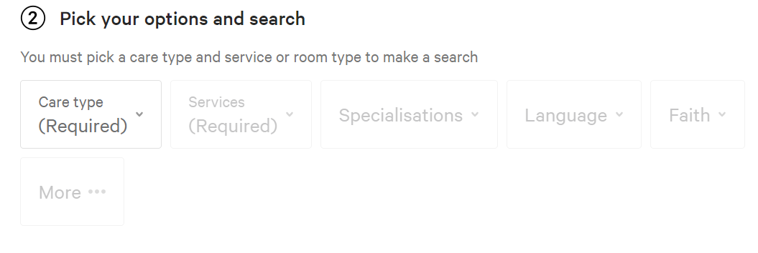

* Click the blue 'Search' button
* Scroll down to locate the provider/s
* Click on the '+ Compare' button next to the blue 'View Provider' button underneath the providers you want to compare



* After you have selected the providers you want to compare, go to the 'Compare providers' button (which will also show the number of providers you have chosen to compare). This will be located at the beginning of the search results

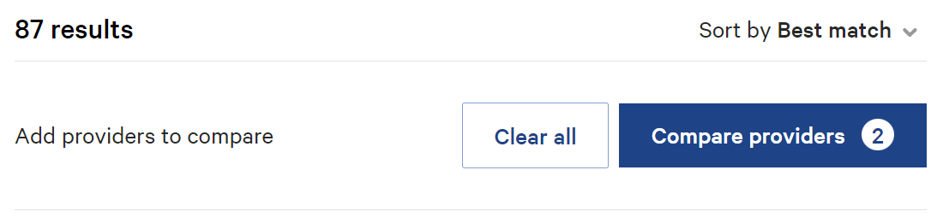

* This will take you to the 'Compare Home Care Packages' webpage.   
  In each 'Choose box' click on each provider you want to compare



* Scroll down to view and compare charges across your chosen providers.