# AUSTRALIAN CAPITAL TERRITORY

1. KEY FACTS AND FIGURES

This document provides a profile of how each PHN has implemented the NPS-M and CoS programs.

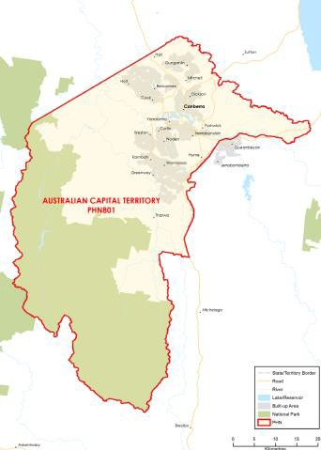

### FUNDING[1] AND PARTICIPANT[2] LEVELS

#### Funding ($M):

**All** **$1.95M** (Year coverage for NPS-M and CoS)

**NPS-M** **$1.33M** (Between FY17-18 and FY20-21)

**CoS $0.61M** (Between FY19-20 and FY21-22)

#### Participants

**All 81** (Year coverage for NPS-M and CoS)

**NPS-M 77** (Between 1 July and 31 Dec 2019)

**CoS 4** (Between 1 July and 31 Dec 2019)

### INDICATORS OF NEED

#### Psychological distress among Aboriginal and Torres Strait Islander peoples

In ACT, almost one third of Aboriginal and Torres Strait Islander people reported having a high level of psychological distress – a percentage 3.4 times higher than the non-Indigenous population.

#### ED presentations among older people

Between 2004-2013, the proportion and rate of ED presentations for older people in the ACT increased by 14.4%, with the increase driven by those 85 years and older.

#### NPS-M – Average wait time (July – Dec 2019)

24 hours.

### POPULATION[3] AND DEMOGRAPHICS[4]

#### Population (ERP1 from 2016 census)

403,468

#### Population growth 2012-2016

7.14%

#### Indigenous population

6,472

#### Gender (%)

Male: 49.7%  
Female: 50.3%

#### Area (Square Kilometres)

2,351

1. OVERVIEW OF NPS-M AND COS IN EACH PHN

### STRUCTURE AND SCOPE

1. Program structure

NPS-M and CoS are considered separate programs and are issued through different contracts. NPS-M services are co- commissioned ACT PHN and ACT Health with pooled funding from both organisations.

1. Population access and eligibility

Entry requirements are in line with national guidelines.

1. Geographic coverage of programs

Both programs cover the entire PHN region.

1. Assessment, entry and exit processes

##### NPS-M:

1. What is the consumer application and assessment process?

* Applications and referrals may come through OneLink (ACT central intake service), web enquiry, telephone, or directly through service provider websites.
* Those entering the program will be given an eligibility and functional assessment with a recovery worker to assess three basic life areas: Personal Capacity; Participation and Independent Living Skills.
* One NPS-M provider employs either the K10, K5, CANSAS or RAS assessment tools, and completes an Individual Recovery Plan for each consumer.

1. What are the referral pathways into the program?

* Admitted/Hospital mental health services
* Non-admitted mental health services
* GP
* Other clinician (e.g. Psychologist/Psychiatrist)
* State-based psychosocial programs
* Self-referral

1. Duration/intensity of support:

* Service duration per participant is aimed to be four months and no more than nine months.
* Re-entry is permitted where appropriate and when meeting re-assessment criteria with a willingness to fully participate.
* Intensity and frequency of contact is determined by a continuum of active care through to program completion – support stages span from Intensive Support to Continuing Care to Role Reduction to Occasional Assistance.

1. Is entry into the program time limited, goal oriented or ongoing?

* Time limited (i.e. exit after a set time).
* Goal oriented (i.e. exit after achievement of a goal or milestone).

1. Has the PHN specified or suggested a number of consumers per FTE staff)?

No

##### CoS:

1. What is the consumer application and assessment process?

* All CoS consumers are asked to consent to the program upon transitioning from former Commonwealth Community Mental Health (CCMH) programs and complete the K10 and RAS outcome measures.
* Their needs are assessed upon entry and discussed with the Support Facilitator to develop an Action Plan with agreed goals and activities, which are regularly reviewed.

1. How have PiR, D2DL and PHaMs consumers transitioned to CoS services?

All CoS consumers who have transitioned from CCMH programs have been provided with a ‘warm’ referral from the NPS-T provider.

1. Duration/intensity of support:

* CoS supports are provided for as long as consumers wish.
* CoS consumers are offered responsive individual support during times of increased need, and peer group activities and skill-based activities are also offered.

1. Is entry into the program time limited, goal oriented or ongoing?

Ongoing (i.e. continuing support provided).

1. Has the PHN specified or suggested a number of consumers per FTE staff)?

No

1. Services Types

NPS-M and CoS: Both programs provide services as specified in the national guidelines.

### MODELS OF CARE, INTEGRATION AND PRIORITY COHORTS[5]

1. Models of care: Does the PHN specify a model of care to be used?

Yes

1. Care integration:

The PHN and its programs are integrated with the NDIS, Canberra Health Services (for consumers coming in and out of mental health care), Medicare, local charities (i.e. food banks, homelessness services).

1. Priority Cohorts: Does the PHN prioritise particular cohorts, e.g. regions, demographics, diagnosis?

In the NPS-M program, there is a focus on early intervention – for those between 18 and 35 years old.

### IMPLEMENTATION AND COMMISSIONING[6]

1. Roll out dates:

* NPS-M: 14 Feb 2019
* CoS: 16 Oct 2019

1. Commissioning approach

* Sector-led gap analysis and co-design of the intended outcomes for NPS-M measure. This involved formal consultation with consumers, carers, service providers and clinicians.
* ACT PHN worked with ACT Health to co-commission NPS-M services.
* National Mental Health Service Planning Framework (NMHSPF) estimates are available and have been used to inform ACTPHN’s needs assessments, Activity Work Plans, Regional Mental Health and Suicide Prevention Plan and all mental health related planning activities.

1. Strategic planning

##### Key inputs to strategic planning

* The initial commissioning planning process involved a ‘psychosocial support working group’ comprising representatives of ACT PHN, ACT Health and key stakeholders.
* Planning also involved a sector-led gap analysis and co- design of outcomes with ACT Health.

1. Purchasing approach

##### Budgeting

1. Has the PHN pooled NPS-M or CoS funding with other funding sources?

* NPS-M: Yes – funding has been pooled with ACT Health funding.
* CoS: No

##### Contracts

1. What is the contracting approach taken by the PHN for each program?

Competitive tendering – Offers from competing providers are invited by open advertisement and evaluated in accordance with predetermined criteria.

1. Is there a mandated/expected capacity for services in the NPS-M and CoS programs?

* NPS-M: No
* CoS: No

1. Does the service provider contract or schedule specify the number and type of staff required to deliver the service?

* NPS-M: Yes
* CoS: No

1. What types of workers are prescribed in contracts?

NPS-M:

* Peer support workers
* Recovery support worker/facilitator CoS:
* Managers/Team Leader
* Peer support workers
* Recovery support worker/facilitator
* Volunteers – members of previous groups

##### Purchasing

1. What is the payment approach taken by the PHN for each program?

Block funding – A fixed amount of money is paid to the provider, regardless of how local needs are being met or the quality of care provided.

1. Of the money allocated to service providers, what was the average proportion designated to administrative or indirect costs?

Non-service delivery costs comprise 36.5% of total costs for service providers in Financial Year 1; 15% in Year 2 and 15% in Year 3.

1. Monitoring and evaluation

##### Data/measures

1. What performance measures are specified in the contract to track service performance providers?

* Number of consumers accessing services
* Number of services provided
* Outcomes from measurement tool (below)
* Consumer Satisfaction/experience

1. Which of the following outcomes measures does the PHN capture/monitor?

* K10, K5 (Kessler Psychological Distress Scale)
* RAS-DS (Recovery Assessment Score)

##### Reporting

1. How frequently do service providers provide formal reports to the PHN?

Monthly

1. Have you conducted a review of your roll out of the NPS-M and CoS programs?

No – planned within next year.

# CENTRAL AND EASTERN SYDNEY

1. KEY FACTS AND FIGURES

This document provides a profile of how each PHN has implemented the NPS-M and CoS programs.

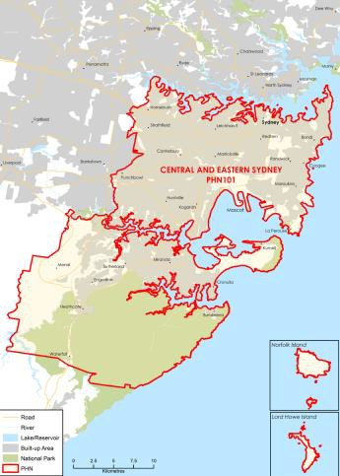

### FUNDING[7] AND PARTICIPANT[8] LEVELS

#### Funding ($M):

**All** **$9.04M** (Year coverage for NPS-M and CoS)

**NPS-M** **$4.05M** (Between FY17-18 and FY20-21)

**CoS $4.99M** (Between FY19-20 and FY21-22)

#### Participants

**All 396** (Year coverage for NPS-M and CoS)

**NPS-M 161** (Between 1 July and 31 Dec 2019)

**CoS 235** (Between 1 July and 31 Dec 2019)

### INDICATORS OF NEED[9]

#### Increased access to Medicare-subsidised mental health services

234,054 people in the PHN region accessed subsidised mental health services in 2017-18, increasing by 27.5% from 2013-14. Females access these services more than males.

#### High rate of hospitalisation due to self-harm

There were 1281 hospitalisations due to self-harm in 2017-18, with an over-representation of females and young adults aged 15-24 years.

#### High number of suicides

151 people in the region died by suicide in 2017.

#### NPS-M – Average wait time (July – Dec 2019)

24 hours.

### POPULATION AND DEMOGRAPHICS[10]

#### Population (ERP1 from 2016 census)

1,572,237

#### Population growth 2012-2016

8.04%

#### Indigenous population

13,506

#### Gender (%)

Male: 49.75%  
Female: 50.25%

#### Area (Square Kilometres)

626

1. OVERVIEW OF NPS-M AND COS IN EACH PHN

### STRUCTURE AND SCOPE[11]

1. Program structure

NPS-M and CoS are considered separate programs and are issued through different contracts.

1. Population access and eligibility

NPS-M and CoS: entry requirement are in-line with national guidelines

1. Geographic coverage of programs

* NPS-M: Coverage spans the entire PHN region.
* CoS: Coverage spans the entire PHN region.

1. Assessment, entry and exit processes

##### NPS-M:

1. What is the consumer application and assessment process?

Consumers develop an Individual Recovery Plan upon application.

1. What are the referral pathways into the program?

* Admitted/Hospital mental health services
* Non-admitted mental health services
* GP
* Other clinician (e.g. Psychologist/Psychiatrist)
* State-based psychosocial programs
* Self-referral

1. Duration/intensity of support:

Service The estimated length of time under psychosocial supports is approximately six months; however, the program is goal- oriented, so consumers remain in the program until personal recovery goals have been achieved.

1. Is entry into the program time limited, goal oriented or ongoing?

Goal oriented (i.e. exit after achievement of a goal or milestone).

1. Has the PHN specified or suggested a number of consumers per FTE staff)?

Yes – 25 consumers per FTE (however, the referred cohort has experienced complex needs greater than initially anticipated, so workers have been taking on lower caseloads).

##### CoS:

1. What is the consumer application and assessment process?

Existing consumers’ needs assessments are reviewed; consumers new to a provider complete a new initial needs assessment – which informs their Individual Support Plan.

1. How have PiR, D2DL and PHaMs consumers transitioned to CoS services?

Where possible, consumers remained with the same provider and key worker from previous programs. Consumers who needed to change providers had individual transition plans and comprehensive, warm handovers with previous workers.

1. Duration/intensity of support:

There is no time limit on CoS support once a consumer has been found ineligible for NDIS. Intensity is flexible and to be negotiated with consumers based on need.

1. Is entry into the program time limited, goal oriented or ongoing?

Ongoing (i.e. continuing support provided).

1. Has the PHN specified or suggested a number of consumers per FTE staff)?

No

1. Services Types

NPS-M and CoS: Both programs provide services as specified in the national guidelines.

NPS-M:

* NPS-M mainly provides one-on-one individual support based on consumers’ needs and recovery goals. Groups are run; however, due to the complex needs of the cohort, most consumers are only supported through individual support.

CoS:

* Levels of support are triaged and based on need.
* Consumers are supported to re-test eligibility for NDIS.

### MODELS OF CARE, INTEGRATION AND PRIORITY COHORTS

1. Models of care: Does the PHN specify a model of care to be used?

Yes, the CESPHN endorses a flexible, stepped care approach to recovery.

1. Care integration:

Consumers are assisted to link in with other health bodies (hospitals, Allied Health, psychologists, primary health, etc.) and social service bodies (Centrelink, housing, human services, etc.) based on identified needs; however, there is no formal integration with other health or social service bodies.

1. Priority Cohorts: Does the PHN prioritise particular cohorts, e.g. regions, demographics, diagnosis?

No.

### IMPLEMENTATION AND COMMISSIONING[12]

1. Roll out dates:

* NPS-M: February 2019
* CoS: January 2020

1. Commissioning approach

* NPS-M: The commissioning process involved an open request for proposal. 13 tender responses were received and evaluated; the tender was awarded to Flourish Australia.
* CoS: The commissioning approach involved a selective limited tender to seven providers who were providing the NPS-T services in our region.

1. Strategic planning

##### Key inputs to strategic planning

* The Regional Mental Health and Suicide Prevention Plan guides decision-making and outlines seven key priority areas.
* A qualitative and quantitative Needs Assessment was conducted.
* CMOs, consumers, carers, peak bodies, GPs and LHD/Ns were consulted and a market analysis was conducted.
* CESPHN Mental Health and Suicide Prevention Needs Assessment (data from 2015) estimates the yearly prevalence rate of severe mental illness in the CESPHN region is approximately 46,372 people.

1. Purchasing approach

##### Budgeting

1. Has the PHN pooled NPS-M or CoS funding with other funding sources?

* NPS-M: No
* CoS: No

##### Contracts

1. What is the contracting approach taken by the PHN for each program?

NPS-M:

* Competitive tendering – Offers from competing providers are invited by open advertisement and evaluated in accordance with predetermined criteria.

CoS:

* Direct engagement – Existing provider(s) are commissioned
* to continue providing services.

1. Is there a mandated/expected capacity for services in the NPS-M and CoS programs?

* NPS-M: Yes
* CoS: Yes

1. Does the service provider contract or schedule specify the number and type of staff required to deliver the service?

* NPS-M: Yes – 10 FTE mental health workers/peer workers.
* CoS: Yes – 10.4 FTE mental health workers/peer workers and 0.6 FTE employment specialists.

1. What types of workers are prescribed in contracts?

NPS-M:

* Managers/Team Leader
* Peer support workers
* Mental health workers
* Volunteers – members of previous groups CoS:
* Managers/Team Leader
* Peer support workers
* Employment specialist
* Mental health workers

##### Purchasing

1. What is the payment approach taken by the PHN for each program?

Block funding – A fixed amount of money is paid to the provider, regardless of how local needs are being met or the quality of care provided.

1. Of the money allocated to service providers, what was the average proportion designated to administrative or indirect costs?

* NPS-M: 10%
* CoS: 10%

1. Monitoring and evaluation

##### Data/measures

1. What performance measures are specified in the contract to track service performance providers?

* Number of consumers accessing services
* Number of services provided
* Outcomes from measurement tool (below)
* Consumer Satisfaction/experience
* Cost

1. Which of the following outcomes measures does the PHN capture/monitor?

CANSAS/CAN (Camberwell Assessment of Need).

##### Reporting

1. How frequently do service providers provide formal reports to the PHN?

Quarterly.

1. Have you conducted a review of your roll out of the NPS-M and CoS programs?

No – planned within next year.

# HUNTER NEW ENGLAND AND CENTRAL COAST

1. KEY FACTS AND FIGURES

This document provides a profile of how each PHN has implemented the NPS-M and CoS programs.



### FUNDING[13] AND PARTICIPANT[14] LEVELS

#### Funding ($M):

**All** **$10.59M** (Year coverage for NPS-M and CoS)

**NPS-M** **$4.77M** (Between FY17-18 and FY20-21)

**CoS $5.82M** (Between FY19-20 and FY21-22)

#### Participants

**All 1166** (Year coverage for NPS-M and CoS)

**NPS-M 671** (Between 1 July and 31 Dec 2019)

**CoS 495** (Between 1 July and 31 Dec 2019)

### INDICATORS OF NEED

#### Service availability

#### Rural and smaller outer regional locations have limited availability of psychosocial support services, with the NGOs challenged to provide outreach services to clients dispersed across large geographic areas.

#### Population health data points

The premature mortality rate from suicide and self-inflicted injuries in HNECC PHN region is higher than the NSW average. In 2016-17, there were 1,281 methamphetamine-related hospitalisations in the HNECC PHN region, at a rate of 157.6 per 100,000 population, higher then the NSW average (136.3).

#### NPS-M – Average wait time (July – Dec 2019)

24 hours.

### POPULATION[15] AND DEMOGRAPHICS[16]

#### Population (ERP1 from 2016 census)

1,247,255

#### Population growth 2012-2016

3.23%

#### Indigenous population

65,185

#### Gender (%)

Male: 49.21%  
Female: 50.79%

#### Area (Square Kilometres)

130,646

1. OVERVIEW OF NPS-M AND COS IN EACH PHN

### STRUCTURE AND SCOPE

1. Program structure

* NPS-M and CoS are considered separate programs provided through separate programs.
* Some service providers deliver services for both NPS-M and CoS.

1. Population access and eligibility

*NPS-M and CoS*: Entry requirements are largely in line with national guidelines. Some NPS-M service providers indicate that consumers can not be receiving services through state funded programs Community Living Supports or Housing and Support Initiative.

1. Geographic coverage of programs

NPS-M and CoS: Both programs cover the entire PHN region.

1. Assessment, entry and exit processes

##### NPS-M:

1. What is the consumer application and assessment process?

A comprehensive psychosocial assessment is undertaken over two separate sessions to identify the type of service and key activity area to focus on the consumer’s goal.

1. What are the referral pathways into the program?

* Non-admitted mental health services
* GP
* Other clinician (e.g. Psychologist/Psychiatrist)
* Self-referral

1. Duration/intensity of support:

* NPS-M: Consumers receive services for a period of six to nine months. Milestones and an exit plan are developed with the client.
* CoS: There is no time limit on supports under the CoS program.

1. Is entry into the program time limited, goal oriented or ongoing?

* Time limited (i.e. exit after a set time).
* Goal oriented (i.e. exit after achievement of a goal or milestone).

1. Has the PHN specified or suggested a number of consumers per FTE staff)?

No

##### CoS:

1. What is the consumer application and assessment process?

A comprehensive psychosocial assessment is undertaken with the consumer to assess the type of service and supports they require.

1. How have PiR, D2DL and PHaMs consumers transitioned to CoS services?

Upon receiving funding for NPS-M and CoS, HNECC PHN contracted existing PiR, D2DL and PHaMsproviders. This ensured a smooth and streamlined transition for consumers.

1. Duration/intensity of support:

The intensity of support provided to consumers is flexible and to be negotiated based on their needs. Targeted individual support can be provided at times of increased need.

1. Is entry into the program time limited, goal oriented or ongoing?

Ongoing (i.e. continuing support provided).

1. Has the PHN specified or suggested a number of consumers per FTE staff)?

No

1. Services Types

* NPS-M and CoS: Both programs provide services as specified in the national guidelines.
* NPS-M: Additional services aligned with the consumer’s care plan can be purchased from suitable third-party providers through the use ofa ‘Brokerage Fund Pool’.

### MODELS OF CARE, INTEGRATION AND PRIORITY COHORTS[17]

1. Models of care: Does the PHN specify a model of care to be used?

Yes, the specific model of care was co-designed by providers, consumers and the PHN through an external needs assessment and consultation process.

1. Care integration:

The PHN is in discussions with state-funded LHDs and other HNECC PHN-funded mental health services to implement care integration with providers. Some providers that deliver both clinical and psychosocial supports implement care integration where required internally. Care integration is also part of the CoSservice model to ensure wrap-around care, with one care plan involving all required supports and providers (including social services). Further discussions are occurring to better integrate care between psychosocial and clinical mental health providers.

1. Priority Cohorts: Does the PHN prioritise particular cohorts, e.g. regions, demographics, diagnosis?

Yes, women with perinatal depression, Aboriginal and Torres Strait Islander people, people living in rural/remote areas, people with low income, people from Culturally and Linguistically Diverse backgrounds, people with a recent suicide attempt or suicidal behaviour/ideation.

### IMPLEMENTATION AND COMMISSIONING[18]

1. Roll out dates:

* NPS-M: 2 January 2019 (Phase 1), 2 January 2020 (Phase 2)
* CoS: 30 June 2019 (Phase 1), 1 July 2020 (Phase 2)

1. Commissioning approach

* NPS-M: Existing PIR service providers were engaged to provide services during Phase 1 while a new service was co-designed involving an external needs assessment and consultation. In Phase 2, HNECC PHN commissioned new providers through an open tender process.
* CoS: For the first 12 months (Phase 1) existing PIR, PHaMsand D2DL service providers were directly engaged to ensure participants are appropriately transitioned into CoS.Subsequently, a new service model was co-designed with existing providers, consumers, carersand LHDs for commencement in July 2020 (Phase 2). The same providers were recommissioned to deliver this service to minimize disruption.

1. Strategic planning

##### Key inputs to strategic planning

* Psychosocial Needs Assessment was carried out by an external consultant.
* Consultation with external stakeholders and HNECC’s Clinical and Community Advisory groups, consumers, carers and local providers.
* HNECC’s Health Planning team were engaged in the CoS co-design process to develop a literature review to help inform the service model.

1. Purchasing approach

##### Budgeting

1. Has the PHN pooled NPS-M or CoS funding with other funding sources?

* NPS-M: No.
* CoS: No

##### Contracts

1. What is the contracting approach taken by the PHN for each program?

* *Competitive tendering* – Offers from competing providers are invited by open advertisement and evaluated in accordance with predetermined criteria.
* *Direct engagement* – Existing provider(s) are commissioned to continue providing services.
* Mental health support worker.

1. Is there a mandated/expected capacity for services in the NPS-M and CoS programs?

* NPS-M: Yes
* CoS: Yes

1. Does the service provider contract or schedule specify the number and type of staff required to deliver the service?

* NPS-M: No
* CoS: No – though appropriate professions are specified.

1. What types of workers are prescribed in contracts?

NPS-M: N/A

CoS:

* Peer support worker
* Mental health support worker

##### Purchasing

1. What is the payment approach taken by the PHN for each program?

Outcomes based payment Payment models that incentivise providers to provide services that better promote outcomes for patients.

1. Of the money allocated to service providers, what was the average proportion designated to administrative or indirect costs?

* NPS-M: N/A
* CoS: N/A.

1. Monitoring and evaluation

##### Data/measures

1. What performance measures are specified in the contract to track service performance providers?

* Number of consumers accessing services
* Number of services provided
* Outcomes from measurement tool (below)
* Consumer Satisfaction/experience

1. Which of the following outcomes measures does the PHN capture/monitor?

* K10, K5 (Kessler Psychological Distress Scale)
* PROMS (Patient Reported Outcomes Measures)
* PREMS (Patient Reported Experience Measures)

##### Reporting

1. How frequently do service providers provide formal reports to the PHN?

Quarterly

1. Have you conducted a review of your roll out of the NPS-M and CoS programs?

No – planned within next year (A review of Phase 1 ahs been conducted; a review of Phase 2 is planned within the next year).

# MURRUMBIDGEE

1. KEY FACTS AND FIGURES

This document provides a profile of how each PHN has implemented the NPS-M and CoS programs.

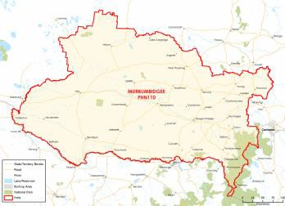

### FUNDING[19] AND PARTICIPANT[20] LEVELS

#### Funding ($M):

**All** **$3.28M** (Year coverage for NPS-M and CoS)

**NPS-M** **$1.13M** (Between FY17-18 and FY20-21)

**CoS $2.15M** (Between FY19-20 and FY21-22)

#### Participants

**All 36** (Year coverage for NPS-M and CoS)

**NPS-M 36** (Between 1 July and 31 Dec 2019)

**CoS 0** (Between 1 July and 31 Dec 2019)

### INDICATORS OF NEED

#### High prevalence of psychological distress among residents

11.1 per 100 residents in Murrumbidgee PHN currently experience psychological distress.

#### Increased suicide mortality

The suicide rate among residents of Murrumbidgee PHN is 19.8 per 100,000 people.

#### Age-related mental health issues

Community consultations identified significant mental health issues for youth and over 60s.

#### NPS-M –Average wait time (July – Dec 2019)

N/A – No wait time data provided during this period.

### POPULATION[21] AND DEMOGRAPHICS[22]

#### Population (ERP1 from 2016 census)

242,867

#### Population growth 2012-2016

1.8%

#### Indigenous population

11,463

#### Gender (%)

Male: 49.95%  
Female: 50.05%

#### Area (Square Kilometres)

124,413

1. OVERVIEW OF NPS-M AND COS IN EACH PHN

### STRUCTURE AND SCOPE

1. Program structure

NPS-M and CoS are considered separate programs and are issued through different contracts.

1. Population access and eligibility

Entry requirements are in line with national guidelines.

1. Geographic coverage of programs

NPS-M and CoS: Coverage spans the entire PHN region.

1. Assessment, entry and exit processes

##### NPS-M:

1. What is the consumer application and assessment process?

Consumers must undertake an initial assessment with a support worker, determining the level of support required and resulting in an Individual Support Plan.

1. What are the referral pathways into the program?

* Admitted/Hospital mental health services
* Non-admitted mental health services
* GP
* Other clinician (e.g. Psychologist/Psychiatrist)
* PHaMS/D2DL/ PIR for CoS
* State-based psychosocial programs
* Self-referral

1. Duration/intensity of support:

Exit is pre-planned, and providers work with consumers to ensure a smooth transition and ongoing recovery.

1. Is entry into the program time limited, goal oriented or ongoing?

Time limited (i.e. exit after a set time).

1. Has the PHN specified or suggested a number of consumers per FTE staff)?

No

##### CoS:

1. What is the consumer application and assessment process?

Service providers use approved transition flyer and transition form to share with participants about CoS supports.

1. How have PiR, D2DL and PHaMs consumers transitioned to CoS services?

PHN coordinators work with a service provider to start transition. Coordinators arranged for local morning tea events where transitioning participants were introduced to provider and the CoS Recovery Support workers.

1. Duration/intensity of support:

Once a consumer has been found ineligible for NDIS there is no time limit on CoS support. Intensity is flexible and to be negotiated with consumers.

1. Is entry into the program time limited, goal oriented or ongoing?

Ongoing (i.e. continuing support provided).

1. Has the PHN specified or suggested a number of consumers per FTE staff)?

Yes – 29 per FTE.

1. Services Types

* NPS-M: Align with the national guidelines with a focus on early intervention support services including a range of trauma-informed non-clinical individual and group supports.
* CoS: Align with the national guidelines. Service is delivered under two tiers 1) socially-based capacity building and 2) targeted individual support for clients at times of increased need.

### MODELS OF CARE, INTEGRATION AND PRIORITY COHORTS[23]

1. Models of care: Does the PHN specify a model of care to be used?

Yes, the Murrumbidgee PHN endorses a recovery- approach to service delivery that is trauma-informed.

1. Care integration:

Integration exists between NPS-M providers and the Mental Health Drug and Alcohol Alliance).

1. Priority Cohorts: Does the PHN prioritise particular cohorts, e.g. regions, demographics, diagnosis?

Yes, elderly (65+), Aboriginal and Torres Strait Islanders.

### IMPLEMENTATION AND COMMISSIONING[24]

1. Roll out dates:

* NPS-M: 1 January 2019
* CoS: 1 November 2019

1. Commissioning approach

* NPS-M involved consultation with LHD and co-design process. This was followed by open tender commissioning.
* CoS services were commissioned through a closed tendering process with existing providers of psychosocial supports.

1. Strategic planning

##### Key inputs to strategic planning

* Health Needs Assessment, including ‘HNA Live’ – a mechanism for consumers and health bodies to give feedback about ongoing needs.
* A Data Prioritisation Tool, which enables MPHN to identify areas of greatest need on a local government area basis.
* (For CoS) The PIR Community Advisory Committee was consulted

1. Purchasing approach

##### Budgeting

1. Has the PHN pooled NPS-M or CoS funding with other funding sources?

* NPS-M: No.
* CoS: No

##### Contracts

1. What is the contracting approach taken by the PHN for each program?

Competitive tendering – Offers from competing providers are invited by open advertisement and evaluated in accordance with predetermined criteria.

1. Is there a mandated/expected capacity for services in the NPS-M and CoS programs?

* NPS-M: Yes – 1,400 service contacts per quarter
* CoS: Yes – 1,000 service contacts per quarter/180 clients over the term of the contract

1. Does the service provider contract or schedule specify the number and type of staff required to deliver the service?

* NPS-M: Yes
* CoS: Yes

1. What types of workers are prescribed in contracts?

NPS-M:

* Peer support workers
* Recovery support worker/facilitator

CoS:

* Managers/Team Leader
* Peer support workers
* Recovery support worker/facilitator
* Volunteers – members of previous groups

##### Purchasing

1. What is the payment approach taken by the PHN for each program?

Block funding – A fixed amount of money is paid to the provider, regardless of how local needs are being met or the quality of care provided.

1. Of the money allocated to service providers, what was the average proportion designated to administrative or indirect costs?

* NPS-M: 13%
* CoS: 13%.

1. Monitoring and evaluation

##### Data/measures

1. What performance measures are specified in the contract to track service performance providers?

* Number of consumers accessing services
* Number of services provided
* Outcomes from measurement tool (below)
* Consumer Satisfaction/experience

1. Which of the following outcomes measures does the PHN capture/monitor?

* K10, K5 (Kessler Psychological Distress Scale)
* SDQ (Strengths and Difficulties Questionnaire
* Living in the Community Questionnaire

##### Reporting

1. How frequently do service providers provide formal reports to the PHN?

Monthly

1. Have you conducted a review of your roll out of the NPS-M and CoS programs?

No – planned within next year.

# NEPEAN BLUE MOUNTAINS

1. KEY FACTS AND FIGURES

This document provides a profile of how each PHN has implemented the NPS-M and CoS programs.

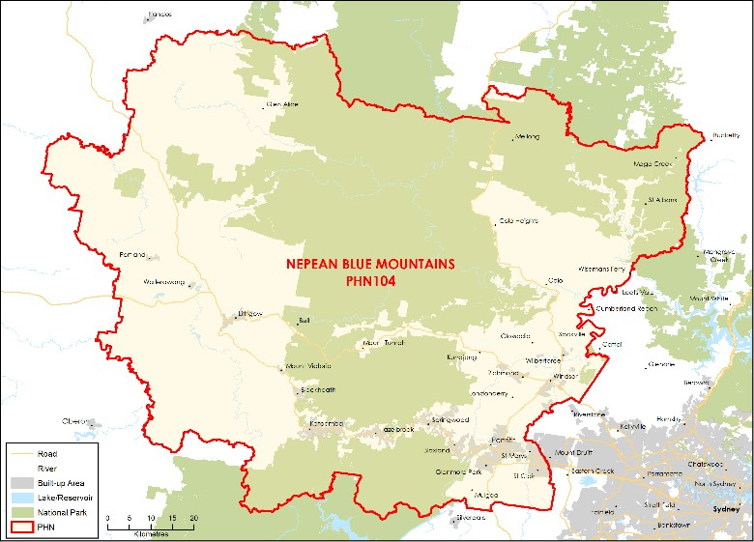

### FUNDING[25] AND PARTICIPANT[26] LEVELS

#### Funding ($M):

**All** **$2.95M** (Year coverage for NPS-M and CoS)

**NPS-M** **$1.11M** (Between FY17-18 and FY20-21)

**CoS $1.84M** (Between FY19-20 and FY21-22)

#### Participants

**All 194** (Year coverage for NPS-M and CoS)

**NPS-M 90** (Between 1 July and 31 Dec 2019)

**CoS 104** (Between 1 July and 31 Dec 2019)

### INDICATORS OF NEED

#### Suicide rates

Suicide rates are 13.6 per 100,000 in the NBM catchment, as compared to the national average of 10.8.

#### Increased rates psychological distress

The prevalence of high or very high psychological distress has increased from 9.7% in 2013 to 17.2% in 2017.

#### Mental health- related hospitalisations

Rates of mental health-related hospitalisations were the second highest in NSW during the 2017- 18 period.

#### NPS-M –Average wait time (July – Dec 2019)

Four to Six weeks.

### POPULATION[27] AND DEMOGRAPHICS[28]

#### Population (ERP1 from 2016 census)

367,783

#### Population growth 2012-2016

4.62%

#### Indigenous population

13,168

#### Gender (%)

Male: 49.57%  
Female: 50.43%

#### Area (Square Kilometres)

9,063

1. OVERVIEW OF NPS-M AND COS IN EACH PHN

### STRUCTURE AND SCOPE

1. Program structure

* CoS and NPS-T are separate programs but commissioned in a combined agreement. Three providers offer both CoS and NPS-T programs.
* NPS-M program is provided by one of the Cos and NPS-T providers.

1. Population access and eligibility

NPS-M and CoS: Entry requirements are in line with national guidelines.

1. Geographic coverage of programs

NPS-M and CoS: Both programs cover the entire PHN region.

1. Assessment, entry and exit processes

##### NPS-M:

1. What is the consumer application and assessment process?

* Consumers have an initial assessments that determines the level of support required and whether clients require access to time-limited, intensive one-on-one support.
* Initial assessments are person-focussed and conducted in an environment where consumers are comfortable.

1. What are the referral pathways into the program?

* Admitted/Hospital mental health services
* Non-admitted mental health services
* GP
* Other clinician (e.g. Psychologist/Psychiatrist)
* State-based psychosocial programs
* Self-referral

1. Duration/intensity of support:

One to two hrs per week for six months.

1. Is entry into the program time limited, goal oriented or ongoing?

* Time limited (i.e. exit after a six months with the objective to have achieved goals).
* Goal oriented (i.e. exit after achievement of a goal or milestone. Extension past six months can be provided with extenuating circumstances).

1. Has the PHN specified or suggested a number of consumers per FTE staff)?

Yes – 23 per FTE.

##### CoS:

1. What is the consumer application and assessment process?

Service providers carry out an initial assessment, involving a needs assessment and a determination of whether clients require one-on-one support. This is assessment through the Kessler Psychological Distress Scale (K10 or K5), potentially with the addition of other tools such as the WHODAS. As part of recovery planning, the provider must identify the mental health primary/secondary care source of support – e.g. GPs, psychiatrist or an LHD Community Mental Health case manager.

1. How have PiR, D2DL and PHaMs consumers transitioned to CoS services?

The existing PiR, D2DL and PHaMs providers were commissioned to offer CoS. Any participants of these programs that had been found ineligible for the NDIS were support by CoS. Any NPS-T participants found ineligible for the NDIS also move to CoS.

1. Duration/intensity of support:

Support is ongoing.

1. Is entry into the program time limited, goal oriented or ongoing?

Ongoing (i.e. continuing support provided).

1. Has the PHN specified or suggested a number of consumers per FTE staff)?

No.

1. Services Types

NPS-M and CoS: Both programs provide services as specified in the national guidelines, though CoS suppliers are required to provide 70% of services through group-based activities.

### MODELS OF CARE, INTEGRATION AND PRIORITY COHORTS[29]

1. Models of care: Does the PHN specify a model of care to be used?

Yes, the Murrumbidgee PHN endorses a recovery- approach to service delivery that is trauma-informed.

1. Care integration:

Integration exists between NPS-M providers and the Mental Health Drug and Alcohol Alliance).

1. Priority Cohorts: Does the PHN prioritise particular cohorts, e.g. regions, demographics, diagnosis?

Yes, elderly (65+), Aboriginal and Torres Strait Islanders.

### IMPLEMENTATION AND COMMISSIONING[30]

1. Roll out dates:

* NPS-M: January 2019
* CoS: July 2019

1. Commissioning approach

* All delivery and commissioning of services in NBMPHN is conducted by Wentworth Healthcare Limited.
* Direct commissioning was conducted to create new contracts with providers that previously delivered PiR, D2DL and PHaMs.

1. Strategic planning

##### Key inputs to strategic planning

Planning aligned psychosocial services with a comprehensive needs analysis and the stepped-care model outlined in NBMPHN’s regional plan.

1. Purchasing approach

##### Budgeting

1. Has the PHN pooled NPS-M or CoS funding with other funding sources?

* NPS-M: No.
* CoS: No - while contracted with NPS-T the programs have separate budgets

##### Contracts

1. What is the contracting approach taken by the PHN for each program?

Direct engagement – Existing provider(s) are commissioned to continue providing services.

1. Is there a mandated/expected capacity for services in the NPS-M and CoS programs?

* NPS-M: Yes
* CoS: Yes – funding was based on current participant numbers with each provider

1. Does the service provider contract or schedule specify the number and type of staff required to deliver the service?

* NPS-M: Yes - – 0.3 FTE Team Leader, 2 FTE support workers
* CoS: No

1. What types of workers are prescribed in contracts?

NPS-M:

* Managers/Team Leader
* Peer support workers
* Social Worker
* Recovery support worker/facilitator

CoS:

* N/A

##### Purchasing

1. What is the payment approach taken by the PHN for each program?

Block funding – A fixed amount of money is paid to the provider. This is paid via milestone payments each quarter following submission of progress report addressing KPI’s and financial progress report. Milestone payments are made after a contract management meeting to discuss progress report outcomes to ensure local needs are met and program objectives are achieved/maintained.

1. Of the money allocated to service providers, what was the average proportion designated to administrative or indirect costs?

• NPS-M/ CoS: 13%

1. Monitoring and evaluation

##### Data/measures

1. What performance measures are specified in the contract to track service performance providers?

* Number of consumers accessing services
* Number of services provided
* Percentage of assessments conducted within four weeks of consumer entering program and support plans produced
* Outcomes from measurement tool (below)
* Consumer Satisfaction/experience
* Number and quality control of NDIS applications

1. Which of the following outcomes measures does the PHN capture/monitor?

* K10, K5 (Kessler Psychological Distress Scale)
* RAS-DS (Recovery Assessment Score)
* WHODAS (World Health Organisation Disability Assessment Schedule)

##### Reporting

1. How frequently do service providers provide formal reports to the PHN?

* Monthly vis MDS and TRIS.
* Detailed progress reporting quarterly

1. Have you conducted a review of your roll out of the NPS-M and CoS programs?

No – planned within next year.

# NORTH COAST

1. KEY FACTS AND FIGURES

This document provides a profile of how each PHN has implemented the NPS-M and CoS programs.

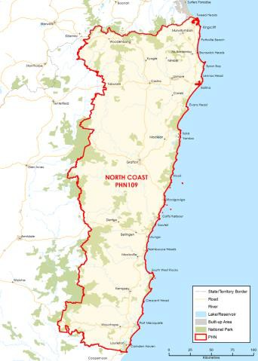

### FUNDING[31] AND PARTICIPANT[32] LEVELS

#### Funding ($M):

**All** **$5.07M** (Year coverage for NPS-M and CoS)

**NPS-M** **$2.32M** (Between FY17-18 and FY20-21)

**CoS $2.74M** (Between FY19-20 and FY21-22)

#### Participants

**All 236** (Year coverage for NPS-M and CoS)

**NPS-M 116** (Between 1 July and 31 Dec 2019)

**CoS 120** (Between 1 July and 31 Dec 2019)

### INDICATORS OF NEED

#### Rate of hospitalisation for mental disorders

In 2017-18, the Mid North Coast region had a higher rate of hospitalisation for mental disorders (2,076.9 per 100,000) than the state average.

#### Prevalence of mental illness

The National Mental Health Service Planning Framework (NMHSPF) estimates that 16.7% of the population will meet the criteria for a mental illness in any year.

#### Community concern about mental health issues

Over half (54.1%) of persons aged 26-64 years thought mental health was one of three of the most serious health concerns in their community.

#### NPS-M –Average wait time (July – Dec 2019)

No wait time.

### POPULATION[33] AND DEMOGRAPHICS[34]

#### Population (ERP1 from 2016 census)

513,379

#### Population growth 2012-2016

2.86%

#### Indigenous population

25,075

#### Gender (%)

Male: 48.8%  
Female: 51.2%

#### Area (Square Kilometres)

32,047

1. OVERVIEW OF NPS-M AND COS IN EACH PHN

### STRUCTURE AND SCOPE

1. Program structure

* NPS-M is a stand-alone program delivered by the Buttery Consortium.
* CoS and NPS-T are interwoven programs largely delivered by previous PiR, D2DL and PHaMs providers

1. Population access and eligibility

NPS-M and CoS: Entry requirements are in line with national guidelines.

1. Geographic coverage of programs

NPS-M and CoS: Both programs cover the entire PHN region.

1. Assessment, entry and exit processes

##### NPS-M:

1. What is the consumer application and assessment process?

Consumers can apply directly to service providers are through ‘Connect to Wellbeing’ the North Coast’s assessment and referral program.

1. What are the referral pathways into the program?

* Admitted/Hospital mental health services
* Non-admitted mental health services
* GP
* Other clinician (e.g. Psychologist/Psychiatrist)
* State-based psychosocial programs
* Self-referral

1. Duration/intensity of support:

Service is intended to be provided in episodes of care not longer than six months.

1. Is entry into the program time limited, goal oriented or ongoing?

* Goal oriented (i.e. exit after achievement of a goal or milestone. Extension past six months can be provided with extenuating circumstances).

1. Has the PHN specified or suggested a number of consumers per FTE staff)?

Yes – 12 consumers per FTE.

##### CoS:

1. What is the consumer application and assessment process?

The provider completes an initial assessment of the needs of each consumer using the CANSAS tool. Every three months thereafter, the provider must develop an Individual Recovery Plan (and review the consumer’s progress against the previous one), and conduct an assessment using the K10 for non- Aboriginal consumers and the K5 for Aboriginal consumers.

1. How have PiR, D2DL and PHaMs consumers transitioned to CoS services?

Consumers from these programs continue to be receive support through the same service provider.

1. Duration/intensity of support:

Flexible support is provided in line with national guidelines.

1. Is entry into the program time limited, goal oriented or ongoing?

Ongoing (i.e. continuing support provided).

1. Has the PHN specified or suggested a number of consumers per FTE staff)?

Yes – 12 consumers per FTE.

1. Services Types

NPS-M and CoS: Both programs provide services as specified in the national guidelines.

### MODELS OF CARE, INTEGRATION AND PRIORITY COHORTS[35]

1. Models of care: Does the PHN specify a model of care to be used?

Yes the NCPHN specifies that services delivered must be in line with a recovery-oriented and strengths-based approach.

1. Care integration:

In accordance with the Statement of Work, service providers must build and maintain strong linkages and partnerships with local clinical services to streamline referral pathways.

1. Priority Cohorts: Does the PHN prioritise particular cohorts, e.g. regions, demographics, diagnosis?

No.

### IMPLEMENTATION AND COMMISSIONING[36]

1. Roll out dates:

* NPS-M: 1 July 2019
* CoS: 1 July 2019

1. Commissioning approach

* NPS-M was commissioned via an open tender process.
* CoS was commissioned directly to the service providers of PiR, PHaMs and D2DL.
* NCPHN commissions services that are cost effective and support integrated clinical and psychosocial service delivery and identify appropriate assessment and referral pathways.

1. Strategic planning

##### Key inputs to strategic planning

* Stakeholders consulted include LHDs and drew on information from the recent regional Needs Assessment which had a broad consultation base.
* NGO providers of severe and complex mental health services were also.

1. Purchasing approach

##### Budgeting

1. Has the PHN pooled NPS-M or CoS funding with other funding sources?

* NPS-M: No.
* CoS: Yes – with NPS-T

##### Contracts

1. What is the contracting approach taken by the PHN for each program?

* Competitive tendering – Offers from competing providers are invited by open advertisement and evaluated in accordance with predetermined criteria.
* Alliance contracting – A set of providers enter into a single arrangement with a regional commissioner to deliver services.
* Direct engagement – Existing provider(s) are commissioned to continue providing services.

1. Is there a mandated/expected capacity for services in the NPS-M and CoS programs?

* NPS-M: No
* CoS: No

1. Does the service provider contract or schedule specify the number and type of staff required to deliver the service?

* NPS-M: Yes
* CoS: Yes

1. What types of workers are prescribed in contracts?

NPS-M:

* Managers/Team Leader
* Peer support workers
* Social Worker
* Recovery support worker/facilitator

CoS:

* Managers/Team Leader
* Peer support workers
* Social Worker
* Recovery support worker/facilitator

##### Purchasing

1. What is the payment approach taken by the PHN for each program?

Outcomes-based payment – Payment models that incentivise providers to provide services that better promote outcomes for patients.

1. Of the money allocated to service providers, what was the average proportion designated to administrative or indirect costs?

* NPS-M: N/A
* CoS: 10-15%

1. Monitoring and evaluation

##### Data/measures

1. What performance measures are specified in the contract to track service performance providers?

* Number of consumers accessing services
* Number of services provided
* Outcomes from measurement tool (below)
* Consumer Satisfaction/experience

1. Which of the following outcomes measures does the PHN capture/monitor?

* K10, K5 (Kessler Psychological Distress Scale)
* CANSAS/ CAN (Camberwell Assessment of Need)
* Recovery Star

##### Reporting

1. How frequently do service providers provide formal reports to the PHN?

Quarterly

1. Have you conducted a review of your roll out of the NPS-M and CoS programs?

No – planned within next year.

# NORTHERN SYDNEY

1. KEY FACTS AND FIGURES

This document provides a profile of how each PHN has implemented the NPS-M and CoS programs.

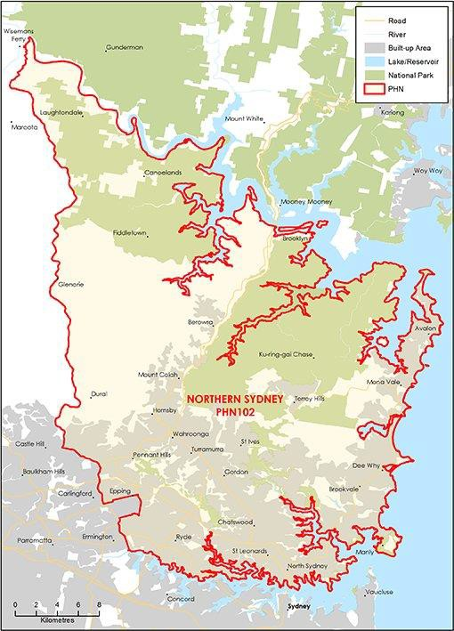

### FUNDING[37] AND PARTICIPANT[38] LEVELS

#### Funding ($M):

**All** **$4.75M** (Year coverage for NPS-M and CoS)

**NPS-M** **$2.06M** (Between FY17-18 and FY20-21)

**CoS $2.69M** (Between FY19-20 and FY21-22)

#### Participants

**All 139** (Year coverage for NPS-M and CoS)

**NPS-M 40** (Between 1 July and 31 Dec 2019)

**CoS 99** (Between 1 July and 31 Dec 2019)

### INDICATORS OF NEED[39]

#### Substantive population may require psychosocial support

Approximately 2.5% of the total population with severe/not complex mental illness may require psychosocial support. This equates to approximately 23,000 people within the PHN region.

#### Mental health hospitalisation rate

Northern Sydney has a higher rate of hospitalisation for mental health disorders (2,474 per 100,000) compared to NSW (1,981 per 100,000).

#### NPS-M –Average wait time (July – Dec 2019)

Five to 10 days.

### POPULATION AND DEMOGRAPHICS[40]

#### Population (ERP1 from 2016 census)

914,229

#### Population growth 2012-2016

5.81%

#### Indigenous population

3,326

#### Gender (%)

Male: 48.81%  
Female: 51.19%

#### Area (Square Kilometres)

890

1. OVERVIEW OF NPS-M AND COS IN EACH PHN

### STRUCTURE AND SCOPE

1. Program structure

NPS-M and CoS are provided as separate services administered through different contracts.

1. Population access and eligibility

NPS-M and CoS: Entry requirements are in line with national guidelines.

1. Geographic coverage of programs

NPS-M and CoS: Both programs cover the entire PHN region.

1. Assessment, entry and exit processes

##### NPS-M:

1. What is the consumer application and assessment process?

* Referred participants undergo an initial eligibility screen.
* Consumers who meet eligibility criteria and are accepted into the program undergo a comprehensive bio-psychosocial assessment to determine their level of functioning in the community to understand recovery goals and support.

1. What are the referral pathways into the program?

* Admitted/Hospital mental health services
* Non-admitted mental health services
* GP
* Other clinician (e.g. Psychologist/Psychiatrist)
* State-based psychosocial programs
* Self-referral

1. Duration/intensity of support:

12 months with flexibility to provide longer term support as required.

1. Is entry into the program time limited, goal oriented or ongoing?

Goal oriented (i.e. exit after achievement of a goal or milestone).

1. Has the PHN specified or suggested a number of consumers per FTE staff)?

Yes – 12 consumers per FTE.

##### CoS:

1. What is the consumer application and assessment process?

Comprehensive initial needs assessment to assess each person’s level of functioning in the community to understand recovery goals and develop individual support plans. A consumer’s existing support plan will transfer across to CoS service where it is still valid.

1. How have PiR, D2DL and PHaMs consumers transitioned to CoS services?

New service providers work closely with existing service providers to ensure all consumers transitioned. Joint meetings with consumers and existing support workers were held to hand over support plans and maintain relationship.

1. Duration/intensity of support:

Level of support determine according to each individuals needs.

1. Is entry into the program time limited, goal oriented or ongoing?

Ongoing (i.e. continuing support provided).

1. Has the PHN specified or suggested a number of consumers per FTE staff)?

No.

1. Services Types

NPS-M and CoS: Both programs provide services as specified in the national guidelines.

### MODELS OF CARE, INTEGRATION AND PRIORITY COHORTS[41]

1. Models of care: Does the PHN specify a model of care to be used?

Yes both NPS-M and CoS use a recovery-oriented and trauma informed model of care.

1. Care integration:

Service providers engage GPs, other local service providers and the Northern Sydney Local Health District.

1. Priority Cohorts: Does the PHN prioritise particular cohorts, e.g. regions, demographics, diagnosis?

Yes, people under 25 years, people experiencing homelessness, people with personality disorders, people with co-existing substance misuse issues, Aboriginal and Torres Strait Islander people, people from culturally and linguistically diverse backgrounds.

### IMPLEMENTATION AND COMMISSIONING[42]

1. Roll out dates:

* NPS-M: January 2019
* CoS: July 2019 (Initially provided by existing PiR, D2DL and PHaMs providers. New service started in March 2020)

1. Commissioning approach

Both NPS-M and CoS services were commissioned using open tendering (CoS had an initial period where existing service providers were contracted to provide services while the CoS service was being designed and commissioned.

1. Strategic planning

##### Key inputs to strategic planning

* Consultation with the NSLDH and the NDIA to identify gaps in service provision, barriers to access and opportunities for partnership.
* Co-design surveys and workshop which consulted NSLHD, consumers, carers, GPs, the local Indigenous community, allied health, service providers and mental health workers.
* Estimates from the National Mental Health Service Planning Framework have been used to inform the Needs Assessment.

1. Purchasing approach

##### Budgeting

1. Has the PHN pooled NPS-M or CoS funding with other funding sources?

* NPS-M: No.
* CoS: No

##### Contracts

1. What is the contracting approach taken by the PHN for each program?

* Competitive tendering – Offers from competing providers are invited by open advertisement and evaluated in accordance with predetermined criteria.
* *Contract extension* – Existing contracts between the PHN and provider are extended. (CoS services were initially provided through a contract extension but a new service was contracted through open tender).

1. Is there a mandated/expected capacity for services in the NPS-M and CoS programs?

* NPS-M: No
* CoS: No

1. Does the service provider contract or schedule specify the number and type of staff required to deliver the service?

* NPS-M: Yes
* CoS: Yes

1. What types of workers are prescribed in contracts?

NPS-M:

* Lived Expertise Worker
* Recovery Worker
* Service Manager

CoS:

* Lived Experience Worker
* Recovery Worker
* Program Manager
* Administration Officer
* Area Manager

##### Purchasing

1. What is the payment approach taken by the PHN for each program?

Block funding– A fixed amount of money is paid to the provider, regardless of how local needs are being met or the quality of care provided.

1. Of the money allocated to service providers, what was the average proportion designated to administrative or indirect costs?

* NPS-M: 15%
* CoS: 15%

1. Monitoring and evaluation

##### Data/measures

1. What performance measures are specified in the contract to track service performance providers?

* Number of consumers accessing services
* Outcomes from measurement tool (below)
* Consumer Satisfaction/experience
* Staff satisfaction
* 100% clients of Indigenous background are seen by staff who have undertaken cultural awareness training

1. Which of the following outcomes measures does the PHN capture/monitor?

K10, K5 (Kessler Psychological Distress Scale)

##### Reporting

1. How frequently do service providers provide formal reports to the PHN?

Quarterly

1. Have you conducted a review of your roll out of the NPS-M and CoS programs?

Yes – formal evaluation undertaken for the NPS-M service in March 2020, aligned to the Northern Sydney PHN’s Commissioning Evaluation Framework.

# SOUTH EASTERN SYDNEY

1. KEY FACTS AND FIGURES

This document provides a profile of how each PHN has implemented the NPS-M and CoS programs.

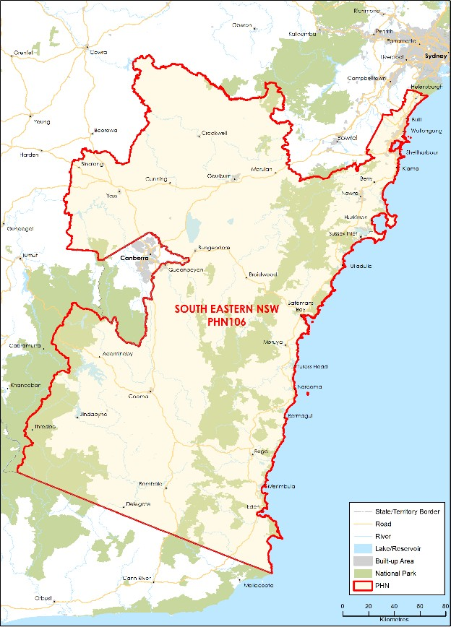

### FUNDING[43] AND PARTICIPANT[44] LEVELS

#### Funding ($M):

**All** **$5.37M** (Year coverage for NPS-M and CoS)

**NPS-M** **$2.21M** (Between FY17-18 and FY20-21)

**CoS $3.16M** (Between FY19-20 and FY21-22)

#### Participants

**All 276** (Year coverage for NPS-M and CoS)

**NPS-M 123** (Between 1 July and 31 Dec 2019)

**CoS 153** (Between 1 July and 31 Dec 2019)

### INDICATORS OF NEED[45]

#### Poor access and understanding of services

Limited access to transport (both rural and regional) including cost barriers. Poor health literacy including understanding of current services by consumers, carers and providers.

#### Limited services that facilitate social skills

Desire for community members to voluntarily support consumers to connect with the wider community.

#### Low mental health awareness and education

Low awareness and understanding about mental health. Need for appropriate training amongst current and potential peer workers.

#### NPS-M – Average wait time (July – Dec 2019)

No waitlist during this period.

### POPULATION AND DEMOGRAPHICS[46]

#### Population (ERP1 from 2016 census)

611,202

#### Population growth 2012-2016

4.09%

#### Indigenous population

21,122

#### Gender (%)

Male: 49.66%  
Female: 50.34%

#### Area (Square Kilometres)

50,177

1. OVERVIEW OF NPS-M AND COS IN EACH PHN

### STRUCTURE AND SCOPE

1. Program structure

There are separate programs for NPS-M and CoS services:

* NPS-M: Delivered by one lead service provider.
* CoS: Funding is pooled with NPS-T and delivered by four providers.

1. Population access and eligibility

NPS-M and CoS: Entry requirements are in line with national guidelines.

1. Geographic coverage of programs

NPS-M and CoS: Both programs cover the entire PHN region.

1. Assessment, entry and exit processes

##### NPS-M:

1. What is the consumer application and assessment process?

Applications are received through the service provider’s website or referral form.

1. What are the referral pathways into the program?

* Admitted/Hospital mental health services
* Non-admitted mental health services
* GP
* Other clinician (e.g. Psychologist/Psychiatrist)
* State-based psychosocial programs
* Self-referral

1. Duration/intensity of support:

Typically three to six months.

1. Is entry into the program time limited, goal oriented or ongoing?

* Goal oriented (i.e. exit after achievement of a goal or milestone)
* Ongoing (i.e. continuing support provided)

1. Has the PHN specified or suggested a number of consumers per FTE staff)?

No.

##### CoS:

1. What is the consumer application and assessment process?

This is a closed cohort with no intake of new participants.

1. How have PiR, D2DL and PHaMs consumers transitioned to CoS services?

Consumers continue to receive the same service through the service provider they received PiR, D2DL and PHaMs support.

1. Duration/intensity of support:

Six to 12 months with a small proportion receiving longer support.

1. Is entry into the program time limited, goal oriented or ongoing?

Ongoing (i.e. continuing support provided if NDIS support is not granted otherwise exit to NDIS if deemed eligible).

1. Has the PHN specified or suggested a number of consumers per FTE staff)?

No.

1. Services Types

NPS-M and CoS: Both programs provide services as specified in the national guidelines, though NPS-M group activities are facilitated by volunteers who are members of previous groups. These volunteers receive support from experts in guiding the group activities.

### MODELS OF CARE, INTEGRATION AND PRIORITY COHORTS[47]

1. Models of care: Does the PHN specify a model of care to be used?

Yes, the PHN endorses a stepped-care approach; there is also a strong focus on peer support and group programs.

1. Care integration:

Service providers are required to work collaboratively and maintain partnerships with other providers (both internal and external) to ensure the system is integrated and aligned with a stepped-care approach.

1. Priority Cohorts: Does the PHN prioritise particular cohorts, e.g. regions, demographics, diagnosis?

No.

### IMPLEMENTATION AND COMMISSIONING[48]

1. Roll out dates:

* NPS-M: 1 January 2019
* CoS: 1 July 2020

1. Commissioning approach

* NPS-M was commissioned through an open competitive tender. One service provider was awarded the contract.
* Existing PiR, PHaMs and D2DL providers were engaged to provide the CoS program.

1. Strategic planning

##### Key inputs to strategic planning

SENSW PHN carried out consultation and co-designed the service through community forums with the LHD working group, which included service providers, consumers and carers.

1. Purchasing approach

##### Budgeting

1. Has the PHN pooled NPS-M or CoS funding with other funding sources?

* NPS-M: No.
* CoS: Yes – CoS funding was pooled with transition funding

##### Contracts

1. What is the contracting approach taken by the PHN for each program?

* NPS-M: Competitive tendering – Offers from competing providers are invited by open advertisement and evaluated in accordance with predetermined criteria.
* CoS: Direct engagement – Existing provider(s) are commissioned to continue providing services.

1. Is there a mandated/expected capacity for services in the NPS-M and CoS programs?

* NPS-M: No
* CoS: No

1. Does the service provider contract or schedule specify the number and type of staff required to deliver the service?

* NPS-M: Yes
* CoS: No

1. What types of workers are prescribed in contracts?

NPS-M:

* Peer workers
* Voluntary community members

CoS:

NA

##### Purchasing

1. What is the payment approach taken by the PHN for each program?

Block funding– A fixed amount of money is paid to the provider, regardless of how local needs are being met or the quality of care provided.

1. Of the money allocated to service providers, what was the average proportion designated to administrative or indirect costs?

* NPS-M: 36%
* CoS: Varies between 10% and 18% across providers

1. Monitoring and evaluation

##### Data/measures

1. What performance measures are specified in the contract to track service performance providers?

* Number of consumers accessing services
* Number of services provided
* Outcomes from measurement tool (below)
* Consumer Satisfaction/experience
* Cost

1. Which of the following outcomes measures does the PHN capture/monitor?

* K10, K5 (Kessler Psychological Distress Scale)
* SDQ (Strengths and Difficulties Questionnaire

##### Reporting

1. How frequently do service providers provide formal reports to the PHN?

* Six-monthly
* Monthly reports for NPS-T and CoS

1. Have you conducted a review of your roll out of the NPS-M and CoS programs?

Yes – reviewed every 6 months.

# SOUTH WESTERN SYDNEY

1. KEY FACTS AND FIGURES

This document provides a profile of how each PHN has implemented the NPS-M and CoS programs.

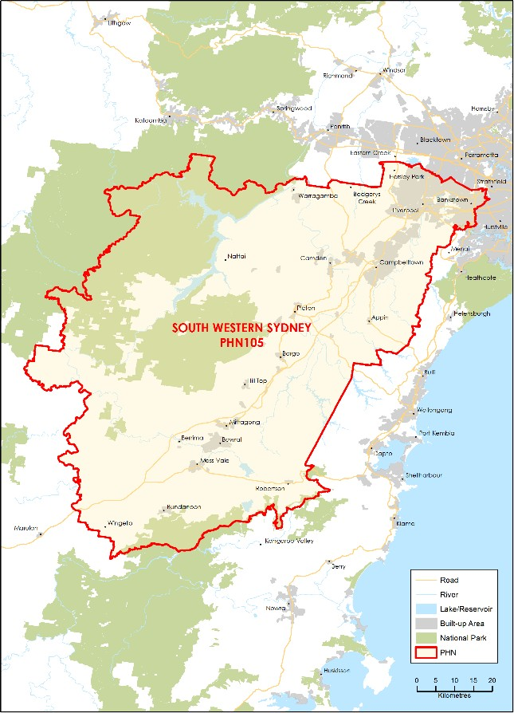

### FUNDING[49] AND PARTICIPANT[50] LEVELS

#### Funding ($M):

**All** **$6.16M** (Year coverage for NPS-M and CoS)

**NPS-M** **$3.26M** (Between FY17-18 and FY20-21)

**CoS $2.90M** (Between FY19-20 and FY21-22)

#### Participants

**All 312** (Year coverage for NPS-M and CoS)

**NPS-M 120** (Between 1 July and 31 Dec 2019)

**CoS 192** (Between 1 July and 31 Dec 2019)

### INDICATORS OF NEED[51]

#### Large population with severe mental illness

An estimated 30,432 people in South Western Sydney have severe mental illness, including 20,217 people aged between 18 and 64 years of age.

#### Lack of availability of psychosocial services

The top five most poorly available services align directly with the top five areas of need, as per a list of priority areas for capacity building and stability generated by the Department of Health in 2018. These areas include the management of daily living needs, and the development of social skills and friendships.

#### NPS-M – Average wait time (July – Dec 2019)

N/A – No wait time data provided during this period. Waiting lists are expected tocommence in October 2020.

### POPULATION AND DEMOGRAPHICS[52]

#### Population (ERP1 from 2016 census)

964,351

#### Population growth 2012-2016

8.48%

#### Indigenous population

16,445

#### Gender (%)

Male: 49.59%  
Female: 50.41%

#### Area (Square Kilometres)

6,186

1. OVERVIEW OF NPS-M AND COS IN EACH PHN

### STRUCTURE AND SCOPE

1. Program structure

NPS-M and CoS are separate programs administered through different contracts.

1. Population access and eligibility

NPS-M and CoS: Entry requirements are in line with national guidelines.

1. Geographic coverage of programs

NPS-M and CoS: Both programs cover the entire PHN region.

1. Assessment, entry and exit processes

##### NPS-M:

1. What is the consumer application and assessment process?

* Referrals are received through SWSPHN Mental Health Central Intake, or online through the Connector Hub Website. Anyone can refer (with the consumer’s approval) to maximise access.
* Once accepted into the program, a mental health support worker will commence the engagement and assessment process which involves a Safety and Wellness Assessment and Goal Setting worksheet.

1. What are the referral pathways into the program?

* Admitted/Hospital mental health services
* Non-admitted mental health services
* GP
* Other clinician (e.g. Psychologist/Psychiatrist)
* Self-referral

1. Duration/intensity of support:

* There are no minimum or maximum timeframes for receiving supports.
* During FY2019-20, the average duration of supports was 3.75 months, with an average of one hour per week per consumer.
* Many consumers have extremely complex, multiple needs and are often in crisis but there is limited ability to provide individual support. Consumers are reporting (through YES surveys) that they would like more individual support.
* Providing assistance to test for NDIS occupies considerable staff time (15-20 hours per consumer), which SWSPHN notes the NPS-M model is not set up or adequately funded to do.

1. Is entry into the program time limited, goal oriented or ongoing?

* Goal oriented (i.e. exit after achievement of a goal or milestone)
* Ongoing (i.e. continuing support provided)

1. Has the PHN specified or suggested a number of consumers per FTE staff)?

* No. SWSPHN did not specify the amount of staff during the tendering process; however, for FY2019-20 there were nine FTE (4x MH Support Workers, 4x Peer Workers, 2x 0.5 Coordinators) for a total of 250 ‘active’ consumers across the region. The original target of 300 consumers was reduced given feedback from providers regarding the complexity of consumer mental illness.
* Therefore, there was an average of 27.7 NPS-M consumers per FTE.

##### CoS:

1. What is the consumer application and assessment process?

Consumers were automatically transferred to CoS from existing services.

1. How have PiR, D2DL and PHaMs consumers transitioned to CoS services?

* Ongoing support was ensured through the same service providers continuing to provide consumers with the same or similar level of support.
* SWSPHN did data migration from providers’ CIMS onto the PHN’s CIMS, or direct uploaded PMHC MDS onto the DoH portal.

1. Duration/intensity of support:

The intensity of support provided to consumers is flexible and negotiated with each consumer based on their needs.

1. Is entry into the program time limited, goal oriented or ongoing?

* Goal oriented (i.e. exit after achievement of a goal or milestone).
* Ongoing (i.e. continuing support provided), depending on consumer needs

1. Has the PHN specified or suggested a number of consumers per FTE staff)?

Yes – CoS is a closed program so the ratio is approximately 20 consumers per FTE.

1. Services Types

NPS-M and CoS: Both programs provide services as specified in the national guidelines.

### MODELS OF CARE, INTEGRATION AND PRIORITY COHORTS[53]

1. Models of care: Does the PHN specify a model of care to be used?

Yes, NPS-M and CoS employ a recovery-oriented, person-centred and trauma-informed model of care.

1. Care integration:

Both NPS-M and CoS service models specify that the service model should address all areas of health and wellbeing including linking consumers with GPs, clinical mental health supports and also addressing the physical health needs of consumers.

1. Priority Cohorts: Does the PHN prioritise particular cohorts, e.g. regions, demographics, diagnosis?

No. Services are provided based on an individual needs basis and depending on the level of assistance required.

### IMPLEMENTATION AND COMMISSIONING[54]

1. Roll out dates:

* NPS-M: 1 January 2019
* CoS: 1 July 2020

1. Commissioning approach

* NPS-M: Open Request for Tender via TenderLink.
* CoS: Direct Engagement of Existing Providers.

1. Strategic planning

##### Key inputs to strategic planning

* Conducted a Psychosocial Needs Assessment for the region that included using an online survey and face-to-face consultations with stakeholders.
* Used the National Service Planning Framework to estimate potential consumer population.

1. Purchasing approach

##### Budgeting

1. Has the PHN pooled NPS-M or CoS funding with other funding sources?

* NPS-M: No.
* CoS: No

##### Contracts

1. What is the contracting approach taken by the PHN for each program?

* Competitive tendering (for NPS-M) – Offers from competing providers are invited by open advertisement and evaluated in accordance with predetermined criteria.
* Direct engagement (for CoS) – Existing provider(s) are commissioned to continue providing services.
* Contract extension – Existing contracts between the PHN and provider are extended.

1. Is there a mandated/expected capacity for services in the NPS-M and CoS programs?

* NPS-M: Yes – it is expected that commissioned service providers deliver support and programs as per the schedule and DoH guidance to 300 (FY2019-20) and 250 (FY2020-21) consumers across the region.
* CoS: Yes – it is expected that commissioned service providers deliver support and programs as per schedule and DoH guidance to all consumers who transitioned to CoS/NPS-T. 80% of NPS-T consumers testing their eligibility for the NDIS

1. Does the service provider contract or schedule specify the number and type of staff required to deliver the service?

* NPS-M: Yes
* CoS: Yes

1. What types of workers are prescribed in contracts?

NPS-M:

* Coordinators
* Peer Workers
* Recovery Worker
* Volunteers
* Project Implementation Manager (first 6 months only)

CoS:

* Managers/Team Leader
* Peer support workers
* Recovery support worker/facilitator

##### Purchasing

1. What is the payment approach taken by the PHN for each program?

Block funding– A fixed amount of money is paid to the provider per quarter once the deliverables are received as per their schedule and are reviewed and approved by the SWSPHN. This includes consumer feedback, quarterly scorecards, six-monthly reports and a review of outcome measures.

1. Of the money allocated to service providers, what was the average proportion designated to administrative or indirect costs?

* NPS-M: 20%
* CoS: 11% (reduced due to smaller funding amount)

1. Monitoring and evaluation

##### Data/measures

1. What performance measures are specified in the contract to track service performance providers?

* Number of consumers accessing services
* Number of services provided
* Outcomes from measurement tool (below)
* Consumer Satisfaction/experience
* Review of PHMC MDS data

1. Which of the following outcomes measures does the PHN capture/monitor?

* K10, K5 (Kessler Psychological Distress Scale)
* RAS-DS (Recovery Assessment Score)
* Your Experience of Service (YES)

##### Reporting

1. How frequently do service providers provide formal reports to the PHN?

Quarterly

1. Have you conducted a review of your roll out of the NPS-M and CoS programs?

Yes

# WESTERN NSW

1. KEY FACTS AND FIGURES

This document provides a profile of how each PHN has implemented the NPS-M and CoS programs.

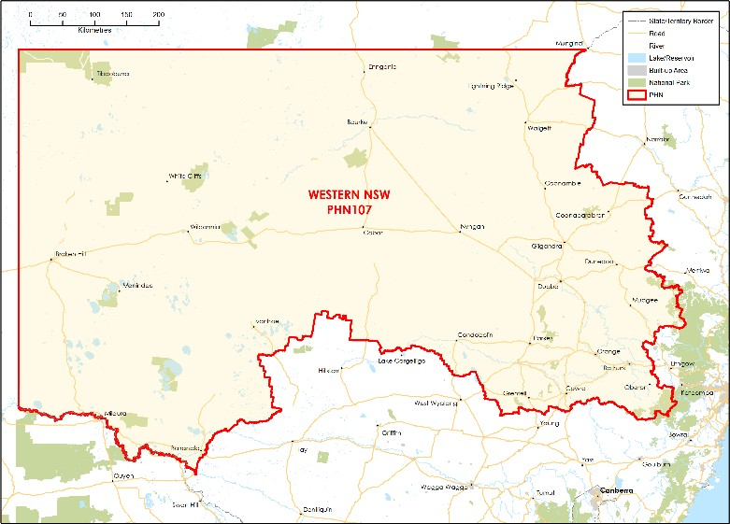

### FUNDING[55] AND PARTICIPANT[56] LEVELS

#### Funding ($M):

**All** **$4.64M** (Year coverage for NPS-M and CoS)

**NPS-M** **$1.85M** (Between FY17-18 and FY20-21)

**CoS $2.79M** (Between FY19-20 and FY21-22)

#### Participants

**All 143** (Year coverage for NPS-M and CoS)

**NPS-M 6** (Between 1 July and 31 Dec 2019)

**CoS 137** (Between 1 July and 31 Dec 2019)

### INDICATORS OF NEED[57]

#### Rates of hospitalisation due to mental health issues

Rates of emergency presentations for mental health problems increased by 70% from 2011 to 2016. The rate of mental health overnight hospitalisations for anxiety and stress disorders in was 80% higher than the national average in 2015-16.

#### Community concern about mental health

Mental health illness was ranked as the top health concern in an Online Community Health Survey. More than half of Aboriginal people surveyed in the Western NSW PHN Telephone Community Health Survey reported mental health as an important health concern.

#### NPS-M – Average wait time (July – Dec 2019)

N/A – Data not available.

### POPULATION AND DEMOGRAPHICS[58]

#### Population (ERP1 from 2016 census)

307,403

#### Population growth 2012-2016

1.47%

#### Indigenous population

31,449

#### Gender (%)

Male: 49.84%  
Female: 50.16%

#### Area (Square Kilometres)

307,402

1. OVERVIEW OF NPS-M AND COS IN EACH PHN

### STRUCTURE AND SCOPE

1. Program structure

NPS-M and CoS are separate programs and are administered through different contracts.

1. Population access and eligibility

NPS-M and CoS: Entry requirements are in line with national guidelines.

1. Geographic coverage of programs

NPS-M and CoS: Both programs cover the entire PHN region.

1. Assessment, entry and exit processes

##### NPS-M:

1. What is the consumer application and assessment process?

NPS-M recovery coach gathers relevant documentation and makes an appointment with the participant to assess eligibility for the program. Once completed, the referral is presented to the intake panel for assessment.

1. What are the referral pathways into the program?

* Admitted/Hospital mental health services
* Non-admitted mental health services
* GP
* Other clinician (e.g. Psychologist/Psychiatrist)
* PHaMS/D2DL/ PIR for CoS
* State-based psychosocial programs
* Self-referral

1. Duration/intensity of support:

PHN encourages time-limited support based on client’s need and eligibility for other ongoing support services.

1. Is entry into the program time limited, goal oriented or ongoing?

Goal oriented (i.e. exit after achievement of a goal or milestone)

1. Has the PHN specified or suggested a number of consumers per FTE staff)?

No.

##### CoS:

1. What is the consumer application and assessment process?

Referral is made by existing support provider.

1. How have PiR, D2DL and PHaMs consumers transitioned to CoS services?

Service providers are responsible for transitioning consumers to the CoS service.

1. Duration/intensity of support:

Ongoing support is provided to meet consumer needs without exit plans.

1. Is entry into the program time limited, goal oriented or ongoing?

Ongoing (i.e. continuing support provided)

1. Has the PHN specified or suggested a number of consumers per FTE staff)?

No.

1. Services Types

* NPS-M: Provides services as specified in the national guidelines.
* CoS: Provides services as specified in the national guidelines.

### MODELS OF CARE, INTEGRATION AND PRIORITY COHORTS[59]

1. Models of care: Does the PHN specify a model of care to be used?

Yes, the WNSW Regional Mental Health identifies a stepped-care continuum and a ‘no-wrong-door’ approach as central to achieving its objectives.

1. Care integration:

Agencies in smaller regional and remote locations work together to delivery services for consumers.

1. Priority Cohorts: Does the PHN prioritise particular cohorts, e.g. regions, demographics, diagnosis?

Yes, elderly (65+), Aboriginal and Torres Strait Islanders.

### IMPLEMENTATION AND COMMISSIONING[60]

1. Roll out dates:

* NPS-M: 1 July 2019 (a trial was conducted in 6 local government areas by one provider from January 2019)
* CoS: 1 July 2019

1. Commissioning approach

* NPS-M: A trial of the NPS-M was conducted with one provider in six LGAs in the first financial year (2018-2019). In the second year, seven providers were funded to deliver both NPS-M and CoS across the whole PHN.
* Interim/Trial NPS-M service were commissioned at the start of 2019 through a co-design process with the Western NSW Partners in Recovery Consortium members and other organisations currently delivering psychosocial support programs. These trial/interim programs were continued throughout the 2019/2020 financial year.
* CoS: For 2019 to 2020, the existing Partners in Recovery, Personal Helpers and Mentors and Support for Day to Day Living were given contracts to ensure continued services for existing clients.
* A co-design process and commissioning/procurement process was undertaken in 2019-2020.

1. Strategic planning

##### Key inputs to strategic planning

* Analysis using the National Mental Health Service Planning Framework estimated the cohort eligible for the NPS-M was 2,834. This included individuals with severe (but not complex) mental illness.
* The Initial Psychosocial Support Needs Assessment involved analysis of data at a regional and sub-regional level and information from stakeholder workshops conducted in mid-2018.

1. Purchasing approach

##### Budgeting

1. Has the PHN pooled NPS-M or CoS funding with other funding sources?

* NPS-M: No.
* CoS: Yes – CoS funding is pooled with NPS-T funding

##### Contracts

1. What is the contracting approach taken by the PHN for each program?

* Competitive tendering – Offers from competing providers are invited by open advertisement and evaluated in accordance with predetermined criteria.
* Direct engagement – Existing provider(s) are commissioned to continue providing services.

1. Is there a mandated/expected capacity for services in the NPS-M and CoS programs?

* NPS-M: No.
* CoS: No

1. Does the service provider contract or schedule specify the number and type of staff required to deliver the service?

* NPS-M: No
* CoS: No

1. What types of workers are prescribed in contracts?

* NPS-M: NA
* CoS: NA

##### Purchasing

1. What is the payment approach taken by the PHN for each program?

Block funding– A fixed amount of money is paid to the provider, regardless of how local needs are being met or the quality of care provided.

1. Of the money allocated to service providers, what was the average proportion designated to administrative or indirect costs?

* NPS-M: 10%
* CoS: 10%

1. Monitoring and evaluation

##### Data/measures

1. What performance measures are specified in the contract to track service performance providers?

* Outcomes from measurement tool (below)
* Demonstration of culturally appropriate service delivery for the Indigenous population

1. Which of the following outcomes measures does the PHN capture/monitor?

* K10, K5 (Kessler Psychological Distress Scale)
* SDQ (Strengths and Difficulties Questionnaire

##### Reporting

1. How frequently do service providers provide formal reports to the PHN?

Quarterly

1. Have you conducted a review of your roll out of the NPS-M and CoS programs?

No – not planned.

# WESTERN SYDNEY

1. KEY FACTS AND FIGURES

This document provides a profile of how each PHN has implemented the NPS-M and CoS programs.

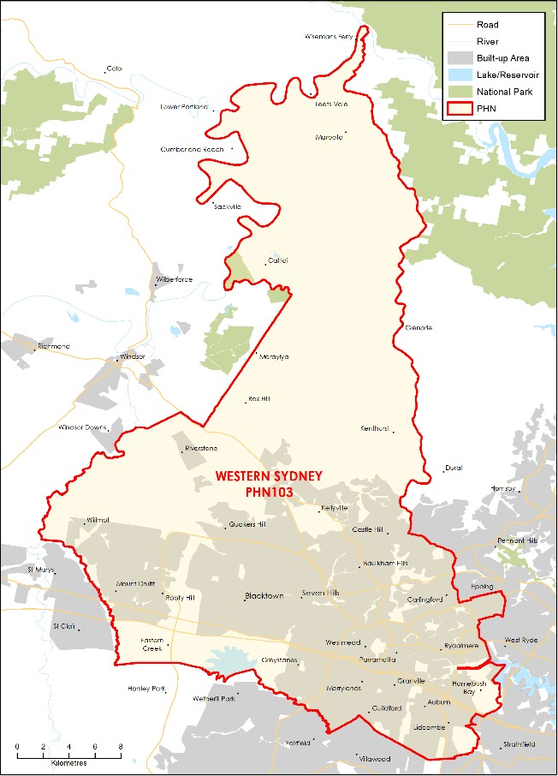

### FUNDING[61] AND PARTICIPANT[62] LEVELS

#### Funding ($M):

**All** **$5.40M** (Year coverage for NPS-M and CoS)

**NPS-M** **$2.79M** (Between FY17-18 and FY20-21)

**CoS $2.61M** (Between FY19-20 and FY21-22)

#### Participants

**All 165** (Year coverage for NPS-M and CoS)

**NPS-M 40** (Between 1 July and 31 Dec 2019)

**CoS 120** (Between 1 July and 31 Dec 2019)

### INDICATORS OF NEED[63]

#### Proportion of people with severe and persistent mental illness

1.1% of adults experience a persistent mental illness that requires ongoing services and 0.4% of the adult population experience severe and persistent mental illness that requires multi-agency support.

#### High levels of psychological distress in youth

A larger proportion of 16-24 year olds in WSPHN report moderate, high and very high psychological distress (16.8%) compared with PHN as a whole (9.1%).

#### Vulnerable populations

WSPHN has several demographics who are vulnerable and need extra support: homeless, CALD, LGBTIQ+ and Aboriginal and Torres Strait Islander people.

#### NPS-M – Average wait time (July – Dec 2019)

Average participant did not experience a wait time to access service. Two consumers had a two- week wait time.

### POPULATION AND DEMOGRAPHICS[64]

#### Population (ERP1 from 2016 census)

948,593

#### Population growth 2012-2016

9.93%

#### Indigenous population

13,378

#### Gender (%)

Male: 50.47%  
Female: 49.53%

#### Area (Square Kilometres)

766

1. OVERVIEW OF NPS-M AND COS IN EACH PHN

### STRUCTURE AND SCOPE

1. Program structure

* All delivery and commissioning of services in WSPHN is conducted by WentWest.
* There are four different psychosocial support programs: NPS-Transition, CoS, NPS-M and NPS Access.
* NPS-M is delivered by two providers, split geographically.

1. Population access and eligibility

NPS-M and CoS: Entry requirements are in line with national guidelines.

1. Geographic coverage of programs

NPS-M and CoS: Both programs cover the entire PHN region.

1. Assessment, entry and exit processes

##### NPS-M:

1. What is the consumer application and assessment process?

Referrals are made directly to each service provider of the NPS-M service. Referrals are assessed to determine whether they meet the national criteria for the NPS-M.

1. What are the referral pathways into the program?

* Admitted/Hospital mental health services
* Non-admitted mental health services
* GP
* Other clinician (e.g. Psychologist/Psychiatrist)
* State-based psychosocial programs
* Self-referral

1. Duration/intensity of support:

* There is no limit on the duration within which a client can engage with the program.
* Intensity of support is personalised to client need including whether group or individual support is more appropriate.

1. Is entry into the program time limited, goal oriented or ongoing?

Ongoing (i.e. continuing support provided)

1. Has the PHN specified or suggested a number of consumers per FTE staff)?

No.

##### CoS:

1. What is the consumer application and assessment process?

Consumers who were participants in Western Sydney PiR, PHaMs or D2DL programs as of 30 June 2019 and who have had NDIS applications submitted and declined, are automatically provided support through the CoS program.

1. How have PiR, D2DL and PHaMs consumers transitioned to CoS services?

All PIR, D2DL and PHaMS clients were assessed on NDIS status in the lead up to 1 July 2019. All providers transitioned clients to NPS-Transition or CoS on 1 July 2019 depending on NDIS status (not yet submitted transitioned to NPS-Transition, declined transitioned to CoS.

1. Duration/intensity of support:

* There is no limit on how long a client can engage with the program.
* Intensity of support is tailored to each individual.

1. Is entry into the program time limited, goal oriented or ongoing?

Ongoing (i.e. continuing support provided)

1. Has the PHN specified or suggested a number of consumers per FTE staff)?

No.

1. Services Types

* NPS-M: Provides services as specified in the national guidelines.
* CoS: Provides services as specified in the national guidelines.

### MODELS OF CARE, INTEGRATION AND PRIORITY COHORTS[65]

1. Models of care: Does the PHN specify a model of care to be used?

No specific model of care is used but expectations and level of care are specified consistently across service providers including Department of Health guidelines.

1. Care integration:

Providers engage with other commissioned service providers, NGOs providing other community support services and with NDIS Local Area Coordinators to help shape referral pathways and meet local need.

1. Priority Cohorts: Does the PHN prioritise particular cohorts, e.g. regions, demographics, diagnosis?

No cohort is prioritised; however, the Western Sydney PHN does have a high percentage of clients who identify as Aboriginal and/or Torres Strait Islander and Culturally and Linguistically Diverse.

### IMPLEMENTATION AND COMMISSIONING[66]

1. Roll out dates:

* NPS-M: 18 June 2019
* CoS: 1 July 2019

1. Commissioning approach

* NPS-M are collaboratively designed with key stakeholders, people with lived experience and representatives from carers, Aboriginal and Torres Strait Islander communities and Culturally and Linguistically Diverse communities.

1. Strategic planning

##### Key inputs to strategic planning

* Throughout the Needs Assessment process, consultation took place between WSPHN and LHDs, Partnership Committees, Independent Selection panels, community and mental health care services, consumers and WSPHN Advisory Councils.
* The PHN has also completed a Regional Mental Health and Suicide Prevention Plan.

1. Purchasing approach

##### Budgeting

1. Has the PHN pooled NPS-M or CoS funding with other funding sources?

* NPS-M: No.
* CoS: No

##### Contracts

1. What is the contracting approach taken by the PHN for each program?

* Direct engagement – Existing provider(s) are commissioned to continue providing services (CoS).
* Competitive tendering – Offers from competing providers are invited by open advertisement and evaluated in accordance with predetermined criteria (NPS-M)

1. Is there a mandated/expected capacity for services in the NPS-M and CoS programs?

* NPS-M: Yes.
* CoS: No

1. Does the service provider contract or schedule specify the number and type of staff required to deliver the service?

* NPS-M: Yes
* CoS: No

1. What types of workers are prescribed in contracts?

NPS-M:

* Managers/Team Leader
* Peer support workers
* Recovery support worker/facilitator

CoS:

* N/A

##### Purchasing

1. What is the payment approach taken by the PHN for each program?

Outcomes-based payment – Payment models that incentivise providers to provide services that better promote outcomes for patients.

1. Of the money allocated to service providers, what was the average proportion designated to administrative or indirect costs?

* NPS-M: 15%
* CoS: 15%

1. Monitoring and evaluation

##### Data/measures

1. What performance measures are specified in the contract to track service performance providers?

* Number of consumers accessing services
* Number of services provided
* Outcomes from measurement tool (below)
* Consumer Satisfaction/experience
* Waiting time
* Cost
* Number of NDIS applications submitted per period
* Partnerships established with other Western Sydney organisations

1. Which of the following outcomes measures does the PHN capture/monitor?

* K10, K5 (Kessler Psychological Distress Scale)

##### Reporting

1. How frequently do service providers provide formal reports to the PHN?

Quarterly

1. Have you conducted a review of your roll out of the NPS-M and CoS programs?

Yes.

# NORTHERN TERRITORY

1. KEY FACTS AND FIGURES

This document provides a profile of how each PHN has implemented the NPS-M and CoS programs.

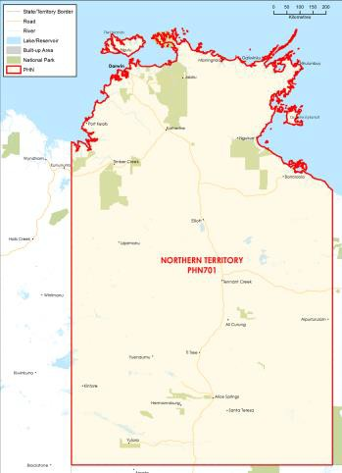

### FUNDING[67] AND PARTICIPANT[68] LEVELS

#### Funding ($M):

**All** **$5.08M** (Year coverage for NPS-M and CoS)

**NPS-M** **$0.80M** (Between FY17-18 and FY20-21)

**CoS $4.29M** (Between FY19-20 and FY21-22)

#### Participants

**All 340** (Year coverage for NPS-M and CoS)

**NPS-M 136** (Between 1 July and 31 Dec 2019)

**CoS 204** (Between 1 July and 31 Dec 2019)

### INDICATORS OF NEED[69]

#### Prevalence of mental health issues among Aboriginal and Torres Strait Islander peoples

43% of all consumers of community-based mental health services are Aboriginal (13% above expected population proportion).

#### Suicide rates among children and Aboriginal males

Premature mortality due to suicide in children and Aboriginal males has been up to four times the national rate in the Central Desert, East Arnhem and Roper Gulf LGAs.

#### NPS-M – Average wait time (July – Dec 2019)

N/A – Service model does not allow for accurate data capture from providers.

### POPULATION AND DEMOGRAPHICS[70]

#### Population (ERP1 from 2016 census)

245,740

#### Population growth 2012-2016

4.14%

#### Indigenous population

57,522

#### Gender (%)

Male: 51.4%  
Female: 48.6%

#### Area (Square Kilometres)

2351

1. OVERVIEW OF NPS-M AND COS IN EACH PHN

### STRUCTURE AND SCOPE

1. Program structure

* NPS-M and CoS are funded as separate programs.
* Some overlap in NT Government funding and NPS-M and CoS funding exists in Darwin and Palmerston with NTGOV funding separate supports (e.g. NT HASI) for this psychosocial cohort.

1. Population access and eligibility

NPS-M and CoS: Entry requirements are in line with national guidelines.

1. Geographic coverage of programs

NPS-M and CoS are intended to cover all the Northern Territory; however, limited funding means that actual service provision is limited to the following areas:

| Provider | Service Delivery Area |
| --- | --- |
| Catholic Care NT | Barkly Region (Tennant Creek) |
| Mental Health Association of Central Australia (MHACA) | Alice Springs |
| Miwatj Health Aboriginal Corporation | East Arnhem Region (Nhulunbuy) service only indigenous clients |
| Mission Australia | Darwin, Katherine, Alice Springs (including Papunya, Mt. Liebig and Haasts Bluff) |
| Sunrise Health Service | Roper Gulf Region (Ngukkurr) |
| TeamHEALTH | Darwin, West Arnhem Region (Maningrida) |

1. Assessment, entry and exit processes

##### NPS-M:

1. What is the consumer application and assessment process?

Defined by individual providers based on their service model..

1. What are the referral pathways into the program?

* Admitted/Hospital mental health services
* Non-admitted mental health services
* GP
* Other clinician (e.g. Psychologist/Psychiatrist)
* State-based psychosocial programs
* Self-referral

1. Duration/intensity of support:

Specific to need of client.

1. Is entry into the program time limited, goal oriented or ongoing?

* Ongoing (i.e. continuing support provided)
* Goal oriented (i.e. exit after achievement of a goal or milestone)

1. Has the PHN specified or suggested a number of consumers per FTE staff)?

No, FTE is determined by contract provider based on funding/client need.

##### CoS:

1. What is the consumer application and assessment process?

An Initial Needs Assessment is conducted to determine the level of support and informs an Individual Support Plan.

1. How have PiR, D2DL and PHaMs consumers transitioned to CoS services?

Consumers previously accessing Commonwealth- funded Community Mental Health programs are referred into the program if they are ineligible for the NDIS.

1. Duration/intensity of support:

There is no time limit for support, though providers can cease service provision when a consumer transitions to NDIS.

1. Is entry into the program time limited, goal oriented or ongoing?

Ongoing (i.e. continuing support provided)

1. Has the PHN specified or suggested a number of consumers per FTE staff)?

No, FTE is determined by contract provider based on funding/client need.

1. Services Types

NPS-M and CoS: Both programs provide services as specified in the national guidelines.

### MODELS OF CARE, INTEGRATION AND PRIORITY COHORTS[71]

1. Models of care: Does the PHN specify a model of care to be used?

? No. The PHN is trailing a Peer Led Education Pilot aiming to increase the capacity of people with severe and complex mental illness to self-manage their illness in a peer-led, group setting. The pilot involves the co-design of a psycho-education program to be delivered by Peers and suited to urban settings of the NT, namely Darwin. Seeks to trial a model of support that has broad reach and requires relatively low resourcing.

1. Care integration:

Integration occurs through referrals with Primary Health Care, NDIS and social services bodies. On an

individual client basis, secondary care/specialist services may also be integrated in a client’s care plan.

1. Priority Cohorts: Does the PHN prioritise particular cohorts, e.g. regions, demographics, diagnosis?

Priority cohorts Aboriginal and Torres Strait Islander peoples including people residing in all serviced areas, Darwin, Darwin Rural, Alice Springs, Katherine, Maningrida, East Arnhem, Yuendumu, Ngukurr, the Tiwi Islands and Barkly region.

### IMPLEMENTATION AND COMMISSIONING[72]

1. Roll out dates:

* NPS-M: 1 July 2019
* CoS: 1 July 2019

1. Commissioning approach

* The PHN has Integrated the commissioning of the NPS-M and CoS programs.
* NT PHN directly contracted PIR, PHaMS and D2D Living providers; a) to minimise disruption to clients and b) due to minimal options within a given region.
* NT PHN will develop a financial model to commission services based on client needs within each region, and work with providers to support the objectives of the NPS-M and CoS.

1. Strategic planning

##### Key inputs to strategic planning

* Planning is guided by the NT PHN Comprehensive Primary Health Care Advisory Group (CPHCAG), comprising of representatives from the Australian Government, Northern Territory Government, Local Hospital Networks (Top End Health Service [TEHS] and Central Australian Health Service [CAHS]) and AMSANT.
* [Are the National Mental Health Service Planning Framework estimates for your PHN available?] No.

1. Purchasing approach

##### Budgeting

1. Has the PHN pooled NPS-M or CoS funding with other funding sources?

* NPS-M: No.
* CoS: No

##### Contracts

1. What is the contracting approach taken by the PHN for each program?

Direct engagement – Existing provider(s) are commissioned to continue providing services (CoS).

1. Is there a mandated/expected capacity for services in the NPS-M and CoS programs?

* NPS-M: No.
* CoS: No

1. Does the service provider contract or schedule specify the number and type of staff required to deliver the service?

* NPS-M: Yes
* CoS: No

1. What types of workers are prescribed in contracts?

NPS-M:

* N/A – no workers are prescribed in contracts.
* Providers do report quarterly on FTE allocated to CoS/NPS programs, but not the roles occupied by FTE.
* In initial stages of roll-out, providers outsourced specialist assessment from Ots

CoS:

* N/A – no workers are prescribed in contracts.
* Providers do report quarterly on FTE allocated to CoS/NPS programs, but not the roles occupied by FTE.
* In initial stages of roll-out, providers outsourced specialist assessment from OTs

##### Purchasing

1. What is the payment approach taken by the PHN for each program?

Block funding – A fixed amount of money is paid to the provider, regardless of how local needs are being met or the quality of care provided.

1. Of the money allocated to service providers, what was the average proportion designated to administrative or indirect costs?

NPS-M and CoS: As per the NT PHN standard contract, providers can use no more than 20% of allocated funding on non-client-related costs

1. Monitoring and evaluation

##### Data/measures

1. What performance measures are specified in the contract to track service performance providers?

* Number of consumers accessing services
* Number of services provided
* Outcomes from measurement tool (below)
* Client flow (entry and exit from programs)
* Waiting time (specifically Waitlist length)
* Cost
* Demographics; additional free-text feedback re: challenges; additional free-text feedback re: NT PHN support

1. Which of the following outcomes measures does the PHN capture/monitor?

K10 is recorded via PMHC MDS reporting. At present, NT PHN is assisting providers to register and train, enabling providers to become client with MDS reporting

##### Reporting

1. How frequently do service providers provide formal reports to the PHN?

* Monthly – client/service data
* Quarterly – expenditure

1. Have you conducted a review of your roll out of the NPS-M and CoS programs?

No – not planned.

# BRISBANE NORTH

1. KEY FACTS AND FIGURES

This document provides a profile of how each PHN has implemented the NPS-M and CoS programs.

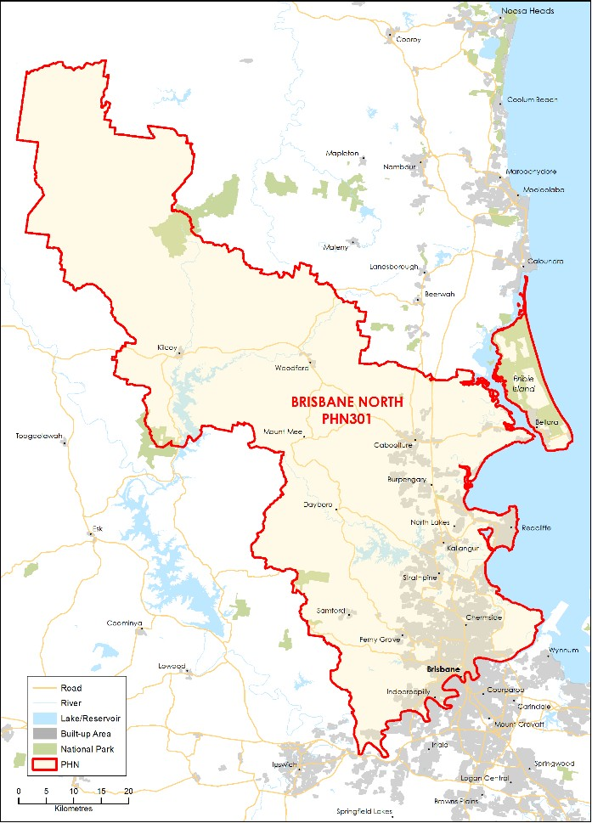

### FUNDING[73] AND PARTICIPANT[74] LEVELS

#### Funding ($M):

**All** **$6.65M** (Year coverage for NPS-M and CoS)

**NPS-M** **$2.36M** (Between FY17-18 and FY20-21)

**CoS $4.29M** (Between FY19-20 and FY21-22)

#### Participants

**All 285** (Year coverage for NPS-M and CoS)

**NPS-M 174** (Between 1 July and 31 Dec 2019)

**CoS 111** (Between 1 July and 31 Dec 2019)

### INDICATORS OF NEED[75]

#### Estimated number of people with severe mental illness

30 842 - Estimated for year 2019 from National Mental Health Service Planning Framework Planning Support Tool Estimates.

#### Hospitalisations for mental health conditions

In 2016-17, there was a total of 32,693 hospitalisations for mental health conditions in the PHN region. Admissions for mental and behavioural disorders increased 19.7 % between 2014-15 and 2016-17.

#### NPS-M – Average wait time (July – Dec 2019)

Five days.

### POPULATION AND DEMOGRAPHICS[76]

#### Population (ERP1 from 2016 census)

980,908

#### Population growth 2012-2016

7.82%

#### Indigenous population

20,075

#### Gender (%)

Male: 49.3%  
Female: 50.7%

#### Area (Square Kilometres)

3901

1. OVERVIEW OF NPS-M AND COS IN EACH PHN

### STRUCTURE AND SCOPE

1. Program structure

NPS-M and CoS are delivered through one program.

1. Population access and eligibility

* NPS-M and CoS: consumers must align with the national guidelines and be:people not currently or recently (within last three months) accessing mental health clinical care from a public hospital, and
* people who are experiencing significant disruption to their daily life, wellbeing and functioning (this may include risks to personal safety.

1. Geographic coverage of programs

NPS-M and CoS: Both programs cover the entire PHN region.

1. Assessment, entry and exit processes

##### NPS-M:

1. What is the consumer application and assessment process?

Processes were established by service providers.

1. What are the referral pathways into the program?

* Admitted/Hospital mental health services
* Non-admitted mental health services
* GP
* Other clinician (e.g. Psychologist/Psychiatrist)
* PHaMS/D2DL/ PIR
* State-based psychosocial programs
* Self-referral

1. Duration/intensity of support:

Maximum of 12 months and intensity support dependent on needs of consumers

1. Is entry into the program time limited, goal oriented or ongoing?

* Time limited (i.e. exit after a set time).
* Goal oriented (i.e. exit after achievement of a goal or milestone.

1. Has the PHN specified or suggested a number of consumers per FTE staff)?

No.

##### CoS:

1. What is the consumer application and assessment process?

* Processes were established by service providers
* Welcome/reception
* Initial assessment to determine eligibility
* Comprehensive assessment
* Creation of individualised care plan.

1. How have PiR, D2DL and PHaMs consumers transitioned to CoS services?

N/A.

1. Duration/intensity of support:

* Maximum of 12 months and intensity of support dependent on needs of consumers.

1. Is entry into the program time limited, goal oriented or ongoing?

* Time limited (i.e. exit after a set time).
* Goal oriented (i.e. exit after achievement of a goal or milestone)

1. Has the PHN specified or suggested a number of consumers per FTE staff)?

No.

1. Services Types

NPS-M and CoS are provided by the same providers, and service types are as per the national guidelines.

### MODELS OF CARE, INTEGRATION AND PRIORITY COHORTS[77]

1. Models of care: Does the PHN specify a model of care to be used?

Yes, integrated supports are provided through a service hub (and spoke) approach in a stepped care model.

1. Care integration:

The service hub model integrates psychosocial supports on two levels: 1) With other psychosocial supports as service hubs coordinate provision of psychosocial supports and 2) With clinical care e.g. psychological therapies, mental health nursing and psychosocial supports. Integration strategies used include: 1) colocations of services, 2) using a single multiagency care plan to ensure coordination across clinicians including GP and private MH sector and 3) commissioning psychological and psychosocial services in one contract.

1. Priority Cohorts: Does the PHN prioritise particular cohorts, e.g. regions, demographics, diagnosis?

Psychosocial services target people with severe and complex mental illness who are best managed in primary health care, as well as hard to reach/underserved communities.

### IMPLEMENTATION AND COMMISSIONING[78]

1. Roll out dates:

* NPS-M: 1 July 2019
* CoS: 1 July 2019

1. Commissioning approach

* First round: The PHN decommissioned existing services and commissioned NPS-M and CoS together to enable an integrated service hubs model.
* Second round: There has only been one round of commissioning.

1. Strategic planning

##### Key inputs to strategic planning

* Joint Regional Plan and Health Needs Assessment.
* Other national and state-based policies and frameworks, including the 5th National Mental Health and Suicide Prevention Plan.

1. Purchasing approach

##### Budgeting

1. Has the PHN pooled NPS-M or CoS funding with other funding sources?

The PHN Pooled budgets across multiple programs including NPS-M, CoS, psychological therapy services for underserviced groups and mental health nursing services

##### Contracts

Open tender process for a three-year contract which includes NPS-M and CoS services.

1. What is the contracting approach taken by the PHN for each program?

Prime contractor arrangements – (contract one main service provider at each hub who is responsible for procuring any additional services it cannot perform).

1. Is there a mandated/expected capacity for services in the NPS-M and CoS programs?

* NPS-M: Yes – new targets have been put into place for this financial year for expected capacity.
* CoS: Yes – expected to prioritise a smooth transition for CoS participants from their NPS-T providers

1. Does the service provider contract or schedule specify the number and type of staff required to deliver the service?

* NPS-M: Yes – contract notes the type of staff and requirements to deliver services.
* CoS: Yes – contract notes the type of staff and requirements to deliver services

1. What types of workers are prescribed in contracts?

As the funding is part of the broader mental health hub contract which includes, NPS-M, CoS, Psychological Therapies and Care Coordination, the staffing resources are shared and there is no division between streams.

NPS-M/CoS:

* Managers/Team Leader
* Peer support workers
* Nurses
* Social Workers
* Psychologist

##### Purchasing

1. What is the payment approach taken by the PHN for each program?

Block funding – A fixed amount of money is paid to the provider, regardless of how local needs are being met or the quality of care provided.

1. Of the money allocated to service providers, what was the average proportion designated to administrative or indirect costs?

NPS-M and CoS: 31% of total service provider contract value was allocated to indirect costs

1. Monitoring and evaluation

##### Data/measures:

Use of Residata (electronic triage and referral tool) to ensure PHN has access to MDS data.

1. What performance measures are specified in the contract to track service performance providers?

* Number of consumers accessing services
* Number of services provided
* Outcomes from measurement tool (below)
* Consumer Satisfaction/experience
* Cost

1. Which of the following outcomes measures does the PHN capture/monitor?

* K10, K5 (Kessler Psychological Distress Scale)
* RAS-DS (Recovery Assessment Score)

##### Reporting

1. How frequently do service providers provide formal reports to the PHN?

Quarterly

1. Have you conducted a review of your roll out of the NPS-M and CoS programs?

No – planned within next year.

1. INTEGRATED SERVICE HUB MODEL

### KEY INSIGHTS

* Integration is encouraged via pooled funding across multiple Commonwealth programs, contracting psychosocial supports and clinical supports through a single contract with a lead provider.
* Longer term contracting arrangements (three years) enable a deep partnership and collaboration between PHNs and service providers.

#### Brisbane North's Primary Mental Health Care Program

This includes an integrated service hub model which aims to improve mental health and suicide prevention planning, commissioning, and integration of services at a regional level to improve outcomes for people with or at risk of mental illness and/or suicide.

#### Overview of commissioning approach for integration

Brisbane North PHN co-designed the integrated service model with consumers, carers, service providers and other stakeholders through targeted reviews of its mental health services.

The program pools funding from multiple Commonwealth programs to commission integrated and coordinated primary mental health care including psychosocial supports for a wide range of cohorts:

* Primary mental health care services, clinical care coordination and psychosocial supports for people with severe mental illness and associated psychosocial functional impairment. The PHN specifically targets people who are best managed in primary care, excluding people who currently or recently (within the last three months) accessed mental health clinical care from a public hospital.
* Low-intensity mental health services and psychological interventions for people with mild to moderate mental illness.
* Early intervention and integrated primary mental health care services for children and young people (including those with severe mental illness being managed in primary care).

The PHN has contracted one service hub covering each Metro North Mental Health Service (MNMHS) catchment area (Redcliffe/Caboolture, The Prince Charles Hospital, The Royal Brisbane and Women’s Hospital).

This reflects a Prime Contracting Model in which a lead organisation (the service hubs) which are required to either deliver or contract out services, remaining accountable for the provision of quality, integrated care.

#### Essential elements of integrated service hub model

* Services are provided through a hub and spoke model.
* Clinical and non-clinical services are integrated (with services within and external to the hub).
* Use of a stepped care approach that matches care with the level of need for people with severe mental illness.
* Psychological therapies, mental health nursing and psychosocial supports are physically co-located in the hub and outreach is provided to ensure maximum geographical reach in the catchment area.
* Formalised agreements with external providers ensures provision of in-reach services (e.g. AOD treatment, financial counselling) and strong referral pathways and smooth transitions.
* A diverse workforce, including people with a lived experience of mental illness, provide services and support ensuring the ability to accommodate varying types of presentations, needs and supports

1. KEY FEATURES OF INTEGRATED SERVICE HUB MODEL

### Pooled funding from multiple Commonwealth funding streams:

* NPS-M
* CoS
* Primary Mental Health Care flexible funding

### Integrated contracting

* Commission integrated psychosocial supports and clinical supports through a single contract
* Prime Contracting model in which a provider (the Service Hub) is responsible for delivering or contract all services.

### Functions of Service Hubs:

* welcome/reception
* assessment, triage/intake
* service navigation – linking to other services at the hub or in the community as appropriate
* provision of psychosocial supports, mental health nursing/physical health support, psychological therapy services
* care coordination, ongoing review and exit and follow-up

# BRISBANE SOUTH

1. KEY FACTS AND FIGURES

This document provides a profile of how each PHN has implemented the NPS-M and CoS programs.

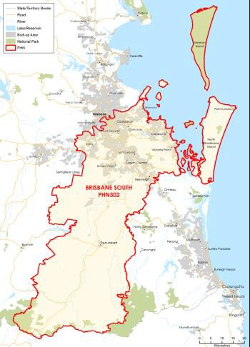

### FUNDING[79] AND PARTICIPANT[80] LEVELS

#### Funding ($M):

**All** **$7.49M** (Year coverage for NPS-M and CoS)

**NPS-M** **$2.86M** (Between FY17-18 and FY20-21)

**CoS $4.63M** (Between FY19-20 and FY21-22)

#### Participants

**All 104** (Year coverage for NPS-M and CoS)

**NPS-M 56** (Between 1 July and 31 Dec 2019)

**CoS 48** (Between 1 July and 31 Dec 2019)

### INDICATORS OF NEED[81]

Prevalence of high psychological distress

Over 100,000 adults (18+) were estimated to experience high/very high psychological distress in the region.

High rates of mental disorders in Aboriginal and Torres Strait Islander peoples

Mental disorders was the leading contributor to the burden of disease among Aboriginal and Torres Strait Islander peoples aged 15-29 years (56.7%) in the Brisbane South PHN region; a higher proportion when compared to non-Indigenous people (51.6%).

NPS-M – Average wait time (July – Dec 2019)

N/A – No wait time data provided during this period.

POPULATION AND DEMOGRAPHICS[82]

Population (ERP1 from 2016 census)

1,120,048

Population growth 2012-2016

6.3%

Indigenous population

23,589

Gender (%)

Male: 49.6%  
Female: 50.4%

Area (Square Kilometres)

3,770

OVERVIEW OF NPS-M AND COS IN EACH PHN

STRUCTURE AND SCOPE

1. Program structure

NPS-M and CoS delivered as separate programs. Both offering a blend of group based and individual supports.

1. Population access and eligibility

NPS-M and CoS: Both programs cover the entire PHN region with the addition of ‘at risk of needing hospitalisation in the future if appropriate care is not provided.

1. Geographic coverage of programs

NPS-M and CoS: Both programs cover the entire PHN region.

1. Assessment, entry and exit processes

##### NPS-M:

1. What is the consumer application and assessment process?

Processes were established by service providers.

1. What are the referral pathways into the program?

* Admitted/Hospital mental health services
* Non-admitted mental health services
* GP
* Other clinician (e.g. Psychologist/Psychiatrist)
* PHaMS/D2DL/ PIR
* State-based psychosocial programs
* Self-referral/ Family/ Carer

1. Duration/intensity of support:

Providers deliver different service options in the region. One provider offering a fixed 10-week program (two weeks individual support/eight weeks group based), the other delivering four individual support and up to 10 group activities based on goals identified in the support planning process

1. Is entry into the program time limited, goal oriented or ongoing?

* Time limited
* Goal oriented

1. Has the PHN specified or suggested a number of consumers per FTE staff)?

No.

##### CoS:

1. What is the consumer application and assessment process?

CoS providers receive phone/paper-based referrals through their respective central intake teams. Following an initial determination of eligibility, they are allocated to the CoS team for follow up with the participant and NPS-T provider.

1. How have PiR, D2DL and PHaMs consumers transitioned to CoS services?

CoS providers maintain regular contact with organisations delivering NPS-T services. CoS eligible participants are transition through a warm hand over process, in a timeframe based on individual need.

1. Duration/intensity of support:

CoS service duration/intensity is based on previous service access in place through PIR/PHaMS or D2DL programs, as well as the current goals participants are seeking to achieve in accessing ongoing support.

1. Is entry into the program time limited, goal oriented or ongoing?

* Goal oriented
* Ongoing

1. Has the PHN specified or suggested a number of consumers per FTE staff)?

No.

1. Services Types

NPS-M and CoS are provided by the same providers, and service types are as per the national guidelines.

MODELS OF CARE, INTEGRATION AND PRIORITY COHORTS[83]

1. Models of care: Does the PHN specify a model of care to be used?

No, specific model of care. However, Brisbane South PHN has implemented Primary Mental Health Care Co-Designed Service model with the following core elements embedded across MHSPAOD services across the region. These include: 1. Connector function 2. Sector wide cultural competency and inclusive practice 3. Closest-supporters/carers engagement, capability and support 4. Psychosocial support 5. Lived Experience workforce 6. Place based approach.

1. Care integration:

Brisbane South PHN uses regional governance structures to promote integration. Specifically, the PHN has fostered strong relationships between providers by establishing governance groups in the three local areas within the PHN. BSPHN also commissions a dedicated resource to coordinate care and understanding between addiction treatment services and psychosocial supports.

1. Priority Cohorts: Does the PHN prioritise particular cohorts, e.g. regions, demographics, diagnosis?

Yes, Brisbane South PHN has identified specific priority population groups including Aboriginal and Torres Strait Islander peoples, CALD, LGBTIQ+ communities and people with a disability who need a unique, targeted service response that is tailored to their cultural and individual needs.

IMPLEMENTATION AND COMMISSIONING[84]

1. Roll out dates:

* NPS-M: 1 January 2019 – 30 June 2021
* CoS: 1 January 2019 – 30 June 2022

1. Commissioning approach

* Commissioning approaches include contract extension with existing providers, and an expression of interest (EOI)/open tender procurement system.
* The Strategic Framework expresses commitment to implementing collaborative, joint or pooled funding arrangements where feasible.

1. Strategic planning

##### Key inputs to strategic planning

Co-design through a group of participants, carers and primary care service providers. This group conducted journey mapping with priority populations and service providers.

1. Purchasing approach

##### Budgeting

1. Has the PHN pooled NPS-M or CoS funding with other funding sources?

* NPS-M: No
* CoS: No

##### Contracts

1. What is the contracting approach taken by the PHN for each program?

Competitive tendering – Offers from competing providers are invited by open advertisement and evaluated in accordance with predetermined criteria.

1. Is there a mandated/expected capacity for services in the NPS-M and CoS programs?

* NPS-M: Yes
* CoS: Yes

The upper threshold for the CoS program was initially overestimated, due to the limitations from a closed number of participants accessing NPS-T and eligibility requirements. The upper threshold for NPS-M, the targets negotiated with providers, is not a mandated capacity. It is indicative based on average cost per episode/service contact calculations providers.

1. Does the service provider contract or schedule specify the number and type of staff required to deliver the service?

* NPS-M: No
* CoS: No

Per department guidance. Negotiated with providers based on program proposals and in response to local need

1. What types of workers are prescribed in contracts?

NPS-M:

* Managers/Team Leader – nonclinical
* Peer support workers
* Recovery support worker/facilitator

CoS:

* Managers/Team Leader
* Peer support workers incl. Aboriginal and Torres Strait Islander, CALD and LGBTIQ+ specific
* Recovery support worker/facilitator

##### Purchasing

1. What is the payment approach taken by the PHN for each program?

Split-Block funding – A fixed amount of money is paid to the provider, with funding allocation determined on local needs and the quality and value proposition of support provided.

1. Of the money allocated to service providers, what was the average proportion designated to administrative or indirect costs?

* NPS-M: 33%
* CoS: 67%

1. Monitoring and evaluation
2. What performance measures are specified in the contract to track service performance providers?

* Number of consumers accessing services
* Outcomes from measurement tool (below)
* Cost

1. Which of the following outcomes measures does the PHN capture/monitor?

K10, K5 (Kessler Psychological Distress Scale)

##### Reporting

1. How frequently do service providers provide formal reports to the PHN?

Quarterly

1. Have you conducted a review of your roll out of the NPS-M and CoS programs?

No – not planned.

# DARLING DOWNS AND WEST MORETON

1. KEY FACTS AND FIGURES

This document provides a profile of how each PHN has implemented the NPS-M and CoS programs.

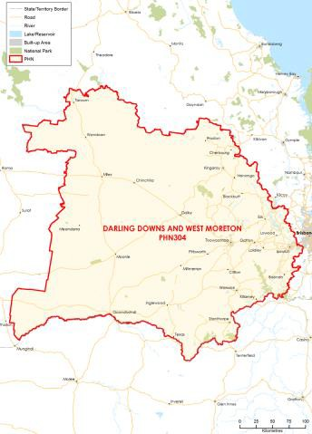

### FUNDING[85] AND PARTICIPANT[86] LEVELS

#### Funding ($M):

**All** **$6.10M** (Year coverage for NPS-M and CoS)

**NPS-M** **$2.01M** (Between FY17-18 and FY20-21)

**CoS $4.09M** (Between FY19-20 and FY21-22)

#### Participants

**All 131** (Year coverage for NPS-M and CoS)

**NPS-M 93** (Between 1 July and 31 Dec 2019)

**CoS 38** (Between 1 July and 31 Dec 2019)

### INDICATORS OF NEED[87]

#### High suicide and self- inflicted injury rate

The annual age-standardised rate per 100,000 for the region from 2011-15 was 15.5 – greater than both the Queensland and national average.

#### Estimated need for community based psychosocial supports

The National Mental Health Service Planning Framework tool estimates that 6,366 people are not eligible for the NDIS but require community- based psychosocial supports in Darling Downs and West Moreton PHN.

#### NPS-M – Average wait time (July – Dec 2019)

24 hours.

### POPULATION AND DEMOGRAPHICS[88]

#### Population (ERP1 from 2016 census)

558,803

#### Population growth 2012-2016

7.00%

#### Indigenous population

24,549

#### Gender (%)

Male: 49.6%  
Female: 50.4%

#### Area (Square Kilometres)

95,639

1. OVERVIEW OF NPS-M AND COS IN EACH PHN

### STRUCTURE AND SCOPE

1. Program structure

NPS-M and CoS are considered separate programs and are issued through different contracts.

1. Population access and eligibility

NPS-M and CoS: Both programs’ entry requirements are in line with national guidelines, with the additional criteria that under care of private hospitals or private health insurance are also ineligible to receive support.

1. Geographic coverage of programs

NPS-M and CoS: Both programs cover the entire PHN region.

1. Assessment, entry and exit processes

##### NPS-M:

1. What is the consumer application and assessment process?

This will vary by provider.

1. What are the referral pathways into the program?

* Admitted/Hospital mental health services
* Non-admitted mental health services
* GP
* Other clinician (e.g. Psychologist/Psychiatrist)
* Mental Health Nurse Care program
* Other community type organisations
* Self-referral

1. Duration/intensity of support:

No duration has been set. Supports provided by peer workers with lived experience of mental ill-health and recovery. A range of non-clinical supports will be provided which focus on building capacity and stability.

1. Is entry into the program time limited, goal oriented or ongoing?

* Goal oriented (i.e. exit after achievement of a goal or milestone)

1. Has the PHN specified or suggested a number of consumers per FTE staff)?

No.

##### CoS:

1. What is the consumer application and assessment process?

As per DoH Guidance.

1. How have PiR, D2DL and PHaMs consumers transitioned to CoS services?

The same providers of PiR, D2DL and PHaMs were funded for CoS and NPS Transition for the 2019-20 period to ensure continuity of support for these consumers.

1. Duration/intensity of support:

There is no time limit on CoS support once a consumer has been found ineligible for NDIS. Intensity is flexible and to be negotiated with consumers based on need.

1. Is entry into the program time limited, goal oriented or ongoing?

Ongoing (i.e. continuing support provided)

1. Has the PHN specified or suggested a number of consumers per FTE staff)?

No.

1. Services Types

NPS-M and CoS are provided by the same providers, and service types are as per the national guidelines.

### MODELS OF CARE, INTEGRATION AND PRIORITY COHORTS[89]

1. Models of care: Does the PHN specify a model of care to be used?

NPS-M – Yes, supports are to be provided by peer workers with lived experience of mental ill-health and recovery. A range of non-clinical supports will be provided which focus on building capacity and stability.

CoS – Yes, provision of psychosocial support using a recovery and strengths-based framework. Support is provided through group-based activities and responsive individual support at times of increased need. Services can be provided by a range of workers including mental health support workers and/or lived experience peer support workers.

1. Care integration:

NPS-M – lived experience peer workers will work closely with PHN funded mental health nurses, where appropriate, to ensure clinical care coordination and non-clinical supports are closely integrated.

The PHN has strong linkages with the Hospital and Health Services through bilateral agreements and integrated and complementary pathways to reduce duplication.

1. Priority Cohorts: Does the PHN prioritise particular cohorts, e.g. regions, demographics, diagnosis?

The PHN prioritises people with severe mental health conditions currently being managed in a primary care setting.

### IMPLEMENTATION AND COMMISSIONING[90]

1. Roll out dates:

* NPS-M: January 2019
* CoS: July 2019

1. Commissioning approach

A direct approach was made to existing service providers of PiR, PHaMs and D2DL for the 2019-20 funding for CoS. Providers of Mental Health Nurse Care were engaged to support an integrated service approach between clinical and non-clinical supports. An open tender process for Mental Health Nurse Care (MHNC), NPSM and CoS occurred early in 2020 for future services.

1. Strategic planning

##### Key inputs to strategic planning

Consultation with other PHNs, existing service providers, consumers and carers. Joint planning with hospital and health services to ensure pathways are complementary and not duplicated.

Activity Plans, Joint Regional Mental Health and Alcohol and Other Drug plans, population health data, SDAC estimates, National Mental Health Service Planning Framework (NMHSPF).

1. Purchasing approach

##### Budgeting

1. Has the PHN pooled NPS-M or CoS funding with other funding sources?

* NPS-M: Yes – these services have been combined in some areas of the PHN region with MHNC or with CoS.
* CoS: Yes – these services have been combined in some areas of the PHN region with NPS-M and/or NPS Transition

##### Contracts

1. What is the contracting approach taken by the PHN for each program?

Competitive tendering – Offers from competing providers are invited by open advertisement and evaluated in accordance with predetermined criteria.

1. Is there a mandated/expected capacity for services in the NPS-M and CoS programs?

* NPS-M: No – but capacity very much depends on what can be delivered with the funding.
* CoS: Yes – as this is a closed program it will be dependent on client numbers as at 30 June 2020 and NPS Transition clients not eligible for NDIS supports.

1. Does the service provider contract or schedule specify the number and type of staff required to deliver the service?

* NPS-M: No to number; yes – must be lived experience peer workers.
* CoS: No to number; yes – mental health support workers and/or lived experience peer workers

1. What types of workers are prescribed in contracts?

* NPS-M: as above
* CoS: as above

##### Purchasing

1. What is the payment approach taken by the PHN for each program?

* Outcomes-based payment.
* DDWMPHN provide quarterly payments in advance under contract, payments are dependant on service delivery and evaluated at the end of each quarter with payments adjusted in negotiation with the provider if variance occurs the preceding quarter. Contracts are managed under a clinical governance framework including safety and quality.

1. Of the money allocated to service providers, what was the average proportion designated to administrative or indirect costs?

* NPS-M: 20%
* CoS: 20%

1. Monitoring and evaluation
2. What performance measures are specified in the contract to track service performance providers?

* Number of consumers accessing services
* Number of services provided
* Outcomes from measurement tool
* Consumer Satisfaction/experience
* Waiting Time

1. Which of the following outcomes measures does the PHN capture/monitor?

* RAS-DS (Recovery Assessment Score)
* Other recovery assessments utilised by individual providers.
* We will be looking at standardising appropriate outcome measures for psychosocial support during this financial year.
* There are no standardised measures mandated by the Department of Health).

##### Reporting

1. How frequently do service providers provide formal reports to the PHN?

Quarterly

1. Have you conducted a review of your roll out of the NPS-M and CoS programs?

No.

# GOLD COAST

1. KEY FACTS AND FIGURES

This document provides a profile of how each PHN has implemented the NPS-M and CoS programs.

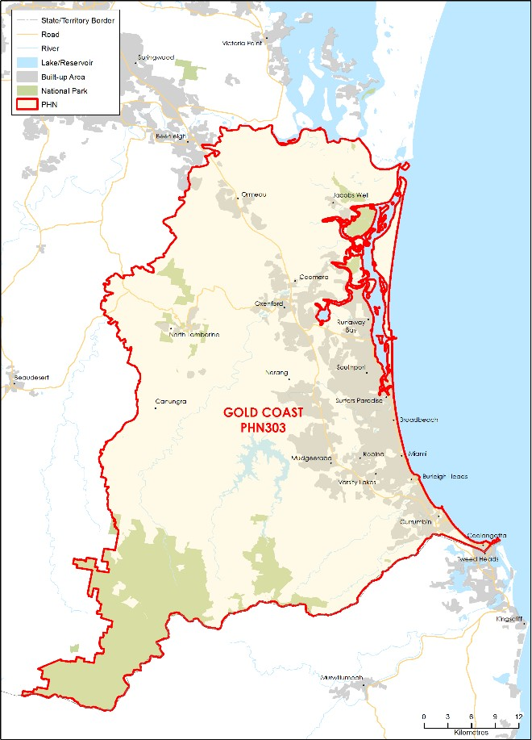

### FUNDING[91] AND PARTICIPANT[92] LEVELS

#### Funding ($M):

**All** **$3.52M** (Year coverage for NPS-M and CoS)

**NPS-M** **$1.40M** (Between FY17-18 and FY20-21)

**CoS $2.12M** (Between FY19-20 and FY21-22)

#### Participants

**All 119** (Year coverage for NPS-M and CoS)

**NPS-M 62** (Between 1 July and 31 Dec 2019)

**CoS 57** (Between 1 July and 31 Dec 2019)

### INDICATORS OF NEED[93]

#### Prevalence of severe mental illness

The total number of people with severe mental health issues in the Gold Coast region is around 20,000 people.

#### Potential cohort eligible for NPS-M

The potential cohort of Gold Coast residents who may be eligible for the National Psychosocial Support measure is estimated to be approximately 4,900. This was calculated based on population numbers and national data available through the ABS.

#### NPS-M – Average wait time (July – Dec 2019)

N/A No wait list during this period.

### POPULATION AND DEMOGRAPHICS[94]

#### Population (ERP1 from 2016 census)

591,448

#### Population growth 2012-2016

9.10%

#### Indigenous population

9,509

#### Gender (%)

Male: 48.8%  
Female: 51.2%

#### Area (Square Kilometres)

1798

1. OVERVIEW OF NPS-M AND COS IN EACH PHN

### STRUCTURE AND SCOPE

1. Program structure

NPS-M and CoS are considered separate programs (issued through different contracts to different service providers).

1. Population access and eligibility

NPS-M and CoS: Entry requirements are in line with national guidelines.

1. Geographic coverage of programs

NPS-M and CoS: Both programs cover the entire PHN region.

1. Assessment, entry and exit processes

##### NPS-M:

1. What is the consumer application and assessment process?

* Gold Coast Psychosocial Alliance has been established to coordinate intake and referrals of individuals across psychosocial services between Queensland Health, PHN and NDIS providers of psychosocial services.
* A universal referral form is used, with referrals received by
* providers’ dedicated intake and triage teams.
* Provider has a brief assessment form/process to refer to the appropriate internal program offer.

1. What are the referral pathways into the program?

* GP
* Other clinician (e.g. Psychologist/Psychiatrist)

1. Duration/intensity of support:

Individual and group-based supports are available, as per individual needs.

1. Is entry into the program time limited, goal oriented or ongoing?

* Time limited (i.e. exit after a set time)
* Goal oriented (i.e. exit after achievement of a goal or milestone)

1. Has the PHN specified or suggested a number of consumers per FTE staff)?

Yes – 20 consumers per FTE.

##### CoS:

1. What is the consumer application and assessment process?

The K-10 tool is utilised in the assessment process and informs individual recovery and care plans.

1. How have PiR, D2DL and PHaMs consumers transitioned to CoS services?

Consumers are transitioned to CoS through collaborative partnerships between providers in the Gold Coast region and existing consortia partners.

1. Duration/intensity of support:

• Once found ineligible for the NDIS, there is no time limit to how long a client can be supported with CoS. Intensity is expected to be one FTE per 15 cases (this is the same for both providers of CoS).

1. Is entry into the program time limited, goal oriented or ongoing?

* Goal oriented (i.e. exit after achievement of a goal or milestone).
* Ongoing (i.e. continuing support provided)

1. Has the PHN specified or suggested a number of consumers per FTE staff)?

Yes – 15 consumers per FTE.

1. Services Types

NPS-M and CoS are provided by the same providers, and service types are as per the national guidelines.

### MODELS OF CARE, INTEGRATION AND PRIORITY COHORTS[95]

1. Models of care: Does the PHN specify a model of care to be used?

No, as per the national guidance and collaboration with providers.

1. Care integration:

NPS-M contract stipulates expectation for service linkage/integration including but not limited to psychosocial supports, private psychiatrist, hospital, NGO service providers (e.g. headspace), drug and alcohol treatment and NPS-T providers. Service providers are also integrated through the Gold Coast Psychosocial Alliance.

1. Priority Cohorts: Does the PHN prioritise particular cohorts, e.g. regions, demographics, diagnosis?

No.

### IMPLEMENTATION AND COMMISSIONING[96]

1. Roll out dates:

* NPS-M: 1 July 2018
* CoS: 1 July 2019

1. Commissioning approach

The commissioning approach involved direct engagement of existing Commonwealth Community Mental Health (CCMH) program service providers.

1. Strategic planning

##### Key inputs to strategic planning

* Joint planning approach with Gold Coast Hospital.
* Gold Coast PHN uses the National Mental Health Service Planning Framework Planning Support Tool (PST) to estimate workforce requirements.

1. Purchasing approach

##### Budgeting

1. Has the PHN pooled NPS-M or CoS funding with other funding sources?

* NPS-M: Yes.
* CoS: No

##### Contracts

1. What is the contracting approach taken by the PHN for each program?

Direct engagement – Existing provider(s) are commissioned to continue providing services.

1. Is there a mandated/expected capacity for services in the NPS-M and CoS programs?

* NPS-M: Yes
* CoS: Yes.

1. Does the service provider contract or schedule specify the number and type of staff required to deliver the service?

* NPS-M: No to number; yes – must be lived experience peer workers.
* CoS: No to number; yes – mental health support workers and/or lived experience peer workers

1. What types of workers are prescribed in contracts?

NPS-M:

* Managers/Team Leader
* Peer support workers
* Recovery support worker/facilitator

CoS:

* Managers/Team Leader
* Peer support workers
* Recovery support worker/facilitator

##### Purchasing

1. What is the payment approach taken by the PHN for each program?

Block funding – A fixed amount of money is paid to the provider, regardless of how local needs are being met or the quality of care provided.

1. Of the money allocated to service providers, what was the average proportion designated to administrative or indirect costs?

* NPS-M: 94%
* CoS: 94%

1. Monitoring and evaluation

##### Data/measures

1. What performance measures are specified in the contract to track service performance providers?

* Number of consumers accessing services
* Consumer satisfaction
* Outcomes from measurement tool (below)
* Waiting time
* Cost

1. Which of the following outcomes measures does the PHN capture/monitor?

K10, K5 (Kessler Psychological Distress Scale).

##### Reporting

1. How frequently do service providers provide formal reports to the PHN?

Monthly

1. Have you conducted a review of your roll out of the NPS-M and CoS programs?

No – not planned.

# NORTHERN QUEENSLAND

1. KEY FACTS AND FIGURES

This document provides a profile of how each PHN has implemented the NPS-M and CoS programs.

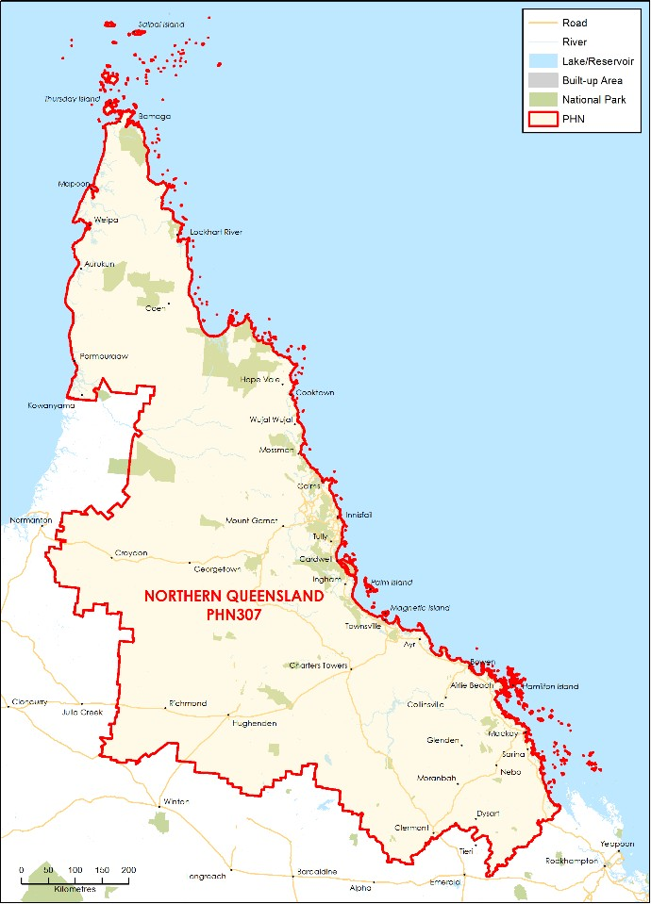

### FUNDING[97] AND PARTICIPANT[98] LEVELS

#### Funding ($M):

**All** **$5.81M** (Year coverage for NPS-M and CoS)

**NPS-M** **$3.78M** (Between FY17-18 and FY20-21)

**CoS $2.03M** (Between FY19-20 and FY21-22)

#### Participants

**All 172** (Year coverage for NPS-M and CoS)

**NPS-M 111** (Between 1 July and 31 Dec 2019)

**CoS 61** (Between 1 July and 31 Dec 2019)

### INDICATORS OF NEED[99]

#### Number of people with severe mental illness

In 2013 it was estimated that 146,311 people across Queensland were treated for mental or substance use disorders that were classified as severe.

#### Overnight hospitalisation rates for mental conditions

Overnight hospitalisation for all mental conditions in NQPHN region was in line with the national (102/10,000) average in 2015-16. However, there were areas in the region with higher rates compared to both the national and NQPHN average rates for specific mental conditions.

#### NPS-M – Average wait time (July – Dec 2019)

N/A – No wait list during this period.

### POPULATION AND DEMOGRAPHICS[100]

#### Population (ERP1 from 2016 census)

692,832

#### Population growth 2012-2016

2.80%

#### Indigenous population

67,763

#### Gender (%)

Male: 50.5%  
Female: 49.5%

#### Area (Square Kilometres)

510,684

1. OVERVIEW OF NPS-M AND COS IN EACH PHN

### STRUCTURE AND SCOPE

1. Program structure

* NPS-M and CoS are delivered as separate programs.
* All three providers of NPS-M are also NDIS providers and NPS-T providers. Providers are set up in Townsville, Cairns and Mackay.

1. Population access and eligibility

* NPS-M and CoS: Both programs’ entry requirements are in line with national guidelines.
* However, consumers are only eligible for NPS-M services if they are currently case managed in the HHS mental health services.

1. Geographic coverage of programs

* NPS-M and CoS: Both programs cover the entire PHN region.
* It has been difficult to commit funding for Cape York given the large remote sparse area and high Aboriginal and Torres Strait Islander population. Potentially four Aboriginal Health Organisations to run services. No provider can cover the entire region.

1. Assessment, entry and exit processes

##### NPS-M:

1. What is the consumer application and assessment process?

Dual referral process through stepped care process (GPs) or Mental Health Integrated Complex Care (MHICC) program. MHICC provides mental health nurses providing clinical support for the same cohort.

1. What are the referral pathways into the program?

* Non-admitted mental health services
* GP
* Other clinician (e.g. Psychologist/Psychiatrist)
* Self-referral

1. Duration/intensity of support:

N/A.

1. Is entry into the program time limited, goal oriented or ongoing?

* Time limited (i.e. exit after a set time)
* Goal oriented (i.e. exit after achievement of a goal or milestone)

1. Has the PHN specified or suggested a number of consumers per FTE staff)?

No (but funding has approximately worked out to 1.5 FTE per contract).

##### CoS:

1. What is the consumer application and assessment process?

Standard entry NDIS decisions.

1. How have PiR, D2DL and PHaMs consumers transitioned to CoS services?

N/A.

1. Duration/intensity of support:

Ongoing support, but some instances of consumers wanting more support than funded.

1. Is entry into the program time limited, goal oriented or ongoing?

Ongoing (i.e. continuing support provided.

1. Has the PHN specified or suggested a number of consumers per FTE staff)?

No.

1. Services Types

NPS-M and CoS are provided by the same providers, and service types are as per the national guidelines.

### MODELS OF CARE, INTEGRATION AND PRIORITY COHORTS[101]

1. Models of care: Does the PHN specify a model of care to be used?

No, but ideally some peer support available.

1. Care integration:

Contingent on provider relationships. Service providers encourage consumers to check in with GPs regularly. Consumers are referred in by GPs.

1. Priority Cohorts: Does the PHN prioritise particular cohorts, e.g. regions, demographics, diagnosis?

No (but noting the difficulties in accessing Aboriginal and Torres Strait Islanders and homeless populations). Trying to get a geographically and culturally appropriate service in the Cape York area.

### IMPLEMENTATION AND COMMISSIONING[102]

1. Roll out dates:

* NPS-M: Contracts awarded October 2019; services began in January 2020 (Townsville, Mackay and Cairns).
  + Cape York and Torres commissioning is still underway.
* CoS: July 2019

1. Commissioning approach

* NPS-M services for Torres and Cape area of PHN are being commissioned separately to the rest of the PHN to enable the co-design of the services to account for the isolated, remote, sparsely population, and the proportion of Aboriginal or Torres Strait Islanders (70% of area).
* CoS: commission existing service providers in the initial year of funding (to be reviewed in March 2020). Roll over of previous contracts.

1. Strategic planning

##### Key inputs to strategic planning

* No one has had the training to be able to use the NMHSPF. Not currently available to PHNs.

1. Purchasing approach

##### Budgeting

1. Has the PHN pooled NPS-M or CoS funding with other funding sources?

* NPS-M: No, however some providers are also delivering other NQPHN funded programs.
* CoS: No, however some providers are also delivering other NQPHN funded programs

##### Contracts

1. What is the contracting approach taken by the PHN for each program?

* NPS-M (Cairns, Townsville, and Mackay): Competitive tendering – Offers from competing providers are invited by open advertisement and evaluated in accordance with predetermined criteria.
* CoS and NPS-M (Cape York region): Contract extension – Existing contracts between the PHN and provider are extended.

1. Is there a mandated/expected capacity for services in the NPS-M and CoS programs?

* NPS-M: No
* CoS: Yes – numbers were identified when commonwealth funded programs came to an end and rolled into NPST; numbers won’t exceed this initial number.

1. Does the service provider contract or schedule specify the number and type of staff required to deliver the service?

* NPS-M: No – but lived experience workers are highly regarded.
* CoS: No – but lived experience workers are highly

1. What types of workers are prescribed in contracts?

NPS-M:

* Peer support workers
* Recovery support worker/facilitator

CoS:

* Peer support workers
* Social Worker
* Recovery support worker/facilitator

##### Purchasing

1. What is the payment approach taken by the PHN for each program?

Block funding – A fixed amount of money is paid to the provider, regardless of how local needs are being met or the quality of care provided.

1. Of the money allocated to service providers, what was the average proportion designated to administrative or indirect costs?

* NPS-M: 10%
* CoS: 10%

1. Monitoring and evaluation

##### Data/measures

1. What performance measures are specified in the contract to track service performance providers?

* Number of consumers accessing services
* Number of services provided
* Outcomes from measurement tool (below)
* Consumer Satisfaction/experience

1. Which of the following outcomes measures does the PHN capture/monitor?

* K10, K5 (Kessler Psychological Distress Scale)
* SDQ (Strengths and Difficulties Questionnaire) [although not relevant to this group]

##### Reporting

1. How frequently do service providers provide formal reports to the PHN?

N/A

1. Have you conducted a review of your roll out of the NPS-M and CoS programs?

No – not planned

# WESTERN QUEENSLAND

1. KEY FACTS AND FIGURES

This document provides a profile of how each PHN has implemented the NPS-M and CoS programs.

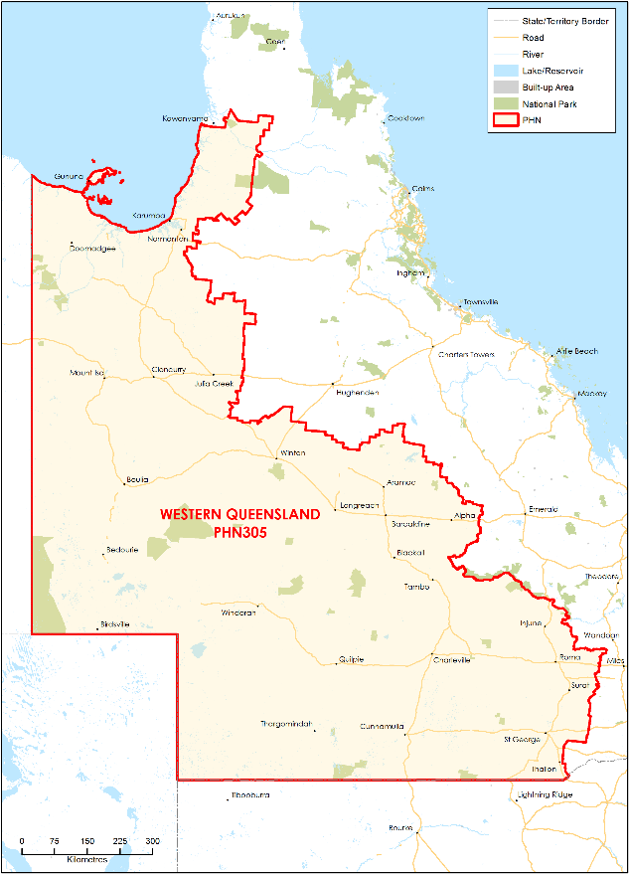

### FUNDING[103] AND PARTICIPANT[104] LEVELS

#### Funding ($M):

**All** **$1.92M** (Year coverage for NPS-M and CoS)

**NPS-M** **$0.65M** (Between FY17-18 and FY20-21)

**CoS $1.27M** (Between FY19-20 and FY21-22)

#### Participants

**All 67** (Year coverage for NPS-M and CoS)

**NPS-M 48** (Between 1 July and 31 Dec 2019)

**CoS 19** (Between 1 July and 31 Dec 2019)

INDICATORS OF NEED[105]

#### Large rural and regional population

Due to the remote or very remote status of 99% of the region, it is estimated that 17% of the total population requires mental health treatment.

#### High rates of serious mental health issues

WQPHN has suicide and mental health hospitalisation rates greater than other Queensland PHNs and double the national average.

#### NPS-M – Average wait time (July – Dec 2019)

N/A – No wait list during this period.

### POPULATION AND DEMOGRAPHICS[106]

#### Population (ERP1 from 2016 census)

63,719

#### Population growth 2012-2016

-9.0%

#### Indigenous population

10,650

#### Gender (%)

Male: 51.6%  
Female: 48.4%

#### Area (Square Kilometres)

937,118

1. OVERVIEW OF NPS-M AND COS IN EACH PHN

### STRUCTURE AND SCOPE

1. Program structure

There are four main providers for CoS with two of the four contracted for NPS-M provision; however, funding and contracting is done separately for each.

1. Population access and eligibility

NPS-M and CoS: Both programs’ entry requirements are in line with national guidelines.

1. Geographic coverage of programs

NPS-M and CoS: Both programs cover the entire PHN region.

1. Assessment, entry and exit processes

##### NPS-M:

1. What is the consumer application and assessment process?

Application and assessment are done through the service providers.

1. What are the referral pathways into the program?

* Admitted/Hospital mental health services
* Non-admitted mental health services
* GP
* Other clinician (e.g. Psychologist/Psychiatrist)
* State-based psychosocial programs
* Self-referral

1. Duration/intensity of support:

Intensity of support depends on the activities (linked to recovery goal outcomes) purchased being the number of and type; however, average support is 1.8 hours as the providers are acting in a brokerage role only.

1. Is entry into the program time limited, goal oriented or ongoing?

* Time limited (i.e. exit after a set time)
* Goal oriented (i.e. exit after achievement of a goal or milestone)

1. Has the PHN specified or suggested a number of consumers per FTE staff)?

No.

##### CoS:

1. What is the consumer application and assessment process?

Application and assessment are done through the service providers driven by age limit (over 65) and ineligibility for NDIS.

1. How have PiR, D2DL and PHaMs consumers transitioned to CoS services?

As above.

1. Duration/intensity of support:

One provider averaged 29 sessions per client during this period. Due to the fact that her clientele are all over 65 and therefore need the intensity of support. Intensity therefore varies depending on age of clientele and individual psychosocial support needs of the client.

1. Is entry into the program time limited, goal oriented or ongoing?

Ongoing (i.e. continuing support provided).

1. Has the PHN specified or suggested a number of consumers per FTE staff)?

No.

1. Services Types

* NPS-M and CoS: Both programs provide services as specified in the national guidelines.
* The exact nature of each service is determined by the consumer’s GP and the provider, based on the consumer’s individual need and mental health plan.

### MODELS OF CARE, INTEGRATION AND PRIORITY COHORTS[107]

1. Models of care: Does the PHN specify a model of care to be used?

Psychosocial services form part of the PHNs Health Care Home Model of Care, and use individual and group delivery options, including telehealth.

1. Care integration:

Contracts mandate linkage with other service providers (GPs/Aboriginal Medical Practices, Primary Care services, specialist mental health services, broader NGO sector, alcohol and other drug treatment services, and income, education, employment and housing support services.

1. Priority Cohorts: Does the PHN prioritise particular cohorts, e.g. regions, demographics, diagnosis?

No.

### IMPLEMENTATION AND COMMISSIONING[108]

1. Roll out dates:

* NPS-M: January 2019
* CoS: September 2019

1. Commissioning approach

WQPHN directly commissioned existing service providers, after investigating previous psychosocial service use data and consulting with consumers and providers.

1. Strategic planning

##### Key inputs to strategic planning

Needs assessments, National Service Planning Framework, Regional Plan for Integrated Mental Health and Suicide Prevention, Activity Work Plan, Health Care Home Model of Care.

1. Purchasing approach

##### Budgeting

1. Has the PHN pooled NPS-M or CoS funding with other funding sources?

* NPS-M: No.
* CoS: No.

##### Contracts

1. What is the contracting approach taken by the PHN for each program?

Direct engagement – Existing provider(s) are commissioned to continue providing services.

1. Is there a mandated/expected capacity for services in the NPS-M and CoS programs?

* NPS-M: Yes – due to funding limitations each client package capped at $1000.
* CoS: No.

1. Does the service provider contract or schedule specify the number and type of staff required to deliver the service?

* NPS-M: Yes
* CoS: Yes

1. What types of workers are prescribed in contracts?

NPS-M:

* Brokerage coordinator

CoS:

* Recovery support worker/facilitator

##### Purchasing

1. What is the payment approach taken by the PHN for each program?

Block funding – A fixed amount of money is paid to the provider, regardless of how local needs are being met or the quality of care provided.

1. Of the money allocated to service providers, what was the average proportion designated to administrative or indirect costs?

* NPS-M: 10%
* CoS: 10%

1. Monitoring and evaluation

##### Data/measures

1. What performance measures are specified in the contract to track service performance providers?

* Number of consumers accessing services
* Number of services provided
* Outcomes from measurement tool (below)
* Consumer Satisfaction/experience
* Cost

1. Which of the following outcomes measures does the PHN capture/monitor?

* K10, K5 (Kessler Psychological Distress Scale)
* SDQ (Strengths and Difficulties Questionnaire) [although not relevant to this group]

##### Reporting

1. How frequently do service providers provide formal reports to the PHN?

N/A

1. Have you conducted a review of your roll out of the NPS-M and CoS programs?

* Formal review planned for CoS annually
* NPS Brokerage December 2020 to prioritise need for further funding (2021 onwards) based on outcomes

# ADELAIDE

1. KEY FACTS AND FIGURES

This document provides a profile of how each PHN has implemented the NPS-M and CoS programs.

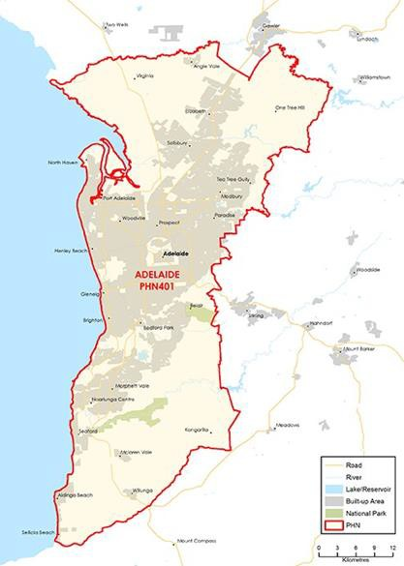

### FUNDING[109] AND PARTICIPANT[110] LEVELS

#### Funding ($M):

**All** **$3.13M** (Year coverage for NPS-M and CoS)

**NPS-M** **$1.02M** (Between FY17-18 and FY20-21)

**CoS $2.11M** (Between FY19-20 and FY21-22)

#### Participants

**All 579** (Year coverage for NPS-M and CoS)

**NPS-M 153** (Between 1 July and 31 Dec 2019)

**CoS 426** (Between 1 July and 31 Dec 2019)

### INDICATORS OF NEED[111]

#### Youth mental health

Estimated 26,100 under 17-year-olds with a mental health issue in 2017. National Mental Health Service Planning Framework Planning Support Tool Estimates.

#### Rate of ED presentations for mental and behavioural disorders

Recent AIHW data (2017-18) listed South Australia as having the highest rate of ED presentations of all States for mental and behavioural disorders of all States – 4.8% compared to 3.6% nationally.

#### NPS-M – Average wait time (July – Dec 2019)

Average wait time during 2020 is 6 months.

### POPULATION AND DEMOGRAPHICS[112]

#### Population (ERP1 from 2016 census)

1,216,051

#### Population growth 2012-2016

3.54%

#### Indigenous population

17,230

#### Gender (%)

Male: 49.2%  
Female: 50.8%

#### Area (Square Kilometres)

1,550

1. OVERVIEW OF NPS-M AND COS IN EACH PHN

### STRUCTURE AND SCOPE

1. Program structure

NPS-M and CoS are considered separate programs and are administered through different contracts.

1. Population access and eligibility

Entry requirements are in line with national guidelines.

1. Geographic coverage of programs

Both programs cover the entire PHN region.

1. Assessment, entry and exit processes

##### NPS-M:

1. What is the consumer application and assessment process?

Entry into the program involves the completion of an intake assessment, to support the identification of personal goals and inform Recovery Action Plans. Providers assess consumers through the K10+ assessment tool, at commencement and during each 30-day goal review.

1. What are the referral pathways into the program?

* Admitted/Hospital mental health services
* Non-admitted mental health services
* GP
* Other clinician (e.g. Psychologist/Psychiatrist)
* State-based psychosocial programs
* Self-referral

1. Duration/intensity of support:

Many of the initial NPS-M consumers were on the waiting list for PiR and PHaMs at the time of transition, and typically required support of greater intensity than that which NPS-M was designed to provide. Therefore, since these consumers have been assisted and moved into more appropriate state-based programs, the average duration of care under NPS-M has reduced – though some higher-level consumers are still being intensely supported, since they were unable to access more appropriate programs.

1. Is entry into the program time limited, goal oriented or ongoing?

* Time limited – Consumers are initially accepted into the program for 3 months. The goals they identified upon entry are reviewed after 3 months, and if a consumer identifies that they are still requiring assistance, they may access supports for another three months.
* At this point, if it appears a consumer may require ongoing support, there is a discussion around transitioning to the NDIS

1. Has the PHN specified or suggested a number of consumers per FTE staff)?

Yes – 15 consumers per FTE at full capacity.

##### CoS:

1. What is the consumer application and assessment process?

Note: assessments must be updated once set up with their new provider. Prior to this, once a provider (receiving both CoS funding and NPS-T funding) receives confirmation that a consumer has been found ineligible for NDIS, they move this consumer internally into their CoS program. As of 1st October, a single provider has been appointed to deliver CoS services across the entire Adelaide Metro region. The referral processes between the NPS-T providers and this CoS provider are yet to be determined.

1. How have PiR, D2DL and PHaMs consumers transitioned to CoS services?

PiR and PHaMs consumers have struggled with the transition to CoS. Due to the reduction in funding, CoS is required to be predominantly a group-based service (with some 1:1 support), as opposed to providing mostly 1:1 services as under previous funding arrangements. Providers also reported difficulties with the levels of support able to be provided under group programs. Some PHaMs and PiR consumers needed assistance to reapply once or twice for the NDIS before getting a successful outcome. D2DL consumers have been more successful, as they had a similar model to CoS and were not used to receiving 1:1 supports. Issues with transition were exacerbated by issues surrounding existing providers and staff having to change their methods and intensity of support.

1. Duration/intensity of support:

Until present, CoS has not been time-limited. The new CoS provider will be expected to operate according to recovery principles and exit consumers when they have achieved their identified goals; if they become unwell again, they can then access support through the NPS-M program.

1. Is entry into the program time limited, goal oriented or ongoing?

Goal oriented (i.e. exit after achievement of a goal or milestone).

1. Has the PHN specified or suggested a number of consumers per FTE staff)?

Yes – 15 consumers per FTE at full capacity

MODELS OF CARE, INTEGRATION AND PRIORITY COHORTS[113]

1. Models of care: Does the PHN specify a model of care to be used?

There is coordination, integration and referral linkage between psychosocial services, broader health and mental health services (including State Mental Health) and various mainstream services – to ensure clinical and non-clinical services are ‘joined up’ and operating within a stepped-care continuum.

1. Care integration:

The PHN and its programs are integrated with the NDIS, Canberra Health Services (for consumers coming in and out of mental health care), Medicare, local charities (i.e. food banks, homelessness services).

1. Priority Cohorts: Does the PHN prioritise particular cohorts, e.g. regions, demographics, diagnosis?

There is coordination, integration and referral linkage between psychosocial services, broader health and mental health services (including State Mental Health) and various mainstream services – to ensure clinical and non-clinical services are ‘joined up’ and operating within a stepped-care continuum.

IMPLEMENTATION AND COMMISSIONING[114]

1. Services Types:

NPS-M and CoS: Both programs provide services as specified in the national guidelines

1. Roll out dates

* NPS-M: July 2019
* CoS: September 2019

1. Commissioning approach

* NPS-M: This program was initially commissioned through two existing Commonwealth Mental Health providers who already had contracts with APHN – in order to ensure the program was up and running quickly. At the end of the initial contractual period, a direct tender approach was used to identify the final NPS-M provider.
* CoS (and NPS-T): These programs remained with the current Commonwealth Mental Health providers to ensure consumers were not disadvantaged. An open tender process has just been completed to identify a single CoS provider.

1. Strategic planning

##### Key inputs to strategic planning

The service approach is the result of a previous co-design process between the Adelaide PHN and service providers.

1. Purchasing approach

##### Budgeting

1. Has the PHN pooled NPS-M or CoS funding with other funding sources?

* NPS-M: No
* CoS: No

##### Contracts

1. What is the contracting approach taken by the PHN for each program?

* Competitive tendering – Offers from competing providers are invited by open advertisement and evaluated in accordance with predetermined criteria.
* Direct engagement – Existing provider(s) are commissioned to continue providing services.
* Contract extension – Existing contracts between the PHN and provider are extended.

1. Is there a mandated/expected capacity for services in the NPS-M and CoS programs?

* NPS-M: Yes
* CoS: Yes

1. Does the service provider contract or schedule specify the number and type of staff required to deliver the service?

* NPS-M: Yes
* CoS: Yes

1. What types of workers are prescribed in contracts?

NPS-M and CoS:

* Managers/Team Leader
* Peer support workers
* Recovery support worker/facilitator

##### Purchasing

1. What is the payment approach taken by the PHN for each program?

Block funding – A fixed amount of money is paid to the provider, regardless of how local needs are being met or the quality of care provided.

1. Of the money allocated to service providers, what was the average proportion designated to administrative or indirect costs?

* NPS-M: 25%
* CoS: 25%

1. Monitoring and evaluation

##### Data/measures

1. What performance measures are specified in the contract to track service performance providers?

* Number of consumers accessing services
* Number of services provided
* Outcomes from measurement tool (below)
* Consumer Satisfaction/experience
* Waiting time
* Cost

1. Which of the following outcomes measures does the PHN capture/monitor?

K10, K5 (Kessler Psychological Distress Scale)

##### Reporting

1. How frequently do service providers provide formal reports to the PHN?

Quarterly

1. Have you conducted a review of your roll out of the NPS-M and CoS programs?

No – not planned within the next 18-24 months.

# COUNTRY SA

1. KEY FACTS AND FIGURES

This document provides a profile of how each PHN has implemented the NPS-M and CoS programs.

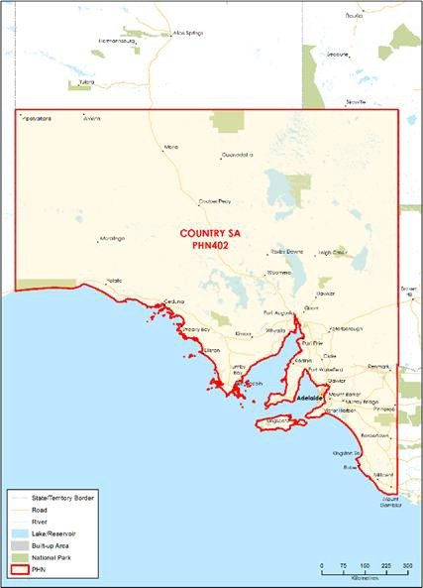

### FUNDING[115] AND PARTICIPANT[116] LEVELS

#### Funding ($M):

**All** **$6.82M** (Year coverage for NPS-M and CoS)

**NPS-M** **$2.24M** (Between FY17-18 and FY20-21)

**CoS $4.59M** (Between FY19-20 and FY21-22)

#### Participants

**All 409** (Year coverage for NPS-M and CoS)

**NPS-M 124** (Between 1 July and 31 Dec 2019)

**CoS 285** (Between 1 July and 31 Dec 2019)

### INDICATORS OF NEED[117]

#### Psychological distress

13% of this PHN population experience high or very high levels of distress, compared to the state average of 11.9%. 31.8% of Aboriginal and Torres Strait Islander people in this PHN population have high or very high distress.

#### Needs assessment for previous programs (PIR)

The PIR needs assessment for 2016/18 demonstrated that 1,095 consumers did not have their needs met, and 85% of PIR consumers for this period were unemployed.

#### NPS-M – Average wait time (July – Dec 2019)

As at 31 Dec 2019, there was no wait time to receive NPS-M in serviced regions. Between 1 July – 31 Dec 2019, there was a period of approximately 8 weeks where wait times occurred in the Riverland region only.

### POPULATION AND DEMOGRAPHICS[118]

#### Population (ERP1 from 2016 census)

497,003

#### Population growth 2012-2016

3.07%

#### Indigenous population

16,703

#### Gender (%)

Male: 50.1%  
Female: 49.9%

#### Area (Square Kilometres)

963,296

1. OVERVIEW OF NPS-M AND COS IN EACH PHN

### STRUCTURE AND SCOPE

1. Program structure

During 2019/20, NPS-M and CoS were considered two distinct programs (administered through separate contracts) that were closely aligned.

As of 1 July 2020, the two programs have been consolidated under the one contract known as Country Wellness Connections (CWC).

1. Population access and eligibility

Entry requirements are in line with national guidelines.

1. Geographic coverage of programs

* NPS-M: These services were provided to residents of the Riverland, Murray Mallee and Limestone Coast regions only up until 31 June 2020.
* CoS: This program covers the entire PHN region and has been consolidated with NPS-M from 1 July 2020 to ensure both programs cover the entire PHN catchment (excluding Anangu Pitjantjatjara Yankunytjatjara Lands as more funding is required to deliver CWC in this region.

1. Assessment, entry and exit processes

##### NPS-M:

1. What is the consumer application and assessment process?

* Providers in each region manage application and assessment processes as per a “one size never fits all” approach.
* There are no age restrictions for NPS-M and a diagnosis from a GP or other health professional is not required for application.

1. What are the referral pathways into the program?

* Admitted/Hospital mental health services
* Non-admitted mental health services
* GP and Other clinician (e.g. Psychologist/Psychiatrist)
* State-based psychosocial programs and services in the community
* Self-referral
* Carers, family or friends (with consent)

1. Duration/intensity of support:

The exact duration of support depends on the participant. Nonetheless, services are intended to be short-term, flexible and responsive by providing targeted psychosocial support when required. Consumers can enter and exit the program as and when needed. Consumers requiring more intense, ongoing individual support are encourage to test/retest for the NDIS.

1. Is entry into the program time limited, goal oriented or ongoing?

Goal oriented (i.e. exit after achievement of a goal or milestone)

1. Has the PHN specified or suggested a number of consumers per FTE staff)?

Yes – 40-50 consumers per FTE. CSAPHN acknowledge this will vary across each region depending on demand and previous Commonwealth supports provided.

##### CoS:

1. What is the consumer application and assessment process?

Providers in each region manage application and assessment processes as per a “one size never fits all” approach.

1. How have PiR, D2DL and PHaMs consumers transitioned to CoS services?

During 19/20, NPS-T and CoS were consolidated into one contract and existing PIR, PHaMs and D2DL providers managed this activity. This meant little disruption for participants transitioning between the two services.

1. Duration/intensity of support:

Same duration and intensity as NPS-M.

1. Is entry into the program time limited, goal oriented or ongoing?

Goal oriented (i.e. exit after achievement of a goal or milestone).

1. Has the PHN specified or suggested a number of consumers per FTE staff)?

Yes – 40-50 consumers per FTE.

### MODELS OF CARE, INTEGRATION AND PRIORITY COHORTS[119]

1. Models of care: Does the PHN specify a model of care to be used?

No. It does provide parameters and expectations surrounding service objectives, outcomes, eligibility, scope and performance measures.

1. Care integration:

NPS-M and CoS are linked to clinical services to support an integrated team approach to meeting the needs of people with severe mental illness, and form part of a multi-agency care plan. NPS-M and CoS are also integrated with State-funded psychosocial programs where appropriate.

1. Priority Cohorts: Does the PHN prioritise particular cohorts, e.g. regions, demographics, diagnosis?

Yes, during 2019/20, residents of the Riverland, Murray Mallee and Limestone Coast regions were recognised as priority cohorts for NPS-M. Within these regions, engagement with vulnerable ‘hard to reach’ groups such as Aboriginal people and those at risk of suicide were prioritised.

1. Services Types

NPS-M and CoS: Both programs provide services as specified in the national guidelines

### IMPLEMENTATION AND COMMISSIONING[120]

1. Roll out dates:

* NPS-M: 1 Jan 2019
* CoS: 1 July 2019
* Consolidated Program:1 July 2020 – known as Country Wellness Connections (CWC) in Country SA

1. Commissioning approach

* CSAPHN went out to Tender for NPS-M in 2018 and the successful tender applicants commenced in January 2019.
* Providers of former Commonwealth-funded programs were commissioned to deliver CoS for an interim period of 12-months commencing July 2019. During this period, CSAPHN went out to tender for the CWC service and the successful tender applicants commenced in July 2020.

1. Strategic planning

##### Key inputs to strategic planning

* CSAPHN undertook a comprehensive needs assessment prior to the implementation of NPS-M.
* CSAPHN worked with the CoS providers when planning arrangements for the CWC program. This program prioritises CoS eligible clients, manages waitlists for new (NPS-M) clients and ensures the service is implemented and delivered in a flexible way by considering both individual and local needs. Services also complement State and other CSAPHN funded services (where appropriate).
* The MH Service Planning Framework was not utilised as part of this process.

1. Purchasing approach

##### Budgeting

1. Has the PHN pooled NPS-M or CoS funding with other funding sources?

* NPS-M: Yes.
* CoS: Yes.

##### Contracts

1. What is the contracting approach taken by the PHN for each program?

* Competitive tendering – Offers from competing providers are invited by open advertisement and evaluated in accordance with predetermined criteria.
* Direct engagement – Existing provider(s) commissioned to continue providing services. Initially contracts were for a six-month period and were extended another 6 months to the end of the financial year.

1. Is there a mandated/expected capacity for services in the NPS-M and CoS programs?

* NPS-M: No.
* CoS: No.

1. Does the service provider contract or schedule specify the number and type of staff required to deliver the service?

* NPS-M: Yes
* CoS: Yes

1. What types of workers are prescribed in contracts?

NPS-M and CoS:

* Managers/team leaders
* Peer support workers
* Mental health support workers
* Allied health and clinical staff
* Volunteers

##### Purchasing

1. What is the payment approach taken by the PHN for each program?

Block funding – A fixed amount of money is paid to the provider, regardless of how local needs are being met or the quality of care provided.

1. Of the money allocated to service providers, what was the average proportion designated to administrative or indirect costs?

* NPS-M: 15%
* CoS: 15%

1. Monitoring and evaluation

##### Data/measures

1. What performance measures are specified in the contract to track service performance providers?

* Number of consumers accessing services
* Number of clients seen
* Number of services provided
* Referrals actioned within one week
* Number of clients being supported by State or other
* CSAPHN funded clinical services
* Outcomes, including measurement tool (below)
* Consumer satisfaction/experience
* Number of FTE
* All staff have completed cultural awareness training

1. Which of the following outcomes measures does the PHN capture/monitor?

* K10, K5 (Kessler Psychological Distress Scale)
* Providers also use their organisation’s own internal outcome measure tool such as the Mental Health Recover Star.

##### Reporting

1. How frequently do service providers provide formal reports to the PHN?

Biannual

1. Have you conducted a review of your roll out of the NPS-M and CoS programs?

No – planned within the next year

# TASMANIA

1. KEY FACTS AND FIGURES

This document provides a profile of how each PHN has implemented the NPS-M and CoS programs.

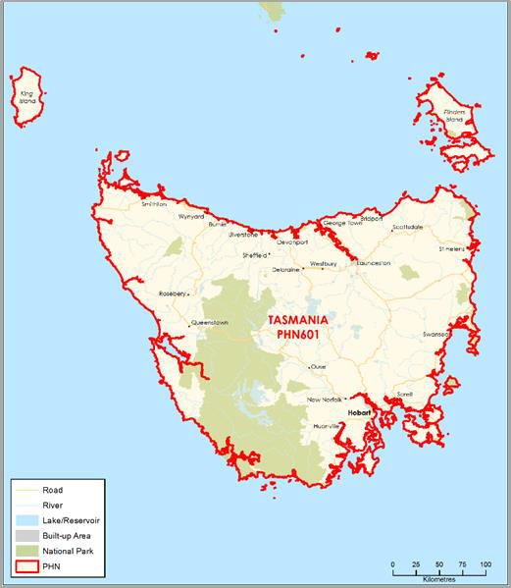

### FUNDING[121] AND PARTICIPANT[122] LEVELS

#### Funding ($M):

**All** **$6.68M** (Year coverage for NPS-M and CoS)

**NPS-M** **$1.70M** (Between FY17-18 and FY20-21)

**CoS $4.98M** (Between FY19-20 and FY21-22)

#### Participants

**All 109** (Year coverage for NPS-M and CoS)

**NPS-M 34** (Between 1 July and 31 Dec 2019)

**CoS 75** (Between 1 July and 31 Dec 2019)

### INDICATORS OF NEED[123]

#### Types of psychosocial support

In Tasmania PHN’s 2018 NPS- M consultation there was a strong identification of services needed to maintain or improve social engagement and connection with the community. Support for maintaining or improving family relationships, managing money, life skills, physical wellness, and looking after a home were also indicated as needed or missing.

#### Length of psychosocial support

The length for support varies according to the needs of the consumer. In Tasmania PHN’s 2018 NPS- M consultation, respondents indicated the length of time support was required ranged from zero to six years. A higher number of respondents said up to two years, followed by zero to six months and six to twelve months.

#### NPS-M – Average wait time (July – Dec 2019)

2 months.

### POPULATION AND DEMOGRAPHICS[124]

#### Population (ERP1 from 2016 census)

517,588

#### Population growth 2012-2016

1.10%

#### Indigenous population

23,526

#### Gender (%)

Male: 49.4%  
Female: 50.6%

#### Area (Square Kilometres)

68,018

1. OVERVIEW OF NPS-M AND COS IN EACH PHN

### STRUCTURE AND SCOPE

1. Program structure

NPS-M and CoS are provided and funded under two different programs with the same provider.

1. Population access and eligibility

Entry requirements are in line with national guidelines.

1. Geographic coverage of programs

Both programs cover the entire PHN region.

1. Assessment, entry and exit processes

##### NPS-M:

1. What is the consumer application and assessment process?

Primary access is done through a 1800 number setup and monitored by the provider. Applications can also be made through the service provider’s website. The consumers are screened using the Life Skills Profile-16 (LSP-16) and must score in the top 50% of any two questions across the subscales.

1. What are the referral pathways into the program?

* Admitted/Hospital mental health services
* Non-admitted mental health services
* GP
* Other clinician (e.g. Psychologist/Psychiatrist)
* State-based psychosocial programs
* Community services organisations

1. Duration/intensity of support:

* Low needs consumers: Estimate average engagement of 4 weeks.
* Medium needs consumers: Estimate average engagement of 3 months.
* High needs consumers: Estimate average engagement of 6 months.

1. Is entry into the program time limited, goal oriented or ongoing?

* Time limited (i.e. exit after a set time)
* Goal oriented (i.e. exit after achievement of a goal or milestone)

1. Has the PHN specified or suggested a number of consumers per FTE staff)?

No.

##### CoS:

1. What is the consumer application and assessment process?

A warm referral is made form the NPS Transition provider once the client has been deemed as not suitable for the NDIS. The Life Skills Profile-16 (LSP- 16) is applied to better understand the client needs and inform services offered.

1. How have PiR, D2DL and PHaMs consumers transitioned to CoS services?

NPS Transition provider notifies CoS provider of consumer consenting to a warm handover to the service. Consumers will not leave the NPS Transition program until this has been completed.

1. Duration/intensity of support:

The intensity of support provided to consumers is flexible and to be negotiated with each consumer based on their needs. Group support can be provided when required.

1. Is entry into the program time limited, goal oriented or ongoing?

* Once a client has tested eligibility for the NDIS and been found ineligible there is no time limit for support.
* While there is no time limit to support, a client is no longer eligible if their mental illness no longer causes significant impairment to their basic life skills functioning using the Life Skills Profile-16 (LSP-16).

1. Has the PHN specified or suggested a number of consumers per FTE staff)?

No.

1. Services Types

NPS-M and CoS are provided by the same providers, and service types are as per the national guidelines.

### MODELS OF CARE, INTEGRATION AND PRIORITY COHORTS[125]

1. Models of care: Does the PHN specify a model of care to be used?

No, however services must be recovery focused and trauma informed, ensuring key principles of safety, trustworthiness, choice, collaboration, empowerment and respect for diversity are maintained.

1. Care integration:

The service provider may link consumers to clinical services as appropriate to support an integrated team approach and form part of a multi-agency care plan for consumers referred to the service.

1. Priority Cohorts: Does the PHN prioritise particular cohorts, e.g. regions, demographics, diagnosis?

No.

### IMPLEMENTATION AND COMMISSIONING[126]

1. Roll out dates:

* NPS-M: July 2019
* CoS: July 2019

1. Commissioning approach

Tasmania PHN’s commissioning process involves assessing needs, designing solutions, implementing through procurement, and evaluating outcomes. Prior to the opening of the tender, Primary Health Tasmania collected and analysed feedback through a survey and focus groups (103 people total) from current and future consumers, carers, local GPs and existing service providers

1. Strategic planning

##### Key inputs to strategic planning

* TPHN used their 2019-2022 Needs assessment and stakeholder consultation to plan and design the psychosocial services.
* NPS-M services have been considered in the National Mental Health Service Planning Framework mapping exercise undertaken by Primary Health Tasmania and the University of Queensland. This occurred post the commissioning of these services and will be referred to during periodical service review in 2020/21.

1. Purchasing approach

##### Budgeting

1. Has the PHN pooled NPS-M or CoS funding with other funding sources?

* NPS-M: No
* CoS: No

##### Contracts

1. What is the contracting approach taken by the PHN for each program?

Competitive tendering – Offers from competing providers are invited by open advertisement and evaluated in accordance with predetermined criteria.

1. Is there a mandated/expected capacity for services in the NPS-M and CoS programs?

* NPS-M: Yes
* CoS: Yes

1. Does the service provider contract or schedule specify the number and type of staff required to deliver the service?

* NPS-M: No
* CoS: No
* During the tender response process, applicants were required to provide a service model that included staff numbers and type required to deliver services. These were assessed and informed the awarding of the service

1. What types of workers are prescribed in contracts?

NPS-M and CoS:

* None

##### Purchasing

1. What is the payment approach taken by the PHN for each program?

Block funding – A fixed amount of money is paid to the provider, regardless of how local needs are being met or the quality of care provided.

1. Of the money allocated to service providers, what was the average proportion designated to administrative or indirect costs?

* NPS-M: 10%
* CoS: 15%

1. Monitoring and evaluation

##### Data/measures

1. What performance measures are specified in the contract to track service performance providers?

* Number of consumers accessing services
* Number of services provided
* Outcomes from measurement tool (below) e.g. Increased periods of stable psychosocial functions, improved quality of life
* Attendance rate
* Quality and safety – completed a recognised training program in delivery of culturally safe services for Aboriginal and Torres Strait Islander peoples
* Timely reporting and MDS compliance rate

1. Which of the following outcomes measures does the PHN capture/monitor?

* LSP-16 (Life Skills Profile)
* AQoL 4d
* Care measure

##### Reporting

1. How frequently do service providers provide formal reports to the PHN?

* Monthly PMHC MDS
* Quarterly service performance reports
* 6 monthly financial statements

1. Have you conducted a review of your roll out of the NPS-M and CoS programs?

No –planned within next year

# EASTERN MELBOURNE

1. KEY FACTS AND FIGURES

This document provides a profile of how each PHN has implemented the NPS-M and CoS programs.

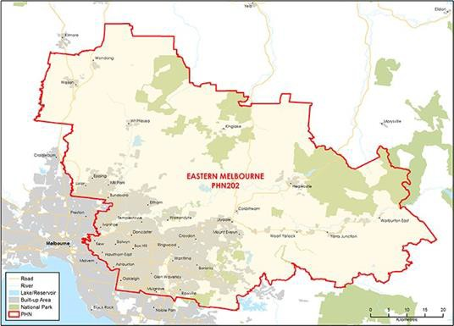

### FUNDING[127] AND PARTICIPANT[128] LEVELS

#### Funding ($M):

**All** **$10.21M** (Year coverage for NPS-M and CoS)

**NPS-M** **$4.13M** (Between FY17-18 and FY20-21)

**CoS $6.08M** (Between FY19-20 and FY21-22)

#### Participants

**All 388** (Year coverage for NPS-M and CoS)

**NPS-M 202** (Between 1 July and 31 Dec 2019)

**CoS 186** (Between 1 July and 31 Dec 2019)

### INDICATORS OF NEED[129]

#### People who experience severe, episodic mental illness

Approximately 30,000 people are affected at any one time with severe, episodic mental illness in EMPHN’s catchment area.

#### People with a severe mental disorder

2-3% of the population have a severe mental health disorder in EMPHN’s catchment area.

#### NPS-M – Average wait time (July – Dec 2019)

2 months – thought there is no waitlist currently.

### POPULATION AND DEMOGRAPHICS[130]

#### Population (ERP1 from 2016 census)

1,506,356

#### Population growth 2012-2016

7.14%

#### Indigenous population

6,849

#### Gender (%)

Male: 49.19%  
Female: 50.81

#### Area (Square Kilometres)

3,956

1. OVERVIEW OF NPS-M AND COS IN EACH PHN

### STRUCTURE AND SCOPE

1. Program structure

NPS-M and CoS are provided through a combined program known as Psychosocial Support Service (PSS), contracted through a sole service provider (Neami National).

1. Population access and eligibility

PSS (combined NPS-M and CoS): Entry requirements are in line with national guidelines.

1. Geographic coverage of programs

PSS (combined NPS-M and CoS): The combined program covers the entire PHN region.

1. Assessment, entry and exit processes

##### NPS-M:

1. What is the consumer application and assessment process?

The consumer completes a PSS referral form with the referee, and the provider administers evidence-based assessment tools with the consumer including the K10, K5, LSP-16 and LCQ.

1. What are the referral pathways into the program?

* Admitted/Hospital mental health services
* Non-admitted mental health services
* Community mental health services
* Stepped Care
* GP and Other clinicians (e.g. Psychologist/Psychiatrist)
* EMPHN Referral and Access Team
* State-based psychosocial programs
* Centrelink
* Housing
* Family support services
* Drug and Alcohol services
* Self-referral
* Carers

1. Duration/intensity of support:

Tiered levels of psychosocial support packages are available for consumers: Intensive support for up to 12 months; Moderate support for up to 6 months; Low support for 4-8 weeks.

1. Is entry into the program time limited, goal oriented or ongoing?

* Time limited (i.e. exit after a set time)
* Goal oriented (i.e. exit after achievement of a goal or milestone)

1. Has the PHN specified or suggested a number of consumers per FTE staff)?

Yes – 17 consumers per FTE (average 19/20).

##### CoS:

1. What is the consumer application and assessment process?

PiR, D2DL and PHaMs consumers found ineligible for the NDIS were transitioned to PSS through a scheduled transition process which included completing a transition summary report, reviewed by our Referral and Access Team, and warm handover provided by the supporting organisation and Neami National.

1. Services Types

* PSS provides a range of service types including support with housing, practical day to day needs, employment, education, emotional support, physical health, family and community connection, care coordination and accessing the NDIS
* PSS supports are provided across into three tiers of service: Intensive, Moderate and Low based on needs.

### MODELS OF CARE, INTEGRATION AND PRIORITY COHORTS[131]

1. Models of care: Does the PHN specify a model of care to be used?

Yes, the PHN has a Psychosocial Support Service model of care and associated Operational Manual.

1. Care integration:

Every PSS consumer receives a Collaborative Care Plan (CCP), which is supported by an integrated collaborative care team.

1. Priority Cohorts: Does the PHN prioritise particular cohorts, e.g. regions, demographics, diagnosis?

Yes, people who are homeless or at risk of homelessness, culturally and linguistically diverse (CALD) communities, migrant and refugee communities, Aboriginal and Torres Strait Islander communities, people with dual diagnosis, and disengaged youth.

### IMPLEMENTATION AND COMMISSIONING[132]

1. Roll out dates:

PSS

* NPS-M: 1 April 2019
* CoS: 1 July 2019

1. Commissioning approach

* Request For Tender to provide the Psychosocial Support Service supporting NPS-M and very likely to support CoS participants (subject to funding).
* Neami National was commissioned as the sole provider of PSS supporting NPS-M and CoS participants across the catchment.

1. Strategic planning

##### Key inputs to strategic planning

* The service design and planning process included a rapid scoping activity, a literature review, a co-design forum, a transition workshop, key stakeholder engagements and focus groups with consumers, carers and services.
* Initial planning of NPS-M in collaboration with North West Melbourne and South East Melbourne PHN.

1. Purchasing approach

##### Budgeting

1. Has the PHN pooled NPS-M or CoS funding with other funding sources?

* NPS-M: Yes
* CoS: Yes

##### Contracts

1. What is the contracting approach taken by the PHN for each program?

Competitive tendering – Offers from competing providers are invited by open advertisement and evaluated in accordance with predetermined criteria.

1. Is there a mandated/expected capacity for services in the NPS-M and CoS programs?

* NPS-M: Yes
* CoS: Yes - based on the number of CoS participants

1. Does the service provider contract or schedule specify the number and type of staff required to deliver the service?

PSS (combined NPS-M and CoS): Yes

1. What types of workers are prescribed in contracts?

PSS (combined NPS-M and CoS):

* Managers/Team Leader
* Recovery support worker/facilitator
* Peer support workers
* Clinicians
* Psychologists
* Social Worker
* Credentialed allied health workers

##### Purchasing

1. What is the payment approach taken by the PHN for each program?

* Outcomes-based payment – Payment models that incentivise providers to provide services that better promote outcomes for patients.
* Payments are based on achievement of KPIs and deliverables, which include standards for the quality and safety of services.

1. Of the money allocated to service providers, what was the average proportion designated to administrative or indirect costs?

PSS (combined NPS-M and CoS): 15%

1. Monitoring and evaluation

##### Data/measures

1. What performance measures are specified in the contract to track service performance providers?

* Number of consumers accessing services
* Number of services provided
* Outcomes from measurement tool (below)
* Consumer Satisfaction/experience
* Waiting time
* Cost

1. Which of the following outcomes measures does the PHN capture/monitor?

* K10/K5
* HONOS (Health of the Nation Outcomes Scales)
* WHODAS (WHO Disability Assessment Schedule)
* LCQ (Living in the Community Questionnaire)
* LSP-16 (Life Skills Profile)
* YES (Your Experience Survey) survey

##### Reporting

1. How frequently do service providers provide formal reports to the PHN?

Quarterly

1. Have you conducted a review of your roll out of the NPS-M and CoS programs?

No – EMPHN evaluation framework is in development.

# GIPPSLAND

1. KEY FACTS AND FIGURES

This document provides a profile of how each PHN has implemented the NPS-M and CoS programs.

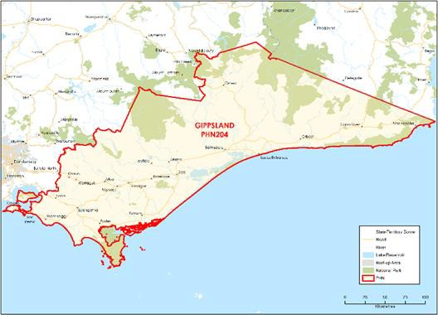

### FUNDING[133] AND PARTICIPANT[134] LEVELS

#### Funding ($M):

**All** **$2.59M** (Year coverage for NPS-M and CoS)

**NPS-M** **$1.27M** (Between FY17-18 and FY20-21)

**CoS $1.32M** (Between FY19-20 and FY21-22)

#### Participants

**All 175** (Year coverage for NPS-M and CoS)

**NPS-M 130** (Between 1 July and 31 Dec 2019)

**CoS 45** (Between 1 July and 31 Dec 2019)

### INDICATORS OF NEED[135]

#### Support for alcohol and drug services

Needs assessment data showed there was little support for children and families who were affected by alcohol and other drugs.

#### Consumers desire non-clinical options

A co-design workshop revealed a desire for a peer support/peer led model that focused on living skills, such as domestic, cooking, cleaning and shopping.

#### NPS-M – Average wait time (July – Dec 2019)

Waitlists are dependent on the case load for each support worker. At some points the wait time may be 2 weeks, and at others 2 months.

### POPULATION AND DEMOGRAPHICS[136]

#### Population (ERP1 from 2016 census)

274,627

#### Population growth 2012-2016

4.42%

#### Indigenous population

4,173

#### Gender (%)

Male: 49.55%  
Female: 50.45

#### Area (Square Kilometres)

42,012

1. OVERVIEW OF NPS-M AND COS IN EACH PHN

### STRUCTURE AND SCOPE

1. Program structure

* NPS-M and CoS are delivered under two different programs and separate contracts
* CoS programs are combined with Transition and Interface support services into a program called Psychosocial Support Services (PSP).

1. Population access and eligibility

Entry requirements are in line with national guidelines with two key distinctions:

* Gippsland PHN also includes consumers involved with the Justice system through the Court Integrated Support Program (CISP) or Community Offender Advice and Treatment Service (COATS).
* The referral form requires consumers who were found to be ineligible for the NDIS to re-test their eligibility

1. Geographic coverage of programs

Both programs cover the entire PHN region.

1. Assessment, entry and exit processes

##### NPS-M:

1. What is the consumer application and assessment process?

Referral and Consent Form’. Providers assess consumers before and after service provision using the Life Skills Profile 16 (LSP16) or the World Health Organisation Disability Assessment Schedule (WHODAS).

1. What are the referral pathways into the program?

* Admitted/Hospital mental health services
* Non-admitted mental health services
* GP
* Other clinician (e.g. Psychologist/Psychiatrist)
* State-based psychosocial programs
* Self-referral

1. Duration/intensity of support:

No consumer is expected to require support past 18 months.

1. Is entry into the program time limited, goal oriented or ongoing?

* Time limited (i.e. exit after a set time)
* Goal oriented (i.e. exit after achievement of a goal or milestone)

Noting participants who engage with the NPSM have longstanding severe and complex mental health diagnosis, it is a combination of both types of entry. Most participants engage for the social groups and supports they receive, however the maximum length of time a participant can engage with NPSM is 18 months. Therefore, referral to the NDIS is recommended for longer term supports. If they choose to test for NDIS this is supported, successful applicants that achieve an access met decision for NDIS are then exited from the program.

1. Has the PHN specified or suggested a number of consumers per FTE staff)?

No – 25 consumers per FTE was recommended by the provider and approved by Gippsland PHN (not contractually stipulated).

##### CoS:

1. What is the consumer application and assessment process?

Applications are received through GPHN’s ‘Referral and Consent Form’. Providers assess consumers before and after service provision using the Life Skills Profile 16 (LSP16) or the World Health Organisation Disability Assessment Schedule (WHODAS).

1. How have PiR, D2DL and PHaMs consumers transitioned to CoS services?

Consumers of PiR and PHaMs programs were supported to transition to CoS via a warm referral process. For most consumers, this did not require a transfer between service providers given that two- thirds of former PIR providers are now PSP providers. There are now Day to Day Living (D2DL) services in Gippsland.

1. Duration/intensity of support?

The duration of CoS services is not defined and intended to provide longer-term support. Clients are supported with a level of care that suits that individual needs. Where appropriate, re-testing of eligibility for NDIS is recommended and supported.

1. Is entry into the program time limited, goal oriented or ongoing?

Ongoing (i.e. continuing support provided).

1. Has the PHN specified or suggested a number of consumers per FTE staff)?

No – 20 consumers per FTE was recommended by the provider and approved by Gippsland PHN (not contractually stipulated).

### MODELS OF CARE, INTEGRATION AND PRIORITY COHORTS[137]

1. Models of care: Does the PHN specify a model of care to be used?

Yes, the PHN endorses a stepped-care approach.

1. Care integration:

Providers are required to integrate supports with ‘relevant organisations’ such as GPs, LHNs and other networks. They must also give feedback to the GP or other referrer upon completion of service, or more frequently for longer term support.

1. Priority Cohorts: Does the PHN prioritise particular cohorts, e.g. regions, demographics, diagnosis?

Yes, the broader PHN’s target cohorts are young people aged 0-25, people aged 65 or older, Indigenous people, and people with disabilities.

1. Services Types

NPS-M and CoS: Both programs provide services as specified in the national guidelines.

IMPLEMENTATION AND COMMISSIONING[138]

1. Roll out dates:

* NPS-M: 1 January 2019
* CoS: 1 July 2019

1. Commissioning approach

* NPS-M: GPHN released a public procurement via request for tender to identify preferred suppliers to deliver the NPS-M program.
* COS, NPS-T and Interface: GPHN facilitated a closed request for proposal process to procure services. The proposal was made available to the three existing PiR program providers. This approach was based on the fact that a) existing providers knew the consumer groups, b) former providers were the only dedicated organisations in Gippsland that provide community-based psychosocial support programs, c) they understand the service landscape and requirements of the NDIS and d) this approach would provide the least disruption for existing consumers, who continue to be supported by the same organisations and often the same workers.

1. Strategic planning

##### Key inputs to strategic planning

* GPHN engaged stakeholders in 2018 though a co-design workshop for NPS-M services.
* The GPHN website indicates future plans to apply the National Mental Health Service Planning Framework.

1. Purchasing approach

##### Budgeting

1. Has the PHN pooled NPS-M or CoS funding with other funding sources?

* NPS-M: No
* CoS: Yes – funding for the NPS-T, CoS and Interface programs have been pooled under Gippsland’s Psychosocial Support Program (PSP)

##### Contracts

1. What is the contracting approach taken by the PHN for each program?

* Competitive tendering – Offers from competing providers are invited by open advertisement and evaluated in accordance with predetermined criteria.
* Prime contracting – A single provider is contracted by a regional commissioner.
* Direct engagement – Existing provider(s) are commissioned to continue providing services.
* Contract extension – Existing contracts between the PHN and provider are extended.

1. Is there a mandated/expected capacity for services in the NPS-M and CoS programs?

* NPS-M: Yes – 25 consumers per FTE, with 3 FTE currently.
* CoS: Yes – 20 consumers per FTE, with 4 FTE currently

1. Does the service provider contract or schedule specify the number and type of staff required to deliver the service?

* NPS-M: Yes
* CoS: Yes

1. What types of workers are prescribed in contracts?

NPS-M and CoS:

* Managers/Team Leader
* Peer support workers
* Social Worker
* Recovery support worker/facilitator

##### Purchasing

1. What is the payment approach taken by the PHN for each program?

Block funding – A fixed amount of money is paid to the provider, regardless of how local needs are being met or the quality of care provided.

1. Of the money allocated to service providers, what was the average proportion designated to administrative or indirect costs?

* NPS-M: Gippsland PHN utilise a unit price model to inform the funding allocations for all commissioned services. Our standardised model providers $29,850 (exc. GST) per every 1.0FTE.
* CoS: Gippsland PHN utilise a unit price model to inform the funding allocations for all commissioned services. Our standardised model providers $29,850 (exc. GST) per every 1.0FTE

1. Monitoring and evaluation

##### Data/measures

1. What performance measures are specified in the contract to track service performance providers?

* Number of consumers accessing services
* Number of services provided
* Outcomes from measurement tool (LSP16 and WHODAS) –
* within program guidelines in addendum to the contract.
* Consumer Satisfaction/experience – not a specific KPI, however clinical effectiveness and appropriateness is a reporting domain

1. Which of the following outcomes measures does the PHN capture/monitor?

* LSP-16 (Life Skills Profile)
* WHODAS (World Health Organisation Disability Assessment Schedule)

##### Reporting

1. How frequently do service providers provide formal reports to the PHN?

Monthly

1. Have you conducted a review of your roll out of the NPS-M and CoS programs?

No – planned within next 18-24 months.

# MURRAY

1. KEY FACTS AND FIGURES

This document provides a profile of how each PHN has implemented the NPS-M and CoS programs.



### FUNDING[139] AND PARTICIPANT[140] LEVELS

#### Funding ($M):

**All** **$5.79M** (Year coverage for NPS-M and CoS)

**NPS-M** **$2.81M** (Between FY17-18 and FY20-21)

**CoS $2.98M** (Between FY19-20 and FY21-22)

#### Participants

**All 323** (Year coverage for NPS-M and CoS)

**NPS-M 190** (Between 1 July and 31 Dec 2019)

**CoS 133** (Between 1 July and 31 Dec 2019)

### INDICATORS OF NEED[141]

#### LGAs with large proportions of psychological distress

Twelve LGAs within Murray have higher proportions of adult population with high or very high levels of psychological distress, higher than the Victorian rate of 15.4% (e.g. Gannawarra (21%).

#### Workforce and service shortage

* Shortage of skilled workforce
* Poor transition and integration services
* Lack of services to help people with severe and persistent mental illness to access the community.

#### NPS-M – Average wait time (July – Dec 2019)

19.5 days.

### POPULATION AND DEMOGRAPHICS[142]

#### Population (ERP1 from 2016 census)

602,738

#### Population growth 2012-2016

4.54%

#### Indigenous population

13,106

#### Gender (%)

Male: 49.7%  
Female: 50.3

#### Area (Square Kilometres)

97,068

1. OVERVIEW OF NPS-M AND COS IN EACH PHN

### STRUCTURE AND SCOPE

1. Program structure

* Murray PHN delivers both psychosocial supports under one program, but splits the funding between NPS-M, NPS Extension (ETA) and CoS.
* Providers for NPS-M are consistent with State funded Early Intervention Psychosocial Support Response (EIPSR) providers. COS and NPS Extension (ETA) support streams are commissioned jointly to providers of previous Commonwealth funded psychosocial support programs.
* Services will be recommissioned for 2021/22 and beyond.

1. Population access and eligibility

Entry requirements are in line with national guideline.

1. Geographic coverage of programs

Both programs cover the entire PHN region.

1. Assessment, entry and exit processes

##### NPS-M:

1. What is the consumer application and assessment process?

Consumers apply directly to the providers, who utilise the Camberwell Assessment of Need Short Assessment Scale (CANSAS) tool initially and again every three months.

1. What are the referral pathways into the program?

* GP
* Other clinician (e.g. Stepped Care provider)
* Self-referral

1. Duration/intensity of support:

A six-month support limit applies for NPS-M, unless there are extreme circumstances.

1. Is entry into the program time limited, goal oriented or ongoing?

Time limited (i.e. exit after a set time).

1. Has the PHN specified or suggested a number of consumers per FTE staff)?

Yes – 20-25 NPS-M consumers per FTE.

##### CoS:

1. What is the consumer application and assessment process?

Consumers of previous Commonwealth-funded psychosocial programs (PiR, PHaMs and D2DL) are transitioned into CoS without the need for application.

New CoS-eligible consumers are rare, but apply directly to the providers, who utilise the Camberwell Assessment of Need Short Assessment Scale (CANSAS) tool initially and again every three months.

1. How have PiR, D2DL and PHaMs consumers transitioned to CoS services?

* PiR, D2DL and PHaMs providers (eight providers) were commissioned to provide ETA and CoS services after 30 June 2019. This ensured continuity of service and that clients already linked with the service were able maintain their supports with minimal disruption.
* There were two providers that declined to continue with contracts. In these instances, the provider was required to work with the client to develop comprehensive recovery action plans, compile documentation and assessments collected during support period to support an NDIS application and other key information. Handover was then arranged and provided to the new service including introductions to clients.
* In most cases this approach worked well and clients were able to transition to new providers. The PHN supported all providers with this process, tracked transition and ensured that all clients were supported into new arrangements.

1. Duration/intensity of support?

There is no specified maximum duration for CoS supports.

1. Is entry into the program time limited, goal oriented or ongoing?

Ongoing (i.e. continuing support provided).

1. Has the PHN specified or suggested a number of consumers per FTE staff)?

Yes – 10-12 CoS consumers per FTE.

### MODELS OF CARE, INTEGRATION AND PRIORITY COHORTS[143]

1. Models of care: Does the PHN specify a model of care to be used?

Yes, the PHN endorses a stepped-care approach. The psychosocial workforce has a mandated minimum wage and includes peer work. Staff are expected to have qualities desired by consumers (that they be consistent, skilled, knowledgeable, genuine and culturally safe).

1. Care integration:

Service providers create an Integration and Coordination plan – including integration between LHNs, psychosocial service providers, Murray PHN-funded stepped-care providers, general practices and the NDIA. NPS-M providers are the same as state-funded EIPSR providers.

1. Priority Cohorts: Does the PHN prioritise particular cohorts, e.g. regions, demographics, diagnosis?

Yes, although access is available to all adults, funding is allocated according to a weighted analysis of need.

1. Services Types

NPS-M and CoS: Both programs provide services as specified in the national guidelines.

### IMPLEMENTATION AND COMMISSIONING[144]

1. Roll out dates:

* NPS-M: 1 July 2019
* CoS: 1 July 2019

1. Commissioning approach

* NPS-M: Closed Tender – Tenders are accepted from agencies eligible to provide state funded EIPSR services – for consistency and ease of access/navigation.
* CoS: Direct to Provider – For consistency and to meet short timelines for implementation.

1. Strategic planning

##### Key inputs to strategic planning

* Murray PHN conducted a Needs Analysis based on population health statistics, academic evidence, and consultation with key stakeholders such as service providers, carers, and people with lived experience.
* Modelled demand (including through use of the National Mental Health Service Planning Framework) is 500 annually region-wide, breaking down as:
  + North West Murray PHN Region: 87
  + North East Murray PHN Region: 83
  + Central Victoria Murray PHN Region: 156
  + Goulburn Valley Murray PHN Region: 174.

1. Purchasing approach

##### Budgeting

1. Has the PHN pooled NPS-M or CoS funding with other funding sources?

* NPS-M: Yes – state funding to same organisation.
* CoS: Yes – Extended Transition Arrangements.

##### Contracts

1. What is the contracting approach taken by the PHN for each program?

Alliance contracting – A set of providers enter into a single arrangement with a regional commissioner to deliver services.

1. Is there a mandated/expected capacity for services in the NPS-M and CoS programs?

* NPS-M: Yes
* CoS: Yes

1. Does the service provider contract or schedule specify the number and type of staff required to deliver the service?

* NPS-M: Yes
* CoS: Yes

1. What types of workers are prescribed in contracts?

NPS-M and CoS:

* Peer support workers
* Recovery support worker/facilitator.
* Volunteers – members of previous groups

##### Purchasing

1. What is the payment approach taken by the PHN for each program?

Block funding – A fixed amount of money is paid to the provider, regardless of how local needs are being met or the quality of care provided.

1. Of the money allocated to service providers, what was the average proportion designated to administrative or indirect costs?

* NPS-M: 15%
* CoS: 15%

1. Monitoring and evaluation

##### Data/measures

1. What performance measures are specified in the contract to track service performance providers?

* Number of consumers accessing services
* Number of services provided
* Outcomes from measurement tool (below)
* Consumer Satisfaction/experience
* NDIS Transition rates
* Deidentified client stories and case studies
* Number of clients identifying at ATSI, CALD, LGBTIQA+, experiencing homelessness or experiencing or at risk of suicide
* Evidence that staff are engaged in regular management and clinical supervision

1. Which of the following outcomes measures does the PHN capture/monitor?

CANSAS/CAN (Camberwell Assessment of Need)

##### Reporting

1. How frequently do service providers provide formal reports to the PHN?

Quarterly

1. Have you conducted a review of your roll out of the NPS-M and CoS programs?

* Not of these programs specifically. However, a pilot evaluation was undertaken within a specific community (Goulburn Valley) to test models fundamentals peer worker, client care duration and use of flexible funds.
* A review is underway in association with the Regional Mental Health planning activity.

# NORTH WESTERN MELBOURNE

1. KEY FACTS AND FIGURES

This document provides a profile of how each PHN has implemented the NPS-M and CoS programs.

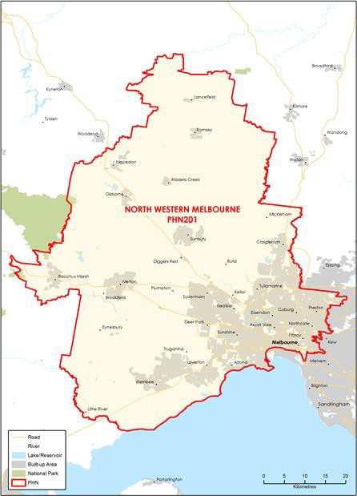

### FUNDING[145] AND PARTICIPANT[146] LEVELS

#### Funding ($M):

**All** **$9.87M** (Year coverage for NPS-M and CoS)

**NPS-M** **$5.31M** (Between FY17-18 and FY20-21)

**CoS $4.55M** (Between FY19-20 and FY21-22)

#### Participants

**All 304** (Year coverage for NPS-M and CoS)

**NPS-M 72** (Between 1 July and 31 Dec 2019)

**CoS 232** (Between 1 July and 31 Dec 2019)

### INDICATORS OF NEED[147]

#### High demand for mental health services

The National Mental Health Strategic Planning Framework (NMHSPF) tool estimates that 28,048 people in the region require treatment for mild mental illness, 22,793 for moderate mental illness, and 19,328 for severe mental illness.

#### Lack of mental health system literacy

A lack of mental health system literacy, about both community and service providers, was raised at consultations across the region in 2018.

#### Limited access to mental health services

In the region, the estimated proportion of respondents that rated their access to mental health services as poor was greater than 50%.

### POPULATION AND DEMOGRAPHICS[148]

#### Population (ERP1 from 2016 census)

628,733

#### Population growth 2012-2016

5.69%

#### Indigenous population

7,577

#### Gender (%)

Male: 49.4%  
Female: 50.6

#### Area (Square Kilometres)

79,843

1. OVERVIEW OF NPS-M AND COS IN EACH PHN

### STRUCTURE AND SCOPE

1. Program structure

* NPS-M and CoS are treated as two different programs, administered through different contracts.
* Two main service providers deliver both programs in each of the two regions (North and West).
* In addition, four smaller providers support the CoS program.

1. Population access and eligibility

Entry requirements are in line with national guideline.

1. Geographic coverage of programs

Both programs cover the entire PHN region, which is split into North and West regions.

1. Assessment, entry and exit processes

##### NPS-M:

1. What is the consumer application and assessment process?

* Consumers are required to go through an intake and assessment process on referral to the program.
* Referral forms are available online to ensure easy access to supports.
* Information required includes eligibility, mental health history/diagnosis, reason for referral, psychosocial support needs, current and previous formal/informal supports, risk assessment and consent.

1. What are the referral pathways into the program?

* Self-referral
* Doctor or General Practitioner (GP)
* A family member or friend
* Clinical mental health services/professionals or
* Community support services
* NWMPHN commissioned services

1. Duration/intensity of support:

Support is offered at the times when consumers most need it. The length of support can range from 8 weeks to a maximum of 12 months. Support packages are offered based on individual need, they range from brief, moderate and comprehensive and allows consumers to move between support levels as required.

1. Is entry into the program time limited, goal oriented or ongoing?

Supports are person-centred and goal orientated and maybe time limited or going depending on a persons support needs focusing on learning strategies and developing skills that helps consumers to:

* Identify your strengths
* Build resilience
* Find people to help you improve your wellbeing
* Connect with family or with your community
* Improve your physical health
* Enjoy a full and vibrant quality of life

1. Has the PHN specified or suggested a number of consumers per FTE staff)?

No.

##### CoS:

1. What is the consumer application and assessment process?

There is no application or assessment process for CoS supports, however a consumer must be eligible as per national guidelines.

1. How have PiR, D2DL and PHaMs consumers transitioned to CoS services?

* The transition to CoS supports has been relatively seamless for the majority of consumers in the north west Melbourne catchments.
* NWMPHN intentionally aligned NPST and CoS service provision, allowing consumers to continue to be supported by the same provider, preventing disruption in support and the risk of people potentially falling through the gaps.

1. Duration/intensity of support?

It is expected that CoS supports will continue to be provided at the same or similar level to what was previously being provider under PiR, D2DL and PHaMs. Additional support is offered to consumers who may choose to re-test their NDIS eligibility.

1. Is entry into the program time limited, goal oriented or ongoing?

CoS supports are person-centred and goal orientated and maybe time limited or going depending on a persons support needs focusing on learning strategies and developing skills that helps consumers to: Identify strengths; Build resilience; Achieve goals; Find people to help improve wellbeing; Connect with family or community; Improve physical health; Enjoy a full and vibrant quality of life.

1. Has the PHN specified or suggested a number of consumers per FTE staff)?

Yes – indicative ratio of 25 CoS consumers per FTE.

### MODELS OF CARE, INTEGRATION AND PRIORITY COHORTS[149]

1. Models of care: Does the PHN specify a model of care to be used?

Yes, the NWMPHN endorses a stepped-care approach and supports recovery focused and trauma informed practice. Psychosocial supports are based on consumer need and may be delivered on a 1:1 basis or in a group environment.

1. Care integration:

Both the north and west region providers are referring and connecting to external services and supports as required. Although formal arrangements are not in place currently, having a collaborative regional approach with all key stakeholders enhances referral pathways and ensures that consumers receive the right supports at the right time that best meets their needs. NWMPHN has also established the Psychosocial Support Services – Operational Managers Meeting (PSS-OMG), bringing together the LAC’s, NDIA, State funded psychosocial programs (EIPSR) and Area Mental Health Services across the region to share learnings and strengthen referral pathways.

1. Priority Cohorts: Does the PHN prioritise particular cohorts, e.g. regions, demographics, diagnosis?

Yes, NWMPHN priority populations demonstrate the diversity across the region and include people identifying as LGBTIQ, those experiencing homelessness, Aboriginal and Torres Strait Islander people, older adults, young people and culturally and linguistically diverse groups.

1. Services Types

NPS-M and CoS: Both programs provide services as specified in the national guidelines and are consistent with the objectives and priorities of the Fifth National Mental Health and Suicide Prevention Plan.

### IMPLEMENTATION AND COMMISSIONING[150]

1. Roll out dates:

* NPS-M: April 2019
* CoS: July 2019, though a full rollout across the PHN region took place in November 2019 after a four-month rapid transition of NPS-T

1. Commissioning approach

NWMPHN implemented an open market, request for tender commissioning process.

1. Strategic planning

##### Key inputs to strategic planning

Co-design took place through a multi-stakeholder workshop (including carers and consumer representatives) that was jointly convened by the three Melbourne PHNs in September 2018.

1. Purchasing approach

##### Budgeting

1. Has the PHN pooled NPS-M or CoS funding with other funding sources?

* NPS-M: No.
* CoS: No.

##### Contracts

1. What is the contracting approach taken by the PHN for each program?

* Competitive tendering – Offers from competing providers are invited by open advertisement and evaluated in accordance with predetermined criteria (NPS-M).
* Direct engagement – Existing provider(s) are commissioned to continue providing services (CoS; former D2DL & PhaMs providers)

1. Is there a mandated/expected capacity for services in the NPS-M and CoS programs?

* NPS-M: Yes – 160 in the North and 220 in the West.
* CoS: Yes – 93 in the North and 123 in the West

1. Does the service provider contract or schedule specify the number and type of staff required to deliver the service?

* NPS-M: No
* CoS: No

1. What types of workers are prescribed in contracts?

NPS-M:

* Managers/Team Leader
* Peer support workers

CoS:

* Managers/Team Leader
* Peer support workers

##### Purchasing

1. What is the payment approach taken by the PHN for each program?

Block funding – A fixed amount of money is paid to the provider, regardless of how local needs are being met or the quality of care provided.

1. Of the money allocated to service providers, what was the average proportion designated to administrative or indirect costs?

* NPS-M: 15%
* CoS: 15%

1. Monitoring and evaluation

##### Data/measures

Qualitative evidence is provided in quarterly progress reports which includes cumulative quantitative data and narrative information demonstrating key areas of work being delivered and quality of service being provided and may when appropriate include case studies.

Quantitative PMHC-MDS data is submitted monthly, enabling regular monitoring against targets and the prescribed set of KPI’S

1. What performance measures are specified in the contract to track service performance providers?

* Number of consumers accessing services
* Number of services provided
* Outcomes from measurement tool (below)
* Consumer Satisfaction/experience
* Waiting time

1. Which of the following outcomes measures does the PHN capture/monitor?

* K10, K5 (Kessler Psychological Distress Scale)
* LSP-16 (Life Skills Profile)

##### Reporting

1. How frequently do service providers provide formal reports to the PHN?

* Quarterly
* Annually

1. Have you conducted a review of your roll out of the NPS-M and CoS programs?

No – Planned within next year.

# SOUTH EASTERN MELBOURNE

1. KEY FACTS AND FIGURES

This document provides a profile of how each PHN has implemented the NPS-M and CoS programs.

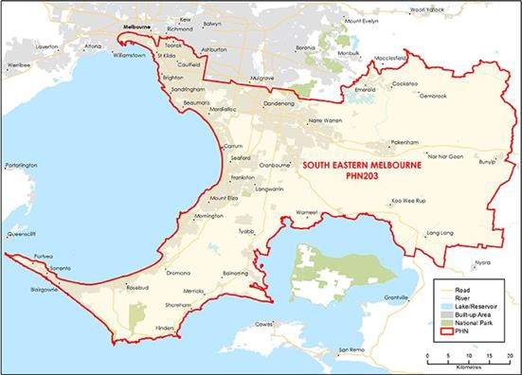

### FUNDING[151] AND PARTICIPANT[152] LEVELS

#### Funding ($M):

**All** **$10.10M** (Year coverage for NPS-M and CoS)

**NPS-M** **$4.50M** (Between FY17-18 and FY20-21)

**CoS $5.60M** (Between FY19-20 and FY21-22)

#### Participants

**All 360** (Year coverage for NPS-M and CoS)

**NPS-M 213** (Between 1 July and 31 Dec 2019)

**CoS 147** (Between 1 July and 31 Dec 2019)

### INDICATORS OF NEED[153]

#### High rates of mental health hospitalisations among middle-aged people

Rates for mental health related hospitalisations were highest in the 25-54 year age group.

#### High rates of hospital admission among refugees

Refugees in the region are 47% more likely to be admitted to hospital than other residents.

#### Significant prevalence of mild, moderate and severe mental illness

Prevalence estimates modelled in 2016 indicate that 9% of the region experience mild mental illness, 4.6% experience moderate mental illness, and 3.1% experience severe mental illness.

### POPULATION AND DEMOGRAPHICS[154]

#### Population (ERP1 from 2016 census)

1,511,585

#### Population growth 2012-2016

9.95%

#### Indigenous population

7,281

#### Gender (%)

Male: 49.36  
Female: 50.64

#### Area (Square Kilometres)

2,935

1. OVERVIEW OF NPS-M AND COS IN EACH PHN

### STRUCTURE AND SCOPE

1. Program structure

NPS-M and CoS are treated as a single program of Psychosocial Support Services (PSS) but there is a distinction drawn between the two when commissioning.

1. Population access and eligibility

Entry requirements are in line with national guideline.

1. Geographic coverage of programs

Both programs cover the entire PHN region, which is split into North and West regions.

1. Assessment, entry and exit processes

##### NPS-M:

1. What is the consumer application and assessment process?

Applications are undertaken through SEMPHN’s Access and Referral team. Assessment is conducted via the Life Skills Profile 16 (LSP16), with providers also suggested to use the Camberwell Assessment of Need (CAN-C) or the Process of Recovery Questionnaire (QPR)..

1. What are the referral pathways into the program?

* Admitted/Hospital mental health services
* Non-admitted mental health services
* GP
* Other clinician (e.g. Psychologist/Psychiatrist)
* State-based psychosocial programs
* Self-referral

1. Duration/intensity of support:

* NPS-M supports are delivered through four ‘tiers’ as follows:
* Tier 1: 8 Therapeutic contacts, 2 Assessments (3 months).
* Tier 2: 14 Therapeutic contacts, 4 Assessments (6 months).
* Tier 3: 30 Therapeutic contacts, 4 Assessments (9 months).
* Tier 4: 48 Therapeutic contacts, 4 Assessments (12 months)

1. Is entry into the program time limited, goal oriented or ongoing?

* Time limited (i.e. exit after a set time)
* Goal oriented (i.e. exit after achievement of a goal or milestone)

1. Has the PHN specified or suggested a number of consumers per FTE staff)?

No.

##### CoS:

1. What is the consumer application and assessment process?

Applications are undertaken through SEMPHN’s Access and Referral team. Assessment is conducted via the Life Skills Profile 16 (LSP16), with providers also suggested to use the Camberwell Assessment of Need (CAN-C) or the Process of Recovery Questionnaire (QPR).

1. How have PiR, D2DL and PHaMs consumers transitioned to CoS services?

The Transition Support program was delivered across the SEMPHN catchment via existing PiR and PHaMs provider, to:

* Help consumers test eligibility for the NDIS or PHN-funded psychosocial programs.
* Support consumers to retest eligibility for the NDIS if unhappy with their access decision or if their circumstances have changed.
* Provide targeted individual support for consumers at times of increased need.
* Collect and manage consumer data to ensure a smooth transition to new arrangements.

Ongoing monitoring of service implementation and transition plans will be established to collaboratively work with existing providers to ensure a skilled, non-clinical mental health workforce is established to deliver these activities.

1. Duration/intensity of support?

Tier 1 entails medium support consisting an average of 30 service contracts in 12 months. Tier 2 entails high support consisting an average of 50 service contacts in 12 months.

1. Is entry into the program time limited, goal oriented or ongoing?

* Goal oriented – Upon achieving their recovery plan goals, a consumer may choose to exit the program.
* Ongoing (i.e. continuing support provided).

1. Has the PHN specified or suggested a number of consumers per FTE staff)?

No.

### MODELS OF CARE, INTEGRATION AND PRIORITY COHORTS[155]

1. Models of care: Does the PHN specify a model of care to be used?

Yes, the PHN endorses a stepped-care approach.

1. Care integration:

Providers are expected to establish pathways with both community services (including non-mental health services) and clinical services to form part of a multi-agency care plan. NPS-M providers employ Care Coordinators, whose role is to help promote integration with and navigation of other services in the catchment.

1. Priority Cohorts: Does the PHN prioritise particular cohorts, e.g. regions, demographics, diagnosis?

Yes, Aboriginal and Torres Strait Islander people, people at risk of suicide, culturally and linguistically diverse (CALD) people, people with substance-use disorders, people with comorbidities, and LGBTIQ+ people.

1. Services Types

NPS-M and CoS: Both programs provide services as specified in the national guidelines.

### IMPLEMENTATION AND COMMISSIONING[156]

1. Roll out dates:

* NPS-M: 1 July 2019
* CoS: 1 July 2019

1. Commissioning approach

Open tender.

1. Strategic planning

##### Key inputs to strategic planning

* SEMPHN conducted a combination of population health analysis, evidence review and service mapping in planning the programs.
* A rapid scoping exercise and stakeholder engagement forums were conducted late 2018. Stakeholder feedback and outcomes from these activities have informed the commissioning approach and service model design elements.
* A model was co-designed across three PHNs that included the scoping of key service elements. The joint PHN forum delivered in September 2018 comprising of 80 stakeholders participating in a range of co-design activities.
* Focus Groups with SEMPHN Stepped Care Model providers was also conducted via the Communities of Practice, and feedback and collaboration will continue with existing funded agencies.

1. Purchasing approach

##### Budgeting

1. Has the PHN pooled NPS-M or CoS funding with other funding sources?

* NPS-M: Yes.
* CoS: Yes.

##### Contracts

1. What is the contracting approach taken by the PHN for each program?

Competitive tendering – Offers from competing providers are invited by open advertisement and evaluated in accordance with predetermined criteria.

1. Is there a mandated/expected capacity for services in the NPS-M and CoS programs?

* NPS-M: Yes
* CoS: Yes

1. Does the service provider contract or schedule specify the number and type of staff required to deliver the service?

* NPS-M: Yes
* CoS: No

Providers are expected to ensure an appropriate mix of qualified staff are engaged to competently deliver the service, with consideration both to formal qualifications and professional experience (including peer support workers with lived experience of mental illness).

1. What types of workers are prescribed in contracts?

NPS-M and CoS:

* Provider is expected to ensure an appropriate mix of qualified staff are engaged to competently deliver the service, with consideration both to formal qualifications and professional experience (including peer support workers with lived experience of mental illness).
* The workforce should be well-informed on and sensitive to the specific needs of people with a severe mental illness and on approaches to ensuring services meet their needs in a compassionate, supportive and evidence-based way.
* Managers/Team Leader
* Peer support workers
* Nurses
* Psychologists
* Social Worker
* Recovery support worker/facilitator

##### Purchasing

1. What is the payment approach taken by the PHN for each program?

Outcomes-based payment – Payment models that incentivise providers to provide services that better promote outcomes for patients.

1. Of the money allocated to service providers, what was the average proportion designated to administrative or indirect costs?

* NPS-M: 20%
* CoS: 20%

1. Monitoring and evaluation

##### Data/measures

1. What performance measures are specified in the contract to track service performance providers?

* Number of consumers accessing services
* Outcomes from measurement tool (below)
* Consumer Satisfaction/experience
* Waiting time
* Cost

1. Which of the following outcomes measures does the PHN capture/monitor?

* K10, K5 (Kessler Psychological Distress Scale)
* SDQ (Strengths and Difficulties Questionnaire)
* LSP-16 (Life Skills Profile)
* CANSAS/ CAN (Camberwell Assessment of Need)

##### Reporting

1. How frequently do service providers provide formal reports to the PHN?

* Quarterly
* Annually

1. Have you conducted a review of your roll out of the NPS-M and CoS programs?

No – Planned within next year.

# WESTERN VICTORIA

1. KEY FACTS AND FIGURES

This document provides a profile of how each PHN has implemented the NPS-M and CoS programs.

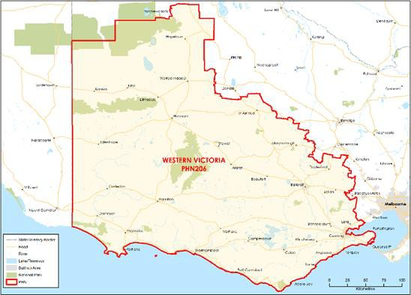

### FUNDING[157] AND PARTICIPANT[158] LEVELS

#### Funding ($M):

**All** **$3.97M** (Year coverage for NPS-M and CoS)

**NPS-M** **$2.50M** (Between FY17-18 and FY20-21)

**CoS $1.47M** (Between FY19-20 and FY21-22)

#### Participants

**All 207** (Year coverage for NPS-M and CoS)

**NPS-M 178** (Between 1 July and 31 Dec 2019)

**CoS 29** (Between 1 July and 31 Dec 2019)

### INDICATORS OF NEED[159]

#### High suicide rates

During 2012-16, all Statistical Area Level 3s (SA3s) in the Western Victoria PHN region had age- standardised suicide rates higher than the Australian average.

#### Low life satisfaction

A large proportion of SA3 residents were not satisfied with their lives, did not think their life was meaningful or had purpose.

#### NPS-M – Average wait time (July – Dec 2019)

1 week.

### POPULATION AND DEMOGRAPHICS[160]

#### Population (ERP1 from 2016 census)

628,733

#### Population growth 2012-2016

5.69%

#### Indigenous population

7,577

#### Gender (%)

Male: 49.44  
Female: 50.56

#### Area (Square Kilometres)

79,843

1. OVERVIEW OF NPS-M AND COS IN EACH PHN

### STRUCTURE AND SCOPE

1. Program structure

* WVPHN has two contracted suppliers delivering both NPS-M and CoS. Each contracted supplier covers two sub-regions within the WVPHN catchment area as follows:
* Wellways Australia delivers NPS-M (through their ‘Well- Connected’ program) and CoS to the Geelong Otway and Great South Coast sub-regions of the WVPHN catchment.
* Ballarat Community Health delivers NPS-M (through their ‘Connecting2Community’ program) to the Geelong Otway and Great South Coast sub-regions of the WVPHN catchment.

1. Population access and eligibility

NPS-M and CoS: Entry requirements are in line with national guidelines, with the addition of an extra position that has been funded for fixed term at each service to deliver Intensive Psychosocial Support. This role supports highly complex clients to make applications to the NDIS.

1. Geographic coverage of programs

Both programs cover the entire PHN region.

1. Assessment, entry and exit processes

##### NPS-M:

1. What is the consumer application and assessment process?

* Applications are received either through the completion of the ‘Referral Point Primary Mental Health Care Referral Form’ (generally involving GP referrals) and submitted directly to the PHN. Referrals can also be received directly by service providers from all other sources.
* Service providers have individual referral forms and intake processes. Assessment is conducted using the Kessler 10+ (K10+) Outcomes Star and the Recovery Star.

1. What are the referral pathways into the program?

* Admitted/Hospital mental health services
* Non-admitted mental health services
* GP
* Other clinician (e.g. Psychologist/Psychiatrist)
* State-based psychosocial programs
* Self-referral

1. Duration/intensity of support:

Support is offered through three streams: Brief interventions (0-3 months); Standard interventions (0-6 months) and Extended interventions (0-12 months)

1. Is entry into the program time limited, goal oriented or ongoing?

* Time limited (i.e. exit after a set time)

1. Has the PHN specified or suggested a number of consumers per FTE staff)?

Yes – 18 consumers per FTE.

CoS:

1. What is the consumer application and assessment process?

* Applications are received either through the completion of the ‘Referral Point Primary Mental Health Care Referral Form’ (generally involving GP referrals), submitted directly to the PHN. Referrals can also be received directly by service providers from all other sources.
* Service providers have individual referral forms and intake processes. Assessment is conducted using the Kessler 10+ (K10+) Outcomes Star and the Recovery Star.

1. How have PiR, D2DL and PHaMs consumers transitioned to CoS services?

* Consumers have been fully supported to transition through use of Psychosocial Support Transition funding. Consumers have been provided with regular psychosocial support whilst being supported to submit applications to the NDIS for support.
* Where clients have been assessed as ineligible for support, they have been warmly transitioned to one of the two CoS providers for support.

1. Duration/intensity of support?

Support is offered through three streams: Brief interventions (0-3 months); Standard interventions (0-6 months) and Extended interventions (0-12 months).

1. Is entry into the program time limited, goal oriented or ongoing?

* Time limited – (i.e. exit after a set time)
* Goal oriented (i.e. exit after achievement of a goal or milestone)

1. Has the PHN specified or suggested a number of consumers per FTE staff)?

Yes – 18 consumers per FTE.

### MODELS OF CARE, INTEGRATION AND PRIORITY COHORTS[161]

1. Models of care: Does the PHN specify a model of care to be used?

Yes, the model of care is provided in line with Commonwealth guidance, but based on a tender submission made by the service provider proposing their mix of group and one to one service provision for clients.

1. Care integration:

Care is integrated with a wide variety of other service providers including NDIS, Primary Health, Allied Health and General Practitioners.

1. Priority Cohorts: Does the PHN prioritise particular cohorts, e.g. regions, demographics, diagnosis?

No.

1. Services Types

NPS-M and CoS: Both programs provide services as specified in the national guidelines.

### IMPLEMENTATION AND COMMISSIONING[162]

1. Roll out dates:

* NPS-M: January 2019 (service delivery commenced April 2019)
* CoS: July 2019

1. Commissioning approach

Open tender across the region.

1. Strategic planning

##### Key inputs to strategic planning

WVPHN engaged in consultations with LHNs, mental health service providers, the Mental Health Commission, psychosocial support providers, the NDIA, previous consumers (through neighbourhood houses), and Latrobe Community Health.

1. Purchasing approach

##### Budgeting

1. Has the PHN pooled NPS-M or CoS funding with other funding sources?

* NPS-M: No.
* CoS: No.

##### Contracts

1. What is the contracting approach taken by the PHN for each program?

Direct engagement – Existing provider(s) are commissioned to continue providing services. Existing providers are contracted to June 2021 in line with current Deed of Variation.

1. Is there a mandated/expected capacity for services in the NPS-M and CoS programs?

* NPS-M: Yes – Wellways Australia: 180 new NPS-M consumers per annum and 25 for Intensive Psychosocial Support; Ballarat Community Health: 126 new NPS-M consumers per annum and 30 for Intensive Psychosocial Support.
* CoS: Yes – Wellways Australia: 20 PHaMs consumers; Ballarat Community Health: 24 PiR consumers and 19 PHaMs consumers

1. Does the service provider contract or schedule specify the number and type of staff required to deliver the service?

* NPS-M: Yes
* CoS: Yes

1. What types of workers are prescribed in contracts?

NPS-M and CoS:

* Managers/Team Leader
* Peer support workers
* Nurses
* Psychologists
* Social Workers
* Recovery support worker/facilitators

##### Purchasing

1. What is the payment approach taken by the PHN for each program?

Block funding – A fixed amount of money is paid to the provider, regardless of how local needs are being met or the quality of care provided.

1. Of the money allocated to service providers, what was the average proportion designated to administrative or indirect costs?

* NPS-M: 15%
* CoS: 15%

1. Monitoring and evaluation

##### Data/measures

1. What performance measures are specified in the contract to track service performance providers?

* Number of consumers accessing services
* Number of clients
* Outcomes from measurement tool (below)
* Consumer Satisfaction/experience

1. Which of the following outcomes measures does the PHN capture/monitor?

* K10, K5 (Kessler Psychological Distress Scale)
* Recovery Star

##### Reporting

1. How frequently do service providers provide formal reports to the PHN?

* Quarterly
* Annually

1. Have you conducted a review of your roll out of the NPS-M and CoS programs?

No – Planned within next year – awaiting results of National evaluation before commencing.

# COUNTRY WA

1. KEY FACTS AND FIGURES

This document provides a profile of how each PHN has implemented the NPS-M and CoS programs.

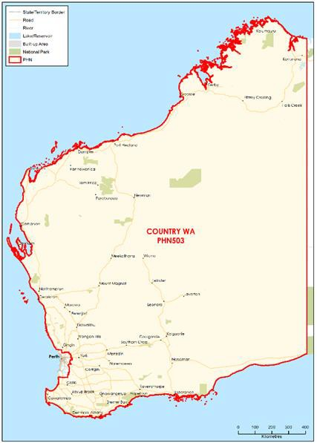

### FUNDING[163] AND PARTICIPANT[164] LEVELS

#### Funding ($M):

**All** **$5.49M** (Year coverage for NPS-M and CoS)

**NPS-M** **$3.17M** (Between FY17-18 and FY20-21)

**CoS $2.32M** (Between FY19-20 and FY21-22)

#### Participants

**All 371** (Year coverage for NPS-M and CoS)

**NPS-M 181** (Between 1 July and 31 Dec 2019)

**CoS 136** (Between 1 July and 31 Dec 2019)

### INDICATORS OF NEED[165]

#### Estimated number of people needing community mental health supports

The National Mental Health Service Planning Framework tool estimates that 326 people are not eligible for the NDIS but require individual support and rehabilitation services in Country WA PHN. It is estimated that 30% of this sub-population will require PHN funding at a total workforce full-time equivalent of $3.54M for Country WA PHN.

#### Hospitalisation rate for schizophrenia and delusional disorders

The Wheatbelt-South and Kimberley SA3s had hospitalisation rates for schizophrenia and delusional disorders around 1.5 times the national average.

#### NPS-M – Average wait time (July – Dec 2019)

3 months.

### POPULATION AND DEMOGRAPHICS[166]

#### Population (ERP1 from 2016 census)

531,934

#### Population growth 2012-2016

0.70%

#### Indigenous population

44,052

#### Gender (%)

Male: 51.20  
Female: 48.80

#### Area (Square Kilometres)

2,477,561

**PERTH NORTH**

1. KEY FACTS AND FIGURES

This document provides a profile of how each PHN has implemented the NPS-M and CoS programs.

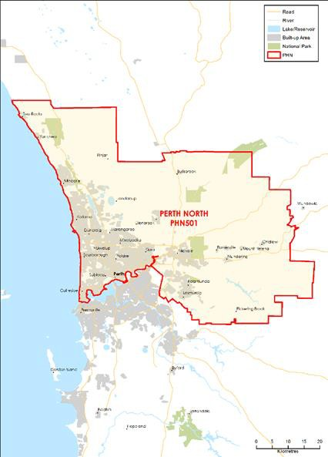

FUNDING[167] AND PARTICIPANT[168] LEVELS

Funding ($M):

**All** **$7.78M** (Year coverage for NPS-M and CoS)

**NPS-M** **$2.61M** (Between FY17-18 and FY20-21)

**CoS $5.17M** (Between FY19-20 and FY21-22)

Participants

**All 564** (Year coverage for NPS-M and CoS)

**NPS-M 395** (Between 1 July and 31 Dec 2019)

**CoS 169** (Between 1 July and 31 Dec 2019)

INDICATORS OF NEED[169]

Hospitalisation rate for bipolar and mood disorders

Perth North had a higher hospitalisation rate (ASR=14 per 10,000) for bipolar and mood disorders compared to the national average (ASR=11 per 10,000).

Estimated number of people needing community mental health supports

The National Mental Health Service Planning Framework tool estimates that 679 people are not eligible for the NDIS but require individual support and rehabilitation services in Perth North PHN. It is estimated that 30% of this sub-population will require PHN funding at a total workforce full-time equivalent of $7.35M for Perth North PHN.

NPS-M – Average wait time (July – Dec 2019)

3 months.

POPULATION AND DEMOGRAPHICS[170]

Population (ERP1 from 2016 census)

1.06M

Population growth 2012-2016

5.70%

Indigenous population

14,112

Gender (%)

Male: 49.90  
Female: 50.10

Area (Square Kilometres)

2,975

# PERTH NORTH

1. KEY FACTS AND FIGURES

This document provides a profile of how each PHN has implemented the NPS-M and CoS programs.

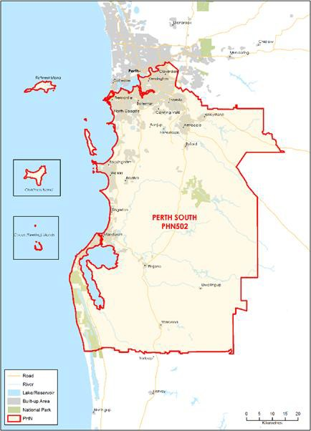

### FUNDING[171] AND PARTICIPANT[172] LEVELS

#### Funding ($M):

**All** **$6.02M** (Year coverage for NPS-M and CoS)

**NPS-M** **$2.62M** (Between FY17-18 and FY20-21)

**CoS $3.40M** (Between FY19-20 and FY21-22)

#### Participants

**All 381** (Year coverage for NPS-M and CoS)

**NPS-M 216** (Between 1 July and 31 Dec 2019)

**CoS 165** (Between 1 July and 31 Dec 2019)

### INDICATORS OF NEED[173]

#### Estimated number of people needing community mental health support

The National Mental Health Service Planning Framework tool estimates that 661 people are not eligible for the NDIS but require individual support and rehabilitation services in Perth South PHN. It is estimated that 30% of this sub-population will require PHN funding at a total workforce full-time equivalent of $6.63M for Perth South PHN.

#### Suicide rate

Rockingham, Mandurah and Fremantle SA3s had the three top suicide rates in Perth South PHN. These areas all had suicide rates that were above the WA rate and at least 1.3 times the national rate.

#### NPS-M – Average wait time (July – Dec 2019)

5 weeks.

### POPULATION AND DEMOGRAPHICS[174]

#### Population (ERP1 from 2016 census)

973,769

#### Population growth 2012-2016

7.90%

#### Indigenous population

17,238

#### Gender (%)

Male: 50.10  
Female: 59.90

#### Area (Square Kilometres)

5,148

1. OVERVIEW OF NPS-M AND COS IN EACH PHN

### STRUCTURE AND SCOPE

1. Program structure

Existing PIR, PHaM and D2DL providers provide both NPS-M and CoS services.

1. Population access and eligibility

Entry requirements are in line with national guidelines with an additional criteria requiring participants be aged between 18 and 64.

1. Geographic coverage of programs

Both programs cover the entire PHN region. However, many of the current providers choose to impose service boundaries within the PHN region due to lack of funding.

1. Assessment, entry and exit processes

##### NPS-M:

1. What is the consumer application and assessment process?

Determined by service providers..

1. What are the referral pathways into the program?

* Admitted/Hospital mental health services
* Non-admitted mental health services
* GP
* Other clinician (e.g. Psychologist/Psychiatrist)
* State-based psychosocial programs
* Self-referral

1. Duration/intensity of support:

On average a NPS-M consumer has accessed supports for between 3.4 and 7.6 months (closed episodes only).

1. Is entry into the program time limited, goal oriented or ongoing?

* Time limited (i.e. exit after a set time)
* Goal oriented (i.e. exit after achievement of a goal or milestone).

1. Has the PHN specified or suggested a number of consumers per FTE staff)?

No.

##### CoS:

1. What is the consumer application and assessment process?

Entry is gained by being a Transition Support participant who is deemed ineligible for NDIS support.

1. How have PiR, D2DL and PHaMs consumers transitioned to CoS services?

On 1 July 2019 all PiR, D2DL and PHaMs consumers entered transition support. Entry gained to CoS once deemed ineligible for NDIS.

1. Duration/intensity of support?

On average a CoS consumer accessed supports for between 5.5 and 11.9 months (Closed episodes only).

1. Is entry into the program time limited, goal oriented or ongoing?

Ongoing (i.e. continuing support provided)

1. Has the PHN specified or suggested a number of consumers per FTE staff)?

No.

1. Services Types

NPS-M and CoS: Both programs provide services as specified in the national guidelines.

### MODELS OF CARE, INTEGRATION AND PRIORITY COHORTS[175]

1. Models of care: Does the PHN specify a model of care to be used?

No.

1. Care integration:

Integration varies by provider.

1. Priority Cohorts: Does the PHN prioritise particular cohorts, e.g. regions, demographics, diagnosis?

No.

### IMPLEMENTATION AND COMMISSIONING[176]

1. Roll out dates:

* NPS-M: 1 January 2019
* CoS: 1 July 2019

1. Commissioning approach

Existing PIR, PHaM and D2DL providers were contracted to provide both NPS-M and CoS services, where possible.

1. Strategic planning

##### Key inputs to strategic planning

WAHPA used direction from DoH on what was required in commissioning services.

1. Purchasing approach

##### Budgeting

1. Has the PHN pooled NPS-M or CoS funding with other funding sources?

* NPS-M: No.
* CoS: No.

##### Contracts

1. What is the contracting approach taken by the PHN for each program?

* NPS-M and CoS: Used direct engagement – existing provider(s) are commissioned to continue providing services.
* NPS-M: Contract extension – Existing contracts between the PHN and provider are extended.

1. Is there a mandated/expected capacity for services in the NPS-M and CoS programs?

* NPS-M: No
* CoS: Yes – providers must service all CoS clients, as determined by the NDIS Ineligibility rate for Transition Support clients.

1. Does the service provider contract or schedule specify the number and type of staff required to deliver the service?

* NPS-M: No
* CoS: No

1. What types of workers are prescribed in contracts?

NPS-M and CoS: None

##### Purchasing

1. What is the payment approach taken by the PHN for each program?

Block funding – A fixed amount of money is paid to the provider, regardless of how local needs are being met or the quality of care provided.

1. Of the money allocated to service providers, what was the average proportion designated to administrative or indirect costs?

* NPS-M: Not available until October 2020
* CoS: Not available until October 2020

1. Monitoring and evaluation

##### Data/measures

1. What performance measures are specified in the contract to track service performance providers?

* Number of consumers accessing services
* Number of services provided
* Outcomes from measurement tool (below)

1. Which of the following outcomes measures does the PHN capture/monitor?

* K10, K5 (Kessler Psychological Distress Scale)

##### Reporting

1. How frequently do service providers provide formal reports to the PHN?

* Monthly

1. Have you conducted a review of your roll out of the NPS-M and CoS programs?

Yes.

1. Department of Health provided data
2. Six Month Performance Report: 1 July 2019 – 31 December 2019
3. ACT PHN Needs Assessment 2018, Six Month Performance Report: 1 July 2019 – 31 December 2019
4. Department of Health PHN Profiles
5. Sources: ACTPHN NPS-M (2018-19) Activity Work Plan, NPS-M & CoS Services Orders, Consultation with ACTPHN and ACT Health Directorate (Mental Health Policy).
6. Sources: ACTPHN NPS-M (2018-19) Activity Work Plan, NPS-M & CoS Services Orders, Consultation with ACTPHN and ACT Health Directorate (Mental Health Policy).
7. Department of Health provided data
8. Six Month Performance Report: 1 July 2019 – 31 December 2019. CoS service started in January 2020. Numbers here reflect estimates of consumers receiving NPS-T services
9. ACT PHN Needs Assessment 2018, Six Month Performance Report: 1 July 2019 – 31 December 2019; 4 Department of Health PHN Profiles
10. Department of Health [PHN Profiles](https://www1.health.gov.au/internet/main/publishing.nsf/Content/PHN-Profiles)
11. Sources: ACTPHN NPS-M (2018-19) Activity Work Plan, NPS-M & CoS Services Orders, Consultation with ACTPHN and ACT Health Directorate (Mental Health Policy).
12. CESPHN Commissioning Framework (2019-22;, Needs Assessment (2019); Activity Work Plan (2019-21); NPS-M and CoS Service Agreements (Redacted); Mental Health & Suicide Prevention Regional Plan (2019-22).
13. Department of Health provided data
14. Six Month Performance Report: 1 July 2019 – 31 December 2019
15. Hunter New England and Central Coast PHN National Psychosocial Support Measure Needs Assessment, Six Month Performance Report, Six Month Performance Report: 1 July 2019 – 31 December 2019
16. Department of Health PHN Profiles
17. Sources: Sources: NPS-M and CoS Service Spcifications , HNECC PHN Needs Assessment 2019 2022
18. Sources: ACTPHN NPS-M (2018-19) Activity Work Plan, NPS-M & CoS Services Orders, Consultation with ACTPHN and ACT Health Directorate (Mental Health Policy).
19. Department of Health provided data
20. Six Month Performance Report: 1 July 2019 – 31 December 2019
21. ACT PHN Needs Assessment 2018, Six Month Performance Report: 1 July 2019 – 31 December 2019
22. Department of Health PHN Profiles
23. Sources: : MPHN Commissioning Framework (2019); Needs Assessment (2019); Activity Work Plans (2019-2022); NPS-M and CoS Service Agreements (Redacted)
24. MPHN Commissioning Framework (2019); Needs Assessment (2019); Activity Work Plans (2019-2022); NPS-M and CoS Service Agreements (Redacted)
25. Department of Health provided data
26. Six Month Performance Report: 1 July 2019 – 31 December 2019
27. NBMPHN Needs Assessment 2019, Six Month Performance Report: 1 July 2019 – 31 December 2019
28. Department of Health PHN Profiles
29. Sources: : NBMPHN Needs Assessment (2019); NBMPHN Needs Assessment Regional Summary (2019); NBMPHN Joint Regional Mental Health and Suicide Prevention Foundation Plan
30. NBMPHN Needs Assessment (2019); NBMPHN Needs Assessment Regional Summary (2019); NBMPHN Joint Regional Mental Health and Suicide Prevention Foundation Plan.
31. Department of Health provided data
32. Six Month Performance Report: 1 July 2019 – 31 December 2019
33. NBMPHN Needs Assessment (2018), Six Month Performance Report: 1 July 2019 – 31 December 2019
34. Department of Health PHN Profiles
35. Sources: NCPHN Health Needs Assessment (2018); NCPHN Monitoring and Evaluation Manual; NCPHN NPS-M Activity Work Plan and Indicative Budget (2018-19).; Executed Contracts
36. Sources: NCPHN Health Needs Assessment (2018); NCPHN Monitoring and Evaluation Manual; NCPHN NPS-M Activity Work Plan and Indicative Budget (2018-19).; Executed Contracts.
37. Department of Health provided data
38. Six Month Performance Report: 1 July 2019 – 31 December 2019
39. Northern Sydney Primary Health Network Needs Assessment 2019 – 2022, Six Month Performance Report: 1 July 2019 – 31 December 2019
40. Department of Health PHN Profiles
41. Source: NSPHN Needs Assessment (2019-22); NPS-M Activity Work Plan (2019-21); NPS-M and CoS Service Agreements (Redacted)
42. Source: NSPHN Needs Assessment (2019-22); NPS-M Activity Work Plan (2019-21); NPS-M and CoS Service Agreements (Redacted)
43. Department of Health provided data
44. Six Month Performance Report: 1 July 2019 – 31 December 2019
45. SENSW PHN 2018 Needs Assessment, Six Month Performance Report: 1 July 2019 – 31 December 2019
46. Department of Health PHN Profiles
47. Sources: SENSW PHN Needs Assessment (2018); NPS-M Activity Summary (2020); NPS-M and CoS Provider Schedules (Deidentified); SENSW PHN Regional Mental Health and Suicide Prevention Plan
48. Sources: SENSW PHN Needs Assessment (2018); NPS-M Activity Summary (2020); NPS-M and CoS Provider Schedules (Deidentified); SENSW PHN Regional Mental Health and Suicide Prevention Plan
49. Department of Health provided data
50. Six Month Performance Report: 1 July 2019 – 31 December 2019
51. National Mental Health Services Planning Framework; Australian Bureau of Statistics, Six Month Performance Report: 1 July 2019 – 31 December 2019, SWS PHN Psychosocial Needs Assessment 2018
52. Department of Health PHN Profiles
53. Sources: SWSPHN Needs Assessment (2019-22); NPS-M Activity Work Plan (2019-21); NPS-M and CoS Schedules (Redacted); SWS Regional Mental Health Plan (2019)
54. Sources: SWSPHN Needs Assessment (2019-22); NPS-M Activity Work Plan (2019-21); NPS-M and CoS Schedules (Redacted); SWS Regional Mental Health Plan (2019)
55. Department of Health provided data
56. Six Month Performance Report: 1 July 2019 – 31 December 2019
57. Western NSW Primary Health Network Health Needs Assessment 2019-2022, Six Month Performance Report: 1 July 2019 – 31 December 2019
58. Department of Health PHN Profiles
59. Sources: WNSW PHN Health Needs Assessment (2019-22); NPS-M Activity Work Plan (2019-20); NPS-M and CoS Service Schedules (Deidentified)
60. Sources: WNSW PHN Health Needs Assessment (2019-22); NPS-M Activity Work Plan (2019-20); NPS-M and CoS Service Schedules (Deidentified)
61. Department of Health provided data
62. Six Month Performance Report: 1 July 2019 – 31 December 2019
63. WSPHN Mental Health Needs Assessment, Six Month Performance Report: 1 July 2019 – 31 December 2019
64. Department of Health PHN Profiles
65. Sources: WSPHN Mental Health Needs Assessment, Six Month Performance Report: 1 July 2019 – 31 December 2019; Department of Health PHN Profiles, WSPHN Commissioning Framework
66. Sources: WSPHN Mental Health Needs Assessment, Six Month Performance Report: 1 July 2019 – 31 December 2019; Department of Health PHN Profiles, WSPHN Commissioning Framework
67. Department of Health provided data
68. Six Month Performance Report: 1 July 2019 – 31 December 2019
69. Health Needs Assessment 2019 -2023, Six Month Performance Report: 1 July 2019 – 31 December 2019
70. Department of Health PHN Profiles
71. Sources: NTPHN NPS-M and CoS Program Specifications; NTPHN Commissioning Policy document; NTPHN Commissioning Procedure document; NTPHN 2019-22 Service Deed; Health Network NT Ltd. (2019-20) Program Agreement: Psychosocial Support Program; NTPHN Needs Assessment (2019-21)
72. Sources: NTPHN NPS-M and CoS Program Specifications; NTPHN Commissioning Policy document; NTPHN Commissioning Procedure document; NTPHN
73. Department of Health provided data
74. Six Month Performance Report: 1 July 2019 – 31 December 2019
75. Health Needs Assessment 2019 -2022; Planning for Wellness Regional Plan 2018-2023, Six Month Performance Report: 1 July 2019 – 31 December 2019
76. Department of Health PHN Profiles
77. Sources: PHN Part A Information Request; Health Needs Assessment 2019 -2022; Planning for Wellness Regional Plan 2018-2023
78. Sources: PHN Part A Information Request; Health Needs Assessment 2019 -2022; Planning for Wellness Regional Plan 2018-2023
79. Department of Health provided data
80. Six Month Performance Report: 1 July 2019 – 31 December 2019
81. BSPHN Health Needs Assessment (2018); BSPHN Health Needs Assessment (2019-2022) Six Month Performance Report: 1 July 2019 – 31 December 2019
82. Department of Health PHN Profiles
83. Sources: Brisbane South Part A Information Request, Brisbane South PHN Activity workplan 2019-2021
84. Sources: Brisbane South Part A Information Request, Brisbane South PHN Activity workplan 2019-2021
85. Department of Health provided data
86. Six Month Performance Report: 1 July 2019 – 31 December 2019
87. Darling Downs and West Moreton PHN Health Needs Assessment 2019-2021, Six Month Performance Report: 1 July 2019 – 31 December 2019
88. Department of Health PHN Profiles
89. Sources: Darling Downs and West Moreton (DDWM) Part A Information Request; DDWM Psychosocial Activity Work Plan 2019-2022; DDWM PHN Regional Mental Health plan
90. Sources: Darling Downs and West Moreton (DDWM) Part A Information Request; DDWM Psychosocial Activity Work Plan 2019-2022; DDWM PHN Regional Mental Health plan
91. Department of Health provided data
92. Six Month Performance Report: 1 July 2019 – 31 December 2019
93. Gold Coast needs assessment, Six Month Performance Report: 1 July 2019 – 31 December 2019
94. Department of Health PHN Profiles
95. Sources: Gold Coast PHN Part A Information Request; Gold Coast PHN Regional Draft Plan; Gold Coast PHN Needs Assessment 2018
96. Sources: Gold Coast PHN Part A Information Request; Gold Coast PHN Regional Draft Plan; Gold Coast PHN Needs Assessment 2018
97. Department of Health provided data
98. Six Month Performance Report: 1 July 2019 – 31 December 2019
99. National Psychosocial Measure – Needs assessment and service model optios (December 2018) . Diminic, S., Harris, M., Sinclair, D., Carstensen, G., & Degenhardt, L. (2013). Estimating the community prevalence and treatment rates for mental and substance use disorders in Queensland. Queensland Mental Health Commission, Six Month Performance Report: 1 July 2019 – 31 December 2019
100. Department of Health PHN Profiles
101. Sources: Northern Queensland PHN Needs Assessment 2019-2022; Northern Queensland Mental Health and Suicide Prevention Plan; Northern Queensland PHN Activity Work Plan 2019 -2022
102. Sources: Northern Queensland PHN Needs Assessment 2019-2022; Northern Queensland Mental Health and Suicide Prevention Plan; Northern Queensland PHN Activity Work Plan 2019 -2022
103. Department of Health provided data
104. Six Month Performance Report: 1 July 2019 – 31 December 2019
105. National Psychosocial Measure – Needs assessment and service model optios (December 2018) . Diminic, S., Harris, M., Sinclair, D., Carstensen, G., & Degenhardt, L. (2013). Estimating the community prevalence and treatment rates for mental and substance use disorders in Queensland. Queensland Mental Health Commission, Six Month Performance Report: 1 July 2019 – 31 December 2019
106. Department of Health PHN Profiles
107. Sources: Western Queensland Health Care Home Model of Care, National Psychosocial Support Program Factsheet, WQLDPHN Needs Assessment, Activity Work Plans
108. Sources: Western Queensland Health Care Home Model of Care, National Psychosocial Support Program Factsheet, WQLDPHN Needs Assessment, Activity Work Plans
109. Department of Health provided data
110. Six Month Performance Report: 1 July 2019 – 31 December 2019
111. Health Needs Assessment 2019 -2023, Six Month Performance Report: 1 July 2019 – 31 December 2019, data provided by PHN
112. Department of Health PHN Profiles
113. Sources: : APHN NPS-M 2018-19 Activity Work Plan, Consultation with APHN
114. Sources: : APHN NPS-M 2018-19 Activity Work Plan, Consultation with APHN
115. Department of Health provided data
116. Six Month Performance Report: 1 July 2019 – 31 December 2019
117. Country SA PHN Needs Assessment Report 2019 – 2022, Six Month Performance Report: 1 July 2019 – 31 December 2019
118. Department of Health PHN Profiles
119. Sources: Western Queensland Health Care Home Model of Care, National Psychosocial Support Program Factsheet, WQLDPHN Needs Assessment, Activity Work Plans
120. Sources: Western Queensland Health Care Home Model of Care, National Psychosocial Support Program Factsheet, WQLDPHN Needs Assessment, Activity Work Plans
121. Department of Health provided data
122. Six Month Performance Report: 1 July 2019 – 31 December 2019
123. PHT 2019-2022 Needs Assessment Report, Six Month Performance Report: 1 July 2019 – 31 December 2019; Tasmania PHN NPSM Summary 2018
124. Department of Health PHN Profiles
125. Sources: Psychosocial Support Diagram, PHT 2019-2022 Needs Assessment, PHN Website, Service Provider’s Website
126. Sources: Psychosocial Support Diagram, PHT 2019-2022 Needs Assessment, PHN Website, Service Provider’s Website
127. Department of Health provided data
128. Six Month Performance Report: 1 July 2019 – 31 December 2019
129. Six Month Performance Report: 1 July 2019 – 31 December 2019
130. Department of Health PHN Profiles
131. Sources: EMPHN Activity Workplan 2019-2022, Consultation notes
132. Sources: EMPHN Activity Workplan 2019-2022, Consultation notes
133. Department of Health provided data
134. Six Month Performance Report: 1 July 2019 – 31 December 2019
135. Gippsland PHN Needs Assessment 2019-2022; Six Month Performance Report: 1 July 2019 – 31 December 2019
136. Department of Health PHN Profiles
137. Sources: EMPHN Activity Workplan 2019-2022, Consultation notes
138. Sources: EMPHN Activity Workplan 2019-2022, Consultation notes
139. Department of Health provided data
140. Six Month Performance Report: 1 July 2019 – 31 December 2019
141. Health Needs assessment, Six Month Performance Report: 1 July 2019 – 31 December 2019.
142. Department of Health PHN Profiles
143. Sources: Murray PHN PRS guidelines, Murray Joint Regional Mental Health plan, Murray PHN Needs Assessment 2018-2022
144. Sources: Murray PHN PRS guidelines, Murray Joint Regional Mental Health plan, Murray PHN Needs Assessment 2018-2022
145. Department of Health provided data
146. Six Month Performance Report: 1 July 2019 – 31 December 2019
147. NWMPHN Needs Assessment, Six Month Performance Report: 1 July 2019 – 31 December 2019.
148. Department of Health PHN Profiles
149. Sources: Murray PHN PRS guidelines, Murray Joint Regional Mental Health plan, Murray PHN Needs Assessment 2018-2022
150. Sources: Murray PHN PRS guidelines, Murray Joint Regional Mental Health plan, Murray PHN Needs Assessment 2018-2022
151. Department of Health provided data
152. Six Month Performance Report: 1 July 2019 – 31 December 2019
153. Needs Assessment Reporting Template – Psychosocial Impairment; SEM PHN Needs Assessment 2019; ix Month Performance Report: 1 July 2019 – 31 December 2019.
154. Department of Health PHN Profiles
155. Sources: SEMPHN Activity Work Plan 2019-2021: National Psychosocial Support measure, Mental Health Stepped Care Model
156. Sources: SEMPHN Activity Work Plan 2019-2021: National Psychosocial Support measure, Mental Health Stepped Care Model
157. Department of Health provided data
158. Six Month Performance Report: 1 July 2019 – 31 December 2019
159. Western Victoria PHN Needs Assessment Report 2019, Six Month Performance Report: 1 July 2019 – 31 December 2019.
160. Department of Health PHN Profiles
161. Sources: Service Provider brochures, Psychosocial Supports webpage, Commissioning webpage
162. Sources: Service Provider brochures, Psychosocial Supports webpage, Commissioning webpage
163. Department of Health provided data
164. Six Month Performance Report: 1 July 2019 – 31 December 2019
165. Six Month Performance Report: 1 July 2019 – 31 December 2019; Country WA PHN Needs Assessment 2019-2022.
166. Department of Health PHN Profiles
167. Department of Health provided data
168. Six Month Performance Report: 1 July 2019 – 31 December 2019
169. Six Month Performance Report: 1 July 2019 – 31 December 2019; Perth North PHN Needs Assessment 2019-2022.
170. Department of Health PHN Profiles
171. Department of Health provided data
172. Six Month Performance Report: 1 July 2019 – 31 December 2019
173. Six Month Performance Report: 1 July 2019 – 31 December 2019; Perth North PHN Needs Assessment 2019-2022.
174. Department of Health PHN Profiles
175. Sources: Country WA PHN Information request Part A; Country WA PHN Activity Work Plan 2019-2021; Country WA needs Assessment 2018-2021
176. Sources: Country WA PHN Information request Part A; Country WA PHN Activity Work Plan 2019-2021; Country WA needs Assessment 2018-2021