What to do if someone you live with has COVID-19

# When you live with someone who has COVID-19

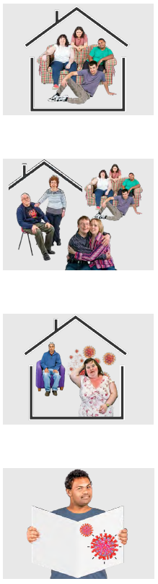You might share your home with other people

This could be

* Family members
* Your partner
* Friends
* Flat mates

If someone you live with has COVID-19 it is easy for you to get it from them.

This info tells you what you can do to stay safe.

# Can you leave the house?

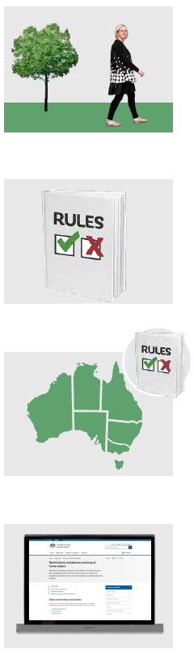Most people can leave the house if they live with someone who has COVID-19.

There are different rules for what you can do when you go outside.

You need to check the rules for your state or territory.

To find the rules for where you live go to [https://www.health.gov.au/health-alerts/covid-19/restrictions-and-lockdowns#state-and-territory-restrictions](https://www.health.gov.au/health-alerts/covid-19/restrictions-and-lockdowns%23state-and-territory-restrictions)

.

# Tip for inside your house

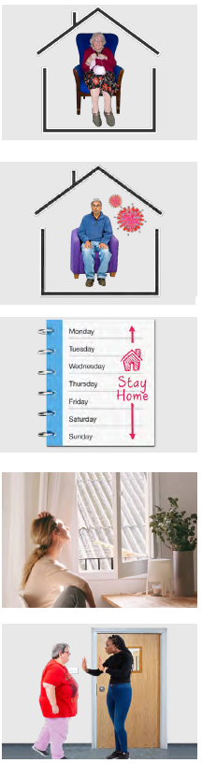There are some things you can do to stay safe from COVID-19 inside your home.

If someone you live with has COVID-19 they must isolate.

Isolate means to stay at home away from other people for 7 days.

They should stay in 1 room as much as they can.

You should not go into that room

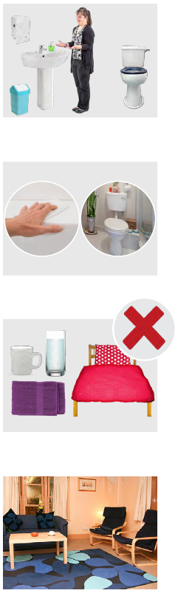They should use a different bathroom if they can.

If there is only 1 bathroom, they should clean it every time they use it.

You should not share things like:

* Cups or glasses
* Towels
* Bed sheets

Only use the common areas of the house if they are not in there.

**Common areas** are parts of the house everyone uses like the kitchen or living room.

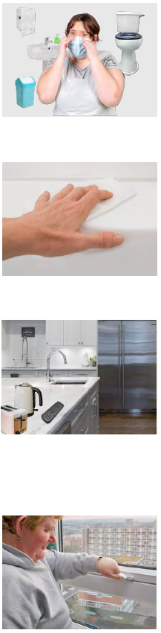You should wear a mask in

* The common area
* The bathroom if you share it with them

You should clean the common areas often.

You should also clean things you share with others often.

This could be things like

* Toaster or kettle
* Fridge
* Remote control for the TV.

You should open the windows in your house a lot to let fresh air in..

# Getting tested for COVID-19

The You should get tested if you think you also have COVID-19.

These are some of the signs that you might have COVID-19

* Fever
* A cough that does not go away
* Feeling tired
* You cannot smell or taste things

It is different in each state or territory if you

* Can do a COVID-19 test at home
* Have to go to a testing place

To find out what the rules in your state or territory are go to [www.healthdirect.gov.au/covid-19/state-and-territory-information](http://www.healthdirect.gov.au/covid-19/state-and-territory-information)

# If the person with COIVD-19 gets very sick

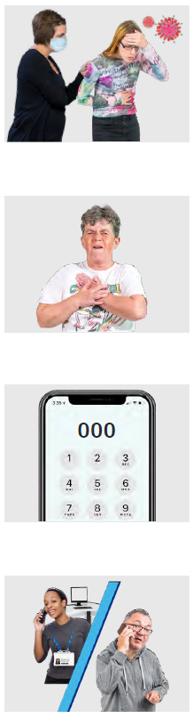If the person with COVID-19 gets very sick you need to get them help.

Signs that they are very sick can be

* They find it hard to breathe
* Their chest hurts

Call **000** if the person has these signs.

Tell the person on the phone and the ambulance that the person has COVID-19.

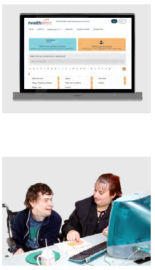If you are not sure if the person needs a doctor you can check online

Go to COVID-19 Symptom Checker <www.healthdirect.gov.au/symptomchecker/tool>

This website is not in Easy Read.

You might want support to use it.

Council for Intellectual Disability made this document Easy Read. CID for short.

You need to ask CID if you want to use any pictures in this document.

You can contact CID at [business@cid.org.au](mailto:business@cid.org.au).