

Dust Disease Research Update

Final report

May 2021

Prepared for Department of Health, National Dust

Disease Taskforce

**Contents**

|  |  |
| --- | --- |
| About the research | **3** |
| Qualitative Findings | **7** |
| Summary of Key Findings | **8** |
| The Impacts of Living with Dust Disease | **10** |
| The Dust Disease Journey | **18** |
| Workers’ and Families’ Suggestions for Change | **30** |
| Quantitative Findings | **40** |
| Summary of Key Findings | **41** |
| Awareness & Attitudes | **42** |
| Dust Control Behaviours | **51** |
| Industry Considerations | **60** |
| Health monitoring and Information | **66** |
| Appendices | **72** |

## About the research



##### Research Objectives

National Dust Disease research conducted in October 2019 showed that core

audiences’ knowledge of and attitudes to dust disease were rapidly shifting. Given the anticipated pace of change, and the work which has been done in the months since the benchmarking research was completed, the Department wished to check-in again with critical audiences. This study focuses on people with silicosis and other dust diseases, and their loved ones. It seeks to understand:

**As the audience and objectives for these phases are different, they are reported in separate sections in this document**

**Phase 2**

Repeat of 2019 survey with workers exposed to dust

**Phase 1**

Focus groups with impacted workers and families

|  |  |
| --- | --- |
| **1.** | Health status of impacted individuals – current symptoms, diagnosis, and needs |
| **2.** | Impacts on you and your family – what support is required and is  it being received |
| **3.** | Work history – what were your working conditions and what had  most impact on your diagnosis |
| **4.** | Awareness and control measures – did you know about dust  disease and take any measures to protect yourself? |
| **5.** | Prevention and risk elimination – what needs to change to prevent occupational diseases like silicosis? |
| **6.** | How have awareness, attitudes and behaviours changed since the October 2019 study? |

**Qualitative Methodology**



n=5 focus groups (1 x face to face, 3 x video conference, 1 x telephone)

**Groups were conducted between 16th February &**

**2nd March 2021**

Groups were approximately 90 minutes to two hours in length

**Participants were recruited through research recruiter networks and through the Australian Workers’ Union**

All participants were incentivised with a $150 eGift

**voucher, as a thank you for their time.**

**Total sample size, n=24**

The target audience for this research were workers impacted by silicosis and other lung diseases, and their families.

|  |  |  |
| --- | --- | --- |
| **Group** | **Description** | **Attendees** |
| **1** | Family members of people with silicosis | 5 |
| **2** | Family members of people with other dust- related diseases (including asbestosis) | 6 |
| **3** | Workers with silicosis (with supporting family members in attendance) | 9 |
| **4** | Workers with dust disease (silicosis &  pneumoconiosis) | 2 |
| **5** | Workers with silicosis | 2 |

Please note, participants were recruited through both standard qualitative recruitment networks and through the Australian Worker’s Union. There was no noticeable difference between the experiences of people recruited each way, or between the experiences of people recruited for this study and other similar studies on this topic. There is no evidence to suggest that the recruitment methods utilised in this study impacted the outcomes.

*The project was carried out in line with the Market Research International Standard, AS ISO 20252.*

**Quantitative methodology**

Total sample size, n=350



A total of 350 people completed the survey, in the following categories:

|  |
| --- |
| **Combined online & CATI survey with stonemasons and other tradespeople** |
| **Fieldwork dates: 3rd – 16th March 2021** |
| **Average survey length was 16 minutes (online) and 21 minutes (CATI)** |
| **Data was unweighted** |

|  |  |  |  |
| --- | --- | --- | --- |
| **Category** | **CATI surveys** | **Online surveys** | **TOTAL** |
| Stonemasons | 44 | 6 | 50 |
| Other tradespeople | 56 | 244 | 300 |

* Participants were free-found using lists of stonemasons and tradespeople and were not recruited to have had any prior experience with silicosis or dust disease.



* Where significance testing has been shown, results are significant at the 95%

significance level.



* The project was carried out in line with the Market Research International Standard, AS ISO 20252.

# Qualitative Findings

##### Summary of Key Findings

Dust disease impacts every part of a diagnosed person’s life

As well as the clear physical impact, the diagnosis can have a significant and far-reaching impact on mental health, both that of the diagnosed person and their loved ones. There is a significant financial impact, with a diagnosis often coming with job loss and lack of financial recourse.

Relationships are impacted as household dynamics shift and families grapple with strong emotions driven by the diagnosis.

***Above all, the not knowing, and the inability to plan for the future is deeply debilitating.***

There is no one-size-fits- all experience, but common themes emerge

Dust disease does not just impact stonemasons or bench cutters.

During this research we heard from people in mining, quarrying, concrete and other industries. Job roles also varied, from people ‘at the front line’ to cleaners and admin workers.

Exposure times also varied enormously, as did time from diagnosis to death. However, there were common themes around a lack of awareness, understanding, accountability and support; that negatively impacted all the individuals we spoke to.

***It is important that silicosis is not solely considered a ‘stonemason’s disease’***

Many report poor working conditions and a lack of enforcement

A lack of PPE, ventilation, dust suppression and other workplace prevention methods were reported, exacerbated by a lack of monitoring of air quality and of employees’ health. Employers were seen to be prioritizing efficiency and profit over safety. Equally, workplace culture often meant employees did not feel comfortable speaking up. There was seen to be insufficient monitoring and enforcement of workplaces by the government and industry bodies.

***The responsibility for safer workplace practices is seen to be with workers, employers and regulatory bodies***

The diagnosis of a dust disease can be traumatic, as is what comes after

While hearing about a terminal diagnosis will always be traumatic, several people we spoke to were informed of their diagnosis in ways which were insensitive and unsupportive. These include being told over the phone and by email. Workers felt that they were not given information, advice and guidance on how to deal with the news, either from their healthcare professionals or workplaces. Many felt let down by their employers as they were made redundant with no further support of any kind – financial, emotional or medical.

***More support is needed for workers who receive a diagnosis***

##### Summary of Key Findings

Medical assistance is perceived to be limited

Interactions with healthcare professionals were not always positive. Some reported a delayed diagnosis due to doctors not noticing or recognizing symptoms, some felt that some doctors may be on the employers’ side, not the employees’, and many experienced a lack of post- diagnosis advice and support. This is also true of mental health professionals, who it was felt often did not understand the nature and severity of the disease, and as such did not offer appropriate support.

***Medical professionals in all fields would benefit from education in the diagnosis and treatment of dust related diseases***

Many worry their experiences will continue to be repeated

Many of those we spoke to felt that very little has changed from the circumstances that led to their diagnosis, and that this will lead to more Australians suffering from dust disease. They feel that employees often lack awareness of the disease; and that in some instances they are afraid to speak out for fear of being seen as a troublemaker or losing their job. The impacted individuals described feeling ignored by the industry, which some felt has a macho culture that also exacerbates the situation.

***While there has been positive changes in the industry, there is concern it doesn’t go far enough***

Suggestions were made for improvements around prevention

The impacted workers and families we spoke to identified a number of areas that they believe would contribute to better prevention of dust diseases. These included better safety equipment and better external monitoring of employer practices, better education of employees and protections to ensure they can speak out about safety without being penalized. They would also like to see general public awareness about dust disease be raised.

***Increased awareness across the board, including among the general public, workers and healthcare professions, will aid prevention***

And for the improvement of post-diagnosis support

The people we spoke to would like to see companies held accountable for employees after diagnosis, rather than ‘washing their hands’ of them.

They would like to see no employee lose out financially from a dust disease diagnosis, as they believe this fear is a barrier to workers getting tested when they have symptoms. They would like to see more sympathetic, knowledgeable and independent individuals in the healthcare system, and a clear support pathway for impacted individuals and their families after diagnosis.

***Support for impacted individuals will help take away some of the ‘unknowns’ that are a debilitating factor of this disease***

**The Impacts of Living with Dust Disease**



**Silicosis and other dust-related diseases affect every part of an impacted person’s life**



Physical health



Mental health



Financial stability



Relationships

Planning for the future



**The physical impacts of dust disease are perhaps the first that come to mind when considering the disease**



Diagnosed individuals and their loved ones described a range of symptoms:

A couple of years ago I was doing some work in the garden, and I had exhausted my oxygen levels… no matter what I’m doing I have to stop

***Worker***

* **Breathlessness & weakness**
* **Chest pains**
* **Flu-like symptoms**
* **Coughing** (including coughing up mucus)

Aside from the symptoms themselves, concerns around physical health create other challenges:

* **Fluctuations** in health – health can be inconsistent from one day to the next, so individuals never know what they will

or won’t be able to do

It’s highly frustrating, no one really knows what’s going to happen to their health. I’ve seen a big decline, it’s become difficult to mow the lawns and if we do something too difficult around the house I’m wrecked

***Worker***

* **Uncertainty** – not knowing if it is ‘just a bad day’ or an actual decline in health, and the impact this has on mental health
* **Susceptibility to other conditions** – awareness that other illnesses such as flu could have a significant impact –

particularly relevant during COVID-19 pandemic

* **Relying on others for help** – the frustration and difficulty of being increasingly unable to complete simple tasks, or to play with one’s children or grandchildren

In the later stages of the disease, family members reported their loved ones needing to be on oxygen, and using mobility

aids such as scooters and handles in the home.

(*Please note: symptoms tend to be a later feature of silicosis, and several participants were not showing symptoms when*

*diagnosed)*

The effects are not just about how health is impacted right now, but how it will be in the future – and the fear and uncertainty that comes from this. People don’t know how long they have to live, or how long they have until their quality of life is severely impacted, and are scared each time they go for a test.

#### For many, the impact on mental health is significant and ongoing

Sufferers reported a range of negative emotions:

* **Fear and anxiety** about their condition, their

future, and their family

* **Guilt** that they cannot work, are less able to contribute to family life, and the potential physical impact on their family
* **Hopelessness** that they have a terminal illness that they feel they have no control over
* **Anger** at the situation they are in, at their employers, other people in positions of power, and themselves
* **Sadness** at the thought of leaving behind their loved ones
* **Boredom and isolation**, with no purpose, nothing

to do, and no-one to talk to

* **Frustration** that they need to rely on others for help, and that they have not received the support and assistance from the system

These feelings were exacerbated by a lack of certainty about their condition and their future.

He can’t reconcile with the idea that you become very dependent. Mentally he’s fine, he’s always been strong willed. But when he has to ask someone you can see how hard it is for him, he’d rather not

***Family member***

I’ve gone from being a happy-go-lucky larrikin to my wife calling me a furious straight down the line grinch – you’re always shitty

***Worker***

I’ve got no patience or tolerance at all. You flare up and come back down again. I only saw a counsellor twice in that first 12 months as there was so much else going on

***Worker***



Few report receiving effective assistance with their mental health. Some were offered 4-5 sessions through an Employee Assistance Program in their first year but often found the person treating them lacked understanding and empathy. Others, particularly older individuals, do not want to receive formal assistance with their mental health.

**Some felt it would be easier to have died than to have silicosis, as support and compensation is easier to access in that case**

Sometimes you feel you’d be better off losing a limb or dying – at least the compensation is set for that

***Worker***

He had no one. His workmates stopped talking to him because they thought it was something they could catch. He thought about taking his own life

***Family member***

I tried to do something stupid. I was feeling useless, no good, there was the shitty comments thrown at me by friends. I did try and do a silly stupid thing that I regret

***Worker***

**This feeling is not just about wanting to end it all** (although one did report a suicide attempt) – but rather a reaction to the processes in place that make gaining proper support, recognition and compensation for dust disease so difficult – whereas a death on the job has a clear compensation that would go to families to support them.

#### The impact on finances goes beyond simply struggling to pay the bills to a feeling of disempowerment

* **Immediate termination from role** with few offered

a replacement role by their company

* **A relatively short period of time covered by WorkCover** with limited assistance in finding other employment options
* **Diminished employability** among those who are willing and able to work, with several applying for dozens of jobs unsuccessfully
* **A lack of acknowledgement** that this is a terminal disease, with a feeling that they are expected to work even when it is impossible
* **A lack of legal recourse** until they are very ill – several stated they would be unable to seek legal relief until they were visibly very sick or ‘at deaths door’ as compensation is calculated on current physical condition not prognosis

You go for an interview and you go I’ve got dust, I can’t breathe - and they won’t even give you a job. My brother was a tradesman and he ended up on a mower

***Worker***

It’s been financially hard, we survive, I’m grateful we have a roof over our head. Our goals of buying a new car and travelling have gone out the window. It’s definitely had an impact. It’s hard trying to explain to the kids

***Family member***

You feel like a bludger and a heel, you’re sitting there while your wife is going off to work

***Worker***



Financial uncertainty has a significant detrimental impact on mental health, affecting self-esteem, causing anxiety and guilt, and worrying about the future of one’s family.

**There is naturally a knock-on impact on relationships, family and friends**



* + Loved ones often saw significant changes in their family member’s **mental health** when diagnosed, and in the time following, which can put a strain on relationships

He gets frustrated because he has to see me go out to work and he has to stay home and do nothing… we’ve all gone through that mental impact from me, to him, to our kids

***Family member***

* + They need to act as **emotional support**, and increasingly, as **financial** and **physical**

support if the condition continues to progress

* + They might feel **guilty** about their loved one’s situation, and be **worried** about the impact of the situation on other family members (e.g. an elderly mum, or children)
  + Loved ones may not take the time to safeguard their own mental and physical wellbeing, meaning they **experience negative effects** also

I’ve taken a considerable amount of time off work. We moved to be with her when she wasn’t coping very well. She didn’t trust having strangers in the house. I squabble with my husband, he asks why are you always with your mum?

***Family member***

* + They are also **scared for the future**, both in terms of financial practicalities, and the grief

and fear of losing their loved one

* + And for some, there is the real concern that they, or their children might have been

**impacted by dust disease themselves**

Family members of diagnosed people are significantly impacted themselves, and are even less likely to seek support, as their focus is on the wellbeing of the individual with dust disease.

**Above all, the uncertainty at every step is deeply debilitating – there is no way to plan for the future**



*What is wrong with me?*

*Where do I get reliable information?*

*Is there any treatment?*

*When will I get sicker?*

*Will I get compensation?*

*How will I pay my mortgage this month?*

*Has the dust impacted my wife and kids?*

*How do I plan for the future?*

*What is silicosis?*

*Am I dying?*

*Why is no one helping me?*

*Will I get laid off?*

*Will anyone else employ me?*

*Why am I so angry all the time?*

*What could I have done differently?*

It’s hard I don’t know what’s going to happen…I’ve got a 2-year-old and a 4- year-old and it breaks my heart and it makes me teary every time I talk about my children

***Worker***

Our future is uncertain. I don’t like to admit it, but I do cry. I love my wife, and I love my kids to death. I want to be there for them

***Worker***

The hardest thing for me is if I die, what happens to my wife and family…the financial side plays on my mind. And my little granddaughter asked me if I had poison in me – it brought me to tears

***Worker***

## The Dust Disease Journey



##### There is no one-size-fits-all journey, but similar contributing themes emerge in many stories

People from a wide



**variety of industries**

Not just stonemasonry or bench cutting but miners, quarry workers, tunnellers, concrete and brick workers, construction workers and more.

People in a wide

**variety of job roles**



Not just people ‘on the front lines’ but cleaners and admin workers too – this disease can impact anyone working within these industries.

Very different lengths

**of exposure**



Some people we spoke to had developed dust disease after a 30+ year career, one woman had developed it after four months.

Wide variety of

**prognoses**

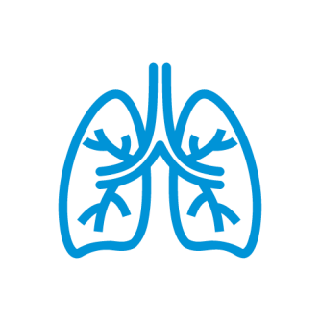

Some were in their 80s or 90s, and had been living with their diagnosis for decades – another had died a few short years after their diagnosis at the age of 43

Despite these variations, many diagnosed workers and their loved ones have similar stories to tell, that carry themes of a lack of awareness,

understanding, accountability and support.

However it is of high importance to the people we spoke to that their individual stories are heard and recognised, and that the breadth of impact that dust diseases can have are acknowledged.

**Until diagnosis, many had not heard of their disease**

In my 15 years underground, I had never heard the word black lung mentioned, not in our training videos, nothing. A lot of the older guys who had worked overseas knew about it, but most of us didn’t even know there was such a thing

***Worker***

The boys [at work] were complaining that they had a lot of dust and couldn’t breathe at night. I was also having trouble breathing. I work making concrete panels. There was so much dust there, I didn’t know about safety. I was always thinking about being careful breaking an arm, not about this

***Worker***

She used to clean my dad’s factory and was not aware of the danger. She said she couldn’t breathe wearing a mask, so she didn’t wear it.

She took off her apron she wore, she didn’t come home with it, but that was it

***Family member***

Everyone we spoke to described a lack of awareness of the disease – many heard the name of their condition for the first time on diagnosis – and many feel this is still the case today.

**Many experienced working conditions (and attitudes) that directly contributed to their diagnosis**

There was no such things as protective gear when he started working. He was so unwell from such a young age…I would say at least 90% of the gentlemen he use to work with have passed away

***Family member***

✗ **Lack of suitable PPE** – if masks were used, they were often paper, re-used (by multiple people), stored poorly, not fitted correctly

✗ **Lack of ventilation/air conditioning** – several people described working in spaces with no ventilation or air conditioning in very dusty environments

✗ **No dust suppression** – many instances of dust routinely in the atmosphere e.g. kicked up by lorries on site, with no water suppression

✗ **Lack of dust-specific safety training** – most told us that there was little or no mention of dust

I always wore my mask but there was no enforcement of it. They put warning signs on the finished products to warn consumers, but there was no understanding, no training, no monitoring

***Worker***

during their inductions

✗ **Lack of other facilities e.g. showers & washing machines** – while some sites seem to be adding these facilities, they are patchy or insufficient, e.g. 2 showers for a whole site and people are obliged to be off site within 15 minutes of their shift ending

✗ **Lack of air monitoring (or monitoring incorrectly carried out)** – many reports of air monitoring results being hidden/not submitted, or written off as ‘incorrect’ if showing a high count

✗ **Lack of routine medical testing** – stories of no medicals being given, whole workforces being laid

off and re-hired to avoid routine testing

✗ **Employer attitudes – don’t complain, get the job done** – a feeling that any complaint will result in a loss of job

✗ **Employee attitudes – don’t be ‘seen as weak’** – a feeling that colleagues will put pressure on you if you choose to speak up about safety

We used to sweep up the dust with brooms and pick it up with shovels. We were covered in the stuff

***Worker***

While some workers and family members attributed these conditions to a lack of awareness, others stated clearly that employers were aware of the dangers and chose to cut corners, putting efficiency and profitability above safety.

#### And they feel a lack of enforcement from government and industry bodies means employers were not held accountable

* While some believed that there was a lack of awareness among employers, others believed employers knew the risks and chose productivity over safety
* They held their employers responsible, but they also laid blame with WorkSafe and the government for a perceived lack of proper regulation, monitoring and enforcement of company practices
* They would also like to see the government take more of a role in providing accurate information about dust disease
* As well as providing support in terms of financial assistance, and physical and mental health

Companies will do the minimum to comply with regulations, not the maximum to keep the employees safe

***Worker***

Employers have known about silicosis but nothing was set in stone, the medical screening was not constant… companies are allowed to get away with slacking off for their responsibilities. There should be penalties

***Worker***

Inspectors would call the company beforehand and so employees know WorkSafe is coming, so they clean up or only run certain equipment

***Worker***

Impacted people felt that without stricter regulations, better monitoring and harsher penalties, Australians will continue to be diagnosed with, and die from, silicosis and other dust related diseases – and they believe the government should take a more active role in supporting them now they have been diagnosed.

**The trauma of diagnosis is exacerbated if professionals lack knowledge, sensitivity, and ethical standards**



Mine was picked up by a company medical. I got an email back with all these bloody words you’ve never heard of. They gave me no information. I looked it up and it said life expectancy was 2 – 5 years

***Worker***

* + **Lack of knowledge** – medical professionals not spotting the disease (and instead diagnosing asthma, bronchitis etc.), not understanding the prognosis, and not informing patients of their options for information, advice and support at diagnosis
  + **Lack of sensitivity** – particularly when a condition is diagnosed by a workplace medical or WorkCover doctor, individuals report receiving a diagnosis over the phone, or even by email – with no support whatsoever, and being left to themselves to process the news and inform their families

When I found out about my diagnosis I had had no symptoms, it was a routine check. I was taken off to one of the offices and I was told over the phone ‘you have silicosis, don’t be alarmed’ and then they said ‘are your affairs in order’ I said no, he said ‘get your affairs in order’.

There was no manager there to see if I was alright, so I just went back to work. And then I had to go and tell my wife

***Worker***

* + **Lack of ethics** – some felt that the medical professionals they were sent to by their workplace were ‘in the pockets’ of their employers and had a vested interest in not spotting the condition, or of blaming it on smoking, childhood pneumonia, or some other pre-existing condition in an attempt to absolve the employer of liability

This negative diagnosis experience has an impact on mental health, on ongoing treatment, and in the confidence that impacted individuals have in the professionals who are supposed to treat them. This can leave them feeling isolated and unsupported.

#### The battle continues after diagnosis, as employees are immediately made redundant with no support

* **Immediately sent home/laid off from work** with no discussion, support or care
* **Offered inappropriate or impossible work placements** e.g. working from home without proper equipment or offered a role hours away
* **No support to process diagnosis** or get information or advice
* **Discouraged from speaking to other employees**

and even threatened with action for doing so

* **Misinformation spread about them in workplace**

e.g. that they did not get the illness there and shouldn’t be trusted, leading to them losing friends

* **Feeling blamed** for their own diagnosis and feeling that their employer is doing everything possible to not take responsibility e.g. blaming smoking or pre-existing conditions
* **Receiving no further contact** from their workplace leaving them feeling poorly treated
* **Getting no help to find another job** despite knowing they get only a limited amount of money from WorkCover/ employer’s insurance

After I got my diagnosis I went home and they went and told everyone that if anyone heard about someone being sick it wasn’t true, it was a rumour, that person had got it elsewhere

***Worker***

My work said you can’t come on site… they were making it difficult to work from home, I had no printers, they’re just trying to push me out

***Worker***

I’d had a scan but hadn’t been ‘properly’ diagnosed yet. I asked if I could minimise my exposure until I was fully diagnosed. I was scared. They said no

***Worker***

Aside from the obvious financial implications of being out of work with few employment prospects, the way

workers have been treated by their employers makes them feel rightfully angry and bitter.

**A lack of immediately available, relevant information makes a difficult time far worse**

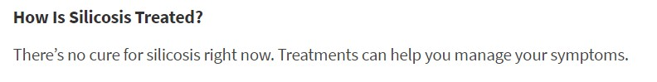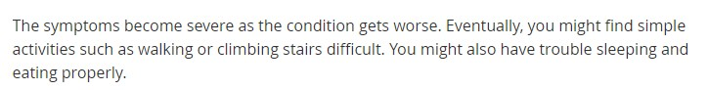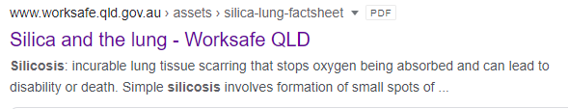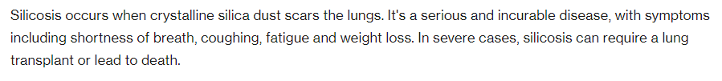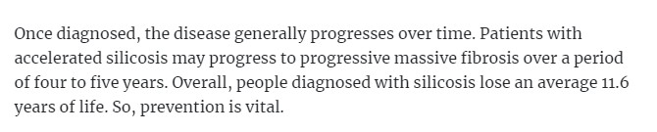

* + Without support and information from healthcare professionals, newly diagnosed people and their families naturally turn to the internet
  + The information found tends to be basic, and describing worst case scenarios
  + Few reported finding information from Australia, and only one or

two had come across The Lung Foundation

My wife had been crying everyday because we’d read that it was a 2-5 year diagnosis. My company told me I shouldn’t have googled.

But they didn’t give me any information!

***Worker***

This influx of negative information at their most vulnerable point has a profound impact on the mental health of the impacted individual and their loved ones.

##### The perception is that financial support only lasts a short time – and the bureaucracy can be overwhelming

* + - The workers reported being able to access from 52 to 130 weeks of WorkCover financial payments (with 52 weeks being the case for all but one of the people we spoke to)

This is a total, permanent disability. Why should we have to jump through hoops when it’s all in front of their faces?

***Worker***

* + - * *Please note – this may reflect a lack of knowledge, awareness or support in accessing financial assistance among impacted individuals, as WorkCover is not limited in this way*
    - Some reported even finding accessing this support difficult, feeling that the insurance companies made a stressful time even worse
    - Where WorkCover has helped find employment, there were two instances of employment being unsuitable – one person was placed in casual employment, and another was placed in a COVID quarantine hotel as a security guard despite being in a vulnerable group due to their diagnosis

I wake up from the breathing problems and I’m scared to go back to sleep. The insurance companies are very difficult to deal with - they keep going ‘why aren’t you better yet, haven’t you got better yet’ – they make the problems worse

***Worker***

* + - After the initial period of payments has ceased, impacted individuals are then unable to access any further support until they are visibly very ill, as pay-outs are based on (or perceived to be based on) one’s current physical condition rather than future prognosis

Financial support lasts a relatively short time, and even so, impacted workers sometimes feel like they are being accused of being liars, or lazy. It does not feel like dust disease is acknowledged as a terminal disease. Those who want to work find it difficult to access employment, and those who cannot work do not get the support they need in the longer term.

#### Despite the significant impacts on mental health, services are perceived to be limited and sometimes not fit for purpose

* **Some workers received 4 – 5 sessions through an Employee Assistance Program** which have to be taken within the first year rather than on an ongoing basis when required as impacted people come to terms with their condition
* **The mental health professionals they saw often did not understand the condition** and so could not effectively treat the impacted individuals
* **Despite the significant impact on families**, no support was offered to the loved ones of impacted people, so they often go entirely unsupported
* **Many of the impacted individuals are men** for whom seeking mental health support might not come naturally

I’d rather see someone who knows what I am going through, who is sympathetic and understanding. I went for five sessions, the therapist told me to apply for more. It took them three months to approve them

***Worker***

The first 12 months is not when you need it – you’re occupied with finding out about it, tying up loose ends. It’s after the 12 months when you’re sitting at home and it’s on your mind every single day

***Worker***

Going to see a psychologist was uncomfortable. She didn’t understand it. I had to explain it but even I didn’t know how to explain it. She thought maybe it was like a cold

***Worker***

The lack of mental health support contributed to the overall impact on the lives of diagnosed individuals and their loved ones

**And this is exacerbated by a lack of support and understanding from other sources too**

We’ve never been offered emotional support for families. We were not offered support groups, I had to search Facebook and things to find likeminded people

***Worker***

* + Some **lost friends** from their workplace, with some friends stepping back as they don’t understand the diagnosis, or don’t want to be seen as ‘supporting’ someone with dust disease
  + Impacted people felt they have **no support from the government** who they see as failing to support them, and failing in their duty to properly regulate and monitor the industries where this occurs

I’ve lost friends that still work there. It’s the vilification and brain washing, they’ve been telling them it’s my fault, HR told them I used to be a stonemason, a benchmaker. I have NEVER done that job”

***Worker***

* + Few had managed to find **support groups** to reach out to
  + Some had sought out people with similar experiences through **Facebook**, and found this

beneficial

* + And where people had made contact with a **support group**, this made a positive difference in their lives

GARDS are good at supporting people through the journey, and loan equipment while you’re ill… they show you where to go and what to do.

***Family member***



People impacted by dust disease often feel alone and like no-one can understand their situation. Making contact with like-minded people can make a genuine positive difference to their lives

##### They are worried that workplace practices and culture means more of their colleagues and friends will be affected









Scared of losing their job

As soon as diagnosis of a dust-related disease happens, workers can no longer stay in the industry and will lose their job, and know they might find it very difficult to find work elsewhere

Scared to ‘rock the boat’

Some report that other workers won’t engage with discussion around dust disease, talk to unions or sign petitions about it, for fear of being censured by employers, particularly when contract or casual as many staff in these industries are

Not enough education / training

Staff are not told about the dangers they face from silica dust, and as such cannot make informed choices about their willingness to be exposed to risk



Impacted people are ignored

People who are impacted by dust disease are kept away from the workforce – and in some cases, threatened with legal action if they talk to their colleagues about the risks

‘Macho’ culture

Some have a fear of being seen to be ‘weak’ by wearing protective equipment or expressing concerns about safety.

Also a stereotypically male reticence to seek medical advice

Several of those we spoke to have sought to advocate to their colleagues about silicosis and other dust diseases, since their diagnosis

– and have found it difficult to connect with and engage other workers, who are fearful of the consequences.

## Workers’ and Families’ Suggestions for Change

##### Based on their experiences, the workers and family members we spoke to identified a number of areas for change, with two overarching themes



Dust Disease Prevention

* + - Better safety equipment and monitoring in the workplace
    - Education, education, education
    - Protect employees and give them ways to speak

up

* + - Increase awareness and understanding of the disease – who is affected and the impacts it has
* Enforce employer accountability after diagnosis
* Ensure no employee loses out financially through a dust disease diagnosis



Supporting impacted

individuals

* Ensure healthcare professionals are impartial,

knowledgeable and sensitive

* Give impacted workers and their families clear pathways for support after diagnosis

**What workers and their families would like to see:**

**Workplace safety should be paramount, and employers should be required to provide proper and appropriate safety gear including masks/helmets, suits, dust extraction equipment, showers, washing machines etc.**

##### Better safety equipment and monitoring in the workplace

I have mates still using a portable vacuum cleaner. At the start we were only given a plastic mask, then a rubber…[he] kept asking for one but the best they could do was give them a second hand one. They always say safety before production but there’s no enforcement

***Worker***

**What we heard from workers and their families:**

**Employers choose productivity over safety, choosing to cut corners and not follow best practice; and do not provide appropriate PPE or equipment to maximise the safety of their employees**



**Suggested solutions from impacted individuals:**

* Set comprehensive and detailed minimum standards for all safety equipment
* Set and enforce safe exposure times, regular health checks, ongoing air monitoring etc.
* Monitor and enforce these standards through regular surprise inspections
* Set significant financial penalties for companies that do not adhere to these requirements
* Facilitate anonymous reporting channels to allow workers to report unsafe conditions without

feeling their job is at risk

With the dust monitoring… if you were bagging it and a bag pops, you’d be covered in dust like a snowman. If you were wearing a dust monitor they wouldn’t send those results as they’d say it wasn’t ‘typical exposure’

***Worker***

What better person to get an induction from than someone who has already got it, and what better way to keep those people employed. You may as well get them to stand in front of the next employees and say it’s real and it will hurt you because that’s what it did to me

***Worker***

**Suggested solutions from impacted individuals:**

* Education around silica dust from VCAL and other training onwards
* A focus on the dangers of silica and other dusts in employee inductions
* Ensure self-employed people and sole traders are communicated with also
* OH&S audits to ensure all employees are up to date with training
* Graphic messaging showing the impacts on lungs, potentially delivered to employees by people

suffering from the disease

**Education, education, education**



I encouraged her to get this job. They said ‘are you okay with a dusty environment’, we said fine - if they had said to us ‘silica dust is as deadly as asbestos’, we would have said no we’ll deal with the financial issues a different way

***Family member***

**What we heard from workers and their families:**

**Many employees have not heard of silicosis (or other dust diseases), and do not know the dangers of working with silica dust, or how to mitigate those dangers**

**What workers and their families would like to see:**

**Employees should fully understand the dangers of silica dust, they should know where**

**silica dust comes from and how to protect themselves and their colleagues from exposure**

##### Protect employees and give them ways to speak up



Back in the day if you handed them a mask they would have laughed, it was more of a boys’ world. If you brought in a doctor or a medical professional to put it in black and white and show what is going to happen if they didn’t protect themselves, maybe they’d listen

**What workers and their families would like to see:**

**Employees should feel empowered and safe to speak up about dangers in the workplace**

**and be given appropriate channels to do so**

**What we heard from workers and their families:**

**Workplace culture does not encourage employees to speak up about safety issues, and employees can worry that by speaking up they will lose their job**

***Worker***

**Suggested solutions from impacted individuals:**

* Emphasise the importance of taking responsibility for one’s own safety and the safety of one’s

colleagues, from induction

* Encourage employees to communicate with one another and with ex-employees, including those who have received diagnoses
* Ensure that no employee is penalised for speaking up about working conditions

I walked around last night trying to get signatures… to my amazement guys would not sign or succumb to do a test because they were too scared to lose their job

***Worker***

##### Increase awareness and understanding of the disease – who is affected and the impacts it has



Another concern of mine, it’s not current

**What we heard from workers and their families:**

**Very few people know about or understand dust disease, and those who do often associate it erroneously with the stone bench top industry alone. This lack of knowledge contributes to sufferers feeling misunderstood, and potentially conditions going undetected among impacted individuals**

employees, it’s the previous ones. Are you going to do anything for them? We’ve got a silicosis register together; we’re telling people at work to fill it in to safeguard themselves in future

**What workers and their families would like to see:**

**General awareness of silicosis and other dust diseases should be raised, the same way it**

**was with asbestosis – the general public being more aware will be a catalyst for change**

***Worker***

**Suggested solutions from impacted individuals:**

* Education across the board (public, professionals, employers and government) that this disease

impacts people in a wide range of industries and occupations

* Highlight how and why people are getting this diagnosis
* Use public opinion to put more pressure on employers and regulatory bodies to take action against silicosis and other dust diseases
* Create a register of impacted individuals, past and current, and ensure that people who have a history of working in dust related industries are receiving health checks

I saw people commenting on a news story about a silicosis sufferer, saying they were milking the system. It was disgusting. It’s down to a lack of knowledge and awareness

***Worker***

**What workers and their families would like to see:**

**If an employee becomes ill or incapacitated on the job, the employer should be held**

**financially responsible**

##### Enforce employer accountability after diagnosis

Once you’re off the books it feels like they wash their hands of you. For all the money these big companies make…it’s ‘see you later, good luck’ - it’s pretty heartbreaking

***Worker***



**What we heard from workers and their families:**

**Employers wash their hands of impacted workers after their diagnosis**

**Suggested solutions from impacted individuals:**

* Establish liability, meaning workers don’t have to fight to prove that their occupation caused their

illness

* Make employers financially responsible for the diagnoses people receive
* Ensure any company working with silica is on a register
* Consider creating an industry fund to increase financial accountability and give impacted people financial recourse, whether they are full time or contract
* Make it illegal to penalise workers for speaking out

When you find out you have it, you get fired and they often turn their back on you. No responsibility, no sympathy

***Worker***

**Ensure no employee loses out financially through a dust disease diagnosis**

Regardless of the risk they need to go there to put bread and butter on their plate, you just don’t want to give up your job, the importance of money and feeding your family is absolutely paramount

***Worker***



**What workers and their families would like to see:**

**No employee should suffer financially as a result of a dust disease diagnosis**

**What we heard from workers and their families:**

**Some employees are unwilling to get tested for dust disease despite displaying symptoms, as they know that if they test positive, they will lose their job**

**Suggested solutions from impacted individuals:**

* If the employee is willing and able to work, they should be offered appropriate equivalent employment at a place suitable for them (e.g. not delivering pizzas, and not a two hour commute away)
* In the event that it is required, retraining should be offered
* If the employee is unable to work, full lifetime compensation should be given upon diagnosis of a dust disease
* Medical needs (including mental health support) should be provided without cost

I’ve got a lot of mates that are too scared to get their lungs x-rayed because they’ll end up like me, unemployed. A lot of these blokes have family – they can’t afford to be told one day you’ve got something on your lungs and you’re not allowed back on site

***Worker***

**What workers and their families would like to see:**

**Healthcare professionals should be knowledgeable, impartial and sensitive**

##### Ensure healthcare professionals are impartial, knowledgeable and sensitive

None of these doctors have never even seen a coal mine. Some of them have been trained in the last 2 years but they’re still missing it [when they look at the x-rays]

***Worker***



**What we heard from workers and their families:**

**Some people’s diagnoses were delayed due to a lack of knowledge and understanding of dust disease, and some diagnoses were delivered in insensitive ways. Appropriate support post-diagnosis was also lacking**

**Suggested solutions from impacted individuals:**

* No doctor should be in paid employment of any company in a dust-related industry
* No diagnosis of any life altering or terminal disease should ever be given over the phone or in an email – this news should be delivered face to face, by a knowledgeable professional, with appropriate support and advice available
* Healthcare professionals in both physical and mental health should be educated on the symptoms, diagnosis, prognosis and implications of dust diseases and taught how to offer appropriate support

The doctors that get paid by the coal companies will look and say you don’t have it. So all the workers got x-rays by their local doctors, but those doctors admitted they didn’t even know what to look for

***Worker***

**Give impacted workers and their families clear pathways for support after diagnosis**

It was all still very new when I got diagnosed. My employer wasn’t allowed to have me back on site so they let me go.

There was no re-training, no assistance to help me get a new job

***Worker***



**What workers and their families would like to see:**

**Impacted people and their families should have personalised, one to one support to help**

**them navigate the situation they find themselves in**

**What we heard from workers and their families:**

**Upon diagnosis, impacted workers don’t know where to go for information, advice and guidance on the physical, emotional, financial or practical realities they face. This can have a significant negative impact on themselves and their families**

**Suggested solutions from impacted individuals:**

* Detailed, clear and impartial information available at diagnosis
* More support and advocacy groups to connect up sufferers
* Specialised doctors and mental health professionals to provide targeted advice
* Specialised clinics that focus on the management and treatment of dust diseases through exercise etc.
* Provide case workers to help people navigate any sources of support they can access
* Assistance with accessing employment and financial aid
* Holistic focus on family mental health after diagnosis, dealing with feelings of grief and guilt, depression, anxiety, disruption in sleeping patterns etc.

We live in a small rural town, so I have to advocate for him. When I’ve been to specialists, people don’t talk about it, it’s not discussed, in our world there’s nothing available, there’s no groups

***Family member***

## Quantitative Findings

##### Summary of Key Findings

Stonemasons have a good awareness of the dangers of silica dust, and this has stayed steady since last wave, with some directional improvements



Almost all (94%) of stonemasons had heard of silica dust, and the majority of stonemasons remain **very familiar with the risks** of silica dust (74%). Both these figures are comparable with 2019.

Although not statistically significant, there is a **directional positive shift** in the number of stonemasons’ **workplaces engaging with best practice** around silica dust.

**Almost all (94%) say any exposure to silica dust is a risk to avoid**. Having said that, there remains a small but significant minority who are **willing to tolerate some exposure (15%)** and a strong perception that **sometimes exposure is unavoidable (70%),** and almost a **third (29%) agree that sometimes dust control measures get in the way**. These figures all stayed relatively steady since last wave, suggesting there is still some work to be done communicating risk.

A significant change this wave is to the number of stonemasons who **personally suspect their health has been impacted by silica dust**, which is **up to 42% from 23%.** This could be related to the increase in the number aware of most symptoms, which increases from 59% to 73%. **Almost a quarter (24%) have sought or intend to seek medical attention**, up from 14%.

There is a less positive story among other tradespeople, with a range of awareness and positive behaviour measures decreasing since 2019

While awareness of silica dust remains stable (73% in 2021, cf. 75% in 2019), the number of **other tradespeople saying they are ‘very familiar’ with the risks of silica dust has dropped significantly, to just 24%** (from 33% in 2019). This could be driven by a lower number of stories in the news/media, which has dropped significantly as a channel through which to hear about silica.



The number of other tradespeople saying **‘any silica exposure is a risk they would avoid’ has dropped, from 85% to 76%;** and the number who say their **risk is ‘not completely under control’ has increased significantly, from 62% to 73%.**

The **engagement of other tradespeople with a range of dust control measures** has **decreased significantly** since 2019. A **significantly lower** number of other tradespeople say their workplaces are **actively taking steps to minimize exposure** (from 73% in 2019 to 62% in 2021).

**This data indicates that it will be important to increase communications to relevant individuals and workplaces outside the stonemason industry around the dangers of silica dust, as their understanding of and engagement with the issues seem to be decreasing.**



# Awareness & Attitudes

##### Awareness of silica dust is high, and remains unchanged between the two waves

Awareness and familiarity with the risks of crystalline silica dust

*Base: Those exposed to silica dust in the workplace | stonemasons (n=65) | other tradespeople (n=402)*

Oct 2019

**Stonemasons Other Tradespeople**

*Base: Those exposed to silica dust in the workplace | stonemasons (n=50) | other tradespeople*

*(n=300)*

Mar 2021

Stonemasons Other Tradespeople



**95%**

**75%**

**Aware of**

**silica dust**



**94%**

**73%**

**Aware of**

**silica dust**

*Q19. Before today, had you heard of crystalline silica dust?*

##### The proportion of other tradespeople ‘very familiar’ with the risks has dropped significantly since 2019

Awareness and familiarity with the risks of crystalline silica dust

*Base: Those exposed to silica dust in the workplace | stonemasons (n=65) | other tradespeople (n=402)*

Oct 2019

74%

I’m very familiar with the

risks

33%

12%

I have some knowledge

of the risks

30%

*Base: Those exposed to silica dust in the workplace | stonemasons (n=50) | other tradespeople*

*(n=300)*

Mar 2021



**86%**

**63%**

**Total who believe they have at least some knowledge of the risks**

74%

I’m very familiar with the

risks

24%

12%

I have some knowledge

of the risks

38%

I know there are risks, but I don’t know much about

them

No, I’m not aware of the

9%

10%

0%

I know there are risks, but I don’t know much about

them

No, I’m not aware of the

6%

11%

2%

risks 1%

5%

Not aware of silica dust

25%

Stonemasons

Other tradespeople

risks 0%

6%

Not aware of silica dust

27%

Stonemasons

Other tradespeople

*Q20. And how familiar are you with the risks of silica dust exposure?*



**86%**

**62%**

**Total who believe they have at least some knowledge of the risks**





*Denotes significant difference between waves at the 95% level of confidence*

##### Although industry and workplace channels remain the same as a driver of knowledge, awareness through news / media is significantly lower this wave

Oct 2019 Mar 2021

**Channels driving awareness**

**42%**

**47%**

**Aware through any**



**workplace sources**

**Aware through any workplace sources**

*Q40. Through what channels have you heard about silica dust and/or silicosis in the last 12 months?*

*\*Online sample only excludes CATI. Comprises n=244 tradespeople and n=6 stonemasons (2019) and n=244 tradespeople and n=6 stonemasons (2021).*

  *Denotes significant difference between waves at the 95% level of confidence*



*Base: Tradespeople exposed to silica dust in the workplace (n=250* each wave)*

In the news / media

42%

28%

**Tradespeople**

26%

24%

Word of mouth

Social media Google / internet search

A medical professional

Not aware of silica dust or silicosis

25%

23%

22%

24%

16%

8%

14%

13%

13%

17%

12%

15%

10%

11%

9%

8%

9%

11%

29%

28%

Government websites

The Worksafe website

Industry conventions or publications

Suppliers (e.g. materials and

equipment)

Workplace inductions

Safety talks in the workplace

##### Exposure levels among both groups have gone up slightly – while not statistically significant at this stage it should be monitored

Exposure to silica dust

*Base: Those exposed to silica dust in the workplace | stonemasons (n=65) | other tradespeople (n=402)*

Oct 2019

*Base: Those exposed to silica dust in the workplace | stonemasons (n=50) | other tradespeople*

*(n=300)*

Mar 2021

Frequently (e.g. multiple hours, most



**62%**

**27%**

**Total who report being exposed a few days per week or more**

Frequently

(e.g. multiple hours, most

days)

Regularly (e.g. a few days per week or short exposure most days)

34%

13%

Stonemasons

Other tradespeople

28%

14%

Sometimes

(e.g. a few hours per week)

14%

24%

Rarely (e.g. less than once a week)

18%

34%

Never

6%

15%

days)

Regularly (e.g. a few days per week or short exposure most days)

11%

26%

22%

40%

Stonemasons Other tradespeople

Sometimes

(e.g. a few hours per week)

18%

25%

Rarely

(e.g. less than once a week)

Never

14%

2%

25%

7%

*Q21. Which of the following best describes how much time you spend working around silica dust on a typical workday or week?*



**66%**

**33%**

**Total who report being exposed a few days per week or more**

*Q21. Which of the following best describes how much time you spend working around silica dust on a typical workday or week?*

##### Perceptions of personal risk from slightly but not significantly

**dust exposure has also raised**

*Base: Those exposed to silica dust in the workplace | stonemasons (n=50) | other tradespeople (n=300)*

**36%**

**26%**

**Significant or considerable risk**

Perceived personal risk of silica dust exposure

*Base: Those exposed to silica dust in the workplace | stonemasons (n=65) | other tradespeople (n=402)*

**29% 22%**

**Significant or considerable risk**

Don’t know No risk Little risk Some risk

**3%**

**8%**

**31%**

**3%**

**15%**

**37%**

**14%**

**29%**

Considerable risk Significant risk

**12%**

**23%**

Don’t know No risk Little risk Some risk

Considerable risk Significant risk

**2%**

**6%**

**26%**

**16%**

**28%**

**30%**

**3%**

**13%**

**30%**

**22%**

**14%**

**10%**

Stonemasons Other tradespeople



**15%**

**10%**

Oct 2019

*Q22. To what extent do you personally think you are at risk of harm from exposure to silica dust?*

Stonemasons Other tradespeople

Mar 2021





##### As in 2019, the level of personal risk perceived amongst tradespeople increases with frequency of exposure to silica dust

Perceived risk by time spent working around silica dust

*Base: Those exposed to silica dust in the workplace | stonemasons (n=65) | other tradespeople (n=402)*

*Base: Those exposed to silica dust in the workplace | stonemasons (n=50) | other tradespeople (n=300)*

Oct 2019



Significant risk of harm Considerable risk of harm Some risk of harm



Mar 2021

Significant risk of harm

Considerable risk of harm Some risk of harm

**24%**

**30%**

**36%**

**41%**

**22%**

**30%**

**16%**

**18%**

**14% 3%**

Stonemasons (n=50)

Frequently (n=33)

**8%**

Regularly (n=66)

**11%**

Sometimes (n=75)

**5%**

Rarely (n=76)

**29%**

**14%**

**15%**

Stonemasons (n=69)

**21%**

**28%**

**30%**

Frequently (n=53)

**36%**

**30%**

**11%**

Regularly (n=56)

**10%**

**48%**

**7%**

Sometimes (n=97)

**9%**

**42%**

**45%**

**32%**

Rarely (n=136)

*Q22. To what extent do you personally think you are at risk of harm from exposure to silica dust? Q21. Which of the following best describes how much time you spend working around silica dust on a typical workday or week?*

Perceptions of risk from silica dust are closely linked with risk of exposure, though even amongst those working around silica dust frequently, only three in ten identify significant personal risk.

##### The number of other tradespeople saying any exposure is a risk to avoid has seen a significant drop in this wave



Any exposure is a risk to avoid

*Base: Those exposed to silica dust in the workplace | stonemasons (n=65) | other tradespeople (n=402)*

**Agree any exposure is**

**97% 85%**

**a risk they would avoid**

**44%**

*Base: Those exposed to silica dust in the workplace | stonemasons (n=50) | other tradespeople (n=300)*

**Agree any exposure is**

**94% 76%**

**a risk they would avoid**

**3%**

Stonemasons

**43%**

**42%**

**10%**

**34%**

**63%**

**3%**

1%

Other tradespeople

Strongly agree

Agree

Neither agree nor disagree Disagree

Strongly disagree

*Tradespeople working for 2 years or less are less likely to agree that any exposure is a risk to avoid (74%)*

**50%**

**4% 2%**

Stonemasons

**15%**

**40%**

**36%**

**4%**

**5%**

Other tradespeople

Strongly agree

Agree

Neither agree nor disagree Disagree

Strongly disagree

*Likelihood to agree that ‘Any exposure is a risk to avoid’ increases with amount of time spent in the industry among tradespeople, up to 90%+ among those working for 20 years or more*

Oct 2019



*Q30. Agreement level about working with silica dust. Any exposure to silica dust is a risk that I will try to avoid.*

Mar 2021

 *Denotes significant difference between waves at the 95% level of confidence*





##### However those willing to tolerate some dust exposure has stayed relatively steady since last wave

Willing to be exposed to some silica dust

*Base: Those exposed to silica dust in the workplace | stonemasons (n=65) | other tradespeople (n=402) Base: Those exposed to silica dust in the workplace | stonemasons (n=50) | other tradespeople (n=300)*

##### 20% 20%

**42%**

**31%**

**26%**

**36%**

Stonemasons Other tradespeople

Oct 2019

**3%**

**17%**

**7%**

**4%**

**16%**

**18%**



**Agree they are willing**

**to be exposed**

Strongly agree

Agree

Neither agree nor disagree Disagree

Strongly disagree

*Stonemasons are more inclined to strongly disagree that they are willing to be exposed to silica dust*

##### 15% 23%

Stonemasons Other tradespeople

**26%**

**51%**

**34%**

**18%**

**28%**

**6%**

**15%**

**8%**

**2%**

**13%**





Mar 2021

**Agree they are willing**

**to be exposed**

Strongly agree

Agree

Neither agree nor disagree Disagree

Strongly disagree

*Q30. Agreement level about working with silica dust. I don’t mind a bit of dust, you need to be exposed to a lot of it for it to cause harm.*



# Dust control behaviours

##### There is still a strong perception that sometimes exposure to silica dust is unavoidable

Oct 2019 Mar 2021

**71%**

**Of stonemasons agree that sometimes exposure to silica dust is unavoidable**

**% Of other**



**70%**

Of stonemasons agree that sometimes exposure to silica dust is unavoidable

**53% Of other**

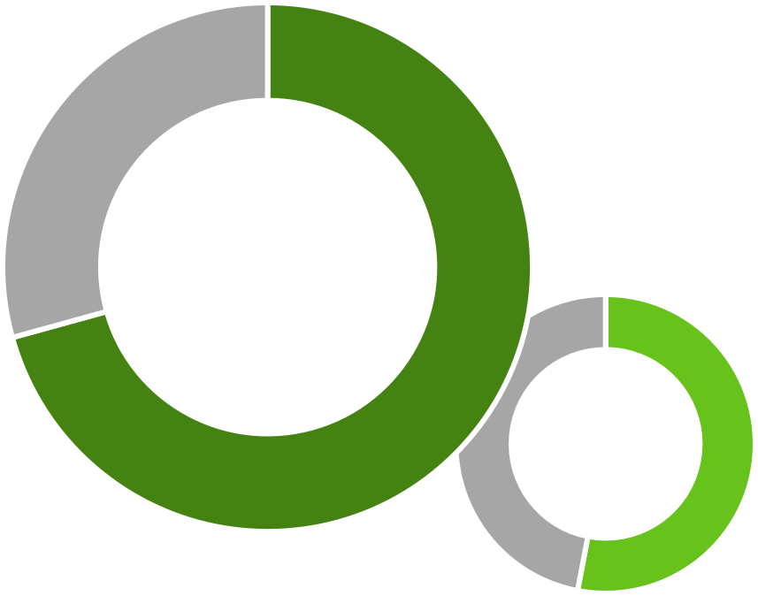

52 tradespeople agree

**tradespeople**

agree

*Base: Those exposed to silica dust in the workplace | stonemasons (n=65) | other tradespeople (n=402)*

*Base: Those exposed to silica dust in the workplace | stonemasons (n=50) | other tradespeople (n=300)*

*Q30. Agreement level about your safety in the workplace and working with silica dust: Sometimes my exposure to silica dust is unavoidable*

*(Excludes Don’t know / not applicable)*

##### The number of tradespeople saying their exposure is not completely under control has significantly increased

Level of control of silica dust exposure

*Base: Those exposed to silica dust in the workplace | stonemasons (n=65) | other tradespeople (n=402) Base: Those exposed to silica dust in the workplace | stonemasons (n=50) | other tradespeople (n=300)*

**Exposure is not**

**60% 62%**

**completely under control**

##### 60% 73%

**Exposure is not**

**completely under control**

Completely under control Somewhat under control

**38%**

**40%**

Out of control

**8%**

**11%**

**43%**

Don’t know

**48%**

**54%**

**13%**

**13%**

Completely under control Somewhat under control

Out of control Don’t know

**47%**

**27%**

**40%**

Stonemasons

Other tradespeople

**24%**

Stonemasons

Other tradespeople

**6%**

**6%**



Oct 2019 Mar 2021

*Denotes significant difference between waves at the 95% level of confidence*

*Q23. To what extent do you feel you are implementing adequate control measures in your workplace to protect you from exposure to silica dust? My exposure is…*

##### Those who say exposure is out of control state the need for improved safety precautions

Reason for response amongst tradespeople

No exposure/dust activity

**Completely under control**

(n=74)

36%

Oct 2019

No exposure/dust activity

31%

Mar 2021

Safety precautions/OHS in place Control measures in place

Wear masks Wear PPE

15%

14%

12%

12%

*“Cutting of stone is done*

Wear masks Wear PPE

Safety precautions/OHS in place Control measures in place

**Completely under control**

(n=59)

29%

24%

19%

15%

*“PPE issued and*

Try to avoid it/keep away from dust

Use suitable equipment We wear protective clothing Water control/wetting of the area

Wear masks Wear PPE

**Somewhat under control**

(n=106)

8%

7%

4%

4%

17%

*only with a wet saw now*

*and is not done on-site.”*

DK/Other 12%

35%

Safety precautions/OHS in place Water control/wetting of the area Use suitable equipment

Safety precautions/OHS in place

Wear masks

**Somewhat under control**

(n=106)

15%

8%

7%

20%

17%

*hardworking safety in*

*the workplace staff”*

DK/Other 15%

Try to avoid it/keep away from dust Control measures in place

Need more/better safety precautions

No exposure/dust activity Use suitable equipment

Water control/wetting of the area Safety precautions/OHS in place We wear protective clothing Can't avoid it/hard to control it

Use respirators/respiratory equipment

Need more/better safety precautions Can't avoid it/hard to control it Need more education/awareness

**Out of control**

(n=43)

10%

9%

9%

8%

8%

8%

6%

6%

6%

4%

14%

*“Sometimes I use safety masks, I don't use it regularly ‘cos it's kind of itchy.”*

DK/Other 11%

40%

33%

DK/Other 26%

Wear PPE

No exposure/dust activity Control measures in place Use suitable equipment

Need more/better safety precautions Control measures in place

Need more/better safety precautions Try to avoid it/keep away from dust Water control/wetting of the area Can't avoid it/hard to control it

Need more/better safety precautions Can't avoid it/hard to control it Other workers doing wrong thing

**Out of control**

(n=43)

17%

11%

11%

11%

9%

9%

9%

8%

7%

6%

11%

*“In my section of the workplace, exposure is very limited. However people in other functions have a higher risk of*

*exposure”*

DK/Other 14%

43%

30%

DK/Other 24%

*Q24. Why do you say that your exposure to silica dust is completely / somewhat under / out of control?*

**The number of tradespeople agreeing that time and cost efficiency is promoted over safety in their workplace has stayed relatively steady**

Time and cost efficiency vs. safety in the workplace

*Base: Those exposed to silica dust in the workplace | stonemasons (n=65) | other tradespeople (n=402) Base: Those exposed to silica dust in the workplace | stonemasons (n=50) | other tradespeople (n=300)*

**Total agree efficiency is**

**29% 32%**

**promoted over safety**

Strongly agree Agree

**5%**

**30%**

**37%**

**17%**

**11%**

**22%**

**29%**

**17%**

**22%**

**10%**

Neither agree nor disagree Disagree

Strongly disagree

##### 29% 36%

**Total agree efficiency is**

**promoted over safety**

Strongly agree Agree

|  |  |  |  |  |
| --- | --- | --- | --- | --- |
|  | **4%**  **24%** |  | **11%** |  |
| **26%** |
| **8%** |
| **39%** | **19%** |
| **21%** |
| **24%** | **24%** |

Neither agree nor disagree Disagree

Strongly disagree

Stonemasons Other tradespeople

Stonemasons Other tradespeople





Oct 2019 Mar 2021

*Q30. Agreement level about working with silica dust. Time and cost efficiency is often promoted over safety in my workplace*

##### In this wave, the engagement of other tradespeople with a number of dust control measures has dropped significantly

Control measure behaviour – average engagement in control measures from 0 (never) to 5 (always)

*2019 Base: Those exposed to silica dust in the workplace | stonemasons (n=65) | other tradespeople (n=402) 2021 Base: Those exposed to silica dust in the workplace | stonemasons (n=50) | other tradespeople (n=300)*

4.0

3.9

4.1

3.8

4.0

Stonemasons ('19)

Other tradespeople ('19)

3.7

3.3

3.8

3.2

3.6

3.5

3.4

3.0

3.5

3.4

3.3

3.0

3.2

3.3

2.3

2.8

2.9

Working in a well-

Oct 2019

Wearing a dust

Cleaning and

Ensuring all silica

Choosing

Use water

Storing your dust

Change clothing

Making sure you

Using an on-tool

Wearing a

ventilated area

mask

maintaining PPE

dust is safely

equipment that

suppression when

mask correctly

and clean-up dust are clean shaven

extraction when

respirator

when working with silica dust

and equipment regularly

removed and areas kept clean

helps minimise exposure to dust

generating dust

when it’s not

being worn

after finishing work

when wearing a dust mask

working with dust



4.2

3.4

3.9

4.0

3.3

3.9

4.2

Stonemasons ('21)

3.2

3.1

3.2

3.7

3.6

Other tradespeople ('21)

2.9 2.9 2.9

3.0

2.6

2.7

2.6

3.0

2.9

2.7

Working in a well-

Mar 2021

Wearing a dust

Cleaning and

Ensuring all silica

Choosing

Use water

Storing your dust

Change clothing

Making sure you

Using an on-tool

Wearing a

ventilated area

mask

maintaining PPE

dust is safely

equipment that

suppression when

mask correctly

and clean-up dust are clean shaven

extraction when

respirator

when working with silica dust



*Denotes significant difference between waves at the 95% level of confidence*

and equipment regularly

removed and areas kept clean

helps minimise exposure to dust

generating dust

when it’s not being worn

after finishing work

when wearing a dust mask

working with dust

*Q27. How often do you typically engage in the following control measures when working with silica dust? (Excludes not applicable)*

**The key barriers to**

Barriers to appropriate dust control measures

*Base: Tradespeople exposed to silica dust in the workplace (n=250* per wave)*

**Tradespeople**

### appropriate control measures remain unchanged since the last wave

Dust masks can be uncomfortable It’s not a priority in my workplace I don’t think I’m at risk of harm

It’s just not top of mind

I don’t know enough about what I should

be doing

It takes more time and makes me less

efficient The risks are out of my control

19%

19%

19%

16%

19%

20%

18%

14%

16%

12%

15%

13%

14%

13%

2019

2021

My employer doesn’t cover the costs

I don’t feel comfortable raising the issue

The equipment is too expensive

12%

12%

9%

9%

8%

10%

*In 2019,tradespeople selected* ***1.6 barriers*** *on average.*

*In 2021, they selected*

*1.5 on average*

I don’t want to attract attention 7%

8%

None of the above

31%

26%



*Q28. Which of the following currently prevents you from using the appropriate dust control measures?*

*\*Online sample only excludes CATI. 2019 Comprises n=244 tradespeople and n=6 stonemasons. 2021 Comprises n=244 tradespeople and n=6 stonemasons.*

##### As in 2019, around a third of tradespeople acknowledge that dust control measures get in the way

Dust control measures get in the way of doing the job

*Base: Those exposed to silica dust in the workplace | stonemasons (n=65) | other tradespeople (n=402) Base: Those exposed to silica dust in the workplace | stonemasons (n=50) | other tradespeople (n=300)*

**Total agree dust control**

**34% 27%**

**measures get in the way**

##### 29% 28%

**Total agree dust control measures get in the way**

Strongly agree Agree

**17%**

**38%**

**18%**

**19%**

**8%**

**25%**

**36%**

**5%**

**24%**

**10%**

Neither agree nor disagree Disagree

Strongly disagree

**40%**

|  |  |  |  |
| --- | --- | --- | --- |
| **10%** |  | **8%** | Strongly agree |
| **19%** |  | **20%** | Agree |
| **6%** |  | **19%** | Neither agree nor  disagree Disagree |
|  |  |  |  |

**31%**

Strongly disagree

**25%**

**22%**



Stonemasons Other tradespeople Stonemasons Other tradespeople

Oct 2019 Mar 2021

*Q30. Agreement level about working with silica dust. Dust control measures get in the way of me doing my job*

##### Around one in three tradespeople admit they sometimes cut corners when it comes to dust safety

Cutting corners when it comes to safety

*Base: Those exposed to silica dust in the workplace | stonemasons (n=65) | other tradespeople (n=402) Base: Those exposed to silica dust in the workplace | stonemasons (n=50) | other tradespeople (n=300)*

##### 46% 25%

**Total agree they**

**sometimes cut corners**

Strongly agree Agree

**30%**

**29%**

**16%**

**20%**

**5%**

Neither agree nor disagree Disagree

Strongly disagree

##### 32% 30%

**Total agree they sometimes cut corners**

Strongly agree Agree

**28%**

**26%**

**16%**

**22%**

**8%**

Neither agree nor disagree Disagree

Strongly disagree

**22%**

Stonemasons Other tradespeople

**29%**

**3%**

**37%**

**10%**

**2%**

**30%**

**4%**

**32%**

**32%**



Oct 2019

*Q30. Agreement level about working with silica dust. For a quick task, sometimes I will cut corners when it comes to safety*

Stonemasons Other tradespeople

Mar 2021





# Industry considerations

###### As in 2019, around three in four stonemasons and other tradespeople agree that workplaces should do more to minimise dust

Workplaces should do more to minimise exposure to dust.

*Base: Those exposed to silica dust in the workplace | stonemasons (n=65) | other tradespeople (n=402) Base: Those exposed to silica dust in the workplace | stonemasons (n=50) | other tradespeople (n=300)*

**Total agree workplaces**

**85% 78%**

**should do more**

Strongly agree

**39%**

**47%**

|  |
| --- |
| **38%** |
| **40%** |
| **14%** |
| **6%** |

Agree

Neither agree nor disagree Disagree

Strongly disagree

**11%**

**3%**

**2%**

Stonemasons Other tradespeople

**79% 74%**

**4% 4%**

|  |
| --- |
| **40%** |
| **38%** |
| **11%** |
| **6%** |

|  |
| --- |
| **34%** |
| **40%** |
| **16%** |
| **6%** |

Stonemasons Other tradespeople

**Total agree workplaces**

**should do more**

Strongly agree Agree

Neither agree nor disagree Disagree

Strongly disagree



Oct 2019 Mar 2021

*Q30. Agreement level about working with silica dust. Workplaces and companies should be doing more to minimise their employees / contractor’s exposure to dust.*

##### And a majority of both groups still feel that it is also up to the individual to manage their own exposure

Individuals should take responsibility for managing exposure

*Base: Those exposed to silica dust in the workplace | stonemasons (n=65) | other tradespeople (n=402) Base: Those exposed to silica dust in the workplace | stonemasons (n=50) | other tradespeople (n=300)*

##### 63% 58%

**Total agree it’s up to**

**the individual**

Strongly agree Agree

**7%**

**18%**

**16%**

**40%**

**18%**

Neither agree nor disagree Disagree

Strongly disagree

##### 60% 56%

**Total agree it’s up to**

**the individual**

Strongly agree Agree

**8%**

**18%**

**18%**

**38%**

**18%**

Neither agree nor disagree Disagree

Strongly disagree

Stonemasons Other tradespeople



**10%**

**20%**

**10%**

**42%**

**18%**

**10%**

**18%**

**10%**

**35%**

**27%**

Oct 2019

*Q30. Agreement level about working with silica dust. It’s up to the individual to take responsibility for managing their own exposure to dust.*

Stonemasons Other tradespeople

Mar 2021





##### In 2021, a significantly lower number of other tradespeople agree that their workplace is actively taking steps to minimise exposure

Oct 2019 Mar 2021

**85%**

**Of stonemasons agree that their workplace is actively trying to minimise silica dust exposure**

**73% Of other**



**90%**

Of stonemasons agree that their workplace is actively trying to minimise silica dust exposure

**% Of other**

tradespeople agree

**62 tradespeople**

agree

*2019 base: Those exposed to silica dust in the workplace | stonemasons (n=65) | other tradespeople (n=402) Q30. Agreement level about your safety in the workplace and working with silica dust. My workplace is actively trying to minimise exposure to silica dust*

*(Excludes Don’t know / not applicable)*

*2021 Base: Those exposed to silica dust in the workplace | stonemasons (n=50) | other tradespeople (n=300)*

  *Denotes significant difference between waves at the 95% level of confidence*

##### There are some directional increases in the workplace control measures undertaken ‘sometimes’ by stonemasons’ workplaces

Workplace control measures – % always or sometimes undertaken by workplace

*2019 Base: Those exposed to silica dust in the workplace | 2019 stonemasons (n=65) 2021 Base: Those exposed to silica dust in the workplace | 2019 stonemasons (n=50)*

Provide PPE for employees / contractors



Actively monitor and prompt employees to wear PPE Chooses equipment that helps minimise exposure to

dust when it’s created Enforce best practice when working with and around dust

Actively educate and prompt employees to correctly

store, clean and maintain PPE Ensures any silica dust is cleaned up quickly

Enforcing an exclusion zone or barrier between workers

and silica dust hazard

44%

40%

26%

23%

65%

62%

55%

32%

23%

80% 8%

77% 11%

19%

Provide PPE for employees / contractors

Actively monitor and prompt employees to wear PPE Chooses equipment that helps minimise exposure to

dust when it’s created Enforce best practice when working with and around

30%

dust Actively educate and prompt employees to correctly

store, clean and maintain PPE

Ensures any silica dust is cleaned up quickly Enforcing an exclusion zone or barrier between

workers and silica dust hazard

39%

30%

67%

61%

33%

54%

34%

51%

32%

29%

84% 11%

80%

16%

27%

Hold safety talks or shared information about silica dust Chooses equipment that helps minimise exposure to

dust after it is airborne

Put up signs warning people of the work or risks

29%

33%

18%

39%

39%

17%

Hold safety talks or shared information about silica

dust Chooses equipment that helps minimise exposure to

dust after it is airborne Put up signs warning people of the work or risks

36%

36%

48%

45%

23%

Take part in a workplace health and safety audit

Arrange for employee health checks

24%

20% 17%

31%

Take part in a workplace health and safety audit

Arrange for employee health checks

26%

39%

24%

Arrange for employees / contractors to have dust masks

professionally fitted Conduct air monitoring in the workplace

20% 9%

16% 17%

Yes, always

Yes, sometimes

Arrange for employees / contractors to have dust

masks professionally fitted Conduct air monitoring in the workplace

32% 9%

26%

13%

Yes, always

Yes, sometimes

Provide laundry services or disposable clothing for those

10% 12%

working with silica dust

Oct 2019

Provide laundry services or disposable clothing for

those working with silica dust

18% 13%

Mar 2021

**The number of workplaces of other tradespeople ‘always’ using a number of workplace control measures has decreased this wave**

Workplace control measures – % always or sometimes undertaken by workplace

*2019 Base: Those exposed to silica dust in the workplace | other tradespeople (n=402) 2021 Base: Those exposed to silica dust in the workplace | other tradespeople (n=300)*

Actively monitor and prompt employees to wear PPE



Provide PPE for employees / contractors Enforce best practice when working with and around

dust Chooses equipment that helps minimise exposure to

dust when it’s created

Actively educate and prompt employees to correctly

store, clean and maintain PPE

Ensures any silica dust is cleaned up quickly

Chooses equipment that helps minimise exposure to

dust after it is airborne Take part in a workplace health and safety audit

Put up signs warning people of the work or risks Enforcing an exclusion zone or barrier between

workers and silica dust hazard

Hold safety talks or shared information about silica

dust

Arrange for employees / contractors to have dust

masks professionally fitted

65%

63%

22%

56%

29%

54%

30%

52%

27%

50%

30%

48%

33%

47%

27%

45%

23%

42%

27%

40%

31%

29%

17%

Actively monitor and prompt employees to wear PPE

Provide PPE for employees / contractors Enforce best practice when working with and around

20%

dust

Chooses equipment that helps minimise exposure to

dust when it’s created Actively educate and prompt employees to correctly

store, clean and maintain PPE

Ensures any silica dust is cleaned up quickly

Chooses equipment that helps minimise exposure to

dust after it is airborne Take part in a workplace health and safety audit

Put up signs warning people of the work or risks Enforcing an exclusion zone or barrier between

workers and silica dust hazard

Hold safety talks or shared information about silica

dust

Arrange for employees / contractors to have dust

masks professionally fitted

53%

58%

26%

28%

48%

33%

46%

30%

46%

33%

46%

27%

43%

34%

43%

30%

47%

25%

38%

30%

37%

35%

30%

24%

Provide laundry services or disposable clothing for

those working with silica dust

Conduct air monitoring in the workplace

Arrange for employee health checks

27%

25%

24%

Yes, always Yes, sometimes

Oct 2019

25%

26%

23%

Provide laundry services or disposable clothing for

those working with silica dust

Conduct air monitoring in the workplace

Arrange for employee health checks

31%

29%

29%

Yes, always Yes, sometimes

Mar 2021

30%

29%

21%



# Health Monitoring and Information

##### The number of stonemasons personally suspecting their health has been impacted has increased significantly this wave

Suspected health impact from silica dust

*2019 Base: Those exposed to silica dust in the workplace | stonemasons (n=65) | other tradespeople (n=402) 2021 Base: Those exposed to silica dust in the workplace | stonemasons (n=50) | other tradespeople (n=300)*

Taken in conjunction with the generally positive numbers elsewhere relating to stonemasons, this increase may be due to an increased awareness and understanding of silicosis and its symptoms, as opposed to more people actually suffering negative impacts.



**23%**

**9%**

Oct 2019

**14%**

**Have sought**

**medical**

**as or**

**sistance**

**5%**

**plan to**



**42%**

**9%**

Mar 2021

**24%**

**Have sought**

**medical**

**as or**

**sistance**

**5%**

**plan to**

*Q34. Have you ever personally suspected your health has been impacted in any way due to exposure to silica dust? Q35 - Did you seek medical assistance or advice for this health concern?*



**Department of Health** Dust Disease Research Update, May 2021 67

  *Denotes significant difference between waves at the 95% level of confidence*

**There is a directional increase in awareness of most silicosis symptoms among stonemasons, but a slight drop amongst other tradespeople**

% aware of most of the symptoms associated with silicosis

*Base: Those aware of silicosis | stonemasons (n=61) | other tradespeople (n=253)*

Oct 2019

*Base: Those aware of silicosis | stonemasons (n=61) | other tradespeople (n=253)*

Mar 2021



**59%**



**48%**



**73%**



**41%**

**Department of Health** Dust Disease Research Update, May 2021 68



*Q38. Before today, were you aware of the symptoms associated with silicosis?*

##### This wave, around a quarter of stonemasons personally know someone diagnosed with silicosis

Proximity to silicosis diagnosis

*Base: Those exposed to silica dust in the workplace | stonemasons (n=65) | other tradespeople (n=402)*

Oct 2019

Stonemasons

*Base: Those exposed to silica dust in the workplace | stonemasons (n=50) | other tradespeople (n=300)*

Mar 2021

Stonemasons

Yes, me personally

Yes, a friend, family

member or colleague

Yes, heard about it in the media / outside my personal network

3%

2%

10%

14%

15%

34%

Other tradespeople

Yes, me personally

Yes, a friend, family

member or colleague

Yes, heard about it in the media / outside my personal network

2%

1%

10%

22%

19%

22%

Other tradespeople

54%

No

75%

54%

No

73%

*Q39. Do you know anyone who has been diagnosed with silicosis?*

##### Again, the most preferred communication channels are safety talks and workplace inductions

Most effective channels for communication

*Base: Those exposed to silica dust in the workplace | stonemasons (n=65) | other tradespeople (n=402)*

Oct 2019

*Base: Those exposed to silica dust in the workplace | stonemasons (n=50) | other tradespeople (n=300)*

Mar 2021





Safety talks in the workplace Workplace inductions

62%

60%

80%

78%

Safety talks in the workplace Workplace inductions

38%

49% 

32%



46%

In the news / media

Word of mouth

48%

45%

71%

63%

In the news / media

Word of mouth

24%

25%

20%

25%

While the level of preference

for almost all communication

methods has decreased

Suppliers (e.g. materials and equipment)

40%

62%

Suppliers (e.g. materials and equipment)

10%

25%

significantly, the order of

A medical professional

The Worksafe website

34%

39%

62%

55%

A medical professional The Worksafe website

16%

22%

6%

29%

preference remains similar to the 2019 wave.

The most common ‘Other – specify’ answers were via

Industry conventions or publications

Google / internet search

36%

33%

55%

48%

Industry conventions or publications

Google / internet search

14%

22%

14%

19%

email, and **‘Toolbox talks’** which is a type of workplace safety talk

Government websites

31%

46%

Stonemasons

Government websites

6%

21%

Stonemasons

Social media

Other 3%

3%

43%

36%

Other tradespeople

Social media

Other

10%

18%

12%

36%

Other tradespeople

  *Denotes significant difference between waves at the 95% level of confidence*

*Q41. What would be the most effective way to communicate about silica dust and silicosis to you personally?*

##### There is significantly more interest this wave in hearing about disease prevention

Key information tradespeople would like to receive



*Base: Tradespeople (including stonemasons) exposed to silica dust in the workplace (n=250*) Base: Tradespeople (including stonemasons) exposed to silica dust in the workplace (n=250*)*

|  |  |  |  |  |  |  |
| --- | --- | --- | --- | --- | --- | --- |
| The health risks//long term effects |  | 29% | The health risks//long term effects |  |  | 28% |
|  |  |  |  |  |  |  |
| How to prevent it/precautions to take |  | 18% | How to prevent it/precautions to take |  |  | 32% |
|  |  |  |  |  |  |  |
| Proper equipment for safety/PPE/mask |  | 17% | Proper equipment for safety/PPE/mask |  |  | 11% |
|  |  |  |  |  |  |  |
| The dangers of silica dust exposure |  | 15% | The dangers of silica dust exposure |  |  | 17% |
|  |  |  |  |  |  |  |
| Minimise exposure/avoidance of dust |  | 14% | Minimise exposure/avoidance of dust |  |  | 16% |
| Everything/all about it |  | 9% | Everything/all about it |  | 3% |  |



|  |  |  |  |  |  |  |  |  |  |
| --- | --- | --- | --- | --- | --- | --- | --- | --- | --- |
| Causes/how you get it |  |  |  | 9% | Causes/how you get it |  |  |  | 5% |
|  |  |  |  |  |  |  |  |  |  |
| How to be safe |  |  |  | 8% | How to be safe |  |  |  | 8% |
| Be aware of the risks/workplace hazards |  |  |  | 8% | Be aware of the risks/workplace hazards |  |  |  | 11% |
| Symptoms/identify the symptoms |  |  |  | 5% | Symptoms/identify the symptoms |  |  |  | 6% |
| How serious it is/can be fatal |  |  |  | 5% | How serious it is/can be fatal |  |  |  | 3% |
| Employment laws/WHS regulation/OH&S |  |  |  | 5% | Employment laws/WHS regulation/OH&S |  |  |  | 8% |
|  |  |  |  |  |  |  |  |  |  |
| Provide information/advertising |  |  |  | 4% | Provide information/advertising |  |  |  | 7% |
|  |  |  |  |  |  |  |  |  |  |
| What it is |  |  |  | 3% | What it is |  |  |  | 4% |
| Other |  |  |  | 7% | Other |  |  |  | 13% |

*Q42. What should be communicated? What is the most important information you would like to know?*

*\*Online sample only excludes CATI. Comprises n=244 tradespeople and n=6 stonemasons.*

  *Denotes significant difference between waves at the 95% level of confidence*

# Appendix I

**Discussion Guide**

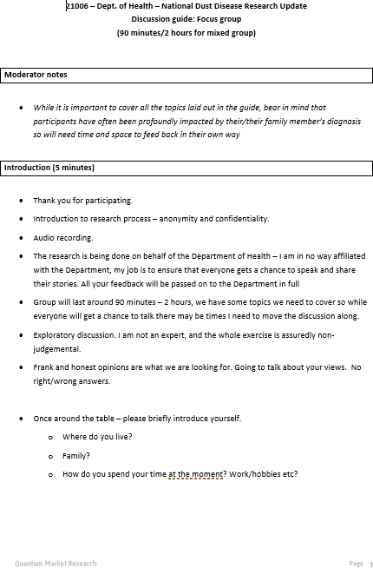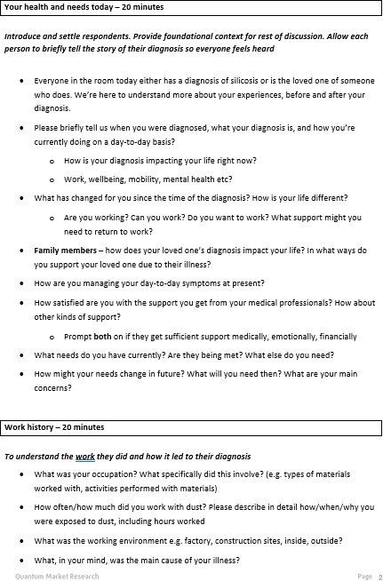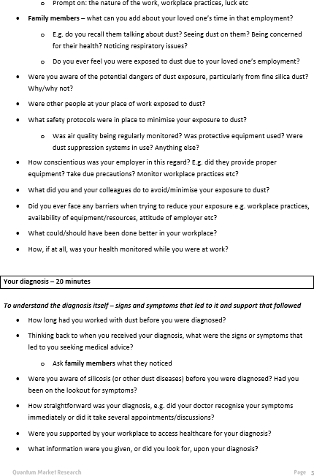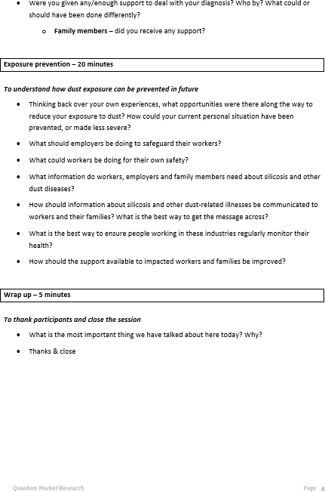

# Appendix II

#### Questionnaire

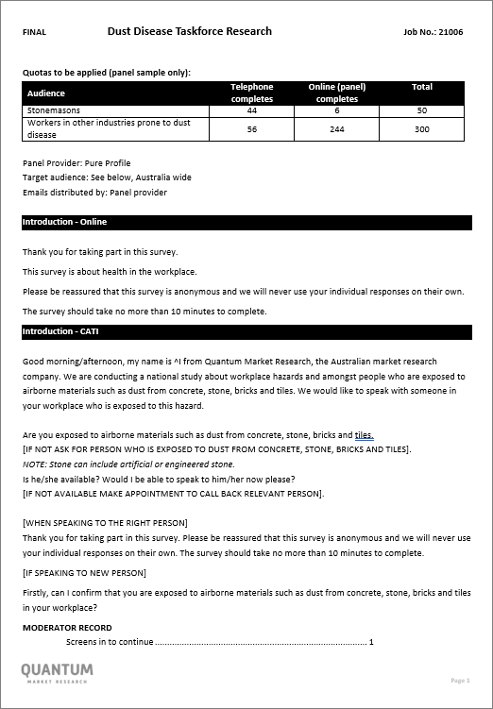 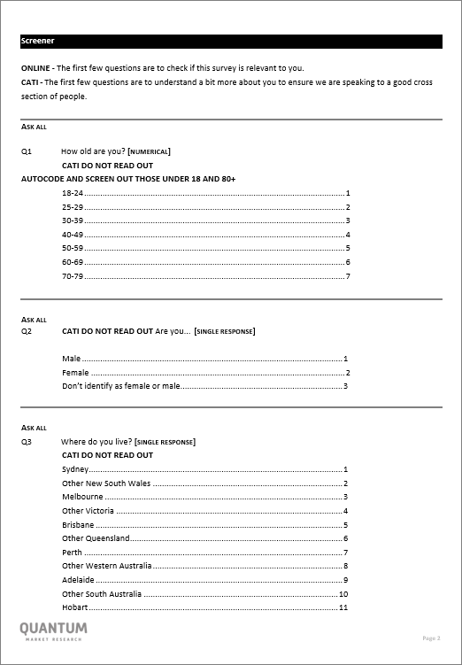

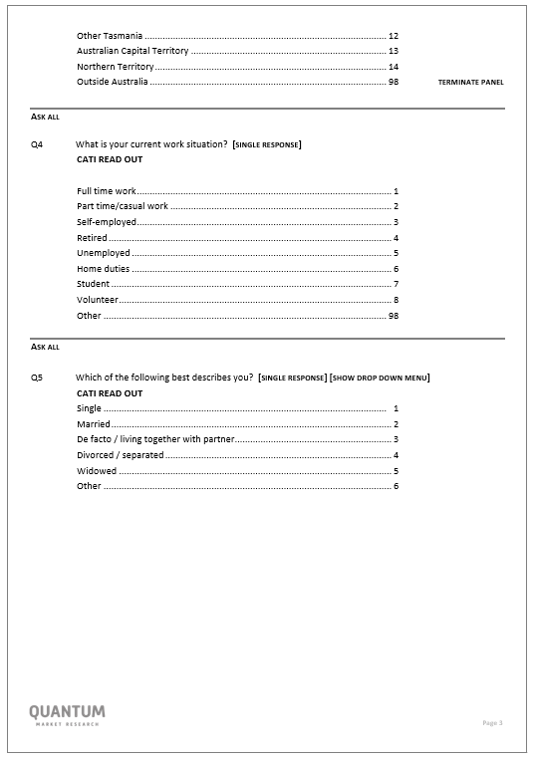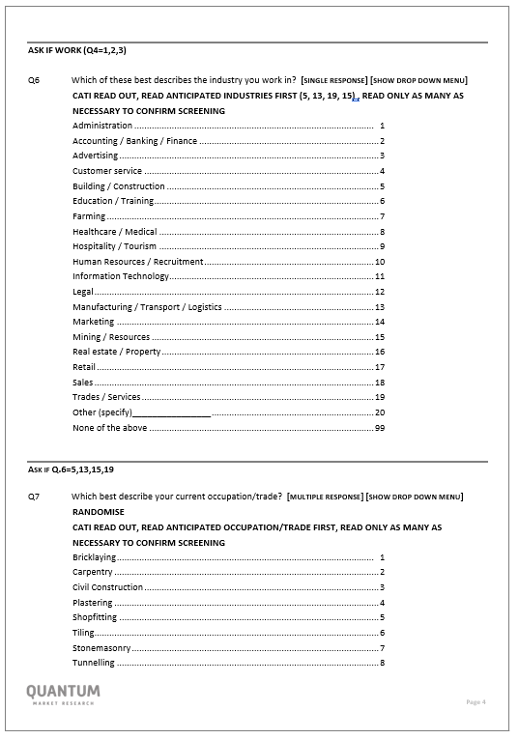

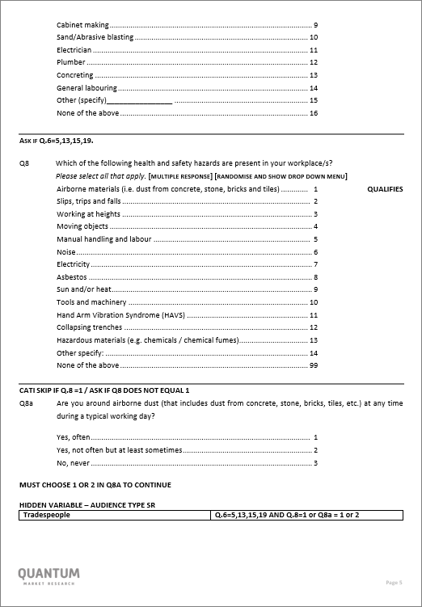 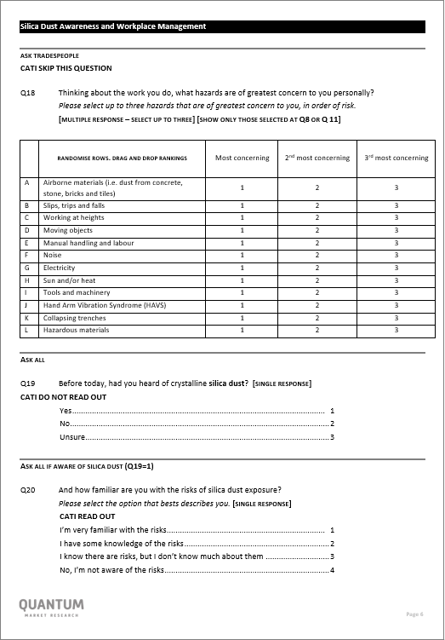

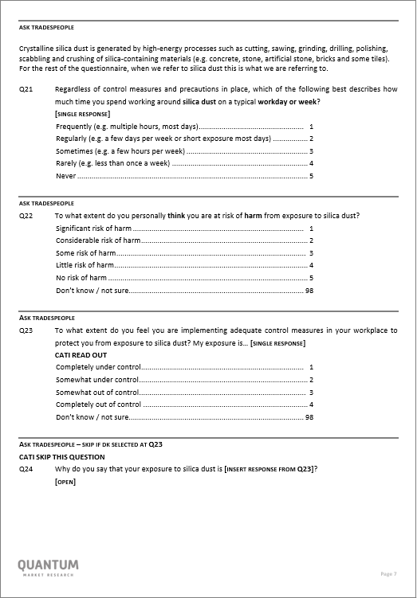 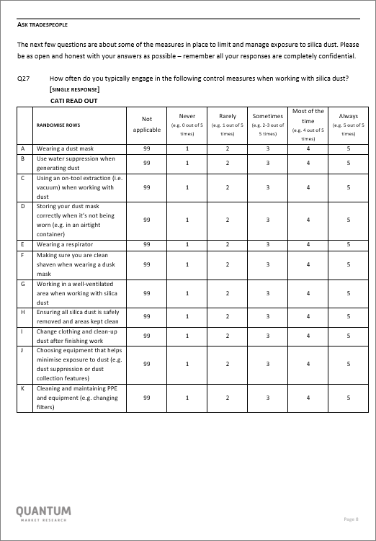

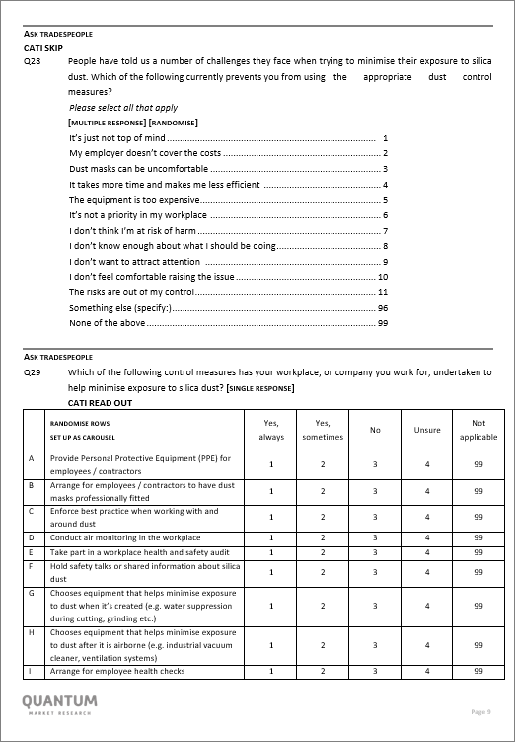 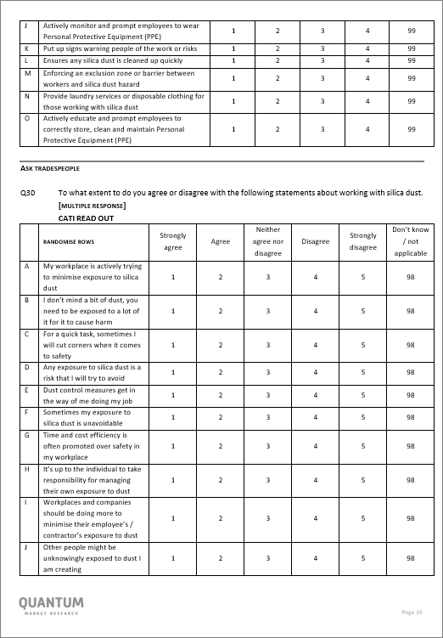

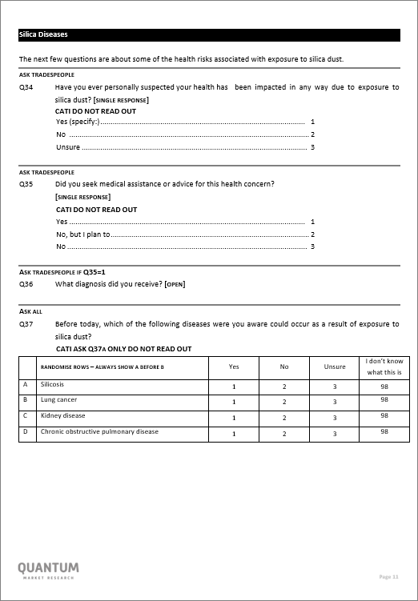 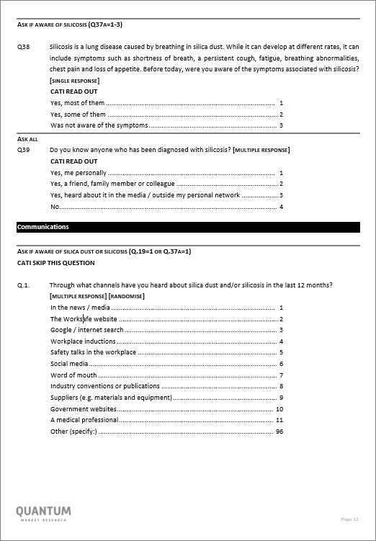

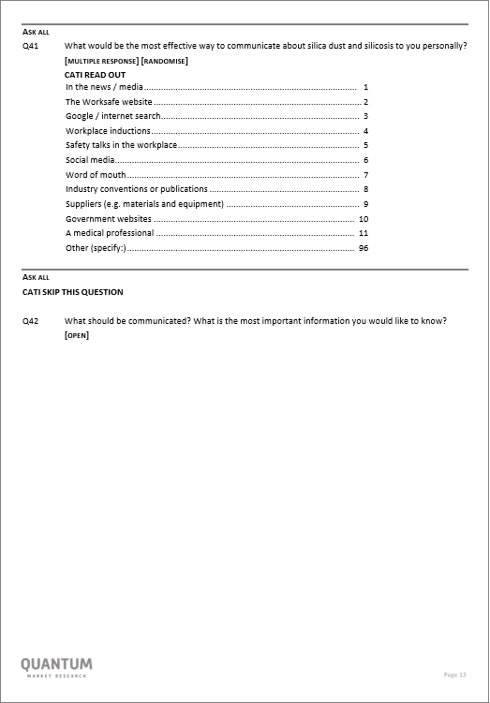 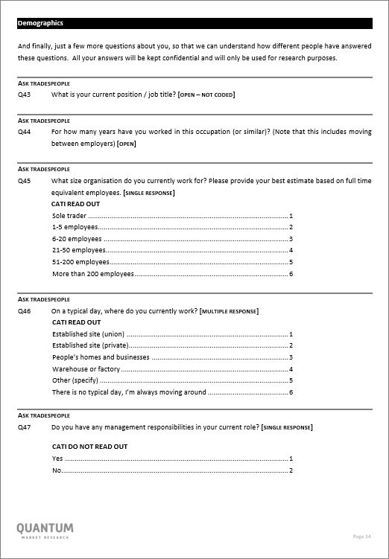

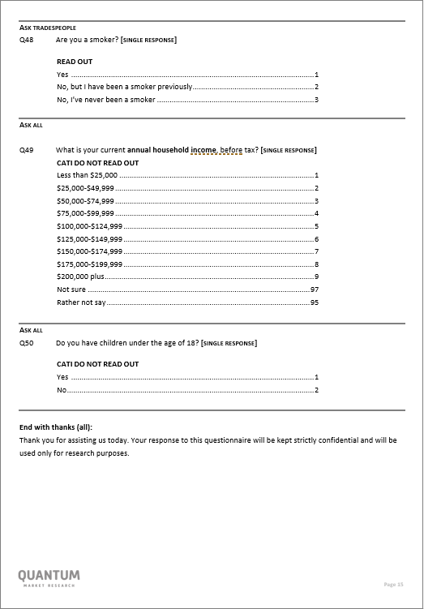

**Appendix III**

**2019 survey – demographics & key findings 2021 survey – demographics & additional charts**

##### Who we spoke to – stonemasons and tradespeople (2019)





|  |  |  |  |  |  |
| --- | --- | --- | --- | --- | --- |
| **Age Current occupation Location** | | | | | |
| Stonemasons  Other tradespeople  32%  24% 24% 24%  22% 22%  18%  15%  8%  5% 5%  2%  18-24 25-29 30-39 40-49 50-59 60+ | | Carpentry 15%  General labouring 14%  Civil Construction 13%  Cabinet making 10%  Electrician 8%  Manager/Director 7%  Office worker/admin/accounts 5%  Builder/construction 5%  Manufacturing 5%  OH&S/safety management 5%  Bricklaying 4%  Plastering 4%  Tiling 4%  Concreting 4%  Other 23% | | 32%  27% 26%25% 26%  14% 15%  10% 9%  6% 5%  2% 2% 1%  NSW VIC QLD WA SA TAS Other | |
| **Gender Business size Typical site location Managerial responsibilities** | | | | | |
| 5  21  95  79  Female Male  Stonemasons Other  Tradepeople | Sole trader 32%  13%  1-5 employees 21%43%  6-20 employees 14%  24%  21-50 employees 8%  11%  51-200 employees 3%  13%  More than 200 employees 0%  18% | | Established site 12%  (union) 12%  Established site 62%  (private) 55%  People’s homes and 63%  businesses 26%  Warehouse or factory 26% 22%  There is no typical 12%  day, I’m always 15%  moving around | | 48%  42%  Stonemasons Other Tradepeople |

**Who we spoke to – stonemasons and tradespeople (2021)**





**Age Current occupation Location**

|  |  |  |  |  |  |
| --- | --- | --- | --- | --- | --- |
| Stonemasons  Other tradespeople 34%  32% 32%  21% 19% 22%  12% 14%  4% 6%  0% 0%  18-24 25-29 30-39 40-49 50-59 60+ | | Civil Construction 16%  General labouring 10%  Carpentry 8%  Electrician 7%  Concreting 6%  Plumber 6%  Bricklaying 5%  Cabinet making 5%  Sand/Abrasive blasting 3%  Tunnelling 3%  Logistics/driver/transport 3%  Builder/construction 2%  Plastering 2%  Manager/Director 2%  Tiling 2%  Manufacturing 2%  Other 25% | | 36%  33%  22%22%  18%16% 14%  11%  8% 8% 6%  2% 3% 1%  NSW VIC QLD WA SA TAS Other | |
| **Gender Business size Typical site location Managerial responsibilities** | | | | | |
| 10%  32%  90%  68%  Female Male  Stonemasons Other  Tradepeople | Sole trader 44%  8%  1-5 employees 24%  12%  6-20 employees 18%  22%  21-50 employees 10%  16%  51-200 employees 4%  18%  More than 200 employees 0%  24% | | Established site 2%  (union) 16%  Established site 26%  (private) 44%  People’s homes and 30%  businesses 20%  Warehouse or factory 24% 23%  There is no typical 28% day, I’m always 12% moving around | | 92%  52%  Stonemasons Other Tradepeople |

##### 2019: Key findings by audience

|  |  |  |  |  |
| --- | --- | --- | --- | --- |
|  | **Stonemasons** | **Other Tradespeople** | **Partners of Tradespeople** | **Artificial stone benchtop consumers** |
|  | n=65 | n=402 | n=154 | n=202 |
| % aware of silica dust | **95%** | **75%** | **36%** | 49% |
| % very familiar with the risks of exposure | **74%** | **33%** | **7%** | 13% |
| % aware of silicosis as a result of  exposure | **94%** | **63%** | **31%** | 48% |
| % at considerable or significant risk of harm from exposure | 29% | 22% | 27% | - |
|  |  |  |  |  |
| **Audience**  **Insight:** | Stonemasons are well aware of the issue of silica dust and associated risks. With control measures in place many feel less at risk though findings suggest shortcuts are still taken. | Awareness is growing amongst other trades, but there is an opportunity to increase awareness and understanding of the risks. | Partners play a significant role in supporting the safety of tradespeople at work, even if it is a reminder of what’s at stake when people get complacent, or lending an ear when concerns are raised. | Recent consumers of artificial stone benchtops are broadly aware of the issue and the risks, but it is unlikely to impact their behaviour. |
| **Audience Implications** | Empowering stonemasons with industry updates, best practice and health trends will increase perceptions of control, though strict enforcement of legislation will be required to change the culture amongst some stubborn workplaces. | Current knowledge, perceptions and behaviours differs greatly depending on workplace and profession. For this audience, silica dust is very much an unknown and they want to understand their personal level of risk and required control measures. | Partners can play a role in raising awareness of the issue amongst tradespeople and prompting conversation. They are also often best placed to notice changes in health and to encourage health checks and monitoring. | Artificial stone benchtop consumers just want to be assured that there is no personal health impact, and that suppliers and installers are adhering to best practice to reduce harm for employees and anyone else who might be impacted. |

**The number of other tradespeople who could be taking more control measures has increased significantly**

**Control measure behaviour – % not engaging most of the time (i.e. only sometimes, rarely or never)**

*2019 Base: Those exposed to silica dust in the workplace | stonemasons (n=65) | other tradespeople (n=402) 2021 Base: Those exposed to silica dust in the workplace | stonemasons (n=50) | other tradespeople (n=300)*

Stonemasons ('19) Other tradespeople ('19)

60% 55%

Working in a well- ventilated area when working with silica dust

49%

39%

41%

38% 40%

42% 41%

47%

45%

43%

50%

25% 26%

25% 30%

24%

31%

28%

33%

36%



Stonemasons ('21)

Other tradespeople ('21)

57% 55%

62%

56%

43% 44%

44%

45%

50%

44% 50%

48%

48%

44%

35%

33%

33%

16%

24%

22%

26%

15%

Oct 2019

Wearing a dust

mask

Cleaning and maintaining PPE and equipment regularly

Ensuring all silica dust is safely removed and areas kept clean

Choosing equipment that helps minimise exposure to dust

Use water suppression when generating dust

Storing your dust mask correctly when it’s not being worn

Change clothing and clean-up dust after finishing work

Making sure you are clean shaven when wearing a dust mask

Using an on-tool extraction when working with dust

Wearing a

respirator

Working in a well- ventilated area when working with silica dust

Mar 2021

Wearing a dust mask

Cleaning and maintaining PPE and equipment regularly

Ensuring all silica dust is safely removed and areas kept clean

Choosing equipment that helps minimise exposure to dust

Use water suppression when generating dust

Storing your dust mask correctly when it’s not being worn

Change clothing and clean-up dust after finishing work

Making sure you are clean shaven when wearing a dust mask

Using an on-tool extraction when working with dust

Wearing a respirator

*Denotes significant difference between waves at the 95% level of confidence*





*Q27. How often do you typically engage in the following control measures when working with silica dust? (Excludes not applicable)*

##### There is a directional positive shift in the number of stonemason’s workplaces engaging with best practice

**Workplace culture control measures – % always or sometimes undertaken by workplace**

*2019 Base: Those exposed to silica dust in the workplace | stonemasons (n=65) | other tradespeople (n=402) 2021 Base: Those exposed to silica dust in the workplace | stonemasons (n=50) | other tradespeople (n=300)*

Enforce best practice when working with and around dust

92%

85%

89%

85%

78%

79%

66%

Stonemasons ('19)

70%

Other tradespeople ('19)

37%

49%

Oct 2019

Actively monitor and prompt employees to wear Personal Protective Equipment (PPE)

Actively educate and prompt employees to correctly store, clean and maintain Personal Protective

Hold safety talks or shared information about silica dust

Arrange for employee health checks

Enforce best practice when working with and around dust



94%

80%

95%

80%

88%

Equipment

79%

77%

Stonemasons ('21)

72%

Other tradespeople ('21)

50%

59%

Mar 2021

Actively monitor and prompt employees to wear Personal Protective Equipment (PPE)

Actively educate and prompt employees to correctly store, clean and maintain Personal Protective

Hold safety talks or shared information about silica dust

Arrange for employee health checks

Equipment





*Denotes significant difference between waves at the 95% level of confidence*

###### Choosing equipment that minimises airborne dust exposure and the professional fitting of dust masks have increased since last wave

**Equipment control measures – % always or sometimes undertaken by workplace**

*2019 Base: Those exposed to silica dust in the workplace | stonemasons (n=65) | other tradespeople (n=402) 2021 Base: Those exposed to silica dust in the workplace | stonemasons (n=50) | other tradespeople (n=300)*

88%

85%

84%

84% 81%

Stonemasons ('19) Other tradespeople ('19)

Provide Personal Protective Equipment

57%

46%

29%

Oct 2019

(PPE) for employees / contractors

Chooses equipment that helps minimise exposure to dust when it’s created

Chooses equipment that helps minimise

exposure to dust after it is airborne

Arrange for employees / contractors to have

dust masks professionally fitted

95% 94%



84%

76%

82%

77%

Stonemasons ('21)

54%

41%

Provide Personal Protective Equipment (PPE) for employees / contractors

Mar 2021

Chooses equipment that helps minimise exposure to dust when it’s created

Chooses equipment that helps minimise exposure to dust after it is airborne

Arrange for employees / contractors to have dust masks professionally fitted

*Denotes significant difference between waves at the 95% level of confidence*





###### Tradespeople are more likely to report some environmental control measures than higher risk stonemasons, although there has been directional positive movement since last wave

**Workplace environment control measures – % always or sometimes undertaken by workplace**

*2019 Base: Those exposed to silica dust in the workplace | stonemasons (n=65) | other tradespeople (n=402) 2021 Base: Those exposed to silica dust in the workplace | stonemasons (n=50) | other tradespeople (n=300)*

76%

80%

62%

69%

75%

68%

54%

46%

Stonemasons ('19)

51%

33%

Other tradespeople ('19)

49%

21%

Oct 2019

Ensures any silica dust is

Enforcing an exclusion zone or Take part in a workplace health Put up signs warning people of

Conduct air monitoring in the

Provide laundry services or

cleaned up quickly

80% 

73%

70%

68%

72%

73%

72%

60%

58%

52%

38%

31%

Mar 2021

barrier between workers and silica dust hazard

and safety audit

the work or risks

workplace

disposable clothing for those working with silica dust

Ensures any silica dust is

Enforcing an exclusion zone or Take part in a workplace health Put up signs warning people of

Conduct air monitoring in the

Provide laundry services or

cleaned up quickly

barrier between workers and silica dust hazard

and safety audit

the work or risks

workplace

disposable clothing for those working with silica dust

*Denotes significant difference between waves at the 95% level of confidence*







Level 3, 650 Chapel Street,

South Yarra, VIC 3141, Australia

[**research@qmr.com.au**](mailto:research@qmr.com.au)