National Service Model: Head to Health Assessment and Referral Phone Service

June 2022

What’s on your mind today?

Get it out in the open.

Contents

Version history 3

Key terms 3

Introduction 5

What is the phone service aiming to achieve? 6

Assumptions underpinning the service model 7

Core service elements 7

Operating hours 8

National telephony infrastructure 8

Assessment 9

Warm referral 10

Crisis response 10

Integration and planning 11

Safety and quality 11

Staged implementation 12

Communications and branding 12

Monitoring and evaluation 13

Head to Health intake services reporting requirements 13

PMHC-MDS 13

Telephony data 13

Contacts 14

PHN Mental Health Performance Framework key performance indicators 14

Appendices 15

Appendix 1: HeadtoHelp and Head to Health Pop-Up Services – Lessons learnt 15

HeadtoHelp (VIC) 15

Head to Health Pop Up Services (NSW & ACT) 15

Appendix 2: National Head to Health Service Pathway 17

# Version history

|  |  |  |
| --- | --- | --- |
| Version | Date | Notes |
| 1.0 (Draft) | December 2021 | Released for first round of consultations with PHNs |
| 2.0 | June 2022 | Updates to incorporate PHN feedback and specify reporting requirements |

# Key terms

**Appropriate care:** Intervention or action provided is relevant to the person’s needs and is based on established standards.

**Carer:** A person who has a caring role for a person with a mental health problem or mental illness. They could be family, a friend or staff and be paid or unpaid. The role of the carer is not necessarily static or permanent, and may vary over time according to the needs of the person and carer.

**Clinician:** a healthcare practitioner who spends most of their total weekly working hours engaged in clinical practice (that is, in diagnosis and/or treatment of patients including recommending preventive action).

**Consumer:** A person who uses or has used a mental health service.

**Contact:** the first point of interaction for any person who accesses the Head to Health phone service for their own needs, or on behalf of someone they care for, or are supporting.

**Follow up:** the process of proactively contacting a consumer and/or service after a referral has been made to confirm the referral is appropriate for both parties and will be acted upon.

**IAR:** Initial Assessment and Referral for Mental Healthcare. The IAR is an initiative of the Commonwealth Department of Health and brings together information from a range of sources including Australian and international evidence. The Guidance and Decision Support Tool (DST) was developed with expertise provided by an Expert Advisory Group including general practitioners, psychiatrists, psychologists, nurses, social workers, as well as people with lived experience.

**Intake:** a service which acts as a first point of contact and undertakes a welcoming process to understand a consumer’s mental health needs.

**Mental health professional:** A person who offers services for the purpose of improving an individual’s mental health or to treat mental illness. These professionals include (but are not limited to) psychiatrists, clinical psychologists, clinical social workers, occupational therapists and psychiatric nurses.

**Service navigation:** support provided by a person or service in collaboration with consumers and carers to assist them in finding the most appropriate treatment, care or supports.

**Warm referral:** actively communicating with the service to which the individual is connected to provide essential information about their needs before transferring them. Support is maintained for the individual by the site until they are received by the service.

# Introduction

Announced as part of the Mental Health and Suicide Prevention package in the 2021-22 Budget, the Australian Government is investing $487.2 million over four years from 2021-22 to improve access to mental health services in the community through establishing the Head to Health network.

The Head to Health network includes the establishment of a national assessment and referral phone service (the Head to Health phone service) to promote consistent assessment and enable warm transfer and referral to the most appropriate services. Where appropriate, it will provide referrals into community-based mental health treatment services to provide short to medium term care. The Head to Health phone service will also be integrated with the Head to Health website to facilitate referrals and provide access to digital support options.

Both the Productivity Commission’s (PC) findings from its Inquiry into Mental Health and the response to the COVID-19 pandemic have informed the planning and development of new mental health services. The PC report found that the mental health system was complex and that many people who needed treatment and care were unable to access appropriate services that were well integrated with other parts of the system – both those funded through Commonwealth and state and territory services.[1]

To address this, the Head to Health phone service is intended to provide initial clinical assessment where required and service navigation to connect people to the right mental health services to meet their identified needs. It is designed to complement, not replace, or duplicate, mental health support lines and services already provided in the community, including crisis support lines and state-funded triage services facilitating intake into tertiary services.

The Australian Government has already invested $5.1 million to establish state/territory-wide phone services as part of the HeadtoHelp and Head to Health Pop Up COVID-19 response initiatives in Victoria, NSW and the ACT (further detail provided in Appendix 1). PHNs in Victoria, NSW and the ACT will leverage this initial investment, and these models will be enhanced and replicated across other jurisdictions to provide a nationally consistent approach.

# What is the phone service aiming to achieve?

The Head to Health phone service is designed to operate alongside Head to Health centres and satellites and the Head to Health digital platform to provide a suite of entry points to engagement, assessment, and treatment for people with a range of mental health needs. Providing multiple entry pathways (website, phone, face-to-face) into mental health services under the consistent and trusted “Head to Health” brand will allow consumers to access the services that best meet their needs through their preferred platform. GPs, psychiatrists, and other health professionals may also use the Head to Health phone service to find service options for their patients.

A key objective of this investment is local service integration to address fragmentation and offer a seamless care pathway for consumers to receive the right level of care at the right time to meet their mental health needs. The Head to Health phone service will provide a free, easily accessible entry point into and between community mental health services, including Head to Health centres and satellites, headspace, and other community-based mental health services, such as those provided by jurisdictions, NGOs, and private providers.

The Head to Health phone service will be commissioned by Primary Health Networks (PHNs), consistent with the national service model outlined in this document, with flexibility for local needs. Where possible, PHNs within each state and territory will work collaboratively to establish the phone service in a way that is well-integrated with services and systems operating within their jurisdiction and at the local and regional levels. As part of their commissioning and ongoing quality improvement processes, PHNs will undertake consultation at a local level, with consumers, carers, Local Hospital Networks (LHNs) or their equivalent and other local stakeholders to shape the service model to meet the particular needs of the area, within the framework presented by this model. Avoiding further fragmentation and ensuring sustainability will be key priorities in the delivery of this initiative, as recommended by the PC report.

A key imperative will be ensuring the model of care offers a culturally safe response to the needs of Aboriginal and Torres Strait Islander people, in line with the principles of the Gayaa Dhuwi (Proud Spirit) Declaration[2] and the diverse needs of Culturally and Linguistically Diverse (CALD) and Lesbian, Gay, Bisexual, Trans, Intersex and Queer (LGBTIQ+) people. Whilst working within the principles of this service model, phone services will differ in their service delivery approach which will be tailored to meet the needs of each region.

# Assumptions underpinning the service model

The Head to Health assessment and referral phone service will provide:

* a welcoming and accessible entry point for people experiencing emotional distress, mental ill health, and/or addiction, and their families and carers through a ‘no wrong door’ approach that is consistent with the Mental Health Statement of Rights and Responsibilities[3]
* a holistic approach to care, including linking to services that address a broad range of health, social, physical, and emotional needs, supported by best practice in evidence-based and evidence-informed care
* information and advice to consumers in a way that is person-centred and prioritises self-determination, choice, and agency
* information, support and advice for carers and family members that acknowledges and validates their needs authentically and supports informed decision-making
* a service which complements and does not duplicate existing services, including crisis phone lines and state-based acute care intake services
* flexibility for regional variation to address local population needs and to make optimal use of already available services
* a seamless service pathway, by working collaboratively with local mental health service providers to develop strong working relationships, including shared or common information systems to allow smooth transfer of information and transition between providers with consumer consent, with the aim of a consumer only having to tell their story once and not requiring a full re-assessment when receiving treatment services
* services within appropriate clinical governance and safety and quality frameworks, including by ensuring the risks of supporting individuals who may be experiencing high distress or acute illness are managed, and attending to appropriate ongoing support, supervision, and training for all staff.

# Core service elements

While allowing for local flexibility, the service model for the Head to Health phone service will address the following core service elements:

* act as a central point for people to speak to someone about mental health issues and receive information and advice about mental health and AOD use
* provide holistic assessment of needs provided by a trained professional using the Commonwealth’s Initial Assessment and Referral (IAR) tool
* connect people seamlessly to the most appropriate local service to meet their identified needs
* collect data about phone call activity including the number of callers, the IAR level of care, referrals to PHN commissioned services, referral out destination, and demographic characteristics of consumers, including reporting the required data to the Primary Mental Health Care Minimum Data Set (PMHC-MDS). This will provide a greater understanding of mental health need across Australia. Please see the ‘Monitoring and Evaluation’ section for detailed data reporting requirements.

## Operating hours

The Head to Health phone services will, at a minimum, be staffed and operational during core business hours (8:30am to 5pm Monday to Friday). Over time, as demand for the service grows, extended opening hours should be offered to best meet the needs of the local community, including after hours and weekends, particularly in regions where a Head to Health centre is operational for extended hours. PHNs should ensure support and advice are available to the community seven days a week, and after hours, including through providing information about how to access another digital contact point for people experiencing distress (e.g. Lifeline, Beyond Blue) at times when the Head to Health phone service is not taking calls. Opening hours may be adjusted in response to demand and to complement availability of other regional services.

Consumers contacting the service out of hours should have the option to request a call back. All call back requests should be contacted within 24 business hours.

## National telephony infrastructure

North Western Melbourne PHN (NWMPHN) will administer the national telephony phone line (1800 595 212) across all PHN regions. All calls are routed based on client postcode to intake teams servicing each PHN region. Once calls have been routed from the central line, the call becomes the responsibility of the receiving intake team. This includes ensuring calls are answered, voice messages are on outside of operating hours, and any callers requesting a call back are followed-up within the required timeframes.

If an individual enters an invalid postcode when prompted, they will be redirected to a default PHN intake team in their state or territory. PHNs in each state and territory will need to determine a protocol for these instances, including either routing these calls to a nominated default PHN intake team, or to any of the intake teams via a round-robin process (see Figure 1).

NWMPHN will provide further guidance, including access to interactive voice response (IVR) phone message recordings before the service goes live. All PHNs must work with NWMPHN to provide relevant data, documentation, and other information to support the implementation of the telephony system nationally.

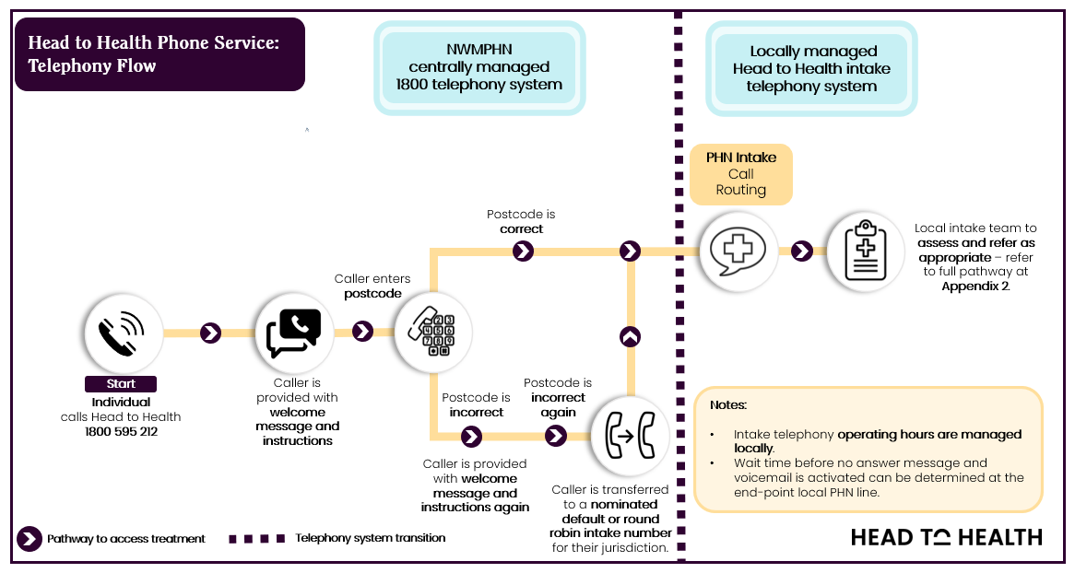

Figure 1: Head to Health phone service call pathway (national line to local intake team)

## Assessment

The intake team will identify those requiring more than information or assistance with identifying appropriate services, and will provide an assessment of their clinical needs, to be undertaken using the Initial Assessment and Referral Decisional Support Tool (IAR-DST). GPs and other health professionals, carers and family members can also contact the phone service to get advice or find additional supporting services for their patients or loved ones.

A comprehensive clinical governance framework will be required to implement the service. The assessment process will be conducted by a trained professional to match people with the services they need. All intake staff must be trained in the use of the IAR and suitably qualified to perform a mental health assessment[4]. In addition, a mental health clinician must be available for the review and escalation of assessments where undertaken by a non-clinical intake team member. All staff involved in taking consumer phone calls should also be trained to recognise an individual who may need urgent support and who should be transferred immediately to crisis or emergency care. It is at the discretion of clinical intake teams to determine instances where conducting an IAR may not be clinically appropriate.

Individuals will be referred into the most appropriate mental health service to meet their needs which may include a Head to Health centre or satellite, other available local PHN-commissioned service, jurisdictional services, or private services, including those offered on a fee-for-service basis, where this is most appropriate to meet individual needs. Connecting people to services will take account, among other things, of the cost of the service, wait list and eligibility criteria to minimise barriers to help seeking, in addition to assessed need. Choice and agency for consumers will be prioritised when connecting people to services.

Where possible consumers should not be required to go through two stages of assessment, nor tell their story more than once. Where consent is provided, the information a consumer shares throughout the assessment process will be recorded and securely shared with any referring service, and the outcome of the assessment shared with the consumer’s usual general practitioner and/or referrer (within 7 business days of initial assessment).

## Warm referral

Smooth referral pathways which are seamless for people requiring support will be essential to the effective operation of the Head to Health phone service. This must include capacity for warm referrals, including for people experiencing high levels of distress and/or who require long term care.

Warm referral involves supporting the person to access the service and ensuring the service is suitable before handing over the relationship to the chosen provider. Through warm transfers the intake team actively communicates with the service to which the individual is referred to provides essential information about their needs before transferring them. Support is maintained for the individual by phone service staff whilst they are waiting to be accepted and contacted by the agency to which they have been referred.

Warm referral should ideally be supported through digital solutions to securely transfer patient information to the treating service provider, have visibility of wait times, and allow for intake staff to make bookings on behalf of consumers.

All consumers referred to services will be followed-up via an outbound phone call or SMS within 7 business days of initial assessment.

## Crisis response

While not intended to be a crisis service, protocols for responding to people experiencing high levels of distress, suicidal crisis or acute mental illness must be in place including agreements with LHNs (or equivalent) and emergency departments to:

* ensure swift identification of those individuals who are experiencing a crisis, are acutely unwell and in need of urgent treatment or who are at risk of harm to themselves or others
* provide immediate support over the phone to manage symptoms
* have in place clear arrangements for contacting ambulance services or arranging other transport to an emergency department if required, or connection to other immediate support services.

Any consumers who have contacted the assessment and referral service experiencing high levels of distress and any consumers who are assessed as having an IAR score of 5, will be followed-up by an intake staff member via outbound call within 24 business hours of the initial call.

## Integration and planning

Each phone service will be established within a unique service landscape. The mix of state and territory government, non-government and PHN funded mental health and social support services available in each region will vary. Therefore, it is important that planning for the phone service includes comprehensive mapping of the local service landscape, accounting for existing and planned intake and treatment services, to inform advice and referral pathways for consumers.

Additionally, it will be critical to ensure that appropriate information is shared between the phone service and other agencies about roles and relationships, facilitated by shared information systems. PHNs, with support from the Commonwealth, should identify any risk of service duplication or confusion where other mental health phone lines already exist and ensure the purpose of the Head to Health assessment and referral phone service is clearly promoted.

## Safety and quality

A comprehensive safety and quality framework will be required as part of the implementation of the phone service. This should include the following:

* compliance with relevant safety and quality standards, including the National Safety and Quality Digital Mental Health Standards 2020[5]
* implementing appropriate confidentiality and privacy arrangements in accordance with the Privacy Act 1988, the Australian Privacy Principles and other relevant federal and state/territory legislation, whilst ensuring appropriate information sharing is in place between services involved in a care pathway to support quality care and effective collaboration with consumers and carers
* clinical governance to ensure that staff are appropriately qualified, well supported and trained to provide high quality care. Protocols must be in place to guide review of the care provided and for responding to critical incidents and complaints. There should be clear lines of accountability and processes for escalation within the phone service
* regular data collection and reporting processes to ensure continual service improvement, and quality outcomes for consumers of the phone service
* protocols with other relevant organisations, for example LHNs and their services, to ensure that offering alternative services to those offered in acute settings does not result in a delay in providing urgent services or otherwise risk the safety and wellbeing of individuals
* consideration in general of safety and quality priorities outlined in the Fifth National Mental Health and Suicide Prevention Plan
* cultural safety considerations to ensure that Aboriginal and Torres Strait Islander, CALD, LGBTIQ+ people and people from other diverse backgrounds receive quality responses and equality of care
* support for carers which is timely, responsive, appropriate, and accessible, in line with the Carer Recognition Act 2010.

# Staged implementation

As existing intake systems vary considerably by PHN region and jurisdiction, a staged approach to implementation is necessary. At a minimum, all PHN regions are required to deliver the core service elements from July 2022. The Department recognises that referral pathways will be limited in some regions during the initial establishment phase, with most referrals provided into other Head to Health services and PHN commissioned services.

Beyond this initial phase, and for PHN regions with established phone services in place, the Head to Health phone service should expand its referral pathways to link consumers into a broader range of community-based mental health and support services. This should include enhanced integration with other digital platforms and services funded by the Commonwealth and state and territory governments.

Opportunities for enhancement include:

* digital solutions to securely share consumer information
* tracking of patients through the system of care following referral to better understand treatment received, consumer and carer reported experiences of care, and outcomes achieved
* interface with the Head to Health Digital Platform, to support online virtual assessment for people who choose to connect to services digitally
* integration of real-time booking systems, providing visibility of service wait times to enable real-time demand management
* evaluating and elevating the experience of care from consumer and family/carer perspectives.

# Communications and branding

It is expected that all branding and communications materials created and disseminated by PHNs and lead agencies will follow the Department’s Head to Health brand identity guidelines, including following guidance around colours, logos, fonts, and design elements.

Once the phone service is established and operational, communications and branding materials should reference the national Head to Health 1800 phone number (1800 595 212) as a key entry point for IAR assessment and referral into Head to Health, and other PHN commissioned services.

# Monitoring and evaluation

The following outcomes from the phone service for consumers and carers are expected:

* people requiring support will recognise Head to Health as an accessible entry point to the mental health care system for the services and information they need
* people will be able to access, or be connected to, the particular mental health and related services they are assessed as needing
* people will receive the most appropriate service for their individual needs
* demand for services and waitlists are actively monitored at a national level with the aim to connect people to a level of care based on their assessed needs.

Head to Health phone services will need to collect data to inform an evaluation of the service, and to contribute to continual quality improvement of the service to ensure it is meeting community needs. This includes collecting and reporting to the PMHC-MDS for all Head to Health intake activity.

## Head to Health intake services reporting requirements

### PMHC-MDS

Individual PHNs are required to report via the PMHC-MDS on their intake, assessment, and referral activity in line with the specifications of the PMHC-MDS[6]. All PHNs are responsible for complying with the reporting requirements of the PMHC-MDS.

The Department is working to implement Version 4 of the PMHC-MDS. Version 4 includes data collection for Intake and IAR-DST data. Supplementary guidance, including reporting specifications for Version 4, will be provided in due course.

To support PHNs to collect intake and IAR-DST assessment data and upload that data to the PMHC-MDS, NWMPHN has developed a National Intake, Assessment and Referral (IAR) data management system that will be available for use by all PHNs without charge. PHNs may opt-in to using the National IAR data management system to collect their phone service data in line with PMHC-MDS requirements, or they may choose to use their own data collection systems.

### Telephony data

As manager of the national telephony infrastructure, NWMPHN will provide the Department and PHNs the telephony-specific data reporting that is required to monitor the initial establishment of the national phone line. This will include metrics on call volumes and times, location of callers, and the PHN intake team a call is routed to. Individual PHNs will therefore not need to provide their own telephony reporting.

### Contacts

Individual PHNs are also required to report on all contact activity. Contact data informs how the phone service is being used and is valuable for service analysis and enhancement. Not all people who call the Head to Health phone service need to be assessed or referred for treatment services. However, for service analysis and clinical governance reasons it is helpful to understand the nature of these calls. This includes knowing the type of person calling (for example, consumer, carer, or healthcare professional), and the outcome of the contact.

Contact activity data must be reported to the Department each month, alongside all other phone service reporting requirements. The Department encourages PHNs to report this data through the National IAR data management system, or if PHNs choose it can be reported separately in line with Departmental requirements. Contact data specifications, including field descriptions/values and reporting timeframes, will be provided in due course.

### PHN Mental Health Performance Framework key performance indicators

The current PHN Mental Health Performance Framework key performance indicators will continue to apply in relation to mental health service activity.

Further development of performance indicators will be led by the Department in consultation with PHNs and will be informed by the staged roll-out and expansion of the phone service and use of the PMHC-MDS and National IAR data management system to support data collection. PHNs are expected to collaborate with the Department in the development of any additional performance indicators over time to allow better assessment of the outcomes of the phone service in connecting people to appropriate mental health care in the community.

# Appendices

## Appendix 1: HeadtoHelp and Head to Health Pop-Up Services – Lessons learnt

### HeadtoHelp (VIC)

*HeadtoHelp* was designed as a rapid response to the rising mental health challenge occurring in Victoria as a result of COVID 19, with the dual aim of improved service navigation and additional system capacity. As part of the *HeadtoHelp* program, PHNs in Victoria operate a state-wide intake phone service across three hubs. The phone service has been operational since September 2020 and has received over 22,800 contacts (as at 24 April 2022).

The Department of Health commissioned Nous to undertake an evaluation of *HeadtoHelp* which commenced in January 2021 and concluded in March 2022. Findings from the evaluation that relate to the phone service component include:

* An effective Commonwealth/State governance mechanism, and deep PHN collaboration, are critical components for establishment success
* HeadtoHelp appears to be appropriately designed to respond to long-standing issues of service navigation and service provision for the ‘missing middle’
* HeadtoHelp was the first large scale roll-out of the IAR tool, and feedback was largely positive across all stakeholder groups
* The level of integration between HeadtoHelp and local services appears variable between locations and is likely to be critical to its success
* Multiple entry pathways (eg. phone call, walk-in) into the service allows participants to access the service in a way that meets their preferences. Importantly, HeadtoHelp does not require participants to first consult with a GP to develop a mental health plan, which participants have previously reported to the Royal Commission can be a barrier to seeking help[7]
* There is a need for a consistent approach to intake to support the simple, accessible ‘front door’ into the mental health service system, and HeadtoHelp should maintain a centralised intake approach at the PHN level
* Investing in recruiting the right clinicians, with the right qualifications for the intake service, and providing consistent training, will support participants having positive experiences at intake.

*These findings were provided in the Evaluation of HeadtoHelp and AMHC Early Findings Report (May 2021) and the Independent Evaluation of HeadtoHelp and AMHCs: Final Evaluation Report (1 March 2022) produced by Nous.

### Head to Health Pop Up Services (NSW & ACT)

The *HeadtoHelp* model has been replicated in NSW and ACT to support intake and assessment for the COVID-19 Head to Health Pop Up Clinics across both jurisdictions. The same 1800 phone number (1800 595 212) used in Victoria has been adopted in NSW and the ACT, however the implementation approach in NSW has differed slightly. In NSW, eight PHNs have contracted a lead organisation to operate the phone service on their behalf, one PHN has contracted the same lead organisation that is operating the Pop Up clinic to deliver the phone service, and one PHN is operating their phone service in-house.

The NSW intake service has been operational since September 2021 and the ACT service commenced in mid-October 2021, so both are in the early stages of operation and outcomes data is limited.

## Appendix 2: National Head to Health Service Pathway

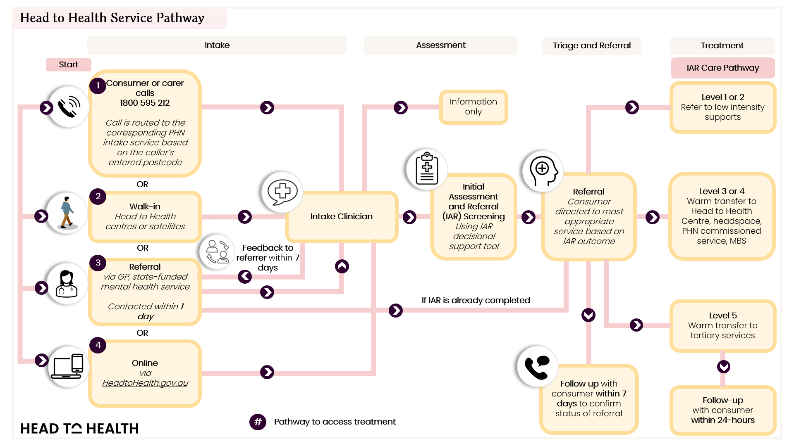

1. Productivity Commission 2020, Mental Health, Report no. 95, Canberra – Recommendation 15.
2. The Gayaa Dhuwi (Proud Spirit) Declaration. Available from: <https://www.gayaadhuwi.org.au/resources/the-gayaa-dhuwi-proud-spirit-declaration/>.
3. Standing Council on Health (2012), Mental health statement of rights and responsibilities. Available from: <https://www.health.gov.au/resources/publications/mental-health-statement-of-rights-and-responsibilities-2012>.
4. Commonwealth Department of Health 2021, National PHN Guidance – Initial Assessment and Referral for Mental Health Care – version 1.05. Available from: <https://www.health.gov.au/resources/publications/primary-health-networks-phn-mental-health-care-guidance-initial-assessment-and-referral-for-mental-health-care>.
5. Australian Commission on Safety and Quality in Health Care (2020) National Safety and Quality Digital Mental Health Standards. Sydney: ACSQHC. Available from: <https://www.safetyandquality.gov.au/publications-and-resources/resource-library/national-safety-and-quality-digital-mental-health-standards>.
6. Data specifications for the PMHC-MDS are available from: <https://docs.pmhc-mds.com/>
7. Anonymous. 2019 Submission – Royal Commission into Victoria’s Mental Health System. Accessed April 2022.