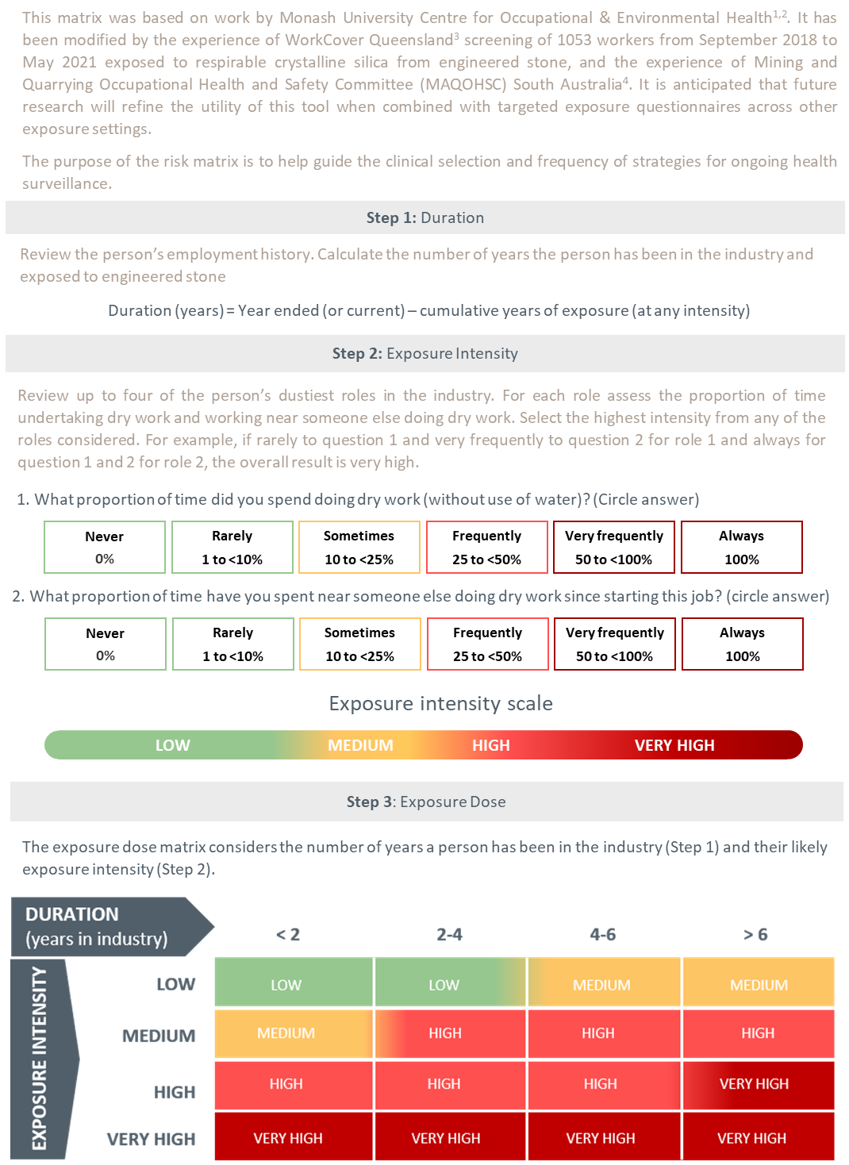
Exposure risk matrix
1. Monash University Centre for Occupational & Environmental Health (MonCOEH) (79); 2. Hoy, Glass (80); 3. WorkSafe Queensland Government (16); 4. Government of South Australia (84)

