

National Dust Disease Taskforce

Interim Advice to
Minister for Health
DECEMBER 2019


Foreword
The Hon Greg Hunt MP
Australian Minister for Health
Dear Minister,
As Chair of the National Dust Disease Taskforce (the Taskforce), I am pleased to present this interim advice to you.
Since the establishment of the Taskforce on 26 July 2019, members of the Taskforce have worked to understand the issues underlying the re-emergence of silicosis, in particular the emerging trend of accelerated silicosis among workers in the engineered (composite) stone industry. We anticipate that lessons learnt through our review have the potential to inform Australia's approach to handling other occupational dust diseases.
Through an intensive consultation period, we have listened to stakeholders and taken a systems view approach, to identify the core issues that sit along the supply chain for engineered stone. We have also identified where there are immediate opportunities to develop a nationally consistent approach to ensuring safe workplaces, health screening of exposed workers and potential research into the pathogenesis, monitoring and treatment of the accelerated silicosis disease.
On behalf of the Taskforce, I would like to acknowledge and thank all those who have contributed to our discovery phase. They include representatives from government, industry, clinical, legal, research, consumers, unions, families and most importantly, from those workers at risk of, or affected by, accelerated silicosis.
I present to you our interim advice, which includes early recommendations and findings. We will examine many of the findings further in 2020.
Yours sincerely,
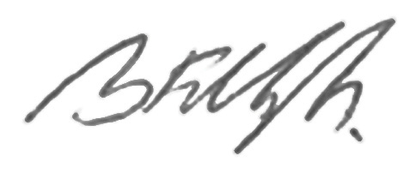
Professor Brendan Murphy
Chief Medical Officer
Chair, National Dust Disease Taskforce
20 December 2019

Contents
Foreword 2
Executive Summary 4
Early recommendations and findings 4
Early recommendations 5
Initial findings 6
Background 8
What is silicosis? 8
Our Findings: Themes 9
Regulatory and Governance 9
Workforce Organisational Culture 12
Resourcing and Capability 13
Research and Development 14
Appendix A. National Dust Disease Taskforce Members 16
Appendix B - National Dust Disease Taskforce Terms of Reference 17

Executive Summary
Although Australia is known for its strong regulatory systems, aiming to provide the highest of standards to protect the health and safety of workers, the re-emergence of silicosis demonstrates that there have been failings in these systems. The Work, Health and Safety (WHS) regulatory framework established to protect workers and other persons at workplaces is facing both challenges and opportunities, particularly for those who have, or are at risk of silicosis. Coordinated action across this framework and with the public health system and industry, will be necessary to address the re-emergence of silicosis.
To inform our terms of reference, we consulted widely to hear a range of perspectives on the issues that underpin the re-emergence of silicosis, who is at risk and why, and who should be involved in addressing the problem. We heard tragic stories of young workers in the prime of their lives being diagnosed with this preventable occupational lung disease and given a bleak prognosis. They are told they need to leave their career-of-choice immediately. Many have partners and young families. Long-term medical, financial and mental health implications are, in some cases, uncertain.
We heard stakeholders are exasperated with the re emergence of a disease with a known and preventable cause, and that action at a state and national level to address it was initially too slow.
We consider there are highly beneficial opportunities to bring together the shared interests and willingness of WHS regulators, industry, trade unions, health care professionals and medical researchers to pursue a coordinated national effort in the protection, screening, treatment and support of affected workers.
Although many workers have already been diagnosed with silicosis, these shared interests include the important area of prevention by providing enhanced and targeted communication and education on the risks of working with engineered stone. Prevention at the highest level may need to include stricter regulation and restrictions on the supply of some of these high silica-content products, if the risks cannot be managed.
Highly effective dust control measures must be in place in all environments when there is work with engineered stone. Any person conducting a business or undertaking (PCBU) has a legal duty to do all that is reasonably practicable to eliminate or minimise the risks to worker health posed by exposure to silica dust. WHS regulators must play an active role in enforcing this duty and it is our view that this is a priority. Additional guidance and support must also be provided for micro, family businesses and Small to Medium Enterprises (SMEs) to ensure they understand and meet their WHS obligations.
We strongly recommend that all workers at risk of developing accelerated silicosis be identified. Early intervention is critical to minimising harm and maximising positive health outcomes. A national approach for case finding for all people who have worked with engineered stone needs to be developed. A National Dust Disease Registry should be implemented to capture jurisdictional disease notification data (where available), with the capability to identify early new cases of disease/s.
We need to understand the pathway of this disease from the risks of exposure, the type of stone dust causing the most harm, through to accurate diagnosis and treatment. Currently, there is very limited information, data and robust research available and no identified treatment options. To address this knowledge gap, we have proposed initial research priority areas that can be offered through a one-off request for grant applications or targeted call for research.
We note most Australian jurisdictions have increased their focus on prevention and awareness activities around controlling exposure to silica dust and protecting against accelerated silicosis. There is benefit in leveraging jurisdictional efforts to ensure activities are nationally consistent, coordinated in understanding why this outbreak of silicosis has occurred, and focused on preventing any future incidence.
Our interim advice provides immediate actions and outlines our plan for 2020 to formulate our advice to the Council of Australian Governments (COAG) through the Minister for Health.
Fundamentally, our advice is based on a need to ensure the issue of accelerated silicosis can be fully understood and addressed as a priority, while providing a blueprint to minimise the risk of another similar occupational disease remaining undetected in the future.

Early recommendations and findings
Since our establishment as a Taskforce in July 2019, we have undertaken four months of discovery work to better understand the issues underlying the emerging trend of new cases of accelerated silicosis, and to support the development of a national approach to the prevention, early identification, control and management of occupational dust diseases in Australia.
During this phase, we have consulted a wide range of stakeholders and interested parties on accelerated silicosis and the management of occupational dust diseases. Through collating formal and informal reports, we are aware of more than 300 silicosis cases diagnosed across Australia since September 2018. As further screening of silica-exposed workers is undertaken, more cases will be identified in the coming months and years.
The discovery phase has culminated in the development of this interim advice to the Hon Greg Hunt MP, Minister for Health.
Our interim advice proposes a set of Early Recommendations for actions that can be taken in the short-term to address accelerated silicosis ahead of our final advice to COAG in 2020.
Our advice also includes a set of Initial Findings. These findings are not conclusive, but point to areas for further examination. These initial findings will underpin our 2020 work plan.

Early recommendations
We have identified five (5) national actions (not in priority order) that can be taken in the immediate and short-term to address specific issues related to the re-emergence of silicosis:
- Develop and implement a prevention strategy, with an initial immediate targeted education and communication campaign.
- This campaign should build on the existing efforts underway through Safe Work Australia and across and within each jurisdiction. It should target businesses and individuals most at risk, their families and their social networks.
- Enhanced material concerning the risks associated with processing engineered stone and clearer guidance on best practice dust control measures should be developed.
- Develop a national approach to understand the extent of occupational dust diseases in Australia through identification and capture of data, information collection and sharing, including:
- Staged establishment of a National Dust Disease Registry that is initially focussed on accelerated silicosis related to engineered stone.
- The registry should include disease notifications from all jurisdictions together with available case finding data, exposure history and air sampling data.
- The registry should be designed with the capability for potential future expansion to cover other occupational lung diseases.
- Exploring opportunities for data linkage and information sharing across systems to facilitate monitoring of the work-related hazards, and a better understanding of emerging workplace risks, to enable more sophisticated reporting on the incidence and trends in occupational diseases.
- This could assist with more timely and appropriate interventions and prevention actions.
- Apply a strategic approach to research to better understand accelerated silicosis with the ultimate aim of improving prevention and treatment options. This includes establishing a research collaboration platform across Australia to ensure resources are targeted, activities address identified research gaps and efforts are not duplicated. The immediate research related recommendations are:
- Invest in research to investigate
- the pathogenesis of engineered stone associated silicosis, especially accelerated silicosis, including exposure patterns, and effect of particle size;
- identify factors, such as biomarkers, associated with disease severity and risk of progression;
- best practice to minimise exposure, including engineering and technologies to eliminate or minimise risks; and
- the efficacy and sensitivity of radiological methods to diagnose early silicosis.
- Coordinate and focus priorities on improved case finding, clinical management and outcomes for individuals.
- Develop national guidance on an approach to actively search for people at risk from respirable crystalline silica dust exposure at the workplace.
- Develop a strategic national approach to improve Australia's ability to detect and rapidly respond to any future emerging occupational diseases of significance.

Initial findings
The following initial findings are not conclusive and highlight areas for further examination in 2020. These have been categorised under themes identified in the table below.

Regulatory and Governance
Government interventions undertaken in response to the rise in cases of accelerated silicosis appear to have been inconsistently implemented and monitored, creating an unequal and fragmented level of health protection.
- Actions implemented to mitigate future silica dust exposure were found to be similar across jurisdictions but with significant gaps. Various WHS regulators have published Codes of Practice and guidance to ensure PCBUs and workers are assessing risks and are working to the requirements of the WHS laws and recommended guidelines. However, it has been difficult to determine the impact of these approaches and the extent WHS regulators were monitoring compliance with WHS laws or taking enforcement action. WHS regulators agreed to an audit of actions being taken by each jurisdiction to further inform a national approach.
- Stakeholder evidence suggests historic regulatory effort has focused on the visible, immediate and acute safety risks, such as physical injury prevention, over the more chronic or 'invisible' risks to health. Further work is required to examine the WHS regulatory system's current and future capability to manage latent and emerging WHS risks.
- There are perceived inconsistencies and gaps in WHS regulatory protections for workers. There is a need to determine if additional national model dust disease regulations are required to strengthen compliance and enforcement. Consultations indicate existing provisions in the current model WHS laws may not be consistently understood or enforced. This requires further analysis to determine what work is being undertaken and, if there are gaps, how can these be minimised. The WHS regulatory audit will help inform this matter and we acknowledge the work already underway by Members of Safe Work Australia on this aspect.
- PCBUs are required to provide health monitoring for workers under WHS laws so far as is reasonably practicable, including where there is a significant risk to health. Imposing these requirements on a PCBU has led to gaps in, and fragmentation of information. Actual observational data from public and private sources in each jurisdiction needs to be shaped into a consolidated dataset that can more inform strategic decision-making.
Ministers with responsibility for WHS recently agreed to reduce the workplace exposure standard for respirable crystalline silica to better protect workers from the effects of exposure. Additionally, there is also a need for agreement on what is an unacceptable level of exposure to silica dust for workers who have already developed disease, or those people who have had significant cumulative exposure that places them at very high risk of developing disease.
- Acknowledging that, the highest level of protection required under the WHS laws is to eliminate all risks, including by eliminating hazards, there is growing support for the consideration of the prohibition of the importation of some of the engineered stone products that have very high levels of silica (and then substituting with products with lower concentrations of silica or alternative products).

Workforce Organisation and Culture
Culture is an important consideration to address the problems identified. All stakeholders have an important role to shape the attitudes and behaviours required to achieve meaningful change.
- Early indications highlight historical workplace cultural norms, underpinning complacent attitudes and behaviours towards safety which are creating barriers to safe work practices and these have contributed to the re-emergence of the disease. These barriers prevent workforce and regulatory initiatives focused on ongoing awareness of the risks to workers' health. The Taskforce found that a safety culture appears to be disproportionately influenced by factors such as short-term financial reward and historical practices. Past practices have tended to focus on injury and incidents rather than protecting for longer-term health impacts.
- Structured market research and stakeholder submissions informed the Taskforce that less experienced workers, especially younger workers and apprentices, casual hire and temporary workers including culturally and linguistically diverse workers, generally have lower awareness of the risks of exposure to silica dust, and less confidence in questioning workplace processes and directions, even in jurisdictions that have more actively promoted the issues. The Taskforce will further explore the implications for future interventions.
- The Taskforce found the level of regulatory engagement by SMEs, particularly micro and family businesses, is lower than with large businesses (i.e. Tier 1 and 2 construction companies). Financial matters and other capacity challenges faced by SMEs appear to impact both the awareness of best practice dust management and compliance requirements. The Taskforce will look into how to facilitate behavioural change and educate this part of the industry in 2020.

Resourcing and Capability
To ensure the health of workers there are opportunities to align and harness the skills and knowledge of industry, workplaces, workers and governments to identify, and control silica dust exposure.
- There is a need to improve the coordination/prioritisation across the WHS, private health and public health systems to identify and communicate emerging issues from national and international signals. How Australia can position itself to be better informed of emerging knowledge about risks will be an area of further examination.
- Preliminary consultations have highlighted the potential for industry-led, regulatory oversighted initiatives aimed to reduce exposure to silica dust. Manufacturers and suppliers could have a greater role in product stewardship to ensure intended use and safety information flows through the supply chain and restrict supply to only authorised, demonstrably safe, fabricators and installers. We will continue to explore the legislative, policy and other levers (such as insurance arrangements) that exist along these chains.
- Existing WHS policy and regulatory practice could be significantly strengthened by the structured integration of epidemiology, occupational hygiene, occupational physician expertise and worker representation, to complement the policy and regulatory expertise across and within departmental structures.
- Clear, consistent and ongoing awareness and education activities are necessary to improve the levels of understanding across the industry and workforce, with particular support for micro and family businesses, SMEs and all PCBUs.

Research and Development
To inform government decision making there is limited information on the development pathway of accelerated silicosis resulting from working with engineered stone, and no identified treatment plan.
- Although silicosis is not a new disease, there is very limited research available regarding accelerated silicosis resulting from short-term, moderate to high-level silica exposure. Apart from lung transplantation, no treatments have been identified. The Taskforce recommends immediate research to address this gap, and a longer-term strategic approach for investment in research in this sector.
- Initial findings suggest there are gaps in the collection and sharing of information about workplace hazards and health monitoring data. This prevents visibility of data on a national level and creates a barrier for policy makers to adequately assess the scale and extent of occupational dust diseases.
- The Taskforce heard from stakeholders about the importance of innovation in research and development in this sector, particularly in terms of process engineering, technology to minimise airborne dust levels and personal protective equipment (PPE).
- Greater support is needed for those who have been diagnosed with accelerated silicosis, to access and manage legal support, financial support, access to compensation schemes, physical and mental health and future employment opportunities, including for their families.
- Future workforce planning for respiratory and occupational physicians and occupational health nurses will need to take account of the rise in accelerated silicosis cases. This extends to the education needs of general practitioners with patients with occupational dust disease.

Background
Following the announcement by the Australian Government on 26 July 2019, to establish a National Dust Disease Taskforce (membership at Appendix A), the Minister for Health, the Hon Greg Hunt MP, asked us to undertake this work, according to the Terms of Reference (Appendix B).
Given our Terms of Reference and the timeframes, we limited our focus to the incidence of accelerated silicosis related to exposure to silica dust generated through the fabrication and cutting of engineered stone. However, in doing so, we are mindful of the broader issues related to silica exposure and other occupational lung disease.
We have focused on the re-emergence of silicosis within Australia and the current WHS and public health systems' responses to this epidemic. In this advice, we outline immediate actions for prevention, education, awareness raising, and possible regulatory reforms for workplaces, to eliminate and control the incidence of occupational dust diseases.
We acknowledged early on the importance of timely and effective engagement to hear the range of perspectives from the community and stakeholders across Australia. In September 2019, we released a consultation paper to invite written submissions. From September to November 2019, we conducted a series of open consultations across Australia, a workshop dedicated to research and we commissioned structured market research.
We have also considered evidence and information provided by jurisdictions, medical and public health experts and have been cognisant of previous reviews, reports or inquiries of relevance to our work.

What is silicosis?
Silicosis is a preventable occupational lung disease (a pneumoconiosis) and is one of the diseases caused by inhalation of very fine silica dust.
Silicosis affects the lungs by damaging the lining of lung air sacs. It is a form of fibrosis (scarring) of the lungs resulting in progressive loss of lung function. This form of fibrosis is incurable and may progress after exposure has stopped. Persons with advanced silicosis suffer severe shortness of breath and may suffer complications including respiratory failure and death. In the early detectable stages the person does not manifest symptoms.

Our Findings: Themes
In undertaking our review, we have found that issues have fallen into four key themes:
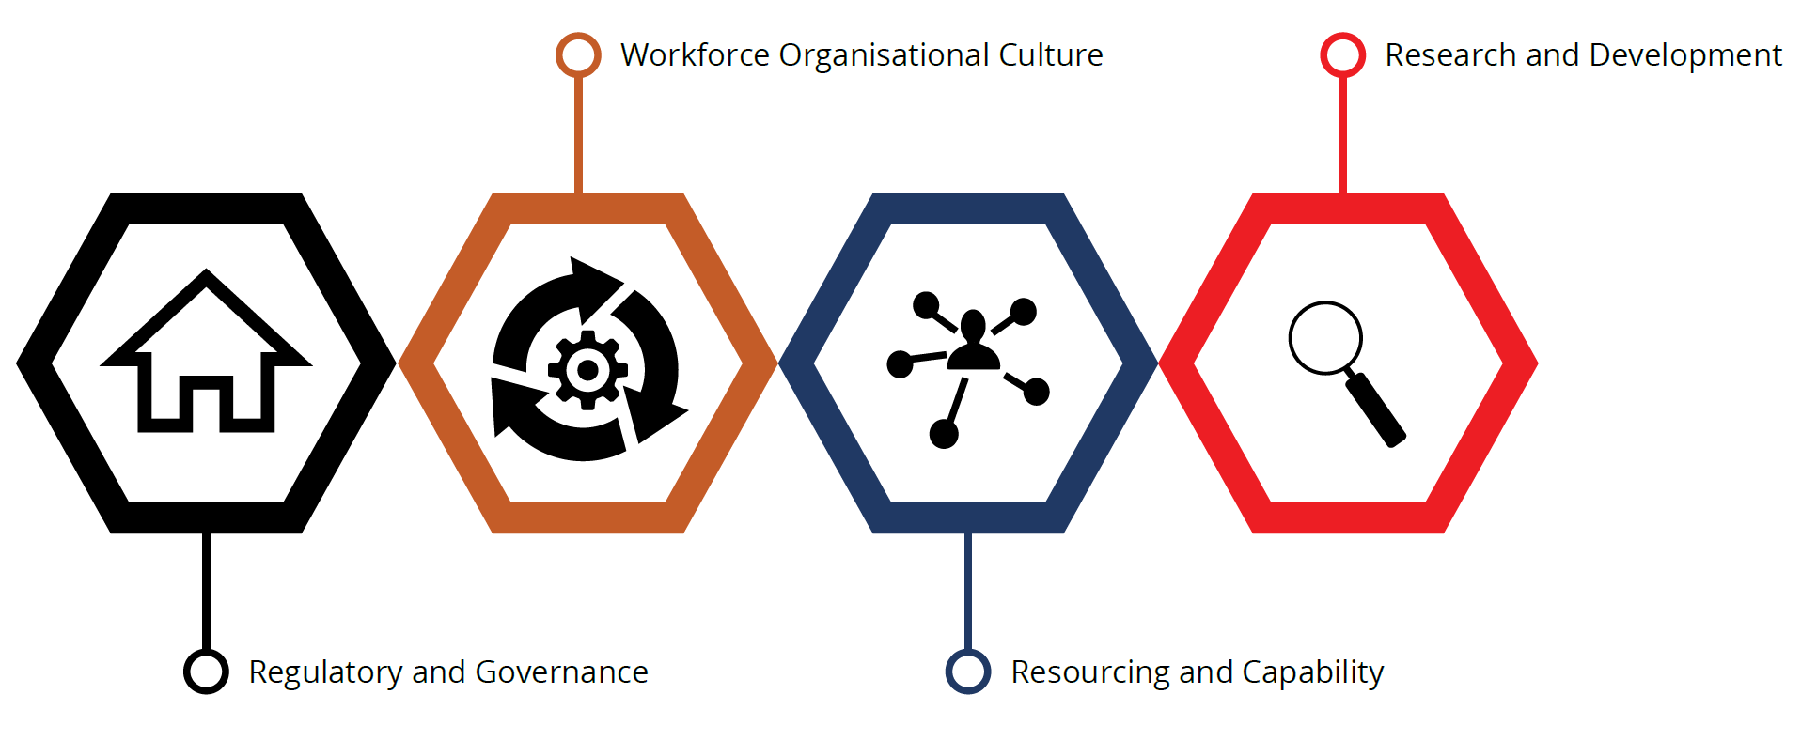
Figure 1: Consolidated themes from consultation forums

Regulatory and Governance
There is significant opportunity to improve existing WHS arrangements in Australia to ensure the risks associated with engineered stone are controlled and those working with this product are well informed of these risks and how to adequately protect themselves.

Australian WHS & Workers Compensation Frameworks
Australia's national WHS framework is established through the Intergovernmental Agreement for Regulatory and Operational Reform in Occupational Health and Safety agreed by COAG on 3 July 2008. In 2011, a single set of WHS laws were agreed to be implemented across Australia, known as 'model' laws. WHS regulators in the Commonwealth and in each State and Territory are responsible for regulating and enforcing the laws in their jurisdictions. To date all jurisdictions except Victoria and Western Australia have implemented the model WHS laws.
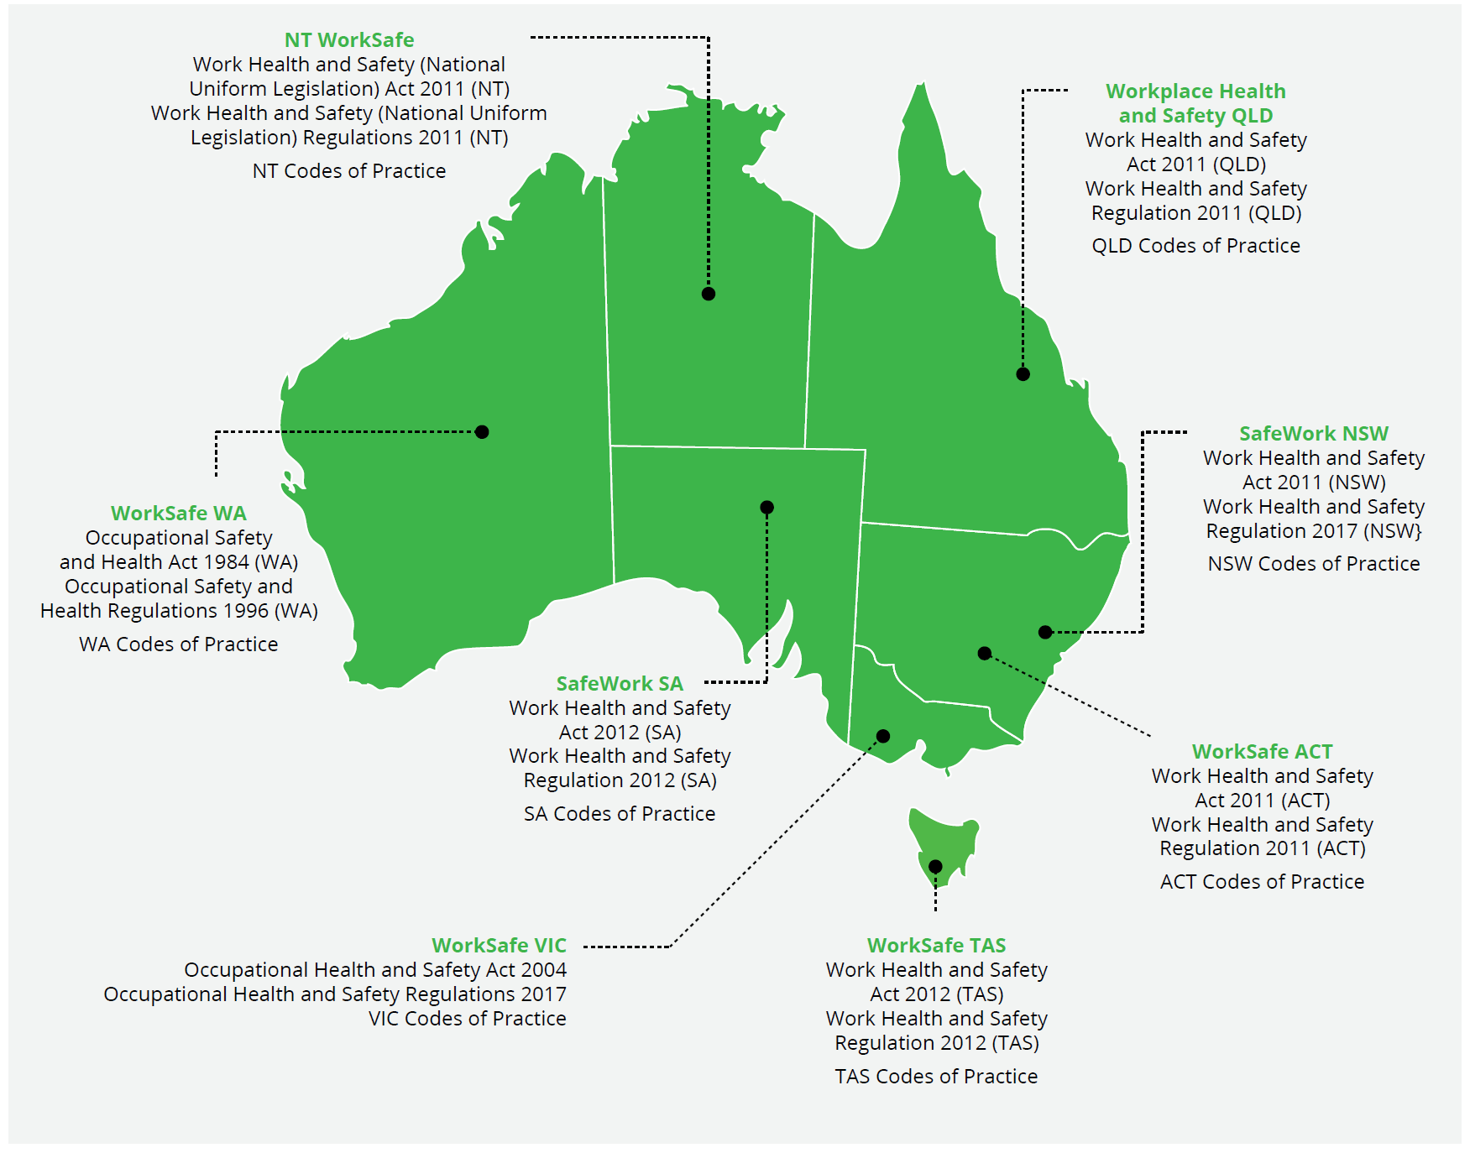
Figure 2: Work health and safety laws
Each of the eight Australian states and territories have their own workers' compensation scheme, and the Commonwealth has three main schemes. These schemes provide support for workers with a work related injury. To be eligible for compensation, a person who is injured in the workplace must fall within the definition of worker/employee in their jurisdiction and have suffered an injury that arises out of, or in the course of, employment.

Consultation Findings

Coordination across WHS framework
Stakeholders suggested that collaboration between the jurisdictions across the WHS framework should be strengthened, particularly in the timely sharing of information on emerging issues and early responses to emerging workplace diseases.
A recurrent theme was that those workplaces with poor practices often had poor understanding of requirements under WHS laws. In addition, while some workplaces had attempted to reduce exposure to silica dust, without the requisite knowledge, this was not done to the required standard.
The lack of a formal system to capture data about exposure and air monitoring or prevalence of associated health conditions was highlighted by stakeholders as an important contributor. Businesses or WHS regulators have, or had, no formal system to record and monitor exposure and to report this information in a routine way to inform policy-making or compliance responses. Some stakeholders believe that imposing the duty for health monitoring on employers, also known as PCBUs, and private health surveillance providers has led to gaps in information.

Industry regulatory engagement
We heard evidence that the construction industry has evolved in terms of its approach to safety. Large industry corporations in general have well-established approaches to ensuring safety. However, SMEs, micro and family businesses may be less likely to have the knowledge, scope or resources to do the same.
Awareness of the existing requirements under WHS laws to eliminate or minimise exposure to silica dust appears to vary. Further, it seems the WHS requirements are also inconsistently enforced, which may also exacerbate confusion about what is required.
A lack of explicit regulation has contributed to the lack of understanding amongst employers, particularly those within small and medium enterprises, which would not be likely to access WHS/OHS expertise.'
— Health & Safety Organisation submission, Nov 2019
More practical guidance is needed to support to organisations meet their regulatory requirements.
Some stakeholders expressed the view that WHS regulators may be primarily focusing on 'tier 1' large-scale operators, with less attention to small businesses who are perceived to carry a lot of the risk.
'Regulatory bodies target tier 1 organisational as they have the ability to drive change through sub-contractors that they engage. This model is flawed in that there are higher level of risk exists in the small operations, not just the tier 1 and 2 organisations.' (sic)
— Industry submission, Nov 2019

Compliance
To discharge some duties under WHS laws, duty holders (PCBUs) must apply the hierarchy of control measures to manage risks, if they cannot be eliminated. Our consultations have indicated that, at some workplaces, control measures for managing dust are not being effectively applied.
While many stakeholders suggest the current WHS laws are sufficiently robust to control dust related diseases, there was a general consensus that laws are not adequately enforced throughout the whole supply chain, with the focus on the PCBU involved in installation as defined in the WHS laws.
A number of stakeholders raised concern that inspectors commonly focused on the more obvious safety risks, such as risk of working with high-risk machinery. Workplace Health and Safety regulatory arrangements rely on businesses and workplace health and safety representatives taking responsibility for managing health and safety risks in their workplace. This includes understanding the full range of risks present in workplaces, including more long-term and less easily observable health risks, such as exposure to silica dust.
Without adequate understanding of risk at the workplace level, the system is then dependent on having a sufficiently resourced inspectorate, with adequate occupational hygiene knowledge, to identify risks and ensure their remediation. Consultations identified that many businesses were not sufficiently informed of the risks, and that the regulator's inspection programs were not effective in ensuring compliance with occupational health standards in engineered stone related industries.

Prohibition
Some stakeholder feedback proposed elimination of the risks of exposure to dust through regulatory prohibition or restriction on the importation of engineered stone into Australia. It was noted that there are a range of engineered stone products, some with very high silica content. Selective restriction of the highest risk products is considered an option. Others highlighted the need for mandatory provision of WHS information and product labelling, or mandatory oversight of engineered stone use throughout the supply chain, with tighter requirements for product stewardship.

Health screening/Case finding
We heard differing views on what the most appropriate health screening methods are, with many critical of the minimum health monitoring processes required under the WHS Regulations. We heard that the use of conventional chest X rays and spirometry may not detect the early stages of silicosis. There was agreement that all jurisdictions need to have a consistent and comprehensive program to make screening available to all exposed workers and that there must be consistent national standards in the methodology of screening and case detection.

Support for those affected
There was a strong view from stakeholders that more support is required for workers who have already been diagnosed with silicosis. This could include pathways for return to work for those who could continue to work safely within the industry. This includes defining future limits on exposure, as well as retraining of workers into alternative employment.
In terms of workers' compensation arrangements, coverage, benefits and return to work provisions are set out in legislation and vary between workers' compensation schemes. Coverage of workers in small and micro business is determined based on the relationship between the worker/employee and the employer. Individual contractors are generally not covered by workers' compensation schemes; however, this is dependent on the tests applied in each jurisdiction.
Workers covered by compensation schemes have variable eligibility for benefits including income replacement, costs of medical and hospital treatment, permanent impairment entitlement and death entitlement. The duration and level of support is determined by the scheme arrangements and level of incapacity, but is typically time limited unless the worker elects to receive benefits in a lump sum. In some jurisdictions, workers' can pursue common law remedies; however, there may be restrictions and caps on the damages that can be awarded.
Workers that are not eligible for workers' compensation may access other forms of support such as life insurance, income support, public health and social security. This includes family members who are unable to access the worker compensation schemes. Additional, longer-term support mechanisms may be required.
Beyond workers' compensation arrangements, there needs to be greater effort put into developing consistency across jurisdictions, identifying new treatment options, and ensuring that rehabilitation and mental health support services are available for all those affected, including immediate family members.

Workforce Organisational Culture
Workplace culture, in the context of our review, includes the extent to which the workplace values and prioritises WHS. Individual tolerance and risk profiles appear to be driven by a range of factors.

Consultation Findings
Through our consultation forums, we became aware of variations in organisational cultural attitudes and behaviours.

Awareness
Across all sectors, the lack of awareness of the risks of dust diseases was acknowledged as a problem. This is despite PCBUs' duty to inform and equip workers with appropriate information and training about potential risks to health and safety.
Our market research, and the work of Safe Work Australia, has identified a lack of awareness of compliance requirements and appropriate control measures, as well as cultural barriers to adhering to them. We heard the desire to 'fit in' or 'pressure to finish a job quickly' can lead to choosing the quick and easy process rather than the safest approach, such as reaching for inappropriate PPE options that do not provide the right level of protection.
"I'll wear a mask if it's nearby, but there's no point walking to the office five minutes away to get a mask to do one or two cuts."
— Stonemason
It was reported to us that some PCBUs appear to take 'short cuts' in the safety controls they put in place for handling products with high silica content. Some written submissions raised the excessive reliance on the use of PPE to protect workers, where there should be a focus on higher-level controls (e.g. engineering and administrative controls such as working in different ways or using more sophisticated dust extraction technology).

Poor practice
We identified many poor practices in dust control; resulting in continued risk of exposure. For example, workers not properly handling hazardous materials and incorrect application of personal respiratory equipment. Additionally, workplace environments may lack facilities or effective equipment to reduce dust exposure (e.g. no ventilation, no wet cutting or sealed off rooms) or there is no monitoring in place so that they know what the exposure is.

Training and education
Stakeholders noted there is a lack of education on the hazards and risks that lead to dust related diseases. This contributed to a reduced drive to change current processes and procedures.
We heard that workforce awareness is improved through ongoing education. However, retaining this knowledge and its transfer is facing challenges, as the engineered stone workforce can be transient, and to a degree, less skilled due to ease of working with engineered stone compared to traditional stone products.

Effective communication strategies
There has been an increase in education and awareness campaigns and activities in most jurisdictions. However, we have heard tradespeople are still predominantly receiving their information via the news and social media platforms. They value safety talks in the workplace and workplace inductions as the most effective channels for communication. Additionally, many of the workers come from a non-English speaking background and there are limited non-English information resources available.

Loss of professional knowledge
Stakeholders highlighted that the decline of the 'stonemason' professional identity has resulted in a loss of knowledge transfer. We heard that where workplaces, or workers, lack understanding of the risks, other cultural influences dominate personal health decisions. Stakeholders pointed to examples of poor practice, such as: the high incidence of incorrect fitting of PPE, which should be fit tested, with filters checked regularly, and the wearer clean-shaven; intermittent use of PPE rather than continuous use; and all supplied PPE kept on for the duration of work.

Resourcing and Capability
Resourcing and the capability of the system are important to enable WHS, public health systems and workplaces to function properly in support of the health, safety and well-being of workers.

Consultation Findings

Supply chain
We heard that while importers and suppliers at the start of the supply chain may be well informed about the potential hazards associated with their product, as it is passed along the supply chain, crucial safety information is lost without adequate measures in place to pass information along the chain. While government led action and oversight may be required, there is industry support for industry-initiated actions that assume a greater role in product stewardship.

Health and Safety verses efficiency
There is acknowledgement that adherence to regulatory standards is seen to be a cost when there is limited awareness of the impact of non-compliance.
Despite the WHS laws, and education campaigns by WHS regulators, there appears to be uncertainty and misunderstanding of what constitutes a hazardous level of silica dust exposure and how to safely handle the high silica content products in the workplace. This could be leading workers to believe that they are not at risk of exposure if they are using 'wet cutting' techniques, or to workers being exposed if they are not aware of how to safely dispose of contaminated water, for example by vacuum techniques.
Some stakeholders identified a relative lack of technical and clinical capability within the staff of the WHS regulators as an issue that may have contributed deficiencies in the initial response to accelerated silicosis.
"It can be a bit of a sticking point. The operations manager will tell you do something one way, and wants it done to a deadline, but the OHS guy will come along later and tell you to do it differently, which usually takes longer. I don't always know who I should be listening to."
— General Labourer

Control measures, profit margins and safety
We heard that the profitability and viability of business is impacted by the costs associated with complying with WHS laws, including the costs of WHS expertise and upgrading control technology and equipment. The size of a business underpins its ability to fund these resources, and to provide information and education to their workforce. For example, the costs associated with air monitoring, isolation of processes with sealed environments or putting in place good ventilation are further impacted by the time required to implement them and the impact on project completion or other deadlines.

Jurisdictional actions
Many jurisdictions have begun educating businesses and workers who are handling engineered stone. They have commenced education and advertising campaigns to inform PCBUs and workers about the need for protecting workers against dust diseases. Jurisdictions have increased inspections in workplaces handling silica containing products for compliance with WHS laws. We will continue to develop a better understanding of actions taken across jurisdictions as part of further work we will be undertaking in 2020.

Research and Development
Silicosis may not be a new disease; however, the emergence of accelerated silicosis has tested our understanding of this disease and treatment options. Research and development plays a key role in closing these gaps.

Consultation Findings
We identified a broad range of research needs in relation to engineered stone and accelerated silicosis, covering epidemiology, prevention, early diagnosis, pathology and management. This has included the potential benefits from immediate investment in research that would:
- contribute to our understanding of engineered stone associated silicosis;
- identify factors associated with disease severity and risk of progression;
- define best practice to minimise exposure; and
- evaluate the efficacy and sensitivity of methods to diagnose early silicosis.
Consultations further highlighted that:
- the evidence base and supporting data on accelerated silicosis are limited;
- there needs to be research on best practice management protocols for working with high silica content products;
- research gaps exist around case finding (screening), diagnosis, pathogenesis of the disease, treatment, and improving the health status and outcomes of individuals suffering from accelerated silicosis.
A national picture on workforce monitoring, risk identification and data collection would significantly enhance the understanding of accelerated silicosis.

Research on prevention
We heard there are strategies being put in place by WHS regulatory agencies to minimise exposure; but research is also needed on the interventions, engineering controls, and exposure levels, what are the most important risk factors, and what combination of controls is required to protect workers. Further innovation in engineering and technology could reduce dust generation, create improved barriers between workers and dust, and improve the effectiveness of PPE.
Research is needed on how best to target education and training to those at risk and to increase awareness, and change perceptions and behaviours of workers across other industries who may also be at risk of dust disease.

Other occupational dust diseases
We heard from stakeholders that the benefits of research into accelerated silicosis should extend and be applied more broadly. This includes understanding of the disease, treatment and the WHS regulatory systems to manage exposure rates and compliance to other dust diseases, as well as medical and business innovation.
Research outcomes should inform WHS policy and regulatory approaches to managing existing and emerging risks in dust diseases, including the targeting of WHS regulatory resources to areas of greatest risk.
Research outcomes will also assist in future workforce planning for respiratory and occupational physicians and occupational health nurses and consideration would need to be given as to how to ensure general practitioners are best positioned to support patients with occupational dust disease.

Collaboration
It was also agreed by leading researchers and academics in this field that further collaboration will be key. Collaboration at a national level will be necessary to ensure knowledge, skills and techniques are shared in order to maximise efficiency and meaningful research output.

Appendix A. National Dust Disease Taskforce Members
The National Dust Disease Taskforce consists of the following nine individuals:
Professor Brendan Murphy (Chair)
Professor Murphy is the Chief Medical Officer for the Australian Government and is the principal medical adviser to the Minister and the Commonwealth Department of Health.
Ms Sophie Dwyer (Deputy Chair)
Ms Dwyer is the Executive Director of the Health Protection Branch within Queensland Health, and has extensive experience at a senior departmental level in relation to regulatory practice including standards setting, compliance and enforcement.
Ms Clare Amies
Ms Amies is the former Chief Executive of WorkSafe Victoria and has held several Executive Director roles at WorkSafe. Ms Amies has held senior management positions in social welfare, health policy, return to work, operational management, strategy and planning.
Ms Michelle Baxter
Ms Baxter is the Chief Executive Officer of Safe Work Australia and brings more than 20 years of public sector experience to her positions as a Member of SWA and its committees.
Professor Fraser Brims
Prof Brims is a consultant Respiratory Physician at Sir Charles Gairdner Hospital in Western Australia. His main research interests include clinical and epidemiological aspects of occupational related lung disease, mesothelioma and the detection of early lung cancer.
Dr Graeme Edwards
Dr Edwards is a consultant physician at The Work Doctor in Queensland. He has worked as a medical adviser and consultant to a large number of businesses across a diverse range of industries and locations.
Dr Ryan Hoy
Dr Hoy is a Respiratory and Sleep Physician at the Cabrini Medical Centre in Victoria. He is a Research Fellow at the Monash Centre for Occupational and Environmental Health, and a Visiting Medical Officer at The Alfred Hospital.
Professor Christine Jenkins
Professor Jenkins is the Professor of Respiratory Medicine at UNSW Sydney, Clinical Professor at the University of Sydney, and a Thoracic Physician at Concord Hospital in New South Wales. Prof Jenkins has had major roles in advocacy and leadership for lung health.
Dr Richard Slaughter
Dr Slaughter is an experienced thoracic radiologist with expertise in lung imaging. In addition to his clinical experience, Dr Slaughter has had extensive ongoing engagement with occupational lung disease matters.

Appendix B - National Dust Disease Taskforce Terms of Reference
The Australian Government, in response to the emerging trend of new cases of accelerated silicosis, is supporting the development of a national approach to the prevention, early identification, control and management of occupational dust diseases in Australia.
The National Dust Disease Taskforce will inform a national approach by undertaking an independent review of the systems in place to protect Australians who are at risk from occupational dust disease. This will include providing advice on:
- Actions that have been taken to date to address occupational dust disease across all Australian jurisdictions.
- Existing policy and regulatory arrangements in Australia to protect those at risk from occupational dust disease, more specifically reviewing what controls are in place; and how these are applied and monitored by the system.
- Opportunities for improvement across the system to ensure protection of those at risk populations.
- Options for sustainable approaches for the future prevention, detection and management of occupational dust diseases, including the consideration of the establishment of a National Dust Disease register, including its scope and outcomes to be achieved.
- Options for potential new research required to support understanding, prevention and treatment of preventable occupational lung disease.
The Taskforce will engage with a broad range of stakeholders including key health and medical professionals, relevant state and territory governments and regulators, consumers, industry and workplace health and safety stakeholders, including Safe Work Australia.
The Taskforce will provide interim advice by the end of 2019 to the Hon Greg Hunt MP, Minister for Health. The Taskforce will provide their final report to COAG Health Council, through the Commonwealth Minister for Health, by no later than December 2020.
Membership:
The Taskforce will be initially chaired by the Chief Medical Officer of Australia, and will comprise of no more than six to eight independent experts that would include expertise in the following areas:
- Thoracic and/or respiratory disease with a focus on dust disease;
- Occupational health;
- Public Health/health protection;
- Policy, administration and governance;
- Regulatory practice including standards setting, compliance and enforcement; and
- Industry practice.

https://employsure.com.au/blog/what-regulations-do-employers-need-to-follow-in-australia/

