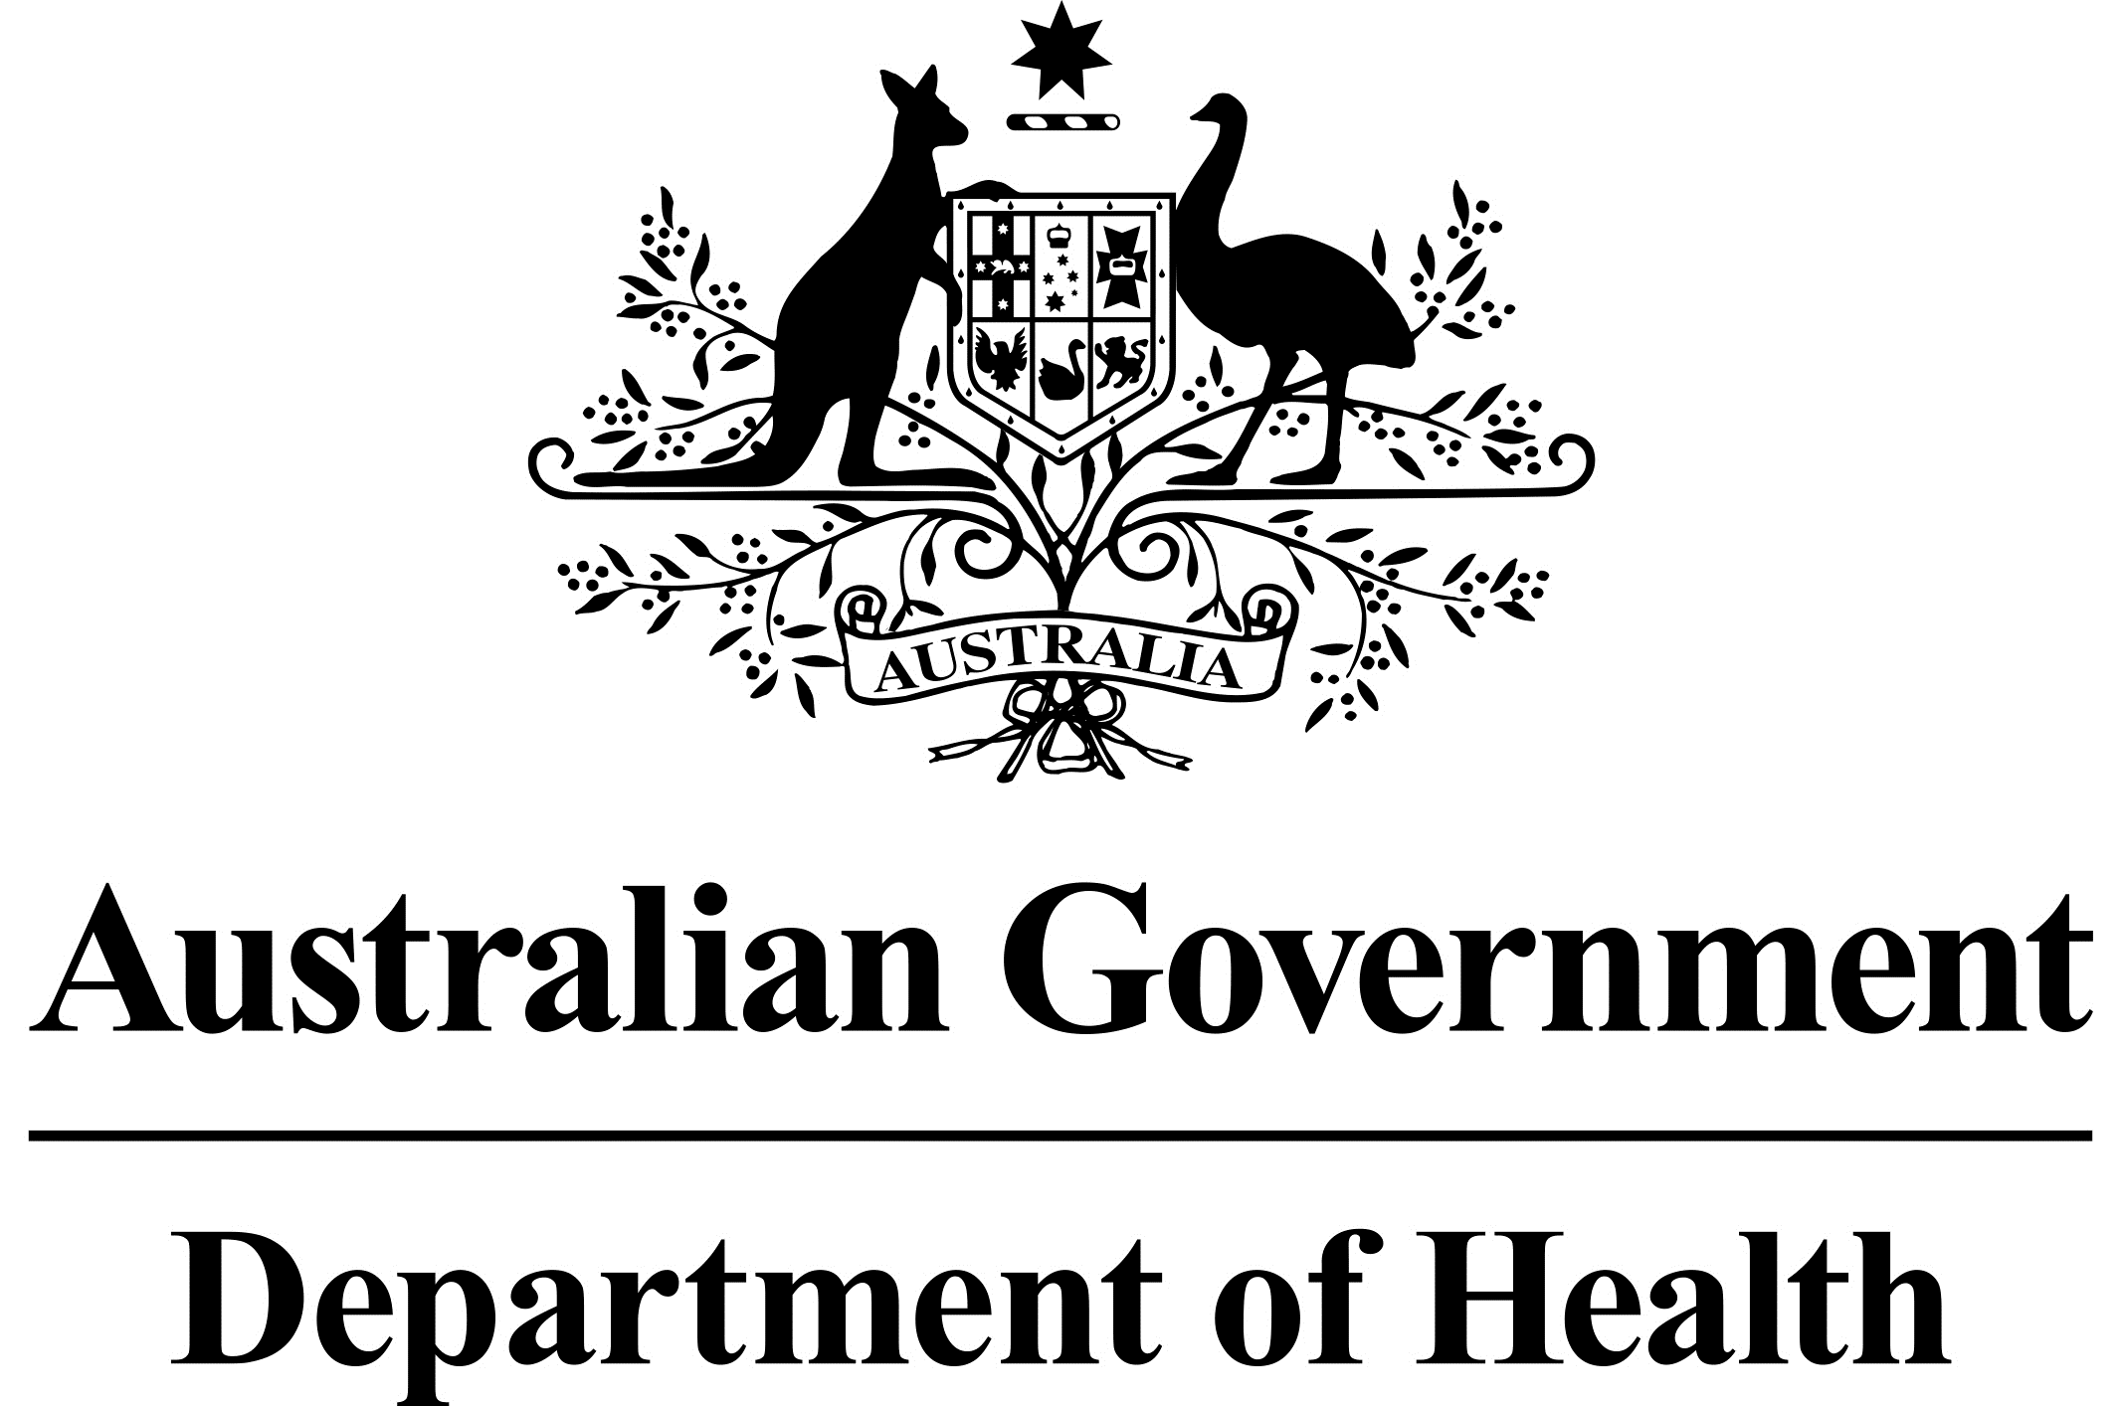

# 

# National Dust Disease Taskforce Communique

The National Dust Disease Taskforce held its eighth meeting via videoconference on   
7 June 2021.

## Issues considered at the eighth meeting

The Taskforce focused on further refining its final set of recommendations and progressing its Final Report.

Members discussed options for a potential governance mechanism to be established by the Australian Government to maintain the momentum of the Taskforce’s work beyond

30 June 2021.

## Next steps

The Taskforce will provide its Final Report to the Minister for Health and Ageing by   
30 June 2021.

Further information regarding the National Dust Disease Taskforce Terms of Reference and membership is available on the Department of Health’s National Dust Disease Taskforce webpage (<https://www.health.gov.au/dust>) or by emailing the National Dust Disease Taskforce Secretariat ([dust@health.gov.au](mailto:dust@health.gov.au)).